Table of content
3. Energy content in exports and eco-innovation 91
3.1. Energy Efficiency from an Economic Perspective 92
3.2. Energy content in exports and globalisation 96
3.2.1. Energy content in total exports 96
3.2.2. Energy content in manufacturing and service exports 101
3.2.3. Globalisation and the energy content in exports worldwide 109
3.2.5 Domestic-energy inputs vs domestic inputs in exports 119
3.2.6 Measuring energy efficiency in the manufacturing sector 121
3.3. ECO-INNOVATION ADOPTION AND THE COMPETITIVENESS OF EU FIRMS 128
3.3.1. Background and literature review 128
3.3.2. Adoption of energy-saving technologies 131
3.3.3 Market success of energy-efficiency product innovators 132
3.4. Policy Implications 138

3. Energy content in exports and eco-innovation
The prices of energy commodities, particularly oil, have risen sharply in the last decade (see Figure 3.1). Some of the causes are structural, such as globalisation and the increasing demand from developing countries, limited fossil-fuel resources and an overall increase in exploration costs, and these tend to lead to permanent energy-price increases. Cyclical factors such as the considerable rigidity of energy demand in the short term; the failure to fully anticipate its fast growth, as shown by preceding low levels of exploration investment and spare capacity; or concerns related to geopolitical events were often the major causes behind some of the recurrent energy price hikes and volatility observed. In addition there has been a significant increase in financial investment flows into energy commodity derivative markets. While the debate on the relative importance of the multiple factors influencing energy prices is still open, it is clear that energy commodity markets have become more closely linked to financial markets.

Figure 3.1 – Crude oil spot prices (USD/barrel)

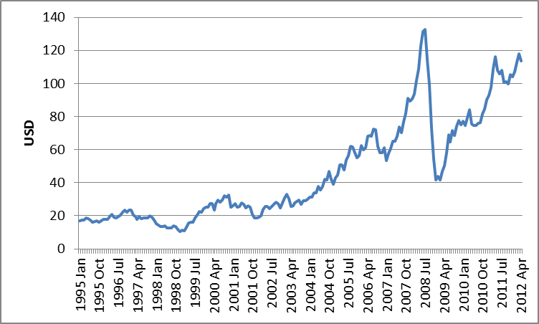
Source: IMF.

Rising energy price and volatility levels have a series of potential effects on businesses, production costs, economic activity or external accounts and competitiveness. These effects will be larger for countries or sectors that are less energy-efficient, more specialised in energy-intensive products or more energy-dependent (e.g. countries more heavily dependent on imported fossil fuels).

This chapter studies the energy content in exports and energy-efficiency trends over the past 15 years in the context of key economic developments such as the globalisation of industrial activities, investments in energy-efficient technologies and eco-innovation. Their impact on competitiveness is analysed at country, sector and firm level. Section 3.2 analyses the developments and the improvements in overall energy productivity and investments in more energy-efficient technologies at an international level. Section 3.3 analyses the interplay between the trends in the energy content in exports and globalisation, their impact on competitiveness and the prominent role played by industry and services. This is a novel integrated analysis (mapping) of energy use per sector at domestic and global levels based on the World Input Output Database (WIOD) made available recently. Section 4 analyses the evidence for the adoption and development of eco-innovations by EU firms and how this translates into performance and competitiveness, focusing on energy-efficiency process technologies and products. Section 5 draws conclusions.

3.1. Energy Efficiency from an Economic Perspective
This section provides a short analysis of the global trends in energy efficiency in the last 15 years using the World Input Output Database (WIOD). A cross-country comparison of energy-efficiency performance makes it possible to identify and introduce such related key economic developments as the internationalisation of production chains or investments in energy-efficient technologies, underpinning the more detailed analyses (at country, sector and firm level) that follow in the other sections.

The WIOD accounts for approximately 85 percent of the world’s production. The world input-output data is reported for 41 countries (the EU-27 countries, 13 other major world economies and the rest of the world) and 35 sectors (NACE rev. 1) over the period 1995-2009 (see Box 2.1 in Chapter 2 of this report). Most importantly for this chapter, the economic data is linked to environmental accounts and energy use. The WIOD database considers the use-side of energy and reports ‘gross energy use’ covering the transformation of primary energy into other forms of energy like electricity and heat, as well as the final use of energy. Energy is reported in terajoules of crude-oil inputs. As a general rule, throughout this chapter the other economic variables used to compute energy-efficiency indicators and ratios are first transformed into constant prices.

Figure 3.2 shows the patterns of energy consumption and economic output (per capita) for the European Union and its most important competitors (as well as separately for a selection of Member States: Bulgaria, Ireland and the Netherlands). Countries’ per capita GDP are plotted against the amount of energy per capita that was used to produce per capita GDP (PPP adjusted GDP was considered to be closer to the real level of economic activity and output). The figure also shows energy-efficiency improvements over time. Country-level observations for 1995 are indicated by light colours. The more recent an observation is, the darker it is plotted.

Figure 3.2 – GDP and Energy Use per Capita (1995 – 2009)
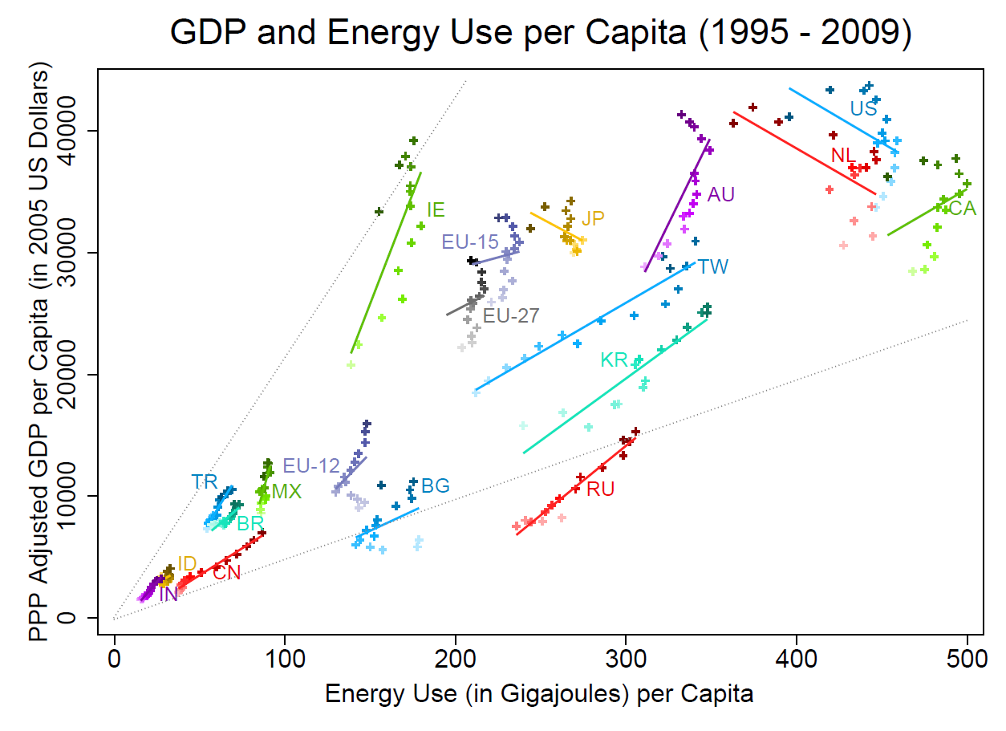
Note: Bulgaria (BG), Ireland (IE), United States (US), Japan (JP), China (CN), (South) Korea (KR), Taiwan (TW), Canada (CA), Australia (AU), Turkey (TR), Brazil (BR), India (IN), Mexico (MX), Indonesia (ID), and Russia (RU). Source: WIOD.

A measure of energy productivity (a crude measure of energy efficiency) is indicated by the slope of grey dotted lines. The steeper the line the higher the energy productivity, meaning that less energy per capita is used to produce a unit of GDP per capita. In 2009, energy productivity was highest in Ireland and lowest in Russia (comparing the two grey dotted lines at their 2009 values, using one gigajoule of energy one person in Ireland is able to produce goods and services with a value of USD 215, 4 times more than in Russia — USD 49 — using the same amount of energy). It has to be noted that using purchasing power parities rates (instead of exchange rates) increases the value of GDP — and therefore measured energy productivity — in countries with a low cost of living. Overall PPP adjustment narrows the gap in measured energy productivity between countries and regions, but leaves the trends unchanged.

Energy efficiency improved overall in the period 1995-2009 in advanced economies (the decline in measured energy productivity in 2008 and 2009 in some countries can to a large extent be explained by cyclical low capacity utilisation associated with the economic crisis). The European Union and Japan reinforced their lead in terms of energy productivity. EU-12 countries as a whole significantly narrowed their gap in energy efficiency vis-à-vis the EU-15 (Bulgaria is one of the EU Member States with the lowest energy-productivity levels). Conversely, in countries like China, India, Taiwan and Korea energy-efficiency improvements from 1995 until 2009 are much less perceptible.

Energy is used in practically all production processes and the importance of energy efficiency as a competitiveness factor is growing over time with globalisation. The globalisation of industrial activities tends overall to exert pressure to improve energy efficiency and speed-up the convergence of energy productivity in industry across countries. As result, significant economic changes and differentiated impacts on the competitiveness of different countries and sectors are to be expected. Section 3 analyses the changes in the energy content in exports in the context of the increasing global trade in intermediates and the internationalisation of production networks.

Rising energy prices and volatility levels were major underlying drivers for the changes observed in energy use and the overall improvement in energy productivity. Permanent increases in energy prices and volatility levels lead to significant economic changes, in particular in terms of energy-saving efforts and investments in energy-efficient technologies. The search for energy savings includes choosing products and services with less energy content and more energy-efficient production technologies. A prominent example is the development and use of more energy-efficient consumer durables and capital goods. Typically, they are the result of investment decisions comparing higher initial capital costs with expected future savings in energy operating costs. This example also provides a straightforward illustration of the well-known limitations in energy-efficiency the improvements in the short run (due, for example, to the long lifetimes of the capital equipment) versus a higher degree of responsiveness in the medium and long run.

The WIOD data is now linked to country-level data from the Penn World Tables 7.0. Figure 3.3 plots energy use against the countries’ physical capital stock (both energy use and the physical capital stock are scaled by the GDP). The y-axis reports the countries’ energy intensity, meaning the quantity of energy (in gigajoules) needed to produce 1 US dollar (at 2005 prices) of GDP. The x-axis indicates capital intensity, i.e. the dollar value of the capital stock of a country that was needed to produce 1 US dollar of GDP. Only a selection of countries is presented for the sake of illustration (Australia, India, and Brazil are no longer included in the figure due to visual overlap). Again, country-level observations for 1995 are indicated by light colours. The more recent an observation is, the darker it is plotted.

Figure 3.3 – Capital Stock and Energy Use per GDP (1995 – 2009)
SS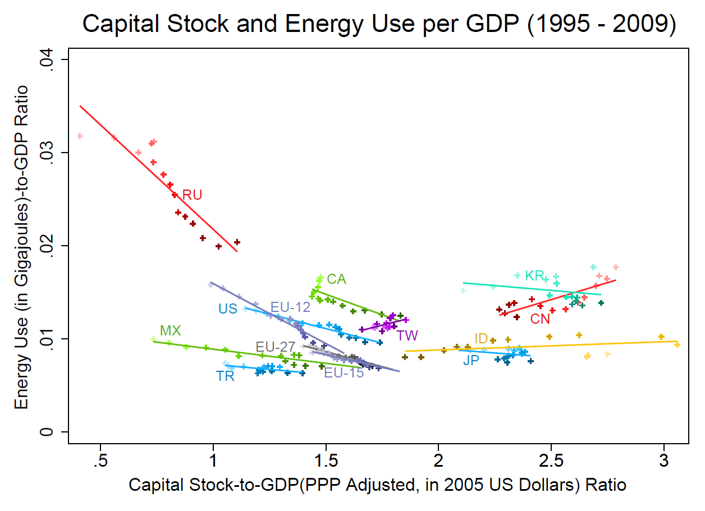
Source: WIOD, Penn World Tables 7.0.

China has reduced both energy use and capital use to produce one dollar of GDP over time. In other countries (including also the European Union), a shift towards less energy intensive and more capital-intensive production tends to be observed. This overall trend of the substitution of energy by capital reflects the choice at aggregate level for more energy-efficient technologies embodied in capital goods following the overall increase in the international price of energy observed in the period up to 2008 (see Figure 3.1).

The aggregate analysis just made applies similarly at the sectoral, firm or household levels. Permanent increases in energy prices are one of the factors exerting strong pressure for the adoption of more energy-efficient technologies, the replacement of older capital equipment and the attraction of new entrants (Linn, 2008), as well as inducing the development of energy-efficiency eco-innovations over the medium and long term. Popp (2002) identified increasing prices of energy in the oil crisis as the significant driver of energy-saving inventions (energy-related patent applications appear to respond with a lag). Newell et al. (1999) provide evidence of price-induced eco-innovation in new air conditioners. Jaffe and Stavins (1995) find noticeable impacts on the adoption of energy-efficient technology for buildings. Energy efficiency and eco-innovation can be promoted through a broad range of public policies and instruments such as regulations and standards, eco-design, eco-labels, energy taxes and subsidies. Evidence on energy efficiency and eco-innovations adoption and its impact on the competitiveness of EU firms are analysed in section 3.5 (using firm-level data from the European Community Innovation Survey).

3.2. Energy content in exports and globalisation

Increasing global competition and integration of production chains (involving more and more economic activities and tasks and covering new countries and geographical areas) are developments with far-reaching social, political and economic consequences. Global competition and off-shoring have an enormous potential and offer new opportunities in terms of the efficient exploitation of existing technologies and resources. The development and adoption of eco-innovations tend also be fostered by global competition. As a result, greater energy-efficiency improvements can be expected within and across firms, sectors and countries, helping to achieve environmental and climate change goals world-wide.

However, the quest for economic efficiency does not necessarily translate into energy efficiency and related environmental efficiency. Market failures (in energy or other markets) or regulatory failures may stand in the way and impair the simultaneous achievement of eco-efficiency, in particular on a world-wide basis. For example, various stages of production may be offshored to less energy-efficient countries or firms as a result of distorting taxes or subsidies on energy products. Existing plants in pollution-intensive industries can be relocated to regions with less stringent or unenforced regulations. Some evidence for this is presented by Henderson (1996) (see also List, Millimet, Fredriksson and McHone (2003); a survey of this strand of the literature is offered by Brunnermeier and Levinson (2004)).

A fully-fledged analysis of these complex issues is beyond the scope of this chapter. This section merely investigates the relationship between the internationalisation of production and changes in the energy content in exports, focusing on the EU, US and Japan. The main interest is in analysing (mapping) the energy use for exports in terms of its sources: domestic intermediates versus foreign intermediates (focusing on the energy content of exports — via embodied energy in intermediate imports). The role and different impacts on manufacturing and service exports are also analysed. The contribution of improved technical efficiency in the manufacturing sector to overall energy efficiency and competitiveness is also briefly analysed using a standard decomposition method.

3.2.1. Energy content in total exports

Input-output tables and in particular the WIOD database (which, as mentioned, contains detailed information on international and inter-industry transactions, for N=35 industries and C=41 economies – including the rest of the world – from 1995 to 2009) make it possible to trace the source and the energy content of goods and services produced in vertically-integrated industries and cross-border production networks. This provides an integrated global framework for the analysis of energy use that does not suffer from the limitations of standard sectoral or purely domestic input output data which do not take the interlinkages between sectors/countries into account.

Suppose there was interest to trace the energy inputs (per sector and country) and to calculate the energy content of a German car exported to China. The energy (e.g. electricity) used directly in the car-manufacturer’s plant would be one element. To that must be added the series of (indirect) energy consumptions embodied in the car components purchased by the manufacturer (e.g. the electricity used in the mining industry in Australia or in the production of the intermediates purchased from the electronics industry in Germany or other countries). The inverse Leontief matrix (from the input-output tables) can be used to calculate the total energy inputs (direct and indirect, in all rounds of production of the car and car components).

With data on energy use by industry, the Leontief inverse matrix can be pre-multiplied by the energy coefficients vector (i.e. energy used per unit of output) and post-multiplied by the vector of exports. This then allows a separation of the energy directly and indirectly used by a partner country to produce another country’s exports and its domestic energy use. The calculation of energy-input coefficients (i.e. energy use per unit of gross output) was performed using deflated gross output series. Gross output was deflated to constant 1995 prices, using industry-level price indices for each country.

The energy embodied in country r exports (measured in terajoule, TJ) is given by

where e denotes the NCx1 vector of energy use per unit of gross output (measured in constant prices, the prime denotes transposition), is the inverse Leontief matrix and the NCx1 vector with country r exports (see Box 2.1 in Chapter 2 of this report).

The left-hand panel in figure 3.4 shows an index of the energy embodied in exports for EU-15, EU-12, Japan and the US, over the period 1995-2009. Total energy inputs in exports increased globally in the four economies in the pre-crisis period (between roughly 130% in the US and 180% in the EU-15 up to 2007). In 2008-2009 the energy embodied in exports declined significantly and globally as a result of the economic crisis and the collapse in worldwide trade. The impact of the crisis and the sudden reversal of the long term upward trends in global trade can be seen in the right-hand panel in Figure 3.4 (presenting the underlying trade trends in terms of the index for total exports, for each of the four economies over the whole period 1995-2009).

Figure 3.4 – Indexes (1995=100): total energy embodied in exports (left panel) and total exports (right panel), 1995–2009
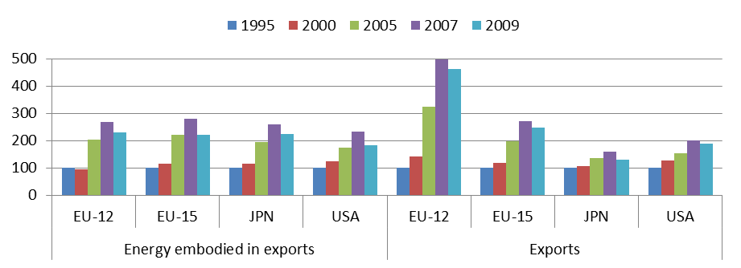

Source: WIOD.

The growth of total exports was higher in the EU overall (in particular the EU-12) than in Japan and in the US over the period analysed. The significant increase in total exports in the EU-12 economies as a whole is to a large extent due to their relatively high and increasing degree of vertical specialisation (e.g. in their role as providers of intermediates namely to EU-15, as documented in section 2.3.2 of the second chapter in this report, see e.g. Figure 2.1). This fact is corroborated by the much less than proportional growth rate in the energy embodied in exports (observed in the left-hand panel of Figure 3.4) for the EU-12.
A slight opposite trend occurs in Japan, for which the increase in energy inputs was slightly higher than the growth in the underlying total exports. In part, this may be due to the specialisation of the Japanese economy and eventually to its relatively high degree of vertical specialisation and its integration links with the Chinese economy (see, for example, Table 3.1 below or Figure 2.2. in Chapter 2 of this report). For the other two advanced economies (the EU-15 and the US), the underlying growth in total exports has been accompanied by a (broadly) a more proportional variation in the energy embodied.

This can be observed in Figure 3.5, presenting the energy embodied per unit of total exports for the four economies over the same period. In the left-hand panel, the marked decline in the total energy inputs per unit of exports in the EU-12 (and only to a much smaller extent in the EU-15) contrasts with the increase in the energy content in Japanese exports and the relative stagnation observed in the US for the whole period. The EU-15 and Japan lead in terms of the lowest energy content in exports but the catching-up achieved by the EU-12 over the period is noticeable.

The right-hand panel in Figure 3.5 depicts the energy embodied per unit of exports that is sourced domestically in each of the four economies (i.e. the sum of the energy incorporated by each of the 35 domestic sectors in all the various implicit rounds, stages of production and embedded economic activities in the achievement of the total exports of goods, services, raw materials and intermediates).

Figure 3.5 – Energy embodied (TJ) per unit of exports (USD million), 1995–2009
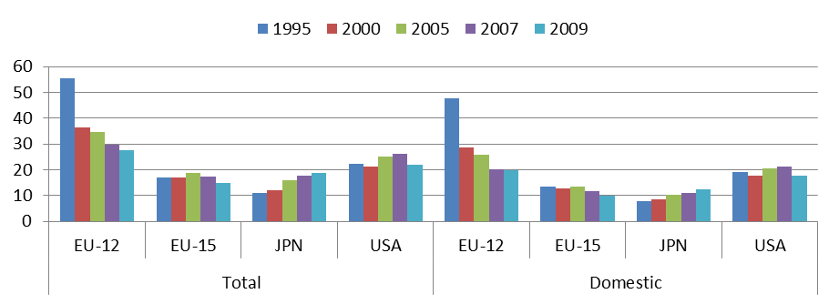
Source: WIOD.

The energy embodied per unit of exports that is sourced domestically is dominant in all four economies (particularly in the US, given the similarity in size of the respective columns (bars) in the two panels in Figure 3.5). Over time, the domestic energy embodied in exports and the overall energy content tend to move in parallel to a large extent but some differences can be noticed. For the EU-15 and EU-12, for instance, the observed drop in the domestic component of the energy content in exports is more pronounced than the decline in the total energy embodied, reflecting the rising importance of foreign sources in the energy embodied in exports. As a result, the EU-15 caught up Japan in 2007 (and outperformed it in 2009) in terms of the lowest domestic energy content in exports.

One of the effects of the increasing cross-border integration of production networks can be seen in the rising importance of foreign economies as a source of the energy inputs embodied in exports. Figure 3.6 presents the share of foreign energy inputs embodied in exports. The energy content in exports sourced from foreign countries rose continuously in all four economies up to 2007, but at a slower pace in Japan and the US. In the US, the domestic component is more important, representing more than 80% of the overall energy content in exports, partly reflecting the USA’s lower dependence in terms of imported fossil fuels compared to the other three economies overall (in 2009 the domestic energy shares were 72%, 66% and 67% in the EU-12, EU-15 and Japan, respectively).

Figure 3.6 – Share of foreign energy embodied in exports, (percentage 1995–2009)
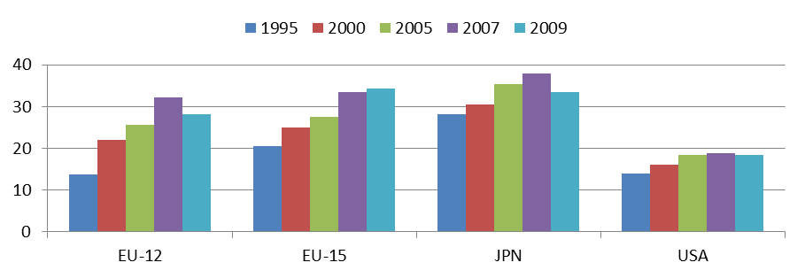
Source: WIOD.

This is unlike the pattern observed in Figure 2.1 (Chapter 2 of this report) in which the EU-12 had a higher level of import content in exports relative to the EU-15, Japan and the US (the reasons are discussed in Chapter 2, namely the openness of the EU-12 — being a group of small and medium-sized countries — and their vertical-integration links in particular with the EU-15). This contrasts with broadly identical levels of foreign-energy content in exports for the EU-15 and EU-12 (and Japan in the later years) observed in Figure 3.6. Another distinctive feature is apparent in Table 3.1. It concerns the greater weight overall of energy-rich economies (such as some countries in BRII and ROW) in terms of foreign-energy content relative to import content in exports (see also subsection 3.3.3 and Figure 3.16 below).

Table 3.1 presents a detailed breakdown of the sourcing structure of embodied energy inputs in exports (the domestic component is highlighted in grey). The changes over time and the geographical patterns follow expectations for each of the four economies. In the EU-12, the considerable reduction (by almost 20 percentage points in the period 1995-2007) in the domestic share of energy embodied in exports is mirrored in the large increases in the weight of traditional trade and energy supplier partners (like the EU-15, BRII — Brazil, Russia, India and Indonesia — and the Rest Of the World — ROW) and China (and smaller increases in the shares of other trade partners). In the period 1995-2007, all EU-12 trade partners in Table 3.1 steadily increased their shares of the energy embodied in EU-12 exports (except Mexico and the US in 2005).

Table 3.1 – Geographic (source) structure of energy embodied in exports (1995–2009, share in percentage, domestic source highlighted in grey)
 | EU-12 |  |  |  |  | EU-15
 | 1995 | 2000 | 2005 | 2007 | 2009 | 1995 | 2000 | 2005 | 2007 | 2009
BRII | 5.0 | 6.6 | 6.8 | 8.4 | 6.4 | 3.7 | 4.0 | 6.0 | 7.4 | 6.8
Canada | 0.1 | 0.2 | 0.3 | 0.4 | 0.3 | 0.7 | 0.8 | 0.7 | 0.8 | 0.7
China | 0.3 | 1.1 | 2.9 | 4.7 | 6.1 | 1,6 | 2.2 | 3.4 | 4.8 | 6.5
EU-12 | 86,2 | 78.0 | 74.4 | 67.7 | 71.7 | 2.4 | 2.2 | 2.5 | 2.7 | 2.8
EU-15 | 4.5 | 6.9 | 7.8 | 8.8 | 7.1 | 79.4 | 75.0 | 72.4 | 66.5 | 65.8
Japan | 0.1 | 0.3 | 0.4 | 0.5 | 0.4 | 0.4 | 0.6 | 0.5 | 0.6 | 0.6
S. Korea | 0.1 | 0.3 | 0.5 | 0.8 | 0.8 | 0.3 | 0.6 | 0.6 | 0.8 | 0.8
Mexico | 0.0 | 0.1 | 0.1 | 0.1 | 0.1 | 0.2 | 0.3 | 0.3 | 0.3 | 0.3
USA | 0.5 | 1.3 | 1.0 | 1.3 | 1.1 | 2.3 | 3.1 | 2.6 | 2.9 | 2.9
ROW | 3.2 | 5.3 | 5.8 | 7.3 | 6.0 | 9.0 | 11.3 | 11.0 | 13.3 | 12.8
 | Japan |  |  |  |  | USA
 | 1995 | 2000 | 2005 | 2007 | 2009 | 1995 | 2000 | 2005 | 2007 | 2009
BRII | 4.4 | 4.7 | 5.2 | 6.1 | 4.7 | 1.4 | 1.8 | 2.4 | 2.4 | 2.1
Canada | 0.9 | 0.7 | 0.5 | 0.5 | 0.4 | 2.3 | 2.6 | 2.7 | 2.5 | 2.1
China | 3.1 | 4.0 | 7.6 | 7.9 | 8.5 | 1.6 | 1.9 | 3.4 | 3.7 | 4.7
EU-12 | 0.2 | 0.2 | 0.3 | 0.3 | 0.2 | 0.2 | 0.2 | 0.3 | 0.2 | 0.2
EU-15 | 2.1 | 2.0 | 2.1 | 1.8 | 1.3 | 1.7 | 1.9 | 2.2 | 2.0 | 1.6
Japan | 71.9 | 69.5 | 64.7 | 62.1 | 66.6 | 0.6 | 0.6 | 0.5 | 0.5 | 0.4
S. Korea | 2.4 | 3.2 | 2.8 | 2.4 | 1.7 | 0.5 | 0.6 | 0.6 | 0.7 | 0.6
Mexico | 0.1 | 0.2 | 0.1 | 0.2 | 0.1 | 0.6 | 0.8 | 1.0 | 1.0 | 1.2
USA | 2.9 | 3.3 | 2.6 | 2.5 | 1.6 | 86.0 | 83.9 | 81.5 | 81.2 | 81.5
ROW | 11.9 | 12.2 | 14.1 | 16.3 | 14.9 | 5.1 | 5.6 | 5.5 | 5.7 | 5.6

Source: WIOD. Note: BRII denotes Brazil, Russia, India and Indonesia, ROW-Rest of the world.

The domestic proportion of the energy content in EU-15 exports decreased steadily over the whole period (from 4/5 in 1995 to 2/3 in 2009) reflecting the increasing weights of the BRII economies, the ROW and China. In 2009, China’s share of energy embodied in EU-15 exports was already more than twice the — relatively stable — share accounted for by traditional trade partners like the EU-12 or the US. The other trade partners listed in the table have smaller shares that increased slightly overall or tended to remain relatively stable.

The increased importance of China as a source of energy content in exports globally is particularly striking in the case of Japan (accounting for more than 8% of the energy content in total exports in 2009). The increase in China’s share, and to a smaller extent that of the ROW and the BRII economies, almost compensates for the reduction in the domestic share in the energy content in Japanese exports in the period 1995-2007. The shares of other important Japanese trading partners like South Korea and the US remained fairly stable or decreased only slightly in the period 1995-2007.

The US maintained a relatively higher domestic share of the energy content in exports and relatively lower shares for typical energy-sourcing countries within the BRII and the ROW, partly reflecting the US’s lower dependence in terms of imported fossil fuels compared to overall the EU-15, EU-12 and Japan. China has comparatively a smaller share of the energy embodied in US exports and Canada has a more prominent weight in the US (relative to the EU-15, EU-12 and Japan).

The recent crisis together with its impact on global trade, in particular for industries with more developed cross-border production networks, led to a halt and in some cases a reversal of the previous trends. Overall, the domestic content of energy embodied in exports started rising at the expenses of the foreign content for the majority of trade partners. The exception is China, which continued to increase its share for the four economies analysed, squeezing the shares of other foreign economies. In fact, China is the single economy whose share increased more over the whole period for all the four economies analysed (China’s share increased by 5 percentage points or more for Japan, the EU-12 and EU-15 and by 3 percentage points in the US in the period 1995-2009).

These developments are to a great extent the result of the globalisation of production and underlying vertical-specialisation trends observed in terms of the import content of exports in the second chapter of this report (see, for example, Table 2.2). The analysis suggests that, along with increasing globalisation, the EU economies (as a whole) have been able to export more and at the same have reduced the energy embodied in their exports, in particular the part that is sourced domestically. Overall, the EU economies have been leading (relative to Japan and the US) in the reduction of the energy content per unit of exports and in the global trends towards the increasing weight of foreign-energy inputs in the total energy embodied in exports. Services and manufacturing exports have played a central role in this process. This is the subject of the analysis in the next subsection.

3.2.2. Energy content in manufacturing and service exports

Manufacturing transforms primary energy inputs into final energy products and uses energy in the transformation of materials into products; many manufacturing sectors are at the forefront of the internationalisation of production networks.

Figure 3.7 highlights the importance of manufacturing in terms of exports and how this is translated into the energy embodied in exports for the four economies being analysed. The right-hand panel shows that manufacturing exports accounted in the years 2007-2009 for around 80% of total exports in Japan, 70 % in the European economies and 60 % in the US. The share of manufacturing in total exports has been falling in all economies, except for the EU-12 (reflecting the vigorous increase in manufacturing exports; to a great extent, this is the result of the increasing vertical integration of the EU-12 documented in Chapter 2 of this report). A number of manufacturing industries (e.g. producing durable goods) were severely hit during the most recent crisis and the share of manufacturing in total exports dropped in all economies in 2007-2009 except for Japan, for which the exports of services declined more than manufacturing exports during the crisis, see Figure 3.8 below.

Manufacturing activities involve transforming a range of material inputs into products, so manufacturing exports generally tend to have a higher energy content than total exports. The share of energy embodied in manufacturing relative to total exports (in the left-hand panel in Figure 3.7) is higher overall than the weight of manufacturing in total exports. This is true for all four economies, except for the EU-12 in 2009 and Japan in the years 1995, 2005, cases in which the shares in the left-hand and right-hand panels in Figure 3.7 are roughly identical.

Figure 3.7 – Energy embodied in manufacturing exports relative to total energy embodied in total exports (left panel) and share of manufacturing exports in total exports (right panel), 1995–2009

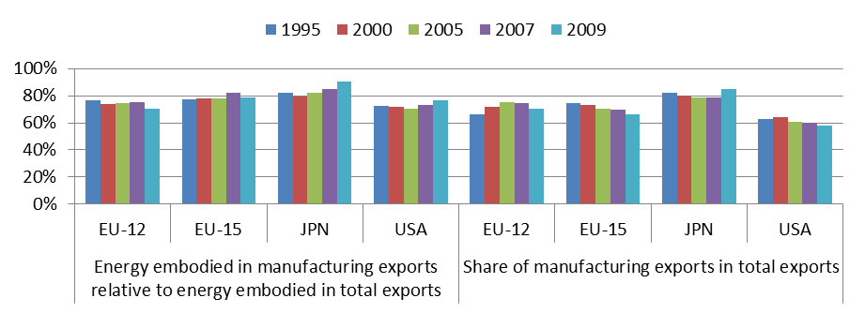
Source: WIOD.

Moreover, the energy embodied in manufacturing exports as a share of the energy embodied in total exports remained broadly stable (or even increased slightly in some sub-periods and for the whole period 1995-2009) while at the same time the share of manufacturing exports fell overall. The exception was the EU-12, for which manufacturing as a whole outperformed the overall reduction of energy content in total exports.

Figure 3.8 illustrates the growing importance of service exports and their overall lower energy content relative to manufacturing exports. The right-hand panel shows that the share of services in total exports has been growing for all economies in the last 15 years, except in the EU-12 (for which manufacturing remained the dominant driver of export growth). Altogether, manufacturing and services accounted for more than the 95 % of total exports for all four economies (the highest share is reached in Japan, 99 % of total exports, see Table 3.4).

The growth of service exports was particular strong in the European economies (+320 % in the EU-12 and +250 % in the EU-15 in the period 1995-2007). In the EU-15, the growth of manufacturing exports was much lower (around +150 % in the period 1995-2007) and as a result the share of services in total exports rose from 20 % in 1995 to close to 30 %. In 2007, the share of services accounted for more than 1/3 of total exports in the US and for around 20 % in the EU-12 and Japan. Japan has a much lower share than the US and the EU-15 in services such as financial intermediation and Renting and Machinery and Equipment and other business services (including ICT and R&D-related services). During the recent crisis, exports dropped considerably in a number of service sectors (including more cyclical-related sectors such as water transport and wholesale trade and commission trade, NACE codes 61 and 51, respectively), leading to the observed fall in the share of services in total exports in Japan.

Figure 3.8 – Energy embodied in service exports relative to total energy embodied in total exports (left panel) and share of service exports in total exports (right panel), 1995–2009
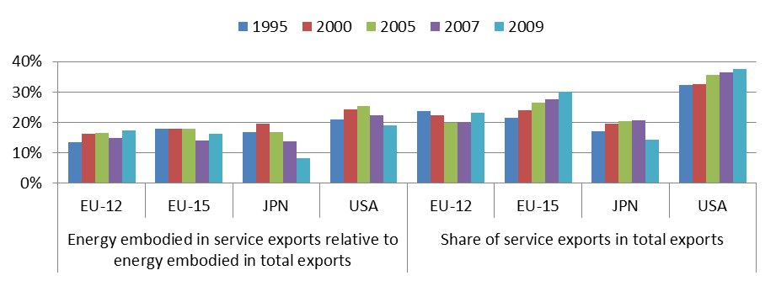
Source: WIOD. Note: Service includes the sectors NACE rev. 1 codes 50 to P.

Not surprisingly, Figure 3.8 shows that service exports as a whole tend to have a relatively lower energy content (the share of energy embodied in service exports relative to total exports (left-hand panel) is lower overall than the weight of services in total exports (right-hand panel)). Moreover, energy embodied in service exports relative to total exports decreased (or remained broadly stable in the case of EU-12 and US) while the share of service exports increased overall (except in the crisis period 2007-2009 in the case of Japan and for the EU-12, where growth in manufacturing exports dominated the whole period).

Table 3.2 presents energy embodied per unit of exports (panel A) and the share of the energy inputs that is sourced from foreign countries (panel B) for manufacturing, services and total exports (in the latter case, a convenient recast of the data in Figures 3.4 and 3.6 above).

Panel B shows a steady rise in the share of foreign-energy inputs in the total energy embodied in exports (both manufacturing and services up to 2007). Partly reflecting a higher degree of cross-border production linkages (see Chapter 2 of this report, Figure 2.2), manufacturing has a higher share of foreign energy content relative to services (except for the EU-12 in 1995). However, the gap between the share of foreign energy in manufacturing and services narrowed, in particular in the EU-15. The input-output linkages between services and manufacturing explain why the differences between the two sectors are much smaller in terms of foreign-energy content than in import content. Services source many of their more energy-intensive inputs from manufacturing, some of which are in turn directly and indirectly sourced from foreign countries.

Japan leads over the period 1995-2007 in terms of the highest content of foreign energy inputs in exports. The US has overall a larger share of domestic-energy inputs in exports, particularly in services.

Figure 3.9 plots the changes (in the period 1995-2007) against the level of the energy content in exports in 2007 (highlighting the main trends in the data presented in panel A of Table 3.2). Manufacturing is depicted by the larger bubbles. The EU-15 and Japan lead in terms of having the lowest energy content in services and manufacturing exports but the energy content in manufacturing exports increased in the period 1995-2007, particularly in Japan. The EU-15 kept the energy content in total exports broadly constant in the period up to 2007 mainly thanks to a reduction in the energy embodied in service exports (together with their greater and increasing weight in total exports relative to Japan, see also Figure 3.8).

Table 3.2 – Energy embodied (TJ) per unit of exports (USD million) (left panel) and share of foreign energy embodied in exports (right panel) 1995–2009

 | (A) Energy inputs per unit of exports |  |  |  |  |  | (B) Share of foreign energy inputs
 | 1995 | 2000 | 2005 | 2007 | 2009 |  | 1995 | 2000 | 2005 | 2007 | 2009
 | Manufacturing (NACE D)
EU-12 | 63.6 | 38.0 | 34.8 | 30.0 | 27.3 |  | 14% | 23% | 29% | 36% | 33%
EU-15 | 17.6 | 18.2 | 20.8 | 20.5 | 17.8 |  | 23% | 27% | 29% | 34% | 35%
Japan | 11.1 | 12.1 | 16.7 | 19.5 | 20.1 |  | 29% | 31% | 36% | 38% | 34%
USA | 25.9 | 23.8 | 29.0 | 31.8 | 28.6 |  | 16% | 19% | 21% | 20% | 20%
 | Services (NACE 50 to P)
EU-12 | 31.4 | 26.7 | 29.1 | 22.0 | 20.8 |  | 16% | 22% | 19% | 26% | 22%
EU-15 | 14.3 | 12.7 | 12.6 | 8.8 | 8.1 |  | 13% | 19% | 22% | 32% | 33%
Japan | 10.9 | 12.1 | 13.1 | 12.1 | 10.8 |  | 26% | 30% | 34% | 35% | 30%
USA | 14.4 | 15.8 | 17.9 | 16.0 | 11.0 |  | 8% | 9% | 12% | 14% | 15%
 | .Total exports (NACE A to P)
EU-12 | 55.5 | 36.6 | 34.8 | 29.6 | 27.6 |  | 14% | 22% | 26% | 32% | 28%
EU-15 | 17.0 | 16.9 | 18.8 | 17.4 | 14.9 |  | 21% | 25% | 28% | 33% | 34%
Japan | 11.0 | 12.1 | 15.9 | 17.8 | 18.8 |  | 28% | 30% | 35% | 38% | 33%
USA | 22.2 | 21.3 | 25.2 | 26.1 | 21.8 |  | 14% | 16% | 19% | 19% | 19%

Source: WIOD.

Following its integration in cross-border production networks and strengthening of its vertical specialisation, the EU-12 achieved a noticeable reduction and catching-up in the energy content of manufacturing exports. The EU-12 reached the same energy content in manufacturing exports as the US in 2007. The reduction in the energy content in service exports was comparatively much smaller.

The energy content in the US increased both for manufacturing and service exports in the period 1995-2007 (in a broadly similar trend to Japan’s). The higher energy content in US exports vis-à-vis the EU-15 and Japan is less pronounced in services. Combined with a larger share of service exports in the US, this mitigates the gap in energy embodied per unit of US total exports.

Figure 3.9 – Energy content in exports (for manufacturing, services and total exports): change 1995-2007 versus level in 2007
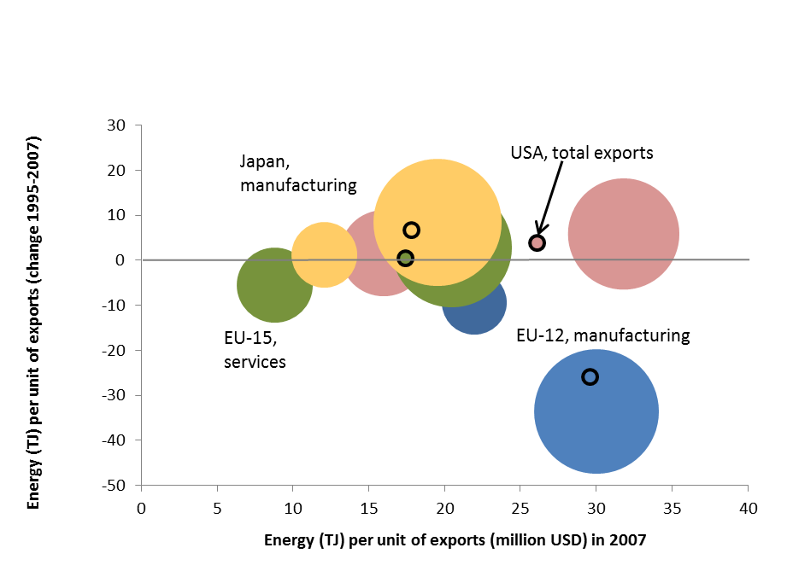

Source: WIOD. Note: Manufacturing is depicted by the larger bubbles. The size of the bubbles reflects the weight of manufacturing and services in total exports in 2007. The points enclosed in the small black circles of uniform size represent total exports.

Figure 3.10 presents the breakdown of energy inputs per unit of exports by domestic and foreign countries’ sources. The amount of foreign-energy inputs per unit of exports increased overall in all four economies for both manufacturing and services in the period 1995-2007. In the period 1995-2007, (as already observed in Figure 3.5 above), the domestic energy content in total exports decreased in the European economies and increased in Japan and to a lesser extent in the US. For the EU-12, this is due to a significant drop in the energy incorporated domestically in manufacturing exports and to a much lesser extent in service exports. In contrast, in the EU-15 this is mainly the result of the considerable drop in the domestic- energy content of service exports. As from 2007, the EU-15 also clearly leads in terms of the lowest domestic-energy inputs per unit of service exports. Regarding manufacturing exports, the EU-15’s domestic-energy content remained constant and the increase in total energy embodied was due to the increase in foreign-energy inputs. For Japan and the US, the increase in the domestic energy content in total exports was primarily due to the rise in the (corresponding domestic) energy inputs in manufacturing.

During the crisis period 2007-2009, following the slump in global trade, the previous upward trend in the share of foreign energy inputs in total energy embodied in manufacturing and service exports ended or in some cases temporarily reversed. Panel B in Table 5.2 above showed that in the period 2007-2009 the share of foreign-energy inputs in total energy embodied in exports stabilised in the EU-15 and USA and decreased in Japan and the EU-12. This may be due in part to the fact that manufacturing exports, which were more severely hit overall during the crisis, account for a larger share of total exports in Japan and in the EU-12.

Figure 3.10 – Energy (TJ, domestic and foreign) content in (manufacturing, services and total) exports (Million USD, 1995, 2007)

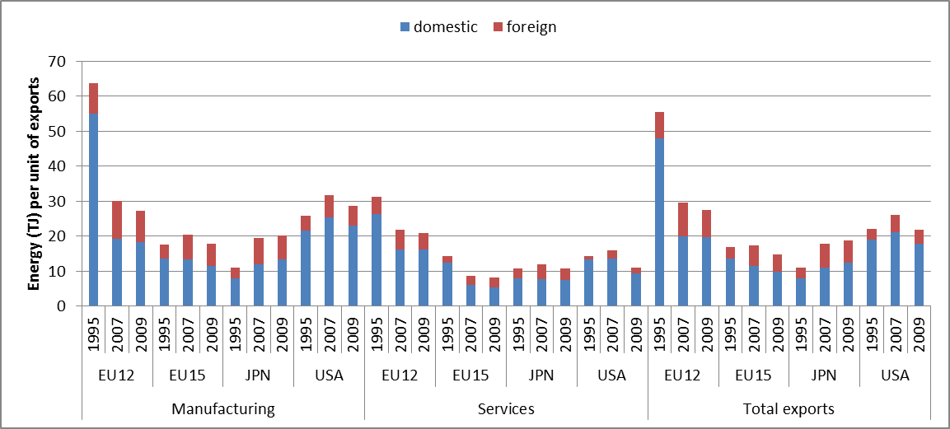
Source: WIOD.

Figures 3.9 and 3.10 show for the period 1995-2007 an overall increase in the energy content in manufacturing (except in the EU-12) and to a lower extent in service exports (except for the EU-12 and EU-15). These figures also suggest that this could in part be related to the increasing globalisation of production and the increasing weight of foreign-energy inputs. Panel B in Table 3.2 points in the same direction by showing a steady rise in the share of foreign-energy inputs in the total energy embodied in exports (both in manufacturing and services up to 2007). Subsection 3.2.3 below presents a short exploratory analysis of the country and sectoral trends in the energy content in exports in relation to globalisation of production and trade.

Figure 3.11 further illustrates the geographic patterns implicit in the changes in the structure of the energy inputs embodied in exports over the period 1995-2007. The figure presents the changes in the shares of energy inputs embodied in manufacturing, services and total exports for each of the four economies (e.g. the share of domestic-energy inputs in total energy embodied in the EU-15 exports of services decreased by 19% in the period 1995-2007, while the share of energy inputs that EU-15 exporters sourced directly and indirectly from the BRII countries increased by 5% in the same period).

Figure 3.11 shows a large shift overall from domestic to foreign energy inputs embodied in exports in the period 1995-2007. Interestingly, the figure also reveals for this period a higher (or at least comparable in the case of Japan) shift towards foreign-energy inputs in service exports relative to manufacturing exports. The exception is the EU-12, whose share of domestic-energy inputs in manufacturing exports declined (significantly by 22 %) by more than twice the contraction observed in the share of domestic-energy inputs in service exports. A major and almost equivalent drop (19%.) was observed in the share of domestic-energy inputs in EU-15 exports of services. This, together with the relative weights of the manufacturing and services in total exports in the EU-12 and EU-15, explains why the European economies had the largest falls in the share of domestic-energy inputs in total exports. The US had a much lower reduction in the share of domestic-energy inputs in exports (around 4% in manufacturing and 6% in services).

The reciprocal increase in the share of foreign-energy inputs embodied in exports was not distributed equally across all trade partners. However, almost all of them increased their shares of total energy inputs embodied in the exports in the period 1995-2007. The very few exceptions concern Japan. There were marginal decreases in the shares of S. Korea and EU-15 energy inputs in Japanese service exports or in the share of US, Canadian and EU-15 energy inputs in Japanese manufacturing exports. This means that in the case of Japan domestic energy inputs, but also (to a minor extent) those from some foreign countries, were shifted to other economies (e.g. China and the RoW).

Figure 3.11 – Changes in the share of energy inputs embodied in exports in the period 1995–2007 (in p.p.)

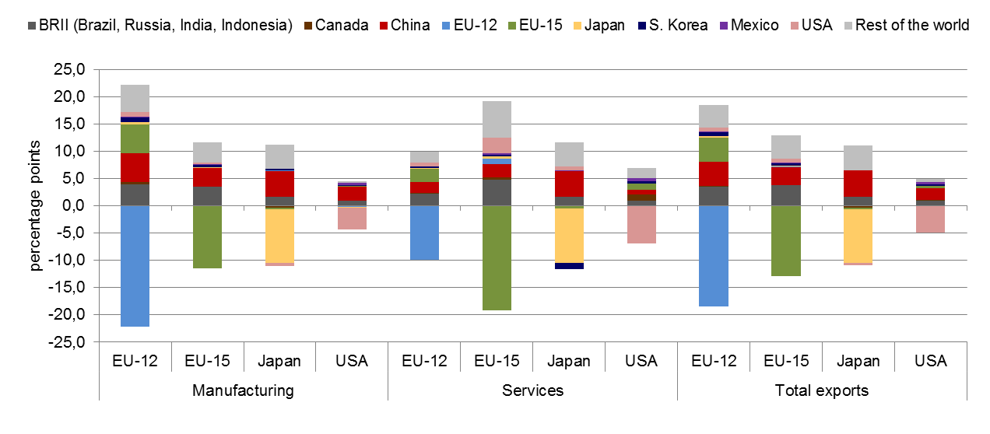
Source: WIOD.

Figure 3.12 below summarises the main changes in the structure of (shares per trade partner in) foreign-energy inputs embodied in exports. A joint reading of Figures 3.11 and 3.12 shows that in the period 1995-2007 a significant part of the energy inputs embodied in exports were diverted from domestic to foreign countries, in particular to China.

Figure 3.12 shows that this is particularly noticeable in manufacturing, where off-shoring trends in the period 1995-2007 led to virtually a doubling of the share (8 times higher in the case of EU-12) of Chinese energy inputs in the foreign-energy inputs in manufacturing exports. The increase in the weight of China as source of foreign-energy inputs led to an overall contraction in the shares of other trade partners. Overall, the shares of the RoW or the BRII contracted as well as the share of energy inputs embodied in bilateral manufacturing trade between the EU-12, EU-15, Japan and the US.

Compared to manufacturing, the rise in the weight of China as source of foreign-energy inputs embodied in service exports was less pronounced, except for Japan. For Japan in the period 1995-2007, the share of Chinese energy inputs in the foreign-energy inputs in Japanese service exports also more than doubled, while the corresponding shares of S. Korea and EU-15 were roughly halved. In the EU-15, despite the significant decline in the relative weight of domestic-energy inputs in service exports (remember Figure 3.11), the relative increase in Chinese energy inputs was less pronounced and the US and the EU-12 kept their shares broadly stable. Similarly, in the US in the period 1995-2007, the shares of Canadian and EU-15 energy inputs in US service exports remained fairly stable while the increase in the corresponding share of China was much smaller compared to manufacturing.

Regarding the recent crisis period, Figure 3.15 shows that China continued to increase its share of foreign-energy inputs in exports both for manufacturing and services, now at the expense of the other trade partners in general. Over the whole period (1995-2009), it more than doubled its share of the foreign-energy inputs embodied in both manufacturing and service exports of the EU-15, Japan and the US (the corresponding increase was much higher in the case of the EU-12).

Figure 3.12 – Shares (per trade partner) in foreign-energy inputs embodied in exports, 1995, 2007, 2009
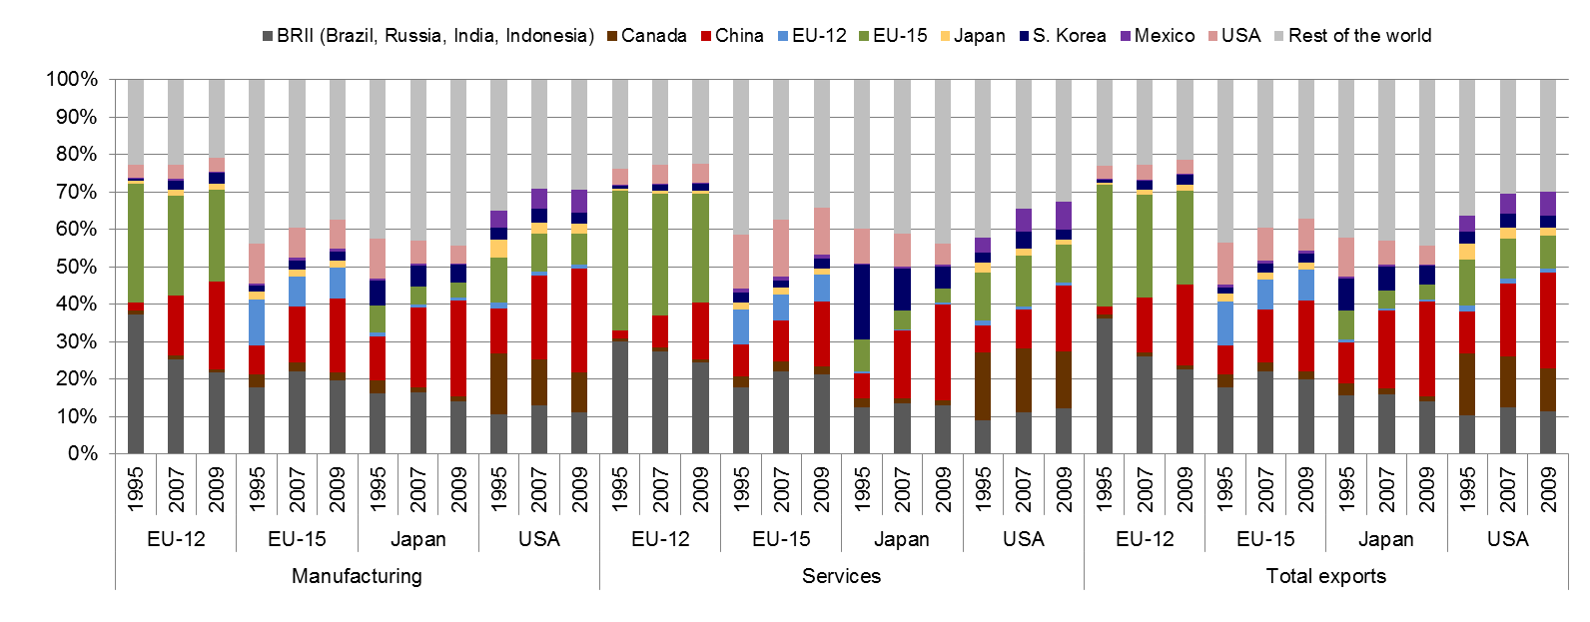
Source: WIOD.

The changes in the sourcing structure of foreign-energy inputs embodied in exports reflect many factors such as differences in energy-efficiency trends across countries and sectors, together with global-trade and vertical-specialisation developments. For instance, Figure 3.12 shows a relatively high share of the EU-15 in the foreign-energy inputs embodied in EU-12 exports (for manufacturing, services and total exports). This is to a great extent a reflection of the strong links and importance of the EU-15 (e.g. as providers of intermediate inputs) in the import content of EU-12 exports (documented in Chapter 2). Subsection 3.2.4 below analyses in more detail the relations between imports and foreign-energy content in exports and some of their implications for competitiveness across countries and sectors.

3.2.3. Globalisation and the energy content in exports worldwide

This section explores to what extent globalisation and increasing vertical specialisation have been followed by changes (and eventually some convergence) in the energy content in exports at the world level. World exports are proxied by the whole WIOD exports. The different developments and contributions of manufacturing and service exports are also briefly analysed, focusing on the long term changes in the period 1995-2007.

Figure 3.13 plots the changes (in the period 1995-2007) against the level of the energy content in total exports in 2007. The size of the bubbles reflects the proportion that the energy embodied in each of the ten economies’ total exports makes up of the total energy embodied in (the whole ten economies’) WIOD total exports. The world is proxied by total WIOD and is represented by the largest circle (with vertical and horizontal lines crossing at its centre).

Figure 3.13 – Energy content in total exports: change 1995-2007 versus level in 2007

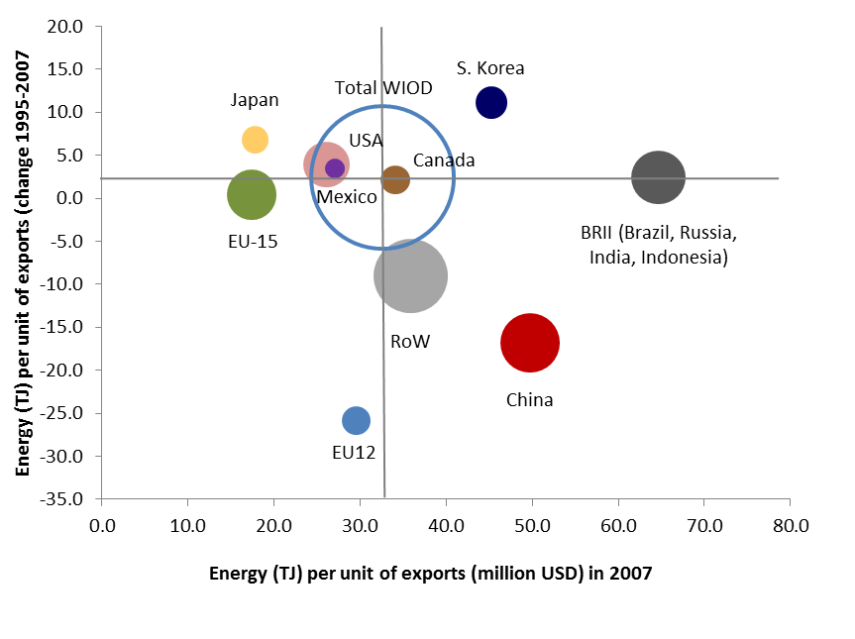
Source: WIOD. Note: The size of the bubbles reflects the weight that the energy embodied in the each economy's total exports has in the total energy embodied in all WIOD total exports in 2007. Total WIOD is represented by the largest circle.

The figure shows an increase (of 8 %, see Table 3.3) in the energy use per unit of worldwide exports in the period 1995-2007. This was a period of sustained growth in global trade and intensified vertical specialisation and appears to have led to significant reductions and some convergence in the energy content in exports for economies such as the EU-12, China and the RoW.

China achieved partial convergence by reducing the energy content in its exports by ¼ in the period 1995-2007 (see also Table 3.3 below). However, this reduction was much smaller than the increase (it almost tripled) in China’s share in total WIOD exports in the same period. This explains to a large extent the observed increase in energy inputs per unit of worldwide exports in the period 1995-2007. It has to be noted that domestic-energy inputs account for a relatively high share (85 % in 2007) of the energy content in Chinese exports. Even if the share of foreign-energy inputs embodied in Chinese total exports has almost doubled (it increased from 8 % to 15 %) in the period 1995-2007, this is still a relatively low value. In fact, this is the second-lowest value after the BRII economies and less than half of the weight of foreign-energy inputs in exports in the majority of the other economies (except for the US, Canada and the RoW, that are less dependent on energy imports, see the last three columns in Table 3.3).

The increasing contribution and role of energy embodied in Chinese exports can also be seen by comparing the shares in total WIOD energy embodied with the shares in total exports in Table 3.3. Despite some improvement, in 2007 China still had the second-highest ratio (after the BRII economies) between the share of energy embodied and the share in total WIOD exports (e.g. in 2007 China and the US already had comparable shares of total WIOD exports – 11 % and 13 % respectively – while the share in terms of energy embodied is considerably higher in China – 17 %, as against 10 % in the US).

BRII economies as a whole also contributed (but to a lower extent than China) to the observed increase in energy inputs per unit of total WIOD exports in the period 1995-2007. This is due to the marginal increase in the BRII economies’ share of total WIOD exports, combined with their overall high (unchanged) level of energy content in exports. The high level of energy content in exports may in part reflect the relatively abundant energy resources in some of the BRII economies.

The convergence (and significant reduction) in the energy content in exports of the RoW economies was roughly proportional to the increase in their share of total WIOD exports which led to a neutral (slight reduction) effect on the energy inputs per unit of worldwide exports.

The EU-12 in particular (but also the EU-15) outperformed overall in the reduction on energy content in exports. The EU-12 achieved full convergence with the total WIOD level in the period 1995-2007. The increase in the energy inputs per unit of exports in South Korea and Japan may partly reflect the particular and intense vertical-specialisation links of these two economies with China.

Figure 3.14 plots the changes (in the period 1995-2007) against the level of the energy content in manufacturing exports in 2007. The two panels are equal except for the size of the bubbles. In panel A (on the left), the size of the bubbles reflects for each economy the weight that the energy embodied in its manufacturing exports has in the energy embodied in total WIOD manufacturing exports. On the right in panel B, the size of the circles reflects the share of manufacturing exports in total WIOD manufacturing exports in 2007. Total WIOD is represented by the largest circle in both panels.
Table 3.3 – Energy embodied (TJ) per unit of exports (USD million) and share of trade, energy and foreign energy embodied in manufacturing, service and total exports: 1995, 1997, 2009
 | Energy (TJ) per unit of exports (Million USD) |  |  | Share in total WIOD exports |  |  | Share in total WIOD energy embodied |  |  | Share of foreign energy inputs
 | 1995 | 2007 | 2009 | 1995 | 2007 | 2009 | 1995 | 2007 | 2009 | 1995 | 2007 | 2009
MANUFACTURING (NACE D)
BRII | 74.9 | 82.4 | 77.3 | 5% | 6% | 5% | 11% | 13% | 12% | 7% | 7% | 7%
Canada | 32.8 | 37.6 | 34.8 | 6% | 4% | 3% | 6% | 4% | 3% | 22% | 26% | 24%
China | 68.1 | 51.2 | 46.1 | 5% | 15% | 21% | 10% | 21% | 28% | 8% | 15% | 17%
EU-12 | 63.6 | 30.0 | 27.3 | 3% | 5% | 5% | 5% | 4% | 4% | 14% | 36% | 33%
EU-15 | 17.6 | 20.5 | 17.8 | 27% | 24% | 23% | 14% | 14% | 12% | 23% | 34% | 35%
Japan | 11.1 | 19.5 | 20.1 | 14% | 8% | 7% | 5% | 4% | 4% | 29% | 38% | 34%
S. Korea | 33.4 | 48.8 | 50.0 | 4% | 5% | 5% | 4% | 6% | 7% | 30% | 31% | 32%
Mexico | 26.4 | 30.5 | 32.8 | 2% | 2% | 2% | 2% | 2% | 2% | 29% | 36% | 32%
USA | 25.9 | 31.8 | 28.6 | 17% | 12% | 11% | 14% | 10% | 9% | 16% | 20% | 20%
RoW | 53.8 | 37.6 | 37.3 | 18% | 20% | 17% | 30% | 21% | 19% | 12% | 33% | 31%
WIOD | 32.6 | 35.8 | 34.6 | 100% | 100% | 100% | 100% | 100% | 100% | - | - | -
SERVICES (NACE 50 to P)
BRII | 37.8 | 37.9 | 37.4 | 6% | 9% | 8% | 13% | 19% | 16% | 6% | 6% | 6%
Canada | 20.6 | 16.5 | 15.7 | 3% | 2% | 2% | 3% | 2% | 2% | 19% | 21% | 19%
China | 55.9 | 39.2 | 36.9 | 2% | 7% | 14% | 7% | 16% | 30% | 8% | 15% | 16%
EU-12 | 31.4 | 22.0 | 20.8 | 3% | 4% | 4% | 5% | 5% | 5% | 14% | 32% | 28%
EU-15 | 14.3 | 8.8 | 8.1 | 26% | 29% | 29% | 19% | 15% | 13% | 21% | 33% | 34%
Japan | 10.9 | 12.1 | 10.8 | 10% | 6% | 4% | 6% | 4% | 2% | 28% | 38% | 33%
S. Korea | 38.5 | 26.6 | 30.3 | 3% | 3% | 2% | 7% | 4% | 4% | 27% | 31% | 32%
Mexico | 16.2 | 17.1 | 17.1 | 2% | 2% | 1% | 2% | 2% | 1% | 25% | 31% | 28%
USA | 14.4 | 16.0 | 11.0 | 30% | 21% | 21% | 22% | 19% | 13% | 14% | 19% | 19%
RoW | 22.8 | 14.8 | 15.7 | 14% | 17% | 15% | 17% | 15% | 13% | 11% | 22% | 20%
WIOD | 19.2 | 17.5 | 17.6 | 100% | 100% | 100% | 100% | 100% | 100% | - | - | -
TOTAL EXPORTS (NACE A to P)
BRII | 62.2 | 64.7 | 61.0 | 6% | 7% | 7% | 12% | 14% | 13% | 6% | 6% | 6%
Canada | 32.0 | 34.1 | 31.4 | 5% | 4% | 3% | 6% | 4% | 3% | 19% | 21% | 19%
China | 66.6 | 49.7 | 44.5 | 4% | 11% | 17% | 9% | 17% | 24% | 8% | 15% | 16%
EU-12 | 55.5 | 29.6 | 27.6 | 3% | 4% | 4% | 5% | 4% | 4% | 14% | 32% | 28%
EU-15 | 17.0 | 17.4 | 14.9 | 25% | 23% | 22% | 14% | 12% | 10% | 21% | 33% | 34%
Japan | 11.0 | 17.8 | 18.8 | 12% | 6% | 6% | 4% | 4% | 3% | 28% | 38% | 33%
S. Korea | 34.2 | 45.3 | 46.9 | 4% | 4% | 4% | 4% | 5% | 5% | 27% | 31% | 32%
Mexico | 23.6 | 27.1 | 29.5 | 2% | 2% | 2% | 2% | 2% | 2% | 25% | 31% | 28%
USA | 22.2 | 26.1 | 21.8 | 19% | 13% | 13% | 14% | 10% | 9% | 14% | 19% | 19%
RoW | 45.0 | 35.9 | 36.5 | 21% | 25% | 22% | 31% | 27% | 26% | 11% | 22% | 20%
WIOD | 30.3 | 32.7 | 31.7 | 100% | 100% | 100% | 100% | 100% | 100% | - | - | -
Source: WIOD.

Manufacturing exports are dominant overall in total exports (see Table 3.4 below) and appear to explain to a large extent the observed increase in energy embodied in exports at world level in the period 1995-2007. Figure 3.12 shows (see also Table 3.3) an increase of 10 % in the energy use per unit of world-wide manufacturing exports, which is slightly higher than the (8 %) rise in energy use per unit of total exports depicted in Figure 3.11 and Table 3.3 above.

The rise in energy content in total WIOD manufacturing exports appears to be primarily driven by the increasing vertical-specialisation links with China. The energy content in Chinese manufacturing exports declined by ¼ in the period 1995-2007 while its share in total WIOD manufacturing exports tripled in the same period (see Table 3.3). To a lesser extent, the BRII economies as a whole and S. Korea also contributed to the rise in the energy use per unit of total WIOD manufacturing exports. This can be seen by the position and size of bubbles in Figure 3.14. For China, BRII and S. Korea, the bubbles in panel B (reflecting export shares) are smaller relative to panel A (in which they reflect the shares in energy embodied in exports).

Figure 3.14 – Energy content in manufacturing exports: change 1995-2007 versus level in 2007

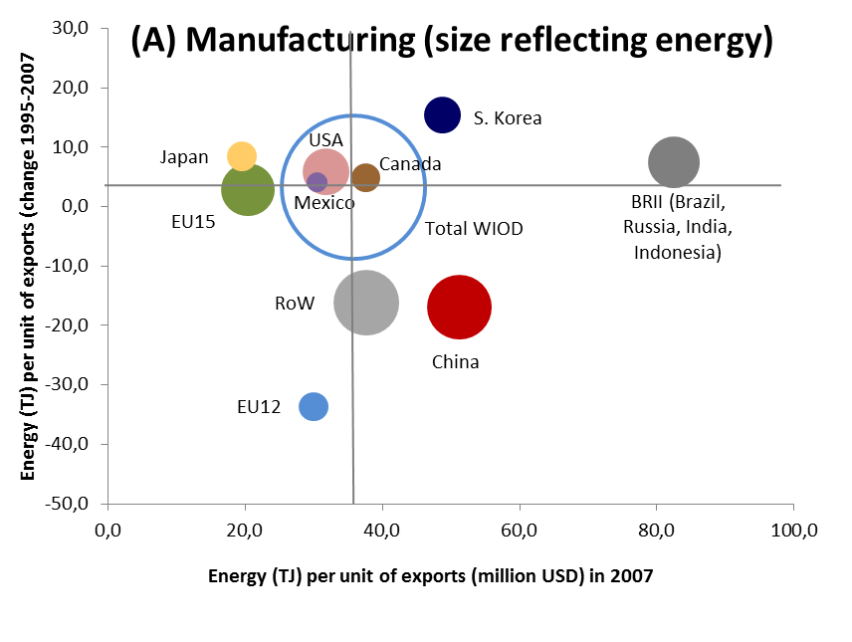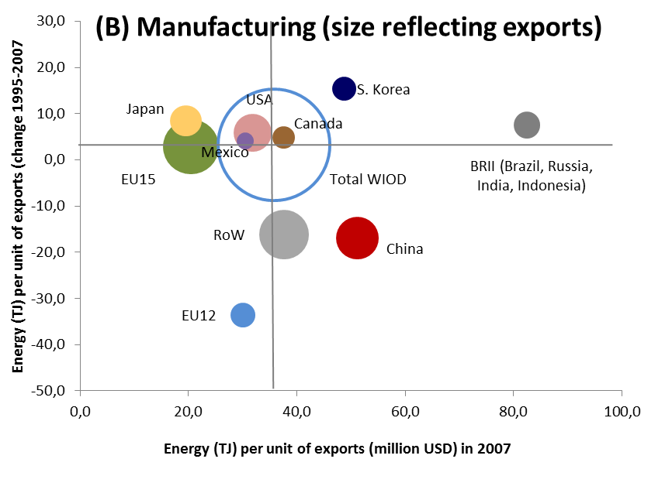
Source: WIOD. Note: In panel A (on the left) the size of the bubbles reflects the weight that energy embodied in the manufacturing exports of each economy has in the total energy embodied in the whole WIOD manufacturing exports in 2007. On the right in panel B the size of the bubbles reflects the share of manufacturing exports in total WIOD manufacturing exports in 2007. Total WIOD is represented by the largest circle.

The EU-12 more than halved their energy inputs per unit of manufacturing exports (starting from roughly the same level as China in 1995). The ROW economies also reduced significantly (by 30 %) the energy content in exports and moved closer to the total WIOD average in the period 1995-2007.

Figure 3.15 presents similar plots of the changes (in the period 1995-2007) against the level of the energy content in service exports in 2007. Unlike manufacturing, the energy inputs embodied in service exports declined by 9 % in the period 1995-2007. The energy content in service exports is converging in the majority of countries, except for the BRII economies, as with manufacturing. Despite a significant improvement, in China the energy content in service exports in 2007 was similar to the level in the BRII economies.

Services and manufacturing have different weights in the various economies. Moreover, for some economies exports from other sectors such as agriculture, forestry or mining are also significant (e.g. in the RoW, BRII economies and Canada, exports other than manufacturing and services accounted for between 1/5 and 1/3 of the total exports in 2007, see Table 3.4).

Figure 3.15 – Energy content in service exports: change 1995-2007 versus level in 2007

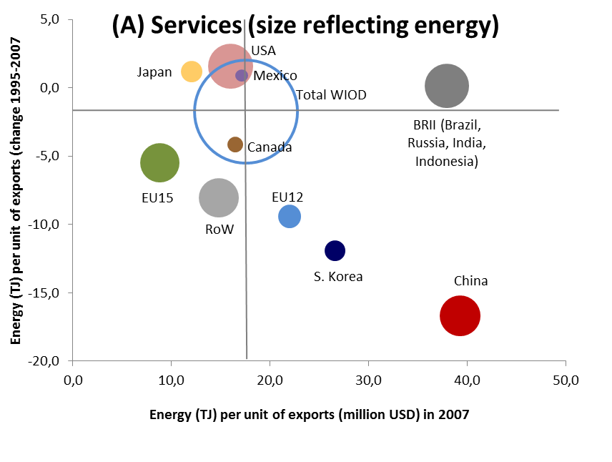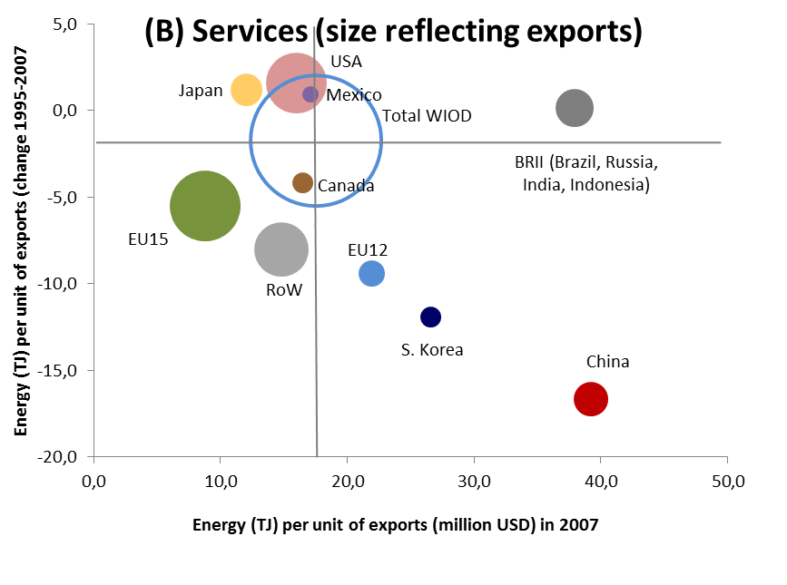
Source: WIOD. Note: On the left panel (A) the size of the bubbles reflects the weight that energy embodied in the service exports (NACE 50 to P) of each economy has in the total energy embodied in the whole WIOD service exports in 2007. On the right panel the size of the bubbles reflects the share of service exports in total WIOD service exports in 2007. Total WIOD is represented by the largest circle.

Table 3.4 – Shares of manufacturing, services and other exports in total exports,
1995, 1997, 2009

 | MANUFACTURING (NACE D) |  |  | SERVICES (NACE 50 to P) |  |  | OTHER (NACE A to C, E,F)
 | 1995 | 2007 | 2009 | 1995 | 2007 | 2009 | 1995 | 2007 | 2009
BRII | 58% | 51% | 50% | 23% | 26% | 26% | 19% | 23% | 24%
Canada | 75% | 65% | 59% | 12% | 14% | 17% | 13% | 22% | 25%
China | 81% | 84% | 79% | 12% | 14% | 19% | 7% | 2% | 2%
EU-12 | 66% | 75% | 71% | 24% | 20% | 23% | 10% | 5% | 6%
EU-15 | 75% | 70% | 67% | 21% | 28% | 30% | 4% | 3% | 3%
Japan | 83% | 79% | 85% | 17% | 21% | 14% | 0% | 0% | 1%
S. Korea | 81% | 84% | 84% | 18% | 16% | 16% | 1% | 0% | 0%
Mexico | 68% | 69% | 72% | 21% | 15% | 14% | 12% | 16% | 14%
USA | 63% | 60% | 58% | 32% | 36% | 38% | 5% | 4% | 4%
RoW | 60% | 52% | 50% | 14% | 15% | 15% | 25% | 32% | 35%
WIOD | 70% | 66% | 64% | 21% | 22% | 23% | 10% | 12% | 12%
Source:WIOD.
3.2.4. Foreign-energy inputs vs import content in exports

Figure 3.16 presents the shares (per trade partner) of foreign-energy inputs and import content in exports (the latter studied in Chapter 2 of this report) side-by-side. As expected, the figure depicts a significant overall similarity between the two structures but also some important differences. Firstly, energy-rich economies (such as some countries in BRII and ROW) have a higher weight in terms of foreign-energy inputs relative to import contents in total exports. This general pattern is also found for manufacturing and service exports. The direction of the changes (in the period 1995-2007) in the shares of foreign energy sourced from these (BRII and ROW) countries tend to follow the direction of the changes in import content in exports. However, the relationship is not one-to-one: the ratio between the shares in foreign energy and import content in exports is rising overall for the BRII and declining for the RoW (see Table 3.5 below), perhaps reflecting many factors such as energy-efficiency trends, preferential trade and energy supply relations between different countries, etc.

Figure 3.16 – Shares (per trade partner) in foreign energy inputs vs import content in EU-12, EU-15, Japan, US, China, BRII and RoW total exports, 1995, 2007

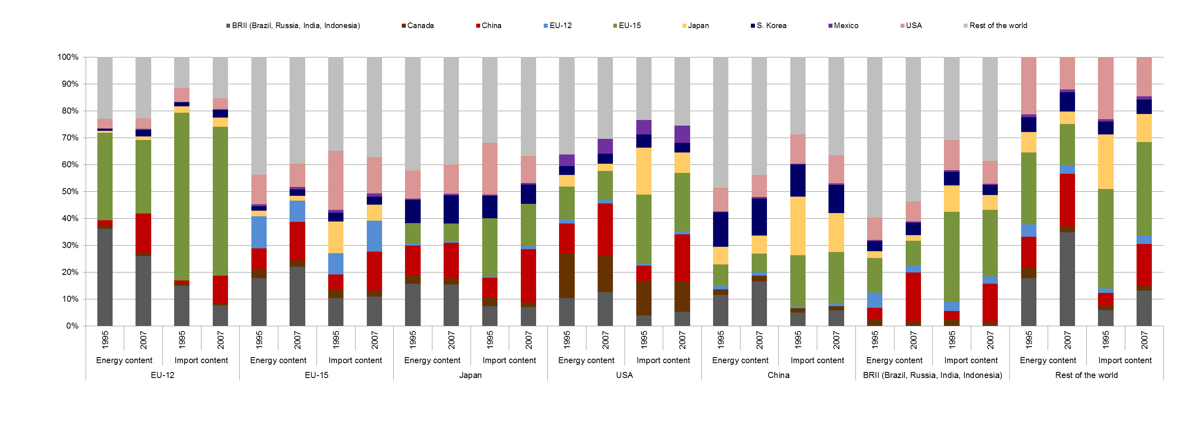
Source: WIOD.

Secondly, advanced economies (in particular the EU-15, Japan and to a lesser extent the US) tend to have higher shares of import content relative to foreign-energy content in exports. Both shares decreased overall for the EU-15, Japan and the US in the period 1995-2007. Thirdly, and unlike these advanced economies, China significantly increased its overall share of both foreign-energy inputs and import content in exports over the same period. However, China’s share of foreign-energy inputs is higher (or broadly as great in some cases in 2007) than the share of import content in exports. Fourthly, regarding China’s exports, the increase in energy use was reflected in a significant increase in the energy content share of the BRII in the period 1995-2007, mostly at the expense of the RoW economies. These movements do not have an immediate parallel in the import-content structure of Chinese exports. In fact, partly reflecting the increased use of non-energy raw material inputs, the import-content share of the RoW economies increased over this period, mostly at the expense of Japan and to a much lesser extent of the other economies (in 2007, the EU-15 as a whole had the second-largest import-content share in Chinese exports, after the ROW). The figures for manufacturing and service exports show similar patterns and were omitted.

Table 3.5 presents the ratio between the shares in foreign-energy inputs and import content in manufacturing, service and total exports (panels A, B, C respectively) for all ten economies. The ratio provides a measure of relative energy intensity in total foreign inputs. It can similarly be seen as the share of energy in total (energy and non-energy) inputs sourced from a given trade partner relative to the corresponding average share for all trade partners of a given country. Therefore it indicates (in relative terms, per trade partner) how energy intensive the import contents are in the exports of a given country. A value lower than one indicates that a given trade partner has a lower than average weight of energy inputs relative to all foreign inputs embodied in the exports of a given country. In order to facilitate reading, values lower or equal to one (and higher than ½) are highlighted in yellow. Values lower or equal to ½ are highlighted in green.

The import content of exports is growing with the globalisation of production and vertical specialisation and this ratio provides a summary of the relative energy intensities and vulnerabilities to increases in the relative price of energy. It permits analysis of relative performances across countries and sectors as a consequence, for instance, of specialisation or energy-efficiency trends. For instance, the two columns for China indicate (for the years 1995 and 2007) the ratio between foreign-energy inputs and import contents in Chinese (manufacturing, service and total) exports. In 2007, the Japanese share of total foreign-energy inputs embodied in Chinese exports was only half of the Japanese share in the import content of Chinese exports. For the EU-15, the corresponding figure was even smaller. Incidentally, in this particular case the ratios for Chinese total exports and manufacturing exports are identical (in terms of the figures presented, rounded to one decimal place). For Chinese service exports in 2007, the lead of the EU-15 in terms of the lowest relative weight of energy inputs is even more pronounced.

The diagonal is empty because only foreign-energy inputs and import content in exports are being compared. The last two columns (labelled WIOD) present the ratio between the shares in foreign-energy inputs and import content in total WIOD exports (for manufacturing, service and total exports). Standard deviations are presented in the last three rows for manufacturing, service and total exports.

The EU-15 and Japan have the lowest relative weight of energy inputs in the total foreign inputs incorporated in exports (globally and overall across countries and sectors, manufacturing and services). Among the economies with a high overall dependency on energy imports, the EU-15 as a whole and Japan are therefore those economies that in principle will suffer lower external competitiveness losses as a result of an increase in the relative price of energy. One distinction is that the EU-15 slightly reduced overall the relative weight of energy inputs in total inputs across countries and sectors in the period 1995-2007 (one exception was the increase from 1.4 to 1.7 in the relative weight of EU-15 energy inputs embodied in US service exports).

By contrast, for Japan the relative weight of energy inputs in the total inputs it embodies in exports increased overall in the same period. The EU-15 and Japan are among the countries having the lowest dispersion in the relative weights of energy inputs, reflecting a relatively diversified sourcing among their trade partners of the energy inputs embodied in their exports.

In the US, the relative weight of energy inputs is higher (twice the relative weight in the EU-15 and Japan in 2007 in WIOD exports) and, as with Japan, also increased overall in the period. Despite this increase, the relative weight of US energy inputs is overall below (or in some cases close to) the average. The standard deviation of the relative weight of energy inputs embodied in US exports decreased, particularly in manufacturing exports.

The EU-12 as a whole achieved the greatest reduction in the relative weight of energy inputs embodied in exports (halving or more than halving the ratio for all WIOD service, manufacturing and total exports) in the period 1995-2007. In 2007, the relative weight of EU-12 energy inputs embodied in exports was already below the average for total WIOD and for many of the single-country exports. The standard deviation of the relative weights of foreign inputs embodied in EU-12 exports increased, in particular for manufacturing, as result of the increase in the relative weight of the energy inputs sourced from the BRII in the period 1995-2007.

Table 3.5 – Ratio between the shares in foreign energy inputs and import content in manufacturing, service and total exports in 1995 and 2007

 | BRII |  | Canada |  | China |  | EU-12 |  | EU-15 |  | Japan |  | Korea |  | Mexico |  | USA |  | RoW |  | WIOD
 | 1995 | 2007 | 1995 | 2007 | 1995 | 2007 | 1995 | 2007 | 1995 | 2007 | 1995 | 2007 | 1995 | 2007 | 1995 | 2007 | 1995 | 2007 | 1995 | 2007 | 1995 | 2007
A) Manufacturing exports
BRII |  |  | 3.4 | 2.7 | 2.3 | 2.9 | 2.4 | 3,. | 1.7 | 2.0 | 2.2 | 2.3 | 2.5 | 2.7 | 3.6 | 2.7 | 2.7 | 2.5 | 3.1 | 2.6 | 2.5 | 2.6
Canada | 1.2 | 1.3 |  |  | 1.3 | 1.4 | 1.4 | 1.6 | 1.1 | 1.1 | 1.0 | 0.9 | 1.3 | 1.1 | 1.7 | 1.1 | 1.3 | 1.1 | 2.0 | 1.4 | 1.3 | 1.2
China | 1.4 | 1.3 | 2.8 | 1.5 |  |  | 1.9 | 1.5 | 1.4 | 1.0 | 1.6 | 1.0 | 1.5 | 1.2 | 2.7 | 1.4 | 2.1 | 1.2 | 2.5 | 1.2 | 2.0 | 1.2
EU-12 | 1.8 | 1.0 | 2.8 | 1.2 | 2.5 | 1.0 |  |  | 1.5 | 0.7 | 1.8 | 0.7 | 2.0 | 0.7 | 3.2 | 1.0 | 2.3 | 1.0 | 3.1 | 1.1 | 2.2 | 0.9
EU-15 | 0.4 | 0.4 | 0.6 | 0.5 | 0.4 | 0.4 | 0.5 | 0.5 |  |  | 0.3 | 0.3 | 0.4 | 0.3 | 0.6 | 0.5 | 0.5 | 0.5 | 0.7 | 0.4 | 0.5 | 0.4
Japan | 0.3 | 0.4 | 0.3 | 0.3 | 0.3 | 0.5 | 0.3 | 0.4 | 0.2 | 0.3 |  |  | 0.3 | 0.4 | 0.3 | 0.4 | 0.3 | 0.4 | 0.4 | 0.4 | 0.3 | 0.4
Korea | 0.7 | 1.2 | 1.0 | 0.9 | 1.0 | 1.3 | 0.6 | 0.9 | 0.5 | 0.7 | 0.9 | 0.9 |  |  | 0,8 | 0.8 | 0.6 | 1.0 | 1.1 | 1.3 | 0.8 | 1.1
Mexico | 0.9 | 1.0 | 0.8 | 0.7 | 1.1 | 0.8 | 1.2 | 1.1 | 0.6 | 0.7 | 0.7 | 0.6 | 1.0 | 0.7 |  |  | 0.8 | 0.8 | 1.2 | 0.8 | 0.8 | 0.8
USA | 0.8 | 0.8 | 0.9 | 0.8 | 0.8 | 0.8 | 0.7 | 1.0 | 0.5 | 0.6 | 0.5 | 0.6 | 0.7 | 0.6 | 0.9 | 0.9 |  |  | 0.9 | 0.8 | 0,7 | 0.8
RoW | 1.9 | 1.4 | 2.2 | 1.6 | 1.7 | 1.2 | 2.0 | 1.5 | 1.2 | 1.1 | 1.3 | 1.2 | 1.8 | 1.3 | 2.0 | 1.1 | 1.5 | 1.2 |  |  | 1.8 | 1.3
St dev | 0.6 | 0.4 | 1.2 | 0.7 | 0.8 | 0.7 | 0.8 | 0.9 | 0.5 | 0.5 | 0.6 | 0.6 | 0.7 | 0.7 | 1.2 | 0.7 | 0.9 | 0.6 | 1.0 | 0.7 | 0.8 | 0.6
B) Service exports
BRII |  |  | 2.7 | 2.1 | 1.9 | 2.4 | 2.5 | 2.8 | 1.7 | 2.1 | 1.7 | 2.4 | 1.9 | 2.7 | 2.5 | 2.0 | 2.7 | 2.2 | 3.2 | 3.2 | 2.2 | 2.5
Canada | 0.8 | 1.1 |  |  | 0.9 | 1.1 | 1.2 | 1.1 | 1.0 | 1.0 | 0.7 | 0.9 | 0.9 | 1.2 | 1.3 | 0.8 | 1.5 | 1.6 | 2.1 | 1, | 1.3 | 1.5
China | 1.0 | 1.2 | 2.0 | 1.1 |  |  | 1.6 | 1.2 | 1.2 | 1.0 | 1.1 | 1.1 | 0.8 | 1.3 | 2.1 | 0.9 | 1.6 | 0.8 | 2.6 | 1.3 | 1.5 | 1.1
EU-12 | 1.3 | 0.8 | 1.6 | 1.0 | 1.7 | 0.8 |  |  | 1.4 | 0.7 | 1.0 | 0.6 | 0.8 | 0.6 | 2.1 | 0.7 | 1.2 | 0.7 | 2.9 | 1.0 | 1.6 | 0.8
EU-15 | 0.3 | 0.3 | 0.5 | 0.6 | 0.4 | 0.3 | 0.6 | 0.6 |  |  | 0.4 | 0.3 | 0.3 | 0.3 | 0.4 | 0.7 | 0.4 | 0.7 | 0.8 | 0.5 | 0.5 | 0.4
Japan | 0.2 | 0.3 | 0.3 | 0.5 | 0.3 | 0.5 | 0.2 | 0.3 | 0.2 | 0.3 |  |  | 0.4 | 0.4 | 0.3 | 0.4 | 0.2 | 0.4 | 0.4 | 0,5 | 0.3 | 0.4
Korea | 0.7 | 1.5 | 1.1 | 1.0 | 1.7 | 1.9 | 0.4 | 0.8 | 0.7 | 0.7 | 1.4 | 0.9 |  |  | 0.7 | 0.9 | 0.8 | 1.7 | 1.4 | 1.8 | 1.3 | 1.4
Mexico | 0.7 | 1.0 | 0.8 | 0.9 | 0.9 | 0.7 | 1.1 | 1.0 | 0.8 | 0.9 | 1.0 | 1.0 | 1.1 | 1.1 |  |  | 0.9 | 1.2 | 1.3 | 1.0 | 0.9 | 1.2
USA | 0.6 | 0.9 | 1.0 | 1.0 | 0.7 | 0.7 | 0.6 | 0.9 | 0.5 | 0.7 | 0.6 | 0.9 | 0.6 | 0.9 | 1.1 | 1.2 |  |  | 1.0 | 1.0 | 0.7 | 0.8
RoW | 2.2 | 1.5 | 1.6 | 1.2 | 1.8 | 1.3 | 2.0 | 1.3 | 1.4 | 1.1 | 1.3 | 1.1 | 1.7 | 1.4 | 1.7 | 1.0 | 1.5 | 1.0 |  |  | 1.9 | 1.2
St dev | 0.6 | 0.4 | 0.8 | 0.5 | 0.7 | 0.7 | 0.8 | 0.7 | 0.5 | 0.5 | 0.4 | 0.6 | 0.5 | 0.7 | 0.8 | 0.4 | 0.7 | 0.6 | 1.0 | 0.8 | 0.6 | 0.6
C) Total exports
BRII |  |  | 3.4 | 2.7 | 2.3 | 2.8 | 2.4 | 3.4 | 1.7 | 2.0 | 2.1 | 2.3 | 2.4 | 2.7 | 3.5 | 2.6 | 2.7 | 2.4 | 3.1 | 2.6 | 2.5 | 2.5
Canada | 1.1 | 1.2 |  |  | 1.3 | 1.4 | 1.3 | 1.5 | 1.0 | 1.1 | 1.0 | 0.9 | 1.2 | 1.1 | 1.6 | 1.1 | 1.3 | 1.2 | 2.0 | 1.4 | 1.3 | 1.2
China | 1.3 | 1.3 | 2.8 | 1.4 |  |  | 1.8 | 1.4 | 1.4 | 1.0 | 1.5 | 1.0 | 1.4 | 1.2 | 2.6 | 1.3 | 2,0 | 1.1 | 2.5 | 1.2 | 1.9 | 1.2
EU-12 | 1.7 | 0.9 | 2.7 | 1.2 | 2.4 | 1.0 |  |  | 1.5 | 0.7 | 0.7 | 0.7 | 1.9 | 0.7 | 3.0 | 1.0 | 2.1 | 0.9 | 3.0 | 1.1 | 2.2 | 0.9
EU-15 | 0.4 | 0.4 | 0.6 | 0.5 | 0.4 | 0.4 | 0.5 | 0.5 |  |  | 0.4 | 0,3 | 0.4 | 0.3 | 0.6 | 0.5 | 0.5 | 0.5 | 0.7 | 0.4 | 0.5 | 0.4
Japan | 0,3 | 0.4 | 0.3 | 0.4 | 0.3 | 0.5 | 0.3 | 0.4 | 0.2 | 0.3 |  |  | 0.3 | 0,4 | 0.3 | 0.4 | 0.3 | 0.4 | 0.4 | 0.4 | 0.3 | 0.4
Korea | 0.7 | 1.3 | 1.0 | 0.9 | 1.1 | 1.3 | 0.5 | 0.8 | 0.5 | 0.7 | 1.0 | 0.9 |  |  | 0.8 | 0.8 | 0.6 | 1.1 | 1.1 | 1.3 | 0.9 | 1.1
Mexico | 0.9 | 1.0 | 0.8 | 0.7 | 1.0 | 0.8 | 1.2 | 1.1 | 0.7 | 0.7 | 0.7 | 0.6 | 1.0 | 0.7 |  |  | 0.8 | 0.9 | 1.2 | 0.8 | 0.8 | 0.8
USA | 0.7 | 0.9 | 0.9 | 0.8 | 0.8 | 0.8 | 0.7 | 1.0 | 0.5 | 0.7 | 0.5 | 0.7 | 0.7 | 0.7 | 0.9 | 1.0 |  |  | 0.9 | 0.8 | 0.7 | 0.8
RoW | 1.9 | 1.4 | 2.2 | 1.6 | 1.7 | 1.2 | 2.0 | 1.5 | 1.3 | 1.1 | 1.3 | 1.2 | 1.8 | 1.3 | 2.0 | 1.1 | 1.5 | 1.2 |  |  | 1.8 | 1.3
St dev | 0.6 | 0.4 | 1.1 | 0.7 | 0.7 | 0.7 | 0.8 | 0.9 | 0.5 | 0.5 | 0.6 | 0.6 | 0.7 | 0.7 | 1.1 | 0.6 | 0.8 | 0.6 | 1.0 | 0.7 | 0.8 | 0.6
.
Source: WIOD. Note: values lower or equal to one and higher than ½ are highlighted in yellow. Values lower or equal to ½ are highlighted in green.

China and the RoW economies have also significantly reduced the relative weight of their energy inputs embodied in the exports of the other countries. However, unlike the EU-12 the relative weight of Chinese and RoW energy inputs in general remain above the average of relative weight of foreign energy inputs embodied in the exports of most of the countries in 2007. Exceptions include the considerable convergence of China towards the average of the relative weights in energy inputs embodied in EU-15 and Japanese manufacturing and total exports.

Some of the BRII countries are energy-rich and this may in part explain why energy has a relatively high weight in the BRII inputs embodied in exports of the other economies. The relative weight of BRII energy inputs in manufacturing and service exports has increased in the period 1995-2007.

Table 3.5 (panel C) indicates a constant or reduced variability of the relative weight of energy in the total foreign inputs embodied in the total exports of countries and total WIOD exports in the period 1995-2007 (the exception is the EU-12). This appears to be result of the convergence that occurred across countries in terms of the weight of energy inputs embodied in manufacturing exports (as indicated by overall lower – except for the EU-12 – standard deviations in 2007 in panel A of Table 3.5).

3.2.5 Domestic-energy inputs vs domestic inputs in exports

Figure 3.17 presents the country shares in total (the across-countries sum of) domestic energy inputs in exports side-by-side with the shares in total (the sum of) domestic inputs in exports (the latter studied in Chapter 2 of this report).

Figure 3.17 – Shares in domestic energy inputs vs. domestic content in (manufacturing, service and total) exports, 1995, 2007 and 2009

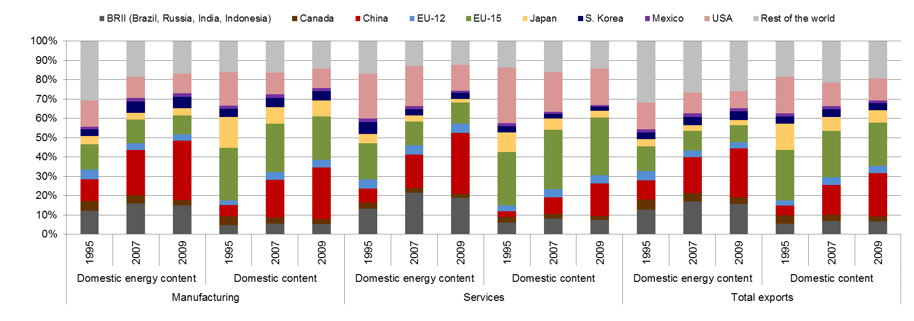
Source: WIOD.

Figures 3.16 and 3.17 depict broadly similar patterns. The BRII economies as a whole have relatively high energy intensities in total domestic inputs embodied in exports. By contrast, in the EU-15, Japan and (to a lesser extent) the US, the share in domestic content in exports is higher than the share in domestic-energy inputs in exports. However, both shares are decreasing over time, in particular in the US and Japan (including during the crisis period 2007-2009). They are giving way to the larger shares of China in both domestic-energy inputs and domestic content in exports (as in the case described above of the foreign-energy inputs and import content in exports), reflecting the Chinese exports boom in the period.

Table 3.6 presents the ratio between the shares in domestic energy inputs and domestic content (in manufacturing, service and total) exports. Similarly, the ratio provides a measure of energy intensity relative to total domestic inputs embodied in exports. Again, a value lower than one indicates that a given country has a lower than average weight of energy inputs relative to all domestic inputs embodied in exports (which for economies that are dependent on energy imports may represent relatively lower potential competitiveness losses arising from an increase in the relative price of energy).

Table 3.6 – Ratio between the shares in domestic energy inputs and domestic content in manufacturing, service and total exports in 1995, 2007 and 2009

 | Manufacturing |  |  | Services |  |  | Total exports
 | 1995 | 2007 | 2009 | 1995 | 2007 | 2009 | 1995 | 2007 | 2009
BRII | 2.6 | 2.9 | 2.8 | 2.2 | 2.6 | 2.5 | 2.4 | 2.5 | 2.4
Canada | 1.2 | 1.3 | 1.2 | 1.2 | 1.0 | 1.0 | 1.2 | 1.3 | 1.2
China | 1.9 | 1.2 | 1.1 | 2.5 | 2.0 | 1.9 | 1.9 | 1.2 | 1.1
EU-12 | 2.2 | 0.9 | 0.8 | 1.5 | 1.2 | 1.2 | 1.9 | 0.9 | 0.9
EU-15 | 0.5 | 0.5 | 0.4 | 0.7 | 0.4 | 0.4 | 0.5 | 0.4 | 0.4
Japan | 0.3 | 0.4 | 0.5 | 0.5 | 0.6 | 0.5 | 0.3 | 0.4 | 0.4
Korea | 0.8 | 1.2 | 1.3 | 2.0 | 1.3 | 1.5 | 0.9 | 1.2 | 1.2
Mexico | 0.8 | 1.0 | 1.1 | 1.0 | 1.3 | 1.3 | 0.8 | 0.9 | 1.1
USA | 0.8 | 1.0 | 1.0 | 0.8 | 1.0 | 0.7 | 0.7 | 0.9 | 0.8
RoW | 1.9 | 1.1 | 1.2 | 1.2 | 0.8 | 0.9 | 1.7 | 1.3 | 1.3
St dev | 0.8 | 0.7 | 0.6 | 0.7 | 0.7 | 0.7 | 0.7 | 0.6 | 0.6

Source: WIOD. Note: values lower or equal to one and higher than ½ are highlighted in yellow. Values lower or equal to ½ are highlighted in green.

The EU-15 and Japan also have the lowest relative energy intensity in terms of domestic inputs embodied in (total, manufacturing and service) exports. The energy intensity ratio decreased by almost ½ for the EU-15 in the period 1995-2007, eliminating the gap with manufacturing and broadly converging to the Japanese energy-intensity levels (that increased slightly over the period). The US also has a higher energy intensity when it comes to domestic inputs in exports (that, as in Japan, increased slightly in the period 1995-2007), but that still remains below the average overall (for manufacturing, service and total exports). For these economies, the energy intensity levels in the domestic and foreign content in exports (the latter presented in Table 3.5) are broadly similar.

The EU-12 significantly reduced energy intensity in domestic inputs in manufacturing exports but achieved only a much smaller reduction in relation to service exports. The weight of energy inputs in domestic inputs embodied in service exports remained above one over the whole period and the gap vis-à-vis the EU-15 was not reduced. This may be one of the factors undermining the competitiveness of service exports in the EU-12 and may partly explain its lower growth when compared to manufacturing exports in the period (see Figure 3.9 and Table 3.3 for the evolution of the EU-12 market shares in each sector relative to total WIOD exports). The contrast is evident not only with the substantial reduction in the weight of energy inputs in the domestic content in manufacturing exports, but also with the roughly similarly reduction observed in Table 3.5 above in terms of the relative weight of the EU-12 energy inputs embodied in both manufacturing and service exports of the other economies.

Similarly, China has considerably reduced the energy intensity of the domestic content in manufacturing exports but to a much lesser extent in service exports. This contrasts with the RoW, where the weight of energy in the domestic content in exports declined both in manufacturing and services.

The standard deviations at the bottom of Table 3.6 point to some convergence in the energy intensity of domestic inputs embodied in manufacturing but not in service exports. This may be partly explained by an overall greater competition, larger weight of tradable goods and more developed vertical specialisation within manufacturing. Table 3.5 indicated some convergence in the energy intensity of foreign energy inputs in the import content of both manufacturing and service exports. This is a further indication of the importance of internationalisation and the development of cross-border production networks for the reduction and convergence of energy-intensity levels across countries. The next subsection, focusing on manufacturing, analyses whether part of the reduction of the energy intensity of the inputs embodied in exports is due to improvements in energy efficiency.

3.2.6 Measuring energy efficiency in the manufacturing sector
There has been a substantial improvement in industrial competitiveness due to investment in more energy-efficient technology and innovative products and processes. This subsection analyses how to measure energy-efficiency changes that are genuinely the result of technology improvements in EU manufacturing and to what extent they have contributed to improved competitiveness.
Energy efficiency is analysed by breaking down the changes in energy use to a number of causative factors, focusing on manufacturing in the European Union and on its major competitors.
Table 3.7 presents energy intensity in the EU-27 in the years 1995, 2007 and 2009. Manufacturing activities involve transforming different material inputs into products and tend to use relatively more energy in terms of gross output volumes but not in relation to value added. Manufacturing sectors contributed significantly to the overall improvement in energy productivity in the period 1995-2009. The improvement was particularly noticeable in energy intensive sectors such as Coke, Refined Petroleum and Nuclear Fuel, Basic Metals and Fabricated Metal or Chemicals, but also in some less energy-intensive sectors. The few exceptions, such as Wood and Products of Wood and Cork, seem to be more a result of a cyclical increase in measured energy intensity that may be due to the crisis and to low capacity utilisation.

Table 3.7 Energy intensity in TJ per Unit of Output (O) and Value Added (VA) (EU-27 in 1995 prices and US Dollars)

NACE Rev. 1.1 | Description | Energy Intensity |  |  |  |  |  | Change
NACE Rev. 1.1 | Description | 1995 |  | 2007 |  | 2009 |  | 1995-2009
NACE Rev. 1.1 | Description | O | VA | O | VA | O | VA | O | VA
TOTAL | ALL SECTORS | 5.94 | 31.63 | 4.48 | 22.90 | 4.37 | 23.98 | -26% | -24%
D | MANUFACTURING (Total) | 10.28 | 11.85 | 6.96 | 9.60 | 7.12 | 9.19 | -31% | -22%
15t16 | Food , Beverages and Tobacco | 1.97 | 7.84 | 1.48 | 6.15 | 1.47 | 6.33 | -25% | -19%
17t18 | Textiles and Textile | 2.13 | 6.31 | 1.49 | 4.66 | 1.35 | 4.19 | -36% | -34%
19 | Leather, Leather and Footwear | 1.24 | 4.31 | 0.81 | 3.06 | 0.77 | 2.79 | -38% | -35%
20 | Wood and Products of Wood and Cork | 2.79 | 8.21 | 2.84 | 9.41 | 3.42 | 11.31 | 23% | 38%
21t22 | Pulp, Paper, Printing and Publishing | 3.69 | 9.73 | 3.64 | 10.43 | 3.64 | 10.37 | -1% | 7%
23 | Coke, Refined Petroleum and Nuclear Fuel | 195.71 | 1231.89 | 128.76 | 1199.02 | 95.33 | 967.93 | -51% | -21%
24 | Chemicals and Chemical | 13.60 | 39.97 | 9.29 | 28.25 | 8.95 | 27.11 | -34% | -32%
25 | Rubber and Plastics | 1.62 | 4.40 | 1.47 | 4.36 | 1.41 | 4.23 | -13% | -4%
26 | Other Non-Metallic Mineral | 9.45 | 23.20 | 7.63 | 20.22 | 7.85 | 20.61 | -17% | -11%
27t28 | Basic Metals and Fabricated Metal | 7.83 | 22.46 | 5.24 | 16.38 | 4.70 | 15.11 | -40% | -33%
29 | Machinery, Nec | 0.95 | 2.54 | 0.57 | 1.73 | 0.61 | 1.82 | -36% | -28%
30t33 | Electrical and Optical Equipment | 0.68 | 1.92 | 0.33 | 0.87 | 0.31 | 0.84 | -54% | -56%
34t35 | Transport Equipment | 0.77 | 2.83 | 0.43 | 1.90 | 0.47 | 2.13 | -38% | -25%
36t37 | Manufacturing Nec; Recycling | 1.11 | 3.09 | 1.02 | 3.31 | 1.22 | 3.83 | 10% | 24%
Source: WIOD.

The analysis of the changes in energy use and the improvements in energy efficiency are carried out through a standard index decomposition method (the Log-Mean Divisia Index, see Annex 1). The change in total energy use in manufacturing sectors is decomposed into three factors: i) scale; ii) composition and, most importantly, iii) ‘technical effect’. The scale factor accounts for the change in energy use that is due to a change in economic activity (overall level of production). The composition factor isolates the effect of sub-sectoral/structural changes within manufacturing. Finally, the technical effect shows how energy use would have changed if the total level of production (scale) and the industry structure (composition) had remained unchanged over time.
Figure 3.18 presents the results of the decomposition for the EU, EU-15 and EU-12. The grey lines in the figure show the development of total energy use in manufacturing in the EU-27, EU-15, and EU-12. In general, the EU-15 aggregate accounts for a very high share of the EU-27’s overall economic activity and energy use in manufacturing sectors (that is the reason why the lines corresponding to these two aggregates appear superimposed). The yellow lines (for the scale effect, controlling for a fixed technology and sector composition) indicate a significant increase in total energy use up to 2008 (in particular in the EU-12, almost a 200 % increase from 1995 to 2008). However, this effect was more than compensated for by the improvement in energy efficiency (accounted for by the green lines). The better performance of EU-12 (vis-à-vis the EU-15) indicates a genuine improvement in energy efficiency in manufacturing and an important contribution to the overall performance and catching-up (from their low initial efficiency levels as observed above in Figure 3.2). Finally, the blue lines indicate negligible composition effects for the EU-15. For the EU-12, the composition effect indicates a shift towards less energy-intensive manufacturing subsectors.
Figure 3.19 shows that the manufacturing sector in the US has improved its energy efficiency and contributed to the overall improvement in energy-use in that country. However, the technical effect is much smaller than the one observed in the European Union. The scale effect is positive but also smaller compared to the EU (largely a result of the higher growth in manufacturing output in the EU in the period 1995-2007, as afterwards the drop in activity was roughly similar in both areas).

Figure 3.18 – Index Decomposition Analysis of Total Energy Use in Manufacturing Sectors Using the Log Mean Divisia Index: EU-27, EU-15, and EU-12
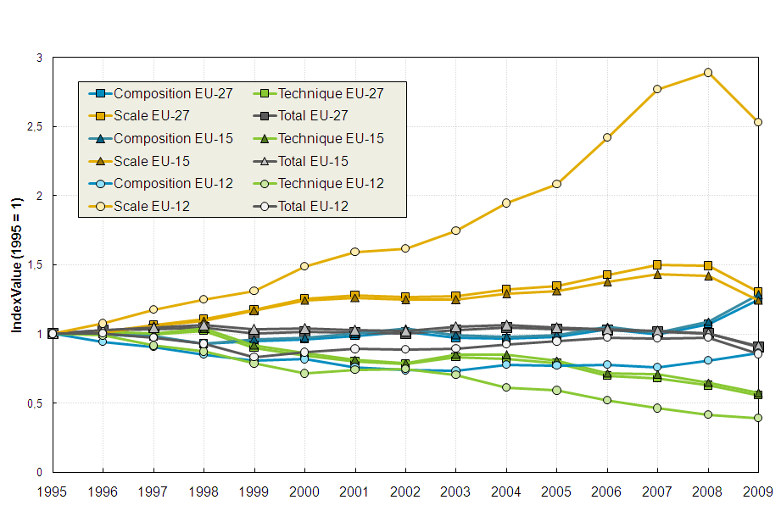Source:WIOD.

Figure 3.19 - Index Decomposition Analysis of Total Energy Use in Manufacturing Sectors Using the Log Mean Divisia Index: United States
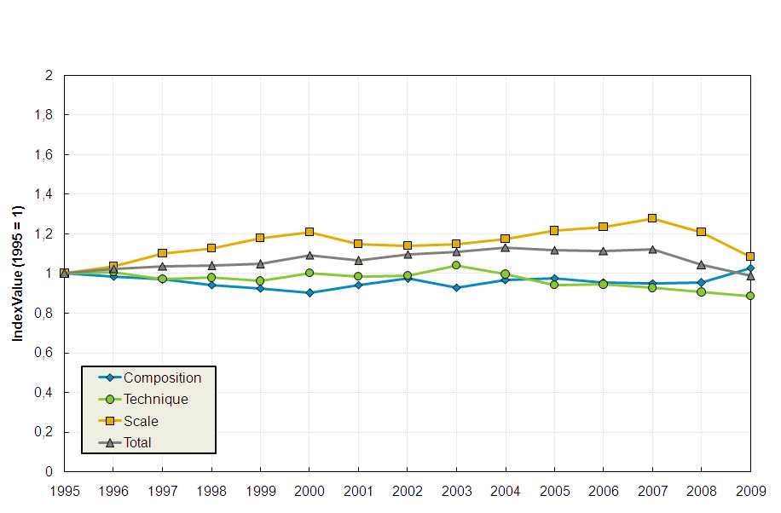
Source: WIOD.

Japan, one of world leaders in energy efficiency in manufacturing (see European Competitiveness Report 2011, Chapter 5), has not achieved an improvement of the kind seen in the EU and the US in this period (in fact, the technical effect even displays a slight upward trend in the period from 1998-2009, see Figure 3.20). The scale effect is relatively flat and the slight reduction in total energy use observed in the later period in the figure is due to a shift towards less energy-intensive manufacturing sectors.
Figure 3.20 - Index Decomposition Analysis of Total Energy Use in Manufacturing Sectors Using the Log Mean Divisia Index: Japan
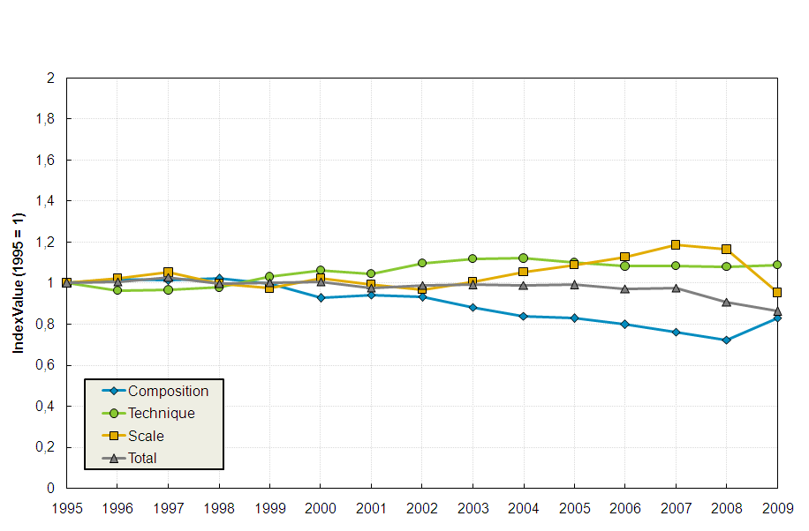Source: WIOD.

Figure 3.21 shows that for China the increase in economic activity in the manufacturing sector was the dominant factor (it would have accounted for an overwhelming 600 % increase in energy use had other factors remained unchanged in the period 1995-2009). At the same time, there was a significant improvement in energy efficiency and a progressive shift towards less intensive manufacturing sectors. As a result, total energy use of the Chinese manufacturing sector more than doubled from 1995 until 2009.
Figure 3.21 - Index Decomposition Analysis of Total Energy Use in Manufacturing Sectors Using the Log Mean Divisia Index: China
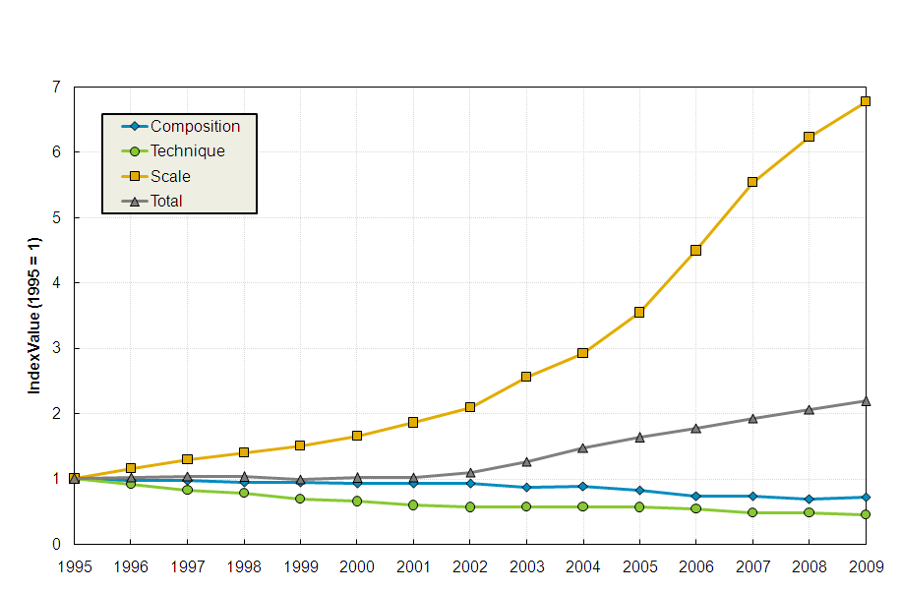Source: WIOD.

So far, the analysis suggests that EU manufacturing sectors had a relatively good performance overall in improving energy efficiency and contributed to the leading position and eco-performance of the European Union as a whole. Figure 3.22 reports the changes in total energy use and the three decomposition factors per Member State in the period 1995-2009.
Figure 3.22 - Decomposition Analysis of Total Energy Use in Manufacturing Sectors
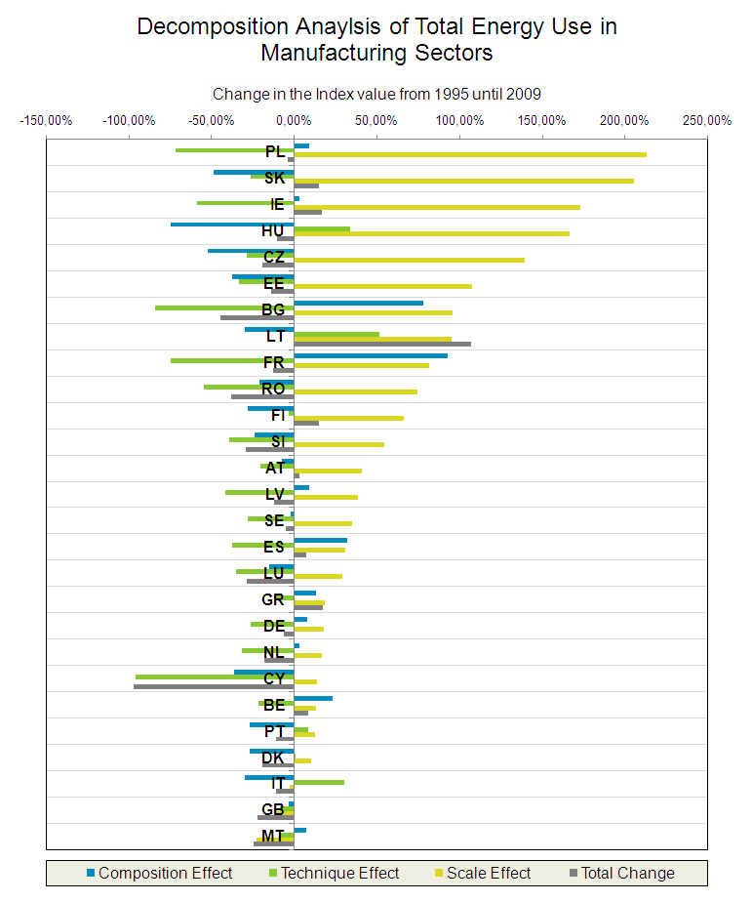Source: WIOD.

Overall total energy use in the manufacturing sectors decreased from 1995 until 2009 in most of the Member States (there are only a few exceptions, e.g. Lithuania). Those countries with a high scale effect (Ireland and a subset of the EU-12 countries) are at the same time those countries that overall achieved the greatest improvement in energy efficiency (technical effect). However, all Member States (except five, Lithuania, Hungary, Italy, Portugal and Denmark) have improved energy efficiency in manufacturing. There was a shift towards less energy-intensive sectors in the EU-12 countries with only a few exceptions (in particular Bulgaria). The composition effect is heterogeneous across EU-15 countries (e.g. there is no discernible shift towards less energy-intensive sectors as observed in Figure 3.20 above for Japan).

3.3. ECO-INNOVATION ADOPTION AND THE COMPETITIVENESS OF EU FIRMS
This section analyses the evidence for the adoption and development of eco-innovations by EU firms, focusing on energy-efficient process technologies and products. It is of particular interest to study how the adoption of energy efficiency translates into the performance and competitiveness of European firms.

This section is organised as follows: i) it starts by presenting some background and a short literature review; ii) the second part studies the reasons why firms introduce energy-efficient technologies; iii) the third part analyses whether firms that introduce new products on the market that allow their customers to save energy have a higher success rate in terms of commercialisation of their product innovations, compared to conventional product innovators. The section ends with a brief analysis of the competitive position of EU firms in the growing cross-border investments in clean, more energy-efficient and other technologies related to the development of environmental goods and services. This assessment paves the way for the in-depth analysis that follows in Chapter 4 on general FDI flows and their impact on competitiveness.

3.3.1. Background and literature review

Eco-innovation is any form of innovation resulting in or aiming at significant and demonstrable progress towards the goal of sustainable development, through reducing impacts on the environment, enhancing resilience to environmental pressures, or achieving a more efficient and responsible use of natural resources (European Commission (2011)). It can be understood as the ﬁrst introduction of a pollution-abatement technology or resource-saving technology (energy or material inputs) by a ﬁrm. It is required that the respective technology only to be novel to the introducing ﬁrm and, of course, does not distinguish between technology invented by the ﬁrm itself and the adoption of well-known abatement technology that had already been invented by others (see Rennings (2000) for a more detailed discussion).

The choice to invent or to adopt a new process technology is determined by several factors (such as input prices or regulations), but eco-innovation has also associated a positive environmental externality. While for conventional technical change the innovator is rewarded with private benefits, the eco-innovator in general also creates social benefits and has to bear the costs of introducing technical change alone. For energy-efficiency technology, there are usually both private returns (e.g. lower energy and maintenance costs, etc.) and social benefits (such as reductions in CO2 emissions).

This chapter restricted the scope of the empirical analysis to energy-saving technologies and the words ‘eco-innovation’, ‘invention’, ‘innovation’ and ‘adoption’ - of an existing technology that is new to the firm - have been used interchangeably.

The Community Innovation Survey 2008 (CIS 2008) reports information for more than 76500 firms across 18 EU Member States on whether they adopted energy-saving technologies (amongst other eco-innovations) between 2006 and 2008. The countries included are Bulgaria, Cyprus, the Czech Republic, Estonia, Finland, France, Germany, Hungary, Ireland, Italy, Lithuania, Latvia, Malta, The Netherlands, Portugal, Romania, Slovakia, and Sweden.

A first look at both the CIS micro-data and WIOD sectoral data (see Figure 3.23) reveals that manufacturing – as a whole and in particular energy-intensive sectors – achieved a relatively greater reduction in their energy intensity and that this corresponds to higher eco-innovation activities observed in the firm-level data for the same sectors. The left-hand side of Figure 3.23 presents the change in energy intensity from 1995 until 2009, based on WIOD. The share of firms in the CIS micro-data that introduced energy-saving process technologies between 2006 and 2008 is presented in the right-hand-side (RHS) figure.

Figure 3.23 - Change in Energy Intensity 1995 - 2009 by Sectors in 18 EU Member States (LHS) and Energy-efficiency Innovation Activities of Firms by Sectors in 18 EU Member States (RHS)
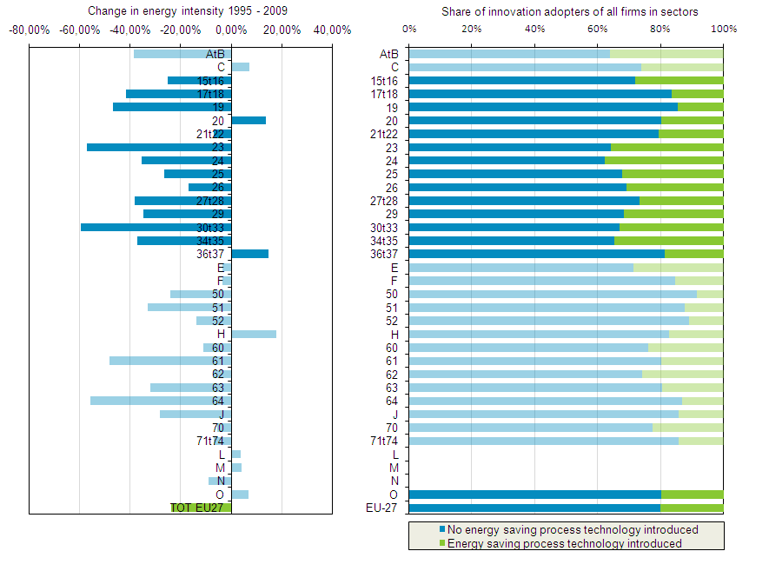

Source: WIOD, CIS 2008.

The arguments and brief discussion in section 3.2 had already suggested — at a macroeconomic level — that increases in the price of energy were one of the major drivers for energy saving eco-innovations. An interesting follow-up would be to study whether firms that use energy rather intensively are more affected by increasing energy prices and have a higher level of induced energy-saving eco-innovation activities (bearing in mind that existing capital goods can limit the opportunity space for the adoption of energy-efficiency technology, etc.). Unfortunately, the CIS data offers no information on either energy prices or on how much energy is consumed by firms.

There exist a large number of studies indicating that, apart from prices, regulation is another important driver for the adoption of eco-innovation in general. The price-induced innovation argument can be ‘translated’ to environmental regulation that induces technical change. Early empirical evidence that regulation triggers eco-innovations is given by Lanjouw and Mody (1996). They associate international patenting behaviour regarding environmentally related technologies with pollution-abatement spending in different countries. Jaffe and Palmer (1997) take the R&D process into account as well as the outcomes of inventive processes (measured with patent applications) and do not find a statistically significant effect of pollution-control expenditures on patenting activities. In contrast to this study, Brunnermeier and Cohen (2003) find a link between pollution-abatement spending and successful patent applications related to environmental technologies. Popp et al. (2010) contains a detailed and comprehensive survey of this literature.
In contrast to the literature on the drivers of eco-innovation adoption, a much less clear-cut prediction is provided regarding eco-innovation’s impact on competitiveness. The large body of research on the competitiveness impact of eco-innovation adoption in general is mostly focused on the role played by regulation (e.g. the very early literature begins in the 1980s after the United States and other highly industrialised countries had started to regulate local water and air pollutants; for instance, sulphur dioxide (SO₂)).
Christiansen and Haveman (1981) associate an 8–12 % slowdown in U.S. productivity between 1965 and 1979 with environmental regulations. Other studies, like Gollop and Roberts (1983) or Greenstone (2002), also find that regulation has negative effects on economic performance. Jaffe et al. (1995), in a comprehensive survey, conclude that overall there was relatively little evidence to support the hypothesis that environmental regulations have had a large adverse effect on competitiveness. Several sectoral studies on how firms’ productivity is affected by environmental regulation appear to reach similar mixed and inconclusive results: Berman and Bui (2001) find that for U.S. oil refineries, regulation is associated with a ‘substantial’ investment in pollution-abatement capital and productivity growth in the more stringently regulated regions; conversely, Gray and Shadbegian (2003) find the opposite is the case for pulp and paper plants, again in the U.S.; however, Boyd and McClelland (1999), based on a new (regression-free) methodology, find some evidence for productivity-decreasing effects of abatement technology in the paper industry; Aiken et al. (2009) does not find negative effects of pollution abatement on the productivity of several sectors in the U.S., Germany, Japan, and the Netherlands. In a more recent contribution, Rexhäuser and Rammer (2011) use German CIS data — distinguishing between regulation and non-regulation-induced eco-innovations (these further broken down into pollution-preventing ones and those that reduce energy and material use) — finding productivity-enhancing effects at firm level but only for energy and material-saving technology adoption.

3.3.2. Adoption of energy-saving technologies
The choice to introduce energy-efficiency technology is expected to be driven by environmental regulation and increasing prices for energy in the first place. For regulation, the CIS data offers firms’ responses to the question whether energy-saving process technology was introduced to meet regulatory requirements or whether it was introduced because regulation was expected to come into force in the future. For energy prices, however, the CIS data unfortunately offers no information.

Examples of other potential determinants of eco-innovations reported in the CIS data are whether the innovation was introduced in response to demand by customers, due to voluntary environmental agreements by the firm or due to public subsidies for environmental technology. There are also such indicator variables as whether the firm has introduced any other process innovation or new products, exports to European countries or to world markets (which can be seen as a proxy for exposure to international competition).

Given the discrete nature of a firm’s decision whether or not to introduce environmental process technology, a discrete choice (probit) model estimates the probability of introducing energy-saving process technology, controlling for firm-specific characteristics (such as firm size and sector affiliation) and, of course, the determinants for having introduced eco-innovations the firms reported (see Annex 2).

In line with previous research, the analysis supports the view that environmental regulation is a key driver of eco-innovations (the adoption of energy-saving process innovations in this case). For more than 46 000 firms across 16 European countries, the model estimates that those firms that reported they had introduced eco-innovations due to environmental regulation have (on average) an 11.70 percentage points higher probability of adopting energy-efficiency technology than those firms that did not introduce such innovations due to regulation (see Annex 2). The mere expectation of further regulation increases by 9.56 percentage points the probability of adopting energy-saving technology. However, the results differ across countries. The effect of regulation is found to be greater in Romania (25.9 percentage points), Slovakia (24.8 percentage points), and Bulgaria (24 percentage points). In contrast, the effect is very low but still significant in Italy (4.7 percentage points).

Other important determinants are voluntary environmental agreements by firms and the adoption of other process innovation. Firms that reported voluntary environmental agreements as the reason for eco-innovation adoption have (on average) a 17.0 percentage points higher probability of adopting energy-saving innovation compared to firms where this was not the case. The effect of having introduced another process innovation boosts by 13.2 percentage points the probability of adopting an energy-saving innovation; a possible interpretation for this is that energy-saving process technology is to some degree adopted together with conventional process technology. The effect that introducing new products has on the probability of adopting energy-saving innovation is also positive but smaller (+5.3 percentage points).

Firms exporting to other European countries or to world markets have higher probabilities of adopting energy-saving innovations but in no case is this statistically significant. Interestingly, the two export dummy variables were statistically significant in a different model specification, not controlling for the introduction of new products and other process innovations. This result suggests there might be an indirect link between the internationalisation of EU firms and the adoption of energy-efficiency innovation — meaning that (exporting) internationalised firms tend to be more innovative (introducing new products or adopting conventional process technology), this being associated with the adoption of energy-saving innovations. Anticipating the results in the next section, an example would be a firm that introduces a new product embodying energy-saving features.

3.3.3 Market success of energy-efficiency product innovators
The existing literature largely focuses on the adoption of energy-efficiency-improving technologies (especially if regulation-induced) and the impacts on measured productivity at firm, sector or aggregate level. Unfortunately, the CIS data does not make it easy to study the impact of eco-innovation on productivity measures such as total factor productivity. With CIS it is possible only to study the impact on rather rough productivity measures, such as turnover or turnover per worker. Moreover, the non-availability of important factors such as capital use or energy further complicates matters. The non-availability of capital data is problematic since capital is expected to be correlated with the adoption of energy-efficiency technology. Firms that have a higher capital endowment also need more energy inputs to operate capital goods and therefore (if energy prices are high) may find a need to replace capital goods by more energy-efficient ones. In summary, in a standard regression the effect of energy-efficiency-technology adoption could therefore be biased.

Rennings and Rexhäuser (2012) made several attempts to circumvent these problems (e.g. by proxying capital by lagged firm turnover). The regressions performed seem to suggest that energy-saving process innovation adoption has only minor, if any, effects on the growth rates of turnover or turnover per worker.

This section takes another approach to studying the impact of energy-efficiency innovation activities on the performance and competitiveness of EU firms. A major — and largely neglected — aspect of competitiveness and eco-innovations is whether ‘green’ product innovations lead to a better competitive position of the innovators. In what follows, the competitiveness of product innovators will be studied using firms’ innovation success which is measured, as is commonly done, by the share of new products in firms’ total sales.

Innovation success is measured as the sum of the turnover share of market novelties in total sales plus the share of new products introduced into the market that are new only to the firm (reported in percentage points in CIS). The CIS data also offers information on whether the product innovations of firms allow their customers to save energy. For instance, the data shows (as expected) that manufacturing firms lead in the introduction of product innovations that allow their customers to save energy but that other firms also have important energy-saving innovation activities. Around 15 000 firms (more than 9 250 in manufacturing) across 17 EU countries reported having introduced newly developed products on the market between 2006 and 2008. New products account for around 28 % of the firm’s total sales on average (both for the whole 15 000 and for manufacturing firms only). However, 41 % of the manufacturing firms reported energy-saving product innovations, against 38 % in the whole sample of product innovators (see Annex 3).

The central question addressed here is then the extent to which the introduction of energy-efficient products by firms is valued by the market and whether this translates into greater firm success compared to conventional product innovators.

One of the major determinants of innovation success is to what extent a firm is engaged in innovative activities. A firm that invests more in R&D will in principle have a higher share of new products in total sales. Moreover, firms that are continuously engaged in R&D activities may also be more innovative as well as those that cooperate with other firms, customers or research institutes. Firms owned by domestic groups or belonging to foreign multinationals may also have access to external knowledge. The economic literature also offers evidence of the effect of other variables. For instance, innovative outputs tends to increase with firm size, but that this relationship follows a less than proportionate rate (see for instance Scherer (1965) or Acs and Audretsch (1988)). These are the main variables serving as controls in the regression analysis (see Annex 3).

In surveys, firms often report rather ‘round’ numbers if they are asked to state a percentage number, for instance because they simply do not know the exact number. This was also observed in the CIS data on innovation success. The dependent variable in the regression was therefore transformed into a categorical variable recording innovation success in 10 equally distributed intervals. A sensitivity check has shown that this rearrangement has only a very small impact on the results. The analysis reported here is restricted to European firms in the CIS that stated they had introduced newly developed products on the market (as a large number of non-innovator firms report missing values for several control variables).

The regression analysis provides evidence that innovators that introduce new products into the market, allowing their customers to save energy, are more successful innovators. Compared to firms which introduce only conventional product innovations into the market, eco-product innovators have on average a 2 percentage points higher share of product innovations in total turnover. At aggregate level, the mean share of turnover that is earned by selling new products would rise from approximately 28 to 30 per cent. This may seem to be a small percentage at first glance but individually the effect can be higher (see Figure 3.24) and mostly importantly may represent a significant competitive advantage. Eco-product innovators in manufacturing sectors enjoy a 2.6 percentage point increase in innovation success compared to conventional product innovators. For manufacturing firms, this effect is illustrated graphically below.

Figure 3.24 – Innovation Success in Manufacturing Sectors
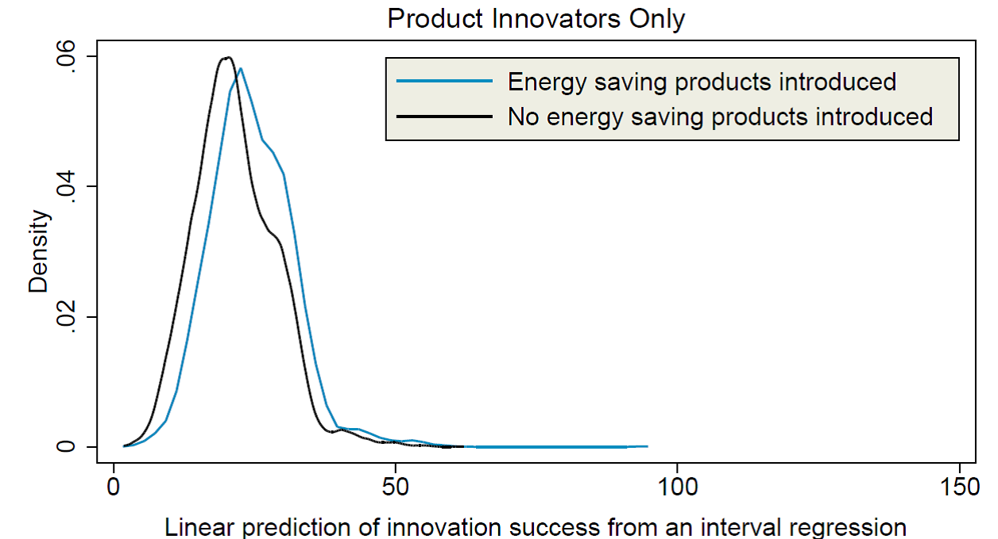
Source: CIS 2008.
The figure predicts the likelihood of a certain level of innovation success being recorded and compares firms that introduced energy saving product innovations with those that did not, controlling for any other differences in innovation success. The interpretation of these density plots is as follows: For ‘green’ product innovators, the likelihood of levels of innovation success from zero up to, say, 25 per cent being recorded is smaller compared to conventional innovators. Conversely, the likelihood of eco-product innovators being recorded at levels above 25 per cent, but most importantly between 25 and 40 per cent, is higher for ‘green’ innovators compared to non-green innovators.

Overall, there seems to be evidence that product innovators introducing energy-saving products on the market enjoy higher sales generated by product innovation compared to conventional product innovators. This, of course, may also reflect an important competitive advantage.

3.3.4. The internationalisation and competitive position of EU firms in ‘green FDI’
Energy efficiency and related environmental goals are global challenges presenting many business opportunities for EU firms. This subsection uses the fDi markets database to analyse the internationalisation and competitive position of EU firms and some EU leading industries in the area of environmental goods and services. The analysis focuses on cross-border greenfield investments in an environmental-technologies cluster related to the provision of environmental goods and services (Golub et al. 2011). The assignment of greenfield FDI to the environmental cluster is done at the project level. For example, particular FDI projects within the machinery industry are included if they relate to environmental goods (e.g. if the project consists of new production facility for water-treatment systems). Another example is the electronics industry where projects related to solar modules from part of the environmental technology cluster. This classification entails a very large overlap with Eurostat’s definition of Environmental Goods and Services Industries. In particular, it includes both the main environmental-protection industries, i.e. waste and wastewater treatment, and the resource-management industries, i.e. alternative-energy generation (Eurostat, 2009). In addition, the definition also includes several investments related to what Eurostat calls ‘connected’ products such as wind turbines.

Table 3.8 presents the amounts (in million USD) of green FDI projects undertaken by EU MNEs across four main sectors of environmental technology in the period 2007-2011 and compares them with the activities of major competitors (MNEs from the US, China and Japan). Renewable energy is clearly the dominant industry in terms of the amount of green FDI (374 000 million USD worldwide over the period 2007-2011, accounting for 4/5 of all green FDI projects). In terms of the common industry classification, the renewable-energy industry would be part of the electricity, gas and water supply sector – NACE E according to NACE Rev1.). Other important industries for green investment projects are also found within manufacturing, namely the electronic-components industry (48 000 million USD worldwide, a share of 10 % of the total green FDI), the engines and turbines industry (with a 4 % share of the total worldwide green FDI). Industrial machinery accounts for a smaller share (around 1 %) of the worldwide green FDI but includes a considerable number of cross-border FDI projects (around 250 projects worldwide in the period 2007-2011 — not reported in Table 3.8, comparable to the number of green FDI projects in the engine and turbine industry over the same period).

The prominence of these industries stems from the fact that companies in these sectors build the equipment needed for alternative forms of power generation (FDI projects include plants producing wind engines and turbines or the electronic components of solar panels). The remaining green FDI is attributed to several sectors (e.g. Metals, Chemicals, Business Service), each with much lower individual shares.

Table 3.8 - Position of EU companies in green cross-border investment projects relative to the US, Japan and China (2007-2011, million USD)

 |  | EU total | intra-EU | extra-EU | US | Japan | China | RoW | WORLD
Alternative/Renewable | inv. | 236820 | 116053 | 120767 | 47873 | 20145 | 11001 | 58211 | 374049
Energy | share | (63.3) | 31.0 | (32.3) | (12.8) | (5.4) | (2.9) | (15.6) | 79%
Electronic | inv. | 22811 | 6191 | 16620 | 9824 | 2896 | 2449 | 9962 | 47943
Components | share | (47.6) | (12.9) | (34.7) | (20.5) | (6.) | (5.1) | (20.8) | 10%
Engines & Turbines | inv. | 12719 | 1931 | 10788 | 1109 | 932 | 3580 | 1868 | 20208
 | share | (62.9) | (9.6) | (53.4) | (5.5) | (4.6) | (17.7) | (9.2) | 4%
Industrial Machinery, | inv. | 2448 | 392 | 2056 | 911 | 1101 | 28 | 420 | 4908
Equipment & Tools | share | (49.9) | 8.0 | (41.9) | (18.6) | (22.4) | (.6) | (8.6) | 1%
Others | inv. | 14251 | 5229 | 9022 | 2720 | 2796 | 653 | 5942 | 26362
 | share | (54.1) | (19.8) | (34.2) | (10.3) | (10.6) | (2.5) | (22.5) | 6%
Overall Total | inv. | 289048 | 129796 | 159252 | 62438 | 27870 | 17711 | 76402 | 473469
 | share | (61.0) | (27.4) | (33.6) | (13.2) | (5.9) | (3.7) | (16.1)
Note: EU is EU-27. Industry classification of fDi markets database.
Source: fDi markets database.

Overall, leading EU manufacturing and services firms in green industries are highly internationalised and seem to be well positioned in global competition. For the environmental-technologies cluster as a whole, EU companies accounted for almost 2/3 of green FDI by MNEs worldwide in the period 2007-2011 (when Intra-EU FDI is also included). Around 55 % of the EU’s green FDI correspond to extra-EU investments, 160 000 million USD in the period 2007-2011. This is almost 3 times the amount of outward green FDI by US MNEs over the same period.

Among the green industries shown in Table 3.8, EU companies are best positioned in Alternative/Renewable Energy and in the engines and turbines industry (with a share of close to 2/3 of the green FDI worldwide in both sectors). EU companies lead international investment activities in these industries and wind-turbine manufacturing firms in countries such as Denmark, Germany and Spain play a leading role. The emergence of Chinese wind-turbine manufacturers (with about 18 % of FDI worldwide) is reflected by the fact that four of the ten leading companies (in terms of installed capacity) are from China and some of them have already internationalised their operations via cross-border projects.

In the other two main sectors for green FDI, EU companies have a somewhat lower share, but EU MNEs are still global frontrunners. For instance, within the broader electronics industry EU companies managed to occupy a niche and develop a competitive edge in photovoltaic components, at least when judged by their international investment activity. At the same time, it should be stressed that according to sales figures European (as well as US) companies are facing intense competition from Chinese solar-panel producers. China enacted its renewable energies law in 2006, aimed at reducing energy dependence and CO₂ emissions but also at developing domestic production capacities and internationally active firms.

EU outward green FDI is preponderant in all sectors except for Alternative/Renewable Energy, in which Extra-EU and Intra-EU investments are roughly equal, showing the importance of the European single market for this sector. Outside the EU, the main host country for cross-border investments by EU firms in environmental technologies is the United States which accounts for a quarter of total projects (the prominent role of the US as destination is also found in general for FDI by EU multinationals, see Chapter 4 of this report). In second and third position come two other large markets, namely India (6.3 % of projects) and China (4.6 % of projects).

Table 3.9 presents worldwide green FDI in the period 2003-2011 per major host economy (in percentage). The EU attracted more than a third of all green investments globally over the period 2003-2011. This makes the EU the major host economy for green cross-border investments, ahead of the US (12 %), China and India. However, the EU as a whole appears to have lost some of its attractiveness for green FDI in the last 4 years (the share of green FDI located in the EU declined to below 40 %, compared to the exceptionally high pre-crisis level of 55 % in 2007). Similar trends are observed in overall FDI, the subject of a thorough analysis in Chapter 4.

Table 3.9 - Major host economies for green cross-border investments, 2003-2011, shares of global green FDI (in percentage)
Destination Country | 2003 | 2004 | 2005 | 2006 | 2007 | 2008 | 2009 | 2010 | 2011 | average  2003-2011
EU-27 | 21.7 | 34.4 | 36.8 | 44.1 | 54.5 | 44.1 | 37.0 | 37.9 | 39.0 | 40.8
UK | 2.3 | 11.5 | 4.7 | 4.3 | 7.1 | 5.8 | 8.7 | 7.2 | 8.6 | 7.0
Germany | 1.6 | 2.5 | 5.2 | 3.5 | 3.9 | 5.3 | 4.8 | 6.3 | 6.9 | 5.1
Spain | 0.8 | 4.1 | 6.1 | 4.6 | 7.3 | 5.7 | 3.9 | 4.3 | 2.5 | 4.5
France | 3.1 | 0.0 | 4.2 | 7.3 | 7.1 | 9.0 | 3.0 | 1.4 | 2.2 | 4.5
Italy | 1.6 | 0.0 | 1.9 | 0.8 | 4.1 | 3.3 | 4.6 | 4.3 | 3.0 | 3.3
United States | 4.7 | 4.1 | 2.4 | 5.7 | 8.8 | 12.4 | 16.3 | 16.8 | 15.1 | 12.2
China | 6.2 | 11.5 | 4.2 | 5.7 | 8.2 | 8.2 | 7.6 | 8.5 | 5.3 | 7.3
India | 3.1 | 3.3 | 2.8 | 7.6 | 2.1 | 4.5 | 4.0 | 4.0 | 6.1 | 4.5
Canada | 1.6 | 3.3 | 3.8 | 2.2 | 0.4 | 1.7 | 2.4 | 5.7 | 4.8 | 3.1
Brazil | 15.5 | 0.0 | 1.9 | 2.7 | 1.7 | 1.6 | 0.7 | 3.3 | 4.0 | 2.7
Other Countries | 47.3 | 43.4 | 48.1 | 32.2 | 24.2 | 27.5 | 31.9 | 23.9 | 25.7 | 29.5
Overall Total | 100.0 | 100.0 | 100.0 | 100.0 | 100.0 | 100.0 | 100.0 | 100.0 | 100.0 | 100.0

Source: fDi markets database.

Figure 3.25 shows the trends in cross-border investments in green technologies in the EU market (including both intra-EU and extra-EU projects), over time covering the period from 2003 to 2011. In this period, about two thirds of the green FDI correspond to intra-EU investments (a pattern found for EU inward FDI in general, see Chapter 4 of this report). This pattern is also observed across the main four industries for green FDI projects (presented in the right-hand panel of the figure), except for the electronic components industry, for which the extra-EU investments are predominant.
Figure 3.25 - Green cross-border investment undertaken in the EU-27 (left panel) and green cross-border investment in the EU market in leading green technologies industries (right panel), 2003-2011
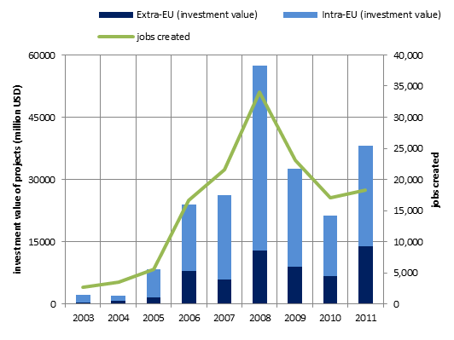 | 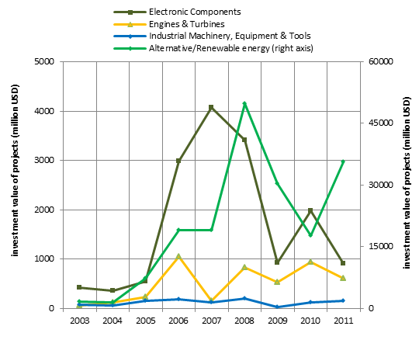
Source: fDi markets database.

The significant decline in green FDI in the EU in 2009 and 2010 (Figure 3.25, left panel) was mainly due to a sharp drop in investment and projects in the renewable-energies industry (Figure 3.25, right panel, right axis). The renewable-energies industry was also driving the recovery observed in green FDI in the EU in 2011. The number of jobs created by new cross-border projects in environmental-technology industries closely follows the trend in investments, though the number of jobs created remained below the 2007 level in 2011.

Despite the recent overall reduction in environmental-technology investment activities in the EU market, there is overall a clear increase in the importance of green technologies in the main industries analysed. Figure 3.26 (left panel) shows that renewable energy FDI has been outperforming cross-border FDI in projects related to oil, coal and natural gas in the EU. The share of renewable energy projects in total energy projects (renewable and conventional) surpassed 70 % in 2011.

Figure 3.26 - Greening of cross-border investment in the EU-27, selected industries, 2003-2011
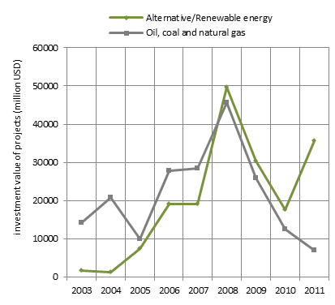
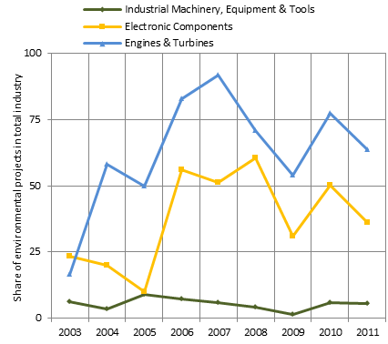

Source: fDi markets database.

Within the other major green-technology industries, the share of environmental-technology projects in total EU cross-border investment projects also increased substantially, with the exception of the industrial-machinery industry. In the engines and turbines industry, the share of environmental-technology projects more than tripled from 25 % in 2003 to more than 75 % in 2010 (Figure 3.25, right panel). The trend is similarly positive in the electronics-components industry.

3.4. Policy Implications

This chapter studied energy content in exports and energy-efficiency trends over the last 15 years. Their impact on competitiveness was analysed at country, sector and firm level in the context of key economic developments such as the globalisation of industrial activities and investments and improvements in technology and eco-innovation.

The developments in energy efficiency were first studied at an international level. Overall energy-efficiency improvements were observed in almost all countries over the period 1995-2009. In Europe, the EU-12 economies improved significantly their initial low levels of energy efficiency and the European Union as a whole reinforced its lead in terms of overall energy efficiency. The analysis highlighted the role of the substitution of energy for capital —in the sense of a more energy-efficient technology embodied in capital goods — that was observed over time in almost all countries.

Increasing global competition and cross-border integration of production chains are developments with far-reaching social, political and economic consequences. The overall increase in the relative price of energy is one of its many side effects, often seen as partly due to the increasing energy demand from developing countries. The rise in the price of energy and volatility levels have significant and highly differentiated impacts on the competitiveness of countries, sectors, firms or households.

The analysis in section 3.2 showed that for EU countries (as a whole) globalisation appears to also represent additional channels for minimising the negative competitiveness effects of the energy-price increases. Overall, EU countries have been able to export more and at the same reduce significantly the energy embodied in their exports, in particular the proportion of energy that is sourced domestically.

The analysis covered EU-12, EU-15, US and Japan and showed that energy use per unit of exports declined in European (particularly in EU-12) countries over time in the period 1995-2009. This contrasts with the increase in the energy embodied in one unit of exports observed in Japan, and to a smaller extent in the US, over the same period.

As expected, the share of energy content in exports sourced from foreign countries (i.e. energy embodied in intermediate imports) has been rising everywhere. The WIOD database shows that EU countries have been leading in this — globalisation induced — upward trend and already have a higher share of foreign-sourced energy embodied in exports compared with Japan, a country that also has a high external dependency on fossil fuels. The importance of emerging economies such as Brazil, Russia and in particular China as sources of the energy embodied in the exports of the advanced economies analysed has been growing over time.

As a result, the domestic-energy content in total exports decreased in the European economies. For the EU-12, this is due mainly to a significant drop in the energy incorporated domestically in manufacturing exports. In the EU-15, the most important contribution came from the drop in the domestic-energy content in service exports.

Along with globalisation of production and increasing vertical specialisation, the European economies have overall reduced in relative terms their vulnerability to potential external-competitiveness losses as a result of an increase in the relative price of energy. The relative weight of energy in their inputs into the foreign content of the generality of their trade partners’ exports decreased overall in the period 1995-2009. The EU-15 as a whole, together with Japan, have the lowest relative weight of energy inputs in the total foreign inputs incorporated in exports globally. The EU-12 as a whole achieved the greatest reduction in the relative weight of energy inputs in the foreign content of its trade partners in WIOD.

Manufacturing is at the crossroads of globalisation and energy efficiency. Manufacturing transforms primary energy inputs into final energy products, uses energy in the transformation of materials into products, and many of its sectors and firms are at the forefront of the internationalisation of production chains and lead in eco-innovation activities and investments.

An index-decomposition analysis has shown that manufacturing in the European Union moderately increased gross output while at the same time maintaining energy use fairly constant due to continuous technical improvement in the period 1995-2009. Structural changes were negligible in this period for the EU as a whole.

Japan, like the EU a world leader in energy efficiency in manufacturing, did not improve technical efficiency in this period (the observed slight reduction in energy use is due to a shift to less energy-intensive manufacturing sectors, as output has remained fairly constant over the period analysed). US manufacturing increased output and improved technical efficiency, but in both cases less than in the EU.

Manufacturing output increased and technical efficiency improved in the very large majority of the EU-27 Member States but there are significant variations in performance. The highest increases in manufacturing output were observed in the EU-12 countries and Ireland, and these were also the countries that tended to achieve the greatest improvements in technical efficiency. With only a few exceptions, there was a shift towards less energy-intensive sectors in the EU-12 Member States.

Section 3.4 analysed data (from the Community Innovation Survey) showing that EU firms that introduce new products with energy-saving features tend to be more successful innovators, particularly in the case of manufacturing firms. Controlling for other determinants of innovation success in the market, these eco-innovators sell more new products (in terms of the firm’s total sales) than conventional innovators, which may represent an important competitive advantage.

The analysis has also shown that, overall, EU firms are leading in the growing phenomenon of internationalisation and in cross-border ‘eco-investment’ in clean and more energy-efficient technologies and products and services, exploiting many business opportunities offered by the global environmental and societal goals and challenges ahead. For instance, EU firms accounted for almost 2/3 of the FDI by MNEs worldwide in the important area of renewable energy in the period 2007-2011. They are also global frontrunners in many other eco-technologies (such as Engines & Turbines) associated with the provision of environmental goods and services. However, international competition is increasing, including from MNEs of emerging economies.
References
Acs, Z. J. and Audretsch, D.B. (1988), ´Innovation in Large and Small Firms: An Empirical Analysis´, The American Economic Review 78(4), pp. 678-690.

Aiken, D. V., Färe, R., Grosskopf, S. and Pasurka Jr. C.A. (2009): ´Pollution Abatement and Productivity Growth: Evidence from Germany, Japan, the Netherlands, and the United States´, in: Environmental & Resource Economics 44(1), pp. 11-28.

Ang, B. W. and Zhang, F.Q. (2000), ´A Survey of Index Decomposition Analysis in Energy and Environmental Studies´, Energy 25(12), pp. 1149-1176.

Atkeson, A. and Kehoe, P.J. (1999), ´Models of Energy Use: Putty-Putty Versus Putty-Clay´, American Economic Review 89(4), pp. 1028–1043.

Becker, R. and Henderson, V. (2000), ´Effects of Air Quality Regulation on Polluting Industries´, Journal of Political Economy 108(2), pp. 379–421.

Berman, E. and Bui, L. T. M. (2001), ´Environmental Regulation and Productivity: Evidence From Oil Reﬁneries´, The Review of Economics and Statistics 83(3), pp. 498–510.

Berndt, E. R. and Wood, D. O. (1975), ´Technology, Prices, and the Derived Demand for Energy´, The Review of Economics and Statistics 57(3), pp. 259-268.

Berndt, E. R. and Wood, D. O. (1979), ´Engineering and Econometric Interpretations of Energy-Capital Complementarity´, The American Economic Review 69(3), pp. 342-354.

Boyd, G. A. and McClelland, J. D. (1999), ´The Impact of Environmental Constraints on Productivity Improvement in Integrated Paper Plants´, Journal of Environmental Economics and Management 38(2), pp. 121–142.

Brunnermeier, S. B. and Cohen, M. A. (2003), ´Determinants of Environmental Innovation in US Manufacturing Industries´, Journal of Environmental Economics an Management 45(2), pp. 278-293.

Brunnermeier, S. B. and Levinson, A. (2004), ´Examining Evidence on Environmental Regulations and Industry Location´, The Journal of Environment & Development 13(6), pp. 6–41.

Caselli, F. (2005), ´Accounting for Cross-Country Income Differences´, in Phillipe Aghion and Steven Durlauf, eds., Handbook of Economic Growth, (Amsterdam: North-Holland Press), 2005.

Christiansen, G. B. and Haveman, R. H. (1981), ´The Contribution of Environmental Regulation to the Slowdown in Productivity Growth´, Journal of Environmental Economics and Management 8(4), pp. 381–390.

Copeland, B. R. and Taylor, M. S. (2004), ´Trade, Growth, and the Environment´, Journal of Economic Literature 42(1), pp. 7–71.
Ederington, J., Levinson, A. and Minier, J. (2005), ´Footloose and Pollution-Free´, The Review of Economics and Statistics 87(1), pp. 92–99.

European Central Bank (2010), Energy Markets and the Euro Area Macroeconomy, Strutuctural Issues Report, June 2010.

European Commission (2011), Innovation for a sustainable future – The eco-innovation action plan (ECO-AP), COM(2011) 899 final.

Eurostat (2009), ´The environmental goods and services sector. A data collection handbook´, Eurostat methodologies and working papers,
http://epp.eurostat.ec.europa.eu/cache/ITY_OFFPUB/KS-RA-09-012/EN/KS-RA-09-012-EN.PDF.

Gilligham, K., R. G. Newell and K. Palmer (2009), ´Energy Efficiency Economics and Policy´, Annual Review of Resource Economics, 1, 597-619.

Gollop, F. M. and Roberts, M. J. (1983), ´Environmental Regulations and Productivity Growth: The Case of Fossil-fueled Electric Power Generation´, Journal of Political Economy 91(4), pp. 654–674.

Golub, S.S., Kauffmann, C. and Yeres, P. (2011), ´Defining and Measuring Green FDI: An exploratory Review of Existing Work and Evidence´, OECD Working Paper on International Investment, 2, June 2011.

Gray, W. B. (1987), ´The Cost of Regulation: OSHA, EPA and the Productivity Slowdown´, The American Economic Review 77(5), pp. 998–1006.

Gray, W.B. and Shadbegian, R.J. (2003): ´Plant Vintage, Technology, and Environmental Regulation´, Journal of Environmental Economics and Management, 46(3), pp. 384-402.

Greenstone, M. (2002), ´The Impacts of Environmental Regulations on Industrial Activity: Evidence from the 1970 and 1977 Clean Air Act Amendments and the Census Manufacturers´, Journal of Political Economy 110(6), pp. 1175–1218.

Griffin, J. M. and Gregory, P. R. (1976), ´An Intercountry Translog Model of Energy Substitution Responses´, The American Economic Review 66(5), pp. 845-857.

Henderson, J. V. (1996), ´Effects of Air Quality Regulation´, The American Economic Review 86(4), pp. 789–813.

Hicks, J. R. (1932), ´The Theory of Wages´, London, Macmillan.

Horbach, J. (2008), ´Determinants of Environmental Innovation—New Evidence from German Panel Data Sources´, Research Policy 37(1), pp. 163–173.

Jaffe, A. B. and Palmer, K. (1997), ´ Environmental Regulation and Innovation: A Panel Data Study´, The Review of Economics and Statistics 79(4), pp. 610-619.

Jaffe, A. B. and Stavins, R. N. (1995), ´Dynamic Incentives of Environmental Regulations: The Effect of Alternative Policy Instruments on Technology Diffusion´, Journal of Environmental Economics and Management 29(3), pp. 43-63.

Jaffe, A. B., Peterson, S. R., Portney, P. R. and Stavins, R. N. (1995), ´Environmental Regulation and the Competitiveness of U.S. Manufacturing: What Does the Evidence Tell Us?´, Journal of Economic Literature 33(1), pp. 132–163.

Johnstone, N., Haščič, I., and Popp, D. (2010), ´Renewable Energy Policies and Technological Innovation: Evidence Based on Patent Counts´, Environmental & Resource Economics 45(1), pp. 133-155.

Lanjouw, J. O. and Mody, A. (1996), ´Innovation and the International Diffusion of Environmentally Responsive Technology´, Research Policy 25(4), pp. 549 571.

Levinson, A. (2009), ´Technology, International Trade, and Pollution from US Manufacturing´, The American Economic Review 99(5), pp. 2177–2192.

Linn, J., (2008), ´Energy Prices and the Adoption of Energy-Saving Technology´, The Economic Journal 118(533), pp. 1986-2012.

List, J. A., Millimet, D. L., Fredriksson, P. G. and McHone, W. W. (2003), ´Effects of Environmental Regulations on Manufacturing Plant Births: Evidence from a Propensity Score Matching Estimato´, The Review of Economics and Statistics 85(4), pp. 944–952.

Newell, R. G., Jaffe, A. B. and Stavins, R. N. (1999), ´The Induced Innovation Hypothesis and Energy-Saving Technological Change´, The Quarterly Journal of Economics 114(3), pp. 941-975.

Pavitt, K. (1984), ´Sectoral Patterns of Technical Change: Towards a Taxonomy and a Theory´, Research Policy 13(6), pp. 343–373.

Piot-Lepetit, I. and Moing, M. L. (2007), ´Productivity and Environmental Regulation: The Effect of the Nitrates Directive in the French Pig Sector´, Environmental & Resource Economics 38(4), pp. 433–446.

Popp, D. (2002), ´Induced Innovation and Energy Prices´, The American Economic Review 92(1), pp. 160-180.

Popp, D., Newell, R. G. and Jaffe, A. B. (2010), ´Energy, the Environment, and Technological Change´, Chap. 21, in: Handbook of Economics of Innovation (Bronwyn H. Hall and Nathan Rosenberg, eds.), North-Holland, Amsterdam, pp. 873–937.

Rennings, K., (2000), ´Redeﬁning Innovation -Eco-Innovation Research and the Contribution from Ecological Economics”, Ecological Economics 32(2), pp. 319–332.
Rosenberg, N., (1994), “Exploring the Black Box”, Cambridge University Press, Cambridge, Massachusetts.

Scherer, F. M. (1965a), ´Firm Size, Market Structure, Opportunity, and the Output of Patented Inventions´, The American Economic Review 55(5), pp. 1097–1125.
Shadbegian, R. J. and Gray, W. B., (2005), “Pollution Abatement Expenditures and Plant-level Productivity: A Production Function Approach”, Ecological Economics 54(2-3), pp. 196–208.

Annex 1: Index Decomposition Analysis

This annex describes the (Log Mean Divisia index) decomposition method used in Section 3.4 to study energy-efficiency performance in the various countries over time. The decomposition of an economic index — e.g. energy intensity or energy use — into sub-indices helps in understanding the different economic factors behind the changes in the index. Three sub-indices were considered: i) economic growth, ii) structural change, and iii) technical change.

Consider the following variables for a given country and i=1,…N sectors in years t=0,..,T

Variable | Description
Y_{t} | Output in volume of the country in year t
Y_{t,i} | Output of sector i in year t
E_{t} | Total energy use of a country in year t (E_{t}= )
E_{t,i} | Energy use of sector i in year t
I_{t} =E_{t} / Y_{t} | Energy intensity of the country in year t
I_{t,i} =E_{t,i} / Y_{t,i} | Energy intensity of sector i in year t
S_{t,i} =Y_{t,i} / Y_{t} | Share of sector i in the country’s output

The impact of economic growth on the index is called the ‘scale effect’. It describes how the index would have changed if the other two factors had remained fixed (i.e. no structural and technical change had taken place). The composition and technical effects are defined in a similar way. In a simple Laspeyres index decomposition (see e.g. Ang and Zhang, 2000), the scale effect can be obtained by holding fixed the sectoral energy intensities and weights (S_{t,i} and I_{t,i} at the base year, 1995 in this case) in the calculation of the index; the ‘composition effect’ holds Y_{t} and I_{t,i} fixed in order to isolate the impact of the change in S_{t,i} ; and the ‘technical effect’ holds Y_{t} and S_{t,i} fixed:

The problem with this simple index decomposition is that it leaves a residual that is difficult to interpret. This problem does not appear in the Log Mean Divisia index (developed by Sato, 1976). This decomposition is similar to the Laspeyres method except for the use of a (logarithmic mean) weighting function on the energy used. Let = E_{t,i} / E_{t} be the share of a country’s total energy that is used by sector i. The logarithmic mean of is calculated as:

Note that when the logarithmic mean is equal to (including when =0).

The Log Mean Divisia index decomposition for energy use is computed as follows (see Ang and Liu, 2001 for a detailed discussion of the properties of this decomposition):

Annex 2: Estimation results for energy-efficiency technology adoption

Table A.1: Description of the variables used

Variable | Description
EN_INNO=1,0 | 1 if firm introduced energy saving process innovations, zero otherwise
RD_INT | R&D expenditures in thousands of Euro per employee
PC_INNO=1,0 | 1 if a firm has introduced a process innovation; zero otherwise
PD_INNO=1,0 | 1 if a firm has introduced new products; zero otherwise
ln_SIZE | natural logarithm of the number of employees
REG=1,0 | 1 if firm introduced an environmental innovation in response to existing environmental regulations or taxes on pollution; zero otherwise
REG _EXP=1,0 | 1 if firm introduced an environmental innovation in response expected further regulation; zero otherwise
SUBS=1,0 | 1 if firm introduced an environmental innovation in response to governmental grants or subsidies; zero otherwise
DEMAND=1,0 | 1 if firm introduced an environmental innovation in response to market demand; zero otherwise
VOLUNT=1,0 | 1 if firm introduced an environmental innovation in response to voluntary environmental agreements; zero otherwise
ENV_MANAG = 1 | 1 if firm has introduced environmental management practices; zero otherwise
GROUP_DOM=1,0 | 1 if firm is affiliated in an domestic enterprise group; zero otherwise
GROUP_FOR=1,0 | 1 if firm is affiliated in an foreign enterprise group; zero otherwise
EXPORT_NATIONAL | 1 if firm sells into national market; zero otherwise
EXPORT_ EUROPE | 1 if firm exports into the European market; zero otherwise
EXPORT_WORLD | 1 if firm exports into the world market; zero otherwise
Source: CIS 2008.

Table A.2 reports the marginal effects (at means) for the probit model estimation

,

where the vector x includes all right hind side variable and Φ denotes the (cumulative) standard normal distribution. The marginal effects at means describe by how much the probability of observing EN_INNO = 1 changes if the variable of interest changes by one unit observed at the mean of this variable. For a binary dummy variable, a change from zero to one is considered. Sweden and Finland were omitted due to missing data.

Model (1) includes the standard determinants of eco-innovations while model (2) studies the robustness of these variables when conventional process-technology adoption is introduced as well as product innovation.

Table A.2: Estimation Results for Energy-efficiency Technology Adoption

Dependent Variable | (1) |  |  | (2)
EN_INNO | Marginal Effect | Std. Error |  | Marginal Effect | Std. Error
RD_INT | -0.0005 | (0.0006) |  | -0.0005 | (0.0005)
PC_INNO |  |  |  | 0.1315*** | (0.0062)
PD_INNO |  |  |  | 0.0525*** | (0.0052)
ln_SIZE | 0.0313*** | (0.0020) |  | 0.0265*** | (0.0019)
REG | 0.1290*** | (0.0077) |  | 0.1176*** | (0.0074)
REG_EXP | 0.1029*** | (0.0081) |  | 0.0956*** | (0.0080)
SUBS | 0.0856*** | (0.0097) |  | 0.0804*** | (0.0096)
DEMAND | 0.1138*** | (0.0078) |  | 0.1006*** | (0.0076)
VOLUNT | 0.1811*** | (0.0082) |  | 0.1699*** | (0.0078)
ENV_MANAG | 0.0253*** | (0.0030) |  | 0.0240*** | (0.0029)
GROUP_DOM | 0.0103* | (0.0056) |  | 0.0103* | (0.0057)
GROUP_FOR | 0.0108 | (0.0068) |  | 0.0138** | (0.0069)
EXPORT_NATIONAL | -0.0019 | (0.0068) |  | -0.0119* | (0.0068)
EXPORT_EUROPE | 0.0235*** | (0.0076) |  | 0.0083 | (0.0075)
EXPORT_WORLD | 0.0356*** | (0.0074) |  | 0.0108 | (0.0073)
Observations | 46160 |  |  | 46160
Observed Probability | 0.2798 |  |  | 0.2798
Predicted Probability | 0.2282 |  |  | 0.2231
Pseudo-R² | 0.2237 |  |  | 0.2422
Note: Standard errors appear in parentheses, ***,**,* denotes statistical significance at the 1 %, 5 %, and 10 % level, respectively. The models include 20 sector dummies and 15 country dummies.
Source: CIS 2008.

Figure A.1:
Source: CIS 2008.
Annex 3: Estimation results for energy-efficiency technology adoption

Table A.3: Description of the variables used

Variable | Description
IS | sum of the turnover share of market novelties in total sales and the share of new products introduced into the market that are new only to the firm
IS_INTERVAL | IS in 10 equal intervals
ESPI=1,0 | 1 if firm introduced product innovations into the market which allow the customers to save energy; zero otherwise
GROUP_DOM=1,0 | 1 if firm is affiliated to a domestic enterprise group; zero otherwise
GROUP_FOR=1,0 | 1 if firm is affiliated to a foreign enterprise group; zero otherwise
CONT_RD = 1,0 | 1 if firm performs R&D continuously; zero otherwise
EXT_RD=1,0 | 1 if firm acquires R&D services from external partners; zero otherwise
RD_INT | R&D expenditures in thousands of Euro per employee
COOP=1,0 | 1 if firm is engaged in R&D cooperation with another external partner; zero otherwise
PC_INNO=1,0 | 1 if a firm has introduced a process innovation; zero otherwise

Source: CIS 2008.

The descriptive statistics for all variables used in the later regression appear in the following table.

Table A.4: Descriptive Statistics for Innovation Success Analysis

 | Variable | Unit | Observations | Mean | Std. Deviation
Sample of all Firms
 | IS | % of PD_INNO in turnover | 14877 | 28.582086 | 27.896667
 | IS_INTERVAL | In 10 equal intervals | 14877 | 3.1453922 | 2.6701385
 | ESPI | 0/1 | 14877 | 0.38099079 | 0.48564664
 | GROUP_DOM | 0/1 | 14877 | 0.30389191 | 0.459952
 | GROUP_FOREIGN | 0/1 | 14877 | 0.26698931 | 0.4424016
 | CONT_RD | 0/1 | 14877 | 0.63783021 | 0.4806437
 | EXT_RD | 0/1 | 14877 | 0.42300195 | 0.4940523
 | RD_INT | Euro per employee | 14877 | 6679.6596 | 34722.871
 | EMPLOYEES | Count | 14877 | 484.30295 | 3232.5027
 | COOP | 0/1 | 14877 | 0.53720508 | 0.49863062
 | PC_INNO | 0/1 | 14877 | 0.58983666 | 0.4918797
Sample of Manufacturing Firms
 | IS | % of PD_INNO in turnover | 9259 | 27.458473 | 26.344554
 | IS_INTERVAL | In 10 equal intervals | 9259 | 3.0336969 | 2.5249134
 | ESPI | 0/1 | 9259 | 0.41311157 | 0.49241912
 | GROUP_DOM | 0/1 | 9259 | 0.2891241 | 0.45338014
 | GROUP_FOREIGN | 0/1 | 9259 | 0.28610001 | 0.45196112
 | CONT_RD | 0/1 | 9259 | 0.67566692 | 0.46815041
 | EXT_RD | 0/1 | 9259 | 0.43762825 | 0.4961213
 | RD_INT | Euro per employee | 9259 | 5616.1638 | 33443.144
 | EMPLOYEES | Count | 9259 | 429.39356 | 2615.15
 | COOP | 0/1 | 9259 | 0.52727076 | 0.49928271
 | PC_INNO | 0/1 | 9259 | 0.63818987 | 0.48055021

Source: CIS 2008.

Table A.5 reports the estimation results of the model:

The vectors s and c include sector- and country dummies, respectively. Sweden is now included.

Table A.6: Estimation Results: Innovation Success of European Firms

Dep. Variable | OLS |  |  |  | Interval Regression
Innovation | All |  | Product Innovators Only
Success | Firms Across all Sectors |  |  |  |  |  |  | Manuf. Only
 | (1) |  | (2) |  | (3) | (4) |  | (5)
ESPI | 3.0797*** |  | 2.4069*** |  | 2.0818*** | 2.0333*** |  | 2.5276***
 | (0.4283) |  | (0.4671) |  | (0.4479) | (0.4416) |  | (0.5283)
GROUP_DOM | -0.9404* |  | -1.6176*** |  | -1.5504*** | -1.7128*** |  | -2.1523***
 | (0.5254) |  | (0.5734) |  | (0.5499) | (0.5470) |  | (0.6877)
GROUP_FOR | -0.4156 |  | -0.3844 |  | -0.3878 | -0.4777 |  | -1.0518
 | (0.5820) |  | (0.6332) |  | (0.6072) | (0.5961) |  | (0.7360)
CONT_RD | 4.7795*** |  | 3.8565*** |  | 3.5568*** | 3.2505*** |  | 2.1004***
 | (0.4484) |  | (0.4943) |  | (0.4740) | (0.4739) |  | (0.6058)
EXT_RD | 2.4537*** |  | 2.1714*** |  | 2.1037*** | 2.1441*** |  | 2.0954***
 | (0.4360) |  | (0.4757) |  | (0.4562) | (0.4504) |  | (0.5488)
RD_INT | 0.0393*** |  | 0.0441*** |  | 0.0446*** | 0.0500*** |  | 0.0288***
 | (0.0059) |  | (0.0063) |  | (0.0061) | (0.0064) |  | (0.0080)
ln_EMPLOYEES | -2.1662*** |  | -2.3761*** |  | -2.1502*** | -1.9474*** |  | -1.3668***
 | (0.1571) |  | (0.1700) |  | (0.1630) | (0.1563) |  | (0.2112)
COOP | 1.7278*** |  | 0.6406 |  | 0.6758 | 0.5427 |  | -0.0475
 | (0.4380) |  | (0.4782) |  | (0.4586) | (0.4560) |  | (0.5552)
Constant | 44.2960*** |  | 45.4269*** |  | 42.5886*** | 41.3524*** |  | 36.4683***
 | (1.9737) |  | (2.0335) |  | (1.9499) | (1.9485) |  | (2.2417)
ln_Sigma
ln_SIZE |  |  |  |  |  | -0.0506*** |  | -0.0410***
 |  |  |  |  |  | (0.0037) |  | (0.0050)
PC_INNO |  |  |  |  |  | 0.0395*** |  | 0.0544***
 |  |  |  |  |  | (0.0122) |  | (0.0158)
Constant |  |  |  |  | 3.2288*** | 3.4302*** |  | 3.3343***
 |  |  |  |  | (0.0059) | (0.0185) |  | (0.0257)
R² | 0.1104 |  | 0.0975
Log Likelihood |  |  |  |  | -34984.514 | -34893.501 |  | -21284.462
Observations | 17209 |  | 14877 |  | 14877 | 14877 |  | 9259
Notes: Standard errors appear in parentheses, ***,**,* denotes statistical significance at the 1 %, 5 %, and 10 % level, respectively. The models include 20 sector dummies and 16 country dummies.
Source: CIS 2008.

Model specification (1) uses the innovation success variable (IS) as reported in the questionnaire. Model (2) is similar to model (1) but considers only product innovators (estimated by OLS). Model (3) uses the rearranged dependent variable (coded in ten intervals, OLS). Model (4) corrects for heteroscedasticity (factors that are expected to have some impact on the (logged) variance (ln_Sigma) are reported). Finally, model specification (5) further restricts the sample to product innovators in manufacturing sectors.

See e.g. Berndt and Wood (1975, 1979), Griffin and Gregory (1976), Pindyck (1979), Rosenberg (1994), Atkeson and Kehoe (1999) or Gillingham et al. (2009).
The Penn World Table data offer additional information on gross domestic product (GDP, in 2005 US dollars and purchasing power parity (PPP) adjusted) as well as the share of GDP that is saved. The capital stock is constructed using the perpetual inventory method (see Caselli 2005). A country’s capital stock in period t is K(t) = (1 – δ)·K(t-1) + I(t), where I(t) is investment (savings) and δ is the depreciation rate that is assumed to equal 10 percent for each country and year. The starting value of the capital stock is constructed as K(0) = I(0)·(1 + g)/(g + δ), where g is the average growth rate of investment in the first 5 years. A cross check with the Extended Penn World Tables, where capital data is reported, although only until 2003, indicates a correlation between the calculated and the real capital stock of 99.71 per cent.
Brunnermeier and Cohen (2003) find that international competition is an important determinant of environmental innovations, see also Section 5 and ECR2010, Chapter 3.
The energy embodied in exports that is sourced domestically is given by where is the vector of domestic energy use per unit of gross output (i.e. all elements in the NCx1 vector e are replaced by zero, except for the country r, - N=35 sector-, elements, see Box 2.1 in Chapter 2 of this report).
The difference between total and domestic energy embodied in exports corresponds to energy sourced from other countries (e.g. energy embodied in intermediate imports) and therefore the share of foreign energy embodied in exports is calculated as
Energy inputs per unit of total WIOD exports can be recorded as the sum of energy inputs per unit of exports of each economy weighted by the respective shares in total WIOD exports. A simple analysis consists in decomposing the changes in the weighted sum to obtain the changes in each of the elements of the weighted sum (as a result of the changes in the two variables for each country: energy inputs per unit of exports and shares in total WIOD exports). A more elaborate analysis would for instance be to use an index or structural decomposition analysis (see, for example, subsection 3.3.6; this approach is not followed here).
The level of production is measured by the gross output of the various manufacturing sectors.
The CIS 2008 reports information about eco-innovation for 22 Members States. However, microdata is not available for four of them (Belgium, Luxembourg, Austria and Poland). CIS reports the firms’ responses to the question “During the three years 2006 to 2008, did your enterprise introduce a product (good or service), process, organisational or marketing innovation with any of the following environmental benefits: […]’.
It can be argued that what environmental regulation does is to drive a wedge between the market price of polluting inputs and their shadow price (so that they become ‘loosely speaking’ relatively more expensive). In this sense, environmental regulation would have the same consequences as a price increase for the polluting input factors (such as fossil energy sources), making the concept of induced technical change applicable to green innovations.
Sweden and Finland were omitted due to missing data.
Sweden is not included due to missing data.

