 | 
COUNCIL OF  THE EUROPEAN UNION |  |  | Brussels, 10 May 2012
 | Interinstitutional File:  2012/0042(COD) |  | 9612/12
ENV 333
ONU 54
FORETS 33
AGRI 286
CODEC 1208
INST 325
PARLNAT 220

COVER NOTE
from: | The President of the Federal Council of Austria
Date of receipt: | 4 May 2012
TO/: | General Secretariat of the Council of the European Union
Subject: | Proposal for a Decision of the European Parliament and of the Council on accounting rules and action plans on greenhouse gas emissions and removals resulting from activities related to land use, land use change and forestry [doc. 7639/12 ENV 204 ONU 34 FORETS 23 AGRI 144 CODEC 655 - COM(2012) 93 final]  - Opinionon the application of the Principles of Subsidiarity and Proportionality

Delegations will find attached the above mentioned opinion.

_______________

Encl.
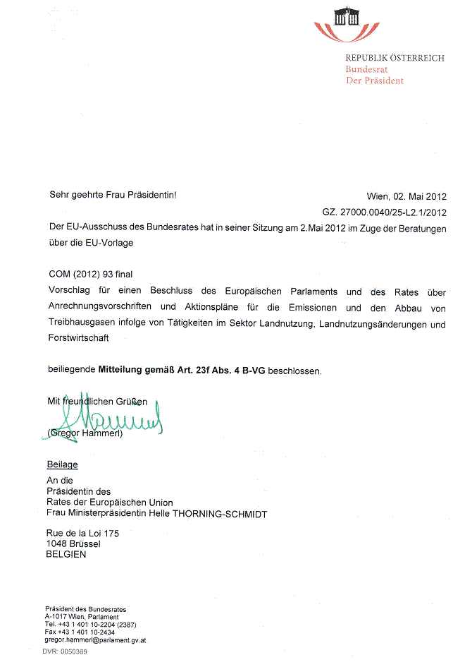
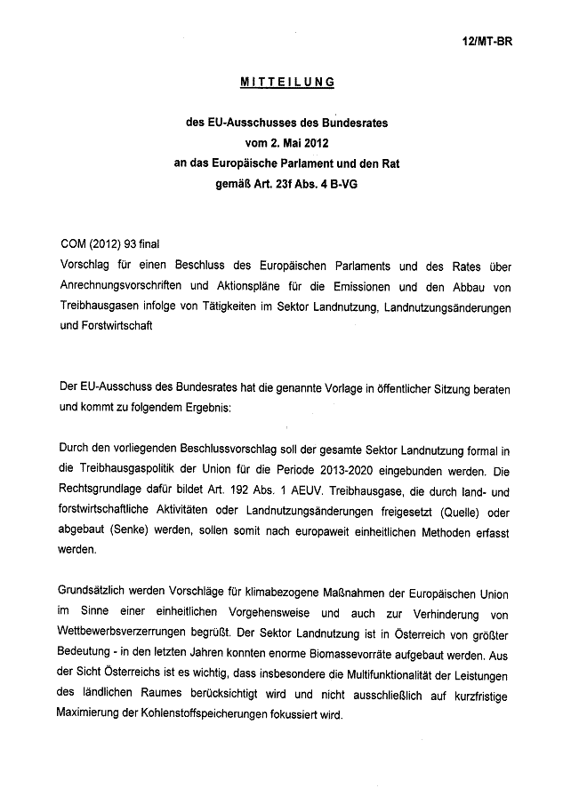
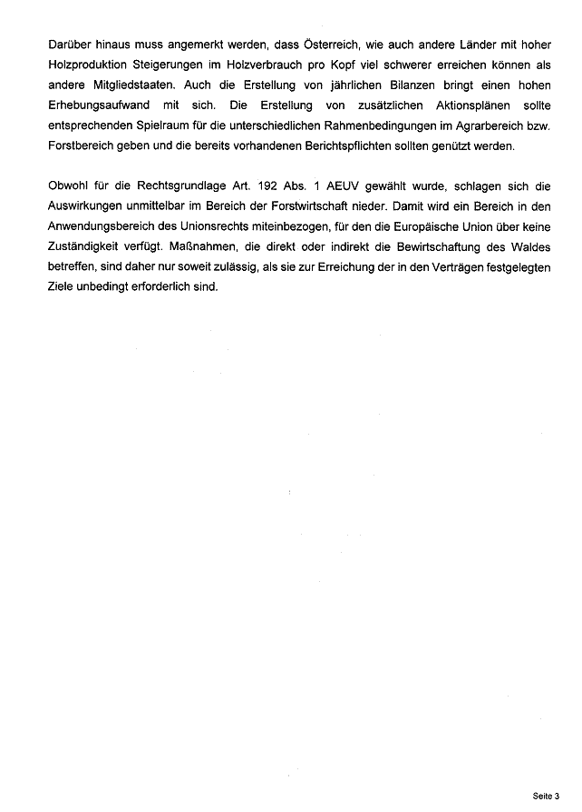

The translation of the following opinion may be available at the Interparliamentary EU information exchange site IPEX at the following address: http://www.ipex.eu/IPEXL-WEB/search.do

