 | 
COUNCIL OF  THE EUROPEAN UNION |  |  | Brussels, 10 May 2012
 | Interinstitutional File:  2012/0042(COD) |  | 9602/12
ENV 332
ONU 53
FORETS 32
AGRI 285
CODEC 1203
INST 323
PARLNAT 218

COVER NOTE
from: | The President of the Assembly of the Republic of Portugal
date of receipt: | 3 May 2012
to:: | General Secretariat of the Council of the European Union
Subject: | Proposal for a Decision of the European Parliament and of the Council on accounting rules and action plans on greenhouse gas emissions and removals resulting from activities related to land use, land use change and forestry [doc. 7639/12 ENV 204 ONU 34 FORETS 23 AGRI 144 CODEC 655 - COM(2012) 93 final]  - Opinionon the application of the Principles of Subsidiarity and Proportionality

Delegations will find attached the above mentioned opinion.

_____________

Encl.
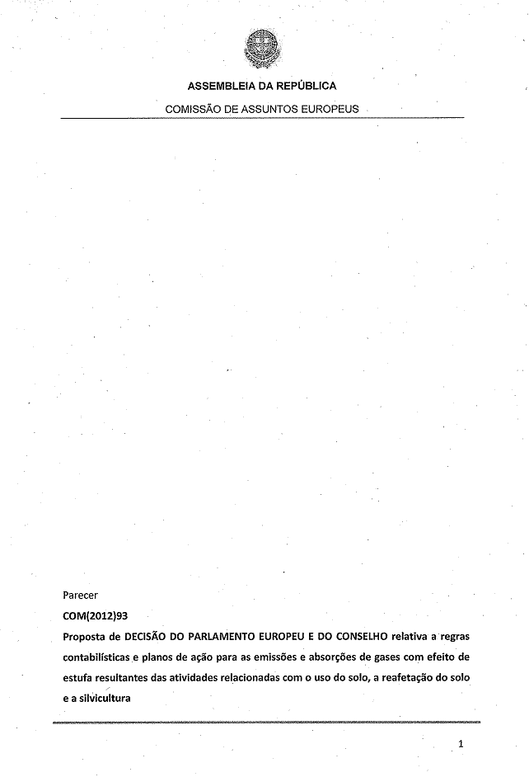

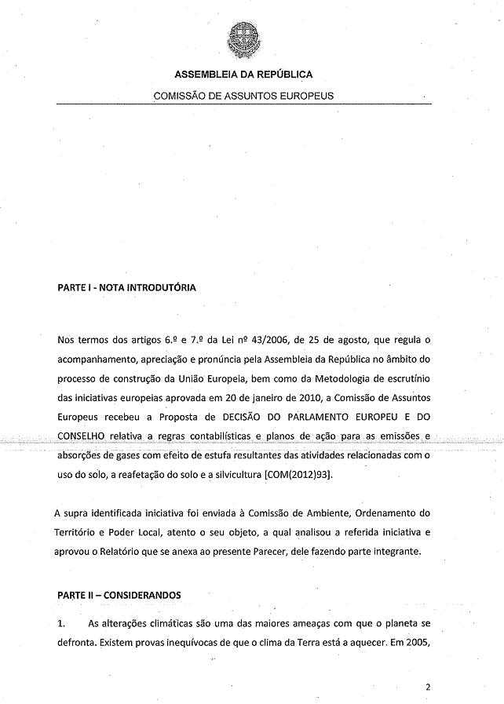
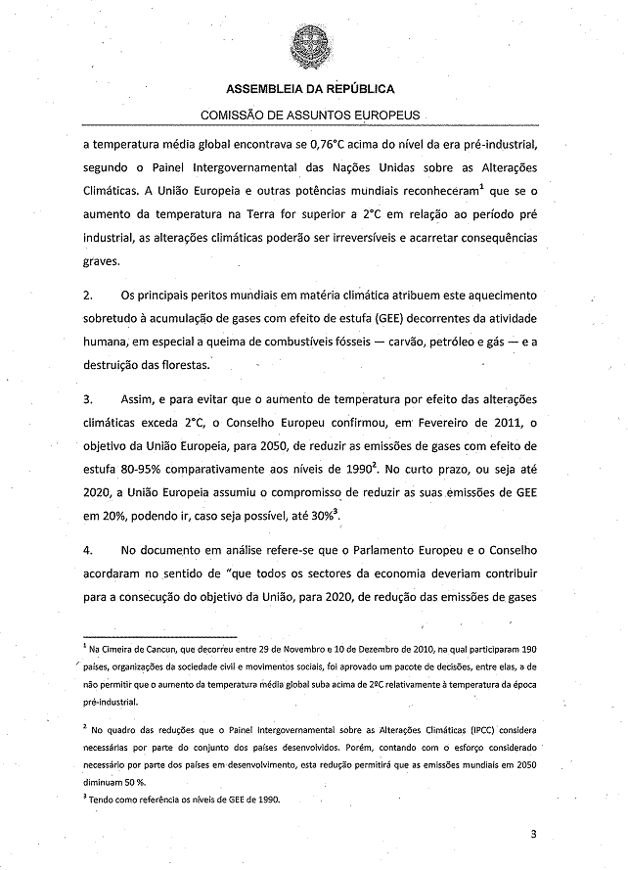
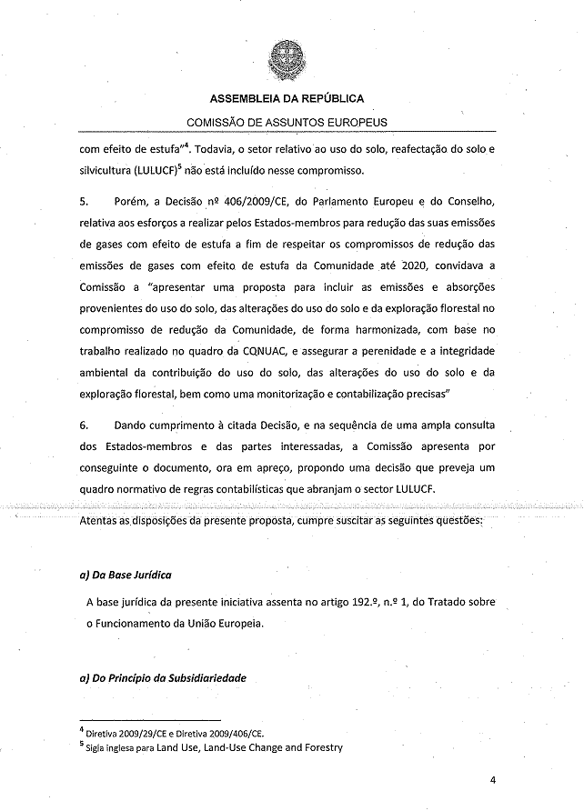
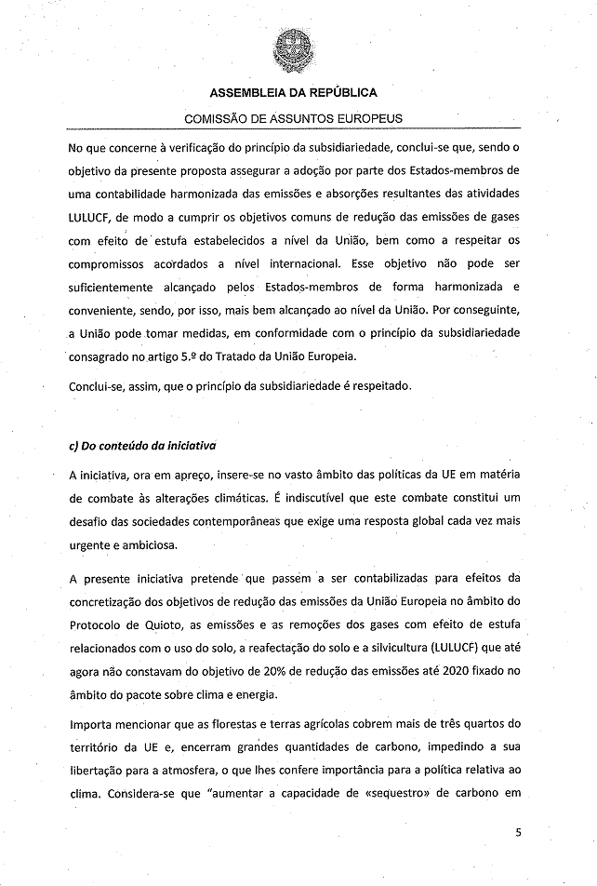
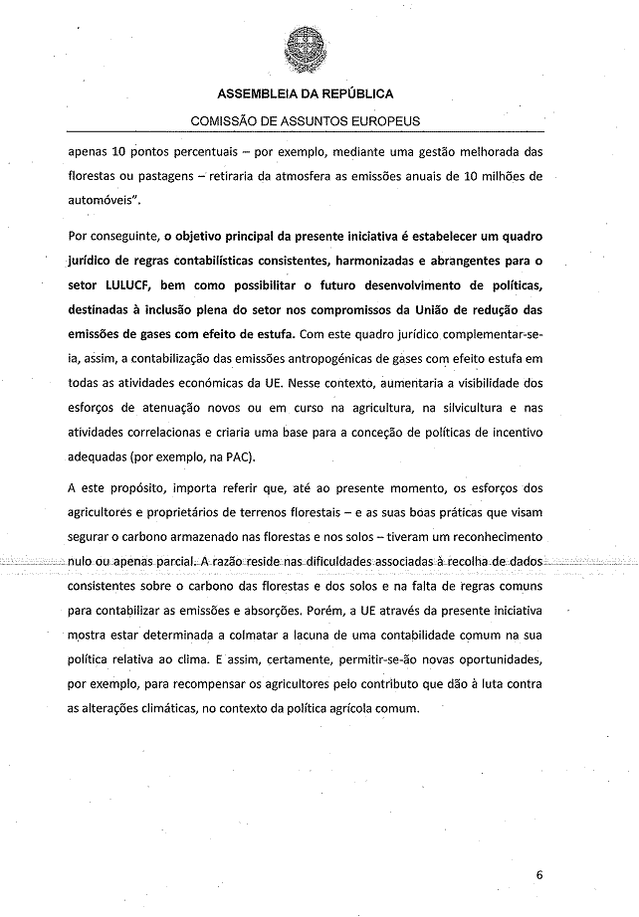
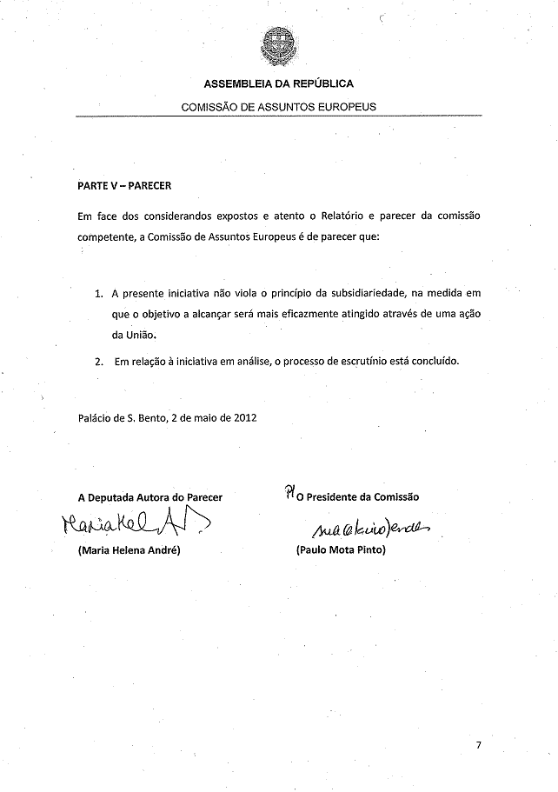

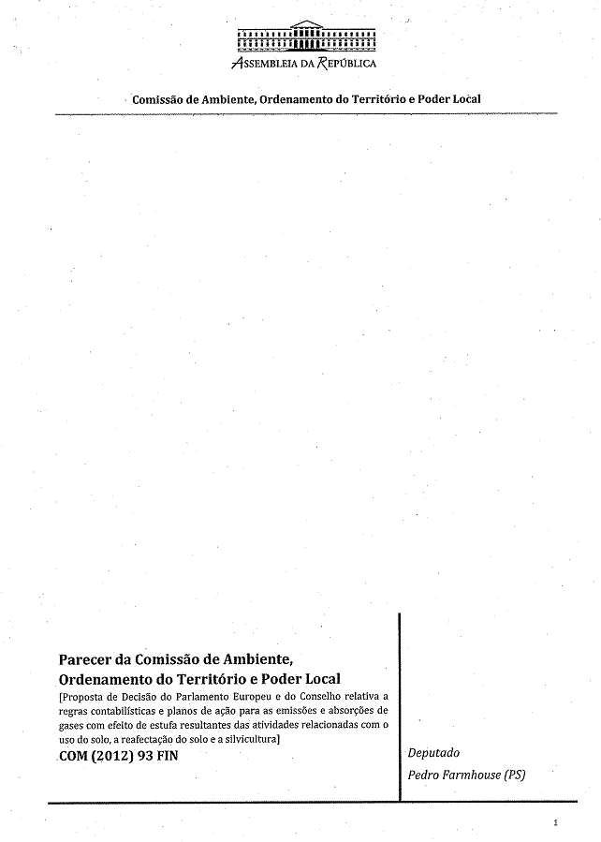
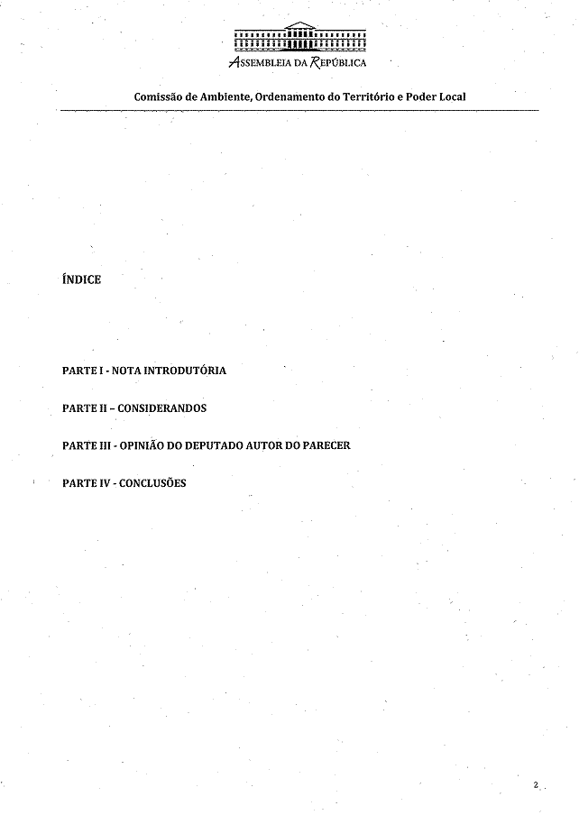
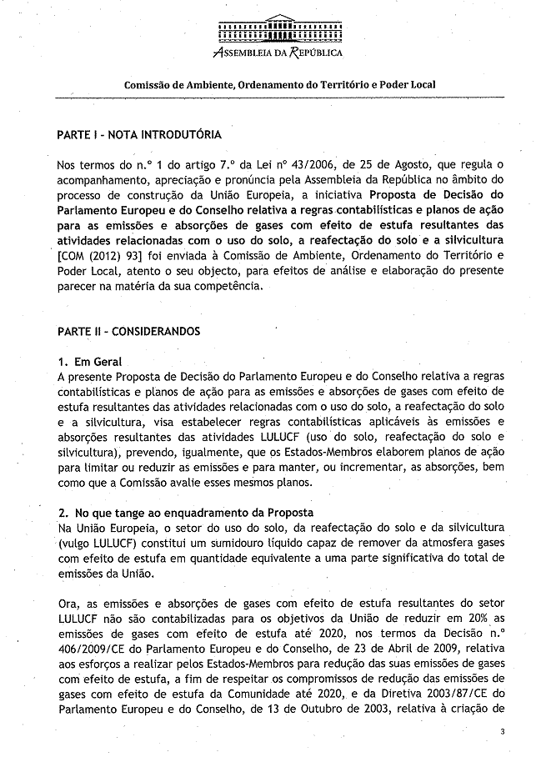
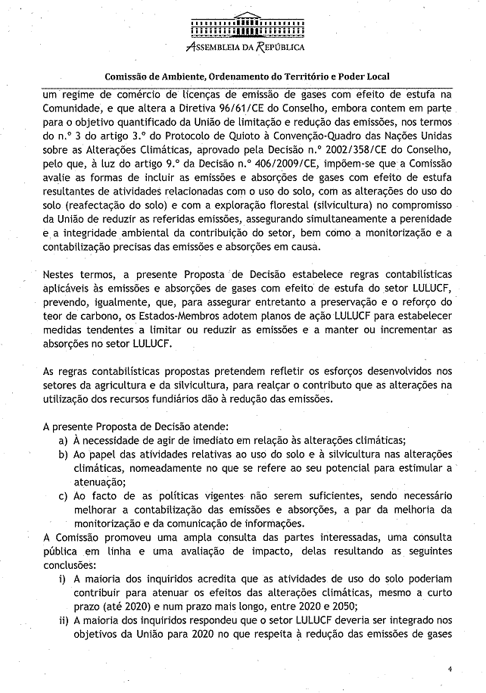
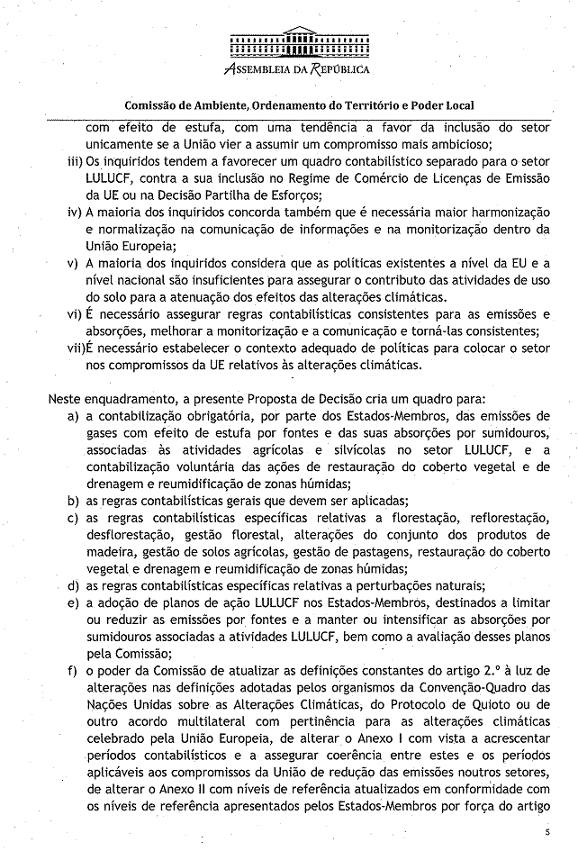
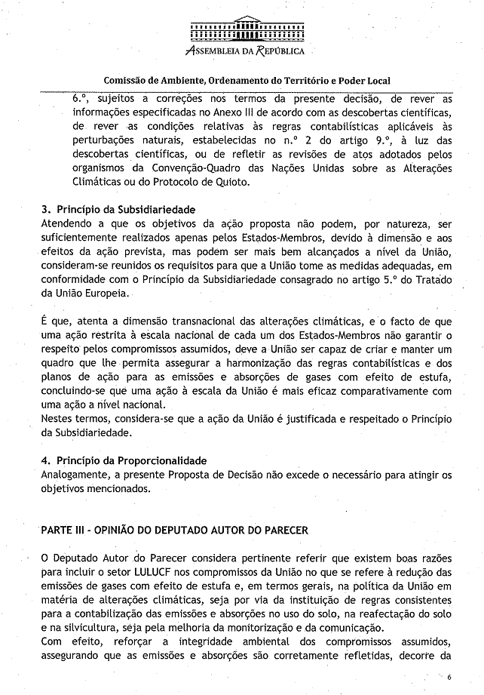
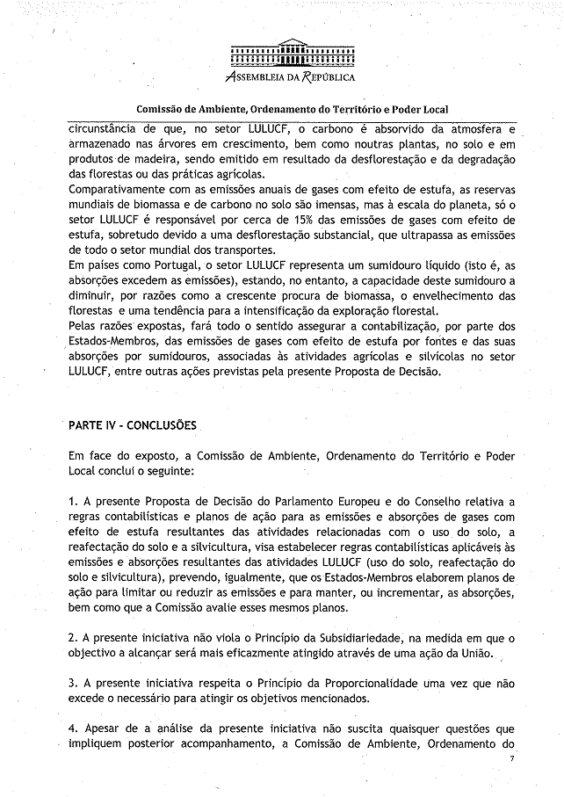
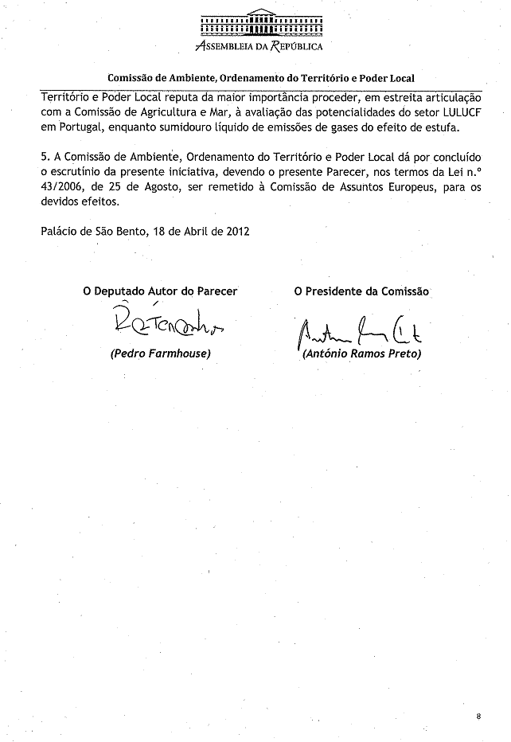

The translation of the following opinion may be available at the Interparliamentary EU information exchange site IPEX at the following address: http://www.ipex.eu/IPEXL-WEB/search.do

