 | 
COUNCIL OF  THE EUROPEAN UNION |  |  | Brussels, 3 May 2012
 | Interinstitutional File:  2008/0256 (COD)  2008/0255 (COD) |  | 8514/12
MI 227
PHARM 17
SAN 71
ECO 45
ENT 81
CODEC 916
INST 264
PARLNAT 182

COVER NOTE
from: | The Senate of the Republic of Poland
date of receipt: | 30 March 2012
to: | The President of the Council of the European Union
No. Cion prop. | 6549/12 MI 104 PHARM 6 SAN 30 ECO 17 ENT 36 CODEC 387 - COM(2012) 48 final  6550/12 MI 105 PHARM 7 SAN 31 ECO 18 ENT 37 CODEC 388 - COM(2012) 49 final
Subject: | Amended proposal for a Directive of the European Parliament and of the Council amending Directive 2001/83/EC as regards information to the general public on medicinal products subject to medical prescription  Amended proposal for a Regulation of the European Parliament and of the Council amending Regulation (EC) No 726/2004 as regards information to the general public on medicinal products for human use subject to medical prescription  - Reasoned opinion on the application of the Principles of Subsidiarity and Proportionality

Delegations will find attached for information a copy of the above opinion.
________________________
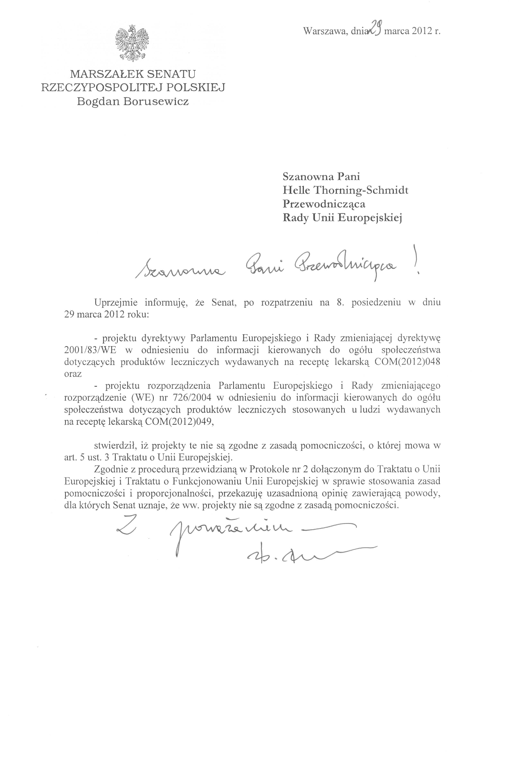

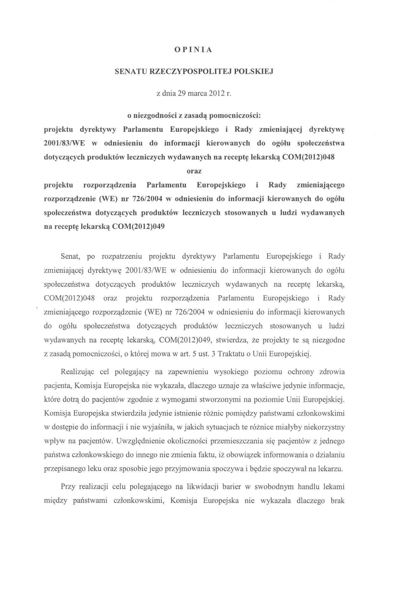
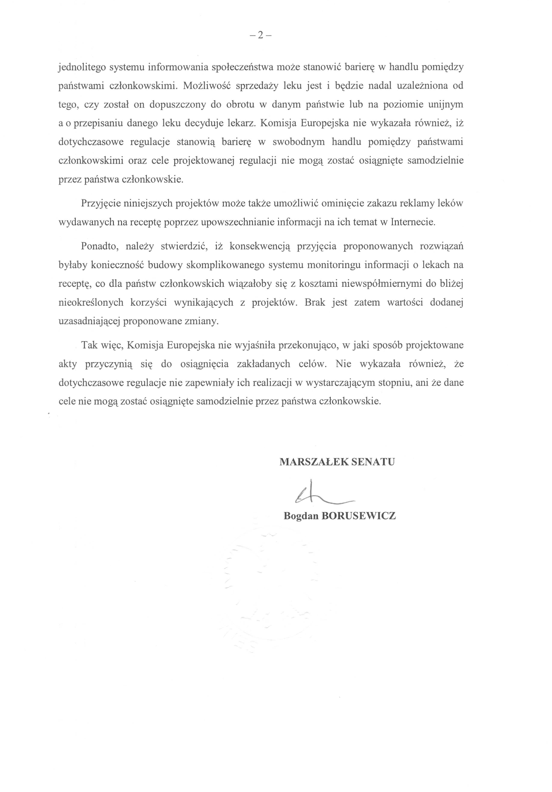

The translation can be found at the Interparliamentary EU information exchange site IPEX at the following address: http://www.ipex.eu/IPEXL-WEB/dossier/document/COM20120049FIN.do#dossier-COD20080255 http://www.ipex.eu/IPEXL-WEB/dossier/document/COM20120048FIN.do#dossier-COD20080256

