 | 
COUNCIL OF  THE EUROPEAN UNION |  |  | Brussels, 3 May 2012
 | Interinstitutional File:  2012/0035 (COD) |  | 9473/12
PHARM 33
MI 293
SAN 96
ENT 114
CODEC 1170
INST 315
PARLNAT 214

COVER NOTE
from: | The Luxembourg Chamber of Deputies
date of receipt: | 25 April 2012
to: | The President of the Council of the European Union
No Cion doc.: | 7315/12 PHARM 14 MI 155 SAN 48 ENT 58 CODEC 567 -  COM(2012) 84 final
Subject: | Proposal for a Directive of the European Parliament and of the Council relating to the transparency of measures regulating the prices of medicinal products for human use and their inclusion in the scope of public health insurance systems  - Reasoned opinion on the application of the Principles of Subsidiarity and Proportionality

Delegations will find attached for information a copy of the above opinion.

________________________

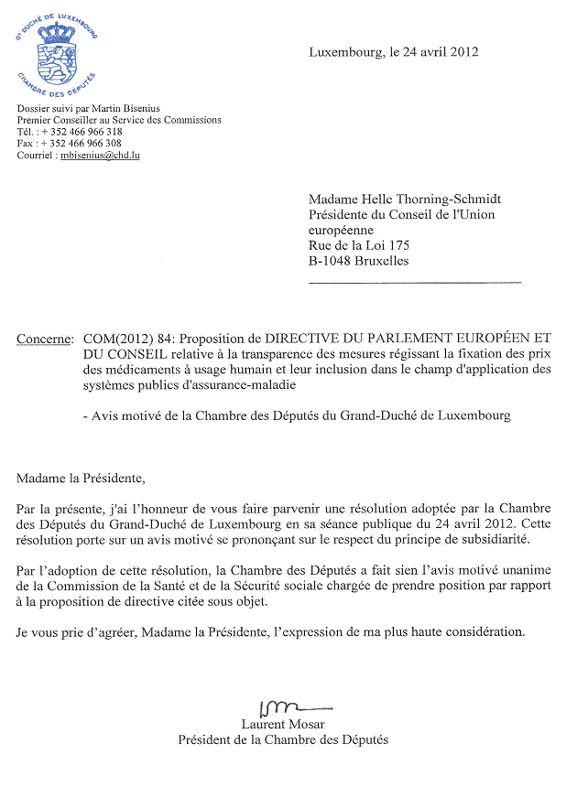
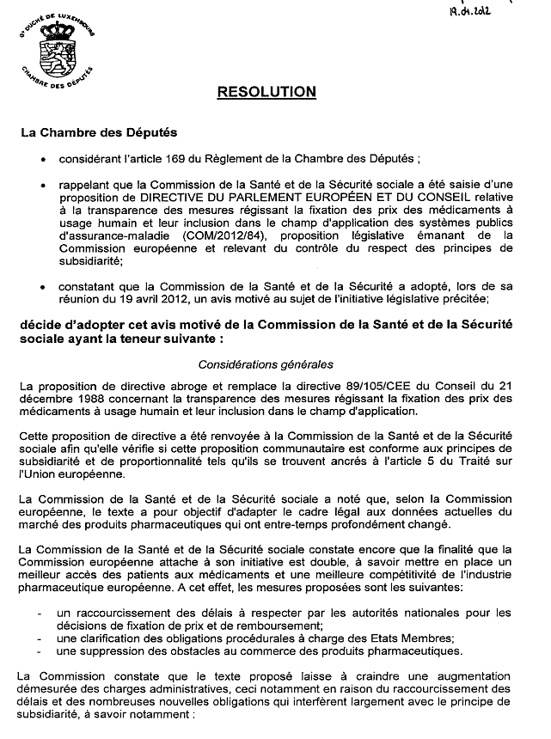
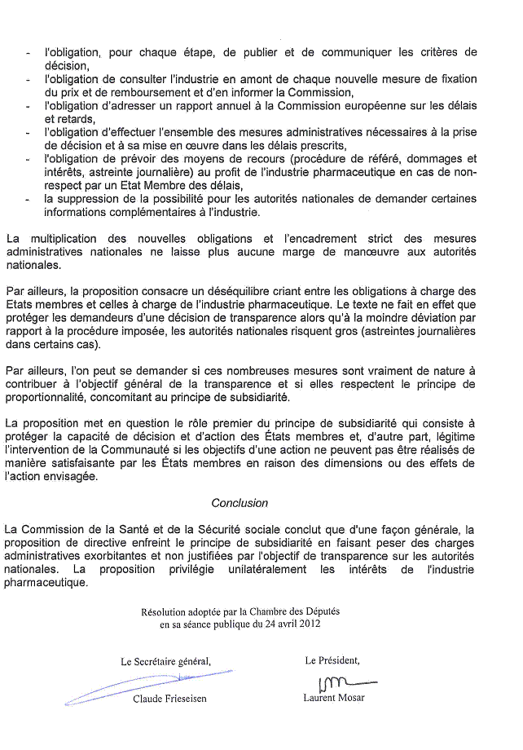

The translation can be found at the Interparliamentary EU information exchange site IPEX at the following address: http://www.ipex.eu/IPEXL-WEB/dossier/document/COM20120084FIN.do#dossier-COD20120035

