 | 
COUNCIL OF  THE EUROPEAN UNION |  |  | Brussels, 9 November 2012
 | Interinstitutional File:  2011/0296(COD) |  | 15990/12
EF 254
ECOFIN 928
CODEC 2616
INST 641
PARLNAT 361

COVER NOTE
from: | The Romanian Chamber of Deputies
date of receipt: | 7 November 2012
to: | President of the European Union
Subject: | Proposal for a REGULATION OF THE EUROPEAN PARLIAMENT AND OF THE COUNCIL on markets in financial instruments and amending Regulation [EMIR] on OTC derivatives, central counterparties and trade repositories  [doc. ST 15938/11 EF 142 ECOFIN 708 CODEC 1783 - COM(2011) 652 final]  - Opinion on the application of the Principles of Subsidiarity and Proportionality

Delegations will find attached the above mentioned Opinion.

________________________

Encl.:
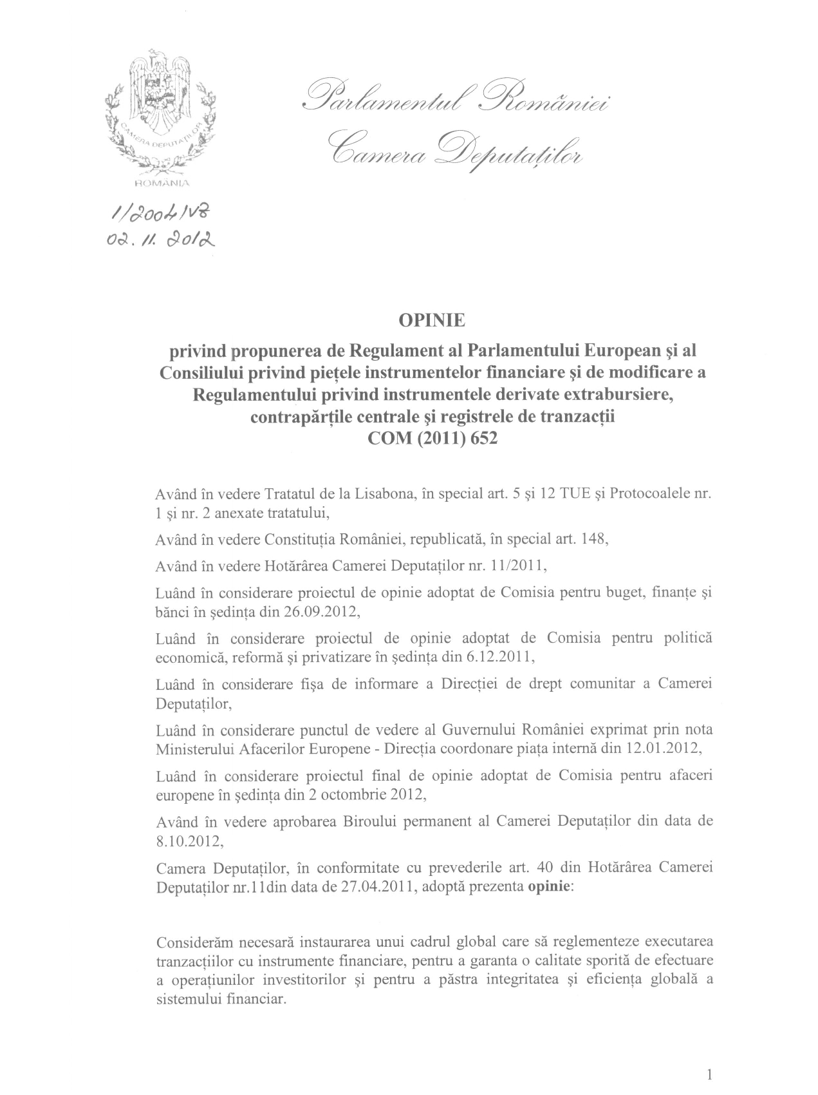
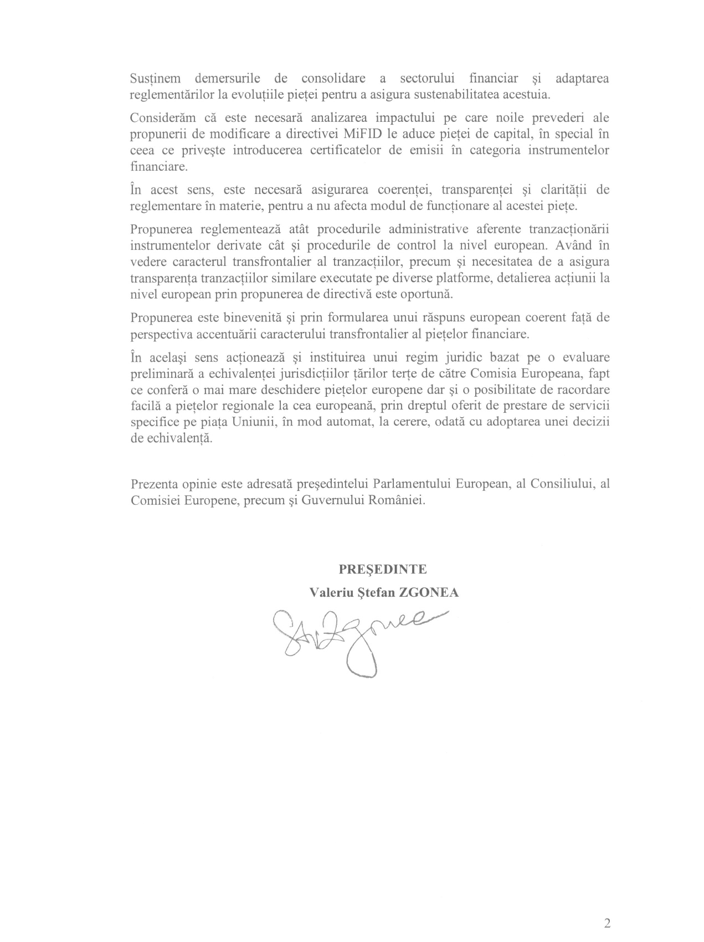

Translation(s) may be available in the Interparliamentary EU information exchange site IPEX at the following address: http://www.ipex.eu/IPEXL- WEB/search.do

