 | 
COUNCIL OF  THE EUROPEAN UNION |  |  | Brussels, 9 November 2012
 | Interinstitutional File:  2011/0298 (COD) |  | 15989/12
EF 253
ECOFIN 927
CODEC 2615
INST 640
PARLNAT 360

COVER NOTE
from: | The Romanian Chamber of Deputies
date of receipt: | 7 November 2012
to: | President of the European Union
Subject: | Proposal for a DIRECTIVE OF THE EUROPEAN PARLIAMENT AND OF THE COUNCIL on markets in financial instruments repealing Directive 2004/39/EC of the European Parliament and of the Council (Recast)  [doc. ST 15939/11 EF 143 ECOFIN 709 CODEC 1784 - COM(2011) 656 final]  - Opinion on the application of the Principles of Subsidiarity and Proportionality

Delegations will find attached the above mentioned Opinion.

________________________

Encl.:
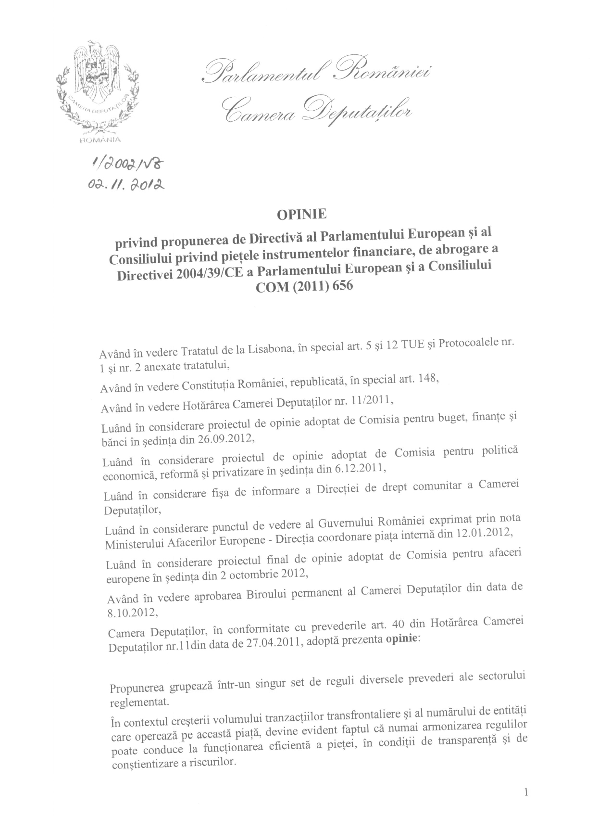
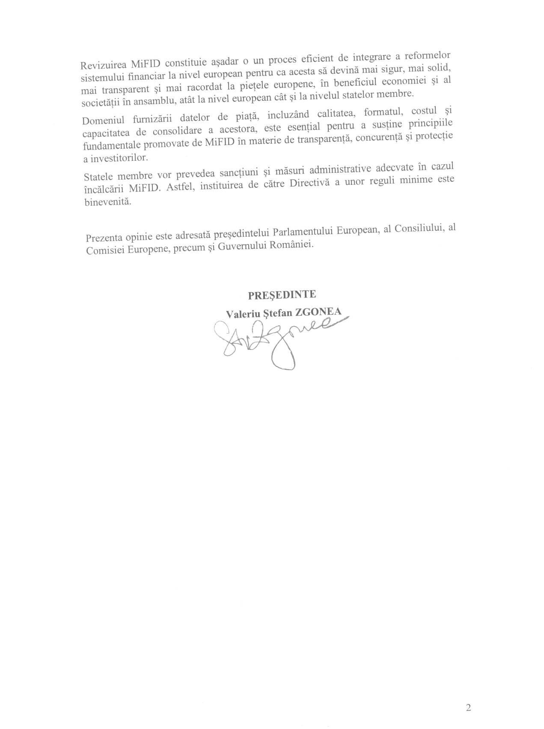

Translation(s) may be available in the Interparliamentary EU information exchange site IPEX at the following address: http://www.ipex.eu/IPEXL- WEB/search.do

