Contents
1. Integration of water scarcity and droughts issues into the River Basin Management plans 5
1.1. Introduction 5
1.2. Relevance of Water Scarcity and Droughts 5
1.2.1. Occurrence of Drought 6
1.2.2. Occurrence of Water Scarcity 6
1.3. Causes of Droughts and Water scarcity 7
1.3.1. Causes of Droughts 7
1.3.2. Causes of Water Scarcity 7
1.4. Effects of Water Scarcity and Droughts 8
1.5. Data on water demand and water availability trend scenarios 8
1.5.1. Water demand trend scenarios 8
1.5.2. Water availability trend scenarios 9
1.6. Measures to deal with Water Scarcity and Droughts 9
1.7. Inter-linkages between Water Scarcity and sector policies 11
1.8. Quality of data and assumptions 12
1.9. Transboundary cooperation on Water Scarcity and Droughts 12
2. Ex-post Assessment of the 2007 Communication 14
2.1. Putting the right price tag on water 14
2.1.1. Review of existing initiatives 14
2.1.2. Evaluation of initiatives 15
2.2. Allocating water and water-related funding more efficiently 17
2.2.1. Improving land-use planning 17
2.2.2. Financing water efficiency 20
2.3. Improving drought risk management 23
2.3.1. Review of existing initiatives 23
2.3.2. Evaluation of initiatives 25
2.4. Considering additional water supply infrastructures 27
2.4.1. Review of existing initiatives 27
2.4.2. Evaluation of initiatives 28
2.5. Fostering water efficient technologies and practices 29
2.5.1. Review of existing initiatives 29
2.5.2. Evaluation of initiatives 29
2.6. Fostering the emergence of a water-saving culture in Europe 31
2.6.1. Review of existing initiatives 31
2.6.2. Evaluation of initiatives 32
2.7. Improving knowledge and data collection 33
2.7.1. Water scarcity and drought information system 33
2.7.2. Research and technological development opportunities 36

Integration of water scarcity and droughts issues into the River Basin Management plans

Introduction
As part of the overall assessment of the River Basin Management Plans (RBMPs) submitted under the Water Framework Directive, a specific assessment has been completed to see how water scarcity and droughts have been considered in plans. This report includes information found in the RBMPs that have been delivered by Member States, covering most of the EU with the exception of PT, EL, parts of ES and BE. Additional information from MS and stakeholders has been taken into account as relevant.
RBMPs analysed
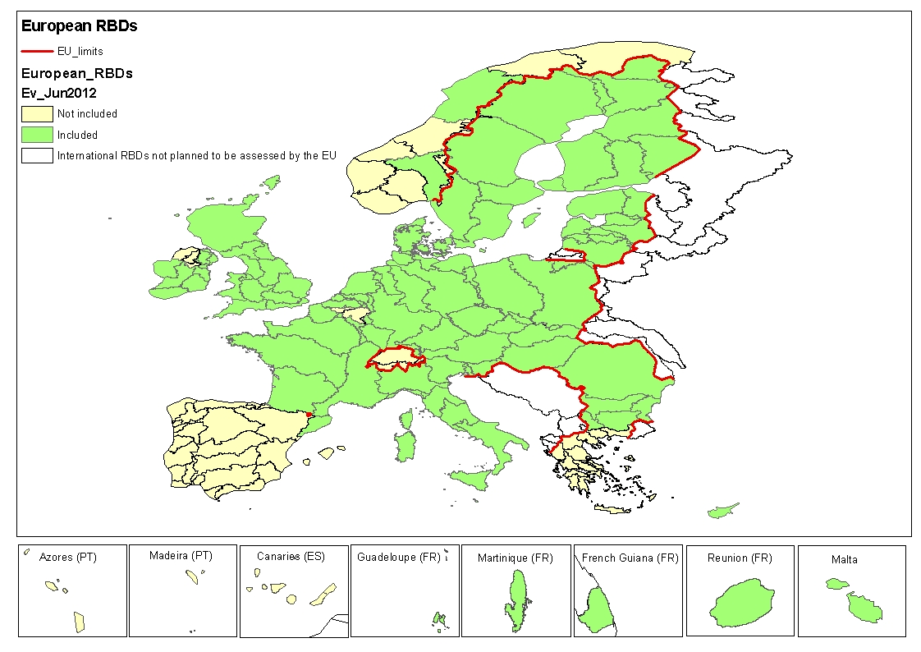

Relevance of Water Scarcity and Droughts
The first aspect that has been assessed is whether the RBMPs have identified either droughts or water scarcity as relevant issues for the River Basin Districts, and if they have been adequately differentiated according to their causes. The assessment shows that for 14 RBDs Water Scarcity and Droughts (WS&D) are not clearly distinguished or the information on this matter is not clear.
Both drought and water scarcity are said to take place together in the majority of the RBDs where they are considered as relevant phenomena (23 RBDs).

Occurrence of Drought
Droughts are reported in the plans for a wide range of RBDs across Europe, although the results from the screening exercise show that approximately 40% (44 RBDs) of the RBMPs assessed, do not consider drought as a relevant phenomenon. According to 10 RBMPs, drought spells are recognised as RBD-wide phenomena, and for 27 other RBDs, local or sub-basins drought spells are reported. In 15 RBDs, droughts and water scarcity affect part of or the entire basin, but the two conditions are not clearly distinguished.
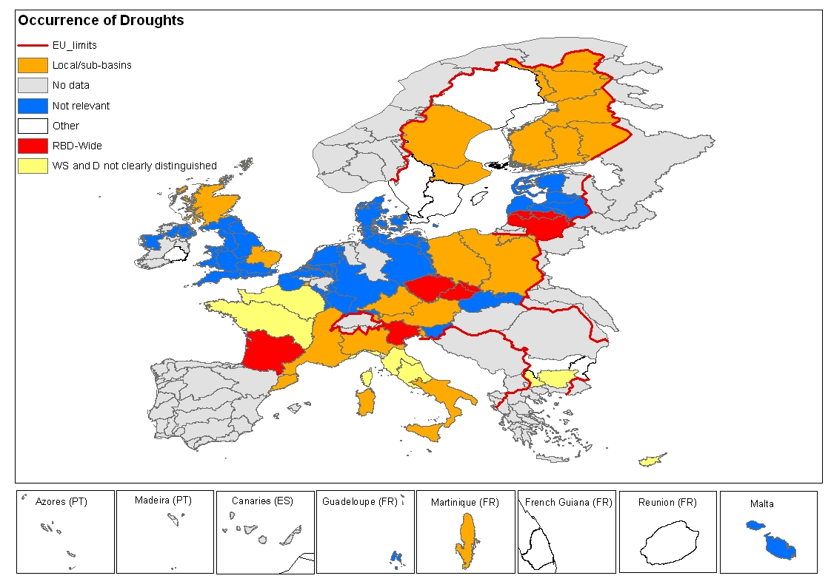

Occurrence of Water Scarcity
Water scarcity is reported in a number of RBDs across Europe, but in 41% of the screened RBDs (46 RBDs), the plans do not consider water scarcity as a relevant concern. For 9 RBDs river basin-wide water scarcity was reported and for 32 RBDs, local or sub-basin water scarcity was reported. In 15 RBDs, droughts and water scarcity affect part of or the entire basin, but water scarcity and droughts are not clearly distinguished.
Therefore, according to the assessment, 41 RBMPs clearly report water scarcity phenomena. The list of RBDs facing water scarcity includes almost the whole EU Mediterranean area, but also some areas in Central, Eastern and Northern Europe with significant water scarcity at local level, mainly due to large water usage in comparison to availability. The maps above and underneath respectively show the European RBDs and the occurrence of droughts and water scarcity as reflected by the RBMPs. The results show that drought is not only common in Southern Europe, but also in other parts of the EU.

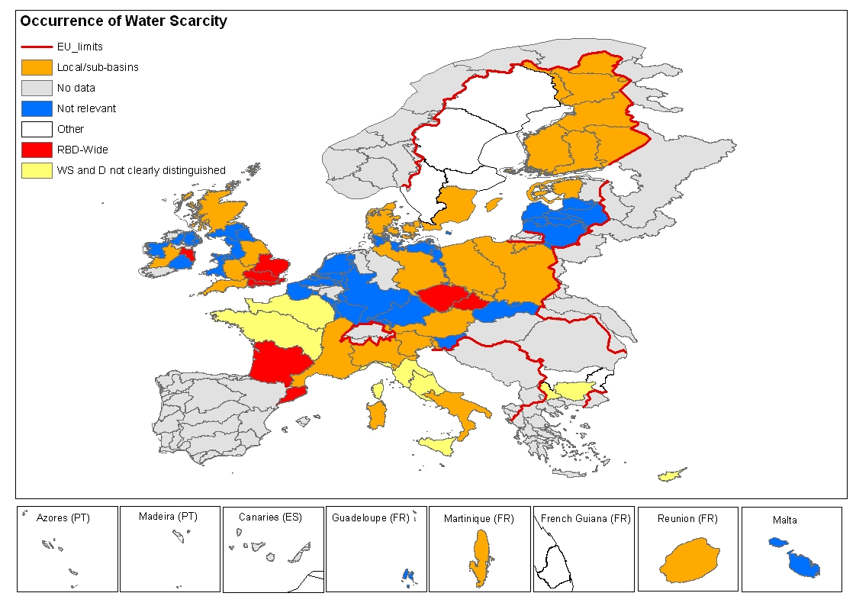

Causes of Droughts and Water scarcity

Causes of Droughts
The most common causes of drought are irregular rainfall patterns (43 RBDs) and the decrease in natural available resources (34 RBDs), but only in 50% of the corresponding RBMPs quantitative data are reflected. Moreover, only 26 of these RBDs consider both as drivers for droughts, showing the misconception that droughts are only a natural meteorological phenomenon due to irregular rainfall patterns that decreases natural available water resources independent from water use.
Only 19 RBMPs have reported causes not related with the meteorological nature of the phenomenon such as past and current water over-allocation, new water demands from agriculture and tourism or water use technologies that do not foster efficient water use. Some RBMPs do not include information on the causes of droughts, although the RBDs are said to be affected by this phenomenon.

Causes of Water Scarcity
According to the RBMPs, water scarcity situations in RBDs are also (mainly) caused by irregular rainfall patterns (for 40 RBDs) and a decrease in natural available water resources (for 36 RBDs), though only 1/3 of the plans provide data that support this analysis.
Only 17 RBMPs recognise past and current over allocation of resources as a cause of water scarcity problems and a similar number of RBMPs identify new water demands (for urban uses, agriculture, industrial and tourism sector) as causes for upcoming water scarcity problems (e.g. RBDs from AT, CZ, EE, FI, FR, IT and UK).

Effects of Water Scarcity and Droughts
From the screening exercise of the RBMPs, different effects were identified and can be expected to be caused by past, current and future droughts spells or water scarcity scenarios, depending on their frequency and magnitude.
- Degradation of surface water quality was reported as a significant effect for both drought (23 RBDs) and water scarcity (30 RBDs) situations. Other “environmental effects”, such as the degradation of groundwater quality and wetlands degradation are also identified as main effects of WS&D according to the assessment. The disruption of ecological flow regime, was reported as an effect for 16 RBDs in the case of drought spells and for 30 RBDs for water scarcity.
- Urban water supply shortages were reported as an effect (and also expected in future scenarios) both for drought spells (18 RBDs) and water scarcity situations (32 RBDs).
- Groundwater over-abstraction was reported as an effect in 13 RBDs for droughts and in 36 RBDs for water scarcity scenarios.
- Economic losses in the agricultural sector, in the tourism sector or in the industrial sector were surprisingly not reported as significant effects for the majority of the RBMPs assessed. The main effects are mentioned for agriculture, in only 5 RBDs (due to drought) and 6 RBDs (due to water scarcity).

Data on water demand and water availability trend scenarios
Regarding the assessment on water demands and water availability (for both current situations and trend scenarios) the different RBMPs present a varying level of detail and analysis.

Water demand trend scenarios
The RBMPs contain data on water demand trend scenarios for almost 35% of the screened RBDs and for the majority of them the data are also analysed by water use type. The completeness of the timeline of these projections (e.g. 2015, 2021 and 2027) and information regarding the geographical scope, magnitude and trend data for each itemised water use, have not been assessed.
However, it is worrying that almost 50% of the assessed RBMPs do not include data on future trend scenarios. This is particularly problematic for those RBDs that have identified WS&D as RBD-wide issues.

Water availability trend scenarios
Regarding the analysis of the water availability trends, the assessment shows that in less than 25% of the RBMPs, these scenarios are provided; in addition, only around 8% of the RBMPs provide itemised data (by water type). The completeness of the timeline of these projections (e.g. 2015, 2021, 2027) and information regarding the geographical scope, magnitude and trend data for each itemised water type have not been assessed so far.
However, it is clear that in more than 50% of the assessed RBMPs, no data on future water availability trend scenarios are provided. This is particularly worrying for those RBDs that have identified WS&D as RBD-wide issues.

Measures to deal with Water Scarcity and Droughts
A set of 22 specific measures to deal with water scarcity and droughts were selected as parameter to analyse the completeness of the battery of measures considered in the plans of the different European RBDs. In addition to the “standard” set of measures, some RBMPs include other actions, which were also taken into account in the screening exercise. The figure below summarizes the results of the assessment.
The “top-5” list of measures considered within the RBMPs assessed includes:
- Reduction/management of groundwater abstraction
- Training, education and capacity building in water saving,
- Studies, research and pilot projects to solve water scarcity problems and improve the response to droughts,
- Reduction of losses in urban distribution networks
- Modification of the water pricing system to foster a more efficient use of water
Great efforts are said to be planned for the reduction/ management of groundwater abstraction (considering that it is included in >90% of RBMPs, and reflected as a priority in more than 60% of these plans). However, the positive impact of this measure still remains unclear, especially taking into consideration that other “enabling” measures that are pre-conditions or should support its implementation (e.g. measures to enhance water metering) are much less present in the RBMPs priorities.
In spite of the investments and efforts planned (in the mid and long-term) regarding studies, research, pilot projects, training, education and capacity building (in aprox. 55 % of the RBMPs), the impact of these measures is unclear, given the general nature.
Measures envisaged in about half of the assessed RBMPs include the modification of the water pricing system to foster a more efficient use of water (in 49% of the RBMPs), the improvement of the efficiency of water agricultural uses (also present in 45% of the RBMPs), measures to enhance water metering (in 40% of the RBMPs) or measures to increase treated water reuse (in 50% of the RBMPs).
Measures included in the “other measures” category such as ecological reconstruction (restoring longitudinal and lateral connectivity), use of best available techniques in industry, improving knowledge on future water demands or reconciling the authorizations for abstractions with the needs of the aquatic environment, are included in a great proportion of the RBMPs assessed.
Among the measures that are less common within the RBMPs, the development or upgrade of desalination plants and the establishment of water rights markets or schemes to facilitate water reallocation are the least considered. According to the assessment, the restrictions to new water-demands (urban, irrigation) are planned only for 15% of the assessed RBMPs; and –even more worrying – only in one basin out of the 41 water-scarce RBDs in Europe.
Measures to enhance the resilience of the ecosystems (e.g. ensuring minimum ecological flow) are very relevant to ensure the achievement of the WFD objectives in areas that face WS&D, and are planned in 45% of the RBMPs. The development of Drought Management Plans (DMPs) was reflected in 41% of the assessed RBMPs.
Some of the main categories of measures and their representation in the RBMPs are presented graphically below.
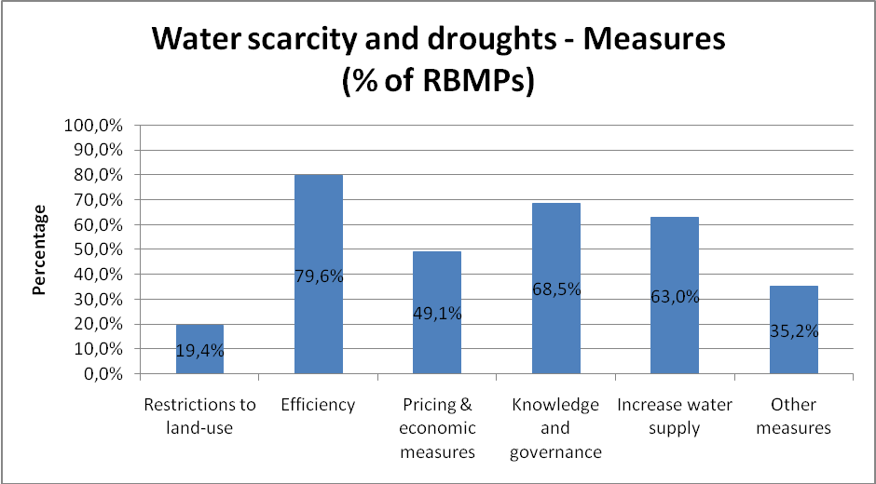
Finally, the majority of the RBMPs include measures to improve efficiency, knowledge and governance and to increase water supply. Less than half of the RBMPs include economic/pricing-oriented measures and less than 20% envisages restrictions to land-use.

Inter-linkages between Water Scarcity and sector policies
Water scarcity problems can be caused by an inadequate design of related policies in water-using sectors. To address this issue, the RBMPs should take into consideration the inter-linkages between the different policy areas, as well as propose measures for the reduction of water scarcity and the mitigation of drought in the RBD.
According to the screening exercise, only for 6 RBDs, the influence of other sectoral policies on the reduction of water scarcity and the mitigation of drought effects is described, and measures are proposed to harmonise those policies with the reduction/mitigation. For only 12% of the assessed RBMPs, the pressures on water resources by sector at present and in the future are identified.
For almost 75% of the RBMPs assessed, the influence of other sector policies on water scarcity and the mitigation of drought effects is not described or not relevant/unclear. Of these RBMPs, more than 2/3 suffer from water scarcity and/or drought.

Quality of data and assumptions
For an adequate design and definition of the general water planning scheme, that should be translated into the corresponding RBMPs and their associated Programmes of Measures (PoMs), it is necessary to use transparent data and clear assumptions. The assessment exercise addresses this issue through one of its questions. The results can be summarized as in following figure:
In almost 45% of the assessed RBMPs, the sources of data for present water consumption and for water availability are explicitly mentioned; however, in only 20-25% of the plans, projections of future water demand and water availability are based on explicit assumptions.
For almost 20% of the assessed plans, uncertainty of data is made explicit in the dataset used and, when relevant, the time span of the dataset is made explicit. For less than 10% of the screened RBMPs, the sources of funds to implement the Programme of Measures are specified for each measure separately, and for even less RBMPs (around 5%) the uncertainty of data is taken into consideration when stating the expected results in the Programme of Measures.
Moreover, for none of the assessed RBMPs, the existing social conflicts were considered as a risk for successful implementation, and for a very small portion of them the interrelation (either positive or negative) between measures was highlighted. This shows the lack of transparency and adequacy of the analysis regarding key quantitative aspects of the water planning scheme, within most of the assessed RBMPs

Transboundary cooperation on Water Scarcity and Droughts
Regarding the 65 International RBMPs, their approach to deal with WS&D in a transboundary context can be summarised as follows:
- In around 60% of the plans, the information on transboundary coordination in the field of water scarcity and droughts is not clear, no information is found or it can be considered as “not relevant”;
- 2% of the plans include co-ordinated measures for the entire international RBD, and for around 5% of the assessed plans specific co-ordinated measures for the different transboundary water bodies were identified;
- 10% of the plans identify joint challenges as the way to address WS&D issues in shared water bodies and in 15% of the plans, transboundary cooperation was indicated as a general coordination issue.

Ex-post Assessment of the 2007 Communication
The ex-post assessment on the Communication on Water Scarcity and Droughts in the EU is intended to evaluate whether the Communication "has achieved its objectives”. However, given that many activities are currently being implemented, the evaluation is intermediate and intended to give input to further policy developments. The following evaluation questions were used:
1) Were the objectives met and coherent with other actions?
2) What were the main impacts?
3) Have Drivers, Pressures or Impacts been addressed?
4) Is this course of action still appropriate?
The evaluation is mainly based on:
- MS follow up reports to the 2007 Communication (2008, 2009 and 2010)
- EU annual reports (2008, 2009 and 2010)
- Gap Analysis and Database of WS&D Measures and Support Actions
- Reports on specific policy instruments

Sections 2.1-2.7 below show the assessments for each of the 7 policy options identified in the 2007 Communication.

Putting the right price tag on water
According to 2007 Communication, policy options aimed at putting the right price tag on water must address the implementation at the EU level of the “polluter pays principle” in the water sector, mainly making the user pay for the water supply and wastewater treatment associated costs.

Review of existing initiatives
According to WFD Article 9, MS had to develop a water pricing policy by 2010 to provide an adequate incentive for users to consume water in a more efficient manner. One of the key elements on which the water tariffs policies should be based, is a reliable metering system for water abstraction. Within the period of 2008-2010 water metering was extended generally within all MS, though further action is required. Data reliability on water consumption is still a concern at EU level.
Many MS have undertaken direct action to address the water pricing issue. First steps were taken in 2008 by defining national strategies for water abstraction, metering for high-volume consumers such as the agriculture sector (ES,FR), promotion of general water metering regarding water abstraction and consumption data (CY,FR, PT) or linking compliance with water metering with authorization/permits for water abstraction (FR,UK).
In 2009 and 2010 water tariffs were introduced by a few more MS and in others tariffs were still under development at the end of 2010. Other widespread water pricing measures are the adoption of block-tariff systems (i.e. volumetric pricing), penalties for excessive consumption (closely linked with enforcement of the water metering) and discounts for water savings.
There is still a significant lack of recovery of both financial and environmental costs from agricultural water use. For about a third of the EU MS, operational and maintenance costs for the provision of irrigation water for agriculture are only partly recovered (generally borne by farmers themselves), whilst associated capital costs (investments such as reservoirs) are often subsidized by public authorities.
As a result, it often remains unclear which share of investment costs can be allocated to the different water users. Volumetric pricing systems is considered as one of the most effective tariff structures with regard to actually providing incentives for water savings in agriculture. A recent study concluded that both water pricing and allocation systems should be based on environmental flow regimes, as key factors to control water over- abstraction and guarantee the adequate provision of the environmental services associated.

Evaluation of initiatives

Were the objectives met and coherent with other actions?
Efforts taken at EU level (specially in the case of enforcement of water metering) are all concurring in moving towards a water efficient and water-saving society, thus in accordance with the objectives of the water scarcity and droughts policy.
However, despite the 2010 deadline, neither the objective of full implementation of the WFD in terms of recovery of costs associated with water services nor the implementation of the “polluter pays” principle within MS have been reached.
Even though increases in the price paid for water services provision do not necessarily entail water consumption decreases, cost recovery from water services is crucial for better awareness of the real value of water (as a resource) and to contribute to a more water efficient society.

What were the main impacts?
There is currently little information regarding the impacts of water pricing, in particular as full implementation of the water pricing provisions is still pending. More experience is needed in order to gain knowledge on the economic and environmental impacts of these measures.
Most existing studies are modeling and ex-ante assessments, and have been criticized by Molle and Berkoff (2007, in Garrido and Calatrava, 2010) for overestimating the income impact of pricing policies and also for underestimating the water demand elasticity. Recent studies conclude that policy makers should expect less change from water pricing (particularly in agriculture), considering that most analyses conclude that demand is somewhat inelastic to water pricing, although it is responsive to agro-environmental policies and farm prices.
According to the information provided by the European Environment Agency (EEA, 2011), based on national statistics on household water consumption both from Spain and Estonia, as the water tariffs increase, water consumption decreases. This is also the case for Denmark (EEA, 2009).This supports the expected impact, suggested in the 2007 Communication regarding the reduction of domestic consumption when water tariffs are applied, especially if they are supported by the introduction of a reliable metering system.

Have Drivers, Pressures or Impacts been addressed?
Putting the right price tag on water tackles both drivers and pressures of water scarcity and/or droughts such as population developments, economic aspects, land use or technological changes.

Is this course of action still appropriate?
Further implementation of the water pricing policy including recovery of costs associated with water services and valuation of water resources is crucial to address the WS&D challenge across Europe, provided that other complementary measures –e.g. modernization of the conveyance infrastructure, large-scale installation of metering devices- are also put in place. Water pricing policies should be introduced gradually, so as to allow users to adapt to changes. In this regard the Payment for Ecosystem Services (PES) could be considered as a complement to current water pricing mechanisms.
MS face different challenges in the implementation of water pricing policies, and price structures should be adapted to local circumstances. Nevertheless, integration of data, development of a common framework for water pricing and efforts to ensure that all EU MS are setting the price right should remain a priority at the European level.

Allocating water and water-related funding more efficiently
Policy options in the 2007 Communication designed to allocate water and water-related funding more efficiently address two separate issues: (1) improving land-use planning and (2) financing water efficiency.

Improving land-use planning

Review of existing initiatives
In order to support sustainable agriculture, including sustainable water use, the European Union introduced two new water-related standards in the cross compliance regime in 2008. Relevant for water scarcity issues is the Good Agricultural and Environmental Condition (GAEC) requiring compliance with authorization procedures in case of use of water for irrigation. This standard is applicable as from 2010. It is also proposed to be maintained for the next programming period as part of Commission proposals for the CAP reform adopted on 12 October 2011. All but one MS notified that standards on the authorisation of the use of water for irrigation were set by linking payments with permitting, one of the main approaches to authorization.
In general, regulations are in place at national level regarding authorisation for water abstraction. MT and IE reported that they are improving their current procedures, focussing on modernising their system of registration and tackling unauthorised abstraction. In addition, some MS reported that restrictions of water use are applied in order to preserve aquatic life and ecological status of water bodies. Several countries also reported that they are adopting prosecution procedures for illegal abstractions (AT, PT, RO) but illegal abstractions remain an important challenge in a number of, particularly southern, MS. Finally, Spain and France have introduced bans on increases in water abstraction in overexploited areas.
To address the issues of biofuels, a study was commissioned in 2008 assessing the impact of bioenergy development on water availability. The study indicated that currently, bioenergy production has a limited effect on water consumption. A significant increase in biomass production in the EU will not need to increase the total irrigation water consumption. Stricter water use restrictions are only needed in the most water scarce regions to reach this low additional pressure on water resources for biomass cropping. In order to reach the bioenergy targets by 2020 it is most efficient therefore to stimulate the cropping of biomass in the Northern and central parts of Europe than in the South. The taking into use of additional land and efficient production techniques are more critical in reaching the targets than access to irrigation water Sustainability criteria have been developed within the Renewables Directive but they do not specifically address water impacts due to the limited effects mentioned above.
At EU level land-use policy options were included in the White Paper on adaptation to climate change, focusing on introducing adaptation measures on water management in rural development; the work is still on-going.
Most MS reported that they have fully implemented the Environmental Impact Assessment (EIA) and Strategic Environmental Impact Assessment (SEA) Directives; only Romania reported that implementation is still on-going. In most MS the SEA is applied at national level and several MS reported that RMBPs were subject to SEA. Additionally, the EIA procedures were also applied to water infrastructure (UK), hydroelectric dams (PT) and desalination plants (CY).

Evaluation of initiatives
Were the objectives met and coherent with other actions?
Efforts at EU level targeted three main policy areas: agriculture (CAP), biofuels, and climate change adaptation (White paper). With respect to ensuring sustainable water use in agriculture, progress has been made at EU level to better incorporate water quantity as well as water quality issues into the CAP: in general, measures included in the legal proposal for the next funding period, including the proposed cross-compliance rules, actually have the potential to prompt sustainable land use practices. With respect to assessing the inter-linkages between biofuel development and water availability, the EU tendered a project investigating the impact of biofuel development on water resources, which found that biomass production for biofuels would not necessarily increase irrigation. While the Renewables Directive introduced sustainability criteria, none of them are related to water resources or irrigation efficiency due to the limited effects biofuel production has on water use. It can be concluded that it is more appropriate to address water scarcity in a horizontal way across all types of agricultural production rather than addressing individual types of production (such as food, feed, fiber, biomass, or biofuel).
At MS level, more effort are still needed in a few MS to strengthen the process for the implementation process for the SEA Directive.
Even prior to the publication of RBMPs, most MS had identified basins facing quasi-permanent or permanent water stress or scarcity. Efforts have been made at MS level to introduce and/or strengthen regulations regarding water abstraction, as shown by the number of MS that reported that restrictions on water use are applied to achieve good ecological status. However, enforcement remains a problem in a number of MS.
A key issue that has not been addressed is the tourism sector. This is clearly highlighted in the 2009 Follow up report with the need to reduce water demand in the peak tourism season and minimise water stress.
What were the main impacts?
Improving land-use planning at EU and MS level involves a number of actions, including promoting sustainable agriculture, improving the framework for EIAs and SEAs, and setting up regulations to restore sustainable water balance. The identification of quasi-stressed or stressed river basins also helps to identify where efforts are most needed.
Evidence suggests that Cross Compliance is having a positive effect in terms of ensuring compliance with obligations. However, it is too early to assess whether this has been the case for the water GAEC mentioned above which was introduced in 2008Any restriction in water use is expected to change the type of crops grown, either towards crops with lower water requirements or towards higher-value crops; in both cases, a change in land use can be expected. Administrative costs borne by farmers could result in a slightly lowered agriculture welfare (-0.6%) across the EU for reaching full compliance¹⁶.
Have Drivers, Pressures or Impacts been addressed?
At European level mainly the pressures from water scarcity and droughts have been tackled by proposing measures such as: Compliance with authorisation procedures at farm level for irrigation water use (CAP current and future programming periods), inclusion of the WFD into cross compliance (CAP future period), widening the scope of the Farm Advisory System to issues such as protection of water (CAP future period), linking water saving requirements to financing of irrigation infrastructure (CAP future period), promoting adaptation and water management measures in regional and rural development policies (current period). No action was taken at EU level to address drivers and very little is being done to address impacts as these are often to be addressed at MS level.
At national level drivers are being tackled in some cases by restricting new urban developments in water scarce areas (ES) and by farm advice on water efficient irrigation practices (FR). Pressures are being tackled in terms of research on less water consuming crops (FR), guidelines and information on irrigation (SE), prohibiting deforestation (BG), reduction of irrigated crop areas (FR), conservation of water through soil improvements (DE), Soil Best Management Practices (EL) and implementation of abstraction authorisation procedures for irrigation (all MS). Impacts have been responded to by limiting irrigation in case of drought (FR, SE), establishing collective irrigation management in water scarce basins (FR), planting local, drought resistant trees (BG, CY, DE ,EE)
The national level interventions show a highly fragmented picture with very few MS implementing support actions or technical measures related to land-use. Moreover, there are currently no examples of integrated land-use planning taking place, where economic activities in a basin are collectively assessed to determine the best course of action. The emphasis of actions taken is on pressures and impacts and less so on drivers. This may be due to the fact that pressures and impacts are more urgent issues to address compared to drivers in the short term.
Is this course of action still appropriate?
Improving land-use planning is a key challenge in addressing water scarcity and droughts. As highlighted by the 2007 Communication, the economic development of some river basins can lead to adverse effects on water resources availability, especially in water scarce regions. All key economic sectors need to be addressed in order to ensure sustainable land-use planning. Water abstraction for agriculture still represents nearly ¼ of all abstractions across the EU, with percentages much higher in the southern MS and much of EU water consumption. All economic activity, including irrigation, should be adapted to the amount of water available locally.
The current actions taken at EU level set a solid framework to drive MS to implement measures at national level. However, at national level it is clear that most MS are not adequately addressing land-use issues.

Financing water efficiency

Review of existing initiatives
The 2007 Communication highlighted the need to improve the financing of water efficiency within the framework of existing regional and rural development policies.
In the case of the cohesion policy, in the current funding period, about 30% of the total cohesion policy funding has been allocated to directly and indirectly environment-related projects, belonging to different areas of environmental management and protection, with a major focus on waste water treatment (13 bn€) and infrastructures for the management and distribution of water (8 bn €) which can include investments in water efficiency. In addition about € 5.8 bn will be spend on the prevention of natural disasters which includes many projects on sustainable water management such as “green” infrastructure approaches and ecosystem-based adaptation to climate change.
In 2009 the Commission prepared a Working Document Regions 2020 – “The climate change challenge to European Regions”, which highlighted the need for action in the field of water scarcity and droughts. The 2010 Communication “Regional Policy contributing to sustainable growth in Europe 2020” calls for increasing investments in environmental programmes by focussing on investing more and better in sustainable growth. Three priorities have been identified in this area: a low-carbon economy, ecosystem services, and biodiversity and eco-innovation. In this context, the above-mentioned Working Document calls for managing authorities to use regional policy funding for natural risk prevention to preserve natural resources, including water, and adaptation to climate change as well as prioritization of green infrastructure. In addition, the Communication emphasizes the need to consider the water hierarchy and give priority to projects on water savings and water efficiency. Under the second pillar on investing better, the paper calls for managing authorities to give priority to projects on water savings, increased efficiency in water utilisation, water pricing policy or cost-effective measures on demand management.
In addition, the Commission's legal proposals for the 2014-2020 cohesion policy both include addressing needs for investment in water sector and protecting/restoring biodiversity, including green infrastructure. Common indicators for water include estimated reduction of leakage in water distribution network, aiming to reduce wastage of water.

The Commission's proposals for a post-2013 rural development policy explicitly set out "improving water management" and "increasing efficiency in water use by agriculture" as elements of the six formal priorities of the policy around which MS and regions must design their rural development programmes. The proposals also make the existence of an appropriate water pricing policy an "ex ante conditionality" of partnership contracts and rural development programmes, and they link support for investments in irrigation to water-quantity-related issues.

At EU level, the European Investment Bank adopted a new lending policy for the water sector taking into account both the 2007 Communication and the White paper on Climate change. The Bank now considers 4 efficiency measures to finance in the water sector under the condition that demand side management options have been implemented: water use by consumers (households, industry, agriculture and hydropower); efficiency in allocation across different users; efficiency of the utility in managing the system; and efficiency of the system itself. .
At national level, MS need to ensure efficient use of the above mentioned EU and national funds to improve water demand management and to promote fiscal incentives for the promotion of water-efficient devices.
In this respect reporting from MS suggest that most MS are using rural development funding; only IE, NL and SE mention that no funds are being used to this end and a few MS (EE, HU) mention that they are using cohesion policy funds. National funds are also being used to a large extent to fund projects related to rainwater harvesting and modernisation of irrigation (ES).

Evaluation of initiatives
Were the objectives of the policy met and coherent with other actions?
Efforts at EU level targeted three main funding opportunities: cohesion policy funding, the CAP and investments under the European Investment Bank. All three funds have taken steps to enhance effective water management.

With respect to Structural and Cohesion funds, one of the main goals was to refine the existing Community Strategic Guidelines. The legal proposals about cohesion policy post
2013 address water issue with a much stronger focus on water efficiency and priority given to demand management options as highlighted in the Common Strategic Framework2. The objectives have therefore been met in part.

The 2008 changes to the CAP and the legal proposal for the CAP post-2013 have made proposed improvements in providing funding for water management measures. The same can be said for the European Investment Bank.

The EU funds available for water management measures complement each other as they cover different economic sectors and regions. While cohesion policy funding and EIB funds focus more on water infrastructure, the CAP focuses on measures at farm level.
Additionally, while the CAP only covers rural areas, the cohesion policy funding and EIB funds can be used in both rural and urban areas.

What were the main impacts?
The main aims of financing water efficiency is on the one hand to enhance the opportunities of European and Member State support to finance water efficient technologies and water management infrastructure, and on the other hand to ensure that the water hierarchy, where efficiency comes before new supply, is adhered to at national level.
In general, it is not possible to provide an estimate of economic or environmental impacts from enhanced funding for water saving and efficiency measures, but specific illustrations at a more local level give indications of the costs and environmental benefits of individual projects that have been supported through enhanced funding opportunities.
At EU level, estimates show that the 2008 Health Check of the CAP and the European Economic Recovery Package together injected some € 5 billion of additional funding (including transfers from Pillar I of the CAP) into rural development policy. Based on the information communicated to the Commission by MS in 2009, they allocated 26.9% of these additional resources to water management in their existing rural development programmes. However, total funding allocated to water management in these programmes (including spending decided before the Health Check) is not precisely known.
Additionally, in the 2007-2013 programming of the Cohesion Policy, more than 6% of the total allocations are used for investments in infrastructure related to water management. In addition a large share of the € 5.8 billion for "risk prevention" under Cohesion Policy support projects on "water", including water scarcity.
MS are not yet fully taking advantage of opportunities to fund water efficiency programmes at national level. Isolated cases and best practice examples show the benefits of water efficiency devices, but there is no widespread application of this policy option.
Have Drivers, Pressures or Impacts been addressed?
Support actions and technical measures (i.e. responses) applied at the EU and national levels appear to only tackle pressures.
At European level pressures from agriculture, households and economic activities in general are addressed as follows: increasing modulation from pillar 1 to pillar 2 (CAP current period), proposal to link 30% of direct payments to greening measures (CAP post 2013), proposal to link water saving requirements to financing of irrigation infrastructure (CAP post 2013), promoting adaptation and water management measures in regional and rural development policies (White paper on Adaptation), emphasis of water demand management in Regional and Cohesion Funds and emphasis of water demand management in European Investment Bank funding.
At national level the focus is also on the same pressures, for example: 10% water saving requirements for irrigation investment (RO); Eco-cheques for rainwater harvesting (BE) and establishing minimal requirements for granting funds to improve irrigation efficiency (CY).
Is this course of action still appropriate?
Improving conditions for EU and national funds to ensure the financing of water saving measures remains an important policy option. However, it is unclear whether efforts taken at EU level are translated into action at MS level; some Member States decided to make only a limited use of Structural, Cohesion and EIB funds to address water scarcity and droughts. It is also unclear whether the Commission proposals to reform the CAP will ultimately contain the above-mentioned greening elements.
A call for evidence regarding support actions and technical measures implemented at MS level has showed very few examples of MS improving funding opportunities for water efficiency. Only a few MS engaged in developing fiscal incentives for the promotion of water-efficient devices and practices. Given the magnitude of water scarcity problems in Europe, it is important that MS make a greater effort to increase funding programmes for the installation of water saving devices in various economic sectors.

Improving drought risk management
The 2007 Communication set out for a shift in drought risk management away from a crisis response to a comprehensive risk management approach. This should be based on a profound understanding of the drivers and impacts of drought including advanced monitoring and early warning systems at the European level. In addition to this new approach, the optimisation of the use of the EU Solidarity Fund and European Mechanism for drought risk management was also put forward. The Communication complemented the EU Water Framework Directive, which mentions droughts as potential threats which may undo the efforts to achieve good ecological status of the EU water bodies.

Review of existing initiatives
The European Commission has promoted and monitored development of drought risk management plans across the MS. In 2007 the Expert Network on Water Scarcity and Droughts produced a report on drought management plans as part of the Common Implementation Strategy (CIS) of the Water Framework DirectiveError: Reference source not found. The 2010-2012 mandate of the Network included, among others, defining commonly accepted indicators for water scarcity and drought and a review of methods for developing drought risk maps. Another CIS guidance document endorsed in 2009 addressed adaptation to climate change in water management, highlighting the role of drought risk management plans in climate adaptation efforts.
The following WS&D indicators are now available on a pre-operational basis:
- Precipitation indicators (updated monthly)
- Soil moisture: actual values and anomalies with respect to long-term averages (updated daily, historical data available as ten-day average values, a 7 day forecast is available)
- Vegetation response: actual values and anomalies with respect to long-term averages (updated every 10 days)
- A combined drought indicator that is targeted to agricultural drought (updated every 10 days). This indicator has been developed and tested on historical drought events.

Work is ongoing to improve the soil moisture indicator and for testing possibilities for meteorological forecasting.
The web-based European Drought Observatory (EDO) for drought forecasting, assessment and monitoring has been developed at the Join Research Center (JRC). EDO provides up-to-date drought-related information at different scales. Respecting the subsidiarity principle, the JRC processes information at the EU level, whereas national/regional datasets are managed at MS/River Basin level or by regional environmental authorities.
During 2011 and early 2012 the prototype of the European Drought Observatory (EDO) has been further developed. Key improvements have been made revising the selection of meteorological stations and re-calculating the baseline statistics from the historical time series.
In addition to the interoperability arrangements with the Drought Management Centre for South East Europe (DMCSEE), the Spanish Observatory for Sustainability (OSE), and the Ebro River Basin Authority, new groundwater indicators (actual levels and trends) for France (BRGM) and higher resolution meteorological indicators for Slovenia have been added.
The European Solidarity Fund (EUSF) has been activated for a case of drought only once in response to the 2008 drought in Cyprus. The persisting and severe drought conditions compromised public water supply and forced Cyprus to deploy exceptional emergency drought measures including temporary water shipping from Greece.
In the context of the Civil Protection Financial Instrument projects addressing prevention, preparedness and response to disaster risk, including drought, are eligible for funding. From among the funded projects, the PREEMPT (Policy-relevant assessment of socio-economic effects of droughts and floods) project sets to assist the authorities to better appreciate the risks posed by droughts and floods and focused on four participating countries: Italy, Spain, Belgium and Germany
Drought Risk Management Plans (DRMPs) are in place or under development in several MS, either as a part of the River Basin Management Plans or as a separate, but interlinked planning instrument. Most MS have systems for drought monitoring and forecast in place.

Evaluation of initiatives

Were the objectives met and coherent with other actions?
The objectives of the initial supporting action have been partially met. Good progress was achieved at MS level, with respect to the number of countries in which the Drought Risk Management Plans (DRMP) have been implemented or are under development. Ideally and following CIS guidance documents, DRMPs should contain quantitative and measurable targets for water conservation and set measures to achieve these targets, prioritized according to their performance and implementation costs. A prerequisite of a drought risk management plan is i) an in-depth knowledge about the pattern of water uses and their welfare values, ii) medium- to long-term projections of climate variability and change, and iii) understanding of the drivers influencing water demand in the water-intensive economic sectors and public water consumption.
While the EIS work, especially on indicators has progressed well, the quality of MS DRMP needs further improvement.
The development of EDO has progressed as planned. The European Solidarity Fund is still insufficiently deployed for coping with drought emergencies which fulfill the eligibility criteria. These rules are being revised in order to streamline screening of the applications.
Promoting drought risk management in Europe is fully in line with the principles of subsidiarity, proportionality and solidarity as well as in accordance with the relevant EU legislation. The DRMPs should be closely coordinated with both the Flood Risk management Plans and WFD RBMPs.

What were the main impacts?
All three actions (EDO, DRMPs and Solidarity Fund) contribute to reducing the economic losses and environmental hardship caused by droughts, but each of them in a different way. Drought risk management plans contain drought risk mitigation measures, reducing the vulnerability of communities and water sensitive sectors to drought. The avoided damage depends on the pattern of water abstraction and use, and on the efficiency of water application. The only Europe-wide assessment of drought economic costs – 100 billion Euro over the last 30 years, or 6.2 billion Euro/year for the recent years – is based on a survey and self-reported damages with little quality check and assurance.

Were Drivers, Pressures or Impacts addressed?
The disaster risk management is typically organized along five stages including prevention, protection, preparedness, response, recovery and review. The supporting actions advanced by the 2007 Communication refer mainly to preparedness and recovery. In doing so, they contribute to reducing impacts of deficient precipitation.
Both at EU and MS level the measures on drought management are mainly focused on impacts as for example: a report produced by the Expert Network on Water Scarcity and Droughts on drought management plans as part of CIS; a CIS guidance document addressing adaptation to climate change in water management; EDO for drought monitoring and forecasting; activation of the EUSF for the 2008 drought in Cyprus; funding within the Civil Protection Financial Instrument of projects addressing prevention, preparedness and response to disaster risk, including drought; Drought Risk Management Plans and systems of drought monitoring and forecast at MS level.

Is this course of action still appropriate?
DRMPs are a fundamental instrument in a risk preparedness strategy, and indispensable for a good water and risk governance. The DRMP should draw on knowledge about the past drought episodes and their impacts, be operationally connected to drought monitoring and early warning systems, and contain specific mitigation measures to be put in place in order to reduce the expected impacts and guarantee sufficient water provision for critically important water uses. The Plans should specify the actors and their responsibilities in coping with droughts. DRMPs should be developed in a coordinated way across the MS and become more widespread under the WFD. The developments so far have been valuable but not sufficient.
EDO is expected to become fully operational by the end of 2012. The experimental design and operation phase has been successful. However, the EDO should be further developed to become a one-stop portal for information about the ongoing and past droughts, and interconnected with the European Water Information System (WISE). The EDO should be extended to contain a database of past drought events in Europe, in a similar way as the Flood Impact Database currently designed by the European Environment Agency. Furthermore, the EDO should be interlinked with the main national and regional drought monitoring systems, providing more detailed and spatially focused information about the ongoing drought situation.
Finally, the EUSF has supported drought relief and recovery operations only once, to help to tackle the impacts of 2008 drought in Cyprus. To this end, Cyprus received 7.6 million Euro. The 2009 annual reportError: Reference source not found highlights the difficulty of activating the EUSF for slow-onset disasters such as droughts. In fact, the EUSF regulation requires that applications are submitted within 10 weeks of the first damage caused by the disaster which is inappropriate for droughts whose onset is difficult to determine. Furthermore, in order to become a fully-fledged instrument of disaster risk reduction or pooling in Europe, it has been suggested that the EUSF could capitalize national public-private insurance programs and provide support for government risk transfer. In doing so, the EUSF could make insurance more affordable to vulnerable communities and sectors currently on their own in dealing with drought risk.

Considering additional water supply infrastructures
The 2007 Communication indicates additional water supply infrastructures as a possible alternative option to mitigate the impacts of severe drought, in regions where demand still exceeds water availability even after all prevention measures (water saving, water pricing policy etc.) have been implemented. The specific policy objectives identified were:
- At the EU level, a Commission assessment of all alternative options must be prepared.
- At MS level, it must be ensured that all adverse effects linked to any additional water supply infrastructure are fully taken into account in the environmental assessment. Moreover, the expected consequences of climate change and the objective to be achieved within the Energy Policy for Europe must be fully considered in order to avoid any incompatibility.

Review of existing initiatives
In relation to alternative water supply options, a study (Campling et al., 2008) for the Commission assessed the risks and impacts of four options (desalination, wastewater re-use, ground-water recharge, and rainwater harvesting) and revealed that it is not possible to provide an EU-wide set of best available mitigation options. The potential problems and mitigation options differ between locations and technologies. Therefore mitigation measures have to be designed to deal with local conditions. Alternative water supply options may be more expensive than conventional options but subsidies to compensate for price differences should only help users in the transition towards more sustainable use of water where the price of water reflects its true cost.
The role of alternative water supply options is likely to grow in the future due to climate change and the reduction of water availability. Therefore particular attention should be paid to their implementation and the continuous improvement of knowledge in the field.
On ensuring that all adverse effects linked to any additional water supply infrastructure are fully taken into account in the environmental assessment the MS replies reflected in the 2008 and 2009 follow-up reports indicate that Environmental Impact Assessment studies are required.
MS refer to some new water infrastructure (desalination plants, dams, tunnels, etc.) and indicate that adverse effects linked to the infrastructure are fully taken into account in the Environmental Impact Assessment and occasionally in the Strategic Environmental Assessment studies.

Evaluation of initiatives

Were the objectives met and coherent with other actions?
The assessment suggests that the objectives of this policy option have been met in the MS that replied to the questionnaires of 2008 to 2010 as they all indicate enactment of legislation/regulations, Environmental Impact Assessment (EIA) studies and, for some, application of Strategic Environmental Assessments (SEA) to new water supply infrastructure plans. The measure is as such coherent with these key EU legal instruments.
Moreover, an assessment of the main alternative water supply options has been carried out.

What were the main impacts?
Conserving water resources and increasing water use efficiency is one of the most effective methods of providing additional water quantities but the volume of water they make available may be insufficient to meet a large portion of the increasing water demand. Innovative water management practices offer potential but take time to become effective to address short-term problems. Thus, often, conventional or non-conventional water supply infrastructures need to be considered.
Non- conventional water supply options such as water transfers or desalination may have very important economic and environmental impacts, which need to be assessed on a case by case basis.

Were Drivers, Pressures or Impacts addressed?
Policy aimed at creating additional water supply can tackle either pressures or impact, depending on the measures chosen but does not respond to drivers.
With wastewater reuse it is possible to obtain additional supply without relying on available water resources, but rather using water which has already been used. In other words, resources are used which were already affected by pressures (water use). In contrast, desalination responds to impacts rather than pressures, as demand for water remains unchanged (pressures stay thus constant) and, in order to reduce impact on available resources, additional water supply is created through desalination.

Is this course of action still appropriate?
The policy option on “considering additional water supply infrastructures” is one of the options of the 2007 Communication to be considered after all other policies exhaust their water saving potential. The priorities set in the Communication remain valid and need continued attention and adherence by MS.

Fostering water efficient technologies and practices

Review of existing initiatives
Water efficient technologies and practices are becoming wide-spread across Europe and are expected to deliver significant results in terms of water savings.
There is scope for further implementing or improving existing legislative measures including the Eco-Design Directive which covers some water-using equipment (white goods) and water-using appliances (taps, shower heads, toilets) and the Construction Products Directive, which could enable introducing appropriate standards related to water efficiency for construction products
Additional measures directly related to technologies and practices at both European and national levels can also prove useful in mitigating the impacts of water scarcity and drought. These include exchange of best practices, enhanced research, widespread monitoring and decision-making tools, effective advisory services and the drawing-up of voluntary agreements with economic sectors.

Evaluation of initiatives

Were the objectives met and coherent with other actions?
Efforts at EU level with respect to fostering water efficient technologies and practices have been varied and many, including inter-alia water saving and water recycling technologies, new governance structures and targets for water efficiency in different sectors.
At the EU level the initiatives are coherent and compatible with other policies. Water efficient technologies and practices are able to run alongside many other measures and interventions at both an EU and MS level. The extent to which MS adopts such water efficient practices depends on their needs.
Different approaches have been followed with respect to irrigated agriculture such as substantial efficiency gains by reviewing application schedules, or modernizing irrigation technologies e.g. from flood irrigation to sprinkler, or from sprinkler to drip irrigation – depending on crops. Uncertainty remains however on how water saving at the field level is effectively translated into overall water saving at the farm and regional (river basin) levels: in some cases, modernization has led to more area being cultivated rather than to reduced water use.
With respect to water for domestic use, recent studies stressed that there is a large diversity of conveyance efficiency in potable water supply systems (from 52% to 92.7%). While additional improvements are necessary for many systems, differences in conveyance efficiencies can be justified and represent efficient conditions adapted to different physical, financial, legal, institutional, regulatory, environmental and socio-economic context under which water utilities operate. In some cases, water distribution systems with low conveyance efficiency can be at their most optimal conveyance efficiency level, meaning that there is no further benefit to either society or the environment to reduce leakages further i.e. additional investments in leakage reduction would result in increased costs to the public but would not result in additional benefits to either the public or the environment.
Efficiency in practice can also be viewed from a policy perspective, with the establishment of coherent and inter-related processes for different plans in general, and between the RBMPs and other plans in particular. Experience to date stresses that the RBMPs have not been adequately coordinated with other internal strategic physical & socio-economic planning documents prior to adaption. The lack of coordination between socio-economic plans, rural development plans, spatial development plans and basin plans, together with the absence of supporting financing plans, severely hinders the implementation of the RBMPs in general and of measures and actions relevant to WS&D (when specified in these RBMPs) in particular.
The Alliance for Water Stewardship (AWS) is currently developing performance standards which can be used globally to certify water users who voluntarily practice sustainable water management (AWS, 2011). The scheme, developed with stakeholder involvement, will have stringent standards on water stewardship and will be able to promote efficient practices by water utilities and by socio-economic operators that use significant quantities of water in their operations (including agricultural producers, beverage manufacturers, food processors and other food producers). To qualify for certification, the AWS anticipates that applicants will be required to measure their direct and indirect water consumption along with other physical and chemical characteristics in the local water sheds in which they operate, ensuring that links between water system efficiency and water stress is adequately accounted for.

What were the main impacts?
At EU level it is very difficult to assess the extent to which water efficient technologies have resulted in economic and environmental impacts, these being best assessed at a national level as the true environmental cost will depend on the true cost of water, the specific environmental conditions at a local level and the full range of costs and benefits.
Generally, the cost of a water efficiency scheme may be less significant than that of a new resource measure, but the long term yield of such measures has a degree of uncertainty due to a possible rebound effect (i.e. increase in efficiency leading to an increase in consumption).
A key issue that has not been addressed is the longevity of the measures. The short term effectiveness has been demonstrated by many MS but the sustainability of this is as yet unclear.

Were Drivers, Pressures or Impacts addressed?
Support actions and technical measures (i.e. responses) applied at the EU and national level tackle pressures and impacts and to some extent drivers. The specific way the initiatives have tackled the issue depends on the measures chosen.

Can this course of action be still considered appropriate?
Given current and expected future magnitude of the challenge of water scarcity and droughts at European level this course of action is a vital recommendation of the 2007 Communication. A wide range of applications of water efficient technologies and practices show that important water savings are feasible. More importantly, a consistent water efficiency message can foster behavioural change in the population with lasting positive effects.
There is a risk, however, that water savings with a positive long term effect on the water balances of the aquatic ecosystems are not fully considered in comparison to increasing supply from, inter alia, desalination or new reservoirs. At national level MS should rely more on water efficient technologies and practices as part of a twin track approach to water resource planning and as a tool against water scarcity and drought.

Fostering the emergence of a water-saving culture in Europe
As a cumulative effect of climate and other environmental changes, a fast growing population and the efforts to decarbonize energy supplies, the demand for water may increasingly exceed the renewable yield of water and its interannual distribution. This is why a culture of water saving becomes imperative throughout Europe. To this end, a number of awareness raising, education, training and capacity building activities can be deployed.
The 2007 Communication on water scarcity and drought COM(2007) 414 final envisaged the following goals:
- attempts to translate a water-saving culture into corporate social responsibility;
- inclusion of rules on water management in certification schemes; and
- an attempt to expand existing EU schemes whenever appropriate in order to promote water efficient devices and water-friendly products.

Review of existing initiatives
In 2009, the Directive 2009/125/EC, established a framework for the setting of ecodesign requirements for energy-related products, including energy-using products and other energy related products which do not use energy but have an impact on energy and can therefore contribute to saving energy. Among the latter products are water-using products such as shower heads or taps. In addition, because water is used for energy generation, any saving of energy translates into reduced water abstraction or consumption. In other words, energy saving has side-benefits for conservation of water resources. The term ‘water-energy nexus’ refers to the inextricably linked nature of water and energy resources: supplying energy requires water and impacts water quality, while supplying water requires energy.
Energy and water are essential resources of the buildings sector. Building codes are the regulatory instrument determining the resource use and other performance characteristics of buildings. Building codes, if implemented properly, are cost-effective in reducing greenhouse gas emissions from buildings. At the European level the recently recast Energy Performance of Buildings Directive (EPBD) regulates the energy use of buildings, adopting an integrated approach to different aspects of energy use.
A number of different awareness campaigns were lunched at EU level. The Aquawareness, the European Water Awareness and Water Stewardship Programme, was launched in 2008 by the European Water Partnership (EWP). The initiative involves many stakeholders from various sectors across Europe.
MS have developed and implemented a number of awareness raising and training campaigns, aiming at enhancing a water–saving culture. These initiatives take different forms and are implemented by various public and/or private bodies including governments, river basin authorities, irrigation associations, educational institutions, NGOs, local stewards and campaigners etc. Part of the information and awareness-raising campaigns is information provision about for example the state of the water resources in the MS and public access to the River Basin District Management Plans. The portfolio of regulatory instruments relevant for the development of a water-saving culture includes among others building codes and water requirements (e.g. harvesting of rainwater, dual pipeline system for white and grey water, etc.); and the ‘river contracts ‘,a form of agreement between authorities and stakeholders.

Evaluation of initiatives

Were the objectives met and coherent with other actions?
Despite a number of activities launched at EU level, and while fully acknowledging the indirect impacts on water use achieved by Ecodesign of energy related products, there is no labelling which is directly related to water. No consistent indicator of the development of a water saving culture can be identified at this level. In addition, the attempts to initiate a water scarcity related scheme in the framework of the European Alliance on Corporate Social Responsibility (CSR) has not been further pursued as the members of CSR felt that such an initiative might be at risk of duplication with other initiatives.
There is a great variety of actions undertaken at the MS level to promote water saving and this shows high level of creativity and commitment but the picture is one of many piecemeal activities without an overall strategic approach with large impact.
There is a scope to integrate an EU water-related labelling and/or certification scheme within existing schemes which make the consumer aware of environmental impacts of certain products or business practices.

What were the main impacts?
The great diversity of activities promoting a water saving culture makes it difficult to assess their impacts. The actions on a water saving culture identified in the 2007 Communication are not able to promote a shift from low to higher value water uses (allocation efficiency). Instead, they contribute to promote water use efficiency and reduce wasteful use of water. Hence the development of a water saving culture in Europe should be seen as an addition to the efforts aimed at maximising overall society’s benefits from water uses.
Generally, the performance of water labelling, certification and environmental footprinting is limited to the cost-efficiency of further reduction in water consumption. In other words, the companies will engage in activities aimed at reducing consumption of water up to the level this pursuit is cost efficient and/or contributes to achieving business objectives. The possible outcomes (water savings) thus depend on the initial efficiency of water use which varies depending on a host of environmental, institutional, cultural and socioeconomic conditions.

Were Drivers, Pressures or Impacts addressed?
The policy aimed at fostering a water saving culture is mainly meant to tackle pressures.
At EU level, pressures have been tackled inter alia through the: Eco design requirements for energy-related products (ERP); Energy Performance of Building Directive (EPBD) (2010/31/EU). However, eco-design for taps and showerheads is still not included in the work plan of the eco-design directive. At MS level examples of pressures addressed include: Austria: Food Ministry’s initiative "Generation blue" offers information of a wise and sustainable use of resources; Belgium (Flanders): ‘water audit’ scheme is promoted as a tool to study the water management of a farm; Cyprus: educational programme on water-saving culture at elementary schools and kindergardens; Italy (Emilia Romagna): participation in the LIFE project WaterClick called “WATer Against Climate Change).

Is this course of action still appropriate?
The action is appropriate and should be continued but aiming at developing a structured effort towards the development of a water saving culture.

Improving knowledge and data collection
According to the 2007 Communication, policy options aimed at filling knowledge gaps and enhancing data collection must address two different issues: 1) a Water Scarcity and Drought Information System throughout Europa and 2) Research and technological development opportunities.

Water scarcity and drought information system

Review of existing initiatives
At the EU level, some significant initiatives have been undertaken to create a coherent information system on water scarcity and drought throughout Europe, among which the following programmes can be recalled:
- Development and enhancement of GMES services: the Global Monitoring for Environment and Security is an Earth observation programme which delivers information on the Earth’s environment and is based on a space infrastructure and ‘in situ’ observation infrastructure.
- Water quantity data collection has been included by the EEA in the regular data collection framework organised with the EIONET network of Member States. Data on water availability, abstraction and use are annually collected, at RDB scale and with monthly resolution
- EUROSTAT/OECD Joint Questionnaire on Inland Waters (JQIWA): The reporting aims at the collection of data on water quantity (availability, abstraction, use) at country level and on annual scale via the statistical services.
- Water Information System for Europe Maps: The creation of relevant maps on water quantity and water scarcity at EU scale is currently on going by the EEA, and the first maps in WISE are expected to be launched in 2012.
- System of Environmental-Economic Accounting for Water (SEEAW): Incorporating the SEEAW standard methodology, EEA is currently working on the development of asset accounts for Europe with the purpose of producing water balances for Europe. To enhance this initiative a vast collection of daily streamflow data started in June 2011. The Commission has also awarded a contract to support this activity.
- Commission (JRC) European Drought Observatory (EDO): The JRC has advanced the implementation of the EDO prototype and drought related maps are currently available.
- Indicators and scenarios bringing together hydrological, climate, land-use and socio-economic databases for an assessment of the implications for water resources availability, use and demand under different policy scenarios. The database and maps developed by the Commission (JRC) contributed to the Impact Assessment of the Blueprint to Safeguard Europe's Water Resources.
- WSD Indicators System: the CIS expert group on WS&D has defined a first set of indicators on drought and water scarcity for awareness raising purposes. The Water Exploitation Index plus (WEI+) has been agreed. Integration of the indicators into the WISE and the EDO are to be further defined.
- Commission specific studies: DG Environment has launched a series of studies on specific issues capturing aspects of WS&D and enhancing data gap filling. A study on “Climate Water Adaptation” based on the SCENES WaterGap model has produced different scenario runs to draw the future picture of water stress in Europe based on modeling, as well as a database of relevant measures.
- The Drought Management Centre for Southeastern Europe has focused its work on monitoring and assessing drought, as well as risks and vulnerability connected to drought. Drought monitoring maps of south east are online and monthly drought bulletins are available.
Many MS have undertaken independent monitoring and data collection programmes, covering a variety of issues and variables in the fields of water management, state of water resources, water scarcity and droughts. Some highlights are:
- Czech Republic: Study on temporal and spatial availability of hydrological drought in climate change conditions on the national territory, sponsored by the Ministry of the Environment;
- Italy: Pilot Project against drought and desertification in the Piedmont region, including the acquisition and collation of the necessary data to apply the ESAs methodology (Environmentally Sensitive Areas) and allowing the calculation of several quality indexes.
- Poland: Establishment of a Drought Monitoring System (ADMS) by the Institute of Soil Science and Plant Cultivation – State Research Institute (IUNGPIB) on behalf of the Ministry of Agriculture and Rural Development. It is aimed at indentifying those areas affected by crop losses due to drought conditions.
- Spain: Development of the Spanish National Water Plan and the Global Drought Monitoring System. Development of Indicators System on Hydrological State (SIEH) and Catalogue of Droughts in Spain (CatSE) for the whole country.
- UK: Development by the Environment Agency of a website dedicated to drought, where various information is displayed, including weekly and monthly Water Situation Reports (bulletins)
In addition to the above mentioned examples, other countries developed various forms of monitoring systems, data collection campaigns, information services at national level etc.

Evaluation of initiatives
Were the objectives met and coherent with other actions?
Efforts taken at EU level are all concurring in creating a wide and reliable information base on many environmental and water-related variables across Europe, covering also water scarcity and droughts. Nevertheless, it seems that the first objective for this sub-theme (obtain reliable information on water scarcity and droughts) has not been fully reached yet. When examining the collected information, data gaps that prevent comprehensive assessments are still identifiable despite the considerable effort made. The information needed in relation to water scarcity is generally described as drivers, pressures, state, impact, response. Current information addresses mainly pressures and state. Therefore, information on impacts of WS&D is not widely available, nor has a common typology been developed and definitions still need harmonization across the EU.
Moreover, available information is largely qualitative and lacks quantitative data. Even the data on state and pressures have significant gaps: data on water availability are often lacking, as well as data on environmental requirements associated with water stress conditions. Similarly, the integration of all information sources in WISE is not achieved.
Overall, it appears that more coordination of the MS is needed with respect to data acquisition and monitoring of water scarcity and droughts and, more generally, of water-related parameters, in order to obtain reliable and comparable data which can then be used at EU level.
Looking at the initiatives undertaken at the EU level, links and synergies among the different programmes should be identified and information from the different EU research and regional projects need to be better coordinated in order to be taken up and exploited.
There is generally a lack of coordination and coherence between national level initiatives and information systems which could be improved by a stronger intervention at the EU level.
What were the main impacts?
The creation of information systems and databases are the necessary and fundamental basis for the development of prediction and early warning services on the one hand, and the design of water scarcity and drought management policies on the other. As these all concur in improving and enhancing preparedness to drought events and prevention of water scarcity at the EU level, investments in the creation of information systems will avoid extra social and environmental costs due to water scarcity and droughts in the medium and long term. Due to the above short comings this has only partially been achieved.
Were Drivers, Pressures or Impacts addressed?
The collected information can be used for the identification of the problem, and impact assessment, and therefore trigger additional responses at EU level and/or MS level.
Information systems at MS level focus on the description of the state of the environment, monitoring of impacts and identification of appropriate responses (e.g. early warning systems), although detailed information on the quantification of impacts and the responses’ effectiveness is not available. The least attention is given to the monitoring and measuring of the Drivers: this may be due to the fact that data such as, for example, climate variables, are often registered on a routine basis, so MS did not include these monitoring activities while reporting on the specific issues of water scarcity and droughts. The same may apply for the socio-economic drivers.
Is this course of action still appropriate?
The great efforts undertaken at the European level to create a wide and reliable information system seem appropriate to the magnitude of the challenges they are meant to face.
Considering the national level, MS devised monitoring and information gathering programmes which may not fully address the trans-boundary component of WS&D. From a pan-European perspective, more coordination is needed in order to overcome this.

Research and technological development opportunities

Review of existing initiatives
Major research efforts which have been promoted and financed at the European level in relation to water scarcity and drought are listed below:
- XEROCHORE Support Action: it is the most important research programme tackling drought and, in particular, it aims at identifying the current state of the art of drought-related national and regional policies ; the ultimate objective is to develop a road map identifying research gaps and steps to be taken in order to fill them, and to provide support to the European drought policy.
- Several projects within the 6th Framework Research Programme, such as AQUASTRESS, RECLAIM WATER, GABARDINE, MEDINA, MEDESOL, PLEIADeS and FLOWAID and DROUGHT-R&SPI from FP7, provided scientific and technological inputs in the field of water scarcity and droughts.
- In addition there are a number of agricultural irrigation/water quality projects of interest from FP6 such as IRRIQUAL and SAFIR, and SIRRIMED FIGARO and TREAT&USE from FP7.
- Under the IWRM-Net programme projects related to WS&D has been funded under the 2nd call: Water2Adapt, ICARUS, Water Cap and Trade, CLIMAWARE
MS have also been actively promoting research and development. Many projects dealt with issues such as climate change, its impacts, proposed adaptation measures, its effects on expected water availability or on biological flows and resource availability as well as new opportunities for the food processing-industry. Some ME focused on the role that groundwater resources play during drought events, by developing further research on aquifer modeling (BE), artificial recharge (FR) and groundwater monitoring networks.
Another research area which was addressed by several MS concerned water consumption and efficient resource use, investigating for example consumer behaviour with water using devices (UK), the correlation between water and energy efficiency of dish washers and washing machines (UK), improvements of efficiency of water using devices (UK), improvement of agricultural practices including irrigation (CY, ES, FR), assessment of alternative water supply options (CY, FR).

Evaluation of initiatives
Were the objectives met and coherent with other actions?
EU projects have ensured a broad, pan-European approach to the issue of droughts, and to the most suitable policy measures to address it, producing also relevant science policy briefs. However, water scarcity was not the subject of a single, comprehensive research project, but it was rather tackled, together with other issues, by different projects within the 6th and 7th Framework Programme.
There is weak common coordination in research orientations across MS. On the one hand, some MS concentrated research efforts on the same issues, on the other hand other issues related to water savings and efficiency have been poorly explored. This suggests a better coordination of MS research projects to expand coverage and reduce duplications.
Given the objectives set by the 2007 Communication for research and technological development opportunities (the support, coordination and dissemination of research effort between EU and MS levels), it appears that further efforts are necessary in particular in relation to coordination.
Which were the main impacts?
Assessing the social, economic and environmental impact of research efforts is generally difficult as research policies do not have direct impacts but are rather aimed at generating background information and innovations which will in turn feed other policy measures and interventions with a direct impact, for example, on water allocation. More specifically, in the case of water scarcity and drought-related research programmes, outcomes are expected to enhance preparedness and to bring about the development of adaptation strategies leading to social, economic and environmental benefits. The time lag between research programmes and the translation of findings into policy or societal impacts makes it hard to verify the achievement of these expected positive impacts.
Were Drivers, Pressures or Impacts addressed?
EU research projects investigated mainly pressures and impacts of water scarcity and droughts, while drivers were investigated within the XEROCHORE Support Action project.
At national level, although some attention was given to drivers and state, the greatest effort was, also, directed at tackling pressures and impacts.
Is this course of action still appropriate?
At the EU level great efforts have been made in research activities, particularly on droughts, while water scarcity has not been addressed by an overarching research initiative. This is required to effectively cover all relevant issues and themes related to water scarcity in the future.
Better coordination of research activities e.g. under the Joint Programming Initiative (JPI) on Water and better linking of research to policy making and markets under the Innovation Partnership on Water, is crucial for the future.

COM (2007) 414 final
First Follow-up Report (COM(2008) 875 final) to the Communication on water scarcity and droughts in the EU COM (2007) 414 final
Second Follow-up Report (COM(2010)228 final) to the Communication on water scarcity and droughts in the EU COM (2007) 414 final
Third Follow-up Report (COM(2011) 133 final) to the Communication on water scarcity and droughts in the EU COM (2007) 414 final
Water Scarcity & Droughts Policy in the EU - Gap Analysis. Final Report from ACTeon to the European Commission, 2012
Water Framework Directive (2000/60/EC), OJ L 327, 22.12.2000, p.1
The role of water pricing and water allocation in agriculture in delivering sustainable water use in Europe, http://ec.europa.eu/environment/water/quantity/pdf/agriculture_report.pdf
Molle, F., Berkoff, J., 2007. “Water pricing in irrigation: mapping the debate in the light of experience”. In Molle, F., and Berkoff, J., (eds.), 2007 - “Irrigation Water Pricing”, Chapter 2 - CAB International.
Garrido, A and Calatrava, J. 2010 “Agricultural Water Pricing: EU and Mexico”. Background reports supporting the OECD study (2010) Sustainable Management of Water Resources in Agriculture, www.oecd.org/water.
European Environment Agency (EEA) 201: http://www.eea.europa.eu/data-and-maps/figures/water-pricing-and-household-water/
EEA, 2009. “Water resources across Europe: confronting water scarcity and drought”. EEA Report No. 2/2009.
Legal proposals for the CAP post 2013 further aim to strengthen funding for water management measures and water efficiency. (http://ec.europa.eu/agriculture/cap-post-2013/legal-proposals/index_en.htm)
http://ec.europa.eu/environment/water/quantity/pdf/2009Bioenergy.pdf
Directive 2009/28/EC
Directive 2011/92/EU
Directive 2001/42/EC
Alliance Environment (2007): Evaluation of the application of cross compliance as foreseen under Regulation 1782/2003 Executive Summary - 26/07/2007
Dworak, T., Strosser, P., Joyce, J. (2009): Scenarios of water demand management – Impacts at regional level (summary) Final Report. Study for the European Commission, DG Environment. http://ec.europa.eu/environment/water/quantity/pdf/Summary_Scenarios.pdf
White paper on Adaptation to Climate Change, COM (2009) 147 final.
European Commission, September 2010 - Cohesion policy and the environment, http://ec.europa.eu/environment/pubs/pdf/factsheets/cohesion.pdf
Regions 2020 - The Climate Change Challenge For European Regions
COM(2010) 553 final
http://ec.europa.eu/regional_policy/what/future/proposals_2014_2020_en.cfm
Guidance document No. 24, River Basin Management In A Changing Climate (2009)
Civil Protection Financial Instrument (2007/162/EC)
http://www.feem-project.net/preempt
As required by Directive 2007/60/EC on the assessment and management of flood risks
Hochrainer, S., Linnerooth-Bayer, J. and Mechler, R. 2010. The European Union Solidarity Fund: Its Legitimacy, Viability and Efficiency. Mitig. Adapt. Strat. Glob. Change, 15(7): 797-810.
Campling, P., L. De Nocker, W. Schiettecatte, A. I. Iacovides, T. Dworak, E. Kampa M. Álvarez Arenas, O. Le Mat 2008 “Assessment of the risks and impacts of four alternative water supply options”
Directives 85/337/EC, 97/11/EC and 2003/35/EC on the assessment of the effects of certain public and private projects on the environment
Directive 2001/42/EC of the European Parliament and of the Council of 27 June 2001 on the assessment of the effects of certain plans and programmes on the environment
Directive 2009/125/EC of The European Parliament and of The Council Establishing a framework for the setting of ecodesign requirements for energy-related products
Council Directive 89/106/EEC of 21 December 1988 on the approximation of laws, regulations and administrative provisions of the Member States relating to construction products, now repealed by the EC and Regulation No 305/2011 of the European Parliament and of the Council of 9 March 2011 laying down harmonised conditions for the marketing of construction products and repealing Council Directive 89/106/EEC, which will take effect from 2013 onwards
Water saving potential in agriculture in Europe: findings from existing studies and application to case studies. Final report, European Commission DG ENV, January 2012.
Resource and Economic efficiency of Water Distribution Networks, ERM Final Report to the Commission 2012
Directive 2010/31/EU of the European Parliament and of the Council of 19 May 2010 on the energy performance of buildings (recast)

