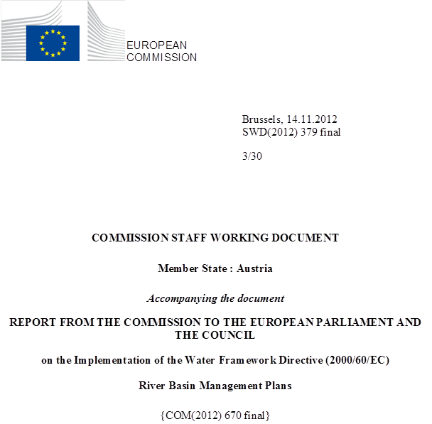

general information
Figure 1.1: Map of River Basin Districts
International River Basin Districts (within EU)
International River Basin Districts (outside EU)
National River Basin Districts (within EU)
Countries (outside EU)
Coastal Waters
Source: WISE, Eurostat (country borders)
Austria has a population of 8.3 million (Eurostat, 2007) and an area of 83870 km².
Austria is situated in 3 transboundary/international river basin districts: Danube (AT1000), Rhine (AT2000) and Elbe (AT5000).
Austria is a land locked country and hence has no transitional or coastal waters.
Austria has 3 River Basin Districts, all international.

RBD | Name | Size (km²) | % National territory within transboundary RB | Countries sharing RBD
AT1000 | Danube | 80565 | 96% | AL, BA, BG, CH, CZ, DE, HR, HU, IT, MD, ME, MK, PL, RO, RS, SI, SK, UA
AT2000 | Rhine | 2365 | 3% | BE, CH, DE, FR, IT, LI, LU, NL
AT5000 | Elbe | 921 | 1% | CZ, DE, PL
Table 1.1: Overview of Austria’s River Basin Districts
Source: River Basin Management Plans reported to WISE: http://cdr.eionet.europa.eu/at/eu/wfdart13
The three international river basins on the Austrian territory all have transboundary cooperation. The Rhine, Elbe and the Danube are all governed by international River Basin Commissions. Austria acts as a party in the Danube and has observer status in the Rhine and Elbe commissions. In addition bilateral agreements exist.
Name international  river basin | National RBD | Countries sharing RBD | Co-ordination category
Name international  river basin | National RBD | Countries sharing RBD | 1
Name international  river basin | National RBD | Countries sharing RBD | km² | %
Danube | AT1000 | AL, BA, BG, CH, CZ, DE, HR, HU, IT, MD, ME, MK, PL, RO, RS, SI, SK, UA | 80423 | 10.0
Rhine | AT2000 | BE, CH, DE, FR, IT, LI, LU, NL | 2370 | 1.0
Elbe | AT5000 | CZ, DE, PL | 921 | 0.6
Table 1.2: Transboundary river basins by category (see CSWD section 8.1) and % share in Austria
Category 1: Co-operation agreement, co-operation body, RBMP in place.
Category 2: Co-operation agreement, co-operation body in place.
Category 3: Co-operation agreement in place.
Category 4: No co-operation formalised.
Source: EC Comparative study of pressures and measures in the major river basin management plans in the EU.

Status of River basin Management Plan reporting and compliance
Austria adopted its River Basin Management Plans (RBMP) for the Danube, Rhine and Elbe main River Basin Districts in March 2010 and reported additional information on these to the Commission in January 2012.
Austria has followed a national and consistent approach for the preparation of the 3 RBMPs. It has followed a wide public consultation process prior to the approval of the plans. The structure of the plans shows the efforts done on following the approaches and methodologies agreed in the Common Implementation Strategy process. The plans show a clear understanding of important issues such as diffuse pollution, hydromorphological pressures (including impacts through hydropower production, flood protection, agriculture, etc.). A substantial effort has been made to ensure international coordination in all basins, and in particular it is important to highlight the efforts made in the Danube basin.
The information provided covers all RBDs in Austria. The largest amount is provided for the Danube which is the largest RBD in the country, covering the majority of the Austrian territory. The main competent authority is the Federal State, which delegates certain implementation powers to the regional States (Länder). Competences are shared between national and regional authorities. The competent authority at Federal level is the Ministry for Agriculture and Forestry, Environment and Water Management. However, the practical and operational implementation of the water law is under the competency of the Länder. Other national ministries and the nature protection authorities of the Länder have also collaborated.

Key strengthens and weaknesses
A National, consistent approach has been adopted and a substantial effort has been made to ensure international coordination. An important degree of international coordination has been followed, in particular in the case of the Danube that covers the majority of Austria's territory. This is particularly significant when compared to what has been done in the Rhine and the Elbe.
An important public participation strategy stating all efforts to integrate stakeholder's interest has also been put in place.
Efforts have been made to follow the approaches/methodologies agreed in the CIS-process (e.g. classification, reference conditions, monitoring, HMWB/AWB).
The RBMPs clearly show an understanding of the main issues (specifically, diffuse pollution and hydromorphological pressures and impacts through hydropower production, flood protection, agriculture etc.).
A lot of important steps necessary for an adequate WFD implementation and preparation of the RBMPs have been taken. Nevertheless, it would be desirable for more details on the detailed process and all measures in place to be included in order to provide a clear picture of the efforts made towards the implementation of the Directive.
A thorough systematic characterisation methodology has been established which includes biological testing to define typologies and ensures consideration of biological relevance.
Monitoring follows a national approach, objectives are mentioned and all relevant QEs are monitored by surveillance monitoring. For operational monitoring there is a clear pressure-BQE relationship and guidance on which QEs to choose. However, a better explanation of how monitoring results have been used when classifying WB status (including how WBs have been grouped) would help to give a proper indication of the level of effort in this area. Additional information sent by the Austrian authorities after the RBMPs were reported expands on this and clarifies that all water bodies at risk of failing the objectives are included in the operational monitoring programme. Those water bodies that are at risk of failing the objective and that were not assessed with data from sampling sites, or by using grouping procedures, were classified as moderate status with low confidence. They will be subject to the monitoring programmes in the future.
When considering hydromorphological pressures and the measures to apply, there has been a "Prioritisation" of water bodies (WB) for the first cycle. More details on the justification behind the application of exemptions (esp. time exemptions) would help to explain the reasoning behind and the rationale applied to affordability considerations.
Overall, the important requirements of the WFD are fulfilled and specific efforts have been made in exploring what could be done in specific areas. It is clear that for some of the tasks required, the work carried out is impressive (e.g. monitoring systems), but in some other areas there is explanation missing on measures. This may be particularly important in the case of hydromorphological pressures (hydropower) and diffuse pollution from agriculture. Additional information provided by the Austrian authorities indicates that the existing programme for rural development, for example, includes agri-environment measures. Many of these measures are intended to improve water quality, e.g. greening, organic farming, reduction of fertilisation.
The Programme of Measures focused mainly on basic measures already in place, providing a lot of information on existing laws, regulations, permitting systems etc. However, no real consideration was given to cost-effectiveness when discussing potential additional measures at the general/RB/national level. Austrian authorities pointed out after the RBMPs reporting, that assessment of cost effectiveness was done on national level, not on local WB level.
Some more details on additional measures would also help provide an explanation of how the work carried out will enable WFD objectives to be achieved. In particular in multi-pressure situations (which are frequently found in large rivers), first measures have been started (e.g. continuity), but additional morphological measures will be necessary in order for WFD objectives to be achieved. It is very difficult to quantify the need for further restoration measures and to forecast the effectiveness of these measures on the basis of the information provided. For reasons of cost-effectiveness a stepwise approach was followed. In this case, the provision of more detail would help in explaining how the benefits would be reached.

Governance

Timeline of implementation
Austria reported that there are provisions in place to ensure that basin authorities are consulted in the preparation of the land use plan of the municipalities, and revisions are to be carried out regularly. The same authorities are the competent authorities for the development of flood risk management plans and the RBMP. The RBMP was adopted in March 2010. Public consultation took place between April and October 2009. There is a clear timeline of implementation from 2012 onwards which is regionalised on the “Länder” level by ordinances.

RBMPs - Structure, completeness, legal status
The national RBMP covers all three basins in one document and methodologies and approaches have been applied at a national level. It covers all aspects required by the WFD and follows more or less the outline structure set out in the Annex of the Directive.
The RBMP is approved by a federal ordinance and as such, is binding on the whole federal territory. It must comply with the federal Constitution and the federal laws. Federal administrative decisions and RBMPs need to comply with Länder ordinances and Länder administrative decisions. The Ordinance approving the RBMP declares chapters 5 (environmental objectives) and 6 (water management system) to be binding to the extent stipulated in that ordinance. Chapter 6 on the water management system includes the Austrian programme of measures.
The legislation stipulates that decisions must be in compliance with the RBMP (including the environmental objectives). The competent authorities must revise or withdraw water-related permit decisions, if projects fail to comply with the public interest, including the environmental objectives. The competent authorities must analyse the permits and revise them, if the monitoring of the surface water status, groundwater status or protected areas indicates that the environmental objectives will not be reached as scheduled.
Generally the RBMP is not directly binding to private persons but it has a directly binding effect on the administration. Therefore, only the administrative decision which, for example, authorises actions of private persons, may be challenged before the courts if it is contrary to the RBMP.

Consultation of the public, engagement of interested parties
In the RBMPs it is mentioned that extensive information and consultation of the interested public was carried out and that a response document was created. The results of the public consultation have been considered in the finalisation of the plan. In some cases the issues raised will be dealt with in the next RBMP 2015 (e.g. pressure/impact analysis for fish ponds, which basically are of minor importance in Austria). These issues are clearly mentioned in the RBMP.

International cooperation and coordination
All the Austrian river basins are international. International Commissions are established for the protection of each river, Danube, Elbe and Rhine (ICPDR, IKSE and IKSR). Austria has only a very small part of its territory in the Elbe Basin (1,1%), so it has only observer status in the International Commission. The same applies for the Rhine. There are a number of bilateral water cooperation agreements in place with the neighbouring countries.
However the roof reports set up and adopted by the International Commissions provide the framework for the national River Basin Management Plans. The priorities of the programme of measures are implemented in the programme of measures in the Austrian RBMP

Characterisation of river basin districts

Water categories in the RBD
As Austria is a land-locked country each of the Austrian RBMPs refers to just two water categories (rivers and lakes).

Typology of surface waters
Several water typologies have been developed for rivers and lakes and they have been validated with biological data: For rivers, the process of setting the typology took place in three steps, setting an abiotic typology according to system B (following the approach of the CIS guidance on reference conditions and ecological status class boundaries for inland surface waters) and some additional parameters. The process followed included three steps: i) to define the basic abiotic river types (17 region types and 9 special types), ii) to review the basic types from a biological perspective –benthic invertebrates, fish, algae/macrophytes- which let to 15 riverine bioregions, and finally iii) to differentiate longitudinal zones into subtypes within the bioregions and special types based on macrozoobenthos analysis which reported 50 stream types.
For lakes (>0.5 km²), typology is based on abiotic criteria and then review using biological data (basic trophic status, macrophytes, fish).
Reference conditions have been established for each of the SW types using spatially based methods. The by-law on "Quality objectives ecology-SWB" gives the reference conditions for the different types, but although there is a reference where the methodology is explained, this could have been better explained in the RBMPs itself. According to the by-law the "reference value" is derived statistically from the range of measures values in the reference sites of a WB type.
RBD | Rivers | Lakes | Transitional | Coastal
AT1000 | 150 | 43 | 0 | 0
AT2000 | 73 | 5 | 0 | 0
AT5000 | 14 | 1 | 0 | 0
Table 4.2.1: Surface water body types at RBD level
Source: WISE

Delineation of surface water bodies
RBD | Surface Water |  |  |  | Groundwater
RBD | Rivers |  | Lakes
RBD | Number | Average Length (km) | Number | Average Area  (sq km) | Number | Average Area  (sq km)
AT1000 | 7054 | 4 | 55 | 7 | 128 | 724
AT2000 | 194 | 4 | 5 | 107 | 7 | 333
AT5000 | 91 | 5 | 2 | 1 | 1 | 921
Total | 7339 | 4 | 62 | 15 | 136 | 705
Table 4.3.1: Surface water bodies, groundwater bodies and their dimensions
Source: WISE
The methodological approach for the delineation of SWB follows a national approach. Overall, Austria has reported 7339 river water bodies and 62 lake water bodies. Medium sized rivers (with a catchment area of 10-100 km²) have not been monitored in the 1st RBMP cycle (the measurement programme for the smaller water bodies is being carried out 2010-2012). Small rivers (with a catchment area of less than 10 km²) and small lakes (area of less than 50 Ha) have not been included in the 1st RBMP cycle. Grouping along a specific set of criteria has been carried out.
Austria seems to have applied a very systematic and thorough methodology to define their typology including biological testing to ensure the biological relevance of the different types - this has led to a substantial amount of types.

Identification of significant pressures and impacts
Significant pressures from point sources are defined in different ways:
- Urban Waste Water Treatment Plants were defined by numerical tools;
- IPPC installations were defined by expert judgement of the competent authorities; and
- Contaminated sites, installations with theoretical water hazard potential and large cooling water discharges were also recorded.
Significant pressures from diffuse sources are identified from agriculture and forestry land use (N/P emissions and pesticides), airports (with organic carbon compounds and nitrogen compounds used for de-icing as possible pollutants), mining sites (heavy metals (chromium, copper and zinc)) and contaminated sites (heavy metals and chlorinated hydrocarbons). The identification is based on expert judgement and, for agricultural pressures, numerical methods.
Hydropower is the main pressure relating to water abstraction. Water abstraction for irrigation is only of importance in South/East Austria. Commercial and industrial abstractions are substantially lower than the significance thresholds established and do not pose a risk for achieving good ecological potential.
RBD | No pressures |  | Point source |  | Diffuse source |  | Water abstraction |  | Water flow regulations and morphological  alterations |  | River management |  | Transitional and coastal water management |  | Other morphological alterations |  | Other pressures
RBD | No. | % | No. | % | No. | % | No. | % | No. | % | No. | % | No. | % | No. | % | No. | %
AT1000 | 2708 | 38.04 | 49 | 0.69 | 1151 | 16.19 | 27 | 0.38 | 3955 | 55.63 | 0 | 0 | 0 | 0 | 209 | 2.94 | 0 | 0
AT2000 | 70 | 35.18 | 9 | 4.52 | 28 | 14.07 | 12 | 6.03 | 111 | 55.78 | 0 | 0 | 0 | 0 | 1 | 0.5 | 0 | 0
AT5000 | 37 | 39.78 | 1 | 1.08 | 26 | 27.96 | 1 | 1.08 | 48 | 51.61 | 0 | 0 | 0 | 0 | 2 | 2.15 | 0 | 0
Total | 2815 | 38.04 | 59 | 0.8 | 1205 | 16.28 | 40 | 0.54 | 4114 | 55.59 | 0 | 0 | 0 | 0 | 212 | 2.86 | 0 | 0
Table 4.4.1: Number and percentage of surface water bodies affected by significant pressures
Source: WISE

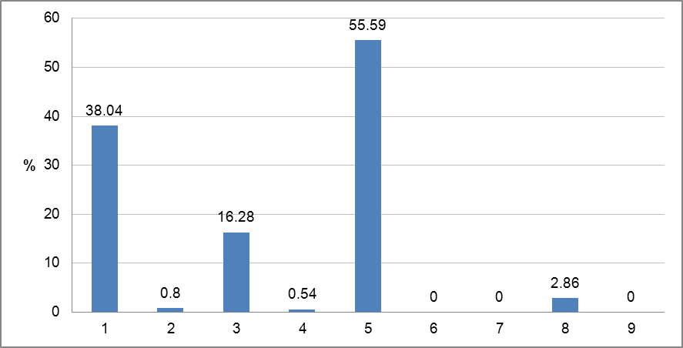
Figure 4.4.1: Graph of percentage of surface water bodies affected by significant pressures
1 = No pressures
2 = Point source
3 = Diffuse source
4 = Water abstraction
5 = Water flow regulations and morphological alterations
6 = River management
7 = Transitional and coastal water management
8 = Other morphological alterations
9 = Other pressures
Source: WISE

Protected areas
In Austria, over 700 protected areas have been designated. Most of these areas are for drinking water abstraction under Art 7 of the WFD and bathing protected areas. 362 protected areas are associated with GWBs.
RBD | Number of PAs
RBD | Article 7 Abstraction for drinking water | Bathing | Birds | European Other | Fish | Habitats | Local | National | Nitrates | Shellfish | UWWT
AT1000 | 210 | 251 | 50 |  | 67 | 86
AT2000 | 20 | 16 | 3 |  | 4 | 6
AT5000 | 1 | 1 | 1 |  |  | 1
Total | 231 | 268 | 54 |  | 71 | 93
Table 4.5.1: Number of protected areas of all types in each RBD and for the whole country, for surface and groundwater
Source: WISE

Monitoring
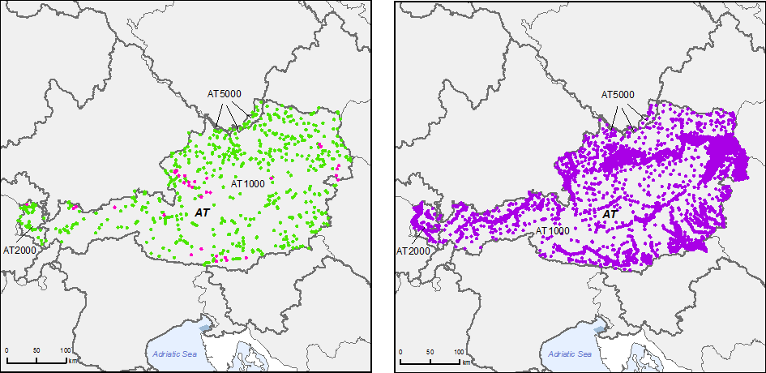
Figure 5.1: Maps of surface water (left) and groundwater (right) monitoring stations
 | • |  | River monitoring stations
 | • |  | Lake monitoring stations
 | • |  | Transitional water monitoring stations
 | • |  | Coastal water monitoring stations
 | • |  | Unclassified surface water monitoring stations
 | • |  | Groundwater monitoring stations
 |  |  | River Basin Districts
 |  |  | Countries outside EU
Source: WISE, Eurostat (country borders)

The methodology applied for monitoring follows a national approach. Objectives are mentioned and all relevant QEs are monitored in surveillance monitoring. In the case of operational monitoring there is a clear pressure-BQE relationship and guidance on which QEs to choose.
RBD | Rivers |  |  |  |  |  |  |  |  |  |  | Lakes
RBD | QE1.1 Phytoplankton | QE1.2 Other aquatic flora | QE1.2.3 Macrophytes | QE1.2.4 Phytobenthos | QE1.3 Benthic invertebrates | QE1.4 Fish | QE1.5 Other species | QE2 Hydromorphological QEs | QE3.1 General Parameters | QE3.3 Non priority specific pollutants | QE3.4 Other national pollutants | QE1.1 Phytoplankton | QE1.2 Other aquatic flora | QE1.2.3 Macrophytes | QE1.2.4 Phytobenthos | QE1.3 Benthic invertebrates | QE1.4 Fish | QE1.5 Other species | QE2 Hydromorphological QEs | QE3 1 General Parameters | QE3.3 Non priority specific pollutants | QE3.4 Other national pollutants
AT1000
AT2000
AT5000
Table 5.1: Quality elements monitored
QE Monitored
QE Not monitored
Source: WISE

All priority substances and specific pollutants are monitored and there is a detailed approach for selecting monitoring sites. There are differences between the number of monitored and classified sites.
RBD | Rivers |  | Lakes |  | Groundwater
RBD | Surv | Op | Surv | Op | Surv | Op | Quant
AT1000 | 77 | 544 | 32 | 2 | 1923 | 234 | 3070
AT2000 | 13 | 38 | 1 | 0 | 72 | 0 | 306
AT5000 | 1 | 15 | 0 | 0 | 13 | 0 | 7
Total by type of site | 91 | 597 | 33 | 2 | 2008 | 234 | 3383
Total number of monitoring sites | 634 |  | 33 |  | 5391
Table 5.2: Number of monitoring sites by water category.
Surv = Surveillance, Op = Operational, Quant = Quantitative
Source: WISE

Monitoring of surface waters
As already outlined in the Article 8 report for the WFD, a surveillance monitoring programme has been established with all relevant quality elements being monitored
The operational monitoring programme responds to the significant pressures. The RBMPs explain the criteria against which the biological quality elements are selected and linked with pressures. Nutrient enrichment in rivers and contamination by priority substances are monitored using benthic invertebrates, aquatic flora and fish. In lakes, phytoplankton, other aquatic flora and fish are reported to monitor the impact of altered habitats.
The priority substances and other relevant specific pollutants are being monitored. The design of the surveillance monitoring programmes is based on a variety of criteria such as the size of the catchment area, the consideration of areas with typically anthropogenic pressures, the presence/discharge of these substances at a certain location, important transboundary water bodies and reference sites in more or less undisturbed areas. The operational monitoring is selected for priority substances that are discharged into the river/lake according to the "status analysis" as well as those substances which pose a risk for the WB to fail the environmental objectives.
Rivers with catchments less than 100 km² were not monitored in the 1st RBMP cycle until 2009. The Austrian authorities have provided information which states that from 2010-2012 water bodies at risk with catchment area 10 - 100km² will be monitored. Those water bodies that have not been monitored are classified based on the results of the risk analysis.
Grouping of water bodies has been applied choosing "representative" water bodies for each pressure situation and then transferring the results of the status according to the monitoring to all water bodies of the same type. For water bodies with a catchment area larger than 100 km², one third of the WB needs to have been monitored within that catchment.
Further details on how the monitoring coordinates with classification of water bodies would help to explain the selection of monitoring sites and their use for ecological status/potential classification of water bodies.

Monitoring of groundwater
In the Rhine and Elbe basin there is no risk of failing good status in groundwater, therefore no operational monitoring is applied. For the Danube RBMP both surveillance and operational monitoring programmes for groundwater are in place.
For the design of the chemical status monitoring the RBMP refers to a monitoring ordinance “Gewässerzustandsüberwachungsverordnung” which determines the number of groundwater monitoring sites in Austria (2016 sites) and defines the criteria for designation. These criteria are those of the EU Groundwater Directive. There is no specific link made to pressures, but instead links are made to the risk of failing the objective and to status information.
In the case of operational monitoring of groundwater bodies, at least 2 measurements per year are to be carried out at the monitoring points in Austria. However, groundwater bodies at risk or groundwater bodies which are not of good status are monitored 4 times a year.
In the case of the Danube RBD, special arrangements have been agreed for the surveillance and operational monitoring of transboundary GWBs within the framework of the ICPDR and with the other International Commissions (Rhine and Elbe Commissions).

Monitoring of protected areas
The groundwater monitoring system also covers protected areas. In Austria drinking water protected areas are only relevant for groundwater abstraction points for drinking water supply, and are monitored according to the Drinking Water Directive. In addition to the national monitoring system, the drinking water suppliers conduct self-monitoring in protected areas.
Protected areas relating to fish are also covered by the national monitoring program.
Bathing waters are monitored by the individual “Länder” in accordance with the EU Bathing Waters Directive.

RBD | Surface waters |  |  |  |  |  |  |  |  | Groundwater drinking water
RBD | Surface drinking water abstraction | Quality of drinking water | Bathing water | Birds sites | Fish | Habitats sites | Nitrates | Shellfish | UWWT | Groundwater drinking water
AT1000 | 0 | 35 | 0 | 39 | 164 | 45 | 0 | 0 | 0 | 514
AT2000 | 0 | 5 | 0 | 0 | 10 | 1 | 0 | 0 | 0 | 5
AT5000 | 0 | 0 | 0 | 1 | 4 | 1 | 0 | 0 | 0 | 8
Total | 0 | 40 | 0 | 40 | 178 | 47 | 0 | 0 | 0 | 527
Table 5.3.1: Number of monitoring stations in protected areas.
Source: WISE

Overview of status (ecological, chemical, groundwater)
RBD | Total | High |  | Good |  | Moderate |  | Poor |  | Bad |  | Unknown
RBD | Total | No. | (%) | No. | (%) | No. | (%) | No. | (%) | No. | (%) | No. | (%)
AT1000 | 6478 | 1301 | 20.1 | 1520 | 23.5 | 3184 | 49.2 | 382 | 5.9 | 76 | 1.2 | 15 | 0.2
AT2000 | 146 | 25 | 17.1 | 51 | 34.9 | 66 | 45.2 | 4 | 2.7 | 0 | 0 | 0 | 0
AT5000 | 91 | 6 | 6.6 | 29 | 31.9 | 49 | 53.8 | 3 | 3.3 | 2 | 2.2 | 2 | 2.2
Total | 6715 | 1332 | 19.8 | 1600 | 23.8 | 3299 | 49.1 | 389 | 5.8 | 78 | 1.2 | 17 | 0.3
Table 6.1: Ecological status of natural surface water bodies.
Source: WISE

RBD | Total | High |  | Good |  | Moderate |  | Poor |  | Bad |  | Unknown
RBD | Total | No. | (%) | No. | (%) | No. | (%) | No. | (%) | No. | (%) | No. | (%)
AT1000 | 631 | 0 | 0 | 169 | 26.8 | 462 | 73.2 | 0 | 0 | 0 | 0 | 0 | 0
AT2000 | 53 | 0 | 0 | 5 | 9.4 | 48 | 90.6 | 0 | 0 | 0 | 0 | 0 | 0
AT5000 | 2 | 0 | 0 | 2 | 100 | 0 | 0 | 0 | 0 | 0 | 0 | 0 | 0
Total | 686 | 0 | 0 | 176 | 25.7 | 510 | 74.3 | 0 | 0 | 0 | 0 | 0 | 0
Table 6.2: Ecological potential of artificial and heavily modified water bodies.
Source: WISE

RBD | Total | Good |  | Poor |  | Unknown
RBD | Total | No. | % | No. | % | No. | %
AT1000 | 6478 | 6446 | 99.5 | 15 | 0.2 | 17 | 0.3
AT2000 | 146 | 146 | 100 | 0 | 0 | 0 | 0
AT5000 | 91 | 86 | 94.5 | 0 | 0 | 5 | 5.5
Total | 6715 | 6678 | 99.4 | 15 | 0.2 | 22 | 0.3
Table 6.3: Chemical status of natural surface water bodies.
Source: WISE
RBD | Total | Good |  | Poor |  | Unknown
RBD | Total | No. | % | No. | % | No. | %
AT1000 | 631 | 628 | 99.5 | 3 | 0.5 | 0 | 0
AT2000 | 53 | 53 | 100 | 0 | 0 | 0 | 0
AT5000 | 2 | 2 | 100 | 0 | 0 | 0 | 0
Total | 686 | 683 | 99.6 | 3 | 0.4 | 0 | 0
Table 6.4: Chemical status of artificial and heavily modified water bodies
Source: WISE

RBD | Total | Good |  | Poor |  | Unknown
RBD | Total | No. | % | No. | % | No. | %
AT1000 | 128 | 125 | 97.7 | 3 | 2.3 | 0 | 0
AT2000 | 7 | 7 | 100 | 0 | 0 | 0 | 0
AT5000 | 1 | 1 | 100 | 0 | 0 | 0 | 0
Total | 136 | 133 | 97.8 | 3 | 2.2 | 0 | 0
Table 6.5: Chemical status of groundwater bodies.
Source: WISE

RBD | Total | Good |  | Poor |  | Unknown
RBD | Total | No. | % | No. | % | No. | %
AT1000 | 128 | 125 | 97.7 | 3 | 2.3 | 0 | 0
AT2000 | 7 | 7 | 100 | 0 | 0 | 0 | 0
AT5000 | 1 | 1 | 100 | 0 | 0 | 0 | 0
Total | 136 | 133 | 97.8 | 3 | 2.2 | 0 | 0
Table 6.6: Quantitative status of groundwater bodies.
Source: WISE

RBD | Total | Global status (ecological and chemical) |  |  |  |  | Good ecological status 2021 |  | Good chemical status 2021 |  | Good ecological status 2027 |  | Good chemical status 2027 |  | Global exemptions 2009 (% of all SWBs)
RBD | Total | Good or better 2009 |  | Good or better 2015 |  | Increase 2009 -2015 |  |  |  |  |  |  |  |  | Art 4.4 | Art 4.5 | Art 4.6 | Art 4.7
RBD | Total | No. | % | No. | % | % | No. | % | No. | % | No. | % | No. | % | % | % | % | %
AT1000 | 7109 | 2990 | 42.1 | 3239 | 45.6 | 3.5 |  |  |  |  |  |  |  |  | 54 | 0 | 0 | 0
AT2000 | 199 | 81 | 40.7 | 91 | 45.7 | 5 |  |  |  |  |  |  |  |  | 54 | 0 | 0 | 0
AT5000 | 93 | 37 | 39.8 | 39 | 41.9 | 2.2 |  |  |  |  |  |  |  |  | 56 | 0 | 0 | 0
Total | 7401 | 3108 | 42 | 3369 | 45.5 | 3.5 |  |  |  |  |  |  |  |  | 54 | 0 | 0 | 0
Table 6.7: Surface water bodies: overview of status in 2009 and expected status in 2015, 2021 and 2027
Waterbodies with good status in 2009 fall into the following category:
1. Ecological status is high or good and the chemical status is good, exemptions are not considered
Waterbodies expected to achieve good status in 2015 fall into the following categories:
1. Ecological status is high or good and the chemical status is good, exemptions are not considered
2. Chemical status is good, and the ecological status is moderate or below but no ecological exemptions
3. Ecological status is high or good, and the chemical status is failing to achieve good but there are no chemical exemptions
4. Ecological status is moderate or below, and chemical status is failing to achieve good but there are no ecological nor chemical exemptions
Note: Waterbodies with unknown/unclassified/Not applicable in either ecological or chemical status are not considered
Source: WISE (for data on status in 2009, 2015 and exemptions) and RBMPs (for data on status in 2021 and 2027)

RBD | Total | Ecological status |  |  |  |  | Good ecological status 2021 |  | Good ecological status 2027 |  | Ecological exemptions (% of all SWBs)
RBD | Total | Good or better 2009 |  | Good or better 2015 |  | Increase 2009 -2015 |  |  |  |  | Art 4.4 | Art 4.5 | Art 4.6 | Art 4.7
RBD | Total | No. | % | No. | % | % | No. | % | No. | % | % | % | % | %
AT1000 | 6478 | 2821 | 43.5 | 3006 | 46.4 | 2.9 |  |  |  |  | 53.4 | 0 | 0 | 0
AT2000 | 146 | 76 | 52.1 | 83 | 56.8 | 4.8 |  |  |  |  | 43.2 | 0 | 0 | 0
AT5000 | 91 | 35 | 38.5 | 37 | 40.7 | 2.2 |  |  |  |  | 57.1 | 0 | 0 | 0
Total | 6715 | 2932 | 43.7 | 3369 | 46.6 | 209 |  | 50 |  | 100 | 53.2 | 0 | 0 | 0
Table 6.8: Natural surface water bodies: ecological status in 2009 and expected status in 2015, 2021 and 2027
Source: WISE (for data on status in 2009, 2015 and exemptions) and RBMPs (for data on status in 2021 and 2027)

RBD | Total | Chemical status |  |  |  |  | Good chemical status 2021 |  | Good chemical status 2027 |  | Chemical exemptions (% of all SWBs)
RBD | Total | Good or better 2009 |  | Good or better 2015 |  | Increase 2009 -2015 |  |  |  |  | Art 4.4 | Art 4.5 | Art 4.6 | Art 4.7
RBD | Total | No. | % | No. | % | % | No. | % | No. | % | % | % | % | %
AT1000 | 6478 | 6446 | 99.5 | 6457 | 99.7 | 0.2 |  |  |  |  | 0.1 | 0 | 0 | 0
AT2000 | 146 | 146 | 100 | 146 | 100 | 0 |  |  |  |  | 0 | 0 | 0 | 0
AT5000 | 91 | 86 | 94.5 | 86 | 94.6 | 0 |  |  |  |  | 0 | 0 | 0 | 0
Total | 6715 | 6678 | 99.4 | 6689 | 99.6 | 0.2 |  |  |  |  | 0.1 | 0 | 0 | 0
Table 6.9: Natural surface water bodies: chemical status in 2009 and expected status in 2015, 2021 and 2027
Source: WISE (for data on status in 2009, 2015 and exemptions) and RBMPs (for data on status in 2021 and 2027)
RBD | Total | GW chemical status |  |  |  |  | Good chemical status 2021 |  | Good chemical status 2027 |  | GW chemical exemptions (% of all GWBs)
RBD | Total | Good or better 2009 |  | Good or better 2015 |  | Increase 2009 -2015 |  |  |  |  | Art 4.4 | Art 4.5 | Art 4.6 | Art 4.7
RBD | Total | No. | % | No. | % | % | No. | % | No. | % | % | % | % | %
AT1000 | 128 | 125 | 97.7 | 125 | 97.7 | 0 |  |  |  |  | 2 | 0 | 0 | 0
AT2000 | 7 | 7 | 100 | 7 | 100 | 0 |  |  |  |  | 0 | 0 | 0 | 0
AT5000 | 1 | 1 | 100 | 1 | 100 | 0 |  |  |  |  | 0 | 0 | 0 | 0
Total | 136 | 133 | 97.8 | 133 | 97.8 | 0 |  |  |  |  | 2 | 0 | 0 | 0
Table 6.10: Groundwater bodies: chemical status in 2009 and expected status in 2015, 2021 and 2027
Source: WISE (for data on status in 2009, 2015 and exemptions) and RBMPs (for data on status in 2021 and 2027)
RBD | Total | Groundwater quantitative status |  |  |  |  | Good quantitative status 2021 |  | Good quantitative status 2027 |  | GW quantitative exemptions (% of all GWBs)
RBD | Total | Good or better 2009 |  | Good or better 2015 |  | Increase 2009 -2015 |  |  |  |  | Art 4.4 | Art 4.5 | Art 4.6 | Art 4.7
RBD | Total | No. | % | No. | % | % | No. | % | No. | % | % | % | % | %
AT1000 | 128 | 128 | 100 | 128 | 100 | 0 |  |  |  |  | 0 | 0 | 0 | 0
AT2000 | 7 | 7 | 100 | 7 | 100 | 0 |  |  |  |  | 0 | 0 | 0 | 0
AT5000 | 1 | 1 | 100 | 1 | 100 | 0 |  |  |  |  | 0 | 0 | 0 | 0
Total | 136 | 136 | 100 | 136 | 100 | 0 |  |  |  |  | 0 | 0 | 0 | 0
Table 6.11: Groundwater bodies: quantitative status in 2009 and expected status in 2015, 2021 and 2027
Source: WISE (for data on status in 2009, 2015 and exemptions) and RBMPs (for data on status in 2021 and 2027)
RBD | Total  HMWB and AWB | Ecological potential |  |  |  |  | Good ecological potential 2021 |  | Good ecological potential 2027 |  | Ecological exemptions (% of all HMWB/AWB)
RBD | Total  HMWB and AWB | Good or better 2009 |  | Good or better 2015 |  | Increase 2009 -2015 |  |  |  |  | Art 4.4 | Art 4.5 | Art 4.6 | Art 4.7
RBD | Total  HMWB and AWB | No. | % | No. | % | % | No. | % | No. | % | % | % | % | %
AT1000 | 631 | 169 | 26.8 | 233 | 36.9 | 10.1 |  |  |  |  | 63.1 | 0 | 0 | 0
AT2000 | 53 | 5 | 9.4 | 8 | 15.1 | 5.7 |  |  |  |  | 84.9 | 0 | 0 | 0
AT5000 | 2 | 2 | 100 | 2 | 100 | 0 |  |  |  |  | 0 | 0 | 0 | 0
Total | 686 | 176 | 25.7 | 243 | 35.4 | 9.7 |  |  |  |  | 64.6 | 0 | 0 | 0
Table 6.12: Heavily modified and artificial water bodies: ecological potential in 2009 and expected ecological potential in 2015, 2021 and 2027
Source: WISE (for data on status in 2009, 2015 and exemptions) and RBMPs (for data on status in 2021 and 2027)
RBD | Total  HMWB and AWB | Chemical status |  |  |  |  | Good chemical status 2021 |  | Good chemical status 2027 |  | Chemical exemptions (% of all HMWB/AWB)
RBD | Total  HMWB and AWB | Good or better 2009 |  | Good or better 2015 |  | Increase 2009 -2015 |  |  |  |  | Art 4.4 | Art 4.5 | Art 4.6 | Art 4.7
RBD | Total  HMWB and AWB | No. | % | No. | % | % | No. | % | No. | % | % | % | % | %
AT1000 | 631 | 628 | 99.5 | 630 | 99.8 | 0.3 |  |  |  |  | 0.2 | 0 | 0 | 0
AT2000 | 53 | 53 | 100 | 53 | 100 | 0 |  |  |  |  | 0 | 0 | 0 | 0
AT5000 | 2 | 2 | 100 | 2 | 100 | 0 |  |  |  |  | 0 | 0 | 0 | 0
Total | 686 | 683 | 99.6 | 685 | 99.9 | 0.3 |  |  |  |  | 0.1 | 0 | 0 | 0
Table 6.13: Heavily modified and artificial water bodies: chemical status in 2009 and expected status in 2015, 2021 and 2027
Source: WISE (for data on status in 2009, 2015 and exemptions) and RBMPs (for data on status in 2021 and 2027)
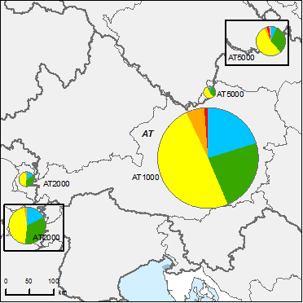
Figure 6.1: Map of ecological status of natural surface water bodies 2009
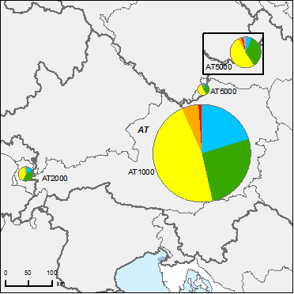
High
Good
Moderate
Poor
Bad
Unknown
River Basin Districts
Countries outside EU
Figure 6.2: Map of ecological status of natural surface water bodies 2015
Note: Standard colours based on WFD Annex V, Article 1.4.2(i).
Source: WISE, Eurostat (country borders)
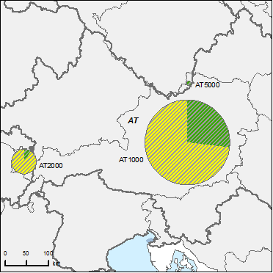
Figure 6.3: Map of ecological potential of artificial and heavily modified water bodies 2009
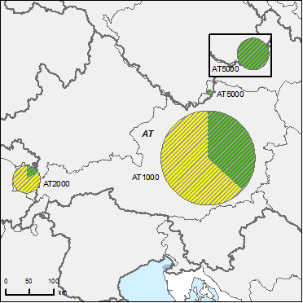
Good or better
Moderate
Poor
Bad
Unknown
River Basin Districts
Countries outside EU
Figure 6.4: Map of ecological potential of artificial and heavily modified water bodies 2015
Note: Standard colours based on WFD Annex V, Article 1.4.2(ii).
Source: WISE, Eurostat (country borders)

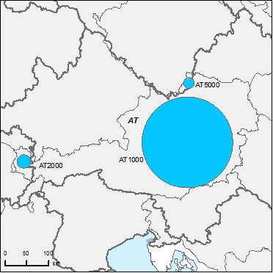
Figure 6.5: Map of chemical status of natural surface water bodies 2009
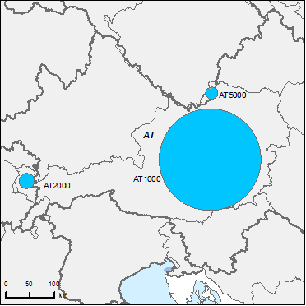
Good
Failing to achieve good
Unknown
River Basin Districts
Countries outside EU
Figure 6.6: Map of chemical status of natural surface water bodies 2015
Note: Standard colours based on WFD Annex V, Article 1.4.3.
Source: WISE, Eurostat (country borders)

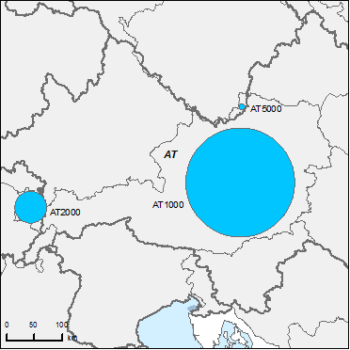
Figure 6.7: Map of chemical status of artificial and heavily modified water bodies 2009
Good
Failing to achieve good
Unknown
River Basin Districts
Countries outside EU
Figure 6.8: Map of chemical status of artificial and heavily modified water bodies 2015
Note: Standard colours based on WFD Annex V, Article 1.4.3.
Source: WISE, Eurostat (country borders)
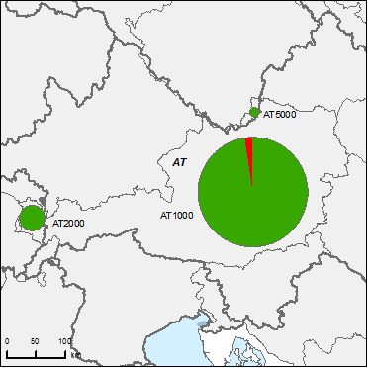
Figure 6.9: Map of chemical status of groundwater bodies 2009
Good
Poor
Unknown
River Basin Districts
Countries outside EU
Figure 6.10: Map of chemical status of groundwater bodies 2015
Note: Standard colours based on WFD Annex V, Article 2.4.5.
Source: WISE, Eurostat (country borders)

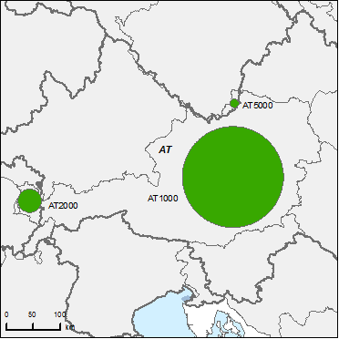
Figure 6.11: Map of quantitative status of groundwater bodies 2009
Good
Poor
Unknown
River Basin Districts
Countries outside EU
Figure 6.12: Map of quantitative status of groundwater bodies 2015
Note: Standard colours based on WFD Annex V, Article 2.2.4.
Source: WISE, Eurostat (country borders)

Assessment of ecological status of surface waters
The assessment of the ecological status of surface waters follows a national approach.

Ecological status assessment methods
The assessment methods for the classification of ecological status are developed as follows:
For rivers methods for Phytobenthos, benthic fauna and fish are fully developed. However, for some river types, the applicability of these methods is restricted (e.g. glacial torrents (very specific biocoenosis with high natural variation – influence of glacier discharge is very changeable)). Methods for Phytoplankton and Macrophytes are partly developed. According to the information provided by the Austrian authorities, Phytoplankton is only relevant in river systems which have a living and reproducing plankton community. The Macrophytes method is developed but its applicability is limited in the Alpine area.
For lakes, methods for Phytobenthos and benthic fauna (macrobenthos) are partly developed. It has been assumed that the status is covered by other BQEs in a better way, that there is no eutrophication, high variability of reference conditions, a limited pressure gradient and that no historical data are available.
The biological classification system has been related to the main pressures (eutrophication - R, organic enrichment - R, hydromorphological alterations – L, fish- L ).
Assessment methods for the classification of ecological status have been developed for all physico-chemical quality elements and for hydromorphological quality elements. Regarding the overall classification of ecological status, more clarification on how physico-chemical and biological parameters and hydromorphological parameters are combined in the consideration of definition of class boundaries would be beneficial to ascertain a full understanding (how exceeding values are considered) of the process.
The “One-out-all-out” principle has been applied.
Additional information sent by Austrian authorities after the RBMPs were reported states that the methodology used for setting EQS follows WFD Annex V, 1.2.6.

With a few exemptions for very specific river types, classification systems have been established for all national water body types. Additional information sent by Austrian authorities clarifies that for these special and particular rare river types it was not possible to determine general values for reference conditions for all BQEs/parameters (mainly due to the high natural variability). The river stretches are treated on a case-by-case basis and expert judgement is required.
Class boundaries have been matched with results from the 1st Intercalibration (IC) decision (2008/915/EC), in particular for Macrozoobenthos and Phytobentos in rivers and Phytoplankton and Macrophytes in lakes. The remaining Quality elements will be intercalibrated and adapted to national methods when the new decision on IC is completed and approved. Types not corresponding to common types have been classified using the following approach:
- In the development of the Austrian assessment systems, the same procedure for setting class boundaries and reference conditions was used for all types (same assessment concept). No changes or adaptations of the methods were necessary following the results of IC. It was assumed that this also applies to all other types not included in IC.
- To verify this assumption, an additional “national intercalibration” (for macroinvertebrates: class boundary comparison between national types) was carried out and confirmed the assumption.

Application of methods and ecological status results
Most sensitive biological quality elements are used in the assessments of ecological status for water bodies included in the operational monitoring programmes. There is a lack of information on the confidence of the methodologies in the plan. According to additional information provided by the Austrian authorities this information can be found in the national instruction manuals for sampling and assessment.
RBD | Rivers |  |  |  |  |  |  | Lakes |  |  |  |  |  |  | Transitional |  |  |  |  |  |  | Coastal
RBD | Phytoplankton | Macrophytes | Phytobenthos | Benthic invertebrates | Fish | Physico-Chemical | Hydromorphological | Phytoplankton | Macrophytes | Phytobenthos | Benthic invertebrates | Fish | Physico-Chemical | Hydromorphological | Phytoplankton | Macroalgae | Angiosperms | Benthic invertebrates | Fish | Physico-Chemical | Hydromorphological | Phytoplankton | Macroalgae | Angiosperms | Benthic invertebrates | Physico-Chemical | Hydromorphological
AT1000 |  |  |  |  |  |  |  |  |  |  |  |  |  |  | - | - | - | - | - | - | - | - | - | - | - | - | -
AT2000 |  |  |  |  |  |  |  |  |  |  |  |  |  |  | - | - | - | - | - | - | - | - | - | - | - | - | -
AT5000 |  |  |  |  |  |  |  |  |  |  |  |  |  |  | - | - | - | - | - | - | - | - | - | - | - | - | -
Table 7.2.1: Availability of biological assessment methods
 |  | Assessment methods fully developed for all BQEs
 |  | Assessment methods partially developed or under development for all or some BQEs
 |  | Assessment methods not developed for BQEs, no information provided on the assessment methods, unclear information provided
- |  | Water category not relevant
Source: RBMPs
RBD | CAS Number | Substance | Percentage Water Bodies Failing Status (%)
AT1000 |  | Ammonium | 13 WB
AT1000 |  | Zinc | 6 WB
AT1000 |  | Copper | 1 WB
AT1000 |  | AOX | 1 WB
AT2000 |  | Ammonium | 13 WB
AT2000 |  | Zinc | 6 WB
AT2000 |  | Copper | 1 WB
AT2000 |  | AOX | 1 WB
AT5000 |  | Ammonium | 13 WB
AT5000 |  | Zinc | 6 WB
AT5000 |  | Copper | 1 WB
AT5000 |  | Ammonium | 13 WB
Table 7.2.2: River basin specific pollutants causing failure of status
Source: RBMPs

Designation of heavily modified water bodies (hmwb) and assessment of good ecological potential
Figure 8.1: Map of percentage Heavily Modified and Artificial waterbodies by River Basin District
0 – 5 %
5 – 20 %
20 – 40 %
40 – 60%
60 – 100 %
No data reported
River Basin Districts
Countries outside EU
Source: WISE, Eurostat (country borders)
The methodology used for defining HMWB and AWB follows a national approach. The designation of HMWB/AWB follows the requirements of WFD Article 4.3 in relation to storage for power generation and flood protection. It describes the physical modifications (dams, canalisations, bed stabilisation and embankment) considered for the designation. The complete process of designation is described in the RBMPs and has followed what is proposed in the CIS guidance. The most common criteria used to define substantial changes in character are the length of the affected WB, height of dams, intensity of fragmentation/number of disruption of lateral connectivity, change in outflow regime water abstractions in connection to filling a storage reservoir.

Designation of HMWBs
In Austria 7,7% of WB are designated as HMWB and 2% as AWB. The designation follows the guidance developed under the CIS process. The RBMP includes a brief justification on the beneficial objectives served by the modifications of the HMWB compared to other means in the case of storage for power generation. Furthermore, it is stated that for navigation and other uses (aquaculture, etc.) an exact analysis of the potential effects of measures to reach GES is not available yet. Future methodological improvements are planned to improve the designation process which should provide more certainty on the methodology and criteria applied for designation.
Additional information provided by the Austrian authorities after reporting states that the HMWB designation in the 1st RBMP was only applied for water bodies where restoring GES would mean a significant adverse effect on hydropower generation (relevant for water bodies affected by impoundments/reservoirs with hydropeaking) or flood protection (including infrastructure). The analysis of potential impacts of restoration measures on navigation was not yet available - no water body was identified as HMWB in relation to navigation as the only beneficial objective (the only river water bodies where there is navigation are in the Danube which are at least identified as HMWB with regard to hydropower generation).

Methodology for setting good ecological potential (GEP)
GEP has been defined using a national approach which is a combination of the CIS and Prague approach. The approach for defining GEP is water body specific, focussing on hydropower as the main water use. For assessing MEP the Prague approach was used and is based on the sensitivity of certain species and life stages of fish using ecological criteria and expert judgement. The difference between MEP and GEP is based on a semi-quantitative approach.
Further studies are planned to evaluate the ecological effects of hydromorphological restoration measures as well as the effects on aquaculture

Assessment of chemical status of surface waters

Methodological approach to the assessment
Quality targets for the description of the good chemical status are defined for synthetic, non-synthetic pollutants and general physico-chemical pollutants used for the assessment of ecological status. 41 substances plus 29 synthetic and 6 non-synthetic substances define the chemical status. There is one single EQS value for each substance. The EQS values established are the same as the AA-EQS from the EQS Directive for inland surface waters in the case of aldrin, chlorfenvinphos, chlorpyrifos, para-para-DDT, DDT total, 1,2-dichlororethane, dichloromethane, dieldrin, diuron, endosulfan, hexachlorobutadiene, isoproturon, naphthalene, nonylphenol, octylphenol, simazine, tetrachloroethylene, carbon tetrachloride, trichlorobenzenes and trichloroethylene. The AA-EQS values from the EQS Directive have not been applied for chloroalkanes, fluoranthene, nickel, PAH and tributyltin compounds.
National standards have been applied for the assessment of the chemical status. For some substances, the standards applied are more stringent than those in Part A of Annex I of Directive 2008/105/EC, which had to be transposed by MS by June 2010, after the adoption of RBMPs.
Measurements lower than the limit of detection are considered. There is no indication as to whether any substances have been monitored in biota or sediment. Mixing zones are defined as the local area after a discharge into a SWB, in which the discharge has mixed with the receiving water body (plume) but no specific methodology is reported.
The allowable pollutant loads have to be set in a way that the EQS are met within a certain distance from the discharge (mixing zones). The distance is 10 times the width of the WB with a minimum length of 1km.

Priority substances
The priority substances identified that cause the failure to achieve good chemical status are:
CAS Number | Name of substances | Number of water bodies failing good chemical status
7440-43-9 | Cadmium and its compounds | 6
7439-92-1 | Lead | 11
87-68-3 | Hexachlorobutadiene | 2
36643-28-4 | Tributyltin compounds | 3
Table 9.2.1: Substances causing failure to achieve good chemical status
Source: RBMPs

Assessment of groundwater status

Groundwater quantitative status
There are no groundwater bodies in poor quantitative status in Austria.
Regarding quantitative status, the conditions considered when assessing GW quantitative status are: 1) no exceedance of the long term annual average rate of abstraction, 2) failure to achieve the environmental objectives under Article 4 for associated SW bodies resulting from anthropogenic water level alteration or change in flow conditions, 3) significant damage to dependent terrestrial ecosystems resulting from anthropogenic water level alteration.
Available GW resources have been assessed as specified in Art. 2.27 of the WFD. The needs of terrestrial ecosystems have also been assessed. The balance between recharge and abstraction is considered as an annual average groundwater abstraction against available GW resource. This has been calculated for a subset of GW bodies.

Groundwater chemical status
There are 136 ground water (GW) bodies, 133 of them in good status and 3 in poor chemical status because of diffuse pollution caused by nitrates.
Information is provided on the pollutants/indicators for which threshold values have been exceeded for chemical status and in which monitoring stations. Overall threshold values were exceeded 454 times for all GW-related quality standards. For groundwater monitoring points where threshold values were exceeded (e.g. local discharges of pollutants), additional investigations are carried if necessary to identify the causes (local investigations and controls) with simultaneous increased frequency of monitoring in order to be able to assess any risk to the groundwater body as a whole. This applies in particular for pesticides.No specific measures are mentioned in cases where some monitoring points exceed the TV.
The methodology for the chemical status assessment of a GW body and on threshold values exceedances have been established by law.
Consideration is given to the associated terrestrial ecosystems in order to prevent the failure of ecosystems objectives significantly.
Trend assessment of GW pollutants and trend reversal were performed.
Threshold values were established considering all parameters of Annex II GWD (Austrian “Qualitätszielverordnung Grundwasser Chemie”). Pollutants considered in the establishment of groundwater threshold values are those relevant for drinking water use.
More information on transboundary coordination in the establishment of groundwater threshold values would be helpful.

Protected areas
Protected areas have been identified but there are no additional objectives established since the other directives are considered to be more stringent (e.g. Bathing Water, Habitats, etc.).

RBD | Good | Failing to achieve good | Unknown
AT1000 | 210
AT2000 | 20
AT5000 | 2
Total | 232 | 0 | 0
Table 10.3.1: Status of groundwater drinking water protected areas
Source: WISE

Environmental objectives and exemptions

Exemptions according to Article 4(4) and 4(5)
There is an overall assessment of the main impacts and drivers causing exemptions with the main drivers being: point source, diffuse, abstraction, flow regulation, river management and other pressures.
The need for time exemptions under Article 4.4 results from the lack of "technical feasibility" (the removal of about 20.000 barriers in the timeframe required is not possible due to the need to obtain land or due to the administrative burden), insufficient knowledge in relation to measures and their impact (for the creation of a cost-effective program of measures), "natural conditions" (in the case of hexachlorobutadiene) and disproportionate costs (re-naturation costs are estimated to be too high to be covered by communities and local authorities until 2015). Therefore a phased approach to improve status is considered
The plan does not provide any detailed methodology for the calculation of disproportionate costs, but it is argued that the total costs for improving the hydro-morphology and removing about 20.000 barriers in rivers with a catchment area >100 km² would cost in excess of €1billion. These costs need to be split over all three planning cycles. There are no details of innovative financial mechanisms that could be used. It is just stated that local authorities and the hydropower plant operators have to carry the costs.
In the reported RBMPs, exemptions under Article 4.5 are applied for 5 SWB (less stringent standards) due to a failure to meet the EQS for zinc. The reason given refers to historical mining activities, for which no technical solution is available.
For rivers failing to meet the GES/GEP due to hydromorphological pressures, exemptions are applied on the basis that high planning and administrative efforts are required, and also because of the uncertainties related to the response of the biological quality elements on hydromorphological measures.
The GWBs that are failing to achieve good chemical status is due to the nitrates concentration. The justification refers to natural conditions (due to the long recharge time).

RBD | Global
RBD | Technical feasibility |  | Disproportionate costs |  | Natural conditions
RBD | Article 4(4) | Article 4(5) | Article 4(4) | Article 4(5) | Article 4(4) | Article 4(5)
AT1000 | 3855 | 0 | 3626 | 0 | 3852 | -
AT2000 | 108 | 0 | 100 | 0 | 108 | -
AT5000 | 52 | 0 | 47 | 0 | 52 | -
Total | 4015 | 0 | 3773 | 0 | 4012 | -
Table 11.1.1: Numbers of Article 4.4 and 4.5 exemptions
Source: WISE

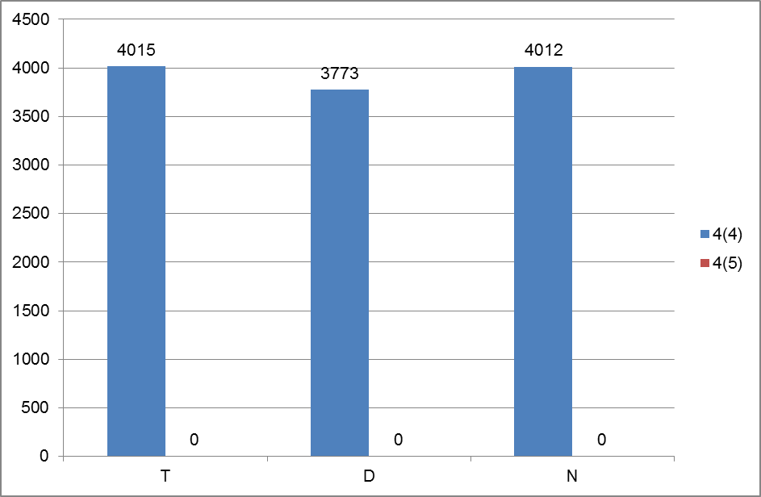

Figure 11.1.1: Numbers of Article 4(4) and 4(5) exemptions
T = Technical feasibility
D = Disproportionate costs
N = Natural conditions
Blue = Article 4(4) exemptions
Red = Article 4(5) exemptions
Source: WISE

Exemptions according to Article 4(6) and Article 4(7)
Article 4 (6) has not been applied.
Article 4(7) is applied for 2 WBs as 'new modifications' but it is not explicitly mentioned. These new modifications are hydropower projects. This exemption of the "no deterioration clause" was applied for "the sustainable development" of hydropower generation. The reasoning provided by the authorities is that these (hydropower) projects will create an important benefit for sustainable development and human health, which outweighs the benefits associated with reaching of the WFD-environmental objectives.

Exemptions to Groundwater Directive
There is a specific inventory on measures to prevent or limit inputs of pollutants into groundwater or reasons indicated for exemptions. The inventory mostly refers to legal acts which have the aim to prevent or limit inputs (e.g. permissions, bans).

Programmes of measures
According to Annex VII of the WFD, the RBMPs should contain a summary of the programmes of measures (PoM), including the ways in which Member States expect to achieve the objectives of Article 4 WFD. The programmes should have been established by 2009, but are required to become operational only by December 2012. The assessment in this section is based on the PoM as summarised by the Member State in its RBMP, and the compliance of this with the requirements of Article 11 and Annex VII of the WFD.
It therefore does not include a comprehensive assessment of compliance with the requirements of Article 11(3) on basic measures. It focuses in particular on key sets of measures. Member States will report to the Commission by December 2012 on the full implementation of their PoMs, including on the progress on the implementation of basic measures as required by Article 11(3). The Commission will assess what Member States report and will publish its assessment in accordance with Article 18 WFD.

Programme of measures – general
Programmes of Measures (PoM) have been coordinated as part of every international RBD. The measures are linked to the status assessment and the related pressure/drives. The PoM includes details at national, regional, RBD and water body unit
In the Danube, a joint transboundary programme of Measures has been developed for 'measures of basin-wide importance'. The PoM is coordinated with non-Member States. This is based on the national programmes of measures which shall be made operational in 2012 and describes the expected status by 2015. Priorities for the effective implementation of national measures on the basin wide scale are highlighted and are the basis of further international coordination. It is coordinated through the International Commission for the Protection of the Danube (ICPDR). This joint PoM is structured according to the significant management issues (SWI) (organic, nutrient and hazardous substances pollution, hydromorphological alterations and GW bodies). It follows the basin wide management objectives according to SWI in order to achieve environmental objectives by 2015. National measures have been incorporated into the international PoM. It is coordinated also with riverine non-Member states. The International PoM addresses river continuity, nutrient reduction and exceeding of environmental quality standards (EQS) due to transboundary chemical pollution.
The PoM includes details at national, regional, RBD and water body unit.
In the Rhine, The RBMP at the international level provides a summary of the PoM. These are based on the national PoM linking the national activities to the transboundary programmes. These cover: re-establishing biological continuity/increase of the habitat diversity, reduction of diffuse pollution and other typical pressures from industrial and communal point sources, bringing water uses (navigation, energy production, flood protection, etc.) in correspondence with reaching WFD objectives and a summary of the national measures take. The PoM is coordinated with non-Member states.
The International PoM addresses river continuity, nutrient reduction and exceeding of environmental quality standards (EQS) due to transboundary chemical pollution.
In the Elbe, The international Elbe RBMP presents limited coordination regarding the PoM. There are only general statements about national PoM that will improve transboundary cooperation. Special emphasis is provided to hydro-morphological pressures. The International PoM addresses river continuity, nutrient reduction and exceeding of environmental quality standards (EQS) due to transboundary chemical pollution. The PoM includes details at national, regional, RBD and water body unit.
For all the RBDs, there is national approach having a transboundary coordination.
PoM implementation involves national, regional and local authorities, enterprises and farmers. It includes agriculture, households, industry, navigation, energy and others. The competent authorities for being responsible for implementing measures are clearly identified.
There is no information provided on supplementary measures. Measures for morphological alterations are mentioned as voluntary (supported by a specific fund) and mandatory. Most measures for industry are mandatory. Measures for agriculture and energy are mandatory and voluntary and measures for navigation are mostly voluntary.
The detailed cost of measures is not provided, nor cost breakdown by sector. There is information of costs of measures by pressure (hydro-morphological alteration)
There are general indications on the financing without commitment in particular related to the Rural Development program, the specific fund for restoring hydro-morphology. There is little detailed information provided on the costs of measures and its assessment, but some information on how the costs are shared among the different governmental levels (federal, regional, community). Cost effectiveness is calculated for agriculture, urban pollution and energy although there is no overall cost-effectiveness calculation/estimation for the combination of measures at RB/national scale. There is no indication about the proportion of budget from different contributors.
For most pressures the relating measures are already in force. New morphological measures have to be operational in priority areas until 2015 in others until 2021 or 2027. New measures improving the chemical status, reducing nitrogen and/or organic pollution should also be in force by 2015.
It is indicated that for the period 2009-2015: Hydromorphology: 50-66% of costs have to be covered by hydropower sector and 33-50% must be covered by regional/local authorities. The estimated cost for morphological alteration measures to ensure fish passing in all rivers with a catchment area >100 km² is between €300 and €500M. To remove all barriers cost are estimated to go up to €1000 M for morphological restoration. The overall costs till 2027 are considered to be €2600-3000 M.

Measures related to agriculture
Agriculture has been identified as an important driver leading to significant pressure in the RBD mainly through diffuse sources. There are also morphological modifications due to agriculture (bank enforcement, dams, weirs, drainage, etc.). Eutrophication is also an impact resulting from agriculture.
Though the public participation activity report did not provide specific information, it is assumed that there has been a very significant involvement of farmers in the preparation of the PoM.
The measures related to agriculture identified in the PoM are: reduction or modification of fertilizer application, reduction or modification of pesticide application, change to low input farming, hydromorphological measures (financed through Rural Development programmes and for some projects through LIFE+) and technical water saving measures as part of the permitting requirements. It is indicated that measures for diffuse pollution are already in place.
Measures | AT1000 | AT2000 | AT5000
Technical measures
Reduction/modification of fertiliser application | ✓ | ✓ | ✓
Reduction/modification of pesticide application | ✓ | ✓ | ✓
Change to low-input farming (e.g. organic farming practices) | ✓ | ✓ | ✓
Hydromorphological measures leading to changes in farming practices | ✓ | ✓ | ✓
Measures against soil erosion
Multi-objective measures (e.g. crop rotation, creation of enhanced buffer zones/wetlands or floodplain management)
Technical measures for water saving | ✓ | ✓ | ✓
Economic instruments
Compensation for land cover
Co-operative agreements
Water pricing specifications for irrigators
Nutrient trading
Fertiliser taxation
Non-technical measures
Additions regarding the implementation and enforcement of existing EU legislation | ✓ | ✓ | ✓
Institutional changes | ✓ | ✓ | ✓
Codes of agricultural practice
Farm advice and training | ✓ | ✓ | ✓
Raising awareness of farmers | ✓ | ✓ | ✓
Measures to increase knowledge for improved decision-making | ✓ | ✓ | ✓
Certification schemes | ✓ | ✓ | ✓
Zoning (e.g. designating land use based on GIS maps)
Specific action plans/programmes | ✓ | ✓ | ✓
Land use planning | ✓ | ✓ | ✓
Technical standards
Specific projects related to agriculture | ✓ | ✓ | ✓
Environmental permitting and licensing
Additions regarding the implementation and enforcement of existing EU legislation
Table 12.2.1: Types of WFD measures addressing agricultural pressures, as described in the PoM
Source: RBMPs
The non-technical measures identified are already in existence: implementation and enforcement of existing older EU legislation, controls, setting up or redefining codes of agricultural practice, advice and training, measures to increase knowledge for improved decision making, zoning, development of specific action plans/programmes, land use planning, technical standards.
The information on the scope of application of measures and partially on the implementation calendar is not found in the RBMP, but is outlined in the Rural Development program, the Nitrate Action Program or other national legislation which applied to the agricultural sector..
The Rural Development programmes are mentioned as a source of funding for the measures. Compensation payments regarding Art. 38 of Rural Development Regulation are not mentioned.

Measures related to hydromorphology
The hydro-morphological measures presented are linked to types of hydro-morphological pressures: hydropower, flood protection, housing developments, infrastructural activities, shipping and agriculture. The impacts of the physical modification are impoundment of a stretch or a river – cross profile construction and interruption of continuity, intakes, transfers and bypasses, hydro-peaking and residual flow.
The specific hydro-morphological measures proposed to reach GES or GEP are: Fish ladders, bypass channels, habitat restoration, building spawning and breeding areas, reconnection of meander bends or side arms, restoration of bank structure, setting minimum ecological flow requirements, compensation reservoirs balancing effects of hydropeaking, restoration of degraded bed structure and re-meandering of formerly straightened water courses.
The importance of implementation of measures is different for water bodies. In priority water bodies measures are to be taken until 2015 in other until 2021 or 2027. Detailed maps with priority areas are provided
A specific combination of measures is set for the first RBMP with 2 focal actions: continuity and improvement of WB structure. There is an analysis of costs and necessary exemptions. It is presented a phased approach for reaching GES/GEP indicating intermediate status improvements, reasons for derogation (technical, costs and natural conditions). It is also presented a list of priority WB and planned hydromorphological measures until 2015, 2021 and 2027.
There is information on requirements regarding the flow regime (linked to sunk-peak effects and hydro-peaking), minimum ecological flows in order to reach ecological quality objectives. There are also specific measures proposed regarding the ecologically based flow regime. Measures are proposed by 2015, 2021 and 2027 per WB.
HMWB and natural water bodies are explicitly treated together. HMWB measures to restore continuity will be undertaken by 2015, morphological alterations as well as the decrease of negative effects of hydropeaking will usually be set in the second cycle. In general hydromorphological alterations are clearly linked to hydropower production, flood protection and reclamation of agricultural land.

Measures | AT1000 | AT2000 | AT5000
Fish ladders | ✓ | ✓ | ✓
Bypass channels | ✓ | ✓ | ✓
Habitat restoration, building spawning and breeding areas | ✓ | ✓ | ✓
Sediment/debris management
Removal of structures: weirs, barriers, bank reinforcement
Reconnection of meander bends or side arms | ✓ | ✓ | ✓
Lowering of river banks
Restoration of bank structure | ✓ | ✓ | ✓
Setting minimum ecological flow requirements | ✓ | ✓ | ✓
Operational modifications for hydropeaking | ✓ | ✓ | ✓
Inundation of flood plains
Construction of retention basins
Reduction or modification of dredging
Restoration of degraded bed structure | ✓ | ✓ | ✓
Remeandering of formerly straightened water courses | ✓ | ✓ | ✓
Table 12.3.1: Types of WFD measures addressing hydromorphological pressures, as described in the PoM
Source: RBMPs

Measures related to groundwater
Over-exploitation is not an issue in Austria, all GWBs are in good quantitative status. There are however basic measures implemented to tackle groundwater over-exploitation in the context of water abstraction which relate to permitting regulations and mainly affect the agricultural sector.
Basic measures are implemented to prevent and limit chemical pollution. 3 supplementary measures are mentioned, all of them related to diffuse pollution mainly addressing the agricultural sector. These include education on fertiliser application, soil processes and information to farmers. There are also measures in place to prevent losses from technical installations. The focus remains on the already existing basic measures that are meant to lead to an improvement of the GW status in the future.
In cases where some monitoring points exceed the TV (454 times for 25 pollutants; e.g. local discharges of pollutants), additional investigations are carried if necessary to identify the causes (local investigations and controls) with simultaneous increased frequency of monitoring in order to be able to assess any risk to the groundwater body as a whole. This applies in particular for pesticides.
In sensitive areas, additional groundwater samples are taken to check for possible input of pollutants and also targeted soil analyses are carried out. So far as necessary, protected and closed areas with economic restrictions are ordered for the groundwater body or parts thereof.
There are no details provided on the effectiveness of the measures. There is no information on the timing of measures.

Measures related to chemical pollution
Pollutants are mentioned in the context of point sources and diffuse pollution.
There are just a few water bodies which do not achieve good chemical status and measures are mentioned for all of them (basically improvement of wastewater treatment plants).
There is also an inventory of all existing measures (legally binding, funds) to reduce emissions from point sources (in regard to chemical status), and diffuse emissions.
The measures taken are regulations/laws/by-laws regulating permitting and emission standards for SW and GW.
The measures are targeted to reduce/phase-out the emissions, production and use of these substances although there is some information on the application and effectiveness of these measures.

Measures related to Article 9 (water pricing policies)
Water uses that have been identified for Article 9 purposes: abstraction as part of water supply, agriculture activity, 10 sub-sectors of industry, water supply and sewage disposal for households, waste water treatment, water supply, hydropower and cooling water use.
A narrow definition of water services is implemented. Water services that have been identified for Article 9 purposes are mainly the public water supply and the municipal sewage disposal; waste water treatment, water supply.
Navigation, storage, self-abstraction, impoundment and flood protection are among those water services which haven't been analysed in the 1st RBMPs.
Regulations and specific laws are used. The measures implemented are: an incentive function of water pricing of water use and the implementation of the polluter pays principle regarding the costs of water services. The use of water metering creates a direct relation between the used volume and the amount to be paid. Fees are published aiming at ensuring transparency. Incentives to wise use of water are in place for water uses and pricing regulations are in place mainly for water supply for households and agriculture and municipal waste water treatment.
The contribution from the different sectors to cost recovery for water supply and sewage disposal: households 70-75%, industry 20-25% and agriculture 2-5%. It is mentioned although not explained that the cost-recovery rate calculated is 99.7% per each sector as; agriculture, water supply and waste water treatment for industry and households.
Financial costs included in the calculation of recovery levels are capital costs, operating and maintenance costs. Environment and resource costs are mentioned, but these have not been calculated due to a lack of data and appropriate methodology. Nonetheless, environment and resource costs are considered to be internalised, so it is unclear to what degree this is the case if no quantification and division into financial, environment and resource costs have been made.

Additional measures in protected areas
It is considered that these measures are implemented through respecting the obligation of directives addressing the protected areas (Birds Directive, Habitats Directive, Shellfish Directive, Freshwater fish Directive Bathing water Directive). It is mentioned that measures need to be coordinated but there is no further indications on how it is done. There is a specific section in the RBMP that addresses water abstraction zones. These measures are mainly referring to safeguard zones regulated in the federal Water Act.

Climate change adaptation, water scarcity and droughts and flood risk management

Water Scarcity and Droughts
Water scarcity and droughts were not clearly stated as relevant in Austria, although they were recognised to be an issue locally/seasonally. WS&D are dealt with in the context of climate change effects on water management. It was mentioned that they will be taken into account in future planning cycles when an analysis of the effects and adaptation to climate change will also be considered.
Since climate change is considered the main driver in the future for WS&D, the current programme of measures does not specifically mention measures for dealing with WS&D situations. There are measures for hydropower production and its quantitative effects downstream, and measures related to reduction/management of groundwater abstraction.
At present, there are very minor local problems with groundwater recharge which might be relevant in the future with the impact of climate change. This issue will also be considered in future planning cycles.

Flood Risk Management
There is an important programme of measures on flood risk management which is coordinated with the transboundary actions in place for the Danube and the Rhine.

Adaptation to Climate Change
The RBMP contains a chapter on climate change summarizing the current knowledge on the issue. A reference is made in the RBMPs to the national Climate Strategy.
A climate check of the PoMs was not carried out. The effects that are described are too uncertain at the current time to extensively affect the selection of the PoM, but may have more of an impact for future RBMP when more information is available. Furthermore, the climate change chapter of the RBMP mentions 'potential' measures that could be taken in the future (mid-long term) for some of the increased pressures expected through climate change (e.g. in order to deal with reduced water availability, water saving measures etc.).

recommendations
Following the steps of river basin planning as set out in the WFD should ensure that water management is based on a better understanding of the main risks and pressures in a river basin and as a result, interventions are cost effective and ensure the long term sustainable supply of water for people, business and nature.
To deliver successful water management requires linking these different steps. Information on pressures and risks should feed into the development of monitoring programmes, information from the monitoring programmes and the economic analysis should lead to the identification of cost effective programmes of measures and justifications for exemptions. Transparency on this whole process within a clear governance structure will encourage public participation in both the development and delivery of necessary measures to deliver sustainable water management.
To complete the 1st river basin management cycle, and in preparing for the second cycle of the WFD, the following recommendations can be made:
- Further details on how the monitoring relates to the classification of water bodies would better support the selection of monitoring sites and their use for ecological status/potential classification.
- The identification of river basin specific pollutants needs to be more transparent, with clear information on how pollutants were selected, how and where they were monitored, where there are exceedances and how such exceedances have been taken into account in the assessment of ecological status. It is important that to take an ambitious approach to combatting chemical pollution and that adequate measures are put in place.
- Although most BQEs are used for the classification of ecological status it should be clearer why some BQEs have not been considered for certain water body types.
- The designation of HMWBs should comply with all the requirements of Article 4(3). The assessment of significant adverse effects on their use or the environment and the lack of significantly better environmental options should be specifically mentioned in the RBMPs. This is needed to ensure transparency of the designation process.
- The assessment of chemical status should be based on all the substances listed in the EQSD, and on the EQS listed in that Directive, unless equivalently protective EQS are derived.
- Mercury, hexachlorobenzene and hexachlorobutadiene should be monitored in biota for comparison with the biota standards in the EQSD, unless water EQS providing an equivalent level of protection are derived. Trend monitoring in sediment or biota for several substances as specified in Directive 2008/105/EC Article 3(3) will also need to be reflected in the next RBMP.
- A significant number of exemptions have been applied in this first cycle of RBMPs. The application of exemptions needs to be more transparent and the reasons for the exemptions should be clearly justified in the plans, especially in relation to disproportionate costs.
- A significant number of exemptions have been applied in this first cycle of RBMPs. While the WFD does provide for exemptions, there are specific criteria that must be fulfilled for their use to be justified. The application of exemptions needs to be more transparent and the reasons for the exemptions should be clearly justified in the plans. The high number of exemptions applied in these first RBMPs is a cause of concern. Austria should take all necessary measures to bring down the number of exemptions for the next cycle, including the needed improvements in the characterisation process, monitoring networks and status assessment methods, as well as reducing significantly the degree of uncertainties.
- Only little improvement of the water status is expected by 2015 and the further objectives are not always clear. Objectives should be clearly indicated in order to be able to reach good status of waters in a reasonable timeframe.
- Meaningful information regarding the scope, the timing and the funding of the measures should be included in the PoM so that the approach to achieve the objectives is clear. All the relevant information on basic and supplementary measures should be included in the summary of the PoM to ensure transparency of the planned actions for the achievement of the environmental objectives set out in the WFD.
- For agriculture: i) there is a need to define more clearly how measures are linked to status assessment, ii) experience shows that a high level of co-operation with the farming community at the different stages of the preparation of the PoM is important as it ensures technical feasibility, acceptance and the expected success, iii) a strategy mainly built on voluntary measures will have difficulties to deliver. The correct balance between voluntary actions and a strong baseline of mandatory measures needs to be established. A clear commitment at political level is indispensable, iv) the baseline for water protection needs to be very clear so that, on the one hand any farmer know the rules, and on the other hand, the authorities in charge of the CAP funds can adequately set up Rural Development programmes and cross compliance water requirements.
- Water pricing should provide an incentive to water efficiency.
- The cost-recovery should address a broad range of water services, including impoundments, abstraction, storage, treatment and distribution of surface waters, and collection, treatment and discharge of waste water, also when either of these services are so called "self-services", for instance self-abstraction for agriculture. The cost recovery should be transparently presented for all relevant user sectors, and environment and resource costs should be included in the costs recovered. Information should also be provided on the incentive function on water pricing for all water services, with the aim of ensuring an efficient use of water. Information on how the polluter pays principle has been taken into account should be provided in the RBMPs.

This MS Annex reflects the information reported by the MS to WISE which may have been updated since the adoption of the RBMPs. For this reason there may be some discrepancies between the information reported in the RBMPs and WISE.
Categorisation determined under the EC Comparative study of pressures and measures in the major river basin management plans in the EU (Task 1b: International co-ordination mechanisms).
As example provided by the Austrian authorities, it was decided to start with measures in larger rivers with middle-distance migration fish
In the plan there is a reference linked to an explanatory document on detailed methodology: http://wisa.lebensministerium.at/article/articleview/81529/1/29401/
Additional information indicated that the grouping procedure is restricted to: 1. longitudinal grouping (e.g.: In a series of consecutive water bodies with risk due to pollution the most downstream water body was monitored) 2. Grouping by using the correlation between abiotic factors and status – obvious or based on scientific studies: a) e.g. obvious: river bed completely dry due to water abstractions results in bad ecological status b) e.g. scientific studies: impoundments longer than 1000 meters for rivers with catchment area < 10.000 km² results in bad status because the accumulation of fine sediment modifies the habitat for invertebrates significantly, resulting in bad status.
This information corresponds to the reporting of protected areas under the WFD. More/other information may have been reported under the obligations of other Directives.
The total number of monitoring sites may differ from the sum of monitoring sites by type because some sites are used for more than one purpose.
Information received after the RBMPs have been reported.
It is not clearly mentioned if a quantitative monitoring programme is in place.
Number can be explained since the whole territory is designated as NVZ.
Number of sites calculated from data reported at site level. If no data reported at site level, then table supplemented with data reported at programme level.
Data for 2009 and 2015 extracted from WISE. Data for 2021 and 2027 established during the compliance assessment of the RBMPs.
Information reported at Member State level and refers to natural river water bodies only.
Information reported at Member State level and refers to natural river water bodies only.
Data for 2009 and 2015 extracted from WISE. Data for 2021 and 2027 established during the compliance assessment of the RBMPs.
Data for 2009 and 2015 extracted from WISE. Data for 2021 and 2027 established during the compliance assessment of the RBMPs.
Data for 2009 and 2015 extracted from WISE. Data for 2021 and 2027 established during the compliance assessment of the RBMPs.
Data for 2009 and 2015 extracted from WISE. Data for 2021 and 2027 established during the compliance assessment of the RBMPs.
Data for 2009 and 2015 extracted from WISE. Data for 2021 and 2027 established during the compliance assessment of the RBMPs.
Data for 2009 and 2015 extracted from WISE. Data for 2021 and 2027 established during the compliance assessment of the RBMPs.
Additional information sent by Austrian authorities after the RBMPs have been reported.
Exemptions are combined for ecological and chemical status
These are the minimum requirements to be complied with and include the measures required under other Community legislation as well as measures to achieve the requirements of other WFD Articles and to ensure appropriate controls on different activities affecting water management.

