8.4. Classification of ecological status

8.4.1. WFD requirements related to Ecological Status
Ecological status is an expression of the quality of the structure and functioning of aquatic ecosystems associated with surface waters, classified in accordance with Annex V. Ecological status is the fundamentally new concept of the WFD, distinguishing the Directive from other water directives. The main objective of the WFD is that all surface waters should be in good or better ecological status by 2015 (Article 4 Environmental objectives). High, Good and Moderate ecological status is further described in the normative definitions in Annex V for biological and supporting quality elements within each surface water category (rivers, lakes, transitional and coastal waters). The biological quality elements include phytoplankton, benthic flora, benthic invertebrate fauna and fish, while the supporting quality elements include general physico-chemical quality elements (e.g. nutrients, organic matter, oxygen, turbidity etc.), specific national pollutants and hydromorphological quality elements.
Each Member State is obliged to develop methods to assess ecological status for all biological quality elements. Assessment methods for the supporting quality elements must be linked to the biological quality elements according to the normative definitions given in Annex V. Methods should be developed for the full range of quality elements to allow detection of all pressures on surface water bodies and together provide a holistic picture of the ecological status of the aquatic environment. The ecological status of each water body is determined by the quality element having the lowest status class, according to the one-out-all-out principle. This principle is at the heart of integrated river basin management that addresses all pressures and impacts on aquatic environment. It ensures that the negative impact of the most dominant pressure on the most sensitive quality element is not averaged out and obscured by minor impacts of less severe pressures or by less sensitive quality elements responding to the same pressure. All water bodies that are currently in less than good ecological status must be restored to good or better ecological status through the programme of measures, without prejudice to the possible and proper application of exemptions.
To ensure comparable definitions of good ecological status across Europe, Member States are also obliged to intercalibrate the good ecological status class boundaries of their methods for each biological quality element in each water category with other Member States having common types of water bodies. Intercalibration is a distinct obligation at EU level in addition to the obligation to develop national ecological status methods, i.e. the lack of success of intercalibration does not exempt Member States from the obligation of developing assessment methods for all biological quality elements.

8.4.2. Assessment of ecological status: main findings at EU level
Most Member States have a national, rather than a regional or RBD specific, approach to ecological status assessment. Some Member States have a regional approach where different assessment methods are developed for all or for some biological quality elements, e.g. in Spain: Catalonia versus other Spanish regions; in Belgium: the Flemish Region versus the Walloon Region; as well as the different parts of the UK: Scotland, England and Wales, Northern Ireland.
- Ecological status assessment methods, development and application
In most Member States, WFD-compliant assessment methods for the classification of ecological status were not fully developed for all biological quality elements (BQEs), in time for the first RBMPs, see table 8.4.1. The most common biological methods developed are phytoplankton (chlorophyll a) in lakes and benthic fauna in rivers. The BQEs that were least developed in rivers are phytoplankton and macrophytes, and in lakes phytobenthos, benthic invertebrates and fish. Assessment methods show the most gaps for transitional waters (all BQEs) and for coastal waters, where particularly macroalgae and angiosperms were fully developed only in a few Member States.
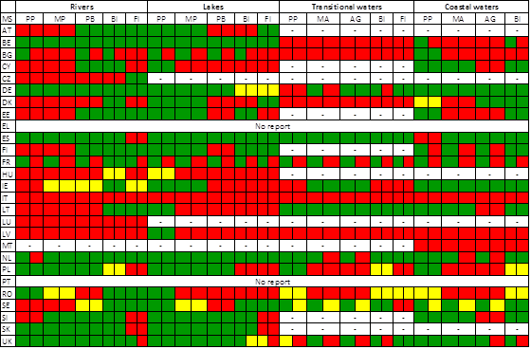
Legend:
Table 8.4.1: Overview of Ecological status assessment methods for different biological quality elements, based on assessment of information reported in the first RBMPs. PP = Phytoplankton, MP = Macrophytes, PB = Phytobenthos, BI = Benthic invertebrates, FI = Fish, MA = Macroalgae, AG = Angiosperms. Colour legend given below table.
Source: WISE

There are several uncertainties in the overview of the level of development of BQE methods in each Member State presented in table 8.4.1. These uncertainties are related to availability and quality of information about the national methods, and to whether a national method for a BQE actually has been applied in the first RBMPs for all RBDs. There is also uncertainty related to inconsistent information in different sources of information (the RBMP, information reported in WISE, national classification guidance).
Still, the overall picture indicates that fully WFD-compliant assessment methods were not in place for all BQEs for the first RBMPs. Although some of the gaps can be scientifically justified, e.g. too high variability for certain BQEs relative to certain pressures or mix of pressures, others gaps may be caused by insufficient efforts in terms of monitoring, data analysis and metric development. Thus, in many Member States, the assessment of ecological status in this first cycle of RBMPs was based on pressure and impact data rather than on biological monitoring data for a large proportion of water bodies. The confidence in the assessment of ecological status for those countries that have not developed methods is therefore low or unknown, and comparability with the assessments from other Member States questionable (see intercalibration section below).
Most of the biological assessment methods are able to detect nutrient and organic matter pressures from point and diffuse sources causing eutrophication and organic enrichment impacts. Hydromorphological pressures are less well captured by the biological assessment methods developed for the first RBMPs, and are thus less well assessed.
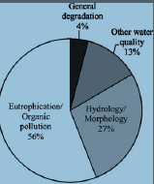
Figure 8.4.1:Percentage of biological assessment methods able to detect certain pressures
Source:RBMPs

Further development of national methods for biological quality elements has recently been done, after the adoption of the first RBMPs, supported by major EU research projects like REBECCA and WISER. However, the majority of national methods still address mainly eutrophication and organic enrichment impacts. Biological assessment methods addressing hydromorphological pressures are still lacking in many member states. On-going research projects (e.g. REFORM) may provide a better basis for such methods to be developed and applied for the next RBMP cycle.
Standards have been set for some supporting physico-chemical and hydromorphological quality elements. However, most of the physico-chemical standards relate to nutrients and organic matter and are in most cases not clearly linked to the good/moderate class boundaries for the sensitive biological quality elements. If the programme of measures is based on nutrient standards that are too relaxed relative to the good/moderate boundaries for the biological quality elements, then good ecological status may not be achievable. Thus, further efforts are needed to adjust the nutrient standards to be coherent with the good/moderate boundaries for the biological quality elements for the next cycle of RBMPs. Hydromorphological standards are less well developed than nutrient standards. Further developments are clearly needed, using available CEN standards for rivers and lakes habitat surveys, as well as new research results and good practice examples.
In terms of national specific pollutants, EQS values have been set for some national specific pollutants in many Member States, but it is not always transparent how these substances have been identified and whether the methodology used follows Annex V, section 1.2.6. There is a wide difference in the identification of river basin specific pollutants. Some Member States have identified dozens of substances whilst others only a handful of substances already regulated before the WFD (by Directive 76/464/EEC). In addition, the EQS set by the Member States vary widely from country to country for the same substance. For example, the EQS for 1,1,2-Trichloroethane range from 10 to 300 μg/l, and for the pesticide MCPA from 0.01 to 1.6 μg/l. This puts into question the comparability of the classification of ecological status. Moreover, generally very low exceedances of EQS values have been reported, and it is generally not transparent which river basin specific pollutants are responsible for exceeding good ecological status, and in which water bodies.
The one-out-all-out principle has been applied to derive the overall ecological status by almost all Member States, sometimes excluding highly uncertain quality elements. In Finland, an alternative procedure was used which is based on a weight-of-evidence approach. This approach combines information from all the monitored QEs by using average status class after down-weighting or excluding highly uncertain QEs. The use of different combination methods undermines the comparability achieved in the intercalibration exercise because methods have been intercalibrated at BQE level. The overall ecological status of a water body will not be comparable to a water body with similar type and pressures in other countries due to these different combination methods. By averaging the results of various quality elements Member States incur in risks of hiding existing significant impacts. The weight-of-evidence approach is not WFD-compliant and does not respect the precautionary principle to ensure protection of the most sensitive BQE to the various pressures.
The RBMPs provide no clear picture on whether or not ecological status assessment methods have been developed for all national surface water body types or whether there are gaps. In some Member States and for some BQEs the assessment methods are not type-specific, but rather more generally applied for all national types (e.g. benthic fauna methods for rivers and coastal waters). Other methods are more type-specific with a unique set of reference values and class boundaries for each national type although it is unclear whether all national types are covered. In general, the transparency of the information about availability of methods, reference conditions, class boundaries and applicability to national types can be substantially improved.
Only few MSs have used all relevant quality elements in ecological status assessment of surveillance monitoring sites. The quality elements used by most Member States are benthic invertebrates in rivers, phytoplankton (mainly chlorophyll a) in lakes, and both benthic invertebrates and phytoplankton (mainly chlorophyll a) in coastal and transitional waters, as well as supporting QEs for all water categories. Fish is also used by many Member States for classification of rivers and transitional waters. Benthic flora is less used than the other BQEs in all the water categories, in spite of the existence of WFD compliant assessment methods.
The most sensitive biological quality elements have been selected for ecological status assessment for operational monitoring sites in some Member States, while others use only supporting QEs. This is particularly done for lakes, only adding chlorophyll a. For rivers, most Member States use mainly benthic invertebrates and/or fish in addition to supporting QEs, while phytobenthos is often ignored. The limited use of phytobenthos for assessing ecological status in some Member States is surprising, as this BQE is the most sensitive BQE to nutrient enrichment, which is still affecting a large proportion of Europe’s waters. Thus, the ecological impacts of nutrient pressures in rivers may not be sufficiently detected, especially where nutrient standards are not set in accordance with the good-moderate boundaries for the most sensitive BQE (i.e. phytobenthos). For coastal and transitional waters most Member States use benthic invertebrates and phytoplankton in addition to supporting QEs.
For most Member States a background document or national/regional classification guidance document exists, but in some cases this document was not reported by the RBMPs, nor found in the annexes, thus causing problems for the assessment of ecological status methods. Given the key role that the assessment of ecological status plays in the implementation of the WFD, transparency on the methods used is important and Member States should make publicly available the methods used.
Uncertainty is a problematic issue in the first RBMPs. There is no common understanding across Member States on how uncertainty should be assessed, and the information reported on uncertainty is often insufficient or missing in the RBMPs and associated documents. This lack of information concerns especially the uncertainty in the assessment methods themselves, e.g. uncertainty in relationships between the biological metrics used and the main pressures, as well as uncertainty in the boundary setting. The uncertainty in the actual status assessment of ecological status of water bodies are reported by most Member States in confidence categories (low, medium, high), with no or little information on spatial and temporal variability. Low confidence or no information on confidence is reported for ca. 60% of all classified water bodies, while less than 20% are classified with high confidence at the EU level. This illustrates the generally low confidence in the ecological status assessment in these first RBMPs. Moreover, a large proportion of water bodies are classified by grouping, especially in Member States with a high number of water bodies (e.g. SE). Assessing water bodies by grouping without any monitoring data increases the uncertainty but may be justified in areas where most water bodies are of the same type and are subject to the same level of pressures and hence can be assumed to present the same ecological status.
- Intercalibration of ecological status assessment methods and compliance with intercalibrated class boundaries
The class boundaries for ecological status assessment reported in the first RBMPs are mostly consistent with the results of the intercalibration of phase 1 with minor deviations in some Member States. Large inconsistencies with more relaxed boundaries are rarely found but the reporting is unclear to allow consideration of consistency in some cases. The RBMPs are also often unclear on whether the intercalibration results have been properly ‘translated’ to other national surface water types that have not been intercalibrated.
A large proportion of biological methods required for assessing ecological status in the different water categories were not intercalibrated in phase 1, partly due to the lack of national assessment methods but in some cases due to large differences between the national assessment methods. No assessment methods were intercalibrated for fish in phase 1, and for lake phytoplankton most methods were limited to only chlorophyll a. Also phytobenthos in lakes and macrophytes in rivers were not intercalibrated in phase 1. Transitional waters assessment methods were not intercalibrated for any BQE in phase 1 mainly due to the lack of national assessment methods. Thus, the phase 1 results are uncomplete and a second phase was needed to close remaining gaps.
The second phase of the Intercalibration process, mostly completed in 2011-2012, has provided improved comparability of national methods for several BQEs after further adjustment of metrics, reference values and class boundaries, as well as results for some of the BQEs remaining after phase 1. When these intercalibrated class boundaries are adopted in the new IC Decision (due to be approved by the end of 2012) they should be applied for status assessment as a basis for the preparation of the second RBMPs.

8.4.3. Conclusions
- The development of classification systems for the assessment of ecological status was one of the most challenging tasks in the implementation of the WFD.
- Many Member States have made a huge effort to develop and implement WFD-compliant methods to assess ecological status of their water bodies. The progress has been impressive. Thanks to this effort, the methods for assessing ecological status of surface waters in Europe today are better than before the WFD.
- The work at EU level through the CIS Working Group A Ecological Status (ECOSTAT), in particular in the context of the intercalibration exercise facilitated by the Commission, has been essential in achieving this progress, not only for the work delivered but also for the extensive exchange of information and knowledge that this has fostered.
- However, for the first RBMPs, many Member States did not apply the new methods but primarily used their traditional assessment methods, e.g. benthic fauna and phytoplankton chlorophyll, as well as supporting general physico-chemical QEs. Thus, there is a need to overcome the weight of tradition (business as usual) and start to apply the new WFD-compliant methods including more complete phytoplankton methods (not only chlorophyll), benthic flora and fish to a larger extent.
- Moreover, there are still important gaps and weaknesses remaining, especially concerning assessment methods for transitional and coastal waters which are important in view of the implementation of the Marine Strategy Framework Directive; benthic flora in rivers and fish in rivers, lakes and transitional waters, as well as methods sensitive to hydromorphological pressures in all water categories.
- The obligation to identify river basin specific pollutants and set EQS for them has not been equally observed, with some Member States identifying many more than others, and some standards being much less stringent than others for the same substances. This has implications for the comparability of conclusions drawn regarding ecological status.

8.4.4. Recommendations for improvement in the next planning cycles
- Member States are encouraged to be ambitious in terms of developing and improving assessment methods to remove the gaps and reduce the weaknesses remaining after the first RBMPs and the second phase of intercalibration (see conclusions above). The GIG and ECOSTAT structures and guidance, as well as results from WFD support projects, e.g. WISER and REFORM should be used as support.
- Biological indicators for other major pressures than organic pollution and eutrophication are still missing in many Member States and should be developed. This is particularly important to assess impacts of hydromorphological pressures which are currently reported to affect a large proportion of Europe’s waters.
- Methods included in the Official Intercalibration Decision based the second phase of the intercalibration process should be applied, including more complete phytoplankton methods (not only chlorophyll), as well as benthic flora and fish to a larger extent.
- Standards for supporting QEs, including nutrient standards, should be better linked to the good-moderate boundaries for the most sensitive BQEs. This is important to ensure coherent assessments and sufficient ambition level in terms of mitigation measures to reduce nutrient pressures to a level compatible with the achievement of good ecological status.
- National guidance documents on classification should be revised taking the final results of intercalibration into account. Translation of Intercalibration results for common types to the national types must be made more transparent and clear-cut than for the first RBMPs.
- Monitoring of sensitive BQEs should be increased to provide more reliable assessments with known confidence and uncertainty, as a basis for more targeted PoMs for the next cycle of RBMPs.
- The status assessment should be used as the main driver for the selection of targeted measures, complemented as necessary with other information, such as pressure data.
- The substantial flexibility allowed by the WFD for Member States to develop national methods and typologies has resulted in a wide variety of national types (ca. 2200) and national assessment methods (ca. 300, Birk et al. 2012). Although these may be appropriate at the national level and have also to some extent been intercalibrated, their large variation makes comparability of ecological status across Europe difficult. Comparability could be further facilitated by progressing towards a larger degree of harmonisation of national types and national methods, also taking into account the fact that many RBDs are shared with other Member States.
- Identification of relevant specific national pollutants should be improved in the context of the update of the pressure-impact analyses under WFD Article 5. The methods for setting of EQS values for these specific pollutants should be more transparent.
- Regarding the specific pollutants it is hoped that the standards for different substances will be more similar in future if Member States collaborate to derive them or at least follow the Common Implementation Strategy Guidance for Deriving Environmental Quality Standards that was published in 2011.

8.5. Classification of chemical status for surface waters

8.5.1. Introduction
Good surface water chemical status means the chemical status required to meet the environmental objectives for surface waters established in Article 4(1)(a) of the WFD, that is the chemical status achieved by a body of surface water in which concentrations of pollutants do not exceed the environmental quality standards established in Annex IX and under Article 16(7), and under other relevant Community legislation setting environmental quality standards at Community level.
Decision 2455/2001/EC of the European Parliament and of the Council of 20 November 2001 established the list of priority substances in the field of water policy. The Decision identified the substances for which quality standards were to be set at Community level which was implemented by means of Directive 2008/105/EC (EQS Directive (EQSD)). Eight other pollutants that were regulated by Directive 76/464/EEC were also incorporated into the assessment of chemical status. The EQSD includes a number of other obligations related to priority substances such as monitoring of sediment and biota and the establishment of an inventory of emissions, discharges and losses.
Directive 2009/90/EC (QA/QC Directive) on the quality and comparability of chemical monitoring completes the legislative framework providing minimum performance criteria to ensure the quality of the analytical results. The deadline for transposition of the QA/QC Directive into national legislation was 21 August 2009, just before adoption of the RBMPs.

8.5.2. Status of implementation of the EQSD for the first RBMP
The list of priority substances was published in 2001 but the EQS were published only in the EQSD at the end of 2008. The transposition of the EQSD into national legislation was due in July 2010, after the adoption of the RBMPs. The EQSs were known from June 2006, at the time that the Commission proposed the EQSD. The EQSs were not discussed during the negotiations. The obligations for monitoring priority substances under the WFD Article 8 were fully in place by the end of 2006, as the list of substances was already known.
The timing of the adoption and transposition of the EQSD has influenced the uptake of the derived obligations in the first RBMPs. Some Member States have implemented the EQSs as laid down in the EQSD for all priority substances. In many RBMPs the situation is unclear. Others have implemented existing national standards or have even taken into consideration other national river basin specific pollutants in the assessment of chemical status, which is clearly not in line with the WFD.
Furthermore, the extent of monitoring of priority substances across the EU has been very diverse. Only very few Member States have monitored all priority substances. The grounds for the selection of substances to monitor in other cases are generally unclear. The result is that the basis for the assessment of chemical status is different across Member States. Overall, the extent of monitoring is insufficient to provide an assessment of chemical status as proved by the high percentage of surface water bodies with unknown status (above 40%).
As a consequence of the above elements, the chemical status of water bodies as reported by Member States is hardly comparable.

8.5.3. EQS used for assessment of chemical status of surface waters
The following table presents an overview of the degree of application in the RBMPs of the EQSs laid down by the EQSD in the assessment of chemical status (see country specific parts of the Commission Staff Working Document for more details).
Member State | Application of standards in the EQSD in the first RBMP
AT | It is stated in the RBMPs that the priority substances and other pollutants in the EQSD were used in the assessment of chemical status. The chemical pollution by-law in force at the time of the RBMP includes national standards that are less stringent than those in the EQSD for a number of priority substances. In addition, the following substances are missing: chloroalkanes, fluoranthene, nickel, polyaromatic hydrocarbons (PAH) and tributyltin compounds (TBT).
BE | It is stated in the RBMPs that the priority substances and other pollutants in Annex I of the EQSD were used in the assessment of chemical status; however the biota standards for mercury, hexachlorobenzene and hexachlorobutadiene were not applied, and three priority substances were not monitored.
BG | The EQSs in the EQSD were applied for the water phase only for those priority substances, for which there were results from monitoring. No data were collected for a number of priority substances such as brominated diphenylether (BDE), C_{10 – 13 c}chloralkanes, di(2-ethylhexyl) phthalate (DEHP), nonylphenol, octylphenol, pentachlorophenol, and tributyltin compounds (TBT). Insufficient datasets were reported for alachlor, chlorfenvinphos, chlorpyrifos, diuron, isoproturon, trifluralin and in general the confidence level of data on priority substances was low.
CY | It is stated that the EQSs for the priority substances and other pollutants in the EQSD were applied for the assessment of chemical status. However, not all pollutants/measurements were used for the assessment of chemical status, leading to a ‘not assessed/unclear’ chemical status for 53 out of 216 river WBs and for two out of 18 lake WBs.
CZ | A version of the proposed EQSD dated 21 June 2007 was used to set up the monitoring parameters, AA and MAC values. All the substances and corresponding EQS in Annex I of the EQSD were taken into consideration in assessing the chemical status with two exceptions: 4-nonylphenol (only nonylphenol with CAS No. 25154-52-3 is covered) and five out of six BDE congeners were not covered. This is because the methodologies for chemical status assessment were set in 2007 based on the 2007 working version of the EQSD, and some inaccurate interpretation occurred.
DE | In principle the EQSs for the priority substances and other pollutants in the EQSD were applied in the assessment of chemical status, however, there are numerous discrepancies or lack of clarity regarding whether all EQSs were really applied in the different German Federal States. The assessment of chemical status in Germany depended on the availability of data. Several Lander reported that monitoring did not include all priority substances (BDE, C10-13 chloroalkanes, TBT). Some national quality standards were used as well, e.g. the EQSs for chlorpyrifos was higher than that in the EQSD.
DK | The EQSD was formally applied but many substances were not taken into consideration. In Bornholm and Vidaa RBDs data on priority substances are missing. For lakes, the substances listed in Annex I were not measured at all in Jutland RBD and in other RBDs only a few data are available. The monitoring programme was more about spot checking rather than a monthly regular activity. Its overall output for chemical status assessment is thus vague.
EE | From RBMPs it is not clear whether EQSs from the EQSD have been applied for the assessment of the chemical status. There is a lack of monitoring data as insufficient monitoring programmes for priority substances were in place.
EL | No assessment provided.
ES | Information is available only for Catalonia. Chemical status was assessed by analysing the priority substances included in Annex X of the WFD (Decision 2455/2001/EC), modified by Directive 2008/105/CE, and with the objectives set by Directive 76/464/CEE. The overall procedure is however unclear and some parameters were reported missing due to high limits of quantification (LOQs) of the analytical methods used.
FI | RBMPs were prepared in compliance with the provisions of the WFD, Decision No 2455/2001/EC and Directive 2006/11/EC. The EQSD was not applied for the chemical status assessment of waters in the RBMPs reported in 2010 because it was transposed only by 13 July 2010. Only those priority substances were monitored for which discharges into water were known based on a risk analysis and presence of which in water had been verified by sample surveys and for which suitable analytical techniques were available. Several priority substances were thus excluded from the chemical status assessment (e.g., TBT, BDE, C10-13 chloroalkanes, chlorobenzenes, chlorinated hydrocarbons, PAH). Analyses of biota and sediments were not considered.
FR | All substances listed in Annex I of the EQSD were used for the assessment of chemical status of inland and other surface waters in the Scheldt, Somme and coastal waters of the Channel and the North Sea, Seine and Normandy coastal waters, Corsica and Loire, Brittany and Vendee coastal waters RBDs. Information was not clear for Rhone and Coastal Mediterranean, Adour, Garonne, Dordogne, Charente and coastal waters of Aquitania, Meuse, Sambre, Rhine, Guadeloupe, Martinique, Guyana and Reunion RBDs.
HU | Most of the EQSs in the EQSD were applied for chemical status assessment except those for which there was no analytical methodology / laboratory available (BDE, C10-13 chloroalkanes, TBT).
IE | The EQSD was applied (except for trifluralin) but it is not clear which substances were monitored. It seems that only a fraction of SWBs was assessed for chemical status.
IT | The basis for the assessment of the chemical status is unclear in all RBDs. It is not clear what was monitored, in which water category and which EQSs were used. For 77.6% of all SWBs the chemical status is unknown with strong differences across the RBDs (chemical status was unknown for 100% of the SWBs in two RBDs). For a number of RBDs it is not clear which priority substances were monitored.
LT | Chemical status compliance checking was based on the national standards, which did not include all priority substances from the EQSD; for those included, the extent of compliance is not clear. The procedure applied for chemical status assessment is not clear; it seems to be based on incomplete monitoring. Only substances registered to be released and allowed to circulate in international rivers were monitored.
LU | In principle the EQSs for the priority substances and other pollutants in Annex I of the EQSD were applied for the assessment of chemical status (higher MAC-EQS were applied for anthracene and hexachloro-cyclohexane (HCH)) but it is not clear if all of them were measured in all SWBs. There is an indication that only a limited number of monitoring sites was examined.
LV | Only four priority substances (cadmium, lead, nickel and mercury) were monitored in water and the required frequency of monitoring was not respected. Only those priority substances were monitored for which following the justifications for selection could be found: (i) where significant amounts of substances were discharged according to the permits issued by the regional environmental authorities; (ii) which are strategically significant for the country, e.g., transboundary water bodies.
MT | Assessment of the chemical status was based on risk assessment and was not verified by monitoring.
NL | Although it is mentioned in all Dutch RBMPs that some of the priority substances were not used for the assessment of the chemical status, recent information from the Netherlands indicated that all priority substances were included in the assessment.
PL | The EQSs for the substances listed in Annex I of the EQSD were used in the chemical status assessment, but it is not clear whether all of them were applied in each water body.
PT | No assessment was provided.
RO | It is stated in the RBMP that chemical status assessment is based on the EQS values laid down in Annex I of the EQSD, including MAC and AA. However, the biota standards for mercury, hexachlorobenzene and hexachlorobutadiene were not applied, and substances were monitored only if significant discharges were identified.
SE | It is not clear in the RBMPs which priority substances were monitored for chemical status assessment, nor which matrix they were monitored in. The informal Swedish feedback clarified that all priority substances except hexachlorobutadiene (HCBD) were regularly monitored.
SI | Classification of chemical status was based on all priority substances but some priority substances were not included in the assessment of chemical status, since their limits of detection (LOD) were higher than the corresponding EQSs (TBT, trifluralin, some PAHs). There was no monitoring of priority substances in lakes.
SK | All EQSs in Annex I of the EQSD were applied for the assessment of the chemical status of SWBs, but the biota standards for mercury, hexachlorobenzene and hexachlorobutadiene were not applied, and in most SWBs not all priority substances were monitored.
UK | In England and Wales, monitoring of priority substances was largely based on permitted discharges and the choice of substance and location was as for existing legislation. In Scotland, SEPA monitored priority substances at surveillance sites for which there where likely sources giving rise to discharges into the catchment of the water body concerned. However, a number of priority substances were not monitored at all. Nor does information on monitoring in lakes appear to have been provided. In general, a large proportion of water bodies were not monitored for priority substances and their chemical status is therefore unknown.
Table 8.5.1: Overview of application of standards in the EQSD in the first RBMP
Source:RBMPs

8.5.4. EQSs for biota for mercury, HCB and HCBD
According to the Article 3(2 a) of the EQSD, Member States may opt to apply, for mercury and its compounds, an EQS of 20 μg/kg, and/or for hexachlorobenzene (HCB), an EQS of 10 μg/kg, and/or for hexachlorobutadiene (HCBD), an EQS of 55 μg/kg, these EQS being for prey tissue (wet weight), choosing the most appropriate indicator from among fish, molluscs, crustaceans and other biota. In order to allow Member States flexibility depending on their monitoring strategy, Member States should be able either to monitor and apply those EQS for biota, or to establish EQS for surface water that provide the same level of protection.
EQS in biota were applied only in NL, NO, SE and UK, while the RBMPs of other countries either reported negatively on this issue or made no reference to the use of the biota EQS for the above substances.
According to footnote 9 of Annex I to the EQSD, where Member States do not apply the standards for biota for the three substances in Article 3(2)a of the EQSD, they should introduce a water standard that is more stringent than the one in Annex I to the EQSD. There is no indication that any Member State has set such a standard for the first RBMP. As a consequence, an assessment of chemical status for mercury, HCB and HCBD as good in the first RBMP, if made against the water standard, cannot be assumed to represent a sufficiently protective situation.

8.5.5. EQSs for sediment and biota for other substances
According to the Article 3(2)b of the EQSD, Member States may opt to apply EQS for sediment and/or biota instead of those laid down in Part A of Annex I (33 priority substances plus 8 other pollutants) in certain categories of surface water. Member States that apply this option shall establish and apply EQS for sediment and/or biota for specified substances.
Only BE, ES (Distrito Fluvial de Cataluña), IT and NO opted to derive EQSs for sediment and/or biota for some of the 33 plus 8 substances (see country specific parts of the Commission Staff Working Document for more details).

8.5.6. Measurements lower than the limit of quantification
Article 5 of the QA/QC Directive requires Member States to apply certain rules for handling measurements lower than the limit of quantification.
Information about compliance with Article 5 of the Directive 2009/90/EC (QA/QC Directive) was generally not reported. Only AT, LU, RO, SI and UK provided some information indicating that they are already applying the provisions of this Directive.

8.5.7. Background Concentrations & Bioavailability
Annex I Part B of the Directive 2008/105/EC stipulates that Member States may, when assessing the monitoring results against the EQS, take into account:
- Natural background concentrations for metals and their compounds, if they prevent compliance with the EQS value;
- Hardness, pH or other water quality parameters that affect the bioavailability of metals.
The background concentrations were considered in the assessment of compliance with EQS in AT, IE, IT and RO while the bioavailability of metals was not considered in any of the RBMPs.

8.5.8. Identification of EQS exceedances
Based on the results of the monitoring campaigns and compliance checks against the EQSs, Member States assessed the chemical status of surface water bodies. A number of priority substances/certain other pollutants were identified as causing failure of good chemical status of certain water bodies and these failures were reported in the RBMPs. Information on the priority substances causing failure to achieve WFD environmental objectives was missing in a large number of RBMPs.
For the majority of reviewed RBDs, data on the priority substances causing failure were provided but examination of the existing monitoring networks revealed the following facts:
- There are large percentages of water bodies that have not been assessed for chemical status (i.e. status is unknown). Generally, most Member States only classify chemical status of water bodies for which they have some monitoring information.
- Many monitoring programmes seem to be rather limited in terms of numbers of substances and monitoring stations. It is not transparent how the selection of the substances that are monitored has been carried out. There are many statements related to substances ‘discharged in the basin’ but there is no further evidence or justification provided from WFD-compliant monitoring programmes.
- The above mentioned gaps in monitoring networks explain why in many cases the substances causing failures are not identified or reported either in WISE or in the RBMPs. Therefore, it is not possible to know what is causing the problems.

8.5.9. Mixing zones
According to Article 4 of the Directive 2009/105/EC Member States may designate mixing zones adjacent to points of discharge. Concentrations of one or more substances listed in Part A of Annex I may exceed the relevant EQS within such mixing zones if they do not affect the compliance of the rest of the body of surface water with those standards.
The use of mixing zones was reported only by two Member States: AT and ES (Catalonia RBD). In AT, pursuant to §5 (6) of the Austrian law when providing permits for discharges of the priority and national substances into SWB, the allowable pollutant loads have to be set in a way that the EQS are met within a certain distance from the discharge (the mixing zone). This distance is normally ten times the width of the SWB at the point of discharge, but limited to 1 kilometre. In Catalonia, mixing zones have been considered for rivers and coastal waters. In coastal waters the zones have a radius of 50 meters around the outflow of the discharge into the sea. In rivers the mixing zone is designated in a stretch of river 50 m downstream from the wastewater discharge point.

8.5.10. Conclusions
- As a result of different degrees of implementation of the EQSD in the first RBMPs there is a lack of comparability of the information on chemical status of surface water bodies among Member States.
- Only few Member States opted to apply, according to the Article 3(2 a) of the Directive 2008/105/EC, EQSs for mercury and its compounds, hexachlorobenzene and/or hexachlorobutadiene in biota. However, no Member State has set more stringent EQSs for mercury in water as required by the Directive 2008/105/EC where the biota standards are not used. The necessity of a very careful and sensitive monitoring of mercury in the environment can be demonstrated by the situation in Sweden where atmospheric deposition of mercury was found as one of the major environmental problems with the effect that no surface water body would meet the EQS for mercury in biota. Having regard to the situation in Sweden, it must be pointed out that the lack of detection of the mercury problem in other Member States might be a consequence of the insufficient monitoring practices and of the fact that more stringent standards for mercury in water have not been set.
- Most of the Member States reported very limited failures for some of the priority substances. A large proportion of water bodies (above 40%) have not been assessed for chemical status and many monitoring programmes seem to be very limited in terms of number of substances and monitoring stations. As a consequence, the picture presented by the chemical status assessment of the first RBMPs is incomplete.

8.5.11. Recommendations
- Full transposition and implementation of the Directive 2008/105/EC has to be ensured during the next RBMP planning period.
- Improvement of monitoring networks has to be achieved to enable analysis of all priority substances under conditions of full compliance with the provisions of Directive 2009/90/EC. The option to monitor priority substances in certain categories of surface water in sediment and biota should be fully exploited, in particular for hydrophobic substances such as many persistent, bio-accumulative and toxic substances where monitoring in water is not capable of delivering meaningful results. The monitoring strategy should be designed to reflect a true picture of the chemical pollution in the aquatic environment. Current widespread efforts to monitor highly hydrophobic substances in water are a waste of resources and the results do not reflect the reality. Sediment or biota monitoring is in any case specifically required for the trend monitoring specified in EQSD Article 3(3).
- The monitoring programme for priority substances should make use of all types of WFD monitoring (surveillance, operational, investigative). The results of the pressures analysis should be used by Member States to start investigative screening programmes to identify the relevant priority substances in the RBD, the results of which can inform the design of the monitoring programmes. It has to be emphasised that for developing smart and efficient monitoring programmes the information on pressures and emissions is very important but in many cases not sufficient to predict which substances will be present in water bodies in significant quantities. This refers especially to those substances with more complex use patterns and environmental fates.
- Although it is not expected that all water bodies be monitored, all water bodies should be assessed for chemical status. Grouping techniques and estimations need to be developed, together with a sound monitoring strategy to provide representative data. The design of the monitoring programme should be guided to provide enough confidence in the status assessment.
- Monitoring of mercury in biota should be the norm. If this is not done, Member States are obliged to set a more stringent standard for water than the one set in Annex I to the EQSD, but reliable monitoring is not possible at that level with current analytical techniques. The application of the EQSs for water in Annex I to the EQSD is not an option as it is not protective enough. The monitoring of hexachlorobenzene and hexachlorobutadiene should also be in biota.
- It is essential that failures of the EQSs are reported transparently. Substances causing failures and the water bodies affected should be clearly identified. There are RBMPs that do not report which standards are failing where. This is essential basic environmental information that should be publicly available. Aggregated reporting (such as ‘heavy metals’, ‘industrial pollutants’ or ‘pesticides’) is not useful to transparently identify the causes of the problems and to take action. Therefore it should be avoided.
- Full transposition and implementation of the Directive 2009/90/EC has to be ensured during the next RBMP planning period.

8.6. Designation of Heavily Modified Water Bodies (HMWB)
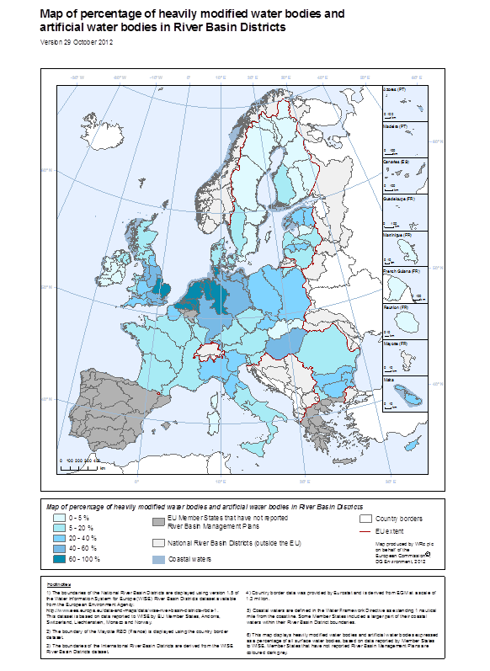

Figure 8.6.1: map of distribution of HMWBsand AWBs in EU RBDs
Source: WISE Note: Better quality maps are available on: http://ec.europa.eu/environment/water/water-framework/facts_figures/index_en.htm

8.6.1. Introduction
The WFD aims to bring all water bodies to a good ecological status by 2015. Measures have to be identified and implemented for impaired water bodies to improve their quality. Not all water bodies, however, can be brought to a good ecological status (GES) which refers to a nearly natural undisturbed condition. Many water bodies have been heavily modified in their physical structure to serve various uses including navigation, flood protection, hydropower, and agriculture. In many cases, it is not viable nor desirable from a socio-economic perspective to abandon such uses and to remove the physical modifications which affect the water bodies. Member States can, thus, designate such water bodies as heavily modified water bodies (HMWB) whose environmental objective is good ecological potential (GEP) instead of GES.
According to the WFD Article 4(3)(a) and (b), Member States may designate a water body as heavily modified if:
(a) The changes to the hydromorphological characteristics of that body which would be necessary for achieving GES would have significant adverse effects on:
(i) The wider environment.
(ii) Navigation, including port facilities, or recreation.
(iii) Activities for the purpose of which the water is stored, such as drinking water supply, power generation or irrigation.
(iv) Water regulation, flood protection, land drainage.
(v) Other equally important sustainable human development activities.
AND
(b) The beneficial objectives served by modified characteristics of the water body cannot, for reasons of technical feasibility or disproportionate costs, reasonably be achieved by other means, which are a significantly better environmental option.
A guidance document on the designation of HMWBs was developed in the framework of the Common Implementation Strategy.
HMWB designation refers to existing modifications. Any new modification with potential significant effect on the ecological status of the water body needs to be handled through WFD Article 4(7). Therefore, designation of HMWB in view of future modifications is not in line with the WFD.
The WFD takes a very similar approach to AWB and HMWB. AWB must have been created by the same specified uses listed in Article 4(3)(a). The Guidance document number 4 interprets an AWB "as a surface water body which has been created in a location where no water body existed before and which has not been created by the direct physical alteration or movement or realignment of an existing water body".

8.6.2. Extent of water body designation as heavily modified or artificial
The following figures give an overview of designated heavily modified water bodies (HMWB) and artificial water bodies (AWB) by Member State in relation to the number of total surface water bodies. Around 12% of water bodies have been designated as heavily modified at EU level. However, a large number of water bodies remain ‘unknown’ as regards their natural or heavily modified status in some countries indicating that the designation process has not been completed. Around 4% of water bodies have been designated as artificial water bodies at EU level.
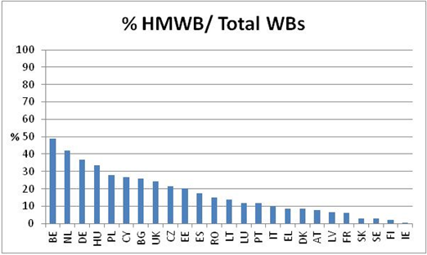

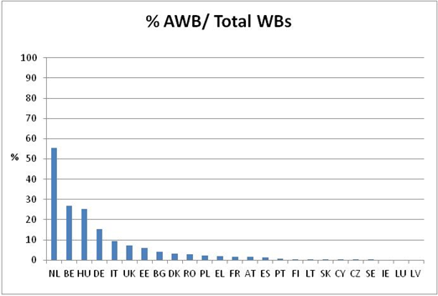
Figure 8.6.2: Designated HMWBs and AWBs in the EU Member States
Source: WISE
Note: FI, LT, SK, CY, CZ and SE have less than 0.5% AWB and thus no visible bars in the chart on AWB. . There are no AWBs in IE, LU, LV and MT.

In the 2005 Article 5 reports, all Member States made preliminary identifications of HMWBs; the percentage of provisional HMWBs varied greatly from country to country.
In most cases, there are no significant changes in the percentage of finally designated HMWBs compared to provisional HMWBs in the Article 5 reports. In some Member States there is a significant decrease in the percentage of HMWBs (e.g. in Czech Republic and Slovakia). In other Member States there has been an increase in the percentage of HMWBs compared to the provisional identification phase (e.g. Hungary, Germany, Belgium, Poland).

8.6.3. Water uses and physical modifications for HMWB designation
The majority of RBDs (91%) specify the water uses for which the water bodies have been designated as HMWB, clearly related to the uses of WFD Article 4(3)(a). This has not been clearly identified in the remaining 9% of RBDs.
Storage for power generation, navigation, flood protection, water regulation and water storage for drinking water supply appear as the most common uses for designating HMWBs (reported in more than 60% of RBDs which specified the water uses of HMWBs).

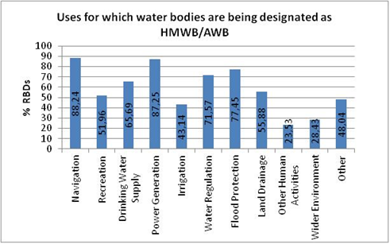
Figure 8.6.3 – Uses for which water bodies are being designated as heavily modified water bodies and artificial water bodies
Source:RBMPs

The majority of RBDs (74%) also describe the kind of physical modifications that have led to the designation of HMWBs. However, in 23% of RBDs, the physical modifications for HMWB designation are not described, and in 3% or RBDs, no clear information has been provided.
Weirs/dams/reservoirs, channelization/straightening/bed stabilisation and land reclamation/ports/coastal modifications appear as the most common physical modifications that have led to HMWB designation (reported in more than 70% of RBDs which described physical modifications for HMWBs).

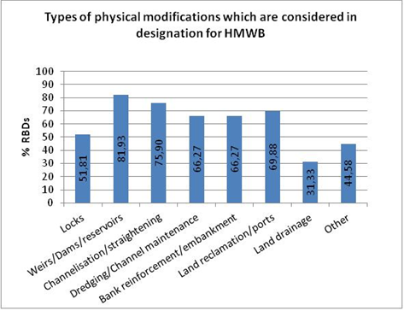
Figure 8.6.4 – Types of physical modifications in the designation of heavily modified water bodies
Source: RBMPs

8.6.4. Methodology for HMWB designation
Around half of RBDs assessed followed the complete stepwise approach for HMWB designation described in CIS HMWB Guidance nº4. However, the extent and transparency of the implementation of the key steps is variable (see below).
The remaining RBDs either used some steps of the CIS approach or, in some cases, followed a different approach than the one described in the CIS HMWB Guidance nº4 (mainly in Bulgaria and Sweden).
In ca. 11% of RBDs, the designation methodology is not explained or the information given is unclear (this is the case for all RBDs in Italy and single RBDs in France, Finalnd and Germany). For some RBDs, the methodology may be described in background documents but these have not been clearly referenced in the RBMPs in all cases.
The following steps of the HMWB designation process (according to the CIS HMWB Guidance nº4) have been followed to varying extents:
Definition of 'substantial changes in character'
The definition of 'substantial changes in character' due to human activity (physical modifications) is explained in the majority of RBDs (ca. 63% of RBDs); in the remaining RBDs, this definition is not given or is unclear.
The following are key observations on the set of criteria used to define 'substantial changes in character due to physical modifications:
- Several approaches refer to simple presence of certain structures as criterion for 'substantial changes in character, e.g. the presence of dams, dikes or ports.
- Criteria are frequently connected to specific thresholds or ranges of values for a certain pressure or impact.
For example, thresholds often relate to the surface of reservoirs and impoundments or the percentage of river channelized for different uses, e.g. for urbanisation or navigation.
- In some Member States, scoring systems or methods have been developed to take the effect of combined pressures into account, e.g. UK.
- In other Member States, hydromorphological structure class systems exist to assess physical alterations (e.g. the German Stream Habitat Survey) and substantial changes in character of water bodies are defined as failure of a specific class.

'Significant adverse effects'
A description of the approach on how significant adverse effects of restoration measures on the use or wider environment have been defined is given in around half of the RBMPs assessed; in the remaining, such description is not given or is unclear.
Several plans mention that the assessment of significant adverse effects has been undertaken but they do not specify the methodology or give reference to a background document which is not clearly referenced in all cases.
When it comes to the development of criteria and/or specific thresholds of 'significance', such have been found in only 14% of the RBDs assessed. In most cases, significance has been defined on the basis of qualitative criteria rather than quantitative criteria. In the majority of RBDs, criteria were not developed or the information was unclear. In many RBDs with lack of criteria, the significance of effects has been estimated on the basis of expert judgement.
In general, significant adverse effects include:
- Complete loss of use, especially in the case of water storage for drinking-water supply, power generation or irrigation.
- Significant reduction of use, e.g. loss of cargos and reduction of passenger traffic, reduction of bathing sites, and loss of energy generation (peak load and base load).
- Production losses or socio-economic losses (with % thresholds), e.g. reduction of flood protection levels and loss of production from agricultural land.
The evaluation of the RBMPs indicates that the assessment of significant adverse effects of restoration measures on the use or wider environment is in many cases vague and not transparent as expert judgement is the basis for the estimations. The lack of criteria and/or specific thresholds of 'significance' indicate that the assessment of significant adverse effects is not comparable yet between Member States.

'Better environmental options'
The checking of whether the beneficial objectives served by the modifications of the HMWB can be achieved by 'other means' which are significantly better environmental options, technically feasible and not disproportionately costly has taken place in around half of the RBDs assessed. In the remaining RBDs, 'other means' have not been checked (ca. 30% of RBDs) or information given was unclear (ca. 19%).
In general, other environmental options considered included:
- Replacement of the existing use with a better alternative, such as replacement of navigation with other environmentally friendly transport options, replacement of hydropower with other renewable energy (national level decisions), supply of irrigation water from groundwater sources or seawater desalination.
- Displacement of the existing use to another water body, such as relocation of properties (under flood protection), movement of recreation activities to other water bodies, displacement of navigation to an alternative port/harbour.
- Reduction of environmental impact of existing use, such as reduction of impact of water storage by compensatory and ecological discharges.
Overall, in the majority of the plans, the assessment of better environmental options has been rather superficial without detailed consideration of alternatives. For most HMWB and AWB, there are no real alternatives to deliver the water use they serve. Difficulties in this first cycle have persisted in applying the designation test and the process should be improved for next planning cycles.

8.6.5. Uncertainties and future actions
Uncertainty in relation to the designation of HMWBs is discussed clearly in only 22% of the RBDs. In more than half of the plans, the issue of uncertainty is not discussed or information provided is uncler.
Future actions to improve the designation process (e.g. methodological improvements) are planned in ca. 20% of the RBDs. However, in most cases, no future actions for improvement of the designation process are planned or information provided in the plan is unclear.

8.6.6. Conclusions
- The designation of HMWBs in the first RBMPs has been based largely on expert judgement. The extent and transparency of the implementation of the key steps of designation is variable in the Member States.
- The assessment of significant adverse effects of restoration measures on the use or wider environment is in many cases vague and not transparent as expert judgement is the basis for the estimations. This entails the risk of wide interpretation of 'significant adverse effects' as only in a few cases transparent thresholds or criteria of 'significance' have been developed.
- The assessment of better environmental options has been quite superficial without detailed consideration of alternatives. In many plans, alternatives have not been checked at all or information given is very unclear.
- HMWB designation according to the WFD has a built-in driver for restoration (which is the default). Overall, in the first WFD planning cycle, it is unclear to what extent the designation process has been used as a driver for restoration or as a consolidation of status quo. Nevertheless, in the majority of RBDs there is clear evidence that hydromorphological measures are planned to improve the ecological potential of HMWB with the minimum of impact on use (see Section 8.14 on measures related to hydromorphology). This indicates efforts made to improve the conditions of HMWBs. At the same time, there is little information reported on the expected ecological improvements of measures at the water body level which indicates uncertainty on the resulting effects.

8.6.7. Recommendations
- The methodology and specific criteria for HMWB designation (application of all relevant steps according to CIS HMWB guidance no. 4) should be clearly explained in the plans or clear reference and links to the relevant background documents needs to be given.
- The use of thresholds (e.g. percentage of river stretch affected) to define substantial changes in character for HMWB designation should be justified to ensure that significant modifications are not overlooked.
- There needs to be a clear check whether good ecological status is achievable in the water body. In case it is, designation is not an option but restoration to GES is an option.
- In order to designate water bodies as heavily modified, the explicit tests of the WFD Article 4(3)(a) and (b) (assessment of significant adverse effects and significantly better environmental options) should be applied on the basis of clear and transparent criteria. There is much room for improvement in this respect, since the assessment of 'significant adverse effects' and 'significantly better environmental options' is generally weak or has not been carried out in many RBMPs in the first cycle. At the same time, nearly all RBMPs report designated HMWBs which shows that the basis for designation is not solid in all cases.
- Uncertainties in the HMWB designation process (especially in cases of lack of assessment of significant adverse effects and better options) should be explained in the RBMPs. Planned actions for improvement of the designation process should be included in the reporting.

8.7. Definition of Good Ecological Potential for HMWB and AWB

8.7.1. Introduction
Within the WFD implementation, the status of HMWB and AWB needs to be assessed in terms of achieving at least Good Ecological Potential (GEP) as this is defined in Annex V of the Directive. A water body shows a GEP when there are slight changes in the values of the relevant biological quality elements as compared to the values found at Maximum Ecological Potential (MEP). The MEP is considered as the reference conditions for HMWB, and is intended to describe the best approximation to a natural aquatic ecosystem that could be achieved given the hydromorphological characteristics that cannot be changed without significant adverse effects on the specified use or the wider environment.
The definition of ecological potential for HMWB and AWB has been a subject of long and still on-going discussions between Member States and the Commission in the context of the CIS. Defining ecological potential is a challenging and complex subject in the WFD implementation, which needs to be defined on the basis of a sound methodological approach in order to set appropriate environmental objectives for the numerous HMWB and AWB in Europe.

8.7.2. Methodologies for the definition of GEP
So far, the following two approaches have been put forward and discussed on EU level for the definition of Good Ecological Potential (GEP).
Reference-based approach (CIS approach)
The first approach is based on biological quality elements as illustrated in CIS Guidance No 4 (see Figure 8.7.1, right). The MEP for HMWBs relates to the values of biological quality elements after all mitigation measures have been implemented that do not have a significant adverse effect on the use. GEP is defined as only slight changes from those values at MEP. GEP represents a state in which the ecological potential of a water body is falling only slightly short of the maximum it could achieve without significant adverse effects on the wider environment or on the relevant water use or uses. An assessment of disproportionate costs of the mitigation measures should not be considered (as these are considered when applying exemptions).
Mitigation-measures approach (alternative Prague approach)
The alternative Prague approach takes a different route and bases the definition of GEP on the identification of mitigation measures (see Figure 8.7.1, left). Starting from all measures that do not have a significant adverse effect on the water use, those measures are excluded that, in combination, are predicted to deliver only slight ecological improvement. GEP is then defined as the biological values that are expected from implementing the remaining identified mitigation measures. As in the first approach, an assessment of disproportionate costs of the mitigation measures should not be considered.
A key difference to the first approach is that the GEP is derived directly from the mitigation measures, and not indirectly from the specification and prediction of biological quality elements at MEP.
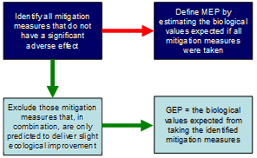 | 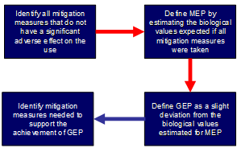
Figure 8.7.1: Steps involved in defining GEP using the alternative “Prague” approach (left side of figure) compared to the relevant steps in the approach described in CIS Guidance Document No. 4 (right side of figure); red arrows: steps following CIS method; green arrows: “Prague” modifications of CIS method.
Source: CIS Guidance Document nº4

8.7.3. To what extent has GEP been defined and which approach is used?
Only a few well developed and implemented methods for defining GEP could be identified in the first planning cycle.
So far, 3 Member States used the reference-based approach (see table 8.7.1). Some of these applications still need to be further developed to be fully in line with the WFD. In Germany, the reference-based approach has been applied by one Federal State, while the majority of States made use of the mitigation measures approach. In Slovakia, GEP is defined for rivers but no system has been developed for reservoirs.
A larger number of Member States in the 1st planning cycle based GEP definition on the mitigation-measures approach.
No clear information could be found in any of the plans on a comparison between the results of GEP definition on the basis of the mitigation-measures approach and results on the basis of the reference-based approach.
In some Member States, information on GEP definition is provided but it is not made explicit which of the two approaches or which elements of the two approaches (reference-based or mitigation-measures) are being used.
In a large number of Member States, GEP has not been defined at all or not to a sufficient extent yet. In several of these States, due to the lack of relevant monitoring data and classification systems for the ecological potential, the principles of ecological status assessment and expert judgment have been applied to classify HMWB and AWB.
In many RBDs, it is reported that as further monitoring data is gathered and intercalibration progresses, the GEP methodologies will be refined, clearly indicating a still on-going process.
An overview of the approaches used is presented in the following table. More details are available in the country specific parts of the Commission Staff Working Document.
Approach for GEP definition |  |  | Member States | GEP definition in biological terms | Scale of GEP criteria definition | Source
Reference-based approach (CIS) | All steps followed |  | - | - | - | -
Reference-based approach (CIS) | Some steps followed  (some steps only partially or not followed) |  | DE | Yes, to considerable extent  GEP defined on the basis of BQEs using the assessment methods for ecological status and considering changes in water category and type | Approach based on water types and water uses – applied on WB level | RBMPs assessment
Reference-based approach (CIS) |  |  | RO | Yes, to some extent  BQEs estimation of values based on statistical analysis of available data (mathematical basis for classes) and expert judgment (e.g. in estimating biological references for closest comparable water body type)  Some lack of data and monitoring stations  Some methods for sensitive BQEs still in development  GEP characterisation for coastal waters done with medium confidence so far. | Approach for water categories (rivers, reservoirs, lakes, coastal) | RBMPs assessment
Reference-based approach (CIS) |  |  | SK | Yes, to some extent  Use of assessment methods for ES and closest comparable water body of the same type (still gaps in ES assessment methods and data missing, to be completed by monitoring)  For each HMWB: definition of relevant type-specific BQEs, MEP for relevant QEs by expert judgement | Approach only for rivers (for reservoirs, in next cycle); method also WB-specific | RBMPs assessment
Mitigation measures approach (Prague) | All steps followed |  | - | - | -
Mitigation measures approach (Prague) | Some steps of approach followed  (some steps only partially or not followed) |  | FI | Yes, to some extent  Method estimates the % changes in the values of BQEs due to mitigation measures on water body level; based partly on expert judgment  Actual biological values at MEP and GEP are not estimated and not explicitly described. | Applied on WB level | RBMPs assessment  Presentation by Finland on GEP definition, CIS Workshop WFD & HMWB, 12-13.3.2009, Brussels
Mitigation measures approach (Prague) |  |  | DE | Yes, to some extent  Biological values at GEP not estimated, but in some cases there is expert judgement estimation (qualitative) of the biological effectiveness of mitigation measures on BQEs.  In general, the Prague approach has been accompanied by the use of biological assessment criteria for ES of natural WBs. | Approaches usually address different water categories and water body types | RBMPs assessment  RBMP supporting documents on GEP methods (for different Länder & RBDs)
Mitigation measures approach (Prague) |  |  | UK | No  Not possible to reliably predict a numeric value for BQEs in response to mitigation measures. Biological standards only applied to assess the impact of pollution pressures on HMWB/AWB and, in E&W, also to classify WBs impacted by abstraction.  Biological elements also considered in designing mitigation to improve ecological conditions. | Water-use specific checklists of mitigation measures - applied on WB level | RBMPs assessment  Presentation by the UK on GEP definition, CIS ECOSTAT Hydromorphology Workshop, 12-13.6.2012, Brussels
 | Unclear application of individual steps |  | FR | To little extent / no  Combination of Prague approach and available data regarding status  GEP class boundaries based on intensity of hydromorphological pressures and BQEs not sensitive to hydromorphology, e.g. diatoms, chlorophyl-a (expert judgement) | Definition of HMWB types based on uses and modifications – applied on WB level | RBMPs assessment  Annex V of Decree of 25 January 2010 on the methods and criteria for assessing the ecological status, chemical status and ecological potential of surface water  Presentation by France on GEP definition, CIS Workshop WFD & HMWB, 12-13.3.2009, Brussels
 |  |  | DE | Unclear  In some cases mention of expert judgement and use of classification methods for assessing ES | Applied on WB level | RBMPs assessment  RBMP supporting documents on GEP methods (for different Länder & RBDs)
 |  |  | IE | To little extent / no  Measures-based hydromorphological classes combined with interim ES (based on biology and physico-chemical data). | Applied on WB level | RBMPs assessment  Surface water Status Group (2008). Report on the Interim Classification of Ecological Potential and identification of measures for Ireland’s HMWB. Towards the draft River Basin Management Plan, December 2008.
 |  |  | SE | No | Use-specific approach in progress (hydropower) | RBMPs assessment
 |  |  | DK | Unclear (information incomplete) | Unclear (information incomplete) | RBMPs assessment
Combination or both approaches used (reference-based & Prague approach) |  |  | NL  Both; different for HMWB & AWB | Yes, to considerable extent  Prague for HMWW: Effect of measures estimated in EQR per WB and added to present status (for each BQE)  Reference-based for AWB: Based on data availability for reference conditions of “best” ditches and canals | Approaches for HMWB and AWB  Applied on WB level | RBMPs assessment  Presentation by the NL on GEP definition, CIS ECOSTAT Hydromorphology Workshop, 12-13.6.2012, Brussels  Ministry of Transport, Public Works and Water Management (2005). Dutch MEP/GEP Guidelines (Handreiking MEP/GEP).
 |  |  | AT  Combination; closer links to Prague approach | Yes, to some extent (qualitatively)  MEP and GEP definition include a verbal description of the ecological status for fish (only) to be achieved (but no specific values)  Verbal description of MEP and GEP in biological terms and effects of mitigation measures (on a qualitative scale) are based on expert judgement | Use/pressure specific guidance - applied on WB level | RBMPs assessment
 |  |  | LT  Both (primary use Prague approach; secondary reference-based approach) | Yes, to some extent  GEP related to GES of natural WBs: for lakes, ponds and transitional waters MEP equals HES and GEP equals GES; for straightened rivers, MEP equals GES of natural water bodies and GEP equals moderate status.  GEP definition tested by field surveys using comparison of natural water bodies and HMWB of the same water body type  Possible impact of mitigation measures tested by field surveys. | For water categories (rivers – straightened rivers and canals; lakes, ponds, quarries; transitional waters) | RBMPs assessment
 |  |  | DE  Elements of both approaches | Yes, to some extent  Saarland : For macroinvertebrates only, class limits proposed for maximum, good, moderate, poor, bad potential  Thüringen : For fish and macroinvertebrates, BQE values calculated using mathematical/empirical models | Applied on WB level | RBMPs assessment  RBMP supporting documents on GEP methods (for different Länder & RBDs)
GEP defined but not made explicit which of two approaches is used |  |  | BE-Flanders | Yes, to considerable extent  Calculation of GEP values (for all BQEs) in relation to GES and current status due to irreversible pressures | Generic approach for rivers  WB-specific for lakes and transitional waters | RBMPs assessment  Presentation of BE to COM on Approach to define GEP in Flanders, 11.6.2012
 |  |  | ES-Catalonia | Yes, to some extent  Rivers: expert judgement on expected populations of fish, macro-invertebrates and diatomeas ; Impoundments : Use of an ecological potential index; Lakes, trasitional and coastal waters (close to coast) : GEP considered similar to good status of natural waters of respective type. | For water categories (impoundments, rivers, lakes, transitional, coastal) | RBMPs assessment
 |  |  | SI | To little extent  For rivers and for BQE of macroinvertebrates only : GEP defined on the basis of an index, assessing hydromorphological impacts on communities of organisms; moderate/poor boundary of index for ecological status of base type of river is used as good/moderate boundary for ecological potential | For rivers only | RBMP assessments
GEP defined to limited extent |  |  | CZ (lakes), HU, BG, CY, EE | - | - | RBMP assessments
GEP not defined |  | Reference made to the use of GES | IT, LU, PL, CZ (rivers), LV, DE | - | - | RBMPs assessment
 |  | No definition | MT | - | - | RBMPs assessment
Table 8.7.1: overview of the approaches used in different Member States for the definition of GEP
Source: The European State questionnaires on Hydropower and the WFD. 2nd Workshop on Water Management, Water Framework Directive and Hydropower. Brussels, 13-14 September 2011 (http://www.ecologic-events.de/hydropower2/background.htm )

8.7.4. Translating ecological potential into a biological target
Progress in 'translating' ecological potential (based on mitigation without significant impacts on the use) into biological targets differs among Member States. Overall, information in the plans on how ecological potential has been defined in biological terms is relatively scarce.
Table 8.7.1 above gives among others indications on the definition of GEP in biological terms for different Member States, bearing in mind the following: the derivation of numerical values or other value approximation for BQEs (especially BQEs sensitive to hydromorphological alterations) and/or specific assessments of the ecological changes due to mitigation measures.
So far, there are few well developed approaches for quantifying biological targets for ecological potential at water body level. Such examples are found in Member States which used the reference-based approach (Germany – State of Bavaria), the mitigation-measures approach (The Netherlands), or other approaches (Belgium-Flanders). In these cases, it has been possible to calculate values of BQEs at GEP for the main types of HMWB and AWB. In the Netherlands, which used the mitigation-measures approach for HMWB, the effects of mitigation measures have been estimated in Ecological Quality Ratios per water body and added to the present status for the purpose of defining GEP.
Several other Member States have made to some extent progress in the biological definition of GEP. In Member States using the reference-based approach, the estimation of BQE values is based on analysis of available data, information on closest comparable water body types and expert judgement. Limitations result from gaps in relevant data and monitoring and the lack of fully developed assessment methods for certain BQEs.
In most Member States using the mitigation measures approach, it has not been possible to estimate numerical values of BQEs. However, there have been several qualitative estimations of the biological targets, using expert judgement. For example, in Finland, the % change in values of BQEs due to mitigation measures is estimated on water body level and, in AT, GEP is verbally described in biological terms (for fish) setting a biological goal for the mitigation measures.
In the same time, in other Member States applying the mitigation measures approach, GEP definition in biological terms has not taken place so far or the information provided is not explicit and clear in this respect.
Overall, information in the RBMPs indicates that GEP definition is a learning process. In several plans, it is made clear that approaches are still incomplete and more work is required or even under way for the next planning cycles on the development of harmonised GEP methods using biological quality elements sensitive to hydromorphological changes.

8.7.5. Scale of GEP definition
Methods for defining ecological potential are water-body specific only in 44% of RBDs. In 29% of RBDs, definition of ecological potential is water use specific and in 27% of RBDs, water body type specific. In certain RBDs, the method is a combination of water-body specific and water use specific methods (e.g. Austria, UK).

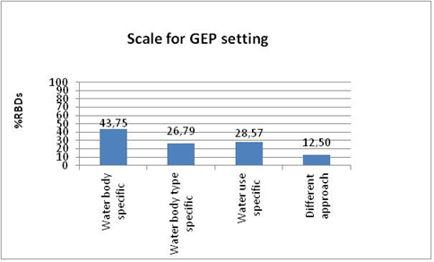

Figure 8.7.2:Scale at which the GEP has been defined
Source: RBMPs

8.7.6. Defining Maximum Ecological Potential
In the majority of RBDs, only good ecological potential (GEP) is defined, whereas in ca. 85% of RBDs, maximum ecological potential (MEP) is not defined or no information is found on the techniques for estimating biological values at MEP.
In ca. 15% of RBDs, the estimation of biological values at MEP has been done on the basis of expert judgement. Similarly, it has often been reported that GEP is defined on the basis of expert judgement and in relation to the principles of GES assessment (e.g. potential is status minus 1 class), due to the lack of appropriate monitoring data and specific classification systems. In the same time, no clear information is found in the plans on the comparability between defined GEP and good ecological status (GES), with the exception of few Member States (e.g. Belgium-Flanders, the Netherlands).

8.7.7. Mitigation measures and expected ecological improvements
In 35% of RBDs, specific mitigation measures have been considered and reported. In 20% of RBDs, mitigation measures have been considered but no reference was found which measures specifically. In 23% of RBDs, no reference was found to mitigation measures.
Mitigation measures in the RBMPs are frequently referenced as measures to improve hydromorphological conditions (and the related ecological status/potential) in the programmes or catalogues of measures, without clarifying whether and how these measures have been used for the GEP/MEP definitions. Often, the mitigation measures without significant adverse effects on the use or the wider environment used for MEP/GEP definition are not explicitly listed in the RBMP.
In some cases, lists of possible mitigation measures for GEP/MEP definition are given but no definitive list of the measures that have no significant adverse effects on the use, depending on the nature and characteristics of the specific water bodies being assessed.
The ecological changes that the mitigation measures are designed to achieve are described in only ca. 12% of RBDs. In 24% of RBDs, there is some general information on ecological improvements of mitigation measures but the ecological benefits of individual measures remain unclear. In a large number of the RBDs, there is no explanation of the expected ecological changes. Considering the key role of mitigation-measures in GEP definition, this is clearly an information gap. Mitigation measures need to be linked to specific ecological improvement targets to set the environmental objective of HMWB and AWB.

8.7.8. Conclusions
- In the first RBMPs, only a few well developed and implemented methods for defining GEP could be identified. In many Member States, GEP has not been defined in the first planning cycle or not to a sufficient extent.
- Progress in 'translating' ecological potential into biological targets also differs greatly among Member States. There are only a few well developed approaches for quantifying biological targets for GEP at water body level. In some Member States, especially those which applied the mitigation-measures approach, the estimation of biological values for the ecological potential is done in qualitative way using partly expert judgement.
- In several plans, it is made clear that approaches for GEP definition are still incomplete and more work is required or even under way for the next planning cycles on the development of harmonised GEP methods using biological quality elements sensitive to hydromorphological changes.
- Mitigation measures have been considered in ca. 2/3 of the RBMPs but the selection of those measures that have no significant adverse effects on the use or the wider environment (for MEP/GEP definition) is often not made explicit. Only in a few cases, the ecological improvements that the individual mitigation measures are designed to achieve are described.

8.7.9. Recommendations
- RBMPs or accompanying technical documents need to make explicit which of the two approaches discussed in the context of the CIS to define GEP is being used (reference-based or mitigation measures approach). If another approach is used, it should be clear which elements of the two approaches discussed in the CIS are used / combined and why.
- All approaches for GEP definition (reference-based approach, mitigation-measures approach or other approach) should be drivers for ecological improvement and should be able to deliver comparable results in terms of ecological improvements on the ground.
- The environmental objective of GEP is not just a list of mitigation measures but it is about the ecological change those measures are designed to achieve. The ecological changes that mitigation measures are designed to achieve should be clearly reported (part of objective setting for HMWB). In this context, it is essential that RBMPs are explicit about the approach used to biologically validate the results of GEP definition. HMWB should not be classified only on the basis of principles of ecological status assessment but it is necessary to use biological assessment methods that are sensitive to hydromorphological alterations. It is also recommended to compare the ecological quality represented by GEP with class boundaries of ecological status (reality check on GEP).
- Mitigation measures without significant adverse effects on the use or wider environment need to be clearly indicated in defining GEP and criteria for the 'significance' of adverse effects need to be transparently identified (also linked to HMWB designation). RBMPs should indicate in a transparent and clear manner the mitigation measures which are considered and the mitigation measures which are not considered due to their significant adverse impact on the use.
- More transparency is also needed on specific criteria used in the context of GEP definition, e.g. criteria to define significant adverse impacts of mitigation measures on the use or the wider environment. The RBMPs should show explicitly that the financial costs of mitigation measures are not included in the objective setting for HMWB and AWB.

8.8. Assessment of groundwater status

8.8.1. Requirements of the WFD
The groundwater related aspects of the WFD cover a number of elements to be considered by the Member States. Article 4.1(b) of the WFD specifies five objectives for groundwater that are to be met:
- Prevent or limit the input of pollutants.
- Prevent the deterioration of status of groundwater bodies.
- Achieve good groundwater status (both chemical and quantitative).
- Implement measures to reverse any significant and sustained upward trends of concentrations of pollutants.
- Meet the requirements of protected areas.

This chapter discusses the requirements related to groundwater status.
Overall 13,261 groundwater bodies were identified and reported in Europe. More than half of them are located in Finland and Sweden, mainly due to the specific hydrogeological situation in these Member States. About 87% of all groundwater bodies are in good quantitative status and about 80% were reported to be in good chemical status.
Overall, for 2009 about 74% of the 13,261 groundwater bodies (representing 63% in terms of area) were reported to be both of good chemical and quantitative status which is expected to increase to 80% in 2015 (representing 68% in terms of area). Member State specific information can be found in WFD aggregation table GWB_STATUS_2015.

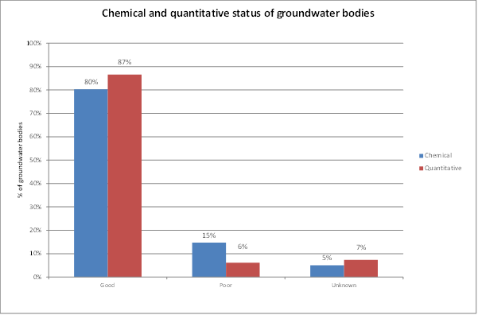

Figure 8.8.1: Percentage of groundwater bodies achieving good, poor or unknown chemical and quantitative status
Source: WISE

The figure above shows a relatively high percentage of groundwater bodies in good status in Europe but it is also necessary to consider the differences in the methodologies how the assessment of the groundwater status was done by Member States.

8.8.2. Groundwater chemical status
The definition of chemical status is set out in WFD Annex V (2.3.2). Good groundwater chemical status is achieved when there is no saline intrusion in the groundwater body, when monitoring data do not exceed relevant standards and when concentrations in groundwater do not result in failure of status of associated surface waters nor any significant diminution of the ecological or chemical quality of such bodies nor in any significant damage to terrestrial ecosystems which depend directly on the groundwater body.
About 80% of almost 13,300 groundwater bodies (representing 72% in terms of area) were reported to be of good chemical status in 2009, for 5% of the groundwater bodies (3% in terms of area) the status is unknown, and nearly 2,000 groundwater bodies (~15% in terms of numbers and 25% in terms of area) were reported to be of poor chemical status.
Poor status is mainly caused due to exceedance of groundwater quality standards or threshold values affecting nearly 12% of all groundwater bodies in 21 Member States (and more than 75% of those in poor status) and the main responsible pollutant is nitrate. The second most common reason for poor chemical status (4% of all groundwater bodies) in 13 Member States is the deterioration in quality of waters for human consumption and the significant impairment of human uses. It should be noted that poor status of a groundwater body can be caused by more than one reason.

8.8.2.1. Consideration of associated surface waters and GW dependent terrestrial ecosystems
The health of associated surface waters and groundwater dependent terrestrial ecosystems is a key element in the assessment of groundwater body status and hence their proper consideration in the assessment procedure via the groundwater threshold values.
Two thirds of the RBMPs (68%, from 15 Member States) reported the consideration of these elements in the groundwater status assessment, but it is not clear in a lot of cases whether this is only a theoretical consideration or whether the considerations were taken into account and put into practice. For the remaining 32% of RBMPs no such information was reported or it was unclear whether these elements were considered in the status assessment.
The failure to meet environmental objectives in associated surface water bodies or significant diminution of the ecological or chemical status of such bodies was reported to cause poor status in 189 (1.5%) groundwater bodies (from 6 Member States), but significant damage to terrestrial ecosystems which depend directly on the groundwater body was only reported for 6 groundwater bodies (from 3 Member States) to cause poor status.
Several Member States reported a considerable lack of knowledge in assessing the needs of terrestrial ecosystems and the interaction between groundwater and these ecosystems. It needs specific attention and considerable efforts to bridge this gap in the coming years. This gap was also confirmed by the background document "In-depth assessment of the differences in groundwater threshold values established by Member States" which revealed that environmental quality standards and threshold values were only reported by the Member States to be considered for aquatic ecosystems but not for terrestrial ecosystems.

8.8.2.2. Groundwater threshold values
Regarding the provision of not exceeding relevant standards, the Groundwater Directive 2006/118/EC (GWD) provides EU-wide groundwater quality standards for nitrates and pesticides and requests Member States to establish further national groundwater quality standards (referred to as ‘threshold values’) taking into account identified risks and the indicative list of substances given in Annex II of the GWD. This approach considers the actual risks identified by the analysis of pressures and impacts under Article 5 of the WFD and the high natural variability of substances in groundwater (depending upon hydrogeological conditions, background levels, pollutant pathways and interactions with different environmental compartments).
The groundwater bodies at risk of not meeting good chemical status at the end of the RBMP cycle and the parameters responsible for such a classification play an essential role in the compliance regime, both through the establishment of groundwater threshold values and the assessment of good chemical status, as groundwater bodies not identified at risk can automatically be classified as being of good status. Threshold values should be established for all pollutants that characterise groundwater bodies at risk of not achieving the good chemical status objective and this should be done at the most appropriate level, e.g. Member State, RBD or groundwater body level. The GWD provides general guidelines on how to establish threshold values (Annex II).
The WFD requirement of considering the list of substances given in Annex II GWD and all pollutants posing risk in the establishment of threshold values was met by nearly all Member States (24). In total, threshold values were established for about 560 different substances or indicators but it is not clear which of these substances or indicators from this impressive list pose an actual risk to groundwater bodies of not meeting good status in 2015. Many of these reported threshold values seem not to be established as a result of an actual risk but to enable risk and status assessment.
The GWD requirement (Annex II Part C (a) WFD) to include, where feasible, information on the number of bodies or groups of bodies of groundwater characterised as being at risk, and on the pollutants and indicators of pollution which contribute to this classification in the RBMPs was met by only half of the Member States. One of the reasons for this reporting gap could be that this information should have already been included in the recent reporting of groundwater risk in the form of the WFD Article 5 report on the analysis of pressures and impacts (due in 2005) and the assumption by many Member States that the situation concerning the risk remained unchanged and still valid.
In the case of naturally-occurring substances the GWD (Annex II Part A and C) requires the consideration of natural background levels of substances when establishing threshold values and reporting on the relationship between the threshold values and the observed background levels. Such a consideration was reported by 23 Member States in 102 RBMPs. The relationships between the threshold values and the background values vary considerably from Member State to Member State depending on the national approaches taken. Figure 8.8.2 illustrates the different national approaches which were applied and which then lead to different levels of threshold values.
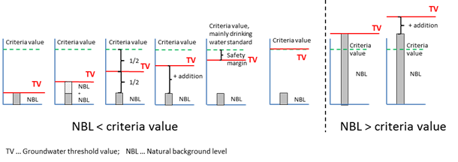
Figure 8.8.2: Different approaches for deriving groundwater threshold values (TV) considering natural background levels (NBL) and criteria values, leading to considerably different TVs.
Note: Criteria value is the concentration of a pollutant, not taking into account any natural background concentrations, that if exceeded may lead to a failure of the good status criterion concerned.
Source: Background document "In-depth assessment of the differences in groundwater threshold values established by Member States"

In 2 Member States (4 RBMPs) the background values were reported as not considered in the threshold values but later in the compliance assessment. In 13 RBMPs of 4 Member States no details on the consideration of background levels were mentioned.
Not only the relationships between the threshold values and the of background levels vary between Member States but also the methodologies for calculating such background levels differ due to the individual national approaches taken.
The evaluation of compliance is based on a comparison of monitoring data with quality standards and threshold values. In principle no groundwater body is allowed to exceed these standard values and in case of an exceedance at one or more monitoring points good status is still possible. In this case, an appropriate (case by case) investigation should confirm that such exceedance may be due to a local pressure (e.g. point source pollution) that does not endanger the status of the overall groundwater body concerned (Annex III GWD). Nevertheless, although the whole groundwater body is still in good status despite of local exceedance, measures need to be implemented to control and possibly remediate such pollution. Only 8 RBMPs reported that no exceedance of quality standards or threshold values at any monitoring point in groundwater bodies of good status occurred and 46 RBMPs reported such exceedance. In 54 RBMPs no related information was reported.
The background reports relating to the RBMPs showed that the extents of acceptable exceedance are calculated by different national approaches, either by considering the number of monitoring sites (12 Member States), the affected (weighted) area (9 Member States), the affected GWB volume (3 Member States) or by expert judgements for which further information was not provided (and which are therefore not comparable at the European level). The acceptable extent of a GWB which might exceed quality standards or threshold values, where the conditions of good chemical status are still met, varies from a fixed value of 25 km² to 10% up to 50% of the monitoring points / area / volume. But expert judgment was also reported without further specifying the underlying criteria. Most of the Member States (11), where information was available, reported 20% as an acceptable extent of exceedance, 4 Member States reported 30% and 2 others reported 33%.
The background document "In-depth assessment of the differences in groundwater threshold values established by Member States" contains more details on the assessment of the different methodologies of compliance regime and of threshold value establishment used in Member States and reveals that threshold values established in Europe are hardly comparable.

8.8.2.3. Trend and trend reversal assessment
According to the WFD Member States need to identify significant and sustained upward trends in concentrations of pollutants. The details are laid down in Annex IV of the GWD which requires - among others - that the assessment is based on a statistical method.
68 RBMPs reported by 17 Member States reported that trend assessments have been performed, in 57 RBMPs the assessment methods have been described and it can be concluded that mainly statistical methods were applied as required by the GWD. The length of the considered time series varies considerably starting mainly from 1995 up to 2008. Due to the fact that in many groundwater bodies in Europe monitoring started in December 2006 under the WFD with the surveillance monitoring, performing trend assessment is currently premature. A more complete picture on trends is expected in 2015 with time series of WFD monitoring of seven years (in case of operational monitoring).
Additional trend assessments are required by the Article 5.5 GWD to assess the impact of existing plumes of pollution resulting from point sources and contaminated land and to verify that these plumes do not expand and do not present a risk for human health and the environment. Only very few RBMPs reported the application of such an additional trend assessment without providing details and it is not clear whether such assessments were performed already or are to be performed. Some Member States mentioned that it is not applicable in their territory; others reported that the available data are not sufficient; some RBMPs mentioned that such an assessment is done by modelling.
Each significant and sustained upward trend needs to be reversed by implementing appropriate measures and such a trend reversal needs to be demonstrated by the Member States. 23 RBMPs of 6 Member States already reported information on the establishment of such a methodology whereas 42 RBMPs of 9 Member States stated that a methodology is not yet defined. Trend reversal assessment usually needs the assessment of a trend first therefore longer time series will be necessary to complete them. Even in 2015 trend reversal assessments might not be carried out in every RBD.

8.8.3. Groundwater quantitative status
The definition of quantitative status is set out in WFD Annex V (2.1.2). Good groundwater quantitative status is achieved when the level of groundwater in the groundwater body is such that the available groundwater resource is not exceeded by the long term annual average rate of abstraction. Accordingly, the level of groundwater is not subject to anthropogenic alterations such as it would result in failure to achieve the environmental objectives for associated surface waters; any significant diminution in the status of surface waters; and any significant damage to groundwater body dependent terrestrial ecosystems. Furthermore, there is no anthropogenic caused saline or other intrusion.
About 87% of the 13,261 groundwater bodies (84% in terms of area) were reported to be in good quantitative status in 2009, for 7% of the groundwater bodies (4% in terms of area) the status is unknown and nearly 800 groundwater bodies (~6% in terms of numbers and 12% in terms of area) were reported to fail good quantitative status, mainly due to the exceedance of the available groundwater resource by the long-term annual average rate of abstraction.
Failure to meet environmental objectives in associated surface water bodies or significant diminution of the ecological or chemical status of such bodies was reported for rather few groundwater bodies (326) from 10 Member States. Significant damage to terrestrial ecosystems which depend directly on the groundwater body was reported for only 38 groundwater bodies from 5 Member States.
Most of the RBMPs (93%) reported on the considered elements in the quantitative status assessment. The comparison of the available groundwater resource with the long-term annual average rate of abstraction in the assessment of quantitative status was considered in all of these RBMPs. The further elements like the diminution of the status of associated surface water bodies was reported to be considered by 53% of these RBMPs, damage to groundwater body dependent terrestrial ecosystems by 76% and saline and other intrusion were reported to be considered by 74% of these RBMPs. For 7 % of the RBMPs the considered criteria were not described or the information was unclear.
About 72% of the RBDs which reported information on the considered elements in the status assessment mentioned that the needs of dependent terrestrial ecosystems have been assessed.
In total 56% of all RBMPs reported that the definition of ‘available groundwater resource’ was fully or partly applied in accordance with Article 2.27 WFD. Therein, ‘available groundwater resource’ is defined as the long-term annual average rate of overall recharge of the body of groundwater less the long-term annual rate of flow required to achieve the ecological quality objectives for associated surface waters specified under Article 4, to avoid any significant diminution in the ecological status of such waters and to avoid any significant damage to associated terrestrial ecosystems. For the remaining 44% of RBMPs the respective information was not found or rather unclear.
A bit more than half of the RBMPs reported that the balance between recharge and abstraction of groundwater was assessed in order to verify whether the available groundwater resource is exceeded. In the remaining 46 RBMPs (43%) the respective information was not found or rather unclear. The methodologies described very often compare the abstractions with the recharge (considering a safety margin) others conclude from stable groundwater levels to an appropriate balance between recharge and abstraction, while some Member States combine both assessments. Ecological flow needs were frequently mentioned to be considered in the assessments.

8.8.4. Drinking water protected areas
In total about 28,000 groundwater related drinking water protected areas (DWPA) according to Article 7 of the WFD were reported by Member States. About 12,500 (45%) were reported to be in good status, 322 (1%) are failing good status and for more than 15,000 groundwater DWPAs (54%) the status has not been reported.
More than half (6,669) of the identified groundwater bodies are associated with DWPAs. The percentage of groundwater bodies within a Member State associated to DWPAs range from about 9% up to 100%. Most of these groundwater bodies are only linked to one DWPA but 772 of these groundwater bodies are associated to six and more DWPAs.
This very close linkage between groundwater and drinking water use is very well reflected in the established threshold values, which are in many cases primarily derived from drinking water standards.

8.8.5. Transboundary co-ordination
Where groundwater bodies are shared between two or more Member States it should be ensured that the establishment of threshold values is co-ordinated between the relevant Member States (Article 3.3 GWD) and where EU Member States share groundwater bodies with countries that are not in the EU, the Member States should endeavour to establish threshold values with the non-EU countries concerned (Article 3.4 GWD).
15 Member states reported having transboundary groundwater bodies. For 22 RBDs (from 9 Member States) co-ordination of the establishment of their threshold values with all (17 RBDs, 7 Member States) or at least some (5 RBDs, 2 Member States) of the neighbouring countries was explicitly reported. For further 40 international RBDs (from 15 Member States), no such transboundary co-ordination activities were reported. (47 RBDs are national RBDs).

8.8.6. Conclusions
Overall, about 74 % of the groundwater bodies (representing 63% in terms of area) were reported to be both in good chemical and quantitative status in 2009 which is expected to increase to 80% in 2015 (representing 68% in terms of area).
About 80% of the groundwater bodies were reported to be in good chemical status in 2009, but nearly 2,000 groundwater bodies were reported to be still in poor chemical status and for 5% of the groundwater bodies the status is still unknown. Poor status is mainly caused due to the exceedance of groundwater quality standards or threshold values affecting nearly 12% of all groundwater bodies in 21 Member States and the main responsible pollutant is nitrate.
About 87% of the groundwater bodies were reported to be in good quantitative status in 2009, but nearly 800 groundwater bodies were still reported to fail good quantitative status, mainly due to the exceedance of the available groundwater resource by the long-term annual average rate of abstraction. For 7% of the groundwater bodies the status is still unknown.
Although quite high percentage of groundwater bodies are considered to be in good status the methodologies used show significant shortcomings that puts in question the results of the status assessment.
It is not clear in a lot of cases whether – besides theoretical considerations - associated surface waters and groundwater dependent terrestrial ecosystems were practically included in the groundwater status assessment. Environmental quality standards and threshold values were only reported to be considered for aquatic ecosystems but not for terrestrial ecosystems. Member States reported a considerable lack of knowledge in assessing the needs of terrestrial ecosystems and the interaction between groundwater and these ecosystems.
Regarding the establishment of groundwater threshold values nearly all Member States (24) met the requirement of considering the list of substances given in Annex II GWD and of all pollutants posing a risk on groundwater bodies. In total, threshold values were established for about 560 different substances/indicators. However it makes extremely difficult to compare these threshold values as national approaches vary considerably in Member States in terms of relationships between the threshold values and the background values, the methodologies for calculating such background levels and the extents of acceptable threshold value exceedance. As mentioned in the section on groundwater monitoring, the core parameters are not monitored everywhere that makes the compliance assessment even more difficult.
17 Member States reported that some, not always complete trend assessments have been performed while establishment of a trend reversal methodology was reported only by 6 Member States. A more complete picture on trends is expected in 2015 with time series of WFD monitoring of at least seven years.
The information included in the RBMPs on the status of drinking water protected areas is scarce: for more than half of those areas the status was not reported even though most of the established threshold values are primarily derived from drinking water standards representing the main groundwater use.
Regarding groundwater quantitative status the methods for calculating groundwater recharge, abstraction and their balance as well as available groundwater resource are different in Member States and in a number of cases those methods are not transparent. It is also not clear whether associated surface waters and groundwater dependent terrestrial ecosystems were included in the assessment in practice.
15 Member States reported having transboundary groundwater bodies, but only 9 of them reported explicitly on the co-ordination of the establishment of their threshold values with all (7 Member States) or at least with some (2 Member States) of the neighbouring countries.

8.8.7. Recommendations
- Reliability of the status assessment should be improved by extended monitoring and by correctly applying all the required elements of status and trend assessments.

- RBMPs should clearly address all elements specified in the WFD related to both the good chemical and the good quantitative status of groundwater. RBMPs should clearly report the reasons for not considering certain elements.

- Groundwater bodies characterised as being at risk and the pollutants that contribute to this classification should be reported in the RBMPs.

- RBMPs should clearly indicate whether all substances causing a risk of not meeting good chemical status and all Annex II substances were considered in the establishment of groundwater threshold values and what are the results of these considerations.

- Information on exceedances of quality standards and/or threshold values should be reported also for groundwater bodies in good chemical status.

- Groundwater dependent ecosystems and groundwater associated surface water bodies should always be considered. Member States should take the opportunity of sharing and exchanging experience gathered so far regarding the interconnections between groundwater and the ecosystems and regarding the needs of the ecosystems e.g. in the frame of the Common Implementation Strategy of WFD. Knowledge gaps need to be filled with appropriate studies to inform the RBMP process.

- Methodologies for the establishment of threshold values need to be transparent and better harmonised among Member States. Acceptable extent of exceedance of quality standards and threshold values should be based on transparent criteria considering CIS guidance documents.

- Trend assessments should be completed in the second RBMP cycle and trend reversal assessment should be implemented as far as data series allow.

- The definition of ‘available groundwater resource’ according to Article 2.27 of the WFD should be fully applied and reported.

- Methodologies to calculate the balance between recharge and abstraction of groundwater should be transparent and better harmonised between Member States. Ecological flow should be considered.

- Information on the status of drinking water protected areas should be included in the RBMPs.

- Transboundary co-ordination of the establishment of threshold values should be applied in all transboundary groundwater bodies.

8.9. Environmental objectives and exemptions

8.9.1. The requirements of the WFD
The WFD defines its environmental objectives in Article 4 and sets the aim for long-term sustainable water management. Article 4(1) defines the WFD general objective to be achieved in all surface and groundwater bodies, i.e. good status or potential (for HMWBs) by 2015, and introduces the principle of preventing any further deterioration of status. A number of exemptions to the general objectives are possible under certain conditions. Article 4(4) allows for an extension of the deadline beyond 2015, Article 4(5) allows for the achievement of less stringent objectives, Article 4(6) allows a temporary deterioration in the status of water bodies and Article 4(7) sets out conditions in which deterioration of status or failure to achieve certain of the WFD objectives may be permitted for new modifications to the physical characteristics of surface water bodies, and deterioration from high to good status may be possible as a result of new sustainable human development activities.
The WFD provides the general framework on exemptions but there is scope for differences in understanding and implementation. From the outset of implementation it was clear that the use of exemptions needed to be explained further and the rules for application had to be made clearer. These clarifications can be found in the guidance document on exemptions, which was developed over several years.

8.9.2. Setting environmental objectives
The WFD sets environmental objectives for the whole aquatic ecosystem. The development of these objectives requires a complex process from setting reference conditions, characterising water bodies, monitoring current status and estimating the effectiveness of measures. At the end of this process achieving good status cannot always be possible in the time frame provided by the WFD and the above mentioned exemptions might be applied.
In 2009, 42% water bodies were in good or high status and the water bodies expected to reach good status in 2015 represent 52% of water bodies. It is difficult to establish the percentage of water bodies that will achieve good status in 2021 and 2027 as Member States have rarely provided that information in the RBMPs (reported by fewer than 10 Member States).
Among other things, the ecological status conclusions in future plans, and the comparability of the results, will depend to an extent on the efforts made by Member States to consistently identify river basin specific pollutants and set harmonised standards for them.
The information provided on chemical status has been very limited and not consistent (see chemical status chapter). More than 40% of the surface water bodies are reported as having ‘unknown chemical status’. The assessment of chemical status for the other 60% of water bodies is not comparable. Therefore, it is not possible to present a reliable picture of surface water chemical status and expected progress at EU level.
The information provided in the RBMPs on chemical status is not sufficiently clear or complete to establish a baseline for 2009. It is worth recalling that the objective of good chemical status refers only to the 33 priority substances identified in 2001 plus 8 other pollutants that were subject to earlier regulation. The chemical quality of water bodies has significantly improved in the last 30 years but the situation as regards these priority substances introduced by the WFD is unclear. A large proportion of water bodies are reported as unknown status. In addition, the first RBMPs show different degrees of implementation of the Directive 2008/105/EC setting Environmental Quality Standards, which makes the status assessment difficult to compare.
For groundwater, 80% of groundwater bodies were already in good chemical status and 87% are in good quantitative status in 2009. For 2015 an increase of groundwater bodies achieving good status is foreseen in the RBMPs, which would be at good quantitative status for 96% of groundwater bodies and at good chemical status for 89%.
 | No of MS | No of water bodies | % Water bodies in good status or potential 2009 | % Water bodies in good status or potential 2015 | Progress 2009-2015 in % | Unknown status in 2009 in %
Ecological status of surface waters | 21 | 82684 | 43 | 53 | 10 | 15
Chemical status of surface waters | Information unclear to establish the 2009 baseline |  |  |  |  | 40
Quantitative status of groundwater | 24 | 5197 | 85 | 92 | 7 | 6
Chemical status of groundwater⁷⁴ | 24 | 51797 | 68 | 77 | 9 | 3
Table 8.9.1: Water bodies in good status in 2009 and 2015
Source: Information reported by member States in 2012
The number of exemptions applied varies significantly in the different Member States. However it should also be noted also the starting point (water bodies already in good or high status) also differs significantly.
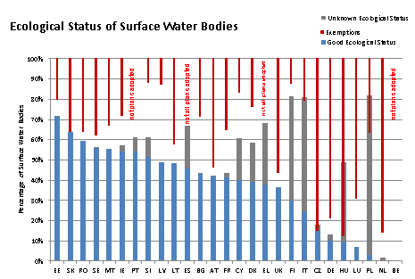

Figure 8.9.1: Water bodies in good ecological status and use of exemptions
Note: No exemptions reported for ES, EL and PT as not all plans have been adopted and reported
Source: WISE

The lack of information on expected status for future planning cycles (2021 and 2027) is a major concern given that almost half of water bodies are not expected to be in good status by 2015. Only around 20% of the reported RBMPs include information on expected ecological status of surface waters by 2021 and 2027 and only between 15% and 18% for chemical status of surface waters. For groundwater, the expected quantitative status has been reported only for 28% of RBMPs, while the chemical status has been reported for almost 40% of the plans.
The uncertainties in the whole planning process are important and have a considerable impact in the establishment of environmental objectives and exemptions to those objectives. The uncertainties of particular concern are those with regard to the status assessment (lack of full developed methods for ecological status), the gaps in the monitoring programmes, and the effectiveness and expected rate of improvement of the proposed measures. In most cases RBMPs state that further investigations are required to confirm the status of a water body and to confirm the extent of impacts or to identify appropriate measures and their effectiveness.
It is stated in the following basins that the application of exemptions that have been co-ordinated in a transboundary context: Ems, Odra, Meuse, Schlei/Trave, Rhine, Danube, Elbe, Venta, Lielupe, Daugava, Scheldt and Solway Tweed (see section 8.1 on Governance).

8.9.3. Additional objectives in protected areas
Article 4(1)(c) describes the objectives for protected areas such as for Drinking Water, Shellfish, Bathing Water and Natura 2000. For water bodies which are in a protected area, the environmental objectives set need to go beyond good status because more stringent objectives have been set for those areas in the relevant Community legislation under which the individual protected areas have been established.
 | Number of Protected Areas
Country | Article7 Abstraction for drinking water | Bathing | Birds | European Other | Fish | Habitats | Local | National | Nitrates | Shellfish | UWWT
AT | 231 | 268 | 54 |  | 71 | 93
BE | 168 | 2 | 17 |  |  | 27 |  | 1 | 2 | 1 | 2
BG | 331 | 93 | 111 |  | 106 | 231 |  | 103 | 4 | 8 | 22
CY | 18 | 113 |  |  |  | 36 |  |  | 5 |  | 2
CZ | 2.673 | 188 | 15 |  |  | 439 |  | 746 | 6.040
DE | 1.418 | 2.271 | 1.022 | 295 |  | 4.878 |  |  | 139
DK | 368 |  | 113 |  |  | 257 |  |  |  | 36
EE | 2 | 89 | 73 |  | 111 | 542 |  |  | 2
EL | 150 | 2.108 | 181 |  |  | 273 |  |  | 11 |  | 48
ES | 25.857 | 1.515 | 519 | 134 | 156 | 1.125 | 1025 | 1.302 | 366 | 201 | 440
FI | 2.302
FR | 28.978 | 3.342 | 314 | 42 |  | 771 |  |  | 8 | 83 | 64
HU | 1.756 | 265 | 55 |  | 7 | 467 |  | 210 | 1 |  | 3
IE | 943 | 126 | 136 |  | 31 | 420 |  |  | 7 | 63 | 42
IT | 6.023 | 1.645 | 474 | 8 | 566 | 1.725 | 718 | 43 | 92 | 141 | 213
LT | 1.305 | 99 | 88 | 31 |  | 427 | 185 | 1.005 | 4 |  | 4
LU | 84 | 4 | 13 |  |  | 30 |  |  | 2 |  | 2
LV | 2 | 222 |  |  | 196 | 308 |  |  | 56
MT | 7 |  | 3 |  |  | 9 |  | 1 | 1 |  | 8
NL | 31 | 644 | 90 |  |  | 159 |  |  |  | 9
PL | 357 | 320 | 141 |  |  | 364 |  |  | 19
PT | 526 | 462 | 60 |  | 81 | 92 | 78 |  | 17 | 34 | 12
RO | 1.879 | 35 | 106 |  | 12 | 213 |  | 381 | 42 | 4
SE | 1.099 | 469 | 391 |  | 28 | 1286 |  |  | 7 | 32 | 31
SI | 1.265 |  |  |  | 14
SK | 213 | 36 | 38 |  | 73 | 381 |  |  | 1.524 |  | 1
UK | 1.569 | 522 | 100 | 153 | 6.650 | 302 |  |  | 574 | 135 | 17
Table 8.9.2: Number of protected areas of each type at country level
Source: WISE

From the assessment of the RBMPs, the additional objectives for the different types of protected areas have rarely been established (except relating to the Shellfish protected areas, for which almost 40% of RBMPs include specific additional objectives). In those cases where additional objectives have been set, the plans generally make reference to the specific national legal acts by which these additional objectives are regulated.
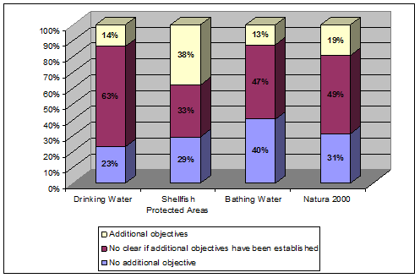

Figure 8.9.2: Objective setting in protected areas per category of protected area
Source: WISE

8.9.4. Justifications for exemptions according to Articles 4(4) and 4(5)
Approximately 72% of surface water bodies in less than good ecological status and 88% of water bodies failing to achieve chemical status are subject to an exemption. More than 95% of all exemptions applied relate to the extension of the deadline (Article 4(4) WFD).
According to the information reported by Member States in WISE, in 42.738 surface water bodies (40% of total number of water bodies) an extension of the deadlines for achieving the environmental objectives (Article 4(4) WFD) will be required and in 23.797 cases (19%) less stringent objectives have been established for 2015 (Article 4(5) WFD). However, exemptions under Article 4(5) have actually been very limited in this first cycle, as ca. 23.000 of those water bodies relate to Swedish cases for mercury pollution (see section 8.6 on classification of chemical status of surface waters).
As reported by Member States, 1.498 groundwater bodies (11% of total number of groundwater bodies) are subject to an exemption under Article 4(4) WFD, and 181 groundwater bodies (just over 1%) will be subject to Article 4(5) WFD.

According to Article 4(4) the status the achievement of good status can be delayed for one or several of the following reasons:
- The scale of improvements required can only be achieved in phases exceeding the timescale, for reasons of technical feasibility.
- Completing the improvements within the timescale would be disproportionately expensive.
- Natural conditions do not allow timely improvement in the status of the body of water.
The figure below sets out the application of Article 4(4) per Member State. The highest values can be found in Belgium, Hungary and The Netherlands.
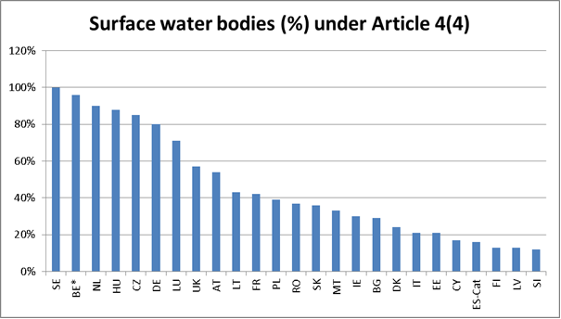
Figure 8.9.3: Percentage of surface water bodies per Member State falling under Article 4(4)
Note: * Flemish RBDs
Source: WISE

In terms of the reasons for the application of exemptions, in general natural conditions and technical infeasibility are far more often used than disproportionate costs (see figure 8.9.4). This might be explained by the fact that methodologies for assessing disproportionality are often lacking or the necessary data to carry them out does not exist. The interpretation of the different reasons has varied significantly across Member States, making interpretation difficult
Natural conditions are substantially different from the reasons of technical feasibility or disproportionate costs. Technical infeasibility is the most frequently used reason to exempt surface water bodies from achieving good ecological status (see Figure 8.9.4), either alone (46% of the exempted water bodies) or in combination with natural conditions (12% of exempted water bodies), disproportionate costs (12%) or with both (9%). The disproportionate cost argument is used as single reason for 8% of exempted water bodies and for 30% of the exempted water bodies when combined with one or both of the other arguments. Finally, natural conditions is used as an argument in 33% of exempted water bodies, either alone (11%) or in combination with the other two reasons.
In the case of groundwater, natural conditions is the most frequent reason to exempt water bodies from achieving good chemical status in 2015 (65% of the water bodies exempted). This is consistent with the long recovery times that are typical of groundwater bodies.

Surface water Ecological status  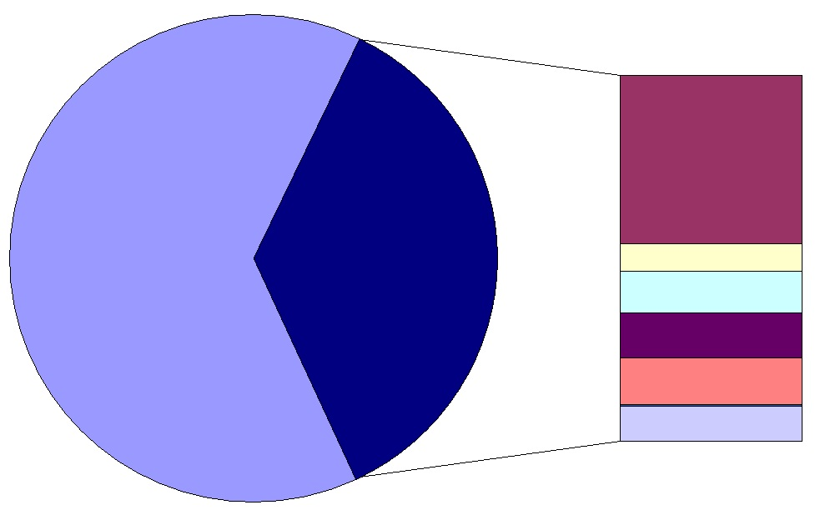 | Legend  T means technical feasibility  D means disproportionate costs  N means natural condition  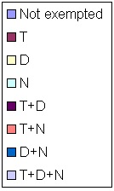
Groundwater quantitative status  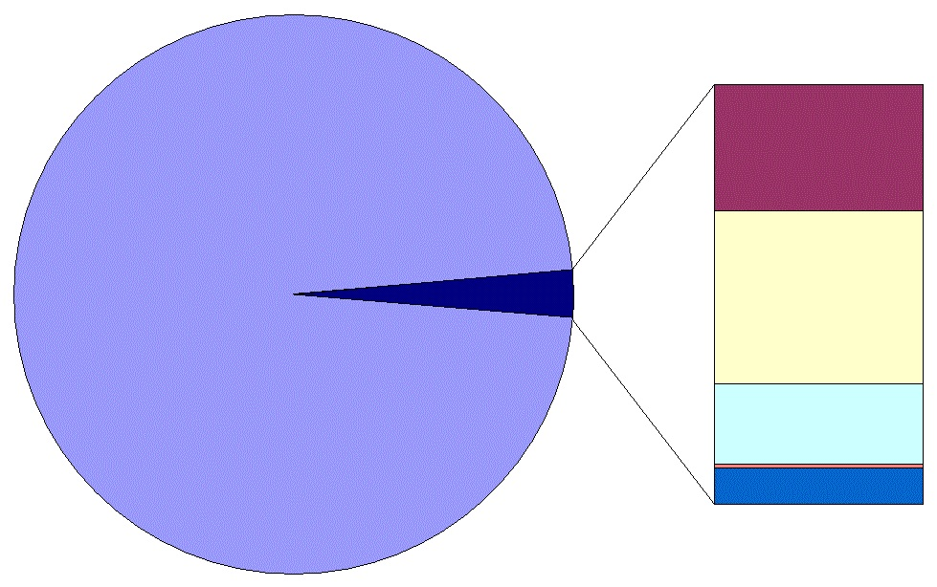 | Groundwater chemical status  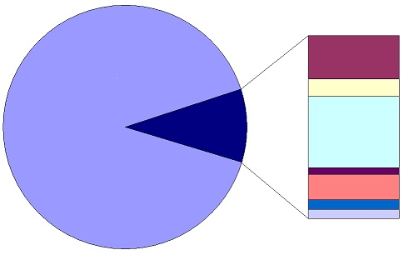

Figure 8.9.4: Exemptions reported by Member States to extend the deadline of the achievement of good status beyond 2015 and reasons given.
Source: WISE

The drivers behind the application of exemptions are mainly agriculture (primarily diffuse pollution from nutrients and pesticides) and hydromorphological pressures from urbanisation, hydropower, navigation and flood protection.
The use of exemptions, if properly justified, and if determined action is taken to move towards the objective of good status, is a valid and acceptable practice under the WFD. Some RBMPs show this determined action. In others, the added value of the WFD in relation to existing water management practices is less evident.
Article 4(4)(d) establishes that the measures required to bring water bodies progressively to the required status by the extended deadline, together with the expected timetable for the implementation of those measures should be described in the RBMPs. However, it is generally unclear when the environmental objectives are expected to be reached when the derogation under Article 4(4) has been used.
Under Article 4(5) Member States may aim to achieve less stringent environmental objectives for specific bodies of water when they are so affected by human activity, as determined in accordance with Article 5(1), or their natural condition is such that the achievement of these objectives would be infeasible or disproportionately expensive.
In this first cycle of RBMPs the derogation under Article 4(5) has been rarely used, and less than 5% of the exemptions applied are for setting less stringent objectives. The exception is the generalised used of Article 4(5) in the Swedish RBMPs. Sweden has reported all surface water bodies as failing to achieve good chemical status due to pollution by mercury, and applied an exemption for less stringent objectives under Article 4(5) to all water bodies.

8.9.5. Use of exemptions in accordance of Article 4.6
Article 4(6) provides, under certain conditions, an exemption for temporary deterioration of the status of water bodies in certain circumstances, which are exceptional or could not reasonably have been foreseen. The reason for invoking an exemption under Article 4(6) is that an extreme event may affect the status of a water body considerably and during a significant period of time, so that temporary deterioration may be inevitable even with the implementation of the best water management practices (see section 8.17 on water scarcity and droughts).
The application of exemptions under Article 4(6) has been reported in 5 RBDs in Spain, Bulgaria, France and Belgium. The reasons for the application of such derogation are linked to extreme floods, prolonged droughts, accidents and force majeure.
According to Article 4(6)(b), the circumstances under which this exemption can be applied should be declared in the RBMPs, including the adoption of appropriate indicators. This information has not, however, been reflected in the RBMPs. There are only some general statements in some RBDs that Article 4(6) might be applied more often in the future, mainly because of extreme floods, prolonged droughts and accidents.

8.9.6. Application of exemptions under Article 4(7)
Under Article 4.7 exemptions can be applied for new modifications to the physical characteristics of surface water bodies and new sustainable human development activities. This can relate to modifications in the planning phase (e.g. renewable energy plans which include hydropower) or to projects (e.g. new specific hydropower dams). In only 12 RBMPs (10.3%) there is a statement that Article 4(7) will be applied for specific projects and in 4 RBMPs it is unclear. Article 4(7) will be applied in Slovenia, Poland, France, Romania and the UK.
The exemptions that have been most commonly applied under Article 4(7) are due to flood protection (7 cases) followed by navigation (6 cases) and port development (4 cases). Hydropower and other electricity generation facilities are mentioned in only three and two RBMPs respectively.
However, according to the information available through other sources such as complaints, requests for EU funding and discussions with the energy and navigation sectors, it seems that the information given by Member States in the RBMPs does not fully reflect the current situation. Indeed, in many RBDs, projects which could fall under Article 4(7) are currently being developed. Furthermore, there are a number of major projects in the pipeline in several Member States that have not been included in their RBMPs.

8.9.7. Conclusions
- The WFD sets environmental objectives for the whole aquatic ecosystem. However the approaches and methods for setting these objectives are not always transparent.
- The extensive use of exemptions may reflect the low level of ambition in many of the plans as regards achieving the environmental objectives.
- In general, there is transparent information about which water bodies are subject to exemptions and the reason for it (technical infeasibility, natural conditions and/or disproportionate costs). However, the interpretation of the different reasons for the application of exemptions has varied significantly across the different Member States.
- There is generally a lack of appropriate and transparent justification of the criteria applied for the use of exemptions under Articles 4(4) to (7).
- Most of the RBMPs do not contain any reference to the application of exemptions under Article 4(7), even if in some cases there are large projects in the pipeline that are likely to bring about new modifications of water bodies. This indicates a lack of integration with other policies and infrastructure planning.
- Furthermore, when Article 4(7) is applied, the justification is often not clearly explained in the RBMP, and in particular the explanation on how the disproportionate costs have been calculated is missing.
- Some plans provide good examples for additional objectives for protected areas but, in general, additional objectives for protected areas have not been clearly defined in most RBMPs, with the exception of Shellfish protected areas.

8.9.8. Recommendations
- Member States should raise the level of ambition in the next RBMP cycle as far as the use of exemptions is concerned. In case of uncertainties about the effectiveness of the measures, Member States are recommended to take no-regret measures and continue the efforts on research in order to take better measures in the future.
- The justifications for the use of exemptions should be more transparent and include clear criteria for the decision. In case of extending deadlines or lowering objectives, the expected timeline and appropriate measures should be clearly indicated.
- Member States should engage relevant stakeholders and different authorities (regional, local) early in the planning process in order to improve the decision making for adoption of exemptions.
- Member States should include in the RBMPs an inventory of projects under development, including the stage of development of the individual projects, in order to ensure that the RBMPs present a complete overview of all current and planned developments within a RBD. The list should be continuously updated and open to all stakeholders and competent authorities.
- For the development of hydropower, navigation and flood protection, Member States are recommended to implement the policy recommendations and the best practice guidance that has been developed under the CIS and other processes.

8.10. Programme of measures – general

8.10.1. Introduction
The WFD requires, that within each RBD, a Programme of Measures (PoM) is established to address the significant issues identified and to allow the achievement of the objectives established under Article 4. The Directive further specifies that the PoM shall include as a minimum 'basic measures' and where necessary to achieve objectives 'supplementary measures'.
Basic measures as a minimum must comprise:
- Measures required in order to implement existent Community water legislation and other environmental legislation (set out in Article 10 and in Part A of Annex VI – detailed below).
- Measures to implement Article 9 (cost recovery).
- Measures to promote efficient and sustainable water use.
- Measures to protect drinking water quality and reduce level of treatment required.
- Measures to control abstraction from surface and groundwater.
- Measures to control recharging of groundwater.
- Measures to control point source discharges.
- Measures to prevent or control inputs of diffuse pollutants.
- Measures to address any other significant impacts on status, in particular the hydromorphological condition.
- Measures to eliminate or reduce pollution by priority substances.
- Measures to prevent accidental pollution.
Legislation in Article 10 and in Part A of Annex VI:
(i) The Bathing Water Directive (76/160/EEC).
(ii) The Birds Directive (79/409/EEC).
(iii) The Drinking Water Directive (80/778/EEC) as amended by Directive (98/83/EC).
(iv) The Major Accidents (Seveso) Directive (96/82/EC).
(v) The Environmental Impact Assessment Directive (85/337/EEC).
(vi) The Sewage Sludge Directive (86/278/EEC).
(vii) The Urban Waste-water Treatment Directive (91/271/EEC).
(viii) The Plant Protection Products Directive (91/414/EEC).
(ix) The Nitrates Directive (91/676/EEC).
(x) The Habitats Directive (92/43/EEC).
(xi) The Integrated Pollution Prevention Control Directive (96/61/EC).

Supplementary measures are those measures designed and implemented in addition to the basic measures, where it is necessary to achieve the environmental objectives of the WFD as established in Article 4 and Annex V. Supplementary measures can include additional legislative powers, fiscal measures, research, educational campaigns that go beyond the basic measures and are deemed necessary for the achievement of objectives.
According to Article 11(5), additional measures may be necessary when a water body is unlikely to achieve the objectives under Article 4, after the adoption of the measures under the first RBMP.
This chapter covers general issues concerning the PoM. The following chapters cover specific measures targeted to agriculture, groundwater and water pricing measures, as well as measures to tackle specific pressures like hydromorphology or hazardous substances.

8.10.2. Status assessment and selection of measures
Measures should be targeted in terms of their type and extent to ensure that pressures are addressed and that this will deliver improvements towards achieving good status or potential in the individual water bodies. The measures should be designed based on the assessment of the actual status of the water body, supplemented with the information from the analysis of pressures and impacts affecting the water body.
Each step of the planning process of the WFD is, therefore, necessary to ensure the correct measures are implemented in the appropriate location. The planning process started with the transposition of the Directive into national law and the administrative arrangements, and was followed by the characterisation of the RBD (including the pressure and impact analysis, the economic analysis, the delineation of water bodies and the establishment of the typology and reference conditions for surface water bodies: the basis for the ecological status assessment). The status assessment based on sufficient (parameters, frequency, etc.) and updated monitoring results is a fundamental element of the planning process, but is also often the weak part of the chain. Finally, the environmental objectives are set and the PoM to achieve those objectives established. The PoM should become operational by December 2012 at the latest. There is also a need to monitor the effects and effectiveness of the measures in the improvement of the water status and (as stated in Article 11.5) where monitoring or other data indicate that the objectives set are unlikely to be achieved. The cause of the possible failure should be investigated, relevant permits and authorisations should be reviewed, monitoring programmes reviewed and adjusted and amended or additional measures devised to ensure achievement of objectives.
The assessment of the RBMPs has shown that the measures are often not concrete and the expected achievements not always clear. In general, there is limited understanding that the PoM are to reflect the result of the analysis of pressures and impacts and the status information from the monitoring programmes. Often the definition of the measures is too vague and there is little clarity on the scope of the measure.
Furthermore, the financial commitment, the actors responsible for the implementation, the planned timetable and the expected effects on the improvement of the status are not described in the majority of the RBMPs. This lack of detail in the definition of the measures may lead to insufficient action to tackle the specific problems of the water bodies and hinder the achievement of the WFD at local level.
There are, however, good examples of the definition of appropriate measures, e.g. Denmark links the protection of eelgrass beds to nutrient reduction load to specific measures deemed most cost effective. Detail is provided on costs and the area of land involved. This information is necessary to allow stakeholders to understand exactly what is proposed and to also plan for implementation.
More information can be found in the following chapters for the specific measures on agriculture, hydromorphology, chemical pollution, groundwater, protected areas and water pricing.
Despite the importance of designing the PoM based on the actual status of water bodies to meet clearly defined objectives, less than 30% of the RBMPs establish a clear link between the ecological and chemical status of the water bodies and the measures proposed in the PoM. Less than 25% of plans establish at least partially such a link and for almost 40% it is very often unclear whether the proposed measures are based on the status assessment, and therefore it is not clear whether the measures will be sufficient to reach the good status or potential of water bodies.
For groundwater, only around 21% of RBMPs have provided details of this clear link between the quantitative status of groundwater bodies and the measures to be implemented. 29% have a clear link with regard to the chemical status of groundwater.

 | Yes |  |  |  |  |  |  |  | No | No information | Unclear
 | rivers |  | lakes |  | groundwater |  | transitional & coastal
 | entirely | partly | entirely | partly | entirely | partly | entirely | partly
Ecological status | 29% | 24% | 28% | 24% | - | - | 24% | 28% | 5% | 4% | 37%
Chemical status | 28% | 27% | 28% | 27% | 29% | 26% | 25% | 29% | 5% | 4% | 36%
Quantitative status groundwater | - | - | - | - | 21% | 30% | - | - | 4% | 12% | 32%
Table 8.10.1: Percentage of RBMPs that establish a clear or partial link between the assessment of status and the adoption of measures
Source: RBMPs assessment

The link between the status and measures is essential to ensure that the measures are conceived and implemented to tackle the specific pressures that have an impact on the status of both surface and groundwater bodies and to address a particular environmental problem. The reasons explained in the RBMPs to justify the lack of this link are mainly in relation to insufficient monitoring data, and the need for improvement in the status assessment methods. When there is not enough monitoring data, the decisions are generally based on expert judgement or an analysis of the pressures. This may well lead to partial fulfilment of the environmental objectives.

8.10.3. Implementation of measures
Measures are applied on a number of geographical levels (see Figure 8.10.1) from national to the individual water body, probably also reflecting the administrative set-up in the different countries.
In terms of the geographical scope of the implementation of measures, the measures are mainly applied at water body level and national level, but also at RBD level.
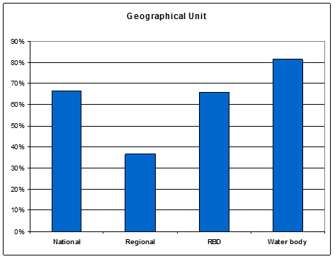
Figure 8.10.1: Geographical scope of the implementation of the measures
Source: RBMPs assessment

For nearly all RBMPs some measures are applied at water body or sub-basin level, and in some RBMPs the application of supplementary measures is systematically done at small scale, either water body or sub-basin. This approach is in line with the WFD objective of applying the supplementary measures in a targeted way, in order to address the specific pressures and needs for improvement of the specific water bodies.
Information about whether the measures are voluntary or mandatory is not existing or unclear in nearly half of the RBMPs (including the supporting documents). Basic measures should be mandatory and should address point and diffuse sources of pollution, and other measures required by other Community legislation. However, many PoMs only contain supplementary/voluntary measures, which is not in compliance with the requirements of the WFD.
The number of authorities and/or others (enterprises, farmers, etc.) involved in the implementation of the measures differs very much between the Member States and reflects to some extent the different approaches concerning mandatory and/or voluntary implementation. In some countries, a very complex matrix of responsible authorities has been established, while in others there are a high number of actors involved in the implementation of the measures. This type of set-up will likely require a very strong co-ordination and a high level of exchange of information, which will in turn be very costly. Furthermore, it makes it very difficult for the citizens to see how a common goal can be reached (see also section 8.1 on Governance).
The information in table 8.10.2 shows that for the majority of Member States several authorities are involved in the implementation of measures for a particular sector. The national approach seems to be widespread, especially with regard to the agricultural sector.

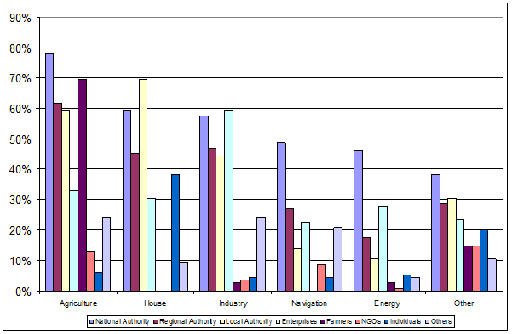Figure 8.10.2: Percentage of RBMPs where different authorities are responsible for the implementation of measures related to sectors (in many cases there are several responsible authorities).
Source: RBMPs assessment

According to Article 11(7) WFD, the PoMs shall be established in the RBMPs submitted in 2009, and should be made operational at the latest by December 2012. The Commission will then assess the progress made by the different Member States in making their measures operational. Although some measures are already being implemented in all Member States, clear information on the timeline for implementation of all measures in the PoMs has been found in 20% of the RBMPs. An alternative date for some or all measures is mentioned in 31% of the RBMPs. For around half of the RBMPs, there is no information on the timetable for making the measures operational.
Measures should be made operational by December 2012 and should consider the time lag for the biological response, recharge of aquifers, internal load in lakes, etc. When the effect on status of water bodies may not be detectable even in 2015 then exemptions might be considered. The time needed for status improvement due to natural conditions is the reason for the exemption of 33% of exempted water bodies (see section 8.9 on environmental objectives and exemptions). In nearly 50% of the PoMs, some kind of assessment of the uncertainty of the effect of the measures is mentioned. However, this uncertainty is quantified in only a few cases.
The effectiveness of the proposed measures towards the objective of good status is not systematically presented in this first set of RBMPs. These uncertainties will also be present for the objectives setting, the analysis of exemptions, on the cost and benefits analysis, and in the definition of the PoMs.
However, non-action cannot be the result of such uncertainties and no-regret measures (reversible measures, measures that can be easily adapted, measures that can be carried out iteratively or measures with low risk and costs, and high return) should be implemented.
But lessons should be learned and Member States should now be in a better position to align these two processes in the second cycle. Better understanding of pressures through better monitoring should result in more targeted interventions in the second cycle.
Additional information on how the uncertainties on the establishment and effectiveness of the measures have been considered in the different countries (or general information on the different approaches) will be available with the final report of the 'Pressures and Measures study'. It has proved very difficult to predict the effectiveness of the measures at EU level, with the level of information available, as local conditions are determinant in many cases.

8.10.4. Water rights and the implementation of the programme of measures
Article 11(3) requires the establishment of all necessary measures to implement other Community legislation, to implement the provisions of Article 9 and to ensure sustainable use or abstraction of water. These measures should be implemented, where necessary, with the aim of achieving the WFD environmental objectives.
The management of historical rights is a good example of the mismatch between the objective of good status of water bodies introduced by the WFD and the tools available for implementation. The principles of existing concessional systems across the EU date back many decades to the origins of water management. These are closely linked to the concept of property and the aim of ensuring a stable legal framework that promoted investment and economic development. In most cases, concessions were given for decades or even without time limit. Environmental conditions in the permits were non-existent or only considered to a very limited extent. As a consequence, dry river stretches are common in many parts of the EU due to existing water diversions for hydropower or irrigation. Hundreds of kilometres of rivers are not accessible for migratory fish due to dams which were not equipped with installations for fish passage. Over-exploitation of aquifers due to over-allocation of water rights is also a severe environmental problem in some parts of the EU, difficult to reverse, and affecting in some cases important nature reserves.
The WFD objective of good status is not compatible with these situations. However, existing legal frameworks and judicial systems are very protective over water rights in most of EU countries which leaves water managers in a very weak position to enforce the review of the concessions to ensure the attainment of new environmental objectives. A profound modification of the national legal frameworks is necessary to enable water authorities to introduce the necessary measures to achieve the WFD objectives. Whereas the review of industrial waste water permits is seen as a natural consequence of the introduction of new environmental objectives (e.g. the introduction of the EQS or the IPPC Directives), and the costs incurred by industry are considered to be part of the business risk, the situation for uses such as hydropower or agriculture is much more advantageous in situations where impacts on the aquatic environment can be more severe.
The need to provide water managers with the appropriate tools to enforce the attainment of the environmental objectives for existing concessions is without prejudice to the possibility to achieve win-win agreements between the water administration and the holder of the water right. This is being pro-actively and successfully promoted by water administrations in many Member States, typically working together to find solutions that can deliver both ecological improvements and benefits for the economic activity. However, in situations where these win-win solutions are not possible, or where the owner of the right is not amenable to change, water administrators should have the right tools at hand to review the concession without entering long judicial battles with uncertain outcome. The legal framework should strike a right balance between individual rights and the legitimate expectations of the society related to the protection of a public amenity such as water.

8.10.5. Costs of measures

Figure 8.10.2 presents the relative distribution of costs between the most common pressures, showing that the cost for point sources represents nearly two thirds of the total costs for these three pressures.
Figure 8.10.2: Costs of measures divided according to different types of pressures
Source: RBMPs assessment

A clear distinction of the costs for basic and supplementary measures was found in 16% of RBMPs. In general, a significant part of the costs are related to basic measures, especially for newer Member States, whereas some of the older Member States only report around 25% of costs as being for basic measures, the rest being costs for supplementary measures. In countries like Bulgaria, Slovenia or Finland, for some RBDs more than 95% of the costs relate to basic measures, mainly related to waste water treatment, whereas countries like France or Luxembourg only around 25% of the costs are for basic measures.
Calculation of the cost effectiveness of the different kind of measures may be a good instrument for making decisions leading to the most cost effective implementation and, ultimately, for good ecological status.
In around 50% of RBMPs it is clearly stated that the cost effectiveness has been calculated for all measures, or for a selection of measures, or for a specific sector. The cost effectiveness is calculated at RBD level in only 2% of RBMPs. A national calculation has probably been used in the remaining RBMPs.
This tool for decision making has not yet been widely implemented but a number of good examples can be found and act as inspiration for the second planning period. For example, in the Swedish RBMPs a comprehensive cost effectiveness calculation has been provided for the relevant measures which even include the administrative costs. In Lithuania, this calculation has been applied for agricultural measures.
There is very little information in the RBMPs on the share of the main contributors financing the costs of measures. Nearly all of the reported RBMPs contain a mix of contributors of national, regional or private origin, whereas only 7% mention funding from the EU. The main contributors are the national authorities which generally contribute more than 75% of the total costs. The regional authorities and the private sector have in general a lower share (below 25% or between 25% and 50%).

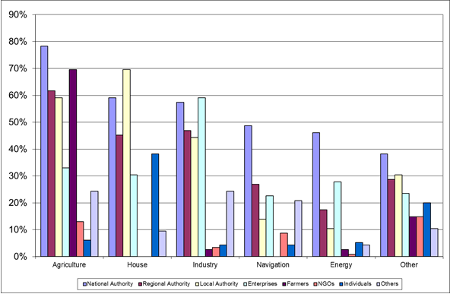

Figure 8.10.3: EU overview of financial contributions by public authorities and different sectors for main types of measures
Source: RBMPs assessment

When measures are adopted to tackle specific impacts of specific sectors and uses, the implementation of the cost recovery obligations should provide also for the application of the polluter-pays principle in the financing of measures.

8.10.6. Financial commitment
For ca. 60% of the PoMs, there is no financial commitment specified in the RBMPs. The main concern of this lack of commitment is that the PoMs will remain a theoretical document that may not be properly implemented due to the lack of resources or clarity regarding the responsible actors.
Though the total costs have been estimated or calculated for the majority of RBMPs, a clear financial commitment has only been reported for approximately 40% of the RBMPs, some apparently only have a partial commitment (e.g. only for point sources). For the rest of the RBMPs, the resources should be made available so all measures can become operational at the latest by December 2012 (Article 11(7) WFD).
Many of the RBMPs refer to other possible financial sources (e.g. EU funding or private), but not if the funding is not yet in place (i.e. only as expected funding, but not yet approved). It should be noted that information on the financial commitment may be available in documents like political agreements, budget remarks, etc that were not reported by Member States. However, information on how the measures are going to be financed should be explained in the RBMPs for all interested parties to be informed on the financing planning, and who will be responsible for those costs - national, regional budget, EU funds, etc.

8.10.7. Transboundary PoM
WFD Article 13.2 states that 'in the case of an international river basin district (IRBD) falling entirely within the Community, Member States shall ensure co-ordination with the aim of producing a single international river basin management plan'. A summary of the PoMs should be part of the international RBMPs and, if not, an explanation of why the PoMs have not been co-ordinated should be included in the RBMPs. The same should apply where international RBDs involve non-EU Member States (see section 8.1 on Governance).
There has been international co-ordination in some RBDs, mainly for those large international RBDs involving several Member States and non-EU Member. The co-ordination of those measures that are more relevant in a transboundary context is presented in table 8.10.4. For those RBDs where transboundary co-ordination is relevant, measures to restore river continuity has been addressed for 20% of RBDs, measures to reduce nutrients in water bodies have been coordinated in 18% of the cases, and measures related to exceedance of Environmental Quality Standards (EQSs) due to a transboundary chemical pollution have been established for 19% of those RBDs.
Have the following issues been specifically addressed in the internationally coordinated PoM?
 | Yes | % of yes | No
River continuity | 24 | 20% | 99
Nutrients | 22 | 18% | 101
EQS | 23 | 19% | 100
Table 8.10.4: RBMPs that have co-ordinated internationally measures to ensure river continuity, to reduce nutrients loads and to reduce chemical pollution across international RBDs.
Source: WISE

For the small international RBDs involving only two Member States or only one non-EU Member State, the picture is more unclear. In some RBMPs it is noted that part of the catchment situated in a neighbouring Member State is very small and not impacted, i.e. no measures needed. Other RBMPs say that the time line in the two Member States involved is different so co-ordination has not been possible. In general, the PoMs have not been co-ordinated with third countries for the smaller RBDs involving only one Member State and one non-EU Member State (e.g. Norway/Sweden or Latvia/Belarus).

8.10.8. Conclusions
- The poor level of detail of the measures makes it difficult to ascertain the extent of the action and the expected effects of the measures. This detail must exist in the Member State to allow for implementation and so it is not an undue burden to provide such information in RBMPs.
- Many PoMs are quite vague and general, without clear definition of the specific actions, the financial commitment, the actors responsible for the implementation, the planned timetable and the expected effects on the improvement of the status.
- The ‘story line’ between status assessment and the definition and implementation of the measures should be improved and described clearly in the RBMPs and/or the PoMs. In the first RBMP cycle, many PoMs are based on expert judgements, etc with the risk of under implementation.
- It should be taken into account that the subsequent phase of ‘making measures operational’ is generally not consulted.
- The information about the financial commitment, sources for funding, implication for different sectors, etc is in general very poorly described in the RBMPs and the PoMs.
- Waste water treatment is the by far the most costly action according to the information reported in the RBMPs, probably due to high investment level in many new Member States to meet the requirements of the Urban Waste Water Treatment Directive.
- The WFD timetable for the making the measures operational (22 December 2012) is explicitly mentioned in only around 20% of the RBMPs. In nearly every second RBMP, a timetable is not presented at all.

8.10.9. Recommendations
- The level of detail and the available information in relation to the measures should be improved in the next cycle of RBMPs.
- Basic measures should be defined to address all pressures and linked to Article 11. The full implementation of these measures should continue to be a priority during the next cycle of RBMPs.
- It would strengthen the RBMPs and the whole planning process if a clear financial overview, together with sources and the necessary commitment, could be added to the next plans.
- A cost effectiveness analysis is a very strong instrument to help decision makers. This instrument has only been reported in a limited number of RBMPs and it is recommended that it should be used to greater effect in the next generation of RBMPs. Combined with better monitoring and understanding of pressures this should result in more cost effective delivery of WFD objectives.
- Align funding decisions to priorities and actions identified in the RBMPs. Make links to floods, rural development and structural fund budgets. This is a practical step towards integration of delivery.
- Include in the RBMPs and the PoMs transparent information on the costs of the measures, the responsible authorities and indicate who is bearing the costs.
- Make use of GIS and other mapping tools to show where pressures exist and where measures will be targeted.
- Assess the obstacles that have hindered the implementation of measures in the first cycle and take action to overcome them in order to be better prepared for the second cycle.
- The existing legal frameworks should be adapted to enable water authorities to introduce the necessary measures to achieve the WFD objectives. The review of the permitting systems for sectors such as hydropower or agriculture should allow these economic activities to be developed in accordance with the environmental requirements of EU legislation.

8.11. Measures related to groundwater

8.11.1. Introduction
The procedure for identifying measures necessary for protecting groundwater from human impacts and for enhancing or restoring groundwater bodies builds on the analysis of the characteristics of each groundwater body and the review of the impacts of human activities on the status of groundwater (according to Article 5 and Annex II of the WFD). For all groundwater bodies the analysis of pressures and impacts of human activities identifies whether there is a risk of not meeting the environmental objectives established under Article 4 of the WFD at the end of the RBMP period. In the event that surveillance monitoring confirms a risk, operational monitoring is needed as well as the implementation of a programme of measures. In this respect, Article 11 of the WFD requests Member States to implement all necessary measures to prevent or limit the input of pollutants into groundwater in order to prevent the deterioration of the status of all groundwater bodies. Member States have to protect, enhance and restore all groundwater bodies, ensure a balance between abstraction and recharge of groundwater and achieve good groundwater status by 2015.
All groundwater bodies identified not to be at risk can automatically be considered as of good status. For those groundwater bodies the clause of no deterioration of status is relevant and measures might be needed to preserve the good status of groundwater bodies. Groundwater bodies classified as being in good chemical status may still need measures in case a groundwater quality standard or a threshold value has been exceeded in a part of the groundwater body (Article 4.5 of the Groundwater Directive).
Measures are also needed to reverse any significant and sustained upward trend in the concentration of pollutants resulting from human activities. If an additional trend assessment identifies that existing plumes of pollution in groundwater bodies do extend and deteriorate the chemical status of groundwater bodies or present risk to health and environment, appropriate measures also need to be established.
Most of the measures for groundwater are defined in Article 11 of the WFD and the related Annexes, distinguishing between ‘basic measures’ and in cases these are not sufficient, ‘supplementary measures’. The measures to prevent or limit inputs of pollutants into groundwater are specified in Article 6 of the Groundwater Directive.
It has to be noted that the considerable inertia of groundwater bodies reflected in renewal rates of decades or even centuries, calls for a precautionary approach towards their protection. Any pollution or degradation is very expensive to remediate and requires a long time for improvements to be seen, therefore preventative measures play a very important role in groundwater management.
Whenever implementing measures on groundwater it is essential that the environmental objectives (water quantity, chemistry and ecology) of groundwater dependent terrestrial ecosystems and associated surface waters are considered and not compromised.
This chapter elaborates further on the measures that have been reported as part of the RBMPs and programmes of measures, in particular on:
- Groundwater quantity and whether the need of groundwater dependent terrestrial ecosystems were taken into account.
- Preventing inputs of hazardous substances.
- Limiting inputs of non-hazardous substances.
- Specific measures in parts of the groundwater bodies where quality standards were exceeded.
- International co-ordination of measures.

8.11.2. Measures related to groundwater chemical status
87 of 100 RBMPs, where groundwater bodies failed good chemical status, reported significant chemical pressures to groundwater. All but two of these RBMPs (85) provided detailed information. The detailed information shows that diffuse source pollution – mainly from agriculture (50%) and from urban land use (25%) – is a significant pressure in all of these 85 RBMPs, and point source pollution – mainly from waste deposit sites (20%), from contaminated sites (15%) and from discharges to groundwater (15%) – is a significant pressure in about 70% of those RBMPs.
The overarching measures protecting groundwater from pollution are the measures to prevent inputs of hazardous substances and to limit inputs of non-hazardous substances into groundwater (Article 6 of the GWD).

8.11.2.1. Preventing inputs of any hazardous substances
According to Article 4 of the WFD and Article 6 of the GWD, Member States have to ensure that the programme of measures established includes all measures necessary to prevent inputs (from point and diffuse sources of pollution) into groundwater of any hazardous substances.
About 88% of the RBMPs reported that respective measures have been implemented. The remaining RBMPs did not describe whether such measures were implemented or the description was unclear.
Several RBMPs refer to the implementation of other pieces of European legislation as basic measures contributing to pollution prevention, like the Seveso Directive (96/82/EC) on major accidents, the Environmental Impact Assessment Directive (85/337/EEC), the Integrated Pollution Prevention Control Directive (96/61/EC), the Urban Waste Water Treatment Directive (91/271/EEC) or the Plant Protection Products Directive (91/414/EEC).
Further frequently reported measures include the prohibition of discharges of such substances and/or the ban of their use (mainly mentioning pesticides) by national regulations and laws.
The replacement of hazardous chemicals by non-hazardous substances or the use of alternative techniques, the application of best available techniques to prevent releases to the environment and plans to prevent accidental pollution or risk management are also commonly considered.
The development of risk analyses of contaminated sites and the decontamination and remediation of soils and historical pollution sites and finally the monitoring of hazardous substances in water were reported in a few RBMPs contributing to the requirement of preventing the inputs of any hazardous substances into groundwater.

8.11.2.2. Limiting inputs of any non-hazardous substances
According to Article 4 of the WFD and Article 6 of the GWD all measures necessary to limit inputs of non-hazardous pollutants into groundwater have to be established in the programme of measures to avoid any deterioration of groundwater and any significant and sustained upward trends in pollution concentrations.
The assessment focused on those measures that aim at tackling the limitation of the inputs of non-hazardous substances from point sources and the prevention of losses from technical installations. About 93% of the RBMPs reported having implemented such measures. The remaining RBMPs did not describe whether such measures were implemented or the description was unclear.
As already listed above, several RBMPs refer to the implementation of other pieces of the European legislation as basic measures, especially the Environmental Impact Assessment Directive, the Integrated Pollution Prevention Control Directive and the Urban Waste Water Treatment Directive, which already contribute to limiting the input of non-hazardous substances to groundwater via point sources of pollution.
Frequently reported measures are the general prohibition of direct discharges into groundwater, prior authorisation of any indirect discharges together with a regime of emission controls (e.g. restrictions on loads or concentrations of pollutants) and the implementation of protection zones where activities can be banned or restricted as well as the reductions of the discharge of urban and industrial waste water and the proper handling and storage of agrochemicals (fertilisers and non-hazardous pesticides).
Other reported measures cover the reduction of pollutants at the source, the adequate treatment prior to release, the implementation of best available techniques and best environmental practice, the monitoring of substances in water but also the monitoring of the authorizations, licenses, emission limits and the performance of the treatment prior to release.
The decontamination and remediation of soils and historical pollution sites contribute to limiting the inputs of non-hazardous substances to groundwater as well.

8.11.2.3. Supplementary measures
More than half of the RBMPs reported the need for supplementary measures to be specifically implemented in groundwater bodies at risk or in poor status to achieve the objectives under Article 4 of the WFD. 20% of the RBMPs reported that there was no need and the remaining RBMPs (25%) were rather unclear in this respect.
The most frequently reported supplementary measures tackling groundwater pollution comprise the development of risk analyses and the decontamination and remediation of soils and historical pollution sites, the application of best available techniques and codes of good practice as well as further monitoring.

8.11.2.4. Specific measures in groundwater bodies with exceedances of quality standards or threshold values
According to Article 4.5 of the GWD, measures are needed if the value for a groundwater quality standard or threshold value is exceeded at one or more monitoring point, even though investigation confirms that the extent of the exceedance is limited and therefore the groundwater body is classified as being in good chemical status. Member States have to take measures as may be necessary on the part of the groundwater body represented by the monitoring point or points at which the groundwater quality standard value or the threshold value has been exceeded.
Very few RBMPs mention explicitly specific measures to be implemented in the area of exceedance. It seems to be a very common approach that Member States implement the measures following the overarching groundwater quality objective of pollution prevention by tackling the pressures, rather than being driven by failures. According to a statement that is very often found in RBMPs measures are implemented in all groundwater bodies irrespective of whether their status is good or poor.

8.11.3. Measures related to groundwater quantity
All of the RBMPs where groundwater bodies are failing good quantitative status (62 RBMPs) and where information on pressures are available at the same time (53 RBMPs) reported that abstraction (mainly for public water supply) is the main quantitative pressure, followed by saltwater intrusion (50%). Other quantitative pressures (not further specified) were mentioned in about 20% of the RBMPs while artificial recharge (13%) plays a rather minor role.
The main reported reason for failing good groundwater quantitative status was the exceedance of the available groundwater resource by the long-term annual average rate of abstraction.
Controls over the abstraction of fresh surface water and groundwater and impoundment of fresh surface waters including a register or registers of water abstractions and a requirement for prior authorization of abstraction and impoundment is explicitly required by Article 11.3 (e) WFD. These controls have to be periodically reviewed and, where necessary, updated.
Member States can be exempt from these controls, abstractions or impoundments which have no significant impact on water status. This exemption clause was only reported by UK to be applied and only in the case of abstractions below 10 m³ and 20 m³ per day respectively.
Nearly all (91%) RBMPs where groundwater bodies fail good quantitative status reported that controls over water abstractions including registers of abstractions and the need for prior authorization of abstractions are the main measures tackling groundwater over-exploitation.
More than 80% of the RBDs with groundwater bodies in poor quantitative status reported controls of artificial recharge or augmentation of groundwater bodies – including a requirement for prior authorization – as an important measure.
The same percentage of RBDs (more than 80%) reported programmes to increase water use efficiency (e.g. (waste) water re-use and rain water management) and programmes to promote sustainable and efficient use of water by awareness raising, advice or educational programmes.
As supplementary measures the intensification of monitoring, both of abstractions and of groundwater levels, was mentioned in about 35% of the RBMPs. Financial incentives, pricing policy for sustainable use (e.g. charges, fines, taxes for water abstractions) were reported by 23% of the RBMPs, and the implementation of research projects and risk and vulnerability assessments were reported by about 30% of the RBMPs where groundwater bodies of poor quantitative status occur.
The WFD requires that the use of abstracted groundwater does not compromise the achievement of the environmental objectives of groundwater dependent terrestrial ecosystems. About 43% of the RBMPs reported that the requirements of these terrestrial ecosystems have been taken into account in the definition of required measures. This seems to indicate that the knowledge on the quantitative needs of such ecosystems is slightly better than in the case of chemical status. 32% of the RBMPs did not consider this definition and for the remaining 25% it was not relevant or no indication could be found that the needs were considered.

8.11.4. International co-ordination of measures
About 40% of the international RBMPs report co-ordination with neighbouring Member States or non-EU Member States. In about 15% of these international RBDs such international co-ordination was reported as not relevant, mainly due to the fact that there were no transboundary groundwater bodies identified. In 45% of these RBDs, no information on international co-ordination was mentioned in the RBMPs which is a clear gap either in the implementation of the WFD or in the reporting.

8.11.5. Conclusions
Diffuse source pollution – mainly from agriculture (50%) and from urban land use (25%) – is a significant pressure in all RBMPs that indicate a failure of good groundwater chemical status while point source pollution – mainly from waste deposit sites (20%), from contaminated sites (15%) and from discharges to groundwater (15%) – is a significant pressure in about 70% of those RBMPs. Regarding quantitative status, all of the RBMPs reported that abstraction (mainly for public water supply) is the main quantitative pressure, followed by saltwater intrusion (50%).
Any pollution or degradation of groundwater is very expensive to remediate and takes a long time period to implement, therefore preventative measures play a very important role in groundwater management. Measures related to groundwater protection seem to be in place as about 88% of the RBMPs reported that measures to prevent inputs of hazardous substances have been implemented and about 93% of the RBMPs reported having implemented measures that aim to tackle the limitation of the inputs of non-hazardous substances from point sources and the prevention of losses from technical installations. However most of the measures are very general and not linked to pressures.
More than half of the RBMPs reported the need for supplementary measures specifically implemented in groundwater bodies at risk or of poor status to achieve the objectives under Article 4 of the WFD, but almost no RBMP explicitly mentions specific measures to be implemented in the area where an EQS or threshold value is exceeded. It seems to be a very common approach that Member States implement the measures following the overarching groundwater quality objective of pollution prevention by tackling the pressures rather than being driven by failures. It is very often found in RBMPs that measures are implemented in all groundwater bodies irrespective of whether their status is good or poor.
Nearly all (91%) RBMPs, where groundwater bodies fail good quantitative status, reported that controls over water abstractions including registers of abstractions and the need for prior authorisation of abstractions are the main measures tackling groundwater over-exploitation. About 43% of the RBMPs reported that the requirements of groundwater dependent terrestrial ecosystems have been taken into account in the definition of required measures.
In 45% of the transboundary RBDs no information on international co-ordination was mentioned in the RBMPs which is a clear gap either in the implementation of the WFD or in the reporting.

8.11.6. Recommendations
- The description of measures in the RBMPs should distinguish between basic measures and supplementary measures and also assign the measures to the water body types (surface water or groundwater) to which the measure is targeted.
- Measures should be better linked to pressures and better targeted to the groundwater bodies and address the specific pressures causing risk, poor status or unfavourable trends.
- Specific measures in the area of exceedance should be better taken up and reported.
- The needs of groundwater dependent terrestrial ecosystems should be better considered in the definition of the measures.
- International co-ordination of measures should be established and reported in all transboundary groundwater bodies.

8.12. Measures related to agriculture

8.12.1. Introduction
In accordance with the environmental objectives laid out in Article 4 WFD and based on a risk assessment and the status assessment delivered by the monitoring programmes, Member States are required to implement necessary measures to prevent the deterioration of water bodies and to achieve good water status in surface and groundwater. These measures should be listed in a programme of measures (Article 11 WFD).
Under the risk assessment carried out in 2005, and this was confirmed by other preliminary assessments, agricultural pressure has been identified as one of the main pressures on the water resources .
A PoM must include basic measures and supplementary measures addressing the identified pressures. Basic measures relevant for the agriculture sector include those set out in Article 10 (IPPC Directive, Nitrates Directive) and in Annex VI including the Habitats Directive and PPP Directive. Articles 16 and 17 further affect the agricultural sector by requiring the establishment of a list of priority substances that pose a risk to the aquatic environment, including those in relation to fertiliser and pesticide application in the agriculture sector.
As basic measures alone will mostly likely not lead to sufficient improvements in water body status, supplementary measures (Annex VI, Part B) are expected to target the significant pressure the agriculture sector puts on the water environment and to achieve the objectives set out in Article 4.
The following sections present the main EU level findings on how agriculture pressures have been addressed in the Member States. The results are based on the assessment of RBMPs and their corresponding PoMs in 23 Member States plus Norway covering 115 river basins. This is followed by recommendations to improve actions taken in the agricultural sector in the next planning cycle.

8.12.2. Pressures related to agriculture
Over 92% of the national RBDs consider agriculture as a significant pressure.
Diffuse pollution is by far the most important pressure resulting from agriculture, largely due to fertiliser use but also to pesticide application. Point source pollution is identified as significant to a lesser extent. As a consequence eutrophication problems are reported. However the link to agriculture is not always very clear as few RBDs were able to report eutrophication problems from solely agriculture source, while others aggregated the pressure from agriculture, domestic and industrial sources.
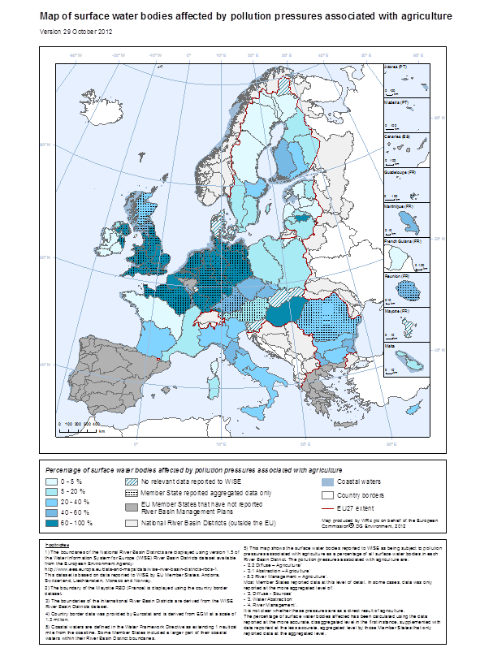
Figure 8.12.1: Geographical distribution of agriculture pressures in the EU
Source:WISE Note: Better quality maps are available on: http://ec.europa.eu/environment/water/water-framework/facts_figures/index_en.htm

Pressures from water abstraction and morphological modifications due to agriculture were reported in 36% and 37% of the RBDs, respectively.
The regional distribution of pressures from water abstraction for agriculture uses indicates south-eastern Europe (Bulgaria, Hungary Romania, Slovenia), southern Europe (Cyprus, France, Italy, Malta) and also parts of the UK and Ireland.
Soil erosion poses a considerable threat in individual river basins, but at EU level it is a less significant pressure compared to other pressures, identified in only 27% of RBDs.
It is, however, important to consider that for these pressures quite a few river basins did provide clear information and this represents a clear gap in knowledge. No clear picture for soil erosion was possible in 37% of the RBDs; for morphological pressures 41% of RBDs could not make definitive statements on the problem due to insufficient information. Another important gap in knowledge is the impact of self-abstraction on water bodies. Here, only 5% of RBDs mentioned it as a pressure, but it is important to consider that 57% of RBDs did not provide or only gave unclear information.

8.12.3. Types of measures applied in the PoM
To address the pressures mentioned above, Member States have included a range of technical, economic and non-technical supplementary measures in their PoMs.
As can be seen from the graph below (Figure 8.12.1), technical measures are the most prevalent category of measures in the PoMs.
The reduction or modification of fertiliser application is the most common technical measure found, followed by measures to reduce pesticide application and to improve the morphology of rivers; this largely corresponds to the pressures identified by the river basins.
52% of RBDs linked technical fertiliser measures to the Nitrates Directive, indicating that many have chosen to emphasise basic measures in their PoMs.
It appears that twice as many basins include measures targeting soil erosion than mentioned it as a pressure. This could be due to the uncertainty of the problem. In addition, considerably more Member States include hydro-morphological measures than those that have problems with morphological alterations (37% RBDs with problems versus 69% with measures).
As with water abstraction, Member-States applying water saving technical measures are predominantly located in southern and south-eastern Europe as well as the UK. Some other Member-States outside of these recognised water scarce areas are implementing water saving measures as well, e.g. Austria, Belgium, Germany, Latvia or Poland.
Non-technical measures such as training (65% RBDs)) are also very common. Educational measures such as awareness raising or increasing knowledge (e.g. through research) are relatively popular with 52% of the basins. The prevalence of non-technical measures has greatly increased since the assessment of the draft plans.
The graph also highlights how few river basins include economic instruments targeting agriculture in their PoMs. Compensation for land cover is the economic measure most often applied (around 32% of RBDs); nutrient trading was only found in one RBD and fertiliser taxes in 6 RBDs (5%). It can be assumed that water pricing in agriculture was not specifically mentioned by 74% of the RBDs since it is a stand-alone requirement under the WFD. The will to apply economic instruments seems to have improved since the assessment of the draft RBMPs where much fewer basins were intending to compensate for land cover (4% of the RBDs) or establish co-operative agreements (15% of the RBDs).

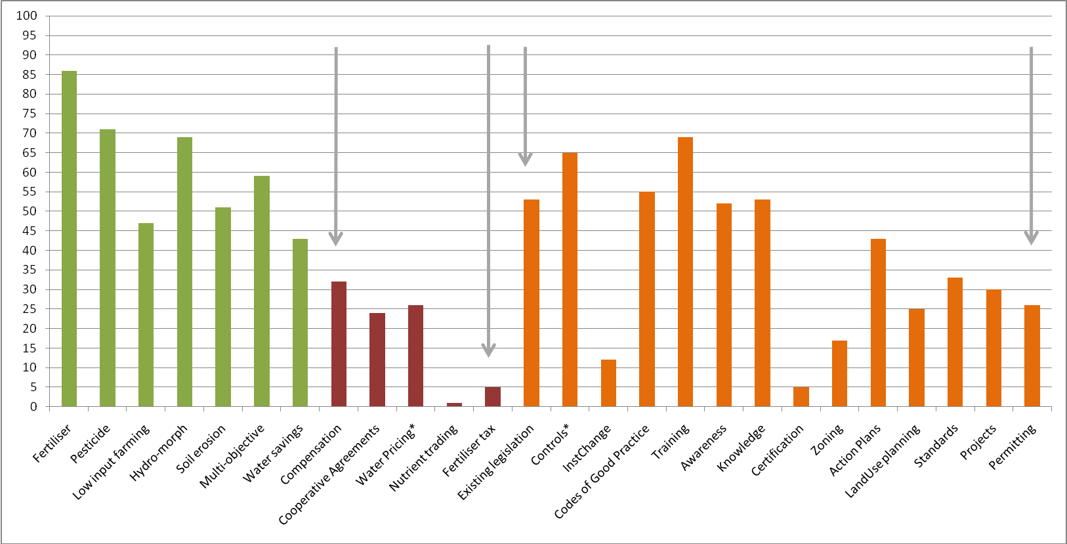
Technical Measures
Economic M.
Non-Technical Measures
* Measures by and large related to provisions already in place
Figure 8.12.1: Percentage of RBDs including agriculture measures in their PoM
Source: RBMP assessment

8.12.4. Stakeholder involvement when selecting the measures
Stakeholder involvement has been assessed using the following categorisation:
- Basic involvement: Farmers and farm associations were involved in the consultation processes but do not provide detailed information on the extent to which their contributions have influenced the selection process.
- Moderate involvement: Farmers were not only involved in the public consultation process but were also included as stakeholders in working groups or steering committees.
- Significant involvement: Farmers were actively involved in identifying, selecting and evaluating measures to include in the programs.
In terms of the involvements of farmers in the measures selection process, 78% of the assessed Member States (18 out of 23) indicated stakeholder involvement by farmers and in about 37% of RBs (43 basins out of 115) the involvement was significant or moderate.

8.12.5. Are the proposed measures addressing the pressures?
It is not clear whether the proposed measures will lead to a significant reduction of pressures and ultimately to the achievement of good status.
Moreover the PoMs mainly tend to focus on the implementation of existing legislation, especially the Nitrates Directive. This might indicate a “business as usual” approach and could be interpreted as a low level of ambition by the Member States.
Agriculture being the driver for many water body failings, implementation of existing legislation is not sufficient and therefore substantial supplementary measures are unavoidable.
That many of the supplementary measures found in the PoMs are linked to the Rural Development Programmes is potentially troublesome due to the voluntary nature of measure implementation. For some Member States with high farmers' involvement, this approach may be wise, but for others the reliance on voluntary mechanisms may be a problem.

8.12.6. Information provided regarding measure implementation
The information regarding the geographical application and the extent of application are mostly lacking. It seems that most of the Member States took a geographical approach using different units, such as per ha, at water body level, at sub-basin level, basin-wide or nation-wide. Water body level and sub-basin level are the most common method, at 37% (30 out of 81) and 40% (32 out of 81) of RBDs using a geographical approach, respectively.
What is by and large lacking in many of the river basins, is information on how these measures will be implemented in terms of timing, financing as well as monitoring. This information is very important to gain a clear understanding of the possibility for river basins to achieve the environmental objectives set out in Article 4. 38% (44 out of 115) of RBDs provide information on how the measures are being funded, of which 62% (30 out of 44) of these RBDs indicate they intent to use Rural Development funds. Out of the river basins eligible for Rural Development funds (Norway does not take part), only 4% indicate they will use Article 38 of the RDR on providing subsidies to farmers for requirements under the WFD. Besides the Rural Development funds, only limited information is given on other EU or national level funds.

8.12.7. Conclusions
- While Member States are relatively clear about the types of pressures their river basins are facing, precise information is missing on how these pressures are going to be addressed and to what extent the selected measures will contribute to the achievement of the environmental objectives in 2015.
- The emphasis on the basic measures and the existing regulations with the prevailing of voluntary approaches may result into a ‘business as usual’ approach and jeopardize the fulfilment of the WFD objectives.

8.12.8. Recommendations
- Experiences show that an advanced co-operation with the farmers' community at the different stages of the preparation of the PoM is important as it will ensure technical feasibility, acceptance and the expected success.
- A strategy mainly built on voluntary measures will not deliver. A right balance between voluntary actions and a strong baseline of mandatory measures / rules needs to be set up. A clear commitment at political level is unavoidable.
- Then this baseline needs to be clear so on one hand any farmer knows the rules, and on the other hand the authorities in charge of the CAP funds can adequately set up Rural Development programmes and cross compliance water requirements.
- More generally the authorities in charge of water and those in charge of agriculture at national and river basin levels need to improve their cooperation. The national legislations and the funding mechanisms should be made consistent and function in synergy. For instance information on infringement with the water legislation should be shared with the agricultural authority so it can count for cross compliance.
- A proper water pricing for farmers, based on volumetric pricing associated with mandatory metering, should be set up in accordance with WFD article 9 provisions. In complement the water allocation systems should be revised to take into consideration sustainability and climate change. It should foresee action to address efficiently illegal water abstraction.
- As for the voluntary measures, which are mainly derived from the Rural Development programmes, they also need to be very clear so any farmer knows what actions he is encouraged to do beyond the baseline.
- Meaningful information regarding the scope, the timing and the funding of the measures should be included in the PoM so the ambition of the RB authority is transparent and the plan to achieve the objectives is clear.
- In particular the Rural Development tool representing the first source of funding for water protection measures in agriculture, information on how the measures will be funded through the Rural Development programmes should figure in the PoM.
- When implementing the PoM a direct contact with the farmer is the key. As mentioned in the CAP reform legal proposal the Farm Advisory System should fully advertise on the WFD and the programme of measures. More generally any initiatives advertising the PoM directly to the farmer should be promoted. To ensure acceptance information on cost-efficiency should be shared with the famer.
Two documents elaborated by the CIS are a valuable source of information. They can be found on DG ENV website in all EU languages: "Guidance for administrations on making WFD agricultural measures clear and transparent at farm level" and "Handbook on Farm Advisory Systems and water protection".

8.13. Measures related to chemical pollution

8.13.1. Introduction
The WFD provides for measures against chemical pollution of surface waters by particular substances. In particular, it provides for the selection and control of substances of EU-wide concern (the priority substances) and the selection and control of substances of national or local concern (river basin specific pollutants). Other EU legislation, including REACH, the Plant Protection and Biocidal Products Regulations, the Directive on the Sustainable Use of Pesticides, and the Industrial Emissions Directive, may be relevant to the control of the substances, but some measures would be likely to be taken at national or local level. Before deciding on appropriate measures it is necessary to monitor the concentrations of pollutants in surface waters as well as their presence in discharges. This monitoring should be accompanied by an analysis of the pressures on the aquatic environment. This requires Member States to collect information on all possible point and diffuse anthropogenic sources of pollution coming mainly from industrial, urban and agricultural activities.
Chemical pollution of surface waters could be caused by different types of pollutants such as:
- Priority substances and certain other pollutants which are included in the assessment of chemical status (mainly heavy metals, pesticides and industrial pollutants).
- River basin specific pollutants identified as being of concern by Member States at river basin or national level.
- Deoxygenating substances (COD, BOD₅).
- Nutrients (nitrogen and phosphorus).
- Saline discharges (if applicable).
The appropriate control policies addressing chemical pollution set out in the EU legislation include:
Article 16 of the WFD which requires the establishment of a list of priority substances (Annex X) as well as the adoption of the specific measures against pollution by these substances (i.e. progressive reduction and, for priority hazardous substances, cessation or phasing-out of discharges, emissions and losses):
- Directive 2008/105/EC (EQSD) laying down the environmental quality standards for the 33 priority substances and 8 other pollutants.
- Dangerous Substances Directive 76/464/EEC (codified as Directive 2006/11/EC) and its ‘daughter directives’ (listed in Annex IX of the WFD) establishing the emission limit values for the control of discharges for 9 priority substances and 8 other pollutants.
- Article 10 of the WFD stating the combined approach principle for the control of both point and diffuse sources of discharges. According to this Article, Member States shall ensure the establishment and/or implementation of: (a) the emission controls based on best available techniques, or (b) the relevant emission limit values, or (c) in the case of diffuse impacts the controls including, as appropriate, best environmental practices.
- Article 11 and Annex VI of the WFD specifying the type of the programme of measures.
The assessment of chemical status of surface water bodies is based on the 33 priority substances and the 8 other pollutants listed in Part A of Annex I to Directive 2008/105/EC. An overview on the degree in which the provisions of this Directive have been followed has been given previously (Table 8.5.1). Other substances (e.g. river basin specific pollutants, deoxygenating substances, nutrients and salinity as specified above) are considered as components of the biological quality elements, and therefore included in the ecological status assessment. If one or more environmental quality standard (EQS) which have been established for a specific pollutant for a certain type of water body are exceeded, then the water body is considered as not reaching good ecological status/potential and appropriate measures have to be taken to improve the situation.

8.13.2. Inventory of sources of pollution
The establishment of inventories of sources of pollution is a prerequisite for minimising chemical pollution. Article 5 of Directive 2008/105/EC stipulates that Member States shall establish an inventory, including maps, if available, of emissions, discharges and losses of all priority substances and pollutants listed in Part A of Annex I of Directive 2008/105/EC for each RBD or part of a RBD lying within their territory including their concentrations in sediment and biota, as appropriate. The inventories are to be established on the basis of the information collected in accordance with Articles 5 and 8 of the WFD, under Regulation (EC) No 166/2006 concerning the establishment of a European Pollutant Release and Transfer Register (E-PRTR), and other available data. As explained previously, the EQSD was proposed in 2006 but not adopted until the end of 2008, and the transposition deadline was July 2010, after the adoption of the RBMPs. However, the obligations for gathering data under Articles 5 and 8 of the WFD were effectively in place by the end of 2006, as the list of substances was already known and emissions data on some substances have been gathered for the E-PRTR. In that respect Member States could be expected to have extensive elements for an inventory, even though an inventory precisely according to Article 5 of the EQSD might not yet have been established by the time of submission of the RBMPs.
Approximately two thirds of the reviewed RBDs report an inventory focussing on pollution sources. In 43 out of 122 RBDs, no information or no clear information was found. All reported inventories included data on pollution by nutrients and most covered priority substances, the river basin specific pollutants and the deoxygenating substances.
Identification of significant sources
Industrial emissions (including direct and indirect discharges) and households (including discharges through sewage treatment plants, facilities not connected to the sewerage system and storm water overflows) were the sectors most reported as contributing significantly to chemical pollution.
Waste deposits in landfills and atmospheric deposition were considered as significant sectors in only one third of the RBDs (atmospheric deposition of mercury was noted as one of the greatest environmental problems in Sweden with the result that no surface water body will meet the EQS for mercury in biota). Other sources significantly contributing to chemical pollution of waters were identified in about 60% of the reviewed RBDs. These sources included:
- Mining (present and historic sites (DE, IE, IT); acid-mine drainage (DE) and salt mining (ES)).
- Corrosion of metallic surfaces (DE).
- Historically contaminated land (DE, FI, FR, IE, IT, SE, UK).
- Paved areas (DE).
- Potential effects of leakage from underground oil and gas pipes (ES).
- De-icing substances used on roads and airfields (FI).
- Potential risk from transport of hazardous substances (FI).
- Runoff from roads (IE).
- Transboundary pollution (di(2-ethylhexyl) phthalate detected in the Neris river in LT at the border with Belarus).
- Pesticides from agriculture (SK).
- Diffuse urban sources (UK).
- Forestry (UK).

8.13.3. Identification of failures
A number of priority substances, physico-chemical quality elements and chemical substances were identified to cause failure to achieve good chemical status and good ecological status/potential but gaps in monitoring mean that a complete picture of non-compliance cannot be drawn. 65 out of 122 RBMPs did not provide any information on physico-chemical quality elements or chemical substances considered as components of the biological quality elements. Most countries reported few failures for some of the priority substances. 40% of water bodies were not assessed for chemical status and many monitoring programmes seem to be rather limited in terms of substances and monitoring stations. More information on failures is provided in the summaries of ecological and chemical status.
The physico-chemical quality elements causing most failures include ammonia, total phosphorus, total nitrogen, nitrates, nitrites, phosphates, pH, BOD, COD and AOX. Several river basin specific pollutants such as zinc, copper, arsenic, manganese, iron, thalium, molybdenium, benzo(a)anthracene, acenaphthene, DDD, DDE, metalachlor, bisphenol-A, cypermethrin, dibutyltin, mecoprop, dicloprop, MCPA, chloridazone, bentazone, linuron, dimethoate and terbutylazine were found to be causes of non-compliance.

8.13.4. Chemical measures
Two broad categories of chemical measures can be established for a RBD:
- Measures affecting general pollution that allow the reduction/phasing-out of more than one pollutant (e.g. waste water treatment).
- Measures affecting particular substances (e.g. banning of substance, limitation of one of its specific uses).
General measures
These measures can be sub-divided according to the source of pollution into measures addressing:
- Industrial emissions.
- Waste deposits in landfills.
- Households.
- Atmospheric deposition.
- Other measures.
Measures to tackle industrial pollution were reported by almost all RBDs and include mainly:
- Various regulations/laws/by-laws that regulate permitting/emission standards (combined approach) for surface waters and groundwater
- Implementation of the requirements of the EC directives:
  - Major Accidents (Seveso) Directive (96/82/EC)
  - Environmental Impact Assessment Directive (85/337/EEC)
  - Integrated Pollution Prevention & Control Directive (96/61/EC)
The measures focussing on household related pollution cover mostly measures related to the UWWT Directive and to WFD Article 11(3g, h and k) such as:
- Actions to reduce the use of pesticides by industry and civilians.
- Sensitising civilians to the use of environmentally friendly products.
- Reducing POPs use in consumer goods.
- Promoting use of phosphate-free products.
- Extension of the sanitation infrastructure.
- Measures to improve the efficiency of UWWTPs / construction of new UWWTPs.
- Measures suppressing illegal waste dumping in river beds and reservoirs.
- Expansion of sewerages / sewage sludge recycling.
- Improving treatment of storm water overflows.
The measures addressing waste deposits in landfills include implementation of the requirements of the Major Accidents (Seveso) Directive (96/82/EC) and Integrated Pollution Prevention Control Directive (96/61/EC) and measures based on WFD Article 11(3g, k and l).
Substance-specific measures
The substance-specific measures focus on reducing emissions of priority substances, river-basin specific pollutants and nutrients. The examples of measures provided below demonstrate the approaches taken by the Member States to tackle the elevated concentrations of chemical substances in water which prevent the achievement of good water status:
Priority substances:
- More stringent control of emissions and setting conditions for adaptation to threshold values for cadmium and mercury (SI).
- Ban on the use of atrazine, diuron and simazine (UK).
- Reducing emissions of indeno(1,2,3-cd)pyrene (LU).
- Reducing use and emissions of mercury and cadmium (FR).
River basin specific pollutants:
- Limiting leaching of metals from street furniture, limiting leaching of zinc ashes (BE).
- National programme to reduce discharge of phenols into water environment 2004-2014 (EE).
- Restricted use of chlorides for road de-icing, replacing them with less hazardous substances (FI).
- Improving storage and handling of pesticides / changing cropping patterns to reduce pesticide use / implementation of best practices to reduce the use of pesticides and fertilisers (FR).
- UK-wide (temporary) suspension on use of cypermethrin as sheep dip (UK).
- Targeted action to address diffuse pollution by dichlobenil (UK).
- Catchment action plan for safeguard zone and proactive ‘Get Pelletwise’ measures to reduce pollution by metaldehyde (UK).
Nutrients:
- Set of measures to reduce pollution by phosphates (shortening the period for application of manure, requirement for a bigger storage capacity for animal manure, application of measures to reduce emissions) (NL).
- Requirement that the purification efficiency for phosphorus and nitrogen is at least 75% (NL).
- Ban on phosphorus additives in household detergents (IT, LT).
- Improvement of point-source installations in order to reduce emissions of ammonium (AT) / reduction of ammonium emissions (LT).

8.13.5. Conclusions
- One of the most important steps in developing appropriate policies to reduce chemical pollution is to establish inventories of sources of pollution. However, in 43 out of 122 reviewed RBDs, no information or no clear information was found regarding whether there was an inventory of the sources of chemical pollution.
- Substance-specific measures can be adopted to reduce the emissions of the chemical substances preventing the achievement of good water status. The identification of such measures is still a significant gap in tackling chemical pollution, as only for a few RBDs are substance-specific measures reported, and they are generally not linked to failures of chemical and ecological status. Many of the measures addressing chemical pollution in the Member States are general and it is not always clear whether the value they provide can be attributed to action taken specifically to meet the WFD objectives.
- However, positive examples are provided of incentives to industry to improve wastewater treatment to more stringent levels than those imposed by the WFD or to apply a higher standard of treatment (stricter emission controls) where necessary to achieve water quality objectives.

8.13.6. Recommendations
- Inventories of sources of pollution are a key component of the EU strategy against chemical pollution of surface waters. These inventories should be elaborated for each RBD to collate information about the emissions of chemical substances into water. The identification of significant sources, pathways and transformation processes, their causes and their seasonality helps to prioritise the measures to be taken to achieve good water status. These inventories should focus not only on the priority substances and other pollutants in Annex I of the EQSD but also on the river basin specific pollutants. Member States should refer to Guidance No 28 prepared under the Common Implementation Strategy for the Water Framework Directive to assist them in preparing future inventories.
- The proposed measures should be clearly linked to the reduction or termination of pollution by the particular chemical substances that are preventing the achievement of good chemical and/or ecological status of surface waters. Measures reducing emissions closer to their source may be more cost-effective than those closer to the ‘end-of-pipe’, although consideration should be given to, among other things, the number of substances whose emissions might be reduced by the measures.
- Member States may draw inspiration from the measures being planned or taken by other Member States, as many appear more widely applicable than their mention in the plans suggests. For example, in the context of pesticides (priority or river basin specific substances), Member States should now be initiating actions under the Sustainable Use of Pesticides Directive 2009/128/EC which requires, among other things, the development of National Action Plans to reduce the risks and impacts of pesticide use, including by encouraging alternative approaches."

8.14. Measures related to hydromorphology

8.14.1. Introduction
The WFD is the first piece of European environmental legislation which addresses hydromorphological modifications and impacts on water bodies. The Directive explicitly requires Member States to manage the effects on the ecological quality of water which result from changes to physical characteristics of water bodies. It requires action in those cases where the hydromorphological pressures are having an impact on the ecological status interfering with the ability to achieve the WFD objectives.
Measures related to hydromorphological improvements in the RBMPs are mainly supplementary measures with the aim of achieving the objectives established pursuant to Article 4.

8.14.2. Hydromorphological measures in the RBMPs
In most RBDs assessed (96% of RBDs), there are hydromorphological measures proposed in the PoMs. Only in 4% of RBDs, no specific hydromorphological measures were proposed or no relevant information could be found.
In the majority of RBDs assessed (ca. 68%), the plans provide clear evidence that hydromorphological measures are also planned for heavily modified water bodies (HMWBs). In 18% of RBDs assessed, no relevant information was found (including 4 plans where no HMWBs have been designated and thus specific measures are not relevant). In 14% of RBDs, the relevant information was not clear.
In 62% of the RBDs which provided clear evidence that hydromorphological measures are planned for HMWB, specific information is given in the plan which indicates that hydromorphological measures are planned for each HMWB. Another 43% of RBDs indicate in more general terms that hydromorphological measures are planned for HMWB. In ca. 26% of RBDs, it could be concluded (indirectly) from the setting of GEP that hydromorphological measures are planned in HMWB.
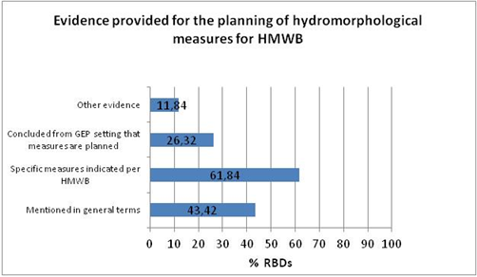
Figure 8.14.1: Evidence provided for the planning of hydromorphological measures for HMWBs
Source: RBMPs assessment

8.14.3. Which hydromorphological measures have been proposed in the plans?
The following hydromorphological measures (non-exhaustive list of pre-selected measures for the assessment of all RBDs) have been proposed to varying extents, as indicated below:
- In >60% of RBDs:
  - Removal of structures (weirs, barriers, bank reinforcement).
  - Fish ladders.
  - Habitat restoration, including building spawning and breeding areas.
- In 30 – 60% of RBDs:
  - Restoration of bank structures.
  - Sediment and debris management.
  - Restoration of degraded bed structure.
  - Minimum ecological flow.
  - Bypass channels.
  - Reconnection of meander bends or side arms.
  - Remeandering of formerly straightened water courses.
- In <30% of RBDs:
  - Operational modifications for hydropeaking.
  - Reduction or modification of dredging.
  - Inundation of floodplains.
  - Construction of retention basins.
  - Lowering of river banks.
The assessment of several plans (e.g. in France, Germany, Italy) shows that often hydromorphological measures are described in the plans in a general manner without giving specific descriptions of the measures. This may be the case because only a summary of the PoMs has been requested by the WFD (thus, specific hydromorphological measures are listed in internal documents which have not been officially reported) or because some measures require further investigation before they can be defined with more precision.
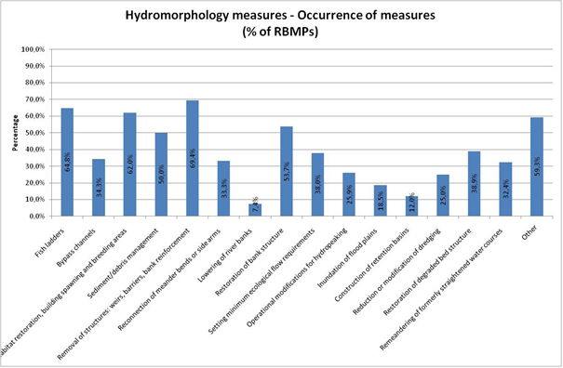
Figure 8.14.2: Hydromorphological measures and occurrence at EU level
Source: RBMPs assessment

8.14.4. Measures to achieve an ecologically based flow regime
Establishing ecologically based flow regimes is an important hydromorphological measure since to have a sufficient ecological flow regime is a prerequisite to reach good ecological status in rivers and it is crucial to maintain a flow throughout the river continuum.
In 45% of RBDs, the plans make reference to (national/regional) guidelines or regulations to define an ecologically based flow regime: Austria, Bulgaria, Denmark, Spain, France, Germany, Hungary, Italy, Lithuania, Latvia, Slovenia, Sweden and UK (method in UK is under development). However, other countries may also have guidelines or regulations, which were not reported in the plans since this has not been a specific requirement for reporting.

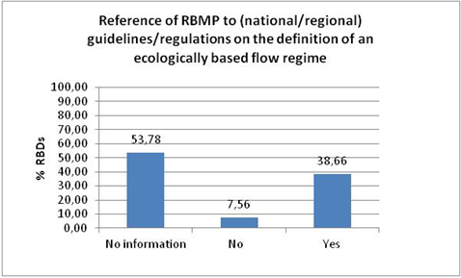
Figure 8.14.3: Reference in RBMPs to national or regional guidelines on definition of ecologically based flow regime
Source: RBMPs assessment

In around half of the RBDs assessed, it is indicated that specific measures are taken to achieve an ecologically based flow regime.
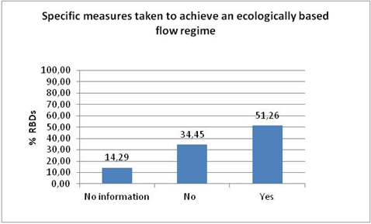

Figure 8.14.4: Measures to achieve ecologically based flow regime
Source: RBMPs assessment

In recent questionnaires filled in by Member States for the CIS Workshop on Water Management, Hydropower & WFD (September 2011), most countries reported to have relevant legislation at national level (in a few, also on regional level) to ensure ecologically based flow at hydropower plants. See table below for details.
 | There is relevant legislation |  | There is no legal requirement but there is a relevant recommendation |  | No legal requirement or recommendation but defined in individual cases | Generally no legislative means
 | National | Regional | National | Regional |  | Generally no legislative means
Minimum ecological flow | AT, BG, CH, CZ, DE, ES, FR, HU, IT, LT, LV, NL, NO, RO, SI | DE, IT | CZ, PT, SK, UK | UK | BE, DE, FI, IS, LU, NO, SE | FI
Table 8.14.1: Legislation to ensure ecologically based flow regime
Source: RBMPs assessment

Many countries use a static definition for minimum ecological flow (e.g. 5% to 10% of annual mean flow) (Bulgaria, Czech Republic, Lithuania, Romania, Sweden and Slovakia) which is not necessarily linked to the achievement of WFD environmental objectives. A dynamic definition of minimum ecological flow (different fixed minimum flow values distributed over the year) is applied in Finland, The Netherlands, Portugal, Slovenia, and Iceland (in some cases, complemented by modelling). In other countries, static definitions of minimum ecological flow are combined with a dynamic definition and modelling determination (Austria, France, Germany, Italy, UK and Switzerland). In Latvia and Luxembourg, a static definition is combined with a dynamic definition of minimum ecological flow. Belgium (Wallonia) combines a static definition with modeling determination. In Spain, for relevant locations, double studies are carried out, using hydrological and ecological (IFIM) data. According to the results obtained, the most adequate results are used, on a case by case basis. For Hungary, no specific information was provided on the methods applied to define minimum ecological flow.
Indeed, there are different methods to define minimum ecological flow requirements and, currently, there is no standardised method or a common understanding for setting minimum ecological flow. To gain knowledge for the further development of minimum ecological flows, there is a need for monitoring the effects of minimum flow on biological quality elements.

8.14.5. Links between uses, pressures and measures
The linkage between specific water uses, types of hydromorphological pressures and specific hydromorphological measures has been made explicit in 39% of RBDs.
In 41% of RBDs, no clear links were reported between uses, pressures and hydromorphological measures but there is partial information on links between uses and measures or between pressures and measures. For example, an RBMP may indicate the number of fish passes proposed to restore river continuity at specific barriers, but the water uses which these barriers serve are not stated (e.g. navigation, hydropower etc).
Nevertheless, even in those RBDs where explicit links between uses, pressures and hydromorphological pressures could be found, specific pressures and uses have not been addressed with all necessary measures in all cases.
In the case of hydropeaking which is a pressure related to the use of water for hydropower, the ecological status of water bodies can be improved through operational modifications that reduce the volume and frequency of artificially generated abrupt waves and avoid extreme water level fluctuations. However, operational modifications for hydropeaking have not been proposed as a measure in all RBDs which report hydropeaking as a pressure linked to hydropower (see table below for details).
In RBDs which report the interruption of longitudinal continuity (dams, weirs, impoundments) due to hydropower use, fish ladders, bypass channels or removal of structures have been proposed as measures in different combinations. However, in a few of these RBDs, none of these three measures has been proposed to counteract the interruption of longitudinal continuity.

Uses - Pressures | Relevant measure(s) (selection) | Nr. RBDs
Hydropower – Interruption of longitudinal continuity |  | 39
 | Fish ladders | 27
 | Bypass channels | 23
 | Habitat restoration | 19
 | Sediment/debris management | 19
 | Minimum ecological flow | 24
 | Removal of structures | 20
Water supply & storage - Interruption of longitudinal continuity |  | 21
 | Fish ladders | 16
 | Bypass channels | 13
 | Habitat restoration | 13
 | Sediment/debris management | 16
 | Minimum ecological flow | 17
 | Removal of structures | 17
Flood protection - Bank reinforcement |  | 17
 | Habitat restoration | 10
 | Removal of structures | 7
 | Reconnection of meander bends | 11
 | Restoration of bank structure | 10
Hydropower - Residual Flow |  | 17
 | Minimum ecological flow | 13
Hydropower - Hydropeaking |  | 15
 | Operational modifications for hydropeaking | 8
 | Minimum ecological flow | 13
Flood protection – Interruption of lateral connectivity |  | 15
 | Habitat restoration | 7
 | Removal of structures | 7
 | Reconnection of meander bends | 9
 | Restoration of bank structure | 9
Table 8.14.2: Selection of hydromorphological measures
Source: RBMPs assessment
Note: The combinations of uses-pressures-measures shown in this table were the most frequent ones in the RBDs assessed.

In RBDs with HMWBs designated due to hydropower, relevant measures proposed to deal with hydropower-related pressures are varying. In more than 80% of these RBDs, removal of structures and fish ladders are proposed, but only 30% of these RBDs propose operational modifications of hydropeaking.
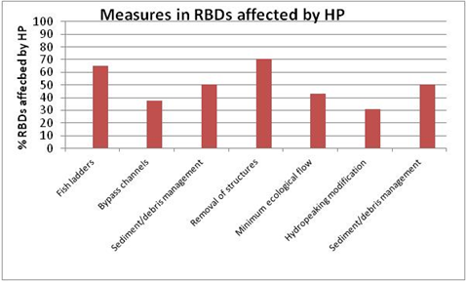
Figure 8.14.5: Measures related to hydropower installations
Source: RBMPs

In RBDs with HMWBs designated due to navigation, relevant measures proposed to deal with navigation-related pressures are varying. In more than 60% of these RBDs, sediment/debris management and habitat restoration are proposed, but only ca. 30% of these RBDs propose reduction or modification of dredging.
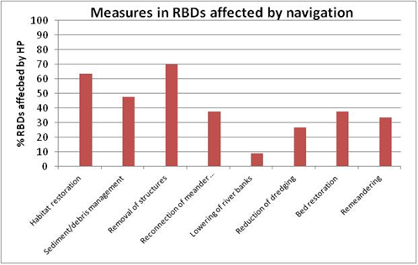
Figure 8.14.6: Measures related to navigation
Source: RBMPs

In RBDs with HMWBs designated due to flood protection, relevant measures proposed to deal with flood protection-related pressures are varying. In ca. 80% of these RBDs, bank restoration is proposed, but only 30% of these RBDs propose inundation of floodplains and less than 20% retention basins.
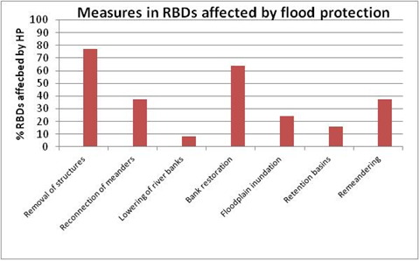
Figure 8.14.7: Measures related to flood protection
Source: RBMPs

8.14.6. Assessment of expected effects of measures
In 34% of RBDs, the expected improvements due to hydromorphological measures are described in the RBMPs. The information provided in this respect is quite heterogeneous and overall, it remains general. In the majority of plans, the measures are not reported for specific water bodies, thus there is no information on the expected effects of measures at water body level. In some cases, alternative indications on the geographical extent of the measures are given, e.g. km or ha of application of a measure.
Several plans describe the expected effects of specific measures on habitat and biota in a general way (in some plans, effectiveness is also specified for each BQE and type of pressures in the context of generic catalogues of measures) but there are usually no specific remarks on how measures are expected to improve the GES/GEP.
It is often argued that the biological assessment methods are not (or not sufficiently) sensitive yet to hydromorphological pressures. This has an effect on the adequateness of the current assessment of hydromorphological impacts, the selection of appropriate measures and predictions of specific expected effects on good ecological status or potential.
For 66% of RBDs, there is no description or no information found on the effects of planned hydromorphological measures and on whether they will improve the ecological status/potential.

8.14.7. Conclusions
- Hydromorphological measures have been systematically included in the RBMPs, and in most cases, these measures are also foreseen for HMWBs.
- Only in half of RBMPs assessed is there a clear indication that specific measures are taken to achieve an ecologically based flow regime.
- Only in around 40% of the RBMPs assessed there has been reported a linkage between water uses, types of hydromorphological pressures and specific hydromorphological measures.
- It is in general not clear how the proposed measures are expected to contribute to the improvement of the ecological status or potential.

8.14.8. Recommendations/proposals for next planning cycles
- The link between the status, the pressures and the hydromorphological measures should be clearly explained in the RBMPs.
- As more information becomes available through further investigations, hydromorphological measures should be more clearly defined and described in the plans (e.g. their geographical extent, technical details). Efforts should be made to report on proposed hydromorphological measures on water body level.
- The second RBMPs should be more precise on the expected effects of specific hydromorphological measures, especially on the way they are expected to improve the GES/GEP at water body level.
- There should be a clear distinction in the PoMs between hydromorphological measures proposed for natural and for heavily modified or artificial water bodies.
- Methods used to define ecological flow requirements (national or regional methods) should be clearly indicated in the plans. At EU level, there is a need for more standardised methods and development of a common understanding for setting ecological flow. In the Member States, monitoring programmes should target stretches where ecological flows are applied to gain further knowledge on the specific effects of ecological flow application on biological quality elements.
- The linkage between specific water uses, types of hydromorphological pressures and specific hydromorphological measures needs to be reported in a clearer and more transparent way in the plans.
- More analysis would be needed on how hydromorphological measures are expected to improve the GES/GEP and the impact of their effectiveness.

8.15. Measures related to Article 9 (water pricing policies)

8.15.1. Introduction
With the Water Framework Directive, it is the first time in EU environmental policy that economic principles (e.g. polluter-pays-principle), economic tools and methods (e.g. cost-effectiveness analysis) and economic instruments (e.g. environmental charges and taxes) are explicitly integrated into a piece of EU water legislation. This is based on the understanding that economic principles and instruments are potentially important tools in managing the pressures that affect Europe’s waters.
WFD set three general concepts, closely related but not equivalent, each one imposing specific requirements on economics in general and water pricing schemes specifically:
- Incentive pricing deals with the way water users pay for their use and whether the right price signals are transmitted, i.e. it addresses the question how water is being paid for and how the water price affects the behaviour of water users.
- The polluter-pays-principle establishes how environmental costs should be covered among economic agents i.e. it looks at the adequacy of contributions from the different agents based on their role in causing these costs.
- Cost recovery establishes the overall amount that users are charged for water services. The WFD foresees an adequate degree of recovery, not only to the financial costs for the provision of a water service, but also of the costs of associated negative environmental effects (environmental costs) as well as forgone opportunities of alternative water uses (resource costs).
Based on the above and on the results of the assessment of the first RBMPs produced for the implementation of the WFD (plans date from 2009), it needs to be noted that while considerable efforts have been done by the Member States, the implementation of Article 9 foreseen for 2010 has yet to reach its full potential for using economic instruments for efficient water management. Only a number of Member States have changed or are considering changing their previous water pricing policies based on the work done for Article 9. The RBMPs in the majority of cases report a status quo of existing pricing policies.
More detail regarding the key elements of Article 9 forming the basis for understanding and improving the situation as regards to economics are described in the following sections.

8.15.2. Water pricing policy providing adequate incentives for users to use water resources efficiently
Incentive pricing is referred to in approximately two thirds of the RBMPs. Even when it is referred to, the information is too general and does not present the situation in appropriate analytical detail. The existing tools and instruments used for creating appropriate incentives through water pricing policies are described as follows (the ones mentioned are in % of RBMPs): volumetric pricing in place for water uses (63%), water metering in place for water uses (53%) and other economic incentives (45%). The assessment of their incentive function is not reported in detail, and only general statements regarding this issue are given.
In many cases there is not sufficient information on whether water metering is in place for different water uses, information that is fundamental when considering an incentive pricing policy.

8.15.3. Cost recovery rates calculations, including environmental and resource costs
In 16 out of 24 Member States assessed so far, a narrow definition of water services is used, meaning that mainly public water supply and waste water collection/treatment are covered. This limits very significantly the potential impact of Article 9 provisions by reducing the scope of the analysis/cost recovery calculations to a limited number of water services.
Overall, there are varying methodologies for the calculation of cost recovery rates, which makes difficult to compare the costs among different RBMPs.
Regarding the calculation of financial costs (within cost recovery estimations) of water services, considerable work is reported in all MSs. However in 2 MSs any details on financial costs calculation was found, even if they are reported to be considered in cost recovery calculation. In general, a consensus is present over the need to cover financial costs of water services. The following financial costs are reported as being included in the calculation of cost recovery (in % of RBMPs): capital costs (70%), operating costs (68%), maintenance costs (63%), administrative costs (40%), other direct costs (10%). At the same time, it is not always clear how financial costs are calculated in the cost recovery and if all elements of financial costs are taken into account in the calculation, for example regarding capital costs (investment costs, depreciation, cost of capital, replacement costs etc.).
On the issue of subsidies/cross subsidies19 MSs report on how these are taken into account into the calculations, but in 5 cases this is lacking. An additional work is being done/planned (esp. in MSs lacking detailed information so far) in order to improve the data situation concerning financial cost recovery and a more in-depth understanding of certain issues (e.g. financial flows/subsidies).
Regarding the estimation and integration of environmental and resource costs (ERC) - which is linked to the polluter pays principle - in the cost recovery calculations, in 19 MSs there is reference to ERC. At the same time, very different approaches for ERC estimation or lack of methodology of their estimation are reported. The main reason is the lack of practicable methodologies.
An often-shared opinion is that the ERC are already minimized though permit systems and internalized though charges and fees established (the approach found in 11 MSs). In cases in which the good environmental status is not reached in a water body due to a specific water service, the ERC of that service are assumed to be as high as the costs of the measures that would be needed to reach the good status (abatement cost approach).

8.15.4. Adequate contribution of water uses to cost recovery of water services
In the first RBMPs limited efforts were conducted on the adequacy of the contribution of water uses to the costs of water services. While 12 MSs mention the contribution of households and industry to cost recovery, the contributions of other user groups remain unclear in an important number of RBMPs. Agriculture is often excluded (14 MSs) from the analysis of adequate contribution without a clear justification, even where agriculture constitutes an important pressure.
In all RBMPs, water uses were generally described. At the same time, the ways water uses have been identified especially in the Article 9-context is not always clear. In all, except 1 MS, at least households, industry and agriculture have been defined as water uses. Even if the pressures and impacts analysis showed that significant pressures are linked to a specific activity (e.g. agriculture), it was not always defined as a water use for Article 9-analysis. This is of importance since water uses have to contribute adequately to the costs water services, so all activities with significant impacts should be considered as water uses.
The polluter-pays-principle - of importance for taking into account the cost recovery principle (including environmental and resource costs) in general and for adequate contributions to cost recovery - is mentioned in 11 MSs only in a general way without analysing the situation in detail.
The often unclear consideration of subsidies and cross-subsidies in the cost recovery calculations is also hindering a clear view on the adequateness of contributions of different water uses to the recovery of the costs and the consideration of the polluter-pays-principle.
In only 9 MSs, social and/or environmental and/or economic effects of the recovery as well as the geographic and/or climatic conditions of the region or regions affected are mentioned when implementing Article 9.

8.15.5. Other issues: national and international cooperation regarding the application of Article 9, use of Art. 5 economic analysis
In 22 MSs Article 9 was applied following a national approach, with international cooperation only in 2 cases. At the international level, exchange of information regarding approaches used and experiences made took place through working groups/expert meetings. In 2 MSs common work was reported, but regarding only the description of water uses and summarizing the developed measures at the RB-scale.
In smaller/less federal Member States, common national approaches have been developed and used. In more federal/larger Member States, while national cooperation took place, also sub-national approaches to Art.9-implementation were used.
Regarding the use of the Art.5/Annex III economic analysis for implementing Article 9, the picture is mixed: 5 MSs refer to the economic analysis reported in 2004, 11 MSs use an updated version of this economic analysis, while 6 MSs do not make an reference/link to the economic analysis.

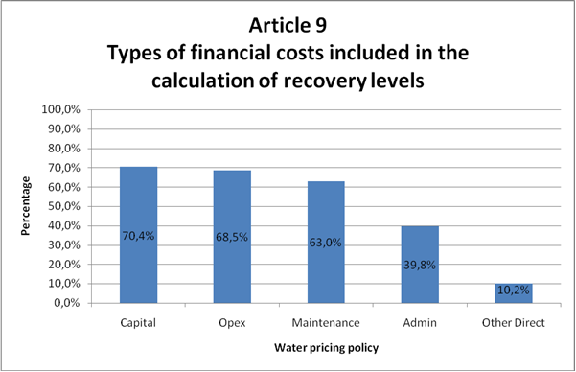

Figure 8.15.1: Percentage of RBMPs in which financial costs (by type of costs) were reported to be included in the cost recovery calculation
Source: RBMP Assessment

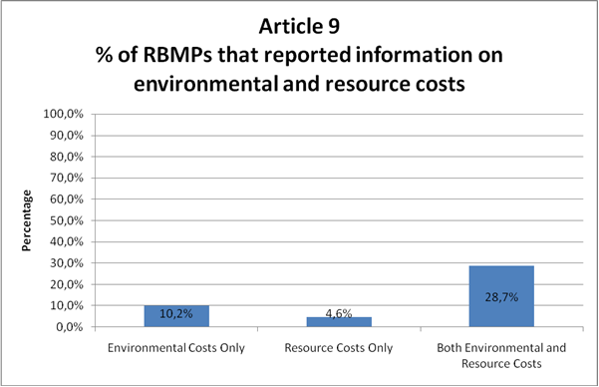

Figure 8.15.2: Percentage of RBMPs in which environmental and resource costs were reported to be included in the cost recovery calculation. It does not mean that the calculation is transparent and that the implementation is effective
Source:RBMP assessment

8.15.6. Conclusions
Summarising the implementation of Article 9 hasn't yet reached its full potential by using economic instruments for efficient and fair water management. The main implementation failures can be associated with:
- diverse methodologies or lack of transparency in calculation of cost recovery and high number of RBMPs where environmental and resource costs are not included in the calculation,
- lack or insufficient use of economic instruments to incentivise water use, mainly volumetric pricing and water metering being fundamental when considering an incentive pricing policy,
- inadequate, usually too low, and unjustified contribution of different water uses, especially agriculture, to cost recovery of water services and the narrow approach to water services.

8.15.7. Recommendations
Based on the above, there is significant room for improvement of Art. 9 implementation by the MSs for the next implementation cycle of the WFD. At the same time, the European Commission is ready to support the work done for better implementation through the CIS-process and beyond. This needs to take place in close cooperation with the MSs and the River Basin authorities and focus on implementable approaches that will support an overall better water management. Main topics that that should be in the focus of further work are:
- A “broad” definition of water services should be used for the second implementation cycle. The EU-Commission will support the practical application of a wider definition of water services as needed;
- The contributions of all relevant sectors (water users or polluters) to cost recovery, taking into account the polluter-pays-principle, needs to be shown more transparently and their adequacy compared with the pressure on water resources caused the sector needs to be further assessed. This concerns not only financial cost recovery calculation (e.g. consideration of capital costs and of subsidies/cross-subsidies), but also the way ERC are estimated with sufficient methodological accuracy and at limited cost. However, the lack of a standardised methodology of calculation ERC should not prevent further work on the issue by the MS, esp. where estimations of ERC are of importance.
- There is a need to improve the incentives of the water pricing system. This should be based on better understanding of the incentive function of economic instruments (e.g. price elasticity) and of the preconditions for their functioning (e.g. metering). Based on this, the effectiveness of changes in the water pricing policies referring to requirements of Art. 9 should be further assessed at Member State level;
- The European Commission can support the development of more consistent methodologies for calculating the degree of cost recovery and assess the effectiveness of the pricing system, that at the same time allow for consideration of the existing legal, institutional etc. differences among RBD/MS. However, the lack of standardised methodologies should not prevent further work on the issue by the Member States.
- The international cooperation in the implementation of Art. 9 needs to be fostered, moving beyond the exchange of information towards a more coherent consideration of Art. 9 requirements;
- Finally, the way the quantification and monetary valuation of ecosystem services can be integrated in the pricing system and support Art. 9 implementation should further be assessed (e.g. linked to the consideration of ERC) as well as the consequences the economic crisis can have on the contribution of tariffs, taxes and transfers to the financing of measures, and on the effectiveness of the pricing system in contributing to a more resource efficient economy. Putting a “true value” on resources has never been so important as during the current economic crisis

8.16. Additional measures in Protected Areas

8.16.1. Introduction
The 'additional measures in protected areas' refer to those measures needed to achieve more stringent objectives than good status required by Article 4 of the WFD. More stringent objectives are those that have been set out in the relevant Community legislation under which the individual protected areas have been established, as set in Article 4(1)(c) (see section 8.10 on environmental objectives). Article 4(2) of the WFD requires that where more than one objective relates to a given body of water, the most stringent shall apply. The timeline for the implementation of those objectives may be different than the deadline established in the WFD for achieving good status.
According to Article 6 and Annex IV, Member States should designate those protected areas of the RBD that requires special protection under specific Community legislation for the protection of surface or groundwater or for the conservation of habitats and species directly depending on water, including the protection of Natura 2000 sites and economically significant aquatic species (e.g. shellfish). The protected areas should also include all water bodies used for abstraction of drinking water and bathing waters.
A summary of the register of protected areas should be part of the RBMPs, including maps indicating the location of each protected area and a description of the Community, national or local legislation under which the protected areas have been designated.
The relevant EU legislation for the protection of water with more stringent objectives includes the following directives:
- Drinking Water Directive (80/778/EEC, as amended by Directive 98/83/EC).
- Shellfish Directive (79/923/EEC).
- Freshwater Fish Directive (78/659/EEC).
- Bathing Water Directive (76/160/EEC).
- Nitrates Directive (91/676/EEC).
- Urban Wastewater Treatment Directive (91/271/EEC).
- Birds Directive (79/409/EEC).
- Habitats Directive (92/43/EEC).

The Freshwater Fish Directive (78/659/EEC) and the Shellfish Directive (79/923/EEC) will be repealed on 22 December 2013. The protection of the freshwater fish and shellfish waters will be ensured with the implementation of the necessary additional measures for the achieving of the more stringent objectives that Member States should have designated as protected areas under these two Directives, as required by Article 6 and Annex IV WFD.
For water bodies which are designated as a protected area, the environmental objectives set are beyond good status, as more stringent objectives have been set out for those areas in the relevant Community legislation. For those RBMPs for which it is relevant, almost 40% have clearly designated objectives for shellfish waters that go beyond the good status of water bodies and almost 20% for Natura 2000 protected sites. For drinking water and bathing water, these more stringent objectives have been identified in 14% and 13% of the RBMPs respectively. In those cases where additional objectives have been set, the RBMPs generally make reference to the specific national legal acts by which these additional objectives have been regulated.
Annex VII (7)(1) WFD requires that the RBMPs contain 'a summary of the measures required implementing Community legislation for the protection of water'. The additional measures for protected areas should be an integral part of the RBMPs in order to ensure that the requirements of those protected areas are included in the overall management of the RBDs and to ensure the coherence of the entire water planning with the objectives already established by other Community and national legislation.
The additional measures can be of the same nature as those for the WFD (e.g. measures to reduce nitrogen loss from agriculture or measures to improve the hydromorphological status in a river) but they need to reach a higher level of improvement of status. There can also be different kinds of measures targeted towards the specific objectives for the protection of the area.

8.16.2. Protected areas
Around 66% of RBMPs do not include a clear identification of water bodies that require additional measures on the basis of their designation as protected areas.
For some Member States it is indicated that additional measures are not needed because the measures taken to reach the good ecological status according to the WFD is sufficient to reach the objectives relating to protected areas. This may be a critical assumption, as the required status for the protected areas is often stricter than the good status according to the WFD. Other types of measures are needed to protect specific habitats, species and to achieve stricter objectives on water quality.
The achievement of the good status is generally not enough to reach the objectives of other EU legislation (e.g. Habitat and Bathing Water Directives). Other examples are related to drinking water protection, where the basic and supplementary measures are not sufficient for the protection of drinking water supply, both for surface and groundwater.
Concerning the measure for protected areas in those plans that have included such measures (i.e. around one third of all RBMPs), the plans generally contain very little information on the type and the magnitude of the measures foreseen.
However, there are also good examples in some RBMPs, such as transparent designation of protected areas and clear identification of those areas failing to achieve the more stringent objectives.
Even when additional measures are incorporated into other planning instruments, these measures should also be explained in the RBMPs. The plans should contain all relevant information on all impacts, objectives and measures for all water bodies to ensure that an integrated approach is taken for the whole RBD. The limited information that has been reflected in most of the RBMPs shows that the integration of protected areas in the whole planning cycle has not been a priority in this first set of RBMPs. Some Member States have argued that the effect of the measures of the current cycle in the water status has to be assessed before any decision on introduction of additional measures is taken.

8.16.3. Drinking water protection
The information in this section has mainly been extracted from the 'EC Comparative Study of Pressures and Measures in the major river basin management plans in the EU'
Groundwater
Groundwater is the major source of drinking water in 15 Member States while surface water is the major source in 9 Member States (see Figure 8.16.1). The share of groundwater used for drinking water purposes in Europe ranges from 16% (Ireland) up to 100% (Austria, Denmark and Lithuania). At the Mediterranean islands of Cyprus and Malta, drinking water is dominantly produced from desalination of marine and brackish water.
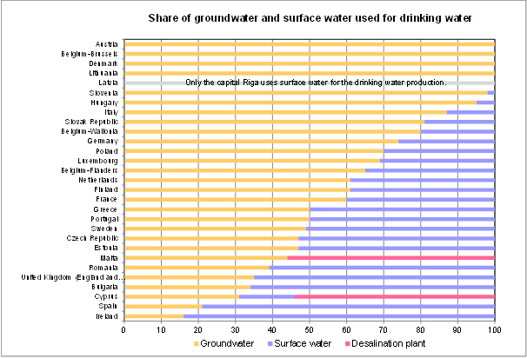
Figure 8.16.1: Share of groundwater and surface water used for drinking water production in Europe
Source: 'Pressures and Measures study'

Drinking water safeguard zones around groundwater abstractions are commonly established in Europe. Almost all Member States have reported that such zones are already established or planned to be established. However, the design and establishment of drinking water safeguard zones is costly and is often only established for abstractions exceeding a certain quantity. Smaller abstractions are often not covered and might lack of comparable protection.
Drinking water safeguard zones in groundwater are protection zones in the recharge area of groundwater abstraction(s) covering parts or the whole aquifer. The size of safeguard zones varies considerably between different Member States, and it is often divided into different zones of protection levels, mainly dependent on the distance respectively the transport time of potential pollutants to the abstraction point. The protection measures are adapted to these different zones or levels of protection.
The measures implemented for drinking water resource protection address all kinds of diffuse and point sources of pollution, mainly from agricultural activities, urban land use, infrastructure, water abstractions and recharge.
The objective of the safeguard zones is to reduce existing but mainly to prevent potential pressures of any kind, including both diffuse and point sources of pollution. This covers all sectors and human activities causing pressures on groundwater quality and quantity which might endanger safe and secure use of groundwater for drinking water production, both on the short and on the long term.
The implementation of a safeguard zone is not a measure as such but a bundle of individual, specific and targeted rules accommodated therein. In general, measures which are established for the protection of drinking water abstractions from groundwater consist of a combination of specific measures within safeguard zones and the general measures implemented in the whole territory of a Member State, based on European and national legislation, which also contribute to the protection of drinking water. Such general provisions comprise for example the implementation of the 'prevent or limit' requirement under the Water Framework Directive and the Nitrates Action Programmes, as well as the associated codes of good agricultural practice under the Nitrates Directive.
Some direct measures implemented in safeguard zones include prohibitions and restrictions of and permits for human activities. The effectiveness of these measures strongly depends on strict monitoring, control and enforcement. Other indirect measures may be the improvement of land use or the development of codes of good practice, monitoring networks, research, awareness raising, etc.
About half of Member States implement drinking water protection related measures also outside the safeguard zones. Figure 8.16.2 shows the different measures and the occurrence in the Member States of the different protection measures for drinking water sources in groundwater.
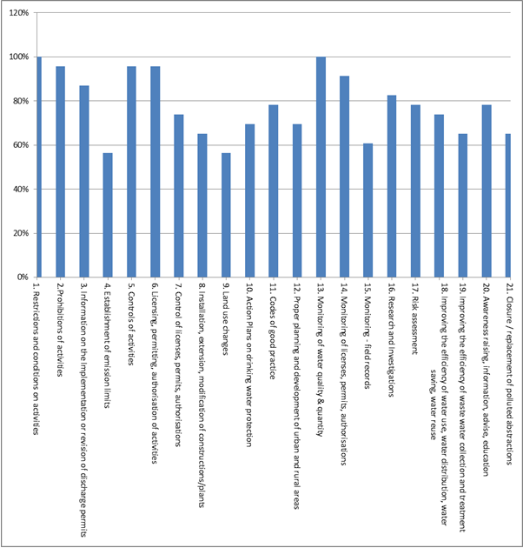

Figure 8.16.2: Percentage of Member States in which different protection measures are applied
Source: 'Pressures and Measures study'

Concerning the costs of the measures in these groundwater safeguard zones, the public authorities and the water companies generally cover the costs of:
- the preparatory work for establishing safeguard zones like the identification of the recharge area, the conceptual model, the characterisation of the pressure situation, risk assessments etc. Such investigations and assessments might also be performed at a later stage during the operational phase
- the establishment of safeguard zones by delineation and definition of restrictions, limitations, conditions and prohibitions of activities in general
- the monitoring of groundwater quantity and quality in the safeguard zone
- improving efficiency of water use, water distribution, water saving, water reuse, awareness raising, information, advise, education
- Action Plans
- compensations to polluters if a safeguard zone and/or a condition were introduced after the polluter started his activity or to raise acceptance of a voluntary measure

The water company is mainly paying for the closure and replacement of abstraction sources.

The public is primarily covering the costs of:
- monitoring and controlling individual decisions (licenses, permits, authorisations)
- land use planning in general and the development of codes of good practice

And the potential polluter is mainly paying for:
- the establishment of individual conditions within the application procedure of licenses, permits and authorisations and also for their revision
- conditions implemented at a general level (e.g. Nitrates Action Programme, codes of good practice)
- the monetary effects of non-performing activities (or performing it at an extensive level) which are prohibited or restricted by general conditions or limited by individual conditions in a safeguard zone

Surface waters
The use of surface water for drinking water varies considerable between the Member States, from 0 to 84% (in Ireland), with an average of 34% (see figure 8.16.1).
To protect the surface waters that are source for drinking water, safeguard zones are applied or legislation on safeguard zones is in preparation in 90% of Member States. In most Member States safeguard zones are mandatory or mandatory if the abstraction exceeds certain limits.
In general the Member States legislation on drinking water protection provides regulation for inside the safeguard zones. However, there are also often measures in context to general water protection taken outside the safeguard zone will contribute to protection of drinking water.
The primary pressures for drinking water are pollution by point sources of all kinds, diffuse sources (mainly agricultural) and overexploitation of a water body. Secondary pressures are disturbances of the water body and its catchment which are not directly or potentially influencing water quality and water supply. Such as morphological changes, changes in river management or legislation in a catchment and climate change.
The legislation related to safeguard zones on surface waters zones focuses mainly on preventing and reducing impacts on the water body by human activities, as for example reducing or prohibiting economic and agricultural activities, fertilizers and pesticides and other emissions in the safeguard zones. In addition to these, other measures are often taken on monitoring of water quality and quantity and surveillance and control of activities in the field.
An important issue with the safeguard zones is that they address the pressures within the zone, when the legislation only regulates the activities within the zone. However, around half of the Member State implements protection measures also outside those safeguard zones. In general, measures outside the safeguard zone fall under general water management or other legislation. Therefore, it is crucial that the safeguard zones are taken into account in the more holistic planning of the RBDs, in order to reduce as much as possible the necessary treatment of drinking water.
A safeguard zone is considered to have an effect mainly on the chemical status of a water body. By affecting the chemical status, the biological status may be improved as well, but this is a generally secondary effect. The effect of drinking water protection measures on hydro-morphological status of a water body is not very high.
Figure 8.16.3 shows the percentage of Member States in which the different measures to protect safeguard zones are being applied.
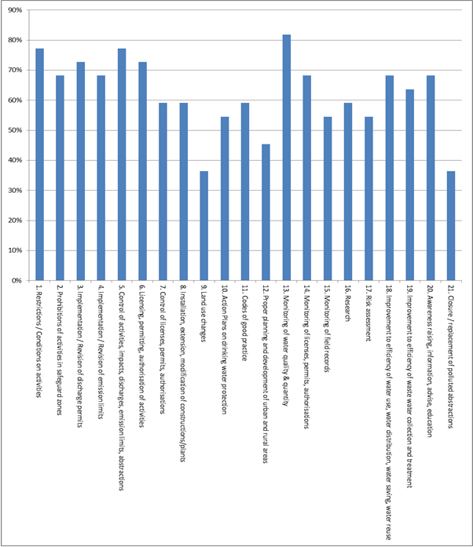

Figure 8.16.3: Percentage of Member States in which different protection measures are applied
Source: 'Pressures and Measures study'

The effectiveness of safeguard zone implementation depends on the related combination of measures, which differs between Member States quite significantly. Some of the measures directly impact the pressures in the area, such as, land use change and improvement of sewer systems, or some control measures such as restrictions, prohibits, permits and licences. Finally, other measures have an indirect impact on the protection of the area, e.g. research, risk assessment, proper planning and awareness raising, which may have a positive impact in the long-term.
The costs of establishing a safeguard zones are generally paid by the water company or by the final users, including the implementation and the legal embedding of the zone. Once the zone is in function, the distribution of financing is generally as follows: the compliance of restrictions and prohibitions, permits, licences and codes of good practice are generally paid by the polluter. The public finances control, monitoring and planning. And the other measures are subsidized by both the water company and the public.

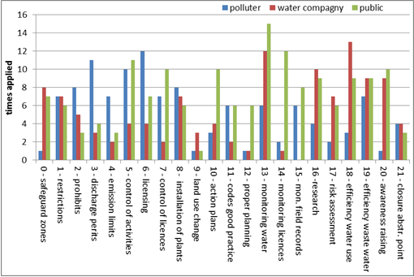
Figure 8.16.4: Different groups of contributors for the protection measures in safeguard zones
Source: 'Pressures and Measures study'

8.16.4. Shellfish water
The information in this section has been extracted from the Member States RBMPs and complemented with information from the 'EC Comparative Study of Pressures and Measures in the major river basin management plans in the EU'
Directive 2006/113/EC on the Quality Required of Shellfish Waters is to be repealed in 2013 when the WFD must provide at least the same level of protection to shellfish waters (which the WFD classifies as protected areas) as the current Shellfish Waters Directive does. The quality of commercially harvested shellfish intended for human consumption must comply with EU Food Hygiene Regulations which set standards for the quality of the shellfish flesh according to three levels (A, B or C) of designated shellfish Production Areas. In principle, these Production Areas should correspond to the Shellfish Protection areas given in the RBMPs.
It is clear that in some of the Member States there is a relationship between Shellfish Protection Areas and Shellfish Production Areas. In these cases even if the additional measures are not clearly described, it may be inferred that a level of protection is given. In a number of RBMPs additional objectives and measures have been established above those required to achieve other WFD objectives through the establishment of for example of Pollution Reduction programmes (Ireland). For some other MS such as the UK (England, Wales or Scotland) this information was not clearly given in the RBMPs but could be implied from other sources of information or could be inferred as established though national regulation (France, Italy, Germany, or the Netherlands). These national sources also confirmed that measures undertaken within RBMPs will achieve objectives associated with Production Areas (UK). In other cases additional measures have not been defined at all as the objectives of the Shellfish Directive were assessed as having been met already (Germany). In addition in others, even if the objectives for Protected Areas had been established, there were no clear additional measures identified to reach those objectives, neither in the RBMPs nor in additional documentation. In none was there an explicit linkage with the objectives associated with Production Areas and the relevant EC Hygiene Regulations.
This also shows the need for a better integration of aquaculture policy in the water management process in order to ensure both water of good status and sustainable aquaculture growth. This is of special importance since the Commission has given aquaculture a prominent role in the Common Fisheries Policy (CFP) reform package and the proposal for a European Maritime and Fisheries Fund (EMFF) reflects the commitment of the Commission to substantially reduce the impact of aquaculture enterprises on water.

8.16.5. Conclusions
- Member States with important production of shellfish (Denmark, France, Germany, Ireland, Italy, the Netherlands, Slovenia, Sweden and the UK) have in general terms linked the designated Protection Areas with Production Areas. However the level of ambition and detail provided in order to safeguard shellfish from various harmful consequences by setting additional measures to those required by the WFD varies from one MS to the other. In many cases even if the measures are established this is not reflected in the RBMPs and the possibly available information needs to be extracted from other national sources or inferred by measures established under other Directive's objectives.
- In some cases objectives and additional measures were established as they come under national regulation but this was not included in the RBMPs.

8.16.6. Recommendations
- Additional measures should be foreseen for protected areas in order to ensure the level of protection required by the relevant legislation under which these protected areas have been designated.
- The additional objectives and measures for protected areas (Shellfish, Natura, Drinking water, etc.) should be clearly described in the RBMPs. The plans are the overarching tool to ensure a proper management of all activities taking place in the RBD, and should therefore include references to the measures foreseen for the special protection of protected areas.

8.17. Strategy to deal with water scarcity and droughts

8.17.1. Requirements of the WFD
The WFD provides a comprehensive framework for the protection and management of water. The following elements are linked to the management of quantitative aspects:
- The Directive provides a framework for the protection of waters which prevents further deterioration (Articles 1.a and 4).
- The Directive contributes to mitigate the effects of droughts (Article 1.e).
- Water quantity can have a strong impact on water quality and therefore on the achievement of good ecological status. Hence quantitative requirements are implicit in the definition of good ecological status and explicitly through the inclusion of flow regime as a supporting hydromorphological element.
- Good quantitative status is required for groundwater; a balance between abstraction and recharge must be ensured. Furthermore, groundwater levels should not be subject to anthropogenic alterations that might have impacts on surface waters and groundwater dependent ecosystems.
Sound water management requires joint management of qualitative and quantitative aspects. When developing the WFD RBMPs and associated PoMs, quantitative and qualitative aspects should be jointly considered to be coherent and to create synergies where possible. Quantitative issues should, in particular, be taken into account when making operational the objective of good ecological status and the objective of no further deterioration of current status (Articles 4.1, 4.5, 4.6 and 4.7).
- In particular, actions to manage water quantity (e.g. water scarcity) should be considered as measures (basic/supplementary) when developing the RBMP and associated PoM.
- When and where needed, a specific drought management (sub)plan should be included in the RBMP (Article 13.5).
- Public participation (Article 14) should also be organised around water scarcity management issues, in basins where this is a significant water management issue, as required by the WFD.
The water scarcity and drought phenomena can be understood in the following way:
- Drought is a natural phenomenon. It is a temporary, negative and severe deviation along a significant time period and over a large region from average precipitation values (a rainfall deficit), which might lead to meteorological, agricultural, hydrological and socioeconomic drought, depending on its severity and duration.
- Water scarcity is a man-made phenomenon. It is a recurrent imbalance that arises from an overuse of water resources, caused by consumption being significantly higher than the natural renewable availability. Water scarcity can be aggravated by water pollution (reducing the suitability for different water uses), and during drought episodes.
- If droughts or water scarcity pass certain thresholds, they can significantly affect the environment (terrestrial and freshwater ecosystems, air, soils), the economy (agriculture and water uses) and society (e.g. public water supplies, welfare, recreational activities, cultural and aesthetic concerns).
A specific Communication from the Commission to the European Parliament and the Council for addressing the challenge of water scarcity and droughts in the European Union has given further indication on the key measures that should be promoted in the RBMPs and other tools in order to reduce the impacts of both phenomena. The Commission has assessed progress in implementing the Communication and based on the findings reviewed the policy on water scarcity and droughts. Further details can be found in the Annexed Commission Staff Working Document Supporting the Review of the Water Scarcity & Droughts Policy.

8.17.2. Findings at EU level
The screening exercise based on the RBMP assessment and complementary information covers 111 European RBDs. The following conclusions can be drawn.
Water scarcity and droughts (WS&D) are relevant across the EU territories. Water scarcity is reported for all the Mediterranean area some areas in Central, Eastern and Northern Europe. In this sense 9 RBDs reported river basin-wide water scarcity, 32 RBDs local or sub-basin water scarcity, 14 RBDs droughts and water scarcity affect part of the basin, but not clearly distinguished. 41% of the screened RBMPs do not consider water scarcity relevant. Drought is reported for a wide range of RBDs across Europe: 10 RBMPs face RBD-wide drought spell, 27 RBDs at local or sub-basins levels, and 40% (44 RBDs) of the RBMPs assessed, do not consider drought relevant.
In general, the analysis around water quantity issues is not adequate. Some misconception around the phenomena and their causes is present in the current plans. In a significant number of these basins, both WS&D are not clearly distinguished. This later statement is supported by the fact that only around a 30% of the WS-affected RBDs recognise past and current over allocation of resources as a driver for WS situations. In addition to this, a significant number of RBMPs affected by drought spells do not apparently include information on the causes of the phenomenon.
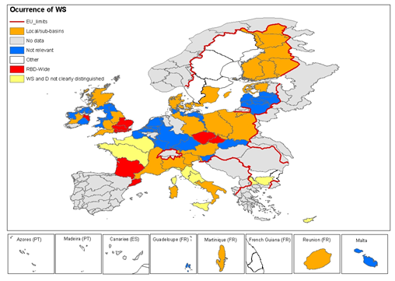
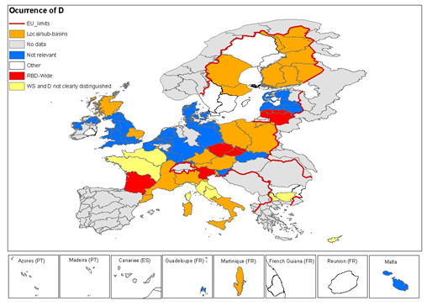
Figure 8.17.1: Occurrence of water scarcity (above) and droughts (below)in the EU Member States as reported in the RBMPs
Source: Commission Staff Working Document Supporting the Review of the Water Scarcity & Droughts Policy

The general lack of an adequate analysis around WS&D is also highlighted by the insufficient datasets provided for the water management planning scheme. This statement could be reflected by the fact that data on water demand trend scenarios are presented only for a 35% and for water availability trend scenarios in less than 25% of the RBMPs. Regarding the quality of data, although in almost 45% of the assessed RBMPs the sources of data for present water consumption and for water availability are explicitly mentioned in only around 20% of the plans, projections of future water demand and water availability are based on explicit assumptions.
For only 20% of the assessed plans, uncertainty of data is made explicit in the dataset used and, when relevant, the time span of the dataset is made explicit. For less than 10% of the screened RBMPs, the sources of funds to implement the PoMs are specified for each measure separately, and for only 5% of the RBMPs the uncertainty of data is taken into consideration when stating the expected results in the PoMs.
Regarding measures, the 5 most present measures includes: 1) Reduction of groundwater abstraction; 2) Training, education and capacity building in water saving; 3) Studies, research and pilot projects; 4) Reduction of leakages; and 5) Modification of water pricing. Measures to ensure the achievement of the WFD environmental objectives via enhancing the resilience of the ecosystems are included in 45% of the RBMPs. Only a few basins out of the more than 40 RBDs that face water scarcity include restrictions to new water-consuming developments as a high priority in their RBMPs.
Only for 6 RBDs, the influence of other sector policies on the reduction of water scarcity and the mitigation of drought effects is described, and measures are proposed to harmonise those policies with that reduction/mitigation. For more than 55% of the RBMPs, the information is not relevant or unclear, or simply no information has been found. For only 12% of the assessed RBMPs, the pressures on water resources by sector at present and in the future are identified.
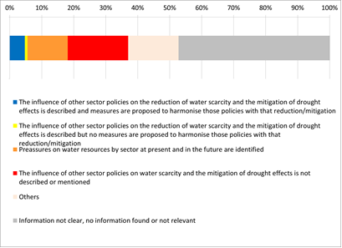
Figure 8.17.2: Influence of other sector policies on reduction of water scarcity and droughts as reported in the RBMPs
Source: Commission Staff Working Document Supporting the Review of the Water Scarcity & Droughts Policy

In international basins there is still a major gap to deal with water quantity in a way that reduces conflict risks and contributes to the WFD environmental objectives. Out of the 65 screened national parts of international RBMPs, in more than 60% of the plans the information is not clear, no information found or not relevant and only around 5% of the RBMPs include co-ordinated measures for the entire international RBD.

8.17.3. Conclusions
- Water scarcity and droughts are recognised in many RBMPs as relevant issues across the EU, but the two phenomena are not well differentiated.
- Water quantity issues are not sufficiently addressed in the RBMPs, the quantitative datasets are incomplete in many plans, and they are insufficient for pro-active planning. Water demand and availability trend scenarios were not identified in most of the plans.
- The majority of measures applied by Member States target pressures, state and impacts and only very few measures target key drivers. The sources of funds to implement the relevant measures are not specified in the majority of the RBMPs.
- Restrictions to new water-consuming developments are envisaged as a high priority in the RBMPs of only a few basins that face water scarcity.
- The influence of other sectoral policies on the reduction of water scarcity and the mitigation of drought effects is not sufficiently addressed.
- In the case transboundary river basins there is still a major gap in dealing with water quantity, very few of the international river basins include co-ordinated measures between the neighbouring countries.

8.17.4. Recommendations or proposals for improvement in the next planning cycles
- Droughts and water scarcity should be clearly differentiated in the next RBMPs cycle, including DPSIR relations. This is particularly relevant for understanding the (different) causes of water scarcity and for drought and the different measures and their effectiveness. A common understanding of water scarcity and droughts has been reached in the framework of the CIS process. This needs to be fully considered in the next RBMPs.
- When and, where needed, a specific Drought Management Plan or sub-plan should be developed taking into consideration the CIS report on Drought Management Plan that serves as guideline for developing such plans.
- Trend assessments should be completed in the second RBMP cycle and, if needed, trend reversal assessment should also be considered.
- The establishment and enforcement of adequate ecological flows for all water bodies in Europe is essential for dealing efficiently with WS&D issues.
- In drought-prone areas, drought uncertainties and variations (e.g. of the water availability) should be considered in the RBMPs’ baseline and not be interpreted as unexpected natural climate extremes.
- Datasets should be improved, including better forecasting of water availability, use and consumption. Data should also be more transparent, revealing uncertainties, time spans, and sources.
- The PoMs provided in the RBMPs still need to improve significantly in order to develop coherent and effective sets of measures to tackle WS&D. In particular, major efforts should be taken to address drivers and pressures with a coherent and compact package of measures, thus establishing also clearer buy-in from other sectors (agriculture, tourism, energy, etc.). Implementation risks related to funding, social or transboundary conflicts should be better stated, monitoring and control should be put in place. Better measures with specified timing are also required to ensure the environmental objectives of the different water bodies under water scarcity and drought conditions.
- Quantitative and qualitative aspects should be jointly considered when developing the plans and programmes.
- In the case of transboundary water bodies international co-ordination should be improved.

8.18. Adaptation to climate change

8.18.1. Introduction
Floods, droughts and water scarcity have already affected large parts of the European Union and have an important impact on socio-economic developments. In the future, climate change will probably increase both the number and magnitude of these hydrological extremes. Further changes in annual river flows are projected. Flows might decrease in many parts of southern and south-eastern Europe and increase in northern and north-eastern Europe. Projections state strong changes in seasonal run-offs with lower flows in the summer and higher flows in the winter. Consequently, droughts and water stress will increase in the summer season. Low water conditions will also have an impact on water quality due to increased water temperature and less possibility for dilution of discharged substances. In order to mitigate these effects, long term investments might be needed. Therefore it is important to consider climate change in water management at an early stage.
The WFD does not explicitly refer to adaptation to climate change. However, when drafting the CIS guidance document No. 24 River Basin Management in a Changing Climate Member States agreed that from the second planning cycle onwards climate-related threats and adaptation planning should be incorporated in their RBMPs. This is reinforced by the fact that almost all the elements which are included in the definition of WFD qualitative and quantitative status are sensitive to climate change and due to the step-by-step cyclical approach are well-suited for adaptation action. The requirements include:

- Assessing direct and indirect (primary and secondary) climate pressures in order to provide information for the pressures analyses.

- Assessing monitoring programmes to ensure early climate impact signal detection.

- Close monitoring of climate impacts in reference sites (sites with limited anthropogenic modification).

- Integration of potential additional pressures, impacts and constraints caused by climate change in the economic analysis of WFD.

- Undertaking a ‘climate check’ of the PoMs by applying a transparent and fully documented methodology.

- Outlining of specific adaptation measures with preference of robust no-regret actions is further recommended.

8.18.2. How is climate change included in the plans?
Even if the WFD does not explicitly refer to climate change, it is mentioned as being linked to nearly all RBDs (87.5%) in various ways. Only 16 out of 112 RBDs do not mention climate change. 40% (45 out of 112) of the RBMPs dedicate a separate chapter to the topic of adaptation to climate change. In 9 Member States all RBMPs address the issue in a separate chapter and 3 further Member States have addressed the issue in at least part of their RBMPs. Seven Member States have chosen the approach of embedding the climate change and adaptation issues within other relevant chapters, e.g. as a pressure arising from human actions in the threats and pressures assessment, as part of state of water and future trends analyses, or within the discussion on objectives or PoMs. In 14 cases a ‘mix’ of separate chapters and embedding climate change in other chapters was found. It should be noted that the Member States which have not submitted their RBMPs so far are most likely to be significantly impacted by climate change.
69.6% (78 out of 112) RBMPs present future climate change scenarios focusing on temperature and/or precipitation projections. Flooding is the most often cited climate change threat (75 cases), followed by changes in water demand and availability (71 cases), threat of drought (65 cases), as well as impacts on water quality and biodiversity (65 cases) (See Figure 8.18.1 for details).

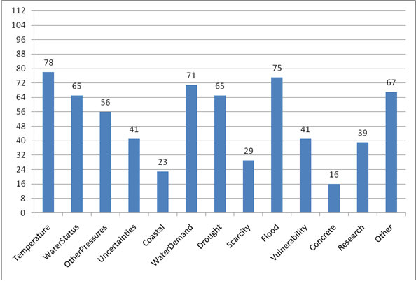

Figure 8.18.1: Inclusion of climate change risks and pressures in RBMPs (absolute values of RBMPs)
Source: RBMPs
The most comprehensive climate change pressures and risk assessments covering all or most of the potential impact categories are consistently provided in RBMPs by Slovenia, Finland, Ireland, Sweden, Germany and the UK.

8.18.3. Has a climate check of Programme of Measures been carried out or planned?
The ‘climate check’ of the PoMs is supposed to carry out a sensitivity analysis of the proposed measures based on a fully transparent methodology to evaluate long-term effectiveness and cost-efficiency under changing climatic conditions. The results of the climate check should be integrated in other RBMP processes.
A climate check of PoMs has been carried out in 41% of the RBMPs (46 out of 112) and 31 of those also give details on the methodology applied. The methodologies employed for climate checking of the PoMs are predominantly qualitative.
In 17.9% (20 out of 112 RBMPs) the climate check of PoMs had some influence on other steps in the process of developing RBMPs. The indications that exist point to influences on the processes of the choice of measures (17%, 19 RBMPs), definition of the extent and magnitude of measures (10.7%, 12 RBMPs) as well as objective setting (7.2%, 8 RBMPs). Additionally 1 RBMP points out that the climate checking of PoMs has led to identification of future research needs and alterations in monitoring planning.
In spite of these indications it remains unclear in most of the cases how the climate check influenced other steps of the process in practice.
Some Member States have provided a comprehensive climate check of the PoMs of their RBMPs and also clearly outlined the methodology. Nevertheless it is difficult to see how the results influenced other RBMP processes or it is clearly stated that this has not been possible in the first cycle. Some examples of the different considerations can be found in Table 8.19.1.

MS | Method for climate proofing of measures
Finland | Qualitative assessment has been carried out. The check has been carried out in relation to the pressures, risks of flooding and/or droughts. All measures have been assessed regarding climate change: measures that weaken climate change effects, neutral, measures that increase climate change effects. Most of the measures are evaluated having neutral effect and some are supposed to reduce the negative effects, so it seems that no further action was required.
Malta | First a screening of the measures was conducted, guided by the following principles: 1. Measures should be resilient to a wide range of future predicted climate scenarios. 2. The outcome of measures should be beneficial regardless of the eventual nature of climate variability and change to avoid irreversible decisions and investments that may not be cost effective under changing climatic conditions. Afterwards, each measure was assessed against a second set of criteria: a. Does the measure address climate change impacts? b. Does the measure address the predicted changes in pressures due to climate change? 3. Is the measure likely able to cope with a range of future conditions including changes in temperature, precipitation, sea level rise and storm surges? 4. Is the measure flexible in a way that it can be changed in the future? For each criterion the potential outcomes (positive, negative, neutral and uncertain) were assessed. This made an overall classification of each measure as either being win-win, low regret, flexible or regret possible. No new measures have been added, but some should be modified due to the recommendations of the Climate Check. For example with regard to the measure 'Maintenance and management of valleys', the recommendation is as follows: 'It is recommended that any infrastructure related to this measure takes climatic changes into account, particularly the predicted increase in heavy rainfall spells and potential changes in water flow.' The extent to which such recommendations will be implemented cannot be concluded from the documents at this stage, however.
UK | Measures and main actions outlined in the PoM have been screened to check how they will perform under future climate conditions. Each action has been designated an adaptation option of win-win, no regrets, low regrets, flexible adaptation or regrets. Measures have been screened in terms of their performance under changing climate conditions. It is noted that certain existing actions (measures) relating to those pressures may require adaptation to be effective under future climate conditions and that new actions may be required. Most have been identified as no-regret measures. A few have been identified as regret measures but there is no evidence that these measures will not be subsequently implemented. It is stated that the Environment Agency (England and Wales) will not incorporate actions (measures) related climate change in the first cycle.
Ireland | The programme of measures was checked in terms of predicted climate change and impacts on water environment and water dependent habitats and species. Measures were climate-checked rather than climate-proofed because of the level of uncertainty in predicted climate change and its impacts. Each of the identified pressures, their associated measures and their significance in the context of climate change were qualitatively assessed in turn. Pressures were assessed in terms of the relative severity of the effect of climate change on the pressure: very high, high, medium and low. In addition areas which requiring particular attention were identified (e.g. protected areas and high status sites, abstractions, and physical modifications), as the impacts of climate change on these areas are predicted to be very high. Measures were assessed with an indication of potential climate adaptation for each and then categorised as win-win, no-regrets, regrets and adaptation actions. There is no information as to whether these considerations led to changes in selected measures. The plan states that during the period of this plan, preparations will be made for more detailed climate-proofing of actions in the next plan.
Table 8.18.1: Examples of methods for climate checking of measures
Source: Assessor's summary based on the RBMPs

8.18.4. Are there specific climate change adaptation measures planed?
46.4% (52 out of 112 RBMP) of the RBMPs in one way or another address specific adaptation measures to climate change. The methodology, types, scope and coverage of the measures vary greatly: from quoting the development of a national climate policy as an adaptation measure to adding wording ‘consider climate change’ to general measures. Some list specific measures for adaptation or outline measures to be considered in future.
Understandably measures diverge due to the differences in climate change risks faced in different river basins, the state of knowledge and political developments as regards adaptation in each region. 11 of 25 Member States can be considered as actively working on the identification and development of climate change adaptation measures as part of RBMPs.
For example, Sweden is actively working on improved climate change predictions, improved mapping of water abstraction, research on impacts and more monitoring, including groundwater-surface water interactions, revision of water and sanitation plans, establishment of water protection areas. The new data will be used as a basis for consideration of revisions of monitoring programmes, environmental objectives, PoMs and RBMPs.
Another example is Malta where it is planned to i) establish a specific advisory service for the farming community ii) carry out a study related to possible application of treated wastewater iii) develop a nationwide awareness campaign on national water issues iv) raise awareness on value of water and water conservation in primary and secondary schools v) prepare and implement a full information campaign on the good agriculture practices.

8.18.5. Is the national climate change strategy referenced by the plan?
To date 11 Member States have developed National Adaptation Strategies, however, interestingly, the majority of those Member States do not refer to those Strategies in the RBMPs while many other Member States quote various national adaptation initiatives in the RBMPs. Often, this remains at a reference level without real integration of the provisions of national strategies into RBMPs.
There are also good examples, like Hungary, where a National Climate Change Strategy was adopted in 2008 and recommendations of this Strategy related to water management are included in the PoMs of the RBMPs.

8.18.6. How does the plan address climate change in the next planning cycle?
As already stated earlier, almost all RBMPs already refer to the issue of climate change. Only 26 out of 112 RBMPs (23.2%) outline clearly how they will address the issue in the second and third planning cycles. In 40 out of 112 cases (35.7%) it is unclear, and no information has been provided in the remaining RBMPs. Those RBMPs which present an insight to the next cycle mainly refer to the inclusion of adaptation measures, better monitoring and increased research on the impacts.

8.18.7. Conclusions
Even if the WFD does not explicitly refer to climate change, it is already included in nearly all RBMPs in various ways, mostly focussing on impacts. This provides a good basis for more specific considerations that are expected to be included in the second RBMPs. For example climate change could not be considered in the assessment of pressures and impacts and monitoring programmes in the first RBMP cycle, but this expected starting from the second planning cycle.
General measures to adapt to the impacts of climate change were however already considered. A climate check of PoMs has been carried out for 41% RBMPs. In about 18% the climate check of PoMs was reported to influence other steps in the process of developing RBMPs but it remains unclear in most of the cases how this was done in practice.
National adaptation strategies do not seem to be well connected to RBMPs as they are not even referenced in the RBMPs in most of the cases.
Only 23% of the RBMPs outline clearly how they will address climate change in the next planning cycles.
A guidance document on climate change considerations in RBMPs and good practice examples on selected aspects in some Member States already exist and can serve as guidance and learning sources for those Member States that have not yet fully integrated climate change facets in their RBMPs.

8.18.8. Recommendations
- Almost all the elements, which are included in the definition of WFD qualitative and quantitative status, are sensitive to climate change therefore it is recommended to consider climate change in water management at an early stage. Planning should consider a time period that is longer than the RBMP six-year cycle.
- Use CIS guidance document No. 24 River Basin Management in a Changing Climate as a reference for the activities in the second and third RBMP cycles.
- Member States are requested to demonstrate how climate change is considered in the assessment of pressures and impacts, monitoring programmes and appraisal of measures (climate checking of PoMs) from the second RBMP cycle.
- It can be useful to integrate the potential additional pressures, impacts and constraints caused by climate change in the WFD economic analysis.
- Climate check of PoMs should be further developed, paying attention to clearly and transparently describing the methodology and integrating the results in other processes of RBMP development.
- Better harmonization and integration with national adaptation initiatives is recommended.
- It is recommended to better identify and describe specific adaptation measures.
- Further research and monitoring is needed to reduce uncertainty and enable early detection of climate impacts on European river basins.
- Information exchange on already existing good practice examples should continuously take place among Member States and stakeholders.

8.19. Flood risk management
Although the full requirement to co-ordinate the preparation and implementation of the Water Framework Directive and the Floods Directive will only be applicable from the second cycle of river basin management planning, the first RBMPs included various aspects of flood risk management as a part of their integrated water management. Most aspects have already been referred to above, and this section summarises these findings.
In synergy with the WFD, the Floods Directive (FD) applies equally to inland floods and to coastal floods. Many aspects of the WFD implementation is relevant for the implementation of the FD, such as the monitoring of hydromorphological quality elements, coherence between the objectives of both Directives, and the use of exemptions justified by an over-riding public interest to protect human safety as set out in the WFD. As for the WFD, integrated management at the catchment level is important for flood risk, as well as in international catchments. The units of management for the FD are the RBDs, apart from in two Member States where smaller units of management have been designated following the hydrological boundaries (Italy, Ireland).
In 20 of the 27 Member States, the same Competent Authority is responsible for WFD and for flood risk management. 38 of the 112 RBMPs assessed refer to flood protection in the more detailed sub-plans.
Flood risk management is included in existing international river basin agreements or in on-going work, or will be included in most international river basin co-operation. Several Member States report that the existing international co-operation structures will also be used for international co-ordination of the FD.
Flood risk protection measures are the third most important reason for the designation of heavily modified water bodies after navigation and energy production, with 78% of RBMPs citing such reasons. Figure 8.6.4 furthermore cites the different types of physical modifications, many of which can be used for flood risk management, such as weirs, dams, reservoirs or embankments or land drainage. When describing the significant adverse effects of restoration measures, socio- economic losses as a result of decreased flood protection capacity is often cited. Better environmental options considered also include measures such as relocation of property to other areas to reduce risk from flood.
Hydromorphological pressures from urbanisation, hydropower, navigation as well as flood protection are also some of the main drivers behind the application of exemptions in addition to agriculture.
Article 4(6) provides a specific possibility for temporary deterioration of the status of water bodies, for example in the case of extreme floods that could not necessarily have been foreseen. This has in only been used in 5 RBMPs (Spain, Bulgaria, France and Belgium) but it is expected to be more used a posteriori following RBMPs.
Article 4(7) exemptions due to new modifications of water bodies have not been extensively applied in the first RBMPs. There is a statement that Article 4(7) will be applied for specific projects in only 12 RBMPs (in Slovenia, Poland, France, Romania and the UK. Flood protection (7 cases) is the most common stated cause. In 4 cases it is unclear.
Among the hydromorphological measures proposed, there are measures such as inundation of flood plains (18% of RBMPs), creation of retention basins (12%) remeandering of formerly straight rivers (32%) and restoration of back structures (52%) which can be linked to flood risk management. The key concern with flood protection measures such as bank restoration is the interruption of lateral connectivity.
In RBDs with HMWBs designated due to flood protection (79 out of 112 RBDs), relevant measures proposed to deal with flood protection-related pressures are varying. In ca. 80% of these RBDs, bank restoration is proposed, but only 30% of these RBDs propose inundation of floodplains and less than 20% retention basins.
Figure 8.19.1: Measures related to flood protection (source: 79 RBDs with HMWB due to flood protection.)
Source: WISE

Floods are also an integral part of the considerations of climate change in the first RBMPs. 70% of RBMPs present future climate change scenarios focusing on temperature and/or precipitation projections, and flooding is the most often cited climate change threat (75 RBMPs).

8.19.1. Conclusions
- Flood risk management is already an integral part of integrated river basin management in the EU, notably in relation to physical modifications of measures. In some cases the flood protection measures are seen as obstacles to ecological restoration to achieve environmental objectives. Flood protection measures are the most common reason for new modifications.
- Floods are natural phenomena that provide important ecosystem functions, and some of the challenge of integrated water and flood management is to retain those functions whilst ensuring lives are saved.
- Floods can also cause pollution (from flooded waste water treatment plants, chemical pollution from point sources, spreading of contaminated sediment etc).
- The impact of climate change on the nature of flooding is feared to become more important in the near future.

8.19.2. Recommendations
- More efforts are needed to identify and implement flood risk management options that provide win-win solutions for water quality and quantity management as well as flood risk reduction.
- Optimal use needs to be made in the preparation of the second RBMPs of information on areas likely to be inundated, flood hazard and risk maps, consultation on significant water management issues. Co-ordination with the flood maps and the second cycle characterisation is required by the FD.
- The flood risk management plans need to be fully integrated in the next cycle of RBMPs. It is recommended to fully integrate and co-ordinate the consultation and preparation phases for the RBMPs and flood risk management plans (starting at the latest end 2012) to prevent them being prepared as separate plans.
- Finally, although the co-ordination requirements between both Directives are set out in the Floods Directive only, they apply equally to water managers and to flood risk managers. All actors are therefore recommended to make full use of the synergies between the two Directives as soon as possible and to ensure real integrated water management at the river basin scales.

9. List of Abbreviations

BQE Biological Quality Element
CIS Common Implementation Strategy
E-PRTR European Pollutant Release and Transfer Register
EQS Environmental Quality Standard
GWB Groundwater Body
IPPC Integrated Pollution Prevention and Control
MS Member State
NGO Non-Governmental Organisation
PoM Programme of Measures
QE Quality Element
RBD River Basin District
RBMP River Basin Management Plan
SCG Strategic Coordination Group
SWB Surface Water Body
WFD Water Framework Directive
WISE Water Information System for Europe

See Figure 3.2 in EEA/ETC Thematic assessment of Ecological and Chemical status and pressures
See Figure 3.4 in EEA/ETC Thematic assessment of Ecological and Chemical status and pressures
Sebastian Birk, Wendy Bonne, Angel Borja, Sandra Brucet, Anne Courrat, Sandra Poikane, Angelo Solimini, Wouter van de Bund, Nikolaos Zampoukas, Daniel Hering, 2012. Three hundred ways to assess Europe’s surface waters: An almost complete overview of biological methods to implement the Water Framework Directive, Ecological indicators, 18: 31-41.
http://www.reformrivers.eu
'Pressures and Measures study' - report for Specific pollutants.
For further information see EEA State-of-Water 2012 report (see figure 3.2 in the draft report on Ecological status and pressures http://forum.eionet.europa.eu/nrc-eionet-freshwater/library/public-section/2012-state-water-thematic-assessments/ecological-and-chemical-status-draft-feb2012
See figure 3.4 in the EEA/ETC draft report on Ecological status and pressures http://forum.eionet.europa.eu/nrc-eionet-freshwater/library/public-section/2012-state-water-thematic-assessments/ecological-and-chemical-status-draft-feb2012
Intercalibration decision COM/915/2008
The WFD Committee approved guidelines on how to translate the results of the intercalibration exercise into national types at their meeting in May 2008.
Reference to CIS Technical guidance document on deriving EQS.
http://circa.europa.eu/Public/irc/env/wfd/library?l=/framework_directive/guidance_documents/guidancesnos4sheavilysmo/_EN_1.0_&a=d
See overview of provisional identification of HMWB per Member State in the Commission Staff Working Document COM(2007) 128 final SEC(2007) 363 available at: http://ec.europa.eu/environment/water/water-framework/implrep2007/pdf/sec_2007_0362_en.pdf
http://circa.europa.eu/Public/irc/env/wfd/library?l=/framework_directive/guidance_documents/gds04shmwbspolicyssummar/_EN_1.0_&a=d
Some of the Information has been provided by the MS in EU questionnaires on HMWB designation for the CIS HMWB Workshop (12-13 March 2009). See workshop discussion paper at http://circa.europa.eu/Public/irc/env/wfd/library?l=/framework_directive/implementation_conventio/modified_brussels_12-13&vm=detailed&sb=Title
Some of the Information has been provided by the MS in EU questionnaires on HMWB designation for the CIS HMWB Workshop (12-13 March 2009). See workshop discussion paper at http://circa.europa.eu/Public/irc/env/wfd/library?l=/framework_directive/implementation_conventio/modified_brussels_12-13&vm=detailed&sb=Title
Some of the Information has been provided by the MS in EU questionnaires on HMWB designation for the CIS HMWB Workshop (12-13 March 2009). See workshop discussion paper at http://circa.europa.eu/Public/irc/env/wfd/library?l=/framework_directive/implementation_conventio/modified_brussels_12-13&vm=detailed&sb=Title
Common Implementation Strategy for the Water Framework Directive 2003: Guidance Document No. 4. Identification and designation of heavily modified and artificial water bodies. Produced by Working Group 2.2-HMWB.
As described in the conclusions of the Workshop on WFD and hydromorphology held in Prague in October 2005, see section 5.3 in http://circa.europa.eu/Public/irc/env/wfd/library?l=/framework_directive/implementation_conventio/hydromorphology/hydromorphology/_EN_1.0_&a=d and the conclusions of the Workshop on Heavily Modified Water Bodies held in Brussels in March 2008, see section 2.3 in http://circa.europa.eu/Public/irc/env/wfd/library?l=/framework_directive/implementation_conventio/modified_brussels_12-13/conclusions_2009pdf/_EN_1.0_&a=d
Common Implementation Strategy for the Water Framework Directive 2006: Good Practice in managing the ecological impacts of hydropower schemes; Flood protection works; and works designed to facilitate navigation under the Water Framework Directive. 30 November 2006. Final version.
Federal State of Bavaria.
Most German States have used the mitigation-measures approach to define GEP. In most States (e.g. Schleswig-Holstein, North Rhine-Westphalia), the steps of the approach have been followed quite closely but numerical biological values at GEP could not be estimated.
In a few Federal States (e.g. Baden-Württemberg, Mecklenburg-West Pomerania), it is unclear to what extent and which steps of the mitigation-measures approach have been followed.
In few Federal States (e.g. Saarland, Thüringia).
In few Federal States, no specific method was applied and GEP was considered equal to GES for the 1st planning cycle.
Research on the issue of BQE sensitivity to hydromorphological alterations is ongoing. For the purpose of this assessment, the following BQEs have been assumed as most sensitive: rivers (fish, macroinvertebrates, macrophytes), lakes (fish, macrophytes), transitional (fish, angiosperm, macroalgae) and coastal waters (macroinvertebrates, angiosperm, macroalgae).
CIS Guidance Document No. 20: Guidance on exemptions to the environmental objectives http://circa.europa.eu/Public/irc/env/wfd/library?l=/framework_directive/guidance_documents/documentn20_mars09pdf/_EN_1.0_&a=d
Unknown status: ES, PT and EL not included because of the lack of RMBPs
Ecological status: countries that have not reported RBMPs, that have not reported exemptions or that reported high unknown status are not included.
Chemical status: More than 40% of the surface water bodies are reported as "unknown chemical status" and for the rest of WBs the assessment is not comparable.
Numbers do not include FI and SE which have large number of small WB in good status
Sweden reported all surface water bodies as failing to achieve good chemical status due to pollution by Mercury, and applied an exemption for less stringent objectives under Article 4(5) to all water bodies.
Ref. to EEA report on pressures and status
Herbke, et al., 2006, Kampa, et al., 2009, Dworak, et al., 2010
Austria, Belgium (the Flemish Region and the coastal waters), Bulgaria, Cyprus, Czech Republic, Germany, Spain (one RBD), Finalnd, France, Hungary, Ireland, Italy, Luxembourg, Latvia, Lithuania, Malta, The Netherlands, Poland, Romania, Sweden, Slovenia, UK
NOTE: Atmospheric deposition of many chemical substances directly to water bodies and indirectly via deposition to watersheds and subsequent input to those water bodies has been conclusively shown to be important in EU and worldwide.
http://circa.europa.eu/Public/irc/env/wfd/library?l=/framework_directive/guidance_documents/guidance_document_2/_EN_1.0_&a=d
http://circa.europa.eu/Public/irc/env/wfd/library?l=/framework_directive/implementation_conventio/hydropower_september/issue_paper/issue_paper_finalpdf/_EN_1.0_&a=i
These central principles are set out in Article 9 in WFD as follow: Member States shall ensure by 2010 that water-pricing policies provide adequate incentives for users to use water resources efficiently, and thereby contribute to the environmental objectives of this Directive, An adequate contribution of the different water uses disaggregated into at least industry, households and agriculture, to the recovery of the costs of water services based on the economic analysis conducted according to Annex III and taking account of the polluter pays principle. Member States may in so doing have regard to the social environmental and economic effects of the recovery as well as the geographic and climatic conditions of the region or regions affected.
extracted from MED Joint Process WFD/EUWI Water Scarcity Drafting Group (2006): Water Scarcity Management in the Context of WFD (2006:109-110)
based on Schmidt, J.J. Benítez & C. Benítez (2012) Document: Working definitions of Water scarcity and Drought. Version 4, and taken note by Water Directors (4 June 2012)
European Commission (2007) Communication from the Commission to the European Parliament and the Council - Addressing the challenge of water scarcity and droughts in the European Union {SEC(2007) 993} {SEC(2007) 996}/* COM/2007/0414 final */
a full report has been prepared
Working definitions of Water Scarcity and Drought , CIS EG on WS&D, April 2012
EEA (2010a) Mapping the impacts of natural hazards and technological accidents in Europe An overview of the last decade. European Environment Agency, Copenhagen, Denmark. Available online: http://www.eea.europa.eu/publications/mapping-the-impacts-of-natural
Flörke, M.; Wimmer, F.; Laaser, C.; Vidaurre, R.; Tröltzsch, J.; Dworak, T.; Stein, U.; Marinova, N.; Jaspers, F.; Ludwig, F.; Swart, R.; Giupponi, C.; Bosello, F.; Mysiak, J; (2011): Climate Adaptation – modelling water scenarios and sectoral impacts.
According to CLIMATE-ADAPT database: http://climate-adapt.eea.europa.eu
Directive 2007/60/EC of 23 October 2007of the European Parliament and of the Council on the assessment and management of flood risks. OJ L288, 6.11.2007, p.27.

