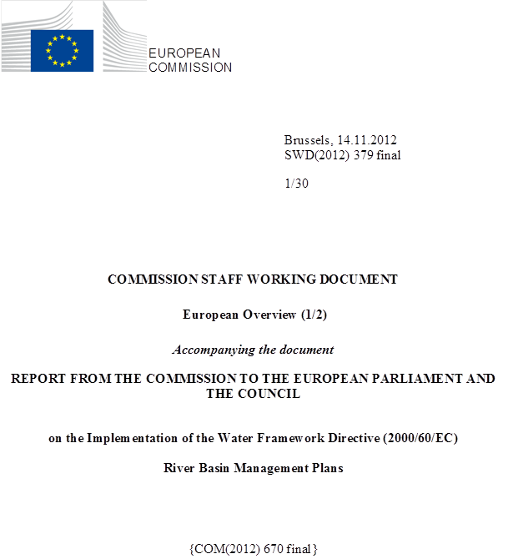

Table of Contents
PART 1
1. Introduction 4
2. Main elements of the Water Framework Directive 5
3. The Common Implementation Strategy 6
4. Approach to the assessment of the river basin management plans 7
5. Status of adoption and reporting of river basin management plans 8
5.1. Overall geographical scope of the River Basin Management Plans 9
6. Overview of legal action by the Commission 11
6.1. Introduction 11
6.2. Transposition of the Water Framework Directive into national law 12
6.3. Bad application cases 13
6.4. Court rulings related to the WFD 16
6.5. Key complaints and other cases 17
6.6. Legal implementation of related Directives adopted in accordance with Article 16 (Environmental Quality Standards) and 17 (Groundwater) of the WFD 17
7. Overview of the status of EU waters and outlook 20
8. Results of the assessment at EU level and recommendations 30
8.1. Governance 30
8.2. Characterisation of the River Basin District 58
8.3. Monitoring of surface waters and groundwater 88

PART 2
8.4. Classification of ecological status 121
8.5. Classification of chemical status for surface waters 129
8.6. Designation of Heavily Modified Water Bodies (HMWB) 137
8.7. Definition of Good Ecological Potential for HMWB and AWB 147
8.8. Assessment of groundwater status 163
8.9. Environmental objectives and exemptions 173
8.10. Programme of measures – general 182
8.11. Measures related to groundwater 194
8.12. Measures related to agriculture 200
8.13. Measures related to chemical pollution 208
8.14. Measures related to hydromorphology 214
8.15. Measures related to Article 9 (water pricing policies) 224
8.16. Additional measures in Protected Areas 231
8.17. Strategy to deal with water scarcity and droughts 241
8.18. Adaptation to climate change 247
8.19. Flood risk management 253
9. List of Abbreviations 257

Introduction
Water is a limited resource essential for life and for economic activity. EU water policy has delivered significant improvements to water quality over the past 30 years. Europeans can safely drink tap water and swim in thousands of coastal waters, rivers and lakes across the EU. Pollution of urban, industrial and agricultural origin has significantly diminished.
The recent Fitness Check of EU freshwater policy has concluded that the overall regulatory framework is sound and sufficient. However, implementation remains a key challenge. Moreover, both the Fitness Check and the analysis underpinning the European Commission's Blueprint to Safeguard Europe's Waters have identified a number of elements that require further reinforcement such as better approaches to the management of integrated water resources including definition of quantitative aspects, sound integrated governance, and the support of an adequate knowledge base.
This Commission Staff Working Document is part of the Commission’s third implementation report as required by Article 18 of the Water Framework Directive (WFD) and is based on the assessment of the River Basin Management Plans (RBMPs) reported by Member States. The report describes in detail the key aspects of the results of the assessment based on the information reported by Member States and other related official sources of information, and provides a view of the status of implementation of the WFD across the EU. This document is accompanied by associated country specific Commission Staff Working Documents describing the results of the assessment by the Commission of the RBMPs relating to each Member State, as well as for the EEA state Norway. All are an integral part of the Commission's Blueprint to Safeguard Europe's Waters and are closely linked to a report on the State of Waters produced by the European Environment Agency.
The RBMPs of one European Economic Area country – Norway – were also analysed alongside those of the 27 EU Member States. This analysis was done in cooperation with the ESA (EFTA Surveillance Authority), responsible for compliance checking of WFD implementation in EEA countries applying the Directive. The deadlines in the Directive for implementing the various obligations were extended (when the WFD was incorporated into the EEA Agreement in 2007), to give the EEA countries the same amount of time to implement the obligations as the EU Member States.

Main elements of the Water Framework Directive
Building on the achievements of existing EU water legislation, in 2000 the WFD introduced new and ambitious objectives to protect aquatic ecosystems in a more holistic way, while considering the use of water for life and human development. The WFD was hailed as a front runner in that it incorporates into a legally binding instrument the key principles of integrated river basin management: the participatory approach in planning and management at river basin scale; the consideration of the whole hydrological cycle and all pressures and impacts affecting it; and the integration of economic and ecological perspectives into water management. It provides a framework to balance high levels of environmental protection with sustainable economic development.
The WFD foresaw a long implementation process leading to the adoption of the first RBMPs in 2009 which describe the actions envisaged to implement the Directive. The plans are expected to deliver the objectives of the WFD including non-deterioration of water status and the achievement of good status by 2015. The preparatory process for the plans has already been subject to two Commission implementation reports, in 2007 and 2009.
The WFD introduced a number of key principles into the management and protection of aquatic resources:
(1) The integrated planning process at the scale of river basins, from characterisation to the definition of measures to reach the environmental objectives.
(2) A comprehensive assessment of pressures, impacts and status of the aquatic environment, including from the ecological perspective.
(3) The economic analysis of the measures proposed/taken and the use of economic instruments.
(4) The integrated water resources management principle encompassing targeting environmental objectives with water management and related policies objectives.
(5) Public participation and active involvement in water management.
The key objective of the WFD is to achieve good status for all water bodies by 2015. This comprises the objectives of good ecological and good chemical status for surface waters and good quantitative and good chemical status for groundwater.
The key tool for the implementation of the WFD is the RBMP and the accompanying Programme of Measures (PoM). The planning process is a step-by-step procedure in which each step builds on the previous one (see Figure 1). Each step is important, starting from the transposition and the administrative arrangements, followed by the characterisation of the River Basin District (RBD), the monitoring and the assessment of status, the setting of objectives, the establishment of an appropriate programme of measures and its implementation including the monitoring and evaluation of the effectiveness of the measures supporting the following RBMP cycle.
The PoM is the tool designed to enable the Member States to respond appropriately to the relevant pressures identified at RBD level during the pressures and impacts analysis, with the objective of enabling the river basin/water body to reach good status. For example, if a significant pressure is overlooked during the pressures and impacts analysis, the monitoring programme may not be designed to assess the pressure, and the programme of measures may not envisage action to address it.
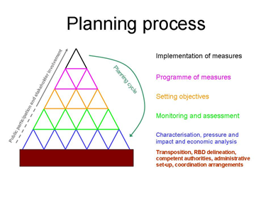
Figure 2.1: Schematic representation of the WFD planning process

The RBMP is a comprehensive document describing the execution of water management and identifying all actions to be taken in the River Basin District.

The Common Implementation Strategy
Implementation of the WFD has been supported since 2001 by an unprecedented informal co-operation under the Common Implementation Strategy (CIS), led by Water Directors of Member States and the Commission with participation from all relevant stakeholders. The CIS has successfully delivered more than 30 guidance documents and policy papers and has been a valuable platform for exchange of experiences and best practices on implementation among Member States.
The CIS is currently the platform used by Member States and the Commission to facilitate implementation, providing a common interpretation of the WFD, exploring common issues of concern and joint responses. This informal mechanism of co-operation under the WFD has been used as a model in other environmental sectors, inspiring compliance promotion activities and supporting the implementation of the environmental acquis through a common platform for electronic reporting and information exchange.

Approach to the assessment of the river basin management plans
This is the European Commission's third implementation report under the WFD. It is based on the assessment of the RBMPs and is an integral part of the Commission's Blueprint to Safeguard Europe's Water Resources. The publication of this implementation report is a requirement of Article 18 of the WFD. The assessment is based on the information reported by Member States, consisting of the published RBMPs and accompanying documentation, the electronic reporting through the Water Information System for Europe (WISE) in predefined formats, and any additional background documents that the Member States considered relevant.
The Commission has co-operated closely with the European Environment Agency (EEA) on the preparation of this implementation report. The WISE reporting has been facilitated through the Water Data Centre hosted by the EEA. The EEA has published a report on the State of Water resources based primarily on the data reported under the WFD. The report has been preceded by a number of thematic assessments on different aspects of water status and pressures.
The RBMPs are comprehensive documents that cover many aspects of water management, consisting of hundreds to thousands of pages of information, published in national languages. The assessment of the RBMPs has been a very challenging and complex task that has involved dealing with extensive information in more than 20 languages.
The quality of the Commission assessments relies on the quality of the Member States' reports. Bad or incomplete reporting can lead to wrong and/or incomplete assessments. It is recognised that reporting is a big effort for Member States, in particular the electronic reporting to WISE. There are examples of very good, high quality reporting. However, there are also cases where reporting contains gaps or contradictions.
In the context of the preparation of this report, the Commission maintained regular informal contact with the Member States to validate its findings and to ensure that the assessment reflects reality.
This document presents the findings of the Commission’s assessment of the RBMPs, structured according to the WFD planning process presented above.
In the frame of the Common Implementation Strategy of the WFD Member States agreed that besides submitting their RBMPs to the Commission they would report pre-defined key information of their RBMPs electronically through the Water Information System for Europe (WISE; http://water.europa.eu). WISE is a web-portal entry to water related information ranging from inland waters to marine that helps streamlining reporting under different water related EU legislation and allows the different European bodies to more easily collect and share information as well as public access to water data and information reported by Member States. WISE is planned to be further developed in the upcoming years to become an even more user-friendly, shared environmental system fully based on the principles of the INSPIRE Directive.
Member States were required to report WISE data until March 2010. After this date updating of the reported data and submission of late reporting was still allowed to Member States in order to ensure the high quality of the dataset. The Commission, where it was available, used the most up-to-date information from WISE (2012) in its Communication and Commission Staff Working Document. Where data was not available in WISE, the RBMPs (2009) and / or other information were used with the indication of the source. The different sources explain the diverging values in some of the tables and figures that the reader may find in the abovementioned documents.

Status of adoption and reporting of river basin management plans
Figure 5.1 presents the state of play regarding the adoption of the RBMPs. 25 Member States plus Norway have adopted and reported 121 RBMPs for their national parts of the River Basin Districts (RBDs) (out of a total of 174).
In Belgium, the Flemish Region, the Federal Government (responsible for coastal waters) and the Brussels Region have adopted plans; the plans for the Walloon Region are awaited. In Spain, only one plan out of the 25 expected, the plan for the Catalan River Basin District, has been adopted and reported. In Portugal and Greece, no plan has yet been adopted.
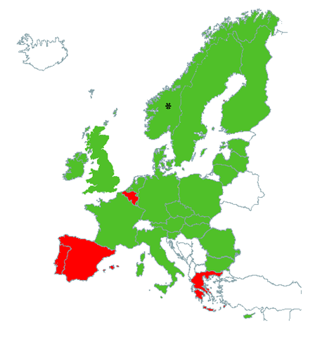
Figure 5.1: State of adoption of the RBMPs. GREEN - River Basin Management Plans adopted. RED - Consultation has not started or is on-going. YELLOW - Consultation closed, adoption pending.

For Belgium, the Brussels Region adopted its RBMP for its part of the Scheldt RBD on 12.7.2012, but due to the late adoption it has not been possible for the Commission to analyse it for this implementation report. The RBMPs for part of the RBDs on the territory of the Walloon region (Seine, Scheldt, Meuse and Rhine) are due to go out to public consultation by the date this report is published, and adoption is foreseen in April 2013.

Overall geographical scope of the River Basin Management Plans
There are 128 RBDs designated in the EU, of which 49 are international. If each national part of an international RBD is counted separately, the total number of RBDs is 170. The geographical scope of the RBMPs does not correspond exactly to the number of RBDs, and a number of different models can be identified:
- Most Member States have prepared one RBMP for each RBD exclusively within their territory, and 40 such plans were received.
- Most Member States who have part of an international RBD within their territory have produced one RBMP for the national part of the international RBD. 63 such plans were received. In some cases they have also reported international RBMPs produced for the whole international RBD. Where such international RBMPs are available, this can be seen as being a successful result of the implementation of the WFD.
- Some Member States have prepared one plan covering all of their territory (for instance in Slovakia or in Slovenia) but which includes sections on each of the relevant RBDs. In these cases, they have been counted as having prepared one RBMP per RBD.
- Some Member States have prepared several RBMPs for each RBD and for sub-basins. For instance, in Romania all of the territory falls within the Danube RBD and is covered by the Danube International RBMP (A-level), as well as by the national Romanian Danube RBMP (B-level). In addition, and fully in accordance with the Directive (Article 13.5 WFD), more detailed sub-RBMPs have been prepared for each of the 11 sub-basins. For the purpose of this assessment, the Romanian Danube RBMP has however been considered as one RBMP.
- In Denmark, 15 RBMPs were reported for the Jutland and Funen RBD, and 7 RBMPs were reported for the Sjaelland RBD, but no overall single RBMP for the whole respective RBD was submitted. For the purpose of this assessment these RBMPs have been assessed as two RBMPS, that is one per RBD.
- In Germany, where most of the territory is covered by international RBDs for which international RBMPs exist (Danube, Elbe, Rhine, Ems, Odra), no RBMP for the national parts of these RBDs were adopted. Instead RBMPs were adopted at the Federal State level. For the purpose of this assessment, the German plans were assessed as one RBMP per RBD, although in reality 16 RBMPs were adopted. A similar situation applies in Belgium, where the RBMPs are adopted by the respective regions, and where the three regions have different timetables relating to the implementation of the Directive due to serious delays in Wallonia and the Brussels Region.
As a result the number of RBMPs assessed for this report is 112, unless otherwise indicated. The subsequent assessment may refer to a different baseline, partly since in some cases, data were reported to WISE also by Member States who had not yet adopted their RBMPs. This may vary by topic.
It should be noted that 11 pilot RBMPs were also adopted by Norway relating to part of their RBDs in advance of the deadline for implementation of 2018 as agreed under the EEA agreement. These pilot RBMPs were assessed alongside EU RBMPs, and the results of the assessment can be found in the relevant annex to this report. However, the statistics in the main body of the report do not include results relating to Norway.

Overview of legal action by the Commission

Introduction
Where needed, after informal compliance promotion activities, the Commission has pursued targeted legal action to enforce the WFD since the transposition deadline of 2003. This compliance promotion has focussed on two main priorities - enforcement of deadlines and conformity of transposition:
- Enforcement of the deadlines: whenever a reporting deadline lapsed, the necessary legal steps were taken against those Member States which failed to respect those deadlines. For the WFD itself this concerned the following deadlines:
- 2003: transposition
- 2004: RBD delineation, competent authorities and administrative arrangements
- 2007: adoption of the monitoring programmes
- 2009: adoption of River Basin management plans (reporting deadline 22.3.2010)
As a consequence of this action, by the time the Member States needed to adopt their RBMPs they had, in principle, undertaken the required preparatory steps (with the exception of Malta for the monitoring programmes, a case that was still before the Court in 2009). Shortcomings have however been identified in the first implementation stages identified in several Member States, as set out in this assessment.
- The Commission also pursued actions to address issues of non-conformity of the national legislation transposing the provisions related to the RBMPs with a view to ensuring that the national legal framework correctly reflects the different EU requirements for the WFD.
The Commission first addressed the gaps identified in the two previous implementation reports through informal mechanisms and dialogue with Member States and, only if this did not prove satisfactory, took the required legal action, always with the objective of ensuring that the issues were addressed in time for the reporting of the RBMPs. In cases where such shortcomings in the national legal framework were not addressed by Member States, they are likely to be gaps or delays related to the RBMPs.

Transposition of the Water Framework Directive into national law
By the latest 22 December 2003, Member States had to bring into force the laws, regulations and administrative provisions necessary to comply with this Directive. Member States must also continuously communicate to the Commission the texts of the main provisions of national law which they adopt in the field governed by this Directive.
After this deadline had passed, and after providing the Member States with a final opportunity to inform the Commission of the adoption of the national measures, the Commission opened so called 'non-communication infringement cases' against those Member States which had not notified transposing legislation to the Commission. Of the 11 non-communication cases mentioned in the first WFD implementation report issued in 2007, the last case was closed in 2009.
After the transposed legislation was notified, the Commission carried out conformity studies to assess the quality of the national transposition into national law. From this first assessment it was clear that a number of Member States would not face infringement proceedings as the transposition was found satisfactory at the time (Austria, Cyprus, Malta and Portugal). Since 2007, non-conformity cases have been opened against 22 Member States. By October 2012, 12 of those cases have meanwhile been closed whilst 10 are still open (see table 6.1 below).
It is, however, inherent in conformity checking that it can never be excluded that new issues of non-conformity reveal themselves even after the closure of the infringement procedure. This can be the result of either new legislation adopted by the Member States or because of a new appreciation of the national legal framework in the light of complaints or experience brought to the attention of the Commission. For this reason, the Commission will continue to stay alert for such issues as they affect the achievement of the objectives of the Directive. It is, therefore, also important that Member States systematically communicate to the Commission changes to their national laws in the field governed by this Directive (Article 24(2) WFD).
In 2006, the European Commission received a horizontal complaint covering 11 Member States on the interpretation of the term 'water services' (Article 2(38) WFD). The scope given to the notion of water services is relevant for the scope of the obligation to apply cost recovery for water services (Article 9 WFD). For pragmatic reasons it was decided to address the interpretation issue, where possible, in the context of the non-conformity cases opened since 2007. Meanwhile, these cases have reached different stages of the infringement procedure. The most advanced case concerns Germany as the Commission decided on 31 May 2012 to ask the European Court of Justice for its views on the interpretation of water services, and other cases may follow.
The outcome of these legal proceedings will play a crucial role in the further implementation of water pricing policies, as further reflected in chapter 8.15 of this report.
Table 6.1 includes an overview of transposition-related infringement cases.

Bad application cases
A rather extensive number of so called 'bad application' infringement cases have been opened since 2003 in relation to the implementation of the WFD. Bad application refers to the Commission's assessment that an infringement of EU law is not due to deficiencies in the legislative framework but due to non-respect by the authorities of that framework. Typically, the majority of the cases related to the WFD concern the failure of a Member State to submit a report by a given deadline. Once the report is received such cases are normally closed.
For the WFD, such cases have concerned the failure to report administrative arrangements (Article 3) or to submit the report on the characterisation of the RBDs (Article 5) as explained in the first implementation report. It also concerns cases for failure to report monitoring networks (Article 8) as explained in the second implementation report. Each of these implementation reports identified a number of shortcomings in the quality of the implementation. If, despite the Commission having communicated their findings to the respective Member States in these implementation reports, the situation has not been redressed and adequately reported in the RBMPs, the Commission intends to address these issues in bad application cases based on the assessments summarised in this third implementation report.
An update on the progress of these cases since the respective implementation reports is given in Table 6.2. This table also presents an overview of the progress on the latest horizontal set of cases related to the failure to comply with Articles 13 (to adopt RBMPs), 14 (to carry out consultation on draft RBMPs) and 15 (to report the RBMPs to the Commission by 22.3.2010). Since it is of utmost importance that the RBMPs are adopted in a timely manner and that they are subject to the required consultation procedures, the Commission decided to proceed swiftly with these infringement procedures.
Following the pre-infringement correspondence which started in April 2010, 11 Member States received a first warning in June 2010. In 2011 the Commission decided to bring 5 Member States to Court for failure to adopt all their RBMPs. One case (Denmark) was withdrawn by the Commission after the RBMPs were adopted and reported. In 2012 the European Court of Justice (ECJ) ruled against Belgium, Greece, Portugal and Spain. Immediately after the rulings the Commission initiated the procedure for ensuring timely respect of these rulings.
The absence of a RBMP, including the Programme of Measures (PoM - considered a key component of the RBMPs, enabling Member States to achieve the objectives of the WFD by 2015), obviously remains of great concern to the Commission. The absence of a RBMP compromises the (timely) achievement of good status of surface and groundwater. The lack of synchronisation of the consultation and adoption processes in RBDs shared by different countries or regions leads to serious problems in co-ordination.
Moreover, the non-timely adoption of a RBMP may also compromise the effectiveness of the second updated RBMPs due for adoption in December 2015, if planning cycles are not synchronised between the Member States. The Commission's efforts will be aimed at preventing delays occurring in one Member State that may have a knock-on effect on the co-ordination and implementation of the second, updated, RBMPs. It is important to highlight that the first step of consultation should start with a 6-month public consultation on the work programme and timetable for preparation of the RBMP according to Article 14(1)(a) and 14(3).

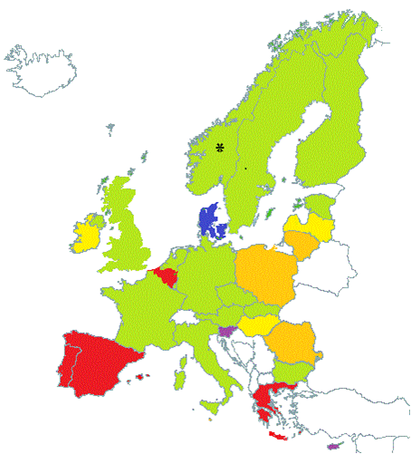
AT | 03/2010
BE | ⁽¹⁾
BG | 03/2010
CY | 06/2011
CZ | 12/2009
DE | 12/2009
DK | 12/2011
EE | 04/2010
EL | -
ES | ⁽²⁾
FI | 12/2009
FR | 12/2009
HU | 05/2010
IE | 07/2010
IT | 03/2010
LT | 11/2010
LU | 12/2009
LV | 05/2010
MT | 03/2011
NL | 11/2009
PL | 02/2011
PT | -
RO | 01/2011
SE | 12/2009
SI | 07/2011
SK | 12/2009
UK | 12/2009
NO* | 06/2010

Figure 6.1: Overview map of timing of adoption of the River Basin Management Plans. Plan adopted and reported by: March 2010 (Green), October 2010 (Yellow), March 2011 (Orange), October 2011 (Purple), March 2012 (Blue); Red: Still not fully compliant.
Notes :
⁽¹⁾ BE (Flemish region reported 08/2010, Brussels Region adopted 07/2012, Walloon region has not adopted its plans)
⁽²⁾ ES (Only Catalonia RBD reported on 14/10/2010).
* Norway is implementing the Water Framework Directive as part of the European Economic Area Agreement, with specific timetable agreed.

Apart from bad application cases based on the non-timely adoption of the RBMPs, the Commission envisages that action may need to be taken on the basis of the assessment it has carried out on the quality and completeness of the reported RBMPs, based on the analysis presented in this report.

Court rulings related to the WFD
The Court of Justice of the European Union (ECJ) has issued several rulings on the basis of the WFD. However, these cases dealt with provisions of the WFD which may be seen as straightforward (such as non-communication of the transposing measures, late reporting, late adoption of monitoring programmes and RBMPs), rather than with less straightforward cases concerning the interpretation of key notions such as water services or the application of exemptions under Article 4 WFD.

Relevant case law by the ECJ so far:

- Commission vs. Luxembourg (Case C-32/05, ruling of 30.11.2006) – Non-Communication Transposition – The Court ruled that Luxembourg had failed to transpose, or to notify transposition, of the Directive to the Commission. Luxembourg argued that their existing legal framework was sufficient; the Court found that this was not the case. Luxembourg has since complied and the case is closed.

- Commission vs. Germany (Ref. Case C-67/05, ruling of 15.12.2005) – Non-Communication Transposition – The Court ruled that Germany had failed to transpose, or to notify such transposition of the Directive to the Commission within the deadline, since the law had not been transposed into the legislation of all Bundesländer. Germany has since complied and the case is closed.

- Commission vs. Italy (Case C85/07, ruling of 18.12.2007) and vs. Greece (Case C264/07, ruling of 31.1.2008) – Bad application - Non-reporting – For failing to submit the reports required under Article 5 of the Directive, on Characterisation of the River Basin Districts, review of the environmental impacts of human activity and economic analysis of water use. Italy and Greece have since complied and the cases are closed.

- Commission vs. Spain (Case C-516/07, ruling of 7.5.2009) – Administrative arrangements – Spain had failed to notify all competent authorities in accordance with Article 3. In this case the Court also emphasised the importance of designating the River Basin Districts in accordance with the hydrological boundaries rather than administrative boundaries. Spain has since complied and the case is closed.

- Commission vs. Malta (Case C-351/09, ruling of 22.12.2010) – Bad application -Monitoring networks – For not having established a network for monitoring of inland waters, and for failure to submit a summary report to the Commission. In this ruling, the court found that even if the Maltese inland surface water bodies are small, there is a need to ensure monitoring.

- Commission vs. Greece (Case C-297/11, ruling 19.4.2012.), vs. Belgium (Case C-366/11, ruling 24.5.2012), vs. Portugal (Case C-223/11, ruling 21.6.2012), and vs. Spain (case C-403/11, ruling 4.10.2012) - On the failure to adopt and report River Basin Management Plans for all of their respective River Basin Districts.

- A preliminary ruling in case C-41/10 on the Acheloos in Greece was issued on 11.09.2012 – On the interpretation of the WFD 2000/60/EC, of Council Directive 85/337/EEC on the assessment of the effects of certain public and private projects on the environment, of Directive 2001/42/EC on the assessment of the effects of certain plans and programmes on the environment and of Council Directive 92/43/EEC on the conservation of natural habitats and of wild fauna and flora.

Key complaints and other cases
The WFD is also the object of complaints received by the Commission. These complaints concern inter alia existing or future projects which may impact water (such as the construction of new hydropower facilities and works related to navigation which allegedly fail to give proper attention to the impact on the ecological and chemical status of the water) and existing or future activities which impact water (such as discharges of salt resulting from mining activities into sweet water negatively affecting water quality). These complaints are all assessed individually and, where needed, the Commission enquires with the Member State authorities as a preliminary step towards formal enforcement action.
Complaints sometimes invoke in particular deficiencies in the RBMPs, such as that the measures proposed are not sufficient or that certain exemptions under Article 4 of the WFD are unlawfully invoked by the authorities. Where possible, complaints related to the RBMPs as such are pursued under the on-going assessment of the RBMPs by the Commission.

Legal implementation of related Directives adopted in accordance with Article 16 (Environmental Quality Standards) and 17 (Groundwater) of the WFD
Two closely related Directives have been adopted since 2000, one further specifying the legal requirements in relation to groundwater status (Directive 2006/118/EC, also known as the Groundwater Directive, transposition deadline 18.1.2008) the second regarding the chemical status of surface waters (Directive 2008/105/EC, also known as the Environmental Quality Standards (EQS) or Priority Substances Directive, transposition deadline 25.7.2010). Non-communication procedures were opened against 22 Member States on Directive 2008/105/EC but they have all since been closed. Non-communication procedures were opened against 20 Member States on Directive 2006/118/EC and these have also since been closed.
The Commission has, in the meantime, performed an assessment of conformity for both Directives. On the Groundwater Directive the first steps were taken (requests for clarification sent through the EU Pilot) in 2012 against 17 Member States, and two cases have been opened. In the second half of 2012 the Commission also raised conformity issues with the national legislation transposing the EQS Directive with six Member States.
MS | Non-communication of transposition into national law | Non-conformity – state of play | Water service interpretation (bad application case)
AT | - | - | Case 2006/4634
BE | Case 2004/0005, closed 2006. | Case 2007/2233, closed 2011. | Case 2006/4635
BG |  | Case 2009/2256, Letter of formal notice.
CY |  | -
CZ |  | Case 2007/2234, closed 2012.
DE | Case 2004/0017, closed 2006. | Case 2007/2243, Case submitted to Court 2012. | Case 2006/4639 – saisine 258 under non-conformity case 2007/2243.
DK |  | Case 2007/2235, closed 2011. | Case 2006/4636
EE |  | Case 2007/2236, closed 2010. | Case 2007/4637- closed in 2012
EL |  | -
ES |  | Case 2009/2003. Case submitted to Court 2012.
FI | Case 2004/0108; closed 2005. | Case 2007/2237, Reasoned opinion | Case 2006/4638
FR | Case 2004/0048, closed 2005. | Case 2007/2242, closed 2010.
HU |  | Case 2007/2249, closed 2010 | Case 2006/4640
IE |  | Case 2007/2238, Reasoned opinion | Case 2006/4641 - IE accepts the COM interpretation
IT | Case 2004/0059, closed 2008. | Case 2007/4680, Reasoned opinion.
LT |  | Case 2007/2245, closed 2010.
LU | Case 2004/0073, closed 2009. | Pilot
LV |  | Case 2007/2244, closed 2009.
MT |  | -
NL | Case 2004/0086, closed 2005. | Case 2007/2248, closed 2010. | Case 2006/4644
PL | Case 2004/2309, closed 2004. | Case 2007/2246, Additional reasoned opinion. | Case 2006/4642
PT | Case 2004/0120, closed 2006. | -
RO |  | Case 2008/2274, closed 2011.
SE | Case 2004/0142, closed 2004. | Case 2007/2239, Additional LFN. | Case 2006/4643
SI |  | Case 2007/2240, closed 2009.
SK |  | Case 2007/2247, closed 2011.
UK | Case 2004/0152, closed 2004. | Case 2007/2241, Additional LFN
Table 6.1 – Overview of open WFD infringement cases, non-communication of transposition, non-conformity and/or interpretation of Article 2(38) WFD
MS | Administrative arrangements  Article 3 reporting |  | Characterization, impact assessment (Article 5 WFD) |  | Monitoring networks  (Article 8 WFD) |  | River Basin Management Plan consultation, adoption (Articles 13, 14 & 15 WFD)
 | Reference | Closed | Reference | Closed | Reference | Closed | Reference | Articles concerned | Closed/Status
AT
BE | A2004/2303 | 2004 |  |  |  |  | 2010/2070 | 13, 14, 15 | Court ruling 2012(Brussels and Wallonia Regions)
BG
CY |  |  |  |  |  |  | 2010/2071 | 13, 14,15 | Closed 2011
CZ
DE
DK | A2004/2304 | 2004 |  |  |  |  | 2010/2072 | 13, 14, 15 | Closed 2012 . Plans adopted December 2011.
EE |  |  |  |  |  |  | 2010/2073 | 13, 15
EL | A2005/2033 | 2004 | A2005/2317 | 2008 | 2007/2490 | 2009 | 2010/2074 | 13, 14, 15 | Court ruling 2012
ES | A2004/2305 | Court ruling 2008 | A2005/2316 | 2006 |  |  | 2010/2083 | 13, 14, 15 | Court ruling 2012. Plans for one RBD adopted 2010.
FI
FR | A2004/2306 | 2004
HU |  |  |  |  |  |  | 2010/2075 | 13, 15
IE |  |  |  |  |  |  | 2010/2076 | 13, 15
IT | A2004/2307 | 2004 | A2005/2315 | 2008
LU
LT |  |  |  |  |  |  | 2010/2077 | 13, 14, 15 | Closed 2011
LV
MT | A2004/2308 | 2004 |  |  | 2007/2491 | Court ruling 258 of 22/12/2010, currently at art 260 stage | 2010/2078 |  | Closed 2011
NL
PL | A2004/2309 | 2004 |  |  |  |  | 2010/2079 | 13, 15 | Closed 2011. Plans adopted 1st semester 2011.
PT |  |  | A2005/2318 | 2005 |  |  | 2010/2080 | 13, 14, 15 | Court ruling 2012
RO |  |  |  |  |  |  | 2010/2081 | 13, 15
SE | A2004/2310 | 2004
SI |  |  |  |  |  |  | 2010/2082 | 13, 15 | Closed 2011. Plans adopted summer 2011.
SK
UK
Table 6.2 – Overview table on non- communication / bad application infringements

Overview of the status of EU waters and outlook
The sources of the figures and maps (except for tables 7.1 and 7.2) in this chapter are the EEA draft reports on 'Ecological and chemical status and pressures draft for consultation' and on 'Ecological status and pressures draft July 2012'.
Overview of ecological status and potential of surface water bodies
Figure 7.1 shows the distribution of ecological status or potential for the different types of water bodies (rivers, lakes, transitional and coastal). Overall, more than half (55 %) of the total number of classified surface water bodies in Europe are reported to have less than good ecological status/potential. Only around 44% of rivers and 33% of transitional waters are reported to be in high or good status. 56% of the lakes are reported to be in good or high status, and 51% for coastal waters.
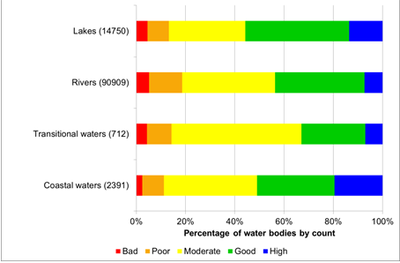
Figure 7.1: Distribution of ecological status or potential of classified rivers, lakes, coastal and transitional waters, calculated as percentage of the total number of classified water bodies.
Source:EEA.

Figure 7.2 shows the classification of ecological status across the EU. There are some River Basin Districts in Northern Germany, the Netherlands and Belgium where the reported status or potential of more than 90% of the water bodies is less than good. Many other RBDs in Northern France, Southern Germany, Poland, Czech Republic, Hungary and Southern England have reported between 70 and 90% of their river bodies in less than good status or potential. There are also significant variations in the status or potential of water bodies within Member States.
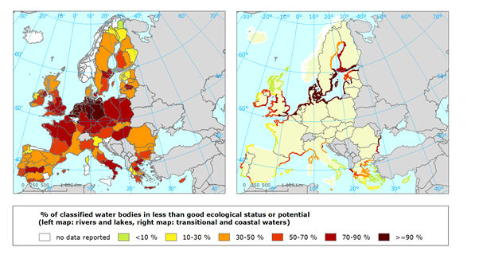

Figure 7.2: Proportion of classified surface water bodies in different River Basin Districts in less than good ecological status or potential for rivers and lakes (left panel) and for coastal and transitional waters (right panel) (percentage, based on number of classified water bodies).
Source:EEA

Overview of chemical status of surface and groundwater bodies
There is a high percentage of surface water bodies for which the reported chemical status is 'unknown'. This has consequences for the whole planning process, in particular for establishing the environmental objectives and defining appropriate measures.
In many cases, the main reason for this gap is that the status assessment methods have not been fully developed yet or there were not enough monitoring data in this first cycle. In that case, it is advisable to adopt and implement "no-regret" measures, at the same time as further developing the assessment methods and monitoring networks. However, in most RBMPs, there is no information on what actions will be taken to improve the monitoring and assessment methods for the next cycles.
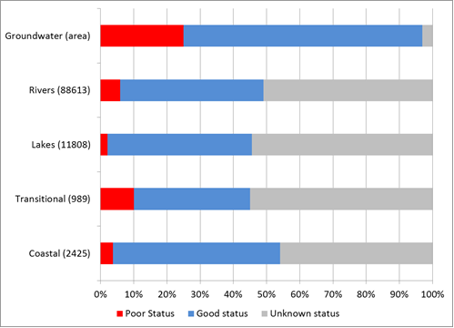

Figure 7.3: Percentage of rivers, lakes, groundwater, transitional and coastal waters in good, poor and unknown chemical status.
Source: WISE
Note 1: Number of Member States contributing to the dataset: Groundwater (26); Rivers (25); Lakes (22); Transitional (15) and Coastal (20). Percentages shown for rivers, lakes, transitional and coastal are by water body count. Groundwater percentages, however, are expressed by area. The total number of water bodies is shown in parenthesis.
Note 2: Data from Sweden are excluded from surface water data illustrated in the figure. This is because Sweden contributed a disproportionately large amount of data and, classified all its surface waters as poor status since levels of mercury found within biota in both fresh and coastal waters exceed the quality standard.

Figure 7.4 shows the percentage of groundwater bodies in good and poor chemical status in the different Member States.
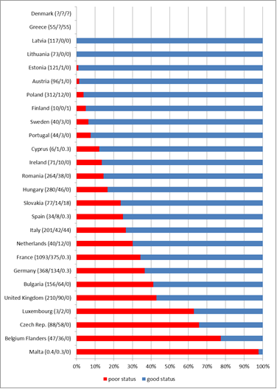
Figure 7.4: Percentage of groundwater bodies in poor and good chemical status, by area.
Source: Based on data available in WISE-WFD database 3rd May 2012
Note: Groundwater bodies in unknown chemical status are not accounted for in the red and blue bars that represent the percentage poor and good chemical status respectively. The reported total area covered by groundwater bodies / the area in poor chemical status/ the area in unknown chemical status (in 1000 km2) per Member State is shown in parenthesis. Denmark did not report the area of groundwater bodies, whilst 164 of 385 (43%) Danish groundwater bodies were reported in poor chemical status.

Even though a small percentage of groundwater bodies are reported to be in unknown chemical status and a relatively high number of groundwater bodies in good status, there are certain shortcomings in most of the Member States regarding groundwater monitoring and methodologies for groundwater status and trend assessment that make the results of the groundwater chemical status assessment questionable, as is shown in later chapters.
Figure 7.5 shows the chemical status of groundwater reported by the different Member States.
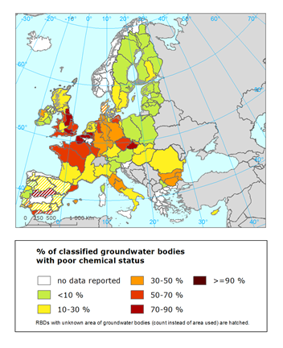
Figure 7.5: Chemical status of groundwater bodies per RBD – percentage of groundwater body area not achieving good chemical status
Note: Groundwater bodies in unknown status are not included in the calculation of the percentage of poor chemical status. Source: Based on data available in WISE-WFD database 3rd May 2012

Overview of quantitative status of groundwater bodies
From the total number of groundwater bodies assessed only 6% are classified as being in poor quantitative status in 2009. Only a few countries, namely Spain, United Kingdom, Belgium, Czech Republic, Germany, Italy, Malta have groundwater quantitative problems which, however, are mainly found in specific RBDs and not in the whole country, with the exception of Cyprus where approximately 70% of its groundwater bodies are in poor status.

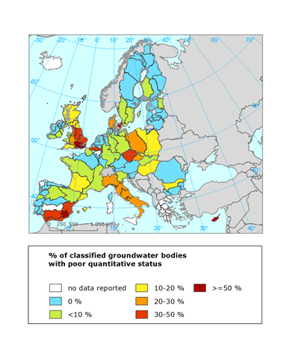

Figure 7.6: Percentage of groundwater bodies in poor quantitative status in 2009 per RBD
Source: WISE-WFD database
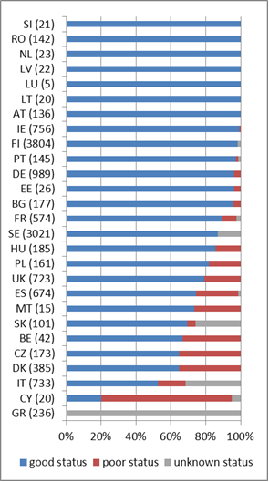
Figure 7.7: Percentage of groundwater bodies in poor quantitative status in 2009 per Member State
Note: Numbers in brackets indicate the number of groundwater bodies
Source: WISE-WFD database
Even though a small percentage of groundwater bodies are reported to be in unknown quantitative status and a high number of groundwater bodies in good status, there are certain shortcomings in most of the Member States regarding the methodologies for groundwater status assessment that make the results of the groundwater quantitative status assessment questionable, as is shown in later chapters.
Overview of environmental objectives – status by 2015
Table 7.1 shows the expected ecological and chemical status for 2015 for surface waters (SW), in comparison with the current status reported by Member States. The percentage of water bodies with unknown status in 2009 is significant in a number of Member States, in particular as regards the chemical status (see also section 8.5).

 | SW – % in good or better ecological status 2009 | SW – % in good or better ecological status 2015 | SW - % unknown ecological status 2009 |  |  | SW – % in good or better chemical status 2009 | SW – % in good or better chemical status 2015 | SW - % unknown chemical status 2009
AT | 42 | 46 | 0 |  | AT | 99 | 100 | 0
BE* | 0 | 4 | 1 |  | BE* | 24 | 72 | 48
BG | 43 | 71 | 0 |  | BG | 79 | 97 | 18
CY | 40 | 83 | 21 |  | CY | 74 | 100 | 21
CZ | 17 | 15 | 1 |  | CZ | 70 | 71 | 1
DE | 10 | 21 | 3 |  | DE | 88 | 94 | 4
DK | 42 | 75 | 14 |  | DK | 0 | 100 | 99
EE | 71 | 79 | 0 |  | EE | 99 | 99 | 0
EL | 38 | No plans | 30 |  | EL | 0 | No plans | 100
ES-Cat | 46 | 85 | 21 |  | ES-Cat | 58 | 97 | 37
FI | 30 | 87 | 52 |  | FI | 64 | 100 | 36
FR | 41 | 64 | 2 |  | FR | 43 | 80 | 34
HU | 10 | 12 | 39 |  | HU | 3 | 97 | 94
IE | 54 | 71 | 3 |  | IE | 28 | 100 | 71
IT | 25 | 79 | 56 |  | IT | 18 | 89 | 78
LT | 48 | 57 | 0 |  | LT | 99 | 99 | 0
LU | 7 | 30 | 0 |  | LU | 70 | 75 | 0
LV | 49 | 87 | 0 |  | LV | 6 | 100 | 94
MT | 56 | 6 | 0 |  | MT | 0 | 100 | 100
NL | 0 | 14 | 1 |  | NL | 70 | 75 | 5
PL | 3 | 61 | 79 |  | PL | 3 | 100 | 92
PT | 54 | No plans | 7 |  | PT | 43 | No plans | 56
RO | 59 | 64 | 0 |  | RO | 93 | 94 | 0
SE | 56 | 62 | 1 |  | SE | 0 | 0 | 0
SI | 52 | 88 | 10 |  | SI | 95 | 100 | 1
SK | 64 | 64 | 0 |  | SK | 95 | 100 | 0
UK | 37 | 43 | 0 |  | UK | 36 | 99 | 63
Table 7.1: Percentage of surface water (SW) bodies in good or high ecological and chemical status in 2009 and 2015, and percentage of surface waters in unknown status in 2009
Source: WISE
Note: BE* data refers to the RBMPs for the Flemish Region and for the Federal Coastal Waters

Table 7.2 shows the expected chemical and quantitative status for groundwater (GW) for 2015, in comparison with the current status reported by Member States.
 | GW – % in good quantitative status 2009 | GW - % in good quantitative status 2015 | GW - % unknown quantitative status 2009 |  |  | GW - % in good chemical status 2009 | GW - % in good chemical status 2015 | GW - % unknown chemical status 2009
AT | 100 | 100 | 0 |  | AT | 98 | 98 | 0
BE* | 80 | 81 | 0 |  | BE* | 43 | 45 | 0
BG | 96 | 96 | 5 |  | BG | 70 | 71 | 0
CY | 20 | 20 | 0 |  | CY | 55 | 55 | 5
CZ | 65 | 66 | 0 |  | CZ | 21 | 30 | 0
DE | 96 | 96 | 0 |  | DE | 63 | 68 | 0
DK | 65 | 65 | 0 |  | DK | 57 | 57 | 0
EE | 96 | 96 | 100 |  | EE | 96 | 96 | 0
EL | 0 | No plans | 1 |  | EL | 0 | No plans | 100
ES-Cat | 75 | 89 | 2 |  | ES-Cat | 69 | 83 | 0
FI | 98 | 98 | 2 |  | FI | 92 | 93 | 6
FR | 89 | 96 | 0 |  | FR | 59 | 64 | 0
HU | 85 | 85 | 0 |  | HU | 80 | 80 | 0
IE | 100 | 100 | 32 |  | IE | 85 | 98 | 0
IT | 53 | 61 | 0 |  | IT | 49 | 63 | 25
LT | 100 | 100 | 0 |  | LT | 100 | 100 | 0
LU | 100 | 100 | 0 |  | LU | 60 | 60 | 0
LV | 100 | 100 | 0 |  | LV | 100 | 100 | 0
MT | 73 | 87 | 0 |  | MT | 13 | 20 | 0
NL | 100 | 100 | 0 |  | NL | 61 | 65 | 0
PL | 82 | 83 | 1 |  | PL | 93 | 96 | 0
PT | 98 | No plans | 0 |  | PT | 84 | No plans | 1
RO | 100 | 100 | 13 |  | RO | 87 | 87 | 0
SE | 87 | 87 | 0 |  | SE | 98 | 98 | 0
SI | 100 | 100 | 26 |  | SI | 81 | 86 | 0
SK | 69 | 74 | 0 |  | SK | 61 | 61 | 26
UK | 79 | 80 | 0 |  | UK | 74 | 79 | 0
Table 7.2: Percentage of groundwater (GW) bodies in good quantitative and chemical status in 2009 and 2015, and percentage of groundwater bodies in unknown status in 2009.
Source:WISE
Note: BE* data refers to the RBMPs for the Flemish Region and for the Federal Coastal Waters

Results of the assessment at EU level and recommendations
This chapter of the Commission Staff Working Document includes the results of the assessment of the RBMPs adopted and reported by Member States.

Governance

Introduction
Directive 2000/60/EC sets out a framework for integrated management of all aspects of water policy. A robust legal framework and appropriate and effective multi-level governance structures are essential pre-requisites for successful integrated river basin management. Vertical co-ordination from the European level to the water-body level, as well as horizontal co-ordination of all relevant measures, stakeholders and policies are challenging tasks for administrations. As a geographical area of management the river basin or catchment level is essential.
Criteria for successful water governance structures include effectiveness, clear and effective alignment of objectives, adequate territorial approaches which take the whole catchment as the basis for management, meaningful sectoral and stakeholder involvement, transparency and accountability of the institutions and decisions taken, adequate human and financial resource allocation, and adaptability of structures and policies to changing circumstances. An OECD study (2012) found that key challenges are institutional and territorial fragmentation and badly managed multi-level governance, but also limited capacity at the local level, unclear allocation of roles and responsibilities and questionable resource allocation. This implementation report explores some of these aspects of water governance in the context of the implementation of the WFD.
The basis for the assessment is the analysis of the RBMPs as reported by Member States, alongside WISE electronic reporting, but also an additional study on water governance, carried out in 2012 in the framework of the contract 'Pressures and Measures study'. This study goes beyond the assessment of the RBMPs, which was taken as a starting point. Additional information was collected on all Member States to better understand different aspects of water governance. Member States themselves contributed in an informal and co-operative manner to that study by validating information and providing additional information. The IMPEL network was also consulted on questions related to enforcement.

Administrative arrangements – river basin districts
The Directive defines the River Basin District (RBD) as ‘the area of land and sea, made up of one or more neighbouring river basins together with their associated groundwaters and coastal waters…’. A 'river basin means the area of land from which all surface run-off flows through a sequence of streams, rivers and, possibly, lakes into the sea at a single river mouth, estuary or delta.' One river basin, including all its tributaries, must not be divided between different RBDs. One RBD may however include several (sometimes smaller) river basins, and shall also include associated coastal areas and groundwaters (e.g. Bothnian Bay (SE), Central Apennines (IT), or Adour-Garonne (FR).
The RBD is the main unit for management of river basins as specified in Article 3(1) for which competent authorities (in both national and international RBDs) need to be identified that will apply the rules of the Directive (Article 3(2) and Article 3(3)). Through Article 3(4) and Article 3(5) there is a requirement to co-ordinate the actions (nationally and internationally) to achieve the environmental objectives established by the Directive (Art. 4) through the planned PoMs.
This designation of RBDs is therefore one of the core aspects of the integrated river basin management approach setting out the geographical extent for the co-ordination of water resources. The principle of holistic water management at the catchment level, from source to sea and based on surface waters and associated groundwater, rather than on administrative boundaries, is reflected in the requirement for RBD designation.
In most cases the RBDs have been established respecting the hydrological boundaries of the river basins, thereby keeping the catchment intact. There are however two kinds of cases where the hydrological boundaries seem not to have been respected:
- In some Member States the administrative boundaries, rather than the hydrological boundaries of the catchment, have dictated the designation of the RBD. This was raised in the Court case against Spain (Case C-516/07). Another example is the Sambre RBD in France where the French part of one sub-basin of the Meuse river basin has been separately designated to other parts of the same catchment even in France.
- The more common case relates to transboundary river basins, where the river basin is designated into different RBDs on each respective side of the border. For instance, this is the case for the river basin shared by Italy and Slovenia which is designated as the Eastern Alps RBD in Italy and as the Adriatic Sea RBD in Slovenia. This is also the case for some rivers forming the border between two countries such as the Torne River between Sweden and Finland, designated as The Finnish part of the Torne River RBD in Finland and as part of the Bothnian Bay RBD in Sweden.
Further examples are given in the country specific parts of this report. Transboundary co-operation is further described in section 8.1.7 below.
Following the initial designation of RBDs in 2004, and after a number of changes, there are now 128 or 170 River Basin Districts in the EU depending on how national parts of international RBDs are counted. As explained in section 5.1, there is no one-to-one relationship between the number of RBDs and the number of RBMPs reported.
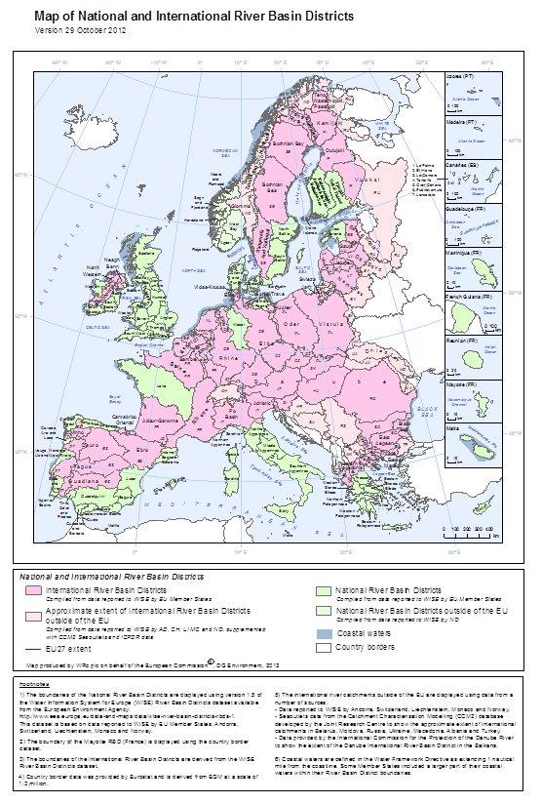
Figure 8.1.1: Map of River Basin Districts in Europe (Better quality maps are available at http://ec.europa.eu/environment/water/water-framework/facts_figures/index_en.htm )

Administrative arrangements – competent authorities
The WFD requires the designation of competent authorities (Article 3, Annex I) within each RBD including for the portion of any international RBD lying within their territory. Member States notified the Commission of their competent authorities in 2004. In addition to name and geographical coverage, information was also provided on the legal and administrative responsibilities of each competent authority and of its role within each RBD. Where the competent authority acts as a co-ordinating body for other competent authorities, a list is required of these bodies together with a summary of the institutional relationships established to ensure co-ordination. The RBMPs should also include a list of competent authorities in accordance with Annex I (WFD Annex VII.10.).
As a follow-up to the assessment of administrative arrangements in the first WFD implementation report in 2007, the set-up and functioning of these administrative arrangements were analysed for the present assessment of the RBMPs.
All Member States reported information to WISE on which institutions are the main competent authority and which main authority is responsible for the WFD.
In 23 (of 112) RBMPs it is stated that one single authority is responsible for the implementation of all WFD activities. Most often this main authority is the Ministry of Environment. In some Member States, specific new River Basin District Authorities have been established for the purposes of the WFD, such as in Sweden and the Czech Republic. In 84 RBMPs (of 112) or 20 Member States it is reported that competences are split between different authorities with responsibilities for different water management related issues. Examples of such divisions are between regional authorities (60 RBMPs) or sub-basin/sub-units authorities(26 RBMPs). In some cases different authorities are responsible for specific water categories, most commonly for coastal waters versus inland waters (12 of 112 RBMPS), but in some cases there are also different authorities for groundwater compared to surface waters. Most often it is the case that one competent authority (whether national, regional, or basin specific) is responsible for core water management issues (water supply, waste water treatment, permitting, reporting, spatial planning, nature conservation, agriculture, navigation, energy, fisheries, other).
Some Member States have adapted their water administrations to ensure better implementation of the WFD, for instance Bulgaria, the Czech Republic, Estonia, Luxembourg, Latvia and Sweden indicate that they have established new authorities as a result of the WFD. However, in the vast majority of cases there has been no adaptation of existing structures to support the implementation of the Directive.
Of the 84 RBMPs that identified divisions of responsibilities between different authorities for the implementation of the Directive, 80% noted that there were co-ordination mechanisms in-place to ensure integration of the management of water between different regions, sub-basins, water categories and sectors. These institutional relationships and co-ordination mechanisms are sometimes very complex and not clearly described in the RBMPs. The degree of co-ordination among authorities at the RBD scale is also variable: from exchange of information, to development of non-legally or legally binding guidance documents for implementation, to a mechanism requiring the agreement of the authorities on a single RBMP.
The WFD requires vertical coordination, in the sense that waterbody level management is required and, at the same time, that Member States ensure that all requirements of the Directive are co-ordinated, including the PoMs, to ensure the achievement of the environmental objectives at the level of the RBD (Article 3.4 WFD). Given that the RBD is the geographical unit of management, incorporating inland waters, coastal waters and groundwater into the integrated framework, the relatively low number of RBMPs reporting a split of responsibilities between different water categories can be viewed as a positive sign of integration of the management of all categories.
Whilst the main, often central, co-ordinating competent authority is often also responsible for key tasks like developing RBMPs and establishing monitoring networks, there can also be a combination of authorities at different levels carrying out core tasks, notably the development of RBMPs and PoMs. Whilst in most Member States the main co-ordinating WFD authority is the central authority, there can also be a combination of different levels. In Austria, for instance, the main competent authority is the Federal State, although it delegates certain implementation powers to the states (regions) ,whilst in countries like Germany and Belgium the states (regions) maintain responsibility. Chapter 8.10 on Programmes of Measures and the subsequent chapters on measures further address the roles and responsibility for the implementation of the specific measures.

Geographical level of the Competent authority (CA) | Lead Competent authority (CA) | Supporting Competent authority (CA)
National, including for federal or quasi federal states | 26 | 1
Regional units of national administration |  | 11
Autonomous Regions | 7 | 6
RBD / catchment authorities | 3 | 6
Local authorities | 3 | 8

Table 8.1.1: Main and supporting authorities by geographical level. The "national" authority is in most cases the Ministry of environment
Source: Pressures & Measures study, task 1 - Governance.

The degree to which the main WFD competent authority is also responsible for other key pieces of water related legislation, including basic measures (Article 11.3.a) and other sectors, may also have an impact on the effectiveness of the implementation of water policies. In some countries, a very complex matrix of responsible authorities has been set up, while in others there are a high number of actors involved in the implementation of the measures. These types of set-up will likely require a very strong co-ordination and a high level of exchange of information which will in turn be very costly. Furthermore, unless co-ordination mechanisms are very clearly explained it may be difficult for interested parties to see how a common goal can be reached.
 | Water directives |  |  |  |  |  | Other Environmental Policies and Directives
 | UWWT | Nitrates | Bathing Waters | Drinking Water | Floods | Marine | Habitats | Climate
Main CA lead | 22 | 8 | 10 | 7 | 20 | 21 | 16 | 14
Shared involvement | 2 | 9 | 5 | 6 | 0 | 3 | 4 | 8
Total CA involvement | 24 | 17 | 15 | 13 | 20 | 21 | 20 | 22
Table 8.1.2.a) Main WFD competent authorities' responsibilities for other water and environmental directives and policies (number of Member States)
 | Key economic sectors
 | Agriculture | Energy | Transport | Industry (IPPC) | Industry (non-IPPC) | Mining
Main CA lead | 6 | 2 | 2 | 7 | 4 | 3
Shared involvement | 2 | 3 | 2 | 6 | 4 | 4
Total CA involvement | 8 | 5 | 4 | 13 | 8 | 7
Table 8.1.2.b) Involvement of the WFD competent authorities in key economic sectors (number of Member States)
Table 8.1.2a and b: Overview on when the main WFD authority is responsible also for other EU directives and for other key sectors, or not. If the responsibility is shared between the main WFD authority and other authority this is indicated. A table including the name of the respective authorities is included in the 'Pressures and Measures study'.
Source : Pressures & Measures study, task 1 - Governance.

This division of responsibility between different authorities is not necessarily a problem, provided that the co-ordination mechanisms are clear and adequate to ensure integrated water management, nor is it in contradiction to the Directive requirements. It is however to be noted that coherent management of all water resources demands more of the administrative structures. As mentioned above, 80% of RBMPs where several authorities were indicated included information on co-ordination mechanisms.
Examples of such co-ordination mechanisms between sectors show a variety of high-level co-ordination mechanisms at ministerial level to a strong role of the WFD competent authority, as well as via more technical working groups and liaison panels. Important co-ordination takes place via the permitting procedures. A further important mechanism for co-ordination is when authorities responsible for other sectors are involved or consulted in the preparation phase of the RBMPs.

Coordination approach | Member State
Coordination organised by one central authority. | AT, DK, FI, IE, LT, LV, NL, PT
Coordination organised by more than one central authority. | HU
RBD authorities coordinate. | BG, SE
Table 8.1.3: Table giving illustrative examples of different mechanisms for coordination between WFD competent authorities and other authorities with responsibilities for other key related sectors. This table is not necessarily inclusive of all models of all MS.
Source: Pressures & Measures study, task 1 - Governance.

Article 11.3 (WFD) sets out a number of basic WFD water related measures to control abstractions, impoundments, artificial recharge or augmentation of groundwater bodies, point source discharges, diffuse sources pollution and other measures including measures to ensure hydromorphological conditions are consistent with ecological status. This should be controlled by prior authorisations, prior regulation and/or registration or prohibitions depending on the nature of the water management issue. These control mechanisms must be reviewed periodically and if necessary updated, and relevant permits and authorisations must be examined and reviewed so that the environmental objectives can be reached (Article 11.5). The governance mechanisms for different types of water related permits were therefore investigated, and it was found that there are different mechanisms in the different Member States.
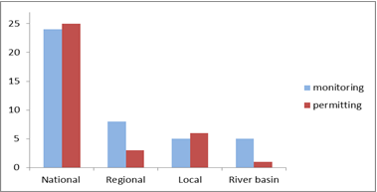
Figure 8.1.2 : Division of responsibility for monitoring as well as water related permits at different geographic levels, by numbers of Member States
Source: Pressures & Measures study, task 1 - Governance.

Where more than one authority is responsible for issuing such permits, there are usually co-ordination mechanisms in place and some illustrative examples are given:
- As the main supervising authority for all types of permits, the regional authorities have a key role. All companies which require a permit (water abstraction, impoundment, hydromorphological alteration) provide an annual environmental report to the County Administrative Board. (Sweden).
- Decentralised regional authorities (Regional State Administrative Agencies) work closely with local authorities and collect statements from other authorities (ELY-centres) regarding possible impacts of plans on RBMP objectives. (Finland).
- If several authorities are relevant for a certain permit requests, one takes charge based on a set of rules. Also, permit requests can be submitted at the municipality level and will then be automatically transferred to the competent authority. (The Netherlands).
- Inter-state authority co-ordination via information exchange and mutual agreement. (Germany).
- Local authorities generally responsible; follow central authority's guidelines where appropriate. (Ireland).
- The higher (central) authority (Lebensministerium) has overall control. (Austria).
Member States are also required to determine penalties applicable to breaches of the WFD as written into national laws, that are effective, proportionate and dissuasive (WFD Article 23). There are different strengths and weaknesses in the enforcement mechanisms, which will have an impact on how effectively the RBMPs can be implemented. Member States have a variety of approaches in organising enforcement activities across their territories. Only a few countries have organised enforcement activities along river basin scales. The few examples are Bulgaria, Hungary, Romania and Spain, where administrative bodies at RBD or sub-basin level have enforcement powers. While comparable information is not available across all Member States, in most cases the same administrative authorities are responsible for enforcement of permits across different sectors though some differences are seen for IPPC permits. In other cases there are differences depending on the type of activity or the scale of the activity. Transparency also differs, and some Member States or regional authorities publish annual reports on enforcement activities.
Co-ordination is a key factor where enforcement activities are carried out by several authorities and at different administrative levels. It is noticeable that the local and regional authorities play a large role in the enforcement of water permits. In several Member States the enforcement authority is also the permitting authority. A number of Member States have specific environmental inspectorates, and the police forces are an additional enforcement institution.
MS | Federal State | National environ. authority | Environ. Inspectorates | Regional authorities | RBD authorities | Local authorities | Police forces
AT | F | ✓ª |  | ✓ |  | ✓ | ✓
BE | F |  |  | ✓ |  | ✓ | ✓
BG |  |  | ✓ |  | ✓
CY |  | ✓
CZ |  |  | ✓ | ✓ |  | ✓
DE | F |  |  | ✓ |  | ✓
DK |  | ✓ |  |  |  | ✓ | ✓^{b}
EE |  |  | ✓
EL |  | ✓ |  | ✓ |  |  | ✓^{b}
ES | Q | ✓ |  | ✓ | ✓^{h} |  | ✓^{f}
FI |  |  |  | (✓)^{c} |  | ✓
FR |  | (✓)^{d} | (✓)^{d} | (✓)^{d} |  | ✓ | ✓
HU |  |  | ✓^{e} |  |  | ✓
IE |  | ✓ |  |  |  | ✓ | ✓
IT | Q |  |  | ✓ |  |  | ✓^{f}
LT |  | ✓
LU |  | ✓
LV |  | ✓
MT |  | ✓
NL |  | ✓ |  | ✓ |  | ✓
PL |  |  | ✓
PT |  |  | ✓ | ✓^{g} |  |  | ✓
RO |  | ✓ | ✓ |  | ✓ | ✓ | ✓
SE |  |  |  | (✓)^{i} |  | ✓
SI |  |  | ✓
SK |  | ✓ | ✓ |  |  | ✓
UK | Q |  |  | ✓ |  | ✓
Table 8.1.4: Overview of enforcement authorities for water permits across Member States
Notes: a. For large IPPC installations, b. Police may be called in to assist environmental inspectors: not a main authority, c. Regional Centres for Economic Development, Transport and the Environment, d. Enforcement in France involves regional and departmental offices responsible for environment and national agencies and their regional and/or department offices, e. Regional officials of the environmental inspectorates are f. In particular, police at national level, g. Only the autonomous regions of the Azores and Madeira, h. RBDs that cross Spanish regions (i.e. Autonomous Communities) are of national responsibility; RBDs within a single region are of regional responsibility, i. County administrations F : Federal system Q: Quasi-federal system
Source: Pressures & Measures study, task 1 - Governance.

Although there seems to be considerable fragmentation of the responsibilities for water related management issues, there are co-ordination mechanisms in place in most countries. No ‘one-size-fits-all’ solution can be found, and flexibility and subsidiarity in how to determine the optimal institutional set-up is important. It is not possible at this stage to assess the effectiveness of these mechanisms based on the RBMPs, and the big ‘effectiveness test’ for each Member States lies in the degree of achievement of the WFD objectives. The strength of the integration of water related aspects into other policy fields is also not only related to the institutional set-up of authorities, but also depends much on the legal status of the RBMPs.

River Basin Management plans – structure, compliance and legal weight
The RBMP is the main tool for water management of all water bodies within a specified RBD and the contents of the plan are outlined in Annex VII. With respect to water governance, the RBMP shall contain: a general description of the RBD; a summary of the significant pressures and impacts on water bodies; a summary of the measures intended to mitigate the impacts identified; a register of any more detailed plans proposed for sub-basins, sectors, management issues or water categories; a summary of public consultation; and, a list of the competent authorities including the relationship with other authorities co-ordinated within a Member State and a summary of institutional relationships established to ensure co-ordination in international RBDs.
Most Member States have provided one RBMP per national part of the RBD. Sometimes the Programme of Measures is a separate document. In some cases the environmental objectives are established in separate documents and thereby in some cases give the environmental objectives a different status. Specific documents may also be submitted for Strategic Environmental Assessments or to public consultation. A large number of annexes and background documents were reported.
In terms of transparency, it was found that the RBMPs from 11 Member States were considered clear and well structured, whilst in some plans it was difficult to find the relevant information. Many RBMPs made reference to national databases with water specific information per water body (Sweden, Denmark), or waterbody specific fact sheets (UK, Belgium-Flanders), or one central national database where all information is gathered (Germany, Wasserblick). When a background document is referred to in the RBMP but where it is neither reported, nor available on the respective webpages, the Commission has raised this with the Member States. It is crucial for transparency of the RBMPs that this information is available also to the public. In a few cases, information was not provided in a way that ensured that the RBMP was easy to digest. The key concern with regard to transparency is, however, not necessarily related to the clarity of the drafting or structure of the plan; it is related to the absence of relevant information at a water body level. This is addressed further below in the sections on monitoring, environmental objectives and PoMs.
Of the 71 RBMPs that indicated that there were more detailed sub-plans (in accordance with Article 13.5), 62% had a focus on sub-basins/sub-units (such as Italy, the Czech Republic, Finland, Romania, Sweden (1 RBD), Slovakia, UK). 45% of RBMPs reported that sub-plans had been developed for different administrative regions (Italy, Poland, Germany, UK). In some cases there were separate plans for specific water categories, most commonly for coastal waters (38 %).
The shortcomings identified in this report in relation to the different obligations are part of the overall completeness assessment. The legal framework sets out a stepwise approach and if one requirement is not complete or correctly carried out, it may pose obstacles for subsequent steps in the implementation process. In many cases the lack of, for instance, monitoring data or waterbody-specific information on classification, is a result of a lack of implementation in previous steps.
Clear and complete RBMPs are also important for accountability as it is also the main tool for communicating to interested parties, including the public, how integrated water management is, or will be, carried out. Incomplete draft RBMPs, or where draft background documents referred to are not made available upon request in a timely manner in the public consultation process, mean that interested parties are not given sufficient information to enable them to express their views in a meaningful way.
The legal status of the RBMPs, PoMs and the environmental objectives differs among Member States. The Directive requires Member States to make the environmental objectives, and the measures to reach those objectives, operational through the RBMP. The legal weight of the document is therefore crucial in terms of the impact the WFD objectives can have on everyday water management decisions as well as decisions taken in other policy fields. The country specific parts of this document include further information on:

- The legal status of the RBMPs, dependent on the rank of the RBMP within the national hierarchical order of policy and legal acts, considering its denomination, the adopting authority and the procedure for its adoption.
- The legal ‘effect’ of the RBMP in relation to other acts such as individual decisions on permit or spatial planning instruments. Here, the question relates more to the operational effect of the RBMP and would typically be regulated in the framework legislation on water or other relevant legal acts, such as on territorial planning. The key issue is whether or not the plan has a legal effect on these other decisions and instruments. The legal ‘effect’ should be considered not only in terms of legal relations but also considering how operational is the plan, and how detailed and prescriptive are the measures provided for within the plan. It also implies looking at the alignment of the different decision-making processes over time.
Weak legal power of the RBMPs, and therefore also the legal weight of the environmental objectives, can be particularly problematic in relation to the implementation of the PoMs, such as the basic measures (set out in Article 11.3.b-l ) and their periodic reviews linked to whether the environmental 'objectives are unlikely to be achieved'. It appears that in many cases the rights to abstract water are based on old land ownership rights, or the right to impound water for power production are based on legal acts pre-dating the adoption of the WFD. Despite the requirements of the WFD, it now appears that the national legal and administrative tools have not always been adopted to provide the legal base for this revision.
The RBMP’s legal status is primarily determined through the type of act which ultimately approves the plan, in particular the level of that act.

Level of approvals of the RBMP | Member States
Parliament | NL
Government or Council of ministers | BE FL (regional government) CY, CZ, EE, ES, FI HU, IT, LT, LU, PL, PT, RO, SI, SK, UK (devolved government/Assembly in Wales)
The RBMP is adopted by the Ministry of Environment | AT (Federal Ministry), BG, DE (Länder Ministry), DK, LV, MT
The RBMP is adopted by decentralised administration | EL, FR, SE
Table 8.1.5 Indicative overview of the level of approval of the RBMPs. Full categorisation of which model applies to which MS is included in the 'Pressures and Measures Study' - Governance report and country specific parts of the Commission Staff Working Document.
Source: Pressures & Measures study, task 1 - Governance.

There is some form of gradation as to the extent the RBMP is ‘binding’, as reflected in the different way the legal requirement is formulated: take into account, have regard to, be compatible, be in conformity, etc. Without defining a precise typology, the legal effect of the RBMP can be distinguished according to the following broad categories (and in relation to individual administrative decisions only):

Type fo act and mechanism | Comment | Member States
Administrative decisions related to water should take into account the RBMP | This obligation is rather vague. It has been interpreted in some countries as the obligation not to contradict the RBMP without clear justification. | BE FL, CZ, DE, FI, HU, IE, SE, SI, SK, UK
Administrative decisions related to water should conform to or be compatible with the RBMP | The obligation implies that the administrative decisions cannot contradict the RBMP. | AT, BG, DK, EL, ES, FR, PL, PT, RO, SE
No specific legal provisions on status. The RBMP is rather considered as a general planning document with limited legal effect. | In such cases, it is mainly left to the approach that will be adopted in practice by the Competent Authorities | CY, EE, IT, LT, LU, LV, MT, NL
Table 8.1.6 Indicative overview of different characteristics of RBMP indicating various grades of legal effect Full categorisation of which model applies to which MS is included in the 'Pressures and Measures Study' - Governance report and country specific parts of the Commission Staff Working Document.
Source: Pressures & Measures study, task 1 - Governance.

The analysis of the legal status and effect of RBMPs and PoMs in the Member States show a variety of situations which make it difficult to draw clear-cut conclusions, and the notion itself of ‘binding’ varies from one Member State to another. Although the notion of what constitutes a legally ‘binding’ document is not always clear, there seems to be some form of gradation as to the extent that the RBMP is ‘binding’, as reflected in the different way the legal requirement is formulated: ‘take into account’, ‘have regard to’, ‘be compatible with’, ‘be in conformity with’, etc. A RBMP or PoM may not be binding as a whole but some parts or some measures may be.
Closely linked to the legal weight of the RBMPs (including objectives and measures) is the role of the plans in relation to other sectors and to different responsible authorities. The country specific parts of the Commission Staff Working Document. include information on the approving authority, the type of act adopting the RBMPs or PoMs, the place in the hierarchy of norms and legal status as well as the relationship of the RBMPs with individual decisions for each Member State.
The relationship between RBMPs including the environmental objectives and other individual permitting decisions should also be considered in relation to specific types of permitting decisions. Whilst in most Member States there is a direct legal effect of the RBMPs and the WFD objectives for different sectors, often through the legal weight of the RBMPs linked to their rank amongst legal and administrative acts. However, few Member States have explicit provisions of reviews of such permits and even fewer have aligned the timetables with the reviews of the WFD (every 6 years). The existence of specific circumstances triggering these reviews, notably non- achievements of WFD objectives, is crucial. This last instance is generally reflected in the legislation as part of the transposition of the WFD, but only in general terms.
 | Effect |  |  | Explicit provision on review |  |  | Alignment of timeline
 | Hydropower | Agriculture | Industry | Hydropower | Agriculture | Industry | Hydropower | Agriculture | Industry
AT | √ | √ | √ | √ | √ | √ | X | X | X
BE (FL) | √ | X | √ | X | X | X | X | X | X
BG | X | √ | √ | X | √ | X | X | √ | X
CY | √ | √ | √ | X | X | X | X | X | X
CZ | √ | √ | √ | X | X | X | X | X | X
DE* | √ | √ | √ | - | - | - | - | - | -
DK | √ | √ | √ | √ | X | X | √ | X | X
EE | √ | √ | √ | X | X | X | X | X | X
EL | √ | √ | √ | X | √ | √ | X | X | X
ES | √ | √ | √ | √ | √ | √ | X | X | X
FR | √ | √ | √ | √ | √ | √ | X | √ | X
FI | √ | √ | √ | X | X | X | X | X | X
HU | √ | √ | √ | X | X | X | X | X | X
IE | X | X | √ | X | X | √ | X | X | √
IT | √ | √ | √ | X | X | X | X | X | X
LT | √ | √ | √ | √ | √ | √ | X | X | X
LU | √ | X | √ | √ | X | √ | X | X | X
LV | √ | √ | √ | X | X | X | X | X | X
MT | X | X | X | X | X | X | X | X | X
NL | √ | √ | √ | √ | X | √ | X | X | X
PL | √ | √ | √ | X | X | X | X | X | X
PT | √ | √ | √ | √ | √ | √ | X | X | X
RO | √ | √ | √ | √ | √ | √ | √ | √ | √
SE** | √ | √ | √ | √ | √ | √ | X | X | X
SI | √ | √ | √ | √ | √ | √ | X | X | X
SK | √ | √ | √ | X | X | X | X | X | X
UK | √ | √ | √ | √ | √ | √ | X | X | X
% √ | 85% | 85% | 96% | 44% | 41% | 48% | 7% | 11% | 7%
Table 8.1.7: Relationship of WFD RBMPs, including objectives with specific permits/concessions for key sectors, and % of Member States. (√ =Yes, x=no)
Notes : * In Germany, the situation varies from one Federal state to another. While there is an obligation to conform to the environmental objectives as set in the RBMP when granting permits, there is no explicit provision on revision and alignment of timeline. ** This relates only to PoMs and EQS
Source: Pressures & Measures study, Task 1, Governance.
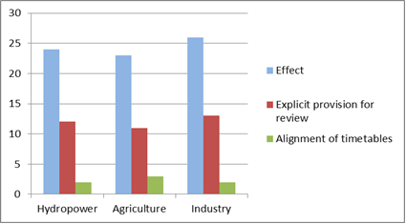

Figure 8.1.3 : Relationship of WFD RBMPs, including objectives with specific permits/concessions for key sectors, by number of Member State. See previosu table for comments.
Source: Pressures & Measures study, Task 1, Governance.

The degree to which the relationships between the RBMPs and sectoral policy plans are regulated is equally important, not least for those dealing with land use and spatial planning, given the important links between water scarcity management and land use. In this case it appears that, in principle, there should be such positive links with land use plans (74% Member States), flood risk plans (89% Member States) and spatial planning (78% Member States).
The different models of legal authority of the RBMPs do not all necessarily seem to effectively provide the means for Member States to ensure that environmental objectives are met. Where there seems to be a significant shortcoming that can be traced back to the transposition of the Directive, and where the weakness of the transposition was not identified before the full nature and content of the RBMP were presented, the Commission does not exclude the need for Member States to review the relevant national legislation.
Whilst the RBMP had to be adopted at the latest 22.12.2009, Article 11.7 requires all ‘measures shall be made operational at the latest’ 22.12.2012. Article 15.3 also requires an interim report to be submitted at that date to include a description of 'progress in implementation of the planned programmes of measures'. This assessment therefore recognises that the RBMPs as assessed may not include all information in relation to the progress of specific measures. However the Commission expected that the RBMPs should provide a summary of the programmes of measures that also sets out 'the ways in which the objectives established under article 4 are thereby to be achieved'.
Many RBMPs are vague in this regard and water body specific information on which measures are planned to be take is rare, leading to weakening of the role of the RBMPs themselves and leading to uncertainly for interested parties (such as the public, economic actors or local authorities). Furthermore, it is very important that the level of detail is such that it is possible to discern which measures are planned for the particular water bodies. This should also be taken into account in the draft RBMPs that are submitted for consultation to the public and interested parties. Unless this level of detail is provided, meaningful consultation of interested parties is not possible since they will be prevented from understanding the extent of the action that is going to be taken. The process of ’making the measures operational by 2012’ is not necessarily subject to public scrutiny, which again reinforces the importance of ensuring that draft RBMPs are sufficiently detailed. Some Member States are carrying out further consultations on sub-plans, for instance the local authority level water plans in Denmark. It is, however, also important to underline the importance of the RBMP consultations as these provide the catchment overview of measures which enables strategic decisions to be taken at that level. When the above mentioned lack of information or lack of access to background information relating to measures is particularly problematic. The Commission will also assess the interim reports on the progress of measures.
Closely linked to this is the availability of financial resources for the implementation of water management measures, including for tasks such as ensuring appropriate monitoring. With the financial crisis in Europe, governmental expenditure is subject to severe restrictions in many countries and it appears this is also being reflected in the rate of implementation of the programmes of measures. Not all RBMPs include information about the overall costs of implementation of the plans, and even in cases where that information is provided, there are no binding financial commitments linked to the plans.

Integration and co-ordination at the river basin district level: territorial and sectorial integration
The Directive requires that ’Member States shall ensure that the requirements of this Directive for the achievement of the environmental objectives established under Article 4, and in particular all programs of measures are coordinated for the whole of the river basin district’(Article 3.4). To assess the effectiveness of the governance structures to achieve this requirement, different aspects of integration need to be further explored in addition to the institutions and nature of the RBMPs as analysed above, notably territorial co-ordination, sectoral integration and the involvement of interested parties or stakeholders. International co-ordination is also further explored in section 8.1.7.
Most Member States have prepared RBMPs for each RBD within their territory, and in many cases the RBDs coincide with the river basins. In some cases there are several river basins in each RBD, and in these instances the catchment level co-ordination is sometimes less clear. There are good examples of ‘river basin sub-plans’ (SE2), or specific sections in the overall RBMPs on sub-basins or individual river basins. Sometimes the evidence of coherent catchment level co-ordination is not apparent, although there are some encouraging examples.
Whilst assessing the RBMPs it became clear that there were national approaches to water management in most cases (69%), with 9% of plans reporting RBD specific approaches. In some Member States the approach differs in different regions. Where there are such distinctive differences, the assessment of the RBMPs has distinguished between such regions of RBDs (or groups of RBDs).
Whilst different regional approaches, per se, is not necessarily a problem, distinctively different approaches within the same catchment can pose problems relating to co-ordination and equal treatment of economic actors. Some illustrative examples of where this seems to be a problem are listed here, but there may be equally important problems in other countries. Further information is available in the country specific parts of the Commission Staff Working Document.
- Germany: Germany is a Federal State with 16 Federal States which hold the majority of the competence in water management. Although there are co-ordination mechanisms in place between the Federal States, many aspects of implementation of the RBMPs are different from one Federal State to another, even within the same RBD. The Commission understands that the co-ordination body in Germany – LAWA – is in the process of improving this co-ordination and coherence in water management between the Federal States for the second RBMP cycle.
- Belgium: Belgium is a federation of three regions (the Flemish, Brussels and Wallonia Regions). Belgium has only international River Basin Districts (Meuse, Scheldt, and small part of the Rhine and Seine RBDs). Whilst co-ordination is taking place at the international 'roof-level’ (A-level) and whilst there are national co-ordination mechanisms in place, there are severe delays in the adoption of the RBMPs in the upstream regions of Wallonia and Brussels compared to the downstream Flanders Region. This may mean that coherent co-ordination of the programmes of measures, and preparation of the plans including public consultation, becomes very difficult.
- Italy: In recent years the Italian state has transferred significant powers to the regional level. The regions in Italy are responsible for a range of activities for water management, including: monitoring; permitting and enforcement (an activity partially shared with the national level); and planning (shared with RBD level). The RBMPs are based on monitoring and analysis undertaken at regional level. Whilst rules and guidance for these activities are set at national level, the regions have implemented national provisions at different paces. As a result, the information provided on water bodies – including assessments of good status as well as the determination of objectives and exemptions – varies considerably across regions, also those within common RBDs. There has been some co-ordination at RBD level among regions but it appears that co-ordination has been only partial in the first round of RBMPs.
Member States with distinctively different approaches to WFD implementation within their catchments are recommended to further enhance co-ordination within their territory to ensure environmental objectives can be reached. This will encourage common approaches for characterisation, monitoring and assessment, co-ordinated measures, and delivery of consistent data among other things.

The WFD includes key requirements on how the RBMPs shall be the framework for integrating different policies and sectors. In addition to the analysis of administrative arrangements above, the consideration of all types of significant anthropogenic pressures is at the core of the WFD with one of the main building blocks being 'the review of impacts of human activity on the status of water' required the first time in 2005 by Article 5. Based on this analysis, monitoring programmes shall be developed to identify the extent of the problem related to a specific pressure to be addressed in the programmes of measures following a consultation process on significant water management issues and draft RBMPs. All potential policy sectors shall therefore be addressed by the RBMPs, including those not part of traditional water management, for instance the agriculture sector, energy production. Article 10 on the 'combined approach' further reinforces policy integration in that if it is not sufficient to implement point source control measures such as the IPPC/IED Directive, UWWT Directive, or diffuse pollution Directives like the Nitrates Directive, in order to reach good status then more stringent measures have to be put in place for sources controlled by those Directives and any other relevant legislation. The issue of groundwater measures, for instance, shows that there are many Member States who have adopted supplementary measures in addition to the basic measures listed in Article 10 in order to reach groundwater chemical status requirements.
To ensure co-ordination and policy coherence, the degree to which the main competent authority is responsible for the different water management issues can be indicative of the degree of co-ordination at the RBD level or between sectors. Another indication on the degree to which the RBMPs are tools for policy integration is the degree to which they integrate references to the different relevant policy fields. Chapter 8.10 to 8.19 provide further information on the degree to which, for instance, agriculture, energy, transport or industrial pollution measures are included in the RBMPs.
The Directive leaves the decision on the use of sub-plans to Member States (Article 13.5 WFD – ‘more detailed programmes and management plans’). Sub-plans may offer Member States the opportunity to provide more details on the issues and actions impacting at different levels within the RBD. Of the 71 RBMPs referring to sub-plans, these sub-plans cover, for instance, agriculture (59%), chemical industry (33%), hydropower (13%), transport (22%), other sectors including energy (general), spatial planning, mining, tourism. The same analysis can be made for other related water management issues and key policy areas (such as climate change, agriculture nutrient pollution or flood protection) where the RBMPs have integrated these issues via such sub-plans.
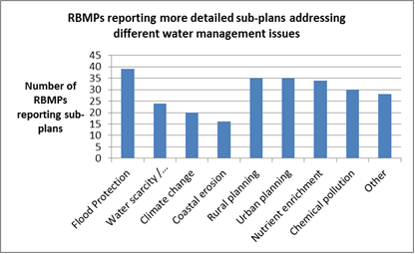

Figure 8.1.4: Number of RBMPs reporting more detailed sub-plans addressing different water management issues. Others include for instance aqueducts, biodiversity, nature protection and Natura 2000, environmental health.
Source: WISE and RBMPs

Making references to other sectors in the RBMPs may not, however, guarantee the full policy coherence and policy integration between the WFD and other policies. The effectiveness of the RBMPs to play this role is closely linked to the legal weight of the RBMPs in relation to other policy sectors, as discussed in section 8.1.4 above.

Integration and coordination at the river basin district level: stakeholder involvement
Another key mechanism for sectoral and territorial integration is the stakeholder involvement in the development of RBMPs by the requirement to 'encourage the active involvement of interested parties in the implementation' of the RBMPs, in particular in the development of plans (Article 14) which sets out a three stage process of stakeholder and public consultation requiring at least six months. The purpose is to involve all stakeholders, including the public, with a view to ensuring that the best and most cost-effective measures are identified and selected, and that acceptance of the measures is built into the process.
Whilst the consultation on the work programme is an obligation to ensure all interested parties are informed of the consultation timetables and mechanism for preparing the RBMPs (3 years before adoption), the two latter steps on significant water management issues (2 years before adoption) and draft RBMPs (1 year after adoption) offer the possibility to hold substantial discussions on the identification of pressures and measures. Background documents must be made available and the public consultation must be open for at least six months.
The requirement to conduct a consultation on draft RBMPs lasting six months was largely complied with, whilst this is not clear for 4 RBMPs (Catalonia (ES), Eastern Alps and Po (IT), Reunion Island (FR)). Several Member States built up serious delays in starting the last round of consultations (see table 6.2) and some consultations have either only just started (as of July 2012- Belgium- Wallonia) or have not even started yet (part of Spain and Greece and the plan of Madeira).
During the first decade of implementation of the WFD, public participation and stakeholder involvement have also become a natural element of river basin management planning. Member States have undertaken considerable efforts in consulting stakeholders and the public and have used a variety of different outreach methods. Nonetheless, the impact of the consultation on the RBMPs is not always clear.
A background document issued for the second European Water Conference, organised by the European Commission halfway through the consultation period for the draft RBMPs (2-3 April 2009) includes an analysis of the timelines, methods and results of the consultation practices until that date, alongside an analysis of the significant water management issues.
The RBMPs indicated that a wide range of outreach methods and consultation mechanisms were used for reaching out to and consulting with stakeholders (including the public).
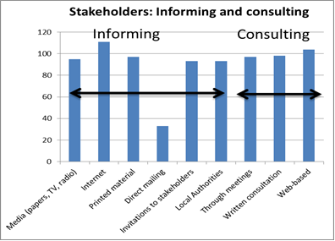
Figure 8.1.5: Means of informing stakeholders and the public, as well as consulting.
Source: WISE and RBMPs.

The most predominant outreach methods were to use the internet for announcing the consultation and for carrying out the consultation by inviting comments via the web. Media was used to a large extent for announcing the consultations, and local authorities played a big role in reaching out. In many cases the interested parties known to the authorities were directly invited to respond. Innovative and interactive outreach methods like travelling exhibitions and means the creation of game shows, board games and web-based material for schools also aim at increasing the awareness of water management issues. In some countries telephone and households surveys were used.
Draft RBMPs were also subject to written consultation and were discussed at a variety of meetings, workshops, and different targeted sector-specific activities. Dedicated telephone lines to engage stakeholders on the draft plans were maintained. Direct mailing to all households was not carried out in many countries but where that was done, notably in some French RBDs, the response rates were relatively high.
In addition to carrying out consultations on the draft RBMPs with all interested parties, some Member States also involved them in the drafting of the draft RBMPs which seem to have led to easier adoption procedures. On the other hand, some Member States seems to have only consulted local authorities at the same time as other stakeholders, rather than develop the draft RBMPs with them. Some Member States carried out their consultation in multiple stages (SI, DK) on different drafts of RBMPs.
It is also important to assess which kind of stakeholders were involved and whether these coincide with the sectors of relevant pressures in the respective Member States. As stated above many Member States have consulted local authorities as stakeholders, rather than being involved in the drafting of the plans. The other most important stakeholder groups are NGOs/nature protection groups, the agriculture sector, the water and sanitation sector and the industry and water industry sectors.
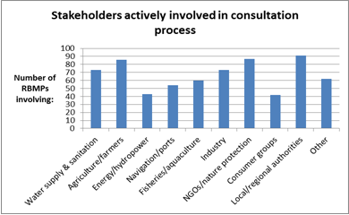
Figure 8.1.6: Stakeholders actively involved in consultation process Other stakeholder groups included sport/recreation, academic institutes, national parks, forestry, tourism, spatial planning, other ministries.
Source: WISE and RBMPs

The WFD requires Member states to include 'a summary of the public information and consultation measures taken, their results and the changes to the plan made as a consequence' in the RBMPs (annex VII.A.9). While there have been many responses by stakeholders to the consultation it has been difficult to assess the real impact of consultations on the RBMPs, including on programmes of measures or other aspects of the WFD implementation. However, the analysis of the 112 RBMPs has shown the following impacts as a result of consultation.
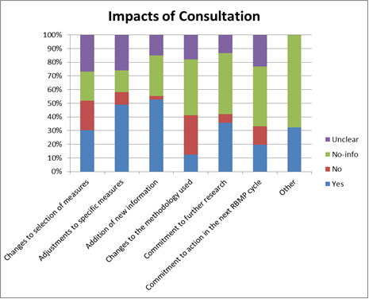
Figure 8.1.7: Type of impacts of public consultation reported in the RBMPs. Other changes include modification of strategic environmental assessment, commitment to future reporting, environmental objectives for mining adjusted, status assessments of HMWBs/AWBs to be undertaken in next cycle, revision of funding for PoMs, adjustment of EQSs, revisions to take account of climate change predictions (UK), improved local focus/ developing community partnerships (UK).
Source: RBMPs

It appears that in some cases the consultation led to less stringent measures or objectives being defined but in some cases an increased level of ambition was reported (France, UK). Over 30% of RBMPs made commitments to undertake further research and/or to action in the next RBMP cycle. For some Member States, no information was provided on the impact of the consultations on the final RBMPs: Austria, Czech Republic, Germany (2 of the RBMPs), Italy (2 of the RBMPs), Luxembourg.
The Directive also requires on-going involvement of interested parties in the implementation of the Directive (Article 14.1 WFD). 20 Member States have formal processes in place to involve stakeholders but for other countries it is either not the case (Bulgaria, Czech Republic, Greece), it is unclear (Hungary, Italy, Portugal) or no information could be found (Poland). Advisory bodies have been set up in 16 Member States to monitor implementation of the WFD although this is not the case in Austria, Bulgaria or Romania, and the information is unclear or not found in Belgium, Finland, Italy, Poland, Hungary, Lithuania, the Netherlands and Sweden.
It is clear that the extensive consultations and the mechanisms for on-going involvement have been one of the achievements of the WFD so far but an analysis of how effective they have been is difficult to carry out on the basis of the information reported in the RBMPs. A Flash Eurobarometer carried out in January-February 2009 showed there was some general awareness (14%) of these consultations among the general public, but it also showed a high interest in getting involved (44%) although the respondents to the survey were not aware of the scheme at the time of the survey.
The Commission has also been informed, via complaints received, of cases where the consultations have not, in the view of the complainants, been undertaken in a way that meaningful comments can be provided by the consulted parties. This may be, for instance, due to the lack of information provided in the plans or the non-availability of background documents. The Commission is further investigating such complaints.

International co-ordination and co-operation
One of the main new elements introduced by the WFD was the legal requirement for transboundary co-operation. 60% of the EU territory is covered by international river basins, and 55 of the 110 RBDs are considered international. Member States 'shall ensure co-ordination with a view of producing a single RBMP' when the RBDs are international. Where a third country shares a river basin with an EU Member State, the Member State 'shall endeavour to produce' such a plan for the same purpose (WFD Article 13). ‘For international river basin districts the Member States concerned shall together ensure this co-ordination’ (WFD Article 3.4).
International co-operation has been significantly enhanced since the adoption of the WFD, in particular in some of the larger international basins. International RBMPs have been adopted in catchments like the larger Danube, Rhine, Elbe, Scheldt, Odra, Meuse, Ems basins but also in the smaller basins shared by the UK and Ireland. Some form of co-operation and co-ordination is on-going in most river basins shared between EU Member States, or with third countries. Co-operation is, however, generally less developed in smaller transboundary catchments where there is no co-ordinating body or agreement in place, and sometimes international co-ordination is not even mentioned in the RBMPs. The highest degree of co-ordination is achieved where international RBMPs are developed.
In some international river basins there has been extensive co-operation for many years, such as in the Rhine where there has been important progress on pollution reduction, and the establishment of hydromorphological measures that has, for instance, led to salmon once again being reintroduced. Most international river conventions have since been amended to fulfil the role of co-ordination of the implementation of the WFD, for instance in the Danube.
Of the 112 RBMPs assessed, 66 RBMPs were reported as ‘international’ with river basins shared between Member States or Member States and third countries. 29 of those national RBMPs indicated that they were linked to the 10 international RBMPs. This assessment shows that co-ordination has taken place on a number of specific requirements of the Directive as further explained later in this report. For instance measures related to key transboundary water management issues like river continuity, nutrient reduction and chemical pollution are indicated as being coordinated (altogether in around 40% of the RBMPs). 40% of the international RBMPs also indicate that there are transboundary monitoring programmes for shared rivers and just over 20% for shared groundwater. The relatively high percentage of RBMPs reporting co-operation on public participation and co-ordination is due to the outreach and consultation activities undertaken by the International River Commissions such as the International Commission on the Protection of the Danube River (ICPDR).
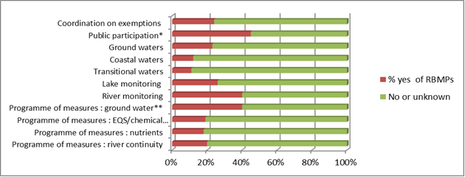
Figure 8.1.8 : Issues coordinated internationally as reported in the reported in the RBMPs (% of national parts of international RBMPs) * mostly via international river commissions.** please note is some international river basisn, cooperation on groundwater may notbe relevant, due to the lack of transboundary GW bodies Source: WISE and RBMPs
To further analyse international co-ordination, it is important to base the assessment on the number of transboundary river basins, rather than individual RBMPs as reported to the Commission which most often present the national parts of international RBDs. A detailed inventory of co-operation in the specific international river basins and international RBMPs where they exist has been carried out, and the following conclusions are primarily based on that study unless indicated otherwise.
There are altogether approximately 75 transboundary river basins in Europe. 22 of those river basin are shared between EU Member States only (30% of the catchment areas), the rest are shared with third countries. In some cases there are specific international agreements in sub-river basins, in which case they have also been studied separately. 30 such sub-basins have been considered in this assessment. There are many more transboundary sub-basins. A small number of international RBDs have a very small proportion of their territory in the adjoining country. These have not been further assessed here, for instance the Seine with less than 1% in Belgium.

Category | Coordination & Cooperation Degree | Number international river basins, including some selected sub-basins
I | International river basins/sub-basins with formal international agreement & international co-ordinating body& international WFD RBMP | 12
II | International river basin/sub-basins with formal international agreement & international co-ordinating body BUT no international WFD RBMP | 71
III | International river basin/sub-basins with formal international agreement BUT no international co-ordinating body & no international WFD RBMP | 19
IV | International river basin/sub-basins with no formal international agreement & no international co-ordinating body & no international WFD RBMP | 3

Table 8.1.8: Four categories of international river basins or sub-basins used for the analysis of transboundary cooperation.
Source: Pressures & Measures study, Task 1, Governance.

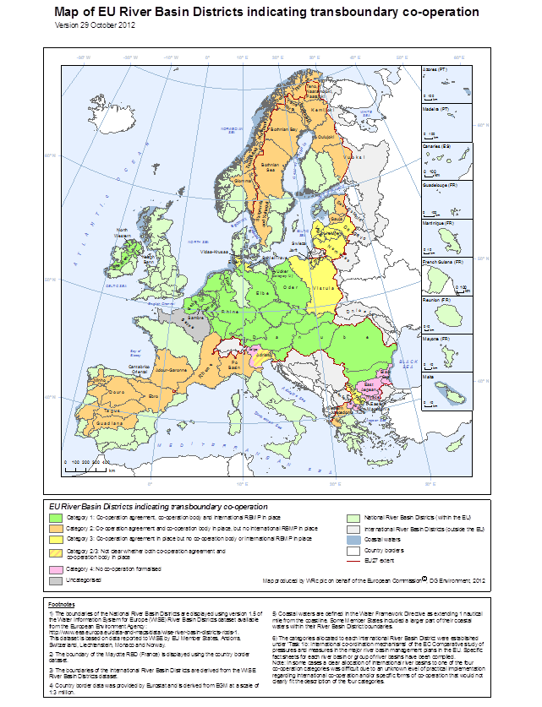
Figure 8.1.9: Map of EUs RBDs indicating to which category they exist. Four categories of international river basins or sub-basins used for the analysis of transboundary cooperation.
Source: Pressures & Measures study, Task 1, Governance. WISE. Note: Better quality maps are available on: http://ec.europa.eu/environment/water/water-framework/facts_figures/index_en.htm
From this analysis we see that although there are only 10 international RBMPs in place (Category 1) for the 75 different transboundary catchments (13% of all basins), we see that these RBMPs cover 46% of the catchment areas of all transboundary catchments in the EU. Basins with co-operation agreements and co-operation bodies but no international RBMPs cover 39% (Category 2) and the area where no international co-ordination takes place is 2%.

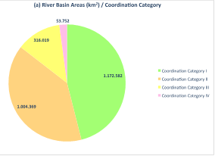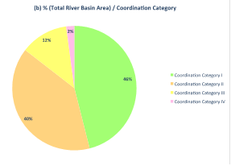

Figure 8.1.10: Size and percentage of river basins in the 4 international cooperation categories.
Source: Pressures & Measures study, Task 1, Governance.

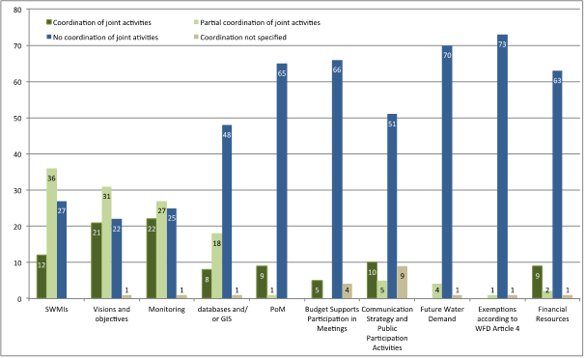
Figure 8.1.11: Key joint activities coordinated, partially coordinated or un-coordinated in 75 European international river basins.
Source: Pressures & Measures study, Task 1, Governance.

The in-depth analysis of international co-operation based on the survey of Member States’ factsheets for specific catchments (Danube, Rhine, etc) or groups of catchments (for instance all catchments shared between Spain and Portugal are included in one factsheet) showed that there are different degrees of co-operation on a variety of aspects such as data-sharing and identification of significant water management issues and sharing of visions of objectives. The survey also found that there are plans for preparing more international RBMPs in the next cycle and the main achievements and obstacles have also been identified.
As we can see above, in a number of international river basins there was little or no evidence in the first RBMPs of co-ordination on joint transboundary activities between some Member States or indeed with third countries, for example: Vistula (shared by Poland, Slovakia and the Czech Republic, as well as Ukraine and Belarus); Mestos/Nestos (shared by Bulgaria and Greece); and Isonzo/Soca (shared by Italy and Slovenia). This is also the case for the 33 river basins shared between Sweden and Norway but this is stated to be due to the later timetable for implementation of the WFD in Norway and work is on-going for the second cycle. In some basins like the Rhône (mainly in FR) or the Po (mainly in IT) there is transboundary co-ordination and agreements in place for part of the basins, or specific sub-basins which are transboundary, but the whole catchment is not considered transboundary. The co-ordination between Member States needs to improve in the second cycle to improve the harmonisation of both assessments and measures to address the pressures in the RBD.
The following reasons for not developing international RBMPs seem to be most prevalent:
- In a number of Member States, co-ordinated plans have not been developed due to the small size in one country as in Latvia (Daugava 2%) or Poland (Nemunas 2%).
- Co-ordination mechanisms with non-EU countries have not yet been developed in all cases or been approved by all parties. There has, however, recently been progress in signing such agreements for international catchments shared with the Russian Federation.
- Existing international legal frameworks not yet adapted to the WFD.
- Some Member States claim there are no significant water management issues and water bodies are ‘largely’ in a good status, and therefore plans are not needed.
- Different timetables for the preparation of the national plans were also cited in a number of cases.
The 'Pressures and Measures Study' provides further information in the 32 factsheets developed, analysing the legal framework, the joint activities, whether methodologies have been shared as well as obstacles for co-operation and plans for future co-operation.

Conclusions
Not all Member States have respected the hydrological boundaries when designating RBDs, including when designating international RBDs.
There is considerable fragmentation of the institutional set-up of authorities responsible for different WFD related activities. Although some form of co-ordination mechanism is in place in most Member States, this is not always clear or well explained in the RBMPs. There is not necessarily one model that can be deemed most effective, instead the effectiveness of the governance structures can only be assessed in view of the degree to which the WFD objectives are met in a timely manner.
The different models of legal authority of the RBMPs do not all necessarily seem to effectively provide the means to the Member States to ensure environmental objectives are met. Where there seem to be considerable shortcomings, these can sometimes be traced back to the transposition of the Directive into national law.
There has been extensive consultation of the public and interested parties in the first cycle and in many cases this has resulted in changes to the RBMPs. The type of stakeholders involved largely reflects the key pressures in the Member States. On-going involvement of stakeholders is in place in many countries. In some cases it was however not clear which the impact was of the consultations on the RBMPs.
International co-operation has been much developed with the implementation of the WFD but international RBMPs are only in place in some, usually the larger RBDs, where there are existing river basin commissions and agreements. Further work is needed to improve co-ordination in the second cycle to ensure the achievements of environmental objectives are co-ordinated across the whole RBD.

Recommendations
- Where there has been serious delays in adoption of the first RBMP, Member States are expected to propose how further delay can be avoided and synchronisation of planning process will be ensured for the second cycle in their work programmes for the preparation of the second plans (due end 2012).
- Although many RBMPs are clearly structured and transparent, not all information required is included. One common shortcoming is the lack of water body specific information, and Member States are recommended to provide information at a water level, to ensure transparency (monitoring, status, measures, exemptions, impact of consultations, etc.)
- Some Member States may need to review the legal status of the RBMPs (including objectives and programmes of measures) if it is found that the current legal effect is not sufficient to enshrine compliance with the requirements of the Directive. . This would entail an evaluation of the need for provisions regulating specifically the review of existing water-related individual decisions and planning documents.
- To improve integration both of actors and of sectoral policies, more use should be made of catchment based policies.
- The Commission recommends that Member States further enhance co-ordination within their territory to ensure environmental objectives can be reached, that there are common approaches for characterisation, monitoring and assessment, co-ordination of measures, delivery of consistent data.
- On-going attention is needed to monitor enforcement activities and ensure their effectiveness, in the context of the Recommendation 2001/331/EC providing for minimum criteria for environmental inspections in the Member States.
- In international river basins where international cooperation has not yet been fully established, Member States concerned need to take the necessary steps to improve this coordination in accordance with the Directive.
- Ensure there are clear and effective co-ordination mechanisms in place when different authorities are responsible for core water management related policies and implementation tasks.
- Clear financial commitments are also necessary to ensure measures become operational.

Characterisation of the River Basin District

Introduction
Article 5 of the WFD requires Member States to undertake an analysis of the characteristics of each RBD or portion of an international RBD falling within their territory. The first characterisation of water bodies had to be finalised by the end of 2004 and reported in March 2005. Member States had to provide a general description of the characteristics of their RBDs (Annex VII, A.1) within the RBMPs.
Characterisation is a key step in the implementation of the WFD and it needs to be undertaken thoroughly and correctly in order to enable the objectives of the Directive to be efficiently and correctly achieved. Characterisation should identify all relevant categories and types of water bodies within the RBD for which specific typologies and reference conditions have to be established. This step is crucial in obtaining robust ecological status assessment and classification systems and in particular correctly identifying water bodies at risk of failing objectives which will be subsequently the focus for implementation of necessary measures for the achievement of objectives.
Water bodies should be delineated at a size that allows the identification and quantification of significant pressures. If water bodies are identified that do not permit an accurate description of the status of the aquatic ecosystems, the impacts of pressures may be masked and not detected. Too small and there may be far too many water bodies for a Member State to deal with in a cost-effective way. The optimum size of a water body is the size that allows the objectivities of the Directive to be most efficiently achieved.
Characterisation also requires the assessment of the risk that a water body may fail (in 2015) the objectives of the Directive unless appropriate measures are taken. The results of the risk assessment inform the monitoring of water bodies and the subsequent classification of status. It is crucial that methodologies used in risk assessment are fit for purpose in the sense of being able to identify and quantify all pressures within the RBD and their potential impact on status of water bodies. If not, (expensive) measures may be incorrectly targeted and objectives may (unexpectedly) not be met.
As part of the characterisation, Member States have defined surface water body types (typology) for each surface water category (i.e. rivers, lakes, transitional waters or coastal waters) in each RBD, and have delineated surface and groundwater bodies in accordance with the methodology specified in Annex II of the WFD. This also includes the identification of heavily modified surface water bodies (HMWB) and artificial water bodies (AWB). For each surface water body type, type-specific reference conditions have been established representing the values for that surface water body type at high ecological status.
Each water category (R = Rivers; L = Lakes; T = Transitional Waters; C = Coastal Waters) has to be divided into types based on abiotic descriptors such as altitude, geology, size, etc. using System A or B (Annex II of WFD). The ecological relevance of the different theoretical types has to be demonstrated by cross-checking against biological data such as macroinvertebrates groups and/or species composition. Not all water categories occur in every RBD and/or sub-unit.
Member States are required to identify the ecological status of water bodies by comparing current status with near natural or reference conditions. Reference conditions have to be established for each of the surface water types. They represent the values for that surface water body type at high ecological status.
According to WFD Annex II reference conditions can be established using different methods (without specific ranking):
- Spatially based reference conditions using data from monitoring sites if sufficient undisturbed or minimally disturbed sites are available.
- When adequate numbers of representative reference sites are not available in a region/type, predictive modelling, using the data available within a region/type or borrowing data from other similar regions/types, can be used in model construction and calibration.
- A combination of the above approaches.
- Where it is not possible to use these methods, reference conditions can be established using expert judgement.
Establishing reference conditions for many quality elements may involve using more than one of the methods described.
The WFD protects all waters independently of their size, but for operational purposes it defines a water body as a ‘discrete and significant’ element of water. The water body is the scale at which status is assessed. The thresholds given in Annex II for System A typology have been used as a possibility for differentiating water bodies but this approach should not exclude smaller water bodies from the protection of the Directive. Member States have flexibility to decide not to designate very small water bodies where, due to the large number of water bodies in a RBD, this would result in a high administrative burden. Instead, Member States can aggregate these small water bodies into groups or include them as part of a larger contiguous water body of the same surface water category and of the same type.
Identifying water bodies will provide for an accurate description of the status of surface water and groundwater requiring information from the characteristics of the river basin and impacts and pressures, further reviews and monitoring programmes.

Water categories in the RBD
The following table presents an overview of the water categories available in each Member State:
Member State | Rivers | Lakes | Transitional | Coastal | Comment
AT | Yes | Yes | Not relevant | Not relevant | Landlocked country
BE | Yes | Yes | Yes | Yes
BG | Yes | Yes | Yes | Yes
CY | Yes | Yes | No | Yes
CZ | Yes | Yes | Not relevant | Not relevant | Landlocked country
DE | Yes | Yes | Yes | Yes
DK | Yes | Yes | No | Yes
EE | Yes | Yes | No | Yes
EL | Yes | Yes | Yes | Yes
ES | Yes | Yes | Yes | Yes
FI | Yes | Yes | No | Yes
FR | Yes | Yes | Yes | Yes
HU | Yes | Yes | Not relevant | Not relevant | Landlocked country
IE | Yes | Yes | Yes | Yes
IT | Yes | Yes | Yes | Yes
LT | Yes | Yes | Yes | Yes
LU | Yes | No | Not relevant | Not relevant | Landlocked country
LV | Yes | Yes | Yes | Yes
MT | No | No | No | Yes
NL | Yes | Yes | Yes | Yes
PL | Yes | Yes | Yes | Yes
PT | Yes | Yes | Yes | Yes
RO | Yes | Yes | Yes | Yes
SE | Yes | Yes | Yes | Yes
SI | Yes | Yes | No | Yes
SK | Yes | No | Not relevant | Not relevant | Landlocked country
UK | Yes | Yes | Yes | Yes
Table 8.2.1: Overview of water categories by Member State
Source: WISE

There are 5 land locked Member States (Austria, Czech Republic, Hungary, Luxembourg and Slovakia) for which transitional and coastal waters are not relevant. Six other Member States (Cyprus, Denmark, Estonia, Finland, Malta and Slovenia) with a coast line have not designated any transitional waters though coastal water bodies have been identified. In addition, LU and SK have not designated any lakes.
Malta has not included any rivers and lakes in its RBMP but had identified some small water bodies in the 2004 characterisation. Following the judgement by the Court of Justice on the lack of monitoring for inland surface waters, the Maltese authorities are currently developing a monitoring programme for the small rivers and lakes that exist in the island.

Typology of surface waters
Member States have largely used System B from WFD Annex II for the development of the typology.
The following table presents an overview of the number of types reported per water category and Member State:
Member State | Rivers | Lakes | Transitional waters | Coastal waters
AT | 169 | 46
BE | 11 | 13 | 4 | 2
BG | 58 | 18 | 5 | 6
CY | 3 | 4 |  | 3
CZ | 89 | 33
DE | 38 | 16 | 2 | 10
DK | 6 | 17 |  | 17
EE | 7 | 8 |  | 6
EL | 17 | 36 | 2 | 5
ES | 46 | 38 | 11 | 18
FI | 17 | 14 |  | 14
FR | 146 | 35 | 16 | 41
HU | 25 | 16
IE | 13 | 14 | 6 | 12
IT | 373 | 24 | 27 | 22
LT | 5 | 3 | 3 | 2
LU | 6
LV | 5 | 9 | 1 | 4
MT |  |  |  | 4
NL | 121 | 131 | 4 | 13
PL | 25 | 13 | 4 | 3
PT | 17 | 5 | 5 | 8
RO | 80 | 23 | 2 | 4
SE | 53 | 76 | 2 | 25
SI | 73 | 2 |  | 2
SK | 36
UK | 45 | 43 | 11 | 19
Table 8.2.2: Overview of the number of types reported per water category and Member State
Source: WISE

Only 50% of the RBMPs assessed indicate that the typology for rivers has been validated against biological data (in the rest there is largely no information about this point). The percentages of RBMPs for lakes, transitional and coastal waters are 44%, 10% and 17% respectively.
The WFD establishes that type-specific reference conditions have to be defined considering Hydromorphological and physico-chemical representing the values of the hydro-morphological and physico-chemical quality elements specified. Furthermore type-specific biological reference conditions shall be established representing the values of the biological quality element for a given water body type at high ecological status. A limited number of Member States have reported to have delineated typology against biological data.
Member State | Rivers | Lakes | Transitional waters | Coastal waters
AT | Yes | Yes | Not relevant | Not relevant
BE* | Unclear or no info | Unclear or no info | Unclear or no info | No
BG | Partly (some types) | Partly (some types) | Partly (some types) | Yes
CY | No | No | Not relevant | No
CZ | Unclear or no info | Unclear or no info | Not relevant | Not relevant
DE | Yes | Partly (some types) | Yes | Partly (some types)
DK | No | No | Not relevant | No
EE | Yes | Yes | Not relevant | Yes
EL | Not assessed
ES** | Unclear or no info | Unclear or no info | Unclear or no info | Unclear or no info
FI | Yes | Yes | Not relevant | Yes
FR | Partly (some types) | Partly (some types) | Partly (some types) | Partly (some types)
HU | No | No | Not relevant | Not relevant
IE | Yes | Yes | Yes | Yes
IT | Unclear or no info | Unclear or no info | Unclear or no info | Unclear or no info
LT | Yes | Yes | Unclear or no info | Unclear or no info
LU | Unclear or no info | Not relevant | Not relevant | Not relevant
LV | No | No | No | No
MT | Not relevant | Not relevant | Not relevant | Unclear or no info
NL | Unclear or no info | Unclear or no info | Unclear or no info | Unclear or no info
PL | Yes | Unclear or no info | Unclear or no info | Unclear or no info
PT | Not assessed
RO | Yes | Yes | Yes | Yes
SE | Unclear or no info | Unclear or no info | Unclear or no info | Unclear or no info
SI | Yes | No | Not relevant | No
SK | Unclear or no info | Unclear or no info | Not relevant | Not relevant
UK | Yes | Yes | Unclear or no info | Unclear or no info
Table 8.2.3: Typology tested against biological data
Source: WISE
* Belgium: Flanders and Coastal Waters, ** Spain: Catalonia
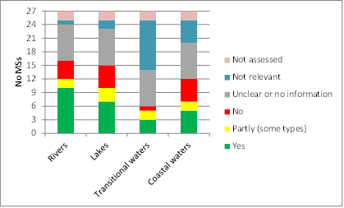

Figure 8.2.1: Testing of typology against biological data
Source:WISE

Reference conditions
The establishment of reference conditions and the establishment of ecological class boundaries (i.e. boundary between high and good) are closely interconnected. Considerations assumed and methodologies for the establishment of reference conditions are crucial for the judgement of the risk that individual water bodies will fail to reach the overall objective of good water status.
43% of the RBMPs assessed provide evidence that reference conditions have been set in rivers (for the rest there is largely no information about this point). The percentages of RBMPs for lakes, transitional and coastal waters are 35%, 32% and 40% respectively. In an additional one third of RBMPs evidence is given that reference conditions have been set for at least some types in each water category.
At the Member State level, most had set reference conditions for at least some types in rivers (22 out of the 26 relevant ones), lakes (20 out of the 25 relevant ones), transitional waters (13 out of the 16 relevant ones) and coastal waters (17 out of the 22 relevant ones). Only very few Member States had not set reference conditions.
 | Rivers | Lakes | Transitional waters | Coastal waters
AT | Yes | Yes | Not relevant | Not relevant
BE* | Yes | Yes | Yes | Partly (some types)
BG | Partly (some types) | Partly (some types) | Partly (some types) | Partly (some types)
CY | No | No | Not relevant | No
CZ | Partly (some types) | No | Not relevant | Not relevant
DE | Partly (some types) | Partly (some types) | Yes | Partly (some types)
DK | Yes | Partly (some types) | Not relevant | Partly (some types)
EE | Partly (some types) | Partly (some types) | Not relevant | Partly (some types)
EL | Not assessed
ES** | Yes | Yes | Yes | Yes
FI | Yes | Yes | Not relevant | Yes
FR | Partly (some types) | Partly (some types) | Partly (some types) | Partly (some types)
HU | Yes | Yes | Not relevant | Not relevant
IE | Yes | Yes | Yes | Yes
IT | Unclear or no info | Unclear or no info | Unclear or no info | Unclear or no info
LT | Yes | Yes | Yes | Yes
LU | Partly (some types) | Not relevant | Not relevant | Not relevant
LV | Yes | Yes | Yes | Yes
MT | Not relevant | Not relevant | Not relevant | Partly (some types)
NL | Yes | Yes | Yes | Yes
PL | Partly (some types) | Partly (some types) | Partly (some types) | Partly (some types)
PT | Not assessed
RO | Yes | Yes | Yes | Yes
SE | Partly (some types) | Partly (some types) | Yes | Yes
SI | Partly (some types) | Partly (some types) | Not relevant | No
SK | Yes | Yes | Not relevant | Not relevant
UK | Partly (some types) | Partly (some types) | Partly (some types) | Partly (some types)
Table 8.2.4: Type-specific reference conditions for each surface water type
Source: WISE
* Belgium: Flanders and Coastal Waters, ** Spain: Catalonia
Figure 8.2.2: Type specific reference conditions established for each surface water type
Source:WISE
According to the Directive, reference conditions need to be established for water body types and quality elements which in turn are represented by parameters indicative of the status of the quality elements. Furthermore, reference conditions should be established for the same quality element indicator that will be used for the classification of ecological status. The main options for establishing reference conditions are:
- Spatially based reference conditions using data from monitoring sites.
- Reference conditions based on predictive modelling.
- Temporally based reference conditions using either historical data or palaeo-reconstructions or a combination of both.
- A combination of the above approaches.
According to Annex II, 1.3.iii of the WFD, where it is not possible to use the methods here above, Member States may use expert judgement to establish the reference conditions.
The following table presents the percentage of RBMPs that have indicated the use of (a combination of) the following methods to set reference conditions:
Percentage of Member States | Rivers | Lakes | Transitional waters | Coastal waters
Spatial | 44% | 48% | 15% | 30%
Modelling | 15% | 15% | 4% | 11%
Combination of spatial and modelling | 26% | 19% | 15% | 22%
Expert judgement | 56% | 48% | 30% | 41%
Method unclear or no information | 22% | 22% | 19% | 19%
Not relevant or not designated | 3.7% | 7.4% | 41% | 19%
No report | 7.4% | 7.4% | 7.4% | 7.4%
Table 8.2.5: Types of method used to establish reference conditions in surface water categories
Source:WISE
Note that the percentages do not add up to 100% as Member States may use more than one method depending on factors such as the quality element of concern.

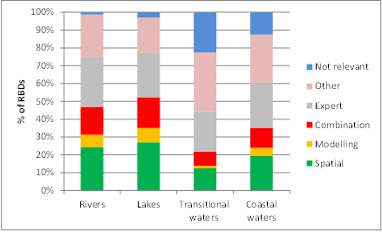
Figure 8.2.3: Types of method used to establish reference conditions in surface water categories
Source: WISE

The use of expert judgment to define reference conditions for some quality elements is particularly important in rivers and lakes. Expert judgment may be used where spatial or modelling approaches are not available or not developed and in some cases may be considered less robust than more quantitative approaches. There was no information or it was unclear what methods had been used in a significant proportion of Member States (~20%) for all water categories. Of the methods for establishing reference conditions the use of historical datasets was reported by Germany, Denmark, Romania and the UK. Historical data sets dated back to 1900 for seagrasses in Danish coastal waters and around 1800 for fish fauna in transitional waters in the UK. Palaeo-limnological methods were also used in the UK for diatoms in lakes, and Latvia indicated that scientific research data were used. BE-Flanders reported that values were adapted from those used in neighbouring countries.

Delineation of surface water bodies
The table in the following page presents the number of surface and groundwater bodies in each Member State for each water category, and the average size.
Throughout the EU, more than 127,000 surface water bodies had been defined (compared to around 70,000 reported for the initial characterisation completed in 2004). Approximately 82% are rivers, 15% lakes, and the remaining 3% coastal and transitional waters. The average size of water bodies in Member States is variable with average river water body lengths varying from 1 km in Denmark to close to the EU average (11 km) in Greece, Slovakia and the UK, and 37 km in Bulgaria. Sweden and Finland have the most lake water bodies, 7232 and 4275, respectively. The average area of water bodies increases (as might be expected) from lakes (5 km²), transitional waters (19 km²) to coastal waters (644 km²). Spain has on average delineated the largest coastal water bodies (8,700 km²).

In terms of groundwater, approximately 13,300 have been delineated in the EU with the most being reported for Finalnd (3804) and the fewest in Luxembourg (5). The average size of groundwater bodies in the EU is around 300 km² with the smallest by far on average being in Sweden (1 km²) and Finland (3 km²) (i.e. there are many small groundwater bodies in Finland and Sweden), and the largest in Lithuania (4,621 km²) and LV (5,827 km²).
 | Rivers |  |  | Lakes |  |  | Transitional |  |  | Coastal |  |  | Groundwater
Member State | Nb | Total L  (km) | Avg L  (km) | Nb | Total A  (km²) | Avg A  (km²) | Nb | Total A  (km²) | Avg A  (km²) | Nb | Total A  (km²) | Avg A  (km²) | Nb | Total A  (km²) | Avg A  (km²)
AT | 7339 | 31392 | 4 | 62 | 934 | 15 |  |  | NR |  |  | NR | 136 | 95930 | 724
BE* | 177 | 2472 | 14 | 18 | 40 | 2 | 6 | 42 | 7 | 2 | 1429 | 715 | 42 | 47038 | 1360
BG | 688 | 25568 | 37 | 43 | 75 | 2 | 15 | 109 | 7 | 13 | 1428 | 110 | 177 | 156026 | 882
CY | 216 | 2579 | 12 | 18 | 28 | 2 |  |  | NR | 27 | 865 | 33 | 20 | 6261 | 313
CZ | 1069 | 18596 | 17 | 71 | 249 | 4 |  |  | NR |  |  | NR | 173 | 88127 | 436
DE | 9072 | 126158 | 14 | 712 | 2399 | 3 | 5 | 814 | 163 | 74 | 22843 | 309 | 989 | 367743 | 445
DK | 16881 | 12047 | 1 | 940 | 462 | 0.5 |  |  | NR | 162 | 40875 | 252 | 385
EE | 645 | 12106 | 19 | 89 | 1966 | 22 |  |  | NR | 16 | 14501 | 906 | 26 | 120915 | 890
EL | 1033 | 11480 | 11 | 29 | 889 | 31 | 29 | 1129 | 39 | 233 | 38390 | 165 | 236 | 54785 | 106
ES | 4298 | 74834 | 17 | 327 | 5281 | 16 | 201 | 2848 | 14 | 186 | 1612156 | 8668 | 626 | 16301 | 0
FI | 1602 | 28875 | 18 | 4275 | 28172 | 7 |  |  | NR | 276 | 32570 | 118 | 3804 | 9862 | 3
FR | 10824 | 241684 | 22 | 439 | 1964 | 4 | 96 | 2840 | 30 | 164 | 26652 | 163 | 574 | 1092891 | 1307
HU | 869 | 18802 | 22 | 213 | 1267 | 6 |  |  | NR |  |  | NR | 185 | 279532 | 1511
IE | 4565 | 21037 | 5 | 807 | 2628 | 3 | 190 | 1068 | 6 | 111 | 13183 | 119 | 756 | 71081 | 105
IT | 7644 | 78813 | 10 | 300 | 2158 | 7 | 181 | 1235 | 7 | 489 | 18930 | 39 | 733 | 201492 | 311
LT | 832 | 14251 | 17 | 345 | 809 | 2 | 4 | 515 | 129 | 2 | 115 | 57 | 20 | 72546 | 4621
LU | 102 |  |  |  |  | NR |  |  | NR |  |  | NR | 5 | 2676 | 535
LV | 204 | 7751 | 38 | 259 | 825 | 3 | 1 | 934 | 934 | 6 | 1283 | 214 | 22 | 117404 | 5827
MT |  |  | NR |  |  | NR |  |  | NR | 9 | 398 | 44 | 15 | 355 | 24
NL | 254 | 4756 | 19 | 450 | 3046 | 7 | 5 | 684 | 137 | 15 | 11889 | 793 | 23 | 39929 | 1156
PL | 4586 | 111483 | 24 | 1038 | 2293 | 2 | 9 | 1936 | 215 | 10 | 666 | 67 | 161 | 312172 | 192
PT | 1611 | 55725 | 35 | 122 | 742 | 6 | 53 | 813 | 15 | 57 | 15690 | 275 | 145 | 44498 | 307
RO | 3262 | 74473 | 23 | 131 | 993 | 8 | 2 | 781 | 391 | 4 | 572 | 143 | 142 | 263754 | 1857
SE | 15563 | 79466 | 5 | 7232 | 29192 | 4 | 21 | 180 | 9 | 602 | 34623 | 58 | 3021 | 39880 | 1
SI | 135 | 2620 | 19 | 14 | 38 | 3 |  |  | NR | 6 | 404 | 67 | 21
SK | 1760 | 18944 | 11 |  |  | NR |  |  | NR |  |  | NR | 101 | 77326 | 598
UK | 9080 | 99749 | 11 | 1119 | 1933 | 2 | 192 | 3716 | 19 | 570 | 63399 | 111 | 723 | 210094 | 950
EU | 104311 | 1175661 | 11 | 19053 | 88383 | 5 | 1010 | 19643 | 19 | 3033 | 1952862 | 644 | 13261 | 3788618 | 286
Table 8.2.6: Number and average size of surface and groundwater bodies in each Member State.(Updated 26 June)
NR means "not relevant" or "not reported"
Nb = number of water bodies
L = length of water body
A = area of water body
Source: WISE

* Belgium: Flanders and Coastal Waters
The average size of water bodies per country hide important differences between RBDs or regions within some of the countries (see country specific parts of the Commission Staff Working Document).
Generally Member States have included information on size thresholds that they have used to delineate river and lake water bodies. A large majority have used the size thresholds in typology System A of WFD Annex II (catchments larger than 10 km² and lakes larger than 50 Ha). Some Member States have explicitly included smaller water bodies if they are protected under other legislation or if they are ecologically important in the basin. In a few cases size thresholds have been set for transitional waters. The following table presents the criteria used to deal with small water bodies for rivers and lakes:
Member State | Rivers | Lakes
AT | Catchment > 10 km2 | Area > 50 Ha
BE | Catchment > 50 km2 | Area > 50 Ha
BG | Catchment > 10 km2 (Eastern Aegean). Not reported in other RBDs. | Area > 50 Ha (Eastern and West Aegean). Not reported in other RBDs.
CY | Catchment > 10 km2 | Area > 50 Ha but also smaller if significant ecological value
CZ | Tributaries with order less than 4 (Strahler) | Area > 50 Ha
DE | Generally catchment > 10 km2; some Lander include smaller water bodies | Generally area > 50 Ha; some Lander include smaller water bodies
DK | Catchment > 10 km2, but also smaller if protected under other environmental legislation | Area > 5 Ha, but also smaller if protected under other environmental legislation
EE | Catchment > 10 km2 | Area > 50 Ha
EL | No information | No information
ES | No information | No information
FI | Length > 30 km, catchment area >200 km2; catchment from 10 km2 to 200 km2 in case of Natura 2000 surface waters, water abstraction over 10 m3/d or serving more than 50 persons, designated bathing waters or waters important for fishing purposes. | Surface area > 500 Ha, catchment over 5 km2; surface area from 50 Ha to 500 Ha, in case of Natura 2000 surface waters, water abstraction over 10 m3/d or serving more than 50 persons, designated bathing waters, waters important for fishing purposes.. In Aland 50 Ha + smaller if used for or potential for drinking water.
FR | Catchment > 10 km2 | Area > 50 Ha
HU | Catchment > 10 km2 | Area > 50 Ha
IE | Catchment > 10 km2 | Area > 50 Ha, smaller included if protected
IT | Variable depending on the region, generally based on 10 km2 catchment area and/or river length of 3 to 10 km; in some cases smaller water bodies are included if protected | Generally 20 Ha for lakes; 50 Ha for reservoirs but no information found in a number of RBMPs
LT | Catchment > 10 km2 | Area > 50 Ha
LU | Catchment > 10 km2 | Not relevant
LV | Catchment > 100 km2 | Area > 50 Ha
MT | No information | No information
NL | Catchment > 10 km2 | Area > 50 Ha
PL | Catchment > 10 km2 | No information found
PT | No information | No information
RO | Catchment > 10 km2 | Area > 50 Ha
SE | Depending on the RBMP, catchment > 10 km2 or 15 km river length; smaller water bodies added if need protection | Area > 100 Ha
SI | Catchment > 100 km2 | Area > 50 Ha
SK | Catchment > 10 km2 | Area > 50 Ha
UK | Catchment > 10 km2 | Area > 50 Ha (10 Ha in Northern Ireland)
Table 8.2.7: Minimum size criteria used by Member States to delineate river and lake water bodies (Updated 26 June)
Source: WISE

Groundwater body characterisation
Details of the delineation of groundwater bodies can be seen in Table 8.2.6 above. The total number of groundwater bodies reported is 13,261. More than half of these groundwater bodies have been reported by Sweden and Finland (3,021 and 3,804 respectively) and are very small in size (on average 7 km²) when compared to the groundwater bodies of the remaining Member States (average size 600 km²). The total area of reported groundwater bodies is about 3.8 million km².
The groundwater characterisation was based on a technical report from 2004 prepared under the CIS by the Working Group on Groundwater. It contains many examples of how Member States carried out the characterisation.
Following the assessment of the RBMPs it has become apparent that Member States have delineated and reported their groundwater bodies in different ways (different three-dimensional layers, different groundwater body sizes). Therefore, it has not been possible to compile a European GIS reference dataset of groundwater bodies.

Identification of significant pressures and impacts
In the case of surface waters, the WFD requires identification of significant pressures from point sources of pollution, diffuse sources of pollution, modifications of flow regimes through abstractions or regulation and morphological alterations, as well as any other pressures. ‘Significant’ is interpreted as meaning that the pressure contributes to an impact that may result in the failing of environmental objectives.
The identification of significant pressures can involve different approaches: numerical tools (e.g. modelling); expert judgement or a combination of both tools. The magnitude of the pressure is compared with a threshold or criteria, relevant to the water body type to assess its significance. The figure shows the types of tools reported to be used to assess the significance of the main types of pressures.

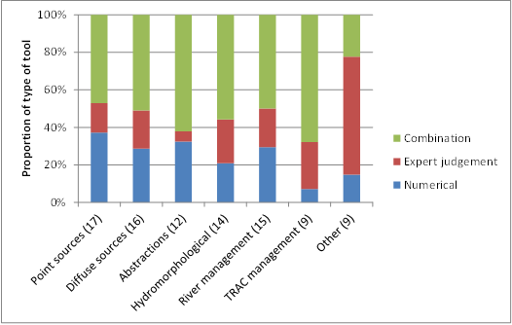

Figure 8.2.4: Type of tools used by MS to identify different types of significant pressures
Source: WISE
Note: Figures in brackets are the number of MSs that had reported methods

For most pressure types, most Member States use a combination of numerical tools and expert judgement. Expert judgement is more extensively used to assess other pressures: the most commonly reported other pressures were recreation, fishing and introduced species.
The EEA is preparing a report on ecological and chemical status and pressures which provides a wide overview of the identification of significant pressures and impacts. The report gathers and describes the information provided in the RBMPs reporting from MS. As mentioned in the report:
- The pressures reported to affect most surface water bodies are pollution from diffuse sources causing nutrient enrichment, and hydromorphological pressures causing altered habitats.
- The worst areas of Europe concerning ecological status and pressures in freshwater are in Central Europe, in particular in Northern Germany, the Netherlands and Belgium, while for coastal and transitional waters the Baltic sea and Greater North Sea regions are the worst affected.
- The hydromorphological pressures in rivers and lakes are reported to be most severe in RBDs in the Netherlands, Germany, Poland, Hungary and south-east England, and least severe in RBDs in Finland, the Baltic countries, Romania, as well as in many RBDs in Spain, Portugal, Italy, Greece, Bulgaria and Cyprus. In coastal and transitional waters, hydromorphological pressure is considerably less than in freshwater bodies and is mainly a problem along the Greater North Sea coast of Germany, the Netherlands and Belgium, as well as the in the southern coast of Italy.
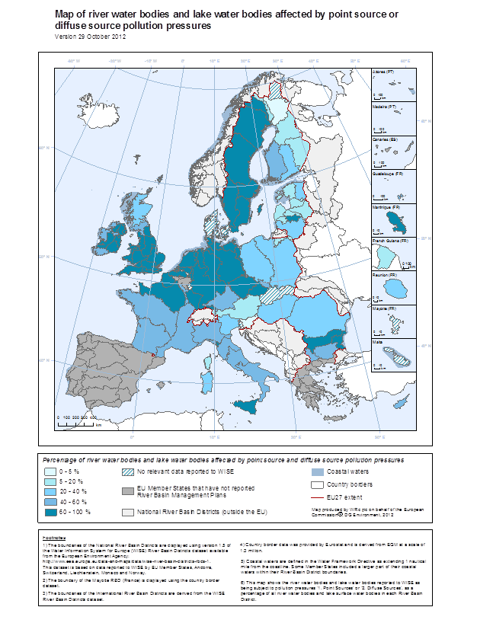
Figure 8.2.6: Proportion of classified water bodies in different River Basin Districts affected by pollution pressures for rivers and lakes
Source: WISE Note: Better quality maps are available on: http://ec.europa.eu/environment/water/water-framework/facts_figures/index_en.htm
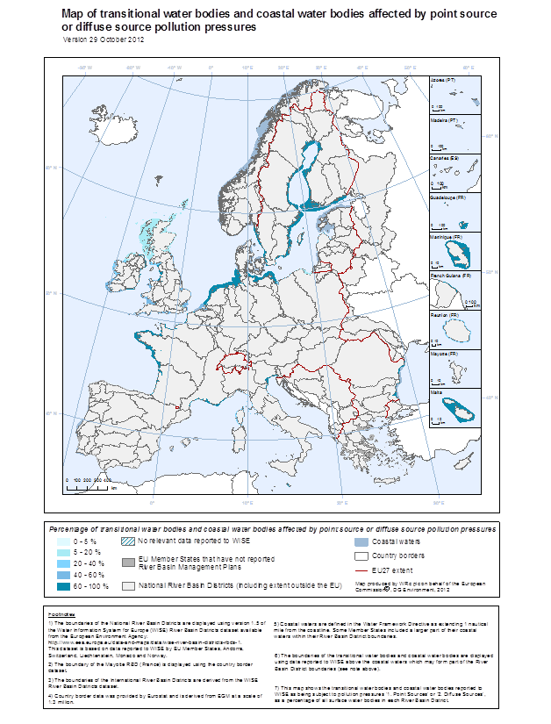
Figure 8.2.7: Proportion of classified water bodies in different River Basin Districts affected by pollution pressures for coastal and transitional waters
Source: WISE Note: Better quality maps are available on: http://ec.europa.eu/environment/water/water-framework/facts_figures/index_en.htm
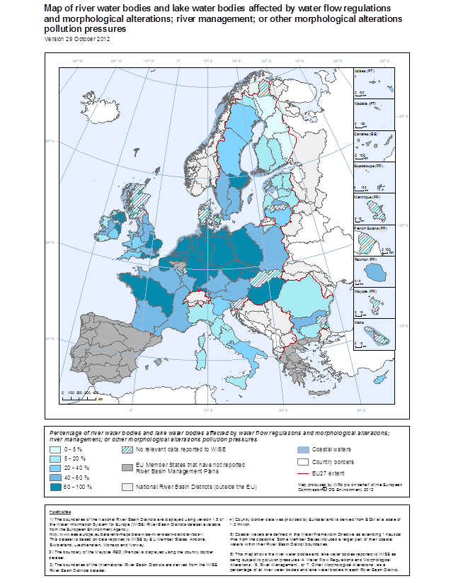
Figure 8.2.8: Proportion of classified water bodies in different River Basin Districts affected by hydromorphological pressures for rivers and lakes
Source: WISE Note: Better quality maps are available on: http://ec.europa.eu/environment/water/water-framework/facts_figures/index_en.htm
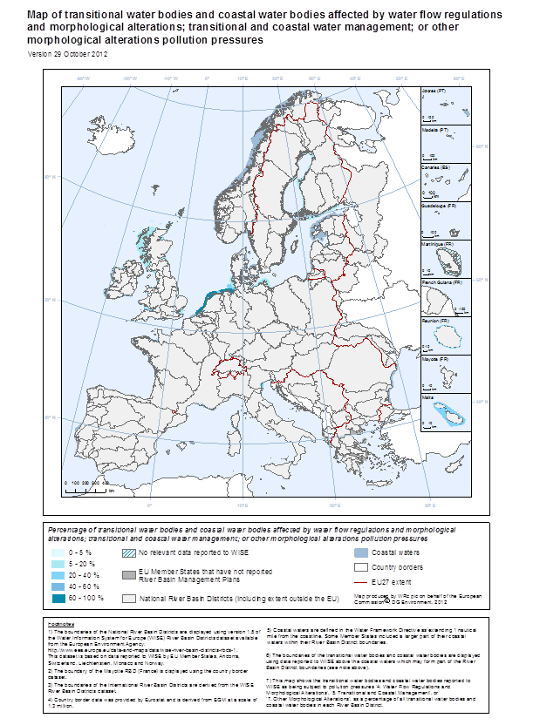
Figure 8.2.9: Proportion of classified water bodies in different River Basin Districts affected by hydromorphological pressures for coastal and transitional waters
Source: WISE Note: Better quality maps are available on: http://ec.europa.eu/environment/water/water-framework/facts_figures/index_en.htm

Protected areas
Article 6 of the WFD requires Member States to establish a register or registers of all areas lying within each RBD which have been designated as requiring special protection under specific Community legislation for the protection of their surface water and groundwater, or for the conservation of habitats and species directly depending on water. RBMPs should identify and map protected areas (Annex VII WFD). The following table presents the WFD protected areas reported by Member States.
WFD requires that objectives for protected areas established under Community legislation should also be met. For example, if a water body falls within a Nitrate Vulnerable Zone then the objectives of the Nitrates Directive (1991/676/EEC) must be met.
Article 7 of the WFD requires Member States to establish drinking water protected areas for bodies of groundwater and surface water providing more than 10m³ a day as an average or serving more than 50 persons, or bodies that are intended for that use in the future. The objective for these areas is to avoid deterioration in quality in order to reduce the level of purification treatment required.
Drinking water safeguard zones are commonly established in Europe. 25 Member States reported that such zones are already established or planned to be established for groundwater and 19 Member States reported for surface water. Ireland, Luxembourg, Sweden, UK (Wales) reported about efforts to start to implement respectively to further extend the establishment of safeguard zones. For Greece and Portugal information was not available.
For 16 and 13 Member States respectively the establishment of groundwater / surface water safeguard zones were reported to be in principle mandatory for each public drinking water abstraction (Ireland, Luxembourg and Slovenia reported that the establishment of such zones is currently not mandatory but will be in the near future). Four Member States foresee exemptions from this obligation for small abstractions (≤10,000m³/a (Czech Republic), ≤ 10 households (Denmark), 10m³/d or 50 people (Estonia and Slovak Republic)) or for confined aquifers (Belgium). Five Member States reported that the establishment is not mandatory but, nevertheless, safeguard zones are established.
However, for some protected areas, notably those designated as Natura 2000 sites under the Habitats Directive, the requirement is to meet the water-related biological criteria of a particular habitat according to the agreed protection programme of the area.
Existing Community legislation designating protected areas is summarised in the following table:
Directive | Reason for protection of waters
2000/60/EC (Water Framework Directive) | Drinking water protected areas
76/160/EEC (Bathing water Directive) | Bathing waters
78/659/EEC (Freshwater fish Directive) | Fresh waters needing protection in order to support fish life.
79/923/EEC (Shellfish waters Directive) | Shellfish waters
79/409/EEC (Birds Directive) | To protect birdlife
92/43/EEC (Habitats Directive) | Natural habitats of wild fauna and flora
91/271/EEC (Urban Waste Water Treatment Directive) | Nutrient sensitive areas
91/676/EEC (Nitrates Directive) | Prevent nitrate pollution

All Member States reported Drinking Water Protected Areas in their RBMPs. Most also reported protected areas under the Habitats (25 Member States), Birds (23), Bathing Waters (23) and Nitrates (22) Directives.
The following table presents the WFD protected areas reported by Member States.
Member State | Drinking Water | Bathing | Birds | European Other | Fish | Habitats | Local | National | Nitrates | Shellfish | UWWT
AT | 231 | 268 | 54 |  | 71 | 93
BE | 168 | 2 | 17 |  |  | 27 |  | 1 | 2 | 1 | 2
BG | 331 | 93 | 111 |  | 106 | 231 |  | 103 | 4 | 8 | 22
CY | 18 | 113 |  |  |  | 36 |  |  | 5 |  | 2
CZ | 2673 | 188 | 15 |  |  | 439 |  | 746 | 6040
DE | 1418 | 2271 | 1022 | 295 |  | 4878 |  |  | 139
DK | 368 |  | 113 |  |  | 257 |  |  |  | 36
EE | 2 | 89 | 73 |  | 111 | 542 |  |  | 2
EL | 150 | 2108 | 181 |  |  | 273 |  |  | 11 |  | 48
ES | 25857 | 1515 | 519 | 134 | 156 | 1125 | 1025 | 1302 | 366 | 201 | 440
FI | 2302
FR | 28.978 | 3.342 | 314 | 42 |  | 771 |  |  | 8 | 83 | 64
HU | 1756 | 265 | 55 |  | 7 | 467 |  | 210 | 1 |  | 3
IE | 943 | 126 | 136 |  | 31 | 420 |  |  | 7 | 63 | 42
IT | 6023 | 1645 | 474 | 8 | 566 | 1725 | 718 | 43 | 92 | 141 | 213
LT | 1305 | 99 | 88 | 31 |  | 427 | 185 | 1005 | 4 |  | 4
LU | 84 | 4 | 13 |  |  | 30 |  |  | 2 |  | 2
LV | 2 | 222 |  |  | 196 | 308 |  |  | 56
MT | 7 |  | 3 |  |  | 9 |  | 1 | 1 |  | 8
NL | 31 | 644 | 90 |  |  | 159 |  |  |  | 9
PL | 357 | 320 | 141 |  |  | 364 |  |  | 19
PT | 526 | 462 | 60 |  | 81 | 92 | 78 |  | 17 | 34 | 12
RO | 1879 | 35 | 106 |  | 12 | 213 |  | 381 | 42 | 4
SE | 1099 | 469 | 391 |  | 28 | 1286 |  |  | 7 | 32 | 31
SI | 1265 |  |  |  | 14
SK | 213 | 36 | 38 |  | 73 | 381 |  |  | 1524 |  | 1
UK | 1569 | 522 | 100 | 153 | 6650 | 302 |  |  | 574 | 135 | 17
EU | 79555 | 14838 | 4114 | 663 | 8102 | 14855 | 2006 | 3792 | 8923 | 747 | 911
Table 8.2.8: Number of different types of Protected Areas in each Member State
Source:WISE

Conclusions
- Six Member States with a coastline have not designated transitional waters and 2 have designated no (natural) lakes.
- Many different types of rivers, lakes, transitional and coastal waters have been identified by Member States. There seems to be a difference between the numbers of types identified and the number used in the classification of status. This may indicate that some of the types originally identified for the Article 5 analysis have not been practically implemented when the ecological classification of water types has been undertaken.
- Typologies used in all water categories appear to have not been tested against biological data for all identified types, and in some cases, no types at all for a significant number of Member States. Testing against biological data has been undertaken by 10 Member States for rivers, 7 for lakes, 3 for transitional waters and 5 for coastal waters.
- It is also clear that reference conditions have not been established for all water body types in a number of Member States for all water categories. This is most prominent in coastal waters where only 8 of the 22 Member States with coastal waters had established reference conditions for all their coastal water types.
- Expert judgment is used by many Member States in establishing reference conditions. Spatially based tools are also widely used particular for lakes and rivers but less so in transitional waters perhaps reflecting that is often difficult to find water bodies in transitional waters that are minimally impacted by human activities that can provide a suitable spatial reference condition.
- There has been an increase in the number of water bodies delineated since the initial characterisation in 2004. Most are rivers (82%) followed by lakes (15%) and transitional and coastal waters (3% combined). There are large differences between Member States in the numbers delineated which does not necessarily reflect the respective land area but perhaps indicates some differences in approach. Many Member States have used the minimum water body size criteria suggested by the WFD for rivers and lakes but there are examples of where larger size minima have been used and others where smaller water bodies have been delineated, for example, where the water body is also a protected area under other EU legislation.
- The identification of significant pressures by Member States involves different approaches such as those involving the use of numerical tools (e.g. modelling), expert judgment or a combination of both. For most pressure types, most Member States use a combination of numerical tools and expert judgement. Expert judgement is more extensively used to assess ‘other’ pressures such as pressures from recreation, fishing and introduced species.
- Member States have delineated and reported their groundwater bodies in different ways (different three-dimensional layers, different groundwater body sizes).
- All Member States reported the designation of drinking water protected areas: there are approximately 80,000 reported for the EU. The next most numerous protected areas were for Habitats Directive and Bathing Waters (both ~15,000 protected areas). The fewest protected areas reported were for Shellfish Waters Directive (747).

Recommendations
- There are 6 Member States with coastal waters that have not designated transitional waters. There is often no reported clear explanation or technical justification for this. It is recommended that these Member States reconsider whether or not transitional waters should be identified and to provide the Commission with the relevant information supporting the inclusion or non-inclusion of such water bodies.
- Many Member States have not validated their water body typology against biological data, and in particular quantified whether or not there are significant differences in the biological quality elements between the types identified by abiotic factors alone. It is recommended that Member States consider doing such validation for the next planning cycle. This should enable the production of a more robust ecological classification and perhaps enable a rationalisation of the large number of different types identified by some Member States.
- The criteria used to define significance of pressures were often not explicit in the RBMPs or in supportive documents. It is recommended that this information is provided in future reporting so that a quantitative comparison of criteria can be made across the EU.
- Delineation and reporting of groundwater bodies should be better harmonised. Reasons for different approaches should be clarified and related guidance documents should be improved, if necessary.
- It is recommended for any future reporting that data on pressures is reported at a more disaggregated level than it has been by some Member States for this cycle. This will enable a better comparison across the EU and help to better identify the link between pressures and sectoral measures.

Monitoring of surface waters and groundwater

Introduction
Article 8.1 of the WFD requires Member States to establish monitoring programmes for the assessment of the status of surface water and of groundwater in order to provide a coherent and comprehensive overview of water status within each RBD. These requirements include monitoring of protected areas as far as the status of surface water and groundwater is concerned. Monitoring programmes were to be operational by 22 December 2006 and reported to the Commission by March 2007. The results of monitoring play a key role in determining whether water bodies are in good status and what measures need to be included in the RBMP in order to reach good status as a rule by 2015. Precise and reliable monitoring results are therefore a prerequisite for sound planning of investments in the programme of measures.
The selection of the quality elements and parameters to be monitored should enable the detection of all significant pressures on water bodies. This is particularly important where the pressures and impact assessment may not have been adequate enough to identify all potential pressures and impacts in the RBD perhaps because of lack of information or methods or because of unexpected, anthropogenic activities within the RBD.
The results of surveillance monitoring should ensure that the potential impacts of all pressures on water bodies in the RBD are detected. Incomplete coverage of quality elements and water bodies in surveillance monitoring could lead to the non-detection of significant pressures, the incorrect classification of water status and inappropriate targeting of measures. Surveillance monitoring must also be able to detect long-term natural changes and those arising from anthropogenic pressures.
The selection of biological quality elements (BQEs) for operational monitoring should focus on those most sensitive to the identified pressures and impacts on water bodies. The results of operational monitoring are used (with the results of surveillance monitoring) in the classification of water bodies and to monitor progress of implemented measures in achieving the objectives of the Directive.
The results of monitoring are used in the assessment and classification of the status of water bodies (ecological and chemical for surface waters, chemical and quantitative for groundwater). The amount of monitoring undertaken in terms of quality elements, parameters, frequency and numbers of sites should be sufficient to obtain a reliable and robust assessment of the status of all water bodies in the RBD. Insufficient monitoring leads to a low confidence in the classification of water bodies, and as a result the (expensive) measures required to achieve objectives may be incorrectly targeted, and objectives such as restoration of water bodies to good status may not be achieved.
Directive 2009/90 lays down technical specifications for chemical analysis and monitoring of water status with the aim of improving the quality and comparability of monitoring results by establishing minimum performance criteria for methods of analysis to be applied by Member States when monitoring water status, sediment and biota, as well as rules for demonstrating the quality of analytical results.
The Commission published a report on Member States programmes for monitoring of water status in April 2009 (SEC(2009)156) accompanied by a Commission staff working document (SEC(2007)415) with an Annex on the monitoring undertaken by each Member State. Member States were given the opportunity to update the information on their monitoring programmes when reporting information on the first RBMPs in March 2010. A map of the monitoring networks established for the purposes of Article 8 and Annex V was also required to be reported in the RBMP (Annex VII WFD).

Overview of monitoring of monitoring networks in the European Union
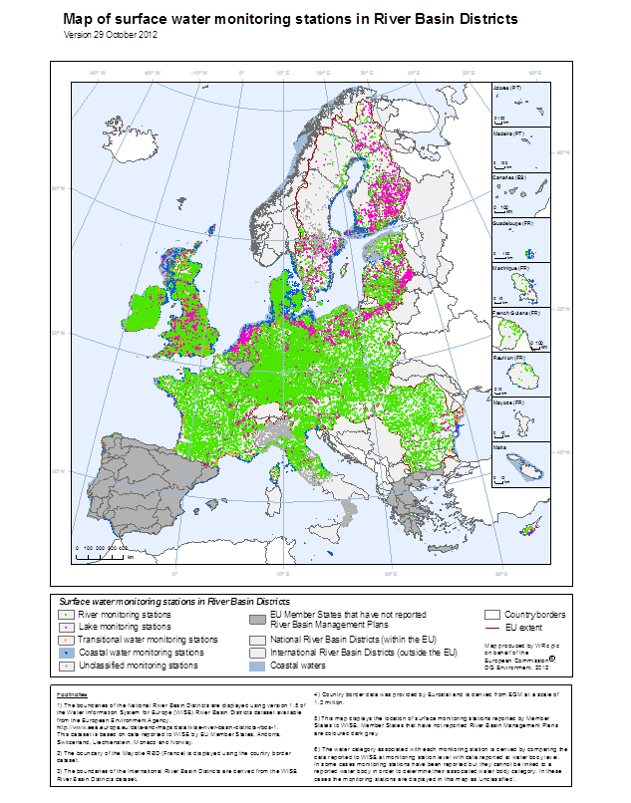
Figure 8.3.1:Surface water monitoring stations in River Basin Districts
Source: WISE
Note: Better quality maps are available on: http://ec.europa.eu/environment/water/water-framework/facts_figures/index_en.htm
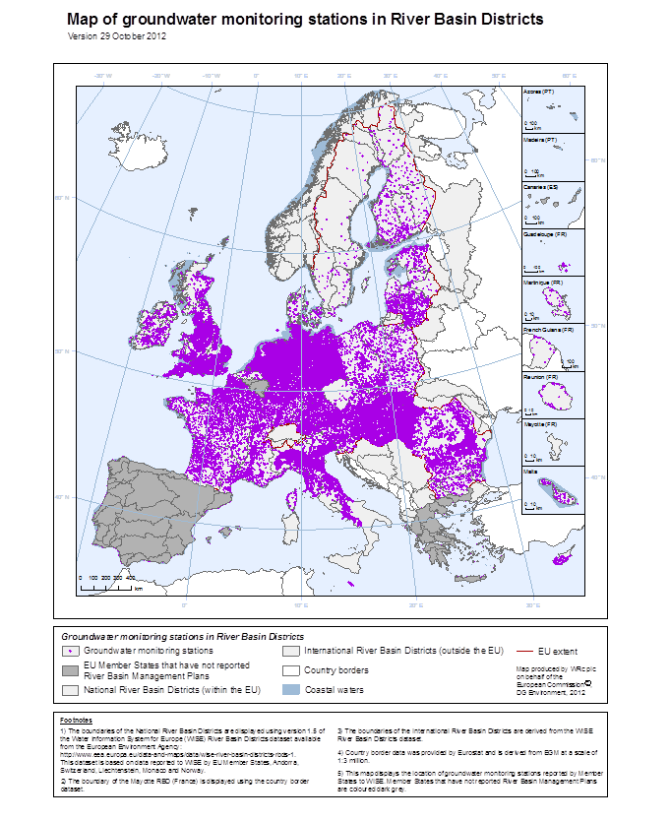
Figure 8.3.2: Groundwater monitoring stations in River Basin Districts
Source: WISE Note: Better quality maps are available on: http://ec.europa.eu/environment/water/water-framework/facts_figures/index_en.htm
The Table below presents the number of monitoring stations reported by Member States, and shows that there are more than 82,000 WFD monitoring stations for surface water and approximately 60,000 for groundwater. The numbers vary considerably between Member States in part because of differences in natural characteristics, population densities, types of water use and exerted pressures. Different concepts applied to the design of the monitoring programmes also play a part and may influence those numbers.
 | Rivers |  | Lakes |  | Transitional waters |  | Coastal waters |  | Groundwater
MS | Surv | Op | Surv | Op | Surv | Op | Surv | Op | Surv | Op | quant
AT | 91 | 597 | 33 | 2 | nr | nr | nr | nr | 2008 | 234 | 3383
BE | 71 | 423 | 11 | 51 | 6 | 13 | 4 | 5 | 42 | 42 | 42
BG | 146 | 218 | 62 | 22 | ni | ni | 7 | 3 | 241 | 121 | 366
CY | 19 | 12 | 10 | 1 | nd | nd | 7 | 1 | 86 | 68 | 84
CZ | 111 | 835 | 27 | 76 | nr | nr | nr | nr | 167 | 167 | 268
DE | 287 | 8348 | 67 | 449 | 5 | 20 | 32 | 100 | 5472 | 3868 | 8963
DK | 776 | 2475 | 0 | 351 | nd | nd | 243 | 434 | 636 | 636 | 636
EE | 189 | 83 | 109 | 28 | nd | nd | 55 | 0 | 154 | 25 | 265
EL | 298 | 134 | 30 | 21 | 2 | 34 | 51 | 30 | 236 | 288 | 524
ES | 2525 | 1393 | 159 | 70 | 238 | 100 | 564 | 132 | 2774 | 2327 | 2509
FI | 273 | 220 | 607 | 288 | nd | nd | 57 | 82 | 206 | 203 | 211
FR | 1673 | 4267 | 199 | 217 | 63 | 72 | 109 | 65 | 1775 | 1446 | 1674
HU | 122 | 474 | 26 | 41 | nr | nr | nr | nr | 2014 | 427 | 1802
IE | 179 | 2516 | 74 | 217 | 26 | 55 | 12 | 24 | 274 | 112 | 186
IT | 1180 | 1276 | 70 | 89 | 4 | 135 | 53 | 263 | ni | ni | ni
LT | 128 | 309 | 188 | 101 | 0 | 25 | 0 | 6 | 240 | 2502 | 76
LU | 8 | 131 | nd | nd | nr | nr | nr | nr | 54 | 54 | 31
LV | 38 | 182 | 32 | 223 | 10 | 2 | 14 | 4 | 79 | 0 | 56
MT | nd | nd | nd | nd | nd | nd | 5 | 6 | 34 | 34 | 21
NL | 81 | 339 | 95 | 454 | 14 | 20 | 26 | 18 | 1164 | 213 | 1045
PL | 521 | 2105 | 586 | 692 | ni | ni | ni | ni | 789 | 369 | 828
PT | 324 | 321 | 56 | 63 | 42 | 5 | 54 | 4 | 575 | 215 | 420
RO | 1263 | 547 | 434 | 228 | 12 | 12 | 42 | 42 | 2365 | 1224 | 3338
SE | 234 | 769 | 338 | 653 | 2 | 1 | 112 | 132 | 115 | 0 | 0
SI | 48 | 200 | 4 | 15 | nd | nd | 4 | 5 | 104 | 29 | 115
SK | 560 | 594 | 23 | 7 | nr | nr | nr | nr | 130 | 1106 | 1507
UK | 5584 | 29702 | 174 | 1081 | 1971 | 2137 | 1133 | 1481 | 4080 | 4006 | 1289
Total | 16214 | 56381 | 2829 | 4750 | 2395 | 2631 | 2585 | 2838 | 25814 | 19716 | 29639
Total | 67178 |  | 7528 |  | 4528 |  | 3156 |  | 34134 |  | 29639
 | Total surface water: 82390 |  |  |  |  |  |  |  | Total groundwater: 60054
Table 8.3.1: Number of monitoring stations in surface waters and groundwater in EU27 (surv = surveillance monitoring, op = operational monitoring, quant = quantitative.
Source: WISE
nr= water category not relevant (land-locked Member State)
nd = water category not designated by Member State
ni = no information reported by Member States

The 2009 report (based mainly on 2007 data) indicated that there were around 57,000 monitoring stations established for WFD monitoring of surface waters and approximately 51,000 for groundwater. This assessment of the RBMPs (based mainly on 2010 data) shows an increase of monitoring stations with around 39% more in surface waters stations and 17% more for groundwater. As in 2009, by far the largest number of monitoring stations in surface waters was in rivers, followed by coastal waters and lakes and with the fewest stations in transitional waters. The Member States with the greatest number of surface water sites were UK (35,221 cf 12,807 in 2007), Germany (9,228 cf 6,688 in 2007) and France (5,507 cf 3,367 in 2007).
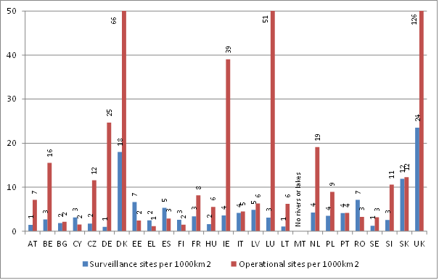
Figure 8.3.3: Number of surveillance and operational monitoring sites for rivers and lakes per 1000 km2 area (some sites may be for both surveillance and operational monitoring)
Source: WISE

Member States are required to monitor for quality elements and parameters indicative of ecological (surface waters only), chemical (surface and ground waters) and quantitative (groundwater only) status, and for surface waters should include biological, hydromorphological and chemical and physico-chemical quality elements. Before the introduction of the WFD and the assessment of ecological status in a regulatory framework, the focus of monitoring was on chemical and physico-chemical quality elements in many Member States. Table 8.3.2 below shows the number of monitoring sites in surface waters for each of the main quality element groupings, and indicates that at the EU level there are now more stations monitoring the biological quality of surface waters than either physicochemical quality or hydromorphological elements.
MS | Biological QEs | Hydro-morphological QEs | Physico-chemical QEs | Priority Substances | Non priority specific pollutants | Other national pollutants
AT | 668 | 567 | 223 | 186 | 186
BE | 455 | 201 | 268 | 116 | 131
BG | 310 | 204 | 448 | 394 | 359 | 61
CY | 49 | 49 | 49 | 22 | 19 | 16
CZ | 821 | 230 | 949 | 577 | 945 | 941
DE | 8071 | 2571 | 4704 | 1896 | 2573 | 1367
DK | Calculation not possible
EE | 13 | 13 | 13
EL | 585 | 585 | 556 | 131 | 131 | 13
ES | 3963 | 3238 | 4308 | 2715 | 2801 | 2032
FI | 1195 | 174 | 1229 | 24 | 23 | 18
FR | 3734 | 4052 | 3821 | 3612 | 3184 | 2591
HU | Calculation not possible
IE | Calculation not possible
IT | 1371 | 615 | 1094 | 574 | 500 | 73
LT | Calculation not possible
LU | 133 | 114 | 140 | 7 | 118 | 20
LV | Calculation not possible
MT | 8 | 8 |  | 3
NL | 734 | 384 | 686 | 345 | 507
PL | Calculation not possible
PT | 841 | 593 | 841 | 312 | 201
RO | 1356 | 1378 | 1275 | 831 | 1014 | 1013
SE | 1382 | 64 | 1503 | 314 | 246
SI | 151 | 94 | 154 | 72 | 139
SK | Calculation not possible
UK | 16422 | 8180 | 10061 | 1505 | 6373
EU | 42262 | 23314 | 32322 | 13636 | 19450 | 8145
Table 8.3.2: Number of monitoring stations (not differentiated between surveillance or operational) in surface waters used for monitoring the different types of quality elements.
Source: WISE

Surface water surveillance monitoring
Member States are required to establish surveillance monitoring programmes to provide information for: supplementing and validating the impact assessment procedure detailed in Annex II; the efficient and effective design of future monitoring programmes; the assessment of long-term changes in natural conditions; and, the assessment of long-term changes resulting from widespread anthropogenic activity.
The assessed RBMPs were not clear in approximately a third of Member States, whether or not all the objectives had been taken into account in the design of surveillance monitoring. In particular it was not clear how the long term changes from widespread anthropogenic activity (7 Member States) and in natural conditions (3 Member States) would be monitored.
Annex V.1.3.1 of the WFD indicates that ‘surveillance monitoring shall be carried out of sufficient surface water bodies to provide an assessment of the overall surface water status within each catchment or sub-catchments within the river basin district’. To that end it might be expected that surveillance monitoring includes water bodies covering the range of statuses within the RBD and Member State. It is not expected that all water bodies will be included in surveillance monitoring. Representative stations should be selected to provide an overall picture of the status of water bodies in the basin.
Figure 8.3.4 shows the percentage of surface water bodies included in surveillance monitoring compared to the total number of water bodies. There is a wide variation in the percentages of surface water bodies included by Member States and this might be explained by the different approaches used in delineating surface water bodies in Member States, i.e. Member States with larger water bodies can easily reach higher percentages. For example, Sweden includes 2% of its surface water bodies in surveillance monitoring, and France 16 % (compared to the EU average of 11%). The average length of Sweden’s 15,563 river water bodies is 5 km and that of France’s 10,824 river water bodies is 22 km.
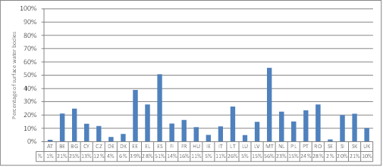
Figure 8.3.4: Percentage of surface water bodies included in surveillance monitoring compared to total number of surface water bodies
Source: WISE

Figure 8.3.5 shows the number of river water bodies included in surveillance monitoring compared to a benchmark. The benchmark is derived from the criteria given in section 1.3.1 of Annex V of the Directive where the selection of monitoring points should include, where appropriate, points on large rivers where the catchment is greater than 2500 km² and gives an average value of how many surveillance monitoring points would be necessary if only this criterion were to be applied. The relevance of the benchmark depends on the hydrography of each country and should be interpreted liberally, meaning that lower numbers do not necessarily represent a poorly designed network. Some Member States such as Denmark, Spain, Poland, Romania and the UK show significantly higher numbers than the benchmark. The very low number for Sweden is influenced by the large unpopulated areas in the North.
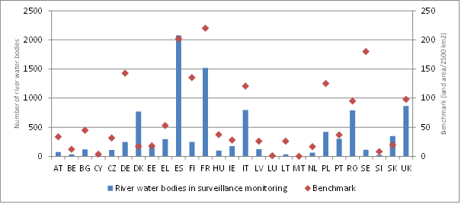

Figure 8.3.5: Number of river water bodies included in surveillance monitoring. The diamonds indicate a benchmark calculated by dividing the area of each Member State by 2500 km2 (criterion given by Annex V, 1.3.1)
Source: WISE

Surveillance monitoring requires that parameters indicative of all BQEs, all hydromorphological quality elements, all general physicochemical quality elements, those priority list pollutants which are discharged into the river basin or sub-basin and those other pollutants discharged in significant quantities in the river basin or sub-basin are monitored in water bodies included in surveillance monitoring. However, the required quality elements will not necessarily be monitored at the same location within the water body as, for example, different habitats will be sampled for different BQEs.
At the time of the introduction of the WFD, monitoring and assessment methods for many quality elements (QEs), such as some biological and morphological QEs, were not developed or were not suitable to meet the requirements of the WFD, in assessing and classifying ecological status of water bodies. Figure 8.3.6 shows that only a few Member States (e.g. Bulgaria and the Czech Republic) monitor for all the relevant BQEs in all of the surface water bodies included in surveillance monitoring. This may be because some Member States have not yet fully developed monitoring methods for some of the QEs and/or water body types. For example, in Slovenia and UK fish are not monitored in lakes and in Sweden benthic invertebrates and fish are the predominant BQEs monitored in lakes; in Italy the predominant biological quality elements monitored in rivers are benthic invertebrates and phytobenthos.
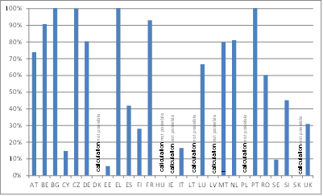
Figure 8.3.6: Percentage of surface water bodies in surveillance monitoring in which all relevant biological quality elements are monitored. In the case of DK, HU, IE, LT, LV, PL and SK it was not possible to extract the information because the data were not supplied at the station level
Source: WISE

Figure 8.3.7 illustrates the use of the different groups of QEs (biological, hydromorphological and chemical and physicochemical) by Member States in the four surface water categories (rivers, lakes, transitional and coastal waters) for surveillance monitoring. For BQEs in rivers, most Member States use macroinvertebrates, in lakes phytoplankton, and in transitional and coastal waters macroinvertebrates. The choice of these elements reflects the traditional use of these indicators in the respective water categories. Surveillance monitoring requires the monitoring of all hydromorphological QEs but data show (Figure 8.3.7 below) that many Member States do not comply with this requirement particularly in terms of the morphological conditions of lakes, transitional and coastal waters. In contrast general physicochemical QEs and non-priority specific pollutants are monitored by most Member States in all water categories.
Figure 8.3.7 indicates that some Member States reported only QE information at an aggregated level for other aquatic flora, hydrological/tidal regime, morphological conditions and general physicochemical parameters. In these cases an estimate of overall monitoring of each component disaggregated element (e.g. nutrient conditions) can be obtained by adding the percentage of Member States reporting aggregated values to that for the disaggregated value. For example, 63% of the Member States reported nutrient conditions and 33% general physicochemical parameters equating to a possible maximum of 96% of Member States monitoring for nutrient status in rivers.

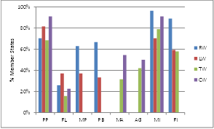 | 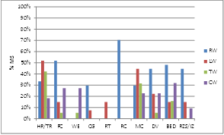
Biological Quality Elements  PP: Phytoplankton  FL: Other aquatic flora  MA: Macroalgae  AG: Angiosperms  MP: Macrophytes  PB: Phytobenthos  MI: Macroinvertebrates  FI: Fish  Note: FL only includes those MS that did not report the component elements of other aquatic flora. | Hydromorphological Quality Elements  HR/TR: Hydrological/Tidal regime - reported only at aggregated level  FC: water flow in transitional waters, lakes and rivers, and currents in coastal waters  WE: Wave exposure in transitional and coastal waters  CG: Connection to groundwater in rivers and lakes  RT: Retention time in lakes  RC: River continuity  MC: Morphological conditions - reported only at aggregated level  DV: Depth variation  BED: Substrate, structure of bed  RSZ/IZ: Structure of shore/riparian zone in lakes and rivers, and intertidal zone in transitional and coastal waters
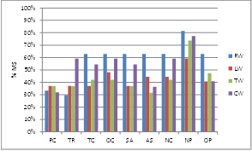 | Chemical and physicochemical Quality Elements  PC: General Physicochemical QEs  TR: Transparency  TC: Thermal conditions  OC: Oxygenation conditions  SA: Salinity  AS: Acidification status  NC: Nutrient conditions  NP: Non-priority specific synthetic and non-synthetic pollutants  OP: Other (national) pollutants  Note: PC only includes those MS that did not report the component elements e.g. nutrient conditions (NC).
Figure 8.3.7: Use of different groups of quality elements in the surveillance monitoring of rivers (RW), lakes (LW), transitional waters (TW) and coastal waters (CW)
Source: WISE

Surface water operational monitoring
Operational monitoring focuses on water bodies at risk of failing WFD objectives because of significant pressures in the RBD and Member State. Generally more surface water bodies are included in operational compared to surveillance monitoring (cf Figure 8.3.8 and Figure 8.3.9).
At first glance the percentages of water bodies with significant pressures that are included in operational monitoring appear to be relatively low. One of the main objectives of operational monitoring is to assess the status of those water bodies that have been identified as being at risk (i.e. subject to significant pressures). Water bodies that are subject to diffuse sources or hydromorphological pressures may be grouped for operational monitoring depending on certain conditions being met, and as long as a sufficient number are monitored within the group to provide an accurate assessment of status of those not monitored within the group. This means that the status of water bodies has to be inferred or extrapolated from the monitoring results of those in the group. Therefore, not all water bodies with significant pressures will necessarily be monitored. However, it may be that the more water bodies monitored, the higher the confidence can be in the status assessment results.
The different approaches adopted by Member States are illustrated in Figure 8.3.6. Sweden monitors 2% of the surface water bodies identified as having significant pressures (from at least one significant pressure), AT, CY and IT monitor around 10%, France and Germany around 50% and Belgium and Slovenia all those identified as having significant pressures. Even accounting for the difference in numbers of water bodies identified as having significant pressures, it is difficult to explain why there is such a large difference between the percentages of water bodies with significant pressures included in operational monitoring. Germany has identified 8,853 water bodies with significant pressures compared to 8,527 in the UK. However, 47% of water bodies with significant pressures are included in operational monitoring in DE whereas 90% are included in the UK. In most cases, operational monitoring includes more water bodies than just those identified as having significant pressures.
Austria, Cyprus, Italy, France, Germany, Belgium, Slovenia and UK report the following percentages of water bodies classified in terms of ecological status with high confidence: 84%, 44%, 1%, 10%, 28%, none, 3 % and 27%, respectively. These figures (when compared with the percentages of water bodies with significant pressures included in operational monitoring above) suggest that the relationship between confidence in classification and the proportion of water bodies with significant pressures that are included in operational monitoring is not a simple one.
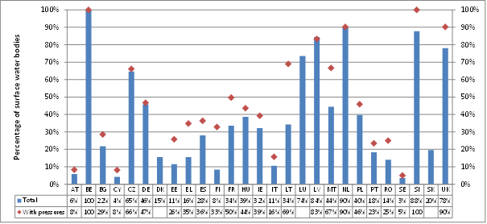
Figure 8.3.8: Percentage of surface water bodies included in operational monitoring compared to total number of surface water bodies and compared to surface water bodies with significant pressures that are included in operational monitoring. DK, LU and SK did not report data on significant pressures on water bodies
Source: WISE
In general, pressures resulting from human activity can be linked to population density in the RBD and thus used as a surrogate of pressures, related to urban wastewater discharges but also to other economic activities such as transport and urban development. Figure 8.3.9 presents the number of operational sites in relation to population density. The figure gives a rough indication of the level of effort in operational monitoring but should be interpreted with care. Member States that show a high number of sites in relation to population density are UK, Sweden and Denmark.
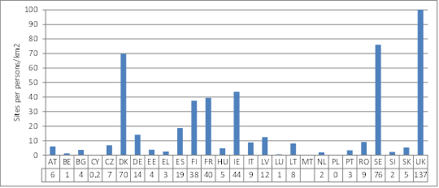
Figure 8.3.9: Number of operational sites in relation to the population density of the Member State; population density is used as an indicator of the amount of potential pressure from human activity. No report on number of sites from MT
Source: WISE

For operational monitoring, Member States are required to monitor for those biological and hydromorphological QEs most sensitive to the pressures to which the water bodies are subjected (Annex V, 1.3.2 Selection of quality elements). Available information from the earlier Article 8 reports shows that Member States may have different understandings of which are those QEs. Member States are expected to select the BQEs most sensitive to the pressures identified as putting a water body at risk. If there are varied and many pressures at the RBD level then it is likely that all BQEs will be included. The selection of QEs is made on the basis of these main pressures. Operational monitoring may also systematically be based on one specific BQE in each water category, (e.g. typically macroinvertebrates for rivers and phytoplankton for lakes and coastal). In this case further information is needed, from detailed site-level information and/or technical supportive information, as to whether or not this is justified in terms of the significant pressures present.
Figure 8.3.10 shows the percentage of water surface bodies in which the main groups of biological quality elements are used in operational monitoring. There are large differences between Member States though most use more than one BQE. The percentages were calculated from information reported for each monitoring site which not all Member States provided. For those Member States not included in Figure 8.3.10, it is however, clear from information reported at the monitoring programme level that: Denmark monitors for one BQE in rivers (benthic invertebrates), and a range of BQEs in lakes and coastal waters; Estonia and Slovak Republic monitor for phytoplankton in lakes/reservoirs; no BQEs are included in Poland for rivers (only physicochemical parameters are included and there was no reported information for lakes, transitional and coastal waters); and Hungary, Ireland, Latvia and Lithuania include more than one BQE in their relevant water categories.

Phytoplankton | Other aquatic flora
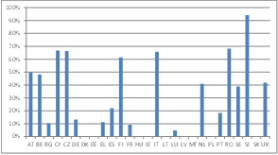 | 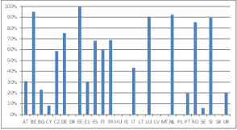
Macroinvertebrates | Fish fauna
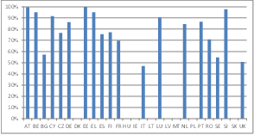 | 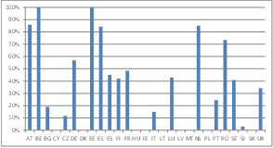
Figure 8.3.10: Percentage of surface water bodies included in operational monitoring in which phytoplankton, other aquatic flora, macroinvertebrates and fish are monitored (includes all relevant water categories).
Source: WISE
Note: It was not possible to calculate the data for DK, HU, IE, LT, LV, PL and SK because data on monitored quality elements was not reported at site level. (No report for MT.)

Regarding to the quality elements monitored in operational monitoring it is clear that approaches are different between Member States. Sweden and Bulgaria monitor only physicochemical QEs in 32% and 11%, respectively of the water bodies included in operational monitoring, and the UK monitors only morphological QEs in 20% of water bodies included in operational monitoring, all contrary to the requirements of the WFD where it would be expected at least one (sensitive) BQE would have been monitored. In other Member States such as France and Germany the focus is more on the BQEs where 60% and 30% of water bodies include at least one BQE.

Monitoring and classification of surface waters

Ecological status/potential
Member States have to report the ecological status or potential status of each water body in the RBD. Where no status has been assigned to a water body, ‘unknown’ is reported. In addition, Member States were also asked to report the classification results in terms of each of the BQEs monitored in each water body. Status in terms of a particular BQE in a monitored water body might also be extrapolated to non-monitored water bodies in the same group. As described above, not all BQEs are appropriate or will be monitored for all water categories and some are considered to be not applicable in some water body types. Figure 8.3.11 summarises the number of Member States where for each relevant BQE there are more or fewer water bodies classified than monitored, or where they are the same.
In cases where the number of monitored water bodies is greater than the number of classified water bodies for any particular QE there may be a lack of confidence in the monitoring results. This may mean that only the monitoring results/assessments with high and perhaps medium confidence are used in classification. Where the number of monitored water bodies is the same as the number of classified water bodies for any particular QE the classification is based on monitored water bodies. There may also be examples of where the number of monitored water bodies is less than the number of classified water bodies for any particular QE. This may indicate that there has been extrapolation of status from monitored water bodies to non-monitored water bodies, perhaps through grouping.
C | More classified than monitored | PP | Phytoplankton | R | rivers
M | More monitored than classified | MP | Macrophytes | L | lakes
S | Same number classified and monitored | PB | Phytobenthos | T | Transitional waters
NI/NC | No information/not clear | MA | Macroalgae | C | Coastal waters
NR | Water category not relevant | AG | Angiosperms
 |  | BI | Benthic invertebrates
 |  | FI | Fish
Figure 8.3.11: Comparison of number of surface water bodies monitored and classified in terms of each biological quality element indicative of ecological status
Source: WISE

The BQEs for which more water bodies are classified than monitored, thereby perhaps indicating there is more confidence that the monitoring and assessment results and the subsequent extrapolation of status by grouping are giving a reliable classification of status, are for benthic invertebrates in rivers, phytoplankton in lakes, and benthic invertebrates and phytoplankton in coastal waters. As described in section 8.3.3 and 8.3.4 these QEs are often the most commonly used for surveillance and operational monitoring. There are also examples (e.g. fish and benthic invertebrates in lakes, angiosperms and fish in transitional and angiosperms and macroalgae in coastal waters) of where more water bodies are monitored than classified perhaps indicating that assessment and classification methods are not yet fully developed in some Member States.
Information on the methods used for grouping water bodies for monitoring purposes was found for 14 Member States of the 25 for which RBMPs were assessed. Most methods involved forming groups of similar or the same types, subject to the same pressure (type and intensity) or combinations of pressures. Cyprus defines types as water bodies with comparable geography (altitude), hydrology, geomorphology and human pressures. Austria has defined ‘pressure’ groups for certain river types that have a specific hydromorphological or diffuse pressure combination. In Ireland clusters of river water bodies were formed based on typology, catchment pressures and the results of the risk assessments. In UK (Scotland) not at risk water bodies were grouped within coastal sediment transport cells (considered to the relevant geographic unit for marine ecosystems) and by pressure profiles. Two Member States (Cyprus, Ireland), describe a statistical analytical approach to identifying groups and the section of monitoring sites or water bodies representative of the group, and some others provide details on the extrapolation of the results and assessment of status from sampled water bodies to the group as a whole (Cyprus, Ireland, Lithuania, Sweden, UK).

Chemical status
In terms of surveillance monitoring Member States are required to monitor all priority substances which are discharged into the river basin or sub-basin. For operational purposes, monitoring is required for those bodies of water into which priority list substances are discharged. The Directive distinguishes between the risk from point source discharges where sufficient monitoring points are required within each body in order to assess the magnitude and impact of the point source, and other types of pressure. For bodies at risk from significant diffuse source pressures (including priority substances), sufficient monitoring points are required within a selection of the bodies in order to assess the magnitude and impact of the diffuse source pressures.
Figure 8.3.12 compares the percentage of water bodies classified for chemical status with the percentage of water bodies monitored for priority substances. There are large differences between the numbers of water bodies monitored compared to those classified. In most Member States (for example, Germany and France) that provided information on classified and monitored water bodies, the percentage of water bodies monitored is lower than those classified whereas in Belgium the numbers are almost the same. These differences may reflect the relative significance of the sources (e.g. point or diffuse) of priority substances in the RBD and also differences in approach by Member States. Sweden has adopted a different approach to other Member States in identifying most of its surface water bodies to be at risk of failing WFD objectives from diffuse sources of priority substances and has classified 99.99% its surface water bodies as in less than good chemical status mainly because of mercury deposition. Thus all water bodies in Sweden were classified on the basis of chemical status even though only around 1% were monitored for priority substances.
Overall in the EU (27 Member States), about 40% of surface water bodies have been reported as having ’unknown’ chemical status and only 9% of surface water bodies (in 18 Member States with reported information) are monitored for priority substances.

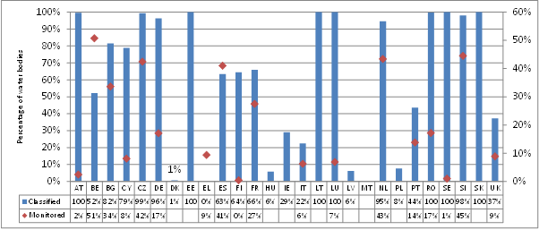

Figure 8.3.12: Percentage of surface water bodies classified for chemical status compared to the percentage of water bodies monitored for priority substances. There is no information on monitored water bodies for DK, EE, HU, IE, LT, LV, PL and SK because they did not report information on monitored quality elements at the site level. No information reported for MT.
Source: WISE

Groundwater monitoring
Figures 8.3.13 and 8.3.14, respectively, show the number of monitoring stations and the number per 1000 km² of land area for quantitative and for chemical groundwater monitoring for each Member State. Some stations are used for both quantitative and chemical monitoring. The figures indicate significant differences across Member States in the approach to groundwater monitoring. The comparison between Member States is difficult because the numbers of stations are influenced by the size of the Member States and the density of the network depends on the intensity and type of groundwater use. For example more intensive monitoring may be needed where groundwater is used as a source of drinking water. However it can be seen from the figures that there is significant difference in the density of groundwater monitoring stations in the Member States.

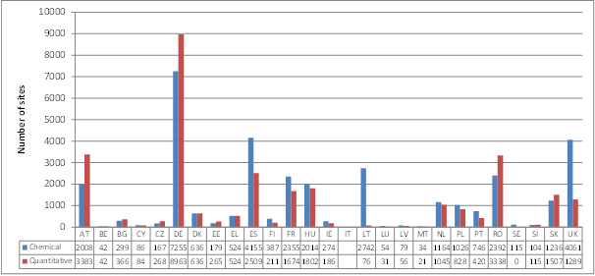

Figure 8.3.13: Total number of monitoring sites for quantitative and for chemical groundwater monitoring. Incomplete information reported for IT.
Source: WISE

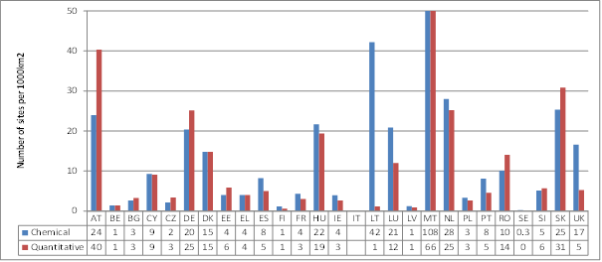

Figure 8.3.14: Number of groundwater monitoring sites per 1000km² of Member State land area for quantitative and chemical monitoring. Incomplete information reported for IT.
Source: WISE

Monitoring the quantitative status of groundwater
The groundwater quantitative monitoring network has to include sufficient representative monitoring points to estimate groundwater level in each groundwater body or group of bodies taking into account short and long-term variations in recharge.

Many Member States include a high percentage of their groundwater bodies in quantitative monitoring with 11 including over 80% of groundwater bodies (Figure 8.3.15). However, the percentage may depend significantly on the delineation of groundwater bodies as some Member States have delineated a large number of groundwater bodies, for example over 3,800 in Finland and therefore the percentage of water bodies included appears low even with a similar number of monitoring stations as in other Member States. Sweden reported no sites for the quantitative monitoring of groundwater and Italy did not report detailed enough information for the calculation to be undertaken.

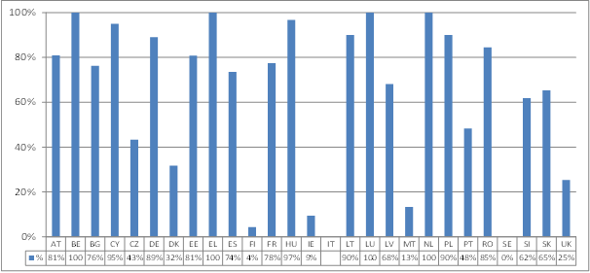
Figure 8.3.15: Percentage of groundwater bodies included in quantitative monitoring. Incomplete information reported for IT
Source: WISE

Figure 8.3.16 shows the number of quantitative monitoring sites per groundwater body. A large number of groundwater bodies in the EU do not have quantitative monitoring. This can be explained mainly due to two Member States that have delineated a large number of groundwater bodies (Finland 3804; Sweden 3021) and where only 4% and 0%, respectively, are included in the monitoring of quantitative status. Of the groundwater bodies monitored 70% have more than one monitoring site. This is partly because groundwater bodies generally are of large extent.
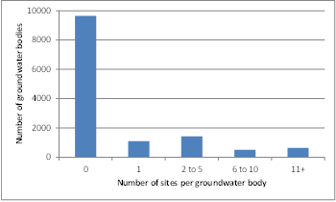
Figure 8.3.16 Number of groundwater bodies with 0, 1, 2-5, 6-10, and 11 and more monitoring sites for quantitative monitoring. Based on 25 MS excluding IT who did not report site purpose designations, and SE where there is no quantitative monitoring reported
Source: WISE

Monitoring the chemical status of groundwater

The surveillance monitoring of chemical status of groundwater needs to be carried out to supplement and validate the impact assessment procedure and provide information for use in the assessment of long term trends both as a result of changes in natural conditions and through anthropogenic activity. Sufficient monitoring sites should be selected for bodies identified as being at risk and for bodies which cross a Member State border.

Figure 8.3.17 (below) shows that a high percentage of groundwater bodies in the EU are included in chemical surveillance monitoring. As with the figure for quantitative monitoring, the percentage is influenced by the delineation of groundwater bodies i.e. lower numbers are not necessarily a signal of weaker monitoring as they may indicate a delineation resulting in a large number of groundwater bodies.

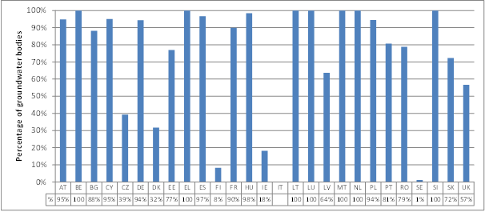
Figure 8.3.17: Percentage of groundwater bodies in chemical surveillance monitoring. IT did not report all required information to calculate the indicator
Source: WISE

Annex V of the WFD indicates that a set of core parameters (oxygen content, pH value, conductivity, nitrate and ammonium) must be monitored in all groundwater bodies included in chemical surveillance monitoring. Only five of the 14 Member States that reported the required level of detail on the parameters monitored achieved that requirement. Other Member States either do not include all core parameters in the groundwater chemical monitoring or the selection of the parameters is not clear. The lowest level of compliance was reported for Sweden and Finland. In the case of Sweden nitrate was not monitored in any water body and for Finland for most groundwater bodies only aggregated information was reported for those water bodies included in surveillance monitoring.
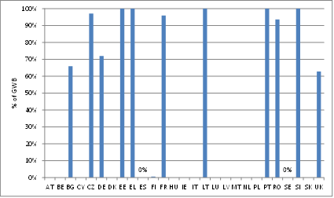
Figure 8.3.18: Percentage of GWB included in chemical surveillance monitoring where all core parameters are monitored. The calculation was not possible for BE, CY, LU and NL because parameter were only reported at an aggregated level; for AT, DK, HU, IE, LV, MT, PL and SK because parameters were not reported at site level; and for IT because groundwater bodies and parameters were not reported at site level.
Source: WISE

Operational monitoring is undertaken in the periods between surveillance monitoring in order to establish the chemical status of all groundwater bodies or groups of bodies determined as being at risk of failing to meet the environmental objectives and the presence of any long-term anthropogenic upward trend in the concentration of any pollutant. Figure 8.3.19 shows the percentage of groundwater bodies included in chemical operational monitoring. Only 6 Member States included more than 60% of their groundwater bodies in the chemical operational monitoring of groundwater.
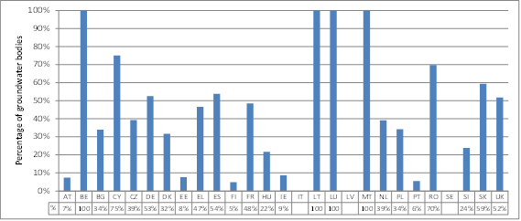

Figure 8.3.19: Percentage of groundwater bodies in chemical operational monitoring. IT did not report all required information to calculate the indicator. There is no operational monitoring reported in LV or SE
Source: WISE

Member States were asked to report the significant pressures affecting groundwater bodies. Significant was in terms of groundwater bodies being at risk of failing to meet the environmental objectives because of the pressure. Figure 8.3.20 compares the number of groundwater bodies included in operational monitoring with those reported to be subject to significant pressures. A ratio of greater than 1 indicates that there are more in operational monitoring than reported with significant pressures, and a ratio less than 1 the reverse situation. Latvia and Sweden have identified groundwater bodies affected by significant pressures but neither has reported operational monitoring. Sweden has not established operational monitoring of groundwater although it reported the failure of chemical status in 61 groundwater bodies because of pesticides, heavy metal and nitrates. In Latvia even though significant pressures and impacts exist, all groundwater bodies are reported to have good chemical status and this may be the reason that no operational monitoring has been reported.
Eight of the 22 Member States that reported information included more groundwater bodies in operational monitoring than have reported significant pressures whereas the other 14 monitor fewer.

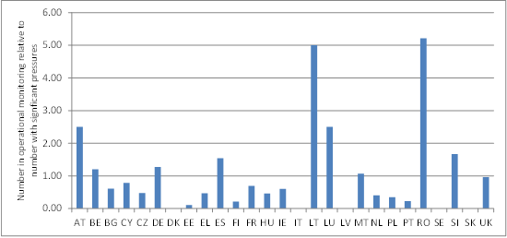
Figure 8.3.20: Relative number of groundwater bodies included in operational monitoring and those with significant pressures. DK and SK did not report significant pressures, SE and LV did not report chemical operational monitoring and IT did not report purpose of monitoring
Source: WISE

Figure 8.3.21 shows the number of chemical status (surveillance and/or operational) monitoring sites per groundwater body. The number of groundwater bodies that are not monitored is highly influenced by the relatively high number of delineated groundwater bodies in some Member States, not of all which are included in chemical monitoring. Almost 70% of groundwater bodies in the EU do not have chemical monitoring. Of the groundwater bodies monitored 70% have more than one monitoring site. This is partly because groundwater bodies generally are of large extent.

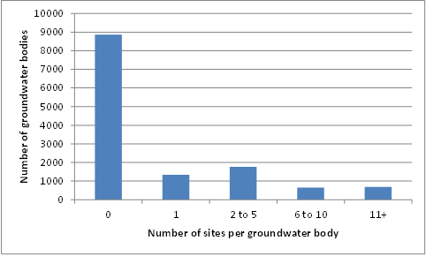
Figure 8.3.21: Number of groundwater bodies with 0, 1, 2-5, 6-10, and 11 and more monitoring sites for chemical monitoring. Based on 26 MS excluding IT which did not report site purpose designations
Source: WISE

Trends in pollutant concentrations in groundwater
One of the objectives of operational monitoring of the chemical status of groundwater is to establish the presence of any long-term anthropogenic induced upward trend in the concentration of any pollutant. The monitoring of the chemical status of groundwater bodies includes the requirement to identify and assess long-terms trends in pollutants resulting from anthropogenic activity. The trends must also be distinguishable from natural variation with an adequate level of confidence and precision. Trends must also be identifiable in sufficient time to allow measures to be implemented to prevent or mitigate environmental significant detrimental changes in groundwater quality.
23 Member States reported in WISE that trends of one or more pollutants in groundwater had been assessed in some or in all RBDs – 14 of these reported upward trends. 10 Member States provided an explanation in their RBMPs on how their monitoring programmes were designed to detect significant trends (see Figure 8.3.22). Trend assessments are however not complete mostly because of the short monitoring time series available.

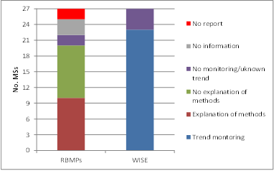
Figure 8.3.22: Detection of trends of pollutants in groundwater bodies and information on how these were determined. RBMP: information from assessment of river basin management plans. WISE: electronic report to WISE
Source: WISE and RBMPs

Monitoring in relation to Article 6 of the Groundwater Directive
Article 6 of the Groundwater Directive (GWD) (2006/118/EC) includes a framework for making operational the WFD objective to 'prevent or limit inputs of pollutants into groundwater'. The Article clarifies which substances shall be prevented from entering and which shall be limited in groundwater. It also clarifies the exemptions from this 'prevent or limit objective'. Under Article 6.3 Member States may exempt groundwater bodies from these measures to provided that their competent authorities have established efficient monitoring of the groundwater bodies concerned, in accordance with point 2.4.2 of Annex V to Directive 2000/60/EC (chemical surveillance monitoring), or other appropriate monitoring, is being carried out. The competent authorities should also decide whether additional monitoring is needed to verify that the effects of an exempted input are acceptable. The competent authorities of the Member States must keep an inventory of the exemptions for the purpose of notification, upon request, to the Commission.
The RBMP of most of the 25 Member States assessed had no information as to whether or not Article 6 exemptions had been applied. Of the 4 Member States (DK, HU, LT, NL) that reported Article 6 exemptions only LT provided an explanation of the associated monitoring undertaken. Here monitoring requirements are set in the permit and are based on case by case analysis. Groundwater monitoring (a part of operational groundwater monitoring programme) is conducted on the basis of individual monitoring requirements set for each economic entity for a period of 3-5 years (programmes approved by the Lithuanian Geological Survey). Monitoring data is reported to the Geological Survey which verifies that the effects of an exempted input are acceptable.
The assessment of the first RBMPs seems to indicate that very few Member States had applied Article 6 exemptions. This may be partially due to the fact that the Groundwater Directive came into force early in 2007 by which time the planning process for the first RBMPs was underway in most Member States, and the measures and tools available in the Groundwater Directive may not have been fully considered at that stage, but is required to fully consider from the second RBMP cycle.

Monitoring of drinking water protection areas
The WFD integrates all existing water legislation into its programme of measures and through the requirement to identify protected areas. Article 8.1 states that for protected areas the WFD monitoring programmes must be supplemented by those specifications contained in the Community legislation under which the individual protected areas have been established. Drinking Water Protected Areas designated under Article 7 of the WFD providing more than 100 m³ of water a day as an average are required to be monitored. There could be specific sub-programmes for this purpose or the requirements could be part of other WFD monitoring programmes. Table 8.3.3 lists the number of sites associated with drinking water abstraction areas. There are differences in the number of sites associated with surface waters and groundwater. For some of the Members in the Table the lack of reported sites in a particular water category may reflect differences in the relative importance of the source in the Member State. For example groundwater is the most important source of drinking water in Austria and Malta and monitoring sites were only reported for groundwater.
For 16 Member States separate programmes for the monitoring of groundwater drinking water abstraction areas were reported whereas there were separate programmes in 12 Member States for both rivers and lakes (Figure 8.3.23). Monitoring was undertaken as part of WFD monitoring in most of the other Member States where the water category was used as a source of drinking water.
Member State | Groundwater | Surface waters
AT | 527 | None reported
BE (Fl) | None reported | 9
BG | 249 | 120
CY | 5 | 17
CZ | None reported | None reported
DE | 1338 | 809
DK | None reported | None reported
EE | 127 | 7
EL | 205 | 8
ES | 525 | 747
FI | 236 | 30
FR | 1565 | 574
HU | 1754 | 13
IE | 195 | 223
IT | 1607 | 184
LT | 359 | None reported
LU | 18 | 6
LV | None reported | 2
MT | 15 | None reported
NL | 223 | 12
PL | 459 | None reported
PT | 287 | 123
RO | 105 | 67
SE | 28 | None reported
SI | None reported | None reported
SK | None reported | 52
UK | None reported | None reported
Table 8.3.3: Number of groundwater monitoring sites in drinking water abstraction areas (groundwater) and associated with Drinking Water Directive (surface waters)
Source: WISE
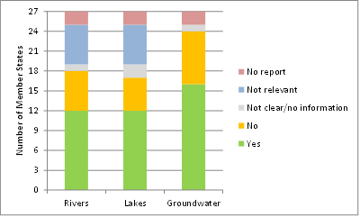
Figure 8.3.23: Number of Member States with Monitoring of Drinking Water Protected Areas in rivers, lakes and groundwater
Key: Yes: there is a specific monitoring programme for DWPAs
No: there is no specific monitoring programme for DWPA though maybe included in other WFD monitoring
Not relevant: since drinking water is mainly abstracted from groundwater
No report: RBMP not reported from EL and PT
Source: WISE

Monitoring in International River Basin Districts
Several international river basins have established transboundary monitoring networks as part of international agreements or Conventions. In addition, Annex V WFD requires that transboundary water bodies are considered in the design of, and selection of monitoring sites for, surveillance monitoring of surface and groundwater. Figure 8.3.24 below indicates that transboundary monitoring networks have been established in a relatively low percentage of the International River Basin Districts (IRBD) where there are transboundary surface or groundwater bodies.
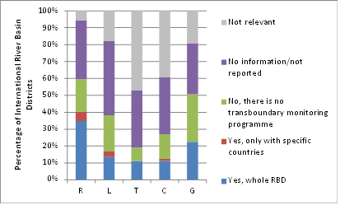
Figure 8.3.24: Number of International River Basin Districts where there are transboundary surface water (Rivers (R), Lakes (L), Transitional (T) and Coastal Waters (C) and Groundwater (G) monitoring programmes in place. There are 89 International River Basin Districts reported to WISE.
Source: WISE

Conclusions
It is clear that Member States have developed monitoring programmes and there has been some progress since reporting to the Commission in 2007. For example, at the EU level there has been a 39% increase in monitoring sites in surface waters and 17% more for groundwater.
Whilst there has been an increase in numbers of surface water monitoring sites in a number of Member States there still is a significant number of Member States where there has been a decrease (9 Member States for rivers, 8 for lakes, 7 for coastal waters and 5 for transitional waters).
In general, there has been an increase in the number of surface water bodies included in operational monitoring between 2007 and 2010 in more Member States than there has been a decrease but there is a significant number that have decreased the number of water bodies included. In terms of surveillance monitoring, more Member States have decreased rather than increased the numbers of surface water bodies included, this is particularly so for rivers and transitional waters.
As was found in the assessment of Member States 2007 reports, there are significant differences between Member States in the approach to the design of surface water and groundwater monitoring programmes. These differences reflect the number and sizes of water bodies Member States have delineated, the extent and intensity of different pressures and impacts on water bodies across Europe and the different stages in the development of adequate monitoring and assessment methods for all of the quality elements and parameters required by the WFD. These differences often make the assessment and comparison of the monitoring undertaken by Member States difficult.
Whilst there has been progress it is not always clear whether or not all of the objectives of surveillance monitoring have been fully designed into surface water monitoring programmes.
Member States are required to monitor for all relevant quality elements in surface water bodies and for a core set of parameters in groundwater bodies in all water bodies included in surveillance monitoring. In terms of biological quality elements only 4 out of the 20 Member States that reported the required information complied with this requirement. In addition the morphological conditions in lakes, transitional and coastal waters are not monitored by many Member States. For groundwater, only 5 out of the 14 Member States that reported the required information monitored all core parameters in all groundwater bodies included in surveillance monitoring. This leads to some uncertainly whether the impacts of all relevant pressures acting on surface water and groundwater bodies are capable of being detected in some Member States.
For operational monitoring of surface waters, Member States are able to select those biological and hydromorphological quality elements most sensitive to the pressures affecting water bodies. Whilst this is clearly done in some water bodies, there are cases where there is still a focus on specific quality elements and others where no biological quality elements are monitored at all rather morphological and/or physicochemical QEs are solely monitored. As approximately 50% of surface water bodies in the EU are subject to more than one pressure/impact this may lead to water bodies being incorrectly classified or classified with low confidence, and may contribute to the inappropriate targeting of expensive measures required to achieve objectives.
The relative numbers of water bodies monitored for particular quality elements and subsequently classified in terms of their ecological status/potential may indicate the confidence in the monitoring and assessment methods in Member States. For all relevant biological quality elements, there are examples in Member States where more water bodies are monitored than classified. However, in particular for fish and benthic invertebrates in lakes, fish in transitional waters and macroalgae and angiosperms in transitional and coastal waters more water bodies are monitored than classified in more Member States than where the reverse is the case. This may indicate that in some Member States the methods may need further development to make them more robust and reliable, and/or so that the methods are applicable to all water body types present in the Member State.
Overall in the EU, 42% of surface water bodies have been reported as having “unknown” chemical status, 58% with either good or less than good status and only 9% (in 18 Member States with reported information) are monitored for priority substances. This may indicate that overall priority substances are inadequately monitored and/or the assessment of the risk to water bodies from priority substance has not been undertaken for all surface water bodies in the EU.
A high percentage of groundwater bodies are included in the monitoring of quantitative status with over 80% included in quantitative monitoring in 11 (out of 26) Member States. Sweden did not report any quantitative monitoring. In terms of chemical surveillance monitoring over 80% of groundwater bodies are included in 16 Member States but fewer are generally included in chemical operational monitoring with at least 80% only included by 4 Member States. No operational monitoring was reported by Latvia or Sweden.
Groundwater monitoring does not seem to be targeted to significant pressures as 14 Member States reported to include less groundwater bodies in operational monitoring than have reported significant pressures for.
Monitoring programmes not in all Member States are able to detect significant trends. Trend assessments are not complete in most of the Member States mostly because of the short monitoring time series available.
The assessment of the first RBMPs seems to indicate that very few Member States had applied exemptions and, if applied, considered the monitoring required in relation to Article 6 of the Groundwater Directive. This may be partially due to the fact that the Groundwater Directive came into force early in 2007 by which time the planning process for the first RBMPs was underway in most Member States, and the measures and tools available in the Groundwater Directive may not have been fully considered at that stage.
Drinking water abstraction areas are generally monitored across the EU. For 16 Member States separate programmes for the monitoring of groundwater drinking water abstraction areas were reported whereas there were separate programmes in 12 Member States for both rivers and lakes. Monitoring was undertaken as part of WFD monitoring in most of the other Member States where the water category was used as a source of drinking water.
There is a significant gap in the co-ordinated monitoring of international transboundary water bodies in the EU. Transboundary monitoring networks have not been established in around 30% of the international RBDs where there are transboundary groundwater bodies and in around 20% of the international RBDs where there are transboundary rivers and lakes. There was also no information in around a third of the international RBDs as to whether or not transboundary monitoring was undertaken.
In general there was only limited information provided, or focus on, monitoring in RBMPs.

Recommendations
- The monitoring network in Member States is a key WFD element and information source that should be maintained and further developed in a consistent way.
- It should be clearer how the characterisation and pressure analysis are linked to the development of the monitoring programmes. Establishment of the monitoring network should consider significant pressures.
- There are significant gaps in the monitoring of the relevant quality elements in surface water bodies and core parameters for groundwater. This should be improved in order to reduce the risk that certain impacts arising from one or several pressures would not be detected.
- Gaps in the monitoring network for ecological status and especially for chemical status are leading to an unknown status classification. These gaps should be addressed in order to improve our knowledge on the status of European waters.
- It was clear from Member States reports to the Commission on monitoring in 2007 that often the reported information was not adequate to undertake a thorough assessment and comparison of the monitoring programmes. Certain areas of improvement were highlighted in individual feedback reports to Member States. It is recommended that these improvements are implemented by Member States for any subsequent reporting of monitoring programmes. In particular detailed and disaggregated information is required on the monitoring undertaken at each site and water body so that a complete assessment of the monitoring across the EU can be done in future. The reporting of more background and interpretative information would also help the Commission to explain and understand the different approaches adopted by Member States.
- It is recommended that more detailed information is provided in future RBMPs as monitoring is one of the key aspects in classifying water bodies and identifying where measures are needed. This should help make the whole decision making process more transparent to all stakeholders.
- All monitoring programmes should be able to detect significant pollution trends in groundwater to provide basis for the groundwater trend assessments and reversals under the GWD. In this respect it is especially crucial to maintain a consistent network of monitoring sites.
- When applying exemptions under Article 6 GWD, appropriate and targeted monitoring is essential.
- Co-ordinated monitoring of international transboundary water bodies should be further developed in order to achieve effective monitoring of those water bodies.

E.g. Directive 2006/7/EC of the European Parliament and of the Council of 15 February 2006 concerning the management of bathing water quality and repealing Directive 76/160/EEC, Council Directive 91/271/EEC of 21 May 1991 concerning urban waste-water treatment, Council Directive 91/676/EEC of 12 December 1991 concerning the protection of waters against pollution caused by nitrates from agricultural sources, Directive 76/464/EEC - Water pollution by discharges of certain dangerous substances
Earlier WFD implementation reports are available at : http://ec.europa.eu/environment/water/water-framework/implrep2007/index_en.htm
European Free Trade Association
Norway chose to follow the same schedule that applies within the EU for approximately 20% of the Norwegian water bodies, on a voluntary basis. This means that Norway has established river basin management plans (RBMP) for the period 2009-2015 for selected water bodies, although there is no legal obligation to do so until 2018. The Norwegian pilot plans were adopted by the Regional Councils who are competent authorities at River Basin District level, and then approved by the Norwegian Government through Royal Decree.
All reported RBMPs are publicly available at www.circa.europa.eu/Public/irc/env/wfd/library?l=/framework_directive/implementation_documents_1/submitted_rbmps&vm=detailed&sb=Title
See http://water.europa.eu and in particular http://www.eea.europa.eu/themes/water/interactive/water-live-maps/wfd
Updated overview at http://ec.europa.eu/environment/water/participation/map_mc/map.htm
Norway has adopted 11 pilot RBMPs. Norway is implementing the Water Framework Directive as part of the European Economic Area Agreement, with the specific timetable agreed therein.
This means the Danube would be counted as 9 instead of 1, if only the EU national parts are counted.
http://eur-lex.europa.eu/LexUriServ/LexUriServ.do?uri=COM:2007:0128:FIN:EN:PDF
http://ec.europa.eu/environment/water/water-framework/implrep2007/pdf/com_209_156_en.pdf
Belgium - C-366/11 http://eur-lex.europa.eu/LexUriServ/LexUriServ.do?uri=CELEX:62011CJ0366:FR:HTML
Greece - C-297/11 http://eur-lex.europa.eu/LexUriServ/LexUriServ.do?uri=CELEX:62011CJ0297:FR:HTML
Portugal - C-223/11 http://eur-lex.europa.eu/LexUriServ/LexUriServ.do?uri=CELEX:62011CJ0223:FR:HTML
Spain – C -403/11 http://curia.europa.eu/juris/document/document.jsf?text=&docid=128021&pageIndex=0&doclang=FR&mode=lst&dir=&occ=first&part=1&cid=5324214
http://forum.eionet.europa.eu/nrc-eionet-freshwater/library/eea_2012_state_report/july-2012-draft-versions/
Comparative study of pressures and measures in the major river basin management plans in the EU. Task 1: 'Water Governance'. (WRc et al, 2012) The report is hereafter referred to as the 'Pressures and Measures study' report, available via : http://ec.europa.eu/environment/water/blueprint/index_en.htm NB. The findings of this study were validated by the respective SCG member for all Member States apart from EL, ES, FR, IT, PT, SI, UK.
This is for instance the case in Sardinia and Sicily(IT), Cyprus, (Vuoksi, Kymijoki-Gulf of Finland, Kokemõenjoki-Archipelago Sea-Bothnian Sea, Oulujoki-Iijoki (FI), Corsica, Guadeloupe, Martinique, Guyana(FR), Luxemburg part of Meuse and Rhine(LU), Slovakia, Eider & Warnow/Peene (DE) and 3 RBD Northern Ireland(UK).
Sub-units have been designated in, for example, international RBDs where there has been a need for a smaller management unit (than a sub-basin) where international borders are not based hydrological boundaries
'Pressures and measures study', task 1 - Governance.
In Hungary, the regional offices of the environmental inspectorate are organized by sub-basin.
Pressures & Measures study, task 1 - Governance.
Pressures & Measures study, Task 1, Governance.
Pressures & Measures study, Task 1, Governance.
Example of regional approaches: FI (mainland Finland is differently managed from the autonomous region Åland Island), FR (Some "Departements Outre Mer", DOMs, are very different from the mainland, such as Reunion Island), UK (different approaches are taken in Scotland, Northern Ireland and in England/Wales respectively).
German Working Group on water issues of the Federal States and the Federal Government represented by the Federal Environment Ministry.
An overview of the timing of consultations can be found here http://ec.europa.eu/environment/water/participation/map_mc/map.htm.
Background document, 2nd European Water Conference 2009, available at : http://ec.europa.eu/environment/water/participation/index_en.htm
Background document 2nd European Water Conference, held 2-3.4.2009
'Pressures and Measures study', task 1, Governance.
http://ec.europa.eu/environment/water/eurobarometer.htm
An in-depth study on international cooperation was carried out in the 'Pressures and Measures study', resulting in 32 factsheets covering specific 75 transboundary river basins and 30 transboundary sub-basins as parts of those basins. The 30 "sub-basins" studied relate to the main river basins as follows (sub-basin or individual smaller basin in brackets) : Po (Adda/Lake Como, Ticino/Lago Maggiore), Rhône (Allaine, Arve, Doubs, Lac Leman/Lake Geneva, Segre), Adour-Garonne RBD (Bidasoa, Nive, Nivelle), Vistula(Bug, Dunajec, Poprad), North Western RBD(Erne, Foyle), Vuoksi RBD (Hiitolanjoki, Hounijoki, Jänisjoki, Juustilanjoki, Kaltonjoki, Kiteenjoki-Tohamajoki, Koutajoki, Saimaa Canal, Tervajoki, Urpalanjoki, Vaalimanjoki, Vilajoki), Drin/Drim (Lake Prespa), Ebro RBD (Segre), Meuse RBD (Sambre), Haldenvassdraget (Strömsan)
Pressures & Measures study, Task 1, Governance.
For the Rhone basin it can be said that coordination of various joint activities takes place in its sub-basins of Doubs, Allaine, Arve and Lake Geneva.
http://ec.europa.eu/environment/water/water-framework/implrep2007/pdf/sec_2007_0362_en.pdf
http://circa.europa.eu/Members/irc/env/wfd/library?l=/framework_directive/guidance_documents/guidancesnos2sidentifica/_EN_1.0_&a=d
http://circa.europa.eu/Members/irc/env/wfd/library?l=/framework_directive/guidance_documents/guidancesnos3spressuress/_EN_1.0_&a=d
See section 8.6 on designation of HMWB
Commission vs. Malta (Case C-351/09, ruling of 22.12.2010) – Bad application -Monitoring networks – for not having established a network of monitoring for inland waters, and for failure to submit a summary report to the Commission. In this ruling, the court found that even if the Maltese inland surface water bodies are small, there is a need to ensure monitoring.
Further details on hydromorphological pressures can be found in the EEA Hydromorphology Thematic Assessment report.
http://eur-lex.europa.eu/LexUriServ/LexUriServ.do?uri=COM:2007:0128:FIN:EN:PDF
COMMISSION DIRECTIVE 2009/90/EC of 31 July 2009 laying down, pursuant to Directive 2000/60/EC of the European Parliament and of the Council, technical specifications for chemical analysis and monitoring of water status.
In the case of Denmark, Hungary, Ireland, Latvia, Lithuania, Poland and Slovakia, , it was not possible to extract the information, because the data were not supplied at the station level
The number of water bodies identified as having significant pressures in Sweden for use in computation of the values in the Figure has been adjusted (reduced) to take into account the approach adopted by Sweden in identifying all of its water bodies as subject to diffuse pressures from hazardous substances (mercury), an approach not adopted by other Member States.

