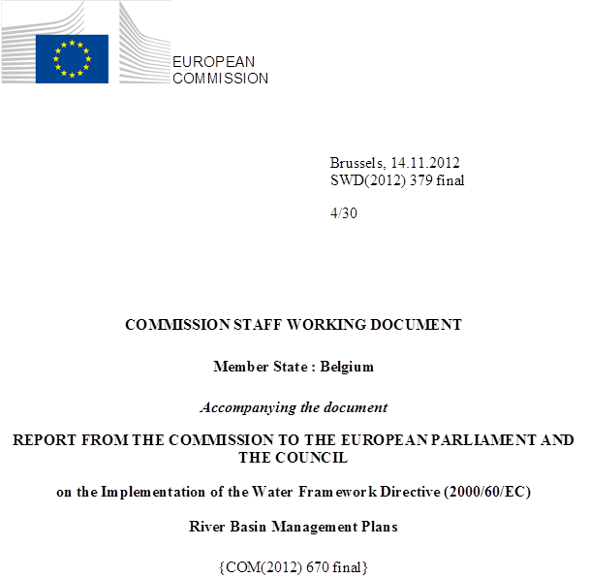

general information
Figure 1.1: Map of River Basin Districts
International River Basin Districts (within EU)
International River Basin Districts (outside EU)
National River Basin Districts (within EU)
Countries (outside EU)
Coastal Waters
Source: WISE
Belgium has a population of about 11 million and has a total area of 30528 km². The country consists of three regions: the Brussels-Capital Region, the Flemish Region and the Walloon Region.
Belgium has four river basin districts, of which the Meuse and Scheldt cover most of the Belgian territory. The Rhine and Seine river basins cover a much smaller part of Belgium. Because of the division of responsibilities among the different regions of the federal state of Belgium there are several plans for the same RBD within Belgium. All the Belgian river basins are shared with other MS and/or third countries:
- Scheldt: FR, NL
- Meuse: FR NL, LU, DE
- Rhine: DE, AT, FR, NL, LI (third country), CH (Third country)
- Seine: FR

RBD | Name | Size (km²) | Countries sharing RBD
BESchelde_VL | Scheldt/L'Escaut | 12026 | FR, NL
BEEscaut_Schelde_BR | Scheldt/L'Escaut | 162 | FR, NL
BEEscaut_RW | Scheldt/L'Escaut | 3745 | FR, NL
BENoordzee_FED | Scheldt/L'Escaut | 1428 | FR, NL
BEMaas_VL | Meuse/Maas | 1601 | DE, FR, LU, NL
BEMeuse_RW | Meuse/Maas | 12255 | DE, FR, LU, NL
BERhin_RW | Rhin (Rhine) | 767 | AT, CH, DE, FR, LI, NL
BESeine_RW | Seine | 80 | FR
Table 1.1: Overview of Belgium’s River Basin Districts
Source: River Basin Management Plans reported to WISE: http://cdr.eionet.europa.eu/be/eu/wfdart13

The three larger international river basins on the Belgian territory (Scheldt/L'Escaut, Maas/Meuse and the Rhine) are all in co-operation category 1, that is there are international RBMPs, international agreements and an international co-operation body.
Name international  river basin | National RBD | Countries sharing RBD | Co-ordination category
Name international  river basin | National RBD | Countries sharing RBD | 1
Name international  river basin | National RBD | Countries sharing RBD | km² | %
Scheldt | BESchelde_VL | FR, NL | 11.991 | 32.9
Scheldt | BEEscaut_Schelde_BR | FR, NL | 161 | 0.4
Scheldt | BEEscaut_RW | FR, NL | 3.770 | 10.4
Scheldt | BENoordzee_FED | FR, NL
Meuse | BEMaas_VL | DE, FR, LU, NL | 1.596 | 4.6
Meuse | BEMeuse_RW | DE, FR, LU, NL | 12.300 | 35.8
Rhine | BERhin_RW | AT, CH, DE, FR, LI, NL | 750 | 0.4
Seine | BESeine_RW | FR
Table 1.2: Transboundary river basins by category (see CSWD section 8.1) and % share in Belgium.
Category 1: Co-operation agreement, co-operation body, RBMP in place.
Category 2: Co-operation agreement, co-operation body in place.
Category 3: Co-operation agreement in place.
Category 4: No co-operation formalised.
Source: EC Comparative study of pressures and measures in the major river basin management plans in the EU.

Status of River basin Management Plan reporting and compliance
Only the two RBMPs of the Flemish Region and the Federal plan on the coastal waters have been adopted and reported. The draft RBMPs for the Walloon region are under consultation between 11/6/2012 and 18/1/2013. Consultation took place in the Brussels Capital Region between 28/2/2011 and 28/8/2011, and the Brussels authorities notified the Commission of the adoption of the RBMP in July 2012. No report has yet been published, and the RBMP has not been assessed.
RBD | RBMP Date of Adoption | RBMP Date of Reporting
BBEscaut_RW | Not yet adopted | Not yet reported
BBEscaut_Schelde_BR | 12 July 2012 (5 September 2012 published in Belgian Official Journal) | Not yet reported
BEMaas_VL | 8 October 2010 (1.11.2011 published in Belgian Official Journal) | 8 October 2010
BEMeuse_RW | Not yet adopted | Not yet reported
BENoordzee_FED | 7 December 2009 (12 February 2010 published in Belgian Official Journal) | 29 January 2010
BRRhin_RW | Not yet adopted | Not yet reported
BESchelde_VL | 8 October 2012 (11 January 2011 published in Belgian Official Journal) | 8 October.2010
BESeine_RW | Not yet adopted | Not yet reported
Table 2.1: Adoption and reporting to the Commission of Belgium's RBMPs
Source: RBMPs
Only the plans of Flanders and the Coastal Waters (competence of the Federal Government) had been adopted and reported to the Commission by the time of the drafting of this report. Therefore, this Member State annex only contains an assessment of those plans. The RBMP for the Region of Brussels was only adopted in July 2012, and the Commission has not yet carried out the assessment of that plan.
The Commission has not yet received the RBMPs of Wallonia. In April 2011, the Commission decided to take Belgium to the European Court of Justice (Case C-366/11) for failing to adopt and report its RBMPs to the European Commission. The ruling of the Court of Justice was published on 24 May 2012, whereby it is established that Belgium has failed to comply with its obligations as required by the WFD Articles 13(2),(3) and (6), Article 14(1c) and Article 15(1).

Key strengths and weaknesses (Flemish and Coastal Waters RBMPs)

Main strengths
- The public consultation has been carried out in transparent way. Information on how the given comments have been used to change the plan is provided in the plans.
- In the Flemish RBMPs, information sheets include information on the different measures and cost-effectiveness has been used to prioritize the measures. In the Coastal Waters plan, there is a complete list of basic and supplementary measures needed for the achievement of the environmental objectives.
- The ecological and chemical status assessment methods have been developed for all water categories.
- In Flanders, there is work foreseen with test areas to assess the effectiveness of supplementary measures in order to have a better knowledge basis for the selection of supplementary measures on for the next RBMPs.

Main weaknesses
- In both Flanders and Coastal Waters RBMPs, most measures are defined very general without a timeline of implementation or committed financial resources and there is generally a lack of a clear link with the status assessment.
- Considering the important number of heavily modified water bodies (HMWBs) in the Flemish region, the designation of HMWBs should more clearly follow the provisions of the Article 4(3) of the WFD.
- The Flemish assessment methods for defining good ecological potential are quite complex and should be described in the RBMP in a clearer way.
- It should be made clearer that the designated coastal water body in the Flemish RBMP was not further considered in the RBMP due to a change of the category of the water body.

Governance

RBMP timelines
The Flemish RBMPs were reported to the EEA Central Data Repository (CDR) on 10.08.2010. The federal plan of the North Sea was submitted on 29 January 2010 on paper to the Commission and in WISE on 20 May 2011.
RBD | Timetable | Work programme | Statement on consultation | Significant water management issues | Draft RBMP | Final RBMP
Due dates | 22/06/2006 | 22/06/2006 | 22/06/2006 | 22/12/2007 | 22/12/2008 | 22/12/2009
BESchelde_VL | 22/11/2006 | 22/11/2006 | 22/11/2006 | 22/11/2006 | 16/12/2008 | 08/10/2010
BEEscaut_Schelde_BR | - | - | - | - | - | -
BEEscaut_RW | - | - | - | - | - | -
BENoordzee_FED | 22/12/2008 | 22/12/2008 | 22/12/2008 |  | 22/12/2008 | 12/02/2010
BEMaas_VL | 22/11/2006 | 22/11/2006 | 22/11/2006 | 22/11/2006 | 16/12/2008 | 08/10/2010
BEMeuse_RW | - | - | - | - | - | -
BERhin_RW | - | - | - | - | - | -
BESeine_RW | - | - | - | - | - | -
Table 3.1: Timeline of the different steps of the implementation process
Source: WISE

Administrative arrangements - river basin districts and competent authorities
Belgium is a federal state with responsibilities for water management at the regional level and at the federal level. The federal and regional responsibilities are exclusive and equivalent with no hierarchy between the standards issued by each group. The regions are responsible in their territory for environment and water policy (including technical regulations regarding drinking water quality), land development, nature conservation and public works and transport. The Federal Government has responsibility for, amongst other things, the economic aspects of drinking water provision (i.e. the establishment of maximum prices and the approval of price increases) in the entire Belgian territory and has environmental responsibilities for coastal and territorial waters (from the lowest low-waterline). Because of these different responsibilities, there are several river basin management plans even within the same river basin district. To deal with this, co-ordination is carried out at national and international level, while the plans are developed at the regional level (except for the Federal plan on coastal waters) and therefore a mainly regional approach to river basin planning is used.
International co-ordination with neighbouring countries and the relevant Belgian actors (federal state and regions) is carried out in the International Scheldt Commission and the International Meuse Commission. (Treaties of Ghent, 3 December 2002).
Regular and systematic internal Belgian co-ordination takes place in the Co-ordination Committee for International Environmental Policy (CCIEP) (Co-operation agreement of 5 April 1995 between the Federal State, the Flemish Region, the Walloon Region and the Brussels Capital Region). The CCIEP is, according to the agreement, inter alia competent for "consultations in order to arrive at co-ordinated implementation of the recommendations and decisions of international organisations". The Water Steering Group of this Committee is the consultative body responsible for the necessary co-ordination of the execution of the WFD between the different competent authorities in Belgium. The regions must consult each other regarding water bodies that extend over more than one region and within the SG Water. The formal and official steps are determined for establishing the river basin management plans in order to arrive at a co-ordinated position. There can however not be an exchange of competences through the co-operation agreement which means that the co-ordination and co-operation carried out does not guarantee the timely reporting by other competent authorities within the MS.
For the Flemish Region the competent authority is the Co-ordination Committee on Integrated Water Policy (CIW). This committee has, according to the Flemish Decree on Integrated Water Policy, the following task:
The CIW is responsible for the preparation, control and the follow up of the integrated water policy at the level of the Flemish Region. It watches over the uniform approach to the management of the basin and has the task to carry out the decisions of the Flemish government in the field of integrated water policy.
The CIW has an important role in the planning and execution of water policy at the river basin level. The CIW is designated as the competent authority for the implementation of the WFD and the FD. Among its responsibilities are the preparation of the RBMPs for the Flemish Region, reporting to the European Commission on WFD implementation, organizing the public consultation of the RBMPs, preparing the methodology and guidance for the development of the RBMPs and aligning the RBMPs with the Flemish Water Policy Note.
The CIW consists of the executive management of the administrations and entities with an important role in water policy. In the RBMP, the members of the CIW are considered as "water managers".
For the organisation and planning of integrated water management, the decree on Integrated Water Policy distinguishes 4 levels:
- The River Basin District (Scheldt and Meuse) with the river basin management plans;
- The Flemish region (river basins Scheldt, Meuse, IJzer, Polders of Bruges) with the Water Policy Note;
- The sub-basin (11) with the river catchment management plans;
- Sub-sub-basin (103) with the sub-river catchment management plans.
The preparation, planning, control and follow-up are carried out at each of these levels. Within the CIW, specific structures have been put in place in order to carry out these tasks. The CIW oversees the functioning of the sub-basin structures, supports it and reviews possible contradictions between binding provisions of the management plans at the different levels.

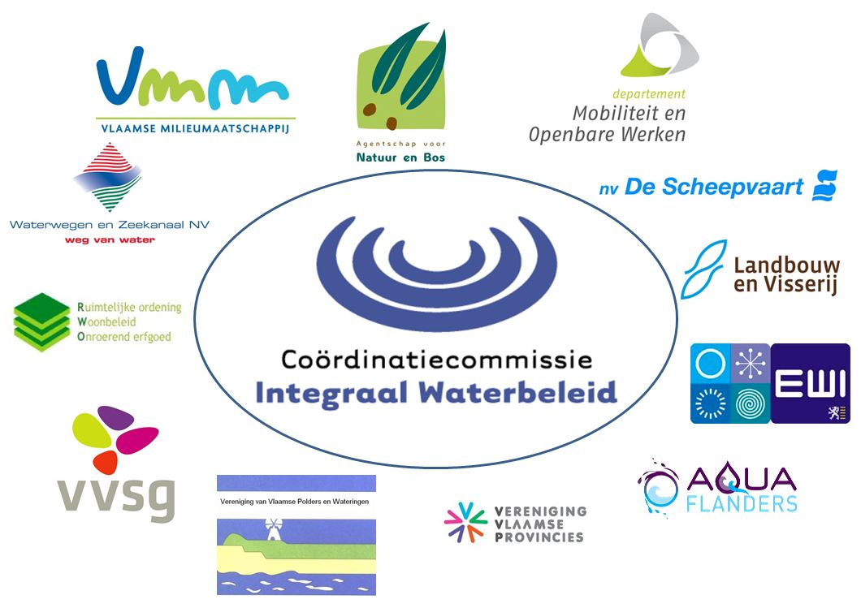

Figure 3.1: Organogram of the Competent Authority for the Flemish Region: CIW and its member administrations and entities.
Source: BE-Flanders authorities

RBMPs - Structure, completeness, legal status
For the Flemish region, the RBMPs are planning documents approved by Governmental Decision. In the hierarchy of legal acts, on the one hand, it falls under laws and regulations (decrees) so cannot contradict other laws and regulations. On the other hand, it stands above water-related administrative decisions including sub-basin management plans. Besides, it applies only on the river basin scale and to specific regional entities and authorities. Hence plans cannot modify national level administrative decisions.
As regards the legal effect, legislation provides that authorities must take into account the established RBMPs in their decision-making. Authorities’ decisions must be motivated in this respect and must take into consideration relevant set objectives. This has been confirmed by a decision of the Belgian Constitutional Court which stated that authorities must take the relevant water management plans into consideration in evaluating a programme, measure or permit. There is according to the legislation a relationship between the RBMPs and the individual permits, with a revision of permits if the environmental objectives are unlikely to be achieved. The Decree stipulates that where it appears from monitoring data or other information that the environmental objectives for water bodies will not be met, the Flemish Government ensures that the relevant permits and authorisations are examined and subject to revision if necessary. The permitting authorities are bound by this.
Concerning international co-operation, the RBMP makes reference to the "management plan roof report" which includes the multi-lateral (between MS and regions) co-operation activities. In Annex 1.1 a short description of this plan is given together with a link to the website of the international commissions where the plan can be retrieved.

Consultation of the public, engagement of interested parties
In Flanders, a campaign called "Vol van water" was used for the involvement of the public. Information on the draft RBMP was made available on the website of the campaign. Information on the public involvement was sent out through announcements in written press, radio and television. There was also a folder and a brochure available. The draft plans were available in town halls where it was possible to submit written remarks. The plan was accompanied by a manual that explained the consultation process, gave a summary of the different chapters and gave some illustrative questions for participation. It was even possible to give remarks online through the campaigns website. The CIW then submitted these remarks to a municipality and by this validated the remarks. For every sub-basin an information meeting was organized where questions on the plans could be formulated and formal remarks could be made. A workshop was organized with the three advisory bodies where they were given information and they could give their responses to the plans.
Also the international parts of the RBMPs have been under consultation and all the relevant competent authorities of other Member States have been contacted to participate. Information on the consultation processes in different Member States has been exchanged between the partners of the international river basins.
The impact of the public consultation on the plans is described in a consideration document. There it is acknowledged that the received remarks have led to a substantial change of the draft plans within the legal provisions, both editorial and content-wise. The impact is described in that document. An annex to the document shows for each remark how it has been taken into account and if it has led to a change of the plan. Some of the adjustments are clarifications and refinements to the text or the information sheets of the measures; refinement and complementing of certain data; clarifications on the co-operation at the bi- and multilateral level and an optimisation of the scenarios. Some of the recommendations that have been included in the CIW working plan of 2010 are greater involvement of the civil society; better co-ordination between the different planning cycles; clearer linkage of measures to specific actions and the consideration of smaller water bodies to be included in the second RBMP.
The RBMP for the Coastal Waters also include a transparent explanation of the feedback received during the public consultation and whether and how this feedback was integrated in the final draft of the RBMP.

International cooperation and coordination
The two RBDs in the Flemish Region are both international. Agreements on the international co-ordination of the implementation of the WFD and the approach to other issues such as the protection against floods in the international river basins have been made in the treaties of Ghent in 2002. The international co-ordination is carried out in the International Scheldt Commission and the International Meuse Commission.
For these two international river basins there are international plans that address the effects of the international co-ordination activities. These plans can be downloaded from the websites of the international commissions. The Flemish RBMPs do not address international co-ordination specifically.
In the Scheldt RBMP it is however mentioned that the standards and classes for physico-chemical parameters have been partly aligned with standard proposals in the Netherlands, France and the Walloon Region. Bilateral consultation and co-ordination is also taking place for issues such as environmental objectives, programme of measures, monitoring, chemical and ecological status and impacts. This is carried out between Member States or regions that share certain water bodies. This work is carried out both within and outside of the international Scheldt commission.

Integration with other sectors
In Annex 1.2 of the RBMP, other plans and programmes relevant to water management and water policy are mentioned together with a summary. Although several of these plans and programmes are mainly addressing water management issues, some have a much broader scope such as the spatial master plan for Flanders.

Characterisation of river basin districts

Water categories in the RBD
In the Flemish Region there are water bodies of all four water body categories (rivers, lakes, transitional and coastal waters). The transitional water bodies have been delineated mainly on the basis of salinity.

Typology of surface waters
RBD | Rivers | Lakes | Transitional | Coastal
BEMaas_VL | 8 | 9 | 0 | 0
BESchelde_VL | 10 | 13 | 4 | 1
BENoordzee_FED | 0 | 0 | 0 | 1
Table 4.1: Surface water body types at RBD level
Source: WISE
In Flanders, a surface water typology has been developed for all water categories, based on system B of the WFD. The RBMPs do not refer to validation of the typology using biological data or to the establishment of reference conditions.
According to recent information provided by Flanders, reference conditions are developed by experts for each BQE and water category. Since there are no reference conditions in Flanders, expert judgement, modelling and data from other member states have been used. These studies have been published in research papers and in some cases peer-reviewed journals. The results have been checked against those of the intercalibration exercise.
In Flanders a total of 26 water body types are defined of which there are 10 river water body types, 12 lake water body types, 3 transitional water body types and 1 coastal water body type. These types include, however, smaller water bodies that are not addressed in the RBMPs. Information on the water body types that are addressed in the RBMPs is given in the next table. It is mentioned in a separate document referred to in the RBMP, that the coastal water body in Flanders will change water body category to a transitional water body. It seems that this has been the reason to not address the coastal water body for monitoring, status assessment and measures. Information on this should have been mentioned more clearly in the RBMP. In the rest of this report, the coastal water body will not be mentioned explicitly since no further information on this has been found.
In the Coastal Waters, the typology of the Belgian coastal waters has been done with system B. The definition of the water type was done with an assessment of latitude, longitude salinity and tidal range. Furthermore, other factors such as substratum and current velocity have been taken into consideration for the differentiation of the different coastal water types in the Scheldt RBD.

 | Number of water body types | No. of water bodies | Average length/area
Rivers | 11 | 177 | 14 km
Lakes | 13 | 18 | 2.2 km²
Transitional waters | 4 | 6 | 7 km²
Coastal waters | 2 | 2 | 715 km^{2*}
Table 4.2: Surface water body types for the two Flemish river basins.
Source: WISE
*This value applies to Belgian territorial waters (12 nautical miles)

Delineation of surface water and groundwater bodies
RBD | Surface Water |  |  |  |  |  |  |  | Groundwater
RBD | Rivers |  | Lakes |  | Transitional |  | Coastal
RBD | Number | Average Length (km) | Number | Average Area  (sq km) | Number | Average Area  (sq km) | Number | Average Area  (sq km) | Number | Average Area  (sq km)
BEMaas_VL | 17 | 16 | 3 | 2 | 0 |  | 0 |  | 10 | 351
BESchelde_VL | 160 | 14 | 15 | 2 | 6 | 7 | 1 | 1 | 32 | 1360
BENoordzee_FED | 0 | 0 | 0 | 0 | 0 | 0 | 1 | 1428 | 0 | 0
Total | 177 | 14 | 18 | 2 | 6 | 7 | 2 | 1 | 42 | 1120
Table 4.3: Surface water bodies, groundwater bodies and their dimensions
Source: WISE

A distinction is made between larger Flemish water bodies and smaller local water bodies. Although there are also environmental objectives for the latter, the plan states that these are not addressed in the plan. The limit for classification as a Flemish water body is 50 ha for lakes and a catchment area of 50 km² for rivers.

Identification of significant pressures and impacts
Pressures are considered as significant if there is a risk of not achieving WFD objectives. The RBMP states that these pressures are related to the intensive use of land, demographic pressures, economic activities and pollution coming from other countries, regions and river basins. The most significant pressures on surface water are pollution from point and diffuse sources and hydro-morphological alterations. For groundwater the most significant pressures are pollution from point and diffuse sources and groundwater abstractions.
Several methodologies are used for defining significant pressures. For surface water pollution with nutrients and oxygen-binding substances an emission inventory, models and estimations are used for UWWT plants, industry and agriculture. For the significance of groundwater abstractions, permits are used.
For groundwater and sediment pollution, monitoring data are used. For some pressures thresholds are used in determining their significance. For point sources to surface water the size of the UWWT plant, the type of industry (IPPC or not) and the pollution loads coming from the industrial non-IPPC plants are used. For surface water abstraction there is a threshold of 500 000 m³ per year per water body. For groundwater point source pollution, the volume of groundwater that is polluted and exceeds the Flemish soil remediation standards without remedial action being taking is used as a threshold. No thresholds are given for diffuse pollution to either surface or groundwater or for groundwater abstraction. The pollution thresholds are also mainly related to nutrients and oxygen-binding substances. The significance of hydro-morphological pressures is determined by the designation as an artificial or heavily modified water body. Water bodies with heavily polluted sediments are also undergoing significant pressures. Monitoring data from stations at the border of the Flemish region have been used for determining water bodies that undergo pressures from incoming pollution loads.
Most information on thresholds is given in WISE. The RBMP gives information on several significant pressures and gives data on pollution loads and abstractions.

RBD | No pressures |  | Point source |  | Diffuse source |  | Water abstraction |  | Water flow regulations and morphological  alterations |  | River management |  | Transitional and coastal water management |  | Other morphological alterations |  | Other pressures
RBD | No. | % | No. | % | No. | % | No. | % | No | % | No. | % | No. | % | No. | % | No. | %
BEMaas_VL | 0 | 0 | 4 | 20 | 20 | 100 | 1 | 5 | 12 | 60 | 0 | 0 | 0 | 0 | 0 | 0 | 3 | 15
BESchelde_VL | 0 | 0 | 83 | 45.6 | 182 | 100 | 13 | 7.14 | 151 | 82.97 | 0 | 0 | 0 | 0 | 0 | 0 | 50 | 27.47
BENoordzee_FED | 1 | 100 | 0 | 0 | 0 | 0 | 0 | 0 | 0 | 0 | 0 | 0 | 0 | 0 | 0 | 0 | 0 | 0
Total | 1 | 0.49 | 87 | 42.86 | 202 | 99.51 | 14 | 6.9 | 163 | 80.3 | 0 | 0 | 0 | 0 | 0 | 0 | 53 | 26.11

Table 4.4: Number and percentage of surface water bodies affected by significant pressures
Source: WISE

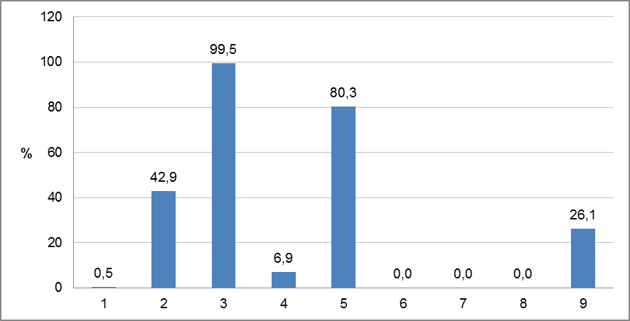
Figure 4.1: Graph of percentage of surface water bodies affected by significant pressures

1 = No pressures
2 = Point source
3 = Diffuse source
4 = Water abstraction
5 = Water flow regulations and morphological alterations

6 = River management
7 = Transitional and coastal water management
8 = Other morphological alterations
9 = Other pressures

Source: WISE

For surface water pollution with nutrients and oxygen-binding substances (BOD, COD), households and agriculture are the most important contributors, with the former being the main polluter with COD, BOD and total phosphorous and the latter the main polluter with total nitrogen in the Scheldt river basin. Agriculture is the main polluter in the Meuse basin. Industry comes in third place, but has a significantly lower contribution. For heavy metals the main sources of pollution are diffuse, leaching from soils and building materials, atmospheric deposition, transport, leaching from Cu-containing paints on ships and the use of wood preservation products. The importance of the different sources depends on the heavy metal. Households and enterprises are also significant contributors, although their share has declined. Plant protection products and industrial pollutants also contribute to chemical pollution and are specifically related to the agricultural and industrial sectors. For diffuse pollution of groundwater, agriculture is contributing to both pollution with nutrients and pesticides, while the latter also comes from public services and households. The significant point source pollution is mainly caused by the non-ferrous metals industry.

In the Federal Coastal Waters RBMP, it is mentioned that data from the OSPAR Convention have been used in the identification of relevant pressures and terrestrial sources of pollution.
The main point source pollution to the coastal waters used to be the discharge of wastewater and, to a lesser extent from industrial discharges. From the late nineties, the wastewater and the industrial discharges were all closed. However, there is still pollution that comes from other parts of Belgium.
The impacts of diffuse source pollution mainly relate to the pollutants present in the rivers and canals, and through horizontal transportation from neighbouring countries (France and the Netherlands). In particular, the diffuse pollution is due to specific pollutants (Cu, Zn), pesticides (Lindane) and nutrients. Hydromorphological pressures are also identified, in particular the impact of the disposal of dredge material and coastal protection activities. The navigation activities in the North Sea are also identified as an important pressure in the Belgian coastal waters, as well as the fisheries, the introduction of alien species, and the military uses of the coast.

Protected areas
RBD | Number of PAs
RBD | Article 7 Abstraction for drinking water | Bathing | Birds | European Other | Fish | Habitats | Local | National | Nitrates | Shellfish | UWWT
BEMaas_VL | 29 | 1 | 2 |  |  | 10 |  |  | 1 |  | 1
BESchelde_VL | 139 | 1 | 12 |  |  | 16 |  |  | 1 | 1 | 1
BENoordzee_FED |  |  | 3 |  |  | 1 |  | 1
Total | 168 | 2 | 17 |  |  | 27 |  | 1 | 2 | 1 | 2
Table 4.5: Number of protected areas of all types in each RBD and for the whole country, for surface and groundwater
Source: WISE

Monitoring
Figure 5.1: Maps of surface water (left) and groundwater (right) monitoring stations
 | • |  | River monitoring stations
 | • |  | Lake monitoring stations
 | • |  | Transitional water monitoring stations
 | • |  | Coastal water monitoring stations
 | • |  | Unclassified surface water monitoring stations
 | • |  | Groundwater monitoring stations
Source: WISE
The following table indicates the quality elements monitored, as reported to WISE.

RBD | Rivers |  |  |  |  |  |  |  |  |  |  | Lakes
RBD | QE1.1 Phytoplankton | QE1.2 Other aquatic flora | QE1.2.3 Macrophytes | QE1.2.4 Phytobenthos | QE1.3 Benthic invertebrates | QE1.4 Fish | QE1.5 Other species | QE2 Hydromorphological QEs | QE3.1 General Parameters | QE3.3 on priority specific pollutants | QE3.4 Other national pollutants | QE1.1 Phytoplankton | QE1.2 Other aquatic flora | QE1.2.3 Macrophytes | QE1.2.4 Phytobenthos | QE1.3 Benthic invertebrates | QE1.4 Fish | QE1.5 Other species | QE2 Hydromorphological QEs | QE3.1 General Parameters | QE3.3 Non priority specific pollutants | QE3.4 Other national pollutants
BEMaas_VL
BESchelde_VL
BENoordzee_FED | - | - | - | - | - | - | - | - | - | - | - | - | - | - | - | - | - | - | - | - | - | -

RBD | Transitional |  |  |  |  |  |  |  |  |  |  | Coastal
RBD | QE1.1 Phytoplankton | QE1.2 Other aquatic flora | QE1.2.1 Microalgae | QE1.2.2 Angiosperms | QE1.3 Benthic invertebrates | QE1.4 Fish | QE1.5 Other species | QE2 Hydromorphological QEs | QE3.1 General Parameters | QE3.3 Non priority specific pollutants | QE3.4 Other national pollutants | QE1.1 Phytoplankton | QE1.2 Other aquatic flora | QE1.2.1 Microalgae | QE1.2.2 Angiosperms | QE1.3 Benthic invertebrates | QE1.4 Fish | QE1.5 Other species | QE2 Hydromorphological QEs | QE3.1 General Parameters | QE3.3 Non priority specific pollutants | QE3.4 Other national pollutants
BEMaas_VL | - | - | - | - | - | - | - | - | - | - | - | - | - | - | - | - | - | - | - | - | - | -
BESchelde_VL
BENoordzee_FED | - | - | - | - | - | - | - | - | - | - | -
Table 5.1: Quality elements monitored
 |  | QE Monitored
 |  | QE Not monitored
- |  | Not Relevant
Source: WISE
It is not possible to compare the number of monitoring stations with the number that is included in the 2009 implementation report, since that number applies to the entire MS Belgium. This explains why for almost all water body categories more monitoring stations were reported in the 2009 implementation report. For lakes however more monitoring stations have been reported than in the 2009 implementation report (Surv 11 vs. 10, Op 51 vs. 36).
RBD | Rivers |  | Lakes |  | Transitional |  | Coastal |  | Groundwater
RBD | Surv | Op | Surv | Op | Surv | Op | Surv | Op | Surv | Op | Quant
BEMaas_VL | 6 | 38 | 3 | 10 | 0 | 0 | 0 | 0 | 10 | 10 | 10
BESchelde_VL | 65 | 385 | 8 | 41 | 6 | 13 | 0 | 0 | 32 | 32 | 32
BENoordzee_FED | 0 | 0 | 0 | 0 | 0 | 0 | 4 | 5
Total by type of site | 71 | 423 | 11 | 51 | 6 | 13 | 4 | 5 | 42 | 42 | 42
Total number of monitoring sites | 424 |  | 51 |  | 13 |  | 5 |  | 42
Table 5.2: Number of monitoring sites by water category.
Surv = Surveillance, Op = Operational, Quant = Quantitative
Source: WISE

Monitoring of surface waters
In Flanders, an overview of the parameters monitored and the monitoring frequency is given in the RBMPs and WISE. All relevant quality elements are monitored for rivers and lakes. For transitional water bodies one BQE, macroalgae, is missing. All the relevant priority substances and other specific pollutants except for pentabromodiphenylether, C10-13-chloralkanes and DEHP (di(2-ethylhexyl)phthalate) were monitored in 2007. This is explained by Flanders by the lack of suitable analysis methods. According to recent information from Flanders polybromodiphenylethers are monitored in sediment and DEHP is monitored in surface water at the moment. There is also a sediment monitoring programme in place that monitors physico-chemistry, eco-toxicology and biology.
In the RBMP there is no information on how BQEs have been selected for operational monitoring. According to recent information received from Flanders no selection has been made since there are often several pressures at the same time and the knowledge of the ecological status was incomplete.
Not all the quality elements are monitored for all water bodies; however, no grouping of water bodies has been applied.
Regarding international co-operation, no information is found in the RBMPs. Some information on co-ordination of monitoring is given in the management roof reports that are made by the International Scheldt and Meuse Commissions.
In the Scheldt river basin there is a homogenous monitoring network where, at 14 monitoring points along the river Scheldt, 36 chemical and physico-chemical parameters are monitored every four weeks. Once a year a report is made that assesses the evolution of the chemical quality of the water. According to information from Flanders, this monitoring programme has been extended. In the context of the Scaldwin project there will be transboundary monitoring of sediment loads.
The monitoring network in the Coastal Waters is based on the existing monitoring of the OSPAR Convention, and has been adapted to the requirements of the WFD. There are a total of six monitoring sites. The biological quality elements (BQEs) that are being monitored are chlorophyll a and Phaeocystis for phytoplankton and macrobenthos. The relevant physico-chemical parameters are also claimed to be monitored.

Monitoring of groundwater
In Flanders, both surveillance and operational monitoring programmes have been established for groundwater covering both quantitative and chemical status. For the operational monitoring programme the RBMP mentions that risk parameters and risk zones are monitored through a water body specific selection of wells with measurements every 6 months, with the possibility for higher frequency measurements in problem areas. In the RBMP an overview of the monitoring frequencies is given.
No assessment of significant and sustained upward trends in pollutant concentrations for groundwater has been carried out. Recent information from Flanders explains that the setup of the monitoring networks allows for this analysis but that the groundwater monitoring networks for the WFD have only been fully operational since 2004 which is insufficient for such an analysis.
The RBMPs do not address the international co-ordination of groundwater monitoring. More information on this is found in the management plan roof reports. For the Scheldt river basin an example is given of a co-ordinated quantitative monitoring campaign for the groundwater body in the cross-boundary Carboniferous Limestone Aquifer shared by the Flemish Region (BEVL063), France (FRA015) and the Walloon Region (BE_Escaut_RWE060).

Monitoring of protected areas
For protected areas in Flanders designated under the Habitats Directive the surface water monitoring network is linked to the surface water monitoring network for the WFD. All the biological quality elements are monitored in the surface waters of the Habitats Directive monitoring network. For protected nature reserves (not always located in designated Natura 2000 areas), monitoring for groundwater is included in the general groundwater monitoring programme.
For surface water monitoring in protected areas designated
- For the protection of economically significant aquatic species (Directive 2006/113/EC);
- As recreational waters, including areas designated as bathing waters under Directive 76/160/EEC;
- As vulnerable zones under Directive 91/676/EEC and areas designated as sensitive areas under Directive 91/271/EEC;
- Monitoring is carried out as requested by the respective Directives.
Monitoring of surface waters used for human consumption is not done according to the provisions of Annex V 1.3.5, since there are no discharges of priority substances or other substances in significant quantities. Rivers feeding into reservoirs are monitored according to Flemish legislation, the same applies to groundwater used for human consumption.
RBD | Surface waters |  |  |  |  |  |  |  |  | Ground-water drinking water
RBD | Surface drinking water abstraction | Quality of drinking water | Bathing water | Birds sites | Fish | Habitats sites | Nitrates | Shell-  fish | UWWT | Ground-water drinking water
BEMaas_VL | 0 | 0 | 0 | 0 | 0 | 0 | 0 | 0 | 0 | 0
BESchelde_VL | 0 | 0 | 0 | 0 | 0 | 0 | 0 | 3 | 0 | 9
BENoordzee_FED | 0 | 0 | 0 | 3 | 0 | 2 | 0 | 0 | 0 | 0
Total | 0 | 0 | 0 | 3 | 0 | 2 | 0 | 3 | 0 | 9
Table 5.3: Number of monitoring stations in protected areas.
Source: WISE

Overview of status (ecological, chemical, groundwater)
RBD | Total | High |  | Good |  | Moderate |  | Poor |  | Bad |  | Unknown
RBD | Total | No. | (%) | No. | (%) | No. | (%) | No. | (%) | No. | (%) | No. | (%)
BEMaas_VL | 8 | 0 | 0 | 0 | 0 | 4 | 50 | 3 | 37.5 | 1 | 12.5 | 0 | 0
BESchelde_VL | 41 | 0 | 0 | 0 | 0 | 4 | 9.8 | 17 | 41.5 | 19 | 46.3 | 1 | 2.4
BENoordzee_FED | 1 | 0 | 0 | 0 | 0 | 1 | 100 | 0 | 0 | 0 | 0 | 0 | 0
Total | 50 | 0 | 0 | 0 | 0 | 9 | 18 | 20 | 40 | 20 | 40 | 1 | 2
Table 6.1: Ecological status of natural surface water bodies.
Source: WISE

RBD | Total | High |  | Good |  | Moderate |  | Poor |  | Bad |  | Unknown
RBD | Total | No. | (%) | No. | (%) | No. | (%) | No. | (%) | No. | (%) | No. | (%)
BEMaas_VL | 12 | 0 | 0 | 0 | 0 | 6 | 50 | 4 | 33.3 | 2 | 16.7 | 0 | 0
BESchelde_VL | 141 | 0 | 0 | 0 | 0 | 25 | 17.7 | 37 | 26.2 | 77 | 54.6 | 2 | 1.4
BENoordzee_FED | 0 | 0 | 0 | 0 | 0 | 0 | 0 | 0 | 0 | 0 | 0 | 0 | 0
Total | 153 | 0 | 0 | 0 | 0 | 31 | 20.3 | 41 | 26.8 | 79 | 51.6 | 2 | 1.3
Table 6.2: Ecological potential of artificial and heavily modified water bodies.
Source: WISE

RBD | Total | Good |  | Poor |  | Unknown
RBD | Total | No. | % | No. | % | No. | %
BEMaas_VL | 8 | 2 | 25.0 | 1 | 12.5 | 5 | 62.5
BESchelde_VL | 41 | 18 | 43.9 | 6 | 14.6 | 17 | 41.5
BENoordzee_FED | 1 | 0 | 0 | 1 | 100 | 0 | 0
Total | 50 | 20 | 40.0 | 8 | 16.0 | 22 | 44.0
Table 6.3: Chemical status of natural surface water bodies.
Source: WISE

RBD | Total | Good |  | Poor |  | Unknown
RBD | Total | No. | % | No. | % | No. | %
BEMaas_VL | 12 | 2 | 16.7 | 3 | 25.0 | 7 | 58.3
BESchelde_VL | 141 | 27 | 19.1 | 46 | 32.6 | 68 | 48.2
BENoordzee_FED | 0 | 0 | 0 | 0 | 0 | 0 | 0
Total | 153 | 29 | 19.0 | 49 | 32.0 | 75 | 49.0
Table 6.4: Chemical status of artificial and heavily modified surface water bodies.
Source: WISE

RBD | Good |  | Poor |  | Unknown
RBD | No. | % | No. | % | No. | %
BEMaas_VL | 4 | 40 | 6 | 60 | 0 | 0
BESchelde_VL | 7 | 21.9 | 25 | 78.1 | 0 | 0
BENoordzee_FED | 0 | 0 | 0 | 0 | 0 | 0
Total | 11 | 26.2 | 31 | 73.8 | 0 | 0
Table 6.5: Chemical status of groundwater bodies.
Source: WISE

RBD | Good |  | Poor |  | Unknown
RBD | No. | % | No. | % | No. | %
BEMaas_VL | 9 | 90 | 1 | 10 | 0 | 0
BESchelde_VL | 19 | 59.4 | 13 | 40.6 | 0 | 0
BENoordzee_FED | 0 | 0 | 0 | 0 | 0 | 0
Total | 28 | 66.7 | 14 | 33.3 | 0 | 0
Table 6.6: Quantitative status of groundwater bodies.
Source: WISE

RBD | Total | Global status (ecological and chemical) |  |  |  |  | Good ecological status 2021 |  | Good chemical status 2021 |  | Good ecological status 2027 |  | Good chemical status 2027 |  | Global exemptions 2009 (% of all SWBs)
RBD | Total | Good or better 2009 |  | Good or better 2015 |  | Increase 2009 -2015 |  |  |  |  |  |  |  |  | Art 4.4 | Art 4.5 | Art 4.6 | Art 4.7
RBD | Total | No. | % | No. | % | % | No. | % | No. | % | No. | % | No. | % | % | % | % | %
BEMaas_VL | 20 | 0 | 0 | 1 | 5 | 5 |  |  |  |  |  |  |  |  | 90 | 0 | 0 | 0
BESchelde_VL | 182 | 0 | 0 | 0 | 0 | 0 |  |  |  |  |  |  |  |  | 97 | 0 | 0 | 0
BENoordzee_FED | 1 | 0 | 0 | 1 | 100 | 100 |  |  |  |  |  |  |  |  | 0 | 0 | 0 | 0
Total | 203 | 0 | 0 | 2 | 1 | 1 |  |  |  |  |  |  |  |  | 96 | 0 | 0 | 0
Table 6.7: Surface water bodies: overview of status in 2009 and expected status in 2015, 2021 and 2027
Waterbodies with good status in 2009 fall into the following category:
1. Ecological status is high or good and the chemical status is good, exemptions are not considered
Waterbodies expected to achieve good status in 2015 fall into the following categories:
1. Ecological status is high or good and the chemical status is good, exemptions are not considered
2. Chemical status is good, and the ecological status is moderate or below but no ecological exemptions
3. Ecological status is high or good, and the chemical status is failing to achieve good but there are no chemical exemptions
4. Ecological status is moderate or below, and chemical status is failing to achieve good but there are no ecological nor chemical exemptions
Note: Waterbodies with unknown/unclassified/Not applicable in either ecological or chemical status are not considered
Source: WISE (for data on status in 2009, 2015 and exemptions) and RBMPs (for data on status in 2021 and 2027)

RBD | Total | Ecological status |  |  |  |  | Good ecological status 2021 |  | Good ecological status 2027 |  | Ecological exemptions (% of all SWBs)
RBD | Total | Good or better 2009 |  | Good or better 2015 |  | Increase 2009 -2015 |  |  |  |  | Art 4.4 | Art 4.5 | Art 4.6 | Art 4.7
RBD | Total | No. | % | No. | % | % | No. | % | No. | % | % | % | % | %
BEMaas_VL | 8 | 0 | 0 | 2 | 25.0 | 25.0 |  |  |  |  | 6 | 75.0 | 0 | 0
BESchelde_VL | 41 | 0 | 0 | 2 | 4.9 | 4.9 |  |  |  |  | 39 | 95.1 | 0 | 0
BENoordzee_FED | 1 | 0 | 0 | 1 | 100 | 100 |  |  |  |  | 0 | 0 | 0 | 0
Total | 50 | 0 | 0 | 5 | 10.0 | 10.0 |  |  |  |  | 45 | 90.0 | 0 | 0
Table 6.8: Natural surface water bodies: ecological status in 2009 and expected status in 2015, 2021 and 2027
Source: WISE (for data on status in 2009, 2015 and exemptions) and RBMPs (for data on status in 2021 and 2027)
RBD | Total | Chemical status |  |  |  |  | Good chemical status 2021 |  | Good chemical status 2027 |  | Chemical exemptions (% of all SWBs)
RBD | Total | Good or better 2009 |  | Good or better 2015 |  | Increase 2009 -2015 |  |  |  |  | Art 4.4 | Art 4.5 | Art 4.6 | Art 4.7
RBD | Total | No. | % | No. | % | % | No. | % | No. | % | % | % | % | %
BEMaas_VL | 8 | 2 | 25.0 | 2 | 25.0 | 0 |  |  |  |  | 12.5 | 0 | 0 | 0
BESchelde_VL | 41 | 18 | 43.9 | 18 | 43.9 | 0 |  |  |  |  | 14.6 | 0 | 0 | 0
BENoordzee_FED | 1 | 0 | 0.0 | 1 | 100 | 100 |  |  |  |  | 0 | 0 | 0 | 0
Total | 50 | 20 | 40.0 | 21 | 42.0 | 2.0 |  |  |  |  | 14.0 | 0 | 0 | 0
Table 6.9: Natural surface water bodies: chemical status in 2009 and expected status in 2015, 2021 and 2027
Source: WISE (for data on status in 2009, 2015 and exemptions) and RBMPs (for data on status in 2021 and 2027)
RBD | Total | Groundwater chemical status |  |  |  |  | Good chemical status 2021 |  | Good chemical status 2027 |  | GW chemical exemptions (% of all GWBs)
RBD | Total | Good or better 2009 |  | Good or better 2015 |  | Increase 2009 -2015 |  |  |  |  | Art 4.4 | Art 4.5 | Art 4.6 | Art 4.7
RBD | Total | No. | % | No. | % | % | No. | % | No. | % | % | % | % | %
BEMaas_VL | 10 | 4 | 40.0 | 4 | 4..0 | 0 |  |  |  |  | 60 | 0 | 0 | 0
BESchelde_VL | 32 | 7 | 21.9 | 7 | 21.9 | 0 |  |  |  |  | 78 | 0 | 0 | 0
BENoordzee_FED | 0 | 0 | 0 | 0 | 0 | 0 |  |  |  |  | 0 | 0 | 0 | 0
Total | 42 | 11 | 26.2 | 11 | 26.2 | 0 |  |  |  |  | 74 | 0 | 0 | 0
Table 6.10: Groundwater bodies: chemical status in 2009 and expected status in 2015, 2021 and 2027
Source: WISE (for data on status in 2009, 2015 and exemptions) and RBMPs (for data on status in 2021 and 2027)
RBD | Total | Groundwater quantitative status |  |  |  |  | Good quantitative status 2021 |  | Good quantitative status 2027 |  | GW quantitative exemptions (% of all GWBs)
RBD | Total | Good or better 2009 |  | Good or better 2015 |  | Increase 2009 -2015 |  |  |  |  | Art 4.4 | Art 4.5 | Art 4.6 | Art 4.7
RBD | Total | No. | % | No. | % | % | No. | % | No. | % | % | % | % | %
BEMaas_VL | 10 | 9 | 90.0 | 9 | 90.0 | 0 |  |  |  |  | 10 | 0 | 0 | 0
BESchelde_VL | 32 | 19 | 59.4 | 19 | 59.4 | 0 |  |  |  |  | 41 | 0 | 0 | 0
BENoordzee_FED | 0 | 0 | 0 | 0 | 0 | 0 |  |  |  |  | 0 | 0 | 0 | 0
Total | 42 | 28 | 66.7 | 28 | 66.7 | 0 |  |  |  |  | 33 | 0 | 0 | 0
Table 6.11: Groundwater bodies: quantitative status in 2009 and expected status in 2015, 2021 and 2027
Source: WISE (for data on status in 2009, 2015 and exemptions) and RBMPs (for data on status in 2021 and 2027)

RBD | Total  HMWB and AWB | Ecological potential |  |  |  |  | Good ecological potential 2021 |  | Good ecological potential 2027 |  | Ecological exemptions (% of all HMWB/AWB)
RBD | Total  HMWB and AWB | Good or better 2009 |  | Good or better 2015 |  | Increase 2009 -2015 |  |  |  |  | Art 4.4 | Art 4.5 | Art 4.6 | Art 4.7
RBD | Total  HMWB and AWB | No. | % | No. | % | % | No. | % | No. | % | % | % | % | %
BEMaas_VL | 12 | 0 | 0 | 3 | 25.0 | 25.0 |  |  |  |  | 100 | 0 | 0 | 0
BESchelde_VL | 141 | 0 | 0 | 0 | 0 | 0 |  |  |  |  | 96.5 | 0 | 0 | 0
BENoordzee_FED | 0 | 0 | 0 | 0 | 0 | 0 |  |  |  |  | 0 | 0 | 0 | 0
Total | 153 | 0 | 0 | 3 | 2.0 | 2.0 |  |  |  |  | 96.7 | 0 | 0 | 0
Table 6.12: Heavily modified and artificial water bodies: ecological potential in 2009 and expected ecological potential in 2015, 2021 and 2027
Source: WISE (for data on status in 2009, 2015 and exemptions) and RBMPs (for data on status in 2021 and 2027)
RBD | Total  HMWB and AWB | Chemical status |  |  |  |  | Good chemical status 2021 |  | Good chemical status 2027 |  | Chemical exemptions (% of all HMWB/AWB)
RBD | Total  HMWB and AWB | Good or better 2009 |  | Good or better 2015 |  | Increase 2009 -2015 |  |  |  |  | Art 4.4 | Art 4.5 | Art 4.6 | Art 4.7
RBD | Total  HMWB and AWB | No. | % | No. | % | % | No. | % | No. | % | % | % | % | %
BEMaas_VL | 12 | 2 | 16.7 | 2 | 16.7 | 0 |  |  |  |  | 25.0 | 0 | 0 | 0
BESchelde_VL | 141 | 27 | 19.1 | 27 | 19.1 | 0 |  |  |  |  | 32.6 | 0 | 0 | 0
BENoordzee_FED | 0 | 0 | 0 | 0 | 0 | 0 |  |  |  |  | 0 | 0 | 0 | 0
Total | 153 | 29 | 19.0 | 29 | 19.0 | 0 |  |  |  |  | 32.0 | 0 | 0 | 0
Table 6.13: Heavily modified and artificial water bodies: chemical status in 2009 and expected status in 2015, 2021 and 2027
Source: WISE (for data on status in 2009, 2015 and exemptions) and RBMPs (for data on status in 2021 and 2027)
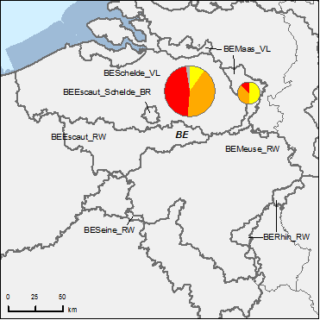
Figure 6.1: Map of ecological status of natural surface water bodies 2009
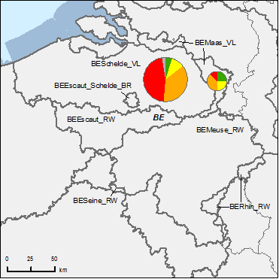
High
Good
Moderate
Poor
Bad
Unknown
River Basin Districts
Countries outside EU
Figure 6.2: Map of ecological status of natural surface water bodies 2015
Note: Standard colours based on WFD Annex V, Article 1.4.2(i).
Source: WISE, Eurostat (country borders)
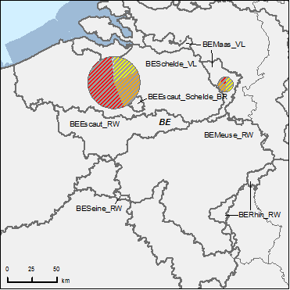
Figure 6.3: Map of ecological potential of artificial and heavily modified water bodies 2009
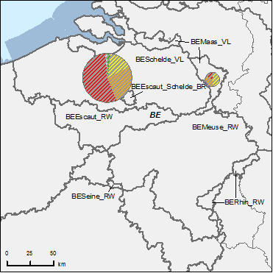
Good or better
Moderate
Poor
Bad
Unknown
River Basin Districts
Countries outside EU
Figure 6.4: Map of ecological potential of artificial and heavily modified water bodies 2015
Note: Standard colours based on WFD Annex V, Article 1.4.2(ii).
Source: WISE, Eurostat (country borders)
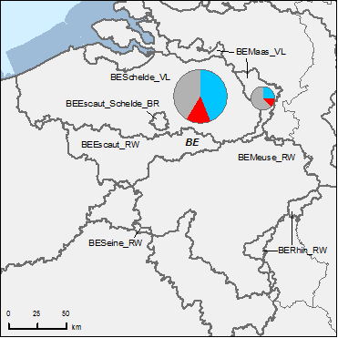
Figure 6.5: Map of chemical status of natural surface water bodies 2009
Good
Failing to achieve good
Unknown
River Basin Districts
Countries outside EU
Figure 6.6: Map of chemical status of natural surface water bodies 2015
Note: Standard colours based on WFD Annex V, Article 1.4.3.
Source: WISE, Eurostat (country borders)
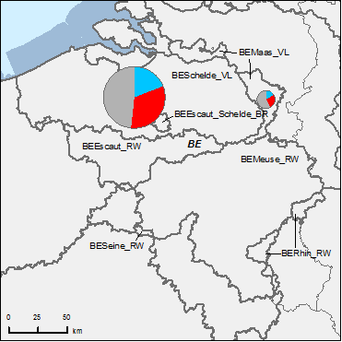
Figure 6.7: Map of chemical status of artificial and heavily modified water bodies 2009
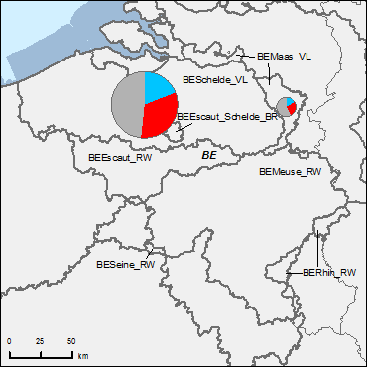
Good
Failing to achieve good
Unknown
River Basin Districts
Countries outside EU
Figure 6.8: Map of chemical status of artificial and heavily modified water bodies 2015
Note: Standard colours based on WFD Annex V, Article 1.4.3.
Source: WISE, Eurostat (country borders)
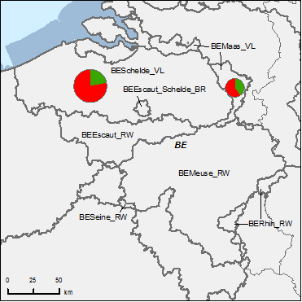
Figure 6.9: Map of chemical status of groundwater bodies 2009
Good
Poor
Unknown
River Basin Districts
Countries outside EU
Figure 6.10: Map of chemical status of groundwater bodies 2015
Note: Standard colours based on WFD Annex V, Article 2.4.5.
Source: WISE, Eurostat (country borders)

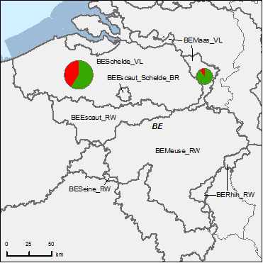
Figure 6.11: Map of quantitative status of groundwater bodies 2009
Good
Poor
Unknown
River Basin Districts
Countries outside EU
Figure 6.12: Map of quantitative status of groundwater bodies 2015
Note: Standard colours based on WFD Annex V, Article 2.2.4.
Source: WISE, Eurostat (country borders)

Assessment of ecological status of surface waters
A regional approach to ecological status assessment has been used.

Ecological status assessment methods
In Flanders, assessment methods are used for all biological quality elements for rivers and lakes although not all biological quality elements (BQEs) are assessed for all types of rivers and lakes. In the RBMP no assessment methods are mentioned for transitional water bodies. More information on assessment methods is however found in a separate document that is referred to in the RBMPs. There it is explained that because all transitional water bodies are either artificial or heavily modified only methods to assess the ecological potential are used since a method for assessing ecological status would not be applicable. There are ecological assessment methods, but these already take into account the hydro-morphological alterations since there are no natural transitional water bodies in Flanders. These methods are used for assessing status classes. These methods have not been developed for macroalgae because these do not or hardly thrive in the Flemish transitional waters and there is no evidence that the situation was much different in the past¹¹. Angiosperms are evaluated by means of a salt marsh assessment method. The assessment methods for transitional water bodies have been reported in the 2009 implementation report for phytoplankton, benthic invertebrates and fish. This can explain the misunderstanding on the definition of status assessment.
It is not clear from the RBMP if the biological assessment methods are able to detect major pressures. In WISE it is however explained that the no deterioration principle for the quality classes should be accompanied with a stand still principle for the human pressures.
Regarding the supporting elements for the biological assessment, class boundaries have been set for physico-chemical quality elements although it is not clear from the RBMP how these are related to the BQE classes. Recent information from Flanders states that the sensitivity of the BQEs to physico-chemical parameters has been taken into account and that these relations have been tested during the intercalibration exercise. For transitional water bodies salinity has not been considered as a supporting quality element since salinity has been a part of the typology of transitional water bodies. For hydro-morphological quality elements monitoring is carried out, but it is unclear how this is related in support of the biological assessment. Recent information from Flanders explains that these elements are not relevant since no surface water body has a high status and hydro-morphological quality elements would be the only contribution to high status. It is however mentioned that results of hydro-morphological monitoring will be included in the next RBMP. EQS have been set for more than 100 specific pollutants including both priority and non-priority substances.
For the status assessment the one-out-all-out principle has been used and the results from the intercalibration exercise have been taken into account. No information has been given on confidence and precision for the biological assessment and also no grouping of water bodies has been done.
BQE | Rivers | Lakes | Transitional
Phytoplankton | Yes | Yes | Not reported in RBMP
Macrophytes and Phytobenthos | Yes | Yes | Not relevant
Macroalgae and Angiosperms | Not relevant | Not relevant | No (Considered not relevant)
Benthic invertebrates | Yes | Yes | Not reported in RBMP¹³
Fish | Yes | Yes | Not reported in RBMP¹³
Table 7.1.1: Availability of data on BQEs in Flanders
Source: RBMPs

In the Coastal Waters assessment methods are used for Phytoplankton and Macroinvertebrates. The supporting physic-chemical QEs are nutrients (DIN and DIP) and oxygen. Salinity and pH, as well as hydromorphological parameters are also described, although not clear if included in assessment.
The one-out-all-out principle is used.

Application of methods and ecological status results
In Flanders, not all relevant BQEs and supporting quality elements have been monitored yet for all water bodies. According to recent information from Flanders, an inventory phase has been carried out in the first monitoring cycle (2009-2012) in order to get a full picture of the ecological status of all biological quality elements, but because of this timing no information has been included in the RBMP. Hydro-morphological quality elements have been monitored but not used for ecological status assessment.
As confirmed by the Flemish authorities, Maps 5.3 and 5.4 of the RBMP show that the BQE were decisive for the ecological status and not the supporting physico-chemical parameters. Information sheets for each of the surface water bodies are also available. The sheets on 'monitoring' contain monitoring results per water body.
RBD | Rivers |  |  |  |  |  |  | Lakes |  |  |  |  |  |  | Transitional |  |  |  |  |  |  | Coastal
RBD | Phytoplankton | Macrophytes | Phytobenthos | Benthic invertebrates | Fish | Physico-Chemical | Hydromorphological | Phytoplankton | Macrophytes | Phytobenthos | Benthic invertebrates | Fish | Physico-Chemical | Hydromorphological | Phytoplankton | Macroalgae | Angiosperms | Benthic invertebrates | Fish | Physico-Chemical | Hydromorphological | Phytoplankton | Macroalgae | Angiosperms | Benthic invertebrates | Physico-Chemical | Hydromorphological
BEMaas_VL |  |  |  |  |  |  |  |  |  |  |  |  |  |  | - | - | - | - | - | - | - | - | - | - | - | - | -
BESchelde_VL |  |  |  |  |  |  |  |  |  |  |  |  |  |  |  |  |  |  |  |  |  |  |  |  |  | -
BE_Nordzee_FED | - | - | - | - | - | - | - | - | - | - | - | - | - | - | - | - | - | - | - | - | -
Table 7.2: Availability of biological assessment methods
 |  | Assessment methods fully developed for all BQEs
 |  | Assessment methods partially developed or under development for all or some BQEs
 |  | Assessment methods not developed for BQEs, no information provided on the assessment methods, unclear information provided
- |  | Water category not relevant
Source: RBMPs

River basin specific pollutants
In the Flemish RBMPs, no information has been found on which river basin specific pollutants were responsible for exceedance of ecological status. Also information on uncertainty for the ecological status results is lacking. All the BQEs of the surveillance monitoring are also used for the operational monitoring. This has recently been explained by Flanders by the limited knowledge and experience in Flanders on the results of biological quality elements.
In the Coastal Waters, the assessment of ecological status has been based on the BQEs Phytoplankton and Macroinvertebrates, Nutrients and oxygen. River basin specific substances (Cu, Zn and PCBs) have been used for assessing chemical status.
RBD | CAS Number | Substance | Percentage Water Bodies Failing Status (%)
BEMaas_VL
BESchelde_VL
BE_Nordzee_FED | 7440-66-6 | Zinc and its compounds | 100
BE_Nordzee_FED | 7440-50-8 | Copper and its compounds | 100
BE_Nordzee_FED | 1336-36-3 | PCB | 100
Table 7.3: River basin specific pollutants
Source: WISE

Designation of heavily modified water bodies (hmwb) and assessment of good ecological potential
Figure 8.1: Map of percentage Heavily Modified and Artificial waterbodies by River Basin District
0 – 5 %
5 – 20 %
20 – 40 %
40 – 60%
60 – 100 %
No data reported
River Basin Districts (outside EU)
Countries outside EU
Source: WISE

Designation of HMWBs
Water category | HMWB  Number  (Percentage of category) |  |  |  | AWB  Number  (Percentage of category)
Water category | BESchelde_VL | BEMaas_VL | BE_Nordzee_FED | Total | BESchelde_VL | BEMaas_VL | BE_Nordzee_FED | Total
Rivers | 87  (54%) | 8  (47%) | 0  (0%) | 95  (54%) | 33  (21%) | 1  (6%) | 0  (0%) | 34  (19%)
Lakes | 1  (7%) | 0  (0%) | 0  (0%) | 1  (6%) | 14  (93%) | 3  (100%) | 0  (0%) | 17  (94%)
Transitional water | 3  (50%) | - | 0  (0%) | 3  (50%) | 3  (50%) | - | 0  (0%) | 3  (50%)
Coastal water | 0  (0%) | - | 0  (0%) | 0  (0%) | 0  (0%) | - | 0  (0%) | 0  (0%)
All water bodies | 91  (50%) |  |  | 99  (49%) | 50  (27%) |  | 0  (0%) | 54  (27%)
Table 8.1: Number and percentage of HMWBs and AWBs.
Source: WISE

In the Flemish RBMPs a methodology is described to objectivise the detection of 'irreversible hydro-morphological alterations'. For the different uses, different criteria are used for the designation of a HMWB. Expert judgement is used and for some uses also thresholds are being applied. For navigation, all water bodies in certain navigation water body classes are designated as HMWBs. A table in the RBMP shows for each water body the uses that are responsible for the designation as a HMWB.
There is no extensive description of the physical modifications that have led to the designation of HMWB and the focus is more on the use that is causing the water body to be heavily modified. The RBMP mentions that the interpretation of the definition of HMWBs according to Flemish legislation is slightly different from the WFD. According to the Flemish legislation water bodies can be designated as HMWBs if taking away or mitigating the hydro-morphological alterations would have negative effects on the environment, and activities of high societal importance. From this definition it can be derived that some aspects of the HMWB designation process have not clearly been addressed such as the link between the modifications and the failure to achieve good ecological status, the identification of restoration measures to achieve good ecological status and the assessment of other means to achieve the beneficial objectives of the use. Although the situation in Flanders related to water bodies with hydro-morphological modifications, the several steps of the assessment process should still be carried out and reflected in the RBMP.
The only non-artificial lake has been designated as a HMWB because of its artificial water level management. This information is however not included in the RBMP but in a separate study that is not mentioned in the plan.
No HMWBs or AWBs have been designated in the RBMP for the Belgian Coastal Waters.

Methodology for setting good ecological potential (GEP)
In the Flemish RBMPs, GEP has been defined for all heavily modified and artificial water bodies. A different approach is used depending on the water body category. For transitional water bodies the heavily modified character has already been taken into account in the status assessment since all transitional water bodies are HMWBs or artificial water bodies. For lakes, lake-specific studies have been carried out for determining MEP and GEP. For rivers a generic approach has been carried out consisting of four steps. Pressures are identified and a possible change of water body type is evaluated. Depending on the hydro-morphological alterations the objectives for macrophytes can be changed. For fish and macro-invertebrates the share of the river that undergoes a certain hydro-morphological pressure and the share that shows no alterations are taken into account together with the current status of the river and the GES of the corresponding natural river type to calculate a GEP. This GEP, by definition, lies between the current status and the GES and thereby is an objective that leads to ecological improvement. Also for a selection of physico-chemical quality elements class boundaries can be adapted. Annex 3 of the RBMP contains tables with GEP-values for dissolved oxygen, sulphates, conductivity and chlorides and the biological quality elements.
Neither the reference-based approach nor the mitigation measures approach has been followed. From the RBMP it is not clear how mitigation measures have been handled. It is only mentioned that for some hydro-morphological alterations some mitigation measures are already assumed. More information on the methodologies is given in a background document. This document also refers to the specific studies that have been carried out for determining the MEP/GEP for lakes and to a background document with more information on the general approach to MEP/GEP definition.

Assessment of chemical status of surface waters

Methodological approach to the assessment
The substances and standards listed in Annex I of the Environmental Quality Standards Directive (EQSD) are set out in the Flemish decree on Environmental Quality Standards of 21 May 2010.
All EQSD substances have been considered for the assessment of the chemical status. Three of them were however not monitored (C10-13 Chloroalkanes, pentabromodiphenylether and Di(2-ethylhexyl)-phthalate (DEHP)). From the RBMP it was not clear that the EQS for transitional water bodies had been applied, but recent information from Flanders has pointed out that these standards are included in the Flemish decree on EQS and that these have been used for the assessment of the chemical status of transitional water bodies. Although not clear from the RBMP, recent information from Flanders has shown that EQS for biota are developed for mercury, hexachlorobenzene and hexachlorobutadiene although they have not been applied in the RBMP because the monitoring network had not been adjusted to this. EQS for sediment have been developed but they serve as target values and are not used for the assessment of chemical status.
Substance causing exceedance | Exceedances per RBD |  | Exceedances in Flanders
Substance causing exceedance | BESchelde_VL | BEMaas_VL | Number of water bodies | Percentage of total number of water bodies
Cadmium | 1 (0.5%) | 1 (5%) | 2 | 1
Mercury | 9 (4.9%) |  | 9 | 4
Alachlor | 3 (1.6%) |  | 3 | 1
Chlorpyriphos | 3 (1.6%) | 1 (5%) | 4 | 2
Chlorvenfinphos | 4 (2.2%) |  | 4 | 2
Diuron | 18 (9.9%) |  | 18 | 9
Endosulfan | 3 (1.6%) |  | 3 | 1
Isoproturon | 4 (2.2%) |  | 4 | 2
Hexachlorocyclohexane | 4 (2.2%) |  | 4 | 2
Anthracene | 1 (0.5%) |  | 1 | 0
Nonylphenol | 17 (9.3%) |  | 17 | 8
Octylphenol | 1 (0.5%) |  | 1 | 0
Fluoranthene | 9 (4.9%) |  | 9 | 4
Pentachlorophenol | 4 (2.2%) |  | 4 | 2
Benzo(a)pyrene | 4 (2.2%) |  | 4 | 2
Benzo(b)fluoranthene | 16 (8.8%) |  | 16 | 8
Benzo(k)fluoranthene | 16 (8.8%) |  | 16 | 8
Benzo(g,h,i)perylene | 35 (19.2%) | 3 (15%) | 38 | 19
Indeno(1,2,3-cd)pyrene | 35 (19.2%) | 3 (15%) | 38 | 19
Tributyltin compounds | 14 (7.7%) |  | 14 | 7
Table 9.1: Substances responsible for exceedances
Source: WISE
The main problems regarding chemical pollution in the Belgian Coastal Waters are the polycyclic aromatic hydrocarbon and the TBT compounds. In the Coastal Waters, the exceedances of the EQS for Tributyltin compounds, Pentabromodiphenyl ether and Benzo(b)fluoranthene have led to bad chemical status of the coastal waters.
The chemical status assessment in the coastal waters includes all 41 priority substances according to the EU Directive 2008/105/EC, which entered into force on 13 January 2009. The chemical assessment is done as much as possible in water, although for 3 substances the assessment is done in biota.

Assessment of groundwater status
The Flemish RBMPs discuss the pressures on groundwater bodies. Of the 42 groundwater bodies in Flanders, 31 have a poor chemical status and 14 have a poor quantitative status. Because of the one-out-all-out principle, only 7 groundwater bodies achieve good status. There seems to be only information on the status and not on the risks.
Status | BESchelde_VL | BEMaas_VL | Total
Poor chemical status | 25 (78%) | 5 (50%) | 30 (71%)
Poor quantitative status | 13 (41%) | 1 (10%) | 14 (33%)
Good status | 7 (22%) | 4 (40%) | 11 (26%)
Table 10.1: Number and percentage of groundwater bodies and their status.
Source: WISE

Groundwater quantitative status
A methodology for the water balance test for the assessment of groundwater quantitative status is given in the Flemish RBMP which includes the influence of climate change. The RBMP mentions the effects on associated surface waters and groundwater dependent terrestrial ecosystems as two of the seven assessment criteria. There is however no further information found on the methodology used.
The only reason for groundwater bodies not achieving good quantitative status is 'exceedance of available groundwater resource by long-term annual average rate of abstraction that may result in a decrease of groundwater levels'.

Groundwater chemical status
Only 'exceedances of one or more quality standards or threshold values' has been given as a reason for failure to achieve good chemical status. There has not been an assessment of significant damage to groundwater dependent terrestrial ecosystems. This is explained in recent information from Flanders by insufficient data and knowledge on these interactions and the degree of negative effects on these ecosystems.
The substances for which threshold values are established are based on the list included in Annex II Part B of the Groundwater Directive and then adapted to the risks at groundwater bodies (threshold values were not established for three listed substances while Threshold Values (TVs) were added for six others). It is unclear how exceedances of threshold values have been dealt with. Background concentrations have been considered for several parameters. International co-ordination of TVs were done in terms of information and experience exchange on methodologies.
No trend assessment or trend reversals have been carried out because groundwater monitoring networks in accordance to the WFD have only been fully operational since 2004.

Protected areas
Information is given in WISE on the number of groundwater drinking protected areas and their status.
RBD | Good | Failing to achieve good | Unknown
BEMaas_VL | 22
BESchelde_VL | 112
Total | 134 | 0 | 0
Table 10.2: Status of groundwater drinking water protected areas
Source: WISE

Environmental objectives and exemptions

Exemptions according to Article 4(4) and 4(5)
In Flanders a very significant number of water bodies (96% of the total) have been exempted from achieving good status by 2015. In the Flemish RBMPs, there have only been exemptions under Article 4(4) extension of the deadline. It is mentioned that there is a lack of information in order to make use of Article 4(5), but that in the next RBMP this could be a possible option. To determine for which surface water bodies this exemption applies models and expert judgement are used. A Maximum Scenario is used, a scenario which comprises all the basic and supplementary measures for achieving good status in 2015. If modelling/expert judgement shows that it is not possible to meet good status by 2015 with this scenario then the exemption applies. For groundwater, 35 out of 42 water bodies have been exempted based on expert judgement and because of natural conditions (slow groundwater flows and geochemical processes). In WISE it is stated that a number of water bodies are exempted because of disproportionate costs. This explanation is however not used in the RBMP and according to recent information from Flanders, this reason has not been used on the water body level since this was not possible methodologically. The argument of 'disproportionality' is however used in the choice of a scenario for the programme of measures. Tables in the annexes of the RBMPs state for every water body the reason for exemption and on what this is based on (e.g. expert judgement, modelling).

In the RBMP for the Belgian Coastal Waters, the exemptions under Article 4(5) are also not used in this first planning cycle. The plan proposes the delay on the timeline for achieving the objectives under the provisions of Article 4(4). Furthermore, the methods for the assessment of chemical status will be reviewed in 2015 on the basis of additional monitoring data, which will allow for a more complete assessment.

RBD | Global
RBD | Technical feasibility |  | Disproportionate costs |  | Natural conditions
RBD | Article 4(4) | Article 4(5) | Article 4(4) | Article 4(5) | Article 4(4) | Article 4(5)
BEMaas_VL | 18 | 0 | 18 | 0 | 0 | -
BESchelde_VL | 177 | 0 | 177 | 0 | 0 | -
BE_Nordzee_FED | 0 | 0 | 0 | 0 | 0 | -
Total | 195 | 0 | 195 | 0 | 0 | 0
Table 11.1: Numbers of Article 4(4) and 4(5) exemptions
Source: WISE
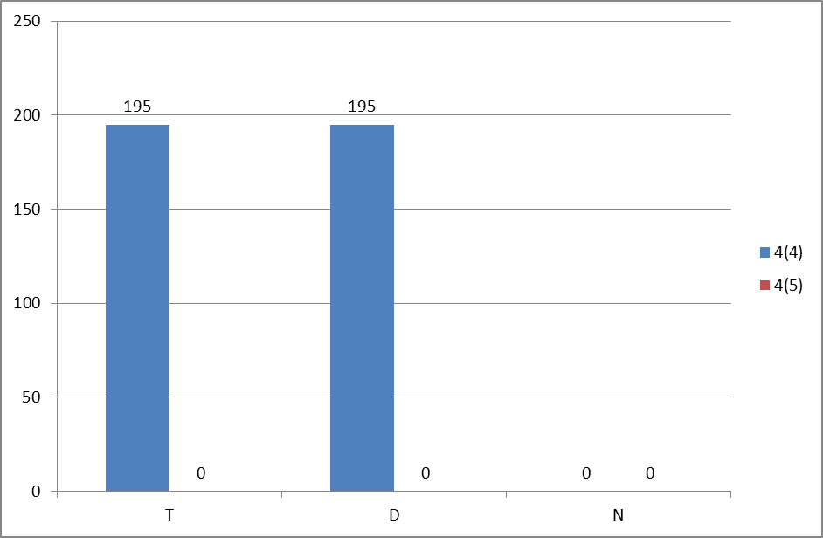

Figure 11.1: Numbers of Article 4(4) and 4(5) exemptions
T = Technical feasibility
D = Disproportionate costs
N = Natural conditions
Blue = Article 4(4) exemptions
Red = Article 4(5) exemptions
Source: WISE

Additional objectives in protected areas
The RBMPs mention additional objectives for two categories of protected areas, surface water protected areas for drinking water and protected areas under the Habitat and Bird Directives and the Ramsar convention.

Programmes of measures
According to Annex VII of the WFD, the RBMPs should contain a summary of the programmes of measures (PoM), including the ways in which Member States expect to achieve the objectives of WFD Article 4. The programmes should have been established by 2009, but are required to become operational only by December 2012. The assessment in this section is based on the PoM as summarised by the Member State in its RBMP, and the compliance of this with the requirements of Article 11 and Annex VII of the WFD.
It therefore does not include a comprehensive assessment of compliance with the requirements of Article 11(3) on basic measures. It focuses in particular on key sets of measures. Member States will report to the Commission by December 2012 on the full implementation of their PoMs, including on the progress on the implementation of basic measures as required by Article 11(3). The Commission will assess what Member States report and will publish its assessment in accordance with Article 18 WFD.

Programme of measures – general
There is one Programme of Measures (PoM) for the entire Flemish Region (comprising the Scheldt and Meuse river basins). The sub-basin management plans have been an important basis for the PoM and the PoM builds on these to meet the environmental objectives as required by the WFD. There is no clear link between the PoM and the status assessment. The kind of measures that should be included in the PoM is determined in the Flemish act on Integrated Water Policy. The different categories of measures include categories that are not compulsory according to the WFD (e.g. measures related to floods). Measures are defined at the regional (Flemish Region), the river basin level, sub-basin level and water body level although most measures are defined in a very general way and at the regional level. For some spearhead areas more concrete measures are defined at the water body level. In these areas different supplementary measures are also tested, experience with these measures (e.g. effectiveness) can then be used in the next planning cycle to prioritize supplementary measures.
The PoM refers to measure information sheets where for every measure information is given on several aspects such as implementation (e.g. state of implementation, experience, timing etc.), target group (e.g. which sector bears the costs, who takes the initiative etc.), information on costs, the expected environmental improvement, chance of success of measure taking into account boundary conditions, an environmental assessment and a climate check. Although these sheets can include a lot of information often several fields are not completed or only completed in a superficial manner.
There are three scenarios with measures, a basic scenario (only basic measures), a maximum scenario (all basic measures and all supplementary measures) and a phased scenario (all basic measures and some supplementary measures). For these scenarios an assessment of disproportionate costs is carried out. This assessment consists of two parts. The first part considers reasonableness where the costs and benefits of three scenarios of measures are assessed. Cost information is given in information sheets of the measures and benefits are derived from a willingness-to-pay study and studies. The second part considers feasibility and the costs and burdens for different sectors are assessed and compared with sector specific parameters. Thresholds are based on available income for households and on added value for industry and agriculture.
In order to select the supplementary measures in the phased scenario, the cost-effectiveness of the measures were assessed using an environmental cost model or a grading scale. However, other aspects of the measures, as described in the information sheets, also played a role in the final selection.
Most measures are defined in very general terms and lack a clear financial commitment or a timeline of implementation. According to recent information from Flanders, a yearly evaluation will determine which additional financial resources can be used for the implementation of the supplementary measures. For the spearhead areas there are more clear commitments.
In the RBMP and PoM co-ordination of the PoM with other MS is not mentioned specifically. The RBMP refers to the management plan roof report that addresses the impact of the international co-ordination activities. In that plan some more information is found on the co-ordination of measures.
For the Scheldt RBD, some measures have been co-ordinated, such as a common warning and alarm system for the river basin to prevent and manage accidental pollution. An example of bilateral co-ordination is the work of the Flemish Region and the Netherlands on hydro-morphological and ecological aspects. As a part of the Scaldit project, a catalogue of the main implemented and planned measures in the different RBMPs of the Scheldt river basin was developed with information on the cost-effectiveness of these measures.
The PoM of the Coastal Waters RBMPs is very much dependent on the measures taken by other regions and Member States, and these are negotiated in the framework of the Scheldt Commission.
The legal basis for the actions to protect and restorethe Belgian Marine Environment are set in the 1999 law.
The plan for the Coastal Waters lists and defines in general terms the basic and supplementary measures that are being and will be applied in order to improve the ecological and chemical status of the water in the Belgian cost. There are supplementary measures specifically mentioned to be applied in those water bodies that are likely to fail in the achievement of the environmental objectives by 2015.

Measures related to agriculture
Agriculture is mentioned in the Flemish RBMPs as a quantitative pressure due to groundwater abstractions. It is also mentioned as a qualitative pressure on surface water (N, BOD, COD, P, pesticides and heavy metals) and on groundwater (diffuse pollution with pesticides and nutrients). According to recent information from Flanders point source pollution from agriculture figures in the calculation of the total pollution loads but this is not a significant pressure at the water body level. The RBMP mentions hydro-morphological pressures from agriculture although it is not quantified.
The Strategic Advice Council Agriculture and Fisheries (SALV) has been consulted on the RBMP and the PoM and during the public consultation phase comments have been received mainly from farmer organisations. In the PoM it is stated that when measures are translated into more concrete actions and if these actions have a special impact on agricultural areas, an agricultural sensitivity analysis will be carried out. If there are significant impacts of certain actions/ projects on agriculture then an agricultural impact report is made. Farmers will be involved in this process.
Measures related to agriculture include different technical measures (e.g. on the reduction of fertiliser application, measures against soil erosion etc.). Several measures are related to permitting and licensing (e.g. an adapted permitting system for groundwater abstraction based on demand and availability of water) and also raising awareness- with farmers is addressed.
Most measures are defined in a general way and lack information on timing of implementation.
Some general information on costs of measures is given in the measure information sheets. The government is bearing some of the costs of the agricultural sector for these measures. For each of the three scenarios the costs and burdens (taking into account government subsidies) for the agricultural sector are compared. Related to financing, according to recent information from Flanders some basic measures contain elements from EU rural development policy and are financed through pillar 2 of the CAP. However, basic measures are mandatory and cannot be supported with rural development funds.
For supplementary measures co-financing by the EU is possible if they contain measures from the Flemish Rural Development Plan. Article 38 of the Rural Development Regulation is not included in the Flemish Rural Development programme and therefore has not been used in the RBMP.
Measures | BEMaas_VL | BESchelde_VL | BE_Nordzee_FED
Technical measures
Reduction/modification of fertiliser application | ✓ | ✓
Reduction/modification of pesticide application | ✓ | ✓
Change to low-input farming (e.g. organic farming practices) | ✓ | ✓
Hydromorphological measures leading to changes in farming practices
Measures against soil erosion | ✓ | ✓
Multi-objective measures (e.g. crop rotation, creation of enhanced buffer zones/wetlands or floodplain management) | ✓ | ✓
Technical measures for water saving | ✓ | ✓
Economic instruments
Compensation for land cover
Co-operative agreements
Water pricing specifications for irrigators
Nutrient trading
Fertiliser taxation
Non-technical measures
Additions regarding the implementation and enforcement of existing EU legislation
Institutional changes
Codes of agricultural practice
Farm advice and training
Raising awareness of farmers | ✓ | ✓
Measures to increase knowledge for improved decision-making |  |  | ✓
Certification schemes |  |  | ✓
Zoning (e.g. designating land use based on GIS maps)
Specific action plans/programmes
Land use planning | ✓ | ✓
Technical standards | ✓ | ✓
Specific projects related to agriculture
Environmental permitting and licensing | ✓ | ✓ | ✓
Table 12.1: Types of WFD measures addressing agricultural pressures, as described in the PoM
Source: RBMPs

Measures related to hydromorphology
In the PoM of the Flemish RBMPs, there is a group of measures related to hydromorphology. These measures also apply to HMWBs, which is important since in the Flemish Region a significant share of the water bodies is classified as HMWBs. There is no clear link between the uses, pressures and measures. In WISE it is mentioned that a measure is linked to a type of pressure but no details on the pressures are given. In the description of the measures the link between pressure and measure can be seen for some measures. For example there is a measure to lift fish migration barriers. This is a link between a pressure and a measure. For what uses the migration barriers are there is not stated (no detailed information given for the migration barriers). For other measures the link between uses and pressures is stated generally. For example the measure on structure restoration of river beds mentions in general that uses like agriculture, construction of living and industrial areas have resulted in pressures like straightening, bank reinforcement etc. No specific hydro-morphological measure is ascribed to lifting a pressure due to a use. In the information sheets of the measures, some information on expected effects is given. These are however general because of the general nature of the measures. For river continuity, priority maps (developed after the RBMP) for fish migration are used to improve certain bottlenecks by a specified time, so with a certain expected effect (measure 8A_012).
No measures have been taken in order to achieve an ecologically based flow regime or a minimum flow that is not ecologically based. According to recent information from Flanders, the Flemish Region does not yet have general water quantity objectives. More underpinning work is needed for this. For Special Protection Zones and water-rich areas there are water quantity objectives. Measures in groups 5B (quantity surface water) and group 4B (protected and water-rich areas) are contributing to achieve those objectives.
Measures | BEMaas_VL | BESchelde_VL | BE_Nordzee_FED
Fish ladders
Bypass channels
Habitat restoration, building spawning and breeding areas
Sediment/debris management |  |  | ✓
Removal of structures: weirs, barriers, bank reinforcement
Reconnection of meander bends or side arms |  | ✓
Lowering of river banks
Restoration of bank structure | ✓ | ✓
Setting minimum ecological flow requirements
Operational modifications for hydropeaking
Inundation of flood plains
Construction of retention basins
Reduction or modification of dredging
Restoration of degraded bed structure
Remeandering of formerly straightened water courses |  | ✓
Table 12.2: Types of WFD measures addressing hydromorphological pressures, as described in the PoM
Source: RBMPs

Measures related to groundwater
In the Flemish RBMPs, most measures are defined very generally and the links between risks, impacts, pressures and measures are not clear. On a website called 'Geoloket' groundwater information sheets are available that list all the measures that are applicable to a specific groundwater body. Information is given on the location, aquifer properties, land use, quantitative pressure, chemical pressure, environmental objectives, monitoring, status assessment, exemptions, functions and measures relevant to that groundwater body.
Both basic and supplementary measures are established to tackle over-exploitation. These measures include an adapted permitting and levy system depending on the quantitative status of the groundwater body. In relation to the chemical status, basic and supplementary measures are defined to prevent and limit inputs of pollution. Most of them are related to agriculture. Other measures are informing different sectors and the public on pesticide use and developing actions to reduce the use of pesticides by industry and the public, carrying out an adapted permitting policy for groundwater bodies with poor status and developing sanitation and management plans to prevent the spreading of pollutants by leaching of point sources.
Several measures focus on groundwater bodies with either a (potential) poor quantitative or qualitative status. Regarding groundwater quality there is a measure to assess the origin and evolution of pollutants in groundwater bodies with poor chemical status. Also in groundwater bodies with poor quantitative status the effect of over-abstraction on the water quality will be further assessed. An assessment method and trend analysis will be developed for the salinization problems in certain groundwater bodies.
The RBMP refers to the management plan roof report for the results of the multilateral co-ordination activities. This plan mentions that co-ordination has focused in particular on three cross-boundary aquifers. However, it is not so clear to what degree co-ordination of measures has been carried out. In the on-going Scaldwin project further steps are taken. Outputs of the project should contain a common numerical model of two transboundary groundwater bodies, two intention statements and a report and congress on transboundary groundwater management. The pursuing of a treaty on transboundary quantitative groundwater problems with France and the Netherlands within the International Scheldt Commission is defined as a supplementary measure.

Measures related to chemical pollution
A description of the main sources of pollution is given for deoxygenating substances, nutrients, priority substances and non-priority specific pollutants. Both point and diffuse pollution is addressed and pollution trends are discussed in the Flemish RBMPs.
Basic and supplementary measures are defined to tackle chemical pollution. Some basic measures are related to awareness-raising, the permits for emissions, measures related to emissions of wastewater treatment plants (WWTPs), technical measures, and financial support to farmers for investments that will lead to a reduction in the pollution of surface water. The supplementary measures address different sectors such as industry, agriculture and WWTPs. Most of the measures are general and are not substance specific. According to recent information from Flanders an inventory of emissions, discharges and losses of priority substances is currently being developed and will allow a clearer picture of the most important sources for every substance. It is the intention that this inventory will serve as a basis for defining more substance specific measures in the next RBMP.

Measures related to Article 9 (water pricing policies)
The broad definition of water services is defined in Belgian RBMPs, but the identification of water services for the purpose of Article 9 is limited to four water services (Public Drinking water Production and Distribution; Public Collection and Wastewater Treatment; Self-service Production and Supply; Self-service Wastewater Treatment) only.
Households, industry and agriculture have been defined as water uses in relation to cost recovery.
It is stated that different water uses (at least households, industry and agriculture) have to make an adequate contribution to cost recovery of water services. In fact cost recovery rates disaggregated into 3 types of water uses are calculated only for one water service – public waste water treatment. It has not been done for other water services because of problems in getting adequate data. Improvements in the calculations are anticipated, for example, in respect to knowledge on environmental and resource costs and determination of a fair contribution of user sectors in order to eliminate cross-subsidies.
According to the RBMP the different water users should pay a reasonable contribution to the recovery of the costs of the water services and this cost recovery has been based on the "polluter pays principle".
In practice environmental and resource costs are addressed to a very limited degree, mainly in respect to public waste water treatment (Self-service Production and Supply and Self-service Wastewater Treatment).
There are a lot of exemptions in the calculation of environmental and resource costs, and subsidies for different water services. This is not very transparent and raises doubts on the implementation of the "polluter pays principle".
There is limited information concerning incentive function of pricing policy with the exception of reported volumetric metering, and aquifer- and region-dependent groundwater abstraction fee.
Despite of mentioned subsidies there is no information on the implementation of flexibility provisions of the Article 9 and no justification of its application has been reported.
According to the information received from Flemish authorities, all above mentioned points of interest have led to the inclusion of supplementary measures in the PoM.

Additional measures in protected areas
The water bodies that lie in protected areas with stricter environmental objectives are identified in both the Flemish and the Coastal Waters RBMPs. For some protected areas it is mentioned that new objectives are being or will be developed. Measures related to these protected areas are defined under the measure category 1 that includes the current policy related to the execution of the directives relevant for the protected areas and measure category 4B that includes supplementary measures related to the protected areas for surface waters.

Climate change adaptation, water scarcity and droughts and flood risk management

Water Scarcity and Droughts
In the Flemish RBMPs, water scarcity and droughts have not been identified as significant pressures. It is mentioned that in times of exceptional droughts a shortage of water may arise. It is also mentioned that pressures on surface water quantity are caused by the effects of climate change on the one hand and by the abstraction of surface water on the other hand. Measures have been defined to deal with potential shortage of water (e.g. provisions in surface water abstraction permits that allow abstraction to be limited or suspended in periods of prolonged drought and low flows). It is also mentioned that due to climate change, drought may become more common in the future. All water-related measures have to take this into account.
There are no trend scenarios but data is given on water abstractions. No data is given on water availability. The effect of climate change on low flows is discussed in the RBMP. Several measures in the PoM are related to the issue of datasets and trend scenarios of water availability and demand. These measures aim to increase the knowledge on water use and water needs. It is mentioned that knowledge of the whole water cycle, water use and social and ecological water needs is needed for supporting management. In order to realise this in the Flemish Region there is a need for gathering information and knowledge on several issues.
Measures related to water scarcity and drought are spread over several groups of measures such as measures on cost-recovery and the polluter pays principle, measures for sustainable water use and measures related to the quantity of surface water and groundwater.
The results of the international co-ordination activities are described in the management plan roof reports. For the Scheldt RBMP, there is a chapter “co-ordination of activities for the prevention of the consequences of floods and periods of drought”.
Related to droughts there has been a discussion about challenges in order to come to a common vision. Work has been done to develop a common methodology for developing a balance between water supply and demand on the district scale. Information has been exchanged and a common analysis on surface water flows has been carried out and knowledge and experience has been exchanged. For groundwater, co-ordinated activities such as monitoring have been carried out for the cross-boundary Carboniferous Limestone Aquifer which has quantitative problems.

Flood Risk Management
In the Flemish RBMPs, floods have not been addressed as a significant water management issue, since it was considered not to be decisive for reaching the objectives of the WFD. However, in the PoM there is a group of measures dedicated to floods and flood protection has been used as a reason for HMWB designation. It is mentioned that there will probably be more floods as a result of climate change. Climate change is identified as causing pressures on water quantity.
The group of measures related to floods (group 6) contains several measures to reduce flood risk. These measures are distributed over the three steps of water retention, water storage and water discharge (in order of priority). Measures related to water retention and storage include, for example, the safeguarding of potential water storage areas that are designated as residential or industrial from buildings and hard surfaces, creating new water retention capacity either by using natural floodplains or by artificial means such as dikes and water level management and the execution of measures from the 'Sigma-plan' which includes several types of measures such as the creation of wetlands, depoldering certain areas, enforcing quays etc. Local measures such as dikes and enforcement of embankments should protect public and industry. In order to improve water discharge, several measures are formulated such as dredging, weed removal, broadening of certain water bodies, pumping stations and other infrastructural works.
Integration of the flood risk management plans and the river basin management plans are also foreseen for the next cycle.

Adaptation to Climate Change
The effects of climate change are discussed in the Flemish RBMPs in the context of precipitation, water scarcity and droughts and floods. In the chapter on pressure and impact analysis for water quantity the effect of climate change on rainfall is discussed. Climate change together with water abstraction is causing pressures on water quantity.
In the PoM it is mentioned that in the information sheets of the measures a climate check of the PoMs was done to see whether the measure contributes to climate adaptation and / or if the measure has a negative climate impact. It was carried out measure by measure and it had an influence on the selection of measures. The methodology and the nature of this influence however are not described.
General climate change measures are also included in PoMs. Some measures are defined concerning quantity changes in groundwater, taking climate change into account.

In the Coastal Waters RBMP, the issue of climate changed is referred to, in particular the likely raise of the level of the sea, the increase in the tidal range and the subsequent increased erosion in the coastal environment, and other effects on fisheries and on the coastal dynamics of sand and fresh water.

RECOMMENDATIONS
Following the steps of river basin planning as set out in the WFD should ensure that water management is based on a better understanding of the main risks and pressures in a river basin and as a result, interventions are cost effective and ensure the long term sustainable supply of water for people, business and nature.
To deliver successful water management requires linking these different steps. Information on pressures and risks should feed into the development of monitoring programmes, information from the monitoring programmes and the economic analysis should lead to the identification of cost effective programmes of measures and justifications for exemptions. Transparency on this whole process within a clear governance structure will encourage public participation in both the development and delivery of necessary measures to deliver sustainable water management.
To complete the 1st river basin management cycle, and in preparing for the second cycle of the WFD, it is recommended that:

- The RBMPs for the region of Wallonia should be urgently adopted. The public consultation in Wallonia will finish on 18 January 2013, and the plan should be adopted as soon as possible after this process is finalised.
- Given the lack of adoption of the plans in the Wallonia and recent adoption in Brussels capital, it is difficult to ensure that there is an effective coordination in the implementation of the WFD, including the setting of objectives and exemptions, and the definition of the necessary measures. The coordination between the different Belgian entities (Flanders, Wallonia, Brussels and the Federal coastal waters) should be enhanced for the next cycle of RBMPs. The implementation of the Directive should be coordinated across the RBDs, to ensure the achievement of the environmental objectives established under Article 4, and in particular all programmes of measures need to be coordinated for the whole of the river basin district, including within a Member State.
- The process of designation of HMWBs in the Flemish region should be brought in line with the requirements of Article 4(3) WFD. In particular, the method used in Flanders should further analyse the link between the physical modifications and the failure to achieve good ecological status and develop an assessment of alternative means to achieve the beneficial objectives served by the use. This assessment should be specifically mentioned in the RBMPs. This indeed needed to ensure transparency of the designation process.
- Very little improvement is expected in the water status by 2015 and the objectives for subsequent plans are not always clear. Objectives should be clearly indicated and transparent in order to be able to reach good status of waters in a reasonable timeframe.
- There have been a large number of exemptions applied in this first cycle of RBMPs. While the WFD does provide for exemptions, there are specific criteria that must be fulfilled for their use to be justified. The application of exemptions needs to be more transparent and the reasons for the exemptions should be clearly justified in the plans. In particular, a complete justification of technical feasibility and disproportionate costs should be included in the RBMPs.
- The high number of exemptions applied in these first RBMPs is a cause for concern. Flanders should take all necessary measures to bring down the number of exemptions for the next cycle, including the needed improvements in the characterisation process, monitoring networks and status assessment methods, as well as reducing significantly the degree of uncertainties.
- It is unclear whether there are new physical modifications planned in RBMPs. If this is the case, the use of exemptions under Article 4(7) should be based on a thorough assessment of all the steps as requested by the WFD, in particular an assessment of whether the project is of overriding public interest and whether the benefits to society outweigh the environmental degradation, and regarding the absence of alternatives that would be a better environmental option. Furthermore, these projects may only be carried out when all possible measures are taken to mitigate the adverse impact on the status of the water. All conditions for the application of Article 4(7) in individual projects must be explained and justified in the RBMPs as early in the project planning as possible.
- Where there are currently high uncertainties in the characterisation of the RBDs, identification of pressures, and in the assessment of status, these need to be addressed in the current cycle, to ensure that adequate measures can be put in place before the next cycle.
- The identification of river basin specific pollutants needs to be more transparent, with clear information on how pollutants were selected, how and where they were monitored, where there are exceedances and how such exceedances have been taken into account in the assessment of ecological status. It is important that there is an ambitious approach to combatting chemical pollution and that adequate measures are put in place.
- Mercury, hexachlorobenzene and hexachlorobutadiene are not the only priority substances for which monitoring in a non-water matrix (biota in these three instances, with reference to the biota standards in the EQSD) is appropriate. Biota EQS should also be considered for the other substances where analysis in water is problematic. The requirement for trend monitoring in sediment or biota specified for several substances in Article 3(3) of the EQSD will also need to be reflected in the next RBMPs.
- On the assessment of groundwater status in the Flemish region, trend assessments should be carried out from the second cycle of RBMPs.
- Meaningful information regarding the scope, timing and funding of the measures should be included in the PoM so that the approach to achieve the objectives is clear. All the relevant information on basic and supplementary measures should be included in the summary of the PoM to ensure transparency of the planned actions for the achievement of the environmental objectives set out in the WFD.
- The baseline for water protection in the agriculture sector needs to be very clear, so that all farmers know the rules, and the authorities in charge of the CAP funds can adequately set up Rural Development programmes and cross compliance water requirements. In particular, information on how the measures will be funded through the Rural Development programmes should be in the PoM.
- Agriculture is indicated as exerting a significant pressure on the water resource in the Flemish RBDs. This should be translated into a clear strategy that defines the basic and mandatory measures that all farmers should adhere to and the additional supplementary measures that can be financed. This should be developed with the farmers' community to ensure technical feasibility and acceptance.
- There should be an advanced co-operation with the farmers' community. A correct balance between voluntary actions and mandatory measures and rules in agriculture based on a clear commitment at political level would be beneficial.
- As per Article 9 requirements, Flanders should present the calculation of contribution of different water uses disaggregated at least into households, industry and agriculture to cost recovery of water services. The cost-recovery should address a broad range of water services, as specified in the definition, including impoundments, abstraction, storage, treatment and distribution of surface waters , and collection, treatment and discharge of waste water, also when they are 'self-services' for instance 'self-abstraction' for agriculture. The rates of cost recovery should be transparently presented by user sector, and environment and resource costs should be included in the costs recovered.
- Flanders should provide precise information concerning the incentive function of water pricing policy, especially in the respect of application of metering, volumetric charging or efficiency promoting tariffs within different water uses.

Statistics Belgium, Key figures 2011. http://statbel.fgov.be/en/binaries/Key%20figures2011_en_tcm327-148284.pdf
This MS Annex reflects the information reported by the MS to WISE which may have been updated since the adoption of the RBMPs. For this reason there may be some discrepancies between the information reported in the RBMPs and WISE.
Categorisation determined under the EC Comparative study of pressures and measures in the major river basin management plans in the EU (Task 1b: International co-ordination mechanisms).
http://ec.europa.eu/environment/water/participation/map_mc/countries/belgium_en.htm
Please note the other regions have not been assessed. Source of information: EC Comparative study of pressures and measures in the major river basin management plans in the EU (Task 1: Governance and legal aspects).
Constitutional Court decision 32/2005 of 9 February 2005
Overwegingsdocument http://www.integraalwaterbeleid.be/nl/stroomgebiedbeheerplannen/wat-vooraf-ging/Overwegingsdocument.pdf/view
http://www.isc-cie.org
http://www.cipm-icbm.be
Ruimtelijk Structuurplan Vlaanderen
More information can be found in the publication "Biological assessment of the natural, heavily modified and artificial surface water bodies in Flanders according to the European Water Framework Directive", available at www.vmm.be (information provided by Flanders)
RBMP 2.2.1.2
These numbers apply to the Flemish water bodies to which the RBMP applies and excludes smaller water bodies
More information in the background document "Overzicht van de inkomende grensoverschrijdende vuilvrachten in Vlaanderen"
http://www.ospar.org/
This information corresponds to the reporting of protected areas under the WFD. More/other information may have been reported under the obligations of other Directives.
The total number of monitoring sites may differ from the sum of monitoring sites by type because some sites are used for more than one purpose.
Triade method
Number of sites calculated from data reported at site level. If no data reported at site level, then table supplemented with data reported at programme level.
Data for 2009 and 2015 extracted from WISE. Data for 2021 and 2027 established during the compliance assessment of the RBMPs.
Data for 2009 and 2015 extracted from WISE. Data for 2021 and 2027 established during the compliance assessment of the RBMPs.
Data for 2009 and 2015 extracted from WISE. Data for 2021 and 2027 established during the compliance assessment of the RBMPs.
Data for 2009 and 2015 extracted from WISE. Data for 2021 and 2027 established during the compliance assessment of the RBMPs.
Data for 2009 and 2015 extracted from WISE. Data for 2021 and 2027 established during the compliance assessment of the RBMPs.
Data for 2009 and 2015 extracted from WISE. Data for 2021 and 2027 established during the compliance assessment of the RBMPs.
Data for 2009 and 2015 extracted from WISE. Data for 2021 and 2027 established during the compliance assessment of the RBMPs.
"Biological assessment of the natural, heavily modified and artificial surface water bodies in Flanders according to the European Water Framework Directive", available at www.vmm.be (information provided by Flanders)
Recent information provided by Flanders
Assessment methods are available and used and have been reported in the 2009 implementation report, but these are not included in the RBMP
http://geoloket.vmm.be/krw_mkn/map.phtml (map), http://geoloket.vmm.be/krw_mkn/tabel_OWL.php (table)
Water Framework Directive Article4.3 and CIS Guidance document N°4
Recent information from Flanders
Louette, G., Van Wichelen, J., Packet, J., Warmoes, T. & Denys, L. (2008). Bepalen van het maximaal en het goed ecologisch potentieel, alsook de huidige toestand voor de zeventien Vlaamse (gewestelijke) waterlichamen die vergelijkbaar zijn met de categorie meren – tweede deel, partim Vinne. D/2008/3241/379. INBO.R.2008.50. Instituut voor Natuur- en Bosonderzoek, Brussel.
"Biological assessment of the natural, heavily modified and artificial surface water bodies in Flanders according to the European Water Framework Directive", available at www.vmm.be (information provided by Flanders)
Van Looy, K., Denys, L. & Schneiders, A. (2008). Methodiek vaststelling Maximaal en Goed Ecologisch Potentieel (MEP-GEP) voor sterk veranderde waterlopen. Rapporten van het Instituut voor Natuur- en Bosonderzoek 2008 (INBO.R.2008.06). Instituut voor Natuur- en Bosonderzoek, Brussel
Besluit van de Vlaamse Regering tot wijziging van het besluit van de Vlaamse Regering van 6 februari 1991 houdende vaststelling van het Vlaams reglement betreffende de milieuvergunning en van het besluit van de Vlaamse Regering van 1 juni 1995 houdende algemene en sectorale bepalingen inzake milieuhygiëne, voor wat betreft de milieukwaliteitsnormen voor oppervlaktewateren, waterbodems en grondwater, 21/05/2010, B.S. 09/07/2010
Annex II Article 4 of Flemish decree on EQS
Recent information by Flanders
Exemptions are combined for ecological and chemical status
These are the minimum requirements to be complied with and include the measures required under other Community legislation as well as measures to achieve the requirements of other WFD Articles and to ensure appropriate controls on different activities affecting water management.
Speerpuntgebieden
Maatregelenformulieren. Available at http://www.integraalwaterbeleid.be/nl/stroomgebiedbeheerplannen/maatregelenprogramma/documenten-maatregelenprogramma
Milieukostenmodel
Loi du 20 janvier 1999 sur la protection du milieu marin dans les espaces marins sous juridiction de la Belgique (MB du 12 mars 1999)
Strategische Adviesraad voor Landbouw en Visserij
http://geoloket.vmm.be/krw_mkn/tabel_GWL.php

