general information
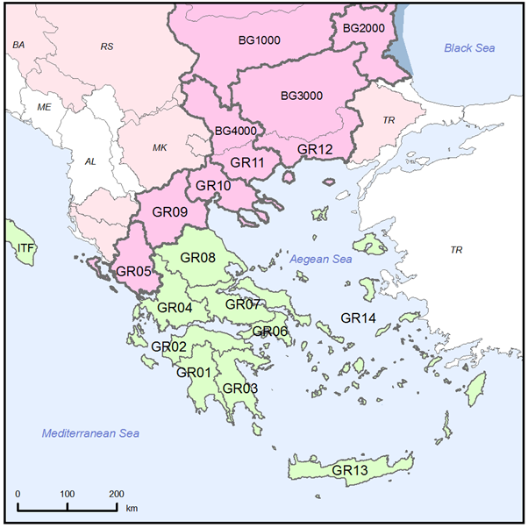
Figure 1.1: Map of River Basin District
International River Basin Districts (within EU)
International River Basin Districts (outside EU)
National River Basin Districts (within EU)
Countries (outside EU)
Coastal Waters
Source: WISE, Eurostat (country borders)
Greece forms the southern extremity of the Balkan Peninsula in south-east Europe. Its territory has an area of 131 957 km² and includes more than 2 000 islands in the Aegean and Ionian seas of which only around 165 islands are inhabited. Greece has a population of 11.2 million.
Greece is a republic with an organisation based on the Constitution of 1975. The country is divided into 13 Administrative Regions.

RBD | Name | Size (km²) | Countries sharing borders
GR01 | Western Peloponnese | 7232 | -
GR02 | Northern Peloponnese | 7426 | -
GR03 | Eastern Peloponnese | 8420 | -
GR04 | Western Sterea Ellada | 10432 | -
GR05 | Epirus | 10007 | AL
GR06 | Attica | 3139 | -
GR07 | Eastern Sterea Ellada | 12268 | -
GR08 | Thessalia | 13153 | -
GR09 | Western Macedonia | 13585 | AL, MK
GR10 | Central Macedonia | 10147 | MK
GR11 | Eastern Macedonia | 7308 | BG, MK
GR12 | Thrace | 11159 | BG, TR
GR13 | Crete | 8301 | -
GR14 | Aegean Islands | 9118 | -
Table 1.1: Overview of Greece’s River Basin Districts
Source: This information may be found in the general fiches for countries in http://europa.eu/about-eu/countries/index_en.htm.
Four major rivers originate in neighbouring countries. The rivers Evros (GR12), Nestos (GR12) and Strymonas (GR11) originate in Bulgaria, while river Axios (GR10) originates in FYROM. These rivers provide an inflow of 34% of the total yearly runoff of Greece.
River Aoos (GR05) originates in Greece and discharges in Albania.
Lake Prespa (GR09) is on the border with Albania and FYROM.

Name international  river basin | National RBD | Countries sharing borders | Co-ordination category
Name international  river basin | National RBD | Countries sharing borders | 2 |  | 3 |  | 4
Name international  river basin | National RBD | Countries sharing borders | km² | % | km² | % | km² | %
Lake Prespa (Part of Drin/Drim Sub-basin) | GR09 | AL, MK | 291 | 33.0
Aoos/Vjosa | GR05 | AL | 2154 | 33.0
Mesta-Nestos | GR12 | BG |  |  | 2843 | 50.7
Struma-Strymonas | GR11 | BG |  |  | 7281 | 40.3
Maritsa-Evros_Meric | GR12 | BG, TR |  |  |  |  | 3340 | 6.0
Axios/Vardar | GR10 | MK, RU |  |  |  |  | 3212 | 13.5
Table 1.2: Transboundary river basins by category (see CSWD section 8.1) and % share in Greece
Category 1: Co-operation agreement, co-operation body, RBMP in place.
Category 2: Co-operation agreement, co-operation body in place.
Category 3: Co-operation agreement in place.
Category 4: No co-operation formalised.
Source: EC Comparative study of pressures and measures in the major river basin management plans in the EU.

Status of River basin Management Plan reporting and compliance
Greece has not reported RBMPs to the Commission
The Greek authorities have informally reported that the consultation process on the RBMPs for those 10 RBDs is expected to be finalised in October 2012 and the RBMPs are expected to be approved by November 2012.
The consultation for the RBMPs for the RBDs of Western Macedonia (GR09) and Central Macedonia (GR10) has started in the end of July 2012. For Crete (GR13) and the Aegean Islands (GR14) the consultation process is expected to start in November 2012.
Two court rulings have been issued against Greece by the European Court of Justice (ECJ):
- For failing to submit the reports required under Article 5 of the Directive, on Characterisation of the River Basin Districts, review of the environmental impacts of human activity and economic analysis of water use. Greece has since complied and the cases are closed.
- On the failure to adopt and report River Basin Management Plans for all of their respective River Basin Districts.
A preliminary ruling has been issued in case C-41/10 on the Acheloos in Greece.

Governance

Timeline of implementation
RBD | Consultation
GR01 | Consultations started 21 November 2011
GR02 | Consultations started 21 November 2011
GR03 | Consultations started 21 November 2011
GR04 | Consultations started 15 October 2011
GR05 | Consultations started 15 October 2011
GR06 | Consultations started 13 January 2012
GR07 | Consultations started 13 January 2012.
GR08 | Consultations started 15 October 2011
GR09 | Consultations started 30 July 2012
GR10 | Consultations started 30 July 2012
GR011 | Consultations started 18 November 2011
GR012 | Consultations started 18 November 2011
Table 3.1.1: Timeline of the different steps of the implementation process
Source: http://wfd.ypeka.gr/
At the national level, the main competent authority is the Ministry of the Environment, Energy and Climate Change, through its Special Water Secretariat. The Presidential Decree 24/2010 OJ A 56/15.04.2010 established that the main competences of the Special Water Secretariat include:
- Coordination on water management issues
- Implementation of the Water Framework Directive
- Monitoring of water quality and quantity
- Management and reuse of wastewater
- Floods management
At decentralized level, Greece is managed by 7 Decentralized Administrations, 13 self-governed Regions, and 325 municipalities. The Decentralized Administrations are led by a General Secretary appointed by the Greek Government.
The RBMPs for the 14 RBDs were prepared by the Special Water Secretariat of the Ministry of the Environment, Energy and Climate Change (which replaced the Greek Central Water Authority (CWA)). This work was carried out on behalf of the former "Regional Water Directorates" with their authorisation since the “Regional Water Directorates” were the competent authorities at the Region and the River Basin level. The Regions were replaced by Decentralised Administrations in 2010, with the Law 3852/2010 (OJA Α/ 7-6-2010), known as “Kallikratis”. The RBMP and the PoM are to be approved by the Minister of the Environment.
As the RBMPs for the 14 RBDs were prepared by the Greek Central Water Agency CWA) and the Special Water Secretariat of the Ministry of the Environment, Energy and Climate Change, a national approach was followed.
To cope with the WFD requirements, Regional Water Directorates and Councils were established within each River Basin District or Water Region RBDs, with the responsibility of organising and coordinating water policy activities including water pricing and specific Water Programmes and Action Plans with specific measures for each RBD.
Greece has signed and ratified Memoranda of Understanding (MoUs) with several neighbouring countries, with an emphasis on cross-border pollution. The purpose of these memoranda, among others, is the transnational cooperation in areas of common interest, such as water pollution, sustainable coastal zone management, soil and air pollution, management of industrial and municipal waste, urban environmental management, the exchange of scientific, technical and legislative experience, organisation of educational seminars etc.
Memoranda include:
- Memorandum of Understanding and Cooperation for Sustainable Development and Environment between the (former) Ministry and the Ministry of Environment and Physical Planning of Macedonia, signed in Skopje on 09.04.2004. This Memorandum has not been ratified by the Greek Parliament;
- Memorandum of Understanding on Environmental Protection between the Greek Republic and the Republic of Bulgaria (Law 3367/2005 169/A/6-7-2005 Gazette);
- Agreement between the Government of the Greek Republic and the Government of the Republic of Albania to establish a permanent Commission on issues of Greek-Albanian border waters (Law 3405/2005 GG 264/25-10-2005); and
- On 14 May 2010, the Ministry of Environment of Turkey and the Ministry of Environment, Energy and Climate Change of Greece signed a Joint Declaration. The Joint Declaration focuses on the cooperation for the sustainable development of the Ebro River Basin, the protection of the marine environment, the protection of biodiversity and cooperation on climate change and adapting to its effects.

Categorisation determined under the EC Comparative study of pressures and measures in the major river basin management plans in the EU (Task 1b: International co-ordination mechanisms).
Commission vs. Greece (Case C264/07, ruling of 31.1.2008)
Commission vs. Greece (Case C-297/11, ruling of 19.4.2012)

