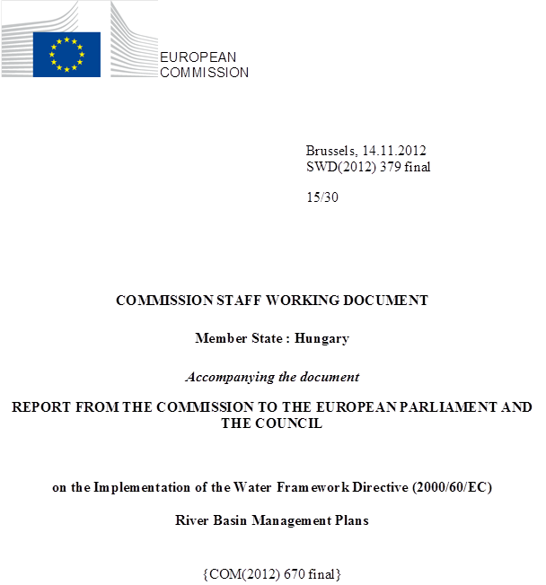

general information
Figure 1.1: Map of River Basin District
International River Basin Districts (within EU)
International River Basin Districts (outside EU)
National River Basin Districts (within EU)
Countries (outside EU)
Coastal Waters
Source: WISE, Eurostat (country borders)
The population of Hungary is 10.1 million and the area of the country covers 93 030 km² (ICPDR, 2009).
Hungary is a landlocked state. It is mostly flat with low mountains in the north. Lake Balaton is the largest lake in central Europe.
The entire territory of Hungary is situated in the middle of the Danube River Basin, which is the second largest basin in Europe. The Danube River Basin is shared by 19 countries. The Danube River Basin District (Danube RBD) has a total area of 807 827 km², of which 11.52% belongs to Hungary.
The Hungarian part of the Danube RBD is coded as HU1000. Beside the national river basin management plan, Hungary has developed 4 sub-basin plans (namely for the Hungarian part of the Tisza River Basin, Drava River Basin, Lake Balaton and the rest of the country, called Danube Basin).
Name international  river basin | Countries sharing borders | Co-ordination category
Name international  river basin | Countries sharing borders | 1
Name international  river basin | Countries sharing borders | km² | %
Danube | Slovak Republic, Austria, Slovenia, Romania, Croatia, Serbia, Ukraine | 93030 | 11.5
Table 1.1: Transboundary river basins by category (see CSWD section 8.1) and % share in Hungary
Category 1: Co-operation agreement, co-operation body, RBMP in place.
Category 2: Co-operation agreement, co-operation body in place.
Category 3: Co-operation agreement in place.
Category 4: No co-operation formalised.
Source: EC Comparative study of pressures and measures in the major river basin management plans in the EU.

STATUS OF River basin Management Plan reporting and compliance

Adoption of the RBMPs
The National River Basin Management Plan was adopted by the Hungarian Government on 21 May 2010 with the Governmental Decision No. 1127/2010. The Decision was published in the Hungarian Official Journal 2010, No. 84. Due to formal legal mandate reasons the Governmental Decision was later repealed and the RBMP, with unchanged content, was newly adopted on 23 February 2012 with the Governmental Decision No. 1042/2012. The new Decision was published again in the Hungarian Official Journal 2012, No 21.
RBMP was reported to WISE on 3 June 2010. Institutional change of the Hungarian administration was reported to WISE on 5 June 2012.

Key strengths and weaknesses
The RBMP has been developed in detail at national, sub-basin and sub-unit levels. It has a number of problem-specific annexes and background documents. Stakeholders and public consultations were given a high importance. International co-ordination is good through multi- and bilateral agreements. Important pressures affecting surface water bodies are identified in the RBMP. The RBMP gives a comprehensive overview on objectives. The Programme of Measures is thoroughly developed providing water body level information about basic, supplementary and additional measures.
Several significant gaps exist though:
- The testing of typology of surface water bodies against biological data has not been completed in the first RBMP cycle because of the lack of sufficient data. There is a significant development in biological quality elements but data gaps still exist. As the methods were not completed for all BQEs, the reference values and class boundaries were not completed for all types.
- Status assessments of surface water bodies are not reliable enough therefore an extremely high percentage of surface water bodies are indicated in unknown status in Hungary. There is also a high uncertainty in HMWB designation.
- Exemptions are extensively used and the justifications for the exemptions are very general.
- Financing of some of the measures does not seem to be ensured.

Governance

Timeline of implementation
During the river basin management planning process, stakeholders and public consultations received high priority. The first step was the discussion on the schedule of planning and working methodology between December 2006 and June 2007. In the second step, not only national, but local level consultations were carried out on significant water management issues (SWMIs). This process started on December 2007 and ended on 22 September 2008, when a summary hearing was held. In the third step, the consultation on draft plans started on 22 December 2008 and ended on 18 November 2009. During this period the published plans and related documents could be commented on through the www.vizeink.hu internet site, written submissions or presentation of oral comments at thematic or regional hearings.

Administrative arrangements - river basin districts and competent authorities
The Ministry of Environment and Water was in charge of strategic leadership, keeping contact with relevant EU organisations, collaborating on the development of the Integrated International Danube River Basin Management Plan, and the preparation of official national reports linked to the implementation of WFD.
The operational duties were shared among different national and regional organisations. The responsible organisation for the preparation of national RBMP and the co-ordination of national planning process was the Central Directorate for Water and Environment. The responsible organisations for the preparation of 4 sub-basins RBMPs and the co-ordination of planning unit plans were the appointed regional environmental and water directorates.

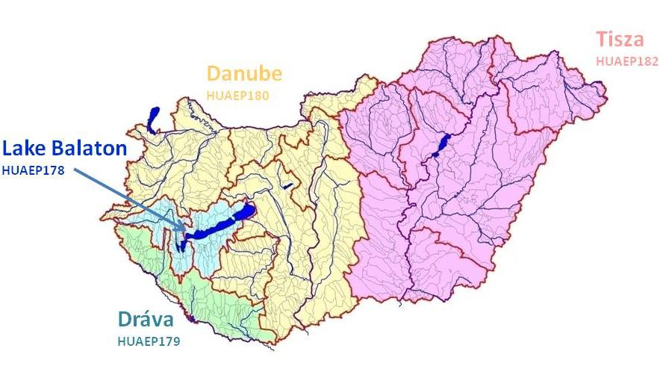
Figure 3.2.1: The four sub-basins of the Danube RBD in Hungary (Danube, Tisza, Lake Balaton and Dráva)
Responsible organisations for the preparation of 42 planning sub-unit plans and involving stakeholders and the public in the process were the relevant 12 regional environmental and water directorates in co-operation with the national park directorates and the regional inspectorates for environment, nature and water.
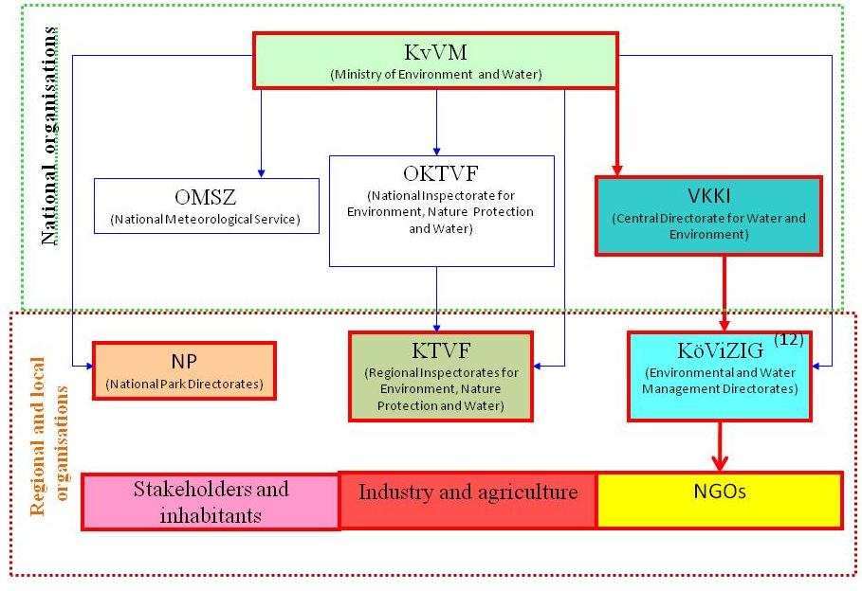
Figure 3.2.2: Organogramme of the institutions, which were involved in the preparation of the Hungarian RBMP (framed in red)

In 2011 the Ministry of Agriculture and the Ministry of Environment and Water were merged into the new Ministry of Rural Development. Under the new Ministry, the State Secretariat for Environmental Affairs took over the responsibility for the implementation of the WFD. At the same time some duties related to water management were transferred to the Ministry of Interior.

RBMPs - Structure, completeness, legal status
Hungary has reported one RBMP for the entire territory of the country because the entire area of the country is within the Danube RBD. It was developed in close co-operation with the International Danube River Basin Management Plan.
The national RBMP as well as the 4 sub-basin and 42 planning unit RBMPs were prepared with the same national approach.
The National River Basin Management Plan was adopted by the Hungarian Government on 21 May 2010 who issued Governmental Decision No. 1127/2010 putting the RBMP into force. Due to formal legal mandate reasons, the Governmental Decision was later repealed and the RBMP, with unchanged content, was newly adopted on 23 February 2012 with the Governmental Decision No. 1042/2012. The new decision was published again in the Hungarian Official Journal 2012, No 21.
The RBMPs are adopted by Government Decisions, which cannot be considered as formal sources of law, as they do not create rights and obligations for individuals, but have legally binding effects only on public authorities. There is no legal instrument that formally regulates the legal effect of the RBMP; its legal effect is a consequence of its nature as a Government Decision. However, legal value is given to the RBMP by other laws that provide direct reference to the RBMP. In particular, the Law on water management stipulates that environmental objectives must be taken into account while planning and carrying out activities that concern the environment. The RBMP calls for the revision of legislation applicable to permitting procedures, in order to make sure that existing and new installations comply with the environmental objectives of the Water Framework Directive. The RBMP considers the revision of the legislation applicable to permitting procedures as a necessary step for its implementation. The RBMP also calls for the revision of existing permits, without specifying a timeline. Legislation applicable to the permitting procedures does not contain a time-frame for the revision of existing permits. Finally, it is noted that the RBMP does not refer to any circumstances that could trigger the review of permitting procedures.

Consultation of the public, engagement of interested parties
The planning process was a multi-step, iterative type in which ecological, technical, social and economic aspects were harmonized.
Prior to the consultations, a Strategy paper on the involvement of public into the planning process was developed, brochures and a guidebook on the methodology of public involvement and consultation in the WFD implementation process was issued and made available for stakeholders.
Detailed discussion materials were also issued on the national / Sub-basin / sub-unit RBMPs. These materials were made available on the internet and in printed forms. Public / stakeholders consultations were held in each sub-basin / sub-unit. RBMP documents were mainly provided via the web, but for some selected stakeholders (i.e. National and Regional Water Management Councils; professional associations, NGOs etc.) printed versions of draft RBMPs were also made available.
Regional and thematic hearings were organised to discuss the national, sub-basin and sub-units draft RBMPs. The 25 thematic hearings covered issues such as agriculture, nature protection, forest management, municipal government tasks, thermal waters, fishery, regulatory and comprehensive measures, institutional development and financing.
In total around 700 organisations were represented in the thematic hearings and 3800 opinions, questions, comments, additions were received during the consultation of the draft RBMP. These hearings were widely advertised in advance and the outcomes of them were processed and utilized in the final version of the national, sub-basin and sub-unit plans. A memorandum was prepared for each forum and made available on the official web site of the Hungarian RBM planning process at www.vizeink.hu.
The following groups of stakeholders were invited to the consultations: professional state organisations (such as Central Agricultural Office, National Public Health Institute, State Forest Service, agricultural extension service etc.), municipalities, civil organisations (for environmental protection, tourism, sport, education, regional development etc.), economic sectors representative organisations, associations (industry, agriculture, regional development, engineering chambers, agricultural chambers etc.), associations of water management (water utility, agricultural water management, fisheries, owners of hydro engineering structures, etc.), scientific communities and the general public.

International co-operation and co-ordination
Hungary is member of the International Commission for the Protection of the Danube River (ICPDR). ICPDR has been authorised by the founder Danube River Basin States to co-ordinate the elaboration of the Danube River Basin District Management Plan. ICPDR has organised numerous international public and stakeholders forums held in different locations throughout the Danube Basin.
The Danube countries have agreed to develop sub-basin management plans. The Tisza RBM Plan was developed by the Tisza countries (UA, SK, HU, RO and RS) also under co-ordination of the ICPDR.

Characterisation of river basin districts
There are two water categories in the Hungarian RBMP, rivers and lakes. Hungary is a land-locked country without coastal area. Thus no transitional and coastal water bodies were delineated.
For river water body typology determination, Hungary used altitude, geology, average bed slope, size of watershed, and grain size distribution of river bed material as selection criteria. For lake water body typology, lake surface area, average depth, altitude, hydrogeochemical characteristics, ratio of open water surface and water cover were used.
Type-specific reference conditions have been established for rivers and lakes. The reference characteristics of each river water body type and each lake water body type are given in the RBMP. The selected reference characteristics for rivers were hydromorphological character, water chemistry (pH, conductivity, chloride, oxygen saturation, dissolved oxygen, BOD, COD, NH₄-N, NO₂-N, NO₃-N, Total N, PO₄-P, Total P) and biology (riparian vegetation, fish, suspended algae, Chlorophyll-a, phytoplankton, phytobentos and macroscopic invertebrates).
The reference parameters for lakes are hydromorphological character, water chemistry (pH, conductivity, chloride, oxygen saturation, dissolved oxygen, BOD, COD, NH₄-N, NO₂-N, NO₃-N, Total N, PO₄-P and Total P) and biology (riparian vegetation (IMMI index), fish, suspended algae, Chlorophyll-a, phytoplankton and phytobentos).
The typology of all surface water bodies has been tested against biological data but the process has not been completed in the first RBMP cycle because of the lack of sufficient data.

RBD | Rivers | Lakes | Transitional | Coastal
HU1000 | 25 | 16 | Not relevant | Not relevant
Table 4.2.1: Surface water body types at RBD level.
Source: WISE and HU

Delineation of surface water bodies
River waters with catchment area larger than 10 km² were delineated as water bodies. The grouping of small watercourses and water bodies with the same characteristics was commonly used.
It was also common to group lakes and lake groups with smaller than 50 ha into one water body. Wetlands were recorded as protected areas rather than lakes.
Statistics of river and lake water bodies are given in the table below.
RBD | Surface Water |  |  |  | Groundwater
RBD | Rivers |  | Lakes
RBD | Number | Average Length (km) | Number | Average Area  (sq km) | Number | Average Area  (sq km)
HU1000 | 869 | 22 | 213 | 6 | 185 | 1511
Table 4.3.1: Surface water bodies, groundwater bodies and their dimensions.
Source: WISE
The number of groundwater bodies identified is 185 (in 4 layers, 1.99 GWBs per 1000 km²) with an average size of 1511 km². The number of transboundary groundwater bodies is 40. There are 56 groundwater bodies with directly dependent terrestrial ecosystems.

Identification of significant pressures and impacts
Important pressures affecting surface water bodies are identified in the RBMP.
In cases of organic material or nutrient pressures, communal or industrial point sources were considered significant if the load from these sources contributed more than 30% of the total load of a given water body. The method applied was not unified for all pressure types.
In cases of diffuse sources from agriculture, nutrients and pesticides were considered as significant pressures. These pressures were calculated from surface water monitoring data and with a river water quality model for phosphorous pressure. For nitrogen compounds and pesticides a mass balance method was used.
Data from obligatory reports and statistics for 2006 from water users on different kinds of water abstractions (domestic, industrial, irrigation, fish pond, energy production, mining, bathing and other, such as ecological and recreational) were used to estimate water abstraction pressures on surface water bodies.
Water abstractions have been summarized for sub-units and compared with a typical low-flow and with the discharge that has to be kept in the river bed for ecological reasons. Water abstraction is significant at sub-unit level if abstraction exceeds 50% of the low-flow of the given river water body.
In 2006 and 2008 Hungary carried out detailed surveys on hydromorphological alterations on all surface waters. The results of these surveys were used in determination of significant pressures. Barrages, flood protection dams, structures for river regulation, newly built river beds, trapezoid shape river reaches, sluices, river bed dredging, vegetation removal, covering, embankment structures and water diversion were considered as hydromorphological alteration pressures. Hydromorphological alterations were considered as important when the ratio of the river affected exceeded 50% within a water body. In some cases, this condition was supplemented with the constraint that the continuous length of the affected part did not exceed 30% of the total length of the water body.
In cases of engineering activities, fisheries enhancement, land infrastructure and dredging it was unclear what tools were applied to define a significant level from these pressure types. Only the number of water bodies affected with these types of pressures was given.
The water quality problems of surface water bodies are predominantly caused by organic and nutrient material loads. 2/3 of the river water bodies and 80% of the lake water bodies are affected by such kinds of significant pressures.
The pollution of surface waters with hazardous substances was not evaluated because of the lack of data.

RBD | No pressures |  | Point source |  | Diffuse source |  | Water abstraction |  | Water flow regulations and morphological  alterations |  | River management |  | Transitional and coastal water management |  | Other morphological alterations |  | Other pressures
RBD | No. | % | No. | % | No. | % | No. | % | No. | % | No. | % | No. | % | No. | % | No. | %
HU1000 | 173 | 15.99 | 180 | 16.64 | 264 | 24.4 | 90 | 8.32 | 543 | 50.18 | 876 | 80.96 | 0 | 0 | 0 | 0 | 143 | 13.22

Table 4.2.1: Number and percentage of surface water bodies affected by significant pressures.
Source: WISE

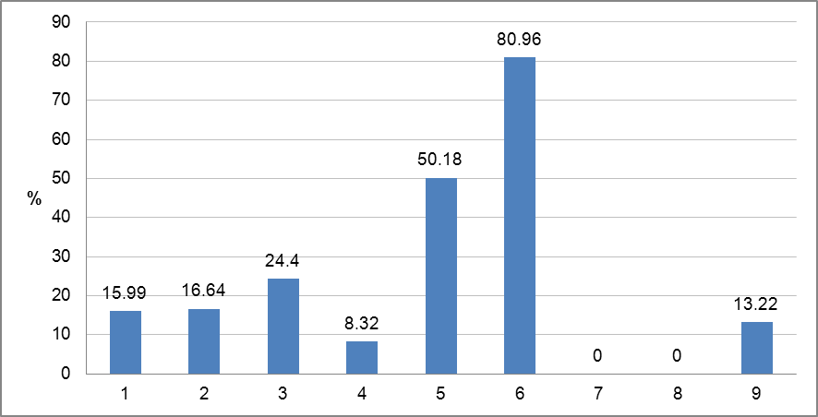
Figure 4.2.1: Graph of percentage of surface water bodies affected by significant pressures
1 = No pressures
2 = Point source
3 = Diffuse source
4 = Water abstraction
5 = Water flow regulations and morphological alterations
6 = River management
7 = Transitional and coastal water management
8 = Other morphological alterations
9 = Other pressures
Source: WISE

Protected areas
RBD | Number of PAs
RBD | Article 7 Abstraction for drinking water | Bathing | Birds | European Other | Fish | Habitats | Local | National | Nitrates | Shellfish | UWWT
HU1000 | 1756 | 265 | 55 | - | 7 | 467 | - | 210 | 1 | - | 3

Table 4.5.1: Number of protected areas of all types in each RBD and for the whole country, for surface and groundwater
Source: WISE

Monitoring

General description of the monitoring network
Figure 5.1: Maps of surface water (left) and groundwater (right) monitoring stations
 | • |  | River monitoring stations
 | • |  | Lake monitoring stations
 | • |  | Transitional water monitoring stations
 | • |  | Coastal water monitoring stations
 | • |  | Unclassified surface water monitoring stations
 | • |  | Groundwater monitoring stations
 |  |  | River Basin Districts
 |  |  | Countries outside EU
Source: WISE, Eurostat (country borders)
Hungary has put surveillance and operational monitoring programmes in place.
In the monitoring report from 2007, Hungary indicated 891 RWBs, 221 LWBs and 108 GWBs. After revisions of the water bodies Hungary reported in the RBMP of 2009, 869 RWBs, 213 LWBs and 185 GWBs. Table 5.1.2 shows the number of monitoring stations in Hungary.
RBD | Rivers |  | Lakes |  | Transitional |  | Coastal |  | Groundwater
RBD | Surv | Op | Surv | Op | Surv | Op | Surv | Op | Surv | Op | Quant
HU1000 | 122 | 474 | 26 | 41 | 0 | 0 | 0 | 0 | 2014 | 427 | 1802
Total by type of site | 122 | 474 | 26 | 41 | 0 | 0 | 0 | 0 | 2014 | 427 | 1802
Total number of monitoring sites | 557 |  | 65 |  | - |  | - |  | 3471
Table 5.1.2: Number of monitoring sites by water category
Surv = Surveillance
Op = Operational
Quant = Quantitative
Source: WISE

Monitoring of surface waters
All quality elements are being monitored in surface waters in the surveillance monitoring programme. All required QEs are monitored at all sites that are included in surveillance monitoring.
8 sub-programmes for operational monitoring were established, 2 programmes for lakes and 6 programmes for rivers. Monitoring sites for water bodies at risk were selected to represent different impacts.
The selection of biological quality elements for the different operational monitoring sub-programmes was based on available biological monitoring data and the stressor-response relationship of each BQE.
The RBMP reported that there is no investigative monitoring of surface waters. Statistics for the surveillance and operational monitoring of surface water bodies are given in the following table.
Water category | Surveillance | Operational | Total number of monitored water bodies | Total number of reported water bodies
River | 101 (11.62) | 390 (44.88) | 443 (50.98) | 869
Lake | 20 (9.39) | 32 (15.02) | 50 (23.47) | 213
Table 5.2.1: Summary of numbers (and % of total reported in brackets) of water bodies included in surveillance and operational monitoring in Hungary.
Source: RBMP
All 33 priority substances specified in the WFD are monitored. The monitoring programme of rivers at risk due to hazardous substances pressures runs on 81 water bodies at 103 points. In these investigations, priority or other hazardous substances are only tested if other surveys showed exceedances of the limits of a substance released into the basin. The monitored substances can vary from point to point. Priority substances and other hazardous substances are monitored in rivers and lakes under the surveillance monitoring programme with 12 samples per year during every 3 years.
Grouping of water bodies was planned to be used in case of river and lake monitoring operational programmes, but there was no strict correlation between water bodies even with the same type and same pressure. Therefore grouping was not used to extend and extrapolate monitoring results from one water body to any other.
For transboundary water bodies Hungary operates surveillance monitoring. Monitoring data are provided to neighbouring countries based on bilateral transboundary agreements or co-operation. For significant water bodies in the Danube River Basin, surveillance monitoring data are shared with Danube countries through ICPDR.

Monitoring of groundwater
Hungary has set up 10 monitoring programmes for groundwater. Out of 10, there are 2 quantitative, 4 chemical surveillance, and 4 chemical operational monitoring programmes. In monitoring programmes for vulnerable groundwater bodies, besides the basic chemical parameters, measurements are carried out for special pollutants, like industrially used organic compounds (solvents, carcinogenic substances, heavy metals, pesticides, etc).
Trend assessment was carried out for the design of monitoring programmes and for the selection of parameters. 4 groundwater bodies were identified with upward trends in nitrate concentration and 1 GWB with an upward trend in ammonium. For the majority of GWBs there were not enough available data to carry out a reliable trend assessment. Only some pollutants were included in trend assessment.
Hungary is participating in the basin wide transboundary groundwater monitoring programme co-ordinated by ICPDR.
The Hungarian RBMP reports 2014 surveillance and 427 operational groundwater quality monitoring sites, while at 1802 sites groundwater quantity parameters are measured.

Monitoring of protected areas
There is a specific monitoring programme in place for surface water to monitor bathing waters, NATURA 2000 areas, drinking water protection areas, fresh waters fish protection and areas designated according to the Nitrates and UWWT Directives. The total number of such specific surface water monitoring sites is 407. The specific monitoring programme for groundwater in drinking water protected areas includes 1754 sites.
RBD | Surface water |  |  |  |  |  |  | Ground water
RBD | Bathing water | Habitats/  Birds | Drinking water | Fish | Shellfish | Nitrates | Urban waste water | Drinking water
Danube | 30 | 115 | 13 | 23 | - | 197 | 27 | 1754
Total | 30 | 115 | 13 | 23 | - | 197 | 27 | 1754
Table 5.4.1: Number of monitoring sites in protected areas
Source: HU

Overview of status (ecological, chemical, groundwater)
11% of the surface water bodies are in good ecological status in Hungary. More than half of the surface water bodies are in less than good status while the ecological status of one third of the river water bodies and of nearly two thirds of the lake water bodies is unknown.
RBD | Total | High |  | Good |  | Moderate |  | Poor |  | Bad |  | Unknown
RBD | Total | No. | (%) | No. | (%) | No. | (%) | No. | (%) | No. | (%) | No. | (%)
HU1000 | 442 | 5 | 1.1 | 44 | 10.0 | 138 | 31.2 | 85 | 19.2 | 37 | 8.4 | 133 | 30.1
Table 6.1: Ecological status of natural surface water bodies
Source: WISE
RBD | Total | High |  | Good |  | Moderate |  | Poor |  | Bad |  | Unknown
RBD | Total | No. | (%) | No. | (%) | No. | (%) | No. | (%) | No. | (%) | No. | (%)
HU1000 | 640 | 0 | 0 | 56 | 8.8 | 182 | 28.4 | 108 | 16.9 | 5 | 0.8 | 289 | 45.2
Table 6.2: Ecological potential of artificial and heavily modified water bodies
Source: WISE
An extremely high percentage of surface water bodies are in unknown chemical status in Hungary. Only 3% of the SWBs were indicated to be in good chemical status.
RBD | Total | Good |  | Poor |  | Unknown
RBD | Total | No. | % | No. | % | No. | %
HU1000 | 442 | 14 | 3.2 | 10 | 2.3 | 418 | 94.6
Table 6.3: Chemical status of natural surface water bodies
Source: WISE
RBD | Total | Good |  | Poor |  | Unknown
RBD | Total | No. | % | No. | % | No. | %
HU1000 | 640 | 21 | 3.3 | 18 | 2.8 | 601 | 93.9
Table 6.4: Chemical status of artificial and heavily modified water bodies
Source: WISE
80% of the groundwater bodies (147 GWBs) are in good chemical status in Hungary and 20% of them in poor chemical status (38 GWBs).
RBD | Total | Good |  | Poor |  | Unknown
RBD | Total | No. | % | No. | % | No. | %
HU1000 | 185 | 147 | 79.5 | 38 | 20.5 | 0 | 0
Table 6.5: Chemical status of groundwater bodies
Source: WISE
Quantitative status of 158 GWBs is good (85%) while 27 of them are in poor quantitative status (15%). There are no groundwater bodies in unknown status in Hungary.
RBD | Total | Good |  | Poor |  | Unknown
RBD | Total | No. | % | No. | % | No. | %
HU1000 | 185 | 158 | 85.4 | 27 | 14.6 | 0 | 0
Table 6.6: Quantitative status of groundwater bodies
Source: WISE
According to the WISE report no improvements in the chemical status of surface and groundwater bodies are expected until 2015. There is no information about improvements in groundwater quantitative status. The PoM of RBMP provides information on measures and a schedule of actions as to when the good status will be achieved (2015, 2021, 2027 or after 2027).
RBD | Total | Global status (ecological and chemical) |  |  |  |  | Good ecological status 2021 |  | Good chemical status 2021 |  | Good ecological status 2027 |  | Good chemical status 2027 |  | Global exemptions 2009 (% of all SWBs)
RBD | Total | Good or better 2009 |  | Good or better 2015 |  | Increase 2009 -2015 |  |  |  |  |  |  |  |  | Art 4.4 | Art 4.5 | Art 4.6 | Art 4.7
RBD | Total | No. | % | No. | % | % | No. | % | No. | % | No. | % | No. | % | % | % | % | %
HU1000 | 1082 | 9 | 0.8 | 9 | 0.8 | 0.0 |  | 22 (RW)  72 (LW) |  |  |  | 74 (RW)  91 (LW) |  |  | 88 | 0 | 0 | 0
Table 6.7: Surface water bodies: overview of status in 2009 and expected status in 2015, 2021 and 2027
RW= River water bodies
LW = Lake water bodies
Water bodies with good status in 2009 fall into the following category:
1. Ecological status is high or good and the chemical status is good, exemptions are not considered
Water bodies expected to achieve good status in 2015 fall into the following categories:
1. Ecological status is high or good and the chemical status is good, exemptions are not considered
2. Chemical status is good, and the ecological status is moderate or below but no ecological exemptions
3. Ecological status is high or good, and the chemical status is failing to achieve good but there are no chemical exemptions
4. Ecological status is moderate or below, and chemical status is failing to achieve good but there are no ecological nor chemical exemptions
Note: Water bodies with unknown/unclassified/not applicable in either ecological or chemical status are not considered
Source: WISE (for data on status in 2009, 2015 and exemptions) and RBMPs (for data on status in 2021 and 2027)

RBD | Total | Ecological status |  |  |  |  | Good ecological status 2021 |  | Good ecological status 2027 |  | Ecological exemptions (% of all SWBs)
RBD | Total | Good or better 2009 |  | Good or better 2015 |  | Increase 2009 -2015 |  |  |  |  | Art 4.4 | Art 4.5 | Art 4.6 | Art 4.7
RBD | Total | No. | % | No. | % | % | No. | % | No. | % | % | % | % | %
HU1000 | 442 | 49 | 11.1 | 54 | 12.2 | 1.1 |  |  |  |  | 85.1 | 0 | 0 | 0
Table 6.8: Natural surface water bodies: ecological status in 2009 and expected status in 2015, 2021 and 2027
Source: WISE (for data on status in 2009, 2015 and exemptions) and RBMPs (for data on status in 2021 and 2027)
RBD | Total | Chemical status |  |  |  |  | Good chemical status 2021 |  | Good chemical status 2027 |  | Chemical exemptions (% of all SWBs)
RBD | Total | Good or better 2009 |  | Good or better 2015 |  | Increase 2009 -2015 |  |  |  |  | Art 4.4 | Art 4.5 | Art 4.6 | Art 4.7
RBD | Total | No. | % | No. | % | % | No. | % | No. | % | % | % | % | %
HU1000 | 442 | 14 | 3.2 | 14 | 3.2 | 0.0 |  |  |  |  | 2.3 | 0 | 0 | 0
Table 6.9: Natural surface water bodies: chemical status in 2009 and expected status in 2015, 2021 and 2027
Source: WISE (for data on status in 2009, 2015 and exemptions) and RBMPs (for data on status in 2021 and 2027)
RBD | Total | GW chemical status |  |  |  |  | Good chemical status 2021 |  | Good chemical status 2027 |  | GW chemical exemptions (% of all GWBs)
RBD | Total | Good or better 2009 |  | Good or better 2015 |  | Increase 2009 -2015 |  |  |  |  | Art 4.4 | Art 4.5 | Art 4.6 | Art 4.7
RBD | Total | No. | % | No. | % | % | No. | % | No. | % | % | % | % | %
HU1000 | 185 | 147 | 79.5 | 147 | 79.5 | 0 |  |  |  |  | 21 | 0 | 0 | 0
Table 6.10: Groundwater bodies: chemical status in 2009 and expected status in 2015, 2021 and 2027
Source: WISE (for data on status in 2009, 2015 and exemptions) and RBMPs (for data on status in 2021 and 2027)
RBD | Total | Groundwater quantitative status |  |  |  |  | Good quantitative status 2021 |  | Good quantitative status 2027 |  | GW quantitative exemptions (% of all GWBs)
RBD | Total | Good or better 2009 |  | Good or better 2015 |  | Increase 2009 -2015 |  |  |  |  | Art 4.4 | Art 4.5 | Art 4.6 | Art 4.7
RBD | Total | No. | % | No. | % | % | No. | % | No. | % | % | % | % | %
HU1000 | 185 | 158 | 85.4 | 158 | 85.4 | 0 |  |  |  |  | 14 | 1 | 0 | 0
Table 6.11: Groundwater bodies: quantitative status in 2009 and expected status in 2015, 2021 and 2027
Source: WISE (for data on status in 2009, 2015 and exemptions) and RBMPs (for data on status in 2021 and 2027)
RBD | Total  HMWB and AWB | Ecological potential |  |  |  |  | Good ecological potential 2021 |  | Good ecological potential 2027 |  | Ecological exemptions (% of all HMWB/AWB)
RBD | Total  HMWB and AWB | Good or better 2009 |  | Good or better 2015 |  | Increase 2009 -2015 |  |  |  |  | Art 4.4 | Art 4.5 | Art 4.6 | Art 4.7
RBD | Total  HMWB and AWB | No. | % | No. | % | % | No. | % | No. | % | % | % | % | %
HU1000 | 640 | 56 | 8.8 | 62 | 9.7 | 0.9 |  |  |  |  | 45.3 | 0 | 0 | 0
Table 6.12: Heavily modified and artificial water bodies: ecological potential in 2009 and expected ecological potential in 2015, 2021 and 2027
Source: WISE (for data on status in 2009, 2015 and exemptions) and RBMPs (for data on status in 2021 and 2027)
RBD | Total  HMWB and AWB | Chemical status |  |  |  |  | Good chemical status 2021 |  | Good chemical status 2027 |  | Chemical exemptions (% of all HMWB/AWB)
RBD | Total  HMWB and AWB | Good or better 2009 |  | Good or better 2015 |  | Increase 2009 -2015 |  |  |  |  | Art 4.4 | Art 4.5 | Art 4.6 | Art 4.7
RBD | Total  HMWB and AWB | No. | % | No. | % | % | No. | % | No. | % | % | % | % | %
HU1000 | 640 | 21 | 3.3 | 21 | 3.3 | 0 |  |  |  |  | 2.8 | 0 | 0 | 0
Table 6.13: Heavily modified and artificial water bodies: chemical status in 2009 and expected status in 2015, 2021 and 2027
Source: WISE (for data on status in 2009, 2015 and exemptions) and RBMPs (for data on status in 2021 and 2027)
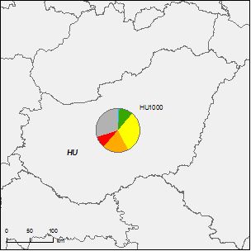
Figure 6.1: Map of ecological status of natural surface water bodies 2009

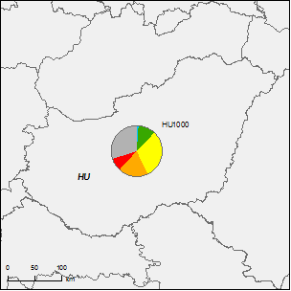
Figure 6.2: Map of ecological status of natural surface water bodies 2015
High
Good
Moderate
Poor
Bad
Unknown
River Basin Districts
Countries outside EU
Note: Standard colours based on WFD Annex V, Article 1.4.2(i).
Source: WISE, Eurostat (country borders)

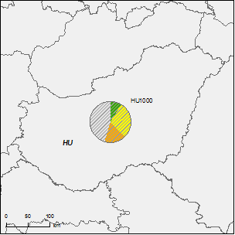
Figure 6.3: Map of ecological potential of artificial and heavily modified water bodies 2009
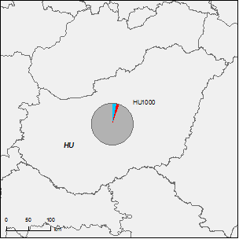
Figure 6.4: Map of ecological potential of artificial and heavily modified water bodies 2015
Good or better
Moderate
Poor
Bad
Unknown
River Basin Districts
Countries outside EU
Note: Standard colours based on WFD Annex V, Article 1.4.2(ii).
Source: WISE, Eurostat (country borders)

Figure 6.5: Map of chemical status of natural surface water bodies 2009
Figure 6.6: Map of chemical status of natural surface water bodies 2015
Good
Failing to achieve good
Unknown
River Basin Districts
Countries outside EU
Note: Standard colours based on WFD Annex V, Article 1.4.3.
Source: WISE, Eurostat (country borders)

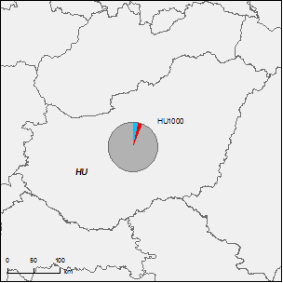
Figure 6.7: Map of chemical status of artificial and heavily modified water bodies 2009
Figure 6.8: Map of chemical status of artificial and heavily modified water bodies 2015
Good
Failing to achieve good
Unknown
River Basin Districts
Countries outside EU
Note: Standard colours based on WFD Annex V, Article 1.4.3.
Source: WISE, Eurostat (country borders)

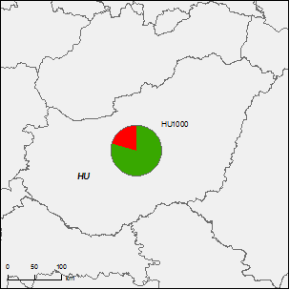
Figure 6.9: Map of chemical status of groundwater bodies 2009
Figure 6.10: Map of chemical status of groundwater bodies 2015
Good
Poor
Unknown
River Basin Districts
Countries outside EU
Note: Standard colours based on WFD Annex V, Article 2.4.5.
Source: WISE, Eurostat (country borders)

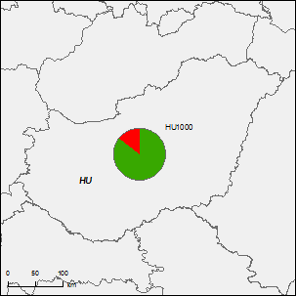
Figure 6.11: Map of quantitative status of groundwater bodies 2009
Figure 6.12: Map of quantitative status of groundwater bodies 2015
Good
Poor
Unknown
River Basin Districts
Countries outside EU
Note: Standard colours based on WFD Annex V, Article 2.2.4.
Source: WISE, Eurostat (country borders)

Assessment of ecological status of surface waters
Hungary followed the methodological approach of ecological status assessment of the WFD for all water bodies in the country.

Ecological status assessment methods
The COM Implementation Report 2009 indicates that there were partly available biological assessment methods for classification of surface water ecological status. Both for rivers and lakes phytoplankton, macrophytes and phytobentos methods were available at that time (2007).
For the assessment of ecological status in rivers phytoplankton, phytobenthos, macrophytes, macroinvertebrates and fish assessment systems were developed.
There are phytoplankton and macrophytes assessment methods for all types of lakes, and a phytobentos assessment method for some types. In bentic fauna and fish groups more data would be necessary for development of assessment methods.
RBD | Rivers |  |  |  |  |  |  | Lakes |  |  |  |  |  |  | Transitional |  |  |  |  |  |  | Coastal
RBD | Phytoplankton | Macrophytes | Phytobenthos | Benthic invertebrates | Fish | Physico-Chemical | Hydromorphological | Phytoplankton | Macrophytes | Phytobenthos | Benthic invertebrates | Fish | Physico-Chemical | Hydromorphological | Phytoplankton | Macroalgae | Angiosperms | Benthic invertebrates | Fish | Physico-Chemical | Hydromorphological | Phytoplankton | Macroalgae | Angiosperms | Benthic invertebrates | Physico-Chemical | Hydromorphological
HU1000 |  |  |  |  |  |  |  |  |  |  |  |  |  |  | - | - | - | - | - | - | - | - | - | - | - | - | -
Table 7.1.1: Availability of biological assessment methods
 |  | Assessment methods fully developed for all BQEs
 |  | Assessment methods partially developed or under development for all or some BQEs
 |  | Assessment methods not developed for BQEs, no information provided on the assessment methods, unclear information provided
- |  | Water category not relevant
Source: RBMPs and HU

The sensitivity of different BQEs was checked against all relevant pressures. Different BQEs were monitored to detect different major pressures. The one-out-all-out principle was used for a group of quality elements. Some relationships could be established between biological classification and pressures.
Physico-chemical quality elements taken into account in determining the ecological status of surface waters were organic matters, nutrients, salinity / alkalinity, temperature, pH and secchi depth for lakes. There is a statement in the RBMP that the applied QEs are WFD compliant. The assessment methods are described in detail. No relationship has been established between BQEs and physico-chemical QEs. The main reason was the lack of appropriate number of BQE data. All hydromorphological QEs of Annex V are covered.
National legislation provides a legal framework for EQSs and for monitoring national river basins for chemical pollutants. River basin specific pollutants were identified in the frame of ICPDR and these pollutants were used in the classification of surface water ecological status in accordance with the procedure determined in the WFD. The RBMP lists the chemical pollutants. Hungary included dissolved zinc, copper, chromium and arsenic into the parameters to be investigated as these compounds are specific to the Danube River Basin.
The one-out-all-out principle has been applied in the overall classification.
For the assessment of the BQEs, the average of BQE sampling results has been used in cases where a water body had several monitoring locations. In the case of multiple sampling, water body classification was based on reliability-weighted average values of individual samples.
The development of indices was intended to be type-specific, but as the methods were not completed for all BQEs, the reference values and class boundaries were not completed for all types. There was however progress in developing methods for the different types. For the validation of physico-chemical QEs statistical evaluation was applied for all biological elements.
No significant relationships have been established between BQEs and physico-chemical QEs for benthic invertebrates, macrophytes and fish. The main reason was the lack of appropriate number of BQE data.
Hungary reported that the intercalibration exercise was not completed by the time of finalizing the first RBMP (intercalibration was completed in 2012). In the case of phytobentos, class boundaries were reported in a background document of the national RBMP which were consistent with the intercalibration boundaries for rivers and lakes in 5 classes. It was mentioned that in case of fish, intercalibration was carried out, but no boundary values were given. No information was provided for other BQEs. For benthic invertebrates there are no intercalibration class boundaries for Hungary in the Official IC Decision Document. The method Hungary used in the process was described as non-WFD compliant.

Application of methods and ecological status results
The RBMP reports that the most sensitive BQEs and other relevant QEs for the dominant pressures were used in the assessments of ecological status for water bodies in the surveillance monitoring programme.

River basin specific pollutants
RBD | CAS Number | Substance | % water bodies failing status
HU1000 | 7440-38-2 | Arsenic and its compounds | 13
HU1000 | 7440-50-8 | Copper and its compounds | 23
HU1000 | 7440-66-6 | Zinc and its compounds | 25
Table 7.3.1: River basin specific pollutants causing failure of status
Source: RBMPs
Due to significant lack of data only 13% of surface water bodies were classified for river basin specific pollutants. The RBMP lists those water bodies which failed to reach good status for one or more of the four specific pollutants.

Designation of heavily modified water bodies (hmwb) and assessment of good ecological potential
In the provisional identification of HMWBs and AWBs in the Article 5 report, Hungary presented about 2% of the designated surface water bodies as heavily modified and about 20% as artificial WBs. In the RBMP from 1082 surface water bodies, 365 (34%) are HMWBs and 275 (25%) are AWBs. From 869 river WBs, 350 (40%) are HMWB and 146 (17%) are AWB, while from 213 lake WBs 15 (7%) are designated HMWBs and 129 (60%) are AWBs.

Figure 8.1: Map of percentage Heavily Modified and Artificial water bodies by River Basin District
0 – 5 %
5 – 20 %
20 – 40 %
40 – 60%
60 – 100 %
No data reported
River Basin Districts
Countries outside EU
Source: WISE, Eurostat (country borders)

Designation of HMWBs
The RBMP specifies the following water uses for which water bodies have been designated as HMWB: navigation including port facilities, recreation, storage for drinking water supply, storage for power generation, storage for irrigation, water regulation, flood protection and land drainage.
Types of physical modifications, which were considered in designation for HMWB were locks, weirs, dams, reservoirs, bed stabilisation, dredging, channel maintenance, riverbank consolidation, land drainage and water transfers.
The designation of heavily modified water bodies was carried out in several phases. During the work the following criteria were considered:
- Identification of interventions significantly modifying the hydromorphological conditions of water bodies.
- Elimination of identified interventions without compromising other purposes / needs included in the scope specified by the WFD (shipping, storage water for drinking water supply or irrigation, power generation, flood and inland water protection, recreation and others).
- Whether specific needs can be solved in another way, which would not affect the implementation, not involve any unreasonable costs, and is backed by the society.
The rate of uncertainties was not assessed but action to reduce gaps was introduced into PoM.

Methodology for setting good ecological potential (GEP)
Good ecological potential (GEP) has been defined in the RBMP. It describes how GEP was determined for HMWBs and AWBs in case of different BQEs (phytoplankton, phytobentos, macrophytes, macroinvertebrates and fish).
The GEP definition is a combination of a reference based approach and mitigation measures approach.
GEP was determined in water bodies, where an appropriate amount of biological data were available. In cases where the data allowed, use-specific GEP values were also determined. This is why it could not be ascertained whether a water body type method or a use type method was used.
The following mitigation measures which do not have significant adverse effects on the use or the wider environment have been identified: fish ladders, habitat restoration, building spawning and breeding areas, sediment management, reconnection of meander bends or side arms, lowering of river banks, restoration of bank structures, channel narrowing, minimum ecological flow, inundation of floodplains and restoration of modified bed structures or basins.

Results of ecological potential assessment in HMWB and AWB
Only 6.3% of the heavily modified RWBs have good or better ecological potential, while for AWBs the figure is 15.8%. The ratios of HMWBs and AWBs with unknown ecological potential are 28.3% and 45.9%, respectively, mainly due to lack of biological data.
The RBMP mentions that improvements of the database will be needed to improve the designation process and to reduce uncertainty in HMWB designation.

Assessment of chemical status of surface waters

Methodological approach to the assessment
The RBMP reports the EQSs for all 33 priority substances. Hungary has applied the EQSs laid down in Part A of Annex I of the Directive 2008/105/EC.
In August 2010 a ministerial decree was issued setting EQSs for biota for three compounds (mercury and its compounds, hexachlorobenzene, and hexachlorobutadiene).
In the RBMP, which had been finished earlier, no information was found on application of EQSs for biota.
The background concentrations were not considered because of the lack of sufficient geological data.
The total (no species) dissolved metal concentration was measured during the monitoring programme. According to the Hungarian authorities as this type of metal is readily bioavailable there is no need to use bioavailability factors.

Substances causing exceedances
Individual priority substances were reported in WISE. In the table below the number of water bodies where EQSs are exceeded and chemical status is less than good is reported by priority substances and certain other pollutants.
CAS Number | Name of substances | Number of surface water bodies failing good chemical status
7440-43-9 | Cadmium | 14 water bodies failed
7439-97-6 | Mercury | 3 water bodies failed
330-54-1 | Diuron | 2 water bodies failed
115-29- | Endosulfan | 2 water bodies failed
734123-59-6 | Isoproturon | 1 water body failed
608-73-1 | Hexachlorocyclohexane | 3 water bodies failed
1582-09-8 | Trifluralin | 1 water body failed
117-81-7 | Di(2-ethylhexyl)phthalate (DEHP) | 1 water body failed
140-66-9 | Octylphenol | 2 water bodies failed
127-18-4 | Tetrachloroethylene | 1 water body failed
 | Polyaromatic hydrocarbons | 5 water bodies failed
Table 9.2.1: Number of surface WBs failing good chemical status
Source: RBMP
Mixing zones were not used in the first RBMP cycle. According to the transposition of EQSD (2008/105/EC) to the national legislation it was indicated that mixing zones will be designated after 2010.

Assessment of groundwater status
Hungary designated 185 groundwater bodies. The total area of designated GWBs is 279 532 km² and 83.4% of it is in good status.
There are 38 GWBs in poor chemical status, which represent 20.54% of the total number of GWBs.
Class | Good | Poor | Unknown
Total number of GWBs: 185 | 147 | 38 | 0
% of Total | 79.46 | 20.54 | 0
Table 10.1: Chemical status classification of groundwater bodies
Source: WISE
Seven pollutants were identified, which caused GWBs to fail good chemical status. Nitrates turned out to be the dominant pollutant which caused 20.54% of total GWBs to fail.
Pollutants causing failure | Number of groundwater bodies failing | Percentage of total groundwater bodies
Nitrates | 38 | 20.54
Pesticides | 6 | 3.24
Ammonium | 1 | 0.54
Sulphate | 3 | 1.62
Trichloroethylene | 2 | 1.08
Tetrachloroethylene | 1 | 0.54
Conductivity | 2 | 1.08
Table 10.2: Summary of pollutants causing GWB to fail good chemical status and the number of affected GWBs in Hungary
Source: WISE

Groundwater quantitative status
It has been reported that the needs of the groundwater dependent terrestrial ecosystems have been assessed.
The report provides information that the abstraction of groundwater was also assessed.
The annual average rate of groundwater abstractions were compared against available groundwater resources (water balance test) for groups of GWBs and the results were applied to individual GWBs.

Groundwater chemical status
It has been reported that the needs of the terrestrial ecosystems associated to groundwater bodies have been taken into account in the assessment of chemical status.
A criterion is reported as to when a groundwater body is considered of good chemical status (less than 20% of its area is affected by pollution and this pollution does endanger groundwater resources used for drinking water purposes).
The only pollutant that caused significant diminution to surface water chemistry is nitrate.
The rules taking into account when determining threshold values are:
- For synthetic substances: a national limit the same as the threshold value of the EU for the same environmental limits has been applied.
- For nitrate, the threshold is 50 mg/l for drinking water use. The ecologically based threshold in case of karst water bodies is 25 mg/l, which is equal to the nitrate level for karst streams (approx. 10 mg/l) increased with dilution. In the mountainous and porous shallow water bodies the denitrification capacity is taken into account and thus the ecological threshold is 50 mg/l.
- For the remaining pollutants the threshold limit is determined taking into account both the drinking water limits and natural background values:
    - If the background level is higher than the drinking water limit, then the threshold value is higher than the background level.
    - If the background level is lower than or equal to the drinking water limit, then the threshold is equal to drinking water standards taking into consideration the dilution and the degradation factor.
Out of 185 GWBs draft statistical assessments were carried out for 63 GWBs though detailed trend analyses were only carried out for 27 GWBs (because of the lack of time series and/or not enough monitoring points) and the trends were only determined for four pollutants, namely conductivity, chloride, NO₃ and NH₄. The reason why only the 4 mentioned pollutants were included into the trend analysis was the lack of time series for other relevant pollutants.
Trend reversals were not included in the first RBMP. It is stated that out of 27 water bodies, which were examined for trends, statistically significant increasing trend was identified at 17 water bodies. Increasing trend was considered as environmentally significant only at 5 GWBs, i.e. the annual average concentration in 2007 exceeded the 75% of the threshold value. Without reversing the trend i.e. the absence of adequate measures the status of water body in 2015 is expected to be in poor condition, thus these water bodies were considered as at risk.

Protected areas
There are 1754 drinking water protected areas, out of these 92 are of bank filtered zone type and 1662 are of groundwater type. There are 15 GWBs associated with drinking water protected areas, which are failing to achieve good status. The reason of failing to achieve good status is mainly nitrate pollution, but in some cases failures are also due to triazine and chlorinated hydrocarbons.
RBD | Good | Failing to achieve good | Unknown
HU1000 | 1739 | 15
Table 10.3.1: Number and status of groundwater drinking water protected areas.
Source: WISE

Environmental objectives and exemptions
Most of the surface waters in Hungary are in unknown chemical status.
Water bodies | Class | Rivers | Lakes | Total
Artificial water bodies | good status (potential = good and above) | 2 | 0 | 2
Artificial water bodies | failure to achieve good | 0 | 0 | 0
Artificial water bodies | unknown / no information | 144 | 129 | 273
Heavily modified water bodies | good status (potential = good and above) | 18 | 1 | 19
Heavily modified water bodies | failure to achieve good | 18 | 0 | 18
Heavily modified water bodies | unknown / no information | 314 | 14 | 328
Natural water bodies | good status (potential = good and above) | 8 | 6 | 14
Natural water bodies | failure to achieve good | 10 | 0 | 10
Natural water bodies | unknown / no information | 355 | 63 | 418
Totals | Total WBs | 869 | 213 | 1082
Table 11.1: The numbers of natural, heavily modified and artificial river and lake water bodies at good chemical status, failing to achieve good chemical status and those with no information or unknown chemical status (2009)
Source: WISE
Exemptions of good chemical status of surface water bodies were applied in 28 cases for rivers, all under Article 4.4 WFD.
105 surface water bodies are in good or higher ecological status in Hungary. At the same time Hungary applied exemptions of good ecological status of surface water bodies in 953 cases (785 for river WBs, 168 for lake WBs), all under WFD Article 4.4.
For groundwater, Hungary applied for 25 exemptions under Article 4.4 and 2 exemptions under Article 4.5. Exemptions under Article 4.6 and 4.7 were not applied.
Category | Ecological status | Chemical status | Global status (Ecological and chemical) | Exemptions (ecological and/or chemical) |  | Ecological exemptions |  | Chemical exemptions
Category | Ecological good or high | Chemical good | Ecological good or high AND chemical good | Subject to a 4.4 exemption (T, D and/or N) | Subject to a 4.5 exemption (T, D) | Subject to a 4.4 ecological exemption (T, D and/or N) | Subject to a 4.5 ecological exemption (T, D) | Subject to a 4.4 chemical exemption (T, D and/or N) | Subject to a 4.5 chemical exemption (T, D)
Category | Independent of chemical status | Independent of ecological status | Not considering water bodies with ecological and/or chemical unknown | Ecological and/or chemical | Ecological and/or chemical | Considering ecological exemptions only | Considering ecological exemptions only | Considering chemical exemptions only | Considering chemical exemptions only
River | 68 | 28 | 5 | 785 | 0 | 785 | 0 | 28 | 0
Lake | 37 | 7 | 4 | 168 | 0 | 168 | 0 | 0 | 0
Total | 105 | 35 | 9 | 953 | 0 | 953 | 0 | 28 | 0
Table 11.2: Status and exemptions of surface water bodies in number
Source: WISE

Additional objectives in protected areas
The RBMP gives some information on additional objectives for protected areas. There are general statements that for each water body directly or indirectly related to protected areas, specific measures have to be accomplished. These are to ensure that the environmental objectives, which were determined at the time of declaration of the protected status of these areas, are achieved.

Exemptions according to Article 4(4) and 4(5)
A guideline was prepared to explain the justification of exemptions applied in the RBMP in connection with Article 4(4) and Article 4(5) of the WFD as well as a background document, which explains the evaluation of the indirect effects.
The background document lists examples of common direct impacts: flood risk level changes, excess water risk changes and drought sensitivity changes. The main drivers mentioned were: agriculture, households, industry and river regulations.
Table 11.2.1 shows the number of surface water bodies with exemptions for technical feasibility, dispropotionate costs or natural conditions.
RBD | Global
RBD | Technical feasibility |  | Disproportionate costs |  | Natural conditions
RBD | Article 4(4) | Article 4(5) | Article 4(4) | Article 4(5) | Article 4(4) | Article 4(5)
HU1000 | 4098 | 0 | 4639 | 0 | 214 | 0
Table 11.2.1: Numbers of Article 4(4) and 4(5) exemptions
Source: WISE
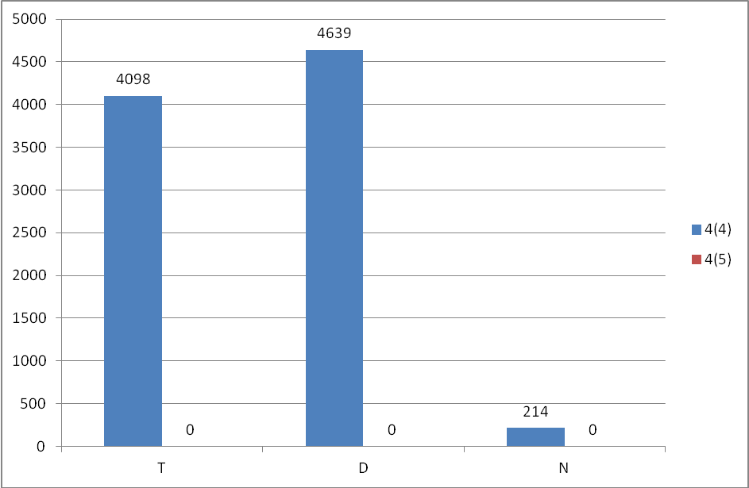

Figure 11.1.1: Numbers of Article 4(4) and 4(5) exemptions
T = Technical feasibility
D = Disproportionate costs
N = Natural conditions
Blue = Article 4(4) exemptions
Red = Article 4(5) exemptions
Source: WISE
Disproportionate costs of measures were taken into account at water body level and the background document describes the disproportionate cost analysis method by impact categories linked to the following demands: water supply, hydropower, energy production, irrigation, navigation, ecological water demand, excess water management and flood protection.
The RBMP gives a comprehensive overview on objectives and measures at water body level. It provides information about the exemptions, including disproportionate cost. The RBMP refers only in general way to exemptions that could be technical, excessive costs related and natural.
In the referenced documents there is no firm statement on what cost-benefit ratio is considered as disproportionate, though the documents list what direct and indirect impacts have to be taken into account when calculating the cost and benefit of a given type of measure.
Basic measures were excluded from the assessment of cost and benefit. The cost of basic measures was presented separately with the relevant deadline set by several directives. The cost of basic measures and additional measures were included together only in the affordability analysis.

Exemptions according to Article 4(6)
Hungary has not applied Article 4(6) exemption in the RBMP.

Exemptions according to Article 4(7)
Hungary did not report exemptions under Article 4(7).

Exemptions to Groundwater Directive
The guideline for justification of exemptions gives the inventory of exemptions from measures including those to prevent or limit pollutants into groundwater. Another annex to the RBMP lists all designated groundwater bodies and information about the type of exemptions applied on them.

Reasons for exemptions | Groundwater bodies  (%)
Currently the status of GWB is not known reliably, or the reason of unfavourable status not known | 25
Co-ordinated actions are needed together with the neighbouring country to achieve good status | 3
The measures would not worth implementing because of the estimated pros and cons of direct and indirect effects, as well as benefits and losses and water body level disproportionate expenses. | 3
The measures would cause disproportional burden on the national economy, certain groups of society or some sectors of the economy, if they were implemented by 2015. | 48
Restoration of groundwater status needs more time. | 22
Table 11.5.1: Summary table on what type of exemptions are applied on the GWBs
Source: WISE
Measures are related to the implementation of WFD objectives linked to feasibility options. Two measures are linked there to the prevention of inputs of pollutants into groundwater.

Programmes of measures
According to Annex VII of the WFD, the RBMPs should contain a summary of the programmes of measures (PoM), including the ways in which Member States expect to achieve the objectives of WFD Article 4. The programmes should have been established by 2009, but are required to become operational by December 2012. The assessment in this section is based on the PoM as summarised by the Member State in its RBMP, and the compliance of this with the requirements of Article 11 and Annex VII of the WFD.
It therefore does not include a comprehensive assessment of compliance with the requirements of Article 11(3) on basic measures. It focuses in particular on key sets of measures. Member States will report to the Commission by December 2012 on the full implementation of their PoMs, including on the progress on the implementation of basic measures as required by Article 11(3). The Commission will assess what Member States report and will publish its assessment in accordance with Article 18 WFD.

Programme of measures – general
According to the RBMP, the program of measures is a result of an iterative social and professional consultation process. The list of measures is defined by water bodies, the measures were determined according to the WB characteristics (classification), status, pressures and impacts.
Information was provided on the effectiveness of measures and on the schedule of actions until 2015, 2021 and 2027. For many river and lake water bodies there is a lack of data on status therefore measures are only partly based on the status assessments and partly on expert judgement. Measures are assigned to each water body.
PoMs have been co-ordinated among the Danube countries in the frame of ICPDR. Under the ICPDR co-ordinated planning process countries in expert groups shared information and discussed specific issues, like river continuity and nutrient reduction measures.
The RBMP identified the estimated costs of measures in detail for different periods. The RBMP provides cost estimates for preparatory actions, basic and supplementary measures as well as for administrative, monitoring, IT costs etc.
Within the basic measures a cost estimate is given for national action programmes, such as Waste Water Treatment Programme, Drinking Water Improvement Programme, Water Resources Protection Programme etc. As these programmes could be related to more than one pressure, it is not possible to separate the costs by pressures or sectors.
Three types of costs for implementation of PoM were presented in the RBMP. The costs which have already allocated, the planned costs and the additional amount that would be necessary to reach the objectives but not yet allocated or planned.

Measures related to agriculture
Agricultural pressures have been identified as significant. From a quantitative point of view, water over-abstraction and agricultural use related to water transfers were considered as significant pressures. Nitrogen, phosphorous and pesticide pollution from point and diffuse sources were also identified as significant pressures. Certain hydromorphological modifications - especially at sub-unit level - are directly connected to farming activity as many of the dams, weirs, drainage systems are used for agricultural purposes.
Forums were organised nationwide for discussion of thematic issues of RBMPs, including agriculture. But it was not clear whether the farmers' organisations were associated with the different steps of the PoM preparation.
A comprehensive list of measures is given in the PoM addressing the pressures. A significant number of measures are related to agriculture, such as reduction of the application of fertilisers and pesticides, hydromorphological measures, measures against soil erosion, water saving technical measures, water retention measures, change in land use, economic instruments (water pricing, agreements, taxes etc.), advice and training, awareness raising, zoning and land use planning.
Information is given regarding the scope of application of the measures with a geographical approach or sectoral approach.
Concerning the costs of measures, the new Hungarian Rural Development programme provides funding for investment programmes, such as advanced irrigation techniques, water reuse etc. Details are provided in the PoM.
A deadline of implementation for each measure is given. The RBMP provides a thematic overview of the measures, the percentage of WBs affected and the deadline by which the given measures will be implemented until 2015 and after 2015.
There is no detailed information regarding the inspection of the WFD agricultural measures (beyond the cross compliance requirements) and regarding the follow up of the implementation.
Measures | HU1000
Technical measures
Reduction/modification of fertiliser application | ✓
Reduction/modification of pesticide application | ✓
Change to low-input farming (e.g. organic farming practices) | ✓
Hydromorphological measures leading to changes in farming practices | ✓
Measures against soil erosion | ✓
Multi-objective measures (e.g. crop rotation, creation of enhanced buffer zones/wetlands or floodplain management)
Technical measures for water saving | ✓
Economic instruments
Compensation for land cover | ✓
Co-operative agreements | ✓
Water pricing specifications for irrigators | ✓
Nutrient trading | ✓
Fertiliser taxation | ✓
Non-technical measures
Additions regarding the implementation and enforcement of existing EU legislation | ✓
Institutional changes | ✓
Codes of agricultural practice
Farm advice and training | ✓
Raising awareness of farmers | ✓
Measures to increase knowledge for improved decision-making
Certification schemes
Zoning (e.g. designating land use based on GIS maps) | ✓
Specific action plans/programmes
Land use planning | ✓
Technical standards | ✓
Specific projects related to agriculture
Environmental permitting and licensing
Table 12.2.1: Types of WFD measures addressing agricultural pressures, as described in the PoM
Source: RBMPs

Measures related to hydromorphology
There is information on links between pressures and measures or between uses and measures. The RBMP lists measures to improve the hydromorphological status of rivers and lakes in three categories: measures related to beds of rivers and lakes in order to achieve an ecologically based flow regime, measures related to flood plains of rivers and riparian zones of lakes and measures related to water use taking into account hydromorphology.
The following specific hydromorphological measures are going to be taken into account in the RBMP: fish ladders, habitat restoration, building spawning and breeding areas, sediment / debris management, reconnection of meander bends or side arms, lowering of river banks, setting minimum ecological flow requirements, inundation of flood plains, construction of retention basins, reduction or modification of dredging, restoration of degraded bed structure, and re-meandering of formerly straightened water courses.
The number of river and lake water bodies subject to hydromorphological measures is reported in the RBMP. No detailed information was found though about the expected effects of hydromorphological measures on these river and lake water bodies.
Measures | HU1000
Fish ladders | ✓
Bypass channels
Habitat restoration, building spawning and breeding areas | ✓
Sediment/debris management | ✓
Removal of structures: weirs, barriers, bank reinforcement
Reconnection of meander bends or side arms | ✓
Lowering of river banks | ✓
Restoration of bank structure
Setting minimum ecological flow requirements | ✓
Operational modifications for hydropeaking
Inundation of flood plains | ✓
Construction of retention basins | ✓
Reduction or modification of dredging | ✓
Restoration of degraded bed structure | ✓
Remeandering of formerly straightened water courses | ✓
Table 12.3.1: Types of WFD measures addressing hydromorphological pressures, as described in the PoM
Source: RBMPs

Measures related to groundwater
Basic and supplementary measures are to be implemented in groundwater bodies. All the relevant Directives and the corresponding national programmes related to basic measures are mentioned in the RBMP.
The RBMP gives information on supplementary measures which are being implemented in groundwater bodies at risk or at poor status to achieve the objectives, like changes in farming methods, water retention in excess water sensitive areas, modernisation of livestock farms, better local wastewater management and better sludge management.
Supplementary measures tackling groundwater over-exploitation are the implementation of sustainable water uses and the termination or revision of illicit or non-compliant water uses.
The RBMP gives information for each GWB what type of measures have to be implemented by what year and in gives justification of the required measures if standards (quantitative, chemical) are not met. Comments are also given whether further international co-ordination would be needed with relevant neighbouring countries (Member State or third countries). There is a general statement in WISE that at the time of RBMP preparation co-ordination actions were on-going with all neighbouring countries, but none of them had been finished.

Measures related to chemical pollution
In the RBMP there is an inventory of sources of pollution and it covers the following categories of pollutants:
- Priority substances and certain other pollutants;
- Non priority specific pollutants or main pollutants identified at the river basin level;
- Deoxygenating substances; and
- Nutrients.
The RBMP provides information about the direct and indirect industrial pollution loads of different compounds (BOD, COD, suspended solids, nitrogen, Fe, sulphides, phosphorous, heavy metals). It describes the pressures and impacts from anthropogenic activities.
The RBMP lists the pollution sources of different pollutant groups (sediment, deoxygenating substances, microbiological pollutants, nutrients, heavy metals, oils and grease, other micropollutants, salts) in urban areas.
The RBMP gives a list of the industrial plants, where accidental pollution events happened and the type of pollution observed.
The RBMP gives the diffuse Nitrogen and Phosphorous load of each surface water body identifying the load from agricultural, urban and other areas to the water body.
The PoM lists the main measures related to chemical pollution reductions from industrial, waste deposits and urban sources. The description of chemical measures does not refer to specific chemicals. The relevant measures listed are related to industrial and illegal wastewater discharges, thermal waters and cooling water.

Measures related to Article 9 (water pricing policies)
In Hungary the Governmental Decree No. 221/2004. (VII. 21) defines water services as: "water services: all services which provide for households, public institutions or any economic activity the abstraction, the impoundment, the storage, the treatment and distribution of surface water or groundwater, the waste-water collection and treatment facilities which subsequently discharge into surface water.”
Despite the above mentioned broad water services definition, which is in line with the WFD, water services taken into account in the economic analysis and cost recovery calculations are limited. The Hungarian position is that two types of water services can be distinguished in terms of the Water Framework Directive:
- Non-economic, community services, for which customers cannot be determined specifically and there is no contractual relationship between the provider and the payee. These community services are flood control, water protection, drainage control, drainage management (general), river and lake regulation, recreation, water distribution and water governance. For these activities, according to the Hungarian position, there is no need to apply the direct financial cost-benefit principle, and full enforcement towards the stakeholders.
- Water services where the consumers are in contractual relationship with the service providers, and the consumers pay a service fee. These community services are drinking and industrial water supply (public water supply), sewerage and waste water treatment, agricultural water services (irrigation, fish ponds) and water energy production. For these services, according to the Hungarian RBMP, the full enforcement of cost recovery is needed.
All types of financial costs are included in cost recovery calculations, as well as subsidies and cross-subsidies.
Environmental and resource costs have not been calculated but they are internalised via existing policy instruments (waste water charges, water abstraction charges).
A background document deals with the assessment of subsidies on national level (subsidies for public water utility investments, for agricultural water use and for low income households).
The contribution of different water uses disaggregated into households, agriculture and industry to cost recovery of water services (includes only defined water services) is presented and is close to 100% of full cost recovery.
The polluter pays principle is taken into account in charging for pollution loads. There is no distinction between sectors and groups of water users. It is also fully regulated by a Governmental Decree how the polluters are responsible for the pollution remediation.
Water metering is in place for practically all users. The existing public utility tariff system, which applies the principle of financial cost recovery, was introduced in the early 90's. As a result, the specific public water consumption has decreased.
The WISE report explains that flexibility provision of the Article 9 is taken into consideration in household water tariffs setting, for social effects (when the state subsidizes the too high tariffs) and in agricultural water use tariffs where regional Water Authorities apply region specific tariffs taking into account social, environmental and economic effects.
Household water supply and sanitation tariffs on those settlements where tariff values exceed a given threshold value (set by the government each year in yearly state budget) are subsidized from the state budget. However, it was pointed out that the budget used for subsidy has been decreased by 33% in the period from 2004 to 2009. The current system of subsidies does not take into consideration the needs. In areas where the cost of the services is high it ensures subsidy for all residents regardless of their social status.
The planned measures are the improvement of water utility/wastewater tariffs in order to ensure financial sustainability and implementation of necessary renewals, and reduction of unjustified discrimination between consumers (households, industry and public sector). Also mentioned are an improvement to agricultural water services pricing and the establishment of unified approaches and conditions for different sectors.
It is stated in the RBMP that there has not been international co-ordination of the economic analysis within the Danube River Basin District. In the RBMP no statement was found on co-operation among administrations within the country in applying Article 9 issues.

Additional measures in protected areas
The water bodies and protected areas that need additional measures are clearly identified. Information on the additional measure(s) is given in the PoM. Besides the basic measures the RBMP gives information about measures which are being implemented for SWBs and GWBs and the additional measures which are needed to reach the more stringent objectives relating to protected areas. The additional measures listed are survey of status of habitats, interventions in surface and groundwater uses, supplying water for oxbows, for tributaries and floodplain habitats, water level control, arrangements for waters containing fish, measures in relation to bathing waters and agricultural conservation measures.
There are 443 river water bodies requiring additional measures of which 164 have high priority. In case of lake water bodies, 127 need additional measures and 44 require high priority additional measures.
Safeguard zones to protect drinking water abstraction areas have been established. In addition to safeguard zones other (basic or supplementary) measures specific to safeguarding drinking water quality were also reported. Measures addressing the issues are changes in water treatment technology, keeping drinking water resources in safe conditions, transition to alternative drinking water resources in case of resources shortages, development of a drinking water safety plan and implementation of safety measures specified in the RBMP.

water scarcity and droughts, flood risk management AND Climate change adaptation

Water Scarcity and Droughts
Droughts and water scarcity affect part of the RBD. In the RBMP the discussion concentrates mainly on climatic effects concerning water scarcity and droughts. Limited information is given about other factors, which may cause current and upcoming water scarcity / drought situations.
A detailed map is given on annual climatic water deficit (Figure 13.1.1). The map shows that a large part of the country is affected by annual climatic water deficit, which will be deepened by the expected climate change.
Figure 13.1.1: Annual climatic water deficit in Hungary
The main reasons for both water scarcity and droughts are a decrease in the natural available water resources and irregular rainfall patterns. Water scarcity is also increased by past and current over-allocation of available water resources and the need to satisfy new agricultural water demands.
Long term annual precipitation datasets show decreasing trends.
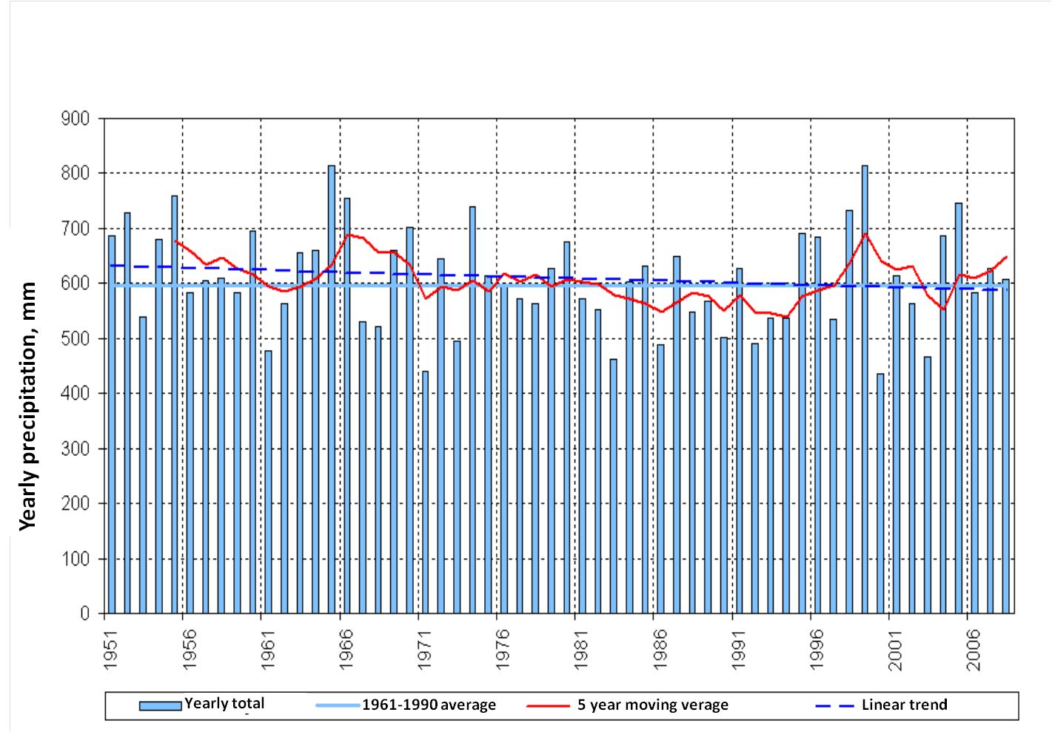
Figure 13.1.2: Linear and 5 year moving average trends in yearly precipitation (1951-2008)
The main measures related to water scarcity and droughts are the reduction of losses in urban distribution networks, measures to increase treated water re-use, improvement of the efficiency of water agricultural uses, reduction / management of groundwater abstraction, measures to enhance the resilience of the ecosystems to water scarcity and droughts, promotion of rainwater harvesting and the development or upgrading of reservoirs.
Development of the Danube River Basin Management Plan was co-ordinated by the International Commission for the Protection of Danube River (ICPDR). The Integrated Tisza RBMP, which is one of the sub-basin plans, was also developed under ICPDR co-ordination and the plan deals with water scarcity and/or droughts.

Flood Risk Management
Flood risk was mentioned as a major issue. It is considered as a significant water management pressure and reason for HMWB designation.
In the RBMP 38% of the planned future infrastructure projects are flood related, such as water retention measures, reservoirs to mitigate flood peak levels and new dams.
Co-ordinated action is going on to harmonise WFD and Flood Directive implementations among the Danube countries. The Flood Risk Action Programme was developed for the Danube RBD in the frame of ICPDR, and the Danube countries are also co-operating in preparation of similar sub-basin plans.

Adaptation to Climate Change
The National Climate Change Strategy (NCCS) was developed and adopted in 2008. The NCCS developed recommendations on adaptation measures (keeping the rainwater in place, retaining river water, construction of small and medium reservoirs and building water transition structures). Water related recommendations and measures of the NCCS are included in the RBMP.
HU1000 RBMP describes specific climate change adaptation measures, such as water retention measures, reduction of run-off, an increase in the utilization of treated waste water, an increase in the ratio of wetland and forest areas in river basins and increases to the base flow of rivers.
Though climate change issues were taken up in the first RBMP, no information was given about how climate change challenges will be taken up in the second and third cycle.

Recommendations
Following the steps of river basin planning as set out in the WFD should ensure that water management is based on a better understanding of the main risks and pressures in a river basin and as a result, interventions are cost effective and ensure the long term sustainable supply of water for people, business and nature.
To deliver successful water management requires linking these different steps. Information on pressures and risks should feed into the development of monitoring programmes, information from the monitoring programmes and the economic analysis should lead to the identification of cost effective programmes of measures and justifications for exemptions. Transparency on this whole process within a clear governance structure will encourage public participation in both the development and delivery of necessary measures to deliver sustainable water management.
To complete the 1st river basin management cycle, and in preparing for the second cycle of the WFD therefore, it is recommended that:
- Financing of some RBMP elements does not seem to be ensured in every case. The monitoring and the Programme of Measures should be sufficiently financed.
- The testing of typology of surface water bodies against biological data has not been completed in the first RBMP cycle because of the lack of sufficient data. This should be remedied.
- As the methods were not completed for all BQEs, the reference values and class boundaries were not completed for all types. Methodologies for all biological quality elements should be established with reference values and class boundaries completed for all types.
- Due to significant lack of data, only 13% of surface water bodies were classified for river basin specific pollutants. The identification of river basin specific pollutants needs to be more transparent, with clear information on how pollutants were selected, how and where they were monitored, where there are exceedances and how such exceedances have been taken into account in the assessment of ecological status. It is important that there is an ambitious approach to combatting chemical pollution and that adequate measures are put in place.
- Status assessments of surface water bodies are not sufficiently reliable, therefore an extremely high percentage of surface water bodies are indicated as being of unknown status in Hungary. Where there are currently high uncertainties in the characterisation of the RBDs, identification of pressures, and in the assessment of status, these need to be addressed in the current cycle, to ensure that adequate measures can be put in place before the next cycle. For example, status assessments of surface water bodies should be made reliable and monitoring should be intensified in order to reduce the high number of water bodies in unknown status. Uncertainty in HMWB designation should be tackled. Improvements in data will be needed for a better designation process and to reduce the uncertainty.
- The designation of HMWBs should comply with all the requirements of Article 4(3). The assessment of significant adverse effects on their use or the environment and the lack of significantly better environmental options should be specifically mentioned in the RBMPs. This is needed to ensure transparency of the designation process.
- Mercury, hexachlorobenzene and hexachlorobutadiene should be monitored in biota for comparison with the biota standards in the EQSD, unless water EQS providing an equivalent level of protection are derived. Trend monitoring in sediment or biota for several substances as specified in EQSD Article 3(3) will also need to be reflected in the next RBMP.
- A large number of exemptions have been applied in this first cycle of RBMPs. While the WFD does provide for exemptions, there are specific criteria that must be fulfilled for their use to be justified. The application of exemptions needs to be more transparent and the reasons for the exemptions should be clearly justified in the plans. The high number of exemptions applied in these first RBMPs is a cause of concern. Hungary should take all necessary measures to bring down the number of exemptions for the next cycle, including the needed improvements in the characterisation process, monitoring networks and status assessment methods, as well as reducing significantly the degree of uncertainties.
- It is unclear whether there are new physical modifications planned in RBMPs. If this is the case, the use of exemptions under Article 4(7) should be based on a thorough assessment of all the steps as requested by the WFD, in particular an assessment of whether the project is of overriding public interest and whether the benefits to society outweigh the environmental degradation, and the absence of alternatives that would be a better environmental option. Furthermore, these projects may only be carried out when all possible measures are taken to mitigate the adverse impact on the status of the water. All conditions for the application of Article 4(7) in individual projects must be included and justified in the RBMPs as early in the project planning as possible.
- Groundwater trend assessments should be carried out more extensively in the 2nd RBMP cycle. Trend reversals should be performed.
- Agriculture is indicated as exerting a significant pressure on the water resources in Hungary. This should be translated into a clear strategy that defines the basic/mandatory measures that all farmers should adhere to and the additional supplementary measures that can be financed. This should be developed with the farmers' community to ensure technical feasibility and acceptance. There needs to be a very clear baseline so that any farmer knows the rules this can be adequately advised and enforced and so that the authorities in charge of the CAP funds can adequately set up Rural Development programmes and cross compliance water requirements.
- Natural water retention measures should be used more extensively.
- The cost-recovery should address a broad range of water services, including impoundments, abstraction, storage, treatment and distribution of surface waters, and collection, treatment and discharge of waste water, also when they are "self-services", for instance self-abstraction for agriculture. The cost recovery should be transparently presented for all relevant user sectors, and environment and resource costs should be included in the costs recovered. Information should also be provided on the incentive function of water pricing for all water services, with the aim of ensuring an efficient use of water. Information on how the polluter pays principle has been taken into account should be provided in the RBMPs.

Categorisation determined under the EC Comparative study of pressures and measures in the major river basin management plans in the EU (Task 1b: International co-ordination mechanisms).
This information corresponds to the reporting of protected areas under the WFD. More/other information may have been reported under the obligations of other Directives.
The total number of monitoring sites may differ from the sum of monitoring sites by type because some sites are used for more than one purpose.
Number of sites calculated from data reported at site level. If no data reported at site level, then table supplemented with data reported at programme level.
Data for 2009 and 2015 extracted from WISE. Data for 2021 and 2027 established during the compliance assessment of the RBMPs.
Data for 2009 and 2015 extracted from WISE. Data for 2021 and 2027 established during the compliance assessment of the RBMPs.
Data for 2009 and 2015 extracted from WISE. Data for 2021 and 2027 established during the compliance assessment of the RBMPs.
Data for 2009 and 2015 extracted from WISE. Data for 2021 and 2027 established during the compliance assessment of the RBMPs.
Data for 2009 and 2015 extracted from WISE. Data for 2021 and 2027 established during the compliance assessment of the RBMPs.
Data for 2009 and 2015 extracted from WISE. Data for 2021 and 2027 established during the compliance assessment of the RBMPs.
Data for 2009 and 2015 extracted from WISE. Data for 2021 and 2027 established during the compliance assessment of the RBMPs.
Decree of the Ministry of Rural Development 10/2010 (VIII. 18) on EQSs of surface waters and rules of their applications
Exemptions are combined for ecological and chemical status.
These are the minimum requirements to be complied with and include the measures required under other Community legislation as well as measures to achieve the requirements of other WFD Articles and to ensure appropriate controls on different activities affecting water management.

