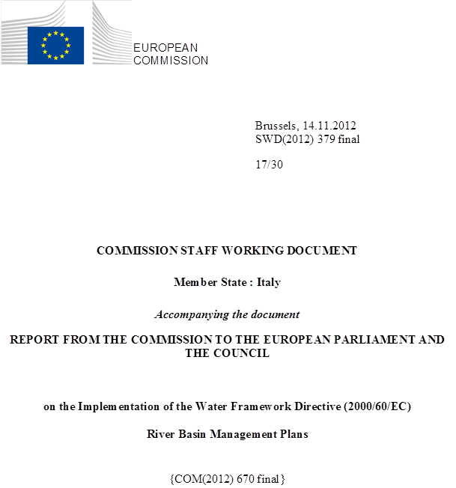

general information
Figure 1.1: Map of River Basin District
International River Basin Districts (within EU)
International River Basin Districts (outside EU)
National River Basin Districts (within EU)
Countries (outside EU)
Coastal Waters
Source: WISE, Eurostat (country borders)
Italy has a population of 60 million and a total surface area greater than 300000 km². A large proportion of the territory is upland or mountainous: in mainland Italy, the Alps spread as an arc across the northernmost part of the country, while the Apennines stretch through the centre of the country. Most of the population lives in lowland areas, which as a result have a high population density.
Italy has eight river basin districts (see table below). The largest, the Po Basin, has 74000 km² and covers almost one-quarter of the country’s territory. Six RBDs cover mainland Italy, while one each covers Italy’s two large islands, Sardinia and Sicily.

RBD | Name | Size (km²) | Countries sharing RBD
ITA | Eastern Alps / Alpi orientali | 40851 | AT, CH, SI
ITB | Po Basin / Bacino del Po | 74000 | CH, FR
ITC | Northern Appenines / Appennino settentrionale | 38131 | FR
ITD | Serchio | 1565 | -
ITE | Middle Appenines / Appennino centrale | 36302 | -
ITF | Southern Appenines / Appennino meridionale | 68200 | -
ITG | Sardinia / Sardegna | 24000 | -
ITG | Sicily / Sicilia | 26000 | -
Table 1.1: Overview of Italy’s River Basin Districts
Source: River Basin Management Plans reported to WISE: http://cdr.eionet.europa.eu/it/eu/wfdart13
Three Italian RBDs share catchments with other Member States, and two with Switzerland:
- ITA shares catchments with Slovenia and small catchments with Austria and Switzerland;
- ITB shares catchments with Switzerland and a small catchment with France;
- ITC shares catchments with France.
The table below provides information for several key shared catchments (note that the data for the Danube refers to Italy’s share of the whole IRDB; for the others, data refers specifically to the catchment).
Name international  river basin | National RBD | Countries sharing RBD | Co-ordination category
Name international  river basin | National RBD | Countries sharing RBD | 1 |  | 2 |  | 4
Name international  river basin | National RBD | Countries sharing RBD | km² | % | km² | % | km² | %
Danube | ITA | AL, AT, BA,BG, CH, CZ, DE, HR, HU, IT, MN, ME, MK, PL, RO, RS, SL, SK, UA | 565 | <0.1
Rhine | ITB | AT, BE, CH, DE, FR, IT, LI, LU, NL | 60 | <0.1
Po | ITB | CH, FR |  |  | 70153 | 94.8
Ticino/  Lago Maggiore (Sub--basin Po) | ITB | CH |  |  | 3229 | 48.9
Adda/  Lake Como (Sub--basin Po) | ITB | CH |  |  | 7448 | 94.0
Isonzo/  Soca | ITA | SI |  |  | 1133 | 33.3
Adige/  Etsch | ITA | CH |  |  |  |  | 11970 | 98.9
Table 1.2: Transboundary river basins by category (see CSWD section 8.1) and % share in Italy
Category 1: Co-operation agreement, co-operation body, RBMP in place.
Category 2: Co-operation agreement, co-operation body in place.
Category 3: Co-operation agreement in place.
Category 4: No co-operation formalised.
Source: EC Comparative study of pressures and measures in the major river basin management plans in the EU.

Status of River basin Management Plan reporting and compliance

Adoption of the RBMPs
In Italy, each RBMP was adopted by the ‘permanent institutional conference’ of the RBD Authority on 24 February 2010 (all RBDs except ITG adopted on 25 February 2010 and ITH on 25 March 2010).
The RBMPs were then passed to Italy’s ‘State-Regions conference’ for its opinion, and then to the President of the Council of Ministers (i.e. the Prime Minister), for approval: this last stage is important, as the final approval gives the RBMPs legal status. (This procedure also encompasses the Programme of Measures, considered part of the RBMPs.) The opinion was provided by the Council of Ministers on 27 July 2011.
There has been a change of the law in Italy since the adoption of the RBMPs, which now do not require the two subsequent stages previously required, that is Opinion of the State/Regions Council, then "Approval by the President of the Council of Ministers".
The eight Italian RBMPs were adopted by the institutional committees of the provisional RBD Authorities in early 2010 (the provisional nature of the RBD Authorities is discussed in Section 3 on Governance), and in July 2011, all the RBMPs received a positive opinion from the State/Regional Council.
Recent information from the Italian authorities states a different process. According to them, the procedure as described in the first paragraph is based on Art.65 of the legislative decree n.152 of the 3 April 2006, prior to the public consultation. The actual adoption is based on Law n.13 of 27 February 2009 (later completed by Art.4 of Legislative Decree n.219 of 10 December 2010) and is done by the Institutional Committees (including ministries of key administrations and presidents of the regions) of the national river basin authorities enlarged with the regions belonging to the districts. They published the RBMPs together with the Programmes of Measures on the above mentioned dates.

Links with other water plans
The RBMPs draw heavily on previous plans, in particular the Piani di Tutela delle Acque (Water Protection Plans) prepared at regional level. The regional plans are dated from 2004 to 2009, and they are an element of the Italy’s approach prior to the transposition of the WFD. The RBMPs take a number of measures from these earlier plans (see Section 12, below). In addition, the RBMPs cite other water plans, for example, the Piani di assetto idrogeologico (Plans of hydrological assets), typically at regional level: these cover water quantity issues.
While the RBMPs provide a means to integrate planning at regional level with planning at RBD level, the added value of the first round of RBMPs is not fully clear.

Key strengths and weaknesses
A common strength for Italy’s RBMPs is that all underwent strategic environmental assessment (SEA).
However, a range of weaknesses exist. Some of the detailed national rules and approaches related to river basin management were issued relatively late in the preparations of the RBMPs. This is the case, notably, for the approach to monitoring and classification set out in the Ministry of Environment’s Decree 56 of 2009. In addition, in recent correspondence with the European Commission, Italy has also highlighted the role of legislation produced after the RBMPs, notably Ministerial Decree (DM) 260/2010 of Nov. 2010.
Partly as a result of this situation, the RBMPs have a number of weaknesses:
- Monitoring programmes (Art. 8 of the WFD) were under revision in many regions: the RBMPs are based on monitoring and other results undertaken at regional level (see section 3 on governance), and the regions have implemented new Italian legislation at different paces. As a result, in key areas such as monitoring, the approaches and methods used by regions within RBDs can vary (see Section 5, below).
- The status classification of many surface and groundwater bodies has not been completed (Art. 4), and the identification of exemptions appears to be incomplete as well. Here too, there are major differences in the extent of assessment across Italy’s regions (see Section 7, below).
- A common approach to ensure adequate incentives for efficient use and an adequate contribution from different users was not in place by 2010 (Art. 9). Moreover, economic analysis varied significantly across the RBMPs.
- The links between the Programmes of Measures, the impacts of human activities and the objectives are not clearly presented in the RBMPs (Art. 11).
It should also be noted that there are some differences in data provided in the RBMPs and that reported in WISE: in some cases, the WISE data are more recent. These differences, however, have made a systematic review of the RBMPs more difficult.

Governance

RBMP timelines
The dates of publication of RBMP documents are provided in the table below: these are behind the due dates set, inter alia, in Art. 14 of the WFD.
RBD | Timetable | Work Programme | Statement on consultation | Significant water management issues | Draft RBMP | Management Plan
Due dates | 22/06/2006 | 22/06/2006 | 22/06/2006 | 22/12/2007 | 22/12/2008 | 22/12/2009
ITA | 29/04/2009 | 29/04/2009 | 01/07/2009 |  | 18/09/2009 | 12/03/2010
ITB | 30/03/2009 | 30/03/2009 | 30/03/2009 | 10/04/2009 | 23/07/2009 | 22/03/2010
ITC | 28/03/2009 | 28/03/2009 | 10/04/2009 | 10/04/2009 | 16/07/2009 | 22/12/2009
ITD | 31/03/2009 | 31/03/2009 | 31/03/2009 | 31/03/2009 | 30/06/2009
ITE | 10/04/2009 | 10/04/2009 | 30/04/2009 | 30/04/2009 | 30/06/2009
ITF
ITG | 22/05/2009 | 22/05/2009 | 22/05/2009 | 22/05/2009 | 22/05/2009 | 25/02/2010
ITH
Table 3.1.1: Timeline of the different steps of the implementation process
Source: WISE
The Directive requires a logic sequence of 3 distinctive consultation steps of each 6 months, to enable meaningful involvement and consultation of interested parties. In Italy these steps were all started within a 3-7 month period, depending on the RBD. It is not clear from the RBMPs if for each of these sequences the 6 month minimum period was respected. No information was reported to WISE on consultations in ITH(Sicily) and ITF.
All of the final RBMPs were reported to the EEA Central Data Repository (CDR) in May 2010, with the exception of ITH (Sicily), reported in July 2010.
It should be noted that the data submitted to WISE was updated compared to that presented in the RBMPs: as a result, it is sometimes difficult to assess the situation set out in the RBMPs.

Administrative arrangements - river basin districts and competent authorities
Overall, the administrative arrangements and relationships are set in national legislation. The national Ministry of Environment, Land and Sea has the lead role for policies and methodologies to implement the Water Framework Directive in Italy, while Italy’s regions are directly responsible for many aspects of implementation, including monitoring, managing and protecting water bodies, as well as many enforcement activities and many aspects of planning. As a result, the RBD authorities, beyond the preparation of the RBMPs, appear mainly to have a co-ordinating role.
Each river basin district (RBD) has an authority in charge of preparing its RBMP. However, by early 2012, these RBD authorities had only been named on a provisional basis: in most cases, the authorities for the river basins of 'national interest' were temporarily designated as the RBD authorities, and notably carried out this role for the preparation of the first RBMPs.
This is an issue in particular for four RBDs where the provisional authority is based on a river basin authority that covers only part of the RBD. Thus, the Arno RBA prepared the RBMP for the Northern Apennines (ITC), though the Arno covers only part of the RBD territory; similar situations are seen in the Eastern Alps (ITA), the Central Apennines (ITE) and the Southern Apennines (ITF).
Figure 3.2.1: Organisation overview of authorities involved in Italy’s RBMPs
Source:Pressures and Measures study on Governance
For each RBD, an ‘institutional committee’ brings together the regions with representatives of key national ministries – environment, agriculture, economic development and infrastructure/transport among others (see the figure 3.2.1). At present, the institutional committees of the former river basin authorities ‘of national interest’ are used for this purpose, with their membership enlarged to all regions in the RBD.
While this temporary system is to be replaced by full RBD authorities, it does not appear that steps are underway to move to a permanent system.

RBMPs - Structure, completeness, legal status
The RBMPs have a binding effect on public administrations and bodies, once they are approved by the President of the Council of Ministers. In principle, this means that they should be binding on permitting and planning decisions; however, this is not explicitly stated in Italy’s legislation. Moreover, the legislation does not contain explicit provisions for the review of existing permits and concessions, for example in terms of environmental objectives set in the RBMPs.
According to recent information from the Italian authorities, the RBMPs and the Programmes of Measures are operational from the moment they have been published by the enlarged Institutional Committees.

Consultation of the public, engagement of interested parties
Italian legislation calls for the active involvement of all concerned parties in the preparation, review and updating of RBMPs.
In all RBDs, the draft RBMP was available via web sites and in print in government offices, public meetings were held and interested parties also had the opportunity to submit written comments. However, the extent of consultation varied. The highest number of consultations was seen in ITB, where meetings included broad public information events, stakeholder meetings and thematic meetings on specific issues. In Sardinia (ITG), on the other hand, the public participation process of the RBMP was integrated with that for the SEA of the plan.
Most of the plans, including ITB and ITC, list written comments and how they have been taken into account: comments brought new knowledge for the RBMPs, they have influenced supplementary measures and in some cases proposed approaches for measures that will be considered in implementation.
No mention was found in the legislation or in the RBMPs concerning the involvement of stakeholders in the implementation stage of the plans.

International cooperation and coordination
Italy has a bilateral agreement with Slovenia for shared catchments in ITA, and joint monitoring has been carried out. In addition, Slovenian authorities (as well as Austrian and Swiss authorities) were consulted on the ITA RBMP. Italy also has a bilateral agreement and commission with Switzerland, in particular affecting shared catchments in ITB. ITB also shares a catchment with France. The RBMP for ITB does not mention co-operation with France or Switzerland for its preparation, though both countries provided input to the SEA of the plan. The RBMP for ITC refers to informal contacts with French authorities regarding a single shared catchment; in addition, according to information recently provided by Italy, documents were exchanged via the national Ministry of Environment.

Integration with other sectors
Most RBMPs refer to a broad range of existing sectoral plans, in particular the Piani territoriali di coordinamento, co-ordinating territorial plans for land use and development, which are prepared at provincial (i.e. sub-regional) level. Some RBMPs cite rural development plans and energy plans; ITE refers to structural fund programmes. Most RBMPs do not describe the specific interactions with these sectoral plans; however, in a few cases, such as the RBMP for ITC, individual measures are linked to rural development plans.

Characterisation of river basin districts
A court ruling has been issues against Italy by the European Court of Justice (ECJ) for failing to submit the reports required under Article 5 of the Directive, on Characterisation of the River Basin Districts, review of the environmental impacts of human activity and economic analysis of water use. Italy has since complied and the case is closed.

Water categories in the RBD
Each of Italy’s RBMPs includes all four water categories (rivers, lakes, transitional and coastal waters).

Typology of surface waters
A national system for typologies is set out in national legislation, based on system B of the WFD. National legislation calls for the validation of typologies with biological data, as well as methods for the establishment of reference conditions. The 2010 RBMPs do not, however, provide information on validation of surface water types with biological data; the plan for ITB refers to work in progress in this area. Nor do the RBMPs refer to reference sites. The RBMP for ITC mentions ongoing work on this topic in the regions.
According to recent information provided by Italy, reference conditions are provided in DM 260/2010, which is legislation issued after the RBMPs were prepared.
Italy has reported almost 600 surface water body types, the great majority of which are river water bodies (see the table below). While the methodology for the identification of surface water types is set at national level, it appears that separate types have been determined on a hydro-ecoregion basis; however, some regional types are also included in the list found in the 2010 legislation.
RBD | Rivers | Lakes | Transitional | Coastal
ITA | 88 | 8 | 10 | 4
ITB | 90 | 13 | 6 | 2
ITC | 63 | 7 | 7 | 7
ITD | 5 | 1 | 1 | 1
ITE | 64 | 7 | 4 | 6
ITF | 107 | 5 | 7 | 10
ITG | 12 | 6 | 10 | 5
ITH | 15 | 4 | 1 | 5
Table 4.2.1: Surface water body types at RBD level
Source: WISE

Delineation of surface water bodies
Overall, Italy has designated over 8600 surface water bodies (see the table above) of which most are rivers.
Nearly all of the RBMPs refer to the criteria for the delineation of small river, lake or transitional water bodies set out in national legislation. However, for the most part the RBMPs do not provide information on how small water bodies have been addressed.
RBD | Surface Water |  |  |  |  |  |  |  | Groundwater
RBD | Rivers |  | Lakes |  | Transitional |  | Coastal
RBD | Number | Average Length (km) | Number | Average Area  (sq km) | Number | Average Area  (sq km) | Number | Average Area  (sq km) | Number | Average Area  (sq km)
ITA | 1853 | 1231 | 40 | 1 | 49 | 13 | 24 | 63 | 123 | 311
ITB | 1906 | 12 | 116 | 14 | 14 | 16 | 2 | 122 | 141 | 566
ITC | 1304 | 28 | 33 | 0 | 11 | 4 | 48 | 19 | 186 | 135
ITD | 51 | 11 | 2 | 4 | 1 | 1 | 1 | 0 | 11 | 444
ITE | 501 | 30 | 38 | 10 | 6 | 3 | 22 | 59 | 133 | 260
ITG | 755 | 0 | 1 | 0 | 57 | 0 | 217 | 0 | 0 | 0
ITH | 256 | 15 | 32 | 1 | 31 | 1 | 65 | 0 | 0 | 0
ITF | 1018 | 6960 | 38 | 4 | 12 | 14 | 110 | 24 | 139 | 136
Total | 7644 | 1236 | 300 | 7 | 181 | 6 | 489 | 14 | 733 | 275
Table 4.3.1: Surface water bodies, groundwater bodies and their dimensions
Source: WISE

Identification of significant pressures and impacts
The RBMPs do not refer to a common approach or criteria to determine significant pressures and impacts. While 2008 Italian legislation identifies key types of pressures to be estimated, it does not describe a method to identify whether they are significant.
Some RBMPs, such as those for ITA and ITC, refer to the use of both numerical tools and expert judgement in pressure analysis; however, they do not provide details on the specific methods used. The RBMP for ITD (Serchio) lists, in a few cases, simple threshold criteria, such as the size of dams. Other RBMPs refer to ongoing work in this area.
While there is limited information on methods in the RBMPs, the data available on WISE shows that determinations of significant pressures have been made in all RBDs. These data indicate that diffuse sources are a significant pressure for almost 40% of surface water bodies, and point sources for over 25%. Water abstraction is a significant pressure for more than 15% of surface water bodies. However, almost 45% of surface water bodies are not subject to significant pressures. Significant differences are seen, however, across the RBDs: for example, diffuse sources are a significant pressure for more than half of the SWBs in ITC (northern Appenines), ITD (Serchio) and ITH (Sicily), but affect less than 30% of the SWBs in ITG (Sardinia).
RBD | No pressures |  | Point source |  | Diffuse source |  | Water abstraction |  | Water flow regulations and morphological  alterations |  | River management |  | Transitional and coastal water management |  | Other morphological alterations |  | Other pressures
RBD | No. | % | No. | % | No. | % | No. | % | No. | % | No. | % | No. | % | No. | % | No. | %
ITA | 1022 | 51.98 | 355 | 18.06 | 572 | 29.09 | 151 | 7.68 | 125 | 6.36 | 490 | 24.92 | 25 | 1.27 | 39 | 1.98 | 394 | 20.04
ITB | 808 | 39.65 | 487 | 23.9 | 784 | 38.47 | 384 | 18.84 | 310 | 15.21 | 45 | 2.21 | 16 | 0.79 | 81 | 3.97 | 13 | 0.64
ITC | 470 | 33.67 | 274 | 19.63 | 769 | 55.09 | 339 | 24.28 | 74 | 5.3 | 65 | 4.66 | 1 | 0.07 | 1 | 0.07 | 66 | 4.73
ITD | 14 | 25.45 | 21 | 38.18 | 39 | 70.91 | 11 | 20 | 5 | 9.09 | 0 | 0 | 0 | 0 | 0 | 0 | 8 | 14.55
ITE | 200 | 35.27 | 221 | 38.98 | 194 | 34.22 | 94 | 16.58 | 41 | 7.23 | 7 | 1.23 | 3 | 0.53 | 3 | 0.53 | 8 | 1.41
ITF | 608 | 51.61 | 507 | 43.04 | 439 | 37.27 | 324 | 27.5 | 6 | 0.51 | 281 | 23.85 | 28 | 2.38 | 27 | 2.29 | 10 | 0.85
ITG | 548 | 53.2 | 229 | 22.23 | 277 | 26.89 | 84 | 8.16 | 102 | 9.9 | 0 | 0 | 72 | 6.99 | 43 | 4.17 | 11 | 1.07
ITH | 165 | 42.97 | 181 | 47.14 | 203 | 52.86 | 15 | 3.91 | 20 | 5.21 | 0 | 0 | 0 | 0 | 0 | 0 | 0 | 0
Total | 3835 | 44.52 | 2275 | 26.41 | 3277 | 38.04 | 1402 | 16.28 | 683 | 7.93 | 888 | 10.31 | 145 | 1.68 | 194 | 2.25 | 510 | 5.92
Table 4.4.1: Number and percentage of surface water bodies affected by significant pressures
Source: WISE
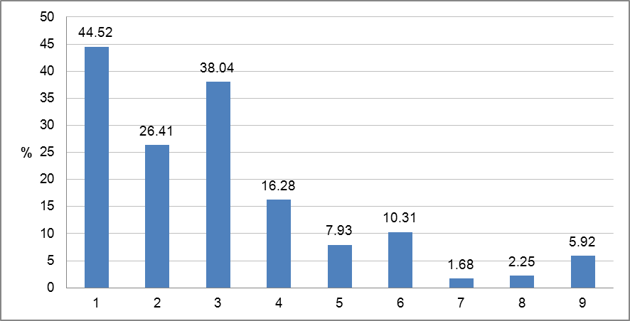
Figure 4.4.1: Graph of percentage of surface water bodies affected by significant pressures
1 = No pressures
2 = Point source
3 = Diffuse source
4 = Water abstraction
5 = Water flow regulations and morphological alterations
6 = River management
7 = Transitional and coastal water management
8 = Other morphological alterations
9 = Other pressures
Source: WISE
The RBMPs identify a broad range of economic sectors that create pressures. These include: for industry, both abstractions and point source pollution; for agriculture, point and diffuse source pollution from livestock raising, as well as abstractions and diffuse source pollution for crops; coastal works, including for recreation, affecting transition and coastal waters. The information is presented for the most part in general terms: only a few RBMPs describe or list significant pressures for individual water bodies. An example is presented in the sub-basin report for the Ticino River, in ITB: this lists the number of SWBs affected by 25 different types of pressures, from urban wastewater discharges to abstractions to engineering works.

Protected areas
In Italy, over 11,000 protected areas have been designated, according to information provided to WISE (see the table below). Just over half of these areas are for drinking water abstraction under Art. 7 of the WFD (no information was found on the breakdown of protected areas associated with SWBs and GWBs).
RBD | Number of PAs
RBD | Article 7 Abstraction for drinking water | Bathing | Birds | European Other | Fish | Habitats | Local | National | Nitrates | Shellfish | UWWT
ITA | 1774 | 71 | 91 |  | 131 | 318 | 272 | 20 | 13 | 18 | 20
ITB | 354 | 46 | 146 |  | 121 | 440 | 125 | 3 | 9 | 9 | 69
ITC | 3259 | 594 | 111 |  | 173 | 334 | 76 | 7 | 26 | 35 | 14
ITD | 327 | 2 | 10 |  | 16 | 23 |  |  | 1 | 1 | 1
ITE | 253 | 269 | 44 | 6 | 89 | 328 | 105 | 6 | 35 | 48 | 6
ITF | 7 | 1 | 35 | 1 | 6 | 190 | 33 | 1 | 7 | 13
ITG | 49 | 662 | 37 |  | 30 | 92 | 107 | 6 | 1 | 17 | 103
ITH |  |  |  | 1
Total | 6023 | 1645 | 474 | 8 | 566 | 1725 | 718 | 43 | 92 | 141 | 213
Table 4.5.1: Number of protected areas of all types in each RBD and for the whole country, for surface and groundwater
Source: WISE

Monitoring
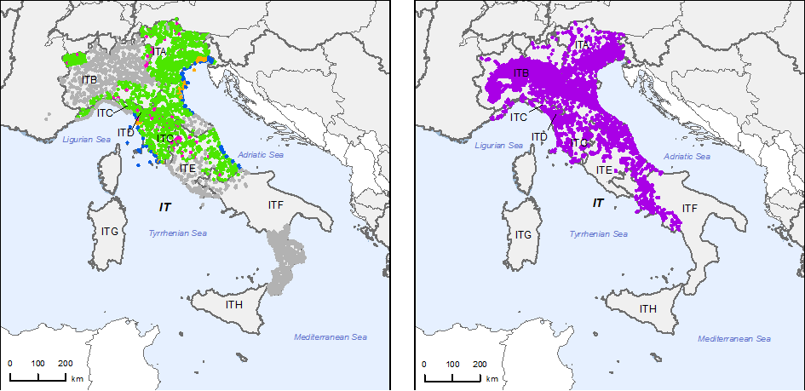
Figure 5.1: Maps of surface water (left) and groundwater (right) monitoring stations
 | • |  | River monitoring stations
 | • |  | Lake monitoring stations
 | • |  | Transitional water monitoring stations
 | • |  | Coastal water monitoring stations
 | • |  | Unclassified surface water monitoring stations
 | • |  | Groundwater monitoring stations
 |  |  | River Basin Districts
 |  |  | Countries outside EU
Source: WISE, Eurostat (country borders)
Italy has reported the number of monitoring sites for six of the eight RBDs (see the Table 5.2). In total, over 2900 sites were reported for surface waters, and over 5100 sites for groundwater. The number of surface water monitoring sites is more or less similar to those provided for the European Commission’s 2009 report on monitoring in the EU (a direct comparison is not possible, however, as that report included sites in ITG, though not those in ITH – data for neither RBD are available now).
A larger number of groundwater sites are reported now: greater than 5000, while the 2009 report identified less than 4000. (Italy’s submission for the Commission’s 2009 report on monitoring identified surveillance and operational monitoring stations, though no quantitative stations; the information now in WISE does not differentiate among type of groundwater monitoring station.)
As noted above, in April 2009 the Ministry of Environment issued a decree setting out a detailed approach for monitoring. That same year, a Legislative Decree of the government transposed Directive 2006/118/EC on groundwater, updating methods for the monitoring of groundwater. Many of the RBMPs state that the introduction of these new approaches was underway at the time of their preparation, and thus had not been fully used for the classification of water body status.
RBD | Rivers |  |  |  |  |  |  |  |  |  |  | Lakes
RBD | QE1.1 Phytoplankton | QE1.2 Other aquatic flora | QE1.2.3 Macrophytes | QE1.2.4 Phytobenthos | QE1.3 Benthic invertebrates | QE1.4 Fish | QE1.5 Other species | QE2 Hydromorphological QEs | QE3.1 General Parameters | QE3.3 on priority specific pollutants | QE3.4 Other national pollutants | QE1.1 Phytoplankton | QE1.2 Other aquatic flora | QE1.2.3 Macrophytes | QE1.2.4 Phytobenthos | QE1.3 Benthic invertebrates | QE1.4 Fish | QE1.5 Other species | QE2 Hydromorphological QEs | QE3.1 General Parameters | QE3.3 Non priority specific pollutants | QE3.4 Other national pollutants
ITA
ITB
ITC
ITD
ITE
ITF
ITG
ITH

RBD | Transitional |  |  |  |  |  |  |  |  |  |  | Coastal
RBD | QE1.1 Phytoplankton | QE1.2 Other aquatic flora | QE1.2.1 Microalgae | QE1.2.2 Angiosperms | QE1.3 Benthic invertebrates | QE1.4 Fish | QE1.5 Other species | QE2 Hydromorphological QEs | QE3.1 General Parameters | QE3.3 Non priority specific pollutants | QE3.4 Other national pollutants | QE1.1 Phytoplankton | QE1.2 Other aquatic flora | QE1.2.1 Microalgae | QE1.2.2 Angiosperms | QE1.3 Benthic invertebrates | QE1.4 Fish | QE1.5 Other species | QE2 Hydromorphological QEs | QE3.1 General Parameters | QE3.3 Non priority specific pollutants | QE3.4 Other national pollutants
ITA
ITB
ITC
ITD
ITE
ITF
ITG
ITH
Table 5.1: Quality elements monitored
 |  | QE Monitored
 |  | QE Not monitored
- |  | Not Relevant
Source: WISE

RBD | Rivers |  | Lakes |  | Transitional |  | Coastal |  | Groundwater
RBD | Surv | Op | Surv | Op | Surv | Op | Surv | Op | Surv | Op | Quant
ITA | 340 | 516 | 14 | 10 | 0 | 93 | 32 | 48 | 0 | 0 | 0
ITB | 365 | 261 | 38 | 48 | 0 | 33 | 0 | 12 | 0 | 0 | 0
ITC | 217 | 149 | 7 | 13 | 2 | 9 | 20 | 189 | 0 | 0 | 0
ITD | 32 | 5 | 2 | 2 | 2 | 0 | 1 | 0 | 0 | 0 | 0
ITE | 115 | 68 | 9 | 16 | 0 | 0 | 0 | 14 | 0 | 0 | 0
ITF | 111 | 277 | 0 | 0 | 0 | 0 | 0 | 0 | 0 | 0 | 0
Total by type of site | 1180 | 1276 | 70 | 89 | 4 | 135 | 53 | 263 | 0 | 0 | 0
Total number of monitoring sites | 2288 |  | 176 |  | 139 |  | 316 |  | 5162
Table 5.2: Number of monitoring sites by water category.
Surv = Surveillance, Op = Operational, Quant = Quantitative
Source: WISE

Monitoring of surface waters
Ministerial Decree 56/2009 calls for monitoring of all relevant quality elements, and it lists the BQEs to be used in relation to existing pressures and impacts. It specifies that all priority substances should be monitored, and it calls for the monitoring of substances in biota and in sediment (the decree identifies 21 substances to be monitored in sediment).
As noted above, this decree’s updated approach was being introduced at the time of the RBMPs, and information on monitoring is not always clear. For several RBDs, such as ITC and ITF, all QEs are cited for surveillance monitoring in the WISE summary; however, in these cases, the full RBMP reports do not specify which QEs were monitored prior to 2009. For other RBDs, the information reported suggests that not all QEs were monitored. For ITB, hydro-morphological elements are only reported at an aggregated level and details for the specific QEs are not provided. For ITE, only hydro-morphological QEs are reported for coastal and transition waters.
Similar gaps are seen for several other areas of monitoring covered in the decree. For priority substances, for example, the RBMP for ITB cites the list provided in DM 56/2009; however, several other RBMPs refer to the decree without specifying the substances it lists. A similar issue is seen for the monitoring of sediments in coastal and transitional waters: while this is set out in the 2009 decree, only the RBMPs for ITG and ITH provide details. It appears, moreover, that grouping was by and large not applied in the monitoring used to prepare RBMPs: it is mentioned for few monitoring programmes, such as one in ITC for rivers.
Overall, more than half of the surface water bodies in Italy have not been classified (see Section 6 below), and this may be linked to the changes underway in the approach to monitoring and classification at the time that the RBMPs were in preparation.
Regarding international cooperation, Italy has had consultations with Slovenia to define a coordinated monitoring programme for shared catchments in ITA. The RBMP for ITB does not detail international monitoring work, though subsequent information provided by Italy mentions joint monitoring activities under the agreement between Italy and Switzerland. No information was found regarding cooperation with France on monitoring in ITB or ITC.

Monitoring of groundwater
It appears that all RBDs have both surveillance and operational monitoring programmes for groundwater, and these cover both quantitative and chemical status. For example, the overview report for ITB refers to 1900 monitoring points, of which 575 gather information on chemical status, 301 on quantitative status, and the remainder cover both areas.
Operational monitoring was not appropriate at the time of establishing the first RBMPs to classify the status therefore a new monitoring network was reported to be under development. There was no link between monitoring and pressures. Detecting trends is the aim of the monitoring but it was not implemented yet in the first plans.
Italy’s 2009 legislation sets out approaches to detect significant and sustained upward trends. Little information on this topic was found in the RBMPs; however, in ITC it is noted that significant upward trends had been detected in two groundwater bodies, indicating that at least to some extent this had been monitored.
Italy has consulted with Slovenia regarding groundwater monitoring; moreover, according to recent information provided by Italy, transboundary projects on groundwater monitoring have been launched with Slovenia, financed by the cross-border cooperation programme under EU structural funds. Italy does not share groundwater bodies with Austria, France or Switzerland.

Monitoring of protected areas
For the most part, the RBMPs do not indicate separate monitoring programmes for protected areas; rather, this type of monitoring is integrated in regular programmes. (Exceptions are seen in ITB and ITC, where separate programmes monitor fish protected areas.)
Italy’s submissions to WISE provide information on the number of monitoring sites associated with protected areas (groundwater sites associated with drinking water abstraction were not reported for ITG and ITH). For some categories, the new data are quite different from those provided in the 2009 report. No bathing water sites were listed then, but the number of fish and shellfish monitoring sites was about three times higher. About 20% fewer urban wastewater monitoring sites are listed now, while the number of groundwater monitoring sites associated with drinking water abstraction is three times higher than the previous information.

RBD | Surface waters |  |  |  |  |  |  |  |  | Ground-water drinking water
RBD | Surface drinking water abstraction | Quality of drinking water | Bathing water | Birds sites | Fish | Habitats sites | Nitrates | Shellfish | UWWT | Ground-water drinking water
ITA | 55 | 34 | 44 | 120 | 193 | 156 | 288 | 69 | 276 | 131
ITB | 19 | 33 | 11 | 118 | 147 | 197 | 319 | 18 | 167 | 595
ITC | 8 | 59 | 113 | 50 | 117 | 186 | 64 | 23 | 158 | 525
ITD | 0 | 1 | 1* | 1 | 10 | 21 | 3 | 1* | 3 | 31
ITE | 101 | 5 | 40 | 65 | 63 | 122 | 56 | 8* | 84 | 208
ITF | 1 | 16 | 4 | 100 | 205 | 112 | 82 | 2 | 196 | 155
ITG | 0 | 0 | 49* | 0 | 0 | 80* | 7* | 0 | 60* | 0
ITH | 0 | 0 | 0 | 0 | 0 | 0 | 0 | 0 | 0 | 0
Total | 184 | 148 | 262 | 454 | 735 | 874 | 819 | 121 | 944 | 1645
Table 5.3.1: Number of monitoring stations in protected areas.
Note: *Number of monitoring sites reported at programme level.
Source: WISE

Overview of status (ecological, chemical, groundwater)
Almost one-quarter of all surface water bodies in Italy have been assessed as being at good ecological status; and 1% are at high status (see Table below). For just over half of Italian surface water bodies, however, the status has not been determined: this includes all the waters in ITG and ITH. There are important variations across the RBMP (See also section 7 below).
Larger differences in assessment, however, are seen across regions (including the two autonomous provinces): in 7 of Italy’s regions, the status of all SWBs is reported as unknown (in an eighth, it is known for less than 4% of SWBs); in 7 other regions, however, the status of less than 15% of SWBs is unknown. This occurs across RBDs – ITB, for example, includes a region where the ecological status of only one SWB is unknown (Emilia-Romagna) as well as a region where the ecological status is unknown for all SWBs (Piedmont). These differences highlight the importance of the regions as the underlying entities for WFD implementation, rather than the RBDs.

RBD | Total | High |  | Good |  | Moderate |  | Poor |  | Bad |  | Unknown
RBD | Total | No. | (%) | No. | (%) | No. | (%) | No. | (%) | No. | (%) | No. | (%)
ITA | 1479 | 53 | 3.6 | 542 | 36.6 | 114 | 7.7 | 26 | 1.8 | 6 | 0.4 | 738 | 49.9
ITB | 1595 | 23 | 1.4 | 493 | 30.9 | 270 | 16.9 | 95 | 6.0 | 15 | 0.9 | 699 | 43.8
ITC | 1008 | 1 | 0.1 | 626 | 62.1 | 208 | 20.6 | 46 | 4.6 | 10 | 1.0 | 117 | 11.6
ITD | 44 | 4 | 9.1 | 21 | 47.7 | 14 | 31.8 | 5 | 11.4 | 0 | 0 | 0 | 0
ITE | 476 | 8 | 1.7 | 84 | 17.6 | 95 | 20.0 | 24 | 5.0 | 0 | 0 | 265 | 55.7
ITF | 785 | 0 | 0 | 17 | 2.2 | 8 | 1.0 | 2 | 0.3 | 0 | 0 | 758 | 96.6
ITG | 999 | 0 | 0 | 0 | 0 | 0 | 0 | 0 | 0 | 0 | 0 | 999 | 100
ITH | 34 | 0 | 0 | 0 | 0 | 0 | 0 | 0 | 0 | 0 | 0 | 34 | 100
Total | 6420 | 89 | 1.4 | 1783 | 27.7 | 709 | 11.0 | 198 | 3.1 | 31 | 0.5 | 3610 | 56.2
Table 6.1: Ecological status of natural surface water bodies.
Source: WISE
RBD | Total | High |  | Good |  | Moderate |  | Poor |  | Bad |  | Unknown
RBD | Total | No. | (%) | No. | (%) | No. | (%) | No. | (%) | No. | (%) | No. | (%)
ITA | 487 | 1 | 0.2 | 80 | 16.4 | 41 | 8.4 | 38 | 7.8 | 10 | 2.1 | 317 | 65.1
ITB | 442 | 1 | 0.2 | 79 | 17.9 | 146 | 33.0 | 121 | 27.4 | 12 | 2.7 | 83 | 18.8
ITC | 388 | 0 | 0 | 93 | 24.0 | 153 | 39.4 | 97 | 25.0 | 16 | 4.1 | 29 | 7.5
ITD | 11 | 0 | 0 | 0 | 0 | 3 | 27.3 | 5 | 45.5 | 3 | 27.3 | 0 | 0
ITE | 69 | 0 | 0 | 1 | 1.4 | 12 | 17.4 | 3 | 4.3 | 1 | 1.4 | 52 | 75.4
ITF | 182 | 0 | 0 | 0 | 0 | 0 | 0 | 0 | 0 | 0 | 0 | 182 | 100
ITG | 31 | 0 | 0 | 0 | 0 | 0 | 0 | 0 | 0 | 0 | 0 | 31 | 100
ITH | 29 | 0 | 0 | 0 | 0 | 0 | 0 | 0 | 0 | 0 | 0 | 29 | 100
Total | 1639 | 2 | 0.1 | 253 | 15.4 | 355 | 21.7 | 264 | 16.1 | 42 | 2.6 | 723 | 44.1
Table 6.2: Ecological potential of artificial and heavily modified water bodies.
Source: WISE
RBD | Total | High |  | Good |  | Moderate |  | Poor |  | Bad |  | Unknown
RBD | Total | No. | (%) | No. | (%) | No. | (%) | No. | (%) | No. | (%) | No. | (%)
ITB | 1 | 0 | 0 | 0 | 0 | 1 | 100 | 0 | 0 | 0 | 0 | 0 | 0
ITE | 22 | 0 | 0 | 1 | 4.5 | 19 | 86.4 | 1 | 4.5 | 1 | 4.5 | 0 | 0
ITF | 211 | 0 | 0 | 0 | 0 | 0 | 0 | 0 | 0 | 0 | 0 | 211 | 100
ITH | 321 | 0 | 0 | 0 | 0 | 0 | 0 | 0 | 0 | 0 | 0 | 321 | 100
Total | 555 | 0 | 0 | 1 | 0.2 | 20 | 3.6 | 1 | 0.2 | 1 | 0.2 | 532 | 95.9
Table 6.3: Ecological status of ‘unknown’ surface water bodies (not specified whether natural, heavily modified or artificial water bodies)
Source: WISE
For over three-quarters of Italy’s surface water bodies, chemical status is unknown, according to the information reported to WISE (see the table below). In each RBD, a majority of SWBs were not assessed, and none were assessed in ITG and ITH. (See also section 9 below.) Here too, there are strong differences across the regions: chemical status is reported as unknown for all SWBs in 9 regions; in contrast, for 2 regions, chemical status is assessed for 85% of SWBs.
RBD | Total | Good |  | Poor |  | Unknown
RBD | Total | No. | % | No. | % | No. | %
ITA | 1479 | 136 | 9.2 | 14 | 0.9 | 1329 | 89.9
ITB | 1595 | 505 | 31.7 | 90 | 5.6 | 1000 | 62.7
ITC | 1008 | 333 | 33.0 | 55 | 5.5 | 620 | 61.5
ITD | 44 | 2 | 4.5 | 3 | 6.8 | 39 | 88.6
ITE | 476 | 161 | 33.8 | 17 | 3.6 | 298 | 62.6
ITF | 785 | 46 | 5.9 | 6 | 0.8 | 733 | 93.4
ITG | 999 | 0 | 0 | 0 | 0 | 999 | 100
ITH | 34 | 0 | 0 | 0 | 0 | 34 | 100
Total | 6420 | 1183 | 18.4 | 185 | 2.9 | 5052 | 78.7
Table 6.4: Chemical status of natural surface water bodies.
Source: WISE

RBD | Total | Good |  | Poor |  | Unknown
RBD | Total | No. | % | No. | % | No. | %
ITA | 487 | 99 | 20.3 | 26 | 5.3 | 362 | 74.3
ITB | 442 | 109 | 24.7 | 106 | 24.0 | 277 | 51.4
ITC | 388 | 118 | 30.4 | 89 | 22.9 | 181 | 46.6
ITD | 11 | 0 | 0 | 3 | 27.3 | 8 | 72.7
ITE | 69 | 12 | 17.4 | 2 | 2.9 | 55 | 79.7
ITF | 182 | 0 | 0 | 0 | 0 | 182 | 100
ITG | 31 | 0 | 0 | 0 | 0 | 31 | 100
ITH | 29 | 0 | 0 | 0 | 0 | 29 | 100
Total | 1639 | 338 | 20.6 | 226 | 13.8 | 1075 | 65.6
Table 6.5: Chemical status of artificial and heavily modified water bodies
Source: WISE
Over 52% of GWBs are assessed at good quantitative status, according to Italy’s reporting; however, the status is unknown for almost 32% (see the table below). No information was reported for ITG or ITH (See also section 10). The breakdown by region is similar to that for the chemical status of GWBs.
RBD | Total | Good |  | Poor |  | Unknown
RBD | Total | No. | % | No. | % | No. | %
ITA | 123 | 95 | 77.2 | 17 | 13.8 | 11 | 8.9
ITB | 141 | 81 | 57.4 | 35 | 24.8 | 25 | 17.7
ITC | 186 | 106 | 57 | 75 | 40.3 | 5 | 2.7
ITD | 11 | 7 | 63.6 | 4 | 36.4 | 0 | 0
ITE | 133 | 43 | 32.3 | 45 | 33.8 | 45 | 33.8
ITF | 139 | 27 | 19.4 | 17 | 12.2 | 95 | 68.3
Total | 733 | 359 | 49 | 193 | 26.3 | 181 | 24.7
Table 6.6: Chemical status of groundwater bodies.
Source: WISE
RBD | Total | Good |  | Poor |  | Unknown
RBD | Total | No. | % | No. | % | No. | %
ITA | 123 | 68 | 55.3 | 2 | 1.6 | 53 | 43.1
ITB | 141 | 89 | 63.1 | 27 | 19.1 | 25 | 17.7
ITC | 186 | 131 | 70.4 | 50 | 26.9 | 5 | 2.7
ITD | 11 | 8 | 72.7 | 3 | 27.3 | 0 | 0
ITE | 133 | 59 | 44.4 | 20 | 15 | 54 | 40.6
ITF | 139 | 31 | 22.3 | 13 | 9.4 | 95 | 68.3
Total | 733 | 386 | 52.7 | 115 | 15.7 | 232 | 31.7
Table 6.7: Quantitative status of groundwater bodies.
Source: WISE
In total, only 8.3% of Italy’s SWBs were assessed as being of good status in 2009; according to the information reported to WISE the number of good status is expected to increase to 10.1% in 2015. As seen in the previous tables, however, the status of most SWBs was unknown, and no information was reported for ITG or ITH.
For groundwater bodies, almost 37% were assessed as being of good status in 2009, and the share is expected to rise to almost 55% in 2015 (See the table below; these figures do not include ITG and ITH.) In ITB, the share of GWBs of good status is expected to rise from 48% to 80%; in ITE, from almost 25% to over 40%.
RBD | Total | Global status (ecological and chemical) |  |  |  |  | Good ecological status 2021 |  | Good chemical status 2021 |  | Good ecological status 2027 |  | Good chemical status 2027 |  | Global exemptions 2009 (% of all SWBs)
RBD | Total | Good or better 2009 |  | Good or better 2015 |  | Increase 2009 -2015 |  |  |  |  |  |  |  |  | Art 4.4 | Art 4.5 | Art 4.6 | Art 4.7
RBD | Total | No. | % | No. | % | % | No. | % | No. | % | No. | % | No. | % | % | % | % | %
ITA | 1966 | 68 | 3.5 | 77 | 3.9 | 0.5 |  |  |  |  |  |  |  |  | 34 | 4 | 0 | 0
ITB | 2038 | 349 | 17.1 | 466 | 22.9 | 5.7 |  |  |  |  |  |  |  |  | 25 | 0 | 0 | 0
ITC | 1396 | 247 | 17.7 | 256 | 18.3 | 0.6 |  |  |  |  |  |  |  |  | 36 | 0 | 0 | 0
ITD | 55 | 0 | 0 | 2 | 3.6 | 3.6 | 55 |  |  |  | 55 |  |  |  | 49 | 0 | 0 | 0
ITE | 567 | 39 | 6.9 | 48 | 8.5 | 1.6 |  |  |  |  |  |  |  |  | 8 | 5 | 0 | 0
ITF | 1178 | 16 | 1.4 | 21 | 1.8 | 0.4 |  |  |  |  |  |  |  |  | 0 | 0 | 0 | 0
ITG | 1030 | 0 | 0 | 0 | 0 | 0 |  |  |  |  |  |  |  |  | 0 | 0 | 0 | 0
ITH | 384 | 0 | 0 | 0 | 0 | 0 |  |  |  |  |  |  |  |  | 0 | 0 | 0 | 0
Total | 8614 | 719 | 8.3 | 870 | 10.1 | 1.8 |  |  |  |  |  |  |  |  | 20 | 1 | 0 | 0
Table 6.8: Surface water bodies: overview of status in 2009 and expected status in 2015, 2021 and 2027
Waterbodies with good status in 2009 fall into the following category:
1. Ecological status is high or good and the chemical status is good, exemptions are not considered
Waterbodies expected to achieve good status in 2015 fall into the following categories:
1. Ecological status is high or good and the chemical status is good, exemptions are not considered
2. Chemical status is good, and the ecological status is moderate or below but no ecological exemptions
3. Ecological status is high or good, and the chemical status is failing to achieve good but there are no chemical exemptions
4. Ecological status is moderate or below, and chemical status is failing to achieve good but there are no ecological nor chemical exemptions
Note: Waterbodies with unknown/unclassified/Not applicable in either ecological or chemical status are not considered
Source: WISE (for data on status in 2009, 2015 and exemptions) and RBMPs (for data on status in 2021 and 2027)

RBD | Total | Ecological status |  |  |  |  | Good ecological status 2021 |  | Good ecological status 2027 |  | Ecological exemptions (% of all SWBs)
RBD | Total | Good or better 2009 |  | Good or better 2015 |  | Increase 2009 -2015 |  |  |  |  | Art 4.4 | Art 4.5 | Art 4.6 | Art 4.7
RBD | Total | No. | % | No. | % | % | No. | % | No. | % | % | % | % | %
ITA | 1479 | 595 | 40.2 | 627 | 42.4 | 2.2 |  |  |  |  | 22.2 | 0.9 | 0 | 0
ITB | 1595 | 516 | 32.4 | 651 | 40.8 | 8.5 |  |  |  |  | 16.0 | 0 | 0 | 0
ITC | 1008 | 627 | 62.2 | 645 | 64.0 | 1.8 |  |  |  |  | 24.6 | 0 | 0 | 0
ITD | 44 | 25 | 56.8 | 28 | 63.6 | 6.8 | 44 | 100 | 44 | 100 | 36.4 | 0 | 0 | 0
ITE | 476 | 92 | 19.3 | 175 | 36.8 | 17.4 |  |  |  |  | 8.8 | 2.1 | 0 | 0
ITF | 785 | 17 | 2.2 | 24 | 3.1 | 0.9 |  |  |  |  | 0.4 | 0 | 0 | 0
ITG | 999 | 0 | 0 | 0 | 0 | 0 |  |  |  |  | 0 | 0 | 0 | 0
ITH | 34 | 0 | 0 | 0 | 0 | 0 |  |  |  |  | 0 | 0 | 0 | 0
Total | 6420 | 1872 | 29.2 | 2150 | 33.5 | 4.3 |  |  |  |  | 13.9 | 0.4 | 0 | 0
Table 6.9: Natural surface water bodies: ecological status in 2009 and expected status in 2015, 2021 and 2027
Source: WISE (for data on status in 2009, 2015 and exemptions) and RBMPs (for data on status in 2021 and 2027)

RBD | Total | Chemical status |  |  |  |  | Good chemical status 2021 |  | Good chemical status 2027 |  | Chemical exemptions (% of all SWBs)
RBD | Total | Good or better 2009 |  | Good or better 2015 |  | Increase 2009 -2015 |  |  |  |  | Art 4.4 | Art 4.5 | Art 4.6 | Art 4.7
RBD | Total | No. | % | No. | % | % | No. | % | No. | % | % | % | % | %
ITA | 1479 | 136 | 9.2 | 143 | 9.7 | 0.5 |  |  |  |  | 7.9 | 0 | 0 | 0
ITB | 1595 | 505 | 31.7 | 512 | 32.1 | 0.4 |  |  |  |  | 9.4 | 0 | 0 | 0
ITC | 1008 | 333 | 33.0 | 334 | 33.1 | 0.1 |  |  |  |  | 16.6 | 0 | 0 | 0
ITD | 44 | 2 | 4.5 | 3 | 6.8 | 2.3 |  |  |  |  | 36.40 | 0 | 0 | 0
ITE | 476 | 161 | 33.8 | 178 | 37.4 | 3.6 |  |  |  |  | 0 | 0 | 0 | 0
ITF | 785 | 46 | 5.9 | 52 | 6.6 | 0.8 |  |  |  |  | 0 | 0 | 0 | 0
ITG | 999 | 0 | 0 | 0 | 0 | 0 |  |  |  |  | 0 | 0 | 0 | 0
ITH | 34 | 0 | 0 | 0 | 0 | 0 |  |  |  |  | 0 | 0 | 0 | 0
Total | 6420 | 1183 | 18.4 | 1222 | 19.0 | 0.6 |  |  |  |  | 7.0 | 0 | 0 | 0
Table 6.10: Natural surface water bodies: chemical status in 2009 and expected status in 2015, 2021 and 2027
Source: WISE (for data on status in 2009, 2015 and exemptions) and RBMPs (for data on status in 2021 and 2027)

RBD | Total | GW chemical status |  |  |  |  | Good chemical status 2021 |  | Good chemical status 2027 |  | GW chemical exemptions (% of all GWBs)
RBD | Total | Good or better 2009 |  | Good or better 2015 |  | Increase 2009 -2015 |  |  |  |  | Art 4.4 | Art 4.5 | Art 4.6 | Art 4.7
RBD | Total | No. | % | No. | % | % | No. | % | No. | % | % | % | % | %
ITA | 123 | 95 | 77.2 | 103 | 83.7 | 6.5 |  |  |  |  | 10 | 0 | 0 | 0
ITB | 141 | 81 | 57.4 | 113 | 80.1 | 22.7 | 102 |  | 140 |  | 2 | 0 | 0 | 0
ITC | 186 | 106 | 57.0 | 142 | 76.3 | 19.4 |  |  |  |  | 22 | 2 | 0 | 2
ITD | 11 | 7 | 63.6 | 7 | 63.6 | 0 | 11 | 100 | 11 | 100 | 36 | 0 | 0 | 0
ITE | 133 | 43 | 32.3 | 65 | 48.9 | 16.5 |  |  |  |  | 18 | 4 | 0 | 0
ITF | 139 | 27 | 19.4 | 31 | 22.3 | 2.9 |  |  |  |  | 9 | 0 | 0 | 0
ITG | 0 | 0 | 0 | 0 | 0 | 0 |  |  |  |  | 0 | 0 | 0 | 0
ITH | 0 | 0 | 0 | 0 | 0 | 0 |  |  |  |  | 0 | 0 | 0 | 0
Total | 733 | 359 | 49.0 | 461 | 62.9 | 13.9 |  |  |  |  | 13 | 1 | 0 | 1
Table 6.11: Groundwater bodies: chemical status in 2009 and expected status in 2015, 2021 and 2027
Source: WISE (for data on status in 2009, 2015 and exemptions) and RBMPs (for data on status in 2021 and 2027)

RBD | Total | Groundwater quantitative status |  |  |  |  | Good quantitative status 2021 |  | Good quantitative status 2027 |  | GW quantitative exemptions (% of all GWBs)
RBD | Total | Good or better 2009 |  | Good or better 2015 |  | Increase 2009 -2015 |  |  |  |  | Art 4.4 | Art 4.5 | Art 4.6 | Art 4.7
RBD | Total | No. | % | No. | % | % | No. | % | No. | % | % | % | % | %
ITA | 123 | 68 | 55.3 | 70 | 56.9 | 1.6 |  |  |  |  | 0 | 0 | 0 | 0
ITB | 141 | 89 | 63.1 | 116 | 82.3 | 19.1 | 122 |  | 140 |  | 0 | 0 | 0 | 3
ITC | 186 | 131 | 70.4 | 155 | 83.3 | 12.9 |  |  |  |  | 14 | 14 | 0 | 7
ITD | 11 | 8 | 72.7 | 8 | 72.7 | 0 | 4 |  |  |  | 27 | 27 | 0 | 0
ITE | 133 | 59 | 44.4 | 63 | 47.4 | 3.0 |  |  |  |  | 12 | 12 | 0 | 0
ITF | 139 | 31 | 22.3 | 33 | 23.7 | 1.4 |  |  |  |  | 8 | 8 | 0 | 0
ITG | 0 | 0 | 0 | 0 | 0 | 0 |  |  |  |  | 0 | 0 | 0 | 0
ITH | 0 | 0 | 0 | 0 | 0 | 0 |  |  |  |  | 0 | 0 | 0 | 0
Total | 733 | 386 | 52.7 | 445 | 60.7 | 8.0 |  |  |  |  | 8 | 8 | 0 | 2
Table 6.12: Groundwater bodies: quantitative status in 2009 and expected status in 2015, 2021 and 2027
Source: WISE (for data on status in 2009, 2015 and exemptions) and RBMPs (for data on status in 2021 and 2027)

RBD | Total  HMWB and AWB | Ecological potential |  |  |  |  | Good ecological potential 2021 |  | Good ecological potential 2027 |  | Ecological exemptions (% of all HMWB/AWB)
RBD | Total  HMWB and AWB | Good or better 2009 |  | Good or better 2015 |  | Increase 2009 -2015 |  |  |  |  | Art 4.4 | Art 4.5 | Art 4.6 | Art 4.7
RBD | Total  HMWB and AWB | No. | % | No. | % | % | No. | % | No. | % | % | % | % | %
ITA | 487 | 81 | 16.6 | 86 | 17.7 | 1.1 |  |  |  |  | 19.3 | 3.9 | 0 | 0
ITB | 441 | 80 | 18.1 | 115 | 26.1 | 7.9 | 102 |  | 140 |  | 55.6 | 0 | 0 | 0
ITC | 388 | 93 | 24.0 | 112 | 28.9 | 4.9 |  |  |  |  | 63.7 | 0 | 0 | 0
ITD | 11 | 0 | 0 | 0 | 0 | 0 | 11 | 100 | 11 | 100 | 100 | 0 | 0 | 0
ITE | 69 | 1 | 1.4 | 15 | 21.7 | 20.3 |  |  |  |  | 0 | 2.9 | 0 | 0
ITF | 182 | 0 | 0 | 0 | 0 | 0 |  |  |  |  | 0 | 0 | 0 | 0
ITG | 31 | 0 | 0 | 0 | 0 | 0 |  |  |  |  | 0 | 0 | 0 | 0
ITH | 29 | 0 | 0 | 0 | 0 | 0 |  |  |  |  | 0 | 0 | 0 | 0
Total | 1638 | 255 | 15.6 | 328 | 20.0 | 4.4 |  |  |  |  | 36.4 | 1.3 | 0 | 0
Table 6.13: Heavily modified and artificial water bodies: ecological potential in 2009 and expected ecological potential in 2015, 2021 and 2027
Source: WISE (for data on status in 2009, 2015 and exemptions) and RBMPs (for data on status in 2021 and 2027)

RBD | Total  HMWB and AWB | Chemical status |  |  |  |  | Good chemical status 2021 |  | Good chemical status 2027 |  | Chemical exemptions (% of all HMWB/AWB)
RBD | Total  HMWB and AWB | Good or better 2009 |  | Good or better 2015 |  | Increase 2009 -2015 |  |  |  |  | Art 4.4 | Art 4.5 | Art 4.6 | Art 4.7
RBD | Total  HMWB and AWB | No. | % | No. | % | % | No. | % | No. | % | % | % | % | %
ITA | 487 | 99 | 20.3 | 101 | 20.7 | 0.4 |  |  |  |  | 5.3 | 0 | 0 | 0
ITB | 441 | 109 | 24.7 | 111 | 25.2 | 0.5 |  |  |  |  | 23.6 | 0 | 0 | 0
ITC | 388 | 118 | 30.4 | 118 | 30.4 | 0 |  |  |  |  | 27.1 | 0 | 0 | 0
ITD | 11 | 0 | 0 | 0 | 0 | 0 |  |  |  |  | 27.3 | 0 | 0 | 0
ITE | 69 | 12 | 17.4 | 14 | 20.3 | 2.9 |  |  |  |  | 0 | 0 | 0 | 0
ITF | 182 | 0 | 0 | 0 | 0 | 0 |  |  |  |  | 0 | 0 | 0 | 0
ITG | 31 | 0 | 0 | 0 | 0 | 0 |  |  |  |  | 0 | 0 | 0 | 0
ITH | 29 | 0 | 0 | 0 | 0 | 0 |  |  |  |  | 0 | 0 | 0 | 0
Total | 1638 | 338 | 20.6 | 344 | 21.0 | 0.4 |  |  |  |  | 14.5 | 0 | 0 | 0
Table 6.14: Heavily modified and artificial water bodies: chemical status in 2009 and expected status in 2015, 2021 and 2027
Source: WISE (for data on status in 2009, 2015 and exemptions) and RBMPs (for data on status in 2021 and 2027)
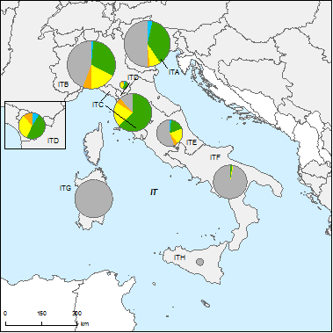
Figure 6.1: Map of ecological status of natural surface water bodies 2009
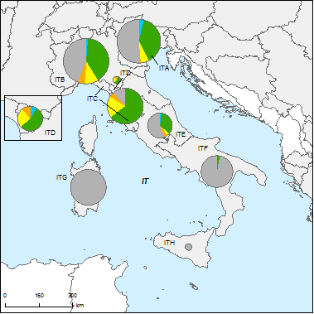
High
Good
Moderate
Poor
Bad
Unknown
River Basin Districts
Countries outside EU
Figure 6.2: Map of ecological status of natural surface water bodies 2015
Note: Standard colours based on WFD Annex V, Article 1.4.2(i).
Source: WISE, Eurostat (country borders)
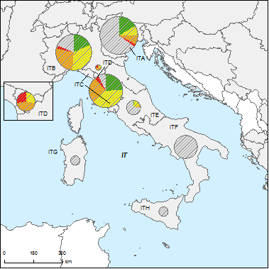
Figure 6.3: Map of ecological potential of artificial and heavily modified water bodies 2009
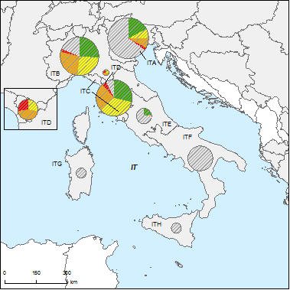
Good or better
Moderate
Poor
Bad
Unknown
River Basin Districts
Countries outside EU
Figure 6.4: Map of ecological potential of artificial and heavily modified water bodies 2015
Note: Standard colours based on WFD Annex V, Article 1.4.2(ii).
Source: WISE, Eurostat (country borders)
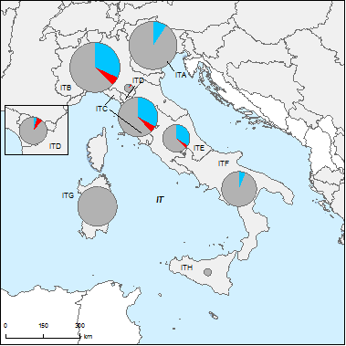
Figure 6.5: Map of chemical status of natural surface water bodies 2009
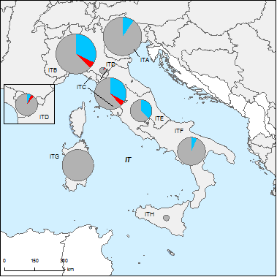
Good
Failing to achieve good
Unknown
River Basin Districts
Countries outside EU
Figure 6.6: Map of chemical status of natural surface water bodies 2015
Note: Standard colours based on WFD Annex V, Article 1.4.3.
Source: WISE, Eurostat (country borders)
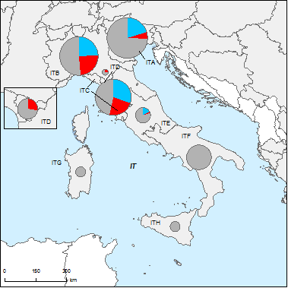
Figure 6.7: Map of chemical status of artificial and heavily modified water bodies 2009
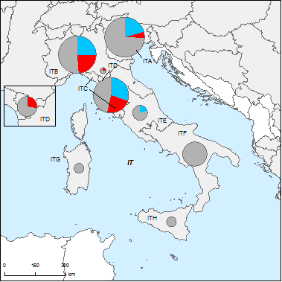
Good
Failing to achieve good
Unknown
River Basin Districts
Countries outside EU
Figure 6.8: Map of chemical status of artificial and heavily modified water bodies 2015
Note: Standard colours based on WFD Annex V, Article 1.4.3.
Source: WISE, Eurostat (country borders)

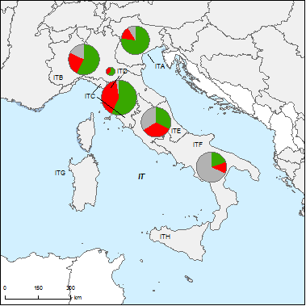
Figure 6.9: Map of chemical status of groundwater bodies 2009
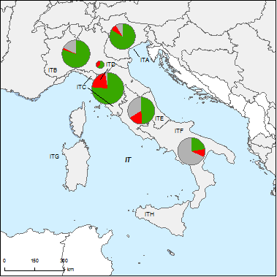
Good
Poor
Unknown
River Basin Districts
Countries outside EU
Figure 6.10: Map of chemical status of groundwater bodies 2015
Note: Standard colours based on WFD Annex V, Article 2.4.5.
Source: WISE, Eurostat (country borders)

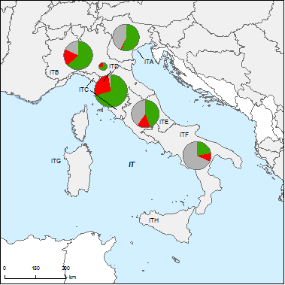
Figure 6.11: Map of quantitative status of groundwater bodies 2009
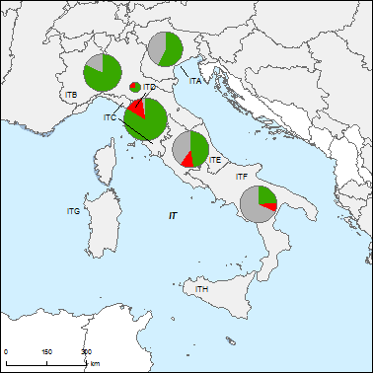
Good
Poor
Unknown
River Basin Districts
Countries outside EU
Figure 6.12: Map of quantitative status of groundwater bodies 2015
Note: Standard colours based on WFD Annex V, Article 2.2.4.
Source: WISE, Eurostat (country borders)

Assessment of ecological status of surface waters

Ecological status assessment methods
Ministerial Decree No. 56 of 2009 sets out the overall approach for the assessment of ecological status of all water categories. The Decree calls for the use of all biological quality elements, and it also identifies BQEs related to specific physico-chemical impacts, as well as the use of the one-out-all-out principle in the assessment of ecological status. A subsequent, 2010 Decree (DM 260/2010) provides further information, for example on the BQEs most sensitive to major pressures; this was issued, however, after the completion of the RBMPs.

Application of methods and ecological status results
The information provided in the RBMPs and WISE on the application of methods is often incomplete. For example, ITB reports the use of supporting QEs in both surveillance and operational monitoring. Information was not found on whether the most sensitive biological quality elements were selected for operational monitoring to assess ecological status. Information was not found on issues such as confidence, precision or uncertainty related to assessment. In general, the system in Italy appears to have been in transition at the time of the RBMPs.
The RBMPs refer to the 2009 Decree; however, most state that its approach is in the process of implementation. According to the national environment agency, some regions had adopted the system by 2008. Nonetheless, many RBMPs refer instead to the use of indices established under previous Italian legislation to determine ecological status: in particular, the SECA (Stato ecologico dei corsi d’acqua, ecological status of waterways), mainly for river water bodies, which uses benthic macro-invertebrates as well as physico-chemical elements; for lakes, the SEL (stato ecologico dei laghi, ecological status of lakes) uses chlorophyll and physico-chemical elements. Moreover, the RBMPs do not refer to the Official Intercalibration Decision (30 October 2008), according to which Italy had intercalibrated benthic invertebrates in rivers and phytoplankton in lakes and coastal waters. It appears that some regions introduced the new approach set out in the 2009 Decree, while others continued to use older methods: as a result, methods appear to have varied within RBDs.
The 2009 decree refers to detailed methods developed by ISPRA (Istituto Superiore per la Ricerca e la Protezione Ambientale, Higher Institute for Environmental Protection and Research); the RBMPs do not, however, identify specific methods used. On this basis, the biological assessment methods are considered to have been under development at the time of the RBMPs. This represents a step forward compared to the situation in 2007, when no information was reported for Italy (see the table below).
RBD | Rivers |  |  |  |  |  |  | Lakes |  |  |  |  |  |  | Transitional |  |  |  |  |  |  | Coastal
RBD | Phytoplankton | Macrophytes | Phytobenthos | Benthic invertebrates | Fish | Physico-Chemical | Hydromorphological | Phytoplankton | Macrophytes | Phytobenthos | Benthic invertebrates | Fish | Physico-Chemical | Hydromorphological | Phytoplankton | Macroalgae | Angiosperms | Benthic invertebrates | Fish | Physico-Chemical | Hydromorphological | Phytoplankton | Macroalgae | Angiosperms | Benthic invertebrates | Physico-Chemical | Hydromorphological
ITA
ITB
ITC
ITD
ITE
ITF
ITG
ITH
Table 7.2.1: Availability of biological assessment methods
 |  | Assessment methods fully developed for all BQEs
 |  | Assessment methods partially developed or under development for all or some BQEs
 |  | Assessment methods not developed for BQEs, no information provided on the assessment methods, unclear information provided
- |  | Water category not relevant
Source: RBMPs

River basin specific pollutants
RBD | CAS Number | Substance | Percentage Water Bodies Failing Status (%)
ITA
ITB
ITC |  | Ammonium | 6.99% of GWBs
ITC | 7440-38-2 | Arsenic | 5.91% of GWBs
ITC | 205-99-2 | Benzo(b)fluoranthene | 0.15% of SWBs
ITC |  | Benzo(g.h.i)perylene | 0.38% of SWBs
ITC |  | Brominated diphenylether | 0.31% of SWBs
ITC | 7440-43-9 | Cadmium | 0.54% of GWBs
ITC |  | Chloride | 9.68% of GWBs
ITC |  | Conductivity | 5.38% of GWBs
ITC | 206-44-0 | Fluoranthene | 0.08% of SWBs
ITC | 193-39-5 | Indeno(1,2,3-cd)pyrene | 0.38% of SWBs
ITC | 7439-92-1 | Lead | 2.15% of GWBs; 0.08% of SWBs
ITC | 7439-97-6 | Mercury | 3.23% of GWBs; 1.23% of SWBs
ITC |  | Nitrates | 19.35% of GWBs
ITC |  | Pesticides | 1.08% of GWBs
ITC |  | Sulphate | 3.76% of GWBs
ITC | 127-18-4 | Tetrachloroethylene | 3.76% of GWBs
ITC |  | Tributylin compounds | 0.15% of SWBs
ITC | 79-01-6 | Trichloroethylene | 1.08% of GWBs
ITD
ITE
ITF
ITG
ITH
Table 7.3.1: River basin specific pollutants causing failure of status
Source: RBMPs

Designation of heavily modified water bodies (hmwb) and assessment of good ecological potential
Figure 8.1: Map of percentage Heavily Modified and Artificial waterbodies by River Basin District
0 – 5 %
5 – 20 %
20 – 40 %
40 – 60%
60 – 100 %
No data reported
River Basin Districts
Countries outside EU
Source: WISE

Designation of HMWBs
In 2007, the Commission noted that ‘Italy reported unclear data’ for HMWBs and AWBs. In the reporting for the RBMPs, the number of designated HMWBs/AWBs is provided for 7 of the 8 river basin districts. In total 734 HMWBs and 699 AWBs have been designated.
Information on methodologies to designate HMWBs/AWBs varies across RBMPs and also within. The indications in Italian legislation are brief, and national guidance has not been developed on this subject. Several plans refer to the use of the CIS Guidance document N°4. For ITA, the approach for designation is described separately and with varying detail for each region and autonomous province in the RBD, though a clear stepwise approach is not provided.

Methodology for setting good ecological potential (GEP)
Information was not found in the RBMPs regarding the methodology for defining GEP, though several plans mentioned work underway at national level. It appears that some plans provisionally defined GEP with reference to GES. Since the RBMPs were published, Italian legislation has set out an approach for GEP of reservoirs based on the analysis of phytoplankton, similar to the approach for natural lakes.

Results of ecological potential assessment in HMWB and AWB
Although the definition used for GEP is not clear, Italy has reported assessment results for HMWBs and AWBs in several river basin districts.

Assessment of chemical status of surface waters
Ministerial Decree no. 56/2009 sets out the substances and standards listed in Annex I of the Environmental Quality Standards Directive (EQSD). The Decree calls for the consideration of background concentrations as well as bioavailability factors of metals, and for the monitoring of biota and sediments (it sets EQSs for sediment). It also presents an approach for monitoring in mixing zones.
As noted above, the approach set out in DM 56/2009 was in the process of being introduced at the time of the RBMPs. While the plans cite this piece of legislation, many also refer to prior Italian legislation. For example, the RBMP for ITB refers to the list of EQS set in Ministerial Decree 367 of 2003: this list includes the substances subsequently found in Annex I of the EQSD, and others as well.
As a result of the transition underway, it is not always clear which substances were monitored and used for the determined of good chemical status; moreover, monitoring programmes are by and large carried out at regional level, and as a result there are differences in approach across and within RBDs. Information recently provided by Italy refers, in fact, to the creation of working groups in several RBDs to tackle common monitoring and classification isssues.
Nor is it clear the extent to which the other provisions of the new legislation were implemented, though several RBMPs, such as those for ITG and ITH, specifically refer to the monitoring of biota.
A few of the RBMPs – in particular ITA, ITB and ITC – provided information on specific substances causing failure to achieve good chemical status (see the Table below).
Substance | ITA | ITB | ITC | ITD | ITE | ITF* | ITG* | ITH*
Cadmium | ✓ | ✓ |  |  | ✓
Nickel |  | ✓ | ✓ | ✓
Diuron |  | ✓
Atrazine |  | ✓
1,2-Dichloroethane |  | ✓
Dichloroethane |  | ✓
Flouranthene |  | ✓ | ✓
Benzo(b)fluoranthene |  | ✓ | ✓
Benzo(g,h,i)perylene |  | ✓ | ✓
Lead | ✓ | ✓ | ✓ |  | ✓
Brominated diphenylether |  |  | ✓
Indeno(1,2,3-cd)pyrene |  |  | ✓
Tributyltin compounds |  |  | ✓
Mercury | ✓ | ✓ | ✓ | ✓ | ✓
Alachlor | ✓ | ✓
Chlorpyriphos | ✓
Pentachlorophenol | ✓
Table 9.1: Substances responsible for exceedances
* No data found for ITF, ITG, ITH
Source: RBMPs

Assessment of groundwater status
Several RBMPs provide an overview of key pressures and risks for groundwater status. The information is very general and often on a district-wide level.

Groundwater quantitative status
National Legislative Decree no. 30 of 2009, transposing Directive 2006/118/EC, sets out a clear approach for determining groundwater quantitative status. It refers, for example, to all the criteria in Annex V of the Directive, thus addressing the impacts of abstractions as well as possible damage to groundwater dependent terrestrial ecosystems.
The RBMPs cite this 2009 decree – however, it appears that its provisions were still being introduced. For example, the RBMP for ITB only makes clear reference to one of the criteria in Annex V for good quantitative status, the long-term average rate of abstraction. The RBMP for ITE refers both to this and to impacts on the status of surface waters.
Thus, it does not appear that all criteria were considered in the RBMPs: for example, the plans do not refer to the consideration of groundwater dependent terrestrial ecosystems.

Groundwater chemical status
National Legislative Decree no. 30 of 2009 also sets out the approach for assessing groundwater chemical status. It establishes threshold values for all the substances listed in Annex II Part B of Directive 2006/118/EC. It calls, for example, for the consideration of associated surface waters and groundwater dependent terrestrial ecosystems in the assessment process. The 2009 decree also provides an approach for determining chemical status when threshold values are exceeded at some but not all monitoring points; a method for considering trend assessments and trend reversals; and also a method for addressing background concentrations.
While the RBMPs cite the decree, by and large they do not establish whether its methods were used in monitoring of GWBs or in their status assessment: for many RBDs the original plans and the reporting to WISE provide few details on methods.

Protected areas
Information reported in WISE on the status of groundwater drinking protected areas is fragmentary. In ITA, 687 out of 776 such areas have good status; however, in ITB, only 4 such areas are reported (1 is of good status).
RBD | Good | Failing to achieve good | Unknown
ITA | 687
ITB | 1 |  | 1
ITF | 1
Total | 689 | 0 | 1
Table 10.3.1: Number and status of groundwater drinking water protected areas.
Source: WISE

Environmental objectives and exemptions
The information found in the RBMPs on the environmental objectives and exemptions for water bodies is fragmentary.
Based on the information for SWBs, it appears that information is complete only for ITD (Serchio). Information on objectives was not found for three RBMPs. Four of Italy’s eight RBMPs refer to the use of Art. 4.4 exemptions; only for ITA, however, are other types of exemptions cited – in this case, Art. 4.5.
RBD | Total no. of SWBs | Percent of SWBs at good status |  |  |  | SWB exemptions (percent of all SWBs)
RBD | Total no. of SWBs | Now | 2015 | 2021 | 2027 | Art. 4.4 | Art. 4.5 | Art. 4.6 | Art. 4.7
ITA | 1966 | 34 | 57 | 75 | 75 | 34 | 4
ITB | 2038 |  |  |  |  | 25
ITC | 1396 | 52 |  |  |  | 36
ITD | 55 | 44 | 51 | 100 | 100 | 49
ITE | 567 | 29 |  |  |  | 8 | 5
ITF | 1178
ITG | 1030 |  | 72
ITH | 384
Table 11.1: Objectives and exemptions for surface water bodies
Source: WISE
For groundwater bodies as well, information appears to be incomplete (see the table below). In four of Italy’s RBDs, no exemptions have been identified for either SWBs or GWBs.
RBD | Total no. of GWBs | Percentage of GWBs at good status |  |  |  | GWB exemptions (percentage of all GWBs)
RBD | Total no. of GWBs | Now | 2015 | 2021 | 2027 | Art. 4.4 | Art. 4.5 | Art. 4.6 | Art. 4.7
ITA | 123 | 55 |  |  |  | 10
ITB | 141 | 63 | 82 | 86 | 99 | 2 |  |  | 3
ITC | 186 | 97 |  |  |  | 14 | 14 |  | 7
ITD | 11 | 0 | 64 | 100 |  | 36 | 27
ITE | 133 | 39
ITF | 139 | 22
ITG
ITH
Table 11.2: Objectives and exemptions for groundwater bodies
Source: WISE
Further differences are seen in data at regional level. In fact, no exemptions were identified for SWBs in 8 regions as well as the 2 autonomous provinces; no exemptions for GWBs were identified in 8 regions and 1 autonomous province. In many cases, these are regions where status assessments are not complete.

Additional objectives in protected areas
Protected areas for drinking water, shellfish, bathing water and Natura 2000 sites have been designated in most of the RBDs.
For drinking water areas, Italian legislation sets more stringent planning requirements in the vicinity of such areas (D.Lgs 152/2006, Art. 94) and additional monitoring requirements (DM 56/2006); in addition, the regions are to classify surface water bodies for drinking water and provide treatment in accordance with the classification (D.Lgs 152/2006, annex).
For shellfish areas, additional objectives are set in D.Lgs 152/2006: an annex reproduces the annexes of the EU Shellfish Directive which suggests that the additional objectives are incorporated into the RBMPs.. For bathing water, Italy has set additional objectives through its transposition of the Bathing Water Directive. Information was not found in the RBMPs on additional objectives for Natura 2000 sites.

Exemptions according to Article 4(4) and 4(5)
In total, exemptions have been reported for 1838 water bodies in Italy, about 21% of the total. Most exemptions are under Art. 4.4 (extension of the deadline for meeting good status), and less than 10% under Art. 4.5 (lower objective). No exemptions under Art. 4.6 or 4.7 were reported. Moreover, no exemptions under the Groundwater Directive were reported.
Under Art. 4.4, technical infeasibility is cited for a great majority of the exemptions; disproportionate costs are cited for about half. Under Art. 4.5, disproportionate costs are cited for most of the cases, and technical infeasibility for about half.
Many surface and groundwater bodies in Italy have not been assessed, however (see section 6, above), including all of the water bodies in ITG and ITH. Only one RBMP provides information on the methodology for determining disproportionate costs: ITB presents a case study.
RBD | Global
RBD | Technical feasibility |  | Disproportionate costs |  | Natural conditions
RBD | Article 4(4) | Article 4(5) | Article 4(4) | Article 4(5) | Article 4(4) | Article 4(5)
ITA | 622 | 78 | 30 | 42 | 14 | -
ITB | 501 | 0 | 314 | 0 | 6 | -
ITC | 499 | 0 | 452 | 0 | 0 | -
ITD | 27 | 0 | 27 | 0 | 0 | -
ITE | 46 | 26 | 4 | 12 | 0 | -
ITF | 4 | 1 | 1 | 10 | 0 | -
ITG | 0 | 0 | 0 | 0 | 0 | -
ITH | 0 | 0 | 0 | 0 | 0 | -
Total | 1699 | 105 | 828 | 55 | 20 | -
Table 11.2.1: Numbers of Article 4(4) and 4(5) exemptions
Source: WISE
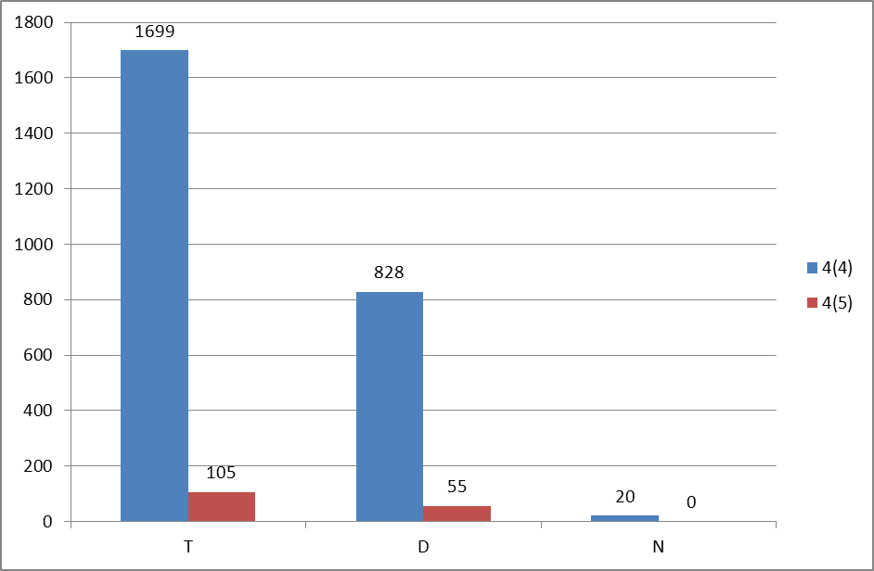

Figure 11.2.1: Numbers of Article 4(4) and 4(5) exemptions
T = Technical feasibility
D = Disproportionate costs
N = Natural conditions
Blue = Article 4(4) exemptions
Red = Article 4(5) exemptions
Source: WISE

Programmes of measures
According to Annex VII of the WFD, the RBMPs should contain a summary of the programmes of measures (PoM), including the ways in which Member States expect to achieve the objectives of Article 4 WFD. The programmes should have been established by 2009, but are required to become operational only by December 2012. The assessment in this section is based on the PoM as summarised by the Member State in its RBMP, and the compliance of this with the requirements of Article 11 and Annex VII of the WFD.
It therefore does not include a comprehensive assessment of compliance with the requirements of Article 11(3) on basic measures. It focuses in particular on key sets of measures. Member States will report to the Commission by December 2012 on the full implementation of their PoMs, including on the progress on the implementation of basic measures as required by Article 11(3). The Commission will assess what Member States report and will publish its assessment in accordance with Article 18 WFD.

Programme of measures – general
All of the RBMPs include a Programme of Measures (PoM). These Programmes identify individual measures and classify them in terms of priority areas of action. For example, the priorities for ITG include balancing water resources and demand and strengthening flood protection. The RBMPs do not indicate that the status assessments of surface water and groundwater bodies were used to identify their Programmes of Measures.
It appears that many measures listed in the RBMPs are drawn from previous plans, such as the regional Water Protection Plans. This is clearly shown in the PoM for ITA, which lists the plans that are the original sources of the measures. For ITB, the PoM distinguishes between measures from previous plans and new measures. As these prior plans addressed EU water legislation, in many cases they provide basic measures for the RBMPs.
A few RBMPs provide cost information on the plans: for ITB, these are listed in terms of measures identified in previous plans and new measures (each category is estimated at slightly above 5 billion Euro). Total costs are provided for ITE (about 1.5 billion Euro) and ITF (under 100 million Euro). For ITG, the RBMP states that costs will be determined in the near future. Information on financing is available for only a few plans: for ITB, for example, total available financing is indicated – and is less than the total cost of the measures.
In terms of geographic scope, many measures presented in the RBMPs have a basin-wide scope; it should be noted, however, that the RBMPs for the most part identify regional authorities as those responsible for the measures.
Some RBMPs, such as the ITE, also note measures at sub-basin level and, in a few cases, water body level. For ITB, a series of sub-basin reports were prepared. Some of these, such as the report for the Crostolo River basin, list measures that include individual investments, for example in UWWT plants, related to specific water bodies.
The RBMP for ITA refers to bilateral coordination on the Programme of Measures on shared catchments with Austria, Slovenia and Switzerland. Similar information was not found for ITB or ITC, however.
A few RBMPs provide a timetable for the measures. For ITF, measures are divided into short-term actions to 2013, medium-term actions to 2015, and long-term actions for the next cycle. Two RBMPs indicate that the measures are not fully defined. For ITA, the RBMP reports that from 2010-2013, the plan will be updated with new assessment results; it is not clear how this will influence implementation of the measures; in ITD, the measures are described as ‘approximate’, to be updated with further monitoring results.
According to information recently provided by Italy, ‘operational programmes’ have been under preparation, and these are to elaborate information not provided in the current PoMs.

Measures related to agriculture
All RBMPs refer to agriculture as a significant pressure due to diffuse pollution and abstractions. The WISE Summary for ITC, for example, indicates that diffuse pollution from agriculture is a significant pressure for 27% of the surface water bodies, and the sector’s abstractions are a significant pressure for 23% of groundwater bodies. In contrast, point source pollution and hydromorphological pressures from agriculture are cited in only some RBMPs: for ITC, ITG and ITH, for example, it appears that agricultural point sources have not been identified as an important pressure.
The extent of the sector’s involvement in the preparation of the RBMPs varies. Several RBMPs mention consultation of farmers’ associations in the stakeholder process; in ITB, one thematic meeting for the plan covered agriculture.
Measures | ITA | ITB | ITC | ITD | ITE | ITF | ITG | ITH
Technical measures
Reduction/modification of fertiliser application | ✓ | ✓ | ✓ |  |  |  | ✓
Reduction/modification of pesticide application | ✓ |  | ✓ |  |  | ✓
Change to low-input farming (e.g. organic farming practices) | ✓ | ✓ | ✓ |  |  | ✓ | ✓ | ✓
Hydromorphological measures leading to changes in farming practices | ✓ | ✓ | ✓ | ✓ | ✓ | ✓ |  | ✓
Measures against soil erosion |  |  |  |  |  |  | ✓
Multi-objective measures (e.g. crop rotation, creation of enhanced buffer zones/wetlands or floodplain management) | ✓ | ✓ | ✓ | ✓ | ✓ | ✓ | ✓ | ✓
Technical measures for water saving in agriculture | ✓ | ✓ | ✓ | ✓ | ✓ | ✓ | ✓ | ✓
Economic instruments
Compensation for land cover
Co-operative agreements |  |  |  |  |  | ✓
Water pricing specifications for irrigators | ✓ |  | ✓ | ✓ |  | ✓ | ✓
Nutrient trading
Fertiliser taxation
Non-technical measures
Additions regarding the implementation and enforcement of existing EU legislation |  | ✓ |  |  |  |  |  | ✓
Institutional changes |  | ✓ |  |  | ✓ |  | ✓
Codes of agricultural practice | ✓ | ✓ | ✓ |  |  |  | ✓
Farm advice and training | ✓
Raising awareness of farmers |  |  | ✓
Measures to increase knowledge for improved decision-making |  | ✓ | ✓ | ✓ |  | ✓ | ✓
Certification schemes | ✓ |  | ✓
Zoning (e.g. designating land use based on GIS maps) |  | ✓ |  |  |  | ✓ | ✓
Specific action plans/programmes |  | ✓ | ✓ | ✓ | ✓ | ✓ |  | ✓
Land use planning |  |  |  |  |  |  |  | ✓
Technical standards
Specific projects related to agriculture | ✓ | ✓
Environmental permitting and licensing | ✓ |  | ✓ | ✓
Table 12.2.1: Types of WFD measures addressing agricultural pressures, as described in the PoM
Source: RBMPs
The Programmes of Measures identify a broad range of measures to address pressures arising from agriculture. In particular, many technical measures are identified. Six PoMs have measures to promote low-input agriculture. Seven PoMs refer to hydromorphological measures: examples include the definition of minimum flow regimes and of water management policies for droughts (ITH). All the PoMs refer to multi-objective measures, though these vary greatly, from the requalification of drainage canals for ecological improvement (ITC) to the creation of buffer zones (ITG and others). All of the PoMs include measures for water savings in agriculture, highlighting the importance of this sector’s abstractions. (Other measures may also influence water use in agriculture, such as those for minimum flows, noted under hydromorphological measures.)
For economic instruments, only the PoM for ITF refers to co-operative measures. Five PoMs refer to water pricing measures for the agriculture sector.
A range of non-technical measures are cited in the PoMs: in six cases, greater controls are mentioned (often specifically related to abstractions). Six PoMs refer to specific action plans and programmes. These vary greatly: for ITF, examples include management plans for periods of water crisis and reform of irrigation systems.
Little information is provided on costs or financing for agricultural measures, though several RBMPs – for example ITH and ITG – mention the use of the Rural Development Fund.
No substantial information regarding the scope of the measures or the timing of the implementation could be found.

Measures related to hydromorphology
All the Italian RBMPs include measures related to hydromorphology. The links between these measures and the water use or pressure they address are mostly described in broad terms; links are not specified for all measures. In ITC, for example, measures address residual flow from water supply and storage, in particular irrigation, and modifications to the substrate of rivers for gravel extraction. Measures in ITG refer to several types of uses and pressures, including dams and other constructions, related to hydropower and water supply and storage, as well as bank reinforcement and channelisation for flood protection.
In at least two RBMPs, some measures are directed at both natural water bodies and HMWBs/AWBs: this is the case, for example, for buffer zones in ITB. In ITC, a measure will develop management plans for reservoirs.
Five RBMPs refer to measures for habitat restoration (see table below). In addition, five refer to measures for sediment/debris management: in most cases, this refers to management of gravel extraction.
All the RBMPs refer to measures for ecological flow regimes – in particular, to implementing, refining or enforcing minimum flow rules in response to national requirements. National guidelines on minimum flows – notably a 2004 ministerial decree – include among the criteria the maintenance of physical, physico-chemical and biological conditions. National legislation or guidance was not found, however, on other issues related to hydromorphology.
Measures | ITA | ITB | ITC | ITD | ITE | ITF | ITG | ITH
Fish ladders |  | ✓ |  | ✓
Bypass channels
Habitat restoration, building spawning and breeding areas | ✓ | ✓ | ✓ | ✓ |  | ✓
Sediment/debris management |  | ✓ | ✓ | ✓ |  |  | ✓ | ✓
Removal of structures: weirs, barriers, bank reinforcement |  | ✓ |  |  |  |  |  | ✓
Reconnection of meander bends or side arms |  | ✓
Lowering of river banks
Restoration of bank structure | ✓ |  |  |  | ✓ | ✓
Setting minimum ecological flow requirements | ✓ | ✓ | ✓ | ✓ | ✓ | ✓ | ✓
Operational modifications for hydropeaking
Inundation of flood plains
Construction of retention basins
Reduction or modification of dredging |  |  | ✓ |  |  |  | ✓
Restoration of degraded bed structure |  | ✓
Remeandering of formerly straightened water courses |  |  | ✓
Table 12.3.1: Types of WFD measures addressing hydromorphological pressures, as described in the PoM
Source: RBMPs

Measures related to groundwater
Many measures related to groundwater target specific pressures, such as over-exploitation, and many refer to the sectors driving these pressures: abstraction for irrigation, for example, is frequently cited. However, the measures for the most part are at RBD or sub-basin level and not related to specific water bodies; detailed links between risks, impacts, pressures and measures are not provided.
Most RBMPs include both basic and supplementary measures to address over-exploitation of groundwater. Among the basic measures, the RBMP for ITA foresees changes in the tariffs of water use and studies on aquifer recharge and rainwater harvesting; several RBMPs, such as ITC and ITF, have measures to strengthen the quantitative monitoring of groundwater; and ITC also refers to the implementation of regional water conservation plans. Moreover, a number of RBDs will undertake studies on groundwater resources.
Supplementary measures include limits to abstractions in ITA.
- ITA, ITB, ITC and ITF have measures to promote water conservation in agriculture;
- Several RBMPs, including ITB, ITC and ITH, have measures to strengthen controls on abstractions;
- A number of RBMPs have measures to improve their database of abstractions.
A range of measures are included regarding chemical status. Basic measures that are cited include: aquifer vulnerability mapping to curtail pollution from agricultural sources; identification and zoning of areas vulnerable to nitrates; identification of aquifer protection zones; hazardous substances training for farmers. The supplementary measures vary: in ITB, this includes the reduction of the discharge of hazardous substances and the strengthening of controls on existing wells to reduce risks of pollution in deep aquifers.
Co-ordination with neighbouring Member States is seen in ITA, where one measure refers to the development of common monitoring of trans-boundary GWBs. (Trans-boundary GWBs are not found in ITB or ITC.)

Measures related to chemical pollution
Only a couple of RBMPs provide information for an inventory of the sources of chemical pollution: for ITA, there is a list of UWWT plants and industrial facilities that are major point sources; for ITB, an inventory of UWWT plants is provided. For ITG, a study of potential dangerous substances affecting the RBD was undertaken, via an inventory of industrial facilities as well as current and past waste management sites.
Other RBMPs indicate the total load of major pollutants from key sectors but do not provide detailed inventories.
A variety of measures are identified in the RBMPs to address chemical pollution:
- Measures to address contaminated sites are identified in ITA and ITB;
- Some RBMPs, including ITC and ITE, contain measures to strengthen UWWT plants;
- A few, including ITE and ITH, have measures to reduce point and diffuse source pollution from agriculture;
- A number of plans, such as ITF and ITH refer to improving information systems;
- ITA includes measures specifically addressed at the chemical industry (in particular on the Lagoon of Venice).
Only ITC, however, lists substance-specific measures (directed at 16 substances).

Measures related to Article 9 (water pricing policies)
Italy has defined water services in national legislation (D.Lgs 152/2006, Art. 74(oo)): ‘any services that furnish families, public bodies or any economic activities with: extraction, embankment, storage, treatment and distribution of surface waters or groundwater; 2) structures for the collection and treatment of waste waters, which are subsequently discharged in surface waters’. The definition is broad as it covers households as well as all types of economic activities (thus both industry and agriculture) and it includes embankment and storage of water.
National legislation calls for the implementation of the principle of cost recovery for water services by 2010, with prices that provide adequate incentives for efficient water use and that take into account environmental and resource costs (D.Lgs 152/2006, Art. 119); economic analysis should include investment costs (D.Lgs 152/2006, including its Annex 10). However, as noted in the RBMP for ITC, the transition from previous approaches – in which pricing mainly covered operating costs – was still underway when the RBMPs were in preparation.
There is no information on the calculation and inclusion to the cost recovery calculation of environmental and resource costs.
Information provided on existing cost recovery levels varies. The RBMP for ITB presents a detailed methodology and calculations for contribution to cost recovery by agriculture, industry and households, based on case studies. These calculations are made for both operating and capital costs. In this RBD, it appears that prices set for households and agriculture by and large cover operating costs for water supply (and, for households, wastewater treatment). Industry covers its own costs for water supply and wastewater treatment. Other RBMPs provide less information; many do not provide any, though several (such as ITA) describe methodologies to be used in further work.
According to information recently provided by Italy, legislation now in preparation will advance the implementation of the cost recovery principles set out in the WFD and D.Lgs 152/2006. This legislation will also designate a national body to oversee prices set by water services.
Despite the above mentioned national legislation requirements for the implementation of pricing policy to provide adequate incentives for efficient water use, the implementation of incentive pricing is not explained in RBMPs.
Information on the application of flexibility provisions or provisions of art. 9(4) of the WFD , as well as on international cooperation regarding the implementation of Art. 9 were not found.

Additional measures in protected areas
Most RBMPs provide for additional measures in protected areas. In particular, many refer to Natura 2000 sites: for example, ITB and ITC both have measures for the preparation of site management plans; ITG refers to the establishment of these sites, and ITH to improved information on them. One RBMP, for ITG, has a measure to improve monitoring of bathing water.
Most the RBMPs refer to the establishment of safeguard areas for drinking water collection areas. In addition, the RBMP for ITC indicates that regions are adopting specific legislation for these areas.
The RBMPs do not, however, identify the specific water bodies where these additional measures are to be applied.
Even when additional objectives coming from the Shellfish Directive have been incorporated to meet national legislative decrees, no specific information on additional measures in Shellfish PAs is given in the RBMPs.

Climate change adaptation, water scarcity and droughts and flood risk management

Water Scarcity and Droughts
Droughts have affected Italy in recent years: in the summer of 2003, for example, essentially the whole country faced drought conditions. Several RBMPs, including ITA (Eastern Alps) and ITG (Sicily) acknowledge the importance of droughts. Water scarcity affects many parts of Italy’s river basins: for example, many RBMPs note that groundwater abstractions in certain areas exceed the sustainable recharge rate.
A few RBMPs present data on drought trends. One example is ITG (Sardinia), where the RBMP contains a section on drought management that presents historical data, such as on the water levels of reservoirs.
All the RBMPs identify measures to address water scarcity and drought (though not all refer identify the measures as responses to these issues). These include:
- Measures to improve water efficiency in agriculture are seen in most RBMPs;
- The re-use of treated wastewater, in particular in agriculture, is also identified in most RBMPs;
- A few RBMPs, such as those for ITA and ITG, include measures to reduce losses in urban distribution networks;
- Improved water metering and changes to water pricing are noted in most RBMPs;
- Measures to improve water governance are also common;
- A few RBMPs, such as ITE, include the development of Drought Management Plans;
- ITE also gives high importance to water transfer schemes, and these are also indicated in ITF; in ITG, improvements to reservoirs and water networks are cited.
Information was not found on international aspects of droughts and water scarcity, or on international co-ordination.
According to information recently provided by Italy, further work is underway to address water scarcity and droughts: in ITB and ITD, for example, Piani di bilancio idrico (Water balance plans) are in preparation.

Flood Risk Management
The RBMPs by and large make few references to floods and flood risk management, though many mention the Floods Directive.

Adaptation to Climate Change
All the RBMPs refer to climate change impacts, though most do so in very general terms. For ITB, the RBMP notes impacts on the Alps and on coastal zones. ITC describes the expected effect of IPCC forecasts for the RBD. For ITD and ITF, climate change is addressed in the SEAs of the plans. ITE mentions climate change as a future pressure on water availability across the RBD.
Two RBMPs include measures related to climate change: for example, ITB refers to measures to address agricultural water use as well as integrating climate change scenarios into river basin management planning.
Climate check of the Programmes of Measures was not performed.
A national strategy for climate change adaptation was not in place when the RBMPs were in preparation; however, preparatory steps have recently been taken to establish one.

Recommendations
Following the steps of river basin planning, as set out in the WFD, should ensure that water management is based on a better understanding of the main risks and pressures in a river basin and, as a result, that interventions are cost effective and ensure the long term sustainable supply of water for people, business and nature.
To deliver successful water management requires linking these different steps. Information on pressures and risks should feed into the development of monitoring programmes, information from the monitoring programmes and the economic analysis should lead to the identification of cost effective programmes of measures and justifications for exemptions. Transparency on this whole process within a clear governance structure will encourage public participation in both the development and delivery of necessary measures to deliver sustainable water management.
To complete the 1st river basin management cycle, and in preparing for the second cycle of the WFD, it is recommended that:
- The transition of the RBD authorities from a provisional to a permanent system should be completed and it should be ensured that these cover the entire area of the relevant RBD.
- Methods are effectively coordinated between the regions at the level of the RBD in order to achieve water management at the river basin level instead of management according to administrative boundaries.
- Monitoring is an important part of river basin planning and affects the quality and effectiveness of subsequent steps. The current monitoring gaps for BQEs, supporting quality elements and priority substances should be addressed.
- Quantitative aspects for surface and groundwater should be properly taken into account during the monitoring and assessment phases.
- The identification of river basin specific pollutants needs to be more transparent, with clear information on how pollutants were selected, how and where they were monitored, and where there are exceedances how such exceedances have been taken into account in the assessment of ecological status. It is important that there is an ambitious approach to combatting chemical pollution and that adequate measures are put in place.
- The plans should state clearly which priority substances have been measured where, and in which matrix, and monitoring should be extended where necessary to ensure that the chemical status of all water bodies can be assessed. The assessment should be based on the EQS in the EQSD, including the biota EQS for mercury, hexachlorobenzene and hexachlorobutadiene unless EQS for water that provide an equivalent level of protection have been derived. Trend monitoring in sediment or biota for at least the substances specified in EQSD Article 3(3) will also need to be reflected in the next RBMP.
- The high percentage of water bodies that have an unknown status prevents effective planning and comparability with other Member States. WFD compliant assessment methods should be used taking into account the work on intercalibration.
- Where there are currently high uncertainties in the characterisation of the RBDs, identification of pressures, and assessment of status, these need to be addressed in the current cycle, to ensure that adequate measures can be put in place before the next cycle.
- The designation of HMWBs should comply with all the requirements of Article 4(3). The assessment of significant adverse effects on their use or the environment and the lack of significantly better environmental options should be specifically mentioned in the RBMPs. This is needed to ensure transparency of the designation process.
- The absence of objectives in some RBDs is problematic and should be addressed.
- The application of exemptions needs to be more transparent and the reasons for the exemptions should be clearly justified in the plans.
- It is unclear whether there are new physical modifications planned in RBMPs. If this is the case, the use of exemptions under Article 4(7) should be based on a thorough assessment of all the steps as requested by the WFD, in particular an assessment of whether the project is of overriding public interest and whether the benefits to society outweigh the environmental degradation, and regarding the absence of alternatives that would be a better environmental option. Furthermore, these projects may only be carried out when all possible measures are taken to mitigate the adverse impact on the status of the water. All conditions for the application of Article 4(7) in individual projects must be included and justified in the RBMPs as early in the project planning as possible.
- Meaningful information regarding the scope, the timing and the funding of the measures should be included in the PoM so the approach to achieve the objectives is clear and the ambition in the PoM is transparent. All the relevant information on basic and supplementary measures should be included in the summary of the PoM to ensure transparency on the planned actions for the achievement of the environmental objectives set out in the WFD.
- Many measures in the Programmes of Measures originate from other existing plans and no clear link between measures and status assessment is made. In order to address this, the gaps in the steps leading to the Programme of Measures such as monitoring and status classification should be addressed. This is important in order to implement measures where they are needed to reach the WFD objectives.
- Agriculture is indicated as exerting a significant pressure on the water resource in most Italian RBDs, both from point and diffuse source pollution from livestock raising, as well as abstractions, hydro-morphological pressures and diffuse source pollution for crops. This should be translated into a clear strategy that defines the basic/mandatory measures that all farmers should adhere to and the additional supplementary measures that can be financed. This should be developed with the farming community to ensure technical feasibility and acceptance. There needs to be a very clear baseline so that any farmer knows the rules this can be adequately advised and enforced and so that the authorities in charge of the CAP funds can adequately set up Rural Development programmes and cross compliance water requirements.
- The cost-recovery should address a broad range of water services, including impoundments, abstraction, storage, treatment and distribution of surface waters, and collection, treatment and discharge of waste water, also when they are "self-services", for instance self-abstraction for agriculture. The cost recovery should be transparently presented for all relevant user sectors, and environment and resource costs should be included in the costs recovered. Information should also be provided on the incentive function of water pricing for all water services, with the aim of ensuring an efficient use of water. Information on how the polluter pays principle has been taken into account should be provided in the RBMPs.
- In order to function as a framework document for water management it is important that all additional measures to reach additional objectives for protected areas are included in the Programmes of Measures.

European Commission - http://europa.eu/about-eu/countries/member-countries/italy/index_en.htm
This MS Annex reflects the information reported by the MS to WISE which may have been updated since the adoption of the RBMPs. For this reason there may be some discrepancies between the information reported in the RBMPs and WISE.
Categorisation determined under the EC Comparative study of pressures and measures in the major river basin management plans in the EU (Task 1b: International co-ordination mechanisms).
Sources: Web sites of the provisional RBD Authorities; web site of the state/regions council.
In particular, Legislative Decree (D.Lgs) no. 152 of 1999.
Notably, in Sardinia (ITG) and Sicily (ITH), both Piani di Tutela and RBMPs are prepared, even though these two RBDs each correspond to one region.
Published in the Gazzetta ufficiale on 30 May 2009. The Decree amends annexes to Legislative Decree 152 of 2006.
DM 260/2010 was published in the Gazzetta Ufficiale in published Feb. 2011.
Italy has 20 regions; in the region of Trentino-Alto Adige, however, the two autonomous provinces of Trento and Bolzano/Bozen carry out regional functions for water management.
Law 13 of 27 February 2009.
The river basins of ‘national interest’ were set up under legislation prior to the transposition of the WFD in D.Lgs 152/2006.
For the other four RBDs: for ITB, the Po River Basin Authority (an existing river basin of ‘national interest’) prepared the RBMP; the Po River Basin Authority and the forthcoming RBD authority cover the same territory. For ITD, Italy’s smallest RBD, the existing pilot authority covers the whole basin. For ITG and ITH – the islands of Sardinia and Sicily – the regions are designated as the provisional authorities, and their territory coincides with the new RBDs.
Article 65(4) of Legislative Decree No. 152/2006.
Based mainly on a review of Legislative Decree No. 152/2006.
Article 66(7) of Legislative Decree No. 152/2006.
Commission vs. Italy (Case C85/07, ruling of 18.12.2007)
In particular in Ministerial Decree 131 of 2008, amending Legislative Decree No. 152/2006. In listing reference documents, this Decree cites work by the French Ministry of the Environment on hydro-ecoregions, as Italy appears to have applied a similar approach for the typology of SWBs.
Found in Ministerial Decree 56 of 2009, amending Legislative Decree No. 152/2006.
Based on the list of types provided in the appendix to Ministerial Decree 260 of 2010.
Ministerial Decree 131 of 2008, section C.3.
DM 131/2008.
Comparatively few areas were reported for ITF (southern Appenines) and ITH (Sicily), suggesting that the designation process was not completed in these RBDs at the time the RBMPs were prepared.
This information corresponds to the reporting of protected areas under the WFD. More/other information may have been reported under the obligations of other Directives.
Ministerial Decree 56 of 2009.
The total number of monitoring sites may differ from the sum of monitoring sites by type because some sites are used for more than one purpose.
Piano di gestione del distretto idrografico del fiume Po, relazione generale, pp. 89-95, 2010
Number of sites calculated from data reported at site level. If no data reported at site level, then table supplemented with data reported at programme level.
Data for 2009 and 2015 extracted from WISE. Data for 2021 and 2027 established during the compliance assessment of the RBMPs.
Data for 2009 and 2015 extracted from WISE. Data for 2021 and 2027 established during the compliance assessment of the RBMPs.
Data for 2009 and 2015 extracted from WISE. Data for 2021 and 2027 established during the compliance assessment of the RBMPs.
Data for 2009 and 2015 extracted from WISE. Data for 2021 and 2027 established during the compliance assessment of the RBMPs.
Data for 2009 and 2015 extracted from WISE. Data for 2021 and 2027 established during the compliance assessment of the RBMPs.
Data for 2009 and 2015 extracted from WISE. Data for 2021 and 2027 established during the compliance assessment of the RBMPs.
Data for 2009 and 2015 extracted from WISE. Data for 2021 and 2027 established during the compliance assessment of the RBMPs.
APAT, Environmental Yearbook 2008: Ch. 4 Water Quality, April 2009.
SECA is based on two indices, IBE (indice biotico esteso, extended biotic index), which uses benthic macro-invertebrates; and LIM (livello di inquinamento da macrodescrittori, level of pollution from macro-descriptors), based on dissolved O₂, BOD₅, COD, NH₄, NO₃, total P and Escherichia Coli). SEL uses transparency, Chlorophyll A, total P and dissolved O.
Commission Staff Working Document SEC(2007) 362final.
DM 131/2008, section B4.
DM 260/2010, A.4.2.1.
Exemptions are combined for ecological and chemical status.
These are the minimum requirements to be complied with and include the measures required under other Community legislation as well as measures to achieve the requirements of other WFD Articles and to ensure appropriate controls on different activities affecting water management.
A requirement for minimum flows is found in Legislative decree No. 152 of 1999. Guidelines are found in DM no. 268 of 2004.
The exceptions are ITD, which does not have basic measures for this topic; ITF does not have supplementary measures; and ITG has measures but does not distinguish between the two categories.

