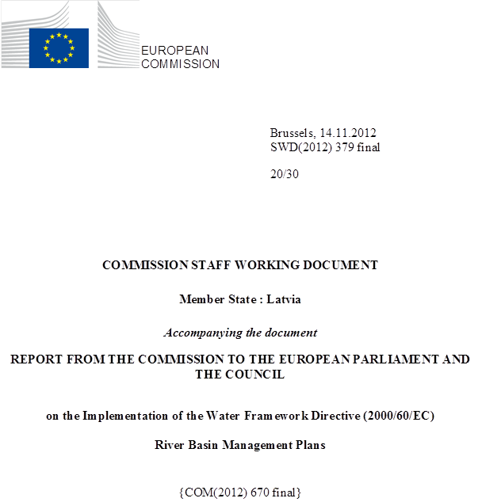

general information
Figure 1.1: Map of River Basin District
International River Basin Districts (within EU)
International River Basin Districts (outside EU)
National River Basin Districts (within EU)
Countries (outside EU)
Coastal Waters
Source: WISE, Eurostat (country borders)
In Latvia there are 2,067,887 inhabitants, (2.22 million, Eurostat 2011) and its territory is 64,589 km². Latvia is one of the least populous and least densely populated countries of the European Union. The major rivers are Daugava, Lielupe, Gauja, Venta, and Salaca. Latvia's coastline extends for 531 kilometres.
According to the Law on Water Management the territory of Latvia is divided in Daugava, Gauja, Lielupe and Venta river basin districts. All four RBDs of Latvia are transboundary RBDs.
RBD | Name | Size (km²) | Countries sharing RBD
LVDUBA | Daugava | 27026 | BY, LT, RU
LVGUBA | Gauja | 13051 | EE
LVLUBA | Lielupe | 8849 | LT
LBVUBA | Venta | 15625 | LT
Table 1.1: Overview of Latvia’s River Basin Districts
Source: River Basin Management Plans reported to WISE: http://cdr.eionet.europa.eu/lv/eu/wfdart13
All Latvia’s RBDs are international, some shared with third countries. A very small part of the Narva (including Lake Peipsi) which is predominantly in Estonia, is also on Latvian territory as part of the Daugava RBD.
Name international  river basin | National RBD | Countires sharing RBD | Co-ordination category |  | Co-ordination category
Name international  river basin | National RBD | Countires sharing RBD | 2 |  | 3
Name international  river basin | National RBD | Countires sharing RBD | km² | % | km² | %
Daugava | LVDUBA | BY, LT, RU |  |  | 27077 | 32.7
Gauja/Koiva | LVGUBA | EE | 13051 | 90.7
Lielupe | LVLUBA | LT |  |  | 8849 | 49.7
Narva (including Lake Peipsi/ Chudkoe, Lake Pihkva/ Pskovskoye) | LVDUBA | EE, RU | 3100 | 5.5
Venta | LVDUBA | LT |  |  | 6507 | 55.7
Table 1.2: Transboundary river basins by category (see CSWD section 8.1) and % share in Austria
Category 1: Co-operation agreement, co-operation body, RBMP in place.
Category 2: Co-operation agreement, co-operation body in place.
Category 3: Co-operation agreement in place.
Category 4: No co-operation formalised.
Source: EC Comparative study of pressures and measures in the major river basin management plans in the EU.

Status of River basin Management Plan reporting and compliance
The final version of the River basin district management plans was approved by the Order of the Minister of Environment on 6 May 2010. The RBMPs were reported to the Commission on 18 May 2010.
The RBMPs and programmes of activities included therein are aimed at ensuring Latvian surface waters and groundwater reach environmental quality objectives. The principal objectives of the RBMPs are to prevent deterioration in the condition of the waters and to improve the surface waters and groundwater in order to reach a good water quality by 2015.

Main strengths of the RBMPs
The river basin and groundwater management approach has been introduced to surface and groundwater management in Latvia. The basin approach in the management of water resources has been approved by the Cabinet of Ministers and it is binding to everyone who is using those resources.
In each RBMP, the main objectives are clearly defined together with the measures proposed for achieving good quality in the water bodies.
The established consultative RBD boards are an effective panel for the discussion of the RBMP issues.

Main weakness of the RBMPs
All four RBDs are international RBDs, but transboundary issues have not been coordinated, especially with non-Member countries. International RBMPs have not been developed.
The classification of the ecological status, pressure impact analysis and setting of the ecological objectives is provisional for all water bodies. It was not based on all quality elements required by the WFD but on all information available at the time of the development of RBMPs. No river basin specific pollutants have been identified. There are significant shortcomings in the monitoring network, and monitoring data is not available for the assessment of all water bodies. There are also shortcomings on the classification os chemical status,.

Governance

Timeline of implementation
The RBMPs were reported to the Commission on 18/05/2010. The information on the reports delivered by Latvia to WISE is presented below. The consultation as required by Article 14 took place with the following timetable for publication of documents:
- Timetable, Work programme: 03/11/2006.
- Statement on consultation measures to be taken : 22/12/2008.
- Full document "Significant water management issues": 03/11/2006.
- Draft River Basin Management Plans: 22/12/2008.
- Publication of RBMP: 22/12/2009.

Administrative arrangements - river basin districts and competent authorities
The competences are divided on a basis of the legal acts that determine each institution's responsibility in the public administration system. The Ministry of Environmental Protection and Regional Development (MEPRD) is responsible for the transposition of the WFD into national legislation and ensuring the implementation of WFD. The Latvian Environment Geology and Meteorology Centre (LEGMC) is responsible for the implementation of the specific tasks set out in the Water Management Act and other legal acts.
LEGMC is responsible for the development of the river basin management plans, coordinating the implementation of the PoM, and ensuring the work of the RBD advisory councils.
The co-ordination between the LEGMC and MEPRD is agreed annually where the responsibilities of the LEGMC are listed for the given year. In addition, to ensure the compliance with the WFD, representatives of the two institutions have special meetings on the additional tasks.

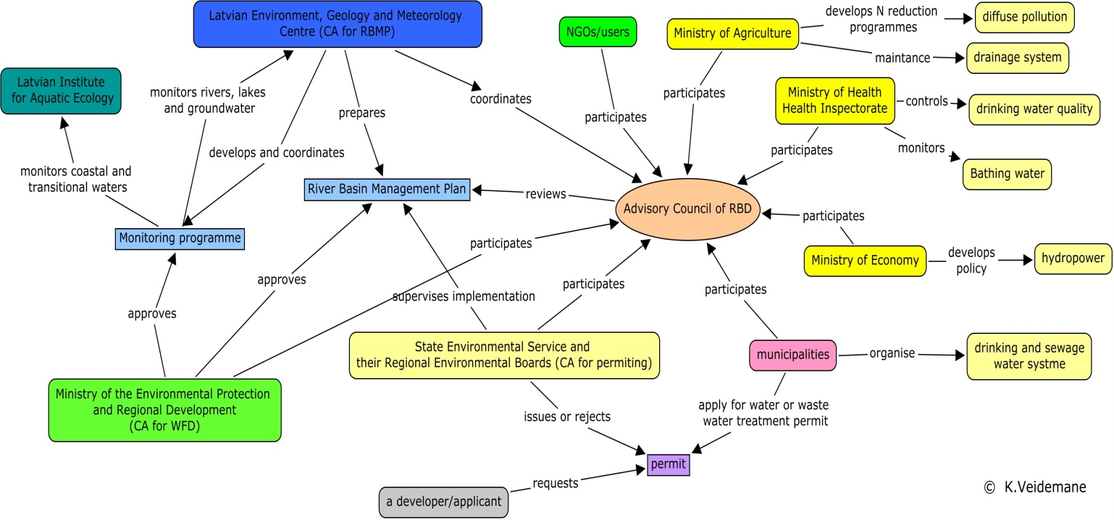
Figure 3.2.1: WFD implementation structure in Latvia
Source: K. Veidemane, Baltic Environmental Forum

RBMPs - Structure, completeness, legal status
There are four separate RBMPs – each for one RBD. The RBMP development followed a national approach and include a water quality assessment, assessment of pressures and impacts and trend analysis, and economic analysis of water users. Each plan identifies the environmental quality objectives and program of measures to reach the goals for the period up to 2027. RMBPs consist of 8 chapters, which contain information required by the LV legal acts and the Water Framework Directive 2000/60/EC:
- a characterisation of a river basin district;
- information regarding the most important anthropogenic loads and impact of human activity on the status of surface water and groundwater;
- information regarding protected areas;
- information regarding the monitoring network and results of the implemented monitoring programmes;
- a summary of the economic analysis;
- the quality objectives determined for water bodies and protected areas;
- information regarding the planned measures in order to prevent or reduce emission of pollutants, as well as to achieve the environmental quality objectives (Programme of measures);
- information regarding other programmes related to the management of the river basin district;
- a survey regarding public information and consultations performed when developing and updating the plan.
The RBMPs were designed considering the various interests, knowledge and needs of the readers. Each chapter begins with a brief summary of the topic emphasizing the actual problems. In order to summarize the information a number of graphs and tables are included in each plan. Maps and supporting textual information is included in annexes. Some of the supporting textual annexes are the same for all RBMPs, but overall all annexes are RBD specific. Each plan is supplemented with 15 maps and 23 – 25 textual annexes.
For the first planning period (2009 – 2015) joint international plans were not produced for Daugava, Gauja, Lielupe and Venta RBD.
The River basin district management plans were approved by the Order of the Minister of Environment on 6 May 2010. RBMPs and PoMs are planning documents which are approved by resolutions. They are legally binding, but cannot contradict existing laws. As RBMPs are approved by the Minister of Environment, they are binding to all institutions subordinated to the Ministry of Environment and have to be taken into account when adopting internal legal acts. However, the plans are not binding to individuals. In other words, it is not possible to refer only to the RBMPs in order to adopt administrative acts (decisions issued by state institutions regarding individuals). Any reference to the RBMPs in such decisions would only be informative, not legal. However, the RBMP is binding on the administration in performing their tasks and functions. There is only an indirect link between RBMP and individual decisions, and this indirect link is not specified in legislation.. The State Environmental Service shall supervise the implementation of the programme of measures and review the conditions of the issued permits, taking into account RBMPs and PoMs. This is a general provision providing for permits to be reviewed on the basis of programme of measures and if the SES considers it necessary. As the PoM according to the national legislation is included in the RBMP, this part of RBMP becomes binding on permitting decisions.

Consultation of the public, engagement of interested parties
Strategic Environmental Assessments have been undertaken on the Programme of Measures for all RBMPs. The SEA is a separate document for each RBD and is available on a LEGMC web site. The SEA reports are in Latvian. The SEAs took place during March - June 2009, after finalisation of the draft RBMPs on December 2008. The SEAs were performed simultaneously with the public consultation procedure.
The results of the SEAs are summarised in the report: "Report on the influence of the SEAs to the RBMPs". Some examples of the changes to the PoM as a result of the SEAs are: the geographical scale of the measure for the agriculture sector, implementation of buffer zones, has been narrowed. The water bodies were specified for which this measure has to be implemented, previously it had been more general. In another measure from the agriculture sector, the measure regarding environmentally safe manure collection and storage was assessed as carrying significant costs. In the program of measures therefore it has been specified that this measure has to be implemented within the limits of available finances. Sources of financing of this measure have been specified. A number of measures have been specified and supplemented with more detailed descriptions, for example the implementation of buffer zones in forestry.
The public and interested parties were informed about the consultations on the draft RBMPs by following means: through media, via the internet, via active invitations to known stakeholders/organisations, through local authorities, interviews of the representatives from different stakeholder groups, consultative board of the RBD, meetings with stakeholder groups and discussion forums.
The consultations were carried out using meetings, written submissions and web based consultation. Following the consultations changes were made to measures already proposed and new measures were added. Commitments to further research were also made.
The drafts of RBMPs were available during the 6 months for feedback.

International co-operation and co-ordination
All four RBDs are international RBDs and transboundary issues have not been coordinated, especially with non-Member countries. This issue concerns particularly Daugava RBD which is a transboundary RBD with Lithuania, Russia and Belarus.
It was planned to conclude the trilateral agreement between the governments of Latvia, Belarus and the Russian Federation concerning co-operation in the Daugava/ Zapadnaja Dvina river basin in 2003. The Latvian government approved a draft agreement but it was not signed in 2003 as Russia and Belarus postponed the final decision several times due to various reasons. After joining the EU on the 1st of May 2004 water quality became a topic of shared responsibility between the Member States and the EU. Therefore any international agreement on water management between an EU Member State and a non-Member State requires the EU as a Contracting Party. Co-operation agreements were on the list of topics to be discussed during high-level meetings of the European Union and Russia; however, this has not led to renewal of the negotiations concerning river basin management agreement. Latvia has no framework agreement with Belarus and Russia on co-operation in river basin management and therefore it is not possible to plan joint activities or develop management plans with non-member countries. Also exchange of data and information is very limited. The next steps should be submission of the draft agreement and explanatory nota via diplomatic means to the relevant public authorities in Russia and Belarus.

Integration with other sectors
For the involvement of the different stakeholder groups there were organised discussion forums in each RBD. The main stakeholder groups involved were: farmers, foresters, local municipalities, Regional development agency, Ministry of Environment, NGOs and community representatives. The most active groups were representatives of municipalities and community representatives (local inhabitants, students, tourism sector representatives and local entrepreneurs).
The RBMPs are linked with the other sectoral plans, of which the most important are: Environmental Policy Strategy 2009–2015, National Flood Risk Management Strategy 2008-2015, National Development Plan 2007-2013, Regional development plans (depending on a RBD), HELCOM, and EU directives.

Characterisation of river basin districts

Water categories in the RBDs
Rivers and lakes have been designated in all RBDs. Transitional waters have only been designated in the Dauguava RBD. Coastal waters were only designated in the Gauja and Venta RBDs. The one designated transitional water body belongs jointly to Daugava, Gauja and Lielupe RBD, but is here listed with the Daugava RBD.

Typology of surface waters
The typology of surface water bodies is based on system B. The typology of rivers and lakes is based on abiotic data. For river water bodies typology is based on the following parameters - size of a catchment area and an average slope. The factor of average slope has traditionally been used in Latvia to separate potamal (or slow flowing) rivers and rhitral (or fast flowing) rivers. For lake water bodies – size, depth, geology and concentration of organic matter were used to define the typology. Most Latvian lakes are small – more than 10 000 lakes have surface area below 1 ha and few lakes exceed 10 km². Shallow lakes with a mean depth between 1 and 6 m are the most common type (~ 70 % of all Latvian lakes). The following depth typology (based on the mean depth) is used in Latvia: 1. Very shallow lakes (depth <2 m); 2. Shallow lakes (depth 2 – 9 m); 3. Deep lakes (depth >9 m). Transitional and coastal water types adopted in Latvia are consistent with the CHARM project outcomes and coordinated with other countries of the Baltic Sea Ecoregion. Salinity, depth/mixing and water residence time of enclosed areas (residence time) were used as factors in classification of transitional and coastal water types.
Based on the information presented in the RBMPs and WISE, it appears that the surface water typology has not tested against biological data for any of the relevant water category (R, L and T waters). Latvian authorities have clarified that all information about the characterisation was set out in the Article 5 report submitted in 2005.
Specific reference conditions have been established for all types according to the Article 5 report. The data was however, according to the Latvian reports, not submitted to WISE, since the quality class boundaries were not developed for the different quality elements by the time Article 5 reports were submitted, and the RBMPs did not include an update taking into account intercalibration process since 2005. Reference conditions have been established with a combination of spatially based method and expert judgement.
RBD | Rivers | Lakes | Transitional | Coastal
LVDUBA | 4 | 8 | 1 | 0
LVGUBA | 5 | 7 | 0 | 1
LVLUBA | 4 | 5 | 0 | 0
LVVUBA | 4 | 6 | 0 | 4
Table 4.2.1: Surface water body types at RBD level
Source: WISE

Delineation of surface water bodies
The methodological approach for delineation of surface water bodies follows a national approach for all RBD. The minimal requirements for delineation of a separate water body for a river –is a catchment area more than 100 km² (which is larger than the WFD limit) and for a lake, a surface area 0.5 km² or more.
A river with a smaller catchment area, or a lake with a less surface area can be delineated as a separate water body if it is necessary for the achievement of environmental objectives or if this is a water body in the protected area in order to ensure the protection of this territory.
There is only one transitional water body delineated in Latvia. This is a low salinity zone in the southern part of the Gulf of Riga, near the estuaries of the Daugava, Gauja and Lielupe rivers.
RBD | Surface Water |  |  |  |  |  |  |  | Groundwater
RBD | Rivers |  | Lakes |  | Transitional |  | Coastal
RBD | Number | Average Length (km) | Number | Average Area  (sq km) | Number | Average Area  (sq km) | Number | Average Area  (sq km) | Number | Average Area  (sq km)
LVDUBA | 65 | 43 | 181 | 3 | 1 | 934 | 0 |  | 6 | 5782
LVGUBA | 46 | 36 | 35 | 2 | 0 |  | 1 | 176 | 5 | 5406
LVLUBA | 32 | 45 | 13 | 4 | 0 |  | 0 |  | 3 | 6854
LVVUBA | 61 | 31 | 30 | 6 | 0 |  | 5 | 221 | 8 | 4356
Total | 204 | 38 | 259 | 3 | 1 | 934 | 6 | 214 | 16* | 5337
Table 4.3.1: Surface water bodies, groundwater bodies and their dimensions * Some groundwater bodies belong to more than one RBD.
Source: WISE

Identification of significant pressures and impacts
RBD | No pressures |  | Point source |  | Diffuse source |  | Water abstraction |  | Water flow regulations and morphological  alterations |  | River management |  | Transitional and coastal water management |  | Other morphological alterations |  | Other pressures
RBD | No. | % | No. | % | No. | % | No. | % | No. | % | No. | % | No. | % | No. | % | No. | %
LVDUBA | 210 | 85.02 | 6 | 2.43 | 13 | 5.26 | 0 | 0 | 23 | 9.31 | 5 | 2.02 | 0 | 0 | 0 | 0 | 15 | 6.07
LVGUBA | 58 | 70.73 | 3 | 3.66 | 7 | 8.54 | 0 | 0 | 9 | 10.98 | 3 | 3.66 | 0 | 0 | 0 | 0 | 12 | 14.63
LVLUBA | 18 | 40 | 4 | 8.89 | 7 | 15.56 | 0 | 0 | 14 | 31.11 | 4 | 8.89 | 0 | 0 | 0 | 0 | 22 | 48.89
LVVUBA | 64 | 66.67 | 6 | 6.25 | 4 | 4.17 | 0 | 0 | 9 | 9.38 | 6 | 6.25 | 0 | 0 | 0 | 0 | 25 | 26.04
Total | 350 | 74.47 | 19 | 4.04 | 31 | 6.6 | 0 | 0 | 55 | 11.7 | 18 | 3.83 | 0 | 0 | 0 | 0 | 74 | 15.74
Table 4.4.1: Number and percentage of surface water bodies affected by significant pressures
Source: WISE

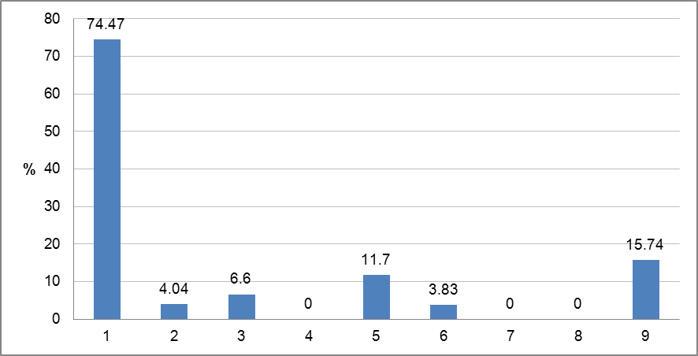
Figure 4.4.1: Graph of percentage of surface water bodies affected by significant pressures
1 = No pressures
2 = Point source
3 = Diffuse source
4 = Water abstraction
5 = Water flow regulations and morphological alterations
6 = River management
7 = Transitional and coastal water management
8 = Other morphological alterations
9 = Other pressures
Source: WISE

The methodological approach for identification of significant pressures and impacts overall follows a national approach in all RBMP.
For the assessment of a "significant" pressure to the WB from diffuse sources, summary loads of three types of pressures are evaluated: total load from agriculture, forestry and population without a centralised waste water treatment. The diffuse pollution is assessed as significant pressure to the WB taking into account following thresholds: for P > 0.180 kg/ha and for N > 10.0 kg/ha. These thresholds are compared with the total loads of P or N by agriculture, forestry and urban runoff (population without a centralised waste water treatment) to the water body and then divided with the total area of the water body.
For the assessment of a "significant" pressure to the WB from a point source only one point source pressure type - "UWWT in general" has been evaluated. There are different limits for point source pollution for river WB and lake WB. For river WB: Ptot >2 t per annum, Ntot >10 t per annum and total amount of waste water >1 million m³/year ; for lake WB: Ptot >1 ton per annum, Ntot >5 ton per annum and total amount of waste water >500 000 m³/year.
If all three values (Ptot, Ntot and volume) have been exceeded then the point source pollution has been assessed as significant pressure to the WB.
From an assessment of the pressures from water abstractions, no water body has been there has been identified as having a significant pressure from water abstraction. For the assessment of significant pressure from water abstraction in the RBMP the data from the statistical report "2-Water" are used. The assessment concerns all types of water users who are the subjects of the water use permits i.e. average daily use of surface or groundwater is more than 10 m³. The criterion to assess the abstraction as a significant was the proportion between the total amount of the abstracted water (all types of users) and available surface and groundwater resources (total in the RBD area). If this ratio is more than 0.4, the pressure is significant.
For the assessment of the significant pressures in water bodies with hydrological and/or morphological changes the information from various sources is used - the Marine Environment Administration, LEGMC, A/S Latvenergo, the Rural Support Service and the State Construction Inspection together with expert judgement for some of the pressures. Water flow and morphological alteration is evaluated for 4 groups of hydro-morphological alterations: hydroelectric power stations, ports, water flow regulations and polders (land reclamation). If the load of one of these groups in the water body is significant the pressure from water flow regulations of morphological alterations is assessed as significant.
The effects of flooding in the flood affected areas are also considered as a pressure to the water bodies and RBD. As there is no methodology for the assessment of this pressure within the framework of the RBMP, the information provided in the "National program for the flood risk and management 2008-2015" (accepted in 2007) is transferred to the RBMP. Transboundary pollution is also mentioned as one of the other types of pressure to be considered for evaluation of the significant pressures, but there are no values set. The transboundary pressure is evaluated based on whether a water body is a transboundary water body or not together with the total load of N and P coming from the neighbouring country. There are no water bodies identified which are considered as significantly affected from the transboundary pollution pressure. In the RBMP chapter 2.6 "Other pressures" climate change is mentioned as a possible pressure to the water body. As there is no methodology developed within the framework of RBMP, the state research program "Impact of climate changes to the water quality of Latvia" (KALME project) information is transferred to the RBMP. There are no water bodies identified to be considered as significantly affected from climate change.

Protected areas
Latvia applies stringent waste water treatment in the whole of its territory and therefore, in accordance with article 5.8 of the Urban Waste Water Directive (1991/271/EEC), it is exempted from designation of specific vulnerable zones. There are no shellfish protected areas in Latvia.
RBD | Number of PAs
RBD | Article 7 Abstraction for drinking water | Bathing | Birds | European Other | Fish | Habitats | Local | National | Nitrates | Shellfish | UWWT
LVDUBA | 2 | 84 |  |  | 82 | 112 |  |  | 12
LVGUBA |  | 43 |  |  | 49 | 74 |  |  | 9
LVLUBA |  | 40 |  |  | 17 | 47 |  |  | 32
LVVUBA |  | 55 |  |  | 48 | 75 |  |  | 3
Total | 2 | 222 |  |  | 196 | 308 |  |  | 56
Table 4.5.1: Number of protected areas of all types in each RBD and for the whole country, for surface and groundwater
Source: WISE

Monitoring
Figure 5.1: Maps of surface water (left) and groundwater (right) monitoring stations
 | • |  | River monitoring stations
 | • |  | Lake monitoring stations
 | • |  | Transitional water monitoring stations
 | • |  | Coastal water monitoring stations
 | • |  | Unclassified surface water monitoring stations
 | • |  | Groundwater monitoring stations
 |  |  | River Basin Districts
 |  |  | Countries outside EU
Source: WISE, Eurostat (country borders)
The assessment for the current RBMP is based on the Monitoring program 2006-2008. In 2010 a new Monitoring program 2009-2014 was approved by the Minister of Environment.
The monitoring program 2006-2008 was a standard national monitoring program for both operational and surveillance monitoring with sub programmes for rivers, lakes, transitional and coastal waters. There is no clear separation of surveillance and operational programmes. Many stations are identified as belonging neither to surveillance nor to operational (i.e. reporting of networks for other purposes). In the monitoring program only one reference monitoring site is reported. The need for formal investigative monitoring is foreseen, but there is no any additional information provided.

RBD | Rivers |  | Lakes |  | Transitional |  | Coastal |  | Groundwater
RBD | Surv | Op | Surv | Op | Surv | Op | Surv | Op | Surv | Op | Quant
LVDUBA | 11 | 58 | 19 | 156 | 10 | 2 | 0 | 0 | 22 | 0 | 19
LVGUBA | 10 | 36 | 3 | 31 | 0 | 0 | 5 | 1 | 23 | 0 | 9
LVLUBA | 8 | 31 | 3 | 9 | 0 | 0 | 0 | 0 | 13 | 0 | 8
LVVUBA | 9 | 57 | 7 | 27 | 0 | 0 | 9 | 3 | 21 | 0 | 20
Total by type of site | 38 | 182 | 32 | 223 | 10 | 2 | 14 | 4 | 79 | 0 | 56
Total number of monitoring sites | 220 |  | 255 |  | 12 |  | 20 |  | 88
Table 5.2: Number of monitoring sites by water category.
Surv = Surveillance, Op = Operational, Quant = Quantitative
Source: WISE

Monitoring of surface waters
Not all of the relevant quality elements required for the surveillance monitoring included in the design of the monitoring programme are monitored:
Water  category | Quality element NOT monitored | Comment
Rivers | phytobenthos, fish, connection to groundwater bodies, other species, other national pollutants
Lakes | watzer flow,, , connection to groundwaters bodies,, other species, priority substances,, non- priority specific pollutants, other pollutants
Transitional | other aquatic flora,,fFish, structure of the tidal zone, , tidal regime, salinity, other national pollutants | In transitional water QE1-5 from “other species” is monitored zooplankton
Coastal | Microalgae, angiosperms,, direction of dominat currents, wave exposure, other national pollutants.
Table 5.1.1: List of quality elements not monitored by water category.
Source: RBMPs
According to the national authorities the main reason why not all the quality elements were included in the surveillance monitoring program in the first river basin management planning period, was a lack of the relevant national assessment methods and a lack of data to establish quality class boundaries. This is not in line with WFD requirements.
The monitoring program developed for 2006 – 2008 did not clearly differentiate between operational and surveillance monitoring. Only a few biological quality elements (benthic invertebrates and phytoplankton) were regularly monitored and had long-term data chains. Only those elements that have been used and tested in a long term, justifying their adequacy and reflection of the impacts on water quality in Latvia have been used. For the others, assessment methods and/or classification systems had to be developed,
Grouping of water bodies has not been applied.
The State Monitoring Programme for the period of 2006 – 2008 provided for monitoring of 4 priority substances (metals) and several other chemical pollutants – mainly metals and oil hydrocarbons. The selection of hazardous substances and priority substances monitored was planned in those water bodies only:
1) where significant amounts of such substances were discharged according to the permits issued by the regional environmental authorities;
2) which are strategically significant for Latvia, for instance, trans-boundary water bodies.
In addition to that, selected water bodies were monitored in 2006 and 2007, to identify prospective concentrations of several organic pollutants, for instance, polyaromatic hydrocarbons PAH, monoaromatic hydrocarbons BTEX, and several organochlorine substances (solvents, pesticides etc.). Monitoring data of chemical pollutants collected in 2003-2005 were also used for the assessment of the chemical status.
Several large-scale screening projects have been implemented since 2009 in order to assess water pollution and to obtain sufficient information for the development of a monitoring programme adapted and optimal for the Latvian conditions. During these projects the presence and concentrations of more than 200 substances/groups of substances in Latvian waters (including sediments, wastewaters, sewage sludge and fish) have been examined. These studies significantly extended knowledge about surface water chemical quality in Latvia. The results of these studies also provide assurance that there are no reasons for concerns about surface water chemical quality.
There is no special trans-boundary monitoring programme. However, water quality monitoring is carried out in the water bodies located on the Latvian – Lithuanian border. The data obtained are exchanged with the Lithuanian Environmental Protection Agency in accordance with the co-operation agreement. The monitoring data exchange covers Lielupe and Venta river basin districts. A joint trans-boundary monitoring program is not of a high priority for the Gauja/Koiva river basin district as trans-boundary pollution is not regarded as a significant pressure neither on the Latvian nor on the Estonian side. However, there is an on-going project “Towards joint management of the trans-boundary Gauja/Koiva river basin district”. The data collected during the project and recommendations developed by its experts will be analysed and decisions about trans-boundary monitoring might be taken, if necessary.

Monitoring of groundwater
There was no separate operational monitoring for groundwater in Latvia within the monitoring programme for the period of 2006 – 2008. However, operational monitoring in the parts of groundwater bodies considered as being at risk in the first river basin management plans was included in the monitoring programme for 2009 – 2014.
A quantitative groundwater monitoring programme has been established.
There has been no groundwater chemical status monitoring to detect significant and sustained upward trends in pollutants.
In the vicinity of Riga and Liepaja upward trends of chlorides, sodium, potassium and/or other ions indicative of saline intrusion or infiltration have been detected in the past. These processes started in the 1970s due to intensive water abstraction; today they are decreasing. Another area is identified where pollution of shallow groundwater is caused by numerous point-sources; the monitoring network allows following up these processes as well.
Latvia plans to improve groundwater monitoring in the future.
Transboundary groundwater monitoring program does not exist at the moment in Latvia but negotiation are planned with Lithuania.

Monitoring of protected areas
There are only 2 surface water bodies in Latvia used for production of drinking water, both of them are located within Daugava river basin district. Monitoring of these 2 sites has been referred in the monitoring programme for 2006 – 2008. As Latvia is rich in groundwater resources, there are no plans to use any other surface water body for drinking water production.

RBD | Surface waters |  |  |  |  |  |  |  | Ground-water drinking water
RBD | Surface drinking water abstraction | Quality of drinking water | Bathing water | Fish | Habitats/Bird sites | Nitrates | Shellfish | UWWT*
LVDUBA | 2 | 0 | 1 | 52 | 118 | 7 | 0 | 0 | 0
LVGUBA | 0 | 0 | 13 | 44 | 57 |  | 0 | 0 | 0
LVLUBA | 0 | 0 | 11 | 25 | 64 | 11 | 0 | 0 | 0
LVVUBA | 0 | 0 | 10 | 13 | 22 | 37 | 0 | 0 | 0
Total | 20 | 0 | 35 | 134 | 261 | 55 | 0 | 0 | 0
Table 5.3.1: Number of monitoring sites in protected areas
Note : Number of sites calculated from data reported at site level. If no data reported at site level, then table supplemented with data reported at programme level.
*The whole territory is designated as sensitive, so no specific monitoring stations reported.
Source: WISE

Overview of status (ecological, chemical, groundwater)
51% of the Latvian surface water bodies and almost all groundwater bodies are classified as having good or high status. Despite the shortcomings of the monitoring programme and surface waters classification system the assessment correctly reflects the real situation, because:
- It is in accord with the assessment of biological quality of small rivers, which was carried out several times: in 1993 – 1997 in 1086 monitoring stations on 527 small rivers and in 1998 – 2000 in 3920 monitoring stations all over the country. In both cases the assessment was based on the evaluation of biotic communities of the benthic invertebrates. In 1993 – 1998, 85% of the assessed rivers were classified as clean or slightly polluted. In 1998 – 2000, 88% of the assessed rivers were classified as clean or slightly polluted. Therefore the large majority of small rivers were assessed as having slight anthropogenic impact according to biological quality elements. The largest share of polluted rivers was found in the Lielupe river basin; this conclusion is in line with the findings of river basin management plans. Even if this assessment did not include all the quality elements required by the Water Framework Directive, its scale and long term makes its conclusions reliable.
- In 2001 and 2002 a synoptic monitoring of lakes was carried out, where both chemical and biological quality criteria (phytoplankton, zooplankton and macrophytes) were analysed. This monitoring included 57 lakes in 2011 and 56 lakes in 2002. According to the results of these studies, 23,8 % of the surveyed lakes were assessed as eutrophic, 13,8% as very eutrophic and 6,2 % as hypereutrophic. These results do not contradict with the assessment given in the river basin management plans.
- Several screening activities carried out in 2009 – 2011 show that pollution with hazardous (priority) substances is present in some places, but is not a widespread problem.
The pressures on waters in Latvia are lower than the EU average. Low population density (34,2 persons/km²), large share of forests (~ 45% of the state territory), rather small share of agricultural land (38%, while the EU average is 44%) and unmodified floodplains together ensure moderate impact on the environment. Taking into account both the historical data and mediocrity of the pressures, the current assessment is made with a precaution and that the real water status could be better than assessed.

RBD | Total | High |  | Good |  | Moderate |  | Poor |  | Bad |  | Unknown
RBD | Total | No. | (%) | No. | (%) | No. | (%) | No. | (%) | No. | (%) | No. | (%)
LVDUBA | 232 | 5 | 2.2 | 114 | 49.1 | 65 | 28.0 | 20 | 8.6 | 28 | 12.1 | 0 | 0
LVGUBA | 80 | 5 | 6.3 | 38 | 47.5 | 26 | 32.5 | 9 | 11.3 | 2 | 2.5 | 0 | 0
LVLUBA | 38 | 0 | 0 | 6 | 15.8 | 13 | 34.2 | 3 | 7.9 | 16 | 42.1 | 0 | 0
LVVUBA | 89 | 3 | 3.4 | 45 | 50.6 | 25 | 28.1 | 7 | 7.9 | 9 | 10.1 | 0 | 0
Total | 439 | 13 | 3.0 | 203 | 46.2 | 129 | 29.4 | 39 | 8.9 | 55 | 12.5 | 0 | 0
Table 6.1: Ecological status of natural surface water bodies.
Source: WISE

RBD | Total | High |  | Good |  | Moderate |  | Poor |  | Bad |  | Unknown
RBD | Total | No. | (%) | No. | (%) | No. | (%) | No. | (%) | No. | (%) | No. | (%)
LVDUBA | 15 | 1 | 6.7 | 7 | 46.7 | 4 | 26.7 | 2 | 13.3 | 1 | 6.7 | 0 | 0
LVGUBA | 2 | 0 | 0 | 1 | 50.0 | 0 | 0 | 1 | 50.0 | 0 | 0 | 0 | 0
LVLUBA | 7 | 0 | 0 | 0 | 0 | 2 | 28.6 | 0 | 0 | 5 | 71.4 | 0 | 0
LVVUBA | 7 | 0 | 0 | 5 | 71.4 | 1 | 14.3 | 1 | 14.3 | 0 | 0.0 | 0 | 0
Total | 31 | 1 | 3.2 | 13 | 41.9 | 7 | 22.6 | 4 | 12.9 | 6 | 19.4 | 0 | 0
Table 6.2: Ecological potential of artificial and heavily modified water bodies.
Source: WISE
RBD | Total | Good |  | Poor |  | Unknown
RBD | Total | No. | % | No. | % | No. | %
LVDUBA | 232 | 4 | 1.7 | 0 | 0 | 228 | 98.3
LVGUBA | 80 | 4 | 5.0 | 0 | 0 | 76 | 95.0
LVLUBA | 38 | 6 | 15.8 | 0 | 0 | 32 | 84.2
LVVUBA | 89 | 11 | 12.4 | 0 | 0 | 78 | 87.6
Total | 439 | 25 | 5.7 | 0 | 0 | 414 | 94.3
Table 6.3: Chemical status of natural surface water bodies.
Source: WISE
RBD | Total | Good |  | Poor |  | Unknown
RBD | Total | No. | % | No. | % | No. | %
LVDUBA | 15 | 1 | 6.7 | 0 | 0 | 14 | 93.3
LVGUBA | 2 | 1 | 50.0 | 0 | 0 | 1 | 50.0
LVLUBA | 7 | 0 | 0 | 0 | 0 | 7 | 100
LVVUBA | 7 | 2 | 28.6 | 0 | 0 | 5 | 71.4
Total | 31 | 4 | 12.9 | 0 | 0 | 27 | 87.1
Table 6.4: Chemical status of artificial and heavily modified water bodies
Source: WISE
RBD | Total | Good |  | Poor |  | Unknown
RBD | Total | No. | % | No. | % | No. | %
LVDUBA | 6 | 6 | 100 | 0 | 0 | 0 | 0
LVGUBA | 5 | 5 | 100 | 0 | 0 | 0 | 0
LVLUBA | 3 | 3 | 100 | 0 | 0 | 0 | 0
LVVUBA | 8 | 8 | 100 | 0 | 0 | 0 | 0
Total | 22 | 22 | 100 | 0 | 0 | 0 | 0
Table 6.5: Chemical status of groundwater bodies.
Note: There are 16 GWB, overlapping RBD boundaries
Source: WISE
RBD | Total | Good |  | Poor |  | Unknown
RBD | Total | No. | % | No. | % | No. | %
LVDUBA | 6 | 6 | 100 | 0 | 0 | 0 | 0
LVGUBA | 5 | 5 | 100 | 0 | 0 | 0 | 0
LVLUBA | 3 | 3 | 100 | 0 | 0 | 0 | 0
LVVUBA | 8 | 8 | 100 | 0 | 0 | 0 | 0
Total | 22 | 22 | 100 | 0 | 0 | 0 | 0
Table 6.6: Quantitative status of groundwater bodies.
Note: There are 16 GWB, overlapping RBD boundaries
Source: WISE

RBD | Total | Global status (ecological and chemical) |  |  |  |  | Good ecological status 2021 |  | Good chemical status 2021 |  | Good ecological status 2027 |  | Good chemical status 2027 |  | Global exemptions 2009 (% of all SWBs)
RBD | Total | Good or better 2009 |  | Good or better 2015 |  | Increase 2009 -2015 |  |  |  |  |  |  |  |  | Art 4.4 | Art 4.5 | Art 4.6 | Art 4.7
RBD | Total | No. | % | No. | % | % | No. | % | No. | % | No. | % | No. | % | % | % | % | %
LVDUBA | 247 | 2 | 0.8 | 4 | 1.6 | 0.8 | 245 | 99 | 247 |  | 247 |  | 247 | 100 | 11 | 0 | 0 | 0
LVGUBA | 82 | 2 | 2.4 | 4 | 4.9 | 2.4 | 79 | 94 |  |  |  | 100 |  |  | 12 | 0 | 0 | 0
LVLUBA | 45 | 1 | 2.2 | 2 | 4.4 | 2.2 | 44 | 96 |  |  |  | 100 |  |  | 38 | 0 | 0 | 0
LVVUBA | 96 | 5 | 5.2 | 8 | 8.3 | 3.1 | 93 | 97 | 69 |  | 96 | 100 | 69 |  | 9 | 0 | 0 | 0
Total | 470 | 10 | 2.1 | 18 | 3.8 | 1.7 |  |  |  |  |  |  |  |  | 13 | 0 | 0 | 0
Table 6.7: Surface water bodies: overview of status in 2009 and expected status in 2015, 2021 and 2027
Waterbodies with good status in 2009 fall into the following category:
1. Ecological status is high or good and the chemical status is good, exemptions are not considered
Waterbodies expected to achieve good status in 2015 fall into the following categories:
1. Ecological status is high or good and the chemical status is good, exemptions are not considered
2. Chemical status is good, and the ecological status is moderate or below but no ecological exemptions
3. Ecological status is high or good, and the chemical status is failing to achieve good but there are no chemical exemptions
4. Ecological status is moderate or below, and chemical status is failing to achieve good but there are no ecological nor chemical exemptions
Note: Waterbodies with unknown/unclassified/Not applicable in either ecological or chemical status are not considered
Source: WISE (for data on status in 2009, 2015 and exemptions) and RBMPs (for data on status in 2021 and 2027)

RBD | Total | Ecological status |  |  |  |  | Good ecological status 2021 |  | Good ecological status 2027 |  | Ecological exemptions (% of all SWBs)
RBD | Total | Good or better 2009 |  | Good or better 2015 |  | Increase 2009 -2015 |  |  |  |  | Art 4.4 | Art 4.5 | Art 4.6 | Art 4.7
RBD | Total | No. | % | No. | % | % | No. | % | No. | % | % | % | % | %
LVDUBA | 232 | 119 | 51.3 | 209 | 90.1 |  | 231 | 99 | 232 | 100 | 9.9 | 0 | 0 | 0
LVGUBA | 80 | 43 | 53.8 | 71 | 88.8 |  | 77 | 94 |  | 100 | 11.3 | 0 | 0 | 0
LVLUBA | 38 | 6 | 15.8 | 27 | 71.1 |  |  | 100 |  | 100 | 28.9 | 0 | 0 | 0
LVVUBA | 89 | 48 | 53.9 | 80 | 89.9 |  | 86 | 97 | 89 | 100 | 10.1 | 0 | 0 | 0
Total | 439 | 216 | 49.2 | 387 | 88.1 |  |  |  |  |  | 11.8 | 0 | 0 | 0
Table 6.8: Natural surface water bodies: ecological status in 2009 and expected status in 2015, 2021 and 2027
Source: WISE (for data on status in 2009, 2015 and exemptions) and RBMPs (for data on status in 2021 and 2027)
RBD | Total | Chemical status |  |  |  |  | Good chemical status 2021 |  | Good chemical status 2027 |  | Chemical exemptions (% of all SWBs)
RBD | Total | Good or better 2009 |  | Good or better 2015 |  | Increase 2009 -2015 |  |  |  |  | Art 4.4 | Art 4.5 | Art 4.6 | Art 4.7
RBD | Total | No. | % | No. | % | % | No. | % | No. | % | % | % | % | %
LVDUBA | 232 | 4 | 1.7 | 4 | 1.7 | 0 | 247 |  | 247 |  | 0 | 0 | 0 | 0
LVGUBA | 80 | 4 | 5.0 | 4 | 5.0 | 0 |  |  |  |  | 0 | 0 | 0 | 0
LVLUBA | 38 | 6 | 15.8 | 6 | 15.8 | 0 | 46 |  | 46 |  | 0 | 0 | 0 | 0
LVVUBA | 89 | 11 | 12.4 | 11 | 12.4 | 0 | 69 |  | 69 |  | 0 | 0 | 0 | 0
Total | 439 | 25 | 5.7 | 25 | 5.7 | 0 |  |  |  |  | 0 | 0 | 0 | 0
Table 6.9: Natural surface water bodies: chemical status in 2009 and expected status in 2015, 2021 and 2027
Source: WISE (for data on status in 2009, 2015 and exemptions) and RBMPs (for data on status in 2021 and 2027)

RBD | Total | GW chemical status |  |  |  |  | Good chemical status 2021 |  | Good chemical status 2027 |  | GW chemical exemptions (% of all GWBs)
RBD | Total | Good or better 2009 |  | Good or better 2015 |  | Increase 2009 -2015 |  |  |  |  | Art 4.4 | Art 4.5 | Art 4.6 | Art 4.7
RBD | Total | No. | % | No. | % | % | No. | % | No. | % | % | % | % | %
LVDUBA | 6 | 6 | 100 | 6 | 100 | 0 | 6 | 100 | 6 | 100 | 0 | 0 | 0 | 0
LVGUBA | 5 | 5 | 100 | 5 | 100 | 0 | 5 | 100 | 5 | 100 | 0 | 0 | 0 | 0
LVLUBA | 3 | 3 | 100 | 3 | 100 | 0 | 3 | 100 | 3 | 10 | 0 | 0 | 0 | 0
LVVUBA | 8 | 8 | 100 | 8 | 100 | 0 | 8 | 100 | 8 | 100 | 0 | 0 | 0 | 0
Total | 22 | 22 | 100 | 22 | 100 | 0 |  |  |  |  | 0 | 0 | 0 | 0
Table 6.10: Groundwater bodies: chemical status in 2009 and expected status in 2015, 2021 and 2027
Source: WISE (for data on status in 2009, 2015 and exemptions) and RBMPs (for data on status in 2021 and 2027)
RBD | Total | Groundwater quantitative status |  |  |  |  | Good quantitative status 2021 |  | Good quantitative status 2027 |  | GW quantitative exemptions (% of all GWBs)
RBD | Total | Good or better 2009 |  | Good or better 2015 |  | Increase 2009 -2015 |  |  |  |  | Art 4.4 | Art 4.5 | Art 4.6 | Art 4.7
RBD | Total | No. | % | No. | % | % | No. | % | No. | % | % | % | % | %
LVDUBA | 6 | 6 | 100 | 6 | 100 | 0 | 6 | 100 | 6 | 100 | 0 | 0 | 0 | 0
LVGUBA | 5 | 5 | 100 | 5 | 100 | 0 | 5 | 100 | 5 | 100 | 0 | 0 | 0 | 0
LVLUBA | 3 | 3 | 100 | 3 | 100 | 0 | 3 | 100 | 3 | 100 | 0 | 0 | 0 | 0
LVVUBA | 8 | 8 | 100 | 8 | 100 | 0 | 8 | 100 | 8 | 100 | 0 | 0 | 0 | 0
Total | 22 | 22 | 100 | 22 | 100 | 0 |  |  |  |  | 0 | 0 | 0 | 0
Table 6.11: Groundwater bodies: quantitative status in 2009 and expected status in 2015, 2021 and 2027
Source: WISE (for data on status in 2009, 2015 and exemptions) and RBMPs (for data on status in 2021 and 2027)

RBD | Total  HMWB and AWB | Ecological potential |  |  |  |  | Good ecological potential 2021 |  | Good ecological potential 2027 |  | Ecological exemptions (% of all HMWB/AWB)
RBD | Total  HMWB and AWB | Good or better 2009 |  | Good or better 2015 |  | Increase 2009 -2015 |  |  |  |  | Art 4.4 | Art 4.5 | Art 4.6 | Art 4.7
RBD | Total  HMWB and AWB | No. | % | No. | % | % | No. | % | No. | % | % | % | % | %
LVDUBA | 15 | 8 | 53.3 | 12 | 80.0 | 26.7 | 14 | 93 | 15 | 100 | 20.0 | 0 | 0 | 0
LVGUBA | 2 | 1 | 50.0 | 1 | 50.0 | 0 | 2 | 100 | 2 | 100 | 50.0 | 0 | 0 | 0
LVLUBA | 7 | 0 | 0 | 1 | 14.3 | 14.3 | 5 | 71 | 7 | 100 | 85.7 | 0 | 0 | 0
LVVUBA | 7 | 5 | 71.4 | 7 | 100 | 28.6 | 7 | 100 | 7 | 100 | 0 | 0 | 0 | 0
Total | 31 | 14 | 45.2 | 21 | 67.7 | 22.5 |  |  |  |  | 32.3 | 0 | 0 | 0
Table 6.12: Heavily modified and artificial water bodies: ecological potential in 2009 and expected ecological potential in 2015, 2021 and 2027
Source: WISE (for data on status in 2009, 2015 and exemptions) and RBMPs (for data on status in 2021 and 2027)
RBD | Total  HMWB and AWB | Chemical status |  |  |  |  | Good chemical status 2021 |  | Good chemical status 2027 |  | Chemical exemptions (% of all HMWB/AWB)
RBD | Total  HMWB and AWB | Good or better 2009 |  | Good or better 2015 |  | Increase 2009 -2015 |  |  |  |  | Art 4.4 | Art 4.5 | Art 4.6 | Art 4.7
RBD | Total  HMWB and AWB | No. | % | No. | % | % | No. | % | No. | % | % | % | % | %
LVDUBA | 15 | 1 | 6.7 | 1 | 6.7 | 0 |  |  |  |  | 0 | 0 | 0 | 0
LVGUBA | 2 | 1 | 50.0 | 1 | 50.0 | 0 |  |  |  |  | 0 | 0 | 0 | 0
LVLUBA | 7 | 0 | 0 | 0 | 0 | 0 |  |  |  |  | 0 | 0 | 0 | 0
LVVUBA | 7 | 2 | 28.6 | 2 | 28.6 | 0 |  |  |  |  | 0 | 0 | 0 | 0
Total | 31 | 4 | 12.9 | 4 | 12.9 | 0 |  |  |  |  | 0 | 0 | 0 | 0
Table 6.13: Heavily modified and artificial water bodies: chemical status in 2009 and expected status in 2015, 2021 and 2027
Source: WISE (for data on status in 2009, 2015 and exemptions) and RBMPs (for data on status in 2021 and 2027)
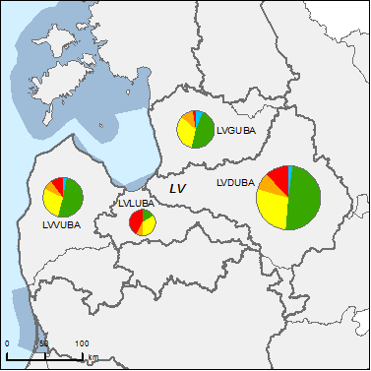
Figure 6.1: Map of ecological status of natural surface water bodies 2009
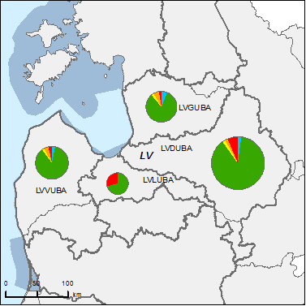
High
Good
Moderate
Poor
Bad
Unknown
River Basin Districts
Countries outside EU

Figure 6.2: Map of ecological status of natural surface water bodies 2015
Note: Standard colours based on WFD Annex V, Article 1.4.2(i).
Source: WISE, Eurostat (country borders)
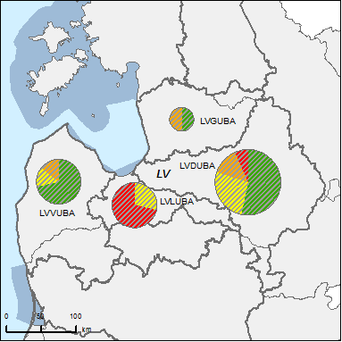
Figure 6.3: Map of ecological potential of artificial and heavily modified water bodies 2009
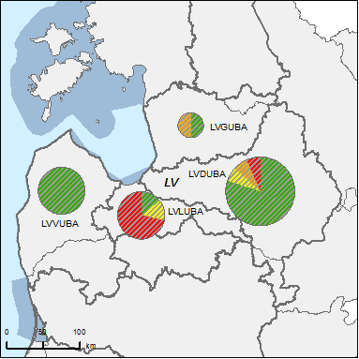
Good or better
Moderate
Poor
Bad
Unknown
River Basin Districts
Countries outside EU

Figure 6.4: Map of ecological potential of artificial and heavily modified water bodies 2015
Note: Standard colours based on WFD Annex V, Article 1.4.2(ii).
Source: WISE, Eurostat (country borders)
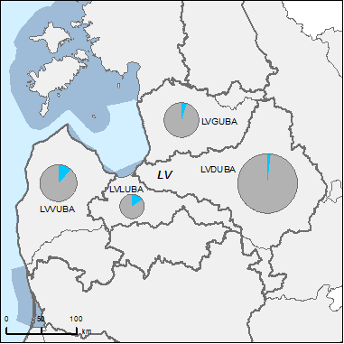
Figure 6.5: Map of chemical status of natural surface water bodies 2009
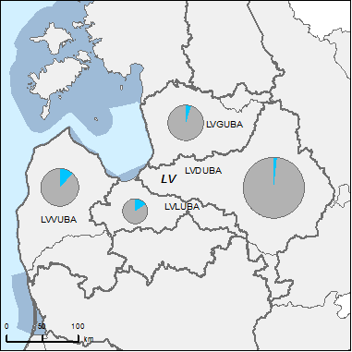
Good
Failing to achieve good
Unknown
River Basin Districts
Countries outside EU

Figure 6.6: Map of chemical status of natural surface water bodies 2015
Note: Standard colours based on WFD Annex V, Article 1.4.3. A 1cm diameter pie chart represents 150 natural surface waterbodies.
Source: WISE, Eurostat (country borders)

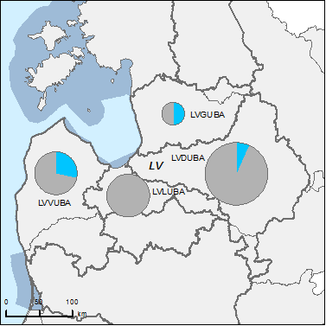
Figure 6.7: Map of chemical status of artificial and heavily modified water bodies 2009
Good
Failing to achieve good
Unknown
River Basin Districts
Countries outside EU

Figure 6.8: Map of chemical status of artificial and heavily modified water bodies 2015
Note: Standard colours based on WFD Annex V, Article 1.4.3.
Source: WISE, Eurostat (country borders)
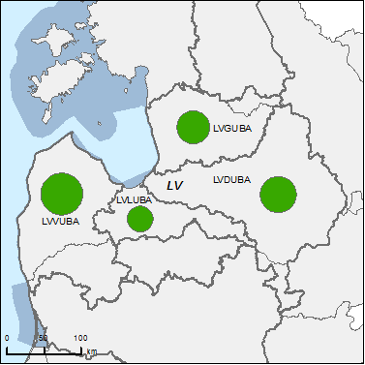
Figure 6.9: Map of chemical status of groundwater bodies 2009
Good
Poor
Unknown
River Basin Districts
Countries outside EU

Figure 6.10: Map of chemical status of groundwater bodies 2015
Note: Standard colours based on WFD Annex V, Article 2.4.5.
Source: WISE, Eurostat (country borders)

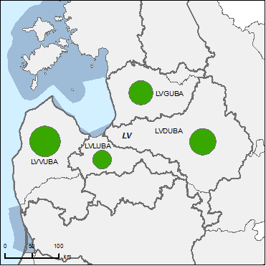
Figure 6.11: Map of quantitative status of groundwater bodies 2009
Good
Poor
Unknown
River Basin Districts
Countries outside EU

Figure 6.12: Map of quantitative status of groundwater bodies 2015
Note: Standard colours based on WFD Annex V, Article 2.2.4.
Source: WISE, Eurostat (country borders)

Assessment of ecological status of surface waters
The methodological approach for the assessment of ecological status of surface waters follows a national approach.
In the conclusions of 2009 WFD implementation report it is stated the there is no information provided neither on development of biological assessment methods nor on confidence levels and precision.
According to the RBMPs of 2010 the applied assessment methodology is described in the RBMP annex 1.5, however, none of the assessment methods are fully developed.
The ecological status assessment for the RBMP of 2010 was called “preliminary” to indicate that it was not based on the all quality elements required by the WFD though it was based on all information available at the time of the development of river basin management plans and serves as a basis for their implementation. Complete ecological status assessment is envisaged for the following planning cycles.
Despite the fact that the methods for BQE are not fully developed, the classification of a water body is performed on a basis of the available information applying the one-out-all-out principle. During the elaboration of the first river basin management plans it was not possible to establish class boundaries for all required biological quality elements. In the absence of full spectrum of the quality elements, the class of a water body was determined by the condition of the quality element in the worst status. This classification scheme was applied both to biological and chemical quality elements for which class boundaries were established. Quality classification will be improved for the updated river basin management plans.
The class boundaries for good ecological status reported in WISE summary were consistent with the intercalibrated class boundaries given in the Intercalibration Official Decision for lake waters, but not consistent for river and coastal waters. The class boundaries for phytoplankton chlorophyll a for two additional lake types are only partly consistent with the intercalibrated class boundaries.

Ecological status assessment methods
Assessment methods for the classification of the river WB following physico-chemical parameters were assessed: O₂, BOD5, NH₄, Ntot, Ptot; for lake WB classification: Ntot, Ptot, transparency. The assessment of hydro-morphological quality elements have not been applied for the classification at this stage, because the hydro-morphological quality elements were not used in the monitoring before adoption of WFD requirements. During the development of the first river basin management plans it was not possible to use hydro-morphological quality elements in quality classification, as the assessment methods and, to large extent, data were missing.
None of the assessment methods are fully developed. The assessment method for classification of ecological status is developed only for following BQE - saprobity index in rivers, Chlorophyll a and phytoplankton in lakes and Chlorophyll a in transitional waters.
RBD | Rivers |  |  |  |  |  |  | Lakes |  |  |  |  |  |  | Transitional |  |  |  |  |  |  | Coastal
RBD | Phytoplankton | Macrophytes | Phytobenthos | Benthic invertebrates | Fish | Physico-Chemical | Hydromorphological | Phytoplankton | Macrophytes | Phytobenthos | Benthic invertebrates | Fish | Physico-Chemical | Hydromorphological | Phytoplankton | Macroalgae | Angiosperms | Benthic invertebrates | Fish | Physico-Chemical | Hydromorphological | Phytoplankton | Macroalgae | Angiosperms | Benthic invertebrates | Physico-Chemical | Hydromorphological
LVDUBA |  |  |  |  |  |  |  |  |  |  |  |  |  |  |  |  |  |  |  |  |  | - | - | - | - | - | -
LVGUBA |  |  |  |  |  |  |  |  |  |  |  |  |  |  | - | - | - | - | - | - | -
LVLUBA |  |  |  |  |  |  |  |  |  |  |  |  |  |  | - | - | - | - | - | - | - | - | - | - | - | - | -
LVVUBA |  |  |  |  |  |  |  |  |  |  |  |  |  |  | - | - | - | - | - | - | -
Table 7.1.1: Availability of biological assessment methods
 |  | Assessment methods fully developed for all BQEs
 |  | Assessment methods partially developed or under development for all or some BQEs
 |  | Assessment methods not developed for BQEs, no information provided on the assessment methods, unclear information provided
- |  | Water category not relevant
Source: RBMPs
Assessment methods for the classification of the river WB following physico-chemical parameters were assessed: O₂, BOD5, NH₄, Ntot, Ptot; for lake WB classification: Ntot, Ptot, transparency. The assessment of hydro-morphological quality elements have not been applied for the classification at this stage, because the hydro-morphological quality elements were not used in the monitoring before adoption of WFD requirements. During the development of the first river basin management plans it was not possible to use hydro-morphological quality elements in quality classification, as the assessment methods and, to large extent, data were missing.
Before the adoption of the Water Framework Directive, water quality assessment in Latvia was based on the physico-chemical quality elements; only few biological quality elements were used. During the development of the first river basin management plans the other assessment methods were in the process of development. It was not possible to speed up this process as it was dependent not only on human and other resources, but also on the data, which were not available in most cases. The responsible authority is working on the elimination of the existing deficiencies by means of the intercalibration results and activities of several national projects.
Despite the fact that the methods for BQE are not fully developed, the classification of a water body is performed on a basis of the available information applying the one-out-all-out principle.
No specific information can be found to assess whether the biological classification system is related with all major pressures, the supporting methodology is not available.
River basin specific pollutants were not identified for the first RMPs, and were hence not used for the assessment of ecological status.
The intercalibrated class boundaries are applied to national types that are comparable to the common intercalibration types i.e. for lake water bodies.
The assessment of confidence and precision is based on the reliability of the parameter values (high/medium/low).

Application of methods and ecological status results
For the actual assessments of ecological status reported in the RBMP the number of quality elements included in the monitoring program was very limited and they were mainly physico-chemical parameters. The new assessment will be based on the elaborated and improved classification system which is currently under development.
The current ecological status assessment is preliminary, since the quality of the assessment methods will be further improved. If there was more than one monitoring station in the territory of the water body, the data of these monitoring stations were compared were, during the assessment. Data were excluded where they corresponded to one of the following principles: more recent data were available; the monitoring point is located in the upper (upstream) part of the WB; the monitoring point is located directly downstream the city.
Because the limited availability of assessment methods for BQEs, probably not the most sensitive BQEs have been chosen.
When assessing the ecological quality of the water bodies the level of reliability has been determined for the assessment (high, medium, low). 1) reliability is assessed as low, if the final assessment key parameter value differs from the other parameters by more than one quality class; 2) reliability is assessed as a medium, if the final assessment key parameter value differs from the other parameters by one quality class; 3) reliability is assessed as high, if the final assessment is determined by two or more parameters.
The percentage of water bodies in good status is quite high, especially considering the shortcomings of monitoring.

Designation of heavily modified water bodies (hmwb) and assessment of good ecological potential
According to the Article 5 analysis report, Latvia have provisionally identified less than 2% of their water bodies as heavily modified or artificial water bodies. In the RBMPs of 2010 out of 470 surface water bodies reported, 34 water bodies are designated as HMWBs (i.e. 7%).
Figure 8.1: Map of percentage Heavily Modified and Artificial water bodies by River Basin District
0 – 5 %
5 – 20 %
20 – 40 %
40 – 60%
60 – 100 %
No data reported
River Basin Districts
Countries outside EU
Source: WISE

Designation of HMWBs
The RBMPs according to the Art. 4.3(a) specify the following water uses for which water bodies are designated as HMWB:
- Navigation, including port facilities;
- Storage for power generation;
- Water regulation;
- Land Drainage.
The RBMPs describe following the types of physical modifications which are considered in designation for HMWB: locks, channelisation/ straightening/ bed stabilisation, dredging, bank reinforcement/embankment, land drainage.
The methodology of designation of the HMWB has been reported and CIS Guidance Document No. 4 has been followed. In addition the Cabinet of Ministers regulations No. 858 “Regulations on typology of surface water bodies, classification, quality elements and procedures for identification of anthropogenic loads” have been followed.
HMWBs were designated taking into account the step-by-step process described in the CIS Guidance Document No. 4 “Identification and Designation of Heavily Modified and Artificial Water Bodies.” The designation was carried out by experts that used all available data and information about the water bodies, mainly about the present morphological changes and, as far as possible, on their impacts on water flow, migration of species, sediment transport etc.
The WB has been designated as HMWB if there were identified following modifications: port constructions, HEPP (hydroelectric power plant) dams and constructions or land reclamation.
Following criteria are used to define “substantial changes in character” due to physical modifications:
- % of water body affected;
- Length (km) of water body affected;
- The age of modification - since when the modification has taken place.
The RBMPs discuss the issue of uncertainty in relation to the designation of HMWB. The designation of HMWB is based mainly on the expert judgement and on extrapolation of available information. Further monitoring of designated HMWBs has to be done and the designation criteria revised. Accordingly the ecological potential has to be defined for each HMWB type.
A background document has been reported: Report on designation of the HMWB.

Methodology for setting good ecological potential (GEP)
HMWBs have been designated but GEP has not been defined. GEP is fully aligned with the natural water ecological classification system - ecological status classification is used as an interim solution. Values of the parameters are identical. Due to lack of monitoring data of biological quality elements and lack of relevant scientific studies, it was not possible to define ecological potential during the development of the first river basin management plans.

Results of ecological potential assessment in HMWB and AWB
Due to lack of monitoring data of biological quality elements and lack of relevant scientific studies, it was impossible to define ecological potential during the development of the first river basin management plans. At the moment heavily modified water bodies are required to achieve a good ecological status – more stringent requirements applicable to the natural water bodies.

Assessment of chemical status of surface waters

Methodological approach to the assessment
EQSs laid down in Part A of Annex I of the Directive 2008/105/EC for the assessment of the chemical status of bodies of surface water have been applied partially.
The general information on the Chemical status of surface waters in the RBD is described in the RBMP chapter 1.5.4 and in the annex 1.6. The detailed information on the EQSs for the assessment of chemical status of surface waters is in the supporting documentation of the RBMP - Cabinet of Ministers Regulations No. 118 adopted on March 12, 2002 "Regulations regarding the Quality of Surface Waters and Ground waters" with amendments until 08.10.2005 (there is a clear reference in the RBMPs that this was the version of the CM Regulations applied for the purpose of this plan).
The deadline for transposition of the Directive 2008/105/EC into national legislation was 13 July 2010. River basin management plans were developed in 2008 – 2009, according to the WFD timescale. Due to this time difference EQS from the Directive 2008/105/EC for the chemical status assessment and river basin characteristics were not applied. In 2008 – 2009 national environmental quality standards, different from those of the EQS Directive, were in force.
National standards as set in the CM regulations 118 (with amendments until 08.10.2005.) were applied for the assessment of the chemical status. The substances for which national standards have been set were separated - annex 1 particularly dangerous substances, and annex 2 dangerous substances. Both annexes have been taken into consideration for the assessment of the chemical status. There are a number of substances in Part A of Annex I of the Directive 2008/105/EC which are not used for the assessment of chemical status.
EQSs for biota for mercury and its compounds, and/or for hexachlorobenzene, and/or for hexachlorobutadiene according to Article 3(2a) of the EQSD were not set and there are no EQSs derived for sediment and/or biota for some of the 33 plus 8 substances.
Cabinet Regulation No. 118 adopted on March 12, 2002 "Regulations regarding the Quality of Surface Waters and Ground waters" was later amended. In the current version of the Cabinet Regulation No. 118 with the amendments, since 01.01.2010 the approach of the assessment of the chemical status has been revised and now it follows the requirements of the WFD and Directive 2008/105/EC.

Substances causing exceedances
Monitoring of priority substances, according to the national legislation, for the first RBMPs was carried out in the
- Daugava RBD in four WB;
- Gauja RBD in four WB;
- Lielupe RBD in six WB;
- Venta RBD in eight WB.
The chemical status for all water bodies in all RBDs was assessed as good.

Other issues
Mixing zones in current version of RBMPs are defined in general, but they are not designated and there are no specific measures foreseen in the RBMP. The mixing zone is described in the CM regulations No. 34 (version with amendments 14.08.2010). According to the CM regulations mixing zones have to be defined when a water use permit is issued.
According to the CM regulations No. 34 the mixing zone adjacent to points of discharge is determined taking into account following:
1) considering the pollution reduction program prepared by the operator and the capacity of the enforcement of the best available techniques; the characteristics of the priority substances emitted or physical-chemical characteristics and the hydrological conditions in the water body;
2) pollutant concentrations in the discharge permit conditions and pollutant emissions in a given water body, the mixing zone would not be disproportionate in comparison to the above the overall impact on the quality of the water body;
3) concentration of the polluting substances at the point of discharge and requirements of the pollution permit in order to ensure the comparability with the impact to the overall quality of the water body.
Considering the requirements defined in the CM regulations No.34 chapter 20'3 the Regional Environmental board may revise the water use permits and define additional measures in order to reduce the mixing zone if the proper water quality is not achieved.

Assessment of groundwater status
The RBMP provides the following information on the number of GWBs at risk and the respective pollutants:
- Daugava RBD: there is a risk that the concentrations of chloride, heavy metals, nitrogen and PAHs could be increased due to the intrusion of sea water and possible intrusion of polluted surface water. Another risk is the filtration of pollution from a number of surface point source pollution sites. In some places the polluted GW area has been as assessed as up to 200 ha. The infiltration of the pollution is related to historical pollution.
- Gauja RBD and Lielupe RBD - there are no groundwater bodies that are at risk of not meeting good chemical status.
- Venta RBD - part of one groundwater body is at risk due to saline water intrusions.

Groundwater quantitative status
Groundwater quantitative status is not considered a significant issue in Latvia.
In the RBMP the general information of how the assessment of groundwater quantitative status was carried out is provided, no values are presented.
When assessing the groundwater quantitative status the criteria of WFD and GWD has been used: available groundwater resource is not exceeded by the long term annual average rate of abstraction, needs of surface water connected to groundwaters and groundwater dependent terrestrial ecosystems, alterations to the flow direction, saltwater intrusion. It is not clear how the assessment was done in practice though.

Groundwater chemical status
In Daugava RBD there are 17 monitoring points and in 3 of these points pollution has been registered. In all cases Nitrate pollution has been registered.
The following criteria have been applied to assess the good groundwater chemical status 1) chemical composition of the water should be the same as the natural water chemical composition which is characteristic to the particular water body and no QS or TVs should be exceeded; 2) in one or more monitoring points the concentration of the polluting substances annual average concentration exceeds the QS or TVs, but in the assessment process it is stated that polluting substances do not cause a significant risk to the environment and pollution has not compromised the use of the water body for human needs; 3) there are no saltwater or other intrusions to the water body or other unfavourable changes.
All substances of Annex II Part B of the GWD have been taken into account in the establishment of the threshold values. The threshold values are established considering the principles reported in the Cabinet Regulation No. 42 “Requirements regarding the groundwater assessment and quality criteria”. The following elements are included in these principles: protection of aquatic ecosystems (surface waters), protection of groundwater dependent terrestrial ecosystems (e.g. wetlands), actual and potential legitimate uses and functions of groundwater (e.g. drinking water, irrigation, industrial use etc.), saline or other intrusions. Natural background levels of substances have also been considered within the establishment of threshold values, but it is not clear, how. TVs seem to be coordinated with neighbouring Member States but not with neighbouring third countries.
There is no methodology on how to estimate TV exceedances, expert judgement is used. The number of GWBs with TV exceedances cannot be assessed as they are not reported per GWB.
Trend assessments and trend reversal assessments have not been performed during the first planning cycle, methodologies were not established.

Protected areas
Latvia did not provide data on the status of groundwater drinking water protected areas to WISE.

Environmental objectives and exemptions

Additional objectives in protected areas
There are Drinking Water Protected Areas (WFD Article 7); Bathing water areas (Directive 76/160/EEC) and Natura 2000 sites designated under Directive 92/43/EEC (Habitats) and Directive 79/409/EEC (Birds) in Latvia, but no additional objectives have been established for any of these protected areas. In the process of setting the environmental objectives the presence of all these types of protected areas has been considered and results of the assessment for all water bodies are presented in the summary tables of the environmental objectives.

Exemptions according to Article 4(4) and 4(5)
There is an overall assessment of the main impacts and the main drivers causing exemptions (the application of exemptions Article 4.4 (later deadline) and 4.5 (lower objective)). The assessment of the main impacts and main drivers causing the exemptions is not equal for all water bodies. For some water bodies the information presented is more detailed and water body specific, but for some water bodies there is more general assessment. Here are some of the examples mentioned as an impacts and drivers causing the exemptions: historical pollution, hydro morphological modifications, and pollution from the WWTP (lack of financial resources in private sector to improve the water treatment installations). For a number of water bodies the justification is uncertainty - lack of information (data) to justify the reason of the pollution that cause the bad water quality. Exemptions due to natural conditions have not been defined; there is a general statement that natural conditions could be used as a reason for exemptions. At this stage they have not been applied.

RBD | Global
RBD | Technical feasibility |  | Disproportionate costs |  | Natural conditions
RBD | Article 4(4) | Article 4(5) | Article 4(4) | Article 4(5) | Article 4(4) | Article 4(5)
LVDUBA | 24 | 0 | 2 | 0 | 0 | -
LVGUBA | 10 | 0 | 11 | 0 | 0 | -
LVLUBA | 13 | 0 | 1 | 0 | 0 | -
LVVUBA | 9 | 0 | 0 | 0 | 0 | -
Total | 56 | 0 | 14 | 0 | 0 | -
Table 11.2.1: Numbers of Article 4(4) and 4(5) exemptions
Source: WISE
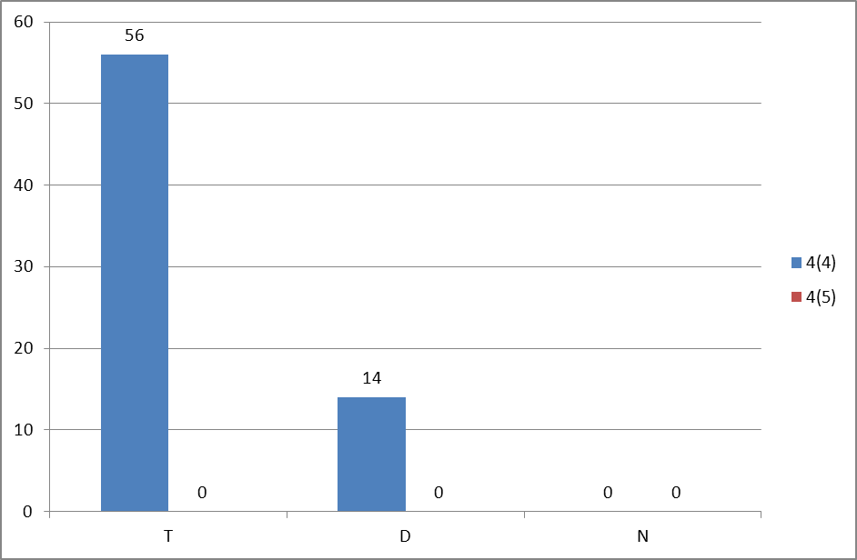

Figure 11.2.1: Numbers of Article 4(4) and 4(5) exemptions
T = Technical feasibility
D = Disproportionate costs
N = Natural conditions
Blue = Article 4(4) exemptions
Red = Article 4(5) exemptions
Source: WISE

Exemptions according to Article 4(6)
Not relevant, Article 4(6) is not applied.

Exemptions according to Article 4(7)
There are no exemptions for new modifications applied for Plans and/or Projects at this stage, so article 4(7) has not been used.

Exemptions to Groundwater Directive
No information has been reported if exemptions related to prevention or limiting input of pollutants into groundwater have been applied.
Article 4(4) exemptions have been applied for 3 GWBs where the chemical status is not good. No exemptions have been applied for quantitative status.

Programmes of measures
According to Annex VII of the WFD, the RBMPs should contain a summary of the programmes of measures (PoM), including the ways in which Member States expect to achieve the objectives of Article 4 of the WFD. The programmes should have been established by 2009, but are required to become operational only by December 2012. The assessment in this section is based on the PoM as summarised by the Member State in its RBMP, and the compliance of this with the requirements of Article 11 and Annex VII of the WFD.
It therefore does not include a comprehensive assessment of compliance with the requirements of Article 11(3) on basic measures. It focuses in particular on key sets of measures. Member States will report to the Commission by December 2012 on the full implementation of their PoMs, including on the progress on the implementation of basic measures as required by Article 11(3). The Commission will assess what Member States report and will publish its assessment in accordance with Article 18 WFD.

Programme of measures – general
The status assessments have been used for the planning of the PoM. The measures are not coordinated with neighbouring countries at the moment. The main reason for non-co-ordination is the different timing for the development of the programs of measures for international RBDs with Lithuania (Venta, Lielupe and Daugava RBDs). In Lithuania draft programs of measures are available whilst in Latvia, public consultation about the plans and programs has already been concluded and management plans have been prepared for their adoption.
The reason for non-co-ordination of Gauja RBD is the fact that both surface waters and groundwater are in good status on the Estonian part of Gauja/Koiva river basin district and therefore specific measures are not envisaged in this territory. Further consultations and co-ordination may take place during the next planning period.
In the PoM for each measure defined, the level of covered geographic area is specified. The level of detail of geographical area is measure specific. The measures have been established at national, RBD, local (regional administrative unit) and WB level. For each defined measure the institution(s) responsible for implementation is/are specified.
The cost break down of the PoM per sector, by pressure and by water category is not presented. There are only total costs calculated for the implementation of the PoM:
Daugava RBD: €1508,2 million. The implementation of Drinking Water Directive and Waste Water Treatment Directive will cost €1475,7 million. The implementation of the supplementary and additional measures will cost €20,7 million for Daugava RBD and €0,28 million at National level (for example development of technical standards for forest drainage in an environmentally friendly manner, development of the strategy and guidelines for river remediation etc.).
Gauja RBD: €270,3 million. The implementation of Drinking Water Directive and Waste Water Treatment Directive will cost €263,6 million . The implementation of the supplementary and additional measures will cost €6,7 million for Gauja RBD and €0,28 million at National level (for example development of technical standards for forest drainage in an environmentally friendly manner, development of the strategy and guidelines for river remediation etc.).
Lielupe RBD: €499 million. The implementation of Drinking Water Directive and Waste Water Treatment Directive will cost €436,7 million. The implementation of the supplementary and additional measures will cost €42 million for Lielupe RBD and €0,28 million at National level (for example development of technical standards for forest drainage in an environmentally friendly manner, development of the strategy and guidelines for river remediation etc.).
Venta RBD: €389,9 million. The implementation of Drinking Water Directive and Waste Water Treatment Directive will cost €385,6 million. The implementation of the supplementary and additional measures will cost €4,3 million for Venta RBD and €0,28 million at National level (for example development of technical standards for forest drainage in an environmentally friendly manner, development of the strategy and guidelines for river remediation etc.).
The supplementary and additional measures in the program of measures are grouped in two parts those to be implemented at national level(Annex7.2) and Supplementary and additional RBD Specific measures (Annex 7.3).
The entire PoM for all RBDs will become operational from 2012 or earlier.

Measures related to agriculture
Hydromorphological modifications due to drainage of agricultural lands (melioration) and diffuse pollution are mentioned as a significant pressures related to agriculture. The water use for agriculture is not indicated as a significant pressure. Diffuse pollution from agriculture sources is assessed as a significant pressure on surface water.
Measures related to agriculture have been discussed and agreed in the public consultation where all stakeholder groups were involved; there were no specific farmers’ consultative boards or working groups established.
The following measures have been selected to address the pressures:
Measures | LVDUBA | LVGUBA | LVLUBA | LBVUVA
Technical measures
Reduction/modification of fertiliser application | ✓ | ✓ | ✓ | ✓
Reduction/modification of pesticide application | ✓ | ✓ | ✓ | ✓
Change to low-input farming (e.g. organic farming practices)
Hydromorphological measures leading to changes in farming practices | ✓ | ✓ | ✓ | ✓
Measures against soil erosion
Multi-objective measures (e.g. crop rotation, creation of enhanced buffer zones/wetlands or floodplain management) | ✓ | ✓ | ✓ | ✓
Technical measures for water saving | ✓ | ✓ | ✓ | ✓
Economic instruments
Compensation for land cover
Co-operative agreements
Water pricing specifications for irrigators | ✓ | ✓ | ✓ | ✓
Nutrient trading
Fertiliser taxation | ✓ | ✓ | ✓ | ✓
Non-technical measures
Additions regarding the implementation and enforcement of existing EU legislation | ✓ | ✓ | ✓ | ✓
Institutional changes
Codes of agricultural practice
Farm advice and training
Raising awareness of farmers | ✓ | ✓ | ✓ | ✓
Measures to increase knowledge for improved decision-making | ✓ | ✓ | ✓ | ✓
Certification schemes
Zoning (e.g. designating land use based on GIS maps)
Specific action plans/programmes
Land use planning | ✓ | ✓ | ✓ | ✓
Technical standards | ✓ | ✓ | ✓ | ✓
Specific projects related to agriculture
Environmental permitting and licensing
Table 12.2.1: Types of WFD measures addressing agricultural pressures, as described in the PoM
Source: RBMPs
The scope of the application of the measures is either geographic area specific (ha, river basin, water body, length) or sector (or part of sector) specific (e.g. crop farming, livestock farming).
For all measures the possible funding source/s for implementation of the measure is indicated, however the information is very general. In the PoM the following funding sources are indicated for the implementation of the measures related to agriculture: the Rural Development Programme, National Fish Fund, the Regional Development Fund, National budget and private budget.
The due date for the implementation of the measures is specified. Most of the basic measures have to be implemented by 2012, and overall all measures that are expected to be implemented by 2015.

Measures related to hydromorphology
The expected improvements due to the hydromorphological measures are described in the RBMP, but no numbers are specified. Most of the measures are non-technical measures and therefore the expected results are also more general.
Hydromorphological measures are planned in HMWB. The measures included in the PoM, which are planned to be implemented in the HMWB, are however not always related with the reduction of the hydromorphological pressure.
There are specific measures planned to achieve an ecologically based flow regime. There are scientifically based recommendations for small hydro power plants developed by the Latvian Fish Resources Agency: the minimal ecological flow in the rivers below the HPP dam (in the impacted area) has to be kept at least 50% above the average summer minimal water level.
Cabinet Regulation No. 736 “Regulations Regarding a Permit for the Use of Water Resources” includes regulations for planned activities which are related with the hydromorphological modifications, requiring an ecologically based flow regime to be considered.
Measures | LVDUBA | LVGUBA | LVLUBA | LBVUVA
Fish ladders | ✓ | ✓ | ✓ | ✓
Bypass channels | ✓ | ✓ | ✓ | ✓
Habitat restoration, building spawning and breeding areas
Sediment/debris management | ✓ | ✓ | ✓ | ✓
Removal of structures: weirs, barriers, bank reinforcement
Reconnection of meander bends or side arms
Lowering of river banks
Restoration of bank structure
Setting minimum ecological flow requirements
Operational modifications for hydropeaking
Inundation of flood plains
Construction of retention basins
Reduction or modification of dredging
Restoration of degraded bed structure
Remeandering of formerly straightened water courses
Table 12.3.1: Types of WFD measures addressing hydromorphological pressures, as described in the PoM
Source: RBMPs
In addition to the above, the development of strategy or guidelines aiming to reduce the pressures of the hydromorphological modification (assessment of the possible measures to be implemented) and the technical assessment of the impact of the HPP dams are also considered.

Measures related to groundwater
Groundwater over-exploitation is not an issue therefore there are no measures foreseen to tackle this issue. The Cabinet Regulation No. 736 “Regulations Regarding a Permit for the Use of Water Resources” stipulates the conditions for the use of water resources including the use of groundwater.
In national legislation there are restrictions in order to reduce the pollution caused by agriculture, such as restrictions for manure spreading, use of biocides and pesticides, use of waste water sludge and storage of manure.
There are no supplementary measures foreseen to be specifically implemented in groundwater bodies at risk or of poor status to achieve the objectives under Article 4 of the WFD. The implementation of only the basic measures is planned. It is reported in RBMPs that this will be sufficient.
The measures related to international river basin districts and transboundary groundwater bodies are not coordinated at the moment due to different timing of the development of the programs of measures. In Lithuania draft programmes of measures have become available whilst in Latvia public consultation about the plans and programmes have already been concluded and management plans have been prepared for their adoption. Further consultations and co-ordination were planned in 2010.

Measures related to chemical pollution
There is an inventory of sources of pollution and it covers the following categories of pollutants:
- Priority substances and certain other pollutants;
- Non priority specific pollutants or main pollutants identified by each Member State at the river basin level;
- Deoxygenating substances;
- Nutrients.
In the RBMP, information is reported on all possible point and diffuse anthropogenic sources of pollution coming from industrial, urban and agricultural activities. There are no detailed inventories of the categories of the pollutants by sources of pollution. Industries and intensively cultivated agricultural lands are identified as the most possible source of chemical pollution.
During the drafting of the first RBMP the monitoring data up to 2008 were used, and according to these data the chemical quality of all water bodies was assessed as good. There are no chemical pollutants indicated as causing a failure to achieve good ecological status/potential for surface waters. In the RBMP indirect discharges of industrial emissions through the urban sewerage system are indicated as possible significant sources of chemical pollution, but as chemical quality was assessed as good there are no further analyses of specific sectors reported in the RBMP.
There are no specific group of measures defined in the PoM to solve particularly the chemical pollution. The basic measures - implementation of the national legal acts will assure the reduction of possible pollution of surface waters by priority substances and reduce the pollution from other substances that would otherwise cause problems with the achievement of the objectives set by the RBMP.
There are no substance specific measures foreseen in the PoM.

Measures related to Article 9 (water pricing policies)
According to the information reported in RBMPs the main approach was to follow the WFD definition of "water services". However it is not clear if water services cover self-abstraction by households, industry and agriculture.
The water uses have been identified with reference to the impact on water status and following the WFD requirements. The impact on water status and pressure on resources from industry, households and agriculture has been identified. An impact analysis for forestry and port activities has also been identified.
In the RBMP detailed analysis is provided of the cost recovery calculation for households, industry and agriculture, and general information is reported for forestry and port activities. The following financial costs have been included in the calculation of recovery levels: capital costs, operating costs, maintenance costs, administrative costs, costs of capital and nature resource tax. Financial cost data were collected and reported at river basin level.
Subsidies are considered within cost recovery calculation.
Environmental and resource costs are internalised through the nature resource tax, but they have not been calculated. Only a qualitative description of those costs is available.
Adequate contribution from the 3 main sectors (households, industry and agriculture) is in principle assured, but it is considered that despite the implementation of good agricultural practice for the agriculture sector, the current economic instruments are not adequate to cover the environmental costs; the same is true for the forestry sector. The ports are covering only the damage to the fish resources. The other negative hydro morphological impacts caused by the port activities are not recovered and included in the environmental cost recovery system. It is reported that there is a supplementary measure that envisages evaluation of the efficiency of the natural resources tax and development of recommendations for its optimisation.
In the PoM the funding of the measures is based on a polluter pays principle, i.e. the responsibility (financing) for the realisation of the measures is binding for those who are responsible for causing the pressure to the environment. The following instruments are identified: cost for water actually used, based on water metering of households; nature resource tax (NRT) - cost for water actually used and water pollution. It has to be remembered that the current NRT rate might not be stimulating rational water use, (the rate is too low).
Despite the information on water metering, very little information can be found on any incentive function of water pricing in different sectors.
The provisions of Article 9(4) on flexibility have not been used.
No information is reported on international co-operation.

Additional measures in protected areas
The water bodies and protected areas needing additional measures are not clearly identified and there is no specification on the type of measures necessary.
No additional measures have been included in the PoM to reach the more stringent objectives of the Birds Directive, Habitats Directive, Shellfish Directive, Fresh Water Fish Directive or Bathing Water Directive. The good quality will be reached by implementation of the basic measures. There are no additional measures included in the RBMP in order to safeguard areas for drinking water.

water scarcity and droughts, flood risk management and Climate change adaptation

Water Scarcity and droughts
Water scarcity and droughts are considered as not relevant for RBMP in Latvia. However measures related to water efficiency and water saving are included in the plans. Sources of funds to implement measures are specified and water demand trend scenarios are provided, itemised by water use.

Flood risk management
The RBMPs are linked with the other sectoral plans, including the National Flood Risk Management Strategy 2008-2015. The effects of flooding in the flood affected areas are also considered as a pressure to the water bodies and RBD. The methodology for the assessment of this pressure transferred from the "National program for the flood risk and management 2008-2015" (accepted in 2007).
Neither article 4(6) on temporary deteriorations of status due to fir instance floods), not article 4(7)(on new modifications leading to deterioration of the status ) have been applied in this RBMP.

Climate change adaptation
The issues in relation to adaptation to climate change are mentioned in a general way, they have not been analysed and described in detail.
According to the information in the RBMPs due to the lack of scientifically proved information about the possible climate change impact to the water ecosystems, hydrological regime etc. until 2015, climate change has not been considered in the PoM. As climate change has not been considered as a significant issue there are no specific measures defined.
There is a National Climate Change Strategy developed but there are no references found to it in the RBMP.

Recommendations
Following the steps of river basin planning as set out in the WFD should ensure that water management is based on a better understanding of the main risks and pressures in a river basin and, as a result, interventions are cost effective and ensure the long term sustainable supply of water for people, business and nature.
To deliver successful water management requires linking these different steps. Information on pressures and risks should feed into the development of monitoring programmes, information from the monitoring programmes and the economic analysis should lead to the identification of cost effective programmes of measures and justifications for exemptions. Transparency on this whole process within a clear governance structure will encourage public participation in both the development and delivery of necessary measures to deliver sustainable water management.
To complete the 1st river basin management cycle, and in preparing for the second cycle of the WFD, it is recommended that:
- Latvia needs to update the characterisation process from 2005 and report it to the Commission in the RBMPs and the WISE reporting on characterisation, including taking into account developments on intercalibration.
- The process of designating HMWBs and classifying status are currently largely based on expert judgement, and more monitoring is needed for a thorough assessment. The designation of HMWBs should comply with all the requirements of Article 4(3). The assessment of significant adverse effects on their use or the environment and the lack of significantly better environmental options should be specifically mentioned in the RBMPs. This is needed to ensure transparency of the designation process.
- The size limit for lakes needs to be brought in line with the WFD requirements.

- The significant shortcomings in the monitoring system, (absence of many biological, hydromorphological, physico-chemical quality elements) need to be addressed. An adequate monitoring network is a necessary investment for efficient water management.
- Once the monitoring network is in place and results are analysed this may allow a more robust assessment of the pressures that are having an impact on the water environment (currently few pressures are identified as significant).
- More efforts are needed to address chemical pollution, starting from identification of relevant river basin specific pollutants, to monitoring and application of results for ecological status assessments.
- There is a large degree of unknown status, mostly for chemical status. Latvia needs to improve the knowledge base, to make sure measures are in place to achieve progressive improvement of water status during the second cycle. The assessment of chemical status should be based on all the substances listed in the EQSD, and on the EQS listed in that Directive, unless equivalently protective EQS are derived.
- Mercury, hexachlorobenzene and hexachlorobutadiene should be monitored in biota for comparison with the biota standards in the EQSD, unless water EQS providing an equivalent level of protection are derived. Trend monitoring in sediment or biota for several substances as specified in Directive 2008/105/EC Article 3(3) will also need to be reflected in the next RBMP.
- A groundwater operational monitoring based on WFD requirements should be established. Groundwater trend assessments and reversals should be carried out in the second RBMP cycle.
- Exemptions have been applied in this first cycle of RBMPs. While the WFD does provide for exemptions, there are specific criteria that must be fulfilled for their use to be justified. The application of exemptions needs to be more transparent and the reasons for the exemptions should be clearly justified in the plans. Insufficient monitoring contributes to shortcomings in the application of exemptions. The high numbers of exemptions applied in these first RBMPs are a cause for concern. Latvia should take all necessary measures to bring down the number of exemptions for the next cycle, including the needed improvements in the characterisation process, monitoring networks and status assessment methods, as well as reducing significantly the degree of uncertainty.
- It is unclear whether there are new physical modifications planned in the RBDs. If this is the case, the use of exemptions under Article 4(7) should be based on a thorough assessment of all the steps as required by the WFD, in particular an assessment of whether the project is of overriding public interest and whether the benefits to society outweigh the environmental degradation, and the absence of alternatives that would be a better environmental option. Furthermore, these projects may only be carried out when all possible measures are taken to mitigate the adverse impact on the status of the water. All conditions for the application of Article 4(7) in individual projects must be included and justified in the RBMPs as early in the project planning as possible.
- It is vital that adequate pollution control measures are included in PoMs as these can be the most cost effective measures and can deliver a range of environmental and economic goals.
- Agriculture is indicated as exerting a significant pressure on the water resource in all of Latvia. This should be translated into a clear strategy that defines the basic/mandatory measures that all farmers should adhere to and the additional supplementary measures that can be financed. This should be developed with the farmers' community to ensure technical feasibility and acceptance. There needs to be a very clear baseline so that farmers know the rules and the authorities in charge of the CAP funds can adequately set up Rural Development programmes and cross compliance water requirements.
- The cost-recovery should address a broad range of water services, including impoundments, abstraction, storage, treatment and distribution of surface waters, and collection, treatment and discharge of waste water. Latvia should ensure that self-abstraction by households, industry and agriculture is defined as water service and is taken into account in the calculation of cost recovery of water services. The cost recovery should be transparently presented for all relevant user sectors, and environment and resource costs should be included in the costs recovered. Information should also be provided on the incentive function of water pricing for all water services, with the aim of ensuring an efficient use of water. Information on how the polluter pays principle has been taken into account should be provided in the RBMPs.
- Further effort is needed to ensure effective co-ordination with neighbouring countries on all relevant aspects of the WFD, both with other EU member states as well as with non-EU countries.

"On key provisional results of Population and Housing Census 2011". Central Statistical Bureau of Latvia. 18 January 2012.
This MS Annex reflects the information reported by the MS to WISE which may have been updated since the adoption of the RBMPs. For this reason there may be some discrepancies between the information reported in the RBMPs and WISE.
Categorisation determined under the EC Comparative study of pressures and measures in the major river basin management plans in the EU (Task 1b: International co-ordination mechanisms).
Pressures and Measures Study, Task 1 Governance.
Characterization of the Baltic Sea Ecosystem: Dynamics and Function of Coastal Types, 2002-2006.
Cabinet of Ministers regulations No.858, 2004.10.19., "Regulations on typology of surface water bodies, classification, quality elements and procedures for identification of anthropogenic loads.
In the case of Nitrates protected areas, these figures reflect the number of surface waters bodies within a single vulnerable zone.
This information corresponds to the reporting of protected areas under the WFD. More/other information may have been reported under the obligations of other Directives.
The total number of monitoring sites may differ from the sum of monitoring sites by type because some sites are used for more than one purpose.
Data for 2009 and 2015 extracted from WISE. Data for 2021 and 2027 established during the compliance assessment of the RBMPs.
Data for 2009 and 2015 extracted from WISE. Data for 2021 and 2027 established during the compliance assessment of the RBMPs.
Data for 2009 and 2015 extracted from WISE. Data for 2021 and 2027 established during the compliance assessment of the RBMPs.
Data for 2009 and 2015 extracted from WISE. Data for 2021 and 2027 established during the compliance assessment of the RBMPs.
Data for 2009 and 2015 extracted from WISE. Data for 2021 and 2027 established during the compliance assessment of the RBMPs.
Data for 2009 and 2015 extracted from WISE. Data for 2021 and 2027 established during the compliance assessment of the RBMPs.
Data for 2009 and 2015 extracted from WISE. Data for 2021 and 2027 established during the compliance assessment of the RBMPs.
http://www.meteo.lv/fs/CKFinderJava/userfiles/files/Vide/Udens/Ud_apsaimn/Papildus%20materiali/Projekts_SPUO%20Latvija_ELLE%202007%20.pdf
Exemptions are combined for ecological and chemical status.
These are the minimum requirements to be complied with and include the measures required under other Community legislation as well as measures to achieve the requirements of other WFD Articles and to ensure appropriate controls on different activities affecting water management.
The assessment is based on WISE, and Chapter 7 of the different RBMPs. Costs in the RBMP are presented in National currency LVL, here they are converted to Euro according to the fixed currency exchange rate 1Euro = 0,702804 LVL.
Development of fertilisation plans particularly in nitrate vulnerable zones; following the requirements regarding the application of fertilisers; restriction or prohibition of fertiliser application during certain periods of the year; prior authorisation or prior registration of fertiliser application; planting of winter crops.
Restriction of application in terms of quantity or location; use of alternatives to pesticides such as integrated pest management or measures to reduce point source pollution such as improved pesticide handling techniques; prohibition of use; prior authorisation or registration.
Development of the regulations for the construction of the agricultural melioration system where mitigation measures are defined as obligatory in order to reduce the agricultural run-off diffuse pollution.
The creation of buffer zones; creation of wetlands; management of crop rotation.
Planning of water use cycle at the farm level.
A measure to enforce the polluter-pays-principle and incentives for a sustainable water use.
Enforcement of measures in NVZs, improved inspections at farm level to control farming practice; Enforcement of Council Directive 91/414/EEC concerning the placing of plant protection products on the market.

