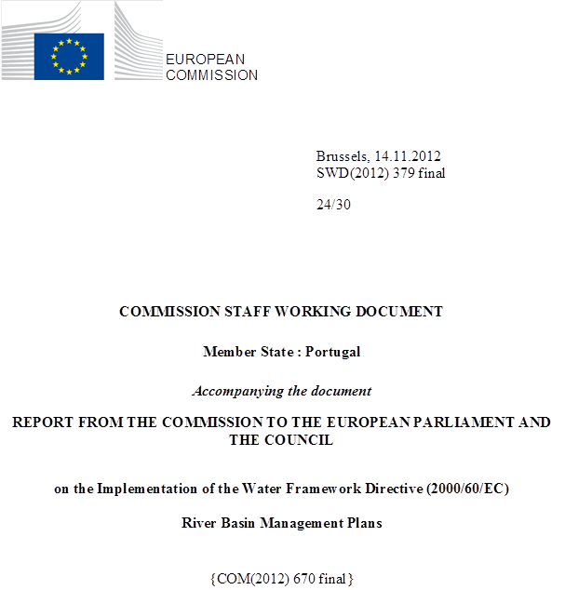

general information
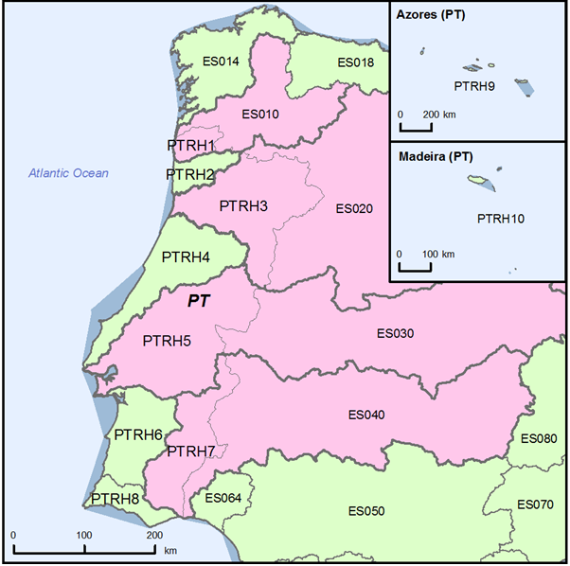
Figure 1.1: Map of River Basin District
International River Basin Districts (within EU)
International River Basin Districts (outside EU)
National River Basin Districts (within EU)
Countries (outside EU)
Coastal Waters
Source: WISE, Eurostat (country borders)
Portugal is a republic comprised of a continental part and two autonomous regions. The total area of Portugal is 92072 km², and an economic exclusive zone of 1727408 km². The population is about 10.6 million.

RBD | Name | Size (km²) | Countries sharing RBD
PTRH1 | Minho and Lima | 2442* | ES
PTRH2 | Cavado, Ave and Leca | 3615 | -
PTRH3 | Douro | 19213* | ES
PTRH4 | Vouga, Mondego, Lis and West Rivers | 12633 | -
PTRH5 | Tagus | 30014* | ES
PTRH6 | Sado and Mira | 12147 | -
PTRH7 | Guadiana | 11613* | ES
PTRH8 | Algarve Rivers | 5509 | -
PTRH9 | Azores | 10045 | -
PTRH10 | Madeira |  | -
Table 1.1: Overview of Portugal’s River Basin Districts
Note: *Area in Portuguese territory
Source: This information may be found in the general fiches for countries in http://europa.eu/about-eu/countries/index_en.htm.
Name international  river basin | National RBD | Countries sharing RBD | Co-ordination category
Name international  river basin | National RBD | Countries sharing RBD | 2
Name international  river basin | National RBD | Countries sharing RBD | km² | %
Miño/Minho | PTRH1 (Minho-Lima) | ES | 854 | 5.0
Lima/Limia | PTRH1 (Minho-Lima) | ES | 1180 | 47.1
Duero/Douro | PTRH3 (Duoro) | ES | 18855 | 19.3
Tajo/Tejo | PTRH5 (Tejo) | ES | 15415 | 21.7
Guadiana | PTRH7 (Guadiana) | ES | 11598 | 17.3
Table 1.2: Transboundary river basins by category (see CSWD section 8.1) and % share in Portugal
Category 1: Co-operation agreement, co-operation body, RBMP in place.
Category 2: Co-operation agreement, co-operation body in place.
Category 3: Co-operation agreement in place.
Category 4: No co-operation formalised.
Source: EC Comparative study of pressures and measures in the major river basin management plans in the EU.

Status of River basin Management Plan reporting and compliance
Portugal has not reported RBMPs to the Commission. All the 8 RBMPs of Continental Portugal, and the RBMP of the Azores started Public Consultation in the second semester of 2011. All except Azores RBMP have concluded the consultation period. No information on the RBMP of Madeira could be found. It should be noted that no WFD Art 5 Report has been submitted by Madeira (or by Portugal as MS). However, Portuguese authorities have informed that they are working on the final revisions of the various plans in order to be able to proceed with their approval and publication in the official journal (Diario da Republica).

RBD | Period of consultation | Availability
PTRH1 | From 3 October 2011 to 3 April 2012 | Available at the website of Norte River District Authority (ARH Norte)
PTRH2 | From 3 October 2011 to 3 April 2012 | Available at the website of Norte River District Authority (ARH Norte)
PTRH3 | From 3 October 2011 to 3 April 2012 | Available at the website of Norte River District Authority (ARH Norte)
PTRH4 | From 11 October 2011 to 11 April 2012 | Available at the website of Centro River District Authority (ARH Centro)
PTRH5 | From 8 August 2011 to 8 February 2012 | Available at the website of Tejo River District Authority (ARH Tejo).
PTRH6 | From 15 July 2011 to 15 January 2012 | Available at the website of Alentejo River District Authority (ARH Alentejo)
PTRH7 | From 15 July 2011 to 15 January 2012 | Available at the website of Alentejo River District Authority (ARH Alentejo)
PTRH8 | From 26 September 2011 to 26 March 2012 | Available at the website of Algarve River District Authority (ARH Algarve).
PTRH9 | From 16 January 2012 to 16 July 2012 | Available at the website of Azores River District Authority (SRAM/DRA/AHA)
Table 2.1: Timeline of the different steps of the implementation process.
Source: National websites
In continental Portugal the development of the RBMPs has been coordinated by 5 River Basin Districts Authorities created in 2007 and whose activities started in 2009.
These entities have been integrated under the renewed Portuguese Environment Agency (APA I.P). The organic structure of APA (Decree Law no. 56/2012, of 12 March) establishes that APA is the Portuguese Water Authority and concentrates all the functions of the 5 River Basin Districts Authorities of Continental Portugal.
The competences of the RBDA of Azores autonomous region have been approved by Regional Regulatory Decree 23/2011/A which establishes that the Competent Authority is the Regional Secretariat of Environment and the Sea.
The competences of the RBDA of Madeira autonomous region have been approved by Regional Legislative Decree 33/2008/M which establishes that the Regional Water Authority is the Regional Directorate of Environment, and that the coastal zone and safety issues (floods, safety and security related to dams) are administered by the Regional Secretariat of Social Equipment, except in ports in which the authority is the Port Administration of the Autonomous Region of Madeira.
A court ruling has been issued against Portugal by the European Court of Justice (ECJ) on the failure to adopt and report River Basin Management Plans for all of their respective River Basin Districts.

Categorisation determined under the EC Comparative study of pressures and measures in the major river basin management plans in the EU (Task 1b: International co-ordination mechanisms).
Commission vs. Portugal - C-223/11 (21.6.2012)

