TABLE OF CONTENTS
1. Introduction 3
2. The state of the carbon market 4
3. A review of the auction timetable as the short term measure 6
4. Options for structural measures 6
4.1. Option a: Increasing the EU reduction target to 30% in 2020 7
4.2. Option b: Retiring a number of allowances in phase 3 7
4.3. Option c: Early revision of the annual linear reduction factor 8
4.4. Option d: Extension of the scope of the EU ETS to other sectors 8
4.5. Option e: Use access to international credits 9
4.6. Option f: Discretionary price management mechanisms 9
5. Conclusions 11
REPORT FROM THE COMMISSION TO THE EUROPEAN PARLIAMENT AND THE COUNCIL
The state of the European carbon market in 2012
(Text with EEA relevance)

1. Introduction
This report on the functioning of the carbon market is presented in accordance with Articles 10(5) and 29 of the EU Emissions Trading System Directive. The report was envisaged by the ETS Directive in 2013, the first year of phase 3. At their informal meeting in April 2012, Environment ministers were informed about Commission's intention to bring forward the first report and prepare it already in 2012, which they welcomed.
The EU Emissions Trading System (EU ETS) has produced since its start an EU-wide carbon price signal that influences daily operational and strategic investment decisions. From 2013 onwards it will cover around half of the greenhouse gas (GHG) emissions in the EU.
As stipulated in Article 1 of the ETS Directive the system has been established in order to promote reductions of greenhouse gas emissions in a cost-effective and economically efficient manner. This aim is not limited in time. The ETS will be critical in driving investments in a wide range of low carbon technologies. It is designed to be technology neutral, cost-effective and fully compatible with the internal energy market. The ETS will need to play an increased role in the transition to a low-carbon economy by 2050. Since the start of the second trading period in 2008, emissions are down by more than 10 % but while the carbon price signal of the EU ETS has certainly contributed to this, the economic crisis is clearly the major cause of these strong emission reductions.
This said, the EU ETS is widely recognised as a liquid market with a functioning infrastructure and inspires an increasing number of countries to follow the European lead and put in place domestic carbon markets, such as Australia, South Korea and China.
The purpose of this first report is to analyse the functioning of the carbon market and to consider whether regulatory action is needed, as foreseen under Article 29 of the EU ETS Directive. It also responds to the call of the European Parliament and the Council made in the context of the Energy Efficiency Directive, on the Commission
- "to examine in this report options, including among others permanent withholding of the necessary amount of allowances, for action with a view to adopting as soon as possible further appropriate structural measures to strengthen the ETS during phase 3, and make it more effective."

2. The state of the carbon market
The implementation of the EU ETS has been accompanied by a wealth of market and operational experience for governments and companies. This experience fed into the major revision of the system’s operational design, agreed in 2008 for application as of 2013, where the following fundamental changes will apply:
1. an EU-wide cap on allowances, as opposed to 27 individual Member State caps, decreasing by 1.74% annually, up to and beyond 2020, providing much greater regulatory predictability and stability
2. auctioning as the default system of allocation in phase 3
3. harmonised rules for free allocation, based on performance benchmarks established prior to phase 3
4. stricter rules on the type of international credits that are allowed for use in the EU ETS
5. replacement of 27 national electronic registries by a single Union registry
These changes imply from a regulatory perspective a fundamental transformation of the European carbon market. Despite the fact that some work (e.g. establishment of auctioning infrastructure) still remains to be fully completed, the regulatory infrastructure is today largely in place.
With the start of the second trading period it was expected that the ETS phase 2 cap would be ambitious. But the crisis unfolding as of 2008 has radically altered the picture and the ETS has since experienced a surplus of allowances and international credits compared to emissions (see table below). The number of allowances that were put in circulation has been increasing every year, as well as the supply and use of international credits, most notably in 2011. By the end of 2011, 8171 million allowances had been put into circulation and 549 million international credits had been used for compliance, in total adding up to 8720 million units that were available for compliance over the period 2008-2011. In contrast, verified emissions in the period 2008-2011 were only 7765 million tonnes CO₂₋eq.
Consequently, by early 2012, a surplus of 955 million allowances had accumulated. Even excluding the part of the surplus arising from the use of international credits for compliance, the surplus would still have been 406 million allowances.
Table 1: The supply-demand balance 2008-2011
(in Mt) | 2008 | 2009 | 2010 | 2011 | Total
Supply: Issued allowances and used international credits | 2076 | 2105 | 2204 | 2336 | 8720
Demand: Reported emissions | 2100 | 1860 | 1919 | 1886 | 7765
Cumulative surplus of allowances | -24 | 244 | 285 | 450 | 955
Source: Community Independent Transaction Log (CITL), compliance data 2011 as published on 2 May 2012, European Commission
The pattern of an increasing supply of allowances and international credits, combined with low demand is partially reflected in the observed price evolution since 2008. The price of allowances is the result of a wide range of factors but without doubt the economic recession in 2009 had a major impact on prices. The marked reduction of prices in the second half of 2011 to levels below € 10 coincides with the accelerated build-up of a surplus in allowances and international credits.
Figure 1: Carbon price evolution
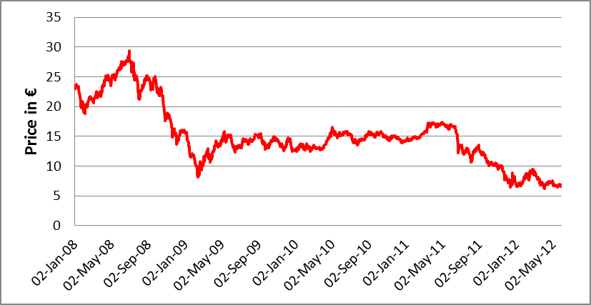
Source: Intercontinental Exchange. Data for front-year futures contracts with delivery in December
A continued rapid build-up of the surplus in 2012 and 2013 is to be expected, largely due to temporary elements directly related to the transition to phase 3. Supply of allowances on the short term is increasing, notably through the forward selling of phase 3 allowances to generate funds for the NER300 programme for carbon capture and storage and innovative renewables, early auctioning to meet power sector hedging demand, and the selling of left-over allowances in national phase 2 new entrant reserves. The combined effect of these three sources amounts to some 500 million allowances by end 2013. At the same time supply of international credits is likely to remain high and its use in the EU ETS probably increasing in the transition to phase 3. Emissions in 2012 and 2013 are not expected to change significantly, therefore the surplus at the start of phase 3 could be well over 1.5 billion allowances, and even as large as 2 billion allowances.
While from 2014 onwards the rapid build-up of the surplus is expected to come to an end, the overall surplus is not expected to decline significantly during phase 3, resulting potentially in a structural surplus in most of phase 3 of around 2 billion allowances. The magnitude of the surplus by 2020 will largely depend on longer term energy developments, such as the penetration of renewable energy and on-going efforts to increase energy efficiency, as well as on the speed of economic recovery.
Figure 2: Historic and likely future profile up to 2020 of supply and demand
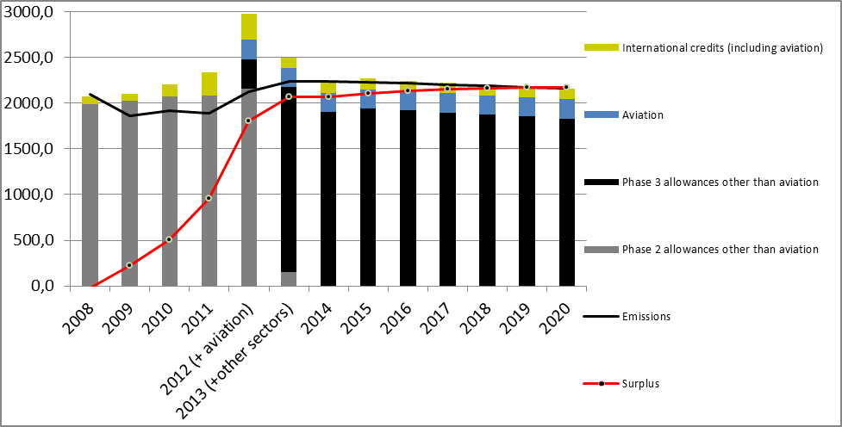
Source: SWD(2012) 234 final

3. A review of the auction timetable as the short term measure
Normally weakened demand is accompanied by decreasing supply. However in the EU ETS, the supply actually increases temporarily in the next years due to specific regulatory provisions, as outlined in section 2.
Some surplus is a normal feature of a carbon market, which allows there to be differences between the cap and emissions. But with the surplus already at almost a billion allowances in 2011, there is a real risk of seriously undermining the orderly functioning of the carbon market by causing excessive price fluctuation due to the additional short-term over-supply of allowances.
With the exceptional situation at present of continued increases in supply due to regulatory provisions, it is appropriate to review the timetable which determines the supply within phase 3 of the EU ETS and delay some of the auctioning. Therefore, to improve the orderly functioning of the carbon market, the Commission proposes as an immediate measure to change the timing of the auctioning in phase 3 and postpone auctions of a certain amount of allowances planned for 2013, 2014 and 2015.
This report is therefore complemented by a draft amendment of the Auctioning Regulation, accompanied by a proportionate impact assessment. It demonstrates that such "back-loading", if well designed, can rebalance supply and demand in the EU ETS market into the transition into phase 3 and reduce volatility caused by the rapid build-up of surplus allowances. It can do so without any significant impacts on competitiveness and it can strengthen government revenues early in phase 3.
But "backloading" would not affect the structural surplus of around 2 billion allowances over the 2013-2020 period. As allowances allocated during the crisis can be used long after the crisis is over, the effects of the surplus will be making themselves felt up to 2020 and beyond. A structural measure could correct this over-supply, thereby limiting its longer-term effects.

4. Options for structural measures
In order to tackle the growing structural supply-demand imbalance, and to seek views of stakeholders, six non-exhaustive options for structural measures have been identified by the Commission.Should the Commission decide to pursue any of these options, all would require a legislative proposal by the Commission to the co-legislators, accompanied by a full impact assessment in line with smart regulation principles.

4.1. Option a: Increasing the EU reduction target to 30% in 2020
In the case that the EU were to increase its GHG reduction target to 30% in 2020, if the conditions are right, as repeatedly confirmed by the European Council, then there would need to be a consequential amendment to the quantity of allowances in the EU ETS either via a permanent retirement of allowances or a revision of the annual linear reduction factor, the two mechanisms also described in more detail as options b and c. A more ambitious cap for phase 3 would also have implications on the carbon market beyond 2020.
The Commission has already analysed previously the implications of a volume of a retirement of allowances that would align the EU ETS cap up to 2020 with an overall target of 30% compared to 1990 and the EU's agreed long-term objective of 80-95% by 2050 compared to 1990. Such a volume would be equal to around 1.4 billion allowances. The Commission has also analysed the associated implications at Member State level.
This option would not only require changes to the quantity of allowances in the EU ETS but also affect the targets adopted under the Effort Sharing Decision.

4.2. Option b: Retiring a number of allowances in phase 3
The surplus can be reduced by retiring some phase 3 allowances on a permanent basis. This measure requires primary legislation and could be implemented by a separate decision, to be taken by the European Parliament and Council, rather than a fully-fledged revision of the EU ETS Directive. As such it would fully maintain regulatory stability of the wider legislative ETS framework for phase 3.
The results sought of this option are to reduce the number of allowances issued in phase 3 by permanently retiring a number of allowances from the amount foreseen to be auctioned. This option would by design leave the amount of free allocation or existing holdings of allowances untouched.
The measure can be effective in addressing the overall supply-demand imbalance over phase 3. It would implicitly increase the numerical reduction target for 2020 and thus (partially) restore the ambition level of the 2008 climate-energy package, but it would not directly affect the framework after 2020. It would reduce the surplus of allowances in phase 3 and depending on the amount retired ensure that the ETS contributes to renewables and energy efficiency objectives. Various approaches for the amounts and time profile of the permanent retirement can obviously be considered.

4.3. Option c: Early revision of the annual linear reduction factor
The total amount of allowances decreases by the linear factor of 1.74% annually, compared to the average annual total quantity for the period 2008-2012. This linear factor applies also after 2020 pending any change of the ETS Directive. The Directive foresees a review of the linear factor as from 2020 with a view to the adoption of the decision to change it by 2025. This review could be advanced, as such potentially lowering the total amount of allowances available already in phase 3 depending on how soon it would take effect.
This structural measure could not only address the imbalance and (partially) restore the ambition level up to 2020, but would also impact the ambition level after 2020. As such the linear factor could be set at levels in-line with an overall EU target of 30% GHG reductions compared to 1990, as described under option a. The current linear factor leads to a just over 70% reduction in the ETS cap by 2050, which is not consistent with the EU's agreed long term objective of 80-95% reduction by 2050 compared to 1990, as the Commission has pointed out in the 2050 Low-carbon Roadmap.
An early revision of the linear factor thus also impacts the period beyond phase 3. For this period a number of other important policy questions impact the market fundamentally, such as how to increase the EU's competitiveness on key low carbon technologies, the link with the EU's post-2020 policy framework, the link with the development of an international carbon market and the risk of carbon leakage. Changing the linear factor would also require addressing these.

4.4. Option d: Extension of the scope of the EU ETS to other sectors
The fourth structural option could be to include sectors less strongly influenced by economic cycles. Whereas the emissions in the EU ETS decreased in 2009 by more than 11%, in the sectors outside the EU ETS this reduction was only around 4%. This difference may be partially explained by differing impacts of the economic crisis on individual sectors.
The coverage of the EU ETS could therefore be expanded to other energy related CO₂ emissions in sectors currently outside the EU ETS by for instance including fuel consumption in other sectors. This could be a next step in the further development of the European carbon market. It would be consistent with potential energy system changes such as the increased use of electricity, gas and biomass in all energy related sectors in the transition towards a low carbon economy by 2050.
A more comprehensive extension to all energy related emissions would substantially increase the emissions coverage and can impact the overall ambition level, depending on the level of the cap foreseen for the sectors included. Several policy questions would need to be addressed, such as who would carry the obligation to report emissions and surrender allowances, fuel producers or users, or some kind of a hybrid system. Therefore, this measure requires more analytical work, including on how it would relate to existing policies in these sectors.

4.5. Option e: Limit access to international credits
International credits have been allowed for use in the EU ETS primarily to contain compliance costs. Following the exceptional macro-economic developments and the fact that emissions have been substantially lower than the cap, the quantity limit of international credits in the period 2008 to 2020 has turned out to be rather generous and is a major driver for the build-up of the surplus. Without international credits, the surplus in the EU ETS by 2020 would potentially be only around a quarter (25%) of the presently expected surplus.
In phase 4 the regulatory framework could be crafted in a manner that initially allows for no or much more limited access to international credits. This would create more certainty about the effort to be undertaken in Europe and thus could spur indigenous investment in low carbon technologies, instead of external monetary and technology transfers through the EU ETS. This may, however, have to be balanced against adverse impacts on financial flows and transfer of technology to developing countries.
Short term demand shocks in the EU ETS could be contained through the remaining surplus in the EU ETS, and do not require per definition a large amount of international credits. Additional flexibility regarding the access to international credits could be foreseen in case of strong and sustained price increases. Such a mechanism could have a similar function as Article 29a of the Directive, but would not result in the rapid growth of the surplus as experienced at present.
Furthermore, the right international conditions could enable a strengthening of the cap and therefore allow for additional cost containment through increased access to international credits. Care should be taken that this does not lead again to too limited mitigation for too much money, as was the case for instance with international credits from certain industrial gas projects.

4.6. Option f: Discretionary price management mechanisms
To achieve the EU goals of promoting emission reductions in a cost-effective manner as well delivering gradual and predictable reductions of emissions over time, the EU ETS is designed as a quantity-based instrument, where a predefined quantity of emission allowances is issued determining the environmental outcome. It is the scarcity of allowances, together with the flexibility provided by the ability to trade, that sets the carbon price in the market in the short, medium and long term. To reduce volatility and prevent price drops due to temporary mismatch between supply and demand, two mechanisms could be conceived as a temporary way of supporting the carbon price.
As from the third trading period a large amount of allowances will be auctioned, a carbon price floor has been discussed as a feature applied primarily in the primary market, i.e. for auctions. A carbon price floor would create more certainty about the minimum price, giving a better signal for investors.
Alternatively, a mechanism could be devised that adjusts the supply of allowances, when the carbon price would be affected by a large temporary supply-demand imbalance, by means of a price management reserve. If decreases in the demand were to generate an excessive price decrease below a certain level deemed to affect the orderly functioning of the market, an amount of allowances to be auctioned could be deposited in such a reserve. In the opposite case, allowances could be gradually released from the reserve. The reserve could initially be funded by reducing phase 3 auction volume by an amount corresponding to a substantial share of the accumulated surplus. The rulebook could foresee the permanent retirement of some allowances, in case the size of the reserve would exceed a certain magnitude.
Discretionary price-based mechanisms, such as a carbon price floor and a reserve, with an explicit carbon price objective, would alter the very nature of the current EU ETS being a quantity-based market instrument. They require governance arrangements, including a process to decide on the level of the price floor or the levels that would activate the reserve. This carries a downside in that the carbon price may become primarily a product of administrative and political decisions (or expectations about them), rather than a result of the interplay of market supply and demand.
Such discretionary price management would also raise a number of design issues, central to the effectiveness of the instrument, starting with the appropriate price levels. For instance:
- If it would not lead to cancellation of allowances which were withdrawn from the auctioning process because prices were too low, then it would not achieve any additional environmental benefit which is determined by the cap.
- If the floor price or minimum price for the reserve were set too high, it would in fact just fix the carbon price, reduce the flexibility and result in higher costs. If set too low to be triggered, they would not be effective in their aim to address the problems identified and create more certainty about the price.
- A carbon price floor or minimum price for the reserve would provide more certainty for investors and suppliers of low-carbon technologies at the risk of potentially imposing excessive cost on ETS participants and society for emissions abatement in case of technological breakthroughs, which substantially lower abatement costs.
Such discretionary mechanisms may also raise questions on the further development of an international carbon market, as it would make linking with other emission trading systems more difficult.

5. Conclusions
The EU ETS has created a functioning market infrastructure and a liquid market producing an EU wide carbon price signal. This has contributed to delivering real GHG emissions reductions in line with the EU targets for 2020. However, the effects of the crisis compounded by a number of regulatory provisions related to the transition to Phase 3 have caused serious imbalances to emerge between supply and demand in the short term with potentially negative long-term repercussions. If not addressed, these imbalances will profoundly affect the ability of the EU ETS to meet the ETS target in future phases in a cost-effective manner, when significantly more demanding domestic emission objectives than today would have to be reached. As the central pillar of European climate policy, the ETS has been designed to be a technology neutral, cost-effective and harmonised component of the internal market and, notably, the internal energy market.
The Commission therefore proposes action on two fronts:
Firstly, in order to address the rapid increase of supply in the transition to phase 3 it proposes to change the auctioning timetable and invites the Climate Change Committee to give an opinion on the draft amendment to the Auctioning Regulation before the end of the year in order to provide certainty for market participants. To eliminate any legal uncertainty, Parliament and Council are invited to urgently adopt the proposed "mini-amendment" of the EU ETS Directive that would clarify expressly the relevant provision and would then allow the Commission to swiftly adopt an amendment to the Auctioning Regulation.
Secondly, structural measures should be discussed and explored with stakeholders without delay. These discussions can benefit from insights of the 2050 Low Carbon Economy and Energy Roadmaps. Changing the auctioning profile is only a short-term and temporary measure that would allow for a more stable phase 3 and more gradual build-up of the surplus. It would not be a solution that addresses the structural surplus. To do so would require deploying a structural measure affecting more profoundly and permanently the balance between supply of and demand for allowances. The table below summarises some key features of the options listed in the report.
Table 2: Features of the various options
Option | Effects supply or demand | Speed of deployment | Changes ambition post-2020 | Impacts free allocation
a. Increasing the EU GHG target to 30% | Supply | Depending on the mechanism* | Depending on the mechanism* | Depending on the mechanism*
b. Retiring a number of allowances | Supply | Relatively fast | No | No
c. Early revision of the linear reduction factor | Supply | Slow | Yes | Yes
d. Extension of the scope | Demand | Slow | Depending on design | No
e. Access rules to international credits | Supply | Slow | No | No
f. Discretionary price management | Supply | Slow | No** | No
* This depends on and corresponds to features of the mechanism that would operationalise the increase, i.e. retiring allowances or a revision of the linear reduction factor.
**Assuming that the mechanisms would not result in the cancellation of those allowances that are temporarily not auctioned.
While each option affects supply or demand, some options will require more time to analyse, decide upon and subsequently implement. Options also have different impacts on market certainty in the short term and the interaction with other policies such as renewables and energy efficiency will need to be further analysed.
The Commission welcomes stakeholders' views on structural options and will as the next step shortly launch a formal stakeholder consultation process.

Directive 2003/87/EC
An international credit that is used for compliance frees up one allowance that does not need to be used for compliance. As such the use of international credits for compliance increases the surplus of allowances available to the market.
http://www.eib.org/about/news/ner-300.htm
Additional information can be found in the Staff Working Document on 'Information provided on the functioning of the EU Emissions Trading System, the volumes of greenhouse gas emission allowances auctioned and freely allocated and the impact on the surplus of allowances in the period up to 2020' (SWD(2012) 234 final)
Staff Working Document accompanying the Communication 'Analysis of options to move beyond 20% greenhouse gas emission reductions and assessing the risk of carbon leakage' SEC(2010) 650
Staff Working Document accompanying the Communication ' Analysis of options beyond 20% GHG emission reductions: Member State results' SWD(2012) 5 final'
The targets for sectors not covered by the EU ETS are determined by Decision No 406/2009/EC on the effort of Member States to reduce their greenhouse gas emissions to meet the Community’s greenhouse gas emission reduction commitments up to 2020.
This does not automatically change the ambition level of the sectors not covered by the EU ETS, whose target is determined by Decision No 406/2009/EC on the effort of Member States to reduce their greenhouse gas emissions to meet the Community’s greenhouse gas emission reduction commitments up to 2020
COM(2011) 112 final, Communication 'A Roadmap for moving to a competitive low carbon economy in 2050'.
This concept is distinct from a reserve price for auctions that is already foreseen in the Auctioning Regulation. An auction reserve price is the secret minimum clearing price of an auction, set on the basis of the going market price for emission allowances before the auction. An auction clearing price significantly below this reserve price most likely indicates a deficiency of the auction. Given the objective of a clear price signal for the carbon market, the Auctioning Regulation requires the auction to be cancelled in case of such a low clearing price.
Proposal for a Decision amending Directive 2003/87/EC clarifying provisions on the timing of auctions of greenhouse gas allowances, COM(2012)416

