TABLE OF CONTENTS
1. Synopsis 4
2. Introduction 6
2.1. Policy and legal context 6
2.1.1. Policy context 6
2.1.2. The Energy Infrastructure Package 6
2.1.3. Legal basis 7
2.2. Methodology 8
2.3. Consultation of experts 9
3. Investment projects in energy infrastructure 9
3.1. Oil infrastructure 9
3.1.1. Oil refining 10
3.1.2. Oil transport 12
3.1.3. Oil storage 13
3.2. Gas infrastructure 14
3.2.1. Gas transport 15
3.2.2. LNG terminals 19
3.2.3. Gas storage 20
3.3. Electricity infrastructure 21
3.3.1. Electricity generation 22
3.3.2. Electricity transmission 25
3.4. Biofuels infrastructure 30
3.5. Carbon Capture and Storage infrastructure 31
4. Overcoming barriers to investment 31
5. Conclusion 33
6. Annexes 34
COMMISSION STAFF WORKING DOCUMENT
Investment projects in energy infrastructure
Accompanying the document
COMMUNICATION FROM THE COMMISSION TO THE EUROPEAN PARLIAMENT, THE COUNCIL, THE EUROPEAN ECONOMIC AND SOCIAL COMMITTEE AND THE COMMITTEE OF THE REGIONS
Making the internal energy market work

1. Synopsis
This document reports on the notifications made by EU Member States on their investment projects in energy infrastructure, under Council Regulation (EU, Euratom) No 617/2010 in 2011. It highlights the importance of investing in energy infrastructure to contribute to a more integrated and efficient internal energy market in electricity and gas, and in related sectors, such as oil and biofuels.
It concludes that, although investment is being made in all sectors, it is not reaching the rate needed to meet the policy ambitions. There is also concern that the current economic and financial situation is having a detrimental impact on energy infrastructure investment, particularly in new supply sectors. Investing in energy infrastructure can help generate growth and job creation in the EU. This report therefore confirms the need for policy makers to keep up the momentum towards market integration, improve the economic conditions for energy-sector investment across Europe and develop European instruments to promote investment in sustainable, secure and competitive energy.
This document provides a sector-by-sector analysis and a good overview of the current state of existing and planned energy infrastructure per Member State.
In the electricity sector, most Member States are investing in generating capacity. This is driven by the increasing demand for electricity and the binding renewables targets in 2020. Between 2005 and 2010, substantial investment was made in renewable energy, leading to an installed capacity of 288 GW in 2010 (increasing its share in gross final energy consumption from 8.6 to 12.7 % and in electricity generation from 14.7 to 19.6 %). Nevertheless, more investment is needed to achieve the national targets. The total investment of 40 GW notified by Member States is still far from the additional capacity needed to achieve the level of 487 GW in 2020, agreed in the National Renewable Energy Action Plans. However, due to the limitations of the method applied (threshold for reporting of 10 MW for photovoltaic projects and 20 MW for wind parks), the notifications may have underestimated investment in power generation from renewable energy.
The notifications also report major investment in the coming years in electricity generation from nuclear energy and fossil fuel-fired power stations. Concerning nuclear energy, Bulgaria, the Czech Republic, Finland, France, Lithuania, Romania, Slovakia, Sweden and the United Kingdom have notified the Commission that they are planning to build new nuclear capacity or increase the capacity of their existing nuclear power plants. Regarding fossil fuels, Germany (following its decision to decommission nuclear power plants), Greece, Ireland, the Netherlands, Spain and the United Kingdom are significantly investing in additional capacity generated by conventional thermal power stations and/or cogeneration plants.
In addition, most Member States are expanding their national and cross-border electricity transmission capacity. This is in line with the announced grid reinforcements, needed to cope with increasing electricity demand and supply and the take-up of variable generation from renewables. However, the Ten-Year Network Development Plan (TYNDP) for electricity found that one in three planned investments is experiencing delays in implementation due to long permitting processes. In addition, as the investment volumes need to increase by on average 70 % from past years, access to finance remains a challenge, especially in the current economic situation. The main areas of investment in renewable integration have been identified in northern Europe (to integrate wind energy) and the Iberian Peninsula (for wind, hydro and solar integration). The Baltic countries need to connect better their energy markets to other EU electricity networks in order to develop regional trade (thereby implementing the Baltic Energy Market Interconnection Plan). In the south-east and south-central regions, investment is needed to cope with major energy flows in the north-south direction.
In the gas sector, although Member States have notified significant investment projects, major investment is still needed to properly address the security of supply, diversification of sources, low-carbon objectives and completion of the internal market. Some Member States still find themselves on a ‘gas island’ as a result of no or insufficient infrastructure connections with the rest of the EU (in particular the three Baltic States, Finland, Malta and the Iberian Peninsula). Single-source dependency still prevails in northern and eastern Europe (with varying degrees of import dependency: Finland, Estonia, Latvia, Lithuania, Slovakia, Bulgaria and Romania).
On the LNG front, several projects are planned to help diversify gas sources and routes and therefore improve the security of supply. Belgium, Italy, Lithuania, the Netherlands, Poland, Portugal and Spain have notified plans to build LNG terminals. Future LNG terminals are also planned in Cyprus, Estonia, Germany, Greece, France, Ireland, Latvia and Romania, but most of these projects have not yet received a final investment decision. Concerning gas storage, at the moment, it seems that the overall EU storage capacity is sufficient to cover seasonal demand, but tight supply-demand situations may appear in some regions, due to the uncertainty of future gas demand and of planned investment.
In the oil sector, only minor oil infrastructure additions are planned. This is in line with the European oil sector analysis, since demand is projected to slowly fall over the coming decade and investment needs for oil infrastructure will be mainly to replace existing infrastructure. However, the oil refining industry needs to invest in conversion capacity, to produce more middle distillates.
In the biofuel sector, notifications show that the biofuel production capacity will be expanded in some Member States in the coming years and there is already an overcapacity in biodiesel production. However, more investments will be needed, specifically on infrastructure for producing second generation biofuels, in order to meet the projected increase in demand in response to EU renewables targets for 2020 and to compensate the reduction in oil demand.
CCS projects are currently at an early stage of development, to be analysed properly via the notifications. Only France and Hungary reported on a CO₂ transport pipeline. This is likely to change, though, for future notifications, as the CCS sector is developing.

2. Introduction

2.1. Policy and legal context

2.1.1. Policy context
Investment in energy infrastructure is crucial to secure energy supply in the European Union. It is a key factor to ensure the development of the internal market and to reach the 2020 energy and climate targets and the longer-term climate and energy objectives.
It has been estimated that Europe’s energy system requires investment of EUR 1 trillion by 2020. Of this, EUR 540 billion are for power generation and EUR 210 billion are for electricity and gas networks of European importance:
- About EUR 140 billion for high voltage electricity transmission systems, both onshore and offshore, storage, and smart grid applications at transmission and distribution level;
- About EUR 70 billion for high pressure gas transmission pipelines (coming into the EU and between EU Member states), storage, liquefied/compressed natural gas (LNG/CNG) terminals and reverse flow infrastructure;
The volume of investment for the period 2011-2020 will need to increase by 30 % for gas and by around 70 % for electricity compared to current levels.
In order for the Commission to assess the development of investment in energy infrastructure in the EU and design a European infrastructure policy, it is essential to have a more precise and updated picture of existing infrastructure and investment projects in the Member States. This is why Council Regulation (EU, Euratom) No 617/2010 requires Member States to notify the Commission of their investment projects in energy infrastructure. The main objectives of this Regulation are to: (i) collect up-to-date, reliable and comparable data to better observe energy infrastructure in the EU; (ii) identify potential gaps between energy demand and energy supply capacity and therefore decide on the future priorities to support investment projects and (iii) identify investment obstacles and propose best practices to address them.

2.1.2. The Energy Infrastructure Package
The Commission’s proposal for a Regulation on ‘Guidelines for trans-European energy infrastructure’ (Energy Infrastructure Package) was adopted on 19 October 2011. It identifies twelve priority corridors and specific areas in electricity, gas, oil and CO₂ networks that need to be implemented by 2020 to enable the EU to achieve its energy policy objectives of completing the internal market, security of supply and sustainability. It also proposes measures to speed up implementation of these projects through provisions on permit granting, improving regulations and financing. The priority corridors and areas are broken down into specific projects, labelled projects of common interest, organised by region and against technical criteria reflecting the policy objectives. This approach builds on the Ten-Year Network Development Plans (TYNDPs) developed by the European Network of Transmission System Operators for Gas and Electricity (ENTSO-G and ENTSO-E). In the future, the TYNDPs should be accompanied by a cost-benefit analysis.
The Impact Assessment showed a lack of consistent public data across the EU on existing infrastructure and future investment needs. Information collected by ENTSO-G and ENTSO-E for the TYNDPs is in some cases incomplete: (e.g. on liquefied natural gas, storage, etc.). To address these gaps, Regulation (EU, Euratom) No 617/2010 can complement and provide consistency checks and a clearer picture on the investment situation. Furthermore, the proposed Regulation on Guidelines will introduce strong reporting obligations for all projects of common interest covering the key stages, from planning until commissioning.

2.1.3. Legal basis
Council Regulation (EU, Euratom) No 617/2010 concerning the notification to the Commission of investment projects in energy infrastructure within the European Union and repealing Regulation (EC) No 736/96 requires Member States to notify every two years to the Commission (starting in 2011) data and information on investment projects concerning the production, storage and transport of oil, natural gas, electricity (including electricity from renewable sources), biofuels and the capture and storage of carbon dioxide.
The scope of the Regulation includes planned and under-construction projects, transformation of existing infrastructure and decommissioning projects of a certain size, on a five-year horizon, in the territory of Member States, including interconnections with third countries. The entities involved in these projects should be obliged to notify this data to the Member State in question.
The form and technical details of the notification to the Commission of data and information on investment projects in energy infrastructure are set out in the Annex to Commission Regulation (EU, Euratom) No 833/2010 of 21 September 2010 implementing Council Regulation (EU, Euratom) No 617/2010.
To ensure that this does not give rise to a disproportionate administrative burden, Article 3.2 of Regulation 617/2010 allows Member States to be exempt from reporting obligations provided that equivalent information is supplied to the Commission. This should avoid duplicating the reporting requirements specified in the third internal market package for electricity and natural gas. This is the case, for instance, with data already collected by ENTSO-G and ENTSO-E in the framework of the TYNDP and data collected by DG Energy on projects relating to nuclear power stations, including decommissioning.
This staff working document is published in line with Article 10(1) of Regulation 617/2010, which states that the Commission should make a cross-sectoral analysis of the structural evolution and perspectives of the energy system of the EU, on the basis of data collected from Member States and taking into account relevant analyses such as the multi-annual network development plans for gas and for electricity.
This procedure is to be repeated every two years. However, in October 2010, the Parliament requested the European Court of Justice to annul Council Regulation 617/2010, contesting the legal base used to adopt the Regulation (Case C-490/10). The Council had decided to use Articles 337 TFEU and 187 TEAEC as a legal base, on the grounds that the Regulation relates to the collection of general information. Under this legal base, the Council acts by simple and qualified majority and the Parliament does not take part in the adoption process. The Parliament considered Article 194 TFEU to be the correct choice, which implies an ordinary legislative procedure. On 6 September 2012, the Court annulled Regulation 617/2010 but maintained its effects until a new regulation is adopted on the new legal basis, Article 194(2) TFEU.

2.2. Methodology
The Member States had to send their notifications to the Commission before 31 July 2011. By the time of publication, all Member States had done so. Some countries did not notify all their investment projects, using the exemptions under Article 3(2) of Regulation 617/2010.
For each type of infrastructure (production, storage and transport) and energy sector (oil, natural gas, electricity, including electricity from renewable sources, biofuels and the capture and storage of carbon dioxide), they had to provide data using the following classification:
- Existing infrastructure (at 1/1/Y and infrastructure non-operational at >3 Y);
- Infrastructure under construction (at 31/3/Y);
- Planned infrastructure with final investment decision (FID) (at 31/3/Y);
- Additions to be commissioned (under construction + FID) (at Y+ [0-2] and at Y+ [3-5]);
- Infrastructure to be decommissioned (at Y+ [0-2] and at Y+ [3-5]).
Y corresponds to the year 2011 in this first reporting exercise.
This document refers to planned additions, which correspond to the sum of under construction and planned projects, minus infrastructure that will be decommissioned.
To analyse the notifications and identify potential gaps between energy demand and energy supply capacity, a study was commissioned from Cowi/Ecorys. The main tasks to be performed by the contractor included checking the robustness of the data received and the consistency, completeness and reliability of data.
As stated in the Regulation, the Commission must preserve the confidentiality of commercially sensitive data or information in its possession and may publish data and information forwarded by Member States, provided that it is published in an aggregated form and that no details concerning individual undertakings and installations are disclosed or can be inferred. Therefore, only charts and tables with aggregated data are disclosed in this document.

2.3. Consultation of experts
The Commission consulted governmental and non-governmental experts in order to develop a common understanding on future investments in a transparent and concerted way.
During the consultation process, the additional utility of Regulation 617/2010 was questioned, given the other investment monitoring instruments, in particular the Ten-Year Network Development Plans for gas and electricity developed by ENTSO-G and ENTSO-E. The Commission explained that the objective of Regulation 617/2010 was to take a cross-sectoral approach at EU level and to provide a shared and public analysis. The regulation requirements aim at reinforcing other policy instruments and improve the quality of data necessary for policy-making. However, clearer indications could be given to use the TYNDP process as the sole basis for notifying electricity and gas transmission infrastructure projects to ensure consistent data and analysis and to minimise the administrative burden. The risk of duplication was a major issue of concern, despite the fact that Regulation 617/2010 allows Member States to be exempt from the reporting obligations, provided that they supply equivalent information.

3. Investment projects in energy infrastructure
This section analyses existing infrastructure and investment projects on the basis of the notifications sent by the Member States and alternative sources of information. It first gives a concise overview of the current state of infrastructure and the main challenges faced in each sector.

3.1. Oil infrastructure
In the oil sector, only minor additions to the oil infrastructure are planned, according to the notifications sent by the Member States. While this could be considered unsurprising given that it is projected that the demand for oil will continue to fall in the coming decade, there is a widely recognised need for investment in conversion capacity to reduce the high gasoline yield of the European oil refining sector in favour of higher middle-distillate yields.

3.1.1. Oil refining
The EU is the second largest producer of oil-derived products, after the United States. Its production capacity is some 15.5 million barrels per day, or 18 % of global refining capacity.
EU refining margins have been depressed since the beginning of the crisis, and EU demand continues to fall. The fall in demand coupled with excess capacity are the main reasons for the depressed margins.
In addition, projections for future EU petroleum demand indicate that the fall will continue, with the exception of growth in middle distillates. Even this, however, is projected to be positive only for a few more years (even taking into account future demand from the shipping industry for very low sulphur fuel).
The response of a number of EU refining companies to the current market situation and future prospects has been to put refinery units up for sale or to halt operations, sometimes for indefinite periods of time. However, refineries have not been completely closed, due to the large, and costly, site remediation clean-up work that owners would have to face.
Altogether, some eight refineries have ceased operations since the beginning of the crisis, amounting to around 6 % of total EU refining capacity.
Capacity reductions have an impact on the security of supply because every refinery produces a certain amount of products that are valuable from a security of supply standpoint (such as middle distillates and naphtha, of which the EU is a net importer). There is also the concern that shutting down refining operations will lead to job losses for the employees of those refineries.
In addition to shut-downs, some 12 % of EU capacity has changed hands since the beginning of the crisis. Many of the sellers have been vertically integrated oil companies, but a number of the buyers have either little or no experience in refining. A large proportion of the EU refining capacity sold since the crisis has been bought by non-EU companies.
In sharp contrast to EU demand, non-EU petroleum product demand, especially for products such as diesel, gasoil and naphtha, is projected to grow significantly. The expectation, therefore, is that global competition will rise — and, therefore, prices will rise — for supplies of these products, which also happen to be the petroleum products that the EU consumes more than it produces. The EU has been experiencing a growing trend in net imports of middle distillates and naphtha in the EU over the last few years.
On the other hand, the EU produces much more gasoline than it consumes and it exports the rest. The US has been the main outlet for this excess gasoline over the last few years, but it is widely believed that it will significantly reduce its imports of gasoline in the future. Finding new outlets for gasoline exports is deemed a difficult challenge.
Going forward, and given the falling EU demand, it is very likely that the EU will increase its import dependence on certain products such as gasoil/diesel, unless the industry is able to invest in further conversion capacity to produce more middle distillates. This investment is also necessary to decrease the high gasoline yield of the EU refining industry, which would reduce the EU refining industry’s ‘export dependence’ in that fuel.
Notifications from Member States
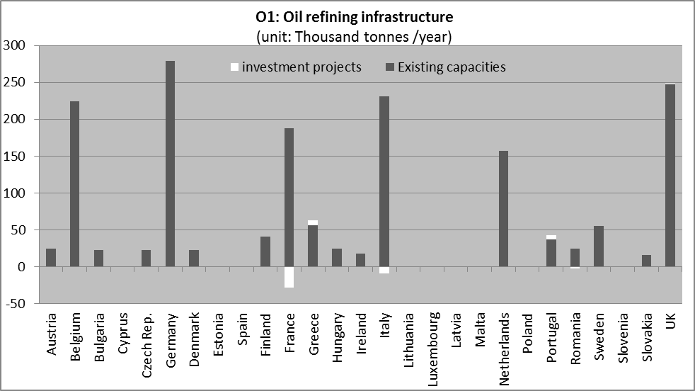
Existing capacity at 1/1/2011. Investment projects at 31/3/2011.
Source: Notifications from Member States under Council Regulation 617/2010 and Commission Regulation 833/2010.
According to investment plans known by March 2011 notified by the Member States (see chart O1), oil refining capacity will decrease by 2 %. This represents an aggregate of Member States that anticipated reducing their refining capacity and other Member States that projected increasing their refining capacity. Member States such as France, Romania and Italy expect to reduce their oil refining capacity (by 15 %, 12 % and 4 % respectively), while Portugal and Greece anticipated investment in additional capacity (+14 % and +12 %).
Decommissioning plans in France and Italy reflect the situation of gasoline overcapacity and low margins as mentioned earlier, with expectations of additional closures of refineries also likely in other Member States for the same reasons. The only signs of anticipated investment in conversion capacity to produce less gasoline and more middle distillates were in the notifications sent by Greece and Portugal.
The situation of the EU refining sector prompted the European Commission to organise and invite stakeholders to a round table meeting on refining in May 2012 to discuss the need for coordinated action at EU level to deal with the sector’s difficulties. A decision was taken to assess and monitor the situation of the security of supply of petroleum products and the impact of current and future EU legislative proposals on the competitiveness of the refining sector.

3.1.2. Oil transport
Most of the crude oil imported into the EU arrives by sea. Approximately 20 % of EU oil imports are transported via two cross-border pipelines: the Druzhba pipeline, connecting Russia with central Europe; and the Norpipe pipeline, supplying oil from the Norwegian oil fields in the North Sea to the United Kingdom.
In addition, the EU has a wide network of oil pipelines, transporting crude oil and refined products internally. Products are also transported by trucks, ships and trains.
To increase the security of supply and reduce environmental risks, the Commission has identified an oil priority corridor among the twelve priority corridors listed in the draft Regulation on Guidelines for trans-European energy infrastructure’. The Oil supply connections in Central Eastern Europe (‘OSC’) will ensure interoperability of the oil pipeline network in Central Eastern Europe. The Member States concerned are Austria, the Czech Republic, Germany, Hungary, Poland and Slovakia.
Notifications from Member States
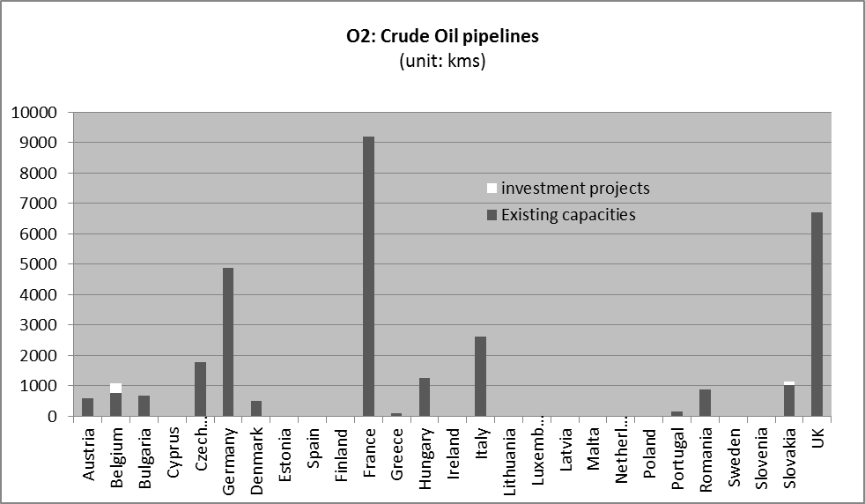
Existing capacity at 1/1/2011. Investment projects at 31/3/2011. Source: Notifications from Member States under Council Regulation 617/2010 and Commission Regulation 833/2010.
Only Austria, Belgium, Bulgaria and Slovakia have reported investment projects in crude oil pipelines for the years to come (see charts O2 and O3), representing an additional capacity of 42 % in Belgium and 11 % in Slovakia in national pipelines, while investment projects represented 100 % more cross-border pipeline capacity in Austria and 11% more in Bulgaria.
However, it seems that information is missing for some countries, when comparing with alternative sources. For instance, the data provider IHS also reports investment in Poland, the Czech Republic and Greece.
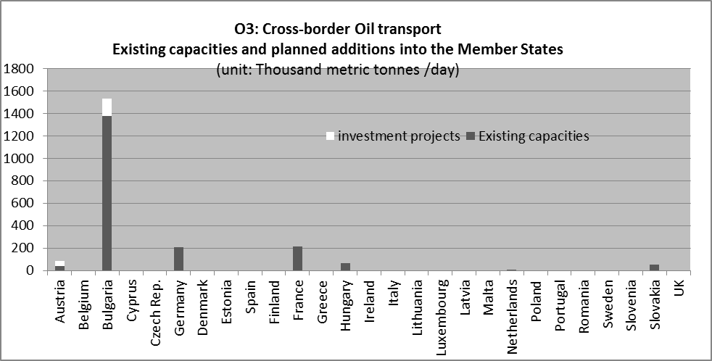
Existing capacity at 1/1/2011. Investment projects at 31/3/2011.
Source: Notifications from Member States under Council Regulation 617/2010 and Commission Regulation 833/2010.

3.1.3. Oil storage
Since 1968, all Member States must have crude oil and/or petroleum product stocks equivalent to 90 days of average consumption of the main fuels. In 1974, the treaty setting up the International Energy Agency (IEA) established a similar rule for its Member countries, requiring them to hold oil and petroleum product stocks equivalent to 90 days of net imports.
The new Oil Stocks Directive (2009/119/EC) aligns the EU obligation to that of the IEA, so for most Member States, the stockholding obligation will be 90 days of net imports. The new directive is to be transposed into national legislation by 31 December 2012.
Notifications from Member States
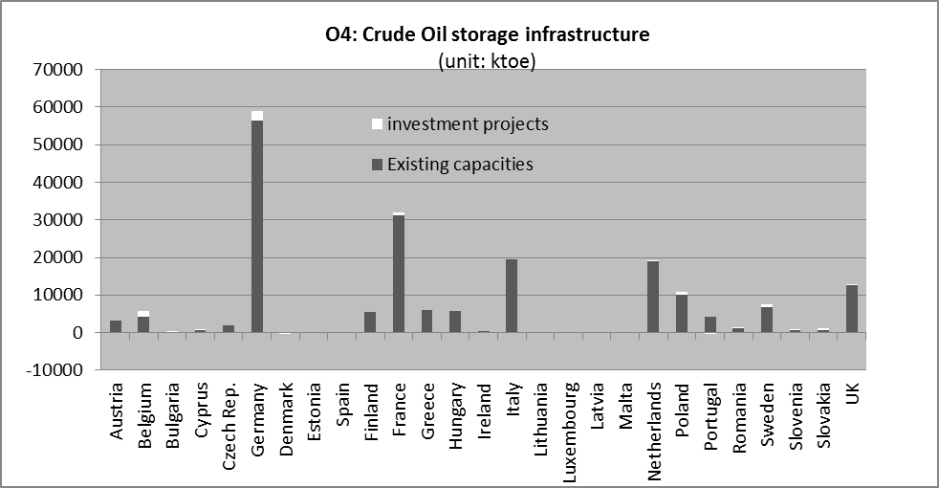
Existing capacity at 1/1/2011. Investment projects at 31/3/2011. ktoe: thousand tonnes of oil equivalent.
Source: Notifications from Member States under Council Regulation 617/2010 and Commission Regulation 833/2010.
Chart O4 presents the notification data on oil storage capacity. The data is the sum of storage capacity of crude oil and petroleum products as provided by Member States. In total, oil storage capacity in the coming years should increase by 4 %, according to the notifications.
Given that overall demand for oil products is falling in most Member States, no major problems regarding storage capacity are expected in the immediate future. However, as demand shifts, storage facilities need to be changed. Thus, the anticipated increases in demand for kerosene and transport diesel call for further investment in storage capacity for these products.

3.2. Gas infrastructure
Gas consumption in Europe has increased rapidly over the last 10 years. The share of natural gas in the European energy mix rose to 25 % in 2010 from 20 % in 1995. This trend is likely to continue as gas will be an important source of energy in the next decade. It may be used for the transformation of energy systems by acting as a backup supply to balance the increasing share of power generation from variable renewables.
Increasing consumption alongside decreasing domestic production have contributed to increasing imports of natural gas, resulting in higher import dependency. The gas import dependency of the EU increased from 43.5 % in 1995 to 62.4 % in 2010. In 2010, the EU imported its natural gas mainly from Russia (35 %), Norway (27 %) and Algeria (14 %).
Single-source dependency prevails in northern and eastern Europe, with varying degrees of import dependency (in Member States such as Finland, Estonia, Latvia, Lithuania, Slovakia, Bulgaria and Romania). Certain Member States find themselves on a ‘gas island’ as they have no or insufficient infrastructure connections with the rest of the EU (in particular the three Baltic States and Finland, Malta and the Iberian Peninsula).
Gas sources and routes need to be diversified. Investment in reverse-flow infrastructure, increased storage capacity and additional LNG terminals are needed to address the security of supply challenge and increase market integration and competition.
In the impact assessment of the Communication on Energy infrastructure priorities for 2020 and beyond, the investment need for gas infrastructure in the coming decade was estimated to reach EUR 70 bn, including EU internal interconnectors, new import infrastructure (pipelines and LNG terminals) and storage requirements. In volume, it is projected that gas transmission capacity needs to be increased by 30 %.

3.2.1. Gas transport
Around 80 % of imported gas flows into Europe through pipelines while the remaining 20 % is transported through shipping in the form of Liquefied Natural Gas (LNG).
Notifications from Member States
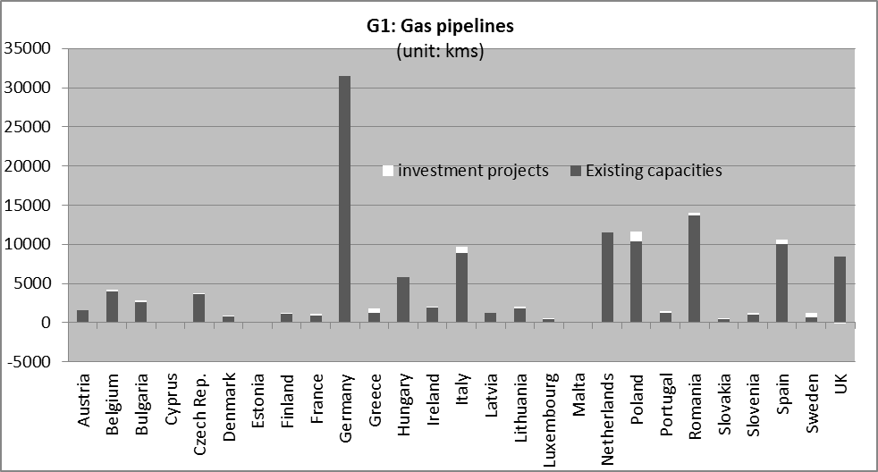
Existing capacity at 1/1/2011. Investment projects at 31/3/2011.
Sources: Notifications from Member States under Council Regulation 617/2010 and Commission Regulation 833/2010; ENTSO-G ENTSO-G data used for AT, DE, ES, LV, NL, and UK.
Only minor investments in national gas pipelines were reported by Member States (except in Sweden and Greece, for their existing network, and in Poland).
By contrast, there were reports of significant investment projects for cross-border gas pipelines in the vast majority of Member States, to extend the total gas network capacity by 18 %. The most significant investments in cross-border interconnections are expected in the coming years in Germany, the Czech Republic, Italy, the Netherlands and Greece (see chart G2).
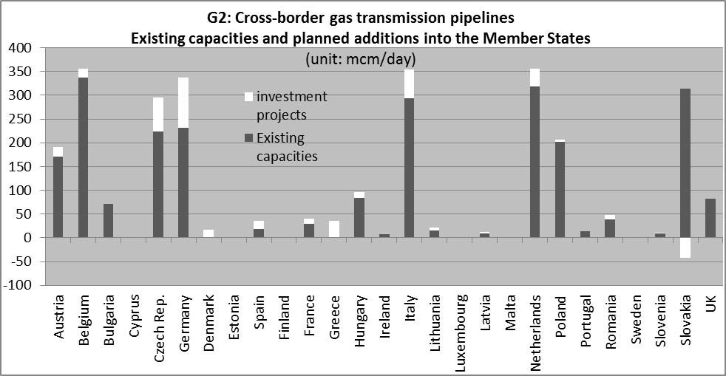
Existing capacity at 1/1/2011. Investment projects at 31/3/2011.
Sources: Notifications from Member States under Council Regulation 617/2010 and Commission Regulation 833/2010; ENTSO-G data used for AT, DE, ES, FR, IE, LT, LV, NL and UK.
As previously mentioned, Member States are exempt from the obligation to report data and information that are already provided by ENTSO-G in the TYNDP for gas. The exemption was used by ten Member States for some data.
The Ten-Year Network Development Plan for gas (TYNDP)
According to the 3rd Energy Package, the principle aim of the TYNDP for gas is to provide a consistent outlook for European gas infrastructure signalling potential gaps in future investment. It also endeavours to capture the wider gas market dynamics by looking at aspects such as supply potential, market integration, and security of supply. The TYNDP for gas thus provides a comprehensive analysis of the gas market and identifies the range of projects in the pipeline. The process of framing the TYNDP follows the annual winter and summer outlooks and includes a comprehensive stakeholder consultation.
The latest TYNDP was adopted in 2009 and covers the period 2011-2020. It includes 77 projects for which the final investment decision (FID) has been taken and 96 projects with the FID pending. The projects include transmission pipelines, storage and LNG projects and represent total investment of EUR 89.3 billion.
The underlying market analysis, however, shows that from the European policy perspective, more investment is still needed in addition to the FID projects to properly address the security of supply, low-carbon objectives and completion of the internal market. According to the TYNDP, the European transmission system offers reasonable flexibility, while storage will continue to play a key role in meeting the increased demand for gas during the winter season and to provide for more supply flexibility. Regarding market integration, the TYNDP concluded that all investment projects will help reduce network clustering and improve integration of the energy market.
Country Specific Recommendations
The Council recently sent Country Specific Recommendations, as part of the ‘Europe 2020 Strategy’, to the Baltic States, Bulgaria, Germany, Hungary, Italy, Poland and Spain regarding the need to increase gas interconnections.
Baltic countries need to connect their energy markets to other EU gas networks in order to increase the security of supply and develop regional trade (thereby implementing the Baltic Energy Market Interconnection Plan). A risk assessment is underway on gas interconnections with Estonia and Lithuania, as well as an assessment of pipeline projects (the Poland-Lithuania ‘Baltic Connector’ gas pipeline).
Bulgaria needs to complete its ongoing investment projects on gas interconnectors (in particular with Romania, Serbia and Greece) and make physical and contractual reverse-flow possible on the interconnector with Turkey. Bulgaria also needs to play a more proactive part in opening up the Southern Gas Corridor, which has the potential to diversify supply sources and routes and to strengthen competition.
Germany needs to improve the north-south gas transport capacity and integrate the German gas market more with its neighbours in central Europe to improve the availability of gas capacity, to provide a back-up of renewable energies and improve the security of both gas and electricity supply. Germany should enhance the interconnectivity of its gas infrastructure to neighbouring countries, including reverse flows, and develop new north-south and east-west transport capacity. Good progress is underway on reverse flows with Austria. Significant bottlenecks remain at the border with Denmark (Ellund), Poland (Lasow), in southern Germany and on the north-south route.
In Central-Eastern Europe the North-South energy corridor has to be further developed in order to create or further complete the North-South gas route that connects import sources from the Baltic, Black and Adriatic Seas, to integrate the market and enhance security of supply.
Hungary needs to increase its cross-border capacity in gas. Its current capacity is insufficient to ensure the integration of national markets on a regional level.
In Italy, the high share of imported gas in electricity generation means that it needs to have a secure gas supply. The country should therefore continue to actively diversify its supply sources and routes, including implementation of the Trans-Adriatic pipeline forming the Italian branch of the Southern Gas Corridor.
In Poland, the key problem is the lack of diversification, with almost 90 % of gas imported from Russia. The recent new interconnections with the Czech Republic and Germany are improving the situation.
The Council recommended that Spain improve its gas interconnections with neighbouring countries, France and Portugal, and to develop the Africa-Spain-France gas corridor.
A more detailed country analysis is provided in the Staff Working Document on European Energy Markets.
EU priorities
The following priority gas corridors were identified in the draft Regulation on Guidelines for trans-European energy infrastructure:
- North-South gas interconnections in western Europe (‘NSI West Gas’)
Member States concerned: Belgium, France, Germany, Ireland, Italy, Luxembourg, Malta, the Netherlands, Portugal, Spain and the United Kingdom;
- North-South gas interconnections in central-eastern and south-eastern Europe (‘NSI East Gas’)
Member States concerned: Austria, Bulgaria, Cyprus, Czech Republic, Germany, Greece, Hungary, Italy, Poland, Romania, Slovakia and Slovenia;
- Southern Gas Corridor (‘SGC’)
Member States concerned: Austria, Bulgaria, Czech Republic, Cyprus, France, Germany, Hungary, Greece, Italy, Poland, Romania, Slovakia, Slovenia;
- Baltic Energy Market Interconnection Plan in gas (‘BEMIP Gas’)
Member States concerned: Denmark, Estonia, Finland, Germany, Latvia, Lithuania, Poland and Sweden.

3.2.2. LNG terminals
Alongside increasing volumes of imported gas into the EU, the share of liquefied natural gas (LNG) deliveries has risen from 10 % twenty years ago to slightly under 20 % in 2011.
Investment in LNG (liquefied natural gas) will help diversify energy sources and increase the security of supply.
Notifications from Member States
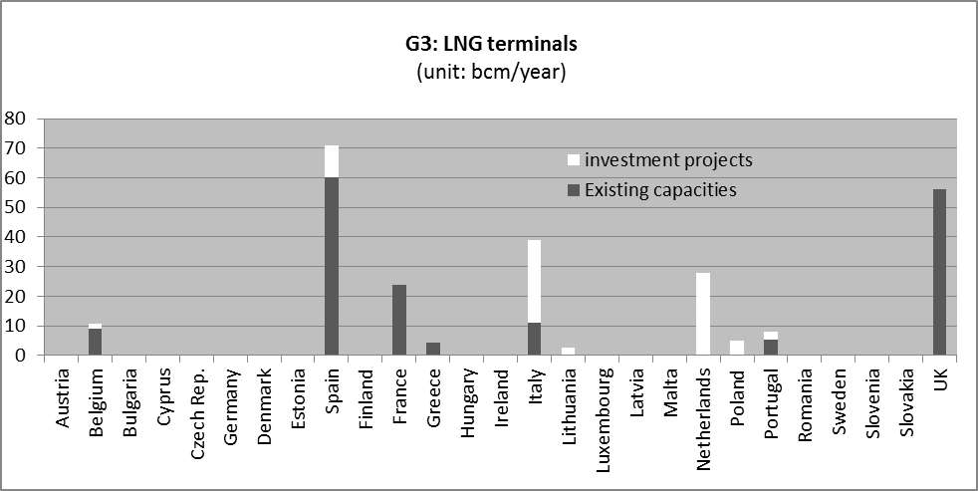
Existing capacity at 1/1/2011. Investment projects at 31/3/2011. Type of infrastructure: maximum regasification capacity.
Sources: Notifications from Member States under Council Regulation 617/2010 and Commission Regulation 833/2010; ENTSO-G for LNG terminals in EL, ES and PT.
Belgium, Italy, Lithuania, the Netherlands, Poland, Portugal and Spain have all notified plans for LNG regasification terminals (see chart G3).
According to Gas Infrastructure Europe (GIE), future LNG terminals are also planned in Cyprus, Estonia, Germany, Greece, France, Ireland, Latvia and Romania.
The LNG terminal in the east Baltic region would cater for the needs of the three Baltic States and Finland, with the ideal location generally considered being near the Gulf of Finland.

3.2.3. Gas storage
The supply flow of natural gas is relatively stable but demand varies, mainly between seasons. Underground gas storage is an effective tool to respond to these demand variations.
For instance, massive withdrawals from gas storage helped to meet high increases in demand during the fourth quarter of 2010, limiting the need for imports. It also played a key role in meeting the peak demand in Europe during the cold spell in February 2012.
Gas storage is considered a secure and economically viable way to ensure the supply of natural gas and deal with potential gas supply shortages. Natural gas undertakings keep gas stocks in commercial storage to guarantee delivery to their consumers at times of changing supply and demand conditions. Some Member States have developed strategic storage sites where gas is reserved exclusively for emergency situations. There is no mandatory EU requirement for gas storage (unlike for oil storage). EU Regulation 994/2010 concerning measures to safeguard the security of gas supply only includes a ‘supply standard’, which requires natural gas undertakings to be able to deliver gas to protected consumers under predefined conditions. Using underground gas storage is one way, but not the only way to fulfil this obligation. Natural gas undertakings may conclude special standby contracts for pipeline or LNG deliveries to comply with this provision.
Natural gas can be stored for an indefinite period of time in natural gas storage facilities and withdrawn as and when needed.
Around 69 % of gas storage is in depleted fields, 19 % in aquifers, 10 % in salt cavities, and 2 % in above-ground storage (LNG peak shaving facilities).
Notifications from Member States
The EU’s current storage capacity amounts to 96 bcm, in terms or working gas capacity, according to notifications. Twelve Member States expect investment in gas storage capacity in the coming years: Austria, Belgium Germany, Denmark, Spain, France, Italy, the Netherlands, Poland, Romania, Slovakia and the United Kingdom. The most significant investments, both in absolute and relative terms, are expected in Poland and in the Netherlands.
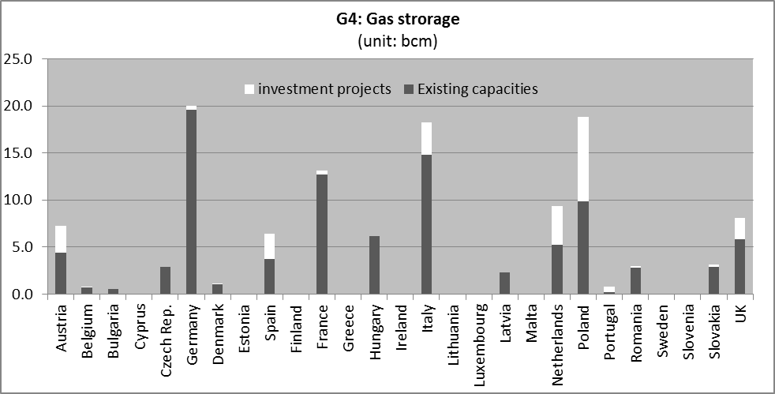
Existing capacity at 1/1/2011. Investment projects at 31/3/2011.
Sources: Notifications from Member States under Council Regulation 617/2010 and Commission Regulation 833/2010..
Notifications were completed by IHS/GIE data for existing capacities in DE, ES, LV, UK and for investments projects in DE and UK.
Poland has an ambitious programme of investment in gas storage, partly supported by European funds. In the Netherlands, several storage sites (salt caverns) have been built on the German border and will be operational by the end of 2012. In addition, seasonal storage is being developed by Taqa (an energy company) and is expected to become operational in 2013.
While current EU storage capacity seems sufficient to cover seasonal demand, tight supply demand situations may appear in some regions due to the uncertainty of future gas demand and the uncertainty of planned investment.

3.3. Electricity infrastructure
The main challenges for electricity infrastructure are: (i) the growing demand for electricity over the coming decades, as expected under all scenarios of the Energy Roadmap 2050; (ii) overcoming bottlenecks to complete the internal market (iii) an increasing share of generation from renewable sources and integration of variable generated electricity; and (iv) decentralising electricity demand and supply. The geographical distance between some of the new forms of electricity generation such as offshore wind and consumption will require substantial network investment. However, other forms of renewable generation, such as distributed generation close to consumption, can reduce the need for grid reinforcement and thereby contain extra costs.
In any case, investing in electricity generation capacity and electricity networks is necessary, along with rapid development of interconnections, to deal with the different characteristics between conventional power plants and some renewable energy plants.

3.3.1. Electricity generation
The total electricity generation capacity for the EU-27 (at 1 January 2011) amounted to 839 GW according to notifications compared to 904 GW in 2010 according to Eurostat. This gap is probably explicable by the thresholds set in Regulation 617/2010 (reporting threshold set at 10 MW for photovoltaic projects and 20 MW for wind parks). This resulted in an underestimation of current capacity and future investment in electricity generation from renewables, as this type of investment is usually small-scale (the electricity generation capacity from renewables was 288 GW in 2010 according to Eurostat, while notifications amounted to 221 GW).
The following chart compares notifications with Eurostat data on installed electricity capacity from renewables.
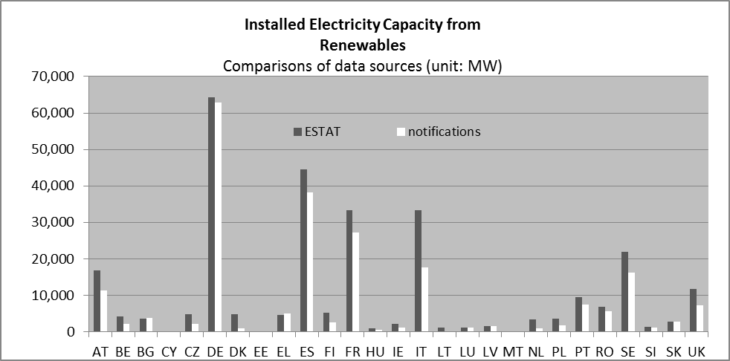
Source: Eurostat (2010 data) and notifications from Member States under Council Regulation 617/2010 and Commission Regulation 833/2010. Missing notifications were replaced by data from Platts for BG, EL, ES, and IE.
Notifications on investment projects
According to notifications, most Member States are investing in their electricity generating capacity (total investments amount to 125 GW). These investments are driven by the increasing demand for electricity and the binding renewables targets in 2020.
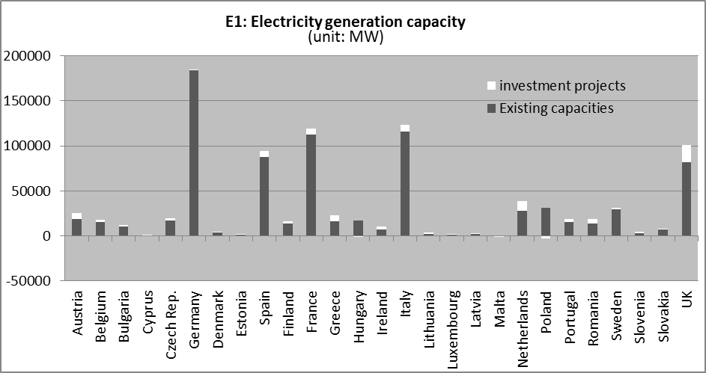
Existing capacity at 1/1/2011. Investment projects at 31/3/2011.
Source: Notifications from Member States under Council Regulation 617/2010 and Commission Regulation 833/2010.
Missing or incomplete notifications from EL, ES, IE, and LT were replaced by data from Platts.
The following charts provide details on the energy source used for electricity generation. As shown in chart E1-1, Germany, Greece, Ireland, the Netherlands, Spain and the United Kingdom are significantly investing in additional electricity generation capacity from fossil fuels. Germany is investing in new fossil fuel-fired power stations, including cogeneration plants, following its decision to decommission nuclear power plants. The United Kingdom is opting for additional electricity generation capacity from gas power plants. In total, the additional capacity in electricity generation from fossil fuels notified by Member States amounts to 50 GW.
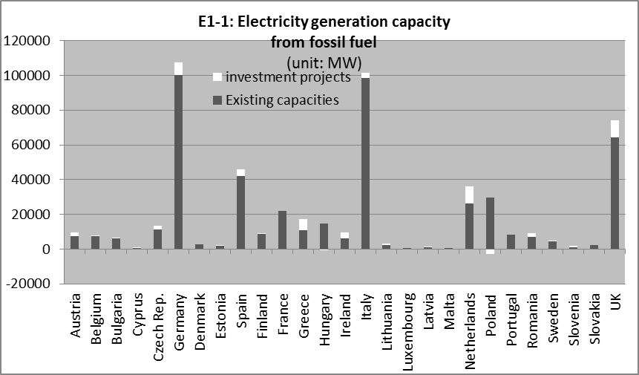
Existing capacity at 1/1/2011. Investment projects at 31/3/2011.
Source: Notifications from Member States under Council Regulation 617/2010 and Commission Regulation 833/2010.
Missing notifications were replaced by data from Platts for BG, ES, IE and LT.
Concerning nuclear energy, Bulgaria, the Czech Republic, Finland, France, Lithuania, Romania, Slovakia, Sweden and the United Kingdom have notified the Commission that they are planning to build new nuclear capacity or increase the capacity of their existing nuclear power plants. In particular, Romania will double its existing capacity, Finland will increase it by 59 % and Slovakia by 45 %. At the beginning of 2011, Germany had started to phase out its nuclear plants, reducing capacity by almost 10 GW. By 2022, Germany plans to phase out all nuclear plants.
Regarding renewables, planned investment amounts to 40 GW and should increase the generation capacity from this source by 18 %, according to notifications. Most Member States are investing in renewables (see chart E1-2), but massive investments are being made by the United Kingdom (10.2 GW), Austria (4.6 GW), Italy (4.2 GW) and France (4.1 GW). The United Kingdom, the Netherlands, Lithuania Estonia and Cyprus will more than double their existing capacity for electricity generation from renewables.
As already mentioned, due to the limitations of the method applied (the reporting threshold set at 10 MW for PV projects and 20 MW for wind parks) no firm conclusions can be drawn from the notifications as to whether the current level of investment is sufficient to achieve the target of 20 % renewable energy in gross final energy consumption, which translates into a share of 34 % electricity from renewable sources.
Looking at the overall development of the sector, between 2005 and 2010 significant investments in renewable energy were made, which led to an increase in its share in gross final energy consumption from 8.6 % to 12.7 % and in electricity generation from 14.7 % to 19.6 %. Nevertheless, significant additional investment remains necessary to achieve the national targets set in Directive 2009/28/EC, subsequently broken down in the National Renewable Energy Action Plans. According to these action plans, Member States need to increase the total level of installed capacity for electricity generation from renewable sources from about 174 GW in 2005 to about 487 GW in 2020 and according to Eurostat the installed capacity was 288 GW in 2010. The difference between the 2010 and 2020 figures remains far higher than the 40 GW reported in the context of this exercise, which underlines the need to continue to ensure a positive investment climate in renewable energy if the targets are to be achieved.
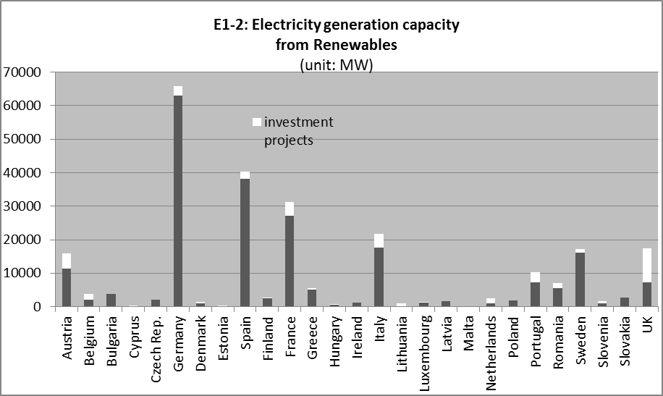
Existing capacity at 1/1/2011. Investment projects at 31/3/2011.
Source: Notifications from Member States under Council Regulation 617/2010 and Commission Regulation 833/2010.
Missing notifications were replaced by data from Platts for EL, ES, and IE.

3.3.2. Electricity transmission
To complete the internal energy market and reach the Europe 2020 targets, energy needs to be able to flow to where it is needed, without physical barriers at national borders. To remove physical bottlenecks in grids, significant investments are needed in energy infrastructure in the coming years. Better connected markets and an end to the isolation of ‘energy islands’ are prerequisites in order to connect Europe with new sources of energy and prepare for the low carbon economy. With sufficient interconnection and a smarter grid, greater absorption of renewable electricity is possible.
Notifications from Member States
According to notifications, several Member States will expand their national transmission network (see chart E2), which is in line with the announced grid reinforcements needed to cope with increasing demand and supply, the take-up of renewables and variable generation. National transmission capacity will be increased by 11 % with a total of around 28 000 km of additional lines. The most significant investment in absolute terms is being made in Spain (with 8 000 km of addition lines, i.e. a 23 % addition to its existing network), the United Kingdom and Italy.
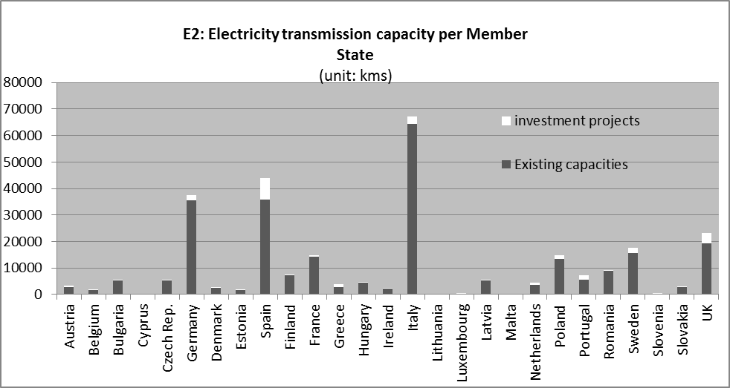
Existing capacity at 1/1/2011. Investment projects at 31/3/2011.
Source: Notifications from Member States under Council Regulation 617/2010 and Commission Regulation 833/2010.
Missing notifications were replaced by ENTSO-E data for IE.
The vast majority of Member States are also investing in cross-border transmission capacity, which is expected to increase by 33 % in the coming years (see chart E3). In addition to the notifications sent by the Member States, it is useful to refer to the findings of the Ten-Year Network Development Plan (TYNDP) for Electricity.
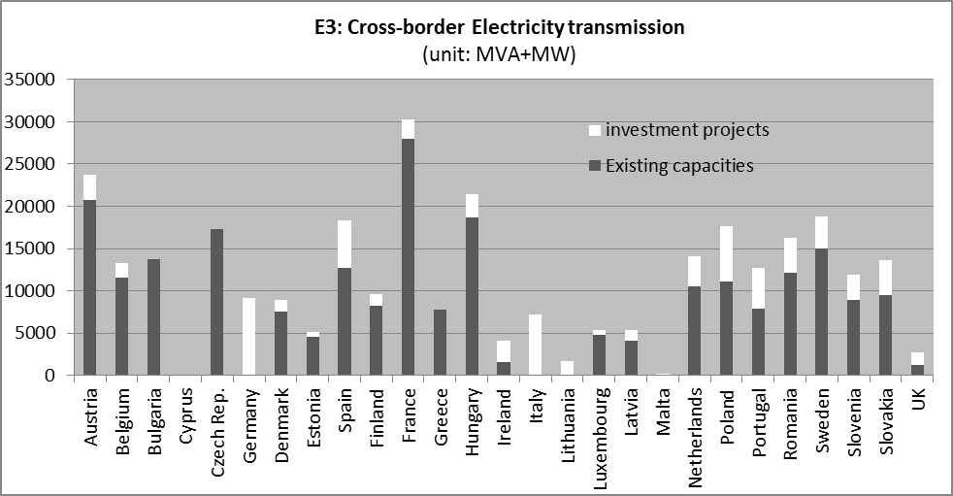
Existing capacity at 1/1/2011. Investment projects at 31/3/2011.
Source: Notifications from Member States under Council Regulation 617/2010 and Commission Regulation 833/2010.
Notifications were completed by ENTSO-E data for DK, IE, IT, PL, PT and SI.
The Ten-Year Network Development Plan for electricity (TYNDP)
The TYNDP 2012 for electricity provides a comprehensive analysis of the electricity market, bottlenecks and investment needs and identifies the range of planned projects in the next five and ten years. Total investment needs amount to EUR 104 billion, of which EUR 23 billion is for sub-sea cables. The figures are in line with the EUR 100 billion envisaged by the Commission in the impact assessment accompanying the Energy Infrastructure Package.
ENTSO-E identified the following main areas of investments:
- Renewable integration (mainly wind) in the northern part of Europe;
- Renewable integration (mainly wind, hydro and solar) in the southern part of Europe (Iberian Peninsula);
- Baltic States integration, with in particular the Baltic Energy Market Interconnection Plan (BEMIP) launched by the Commission in 2008 aiming at full integration of the three Baltic States into the European energy market by improving interconnections with neighbouring countries;
- Major flows in the south-east and south-central regions, also including ‘loop flows’ in the north-south direction.
The TYNDP finds that one in three planned investments are experiencing delays in implementation due to long permitting processes. In addition, as the investment volumes need to increase by on average 70 % from 2011 to 2020, access to finance remains a challenge, especially in the current economic situation. The impact assessment of the Commission’s proposal on Energy Infrastructure package provides a thorough analysis of the multiple factors that risk delaying the necessary investments.
Country Specific Recommendations
Council specific recommendations in the context of the Europe 2020 Strategy were sent to the Baltic States, Bulgaria, France, Germany, Hungary, Italy, Malta, Poland and Spain regarding the need to increase electricity interconnections.
Concerning the Baltic States, Estonia needs to continue developing electricity cross-border connections with Finland to end its relative market isolation. As regards electricity networks in Latvia, for historical reasons, the system is interconnected with the networks of Belarus, Russia, Estonia and Lithuania (BRELL Ring agreement). Latvia needs therefore to strengthen its national electricity grid to transport energy from Finland, Sweden or Poland and to continue cooperation with the Commission in negotiations with Russia and Belarus on operating the electricity network. In Lithuania, the planned interconnections in the electricity sector with Sweden (by 2015) and Poland (by 2016) will allow the country to connect to the European grid and boost competition in the electricity market.
Bulgaria and Hungary should increase their cross-border network capacity in order to facilitate trade with neighbouring countries and integrate renewable energy sources.
The Council recommended France to develop its energy interconnection capacity, given its limited interconnection capacity with neighbouring countries, particularly with Spain, which curbs the development of competition on the domestic electricity market.
In Germany, expanding the north-south axis and the cross-border interconnections is considered necessary, in particular given the reduced back-up capacity in the south of Germany due to the shutdown of nuclear power plants, and the increase in renewable capacities in the North and Baltic Seas.
The Council recommended Italy to take further measures to improve its infrastructure capacity and interconnections. The electricity transmission network still suffers from congestion. The south is poorly interconnected to the central-northern part of the country. Developing the electricity network is expected not only to reduce congestion on the domestic grid, but enhance Italy's interconnection capacity with neighbouring markets.
Malta needs to complete the EEPR electricity interconnection with Sicily, as this will enable it to develop renewable energy and reduce oil consumption.
The Council recommended Poland to speed up development of the electricity grid, including cross-border interconnections, and to eliminate obstacles in electricity cross-border exchange. Congestion on the Polish domestic electricity grid could be reduced by increasing its capacity to interconnect to neighbouring markets.
Spain needs to increase its electricity network’s capacity for cross-border exchange, notably with France, which would allow it to trade more with neighbouring countries and facilitate further integration of renewable electricity from multiple sources, such as wind power.
A more detailed country analysis in provided in the Staff Working Document on European Energy Markets.
EU priorities
The following priority electricity corridors and areas were identified in the draft Regulation on Guidelines for trans-European energy infrastructure:
- Northern Seas offshore grid (‘NSOG’)
Member States concerned: Belgium, Denmark, France, Germany, Ireland, Luxemburg, the Netherlands, Sweden, the United Kingdom;
- North-South electricity interconnections in western Europe (‘NSI West Electricity’)
Member States concerned: Belgium, France, Germany, Ireland, Italy, Luxembourg, Netherlands, Malta, Portugal, Spain, the United Kingdom;
- North-South electricity interconnections in central-eastern and south-eastern Europe (‘NSI East Electricity’)
Member States concerned: Austria, Bulgaria, Czech Republic, Cyprus, Germany, Greece, Hungary, Italy, Poland, Romania, Slovakia, Slovenia;
- Baltic Energy Market Interconnection Plan in electricity (‘BEMIP Electricity’)
Member States concerned: Denmark, Estonia, Finland, Germany, Latvia, Lithuania, Poland, Sweden;
- Smart grids deployment
Member States concerned: all;
- Electricity highways
Member States concerned: all.

3.4. Biofuels infrastructure
In 2009, the EU set a new, mandatory target for the share of renewable energy in the transport sector to reach at least 10 % in all Member States by 2020. In order to reach this target, a sound European biofuel infrastructure is of pivotal importance.
Biofuels produced in a sustainable way are an alternative energy resource that can substitute fossil fuels in the transport sector. The target does not specifically state the use of biofuels but, at least until other renewable energy sources are sufficiently available in the transport sector, biofuels will make a decisive contribution to achieve this target. Therefore, a sound European biofuel infrastructure is crucial.
The figures below (chart B1) show current biofuel production capacity per Member State, and the planned additions. Production capacity is set to be significantly expanded in some Member States over the coming years.
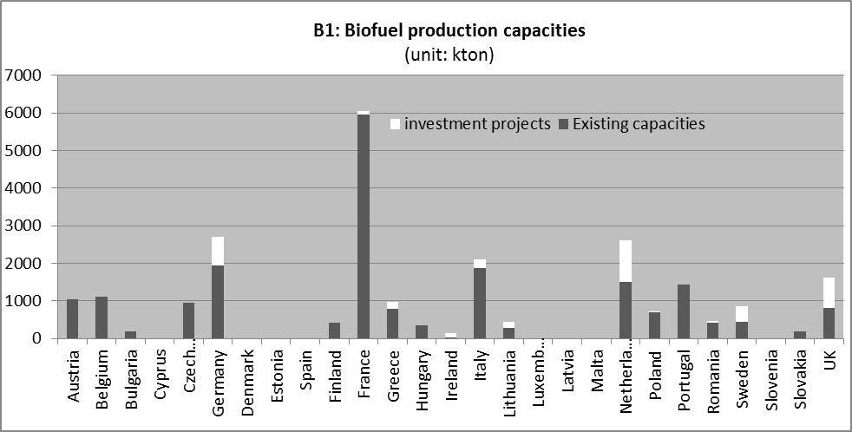
Existing capacity at 1/1/2011. Investment projects at 31/3/2011.
Source: Notifications from Member States under Council Regulation 617/2010 and Commission Regulation 833/2010.
Biodiesel and bioethanol together represent more than 98 % of the biofuels consumed in the EU in 2010. 79 % of total biodiesel consumed in 2010 (or 9.6 mega tonnes) was produced in Europe. All Member States produced biodiesel in that year, except for Luxembourg. The main biodiesel producers were in Germany, Spain, France, Italy and the Netherlands.
However, there is major overcapacity of biodiesel production: of the 20 mega tonnes per year production capacity, 57 % was not used in 2010. There is also overcapacity in bioethanol production: in 2010, almost 24 % of production capacity was not used. Despite this overcapacity, an additional capacity of 4 mega tonnes is planned, according to notifications.
These are all mostly based in the production of biofuels from food crops. However, as the market for biofuels has expanded it has become clear that not all biofuels are the same, in terms of their greenhouse gas impacts from global land use. Recent scientific studies have shown that when taking into account indirect land use change, for example when biofuel production causes food or feed production to be displaced to non-agricultural land such as forests, some biofuels may actually be adding as much to greenhouse gas emissions as the fossil fuels they replace.
Because of these concerns, the Commission published a proposal on 17 October 2012 to strongly encourage the production of second generation biofuels with lower indirect land use change risks in favour of those produced from food and feed crops. It does this through a combination of measures including limiting the contribution of first generation biofuels towards the 10% renewable energy transport target, and increasing current incentives schemes to quadruple counting for those types of biofuels that are more expensive to produce and have no indirect land use change impacts because they do not require land for their production (i.e. waste and residues such as straw). As such, the development of infrastructure for producing second generation biofuels needs to be accelerated.

3.5. Carbon Capture and Storage infrastructure
Carbon Capture and Storage (CCS) is a relatively new field in energy infrastructure. Many CCS projects are being prepared, often with European support for research and/or demonstration. A number of capture projects of a size of around 20-30 MW and some storage research projects are currently operational in Europe. The next step is to demonstrate the technology at integrated projects at a scale of at least 250 MW in order to reduce the costs so that the technology can be commercially deployed after 2020. However, the number of actual demonstration projects currently going forward is low and many are significantly delayed. Therefore, the quality and the quantity of the data available in the notifications are limited, which means that interpretations and conclusions based on these data are relatively weak.
Only France and Hungary reported that they have existing CO₂ transport pipelines and the Netherlands is running investment projects in this field. None of the Member States have reported CO₂ storage in their notifications, except Romania and the Netherlands, where storage installations are planned.
The countries that are running active CCS demonstration projects (but without a final investment decision) are the Netherlands, Spain, Italy, France, Romania, Poland and the United Kingdom.

4. Overcoming barriers to investment
As provided for in Regulation 617/2010, this analysis also aims to identify investment obstacles and promoting best practices to address them.
Problems related to permit-granting procedures, public opposition, financing and the regulatory framework have been identified as the main barriers to investment in the impact assessment accompanying the Regulation on ‘Guidelines for trans-European energy infrastructure’.
Infrastructure projects are primarily financed by the private sector. The financial crisis has affected the lending markets and investors and financial institutions have become more risk averse. The current credit crunch could thus be seen as an obstacle to investment in energy infrastructure. In addition, public budget constraints make it difficult to secure financing for energy infrastructure, especially for cross-border projects.
To boost investment, the Commission proposed in the ‘Guidelines for trans-European energy infrastructure’ streamlining permit-granting procedures and financing support. Each Member State will designate one authority responsible for completing the entire permit-granting process. Projects of common interest contributing to the achievement of the 12 priority corridors identified by the Commission will be aided by these permit-granting procedures, regulatory measures and, under certain conditions, will be eligible for EU funding.
At present, the Structural and Cohesion Funds can be used to support the development of energy infrastructure. Under the 2007-2013 budget, EUR 0.7 billion was allocated in the Member States for projects classified as TEN-E. However, the Member States have been slow to use the available funds so far. Since the decentralised management of Structural and Cohesion Funds, Member States have had difficulties in coordinating across and between countries to ensure that the regional network benefits from investment.
Under the multi-annual financial framework for the period 2014-2020, the Connecting Europe Facility will provide EU financial aid to complete priority energy, transport and digital infrastructure with a single fund of EUR 50 billion, out of which EUR 9.1 bn is earmarked for energy infrastructure. The funds from Connecting Europe should leverage more funding from other private and public investors. A pilot phase of project bonds has been planned for 2012-2013 with a budget of EUR 230 million.
Regarding the policy and regulatory framework, predictability and stability are needed to create a favourable environment for investing in energy infrastructure. The regulatory framework up to 2020 is mainly set, so discussions of policies for the period 2020-2030 in line with the Energy Roadmap 2050 should now start leading to firm decisions that provide certainty for long-term low-carbon investment.
The Communication on the Internal energy market highlights that energy markets are generally perceived not to be transparent or sufficiently open for newcomers. Economically rational and energy-efficient investments are not sufficiently made. Market-based arrangements that encourage flexibility through effective price signals must be introduced. For instance, properly functioning wholesale markets, which reflect the economic value of power at each point in time in each area, can steer investment to where it is most efficient. State support, if needed, should be well-designed, targeted at identified market failures and objectives and limited in time, in order to minimise competition distortions in the internal market. Inappropriate public intervention must be avoided as it can discourage private investment and undermine the internal market.

5. Conclusion
The Member States are investing in energy infrastructure. They are increasing their electricity generation capacity, notably from renewable energy sources, and are investing in biofuel infrastructure, contributing to a low-carbon energy system. Cross-border gas and electricity networks are expanding, which improves integration and competition in the internal market. Projects in LNG and gas storage facilities are being carried out, which increases the security of energy supply in the EU.
The overall picture shows that the European policy drive, boosted by internal market objectives, is having a direct and positive impact on energy investment. However, with short timescales to integrate the whole European energy network by 2015, and to deliver the 2020 targets, the current rate of investment is unlikely to be sufficient to achieve the results expected. While there are many other factors at play (e.g. evolution of demand, production, imports, progress in energy efficiency, current state of infrastructure and replacement needs, utilisation rates, storage needs, energy costs and subsidies), a number of warning signs are emerging.
In the electricity sector, significant additional investment is needed to achieve the national targets in generation from renewables and to adapt transmission networks to more volatile flows and geographical distances between production and consumption. Investment in the grid is also necessary to avoid the current congestion problems worsening (e.g. in Germany and neighbouring countries) and new congestion problems appearing. Regarding gas infrastructure, investment in cross-border pipelines, reverse-flow infrastructure, storage capacity and additional LNG terminals must continue to increase security of supply, in particular in the Baltic States and in Eastern Europe, where single-source dependency still prevails. In the oil sector, the industry should invest in further conversion capacity to adapt to market developments. Also in biofuels, more investments will be needed in infrastructure for the production of second generation biofuels in order to reach the 2020 targets and compensate the reduction in oil demand.
This report should fuel further debate with other EU institutions, Member States and stakeholders with a view to identifying potential risks of under-investment in the EU and assessing how to increase momentum and develop ways to stimulate the markets, find new sources of investment and plug gaps.
***

6. Annexes
Table 1: Existing capacity in energy infrastructure at 1/1/2011
Sources: Notifications from Member States under Council Regulation 617/2010 and Commission Regulation 833/2010.
Notifications on gas pipelines were completed by ENTSO-G data for AT, DE, ES, FR, LV, and NL and on LNG terminals for EL, ES and PT.
Notifications on electricity generation were completed by Platts data for BG, EL, ES, IE, and LT.
Notifications on electricity transmission and cross-border networks were completed by ENTSO-E data for BG, DK, IE, IT, PL, PT and SI.
Table 2: Planned additions in energy infrastructure at 31/3/2011
Planned additions correspond to the sum of under construction and planned projects, minus infrastructure that will be decommissioned.
nd: non disclosed. Only aggregated data are disclosed, in conformity with Article 6.3 and Recital 14 of Council Regulation 617/2010.
Sources: Notifications from Member States under Council Regulation 617/2010 and Commission Regulation 833/2010.
Notifications on gas pipelines were completed by ENTSO-G data for AT, DE, ES, FR, LV, and NL and on LNG terminals for EL, ES and PT.
Notifications on electricity generation were completed by Platts data for BG, EL, ES, IE, and LT.
Notifications on electricity transmission and cross-border networks were completed by ENTSO-E data for BG, DK, IE, IT, PL, PT and SI.
Table 3: Planned additions in energy infrastructure at 31/3/2011 (in % of existing capacity)
Planned additions correspond to the sum of under construction and planned projects, minus infrastructure that will be decommissioned.
Source: Notifications from Member States under Council Regulation 617/2010 and Commission Regulation 833/2010.
Units
Ktoe Thousand tonnes of oil equivalent
Bcm Billion cubic meters
Mcm Million cubic meters
Kton Thousand tonnes
MW Mega watts
MVA Megavolt-ampere

COM(2012) 595 final
http://ec.europa.eu/energy/publications/doc/2011_energy2020_en.pdf
In the Energy Roadmap 2050 scenarios http://ec.europa.eu/energy/energy2020/roadmap/index_en.htm, total investment needs in power stations for the period 2011-2020 range between EUR 452 and 487 bn (at 2005 prices). At 2011 prices, this amounts to around 540 bn € for power generation alone.
SEC/2011/1233 final.
COM/2011/0658 final.
Market Observatory for Energy (2011), Europe’s energy position — Annual report 2010.
COM/2011/0658 final.
SEC/2010/1395
SWD (2012) 368
Austria, Germany, France, Ireland, Lithuania, Latvia, the Netherlands, Spain, Sweden and the United Kingdom.
http://ec.europa.eu/europe2020/making-it-happen/country-specific-recommendations/index_en.htm
SWD (2012) 368
As agreed in the Memorandum of Understanding on North-South Interconnections in Central Eastern-Europe signed on 23 November 2011 in Brussels, by and between the Republic of Austria, Republic of Bulgaria, Republic of Croatia, the Czech Republic, the Federal Republic of Germany, Republic of Hungary, Republic of Poland, Romania, Republic of Slovenia, Republic of Slovakia and the European Commission,
SWD (2012) 368
Other gas infrastructure than transmission are also included in the priority corridors: e.g. LNG/CNG storage and reverse flows.
SWD (2012) 368
Pending on a decision to be taken by the BEMIP high-level group.
The following cases are defined in Regulation 994/2010: (a) extreme temperatures during a 7-day peak period occurring with a statistical probability of once in 20 years; (b) any period of at least 30 days of exceptionally high gas demand, occurring with a statistical probability of once in 20 years; and (c) for a period of at least 30 days, in case of the disruption of the single largest gas infrastructure under average winter conditions.
Study on natural gas storage in the EU: _http://ec.europa.eu/energy/gas_electricity/studies/gas_en.htm.
SWD (2012) 368
http://ec.europa.eu/energy/energy2020/roadmap/index_en.htm. Although the total energy demand fell by 3.6 % between 2005 and 2010, electricity demand rose by 2.4 % over the same time. Energy projections concur that electricity demand is set to increase. This is expected to materialise both under the business-as-usual scenario and in the event of strong decarbonisation of the economy. Transport electrification would increase this electricity demand substantially. .
Missing or incomplete notifications were replaced by data from Platts for BG, EL, ES, IE, and LT.
Notifications from Member States under Council Regulation 617/2010 and Article 41 of Euratom Treaty.
Notifications from Member States under Council Regulation 617/2010.
The NREAPs provide a breakdown of national targets by technology and a growth path until 2020, see http://www.ecn.nl/units/ps/themes/renewable-energy/projects/nreap/reports for a summary of technology results.
Missing notifications were replaced by ENTSO-E data for BG and IE.
SEC/2011/1233 final.
See also section 4 of this document.
http://ec.europa.eu/europe2020/making-it-happen/country-specific-recommendations/index_en.htm.
SWD (2012) 368
Directive 2009/28/EC of 23 April 2009 on the promotion of the use of energy from renewable sources.
COM(2012) 271 final. Communication on Renewable Energy adopted on 6 June 2012.
COM(2012) 595 final
SEC/2011/1233 final.
COM/2011/0658 final.
COM/2011/0658 final.
COM(2011) 665.
SEC(2011) 1565/2.
COM (2012) 662 final.

