Introduction
An integrated Single Market is a key driver for economic growth and jobs and offers additional opportunities for European citizens. It therefore plays a central role in achieving the objectives of the Europe 2020 strategy.

As announced in the June 2012 Commission Communication on better governance for the single market, this report aims at monitoring the functioning of the Single Market within the European semester process. It presents an analysis of the state of Single Market integration in key areas with the greatest growth potential, i.e. services, networks and digital economy. The objective of this report is to identify policy priorities in the context of the Annual Growth Survey 2013, which if carried out by Member States, would contribute to unlocking the full Single Market growth potential, and to removing remaining obstacles to further integration. This report also calls to step up efforts to ensure better implementation and enforcement of rules that are already in place.

1. Single Market integration check-up

By removing the barriers to the free circulation of people, goods, services and capital, the Single Market allows firms to operate on a bigger scale, thereby enhancing their capacity to innovate, to invest, become more productive and generate jobs. The increased competition resulting from the integration process works as a powerful incentive to offer a wider variety of cheaper and higher quality products for European consumers, as indicated by the Consumer Markets Scoreboards. Labour mobility is essential to contribute to a genuine European labour market that enables a good match between employers' needs and job seekers' skills, enhancing EU companies’ productivity and hence growth and employment, and helping eliminate the coexistence of persistent high levels of unemployment in several areas with labour shortages in faster-growing regions of the EU.

The four freedoms

Goods

- Although at a slower pace, the integration of the goods market is still progressing 20 years after the launch of the Single Market with intra-EU trade representing around 17% of EU GDP in 1999 and close to 22% in 2011. The growth of extra-EU exports has been more dynamic, but its value equals only some 12% of EU GDP. This indicates that the Internal Market is still of significant importance for European companies and that there is still potential for improvement in order to stimulate growth of intra-EU trade.

- The positive general trend in terms of integration hides rather contrasting situations among EU Member States. There are positive trends in terms of integration of the goods market, as indicated by the evolution of intra-EU imports and exports to GDP ratios in the period 1999–2011, in CZ, DE, HU, LT, LV, NL, PL, SI, SK, whilst some negative trends or stagnation can be seen in EL, ES, FI, FR, IE, LU and UK. In most of the countries from the first group, the deepening of integration was a part of the process of catching-up, as they started from a low level of openness well below their potential. As regards the achieved level of integration (in terms of the ratio of intra-EU trade in goods to GDP), smaller EU Member States are naturally more open, except for EL, CY which were relatively closed, followed by PT and the Nordic countries.

- Looking at the country group with increasing integration in the Single Market, most of the countries (PL and to some extent CZ, SI, DE, SK and NL) have experienced an improvement in their price competitiveness position since the end of the 1990s. LT and LV were particularly successful in targeting markets with higher GDP growth over that period. HU seems to have benefitted mainly from non-price competitiveness. For almost all these countries higher integration within the internal market also resulted in an improvement in their trade balance position with their EU partners.

Chart 1. Evolution of intra-EU trade in goods
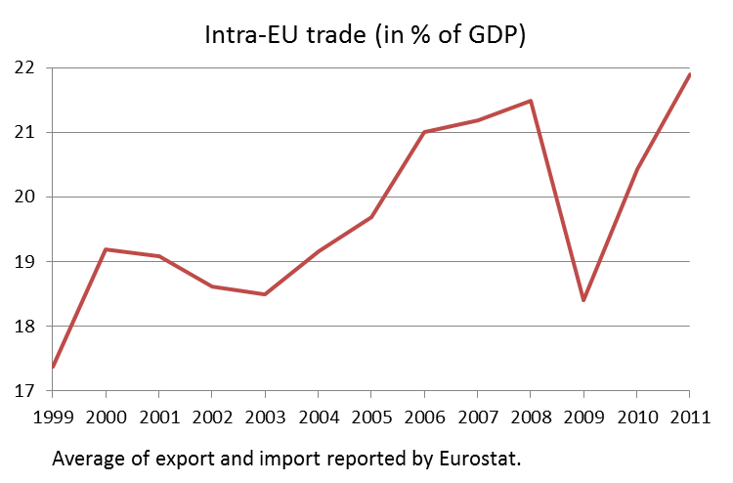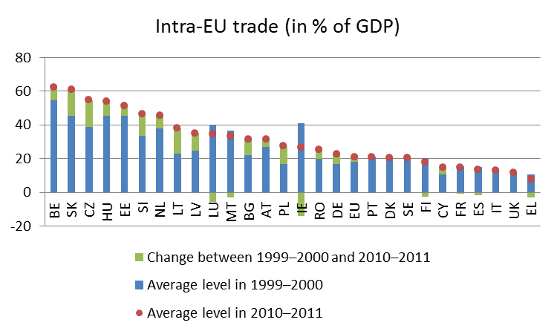

Data source: Eurostat
- As regards the groups with decreasing or stagnating integration (in terms of the ratio of intra-EU imports and exports in goods to GDP), ES and LU suffered from both relatively low demand growth in their partner economies but also from some cost competitiveness losses. Also EL experienced cost competitiveness deterioration. FI and the UK faced problems with non-cost competitiveness. These are the factors which explain the evolution of integration from the export side, but imports are strongly correlated with exports. Nevertheless, for many of these countries the negative integration trend was associated with a deterioration of their trade balance with their EU partners.

- The EU is now integrating faster with third countries than internally, which reflects the globalisation process and the faster growth demand in many emerging markets. This is not necessarily a negative sign since there is no trade-off between intra-EU trade and global trade. Member States who increased their integration in the global economy are also those who have demonstrated the highest integration dynamics within the EU.

Chart 2. Comparison between intra-EU and extra-EU trade in goods
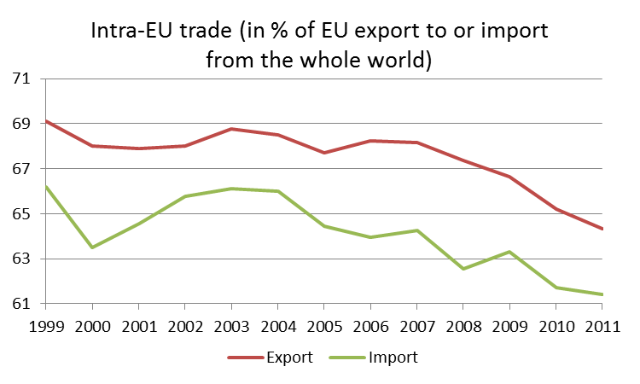
Data source: Eurostat

Services

- The intra-EU trade in services followed broadly similar patterns as the trade in goods (Chart 3). However, the level of integration in this sector that represents more than 70% of the economy continues to be significantly lower than in the goods market. And there are currently no signs of catching up. However, price dispersion upward trends rather indicate possible persisting intra-EU barriers to the trade in services. Whereas the differences in the level of dispersion are to large extent natural and result from much lower transportability, tradability and heterogeneity of services, the differences in the trends between services and goods, in which the dispersion declined, may point to an insufficient level of competition in that sector (Chart 4). The more significant price dispersion trends have been noticed in the oldest Member States of the EU.

Chart 3. Evolution of intra-EU trade in services
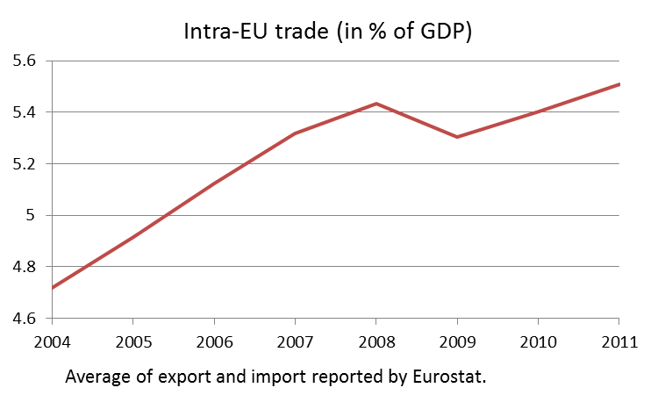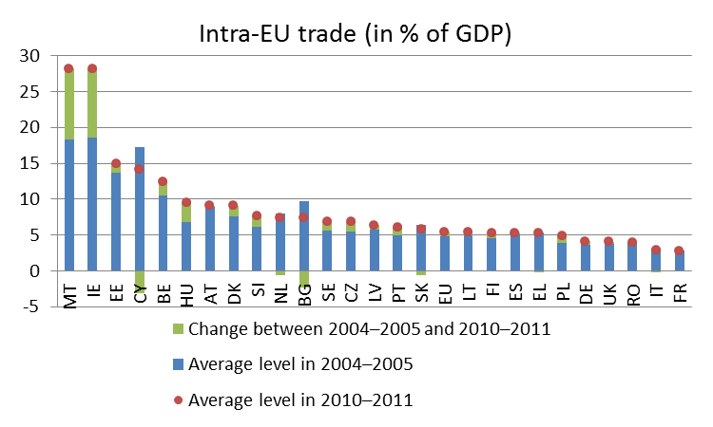
Data source: Eurostat
Chart 4. Dispersion of prices across the EU Member States
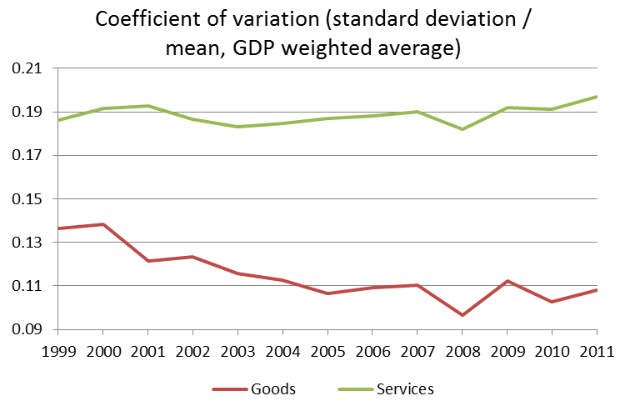
Data source: Eurostat
- Because of the mentioned non-tradability of many services, the services market predominantly integrates through the establishment of companies. The data on foreign control of enterprises shows that the degree of integration of services in almost all the Member States was lower than that of other sectors (Chart 5). Similarly to the trade openness indicators, smaller economies were more open, with the exception of CY, SI, and PT, which are the most closed overall despite their sizes. IT is the least integrated among the large economies from the perspective of the data on the foreign control of enterprises.

Chart 5: Intra-EU establishment levels in services and in other sectors
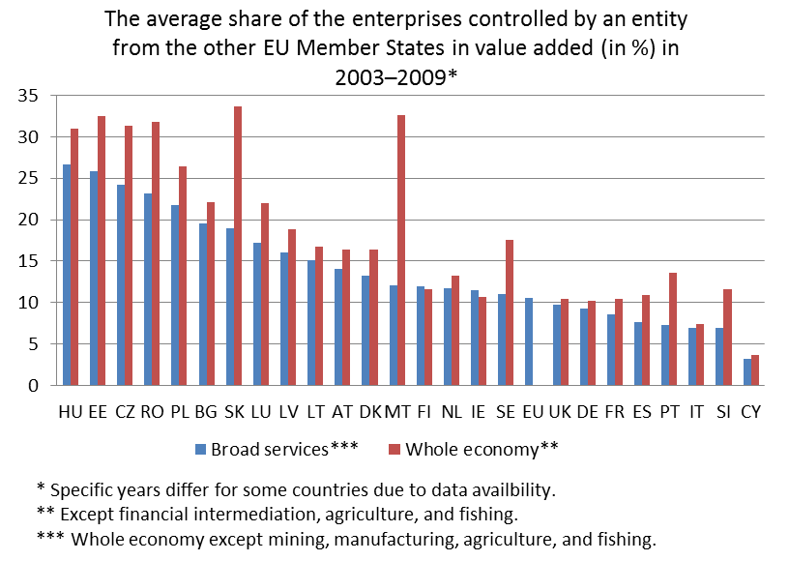
Data source: Eurostat
- The Commission's annual Consumer Markets Scoreboards indicate that the assessment of market performance by European consumers is usually higher for markets that are more integrated. The graph below shows that consumer assessment is lower in the less integrated services markets than in the goods market in almost all Member States.

Chart 6. Performance of goods and services markets as assessed by consumers
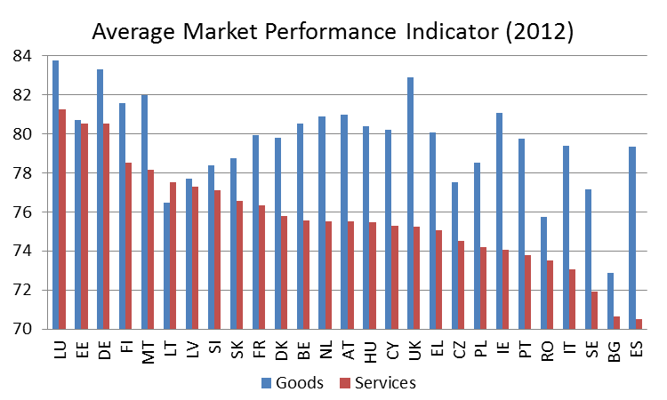
Source: Market monitoring survey 2012 (Commission, DG SANCO)

Capital

- Intra-EU investment is a key factor of integration through which companies establish their operations in other Member States. Cross-border investment is also one of the main modalities through which innovations are disseminated throughout the Single Market.

- After a long period of growth cross-border investment has collapsed with the financial crises and, contrary to cross-border trade, has not fully recovered since.

Chart 7. Evolution of intra-EU foreign direct investment (FDI)
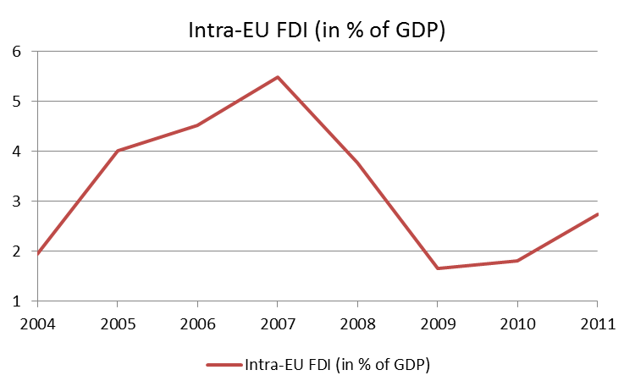
Data source: Eurostat
- Similar negative integration dynamics are noticeable on the financial markets. The crisis has significantly amplified market volatility, and indicators of financial integration reflect that volatility since 2007. The financial system, and the banking sector in particular, have started undergoing a process of restructuring in several countries. The possibility of national solutions implying a retrenchment of banks behind national borders cannot be excluded. This would, however, partly undo the significant benefits of European financial integration and endanger economic integration at large. Much can be gained if the changes are properly coordinated and encompassed in the new supervisory and regulatory frameworks developed at EU level.

Labour

- Although the number of EU nationals working in another Member State is growing, labour mobility across Europe is too low compared to the EU potential and not commensurate to what could be expected within a genuine single labour market. EU citizens economically active in another EU country represent only 3.1% of the EU labour force and the size of the annual increases is only around 0.1%.

- International comparisons also indicate that cross-border mobility between EU Member States is limited compared to other regions (such as United States, Canada or Australia). Although this can be partly explained by the very large linguistic diversity and various institutional frameworks, these comparisons still suggest that more scope exists for higher geographical mobility in the EU.

- According to a Eurobarometer study, 28% of working-age EU citizens would consider working in another EU country while 15% would not consider moving because of too many obstacles. More than half of Europeans consider language and family considerations as main obstacles to European citizens' mobility. Nevertheless, administrative barriers such as red tape, recognition of qualifications and social security are also quoted as reasons for people opting not to work in another EU Member State. Obstacles to labour mobility can also be caused by certain supplementary pension scheme rules, tax obstacles when moving to another Member States (obtaining allowances, tax relief, double taxation or higher progressive tax rates applied to non-residents) and the lack of awareness of many mobile workers of their rights and obligations.

- A recent Commission report also stressed the importance of macroeconomic drivers of mobility such as the relative income level differences, as evidenced by the poorest Member States having seen the largest net outflows of migrants; the role of this factor is expected to decline along with the progress of catching-up. The long-term differences in the levels of unemployment are other, though less evident, macroeconomic drivers. Besides, the report also highlighted social and cultural factors e.g. migrant community networks influencing migration patterns.

Triggers for growth and jobs in the Single Market

- In its Communication on better governance for the Single Market adopted in June 2012 the Commission recommends taking steps to unlock the Single Market potential in areas where such potential is the greatest. Based on a number of economic indicators, services, financial services, transport, digital market and energy have been identified as key areas for priority policy action and enhanced implementation of the Single Market.

- In parallel, it is also important to improve the functioning of the internal market for industrial products, inter alia by identifying gaps and barriers still blocking the free circulation of products and enhancing the quality and efficiency of product legislation. In addition the application of "mutual recognition" in the single market for goods must be monitored closely.

- The June Communication on better governance for the Single Market points at the need to have the Single Market rules properly transposed, implemented and enforced in order to deliver its full potential. It therefore sets ambitious targets for transposing and complying with EU legislation, in particular, but not exclusively, in the above key areas. The recent Internal Market Scoreboard shows some progress in particular with respect to the compliance deficit. However, the number of directives for which transposition is overdue by two years or more has increased.

- Regarding the key areas, the June Communication calls for a zero tolerance approach when it comes to transposing and implementing rules. It pleads for fast-track infringement procedures where problems remain. As the table in the Annex shows, we are not yet there. Only one Member State (DK) already complies with all the targets set in the June 2012 Communication, while more than half of the Member States have not reached more than three targets. The longest delays regarding transposition can be noted in energy while transport is an area where targets are missed almost systematically by most Member States.

- Member States should step up efforts to ensure that individuals and businesses can make effective use of their single market rights, by guaranteeing an effective application and enforcement of Single Market legislation by the national courts, and by offering good quality information, e-government tools and procedures and by investing in mechanisms to rapidly resolve problems. Much remains to be done in this area. For instance, the potential of SOLVIT remains under-used as a key problem-solving tool at national level (about 1300 cases a year), partly due to insufficient staffing in various SOLVIT centres.

- The June Communication also calls for swift delivery on the key actions to boost growth and confidence included in the Single Market Act.

The services markets

Market performance and obstacles to EU integration

- The Services Directive is the cornerstone of Single Market integration in the services area. A recent study estimates that additional gains from the Services Directive could be made if Member States were to increase their level of ambition in the implementation of the Directive. Indeed under an ambitious scenario, in which all Member States approached the average level of the five best countries in terms of barriers per sector (which is close to the elimination of all restrictions covered by the Services Directive) the economic impact could reach a 2.6% increase in GDP. To reap the growth potential of the Services Directive by 2015 the Commission presented an action plan in June this year.

The Services Directive contains some important, unequivocal obligations with which close to half of Member States still do not comply. For instance, some of them still have restrictions based on the nationality or the residence of the service provider (eg. MT and SE for patent agents, IT, CY and PL for some services in the tourism sector).

Regarding the application of the freedom to provide services clause of the Services Directive, Member States have mostly taken a conservative approach, and continue to treat cross-border service providers in the same way as established ones, thus exposing them to unjustified double regulation as they need to comply with both home and host country rules for instance in relation to professional insurance. Moreover, in several Member States there is uncertainty about which rules apply to service providers wishing to provide cross-border services on a temporary basis as opposed to service providers wishing to establish themselves (e.g. BG, FI, IE, IT, LV, PL, RO, SI, SE). This uncertainty can result in temporary service provision being treated as if it were establishment, thus imposing on providers a double regulatory burden, which equally hampers the cross-border provision of services.

- Services sectors include many professions that are regulated at national level. These regulations take the form of entry barriers (e.g. requirements reserving the exercise of certain activities to the holders of specific qualifications) and/or conduct barriers (i.e. restrictions to the exercise of professional activities such as requirements on companies' legal forms and capital ownership). In some Member States (BG, CY, DE, PL, SK, SI, SE), there are also remaining requirements fixing tariffs for certain professions (e.g. engineers/architects, accountants, tax and patent advisors or veterinarians).

Whilst the regulation of professions may be justified by public interests, it is highly heterogeneous across the EU: the number of regulated professions in each Member State varies between 47 and 368. Moreover, there are significant differences in the scope of reserved activities and in the level of qualifications required. In this context, country-specific recommendations (CSRs) have already been addressed to eight Member States in 2012 (AT, CY, FR, DE, IT, PL, SI, ES) on the need to reduce regulatory barriers in professional services. Some Member States (notably PL, PT, IT, ES, CZ) have initiated reforms in this area, with the objective to foster competition, simplify the business environment or reduce unemployment, in particular among young people.

- Effective governance tools are paramount to fully realising the integration potential of Single Market legislation in general and the Services Directive in particular. The Points of Single Contact (PSCs) and the Internal Market Information (IMI) system are among these important tools.

The situation as regards PSCs is very diverse among Member States. DK, EE, ES, LU, NL, SE, UK and LT have the most advanced PSCs whilst, in BG, EL, IE, RO and SI development is substantially lagging behind. In particular, there are large variations in the level of detail and user-friendliness of the information provided by the PSCs on the national rules for the main service sectors. Moreover, many administrative procedures can still not be completed online or by cross-border users.

The overall number of IMI information exchanges on services remains low. Nearly half of all exchanges were initiated by DE, which also has the highest number of authorities registered in IMI for services. BE, DK, EE, FI, IE, NL, RO and UK have not yet sent any requests in 2012. On the receiving end, PL, HU and UK have dealt with the most incoming requests for information.

- Among the services markets the sectors which have the most significant economic weight in terms of GDP and employment and above average growth potential are: business services (11.7% of EU value added in 2009), retail and wholesale trade (11.1%) and construction (6.3%).

- In many Member States, the business services sector is still characterised by heavy regulation. For instance, requirements limiting the free choice of company form and prescribing some kind of capital ownership can be an obstacle to the development of cross-border professional services. Some of such barriers have been made less stringent since the entry into force of the Services Directive (in PL, DE, FR, CY and IT), but others have not been affected (notably in AT, BE, BG, CZ, DK, FR, DE, IT, MT, PL, PT, RO, SK, SI and UK, the legal profession seems to be the most affected).

- The European retail and wholesale sectors are characterised by unequal levels of economic maturity and saturation of many markets. Competition in retail is hindered by remaining barriers such as burdensome legislation, which may have protectionist motivations, or disproportionate restrictions imposed on store formats. The 2012 country-specific recommendations have stressed the need to eliminate restrictions in the retail sector (BE, FR, HU, ES). Some Member States (ES) have already initiated reforms in this area. CSRs 2012 have also stressed more generally the need to strengthen competition in the retail sector (BE, DK, FI).

Some Member States require businesses to meet an “economic needs test”. These are tests that make the granting of an authorisation subject to (1) proof of the existence of an economic need or market demand, (2) an assessment of the potential or current economic effects of the activity (for example on established providers), or 3) an assessment of the appropriateness of the activity in relation to the planning objectives set by the competent authority as a pre-condition for establishment. These tests leave room for arbitrary decisions, unjustified restrictions and generate significant costs for business. Such requirements are prohibited under the Services Directive but are nevertheless still in place in RO, AT, EL, NL, HU and in certain regions of DE and ES.

Retail performance may also be affected by barriers to cross-border supply of goods. Retailers are not always free to source their goods at best prices all across Europe. There are indications of territorial supply constraints that prevent lower prices in some national markets (LU and BE), especially in the case of branded products.

- The development of a dynamic construction sector within EU borders is affected by businesses and professionals facing obstacles because of the lack of mutual recognition of authorisation schemes or the certification of experts providing specialised services e.g. in the area of environmental certification of buildings. For example, regarding authorisation procedures for energy efficiency certification providers, cross-border provision of services does not seem possible in BE, CY, LV, LT and MT.

- Public procurement is an important market for the service industry – in 2010, business opportunities in procurement covered by the EU rules amounted to around EUR 447 billion (3.7% of EU GDP), with service contracts accounting for about 42% of this total. However, only 3.5% of procurement contracts above the EU thresholds are awarded cross-border (in services this proportion is even lower i.e. 2%) and obstacles to integrated public procurement market remain. Better implementation of procurement rules in Member States could deliver significant efficiency gains. CSRs were addressed to 5 Member States in 2012 (BG, CZ, DK, HU and SK).

- Given the importance of public procurement, it is of particular concern that public authorities remain the worst payers in the European Union. The amount of written off debt in Europe has grown in 2012 to 2.8% of total receivables to the unprecedented level of €340 billion. The difference between northern and southern Member States is severely hampering the integration of the EU's single market. The 2011 Late Payment Directive, if properly implemented, will unlock €180 billion per year due the obligation for public authorities to pay within 30 days, thereby greatly improving the cash flow of businesses and helping them to overcome the economic crisis.

- From a consumer perspective, retail banking services remain the worst performing group of markets, notably on comparability of fees and conditions offered, choosing the best deal or switching to another provider. A robust EU framework ensuring consumer information, rights, means of redress and facilitating access to basic banking services will enable greater participation by all consumers, especially the vulnerable, in the retail banking sector.

Policy priorities

- Member States should focus on the following key priorities

- Make their legislation fully compatible with the Services Directive, in particular by complying with all its unequivocal obligations.

- Adopt a more ambitious approach in the implementation of the Services Directive by:
  - reviewing the necessity and proportionality of remaining requirements in particular those fixing tariffs for certain professions and those limiting company structures and capital ownership.

  - conducting a review of the application of the freedom to provide services clause in the key sectors i.e. construction, business services and tourism.

Such a review should take the form of a systematic peer review process assisted by the Commission and aiming at removing remaining unnecessary, unjustified and disproportional restrictions.

- Assess the justification of the requirements limiting both the access and the conduct of regulated professions, including the role of professional bodies, and remove or relax these requirements where they are unjustified. Such assessments should also include a review of the criteria for introducing new regulated professions.

- Strengthen competition in the retail sector by lowering barriers and reducing operational restrictions. In particular, remaining economic needs tests should be systematically abolished.

- Improve the Points of Single Contact to become fully-fledged e-government tools responding adequately to the needs of service providers and recipients. In particular, in order to improve their user-friendliness, the objective should be that the Points of Single Contact cover all procedures during the business life cycle and are multilingual.

- Transpose as early as possible the Late Payment Directive (the transposition deadline for Member States is 16 March 2013).

The energy markets

Market performance and obstacles to EU integration

- The GDP share of the energy sector in the EU has been increasing since 2000 and has exceeded 2½% in recent years. However, this indicator does not fully reflect the importance of this sector in the economy, which provides critical production inputs for all other sectors thus contributing significantly to their cost competitiveness.

- The internal energy market slowly but surely starts to bear fruit. Wholesale electricity prices in the EU have increased less than global primary energy prices and less than inflation. Wholesale gas prices have been noticeably lower in those Member States where markets work better. Gas supplies to retail consumers have been more resilient to temporary volume reductions by exporting countries thanks to more flexible infrastructure and clear price signals inside the EU.

- However, we are not there yet. The energy services (both gas and electricity) performed below the average in the most recent Consumer Markets Scoreboard, with electricity supply being among the 5 worst performing sectors (out of 30). In addition, energy markets are generally perceived not to be transparent or sufficiently open for newcomers.

- The lack of integration of the energy market is also illustrated by the fact that there is little convergence in retail prices for electricity and gas across the EU, with the price paid in the most expensive Member State representing several times the price paid in the cheapest. This is due to a number of reasons: price regulation in several Member States (BG, CY, DK, EE, FR, EL, HU, LT, MT, PL, PT, RO, SK, ES), a lack of diversity of supply, limited cross-border interconnection, differences in network costs, taxation and labour costs. Regulated prices fail to create a competitive environment in which the right type of investments take place. Instead, they are perceived by investors as an indicator of political interference which stifles investment. Moreover, prices regulated at a level below the market price can lead to tariffs that are economically unsustainable for suppliers, the cost of which is ultimately borne by consumers as a whole. In addition, regulated prices also fail to provide incentives for energy efficiency.

Member States have a diverging level of retail competition, the main market concentration indicator (HHI) is very high (above 5000) in EL, PT, EE, LT, LV, IT and FR. In Southern and Eastern countries switching rates are very low. In general, consumer assessment of electricity markets is low even in those Member States that have fairly liberalised energy markets, due to perceived lack of transparency and low satisfaction with customer service.

- As regards wholesale markets, price convergence is greater than in retail markets. Power market liquidity has increased in recent years, which has a positive impact on the functioning of the European wholesale electricity market and on competition. Market integration has also been strengthened by increasing market coupling (17 Member States have the system in place). The lack of market coupling prevents prices acting as effective signals for the direction of power flows between markets. This increased integration could explain why wholesale electricity prices in the EU did not follow the sharp increase in fossil fuel prices in the recent years.

- Considerable investment in energy infrastructure, such as transmission pipelines and electricity networks, storage and LNG projects is still needed to complete the internal gas and electricity markets and to address the security of supply. To this end, in 2012 CSRs have been addressed to 11 Member States (BG, DE, EE, ES, FR, HU, IT, LT, LV, MT and PL) regarding the need to increase electricity and/or gas interconnections. With electricity, the need for investment in generation reflects increasing demand for electricity and the binding renewables targets for 2020. Optimal use of renewables requires sufficient interconnection and smarter grids, including storage capacities and back-up generation infrastructure. Obstacles to investment relate to permit granting procedures in Member States, financing and regulatory framework. The Commission has launched a public consultation in November on security of supply in electricity and generation adequacy.

- The Third energy package is the cornerstone of the integration of the gas and electricity market. However there are delays in its transposition and enforcement. As of 25 October 2012, several Member States have not yet communicated full transposition of one or both of the Third energy package Directives. An examination of the measures notified by the Member States that have communicated full transposition has also been carried out and action will be taken in the case that transposition is considered incomplete. Further information is provided in the Annex. The smooth implementation of the legislation is encountering difficulties in a number of sensitive areas i.e.: (i) the unbundling of transmission networks, (ii) consumer protection issues (including the effective protection of vulnerable customers) and (iii) the independence and powers of the national regulatory authorities (NRAs) given that the independence requirements of the Directives are very strict.

- The swift adoption and implementation of the Energy Infrastructure Package and adoption of the first Union-wide list of Projects of Common Interest in energy infrastructure are of central importance for a future secure and affordable energy supply.

- As regards energy efficiency, the greatest energy saving potential lies in buildings, which have a 40% share in the European Union's total energy consumption. Reducing energy consumption in this area is therefore a priority under the energy efficiency part of the “20-20-20” climate and energy targets, as well as under the building milestone of the Roadmap for a Resource efficient Europe. The timely and adequate transposition and swift implementation on the ground of key legislation in this area is important in making these objectives a reality. The construction sector also has an important role to play in achieving these targets. New technologies offer a big potential, not only for new houses, but also for renovating millions of existing buildings to make them highly energy efficient.

Policy priorities
- In order to achieve integrated and well-functioning energy markets, Member States should focus on the following key priorities:

- Timely and comprehensive transposition of the third energy package directives and proper application of the third energy package regulations if they have not done so yet so as to fully reap the benefits for European consumers and businesses. Transpose and Implement the key legislation in the field of energy efficiency, in particular the Energy Efficiency Directive.

- Undertake an analysis of whether there is a lack of investment in generation, and why generation and consumption patterns are changing fundamentally. Member States should seek cross-border solutions to any problems they find before planning to intervene to avoid fragmentation of the internal energy market.

- Empowering consumers by enabling them to make informed choices and increasing the incentives for energy-efficient behaviour.

- Gradually phasing out regulated prices while ensuring robust competition and strengthening the protection of vulnerable consumers. Phasing out regulated prices would send the correct price signals needed to secure enough investment and enhance energy efficiency. In the longer run, this would provide consumers with more choice and sustainable market prices.

- Sector specific legislation and regulation need to be complemented by continued enforcement of competition rules in the energy sector in order to create more competitve and efficient energy markets.

The transport markets

Market performance and obstacles to EU integration

- The transport sector represents a key area for growth and competitiveness, not only due to its size (accounting for about 5% of EU total value added), but also due to its function in servicing the other sectors of the economy. Efficient and sustainable transport services, adequate infrastructures and modern technologies are a precondition for a well-functioning internal market and key to exploiting the strength of all regions.

- As a result of delayed action, transport, and more particularly some transport modes, are lagging behind other sectors in terms of market opening and overall performance. Not only is the extent of market opening heterogeneous across different transport modes (air, rail, road and sea), but also the achievement of a true internal market for transport services is still incomplete, and inadequate to cope with the evolving demand.

- Lack of integration is partly due to difficulties in adequate and timely transposition and implementation of the key legislation in this field (see the Annex), in particular in the area of road and railway transport and maritime safety. Application of internal market principles in the port sector, in particular restrictions to the freedom of establishment in ports, is also the object of much attention. In aviation, access to the ground handling market continues to pose problems in several Member States. The infringements relate in particular to market access difficulties for new entrants and to the tender procedures for the selection of providers which are not considered to be in line with EU law. This results in heterogeneous EU consumer assessment, with the airline services taking 5th (out of 30) place in the 2012 ranking of the service markets, whereas the railway services occupy only 27th position.

- The heterogeneous state of play in terms of market opening and competition is mirrored in the 2012 CSRs, namely recommendations to foster competition and facilitate market entry of new operators have been addressed to those Member States that are key players in the EU transport network (AT, BE, FR, DE and IT), while recommendations to strengthen administrative capacity and market regulation in the transport sector have been addressed to BG and PL. More generally, in several Member States there are still barriers to market entry and regulatory burden in transport markets, in particular in large and/or transit countries (DE, FR, IT, ES, and AT) which puts a brake on the EU economy, as a whole.

- The area where bottlenecks are still most evident is the internal market for rail services. Whereas markets for rail freight services have been fully opened to competition since 2007 and those for international passenger transport services as of 2010, domestic passenger transport remains largely closed to competition. Besides, the lack of competition to incumbent operators, which often enjoy a de facto monopoly situation on the national market, is one of the reasons explaining the low quality and efficiency of rail services, which is also reflected in very low consumer assessment of the market.

- Despite EU legislation granting access to rail freight and international passenger transport services markets, difficulties in the entry of new operators still persist, particularly in FR and in IT, while in DE the institutional set-up does not guarantee effective competition. The market opening process is most advanced in DK, SE, UK, which all enjoyed a rising market share for rail. SE and the UK are also the only Member States, together with DE, to award all public service contracts on the basis of competitive tendering.

- The provision of port services is still fragmented. For EU companies, port and terminal costs may represent up to 25% of the total door-to-door logistic cost. In countries like DE, the NL, FI or DK, ports contribute significantly to the overall logistic performance of the country in terms of time, cost, and reliability. On the other hand, poor connectivity, red tape and market entry barriers for private sector involvement - technical-nautical and cargo-handling services are often restricted to monopolies or to a few established operators - act as trade barriers in other European ports, in particular, in the Mediterranean, Black and Baltic Sea regions.

- In contrast to other transport modes, short sea shipping between Member State ports is often still considered as going beyond the external borders of the internal market, thus requiring extensive administrative procedures. Also, fair competition between ports calls for a level-playing field: information on funds that public authorities make available to any port should be transparent, as well as the conditions under which port authorities grant market access to service providers.

- So far, market opening has been very successful in aviation, where liberalisation in the 1990s led to an unprecedented growth in both the number of passengers flown and the number of routes served inside the EU, along with a significant decrease in airfares. However, Europe's airspace is still fragmented, which brings extra costs to both airline companies and customers, and is a source of economic inefficiency. In this respect, the completion of the Single European Sky is one of the key elements for achieving a single European transport area. In particular, the creation of genuine Functional Airspace Blocks would defragment Europe’s airspace and optimise its air navigation service provision very significantly. Besides, consolidation of supply, if fully compliant with competition rules and principles applicable to merger and alliances, can contribute to increasing economic efficiency of the airline sector.

- Market opening has been very successful in international road transport. International road haulage increased by 35% in 2000–2010 (compared to 8% growth in the national haulage market). However, a number of significant cabotage restrictions remain and prevent an optimal matching of transport supply and demand.

- The inland waterway transport market has been liberalised since the 1990s. Competition on the inland waterways has intensified and the freight prices decreased. However, barriers still remain with respect to access to the profession.

Policy priorities
- In order to remove those bottlenecks that prevent the completion of a true internal market for transport, Member States should focus on the following key priorities:

- Ensure a timely and high-quality transposition of the transport acquis, in particular in the area of road, railways and maritime safety.

- Open domestic rail passenger services to competition and ensure that the institutional set-up allows effective competition in railway markets ensuring equal access to infrastructure.

- Remove red tape and market entry barriers in the port services sector (especially in the case of Mediterranean, Black and Baltic Sea regions).

- Accelerate the implementation of the Single European Sky (e.g. progressing in the implementation of Functional Air Blocks) to improve safety, capacity, efficiency and the environmental impact of aviation.

- Allow more cabotage opportunities for foreign road hauliers.

2.4. The digital markets

Market performance and obstacles to EU integration

- Internet, and in particular broadband Internet, provides the platform for the huge growth potential of applications such as eCommerce and cloud computing: a 10 percentage points increase in high-speed Internet is estimated to lead to an annual growth in per capita GDP of some 1-1.5percentage points.

- The continued growth in broadband has been possible in particular thanks to increasing levels of competition brought about by the implementation of the EU regulatory framework for electronic communications, with a corresponding reduction in the retail prices of services. The new operators sold two thirds of all the new fixed lines in 2011. This being said, persistent price differentials between Member States indicate the internal market in this sector is still incomplete.

- The availability of infrastructure for broadband Internet is another important factor for the development of the digital economy. The broadband gap, a measurement of the dispersion of penetration and take-up rates between EU countries, continued to decline. Coverage of rural areas remains a challenge in particular in PL, BG, DE and SI. While growth in the overall number of broadband connections is slowing down, the trend towards higher speeds is clear and speeds have increased significantly.

- In addition to ensuring ubiquitous coverage, it is important that Member States continue promoting effective investments in fast and ultrafast broadband in line with the performance targets set in the Digital Agenda. This requires providing adequate investment incentives, in particular a predictable and effective regulatory framework anchored on strong and independent regulators, and targeted public support, where appropriate.

- The mobile sector is the most competitive segment of the overall telecoms market. Mobile broadband surged in 2011 with penetration reaching 43% of the population in January 2012 from 26.8% in January 2011, with wide differences among the Member States. The market shares of both the leading and the second operators have been slightly declining. High levels of concentration however are still observed in CY, (only two operators), followed by LU and SI. In addition, certain parts of the mobile market (i.e. roaming) have been largely impervious to competition, requiring legislative intervention to secure structural reform.

- However, the expected exponential growth will only be possible as long as sufficient spectrum is available. Given current growth rates of services and thus of spectrum usage, Member States must make the full amount of harmonised spectrum available, and ensure its efficient use. Regarding the 800 MHz band, this concerns BE, BG, CZ, EE, EL, ES, CY, LV, LT, HU, MT, AT, PL, RO, SI, SK, FI and UK. While a number of these Member States have applied for derogations, every effort must be made to clear the band and make it available for wireless broadband as rapidly as possible.

- Whilst the ‘internet economy’ in the EU-27 is expected to grow from 3.8% of GDP in 2010 to 5.7% in 2016, progress in cross-border e-commerce remains very low. In 2011, only 10% of the total EU population ordered goods or services from sellers from other EU countries. Moreover, the more developed countries in cross-border e-commerce are progressing much faster than the less developed ones, creating an ever wider gap.

- The low use of cross-border e-commerce by individuals is matched by the limited number of enterprises selling cross-border electronically. In 2010, only 6% of enterprises engaged in e-commerce made e-sales to other EU countries, including in the countries with the highest share of firms involved in e-commerce. The EU is still missing out on the big benefits of e-commerce. This leads to a total loss of potential cross-border trade of 26 billion euros each year. Accordingly, significant welfare gains for European consumers from lower online prices and increased online choice could be brought by enhanced integration of e-commerce in the EU.

- Although consumers appreciate the convenience of shopping anytime and anywhere via the e-commerce sales channel and getting access to information and a broader selection of products, not all users who take advantage of informing themselves over the Internet about available goods or services finally purchase the products online. Reasons include lack of trust or information, privacy and/ or security concerns and concerns about getting redress in case something goes wrong.The Commission has taken a number of initiatives to address these concerns. For instance the new Consumer Rights Directive (CRD), which will become applicable from 13 June 2014 at the latest, will strengthen consumers' rights when buying on the Internet thereby encouraging legitimate e-commerce. The proposal for ADR-ODR legislation aims to ensure that quality alternative dispute resolution tools are effectively put in place and work in practice and that an EU-wide on-line platform is established for cross-border e-commerce complaints. A proposal for a Regulation on a Common European Sales law has been tabled with the aim to give traders the option to sell their products to citizens in other Member States on the basis of a single set of contract law rules, based on a high level of consumer protection.

- Another key obstacle to cross-border e-commerce is delivery. This is a key element for building trust between sellers and buyers. To address this barrier, a Green paper on an integrated parcel delivery market will launch a wide-ranging consultation and will be followed by a set of actions with the view to support the growth of e-commerce in the EU.

- In these times of austerity, eGovernment has the potential to substantially improve the way in which public services are provided and yield considerable public savings, and also reduce costs for business. A full transition to e-procurement in the EU could deliver savings in public expenditure of up to €100bn. E-procurement can also increase the share of cross-border procurement. However, the use of electronic procedures in public procurement remains limited at 5% to 10%. Some Member States have nevertheless made significant progress towards full use of e-procurement, i.e. PT (mandatory for most procedures) and LT (75% in 2011). By contrast, electronic submission of tenders is currently not implemented in BG and SI. Generally on eGovernment, AT, DK, EE, SE are well advanced, whilst other are currently lagging behind in this area i.e. SI, BG, RO, IT, PL HU.

- ICT skills are a prerequisite for firms and citizens to fully seize the growth and employment opportunities brought by the digital economy. The EU faces a shortage of ICT professionals: it is estimated that there will be up to 700 000 unfilled ICT practitioners' vacancies in the EU by the year 2015. Despite the economic downturn demand for ICT specialists is growing by 3% per year. In addition, ICT skills are needed throughout the economy and have become a precondition for business performance and employability. This challenge has been well addressed in SE, LV, DK, LU and FI.

Policy priorities

- Member States should focus on the following key priorities:

- Step up efforts in the deployment of fixed and wireless broadband and in improving its quality. This investment requires putting in place adequate incentives, both in terms of efficient regulation and, where necessary, targeted public support (e.g. via the Structural Funds and, in the next MFF, CEF) bringing the radio spectrum available for wireless broadband to 1200 MHz of bandwidth and effectively licensing the spectrum bands already harmonised including the 800 MHz band.

- Ensure the correct application of the E-commerce Directive. Applying harmonised rules on issues such as transparency, information requirements and electronic contracts will contribute to restoring legal certainty for business and consumers.

- Ensure timely and correct transposition in national law (due by 13 December 2013) and subsequent implementation of the Consumer Rights Directive to enhance consumer protection and therefore reinforce confidence and trust in the e-commerce sales channel.

- Increase the availability of user-friendly on-line public services, including through cross-border interconnection and infrastructures (notably with the support of the Connecting Europe Facility), making eProcurement interoperable and mandatory and reinforcing the introduction of eHealth for more efficient public health systems.

- Invest in ICT training, notably with the use of ESF, and adopt an eCompetence Framework to ensure sufficient qualifications among the workforce for modern business practices.

Annex:

European Commission Communication "Better Governance for the Single Market", COM(2012)259 final
These sectors were also identified among the most problematic for consumers and with the biggest impact on household budgets in the recent European Consumer Agenda.
Measured as depreciation of real effective exchange rate with unit wage cost in manufacturing as a deflator. See: http://ec.europa.eu/economy_finance/db_indicators/competitiveness/data_section_en.htm
Since neither price competitiveness nor foreign demand explain its trade evolution well, though non-price competitiveness is hardest to measure.
Exports allow financing imports and there is a sizeable input of imports in exports, especially with the rapidly increasing role of international production chains.
Integration and competitiveness appear to be mutually supportive, creating virtuous circles, through e.g. higher competitive pressure and access to better or cheaper production inputs.
There is indeed a high positive correlation (0.8) between the EU trade and extra-EU trade (measured as annual average change in percentage points of GDP) across the Member States
However, the tradability of services is increasing thanks to the rapid development of the information and communication technologies (ICT).
Eurostat Foreign AffiliaTes Statistics (FATS). The data is currently available until 2009.
8th Consumer Markets Scoreboard, 2012, Commission, DG SANCO.. This assessment is supported by the high negative correlation between the EU average levels of consumer assessment of market performance and the dispersion of this indicator across the internal market. The dispersion is a proxy for integration since more integrated markets are expected to exhibit more similar levels of consumer assessment. The average level and the dispersion (variance) are calculated for several goods and services sector (i.e. across the Member States). The negative correlation between the dispersions and the average levels is then observed across the sectors.
See for instance OECD, Economic survey of the EU, 2012
Special Eurobarometer 363, http://ec.europa.eu/public_opinion/archives/ebs/ebs_363_en.pdf
European Commission (DG EMPL), “Employment and Social Developments in Europe 2011”, December 2011. http://ec.europa.eu/social/main.jsp?catId=738&langId=en&pubId=6176&type=2&furtherPubs=no
European Commission Communication "Better Governance for the Single Market", COM(2012)259 final
Financial services sector is not reviewed in the present report. However, part of the relevant legislation selected in this sector included in the June Communication is taken into consideration in the annex.
The methodology and criteria for defining the key areas are presented in the annex to the Commission Communication "Better Governance for the Single Market", COM(2012)259 final
First Report on the application of the Mutual Recognition Regulation http://ec.europa.eu/economy_finance/publications/economic_paper/2012/ecp456_en.htm
The transposition deficit (percentage of Internal Market directives not yet notified to the Commission in relation to the total number of directives that should have been notified by the deadline) has decreased from 1.2% in November 2011 to 0.9% in May 2012; the compliance deficit (number of directives transposed where an infringement proceeding for non-conformity has been initiated by the Commission) has decreased from 0.8% in November 2011 to 0.7% in May 2012 (source: Internal Market Scoreboard nº 25, September 2012 http://ec.europa.eu/internal_market/score/docs/score25_en.pdf).
Annual governance check-up 2011 "Making the single market deliver", February 2012, http://ec.europa.eu/internal_market/score/docs/relateddocs/single_market_governance_report_2011_en.pdf
European Commission Communication: "Single Market Act. Twelve levers to boost growth and strengthen confidence. Working together to create new growth", COM(2011)206 final.
http://ec.europa.eu/economy_finance/publications/economic_paper/2012/ecp456_en.htm
The countries which re-appear most frequently in the groups of sector-specific “best five” countries covered by the analysis are: Slovakia, the UK, DK, IE, FI and ES
Calculated as an additional 1.8% of GDP on top of the effects of already implemented barrier reductions estimated at 0.8% of GDP
European Commission Communication on the implementation of the Services Directive "A partnership for new growth in services 2012-2015", COM(2012) 261 final
These unequivocal obligations are listed in the European Commission Communication on the implementation of the Services Directive. "A partnership for new growth in services 2012-2015", COM(2012) 261 final
"Reserved activities" are economic activities reserved to the holders of specific professional qualifications, who benefit from exclusive rights to exercise these activities and offer the related services.
http://ec.europa.eu/internal_market/publicprocurement/docs/indicators2010_en.pdf
Study on "Cross-border procurement above EU thresholds" http://ec.europa.eu/internal_market/publicprocurement/docs/modernising_rules/cross-border-procurement_en.pdf
It takes an average of 91 days for B2B transactions to be paid in the southern region, as compared to an average of 31 days in the north
Directive 2011/7/EU of 16 February 2011 on combating late payment in commercial transactions.
8th Consumer Market Scoreboard, 2012, Commission, DG SANCO.
This includes the proper implementation of the 2008 Consumer Credit Directive and the forthcoming legislative initiative on transparency and comparability of bank account fees, switching of bank accounts and access to a basic payment account.
Here the sector is approximated as NACE Rev. 1 “E: Electricity, gas and water supply”.
On 15 November 2012, the European Commission presented a Communication assessing the state of play of the internal energy market, "Making the internal energy market work", COM (2012)663
8th Consumer Markets Scoreboard, 2012, European Commission, DG SANCO
European Commission Communication "Making the internal energy market work", COM(2012)663
The HHI (Herfindahl-Hirschman Index) is a commonly accepted measure of market concentration. It is calculated by squaring the market share of each firm competing in the market and then summing the resulting numbers (the higher the index, the more concentrated the market). Moderate concentration: 750–1800; high concentration: 1800–5000; very high concentration: above 5000. For more information, please see Commission Staff Working Document "Energy Markets in the European Union in 2011" SWD (2012) 368, part 2
“The functioning of retail electricity markets for consumers in the European Union”, Study on behalf of the European Commission, DG SANCO, 2010.
Market coupling optimises interconnection capacity and ensures that electricity flows from low price to high price areas by the automatic linking of supply and demand on either side of a border.
Directives 2009/72/EC and 2009/73/EC
Proposal for a Regulation on guidelines for trans-European energy infrastructure COM/2011/658, and Proposal for a Regulation on the Connecting Europe Facility covering Energy, Transport and Telecommunication infrastructure (2014-2020), COM(2011)665
European Commission Communication "Roadmap to a Resource Efficient Europe", COM(2011)571 final
8th Consumer Markets Scoreboard, 2012, Commission, DG SANCO. These findings are also confirmed by the World Bank's Logistics Performance Index.
World Bank - Logistic Performance Index, Connecting to Compete (2012).
Transport of goods and passengers between two points in the same country by a vehicle registered in another country.
Czernich, N., Falck, O., Kretschmer, T., and Woessman, L. (2009) Broadband infrastructure and economic growth (CESinfo Working Paper no. 2861. The estimate is based on a panel of OECD countries over 1996-2007.
Although Germany has a low rural coverage of fixed broadband, it has the highest rural coverage of fourth generation mobile broadband (LTE), at 41% as of December 2011. Moreover, LTE spectrum license obligations target 90% of population residing in the "white gaps" (i.e. areas where the download speed of broadband services is less than 1Mbps).
Mobile broadband is most popular in the Nordic countries, where penetration is above 80%. Four Member States (RO, BU, HU, BE) have a mobile broadband penetration rate lower 20%
https://www.bcgperspectives.com/content/articles/media_entertainment_strategic_planning_4_2_trillion_opportunity_internet_economy_g20/
Preliminary results of very recent surveys indicate a significant improvement in this area lately.
Civic Consulting (2011)
Eurobarometer (299/2011)
Directive 2011/83/EU of 25 October 2011 on consumer rights, amending Council Directive 93/13/EEC and Directive 1999/44/EC of the European Parliament and of the Council and repealing Council Directive 85/577/EEC and Directive 97/7/EC of the European Parliament and of the Council
Proposal for a Directive on alternative dispute resolution for consumer disputes, COM(2011)793 final of 29 November 2011; Proposal for a Regulation on online dispute resolution for consumer disputes, COM(2011)794 final of 29 November 2011.
Proposal for a Regulation on a Common European Sales Law, COM (2011) 635 final
European Commission Communication: "A strategy for e-procurement" COM(2012)179 final
European Commission Communication: "A strategy for e-procurement" COM(2012)179 final
Report for the European Commission "Anticipating the Evolution of the Supply and Demand of e-Skills in Europe (2010-2015)" Empirica and IDC Europe, December 2009.
European Commission Communication "A European Consumer Agenda - Boosting Confidence and Growth", COM(2012) 225 final
Proposal for a Regulation establishing the Connecting Europe Facility, COM(2011)665 final

