REPORT FROM THE COMMISSION TO THE EUROPEAN PARLIAMENT AND THE COUNCIL
Quality of petrol and diesel fuel used for road transport in the European Union:
Ninth annual report
(Reporting year 2010)

Executive Summary
Directive 98/70/EC sets minimum technical specifications on health and environmental grounds for fuels to be used for vehicles equipped with positive-ignition and compression-ignition engines. Fuel quality is environmentally important because it affects engine pollution emissions and thus air quality. It also affects the ease and cost with which desired pollution and greenhouse gas emission limits can be achieved by manufacturers.
Non-respect of the fuel specification can lead to increased emissions (for example excess oxygenates can increase NOx emissions) and might damage engine and exhaust after-treatment systems (for example excess sulphur damaging catalysts) leading to greater air pollution. In order to ensure compliance with the fuel quality standards mandatory under this Directive, Member States are required to introduce fuel quality monitoring systems.
Article 8 of Directive 98/70/EC requires the Commission to publish an annual report on fuel quality in the Member States. This ninth Commission Report summarises Member States’ submissions on the quality of petrol and diesel, as well as the volumes sold, for 2010. All Member States submitted a full report for 2010. Some Member States reported later than the required deadline of 30 June.
The timeliness of the submission of reports was slightly worse than in 2009, 17 Member States submitted their 2010 report before the annual deadline, of the remaining 10 reports 5 were received 3 months or more after the reporting deadline.
Fuel quality monitoring data in 2010 showed that the specifications for petrol and diesel laid down in Directive 98/70/EC were in general met and few exceedances were identified. For petrol the main parameters where exceedances were identified were research/motor octane number (RON/MON), summer vapour pressure, distillation/evaporation at 100/150°C and the maximum sulphur content. For diesel the main parameters where exceedances were identified were sulphur content, distillation 95% point and cetane number.
As exceedances are relatively rare, and most Member States take action to remove non-compliant fuel from sale, the Commission is not aware of any negative repercussions on vehicle emissions or engine functioning. However, the Commission urges Member States to continue to take action to ensure full compliance so that such problems do not arise in the future.
Low sulphur content helps reduce air pollution and the introduction of new engine technology. A new specification for automotive road fuels came into force on 1 January 2009 which limits the sulphur content of all automotive road fuels in the EU to 10 ppm (sulphur-free fuels). This represents the second year of reporting since this requirement came into force and the average sulphur continued below this level in 2010, as shown in Table 1:
Table 1: Annual trend in average sulphur content in petrol and diesel fuels
EU | Average sulphur content, ppm*
Fuel/Year | 2002 | 2003* | 2004* | 2005* | 2006** | 2007*** | 2008*** | 2009*** | 2010
Petrol | 51 | 37 | 38 | 19 | 18 | 18 | 14 | 6 | 6
Diesel | 169 | 125 | 113 | 25 | 22 | 23 | 18 | 8 | 7.5
*Excludes France, which did not report in 2003 – 2005.
**Excludes Malta, which did not report in 2006.
***Excludes Luxembourg, which did not report in 2007, 2008 or fully in 2009.
National fuel quality monitoring systems still differ considerably. However, the Directive's requirements are expected to promote homogeneity and to improve the quality of reporting.
2. Introduction
The specifications for petrol and diesel sold in the European Union are laid down in the Directive 98/70/EC. The Directive requires Member States to report summaries of the quality of fuels sold in their territories. From 2004 onwards, Member States are required to report their monitoring in accordance with European Standard, EN 14274, or with systems having an equivalent degree of confidence. Article 8 of Directive 98/70/EC, as amended by Article 1(5) of Directive 2003/17/EC, requires the Commission to publish the results of Member States’ fuel quality reporting. In compliance with this request, this ninth Commission Report summarises the quality of petrol and diesel, as well as the volumes sold, in the EU for the year 2010. Previous years' reports can be found on the Commission's web pages.

3. National monitoring systems
Commission Decision 2002/159/EC and European Standard EN 14274, have enhanced the usefulness of the information and facilitated analysis of EU fuel trends. The quality of the monitoring systems’ design, compliance with limit values and information provided in submissions is continuing to improve. However, there are still a few key areas for improvement, summarised as follows:
Member States are encouraged to continue to improve the timeliness of the submissions.
Several Member States do not complete sufficient sampling for all fuels or are not sampling sufficiently at service stations (as opposed to depot/refinery) to meet the requirements of EN 14274, see Table 4.
Where Member States use their own national monitoring systems, they should be fully described in order to be able to verify whether they comply with the European Standard. This description should show the monitoring system’s equivalency in statistical confidence to EN 14274.
Member State reports are assessed according to the appropriate seasonal periods to ensure comparability for EU-wide reporting. Where a Member State has chosen to use a different seasonal period to that specified, appropriate information should be provided in the national annex within the Fuel Quality Monitoring report.

4. 2010 Reporting
4.1 Fuel qualities and volumes
In contrast to previous years, the new sulphur content limit of a maximum of 10 ppm (introduced in 2009) for all automotive road fuels has precipitated a switch from RON 95 (<50 mg/kg) to RON 95 (<10 mg/kg) petrol. Concerning the octane number, the majority 67% of petrol sales in 2010 comprised RON 95. Of the remainder, 27% was 95=<RON<98, RON 98 was around 5% and RON 91 at 1% of the total sales.
Figure 1: 2010 EU fuel sales proportions by fuel type (%)*
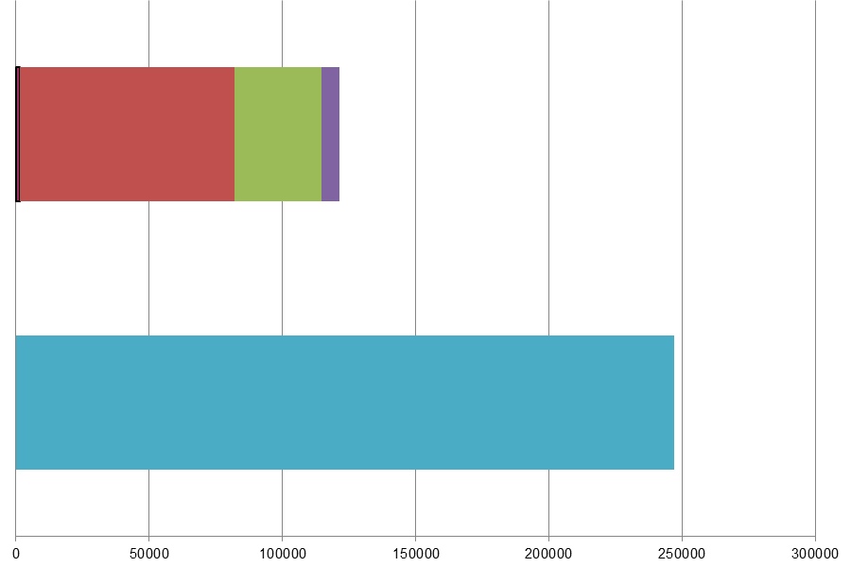
Million litres
 |  |  | RON=91 |  |  | RON = 95 |  |  | RON 95=<RON<98 |  |  | RON 98 |  |  | Diesel
Table 2: 2010 Summary by fuel type
Fuel grade | Million litres | EU market share
Unleaded min. RON=91 | 1,618 | 1%
Unleaded min. RON=95 | 80,308 | 67%
Unleaded 95≤RON<98 | 32,898 | 27%
Unleaded RON≥98 | 6,409 | 5%
Total petrol | 121,233 | 100.0%
Diesel (<10 ppm S) | 246,841 | 100.0%
Total diesel | 246,841 | 100.0%
Temporal trends in EU fuel sales
Figure 2 illustrates the evolution of the fuel consumption in the EU for the last 10 years and shows a clear increase in the consumption of diesel compared to petrol.
Figure 2: evolution of fuel consumption in the EU
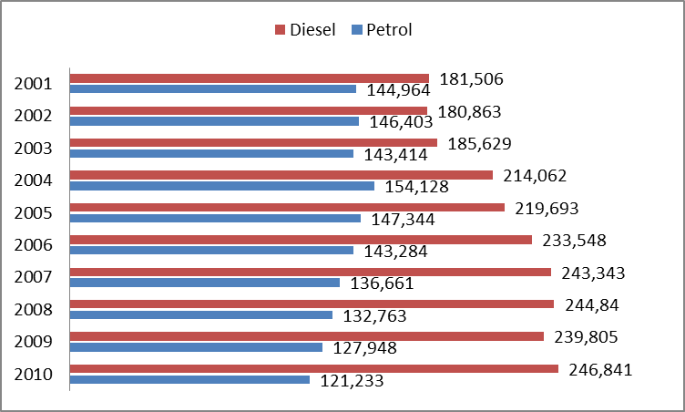
Million litres
Excludes France in 2003 - 2005, as no submissions were provided; excludes Luxembourg in 2007 to 2009 and Malta in 2006 and 2009 when no reports were provided.
EU27 Fuel Sales by type
Table 3 shows fuel consumption per type and Member State for 2010:
Table 3: Fuel consumption per type and Member State
Fuel Type | Petrol Sales  (million litres) |  |  |  |  | Diesel Sales  (million litres)
Member State | min. RON=91 | min. RON=95 | 95≤ RON <98 | RON ≥98 | Total Petrol | Total Diesel
Austria | 150 | - | 2,251 | 64 | 2,465 | 7,437
Belgium | - | 1,251 | - | 363 | 1,614 | 7,733
Bulgaria | - | 847 | - | - | 847 | 2,168
Cyprus | - | 479 | - | 47 | 526 | 428
Czech Rep. | 5 | - | 2,459 | 49 | 2,513 | 4,637
Denmark | 517 | 1,570 | - | 3 | 2,090 | 3,101
Estonia | - | - | 338 | 33 | 371 | 572
Finland | - | 2,075 | 162 | - | 2,237 | 2,790
France | - | 8,677 | - | 2,202 | 10,879 | 39,749
Germany | 943 | - | 24,901 | 740 | 26,584 | 38,356
Greece | - | 4,634 | 220 | 153 | 5,007 | 2,977
Hungary | - | 1,743 | - | 47 | 1,790 | 3,274
Ireland | - | 1,974 | - | - | 1,974 | 2,672
Italy | - | 11,678 | - | - | 11,678 | 30,238
Latvia | - | - | 347 | 29 | 376 | 801
Lithuania | - | 385 | - | 9 | 394 | 1,190
Luxembourg | 1 | 373 | - | 92 | 466 | 1,894
Malta | - | - | 91 | 10 | 101 | 120
Netherlands | - | 5,496 | - | 75 | 5,571 | 7,634
Poland | - | 5,138 | - | 513 | 5,651 | 13,896
Portugal | - | - | 1,703 | 187 | 1,890 | 5,898
Romania | - | - | 1,274 | 793 | 2,067 | 4,997
Slovakia | - | 781 | - | 19 | 800 | 1,281
Slovenia | - | - | 660 | 79 | 739 | 1,419
Spain | - | 6,908 | - | 766 | 7,674 | 31,540
Sweden | - | 4,394 | - | 138 | 4,532 | 5,164
UK | - | 19,444 | 953 | - | 20,397 | 24,875

Table 3 shows the volume of fuel sales per Member State by fuel type. Some general trends can be noted:
- Diesel dominates the market in all but two of the Member States.
- Belgium demonstrates the heaviest dependence on diesel which dominates fuel sales having 82.7% share of the market – the highest proportion of all the Member States.
- The greatest volume of fuel sales in 2010 took place in Germany, with 17.6 % of total EU fuel sales and a petrol/diesel share of 21.9% petrol and 15.5% diesel. The next biggest market was the France with a 13.8% share of EU petrol and diesel fuel sales of 9.0% and 16.1% respectively while UK fuel sales totalled 12.3% of all fuel sales with a breakdown of 16.8% (petrol) and 10.1% (diesel).
Similar to the period from 2001 to 2009, France, Germany, Italy, Spain and the United Kingdom had the greatest volume of fuel sales in 2010.
Since 2001 there has been increased homogeneity in the types of grades of fuel reported to be available across the EU. Petrol distinction between grades has mainly resulted from different octane levels (RON category). In 2010, only six Member States reported three petrol grades available, with the remainder reporting two petrol grades (no Member State has reported the availability of only one petrol fuel grade).
Before 2009, two diesel grades were available for use in automotive road vehicles: low sulphur and sulphur free (i.e. concentrations of. less than10 ppm sulphur). As expected, and confirmed by the 2010 data, all Member States have transitioned to 100% sulphur free diesel fuels in accordance with the mandatory sulphur content limit, hence, the number of grades of diesel has recede to one.
5. Sampling and reporting
There are detailed requirements in EN 14274 on the number and location of samples to be taken and reported in Member States' fuel quality reports. EN 14274 lists a number of factors to be taken into account when assessing the sampling regime: such as the number of refineries supplying the market, the number of fuel grades available and the number of different imported fuel grades and sources. The standard specifies a minimum number of samples per fuel grade in each of the winter and summer periods. In previous years, there was some uncertainty in Member States about the sampling requirements – however sample quantities and the division of reporting between summer and winter periods have improved in recent years.
Table 4 provides a breakdown of individual Member States sampling and reporting in 2010. The total minimum samples required is calculated where the Member State has used a statistical model as outlined in EN 14274, given that the minimum sample requirement is known for each model. The table also provides a breakdown of the total samples taken and the sampling carried out at service stations. Not all Member States provided this breakdown in 2010 (Sweden, the UK, Spain, Germany and Latvia). EN 14274 specifies that the minimum sampling requirement should be taken from fuel dispensing sites – which are defined as a “site, retail or commercial where fuel is dispensed into road vehicles for propulsion.” Therefore any sampling taken at distribution terminals or refineries should be taken in addition to those from service stations in order to meet minimum sampling requirements.
Where Member States have reported using a "national monitoring system" – an assessment has been made of the equivalent minimum sample requirements on the basis of the size of the country, and other details provided. Where the location of samples is known – it is possible to determine whether sample quantities demonstrate compliance with EN 14274.
Seven Member States (either using a system based on EN 14274 or a national monitoring system) failed to fully comply with the requirements of the standard. This was due to the locations where samples were taken and also the number of samples collected; however, those problems do not compromise the effectiveness and creditability of the results reported to the Commission.
The Commission is currently working with the Member States to clarify the reasons for those deviations and trying to guarantee that this situation will be improved in the future.
Table 4 details the minimum sample number required to be taken from service stations for Member States to have demonstrated compliance with the Directive.
Table 4: Summary of Member State sampling and reporting in relation to the requirements of Directive 98/70/EC and of European Standard EN 14274
MS |  | FQMS Model (1) | Size (2) | Separate S&W? (3) | Samples per grade per period (4) |  | Total samples required (5) |  | Samples Taken (6) |  | Samples Taken at Service Stations (7)
 |  |  |  |  |  |  | Pet. | Dsl. | Pet. | Dsl. | Pet. | Dsl.
Austria | AT | C | S | ✓ |  | 50 | 102 | 100 | 203 | 100 | 203 | 100
Belgium | BE | N | S | ✓ |  | 100 | 400 | 200 | 2133 | 4985 | 2133 | 4958
Bulgaria | BG | B | S | ✓ |  | 100 | 200 | 200 | 427 | 468 | 418 | 456
Cyprus | CY | C | S | ✓ |  | 50 | 100 | 100 | 293 | 167 | 149 | 167
Czech Republic | CZ | C | S | ✓ |  | 50 | 101 | 100 | 747 | 877 | 747 | 877
Denmark | DK | N | S | ✓ |  | 50 | 201 | 100 | 42 | 22 | 42 | 22
Estonia | EE | C | S | ✓ |  | 50 | 103 | 100 | 350 | 200 | 350 | 200
Finland | FI | A | S | ✓ |  | 50 | 103 | 100 | 185 | 162 | 140 | 117
France | FR | B | L | ✓ |  | 200 | 416 | 400 | 827 | 395 | 827 | 395
Germany | DE | N | L | ✓ |  | 200 | 405 | 400 | 417 | 305 | - | -
Greece | EL | A | S | ✓ |  | 50 | 105 | 100 | 250 | 120 | 29 | 17
Hungary | HU | C | S | ✓ |  | 50 | 101 | 100 | 120 | 120 | 120 | 120
Ireland | IE | C | S | ✓ |  | 50 | 100 | 100 | 144 | 126 | 92 | 92
Italy | IT | A | L | ✓ |  | 100 | 200 | 200 | 200 | 200 | 100 | 100
Latvia | LV | N | S | ✓ |  | 100 | 400 | 200 | 438 | 674 | - | -
Lithuania | LT | C | S | ✓ |  | 50 | 101 | 100 | 101 | 100 | 97 | 95
Luxembourg | LU | C | S | ✓ |  | 50 | 104 | 100 | 47 | 75 | 43 | 71
Malta | MT | N | S | ✓ |  | 100 | 209 | 200 | 49 | 43 | 39 | 30
Netherlands | NL | A | S | ✓ |  | 50 | 100 | 100 | 100 | 100 | 100 | 100
Poland | PL | B | L | ✓ |  | 200 | 408 | 400 | 291 | 229 | 291 | 229
Portugal | PT | N | S | ✓ |  | 100 | 209 | 200 | 236 | 118 | 200 | 100
Romania | RO | B | S | ✓ |  | 100 | 400 | 200 | 360 | 210 | 360 | 210
Slovakia | SK | C | S | ✓ |  | 50 | 101 | 100 | 168 | 137 | 168 | 137
Slovenia | SI | C | S | ✓ |  | 50 | 103 | 100 | 149 | 181 | 145 | 115
Spain | ES | N | L | ✓ |  | 200 | 409 | 400 | 520 | 264 | - | -
Sweden | SE | N | S | ✓ |  | 100 | 203 | 200 | 553 | 620 | - | -
UK | UK | N | L | ✓ |  | 200 | 404 | 400 | 2195 | 2428 | - | -

6. Compliance with Directive 98/70/EC in 2010
6.1 Petrol
In 2010, most Member States provided full information about petrol sample compliance. In order to determine compliance, it is necessary to know which test method has been used to test for some parameters (because reproducibility and tolerance levels differ according to test method). Provision has been made for Member States to give this information within the reporting template – although this is not a mandatory part of the reporting it is vital to determine compliance levels. In 2010 11,531 samples were collected for petrol and 13,391 for diesel.
The parameters found to be out of specification most frequently within the Union in 2010 were:
- Summer vapour pressure was exceeded 215 times in 2010 or 1.85% of the total samples. However it is becoming apparent that many exceedences are the result of transitional fuels when suppliers swap the summer specification fuel for winter specification fuels and vice versa.
- RON/ MON samples found to be out of specification in 2010 totalled 59 samples or 0.5 % of the total samples.
- The sulphur content maximum of 10ppm was exceeded in 34 samples or 0. 29 % of the total samples, with the highest sample value being 45.9 mg/kg. However the average sulphur content for all Member States remains below the mandatory limit of 10ppm at 5.8 ppm.
The Netherlands has not provided full details of samples found to be out of compliance with the tolerance limits and Germany was unable to provide the details of some non-compliance for RON 91 petrol.

6.2 Diesel
In 2010, only two Member State did not provide details of samples found to be out of specification for diesel (Latvia and the Netherlands – where at least one fuel sample tested in each Member State exceeded tolerance limits). Of the five parameters tested for diesel in 2010, the following were found to be out of specification:
- In spite of the average EU sulphur content remaining below the mandatory 10ppm limit – at 6.5 ppm,- there were 169 samples or 1.26 % of the total samples found to be non-compliant with extreme values of:
- a maximum value of 500 mg/kg in Bulgaria (where the supplier was fined as a result of the non-compliant fuel sample)
- One or more samples in Poland were found to be out of compliance – with a maximum sulphur content value of 455 mg/kg. In Poland, where fuel was found to have extremely high sulphur content, it was withdrawn from the market. The Polish authorities also notified the Office of Fiscal Control and Customs Board and the Regional Inspectorate of Environment Protection of the non-compliant fuel.
- 294 mg/kg in Romania (no details of action taken has been provided) and;
- 94.2 mg/kg in Cyprus - where contamination at the service station was found to be as a result of mixing automotive diesel with heating diesel. Penal prosecution was instigated against the petrol station.
- A total of 38 samples exceeded distillation limits in 2010.
- In total, 4 samples tested for cetane number were found to be out of specification.
6.3 Summary
Table 5 summarises the compliance of Member States with Directive 98/70/EC for 2010 reporting in terms of the results of the analysis of samples against Tolerance Limits and the reporting format and content. Amendments to Directive 98/70/EC (Directive 2003/17/EC) included the insertion of a paragraph stating “Member States shall determine the penalties applicable to breaches of the national provisions adopted pursuant to this Directive. The penalties determined must be effective, proportionate and dissuasive.”
Some Member States have provided an explanation of the remedial actions and penalties imposed by national authorities where samples are found to be out of specification.
In general, of the 11,531 samples tested for petrol in 2010, 411 were found to be out of specification with tolerance limits for one or more parameter – which represents a non-compliance rate of 3.6%. Of the 13,391samples tested for the 5 mandatory parameters for diesel in 2010, 211 were found to be non-compliant with specified limits – representing 1.6% of all samples reported.
The proportion of samples found to be out of specification is reliant on the number of samples taken – which should be dependant (within each Member State) on the fuel sales volume, and supply sources. However, with Member States using national monitoring systems that may not be equivalent to EN 14274, it is necessary to also consider non-compliance within the Union weighted by volume and by sample numbers. Figure 3 gives the rate of non-compliance weighted according to sales volume and sample numbers and shows an upward trend to 2010.
Figure 3: Temporal trends in total limit value non-compliances for petrol and diesel fuels
Non-compliance as a % weighted by fuel sales volume |  | 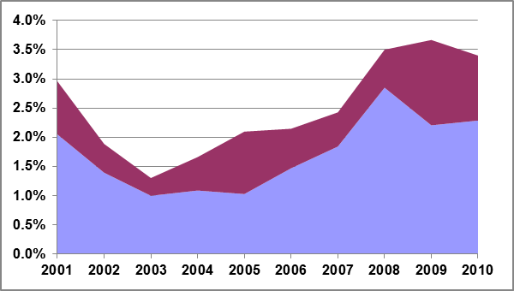
 | Year
 |  | Diesel |  | Petrol
*Excludes France in 2003 - 2005, as no submissions were provided. Excludes Luxembourg in 2007 to 2009 and Malta in 2006 and 2009 as no reports were provided.
Table 5: Summary of Member State compliance with 98/70/EC for 2010 reporting.
 | MS |  | Non-compliance with limit values  non-compliant samples (NC) / total samples |  |  |  |  |  |  | Incomplete reporting  parameters not measured (NM) / total |  |  |  |  | Late report
 |  |  | (1) |  |  |  |  |  |  | (2) |  |  |  |  | (3)
 |  |  | Petrol |  |  | Diesel |  |  |  | Petrol |  |  | Diesel
 |  |  | NC | Total |  | NC |  |  | Total | NM |  | Total | NM | Total | (months)
 | AT |  | 6 | 203 |  | 3 |  |  | 100 | 0 |  | 18 | 0 | 5 | <1
 | BE |  | 103 | 2133 |  | 79 |  |  | 4985 | 0 |  | 18 | 0 | 5 | On time
 | BG |  | 39 | 427 |  | 56 |  |  | 468 | 3 |  | 18 | 0 | 5 | On time
 | CY |  | 41 | 293 |  | 1 |  |  | 167 | 0 |  | 18 | 0 | 5 | <1
 | CZ |  | >61 | 747 |  | 29 |  |  | 877 | 0 |  | 18 | 0 | 5 | On time
 | DK |  | 0 | 42 |  | 0 |  |  | 22 | 0 |  | 18 | 0 | 5 | On time
 | EE |  | 17 | 350 |  | 3 |  |  | 200 | 0 |  | 18 | 0 | 5 | On time
 | FI |  | 0 | 185 |  | 1 |  |  | 162 | 0 |  | 18 | 0 | 5 | On time
 | FR |  | 56 | 827 |  | 10 |  |  | 395 | 0 |  | 18 | 1 | 5 | On time
 | DE |  | >7 | 417 |  | 1 |  |  | 305 | 0 |  | 18 | 0 | 5 | <4
 | EL |  | 0 | 250 |  | 0 |  |  | 120 | 0 |  | 18 | 0 | 5 | <1
 | HU |  | 0 | 120 |  | 0 |  |  | 120 | 0 |  | 18 | 0 | 5 | On time
 | IE |  | 15 | 144 |  | 1 |  |  | 126 | 0 |  | 18 | 0 | 5 | On time
 | IT |  | 2 | 200 |  | 0 |  |  | 200 | 1 |  | 18 | 0 | 5 | <1
 | LV |  | 0 | 438 |  | 0 |  |  | 674 | 0 |  | 18 | 0 | 5 | On time
 | LT |  | 0 | 101 |  | >1 |  |  | 100 | 0 |  | 18 | 0 | 5 | On time
 | LU |  | 7 | 47 |  | 0 |  |  | 75 | 1 |  | 18 | 0 | 5 | <1
 | MT |  | 2 | 49 |  | 3 |  |  | 43 | 0 |  | 18 | 0 | 5 | On time
 | NL |  | >2 | 100 |  | >1 |  |  | 100 | 0 |  | 18 | 0 | 5 | <5
 | PL |  | 15 | 291 |  | 3 |  |  | 229 | 0 |  | 18 | 0 | 5 | On time
 | PT |  | 29 | 236 |  | 8 |  |  | 118 | 0 |  | 18 | 0 | 5 | <1
 | RO |  | >5 | 360 |  | 11 |  |  | 210 | 0 |  | 18 | 0 | 5 | <1
 | SK |  | 0 | 168 |  | 7 |  |  | 137 | 0 |  | 18 | 0 | 5 | On time
 | SI |  | 0 | 149 |  | 0 |  |  | 181 | 0 |  | 18 | 0 | 5 | On time
 | ES |  | 6 | 520 |  | 0 |  |  | 264 | 0 |  | 18 | 0 | 5 | <2
 | SE |  | 0 | 553 |  | 0 |  |  | 620 | 6 |  | 18 | 0 | 5 | On time
 | UK |  | 5 | 2195 |  | 0 |  |  | 2428 | 2 |  | 18 | 0 | 5 | On time
 | No. Countries |  |  |  | 18 |  | 18 |  |  |  | 5 |  | 1 |  | 10
# |  | Column |  |  |  |  |  | Explanatory notes
(1) |  | Non-compliance with limit values  (95% confidence limits) |  |  |  |  |  | It is not possible to confirm whether limit values have been respected in all samples, where reporting data is incomplete. Where it has not been possible to establish from submissions the number of samples exceeding the limit value a ‘>’ symbol indicates that the number of samples exceeding limits is a minimum and might be greater.
(2) |  | Incomplete reporting |  |  |  |  |  | Some parameters may be sampled in smaller quantities, however all parameters should be sampled to accurately assess fuel quality. Member States should make it clear when sample results have been obtained and provide sample results.
(3) |  | Late report |  |  |  |  |  | Directive 98/70/EC states that Member States should submit monitoring reports by no later than 30 June each year

7. Conclusions
Fuel quality has a strong link to both CO₂ and air quality emissions, as well as the ease and cost with which pollutant and greenhouse gas emission limits can be achieved by vehicle manufacturers.
The monitoring of fuel quality in 2010 shows that the specifications for petrol and diesel laid down in Directive 98/70/EC are in general met and very few exceedances were identified. The progressive adoption of standard EN 14274 by Member States is leading to greater consistency in the data available for assessment of the various fuel quality parameters and Member States have been making efforts to improve their understanding of reporting requirements.
As exceedances are relatively rare and most Member States take action to remove non-compliant fuel from sale, the Commission is not aware of any negative repercussions on vehicle emissions or engine functioning due to these exceedances. However, the Commission urges Member States to continue to take action to ensure full compliance so that such problems do not arise in the future and to ensure that report are submitted to the Commission within the requested deadlines.

Directive 98/70/EC relating to the quality of petrol and diesel fuels and amending Council Directive 93/12/EEC O.J. L 350, 28.12.1998, p. 58.
Research Octane Number (RON) is a quantitative measure of the maximum compression ratio at which petrol can be used in an engine without some of the mixture self-igniting in the engine. Self-ignition leads to excess fuel consumption and an increase in Volatile Organic Compound and Carbon Monoxide emissions.
Vapour pressure is a measure of the propensity of the fuel to evaporate. It is regulated in summer because temperatures at that time of year can lead to high emissions of Volatile Organic Compounds, which are a precursor of ground level ozone. Exceedances will result in increased Volatile Organic Compound emissions.
The distillation parameter establishes the proportion of the fuel that evaporates at 100˚C and 150˚C. It limits the range of lighter components that can be blended in the petrol. Exceedances could lead to vapour locks and driveability problems.
EN 14274:2003 - Automotive fuels - Assessment of petrol and diesel quality - Fuel Quality Monitoring System (FQMS).
https://circabc.europa.eu/w/browse/5e89b837-2bec-4284-b9fe-c156271268f7
See section 5 for details.
EN 14274 sets minimum sampling numbers for each fuel (dependant on the statistical model used and sales proportion). The standard specifies a minimum number of samples to be taken per fuel grade Samples per grade and per winter and summer period*ModelSmall countryLarge countryEN 14274 Statistical Model A50100EN 14274 Statistical Model B100200EN 14274 Statistical Model C50-National system--* Annual sampling requirements are therefore double the table values per grade.
"National monitoring systems" are permitted by the Directive so long as it gives results of an equal confidence to EN 14274.

