 | 
COUNCIL OF  THE EUROPEAN UNION |  |  | Brussels, 21 December 2012
 | Interinstitutional File:  2012/0295 (COD) |  | 18125/12
SOC 1026
FSTR 91
CADREFIN 538
REGIO 173
CODEC 3134
INST 754
PARLNAT 400

COVER NOTE
from: | The House of Commons
date of receipt: | 20 December 2012
to: | Mr Dimitris Christofias, President of the Council of the European Union
Subject: | Proposal for a Regulation of the European Parliament and of the Council on the Fund for European Aid to the Most Deprived  [doc. 15865/1/12 REV 1 SOC 902 FSTR 70 CADREFIN 455 REGIO 122 CODEC 2594 - COM(2012) 617 final/2]  - Opinion on the application of the Principles of Subsidiarity and Proportionality

Delegations will find attached the above mentioned opinion.

____________________

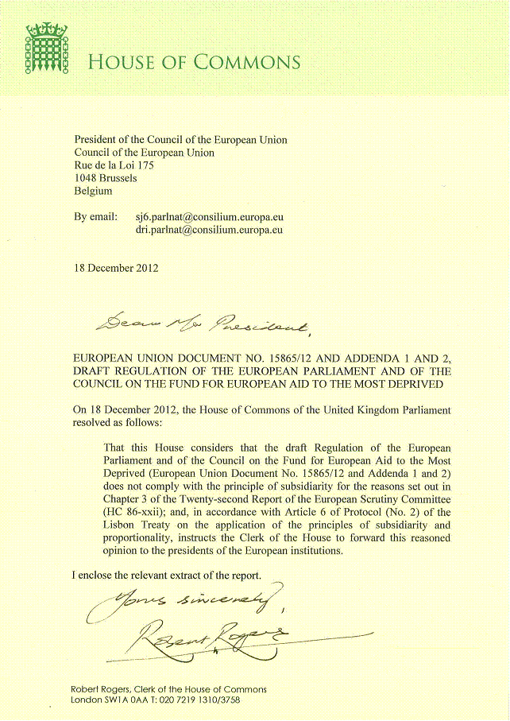

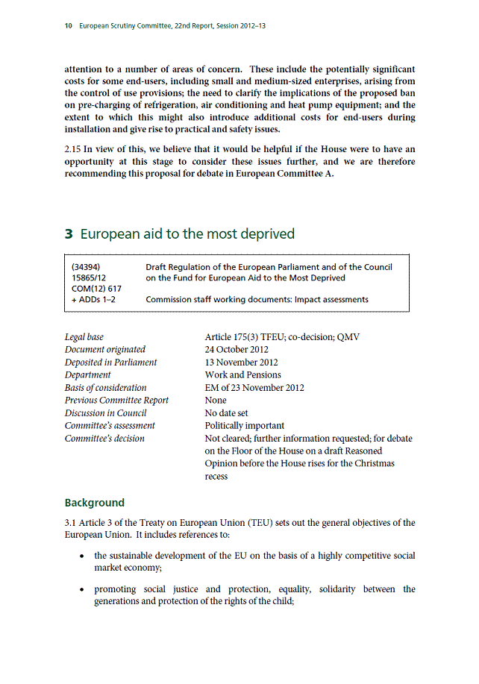
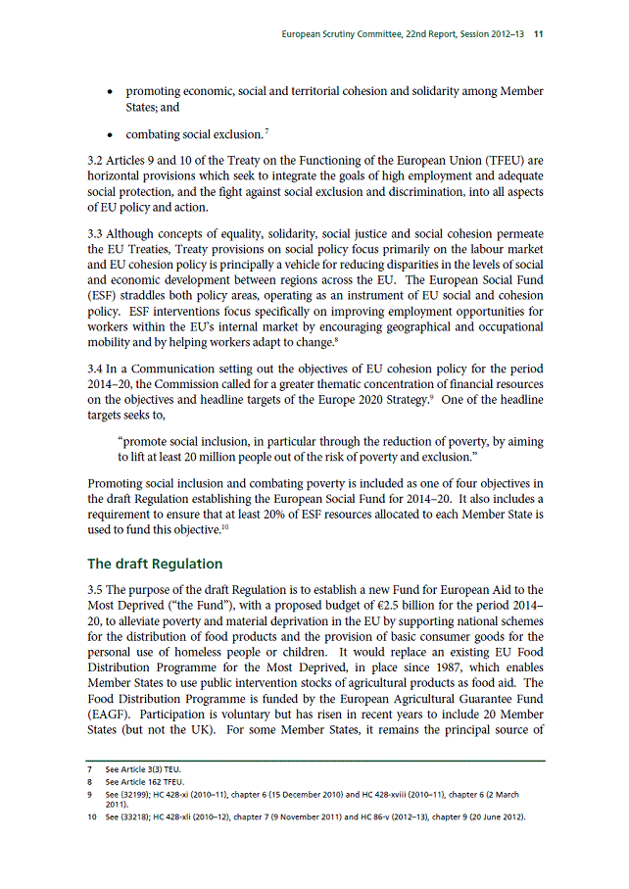
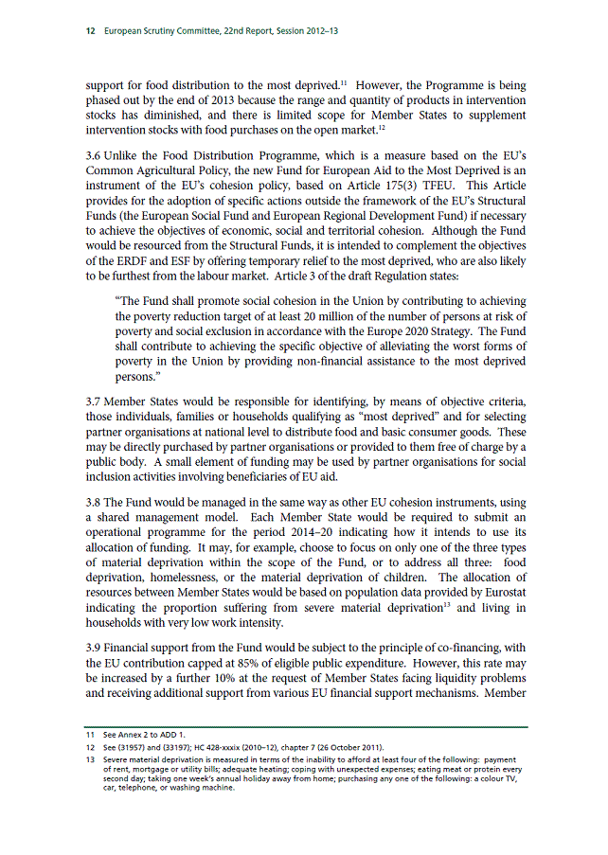
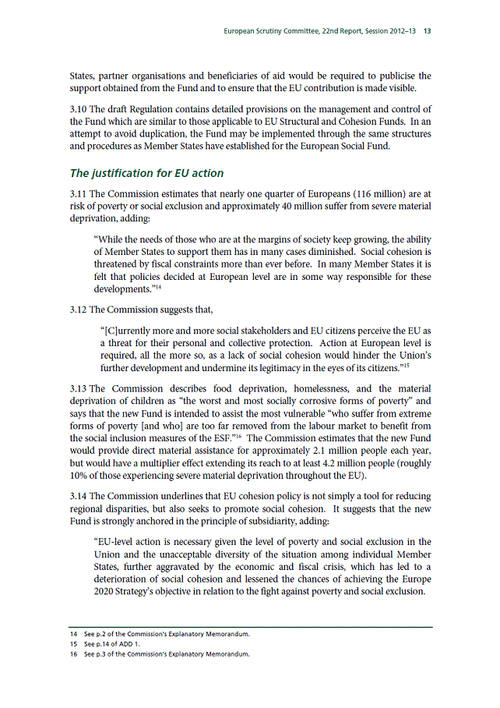
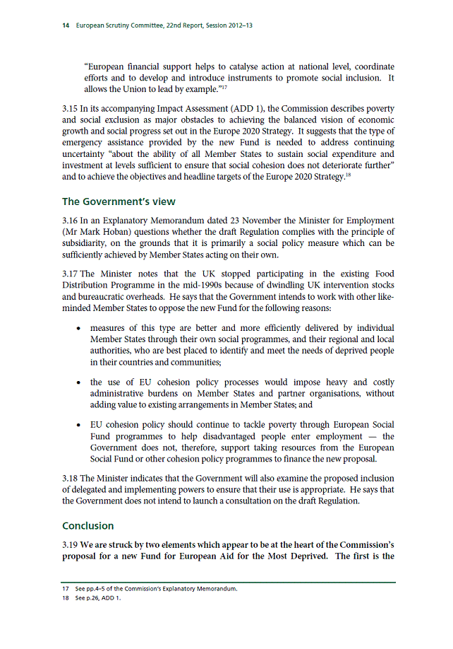
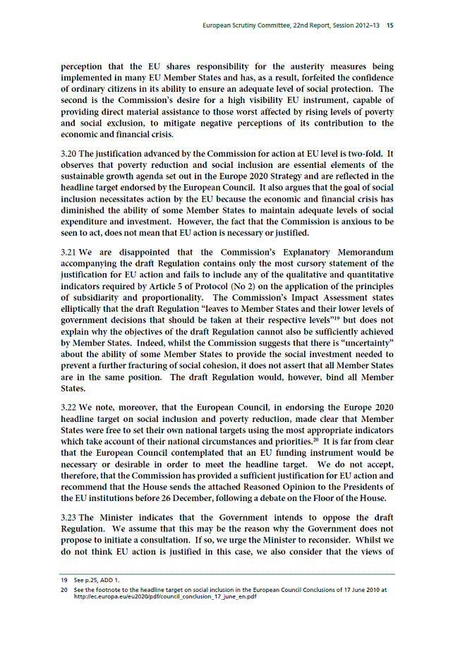
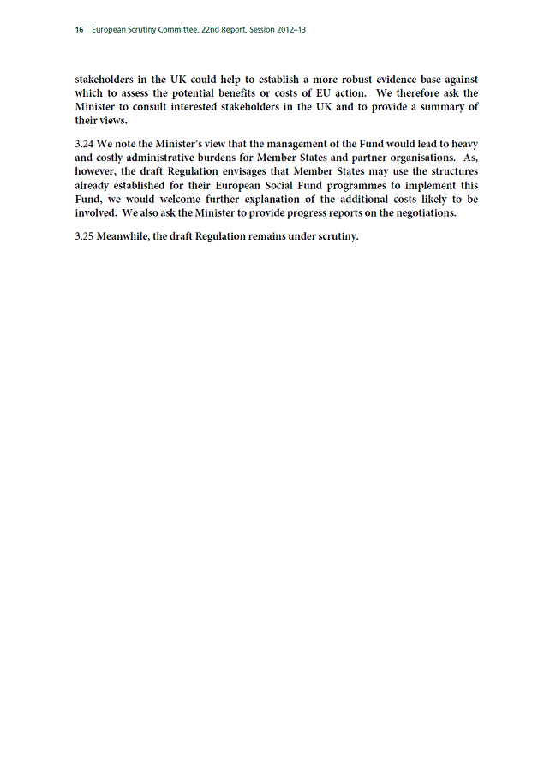
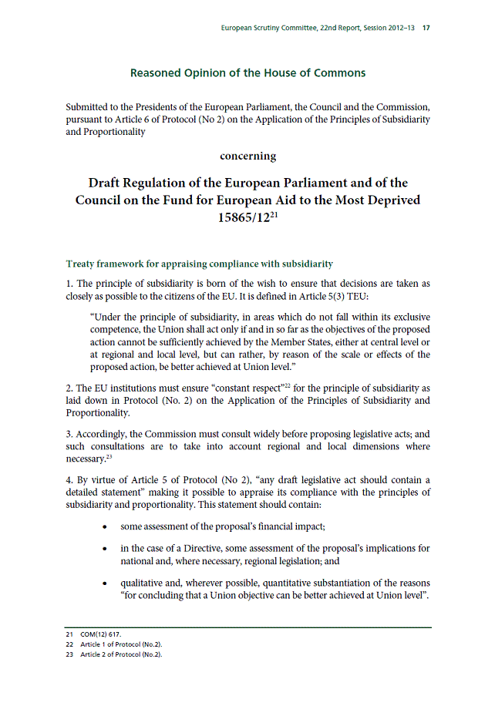
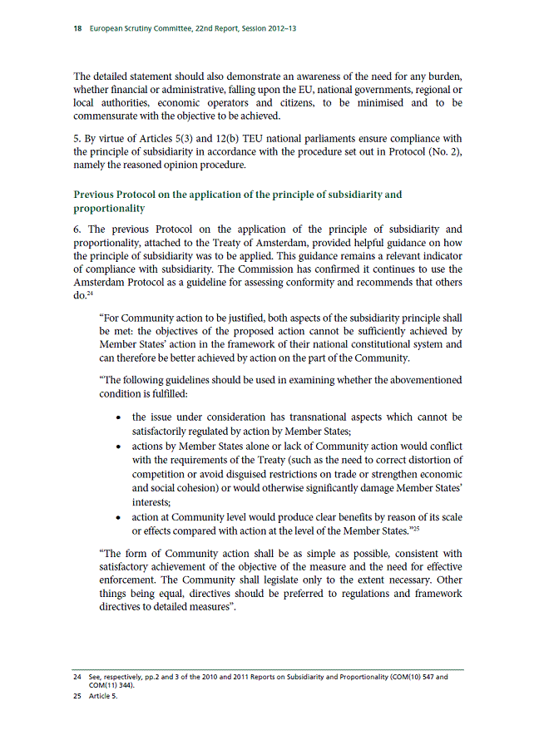
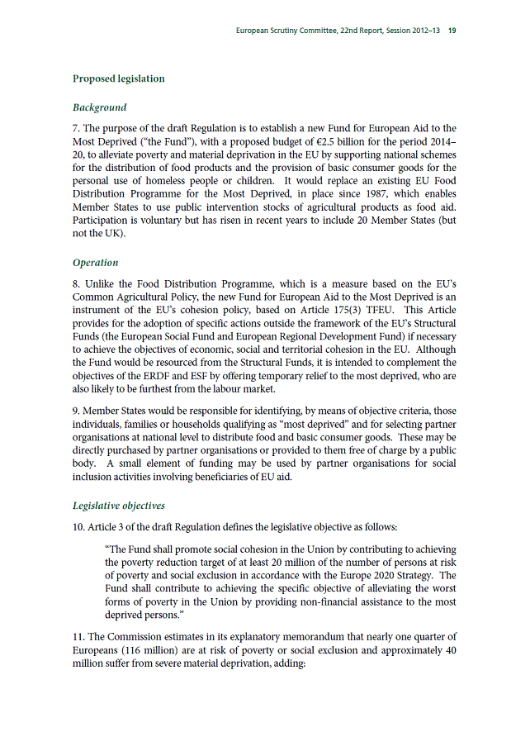
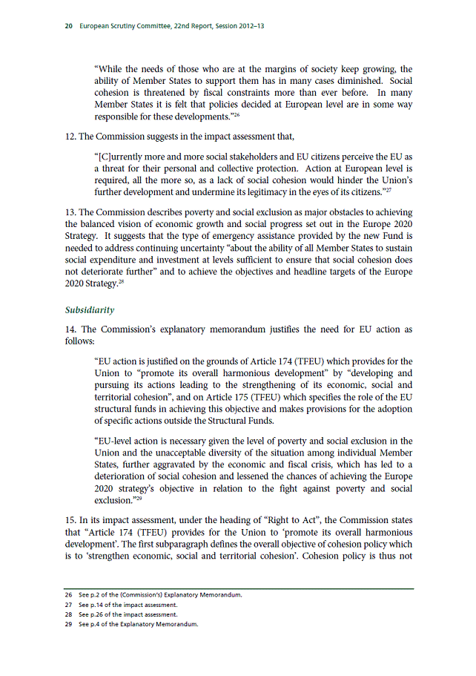
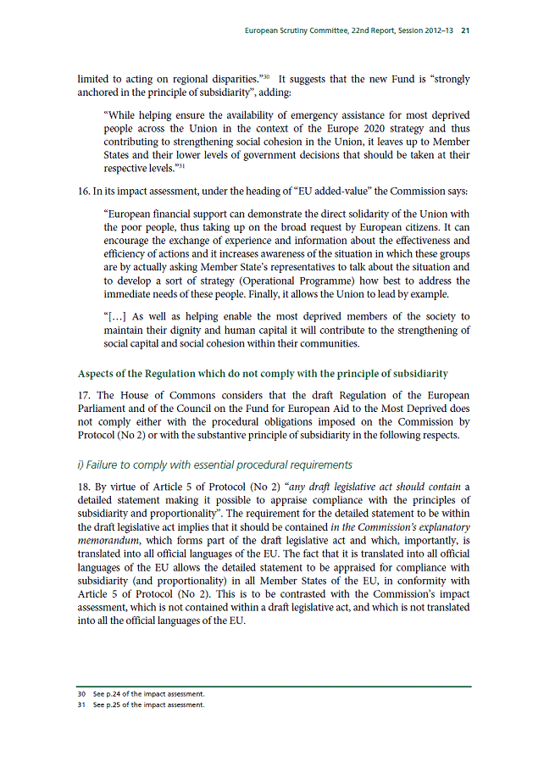
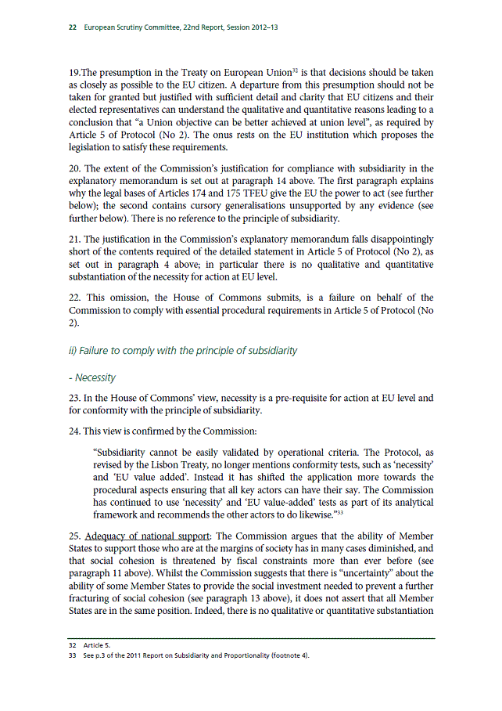
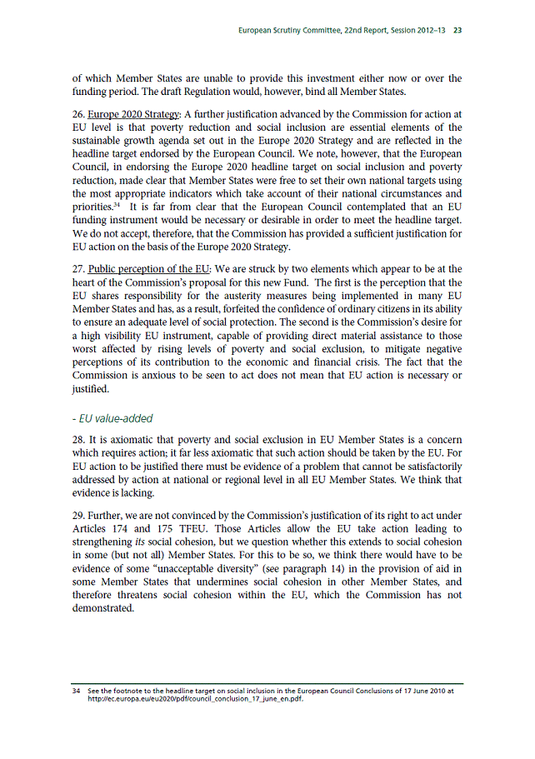
__________________

For available translations of this opinion see the interparliamentary EU information exchange site (IPEX) at the following address: http://www.ipex.eu/IPEXL-WEB/search.do

