 | 
COUNCIL OF  THE EUROPEAN UNION |  |  | Brussels, 18 December 2012
 | Interinstitutional File:  2012/0261(COD) |  | 17859/12
UD 329
ENT 316
CORDROGUE 104
CODEC 3070
INST 739
PARLNAT 392

COVER NOTE
from: | Portuguese Parliament
date of receipt: | 12 December 2012
No. Cion prop.: | 14514/12 UD 240 ENT 235 CORDROGUE 65 CODEC 2290 -  COM(2012) 548 final
Subject: | Proposal for a Regulation of the European Parliament and of the Council amending Regulation (EC) No 273/2004 on drug precursors  - Opinion on the application of the Principles of Subsidiarity and Proportionality

Delegations will find attached the Opinion of the Portuguese Parliament on the above proposal.

________________________

Encl.:

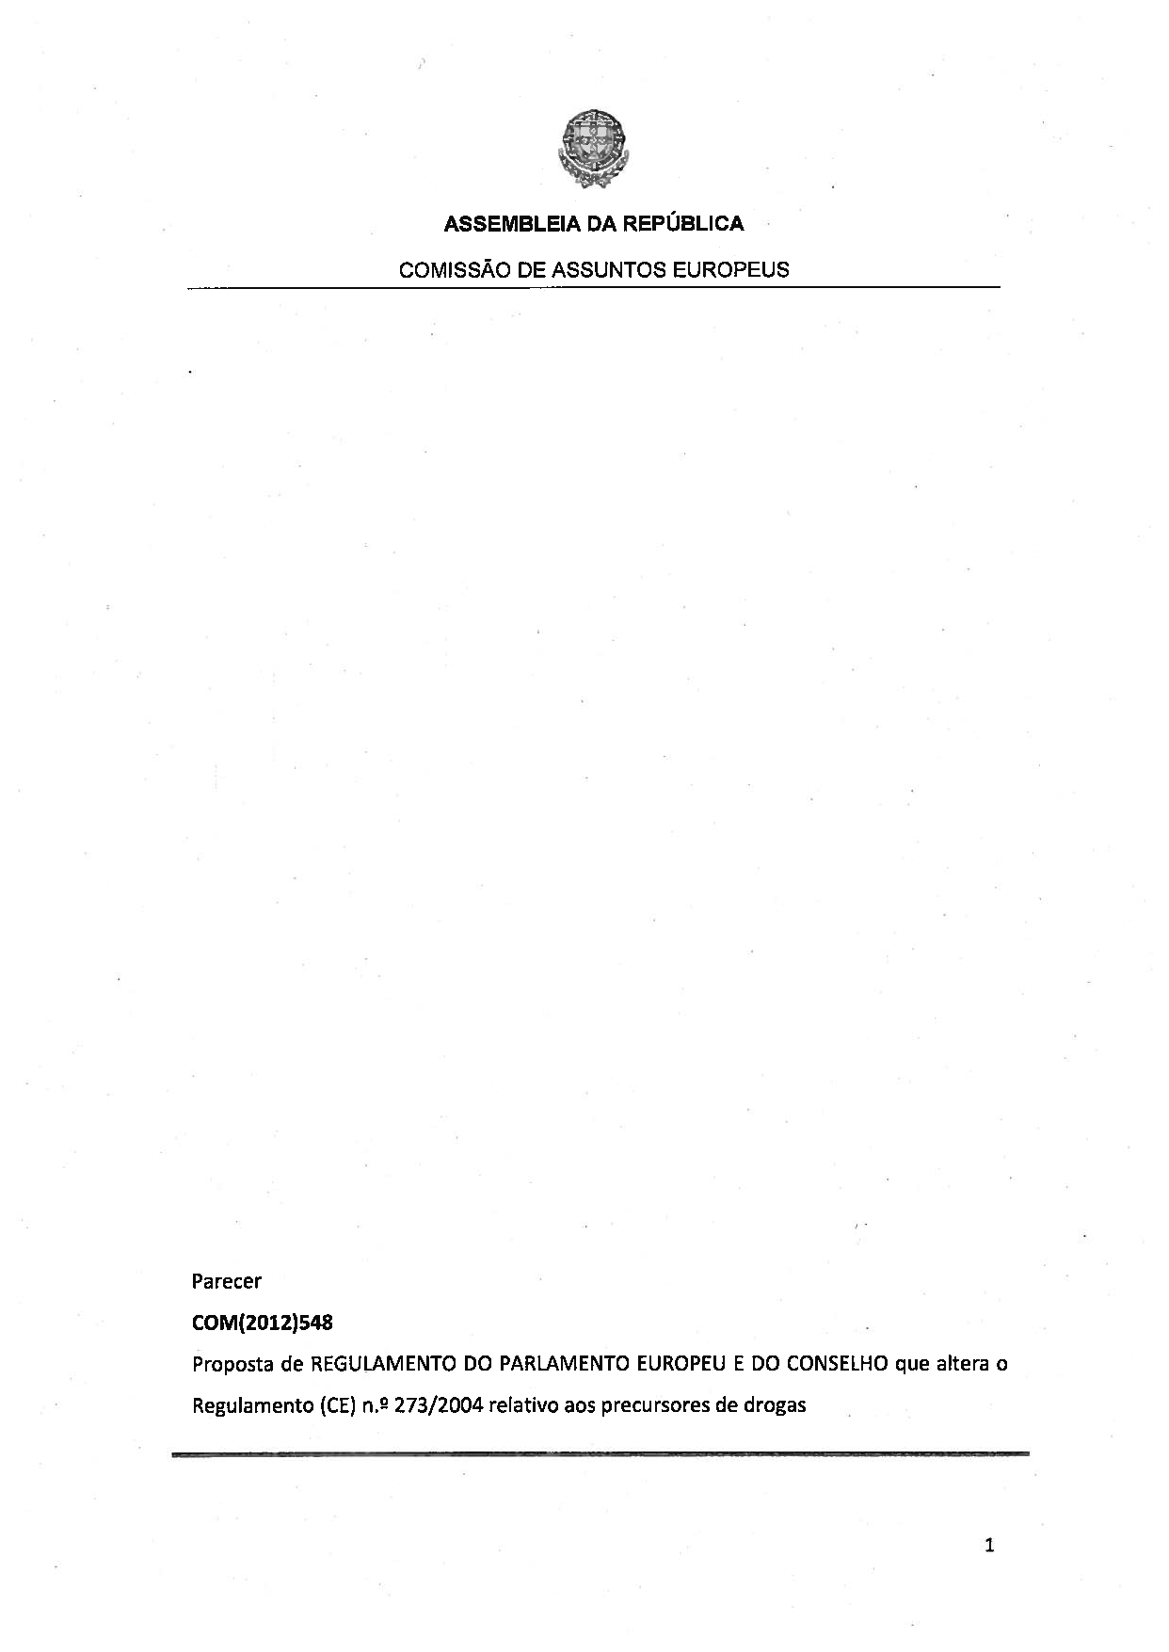
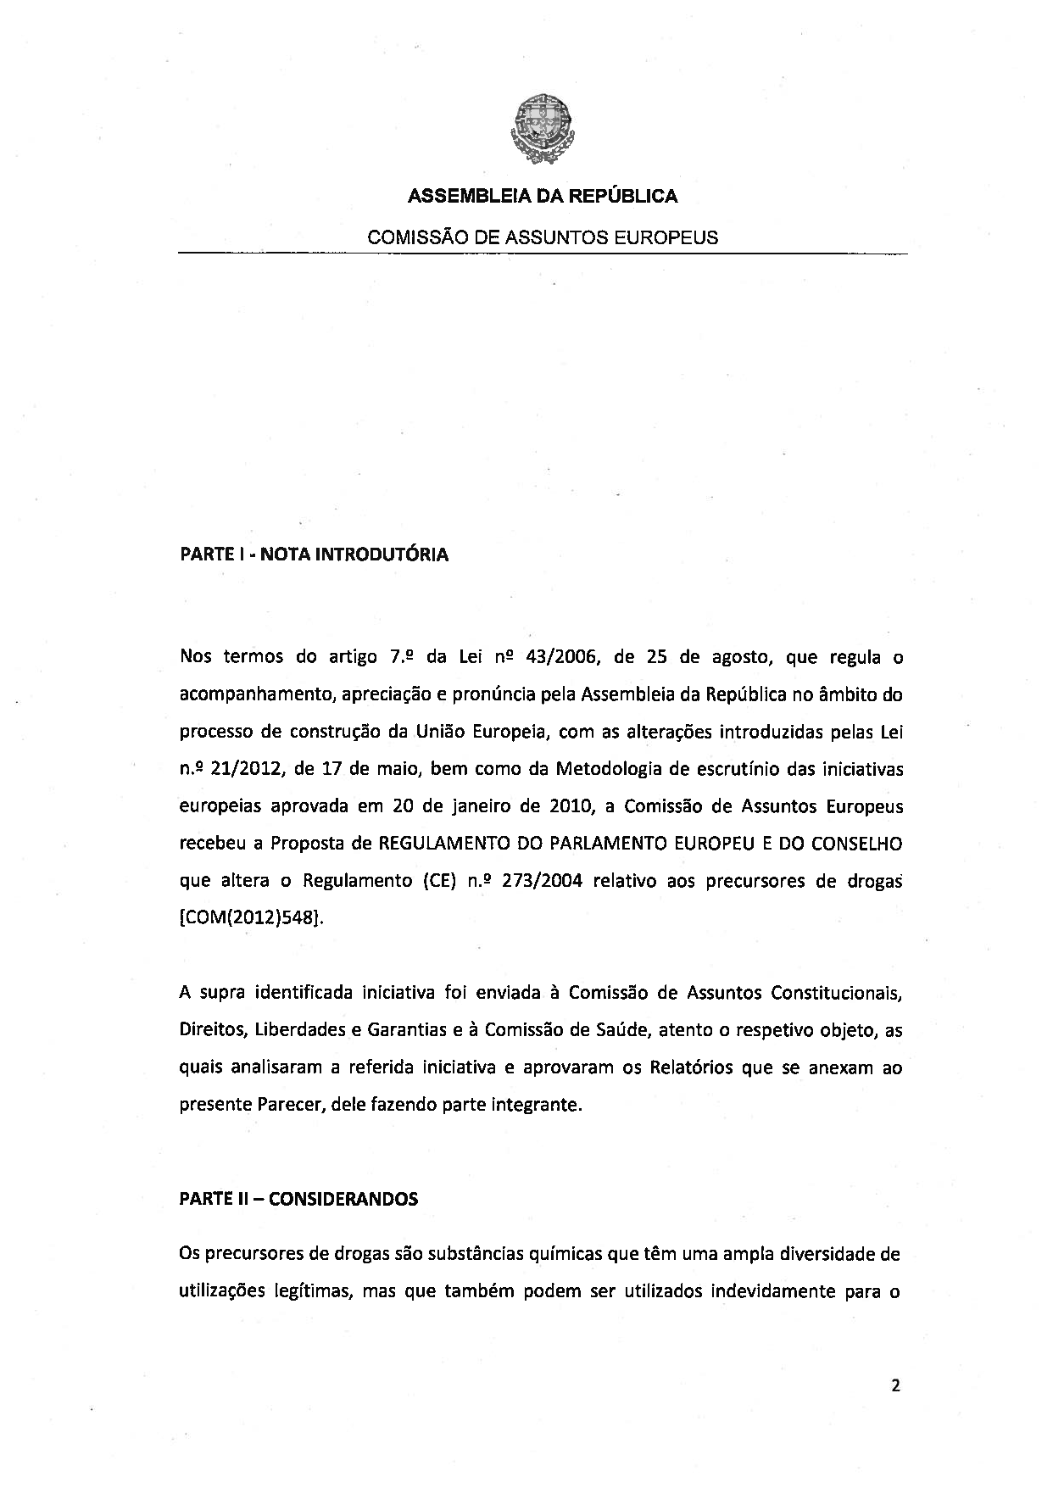
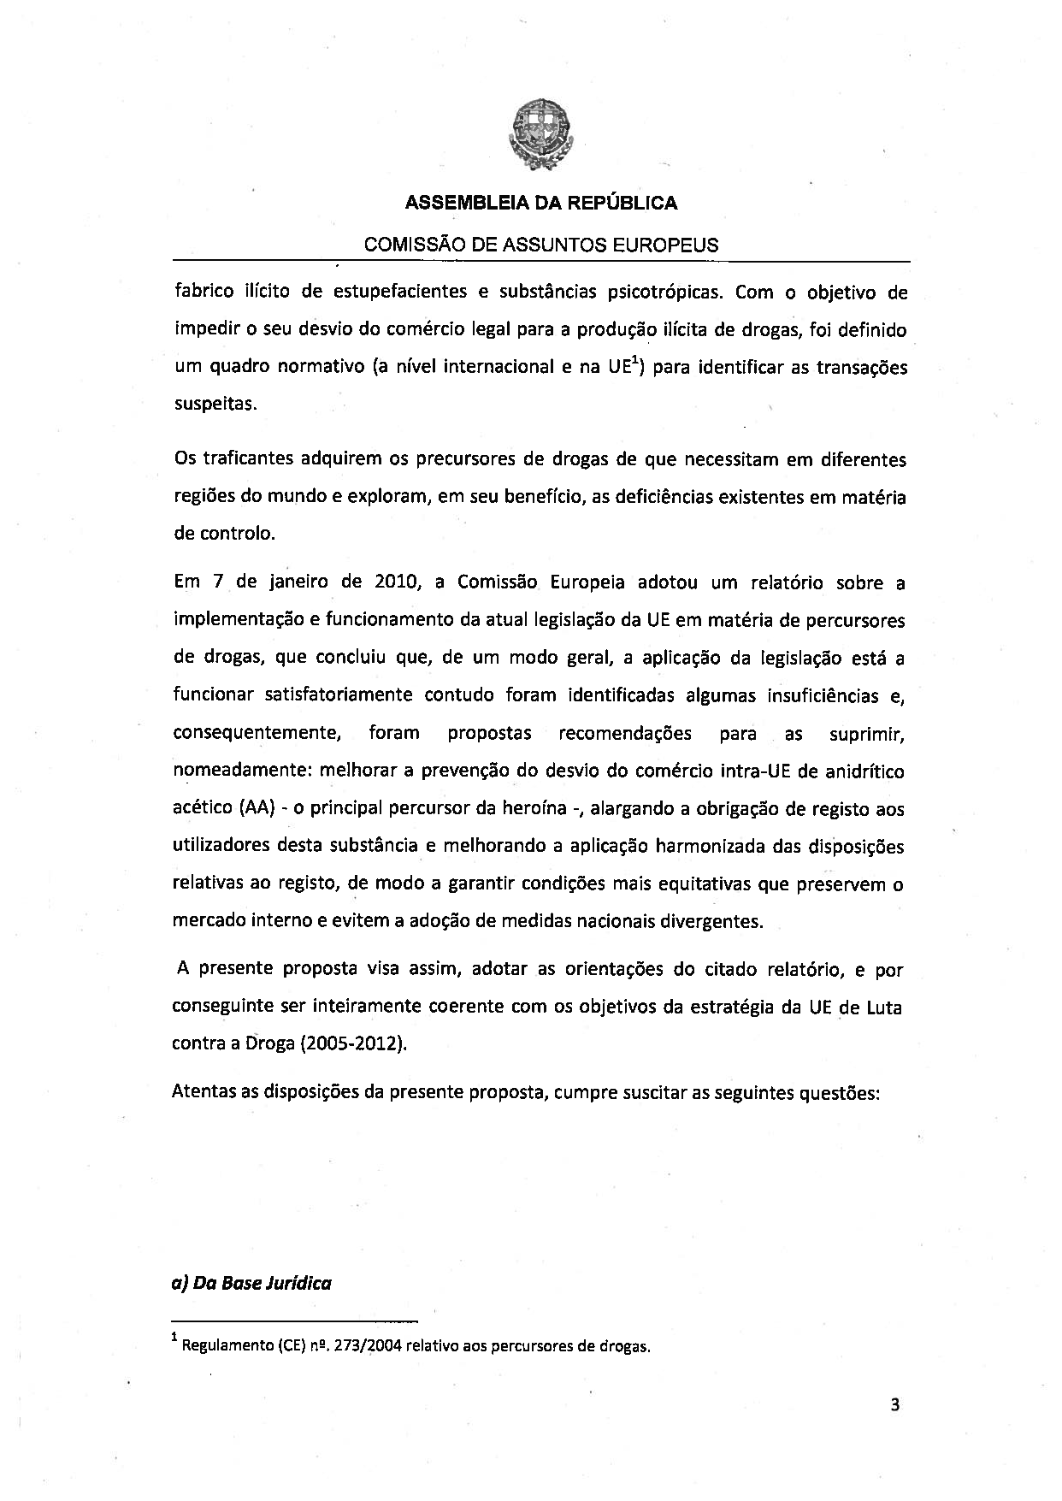
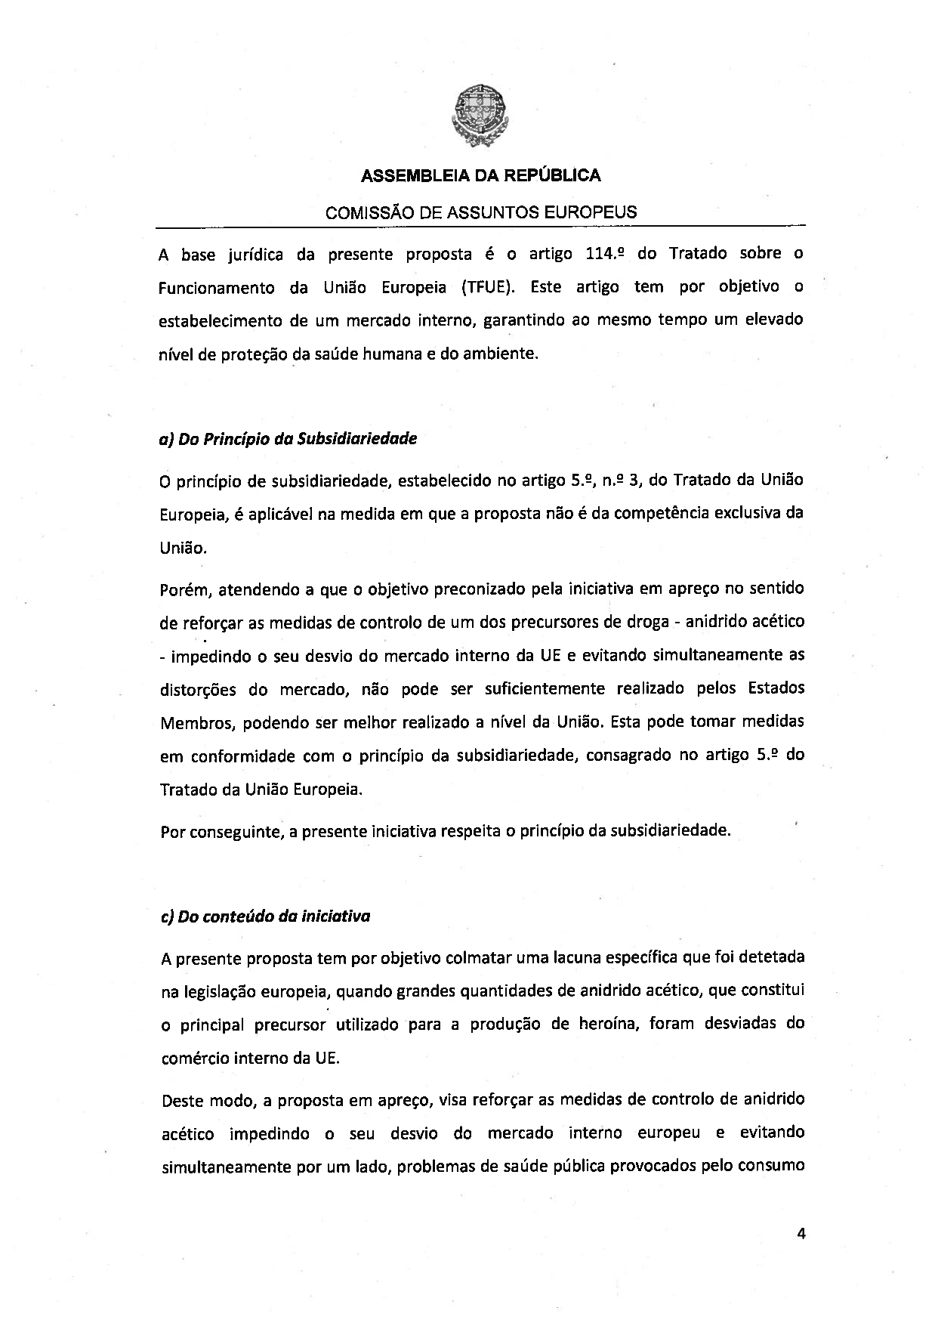
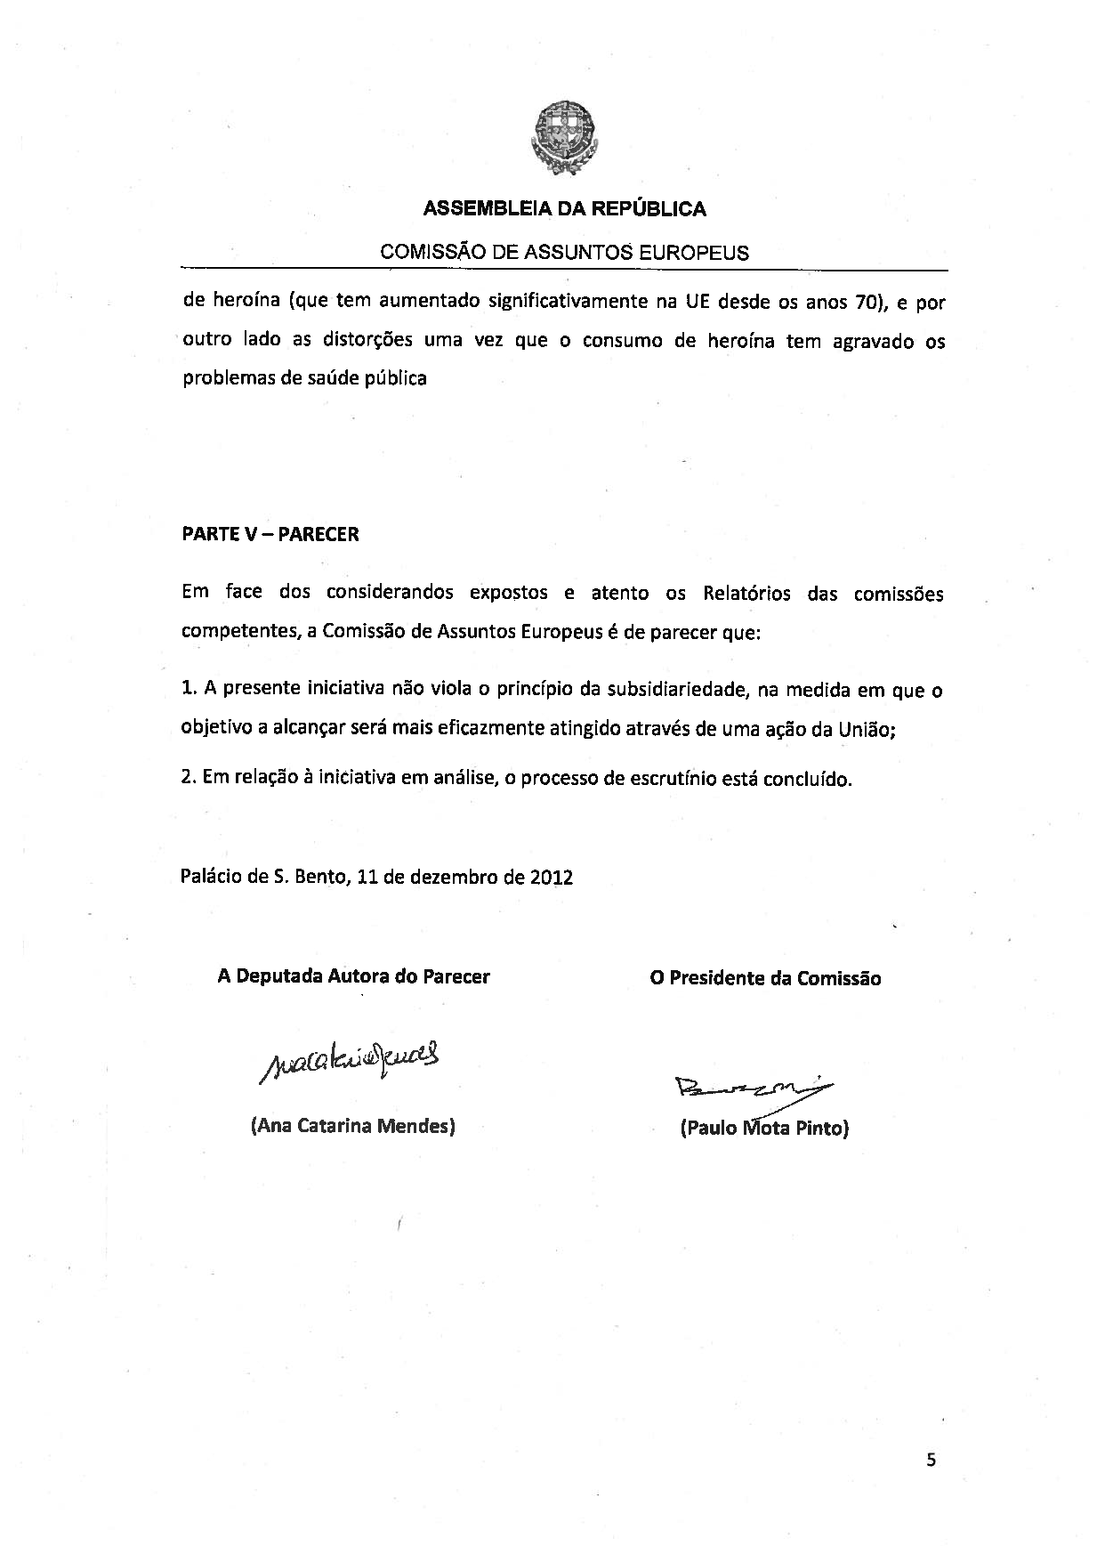

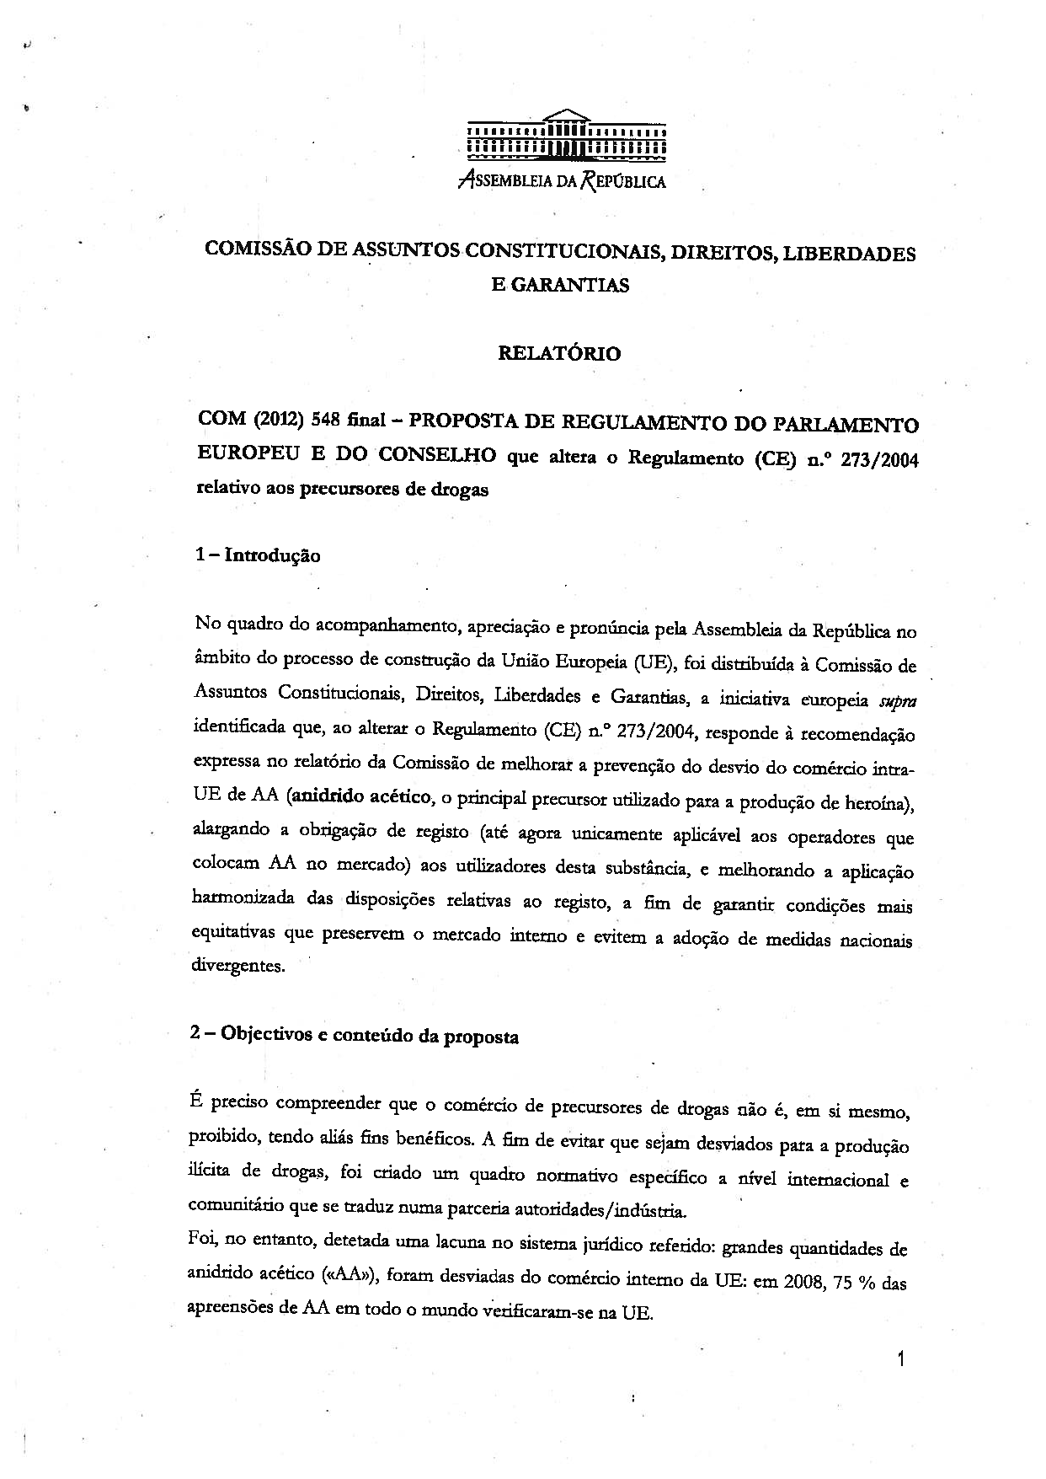
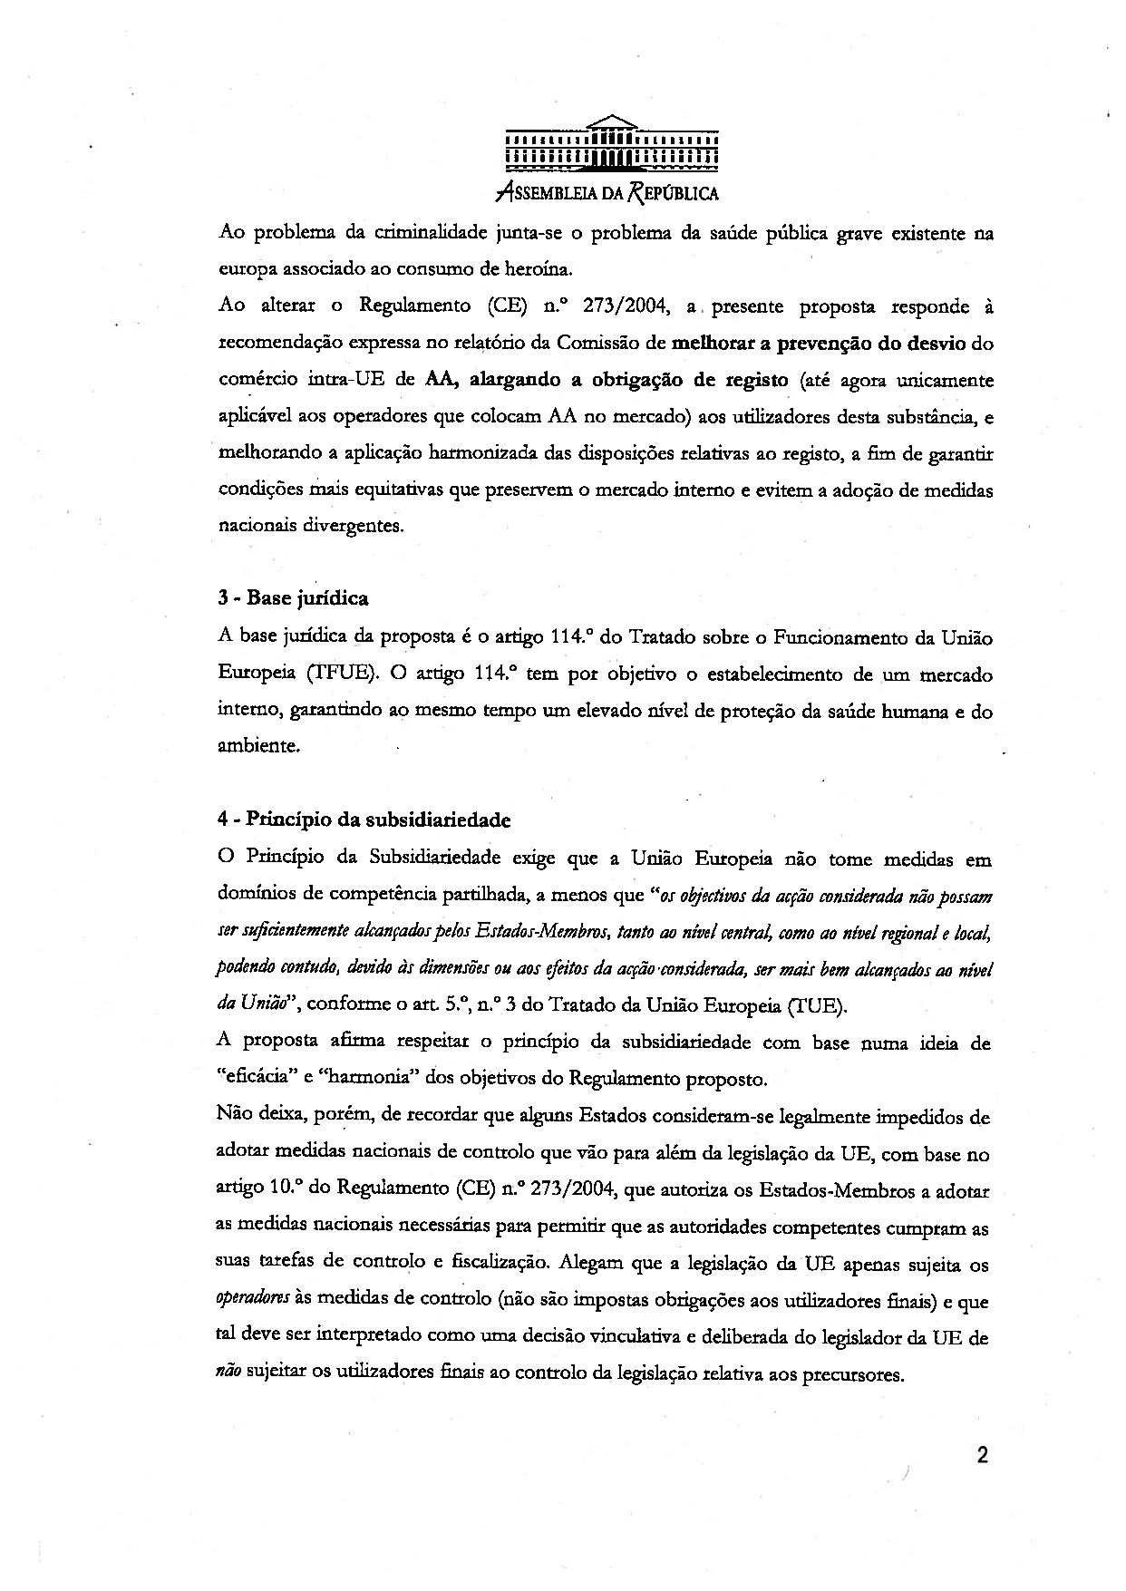
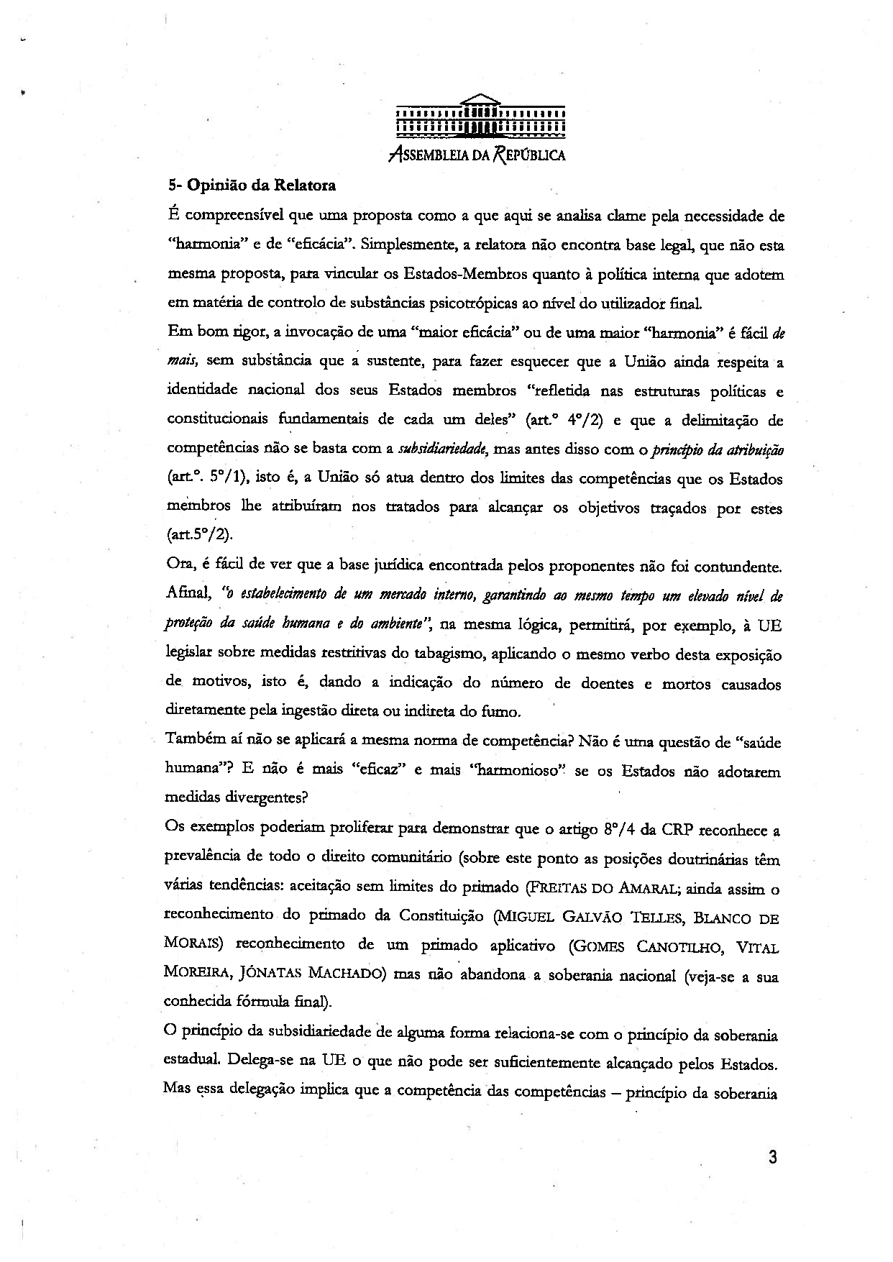
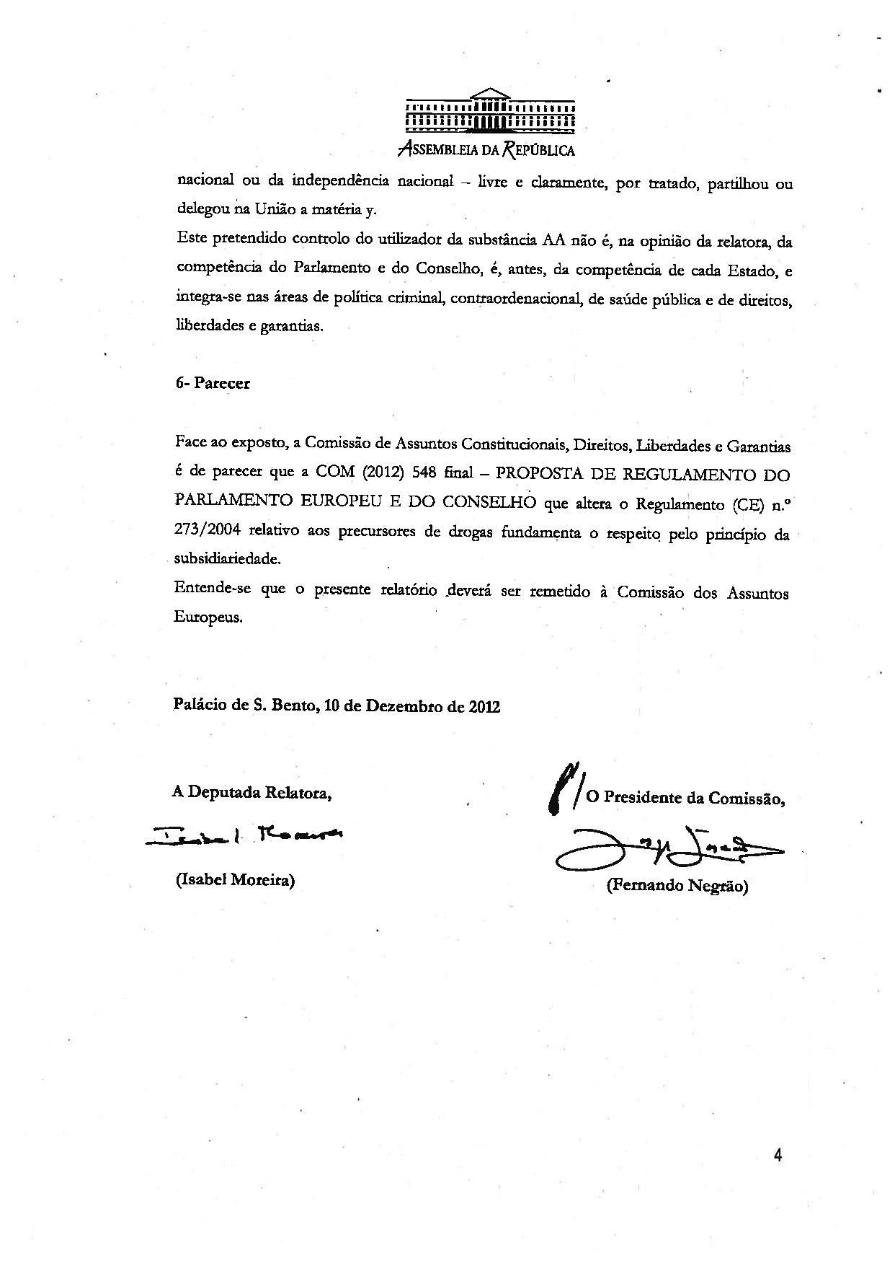
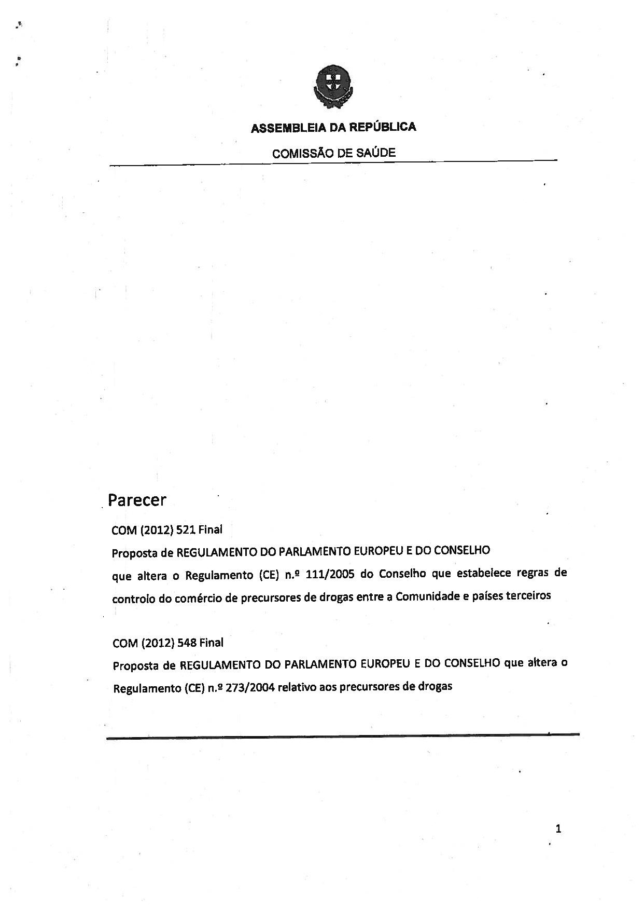

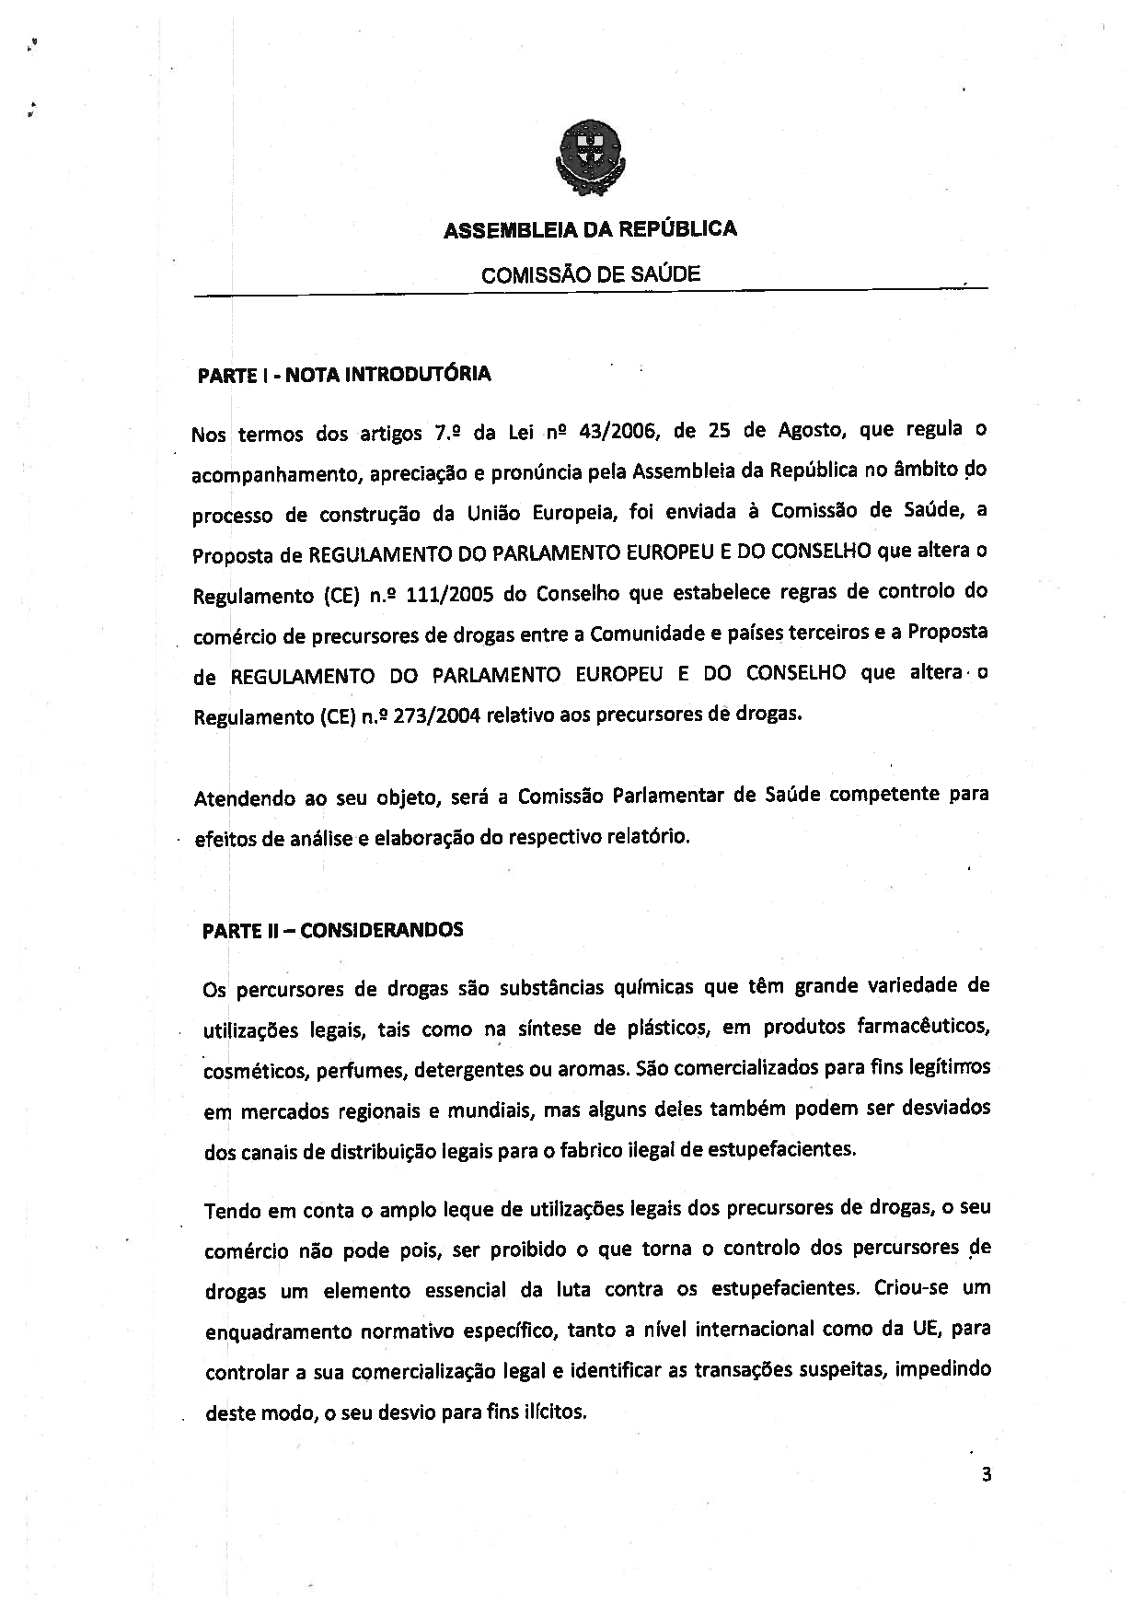
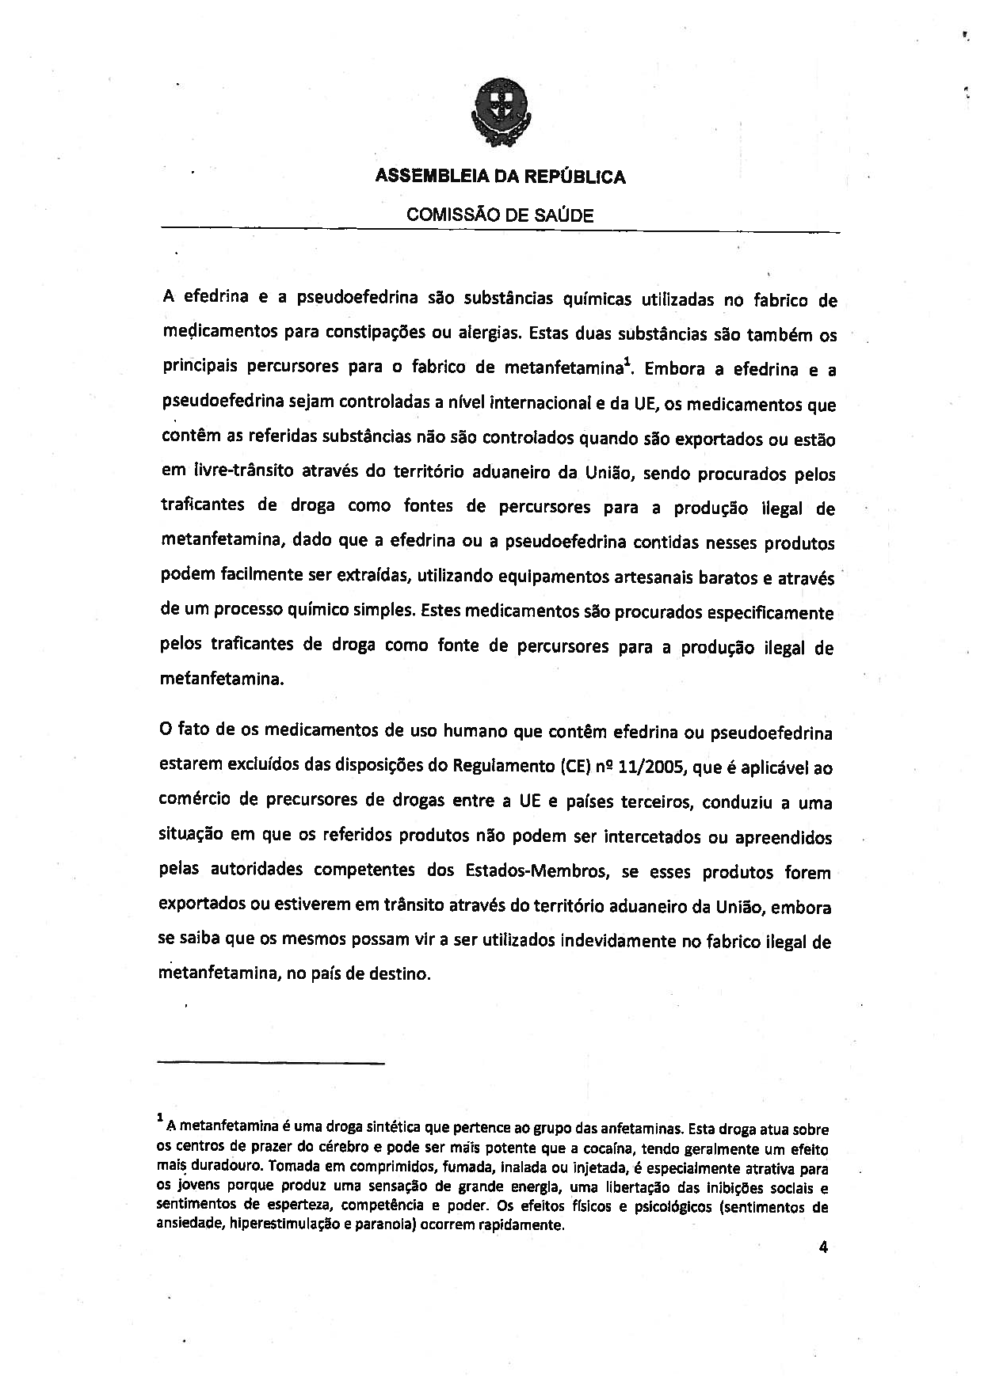
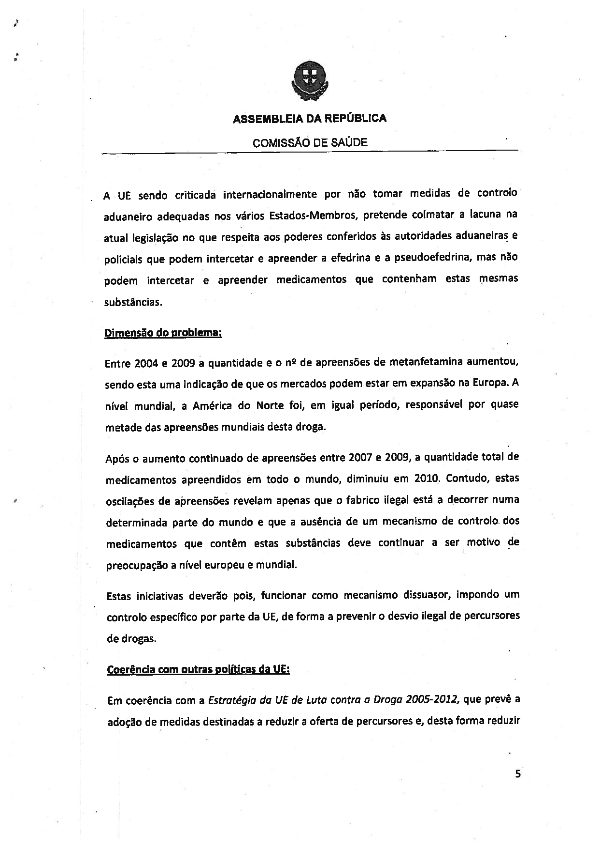
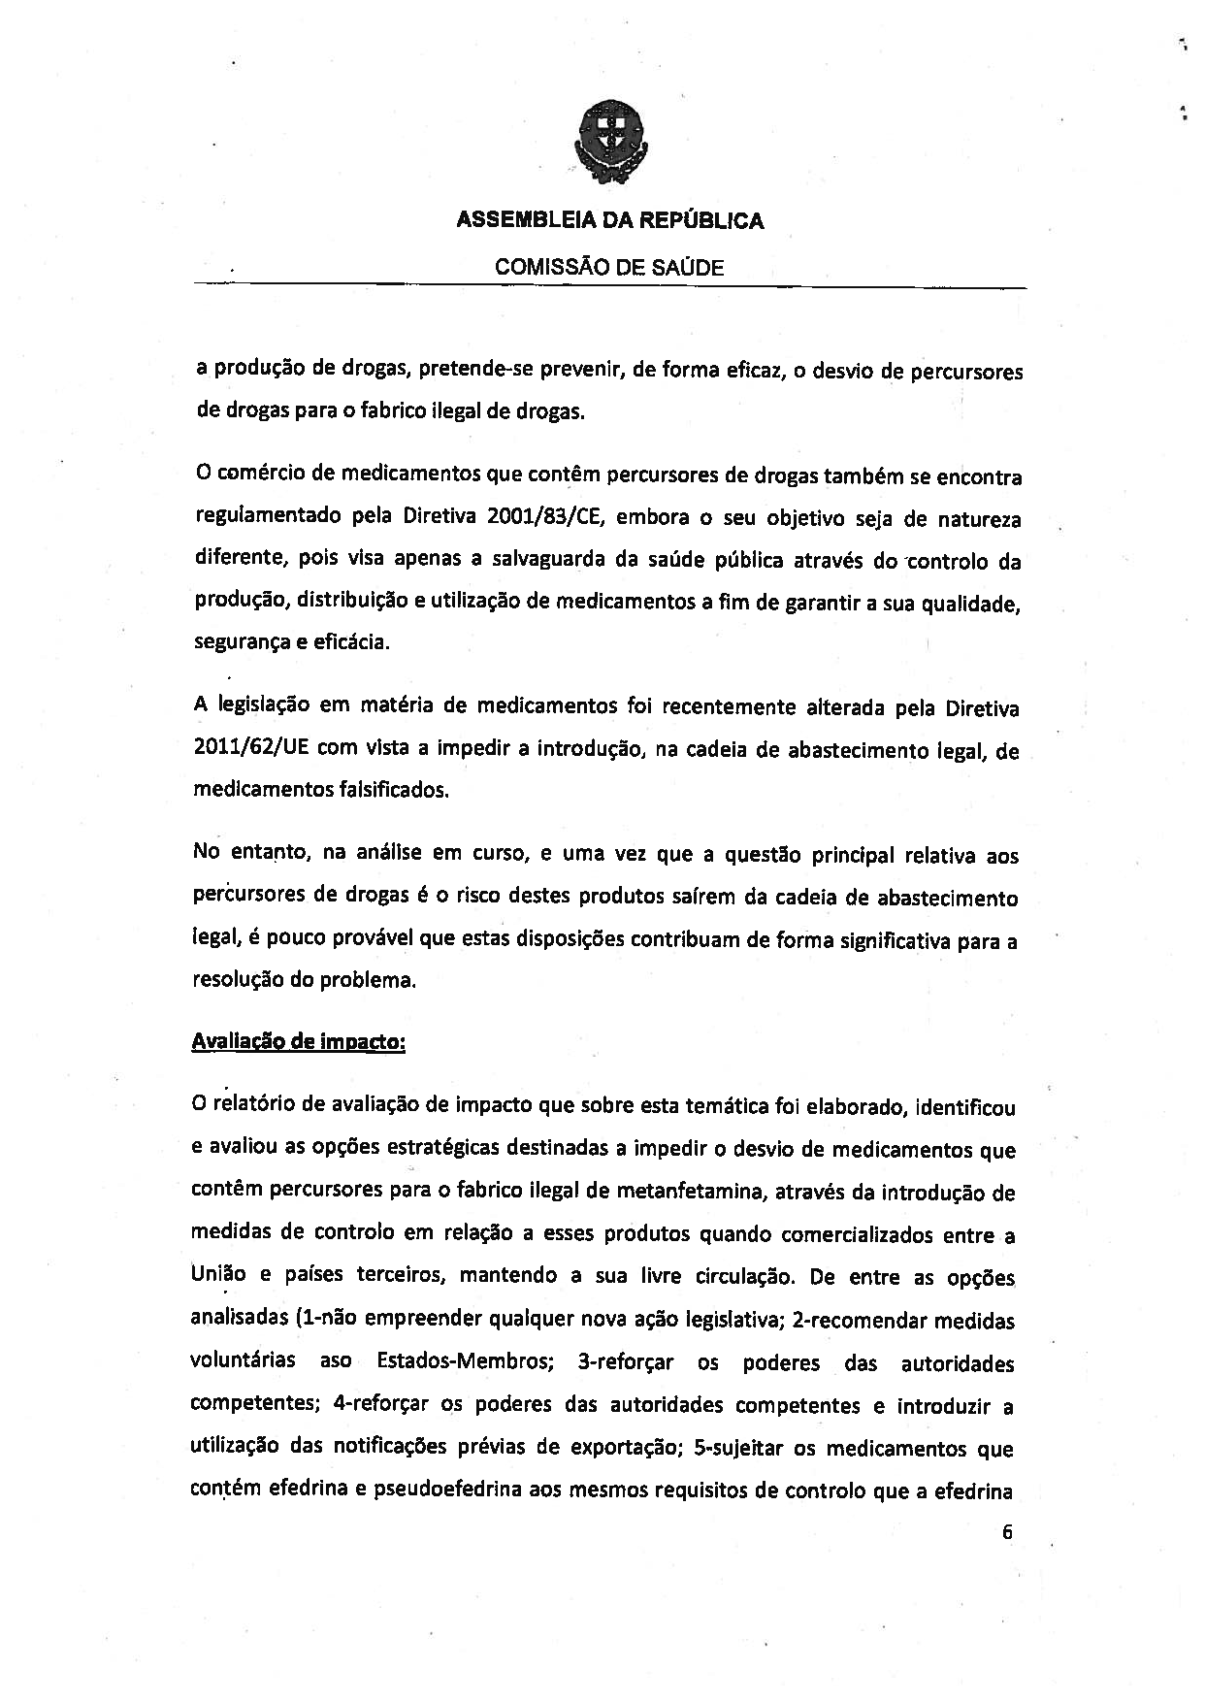
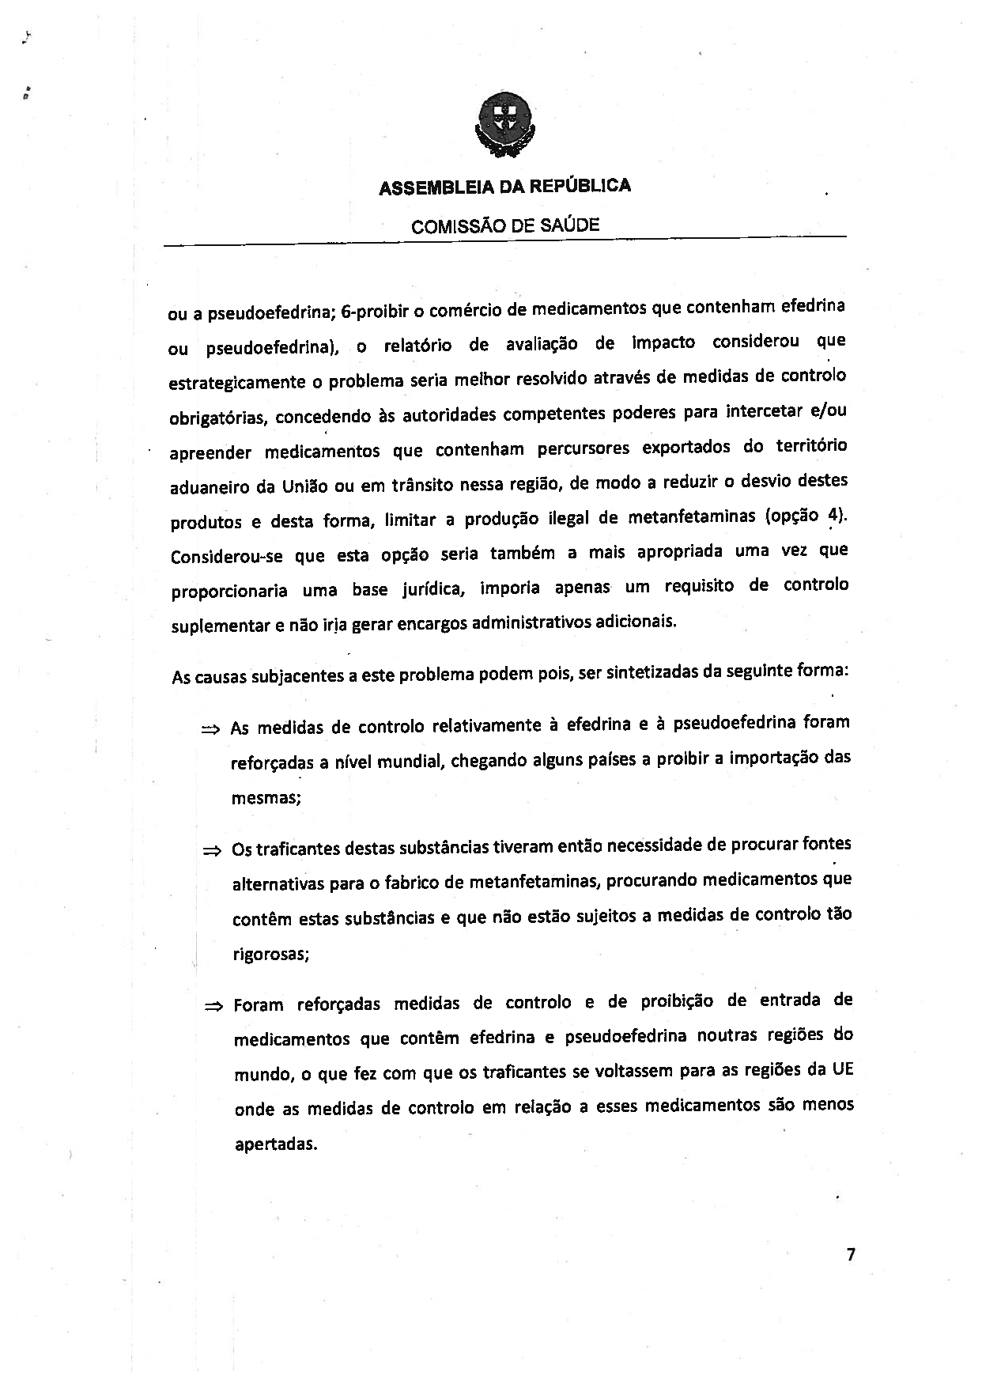
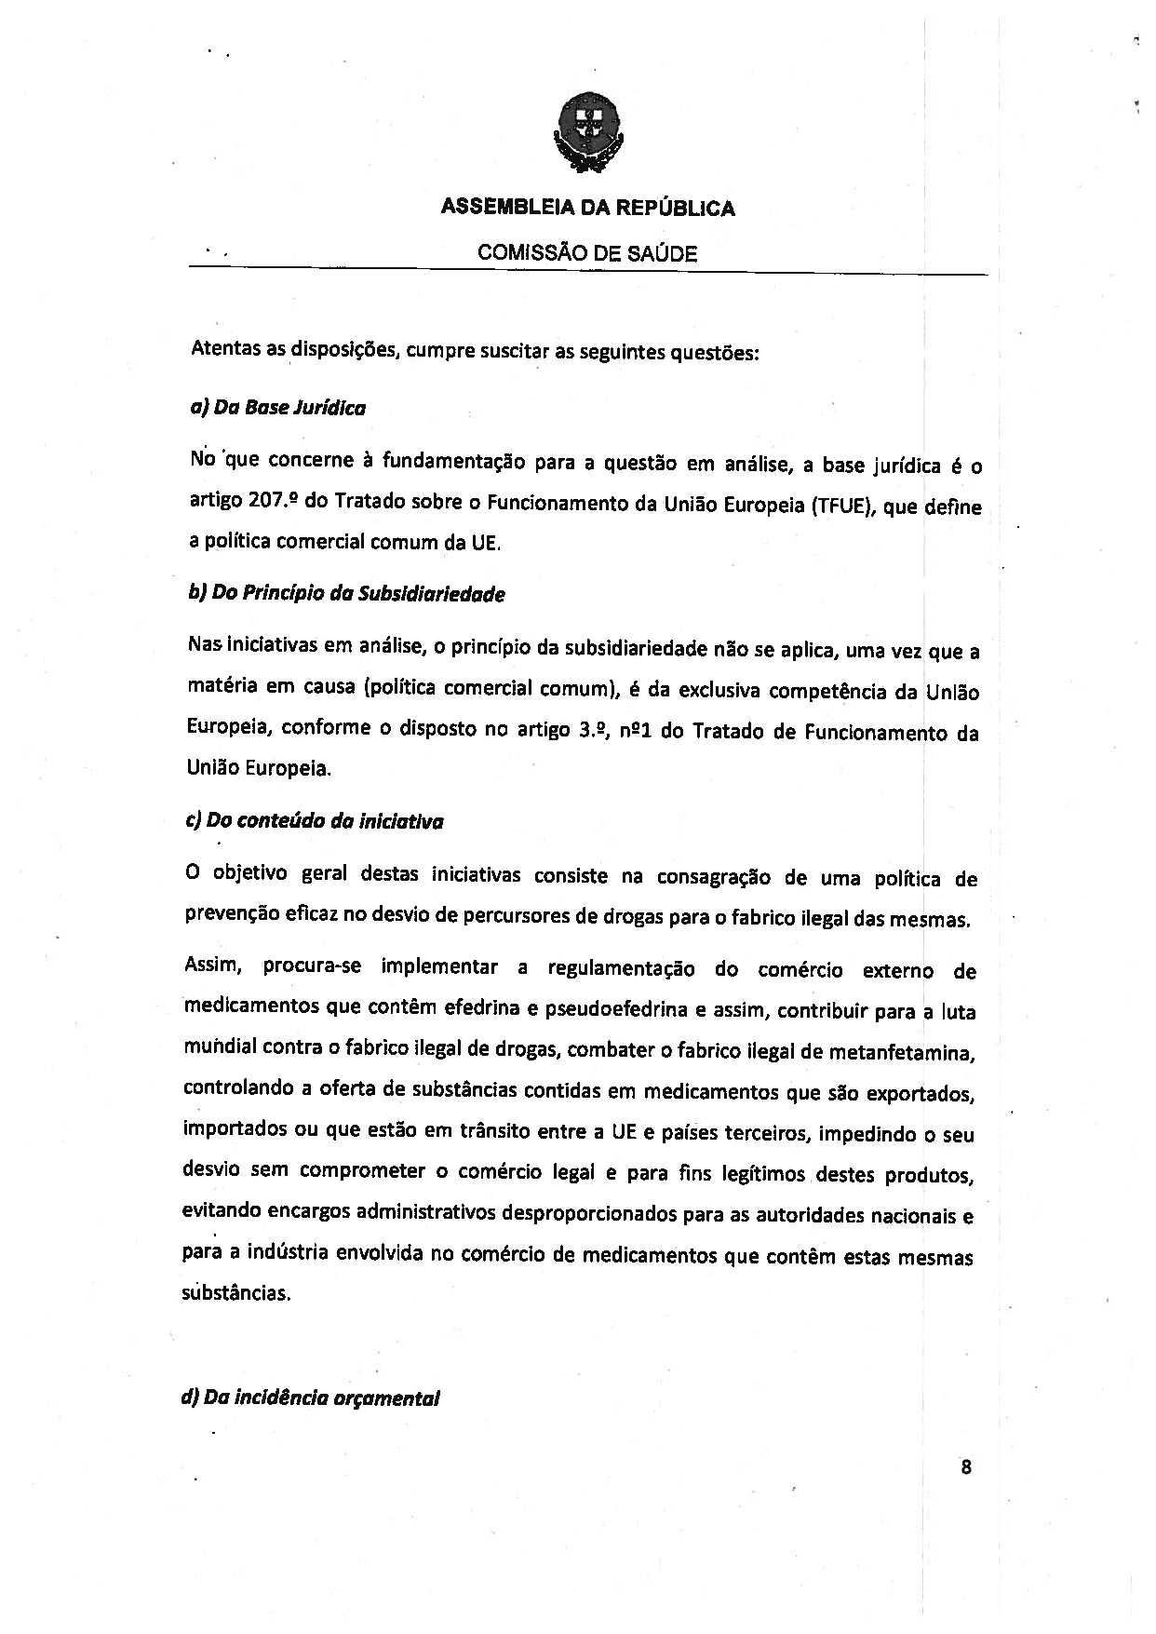
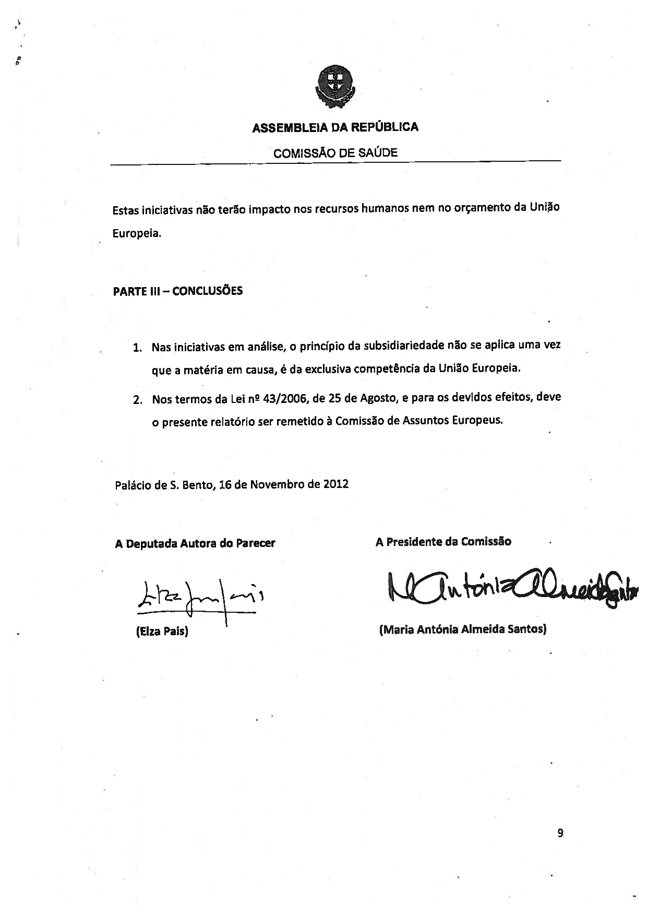

Translation(s) may be available at the Interparliamentary EU information exchange site IPEX at the following address: http://www.ipex.eu/IPEXL-WEB/search.do.

