 | 
COUNCIL OF  THE EUROPEAN UNION |  |  | Brussels, 14 December 2012
 | Interinstitutional File:  2012/0283 (COD) |  | 17803/12
MI 832
ECO 152
ENT 313
IND 235
TELECOM 261
INST 738
PARLNAT 391

COVER NOTE
from: | The Portuguese Parliament
date of receipt: | 12 December 2012
to: | The President of the Council of the European Union
No. Cion prop. | 15339/12 MI 654 ECO 125 INT 261 IND 169 TELECOM 191 - COM(2012) 584 final
Subject: | Proposal for a Directive of the European Parliament and of the Council on the harmonisation of the laws of the Member States relating to the making available on the market of radio equipment  - Reasoned opinion on the application of the Principles of Subsidiarity and Proportionality

Delegations will find attached for information a copy of the above opinion.

________________________

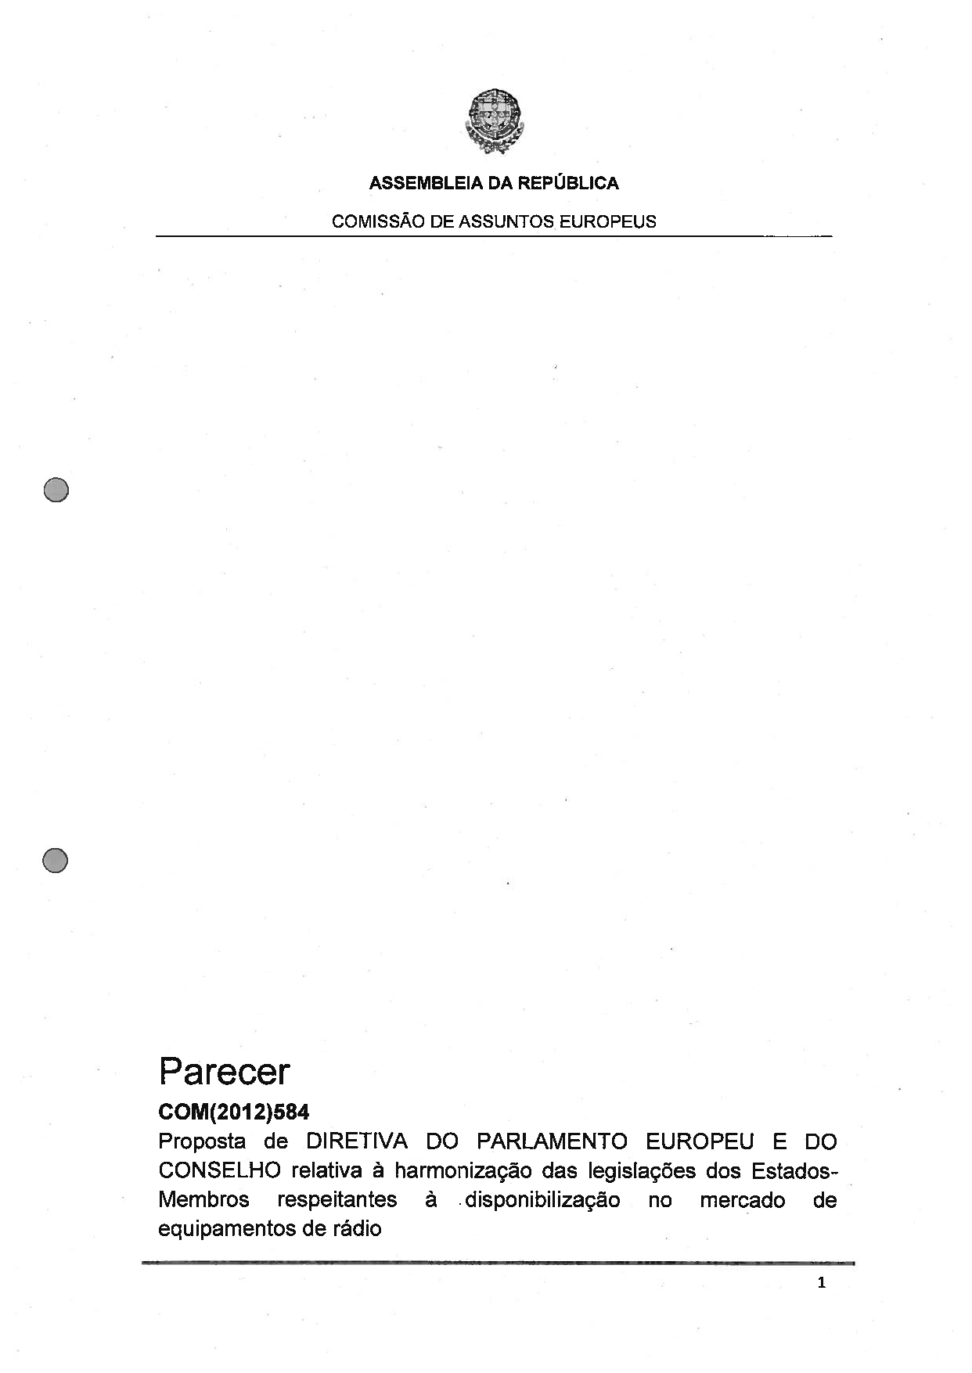
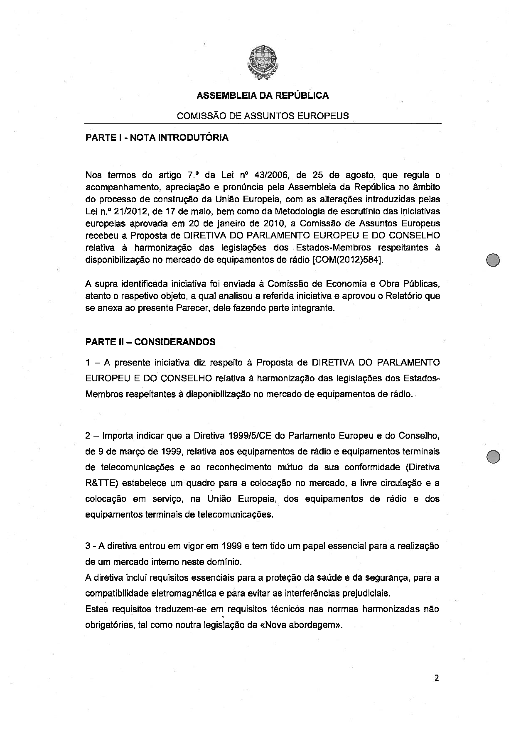
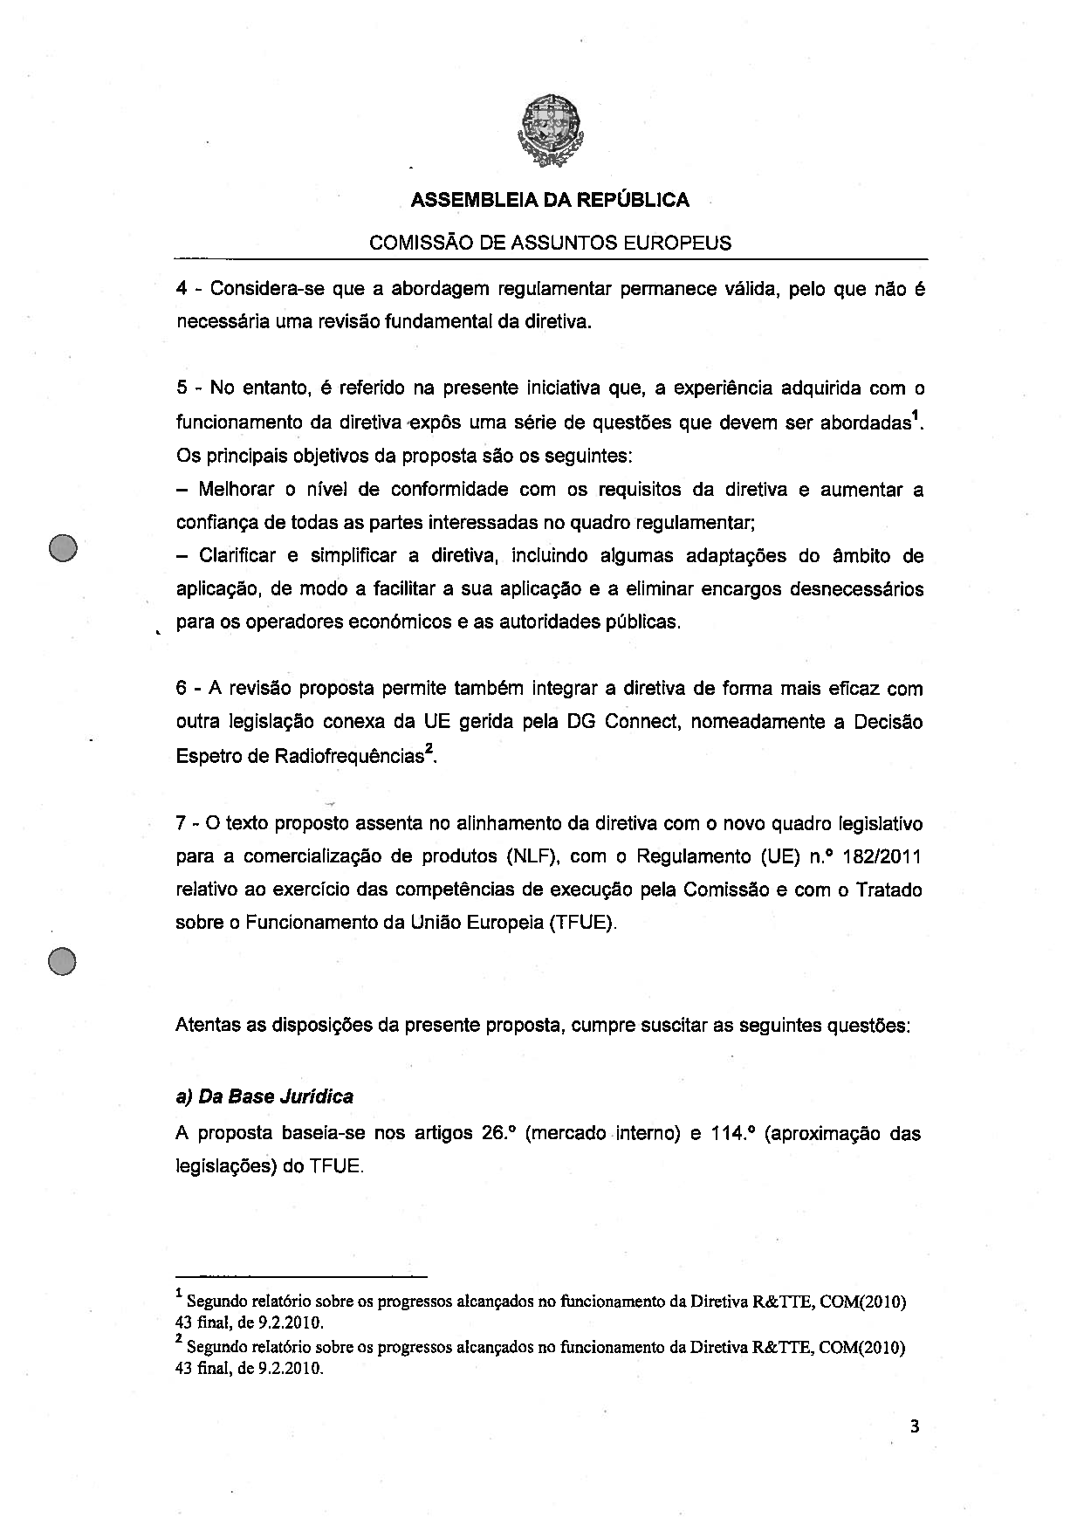
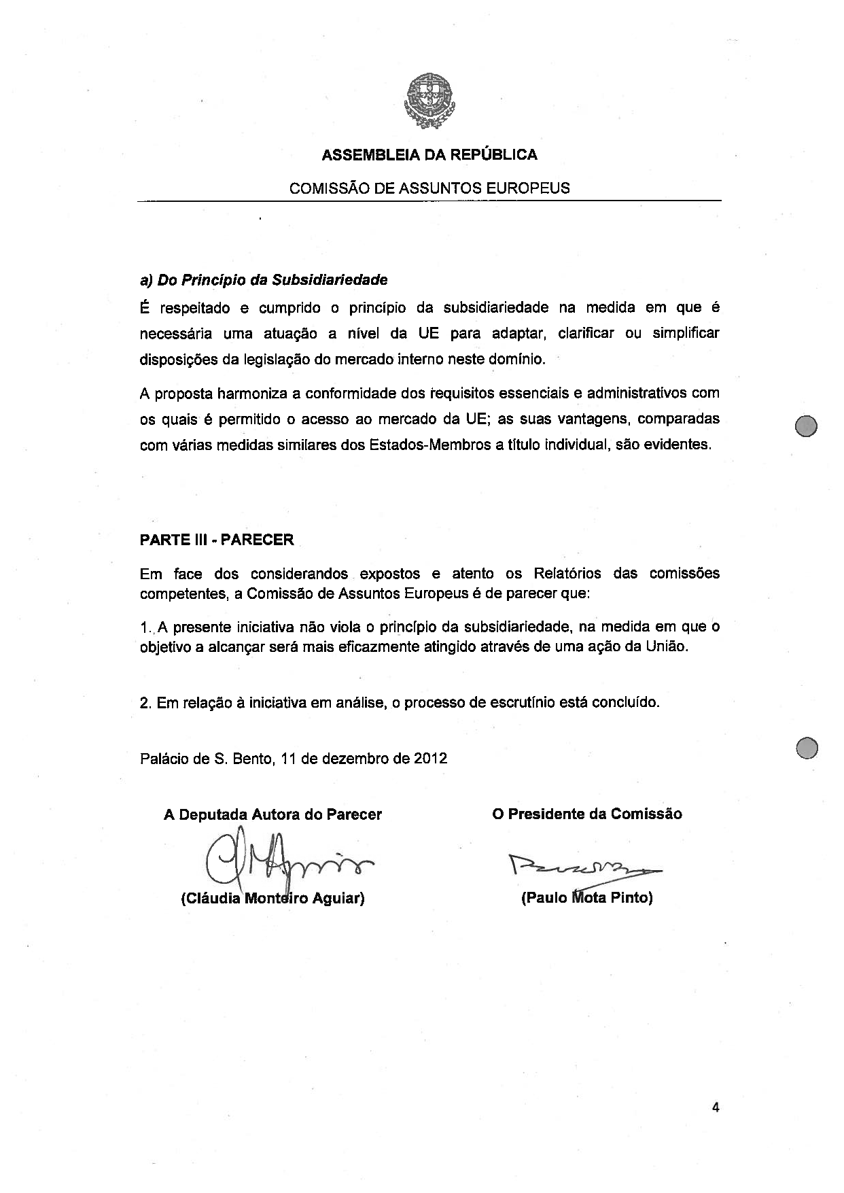
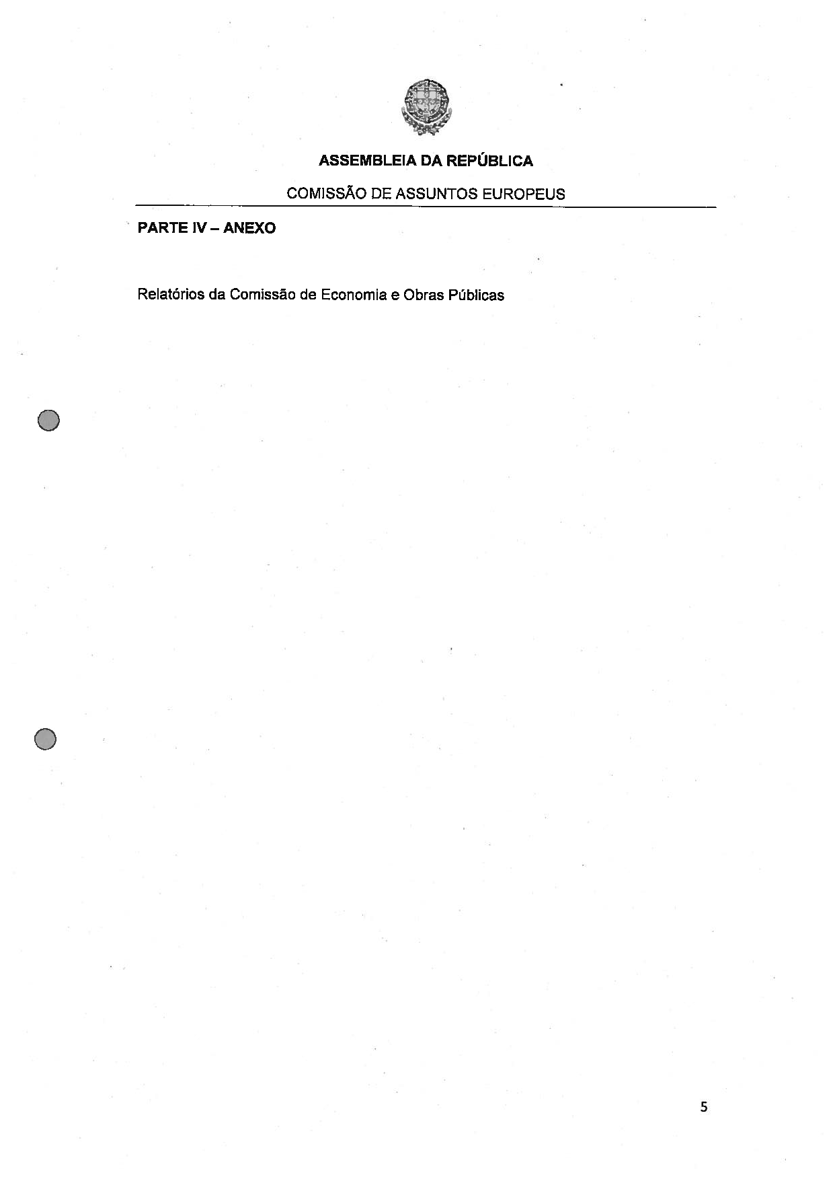
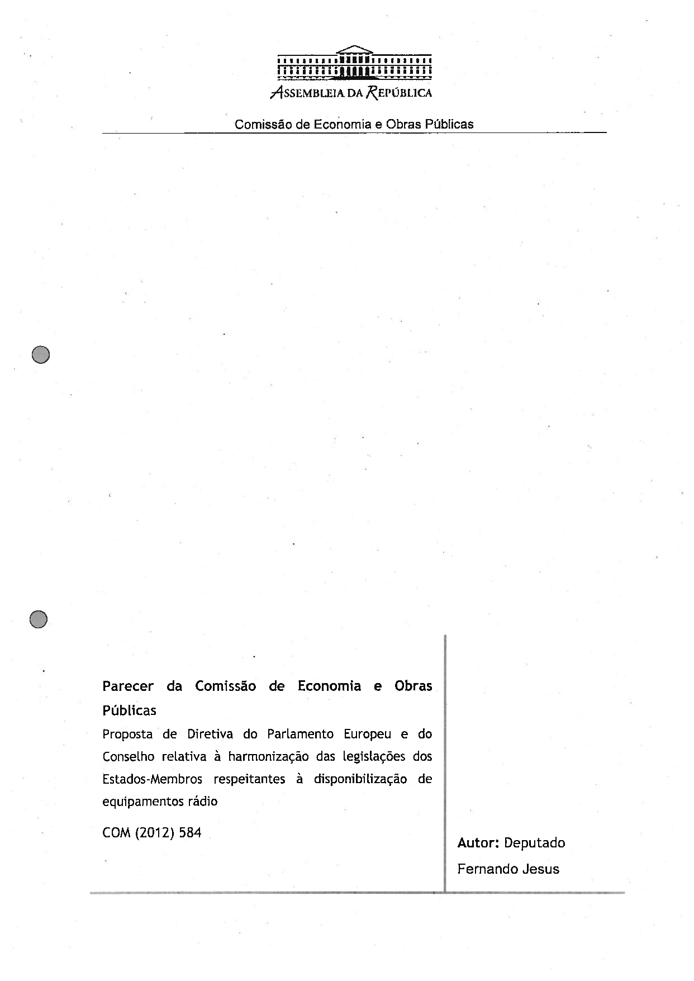
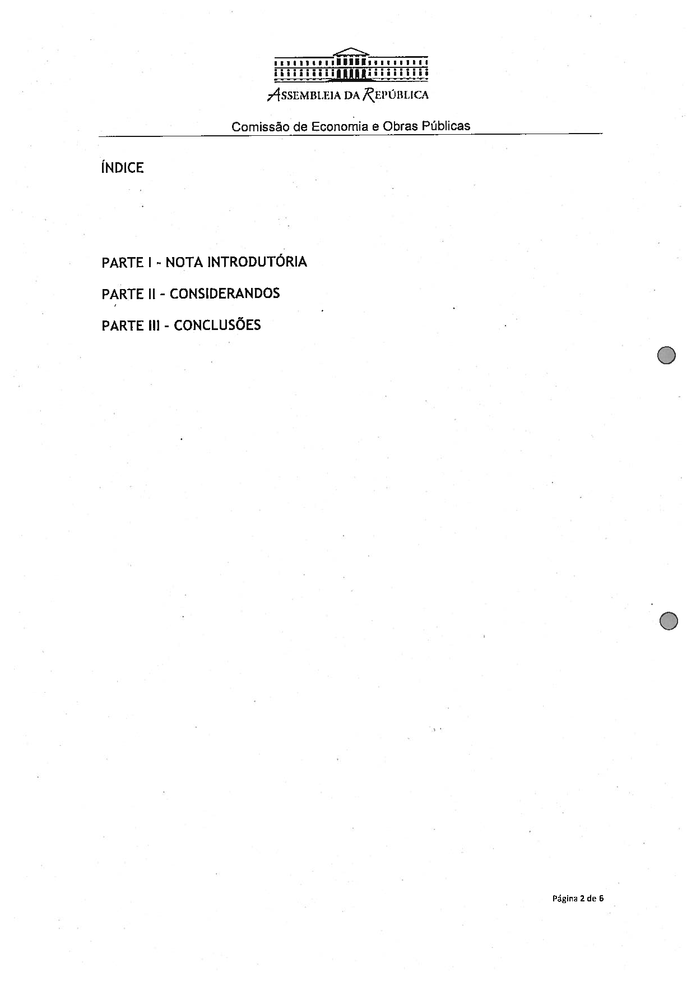
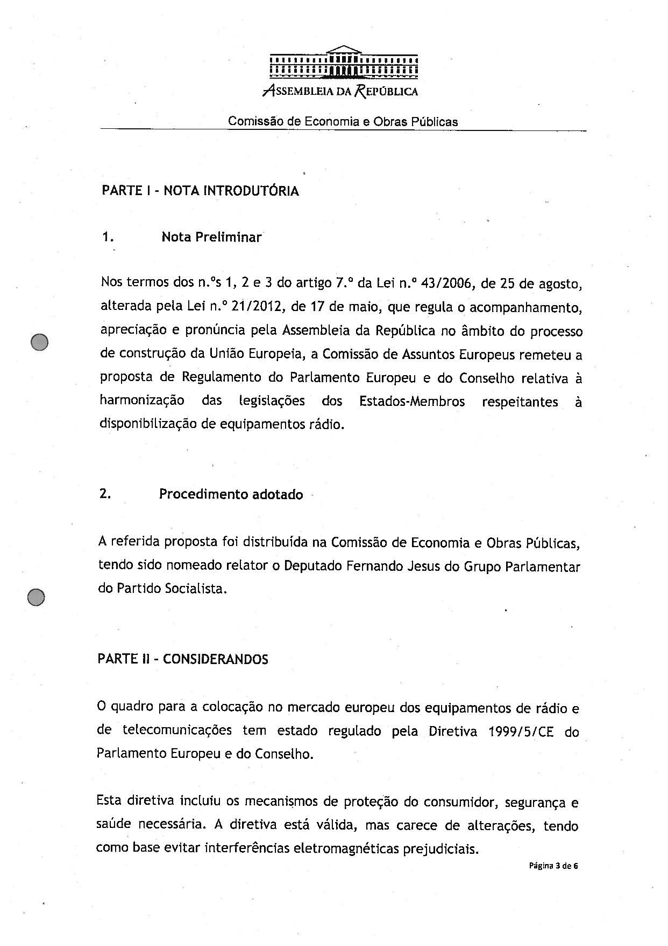
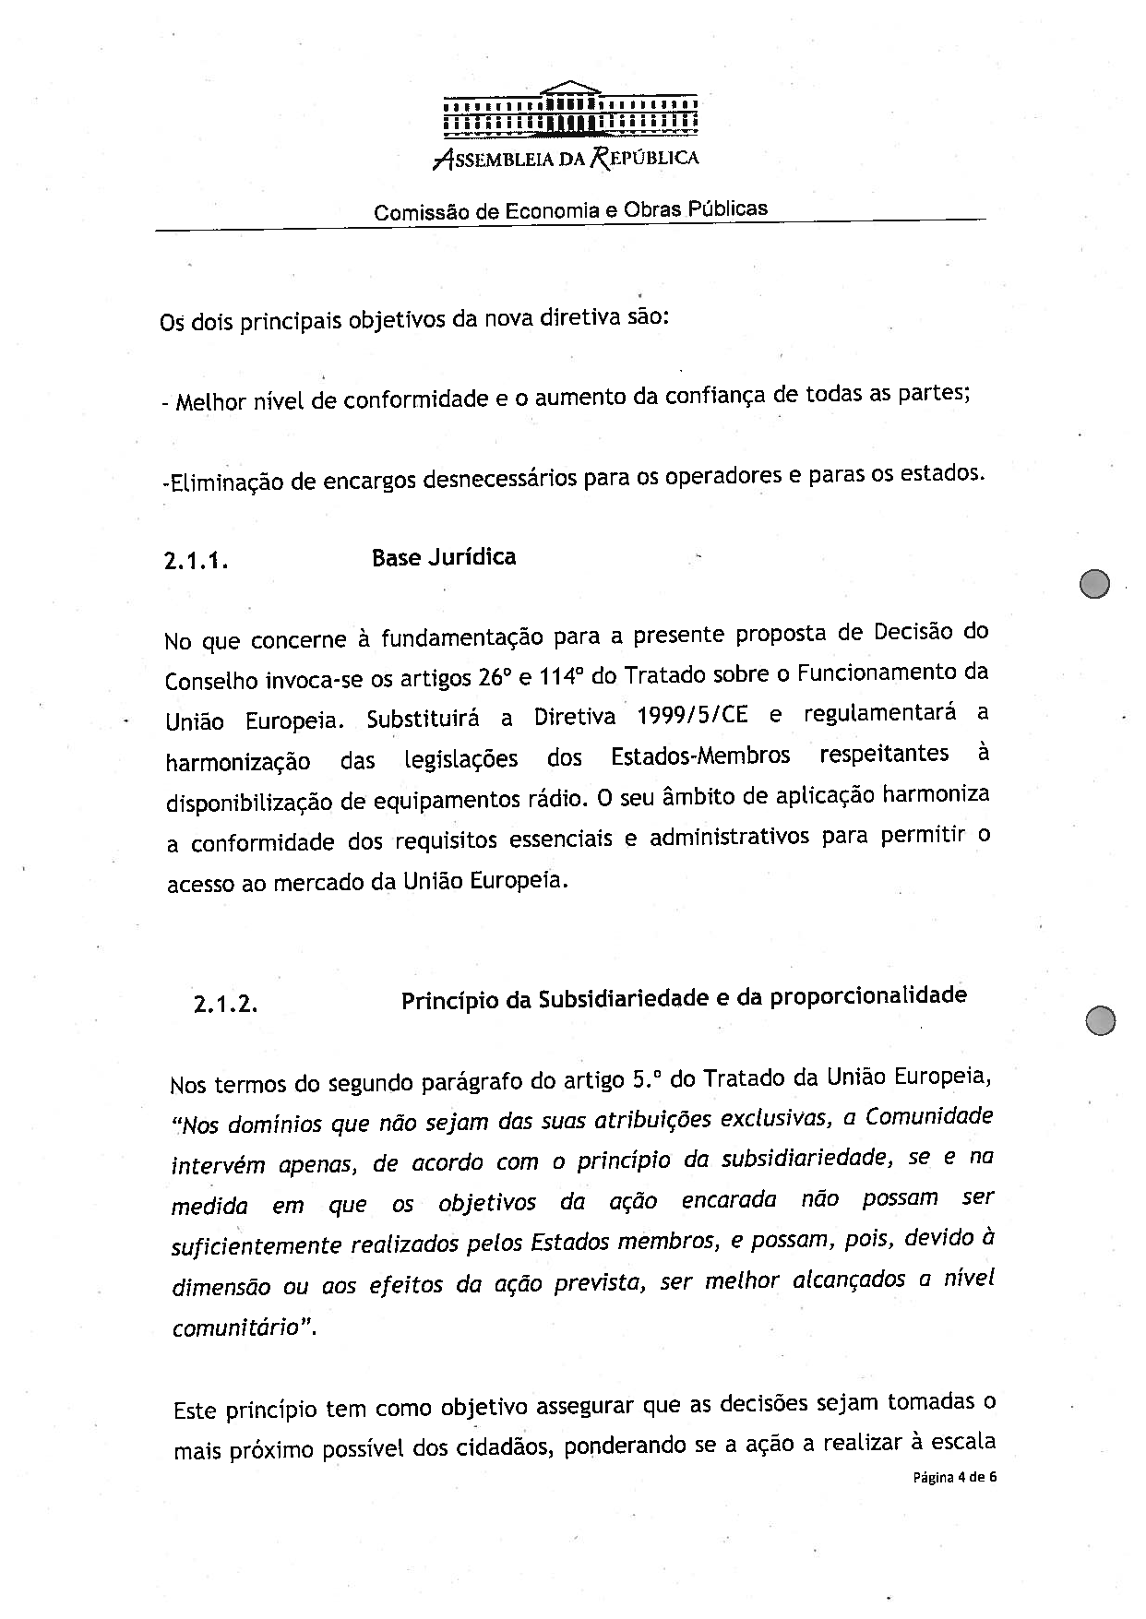
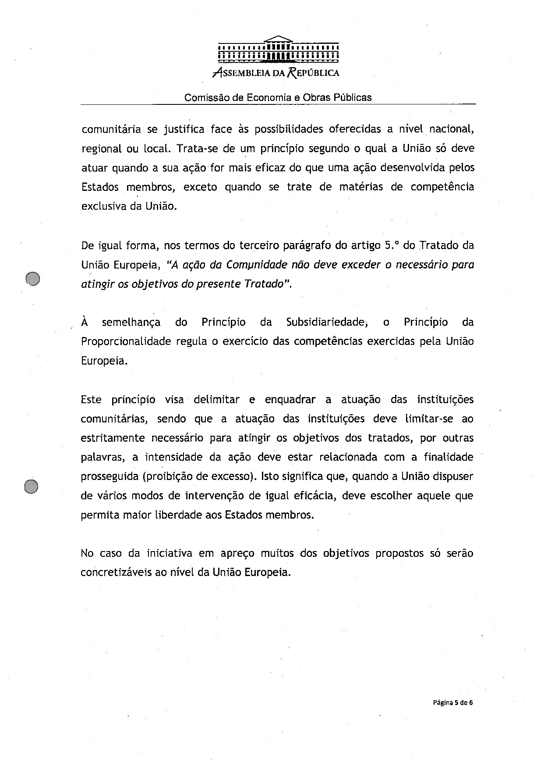
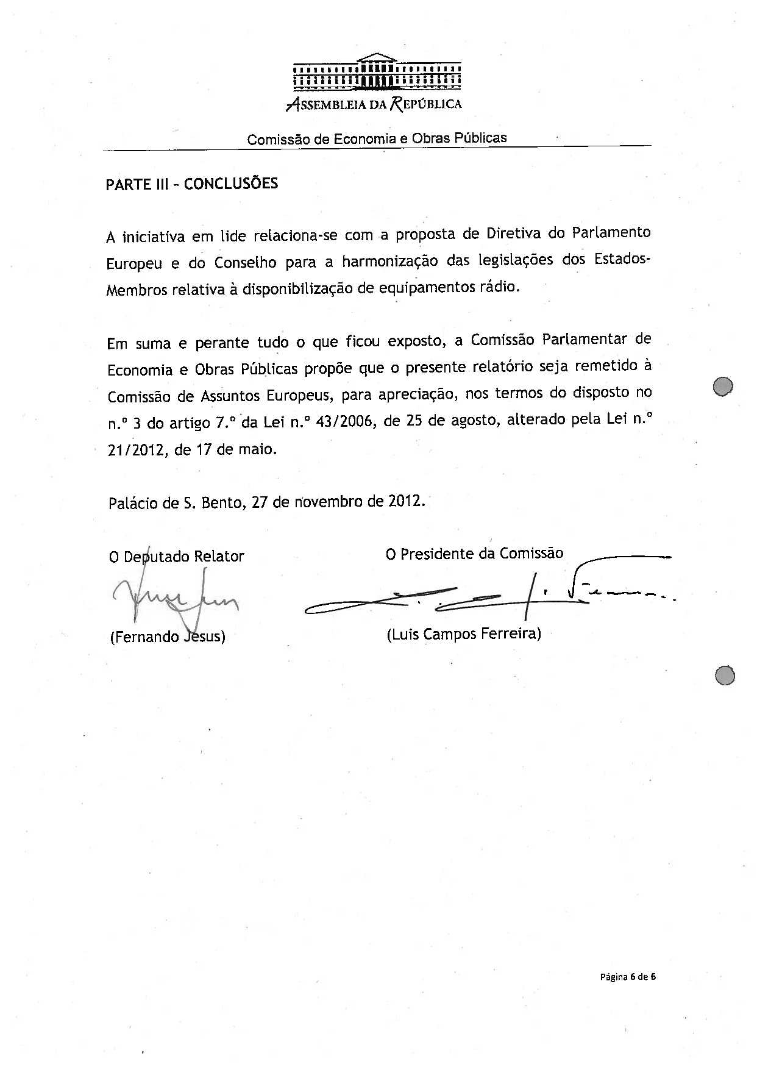

The translation can be found at the Interparliamentary EU information exchange site IPEX at the following address: http://www.ipex.eu/IPEXL-WEB/dossier/document/COM20120584.do#dossier-COD20120283

