 | 
COUNCIL OF  THE EUROPEAN UNION |  |  | Brussels, 12 December 2012
 | Interinstitutional Files:  2012/0266 (COD)  2012/0267 (COD) |  | 17031/12
PHARM 90
SAN 309
MI 796
COMPET 745
CODEC 2870
INST 731
PARLNAT 388

COVER NOTE
from: | Portuguese Parliament
date of receipt: | 27 November 2012
to: | The President of the Council of the European Union
No Cion doc.: | 14499/12 PHARM 72 SAN 216 MI 598 COMPET 599 CODEC 2312 -  COM(2012) 541 final  14493/12 PHARM 71 SAN 215 MI 597 COMPET 600 CODEC 2305 - COM(2012) 542 final
Subject: | Proposal for a Regulation of the European Parliament and of the Council on in vitro diagnostic medical devices  Proposal for a Regulation of the European Parliament and of the Council on Medical devices, and amending Directive 2001/83/EC, Regulation (EC) No 178/2002 and Regulation (EC) No 1223/2009  - Opinion on the application of the Principles of Subsidiarity and Proportionality

Delegations will find attached for information a copy of the above opinion.

________________________

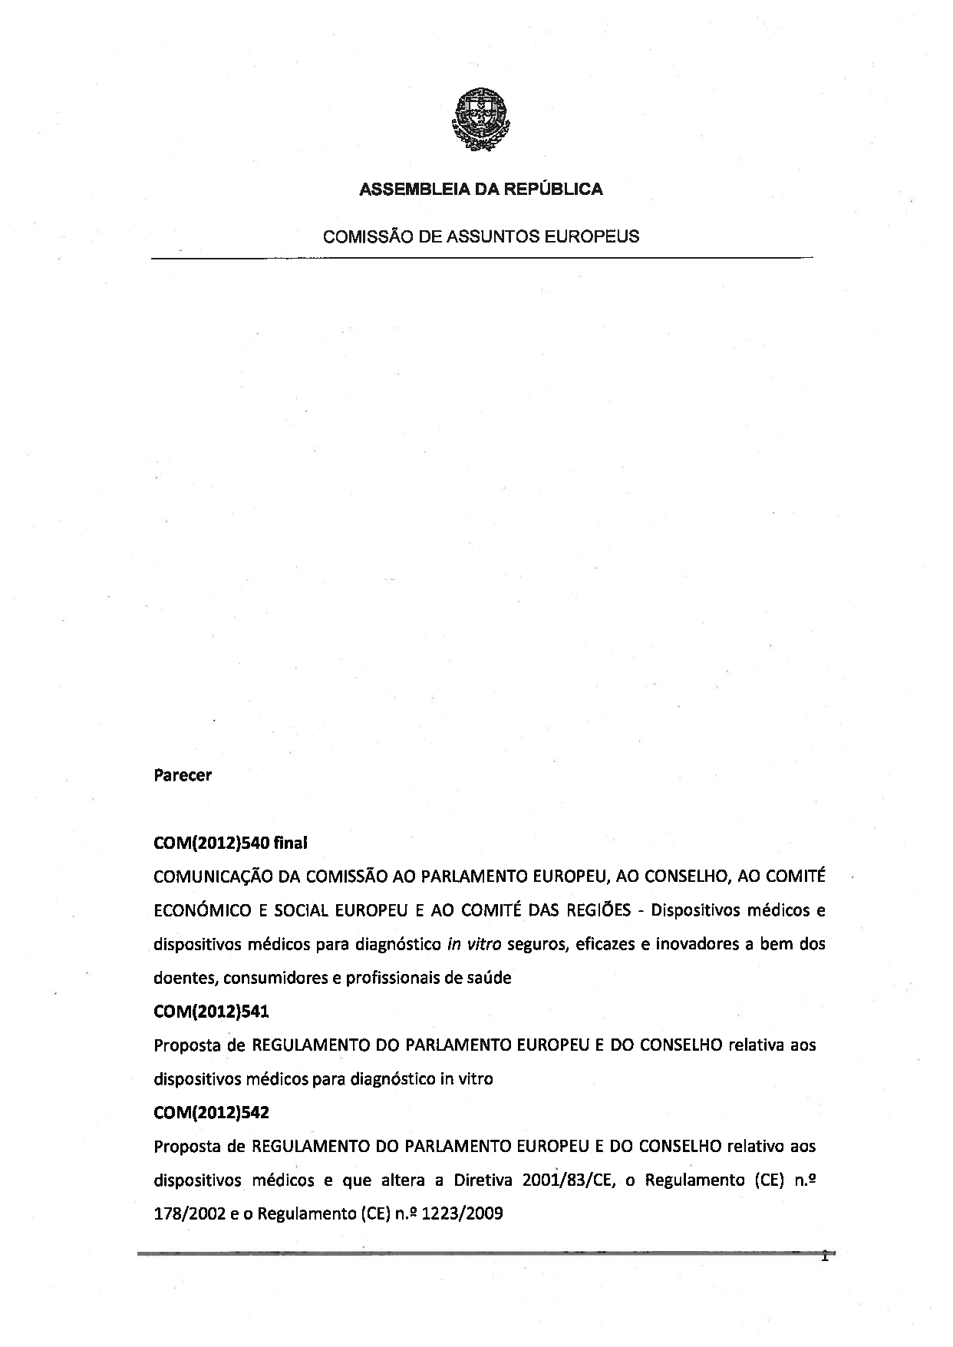

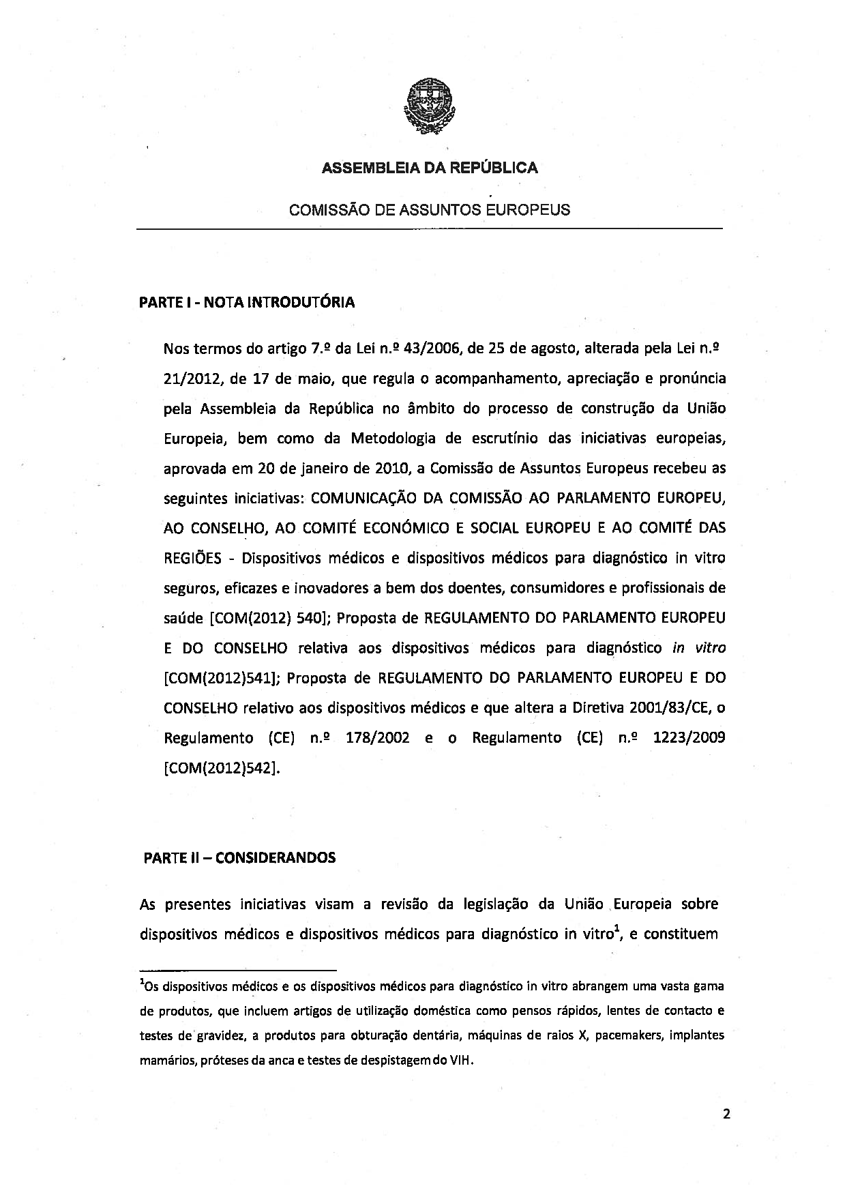

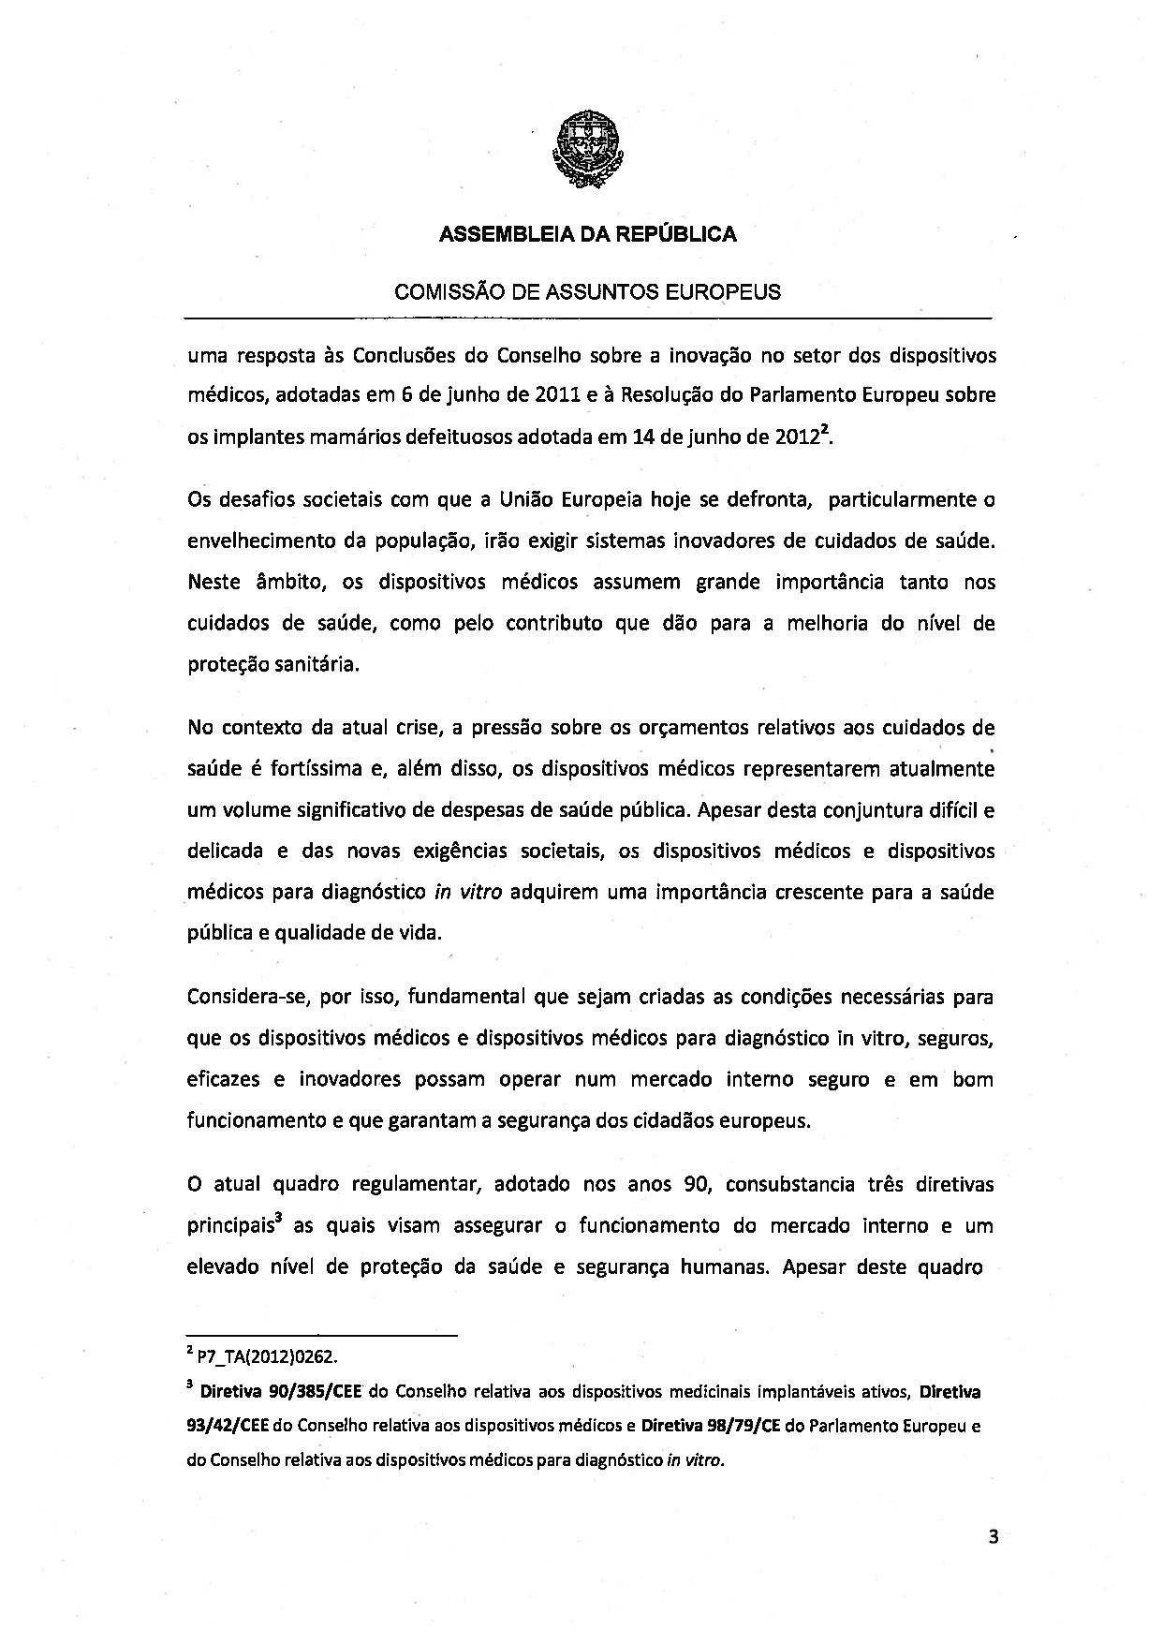

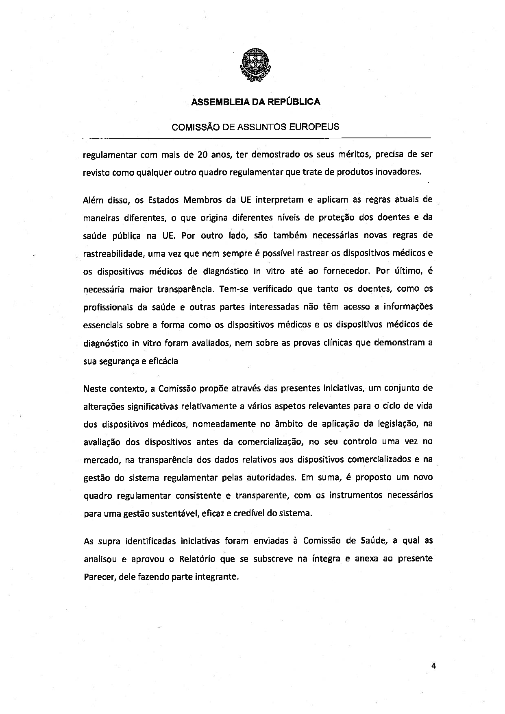

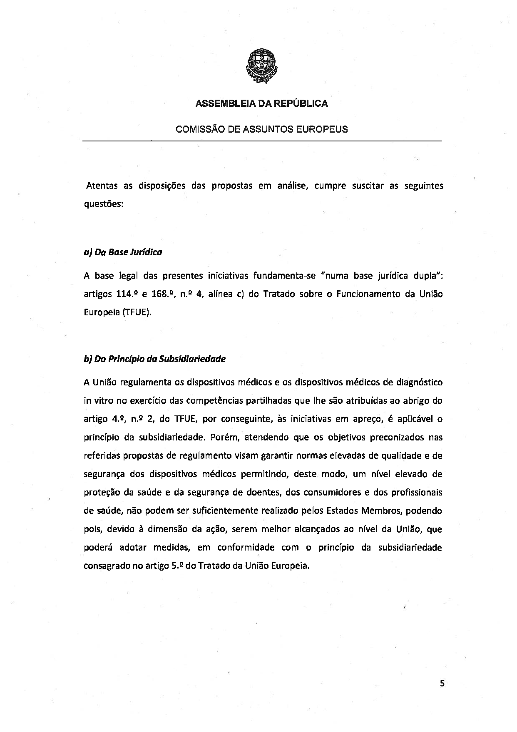

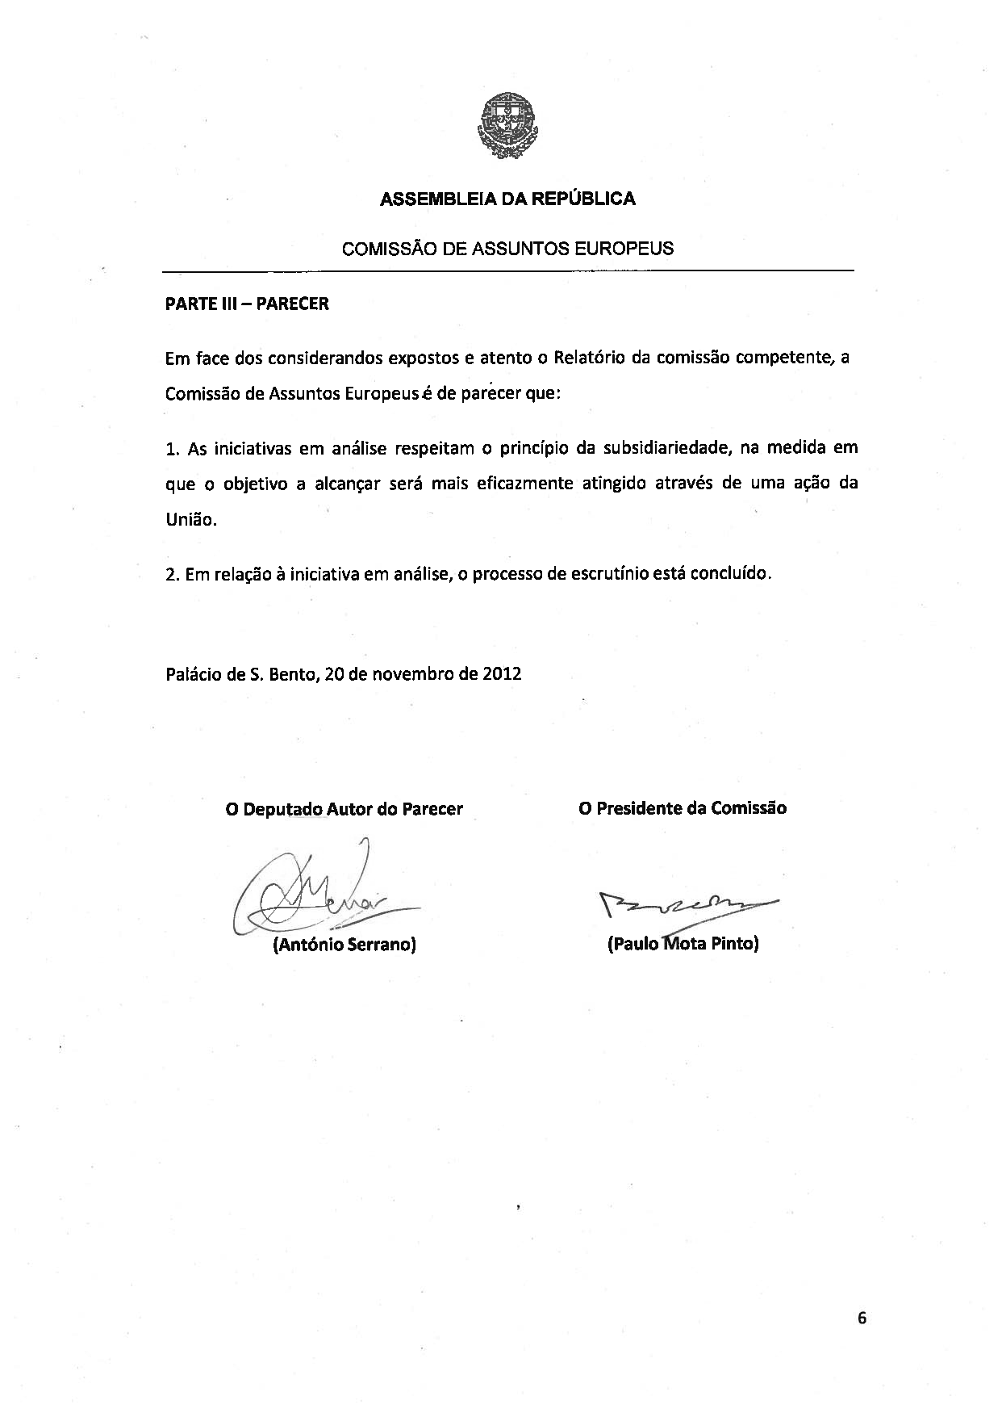



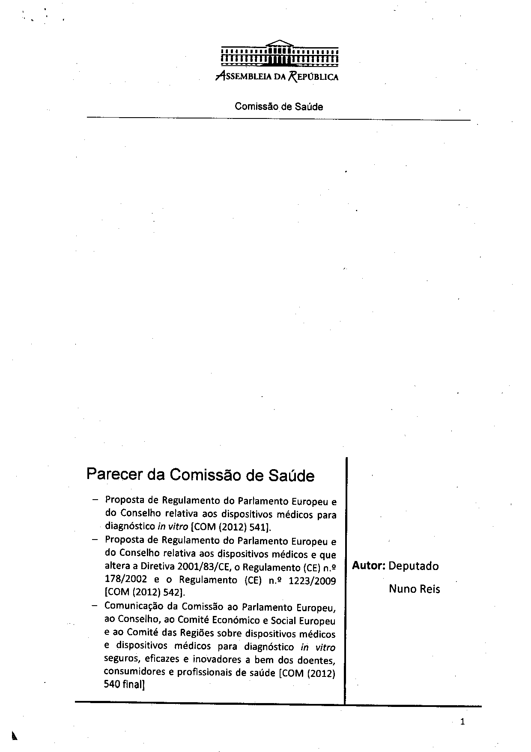



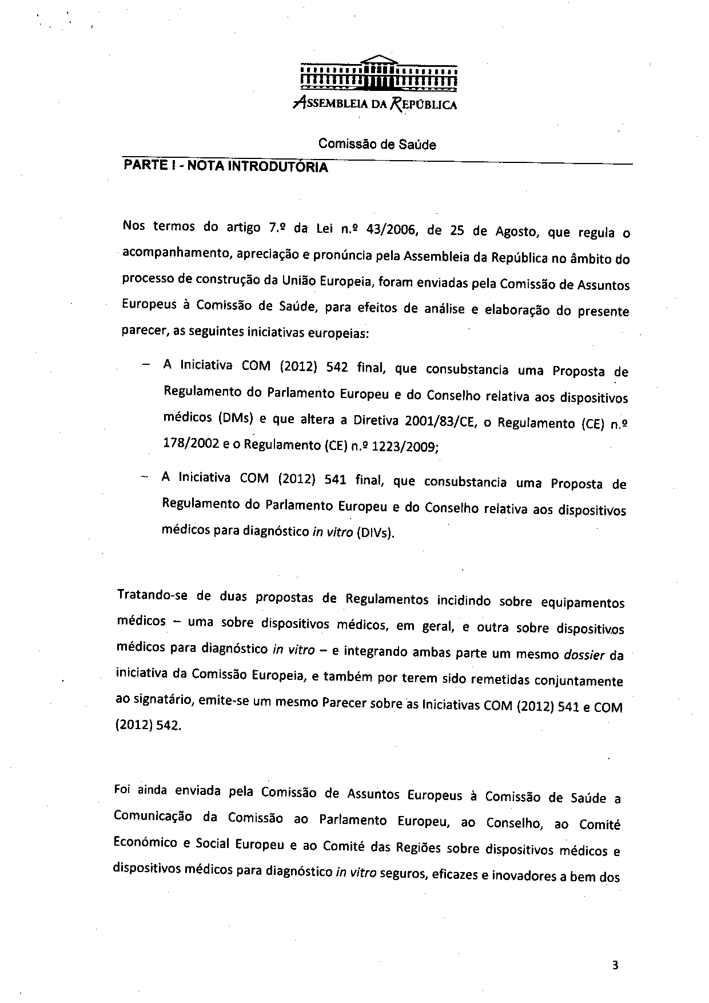

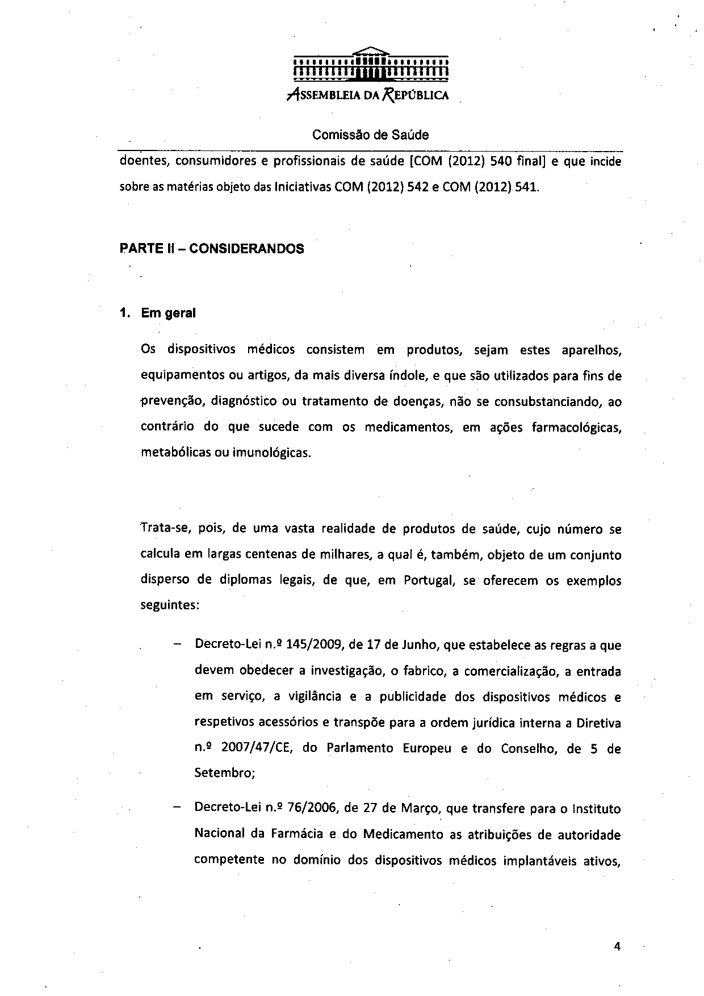

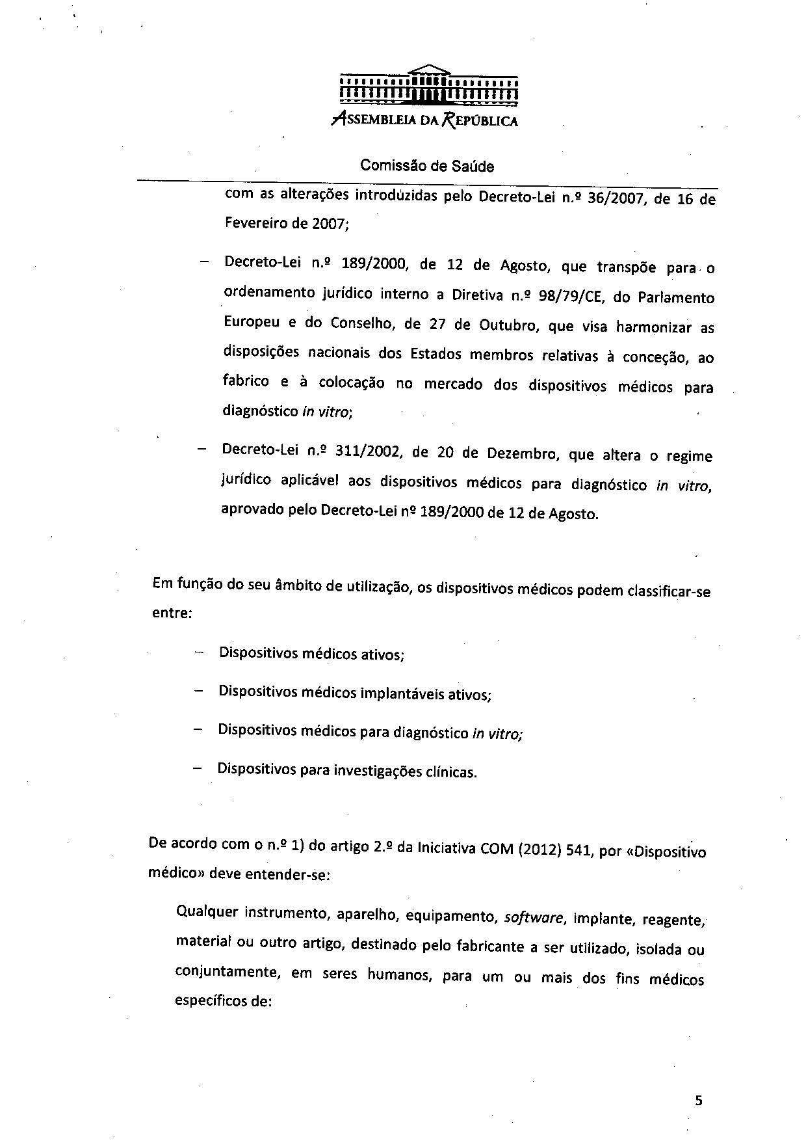

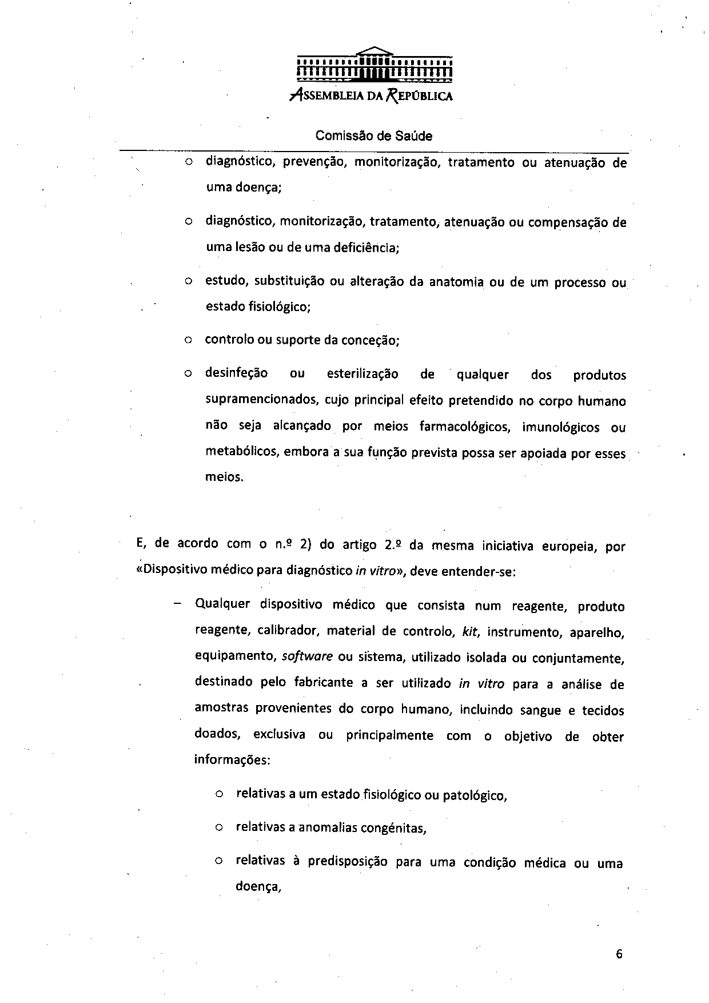

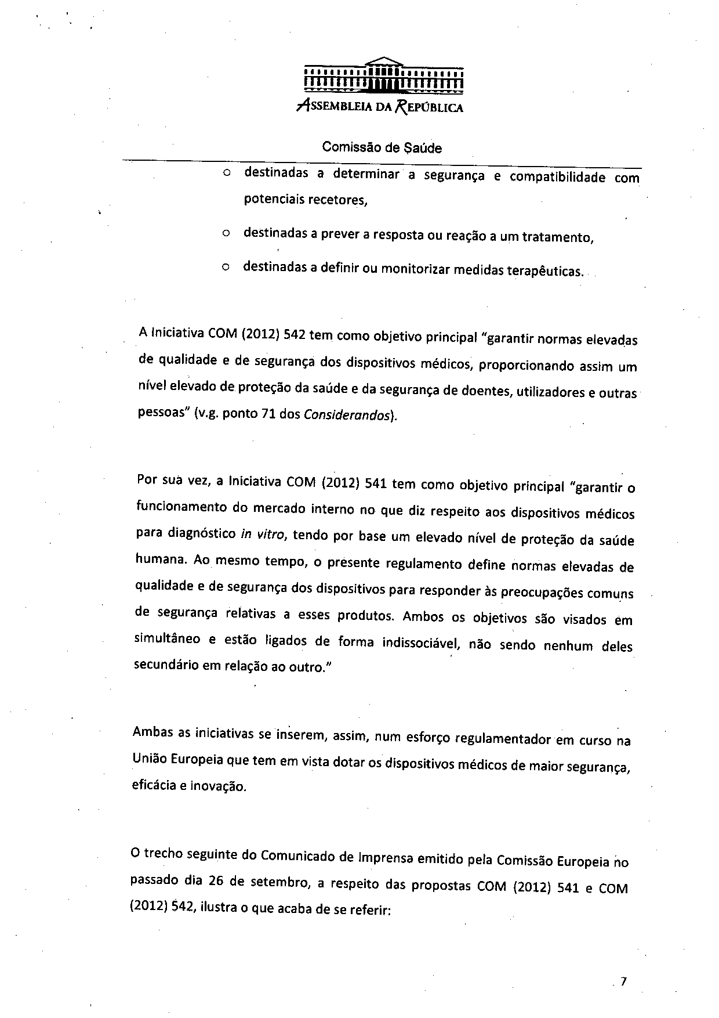

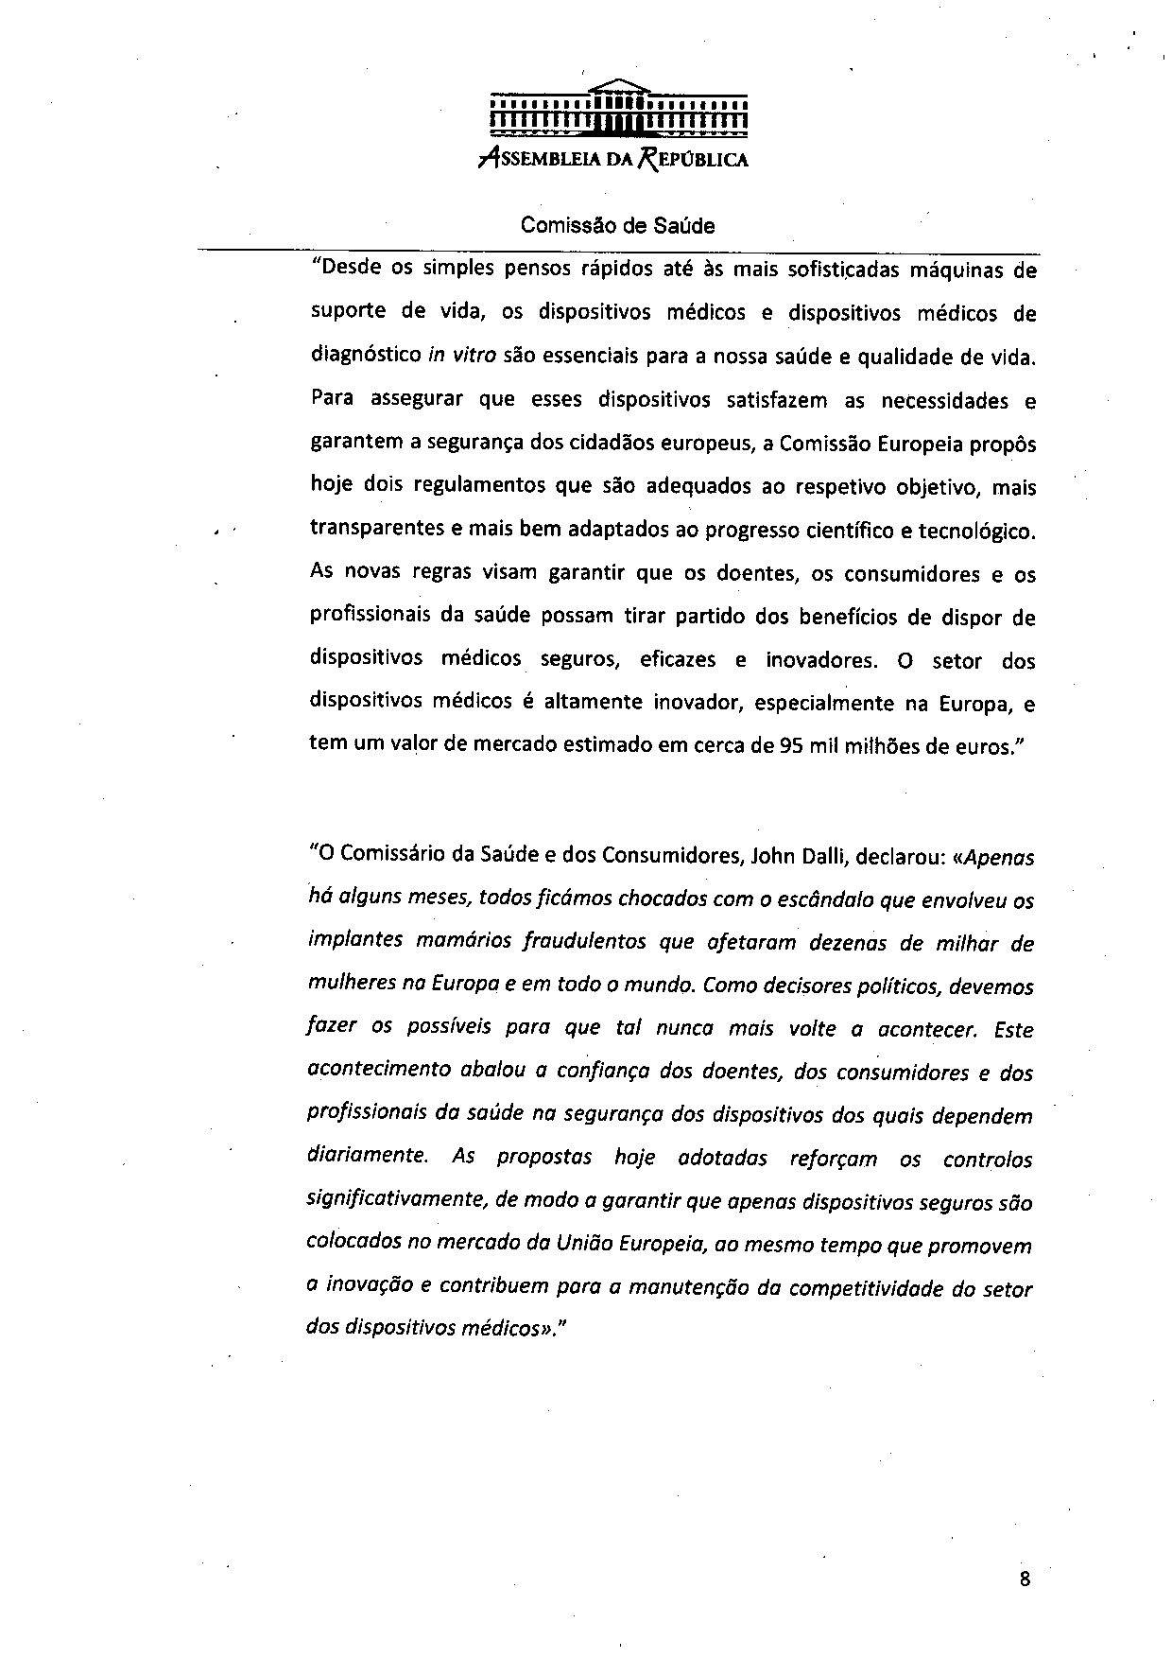

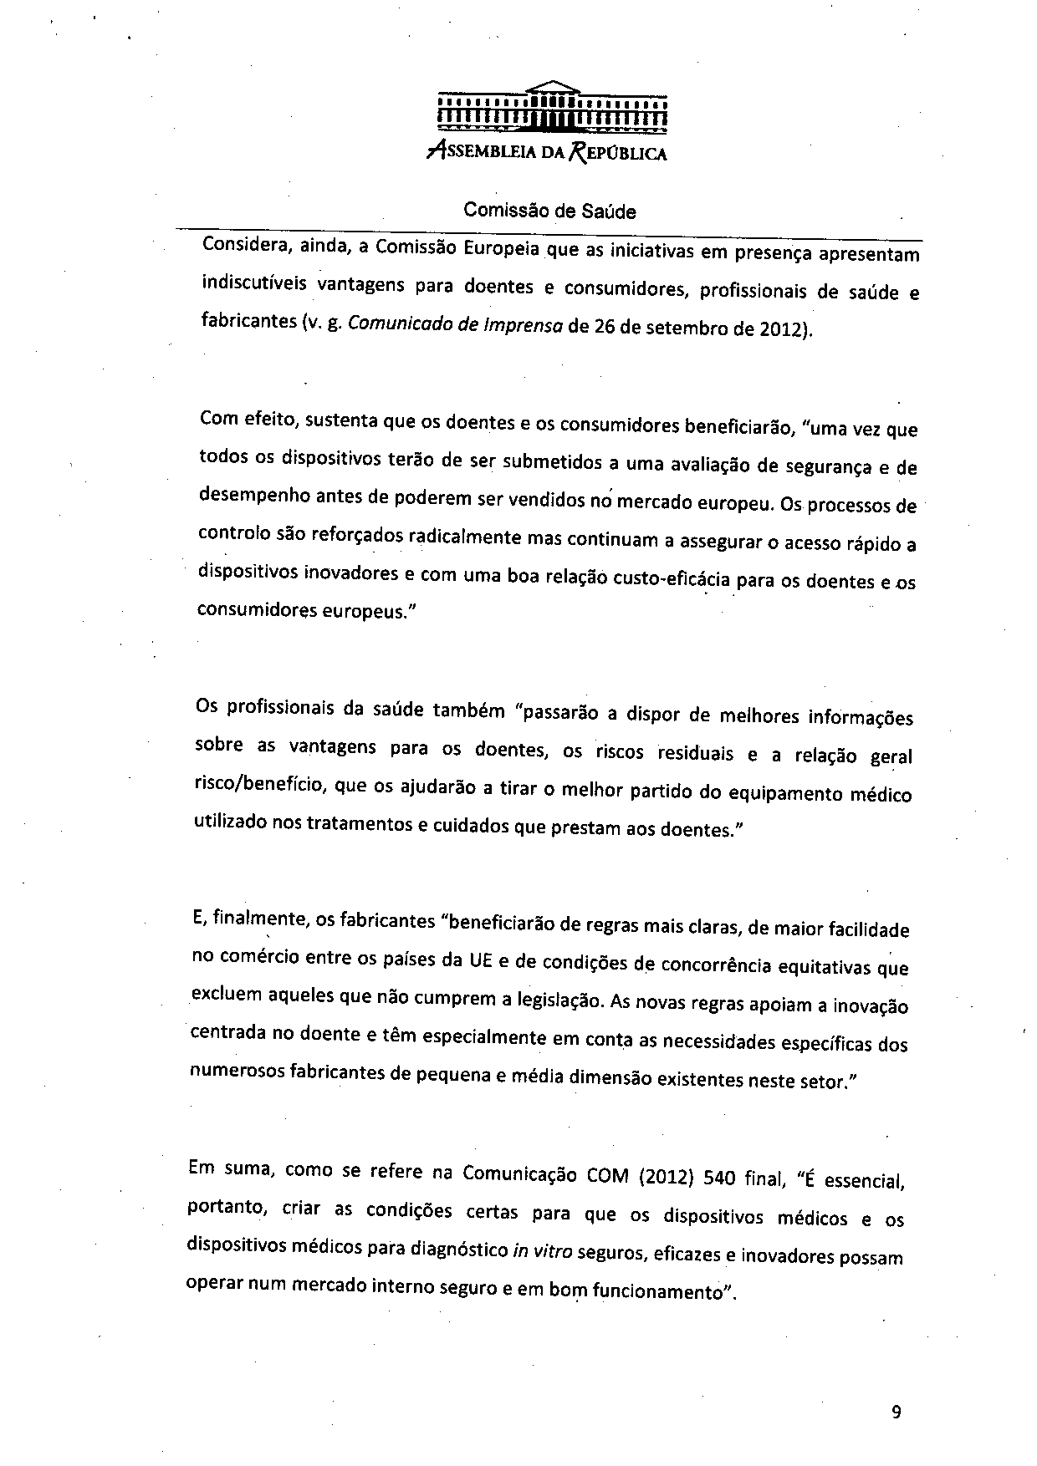

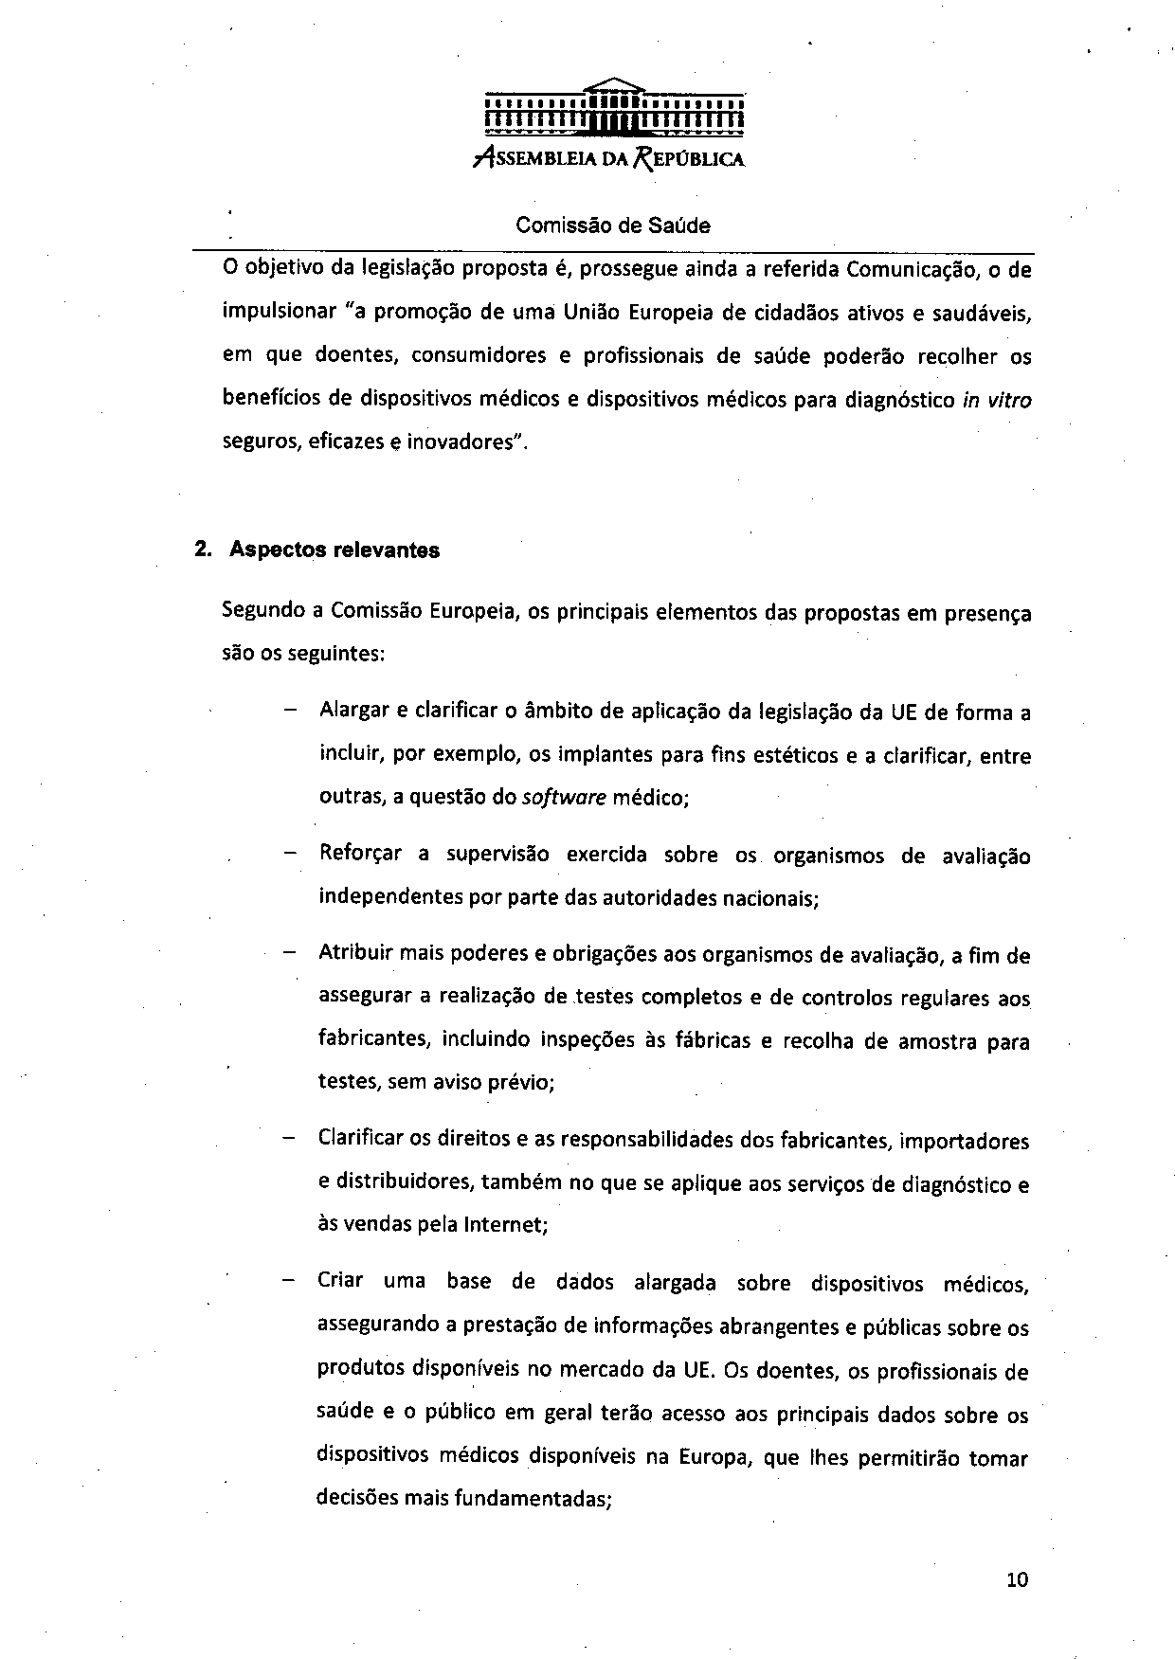

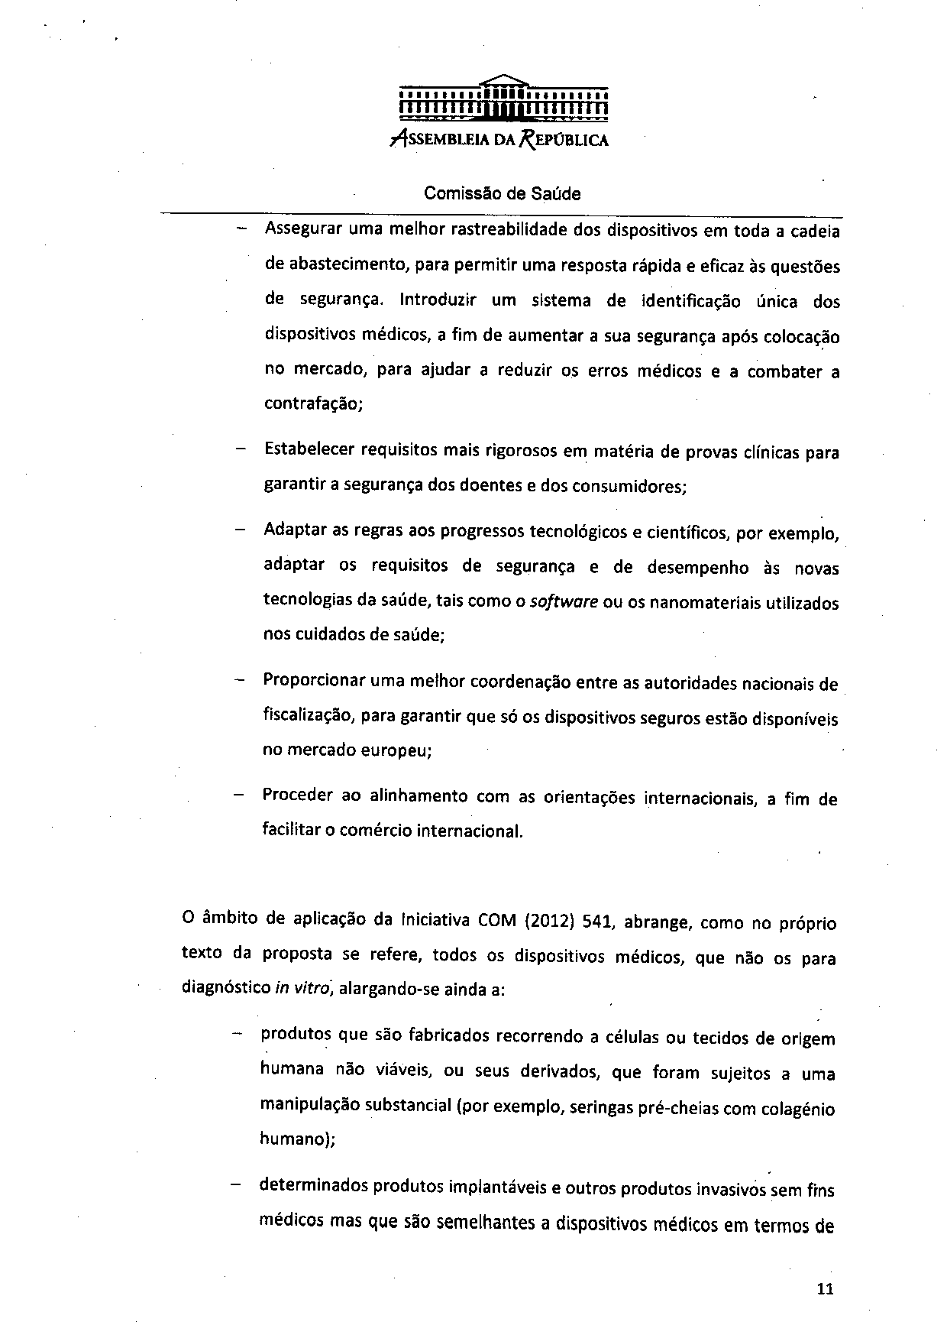

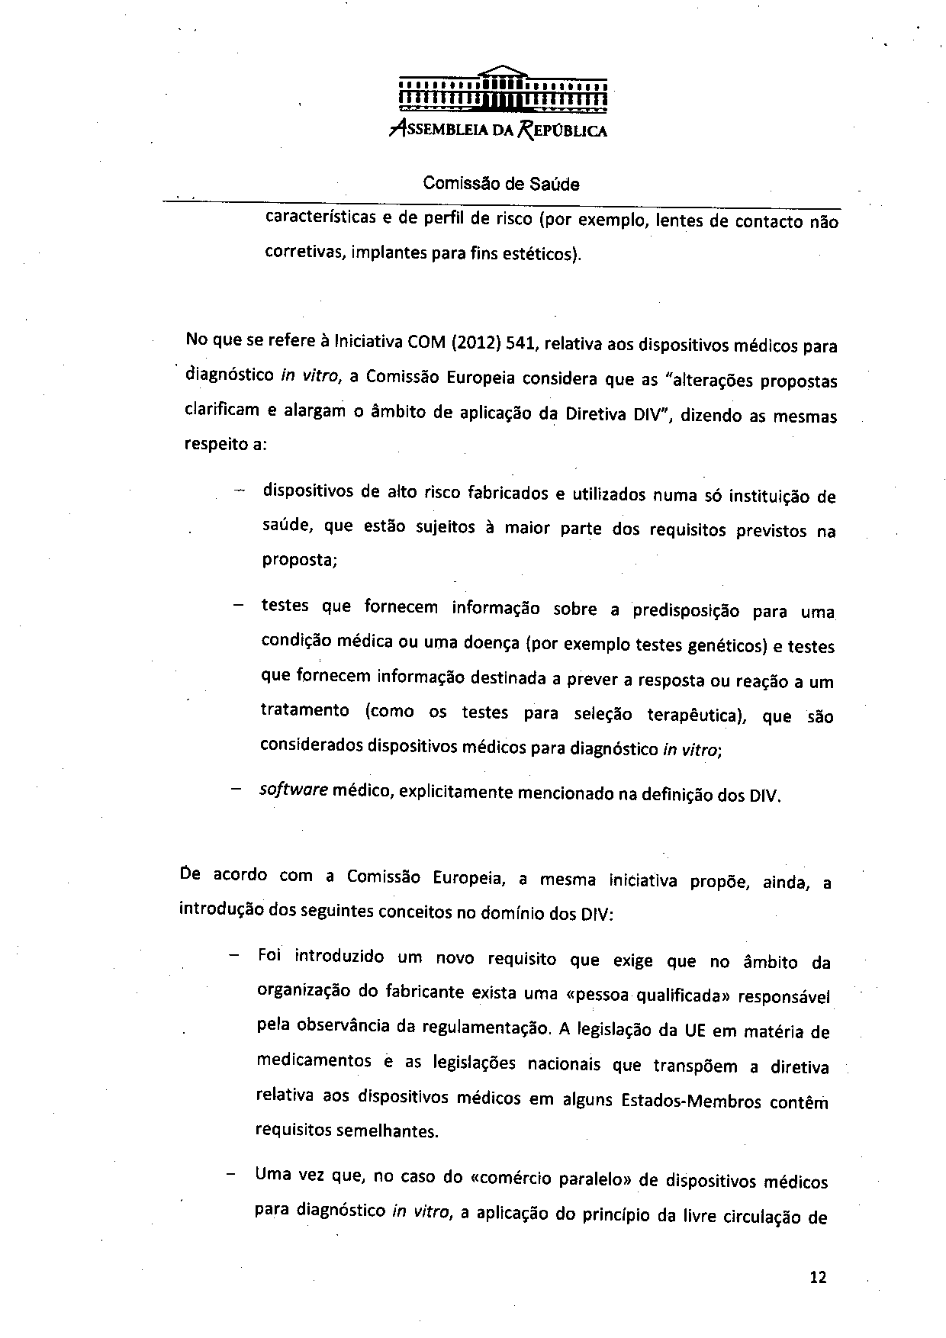

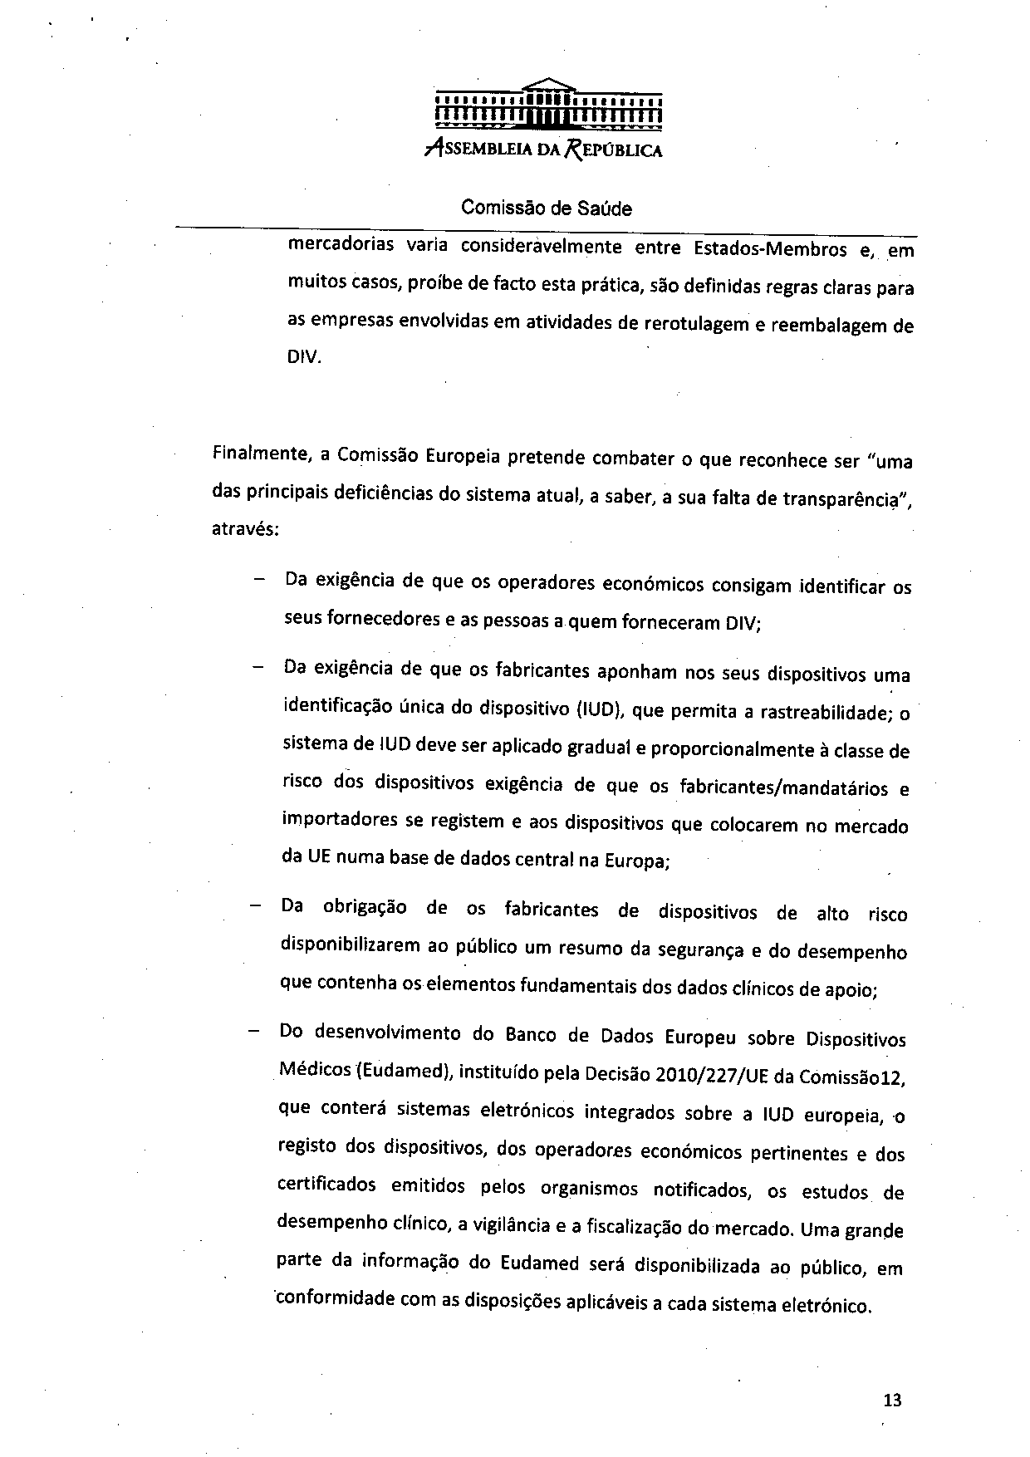

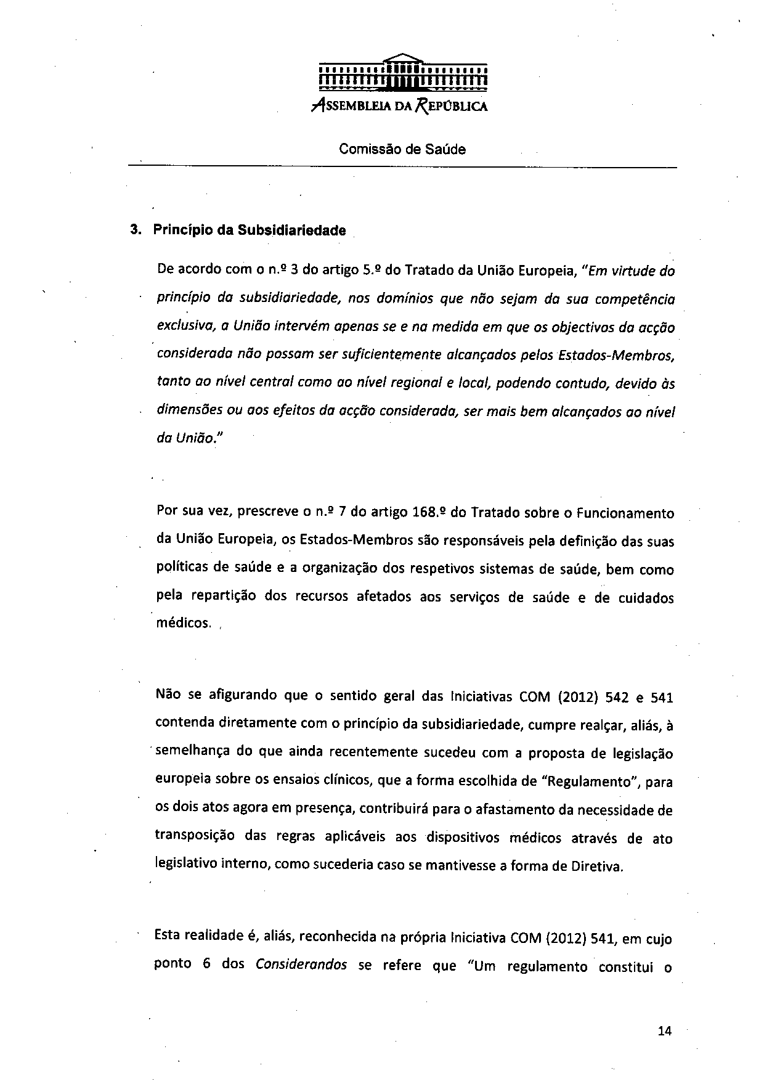

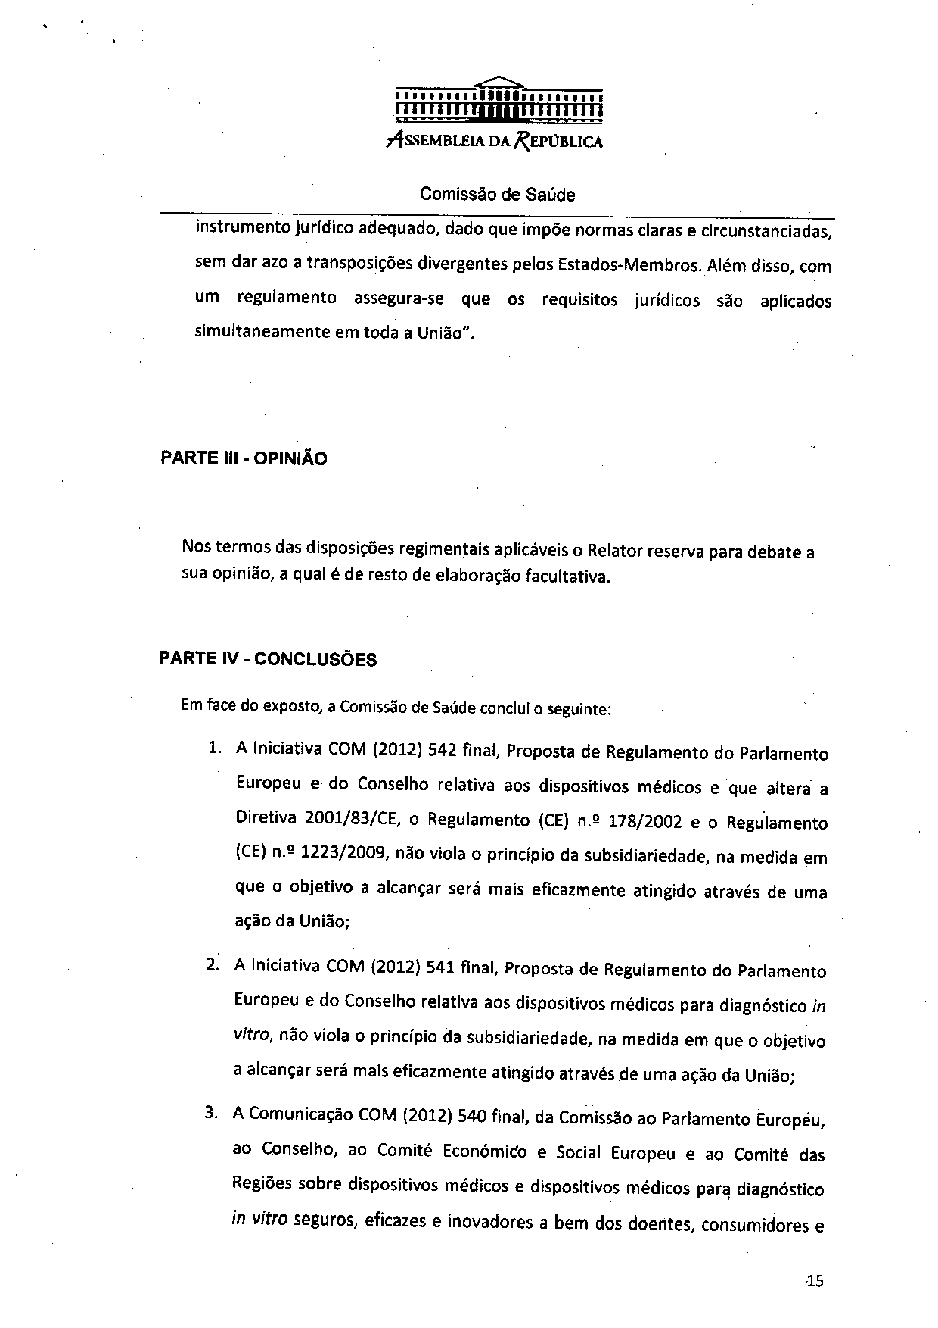

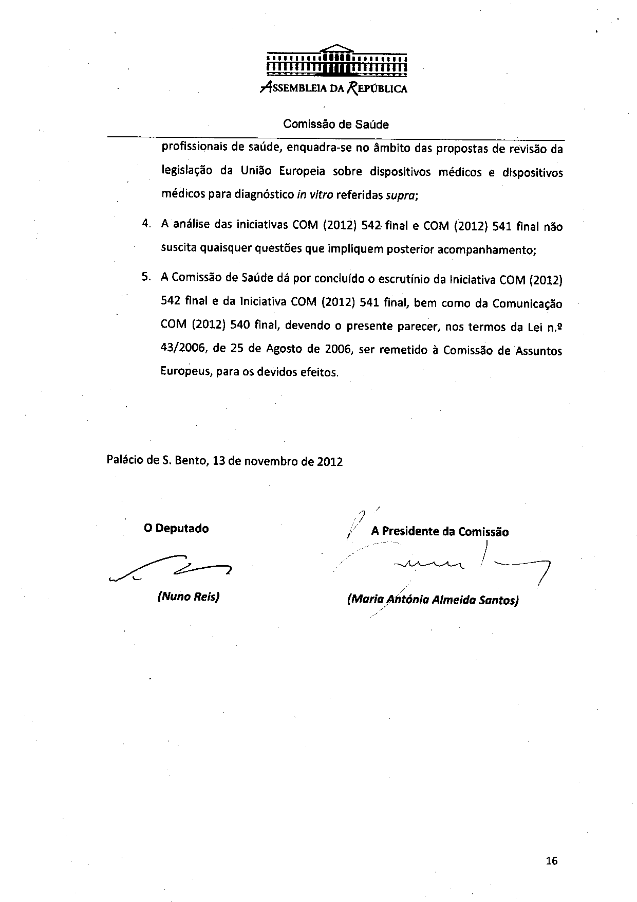

The translation can be found at the Interparliamentary EU information exchange site IPEX at the following addresses: http://www.ipex.eu/IPEXL-WEB/dossier/document/COM20120541.do#dossier-COD20120267 http://www.ipex.eu/IPEXL-WEB/dossier/document/COM20120542.do#dossier-COD20120266

