 | 
COUNCIL OF  THE EUROPEAN UNION |  |  | Brussels, 11 December 2012
 | Interinstitutional File:  2012/0163 (COD) |  | 17647/12
WTO 399
FDI 35
CODEC 3021
INST 730
PARLNAT 387

COVER NOTE
from: | the President of the Assembly of the Republic of Portugal
date of receipt: | 5 December 2012
to: | Mr Dimitris CHRISTOFIAS, President of the Council of the European Union
Subject: | Proposal for a Regulation of the European Parliament and of the Council establishing a framework for managing financial responsibility linked to investor-state dispute settlement tribunals established by international agreements to which the European Union is party  [doc. 11868/12 WTO 242 FDI 18 CODEC 1768 - COM(2012) 335 final]  - Opinion on the application of the Principles of Subsidiarity and Proportionality

Delegations will find attached the above-mentioned opinion.

________________________

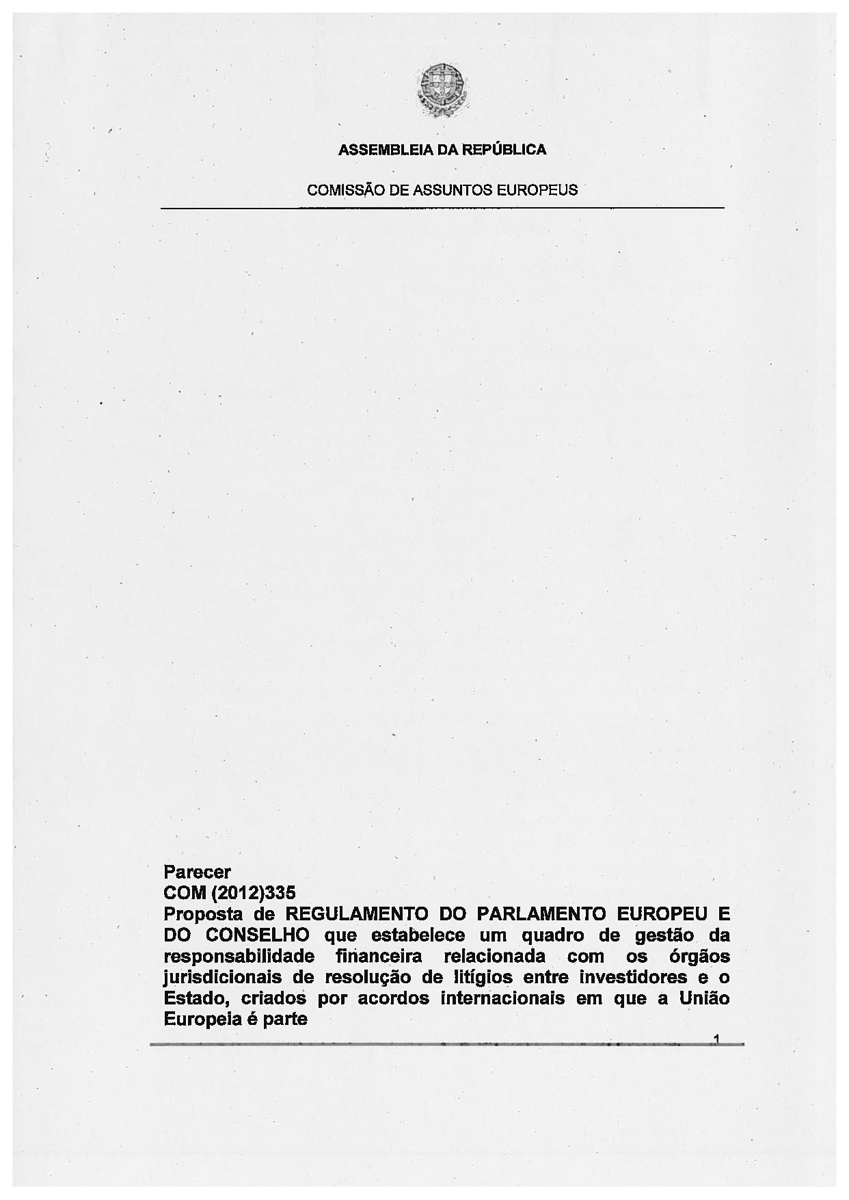
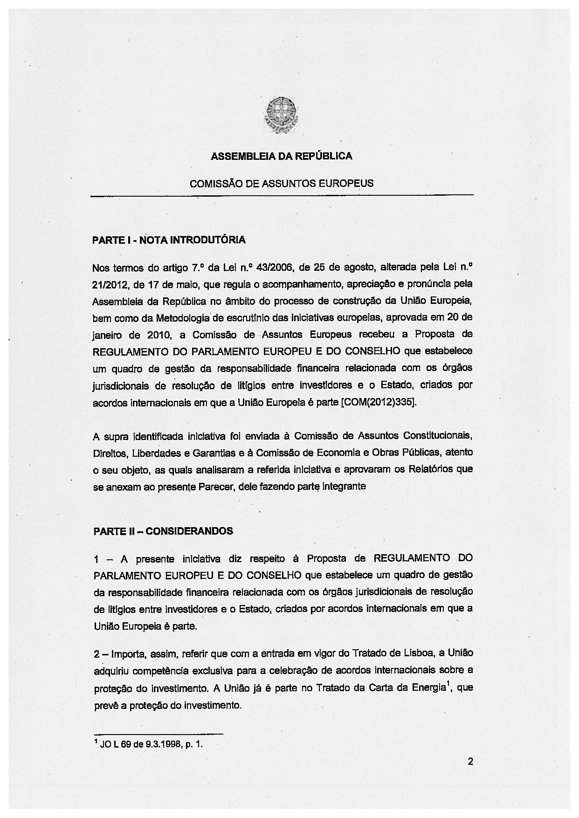
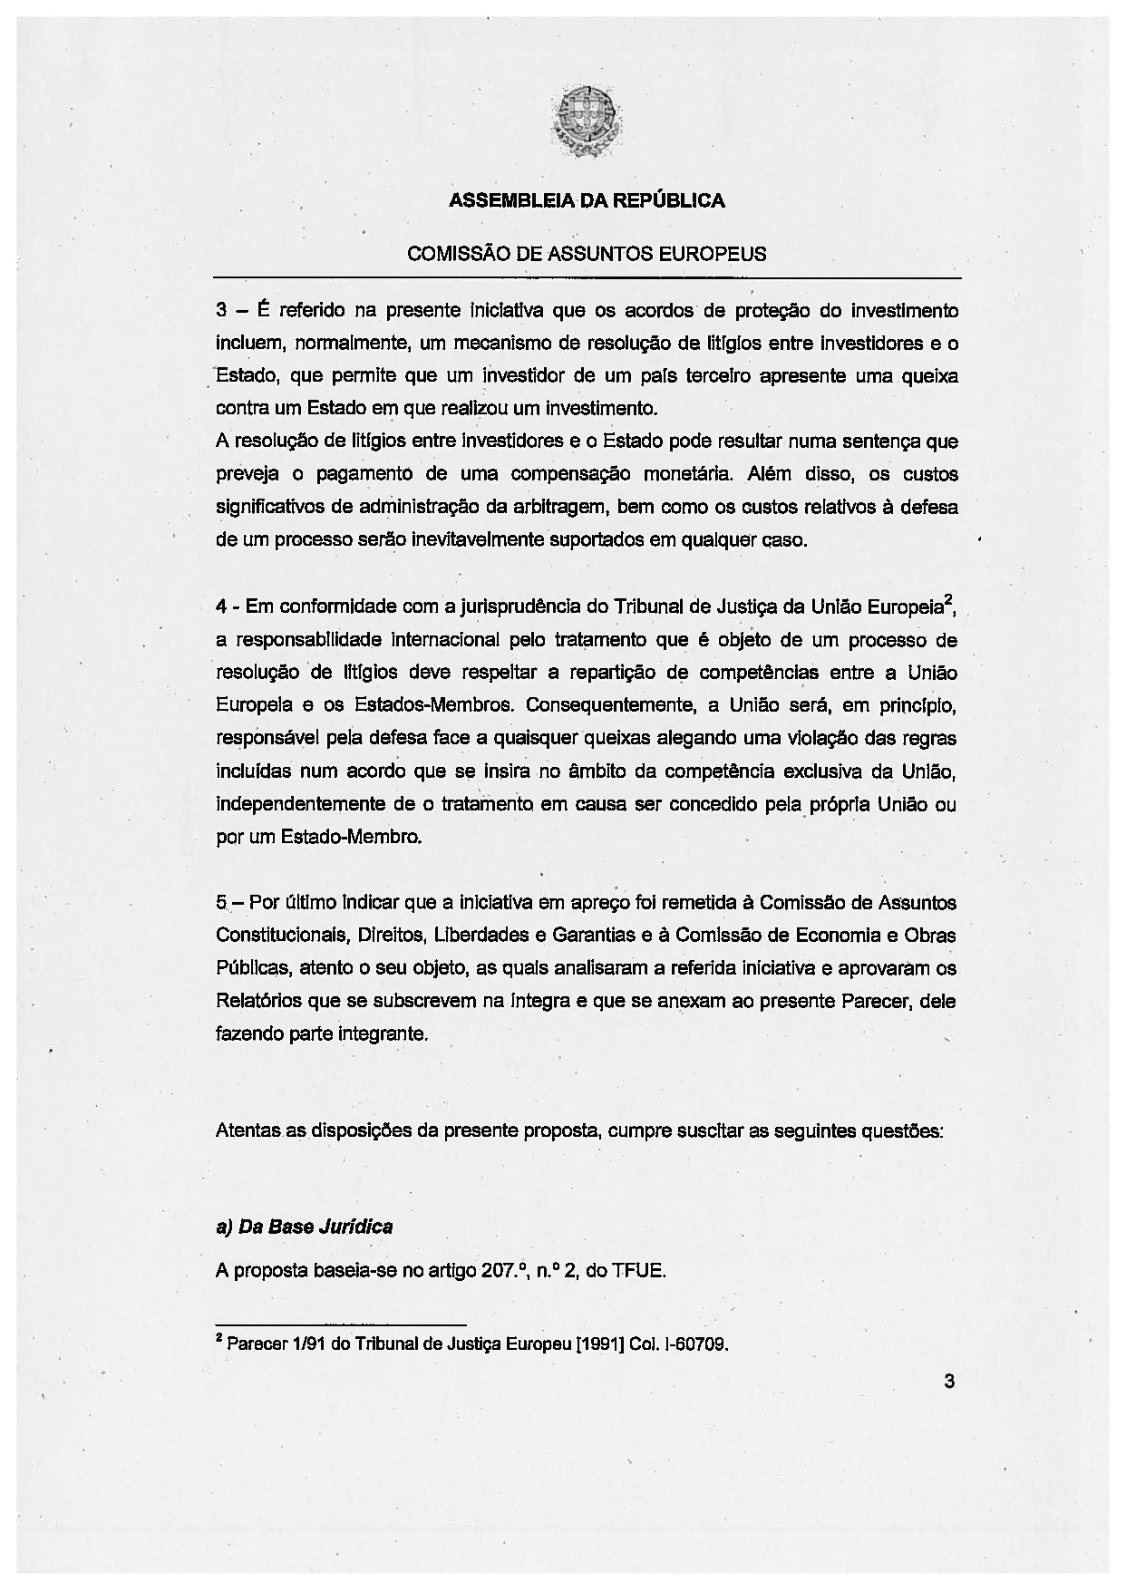
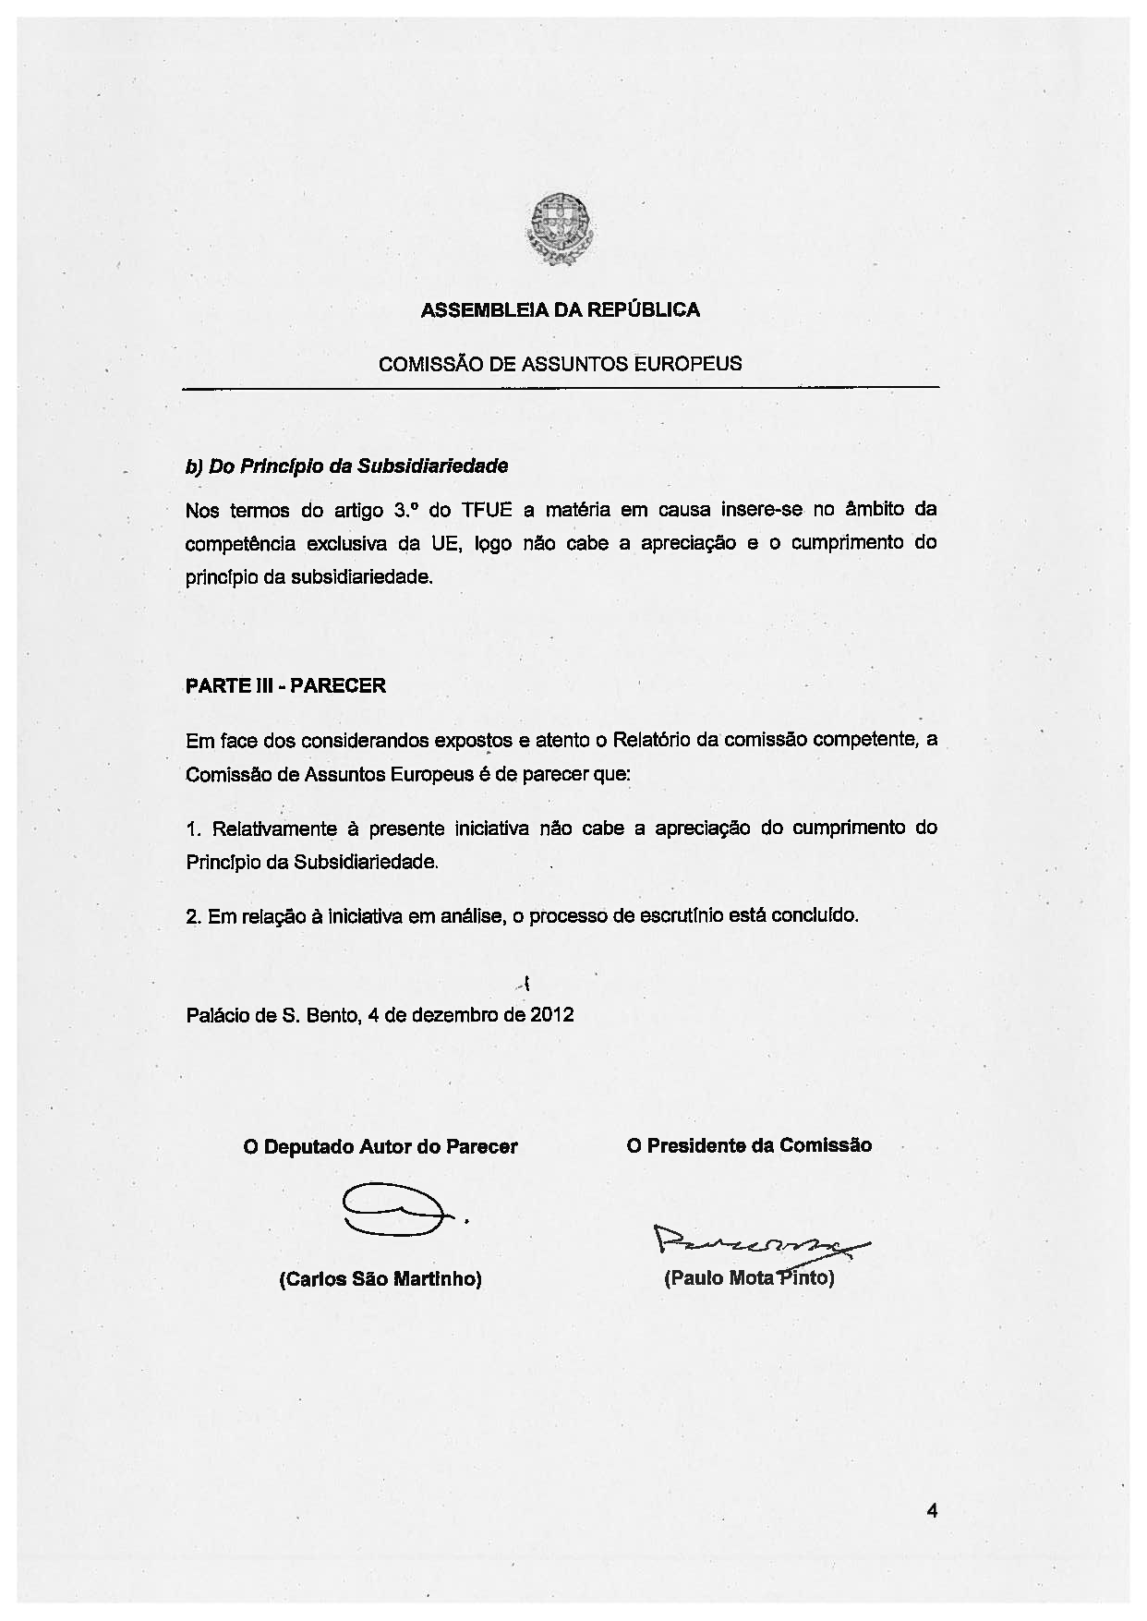
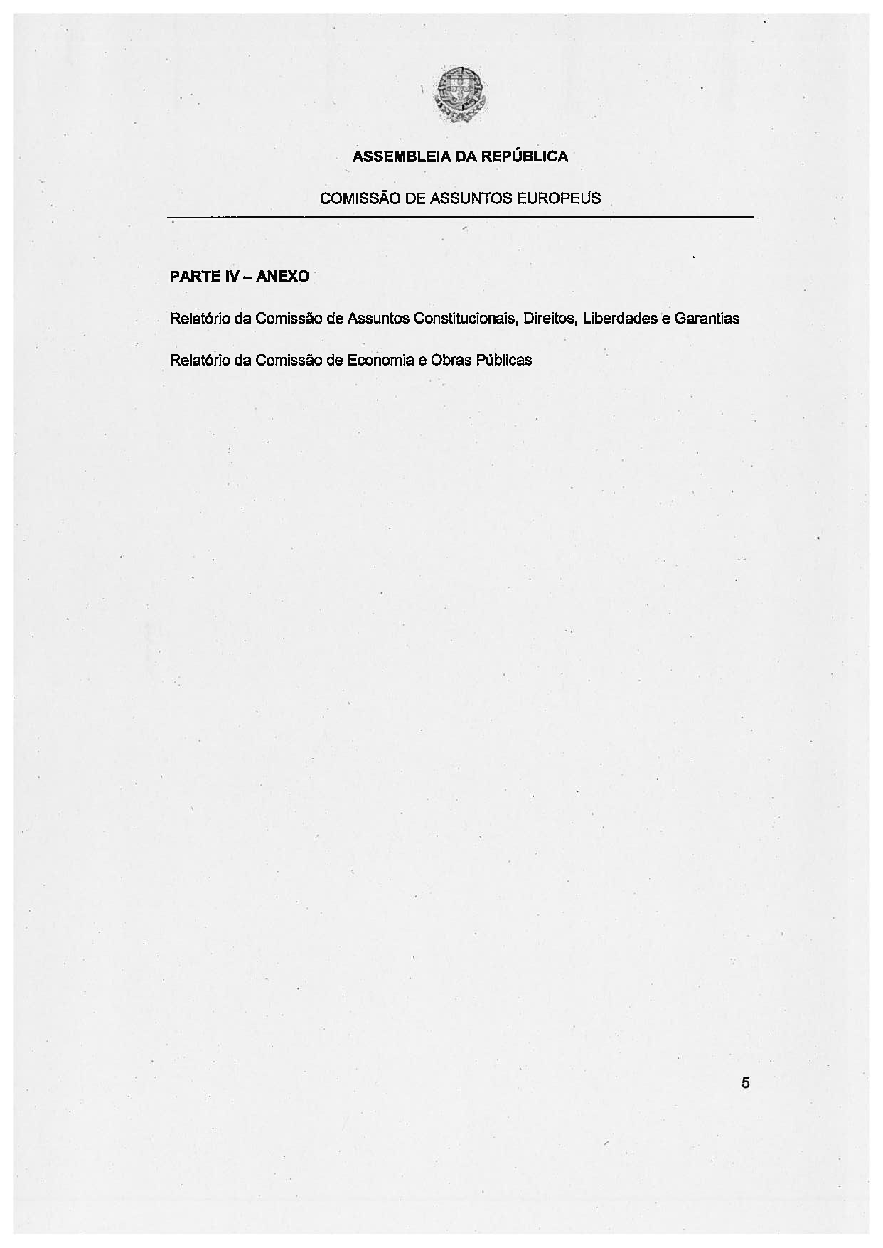
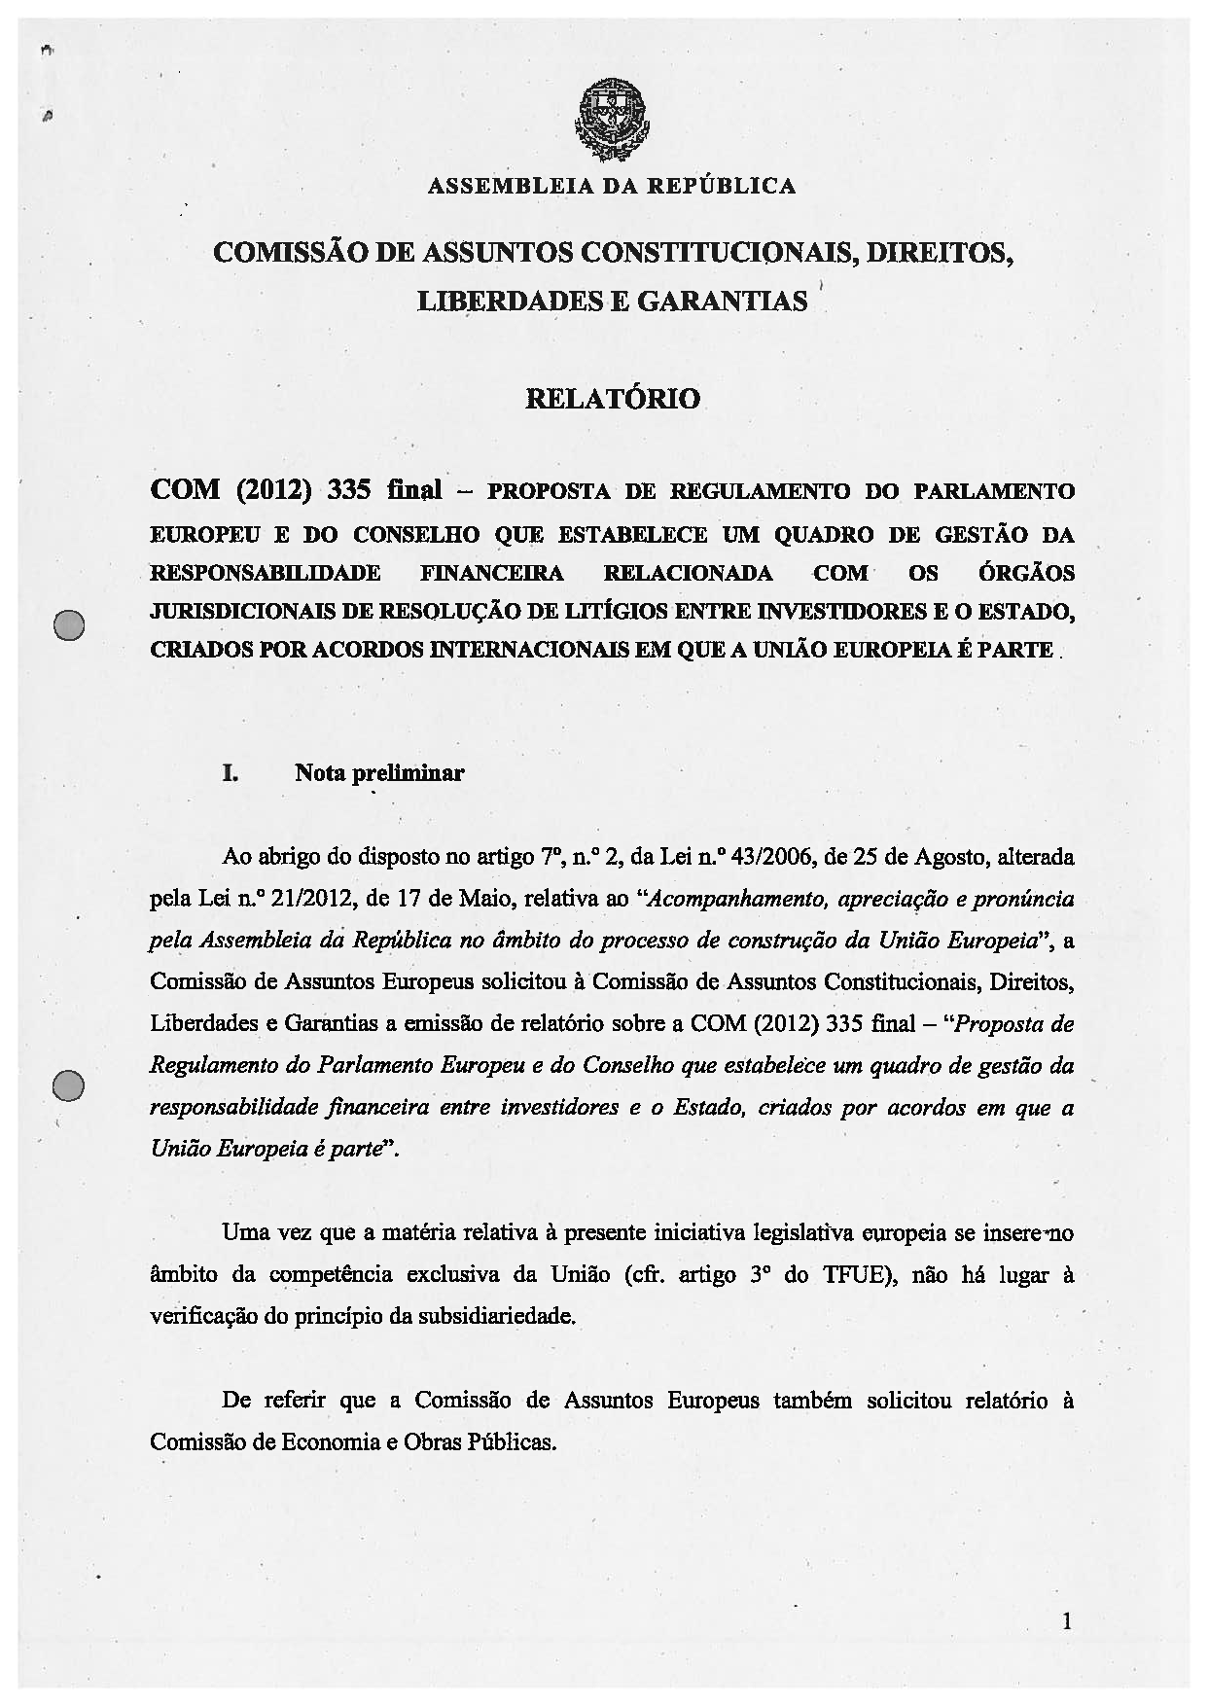
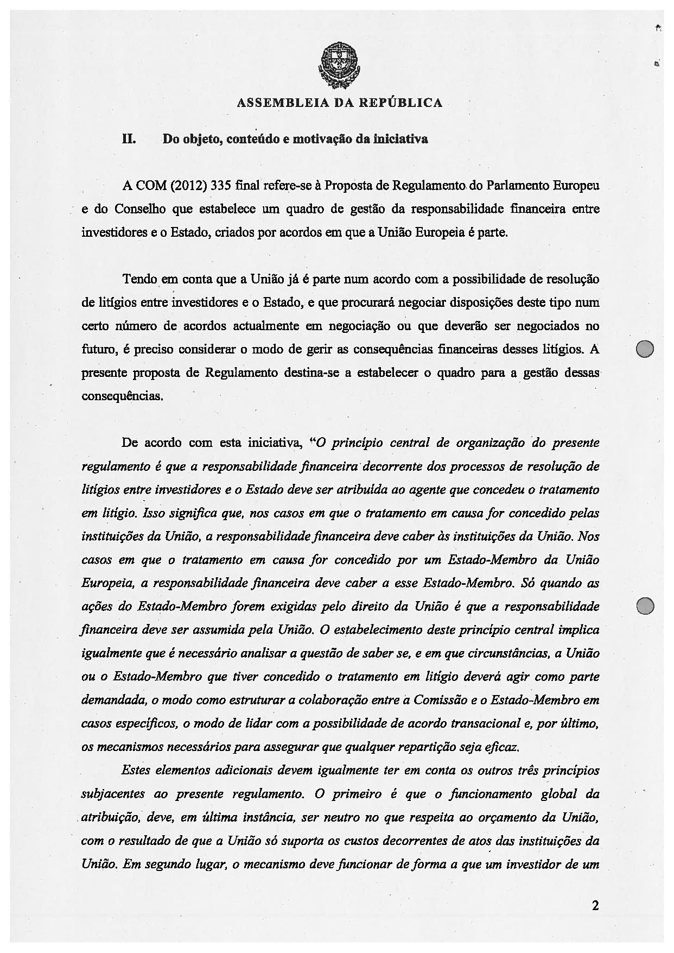
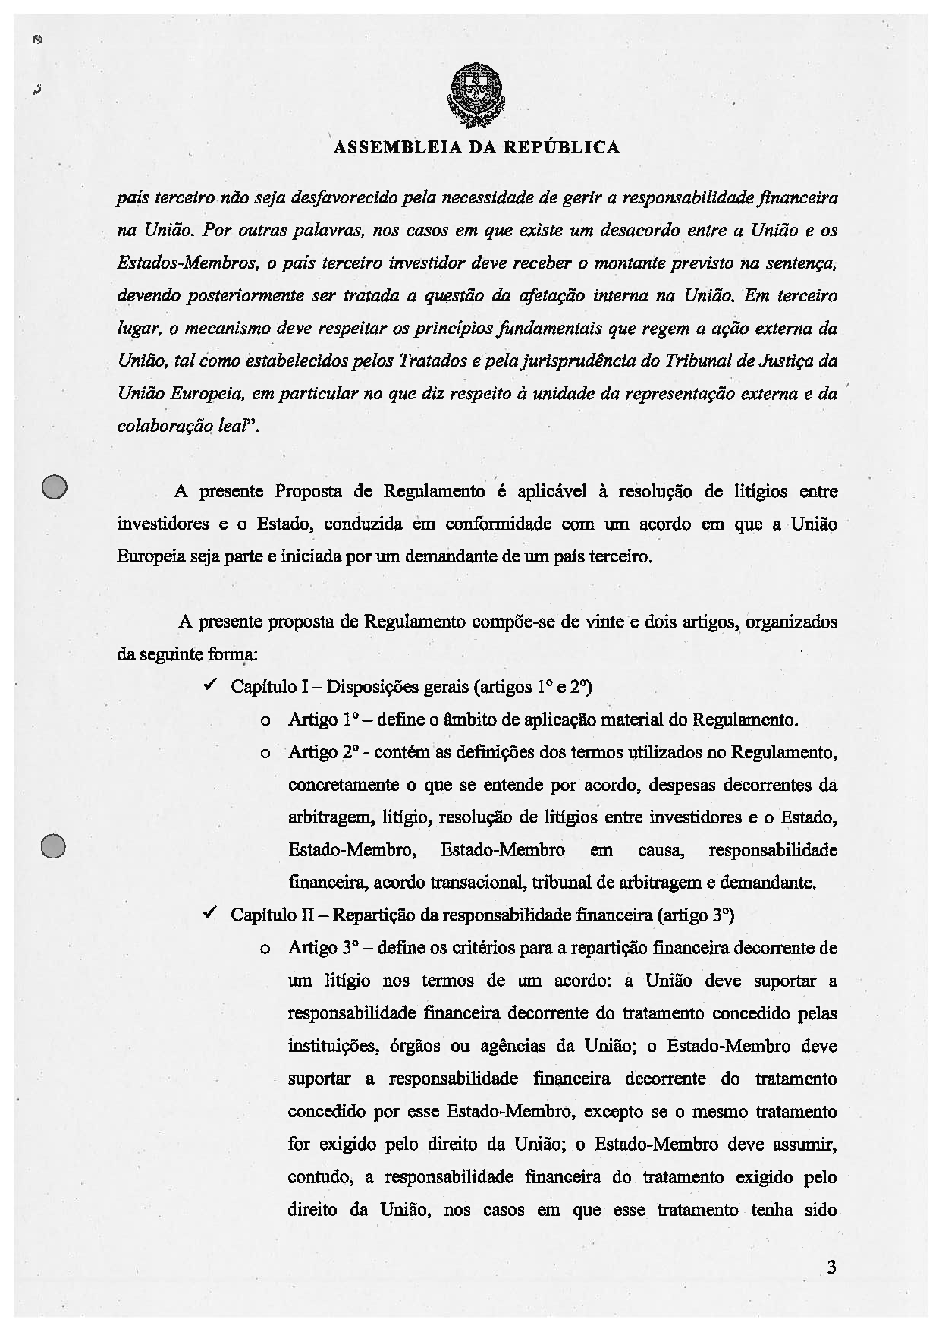
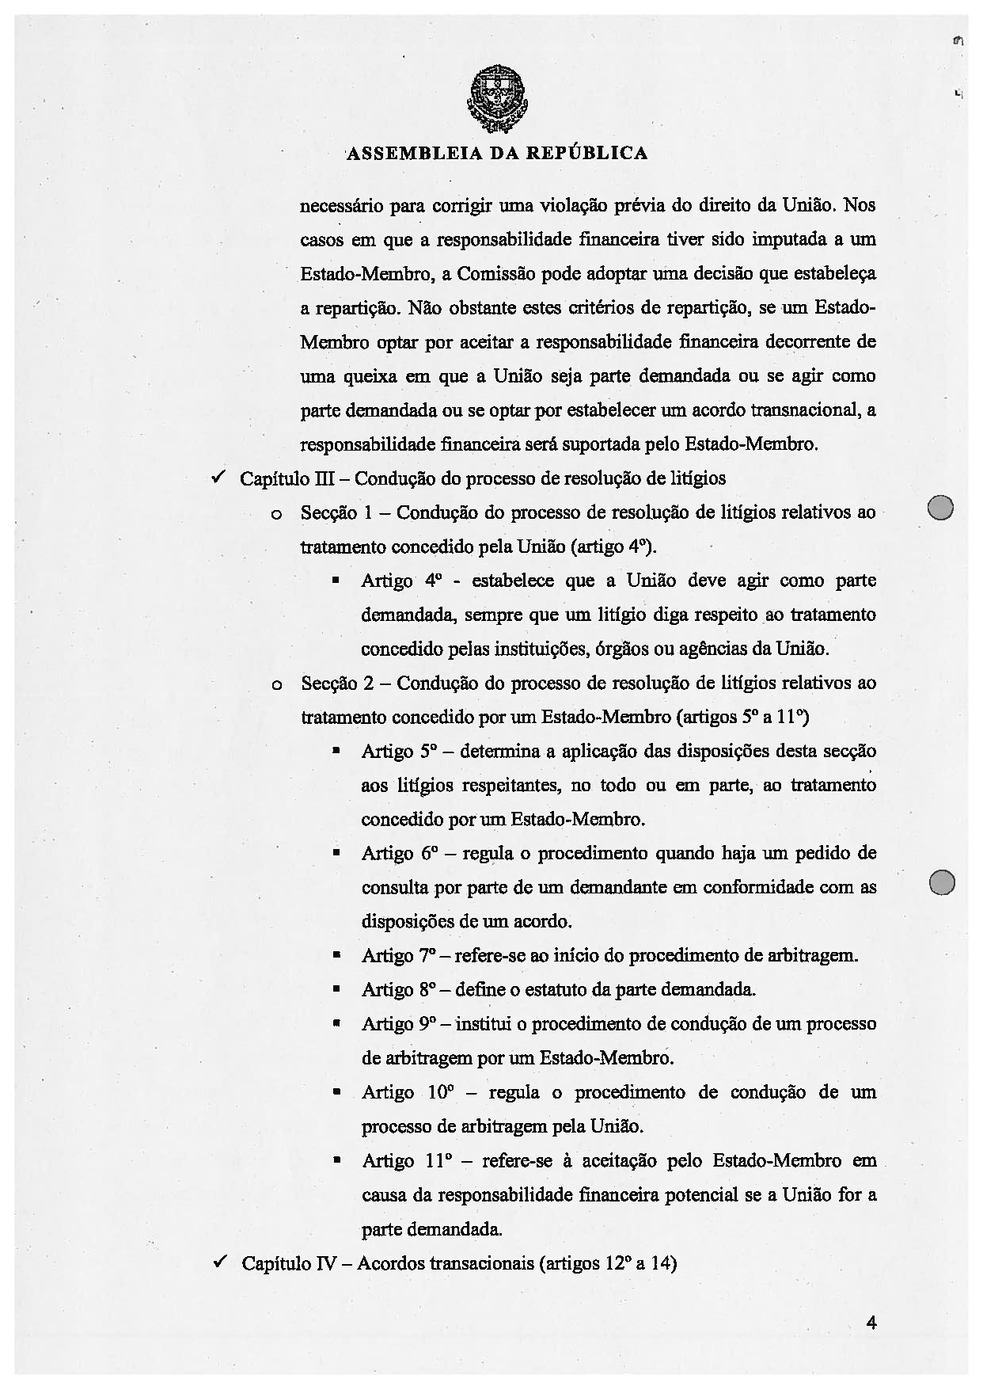
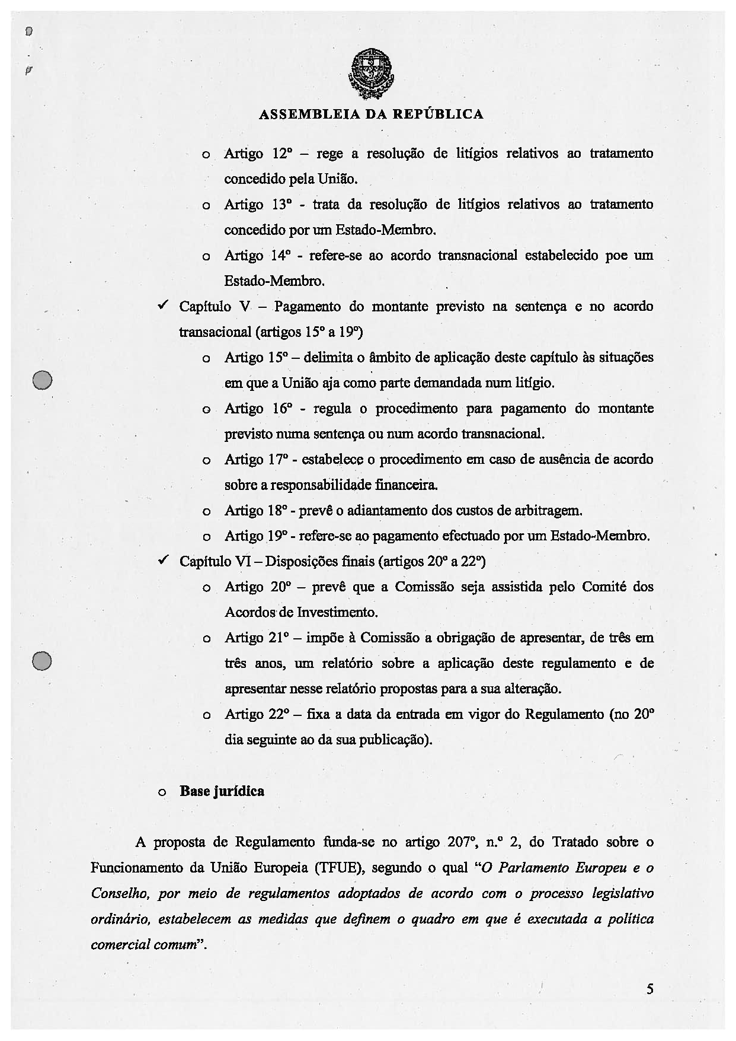
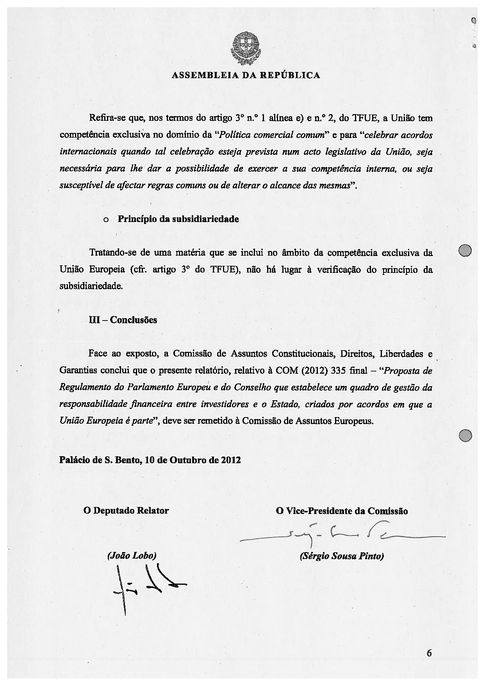
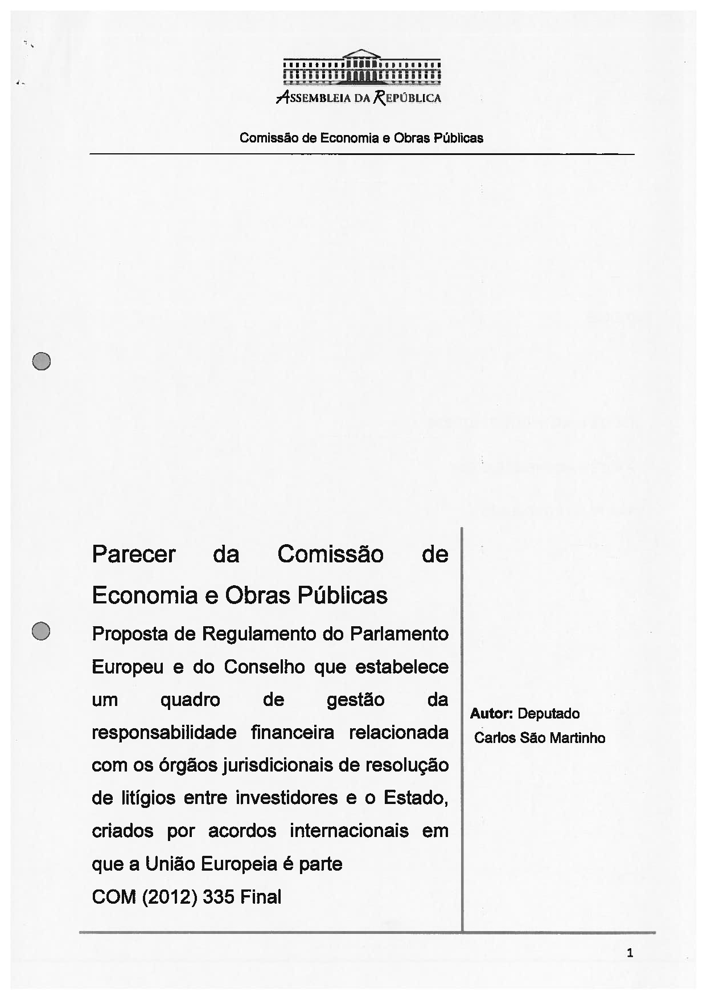
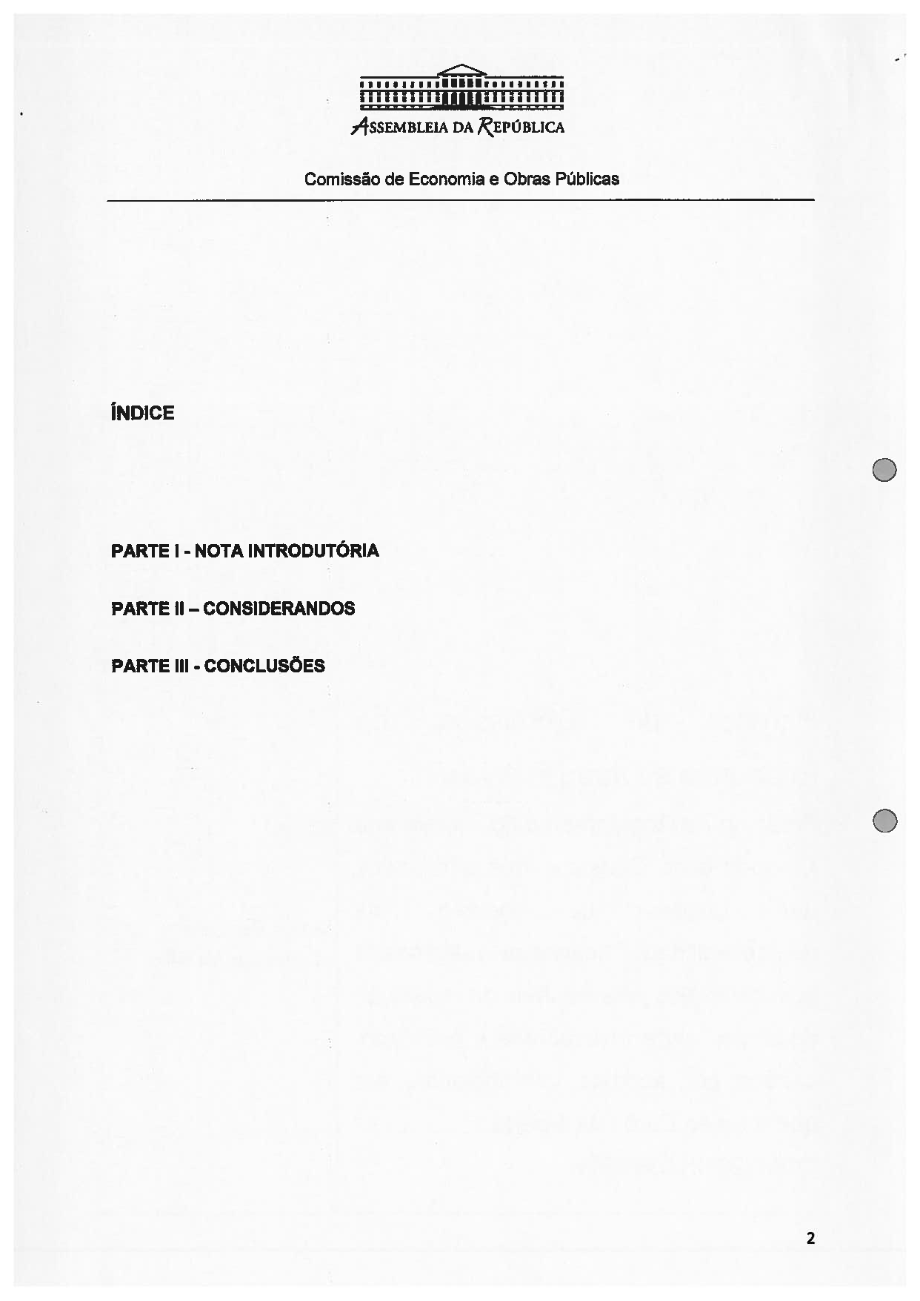
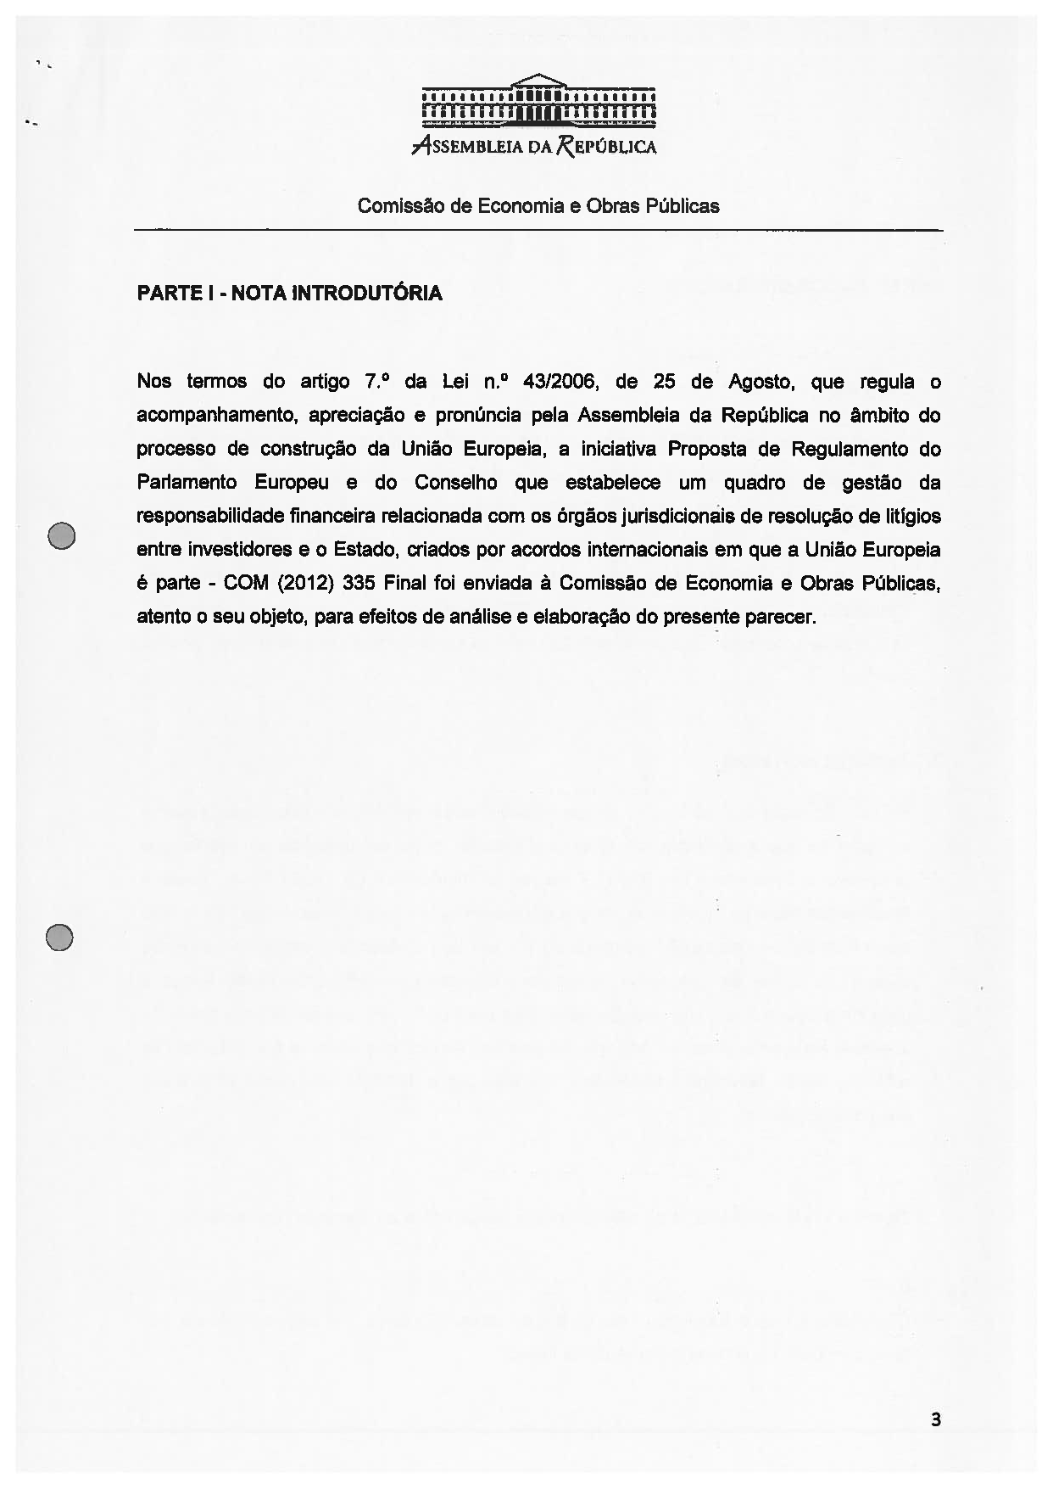
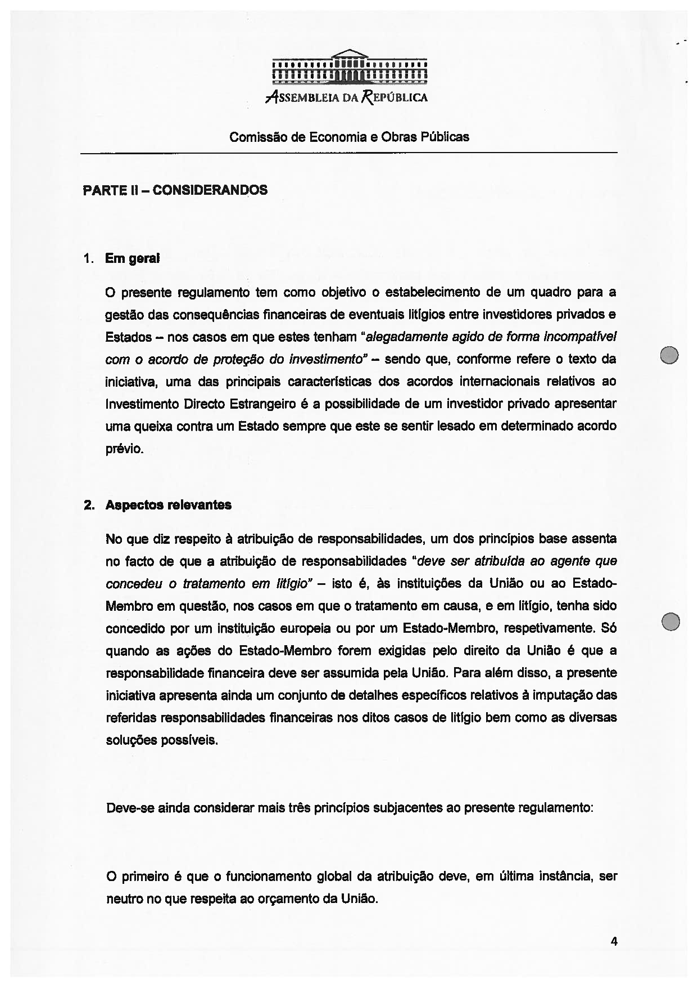
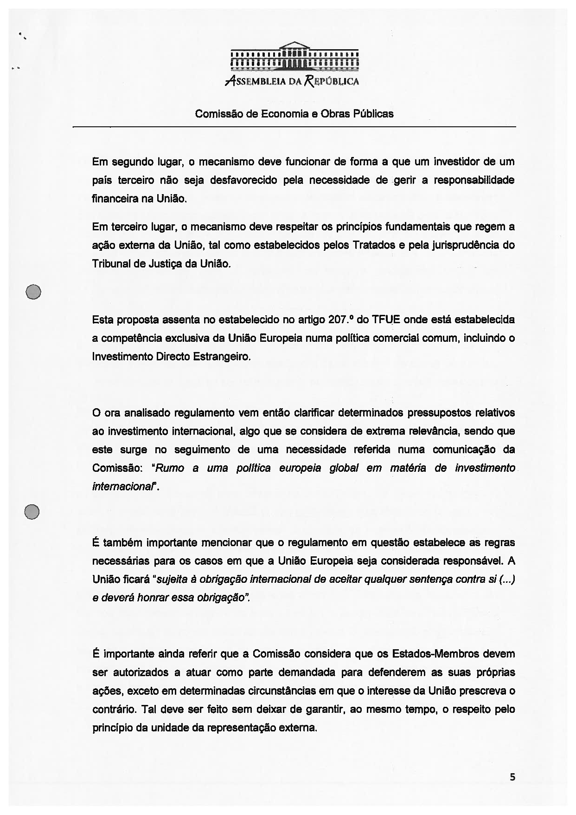
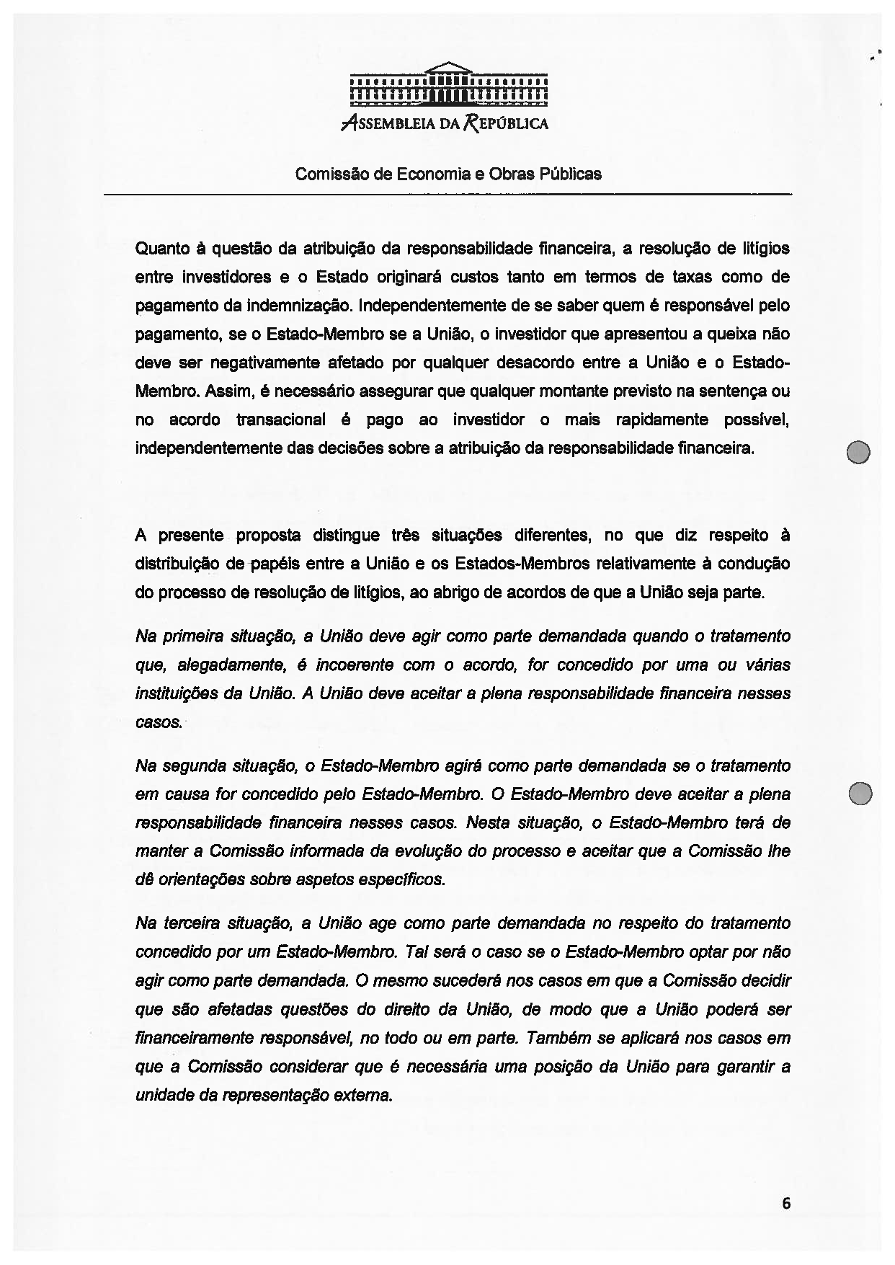
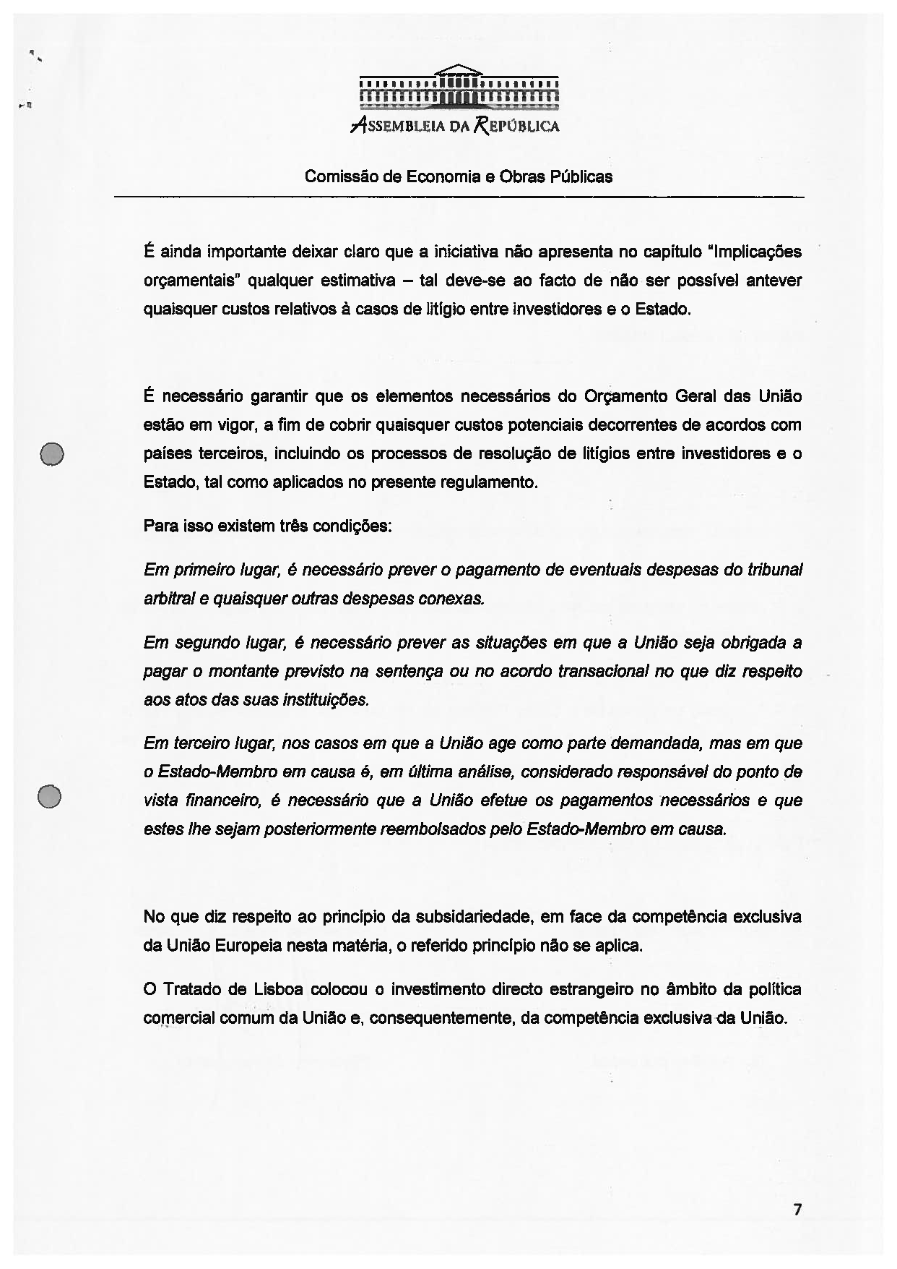
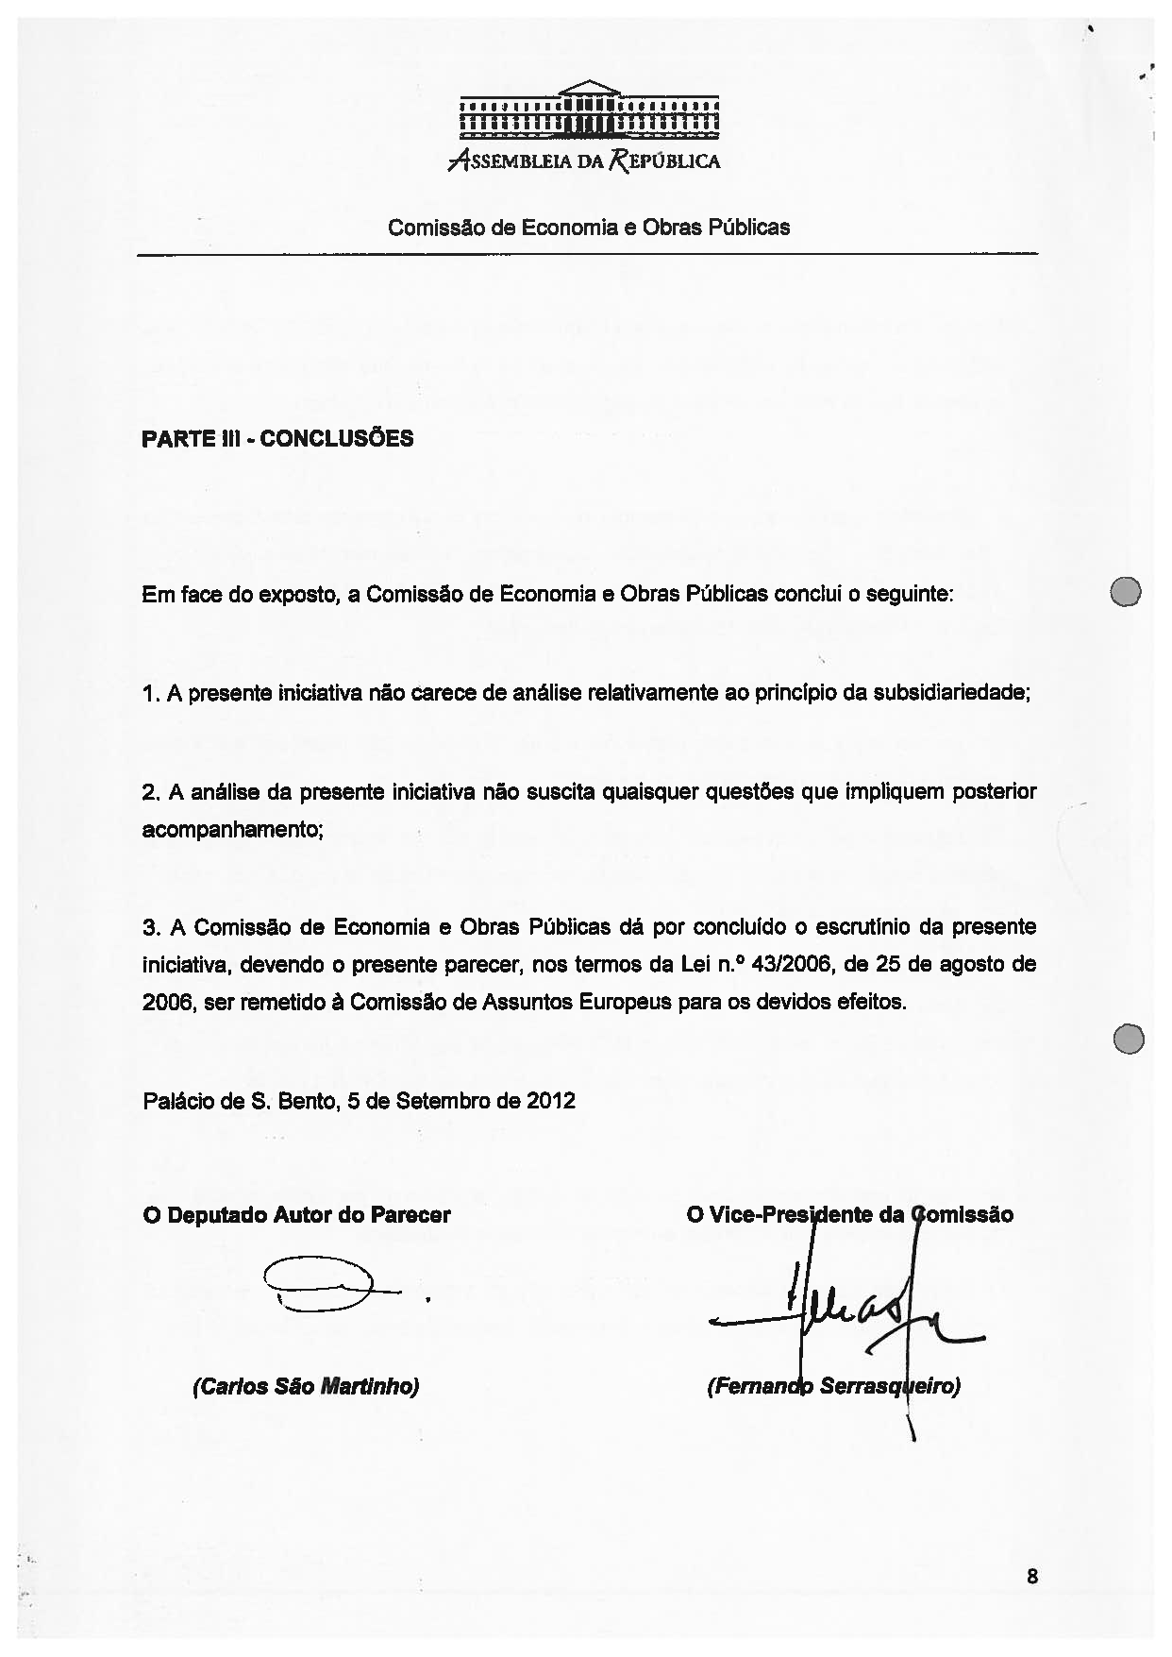

Translation(s) of the opinion may be available at the Interparliamentary EU Information Exchange site IPEX, at the following address: http://www.ipex.eu/IPEXL-WEB/search.do.

