 | 
COUNCIL OF  THE EUROPEAN UNION |  |  | Brussels, 11 December 2012
 | Interinstitutional File:  2012/0154 (NLE) |  | 17641/12
WTO 398
COASI 207
AGRI 863
UD 326
INST 729
PARLNAT 386

COVER NOTE
from: | the President of the Assembly of the Republic of Portugal
date of receipt: | 5 December 2012
to: | Mr Dimitris CHRISTOFIAS, President of the Council of the European Union
Subject: | Proposal for a Council Decision establishing the position to be taken by the European Union within the General Council of the World Trade Organization on the Philippines' request for a WTO waiver to extend the special treatment for rice  [doc. 11641/12 WTO 231 COASI 115 AGRI 436 UD 177 - COM(2012) 293 final]  - Opinion on the application of the Principles of Subsidiarity and Proportionality

Delegations will find attached the above-mentioned opinion.

________________________

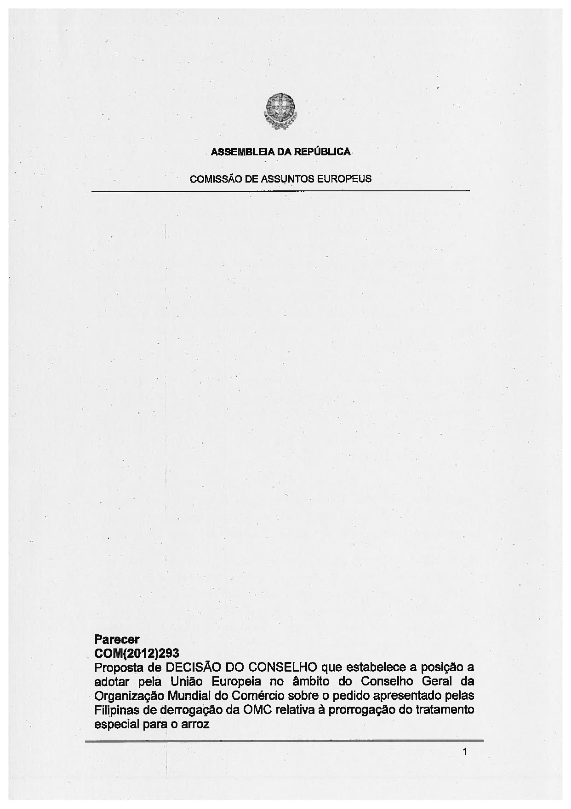
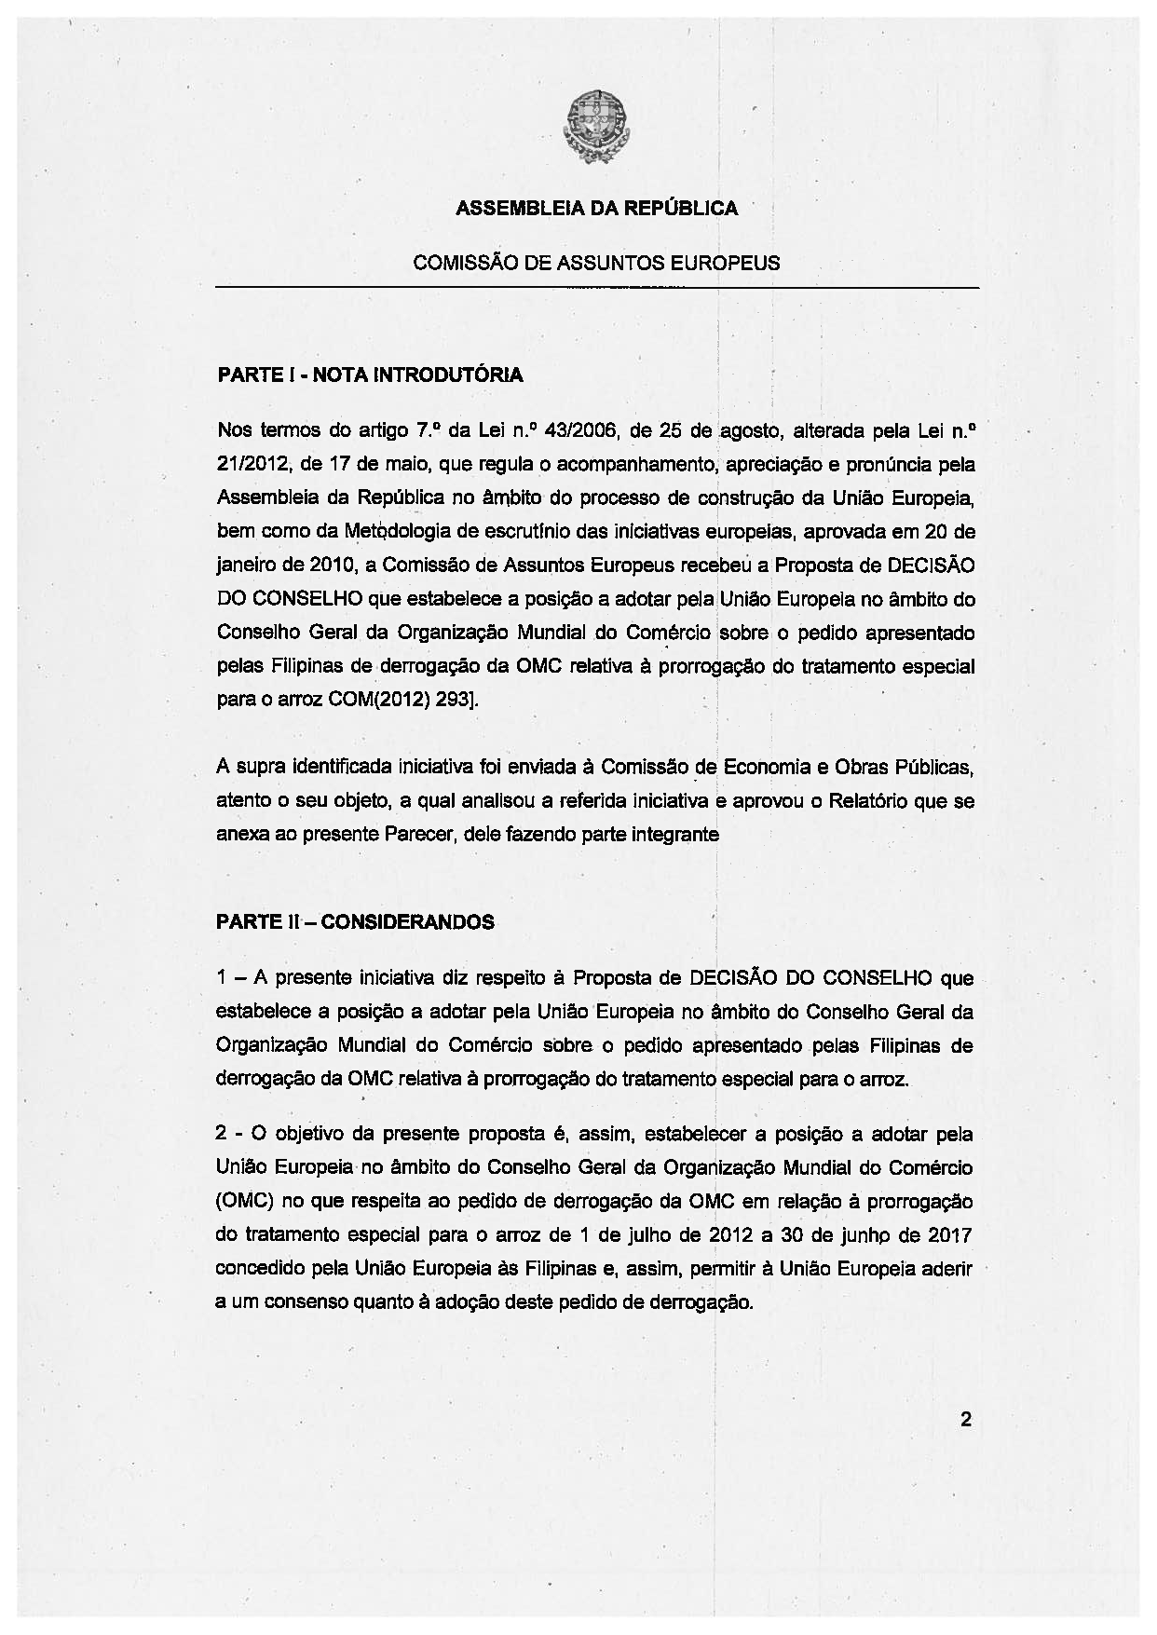
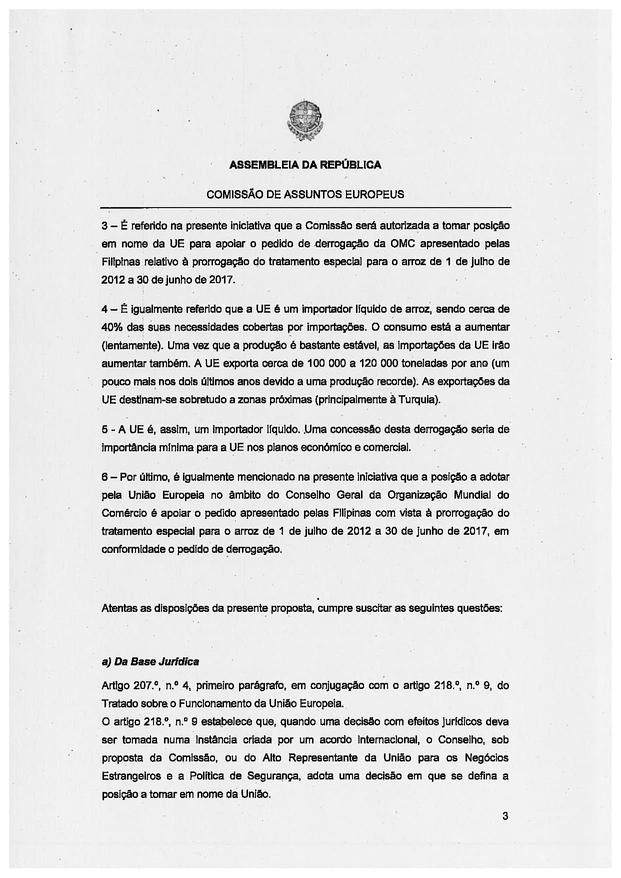
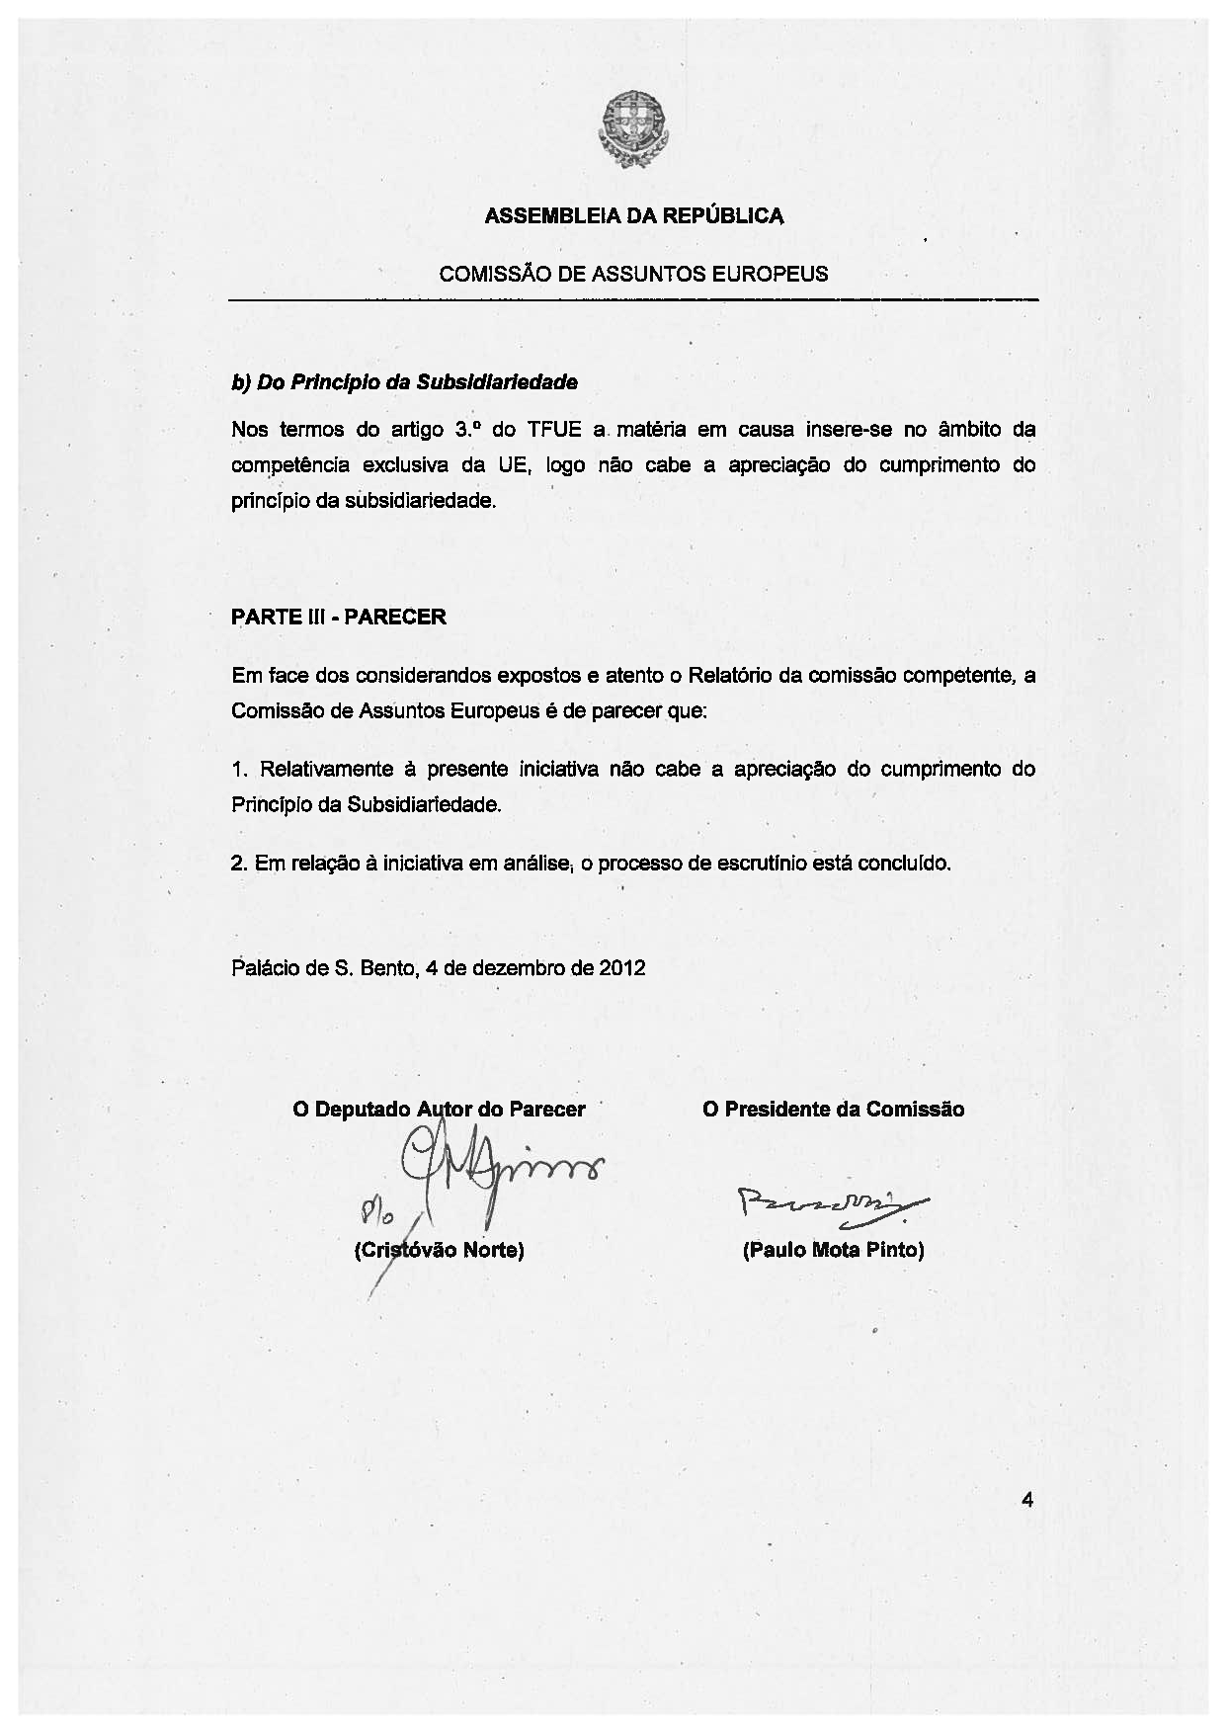
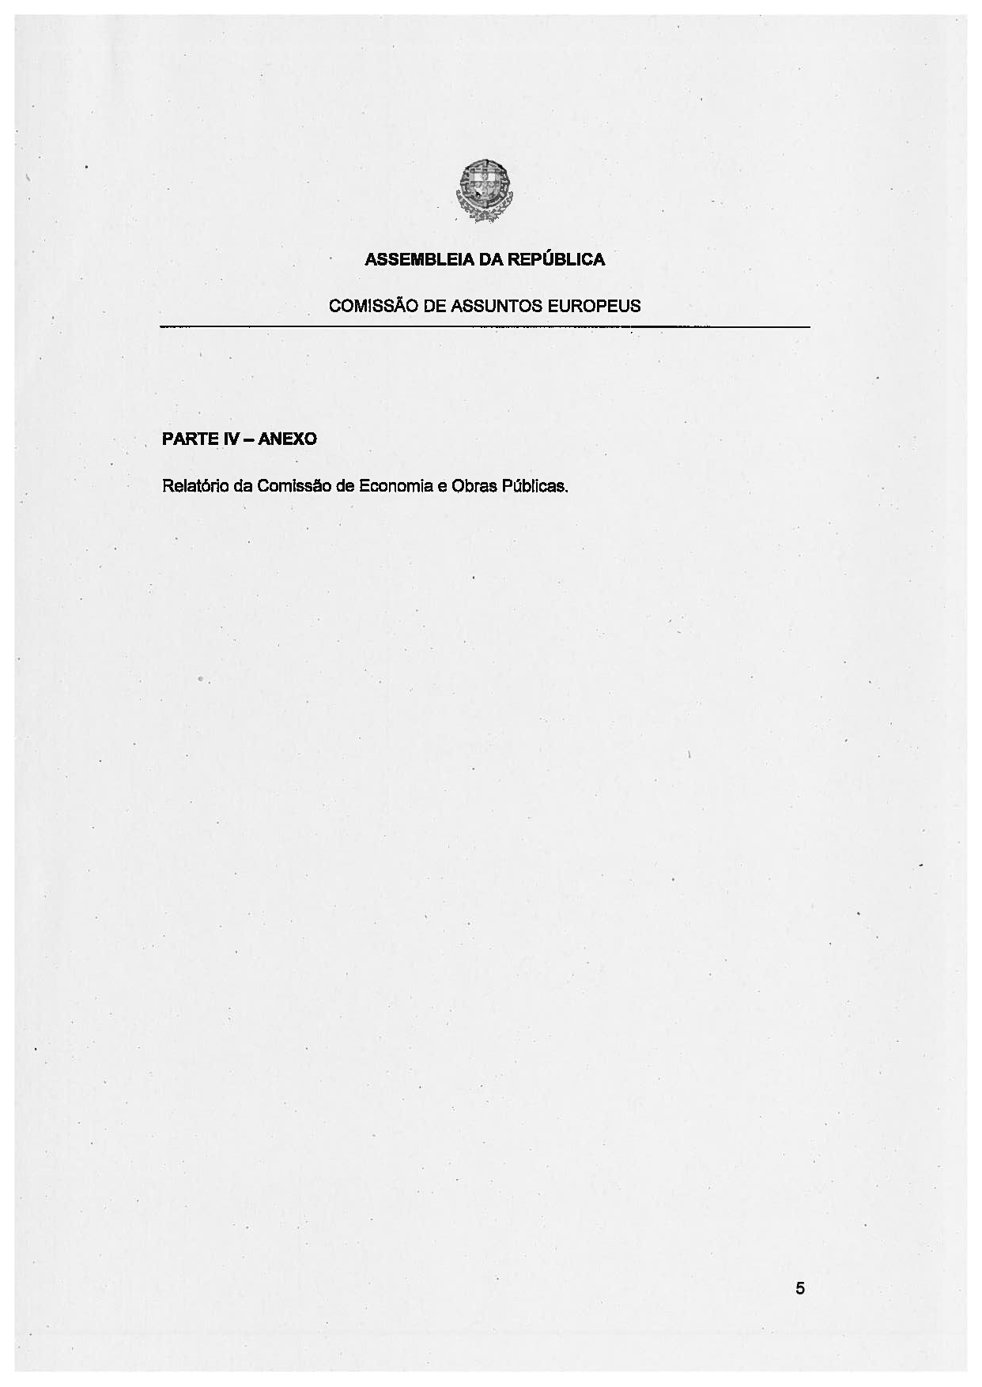
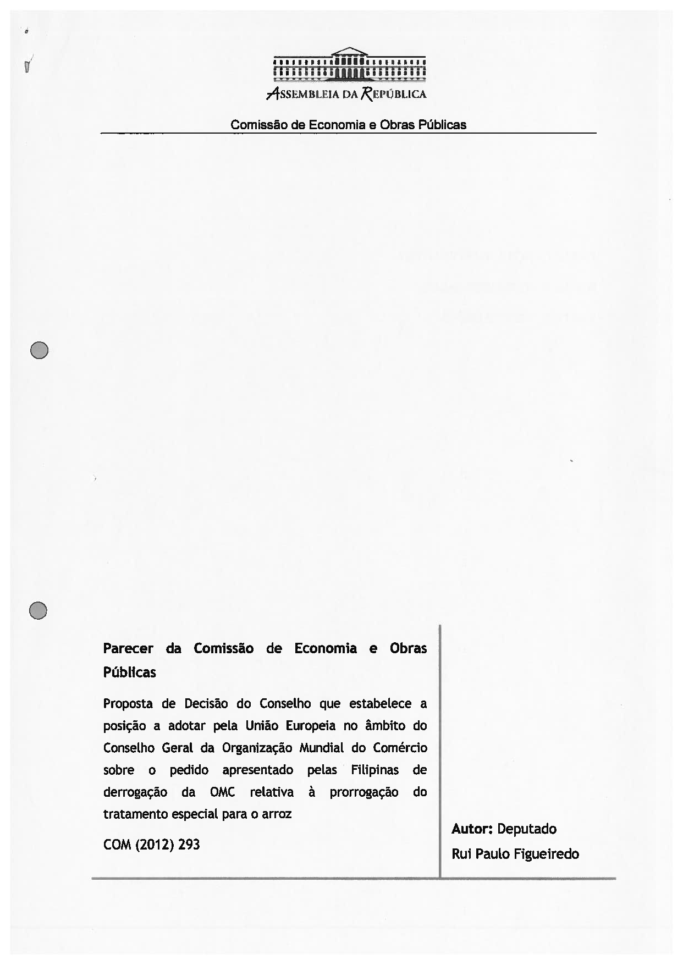
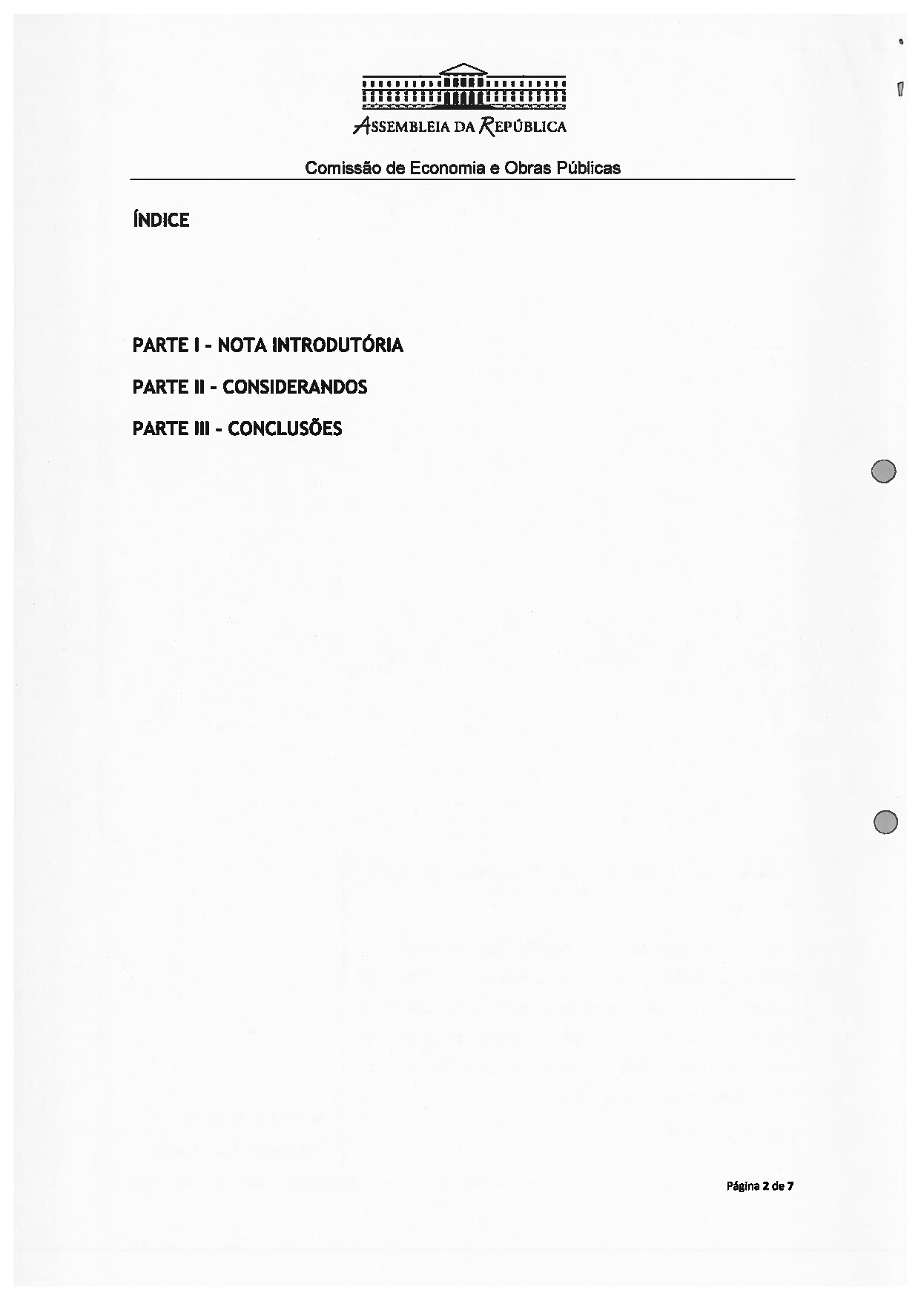
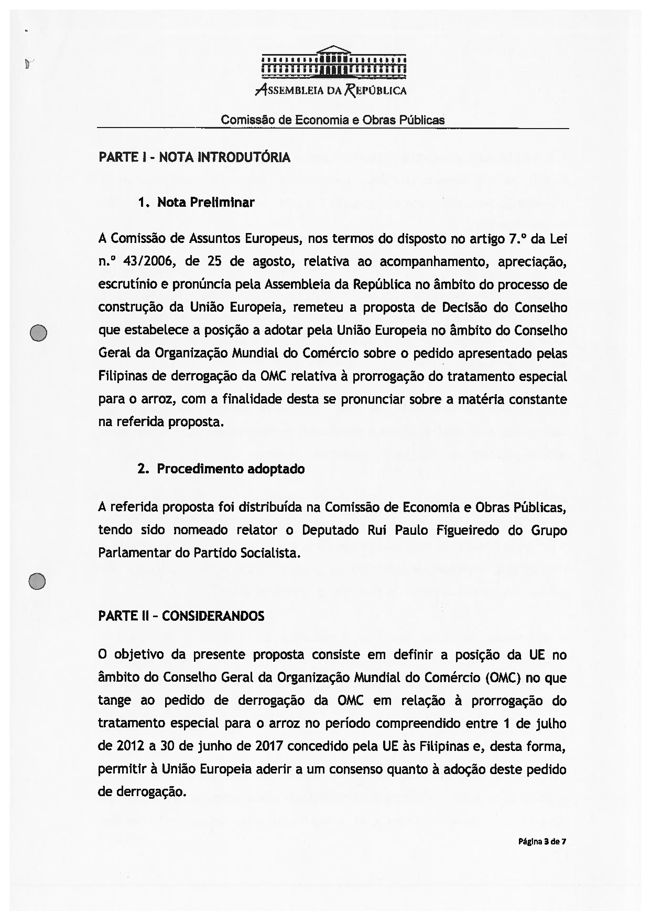
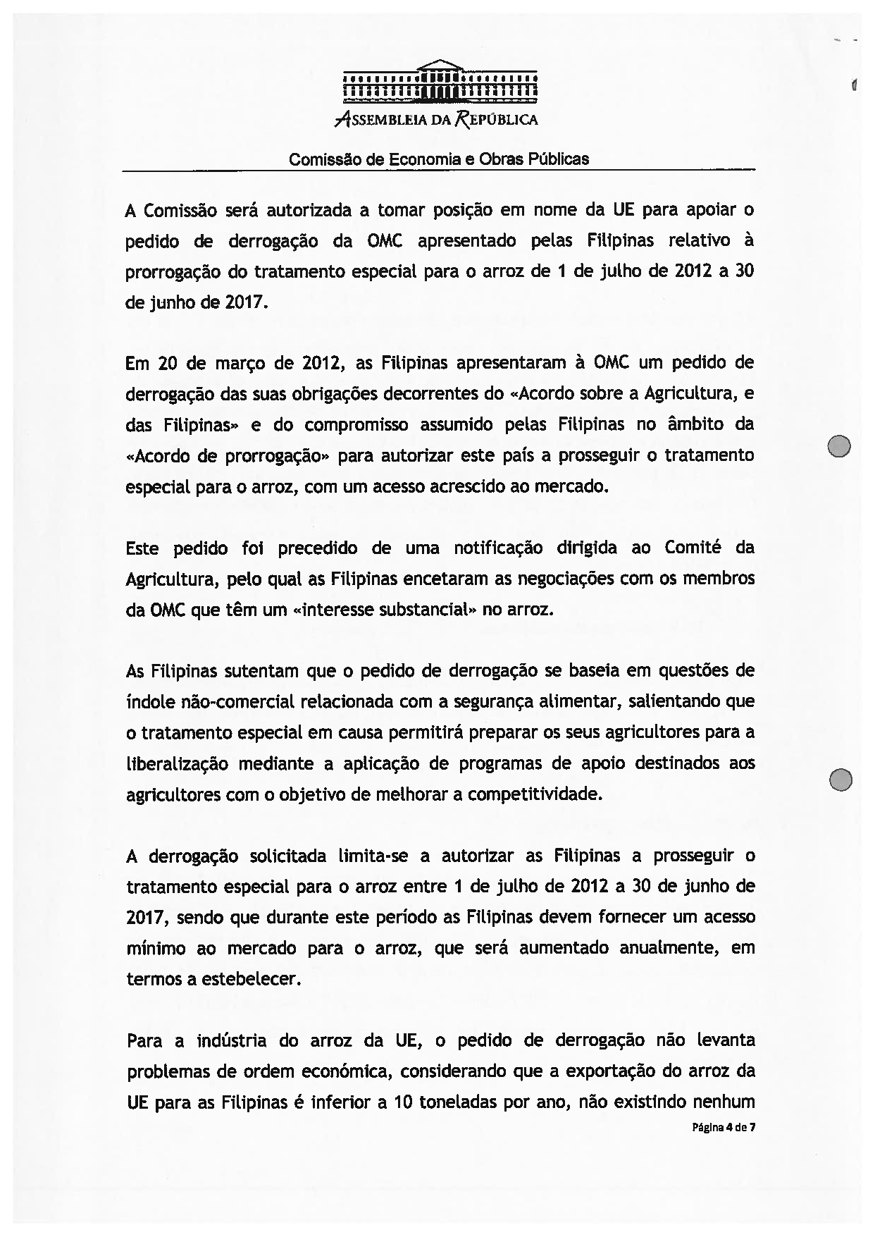
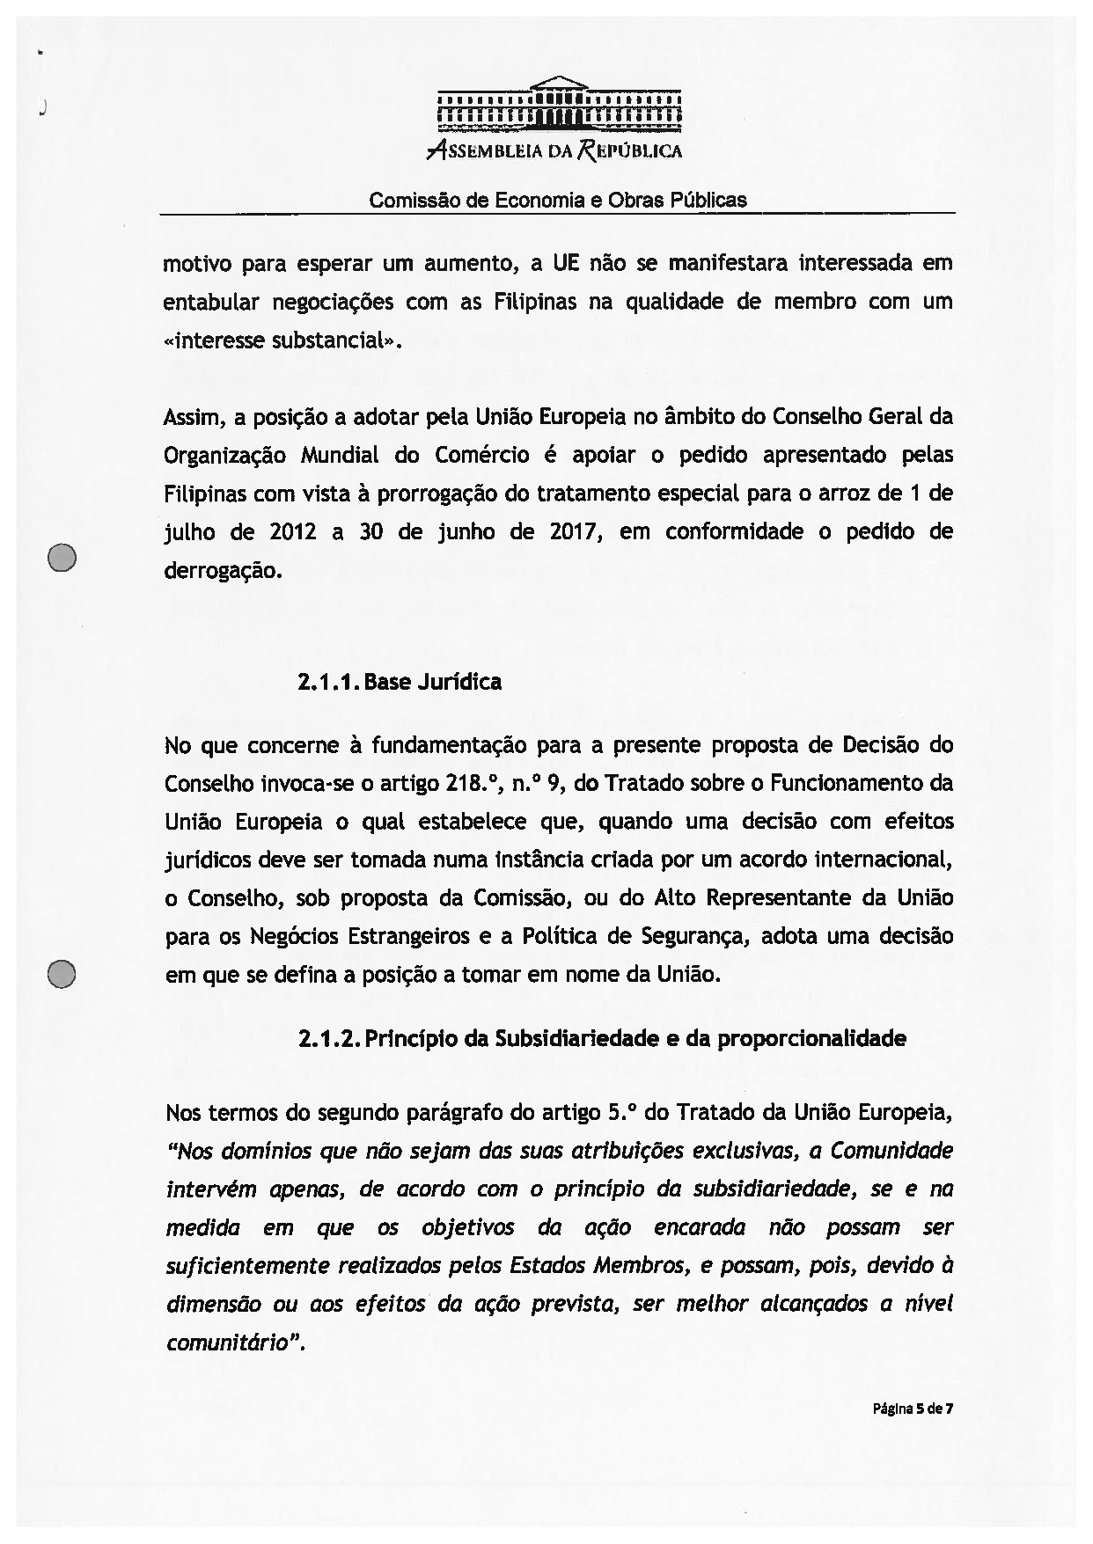
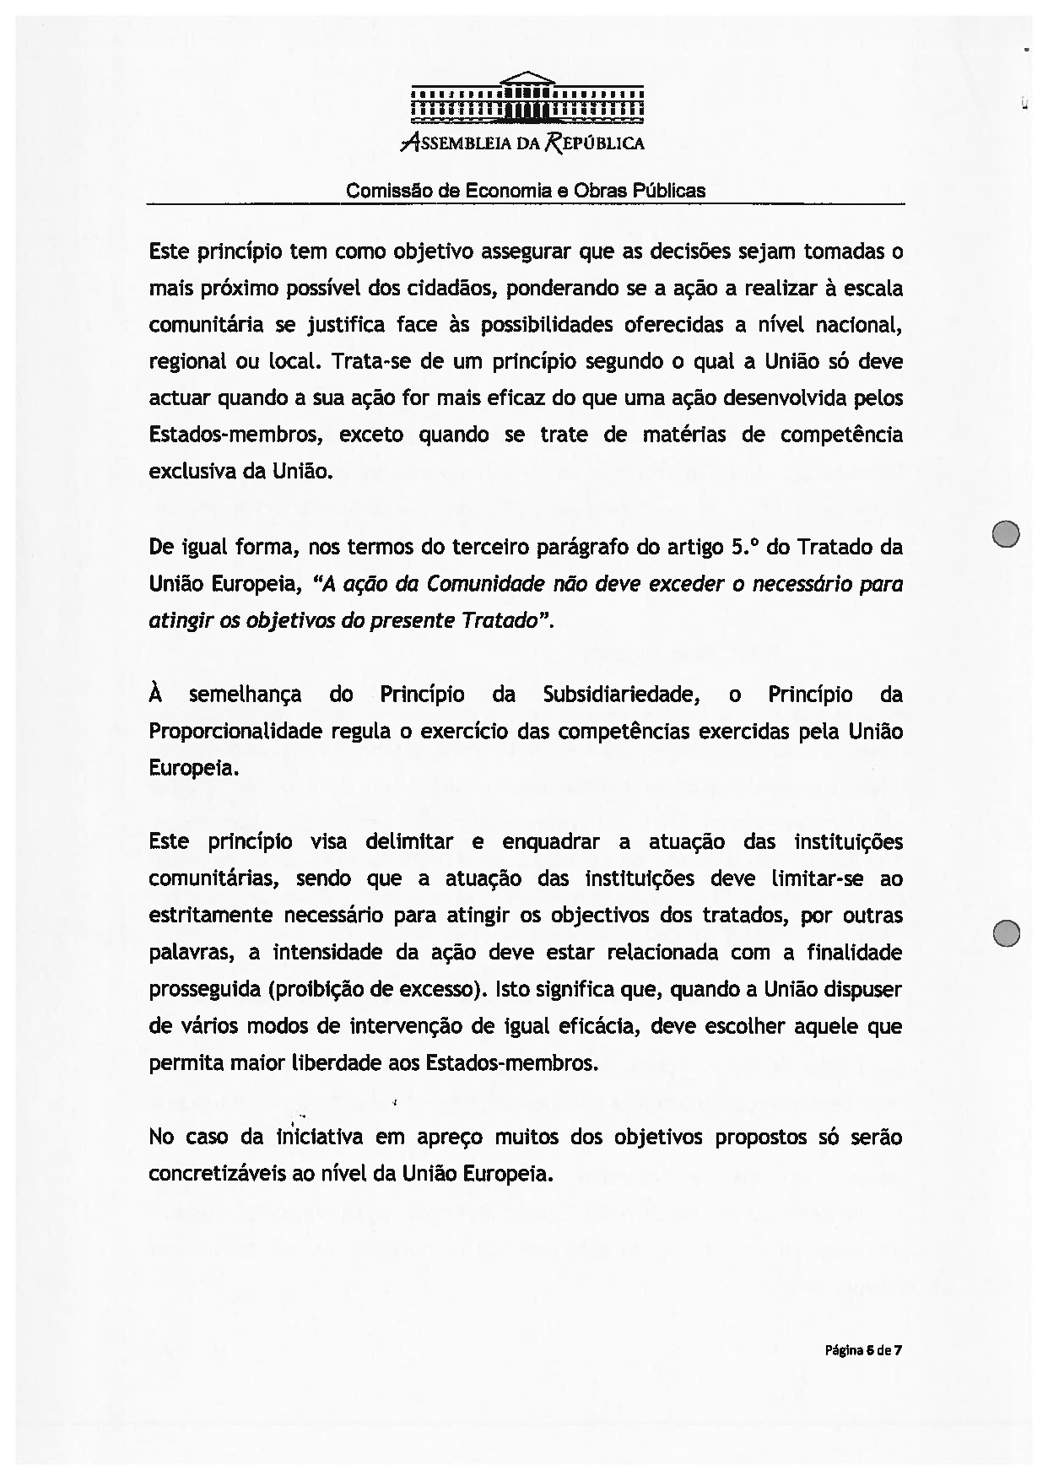
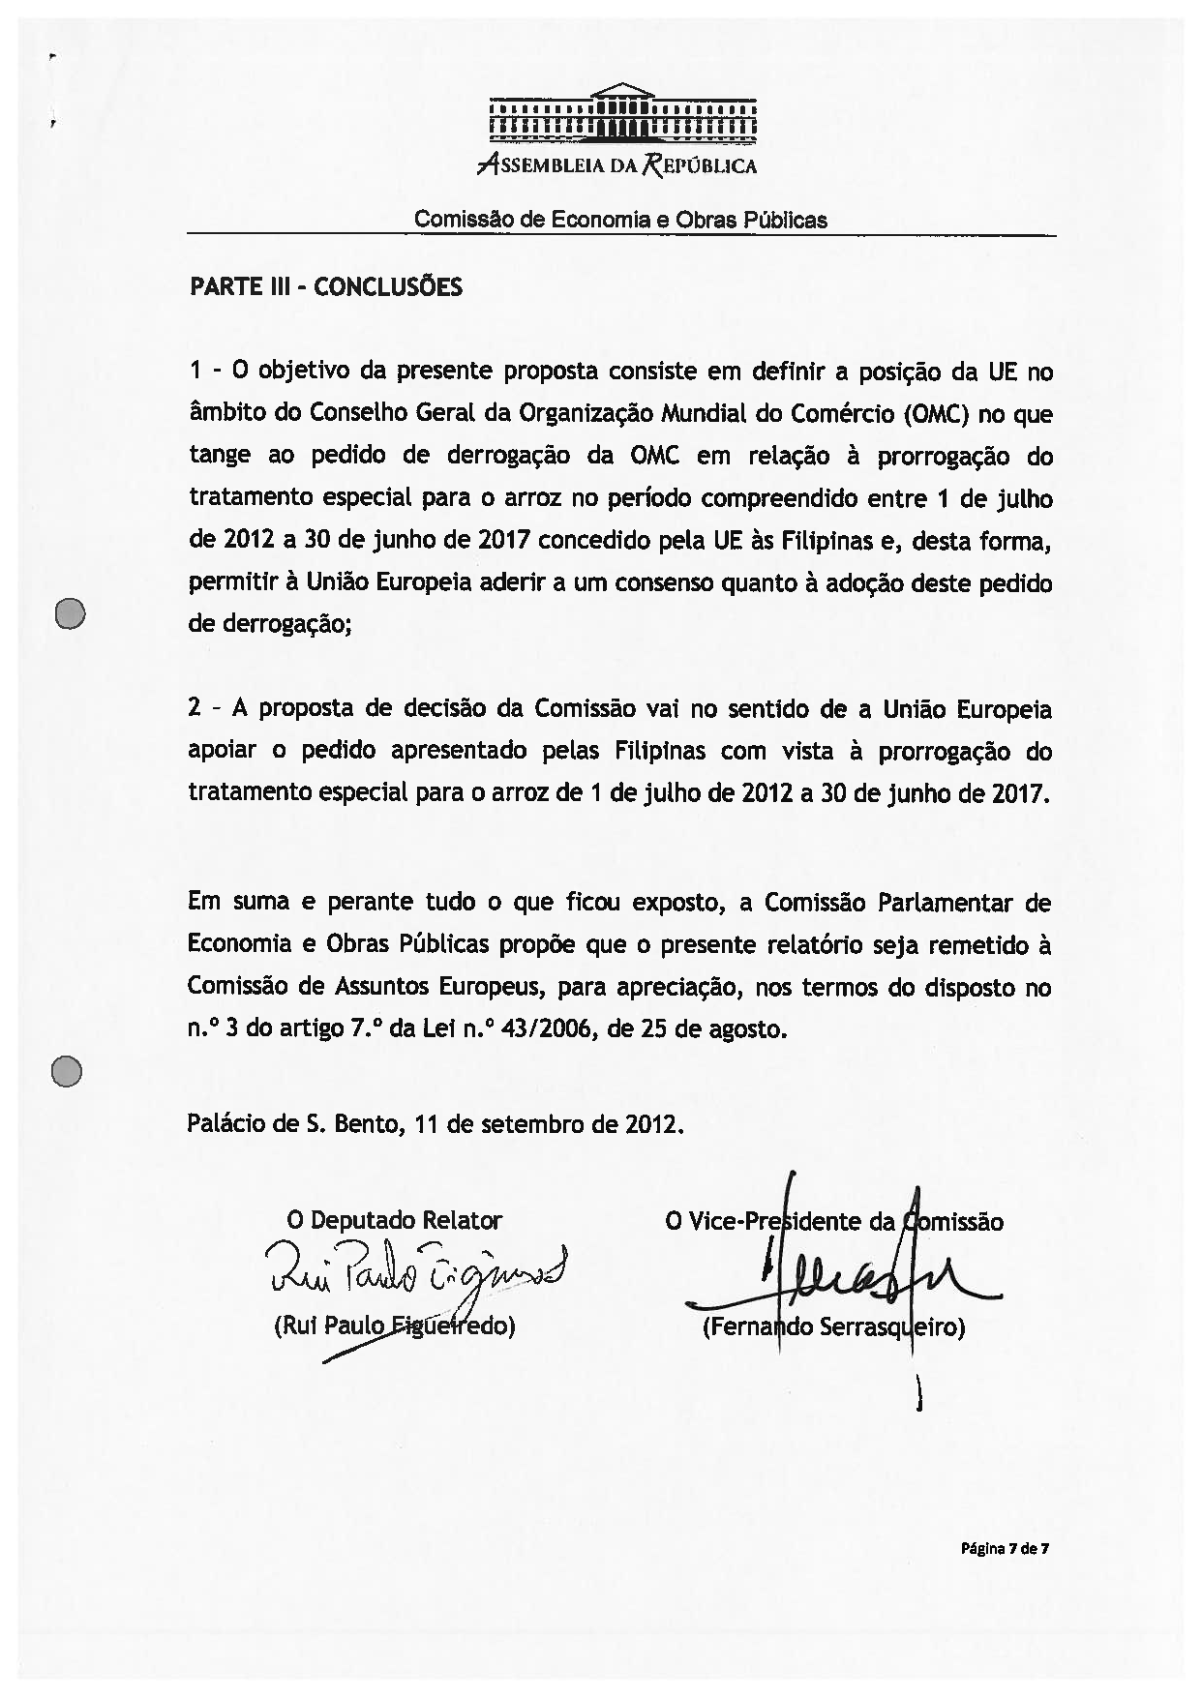

Translation(s) of the opinion may be available at the Interparliamentary EU Information Exchange site IPEX, at the following address: http://www.ipex.eu/IPEXL-WEB/search.do.

