 | 
COUNCIL OF  THE EUROPEAN UNION |  |  | Brussels, 11 December 2012
 | Interinstitutional File:  2012/0145 (COD) |  | 17525/12
ANTIDUMPING 99
COMER 262
WTO 397
CODEC 3011
INST 728
PARLNAT 384

COVER NOTE
from: | the President of the Assembly of the Republic of Portugal
date of receipt: | 5 December 2012
to: | Mr Dimitris CHRISTOFIAS, President of the Council of the European Union
Subject: | Proposal for a Regulation of the European Parliament and of the Council amending Council Regulation (EC) No 1225/2009 on protection against dumped imports from countries not members of the European Community  [doc. 11197/12 ANTIDUMPING 52 COMER 143 WTO 220 CODEC 1636 - COM(2012) 270 final]  - Opinion on the application of the Principles of Subsidiarity and Proportionality

Delegations will find attached the above-mentioned opinion.

________________________

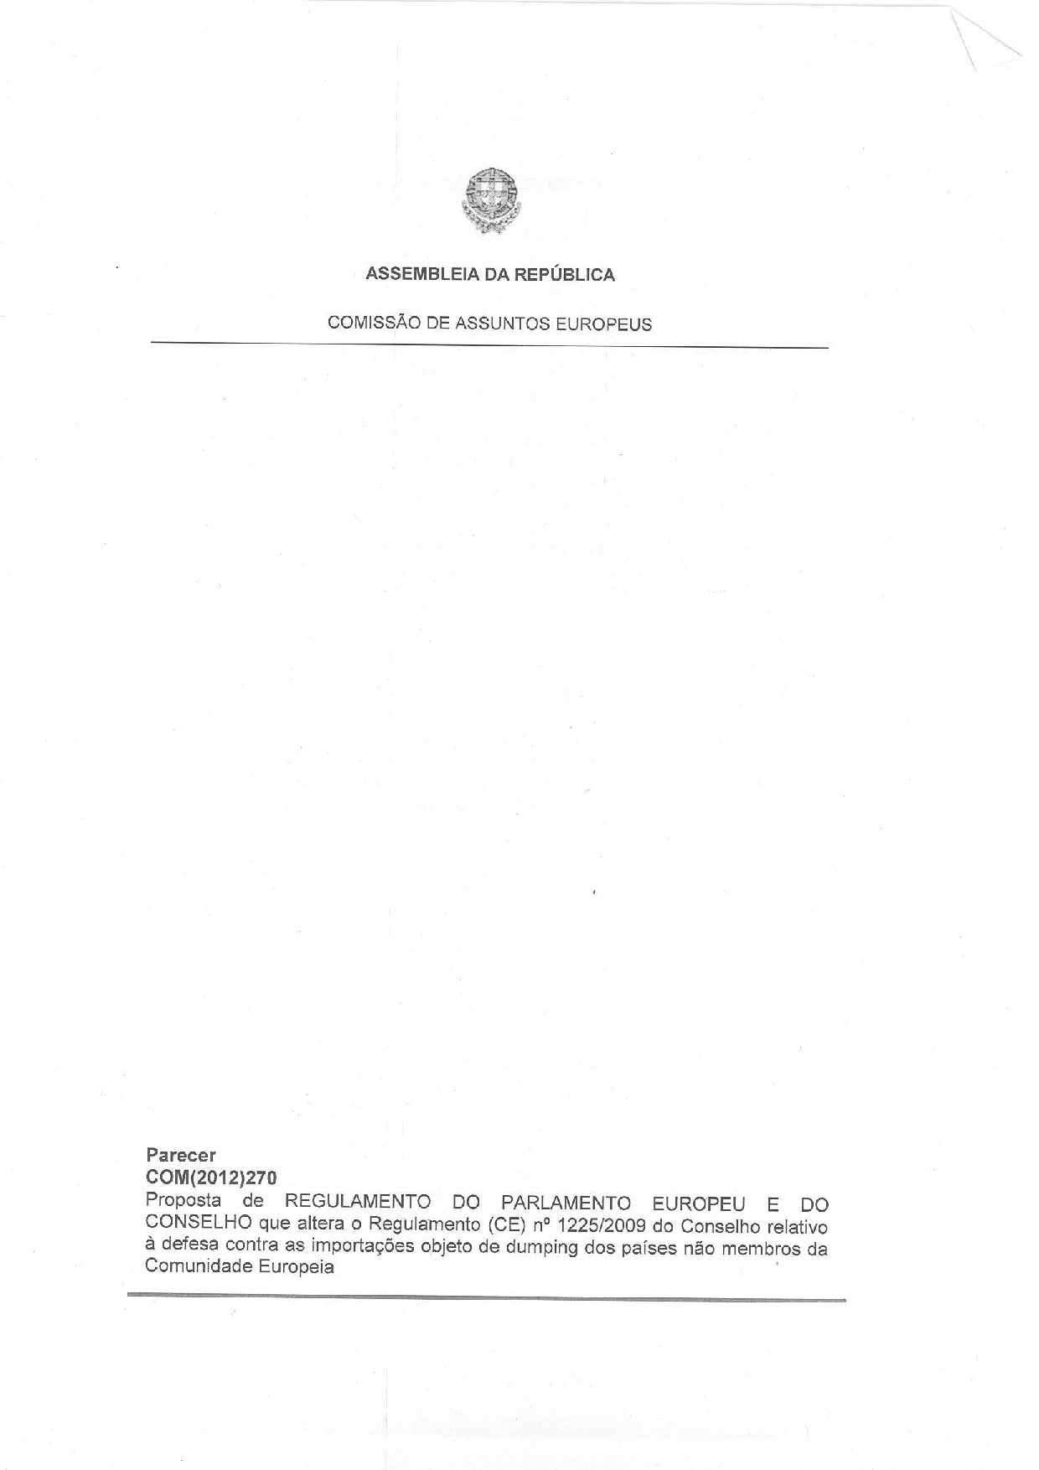
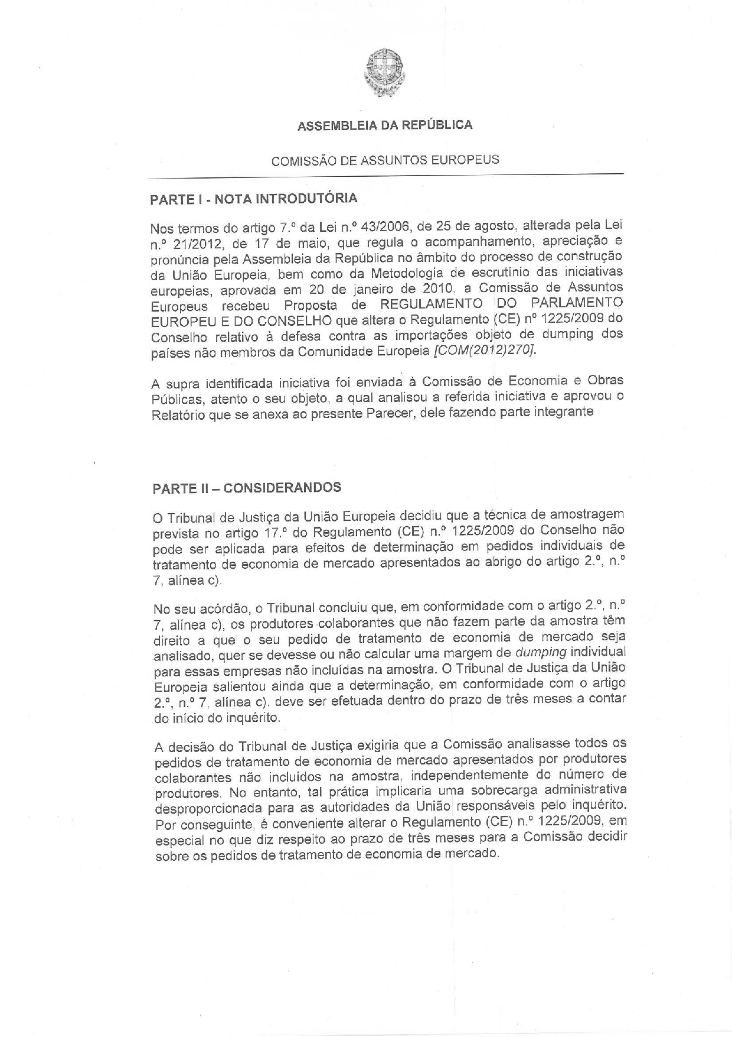
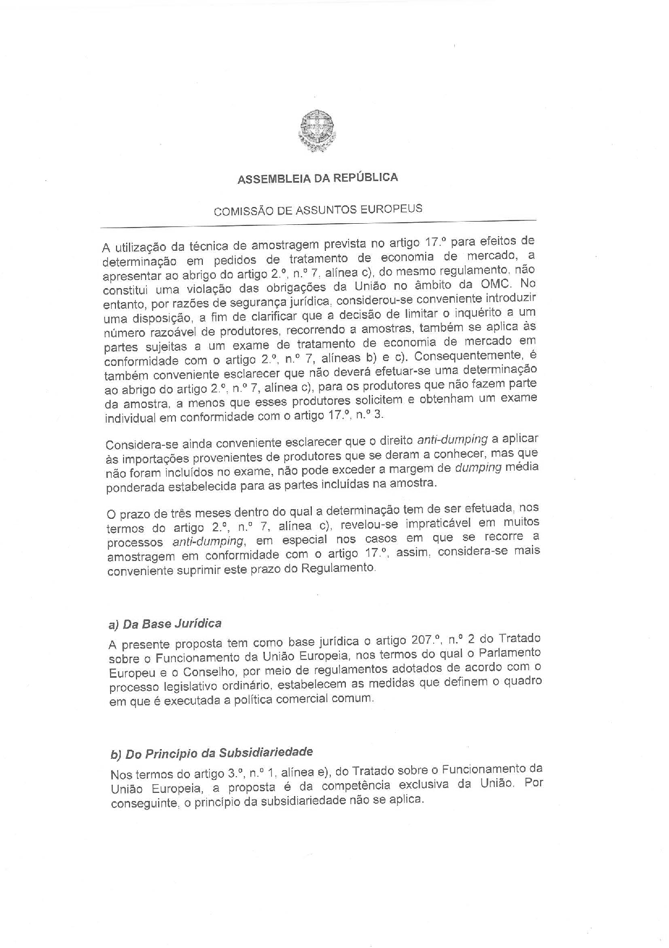
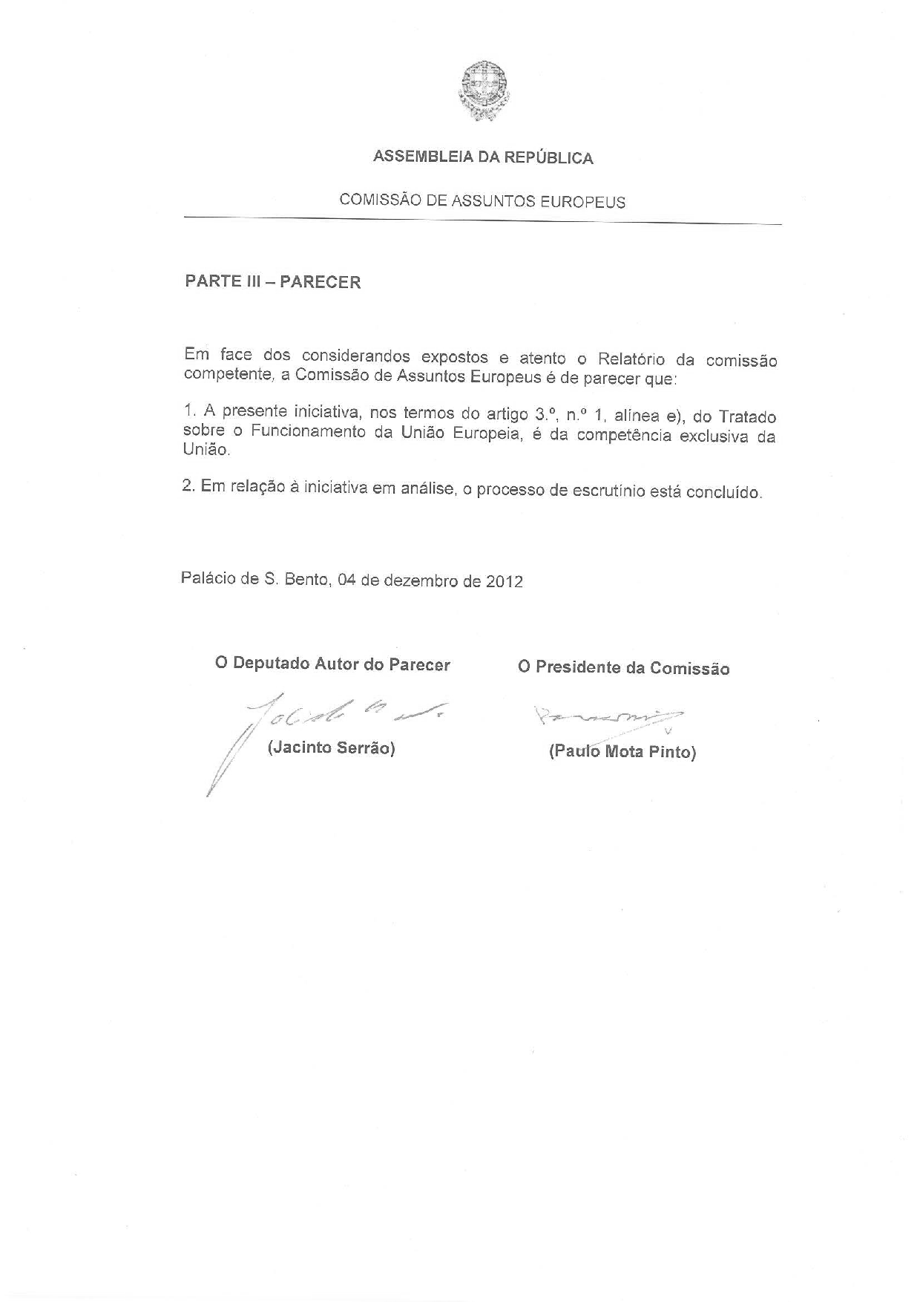
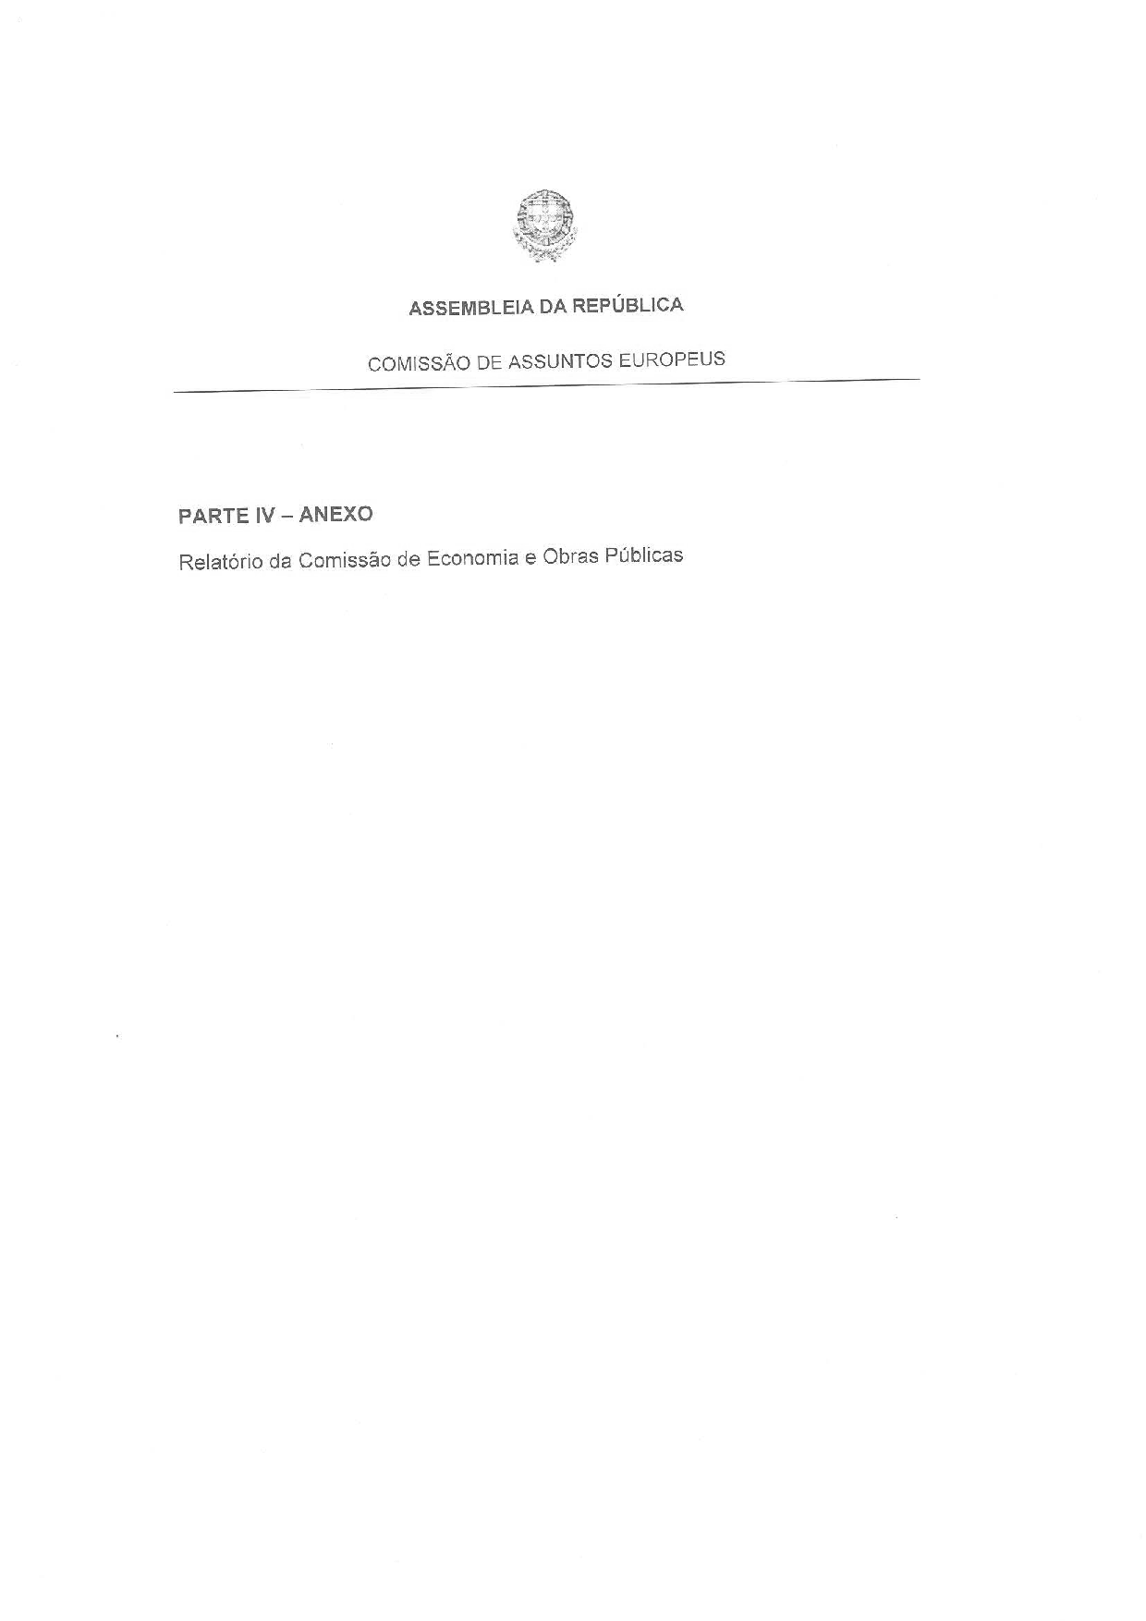
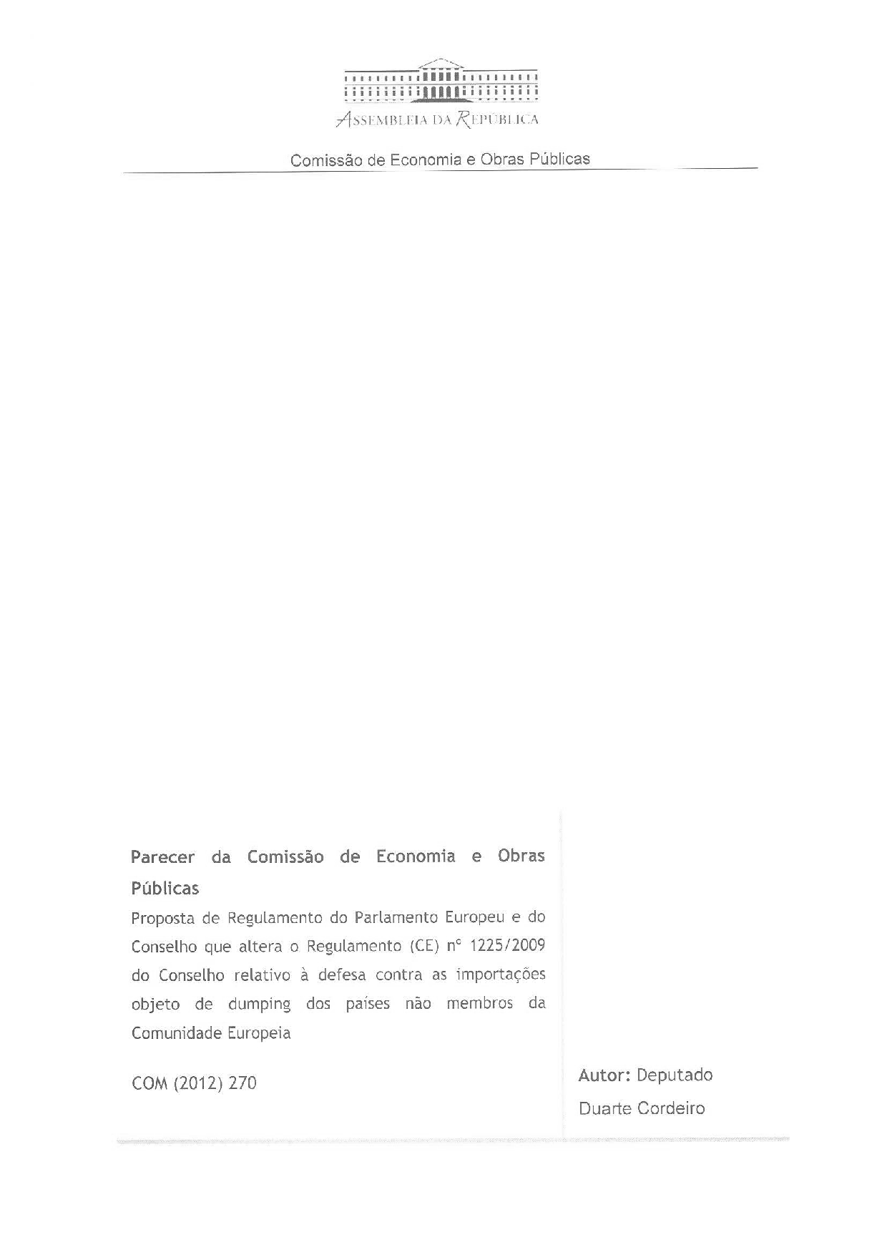
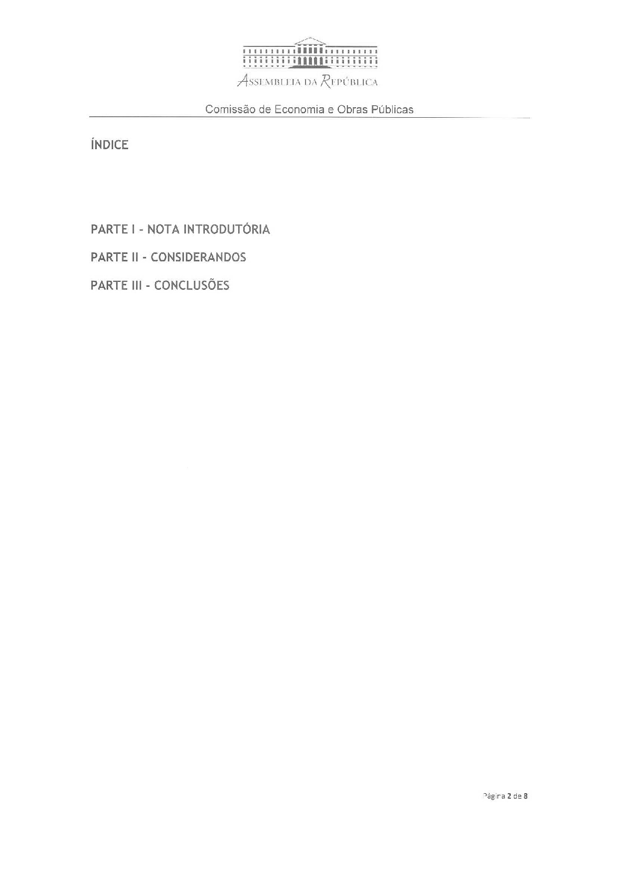
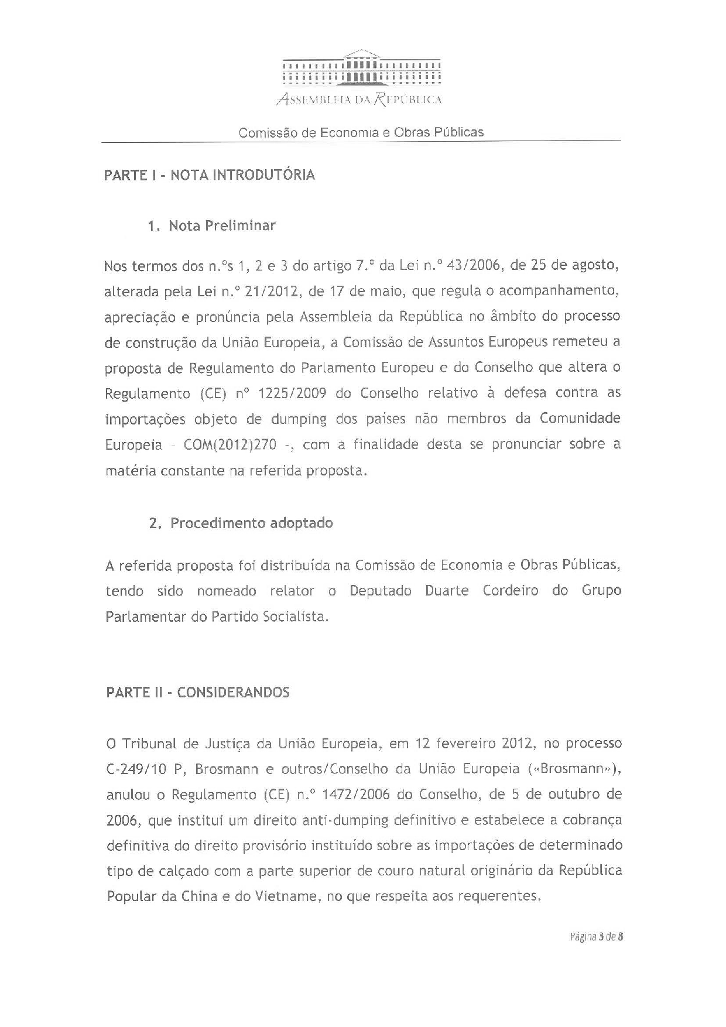
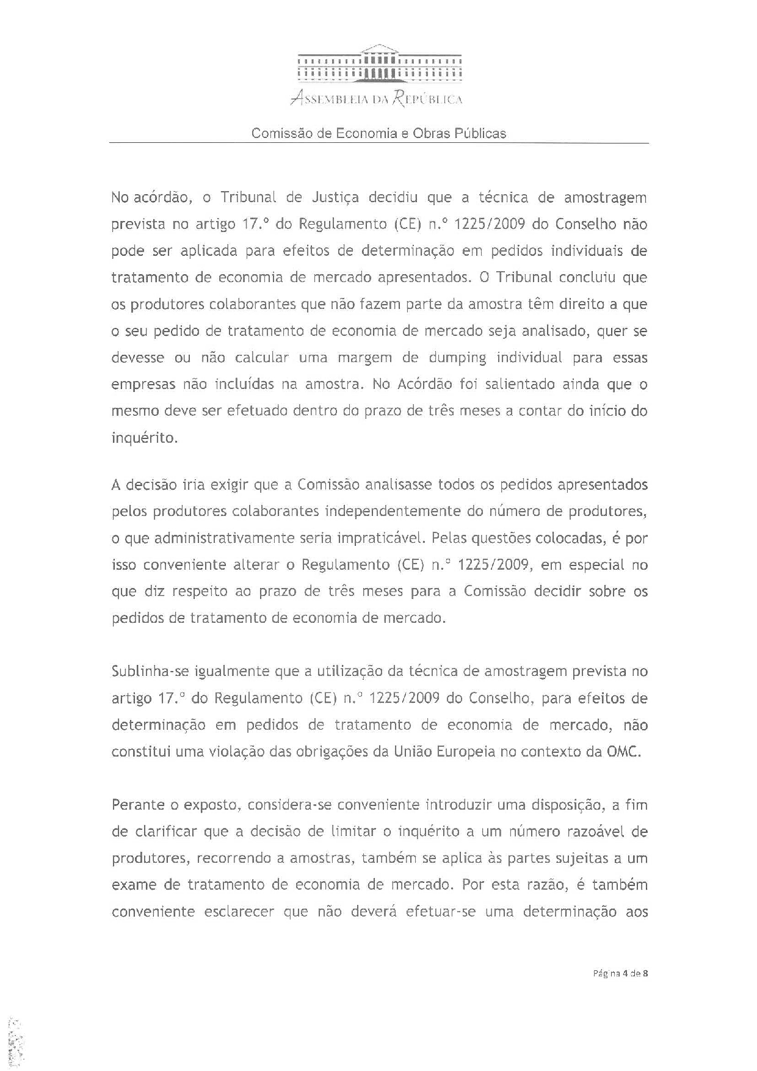
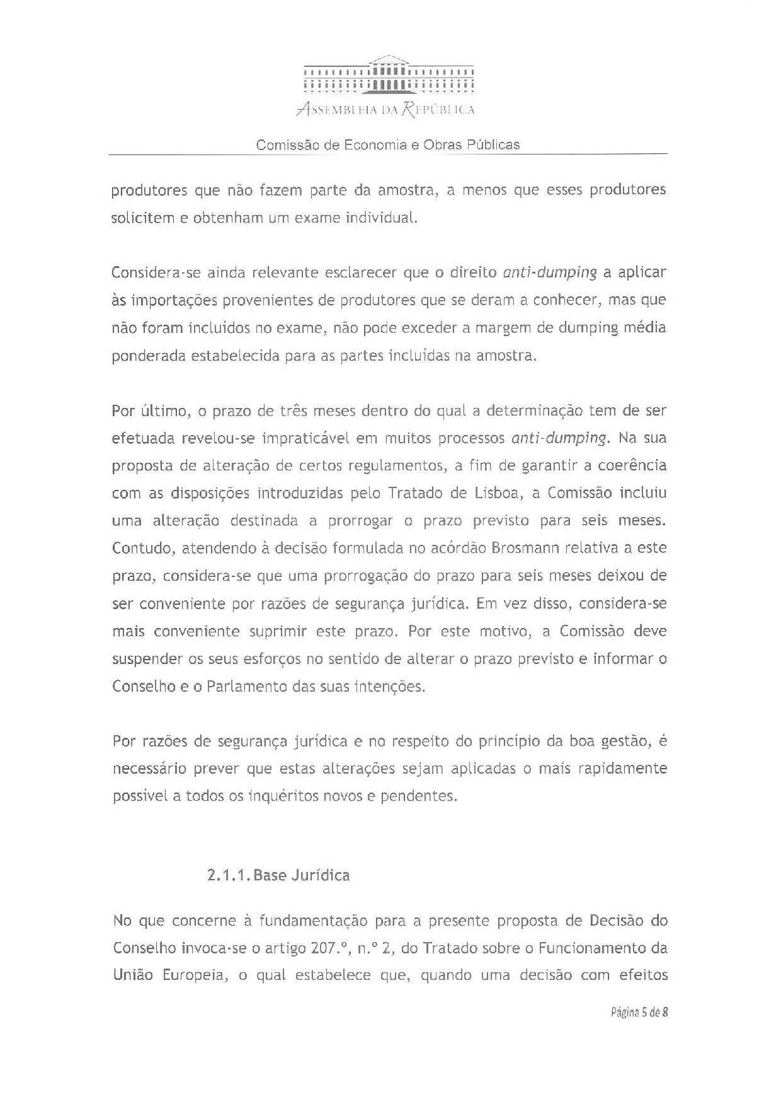
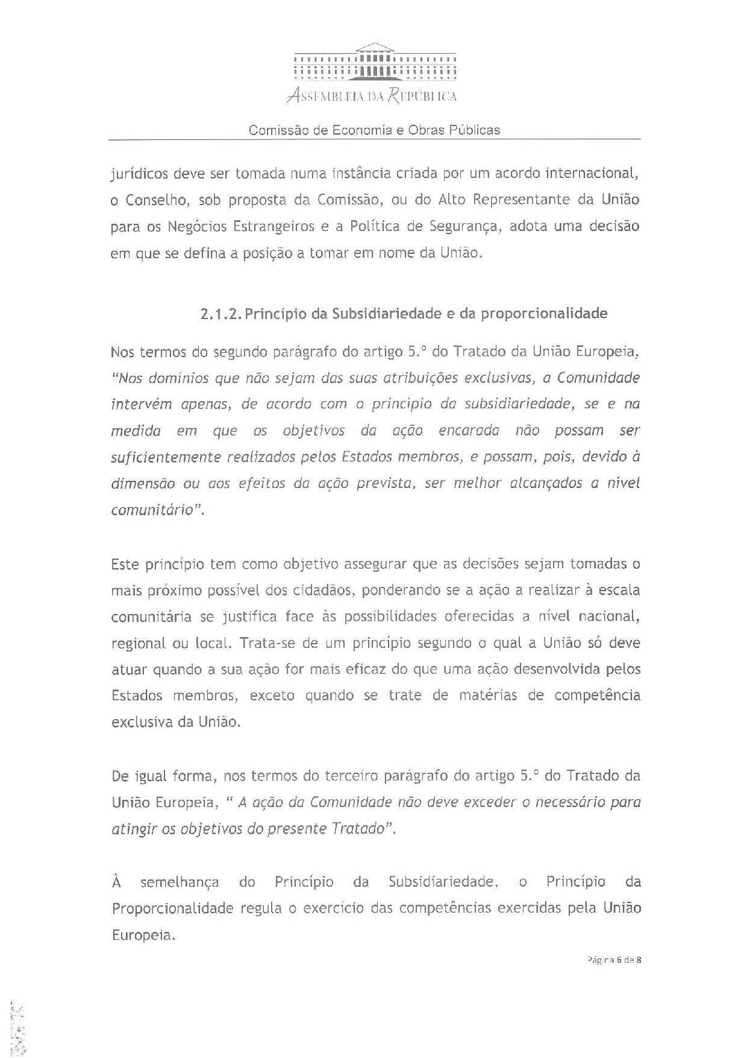
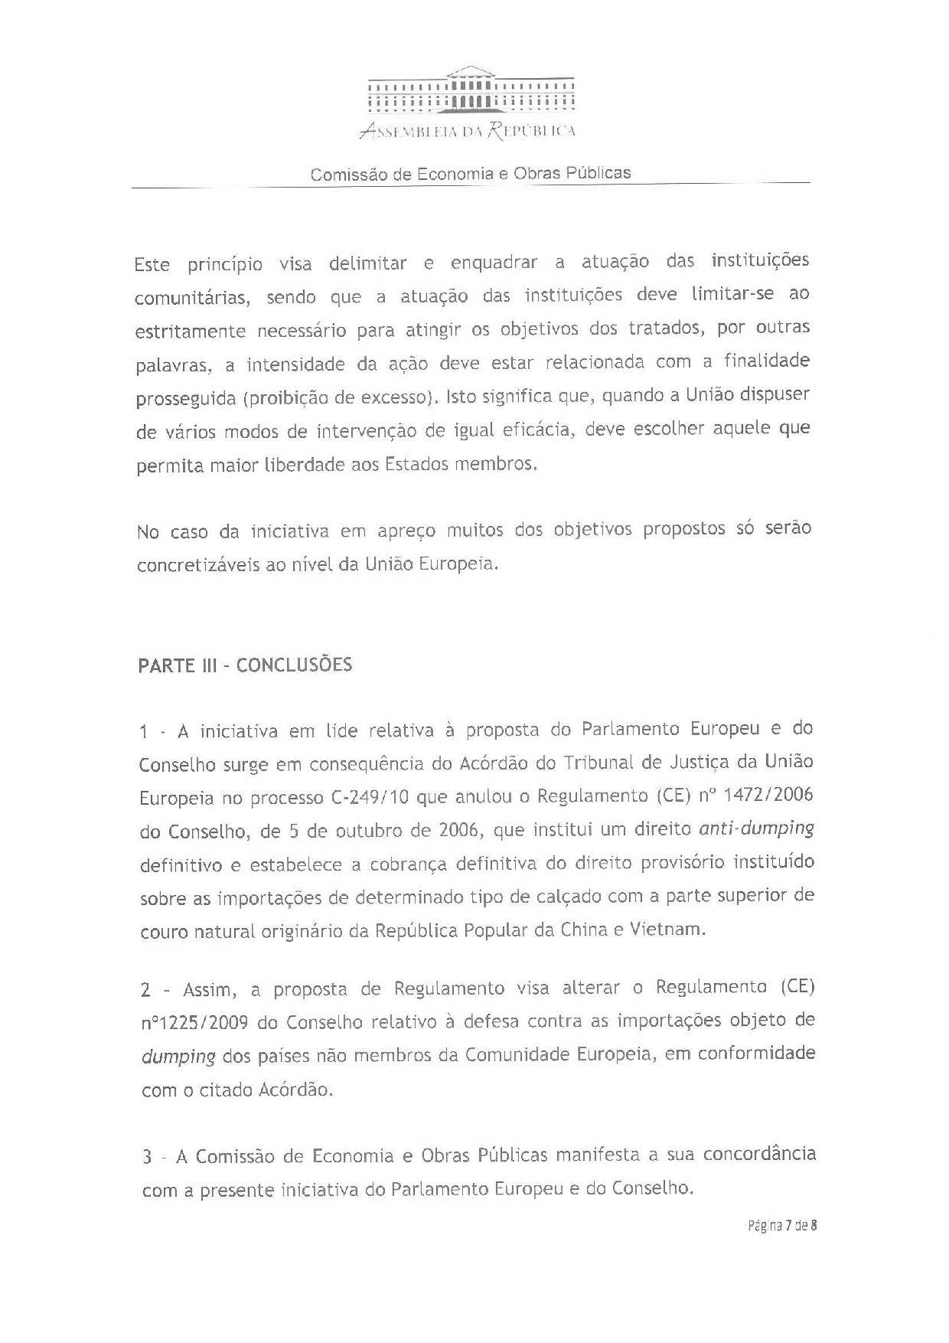
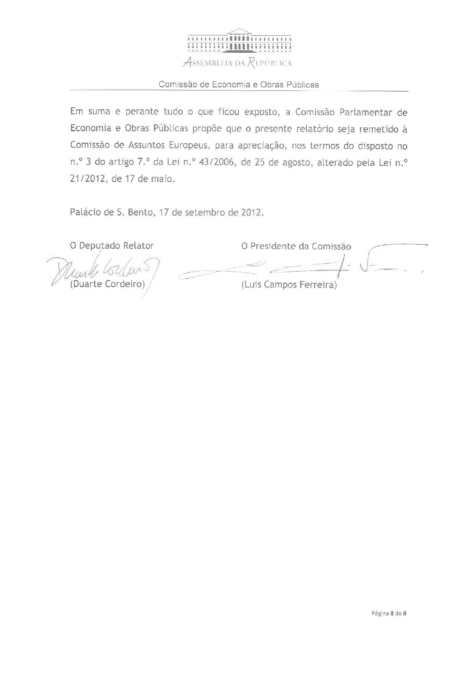

Translation(s) of the opinion may be available at the Interparliamentary EU Information Exchange site IPEX, at the following address: http://www.ipex.eu/IPEXL-WEB/search.do.

