EXECUTIVE SUMMARY

This Staff Working Document (SWD) provides the Social Investment Package's underpinning evidence on the long-term trends and short-term social challenges that Europe is facing.
The document demonstrates that large differences exist between Member States, but that they face similar long-term challenges. Demographic changes, an ageing population and decreased fertility are leading to a smaller working-age population and increasing dependency ratios. This threatens the solidity of financing for social protection budgets, which are generally financed through labour taxation. At the same time, the economic, social and financial crisis has aggravated this situation. Further, it has increased (long-term) unemployment, social exclusion and poverty across Europe.
This SWD highlights the three functions of social policy expenditure — social investment, social protection and economic stabilisation — and shows how they complement and reinforce each other. It analyses the size and structure of these budgets, their efficiency and their adequacy. In doing so, it makes the case that the size, structure and design of social policies all matter for the performance of welfare systems. Expenditure on social policies that focus on social investment is shown to be linked with greater returns to employment. To help illustrate this point, the paper also provides detailed analysis of social policy budgets and their financing before and after the crisis.
The SWD focuses further on the risks people face at different stages of their life courses, and points out that a difficulty experienced at one stage of a person's life can often interact with other difficulties later, and may exacerbate them. Successful policy interventions mitigate disadvantage and prevent it from becoming compounded. Often it is more efficient and effective to prevent than to cure, better to anticipate and prepare, than it is to repair. Evidence in this document shows that certain policies with a focus on prevention and on developing human capital can result in considerable savings later on. This knowledge specifically builds a case for early child education and care (ECEC) and active inclusion measures.
Lastly, the paper notes the main obstacles to obtaining timely and comprehensive social statistics. These jeopardise the way Member States can design their policy interventions, how those efforts are monitored in the European Semester and how EU funding is directed. In response to the issue, it sets out the way forward to improve the availability and timeliness of good social data.

1. Introduction 2
2. The structure of social protection budgets 3
3. Long-term trends 7
3.1 An ageing population 7
3.2 A trend towards a more active society 9
3.3 Geographic trends and growing regional imbalances 10
3.4 More diverse populations, a more diverse workforce, more diverse lives 11
3.5 Changing family structures 13
3.6 The development of information and communications technologies 13
4. The social impact of the economic and financial crisis: divergence between Member States and growing inequality in the European Union 15
4.1. Growing divergence between EU countries 16
4.2. Trends towards greater social inequality in most countries 18
5. The evolution of poverty and social exclusion 22
5.1. The multiple facets of poverty and social exclusion 22
5.2. The gender dimension of poverty and exclusion 25
5.3. The depth and duration of poverty 26
5.4 The most severe forms of poverty and social exclusion: focus on homelessness, the Roma and migrants 29
5.5 The economic returns on social investment and the costs of unemployment, poverty and social exclusion 30
6. Risks over the life course and opportunities for intervention 33
6.1 Children 34
6.2 Youth 38
6.3 Working-age populations 40
6.4 Older people 45

Introduction
European societies have been changing and will continue to change profoundly and rapidly in a number of interlinked areas with major implications for social outcomes and thus for social policy. These areas include demography, family structure, employment, poverty and social inclusion. At the same time the social policy responses and programmes have themselves been undergoing reform in response to economic and social change. The interaction of all of these defines the context for future social policy-making. Social developments in the European Union are also increasingly influenced by the global economy. Many countries outside the EU are experiencing similar challenges, and are engaging in efforts to extend social protection, particularly in emerging economies.
Demographic changes, an ageing population and decreased fertility mean fewer people of working age and increasing dependency ratios. Though a longer life and better health are of course intrinsically desirable, a smaller population of working age relative to the elderly will not only impact the design of Member States' health systems, but will also threaten the solidity of financing for social protection budgets, which are generally financed through labour taxation. Meanwhile, changes in family sizes and structures have led to weaker support systems, as social protection models have failed to adapt. The workforce will become increasingly diverse as the population of working age shrinks. Member States are introducing measures to enable more women, older people and non-EU nationals to join the labour market. In a very positive development, workers are increasingly mobile, but this sometimes creates problems as children and older people are left without family support.
In the decade before the crisis, economic and employment growth in general improved overall living standards. Many governments were able to devote more resources to social policy intervention. However inequalities often grew, so poverty and social exclusion remained a major issue in most EU countries. This included people in employment, though the pattern was very uneven across Europe. The economic crisis has exacerbated economic and social pressures. Recent data point to higher levels and deeper forms of poverty and social exclusion. The proportion of people at risk of poverty or social exclusion has risen in a number of Member States since 2008.
The crisis has also brought about increasing divergence between Member States and between regions of the EU. Unemployment and poverty are major issues in most EU countries, but there are substantial differences among them. The risks of falling into and the chances of getting out of poverty also vary across Member States, and significant differences can also be observed in terms of efficiency of spending when it comes to poverty reduction. The structure of employment across the EU also continues to become more polarised between high-income and low-income jobs, resulting in increases in inequality and thus in relative poverty. Not only do these trends run counter to European values of fairness and dignity for all, they also pose a threat to our economy, as poverty and social exclusion bring with them significant social and economic costs.
Some Member States have sought to confront the long- and short-term challenges with reforms to their social models, changing both the sizes and the structures of their social protection systems. Those that have been most successful in meeting these challenges are those that have maintained adequate social protection systems, reformed their labour markets and adopted policies strongly emphasising social investment, which seeks to empower individuals by facilitating the development of their human capital. These social investment policies reinforce social policies that protect and stabilise by addressing some of the causes of disadvantage and giving people tools with which to improve their social situations. Education and training in particular play a key role in breaking the intergenerational transmission of poverty and improving people's outcomes. Measures to reform labour markets to make them more inclusive can also improve individuals' opportunities to make best use of their skills.
This paper looks at current social trends and challenges that the EU is facing in greater detail, and outlines how these have affected poverty and social exclusion. It puts a strong focus on the specific risks people experience at different stages of their life courses, and shows that a difficulty experienced at one stage of a person's life can often interact with other difficulties later, and may exacerbate them. Social policy interventions, especially those with a social investment focus, may help to mitigate disadvantage and prevent it from becoming compounded. Such interventions take various forms, such as early child education and care (ECEC), up-skilling opportunities, and inclusive labour market measures.
To help illustrate this point, the paper also provides detailed analysis of social policy budgets and their financing before and after the crisis. It discusses the three functions of social policy expenditure — social investment, social protection and economic stabilisation. It shows how these functions complement and reinforce each other. It then analyses the size and structure of these budgets, their efficiency and their adequacy. In doing so, it highlights that it is not only different levels of social policy expenditure, but also different types of expenditure, that affect social outcomes — among other factors. Expenditure on social policies that focus on social investment is shown to be linked with greater returns to employment. It is also shown that social policy interventions to tackle disadvantage throughout the course of life appear to yield the highest returns if started as early in life as possible.
Finally, the paper notes the main obstacles to obtaining timely and comprehensive social statistics, which may impede the ability to take stock of and compare the living conditions of people across the EU, identifying those most excluded from society and monitoring the full impact of social policies. Improved monitoring will help Member States better target their policy interventions, which will help them improve delivery on the Europe 2020 employment, education and poverty targets. It will also better orient the direction of EU funding.

The structure of social protection budgets
Following Musgrave's classical framework, which defines the three main functions of public intervention in the economy as stabilisation (aimed at securing economic stabilisation, in particular of GDP but also of employment and price levels), distribution (aimed at securing adjustments in the distribution of income and wealth, not least an equitable distribution of incomes) and resource allocation (aimed at securing adjustments in the allocation of resources and in particular the efficient use of resources), social policies can be considered according to the three functions of social investment (primarily linked to the allocation function), social protection (primarily linked to the distribution function, considered in a very broad approach covering in particular distribution of incomes over the life course) and stabilisation of the economy.
Investment function. A key function of social budgets is to strengthen people’s skills and capacities, in order to prepare them for confronting or preventing risks over the life course and improving their future prospects. In other words, social policies show their effects not only immediately at the time they are implemented, but also have lasting impacts: with the characteristics of an investment by offering some returns over time, for instance in terms of increased employment or labour incomes, thus enhancing growth. In particular, social policies ‘prepare’ individuals, families and societies to adapt to various risks and transformations (such as changing career patterns, new working conditions or an ageing population, cf. Vandenbroucke et al., 2011) and can thus reduce the need for responses intended to ‘repair’ adverse situations.
For example, good quality childcare and early childhood education have been proven to have a strong impact on improving children’s chances of finishing their studies and finding employment, or of avoiding extreme risks such as delinquency and drug abuse. Preventive health care and health and safety at work help people to avoid sickness and maintain their productivity. Retraining and lifelong education help people to maintain employability and to obtain better jobs over their working careers. Promoting a healthy lifestyle, rehabilitation and improving access to assistive devices enable older people to lead independent lives as they become frail and develop functional limitations.
Box — A growing focus on a social investment approach
The social investment approach stresses the case for considering certain parts of employment and social policies — and possibly other policy areas, such as education — as entailing investments improving prospects for future employment and social participation, together with more social cohesion and stability (Van Kersbergen and Hemerijck, 2012), thus stressing the life course dimension of social policies and their long-term benefits for society.
The focus on social policies as an investment in developing human capital has been gaining ground in Europe since the early 1990s, in particular with the work of Esping Andersen (1992). The last two decades have recently been analysed as a period of emergence of a ‘Social Investment State’ in Europe (Van Kersbergen and Hemerijck 2012), while the roots of the social investment approach have been located in work on social protection as a productive factor developed in Sweden by Alva and Gunnar Myrdal in the 1930s (Morel, Palier and Palme 2012). It has recently been argued that deficits in social investment in some Member States can contribute to explaining the current disequilibria observed in EMU (Hemerijck and Vandenbroucke, 2012).
Protection function. Social budgets also have the function of supporting and protecting people when they have to deal with the reality of some social risk. For instance, social insurance pools risks and redistributes contribution revenues in benefits to those affected by those risks.
Typically, unemployment benefits provide people with an income as they look for jobs, and social assistance does the same if they are unemployed for a prolonged period, while it also supports those who for one reason or another cannot go out to work. Social protection provides insurance against social risks over the course of life (e.g. health and long-term care, sickness benefits, disability and survivors' pensions) and also redistributes income from those actively in work to those who have retired (e.g., through pensions).
Stabilisation function. In periods of economic downturn, the need for social intervention rises rapidly, while receipts also automatically decline, which has a substantial countercyclical macro-economic effect, dampening fluctuations in GDP and in household incomes.
Typically, unemployment benefits (and to a lesser extent other benefits such as social assistance) automatically rise in scale in response to a downturn, while retraining schemes, which are part of active labour market policies, also increase in volume. This cushions the impact of an economic downturn or crisis on those directly affected (e.g., by losing their jobs or working fewer hours). Pensions also stabilise incomes towards the end of life and offer a second line of automatic stabilisers, as they remain stable while active incomes decline.
In the current economic context, public budgets are under pressure due to fiscal consolidation concerns. While some Member States have more fiscal space, most Member States have little room to spend more on social protection. It is therefore essential to ensure the best use of existing resources and to avoid potential lasting adverse effects of solely savings driven adjustments on the short term and longer term employment and growth prospects. In this respect, well designed social systems combining the social investment dimension with the other two functions of protection and stabilisation, can contribute to increase the effectiveness and efficiency of social policies.
In practice, social policies actually very often support two or all three of these functions, which are mutually reinforcing. It would thus be misleading to allocate individual items of expenditure to a specific function (investment, protection or stabilisation), although some areas can be more directly linked to one of the three social functions. Typically, protection of human capital during adverse periods enables former investments made in human capital to be preserved.
For instance, unemployment benefits can function as protection (by providing the actual benefits) but also as investment (by preparing future labour market prospects through effective targeted activation measures and preservation of human capital during unemployment spells) and can also play a key role in automatic stabilisation. Furthermore, active inclusion policies refer to a protective pillar (adequate minimum incomes) and an investment pillar (access to quality services), alongside a labour market pillar (inclusive labour market measures). Pensions have a key protection function and also help stabilise household incomes and internal demand in recessions, while also having a social investment aspect, in that they help older people maintain themselves in a state of independence. Likewise, the provision of healthcare, while having a key protection function, also fulfils a crucial investment function that aims at the early detection and prevention of diseases, such as cancer screening,
While there is thus no exclusive correspondence between the various social policies (or risks) and the three functions of investment, protection and stabilisation, specific social policies can however be more specifically linked to one of these functions, depending in particular on their design, on the specificities of national contexts and circumstances in time. For instance, preserving human capital, the family’s relation to the economy and the link to employment can generally be more directly linked to the social investment function (Vandenbroucke et al. 2011), relating more particularly the social investment dimension to some policies such as childcare, active labour market policies, rehabilitation, education or training.
Nevertheless, the expected returns from specific policies also depend on the national contexts and sequencing. For instance, the impact of childcare provision on the employment rates of women can depend on labour market factors such as the institutional labour market context (e.g., availability of part-time contracts and flexible working time arrangements) and in particular gender equality. Likewise, reforms to rebalance social spending, for instance, between old-age and childcare and unemployment benefits and to revise the design of unemployment benefits in specific countries (e.g., through greater activation measures, reducing work disincentives by aligning tax/benefit policies, etc.) are also expected to achieve efficiency gains in terms of both economic and social effects.
For instance, in some southern European countries (ES, IT, EL, PT) the stabilising impact of social expenditures is relatively weak. These countries also acknowledge a low poverty reduction impact (excluding pensions) of social expenditures and low levels of childcare provision. Given the rigid constraints on public finances, a careful rebalancing of expenditure, most often rather than an increase, would help to reinforce both the poverty reduction impact of social benefits, as well as the investment in childcare and the stabilising effect of expenditures. This could include reviewing the structure of spending, currently skewed towards old age benefits (in comparison to other countries), making sure that unemployment insurance covers the most vulnerable workers (those who are first to lose their jobs), or adjusting the design of schemes to make them more responsive to the economic cycle (e.g., automatic adjustment of the duration of unemployment benefits).
A revision of the mix between cash and in-kind benefits can also lead to efficiency gains. Both cash and in-kind benefits have pros and cons and an optimal choice depends on the type of benefit and national circumstances. In-kind family benefits such as childcare are more employment-friendly than cash family benefits and ease the participation of women into the labour market, generating virtuous effects on female employment. Childcare services also contribute to preventing child poverty and the intergenerational transmission of disadvantage by securing parental incomes and giving access to quality education and care to all children. Cash housing benefits are more efficient in cushioning situations of temporary financial distress, while in-kind housing benefits can hamper workers’ mobility and create ghetto effects.
Promoting an ‘active’ welfare state should also contribute to the well-functioning cyclical behaviour of social spending, whereby expenditures increase more in response to a shock, and then decrease in times of recovery. This is an essential aspect of the sustainability of social systems. A recent study shows that countries that invested heavily in active labour market policies (ALMPs) before the crisis saw their employment levels less severely impacted during the crisis. During the years 2000-2010, a number of countries (the Nordic countries, Germany and the Netherlands, for example) engaged in successful reforms to modernise their welfare states, aimed at reabsorbing high levels of long-term unemployment and/or swelling numbers of people on long-term illness or disability benefits resulting from the recession of the 1990s.
Improving the efficiency and effectiveness of education systems (accompanied by demand-side policies such as enhanced research and development (R&D) spending and innovation) is a key priority for increasing human capital and boosting productivity. Some proposed interventions do not entail higher spending, while at the same time increase future returns from human capital investments. Depending on the country, such interventions may include: curricula reforms in primary and secondary schools to improve basic and traversal schools; promotion of vocational, scientific and technological education with a greater responsiveness to the labour market and attention to innovative sectors; modernising assessment processes and wider use of standardised exams; and avoiding early tracking of students .
More cost-effective provision and use of health services can also be done through better health promotion and disease prevention in and outside the health sector; creating financial incentives to encourage patients to register with a general practitioner (GP) or family doctor and using a referral system; use of less expensive equivalent (generic) drugs; ensuring a balanced mix of staff skills and anticipating staff needs due to ageing; promoting the cost-effective use of medicines; reducing the unnecessary use of specialist and hospital care while improving primary healthcare services; improving data collection and using available information to underpin the improvement of the performance of health systems; and using health technology assessment more systematically for decision-making processes.

Long-term trends

3.1 An ageing population
People in the EU are fortunate to have a life expectancy among the highest in the world. This is a great achievement. This century-long trend seems set to continue, with life expectancy increasing by about a year every five years.
Fertility dropped from 2-3 children per woman in the 1960s to well below the population replacement level (2.1 births per woman) in the 1990s. Then, in the past decade or so, fertility started rising again in most Member States. There are signs that it could rise further, to just below the replacement level. Moreover, low fertility rates in past years have resulted in smaller cohorts of women (and men), so even somewhat higher rates would result in lower numbers of births as compared to some decades ago. That would mean that rapid ageing and rising dependency will occur, and in the long run the population will shrink — bar a large influx of migrants. As evidenced in the 2012 Ageing Report, Labour supply is projected to contract by 11.7% between 2020 and 2060, equivalent to 27.7 million people (24 million compared with the 2010 level).

This will create challenges for economic growth and welfare in two respects:
- First, with more dependents and fewer workers, financing social policies will become more difficult.
- Secondly, with fewer workers, some economic activities will have to be rationalised; unless work-efficient alternatives are found, staffing social services will become more difficult.
Figure 3.1 — Population by sex and age group and working status, EU-27, 2010 and 2030
2010 | age | 2030
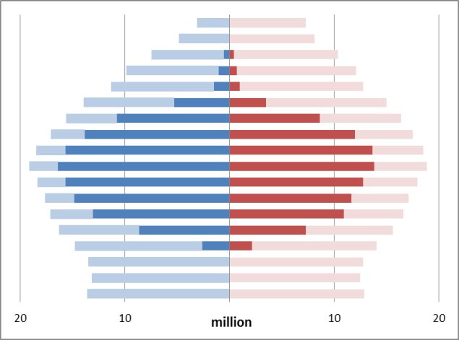 | 90  80  70  60  50  40  30  20  10  0 | 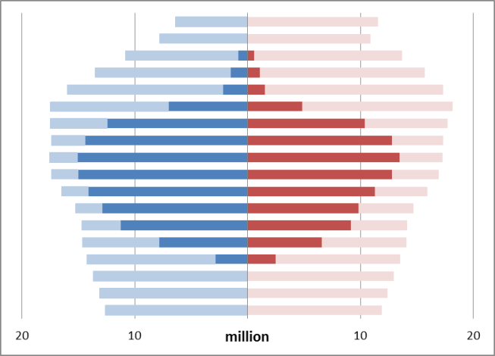
Economic dependency ratio: 1.29 |  | Economic dependency ratio: 1.44
Source: Eurostat, LFS and projections, computations
However, a significant part of the longer lives are not lived in good health, as measured by the healthy life years (HLY) indicator (see Figure below). There is an average difference of 14.3 years between life expectancy and healthy life years for men, and 19.5 years for women. The spread of values for HLY at birth among EU member states are much greater than for life expectancy, being 19 years for women and 18 years for men.
Figure 3.2 — Life expectancy (LE) and healthy life years (HLY) at birth by gender, 2008-2010 Average
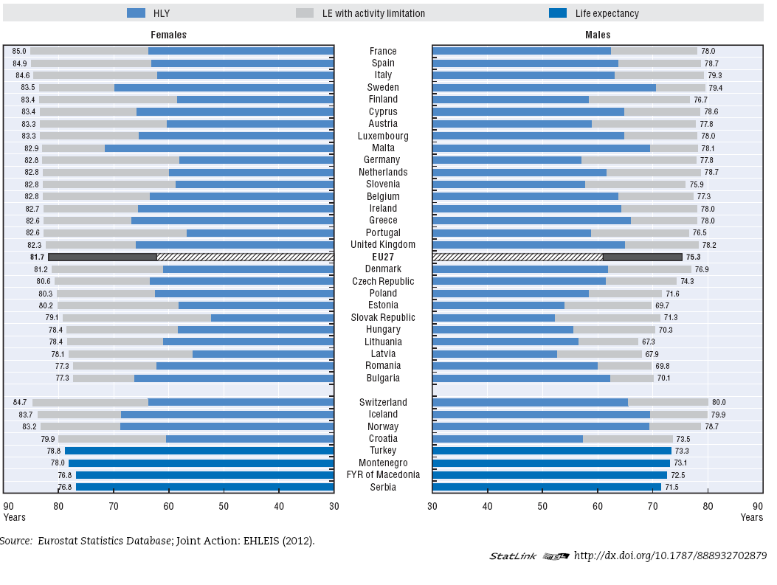

3.2 A trend towards a more active society
Rising average ages are accompanied by rising life expectancies. From a societal viewpoint, this is important, as older people can remain active and independent for longer.
In the past decade, national pension systems have been reformed and more older people have stayed involved in work and society. These were major achievements of what we call active ageing policies. At the same time, more women have entered the labour market while fertility has increased, albeit slowly, showing that policies to reconcile work and family life can work. These gains, together with increased immigration, have contributed to employment and economic growth and partly offset the challenge of ageing. Figure 2.2 below illustrates these trends.
Figure 3.3 — Employment rates by age group and gender, EU-27, 2000-2011
Source: Eurostat, EU-LFS

3.3 Geographic trends and growing regional imbalances
With 10 new Member States joining the EU in 2004 and two more in 2007, more people are on the move. Growing numbers of people from the new EU-12 Member States choose to live in a different country in the EU-27. Their ranks increased almost ten-fold from 2000 to 2010, to 4.5 million. Young adults from the EU-12 brought extra manpower to the EU-15, relieving saturated labour markets and gaining valuable experience. Over the same period, there was a slight rise in the number of EU-15 nationals living abroad permanently, though there are signs that more and more of them move abroad for short periods.
A recent study indicates that people moving from the EU-2 (Bulgaria and Romania) during 2004-2009 may have increased aggregate EU-27 GDP by about 0.2% in the short term and 0.3% in the long term. The study finds that for the receiving EU-15 countries, the long-term impact is even stronger (0.4%), exceeding the economic loss in the sending countries.
The downside of mobility is the cost for sending countries. For Bulgaria, Latvia, Lithuania and Romania, this has meant losing about 5 % of their population in the past decade, a trend expected to continue for the next 20 years. The losses will be heaviest among young adults (a one-third loss) and highly-skilled workers. Though these populations are currently among the youngest in the EU, especially Romania, by 2050-2060 they will all rank among the oldest. This is also a result of a long process of de-industrialisation following the collapse of the Soviet Union, and it will further exacerbate existing inequalities among Europe's regions. Closing the large decentralised industrial plants, mostly in rural regions, that were artificially supported in the times of planned economies has created an exodus towards the cities, especially among young adults in search of employment. Those who leave face difficult conditions at the margins in cities, while those who stay behind experience an aged and declining population and a weaker economy.
People in rural regions are likely to suffer the most from population decline and ageing. These are caught in a vicious cycle where population loss and ageing discourages investment; as a result, talented young adults are even more motivated to move to more developed regions. Many emigrating young adults care for dependent people in need of assistance, such as children or elderly relatives. When these dependent people also move, they often face integration problems (such as learning a language in new school); when they are left behind, they often lack the necessary care.
But the impact is not limited to the rural areas. In northern and western Europe, the employment rate in urban areas is below the national average. This leads to an 'urban paradox'. People arrive to job-rich city centres for work, but the resident population suffers from a lack of jobs. High unemployment among residents further puts pressure on social cohesion in cities and is a contributing factor in social problems such as inadequate housing, crime and delinquency.

3.4 More diverse populations, a more diverse workforce, more diverse lives
The working-age population is shrinking, but it is also becoming more diverse. At the same time, by 2030, the rate of women's participation in the workforce is expected to grow only marginally. The participation of older workers will grow more rapidly (those aged 50-64, to increase from 30 to over 35%) and that of workers with a foreign background will increase considerably (see Figure 3.3). A greater number of older workers will also mean further adaptations in the workplace.
Figure 3.4 — Share of population with a foreign background, EU-27

Non EU-citizens have represented two-thirds of the EU population growth in the past decade and half of employment growth in the past five years. As a result, out of just over 30 million non-nationals in the various EU Member States, 20 million are non-EU citizens. Up to 10-15 million more people were born as non-EU citizens and later acquired citizenship of an EU Member State.
Migrants from outside the EU are generally younger than the population they join, so they rejuvenate it. These migrants also tend to be better educated than older workers, though they are generally less well educated than local-born labour market entrants, so they play a more significant role in maintaining the size of the labour force than in up-skilling it.
There are also country-specific aspects to increasing diversity. The Roma, for instance, are projected to increase from 5 % to 16 % of the Hungarian population of active age by 2050. As low education and low employment are characteristics of many Roma at present, fostering their integration is a priority.
People’s lives are also becoming more varied. The traditional pattern whereby people, predominantly men, first studied, then worked, then retired is slowly being supplanted. People, especially women, tend to stay in education longer and wait longer before having children. Within their working lives, many people have spells of childcare and lifelong learning, reducing or discontinuing work temporarily. People still migrate for long periods, but now many more have short work or study experiences abroad. People are also leaving the labour market later. These new, more varied patterns of life mean that social protection systems have to adapt to the new realities.

3.5 Changing family structures
In recent decades, ever-growing numbers of women have been getting an education and going out to work. Among those born after 1960, more women than men obtain university degrees in almost all EU Member States. Each new generation of women has valued employment and economic independence more and managed to reconcile having children with employment more successfully. Those who work as young adults are also more likely to be working as they grow older, with employment rates growing for women of all ages.
Changes in values, opportunities and increasing mobility have led and continue to lead to changing family structures. Since 1970, there have been fewer marriages, falling from eight to five a year per thousand people, while the number of divorces has risen from one to two per thousand. This has probably increased the number of single-parent and recomposed families. More children, now over a third, are born outside marriage. At the same time, fewer women (traditional informal carers) are available to look after dependants as demographic dependency rises. Overall, the male breadwinner model, on which much family policy has been grounded, is no longer predominant. This means adapting social policies to a new reality, ranging from pensions, education and care, health and elderly care and measures to reconcile work and private life.

3.6 The development of information and communications technologies
Information and communication technologies (ICTs) are increasingly being used across Member States. In 2011, 77 % of households in the EU had access to a computer. The internet was available in 73 % of EU households in 2011, a sharp rise from 41% in 2004. An estimated 180 million people are also using ICTs at work.
In spite of increasing levels of regular internet usage in Europe, large disparities still persist between EU countries and between different socio-economic groups. Age and education are the main factors determining the probability of using the internet. Other socio-economic conditions such as household income or rural/urban living area also strongly influence internet use.
Furthermore, when looking at young people, according to Eurostat, in 2011, 91% were regular internet users, or accessed the internet at least once a week. However, research on the relationship between youth, ICT and inclusion points to worrying trends: (a) the lack of ICT skills of young people, for example digital reading or ICT skills to meet the labour market demands; (b) the fact that socio-economic status affects the frequency of ICT use, the skills and the types of ICT uses, where disadvantaged youth adopt more risky behaviours online and are more likely to be exposed to unsuitable and harmful on-line experiences; and (c) digital exclusion of those with lower socio-economic status is affected by cost, peer pressure, social context, attitudes, and school divides.

The development and increasing use of ICTs has the potential to promote cultural understanding between citizens, to seed innovation in institutions and to create competitive advantage for businesses and employees in the future. These technologies continue to play an important role in improving labour productivity and they also provide responses to major societal challenges. ICTs increase the effectiveness of existing processes and create enormous potential through 'network effects' ('collective intelligence') in order to find effective solutions to societal challenges.
ICTs are a key enabling tool in the development of new forms of work. Thanks to their pervasiveness, people can work remotely, on the go from virtual work stations and indeed also according to their own rhythm. This flexibility allows workers to take up employment positions which otherwise would have been too far away or not compatible with other personal obligations such as child or elderly care or with limitations in activities imposed by a disability.

The ICT sector has increasingly accounted for a substantial part of EU GDP and employment. For the EU as a whole, in 2009, the EU ICT sector represented 4.0% of EU GDP (€ 470 billion) and accounted for 2.7% total employment, amounting to 6.1 million people.
ICT skills have become crucial for employability of individuals, supporting individual empowerment (development of self-confidence and self-efficacy) and the development of other skills, such as transversal skills (social networking, collaboration, problem solving, language skills), job search skills, and e-learning skills.
There is also an increasing demand in the labour market for ICT skills, which not only increases the employability of those having them, but also gives people access to more and better jobs — more creative jobs where they can further develop their skills, enhance their career prospects and earn higher wages. Moreover, ICT skills facilitate access to the labour market as they help people to search for jobs more effectively and can reduce the duration of unemployment.
Furthermore, ICTs have dramatically changed the way job seekers look for jobs and employers recruit and select the best candidates. ICTs support the role of labour market intermediaries (social actors, employment services, etc.) that can offer new online assessment, labour market information and employment services to job seekers and employers, improving service quality, cost-effectiveness, supply-demand matching and reach.
Demand for ICT specialists and people who have strong ICT skills is growing, while shortages of ICT practitioner skills have become endemic. The employment of ICT practitioners is growing so fast that there are not enough workers to fill all the vacancies available in the sector, even with increased unemployment during the economic crisis. According to recent estimates, there will be up to 700,000 unfilled ICT practitioners' vacancies in the EU by the year 2015. The Employment Package underlines the potential for employment growth by developing the ICT sector and ICT skills.
Outside of ICT specialist skills, most jobs nowadays already require some kind of computer-related knowledge. It is forecast that by 2015, 90% of jobs will need at least basic computer skills. Possessing ICT skills is increasingly important in order to lower unemployment risks even among senior workers, and ICTs can also be used to improve other work skills. ICTs can help increase high level skills and up-skill existing skills, for example, by enabling education and training through open and easily available learning resources, open educational practices and the use of open networks.

When exploring the links between ICT and the social inclusion of disadvantaged populations, an analysis of 61 initiatives using ICT to support the inclusion of disadvantage youth at risk of exclusion shows that the short term effects or 'outcome' of ICT-based initiatives are associated with multi-dimensional impacts, typically combining empowering/skilling, social inclusion and social capital and employment-related benefits, supporting protective factors and resilience.

The social impact of the economic and financial crisis: divergence between Member States and growing inequality in the European Union
In the decade before the crisis, economic and employment growth in general improved overall living standards. Many governments devoted more resources to social policy intervention. Despite the clear redistributive effect of social protection, inequalities have often increased. Poverty and social exclusion remain major issues in most EU countries, though the pattern varies substantially across different countries.
The outbreak of the financial and economic crisis in late 2008 put further strain on households in the EU. The timid recovery generating some employment growth after 2010 has not proved durable and the ensuing economic slowdown in 2011 gradually turned into mild recession in the EU, as the escalation of the debt crisis in several Member States led to necessary policy shifts toward fiscal austerity by and large across the EU, with inevitable adverse effects on aggregate demand. As a result, the employment recovery from the 2008-2009 recession has come to a standstill. The number of people in employment in the EU grew by a modest 0.3 % of the working-age population in 2011, owing to the better first half of that year, and then has stagnated until autumn 2012.
Over the period 2008-2011, the employed population shrank by 2.0 %. Unemployment is again rising to historically high levels. The average EU unemployment rate is over 10 %. The rates for long-term and youth unemployment are especially worrying. In autumn 2012, 25 million Europeans were unemployed. More than 10 million of them had been unemployed for over a year, while in the United States and Japan unemployment has been slowly declining.

Growing divergence between EU countries
Employment and social indicators point to growing divergence among EU countries. Some southern and peripheral European countries have seen their unemployment increase sharply and their GDP contract considerably, while most of the countries of northern and central Europe have so far shown greater resilience. The latter tend to combine higher levels of competitiveness with better functioning labour markets and more robust welfare systems. The (in)ability to cope with the shock was frequently compounded by the initial public debt and deficit levels, as well as the property market situation, and subsequent developments followed by the reaction of financial markets.
EU countries have seen very different trends in unemployment, as shown in Figure 3.2. After converging in the years up to 2003-2004, in favour of southern and peripheral countries, it changed in favour of northern countries again in 2008, both within and outside the euro area. In 2011, the gap between the north and the south/periphery in the euro area reached 7.7 percentage points, but was smaller among non-Euro area countries (1.8 %). Labour market divergence has become a major issue for the EU.
Figure 4.1 — Diverging unemployment rates by groups of Member States since 2000, 15-74 age group, 2000-2011

Source: Eurostat, EU LFS.
Much of the post-2008 period in most Member States has been marked by wage deceleration, including pay freezes and sometimes pay cuts. In 2011, this deceleration was increasingly concentrated in Member States with high unemployment and current account deficits, in efforts to reduce the wage bill in the public sector and regain competitiveness in the private sector. Changes in pay per employee ranged between plus 3 % in Finland, Belgium and Germany and a similar rate of negative growth in Greece.
Figure 4.2 — Compensation per employee, productivity and ULC in 2011 (annual % growth)
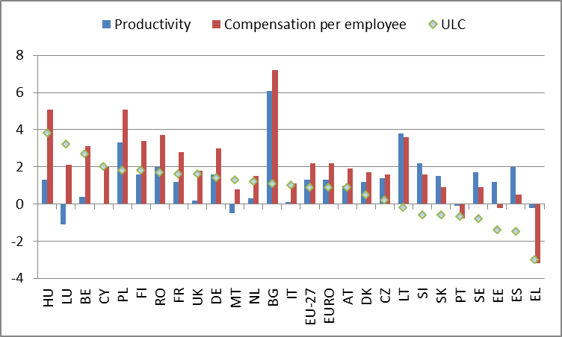
Source: Eurostat, National Accounts
There is growing divergence between the countries where the social impacts of the crisis were somewhat limited, and countries where living conditions have deteriorated markedly. The fall in household disposable income was most significant (above 4%) in the southern countries, Ireland, Hungary and the Baltic States, the result of further deterioration in labour market conditions, together with weakening of the cushioning impact of social expenditure over time (see Figure 4.3).
In the Baltic States the rebound of the economic and labour market situation has contributed to stabilising income levels overall after 2010, but long-term unemployment and poverty remain at high levels.
In stark contrast, northern and continental countries fared far better. The combined effect of robust automatic stabilisers (reinforced by initial discretionary measures) and more resilient labour markets in general helped mitigate the impact of the recession on overall household incomes and private demand. Still, while household incomes continued to rise during the crisis, there were still some groups badly affected by rising unemployment.
Between 2007 and 2009, automatic stabilisers and stimulus packages contributed to sustaining household incomes in most countries. Between 2009 and 2011, household incomes fell in a number of countries, especially where the recession was prolonged, due to: the weakening of the effect of automatic stabilisers (e.g. people losing entitlement) and the phasing out of discretionary measures taken at the onset of the crisis, combined with the introduction of fiscal consolidation measures (cuts in benefits and increases in taxes).
Figure 4.3 — Evolution of Gross Household Disposable Income (GHDI) in real terms (2005=100) 2005-2011 (2012 forecast)
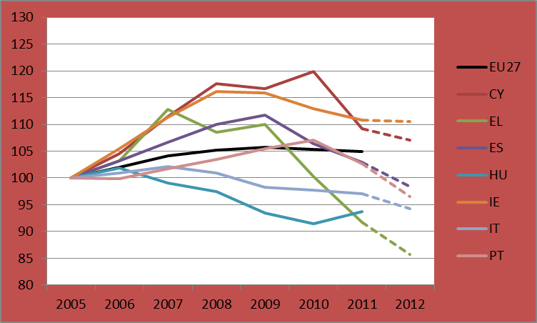 | 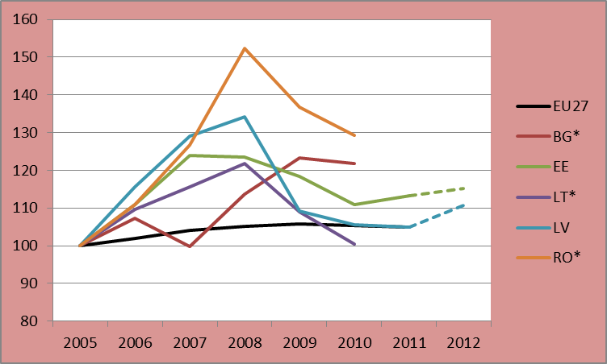
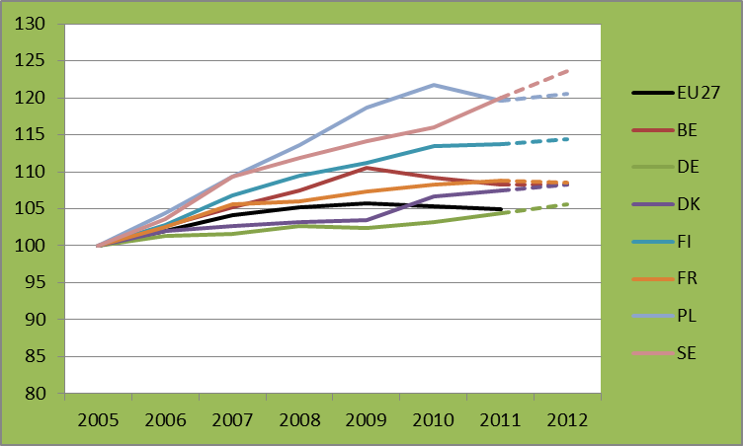 | 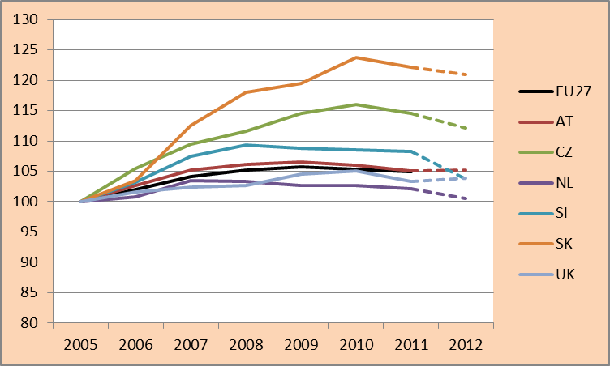

Source: AMECO

Trends towards greater social inequality in most countries
The evolution of incomes since 2008 results both from long-term trends and from the specific impact of the recession. The initial deterioration of labour market conditions primarily affected workers at the lower end or in the middle of the income distribution. This impact was mitigated by the working of automatic stabilisers and initial discretionary measures. Over time, long-term unemployment and the weakening of the protective role of social transfers led to an increase in the share of people on low income in a number of countries. In addition (see section 7) fiscal consolidation measures have had differing redistributive impacts, in some cases exacerbating and in some cases mitigating inequality.
The crisis has not affected the whole population uniformly. It has in several respects worsened the position of people already at heightened risk, thus contributing to social polarisation. Young people have been particularly hard hit, and more than one in five active Europeans aged 15-24 are unemployed. Non-nationals, the low-skilled and men are also badly affected by deteriorating labour market conditions. There has been a levelling down of gender gaps in employment, unemployment, wages and poverty over the crisis. This does not, however, reflect progress in gender equality as it is based on lower rates of employment, higher rates of unemployment and reduced earnings for both men and women.
Even before the crisis, there was a trend towards polarisation of incomes. The polarisation of jobs took root in the decade before the crisis. Most of the jobs created between 1998 and 2007 were either low paid or highly paid. This led to slow erosion of the number of middle-paid jobs (Figure 3.5). The growth of service jobs at the extremes of the wage distribution aggravated this trend.
The recession reinforced the wage polarisation observed in the past. During the current recession, the massive job losses in manufacturing and construction — and the ensuing collapse in middle-ranking jobs — drove wage polarisation for the most part. Job growth in the top wage quintile persisted strongly throughout the recession, mainly because of the rise of knowledge-intensive services (KIS), including public services (mainly education and health) and private services (business services). One of the main factors behind the "disappearing middle" was the polarisation of service sector employment, characterised mainly by employment growth at the top and bottom, which is likely to continue in the long run. This suggests that the service sector cannot be relied upon to fill the gap created by the decline in manufacturing. This trend toward further segregation means that those in lower-end employment are at growing risk of limited career mobility possibilities, exacerbating problems of job-skills mismatches and over-qualification.

Figure 4.4 — Net job creation (difference between the number of jobs created and the number of jobs lost — expressed in thousands of jobs) by wage level
Before the crisis During the crisis
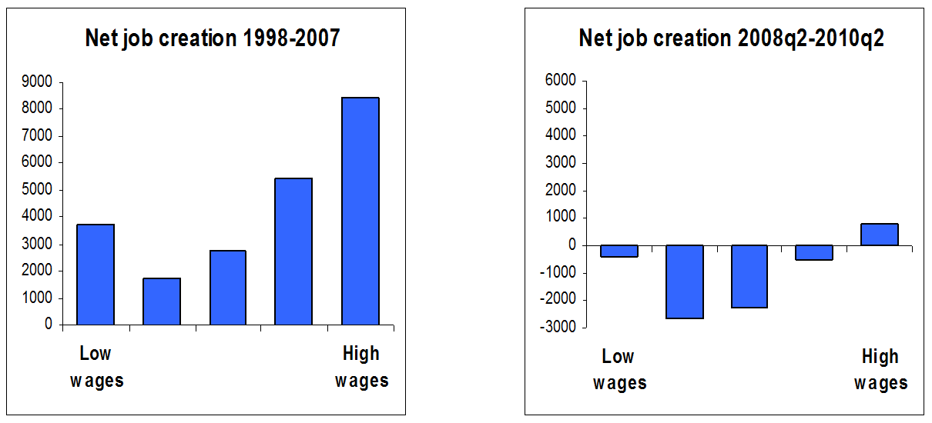Source: ESDE 2011
Another factor driving rising inequalities is the growth in involuntary part-time and temporary contracts. Persistent labour market segmentation is an important determinant of growing earnings inequality, not just because non-standard workers tend to work fewer hours per year, but also because they are generally paid less per hour after taking into account differences in education and experience. Non-standard contracts can also provide opportunities to get back into the labour market and act as stepping stones towards better jobs, as observed in countries with better functioning labour markets.
In most countries, inequalities between workers were further aggravated by the polarisation of jobs between job-rich and job-poor households. Before the crisis, growth in employment was mainly driven by women entering the labour market. The new jobs mostly went to second earners in households that previously had only one earner. Households that included no earners were benefiting less. This is illustrated in the graph below, which shows that while the EU unemployment rate was reduced by 2 percentage points between 2004 and 2007, the share of people in jobless households was reduced by only 1 percentage point.
Figure 4.5 — Employment, unemployment and share of working age adults living in jobless households, EU-27, 2000-2011
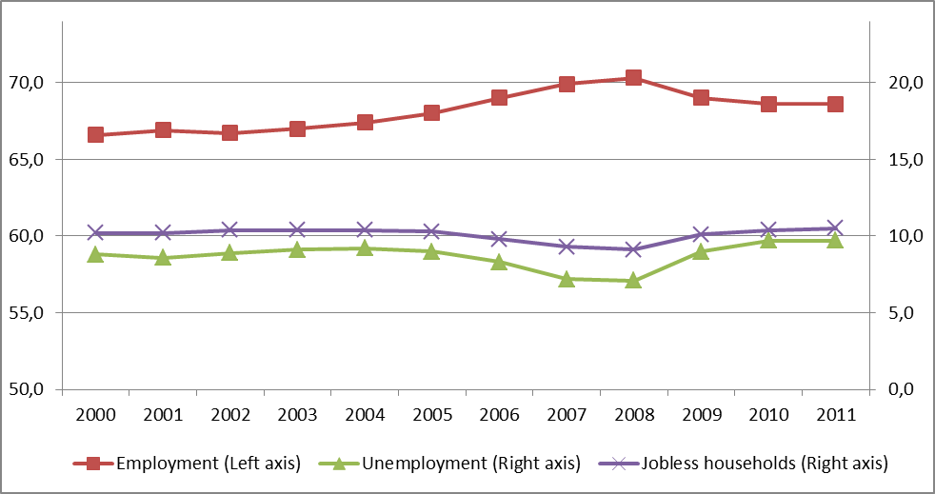
Source: Eurostat — LFS
Welfare systems play an important redistributive role, but in the past decade, government transfers, the tax system and public services have not always been able to mitigate the rise in earnings inequalities (see ESDE 2012). Moreover, the current need for fiscal consolidation and the growing pressure of an ageing population are putting European welfare systems under stress, so there need to be efficiency gains.
The effect of the first phase of the crisis (2008-2009) was uneven across the income distribution. In a third of the EU countries the impact was regressive. In Ireland, Spain and Lithuania, the poorest segment of the population saw their income drop more than the rest of the population. In France, Denmark, Sweden and Slovenia, the incomes of the poorest segment of the population grew significantly less than households higher up the income distribution. In the UK, Hungary and Italy, people in the middle of the income distribution (often workers) were the most affected by the crisis. In a few countries of continental Europe (Germany, Belgium, the Netherlands, Austria and Poland) the trend was relatively even across the distribution. In Latvia, Greece and Portugal, the impact was progressive, with the top incomes proportionally more affected than those of the rest of the population.
Figure 4.6 — Changes in households' disposable income in different parts of the income distribution (% change in national currencies, 2007-2009); Member States grouped according to the degree of progressivity of the change

Source: EU-SILC

Consumer surveys provide a more recent picture (up to spring 2012) of the trends in the way households themselves see their financial situation. The financial stress index monitors the percentage of people declaring that they had to draw on their savings or to go into debt to keep up current expenses. Trends up to spring 2012 show that most households saw a marked deterioration in their financial situation in most EU countries. All income groups were affected.
However, in some countries, those on low incomes felt the impact most, especially in Estonia, Greece, Spain, Italy, Cyprus, Latvia, Hungary, Malta, Portugal and Slovakia. This could herald significant rises in poverty and material deprivation levels in these countries and confirm the increase in subjective poverty that surveys recorded in the first phase of the crisis. According to data from EU-SILC, between 2008 and 2011, the proportion of people reporting that their household was only just making ends meet rose sharply (by more than 4 percentage points) in the Baltic States, Cyprus, Greece, Hungary and Ireland.. This includes countries where the poor may have lost proportionally less than the rich (see above), but nevertheless experience a stronger deterioration of their actual living conditions given that essential consumption items (food, housing) represent a larger share of their budgets.
Figure 4.7 — Reported financial distress in households by income quartile in the EU and in selected Member States (2000-2012)
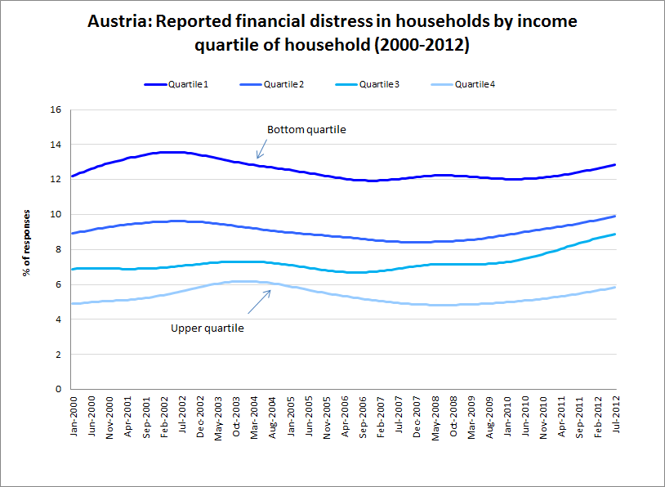 | 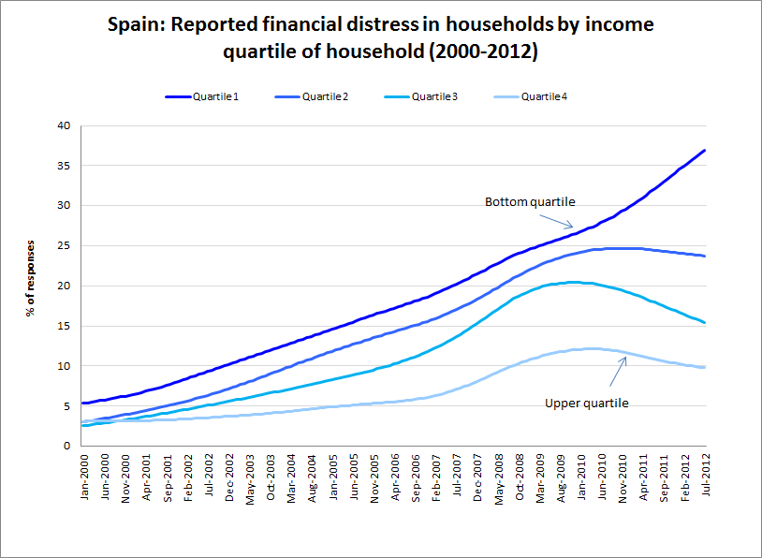
Source: Joint harmonised EU consumer surveys & DG EMPL calculations

The evolution of poverty and social exclusion

The multiple facets of poverty and social exclusion
This section deals with trends in poverty and social exclusion in the EU. EU-SILC data confirm the stagnation of relative poverty between 2005 and 2011, but at the same time show that living standards improved in EU-12 countries before the crisis, as measured by severe material deprivation rates. Material deprivation rates eased in EU-12 countries in parallel with the relative rise in GDP per capita in these countries. The crisis has brought this overall improving trend to a halt and material deprivation started increasing again in many countries, especially those most affected by the crisis.
The impact of the crisis is most visible in the percentage of jobless households. This has started to rise again since 2008, especially in the EU-15 (see next section). Related and significant income losses are also reflected in the increase in material deprivation in some countries (up to 2010-11).
Figure 5.1 — Population at risk of poverty and social exclusion in the EU and in selected Member States
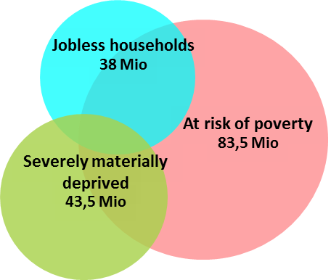
EU 27
AROPE 24%
Source: Eurostat, EU-SILC 2011, 2010 data for Ireland.
Figure 5.2 — Developments in the at-risk-of-poverty or social exclusion (AROPE) rate and its components in the EU, 2005-2011

Source: Eurostat, EU SILC. Note: 2005, 2006 and 2011 are Eurostat estimates.
Poor health, lack of access to health care, poor or unaffordable housing, poor educational outcomes (especially for early school leavers and NEETs ) or poor access to education, and the deterioration of social participation are important dimensions of social exclusion. The impact of the crisis on these is more difficult to capture, but is likely to have long-term detrimental impacts on the formation and quality of human capital. However, a recent paper by the Commission’s Social Situation Observatory (SSO) finds that the financial crisis has had a statistically significant negative effect on health, in the sense of a significant increase in the number of people reporting poor health after the crisis (i.e., between 2006 and 2009 in Greece and Portugal).
Improving access to healthcare is clearly an important aspect of preventing and tackling social exclusion. The EU_SILC indicator of ‘unmet need for medical care' (due to barriers in access to the health care system) improved in most Member States between 2008 and 2010. While slight deterioration occurred in Finland, France and Malta, Latvia and Poland stand out as the only two countries with a marked worsening. The significant income gradient has been maintained across the EU in the reference period of 2008-2010. More recent information stemming from the annual Social Climate Eurobarometer surveys carried out between 2009 and 2012 show a clear downward trend in the 'judgement of the current situation in the health care provision'. The index for Greece went down from –3.1 to –6.3 (on the scale from –10 to +10). Important negative changes in the 'judgement of the current situation in the health care provision' have also been observed in Italy (from –0.1 to –1.8), Latvia (from –1.8 to –2.8) and Portugal (from –1.0 to –1.9). Generally, the countries scoring poorly are the ones heavily affected by the crisis. Yet, the perceptions became only slightly worse in Spain and remained stable in Ireland. Improvements were observed in Germany, France, Belgium and the Netherlands. Poland represents a special case of a country without a GDP decrease and with a sharp drop in the judgement of health care provision to very low levels (from –1.7 in 2009 to –4.0 in 2012). See the Staff Working Document on Investing in Health for concrete policy responses.
Figure 5.3 — Self-reported unmet need for medical care, by income quintiles in selected Member States, 2008-2010
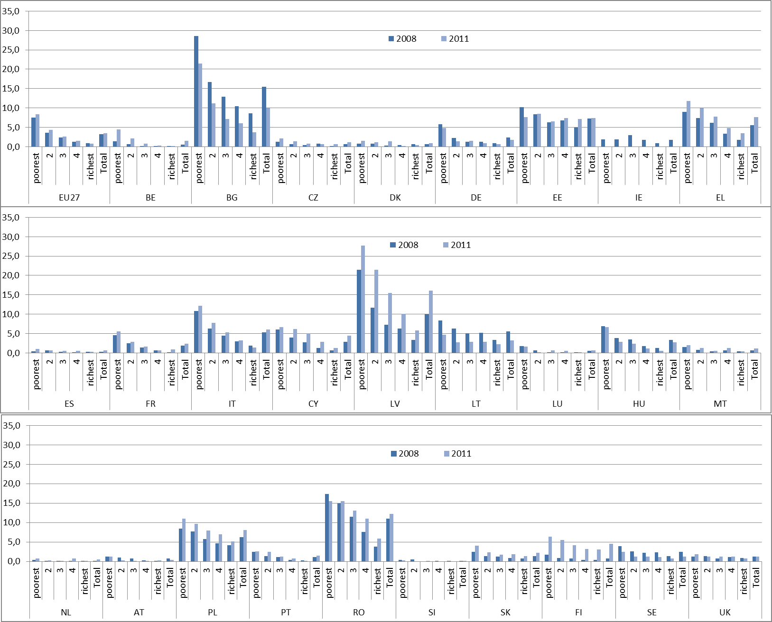
Source EU SILC 2008 2010

The gender dimension of poverty and exclusion
Overall, women face a higher risk of poverty and exclusion than men. The crisis has not widened this gap so far, since prime age men have been most directly hit by the deterioration of labour market conditions. However, some categories of women face significantly higher relative risks of poverty — such as lone mothers, inactive women of working age (27%), and elderly women over 75 (20.7%). Profiling of populations exposed to the risk of poverty show that women are more often represented in groups facing higher risks of persistent poverty, linked in particular to inactivity and care responsibilities, which have long-term impacts on future pension entitlements. While inactivity rates have not increased so far as a consequence of the crisis, retrenchments or freezes in social spending may hamper female participation and aggravate the situation of the most vulnerable women, depending on which expenditure items are affected (e.g. reducing spending on childcare facilities will hamper the labour market participation of mothers).
Figure 5.4 — Male and female at-risk-of-poverty-and-social exclusion rates, and the underlying three components, 2008 and 2011

Source: Eurostat, EU-SILC.
The greater exposure of women to the risk of poverty and exclusion partly results from the combination of three gender gaps. Women's activity rate is still 12.7 percentage points below that of men (64.9 % against 77.6 % for the 15-64 age bracket in 2011), reflecting persistent gender divisions in household and care responsibilities. A higher proportion of women works part-time, which means that on average women work 17.0 % less hours than men (33.7 hours per week against 40.6 in 2011). Finally, the gender pay gap of 17 % (in average hourly gross wage) is partly due to women earning lower pay for work of equal value, and partly due to women being concentrated in jobs that pay less. As a result, women's annual gross labour market earnings can be estimated to be 42 % below those of men on average, resulting in lower GDP, lower social security contributions and higher risk of poverty in old age (see ESDE 2012). Older widows are particularly at risk, as discussed in section 6.4.
A large share of women entered the labour market as second earners and thereby improved the income situation of households already at work. However, in many countries the women who are furthest away from the labour market (lone mothers, the low-skilled, etc.) still face major barriers to finding a job due to lack of childcare or care for other dependants, or lack of measures to improve the work/life balance. They also often have difficulties in finding a job that pays because of involuntary part-time work, and the combined effect of high marginal effective tax rates and high costs of childcare. Work disincentives for secondary earners due to joint taxation systems in some Member States can also exacerbate this.

The depth and duration of poverty
The crisis has increased or is likely to increase the duration and depth of poverty. These deteriorations in the persistence and/or depth of poverty constitute a serious challenge for Member States, requiring more specific actions to prevent the situation deteriorating further and to tackle the deepest roots of poverty.
While relative poverty remained stable in the EU and in most countries, the poverty threshold declined dramatically in a number of countries, reflecting the general decrease of household incomes. Between 2008 and 2011, it fell by 17.4 % in Latvia, 12.5 % in Lithuania, 10.7 % in Ireland, 8 % in Spain, 7.7 % in the UK, 7 % in Greece and 6.7 % in Estonia. This shows that while their relative situation is not deteriorating, people living on low incomes are facing a serious reduction of their resources that were already considered insufficient to maintain a decent living standard before the crisis.
Figure 5.5 — Developments in the at-risk-of-poverty indicator from 2008 to 2011 and the underlying poverty threshold
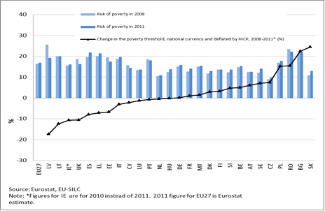
Source: Eurostat, EU-SILC.
Note: Countries sorted by change in deflated poverty threshold.
In many countries, the poor are getting poorer as the gap between the median income of the poor and the 60 % threshold is increasing (the poverty gap was 23.3 % in 2011, up from 21.7 % in 2008). Between 2008 and 2011, the poverty gap increased for all but a few Member States and with especially strong rises (around 3 pps or more) in high-poverty countries such as the Baltic States, Slovakia, Italy and Spain, as well as in some countries with a low incidence of poverty (Austria, Denmark).
Figure 5.6 — Deepening of the risk of poverty: change in the at-risk-of poverty gap 2008-2011

Source: Eurostat, EU SILC

In 2010, 8.5 % of the working-age individuals were at persistent risk of poverty, meaning that they had been at-risk-of-poverty in at least three out of the previous four years (including the last one). Persistent poverty is high (10 % or more) in Italy, Greece, Portugal, Bulgaria, Romania, Poland and Ireland. Young adults, inactive or unemployed women, lone mothers, or older working-age adults out of the labour market are among those facing higher risks of persistent poverty. Typical profiles vary across countries, suggesting that these people face specific structural and institutional barriers in different countries.
Figure 5.7 — Persistent risk of poverty compared to risk of poverty, 2010 data

Source: Eurostat, EU SILC, ilc_li21

5.4 The most severe forms of poverty and social exclusion: focus on homelessness, the Roma and migrants
Homelessness often results from a conjunction of adverse personal, structural and institutional circumstances. The crisis has had a strong impact on both the gravity and the extent of homelessness. There is a growing share of migrants, young people and unemployed or low-income people among the homeless. Women, families and elderly people are also increasingly seeking shelter.
The scale of homelessness is very difficult to fully assess, as homeless people do not show up in traditional data collection processes such as household surveys. However, according to the 2010 Eurobarometer survey more than 3 million Europeans were at the time afraid of becoming homeless and nearly three out of four Europeans (73 %) thought that homelessness had risen in their country over the last three years up to 2010.
Data collected by municipal, local or national organisations show a general trend towards a growing number of people becoming homeless because of economic hardship. Some countries, e.g. the UK, Ireland and Estonia, despite suffering from recession and the collapse of the housing bubble, managed to contain the spread of homelessness through effective assistance schemes. For a more detailed discussion of the scope and severity of homelessness across the EU and its policy implications, see the Staff Working Document on homelessness as part of the Social Investment Package.
Figure 5.8 — Overview of recent trends in the extent of homelessness over the past 1-5 years
Trend reported | Member State | Total
Increase | AT, CZ, FR, DE, ES, EL, HU, IE, IT, LT, PT, PL, SE, SL, , , UK (England + Wales) | 15
Decrease | FI, NL + North Rhine-Westphalia, Scotland | 2
No trend identified | RO, LU, BE | 3
Stable | DK | 1
Total number of Member States examined: 21
Source: FEANTSA Country Report 2012

Ethnic minorities, including the Roma, are not identified in the EU-SILC. However, 2011 survey data provided by the Fundamental Rights Agency (FRA), the United Nations Development Programme and the World Bank show that Roma experience more severe poverty and social exclusion than other groups in the societies in which they live.
This is due to a complex mix of factors, primarily low educational attainment, low levels of employment, significantly worse health status, and poor housing and living conditions. Moreover, poverty and social exclusion experienced by Roma is often intensified by discriminatory treatment and prejudice.
In all 11 EU Member States covered, survey results show that more than 8 out of 10 Roma surveyed are at risk of poverty. The differences between Roma and non-Roma are most marked in France and Italy, where the proportion of Roma living in households at risk of poverty is more than twice as high as for non-Roma living in the same geographic area. The results are also significant in the countries with the largest Roma communities, such as Hungary, Romania, Slovakia and Bulgaria.
Figure 5.9 — Persons living in households at risk of poverty (%)
Source: FRA Roma Pilot Survey (2011), UNDP/World Bank/European Commission Regional Roma survey 2011
Note: Non-Roma here refers to non-Roma living geographically close to areas with a concentrated Roma population.
Migrants and mobile EU people in the European Union face considerable obstacles getting jobs and are more often unemployed than native-born populations, especially in the case of non-EU born migrants. The linguistic, cultural and labour market acclimatisation of migrants can be a long process, hampered yet further by other barriers such as discrimination.
The risk of poverty or exclusion among the migrant population remains much higher than among the EU population overall. For people aged 18+ born outside the EU-27, it stood at 37.8% in 2011, compared to 20.8% for those born in the country and 22.2% for those born in another EU country. Between 2008 and 2010, people born outside the EU have seen the sharpest rises in the risk of poverty or exclusion in Spain (a 3 pps increase), while in France and Italy, citizens from other EU Member States have been worst affected (see ESDE 2012).

5.5 The economic returns on social investment and the costs of unemployment, poverty and social exclusion
Poverty and social exclusion are linked to adverse health, lower literacy, poor school performance for children, higher stress levels for families, and more crime and social unrest. Efforts to illustrate or quantify the costs of unemployment, poverty and social exclusion generally refer to higher public health care costs, increased policing and crime costs, foregone economic activity, lost wages and productivity, lost tax revenues and the intergenerational costs that flow from the likelihood that a significant number of children from disadvantaged families will remain disadvantaged over their lifetimes. Accordingly, a comprehensive approach to the costs of unemployment, poverty and social exclusion would require a very broad range of effects to be taken into account.
A first step in this direction can be to focus on the opportunity costs (accounting for the direct economic loss in labour market incomes) and the related additional public resources (benefits and taxes) rather than on the overall general costs of poverty (for instance health and crime outcomes, intergenerational transmission of poverty, or life course impacts on children experiencing poverty).
From this perspective, the gain that some people would experience from having better access to the labour market can be reflected in their higher labour market incomes. The assessment can reflect the general economic impact (higher individual value added translating into higher wages and higher GDP), distinguishing between both the private side (higher net incomes) and the public side (fewer benefits and higher tax revenue). An assessment of the gains associated with the return of people of active age to employment can be derived from EU wide surveys such as SILC. This can be obtained by directly comparing average labour market outcomes (and related benefits and tax levels) of poor and non-poor people having the same characteristics (such as education, age, sex, household type) or by relying on matching methods, thus enabling estimates that better reflect the heterogeneity of situations, as well as actual assessments of the overall impact on poverty rates (linked to possible changes in the median incomes).
Figure 5.10 — Estimates of the opportunity cost for the poor and unemployed aged 25-59 (size of the population and gains in % GDP)
Size as % the population Gains as a % of GDP
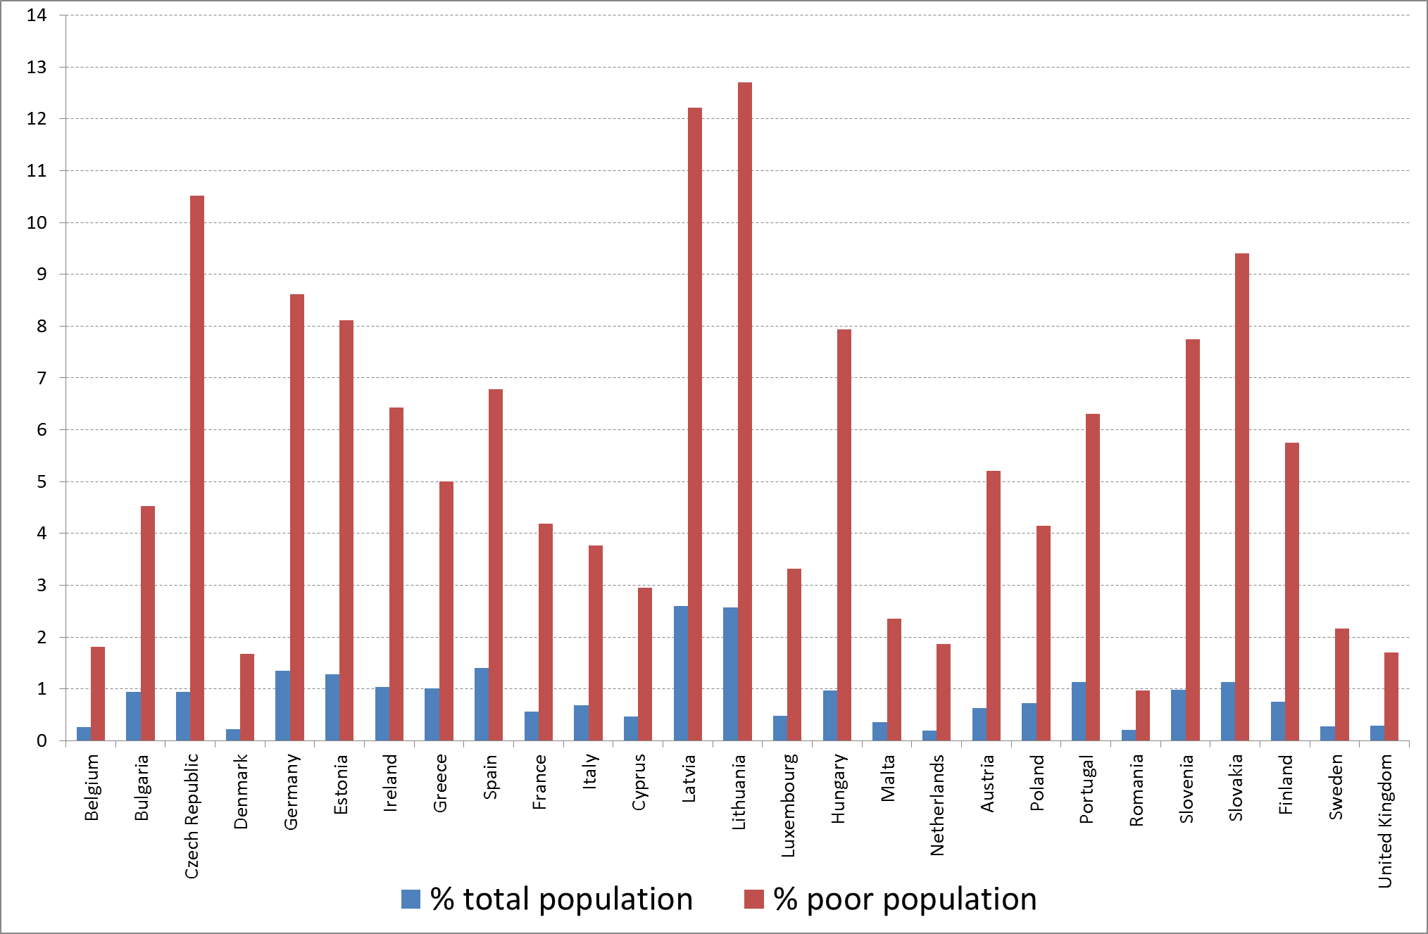
Source: EU-SILC 2010 — SSO calculations.
Note : 'size' refers to the number of people affected (i.e., poor unemployed people who are coming back to work), or in other words the shock expressed as a % of total population or total poor population. 'Gains' refers to the opportunity costs of poverty (or gains of moving out of poverty), associated with the corresponding shock (as a % of GDP).
For instance, the impact of poor unemployed people getting jobs is estimated to account for around 1% of GDP in some Member States and to 0.5% of GDP or more in over half of the Member States (see Figure 5.10). Relying on micro-simulation tools, such as Euromod would enable more accurate estimates to be made, since actual changes in benefits and tax levels could be accounted for after changes in attachment to the labour market, through simulations of employment shocks (for instance among the working poor, or the unemployed or inactive poor).
Estimations of the return from measures to encourage people into jobs could be derived from an assessment of the economic gains if some categories of poor people get jobs, by comparing estimates of the cost and efficiency of various measures such as active labour market policies.
Broader approaches to estimating the economic returns on social investment have been the focus of various studies. For instance, a Commission study from 2002 estimated the return on investment in human capital at the microeconomic and macroeconomic levels. The study suggests that an additional year of schooling increases wages at the individual level by around 6.5 % across European countries. Similarly, a year of training is estimated to increase wages by as much as 5 %. At the macro level, the study suggests that an extra year at the intermediate level of education — all other things being equal — increases aggregate productivity by about 5 % immediately and by a further 5 % in the long term.
A December 2011 Eurofound study estimates the economic cost of the group of young people that are not in employment, education or training (NEETs, who represented 13% of the 15-24 in 2010) in 21 EU countries. The yearly total cost for these countries amounts to approximately €100 billion, which corresponds to 1% of their aggregated GDP. It can be split into €94 billion in foregone earnings and €7 billion in excess transfers. Authors note that the estimation is restricted to the current cost only (in 2008) and may be an underestimate of the real cost of NEETs, as additional costs for health, criminal justice and unpaid taxes on foregone earnings are not included in the definition used.
Recent evidence gathered by Bell and Blanchflower (2011) highlights the long-term scarring effects of youth unemployment in terms of both career and earnings prospects for the individuals, and wasted human capital of a generation affected by the crisis. Their results show that entering the labour market during a recession often leads to substantially lower lifetime earnings for graduates and increased risks of ending up in lower-level occupations. They emphasise the delayed negative impacts of unemployment when young on well-being, health status and job satisfaction, pointing out that short-run government savings may be at the cost of increased future expenditures associated with the negative effects of youth unemployment and reduced well-being.
A UK study estimates that by reducing youth unemployment, up to £10 billion per year could be saved. It takes account of spending on unemployment benefits (-€1.2 bn per year), lost productivity (-€6.9 bn per year), the cost of crime (-€1.2 bn) and the cost of educational underachievement (-€22bn for those aged 17-24). In the UK, the Joseph Rowntree foundation estimated that child poverty costs at least 2% of the GDP, £25 billion a year, including £17 billion that could accrue to the Exchequer if child poverty were eradicated.

Risks over the life course and opportunities for intervention
The risk of social and economic disadvantage occurs at different stages in the life course but often builds upon earlier experiences and is compounded over time.
Numerous studies show that children growing up in poverty have lower education achievement scores, and that the gap between their scores and those of students from higher-income backgrounds widens over time. Levels of educational attainment for students from low-income backgrounds are also lower, resulting in a higher risk of unemployment and lower future earnings potential later in life. Unemployment and low earnings during prime years continue to have an impact on a person's situation in old age, as low pension contributions often affect the level of pension available upon retirement.

6.1 Children
Children are generally more at risk of poverty or social exclusion than the overall population, with a rate of 27.1% as against 24.2% for the population as a whole in the EU in 2011. Only in a minority of EU countries are children less at risk than the overall population.
Children growing up in poverty and social exclusion are less likely than their better-off peers to do well at school, to enjoy good health or to realise their full socio-economic potential later in life. This is reflected in the Recommendation on Investing in Children, as part of the Social Investment Package.
While it is difficult to estimate the exact degree of transmission of inequality and disadvantage across generations and how this changes over time, recent evidence suggests that intergenerational inequality could be higher than analysts believed a decade ago. A recent UK study showed that children of low-income backgrounds have lower achievement rates in school, and that differences in family parental resources widen during the school years. As a result, there are wide gaps between of different income groups as regards achievement at school. Poor performance at school also reduces future earning potential in the long run.
Another study showed that in England, for instance, the highest-performing 15-year-olds from poor backgrounds lag, by around two years of schooling Pisa literary test scores, behind the highest-performing pupils from privileged backgrounds. Evidence also shows that growing up in a disadvantaged environment can have a long-lasting negative impact on adult health, and that upward social mobility has very little effect on this. Yet, as highlighted in the figure below, the degree to which disadvantage is transmitted across generations varies significantly across countries.
Figure 6.1 — Link between individual and parental earnings varies across various countries
Source: d'Addio (2007)
The crisis has also worsened children's situations in most of the Member States, mainly because of the sharp rise in unemployment that has hit adults of working age. Single-parent households have been worst hit. They face a much higher risk of poverty and social exclusion (above 50 %) compared to other household types. However, even families with two adults and two children were exposed to greater risks of poverty or social exclusion.
Figure 6.2 — At-risk-of-poverty or social exclusion rate in the EU (%), children (0-17), EU-27, 2008 and 2011
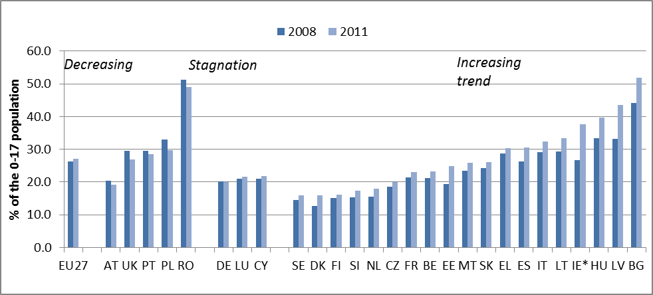 Source: Eurostat, EU-SILC
Child poverty results from the conjunction of parental wages that are too low and inadequate support to households. Social expenditure targeting children can play a supporting role to compensate for the cost of raising a child. However, its impact varies significantly across the EU, resulting in uneven outcomes in poverty reduction and redistributive impact. The role of parental employment and of the tax and benefit systems in preventing child poverty and supporting families with children is analysed in the September 2012 issue of the Employment and Social Situation Quarterly Review, and in the SPC report.
The section below draws largely on these reports.
Parental employment is the main safeguard against child poverty, but sometimes it is not enough. In 2010, 10.7% of the EU working population living in a household with dependent children had an income below the national poverty risk threshold, against 8.5 % of the total working population. In most countries, the family with only one breadwinner is a model that no longer protects its members from poverty. The risk of poverty for individuals in households with low to medium work intensity (typically represented by the one-breadwinner family model) ranges between 15 % and 50 %. Families in which both members of a couple have a job are less likely to be at risk of poverty.
The extent to which second earners, often women, take a job is partly determined by the expected income gain, after deducting potential additional taxes, the loss of benefits and the cost of childcare. An OECD study (OECD, 2011) shows that most women entering the labour market as second earners have weak financial incentives to do so. Before including the cost of childcare, many mothers of young children working full-time are unable to increase their family income by even 50 %. Net childcare costs are also a critical factor for parents' employment decisions. Compared to a situation in which no childcare is bought, the financial reward from employment is substantially reduced by childcare costs. At low earnings levels, single parents find that childcare costs reduce the returns by as much as 40 %; for second earners, this can be up to 50 %.
Child and family benefits and, indeed, social protection as a whole have a significant impact on reducing child poverty, by over 40% on average in the EU. However, the impact varies greatly across Member States.
Differences in efficiency can be partly explained by differences in the structure of benefits (e.g. by function) or their design (e.g. combination of universal versus categorical or means-tested, combination of cash or in-kind benefits). Differences in the demographic characteristics of households and in the pre-benefits risk of poverty also matter.
Figure 6.3 — Poverty reduction effect of family and child benefits for children (0-17)

Source: EU-SILC 2010, UDB, DG EMPL calculations; IE and CY not available.
As illustrated above, affordable childcare, along with appropriate tax and benefit incentives, is very important in enabling parents, and especially mothers, to get a job. For children, quality childcare and other services are essential to their well-being and to help them develop the social, cognitive and emotional skills that can enable them to be successful. Many Member States are lagging behind the so-called Barcelona targets for childcare set in 2002. Besides, evidence shows that children from disadvantaged backgrounds, who would benefit most from quality early childhood education and care, are far less likely to benefit from such services. Households on low incomes face barriers in getting access to childcare. These can include eligibility criteria, for instance, if employed parents get priority; lack of services, especially in disadvantaged or rural areas; or services may simply be too expensive. Only one out of two Roma children attend pre-school or kindergarten in BG, EL, HU, IT, PT, SK, CZ, FR, PL, RO, ES on average.
Health status plays a determining role in defining children’s future life chances. There are still many obstacles to good healthcare for children. National and international studies point to the existence and persistence of social inequalities in children’s health outcomes and access to prevention in various fields across the EU. The 2009 EU-SILC module on material deprivation found that the rate of children with an unmet need to consult a general practitioner or dentist is much higher among those at risk of poverty or materially deprived. It also found that 11 % of the children at risk of poverty did not eat fresh fruit or vegetables once a day because the household could not afford it, against 3 % for the rest of the population.
Differences in educational performance and in early-school-leaving rates can also be observed by gender. In education, the share of low-achieving boys is close to twice the share of low-achieving girls. In almost all EU Member States a lower proportion of boys reaches upper secondary graduation compared to girls and on average early school leaving is more than 30 % higher amongst boys than amongst girls. Research on gender and education points to the significance of gender stereotyping in shaping educational outcomes.
Most indicators of housing quality underline that children (and consequently families) are at a greater disadvantage than the rest of the population. Almost a quarter of children (and 40 % of children at risk of poverty) live in overcrowded accommodation, compared to 18 % of the EU population as a whole. Households with children face a slightly higher risk of being overburdened by housing costs, especially in the southern countries. Children at risk of poverty are more likely to be living in unhealthy and unsafe housing conditions.
Almost 1 million children are estimated to be living in alternative care in the EU. The high number of children from a disadvantaged background in alternative care and the reasons they are there are often associated with poverty and social exclusion. This suggests that more support to families at risk would enable more parents in difficult situations to care for their children themselves. If removal from the family is considered as being in the child’s best interest, then it is essential that children are placed in a supportive, secure environment that helps them develop to their full potential. The negative consequences of large residential institutions on children’s health and psychosocial development are well known.

6.2 Youth
The unemployment rates for young people are generally 2.5 times higher than that for the population of working age as a whole. They have been hit particularly hard by the economic crisis. The lack of jobs has been felt particularly severely by young people aged 15 to 24. This has just exacerbated their already weak position relative to other age groups. The unemployment rate for young people reached 23.7 % in November 2012.
Figure 6.4 — Youth unemployment and year-on-year changes, July 2012
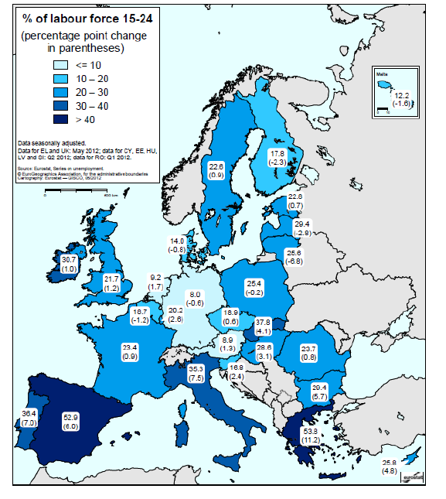

Source: European Commission
The fall in employment for young people was most pronounced in permanent and full-time jobs. The relative resilience or expansion of temporary and part-time jobs was not enough to make up for the falls recorded in permanent and full-time employment. More than 40 % of young employees in the EU have temporary jobs, and that proportion has grown during the downturn. In the first quarter of 2012, the percentage stood at 40.6 %, against 13.1 % for the population of working age as a whole.

The deterioration in the employment situation for the young has also led to a sharp rise in the number of young people who are not in employment, education or training (NEET). This can be seen as a specific measure of youth social exclusion, reflecting their lack of contact with the labour market and education and has implications not just in the present, but also for their future inclusion in society. Risk of NEET status is disproportionately linked to low educational attainment and early school leaving. Many of those concerned also lack soft skills, vocational training, and work experience to navigate the transition into the labour market when leaving school. This often indicates earlier social exclusion, during childhood years.
In the first quarter of 2012, 13.2 % of young people (7.5 million) fell into the NEET category, up sharply (by around 1 million) on the 10.7 % registered four years earlier. This raises concerns about the potential consequences and implications of NEET status. The risk of NEET disaffection has been investigated by a Eurofound study exploring the consequences of the social and political marginalisation of youth; it estimated that the cost of NEETs adds up to 1 % of GDP in the 21 EU Member States studied. The analysis also revealed that NEETs have low trust in institutions and a low level of political and social participation. Empirical evidence confirms that NEETs are at a higher risk of disaffection and more likely to withdraw from society. In response to this the European Commission presented a Communication on a Youth Employment Package with concrete proposals and measures aimed at combating youth unemployment, including a proposal for a Council Recommendation on Youth Guarantees.
Figure 6.5 — NEET rates across EU Member States (2008-2011)

While NEET status is more linked to low educational attainment and early school leaving, the labour market situation of young people who have recently graduated from education and training has also deteriorated. In fact, the employment rate of individuals aged 20-34 that recently graduated from at least upper-secondary education has fallen by almost 5 percentage points since 2008, to 77.2 % in 2011. This figure highlights the particular difficulty that young people have transitioning from school to employment.

6.3 Working-age populations
Employment rates increased in all EU countries before the crisis. In the same period, the numbers of working poor remained unchanged and the number of people living in jobless households was only reduced marginally, while overall poverty rates were not significantly reduced. The jobs created often did not reach the most excluded, or did not provide decent living standards. These trends were mainly due to a growing gap between job-rich and job-poor individuals and households, and to disparities in earnings and working conditions among workers.
Education and skills level is a major factor in employment. In 2011, the long-term unemployment rate was more than four times higher for those with lower education levels (7.9 %) than it was for the highly educated (1.9 %) and more than twice as high as it was for those with a medium education level (3.7 %).
Figure 6.6 — Long-term unemployment rate by educational level, as a percentage of the active population, 2011
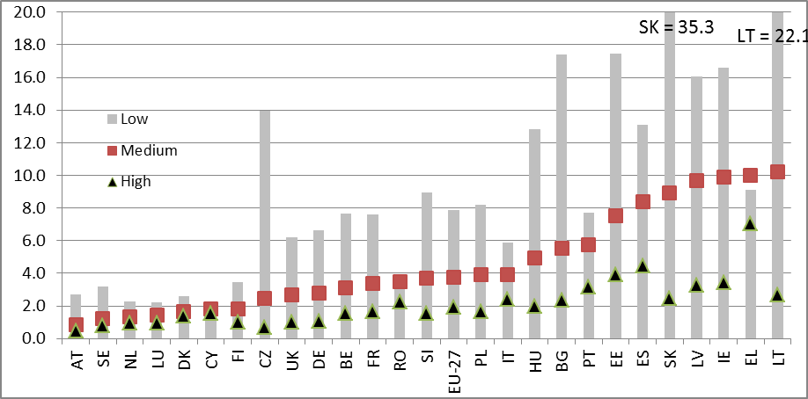
Source: DG EMPL calculations based on Eurostat, EU-LFS
Having a job however does not always avert the risk of poverty, however. The working poor account for a third of adults of working age at risk of poverty. In 2010, 8 % of those in employment were living under the poverty threshold.
In-work poverty significantly increased in a third of EU countries between 2006 and 2010. They included Germany (+2pps), and the Netherlands and Denmark, where labour market reforms (e.g. wage moderation) and reforms of the tax and benefits system contributed to bringing more people into jobs, but did not always provide them with a living wage. Since 2000, there has been a growing trend towards temporary work, part-time work (including situations where that is all the employer offers, rather than being the choice of the employee) and sometimes stagnating wages. Taken together, these factors have increased the number of people on low yearly earnings. These trends particularly affected women and the young. It is also important to note that in many countries, such jobs are not stepping stones towards better ones — they are so-called ‘dead-end jobs’(see ESDE 2011 — chapter 4).
In-work poverty is linked to aspects of poor-quality jobs, such as low pay, low skills, precarious employment and under-employment. In-work poverty is also related to low work intensity in the household, i.e. situations where there are too few adults working in the household, or not working enough to earn a living (working too few hours or for only part of the year). Among these, single-parent households where the parent is not working full-time, and single-earner families face the highest risks of poverty.
Figure 6.7 — In-work poverty: at-risk-of-poverty rate of persons employed, change since 2008

Source: Eurostat – EU-SILC.

The last decade has also seen the persistence of groups that remain outside or on the fringes of the labour market, often facing multiple barriers to getting a job. Low skills, care responsibilities, age, a migrant background, and other factors of discrimination are among these. Those worst-off are in households in which nobody works. In 2010 in the EU-27, 9.9 % of children and adults of working age were living in jobless households (i.e., in households with zero or very low work intensity), against 9 % in 2008. The crisis has already started to increase the number of families having to rely entirely on social benefits.
Figure 6.8 — Developments in the share of people living in jobless/very low work intensity households across EU Member States, 2008-2011

Experience from past crises shows that the numbers of those affected by long-term unemployment or inactivity tend to persist long after recovery has set in. The main reason for this is the loss of human capital and skills caused by long periods spent out of work. In 2011, nearly 10 million unemployed Europeans (accounting for 4.2 % of the active population) had been out of a job for more than 12 months. This is an increase of 3.7 million or 60.8 % in comparison to 2008. Trends in long-term unemployment are becoming increasingly diverse among Member States. Between 2008 and 2011, the long-term unemployment rate rose in almost all Member States, with a particularly strong rise (more than 5 pps) in Greece, Spain, Ireland and the Baltic countries.
Since 2008, the probability of someone unemployed finding a job has decreased in most countries, for both the short- and the long-term unemployed. This trend has been particularly marked in Spain (from 50 % to around 30 %) and Greece (from 25 % to 15 %). On the other hand, the rate has remained stable in the Netherlands and has improved in the Czech Republic and Estonia. The risk of those who have a job falling back into unemployment has also risen. In Spain, Greece and Cyprus (but also in Sweden and Finland) there is a high risk of short spells of unemployment recurring, because of the large number of temporary contracts.
Figure 6.9 — Transition rate from unemployment: situation one year after unemployment, by duration in unemployment, in 2010-11, aged 25-49, EU-13
Long-term unemployed | 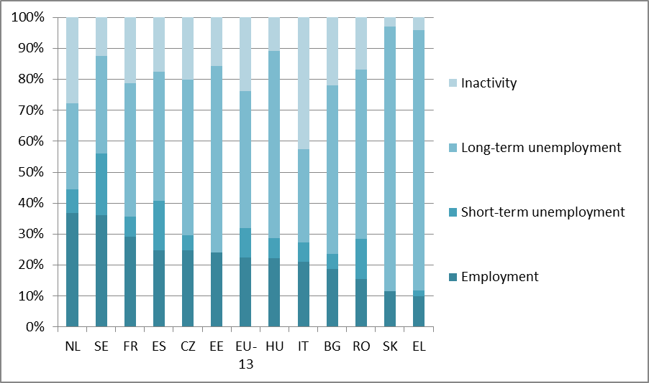
Short-term unemployed | 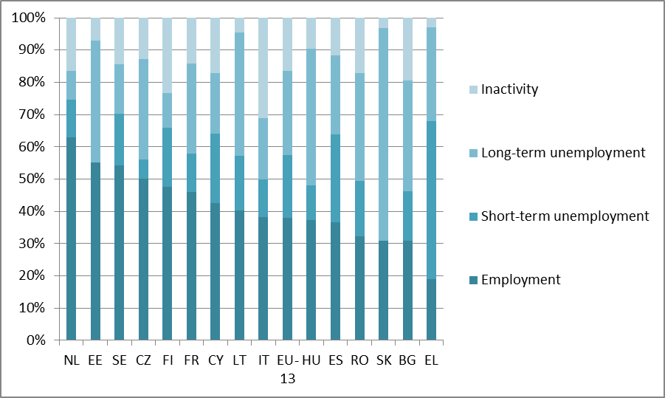

Source: Eurostat, EU-LFS, DG EMPL ad-hoc calculations.
The lingering effects of the crisis and the rise in long-term unemployment have sharply increased the risks of long-term exclusion. Evidence shows that, before the crisis (2005-2009), the risks of entering and exiting poverty varied greatly across Member States. There are three main groups of countries:
Group 1: Austria, France and the UK. Rates of entry into and exit from poverty are high, although in some of these countries, a significant share of those at risk of poverty form a ‘core group’ that does not take part in the churning.
Group 2: Baltic States, Bulgaria, Greece, Italy, Malta and Spain. There is a high risk of entering into poverty, and low chances of getting out of it, creating a massive poverty trap. The evidence relates to pre-crisis data; the trap has certainly got worse since.
Group 3: Nordic and Benelux countries. Rates of entry into and exit from poverty are low. However, the proportion of people at risk of persistent poverty is high, which may be a sign of social polarisation, with a group of people trapped in poverty.
Figure 6.10 —Share of persistent poor crossed with entry and exit patterns

Source: EUSILC LONGITUDINAL UDB 2009 version 3of August 2012; DG EMPL calculations

6.4 Older people
In half the Member States, the oldest generations (aged over 65) face a lower risk of poverty than the population as a whole. But the risk of poverty is relatively high for the elderly in Cyprus, Bulgaria, Greece, the United Kingdom, Slovenia, Spain, Belgium and Portugal. However, the at-risk-of-poverty rate does not take into account housing costs, and might, in some cases, overestimate the extent of poverty among the elderly as they often own their own housing, so do not have mortgage repayments or rent to pay.
The oldest tend to live on lower incomes and those aged 75 and over tend to be at greater risk of poverty. This reflects the lower levels of payments from pension systems developed in the 1950s and 1960s. It can also be attributed to lower accrued pension entitlements and a lower number of years worked, especially among women.
The gap between men and women facing poverty varies with age. It is clearly worse for people over 65 than it is for younger generations. Differences in life expectancy mean a rise in the number of widows and therefore single women. Because they have worked a lower number of years than men, older women often receive lower pensions, though in many Member States, survivor’s pensions do give widows some protection from poverty.
Figure 6.11 — The risk of poverty for elderly people by gender, EU-27, 2011

Source: Eurostat, EU-SILC, 2011
Men’s pension incomes are usually higher than women’s. The gender pension gap is due to differences in employment rates and employment conditions during working life, e.g. the gender pay gap, and an unequal distribution of roles when it comes to looking after others, but can also be due to the design of pension schemes and trends in pension reforms.
More numerous among older cohorts, women are also more exposed to the risk of poverty, but they may receive better replacement rates (i.e., pension as a percentage of pre-retirement labour income) and better returns on their pension contributions since they are the main beneficiaries of minimum, guaranteed and survivor's pensions.
Figure 6.12 — Gender differences towards the risk of poverty in older age groups, 2011
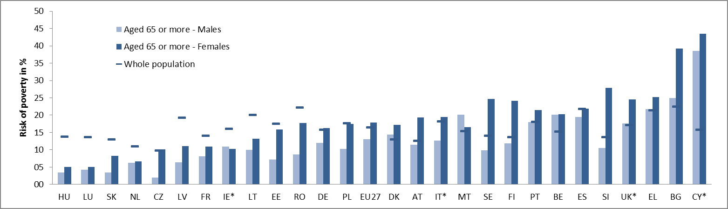
Source: Eurostat, EU-SILC, 2011

European Commission (2012) Draft joint employment report,.
European Commission (2012) Employment and social developments in Europe 2012.
European Commission Communication - Rethinking Education: Investing in skills for better socio-economic outcomes. COM(2012) 669 final
Musgrave, R. A. (1959) The Theory of Public Finance: A Study in Public Economy.
Vandenbroucke, F. and Vleminckx, K. (2011) ‘Disappointing poverty trends: is the social investment state to blame? An exercise in soul searching for policy makers’, CSB Working paper, No 11/01.
Esping Andersen, G. (1992) ‘The making of a social democratic welfare state’, in M. Misgeld and L. Amark (eds), Creating social democracy, a century of the Social Democratic Labor Party in Sweden, The Pennsylvania State University Press.
Van Kersbergen, K. and Hemerijck, A. (2012) ‘Two decades of change in Europe: the emergence of the social investment state’, Journal of Social Policy, Vol. 41, Issue 03. See also Hemerijck (2012). Changing welfare states, Oxford.
Morel, N., Palier, B. and Palme, J. (2012) 'Towards a social investment welfare State? Ideas, policies and challenges' The Policy Press, University of Bristol.
Such as unemployment, old age and survivors pensions, healthcare, sickness, disability, family, housing and social assistance.
OECD (2012) Employment Outlook
European Commission Communication - Rethinking Education: Investing in skills for better socio-economic outcomes. COM(2012) 669 final
European Commission Communication - Efficiency and equity in European education and training systems, COM(2006) 481 final
European Commission Staff Working Document – Investing in Health SWD(2013) 43
The apparent fertility increase in most EU Member States since around 2000 may be simply due to women having children progressively later in their lives, as they extended their education; rebalancing in the number of children per woman also contributed to the effect. According to this view, fertility has stabilised (already) in the EU — after decreasing from its high values in the 1960s— at a level slightly below 2 children per woman.
Dependency comes in different forms, including 'demographic dependency', i.e., the number of people outside the working age (20-64 in the EU) divided by the number of those of working age; and 'economic dependency', i.e., the ratio between people not in employment over people in employment.
European Commission (2012) Ageing report.
Source: Eurostat and DG EMPL. The projections are based on the assumption of constant employment rates per each age, sex, origin (EU-27 or non-EU-27) and education level (ISCED 0-2; 3-4; and 5-6); education attainment rates are assumed to continue increasing in line with the trend of the past five years.
See European Commission-OECD Health at a glance: Europe 2012
See European Commission White Paper -An Agenda for Adequate, Safe and Sustainable Pensions - COM(2012) 55 final
In 2000-2010 EU-27 employment grew by almost 1% per year, which was half the real GDP increase.
Including only people aged 15 and over. Source: Eurostat, Labour Force survey, special query.
See European Commission (2010) Demography report, pages 91-92 (http://ec.europa.eu/social/main.jsp?langId=en&catId=502&newsId=1007&furtherNews=yes)
See European Commission (2011) Report on the Functioning of the Transitional Arrangements on Free Movement of Workers from Bulgaria and Romania
And possibly more, according to preliminary indications from censuses around 2011.
See "Population and social conditions" in Eurostat Statistics in focus — 1/2010 http://epp.eurostat.ec.europa.eu/cache/ITY_OFFPUB/KS-SF-10-001/EN/KS-SF-10-001-EN.PDF
Persons have a foreign background if they themselves or at least one of their parents were born abroad.
See Council Declaration on the European Year for Active Ageing and Solidarity between Generations (2012): The Way Forward http://europa.eu/ey2012/BlobServlet?docId=9231&langId=en
See also G. Lanzieri, ‘Fewer, older and multicultural? A projection of the populations of the European Union Member States by foreign/national background’. Paper for the European Population Conference, Vienna, 1-4 September 2010 http://epc2010.princeton.edu/download.aspx?submissionId=100315
Eurostat, demo_gind
Eurostat, lfsa_egan
See European Commission (2010), Demography report "Older, more numerous and diverse Europeans" chapter I.5 and II.2.
See OECD (2012) International Migration Outlook, page 127.
See Hablicsek, L (2004) 'Demographics of population ageing in Hungary' Discussion Paper No.207 Project on Intergenerational Equity, Institute of Economic Research, Hitotsubashi University
Vlachantoni, A. (2010), The demographic characteristics and economic activity patterns of carers over 50: evidence from the English Longitudinal Study of Ageing, Population Trends Nr. 141, pp. 54-96.
See the special Eurobarometer EBs337 Geographical and labour market mobility published in June 2010 and EBs346 New Europeans published in April 2011 at http://ec.europa.eu/public_opinion/archives/eb_special_en.htm
See European Commission (2010) Demography report
See http://www.coe.int/t/e/social_cohesion/population/N%B049_Family_Formation.pdf
Eurostat, Survey on ICT usage in households and by individuals
Council of European Professional Informatics Societies (2007) 'Thinking Ahead on e-Skills for the ICT Industry in Europe'
European Commission (2012) Digital Agenda Scoreboard, Chapter 1: A vibrant digital single market https://ec.europa.eu/digital-agenda/sites/digital-agenda/files/KKAH12001ENN-chap2-PDFWEB-2.pdf
JRC (2013) Information and Communication Technologies (ICTs) for disadvantaged youth: Opportunities and Challenges. Evidence from literature and practice. Policy Report. Authors: C Centeno, J Cullen, S Kluzer, A Hache (forthcoming 2013), JRC Scientific and Technical Reports Series, EUR NN NNN EN, at http://is.jrc.ec.europa.eu/pages/EAP/eInclusion/youth.html
JRC (2012) The 2012 Predict Report An Analysis of ICT R&D in the EU and Beyond
JRC (2013) Literature Review on Employability, Inclusion and ICT, Report 2: ICT and Employability. Authors: de Hoyos M., Green A. E., Barnes S-A., Behle H., Baldauf B., and Owen D. Editors: Centeno C., Stewart J. JRC Technical Report Series EUR NN NNN EN, Institute for Prospective Technological Studies, Joint Research Centre, European Commission (forthcoming 2013), at http://is.jrc.ec.europa.eu/pages/EAP/eInclusion/employability.html
Op. cit.
Report for the European Commission “Anticipating the Evolution of the Supply and Demand of e-Skills in Europe (2010-2015)” Empirica and IDC Europe, December 2009. Updated forecast presented at the European e-Skills Conference held in Brusselson 13 December 2011.
See European Commission Communication -Towards a Job Rich Recovery, COM(2012) 173 final
IDC White Paper (2009) Post Crisis: e-Skills Are Needed to Drive Europe's Innovation Society
For example, one econometric study of the Italian labour market, monitoring for age and education and following individuals over time, found that low educated workers aged between 35 and 49 with no digital skills have a 5% higher risk of being unemployed than those with digital skills; and highly-educated 50-64 workers with no digital skills have a 20% higher risk of being unemployed than those with digital skills. The dataset used provides four different waves of data (2000, 2002, 2004, and 2006). For the illustration of the dataset see Main Report (Codagnone et al 2009), point 8.2.
JRC (2013) Information and Communication Technologies (ICTs) for disadvantaged youth: Opportunities and Challenges.Evidence from literature and practice. Policy Report. Authors: C Centeno, J Cullen, S Kluzer, A Hache (forthcoming 2013), JRC Scientific and Technical Reports Series, EUR NN NNN EN, at: http://is.jrc.ec.europa.eu/pages/EAP/eInclusion/youth.html
Unit labour cost (ULC) growth = growth compensation per employee adjusted for productivity growth Note: IE: data missing, LV: structural break in data
'Automatic stabilisers' refers to mechanisms that stabilise economic growth, notably through the stabilisation of households' incomes (through higher social benefits such as unemployment benefits, and lower taxation in the event of negative shock) so as to cushion consumption and savings and thus the overall economic cycle.
Data available only until 2010
See European Commission (2011) Employment and social developments in Europe 2011, chapters 1 and 2
See European Commission (2011) Employment and social developments in Europe 2011, chapter 1
European Commission (2011) Employment and social developments in Europe 2011, chapter 4
Consumer surveys carried out under the joint harmonised EU programme of business and consumer surveys
Time series smoothed by applying Hodrick-Prescott filter
"Material deprivation" covers indicators relating to economic strain, durables, housing and environment of the dwelling.
Eurostat, EU-SILC, ilc_mddd11
Note: Jobless households (JLH) refers to people living in households with very low work intensity (LWI) by age and sex (population aged 0 to 59 years). In this document both the abbreviations JLH and LWI are used to cover the same indicator.
The term 'NEET' refers to young people who were not in employment, education or training
Economic Recession and Health Outcomes, Research Note, Sotiris Vandoros, Mauricio Avendano-Pabon, Philipp Hessel and Tiziana Leone (to be checked with D4 if already published)
The barriers considered are "too expensive, "too long waiting lists" or "too far to travel"
Special Eurobarometers "Social Climate" EBs 315 June 2009, EBs349 June 2010, EBs370 June 2011, EBs391 June 2012, at: http://ec.europa.eu/public_opinion/archives/eb_special_en.htm
This indicator refers to people who declare that they did not seek health care even if they needed it because it was too expensive, the waiting list was too long or because it was too far to travel (reasons linked to the organisation of the health care system).
Reference periods for income and activity status for IE and UK differ from the other countries (where the data refers to the previous year).
All data refer to EU-27.
Figures refer to cut-off point: 60% of median equivalised income, white bars indicate declines in the poverty gap and red ones increases.
Data for IE, FR are from 2007 (latest available)
Special Eurobarometer "Poverty and Social Exclusion" EBs355, September 2010, see: http://ec.europa.eu/public_opinion/archives/eb_special_en.htm
This section draws on a review of existing data collections by the SSO (http://www.socialsituation.eu/research-notes/SSO%20RN8%20Homelessness_Final.pdf) and a special focus from the European Commission's June 2012 Employment and social situation quarterly review
European Commission Staff Working Document – ' Investing in Health' SWD(2013) 43
It can be noted that such an approach remains however partial. From an economic point of view, it notably disregards the multiplier impact of additional private consumption or additional public investment, as well as the impact of possible overall lower taxes or public debt. It also doesn't reflect the potential change in the take-up of some in-kind benefits – such as child care or health – and neither changes in the payments of employers’ contributions or indirect taxes such as VAT.
This type of approach may also be used for other types of social protection and social inclusion policies, for instance, providing estimates on the return of child care facilities, or on changes in marginal tax rates for different types of situation (for instance for pension take-up or second earners).
The size of the population poor and unemployed population at the time of the survey (2010) and of the population unemployed for at least one month over the reference income year (generally 2009) ranged around 1% (or above) of the overall population in BG, CZ, DE, EE, IE, EL, ES, LV, LT, HU, PT, SI and SK. It corresponded to more than 10% of the overall poor population in CZ, LV and LT. Estimates of the gains are obtained by comparing average labour market incomes, benefit levels (excluding pensions) and (direct) taxes across 24 categories (accounting for sex, education in three levels and household composition in four levels — single with or without children, two or more adults with or without children) of poor unemployed and non-poor employed people (with overall incomes between the poverty threshold and the median income) and are grouped together in three categories : higher household disposable incomes, lower benefits and higher taxes. In one country (LT), non-poor employed people show on average slightly higher average benefits levels than poor unemployed people.
Ciccone, A. and de la Fuenta, A. (2002) 'Human capital and a knowledge-based economy' at: http://www.antoniociccone.eu/wp-content/uploads/2007/07/humancapitalpolicy.pdf
Prince's Trust (2010) The cost of exclusion: counting the cost of youth disadvantage in the UK. http://www.princes-trust.org.uk/pdf/COE_full_report.pdf
FEANTSA (2008) http://www.feantsa.org/files/Month%20Publications/EN/Articles_and_documents_related_to_the_Flash/08_12_flash/UK_ChildPoverty_October.pdf
See, for instance, Sparkes, J. and Glennester, H. (2002) “Preventing Social Exclusion; Education’s Contribution”
This indicator is the headline indicator for monitoring the Europe 2020 strategy poverty target. It reflects the share of the population living in a household which is either at risk of poverty, or severely materially deprived, or with very low work intensity.
This is due in particular to the lack of comparable longitudinal data.
OECD (2009) Doing Better for Children, 2009.
UK National Equality Panel (2010) An Anatomy of Economic Inequality in the UK
Studied compared students from the top and bottom HISEI quintiles. Jerrim, J ' The Socio-Economic Gradient in Teenagers’ Reading Skills: How Does England Compare with Other Countries?' Institute of Fiscal Studies, Vol. 33, Is. 2
Poulton, R., Caspi, A., Milne, B.J., et al. (2002), 'Association between children's experience of socioeconomic disadvantage and adult health: a life-course study', Lancet, Vol. 360, pp. 1640-1645
The height of each bar measures the extent to which sons’ earnings levels reflect those of their fathers. The estimates are the best point estimate of the intergenerational earnings elasticity resulting from an extensive meta-analysis carried out by Corak (2006) and supplemented with additional countries from d’Addio (2007). The choice of empirical estimates in this meta-analysis is motivated by the fact that they are based on studies that are similar in their estimation technique, sample and variable definitions. The higher the value, the greater the persistence of earnings across generations, thus the lower is the intergenerational earnings mobility.
Quoted in OECD (2010) Economic Policy Reforms Going for Growth
2010 values instead of 2011 for CY, IE, IT and UK; EU-27 is based on Eurostat estimate for 2011.
Social Protection Committee (2012) 'Tackling child poverty and social exclusion, promoting child well-being', Social Protection Committee, see table p. 27
OECD (2011) Can parents afford to work? An update. The following text largely quotes the results of this study.
The Barcelona targets will be used as an indicator in the European Semester
Ghysels, J. and Van Lancker, W. (2011) 'The unequal benefits of activation: an analysis of the social distribution of family policy among families with young children' Journal of European Social Policy, Vol. 21 No. 5 pp. 472-485
European Commission Staff Working Document — Progress towards the common European objectives in education and training-Indicators and benchmarks-2010/2011, SEC(2011)526
Social Protection Committee (2012) 'Tackling child poverty and social exclusion, promoting child well-being', see table p. 27
European Commission Staff Working Document —Education and Training Monitor 2012, (SWD(2012) 373 final, 20.11.2012
Eurydice (2009) Gender differences and Educational Outcomes: Study on the Measures Taken and the Current Situation in Europe
The dwelling is considered overcrowded if one the criteria mentioned below is not fulfilled: - 1 room for the household; plus one extra room for— each couple; —each single person aged 18+; — for two single people of the same sex between 12 and 17 years of age; — for each single person of different sex between 12 and 17 years of age; —for two people under 12 years of age.
'Tackling child poverty and social exclusion, promoting child well-being', Social Protection Committee, 2012, see table p. 27
'Alternative care' refers to care provided to children deprived of parental care, including: (i) informal care: any private arrangement provided in a family environment, whereby the child is looked after on an ongoing or indefinite basis by relatives or by others in their individual capacity, at the initiative of the child, his/her parents or other person without this arrangement having been ordered by an administrative or judicial authority or a duly accredited body; (ii) formal care: all care provided in a family environment which has been ordered by a competent administrative body or judicial authority, and all care provided in a residential environment, including in private facilities, whether or not as a result of administrative or judicial measures
Eurochild (2010) National surveys on children in alternative care
Recent studies have also confirmed the overrepresentation of children of Roma origin in institutions across several EU countries, 'Romani Children in Institutional Care', European Roma Rights Center and Bulgaria Helsinki Committee, 2011.
In particular inadequate housing, single parenthood, lack of access to welfare, unemployment, lack of access to day-care and specialised services for children with disabilities, children's health condition, stigma and discrimination
'Guidelines for alternative care of children', UN framework, 2009
K. Browne (2009) 'The Risk of Harm to Young Children in Institutional Care', pp. 9 – 17; Office of the United Nations High Commissioner for Human Rights (2011) 'Forgotten Europeans, Forgotten Rights – The Human Rights of Persons Placed in Institutions'
Bynner, J. and Parsons, S. (2002) 'Social Exclusion and the Transition from School to Work: The Case of Young People Not in Education, Employment or Training', Journal of Vocational Behavior, 60, pp. 289-309.
Eurofound (2012) 'Young people and NEETS in Europe: First findings', European Foundation for the Improvement of Living and Working Conditions
See: http://europa.eu/newsroom/calendar/event/408085/commission-presents-a-communication-on-a-youth-employment-package
The European Council approved in May 2012 a benchmark highlighting the importance of the youth transition phase from education to employment. In particular, the benchmark states that “By 2020, the share of employed graduates, 20 to 34 years old having left education and training (at levels ISCED 3-6) no more than three years before the reference year, should be at least 82%”.
The classification of educational levels is based on ISCED: low level of education means ‘at most lower secondary’ (ISCED 0-2), a medium level of education means ‘upper secondary and post secondary (non tertiary)’ (ISCED 3-4), and a high level of education means ‘tertiary education’ (ISCED 5-6).
MT: data not publishable due to the sample size being too small.
An in-depth analysis of the drivers of in-work poverty and the policy instruments that can best be mobilised to tackle it is available in the European Commission Staff Working Document 'Follow-up on the implementation by the Member States of the 2008 European Commission recommendation on active inclusion of people excluded from the labour market – Towards a social investment approach' SWD(2013) 39
The income reference period is a fixed 12-month period (such as the previous calendar or tax year) for all countries except the United Kingdom for which the income reference period is the current year of the survey and Ireland for which the survey is continuous and income is collected for the 12 months prior to the survey. 2010 values instead of 2011 for IE ; EU27 is based on Eurostat estimate for 2011.
Social Protection Committee (2009) Growth Jobs and Progress in the EU: A contribution to the evaluation of the social dimension of the Lisbon Strategy. See: http://www.ec.europa.eu/social/BlobServlet?docId=3898&langId=en
European Commission (2012) Employment and social developments in Europe 2012
Whether or not to include housing costs in the definition of income underpinning the risk of poverty rate has sparked much debate in past years and will probably continue to do so in the future. The conclusion of the SPC indicator subgroup was that such costs should not be included. Indeed, imputing rents is a difficult exercise, especially at the European level. Real estate prices are so heterogeneous across geographical zones that they could induce more bias than correcting it.
About a fifth of people aged 65 or older have pension incomes just below or just above the poverty risk threshold, consequently relatively small increases or decreases in their pensions can lead to important variations in the poverty rates of the elderly.
Data for IE, IT, CY, UK refer to 2010

