TABLE OF CONTENTS
Member States' Replies to the Court of Auditors' 2011 Annual Report 3
Executive summary 3
1. Scope of the Report 4
2. Presentation and key messages of the Court's 2011 report 5
3. Towards improvement in Shared management by Member States 6
3.1 First level checks, national rules and systems audits. 7
3.2 Audit Authorities 10
3.3 Public Procurement 10
3.4. Cross compliance 12
4. Conclusion 13

REPORT FROM THE COMMISSION

Member States' Replies to the Court of Auditors' 2011 Annual Report

Executive summary
This report is an analysis of the Member States' replies to the European Court of Auditors' annual report for budgetary year 2011. It is in accordance with the provisions of article162 (5) of the Financial Regulation applicable to the General Budget of the European Union.
For 2011, the Court made further modifications to the presentation of its report, primarily by adding two new chapters. The Court gave a clean opinion on the accounts and it estimated the most likely error rate for the budget as a whole at 3,9% which is similar to last year's overall error rate of 3,7%. The figure of 3.9% now includes errors in cross-compliance for both “Agriculture: market and direct support” and “Rural development” following a change in the Court’s methodology. Without this change, the figure would have been 3.8%.
The majority of replies from Member States were received within the scheduled timeline. As in previous years, the quality varied considerably from one Member State to another. In some cases replies were of a very high standard, while in others it was apparent that very little quality time had been dedicated to the replies.
Member States reiterated their commitment to partnership with the Commission and the Court in order to ensure sound financial management of EU funds. For instance, three quarters of all Member States have expressed an interest in extending tripartite meetings, (which already exist in the Cohesion policy area), to Rural development
Both the Commission and the Member States have expressed their commitment to tackling Rural development issues in order to reduce the error rate. DG AGRI has launched an action plan and as indicated in their replies, Member States are already taking some remedial action in order to address Rural development issues.
In the Cohesion policy as a whole, although there have been significant improvements, concrete and sustained actions are required by both Member States and the Commission to ensure improved results. For this programming period DG REGIO and DG EMPL will continue targeted actions. These will include focusing audits on more risky areas and financial actors, careful monitoring of actions taken by national authorities interrupting/suspending payments and applying financial corrections where justified. For the next programming period, several measures have been proposed by the Commission and are being discussed in the inter institutional process. These measures include wider use of simplified costs, quarterly focused reporting by Member States to the Commission, stricter eligibility rules and the introduction of net financial corrections and management declarations.

REPORT FROM THE COMMISSION

Member States' Replies to the Court of Auditors' 2011 Annual Report

1. Scope of the Report
The Financial Regulation applicable to the General Budget of the European Union states in article162.5 that as soon as the Court of Auditors (the Court) has transmitted its Annual Report, the Commission shall inform the Member States concerned immediately of the details of that report which relate to management of the funds for which they are responsible, under the rules applicable. Member States should reply to the Commission within sixty days and the Commission transmits a summary of the replies to the Court of Auditors, the European Parliament and the Council before 28 February of the following year.
Following publication on 6 November 2012 of the Court's Annual Report for the budgetary year 2011, the Commission duly informed Member States of details of the report. This information was presented in the form of a letter and three questionnaires (presented as annexes) which Member States were required to complete: Annex I was a questionnaire on the paragraphs in the report referring to individual Member States; Annex II was a questionnaire on the audit findings which refer to each Member State and Annex III was a questionnaire on general findings related to the policies and programmes under shared management.
This report is an analysis of the Member States' replies and is accompanied by a Staff Working Document (SWD) which comprises the Member States' replies to Annex I and Annex III.

2 Presentation and key messages of the Court's 2011 report
The Court made further modifications to the presentation of the 2011 Annual Report. Two new chapters were introduced- one each for Agriculture and Cohesion- in order to provide a more detailed analysis of the audit results for these two policy areas. “Agriculture and natural resources” was replaced by “Agriculture: market and direct support” and “Rural development, environment, fisheries and health”. The chapter which was formerly Cohesion, energy and transport was replaced by “Regional policy, energy and transport” and “Employment and social affairs”.
In addition to the new chapters, the Court also provided comparative figures for the most likely error rate (MLE) for 2010 and 2011 for the budget as a whole, as well as for the individual policy areas.
Finally the Court further highlighted EU performance management in Chapter 10-"Getting results from the EU budget"- which was first introduced in the 2010 Annual Report.
In its statement of assurance, the Court noted that the accounts presented fairly the financial position of the Union and the results of its operations and cash flows. Revenue and commitments were free of material error. Payments for Administrative and other expenditure were evaluated as free from material error. Payments for “External relations and enlargement” were also free from material error, except for interim and final payments. All other policy areas were affected by material errors. The Court also considered that the control systems were all classified as 'partially effective', except in policy areas Administrative and other expenditure and Revenue which were classified as 'effective'.
Policy areas affected by material error were as follows: Rural development, environment, fisheries and health with a most likely error rate (MLE) of 7,7%. Agriculture: market and direct support with a MLE of 2,9%. The situation for Cohesion policy as a whole improved significantly with a MLE of 5,1% compared to the 2010 figure of 7,7%. Nonetheless, both Cohesion policy chapters were affected by material error with “Regional policy, energy and transport” having a MLE of 6,0% and “Employment and social affairs” a MLE of 2,2%. Finally, Research and other internal policies had a MLE of 3,0%.
For 2011, the Court's MLE for the EU budget as a whole was 3,9%, comparable to the 2010 figure of 3,7%. The figure of 3.9% includes errors in cross-compliance for both “Agriculture: market and direct support” and "Rural development" following a change in the Court’s methodology. Without this change, the figure would have been 3.8%.
The graph below shows the evolution of the error rate for the budget as a whole since 2006.

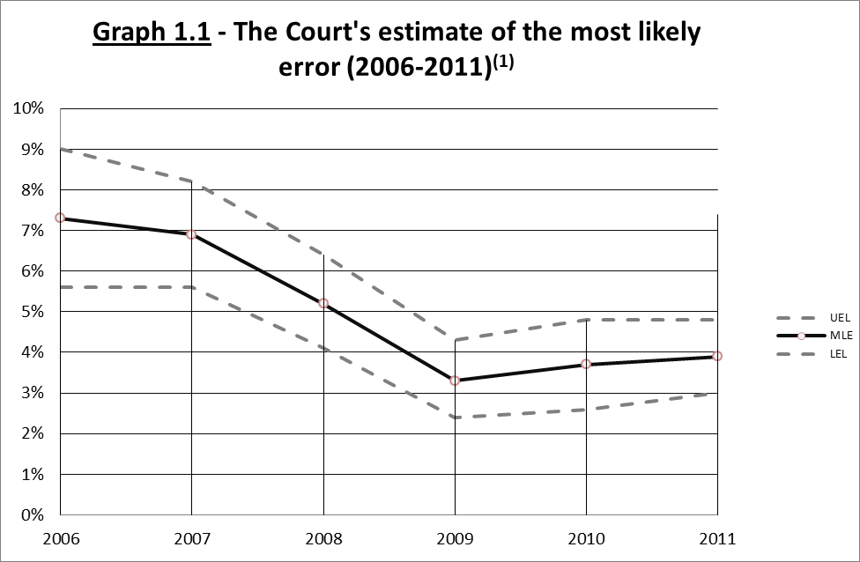
⁽¹⁾ In contrast to previous years, failure to meet cross-compliance obligations by recipients of payments under the CAP has been included in the calculation of the most likely error for 2011. The errors found represent around 0,1 percentage point of the most likely error estimated by the Court for payments as a whole.

3. Towards improvement in Shared management by Member States
As mentioned in the introduction, in addition to the letter, the Commission duly provided each Member State with three annexes: Annex I was a questionnaire on the paragraphs in the report referring to the individual Member States; Annex II was a questionnaire on audit findings which refer to each Member State and Annex III was a questionnaire on general findings related to shared management for DAS 2011. For Annexes I and II, the Member States were requested, where necessary, to provide details of actions taken to rectify the errors as well as the timing, content and expected outcome.
This section of the report analyses the replies provided by Member States to Annexes I, II and III under four main thematic headings – (1) First level checks, national rules and systems audits (2) Audit Authorities (3) Public procurement and (4) Cross compliance.
The majority of replies from Member States were received within the scheduled timeline. As in previous years, the quality varied considerably from one Member State to another. In some cases replies were of a very high standard, while in others it was apparent that very little quality time had been dedicated to the replies. Nonetheless, overall, nearly all Member States reported on and described initiatives for improvement already taken or to be taken in the future. Some Member States reiterated their commitment to partnership with the Commission and the Court in order to ensure sound financial management of EU funds. For instance, three quarters of all Member States have expressed an interest in extending tripartite meetings (which already exist in the Cohesion policy area) to Rural development. -see Graph 1.2 which provides information related to question 5 in Annex III of the questionnaire. This initiative on tripartite meetings is also in line with the Council discharge recommendation for the financial year 2011.
Graph 1.2
For Chapter 5- Regional policy, Energy and Transport and Chapter 6- Employment and Social Affairs, tripartite meetings with the Court, the Commission and Member States are regularly organised. For these chapters, the meetings have proved to be highly successful in avoiding contradictions concerning the assessment of errors. In the case of Agriculture and Rural development, only one such meeting was organised in 2012.
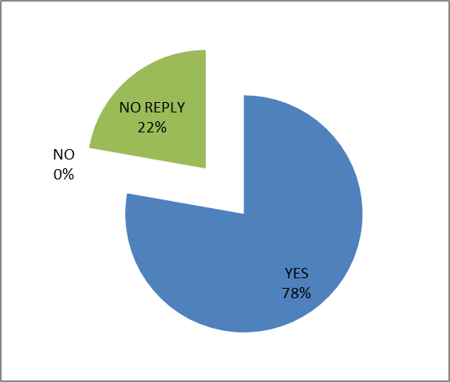
Would your Member State be interested and willing to participate in tripartite meetings for the Agriculture and Rural development chapters?

3.1 First level checks, national rules and systems audits.
Concerning first level checks and national rules, in its report, the Court found weaknesses in the checks made by national authorities and identified some cases in which national authorities had not effectively assessed whether costs claimed were in compliance with applicable rules. In Regional policy for example, the Court considered that for 62% of the transactions affected by error “sufficient information was available for the Member State authorities to have detected and corrected at least some of the errors prior to certifying the expenditure to the Commission”. For policy area Employment and social affairs, the Court made a similar observation for 76% of the transactions affected by error. In Rural development, the Court found that four of the six national authorities audited had not effectively checked whether costs claimed were reasonable and that on the spot checks had not always been properly carried out by paying agencies. In addition, the Court identified non-compliance with national rules as one of the risks to regularity of payments.
With regard to the adequacy of first level checks, Member States provided a variety of responses. Austria and Belgium stated that in each case these checks were satisfactory, with Austria highlighting as evidence the fact that error rates were around the materiality threshold for the two European Social Fund (ESF) programmes audited by the national authorities. Two Member States (Finland and Latvia) stated that complex eligibility and legislative rules did occasionally lead to varying interpretations which in turn had an impact on the quality of the first level checks. Staff turnover with the consequent loss of expertise was cited by Slovakia and Finland as a contributory factor to inadequate first level checks. Finally, Greece summed up the situation by stating that "The reasons are complex and mostly depend on who performs the first level check. First level checks are performed either by Administrative Authorities or intermediate bodies authorized to that end and which have a different form".

Over half of the Member States agreed that national rules need to be simplified in order to lessen the administrative burden and consequently reduce the number of errors. Nonetheless, Member States also indicated that EU directives also needed to be simplified in order to contribute to a reduction in errors. Luxembourg summed up the situation in the following statement: "National rules can always be simplified, but initial simplification of the rules in the (EU) directives would be welcomed".

Finally, in response to a question on systems audits of first level checks (question 2 in the questionnaire Annex III and Graph 1.3) just over 40% of Member States stated that in some cases they were already carrying out such audits. Denmark for example commented that in both Regional policy and Rural development, the Danish Business Audit Authority and the Internal Audit Unit within the Danish AgriFish Agency respectively, had conducted systems based audits. In the case of the Danish AgriFish Agency, the Internal Audit Unit had already carried out an audit of Local Action Groups (LAG) schemes under the Rural Areas Programme and was due to carry out a follow up audit of the same programme in 2013. Lithuania, Latvia, the Czech Republic and Greece all indicated that systems audits were already an integral part of their auditing schedules and were carried out regularly.

Other Member States concluded that specific systems audits were not required as their particular audit strategy was comprehensive. Germany stated that audits of first level checks were already an integral part of systems audits and that specific risk areas could be verified separately. Slovakia summarised its situation in similar terms.

Weaknesses in first level checks and in particular breaches in national eligibility rules have contributed to the error rate in the Cohesion policy area. The Commission is playing an active role in encouraging Member States to address the issue. It has established a series of measures which include support to national authorities in their efforts at simplification, and support for management and control authorities. In addition, it is also carrying out a thematic risk-based audit on the effectiveness of first level checks.
Graph 1.3
The Court recommends that the Commission should encourage audit authorities "to carry out specific system audits concerning ‘first level checks’ done by managing authorities and intermediate bodies" - see for example Chapter 5.73, recommendation 4.
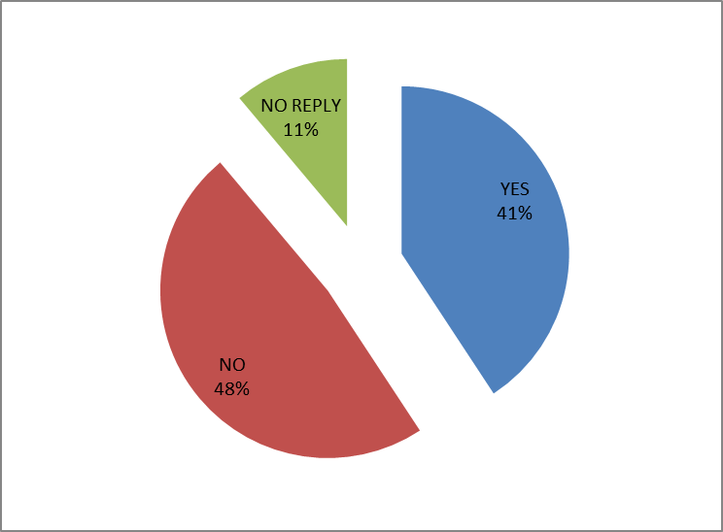
Does your Member State envisage carrying out additional and specific system audits in this area?

3.2 Audit Authorities
In the 2011 Annual Report the Court provided results of the assessments of Audit Authorities (AAs) in seven Member States. The Court reviewed various facets of the working methods of the AAs including organisational arrangements, working documents and annual control reports and opinions. The results of these assessments were that four AAs were 'effective' two were ‘partially effective’ and one was ‘not effective’. The areas highlighted by the Court for improvement included checklists, quality control of audits and audit methodology. Consequently, the Court recommended that the Commission should provide further guidance to AAs, in particular on sampling methods and that AAs should be encouraged to carry out more systems audits.
Generally, the Member States in which AAs had been assessed negatively by the Court and which had provided a reply indicated that where failings had been identified, remedial action had already been taken or was ongoing. The Czech Republic for example stated that: “The negative assessment of the Czech Republic is based on an assessment of the situation in 2011, including a system which had originally been set up in 2007 (and subsequently approved both by the EC and the audit firm PricewaterhouseCoopers). At the time of the ECA audit, work had already been commenced to change this system, following an agreement with the EC.”
In addition, the Member State commented further on the Court’s sampling selection. It stated that: "the ECA report is not based on a representative sample of projects from all the operational programmes in the Czech Republic (but only OP Transport and ROP Southeast). The ECA auditors audited all of the 8, respectively 4, projects of each of these operational programmes. The Audit Authority annually examines 650 projects from all the operational programmes. The conclusions drawn by the ECA auditors on the basis of this negligible sample are not, therefore, conclusive (especially from a statistical perspective) as regards the system of financial control and audit used for all the operational programmes in the Czech Republic.”
Romania stated that in the light of the Court’s observations, its main AA had reviewed the Court’s preliminary findings and had expressed a willingness to participate in a tripartite meeting (ECA, EC and AA) in order to “present to the ECA the measures to be taken on the matters which ECA auditors considered to need some improvement.” This tripartite meeting was held in June 2012 and proved useful in clarifying important issues.
Generally Member States have indicated that where necessary, AAs aim continually to improve the quality of their work in order to ensure that the results are in line with the Court's recommendations in the 2011 report.

3.3 Public Procurement
Public procurement was highlighted in the Court’s 2011 report as one of the major sources of errors. In Regional policy the Court identified non compliance with procurement rules in 25% of the 180 transactions audited. In addition, in 9% of the transactions audited serious failures to respect rules were identified and accounted for 44% of all quantifiable errors in the policy area. Similarly in policy area “Rural development” and “Employment and social affairs” non-compliance with procurement rules contributed to the error rate.
Member States acknowledge the importance of procurement errors and continue to seek measures to remedy the situation. Hungary for example stated that: "In recent times, we have achieved significant progress in the supervision of public procurement.
Since 8 December 2010, a centralised public procurement audit system has been in operation at the National Development Agency. A specialised unit, the Public Procurement Supervisory Department was created with the primary responsibility of performing mandatory ex-ante and ex-post public procurement audits, drafting guidelines and providing expert supervision of the first-level controls carried out by intermediary organisations in the case of public procurements with a lower contract value."
Spain also provided information on measures taken to improve the procurement situation. For Regional policy, five Statements of Preliminary Findings addressed to the Member State concerned findings on public procurement. In four of the five cases Spain stated that it had already taken concrete action to improve the situation and that procedures in the field had either been reinforced or new procedures had been introduced. The fifth case was a limited compliance issue with no financial implications.
Seven Member States - Austria, Denmark, France, Germany, Lithuania, Luxembourg and Poland, all highlighted three main factors which contribute to procurement errors. These were (1) complexity of national public procurement rules (2) complexity of EU public procurement directives and (3) insufficient first level checks. Luxembourg stated additionally that procurement procedures posed a particular challenge to project managers who very often had no expertise in the area.
Other Member States suggested that the reasons for procurement errors were even more specific. The Czech Republic commented that: "The main cause of errors (in procurement) is the ambiguous wording of regulatory public procurement and the associated different perspective of contracting authorities on these provisions".
Member States continue their efforts to improve implementation of public procurement rules and procedures. The Commission is acutely aware of the challenges which Member States face with regard to public procurement and submitted a proposal for modification of the existing Public Procurement Directive in December 2011. The proposal is currently under discussion in Parliament and Council. Consensus has already been reached on the main elements of the Commission proposal, including anti-fraud measures, simplification and greater flexibility of rules and procedures.

3.4. Cross compliance
In its 2011 Annual Report, for the first time the Court included cross compliance errors in the calculation of the error rate for both “Rural development” and “Agriculture: market and direct support”. In both policy areas the Court focused on selected GAEC (good agricultural and environmental conditions) and statutory management requirements (SMRs) and identified some errors. In “Agriculture: market and direct support”, the Court's audit also examined the design and implementation of the systems for cross compliance in six Member States and found that of the six systems audited, one was effective, four were partially effective and one was not effective.. In “Rural development” in particular, cross compliance infringements were identified in 26 of the 73 payments examined by the Court. In addition, the Court also noted significant problems concerning the implementation of cross compliance requirements for the identification and registration of animals.
The Member States where cross compliance systems were audited and weaknesses identified, all provided replies to this finding. They all highlighted the importance of the timing of the verifications and the possible difficulties this entailed. Finland commented that: "In Finland, the climatic conditions pose limitations to the timing of some on-the-spot cross compliance checks. For example, the on-the-spot GAEC checks and SMR checks must be performed during the season in which cultivation work is carried out at the farms; in other words, the checks are in practice primarily performed between June and October".
Denmark stated that cross compliance verifications were being started earlier in the year, while Spain commented that their verifications were now being made throughout the year. Italy has now considered adjusting "the scheduling of the checks for 2013 to comply with the ECA's comments" and finally Hungary seemed to be uncertain of the impact of the timing issue.
In addition, some Member States provided other possible reasons for cross compliance errors - see graph 1.4 with details of reasons given by Member States for non-respect of cross compliance. Malta and Latvia for example stated that cross compliance requirements were not sufficiently clear and Malta stated further "that beneficiaries apply for certain measures with the intention of benefiting from funding and make little effort to learn about the obligations they are taking on." Finally Ireland pointed out that some Member States may consider certain breaches as minor and therefore leading to no reduction. Ireland also cited possible communication breakdowns between the specialised body and the paying agency as a reason for cross compliance errors.

Graph 1.4
In the chapter "Rural Development, Environment, Fisheries and Health" (§4.32), the Court of Auditors found that the non-respect of the cross-compliance requirements in three of the six Member States audited did not always lead to the required reductions in payments.
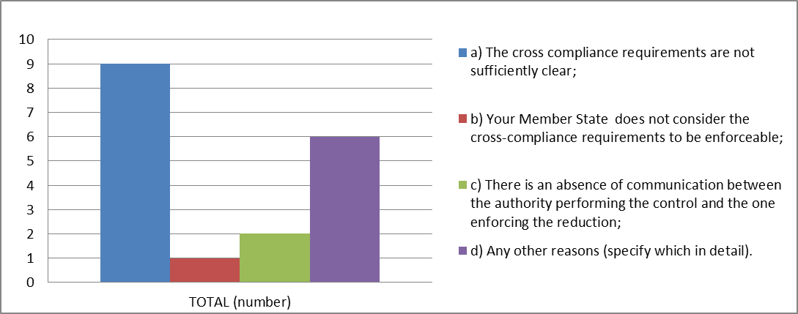
In your opinion, why has this happened:

In order to mitigate the inherent risk of errors in cross compliance, in its recent proposal for a Common Agricultural Policy after 2013, the Commission proposes further simplification and streamlining of cross compliance rules and the respective controls.

4. Conclusion
The vast majority of the replies from the Member States, indicate that the relevant bodies in the Member States carefully follow-up the findings of the European Court of Auditors. Member States agree that first level checks which function well are of critical importance, and that remedial actions, particularly with regard to the performance of Audit Authorities, are on-going.
Weaknesses and errors detected by the Court also show that simplification is a comprehensive process which affects both European and national rules, even if at times, it is difficult to tell the difference between all applicable rules.
The Commission is playing an active role in this area: In December 2011, it tabled ambitious proposals regarding public procurement rules. These are currently under discussion in the European Parliament and Council. Consensus has already been reached on the main elements of the Commission proposal, including anti-fraud measures, simplification and greater flexibility of rules and procedures.
More generally, the Commission has established a series of measures which include support to national authorities in their efforts towards simplification, and support to management and control authorities. In addition, it is also carrying out a thematic audit on the effectiveness of first level checks. For Rural development specifically, the Commission established an action plan which includes measures such as better information, training and new guidelines for beneficiaries and administrations, and a more rigorous audit plan. In addition, the Commission has addressed a letter to all Member States requesting that they identify inter alia, a concrete set of actions aimed at the reduction of errors and that they reinforce preventative measures to reduce the risk of errors in the future implementation of Rural development programmes.
Finally, the Commission welcomes the fact that Member States reiterated their commitment to partnership with the Court in order to ensure sound financial management of EU funds. For instance, three quarters of all Member States have expressed an interest in extending tripartite meetings (ECA, Member States and Commission) which already exist in the Cohesion policy area, to Agriculture - Rural development.

Annex A

MEMBER STATE | Transmission date
AuSTRIA | 18/12/2012
BELGIUM | 21/12/2012
BULGARIA | 14/12/2012
Cyprus | 14/12/2012
czech republic | 14/12/2012
DenMARK | 11/01/2013
ESTONIa
FINLAND | 13/12/2012
France | 18/12/2012
GERMANY | 18/12/2012
GREeCE | 17/12/2012
Hungary | 17/12/2012
IReLAND | 18/01/2013
Italy | 13/12/2012
Latvia | 27/12/2012
LIThuania | 14/12/2012
Luxembourg | 13/12/2012
MALTa | 13/12/2012
netherlands | 14/12/2012
POLand | 13/12/2012
Portugal | 13/12/2012
ROmania | 14/12/2012
SLOVAKIA | 14/12/2012
SLOVENIA | 13/12/2012
SPAIN | 13/12/2012
Sweden | 14/12/2012
united kingdom | 28/01/2013

See Annex A of this report-p15
Annex II comprises the replies of the Member States to individual Statements of Preliminary Findings and is not included in the Staff Working Document, but is made available to the Court.
See previous footnote
See Annex A of this report-p14
SWD p225
SWD see MS replies to Annex III question 5
COMBUD 17/13 p10
ECA Annual Report 2011-5.29-p127
ECA Annual Report 2011 6.15-p155
ECA Annual Report 2011-4.26-4.29-p104-105
ECA Annual Report 2011- Example 5.2-p130, 4.26-p104, 5.29-p127
SWD p164, 166
SWD p179, 192
SWD p215, 179
SWD p185
SWD p198
SWD p176
SWD p195, 192, 173, 185
SWD p181
SWD p215
ECA Annual Report 2011-5.39-5.41-p132-133
ECA Annual Report 2011-5.73-p143-144
SWD p8
SWD p11
SWD p123
ECA Annual Report 2011-5.32-p128
ECA Annual Report 2011-Example 3.1 p78 and Example 6.3 c-p157
SWD p3
Reply to Annex II in which specific SPFs are mentioned
SWD p164, 176, 180, 181, 195, 198, 203
SWD p198
SWD p173
ECA Annual Report 2011 3.9 p75 and 4.16-4.18 p102 and 4.30-4.31-pp105-106
ECA Annual Report 2011 4.17-4.18 p102
SWD p113
SWD p112, p113
SWD p115
SWD p113
SWD p199, p192
SWD p190
Regulation on the financing, management and monitoring of the Common Agricultural Policy (horizontal regulation) containing cross compliance rules - COM(2011) 628 final/2.

