REPORT FROM THE COMMISSION TO THE COUNCIL AND THE EUROPEAN PARLIAMENT
on implementation of the Schengen Facility (2004-2006)
- INTRODUCTION
The Schengen Facility was a temporary instrument aimed at helping beneficiary Member States to finance measures at the EU’s new external borders to implement the Schengen acquis and external border control. It covered the period 2004-2006 and had a total budget of € 961 453 271. The beneficiary Member States were seven of the countries that joined the European Union in 2004: Estonia, Hungary, Latvia, Lithuania, Poland, the Slovak Republic and Slovenia. The other three acceding countries did not participate in the Schengen Facility: the Czech Republic has no external land border, Malta covered the same policy areas through the Transition Facility and, at the time, Cyprus was not yet ready to start the evaluation process for joining the Schengen area. The Schengen Facility helped beneficiaries to keep up their previous efforts and strategies to modernise their border management with a view to joining the Schengen area. It was established by Article 35 and Annex I of the Act of Accession and its final objective was to assist the country’s accession to the Schengen area.
The actual eligible costs under the Schengen Facility amounted to over 1 billion euros, with the EU co-financing 85.27 % and the national governments co-financing 14.73 % of the total. As indicated in the breakdown per country (Figure 1), the range of EU funding varied from € 53 m for the Slovak Republic to € 283 m for Poland. The overall use of the EU contribution was 97.6 %. All measures had to be carried out between 1 May 2004 and 30 September 2007. The deadline for effecting all payments was 31 December 2007.
The Schengen Facility focused on six categories of measures: border checks, border surveillance, visa management, IT systems, training, and management of the Schengen Facility.
Measures co-financed under the Schengen Facility resulted in:
- The integration of all seven Member States into the Schengen area within the set timeframe;
- Improved security at the EU’s external borders;
- Better prevention of irregular immigration.
As far as border management is concerned, the Schengen Facility allowed:
- Better quality border checks, improved quality of service to passengers at Border Crossing Points (BCPs) and faster information exchange;
- Improved border surveillance thanks to increased mobility: new digital radio equipment, new road patrol vehicles and more staff, which increased the response capacity; immediately available and better performing means of transport; increased capacity to intervene in extraordinary conditions: night, winter and difficult weather conditions with low visibility; increased coverage of border line surveillance: additional radar positions, video surveillance;
- Improved document forgery detection through new detection equipment;
- Improved radio location network coverage at the green border;
- Increased quality and speed of the visa issuance procedure;
- Effective border guard and police cooperation and increased operational coordination;
- Increased number of arrests of persons wanted by national and international services as result of efficient checks in the Schengen Information System (SIS) database;
- Increased knowledge base for operational decision making and improved intelligence analysis among services;
- Solid training system put in place.
This report is based on ex post evaluation reports provided by the seven Member States concerned by the Schengen Facility and the analysis of relevant background documents.
- PURPOSE AND SCOPE OF THE FACILITY
The Schengen acquis was the most detailed part of Chapter 24 ‘Justice, freedom and security’ in the negotiations with the candidate countries. These countries signed their Accession Treaty on 16 April 2003 and officially joined the European Union on 1 May 2004 after the ratification procedures were completed.
The Schengen Facility was established by Article 35 of the Act of Accession of Cyprus, Estonia, Hungary, Poland, the Czech Republic, Slovenia, Latvia, Lithuania, Malta and the Slovak Republic. The general objective of the Facility was to help the Member States designated in Article 35(2) of the Act of Accession to finance measures at the EU’s new external borders to implement the Schengen acquis.
Key rules adopted within the Schengen framework include:
- Removal of checks on persons at the internal borders;
- A common set of rules applying to people crossing the external borders of the EU;
- Harmonisation of the conditions of entry and of the rules on short-stay visas;
- Enhanced police cooperation (including rights of cross-border surveillance and hot pursuit);
- Stronger judicial cooperation through a faster extradition system and transfer of enforcement of criminal judgments;
- Establishment and development of the Schengen Information System (SIS).
The specific financial instrument aimed to support the candidate countries then joining the EU in their accession to the Schengen area, and more particularly in lifting internal border controls and strengthening external border management.
According to Article 35 of the Act of Accession, the following types of action were deemed eligible for financing under the Schengen Facility:
– Investment in construction, renovation or upgrading of border crossing infrastructure and related buildings;
– Investments in any kind of operating equipment (e.g. laboratory equipment, detection tools, Schengen Information System-SIS 2 hardware and software, means of transport);
– Training of border guards;
– Assistance towards the costs of logistics and operations.
On 5 February 2004, the Commission adopted a Decision on the management and monitoring of the Schengen Facility, which set up the selection procedures and criteria for the eligibility of expenditure incurred. This was amended by a new Decision which extended the deadline for the execution of contracts until 30 September 2007 (previously: 31 December 2006). As a result of exceptional circumstances which brought about delays in implementing SIS II-related projects, the award of SIS II-related contracts was extended until 31 March 2007.
The Schengen Facility was managed in accordance with the decentralised management system.
- EU RESOURCES MADE AVAILABLE TO MEMBER STATES AND NATIONAL CO-FINANCING
Overall, the actual eligible costs incurred under the Schengen Facility amounted to € 1 067 669 235, with EU co-financing representing € 910 371 476 (85.27 %) and national co-financing € 157 297 780 (14.73 %).

Figure 1: Breakdown per country
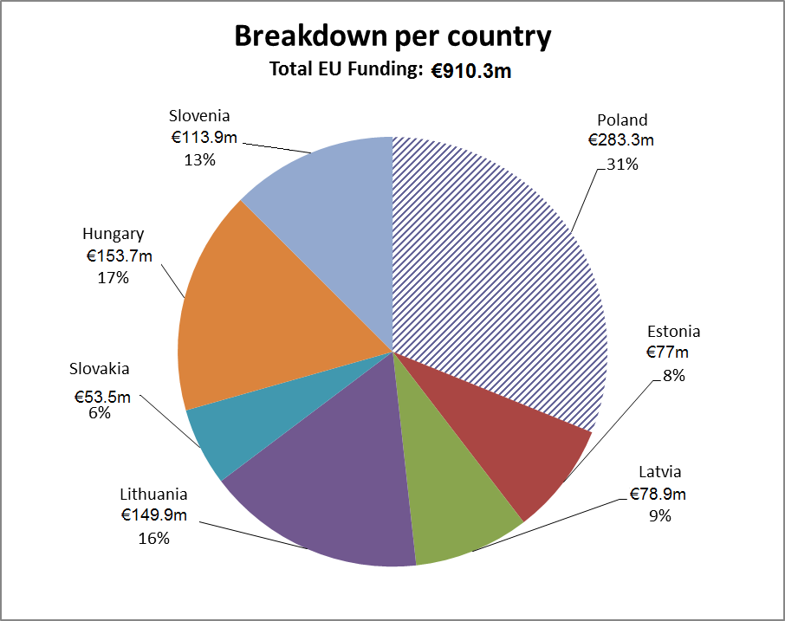
- Main beneficiaries: Poland (€ 283.3 m), Hungary (€ 153.7 m) and Lithuania (€ 149.9 m). The aggregate allocation for these three Member States amounted to 65 % of the total for all participating Member States.
- The following Member States received between 6 % and 13 % of the total for 2004-2006: Slovenia (€ 113.9 m), Latvia (€ 78.9 m), Estonia (€ 77 m) and Slovak Republic (€ 53.5 m).
According to Article 2 of Commission Decision C(2004)248, the rate of EU assistance granted by the Facility could be up to 100 %; no clear criteria were established to determine the percentage of national expenditures to be charged to the Schengen Facility. Member States were therefore free to declare any level of national contribution to the Facility. However, expenditure covered by the Facility could not be charged to any other EU financial instrument. The share of national co-financing varies among the beneficiary Member States as Poland put up only 1.88 % of the eligible costs (€ 5 414 201.99) while Slovenia’s co-financing represented up to 34 % (€ 59 036 202.97), this being mainly due to delays incurred in construction work, which made it necessary to meet these expenses from national funds as they arose outside the implementation period.

Figure 2: National co-financing
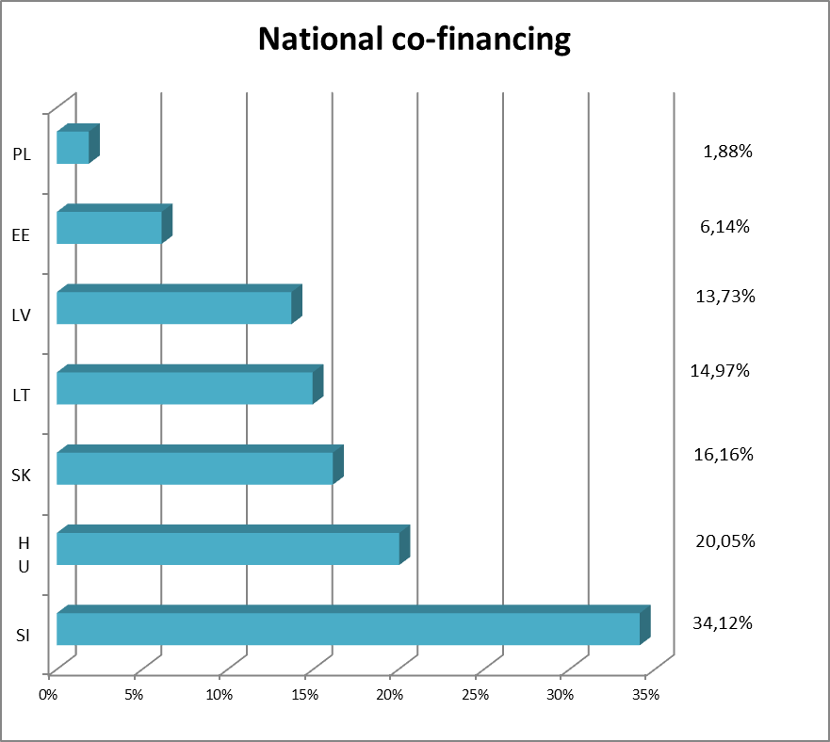
In terms of use of the EU allocation, the result was very high, ranging from 90.6 % for Hungary to over 100 % for Poland, with a total utilisation rate of 97.6 %.

Table 1: Utilisation rate
 | Programmed amounts | Final eligible costs | Utilisation rate
Estonia | € 79 629 000 | € 77 001 525 | 96.70 %
Hungary | € 169 562 611 | € 153 694 401 | 90.64 %
Latvia | € 79 701 739 | € 78 975 718 | 99.09 %
Lithuania | € 151 657 105 | € 149 862 483 | 98.82 %
Poland | € 278 458 520 | € 283 329 466 | 101.75 %
Slovak Republic | € 53 866 478 | € 53 527 465 | 99.37 %
Slovenia | € 119 800 000 | € 113 980 418 | 95.4 %
TOTAL | € 932 675 453 | € 910 371 475 | 97.61 %
- PREPARATION OF IMPLEMENTATION IN THE MEMBER STATES
  - Putting in place assurance as to the regularity and legality of spending
The Commission Decision on the management and monitoring of the Schengen Facility aimed to ensure harmonised use of the instrument and establish rules for the management of the Facility. The rules set out selection procedures and criteria for the eligibility of expenditure incurred under the Facility.
The Schengen Facility was managed in accordance with the decentralised management mode within the meaning of Article 53c of the Financial Regulation. A large share of responsibility for the management and control of the funds allocated by the EU under the Facility was devolved to Member States, with ex post control to be carried out by the Commission.
The Decision laid down the following requirements:
- Article 3(2): The Commission shall satisfy itself that the procurement process is in line with the principles of transparency, proportionality, equal treatment and non-discrimination.
- Article 8: The Commission shall verify that there exist appropriate management and control systems.
- Article 14(1): The Commission shall ensure that a certification procedure exists.
- Article 15(1): The Commission shall ensure that verification systems exist.
Monitoring missions were performed regularly by Commission staff to check these requirements.
The Commission also issued:
- Comments on the compliance with the eligibility rules of measures programmed by the beneficiary Member States in their 2004-2006 indicative schedules.
The beneficiary Member States were responsible for programming, selecting and implementing individual measures and managing funds, the correct use of which was verified ex post by the Commission in line with the Financial Regulation 1605/2002 and its Implementing rules. Member States were responsible for coordinating use of the Facility with assistance from other EU instruments, ensuring compatibility with other EU policies and compliance with the Financial Regulation.
Under the Schengen Facility, the system of payments was based on annual lump-sum payments, granted to each beneficiary Member State following the adoption of annual Financing Decisions by the Commission for each of the countries concerned.
The lump-sum grant payments were to be used within three years from the first payment; any unused or unjustifiably spent funds were to be recovered by the Commission, after the clearance of accounts. Six months after the expiry of the three-year deadline, the beneficiary Member States had to submit a comprehensive report on the financial execution of the lump-sum grant payments with a statement justifying the expenditure.
  - Shaping national strategies for using EU resources
All seven Member States concerned indicated that their overall approach in implementing the Schengen Facility was to keep up their previous efforts and strategies to modernise their border management and policing systems. Member States adopted at least two specific strategic documents in this regard: the Schengen Action Plan (SAP) and the SIS II Master Plan.
They stressed that their main objectives were to strengthen external border security and manage immigration flows.
Overall, their priority investments focused on similar items: construction, renovation and upgrading of border crossing points and other related buildings, operating equipment for data processing and exchange, means of transport and radio communication, language and technical training.
National strategies for the Schengen Facility set targets ranging between four more comprehensive (Poland, Hungary) and 31 more detailed objectives (Latvia).
Hungary, Poland and the Slovak Republic gave a strong strategic dimension to the Schengen Facility by integrating it into general national strategic documents (SAP, Integrated Border Management strategy) and clearly linking it with other sources of funding (Phare programmes, Transition Facility, Norwegian financial mechanism, national funding). Slovenia, Estonia, Lithuania and Latvia largely based the implementation of the Facility on their national Schengen Action Plans.
Before the Schengen Facility was established, Hungary had adopted a series of government decisions (2001-2003) and medium-term ministerial strategies that paved the way for a joint border management strategy. It developed these into the Hungarian Integrated Border Management strategy. Hungary gave priority to border traffic control due to its central position in Europe. The complementarity of sources of funding was also carefully taken into account.
Poland incorporated its Schengen Facility strategy into its Integrated Border Management Strategy (2000-2002, then 2003-2005) with the objective of developing a border security model to safeguard internal security and in particular prevent irregular immigration. It also tied this strategy to a special line of the Phare Fund earmarked for supporting the tasks described in the Integrated Border Management strategic documents. Clear priority was given to operating equipment and IT systems. In addition to the Phare Fund, Poland used Phare 2000, 2001, 2002 and 2003 and the Norwegian mechanism to implement its Integrated Border Management Strategy.
The Slovak Republic went a step further than the SAP with the Slovak National Implementation Strategy for the Schengen Facility, which identified the shortcomings that would be covered by the Schengen Facility alone. These needs were clarified by setting 16 operational objectives for the Schengen Facility and were linked to the SAP, which also incorporated other EU support instruments, such as Phare and the Transition Facility.
Estonia used Schengen Facility resources to implement parts of its SAP without drafting a specific Schengen Facility strategy. Priority in investment was given to operating systems, means of transport and IT systems.
Lithuania opted for two strategic objectives: (1) strengthening the security of the EU external borders and thus preventing irregular immigration and illegal entry into the EU, and (2) controlling the flows of passengers properly. It decided to spread EU co-financing fairly evenly over the following objectives: means of transport, infrastructure, other IT and training.
Slovenia’s strategy with regard to the Schengen Facility was broad and aimed at ensuring the necessary conditions for the proper implementation of the Schengen acquis. Seven objectives (later extended to nine) were designed. The priority investment sectors were infrastructure, IT and salaries of newly recruited staff.
In addition to strengthening external borders and establishing information systems, Latvia focused on increasing the capacity of its institutions and personnel to comply with the requirements of the Schengen acquis. Emphasis was placed on the established regulatory framework, more particularly for technical equipment. One of the strategic objectives was to set up a migration flow management system.
- IMPLEMENTATION OF THE SCHENGEN FACILITY
  - Management and control systems set up to implement the Schengen Facility
The beneficiary Member States designated either the Ministry of the Interior (Estonia, Lithuania, the Slovak Republic, Poland, Latvia) or the Ministry of Finance (Slovenia, Hungary) as the Responsible Authority for the implementation of the instrument. There were various scenarios concerning the organisation of the Responsible Authority: only Lithuania created a special entity, while Estonia, the Slovak Republic and Slovenia designated an existing unit as Responsible Authority and Poland and Latvia appointed an already existing inter-ministry team. The Ministry of Finance was generally designated as Paying Agency.
The beneficiary countries relied heavily on the experience gained while implementing and managing pre-accession funds.
In their national evaluation reports, all beneficiary Member States recognised the importance of the steering, managing and monitoring committees that were set up to guide and supervise implementation of the Schengen Facility. These committees usually brought together all key institutions concerned and were heavily involved in project selection, funds reallocation and monitoring. It was widely reiterated that the flexibility of the management and control system combined with the high degree of responsibility given to the Member States (through steering committees) were key to the success of the Schengen Facility.
Poland, Estonia, Hungary and Latvia used technical assistance contracts to carry out part of the project management activities (preparation of tender documentation, monitoring, training on procurement, audit).
  - Quantitative and qualitative aspects of implementation by Member States
As far as the six categories of the Schengen Facility are concerned, the main spending lines were border surveillance and IT systems, which altogether represented 74 % (€ 672.4 m) of the total investment. Visa management and training amounted to only 6 % (€ 57.9 m).
Figure 3: EU contribution breakdown per category
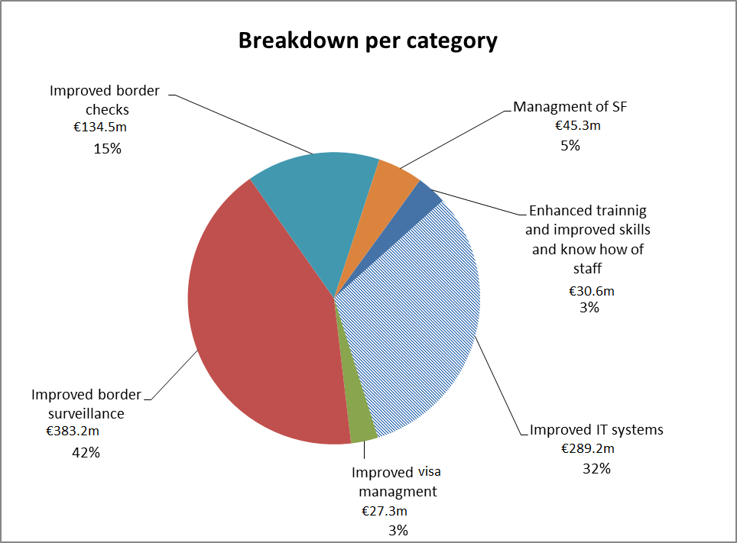

Figure 4: Expenditure per country and per category (EU contribution)
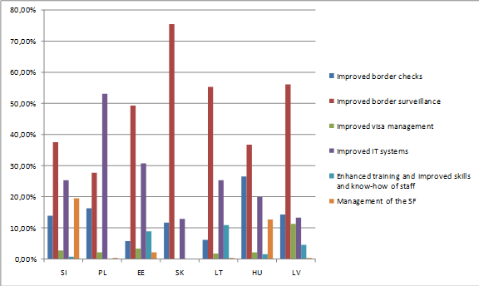
Border surveillance was the key investment sector in all beneficiary Member States except Poland (where it comes second), with a maximum of 75 % in the Slovak Republic. IT systems were also a priority everywhere, either as first target (Poland), or in second place (Slovenia, Estonia, the Slovak Republic, Lithuania) or third (Hungary, Latvia).
National specificities worth noting are:
Slovenia (19.4 %) and Hungary (12.8 %) used over 10 % of the funds for Schengen Facility management (staff).
Lithuania used 11 % of the funds for training and capacity building (establishment of the border guard school and training centre).
Latvia devoted 11.35 % of the funds to visa management (renovation of consular sections, staff training, equipment).
When it comes to subcategories, the main budget lines were: infrastructure (28 %), means of transport (16.6 %) and SIS (12.8 %).

Table 2: Breakdown of EU contribution per subcategories
Subcategories | Amount | Share of EU co-funding
Infrastructure | € 255 341 341 | 28.0 %
Means of transport | € 151 456 150 | 16.6 %
SIS | € 116 578 179 | 12.8 %
Other IT systems | € 95 313 280 | 10.5 %
Equipment | € 88 394 988 | 9.7 %
Systems | € 49 821 637 | 5.5 %
SIS&VIS | € 41 344 964 | 4.5 %
VIS | € 34 176 305 | 3.8 %
Staff | € 31 743 183 | 3.5 %
Training | € 30 527 698 | 3.4 %
Logistics | € 15 642 828 | 1.7 %
Operations | € 30 921 | < 0.1 %
Infrastructure investments are by far the largest. They represent € 255.3 m, 28 % of the total Schengen Facility. This expenditure can be broken down between three objectives: border checks (36 %), border surveillance (62 %) and visa management (2 %).
Figure 5: Breakdown of EU contribution per border category
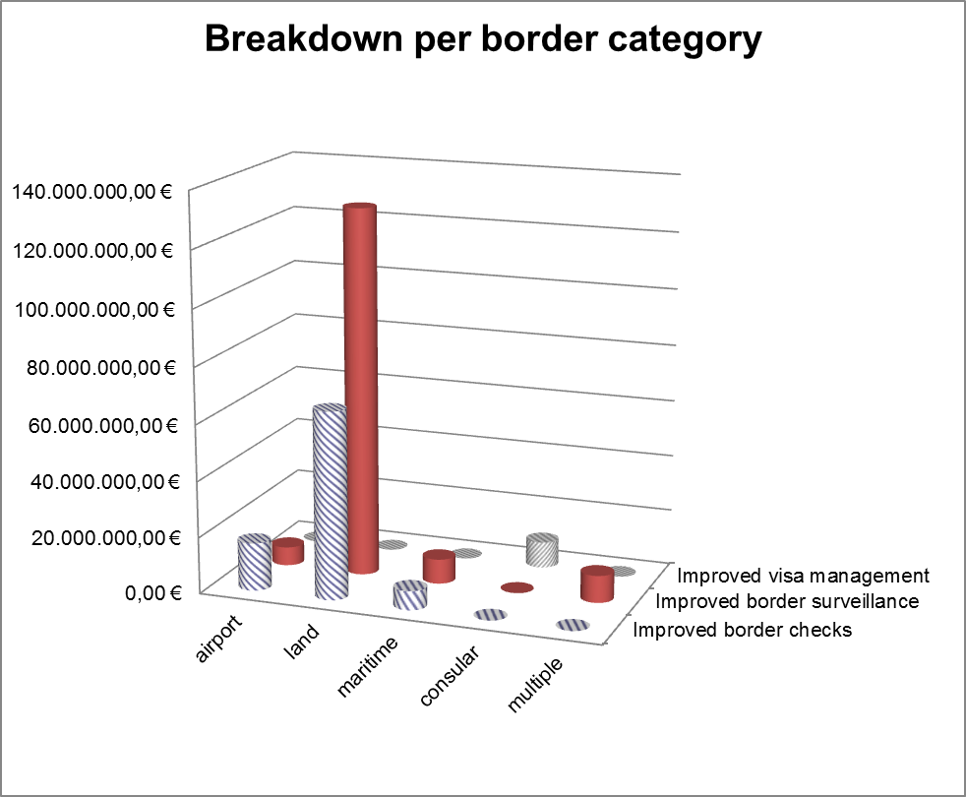
  - Challenges encountered during implementation, and how they were mitigated
The beneficiary Member States unanimously agreed that the most difficult issue for them was applying the eligibility rules. The Commission had clarified the most frequently recurring issues by means of several technical factsheets. These related to the eligibility rules on VAT, salaries, logistics and purchase of land. Most beneficiary Member States reported delays in the first year of implementation, due mainly to the novelty of the mechanism. In particular, Member States encountered problems concerning:
- Implementation rules. Among the issues raised by Member States, precise methodological guidance and more timely clarifications were requested from the Commission.
- Management systems. Difficulties were encountered in setting up a proper and efficient management and control system, as well as problems to do with the recruitment of qualified staff.
Most of these challenges were overcome within a few months of implementation.
The management of procurement was also a challenge faced by most of the beneficiary countries. This led to:
- delays, due to complaints, especially for large contracts;
- budget overruns, due to the underestimation of costs, inflation and limited markets and exacerbated by the availability of large amounts of funds;
- uncertainty about the eligibility of measures and costs.
The mitigation measures adopted mostly consisted in reallocating unspent budgets to different activities. For example, due to procurement complications (budget exceeded and lack of time to retender), Poland cancelled its project on technical protection systems (€ 52 m) and shifted the funds to similar projects. In a comparable situation (tender and implementation delays for construction works), Slovenia decided to meet the expenses from national funds and to use the EU co-financing for other activities. Latvia and Estonia faced budgeting difficulties as their countries were hit by high inflation in 2004-2005. This resulted in budgets being exceeded and tender procedures being cancelled. They therefore decided to limit the number of construction works and equipment and redirect the sums towards similar objectives. Some beneficiary Member States also mentioned difficulties in communicating with the Commission.
Another challenge faced by beneficiary Member States was the development of IT systems aimed at ensuring appropriate information-sharing mechanisms in the Schengen area. More specifically, the technological adaptation to Schengen Information System II (SIS II) standards was considered highly demanding. The Commission decided in 2007 to develop a SISone4all system that permitted the Member States to join Schengen without SIS II. This was welcomed as the solution for finalising the development and implementation of an IT system, which would not have been otherwise possible under the previous timeframe.
In relation to the implementation timeframe, all beneficiary Member States considered the initial closing date for the Schengen Facility (31/12/2006) to be very constraining. According to all of them, the two decisions adopted by the Commission to extend the deadlines for commitments and payments played a crucial role in optimising the use of the EU contribution and allowing the physical implementation of the projects. The beneficiary Member States estimate that approximately 50 % of project implementation took place in 2007. It should be noted that the beneficiaries were able to timely rearrange their programmes, as the Decision to extend the contract execution deadline until end-September 2007 was adopted early in 2006. The Decision facilitated the effective implementation of projects. Furthermore, the financial implementation would have been much lower without that extension.
Poland estimated that € 148 385 650 (52.37 % of the overall amount claimed) was spent after the initial deadline of 31/12/2006. Over € 25 m (nearly 8.6 % of the total EU contribution) out of the € 148 m was directly linked to SIS II projects and consequently benefited from the extension of the eligibility period granted for these projects.
These amounts concerned very important and strategic projects that were at risk of falling outside the eligibility period.
In Lithuania, 40 % of all Schengen Facility programme funds were contracted before 2 October 2006 and 96.21 % by 31 December 2006. Had the Commission not adopted the decision to extend the execution of contracts, it would have been impossible either to award or to completely implement contracts. Lithuania estimated at 40 % the amount that would not have been spent. Only 26 % of Schengen Facility 2004–2006 expenditures was actually paid by 31 December 2006. The extension of SIS-related activities allowed two major SIS II projects to be implemented, totalling over € 26 m (17 % of Schengen Facility funding).
In Slovenia, on 31 December 2006 the payments from the Schengen Facility amounted to € 48.4 m, representing only 40 % of the total EU contribution. The final implementation amounted to 95.11 %, which means that more than 50 % of the financial implementation took place in 2007.
In Latvia, only 11 % of the funds were committed in July 2006 and most of the contracts were signed at the very end of 2006. It was estimated that two thirds of the funds would have been lost without the extension.
In the Slovak Republic, it was estimated that 70 % of the funds would not have been committed in the absence of the first extension, and the decision on SIS-related activities concerned 7 % of the committed funds.
- ASSESSMENT OF IMPLEMENTATION
With a view to assessing the implementation of the Schengen Facility, a comprehensive analysis has been carried out. This exercise included the assessment of the impact of the Facility at national level and the evaluation of the effectiveness of the implementation of the programme, measured on the basis of a set of relevant indicators.
  - Relevance to national situations
According to the beneficiary Member States, the Schengen Facility was relevant to their national situations in several respects:
- Finances. It seriously lessened the financial burden of implementing Schengen acquis requirements in terms of national budgets. All the Member States concerned stated that, without the Schengen Facility, they would not have been able to achieve the same level of compliance with the Schengen acquis within the given timeframe.
- Strategies. The flexible approach of the Schengen Facility allowed all the beneficiary Member States to develop and implement very diversified strategies and operational objectives. The breakdown into five ‘main objectives’, in line with Article 35 of the 2003 Act of Accession, provided sufficient directions to the Member States to design their strategies. This approach was considered by all Member States as relevant as it answered the needs/shortcomings identified when drafting and adopting the Schengen Action Plan (SAP). In this respect, it successfully continued the support provided by the Commission through other funds such as the Phare programme and Transition Facility (Poland, the Slovak Republic, Latvia and Hungary). It helped them to implement their national strategies without imposing objectives on them. Poland mentioned that some changes had to be made to its strategy for adjusting to the Schengen requirements (Schengen Action Plan, Master Plan SIS II and Integrated Border Management Strategy).
- Management. The flexible approach to management and control systems (multi-annual programming and annual indicative schedules, allowing flexible resource allocation among projects with wide-ranging responsibility given to Member States) made it possible for the Member States to rapidly adapt their strategies to the evolving needs. Given the constrained timeframe, only this flexibility could ensure the high degree of implementation of the Schengen Facility.
  - Effectiveness of programme implementation
Effectiveness measures the achievement of the objectives set through the implementation of the programme and the concrete impact of the Schengen Facility on the sector.
The main and most important results pointed out are:
- successful integration into the Schengen area of all beneficiaries;
- improved security at the EU’s external borders (Poland, Lithuania, Latvia);
- strengthened fight against irregular immigration.
The effectiveness of Schengen Facility implementation can be traced also through a self-assessment against the five operational objectives, in which Member States indicate on average a high level of satisfaction.

Table 3: Member States’ self-assessment of achievement of objectives
 | Slovenia | Poland | Estonia | Slovakia | Lithuania | Hungary | Latvia
Improved border checks | 5 | 4 | 5 | 3 | 5 | 4 | 4
Improved border surveillance | 5 | 4 | 4 | 4 | 5 | 4 | 4
Improved visa management | 4 | 4 | 4 | 3.5 | 5 | 4 | 4
Improved IT systems | 4 | 4 | 5 | 4.5 | 4 | 4 | 5
Enhanced training and improved skills and know-how of staff | 5 | No rating | 5 | 4 | 5 | 5 | 4
Rating scale: 5:—highest level of satisfaction,1— lowest level
The ratings have to be taken with caution, as they are self-assessments based on perceptions. For instance, the Slovak Republic seems to have the lowest self-assessment although it does not point to any difficulty. It even considers that the performance of border checks has improved considerably.
In terms of financial effectiveness, it is worth noting that the ratio of actual to planned expenditure is very high and ranges from 90 % (Hungary) to 100 % (Poland).
The effectiveness of the Schengen Facility can also be measured through its impact on border management. The main estimations are:
- Border checks:
- Waiting time reduced in Slovenia and Lithuania (estimated at up to 30 % thanks to passenger flow separation): separation of passenger and vehicle traffic flows and modern equipment to screen and scan vehicles;
- Waiting time the same in Hungary and Latvia but with higher security standards or, in some cases, increased due to stricter security controls (Latvia);
- Better quality passenger interviews thanks to training (especially language training — Latvia and Lithuania) and improved quality of service to passengers at Border Crossing Points (but no data or satisfaction surveys provided);
- Faster information exchange through new information systems (Latvia).
- Improved border surveillance thanks to increased mobility:
- New digital radio equipment, new road patrol vehicles and more staff, resulting in increased response capacity (Hungary);
- Immediately available and better performing means of transport (Estonia, Latvia);
- Increased capacity to intervene in extraordinary conditions: at night (Hungary, Slovenia), in winter and in difficult weather conditions with low visibility (Estonia, Slovenia, Poland);
- Increased coverage of border line surveillance (Estonia): additional radar positions, video surveillance. Consequently, the numbers of false documents and stolen vehicles detected increased. In all Member States, except Latvia, a decrease was observed in the number of persons apprehended while irregularly crossing the EU external borders (up to 50 % in Poland between 2003-2007) and this was explained by the deterrent effect of the strengthened border surveillance;
- Improved document forgery detection: first and especially second line control much more efficient thanks to new detection equipment (Poland, Lithuania);
- Improved radio location network coverage at the green border (from 55 % to 100 % in Latvia);
- Increased quality and speed of the visa issuance procedure thanks to new equipment, information systems and training (Slovenia, Latvia, Lithuania), making visa management faster, more secure and uniform (Latvia); improved security checking system at consulates (Estonia, Lithuania);
- Effective border guard and police cooperation and increased operational coordination (Lithuania).
- Increased number of arrests of persons wanted by national and international services thanks to efficient checks in the SIS database (Poland).
- Increased knowledge base for operational decision making and improved intelligence analysis among services (Lithuania, the Slovak Republic).
- Solid training system put in place, with a train the trainer system (the Slovak Republic) and language training for border guards (Latvia).

Box 1: Poland’s border surveillance system
An example of increased capacity to undertake border surveillance is the border section located in the vicinity of the border guard helicopter-landing site in Huwniki (Podkarpackie Voivodship). The purchase of helicopters under the Schengen Facility has allowed efficient screening of the border with Ukraine and Belarus with high accuracy assured by the equipment mounted on the machines (infrared cameras and powerful spotlights). If an irregular border crossing is encountered by the helicopter team, the ground Border Guard team, using off-road vehicles purchased with the aid of the Schengen Facility, manages to prevent it. This method, possible thanks to the purchases made using the Schengen Facility, has improved the level of security at the EU’s external border.

Box 2: Slovenia’s digital radio system
The Ministry of the Interior has built a digital radio system infrastructure (TETRA) to enhance the efficiency of cross-border police cooperation. The equipment includes 63 base stations, three central switches and 2 160 radio terminals.
This digital radio system has allowed successful information exchange at both national and Schengen levels and has ensured secure exchange of information.
With a view to assessing the effectiveness of the Schengen Facility, a series of indicators has been selected. However, the information provided by Member States was too diverse to allow a comprehensive comparison of these data.

Table 4: Indicators — Number of passengers from/to outside the Schengen area
 | Number of passengers from/to outside the Schengen area checked using new (Schengen-compliant) information technologies at external borders
Estonia | 2008 – 5 971 678  2009 – 6 593 361
Hungary | In 2009, almost 33 million travellers were checked using new IT systems at the external borders. Before 2007, nobody was checked in line with the Schengen requirements.
Latvia | 100 % of passengers from/to outside the Schengen area are checked using new information technologies at national borders.
Lithuania | All third-country passengers crossing the external border are thoroughly checked using the new information systems (VSATIS, SIS).  2007 – 3 181 764  2008 – 2 266 999  2009 – 2 113 326  Q1-Q2 2010 – 1 183 542
Poland | Data not available.
The Slovak Republic | 2005 – 1 876 421  2006 – 2 498 308  2007 – 2 540 180
Slovenia | All passengers coming through the external border are checked using new information technologies as all Border Crossing Points are deploying equipment purchased under the Schengen Facility.
Beneficiary Member States provided varied information regarding the number of false or forged documents identified through the new information technologies.

Table 5: Indicators — Number of false or forged documents identified
 | Number of false or forged documents identified through the new information technologies
Estonia | Year — Number of documents detected  2006 – 63  2007 – 36  2007 – 44
Hungary | No statistical data are available on false/forged documents identified through the new information technologies. Nevertheless, significant progress is clearly visible. The number of forgeries identified increased by 22 % between 2003 and 2008 whilst the length of the external border was halved.
Latvia | 100 % of documents are checked using the new technologies and equipment purchased under the Schengen Facility. The number of forged documents detected increased from 71 in 2006 to 128 in 2010.
Lithuania | The number of high-level travel document forgeries identified has increased.  2007 – 292  2008 – 131  2009 – 203  QI-Q3 2010 – 233
Poland | Data not available.
The Slovak Republic | Year — Number of cases  2005 – 11 travel documents  2006 – 59 = 29 travel documents, 16 traffic stamps, 10 permissions to stay, 4 visas.  2007 – 172 = 47 travel documents, 92 traffic stamps, 21 permissions to stay, 10 visas, 2 driving licences.
Slovenia | All false or forged documents were detected with new equipment, purchased under the Schengen Facility.
All Member States, except Latvia, noted a decrease in the number of irregular immigrants apprehended. This fact was explained by the deterrent effect of the new equipment and the increased efficiency of border control management. The Member States pointed out that this strengthening of the eastern external border has led to a shift in irregular immigration routes. Latvia also considers it a success explained by the effectiveness of the new equipment and improved staff capacity.

Table 6: Number of illegal entries detected
 | Number of illegal entries detected
Estonia | Irregular border crossings:  2003 – 168 entries  2004 – 160 entries  2005 – 135 entries  2006 – 123 entries  2007 – 113 entries  2008 – 101 entries
Hungary | The number of persons apprehended while crossing the green border demonstrates the increased effectiveness of border control. In 2003, 6 455 persons were apprehended; this decreased by 30 % to 4 502 whilst the length of the external border was halved.
Latvia | The number of irregular entries detected increased from 23 in 2006 to 49 in 2010.
Lithuania | Preventive measures and better border controls resulted in reduced numbers of illegal entries. Irregular migrants detained: 1 311 (2007); 1 234 (2008); 1 214 (2009).
Poland | There was a significant decrease in the number of persons apprehended while illegally crossing the eastern border (from 203 in 2003 to 93 in 2007 in three Border Guard's divisions at the eastern border) due to better protection of the external border, which discourages irregular immigration.
The Slovak Republic | Illegal state border crossings:  2005 – 341 migrants detained  2006 – 352 migrants detained  2007 – 400 migrants detained
Slovenia | Before the implementation of the Schengen Facility, surveillance activities during the night and/or at low light hours were lacking. The purchase of new night surveillance equipment, namely mobile and handheld thermal-vision cameras and night vision goggles, helped to fill this gap. This improvement led to a general decrease in the number of irregular migrants.
  - Efficiency of programme implementation
The efficiency of programme implementation can be measured following two lines of approach. The first one concerns the implementation itself. The second one assesses its impact on border management.
However, Member States provided very diverse data with regard to management costs and measured impacts under each of the six objectives. Consequently, only general tendencies can be identified.
The main shared conclusions are:
- Management. The Schengen Facility’s management was considered very cost-efficient as it allowed the objective of joining the Schengen area to be achieved within a limited timeframe and at a relatively low management cost. Lithuania, Slovenia, Latvia and Hungary estimated this cost at between 0.4 % and 1.7 % of their respective overall allocations. Poland and Slovenia considered it to be comparable to other similar programmes, while Lithuania found it much more cost-efficient (0.4 % compared to 1.7 % for the External Borders Fund). Poland considered that the administrative burden was kept to a minimum, whereas Latvia regarded it as excessive (especially for reporting).
- Institutional cooperation. Lithuania, Latvia and Hungary praised the increased cooperation between the bodies in charge of border management and the fight against irregular immigration, thanks to the integration of measures, infrastructure and equipment. The joint involvement in project management has also strengthened these bodies’ capacities and has boosted the efficiency of later similar programmes, in particular the External Borders Fund and the Return Fund. International cooperation is not mentioned as having increased, apart from information exchange through the new information systems (SIS, VIS).
- Impact on expenditure. All Member States noticed a strong impact on the border guarding budget. This is explained by additional maintenance costs (new and more sophisticated equipment, expiry of warranty period), higher salaries (Slovenia) and more costly training (Latvia). Latvia points out the risks to this equipment at a time of economic crisis with reduced budget allocations. Since 2008, Slovenia has charged these costs to its allocation under the External Borders Fund.
- Programme efficiency. A side-effect of the Schengen Facility was noticed in Slovenia, Latvia and Hungary. All three Member States indicated that the costs incurred under this instrument were usually higher than market prices. The following explanations were provided: small markets boosted by huge flows of money in a short period of time, large contracts (especially in Lithuania) leading to less competition, economic boom and inflation (Latvia and Slovenia).
Latvia implemented various projects to improve different aspects of its management of visas, through the Office of Citizenship and Migration Affairs (OCMA) and the Ministry of Foreign Affairs:
- A total of 33 diplomatic and consular representations were provided with computer technology and data transmission equipment enabling them to access the VIS, SIS II and VISION systems. Accessing these systems allowed faster decision making and visa delivery.
- The premises of embassies and consulates were upgraded to provide a secure environment for issuing Schengen visas (separate entrances/exits for consular staff, counters fitted with safety glass screens, separation between the waiting room and the counters, portable detectors for checking the visitors); these upgrades were in line with the security standards and requirements of the Common Consular Instructions and the ‘Catalogue of recommendations for the correct application of the Schengen acquis and best practices: Issuing of visas’.
- The OCMA was equipped with new servers enabling secure storage (only authorised bodies having access to data) and continuity of access to various register systems (Population Register, Invitations Register, Labour Permits Register, Residence Permits, Visas Register and Entrance Black List); this new system complied with EU requirements and the National Visa Information System for the protection, storage and processing of personal data for 1.1 million persons.
Box 3: Latvian projects under the ‘Improved visa management’ objective
Box 4: Estonian projects under the ‘Improved border checks’ objective
The Board of Border Guards provided the Travel Document Assessment Centre and its border checkpoints with new technology for the examination and marking of aliens’ documents:
- The Travel Document Assessment Centre was equipped with Video spectral equipment (VSC 5000) which enabled experts to implement adequate documentation control, examine documents with UV light and therefore carry out a comprehensive examination of documents. Descriptions of documents and forgeries were used in professional and in-service training on document control and for internal and international exchange of information.
Border checkpoints were equipped with appropriate border stamps in compliance with the Schengen requirements.

Box 5: Slovenian projects under the ‘Improved border checks’ objective
The Ministry of Public Administration had planned to build or upgrade 24 border crossing points and carry out seven activities (purchase of land, acquisition of land, preparation of documentation, construction of infrastructures and new facilities, purchase of equipment and hiring of engineers). However, it had to make major changes to its indicative schedule because it realised that some of the projects would fall outside the eligibility period, so that the scope of 14 of the measures was reduced and one measure was excluded altogether. There were two main reasons why the Ministry of Public Administration excluded activities from the Schengen Facility:
- delays in contract signature, which meant that the project fell outside the eligibility period;
- public procurement projects were not published in the Official Journal of the European Union due to incorrect estimation of the cost of works before the opening of the tenders.
However, all measures and activities were carried out as the national budget financed the excluded activities.

Table 7: Impact on overall border management expenditure
EE | LT | PL | SI | SK | LV | HU
+40 %  (2003-2008) | +71 %  (2003-2008) | +17 %  (2002-2008) | Approx. 30 %  (no timeframe indicated) | +40 % (2003-2008)) | Increase  (no data) | +20 % (estimated)  (2002-2009)
  - Complementarity
All the beneficiary Member States considered the question of complementarity from very different viewpoints. While the Slovak Republic and Lithuania mentioned merely that measures under the Schengen Facility were coordinated with Phare and the Transition Facility, the other countries gave the matter very detailed consideration, with two main aspects:
- Management. In five Member States, the aid coordinator for Phare, the Transition Facility and the Norwegian and EEA financial mechanisms was also in charge of the Schengen Facility. This arrangement made the coordination of funds management and allocation much easier.
- Investment sectors. Complementarity in investment sectors needs to be assessed through the national strategies for achieving the objectives of the national Schengen Action Plan (SAP). In this regard, all EU and other funding sources were used to respond to identified needs and shortcomings.
Estonia, Poland, Latvia and Hungary used Phare programmes, Cross-Border Cooperation funds (Poland only), the Norwegian financial mechanism and the Transition Facility to supplement the activities of the Schengen Facility (modernisation and acquisition of their border management equipment, IT systems and infrastructure) in line with their SAP strategy. Poland also benefited from Phare earmarked funds to support its Integrated Border Management strategy.
In Slovenia, Phare programmes 1999-2003 are seen as the predecessors of the Schengen Facility for the acquisition of updated and upgraded equipment and information systems (SIS) in the field of border management, justice and home affairs. Transition Facility funds were devoted to institution building and administrative and legal assistance in Schengen acquis transposition. Also, Slovenia decided not to use Norwegian and EEA funds.

Box 6: Poland’s data communication system under the ‘improved IT systems’ objective
The Border Guard Headquarters developed a large project to modernise the Border Guards’ IT network. It was intended to connect various database systems such as SIS/SIS II through a central node providing user-friendly access to police units of all levels. Thanks to this improvement, information flow between SIS II and VIS central systems and satellite systems of institutional users and the SIRENE office in Poland is also ensured.
The Border Guard IT system was brought into line with the Schengen requirements, allowing the information flow (including SIS) to be improved. Implementation of the project raised the level of protection of the EU’s external border. Consequently, Poland’s new IT system helped to reduce the number of foreigners expelled from Poland and the number of illegal attempts to cross the state border.
Some parts of this Schengen Facility large-scale project were continuations of Phare projects, including Phare National Programmes and Cross-Border Cooperation, for instance the project PNP 2002. The preparation of IT infrastructure for cooperation with SIS allowed successful implementation of Schengen Facility projects at police headquarters. The project is being continued under the External Borders Fund.
Hungary mentioned other EU instruments such as TAIEX, OLAF-assisted Pericles and Hercule II, and Argo projects. More interestingly, Hungary also envisaged complementarity with later programmes to cover those needs that could not be addressed by the Schengen Facility: Security and safeguarding liberties 2007-2013, the EBF, the New Hungary Development Plan, the European Territorial Cooperation Programme, and the Fifth (Eperjeske railway station) and Seventh (Mohacs Inland Waterway) Pan-European Corridors.
- Continuity with the External Borders Fund (EBF)
To all Member States, the continuity between the Schengen Facility and the EBF is obvious in terms of both management and the areas covered. All Member States mentioned that management, control and monitoring systems put in place for the Schengen Facility were used to design the systems for the EBF. Most of them (Poland, Estonia, Lithuania, Latvia, Hungary), decided to keep the institutional memory and organisational culture by maintaining the same structures in charge. Slovenia and the Slovak Republic opted for changing the responsible bodies.
Estonia and Poland emphasised their improved capacities in strategic planning (resource allocation, utilisation plan) and the organisation and management of public procurement procedures, which led to more efficient aid utilisation (Estonia). Lithuania stressed that the good interinstitutional cooperation initiated with the Schengen Facility is maintained with EBF management.
As far as activities are concerned, continuity is ever more concrete for Lithuania, which widely recognised that the 2007 annual programme under the EBF helped to carry out measures that could not be implemented under the Schengen Facility. As most beneficiary countries acknowledged that the modern equipment purchased under the Schengen Facility gives rise to high maintenance costs, they use resources from the EBF to cover these expenses. IT systems, and especially SIS II, are also a sector in which there is continued EU support. Hungary mentions also the need to repeat and update training activities.
- Conclusions
The Schengen Facility has been a success overall as it was instrumental in ensuring that all seven Member States concerned met the Schengen requirements in a limited period of time and became part of the Schengen area as of 1/12/2007. The use of the EU allocation is an illustrative indicator of the good management arrangements put in place and this was confirmed by the Member States, which recognised that they would not have been in a position to join the Schengen area in such a tight timeframe without the Schengen Facility support.
The main reason for this success lies in the specific programme structure, based on annual indicative schedules that were not financially binding. This system proved to be both flexible and efficient in giving wide-ranging responsibilities to Member States for the allocation and reallocation of funds.
Pursuing the objectives set in Article 35 of the Act of Accession, the Schengen Facility was mostly deployed for investments in infrastructures, means of transport and IT systems at land and airport borders. This instrument complemented the national efforts for efficiently managing the external borders and fighting irregular entries into the Schengen area.
The link between the Schengen Facility and the External Borders Fund is clear. Built upon the policy and management achievements of the Schengen Facility, the EBF has been widely acknowledged by the beneficiary countries of the Schengen Facility as a means of continuing and, for some of them, completing the activities carried out under the Schengen Facility. From this standpoint, most of the beneficiary Member States have maintained similar management structures to those set up for the Schengen Facility.
The high rate of use of the EU allocation and efficient financial management demonstrate the successful implementation of the Schengen Facility. The rate of use of EU allocations ranged between 90 and 100 %. Overall, the available resources were used correctly and only limited financial corrections were applied.
Finally, the Schengen Facility for Romania and Bulgaria (2007-2009) was built on the experience gained with the previous instrument, and a comparable management setting will be considered for a similar temporary facility provided for in the Act of Accession of Croatia.

First set at 31 December 2006 (by Commission Decision C(2004)248), the deadline for the execution of contracts was extended until 30 September 2007 by Commission Decision C (2006)684.
The Schengen area and cooperation are founded on the Schengen Agreement of 1985. The Schengen area represents a territory where the free movement of persons is guaranteed. The signatory states to the agreement have abolished all internal borders in lieu of a single external border. Here common rules and procedures are applied with regard to visas for short stays, asylum requests and border controls. Simultaneously, to guarantee security within the Schengen area, cooperation and coordination between police services and judicial authorities have been stepped up. Schengen cooperation was incorporated into the EU legal framework by the Treaty of Amsterdam of 1997.
Act concerning the conditions of accession of the Czech Republic, the Republic of Estonia, the Republic of Cyprus, the Republic of Latvia, the Republic of Lithuania, the Republic of Hungary, the Republic of Malta, the Republic of Poland, the Republic of Slovenia and the Slovak Republic and the adjustments to the Treaties on which the European Union is founded, OJ L 236, 23.9.2003, p. 44.
Commission Decision C(2004)248.
Commission Decision C(2006)684.
Commission Decision C(2007)494.
Article 2(2) of Commission Decision C(2004) 248 states that ‘The rate of Community assistance granted by the Facility may be up to 100 %.’ The indicative schedule should indicate the other sources of funding for each action.
In accordance with Article 7 of Commission Decision C(2004)248, Poland, as a non-euro country, has to use the PLN/€ exchange rate for payments made under the Schengen Facility. The exchange rate for the programming period (and also for the advance payments transferred by the Commission) was higher than for the payments made by the beneficiaries during project implementation. This explains why the utilisation rate is higher than 100 %.
Commission Decision C(2004)248.
Council Regulation No 1605/2002 of 25 June 2002 on the Financial Regulation applicable to the general budget of the European Communities.
Commission Regulation No 2342/2002 of 23 December 2002 laying down detailed rules for the implementation of Council Regulation No 1605/2002 on the Financial Regulation applicable to the general budget of the European Communities.
Article 35 of the Act of Accession stipulated that the Schengen Facility funds were to cover investments in infrastructure, operating equipment, training and logistical costs. Therefore, institution building and legal assistance for transposition of the acquis into national law were not part of the Schengen Facility objectives. Only Slovenia drew up a detailed strategy for using the various funding instruments to respond to these different needs (infrastructure, equipment, institution building, legal assistance).
Commission Decision C(2007)494.
Commission Decision C(2006) 684 amended the deadlines as follows: expenditure commitment and contract signature by 31/12/2006, final contract execution by 30/09/2007 and final payment by 31/12/2007. Commission Decision C(2007) 494 extended the contract signature deadline for SIS II projects to 31/03/2007 and the SIS II contract execution deadline to 31/12/2007. Commitment and payment deadlines were not changed.
B.11. Data Communication System; B.12. Extending access to resources of the SIS for police units — elementary level; B.15. Construction and implementation of the National Informatic System with the SIS II and VIS Central Node (N-SIS PL); B.16. Modernisation of the ‘Pobyt’ (Stay) system; B.18. Implementation of the Schengen acquis in courts and offices of the Prosecution Service; B.19. Improvement of the functionality of the Wiza-Konsul information system; B.20. Organisation of the Safe User Authentication Mode within the SIS; B.21. Preparing the central information systems for implementing the provisions of the Convention Implementing the Schengen Agreement (2005); B.25. Providing access to the resources of SIS for Police units at all levels (2005).
Design and implementation of a country-wide operating digital mobile radio communication system (DMRCS) (€ 22 725 511 charged to the Schengen Facility) and Design and implementation of the MoI’s telecommunication network at the EU’s external borders (€ 3 419 457 charged to the SF).
Border infrastructure (first indent), operating equipment except IT systems (second indent), information technology (second indent), training (third indent), logistics and operations (fourth indent).
The main shortcomings identified were: insufficient Schengen-compliant infrastructure (lacking at certain locations, outdated, not meeting the minimum requirements) at the BCPs (Border Crossing Points) and at police, consular and border guard services buildings; outdated systems and network infrastructure for information and data exchange (visa, fingerprints, vehicle screening, etc.); insufficient institutional cooperation (border guards, police, consular services, justice); insufficient means of transport (vessels, helicopters, winter vehicles) and radio communication systems; lack of staff able to apply Schengen requirements (technical and language skills).
See footnote 8.
Most figures and especially percentages are provided by the Member States without explaining the period covered and the exact scope of the activity.
This low percentage of management costs must be considered with care because, as Latvia indicates, most Member States covered the costs from the state budget and they are therefore not accounted for.
Interestingly, Lithuania indicates that in 2003 the state budget for border issues was reduced to anticipate the additional funding given by the Schengen Facility.
Note from the General Secretariat to the Working Party on Schengen Evaluation (6183/03, 7.2.2003).
The External Borders Fund (EBF) covers the period 2007-2013. A total of 23 Member States participate in the Fund. The general objective is to help Member States to ensure efficient, high-level and uniform control at the external borders and contribute to the development of the common visa policy.
The Responsible Authority was transferred from the Ministry of Finance to the Ministry of the Interior. The Ministry of Finance became the certifying authority.
The responsibility for managing 2007-2013 financial instruments was transferred from the International Police Cooperation Office of the Police Praesidium to the Foreign Aid Department within the Ministry of the Interior. Since 2006 the Foreign Aid Department of the Ministry of the Interior has been strengthened (increase in staff numbers and reduction of staff turnover) and has started to fulfil its task in the field of providing methodological guidance to all ministerial bodies (beneficiaries) as regards EU funds (increasing awareness about EU funds among the ministerial bodies, passing the relevant calls for project proposals to contact persons, funds programming, funds reporting, etc.). The institutional memory was maintained as the staff from the International Police Cooperation Office who were involved in Schengen Facility management participated in the transfer of administrative and organisational capacity and know-how.
Article 32 of the Protocol concerning the conditions and arrangements for admission of the Republic of Bulgaria and Romania to the European Union, OJ L 157, 21.6.2005, p. 39.
Article 31 of the Act concerning the conditions of accession of the Republic of Croatia and the adjustments to the Treaty on European Union, the Treaty on the Functioning of the European Union and the Treaty establishing the European Atomic Energy Community, OJ L 112, 24.4.2012, p. 29.

