Introduction

The Europe 2020 strategy relies to a large extent on efforts made at country level, to which European instruments can contribute. Progress towards a European Innovation Union is therefore closely linked to the performance of Member States in mobilising reforms of R&I systems, investing in knowledge and making structural changes towards more knowledge-intensive economies.

As highlighted in the Commission’s Communication on the State of the Innovation Union 2012, an effective innovation policy requires a combination of three crucial dimensions: Europe needs to reform, invest and transform. In the current period of economic crisis, reforms to achieve greater efficiency are urgent and feasible; alongside these reforms, there need to be continuous investment and smart fiscal consolidation to lay the groundwork for the recovery. However, the crisis has also highlighted more structural weaknesses in the European economy. Our future beyond the crisis depends on having the capacity to transform the structure of the economy towards more knowledge-intensive and innovative industries and services.

Figure: Innovating out of the crisis
PERFORMANCE
for higher efficiency

European Research Area

GROWTH
for more jobs

R&D investment

ADAPTATION
for better jobs

Innovation Union
An innovative and competitive Europe
Reform
Invest
Transform

The Research and Innovation country profiles provided in this publication constitute a key policy tool for stakeholders and policy makers and cover these three dimensions. These country profiles facilitate the framing of policies and the elaboration of national strategies based on factual evidence. They were first published in June 2011 as part of the Innovation Union Competitiveness report, providing policy makers and stakeholders with concise, holistic and comparative overviews of research and innovation (R&I) in individual countries. This 2013 publication is an updated and extended version of the country profiles published in 2011 with particular emphasis on thematic and sector-based analysis.

The country profiles cover the whole innovation cycle: the main policies concerning investment in R&I, performance and reforms of the R&I system, hot spots and specialisation in science and technology, new R&I policy strategies, dynamics of fast-growing innovative firms, upgrading of manufacturing industries, the contribution of high-tech and medium-tech industries to the trade balance, and the overall link between innovation and progress towards Europe 2020.

As in 2011, the performance of individual countries is benchmarked against the EU average and against a group of other European countries with similar knowledge and industrial structures. The benchmarking employs the same methodology that was used in 2011, thus ensuring comparability over time. The policy analysis draws on the policy assessments already published as part of the Europe 2020 process⁴ in the Commission staff working document assessing the National Reform Programmes, and also on the supporting Country-Specific Recommendations.

The statistical data and evidence of policy reforms have been verified with each Member State and associated country. Each country profile, however, does not constitute a policy statement but rather is an objective analysis by the Commission services. In order to ensure cross-country learning and comparability, Eurostat and OECD data have been used, complemented by data from some other sources³.

Key findings

- The need for reforms for a more efficient research and innovation system

One of the Europe 2020 targets is to reach an R&D investment intensity of 3 % in the EU. Governments and firms are investing strongly in research and development. However, the use of these resources will not be effective if they are not invested in a first class research and innovation system that is capable of transforming ideas into innovation and spurring the development and deployment of technologies for industry and society. A more efficient R&I system means generating the best possible output from invested input; a more effective system means attaining more relevant outcomes for the economy and society. The objectives of efficiency and effectiveness should therefore be actively pursued and must cover the whole research and innovation cycle.

There is no ideal or absolute model for an R&I system. Its specific configuration will not be optimal if it is not tailored to the industrial, social and cultural setting at national and regional level. However, many features of a system can be transposed from one setting to another with slight adaptations, notably from other countries with similar patterns.

The country profiles show that some countries excel more than others at science and technology (S&T) for the same level of public investment. In some countries, the challenge for efficiency starts at the reforms needed to achieve scientific and technological excellence. Growing investment has raised levels of excellence in S&T in many countries, but the degree of improvement may still be lower than the EU average. For other countries the main challenge is to trigger fast-growing innovative enterprises and international competitiveness by disseminating knowledge.

The synthesis table below illustrates these findings. The first column shows the latest levels of R&D intensity of each country and its growth over the last decade. This input can be seen alongside two new composite indicators on research excellence and on structural change towards a more knowledge-intensive economy. Finally, an effective innovation system should have an effect on international competitiveness and on the trade balance of more sophisticated products and services. The last column, based on a recognised methodology used by the OECD, provides important insights into the competitiveness of a country. In order to interpret it, parallel information on the trends in absolute values of exports is made available in each country profile.

Table: Overview of R&I performance in Member States and Associated countries
 | Country | R&D intensity¹  2011 |  | Excellence in S&T  2010 |  | Index of economic impact of innovation  2010-2011 | Knowledge-intensity of economy  2010 |  | HT&MT contribution to trade balance  2011
 | Country | value | growth rate¹  (2000-2011) | value | growth rate  (2005-2010) | Index of economic impact of innovation  2010-2011 | value | growth rate  (2000-2010) | value | growth rate²  (2000-2011)
EU | European Union | 2.03 | +0.8 | 47.86 | +3.09 | 0.612 | 48.75 | +0.93 | 4.2 | +4.99%
AT | Austria | 2.75 | +3.25 | 50.46 | +4.51 | 0.556 | 42.4 | +2.78 | 3.18 | +20.24%
BE | Belgium | 2.04 | +0.35 | 59.92 | +3.5 | 0.599 | 58.88 | +1.06 | 2.37 | +10.39%
BG | Bulgaria | 0.57 | +1.06 | 24.65 | +3.4 | 0.234 | 29.45 | +3.65 | -4.78 | n.a.
HR | Croatia | 0.75 | -2.72 | 12.25 | +2.31 | 0.353 | n.a | n.a. | 2.98 | +133.23%
CY | Cyprus | 0.48 | +6.24 | 27.77 | +0.17 | 0.558 | 44.11 | +3.27 | 1.72 | -0.83%
CZ | Czech Republic | 1.84 | +4.23 | 29.9 | +4.58 | 0.497 | 39.58 | +2.91 | 3.82 | +42.62%
DK | Denmark | 3.09 | +4.64 | 77.65 | +3.41 | 0.713 | 54.95 | +1.64 | -2.77 | n.a.
EE | Estonia | 2.38 | +13.31 | 25.85 | +11.7 | 0.450 | 46.48 | +2.94 | -2.7 | n.a.
FI | Finland | 3.78 | +1.12 | 62.91 | +2.71 | 0.698 | 52.17 | +0.49 | 1.69 | +33.50%
FR | France | 2.25 | +1.02 | 48.24 | +3.54 | 0.628 | 57.01 | +0.63 | 4.65 | +1.66%
DE | Germany | 2.84 | +1.28 | 62.78 | +3.88 | 0.813 | 44.94 | +1.04 | 8.54 | -0.70%
EL | Greece | 0.60 | +0.56 | 35.27 | +2.53 | 0.345 | 32.53 | +2.52 | -5.69 | n.a.
HU | Hungary | 1.21 | +4.64 | 31.88 | +2.03 | 0.527 | 50.23 | +1.87 | 5.84 | +9.04%
IE | Ireland | 1.72 | +4.07 | 38.11 | +5.39 | 0.690 | 65.43 | +1.94 | 2.57 | +26.26%
IT | Italy | 1.25 | +1.69 | 43.12 | +3.56 | 0.556 | 35.43 | +1 | 4.96 | +8.13%
LV | Latvia | 0.70 | +4.15 | 11.49 | -0.15 | 0.248 | 34.38 | +3.96 | -5.42 | n.a.
LT | Lithuania | 0.92 | +4.13 | 13.92 | +2.62 | 0.223 | 35.28 | +5.04 | -1.27 | n.a.
LU | Luxembourg | 1.43 | -1.34 | 19.84 | +1.29 | 0.589 | 64.75 | +1.4 | -3.35 | n.a.
MT | Malta | 0.73 | +4.68 | 17.53 | +4.07 | 0.350 | 54.45 | +2.67 | 0.92 | -14.37%
NL | Netherlands | 2.04 | -0.45 | 78.86 | +2.72 | 0.565 | 56.22 | +0.48 | 1.68 | +53.81%
PL | Poland | 0.77 | +1.6 | 20.47 | +4.45 | 0.313 | 31.78 | +1.65 | 0.88 | +37.56%
PT | Portugal | 1.50 | -0.16 | 26.45 | +4.23 | 0.387 | 41.04 | +3.18 | -1.2 | n.a.
RO | Romania | 0.48 | +2.53 | 17.84 | +7.81 | 0.384 | 28.35 | +5.86 | 0.38 | n.a.
SK | Slovakia | 0.68 | +0.41 | 17.73 | +3.85 | 0.479 | 31.64 | +0.07 | 4.35 | +32.26%
SI | Slovenia | 2.47 | +12.46 | 27.47 | +3.99 | 0.521 | 45.9 | +4.25 | 6.05 | +14.72%
ES | Spain | 1.33 | +3.56 | 36.63 | +3.66 | 0.530 | 36.76 | +2.65 | 3.05 | +23.73%
SE | Sweden | 3.37 | -0.96 | 77.2 | +3.58 | 0.652 | 64.6 | +1.41 | 2.02 | -1.97%
UK | United Kingdom | 1.77 | -0.23 | 56.08 | +2.27 | 0.621 | 59.24 | +1.2 | 3.13 | +4.83%
IS | Iceland | 3.11 | +1.7 | 38.8 | +9.22 | 0.485 | n.a | n.a. | -13.57 | n.a.
IL | Israel | 4.40 | +0.31 | 77.13 | +2.68 | n.a. | n.a | n.a. | 5.42 | +8.62%
NO | Norway | 1.70 | +0.66 | 51.77 | +11.61 | 0.433 | 39.99 | +2.22 | -17.38 | n.a.
CH | Switzerland | 2.87 | +1.9 | 97.59 | +3.42 | 0.837 | 70.05 | +2.11 | 8.44 | +2.69%
TR | Turkey | 0.84 | +5.82 | 13.79 | +2.52 | 0.315 | 18.6 | +0.92 | -2.22 | n.a.
Source: European Commission, DG Research and Innovation, Economic Analysis Unit (2012)
Notes: ¹R&D intensity: EL: 2007; CH: 2008; IS: 2009; IL: 2010. Average annual growth rate is calculated for the period 2000-2011, or between the latest available data (considering the breaks in the series for certain countries): CH:2000-2008; DK:2007-2011; EL:2001-2007; FR:2004-2009; HR:2002-2011; HU, MT:2004-2011; IS:2000-2009; IL, NL, TR:2000-2010;
PT:2008-2011; SI:2008-2010; SE:2005-2010; NO:2001-2011.
²CZ: 2001-2011; CY,AT: 2004-2011; FI: 2003-2011; NL: 2007-2011; HR, IE, PL, IL: 2008-2010. These countries have positive values only for the periods mentioned above, the rest of the values are negatives. For countries with negative values of the HT&MT products' contribution to the trade balance, in the period 2000-2011, the average annual growth rate cannot be provided. The EU value is the weighted average of the values for the Member States.

At EU level, growing investment in R&D has had a positive impact on S&T, structural change and competitiveness. The most successful Member States have managed to increase the scientific quality and economic impact of their science through innovation, while others still face efficiency problems or problems related to the inadequate impact of public investment.

EU Member States and associated countries have launched ambitious policy reforms with the aim of making their R&I systems more efficient and more effective in line with the objectives of the European Research Area. Many of these reforms were initiated before the economic crisis, but have since been extended and deepened.

The economic crisis has shown that there is a need for stronger integration of research and innovation in broader industrial and macro-economic policies. New innovation bills have been launched in several countries and many countries are linking innovation to broader reform packages on entrepreneurship, the business environment and the labour market. Most Member States have designed or implemented legislative changes increasing the autonomy of universities. Others have introduced new employment conditions for public sector researchers that allow them to work with the private sector and commercialise their scientific and technological findings. Efficiency is being promoted through a better balance between institutional and project-based funding and a general move towards competitive funding. Performance-based institutional funding is being linked to scientific excellence, internationalisation, and collaboration with business on science and technology.

However, there is still room for improvement. Only a handful of countries have put in place effective mechanisms for allocating funding that give strong incentives to excellence, while such reforms are clearly having an impact on the efficiency of the public R&I systems of these countries. Institutional block funding for universities and public research organisations is often allocated without reference to any performance criteria, and when criteria are used they do not always cover key features such as cooperation with industry or dissemination of results. Individual research actors may still have limited incentives to engage in Europe-wide networking or competition if financial returns are absorbed by the funding institutions. Institutions have limited incentives to strive for excellence or to cooperate with private sector actors when neither their institutional funding nor the evaluation of their work is linked to the results achieved. Equally worrying is the fact that, despite progress in student mobility, too few universities and public research organisations recruit foreign professors or recognise the international professional experience gained by their staff.

In these times of crisis and reduced funding, strategic priority setting and the establishment of technology profiles are gaining increased attention. Most Member States, including the larger ones, are engaged in the strategic priority setting of specific science and technology profiles. They use a combination of criteria for their choices: dialogue with industry on their needs for new knowledge and technologies, dialogue with stakeholders on major societal challenges in the country and beyond, and efforts to streamline the national priorities with thematic priorities at the EU level, in particular the FP7 and the upcoming Horizon 2020. In most Member States, it is the national government that leads the dialogue on strategic priority setting. In some countries the private sector takes the lead while in others regions or public research organisations are responsible for their own priority setting in dialogue with industry.

The approach to priority setting can often be substantially improved. In several Member States there are glaring inconsistencies between scientific specialisation and technological specialisation, indicating both a mismatch and an insufficiency of collaboration between the public and the private sectors. Other Member States are facing the need to diversify and to develop specialised human resources and technology for new industries. Such changes have come about following major changes in global value chains that have affected domestic employment in multinational firms. And while the number of graduates in science and engineering has gone up considerably over the last decade, gaps remain in some knowledge-intensive economies that are faced with the gradual retirement of large numbers of researchers and engineers. Many higher education institutions are revising their courses and curricula to ensure that the qualifications and skills of future professionals are better suited to labour market needs, in particular to the needs of growing industries in areas addressing societal challenges such as health, clean energy and environment.

2. The need for continuous investment in knowledge

The EU still lags behind the United States and Japan in overall R&D intensity; China is rapidly catching up. The EU has set an R&D intensity target of 3 % for 2020, which is below the Japanese target of 4 % but in line with those of the United States and China. The funding allocated to research and innovation in the EU Framework Programme for Research and EU Structural Funds has increased substantially since 2000, and further increases are expected for the period 2014-2020. However, efforts are also needed at Member State level to achieve national R&D intensity objectives, despite the economic crisis.

Figure: R&D Intensity trends and targets
Since the onset of the current crisis, many Member States and associated countries have been engaged in smart fiscal consolidation that prioritises investment in R&I. Public and private investment in R&D increased up to the start of economic crisis. When, in 2008 or 2009, depending on the country, the impact of the crisis started to be felt in public funding, some governments chose to implement a countercyclical strategy, keeping up investment in R&D and incentivising the private sector to follow suit. In fact, most Member States have maintained or increased their investment in R&D despite fiscal constraints. In many Member States this strategy has worked well, in particular in countries where the private sector is knowledge-intensive and internationally competitive. These countries were affected by the crisis for a shorter period of time and have staged a stronger economic rebound.

However, in a few countries the countercyclical strategy did not sufficiently stimulate private investments to generate a rebound. This occurred mainly in those countries where the economy suffered persistent liquidity constraints combined with lower demand for knowledge by business. Unfortunately, the latest information collected from the Member States shows that the number of countries maintaining or increasing their efforts in R&D investment is falling. The importance of staying at the forefront and engaging in smart fiscal consolidation must therefore be emphasised now that some countries might be tempted to lower the priority they give to public investment in knowledge creation.

With increasing fiscal constraints and cuts in national research budgets, in particular in the most crisis-affected Member States, the relative importance of EU funding for research and innovation is increasing. Before the crisis, EU funding represented more than 20 % of project-based funding in Europe, and this has increased since then thanks to higher annual budgets in the Seventh Framework Programme for Research and Technological Development (FP7). The increased budgets for research, innovation and entrepreneurship in the Structural Funds for 2014-2020 and in the upcoming Horizon 2020 are likely to boost this innovation-triggering effect further. This impact is enhanced by the fact that in the 2011-2012 period a larger number of Member States revised how they implement their Structural Funds in order to better incentivise R&I investment by the private sector.

Overall, European enterprises have slightly increased their investments in R&D as a share of GDP since 2008. They also expect to increase their investment in R&D globally by an annual average of 4 % over the period 2012 – 2014. However, there are large differences between Member States and between industrial sectors and actors. Some countries are suffering cuts in R&D investment by the private sector, in particular by SMEs. Larger international corporations tend to increase their level of investment but not necessarily in their country of origin, confronting innovation leaders with the challenge of knowledge specialisation and cluster building on a global scale. As regards sectors, many countries have seen an increase in R&D intensity in more traditional medium-tech industries (metals, rubber and plastics, food products) and in growing markets that are influenced by societal challenges such as waste treatment and the need for clean energy and water.

3. The need for structural change towards a more knowledge-intensive economy

Europe needs to restructure its economy to be more flexible and better adapted to the multi-polar economy that is emerging from the crisis. This requires Europe to adapt to broad societal challenges and to position itself vis-à-vis new technological models and new growth markets. In other words, we need to increase our capacity to channel knowledge, creativity and technology into innovative, internationally competitive products and services that respond to societal needs.

Overall, the European economy has a lower level of knowledge intensity than the economy of the United States, although it is catching up slightly. As in the United States, the proportion of manufacturing sectors in the overall economy has decreased (leftward move in the graph), with the exception of the construction sector before the bursting of the property bubble in 2008. In the period 1995-2008, the EU did achieve a slight R&D-driven upgrade in many manufacturing sectors, including the more strategic high-tech and medium-high-tech sectors (in red). However, momentum was lost in important sectors such as electricity and water, electrical machinery, and office, accounting and computing machinery.

Figure: Structural change in the EU manufacturing

The United States is encountering similar structural challenges to the EU with relatively modest knowledge-driven structural changes, a reduction in the economic weight of the manufacturing industry and a dominant construction sector. In fact, the way in which the manufacturing sectors in the two blocs evolved over the 13-year period before the economic crisis is surprisingly similar. The trend was different in only a few sectors. In the EU, the motor vehicle, pulp and paper, and rubber and plastics sectors have upgraded more than in the United States, while the United States economy has seen more of an upgrade in ICT and health-related sectors such as office, accounting and computing machinery, medical precision and optical instruments and the larger radio, TV and communication equipment sector.

Figure: Structural change in the US manufacturing

Each individual country profile tells a different story as regards industrial upgrading and structural change. However, one striking finding in this country-based report is that Europe’s economic landscape is developing much more than commonly perceived. The challenge is to develop strategies and policies to guide this change in a direction that will create good quality and sustainable jobs over time and across Europe.

Some countries have achieved a knowledge upgrade in traditional sectors such as wood, basic metals and textiles. R&D intensity in the high-tech and medium-high-tech sectors has not increased in all countries, although it has done in the most dynamic countries of the last decade. There are also interesting trends of new (or renewed) industries growing in value added and in knowledge intensity. This has been the case primarily in the recycling, electrical machinery and publishing and printing industries. The construction sector has been dominant in most European countries and the level of R&D intensity in that sector went up in many of these countries (albeit from relatively low levels) in the period up to the economic crisis.

Member States with the highest performing research and innovation systems, backed up by considerable and growing investment, have not only high but increasing levels of knowledge intensity in their economies (see also the previous overview table on R&I performance). However, some of these countries are being tested by the speed of economic globalisation and their competitiveness is falling in relation to high-tech and medium-tech goods. This illustrates that there is no guarantee that currently held competitive advantages will last. For this reason, even the best performing Member States may need to pursue an ambitious policy to increase their R&D intensity further and to improve even more the effectiveness of their R&I systems.

The country profiles also illustrate the catching-up process that has taken place over the last decade. Countries in eastern and southern Europe have in general a lower knowledge-intensity in their economies, but they have almost all managed to work towards structural change, as is evidenced by rising levels of international competitiveness in high-tech and medium-tech goods. The few exceptions are correlated with very low R&D intensities and mediocre performance in science and technology.

Innovation-driven structural change must be analysed at sector and industry level and linked to strategic technological capacity and to areas where there is growing global demand. Adapting the dynamics of business and innovation to growing markets in the post-crisis period will have an impact on technological development, given the crucial role of technologies in both product and process innovation. Incremental innovation is likely to happen inside each area of technology. However, more radical innovation can be expected when different technologies converge, for example in the area of clean energy technologies, renewables as strategic raw materials, technologies addressing water scarcity, mobility technologies and ICT for sustainable and smart cities. There is thus a strong need to review policies and framework conditions to ensure that they are oriented to these types of technologies and the ways in which they converge.

Historically, Europe has been strong in systemic transition technologies while conceding ground in pervasive technologies to the United States and the rising East Asian economies. However, the economic crisis has had a strong mobilisation effect on the United States and China with regard to several systemic transition technologies, in particular renewable energy, environmental and new material technologies. The EU’s share of world PCT patents in green energy and environmental technologies is decreasing while the shares of both the United States and the Asian economies are increasing and are now higher than that of the EU. China is accelerating the wide deployment of several of these technologies. The EU has not adapted its technological specialisation to these growing global markets and remains focused on traditional European industries such as food and agriculture, construction and automobiles. Only a few EU Member States, mainly in western and northern Europe, have large-scale and visible scientific and technological capacity in areas such as health, new materials, energy, environment, ICT and biotechnologies.

European countries and countries outside of Europe have strong international and regional dimensions to their R&I systems and their industries are part of global value chains. EU policies and instruments (for both supply and demand) increasingly influence the national R&I systems of Member States. At the same time, Structural Funds for research, innovation and entrepreneurship reinforce the regional dimension by building regional capacity and boosting diversification. Smart specialisation in science and technology opens up new possibilities for intra-European knowledge flows and trade in related areas and industries and would support economic convergence between EU Member States and regions.

Several Member States have set up cluster policies and in many cases promoted the development of science and technology parks or clusters. Clusters are found in the automobile, food, biotechnology, energy, and ICT sectors, among others. However, there have been only very few cases of the emergence of real innovation-driven clusters in Europe. And so far, no European cluster has had a transformation impact as effective as that of Silicon Valley. At the European level, more can be done both to agglomerate clusters and to enhance knowledge flows between related clusters located in different European countries, thus enhancing dispersion of knowledge in the single market. As in the United States, the most dynamic clusters in Europe are geographically concentrated, with the main concentrations located in central and northern Europe. However, related clusters do exist in other locations, providing opportunities for structural change through technology flows, absorption and adaptation in new European industry.

The following country profiles provide verified information in a structured way that will help guide countries in pursuing ambitious strategies in R&I, integrating reforms, and making changes to investment policies and structures.

Austria

The challenge of further enhancing the innovation base of a knowledge-intensive economy

Summary: Performance in research, innovation and competitiveness

The indicators in the table below present a synthesis of research, innovation and competitiveness in Austria. They relate knowledge investment and input to performance or economic output throughout the innovation cycle. They show thematic strengths in key technologies and also the high-tech and medium-tech contribution to the trade balance. The table includes a new index on excellence in science and technology which takes into consideration the quality of scientific production as well as technological development. The indicator on knowledge-intensity of the economy is an index on structural change that focuses on the sectoral composition and specialisation of the economy and shows the evolution of the weight of knowledge-intensive sectors and products and services.

 | Investment and Input | Performance/economic output
Research | R&D intensity  2011: 2.75% (EU: 2.03%; US: 2.75%)  2000-2011: +3.25% (EU: +0.8%; US: +0.2%) | Excellence in S&T  2010: 50.46 (EU:47.86; US: 56.68)  2005-2010: +4.51% (EU: +3.09%;US: +0.53)
Innovation and  Structural change | Index of economic impact of innovation  2010-2011: 0.556 (EU: 0.612) | Knowledge-intensity of the economy  2010: 42.4 (EU:48.75; US: 56.25)  2000-2010: +2.78% (EU: +0.93%; US: +0.5%)
Competitiveness | Hot-spots in key technologies  Energy, Environment, Transport technology | HT + MT contribution to the trade balance  2011: 3.18% (EU: 4.2%; US: 1.93%)  2000-2011: +20.24% (EU: +4.99%; US:-10.75%)

Austria has expanded its research and innovation system over the last decade with investments in research and innovation growing more quickly than the EU average. These efforts have been translated into a high and growing level of excellence in science and technology and clear strengths in key technologies for energy, environment and transport. The Austrian economy is characterised by specialised niche players, which are in constant need of innovation, in particular technological innovation, in order to remain leaders in their market segment. The level of innovation in Austrian firms is hence relatively high. Overall, according to several indicators on trade, firm innovations and patent revenues from abroad, the Austrian economy is, partly for structural reasons, less knowledge-intensive than many other EU Member States. However, the indexes on structural change and on the trade balance both point towards an upgrading of knowledge-intensity and linked to that an increase of competitiveness.

Nevertheless, the efforts to boost research need to be maintained, given the specialisation of the Austrian economy in a limited number of knowledge-intensive sectors where international competition is strong. This includes for example transport technology, biotechnology and the energy sector. The economic crisis has hit Austria less than other Member States and the unemployment rate is currently the lowest in the EU. To maintain its competitiveness and hence its favourable economic position, Austria is depending on an on-going high rate of innovation.

Austria's research and innovation policies are addressing these challenges by means of educational reform, improved governance of the R&D sector, by establishing new research centres of excellence, by setting up a more effective system of public research funding and more generally by promoting a further increase in the already high level of public and private investment in R&D.

Investing in knowledge

Austria has set a national R&D intensity target of 3.76%, one percentage point above the performance in 2011 and the third highest national target among EU Member States. In the past decade, R&D intensity in Austria has progressed faster than the EU average - reaching 2.75% in 2011. Overall, Austria is almost on track to achieve its national R&D intensity target, if the recent slowdown in R&D investment growth can be overcome.

Public spending on R&D as a % of GDP has shown a clear upward trend in Austria since 2002 and increased also during and after the recession of 2009, despite budgetary constraints. Also business R&D as a % of GDP has expanded strongly in the last decade and is now among the highest in Europe. However, in recent years, progress in private spending has decelerated, with a stagnation in the share of GDP and no increase in absolute spending in real terms during the recession of 2009 and only a moderate increase in 2011.

Austrian research and innovation are also benefitting from support from the EU budget, via co-funding for private and public R&D investment as well as other innovation, training and entrepreneurial activities. Main instruments are the Structural Funds and the 7th Framework Programme for Research. For the ERDF programme period 2007-2013, nearly € 500 million has been allocated from the EU budget to activities related to research, innovation and entrepreneurship in Austrian regions (corresponding to over 70% of the ERDF resources allocated to Austria). Austria still has scope to increase its funding of R&D from the 7th Framework Programme. The success rate of Austrian applicants is 21.7%, slightly lower than the EU average success rate of 22%. Up to mid-2012, over 2000 Austrian participants had been partners in a FP 7 project, with a total EU financial contribution of € 710 million.
An effective research and innovation system building on the European Research Area

The graph below illustrates the strengths and weaknesses of the Austrian R&I system. Reading clockwise, it provides information on human resources, scientific production, technology valorisation and innovation. Average annual growth rates from 2000 to the latest available year are given in brackets.
The graph shows that the Austrian R&I system is balanced, with a good performance in all areas: human resources, scientific production, technology development and innovation. Progress has in general also been good. However, some warning signals come from falling innovation in SMEs and declining shares of R&D investments by foreign firms.

In the field of human resources for research and innovation, Austria performs at or above EU average and progress has been good since 2000. Tertiary attainment has been traditionally low in Austria, with many graduates classified as post-secondary, non-tertiary (ISCED 4), but a relatively high share of Austrian students study science and technology subjects and an above average proportion of them graduate at the doctoral level. Despite a strong inflow of foreign students, notably from Germany, Austria still has a lower share of foreign doctoral students than comparable countries. Highly-skilled graduates are relatively well absorbed into the Austrian economy, as evidenced by the relatively high number of business enterprise researchers and, linked to that, the good performance of Austria in the field of patent applications. Austria does not significantly outperform the EU average in high-quality scientific publications, nor in success in international competitions for EU Framework programme funds to R&D. There is a high share of Austrian universities among the good performers in major international rankings, but Austrian universities are not well represented at the very top of such rankings. Austria has improved public-private cooperation considerably in the past, both in scientific production and in contract research by business enterprises cooperating with public research organisations and now performs above the EU average in this field. Austria also performs well as regards innovation in SMEs.
Austria's scientific and technological strengths

The maps below illustrate several key science and technology areas where Austrian regions have real strengths in a European perspective. The maps are based on the number of scientific publications and patents produced by authors and inventors based in the regions.

Strengths in science and technology at European level

Scientific production Energy Technological production
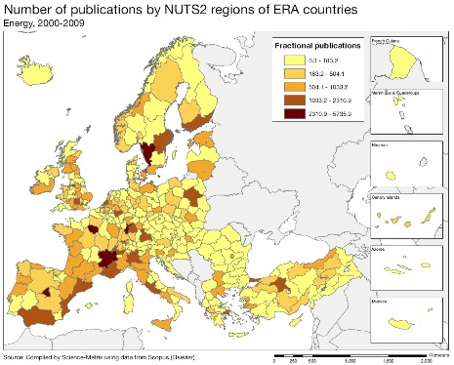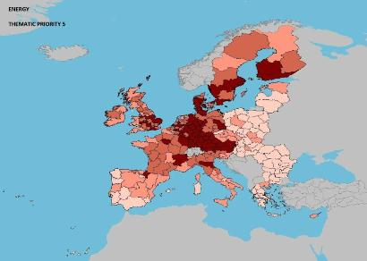

Scientific production Construction and construction technologies Technological production
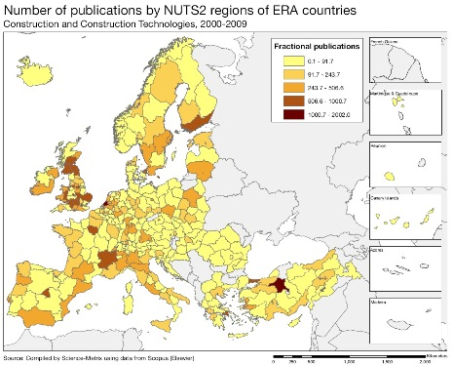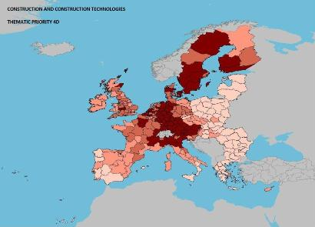

Scientific production Environment Technological production
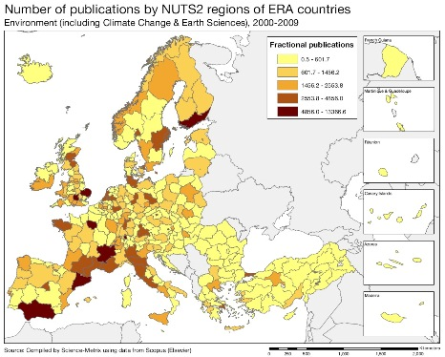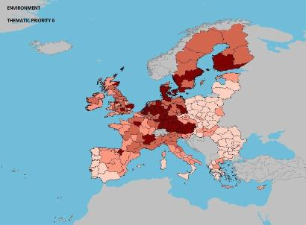

Source: DG Research and Innovation – Economic Analysis unit
Data: Science Metrix using Scopus (Elsevier), 2010; European Patent Office, patent applications, 2001-2010

Scientific production Automobiles Technological production
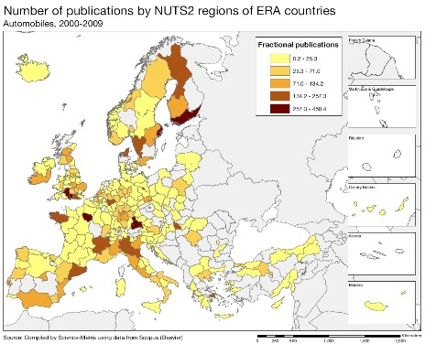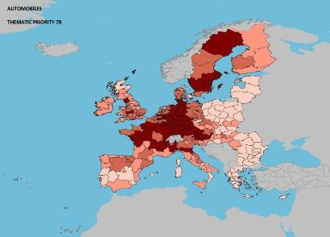
Scientific production Other transport technologies Technological production
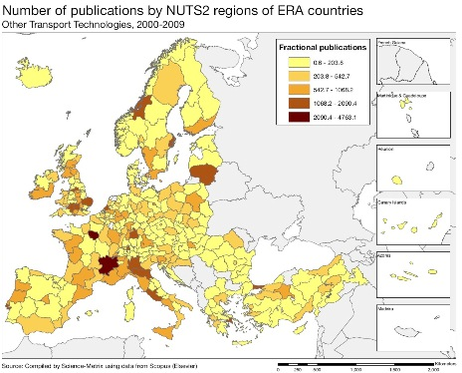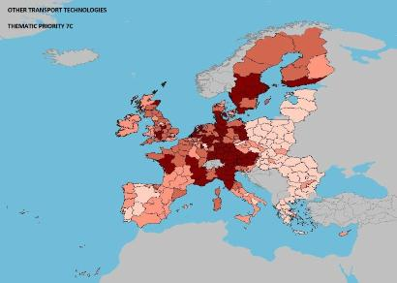
Scientific production New production technology Technological production
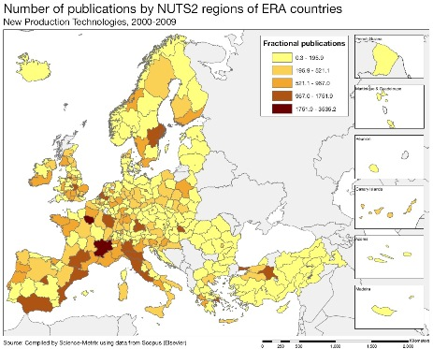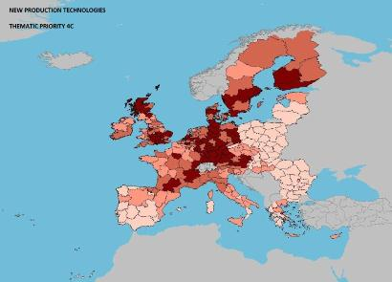
As shown by the maps above, in terms of scientific production, only a few Austrian regions perform at high output levels and the number of high performance sectors, specifically environment, food and agriculture and information and communication technologies (the latter two not illustrated on the maps), is limited. This is partly due to the relatively small size of Austrian regions - the average population of an Austrian NUTS 2 region is less than half the EU NUTS 2 average. Leading regions (Länder) in Austria in terms of scientific production in these fields are Steiermark (Styria) and Vienna.

In terms of technology patenting, which is more closely linked to business innovation, the relative position of Austria is much better than in scientific production, with many Austrian regions among the top quarter in Europe, notably in the fields of energy, construction and construction technologies, environment, automobiles and other transport technologies and in new production technology. This reflects economic structures and the areas where Austrian enterprises are innovative and have a strong market position. The comparison between scientific output in terms of publications and patenting thus shows a certain imbalance, since the strong fields for the Austrian science base are not necessarily the same as the sectors where Austrian firms have the strongest technology development. Moreover, Austria's performance in terms of scientific output is relatively low compared to the EU average and is concentrated in specific fields and regions, whereas in relation to patenting there is good performance over many fields and regions. It will be a challenge for the future to bring scientific output in Austria to the same level as patenting, and also to ensure the long term sustainability of innovation.

Policies and reforms for research and innovation

Austria formulates R&D policies from a relatively favourable position in terms of overall R&D intensity. While research is among the priority areas in public spending, the share of private sector expenditure on R&D in total R&D expenditure has fallen from 71 % in 2007 to 68 % in 2011, thus putting at risk the achievement of the ambitious Europe 2020 R&D intensity target of 3.76 %. Among the factors explaining the recent low growth in private spending are the economic crisis and a shortage of venture capital. However, the government has taken steps to stimulate additional private sector spending on R&D. Between August and November 2011 on the initiative of the Austrian Ministry for Transport, Innovation and Technology (bmvit) 22 of the larger Austrian companies, representing more than one fifth of business enterprise research spending in Austria, have committed themselves to increase R&D spending by 20% by 2015.

The Austrian RTDI Strategy ‘Becoming an innovation leader’, which was published in 2011, contains many initiatives to improve the performance of the research and innovation system. These include initiatives to strengthen the links to the education system, to increase the share of tertiary graduates, to promote high quality research infrastructure and fundamental research and to use public procurement to promote innovation.

The Austrian government has set up a Task Force for the implementation of the RTDI strategy. The initiatives of the RTDI Strategy are echoed and enhanced in the 2012 National Reform Programme and the Euro Plus Pact commitments. The most prominent measure is the simplification of the tax regime for R&D activities to a single tax credit raised from 8 % to 10 %. In addition, the cap on the amount which could be subcontracted while remaining eligible for tax credit rises from € 0.1 million to € 1 million. These measures are budget neutral and are expected to encourage subcontracting to research centres and universities. On the other hand, this approach favours established activities more than the breakthrough research needed for an economy like Austria's. Moreover, whereas the National Reform Programme of 2012 lists numerous initiatives in the field of research and innovation, it still lacks clear prioritisation and details of players and budgets and implementation timetables and it does not address the need for a closer integration of the Austrian R&I system within the European Research Area.

As regards sustainability of economic activities, which plays an important role in the acceptance of innovation by the public and which in itself can be a source of innovation, the National Energy Strategy from 2010 aims at increasing efficiency, energy security and the share of renewables. Funding is available for the greening of industries and an action plan was set up in October 2010 for Green Public Procurement. In 2011 a strategy paper to promote electrical mobility was prepared and in 2012 a resource efficiency action plan (REAP) was adopted.
Economic impact of innovation

The index below is a summary index of the economic impact of innovation composed of five of the Innovation Union Scoreboard's indicators.

Overall, Austria's employment is slightly more oriented towards knowledge-intensive sectors than the EU average. Austria's scores on the indicators "PCT patents application per billion GDP" and "Contribution of medium and high-tech products exports to trade balance" is also above EU average, reflecting the very good innovation performance of its manufacturing sector. Austria's low score on the summary index is strongly influenced by a very low score on the indicator "Knowledge-intensive services export as % of total services exports", which is explained by the dominance in its services export of the tourist sector, which is classified as non-knowledge-intensive.

The recent economic crisis has been less severe on Austria than on other EU Member States with the result that the conditions for innovation have faced fewer challenges in Austria than in most other EU countries, although the availability of business financing has decreased in 2009. In 2010, according to enterprise surveys Austria was among the middle performers in the EU as regards the ease of access to loans and the availability of venture capital. Austria currently also ranks in the middle group of EU member states in the World Bank's index Ease of doing business. However, Austria ranks low regarding the time needed to start a business, since the number of administrative procedures required for setting up a business is still relatively high. There are on-going efforts to reduce the administrative burden on enterprises.

Expenditure on R&D is high by European standards, but Austria may not be sufficiently exploiting and maintaining its innovative potential. One reason for this is an underdeveloped venture capital market (venture capital represented 0.04% of GDP in Austria in 2011 compared to an EU average of 0.35%), which suffers from an unfavourable legal framework and from structural and other problems of the Austrian VC market (e.g. small size and limited differentiation, general reluctance to invest in early stages, uncertainty concerning the treatment of non-incorporated companies as VC funds etc). In addition, the education system faces the challenge of providing the skills required as a basis for innovation and competitiveness, but the low tertiary attainment rate and the general demographic development might lead to a scarcity of skilled people in the long term.

Upgrading the manufacturing sector through research and technologies

The graph below illustrates the upgrading of knowledge in different manufacturing industries. The position on the horizontal axis illustrates the changing weight of each industry sector in value added over the period. The general trend to the left-hand side reflects the decrease of manufacturing in the overall economy. The sectors above the x-axis are sectors whose research intensity has increased over time. The size of the bubble represents the share of the sector (in value added) in manufacturing (for all sectors presented in the graph). The red-coloured sectors are high-tech or medium-high-tech sectors.
Austria is one of the EU countries having a high contribution of manufacturing industry to total value added (around 19% compared to an EU average of 16%). In parallel, Austrian manufacturing industry has clearly increased its knowledge-intensity in high- and medium-high-tech sectors as well as in the medium-low and low-tech sectors (with the notable exception of chemicals, other transport equipment and the electricity, gas and water sector).

As in many other European countries, one of the largest sectors in the economy is the construction sector, but unlike other EU countries, the construction sector did not increase its share of the economy in the years leading up to the economic crisis, while its research intensity improved slightly. Research intensity has mostly increased in high-tech and medium-high-tech sectors, with in most cases positive results when it comes to value added. However, despite an increase in research intensity, the manufacturing of radio, TV and communication equipment has declined in importance, partly as a result of a reclassification of the activities of a large Austrian manufacturing firm, which was until 2006 attributed to this sector and probably also due to a shift of production to low wage countries. The chemicals and chemical products sector, on the other hand, has increased in economic importance despite a decline in research intensity. As regards electrical machinery and medical, precision and optical instruments an increase in research intensity has been accompanied in Austria by a growth in value added.

Competitiveness in reaping income of global demand and markets

Investment in knowledge, technology-intensive clusters, innovation and the upgrading of the manufacturing sector are determinants of a country's competitiveness in global export markets. A positive contribution of high-tech and medium-tech products to the trade balance is an indication of specialisation and competitiveness in these products.

The Austrian economy is characterised by a relatively small contribution of agriculture to GDP and a comparatively high share of manufacturing industry in total value added. The service sector, including a relatively large tourism sector, also has an above EU average share of the economy. The strongest growth in value added over time tends to occur in the service sector.

As shown by the graph above, Austria succeeded in improving its trade balance for most of its high-tech and medium-tech products over the period 2000-2011. A limited number of medium-tech products showed a stagnation or slight decline in their contribution to the trade balance. On the other hand, the trade balance improved significantly in the electrical machinery, apparatus and appliances sector – the high-tech sector, where R&D intensity has increased most over the last decade .

Overall Austria has improved its total factor productivity faster than the EU average over the last decade, a sign of innovation in line with the balanced and expanding R&I system and the upgrading of its manufacturing sector. Progress has also been made in technologies addressing societal challenges such as health and the environment and on all of the Europe 2020 targets. However, compared to other EU Member States, Austria shows a relatively low tertiary education attainment rate. Furthermore, this rate is progressing only slowly. The picture improves if post-secondary, non-tertiary education (ISCED 4), which Austria considers equivalent to tertiary education, is included. Furthermore, the high employment rate and the low rate of early leavers from education and training show that Austria makes good use of its human capital.

Table on key indicators

Belgium
The challenge of fostering innovation-based competitiveness through the business economy

Summary: Performance in research, innovation and competitiveness

The indicators in the table below present a synthesis of research, innovation and competitiveness in Belgium. They relate knowledge investment and input to performance or economic output throughout the innovation cycle. They show thematic strengths in key technologies and also the high-tech and medium-tech contribution to the trade balance. The table includes a new index on excellence in science and technology which takes into consideration the quality of scientific production as well as technological development. The indicator on knowledge-intensity of the economy is an index on structural change that focuses on the sectoral composition and specialisation of the economy and shows the evolution of the weight of knowledge-intensive sectors and products and services.

 | Investment and Input | Performance/economic output
Research | R&D intensity  2011: 2.04% (EU: 2.03%; US: 2.75%)  2000-2011: +0.35% (EU: +0.8%; US: +0.2%) | Excellence in S&T  2010:59.92 (EU:47.86; US: 56.68)  2005-2010: +3.5% (EU: +3.09%;US: +0.53)
Innovation and  Structural change | Index of economic impact of innovation  2010-2011: 0.599 (EU: 0.612) | Knowledge-intensity of the economy  2010:58.88 (EU:48.75; US: 56.25)  2000-2010: +1.06% (EU: +0.93%; US: +0.5%)
Competitiveness | Hot-spots in key technologies  Food and agriculture, ICT, nanotechnologies, new materials, biotechnology, environment | HT + MT contribution to the trade balance  2011: 2.37% (EU: 4.2%; US: 1.93%)  2000-2011: +10.39% (EU: +4.99%; US:-10.75%)

Belgium has a very high quality research system, as reflected by its third highest score among all EU Member States on the S&T Excellence index. Belgium has been able to exploit this strength to its economic advantage in several sectors. A particularly good performance is visible in the bio-pharmaceutical sector, where high scientific quality, business investment, product innovation and trade performance reinforce each other. Moreover, several service sectors, such as computer-related and other business services, strongly contribute in Belgium to a structural change towards a more knowledge-intensive economy, notably through the growth of innovative firms.

However, despite these very positive sectoral dynamics, Belgian R&D intensity stagnated in the period 2000-2011 and there was even a decline in business expenditure on R&D, especially between 2001 and 2005. This is due to a de-industrialisation trend, which has notably affected several high-tech and medium- high-tech manufacturing sectors. The de-industrialisation trend has been accompanied by a rapid deterioration of the Belgian trade balance since 2002, showing that the strengths of the services and of the bio-pharmaceutical sectors cannot alone support the competitiveness of Belgium.

There is a consensus in Belgium about the critical importance of fostering the innovation-based competiveness of Belgian businesses. This has been reflected in the development of sophisticated and comprehensive policy mixes at national and regional levels and in significant budgetary efforts in favour of R&D from all political entities, especially between 2005 and 2009. At federal level, fiscal incentives for R&D are an important tool. In the Walloon Region the focus has been on supporting a limited number of competitiveness poles (a cluster approach). In the Flemish Region, the willingness to address through innovation some specific societal challenges is a main driver of research and innovation policy. In the Brussels Capital Region, an updated innovation strategy including a ‘smart specialisation’ approach has been launched in 2012.
Investing in knowledge
Belgium is not on track to reach its R&D intensity target for 2020 of 3%. After a peak in 2001 at 2.07%, Belgian R&D intensity decreased to 1.83% in 2005. This decrease was due to a fall in business R&D intensity (from 1.51% in 2001 to 1.24% in 2005). Business R&D intensity partially recovered in 2006-2008, up to 1.34%, and in 2011 slightly increased further, up to 1.37%, but this remains still well below its 2001 peak. However, thanks to an increase in public R&D intensity since 2000 (public R&D intensity was 0.52% in 2000, 0.55% in 2007 and 0.65% in 2011), overall R&D intensity in 2008-2011 was again close to its 2001 peak. Since 2010, public investment in R&D has been stable and a 5% increase is expected for 2013. However, the growing role of fiscal incentives must be stressed. If coupled with a reorientation of business investment in Belgium, this may foster R&D business intensity and hence help Belgium to improve its trend to meet the headline target.

The decrease in business R&D intensity during the last decade is linked to a strong reduction of R&D activities in Belgium in two industry sectors: radio, TV and communication equipment, and chemicals and chemical products (excluding pharmaceuticals). In 2000, radio, TV and communication equipment (18%), chemicals and chemical products (excluding pharmaceuticals) (17%) and pharmaceuticals (16%) accounted for slightly more than half of Belgian business R&D expenditure (BERD). Since then, these three sectors have experienced diverging trends. While pharmaceuticals-related R&D expenditure has more than doubled, representing 28% of total Belgian business R&D expenditure in 2009, the R&D expenditure of the two other sectors has declined. R&D expenditure decreased by 8% in the case of chemicals and chemical products (excluding pharmaceuticals) and by 62% in the case of radio, TV and communication equipment, reducing their shares in BERD in 2009 to respectively 11% and 5%. The service sector "Computer and related activities" has on the contrary become increasingly important, accounting for 8% of BERD in 2009, compared to 4% in 2000.

Belgium has been very successful in the EU Framework Programme. Up to early 2012, slightly over 3350 Belgian participants had been partners in an FP7 project (a success rate of 24%), with a total EC financial contribution of € 1.0 billion. Regarding the other main source of EU funding, the FEDER Regional Funds, in the programming period 2007-2013, a total of € 643 million (31.2% of the total FEDER fund to Belgium) was allocated to research, innovation and entrepreneurship in the Belgian regions.
An effective research and innovation system building on the European Research Area

The graph below illustrates the strengths and weaknesses of Belgium's R&I system. Reading clockwise, it provides information on human resources, scientific production, technology valorisation and innovation. Average annual growth rates from 2000 to the latest available year are given in brackets.
The overall shape of the graph highlights the strong performance of the Belgian research and innovation system. Belgium scores higher than the EU average for the vast majority of the indicators. In particular, Belgium has a high quality public research and higher education system, characterised by a strong international openness. The quality of the Belgian research system is evidenced by the high share of its scientific publications within the top 10% most cited scientific publications worldwide, the strong position of Belgium in the context of the EU R&D Framework Programmes, as well as its attractiveness for foreign doctoral students. Its international openness is further evidenced by the highest "Collaboration Index" of all the EU Member States (1.33). Belgium also performs well above the EU average for the two indicators on cooperation between public research institutions and firms (co-publications and business funding of public R&D), confirming the quality of the public scientific and technological base and highlighting its relevance for businesses.
As shown on the graph, a weak point of the Belgian research system is a share of science and engineering graduates in the population aged 25-34 that is lower than the EU average. Combined with the overall ageing demographic in Belgium, this raises the question of how Belgium will be able to assure for the future the pool of highly skilled human resources necessary to keep an innovation-based economy running. However, the share of S&E graduates has rapidly increased in recent years.
Belgium’s scientific and technological strengths

The maps below illustrate six key science and technology areas where Belgium has real strengths in a European context. The maps are based on the number of scientific publications and patents produced by authors and inventors based in the regions.

Strengths in science and technology at European level

Scientific production Food, agriculture and fisheries Technological production
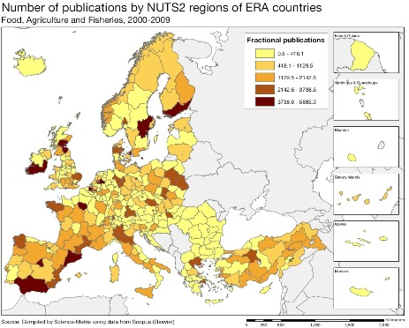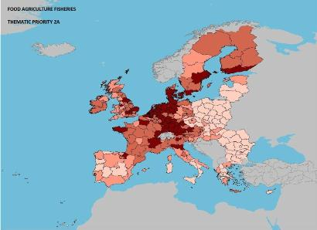
Scientific production Information and Communication Technologies Technological production
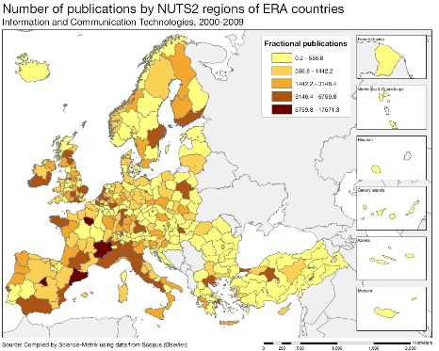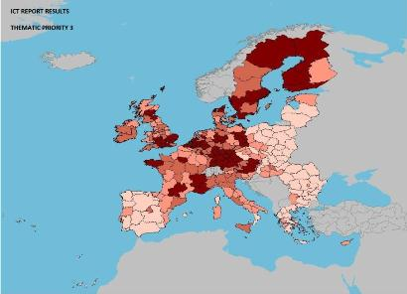
Scientific production Nanosciences and Nanotechnologies Technological production
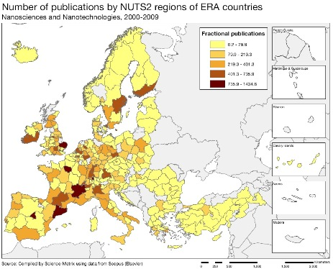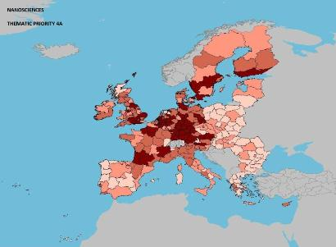

Source: DG Research and Innovation – Economic Analysis unit
Data: Science Metrix using Scopus (Elsevier), 2010; European Patent Office, patent applications, 2001-2010

Scientific production Materials Technological production
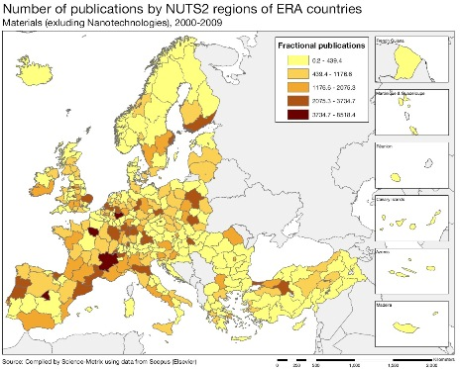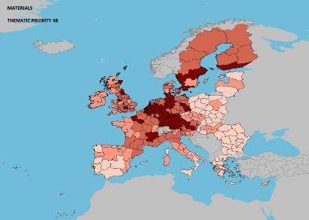
Scientific production Biotechnology Technological production
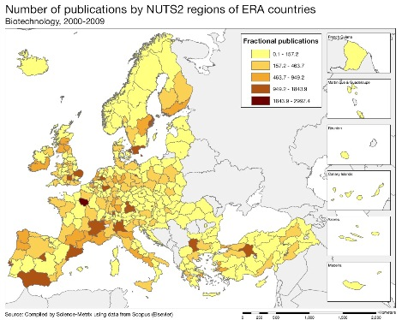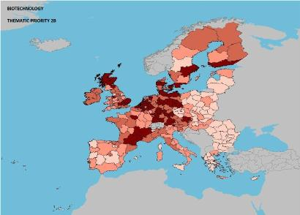
Scientific production Environment Technological production
The maps in the left column above show a high volume of scientific production in some Belgian provinces in food, agriculture and fisheries, ICT, nanoscience and nanotechnologies, biotechnology, and environmental science and technologies. It is mainly in the provinces of Flemish Brabant and Eastern Flanders that these high volumes of scientific production are visible on the maps, reflecting the presence in these provinces of the two largest Belgian universities: Leuven and Ghent. In all the fields mentioned above, Belgium also displays high scientific excellence (based on citations, with Average Relative Citations above 1.35 and a share of scientific publications within the 10% most-cited above 13%), with the notable exception of nanoscience and nanotechologies. Other fields where Belgian scientific production is excellent include science related to materials, new production technologies, construction, other transport technologies, and security. The number of scientific publications has been increasing very rapidly in the case of construction technologies.

Maps on the right side show high volumes of patenting in all six fields in the vast majority of Belgian provinces, revealing clear synergies between scientific strengths and technological innovativeness. In most of those fields, both Flemish and Walloon provinces exhibit high volumes of patenting. The maps show that in these key technological fields nearly the whole of Belgium is part of a transnational knowledge-intensive macro-region which includes also parts of the Netherlands and parts of Germany. Based on patenting activities, Belgium is the most specialized EU Member State in materials and the second most specialised (after Denmark) in biotechnology. Construction is also a strong technological specialisation area for Belgium. Biotechnology is the area with the strongest growth of patenting activities since 2000.
Policies and reforms for research and innovation

In Belgium, policies and funding for research and innovation are mainly in the hands of the Regions and the Communities, but the federal authorities still play an important role in some specific areas (e.g. space) as well as through fiscal instruments. The existing consensus in Belgian political circles about the importance of research and innovation as a key source of economic growth, has led to significant budgetary efforts from all political entities. Between 2000 and 2010, government budget appropriations for research and development (GBAORD) increased by 37% in real terms. This growth was notably driven by strong increases since 2000 in the Flemish budget for R&D (which represents about half of GBAORD). The Walloon budget for R&D has also strongly increased since the launch of the Walloon "Marshall Plan" in 2005. The growth of public funding of R&D since 2000 reinforced proportionally all R&D performing sectors: between 2000 and 2009, public funding of R&D performed by higher education increased by 60%, public funding of R&D performed by other public research organisations increased by 42% and public funding of R&D performed by businesses increased by 45%. Moreover, in recent years the federal government has developed powerful R&D tax incentives (in particular a 75% payroll tax exemption for researchers), leading to a situation where foregone revenues due to R&D tax incentives are almost equivalent to the amount of direct public funding of business R&D. Taking into account both forms of support, public support for business R&D represents in Belgium a higher share of GDP (0.17%) than in most other EU Member States.

After slight decreases in 2009/2010, GBAORD has been stable in 2011/2012 and may grow again in 2013, taking into account the decision by the Flemish government to increase its R&I budget by at least € 200 million between 2011 and 2014 and the willingness of the other entities to preserve the allocations for R&D despite difficult budgetary situations.
The way public funding of research is organised contributes both the quality and the openness of the Belgian research system. Firstly, about half of public funding is allocated through project-based competition (this is one of the highest rates in the EU), secondly, 12% of public funding is transnationally coordinated (this is the highest share among the MS for which information is available), in particular through participation in Europe-wide actions such as ESA, Article 185 initiatives, Joint Technology Initiatives with national funding, and ERA-NET's joint calls.
All Belgian regions have developed strategic innovation approaches covering all major aspects of a successful innovation strategy. In the Walloon Region the focus has been on supporting a limited number of competitiveness poles (a cluster approach); in 2011, € 125 million was allocated to the R&D projects of competitiveness poles under the "Marshall 2.Green" plan. New approaches have been developed under the so-called 'Creative Wallonia' Plan as in the field of support to market take-up for new products and services (technologically based or not) and the promotion of cultural and creative industries. In the Flemish Region, the willingness to address through innovation major economic and societal challenges is a main driver of research and innovation policy. Flanders also has a policy of developing strategic research centres able to provide high quality service to businesses. In 2011, the competence poles for industrial design, logistics, materials research and mobility have been extended and a new competence pole for sustainable chemistry has been created. A particular investment fund (TINA fund) with € 200 million at its disposal has been set up in order to help reform the Flemish economy through innovation. In the Brussels Capital Region, an updated innovation strategy, including a ‘smart specialisation’ approach, has been launched in 2012. To improve innovation financing, the Region created a fund to support young innovative companies (Brustart).

Economic impact of innovation

The index below is a summary index of the economic impact of innovation composed of five of the Innovation Union Scoreboard's indicators.
Belgium's score on this index is comparable to the average scores of the EU and of the reference group of countries. However, Belgium's score results from different situation in each indicator composing the index.
On the positive side, knowledge-intensive sectors provide more jobs in Belgium than (on average and proportionally) in other Member States. Moreover, thanks to excellent trade performance in a range of research-intensive products, the contribution of medium and high-tech product exports to the Belgian trade balance has strongly increased in the last decade.
On the negative side, Belgium's score is lower than EU average on the indicators “Share of knowledge-intensive exports in services exports” and “Sales of new to market and new to firm innovations as % of turnover”. However, the low score of Belgium on the indicator “Share of knowledge-intensive exports in services exports” is largely explained by high volumes of export in some logistics, transport and trade related services which are linked to the geographical intermediation role of Belgium and which are classified as non-knowledge-intensive. Moreover, the low score of Belgium on the indicator “Sales of new to market and new to firm innovations as % of turnover” is explained by the fact that Belgium is strongly specialised in sectors with long innovation cycle as pharmaceuticals or chemicals and strongly under-specialised in sectors with short innovation cycle as IT. As the low scores of Belgium on these two indicators reflect some specificities of the industrial structure of Belgium not related to any underperformance, the situation of Belgium in terms of economic impact of innovation is more positive than the image given by the index.
While the Belgian research and innovation system seems to be effective in generating economic impacts in the sectors in which R&D investments are concentrated, the key issue for Belgium is to broaden its innovation base beyond those sectors. All Belgian regions have developed some efforts in this direction (see last paragraph on previous page). However, Belgium needs more growing innovative firms to fasten the renewal of its economic fabric and speed-up the transition towards a more knowledge-intensive and innovation-driven economy.
Upgrading the manufacturing sector through research and technologies

The graph below illustrates the upgrading of knowledge in different manufacturing industries. The position on the horizontal axis illustrates the changing weight of each industry sector in value added over the period. The general trend to the left-hand side reflects the decrease of manufacturing in the overall economy. The sectors above the x-axis are sectors whose research intensity has increased over time. The size of the bubble represents the share of the sector (in value added) in manufacturing (for all sectors presented on the graph). The red-coloured sectors are high-tech or medium-high-tech sectors.

The graph also points at some of the factors behind the evolution of business R&D intensity described in the section "Investing in knowledge". The shares in total Belgian value-added of nearly all manufacturing sectors declined between 1998 and 2009. This evolution reflects the trends toward a more service-oriented economy, and is similar to the one observed at the level of the EU as a whole. It has however been more pronounced in Belgium, where manufacturing now accounts for 14% of gross value added compared to 19% in 2000. High-tech and medium-high-tech sectors have not been spared from this trend: in particular, the radio, TV and communication equipment sector, which in 2000 was the sector contributing the most to BERD, has been strongly affected. Thus, although the sectoral R&D intensities of most of the manufacturing sectors have been stable or increasing, the negative impact of the de-industrialisation trend on the evolution of overall Belgian business R&D intensity has been overwhelming. Foreign multinationals, which represent nearly 60% of BERD, played a key role in these dynamics: for instance, decisions to disinvest in Belgium from foreign firms active in the radio, TV and communication equipment sectors explain the above mentioned trends in this sector.
Competitiveness in global demand and markets

Investment in knowledge, technology-intensive clusters, innovation and the upgrading of the manufacturing sector are determinants of a country's competitiveness in global export markets. A positive contribution of high-tech and medium-tech products to the trade balance is an indication of specialisation and competitiveness in these products.

Since 2002, the Belgian trade balance has deteriorated rapidly, mainly due to loss of market shares on global markets, to the extent that it now constitutes an important emerging risk for the Belgian economy. The improving services balance has not been sufficient to offset the decline in the goods balance, from a surplus of 4.3% of GDP in 1995 to a deficit of 2% of GDP in 2011. This negative evolution was especially strong in labour-intensive and mainstream industries, where it is linked to a cost-competiveness issue for Belgium.
At the same time, the contribution of high-tech and medium-tech (HT & MT) products to the trade balance has increased. This increase has been driven by excellent performance in pharmaceuticals exports as well as by positive evolutions across a wide range of HT&MT products, notably plastics and other chemical materials and products. The increase of the overall contribution of HT & MT products to trade balance would have been even more impressive without the strong deteriorations of the trade balances in road vehicles and, to a lesser extent, in telecommunication apparatus. The trade balance deterioration in these sectors is due to the sharp reduction of the volume of activities of these industries in Belgium (visible on the bubble graph in the previous section), including through the closure of some factories.
It is thus clear that the strengths of the Belgian research and innovation system have to some extent played a counter-balancing and mitigating role vis-à-vis the Belgian cost-competiveness issue in the manufacturing sector. Since 2000, total factor productivity has remained rather constant in Belgium. Between 1996 and 2007 it was close to 0 but for goods it increased 10% and for services it decreased by 6.5%. The employment rate has increased slightly. Belgium is making progress on the other Europe 2020 targets, in particular in the field of the environment, although there is room for further progress.
Key indicators for Belgium

Bulgaria
Seizing the economic growth potential of innovation – policy coordination and strategic planning

Summary: Performance in research, innovation and competitiveness
The indicators in the table below present a synthesis of research, innovation and competitiveness in Bulgaria. They relate knowledge investment and input to performance or economic output throughout the innovation cycle. They show thematic strengths in key technologies and also the high-tech and medium-tech contribution to the trade balance. The table includes a new index on excellence in science and technology which takes into consideration the quality of scientific production as well as technological development. The indicator on knowledge-intensity of the economy is an index on structural change that focuses on the sectoral composition and specialisation of the economy and shows the evolution of the weight of knowledge-intensive sectors and products and services.
 | Investment and Input | Performance/economic output
Research | R&D intensity  2011: 0.57% (EU: 2.03%; US: 2.75%)  2000-2011: +1.06% (EU: +0.8%; US: +0.2%) | Excellence in S&T  2010:24.65 (EU:47.86; US: 56.68)  2005-2010: +3.4% (EU: +3.09%;US: +0.53)
Innovation and  Structural change | Index of economic impact of innovation  2010-2011: 0.234 (EU: 0.612) | Knowledge-intensity of the economy  2010:29.45 (EU:48.75; US: 56.25)  2000-2010: +3.65% (EU: +0.93%; US: +0.5%)
Competitiveness | Hot-spots in key technologies  Agriculture, Nano- and Biotechnology, ICT and Energy | HT + MT contribution to the trade balance  2011: -4.78% (EU: 4.2%; US: 1.93%)  2000-2011: n.a. (EU: +4.99%; US:-10.75%)
Bulgaria has in the past decade increased its R&D expenditure in nominal terms in line with the strong growth of its GDP, with only slight setbacks during the current crisis. After slowly increasing from 0.09% of GDP in 2002 to 0.16% of the GDP in 2009, business expenditure on R&D has surged to 0.3% of GDP in 2011, matched by sustained catching up in levels of excellence in science and technology, but also innovation. The economy is also steadily catching up to EU-level averages in terms of high-technology and medium-technology sectors, albeit from low levels. There have also been some recent positive policy developments with the adoption of national strategies for research and innovation, as well as the recent establishment of a ranking of universities, which will better inform resource allocation.
However, multiple challenges remain if Bulgaria is to be able to fully benefit from the knowledge economy. Bulgaria has low levels of knowledge-intensive economic activity, and its overall structure has not changed substantially over the last decade. Bulgaria's participation rate in FP7 is much below potential and working conditions are not attractive for highly productive researchers. Consequently, both public and private R&D investment are hampered by a lack of skilled human resources. A substantial increase in R&D spending, both in absolute and relative terms, is a prerequisite if Bulgaria is to raise its economic competitiveness and secure high-quality jobs.
Tackling these challenges is crucial to achieving sustainable economic growth in the future. A new mechanism for effective collaboration and coordination between the structures and institutions that support the executive in conducting scientific and innovation policy in Bulgaria is under development. Recent progress made in securing private investment in ICT and pharmaceuticals should be capitalized upon. Bulgaria has a strategic focus to move up the value chain and away from a sectoral specialisation in low technologies. This will require increased public investment in researchers and infrastructures as well as fostering an environment that is conducive to collaborations between universities and business (implementing what is already in the National Development Programme "Bulgaria 2020"). Moreover, more focus should be placed on incentives for excellence and internationalisation, in particular through an increase in the part of public funding which is allocated competitively, transparently and based on merit. Further support should also be given to research and innovation collaboration platforms such as technology parks and clusters; the drive to create Sofia Tech is a valuable reference point in this regard. At regional level, more support from the Structural Funds should be channelled towards research and innovation infrastructures.

Investing in knowledge

In June 2010, the Bulgarian government adopted a national R&D investment target of 1.5 % of GDP by 2020. R&D intensity has not changed significantly over time: it was 0.51% in 2000 and was 0.57% in 2011. Moreover, the 2011 public budget for science remained at 0.3% of GDP, despite a planned increase in absolute terms. Therefore, although R&D expenditure in Bulgaria has been increasing, a further dramatic increase would be required if Bulgaria is to reach its 2020 R&D intensity target. The public sector has historically been the main research funder and performer: in 2011 it provided 38.8% of total R&D funding, a substantial crisis-related drop from pre-2010 levels. For example, the Academy of Sciences saw a ~40% cut in its initially approved budget.
After slowly increasing from 0.09% of GDP in 2002 to 0.16% of GDP in 2009, business R&D intensity surged to reach 0.3% of GDP in 2011. Business expenditure on R&D more than doubled from € 55 million in 2009 to € 117 million in 2011 surpassing total public expenditure on R&D. In 2011 business enterprise expenditure on R&D accounted for 53 % of total R&D expenditure in Bulgaria compared to an EU average of 62%. This encouraging sudden increase is attributable to investments by ICT and pharmaceutical companies, but. there are doubts as to whether this extremely positive trend can be sustained. The low level of R&D intensity is due to the economic crisis and the lack of demand for development of innovation on the domestic market
Some general trans-national funding initiatives partially complement national R&I funding. The allocated Regional Development and Cohesion Funds support for the 2007-2013 period amount to € 310.6 million for Research and Innovation and related activities and € 292 million for support of innovation in SMEs. The level of Bulgarian participation in the Framework Programmes is low. As of February 2012 Bulgaria ranks 20th among EU Member States both in terms of number of applicants (0.91 % of the EU total) and requested EC contribution (0.55 % of the EU total). The applicant success rate of 17,2 % is lower than the EU average (21.2 %) as is the EC financial contribution success rate of 10,8 % (EU average 20,4 %). Bulgaria received € 64.5 million of FP7 funding, of which € 16.3 million went to SMEs. Adjusted for population, this comes to eight euro per capita, a value comparable to those of Poland and Slovakia.
An effective research and innovation system building on the European Research Area

The graph below illustrates the strengths and weaknesses of Bulgaria's R&I system. Reading clockwise, it provides information on human resources, scientific production, technology valorisation and innovation. Average annual growth rates from 2000 to the latest available year are given in brackets.
Even if its overall position in the Innovation Union Scoreboard is rather low, Bulgaria being among the modest innovators, there are some encouraging signs in the disaggregated dimensions. Most important is the fact that Bulgaria is the "EU catching-up leader", with a 9% growth in innovation performance in 2011 (and ~6% in 2010), albeit from a low level. Bulgaria also scores relatively high on the quality of its Human Resources and in Firm Investments. As the graph above shows, Bulgaria is significantly lower than the EU average for all dimensions except, as would be expected for a catching up innovator, in terms of EU funding and in terms of foreign business expenditure on R&D. Of particular concern is the low level of public-private scientific co-publications and the very small number of business enterprise researchers, which are in a sense related, as well as the very limited number of PCT applications compared to the EU average.
Moreover, Bulgaria still faces major challenges in key policy dimensions related to European Research. Bulgaria has been experiencing massive outflows of researchers and highly skilled people: for example, in 2010 the number of Bulgarian students at graduate level who went to the United States was higher than the corresponding numers for Poland andr Romania. There is therefore an urgent need to enhance the quality of the higher education system and to address the failure to channel skilled people into domestic employment. In 2010 a new Academic Staff Development Act aimed at supporting the career development of researchers was adopted. Bulgaria is slowly catching up in terms of increasing the excellence and internationalisation of its universities and public research organisations. The overall number of scientific co-publications based on collaborations between Bulgarian and other ERA country researchers is one of the lowest in Europe, suggesting that the country is not sufficiently benefitting from international knowledge flows, despite having several bilateral cooperation agreements with over 12 EU and Third countries which promote joint scientific projects, exchange of research staff and support co-publications. Bulgaria's most significant co-patenting partners are Germany, Switzerland and Belgium.
Bulgaria's scientific and technological strengths

The Bulgarian R&I system is faced with the typical dilemma of a catching up innovator with limited resources. Some efforts have been aimed at defining some key areas of focus on which to build a truly excellent research base upon which to further base a framework of support for innovation. In order to concentrate resources, the National Science Fund has decided, under the 2012 call for proposals, to support predominantly fundamental and applied research projects as well as experimental developments in the priority areas defined in the National Research Strategy. However, not enough is currently being done in Bulgaria to properly direct scarce resources, the result being that they are spread too thinly.
The maps below illustrate five key science and technology areas where Bulgaria has real strengths in a European context. The maps are based on the number of scientific publications and patents produced by authors and inventors based in the regions.
Strengths in science and technology at European level

Scientific production Food, agriculture and fisheries Technological production
Scientific production Nanosciences and nanotechnologies Technological production
Scientific production Information and Communication Technologies Technological production
Source: DG Research and Innovation – Economic Analysis unit
Data: Science Metrix using Scopus (Elsevier), 2010; European Patent Office, patent applications, 2001-2010

Scientific production Biotechnology Technological production
Scientific production Energy Technological production

The maps above are selected based on existing or emerging regional clusters in scientific or technological production. These are in the areas of agriculture, nano- and biotechnology, ICT and energy. Furthermore, based on citations and the impact of scientific publications, Bulgaria also shows strength in the area of transport. Nevertheless, current trends indicate a lack of clarity in the country's areas of specialisation that should be addressed with smart specialisation strategies. In order to define the country's areas of Smart Specialization, the Government has signed a service agreement with the Word Bank and set up an inter-institutional working group including representatives of all interested ministries, regional authorities and social partners.
Overall, patenting in Bulgaria is behind most European countries, most probably still affected by the post-communism decline, when activity in its traditional industries (metallurgy, chemicals, heating and medicine) was scaled back. Although these industries are nowadays limited to technological upgrades with foreign capital (rather than in-house development), there are signs of intensification, fuelled by R&D intensive FDI, in other areas, primarily in ICT as seen in the maps above.
Scientific production is increasing but not strongly enough for Bulgaria to improve its global standing. The impact of this research has also increased, and is currently comparable to regional peers such as Romania and Croatia, but is behind Poland. In general, scientific publications are mainly concentrated in the field of pure sciences. Co-authorship with foreign researchers has increased to over half of all publications, the main partners being in Germany, France and Italy, but also in the United States and, more recently, in Poland and Spain.
Policies and reforms for research and innovation
There have not been any notable changes in the innovation policy mix, programmes and measures in Bulgaria between 2009 and 2011. Institutional fragmentation continues to present a challenge to policy implementation: R&I policies remain within the authorities of two different ministries that have different policy-making mechanisms and policy implementation structures. Nevertheless, there has been some collaboration: for example the joint consultation for the elaboration of the National Strategy of Scientific Research to 2020 (NSSR2020). The Strategy, incorporating for the first time important science, technology and innovation policy guidelines into one document, was adopted in 2011. The adoption of a new Law on Innovation, as well as a new Higher Education and Science Law, should be treated as a priority. In order for both the national and Europe 2020 objectives to be achieved, all strategy documents, as well as their implementation measures, should be harmonised and jointly developed by all stakeholders. The measures should include standardisation, public procurement rules, regulations, etc.
The lack of up to date statistical and qualitative data on the implementation of research and innovation policy and measures is another general weakness that affects policies and reforms. Evaluation is performed ad-hoc and irregularly, and statistical data are produced with a time lag of several years. A positive step is the newly introduced university rating system (launched in 2010), which is intended to serve as a tool for discretionary state funding based on the universities’ achievements. Progress has been made in establishing evaluation systems and rules for initiating policy and structural changes in all innovation and research-related institutions based on the recommendations from the evaluations. The NSSR2020 foresees as one of its measures the introduction of scientific activity evaluation of research organisations, which will help the State to design better policy measures. A draft of the "Regulation for the monitoring and evaluation of the research carried out by universities and research organizations" is expected to be adopted soon.
In 2008, for the first time, the ratio between national institutional (direct subsidies for public research organisations) and competitive funding was almost equal. National competitive funding usually does not have strict thematic or sectoral focus, or it tends to focus on the support of 6-7 areas per one open call. It should be noted, however, that several of the sectors listed as priorities in the NSSR2020 currently receive less than 1% of government budget appropriations or outlays on R&D. Notwithstanding the existence of a national roadmap for research, specific R&I cross-border or regional programmes and support schemes have been limited so far, as have been plans for involvement in any ESFRI projects. HEIs provided a minute 0.20% of the total R&D funding in 2011, while total higher education expenditure on R&D (HERD) which amounted to € 22.5 million in 2011 accounted for only 10.2% of total R&D expenditure in Bulgaria. The main change in R&D expenditure trends, in 2011, was the increase in R&D investment from abroad. The share of R&D financed by abroad, which was in the range of 5-8% for the 2000-2009 period, increased to 43.9% in 2011. The main competitive public R&D funding instruments are the National Innovation Fund (NIF) and the National Science Fund (NSF). Due to considerations related to overlapping with EU funding programmes, the NIF has not distributed any funds since 2008, when it reached a budget of € 10.3 million. The NSF’s budget peaked in 2009 (€ 51.1 million), but government cuts in 2010 have substantially reduced it to € 13 million.
The level of cooperation between companies and R&D institutions and universities is still low. A number of measures aimed at building a favourable environment and encouraging the interaction between universities and business are foreseen in the National Youth Strategy 2010-2020, the “Bulgaria 2020” Programme, the NSSR 2020, and are supported by a scheme launched under the Operational Programme “Development of Human Resources”, which has also been used to fund training for some researchers. There are no specific policy measures aimed at promoting public-private knowledge transfer or spin-offs. Mobility of research staff between the public and private sectors is rare and is in general not supported by specialised programmes for fostering inter-sectoral mobility. The majority of Bulgarian enterprises do not have research units and are not attracting research staff from the public sector. In order to promote private investment in R&I, the state should further develop and implement instruments such as start-up funding schemes, support for clusters, technology centres for the commercialisation of patents, while financial engineering instruments, guarantees and venture capital funds should be further enhanced.
Economic impact of innovation

The index below is a summary index of the economic impact of innovation composed of five of the Innovation Union Scoreboard's indicators.

The graph above shows that raising the economic impact of innovation constitutes a challenge for Bulgaria and currently leaves a lot of room for improvement. There is a need to support future growth in the economy as well as employment by harnessing the power of innovation to create new and sustained high value-added exports. This is of paramount importance because Bulgaria's exports have stagnated in terms of quality and product sophistication. There is agreement among policy makers that exports would play a pivotal role in achieving a robust recovery, but for this to happen, exports must become more diversified and more innovation-based and the share of high-technology goods must increase. The economic crisis seems to have accelerated Bulgaria’s structural change towards more advanced and knowledge-intensive industries and sectors, as demonstrated by the sizeable gains in exports by technology-driven and mainstream manufacturing industries. However, Bulgaria is still catching up with respect to competitiveness. Much of the innovation that businesses are currently engaged in is related to catching-up and the upgrading of technology through acquisitions and FDI in the most research-dynamic sectors. For example, in 2007 one fifth of all inward business investment in R&D in Bulgaria originated from the chemical industry, with the majority of the investment coming from outside the EU.
The World Bank (WB) has assessed private innovation based on the World Bank's enterprise survey, and concluded that Bulgarian firms which innovate grow 1.5 times faster and create more jobs than their non-innovating counterparts. But this powerful engine is hampered by insufficient access to the external finance needed for long-term R&I investments. Over the past years, SMEs have encountered difficulties in financing innovative projects due to high interest rates and credit rationing, while start-ups have not been able to find appropriate funding. Bulgaria has also experienced the largest increase in the EU in unsuccessful loan applications - from 3 % in 2007 to 36 % in 2010 (Eurostat). Moreover, the regulatory environment is not stable and predictable for companies as legislative acts change very often. National harmonisation with EU legislation is sometimes complex and contradictory. In the WB Doing Business 2012 survey, Bulgaria's ranking worsened for the second consecutive year (from 57 in 2010 to 59 in 2011), pointing to excessive red tape and inefficiencies, including difficulties with permits, access to electricity, contract enforcement, and the insolvency framework.
Upgrading the manufacturing sector through research and technologies

The graph below illustrates the upgrading of knowledge in different manufacturing industries. The position on the horizontal axis illustrates the changing weight of each industry sector in value added over the period. The general trend to the left-hand side reflects the decrease of manufacturing in the overall economy. The sectors above the x-axis are sectors whose research intensity has increased over time. The size of the bubble represents the share of the sector (in value added) in manufacturing (for all sectors presented on the graph). The red-coloured sectors are high-tech or medium-high-tech sectors.
The manufacturing sector plays a slightly bigger role in Bulgaria than in the EU as a whole. This is mainly due to specialisation in labour-intensive industries (e.g. textiles and clothing, leather and footwear), and in capital-intensive industries (e.g. cement, refined petroleum and non-metallic mineral products). The primary sector is larger than the EU average due to the higher share of agriculture and, in general, the economy is dominated by sectors with low and medium-low technology intensity (DG Enterprise, 2012). The graph shows the large relative weight of textiles, metals and agricultural products in the economy, as well as the large share of value-added growth that they still represent. Two of the high-tech sectors have seen their shares of value added decrease over time (i.e. machinery and equipment, and chemicals, although BERD intensity increased in the case of machinery and equipment), whereas the electrical and optical equipment sector has increased its weight.
Overall there is a positive trend in the evolution of Bulgaria's economic structure. The Composite Indicator on structural change (DG Research and Innovation, 2012) also reflects this by showing steady improvement over time, the largest increase being from 2005 to 2009. There appears to be a general consensus that while improvements are evident and the manufacturing and export sectors are gradually shifting towards higher value-added and a more high-tech mix, this change is not happening fast enough to sustain competitiveness levels in the globalized economy.
Competitiveness in global demand and markets

Investment in knowledge, technology-intensive clusters, innovation and the upgrading of the manufacturing sector are determinants of a country's competitiveness in global export markets. A positive contribution of high-tech and medium-tech products to the trade balance is an indication of specialisation in these products.
So far, the Bulgarian economy has been associated with marketing and organisational innovation but not with technological innovation. Its economic specialisation has been based on low costs and a cheap labour force. The latest strategy documents call for measures to strengthen high value added and technology intensive sectors. There are already some encouraging data to show that this is happening, in particular a reduction of employment in low-tech sectors such as processing and apparel manufacturing coupled with employment growth in ICT. Another positive sign is that several medium-tech products (in particular products in machinery and transport-related sectors) are increasing their weight in Bulgaria's trade balance, as illustrated in the graph above. Although Bulgaria has a negative trade balance, both overall and in high-tech and medium-tech products, the export of medium-tech products has grown in absolute numbers since 2008.
Nevertheless, Bulgaria is still in the process of catching up with the EU average for a series of indicators related to competitiveness (see Key indicators for Bulgaria, below). The trends shown by these indicators are reminiscent of the larger shifts in the economy that have been outlined above, and point to the moderate pace of positive change. For example, while total factor productivity has increased by 13% since 2000 compared to 3% for the EU, employment in knowledge intensive activities is still rather low. Bulgaria has also made some strides in patenting in crucial sectors such as health and environment-related technologies. Overall, Bulgaria is making good progress on several of the Europe 2020 targets, although from a lower level than other EU Member States. A worrying sign is the falling employment rate and the growing share of population at risk of poverty following the economic crisis.
Key indicators for Bulgaria

Country-specific recommendation in R&I adopted by the Council in July 2012:
"Improve the access to finance for start-ups and SMEs, in particular those involved in innovative activities."

State of the Innovation Union 2012, Accelerating change
Link: ec.europa.eu/iuc2011.
See methodological notes at the end of this document.
For an overview of these composite indicators, see the methodological notes at the end of this document.
A reinforced European Research Area Partnership for Excellence and Growth, COM(2012) 392final, 17.7.2012.
See Methodological note for the composition of this index.
World Economic Forum, The Global Competitiveness Report 2012-2013, pages 97-98 and 482
13. 6%, well above EU average of 10. 9% - this is the third best EU performance.
Belgium has proportionally the third largest inflow of doctoral students from other Member States: 12% of doctoral students come from another Member State.
Index calculated by Science-Metrix, based on the number of co-publications while taking into account the size of national scientific output.
Increased to 80% since 1 January 2013
Belgium also participates in several research infrastructure projects as part of the ESFRI roadmap. Its main contribution to the implementation of the ESFRI roadmap is as lead partner on the MYrrHA European Fast Spectrum Irradiation Facility: Belgium will contribute 40% of the construction costs as part of a broad international consortium.
IMEC for instance is selling its service to industrial players from all over the globe.
See Methodological note for the composition of this index.
Due to differences in innovation cycle, the share of innovative products introduced the last three years in the turnover is about 10% for global innovation leaders in pharmaceuticals or chemicals vs. more than 60% in IT hardware: see http://iri.jrc.ec.europa.eu/docs/survey/2012/Survey2012.pdf
See Methodological note for the composition of this index.

