Croatia
The challenge of structural change for a more knowledge-intensive economy

Summary: Performance in research, innovation and competitiveness

The indicators in the table below present a synthesis of research, innovation and competitiveness in Croatia. They relate knowledge investment and input to performance or economic output throughout the innovation cycle. They show thematic strengths in key technologies and also the high-tech and medium-tech contribution to the trade balance. The table includes a new index on excellence in science and technology which takes into consideration the quality of scientific production as well as technological development. The indicator on knowledge-intensity of the economy is an index on structural change that focuses on the sectoral composition and specialisation of the economy and shows the evolution of the weight of knowledge-intensive sectors and products and services.

 | Investment and Input | Performance/economic output
Research | R&D intensity  2011: 0.75% (EU: 2.03%; US: 2.75%)  2000-2011: -2.72% (EU: +0.8%; US: +0.2%) | Excellence in S&T  2010:12.25 (EU:47.86; US: 56.68)  2005-2010: +2.31% (EU: +3.09%;US: +0.53)
Innovation and  Structural change | Index of economic impact of innovation  2010-2011: 0.353 (EU: 0.612) | Knowledge-intensity of the economy  2010:n.a (EU:48.75; US: 56.25)  2000-2010: n.a. (EU: +0.93%; US: +0.5%)
Competitiveness | Hot-spots in key technologies  Healthcare sector; Food processing and agro-business; Energy technology; Electronics and Advanced materials and Digital techniques | HT + MT contribution to the trade balance  2011: 2.98% (EU: 4.2%; US: 1.93%)  2000-2011: +133.23% (EU: +4.99%; US:-10.75%)

Croatia is building up its research and innovation system. Although starting from a low level, its science and technology excellence has clearly improved after 2005. Efforts are still needed to enhance R&D investment and to build up capacities in key technology areas and to improve international competitiveness and trade by producing more technology-intensive goods.

Since 2000, Croatia has restructured its science (and education) system with the objectives of turning the country into a knowledge based society and of strengthening the country's research capacity as a lever for economic development. Driven its determination to join the EU, Croatia has taken steps to strengthen its national research capacity by taking measures and adopting polices that are compatible with EU policy on the European Research Area. Croatia, however, has been slow to implement the envisaged actions and lacks reliable statistics and the administrative capacity to monitor and follow-up the envisaged reforms. Croatia has also suffered from the economic recession.

The new Government elected in December 2011 continued the efforts to reform the science system by proposing amendments to the Act on Scientific Activity and Higher Education aimed at creating an adequate legislative framework for a more programme-based and competitive funding of research institutes (adoption by Parliament foreseen before end of 2012).

A new R&D strategy and a "National Innovation Strategy is under preparation for the period 2013-2020.

Investing in knowledge
In 2011 Croatia had an R&D intensity of 0.75% and a business R&D intensity of 0.33%. Croatia's R&D intensity decreased from 0.90% in 2008 to 0.75 % in 2011. This was mainly due to an overall slowdown of the national economy during the last four years, which was additionally affected by the global financial and economic crisis. Croatia did not meet its own national target of 1% by 2010. Accordingly, Croatia has opted to first reform the science system before setting new targets. Total R&D expenditure (GERD) which amounted to € 330 million in 2011 decreased by 3.2% between 2004 and 2011. Croatia's R&D intensity of 0.75% in 2011 was well below the EU average of 2.03%. and has decreased at an average annual rate of 2.7% over the period 2002-2011.

Regarding EU funding, Croatia participates in FP7 as an associated country. It has a good level of participation (an average success rate close to 18%) which has amounted to about € 50 million of EU funding for Croatian research entities since the beginning of FP7. Croatia is particularly successful under the scientific themes in which it is also strong at national level i.e.: healthcare, ICT, biotechnology and transport. Participation of SMEs is also good: out of 225 applicants 57 (or more than 25%) were selected for funding. Croatia is a full member of the Eurostar initiative. Croatia is also a member of COST and EUREKA.

As a Candidate Country, and since December 2011, an Accession Country, Croatia is eligible for EU support under the Pre-Accession Instrument (IPA) and has used that instrument in support of research and innovation capacity building such as the creation of the Business Innovation Centre of Croatia (BRICO) which is a dedicated institution for the promotion of research and innovation in SMEs. The latter is a good demonstration that Croatia is concentrating its efforts on innovation and creating links between the public and private sectors. Croatia wll become a member State on 1 July 2013 and will then have access to the Structural Funds and notably the European Regional Development Fund (ERDF) and the European Social Fund (ESF) for R&I capacity building purposes. BRICO will be the ggency in charge of the competitiveness axis under the Structural Funds.
An effective research and innovation system building on the European Research Area

The graph below illustrates the strengths and weaknesses of Croatia's R&I system. Reading clockwise, it provides information on human resources, scientific production, technology valorisation and innovation. Average annual growth rates from 2000 to the latest available year are given in brackets.

This graph shows that Croatia is lagging behind the EU average on most key research and innovation indicators but it is doing well or better than several other Member States and Associated Countries with a similar knowledge and economic structure. Croatia is performing above the EU average in attracting business R&D from abroad, although this is also linked to the low total business R&D in the country. Croatia faces a particular challenge in improving private-public cooperation and in valorising and commercialising research generated by publicly funded institutes.

Human capital building in S&T is below the EU average. Croatia still has a large scientific diaspora. The lack of attractive research infrastructures and good research management is leading to a further increase in brain drain. The MSES and the Agency for Mobility have, however, stepped up efforts on human capital building by actively supporting the principles of the European Charter for Researchers and the Code of Conduct for Recruitment of Researchers. In total, nine Croatian institutes have been accredited for HR excellence in research. Croatia is participating in the work of the Steering Group on Human Resources and Mobility (SGHRM). The Croatian Researchers Mobility Portal was launched in 2009.

Competitiveness in global demand and markets

Investment in knowledge, technology-intensive clusters, innovation and the upgrading of the manufacturing sector are determinants of a country's competitiveness in global export markets. A positive contribution of high-tech and medium-tech products to the trade balance is an indication of specialisation and competitiveness in these products.

Croatia is a net importer with a trade deficit in the order of € 8 billion in 2010 compared to about € 3.5 billion in 2001. Following the economic crisis, trade volume decreased significantly in 2009, 2010 and 2011 but exports in high-tech and medium-tech products continued to grow. Croatia is, for example, a net exporter of goods and products in which its research capacity is also strong such as fertilizers, plastic products in primary forms, electrical machinery and transport equipment. The graph above shows that important sectors such as road vehicles, electrical and specialised machinery have increased their contribution to the Croatian trade balance.

Croatia's employment rate has fallen since 2008 as a result of the economic crisis. The share of renewable energy in total energy consumption has slightly increased over the last years. However, Croatia's performance on energy efficiency and reducing the level of CO2 by stimulating the use of renewable energy is still at a low level, which is also reflected in the Croatian research capacity under the FP7 environment theme.
Key indicators for Croatia

Cyprus
A new integrated innovation strategy to valorise opportunities of a small service-oriented economy

Summary: Performance in research, innovation and competitiveness

The indicators in the table below present a synthesis of research, innovation and competitiveness in Cyprus. They relate knowledge investment and input to performance or economic output throughout the innovation cycle. They show thematic strengths in key technologies and also the high-tech and medium-tech contribution to the trade balance. The table includes a new index on excellence in science and technology which takes into consideration the quality of scientific production as well as technological development. The indicator on knowledge-intensity of the economy is an index on structural change that focuses on the sectoral composition and specialisation of the economy and shows the evolution of the weight of knowledge-intensive sectors and products and services.

 | Investment and Input | Performance/economic output
Research | R&D intensity  2011: 0.48% (EU: 2.03%; US: 2.75%)  2000-2011: +6.24% (EU: +0.8%; US: +0.2%) | Excellence in S&T  2010: 27.77 (EU:47.86; US: 56.68)  2005-2010: +0.17% (EU: +3.09%;US: +0.53)
Innovation and  Structural change | Index of economic impact of innovation  2010-2011: 0.558 (EU: 0.612) | Knowledge-intensity of the economy  2010: 44.11 (EU:48.75; US: 56.25)  2000-2010: +3.27% (EU: +0.93%; US: +0.5%)
Competitiveness | Hot-spots in key technologies  New production technologies, Construction, ICT | HT + MT contribution to the trade balance  2011: 1.72% (EU: 4.2%; US: 1.93%)  2000-2011: -0.83% (EU: +4.99%; US:-10.75%)

In the last decade, Cyprus has achieved a significant increase in its R&D intensity, which has led to improved excellence in science and technology. Cyprus has also managed to increase the knowledge-intensity of its economy to a level approaching the EU average.
Research and innovation presents some challenges to policy makers. A main bottleneck of the R&I system is the low number of human resources for research activities. This is due to the weak demand from business and industry. There is a sharp contrast between the high number of tertiary education graduates which has grown by 80% between 2000 and 2010 and the very low number of human resources for research. This is partially explained by a still unfavourable environment for research activities which leads to a substantial brain-drain of S&T graduates to other countries, mainly the United Kingdom and the United States. In addition, business involvement in research and innovation is very limited mainly due to the lack of big companies and the absence of high-tech industrial activity. The business sector is focused on services and is dominated by very small enterprises that have not developed an innovation culture.
The government has introduced financial incentives for business R&D and new support schemes for innovation such as innovation vouchers. There is also a strong emphasis on the importance of a stronger cooperation between the higher education system and industry. Currently, there is a too broad research orientation that lacks prioritisation and an integrated R&I policy. The National Research and Innovation Strategy (2011-2015) is under preparation. The Cyprus authorities consider that the absorption capacity of Cyprus in the field of R&D is limited and that it is better to encourage the development of existing products in an innovative way. Non-technological innovation as well as innovation in services could be real options for Cyprus.
Investing in knowledge
The research and innovation system in Cyprus is relatively new. It has evolved mainly over the last two decades and it relies predominantly on public expenditure. In 2009, 69% of total R&D expenditure (GERD) was financed by government, the highest percentage in the EU and considerably above the EU average of 34.9%. There is indeed a persistent problem of underinvestment in research and innovation by the business sector. Business R&D expenditure (BERD) as a % of GDP was equal to 0.09% in 2010, the lowest level in the EU. In its National Reform Programme Cyprus set a very modest R&D intensity target of 0.5% for 2020, the lowest R&D intensity target in the EU, and in fact this target had been reached in 2010. However, the R&D intensity decreased to 0.48% of GDP in 2011. The economy is not oriented towards high value-added products and services. Cyprus has been affected by the financial crisis with the result that the R&D budget and several measures related to innovation have been put on hold during the process of fiscal consolidation.
In the last decade, a significant increase of public RTDI funding has taken place across various disciplines without focusing on the limited number of scientific fields where the national innovation system could be expected to excel. There is a low involvement of firms in research and innovation activities in terms of participation and expenditure on R&D and innovation. In 2010 only 17.5% of total R&D expenditure (GERD) was performed by business enterprise compared to an EU average of 61.5%. This share has decreased from 22.8% in 2008.
Conversely, research performed by the higher education sector has increased over the same period from 43.7% to 49.6% of GERD, a value which is more than twice the EU average. In 2010 the government budget for R&D amounted to 0.46% of GDP to be compared with the EU average of 0.76%. In 2009, 12.1% of R&D was financed from abroad compared to an EU average of 8.4%. The main source of foreign funding has been the EU Framework Programme for Research and Technological Development (FP7). Cyprus is successful in raising funds from the FP7. Around one third of the EU funds raised by Cypriot participants through the FP7 up to February 2012 were directed to SMEs i.e. € 18.7 million out of € 52.55 million. Cyprus has most FP7 collaborative links with the United Kingdom, Germany and Greece.
An effective research and innovation system building on the European Research Area

The graph below illustrates the strengths and weaknesses of Cyprus's R&I system. Reading clockwise, it provides information on human resources, scientific production, technology valorisation and innovation. Average annual growth rates from 2000 to the latest available year are given in brackets.

The graph above shows that in the case of Cyprus FP7 funding per GERD is much higher than the EU average. The graph also shows that two other indicators, BERD financed from abroad (as percentage of total BERD) and employment in knowledge-intensive activities (as percentage of total employment aged between 15 and 64 years), have higher values than the EU average. The biggest gaps between Cyprus and the EU average occur for BERD as % of GDP, public expenditure on R&D financed by business enterprise as % of GDP, and PCT patent applications per GDP. These findings underline the conclusion that there is a significant underinvestment in research and innovation activities, affecting mainly the business sector.
Research policy has a strong international dimension and is well aligned with the ERA pillars. ERA policy is seen as an opportunity to integrate the small national R&I system into the broader European market and in this context internationalisation of the research system is a high priority. The national scientific landscape does not provide space for large research infrastructures. However, due to the strong performance of its ICT and computing base, Cyprus puts particular emphasis on e-infrastructure. Cyprus participates actively in the FP7 and recent results confirm a successful participation in the ICT programme, in particular.
Cyprus' scientific and technological strengths
The maps below illustrate six key science and technology areas where Cyprus has real strengths in a European context. The maps are based on the number of scientific publications and patents produced by authors and inventors based in the regions.

Strengths in science and technology at European level

Scientific production Information and Communication Technologies Technological production
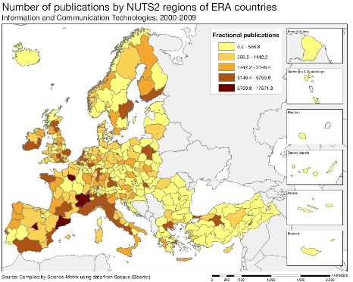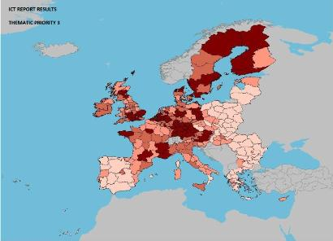
Scientific production Energy Technological production
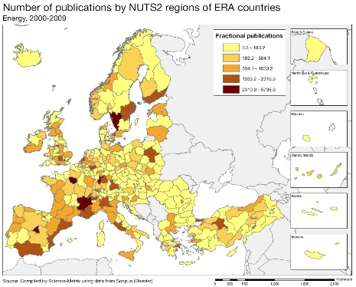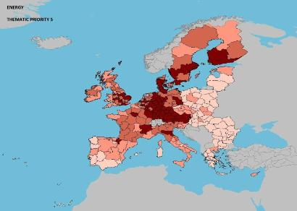
Scientific production Materials Technological production
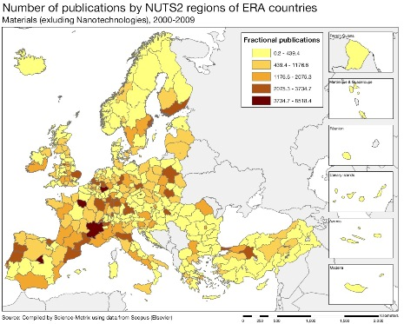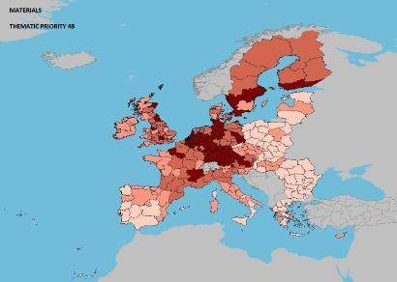

Source: DG Research and Innovation – Economic Analysis unit
Data: Science Metrix using Scopus (Elsevier), 2010; European Patent Office, patent applications, 2001-2010

Scientific production New production technologies Technological production
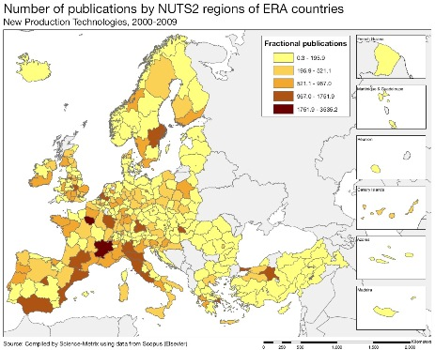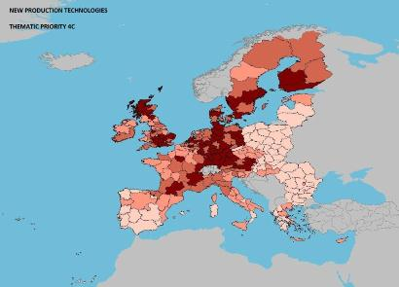
Scientific production Construction Technological production
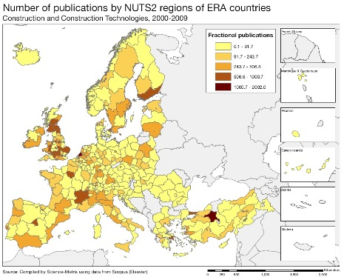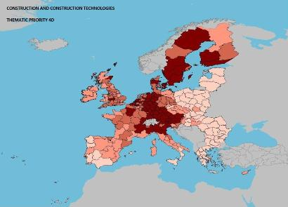
Scientific production Biotechnology Technological production
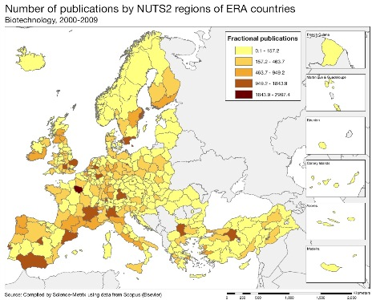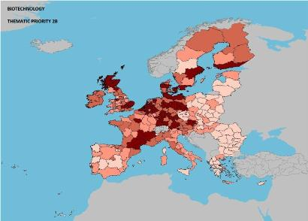
In terms of research output, Cyprus is underperforming. In 2010 Cyprus had the fourth lowest number of scientific publications in the EU ahead of Luxembourg, Latvia, and Malta. However, Cyprus had the second highest average annual growth rate in the EU after Luxembourg in numbers of scientific publications between 2000 and 2010. The level of PCT patent applications is very low with Cyprus well below the EU average. The situation concerning PCT patent applications in societal challenges is even worse.
Bibliometric indicators between 2000 and 2009 on information and communication technologies (ICT), as a FP7 thematic priority, show that Cyprus has one of the highest specialisation index values at 2.59. In addition the collaboration index in information and communication technologies (ICT) for Cyprus at 1.44 is at the highest level in the EU.
The growth index for Cyprus in the field of materials (excluding nanotechnologies) is also very high. Cyprus together with Israel and Denmark has the highest ARIF score (the average of relative impact factors) in this field.
Cyprus produced the most collaborative publications in the EU, relative to its size, in the FP7 research theme of new production technologies (with a Collaborative Index value of 1.82). It has the second highest growth index value (3.84) behind Lithuania for scientific publications in the field of construction and construction technologies. Cyprus together with Lithuania and Turkey is amongst the most specialised countries in this field.
Cyprus has a very high ARC score (the average of relative citations) of 2.29 for scientific publications on energy, meaning that these publications are cited more than twice as often, on average, than the world level in this research area. In addition, 21.2% of Cypriot scientific publications in the field of energy are in the top 10% most cited publications in this field. This is one of the highest levels in the EU.
A quantitative analysis of the numbers of EPO patents (2000-2010) by applicant classified by FP7 thematic priorities shows that Cyprus achieved good results in the fields of information and communication technologies (ICT), new production technologies, construction technologies, materials, and energy and environment. These are areas in which Cyprus also had its best outputs in terms of scientific publications over the last decade.

Policies and reforms for research and innovation

The new R&I strategy currently in preparation should better address the main challenges of the R&I system. These include a more focused employment of the limited financial resources to ensure smart specialisation, better prioritisation, an increased involvement of SMEs in R&I activities and more career opportunities for researchers. In the new research and innovation strategy, research priorities will target a broad spectrum of multi-thematic research projects in the following pre-selected fields: manufacturing technologies, information and communication technologies, sustainable development, health and bio-sciences and social sciences.
The low level of innovation in Cyprus is linked to its particular economic structure which has a limited capacity to increase private research and innovation. The Government is making efforts to support a more active involvement of businesses in innovation activities by introducing new subsidy schemes for enterprises.
The European Commission recommended in 2012 that the government should take further measures to reinforce occupational mobility towards activities of high growth and high value added and to address youth unemployment, with an emphasis on work placements in companies and promotion of self-employment, as well as appropriate policy measures on the demand side to stimulate business innovation. As the service sector is significantly more developed than industry, measures in favour of non-technological innovation could be a useful option to take into consideration.
The Research Promotion Foundation was established in 1996 to promote the development of scientific research, technology and innovation. The National Framework Programme (2008-2010) is a medium-term development mechanism aiming at the development of research and innovation sector of the Cypriot economy. It covers the main research and innovative activities that have been supported and financed by the Research Promotion Foundation and the Structural Funds of the European Union. The budget for new calls for proposals was around € 14.5 million in February 2011.
To date, Cyprus has allocated only around 18% of available Structural Funds (2007-2013) under the Operational Programme for 'Sustainable development and Competitiveness' to knowledge society and innovation. As a result of a limited institutional capacity to absorb these funds, the Cypriot authorities have indicated their intention to redirect a part of this already limited share to other priorities.

Economic impact of innovation

The index below is a summary index of the economic impact of innovation composed of five of the Innovation Union Scoreboard's indicators.

The performance of Cyprus on four out of the five indicators composing this index is slightly above the EU average: contribution of high- and medium-tech products to the trade balance, knowledge-intensive services exports, employment in knowledge intensive activities, sales of new-to-market and new-to-firm products. The resulting index value is below the EU average due to the very low performance of Cyprus in patents inventions.
Business demand is still low and special efforts would be needed to develop an innovation culture among firms. Policies promoting innovation are recent and have a relatively limited impact. Support for innovation is mainly based on traditional direct funding. Venture capital schemes and other less traditional financial incentives are almost non-existent. The government intends to use public procurement as a demand side policy to drive innovation. The adoption of pre-commercial procurement is expected to act as an important stimulus for innovation. However, commercial exploitation of knowledge is difficult to increase further without a significant increase in demand.
A scheme of innovation vouchers is a relatively new measure which is being used to stimulate a more active involvement of SMEs in innovation activities in collaboration with research organisations. The Research Promotion Foundation (RPF) supports the strengthening of links between the academic and business sectors in coordination with the Business Support Centre of Cyprus which is a member of the Enterprise Europe Network. Recent measures supported by the RPF aim to bridge the gap between the supply and demand of innovation through a mechanism of intermediation between research institutions and SMEs. In 2009-2010, an ''innovation clusters'' measure targeted the creation of cooperation networks between enterprises, public research organisations and intermediaries.

Upgrading the manufacturing sector through research and technologies

The graph below illustrates the upgrading of knowledge in different manufacturing industries. The position on the horizontal axis illustrates the changing weight of each industry sector in value added over the period. The general trend the left-hand side reflects the decrease of manufacturing in the overall economy. The sectors above the x-axis are sectors whose research intensity has increased over time. The size of the bubble represents the share of the sector (in value added) in manufacturing (for all sectors presented on the graph). The red-coloured sectors are high-tech or medium-high-tech sectors.
The Cypriot economy is dominated by very small sized family-run enterprises with limited export orientation. This economic structure does not favour R&D. The economy of Cyprus is dominated by the service sector, mainly tourism, transport and finance, with manufacturing representing only around 7%. SMEs which provide mostly low value added support services are unlikely to invest in research and innovation. Most firms tend to concentrate on low value added products and services and do not take risks on new products or export markets.
The graph above shows that manufacturing industry in Cyprus is largely dominated by low and medium-low-tech sectors (which are less research intensive) and mainly by the construction sector followed by the electricity, gas and water sector and the food products, beverages and tobacco sector. Structural changes towards more research-intensive economies are in general driven by high and medium-high-tech manufacturing sectors. In Cyprus, there are three such sectors: machinery and equipment, chemicals and chemical products, and electrical machinery and apparatus. Three manufacturing sectors have an increased their weights in the economy: construction, other non-metallic mineral products, and fabricated metal products which also had the highest growth in research intensity.
Competitiveness in global demand and markets

Investment in knowledge, technology-intensive clusters, innovation and the upgrading of the manufacturing sector are determinants of a country's competitiveness in global export markets. A positive contribution of high-tech and medium-tech products to the trade balance is an indication of specialisation and competitiveness in these products.

The Cypriot economy is currently facing the challenge of strengthening its external competitiveness and fostering growth. The deteriorating outlook for growth and increasing unemployment are challenges for Cyprus’s economy which grew by a modest 0.5 % in 2011. GDP is projected to contract by 0.8% in 2012 due to a fall in domestic demand, traditionally the main driver of growth, and to the weaker external environment, in particular persistent financial market uncertainty. The large exposure of the financial sector to Greece and the banks' need for recapitalisation have increased the cost of financing and have limited the availability of finance to the private sector. Conversely, the external sector has made a positive contribution to growth.

The graph above shows that most high-tech and medium-tech industries have increased their contribution to Cyprus's trade balance over the period 2000-2011. Those industries which significantly improved their contribution are medical and pharmaceutical products, electrical machinery, and telecommunications. In contrast, the contributions of the road vehicles industry, fabrics woven of man-made textile materials and other transport equipment have significantly diminished.

Cyprus is making progress towards most of the Europe 2020 targets, with the exceptions of the targets for greenhouse gas emissions and the share of the population at risk of poverty. Technology development is oriented towards societal challenges such as environment and health, but there is a falling number of environment-related patents. Total factor productivity in the Cypriot economy stagnated between 2000 and 2008, after which it decreased markedly during the economic crisis.
Key indicators for Cyprus

Country-specific recommendation in R&I adopted by the Council in July 2012:
"Take appropriate policy measures on the demand side to stimulate business innovation."

The Czech Republic
Improving the output of the science base to foster business R&I investment

Summary: Performance in research, innovation and competitiveness
The indicators in the table below present a synthesis of research, innovation and competitiveness in the Czech Republic. They relate knowledge investment and input to performance or economic output throughout the innovation cycle. They show thematic strengths in key technologies and also the high-tech and medium-tech contribution to the trade balance. The table includes a new index on excellence in science and technology which takes into consideration the quality of scientific production as well as technological development. The indicator on knowledge-intensity of the economy is an index on structural change that focuses on the sectoral composition and specialisation of the economy and shows the evolution of the weight of knowledge-intensive sectors and products and services.

 | Investment and Input | Performance/economic output
Research | R&D intensity  2011: 1.84% (EU: 2.03%; US: 2.75%)  2000-2011: +4.23% (EU: +0.8%; US: +0.2%) | Excellence in S&T  2010:29.9 (EU:47.86; US: 56.68)  2005-2010: +4.58% (EU: +3.09%;US: +0.53)
Innovation and  Structural change | Index of economic impact of innovation  2010-2011: 0.497 (EU: 0.612) | Knowledge-intensity of the economy  2010:39.58 (EU:48.75; US: 56.25)  2000-2010: +2.91% (EU: +0.93%; US: +0.5%)
Competitiveness | Hot-spots in key technologies  Automobiles, transport, construction, materials, energy and environment | HT + MT contribution to the trade balance  2011: 3.82% (EU¹: 4.2%; US: 1.93%)  2000-2011: +42.62% (EU¹: +4.99%; US:-10.75%)
Public funding of R&D and the available pool of S&E graduates are in line with the level of development of the Czech economy although the level of excellence in S&T is markedly lower than the EU average (with the exception of S&T in other transport and energy) and is catching up only very slowly, which impacts negatively on the ability of the Czech innovation base to expand to its full potential. As a result, business investment in R&D is relatively low in relation to the structure of the economy (size of the manufacturing sector in general and of HT and MT sectors in particular) and the innovation performance of the country is sub-optimal. The situation is, however, improving as evidenced by the structural change towards a more knowledge-intensive economy and the fast-rising contribution of HT and MT sectors to the trade balance. The latter has increased much faster than the EU average in spite of a sharp improvement in the total trade balance over the same period.
Despite progress, the main challenge for the Czech research and innovation system remains therefore the insufficient quality of the scientific and technological output of the science base, which is notably linked to an inadequate system for evaluating research and allocating public R&D funding. Despite a public R&D intensity of 0.72%, similar to the EU average, the level of S&T excellence and the amount of intellectual property assets produced remain, in relative terms, well below the EU average.
Another persistent weakness of the Czech research and innovation system is the low extent of cooperation between the science base and the business sector originating from a combination of poor absorptive capacity of domestic firms, a lack of incentives to support collaboration between universities and firms and the shortage of scientific and engineering skills. This is evidenced notably by the extremely low shares of the R&D carried out by universities and by the government sector that are funded by business - 1% and 3.4%, respectively. According to innovation surveys, neither universities nor public research organisations are considered by firms as key partners for their innovation activities. These challenges are linked to the overdue reform of the higher education system and to the persistent weaknesses of the current system for evaluating research performance and allocating public R&D funding to higher education and research institutions. The Czech Republic International Competitiveness strategy for 2012-2020 plans to address several of these issues, as described in the following parts of the present country profile.
Investing in knowledge
R&D intensity rose steadily from 1.17% in 2000 to 1.49% in 2006 at an average annual growth rate of 4.1%, before falling to 1.41% in 2008 and rising again to 1.84% in 2011. In 2011, the Czech Republic set a target for public funding of R&D of 1% of GDP by 2020. This indicator currently stands at 0.70%, very close to the EU average and significantly higher than in most other EU-12 Member States. The government budget for R&D has so far been protected during the economic crisis (€ 1053 million in 2011) but there is currently no multiannual funding framework to ensure that it will continue to increase.

The relatively good performance of the Czech research and innovation system in terms of business expenditure on R&D (BERD reached 1.11% of GDP in 2011) is largely due to a strong manufacturing sector (24% of total value added in 2009) with a marked industrial specialisation in innovative sectors (such as 'motor vehicles' and 'electrical equipment'), combined with an increasing level of R&D financed from abroad (0.28% of GDP in 2010). However, BERD is highly concentrated in a few multinational corporations that accounted for 55% of total BERD in 2009. Whereas BERD performed by domestic companies almost doubled from € 284 million in 1998 to € 487 million in 2009, inward BERD increased six fold during the same period. This reflects the country’s rising attractiveness for foreign R&D activities and highlights the growing role played by foreign firms in the Czech research and innovation system. Medium-high-tech (MHT) manufacturing and knowledge-intensive services account for the larger share of total inward BERD. The share of inward BERD in high-tech industries almost doubled from 2002 to 2009 (16%) and the share of inward BERD in knowledge-intensive services almost tripled between 2002 and 2009 (22%). During the same period, the share of inward BERD decreased in the MHT sectors, as exemplified by the motor vehicles sector where it went down from 65% in 2002 to 37% in 2009.

About € 5.8 billion of Structural Funds are earmarked for research, innovation and entrepreneurship in the Czech Republic in the current programming period (2007-2013). This represents 22.1% of total ERDF Structural Funds. Structural Funds are therefore one of the largest sources of public funding of R&D in the Czech Republic. Up to 2010, 34.3% of these funds had been absorbed. The success rate of Czech entities in FP7 (20%) is only marginally lower than the EU average (22%) but, if overall progress in quality was significant, their share of the total funding (0.72%) – which corresponds to more than € 164 million - could still be improved when compared to the share of the Czech Republic in total EU investment in R&D (0.95%).
An effective research and innovation system building on the European Research Area
The graph below illustrates the strengths and weaknesses of the Czech R&I system. Reading clockwise, it provides information on human resources, scientific production, technology valorisation and innovation. Average annual growth rates from 2000 to the latest available year are given in brackets.
The Czech innovation system displays a complex pattern of relative strengths and weaknesses affecting both its input and output. While it currently scores lower than the EU average on most S&T indicators, it has been catching up with the group of innovation followers and outperforms its reference group in terms of new graduates in science and engineering, business R&D intensity, researchers employed by the business sector and innovation in SMEs. The region of Prague is amongst the EU regions with the highest share of researchers (full-time equivalent) in total employment (superior to 1.8%) and is the EU leader in terms of the share of the labour force employed in a S&T occupation (more than 50%). Other relative strengths include international co-publications, non-R&D business expenditure and HT and MT exports. The number of international scientific co-publications has surged over the last decade, in particular in partnerships with Germany, the United Kingdom, France, Italy and Slovakia, which is evidence of increased scientific networking within the ERA.
The S&T output of the Czech innovation system is critically weak in terms of high impact scientific publications, PCT patents and attractiveness to foreign doctoral students (other than Slovaks). Other marked weaknesses highlighted in the IU scoreboard include public R&D expenditure, access to venture capital and license and patent revenues from abroad. There are also relatively few co-inventions of patents, which may hint at potential weaknesses in the capacity to engage in international technological networks.
The Czech Republic's scientific and technological strengths
The maps below illustrate six key science and technology areas where the Czech Republic has real strengths in a European context. The maps are based on the number of scientific publications and patents produced by authors and inventors based in the regions.

Strengths in science and technology at European level

Scientific production Automobiles Technological production
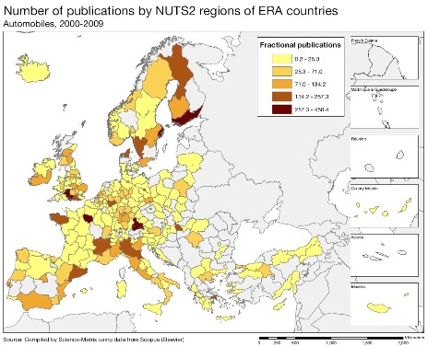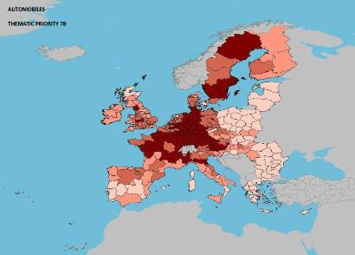
Scientific production Other transport Technological production
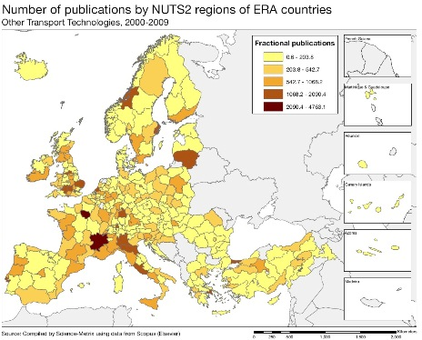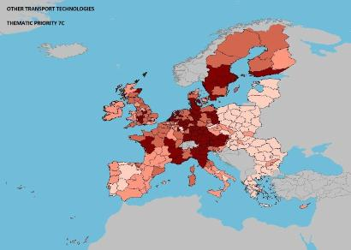
Scientific production Construction Technological production

Source: DG Research and Innovation – Economic Analysis unit
Data: Science Metrix using Scopus (Elsevier), 2010; European Patent Office, patent applications, 2001-2010

Scientific production Materials Technological production
Scientific production Energy Technological production
Scientific production Environment Technological production
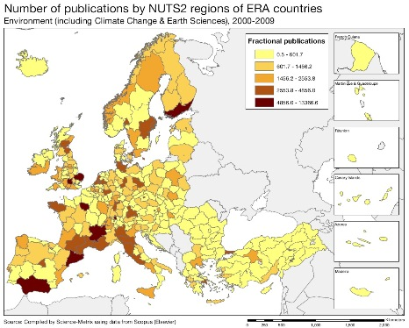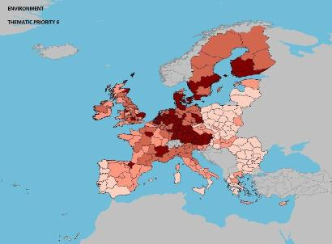
There is a considerable diversity in the Czech Republic amongst regional innovation performances, ranging from low to medium-high. Overall, other transport, construction, materials, energy, and environment are the five areas where the Czech Republic combines a strong scientific output in terms of the number of scientific publications and a strong technological output in terms of the number of patent applications. In the case of other transport and energy this combination is further reinforced by the quality of the scientific output. While the automobiles sector also features a strong technological output, the corresponding scientific field displays weak outputs. Food, agriculture and fisheries stands out as an area of strong scientific specialisation with many publications but has poor scientific impact and little technological output.
In terms of EPO patent applications the Czech Republic and all regions lag significantly behind the European average - in particular in ICT and biotech applications - and on average only 4.9% of Czech scientific publications are amongst the 10% most cited worldwide. Energy, aeronautics and space and transport stand out as scientific fields where the Czech Republic displays a high degree of scientific excellence and of international collaboration. This is also true to a lesser degree for research on biotech, materials and new production technologies. However, with the exception of materials science, these are not areas of high specialisation in the Czech science base.
Policies and reforms for research and innovation
Recent reforms are intended to put the Czech innovation system on path to converge with the EU innovation followers by 2020. The Czech Republic International Competitiveness Strategy for 2012-2020, which includes the new National Innovation Strategy (NIS), aims to strengthen the importance of innovation as a source of competitiveness for the Czech Republic. It builds on the ambitious reform programme presented in the 2011 and 2012 NRPs to increase the effectiveness of the national research and innovation system, including the quality of its output and the links between the science base and the business sector. This includes amending the Investment Incentives Act to offer investors (as of July 2012) tax incentives for creating or upgrading manufacturing facilities, R&D centres and business support centres; amending the Income Tax Act so that private firms can (as of January 2014) deduct from their taxable income the cost of R&D activities contracted out; launching new programmes to stimulate cooperation between R&D institutions and industry in sectors such as transport, energy and environment through the ALFA Programme of the Technology Agency (which also supports the development of Competence Centres); developing a new evaluation methodology to ensure that long-term R&D financing is based on excellence/quality and that support is focused on the best research teams; creating a fund to improve access to venture capital for financing innovation; reforming the tertiary education system and improving researchers' career prospects, especially for top scientists, in order to prevent brain drain.

The implementation of the International Competitiveness Strategy is coordinated by an intergovernmental Steering Committee which is also responsible for the National Innovation Strategy. However, the governance of the national research and innovation system would benefit from a clarification of the respective roles of this Steering Committee and of the Council for R&D and Innovation which advises the Prime Minister on related matters.
The national R&D target currently only covers public funding of R&D. The lack of commitment to an overall R&D target, encompassing both public and private R&D intensity, could jeopardise the adoption (and/or endanger the rigorous implementation) of important policies and measures to incentivise private R&D investment. There are also important delays in implementing the planned reforms which may lead to a loss of attractiveness for domestic and foreign R&I investors. This is particularly the case for the overdue modernisation of the higher education system which is a prerequisite to a change of attitude of academia towards the business sector with whom it should start developing stronger collaborations.
A broad set of priorities for applied research, development and innovation had been defined for the period 2009-2011 by the Council for R&D and innovation, covering in particular biological and ecological aspects of sustainable development; molecular biology and biotechnologies; sources of energy; smart materials; competitive engineering; information society; security and defence. As part of the revision of the National R&D&I policy 2009-2015, the Government adopted in July 2012 a new set of better targeted priorities focusing on six major societal challenges (competitive knowledge economy, sustainable energy and material resources, environment for quality life, social and cultural challenges, healthy people and secure society). The priorities were identified on the basis of the work of expert panels and cover the period up until 2030. A detailed plan of implementation (starting in 2014) will be submitted to the Government by July 2013.

Economic impact of innovation

The index below is a summary index of the economic impact of innovation composed of five of the Innovation Union Scoreboard's indicators.

According to this index, the Czech Republic underperforms its reference group and is clearly below the EU average. The country ranks 17th due in particular to its poor performance in "patent applications per GDP" and "share of knowledge intensive services in total export of services". These marked weaknesses reflect the still insufficient innovation orientation of the national economy and are only partly compensated by a strong performance in terms of the "contribution of medium and high-tech product exports to the trade balance" and the "sales of new to market and new to firm innovations as % of turnover of firms".
Recent policies and reforms – including the extension of the R&D tax incentives, the setting up of a seed fund and the Government's recent approval of a joint stock company to support the creation of SMEs and the development of innovative and technologically oriented enterprises – can contribute to establishing a more stable and predictable legal framework for developing innovation activities. At present the main instruments available for supporting the growth of innovative SMEs are two loan guarantee schemes (one of them is funded through OP Enterprise and innovation) and the more recent pre-seed fund. The capacity to transform the Czech Republic into a strong innovation-oriented economy by 2020 will ultimately depend on the capacity to implement the recent and planed reforms quickly and effectively.

Upgrading the manufacturing sector through research and technologies
The graph below illustrates the upgrading of knowledge in different manufacturing industries. The position on the horizontal axis illustrates the changing weight of each industry sector in value added over the period. The general trend to the left-hand side reflects the decrease of manufacturing in the overall economy. The sectors above the x-axis are sectors whose research intensity has increased over time. The size of the bubble represents the share of the sector (in value added) in manufacturing (for all sectors presented in the graph). The red-coloured sectors are high-tech or medium-high-tech sectors.
The graph above shows that the weights in the economy (horizontal axis) and/or the BERD intensities (vertical axis) of almost all manufacturing sectors in the Czech Republic have increased substantially since 1995. This trend concerns all the HT and MHT manufacturing sectors (colored in red) - in particular motor vehicles, electrical machinery and apparatus and machinery and equipment - which are all contributing to the overall increase of total BERD in the Czech Republic.
This reflects to a large extent the attractiveness of the country for foreign investors, with 55% of BERD performed by foreign-owned affiliates. The share of inward BERD doubled over the period 1999-2009. Around 80% of this inward BERD comes from EU-owned firms out of which half comes from German-owned firms. With shares of inward BERD in total BERD of more than 85%, pharmaceuticals and motor vehicles are the manufacturing sectors that show the highest degree of internationalisation. The dominance of foreign affiliates in HT and MHT sectors is reflected by the absence of Czech firms amongst the EU top 1000 R&D investing firms. In the manufacturing sector, the share of inward BERD in total BERD (about two thirds) is slightly higher than the share of the value added created by foreign affiliates, indicating that foreign-owned affiliates investing in the Czech Republic also invest in R&D and that their R&D intensity is equal or above that of domestic firms. In other words, inward BERD follows FDI.
Competitiveness in global demand and markets
Investment in knowledge, technology-intensive clusters, innovation and the upgrading of the manufacturing sector are determinants of a country's competitiveness in global export markets. A positive contribution of high-tech and medium-tech products to the trade balance is an indication of specialisation and competitiveness in these products.
The trade balance in high-tech (HT) and medium-tech (MT) products of the Czech economy improved considerably between 2000 and 2010. At the beginning of the period the country was running a mild trade deficit to which HT/MT products were contributing. Starting in 2004, HT/MT sectors literally pulled the trade balance out of the red, more than offsetting trade losses in other sectors. Since 2007 the HT/MT trade surplus has been maintained at a very high level and helped the country weather out the economic crisis. HT and MT products have therefore played a critical role in redressing the trade balance of the Czech economy and now constitute the backbone of its trade surplus, indicating a relative HT/MT trade specialisation.
The graph above shows the increase of this positive contribution for the majority of HT and MT products. The largest increases are for telecommunications and sound-recording and reproducing apparatus; office machines and automatic data-processing machines; general industrial machinery and equipment; and road vehicles. This shows that the trade balance situation of these products has improved even faster than the overall trade balance of the Czech Republic, indicating an increasing trade specialisation of the country in these products. This is also true to a lesser extent for professional, scientific and controlling instruments; other transport equipment; machinery specialised for particular industries;, plastics in non-primary form; and chemical materials and products.
The industries corresponding to these products have largely upgraded their R&D intensities and, with the exception of chemicals, they have been growing faster than the Czech economy on average (see graph in previous section), highlighting a mutually supporting pattern of trade and value added specialisation. In contrast, the trade balance in electrical machinery, apparatus and appliances has stagnated despite an increasing research intensity effort and share in the economy.
After an initial sharp increase by 20% from 2000 to 2006, total factor productivity has remained stable in the Czech Republic (table below) which is the 4th best performance in the EU. Regarding the Europe 2020 targets, the country's best ranking is attained for the risk of poverty (1st) and the worst for the level of tertiary education among the 30-34 years old. The employment rate is high, greenhouse gas emissions have been decreasing, backed up by clear growth in renewable energy and environmental technologies.
Key indicators for the Czech Republic

Country-specific recommendation in R&I adopted by the Council in July 2012:
"Adopt the necessary legislation to establish a transparent and clearly defined system for quality evaluation of higher education and research institutions. Ensure that the funding is sustainable and linked to the outcome of the quality assessment."
Denmark
Innovation for productivity addressing societal challenges

Summary: Performance in research, innovation and competitiveness

The indicators in the table below present a synthesis of research, innovation and competitiveness in Denmark. They relate knowledge investment and input to performance or economic output throughout the innovation cycle. They show thematic strengths in key technologies and also the high-tech and medium-tech contribution to the trade balance. The table includes a new index on excellence in science and technology which takes into consideration the quality of scientific production as well as technological development. The indicator on knowledge-intensity of the economy is an index on structural change that focuses on the sectoral composition and specialisation of the economy and shows the evolution of the weight of knowledge-intensive sectors and products and services.
 | Investment and Input | Performance/economic output
Research | R&D intensity  2011: 3.09% (EU: 2.03%; US: 2.75%)  2000-2011: +4.64% (EU: +0.8%; US: +0.2%) | Excellence in S&T  2010:77.65 (EU:47.86; US: 56.68)  2005-2010: +3.41% (EU: +3.09%;US: +0.53)
Innovation and  Structural change | Index of economic impact of innovation  2010-2011: 0.713 (EU: 0.612) | Knowledge-intensity of the economy  2010:54.95 (EU:48.75; US: 56.25)  2000-2010: +1.64% (EU: +0.93%; US: +0.5%)
Competitiveness | Hot-spots in key technologies  Energy, Environment, Food, Biotechnology, Health | HT + MT contribution to the trade balance  2011: -2.77% (EU: 4.2%; US: 1.93%)  2000-2011: n.a. (EU: +4.99%; US:-10.75%)
Denmark has considerably expanded its research and innovation system over the last decade and currently has the third highest R&D intensity among EU Member States. Denmark is also one of the most efficient European countries in terms of quality of scientific output per unit of public R&D investment. In Denmark public R&D investment has been at the level of 1% of GDP since 2009 and the Danish scientific production system is of high quality and efficient in terms of quality citations per invested public money. Nevertheless this good research performance has not yet fully translated into increased competitiveness and productivity in the Danish economy.

In the last decade Denmark experienced a lower productivity growth, especially in construction and in services, than other knowledge-intensive countries, and even experienced falling levels of productivity during the economic crisis over the period 2007-2010. Furthermore, value added in high-tech and medium-high-tech manufacturing sectors plus high-tech knowledge-intensive services as a % of total value added has been lower than the EU average since 2000. Other remaining challenges are weak competition in some sectors and relatively poor innovation performance, despite a favourable innovation environment. There is thus a need for a better valorisation of knowledge by enterprises and for boosting innovation to enhance productivity, growth of firms and structural change.

The Danish government has identified the trend of slow productivity growth as a serious economic challenge and in response has developed a new national innovation strategy which focuses on the five Danish regions and their innovation efforts. A Productivity Commission was furthermore established in spring 2013 in order to examine the reasons for the slow growth of productivity in Denmark and for answering specific questions on ways to make the Danish economy more productive and competitive.
The current policy focus is on expanding public-private cooperation, reinforcing cluster dynamics and finding new solutions to link the supply of innovation closer to public demand (through public procurement of innovative products and services) and to private demand (firm-to-firm technology markets). At the level of human resources, there is a determined effort to enhance creativity and entrepreneurship throughout the education system, including adult education.
Investing in knowledge

In the context of Europe 2020, Denmark set a national R&D intensity target of 3% for 2020. However, this target has already been achieved in 2009. In 2009, Denmark also achieved its objective of reaching a public R&D investment level of 1% of GDP. This target was achieved following an increase in the government budget for R&D of 8.9% over the period 2009-2011. A high share of the EU regional structural funds available to Denmark was allocated to research and innovation (over 34%). However, Denmark was less successful in obtaining funding from the EU research framework programme.

Having reached a public R&D intensity level considered optimal by the government, efforts are currently being focused on how to foster innovation in the business sector. Over the last decade, business R&D intensity has increased in Denmark to reach the level of the United States. In 2010, business expenditure on R&D increased by 5% (in nominal terms), in line with GDP growth thus leaving business R&D intensity unchanged. R&D expenditure by the major research-intensive firms in Denmark increased by 11% over the same period. R&D investment in Denmark is mainly carried out by Danish firms; foreign inward business enterprise research and development spending accounted for less than 7% of total BERD in 2007, while outward business R&D was insignificant.

Denmark still has a lower intensity of business R&D investment than other innovation leaders. Part of the reason is linked to Denmark's economic structure which has a relatively high share of medium-tech and low-tech sectors. However, over the last decade R&D intensity has increased in high-tech/medium high-tech and medium—low-tech/low-tech sectors. At the same time there was a decreasing R&D intensity in some traditional sectors of the Danish economy, such as food products, medical instruments, and machinery and equipment. Moreover, the weights of many of the high-tech and medium-high-tech sectors in the Danish economy have decreased.
An effective research and innovation system building on the European Research Area

The graph below illustrates the strengths and weaknesses of the Danish R&I system. Reading clockwise, it provides information on human resources, scientific production, technology valorisation and innovation. Average annual growth rates from 2000 to the latest available year are given in brackets.
Denmark's research and innovation system benefits from a high level of funding, strong scientific production, and good human resources and mostly performs above the EU average. Denmark has a high tertiary education attainment rate and performs near the EU average on new graduates in science and engineering per thousand populations. A weaker point concerns the number of new doctoral graduates and there is also a lower share of foreign doctoral students than in the EU as a whole. Denmark has a high performance on business enterprise researchers in the labour force and there is a focus on technologies well adapted to the Danish industry profile (environmental technologies, health technologies, biotechnologies). Denmark's scientific production is strong and the country has one of the world's highest levels of scientific excellence (a share of 14.9% of total national scientific publications in the 10% most highly-cited scientific publications in the world) and the trend over the last ten years has been towards a greater quality.
Denmark is well integrated in scientific and cooperation networks across Europe, and also in technological cooperation networks. However, Denmark's scientific cooperation with other European countries, benefiting from the emerging European Research Area, is more intensive and broader in scope than its technological cooperation. A potential for enhancing the internationalisation of SMEs is suggested by the low share of Danish SMEs participating in the FP7 programme. The funding received under the EC framework programme in relation to total research spending in Denmark is also below the EU average.
Denmark's scientific and technological strengths

The maps below illustrate six key science and technology areas where Denmark has real strengths in a European context. The maps are based on the number of scientific publications and patents produced by authors and inventors based in the regions.

Strengths in science and technology at European level

Scientific production Energy Green energy Technological production
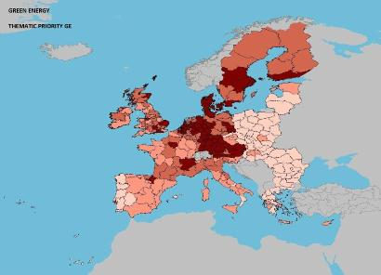
Scientific production Environment Technological production
Scientific production Food, agriculture and fisheries Technological production
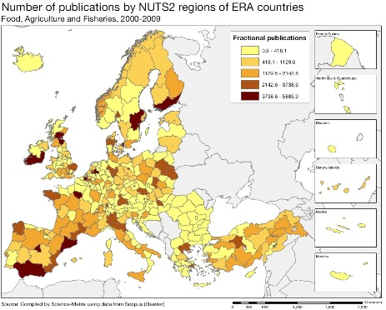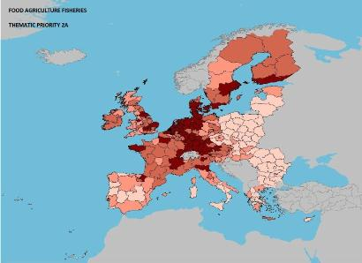

Source: DG Research and Innovation – Economic Analysis unit
Data: Science Metrix using Scopus (Elsevier), 2010; European Patent Office, patent applications, 2001-2010

Scientific production Biotechnology Technological production
Scientific production Health Technological production
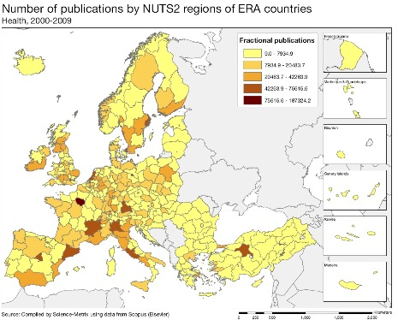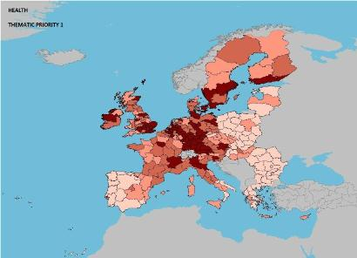
Scientific production Materials Construction technologies Technological production

Denmark shows a stronger performance in patenting than in scientific production. It has a high number of patent applications per inhabitant and it also has a growing number of highly-cited patents (reflecting technology breakthroughs). In scientific production Denmark only excels in food and agriculture, while in technological production (patenting) it has clear strengths at European level in energy (in particular green energy), environment, food and agriculture, biotechnology, health (in particular medical technologies) and construction technologies. Other fields of technology strengths include electrical machinery, engines, pumps and turbines, plastic products, and audio-visual products.

Denmark has scope for enhancing scientific strengths in areas related to these technology fields (mainly industry-led), as shown by the maps above. The high share of total Danish scientific publications in the 10 % most cited scientific publications worldwide shows that the quality of Danish scientific output is world-class. A weakness can be seen in the scale of scientific and technological production as science, technology and industry clusters need both high quality and a critical mass. There are opportunities to be found in an active use of European-wide instruments, such as the ESFRI infrastructure, in networking or smart specialisation scaling up dynamics and in enhancing potential clusters through the use of EU Structural Funds.
Policies and reforms for research and innovation

Denmark has recently launched reforms to boost innovation, in particular through the Danish Globalisation Strategy, the Business Innovation Fund and the proposal "Strengthening innovation in business". Furthermore, the 2010 "Enterprise package" has been extended to 2011 and a new "Competition package" was launched in 2011 with 40 initiatives to promote competition and productivity. Denmark has set a target for reducing the administrative burden for business. Although this target was met in 2010, the government has launched a new strategy for reducing the administrative burden still further. Denmark, already a leading country when it comes to e-government, has launched a new e-government strategy in 2011. From the end of 2012 all new enterprises will be equipped with basic tools for digital communication with the authorities.

In 2009 and 2010, new innovation policy measures have been introduced in Denmark targeting private R&D investment, including increased public procurement of eco-innovations, support for large demonstration facilities, the launch of the Renewal Fund and a risk capital fund. Finally, the "Energy Strategy 2050", a long-term and broad national strategy for energy for the horizons 2020 and 2050, is also relevant in this context as it contains measures for boosting innovation in an area, which is a central challenge for Denmark and a global business opportunity for Danish firms. Furthermore, Our Future Energy, an energy agreement for Danish energy policy 2012-2020, was launched in March 2012. In December 2012 Denmark has adopted a new broad innovation strategy. This includes the identification of areas where Denmark has competitive advantages, in line with the EU Horizon 2020 programme.

There is a good opportunity for active supply-side and demand-side innovation in the areas where Denmark has competitive advantages, such as wind energy, organic chemistry, pharmaceuticals and biotechnologies. Such strategies should from the beginning be connected to European instruments, in particular the European Innovation Partnerships, Horizon 2020 and ESFRI infrastructures. This would create stable and long-term framework conditions for the Danish industry to invest strategically in research and innovation.

Finally, an increase in R&D intensity would probably make it easier for Denmark to maintain its position among the most innovative and knowledge-intensive economies in the world. The mid-term review of the Europe 2020 objectives (in 2014-2015) could constitute an opportunity in this respect. Other Nordic countries (Sweden, Finland) have set R&D intensity targets of 4% and competitors in Asia have R&D intensity targets of up to 5% (South Korea). Given the low productivity growth in Denmark and the need for an evolution towards more broad innovation activities in firms, including investment in intangibles, Denmark would benefit in particular from combining the strategic focus of its innovation policy with increased public investment in R&D.

Economic impact of innovation

The index below is a summary index of the economic impact of innovation composed of five of the Innovation Union Scoreboard's indicators.
Danish SMEs are relatively dynamic, pursuing technology development with a higher intenstiy of patent applications in young firms than is found in the United States and with a high share of SMEs with new-to the-market products. The index of economic impact of innovation is at a clearly higher level than in the EU as a whole and close to the reference group of countries. A relative weakness in Denmark is a lower contribution to the trade balance of medium and high-tech product exports.
The quality of the innovation environment for firms in Denmark is well above the EU average. Denmark has good administrative support for business, a determined policy to promote creative and entrepreneurship skills in primary and secondary schools and a relatively high public procurement culture for advanced technology products as perceived by business leaders.
However, in some areas Denmark is lagging behind other innovation leaders, in particular in private funding of innovation (venture capital investment for the expansion and replacement phase, the presence of business angel groups and the perceived ease of access to loans), in some aspects of entrepreneurship (e.g. the fear of failure rate) and in the intensity of local competition and perceived buyer sophistication. Market mechanisms and indirect funding of R&D through tax incentives have played a larger role in Denmark than direct funding of business R&D, features which distinguish Denmark from the other Nordic countries.
The Danish business environment is marked by a wide range of competition-friendly regulations (it is ranked 5th out of 183 economies on the ease of doing business indicator). The innovation environment for firms in Denmark is well above the EU average and Denmark's R&D investment target of 3% of GDP had already been achieved in 2009. Compared to other innovation leaders, Denmark has a higher share of SMEs among its companies coupled with a relatively high business R&D intensity within SMEs. Denmark therefore has a clear potential to further increase its technology development via a structural change towards a higher share of knowledge-intensive sectors. In fact over the last ten years Denmark has caught up rapidly in terms of patent applications, license revenues and employment in knowledge-intensive activities.
Upgrading the manufacturing sector through research and technologies

The graph below illustrates with the upgrading of knowledge in different manufacturing industries. The position on the horizontal axis illustrates the changing weight of each industry sector in value added over the period. The general trend to the left-hand side reflects the decrease of manufacturing in the overall economy. The sectors above the x-axis are sectors whose research intensity has increased over time. The size of the bubble represents the share of the sector (in value added) in manufacturing (for all sectors presented on the graph). The red-coloured sectors are high-tech or medium-high-tech sectors.

As shown by the graph above the share of value added of high-tech and medium high-tech sectors (red circles) in the Danish economy has decreased since 2001, despite a general increase in R&D intensity (R&D intensity declined only in machinery and equipment, and medical, precision and optical instruments). The only high-tech or medium-high-tech sector with an increase in its share of value added was electrical machinery and apparatus. In general productivity growth has been low. The Danish government recognises as a major challenge the need to increase the number of innovative companies and to accelerate productivity growth in the manufacturing and services sectors.

One possible reason for the low productivity growth is a relatively lower level of innovation in Danish manufacturing enterprises, a level which is far below the levels of other Nordic countries. Underlying factors can be linked to the weaker dimensions of Denmark's innovation environment (risk funding, entrepreneurship, competition and market sophistication) and to the limited internationalisation of Danish technology development and firms. However, it can also be linked to Denmark's industrial structure, which would have to change towards more knowledge-intensive sectors and larger firms to make it more innovation oriented. In this respect fast growing innovative firms represent a key asset and future potential for Denmark as has been illustrated in the previous part of this profile.
Competitiveness in global demand and markets

Investment in knowledge, technology-intensive clusters, innovation and the upgrading of the manufacturing sector are determinants of a country's competitiveness in global export markets. A positive contribution of high-tech and medium-tech products to the trade balance is an indication of specialisation in these products.

Within the framework of an increasing Danish export surplus, the contribution of the majority of high-tech (HT) and medium-tech (MT) products to Denmark's trade balance has not changed significantly between 2000 and 2010. However, inside the important sector of machinery and equipment there are several product categories, including power generating machinery and machinery specialised for particular industries, which showed a significant growth in their contributions to the trade balance. Electrical machinery and apparatus, a sector that has improved its research intensity, also expanded its contribution to the trade balance. Hence, there is an increasing specialisation of the country in the above mentioned products. The contribution of medicinal and pharmaceutical products to the trade balance has decreased significantly between 2000 and 2010. Overall the share of high-tech exports in total exports is below the EU average, but there is a relatively high share of knowledge-intensive services in service exports.

The Danish economy is characterised by a relatively low productivity growth, both in the services and the manufacturing sectors. Possible explanations are an economic structure with a high share of services, which tend to have lower productivity growth than manufacturing industries, a low level of local competition due to the small size of the market and an insufficient level of innovation in relation to the country's potential. Total factor productivity has hardly grown since 2000 implying that there was little contribution from innovation and human capital development to productivity growth. The employment rate and the quality of human capital, as evidenced by the tertiary education attainment rate of the population, are high in Denmark, but there was little progress on these indicators in recent years and even a decline since 2005. However, Denmark has improved its performance as regards the other Europe 2020 targets in recent years.

Key indicators for Denmark

See Methodological note for the composition of this index.
IU scoreboard 2011: http://www.proinno-europe.eu/inno-metrics/page/country-profiles-czech-repucblic
Corresponding resp. to Severozapad and Prague
The proposed Higher Education Act was rejected in June 2012
See Methodological note for the composition of this index.
EU Industrial R&D Scoreboard
Measured as change in GDP per person employed
In the 2011 budget there was an increase for R&D of 4.7%. According to a recent survey (ERAC) the 2012 budget increased by 3.5%. However, a decrease of 3.6% is expected in the 2013 budget.
Mainly due to a low application rate. The financial contribution success rate was the 5th highest in the EU.
For most of the relevant sectors of the Danish economy, business R&D intensity increased over the last decade
Particularly noticeable for the Radio, TV and communication equipment sector.
Denmark's main scientific cooperation partners are the United Kingdom, Germany, Sweden and the Netherlands, but Danish scientists also cooperate extensively with researchers in Southern European countries.
See Methodological note for the composition of this index.
Source: World Bank Doing Business survey 2012.

