Germany

The challenge of maintaining a high innovation capacity for an export oriented economy

Summary: Performance in research, innovation and competitiveness
The indicators in the table below present a synthesis of research, innovation and competitiveness in Germany. They relate knowledge investment and input to performance or economic output throughout the innovation cycle. They show thematic strengths in key technologies and also the high-tech and medium-tech contribution to the trade balance. The table includes a new index on excellence in science and technology which takes into consideration the quality of scientific production as well as technological development. The indicator on knowledge-intensity of the economy is an index on structural change that focuses on the sectoral composition and specialisation of the economy and shows the evolution of the weight of knowledge-intensive sectors and products and services.
 | Investment and Input | Performance/economic output
Research | R&D intensity  2011: 2.84% (EU: 2.03%; US: 2.75%)  2000-2011: +1.28% (EU: +0.8%; US: +0.2%) | Excellence in S&T  2010:62.78 (EU: 47.86; US: 56.68)  2005-2010: +3.88% (EU: +3.09%;US: +0.53)
Innovation and  Structural change | Index of economic impact of innovation  2010-2011: 0.813 (EU:0.612) | Knowledge-intensity of the economy  2010:44.94 (EU: 48.75; US: 56.25)  2000-2010: +1.04% (EU: +0.93%; US: +0.5%)
Competitiveness | Hot-spots in key technologies  Automobiles, Environment, Energy, New production technologies | HT + MT contribution to the trade balance  2011: 8.54% (EU: 4.2%; US: 1.93%)  2000-2011: -0.70% (EU: +4.99%; US:-10.75%)
Germany has expanded its research and innovation system over the last decade. Investment in R&D has grown substantially since 2000 to reach 2.84% of GDP in 2011, which is already close to the 3% national target for 2020. Public expenditure represents one third of investment in R&D. The government increased the public budget on research and innovation even during the 2009 economic crisis as part of a policy of prioritising spending on education and research. Business enterprise expenditure on R&D, which represents two thirds of investment in R&D, also grew as a % of GDP over the period 2000-2010.
The increase in public and private expenditure on research and development in Germany has helped to maintain a high innovation capacity and a strong export performance. The German economy is based to a considerable extent on medium-high technology sectors such as automobiles, electro-technical products, machinery, and chemical products. However, over the last decade Germany has lost its strong market position in pharmaceuticals and in optical industries. Germany has only produced a few successful new players in high-tech industries in the recent past. The development of biotechnology and advanced computer science remains below potential. There is also still underexploited growth potential as regards innovative and knowledge-intensive service economy sectors. Germany has come through the current economic crisis relatively well, partly as a result of a strong export sector. However, the German market position as regards medium-high-tech products may be challenged in the future by new players such as the BRIC countries. An ageing population and fewer young people represent further challenges for the German economy.
The German ministry for research (BMBF) has employed the so-called High-Tech Strategy to address several important challenges. However, further structural reforms of the education, research and innovation system are required. In view of the demographic situation a particular focus on the quality of human resources is necessary and further incentives for excellence and internationalisation are needed. There is room for more public-private cooperation and for implementing targeted supply-side and demand-side measures to foster innovation and fast-growing innovative firms in Germany. Such measures should in particular be targeted at high-tech sectors such as ICT, biotechnology and medical technologies.
Investing in knowledge
With an R&D intensity of 2.84% in 2011 Germany is above the EU average and is already close to the 3% national target. The gap of 0.16 percentage points currently corresponds to € 4 billion (German GDP amounted to about € 2.5 trillion in 2011). About one third of German R&D investment comes from public sources and two thirds from private sources - a distribution that has remained fairly stable over the last decade. Based on this distribution an additional € 1.5 billion of public expenditure on R&D will be needed (compared to 2011) to reach the R&D intensity target of 3.0%.

In the period 2000-2011 the federal public research budgets, which represent more than half of public spending on research, were expanded substantially. Federal spending on research and education increased by a further 7% in 2011 and by 12% in 2012. However, at Länder level, growth in R&D expenditure, including university expenditure on R&D was much lower. R&D intensities vary strongly between German Länder, ranging from 1.26% in Schleswig-Holstein and 1.27% in Saarland to 4.83% (2009) in Baden-Württemberg, the European region (NUTS II level) with the highest research intensity. Berlin (3.67%), Bayern (3.1%) and Hessen (3.05%) also have R&D intensities that are already above the German national target.

A recent survey of the Stifterverband für die Deutsche Wissenschaft revealed that internal R&D spending of the business sector is expected to amount to € 49.4 billion in 2011 (+5.1% in nominal terms compared to the year before) and € 49.9 billion in 2012 (+1.2%), implying a probable increase in real terms in 2011 of slightly below 3%, and if confirmed, a slight decrease in real terms in 2012. Research intensity is especially high in the automobile sector, which represents nearly one third of total German business R&D investment. A weak point of German R&D is the relatively low level of spending in high-tech areas such as pharmaceuticals and ICT.

Concerning EU funding Germany has allocated € 25.5 billion of ERDF Structural Funds to research, innovation and entrepreneurship with a 47.1% absorption rate. Germany counts 11 000 participants in the EU FP7 programme and receives the highest amount of FP7 funding in absolute terms (€ 4.3 billion). Its success rate of applications is above average (24% compared to an EU average of 20.4%), but FP7 funding as a % of GDP is below the EU average.
An effective research and innovation system building on the European Research Area

The graph below illustrates the strengths and weaknesses of the German R&I system. Reading clockwise, the graph provides information on human resources, scientific production, technology valorisation, and innovation. Average annual growth rates from 2000 to the latest available year are given in brackets.
In general Germany's research and innovation system performs very well. However, the international dimension is below the EU average, in particular in relation to foreign investment in business R&D and EU Framework Programme funding. Possible explanations relate to the country size effect, as well as to the high level of German domestic public and private expenditure on R&D. Despite the easy access to and relative abundance of national funding for research, Germany could better use the opportunities offered within the ERA and more specifically within the Framework Programme.

Germany has a particular strength in business R&D especially in innovative SMEs, many of which are world leaders in their particular small market segments. The high level of patenting is an indication of industrial leadership in several domains, most notably in medium-high-tech industries including engineering industries, automobiles and chemicals and also in environmental and energy technologies. Public-private co-operation in publications and in research is functioning well and is further supported by the federal government in the current new programme activities for innovation outlined in the "High Tech Strategy". While Germany performs well in terms of new doctoral graduates, its performance as regards new science and engineering graduates has only recently surpassed the EU average and there is the risk of slower growth in the long term as a result of the ageingof the population. The risk of a scarcity of qualified human resources could in the long term endanger the strong German export position in engineering and science based industries. In recent years there has been an increase in the number of students in science and engineering subjects (MINT), but efforts should be maintained to further reduce dropout rates and to increase the share of female professors, which in turn would attract more female students.
Germany's scientific and technological strengths

The maps below illustrate six key science and technology areas where German regions have real strengths in a European context. The maps are based on the number of scientific publications and patents produced by authors and inventors based in the regions.

Strengths in science and technology at European level

Scientific production New production technologies Technological production
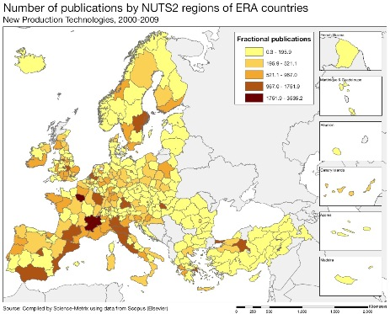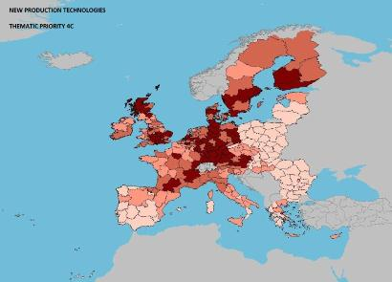

Materials
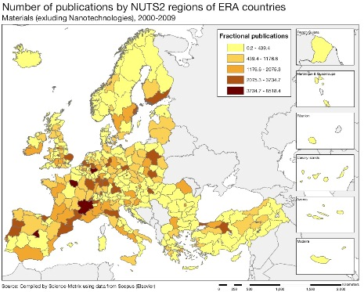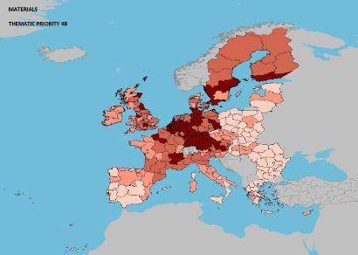

Automobiles
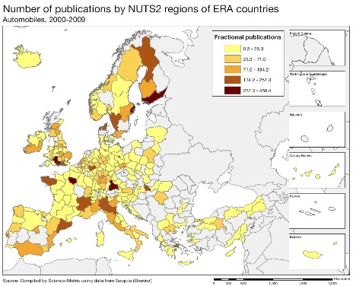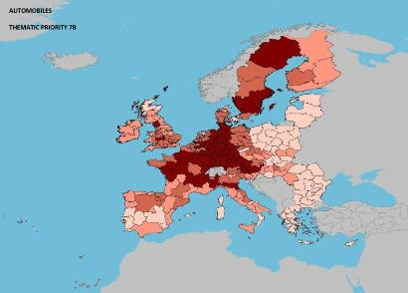

Source: DG Research and Innovation – Economic Analysis unit
Data: Science Metrix using Scopus (Elsevier), 2010; European Patent Office, patent applications, 2001-2010

Energy
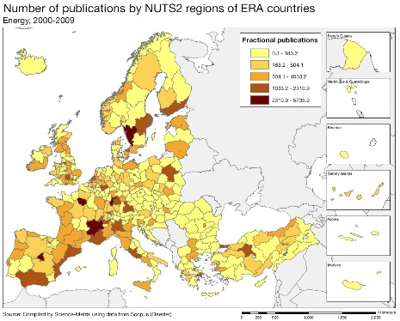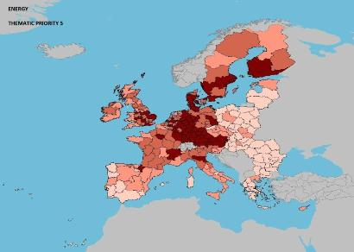
Environment
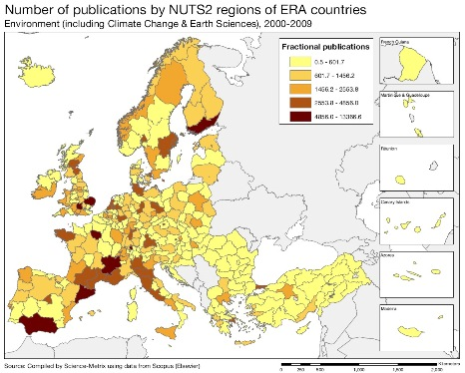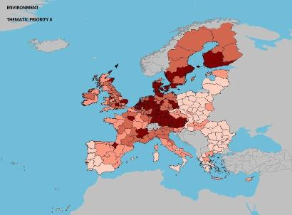

Health
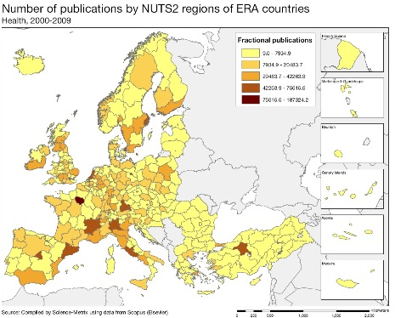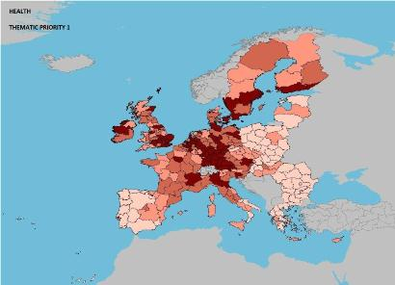

As illustrated by the maps above, there is a notable difference in performance between scientific production (publications) and technological production (patents) in Germany. Levels of scientific publication vary across German regions with only a few regions on the same level as their main competitors in Europe. This is even true for sectors such as production technologies, materials, and automobiles, where German companies are among the world leaders. An explanation of the relatively weak scientific publication activity in Germany may be a language bias.

Patenting activities in Germany are very high in the areas referred to above. Energy, environment and health are other areas where patenting is particularly strong. The big public research institutes such as the Max Planck Society, the Fraunhofer Society, the Helmholtz society, and also the Leibniz institutes are specialised in these areas, work closely with universities and are generally highly ranked in recognised international comparisons. The regions of the south and the south-west of Germany are most active in patenting. Saxony and southern Brandenburg (Potsdam) in the New Länder as well as Berlin also show relatively high levels of patenting.

Policies and reforms for research and innovation

The High-Tech Strategy 2020, launched in August 2006 and updated in July 2010, is seen as an instrument to improve cooperation between science and industry, and to improve the conditions for innovation with a view to enhancing the international competitiveness of technology-intensive manufacturing products in key sectors of the German economy. The 2010 update of the High-Tech Strategy prioritises the targeting by public-private partnerships of prospective markets related to important societal challenges in 10 so called forward-looking projects ("Zukunftsprojekte"). Strategic priorities of the High-Tech Strategy 2020 are health, nutrition, climate and energy security, and communication and mobility.

As regards fiscal policies Germany is one of the few countries that has not introduced R&D tax credits. The introduction of R&D tax credits is currently being considered at federal level as such credits tend to be requested by large international companies.

Germany is already quite close to achieving its national R&D intensity target of 3%. Only an extra 0.16 % of GDP or about € 4 billion are needed to reach the target. However, available data show an increasing disparity between R&D intensity in the northern Länder and the southern Länder. In fact R&D intensity is almost four times higher in Baden-Württemberg (the leading EU region) than in Mecklenburg-Vorpommern and Schleswig-Holstein. This disparity also applies to private investment in R&D.

The university system, which is the responsibility of the Länder, is considered to be underfinanced, given the recent strong increase in student numbers. In order to enable additional federal funding for universities, the Hochschulpakt (higher education pact), voluntary agreements between the federal and the Länder levels, has been set up. This pact was renewed in 2009 and additional resources were allocated in March 2011.

As regards human resources Germany has taken measures to remove restrictions on in-bound researcher mobility in view of a skills shortage in some science and technology domains. The federal government recently decided on a reform of the Immigration Act to facilitate the processing of residence permits, and on an action programme to ensure an adequate supply of labour, and on programmes for enhancing international mobility. The legal parameters for the employment of foreign graduates of German universities have been improved and the recognition of qualifications acquired abroad is being facilitated by new initiatives. This could help to increase the still relatively low share of foreign professors. Researcher salaries in Germany are above the EU average, but lag behind those in the United States and Switzerland. Recently the Constitutional Court issued a ruling on minimum wages for full professors in universities that could lead to increased salaries for those at the lower end of the wage scale.

A national pact to attract more women to science and engineering ('Komm mach MINT-mehr Frauen in MINT-Berufen') was set up on the initiative of the Research Ministry (BMBF) in June 2008 and a second phase of this pact was launched in December 2011.

As regards the knowledge triangle and the fostering of innovation activities the Research Ministry (BMBF) and the Ministry for Economic Affairs (BMWI) are making attempts to focus better their activities. The BMBF fosters public/private partnerships by activities such as the 'Leading-edge cluster competition', which aims at the formation of business and science clusters to boost Germany's innovative strengths in specific areas and more recently (August 2011) the 'Research Campus', a competitive funding scheme to strengthen cooperation between companies and research organisations. The BMWI uses the EXIST programme to stimulate an entrepreneurial environment at universities and research institutions. This programme is aimed at increasing the number of technology and knowledge-based business start-ups. The programme is part of the federal government’s 'High-tech Strategy' and comprises sub-programmes on improving start-up business culture, stipends and knowledge transfers.
Economic impact of innovation
The index below is a summary index of the economic impact of innovation composed of five of the Innovation Union Scoreboard's indicators..

Germany has one of the highest economic impact of innovation in Europe. The German economy is more oriented towards knowledge-intensive sectors than the EU as a whole. This is reflected also in the composition of exports of goods and services and in the innovation activities of enterprises, including those of SMEs, which are clearly above the EU average. Innovative German enterprises have a good growth performance combined with a high level of technology development.
The distribution of business expenditure on R&D reflects the concentration of German industry in medium-high-tech sectors, with more than 30% of R&D spending carried out by the automobile sector alone. Other important medium-high-tech sectors in terms of R&D expenditure are machinery and equipment and chemicals excluding pharmaceuticals. These three sectors represent around 50 % of business expenditure on R&D in Germany. Spending levels are relatively lower in high-tech areas with pharmaceuticals, radio, TV and communication equipment, and medical precision and optical instruments together accounting for only around 20% of business expenditure on R&D. Research is furthermore concentrated in big companies and research intensity is lower in the services sector than in manufacturing. To assist SMEs in enhancing research and innovation a Central Innovation Programme for SMEs (ZIM, 'Zentrales Innovationsprogramm Mittelstand') has been set up in 2008 and will run till 2014.
Framework conditions for entrepreneurship in Germany have improved as indicated by an improved ranking for Germany in the World Banks ease of doing business index. Germany has also made progress in reducing the administrative burden related to reporting obligations in the business sector. In 2011, The Bureaucracy Reduction and Better Regulation programme has been extended to cover other compliance costs. However, Germany remains at around the EU average regarding the administrative burden of the regulatory framework.
Labour productivity in Germany is high and access to bank lending for SMEs is above the EU average. The quality of the infrastructure is good and the legal and regulatory framework is perceived by business as being appropriate. Remaining weak points concern the availability of broadband and the usage of e-government services. Furthermore the availability of venture capital in Germany (0.17% of GDP in 2011) remains below the EU average (0.35%).
In the Global Competitiveness Report 2012-13 Germany is ranked highest among EU countries in capacity for innovation, second highest (after Finland) in company spending on R&D and 6th in the EU on university-industry collaboration on R&D.

Upgrading the manufacturing sector through research and technologies

The graph below illustrates the upgrading of knowledge in different manufacturing industries. The position on the horizontal axis illustrates the changing weight of each industry sector in value added over the period. The general trend of moving to the left-hand side reflects the decrease of manufacturing in the overall economy. The sectors above the x-axis are sectors whose research intensity has increased over time. The size of the bubble represents the share of the sector (in value added) in manufacturing (for all sectors presented in the graph). The red-coloured sectors are high-tech or medium-high-tech sectors.

The German economy is characterised by a relatively strong manufacturing industry. Nevertheless, as in many countries, the share of value added of manufacturing industries in total value added is tending to decrease (illustrated by a leftward shift in the graph above). This is linked to rationalisation and a relative decline in the price levels of manufactured goods, the expanding services sector and also to globalisation and competition from lower wage, emerging economies.

Compared to other EU Member States the German manufacturing industries present an above average dynamic of upgrading knowledge through R&D. Growth in business research intensity since 1995 was moderate, but still faster than the EU average. The motor vehicles industry, a key sector of the German economy, has expanded its high research intensity further and has also succeeded in increasing its share of value added. A second important medium-high-tech sector, machinery and equipment, has expanded its share of the economy even more strongly, despite a more moderate growth in research intensity. The same is true for the high-tech sector medical, precision and optical instruments. The medium-high-tech sector electrical machinery and apparatus, has lost research intensity over the last 15 years, but maintained its share of value added. Office, accounting and computing machinery is the only high-tech sector with a decreasing share of value added. In this sector there was also a decline in research intensity over the last 15 years. The insufficient pace of modernisation in these knowledge-intensive industries endangers their medium-term competitive advantage.
Competitiveness in global demand and markets

Investment in knowledge, technology-intensive clusters, innovation and the upgrading of the manufacturing sector are determinants of a country's competitiveness in global export markets. A positive contribution of high-tech and medium-tech products to the trade balance is an indication of specialisation and competitiveness in these products.
The German economy is strong and has high levels of exports of manufactured goods for an economy of its size. In fact, Germany is the third largest exporter worldwide, after China and the United States. In 2010 Germany was the economy with the largest export surplus in absolute terms. As regards trade in services, in 2010 Germany ranked second, after the United States. In real terms, the German trade balance in high-tech and medium-tech products is positive and has more than doubled over the last decade.
The evolution of the contribution of high-tech and medium-tech products to the trade balance in the decade 2000-2011 shows a mixed picture for Germany, with few sectors expanding their contribution to the trade balance, most sectors not changing their contribution significantly and about one quarter of high-tech and medium-tech sectors decreasing their contribution. As regards the three largest German export industries, all classified as high-tech or medium-high-tech: machinery, in particular office machinery and power generating machinery has expanded its contribution to the trade balance, while road vehicles, today Germany's largest export industry, has also expanded its contribution, but to a lesser extent. The contribution of chemical products, Germany's third largest export industry, to the trade balance has shrunk over the same period.
Total factor productivity of the German economy increased since 2000 by 5% per annum. However, Germany has performed less well when it comes to up-skilling its labour force. The share of the population aged 30-34 who have successfully completed tertiary education has increased only moderately since 2000 and is now below the EU average. Germany is also making progress towards the other Europe 2020 targets, backed up by a very high but decreasing level of patenting in areas of societal challenges, such as health-related and environment-related technologies.
Key indicators for Germany

Greece
Focusing resources for a more knowledge-intensive economy

Summary: Performance in research, innovation and competitiveness

The indicators in the table below present a synthesis of research, innovation and competitiveness in Greece. They relate knowledge investment and input to performance or economic output throughout the innovation cycle. They show thematic strengths in key technologies and also the high-tech and medium-tech contribution to the trade balance. The table includes a new index on excellence in science and technology which takes into consideration the quality of scientific production as well as technological development. The indicator on knowledge-intensity of the economy is an index on structural change that focuses on the sectoral composition and specialisation of the economy and shows the evolution of the weight of knowledge-intensive sectors and products and services.
 | Investment and Input | Performance/economic output
Research | R&D intensity  2011: 0.60% (EU: 2.03%; US: 2.75%)  2000-2011: +0.56% (EU: +0.8%; US: +0.2%) | Excellence in S&T  2010:35.27 (EU:47.86; US: 56.68)  2005-2010: +2.53% (EU: +3.09%;US: +0.53)
Innovation and  Structural change | Index of economic impact of innovation  2010-2011: 0.345 (EU: 0.612) | Knowledge-intensity of the economy  2010:32.53 (EU:48.75; US: 56.25)  2000-2010: +2.52% (EU: +0.93%; US: +0.5%)
Competitiveness | Hot-spots in key technologies  Food, agriculture and fisheries, Textiles, Services for computers, Manufacture of electrical motors generators and transformers | HT + MT contribution to the trade balance  2011: -5.69% (EU: 4.2%; US: 1.93%)  2000-2011: n.a. (EU: +4.99%; US:-10.75%)
Until the recent economic crisis, Greece grew at a faster rate than the economies of most of the other EU Member States and the United States, notably in the period immediately after joining the European single currency (between 2002 and 2005). Greece made clear progress in improving its scientific quality and it benefitted from an expanding global value chains. However, between 2001 and 2007 (the latest available year), R&D intensity in Greece never exceeded 0.60%, with a very low business R&D intensity (0.15% in 2000 and 0.17% in 2007). Overall R&D investment grew significantly over the period 2001-2006, but this did not result in any significant increase in R&D intensity because of almost equally strong growth in GDP over the same period. In addition to the problem of the low level of business investment in R&D, the efficiency and effectiveness of spending on R&D remains a challenge and the pace of implementation of reforms is slow.
Among the most pressing challenges, it can be noted: an integrated legal framework for research performers is lacking (the overall system is dominated by the universities); the articulation of R&I policy with other policies is weak, with feeble links between education, research and the business sector. Exploitation of research results by the business sector is very limited, with very low patenting activity. The knowledge-intensity of the economy is low (35.53 in 2010 compared to an EU average of 48.75).
The strategy defined in 2011 identifies six main research priorities focusing on sectors and technology areas that are either very important for the economy or addressing societal challenges: materials and chemicals; agro-biotechnology and food; ICT and knowledge intensive services; health and biomedicine; energy and environment; applied economic and social research, and research on cultural heritage. A reform of institutional research structures responds to the need to increase critical mass, focus the research agenda and avoid fragmentation. In this respect, Greece has in particular room for a further realignment of its research centres for an increased concentration of resources, as well as an improvement of the efficiency of the research sector and the development of its links with the business sector.
Investing in knowledge

The latest data available for Greece date back to 2007. R&D intensity in Greece was stagnating at around 0.60% and was marked by a particularly low business R&D intensity which increased at an average annual rate of 2.3% between 2000 and 2007. In 2011 Greece set an R&D intensity target of 2% to be achieved by 2020, but this target was cancelled at the end of 2011 due to the budgetary constraints and to the economic crisis. No new target has been announced.

The bailout agreement with IMF, ECB and the European Commission, resulted in a consolidation programme and deep cuts to public expenditure and investment. In 2008 (the latest year available for Greece), the share of government budget for R&D in general government expenditure was 0.59%, significantly lower than the EU average of 1.52%. The percentage of business R&D financed by the government at 4.7% was also well below the EU average of 6.8%. National funding of R&I is complemented by EU funding. In terms of number of FP7 applicants and requested contribution, Greece is ranked in 7th place (2011 data). In terms of number of participations and budget share, Greece is ranked 9th with 1205 contracts.

The main supporting driving force behind the Greek research and innovation system is related to the Cohesion policy. The core Operational programme "Competitiveness and Entrepreneurship" has a total budget of € 1.52 billion of which the Cohesion policy provides € 1.29 billion (EC contribution). The Operational Programme has 3 strategic objectives for the period 2007-2013, with Research and Innovation as one of the major intervention areas.

An effective research and innovation system building on the European Research Area

The spider graph below provides a synthetic picture of strengths and weaknesses in the Greek R&I system. Reading clockwise, the graph provides information on human resources, scientific production, technology valorisation and innovation. The average annual growth rates from 2000 to the latest available year are given in brackets under each indicator.

The innovativeness of the Greek economy depends heavily on imported technology and know-how. It builds on organisational and marketing innovations and until now very little on the production and exploitation of new knowledge, which may lead to difficulties in finding new sources of growth in a context of even increasing global competition. The graph above illustrates this.

Greece is below the EU average for most of the dimensions of its R&I system, namely in human resources, scientific production and technology development. However, it scores above the EU average for innovative SMES introducing marketing, organisational and product or process innovations. BERD financed from abroad as % of total BERD is well above the EU average, and before the economic crisis had an average annual growth rate of 26.5% for the period 2001-2007. Other indicators have shown positive catching-up dynamics before the economic crisis over the period 2000-2007: the quality of the scientific base grew as shown by an average annual growth of 6.2%, the number of researchers per thousand labour force and new doctoral graduates (ISCED 6) per thousand population aged 25-34 grew at a faster rate than the EU average. However, Greece suffered a net outflow of students to the United States before the economic crisis.
Greece's scientific and technological strengths

The maps below illustrate key science and technology areas where Greece has real strengths in a European context. The maps are based on the number of scientific publications and patents produced by authors and inventors based in the regions.

Security: scientific publications
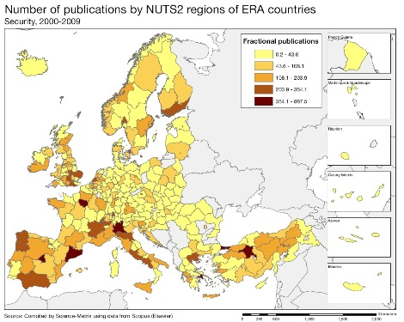
Scientific publications Food, agriculture and fisheries Technological patents 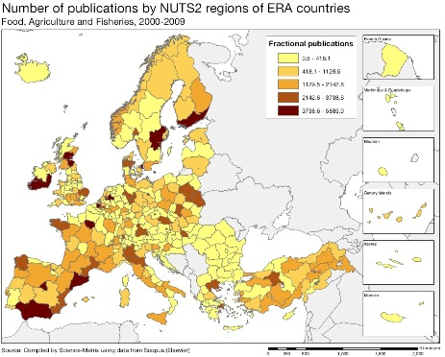 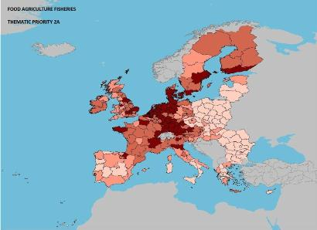

Services for computer patents Manufacture and sales of textiles patents
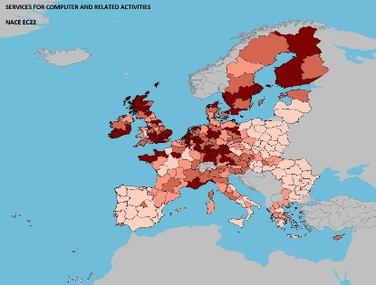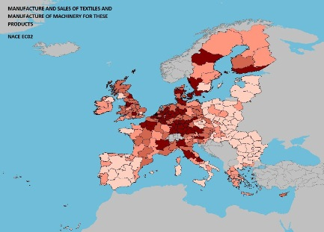

Manufacture of electrical motors generators and transformers patents

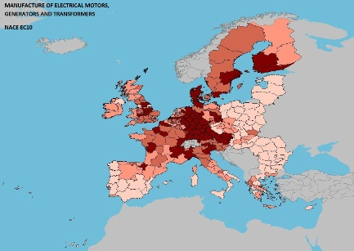

Source: DG Research and Innovation – Economic Analysis unit
Data: Science Metrix using Scopus (Elsevier), 2010; European Patent Office, patent applications, 2001-2010

Greece has a high level of scientific production in construction, ICT, security, aeronautics and space, transport, production and energy. From the point of view of scientific specialisation, only the first three themes together with automobiles can be considered as highly specialised. Greece's technological specialization is mainly in food and agriculture, space, construction, aeronautics and environment. This thematic analysis points at room for improvement in matching the science base and the knowledge needs of the Greek economy. Although there is an insufficient convergence of S&T specializations, there is a strong science base to build upon. The exceptions are the construction sector and the food, agriculture and fisheries sector, where convergence is well marked. Current trends indicate a lack of clarity regarding the country's areas of specialisation that could be addressed in the national/regional smart specialisation strategies under development, in particular in matching science and innovation bases.
Policies and reforms for research and innovation
The General Secretary of Research and Technology, appointed in May 2011, defined a new strategy for R&D and innovation. A number of main areas of strategic importance have been defined as national priorities: 1) agro-food, 2) information and communication technologies, 3) materials/chemicals, 4) energy-environment, and 5) health/biomedical sectors.
The process for meeting those priorities (and serving the country's research needs) is based on four dimensions: (1) strengthening and supporting the scientific/research personnel and research infrastructure; (2) encouraging links between the scientific/research community and businesses and entrepreneurs; (3) supporting bilateral, European and international collaboration; and (4) outreach and education for research in the community (particularly youngsters). Each of these dimensions will be implemented through a series of calls for proposals. In addition, a "Policy Mix Project" formed of six routes to stimulate private R&D investment is on-going.
Existing and planned programs support R&I in enterprises, in particular in SMEs. The Operational Programme “Competitiveness and Entrepreneurship 2007-2013” aims at enhancing cooperation between SMEs and Research centres and universities. This framework is expected to increase the low propensity of SMEs to invest in R&I. A monitoring and evaluation of results would certainly be helpful to meet this crucial challenge for Greece. The success of these programmes is linked both to increasing the user-friendliness of the schemes and to significantly improving framework conditions that would increase the absorption by the private sector.
Public policies indeed face the challenge of shaping the conditions influencing business demand for R&D-based knowledge by opening up the internal market to competition, eliminating factors hampering entrepreneurship and shifting emphasis from supply to demand. An ambitious programme of reforms was launched in 2010 aiming to improve the enabling environment for R&D and innovation investment. The measures include significant improvements to the regulatory framework, the development of industrial areas and business parks, and a roadmap for removing the most important obstacles to entrepreneurship and innovation. In addition, the funding of clusters has become a promising dimension for improving the innovation climate. Following in the footsteps of the Corallia microelectronics cluster (funded with €35 million in 2008), the creation of new "knowledge intensive" clusters is foreseen in 2012. However, the deterioration of the Greek economic situation continues to discourage business investment.

Economic impact of innovation
The index below is a summary index of the economic impact of innovation composed of five of the Innovation Union Scoreboard's indicators.
According to this index, the economic impact of innovation in Greece is slightly above its reference group, much below the EU average. Greece's performance on three of the five indicators is particularly low: patents inventions, contribution of high- and medium-tech products to the trade balance and share of knowledge intensive exports in services exports. In contrast, the performance on sales of new-to-market and new-to-firm products is very good. One key factor to increase the economic impact of innovation is of course the structural change that allows innovation-driven growth. High-growth innovative firms in particular play a catalytic role in this respect.

Greece traditionally has a very low business R&D intensity which is directly linked to two main structural features of the economy: the small size of the firms and the sectoral composition of the economy (mostly low-tech and medium-low-tech sectors). Nevertheless, Greece has maintained a regular presence in the EU Industrial R&D Investment Scoreboard, since 2005, with four to six companies a year in the top 1000 R&D EU investors, mainly in three sectorss: ICT, pharmaceuticals, and services (leisure, travel). These firms have increased their R&D investment in 2009 and 2010, by 5% and 3.2%, respectively.
The challenge is now to foster the creation and development of new innovative firms. Human resources and entrepreneurship provide strong building blocks for Greek firms. However Greek firms are lagging behind in relation to finance, business investment and intellectual assets. The low level of output from research activity and the need to increase the links between universities and industry are two of the key challenges facing the Greek R&I system. The private sector has a reduced share in total expenditure on R&D, reflecting the low demand for research-based knowledge from the business sector. A combination of factors including the predominance of low-tech sectors, significant institutional and bureaucratic obstacles and a volatile policy environment are orienting business activities towards less knowledge-intensive and lower value added segments of the economy.
Restricted access to capital, especially for new firms, due to the reluctance of the financial system to finance innovation and to undertake risky investments, is also among the factors hindering mobilisation of resources for R&D. Greece has recently made good progress in simplifying procedures for start-ups and reducing overall costs. Launched in 2011, this new system has already supported the creation of 7000 new firms. It aims at improving framework conditions and facilitating growth at a time of rising unemployment and frozen hiring procedures in the public sector.
Upgrading knowledge and technologies in the manufacturing sector
The graph below illustrates the upgrading of knowledge in different manufacturing industries. The position on the horizontal axis illustrates the changing weight of each industry sector in value added over the period. The general trend of moving to the left-hand side reflects the decrease of manufacturing in the overall economy. The sectors above the x-axis are sectors whose research intensity has increased over time. The size of the bubble represents the share of the sector (in value added) in the economy (for all sectors presented on the graph). The red-coloured sectors are high-tech or medium-high-tech sectors.
The Greek service sector accounted for 79% of value added in 2009 compared to a share of 10% for manufacturing. In 1995, the corresponding share for the service sector was 70% and for manufacturing was 12%. The construction sector dominates the manufacturing sector. It accounted for 6.01% of total value added in 1995, reaching a peak of 8.16% in 2001 before declining to 4.45% in 2009.
The graph above synthesises the structural change of the Greek economy over the 1995-2007 period. It shows that the economy has become slightly less industrialised and more services oriented. The small increase registered in business expenditures on R&D after 1995 (with a negative trend in the period post 2000) has been caused by the increase in the research intensities of a few individual sectors, in particular the chemicals and chemical products sector. With tourism in a dominant position, the service sector (not shown in the figure above) has overtaken all other sectors in terms of contribution to value added (following a similar trend to most of the other EU countries).

Competitiveness in global demand and markets
Investment in knowledge, technology-intensive clusters, innovation and the upgrading of the manufacturing sector are determinants of a country's competitiveness in global export markets. A positive contribution of high-tech and medium-tech products to the trade balance is an indication of specialisation and competitiveness in these products.
Over the period 1995-2009, the Greek economy gained slightly in world competitiveness. The world market share of Greek products and services was around 0.53% in 2009 compared to 0.42% in 1995, with a smaller share for more knowledge-intensive products. Nevertheless, the situation of the Greek trade balance in general has been negative and deteriorating rapidly with a peak registered in 2008. The trade balance in all high-tech and medium-tech products together followed the same pattern, remaining negative over the last decade and slightly decreasing the gap after 2008. To achieve this inversion of trend, and as shown in the graph above, most high-tech and medium-tech industries improved their contribution to the trade balance. This is the case for road vehicles, general industrial machinery and equipment, plastics in primary forms, iron and steel and machinery specialised for particular industries. In contrast, other transport equipment and fertilizers have reduced contributions to the trade balance while several sectors are stagnating. The strong specialisation of Greek industry in food processing industries, and at a lower scale, in textiles and chemicals, is only partially reflected in the trade balance thus highlighting the need to increase the competitiveness of the main sectors. This situation is also confirmed in the previous graph which shows that most of the manufacturing sectors have not increased their value added over the last 15 years.
Other features of the Greek R&I system are shown in the table below: employment in knowledge intensive activities (manufacturing and business services) as % of total employment is rather low (11.4% compared with EU average of 13.6%). Greek total factor productivity increased from 2000 until 2007, only to decrease afterwards and reach in 2012 a value inferior to the one registered in 2000. The employment rate decreased by three percentage points between 2000 and 2011; this leaves Greece with the lowest employment rate in the EU. A high percentage of the population is at risk of poverty or social exclusion (31% compared to an EU average of 24.2%).
Key indicators for Greece

Hungary
Gearing reforms to removing obstacles to the growth of innovative companies

Summary: Performance in research, innovation and competitiveness

The indicators in the table below present a synthesis of research, innovation and competitiveness in Hungary. They relate knowledge investment and input to performance or economic output throughout the innovation cycle. They show thematic strengths in key technologies and also the high-tech and medium-tech contribution to the trade balance. The table includes a new index on excellence in science and technology which takes into consideration the quality of scientific production as well as technological development. The indicator on knowledge-intensity of the economy is an index on structural change that focuses on the sectoral composition and specialisation of the economy and shows the evolution of the weight of knowledge-intensive sectors and products and services.

 | Investment and Input | Performance/economic output
Research | R&D intensity  2011: 1.21% (EU: 2.03%; US: 2.75%)  2000-2011: +4.64% (EU: +0.8%; US: +0.2%) | Excellence in S&T  2010:31.88 (EU:47.86; US: 56.68)  2005-2010: +2.03% (EU: +3.09%;US: +0.53)
Innovation and  Structural change | Index of economic impact of innovation  2010-2011: 0.527 (EU: 0.612) | Knowledge-intensity of the economy  2010:50.23 (EU:48.75; US: 56.25)  2000-2010: +1.87% (EU: +0.93%; US: +0.5%)
Competitiveness | Hot-spots in key technologies  Health, Environment, Automobiles, Biotechnology | HT + MT contribution to the trade balance  2011: 5.84% (EU: 4.2%; US: 1.93%)  2000-2011: +9.04% (EU: +4.99%; US:-10.75%)

Over the last decade, the Hungarian research and innovation system has made clear progress in the level of private sector investment and in overall R&D intensity, as well as in scientific quality, patent revenues and structural change towards a more knowledge-intensive economy. In spite of the fact that public sector R&D intensity and the internationalisation of science is still less dynamic than the EU average, Hungary shows good progress among the countries with a similar industrial structure and knowledge capacity.
Hungary is still facing some key challenges in research and innovation. These include: a low level of innovation activity, especially by SMEs, together with a low degree of co-operation in innovation activities among the key actors; unfavourable framework conditions for innovation, in particular an unpredictable business environment, a high administrative burden and competition not conducive to innovation; an insufficient number of human resources for research (2015 forecast). Policy evaluation culture is weak in Hungary. According to basic principles stipulated in the Law of Research and Technological Innovation (2004), four external evaluations of funded support schemes were conducted between 2005 and 2011. The freeze of public funding in the second half of 2010 as well as the frequent changes in the structure of STI policy governance point however to some risks regarding the continuous policy commitment needed to further address these important challenges.
The newly-prepared innovation strategy is expected to provide specific well-targeted incentive schemes in support of innovative SMEs and of enterprises of intermediate size, with priority funding in the domains of the national thematic priorities. In addition, a specific scheme should support infrastructures and coordination activities within clusters of excellence in these domains. The principle of smart fiscal consolidation should re-establish the priority of public funding for research and innovation and lead to increasing levels of R&D intensity over the coming years.

Investing in knowledge

In the 2011 National Reform Programme, the Hungarian government set an R&D intensity target for 2020 of 1.8%. Hungary had an R&D intensity of 1.21% in 2011, up from 1.16% in 2010. An intermediary target of 1.5% by 2015 is set by the Science and Innovation Programme (as a part of the broader New Széchenyi Plan of January 2011). In 2010, 39.9% of total R&D expenditure (close to the EU average) was financed by government and 47.4% was financed by the business enterprise sector. This last figure reflects the increase in business R&D intensity from 0.41% in 2005 to 0.69% in 2010.
In Hungary, inward business investment in R&D as a % of total BERD decreased between 2003 and 2007 in contrast to the majority of European countries where internationalisation of R&D increased over the same period. However, the actual amount of inward business investment in R&D increased in nominal terms. Hungary has by far the highest ratio of inward FDI to GDP but only an average inward business investment in R&D intensity. Hungary, Spain and to a lesser extent Italy all suffered declines in intensity of inward investment in R&D over the period 1998-2007 (the latest period for which data are available).
Hungary has had a participant success rate of 20.4% in FP7 close to the EU average of 21.5%, and received more than € 114 million for 681 Hungarian participations in FP7 up to mid-2011. Hungary plans to invest € 2.16 billion of Structural Funds (2007-2013) in R&D and innovation, in particular in the regional growth poles with emphasis on enhancing R&D capacities.
An effective research and innovation system building on the European Research Area

The graph below illustrates the strengths and weaknesses of Hungary's R&I system. Reading clockwise, it provides information on human resources, scientific production, technology valorisation and innovation. Average annual growth rates from 2000 to the latest available year are given in brackets.

Hungary is below the EU average in almost all areas. However, the rate of BERD financed from abroad and EU FP7 funding per thousand GERD are higher than the EU average. The share of employment in knowledge-intensive activities is very close to the EU average.
Vulnerable areas include human resources, scientific production, innovation and technology production. Innovation activities in small firms are at a low level with only around 17% of Hungarian SMEs innovating by introducing a new product or a new process. This (with that of Latvia) is the lowest level in the EU. Only 5% of Hungarian scientific publications are in the top 10%-most cited scientific publications, compared to an EU average of 11.6%. Hungary has a low level of PCT patent applications with a decreasing trend. Hungary does better in terms of licence and patent revenue from abroad (not shown on the graph). This is probably due to the increased role of large foreign-owned enterprises in business R&D investment.
In the FP7, Hungary seems to be relatively well integrated in pan-European research collaborations. The top collaborative of Hungarian researchers are mainly with colleagues from Germany, the United Kingdom and France. The results of Hungarian participation to FP7 show a more intensive European cooperation of the public sector than of the industry.
Hungary's scientific and technological strength

The maps below illustrate six key science and technology areas where Hungary has real strengths in a European context. The maps are based on the number of scientific publications and patents produced by authors and inventors based in the regions.

Strengths in science and technology at European level
Scientific production Health Technological production
Scientific production Information and Communication Technologies Technological production
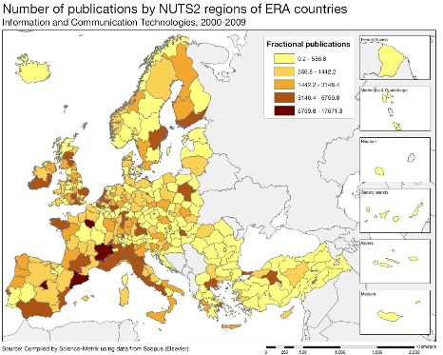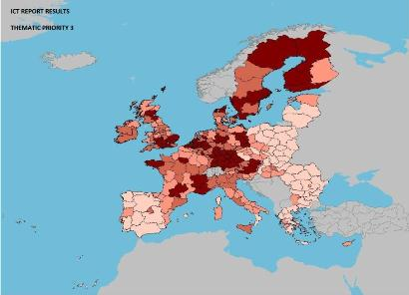
Scientific production Environment Technological production

Source: DG Research and Innovation – Economic Analysis unit
Data: Science Metrix using Scopus (Elsevier), 2010; European Patent Office, patent applications, 2001-2010

Scientific production Biotechnology Technological production
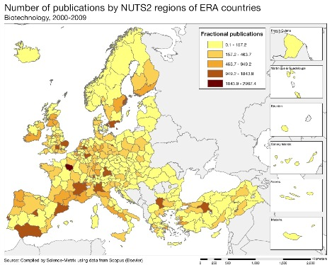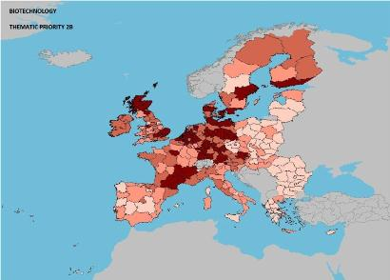
Scientific production Automobiles Technological production
Scientific production Security Technological production
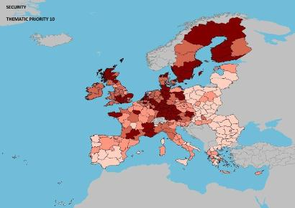

As illustrated by the maps, in terms of scientific production, Hungary´s strengths lie in automobiles and in information and communication technologies. The relative specialisation in terms of patenting is in biotechnologies and health. A quantitative analysis of the number of EPO patents (2000-2010) by applicant classified by FP7 thematic priorities shows that Hungary has a significantly higher share in the domain of health (33.4%) than the EU average (12.8%).
The RTA (revealed technological advance) index confirms that Hungary, with 2.21, is second in the EU after Slovenia in this domain. In the case of environment, Hungary had a growth index of 1.21 between 2000 and 2009 compared to an EU average of 1.25. In the case of automobiles, Hungary has the second highest specialisation index in the EU (2.42 compared to the much lower EU average of 1.07).
Policies and reforms for research and innovation

It is noticeable that R&D intensity increased during the first years of the economic crisis, demonstrating the effectiveness of the R&I strategy. The new strategy on research and innovation, referred to in the 2012 National Reform Programme is currently under preparation. The issue of the low share of innovative enterprises needs urgently to be addressed. Support measures geared to removing obstacles to the growth of innovative companies are indeed expected under the Science and Innovation Programme of the New Széchenyi Plan. The scope and the financial effort implied are however not yet known.

Whereas the new Science and Innovation Programme stipulates that the current policy mix should be reconsidered, no action has been taken to date. Moreover, the new National Research and Innovation Strategy due to be adopted by the end of 2011 has been postponed until the end of 2012. The mid-term STI strategy (2007-2013) stresses the need to align national and EU policy goals. While the national STI policy mix is not explicitly aligned with the specific ERA pillars and objectives, there is no major disparity between the national policy goals and the ERA initiatives.
Research and innovation governance has been reorganised twice since 2009. The high-level STI policy co-ordination body, the Research and Science Policy Council which was created in September 2009 was disbanded in December 2010 and replaced by the National Research, Innovation and Science Policy Council. In June 2010, the government discontinued all funding by the Research Technological Innovation Fund (RTIF). EUR 58.2 million, representing 36.6% of the RTIF's budget has been blocked following budgetary cuts. Several schemes, co-financed with the EU Structural Funds were, however, reopened in 2011. Following the freezing of national public funding, no new schemes have been introduced from mid-2010 with the result that EU funding has become increasingly more important.
The stronger sectoral areas identified in the OECD review (2008) have been confirmed as the national thematic priorities of the new Science–Innovation Programme (January 2011). These are: transport mobility, automotive industry and logistics, health industries (pharmaceutical, medical instruments and balneology), information and communication technologies, energy and environmental technologies, and creative industries. The national innovation strategy (as currently drafted) should be aligned with the concept of smart specialisation and regional innovation strategies in order to ensure increased coordination and to avoid duplication or fragmentation of research and innovation policies. In addition to the metropolitan area of Budapest which is the dominant centre of domestic RTDI activities, six regional development poles have been defined with specific priority fields of science and sectors of industry. This will promote smart specialisation in the regions through spill-overs and technology transfer from the major poles by building on the strengths identified for each region or territory.
Private investment in R&D is primarily carried out by a small number of big foreign-owned enterprises making growth relatively vulnerable. The government is planning to introduce measures to encourage SMEs participation in innovation activities including non-technological innovation, to reduce the relatively high administrative burden and to strengthen the links and networks between public and private research.
A national roadmap for ESFRI is being prepared, with funding reserved for new and updated research infrastructures. The Hungarian authorities are ensuring all necessary support for the implementation of the national Operational Programme (OP): Economic Development for priority R&D and innovation aiming to encourage competitiveness (more than one third of the total budget is devoted to this programme), including the development of the Extreme Light Infrastructure project (ELI).
Economic impact of innovation
The index below is a summary index of the economic impact of innovation composed of five of the Innovation Union Scoreboard's indicators..

The graph above shows that, in Hungary, the economic impact of innovation is lower than both EU average and reference group. In particular, the country shows significantly lower values on the patent applications and knowledge-intesive services export indicators compared to EU average.. In Hungary, innovation policy is mainly a supply side policy based on grants for innovation activities. So far, demand side innovation policy has only been taken into consideration by the government as a future option. For instance, in the New Széchenyi Plan, pre-commercial public procurement is a high priority for the future.
The dominant form of support is through grants for innovation activities. However, there are other tools in place as part of the national policy mix: venture capital, favourable loans, guarantees and tax incentives. Demand side innovation policy is also being taken into consideration as a future option, by the policy makers. The Science and Innovation Programme of the New Széchenyi Plan highlight pre-commercial procurement as a high priority. A strong decline is observed for venture capital as % of GDP which decreased by more than 75% between 2009 and 2010 (the highest decline in the EU).
Links between public sector and private sector research and also levels of cooperation on innovation activities by key actors are still weak. The share of innovative SMEs is rather low compared to other countries. Access to finance and in particular early stage financing is limited. This issue is closely linked to the financing needs of innovation intensive companies which are facing difficulties in finding sources of finance for their innovative projects. Also, there is a weak rate of commercialisation of inventions.
During the last two decades, the internationalisation of business R&D activities has accelerated significantly, with some new players emerging recently that have given rise to new patterns. Some industrial sectors in Hungary have increased their outward R&D activities. The wood, paper, printing and publishing sectors, and the non-metallic minerals sectors have become significantly more internationalised.
Upgrading the manufacturing sector through research and technologies
The graph below illustrates the upgrading of knowledge in different manufacturing industries. The position on the horizontal axis illustrates the changing weight of each industry sector in value added over the period. The general trend to the left-hand side reflects the decrease of manufacturing in the overall economy. The sectors above the x-axis are sectors whose research intensity has increased over time. The size of the bubble represents the share of the sector (in value added) in manufacturing (for all sectors presented on the graph). The red-coloured sectors are high-tech or medium-high-tech sectors.
Although manufacturing in Hungary is mainly concentrated in low skills sectors, there is a growing and promising trend of specialisation in high-tech sectors. From 1995, it can be noticed that almost all medium-high-tech and high-tech sectors, especially motor vehicles, electrical machinery and apparatus, and Radio, TV and communication equipment have increased their weights in the economy, as well as their R&D intensities. In Hungary business enterprise expenditure on R&D (BERD) in the motor vehicles sector accounted for 13.1% of all manufacturing BERD in 2009.
Competitiveness in global demand and markets

Investment in knowledge, technology-intensive clusters, innovation and the upgrading of the manufacturing sector are determinants of a country's competitiveness in global export markets. A positive contribution of high-tech and medium-tech products to the trade balance is an indication of specialisation and competitiveness in these products.

The graph above shows that several high-tech and medium-tech industries significantly improved their contributions to the Hungarian trade balance over the period 2000-2011, in particular telecommunications, scientific and controlling instruments, general industrial machinery and specialized machinery for particular industries, and road vehicles. This indicates a possible gain in relative world competitiveness in line with the increasing weight of these sectors in the economy (see previous graph). In contrast, the office machines and automatic data-processing machines industry suffered a severe reduction in its contribution to the trade balance.

In Hungary total factor productivity grew steadily between 2000 and 2006 and then fell significantly during the years of economic crisis. Regarding progress towards the Europe 2020 indicator targets, Hungary shows a mixed picture with good results for most indicators, such as R&D intensity and the share of population (aged 30-34) with tertiary education, share of renewable energy, greenhouse gas emissions and a slight decrease in the share of population at risk of poverty (although with a negative evolution since the crisis started in 2008. Also the employment rate has been slightly falling, particularly with the economic crisis. However, Hungary's best rankings within the EU are for the contribution of high-tech and medium-tech commodities to the trade balance, sales of new to market and new to firm innovations as % of turnover, and license and patent revenues from abroad as % of GDP. These are indicators which show the contribution of innovation to international competitiveness.

Key indicators for Hungary

Country-specific recommendation in R&I adopted by the Council in July 2012:
"Provide specific well-targeted incentive schemes to support innovative SMEs in the new innovation strategy"

In fact, Germany is planning to achieve its R&D intensity target of 3% in 2015.
See Methodological note for the composition of this index.
In the period 2003-2008 Germany was the largest exporter but has been overtaken in 2009 by China and in 2010 by the USA
If post-secondary non-tertiary education is included (ISCED 4), which Germany considers equivalent to higher education in its national target, Germany performs near the EU average, but growth in attainment still remains below average.
The three intervention areas are: (1) Accelerate the transition to the knowledge economy; (2) Development of healthy, sustainable and extrovert entrepreneurship and improvement of the appropriate framework conditions; and (3) Improve the attractiveness of Greece as an investment location respecting the environment and the concept of sustainability.
See Methodological note for the composition of this index.
This is probably due to the importance of tourism in Greece's economy.
See Methodological note for the composition of this index.

