Estonia
The challenge of upgrading Estonian industry by research and innovation

Summary: Performance in research, innovation and competitiveness

The indicators in the table below present a synthesis of research, innovation and competitiveness in Estonia. They relate knowledge investment and input to performance or economic output throughout the innovation cycle. They show thematic strengths in key technologies and also the high-tech and medium-tech contribution to the trade balance. The table includes a new index on excellence in science and technology which takes into consideration the quality of scientific production as well as technological development. The indicator on knowledge-intensity of the economy is an index on structural change that focuses on the sectoral composition and specialisation of the economy and shows the evolution of the weight of knowledge-intensive sectors and products and services.

 | Investment and Input | Performance/economic output
Research | R&D intensity  2011: 2.38% (EU: 2.03%; US: 2.75%)  2000-2011: +13.31% (EU: +0.8%; US: +0.2%) | Excellence in S&T  2010:25.85 (EU:47.86; US: 56.68)  2005-2010: +11.7% (EU: +3.09%;US: +0.53)
Innovation and  Structural change | Index of economic impact of innovation  2010-2011: 0.45 (EU: 0.612) | Knowledge-intensity of the economy  2010:46.48 (EU:48.75; US: 56.25)  2000-2010: +2.94% (EU: +0.93%; US: +0.5%)
Competitiveness | Hot-spots in key technologies  Energy, Environment, Food and agriculture | HT + MT contribution to the trade balance  2011: -2.7% (EU: 4.2%; US: 1.93%)  2000-2011: n.a. (EU: +4.99%; US:-10.75%)

The development and performance of the Estonian research and innovation system over the past two decades has been outstanding, with policies driven by quality, excellence and competition. The development of R&I policies and of the system have been inspired by what is done in the Nordic and other European countries. This has worked so far, but in the longer run will not be sufficient. A further challenge for Estonia will be to develop its R&I system in ways that will make a difference for the economy at large, as demonstrated by the large remaining gaps illustrated in the table above, both in terms of quality of its science base and in its capacity to generate products competitive on the international market.
A rather significant challenge affecting the R&I system derives from the Estonian industrial sector, which is largely driven by basic subcontracting manufacturing. Therefore any effort to upgrade the role of Estonian industry in the global value chains, by R&I means is of utmost importance for raising productivity and the added value of the economy. This implies developing a broad range of supply and demand policies. In addition, as economic restructuring, diversification and transition to higher value-added output is taking place, skills shortages are becoming apparent creating the need to adapt university curricula and specialisations to the emerging economic fields. Moreover, the fragmentation of R&I could be addressed by governance related measures. The small size of the country is reflected in the small number of companies, lack of economies of scale or critical mass in many areas of research.
Through its policies, Estonia has been able to turn its small size into an advantage by means of specialisation. The two key strategies in place: "Knowledge-based Estonia 2007-2013" (the R&I Strategy) and "Europe 2020" (on general economic development in response to the Europe 2020 agenda) are ambitious and appropriately focused on guiding the country's development by strong commitment to sustainable economic development through R&I. This is expected to address the issue of a research and innovation system which, although performing remarkably well during the last two decades, has remained rather detached from a vast part of the Estonian economy. Therefore a further focus on areas that dominate the Estonian economy today now becomes necessary.
Investing in knowledge
Estonia had an R&D intensity of 2.36% in 2011, with a steep increase from 1.63% in 2010. The increase is significantly due to the private R&D sector expenditures, which doubled in 2011 compared to 2010 in absolute numbers. In relative terms, the business expenditures for R&D as percentage of GDP represent 1.40% in 2011, from 0.82% in 2010, with a remarkable overall annual growth rate of 24.4 between 2000 and 2011. Public expenditures on R&D reached a share of 0.87% of GDP in 2011. With an ambitious 3% R&D intensity target for 2020 (with a 2% milestone in 2015), Estonia takes a decisive commitment for achieving a key feature for an ambitious growth path towards a knowledge-based society.
The Estonia 2011 strategy foresaw a major boost in 2011 provided by front-loaded EU structural funds estimated at up to 1.2% of GDP. Currently 24.7% of the total Structural Funds available to Estonia is allocated to research, innovation and entrepreneurship, which is very close to the overall 25% average at EU level. The current rate of absorption of the funds dedicated to R&I and entrepreneurship is 57.1%. Notwithstanding the high level of public funding of R&D, reaching the 2020 R&D intensity target will depend both on the ability to attract R&D intensive foreign direct investment and a further significant growth in business R&D. Business R&D expenditure as a percentage of GDP has already increased from 0.14% in 2000 to 0.64% in 2009 to 0.81% in 2010. The expected leverage effect of the front-loaded EU structural funds for business R&D will be closely monitored.

The total number of Estonian participants in the 7th Framework Programme is so far 342 (out of 1567 applicants). They have in total received € 552 million. The rate of participant success is 21.83%, which is slightly below the EU average rate of success of 21.95%.

An effective research and innovation system building on the European Research Area

The graph below illustrates the strengths and weaknesses of Estonia's R&I system. Reading clockwise, it provides information on human resources, scientific production, technology valorisation and innovation. Average annual growth rates from 2000 to the latest available year are given in brackets.
The graph above shows a performance above the EU average both in SMEs introducing innovation and in funding from the EC Framework Programme. However, Estonia remains for the time being below the EU average in all four large dimensions of its R&I system: human resources, scientific production, technology development and innovation. In the field of human resources for research and innovation, Estonia is suffering from a low number of new doctoral graduates and business enterprise researchers. The number of foreign doctoral students is particularly low, which however, could be explained by the small size of the country.

These indicators point at the need to enhance the quality of the higher education system and to address the non-absorption of highly-skilled graduates in firms. Estonia has improved its scientific quality and production but still faces the challenge of increasing the excellence and internationalization of its research institutions. Estonia has improved its performance in public-private cooperation although it still performs well below the EU average. Knowledge valorisation takes place in clusters, where SMEs, larger firms and public research organisations cooperate and compete. Business R&D intensity and PCT patent applications have increased, although they still remain below the EU average.

Estonia's scientific and technological strengths

The maps below illustrate six key science and technology areas where Estonia has real strengths in a European context. The maps are based on the number of scientific publications and patents produced by authors and inventors based in the regions.

Strengths in science and technology at European level

Scientific production Food, agriculture and fisheries Technological production
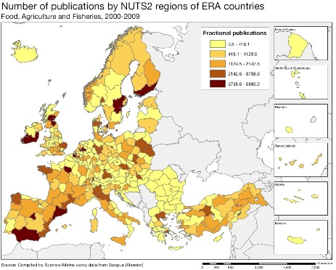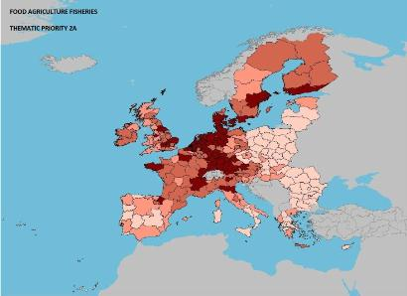

Scientific production Energy Technological production
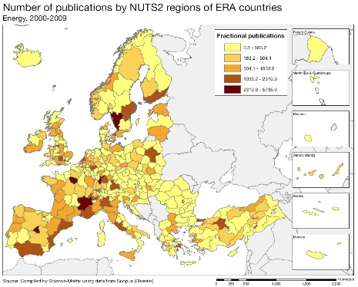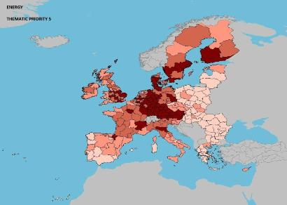

Scientific production Environment Technological production
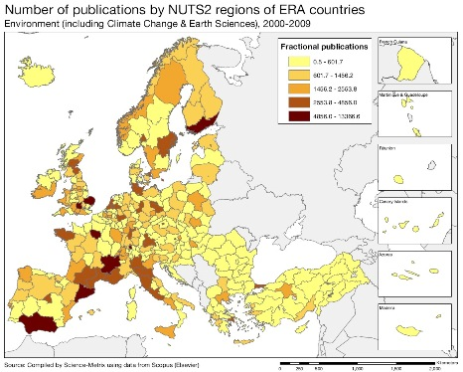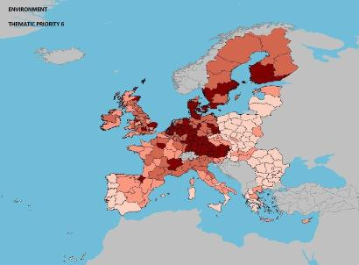

Source: DG Research and Innovation – Economic Analysis unit
Data: Science Metrix using Scopus (Elsevier), 2010; European Patent Office, patent applications, 2001-2010

Scientific production Information and Communication Technologies Technological production
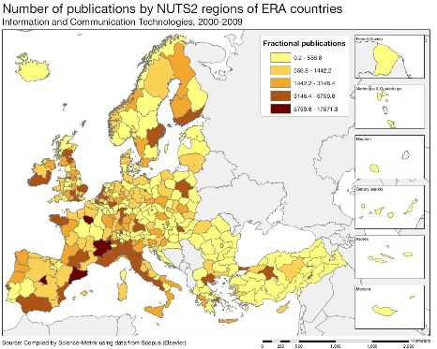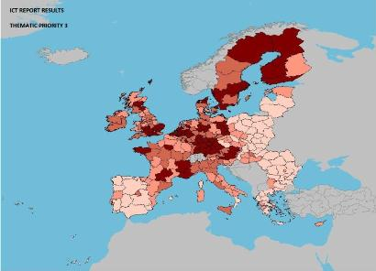

Scientific production Nanosciences and nanotechnologies Technological production
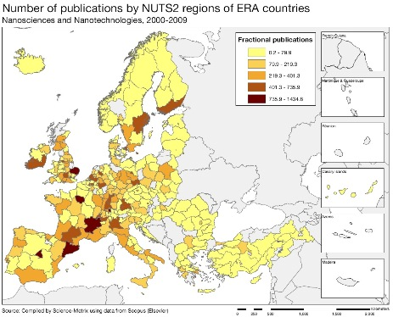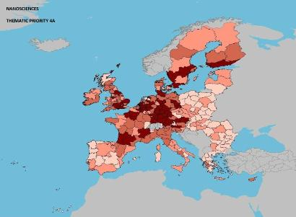

Scientific production Biotechnology Technological production
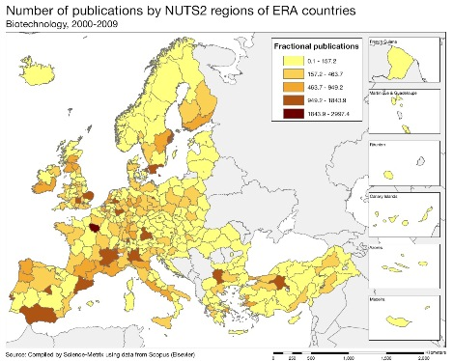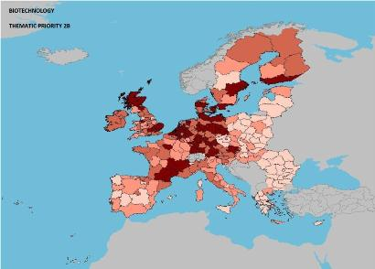
As illustrated by the maps above, Estonia has strong regional scientific and technological capacity in the fields of food, agriculture and fisheries, energy, and environment, as well as technological capacity in ICT, nanosciences and nanotechnologies, and biotechnology.
Regarding Estonia's scientific specialisation index, not visible in the maps above, the main scientific fields are energy, environment, food and agriculture while scientific quality is highest in transport, and food and agriculture (as reflected by the share of scientific publications in the 10% most cited scientific publications worldwide). In terms of technology specialisation, the main technology sectors are biotechnologies, new production technologies, nanotechnologies, environment and security.

Policies and reforms for research and innovation

Estonian research and innovation policy is based on collaboration led by the Research and Development Council. The council has an advisory nature and involves representatives of the public R&I sector, industry, the Ministry of Education and Research, and the Ministry of Economic Affairs and Communications. The two ministries are responsible for the implementation of economic policy, and research and innovation policy.

The Estonian authorities are addressing the challenges indicated at the beginning of this assessment through two key strategies that are already in place: "Knowledge-based Estonia 2007-2013" which is the Research and Innovation Strategy and "Europe 2020", a general economic development strategy in response to the Europe 2020 agenda. The strategies are ambitious and correctly focused on guiding the country's development by strong commitment to sustainable economic development through research, development and innovation, but they would have benefited from a more narrow sectoral focus and detailed objectives. Whereas the development and performance of the research and innovation system has been remarkable during the last two decades, it appears to have remained rather detached from a vast part of the economy. Therefore a further focus on areas that dominate the Estonian economy today has now become necessary. The development of a comprehensive innovation strategy consistent with industrial perspectives would help to identify knowledge-intensive sectors that could raise the country's position on the value chain.

Regarding the particular challenge of skills shortage, the Government is trying to foresee future needs of different skills as well as attempting to reverse the brain drain by building up incentives for Estonian researchers to return to the country after having gained important professional experience abroad.
Overall cooperation between public sector research and business will need to be further encouraged. In general, public actors (i.e. universities and existing excellence centres) do not have sufficient incentives to promote the commercialisation of research results. Eight competence centres focused on industrial research and the creation of innovative products, have been created with the aim of promoting cooperation between academia and business. The Government plans to evaluate their activity, with a view to adjusting the financial support in relation to the actual progress.
The recent international peer review undertaken within the European Research Area Committee (ERAC) - providing input to the government for the renewal of the R&I strategy for 2014-2020 – highlighted less budgetary intensive measures such as knowledge transfer and suggested public-private schemes instead of direct funding tools. Estonia was recommended to further harness its R&I policy to drive structural change in the economy. The ongoing strategy process was recommended to be used to develop a more coherent and systemic policy mix. Increased funding was considered rather as a tool to extend the overall reach and variety of innovation instruments to non R&I performing companies. Currently, in the absence of a coherent strategy, it was noted that Structural Funds can even contribute to the complexity. Developing the new national R&I strategy by taking closely into account EU policy and funding instruments might have major synergies for a country with limited resources but relatively good administrative capacity.

Economic impact of innovation

The index below is a summary index of the economic impact of innovation composed of five of the Innovation Union Scoreboard's indicators.

Estonia has a slightly lower economic impact of innovation than its reference group. In particular, the economy is still less knowledge-intensive in terms of employment and trade. In this context, the Competence Centres and the innovation vouchers intended to encourage R&I activities in SMEs are steps in the good direction (the vouchers have been extended both in terms of value, currently € 4000 per voucher, and target group with the list of R&D providers extended to include competence centres). These measures increase the possibility of attracting foreign companies to Estonia and provide a stimulating environment and networks for innovative firms, boosting knowledge transfer between academia and businesses. Finally, the recent “start-up Estonia” pilot scheme is a new, supplementary policy instrument to motivate young people to start businesses.
Estonia has an average position among EU Member States and a favourable position among new Member States regarding the perception of end business users on availability of both venture capital and access to loans, as well as on financing through local equity markets. The perception of end users regarding both government procurement of advanced technology products and intensity of local competition situates Estonia yet again in a leading position among new Member States and around the EU average. The share of public procurement advertised in the Official Journal relative to GDP was 8.40, i.e. ranking third in Europe after Bulgaria and Latvia. Estonia is also in third place in the EU regarding net foreign direct investment (FDI) inflows relative to GDP (according to 2008 data), immediately after Cyprus and Ireland. According to the Eurobarometer, the greatest fears of Estonians when starting a business are the uncertainty of not having a regular income, the risk of losing their property and the possibility of going bankrupt.

Upgrading the manufacturing sector through research and technologies

The graph below illustrates the upgrading of knowledge in different manufacturing industries. The position on the horizontal axis illustrates the changing weight of each industry sector in value added over the period. The general trend to the left-hand side reflects the decrease of manufacturing in the overall economy. The sectors above the x-axis are sectors whose research intensity has increased over time. The size of the bubble represents the share of the sector (in value added) in manufacturing (for all sectors presented in the graph). The red-coloured sectors are high-tech or medium-high-tech sectors.
Estonia is one of the countries that are catching up fast in terms of manufacturing industry: in 2011, manufacturing production represented 17.3% of total value added (compared to an EU average of 15.6%). Estonia is improving its competitiveness and has a clear potential to join the group of higher income countries specialised in labour-intensive industries. In terms of trade and industry specialisation, Estonia is specialised in the manufacturing of electronic products, fabricated metal products, motor vehicles, electrical equipment, and machinery and equipment.

The graph above synthesises the structural change of the Estonian manufacturing sector over the period 2005-2009. It shows that the economic expansion has been to a certain extent related to lower-tech sectors or large consumer goods and services, in particular, coke, refined petroleum and nuclear fuel, and electricity, gas and water. However, there has been an increase in R&I investment in several industrial sectors of the Estonian economy, both in low-tech and traditional sectors such as rubber and plastics, textiles, wearing apparel and fur, and also in the high-tech sectors of office, accounting and computing machinery, medical, precision and optical instruments, and machinery and equipment.
Competitiveness in global demand and markets

Investment in knowledge, technology-intensive clusters, innovation and the upgrading of the manufacturing sector are determinants of a country's competitiveness in global export markets. A positive contribution of high-tech and medium-tech products to the trade balance is an indication of specialisation in these products.

The Estonian trade balance for all high-tech (HT) and medium-tech (MT) products combined was negative over the last decade; however, there is an increasing trend. At the same time there is a relative stagnation for the total trade balance over the same period. The data suggest a relative shift towards HT and MT in the trade balance of Estonia over the last few years.

The graph above shows the high-tech and medium-tech industries that have improved their contributions to the Estonian trade balance. This is particularly true for electrical machinery, road vehicles, general industrial machinery, machinery specialised for particular industries, and power generating machinery and equipment. In contrast, industries such as telecommunications and medicinal and pharmaceutical products are making decreasing contributions to the trade balance, indicating a possible loss in relative world competitiveness for these sectors. Over the last 15 years, the Estonian economy has made relative gains in world competitiveness as a result of innovation. This is shown by indicators such as knowledge-intensive services exports as % of total service exports. The composite indicator on structural change ranks Estonia in 17th place in the EU over the period 2000-2010 (see table below).

Estonia had a rather flat evolution of total factor productivity over the last decade, and is ranked 16th in the EU in this respect. Greenhouse gas emissions increased up to 2007 but then progressively declined and by 2009 were under the level of 2000. Estonia has also succeeded in increasing the share of renewable energy in gross final energy consumption and is currently ranked 6th in the EU for this indicator. The employment rate increased from 67.4% in 2000 to 70.4% in 2011.
Key indicators for Estonia

Country-specific recommendation in R&I adopted by the Council in July 2012:
"Link training and education more effectively to the needs of the labour market, and enhance cooperation between businesses and academia. Increase opportunities for low skilled workers to improve their access to life-long learning. Foster prioritisation and internationalisation of the research and innovation systems."
Finland
Towards a Digital Service Economy by Broadening the Innovation Base

Summary: Performance in research, innovation and competitiveness

The indicators in the table below present a synthesis of research, innovation and competitiveness in Finland. They relate knowledge investment and input to performance or economic output throughout the innovation cycle. They show thematic strengths in key technologies and also the high-tech and medium-tech contribution to the trade balance. The table includes a new index on excellence in science and technology which takes into consideration the quality of scientific production as well as technological development. The indicator on knowledge-intensity of the economy is an index on structural change that focuses on the sectoral composition and specialisation of the economy and shows the evolution of the weight of knowledge-intensive sectors and products and services.

 | Investment and Input | Performance/economic output
Research | R&D intensity  2011: 3.78% (EU: 2.03%; US: 2.75%)  2000-2011: +1.12% (EU: +0.8%; US: +0.2%) | Excellence in S&T  2010:62.91 (EU:47.86; US: 56.68)  2005-2010: +2.71% (EU: +3.09%;US: +0.53)
Innovation and  Structural change | Index of economic impact of innovation  2010-2011: 0.698 (EU: 0.612) | Knowledge-intensity of the economy  2010:52.17 (EU:48.75; US: 56.25)  2000-2010: +0.49% (EU: +0.93%; US: +0.5%)
Competitiveness | Hot-spots in key technologies  ICT, Environment, Materials, Energy, Security, Food & agriculture, Health | HT + MT contribution to the trade balance  2011: 1.69% (EU: 4.2%; US: 1.93%)  2000-2011: +33.50% (EU: +4.99%; US:-10.75%)

Finland has one of the world's highest R&D intensities. The country also performs very well in terms of scientific and technological excellence, with a strong positive evolution. The Finnish economy is knowledge-intensive, and has achieved an impressive and continuous change towards a stronger high and medium-high-tech specialisation. The country has several hot-spot clusters in key technologies at European and world scale, in particular in ICT, environment, materials, energy, security, and food and agriculture.

However, Finland's competitive position is facing challenges and its large export businesses have suffered. Considering its high level of R&D inputs, the country has a relatively low contribution of high-tech and medium-high-tech goods to the trade balance. Within the past few years, the decline of the important electronics (telecommunications) sector in particular, has created pressure for structural change in Finland. The decline of this sector is expected to be reflected in a decrease in business R&D investments - previously dominated by Nokia. Consequently, as part of the Europe 2020 strategy, the Council recommended to Finland to continue efforts to diversify its business structure, in particular by hastening the introduction of planned R&I measures to broaden the innovation base in order to strengthen productivity growth and external competitiveness. The extent to which the business and public sectors will be capable of absorbing new innovations from the ICT sector - and more concretely the available highly-skilled human resources - is considered a determinant for new growth.

To address these challenges, the Finnish government has intensified the reform of the national innovation system. In addition to general efforts in enhancing the efficiency and improving the internationalisation of its innovation system, current and planned policy reforms are targeted at increasing the number of high growth innovative firms as the major source of future employment growth. The introduced temporary R&D tax incentive from 2013 to 2015 represents a novelty in Finland and targets SMEs and cooperatives. Furthermore, a new tax incentive for private investors into start-ups has been introduced to increase the volume of domestic venture capital market. These actions are expected to support especially knowledge- and innovation-based young growth enterprises.The Finnish Government has also recently fostered innovation and country's transfer to a digital service economy by releasing non-sensitive public data.
Investing in knowledge

Total R&D expenditure (combining public and private R&D spending) decreased to 3.78% of GDP in 2011 (3.87% of GDP in 2010) which is, nevertheless, the highest value in the EU and close to Finland’s national target for 2020 of 4 %. Public R&D investment is however expected to decline in 2012 and 2013, while the on-going decline of the R&D intensive ICT sector will have a negative impact on business R&D intensity. The public R&D budget for 2012 remained at around € 2 billion. According to the Government's multiannual budget framework adopted in March 2012 it will decrease by 1-2% in real terms by 2015. However, due to the R&D tax incentives put in place by end of 2012, the situation may change significantly as the total public support to R&D (direct and indirect) could increase by up to 5% (in real terms) in 2013 compared to 2012.

Finland is the top performer in the EU in terms of business R&D spending (2.67% of GDP in 2011). Aside from the electronics sector, many manufacturing and services sectors have increased their R&D intensities. However, business R&D investments are still highly concentrated in Nokia and a few other large firms. This makes the current good economic position more vulnerable than it appears. Moreover, high growth firms remain slightly less involved in R&D activities than the business sector as a whole.

Public and Private R&D investment receives co-funding support from the European budget. During the ERDF programming period 2007-2013, € 862 million are planned to be allocated to research, innovation and entrepreneurship in the Finnish regions (over half of all ERDF funds for Finland). The share of structural funds allocated to R&I has increased during recent years and 50.7% of the funds had been already committed by the end of 2010. Finland also has the objective to increase its participation in the 7th Framework Programme. Up to mid-2012, almost 1700 Finnish entities had participated in an FP7 project, with a total EC financial contribution of € 558 million and a success rate of 22.42% (slightly above EU average of 21.95%).

An effective research and innovation system building on the European Research Area
The spider graph below provides a synthetic picture of the strengths and weaknesses in the Finnish R&I system. Reading clockwise, the graph provides information on human resources, scientific production, technology valorisation and innovation. The average annual growth rates from 2000 to the latest available year are given in brackets under each indicator.
Finland has overall a strong innovation performance and outperforms its reference group in terms of highly-skilled human resources, public and private investment in R&D and patent applications. However, the share of new doctoral graduates was lower in Finland than in the reference group in 2011. The main weakness of the Finnish innovation system lies in its low level of internationalisation (affecting both the public and private sectors): Finland performs below the EU average on inward BERD, share of foreign doctoral students and participation in EU excellence driven funding programmes. Another relative weakness lays in non-R&D related innovation, in particular the share of SME's introducing marketing and organisational innovations, where Finland also remains slightly below the EU average.

The on-going restructuring of the ICT sector is both a challenge and an opportunity for Finnish SMEs, as much of future innovation and growth depend on them. In 2011, the share of Finnish SMEs introducing product and process innovations was about at the same level with that of the reference group whereas the share of SMEs introducing marketing and organisational innovations was slightly lower than even the EU average. The graph does not fully take into account the on-going structural reforms that are expected to affect in particular the number of business sector researchers and business R&D intensity. In addition, the effect that the expected loss of R&D jobs in the private sector and the subsequent capacity to attract foreign researchers will have on linkages in the R&I system is unknown..
Finland's scientific and technological strengths
The maps below illustrate six key science and technology areas where Finland has real strengths in a European context. The maps are based on the numbers of scientific publications and patents produced by authors and inventors based in the regions.

Strengths in science and technology at European level
Scientific production Information and Communication Technologies Technological production
Scientific production Environment Technological production
Scientific production Nanoscience, nanotechnologies Materials Technology production
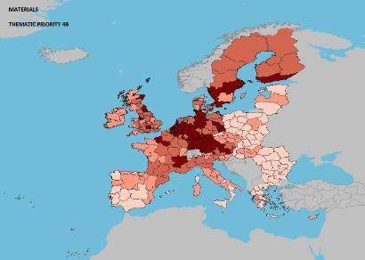

Source: DG Research and Innovation – Economic Analysis unit
Data: Science Metrix using Scopus (Elsevier), 2010; European Patent Office, patent applications, 2001-2010

Scientific production Energy Technological production
Scientific production Security Technological production
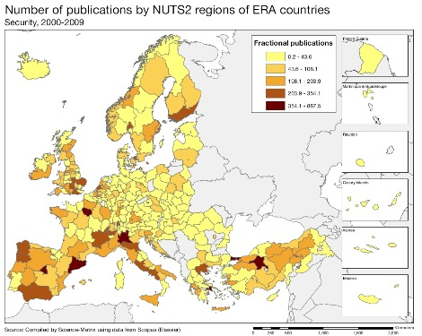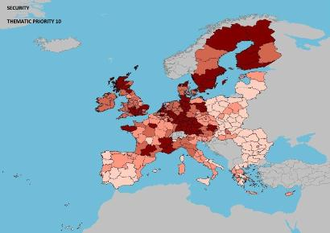
Scientific production Food, agriculture and fisheries Technological production
Finland has well performing hot-spot clusters in the following broad sectors: ICT (incl. services), environment (in particular environmental technology), materials (construction technology, metallurgy, nanosciences and new production technologies), energy, security, food and agriculture. Most regions in South and South-West Finland are performing well in all of these fields whereas other regions, especially in Northern Finland, are well represented in ICT, environmental technologies, materials and security. Apart from the above clusters, Finland has intensive patenting in machine tools, health, medical technology, pharmaceuticals and biotechnologies. In terms of technological specialisation world-wide, Finland stands out in the ICT and security fields whereas its scientific specialisation is dominated by the following fields: ICT, food and agriculture, environment and construction. In terms of scientific quality (as measured by highly-cited publications), Finnish research excels in nine fields including food and agriculture, security, environment and energy. It is also relevant to consider the matching between science and technology (mainly business-driven) in two of the fields where Finland has major technological strengths, ICT and security: in ICT, scientific and technological specialisations are converging whereas in the security field science quality and technological specialisation are already in line. Overall, a relatively clear correspondence is visible between scientific output and technological specialisation. However, the innovation base should be broadened to take full advantage of scientific quality. In this regard Finland would benefit from a diversification strategy.
Policies and reforms for research and innovation
The Finnish Research and Innovation policy reforms are outlined at the strategic level by the Prime Minister led Research and Innovation Council. The current policy guidelines cover 2011-2015 and despite a change of government in 2011, they are well in line with the more operational government programme, an indication of the overall continuity of Finnish policy. Due to exceptionally strong structural change in some key industrial sectors, most recently in the ICT field, the government is adapting and frontloading the measures to address the most urgent challenge namely the re-employment of R&I professionals, especially in the ICT sector, for sustainable growth.

The Ministry of Science, Education and Culture and the Ministry of Employment and the Economy are jointly preparing an operational and interlinked policy programme concerning Research and innovation with a view to introducing new measures to be taken into a mid-term review of the government programme in early 2013. The focus is expected to be on high-growth innovative enterprises and their framework conditions. The R&I incentives for SME's and private investors are new departures in the Finnish R&I policy. The strategy of the main public R&I funding agency (TEKES) has already been changed accordingly. There will also be a likely set of proposals for enhancement of research activities.

In 2012, the National Reform Programme also foresaw the mid-term revision of the current demand and user-driven innovation policy Action Plan 2010-2013. An independent expert group set by the Research and Innovation Council of Finland released a report concerning the structural reorganisation of government research institutions (PROs) in September 2012. The latter is considered important especially in the context of public sector innovations to societal challenges and enhancement of evidence-based decision-making. In the midst of domestic reforms, the relative weaknesses in internationalization (the challenges of attracting foreign experts and investments and linking into international R&I cooperation) are paid an increased attention as well. Finally, the beginning of 2013 will also see the conclusion of a high-level report on Finland's model for sustainable growth.

As regards sectors, the government has set up a Finnish ICT cluster expert task force to assess by the end of 2012 the potential for utilising ICT know-how in other industries in Finland, including the public sector. Also the four other Government strategic growth targeted programmes (environment, forest, welfare, creative industries) build heavily on the increased role of ICT – the traditional main driver of the country's productivity growth. If successful in boosting growth in other sectors, ICT is believed also to have the potential to diversify the Finnish economy while making a contribution to important external trade (i.e. services in manufacturing). The opening up of public data is strongly supported.

Finland’s innovation policy and measures in general are geared towards speeding up the development, commercialization and take up of new technologies. Key Enabling Technologies (KETs) are an integral part of public technology and innovation programmes funded by Tekes, and the Technical Research Centre of Finland (VTT). Finnish universities have competencies in all KETs. A new strategic programme on promoting Finnish clean-tech business has been launched in 2012 and other sectoral programmes will follow. Finally, specific measures provide support for the internationalization of the Finnish R&I system. For example, foreign-established companies are eligible for the Tekes funding and the mechanism for the public funding of universities is under revision with a view to supporting their internationalization. Most universities are introducing reforms of doctoral education and tenure track systems for teaching and research personnel, with the aim of enhancing the attractiveness of an academic career. The funding allocated to the tenure track system is decided by the universities themselves. The new funding model of universities is in operation in 2013. The structural development scheme of polytechnics will be implemented in 2014. Overall, the number and scale of reforms described in the 2012 Europe 2020 National Reform Programme (NRP) signal the continuous commitment to a broad and ambitious innovation policy to ensure growth and jobs for the ageing society in a globalised world.

Economic impact of innovation
The index below is a summary index of the economic impact of innovation composed of five of the Innovation Union Scoreboard's indicators.

Finland performs well above the EU average but slightly below the reference group in terms of the economic impact of innovation. Finland's relative weakness lays in a less knowledge-intensive export, in particular a lower knowledge-intensive service exports as share of total exports.
The stimulation of high-growth innovative companies in Finland remains a key policy priority in the new Government Programme. Despite Finland’s technological sophistication, its current performance in nurturing high-growth companies could be improved and in fact Finland is lagging behind its own objectives in this regard. This challenge is recognised by the Finnish authorities and new policies are expected in 2013.

The government’s decision to introduce R&D tax incentives from 2013 is a new initiative in Finnish R&D policy. This is in line with the new strategy of Tekes (Finnish Funding Agency for Technology and Innovation) to focus more on high risk innovative high-growth companies. Tax incentives will help start-ups and companies seeking primarily private financing and advice (a tax incentive for private investors). The government is also considering a separate tax incentive for companies making better use of their intellectual property rights (patent pool).

The focus of public R&D&I funding is being shifted to SMEs which are growth-oriented, job creating and are successfully establishing international connections. Several specific policy measures have been taken recently, such as: (1) A new joint service “Growth Track” provided by business development organisations, which is intended for enterprises aiming at rapid growth and internationalization; (2) the introduction by Tekes of a programme for funding young, innovative companies; (3) the renewal of Finnvera’s (Export Credit Agency of Finland) export guarantees schemes; (4) the expansion of the Vigo Accelerator Programme to six areas. (5) the focusing by Tekes of one third of company funding on young innovative enterprises (6) the wider use of financial engineering instruments to maximise the benefits of the EU Structural Funds.
Upgrading the manufacturing sector through research and technologies
The graph below illustrates the upgrading of knowledge in different manufacturing industries. The position on the horizontal axis illustrates the changing weight of each industry sector in value added over the period. The general trend to the left-hand side reflects the decrease of manufacturing in the overall economy. The sectors above the x-axis are sectors whose research intensity has increased over time. The size of the bubble represents the share of the sector (in value added) in manufacturing (for all sectors presented on the graph). The red-coloured sectors are high-tech or medium-high-tech sectors.
The Finnish manufacturing sector has achieved a clear upgrading of its knowledge-intensity over the last decade. Finland has undergone a period of important economic restructuring and has evolved from having a primarily pulp and paper and machinery driven manufacturing sector towards being a producer of electronics and now increasingly software and services. Simultaneously the services sector, including business services, has grown significantly. The three most R&D intensive manufacturing sectors (red bubbles) have maintained their contributions to value added in the Finnish economy remarkably well. Electrical equipment and machinery have continuously increased their R&D investments, although R&D investment growth in the chemicals sector has been slower. However, the recent ICT sector reorganisation is expected to reduce its share in both value added and BERD intensity whereas the shares of different R&D intensive IT services are expected to increase.

With regard to traditionally less R&D intensive industries (the other bubbles), the high R&D investment growth in the pulp and paper sector signals important efforts by the sector to renew itself by innovation. Some traditional Finnish pulp and paper companies have repositioned themselves close to the energy business. Similar renewal by R&D can be observed in basic metals – a sector leading the mining boom in the most rural parts of Finland. Finally, the graph illustrates that the economically important construction sector has increased R&D investments steadily. Since 2007 the government has been supporting the renewal of traditional manufacturing sectors with a specific public–private instrument (Strategic Centers for Science, Technology and Innovation).
Competitiveness in global demand and markets

Investment in knowledge, technology-intensive clusters, innovation and the upgrading of the manufacturing sector are determinants of a country's competitiveness in global export markets. A positive contribution of high-tech and medium-tech products to the trade balance is an indication of specialisation and competitiveness in these products.

Many Finnish industry sectors have increased their contribution to the trade balance, which is a sign of improved competitiveness in global markets. Also in real terms, the Finnish trade balance in HT and MT products grew significantly over the period 2000-2008, followed by a sharp fall both in imports and exports. This positive evolution of the HT and MT trade balance up to the economic crisis is consistent with the increased knowledge-intensity in most Finnish manufacturing sectors as shown in the previous graph. Different types of machinery (electrical, specialised and power-generating) have managed to improve their contribution to trade the most, reflecting their strong average annual growth of business R&D intensity over the last 15 years. The outstanding exception is the telecommunication sector (led by Nokia), which despite a strong fall in exports from 2009 onwards however still makes the second largest contribution to the Finnish trade balance in absolute numbers (after sector machinery specialised for different industries, and slightly before the sector for power-generating machinery).

The continuous improvement in Finland's competitiveness in most sectors is also reflected in its productivity level. As shown in the table below, Finland's total factor productivity is stable but with a room for improvement in its growth rate compared to other EU Member States. Technologies are oriented towards societal challenges (here environment and health), but there is a worrying decline in health-related technologies. Finland is making progress on all of the Europe 2020 objectives, including a slightly growing employment rate, better environmental protection with a higher share of renewable energy and more young people completing tertiary education. However, in 2011, a share of the Finnish population at risk of poverty or social exclusion slightly increased.
Key indicators for Finland

Country-specific recommendation in R&I adopted by the Council in July 2012:
"In order to strengthen productivity growth and external competitiveness, continue efforts to diversify the business structure, in particular by hastening the introduction of planned measures to broaden the innovation base…"
France
The challenge of structural change for a more competitive economy

Summary: Performance in research, innovation and competitiveness

The indicators in the table below present a synthesis of research, innovation and competitiveness in France. They relate knowledge investment and input to performance or economic output throughout the innovation cycle. They show thematic strengths in key technologies and also the high-tech and medium-tech contribution to the trade balance. The table includes a new index on excellence in science and technology which takes into consideration the quality of scientific production as well as technological development. The indicator on knowledge-intensity of the economy is an index on structural change that focuses on the sectoral composition and specialisation of the economy and shows the evolution of the weight of knowledge-intensive sectors and products and services.
 | Investment and Input | Performance/economic output
Research | R&D intensity  2011: 2.25% (EU: 2.03%; US: 2.75%)  2000-2011: +1.02% (EU: +0.8%; US: +0.2%) | Excellence in S&T  2010:48.24 (EU:47.86; US: 56.68)  2005-2010: +3.54% (EU: +3.09%;US: +0.53)
Innovation and  Structural change | Index of economic impact of innovation  2010-2011: 0.628 (EU: 0.612) | Knowledge-intensity of the economy  2010:57.01 (EU:48.75; US: 56.25)  2000-2010: +0.63% (EU: +0.93%; US: +0.5%)
Competitiveness | Hot-spots in key technologies  Energy, ICT, Materials, Nanotechnologies, New Production Technologies, Environment | HT + MT contribution to the trade balance  2011: 4.65% (EU: 4.2%; US: 1.93%)  2000-2011: +1.66% (EU: +4.99%; US:-10.75%)

France is among the research-intensive countries in the world. It has a large, relatively strong and competitive science base, is well equipped in large world-class research infrastructures, and is well connected in Europe and internationally. France has, however, the potential to do better in terms of top-end research and high-impact scientific work.

The level of business R&D intensity remains relatively low in France in comparison with other R&D-intensive countries and has not increased substantially over the last decade. This reflects primarily the sectoral composition of the economy, where high-tech manufacturing sectors represent only a modest share. This is also the result of an insufficient engagement of enterprises of intermediate size in R&D activities. France has therefore the potential to reap much larger economic benefits from its scientific and technological strengths. In terms of human capital for R&I, the proportion of students pursuing doctoral studies is lower in France than the EU average. The innovation system would benefit from better promotion of research careers as well as better career opportunities for doctorate holders in the business sector and in the non-academic public sector. To have more of the best talents in doctoral studies and to have more doctorate holders in enterprises is the best way to improve the link between public research and enterprises, and to boost the French economy in innovative sectors. Finally, as successful innovation requires much more than scientific skills, it is important to further develop and expand innovation and entrepreneurship education programmes in higher-education curricula.

In recent years, France has substantially transformed its research and innovation (R&I) system so as to shape it according to some of the best international standards and practice - new funding and evaluation agencies and mechanisms, Pôles de Compétitivité, autonomy of universities, amplified research tax credit (CIR), programme Investissements d'Avenir and the strengthening of public-private cooperation and the valorisation of research results. These transformations are still unfolding and the positive effects of the reform on France's R&I capacity and performance and on the economy at large are expected to grow over time.
Investing in knowledge
France has set a national R&D intensity target for 2020 of 3%. In 2011, France's R&D intensity was 2.25%, with an average annual growth rate of 1% over the period 2004-2009 slightly above the EU annual average growth rate over the whole decade. However, this trend will not allow France to reach its target by 2020 as shown above, unless the reforms and the continuous prioritisation of R&D investment in the public budget allow for changing that trend.
France's public R&D budget has been increasing since 2007 (+7.3% in nominal terms, close to € 17 billion in 2011) despite severe budgetary constraints during the economic crisis. According to preliminary data however, this positive trend was reversed in 2012. In addition to the annual R&D budget, € 22 billion is being allocated (most of it as capital endowment) over the period 2010-2020 to research actors through the programme Investissements d'Avenir. Also, the research tax credit (CIR) has been considerably amplified since 2008 and represented € 4.7 billion of foregone tax revenue in 2009. Finally, about 31% (€ 4.2 billion) of EU FEDER to France is used for R&D, innovation and entrepreneurship. France has been very successful in the 7th EU Framework Programme (the success rate of French applicants is one of the highest at 25.4%) with almost 8000 French participants in selected FP7 projects up to mid 2012, with a total EC financial contribution of € 3.1billion.
France is one of the rare countries where R&D expenditure of the business sector progressed in 2009, in spite of the economic crisis, a trend probably due in large part to the CIR. Together with a decline in GDP, this progress caused a marked increase in overall business R&D intensity from 1.33% in 2008 to 1.40% in 2009. In 2010 and 2011, business R&D intensity further progressed up to 1.43% of GDP. In terms of economic activities, business R&D expenditure in France is dominated by pharmaceuticals (14% of total business R&D expenditure), motor vehicles (14%), aircraft and spacecraft (11%) and radio, TV and communication equipment (10%).

An effective research and innovation system building on the European Research Area

The graph below illustrates the strengths and weaknesses of France's R&I system. Going clockwise, it provides information on human resources, scientific production, technology development and innovation. Average annual growth rates from 2000 to the latest available year are given in brackets.

The graph clearly shows that France's weaknesses are in public-private cooperation and in innovation by SMEs where France's performance is below the EU average. In terms of human resources and scientific production, France performs better but it is noticeable that France has less doctoral graduates per population aged 25-34 than the EU average and is performing slightly below the EU average in terms of highly-cited publications. The limited amount of FP funding relative to total R&D expenditure in the country is largely a size effect, which is observed also in Germany, whereby countries with a large amount of domestic resources have necessarily smaller shares of resources coming from external sources. Also, the relatively limited share of business R&D funded from abroad reflects the much lower share of foreign affiliates in France's business R&D than is the case in the smaller countries of the reference group and in the United Kingdom.

French universities and PROs are very well integrated in European networks where they play a central role. Altogether France's cross-border collaboration in science is high as witnessed by a good level of international scientific co-publications. In most scientific fields France hosts a number of large world-class research infrastructures of pan-European interest open to foreign-based researchers. France is also actively involved in the development of the new pan-European infrastructures of the ESFRI Roadmap and in the different Joint Programming Initiatives.
France's scientific and technological strengths at European level

The maps below illustrate six key science and technology areas where France has real strengths in a European context. The maps are based on the number of scientific publications and patents produced by authors and inventors based in the regions.

Scientific production Energy Technological production
Scientific production Information and Communication Technologies Technological production
Scientific production Materials Technological production
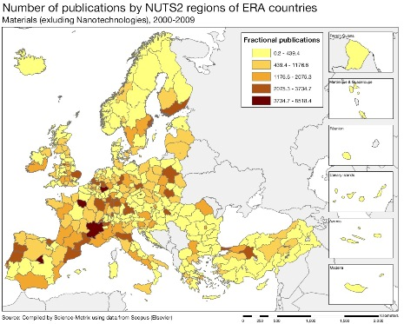
Scientific production Nanosciences and Nanotechnologies Technological production

Source: DG Research and Innovation – Economic Analysis unit
Data: Science Metrix using Scopus (Elsevier), 2010; European Patent Office, patent applications, 2001-2010
Scientific production New Production Technologies Technological production
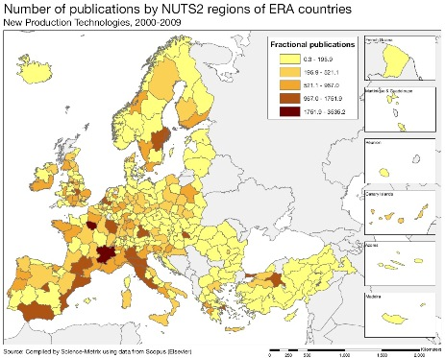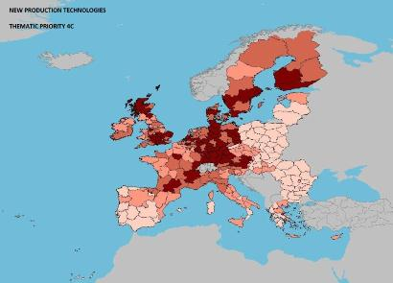
Scientific production Environment Technological production
R&D activities are extremely concentrated in France. Two thirds of the country's total R&D expenditure is performed in 4 (out of 22) regions: about 40% in Ile-de-France (IdF), 12% in Rhône-Alpes (R-A), 8% in Midi-Pyrénées (M-P) and 6.5% in PACA. The scientific and technological production in all thematic fields is consequently the highest in these regions.

IdF is among the very top regions in Europe in the production of scientific publications in each and every FP7 Thematic Priority. R-A shares with IdF this top position in scientific production in Europe in ICT, materials, nanosciences and nanotechnologies, new production technologies (NPT), and other transport technologies. R-A is also strong in Europe in the fields of energy, environment, health, biotechnologies, automobiles, and security. M-P specializes in aeronautics and Sspace, NPT, nanosciences and nanotechnologies, ICT, and environment. The FP7 thematic priorities where more regions in France have a good level of activity are food and agriculture, energy, ICT, materials, nanosciences and nanotechnologies, NPT, environment (maps above), but also security and other transport equipment. Overall, France's scientific publications have their highest impact in materials and energy, followed by other transport equipment, food and agricutlture, NPT, construction, environment, aeronautics and space.

Patenting activity is more evenly distributed across regions in France than scientific publications (maps above), despite the fact that IdF and R-A still dominate and are among the top regions in Europe in most fields. With the exception of these two regions, few French regions are among the top European regions which are dominated by the regions of Germany and the Netherlands. In France, there is a good match between the level of scientific activity and the level of patenting activity in a given field: French regions in dark on the left are also in dark on the right. However, there are a number of French regions with lower volumes of scientific production which maintain a good level of patenting activity, attenuating the sharp regional disparities that are observed in scientific production.
Policies and reforms for research and innovation

The first National Strategy for R&I in France was adopted in 2009 for the period 2009-2012 and will be renewed every four years. It sets out fundamental principles and priority thematic axes, namely health and biotechnologies, environment, ICT, and nanotechnologies. Five Alliances coordinate PROs and universities around five thematic areas (life sciences, environment, energy, ICT, social sciences and humanities) to strengthen the programming function of the system, optimize the distribution of human resources across themes and to play an important role in joint programming orientations at European level. Since 2008, budget programming has become multi-annual.
Since the law on the autonomy of universities was passed in 2007, all universities have become autonomous in managing their budgets and human resources and have the possibility of owning their premises. The law reforms the governance of universities, by reinforcing the role and leadership of the President, reducing the size of the board and opening its membership to external people, from the business sector and local authorities in particular. The French authorities have intensively promoted the emergence of large world class poles of excellence in higher education and research with large financial support through the programme Investissements d'Avenir (IA) and the Opération Campus.
The share of project-based funding in total public R&D funding has been rising continuously with the creation of the Agence Nationale de la Recherche (ANR) in 2005. In addition, an increasing part of institutional R&D funding is based on the performance of the public research institutions. The latter are evaluated by the Agence d'Evaluation de la Recherche et de l'Enseignement Supérieur (AERES) set up in 2007 which also evaluates research units and higher education programmes and diplomas, and validates the personnel evaluation systems of research institutions.
The Plan Carrières 2009-2011 creates a doctoral contract, raises young researchers' salaries, increases the promotion rate, introduces flexibility in the teaching/research balance, and offers "scientific excellence" bonuses and Chairs. Recruitment of academic staff is largely open to foreigners who represent ¼ and 1/6 of the newly recruited researchers and teacher-researchers respectively. Universities have been assigned a third mission, namely the positioning of their graduates in the labour market for which a dedicated office in each university has been created. Closer ties are being built between universities and enterprises. Universities are diversifying their sources of funding. Modules on entrepreneurship, enterprises and economic intelligence are being developed in universities.
Since 2005, France has adopted a number of important measures and taken steps to boost business R&D investment, in particular by SMEs, and to foster public-private collaboration and the exploitation of research results for commercial applications. These include the reformed Crédit d'Impôt Recherche (CIR), the Pôles de Compétitivité, the Jeunes Entreprises Innovantes, the Carnot Institutes, and several initiatives under the programme IA (e.g. Instituts de Recherche Technologique, Société d'Accélération du Transfert Technologique) which devotes 3.5 bn EUR to the valorisation of research results. France has also created the first investment and valorisation fund of patents in Europe, France Brevets, which aims at helping public and private research to valorise their patent portfolios.
France has also put in place a strong cluster policy since 2004 with the Pôles de Compétitivité. Regions have adopted regional innovation strategies. Their higher education, research and innovation strengths and weaknesses are analysed in STRATER documents published by the Ministry of Higher Education and Research in 2011.
Regarding demand-side measures, France has developed initiatives to support public procurement of innovation and facilitate SMEs' involvement in the public procurement process (e.g. Loi de modernisation de l'économie 2008, article 26, and several experiments developed by some of France's leading procurers).
Economic impact of innovation

The index below is a summary index of the economic impact of innovation composed of five of the Innovation Union Scoreboard's indicators.
According to this index, the economic impact of innovation in France is comparable to its reference group, slightly above the EU average. Within this index, the contribution of high- and medium-tech products to the trade balance is particularly high in France compared to the EU average (see analysis by categories of products in the section 'Competitiveness in global demand and markets' below). In contrast, the share of knowledge-intensive exports in total services exports is much lower than the EU value, probably due in part to the important weight of tourism in France's economy. France's performance on the last three indicators (patent inventions, employment in knowledge-intensive activities in total employment and sales of new-to-market and new-to-firm products) is slightly above the EU average.
One key factor to increase the economic impact of innovation is of course the structural change that allows innovation-driven growth. High-growth innovative firms in particular play a catalytic role in this respect. Virtually all R&D performers in France are now using the CIR. It has been found to be an important element of the country's attractiveness for R&D activities of firms and allows firms that were not active in R&D to start R&D activities. Young Innovative Firms can in addition benefit from reduced social charges and taxes through the Jeunes Entreprises Innovantes (JEI) scheme. The vast majority of these firms are in services, primarily ICT services and S&T services The public enterprise OSEO proposes a variety of financial instruments to finance innovation activities in SMEs and in enterprises of intermediary size (ETIs) at all stages of development of the firm, in partnership with regions (through OSEO's network of regional agencies) and European funds. It will be an important element of the Banque Publique d'Investissement which is being created to support SMEs' and ETIs' investment capacity. The Pôles de Compétitivité have contributed to develop and strengthen links between SMEs and large firms. SMEs have been much and increasingly involved in the collaborative R&D projects of the Pôles and substantially benefit from the associated public funding. After two first phases focused on new collaborative R&D projects, the Pôles policy could now focus more specifically on the growth of the Pôles' SMEs and ETIs, in particular by promoting innovation and commercialisation activities. Demand-side measures have received less attention, although some initiatives have been taken to promote the use of public procurement for innovative products.
Upgrading the manufacturing sector through research and technologies

The graph below illustrates the upgrading of knowledge in different manufacturing industries. The position on the horizontal axis illustrates the changing weight of each industry sector in value added over the period. The general trend to the left-hand side reflects the decrease of manufacturing in the overall economy. The sectors above the x-axis are sectors whose research intensity has increased over time. The size of the bubble represents the share of the sector (in value added) in manufacturing (for all sectors presented on the graph). The red-coloured sectors are high-tech or medium-high-tech sectors.

The graph above shows that almost all manufacturing sectors have seen their weight in the economy decrease substantially in France (horizontal axis) since 1995. The only exceptions are other transport equipment and recycling. This evolution, which reflects the trends toward a more service-oriented economy, is similar to the one observed at the level of the EU as a whole, but more pronounced. Since manufacturing high-tech and medium-high-tech sectors (colored in red), are the most research intensive sectors in the economy, the shrinking of these sectors in particular has a negative effect on total business R&D intensity in France. In contrast, the research intensity (vertical axis) of a large majority of the manufacturing sectors has increased, including a majority of high-tech and medium-high-tech sectors. This of course brings the overall business R&D intensity upwards.

In total, the first effect has been stronger than the second - overall business R&D intensity decreased from 1.39% of GDP to 1.31% between 1995 and 2007. Since 2007, it has increased again to 1.38% of GDP. France's manufacturing industry is dominated by the food products, beverages and tobacco, and fabricated metal products sectors and not by high-tech and medium-high-tech sectors. This contributes to limit the R&D intensity of the business sector in France.
Competitiveness in global demand and markets

Investment in knowledge, technology-intensive clusters, innovation and the upgrading of the manufacturing sector are determinants of a country's competitiveness in global export markets. A positive contribution of high-tech and medium-tech products to the trade balance is an indication of specialisation and competitiveness in these products.

The trade balance in all high-tech (HT) and medium-tech (MT) products together remained positive in France over the whole decade, although this positive balance has continuously decreased since 2003. As to the total trade balance, it has become increasingly negative over the decade. HT and MT products have therefore been positively contributing to redress the trade balance in France, which indicates a relative specialisation of the country in these products in international trade. Because the erosion of the positive trade balance in HT and MT products has been slower than the deterioration of the overall trade balance, the positive contribution of these products has increased over the decade.

The graph above shows the increase of this positive contribution for the majority of HT and MT products (the largest increase concerns power-generating machinery and equipment and other transport equipment). This shows that the trade balance situation of these products has improved compared to the overall trade balance in France, indicating an increasing specialisation of the country in these products in trade. The previous graph had shown that the other transport equipment sector was one of the few manufacturing sectors whose share in total value added had increased. These two results highlight the particular importance that this sector has gained in France. In contrast, the trade balance in telecommunications apparatus and in road vehicles has deteriorated much faster than the overall trade balance, despite an increasing research intensity effort (previous graph).

Total factor productivity has basically not changed since 2000 in France, although it has progressed in 21 Member States and by 3% in the EU on average (table below). Regarding the Europe 2020 targets, France's weakest performance concerns greenhouse gas emissions, renewable energy (despite visible efforts in environment-related patenting activities) and employment rate.
Key indicators for France

According to Eurostat provisional data for 2011
See Methodological note for the composition of this index.
Eurobarometer: Entrepreneurship in Europe and beyond, 2010
DG Entreprise, Industrial Performance Scoreboard, 2012
See Methodological note for the composition of this index.
Agence Nationale de la Recherche, OSEO, Agence d'Evaluation de la Recherche et de l'Enseignement Supérieur
Due to a break in series in 2004 and 2010, the annual average growth rate of R&D intensity in France can only be calculated over 2004-2009.
Not included in the government R&D budget which amounted to 16.8 billion EUR in 2011. Estimations of the foregone revenue due to the research tax credit for 2010 and 2011: 5.05 and 5.1 billion EUR respectively; forecast: between 5.3 et 5.5 billion EUR each year in 2012 and 2013.
2007, latest year available, data from OECD, Business R&D expenditure (BERD) by economic activity (ISIC Rev. 3) based on 'product field' information.
i.e. other than aeronautics and space and automobile
Non-university Public Research Organisations
With the exception of Antilles-Guyanne, Polynésie française and La Réunion.
See Methodological note for the composition of this index.
OSEO, PME 2011 report. These services firms however, often serve manufacturing industries.
Entreprise de Taille Intermédiaire, 250-5000 employees. This category of enterprises was officially created in France in the Loi de Modernisation de l'Economie (2008).
Service sectors are not represented on the graph.

