The Netherlands
A 'Top sector's' business policy fostering industrial renewal and promoting innovation

Summary: Performance in research, innovation and competitiveness

The indicators in the table below present a synthesis of research, innovation and competitiveness in the Netherlands. They relate knowledge investment and input to performance or economic output throughout the innovation cycle. They show thematic strengths in key technologies and also the high-tech and medium-tech contribution to the trade balance. The table includes a new index on excellence in science and technology which takes into consideration the quality of scientific production as well as technological development. The indicator on knowledge-intensity of the economy is an index on structural change that focuses on the sectoral composition and specialisation of the economy and shows the evolution of the weight of knowledge-intensive sectors and products and services.

 | Investment and Input | Performance/economic output
Research | R&D intensity  2011: 2.04% (EU: 2.03%; US: 2.75%)  2000-2011: -0.45% (EU: +0.8%; US: +0.2%) | Excellence in S&T  2010: 78.86 (EU:47.86; US: 56.68)  2005-2010: +2.72% (EU: +3.09%;US: +0.53)
Innovation and  Structural change | Index of economic impact of innovation  2010-2011: 0.565 (EU: 0.612) | Knowledge-intensity of the economy  2010: 56.22 (EU:48.75; US: 56.25)  2000-2010: +0.48% (EU: +0.93%; US: +0.5%)
Competitiveness | Hot-spots in key technologies  Food and agriculture, Energy, ICT, Nanotechnology, Security, Health | HT + MT contribution to the trade balance  2011: 1.68% (EU: 4.2%; US: 1.93%)  2000-2011: +53.81% (EU: +4.99%; US:-10.75%)
The Dutch research and innovation (R&I) system has succeeded in maintaining its innovative capacity during the years of financial crisis, with a high efficiency and effectiveness of public R&D investment, an improved S&T excellence from a high existing level and the development of hot-spots in key technologies, in spite of a stagnating R&D intensity. These efforts are reflected in the competitiveness of the Dutch economy, which benefits from a positive contribution of high-tech and medium-tech products to the trade balance. The Dutch economy is very knowledge-intensive, although a warning signal may be the very slow rate of structural change over the last decade. Dutch enterprises, and particularly SMEs, are less innovative than the EU average. The business R&D investment rate is only 70% of the EU average in 2010 and the rate of SMEs innovating in-house (0.73) is at a lower level than the EU average.
Compared to other Member States with similar economic development, the Dutch R&I system has a relatively low level of business expenditure on R&D and innovation which is overly concentrated in a reduced number of multinational firms performing R&D. An additional challenge is a weaker connection between, on the one hand, the Dutch science base (which ranks amongst the world's best performers in terms of output and openness) and, on the other hand, the business sector (which has an average or below average innovative performance according to the Innovation Union Scoreboard). The share of science and engineering graduates (both total and doctorates) in the population aged 25-34 is markedly lower than the EU average and this raises the question of how the Netherlands will be able to assure the future supply of highly skilled human resources necessary to keep an innovation-based economy running.
The recent 'top sectors' business policy addresses directly the issue of underinvestment from the Dutch private sector by the creation of 'top consortia' in innovation involving actors from public research, universities and innovative enterprises and by stimulating knowledge transfer. The Dutch economy needs indeed to foster industrial renewal, faster growing and more innovative sectors which would stimulate increased investment in private R&D and innovation while safeguarding accessibility beyond the strict definition of top sectors and preserving fundamental research. From 2011, the new business policy introduced a sectoral approach implemented by public-private partnerships in the field of research, education and innovation in order to have closer links between science and business.
Investing in knowledge
In 2000-2010, R&D intensity has fluctuated between a minimum of 1.77% (2008) and a maximum of 1.94% (2000). In 2011, the Netherlands had an R&D intensity of 2.04%. The Netherlands set the target to increase R&D intensity to 2.5% by 2020. R&D intensity will have to increase at an average annual growth rate of 3.2% over the current decade if the 2020 target is to be reached. Meeting that target constitutes a challenge, considering recent trends.
The research system in the Netherlands is characterized by a relatively low R&D intensity in the private sector and a relatively high R&D intensity in the public sector. In this context, it was worrying that in the 2011 and 2012 public budgets, R&D investment decreased by 3.7% and 4.1% respectively. A further decrease of 3.3% is planned for the 2013 budget. This decrease is concentrated within the category of applied research, due to a negative trend since the last four years. This however reflects at least partly a shift from direct to indirect funding of R&D, with a stronger weight given to tax incentives for enterprises performing R&D. If we add foregone tax revenues to the budget expenditures, the variation in respect to the previous year is indeed much more positive (2011: -0.2%, 2012: +0.7%; 2013foreseen at -2.3%) Other measures include specific schemes for SMEs and support for public-private partnership in key technologies.
These measures respond to the most outstanding challenge for the R&I system in the Netherlands, namely falling business R&D investment, which in 2010 stood at 0.87% of GDP, well below the EU average of 1.23%. This gap has been addressed by successive governments during the last decade through R&I policies with the aim of creating an attractive climate for R&I intensive firms, including firms from abroad. The Netherlands has a very large services sector and a relatively small manufacturing sector, oriented predominantly towards medium technology intensive industries. Furthermore, business R&D investments are concentrated in a limited number of large multinational firms. Over the last decade research and innovation has become increasingly international and EU Member States having a concentration of R&D in MNEs are particularly affected by an outsourcing of R&D activities in global value chains.
The Netherlands has been successful in its participation in FP7 with an EC contribution of € 1.8 billion up to mid-2012, representing 6.8% of total EC funding. The success rate was 25.65%, which is the second highest among the Member States. The Netherlands is ranked the 5th Member State in numbers of participants and in the 6th position in budget share. The top collaborative links in FP7 are with Germany, the United Kingdom and France. For the 2007-2013 period, the Netherlands has been allocated nearly € 818 million of ERDF Structural Funds for R&I and entrepreneurship (almost half of the ERDF funds) and plans to invest some € 214 million to support business and in particular SMEs.
An effective research and innovation system building on the European Research Area

The graph below illustrates the strengths and weaknesses of the Netherland's R&I system. Reading clockwise, it provides information on human resources, scientific production, technology valorisation and innovation. Average annual growth rates from 2000 to the latest available year are given in brackets.
The Dutch R&I performance stands out in terms of scientific quality, internationalisation, technology development and public-private cooperation. It has high levels of international co-publications, scientific publications, public-private co-publications, PCT patenting, BERD financed from abroad and licence and patent revenues from abroad (as % of GDP).
The Netherlands has a strong and much internationalised research system. The Netherlands is ranked second in the world in terms of highly-cited scientific publications (behind Switzerland and equal to Denmark) and the trend is positive. Many Dutch universities score high in international university rankings and in FP7 success rates. The researchers and research institutions of the Netherlands cooperate extensively with partners in the EU and beyond. The Netherlands is amongst the top EU Member States in terms of international scientific co-publications, and this trend of internationalisation is growing. In the EU, Dutch researchers cooperate mainly with colleagues from Germany and the United Kingdom. An increasing number of Dutch research programmes aimed at talented scientists are open to non-resident applicants. A good example of portability of grants is the Rubicon programme. The Netherlands has a long-standing tradition of participating in joint programmes at the European and international level, in particular through international agencies. It also participates in a large number of ERA-NETs and pan-European research infrastructures.
The main weakness of the Dutch R&I system is in the area of business innovation and in particular innovation by SMEs. There is room to further improve the diffusion of the results of this excellent science and technology base into the national economy itself. Business R&D and business innovation in SMEs would benefit from this. Also, a worrying trend is the very low level (much below the EU average) of new tertiary graduates in Science and Engineering relatively to the population aged 25-34 in the Netherlands. This is a potential threat to the Dutch R&I system.
The Netherland's scientific and technological strengths
The maps below illustrate several key science and technology areas where Dutch regions have real strengths in a European perspective. The maps are based on the number of scientific publications and patents produced by authors and inventors based in the regions.

Strengths in science and technology at European level

Scientific production Food, agriculture and fisheries Technological production
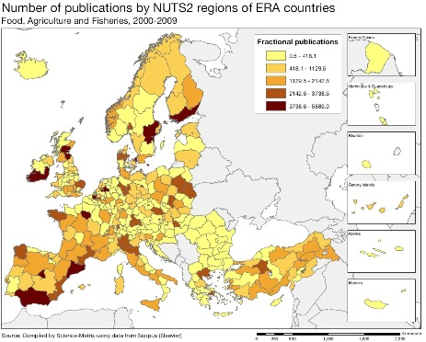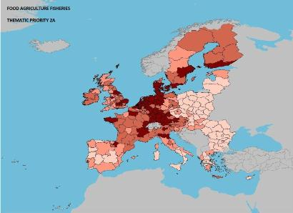

Scientific production Energy Technological production
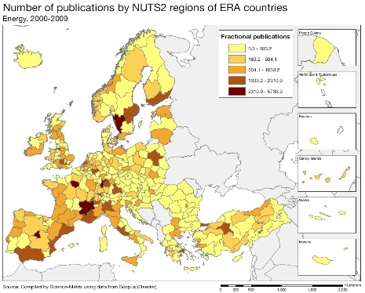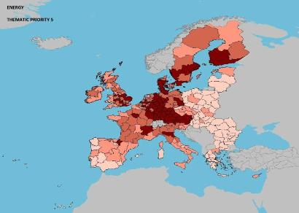

Scientific production Information and Communication Technologies Technological production
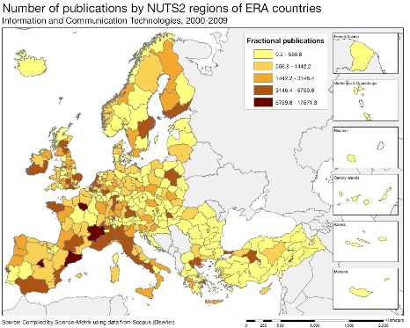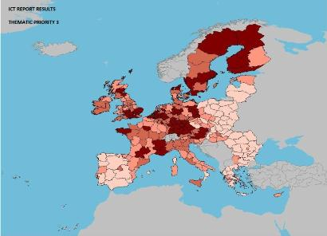
Source: DG Research and Innovation – Economic Analysis unit
Data: Science Metrix using Scopus (Elsevier), 2010; European Patent Office, patent applications, 2001-2010

Scientific production Nanotechnology Technological production
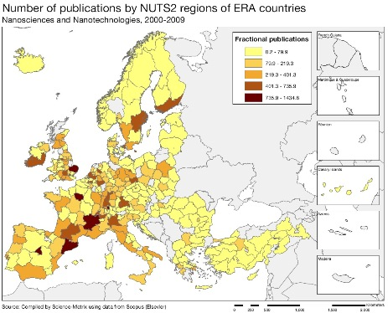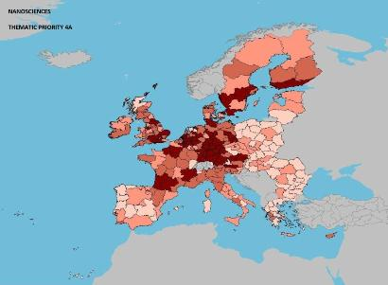
Scientific production Security Technological production
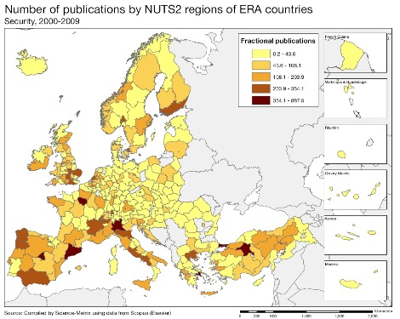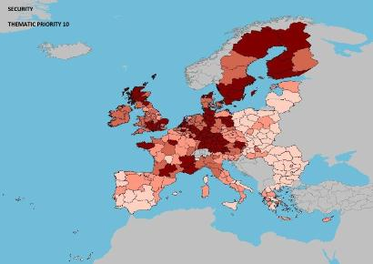
Scientific production Health Technological production
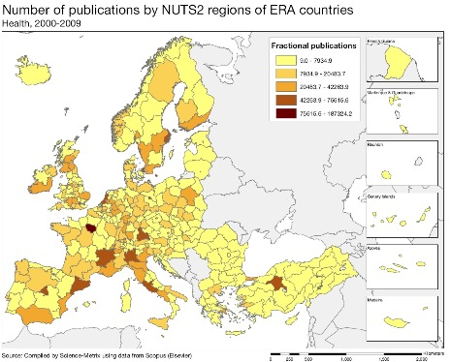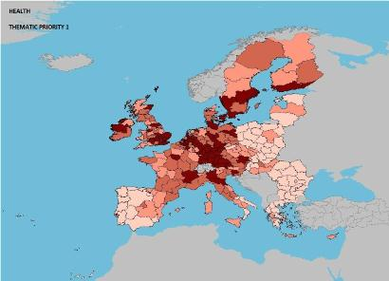
The maps above illustrate the strengths of Dutch science and technology production in absolute numbers in food agriculture and fisheries, energy, ICT, nanotechnology, security, and health. In general, there is a good correspondence between science and technology strengths. These sectors coincide to a large extent with the top sectors of the Dutch enterprise policy 'To-the-Top'.
In terms of specialisation, the Netherlands has globally the highest research intensity in health, with a specialisation index of 1.35. The specialisation patterns between 2000 and 2010 show that the Netherlands is among the first three most specialised countries in the world in audio-visual technology, basic communications processes, semiconductors, optics, macromolecular and food chemistry, and food products and beverages. In the thematic area of food, agriculture and fisheries, the Netherlands had the highest share in the world of scientific publications in the top 10% most cited scientific publications with a score of 17.8% (2000-2009). In the field of nanosciences, the Netherlands had the second highest score in the world (behind Israel) in terms of scientific publications produced between 2000 and 2009.
A quantitative analysis of the number of EPO patents (2000-2010) by applicant classified by FP7 thematic priorities show that the Netherlands has higher shares of total patenting activity than the EU average in some fields including food and agriculture (6.31% vs. 4.07%), information and communication technologies (37.7% vs. 21.4%) and security (3.16% vs. 2.94%).
Policies and reforms for research and innovation
Although the Netherlands traditionally has a good organisational capacity that translates into productivity performance, its relative underinvestment in R&D is not without consequences. For instance, the productivity gains in the Netherlands tend to stagnate albeit at a high level. This may weaken the capacity of the Netherlands to position itself internationally in sectors where it could build comparative advantage over time. These challenges are addressed by a specialisation strategy, but it remains to be seen whether sufficient public resources can be concentrated in the selected domains.
The national innovation strategy ("Naar de top") relies indeed on the new top sectors approach which is characterised by increased focus on demand-driven policies, fewer direct subsidies, more generic indirect support (e.g. tax incentives, deregulation) and more emphasis on entrepreneurship, in particular for innovative SMEs. A significant share of the public R&D budget is to be mobilised in favour of the top sectors. The aim is to reduce the administrative burden and to create additional tools for innovation funding via a revolving Innovation Fund. The shift from grants to tax incentives is based on three main instruments: WBSO scheme for wage subsidies, the RDA for complementary types of cost other than wages, and the Innovation Box.
That strategy identifies nine "top sectors" to stimulate more cooperation between government, business and knowledge institutes through a series of public-private partnerships: chemistry, creative industry, energy, high-tech systems and materials, life sciences and health, agro and food, logistics, horticulture and propagating stock, and water. Each of these sectors is characterised by a strong market and export position with a very good knowledge base and high potential for public-private collaborations. Top sectors are often geographically concentrated in innovation hotspots, such as the Brainport region (Eindhoven area) or Food Valley (Wageningen area). Each top sector will consider how to attract foreign business and top talents to the Netherlands. This approach aims to bring research closer to business and to foster valorisation and product innovation activities. It was presented in 'To the Top: Towards a new enterprise policy' (February 2011) and 'Enterprise policy in action' (September 2011).
So-called 'top teams' involving various stakeholders from these sectors have developed sector policy agendas which will be evaluated regularly. These agendas have been translated in so called innovation contracts per top sector. Innovation contracts comprise are a balanced mix of fundamental research, applied research and valorisation, tailored to the needs of the market and consistent with the European agenda. The societal knowledge needs and overarching topics are also addressed in the contracts. The government puts the responsibility for this on the field by bringing relevant parties to the table under the direction of the leading players. This gives the parties a communal goal: each sector will want to present the best plan possible that is supported by their grass roots and organisations. Drafting contracts is an open process with room for all blood types, including the SME sector.
As part of the top sector approach, 19 Top consortia for Knowledge and Innovation (TKI) are put into action as of September 2012. TKIs are designed as public private partnerships, bundling excellence (in terms of research and business) in promising fields of technology. Driven and supervised by the top teams, they will play an important role in the prioritisation and guiding of public spending and in demand-side management.
An important aspect of the new business policy is to target support for the promotion and creation of fast growing new science-based companies spinning-off from business, universities and research laboratories. In parallel, continued public efforts are envisaged to support non-targeted academic research and to attract and train a larger number of students in science and engineering.
The Strategic Agenda for Higher Education, Research and Science (published on 1 July 2011) complements the "top sectors" approach by encouraging universities and universities of applied sciences to adapt and improve academic curricula, to regroup into knowledge clusters and to strengthen their 'valorisation' mission. Addressing the challenge of a relatively low number of graduates, in particular in science and engineering, the strategic agenda emphasizes the need to focus on research, to foster specialisation in higher education institutions and to reward quality when funding applied science in universities. The government has also reserved funding for new and updated research infrastructures and has put in place a national roadmap for research infrastructures.

Economic impact of innovation
The index below is a summary index of the economic impact of innovation composed of five of the Innovation Union Scoreboard's indicators.
The share of employment in knowledge-intensive activities is in the Netherlands clearly above the EU average. The overall good patenting performance in the Netherlands reflects primarily the patenting behaviour of a small group of MNEs based in the Netherlands while Dutch young firms (less than five years old) have noticeably less PCT patent applications than their equivalents in other R&I intensive Member States. The low score of the Netherlands on the indicator “Share of knowledge-intensive exports in services exports” is largely explained by high volumes of activities in some logistics, transport and trade related services which are linked to the geographical intermediation role of the Netherlands and which are classified as non-knowledge-intensive.
Building on its excellent science base, the Netherlands has the capacity to build up internationally attractive innovation environments for innovative SMEs and to retain and attract R&I activities of MNEs. The existing technology supply of innovative firms in the Netherlands would benefit from closer links with the technology demand from larger MNEs, thus enhancing fast-growing innovative firms. In the medium term, the Netherlands needs to respond to internationalisation by upgrading the economic structure of its economy and injecting knowledge in key growth sectors. Since 1995, there have been few changes in the economic structure in the Netherlands towards higher knowledge intensity in the manufacturing sector. The service sector is growing and would, if oriented towards knowledge-intensive services, have the potential for linking up to the internationalisation of research and innovation.
Finally, the Netherlands is fairly advanced in implementing demand-side policy measures, such as the SBIR (Small Business Innovation Research) programme which stimulates the creation or expansion of innovation markets by supporting SMEs in developing innovative products through several stages of procurement contracts. This scheme can be considered as pilot in Europe (a similar scheme exists in South Korea). As a first step, companies submit their proposals for product development. Several companies are funded for half a year to perform feasibility studies. In the light of these studies, three companies are asked to develop their ideas into a marketable product and are subsidised for 18 months with up to € 450 000 each. After that, the procuring authority is free to buy ownership of one of these three products.

Upgrading the manufacturing sector through research and technologies

The graph below illustrates the upgrading of knowledge in different manufacturing industries. The position on the horizontal axis illustrates the changing weight of each industry sector in value added over the period. The general trend to the left-hand side reflects the decrease of manufacturing in the overall economy. The sectors above the x-axis are sectors whose research intensity has increased over time. The size of the bubble represents the share of the sector (in value added) in manufacturing (for all sectors presented on the graph). The red-coloured sectors are high-tech or medium-high-tech sectors.
Since the mid-nineties, there have been only few changes in the economic structure. Most manufacturing sectors have had stable or declining R&D intensities. However, positive trends are visible in high-tech and medium-high-tech sectors such as machinery, and chemicals, and also in some larger medium-tech sectors such as publishing and printing. In general, the Dutch economic structure is oriented towards the services sector while the manufacturing sector is largely focused on medium-tech and medium-high-tech sectors such as food processing, chemicals, electrical machinery and petroleum refining. In terms of weight in the economy (horizontal axis), the graph above illustrates the decreasing contribution of manufacturing industry to value added in the Netherlands, with many sectors losing relative weight (left-hand side of graph).
The crisis package put forward by the Dutch government with regard to R&D and innovation included measures for leveraging private sector investments. From 2000, private R&D intensity declined in the Netherlands, indicating a shift towards less research-oriented activities. Some medium-high-tech and high-tech sectors have lost importance in the overall Dutch economic structure despite the fact that research investment in various industrial sectors has remained largely stable. The structural development of the Dutch economy is certainly a major concern of the government. One of the main rationales behind top sectors approach is to stimulate knowledge intensive sectors in the economy with a strong competitive position. In the long run this should strengthen the structural composition of the economy.
Competitiveness in global demand and markets

Investment in knowledge, technology-intensive clusters, innovation and the upgrading of the manufacturing sector are determinants of a country's competitiveness in global export markets. A positive contribution of high-tech and medium-tech products to the trade balance is an indication of specialisation and competitiveness in these products.

In the period 2000-2011 many Dutch industry sectors increased their contribution to the trade balance confirming the important role of the Netherlands in the global markets and its strong export capacities. The most significant improvements took place in various sectors of the machinery industries (i.e. specialised and general industrial, power-generating, electrical, data processing) and in the telecommunication, sound-recording and reproducing apparatus sector led by Phillips. In contrast, the photographic apparatus sector suffered a sharp deterioration of its relative contribution to the trade balance.
Also in real terms, the trade balance of HT and MT products have been growing strongly, although affected by the economic crisis after 2008. The continuing competitiveness of high-tech and medium-tech industries can be explained by the stability of Dutch total factor productivity growth since 2005. The key indicators (table next page) also confirm the excellent S&T results of the Netherlands in international cooperation, in particular in terms of scientific co-publications and license and patent revenues from abroad.
The Dutch economy was deeply affected by the financial and economic crises and underwent a severe contraction in 2009 but the employment rate remains. In total, beside a shrinking R&D intensity, the progress towards the other Europe 2020 objectives is positive with falling greenhouse gas emissions, a larger share of electricity from renewable energy, a decrease of the population at risk of poverty and a growing share of population having completed tertiary education. As regards technologies contributing directly to societal challenges, the Netherlands patented more environment-related technologies, which is consistent with its progress on environmental objectives. The evolution of health-related technologies fell slightly, but from a high-performance level.
Key indicators for the Netherlands

Country-specific recommendation in R&I adopted by the Council in July 2012:
"Promote innovation, private R&D investment and closer science-business links, as well as foster industrial renewal by providing suitable incentives in the context of the enterprise policy, while safeguarding accessibility beyond the strict definition of top sectors and preserving fundamental research".
Poland
Improving quality of the science base and fostering innovation in enterprises

Summary: Performance in research, innovation and competitiveness

The indicators in the table below present a synthesis of research, innovation and competitiveness in Poland. They relate knowledge investment and input to performance or economic output throughout the innovation cycle. They show thematic strengths in key technologies and also the high-tech and medium-tech contribution to the trade balance. The table includes a new index on excellence in science and technology which takes into consideration the quality of scientific production as well as technological development. The indicator on knowledge-intensity of the economy is an index on structural change that focuses on the sectoral composition and specialisation of the economy and shows the evolution of the weight of knowledge-intensive sectors and products and services.

 | Investment and Input | Performance/economic output
Research | R&D intensity  2011: 0.77% (EU: 2.03%; US: 2.75%)  2000-2011: +1.6% (EU: +0.8%; US: +0.2%) | Excellence in S&T  2010: 20.47 (EU:47.86; US: 56.68)  2005-2010: +4.45% (EU: +3.09%;US: +0.53)
Innovation and  Structural change | Index of economic impact of innovation  2010-2011: 0.313 (EU: 0.612) | Knowledge-intensity of the economy  2010: 31.78 (EU:48.75; US: 56.25)  2000-2010: +1.65% (EU: +0.93%; US: +0.5%)
Competitiveness | Hot-spots in key technologies  Food, agriculture and fisheries; Energy; Environment; Security; ICT; Materials | HT + MT contribution to the trade balance  2011: 0.88% (EU: 4.2%; US: 1.93%)  2000-2011: +37.56% (EU: +4.99%; US:-10.75%)

Since 2000, Poland has increased its investment in R&D and improved its excellence in science and technology (although at a lower rate than EU average), while focusing on key technologies relevant to industry. The economy has been undergoing structural change towards higher knowledge intensity (a 28% improvement since 2000) and Poland's global competitiveness is improving at a higher rate than the EU average. In addition, Polish exports have been growing and Poland has increased its share of high-tech exports by 2% annually over the period 2000-2010. This development seems to reflect the positive effects of large foreign direct investment inflows and the related imports of advanced investment goods that upgraded domestic production structures. Poland scores relatively low on the indicator of contribution of high-tech and medium-tech goods to the trade balance, but the positive value indicates a small comparative advantage and structural surplus in high-tech and medium-tech trade which is growing (0.19 in 2010 and 0.88 in 2011; EU average of 3.54 in 2010 and 4.2 in 2011). However, Poland is still far behind the EU average in terms of investment, excellence and knowledge-intensity in the economy, thus leaving room for further progress, illustrated by the ambitious Polish R&D intensity target for the Europe 2020 strategy.

The Polish R&D system has undergone major restructuring over the last few years. The recent reforms of the science and higher education systems spurred significant changes, including the move towards more competitive funding, the creation of two R&D agencies for applied and basic research and efforts on tackling fragmentation through concentration of funding on the best performing institutions. These changes were dovetailed with the evolution of the governance structure by the establishment of two advisory bodies: the Committee for Science Policy and the Committee for Evaluation of Scientific Institutions. These reforms are bound to bear fruit in the mid to long term. A key challenge for the Polish economy is to maintain high growth and this requires higher innovation and the deployment of new technologies. Measures adopted so far have not led to visible improvement in the innovativeness of Polish companies. Persistently low R&D spending, in particular severe underinvestment in research and innovation in the private sector, and limited cooperation between research and industry call for giving way to a new approach with well-designed incentives and effective support through public funding, including more public-private cooperation.
Investing in knowledge

Poland has set an ambitious national R&D intensity target of 1.7% by 2020. Poland's R&D expenditure has grown slowly in recent years and remains low at 0.77 % of GDP in 2011, one of the lowest levels in the EU. Poland's R&D intensity experienced an average annual growth of +1.6% between 2000 and 2011. The average annual increase required to hit the 2020 target is considerably higher at +8.7%. The main weakness remains underinvestment by the private sector. Business R&D expenditure accounts for only 0.2 % of GDP. The breakdown of total R&D expenditure by source of funds and sector of performance illustrate reverse shares in comparison to the EU average. In 2010 the government financed more than 60% of total R&D, while business enterprise financed 24.4% of total R&D and performed 26.6% of total R&D.

Compared to countries with a similar catching-up dynamics as Poland, performance is good. However, the shares of R&D financed by and performed by business enterprise have slightly declined over the 2000-2010 period. In the EU as a whole, business enterprise financed more than 50% of total R&D and performed more than 60% of R&D in 2010. Even if Poland's industrial structure was in line with the average industrial structure for OECD countries, there would only be a slight increase in Polish business R&D intensity. This indicates that Poland's business R&D investment is well below average regardless of sectoral specialisation. These indicators do not reflect yet the efforts undertaken recently to increase public R&D spending and to trigger private sector investment in R&D. The 2012 national research budget grew by around 10% and together with funding provided under the EU structural funds (around 20 % of the overall budget) this makes it Poland's highest R&D budget so far. A further increase of around 3.5% is foreseen in 2013.

Structural funds are an important source of funding for research and innovation activities. Out of the 67 billion euro of structural funds allocated to Poland over the 2007-2013 programming period, around 15 billion euro (22.8% of the total) relate to R&D, ICT, business environment and SMEs. Projects amounting to more than 9 billion euro have been selected up to the end of 2011, representing a commitment rate of 61.2% (the EU average is 46.6%). Polish applicants for funding under the EU's 7th Framework Programme (FP7) have a success rate of 19%. Over 1500 partners from Poland have been participating in FP7 receiving a total EC financial contribution of 286 million euro.
An effective research and innovation system building on the European Research Area

The graph below illustrates the strengths and weaknesses of the Polish system. Reading clockwise, it provides information on human resources, scientific production, technology valorisation and innovation. Average annual growth rates from 2000 to the latest available year are given in brackets.
The Polish research and innovation system exhibits a similar performance as comparable countries in the reference group, but in order to progress further towards the EU average Poland should address weaknesses in the innovation cycle - from knowledge production to commercialisation. Poland's relative weaknesses are mostly on the output side and relate to the innovation performance of companies. Its relative strengths are in human resources, where the average annual growth of new graduates in science and engineering exceeds the EU average. However, new doctoral graduates and foreign doctoral students show a decline. Poland has a low intensity of business researchers (less than one per thousand labour force). This reflects the small role that the business sector plays in the national R&D system. On a more positive note, the number of business researchers increased in 2011 and shows a positive average annual growth over the period 2000-2011. Poland is one of the top-20 countries of origin of foreign scholars in the US (2006-08).
Poland relies on transfer of foreign technology to upgrade its economy. Domestic knowledge production is limited. Poland scores low both in terms of high-impact scientific publications and patent applications, where the gap with the EU average is particularly large. Around 3.7% of Polish scientific publications are in the top 10% most cited scientific publications worldwide. This is the third lowest value among EU countries. The level of public-private co-publications is equally very low highlighting weak linkages and a lack of cooperation culture between science and industry in Poland. While the level of employment in knowledge-intensive activities is one of the lowest in the EU, Poland shows a positive trend with an average annual growth of 4.1 % for this indicator. High growth is observed for the share of knowledge-intensive services exports in total services exports and for BERD and license and patent revenues from abroad (but starting from a very low level). Relatively strong declines are observed for the innovation activities of SMEs. Overall, the low level of R&D expenditure and the low R&D and innovation activity of companies, coupled with insufficiently favourable framework conditions, are reflected in a poor scientific and technological performance.
Poland's scientific and technological strengths

The maps below illustrate several key science and technology areas where Polish regions have real strengths in a European context. The maps are based on the numbers of scientific publications and patents produced by authors and inventors based in the regions.

Strengths in science and technology at European level

Scientific production Food, agriculture and fisheries Technological production

Scientific production Energy Technological production

Scientific production Environment Technological production
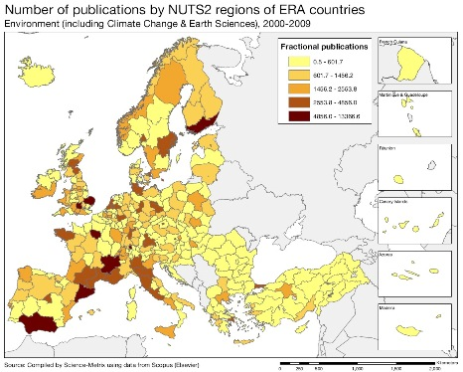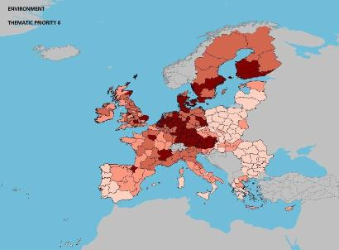

Source: DG Research and Innovation – Economic Analysis unit
Data: Science Metrix using Scopus (Elsevier), 2010; European Patent Office, patent applications, 2001-2010

Scientific production Security Technological production
Scientific production ICT Technological production
Scientific production Materials (excluding nano) Technological production
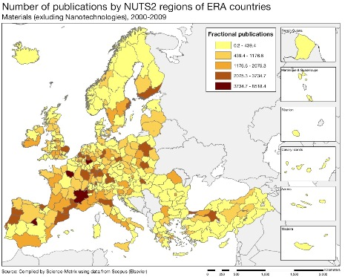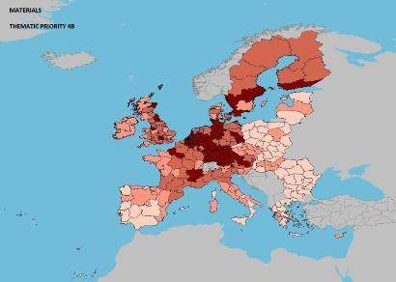

The Polish composite indicator for research excellence is only 35% of the EU average. Performance, of course, varies across sectors. The maps present the sectors in which Poland's scientific and technological production is relatively strong. Interestingly, these sectors largely correspond to the priority areas identified recently in the 2011 National Research Programme (KPB). Poland is therefore focusing its efforts on its strengths. Food, agriculture and fisheries, energy, ICT, and materials are four fields in which Poland's scientific production reaches the highest levels. These strengths are not yet matched on the output side. No Polish region reaches the two highest proxies for technology specialisation in terms of patent applications. This re-affirms the overall finding that Poland has untapped potential in knowledge commercialisation and needs to reinforce its innovation capacity to better translate knowledge into innovative outputs. Poland exhibits low levels of specialisation. The process of consolidating publicly funded research efforts has started only recently.

Policies and reforms for research and innovation

The challenges involved in increasing the quality and effectiveness of the Polish research and innovation system have been addressed by major reforms launched in recent years. The reforms of higher education (“Partnership for knowledge”) and science (“Building on knowledge” - package of six reforming acts) entered into force in October 2011 and October 2010 respectively. The reforms spurred significant changes, including a move towards more competitive funding, the creation and reinforcement of two executive agencies for applied research (the National Research and Development Centre - NCBiR) and basic research (the National Science Centre - NCN) and included efforts to tackle fragmentation through concentration of funding on the best performing institutions. These changes were dovetailed with the evolution of the governance structure by the establishment of two advisory bodies: the Committee for Science Policy and the Committee for Evaluation of Scientific Institutions.

The higher education reform aims to strengthen university-business links and to address the skills and jobs mismatch. The reform aims to make the higher educational system more flexible and better able to respond to the needs of a changing labour market. The first six KNOW (National Leading Scientific Centres) were selected in July 2012. Each of the selected KNOWs will receive up to 50 million PLN additional funding for strengthening research potential and investing in top talent. Good progress has also been made in implementing the science reform six pack. The ministerial decision on the criteria for the evaluation of scientific institutes, after consultations with stakeholders, was adopted in July 2012. Projects run by the applied research agency, NCBiR, focus on stimulating science-industry cooperation, with a cluster initiative in the aviation sector being a good practice example. The Top 500 innovators initiative aims at improving the technology transfer skills of researchers and professionals. It will train up to 500 professionals in the commercialisation of research results and science-industry collaboration. The reforms also included the more effective management and improvement in quality of the Polish Academy of Science (PAN). An example of using the possibilities offered under the new law is the creation of inter-disciplinary centres by research institutes of the PAN.
Poland is also addressing the issue of research fragmentation with initiatives to encourage specialisation outlined in the National Research Programme adopted in August 2011. It identifies seven strategic research and development areas: energy, medicine and pharmaceuticals, IT and advanced technologies, environment and agriculture, socio-economic development, and security and defence. The KPB priorities will be implemented in a series of strategic programmes by the applied research agency. In general, there is a fit between priorities identified in strategic documents and support measures, however further prioritisation and the linking of those priorities with innovation and industrial policies would bring more efficiency, as indicated in the 2012 European Commission assessment of national reform programmes.
The reforms were predominantly designed to correct inherent weaknesses of the Polish R&D system. The new 2020 Innovation and Effectiveness strategy, which will be adopted by the government at the beginning of 2013, aims at an integrated approach to research and innovation embedded in a wider economic context. The strategy builds on previous science and innovation strategies, but is extended to new areas and is rooted in the Europe 2020 strategy and Innovation Union. The strategy is based on a thorough analysis of the strengths and weaknesses of the Polish research and innovation system, including Poland's performance across the Innovation Union Scoreboard's indicators. Given the significant weaknesses in innovative output, the new innovation strategy foresees greater emphasis on financial engineering and demand side measures. Despite various programmes of support, there is still a mismatch between the skills provided by the education system and the needs of industry. A general view voiced by the stakeholders is that the skill shortages relate mainly to innovation, although improving the skills of researchers is also a requirement. This has been a long-standing challenge and different policy responses have been adopted over recent years. The way forward would be to promote new forms of support as a means of fostering closer co-operation between the business sector and HEIs, to improve the mobility and career development of researchers, and to nurture the development of entrepreneurship skills.
Economic impact of innovation

The index below is a summary index of the economic impact of innovation composed of five of the Innovation Union Scoreboard's indicators.
The main challenge for the Polish economy continues to be to enhance investment and innovativeness of Polish businesses, improving the economic impact of innovation. The bar chart above indicates a room for progress for Poland in reaching the EU average, in particular in raising the knowledge and technology intensity of the economy. Poland's main strengths is in the manufacturing trade, where export in high-tech and medium-tech goods give a relatively good contribution to the trade balance. A way foreward is to address the dynamics of innovation and growth of firms. In the EU, more than half of the enterprises in the industry and services sectors reported innovation activity between 2006 and 2008. The second lowest rate was observed for Poland which at 27.9% was little over half of the EU average. There is strong awareness of this challenge at national level and support mechanisms have been launched to encourage science-industry cooperation. However, there are persistent structural problems which have resulted in a failure to drive sufficiently private-public collaboration and to stimulate the growth of innovative companies. Structural funds support for R&D&I have been skewed towards absorption of new technologies, and have been less successful in undertaking indigenous research and innovation projects which are inherently more risky. The new innovation strategy identifies these bottlenecks and sets as priorities the stimulation of demand-side measures for innovative products and services and the facilitation of access to finance.

In the CIS 2010 survey, the surveyed Polish companies reported high costs and weak access to finance as the main factors hampering innovation investment. The sectors in Poland with the highest shares of innovative companies are pharmaceuticals (industry sector) and insurance (services sector). Improving the business environment is one of the Polish government's priorities, with two deregulation acts and the entrepreneurship act entering into force in 2012, but the pace of reform is rather moderate. Poland is close to the EU average in terms of access to finance. With the economic crisis spreading in Europe, a decline in the demand for and the number of loans made to SMEs has followed. However, the latest ECB lending survey shows that in 2011 the willingness of banks to provide loans improved in Poland in contrast to the majority of the other Member States. As the venture capital market is still not very developed, the availability of risk capital for innovative companies at early stages of development is limited. The first Polish 'funds of funds', National Capital Fund (KFK), did not become operational until 2010 and it is too early to assess its impact on the development of start-ups and seed capital funds. It is expected that by the end of 2012, the KFK will invest in 22 venture capital funds which in turn will support up to 200 innovative SMEs by 2016. The Polish growth stock market, New Connect, continues to be a best practice example at the European level. It is focused on SMEs with high growth potential, including those investing in new technologies.
Upgrading the manufacturing sector through research and technologies

The graph below illustrates the upgrading of knowledge in different manufacturing industries. The position on the horizontal axis illustrates the changing weight of each industry sector in value added over the period. The general trend to the left-hand side reflects the decrease of manufacturing in the overall economy. The sectors above the x-axis are sectors whose research intensity has increased over time. The size of the bubble represents the share of the sector (in value added) in manufacturing (for all sectors presented on the graph). The red-coloured sectors are high-tech or medium-high-tech sectors.

The slight decline of business R&D intensity in Poland in the last decade is mainly due to stagnation of the relative research intensity in high technology sectors and the shift of the economic structure towards less research intensive activities. An exception is the motor vehicles sector, which has gained relative importance in total Polish production in the last decade. Four of the most research intensive sectors, i.e. the machinery and equipment sector, the radio TV and communication equipment sector, the chemicals sector, and the motor vehicles sector suffered from a drop in their relative R&D investments over the value of their production.
This finding suggests that Poland is not moving towards more research intensive, higher value added products in these industries. The two other research intensive sectors: office, accounting and computing machinery and medical, precision and optical instruments, show an increase in their R&D intensities while the medical, precision and optical instruments sector has improved its relative importance in total value added. The above economic structure is reflected in the sectors of activity of the top Polish corporate R&D investors. Poland has seven companies in the 2011 EU Industrial R&D Scoreboard, with companies coming from the fields of telecommunications, banking, computer services and pharmaceuticals. Overall, the relatively stable sectoral composition of Polish industry around low research-intensive sectors reflects Poland's comparative weaknesses in terms of research and innovation performance.
Competitiveness in global demand and markets

Investment in knowledge, technology-intensive clusters, innovation and the upgrading of the manufacturing sector are determinants of a country's competitiveness in global export markets. A positive contribution of high-tech and medium-tech products to the trade balance is an indication of specialisation and competitiveness in these products.

Poland's total export of high-tech (HT) and medium-tech (MT) goods grew up to 2008, although the trade balance for HT and MT goods has stayed negative. With a slowdown of imports since 2008, the gap in the HT and MT trade balance remained. However, as overall trade balance in the economy presents a bigger gap which has slightly expanded, the contribution of HT and MT goods to the trade balance has increased for many products.

Overall, Poland has achieved an increasing weight of HT and MT goods in its trade balance, which is noticeable and a potential for structural change. Road vehicles, telecommunications, office machines and industry machinery registered the highest growth in the contribution to the trade balance. The evolution of these goods in the trade balance, confirms the specialisation pattern revealed by their corresponding industry sectors in the bubble graph presented on the previous page. If Poland is to achieve a positive trade balance in HT and MT goods, a more determined knowledge upgrading of a larger span of sectors is needed.

Over the last decade, total factor productivity has grown constantly in Poland. The employment rate has also increased and the share of population at risk of poverty or social exclusion is shrinking. Poland has also made good progress towards the other Europe 2020 targets in environment and education. There are an increasing number of patents in environmental- and health-related technologies.

Key indicators for Poland

Country-specific recommendation in R&I adopted by the Council in July 2012:
"Take additional measures to ensure an innovation-friendly business environment, by ensuring better links between research, innovation and industry, and by establishing common priority areas and instruments supporting the whole innovation cycle; improve access to finance for research and innovation activities through guarantees and bridge financing"
Portugal
The challenge of a recovery

Summary: Performance in research, innovation and competitiveness

The indicators in the table below present a synthesis of research, innovation and competitiveness in Portugal. They relate knowledge investment and input to performance or economic output throughout the innovation cycle. They show thematic strengths in key technologies and also the high-tech and medium-tech contribution to the trade balance. The table includes a new index on excellence in science and technology which takes into consideration the quality of scientific production as well as technological development. The indicator on knowledge-intensity of the economy is an index on structural change that focuses on the sectoral composition and specialisation of the economy and shows the evolution of the weight of knowledge-intensive sectors and products and services.

 | Investment and Input | Performance/economic output
Research | R&D intensity  2011: 1.50% (EU: 2.03%; US: 2.75%)  2000-2011: -0.16% (EU: +0.8%; US: +0.2%) | Excellence in S&T  2010: 26.45 (EU:47.86; US: 56.68)  2005-2010: +4.23% (EU: +3.09%;US: +0.53)
Innovation and  Structural change | Index of economic impact of innovation  2010-2011: 0.387 (EU: 0.612) | Knowledge-intensity of the economy  2010: 41.04 (EU:48.75; US: 56.25)  2000-2010: +3.18% (EU: +0.93%; US: +0.5%)
Competitiveness | Hot-spots in key technologies  Food, agriculture, fisheries, Biotechnology, Materials, Environment, ICT | HT + MT contribution to the trade balance  2011: -1.2% (EU: 4.2%; US: 1.93%)  2000-2011: n.a. (EU: +4.99%; US:-10.75%)

Portugal has expanded its research and innovation system over the last decade, increasing its investment in research at a remarkable average annual real growth rate of 7% between 2000 and 2007. However, R&D intensity in Portugal has decreased by an average of 0.16 % from 2008 to 2011. Public expenditure on R&D was maintained at a level of 0.69% of GDP in 2011, despite the economic crisis. Portugal has also shown notable progress in the number of new doctoral graduates per thousand population aged 25-34 and in the share of researchers in the labour force. Business enterprise investment in R&D grew dramatically, with Portugal nearly quadrupling the intensity of business R&D in its economy between 2000 and 2011. Business enterprise also increased its share as source of funding of GERD from 27% in 2000 to 44% in 2009. These evolutions had a positive impact on scientific production and excellence as well as on innovation, including in SMEs. The knowledge-intensity of the economy has increased by well over the EU average in the period 2000-2010.

However, despite the progress observed on R&D expenditure in the business sector and the large increase in the total number of researchers in recent years, Portugal remains below the EU average in terms of S&T excellence, business enterprise research intensity and business enterprise researchers. Other challenges are the level of education attainment (both secondary and tertiary education), as well as the lower amount of public-private scientific co-publications, PCT patent applications, licence and patent revenues from abroad and knowledge-intensive activities. Some 'traditional' manufacturing sectors like 'leather and footwear' and 'textiles and textile products' lost competitiveness over the last decade and reduced their share in total national added value.
Portuguese policies for research and innovation support adequately the structural change needed by the country to improve productivity and competitiveness and resume growth. The new Strategic Programme for Entrepreneurship and Innovation articulates policies like education, training and employment with the aim of stimulating R&D and Innovation in the scientific system and the business enterprises. New initiatives for research excellence were launched to promote scientific employment of talents and excellent research centres. The Competitiveness Clusters are being rationalised and redirected towards strategic objectives of more competitiveness and an increase in exports and employment. At the same time the programme for applied research and technology transfer to enterprises is being reinforced.
Investing in knowledge

Portugal has set a national R&D intensity target for 2020 of 3%, where public sector R&D intensity would reach 1% and business R&D intensity 2%. From 2005 and up to the crisis, Portugal made a very significant progress towards the R&D intensity target. However, from 2009 onwards, the trend is negative and in 2011, Portuguese R&D intensity had fallen back to 1.50%, with a public sector R&D intensity of 0.69% and a business R&D intensity of 0.69%.

The main challenge for Portuguese R&D, therefore, is to increase the share of business R&D investment in total national R&D investment and to attract foreign business R&D investment. R&D investment has slightly decreased, affected by the economic crisis. Business R&D investment reached its highest level in 2009 in absolute terms and in relative terms after some years of notable growth. The difficult national business environment and the contraction of domestic demand places enterprises in the position of having to find external markets while facing challenges in terms of efficiency (productivity and competitiveness) and financing. The efforts of investing in innovation and research, increasing productivity and competitiveness, point in the good direction. Public funding of R&D has been sustained, despite the pressures created by public expenditure reduction.

Private and public R&D investment also receives support by co-funding from the European budget, in particular through the Structural Funds and from successful applications to the Seventh Framework Program for research. For the FEDER programming period 2007-2013, Portugal benefits from funding of € 5729 million (26.8% of the total allocated to Portugal) for research, innovation and entrepreneurship in the Portuguese regions. In 2010, Portugal had already absorbed 62.5% of these EU funds (the average in the EU was a 46.6% commitment rate). Portugal also has scope to increase its funding of R&D from the 7th Framework Programme. The success rate of Portuguese applicants is 19.1%, lower than the EU average success rate of 21.6%. By early 2012, slightly over 1300 Portuguese participants had been partners in an FP7 project, with a total EC financial contribution nearing € 283 million. Two Portuguese SMEs are among the top twenty SMEs having the highest numbers of FP7 signed grant agreements for the period 2007-2010.
An effective research and innovation system building on the European Research Area

The graph below illustrates the strengths and weaknesses of Portugal's R&I system. Reading clockwise, it provides information on human resources, scientific production, technology valorisation and innovation. The average annual growth rates from 2000 to the latest available year are given in brackets under each indicator.

The graph shows in broad terms that the big increase in R&D investment over the period 2000-2011 has triggered a stronger human resources component, higher scientific quality and some innovation but with less progress on technology valorisation. All in all, while good progress is made on human resources, science and business innovation, Portugal remains below the EU average on technology development, business R&D and the knowledge-intensity of the economy.

In the field of human resources for research and innovation, Portugal is achieving notable progress on numbers of new doctoral graduates and on researchers employed by business. This is the consequence of strong public incentives. However, the share of employment in knowledge-intensive activities has not followed the same trend, reflecting a weakness as regards its capacity to move towards more knowledge-intensive domains. The quality of scientific production improved significantly as reflected by an average annual growth rate of 6.1% in the share of national scientific publications in the 10% most cited scientific publications worldwide. As seen in the graph above, overall technology development is well below the EU average, although the level of PCT patent applications per billion GDP shows remarkable progress for the period 2000-2009. Product or process innovations in SMEs are at a good level, having increased substantially over the last decade.

Portugal's scientific and technological strengths

The maps below illustrate several key science and technology areas where Portuguese regions have real strengths in a European perspective. The maps are based on the number of scientific publications and patents produced by authors and inventors based in the regions.

Strengths in science and technology at European level

Scientific production Food, agriculture and fisheries Technological production

Scientific production Biotechnology Technological production
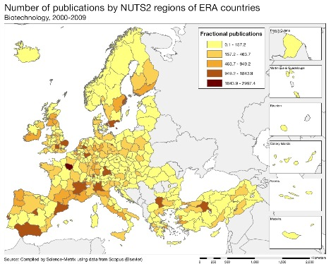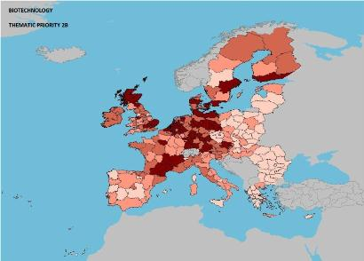

Scientific production Environment Technological production

Source: DG Research and Innovation – Economic Analysis unit
Data: Science Metrix using Scopus (Elsevier), 2010; European Patent Office, patent applications, 2001-2010

Scientific production Materials Technological production

Scientific production Information and Communication Technologies Technological production

Portugal, in terms of scientific production, has stronger capacity in the fields of health, food, agriculture and fisheries, ICT, materials, biotech, production and transport. The scientific specialisation index, covering the period 2000-2009, shows higher values in the fields of food, agriculture and fisheries, ICT, materials, production, construction, transport, biotech and security.

Regional diversity in scientific production and excellence is a reality, particularly for health, biotech, ICT and materials with the region of Lisboa taking the lead, followed by Norte and Centro. However, in areas such as food, agriculture and fisheries and environment participation from other regions is more evident. Scientific excellence, as shown by the impact of scientific publications in terms of citations, is shown to be particularly high for food, agriculture and fisheries, materials, energy, environment and transport.

Notwithstanding the diversification of S&T, as shown by the indicators above, the innovation base could be further strengthened by focusing more on some scientific areas that would improve the quality of technological output, such as biotech, food, agriculture and fisheries, materials, environment and ICT.

Policies and reforms for research and innovation

R&I policy is characterised by a large political consensus and continuity over time that allowed for significant progress from a relatively low base. Long term consistency has proved to be a positive determinant in ensuring the consolidation of the research system. However, the need to pursue a very tight budgetary policy has caused some changes. In 2012, for the first time since the economic crisis, the government budget for R&D has decreased. The budget for the Science and Technology Foundation (FCT) decreased by € 42 million between 2011 and 2012, but from a rather high level. In 2012, the FCT launched a call for proposals for 80 scientists, both Portuguese and foreign nationals, to carry out research in Portugal. New calls will be announced to the coming years. This initiative aims to consolidate the pool of high level scientists working in Portugal. A call for research projects in all scientific domains was also launched following a very similar line to those launched by previous governments. Initiatives have also been launched on doctoral and post-doctoral grants. Financing and evaluation of R&D institutions have been made in different scientific areas on a competitive basis and using new excellence-based demand criteria.
Over recent decades, Portuguese research policy has been horizontal in nature and has covered a broad spectrum. Despite the implementation of a number of recent initiatives addressing more targeted objectives and industry-academia interaction, the fact remains that part of the research carried out in the higher education, government and private non-profit sectors is still essentially organized according to academic criteria and responds to academic incentives. There are, however, signs that ‘targeted and thematic funding’ has been increasing in recent years. Examples are the ‘International partnerships’, addressing well defined areas, such as energy, advanced computation, security and health, the creation of the Iberian Nanotechnologies Laboratory, and the ‘Commitment to Science’ initiative that had identified some specific areas that research should address. Some initiatives are indicative of the future R&I policies of Portugal, e.g. the greater emphasis on competition for funding beyond Portuguese strategic funds, or the renewal of the Carnegie Mellon-Portugal programme to a second phase with a change of the main focus from education and training to entrepreneurship and innovation.
The new Strategic Programme for Entrepreneurship and Innovation (E+I+) includes several measures which are aiming to improve the connections between the two areas of "innovation" and "research". These include: (1) promoting experimentation in basic and secondary education; (2) education for entrepreneurship; (3) promoting the transition of PhD holders to non-academic careers, (4) improving the "articulation" of technology transfer units; (5) encouraging the economic exploitation of scientific knowledge; (6) launching of scientific thematic/priority programmes; (7) support for patent registration and licensing; and (8) a host of initiatives to encourage entrepreneurship. The programme of the new government specifies the "encouragement of the integration of Portugal's scientific system in the European Research Area". This will be achieved through an increased participation of Portuguese companies and research organisations in EU Framework Programmes and by supporting industrial research through public-private collaborations. The Strategic Programme for Entrepreneurship and Innovation (E+ I+) also includes a measure aimed at supporting the participation of Portuguese companies in international R&D programmes.

Economic impact of innovation

The index below is a summary index of the economic impact of innovation composed of five of the Innovation Union Scoreboard's indicators.
The index of economic impact of innovation shows that Portugal is lagging slightly behind in terms of orienting its economy towards innovative and knowledge-intensive sectors. This is of course partly attributable to the severe economic crisis. However, the scale of the gap also points at more structural problems.
Portugal's overall performance in innovation is moderate also according to the IUS report. Although there is a high share of SMEs introducing innovations, exports and employment in high-tech sectors and knowledge-intensive services are particularly weak, showing the difficulty for innovative firms to positioning themselves in markets with high potential for growth. This weakness is recognised and a strategic programme to promote entrepreneurship and innovation, 'E+I+', was introduced at the end of 2011, leading to the creation of a National Council for Entrepreneurship and Innovation and the launch of competitions for innovation and R&D projects to be implemented by micro and SMEs in cooperation with universities and research institutes. Standards on innovation management and guidelines for the valorisation and protection of IPR are being developed. Various measures were adopted to reduce the constraints on credit conditions and to promote the internationalisation and exports of SMEs. The on-going "Digital Agenda 2015" is progressing well, leaving Portugal with one of the most advanced broadband networks in the EU.
If the analysis is not limited to innovative enterprises but refers to all fast-growing firms, it reveals that Portugal's share of high growth enterprises (in terms of employment) in the total of active enterprises was 2.70% for micro enterprises and 3.26% for somewhat larger enterprises (10 employees or more) in 2009. These values are lower than the 2008 values, at a similar level to Spain but lower than Estonia and the Czech Republic. If fast-growing firms are measured in terms of turnover, the values for Portugal for 2009 are higher (4.45% and 6.38%, respectively) which seems to indicate that a critical size (in terms of employment and/or turnover), let alone other important factors, is an important factor in the growth of enterprises. The share of fast-growing enterprises by sector is much higher when measured in terms of turnover than in terms of employment. In 2009 the shares of high growth enterprises in the construction sector, in terms of turnover, were 8.27% (5 to 9 employees) and 11.95% (10 employees or more), whereas in terms of employment the corresponding shares were much more modest at 2.90% and 3.35%, respectively.
Upgrading the manufacturing sector through research and technologies

The graph below illustrates the upgrading of knowledge in different manufacturing industries. The position on the horizontal axis illustrates the changing weight of each industry sector in value added over the period. The general trend of moving to the left-hand side reflects the decrease of manufacturing in the overall economy. The sectors above the x-axis are sectors whose research intensity has increased over time. The size of the bubble represents the share of the sector (in value added) in manufacturing (for all sectors presented in the graph). The red-coloured sectors are high-tech or medium-high-tech sectors.
For a small country like Portugal, the road to growth leads to an extended market beyond the national boundaries, where competition must be confronted with high quality actors in sectors providing more value added. This requires reinforcing the capacity of enterprises to move into more high-tech and medium-high-tech sectors. Portugal has scope to upgrade the knowledge intensity in new areas of industry and in 'traditional' sectors by integrating more R&D with creativity, design, etc. The graph above shows a general picture of manufacturing sectors over the pre-crisis period 1995-2006, showing reduced shares of value added but increased BERD intensities for most of the sectors. In particular, textiles, leather products and other non-metallic mineral products, lost important positions. Wearing apparel and fur, despite a growth in R&D intensity over the period, lost an important share of value added, which can be explained by factors such as aggravated price competitiveness loss. Construction (a non-exposed sector) continues to play an important role in manufacturing value added with a very high growth rate of R&D intensity. The growth in the shares of value added for motor vehicles, and medical, precision and optical instruments is encouraging.
The 2011 EU industrial R&D scoreboard, ranking the top 1000 companies investing in R&D, shows that the top Portuguese companies are in the telecommunications, banking and electricity sectors. Just a year earlier pharmaceuticals and construction were also among the top sectors.

Competitiveness in global demand and markets

Investment in knowledge, technology-intensive clusters, innovation and the upgrading of the manufacturing sector are determinants of a country's competitiveness in global export markets. A positive contribution of high-tech and medium-tech products to the trade balance is an indication of specialisation and competitiveness in these products.

Over the last decade, Portugal has had large current account and trade balance deficits, reflecting the overall weak competitiveness of the majority of enterprises. The graph above shows the changes, from 2000 to 2011, of the contributions of various industries to the national trade balance. The highest positive variation occurred in machinery specialized for particular industries. The second highest positive variation is in road vehicles (including air-cushion vehicles), which passed from a negative contribution in 2000 to a positive contribution in 2011. The next positive variation is in plastics in non-primary forms (this industry had a positive trade balance since 2007). On the negative variations, the highest occurred for electrical machinery, apparatus and appliances, and electrical parts. Medicinal and pharmaceutical products and other transport equipment also had negative variations. Industries that contributed positively to the trade balance throughout the decade are: sanitary, plumbing and heating fixtures and fittings and fabrics, woven, of man-made textile materials.

Total factor productivity is lower than a decade ago (see Table below) and the share of employment in knowledge-intensive activities is also relatively low. Labour productivity increased over the same period, but only slightly. Enterprises need to further integrate new technologies and strive to develop new products, processes and services that may provide higher added value for their activities.

Concerning the other EU 2020 objectives, Portugal is progressing well in particular in relation to increasing the share of renewable energy in total energy consumption and the share of population having completed tertiary education.

Key indicators for Portugal

See Methodological note for the composition of this index.
See Methodological note for the composition of this index.
See Methodological note for the composition of this index.
Enterprises with average annualised growth greater than 20% per annum over a three year period.

