Romania
The challenge of improving policy coordination of R&I and upgrading the economy

Summary: Performance in research, innovation and competitiveness

The indicators in the table below present a synthesis of research, innovation and competitiveness in Romania. They relate knowledge investment and input to performance or economic output throughout the innovation cycle. They show thematic strengths in key technologies and also the high-tech and medium-tech contribution to the trade balance. The table includes a new index on excellence in science and technology which takes into consideration the quality of scientific production as well as technological development. The indicator on knowledge-intensity of the economy is an index on structural change that focuses on the sectoral composition and specialisation of the economy and shows the evolution of the weight of knowledge-intensive sectors and products and services.
 | Investment and Input | Performance/economic output
Research | R&D intensity  2011: 0.48% (EU: 2.03%; US: 2.75%)  2000-2011: +2.53% (EU: +0.8%; US: +0.2%) | Excellence in S&T  2010: 17.84 (EU:47.86; US: 56.68)  2005-2010: +7.81% (EU: +3.09%;US: +0.53)
Innovation and  Structural change | Index of economic impact of innovation  2010-2011: 0.384 (EU: 0.612) | Knowledge-intensity of the economy  2010:28.35 (EU:48.75; US: 56.25)  2000-2010: +5.86% (EU: +0.93%; US: +0.5%)
Competitiveness | Hot-spots in key technologies  Automobiles, ICT, New production technologies, Nanotechnologies, and Security | HT + MT contribution to the trade balance  2011: 0.38% (EU: 4.2%; US: 1.93%)  2000-2011: n.a. (EU: +4.99%; US:-10.75%)

The reform of the Romanian R&I system has been under way over the last decade. A National Strategy for Research and Innovation 2007-2013 is in place. However the economic crisis has hampered its full implementation due to massive cuts in the public budget for R&D. It is noteworthy that Romanian authorities decided to support large projects such as the European Light Infrastructure (ELI) in order to make the most of extremely reduced investments in R&D. At the same time, some Romanian scientific journals have acquired an increasing international visibility and Romanian scientific publications have improved in overall quality. Institutional reforms of universities and research institutes are on-going.
The key challenge for Romania is its low level of competitiveness, a challenge which has significant consequences for the R&I system. Romania's economy is characterised by the prevalence of low- and medium-technology sectors, with a weak demand for knowledge and an underdeveloped innovation culture. Romania is ranked as a modest innovator and has the lowest R&D intensity in the EU and a very low level of business R&D activity. To complete the picture of poor innovation, the Global Competitiveness Report 2011 classifies the country as efficiency-driven (together with Bulgaria), all the rest of the EU economies being either in transition to, or already in the innovation-driven stage.
Over the last decade policy makers have made great efforts to reform the R&I system in Romania. However, the adopted measures would benefit from being supported by a long-term vision and are still hampered by the fact that the awareness of the added value of R&I for increasing competitiveness and secure high-quality jobs is not yet central to the political debate. In addition, a lack of continuity in policy decisions from one government to another and a lack of coordination among ministries that have in their portfolio R&I activities are generating "stops and go's" which are particularly detrimental in a domain that requires development of capacities overtime. In order to leverage the importance of R&I in the overall policy-mix of the country, R&I policy measures would indeed justify to be considered in the broader context of the country's economic development and better integrated in the overarching policy objectives of the country. For instance, improving the overall functioning of institutions would result in a better coordination of R&I policies across various ministries, whereas an increased focus on competitiveness at political levels would draw the attention of policy makers to the added value of R&I for growth and jobs.
Investing in knowledge
Over the last decade, R&D intensity in Romania increased from 0.37% in 2000 to 0.58% in 2008, unfortunately only to drop back to 0.48% in 2011. Romania currently has one of the lowest R&D intensity in the European Union, at a value of less than a quarter of its 2% target for 2020.
In absolute terms, public R&D funding reached a peak in 2008, following the adoption of the 2007-2013 Strategy for R&D and Innovation. The Strategy has foreseen a gradual increase of the R&D public budget, but the planned increase of the R&D public budget in 2009 did not take place. In absolute terms, government budget appropriations for R&D decreased by 25.4% in 2009 and by a further 2.6% in 2010 and then increased by 0.5% (provisional value) in 2011. Higher education expenditure on R&D suffered a large decrease of 32.2% in 2009 but increased by 1.4% in 2010. The Government expressed its intention to increase the public budget by 18.6% in 2011 and by an additional 12.7% in 2012 (according to the ERAC Survey, 2012).
In addition, Romania with a value of 0.17% had one of the lowest business R&D intensities in the EU in 2011 (rank 25 out of 27), with an average annual growth rate of -3.4% between 2000 and 2011. No Romanian firm is among the top-1000 EU R&D investing firms. The recent trends show that the 2% R&D intensity target for 2020 is very ambitious and will be difficult to reach, given both the recent low budgetary commitment and the very low level of business R&D activities. This target could be achieved only if the country prioritises R&I in a context of smart fiscal consolidation, whilst implementing without delay key reforms as outlined in the Action Plan for Research and Innovation adopted by the Government in July 2011.
The total number of Romanian participants in the 7th Framework Programme so far is 704 (out of 4888 applicants); thereby Romania has received € 96 million. The success rate of participants is 14.4%, below the EU average success rate of 21.95%. Romania receives the 19th largest share in the EU of 7th Framework Programme funding and has most collaborative links with Germany, Italy, the United Kingdom, France and Spain.
Private and public R&D investment also receives support by co-funding from the Structural Funds. Currently 13.7% is allocated to research, innovation and entrepreneurship from the total of Structural Funds available to Romania, compared to an overall 25% at the level of EU. A large part of the Structural Funds for R&I has been focussed on programmes for developing R&I infrastructure and human resources which have been developed as complementary to the national R&D programmes. The massive reduction of the R&D budget in 2009 however hampered this complementarity. Whereas the Structural Funds have had an absorption rate of 30% (rate of approved payments) for the R&I sector, the national R&D budget has been indeed severely cut.
An effective research and innovation system building on the European Research Area
The graph below illustrates the strengths and weaknesses of Romania's R&I system. Reading clockwise, it provides information on human resources, scientific production, technology valorisation and innovation. Average annual growth rates from 2000 to the latest available year are given in brackets.
The Romanian R&I system is primarily public-based, with only 38.3% of research performed by the business sector (the EU average is 61.5%). Another structural feature is the fragmentation of the public R&D system which has a large number of research performers and a lack of critical mass of research results. Romania scores well regarding the numbers of new S&T and PhD graduates. However, the overall underfinancing of R&I since the 1990s created a brain drain, which left the country with a pool of researchers with high average age and limited career prospects. Romania is suffering a net outflow of researchers (it is estimated that 15000 researchers are currently working abroad).
In terms of research excellence, Romanian universities are underperforming in all major international rankings and their scientific production and staff composition is less internationalized compared to other Member States. An increase in international scientific co-publications and in the share of national scientific publications in the top 10% most cited publications worldwide are nevertheless noticeable over the last 10 years.
Overall the number of international co-publications with other European countries is one of the lowest in Europe, suggesting that the Romania does not sufficiently benefit from the international knowledge flows favoured by the ERA architecture. However, Romanian scientific and technological cooperation is well distributed across Europe, with France, Germany, Italy, the United Kingdom, and Spain as main co-publication partners and Germany and Ireland as co-patenting partners.
The relative weaknesses of Romanian business sector R&I are striking: very low numbers of PCT patent applications and of business enterprise researchers, and a very low level of business R&D intensity, on a decreasing trend. The business sector is not fuelled by collaborative links between public and private sectors (as reflected by the low number of public-private co-publications).
Romania's scientific and technological strengths

The maps below illustrate six key science and technology areas where Romania has real strengths in a European context. The maps are based on the number of scientific publications and patents produced by authors and inventors based in the regions.

Strengths in science and technology at European level
Scientific production Automobiles Technological production
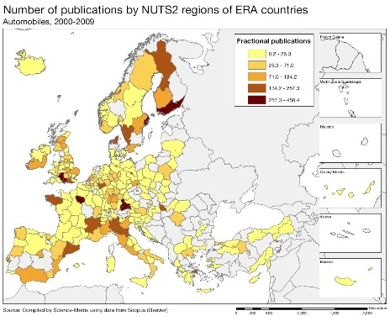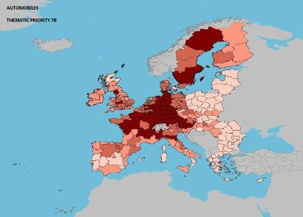

Scientific production Information and Communication Technologies Technological production
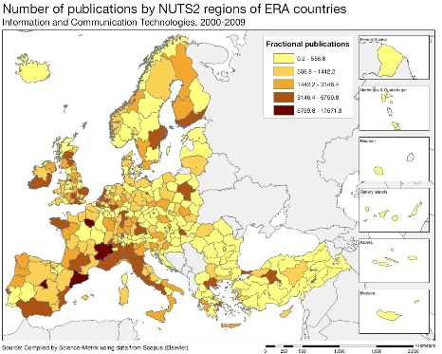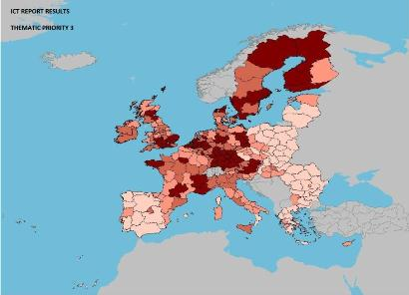

Scientific production New production technologies Technological production
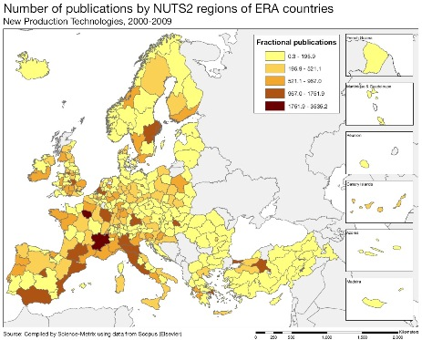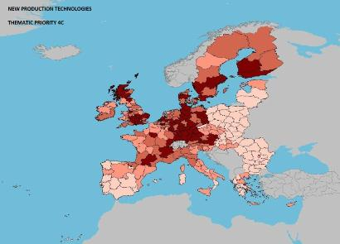

Source: DG Research and Innovation – Economic Analysis unit
Data: Science Metrix using Scopus (Elsevier), 2010; European Patent Office, patent applications, 2001-2010

Scientific production Nanosciences and nanotechnologies Technological production
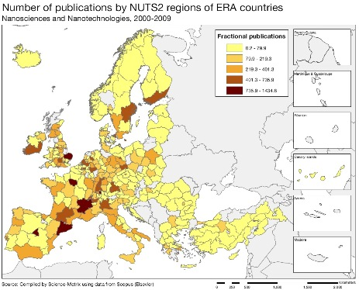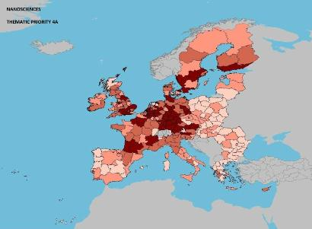

Scientific production Security Technological production
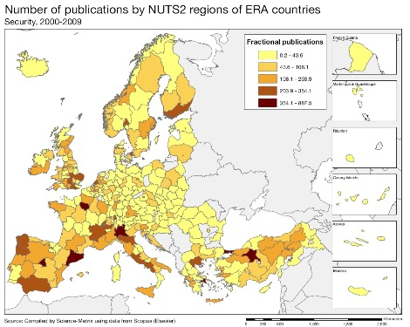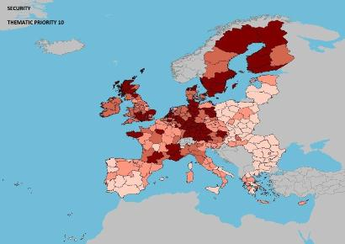

As illustrated by the maps above, in terms of scientific and technological capacity, Romania has potential for regional clusters in the fields of ICT, nano-sciences and nanotechnologies, automobiles, security and new production technologies.

Romania's scientific specialisation index, citations and impact of scientific publications, not visible in the maps above, reveals that the main scientific fields are mathematics and statistics, physics and astronomy, enabling and strategic technologies, engineering, and information and computer technologies. Chemistry has an interesting evolution, being a field with a rather strong specialisation in Romania, but with an overall impact of scientific publications that is low compared to the world average. In addition, it is striking that the field of agriculture, fisheries and forestry which has a lot of potential in Romania for economic growth given the existing raw materials, is not supported by a comparable scientific specialisation. The potential that exists in the field of agriculture is additionally confirmed by the fact that the low number of scientific publications are of very good quality, as reflected by their relative impact which is comparable to the world average.

Patenting activity in Romania is extremely low and does not demonstrate much statistically significant technological specialisation other than what can be seen in the maps above. In addition, based on data of the mid-2000s, no particular specialised established employment or technology cluster could be identified in Romania. The cluster policy put in place around the European Light Infrastructure project funded from the Structural Funds is expected to lead to the emergence of a specialised cluster in Romania around scientific capabilities in the field of physics. Danube-Danube Delta-Black Sea is another large project with cluster potential around it.

Policies and reforms for research and innovation
The country has undertaken a wide range of measures in the R&I field over the last 10 years: the current National R&I Strategy for 2007-2013 was based on a broad consultation (Foresight) exercise; Romanian scientific journals have been promoted on the international circuit; the share of competition-based funding has surpassed the share of institutional funding for research; measures have been taken to improve science-industry links by grants for projects with industrial partners; innovation vouchers and tax incentives have been introduced. In addition, in August 2011, the Romanian Government adopted a Reform Action Plan for R&I in the context of the loan received from the EU. The Action Plan is built around three pillars: governance of the system, management of public research institutes and increase of private sector R&I. Romanian authorities reported on a number of measures related to the Action Plan, either adopted or already implemented. A process of certification of national R&D institutes is ongoing and the legal framework regarding the funding of these institutes has been amended; ambitious reform of universities has been conducted, paving the way towards more autonomy and differentiation between research universities and those more oriented towards teaching and local needs.
However, the measures would have a greater impact if supported by a long-term vision. The adopted/planned measures would indeed need to be better related to each other within an overarching reform, in order to improve the overall efficiency of the R&I system. The setting up of an inter-ministerial Council for R&I could be of great help in terms of governance. The creation of this Council has been announced in 2002 but it has not really started its activities. It has the potential to steer action both for addressing the lack of coordination of research activities undertaken under the authority of various ministries and for promoting innovation across the economy. It can be expected to raise awareness at the highest political levels on the added value of innovation in various sectors (i.e. innovation in fields such as agriculture, transport, services, etc.), notably if its competencies cover both R&D and innovation activities and if its articulation with other similar councils is clarified.
The development, together with the main stakeholders, of a common vision for the progress towards a more knowledge-and innovation-based economy would indeed greatly help in increasing synergies and consistency between the various policies having an impact on business innovation. For instance, there are two different strategies on SMEs and on business environment, with similar objectives but without clear links between them. In this context, it is somewhat worrying that while a strategy for Competitiveness has been developed it is not yet adopted and it is not clear whether or when it will be.
As a matter of fact, private sector R&I remains underdeveloped and has been in continuous decline since 2000 and the existing measures to promote private R&I are not fully commensurable with the challenges faced by local innovative enterprises, multinationals and start-ups. It might be worth considering whether the system could not benefit from replacing the current interventions of a “one size fits all” type by targeted interventions for innovative enterprises with proven successful track records. In addition, there is an obvious need to address the current mismatch between the skills needed by the knowledge market and the qualifications provided by Academia. Multinationals seem somewhat reluctant about setting up R&I facilities in Romania due to the vulnerabilities of the intellectual property rights (IPR) framework, which gives the ownership of an invention/research result to the employees. In this respect, the finalisation of the national patent law is expected to contribute to an increase in foreign direct investment (FDI) for innovative activities that would ensure an increased level of productivity. A regulation on the 'employee patent' is currently under preparation which may address this issue, while additional fiscal incentives for companies undertaking R&D activities are in place and an innovation voucher has been introduced in 2012.
Finally, there is a slow take-off in “high-tech” student's start-ups that would need to be boosted by measures such as financing and mentoring services vouchers. There is a special open operation for innovative start-ups and spin-offs to support the implementation of R&I results. Seed capital is beginning to become available: the Ministry of Economy encourages a network of business angels (venture connectors) in fields such as ICT. However, high risk business angel investment/venture capital is still at a very low level and could benefit from being more easily matched by funding, for instance from an accelerator/investment fund for medium-high and high-tech ventures.
Economic impact of innovation

The index below is a summary index of the economic impact of innovation composed of five of the Innovation Union Scoreboard's indicators.

Romania's index of economic impact of innovation is lower than the EU average but higher than the level of the reference group of countries with similar economic and research profiles. Even if this value needs to be considered over time and not limited to a single year, it highlights a real economic stress for transforming knowledge and technology into economic competitiveness. A key strategy is facilitate the creation of high-growth innovative enterprises, which demands the following three structural challenges: 1) developing an excellent research base focused on sectors where Romania is performing well in terms of international benchmarks and where it has the potential to attract business investment; 2) nurturing entrepreneurship with the aim of disseminating and fostering research and innovation in the economy; and 3) developing appropriate framework conditions for innovation based on an overarching strategy supported by stakeholders.

The most problematic factors in relation to doing business have been identified as tax rates, inefficient government bureaucracy, policy instability, access to finance, and corruption. As a result, measures aiming to improve competitiveness and foster structural change of the business sector should encompass a broad set of measures, going beyond purely R&I related policies and dealing with the business environment, improving the infrastructure, enhancing administrative capacity, fighting corruption and fraud, etc.

As in most of Eastern Europe, the public support for the development of an informal venture capital market (both early stage capital and expansion and replacement phases) is limited. In addition, access to loans for SMEs undertaking R&I activities is practically non-existent, due both to the perception of banks that R&I activities are risky and to the lack of incentives for banks to grant small loans (the cost of processing a file is similar for a small loan taken out by an SME and for a big loan). Patent costs at EPO and other international patent offices are unaffordable for most potential Romanian applicants.

Upgrading the manufacturing sector through research and technologies

The graph below illustrates the upgrading of knowledge in different manufacturing industries. The position on the horizontal axis illustrates the changing weight of each industry sector in value added over the period. The general trend of moving to the left-hand side reflects the decrease of manufacturing in the overall economy. The sectors above the x-axis are sectors whose research intensity has increased over time. The size of the bubble represents the share of the sector (in value added) in manufacturing (for all sectors presented in the graph). The red-coloured sectors are high-tech or medium-high-tech sectors.
Romania's limited innovation performance is reflected in its economic structure which has a prevalence of low- and medium-technology sectors. Demand for knowledge is weak and there is an underdeveloped innovation culture. In terms of trade and industry specialisation, Romania is part of the group of lower income countries in the EU (together with Bulgaria, Estonia, Latvia and Lithuania), with lower GDP per person than the EU average and specialisation in less technologically advanced sectors. Romania is highly specialised in labour-intensive industries (preparation and spinning of textile fibres, sawmilling, wearing apparel and accessories), in capital-driven industries (cement), and marketing-driven ones (footwear). In terms of innovation, Romania is specialised both in low-innovation sectors (wearing apparel, leather) and in medium-high innovation sectors (textiles, basic metals).

In dynamic terms, a certain degree of structural change is shown in the graph above by the increasing added value in technology-driven and innovation sectors (office, accounting and computing machinery and motor vehicles, as well as to a lesser extent electrical machinery and apparatus). On the other hand, fields with high knowledge intensity such as medical precision and optical instruments and, to a certain extent, chemical and chemical products have decreasing shares of value added. However, whereas the quality of labour-intensive industries has improved, this is not yet the case for technology-driven ones.
Competitiveness in global demand and markets

Investment in knowledge, technology-intensive clusters, innovation and the upgrading of the manufacturing sector are determinants of a country's competitiveness in global export markets. A positive contribution of high-tech and medium-tech products to the trade balance is an indication of specialisation and competitiveness in these products.
The trade balance in all high-tech (HT) and medium-tech (MT) products combined was negative in Romania up to 2008 and became positive in 2009 and 2010. This contrasts with the total trade balance, where the positive trend up to 2008 was followed by relative stagnation in 2009 and 2010. The data therefore indicate both a progressive and encouraging shift towards HT and MT in the trade balance of Romania over the last few years, and the fact this shift was instrumental to counterbalance the weaknesses in the rest of the economy.

More precisely, the graph above points to the high-tech and medium-tech industries that have improved their contributions to the Romanian trade balance, in particular road vehicles, electrical machinery, and textiles , and to a certain extent for telecommunication, general industrial machinery and machinery specialised for particular industries. In contrast, industries such as power-generating machinery and equipment, plastics, medicinal and pharmaceutical products, fertilizers and metal working machineries are making decreasing contributions to the trade balance, indicating a possible loss in relative world competitiveness.

Over the last 15 years, the Romanian economy has gained in world competitiveness; however structural change is taking place at a very slow pace. Over the last decade, Romania has had the highest growth of total factor productivity in the EU. Taking 2000 as year of reference, total factor productivity had increased by 50% in 2008 and by 35% in 2012. The relative decrease between 2008 and 2012 can be reasonably attributed to the economic and financial crisis. Romania has made good progress on greenhouse emissions which have fallen and has also succeeded in increasing the share of renewable energy in gross final energy consumption. The employment rate has fallen from 69.1 in 2000 to 62.8 in 2011.
Key indicators for Romania

Slovakia

The challenge of structural change to upgrade knowledge in the context of industrial globalisation

Summary: Performance in research, innovation and competitiveness

The indicators in the table below present a synthesis of research, innovation and competitiveness in Slovakia. They relate knowledge investment and input to performance or economic output throughout the innovation cycle. They show thematic strengths in key technologies and also the high-tech and medium-tech contribution to the trade balance. The table includes a new index on excellence in science and technology which takes into consideration the quality of scientific production as well as technological development. The indicator on knowledge-intensity of the economy is an index on structural change that focuses on the sectoral composition and specialisation of the economy and shows the evolution of the weight of knowledge-intensive sectors and products and services.

 | Investment and Input | Performance/economic output
Research | R&D intensity  2011: 0.68% (EU: 2.03%; US: 2.75%)  2000-2011: +0.41% (EU: +0.8%; US: +0.2%) | Excellence in S&T  2010:17.73 (EU:47.86; US: 56.68)  2005-2010: +3.85% (EU: +3.09%;US: +0.53)
Innovation and  Structural change | Index of economic impact of innovation  2010-2011: 0.479 (EU: 0.612) | Knowledge-intensity of the economy  2010:31.64 (EU:48.75; US: 56.25)  2000-2010: +0.07% (EU: +0.93%; US: +0.5%)
Competitiveness | Hot-spots in key technologies  Food and agriculture, Energy, ICT, Materials | HT + MT contribution to the trade balance  2011: 4.35% (EU: 4.2%; US: 1.93%)  2000-2011: +32.26% (EU: +4.99%; US:-10.75%)

The Slovak Republic is a small country, dynamic and logistically well positioned between Eastern and Western European countries. Since 2000, the country has improved the quality performance of its science and technology base, slightly changed the structure of its economy towards a higher knowledge-intensity and the weight of high-tech and medium-high-tech products in the trade balance. Slovak Republic faces the challenge of further developing its research and innovation system. Currently, the country is catching-up with respect to competitiveness.

In the Slovak Republic, over the last decade, R&D intensity has steadily declined from a peak of 3.88% in 1989 to 0.68 in 2011, one of the lowest within the EU. The rise of a dual economy limited the indigenous R&D capacity: on the one hand a predominance of foreign multinational companies with high productivity and on the other, 60,000 domestic SMEs and a few large companies typically with low productivity levels. Thus, the main challenge for the Slovak Republic consists in raising the knowledge intensity in Slovak firms through investments and spill overs. Moreover, existing public financing suffers from inefficiency, significant administrative burden and a lack of transparency of the procedures used – including those supporting regional innovation. The Slovak Republic has margins to improve its thematic concentration, including a stronger coordination between responsible public authorities, the links between business and science, and the connexion with international S&T networks

In spite of the current economic and financial difficulties, Slovak authorities drafted and partly implemented comprehensive R&I strategies. Since April 2012, the new government has reaffirmed the country's commitment to the EU2020 targets, even if the challenges remain substantial, especially in the case of R&D intensity. Its policies include in particular, the updated "Minerva 2.0" strategy, which identifies problems, constraints and priorities, and focuses on the speedy implementation of a critical mass of measures to stimulate innovation and private R&D investment including structural reforms and the reform of funding.
Investing in knowledge
The Slovak Republic has set a national R&D intensity target of 1%. In 2011, the Slovak R&D intensity was 0.68% of GDP, where public sector R&D intensity amounted to 0.36% and business R&D intensity 0.27%. The Slovak Republic belongs to the group of Member States which are not on track to reach their Europe 2020 target (1% of GDP of R&D intensity) and there is a need to raise its annual rate of increase in total (public + private) R&D investment. Under these circumstances, in order to reach its national target by 2020, the Slovak Republic would need an annual growth rate of 4.7% over the decade 2010-2020, slightly higher of the EU average of 4.1%. This is possible to achieve provided the right policies are implemented.
Overall, the research & innovation system in the Slovak Republic is characterized by a very low R&D intensity in both the public & private sectors The Slovak R&D intensity is one of the lowest in Europe and also very low compared to the reference group countries CZ, IT, HU, SI (average of 1.27%).
However and in spite the overall decrease of the R&D intensity in the Slovak Republic over the last decade, public support to R&D has increased significantly (€86m in 2000 to €219m in 2010), notably due to the financing from EU resources (mainly through Structural Funds). Between the two programming periods of 2000-2006 and 2007-2013, the Slovak Republic increased the allocations to research and innovation (RTDI) by 19%. In total, over the period 2007-2013, the country received €1.103 million of the EU Structural Funds (a ratio of 81.2% of the total GBAORD), to research, innovation and entrepreneurship. For the 2011 and 2012 public state budget allocated to R&D, there was a further increase of 9% and 18% respectively, but a decrease is foreseen for the 2013 budget due mainly to measures to reduce public deficit.
In the private sector, domestic firms, including a great number of SMEs and a few large companies, are characterised by low R&D expenditure and productivity levels. As a result, the production system is dominated by technology imports. Therefore, a major challenge for Slovakia remains to raise the R&D intensity in Slovak firms.
The FP7 success rate of the Slovak Republic in terms of EU contribution of 12.3% is lower than the average EU-27 of 20.4%. In terms of applicants, the Slovak success rate of 19.2% is close to the EU-27 average of 21.2%. Among the FP7 research priority areas, Slovakia is most active in "Marie-Curie Actions", in "information and communication technologies" and in "research for the benefit of SMEs".
An effective research and innovation system building on the European Research Area

The spider graph below provides a synthetic picture of strengths and weaknesses in the Slovak R&I system. Reading clockwise, the graph provides information on human resources, scientific production, technology valorisation and innovation. The average annual growth rates from 2000 to the latest available year are given in brackets under each indicator.

The strengths in Slovakia's R&I system are found in human resources for research and innovation and in attracting business R&D investments from abroad. There is also a positive innovation dynamics in Small and Medium-Sized firms and in attracting foreign doctoral students. By contrast, the country's main weaknesses lay in business research activities, including low patenting, business researchers and R&D investments. In the public sector, the main challenges consist in pursuing the improvement in scientific quality and in public-private cooperation in R&D activities.
There is need to enhance quality of the higher education system and increase excellence and internationalization of its universities, as the latter one are not visible in major international rankings. The overall efficiency of the public science sector can be improved, given the low number of scientific outputs. Meanwhile, the Slovak Republic relative strengths are in Human Resources and Outputs, with a strong increase of the new graduates in science and engineering and at PhD level, although a shrinking number are employed in the business sector.
As the country has been able to attract a large volume of Foreign Direct Investment (FDI) in the recent years, this would create the appropriate conditions for a progressive improvement of the knowledge-intensity of the local production, which would benefit the whole economy of the country, creating better paid and qualified jobs. For all the aforementioned, the Slovak Republic is facing a challenging set of reforms in the R&I fields.
Slovakia's scientific and technological strengths

The maps below illustrate several key science and technology areas where Slovak regions have real strengths in a European perspective. The maps are based on the number of scientific publications and patents produced by authors and inventors based in the regions.

Strengths in science and technology at European level

Scientific production Scientific production
Food, Agriculture and Fisheries, 2000-2009 Information and Communication Technologies, 2000-2009
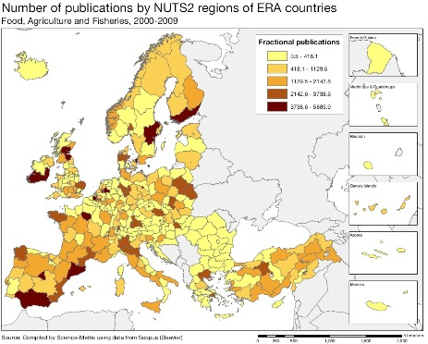
Scientific production Technological production
Materials (2000-2009) Materials, Metallurgy
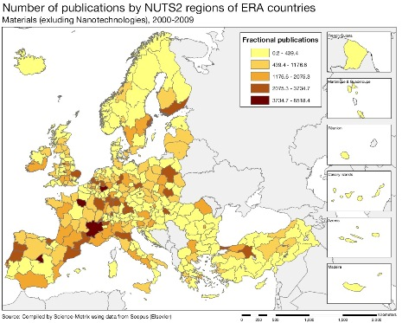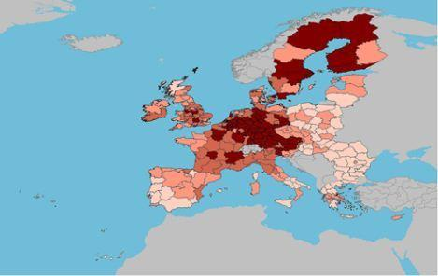
Energy Technological production Biotechnology 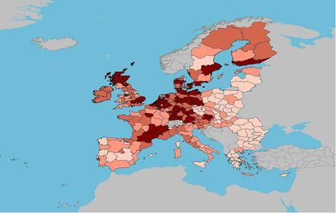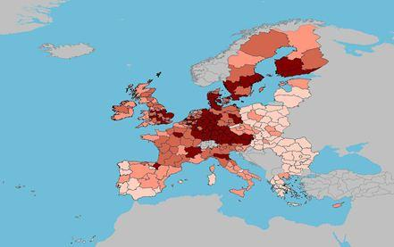

Source: DG Research and Innovation – Economic Analysis unit
Data: Science Metrix using Scopus (Elsevier), 2010; European Patent Office, patent applications, 2001-2010
Transport Technologies Manufacture of Electrical Motors, Generators and transformers
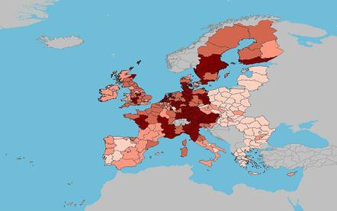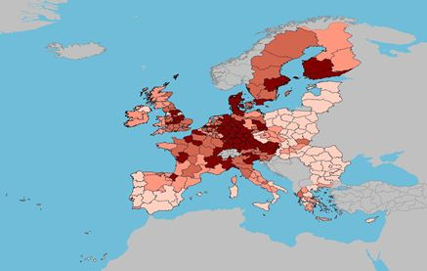
Manufacture of Aircraft and Spacecraft Services for Computer and related activities
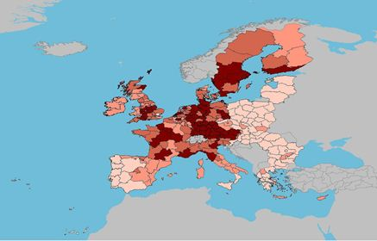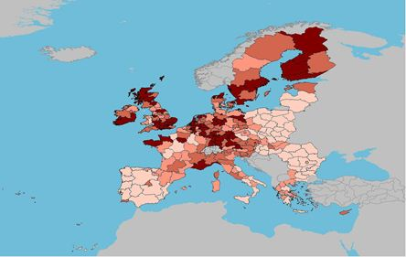
Electrical Machinery, apparatus, energy IT Methods for management
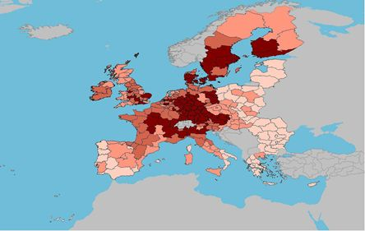 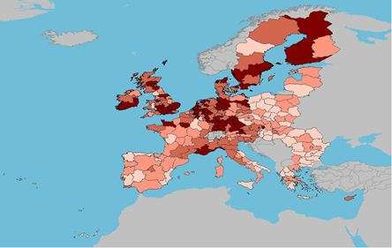

As illustrated in the maps above, in terms of scientific capacity, the Slovak Republic has relative strong regional clusters in the fields of food, agriculture and fisheries, information & communication technologies and materials. Considering the scientific specialisation index, over the period 2000-2009, Slovakia has not significantly improved its rate in new production technologies, energy and transport, with an average below the EU27 average.

In comparison the Slovak regions are less prominent in technology patenting than the Bratislava region, where relative strengths in patenting are quite visible. Overall, significant disparities exist between the capital region and the rest of the country in terms of R&D expenditure and intensity. The main technology sectors are materials, metallurgy, biotechnology, energy, other transport technologies, manufacture of electrical motors. In terms of technological specialisation, considering patenting in industrial sectors within Europe, the Slovak Republic shows particular strengths in the automotive sector.

In terms of importance for economic growth, the plastic product sector is highly relevant for the Slovak Republic, as well as for Poland, Slovenia and Bulgaria in the EU-27 area and worldwide. Additionally, the second largest and the quickest growing industrial sector of the country is electro-technics and electronics. Moreover, as part of global value chains, the Slovak Republic is one of the world leaders in LCD production – a high-tech manufacturing sector. The above referred sectors are for Slovakia the sectors with great potential for doing business in R&D.
Policies and reforms for research and innovation
The last National Reform Programme 2012 (NRP) was drafted by the previous government whose mandate ended on 4 April 2012. The new government set out its policy statement which identifies the objectives of the NRP 2012 but proposes fundamentally different tools. However, the challenges that the Slovak Republic faces today remain the same. Thus, the new Slovak government commits to supplement its policy statement, in the shortest possible time, with measures that will be in line with its own policy conception. At national level, coordinators of the Europe 2020 strategy are the Prime Minister, and the Deputy Prime Minister and Minister of Finance. Furthermore, coordination of the agenda and policies at the inter-ministerial level, of paramount importance for the efficient spending of funds in the years to come, will be the responsibility of the Slovak Government's Council for Science, Technology and Innovation.
The overall government budget for the 2012-2014 period aims to protect expenditures which promote economic growth, such as state budget allocation and Structural Funds. Thus, two priorities stand out in the 2012 budget. The first one is the transport infrastructure and the second priority area is education where the volume of funds at regional level per student has increased by 4.7% in the tertiary school sector. The new Slovak Government considers important to ensure that expenditures on productive areas, such as education, remain among its long-term political priorities in the subsequent years too, and will take steps to improve the quality of higher education and its relevance to market needs. It will focus on measures that will ensure smart, sustainable and inclusive growth as well.
The new strategic policies intend to streamline national objectives to the new EU policies in Europe 2020 and Horizon 2020. In this context, the new government announced further measures to improve collaboration between the public and private sector in terms of financial and organisational arrangements and human capital through partnerships, joint ventures and long term contracts. It plans to set up a new instrument to support young Slovak researchers and to attract the top Slovak scientists working abroad to come back to the country. People should be encouraged to run innovative businesses. This will be promoted by systematically including entrepreneurship teaching (including lessons on tax compliance) in the curricula of primary, secondary and tertiary education establishments. Further, it will develop an adaption of the internationally successful Small Business Innovation Research programme.
In 2011, the Slovak Republic adopted two strategy documents: "Fenix" and the "Minerva 2.0", both aiming at science, technology and knowledge-based economy. They proposed a range of measures for increasing the quality of higher education and research systems, and connecting them to a knowledge-based economy. The "Fenix" strategy also proposed replacing current research and innovation priorities by a demand-driven bottom-up approach, which might indeed reduce the current low share of industry-science cooperation. The strategies identified the main problems in the knowledge triangle policies, and also addressed interaction between the key actors. Further, they defined the reform of research funding and aimed to improve the transparency of the system and to speed up the consumption of resources from Structural Funds. Their coordinated implementation could improve the innovation capacity of the country.
Furthermore, the Innovation Strategy for 2007-2013 sets the general framework for policy intervention, while the Innovation Policy 2011-2013 specifies actions in three areas (infrastructures, quality of human resources, and support for innovation) in order to boost the country's competitive position in Europe. The priority "Infrastructures" includes support to industrial clusters for which the first calls were planned by the end of 2012. Funded mainly by the Operational Programme Competitiveness and Growth, the innovation support for industry is the biggest priority in financial terms. The innovation vouchers are yet to be launched. The Slovak government will concentrate its efforts primarily on social cohesion in regions and notably on science, research and innovation, with a focus on green growth (using cleaner sources of growth and developing green industries, services, technologies and jobs). There is also scope for improving the Slovak innovation capacity and business environment, in particular through more efficient public administration. Finally, a closer integration of the Slovak research and innovation system in the European Research Area is an explicit objective of the national policy.
Economic impact of innovation
The index below is a summary index of the economic impact of innovation composed of five of the Innovation Union Scoreboard's indicators.
According to this index, the Slovak Republic underperforms its reference group and is clearly below the EU average. The country ranks 18th due in particular to its poor performance in "patent applications per GDP", "share of the employment in knowledge-intensive activities" and "share of knowledge intensive services in total export of services". In all three areas, the Slovak Republic scores the lowest amongst its reference group. The only area where it performs extremely well is in the "sales of new to market and new to firm innovations as % of turnover of firms" where it tops the EU ranking.
In July 2011, the previous government adopted the strategy "Singapore" aimed at improving the business environment. This strategy contains 94 short and mid-term measures for the period 2011-2015. The international "Small Business Innovation Research (SBIR)" programme will facilitate experimental development and implementation of innovative solutions. For the Slovak Republic, improvement of the environment for establishing new start-ups and spin-offs by providing administrative support to the technology transfer from public R&D institutions, and by establishing a link between universities, the Slovak Academy of Sciences and technology incubators is strongly needed.
Access to finance has also been difficult since the start of the economic crisis. The rate of rejected loan applications went up, while the number of SMEs using debt financing increased from 61% to 74%. With an underdeveloped stock exchange and venture capital market, equity financing remained very limited. On the other hand, Foreign Direct Investments (FDI) and technology transfer feature strongly, with the Slovak Republic ranking 9th out of a panel of 142 countries. FDI might offer a good opportunity for developing business R&D projects. The country presents sufficient comparative advantages to attract foreign as well as domestic investors. Development of human resources and talents, competitive R&D costs, presence of foreign investors and availability of highly-qualified human resources are valuable competitive indicators for doing business in this country.
In 2011, the innovation environment reform plan was approved. Since April 2012, the new Slovak government intends to revise its measures in order to include other actions aiming at boosting innovation capacity. For example, the Slovak government intends to enhance the innovation potential of the national economy by increasing the share of high–tech exports to 14% by 2020. The Slovak Republic is challenged to offer favourable framework conditions to remain competitive with regard to other Member States and ensure long term growth, productivity gains and improved living standards.
Upgrading the manufacturing sector through research and technologies

The graph below illustrates with four variables the upgrading of knowledge in different manufacturing industries. First, position on the horizontal axe illustrates the changing weight of each industry sector in value added over the period. The general trend of moving to the left-hand side reflects the decrease of manufacturing in the overall economy. The sectors above the x-aces are sectors whose research intensity has increased over time. The size of the bubble represents the share of the sector (in value added) in manufacturing (all sectors presented in the graph), and the red-coloured sectors are those which are already high-tech or medium-high-tech.

Across the EU, as the industrial structures vary considerably, the Member States have been following different paths toward a more knowledge-intensive economy. In the aftermath of the crisis, Slovakia ranks among the fastest growing economies of the entire European Union. The Slovak economy continues successfully recovering, mainly due to external demand and strong manufacturing activity, covering almost 23.4% of total value added against the EU average of 13.8%. Productivity in manufacturing sector profited from a sustained increase, indicating a good industry performance. The share of exports of GDP, as indicator of the openness of the economy, is in the Slovak Republic quite well performing, notably in the sector of medium-high and high-tech product exports, with an average clearly above the EU-27 level.

The graph above synthetises the structural change of the Slovak manufacturing sectors over the last decade. It shows that several medium and high-tech sectors (in red) have grown in economic (value added) importance, while large medium- or low-tech sectors, such as fabricated metal products and food and beverages have increased their knowledge-intensity (as measured by R&D investments). Economic expansion has been mainly related to radio, TV & communication equipment sector, Electric machinery and to the traditional sector of motor vehicles, followed by fabricated metal products. The Slovak economy has also been diversifying over the last decade, and its specialization degree has been decreased from 6.06 to 4.42. Moreover, as a traditional manufacturing country, The Slovak Republic has been more resilient to the economic crisis. However, many of the Slovak manufacturing industries have not upgraded its knowledge intensity over the period 1995-2009, which could indicate a medium-term threat to the sector in the context of increasing globalisation.
Competitiveness in global demand and markets

Investment in knowledge, technology-intensive clusters, innovation and the upgrading of the manufacturing sector are determinants for a country's competitiveness in global export markets. A higher contribution of high-tech and medium-high-tech industries to the trade balance is an indication of competitiveness in more sophisticated products and services.
Over the last decade, the trade balance in high-tech (HT) and medium-tech (MT) goods of the Slovak economy showed a high increase, strongly above the EU average, with a high total productivity factor, notably of its labour level, in particular when compared to its catching–up peers. As shows the graph above, the "telecommunication and sound-recording apparatus" was one of the main sources of this improvement of the trade balance. It yielded a quite remarkable progress. The "general industrial machinery and equipment" and the "office-machines and automatic data-processing machines" sectors also contributed significantly to this improvement, in contrast to the more traditional product sectors of plastics, vehicles, machinery, arms and instruments.

However, this progress has not been well reflected to the research and innovation system of the country. The industries corresponding to these goods have not upgraded their R&D intensity. The Slovak Republic, having a dual economy, where a large part is hold by foreign multinational companies, with high productivity, but transferring technology from abroad where they run their R&D activities and limited liaising activities with Slovak research facilities (i.e. to establish R&D centres in Slovakia). Thus, the strong foreign presence has not yet been translated into significantly higher inward BERD. National companies, including a great number of SMEs and a few large companies, have lower R&D expenditure and productivity levels. As a result, source of major productivity in the past years was mainly the technology imports, but this potential is evaporating due to declining of inflows of FDI. Furthermore, a strong decline is observed in the non-R&D innovation expenditure and in license and patent revenues from abroad. For catching-up Member states, such as the Slovak Republic, price competitiveness and on-going industrial restructuring would help to boost exports. As innovation capacity has improved only modestly, it has yet to move significantly towards more knowledge-intensive economic activities.
Key indicators for Slovakia

Slovenia
Towards a knowledge-intensive economy

Summary: Performance in research, innovation and competitiveness

The indicators in the table below present a synthesis of research, innovation and competitiveness in Slovenia. They relate knowledge investment and input to performance or economic output throughout the innovation cycle. They show thematic strengths in key technologies and also the high-tech and medium-tech contribution to the trade balance. The table includes a new index on excellence in science and technology which takes into consideration the quality of scientific production as well as technological development. The indicator on knowledge-intensity of the economy is an index on structural change that focuses on the sectoral composition and specialisation of the economy and shows the evolution of the weight of knowledge-intensive sectors and products and services.

 | Investment and Input | Performance/economic output
Research | R&D intensity  2011: 2.47% (EU: 2.03%; US: 2.75%)  2000-2011: +12.46% (EU: +0.8%; US: +0.2%) | Excellence in S&T  2010: 27.47 (EU:47.86; US: 56.68)  2005-2010: +3.99% (EU: +3.09%;US: +0.53)
Innovation and  Structural change | Index of economic impact of innovation  2010-2011:0.521 (EU: 0.612) | Knowledge-intensity of the economy  2010:45.9 (EU:48.75; US: 56.25)  2000-2010: +4.25% (EU: +0.93%; US: +0.5%)
Competitiveness | Hot-spots in key technologies  Health, Food and agriculture, ICT, Materials, New production technologies, Environment | HT + MT contribution to the trade balance  2011: 6.05% (EU: 4.2%; US: 1.93%)  2000-2011: +14.72% (EU: +4.99%; US:-10.75%)

Slovenia has significantly increased its R&D intensity over the last decade, with some fluctuations. It increased from 1.38% in 2000 to 2.11 % in 2010 and reached 2.47 % in 2011, a value which is higher than the EU average of 2.3%. The fluctuations over that period are mirrored by fluctuations in the R&D intensities of both the private and public sectors. In 2011, business enterprise expenditure on R&D as a percentage of GDP was 1.83% compared to an EU average of 1.26% and public sector expenditure on R&D as a percentage of GDP was 0.64% compared to an EU average of 0.74%. In the last decade both business expenditure on R&D and government funding of R&D increased.

This is a clear signal that Slovenia regards investment in R&D as a priority for the development of medium-high and high-tech and competitive enterprises and for increased and sustainable economic growth. Slovenia is meeting the challenge of reaching its 2020 R&D intensity target of 3% by mobilising incentives and resources from public and private sources (human, financial, infrastructural) and providing smooth paths for more technological innovation. At the same time the effectiveness and efficiency of the R&I system needs to be upgraded, notably through improved governance and higher dynamics in the knowledge triangle.

In order to tackle these challenges a new National Research and Innovation Strategy 2011-2020 was prepared and approved in 2011. It aims to better integrate research and innovation, to enhance cooperation between PROs and the business sector, to better contribute to economic and social restructuring and to increase scientific excellence. The National Programme 2011-2010 for Higher Education points to improved efficiency of the system and better articulation with needed skills, notably in science and engineering.
Investing in knowledge

R&D intensity in Slovenia increased from 1.66 % in 2008 to 2.47 % in 2011. Slovenia's R&D intensity target of 3% for 2020 is ambitious but achievable despite the economic crisis, provided that there is an effective and efficient increase of resources devoted to research and innovation.

In spite of the economic crisis, the share of R&D financed by business enterprise has been indeed higher than the EU average since 2007. In fact, in 2011 business enterprise expenditure on R&D as a percentage of GDP reached 1.83%, making Slovenia one of the top performers in the EU in terms of business R&D. Notwithstanding, budgetary constraints, public sector expenditure on R&D n 2011 was equal to 0.64%, of GDP, slightly below the EU average but above those of countries with similar research and knowledge structures. Between 2008 and 2010 business expenditure on R&D has increased in real terms at an average annual growth rate of 15,3% while government funding of R&D has increased in real terms over the same period at an average annual growth rate of 1.4%.

Slovenian research and innovation also receives support from the EU budget through two main instruments: the Structural Funds and the 7th Framework Programme. Over the ERDF programme period 2007-2013, a total of €1 207 million has been allocated to activities related to research, innovation and entrepreneurship (29.4% of the total of Structural Funds available for the Slovenian regions). A total of 509 participants from Slovenia benefited by around € 99.4 million from the EU 7th Framework Programme. The participant success rate of participants is 16.12%, was below the EU average success rate of 21.95%.

Slovenia is one of the countries where R&D expenditure has increased steadily both before and after 2008. As a result Slovenia had the sixth highest R&D intensity in the EU in 2011, a development which reflects the Slovenian counter-cyclic commitment to ensure increased and sustainable economic growth.

An effective research and innovation system building on the European Research Area

The graph below illustrates the strengths and weaknesses of Slovenia's R&I system. Reading clockwise, it provides information on human resources, scientific production, technology valorisation and innovation. Average annual growth rates from 2000 to the latest available year are given in brackets.
The graph above shows that Slovenia's research and innovation system is performing well, with several indicators close to or above the EU average and with positive trends. These include human resources, innovation in business, and R&D expenditure. Nevertheless, there are some weaknesses in the domains of knowledge commercialization, private and public sector internationalisation, and research quality.

Regarding human resources, Slovenia already has a high level of new doctoral graduates, above the EU average, but is still catching up in terms of new graduates in science and engineering. Employment of researchers by business enterprises and in knowledge-intensive activities is also at a high level. In this regard it seems that highly skilled graduates are readily absorbed into the Slovenian economy. However, despite its good performance in human resources, Slovenia is still not attractive enough for foreign doctoral students.

Regarding scientific production, Slovenia has high levels of international scientific co-publications and public-private scientific co-publications but needs to improve their quality in order to perform better in terms of scientific publications within the 10% most cited scientific publications worldwide. In terms of knowledge commercialization Slovenia has an increasing number of PCT patent applications and has a high level of patent applications to the EPO in the field of health-related technologies. However, the levels of both total PCT and total EPO patent applications are below the EU average. Slovenian SMEs perform well in terms of (non-technological) marketing and organisational innovations and fairly well in introducing product or process innovations. However, Slovenia needs to improve its attractiveness for R&D investment by foreign firms as is illustrated by the fact that the share of business R&D expenditure financed from abroad is much lower than the EU average.
Slovenia's scientific and technological strengths

The maps below illustrate six key science and technology areas where Slovenia has real strengths in a European context. The maps are based on the number of scientific publications and patents produced by authors and inventors based in the regions.

Strengths in science and technology at European level

Scientific production Health Technological production
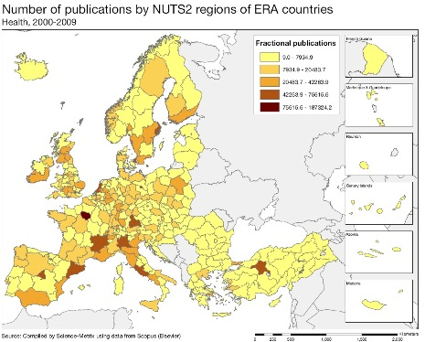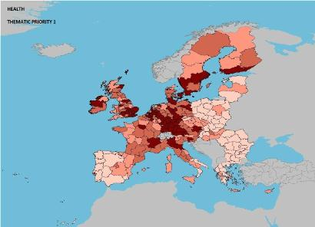

Scientific production Food, agriculture and fisheries Technological production
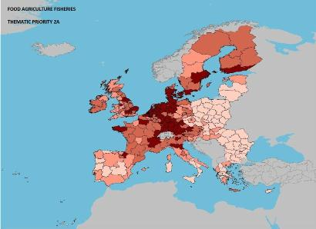

Scientific production Information and communication technologies Technological production

Source: DG Research and Innovation – Economic Analysis unit
Data: Science Metrix using Scopus (Elsevier), 2010; European Patent Office, patent applications, 2001-2010

Scientific production Materials Technological production
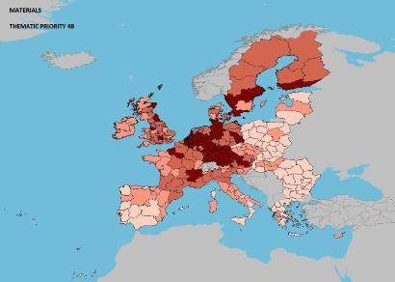
Scientific production New production technologies Technological production
Scientific production Environment Technological production
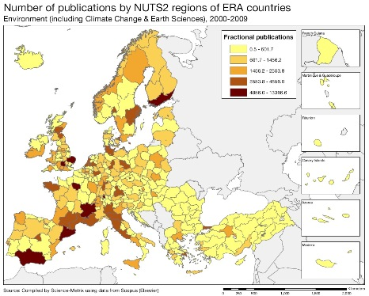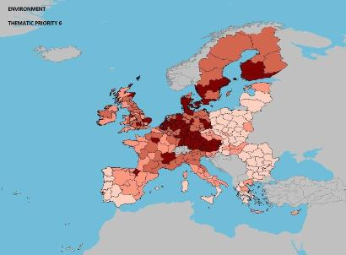

The maps above illustrate the strengths of Slovenian science and technology production in absolute numbers. Slovenia, in terms of scientific production, using the FP7 thematic priorities, has strong capacity in the fields of health, food, agriculture and fisheries, ICT, materials, production, environment, and socio-economics. In terms of specialisation the 'scientific specialisation index', covering the period 2000-2009, shows high values in the fields of food, agriculture and fisheries, ICT, materials, production, construction, energy, transport, socio-economics, and humanities.

Slovenian scientific excellence, as measured by the impact of citations and the share of its total scientific publications in the top 10% cited publications in each respective field, is particularly high for energy, transport, and security. The 'revealed technological advantage' index, also covering the same period, on the basis of the location of inventor of EPO patents, shows particular strength in health, biotechnology, construction, and transport.

Policies and reforms for research and innovation

Research and innovation is a priority in Slovenia. Slovenia's R&D intensity target for 2020 of 3%, therefore, seems to be achievable. One of the main challenges is the structuring of policies that provide support for research and, in particular, that stimulate innovation. In 2011, the Slovenian authorities approved two important long term strategic documents: The Research and Innovation Strategy of Slovenia 2011-2020 (RISS) and the National Higher Education Programme 2011-2020 (NHEP).

The Research and Innovation Strategy of Slovenia (RISS) defines the R&D priorities for the next decade (2011-2012) and aims to create a high performance research and innovation system which will improve the quality of life. It sets out the following main priorities: (1) better integration of research and innovation; (2) increasing scientific excellence, partly by increasing competitiveness within S&T stakeholders and partly by providing necessary resources, both human as well finance; (3) promoting closer cooperation between universities, research institutions and the business sector; (4) strengthened capacity of research to contribute to economic and social development. The National Higher Education Programme (NHEP) aims at upgrading the Slovenian Higher Education system to a level which is more consistent with education and skills needs in general and in science and engineering in particular. The measures outlined in 2011 in both the RISS and NHEP have yet to materialise. Several legal enactments, in particular, a revamped Law on Research and Development are required for their implementation.

Within the RISS a special section is devoted to the issue of research infrastructure, stipulating the need for a special Slovenian Research Infrastructure Roadmap (2011-2020) to deal with two problems related to the current state of Slovenian research infrastructure. These problems are: a lack of cooperation between research institutes, and the fragmentation and sub-optimisation of R&I utilisation. In this regard, the key objectives of the Research Infrastructure Roadmap are: better exploitation of the existing national research infrastructure; upgrade and construction of new research infrastructure in priority areas, and international integration based on access to large research infrastructures.

The new government, which was formed after the elections of December 2011, reallocated the competences for Research and Innovation between the Ministry of Education, Science, Culture and Sports, the Ministry of Economic Development and Technology and the Ministry of Infrastructure and Spatial Planning.

In 2010, different stakeholders in innovation policy introduced several new policy measures. The Competence Centres are led by businesses combining basic and applied research with a view to creating future market opportunities, and to some extent complement the Centres of Excellence, introduced in 2009. The latter are focused on basic research made by PROs, in cooperation with those business R&D units active in the same area. And finally the Development Centres (consortia of business firms) support "close to the market" research projects with a view to developing new products, processes and services. It is also noteworthy that tax allowances for research and innovation were increased in April, 2012.

Slovenia has several programmes and instruments to support Research and Innovation, such as the innovation voucher, the mentorship voucher, the mentorship of young researchers, calls for basic and applied projects, financial assistance to institutions that support innovation, the strengthening of development units in the business sector and the transfer of technologies from the public sector. In the aftermath of the economic crisis Slovenia will focus on cutting its annual budget deficit from 6% to 3% by 2013. This will lead to difficult decisions about priorities for the public sector. It remains to be seen if support for R&I will be affected. The new government announced several policy changes in both strategic documents in order to preserve research and innovation capabilities of Slovenia against reduction of government budget on R&D.

Economic impact of innovation
The index below is a summary index of the economic impact of innovation composed of five of the Innovation Union Scoreboard's indicators.
According to this index, Slovenia underperforms its reference group and is clearly below the EU average. While the country only ranks 16th in the EU, Slovenia displays a contrasted pattern of marked strengths and weaknesses. Slovenia is the best performer amongst its reference group for "patent applications per GDP", "share of the employment in knowledge-intensive activities" and "contribution of medium and high-tech product exports to the trade balance". In all three areas, Slovenia ranks rather well amongst EU Member States, in particular regarding its medium and high-tech trade specialisation where it is second only to Germany. However, these strengths are counterbalanced by equally marked weaknesses in the "share of knowledge intensive services in total export of services" and "sales of new to market and new to firm innovations as % of turnover of firms".
Therefore, it seems that Slovenia may not have fully developed its innovative potential. One of the reasons is that some components of the business and competitive framework have changed very little: links between public sector and private sector are still weak and some structural aspects of the business environment hinder foreign direct investment. In order to improve competitiveness, there would be benefits to consider developing a new industrial policy including a strategy for attracting foreign capital, notably linked to R&I.
The approach to attracting investment outlined in the National Reform Programme seems to rely mainly on financial incentives rather than on making also other improvements to the business environment, while the latter could contribute to maximise the impact of these incentives. Progress has been made through changes in tax legislation: the R&D tax allowance was increased to 100% of the amount invested.
The background of economic crisis and fiscal austerity implies a lower availability of resources, and companies, especially SMEs, struggle to obtain funding not only for projects but also for operational capital. In this regard the government is planning to increase funds for guarantees and credits for R&D and new technologies through the Slovenian Enterprise Funds (SPD) and the Slovene Development and Export Bank (SID) rather than providing direct subsidies to the business sector. The question remains whether credit is a suitable instrument for SMEs with little experience of research and innovation. The Slovene Enterprise Fund also supports start–up companies in the first three years of their life. The results show that this instrument should be reinforced. Most of the stronger financial measures currently being implemented are co-financed from the Structural Funds. Overall the main challenge remains the efficient and effective use of available resources. Slovenia has room to better address funding priorities. There is a need for more focus on and critical mass in sectors related to the existing R&D strengths and economic strengths of Slovenia.
Upgrading the manufacturing sector through research and technologies

The graph below illustrates the upgrading of knowledge in different manufacturing industries. The position on the horizontal axis illustrates the changing weight of each industry sector in value added over the period. The general trend to the left-hand side reflects the decrease of manufacturing in the overall economy. The sectors above the x-axis are sectors whose research intensity has increased over time. The size of the bubble represents the share of the sector (in value added) in manufacturing (for all sectors presented on the graph). The red-coloured sectors are high-tech or medium-high-tech sectors.

The Slovenian economy is characterised by a relatively strong manufacturing industry. Manufacturing makes a higher contribution to total value added than the EU average. Nevertheless, as in many other countries, the share of manufacturing value added is tending to decrease (as shown by the position of most of the sectors on the left side of the graph), due to a corresponding increase in services value added.

Although some industry sectors have achieved slight increases in their shares of the economy, specialization in labour intensive industries has decreased considerably over the last decades. As the graph illustrates, Slovenia's manufacturing industries are moving towards higher research intensity in almost all sectors. Highly innovation-intensive sectors are: electrical machinery and apparatus, chemical products, machinery and equipment, motor vehicles, medical precision and optical instruments, and radio, TV and communication equipment. Slovenia has two companies in the 2011 EU Industrial R&D Scoreboard in the fields of pharmaceuticals, and construction and materials.

Competitiveness in global demand and markets

Investment in knowledge, technology-intensive clusters, innovation and the upgrading of the manufacturing sector are determinants of a country's competitiveness in global export markets. A positive contribution of high-tech and medium-tech products to the trade balance is an indication of specialisation and competitiveness in these products.

The Slovenian trade balance for high-tech (HT) and medium-tech (MT) products has grown progressively since 2000. The contribution of the basket of the above products to the Slovenian trade balance grew at an average rate of over 12% per annum during the last decade. Medicinal and pharmaceutical products, road vehicles, and general industrial machinery and equipment and machine parts increased their contributions whereas iron and steel, professional, scientific and controlling instruments and apparatus, and electrical machinery, apparatus and appliances, and electrical parts have lower contributions.

It should be noted, however, that some commodities, such as the last two referred to above, contribute positively to the national trade balance, whereas others, such as office machines and automatic data-processing machines have reduced their negative contribution over the period. It is also worth noting that medicinal and pharmaceutical products, road vehicles, and general industrial machinery and equipment and machine parts which make a strong positive contribution to the trade balance are produced in sectors with high positive variations in added value and R&D intensity (see previous graph).

Slovenia is investing and catching-up. Total Factor Productivity increased from 2000 to 2011 at a higher rate than the EU average. Gross Fixed Capital Formation grew in real terms from 2000 to 2008 at an average rate of 5.9% per annum but has declined since then. R&D intensity grew at an average annual rate of 12.5% between 2008 and 2010. Labour productivity grew at an average annual rate of more than 3% up to 2010. Slovenian employment in knowledge-intensive activities (manufacturing and services) is at the level of the EU average and EPO patent applications per billion GDP in the domain of health-related technologies are the second highest in the EU.
Key indicators for Slovenia

See Methodological note for the composition of this index.
See Methodological note for the composition of this index.
See Methodological note for the composition of this index.

