Spain
The challenge of structural change for a more knowledge-intensive economy

Summary: Performance in research, innovation and competitiveness

The indicators in the table below present a synthesis of research, innovation and competitiveness in Spain. They relate knowledge investment and input to performance or economic output throughout the innovation cycle. They show thematic strengths in key technologies and also the high-tech and medium-tech contribution to the trade balance. The table includes a new index on excellence in science and technology which takes into consideration the quality of scientific production as well as technological development. The indicator on knowledge-intensity of the economy is an index on structural change that focuses on the sectoral composition and specialisation of the economy and shows the evolution of the weight of knowledge-intensive sectors and products and services.

 | Investment and Input | Performance/economic output
Research | R&D intensity  2011: 1.33% (EU: 2.03%; US: 2.75%)  2000-2011: +3.56% (EU: +0.8%; US: +0.2%) | Excellence in S&T  2010:36.63 (EU:47.86; US: 56.68)  2005-2010: +3.66% (EU: +3.09%;US: +0.53)
Innovation and  Structural change | Index of economic impact of innovation  2010-2011: 0.53 (EU: 0.612) | Knowledge-intensity of the economy  2010:36.76 (EU:48.75; US: 56.25)  2000-2010: +2.65% (EU: +0.93%; US: +0.5%)
Competitiveness | Hot-spots in key technologies  Food and agriculture, Energy, ICT, Security, Biotechnology, Environment | HT + MT contribution to the trade balance  2011: 3.05% (EU: 4.2%; US: 1.93%)  2000-2011: +23.73% (EU: +4.99%; US:-10.75%)

Investment in research and innovation (R&I) has grown substantially in Spain over the last decade. Public investment in R&D grew even beyond the economic crisis, in a counter-cyclic effort. Business investment in R&D also grew over the period 2000-2008. As a result, excellence in science and technology has substantially improved and Spain demonstrated a fair degree of structural change towards a more knowledge-intensive economy and a slight upgrading of the R&D intensity in most manufacturing industries. Another positive sign is the rising contribution of high-tech and medium high-tech goods to the trade balance.

However, despite this positive evolution, the Spanish economy remains less knowledge-intensive than the EU economy as a whole. Investment levels are still low, excellence in science and technology lags behind the EU average, and growth in innovative firms must be boosted. The economic crisis has hit Spain hard, partly because international competition and the globalisation of production has had a particularly harsh impact on several industries and services in which Spain is specialised. In particular, the low scale of hot spots in key technologies and the lack of innovation for societal challenges contrast with the expanding potential for these products and services in global markets and value chains. The main challenges for Spain remain, therefore, to invest in knowledge and to better ensure the effectiveness of this investment in creating a more knowledge-intensive economy.

A new law for Science, Technology and Innovation was adopted in 2011. It strengthens the governance system, simplifies the allocation of competitive funding creating a new national research agency, and stimulates researcher mobility between the public and private sectors. However, with the economic crisis, the government has recently reduced public funding in R&D and in education. Consequently, as part of the Europe 2020 process, it was recommended that Spain should review spending priorities and reallocate funds to support small and medium-sized enterprises (SMEs), research, innovation and employment opportunities for young people. In order to meet with this recommendation, the government has included in its National Reform Programme 2012 a package of structural reforms especially devoted to boosting SMEs, research, innovation and employment opportunities for young people.

Investing in knowledge

Spain has set a national R&D intensity target of 3%, within which public sector R&D investment would reach 1% and business R&D investment 2% of GDP by 2020. In 2011, Spanish R&D intensity was 1.33%. Public sector R&D intensity amounted to 0.64% and business R&D intensity 0.70%. Both values have fallen slightly in 2011 compared to 2010.
Over the period 2000-2009, the Spanish R&D intensity increased with an annual average growth of 4.3%, well above the EU average. In absolute terms, public R&D funding reached a peak in 2009, which means that the Spanish government continued to increase its R&D budget up to two years after the start of the financial crisis in 2008. However, since then, the government R&D budget has been reduced by 4.12% in 2010 and by 7.38% in 2011. The 2012 budget foresees a more drastic decrease of 25.57%.
Private R&D expenditure has also been seriously affected by the economic crisis. Business R&D expenditure in real terms reached a peak in 2008. Spanish firms more than doubled their R&D expenditure in real terms over the period 2000-2008. However, following the economic crisis and liquidity constraints, business R&D investment fell by 6.27% in 2009 and by another 0.81% in 2010. Firms in food, automobiles, and construction, have undertaken the strongest cuts.
A total of € 7.8 billion from the EU FEDER Structural Funds has been allocated to research, innovation and entrepreneurship in the Spanish regions for the period 2007-2013. This represents 22.6% of the total FEDER fund for Spain. By 2010, Spain had committed 38.4% of these EU funds (the average in the EU was a 46.6% commitment rate). Spain also has the scope to increase its funding of R&D from the EU 7th Framework Programme. It will adopt a national strategy to foster the participation of national R&I teams in European projects and programmes. The success rate of Spanish applicants is 19.99%. This is lower than the EU average success rate of 21.95%. Up to mid 2012, over 6400 Spanish participants had been partners in an FP7 project, with a total EC financial contribution of € 1.8 billion (representing 6.88% of total EC funding contribution at that stage in FP7).

An effective research and innovation system building on the European Research Area

The graph below illustrates the strengths and weaknesses of the Spanish R&I system. Reading clockwise, it provides information on human resources, scientific production, technology valorisation and innovation. Average annual growth rates from 2000 to the latest available year are given in brackets.
The graph above indicates that the increase in public funding for R&D (2000-2011 average annual growth) has triggered a stronger scientific excellence but without clear progress in business innovation. Spain faces a negative trend in business R&D investments and is still below the EU average on technology development and innovation. Its performance is however similar to the reference group of countries. In the field of human resources, 40.6% of the population aged 25-34 completed tertiary education, although with lower share of new graduates (ISCED 6) in science and engineering than the EU average. While Spain is below the EU average in highly-cited scientific publications, Spanish researchers are successful in international scientific co-publications.

The number of business researchers in Spain has grown between 1999 and 2010, but Spain has still a lower level than the EU average. These numbers point at the need to enhance the quality of the higher education system and to address the non absorption of highly-skilled graduates in firms. Spain has improved its scientific quality and production but still faces the challenge of increasing the excellence and internationalization of its universities and PROs. The universities are not visible in major international rankings and their scientific production and staff composition is less international than is the case in several other Member States. And despite an improvement, Spain still performs well below the EU average for public-private cooperation in science. Spain also faces challenges in relation to business R&D. As shown on the graph above, overall technology development is low – but increasing. Product and process innovations in SMEs have decreased over the last decade.

Spain's scientific and technological strengths

The maps below illustrate six key science and technology areas where Spain has real strengths in a European context. The maps are based on the numbers of scientific publications and patents produced by authors and inventors based in the regions.

Strengths in science and technology at European level

Scientific production Food, agriculture and fisheries Technological production
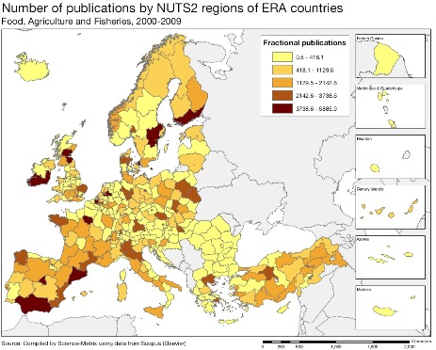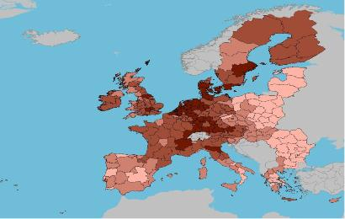

Scientific production Energy Technological production
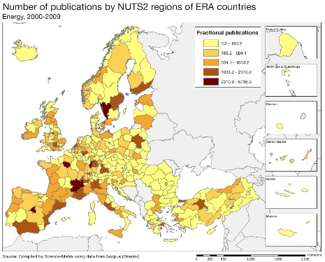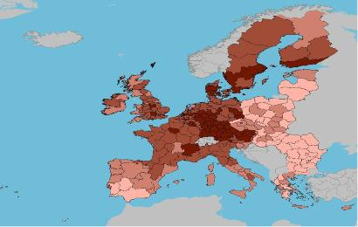

Scientific production Information and Communication Technologies Technological production
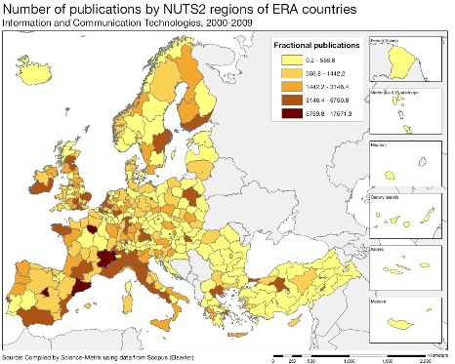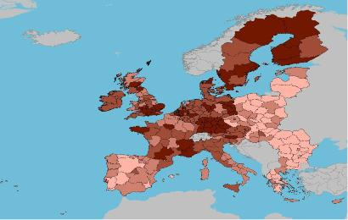

Source: DG Research and Innovation – Economic Analysis unit
Data: Science Metrix using Scopus (Elsevier), 2010; European Patent Office, patent applications, 2001-2010

Scientific production Security Technological production
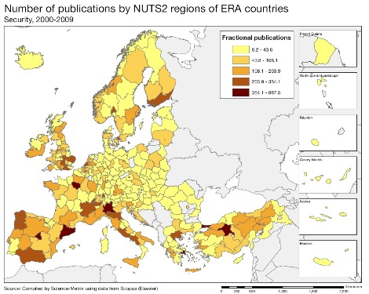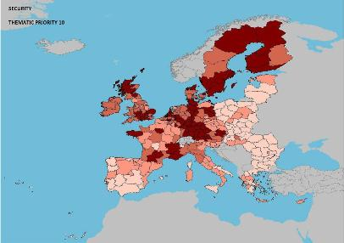
Scientific production Biotechnology Technological production
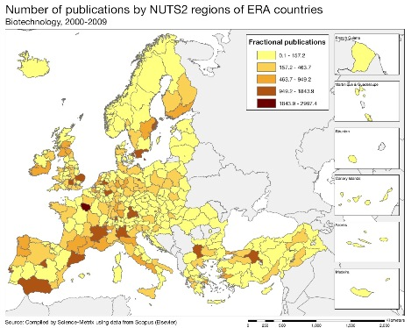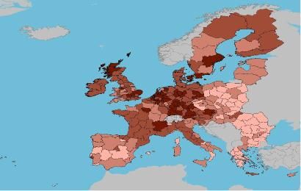
Scientific production Environment Technological production
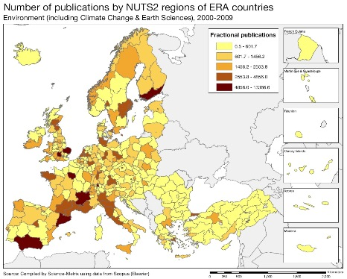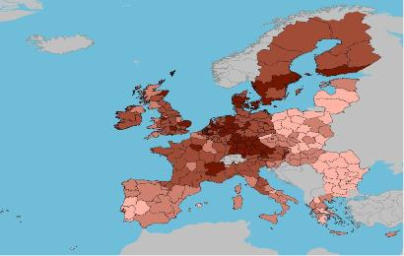

As illustrated by the maps above, in terms of scientific production, Spain has strong regional capacity in the fields of food, agriculture and fisheries, energy, ICT, security, biotechnology and environmental science and technologies (including the important water sector). In terms of scientific quality, the most prominent scientific work in Spain is in energy, security, transport and materials. Spain's scientific specialisation index (not shown on the maps above) shows that the main scientific fields are food, agriculture and fisheries, ICT, security, but also construction technologies and humanities.

The relative strengths in patenting are visible in Catalonia, Madrid and the Basque country, although Aragon and Cantabria are also present in energy patenting. The main technology sectors are food and agriculture, biotechnology, ICT and energy although the core technology development in Europe in these sectors takes place in regions outside Spain. The data on patenting in industrial sectors (not included on the maps above), show that Catalonia has particular strengths (within the highest 25th percentile) in organic fine chemistry, pharmaceuticals, food chemistry, while the Basque country has similar technology strengths in engines, pumps and turbines, thermal process and apparatus, furniture, games, other consumer goods, machine tools, electrical motors and green energy.

Policies and reforms for research and innovation

The Spanish authorities are addressing these challenges in a new Law for Science, Technology and Innovation adopted with broad political support in 2011, as well as in new Spanish Strategy for Science, Technology and Innovation and in the State Plan for Scientific and Technical Research and Innovation adopted in February 2013. The new innovation strategy is very relevant and needed. Reform proposals cover the governance system, the quality of human resources, the funding allocation system and knowledge transfer between actors. The strategy for the Spanish research and innovation system now need to be implemented effectively and swiftly. Stronger coordination between national and regional R&I policies and instruments is a crucial element for improved system efficiency. Objectives and priorities are well aligned with the objectives of Europe 2020, the Innovation Union and Horizon 2020. The law of 2011 also simplifies the allocation of competitive funding for research and innovation by giving responsibility for the allocation of funds to two main bodies, the new national research agency (AEI) and the existing agency for innovation (CDTI). Public-private cooperation will be reinforced by the introduction of legal changes to researchers' contracts, thereby stimulating mobility between the public and the private sector. Legal reforms related to the recruitment and careers of researchers will encourage international outward mobility as well as inward mobility of foreign researchers of high levels of excellence. In addition to these legal reforms, agreed among all parties, a strong policy focus is placed on technology transfer to the market and on instruments to stimulate private R&D.

Key areas for action are a better matching between supply and demand for innovation, a favorable financial framework for innovation, high quality human capital and its engagement in R&I activities of Spanish industry, boosting risk capital activities and instruments alongside a reorientation of part of the public procurement towards innovative products and services, and increasing the participation of Spanish teams in EU research and innovation programmes. The Government has created a trading platform, a user guide and special programs aimed at making easier for firms to bid in innovative and pre-commercial public procurement calls.

The reforms in the Law for Science, Technology and the Spanish Strategy for Science, Technology and Innovation as well as the 2015 University strategy for excellence would need to be implemented fully in 2013. The falling public funding in R&D and education is a worrying trend. An enhanced focus on innovation and competitiveness in the EU Structural Funds for the 2014-2020 period would also contribute to this objective. At present, Spanish regions are designing their new innovation strategies aligned with smart specialization, under close monitoring by the central administration. Building on the positive experiences of other Member States in boosting the efficiency of the public R&I system, Spain could also improve institutional funding, introduce a performance-based financing system for universities and public research institutions, link a proportion of institutional funding to progress in scientific excellence, and increase the levels of internationalization and public-private cooperation.

Since early 2012, a package of reforms has been implemented, while ensuring the execution of some of the initiatives launched previously. Among the new reforms there are comprehensive laws to foster entrepreneurship, reform the labour market, and enhance a more unified domestic market. On-going reforms cover the execution of the Small Business Act for SMEs, simplification of the regulations, modernisation of public administration, boosting the internationalization of firms, and addressing the crucial challenge of access to funding. As part of the future Spanish Entrepreneurship Act, the government has announced the creation of the Spain Co-investment Startup Fund, allocating a budget of 20 million euros to enhance venture capital on early-stage investments. The "AVANZA ICT plan will finish in 2015. The ministry of industry will also revise the existing industrial policy (PIN 2020) which was approved in 2010. Instead of focusing on an identified number of strategic sectors and building on Spain's strengths, the new government wishes to adopt a more horizontal approach where no specific sector is highlighted. There is however scope for further synergies between the industrial policy and the more strategic focus of innovation policies at national and regional level.

Economic impact of innovation

The index below is a summary index of the economic impact of innovation composed of five of the Innovation Union Scoreboard's indicators.

Economic impact of innovation in Spain is clearly above that of the reference group of countries with similar industrial and knowledge structure. However, there is room for further progress in reaching the EU average performance. One of the relevant policy areas is cluster support. Industrial clusters in Spain have been dominated by low-tech and medium-tech sectors such as food, textiles, tourism, leather, and the furniture industry. In order to foster innovation in these clusters as well as the emergence of new sectors, over 80 science and technology parks were established in the last decade where SMEs and larger firms work with research institutions. In terms of employment, these knowledge clusters are focused on transport, ICT and media, tourism, water and energy, health, optics, as well as agro-business, machinery, and wood. Science and technology parks can be found in all of the Spanish regions. Technology platforms are also very active in setting priorities in key sectors and boosting public-private cooperation.
The challenge ahead is to focus on real innovation-based clusters in sectors where Spain or a Spanish region has comparative advantage to address regional or global societal challenges. Strategies must be coordinated in a consistent national policy, including building networks between regions. Incentive-structures are needed to stimulate larger firms to develop smaller technology-based firms in a more sustainable eco-system; in parallel research institutions and researchers must be more incentivized to engage in innovation activity with surrounding firms. Economic impact of innovation is further enhanced by a better matching between science and technology and the regional or national industrial structure.
Spain has had to face the challenge of less favourable framework conditions for innovation, in particular following the economic crisis. In 2011, the ease of access to loans in Spain was among the lowest in the EU and this indicator had fallen sharply compared to 2007-2008 when the economic crisis broke out. Venture capital as % of GDP is also well below most EU Member States, in particular seed and start-up capital. However, in absolute terms, Spain is above the EU average in venture capital investment. Over the last decade, barriers to entrepreneurship have been lowered, but Spain's internal market has been more fragmented with a rapid increase in regional regulations.

Upgrading the manufacturing sector through research and technologies

The graph below illustrates the upgrading of knowledge in different manufacturing industries. The position on the horizontal axis illustrates the changing weight of each industry sector in value added over the period. The general trend to the left-hand side reflects the decrease of manufacturing in the overall economy. The sectors above the x-axis are sectors whose research intensity has increased over time. The size of the bubble represents the share of the sector (in value added) in manufacturing (for all sectors presented on the graph). The red-coloured sectors are high-tech or medium-high-tech sectors.
As recognised by Spanish economic and industrial policy, the medium-term avenue for a more sustainable economy is to upgrade and to move up on the value chain and to internationalise its outreach. Compared to other countries, Spain has the scope to both increase the share of value added of high-tech and medium-high-tech sectors and to increase knowledge intensity in more traditional sectors of the economy.

The graph above synthesises the structural change of the Spanish manufacturing sector over the last decade. It shows that the Spanish manufacturing has been dominated by low-tech sectors or large consumer goods and services. However, there has been an increase in R&I investment and in skilled human resources in most industrial sectors of the Spanish economy, and in particular in the low-tech and traditional sectors. But this knowledge injection has not been directly translated into an increasing share of the value added in the overall economy, except for the construction sector, which dominates the Spanish economy, and for the electricity, gas and water sector.

Firm-level data in the EU Industrial Scoreboard reveals that since the crisis started in 2008, firms active in computer services, telecommunications and banking have in general increased their annual R&D investments until 2010, while firms in pharmaceuticals, biotechnology and food production have decreased their investments in R&D, in some cases considerably. Firms in the electricity sector show a mixed performance.
Competitiveness in global demand and markets

Investment in knowledge, technology-intensive clusters, innovation and the upgrading of the manufacturing sector are determinants of a country's competitiveness in global export markets. A positive contribution of high-tech and medium-tech products to the trade balance is an indication of specialisation and competitiveness in these products.

The contribution of high-tech (HT) and medium-tech (MT) products to the trade balance has grown over the period 2000-2011. The graph above shows that most high-tech and medium-tech industries have improved their contribution to the Spanish trade balance. This is particularly true for machinery sectors, transport equipment, plastics, medical and pharmaceutical products, photographic equipment and fertilizers, indicating an increasing specialisation of the country in these products in international trade. In absolute numbers, trade balance is particularly positive for metalworking machinery.

However, in absolute numbers the Spanish trade balance in almost all high-tech and medium-tech products is negative and has continuously decreased up to 2008 (after which the gap diminished due to a drop in imports). The overall Spanish trade balance has also become increasingly negative over the decade, falling at an even higher degree. Because the erosion of the trade balance in HT and MT products has been slower than the deterioration of the overall trade balance, the positive contribution of these products has increased over the decade.

Over the last decade, Spanish total factor productivity has remained stagnant. The employment rate has fallen dramatically with the economic crisis. However, Spain has made good progress on the other Europe 2020 target indicators, addressing both societal needs and future economic growth sectors. Green house emissions have fallen, supported by progress in the deployment of renewable energy sources and progress in environmental technologies. Progress has also been made in health-related technologies, relevant for economic growth and an ageing population.

Key indicators for Spain

Country-specific recommendation in R&I adopted by the Council in July 2012:
"Review spending priorities and reallocate funds to support access to finance for SMEs, research, innovation and young people."
Sweden
World positioning in challenge-driven innovation

Summary: Performance in research, innovation and competitiveness

The indicators in the table below present a synthesis of research, innovation and competitiveness in Sweden. They relate knowledge investment and input to performance or economic output throughout the innovation cycle. They show thematic strengths in key technologies and also the high-tech and medium-tech contribution to the trade balance. The table includes a new index on excellence in science and technology which takes into consideration the quality of scientific production as well as technological development. The indicator on knowledge-intensity of the economy is an index on structural change that focuses on the sectoral composition and specialisation of the economy and shows the evolution of the weight of knowledge-intensive sectors and products and services.

 | Investment and Input | Performance/economic output
Research | R&D intensity  2011: 3.37% (EU: 2.03%; US: 2.75%)  2000-2011: -0.96% (EU: +0.8%; US: +0.2%) | Excellence in S&T  2010: 77.2 (EU:47.86; US: 56.68)  2005-2010: +3.58% (EU: +3.09%;US: +0.53)
Innovation and  Structural change | Index of economic impact of innovation  2010-2011: 0.652 (EU: 0.612) | Knowledge-intensity of the economy  2010:64.6 (EU:48.75; US: 56.25)  2000-2010: +1.41% (EU: +0.93%; US: +0.5%)
Competitiveness | Hot-spots in key technologies  Health, Environment, Energy, ICT, Materials, Security | HT + MT contribution to the trade balance  2011: 2.02% (EU: 4.2%; US: 1.93%)  2000-2011: -1.97% (EU: +4.99%; US:-10.75%)

Sweden has one of the world's highest R&D intensities. The country also performs very well in terms of scientific and technological excellence, with a very positive evolution. The Swedish economy is very knowledge-intensive, and has achieved a continuous development towards a stronger high-tech and medium-high-tech composition and specialisation. The country has several hot-spot clusters in key technologies at European and world scale, in particular in energy and environmental technologies, health and medical technologies, biotechnologies, ICT, materials and new production technologies, machine tools as well as transport technologies and motor vehicles.

However, Sweden's competitive position is facing challenges. While world competitors in the knowledge-intensive global markets are stepping up their R&D investments, Sweden is losing ground due to an increasing delocalisation of private R&D investment to firms outside the country. Since 2002 the outflow of R&D business investment has exceeded the inflow. Sweden's good R&D position is vulnerable due to its strong dependence on a few large multinational companies, which increasingly orient themselves towards the global innovation system. At the same time, SMEs, which were responsible for the growth in employment in recent years, are not growing fast.

To address these challenges a new bill on research and research-based innovation as well as a new innovation strategy were launched in Autumn 2012 increasing public funding for R&D and fostering the growth of firms in innovative sectors. By orienting innovation more closely towards global societal challenges it aims at enhancing service and product innovation. Supply-side policies will be matched more closely with policies enhancing the demand for innovation, both from private actors and from public procurement and regulation. As part of the Europe 2020 process, it was recommended that Sweden fosters cooperation between the technology and innovation demands of larger multinational companies with the innovative products and services produced by local firms. The new EU Structural Funds for 2014-2020 also provides an opportunity to enhance clusters and infrastructures for the testing and demonstration of new technology-based innovation.

Investing in knowledge
Based on recent trends, Swedish progress towards the national R&D target of 4% of GDP has indeed come to a halt in recent years, with R&D intensity declining from a peak of 4.13% in 2001 to 3.56% in 2005 and to 3.37% in 2011. This is the result of a significant drop in business R&D intensity. Business R&D intensity fell from 3.20% in 2001 to 2.59% in 2005 and to 2.34% in 2011. This will make it a challenge to meet the Swedish target of reaching 4% R&D intensity by 2020. Within the business sector, R&D investment is highly concentrated in large, often foreign-owned, companies, which makes the Swedish prima-facie good position vulnerable to change of firm strategies. At the same time, R&D investment in SMEs has fallen almost 30% between 2005 and 2009.

Public funding of R&D has increased since the research bill of 2008, and this trend is planned to continue up to 2012 with a total increase of around € 500 million for 2008-2012. Sweden raised its public R&D budget by 3.2% in 2011 and another 4.5% in 2012. A new research bill covering 2013-2016 budget, plans an additional SEK 4000 million for R&D. Sweden has received € 741 million of EU ERDF Structural Funds allocated to research, innovation and entrepreneurship over the period 2007-2013, with a high execution level (65.8%). In addition, up to early 2012, 2782 Swedish research teams have been successful in the EU FP7 programme, receiving a total of € 1.0 billion (representing 3.83% of all EU funding from FP7). The success rate of applicants was 23.78% (above the EU average of 21.95%).

This public funding effort seems having a counter-cyclic effect on business R&D investment. All major R&D-intensive firms in Sweden increased their R&D investments between 2009 and 2011. More broadly, total R&D investment (GERD) in Sweden in current Euro increased by 13% in 2010, partly recovering from a 15% decrease between 2008 and 2009. The long-term trend of decreasing business R&D investment is partly linked to a reallocation of investment to countries outside of Sweden. The R&D investment flows are depending on the general globalisation of research and innovation. The outflow of R&D investment from Sweden increased between 2002 and 2007 to € 3000 million. Inward R&D investment grew as well, but for Sweden the outflow of R&D business investment exceeded the inflow.
An effective research and innovation system building on the European Research Area

The graph below illustrates the strengths and weaknesses of Sweden's R&I system. Reading clockwise, it provides information on human resources, scientific production, technology valorisation and innovation. Average annual growth rates from 2000 to the latest available year are given in brackets.
Sweden performs above the EU average in all R&I dimensions except for new graduates in science and engineering, EC framework programme funding, and public expenditure on R&D financed by business. A similar picture emerges when Sweden is compared to the reference group, pointing up Sweden's relative weakness in public-private R&D cooperation, in new graduates for science and engineering and in scientific excellence.

Higher education institutions perform over 26% of R&D in Sweden. More than half of the funding for higher education institutions is competitive funding and part of their institutional funding is now subject to performance-based criteria. Given the small size of Sweden, optimisation of research and innovation also depends on integration into the expanding European research and innovation system. Currently, only the most research-intensive universities in Sweden cooperate extensively with international partners. In contrast, the business sector has developed strong co-patenting activity with firms in Germany, France and the United Kingdom.

However, firm knowledge dynamics are less intensive than could be expected from the high level of research performance and favourable framework conditions. Overall business R&D investment and patent applications are slightly declining. Many of the reference countries, as well as the United States, have higher private R&I investment growth and more dynamic patenting activity, both for PCT patents and for SME patenting. The patenting activity of young firms (less than five years old) in Sweden is clearly lower than that of young firms in the United States and other Nordic countries.

Sweden's scientific and technological strengths

The maps below illustrate six key science and technology areas where Sweden has real strengths in a European context. The maps are based on the number of scientific publications and patents produced by authors and inventors based in the regions.

Strengths in science and technology at European level

Scientific production Environment Technological production
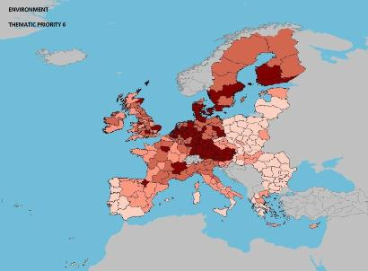
Scientific production Energy Technological production
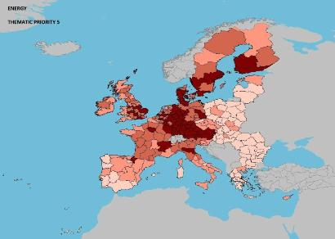
Scientific production Health Technological production
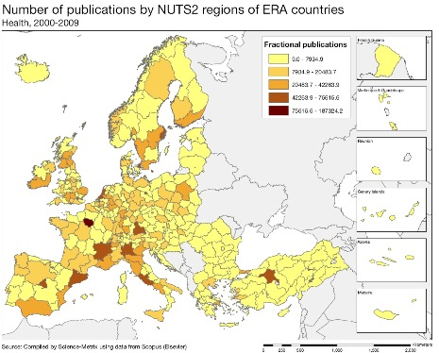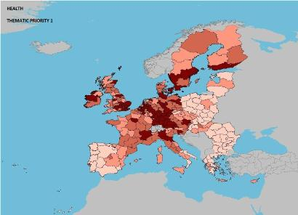
Source: DG Research and Innovation – Economic Analysis unit
Data: Science Metrix using Scopus (Elsevier), 2010; European Patent Office, patent applications, 2001-2010

Scientific production Information and Communication Technologies Technological production
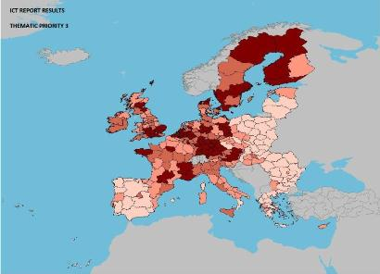
Scientific production Nanoscience, nanotechnologies Materials Technology production
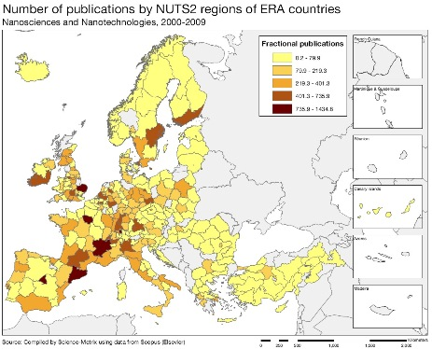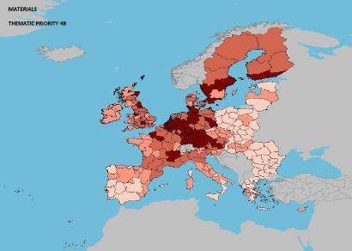

Scientific production Security Technological production
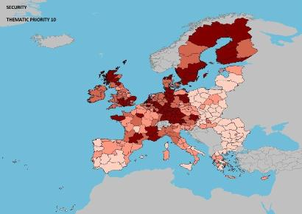

Sweden performs well in most areas of technology production. Apart from the sectors illustrated in the maps above, Sweden has intensive patenting in transport technologies, motor vehicles, machine tools, new production technologies, and biotechnologies, among other sectors. In terms of technological specialisation world-wide, Sweden stands out in digital and basic communication processes, and transport patents.

However, the maps do not always show corresponding scientific strengths in these sectors. These findings are confirmed by the data on shares of the 10 % most cited scientific publications, which show that Sweden is lagging behind the world scientific leaders in future strategic areas such as health, energy, and environment as well as security and automobiles. There is thus room for enhancing scientific excellence in the fields where Swedish industry has European level technology strengths. Being a small country with a large dependency on private multinational research performers, Swedish institutions and clusters need high quality, critical mass and a relevant focus.
Policies and reforms for research and innovation
The current Swedish policy follows the research and innovation bill of 2008, which stresses the links between research and innovation. In the broad sense of innovation policy, governance issues are crucial to actively enhancing innovation in several policy areas and reinforcing comprehensive framework conditions for business innovation. In a more narrow sense, the bill reinforced the funding and strategic focus of research and innovation. Public funding was boosted both for the new performance-based grant funding of universities and for strategic programmes in 24 research areas important to the Swedish business sector and society, including cancer, diabetes, epidemiology, e-science, molecular bioscience, nanoscience and nanotechnologies, neuroscience, stem cell and regenerative medicine, nursing research, eco-systems and natural resources, oceanic environment, climate modelling, sustainable use of natural resources, material science, production technologies, security and crisis, transport, IT mobile communication, and energy. In view of the 2013-2016 budget, a new research and research-based innovation bill gives a strong emphasis to R&D in strategic innovation and in core areas for the Swedish industry, such as mining, steel, wood products and the construction of a sustainable society. Public funding to R&D will be progressively increased and funding allocation systems to universities progressively reformed to enhance scientific excellence

Over the last five years, several initiatives have been launched to enhance the effectiveness of the Swedish R&I system, with a focus on innovation in SMEs through reinforced public-private cooperation with universities and better access to seed funding and venture capital. Industrial Research Institutes have been created to be specific innovation intermediates and to act as an interface between academic research and product development in the business sector. The model is that the private business sector buys R&D services from the Institutes, while the state funds their facilities and skills development. In addition, the bill established innovation offices to foster the commercialisation of research results. The commercialisation of research in seven universities was encouraged by additional state funding (SEK 150m per year). Access to funding, in particular early stage seed financing, for innovative SMEs is enhanced through business incubators and venture funds i.e. Innovationsbron, Industrifonden, Almi and more than 30 incubators, often located in Technology parks. The Swedish innovation agency, Vinnova, also funds programmes to enhance research in SMEs, Forska och Väx, as well as cluster building. However, the overall budget for these programmes is relatively small.

The new national innovation strategy, adopted at the end of 2012, comprises a holistic approach to innovation policy aiming at the year 2020. Interesting proposals have been made for both demand-side measures (i.e. introducing a new procurement law fostering innovation-friendly procurement) and supply-side measures (in particular to fund testing, demonstration infrastructure and reinforce incubators of new research-based products). The role of the public sector as driver of innovation is stressed. The 2011 innovation procurement inquiry proposed the introduction of a new law on pre-commercial procurement. An increasing importance is given to innovation in services, mobilising knowledge in a broad sense and enhancing societal challenge-driven innovation, new business models and design-based thinking.

Additional value is drawn from linking supply-side and demand-side measures more closely to each other. Compared to other EU Member States, Sweden has margins for increasing its state aid to R&I. Direct funding to larger firms could be linked to conditions to buy products and services from Swedish SMEs with the aim of fostering innovative eco-systems in strategic sectors for Sweden. A strategic harnessing of EU Structural Funds for challenge-driven innovation would enable the expansion of infrastructures for testing and demonstration of new technology-based innovation and boost the world-class Swedish innovation clusters, thus better linking demand for innovation by large multinational enterprises with supply of technologies and services from SMEs and enterprises of intermediate size. The building in Lund of a world-class neutron source laboratory in the field of new materials, namely the European ESFRI infrastructure European Spalling Source, and the determined funding to Life science in the region of Uppsala and Stockholm, SciLifeLab, constitute opportunities both for frontier research and for business applications.
Economic impact of innovation
The index below is a summary index of the economic impact of innovation composed of five of the Innovation Union Scoreboard's indicators.

In a Schumpeterian perspective, Sweden offers good framework conditions for innovation in business activities, in particular for the creation of new firms. In general, barriers to entrepreneurship are lower than in most OECD countries. The time involved and the cost of starting up a business are below the EU average. The share of doctoral graduates is high (although less focused on science and technology). Clusters in some sectors (i.e. ICT, power generation, biotechnology) have grown around some of the larger research-intensive firms. Early stage funding as a share of GDP was the highest among the EU Member States. Also venture capital investment as a share of GDP is among the highest in the OECD. However, the share of early stage funding in total risk capital is lower than in other EU Member States, and following the financial crisis, there has been a sharp decline in risk finance.

The innovation challenges for Sweden lay elsewhere. Even if Sweden scores much higher than the EU average in the index above on economic impact of innovation, it performs below its reference group. Despite its very knowledge-intensive labour force and high patenting intensity, the relative weakness of the Swedish economy is rooted in the commercialisation and trade of innovative and knowledge-intensive products. Sales of new to market and new to firm innovations and trade in knowledge-intensive services in total services export are particularly lower than in its reference countries. The challenge of Sweden is not in technology production or firm creation, but in the sustainability of knowledge-intensive firms for medium-term growth and market presence. The survival rate (after two years) of new firms is relatively high, but many innovative start-ups are bought up by larger and often foreign firms. This dynamics is aggravated by the Swedish firm structure, still dominated by a small number of old, large and globalized companies. With an outsourcing of employment, and more recently of research and innovation (visible in the falling business R&D intensity), these larger firms no longer support the sustainability of new Swedish knowledge-intensive firms.

There are positive signs of change. The proportion of high-growth enterprises (measured by revenues or by employment) is higher in Sweden than in other Nordic countries, and is only slightly behind the United States. Among the existing firms, the innovation activity in SMEs as measured by the Eurostat Community Innovation Survey (CIS) is comparable to other knowledge-intensive Member States, although on average is clearly below the innovation activity in German enterprises.
Upgrading the manufacturing sector through research and technologies

The graph below illustrates the upgrading of knowledge in different manufacturing industries. The position on the horizontal axis illustrates the changing weight of each industry sector in value added over the period. The general trend to the left-hand side reflects the decrease of manufacturing in the overall economy. The sectors above the x-axis are sectors whose research intensity has increased over time. The size of the bubble represents the share of the sector (in value added) in manufacturing (for all sectors presented on the graph). The red-coloured sectors are high-tech or medium-high-tech sectors.
The Swedish economy has managed to maintain an important manufacturing industry since the mid 90s. In most other EU Member States, the share of value added of manufacturing industry in total value added has decreased (illustrated by a leftward shift in the graph above), linked to the expanding services sectors. In general, countries with a strong manufacturing sector have been more resilient to the economic crisis.

However, compared to other EU Member States, Swedish manufacturing industry presents a lower dynamic in terms of upgrading knowledge, in particular R&D. This is particularly true of the larger manufacturing sectors, such as the electricity, gas and water industries, fabricated metal products, basic metals, and motor vehicles, all key sectors in the Swedish economy both currently and historically. There are some promising exceptions, such as recycling, publishing and printing, textiles and apparel, but these sectors have a smaller size in the economy.

Considering R&D investment at firm level, as illustrated in the EU Industrial Scoreboard, the large Swedish R&D-intensive enterprises (Ericsson, Volvo, Sandvik, Electrolux, Vattenfall, Atlas Copco, SKF, etc.) broadly maintained or even increased their global R&D intensities in 2010 as compared to 2009. Swedish firms have on average increased their R&D investment over the last three years (2007-2010) by 3.4%, although there are exceptions - firms in the motor vehicle sector, software, biotechnology and pharmaceutical sectors. Many of the Swedish firms operate on a global base with the result that increased R&D investment may not necessarily be made in Sweden.
Competitiveness in global demand and markets

Investment in knowledge, technology-intensive clusters, innovation and the upgrading of the manufacturing sector are determinants of a country's competitiveness in global export markets. A positive contribution of high-tech and medium-tech products to the trade balance is an indication of specialisation and competitiveness in these products.
In real terms, the Swedish trade balance for high-tech (HT) and medium-tech (MT) products grew substantially up to 2006, and thereafter it fell and counted almost half the size in 2010. It was mainly exports in HT and MT products which dropped in the economic crisis in 2009. The graph above shows that most high-tech and medium-tech products and in particular electrical machinery, office machinery, power-generating machinery and general industrial machinery have slightly increased their contribution to the Swedish trade balance over the period 2000-2011. This constitutes a good performance in increasingly competitive markets. However, a serious concern is the falling weight of telecommunications in the Swedish trade balance (and to a less extent other high-tech product sectors such as medical products, vehicles and organic chemistry), possibly a sign of a weaker world competitiveness of Sweden regarding these products. Looking at the data in relation to the previous graph, it is clear that since 1995 these sectors have not substantially upgraded their knowledge intensities in terms of average annual growth of business R&D. On the other hand, the lower dynamics of R&D upgrading is found in most manufacturing sectors, including the machinery and electricity sectors; although these products have expanded their position in the overall trade balance, their exports in real terms have dropped with the economic crisis after 2008.
Total factor productivity grew continuously in Sweden between 2001 and 2007, but since then it has stagnated. The employment rate shows a similar evolution, with an overall level of 80% (the highest in the EU). Apart from falling R&D intensity, Sweden is making good progress on all other Europe 2020 targets. Greenhouse gas emissions have decreased considerably while the share of renewable energy in final energy consumption has grown. In line with this progress, the number of patents in environment-related technologies per billion GDP has increased to the third highest level in the EU. However, the number of patents in health-related technologies (another major societal challenge) has fallen when measured as ratio of GDP. Despite this, Sweden is among the top three EU Member States in both these technology areas.
Key indicators for Sweden

Country-specific recommendation in R&I adopted by the Council in July 2012:
"Take further measures in the upcoming research and innovation bill to continue improving the excellence in research and to focus on improving the commercialisation of innovative products and the development of new technologies"
United Kingdom
Delivering a better environment for commercialising research

Summary: Performance in research, innovation and competitiveness

The indicators in the table below present a synthesis of research, innovation and competitiveness in the United Kingdom. They relate knowledge investment and input to performance or economic output throughout the innovation cycle. They show thematic strengths in key technologies and also the high-tech and medium-tech contribution to the trade balance. The table includes a new index on excellence in science and technology which takes into consideration the quality of scientific production as well as technological development. The indicator on knowledge-intensity of the economy is an index on structural change that focuses on the sectoral composition and specialisation of the economy and shows the evolution of the weight of knowledge-intensive sectors and products and services.

 | Investment and Input | Performance/economic output
Research | R&D intensity  2011: 1.77% (EU: 2.03%; US: 2.75%)  2000-2011: -0.23% (EU: +0.8%; US: +0.2%) | Excellence in S&T  2010:56.08 (EU:47.86; US: 56.68)  2005-2010: +2.27% (EU: +3.09%;US: +0.53)
Innovation and  Structural change | Index of economic impact of innovation  2010-2011: 0.621 (EU: 0.612) | Knowledge-intensity of the economy  2010:59.24 (EU:48.75; US: 56.25)  2000-2010: +1.2% (EU: +0.93%; US: +0.5%)
Competitiveness | Hot-spots in key technologies  Organic chemistry, Biotechnology, Pharmaceuticals, Medical technology, High-value manufacturing, Nanotechnology, Digital technologies | HT + MT contribution to the trade balance  2011: 3.13% (EU: 4.2%; US: 1.93%)  2000-2011: +4.83% (EU: +4.99%; US:-10.75%)

The UK shows overall innovation performance above the EU average. There are particular strengths in human resources, venture capital, international and public-private co-publications, and entrepreneurship. The number of collaborations by innovative SMEs with other entities is increasing rapidly, while rates of improvement in human resources and international co-publications are well above average. The presence of several world-class universities, a significant proportion of young doctoral graduates, and competitive strengths in sectors such as pharmaceuticals and digital technologies have helped achieve this strong performance. However, there are relative weaknesses in RDI investments by firms, the creation of intellectual assets, and SMEs introducing innovations.

The UK economy has several distinctive characteristics that represent actual or potential sources of competitive advantage in the innovation sphere: a world-leading science base and information infrastructure; a prominent financial sector (although this could be better incentivised to support the creation and growth of firms); a rich supply of high-level skills plus a proven attractiveness to globally mobile talents; strong performance by business in creating intangible assets; and a relatively large role of the service sector for industry and export performance. These characteristics, highlighted by the UK Government in its new strategy for innovation published at the end of 2011, underpin the four priority areas identified for policy development: strengthening the sharing and dissemination of knowledge within the innovation system; fostering the development and use of a more coherent innovation infrastructure; driving business innovation in all sectors of the economy — high-tech, medium-tech and low-tech, and in the services sector; and transforming the public sector into a major driver of innovation.

Apart from the recent abolition of regional development agencies, which represents a significant change in the innovation policy delivery infrastructure, the UK continues to benefit from a key strength of its innovation policy governance system: a long-term, strategic view of innovation policy informed by an extensive process of review and evaluation and benefiting from a relative absence of dramatic shifts in priorities, instruments or structures.
Investing in knowledge

The higher education sector was responsible in 2010 for €8.19 billion of R&D activities, representing 27.2% of total R&D performed. This share increased from 20.6% in 2000 at an average annual growth rate of 3.2%. Business enterprise finances 45% of R&D and performs around 61% of R&D. R&D expenditure by business enterprise amounted to €18.3 billion in 2010, close to the level of 2003. Government finances around 32% of R&D. An important characteristic of the UK research system is the significant R&D investment financed from abroad — some 17% (8% EU average) — and from the non-profit sector — about 5%. In 2010, the UK's gross domestic expenditure on R&D was some €33 billion and had decreased by 0.8% in real terms, from 2009. UK institutions also benefitted from € 3.9 billion from FP7 (14.9% of the total, which is the second-highest share among Member States). The success rate of UK applicants in FP7 is 23.62%, well above the average EU rate of 21.5%. For 2007-2013, the UK has been allocated around €10.6 billion in Cohesion Policy funding. The UK plans to invest €4.5 billion of this in RDI.
R&D intensity (2011) was 1.77% of GDP, down from 1.86% and lower than the EU average of 2%. The trend since 2000 shows an initial fall, a mild recovery from 2005 (peaking in 2009), and a recent decline. Public spending accounted for about one-third of the total. Albeit with ups and downs, growth has been negative overall for the past decade (averaging out at -0.3% per year); Business R&D intensity has fell from 1.17% in 2001 to 1.08% in 2010. As part of the government's 2010 fiscal consolidation strategy, the budget for science was frozen in cash terms at just over £4.6 billion (€5.4 billion) for the next four years. This amounts to a cut of some 10% in real terms over the period. The capital expenditure budget for science was not protected and is expected to be cut by some 44% over the same period. In spite of this negative trend, the UK has not set a national R&D intensity target corresponding to the request of the European Council regarding Europe 2020 headline targets. The current Government has stated that it does not believe that Lisbon targets have proved effective in the past. However, it indicated that the level of R&D investment will be monitored on an annual basis, although data will be available with an 18-month time-lag. In the last decade, R&D intensity has averaged around 1.8%. Reinforced fiscal incentives, the new "patent box" and an ambitious public procurement policy may yet succeed in progressively reversing the negative trend in business R&D.
An effective research and innovation system building on the European Research Area

The graph below illustrates the strengths and weaknesses of the UK R&I system. Clockwise, it gives information on human resources, scientific production, technology valorisation and innovation. Average annual growth rates from 2000 to the latest available year are given in brackets.
As a whole, the UK R&I system performs above the EU average, with strengths in the quality of research, but weaknesses in the introduction of innovations to the market. The proportion of human resources in science and technology as a share of the UK labour-force is above the EU average, and has risen since 2006. High numbers of highly qualified UK-educated researchers are resident in other OECD countries, associated with the circulation of high-level human resources. On research infrastructures, the UK recognises that investment in world-class infrastructure is a prerequisite for world-class research: it hosts a large number of national and international facilities and is involved in many facilities in Europe and the rest of the world. Regarding universities, greater emphasis has been placed recently on stimulating their engagement with businesses and local communities, with a Higher Education Investment Fund as the main policy stimulus. Knowledge transfer from the research base to business is a UK policy priority, with several initiatives providing funding to stimulate collaborative research and inter-sectorial mobility or supporting the creation of university and public-sector spin-outs.

Sectorial support is strongly focused on advanced manufacturing, covering vocational skills education, apprenticeships, high-value manufacturing technology innovation accelerators ("Catapults"), incentive prizes, fellowships and advisory services. Life sciences also attract particular support via a Biomedical Catalyst Fund. Overall, public-private partnerships are becoming more significant, particularly in the mobilisation of risk and venture financing, growth capital and other forms of support. Many support measures engage industry in co-funding initiatives, especially in programmes addressing major socio-economic challenges ("research & technology clubs") and cross-cutting technology sectors. 58% of businesses were innovation-active between 2006 and 2008 (UK Innovation Survey, 2009).
UK's scientific and technological strengths

The maps below illustrate six key science and technology areas where the UK has real strengths in a European context. These maps are based on the numbers of scientific publications and patents produced by authors and inventors based in the regions. Caution should be exercised, however, as not all industries either find patents the most useful means of protecting intellectual property or are accustomed to publicising research results in the scientific press.

Strengths in science and technology at European level

Scientific production Automobiles Technological production
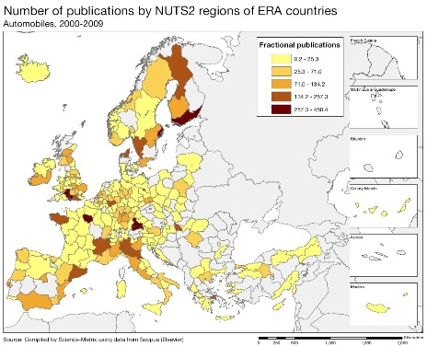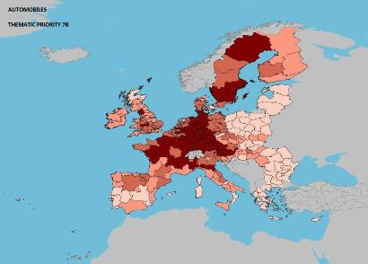

Scientific production Biotechnology Technological production

Scientific production Energy Technological production

Source: DG Research and Innovation – Economic Analysis unit
Data: Science Metrix using Scopus (Elsevier), 2010; European Patent Office, patent applications, 2001-2010
Scientific production Environment Technological production

Scientific production Information and Communication Technologies Technological production

Scientific production Nanoscience and Nanotechnologies Technology production
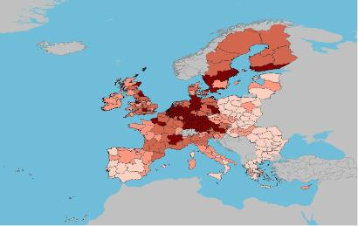

The UK performs well in most areas of technology production. Apart from the sectors highlighted in the maps above, current patent activity suggests that the UK is also relatively strong in the areas of organic chemistry, pharmaceuticals and medical technology. It has a world-class reputation in aerospace and nanotechnology research, and particularly significant R&D capabilities in renewables, especially offshore windpower and marine energy. However, compared to its competitors, UK R&D is concentrated in a relatively small number of sectors and is carried out by relatively few businesses. Greater business investment in R&D would be helpful across all sectors of the UK economy.

In terms of scientific production, the UK research-base is the most productive in the G8, generating more papers and citations per unit of investment than any other large country (International Comparative Performance of the UK Research Base, Elsevier, 2011).
Policies and reforms for research and innovation

The UK Government stated its commitment to prioritising, to a certain extent, spending on science and innovation while pursuing fiscal consolidation. It reiterated its continuing support for RDI in the document "The Innovation and Research Strategy for Growth" published in December 2011, which states that RDI policy, overall, is focused on increasing the UK's ability to innovate and commercialise new technologies as a means for driving economic growth and creating jobs. The aim is to encourage greater levels of innovation in all sectors of the economy, supported by a better-integrated and more cohesive innovation system. The Strategy made a number of specific announcements of additional investments planned in RDI, including additional capital investments in research infrastructure, the creation of a Graphene Global Research & Technology Hub, a large-scale demonstrator in the area of "future cities", and investment to support technology-based SMEs.

RDI policies are managed at national level by the Department for Business, Innovation and Skills, which sponsors the seven UK Research Councils, the Higher Education Funding Council for England (HEFCE), and the Technology Strategy Board (TSB). The TSB is responsible for funding innovation and technology development within business and acts as the national innovation agency for the UK. The devolved administrations of Northern Ireland, Scotland and Wales are responsible for certain elements of funding, specifically for higher education research and for enterprise agencies.

The Government has decided that all programmes for and funding linked to R&I should be delivered by national organisations. Consequently, regional development agencies, which had previously played a role in innovation funding, were dissolved in mid-2012. New "Local Enterprise Partnerships" are being introduced at sub-national level, though without dedicated budgets for research and innovation, and with no a role in delivering innovation support programmes.

Funding for research in the UK is provided in two ways: competitive, project-based funding delivered through the Research Councils, for which researchers in UK universities or public sector research can apply, with each Research Council allocating resources within its field between institutes, facilities, research studentships and projects; and via HEFCE in England and its counterparts in Northern Ireland, Scotland and Wales, covering research, knowledge transfer and infrastructure.

The TSB is the UK’s prime channel for supporting business-led technology innovation. It is responsible for a range of innovation programmes, including knowledge transfer partnerships, which embed new graduates in, mostly, SMEs; knowledge transfer networks, to help industry access knowledge and information; collaborative R&D, which supports the business and research communities working together on projects; funding for proof of concept, market validation studies and the development of prototypes (the "Smart" initiative); and the new network of "Catapult" innovation accelerators.

Tax credits are the biggest single funding mechanism provided by the UK Government for incentivising investment in business R&D. The SME scheme gives companies a deduction from corporate tax of 125% of qualifying expenditure and the possibility of a payable credit. The large-company scheme offers a deduction of 30%.

The Government has also put considerable emphasis on using public procurement to stimulate innovation capacity: the Small Business Research Initiative encourages innovative firms to tackle RDI challenges facing government departments, while the Forward Commitment Procurement programme helps public-sector organisations to develop new products and services to meet demand.

A "Patent Box" scheme, to be launched in 2013, will apply a reduced rate of tax to profits from patents and some other types of intellectual property. The hypothesis is that this will encourage firms to retain existing patents, develop new, innovative technologies and patent them, and to locate jobs and activities associated with patentable activities in the UK.
Economic impact of innovation
The index below is a summary index of the economic impact of innovation composed of five of the Innovation Union Scoreboard's indicators.
The rather good performance of the UK on this index as well as its score on each of its components reflect the specificities of its economic structure, which an overall orientation towards the service economy and a specifically strong specialisation in financial intermediation, a knowledge-intensive sector. The share of the UK's employment in knowledge-intensive activities (17.6 %) is the third highest of all EU Member States, while the share of knowledge-intensive services in services export is the fourth highest.
High-growth firms play a central role in the economic impact of innovation in the UK. Research shows that the 6% of UK businesses with the highest growth-rates generated half the new jobs created by existing businesses between 2002 and 2008 (The vital 6 per cent, NESTA, 2009). Although young firms are more likely to be high-growth, the majority are at least five years old. Furthermore, high-growth firms are found across the UK and across sectors, and are almost equally present in the high-tech and low-tech sectors. Innovation drives firm growth, with innovative companies growing twice as fast (in both employment and sales) in the period studied compared to firms that failed to innovate. In addition, high-growth firms generate spillovers in other regions. Although the analysis covers the period before the current recessionary environment developed, the limited evidence available suggests that high-growth businesses are resilient to downturns, continuing to grow despite worsening economic conditions.
Although the sectoral dynamics of the UK economy will undoubtedly change as the financial and economic crisis continues to unfold, the contribution that high-growth firms make to that economy in both times of growth and times of contraction has been acknowledged by the Government as a valid basis for policy-making. In that light, the Government is committed to providing support via tax incentives, as described above, and to enabling such businesses to access more diverse sources of finance, including debt and equity. Regarding access to finance, the Government has increased the amount committed to an existing enterprise capital funds programme, backed business angels with a co-investment fund, reinforced an investor tax-relief scheme, spurred banks to set up a business growth fund targeting firms with high-growth trajectories, and encouraged investment into new, early-stage companies through an income tax relief and capital gains tax-exemption scheme. Furthermore, research has consistently shown a link in the UK between the use of design and improved business performance across a range of measures, including turnover, profit and market share. The Government continues to support a programme, Design on Demand, to build greater design capability and understanding among SMEs.
Upgrading the manufacturing sector through research and technologies

The graph below illustrates the upgrading of knowledge in different manufacturing industries. The position on the horizontal axis shows the changing weight of each industry sector in value-added over the period 1995-2007. The general trend of moving to the left-hand side reflects the decreasing share of manufacturing in the overall economy. The sectors above the horizontal axis are those whose research intensity has increased over time. The size of a bubble represents the share of a sector (in value-added) in manufacturing (all sectors shown). Red sectors are those that are already high-tech or medium-to-high-tech.

Manufacturing is the third largest sector of the UK economy in terms of share of GDP, after business services and the wholesale and retail sectors. In common with other leading manufacturing countries, the UK has increasingly specialised in higher-technology manufacturing industries such as medical or chemical products and precision machinery and equipment.

Furthermore, there has been a shift in employment in manufacturing away from production and towards support services, logistics and distribution, sales and marketing, and R&D activities. Current patent activity suggests that the UK is presently relatively strong in the areas of organic chemistry, biotechnology, pharmaceuticals and medical technology, while relatively weak in the areas of electronics, optics, nanotechnology and information technology. In addition, the proportion of firms that are exporting is increasing in many manufacturing industries.

The graph demonstrates that a significant proportion of medium-tech and high-tech sectors have increased their research intensity, but not their share of value-added. However, the research intensity of some sectors has stagnated, or in several cases fallen, which could endanger their long-term competitiveness.
Competitiveness in global demand and markets

Investment in knowledge, technology-intensive clusters, innovation and the upgrading of manufacturing are determinants of a country's competitiveness in global export markets. A higher contribution of high-tech (HT) and medium-tech (MT) industries to the trade balance indicates specialisation and competitiveness in more sophisticated products and services.
Overall, the UK's trade balance in HT and MT firms is negative, with an increasing gap over the last decade. The total trade balance demonstrates an even larger gap, in particular in the period 1997-2005 (the negative trend has been halted since 2005 and is improving since 2008). Nevertheless, the graph above shows that several HT and MT industries have improved their contribution to the UK's trade balance, since the erosion of the trade balance in HT and MT has been slower than the deterioration of the overall UK trade balance. While the medical and pharmaceutical products, road vehicles, plastics, and machinery sectors maintain their competitiveness, the telecommunications (especially) and office machines/data-processing industries have markedly diminished their contributions to the trade balance, suggesting a possible loss in relative competitiveness worldwide.

Alongside established enabling technologies such as ICT, new general-purpose technologies are emerging in areas such as materials, tools, transportation and power. These technologies include low-carbon and environmental technology, advanced materials (such as composites), nanomaterials and nanotechnology, photonics, and biotechnology. Official trade data show that the value of UK manufactured exports to emerging markets has risen in recent years. This can be attributed to a rise in the number of exporting firms and an increase in the average value of their exports. Some of the highest rates of growth in the value of exports have been in higher technology products to emerging markets such as Brazil, Mexico and the Middle East (Manufacturing in the UK: an economic analysis of the sector, Department for Business, Innovation & Skills, 2010).

Over the past 12 years, the UK's total factor productivity (see table below) has grown on average by 5% a year, though the financial and economic crisis has knocked back values from a peak in 2007 to 2003's level. Looking at the Europe 2020 targets, the employment rate has fallen slightly, while R&D intensity has recently declined from its 2009 high, averaging around 1.8% over the past decade.

Key indicators for the United Kingdom

See Methodological note for the composition of this index.
There is a break in series between 2005 and the previous years for both R&D intensity and business R&D intensity in Sweden.
See Methodological note for the composition of this index.
See Methodological note for the composition of this index.

