Overview of the decisions of the Court of Justice of the European Union referring to the Charter
The CJEU has increasingly referred to the Charter in its decisions (see Annex I for an overview of all relevant rulings): the number of decisions quoting the Charter in its reasoning almost doubled from 43 in 2011 to 87 in 2012.

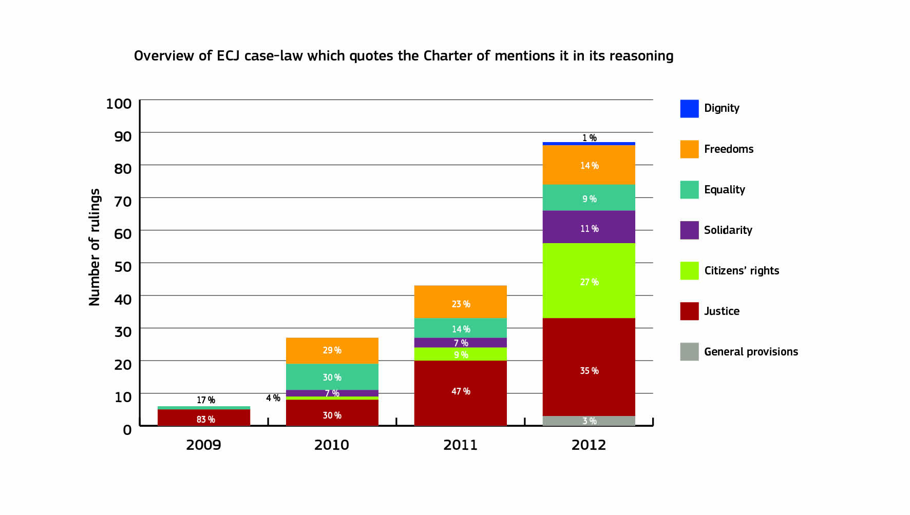
National courts when addressing questions to the Court of Justice (preliminary rulings) have also increasingly referred to the Charter: in 2012, such references rose by 65% as compared to 2011, from 27 to 41.

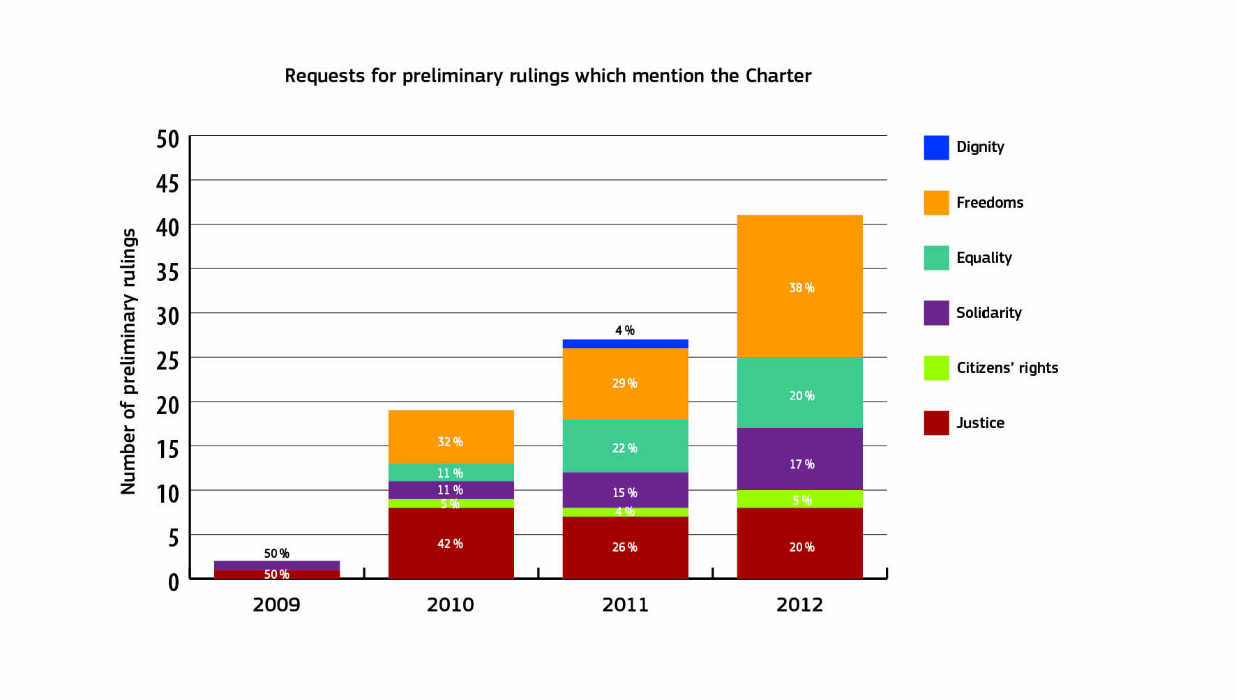

Overview of enquiries with the Europe Direct Contact Centres
The figures collected by the Europe Direct Contact Centres (EDCC) confirm that there is a high degree of interest among citizens on justice, citizenship and fundamental rights. In 2012, the EDCC replied to 9171 enquiries from citizens on topics such as free movement of persons (41% of the total number of enquiries) and judicial cooperation (13%).
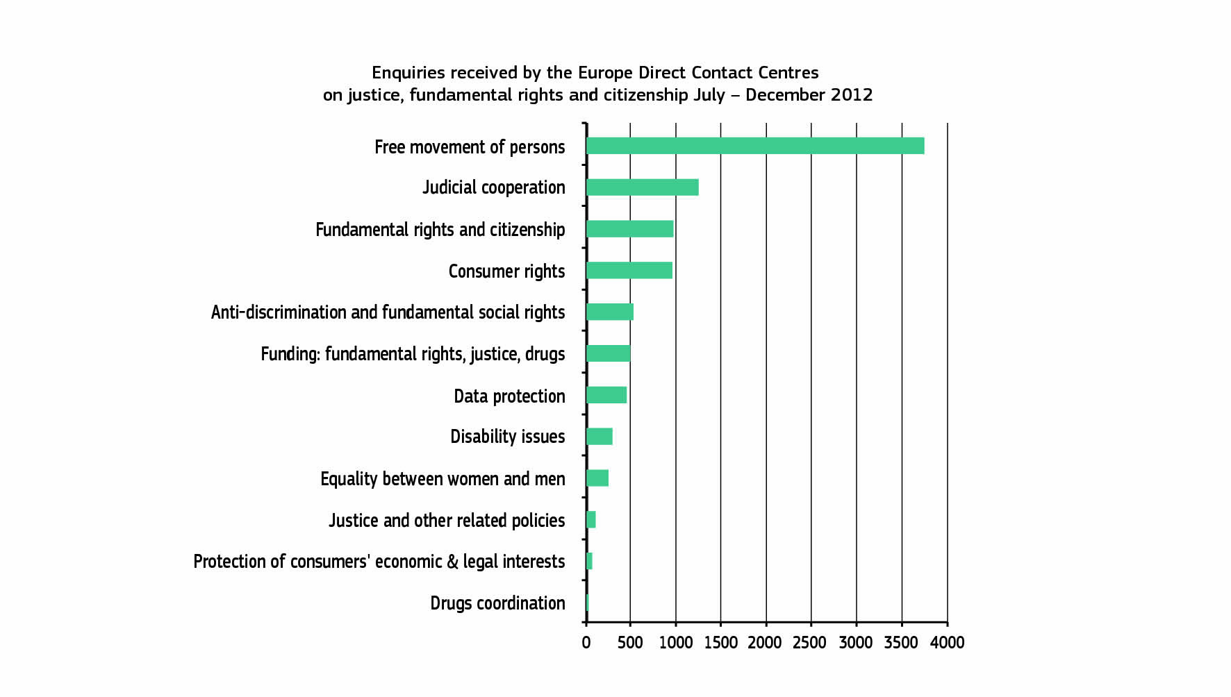

The structure of the Report
The structure of the Report follows the six titles of the Charter itself: Dignity, Freedoms, Equality, Solidarity, Citizens’ rights and Justice. Each of the six chapters of the Report contain the following information on the application of the Charter:
- Examples of how the EU institutions and, where relevant, the Member States have applied the Charter in 2012;
- Questions and petitions from the European Parliament, and letters from the general public received in 2012 focusing on fundamental rights issues;
- Relevant jurisprudence of the CJEU;
- Relevant case-law of national Courts on the Charter;
- Data gathered by the EU Agency for Fundamental Rights throughout 2012.

