COMMISSION STAFF WORKING DOCUMENT
Report on Progress on equality between women and men in 2012
Accompanying the document
2012 Report on the Application of the EU Charter of Fundamental Rights
TABLE OF CONTENTS
1. Introduction 4
2. Equal economic independence during the crisis 6
2.1. A levelling-down of the gender gap in employment 6
2.2. Starting fragile: young men and young women’s economic independence at stake 9
2.3. Reconciling work and family life — a snapshot of the attainment of the Barcelona targets 10
3. Equal pay for equal work and work of equal value 14
3.1. Gender gaps in education and research: the root of segregation and pay inequalities 14
3.1.1. Gender imbalances in education 14
3.1.2. Gender equality in research 15
3.2. Closing the Gender Pay Gap 16
3.3. Women’s earnings are playing a more critical role in household income 18
3.4. Gender gaps in pensions 19
3.5. Women still face a higher risk of poverty and exclusion 20
3.6. Migrants and minorities: fragility and empowerment 22
4. Equality in decision-making 24
4.1. Promoting gender balance on boards of companies listed on stock exchanges 24
4.2. Gender balance in political decision-making: still a challenge for many Member States 26
4.2.1. Elected representatives: gender imbalance in many parliaments 26
4.2.2. Gender imbalance in most EU national governments 27
4.2.3. Women and men in decision-making positions on the environment 28
5. Dignity, integrity and ending gender-based violence: a growing attention to a persisting issue 29
5.1. Reinforcing the rights of victims of crime 29
5.2. A strong stance against female genital mutilation (FGM) 29
5.3. Towards the eradication of trafficking in human beings 30
5.4. Violence against women as a key priority of the Cypriot presidency 30
6. Gender equality in external actions 32
7. Horizontal issues 34
7.1. Mainstreaming gender equality 34
7.2. Investing in gender equality 35
8. Summary of main findings 36
Statistical annex 37

1. Introduction
Equality between men and women is a fundamental right and a common principle of the European Union. It is also a key element of sustainable, smart and inclusive economic growth. Greater gender equality has accounted for a significant share of the employment and economic growth in the past 50 years and its potential impact is not yet fully exploited. New research shows that levelling gender gaps upwards could enhance potential economic growth: the projected gain from full convergence in participation rates by 2020 is an increase of 12.4 % in GDP per capita by 2030: this would represent an important contribution to the EU economic recovery and an important asset for the EU in a time of downturn.
Gender gaps decreased in several domains in the last five years. A closer insight shows that this decrease is not the consequence of an improvement of the situation of women but to a faster deterioration of the situation of men as compared to women, in particular in the first period of the crisis. Therefore, the EU has experienced a levelling down of gender gaps in employment, unemployment, wages and poverty in recent years. Significant challenges also remain in fields such as violence against women, reconciling work and family life and gender balance in decision-making.
This report assesses the situation of women and men and the changes over time, focusing on 2012 but also taking a long-term perspective and putting the current challenges in the context of the evolution of the last decade. It takes stock of major policy developments during the last year. 2012 was indeed rich in new initiatives on gender equality, at both European and national level. The report illustrates some of the many ways in which the European Union and its Member States have promoted gender equality.
This report is structured around the five priority areas defined in the Commission communication Strategy for equality between women and men 2010-2015, namely:
- equal economic independence for women and men,
- equal pay for work of equal value,
- equality in decision making,
- dignity, integrity and ending of gender violence,
- promoting gender equality beyond the EU,
A comprehensive mid-term review of the Strategy for equality between women and men will be presented by the Commission in 2013.
While covering all five priorities of the Strategy, the report focuses on specific aspects that gained importance in 2012 and on new initiatives that should be highlighted:
- The availability, quality and affordability of childcare facilities remain a key driver to enhance women’s employment and contribution to economic growth. The extent to which the so-called Barcelona targets in this field, adopted ten years ago, have been achieved, is scrutinised in a separate part of the report.
- Whereas women constitute an increasing part of the workforce, they are not yet represented at the highest decision-making levels. The Commission proposal for gender balance on boards of publicly listed companies therefore constitutes a key milestone for gender equality.
- Gender-based violence remains a serious and unacceptable violation of human rights. Important steps have been taken at European level to combat it.
The report also presents an insight of current economic issues with a focus on the specific challenges faced by young women and young men. On a longer-term perspective, new findings on the contribution of gender equality to growth are also presented.

2. Equal economic independence during the crisis
Having a job is a necessary — but not always sufficient — condition for economic independence and decent living for working-age men and women. In 2012, the scarcity of jobs has affected the lives of many men and women — though in different ways (section 2.1) — and has particularly affected the youth labour market (section 2.2). More structural factors, such as the unavailability of childcare facilities (section 2.3), partly explain the remaining gender gap in employment, and require to be addressed under the Europe 2020 Strategy.

2.1. A levelling-down of the gender gap in employment
Before the crisis, women were slowly catching up with men on the labour markets of all European countries: their employment rate increased from 55 % in 1997 to 62.8 % in 2007, gaining 6.9 percentage points while the male employment rate increased from 75.3% to 77.9%, gaining 2.6 percentage points in the same period. The crisis has halted these positive trends. However, male employment dropped earlier and faster (as shown in Figure 1): the male employment rate went down to 74.6 % in 2012, its lowest level since 1997, while female employment decreased only slightly at 62.4 %. The fall in female employment was smaller at the beginning of the crisis, as women were underrepresented in sectors such as manufacturing, construction and finance, which were hit the most. However the on-going process of fiscal consolidation is increasingly involving staffing freezes or personnel cuts in the public sector which is female dominated. This diminishes the prospects of a swift recovery for female employment in several countries.
Looking at changes in unemployment since the beginning of the crisis, the female unemployment rate was much higher than the male unemployment rate in the first quarter of 2008 and increased as the recession worsened, but not as much as male unemployment. As a consequence, both rates have converged (see Figure 2). In the fourth quarter of 2012, the male and female unemployment rates reached new highs of 10.6 % and 10.8 %, respectively, corresponding to almost 26 million Europeans in unemployment.
Despite the continuous increase in unemployment, inactivity and discouragement (characterised by abandonment of job search and the labour market) keep falling, in particular among women. Many more women than men were inactive in 2012 (30.5 % compared to 17 %), but the gender gap was lower than five years before (13.5 pp compared to 15.7 pp in 2007). Women are no longer the ‘buffer’ of the labour market, called in when demand is high, but sent back home when demand contracts.
Figure 1: Employment rate of men and women (20-64 years old), EU-27, 1997-2012(%)
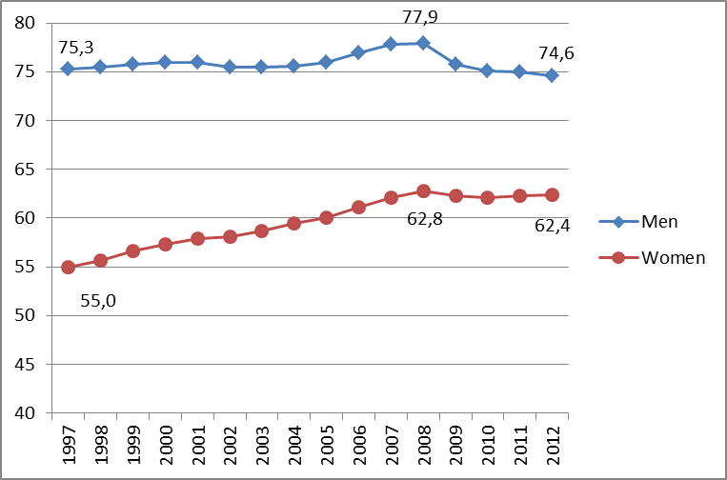
Source: Eurostat, Labour Force Survey (LFS)
Figure 2: Unemployment rate of men and women (15-74 years old) seasonally adjusted, EU-27, from the beginning of the crisis in 2008 to 2012 (%)
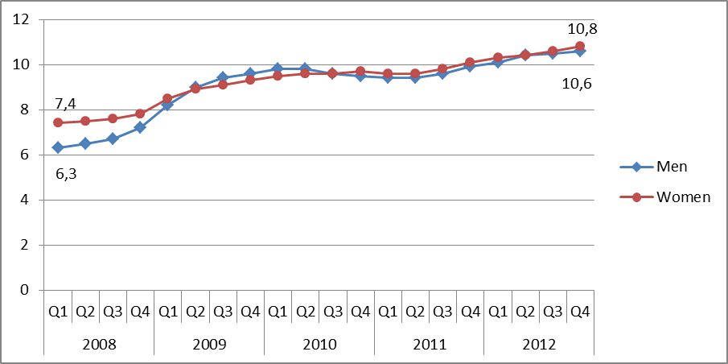
Source: Eurostat, LFS
As an alternative to lay-offs, part-time work has risen during the crisis, in particular among men: 8.4 % of employed men were part-timers in 2012 (compared to 7 % in 2007). However, part-time working remains a much more common feature of female employment (32.1 % in 2012 and 30.8 % in 2007). Involuntary part-time work has also risen among both men and women: involuntary part-time employment represents 39% of total part-time male employment in 2012 (against 30% in 2007) and 24% of total part-time female employment in 2012 (against 20% in 2007).
The situation of men and women varies from one Member State to another (see Figure 3). The female employment rate is lower than 60 % in Malta, Greece, Italy, Hungary, Spain, Romania, Poland, Slovakia and Ireland, while is above 70 % in Germany, the Netherlands, Finland, Denmark and Sweden. Some Member States with the highest female employment rates also display a high share of part-time employment among women (the Netherlands, Germany, Austria, Belgium, the United Kingdom, Sweden, Denmark and Luxembourg).
The differences in terms of number of hours worked can be summarised in one telling figure: if employment is measured in full-time equivalents, only 53.5 % of the female workforce is employed in the EU as compared to 62.4% in terms of employment rate's usual measure.
Improving female labour market participation is needed to ensure a sustained and inclusive growth. Recent evidence from the OECD shows that on average, the projected gain from full convergence in participation rates is an increase of 12.4 % in GDP per capita by 2030 in EU-21. The projected gains are substantially higher in those Member States where the gender gap in labour force participation is currently high. The same OECD report also demonstrates that while childcare facilities remain the key driver of female employment, a comprehensive policy-mix is also required to enable women and men to balance work with their family and private life and to address the difficulties encountered at different stages of life. The following sections present policies that have been implemented and their contribution to the enhancement of labour market participation of women, starting with youth policies.
Figure 3: Employment rate and part-time employment rate of men and women in 2012
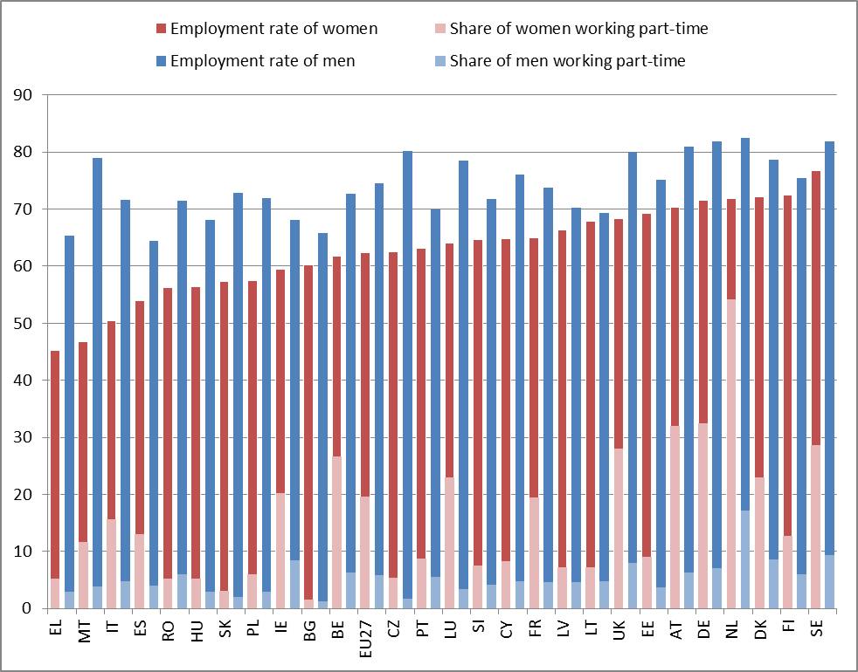
Source: Eurostat, LFS

2.2. Starting fragile: young men and young women’s economic independence at stake
The current crisis has particularly hit young people, who are facing unemployment and discouragement. As a consequence, in 2011, the rate of people not in employment, education or training (NEET) reached 17.5 % among young women (15-29 years old) and 13.4 % among young men in the EU-27. The NEET rate among young women is higher than 20 % in 8 Member States (see Figure 4). Young women are more likely than young men to be not in employment, education or training, mainly because they are more likely to be out of the labour force (or inactive).
Among the NEET group, 42.4 % of young men are involved in active labour market measures, while only 32.6 % of young women are. The share of young men is especially higher in training (59.5 % of young beneficiaries) and start-up incentives (62.9 %). Furthermore, women are underrepresented in apprenticeship schemes to facilitate school-to-work transition. All in all they seem to benefit less from public support in many Member States (training programmes, apprenticeships, etc.).
Figure 4: NEET rate by type and by gender for youth aged 15-29, 2011 (%)
*Luxembourg: data not available for males
**Malta: Total NEET rate
Source: ENEGE's calculation, based on yearly microdata ELFS, average 2009/2010
Young men more frequently experience a successful transition path (i.e. ending with a permanent contract). In contrast, young women are more likely to be part-time and temporary workers and to start in the doubly fragile position of a temporary, part-time job.
Based on this evidence, the Youth Employment Package adopted in December 2012 by the European Commission recognised the need for more gender-sensitive youth policies and proposed a Council Recommendation for a ‘Youth Guarantee’, paying attention to the gender and diversity of the young people targeted.

2.3. Reconciling work and family life — a snapshot of the attainment of the Barcelona targets
The ability of Member States to significantly increase sustainable employment rates and decrease gender gaps depends, among other things, on the ability of women and men to reconcile their professional and private lives. The availability of childcare services is crucial in this regard. Recognising this crucial role, the European Council in Barcelona set what is known as the ‘Barcelona target’: ‘(...) Member States should strive (...) to provide childcare by 2010 to at least 90 % of children between 3 years old and the mandatory school age and at least 33 % of children under 3 years of age;’.
Although some progress has been made since 2002, and despite the commitment of Member States in two successive European pacts for equality between women and men, the provision of childcare facilities in the EU was still short of these targets in 2010.
While 10 EU Member States have reached the Barcelona targets for the first age group in 2011, the majority of Member States have yet to make any substantial effort to meet the targets (see Figure 5). This is particularly the case in Poland, the Czech Republic and Slovakia, whose coverage rate is less than 5 %.
The use of formal childcare increases with the age of children. In the category of children aged from 3 to mandatory school age, 9 Member States reached the target of 90 % coverage in 2011. More worrying, the coverage rate has significantly decreased between 2010 and 2011 in several countries. It is also important to note that for some countries, even if the targets are met, the use of formal childcare is mainly part-time so does not cover a full week of work. The Netherlands, Ireland and the United Kingdom are examples where part-time childcare places may be for less than 20 hours.
Figure 5: Percentage of children cared for under formal arrangements by weekly time spent in care, 2011
Children up to three years of age | Children from three years of age to mandatory school age
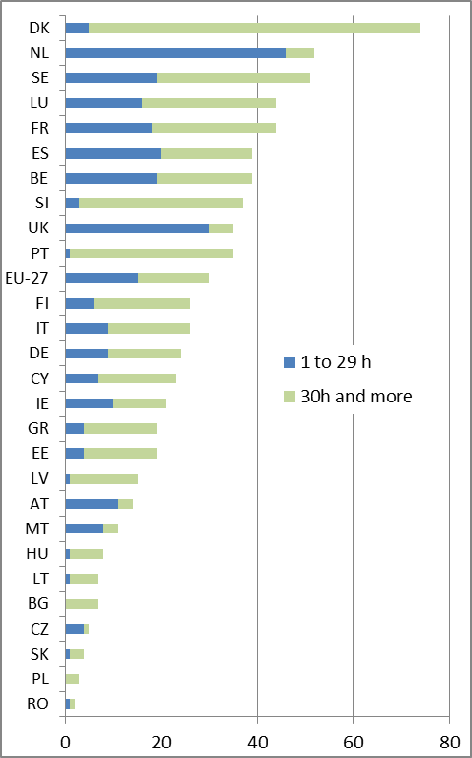 | 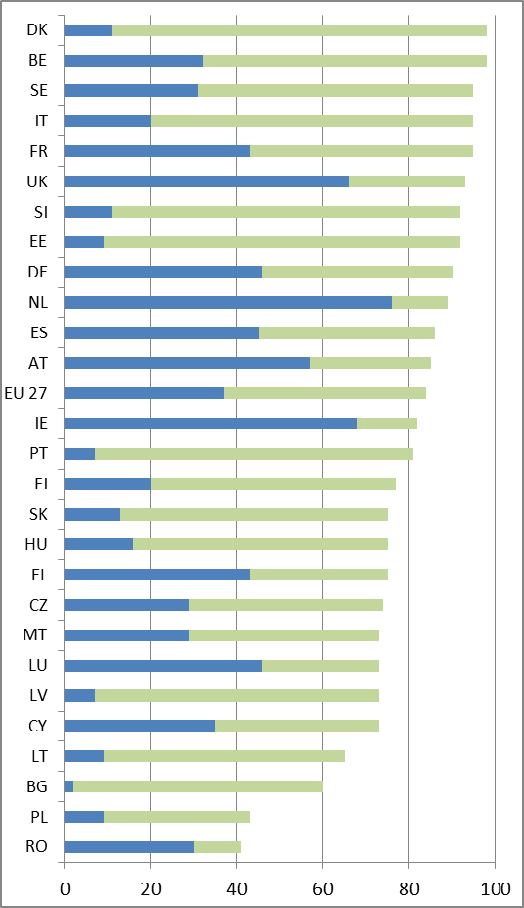
Sources: Eurostat, EU-SILC, 2010.
Note: A number of data points are computed based on small samples and are not considered statistically reliable. These include for first age category: AT, BG, CY CZ, EL, HR, LT, MT, PL, RO, SK.
Breakdowns by weekly time spent in care are laid down on a indicative basis.
Formal childcare services can only help parents enter and stay in employment if they are affordable. However, the price of these services is considered an obstacle for 53 % of mothers who do not work or work part-time on account of childcare. This is particularly the case in Ireland, the Netherlands, Romania and the UK where the price is an obstacle for more than 70 % of mothers who do not work or work part-time on account of childcare. The net costs of childcare services may in fact represent more than 41 % of net income in a household where both parents work in the UK and Ireland.
In addition, the quality of services remains uneven and difficult to measure. Some indicators of the structural quality of formal childcare services show a strong variation from one country to another. Regarding the competences of child carers, research and international policy documents recommend that early-childhood education and care professionals should be trained at bachelor level (ISCED 5) with at least 60 % of the workforce trained at this level. However, formal competence requirements vary widely from one country to another. In addition, in most EU countries competence requirements for auxiliaries or assistants, who provide up to 40-50 % of the workforce, are often overlooked. Assistants are likely to have little or no initial training and limited access to vocational training, while the ‘educators’ (who are already highly qualified in many cases) are able to benefit from such opportunities. Moreover working conditions in the area of childcare remain precarious in most countries.
The above comparative evidence, together with more country-specific analysis as part of the ‘European Semester’ round of economic coordination, provides the basis for country-specific recommendations addressed to nine Member States (Austria, the Czech Republic, Germany, Hungary, Italy, Malta, Poland, Slovakia and the United Kingdom) on female employment and on childcare availability/quality and/or full-day school places. Seven of these countries had already received a recommendation in 2011, while Malta and Slovakia received a recommendation for the first time in 2012.
The Commission will continue to support the development of affordable, accessible and quality childcare services throughout the European Semester, in line with the Annual Growth Survey 2013.
The sole development of childcare facilities is not enough to enable women and men to exercise their choice in how to balance work with their family and private life and does not account for the difficulties encountered at different stages of life. A reconciliation policy mix comprising flexible work arrangements, a system of family leave, including strong incentives for fathers to take on more family responsibility and the provision of affordable and quality care (for preschool children but also for pre-teen children in school and outside school hours and for other dependants) should be promoted.
Directive 2010/18/EU on Parental Leave had to be transposed in the Member States by 8 March 2012. It gives each working parent the right to at least four months leave after the birth or adoption of a child (previously up to three months). At least one of the four months cannot be transferred to the other parent – meaning it will be lost if not taken – offering incentives to fathers to take the leave.
The research on ‘The role of men’ shows men's increasing desire to contribute to family life and, actually, a growing participation in caring for own children in some countries. While some positive trends are documented, the persisting inequality in the take-up of unpaid care activities between women and men restricts the ability of women to engage fully in paid employment.
The new Directive on Parental Leave also provides for better protection against discrimination and a smoother return to work. Member States could request an additional year to comply with the Directive. 6 Member States have requested an extension and have until 8 March 2013 to transpose the requirement of this Directive into their national law. After this extended transposition deadline has expired the Commission will start a comprehensive monitoring exercise on whether the implementing measures are in conformity with the Directive.
In 2012, discussions in the Council on the Commission proposal for a revised maternity leave Directive which the Commission proposed in 2008 continued. The proposal is aiming to amend the current provisions of Directive 92/85/EEC on maternity protection. The most important elements of the Commission proposal are to increase maternity leave from 14 to 18 weeks, to allow women to choose more freely if they want to take maternity leave already before the birth (thus no obligatory periods before birth), an obligatory leave of six weeks after birth, to improve protection against dismissal and to allow the women to ask for changes in their working conditions. Negotiations remain very difficult given the diametrically opposed positions of Council and the European Parliament but the Commission has tried and will continue to try to help broker a compromise that represents tangible progress for pregnant workers.

3. Equal pay for equal work and work of equal value
The root causes of the gender pay gap are well-known: in addition to direct discrimination, women face sector and occupation segregation, undervaluation of their work, and unequal sharing of caring responsibilities. These gender inequalities on the labour market mirror gender segregation and differences in the education and training system (3.1), but recent trends in education and equal pay policy have probably helped reduce the gender pay gap (3.2). However the gender employment and pay gaps still have major consequences for earnings and women’s contribution to household income (3.3), pensions (3.4) and poverty (3.5). Special attention is paid to vulnerable groups: migrant and minorities (3.6).

3.1. Gender gaps in education and research: the root of segregation and pay inequalities

3.1.1. Gender imbalances in education
During the last decade, educational attainment has increased for both men and women in the EU (see Figure 6).
Figure 6: Early leavers from education and training (18-24 years old) and higher education attainment (30-34 years old) by sex, 2012
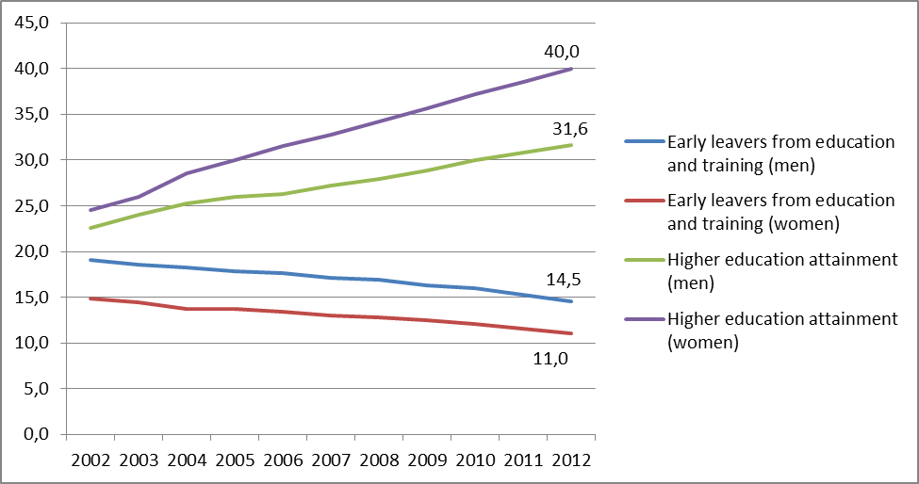
Source: Eurostat, LFS
By 2012, the proportion of early school-leavers had decreased among both boys and girls to 14.5 % and 11 %, respectively. At the same time, the share of young people with higher education massively increased, with the increase among women almost twice as high as that of men. In 2012, 31.6 % of all men and 40 % of all women (EU-27) between 30 and 34 years of age had attained tertiary education. Nowadays women constitute 60 % of new graduates.
However, girls are less likely to choose scientific or technological fields of study. Figures are telling in this regard. Three quarters of the students in engineering, manufacturing and construction-related studies were male. Male graduates also outnumber female graduates in science, mathematics and computing. In contrast, female graduates largely outnumber male graduates in fields such as social sciences, business, law, welfare and health.
Already at the age of 16, girls outperform boys in reading — the difference is equivalent to one year of schooling — but lag behind in mathematics, albeit to a lesser extent than boys in reading.
Policies, in particular education and training policies, can try to tackle gender inequalities at an early stage and so ensure that all boys and girls can realise their potential and choose the field they are good at, without being limited by prejudice. Many countries have tried to remove gender bias in curricula and decided to share their experience in a seminar that took place in October 2012.
The Danish 2012 National gender equality plan explicitly addresses gender segregation in education and training. There is also a specific focus on ‘failing boys’: in January 2012, the Minister for Gender Equality launched a fund (twenty million Danish kroner in total) to support projects and research on breaking down gender-segregated educational choices and enhancing knowledge on how to recruit and maintain boys within the educational system.
In Spain, the Ministry of Education has taken action to fight gender stereotypes in education and in future employment and career-specific programmes and measures to promote coeducation by: i) fostering the design and implementation of non-sexist orientation programmes through different awareness-raising campaigns at school; ii) re-formulating teaching materials to ensure that they meet equality and non-discriminatory criteria; iii) implementing coeducation at schools and training teachers in coeducation, gender violence prevention and gender equality; iv) ensuring gender mainstreaming in sports activities at schools; v) improving school services in order to accommodate student diversity (ethnic and gender) and ensure equality.

3.1.2. Gender equality in research
Despite noticeable progress, gender inequalities in science and in research still persist. According to the last edition of She Figures, women’s academic career remains markedly characterised by strong vertical segregation: in 2010, the proportion of female students and graduates exceeded that of male students, but the proportion of female PhD students dropped back to 49% and that of PhD degree holders to 46%. Furthermore, the percentage of female researchers in Europe stands at 33% while women represent only 20% of the highest grade in academic staff. Gender balance in decision-making bodies and processes is thus far from being achieved. On average in the EU-27 there is only about one woman for every two men in scientific and management boards, and the proportion of women heads of universities or assimilated institutions is even lower, standing at 11%. In addition, research programmes often fail to take adequately into account the gender dimension
Against this backdrop the Communication on the European Research Area adopted by the European Commission in 2012 includes gender equality and gender mainstreaming in research institutions, as one of its five priorities. The aim is (i) to remove legal and other barriers to the recruitment, retention and career progression of female researchers while fully complying with EU law on gender equality; (ii) to address gender imbalances in decision making processes and (iii) to strengthen the gender dimension in research programmes. In addition, the European Commission launched a communication campaign to get more girls interested in science and encourage more women to choose research as a career.

3.2. Closing the Gender Pay Gap
The unadjusted gender pay gap (GPG) stood at 16.2 % in 2011 in the EU as a whole. It is higher than 20% in Estonia, Czech Republic, Austria, Germany and Greece (see Figure 7).
Figure 7: The gender pay gap in 2008 and in 2011
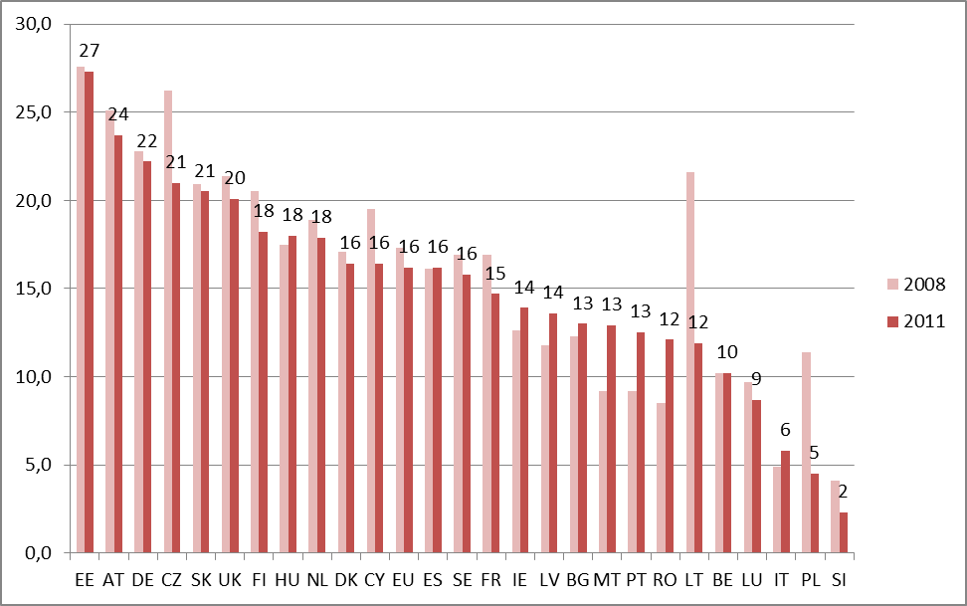
Source: Eurostat, Structure of Earnings Survey, 2010 data for Ireland
However the GPG has narrowed since 2008 from 17.3 % (1.1 percentage points in three years) in the EU as a whole. The decline is also documented in 17 out of 25 Member States for which data are available (see annex). The reasons for this recent slight decline in the GPG are still debated and four hypotheses have been suggested so far:
  - The share of higher educated workers has increased among the female workforce more than among the male workforce. These trends in education might start to decrease the gender pay gap.
  - The change in the sectoral composition of the workforce during the crisis could have reduced the GPG. Indeed, the manufacturing sector, traditionally characterised by a high GPG, lost ground at the beginning of the crisis.
  - A larger cut in additional components of men’s pay packets (premiums for overtime) has contributed to reducing gender inequalities.
  - Equal pay policies at national and European level have contributed to the decline. Cooperation with social partners and increasing awareness in companies of equal pay policies as a part of gender-aware human resources policies are another possible reason for the decrease of the GPG.
As information on pay equality is key to address the GPG, the European Commission held the second European Equal Pay Day on 2 March 2012. The European Commission will continue to raise awareness of the unequal pay conditions women face in the EU by marking the European Equal Pay Day and enhancing partnerships with Member States.
Companies and employers are key players in tackling the GPG. To support equal pay initiatives at the workplace, the Commission started the ‘Equality Pays Off’ project in 2012. The purpose of the project is to support companies in their efforts to tackle the GPG by providing training for companies and by organising exchanges of good practices between companies on actions to foster gender equality.
The European Parliament resolution of 24 May 2012 on application of the principle of equal pay for male and female workers for equal work or work of equal value presents some action proposals addressed to the Commission, Member States, social partners and other stakeholders, including companies. Some of these requests are to review current legislation (Directive 2006/54, the recast directive) in relation to the gender pay gap issue and to continue with awareness-raising campaigns, including providing adequate information on the burden of proof. The resolution also encourages the social partners and Member States to undertake job evaluation schemes free from gender bias, to implement job classification systems, and to foster the concept of work based on equal pay.
On 8 March 2012, the Belgian parliament adopted a law to reduce the gender pay gap. Under this law, differences in pay and labour costs between men and women should figure in companies’ annual audits (‘bilan social’) and therefore will be publicly available. Moreover, the new law stipulates that firms with over 50 workers will be obliged to produce an action plan when the analysis shows that women earn less than men. Finally, if discrimination is suspected, women can turn to their firm’s mediator, who will determine whether there is indeed a pay differential and, if so, will try to find a compromise with the employer. Besides legislative action, policies have been developed to tackle the key question of pay differentials: several training programmes, an implementation guide and check-list of gender neutrality to be used by private and public employers. Through inter-industry agreements, the social partners are encouraged to adopt a gender-neutral approach to job classification.
Equal Pay Day was celebrated on 19 April 2012 by some public activities in Estonia. In July 2012 the Government approved the action plan to reduce the gender pay gap. It includes five main types of actions: (1) improving the implementation of the existing Gender Equality Act (e.g. improving the collection of statistics, awareness raising, supporting the work of the Gender Equality and Equal Treatment Commissioner etc.); (2) improving the scope for reconciling family, work and private life (e.g. working with employers); (3) gender mainstreaming, especially in the field of education; (4) reducing gender segregation; and (5) analysing organisational practices and pay systems in the public sector, improving the situation where necessary.
Despite some progress the GPG is still very high in some countries and it has increased in countries where it was relatively lower (Portugal, Bulgaria, and Ireland, for example). Fiscal consolidation, including wage freezes or wage cuts in the public sector, with a majority of female employees, might deepen the GPG in the future and reverse the current trends.

3.3. Women’s earnings are playing a more critical role in household income
Gender pay gaps are even wider in terms of annual earnings, because women receive lower hourly wages than men and also work fewer hours per year. Yet the household relies more and more on women’s earnings, which should no longer be seen as auxiliary income. Women are increasingly the bread-winners in the household, not least because they live alone (18 % of households) or live with children but no partner (4 % of households) (see Figure 8). The proportion of female-breadwinner couples also increased significantly in 2008 and 2009.Moreover, dual-earner couples represent two thirds of all working-age couples with at least one member working according to data made available in 2012 (see Figure 9).
In many countries, however, women still constitute the second earner in the couple and the taxation system does not give sufficient incentives for them to work. In 2012, a country-specific recommendation on fiscal incentives for second earners was addressed to two countries, and the 2013 Annual Growth Survey recalled the importance of removing fiscal disincentives for second earners.
Figure 8: Type of household in the EU-27
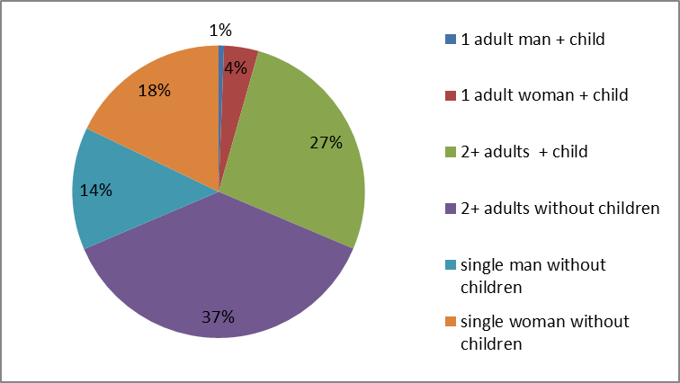
Source: Eurostat, LFS. If more than two adults live in the households (for example if a grandparent live in the household), the household is included in the category "2+adults".
Figure 9: Couples by partner’s earning role in 2009
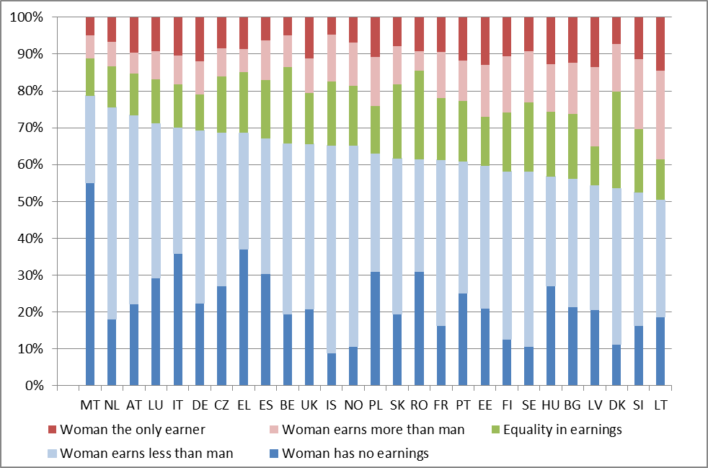
Source: EU-SILC, 2010, ENEGE calculation

3.4. Gender gaps in pensions
Gender inequality in old age has more to do with differences in labour market histories than with pension systems. Due to the higher prevalence of part-time working and career interruption among women, the gender earnings gaps are wide over careers. As most pension systems base their pension calculations on career earnings, the gaps can be very high.
However, the design of a pension system matters because it can reproduce, exacerbate or mitigate gender disparities in employment. It matters for example whether there is a minimum pension or an adequate survivor pension for those with incomplete careers who have not earned full pension entitlements, mostly women. Some mechanisms help to compensate women in retirement for their career interruptions to care for children. However, they cannot fully bridge the gap caused by career breaks.
Gender pension gaps are considerably wider than pay gaps. The average pension gap is 39 %, more than twice as large as the gender pay gap of 16 %. Moreover, the analysis shows that in most Member States, a sizable gap cannot be easily explained by differences in the observable characteristics of women and men (education age, length of working career, marriage status and weight of pension income from third pillar). This highlights that better understanding the causes of the gap remains an important policy challenge. The report also finds that in some Member States, more than a third of women have no pension. In others, the number of women with no pension is closer to one in ten.
Women’s statutory pension ages are still below men’s in several Member States, although most have planned or already adopted legislation to gradually bring them into line with men’s pension ages. In 2012, a country-specific recommendation to harmonise pensionable ages and rights was addressed to three Member States.
Furthermore, policies need to support the extension of working life. The employment rate of women aged 55 to 64 was 40.2 % in 2011 compared to 55.2 % for men. This shows the magnitude of the challenge to extend working lives. There are gender-specific obstacles to, but also opportunities for, extending working lives.
The White Paper on adequate, safe and sustainable pensions adopted by the Commission on 16 February 2012 puts forward a range of initiatives, including encouraging Member States to promote longer working lives and closing the pensions gap between men and women. The Commission will also step up its support for policy coordination and joint work on enabling and encouraging older workers, women in particular, to stay longer on the labour market.

3.5. Women still face a higher risk of poverty and exclusion
In almost all countries, women face a higher risk of poverty and social exclusion, as measured by the indicators agreed within Europe 2020: 55.7 million (23 %) of men experienced poverty and exclusion whereas 63.8 million (25.2 %) of women were in this situation in the European Union in 2011.
A considerable increase in the risk of poverty is visible in the last two years for which data are available (2010 and 2011). Recent years are also characterised by a slight decrease in the gender gap to 2.2 pp in 2011, from 3 pp in 2007. The reason for this narrowing of the gap may be that the crisis has had a different impact on men and women, as described at the beginning of the report.
Figure 10: The risk of poverty and social exclusion, EU-27, 2005-2011 (%)
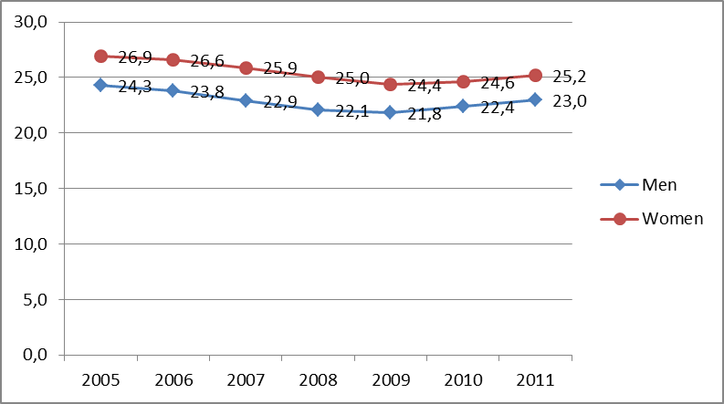
Source: Eurostat, EU-SILC
Note: The ‘people at risk of poverty or social exclusion’ rate is the headline indicator for the EU2020 Strategy poverty target. It reflects the share of the population which is either at risk of poverty or severely materially deprived or lives in a household with very low work intensity.

The Annual Growth Survey 2013 underlines that single-parent households (mainly women) represent a group particularly affected by poverty. The risk of poverty is also significantly higher among elderly women over 75 (20.1 % as against 16.9 % of the total population). Inactive and unemployed women and men of working age also face a high risk of poverty. This risk also affects self-employed and family workers (see Figure 11).
Figure 11: Poverty among different groups, EU-27, (%)
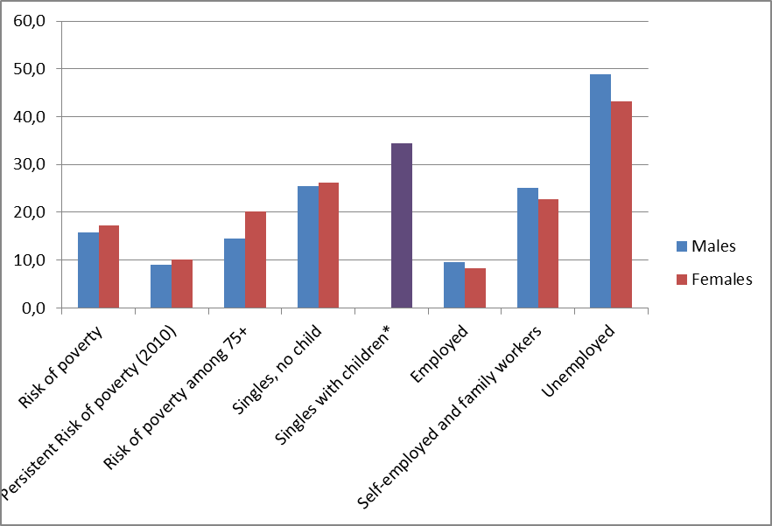
Source: Eurostat, EU SILC (EU 27 estimates for 2011). Note: The reference period for income and activity status for IE and UK differs from that for the other countries (where it refers to the previous year).
Note: The at-risk-of-poverty rate reflects the percentage of people with an equivalised disposable income below the ‘at-risk-of-poverty threshold’. The at-risk-of poverty threshold is set for each country at 60 % of the national median equivalised disposable income.
* No gender breakdown available.

To improve the situation of women who are self-employed workers or the spouses of the self-employed workers, Member States had to transpose Directive 2010/41/EU on the equal treatment of men and women who are engaged in or contribute to an activity in a self-employed capacity by August 5, 2012. The Directive prohibits discrimination on grounds of sex in this area and aims to ensure that the spouses of self-employed workers have access to social security schemes. It also introduces maternity benefits enabling interruptions of the activities of women who are self-employed workers or the spouses of self-employed workers of at least 14 weeks.
Member States could request an additional year to comply with specific provisions of the Directive. 5 Member States have requested an extension for transposition. The Commission is checking compliance with the obligation to communicate the national transposition measures completely or (for the Member States that have requested an extension) partially. A comprehensive monitoring of the correctness of transposition in all Member States will be carried out after the expiration of the extended transposition deadlines.

3.6. Migrants and minorities: fragility and empowerment
At EU level the risk of poverty or social exclusion is much higher among female and male migrants from a non-EU country (respectively 36 % and 34 %). Non-EU-born female migrants are also less likely to be employed. If employed, they are very likely to be over-qualified for the work they do.
Table 1: Employment, over-qualification and poverty among migrants and total population, EU-27 (%) in 2010
 |  | Total population | Foreign-born | Of which
 |  | Total population | Foreign-born | EU born | Non-EU born
Employment rate (20-64 years old) | Men | 75 | 73 | 77 | 71
Employment rate (20-64 years old) | Women | 62 | 56 | 62 | 53
Overqualification rate | Men | 21 | 30 | 23 | 34
Overqualification rate | Women | 22 | 36 | 31 | 39
At risk of poverty and social exclusion (18 years old or over) | Men | 22 | 28 | 18 | 34
 | Women | 24 | 31 | 23 | 36
Source: Eurostat, EU-SILC and LFS, 2010
Note: The overqualification rate is defined as the proportion of the population with a high educational level (i.e. having completed tertiary education, ISCED 5 or 6), and having low- or medium-skilled jobs (ISCO occupation levels 4 to 9) among employed persons having attained a high educational level.
Data are scarce about minorities in Europe, and therefore about gender differences among minorities, including among the Roma, who constitute the largest minority in Europe. However the gender dimension of the problems faced by Roma communities is increasingly recognised.
In its assessment of national Roma Integration Strategies presented in 2012, the Commission noted that several strategies ‘devote specific attention to the situation of Roma women, even though additional efforts are needed to enable them to exercise their rights’ Roma women often face multiple forms of discrimination including within their own communities. Poverty, lack of education, early marriage, domestic violence and exploitation typify their poor status in our societies. Many of them become victims of human trafficking, sexual abuse and enforced prostitution. Therefore, it is important to take appropriate preventive measures, including awareness-raising campaigns, where relevant in cooperation with NGOs, to provide Roma women victims with specific assistance and facilitate their access to victim protection services. Roma women deserve to be respected, but their empowerment is also crucial for improving the difficult situations of whole families. As primary caregivers, they have a direct impact on the lives of their children (e.g. the role of Roma mothers in promoting the education of children as well as raising awareness of family health).

4. Equality in decision-making
Comparable European data have been available on gender balance in economic decision-making (4.1) and in political decision-making (4.2) since 2003, showing slow progress until recently. For the first time this year, additional data are available on gender balance in the environment and energy at the highest decision-making level.

4.1. Promoting gender balance on boards of companies listed on stock exchanges
As a matter of basic equality, women and men should have the same opportunities to reach leadership positions. This principle is set out in the European Commission Strategy for Equality between Women and Men (2010-2015). In addition, there is a well-established economic and business case for gender balance in business leadership. Nevertheless, data collected by the European Commission in October 2012 (Figure 12) show that the average share of women on the top-level boards of the largest publicly listed companies around the EU stands at just 15.8 %. Women are also barely visible among the top business leaders of these companies — 97% company presidents (board) are men.
Figure 12 — Gender balance on company boards, October 2012
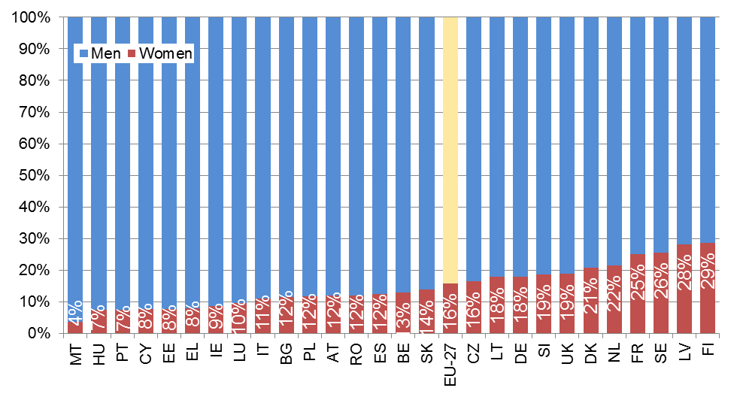Source: European Commission, Database on Women and Men in Decision-Making
Compared to previous years, though, the percentage is higher and is improving at a faster rate: a rise of 4 percentage points was recorded from October 2010 (11.8 %), see Figure 13.
This improvement can be linked to an intensive public debate initiated by the Commission and supported by the European Parliament, and to concrete initiatives in a number of Member States. At present, eleven Member States have adopted some form of legislative or administrative regulation to improve gender balance in private and/or state-owned companies (Austria, Belgium, Denmark, Finland, France, Greece, Italy, the Netherlands, Portugal, Slovenia and Spain).
Figure 13 — Percentage point change in the share of women on boards, Oct 2010 — Oct 2012
Source: European Commission, Database on Women and Men in Decision-Making
It is clear that the rate of improvement in individual Member States has been uneven and self-regulatory initiatives have not made enough progress. Therefore, after a public consultation and following the request of the European Parliament, the Commission took a pro-active approach to accelerate progress towards gender balance on the boards of listed companies.
The proposal for a Directive on improving the gender balance among non-executive directors of companies listed on stock exchanges and related measures sets a minimum target of 40 % of the under-represented sex among non-executive directors on boards of large listed companies, to be achieved by 2020 (2018 for listed companies that are public undertakings). It obliges companies with a lower percentage (40 %) to make appointments to those positions on the basis of a comparative analysis of the qualifications of each candidate, by applying pre-established, clear, neutrally formulated and unambiguous criteria, in order to meet the 40 % target. Member States have to implement effective and dissuasive sanctions. With regard to executive directors, listed companies are required to set their own commitments, to be met within the same timeframe as the target for non-executive directors.
The reasons for the under-representation of women in senior positions are multiple and call for a comprehensive approach to tackle the problem. They stem, among other things, from traditional gender roles and stereotypes, the lack of support for women and men to balance care responsibilities with work and the lack of transparency in recruitment and promotion practices. Therefore, the Commission proposes to complement the proposed legislation with policy measures to fight the roots of gender imbalance. It will work in partnership with governments and relevant stakeholders.

4.2. Gender balance in political decision-making: still a challenge for many Member States

4.2.1. Elected representatives: gender imbalance in many parliaments
Gender-balanced representation in political governance is a cornerstone of an accountable democracy and a key condition for gender equality in society at large. Despite the fact that elected representatives should reflect the composition of the population they represent, progress towards this aim has been slow (Figure 14). In 2012, three out of four members of the single/lower houses of national parliaments across the EU were men.
In the last quarter of 2012, only national parliaments in Sweden, Finland, Denmark and Belgium had a balanced representation with at least 40 % of each gender. The Netherlands, Slovenia, Spain and Germany are the only other countries where the proportion of women members has surpassed the critical mass of 30 %.
At EU level there has been little progress over the past decade, with the share of women rising just 4 percentage points from 22 % in 2003 to 26 % in 2012. However, significant progress has been made in some countries, notably Slovenia, followed by France, Greece, Italy, Portugal and Spain. Four of the six countries demonstrating progress have a mandatory electoral quota system: Slovenia, France, Spain and Portugal.
In Ireland the situation may change, since an important piece of legislation was introduced in 2012: political parties that do not include at least 30 % of women on their lists for the next parliamentary election will lose half of their state funding for the entire duration of the legislature. The level will be raised to 40 % in 2019.
Figure 14 — Percentage of women in national parliaments (single/lower houses) in 2003 and 2012
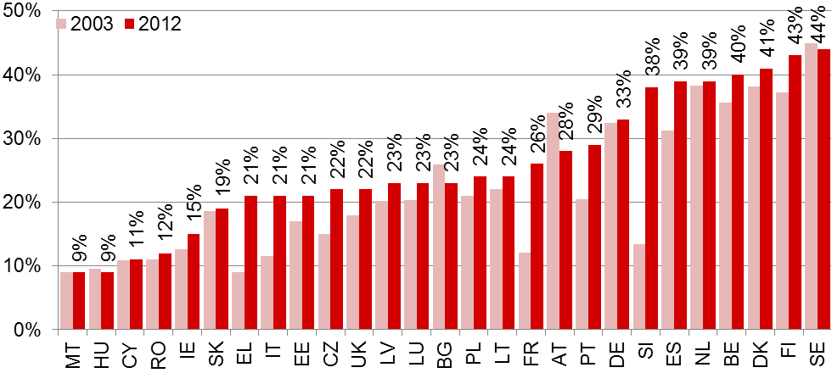

Source: European Commission, Database on Women and Men in Decision-Making
Note: 2003 data for CZ, PL, MT, and LT refer to 2004 (data not collected in 2003).
Experience at regional and local level is considered an important stepping stone to political participation at national level. At EU level, women account for 32 % of both regional and local assemblies compared to 26 % in national parliaments.
The level of female representation in regional assemblies is above 40 % in four Member States (France, Spain, Finland and Sweden) and over 30 % in six more (the UK, Austria, the Netherlands, Germany, Denmark, and Belgium). However, levels of 15 % or less persist in Hungary, Italy, and Romania. In many countries, the levels of female representation in local or regional assemblies are quite close to that in the national parliament.
At local level, balanced representation (at least 40 % of each gender) is found only in Sweden but women account for at least 30 % of local council members in the UK, Finland, Latvia, France, Spain, Denmark, and Belgium.
Action to improve female representation at local level has been taken in Italy: in November 2012, a law was passed requiring municipal and provincial councils to have lists with no more than two thirds of one gender, and a double preference system (which allows for the possibility of expressing a preference for a male and a female candidate) is to be introduced. The impact of the law has yet to be tested in future elections.

4.2.2. Gender imbalance in most EU national governments
Across the EU, the gender balance among appointed members of national governments (73 % men, 27 % women) improved by just 3 percentage points between 2003 and 2012, though the situation varies between Member States (Figure 15). Five EU countries had governments with at least 40 % of each gender in the fourth quarter of 2012: France, Austria, Denmark, Finland and Sweden. Governments in the Netherlands, Belgium and Germany are not far behind with 38 % women.
Figure 15 — Percentage of women in national governments (senior ministers) in 2003 and 2012
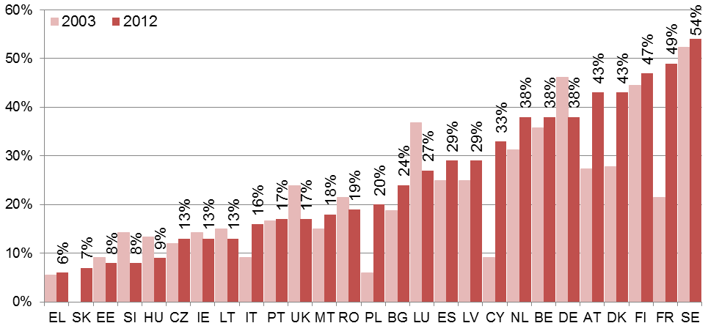
Source: European Commission, Database on Women and Men in Decision-Making
Note: 2003 data for CZ, PL, MT, and LT refer to 2004 (data not collected in 2003).

4.2.3. Women and men in decision-making positions on the environment
In the context of the regular monitoring process of the UN Beijing Platform for Action, and under the initiative of the Danish Presidency of the Council (first half of 2012), the Employment, Social Policy, Health and Consumer Affairs Council (EPSCO) adopted conclusions highlighting the gender perspective in dealing with environmental challenges. The document stresses the urgent need to improve gender equality in decision-making bodies in the transport and energy sectors, in scientific and technological occupations and in relevant high-level scientific bodies.
In the EU, the share of female senior and junior ministers with environmental portfolios decreases when transport and energy are taken into account: 29.5 % of ministers in charge of the environment were women in 2012 but this share drops to 19.6 % when transport and energy responsibilities are included. Mirroring the situation at ministerial level, women are more present at the top of the administrative hierarchy in ministries in charge of the environment and climate change than in transport and energy policy.

5. Dignity, integrity and ending gender-based violence: a growing attention to a persisting issue
In 2012, all EU institutions again committed to a strong policy response to combat all forms of violence against women and gender-based violence. All key EU players shared a common approach, recognising violence against women as a violation of human rights and an obstacle to gender equality. They contributed to major policy developments in the reinforcement of victims' right (5.1) and of a comprehensive set of policies and tools (including support to victims', reporting, data collection) under the Cypriot presidency (5.4) with a focus on female genital mutilation (5.2) and the human trafficking (5.3).

5.1. Reinforcing the rights of victims of crime
The Directive on minimum standards for victims of crime was adopted by the European Parliament and the Council in 2012. It includes the right to respect and recognition, the right to provide and receive information and the right to protection. It also aims to ensure that the needs of victims are individually assessed and that the most vulnerable, including victims of all forms of gender-based violence, receive treatment appropriate to their requirements. This Directive must be implemented at national level by 16 November 2015 at the latest.
The proposal for a Regulation on mutual recognition of protection measures in civil matters is still under negotiation between the Council and the European Parliament. It aims to complement the European Protection Order (which applies in criminal matters) adopted in December 2011. These two instruments will ensure that protection measures issued in one Member State can be recognised in another, following a speedy and efficient procedure, to avoid victims losing their protection if they move or travel.
At UN level, the General Assembly adopted a resolution at the end of 2012 on ‘Intensification of efforts to eliminate all forms of violence against women’.
On 8 March the President of Romania promulgated the changes made to law 217/2003 on preventing and combating domestic violence. The law now allows the victims of domestic violence to ask the courts for a restraining order (or protection) against the aggressor. The list of acts of domestic violence now includes stinging, biting and pulling the victim’s hair. It includes not only physical acts but also acts of verbal, psychological, sexual, social and spiritual violence, the authorities now being forced to respond urgently to cases of domestic violence. The victim has the right to a private life, dignity and respect of personality, social protection, reintegration, free social assistance and medical assistance.

5.2. A strong stance against female genital mutilation (FGM)
On 13 June 2012, the European Commission and the European External Action Service (EEAS) made a joint declaration on FGM confirming their commitment before the European Parliament. The day after, an almost unanimous European Parliament adopted a resolution on ending female genital mutilation, urging the Commission to make it a priority to end violence against women and girls and the Member States to take firm action to combat this illegal practice.
At UN level, the General Assembly adopted in November 2012 a much anticipated resolution aimed at ‘Intensifying global efforts for the elimination of female genital mutilations’.
A bill outlawing female genital mutilation has been passed in Ireland. As well as prohibiting the practice, the law includes the principle of extra-territoriality, which makes it possible to prosecute the practice also when it is committed abroad.

5.3. Towards the eradication of trafficking in human beings
According to preliminary data collected by Eurostat, women and girls accounted for 79 % of the total victims of trafficking in human beings and are used for sexual exploitation. On 19 June 2012, the European Commission adopted the ‘EU Strategy towards the Eradication of Trafficking in Human Beings (2012-2016)’ focusing on concrete actions to support and complement the implementation of the EU legislation on trafficking in human beings adopted in 2011, namely Directive 2011/36/EU (deadline for transposition 6 April 2013).

5.4. Violence against women as a key priority of the Cypriot presidency
The outcomes of the European Police College (CEPOL) Presidency Conference on ‘Overcoming Attrition in Domestic Violence through Policing’ fed into a European Union handbook of good police practices in overcoming attrition in domestic violence. The handbook calls on Member States to aim to encourage ‘victims and witnesses to report (…) crimes to the authorities and to contribute to their effective investigation and prosecution’.
An EU gender equality conference on violence against women held in Cyprus in November 2012 reviewed progress at EU level and good practice in Member States. The European Institute for Gender Equality (EIGE)’s “Review of the Implementation of the Beijing Platform for Action in the EU Member States: Violence against Women, Victim Support” was commissioned by the Cyprus presidency; it is the first report to deliver a full set of comparable and reliable data on support services for women victims of violence in the 27 EU Member States and Croatia. The findings indicate that specialised services are insufficient and unequally distributed in and among the Member States. According to the report, only 12 out of the 27 EU Member States legally foresee state funding of specialised services for women victims of violence. Women shelters and helplines, possibly the most common support for victims of domestic violence, are not in place and available everywhere.
On the basis of these findings the EPSCO Council adopted conclusions on Combating Violence Against Women and the Provision of Support Services for Victims of Domestic Violence on 6 December 2012. These conclusions reaffirm that neither custom, tradition, culture, privacy, religion nor so-called honour can be invoked to justify violence against women, which is a violation of human rights and the most brutal manifestation of gender inequality. They stress that it is important to improve the protection of victims of violence, by providing adequate and sustainable support services and by implementing the newly adopted Directive 2012/29/EU establishing minimum standards on the rights, support and protection of victims of crime as well as the European protection order in civil matters. They call for improving the registration and handling of complaints as well as the collection and dissemination of data by Member States in this under-reported field. They insist on the importance of collecting comparable EU data to enhance knowledge of the extent of the phenomenon and to build further appropriate and informed policies. As violence against women covers so many forms of abuse, the Council conclusions encourage further research on other forms of violence. They also call on Member States to sign and ratify the Council of Europe Convention on violence against women adopted in May 2011.
All these initiatives were valuable contributions to a strong EU position at the 57th session of the UN Commission on the Status of Women that took place in March 2013 on the issue of violence against women. In addition, the European Commission has supported several focused activities on this topic in 2013, such as the launch of a campaign on violence against women on 6 March, and a public consultation on FGM.

6. Gender equality in external actions
The 56th session of the Commission on the Status of Women (CSW) took place in February 2012. The CSW is the UN’s principal global policy-making body on gender equality and advancement of women. The priority theme in 2012 was the empowerment of rural women and their role in poverty and hunger eradication, sustainable development and current challenges. The session was characterised by difficult discussions and did not reach agreement on the main output, the CSW agreed conclusions.
In April 2012, the EU and the United Nations Entity for Gender Equality and the Empowerment of Women (UN Women) signed a Memorandum of Understanding (MoU). The MoU forms the basis of a partnership aimed at making progress towards achieving the key international commitments in the area of gender equality and women’s empowerment. The partnership also aims to contribute to the transformation towards a world where societies are free of gender-based discrimination, where women and men have equal opportunities, where the comprehensive economic and social development of women and girls is ensured, where gender equality and women’s empowerment are achieved, and where women’s rights are upheld in all efforts to further development, human rights, peace and security.
In May 2012, the European Commission adopted its European Neighbourhood Policy package. The package takes stock of policy achievements with both eastern and southern partner countries. Its Strategy Paper highlights that building sustainable democracy also means ensuring gender equality and increasing the participation of women in political and economic life. In some countries, legislative provisions enacted with the aim of ensuring a more balanced composition of parliaments have encountered resistance in practice and therefore have not had the desired effect. The Strategy Paper also underlines that women have been key players in the Arab Spring, and that they should not lose out in the subsequent transformations. The EU will continue to step up its efforts to support women’s rights across the region, ensure that gender equality is mainstreamed into all relevant cooperation activities and promote effective action against trafficking across the neighbourhood.
Human rights have proven to be the silver thread that runs through everything that EU does in the external relations. In June 2012, the European Union has adopted its new Strategic Framework and Action Plan on Human rights and democracy. This is the first time that the EU has had a unified Strategic Framework for this vital policy area that also provided an agreed basis for a truly collective effort, involving EU Member States as well as the EU Institutions. The Action Plan covers priority areas, all designed to improve the effectiveness and consistency of EU policy as a whole and it also anchors a commitment to genuine partnership with civil society. Following the adoption of the Human Rights package the first-ever thematic EU Special Representative on Human Rights was appointed. The EUSR works on exploring ways to better engage and develop synergies with as many relevant players as possible as well as with civil society organisations, and contributes to the better coherence, effectiveness and visibility of EU policies and actions for the protection and promotion of all human rights
In September 2012 in the margins of the UN General Assembly the Equal Futures Partnership was launched. The EU is founding member and committed concrete initiatives for women's political participation and economic empowerment.
The European Commission adopted its annual Enlargement Package in October 2012. The Strategy Paper highlights, as a key challenge facing most enlargement countries, the need to strengthen the handling by law enforcement bodies of issues such as gender-based violence. The country-specific progress reports contain an assessment of progress in terms of alignment with the legal acquis in the field of gender equality and its implementation. They cover in particular issues related to female labour market participation, gender balance in economic and political decision-making, gender-based violence, and administrative capacity. Accession negotiations with Iceland on social policy and employment, including gender equality, were opened in June 2012.
In November 2012 human rights and gender issues were integrated in the agenda and the Joint Conclusions of the EU – UN Steering Committee on Crisis Management (for the first time since 2009).
EU development policy continued to work for progress in gender equality and empowerment of women. The EU Plan of Action on Gender Equality and Women’s Empowerment in Development 2010-2015 contains commitments for the Commission, the European External Action Service and the Member States to support developing countries’ efforts to improve the situation of women with regard to equal rights and empowerment. In November 2012, the second report on the implementation of the EU Plan of Action was published. It concludes that further progress has been made but that some challenges remain.

7. Horizontal issues

7.1. Mainstreaming gender equality
Gender mainstreaming is the integration of the gender perspective within every stage of the policy process — design, implementation, monitoring and evaluation — with a view to promoting equality between women and men. The Commission organised three calls for proposals on improving gender mainstreaming in national policies and programmes between 2007 and 2010. The last gender mainstreaming projects implemented by Member States under the PROGRESS programme have just been closed. It is now time to take stock of the progress made in implementing and practicing gender mainstreaming
In total, 31 initiatives have been supported with the aim of:
- raising awareness of the importance of gender mainstreaming in national policies as an effective contributor to equality between women and men and to better governance;
- improving knowledge of the key concepts and issues of gender mainstreaming and ensuring a better understanding of gender mainstreaming in policies and programmes;
- developing the necessary methods and tools, including dissemination to the main stakeholders, thus ensuring a more long-term effect.
The vast majority of projects have addressed government officials while some training has targeted parliamentarians, parliamentary staff, officials at regional level and stakeholders. Some projects focused on supporting, strengthening and equipping a network of officials for the implementation of gender mainstreaming (for instance the establishment of ad hoc horizontal units on gender mainstreaming in 15 line ministries in Bulgaria, or the creation of a specialised ‘pool of contacts’ on gender budgeting at departmental level in Estonia).
A large amount of material has been produced (gender impact assessment guides, gender budgeting guides, check lists, training modules, databases, e-learning tools), which may be transferable in some cases and contribute to enrichment of the knowledge and methods for gender mainstreaming at European level.
For example, Denmark has developed a website presenting both gender mainstreaming tools and concrete examples showing how public services have taken the gender dimension into account. One of the lessons learned is that, in addition to being available, tools need to be visible, functional and attractive in order to ensure their implementation. A clear message on the benefits of gender mainstreaming should also be conveyed to civil servants.
Spain has also developed tools for helping public policy planners to mainstream gender in the design, implementation and monitoring of employment and economic reactivation measures, such as a guide to measuring the impact of employment and economic recovery policies on women, a report with recommendations for strengthening gender mainstreaming in active employment and economic recovery policies and measures, and a virtual tool to simulate gender impacts.

7.2. Investing in gender equality
On the basis of a proposal of the European Commission on the Multiannual Financial Framework, the European Parliament and the Council discussed in 2012 the future funding programmes covering the period 2014-2020. Gender equality will be explicitly included in the Rights, Citizenships and Equality Programme.
Moreover, integrating a gender perspective in the preparations for the cohesion policy period 2014-2020 is important in order to meet the objectives of the Europe 2020 strategy in a way that supports development towards a more gender-equal society. Following the European Commission’s adoption of a legislative package for future cohesion policy in October 2011, the draft regulations were discussed by the Council and the European Parliament in 2012. The proposals, scheduled to enter into force in 2014, are designed to ensure that EU investment is targeted at Europe’s long-term goals for growth and jobs and priorities identified under the Europe 2020 strategy. The proposals also envisage the conclusion of Partnership Contracts between the Commission and the Member States in 2013. Preparatory work for these Partnership Contracts was carried out in 2012 both within the European Commission and at national and regional level. Gender equality considerations should play an important role in the Partnership Contracts, both in terms of specific actions enhancing gender equality and in terms of effective and correctly implemented gender mainstreaming. In 2012, the Advisory Committee on Equal Opportunities for Women and Men adopted an opinion on how cohesion policy can be used effectively to achieve the EU’s commitments on gender equality over the 2014-2020 period.

8. Summary of main findings
The economic challenges of recent years reveal the current role of women in the economy and their determination to play an increasing role on the labour market. Women are a growing share of the EU workforce. They are also increasingly the breadwinners for their families. New research confirms the economic gain of an equal participation in the labour market for the society as a whole: gender equality can significantly increase the growth potential of the EU economy.
Focused policies can close gender gaps and thereby promote growth and inclusion. A concrete example is the European Commission's proposal on gender balance in boards of publicly listed companies. Intense public debate and regulatory measures have contributed to improving gender balance in decision-making and the 2012 figures on women on boards represents the highest year-on-year change yet recorded.
The policies that can enhance women's labour market participation and contribute to reach the target of 75% of employment are also well-known: increasing childcare facilities, removing fiscal disincentives for second earners and making work pay for women and men. These policies have been highlighted throughout the second ‘European Semester’ and reflected in the 2012 and 2013 Annual Growth Survey. It is essential that Member States continue to work to ensure that both women and men can fully participate in the labour market and reconcile work and family life.
While this report shows that progress has been made in some areas, significant challenges remain in most fields. To meet the targets of the Strategy on equality between women and men, further efforts will have to be made taking action in the five priority areas.

Statistical annex
Employment
Employment rate of population aged 20-64 (as %) – men and women – in 2012
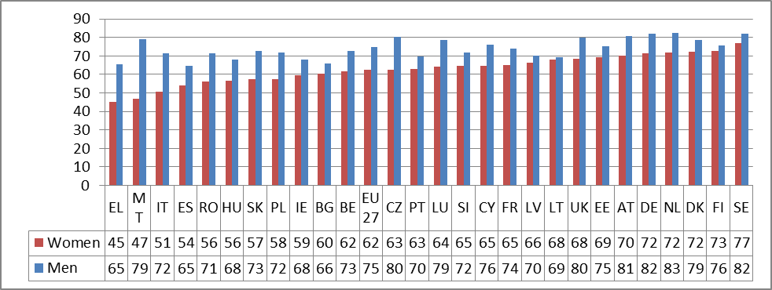
Source: Eurostat, LFS
Employment rate of population aged 20-64 (as %) – men and women – in 2007 and in 2012
 | Women |  | Men |  | Gender Gap
 | 2007 | 2012 | 2007 | 2012 | 2007 | 2012
EU27 | 62.1 | 62.4 | 77.8 | 74.6 | 15.7 | 12.2
BE | 60.3 | 61.7 | 75.0 | 72.7 | 14.7 | 11.0
BG | 63.5 | 60.2 | 73.4 | 65.8 | 9.9 | 5.6
CZ | 62.4 | 62.5 | 81.5 | 80.2 | 19.1 | 17.7
DK | 74.7 | 72.2 | 83.2 | 78.6 | 8.5 | 6.4
DE | 66.7 | 71.5 | 79.1 | 81.8 | 12.4 | 10.3
EE | 72.5 | 69.3 | 81.4 | 75.2 | 8.9 | 5.9
IE | 64.4 | 59.4 | 83.0 | 68.1 | 18.6 | 8.7
EL | 51.6 | 45.2 | 80.4 | 65.3 | 28.8 | 20.1
ES | 58.0 | 54.0 | 80.7 | 64.5 | 22.7 | 10.5
FR | 64.8 | 65.0 | 75.0 | 73.8 | 10.2 | 8.8
IT | 49.9 | 50.5 | 75.8 | 71.6 | 25.9 | 21.1
CY | 67.7 | 64.8 | 86.4 | 76.1 | 18.7 | 11.3
LV | 70.7 | 66.4 | 80.1 | 70.2 | 9.4 | 3.8
LT | 69.5 | 67.9 | 76.5 | 69.4 | 7.0 | 1.5
LU | 61.0 | 64.1 | 78.3 | 78.5 | 17.3 | 14.4
HU | 55.5 | 56.4 | 70.2 | 68.1 | 14.7 | 11.7
MT | 37.4 | 46.8 | 78.7 | 79.0 | 41.3 | 32.2
NL | 70.7 | 71.9 | 84.8 | 82.5 | 14.1 | 10.6
AT | 67.2 | 70.3 | 81.6 | 80.9 | 14.4 | 10.6
PL | 55.5 | 57.5 | 70.2 | 72.0 | 14.7 | 14.5
PT | 66.3 | 63.1 | 79.1 | 69.9 | 12.8 | 6.8
RO | 57.9 | 56.3 | 71.0 | 71.4 | 13.1 | 15.1
SI | 67.1 | 64.6 | 77.5 | 71.8 | 10.4 | 7.2
SK | 58.7 | 57.3 | 76.0 | 72.8 | 17.3 | 15.5
FI | 72.5 | 72.5 | 77.2 | 75.5 | 4.7 | 3.0
SE | 77.1 | 76.8 | 83.1 | 81.9 | 6.0 | 5.1
UK | 68.4 | 68.4 | 82.2 | 80.0 | 13.8 | 11.6
Source: Eurostat, LFS
Employment rate of population aged 55-64 (as %) – men and women – in 2007 and in 2012
 | Women |  | Men |  | Gender Gap
 | 2007 | 2012 | 2007 | 2012 | 2007 | 2012
EU27 | 35.9 | 41.9 | 53.9 | 56.4 | 18 | 14.5
BE | 26 | 33.1 | 42.9 | 46 | 16.9 | 12.9
BG | 34.5 | 41.3 | 51.8 | 50.8 | 17.3 | 9.5
CZ | 33.5 | 39 | 59.6 | 60.3 | 26.1 | 21.3
DK | 52.9 | 55.8 | 64.9 | 65.9 | 12 | 10.1
DE | 43.4 | 54.8 | 59.4 | 68.5 | 16 | 13.7
EE | 60.5 | 61.2 | 59.4 | 59.8 | -1.1 | -1.4
IE | 39.6 | 42.7 | 67.8 | 55.8 | 28.2 | 13.1
EL | 26.9 | 26 | 59.1 | 47.6 | 32.2 | 21.6
ES | 30 | 36 | 60 | 52.4 | 30 | 16.4
FR | 36 | 41.7 | 40.5 | 47.4 | 4.5 | 5.7
IT | 23 | 30.9 | 45.1 | 50.4 | 22.1 | 19.5
CY | 40.3 | 38.2 | 72.5 | 63.5 | 32.2 | 25.3
LV | 52.4 | 52.5 | 64.6 | 53.1 | 12.2 | 0.6
LT | 47.9 | 48.3 | 60.8 | 56.2 | 12.9 | 7.9
LU | 28.6 | 34.3 | 35.6 | 47.4 | 7 | 13.1
HU | 26.2 | 32.2 | 41.7 | 42.6 | 15.5 | 10.4
MT | 11.6 | 15.8 | 45.9 | 51.7 | 34.3 | 35.9
NL | 40.1 | 49.1 | 61.5 | 68.1 | 21.4 | 19
AT | 28 | 34.1 | 49.8 | 52.5 | 21.8 | 18.4
PL | 19.4 | 29.2 | 41.4 | 49.3 | 22 | 20.1
PT | 44 | 42 | 58.6 | 51.5 | 14.6 | 9.5
RO | 33.6 | 32.9 | 50.3 | 51.2 | 16.7 | 18.3
SI | 22.2 | 25 | 45.3 | 40.7 | 23.1 | 15.7
SK | 21.2 | 33.6 | 52.5 | 53.6 | 31.3 | 20
FI | 55 | 59.7 | 55.1 | 56.6 | 0.1 | -3.1
SE | 67 | 69.6 | 72.9 | 76.3 | 5.9 | 6.7
UK | 48.9 | 51 | 66.3 | 65.4 | 17.4 | 14.4
Source: Eurostat, LFS
Part-time employment as percentage of the total employment, by sex, from 15 to 64 years
 | Women |  |  | Men
 | 2002 | 2007 | 2012 | 2002 | 2007 | 2012
EU27 | 33.1 | 30.8 | 32.1 | 6.0 | 7.0 | 8.4
BE | 37.7 | 40.5 | 43.5 | 5.6 | 7.1 | 9.0
BG | 3.5 | 1.9 | 2.5 | 2.1 | 1.1 | 2.0
CZ | 7.7 | 7.9 | 8.6 | 1.6 | 1.7 | 2.2
DK | 31.1 | 35.1 | 35.8 | 10.1 | 12.4 | 14.8
DE | 39.2 | 45.6 | 45.0 | 5.2 | 8.5 | 9.1
EE | 8.4 | 10.6 | 13.2 | 3.7 | 3.8 | 5.1
IE | 30.4 | 31.6 | 34.9 | 6.0 | 6.4 | 13.3
EL | 7.8 | 9.9 | 11.8 | 2.1 | 2.5 | 4.7
ES | 17.0 | 22.7 | 24.4 | 2.6 | 3.9 | 6.5
FR | 29.6 | 30.4 | 30.0 | 4.9 | 5.5 | 6.4
IT | 16.7 | 26.8 | 31.0 | 3.5 | 4.6 | 6.7
CY | 10.8 | 10.4 | 13.1 | 2.7 | 3.0 | 6.4
LV | 10.5 | 6.9 | 11.1 | 6.7 | 4.4 | 6.7
LT | 10.7 | 9.7 | 10.6 | 8.4 | 6.5 | 6.9
LU | 26.4 | 37.1 | 36.1 | 1.7 | 2.6 | 4.7
HU | 4.9 | 5.5 | 9.3 | 2.1 | 2.5 | 4.3
MT | 18.8 | 24.6 | 26.0 | 3.7 | 4.0 | 5.7
NL | 72.7 | 74.8 | 76.9 | 20.6 | 22.5 | 24.9
AT | 35.7 | 40.7 | 44.4 | 4.6 | 6.2 | 7.8
PL | 12.2 | 11.7 | 10.6 | 7.3 | 5.8 | 4.5
PT | 13.5 | 13.6 | 14.1 | 4.2 | 4.7 | 8.2
RO | 10.7 | 8.9 | 9.7 | 8.9 | 8.3 | 8.6
SI | 7.6 | 10.0 | 12.2 | 4.3 | 6.5 | 6.3
SK | 2.7 | 4.3 | 5.5 | 1.1 | 1.0 | 2.8
FI | 16.9 | 18.8 | 19.4 | 7.5 | 8.3 | 9.1
SE | 32.3 | 39.5 | 38.6 | 9.7 | 10.5 | 12.5
UK | 43.3 | 41.4 | 42.3 | 8.4 | 9.4 | 11.5
Source: Eurostat, LFS
Female employment rate and female employment rate in full-time equivalent (FTE) (20-64 years old) in 2012
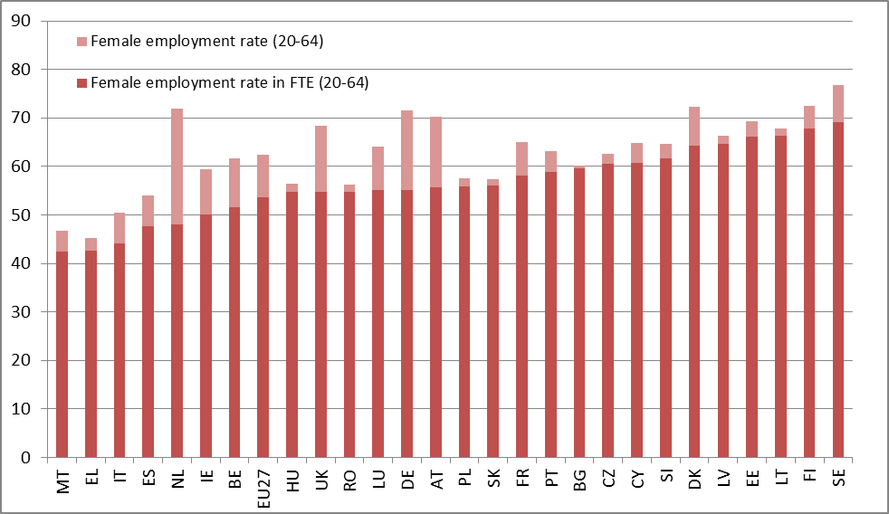
Source: Eurostat, LFS
Employment impact of parenthood: difference in percentage points between employment rates - age group 20-49 - with the presence of a child aged 0-6 and without the presence of any children in 2007 and in 2012
 | Women |  | Men
 | 2007 | 2012 | 2007 | 2012
EU27 | -13.6 | -9.7 | 9.7 | 11.4
BE | -2.8 | -0.3 | 10.1 | 12.3
BG | -19.4 | -16.0 | 5.0 | 9.0
CZ | -43.1 | -35.7 | 9.2 | 9.6
DK | -0.6 | -2.0 | 7.0 | 10.7
DE | -24.4 | -18.2 | 7.7 | 8.0
EE | -25.7 | -24.4 | 11.6 | 14.4
IE | -17.2 | -10.8 | 6.9 | 10.3
EL | -6.9 | -1.0 | 14.9 | 17.1
ES | -8.0 | -1.5 | 10.1 | 14.2
FR | -10.6 | -6.3 | 10.2 | 11.8
IT | -5.8 | -2.0 | 14.1 | 15.7
CY | -3.2 | -3.7 | 9.9 | 13.0
LV | -17.3 | -9.6 | 9.9 | 12.6
LT | -7.0 | -0.7 | 10.8 | 15.4
LU | -3.5 | -0.8 | 12.8 | 12.3
HU | -35.1 | -32.6 | 9.0 | 9.8
MT | -13.9 | -6.3 | 5.8 | 11.3
NL | -8.1 | -2.5 | 5.7 | 10.0
AT | -17.1 | -9.8 | 5.0 | 6.4
PL | -10.1 | -9.8 | 14.9 | 15.2
PT | 1.2 | 3.4 | 10.4 | 13.4
RO | -2.2 | -3.1 | 10.5 | 8.2
SI | 4.9 | 1.6 | 10.5 | 15.2
SK | -33.8 | -31.8 | 8.3 | 12.2
FI | -18.4 | -17.4 | 11.0 | 11.8
SE |  | 0.8 |  | 13.9
UK | -21.9 | -18.3 | 4.8 | 8.2
Source: Eurostat, LFS
Barcelona targets: percentage of children cared for under formal arrangements by age group
 | Less than 3 years |  | From 3 years to minimum compulsory age
 | 2007 | 2011 | 2007 | 2011
EU27 | 26.0 | 30.0 | 81.0 | 84.0
BE | 44.0 | 39.0 | 100.0 | 98.0
BG | 8.0 | 7.0 | 59.0 | 60.0
CZ | 2.0 | 5.0 | 69.0 | 74.0
DK | 70.0 | 74.0 | 97.0 | 98.0
DE | 17.0 | 24.0 | 86.0 | 90.0
EE | 15.0 | 19.0 | 86.0 | 92.0
IE | 24.0 | 21.0 | 86.0 | 82.0
EL | 10.0 | 19.0 | 65.0 | 75.0
ES | 40.0 | 39.0 | 92.0 | 86.0
FR | 27.0 | 44.0 | 93.0 | 95.0
IT | 25.0 | 26.0 | 90.0 | 95.0
CY | 18.0 | 23.0 | 80.0 | 73.0
LV | 16.0 | 15.0 | 52.0 | 73.0
LT | 20.0 | 7.0 | 59.0 | 65.0
LU | 25.0 | 44.0 | 66.0 | 73.0
HU | 8.0 | 8.0 | 80.0 | 75.0
MT | 13.0 | 11.0 | 65.0 | 73.0
NL | 43.0 | 52.0 | 91.0 | 89.0
AT | 8.0 | 14.0 | 70.0 | 85.0
PL | 2.0 | 3.0 | 31.0 | 43.0
PT | 27.0 | 35.0 | 75.0 | 81.0
RO | 6.0 | 2.0 | 57.0 | 41.0
SI | 30.0 | 37.0 | 84.0 | 92.0
SK | 2.0 | 4.0 | 75.0 | 75.0
FI | 26.0 | 26.0 | 76.0 | 77.0
SE | 47.0 | 51.0 | 91.0 | 95.0
UK | 38.0 | 35.0 | 84.0 | 93.0
Source: Eurostat, EU-SILC
Education
Early leavers from education and training in 2012: proportion of persons aged 18 to 24 who have finished no more than a lower secondary education and are not involved in further education or training, as a percentage of the total population aged 18 to 24.
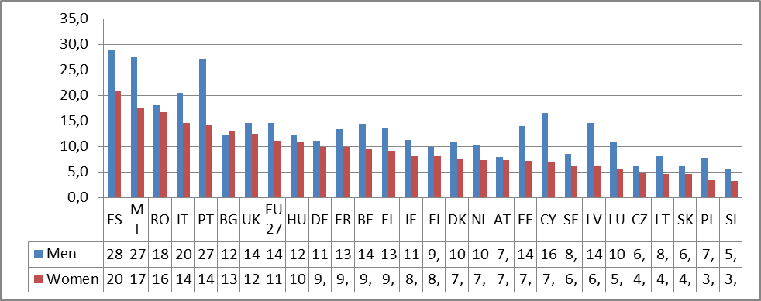
Source: Eurostat, LFS
Early leavers from education and training in 2002, 2007 and 2012
 | Women |  |  | Men
 | 2002 | 2007 | 2012 | 2002 | 2007 | 2012
EU27 | 14.9 | 13.0 | 11.0 | 19.1 | 17.1 | 14.5
BE | 11.0 | 10.3 | 9.5 | 17.1 | 13.9 | 14.4
BG | 19.4 | 14.7 | 13.0 | 22.0 | 15.2 | 12.1
CZ | 5.9 | 4.7 | 4.9 | 5.4 | 5.7 | 6.1
DK | 8.2 | 9.5 | 7.4 | 9.9 | 16.2 | 10.8
DE | 12.5 | 11.9 | 9.8 | 12.5 | 13.1 | 11.1
EE | 9.4 | : | 7.1 | 16.9 | 21.7 | 14.0
IE | 11.2 | 8.4 | 8.2 | 18.0 | 14.6 | 11.2
EL | 12.5 | 10.6 | 9.1 | 20.6 | 18.6 | 13.7
ES | 24.2 | 25.2 | 20.8 | 36.8 | 36.6 | 28.8
FR | 11.9 | 10.3 | 9.8 | 14.9 | 14.9 | 13.4
IT | 20.5 | 16.4 | 14.5 | 27.8 | 22.9 | 20.5
CY | 11.0 | 6.8 | 7.0 | 22.3 | 19.5 | 16.5
LV | 11.0 | 10.1 | 6.2 | 22.7 | 20.0 | 14.5
LT | 11.4 | 5.1 | 4.6 | 15.4 | 9.6 | 8.2
LU | 19.6 | 8.4 | 5.5 | 14.4 | 16.6 | 10.7
HU | 11.9 | 10.1 | 10.7 | 12.5 | 12.6 | 12.2
MT | 49.7 | 34.9 | 17.6 | 56.5 | 41.3 | 27.5
NL | 13.8 | 9.3 | 7.3 | 16.8 | 14.0 | 10.2
AT | 10.2 | 10.1 | 7.3 | 8.7 | 11.4 | 7.9
PL | 5.6 | 3.8 | 3.5 | 8.9 | 6.2 | 7.8
PT | 37.2 | 30.4 | 14.3 | 52.6 | 43.1 | 27.1
RO | 22.1 | 17.4 | 16.7 | 23.9 | 17.1 | 18.0
SI | 3.2 | 2.2 | 3.2 | 6.8 | 5.8 | 5.4
SK | 5.8 | 5.8 | 4.6 | 7.6 | 7.2 | 6.0
FI | 7.6 | 7.2 | 8.1 | 11.8 | 11.2 | 9.8
SE | 8.9 | 6.5 | 6.3 | 11.0 | 9.5 | 8.5
UK | 17.1 | 15.6 | 12.4 | 18.1 | 17.6 | 14.6
Source: Eurostat, LFS
Tertiary educational attainment by sex in 2012: the share of the population aged 30-34 years who have successfully completed university or university-like (tertiary-level) education with an education level ISCED 1997 (International Standard Classification of Education) of 5-6.

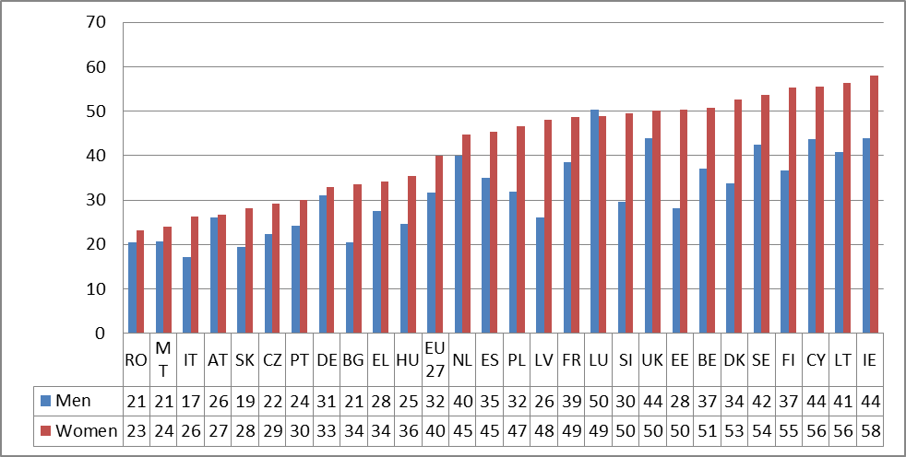
Source: Eurostat, LFS
Tertiary educational attainment by sex (30-34 years old) in 2002, 2007 and 2012
 | Women |  |  | Men
 | 2002 | 2007 | 2012 | 2002 | 2007 | 2012
EU27 | 24.5 | 32.8 | 40.0 | 22.6 | 27.2 | 31.6
BE | 39.0 | 46.4 | 50.7 | 31.5 | 36.6 | 37.1
BG | 28.8 | 33.2 | 33.6 | 17.7 | 18.7 | 20.5
CZ | 11.4 | 13.7 | 29.1 | 13.7 | 13.0 | 22.4
DK | 39.4 | 41.6 | 52.6 | 28.7 | 34.8 | 33.7
DE | 21.4 | 25.7 | 32.9 | 26.8 | 27.3 | 31.0
EE | 33.6 | 42.4 | 50.4 | 22.5 | 24.1 | 28.1
IE | 33.0 | 48.8 | 57.9 | 30.9 | 37.9 | 44.0
EL | 24.8 | 27.3 | 34.2 | 21.9 | 25.0 | 27.6
ES | 35.8 | 44.6 | 45.3 | 31.0 | 34.8 | 35.0
FR | 34.0 | 45.0 | 48.6 | 29.0 | 37.7 | 38.5
IT | 14.2 | 22.3 | 26.3 | 12.0 | 15.0 | 17.2
CY | 36.1 | 48.0 | 55.5 | 35.9 | 44.4 | 43.6
LV | 22.1 | 31.5 | 48.1 | 12.4 | 19.8 | 26.0
LT | 29.6 | 45.0 | 56.4 | 17.0 | 31.0 | 40.7
LU | 21.5 | 38.1 | 48.9 | 25.6 | 32.4 | 50.4
HU | 16.1 | 23.9 | 35.5 | 12.8 | 16.4 | 24.7
MT | : | 23.7 | 24.0 | : | 19.5 | 20.7
NL | 29.3 | 37.3 | 44.8 | 27.8 | 35.5 | 39.9
AT | : | 20.5 | 26.6 | : | 21.8 | 26.0
PL | 16.7 | 31.3 | 46.5 | 12.2 | 22.7 | 31.9
PT | 16.9 | 24.7 | 30.1 | 9.1 | 15.0 | 24.3
RO | 9.0 | 14.3 | 23.2 | 9.1 | 13.6 | 20.5
SI | 29.1 | 41.1 | 49.6 | 12.9 | 21.7 | 29.5
SK | 11.2 | 16.1 | 28.2 | 9.7 | 13.4 | 19.4
FI | 49.3 | 55.4 | 55.4 | 33.4 | 39.3 | 36.7
SE | 31.2 | 47.0 | 53.7 | 25.5 | 35.2 | 42.4
UK | 30.7 | 40.1 | 50.2 | 32.4 | 36.9 | 44.0
Source: Eurostat, LFS
The Gender Pay Gap
Gender pay gap — Difference between men’s and women’s average gross hourly earnings as percentage of men's average gross hourly earnings (for paid employees) from 2007 to 2011
 | 2007 | 2008 | 2009 | 2010 | 2011 | Difference 2011- 2008
EU27 | : | 17.3 | 16.6 | 16.1 | 16.2 | 1.1
BE | 10.1 | 10.2 | 10.1 | 10.2 | 10.2 | 0.0
BG | 12.1 | 12.3 | 13.3 | 13.0 | 13.0 | -0.7
CZ | 23.6 | 26.2 | 25.9 | 21.6 | 21.0 | 5.2
DK | 17.7 | 17.1 | 16.8 | 16.0 | 16.4 | 0.7
DE | 22.8 | 22.8 | 22.6 | 22.3 | 22.2 | 0.6
EE | 30.9 | 27.6 | 26.6 | 27.7 | 27.3 | 0.3
IE | 17.3 | 12.6 | 12.6 | 13.9 | :
EL | : | 22.0 | : | : | :
ES | 18.1 | 16.1 | 16.7 | 16.2 | 16.2 | -0.1
FR | 17.3 | 16.9 | 15.2 | 15.6 | 14.7 | 2.2
IT | 5.1 | 4.9 | 5.5 | 5.3 | 5.8 | -0.9
CY | 22.0 | 19.5 | 17.8 | 16.8 | 16.4 | 3.1
LV | 13.6 | 11.8 | 13.1 | 15.5 | 13.6 | -1.8
LT | 22.6 | 21.6 | 15.3 | 14.6 | 11.9 | 9.7
LU | 10.2 | 9.7 | 9.2 | 8.7 | 8.7 | 1.0
HU | 16.3 | 17.5 | 17.1 | 17.6 | 18.0 | -0.5
MT | 7.8 | 9.2 | 13.8 | 13.4 | 12.9 | -3.7
NL | 19.3 | 18.9 | 18.5 | 17.8 | 17.9 | 1.0
AT | 25.5 | 25.1 | 24.3 | 24.0 | 23.7 | 1.4
PL | 14.9 | 11.4 | 8.0 | 4.5 | 4.5 | 6.9
PT | 8.5 | 9.2 | 10.0 | 12.8 | 12.5 | -3.3
RO | 12.5 | 8.5 | 7.4 | 8.8 | 12.1 | -3.6
SI | 5.0 | 4.1 | -0.9 | 0.9 | 2.3 | 1.8
SK | 23.6 | 20.9 | 21.9 | 19.6 | 20.5 | 0.4
FI | 20.2 | 20.5 | 20.8 | 20.3 | 18.2 | 2.3
SE | 17.8 | 16.9 | 15.7 | 15.4 | 15.8 | 1.1
UK | 20.8 | 21.4 | 20.6 | 19.5 | 20.1 | 1.3
Source: Eurostat, SES
Gender segregation in occupations and in economic sectors in 2007 and in 2012
 | Gender segregation in occupations |  | Gender segregation in economic sectors
 | 2007 | 2012 | 2007 | 2012
EU27 | 25.1 | 24.5 | 18.2 | 18.7
AT | 26.3 | 26.9 | 18.5 | 19.1
BE | 25.2 | 26.0 | 18.1 | 19.7
BG | 29.3 | 28.6 | 20.5 | 20.9
CY | 29 | 28.7 | 20.1 | 19.4
CZ | 28.5 | 28.4 | 19.4 | 21.0
DE | 26.3 | 25.7 | 18.3 | 19.5
DK | 25.4 | 24.9 | 18.1 | 19.5
EE | 32.2 | 30.9 | 25.6 | 25.2
ES | 27.3 | 25.7 | 20.8 | 19.4
FI | 29.6 | 28.7 | 22.7 | 24.1
FR | 26.3 | 25.9 | 18 | 18.9
GR | 22.4 | 19.3 | 16 | 14.5
HU | 28.7 | 28.2 | 19.8 | 20.6
IE | 27.9 | 26.3 | 23 | 20.7
IT | 23.6 | 24.7 | 17.7 | 19.7
LT | 29.2 | 29.5 | 23.3 | 22.3
LU | 27.2 | 23.8 | 18.9 | 17.1
LV | 28.7 | 29.1 | 22.4 | 24.0
MT | 23.1 | 24.3 | 15.8 | 16.3
NL | 25.1 | 25.5 | 18.1 | 14.5
PL | 25.8 | 26.7 | 19.4 | 21.1
PT | 26.7 | 25.6 | 21.1 | 21.3
RO | 22.8 | 22.8 | 16.3 | 17.4
SE | 27 | 25.7 | 21.3 | 21.4
SI | 26.4 | 25.8 | 17.5 | 19.9
SK | 30.1 | 30.6 | 23 | 24.5
UK | 25.1 | 24.1 | 18.4 | 19.0
Source: Eurostat, EU LFS. Gender segregation in occupations is calculated as the average national share of employment for women and men applied to each occupation; differences are added up to produce the total amount of gender imbalance expressed as a proportion of total employment (ISCO classification).
Poverty
People at risk of poverty or social exclusion by sex in 2011: Proportion of persons who are at risk of poverty or severely materially deprived or living in households with very low work intensity. 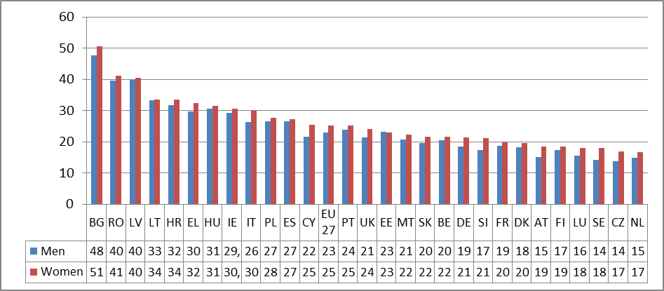Source: Eurostat, EU-SILC
People at risk of poverty or social exclusion by sex in from 2007 to 2011
 | Women |  |  |  |  | Men
 | 2007 | 2008 | 2009 | 2010 | 2011 | 2007 | 2008 | 2009 | 2010 | 2011
EU27 | 25.9 | 25.0 | 24.4 | 24.6 | 25.2 | 22.9 | 22.1 | 21.8 | 22.4 | 23.0
BE | 23.1 | 22.4 | 21.8 | 21.7 | 21.5 | 19.9 | 19.1 | 18.5 | 20.0 | 20.4
BG | 61.9 | 46.4 | 48.1 | 50.9 | 50.5 | 59.4 | 43.0 | 44.1 | 47.3 | 47.7
CZ | 17.4 | 17.2 | 15.7 | 16.0 | 16.9 | 14.2 | 13.3 | 12.3 | 12.7 | 13.7
DK | 17.7 | 17.0 | 18.2 | 19.0 | 19.5 | 15.9 | 15.7 | 17.0 | 17.7 | 18.2
DE | 22.3 | 21.6 | 21.2 | 20.9 | 21.3 | 18.8 | 18.5 | 18.8 | 18.6 | 18.5
EE | 24.2 | 24.3 | 25.5 | 22.0 | 22.9 | 19.4 | 18.9 | 21.1 | 21.5 | 23.2
IE | 24.6 | 24.7 | 26.4 | 30.5 | : | 21.6 | 22.7 | 25.0 | 29.3 | :
EL | 29.9 | 29.8 | 29.0 | 29.3 | 32.3 | 26.8 | 26.3 | 26.1 | 26.0 | 29.6
ES | 24.6 | 24.2 | 24.4 | 26.1 | 27.3 | 21.7 | 21.6 | 22.3 | 24.9 | 26.6
FR | 20.0 | 19.8 | 19.7 | 20.0 | 19.9 | 18.0 | 17.3 | 17.1 | 18.3 | 18.6
IT | 28.1 | 27.2 | 26.4 | 26.3 | 29.9 | 23.8 | 23.2 | 22.8 | 22.6 | 26.4
CY | 27.6 | 25.0 | 25.0 | 24.4 | 25.4 | 22.7 | 19.8 | 20.9 | 21.5 | 21.5
LV | 37.7 | 36.2 | 38.7 | 38.5 | 40.4 | 34.1 | 31.0 | 35.9 | 37.6 | 39.8
LT | 30.9 | 29.7 | 31.4 | 33.8 | 33.6 | 26.3 | 25.3 | 27.3 | 32.9 | 33.2
LU | 16.9 | 16.7 | 19.6 | 17.7 | 18.0 | 15.0 | 14.2 | 16.0 | 16.5 | 15.6
HU | 30.1 | 29.0 | 30.0 | 30.3 | 31.4 | 28.6 | 27.3 | 29.1 | 29.4 | 30.5
MT | 20.6 | 21.0 | 21.4 | 21.2 | 22.2 | 18.3 | 18.2 | 19.0 | 19.4 | 20.6
NL | 16.9 | 15.5 | 15.9 | 16.0 | 16.6 | 14.6 | 14.3 | 14.3 | 14.1 | 14.9
AT | 18.9 | 20.3 | 18.9 | 18.4 | 18.5 | 14.5 | 16.8 | 15.0 | 14.7 | 15.2
PL | 35.1 | 31.2 | 28.6 | 28.5 | 27.7 | 33.5 | 29.9 | 27.0 | 27.0 | 26.6
PT | 26.0 | 26.8 | 25.8 | 25.8 | 25.1 | 24.0 | 25.0 | 24.0 | 24.8 | 23.8
RO | 46.7 | 45.3 | 44.2 | 42.1 | 41.1 | 45.1 | 43.0 | 41.9 | 40.8 | 39.5
SI | 19.2 | 20.3 | 19.1 | 20.1 | 21.1 | 15.0 | 16.6 | 15.1 | 16.5 | 17.4
SK | 23.1 | 22.0 | 21.1 | 21.6 | 21.7 | 19.4 | 18.9 | 18.0 | 19.6 | 19.5
FI | 19.0 | 18.9 | 17.9 | 17.7 | 18.5 | 15.8 | 15.9 | 15.8 | 16.0 | 17.3
SE | 14.2 | 16.1 | 17.5 | 16.6 | 18.0 | 13.6 | 13.7 | 14.4 | 13.4 | 14.2
UK | 24.1 | 24.7 | 22.8 | 24.2 | 24.1 | 21.1 | 21.7 | 21.1 | 22.1 | 21.4
Source: Eurostat, EU-SILC
Decision-making
Change in the share of women on company boards (percentage points), 2010-2012
 | 2010 | 2012 | Percentage point change in Women Board Members 2010-2012
RO | 21.3 | 11.9 | -9.4
SK | 21.6 | 13.8 | -7.8
HU | 13.6 | 7.4 | -6.2
SE | 26.4 | 25.5 | -0.9
PL | 11.6 | 11.8 | 0.2
IE | 8.4 | 8.7 | 0.2
BG | 11.2 | 11.6 | 0.4
EE | 7.0 | 7.8 | 0.7
MT | 2.4 | 3.5 | 1.2
EL | 6.2 | 7.9 | 1.7
PT | 5.4 | 7.4 | 2.0
BE | 10.5 | 12.9 | 2.5
FI | 25.9 | 28.6 | 2.7
ES | 9.5 | 12.3 | 2.8
DK | 17.7 | 20.8 | 3.1
AT | 8.7 | 11.9 | 3.2
CY | 4.0 | 7.7 | 3.7
EU-27 | 11.8 | 15.8 | 4.0
CZ | 12.2 | 16.4 | 4.2
LV | 23.5 | 28.2 | 4.7
LT | 13.1 | 17.8 | 4.7
DE | 12.6 | 17.9 | 5.3
UK | 13.3 | 18.8 | 5.4
LU | 3.5 | 9.7 | 6.1
IT | 4.5 | 11.0 | 6.5
NL | 14.9 | 21.5 | 6.6
SI | 9.8 | 18.7 | 8.9
FR | 12.3 | 25.1 | 12.8
Source: European Commission, Database on Women and Men in Decision-Making
Share of women in national governments (senior ministers), 2003, 2008, 2012
 | 2003 | 2008 | 2012
FR | 21% | 34% | 49%
CY | 9% | 8% | 33%
AT | 27% | 36% | 43%
DK | 28% | 37% | 43%
PL | 6% | 25% | 20%
SK | 0% | 6% | 7%
IT | 9% | 18% | 16%
NL | 31% | 28% | 38%
BG | 19% | 26% | 24%
ES | 25% | 50% | 29%
LV | 25% | 21% | 29%
MT | 15% | 22% | 18%
FI | 44% | 60% | 47%
BE | 36% | 40% | 38%
SE | 52% | 45% | 54%
CZ | 12% | 11% | 13%
EL | 6% | 11% | 6%
PT | 17% | 12% | 17%
EE | 9% | 21% | 8%
IE | 14% | 20% | 13%
LT | 15% | 14% | 13%
RO | 21% | 0% | 19%
HU | 13% | 13% | 9%
SI | 14% | 17% | 8%
UK | 24% | 32% | 17%
DE | 46% | 38% | 38%
LU | 37% | 20% | 27%
Source: European Commission, Database on Women and Men in Decision-Making
Percentage of women in national parliaments (single/lower houses), in regional assemblies and at local level politics in 2012
 | National parliaments (women) | Regional assemblies (women) | Local level politics (women)
EU-27 | 26% | 32% | 32%
BE | 40% | 39% | 35%
BG | 23% | : | 25%
CZ | 22% | 19% | 26%
DK | 41% | 34% | 32%
DE | 33% | 32% | 26%
EE | 21% | : | 29%
IE | 15% | : | 17%
EL | 21% | 17% | 16%
ES | 39% | 42% | 35%
FR | 26% | 48% | 35%
IT | 21% | 13% | 25%
CY | 11% | : | 20%
LV | 23% | 23% | 36%
LT | 24% | : | 22%
LU | 23% | : | 21%
HU | 9% | 9% | 20%
MT | 9% | : | 22%
NL | 39% | 33% | 26%
AT | 28% | 33% | :
PL | 24% | 25% | 24%
PT | 29% | 25% | 28%
RO | 12% | 15% | :
SI | 38% | : | 22%
SK | 19% | 16% | :
FI | 43% | 43% | 37%
SE | 44% | 47% | 43%
UK | 22% | 31% | 30%
Source: European Commission, Database on Women and Men in Decision-Making

Country codes
Code | Name
BE | Belgium
BG | Bulgaria
CZ | Czech Republic
DK | Denmark
DE | Germany
EE | Estonia
IE | Ireland
EL | Greece
ES | Spain
FR | France
IT | Italy
CY | Cyprus
LV | Latvia
LT | Lithuania
LU | Luxembourg
HU | Hungary
MT | Malta
NL | Netherlands
AT | Austria
PL | Poland
PT | Portugal
RO | Romania
SI | Slovenia
SK | Slovakia
FI | Finland
SE | Sweden
UK | United Kingdom

'Closing the Gender Gap: Act Now', OECD report, December 2012
COM(2010)491
"Member States should strive (...) to provide childcare by 2010 to at least 90 % of children between 3 years old and the mandatory school age and at least 33 % of children under 3 years of age "
Proposal for a Directive of the European Parliament and of the Council on improving the gender balance among non-executive directors of companies listed on stock exchanges and related measures, COM(2012) 614 final. Available at: http://eur-lex.europa.eu/LexUriServ/LexUriServ.do?uri=COM:2012:0614:FIN:en:PDF.
See ‘The impact of the economic crisis on the situation of women and men and on gender equality policies’, report of the European Network of Experts on Gender Equality, commissioned by the European Commission, December 2012. Available at: http://ec.europa.eu/justice/gender-equality/files/documents/enege_crisis_report__dec_2012_final_en.pdf.
See ‘The impact of the economic crisis on the situation of women and men and on gender equality policies’, report of the European Network of Experts on Gender Equality, commissioned by the European Commission, December 2012. Available at: http://ec.europa.eu/justice/gender-equality/files/documents/enege_crisis_report__dec_2012_final_en.pdf.
‘Closing the Gender Gap: Act Now’, OECD publication, December 2012.
The EU-21 countries does not include Latvia, Lithuania, Cyprus, Malta, Bulgaria and Romania.
‘Starting fragile: gender differences in the youth labour market’, report prepared for the European Commission by the European Network of Experts on Gender Equality.
‘Starting fragile: gender differences in the youth labour market’, report prepared for the European Commission by the European Network of Experts on Gender Equality.
Communication "Moving Youth into Employment", COM(2012)727
Proposal for a Council Recommendation on Establishing a Youth Guarantee, COM(2012) 729 final, available at: http://ec.europa.eu/social/main.jsp?langId=en&catId=89&newsId=1731.
http://www.consilium.europa.eu/uedocs/cms_data/docs/pressdata/en/ec/71025.pdf.
http://eur-lex.europa.eu/LexUriServ/LexUriServ.do?uri=OJ:C:2011:155:0010:0013:EN:PDF.
A Commission report giving a detailed analysis will be adopted in May 2013
Mandatory school age differs from country to country: from 4 to 7 years.
Sources LFS ad-hoc module 2010. Twenty-three percent of women whose youngest child is under three and 18 % of women whose youngest child is between 3 and mandatory school age work part-time or do not work for childcare reasons.
Where the partner earns the average wage and the female partner earns 50 % of the average wage.
OECD Doing better for families 2011.
See http://ec.europa.eu/education/school-education/childhood_en.htm; Quality is also at the heart of the OECD series ‘Start Strong III’.
Often, a distinction is made between structural and process quality. Process quality refers to the childcare environment in which children play, learn and experience teacher-child interaction. Comparative data are rarely available. In contrast, structural quality refers to structural features of childcare that can be regulated by (local) government. Throughout Europe, group sizes range on average from 10 to 14 children for 0-3 year-olds and from 20 to 25 children for 4-6 year-olds. Child-minders usually have a maximum of four to eight children. The staff-child ratio has been decreasing over the past years in some countries (ES, SK, LI), while in other Member States the opposite can be observed, e.g. in Sweden, where the average group size has been growing over the past years, or in Poland, where the maximum group size is not yet regulated.
Communication "Annual Growth Survey 2013", COM(2012)750: http://ec.europa.eu/europe2020/pdf/ags2013_en.pdf
Study on ‘The role of men in gender equality’, prepared for the European Commission, edited by Elli Scambor, Katarzyna Wojnicka, Nadja Bergmann, Consortium led by L&R Social Research, 2012.
‘Closing the Gender Gap: Act Now’, OECD publication, December 2012.
As shown by the OECD’s PISA survey.
http://ec.europa.eu/justice/gender-equality/tools/good-practices/index_en.htm
The European Commission publishes a new edition of the She Figures every three years since 2003. The She Figures 2012 booklet and leaflet were uploaded on the European Commission website: http://ec.europa.eu/research/science-society/document_library/pdf_06/she_figures_2012_en.pdf
http://science-girl-thing.eu/en/splash.
The unadjusted GPG represents the difference between average gross hourly earnings of male paid employees and of female paid employees as a percentage of average gross hourly earnings of male paid employees.
‘EU Employment and Social Situation. Quarterly Review. December 2012’, with special focus on the gender pay gap.
See ‘The impact of the economic crisis on the situation of women and men and on gender equality policies’, report of the European Network of Experts on Gender Equality, commissioned by the European Commission, December 2012. Available at: http://ec.europa.eu/justice/gender-equality/files/documents/enege_crisis_report__dec_2012_final_en.pdf. The bonuses are not included in the Eurostat definition of the Gender Pay Gap.
See also the project website: http://ec.europa.eu/justice/gender-equality/equality-pays-off/.
http://www.europarl.europa.eu/sides/getDoc.do?pubRef=-%2f%2fEP%2f%2fTEXT%2bTA%2bP7-TA-2012-0225 %2b0 %2bDOC%2bXML%2bV0 %2f%2fEN&language=EN.
However the current indicator used to measure pay inequalities cannot fully reflect the trend in public sector's wages and its potential consequence on the gender pay gap. Firstly the data does not cover public administration (though it covers education and health sector). Secondly, data available in 2012 cover pays in 2010 and cannot completely grasp the effect of fiscal consolidation policies that started in 2010 in most countries.
Communication "Annual Growth Survey 2013", COM(2012)750: http://ec.europa.eu/europe2020/pdf/ags2013_en.pdf
"The Gender Gap in Pension in the EU", report prepared for the European Commission by the European Network of Experts on Gender Equality (ENEGE), 2013
Bulgaria, Austria and Slovenia. On 4 December 2012, the Slovenian National Assembly passed a pension reform which will gradually lead to the equalisation of the retirement age for women and men.
White paper "An Agenda for Adequate, Safe and Sustainable Pensions", COM(2012)55: http://ec.europa.eu/social/main.jsp?langId=en&catId=89&newsId=1194&furtherNews=yes
The Conclusions of the June 2011 European Council set lifting at least 20 million Europeans out of poverty or social exclusion by 2020 as a headline target for the EU. The concept of ‘poverty’ or ‘social exclusion’ refers both to relative income poverty (i.e. a value relative to the median population income in order to better capture poverty as a social and historically contingent phenomenon) and to a multidimensional phenomenon encompassing other domains of social inclusion — namely labour market attachment and access to a number of goods or services. Thus, people are at risk of poverty or social exclusion if they are at risk of poverty (i.e. earn an equivalent disposable income lower than 60 % of median equivalent income), are severely materially deprived (i.e. cannot obtain certain items in a pre-defined list), and/or live in a household with no or very low work intensity.
Communication "Annual Growth Survey 2013", COM(2012)750: http://ec.europa.eu/europe2020/pdf/ags2013_en.pdf
National Roma Integration Strategies: a first step in the implementation of the EU Framework, COM(2012) 226.
The data on women and men in decision-making are regularly updated the following website: http://ec.europa.eu/justice/gender-equality/gender-decision-making/database/index_en.htm.
COM(2010) 491 final.
‘Women in economic decision-making in the EU: Progress report’: http://ec.europa.eu/justice/newsroom/gender-equality/opinion/files/120528/women_on_board_progress_report_en.pdf.
The data cover the largest publicly listed companies. The ‘largest’ companies are taken to be the members (max.50) of the primary blue-chip index, which is a stock-exchange index of the largest companies by market capitalisation and/or market trades. Only companies which are registered in the country concerned are counted. Board members covered: in countries with unitary (one-tier) systems, the board of directors is counted (including non-executive and executive members). In countries with two-tier systems, only the supervisory board is counted.
http://ec.europa.eu/justice/gender-equality/gender-decision-making/database/business-finance/quoted-companies/index_en.htm.
COM(2012) 614 final of 14.11.2012.
Communication on ‘Gender balance in business leadership: a contribution to smart, sustainable and inclusive growth’. COM(2012) 615 final.
Data for regional assemblies are from the fourth quarter of 2012 while data for local assemblies were collected between March and September 2011.
Data refer to ‘senior’ ministers (members of the government who have a seat in the cabinet / council of ministers).
http://www.un.org/womenwatch/daw/beijing/platform/.
http://www.womenandtechnology.eu/digitalcity/servlet/PublishedFileServlet/ AAABTYHK/Council_Conclusions_on_gender-equality_and_environment.pdf.
Directive 2012/29/EU of the European Parliament and of the Council of 25 October 2012 on the rights of victims of crime establishing minimum standards on the rights, support and protection of victims of crime, and replacing Council Framework Decision 2001/220/JHA.
A/RES/67/144
European Parliament Resolution of 14 June 2012 on ending female genital mutilation (2012/2684(RSP)), adopted by 564 votes in favour, 0 against and 2 abstentions.
A/C.3/67/L.21/Rev.1
COM(2012)286: http://ec.europa.eu/anti-trafficking/entity.action?id=714114c7-cd42-46cf-85eb-c09d042c7181
http://www.conventions.coe.int/Treaty/EN/Treaties/Word/210.doc.
Joint Communication, 'Delivering on a new European Neighbourhood Policy', JOIN(2012)14 final
See http://www.consilium.europa.eu/uedocs/cms_data/docs/pressdata/EN/foraff/131181.pdf
Communication, "Enlargement Strategy and Main Challenges 2012-2013", COM(2012) 600 final
2012 Report on the implementation of "EU Plan of Action on Gender Equality and Women Empowerment in Development 2010-2015", SWD(2012) 410 final
VP2007/010, VP2008/12 and VP2010/009.
National authorities in charge of gender equality policy or designated equality bodies.
http://www.ligestillingsvurdering.dk/.
Both the documents and the simulation tool are available on the programme’s website http://paralaigualdadenelempleo.mspsi.gob.es
http://ec.europa.eu/justice/gender-equality/files/opinions_advisory_committee/opinion_on_gender_equality_in_the_cohesion_policy_2014-2020_en.pdf.
Persons are only counted once even if they are present in several sub-indicators. At risk-of-poverty are persons with an equivalised disposable income below the risk-of-poverty threshold, which is set at 60 % of the national median equivalised disposable income (after social transfers). Material deprivation covers indicators relating to economic strain and durables. Severely materially deprived persons have living conditions severely constrained by a lack of resources, they experience at least 4 out of 9 following deprivations items: cannot afford i) to pay rent or utility bills, ii) keep home adequately warm, iii) face unexpected expenses, iv) eat meat, fish or a protein equivalent every second day, v) a week holiday away from home, vi) a car, vii) a washing machine, viii) a colour TV, or ix) a telephone. People living in households with very low work intensity are those aged 0-59 living in households where the adults (aged 18-59) work less than 20% of their total work potential during the past year.

