REPORT FROM THE COMMISSION TO THE EUROPEAN PARLIAMENT, THE COUNCIL, THE EUROPEAN ECONOMIC AND SOCIAL COMMITTEE AND THE COMMITTEE OF THE REGIONS
EU Citizenship Report 2013
EU citizens: your rights, your future

1. Introduction
Citizens are and must be at the heart of European integration. To underscore this, the EU institutions made 2013 the European Year of Citizens to give new impetus to EU citizenship and to the citizens’ dimension of the European project. At a time when the EU is taking major steps towards a deep and genuine Economic and Monetary Union, of which democratic legitimacy is a cornerstone, with a Political Union on the horizon, it is all the more important to focus on the things the EU is doing to make citizens’ lives easier, to help them understand their rights and involve them in a debate on the Europe they want to live in and build for future generations.
EU citizenship brings citizens new rights and opportunities. Moving and living freely within the EU is the right they associate most closely with EU citizenship. Given modern technology and the fact that it is now easier to travel, freedom of movement allows Europeans to expand their horizons beyond national borders, to leave their country for shorter or longer periods, to come and go between EU countries to work, study and train, to travel for business or for leisure, or to shop across borders. Free movement increases social and cultural interactions within the EU and creates closer bonds between Europeans. In addition, it generates mutual economic benefits for businesses and citizens, including those who remain at home, as the EU steadily removes internal obstacles.
In 1993, the Maastricht Treaty defined EU citizenship and granted a set of rights to all EU citizens, whether economically active or not. The Lisbon Treaty and the EU Charter of Fundamental Rights reinforced EU citizens’ rights.
In particular, EU citizens have the right:
- not to be discriminated against on the grounds of nationality;
- to move and reside freely within the EU;
- to vote and stand as candidates in municipal and European Parliament elections wherever they live in the EU, under the same conditions as nationals;
- to be assisted by another EU country’s embassy or consulate outside the EU under the same conditions as a citizen of that country, if their own country is not represented;
- to petition the European Parliament, apply to the European Ombudsman and address the EU institutions (in any official EU language); and
- to organise or support, together with other EU citizens, a citizens’ initiative to call for new EU legislation.
The Court of Justice of the European Union confirmed the constitutional importance of EU citizenship by stating that 'citizenship of the Union is intended to be the fundamental status of nationals of the Member States'. In a recent seminal judgment, the Court of Justice made it clear that Article 20 of the Treaty on the Functioning of the European Union (TFEU) precludes national measures which could deprive Union citizens of the genuine enjoyment of the substance of the rights conferred by their status as EU citizens.
In 2010, the Commission presented its first EU Citizenship Report and announced 25 actions to ensure that EU citizens can enjoy their rights in their daily lives, without being confronted with unnecessary obstacles. Since then, the Commission has acted on these 25 commitments.
Actions taken include:
- Facilitating the smooth circulation of public documents (such as birth, death or marriage certificates or documents relating to real estate);
- Strengthening the rights of around 75 million people who are victims of crime every year across the EU;
- Cutting red tape for 3.5 million people registering a car in another EU country each year, leading to savings of at least EUR 1.5 billion per year for businesses, citizens and registration authorities;
- Proposing fast and inexpensive solutions for consumers to resolve their disputes with traders in the EU out-of-court, enabling them to save around EUR 22.5 billion a year across Europe;
- Improving the accessibility of the railway system for the estimated 80 million Europeans with disabilities;
- Removing obstacles to the effective exercise of electoral rights in European and local elections by the 8 million EU citizens of voting age living in an EU country other than their own; and
- Offering citizens user-friendly information on their EU rights through an online one-stop shop information point — Your Europe and Europe Direct.
Making EU citizenship a reality in citizens’ daily lives is an ongoing process. The fact that hurdles remain has been confirmed by a wide-ranging public consultation on EU citizenship which the Commission launched on 9 May 2012, 2013 Eurobarometer surveys on EU citizenship and electoral rights, and key stakeholders’ events organised in preparation of this report, in cooperation with the European Parliament, the Committee of the Regions, and the European Economic and Social Committee.
Citizens’ Dialogues initiated by the Commission in the framework of the European Year of Citizens are providing further insight into citizens’ concerns and suggestions.
In this 2013 EU Citizenship Report, the Commission is putting forward twelve new actions in six key areas to further remove obstacles standing in the way of citizens’ enjoyment of their EU rights.
Removing obstacles for workers, students and trainees in the EU
Today, peoples’ overriding concern is the financial and sovereign debt crisis and its economic consequences. Nine out of ten Europeans consider unemployment or the economic situation as the most important issues currently facing their region. Europeans’ foremost expectation of the EU is that it should fight the crisis, which also means reducing unemployment and youth unemployment in particular, the rate of which is more than twice as high as that for adults (23.5 % against 9.5 % in the first quarter of 2013). Citizens are calling for a true EU labour market enabling them to benefit from job opportunities in other EU countries and contribute to the European economy. They also ask for initiatives making it possible for them to develop their skills and access quality training opportunities in other EU countries. The Commission is putting forward proposals to make it easier for citizens to work, study and train in another EU country which are beneficial both for the citizens' personal and professional development and for economic growth in the EU as a whole.
Cutting red tape in the Member States
EU citizens know that they have the right to free movement. More than two thirds consider that the free movement of people within the EU brings economic benefits for their country. Citizens actively use that right by making billions of journeys within the EU every year. However, almost one in five of the respondents to the 2012 public consultation on EU citizenship who used their right to free movement experienced problems, often due to lengthy or unclear administrative procedures. Citizens want solutions to make their lives easier when travelling and living in the EU. The Commission is making suggestions to reduce excessive paperwork and simplify procedures in the Member States.
Protecting the more vulnerable in the EU
Specific care and protection for the more vulnerable members of society lies at the core of the European social model. In the consultations, citizens pointed to the specific difficulties people with disabilities (an estimated 80 million people in the EU) encounter when moving around the EU. They also indicated that some citizens are more vulnerable when it comes to asserting their rights, in particular in criminal proceedings, due for instance to their young age or to their mental or physical condition. The Commission is proposing steps to strengthen the rights of the more vulnerable citizens.
Eliminating barriers to shopping in the EU
Cross-border online shopping is growing steadily in the EU. A quarter of citizens who bought over the internet in 2012 ordered from sellers in other EU countries. However, EU citizens are still experiencing problems when shopping online. This calls for consumers to be better protected and informed especially on products in rapidly developing areas such as digital technology. Easy and safe cross-border shopping goes hand in hand with easy and speedy cross-border redress. The Commission is presenting actions to ensure that citizens are better informed, in particular when shopping online, and are given easy ways to seek redress when things go wrong.
Targeted and accessible information in the EU
Much has been done to improve citizens’ awareness of their EU rights, in particular through the Europe Direct and Your Europe one-stop shop. One in three citizens now say they are well informed about their EU rights. This represents an improvement but it is still not enough. Just under a quarter of respondents (24%) feel fairly or very well informed about what they can do if their EU rights are not respected. The Commission is setting out ideas to further streamline and improve information for citizens on their EU rights and on how to use them.
Participating in the democratic life of the EU
Full participation of EU citizens in the democratic life of the EU at all levels is the very essence of Union citizenship. Promoting citizens’ and civil society’s involvement in a debate on European issues is a timely endeavour in the context of the European Year of Citizens and the upcoming European elections, which are key moments for citizens to have their say. Citizens question practices by which some Member States deprive their nationals of their right to vote in national elections because they have been living in another EU country for a certain period of time (disenfranchisement). In the joint European Parliament and Commission hearing of 19 February 2013 on EU citizenship, citizens, civil society, experts and MEPs discussed the justification for disenfranchisement in the light of current realities. The Commission is suggesting avenues to promote EU citizens’ participation in the democratic life of the EU.
The 2013 EU Citizenship Report is accompanied by the Report on progress towards effective EU citizenship 2011 – 2013 (under Article 25 TFEU), which takes stock of the application of the Treaty provisions on EU citizenship in the last three years.
In parallel the Commission also adopted the Annual Report on the application of the EU Charter of Fundamental Rights.

2. Twelve new key actions to improve EU citizens’ lives

2.1 – Removing obstacles for workers, students and trainees in the EU
Making it easier for citizens, in particular young people, to develop their skills, find a job and contribute to growth in the European Union
Citizens on the move boost the EU's economy
Despite high levels of unemployment (over 26 million people in the EU), the number of unfilled vacancies is on the rise compared to mid-2009 and businesses face difficulties recruiting qualified staff. This represents a risk to growth and innovation in the EU economy. Labour mobility can thus be a powerful adjustment mechanism to address imbalances and contribute to a better matching of jobs and skills, whilst restoring dynamism and alleviating social suffering among EU citizens. It increases citizens’ chances of a smooth transition into employment and opens opportunities for personal and professional development.
There is a strong economic case for mobility. The recent experience of the 2004 and 2007 enlargements has shown that intra-EU mobility has positive effects on the economies and labour markets. For instance, the GDP of EU-15 countries is estimated to have increased by almost 1% in the long term as a result of post-enlargement mobility (in 2004-09). For the EU as a whole the GDP effect of recent intra-EU mobility flows is equivalent to a collective income gain of around 24 billion EUR for EU citizens. However, today, mobility of workers is still low in the EU.
EU citizens are still hesitant to look for a job in another EU country because they are worried about their situation if they do not find one quickly. Currently, EU law guarantees that unemployed citizens who are entitled to unemployment benefits and who go and look for a job in another EU country will continue to receive their unemployment benefits from their home country for a period of three months. Although EU law provides the possibility for Member States to extend the right to this entitlement to a maximum of six months, this right is not yet secured by the respective national practices. In the 2012 public consultation on EU citizenship a majority of respondents (69%) considered that they should receive unemployment benefits for at least six months when looking for a job in another EU country.
Source: 2012 Public consultation on EU citizenship - Base: Respondents who had looked for a job in another EU country
Frederico, a young cook from Portugal decided to go to Sweden to look for a new job. He asked the employment services in Portugal for the document enabling him to receive his Portuguese unemployment benefits in Sweden for a period of three months and registered with the employment services in Sweden as soon as he arrived. However, he did not find a job within the three months for which the document was valid. He had to decide whether to return to Portugal in order not to lose his rights to unemployment benefits or stay in Sweden without any entitlement to unemployment benefits. He decided to attend a few additional job interviews in Sweden and returned to Portugal after five months. As a consequence, he lost his right to unemployment benefits in Portugal.
Action 1: The Commission will propose a revision of the social security coordination regulation and look into extending the export of unemployment benefits for longer than the mandatory three months, to make it easier for citizens to look for a job in another EU country. The Commission urges Member States to make full use of the current rules in allowing jobseekers to receive their unemployment benefits for up to six months while looking for a job in another Member State.
Citizens wishing to improve their skills and competencies abroad
As underlined by the Commission in its employment package 'Towards a job rich recovery' and its Agenda for new skills and jobs, investment in education and training systems is fundamental to raising productivity, competitiveness, economic growth and ultimately employment.
Young EU citizens are open to improving their skills and competencies by studying or training in another EU country. Overall, more than one in two young Europeans is willing or keen to work in another EU Member State.
Young people's willingness to work in another EU country
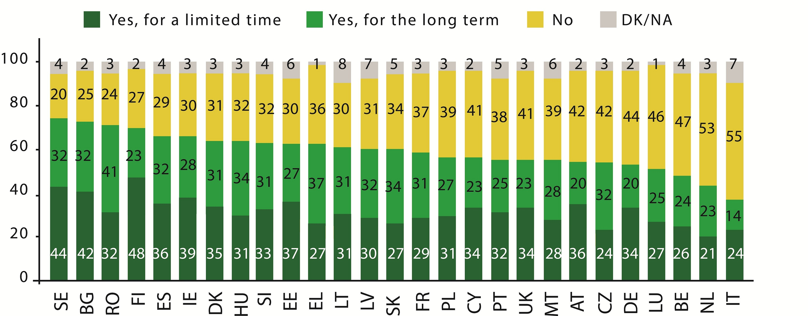
Source: 2011 Eurobarometer on Youth on the Move
Currently available data estimates that only 10% of European higher education graduates have studied elsewhere in the EU. Numbers for degree (full-programme) mobility in the EU are even lower. This is partly because of the costs of studying in another EU country. In its proposal for an Erasmus for All programme the Commission has proposed a students’ loan guarantee scheme to enable Master’s level students who wish to complete a full degree programme in another EU country to access bank loans on favourable conditions. According to the Commission's proposal up to 330 000 students should benefit over the seven-year period of the programme. Furthermore, the Commission will continue to foster mobility for young people to study, train or volunteer abroad or to take part in youth exchanges. Teachers and educational staff will also be given the possibility to teach or train abroad. Thanks to the new programme, almost five million citizens should be able to benefit from these opportunities over the 2014-2020 period.
When considering traineeships in another EU country, young people do not always find relevant information about opportunities that exist and are concerned about the quality and terms of working arrangements. Studies and surveys highlight a number of quality problems relating to traineeships: lack of learning content and insufficient terms and conditions, in particular a low level (or lack) of social protection and compensation/remuneration. Furthermore, a traineeship contract specifying the rights and obligations of the parties is still not compulsory in a number of EU countries (as many as 25% according to a 2011 survey by the European Youth Forum). Low or no pay raises concerns about employers using this as a form of unpaid employment. There is an urgent need to tackle these shortcomings and enhance opportunities for young people to develop their skills and acquire work experience abroad. This is necessary not only to address the concerns voiced by citizens, especially the young, but also to address dramatic levels of youth unemployment.
Nathalie graduated in France and considered starting her professional career in Spain or Germany. Never having lived abroad, she first wanted to do a traineeship but wondered if she would be allowed to do so without being enrolled in an educational programme (in France this is a prerequisite). Also, she did not know what rights she would have as a trainee in those countries and whether she would receive social protection or be entitled to compensation or pay.
In 2013, to make it easier for young people to find quality work experience in another EU country, the Commission will develop a quality framework for traineeships setting out the main features of high quality traineeships in terms of protecting trainees’ rights and helping them make the most of their working experience. It will also review and reform the EURES network to make it more suitable to the real needs of the labour market by enhancing job matching services for the benefit of jobseekers and companies alike. It will in addition launch a pilot initiative with some Member States to improve the EURES information exchange about traineeships and apprenticeships with a view to further facilitating the transition to work for the young people.
Furthermore, the Commission urges Member States to swiftly implement the Youth Guarantee in a sustained and ambitious manner to help young people gain a working experience.
Action 2: In order to help young EU citizens develop their skills and enter the labour market, the Commission will develop, in 2013, a quality framework for traineeships.
The Commission will also put forward an initiative in 2013 to modernise EURES to enhance the role and impact of employment services at national level and improve the coordination of labour mobility in the EU. In addition to the EURES reform, the Commission will launch a pilot initiative to improve the exchange of information about traineeships and apprenticeships opportunities through EURES.

2.2 – Cutting red tape in the Member States
Removing administrative hurdles and simplifying procedures for EU citizens living and travelling in the EU
Citizens’ identity and residence documents
Moving and living freely within the EU is the EU right citizens associate most directly with EU citizenship. According to the 2013 Eurobarometer on EU citizenship, almost nine in ten EU citizens know that they have this right to free movement.
Source: 2013 Eurobarometer on EU citizenship
However, almost one in five of all participants in the 2012 public consultation on EU citizenship reported problems with moving to or living in another EU country (17%); these include administrative hurdles with documents when wanting to travel or prove their identity within the EU. Inquiries on free movement and residence constituted 21% of queries submitted to Your Europe Advice in 2012 and 13% of total SOLVIT cases in 2012.
EU citizens residing in an EU country other than their own for more than three months may be required to register with the local authorities, in which case they receive a registration certificate. However, these certificates are not always accepted as identity documents in the EU (in particular by private entities such as banks, companies, etc.) and citizens cannot use them as travel documents, even within the EU. Similar problems arise for EU citizens who hold identity cards issued in their own country and often cannot rely on them in their transactions in other EU countries. Private companies feel uneasy accepting 'foreign' documents as proof of identity since the format of such documents, unlike passports, is not harmonised at EU level. EU citizens living in another EU country are also confronted with difficulties when they need to obtain or renew ID cards or passports to travel within the EU at short notice, in particular when the nearest consulate is in another country.
Sanna, who is Finnish and lives in Munich, has booked a flight to Finland but, two days before leaving, she is mugged and her passport and ID card are stolen. Sanna cannot get a new passport in time, as the only Finnish consular representations in Germany that could issue a passport are in Berlin and Hamburg, and she cannot get there at such short notice. At the airport, when she shows only her German registration certificate, the airline refuses to allow her to board the plane, citing security regulations.
In the public consultation on EU citizenship, citizens asked for solutions to simplify their life and reinforce their identification with the EU, including through uniform European documents, where applicable. The Commission will inter alia consider whether it would be appropriate to establish rules for a common secure format for registration certificates issued to EU citizens by Member States and for residence documents issued to their family members. This initiative would enable EU citizens and their families to use a single document in their daily life and solve problems they encounter in their dealings with private entities in other EU countries, whilst also enhancing document security.
To further reduce administrative burdens, EU citizens should also be given the option to use such secure registration certificates as travel documents for journeys within the EU, if such documents are issued by the Member State in which they reside.
Action 3: In 2013 and 2014 the Commission will work on solutions to remove obstacles faced by EU citizens and their family members who live in an EU country other than their own in relation to identity and residence documents issued by Member States, including through optional uniform European documents for citizens, where applicable.
Citizens’ cross-border taxation formalities
EU citizens can live in one country, work in another and possess property in a third. This can make it difficult for them to know where they should pay their tax and how to do so. Language barriers and lack of cooperation between tax authorities of different countries in resolving cross-border taxation issues do not make things easier. Citizens might also be confronted with considerable administrative hurdles, in particular when claiming tax refunds due from other countries or because of conflicting tax systems in different Member States which may even lead to the same income being taxed twice by different Member States. Questions on tax alone constituted 9% of the total number of SOLVIT cases in 2012. Your Europe Advice, assistance services such as Consumer Centres in cross-border regions, and EURES also report that they receive many and varied tax queries.
Ylva who is Swedish is married to Martin who is Slovak. They live in Sweden and are now both retired. While Ylva worked only in Sweden, Martin has also worked in Slovakia. They would now like to move to the Netherlands to be near their grandchildren but have many questions with regard to their tax situation and do not know who to turn to. How will their pensions be taxed once they have moved? What about possible inheritance tax? What should they do if they suffer double taxation after moving? If they keep their Swedish home where will they pay property tax and where will income from that property be taxed?
In the course of 2013, the Commission will identify best practices in EU countries as regards helping citizens in cross-border tax situations and will engage in follow-up discussions with national authorities to promote their wider adoption. Best practices could include information contact points in national administrations specialised in cross-border taxation issues, websites providing basic information for citizens and directing them to the most appropriate contact point, simplifying procedures for claiming double taxation relief and excess tax applied abroad, taxpayers’ codes describing taxpayers’ basic rights and obligations, and close cooperation between EU countries in resolving cross-border tax disputes.
The Commission will match this with a new EU-wide compliance initiative to make sure that the laws of all Member States affecting the taxation of mobile persons comply with the jurisprudence of the Court of Justice and that these citizens do not experience unnecessary administrative burden and additional costs when exercising their right to move to other Member States to work or live there.
Action 4: The Commission will, in 2013, take initiatives to promote best tax practice in cross-border situations and ensure the correct application of EU law so as to make it easier for European citizens moving or operating across borders to deal with different sets of tax rules and, in particular, to avoid double taxation.
Citizens’ car paperwork
Currently roadworthiness tests are conducted differently across the Union, with different vehicle categories to be tested, different test intervals, different test methods and different assessments of defects. Consequently, one and the same vehicle could be tested in different EU countries with different results, leading to different safety levels. As a consequence of these diverging standards, EU countries do not recognise each other’s roadworthiness certificates. This entails an unnecessary administrative burden and costs for citizens travelling to another country with their car.
Monika, who is Lithuanian, works in a hotel in an Austrian ski resort five months a year. As the annual roadworthiness test for her car is due in March, when she is in Austria, she has to interrupt her stay and drive all the way back to Lithuania just to present her car for the periodic test. It would be so much easier if she could do the test in Austria and have the roadworthiness certificate automatically recognised in Lithuania, and elsewhere in the EU.
In 2012, the Commission made proposals to establish minimum standards for the control and safety of cars (raising the quality of testing, introducing requirements for the testing equipment, improving the skills of inspectors, reinforcing supervision of testing centres). Building on harmonised standards for controlling the roadworthiness of cars, the Commission will, in the course of 2014, take concrete steps towards establishing an electronic 'vehicle information platform' to facilitate the recognition of roadworthiness certificates.
Action 5: Building on its work to improve EU citizens’ safety on the roads, the Commission will, in the course of 2014, take steps towards establishing a 'vehicle information platform' to facilitate the recognition of roadworthiness certificates, making it easier and safer for citizens to travel to another EU country with their car.

2.3 – Protecting the more vulnerable in the EU
Lifting obstacles for citizens with disabilities and further strengthening procedural rights for citizens, taking into account the specific situation of children and vulnerable citizens
Citizens with disabilities
There are approximately 80 million persons with disabilities in the European Union. They often have access to certain entitlements, in particular in connection with public transport or cultural institutions, linked to their disability card. Unlike parking cards for persons with disabilities, for which a common EU model was established almost fifteen years ago, disability cards are recognised only at national level, making things difficult for disabled persons travelling to another EU country.
Seán, a disabled Irish citizen, would like to join his classmates in their annual school trip. However, he is not sure that his Irish disability card will be recognised in other EU countries and that he will thus benefit from the access to transport enjoyed by disabled local residents. If Seán had an EU disability card he would be reassured about having access to some of the specific benefits that nationals from that country enjoy.
The Commission will launch a pilot initiative with a view to developing a mutually-recognised EU disability card that will facilitate equal treatment of persons with disabilities who travel to other EU countries, when it comes to access to transport, tourism, culture, and leisure.
Action 6: The Commission will facilitate the mobility of persons with disabilities within the EU by supporting, in 2014, the development of a mutually recognised EU disability card to ensure equal access within the EU to certain specific benefits (mainly in the areas of transport, tourism, culture and leisure).
Citizens’ procedural rights
Everyone is presumed innocent until proven guilty. Divergent national rules governing the presumption of innocence can complicate police and judicial cooperation and the mutual recognition of judgments. They also create uncertainty for citizens as to the protection they might get in another EU country. Furthermore, the right to legal aid in criminal proceedings varies considerably across the Member States and persons suspected or accused in criminal proceedings in another EU country are currently not always guaranteed effective and timely legal assistance.
Certain suspected or accused persons are more vulnerable because, owing to age or their mental or physical condition, they have difficulties in understanding, following or effectively participating in discussions. This can affect their right to a fair trial and makes it all the more important that the presumption of innocence and legal aid are guaranteed. In the public consultation on EU citizenship, 73 % of respondents supported the idea of giving children and vulnerable adults safeguards to ensure a fair trial that must apply in any EU country.
Christian, a 16 year old youngster who is living with his parents in an EU country other than his country of origin was arrested at home and taken to the police station for questioning in connection with the theft of a car which had been found that day near the block where he lived. He was questioned for about six hours, during which he first denied any involvement in the theft and later admitted to stealing the car after the police told him that a confession would have a positive impact on the outcome of his case. Christian was questioned without being allowed to contact his parents and without the presence of a lawyer. He was not informed about his right to remain silent and not to incriminate himself.
The Commission intends to propose, by the end of 2013, a package of legal instruments to guarantee the presumption of innocence and legal aid when a citizen is suspected or accused in criminal proceedings in another EU country and to strengthen the procedural rights of children and vulnerable persons.
Action 7: The Commission will, by the end of 2013, propose a package of legal instruments to further strengthen citizens’ procedural rights when they are suspected or accused in criminal proceedings, taking into account the specific situation of children and vulnerable citizens.

2.4 – Eliminating barriers to shopping in the EU
Citizens’ small claims
In the last 12 months, four in ten citizens have bought or ordered goods or services over the internet for private purposes (40%). More Europeans purchase goods or services from sellers based in other EU countries than they did two years ago (+4 percentage points). Almost one in three purchase offline and online goods from businesses based in other Member States (30%). The fact that shopping within the EU is easier may mean that there are more disputes and these have to be solved in a quick and easy manner in order not to discourage citizens.
The European Small Claims Regulation introduced a number of practical solutions to facilitate cross-border litigation for claims under EUR 2 000, such as dropping the need to have the judgement recognised in the case of enforcement abroad or allowing for written procedure based on a standard form. However, citizens’ claims addressed to the Commission show that there is a need to strengthen the existing regulation, in particular to address deficient practices observed in many Member States such as lack of practical assistance in filling application, departure from the principle of written proceedings, unnecessary hearings, insufficient use of tele- and videoconferencing for hearing witnesses, etc.
Tibor, who lives in Hungary, wants to buy a new TV. He found the ideal TV in a shop nearby for EUR 2 750 but decided to check the net for a better price. He found exactly the same TV for EUR 2 200 and placed the order online. The TV was delivered on time, but to his surprise it was black, not silver as he had ordered. He returned the TV and asked for his money back. The seller remained silent. Since the seller was located in Portugal, he wondered how to get redress. A friend told him about the European Small Claims Procedure on the European e-Justice Portal and they quickly spotted all the advantages: it was possible to claim in Hungary and not in Portugal, without paying the costs of the lawyer, and even without going to the court! Then he realised that this easy procedure would not be available to him since the threshold for claims under the procedure was only EUR 2 000.
Citizens consider that raising the threshold for the European Small Claims Procedure would make it easier for consumers to obtain redress in another EU country. In the 2013 Eurobarometer on small claims, respondents said that they would be most encouraged to go to court in their country by the following factors: being able to conduct proceedings only in writing without physically going to court (37%), being able to conduct proceedings without having to instruct a lawyer (31%), and conducting proceedings online (20%). The Commission will revise existing rules to further simplify the European Small Claims Procedure, make sure that the facilities offered by the procedure are used to their full potential and raise the current threshold to EUR 25 000. The Regulation in question will also create a legal environment whereby citizens can conduct the procedure online.
Action 8: By the end of 2013, the Commission will revise the European Small Claims Procedure to facilitate the settling of disputes regarding purchases in another EU country.
Citizens shopping online
European consumers benefit from legislation guaranteeing them fair treatment, safety of the products they acquire, comprehensive information before buying, and, as highlighted above, remedies when something goes wrong. Most recently, in February 2013, the Commission adopted a package of measures to enhance the safety of consumer products, including those bought on line, with a view to boosting citizens’ confidence and stimulate sales.
Despite this protection, citizens still face problems in particular when shopping online, as reported by almost one in four participants (24%) in the 2012 public consultation on EU citizenship. Consumers frequently miss crucial information when comparing or buying digital products (e.g. audiovisual downloads such as music, films or games). Where there is information, non-experts cannot always understand it. They often find it difficult to determine if they will be able to use the product on their device or judge the quality they will get.
Florian is looking for the best place to buy and download his favourite rock band’s new album. It is available as a download from a major online store. Only afterwards does he realise that he also needs to buy the music player from the store in order to play it. The user-friendly display of relevant information about main characteristics, interoperability and functionality would allow Florian to compare offers easily and buy high quality music files that would work on his audio player.
The Commission intends to make sure that consumers buying digital products receive the key information in an understandable and comparable manner.
It will help national authorities to enforce consumer protection rules by giving guidance on the information obligations for digital products. The Commission will also develop a model for uniform and user-friendly display of key information (e.g. price, type of contract, right of withdrawal, interoperability with hardware and software, functionality such as the digital format used, quality of the file, file size, portability to other devices owned by the consumer, possibility to make private copies, etc.) which will appear on the screen at the right moment (e.g. when the offer is made).
This will also make it easier to compare digital products and facilitate the development of accurate comparison websites. More than 80% of European consumers used price comparison websites in 2010, with five out of ten consumers using them at least once a month. The Commission, in consultation with stakeholders, will continue its work for improving the transparency and reliability of such comparison tools for consumers.
The Commission also intends to launch, by spring 2014, a dedicated EU-wide awareness-raising campaign to make citizens more aware of their rights as consumers and hence improve confidence in the digital online market.
Action 9: The Commission will, by spring 2014, develop in close cooperation with national enforcers and relevant stakeholders, a model for the online display of key requirements to make the information on digital products clearer and easy to compare. It will also, by spring 2014, launch a dedicated EU-wide awareness raising campaign on consumer rights.

2.5 – Targeted and accessible information in the EU
Citizens’ free movement rights and the local administration
Front desks in local administrations play a key role in enforcing citizens’ free movement rights as they are often the first interface for citizens settling in a new city and a primary source of information and assistance. However, complaints received by the Commission and EU assistance services show that problems EU citizens encounter when they go to live in another EU country are often due to the fact that front-desk officials in local administrations are not sufficiently familiar with EU citizens’ free movement rights. This is confirmed by the results of a Committee of the Regions study in 2012 and the 2012 public consultation on EU citizenship. One in four citizens residing in another EU country report problems (27%) and almost one in two say that staff in local administrations do not have sufficient information about their EU rights (47%). Staff in local administrations should thus be given the tools to fully comprehend free movement rules.
Source: 2012 Public consultation on EU citizenship - Base: Respondents who faced problems while moving or residing in another EU country
Cécile, who is Belgian, and her husband Nicolás, an Argentinian citizen, go to live in another EU country and, as soon as they settle there, Nicolás successfully passes an interview for a job in a local company. However, in response to the company's enquiry, the official at the town hall says that Nicolás needs a work permit, not immediately realising that such a requirement does not apply to family members of EU citizens exercising their right to free movement. As a result, Nicolás is not hired.
By the end of 2014, the Commission will develop an e-training tool for local administrations to ensure that EU citizens, wherever in the EU they present themselves, will be met by front-desk officials who have a solid knowledge of their rights and of the conditions and procedures to give effect to them.
Also, as of 2013, the Commission will support, via its town twinning scheme, exchanges of best practice between municipalities and projects aimed at enhancing knowledge about citizens’ rights and facilitating their enforcement.
Action 10: The Commission will take actions to ensure that local administrations are given the tools to fully comprehend the free movement rights of EU citizens.
Citizens seeking where to turn to have their rights respected
Too often citizens do not know what to do when their rights are not respected and in particular whether they should go to national authorities, EU institutions or other bodies such as the European Court of Human Rights. Even when it is clear that it is a matter for the EU institutions, citizens are often not sure about which one they should turn to.
The 2013 Eurobarometer on EU citizenship shows that just under a quarter of respondents (24%) feel fairly or very well informed about what they can do when their EU rights are not respected. Roughly half (51%) feel they are not very well informed whilst another quarter (23%) feel that they are not informed at all.
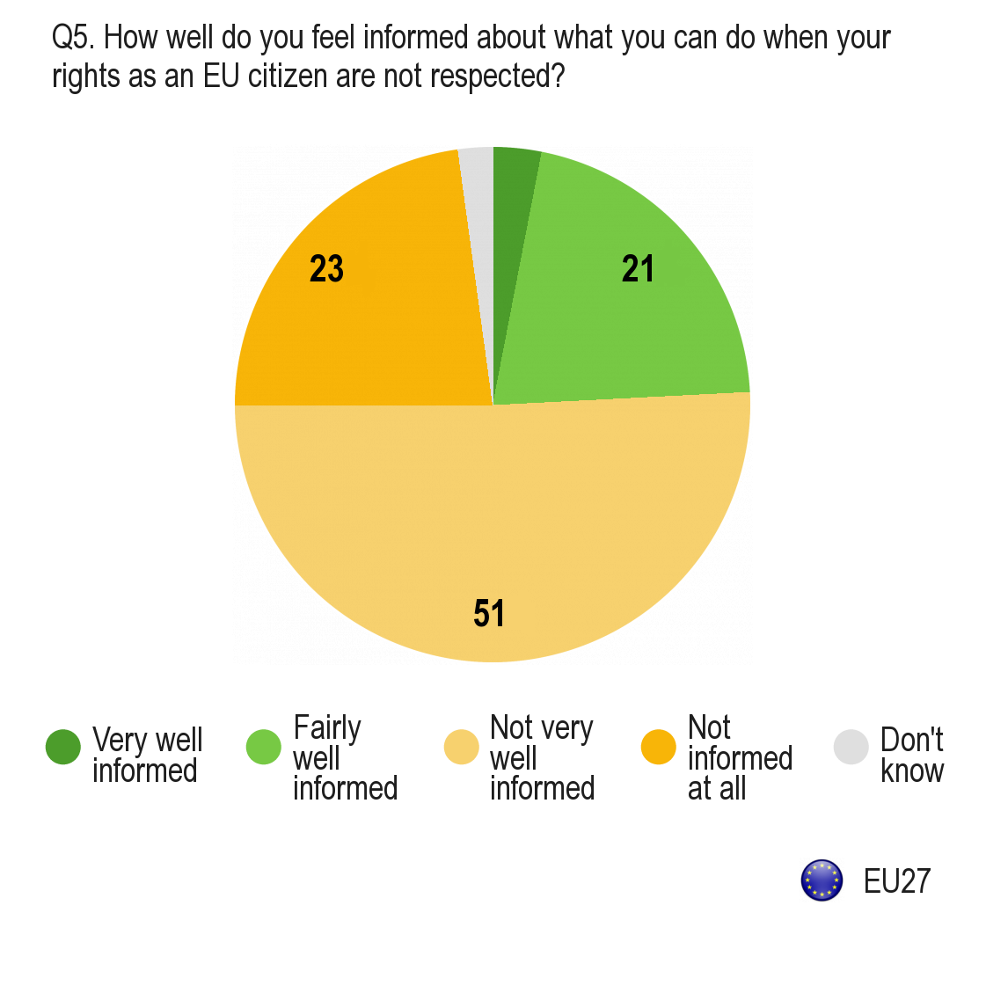
Source: 2013 Eurobarometer EU citizenship
These findings were confirmed by the 2012 public consultation on EU citizenship. Many respondents also said that the tools listed in the question (SOLVIT, Europe Direct, Your Europe Advice) were new to them. The majority of all respondents indicated they would welcome an online tool which would allow them to understand easily at what level (EU, national or local) their problem would best be resolved (63%).
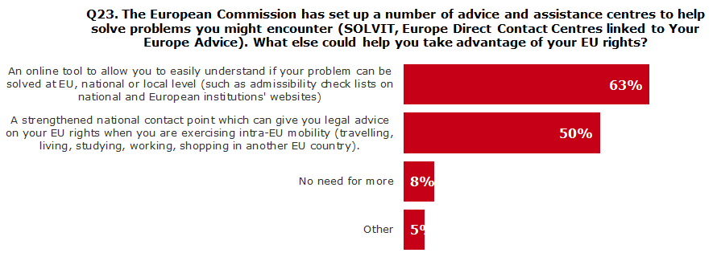
Source: 2012 Public consultation on EU citizenship - Base: All respondents
Maja, who is Slovenian, bought a small apartment in Bulgaria but afterwards discovered that its construction was in breach of several building regulations and that the real estate agent had known about it but withheld this information from her. She thinks that her fundamental right to property has been violated, but wonders whether she should complain to the European Commission, the European Ombudsman or the Bulgarian or Slovenian ombudsman. She did not know that national consumer authorities would be the right body to turn to.
The one-stop-shop information provided through Your Europe and Europe Direct as well as other thematic tools provides citizens with practical information on their rights and will be further developed.
On its central Europa web site, the Commission will guide citizens in a user-friendly way towards the most relevant service to solve their problem, either EU assistance services and institutions, or national and local instances.
Action 11: In the course of 2013, the Commission will make it clearer and easier for citizens to know who to turn to for their rights to be redressed by providing user-friendly guidance on its central Europa web site.

2.6 – Participating in the democratic life of the EU
Enhancing citizens’ electoral rights and promoting their full participation in the democratic life of the EU
Citizens and their political participation in the EU
Bolstering EU citizens’ full participation in the democratic life of the EU, at all levels, is the very essence of EU citizenship. Mobilising citizens, reinforcing the dialogue with civil society and fostering media freedom and pluralism are central to an informed political debate in a democratic process. Participation in European Parliament elections is the primary way for citizens to contribute to the shaping of EU policy and constitutes the bedrock of representative democracy in the European Union. Almost six out of ten EU citizens think that voting in European elections is the best way of ensuring that their voice is heard by EU decision-makers. The Commission recently presented recommendations to further enhance the transparency in the European elections and strengthen the ties between citizens and the EU, underlining the important role to be played by European political parties. Moreover, the Commission will continue to promote the use of the European Citizens' Initiative.
To raise awareness about EU citizenship and the concrete rights it confers to all EU citizens, in particular their electoral rights, and about the possibilities to participate in the decision-making process of the EU, the Commission will produce and promote the dissemination of a handbook presenting in a clear, concise and readable way, the rights attached to EU citizenship. The handbook could be distributed by national authorities to every young EU citizen reaching voting age, but also on other occasions, such as the registration of new births, the issuing of passports, the acquisition of a Member State’s nationality, or as material to be included in school curricula, in particular on citizenship education.
Citizens and their right to take part in elections in their EU country of origin
Generally, Europeans think that EU citizens should not lose their right to vote in national elections in their country of nationality just because they have moved to another EU country (disenfranchisement).
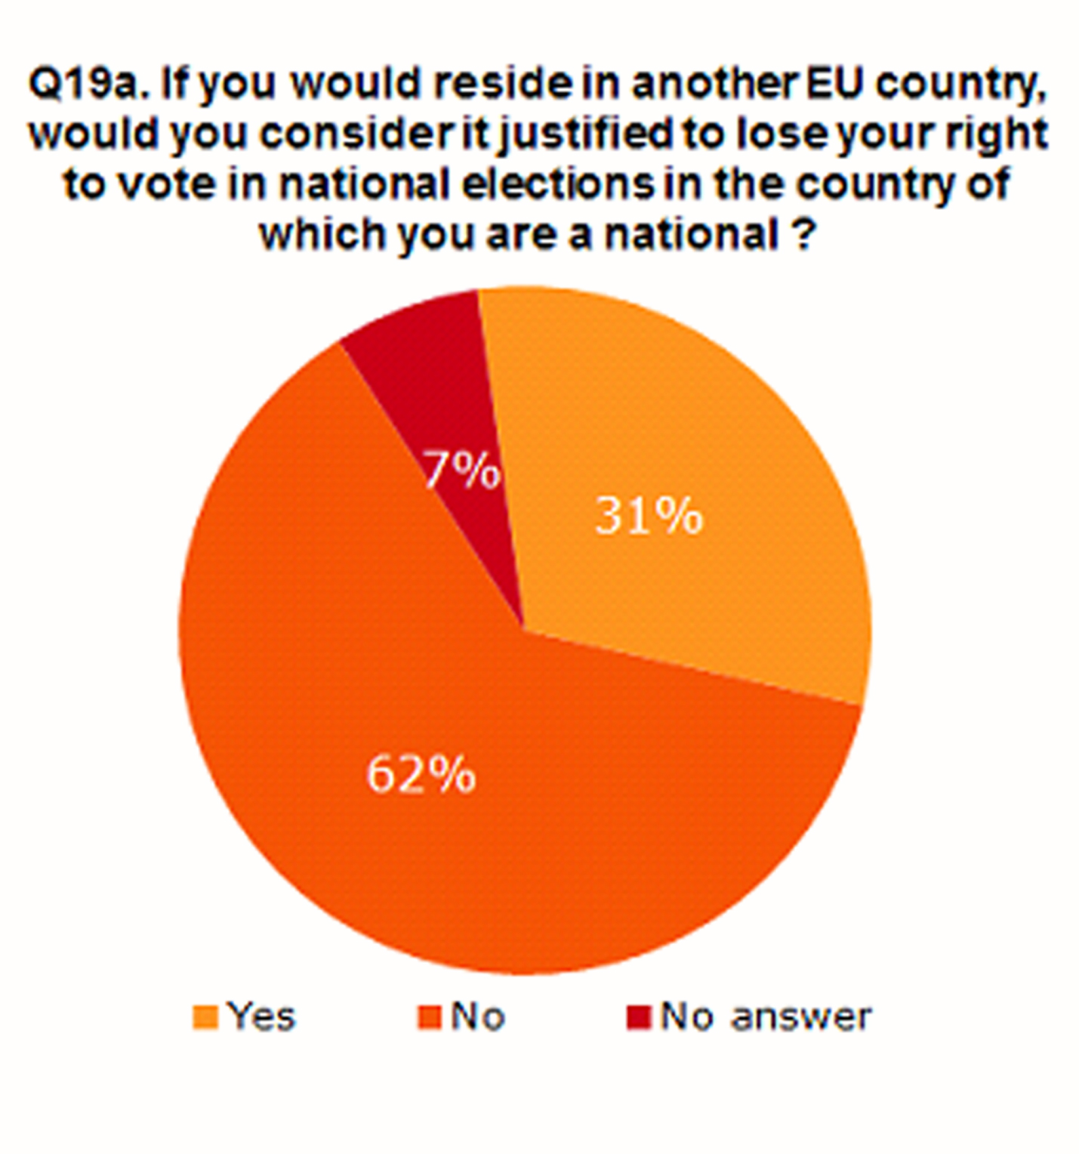
Source: 2012 Public consultation on EU citizenship - Base: All respondents
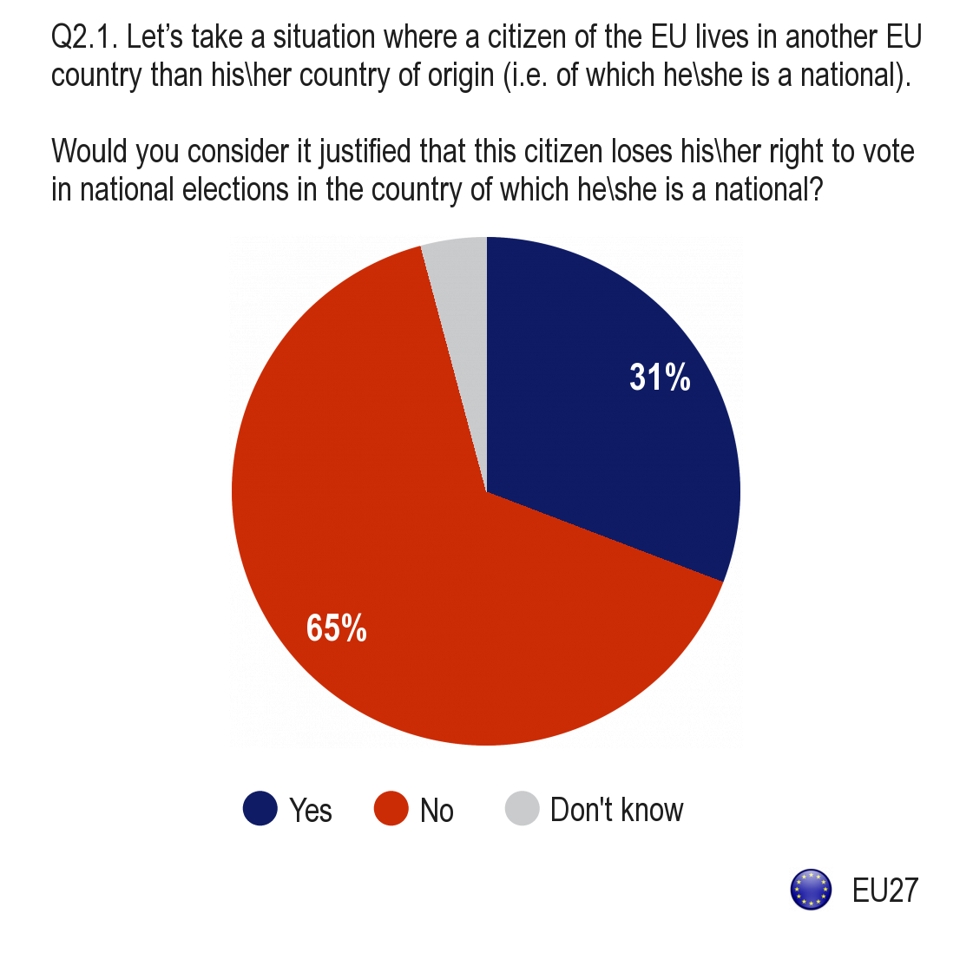
Source: 2013 Eurobarometer on electoral rights
A Danish couple found interesting employment opportunities in a company in Poland and moved to live there, whilst their daughter stayed in Denmark to finish her studies. They often go back to Copenhagen to see their family and friends and remain closely tuned to political and social developments in Denmark where they intend to return eventually. However, they cannot vote in national elections, as current legislation allows Danish citizens leaving the country to remain on the electoral rolls only if they register their intention to return within two years.
National disenfranchisement policies, where they exist, are commonly justified by the fact that, after a certain period of time spent abroad, the link with the society of origin is weakened. This argument should be re-assessed in the light of current socio-economic and technological realities, the fact that people can move around more easily, and increasing social and cultural interpenetration within the EU. Residing in another EU country no longer requires a definitive severing of ties with the country of origin, as may have been the case in the past. EU citizens should now be able to decide for themselves if they want to continue to participate in the political life of their country of nationality or invest in the political life of their host society. Discussions at the joint European Parliament and Commission hearing on EU citizenship on 19 February 2013 also highlighted the incongruity of depriving EU citizens of essential political rights for the very reason that they have exercised their fundamental EU right to free movement. Those who have exercised their right of free movement can find themselves in a less favourable position than if they had stayed at home or curtailed their stay in another EU country. There has been national litigation contesting the conformity of national disenfranchisement policies with EU law, but no preliminary question has to date been referred to the Court of Justice.
Citizens and their right to take part in elections in their EU country of residence
EU citizenship involves the rights of EU citizens to vote and stand as candidates in local and European elections in the host country under the same conditions as nationals. These rights were meant to give concrete effect to the principle of non-discrimination between nationals and non-nationals and enable EU citizens to integrate better and take part in democratic life in their host country. However, they leave uncovered the most important levels of political participation, i.e. the national level, and - in the 13 Member States where regions are vested with legislative capacities - the regional level.
This asymmetry means that EU citizens who are already members of the community at local level are deprived of an effective voice as regards the decisions of the national legislature which directly affect them. This gap in equality of treatment and in political participation for EU citizens who exercise their fundamental EU right to move and reside freely within the EU looms larger as European integration progresses and promoting the participation of EU citizens in the democratic life of the Union increases in importance.
In the 2012 public consultation on EU citizenship and in the 2013 Eurobarometer on electoral rights, 72% and 67 % of respondents respectively thought that non-national EU citizens should be allowed to vote in the national elections of their host country. This represents a significant increase since 2010 (+17 percentage points).
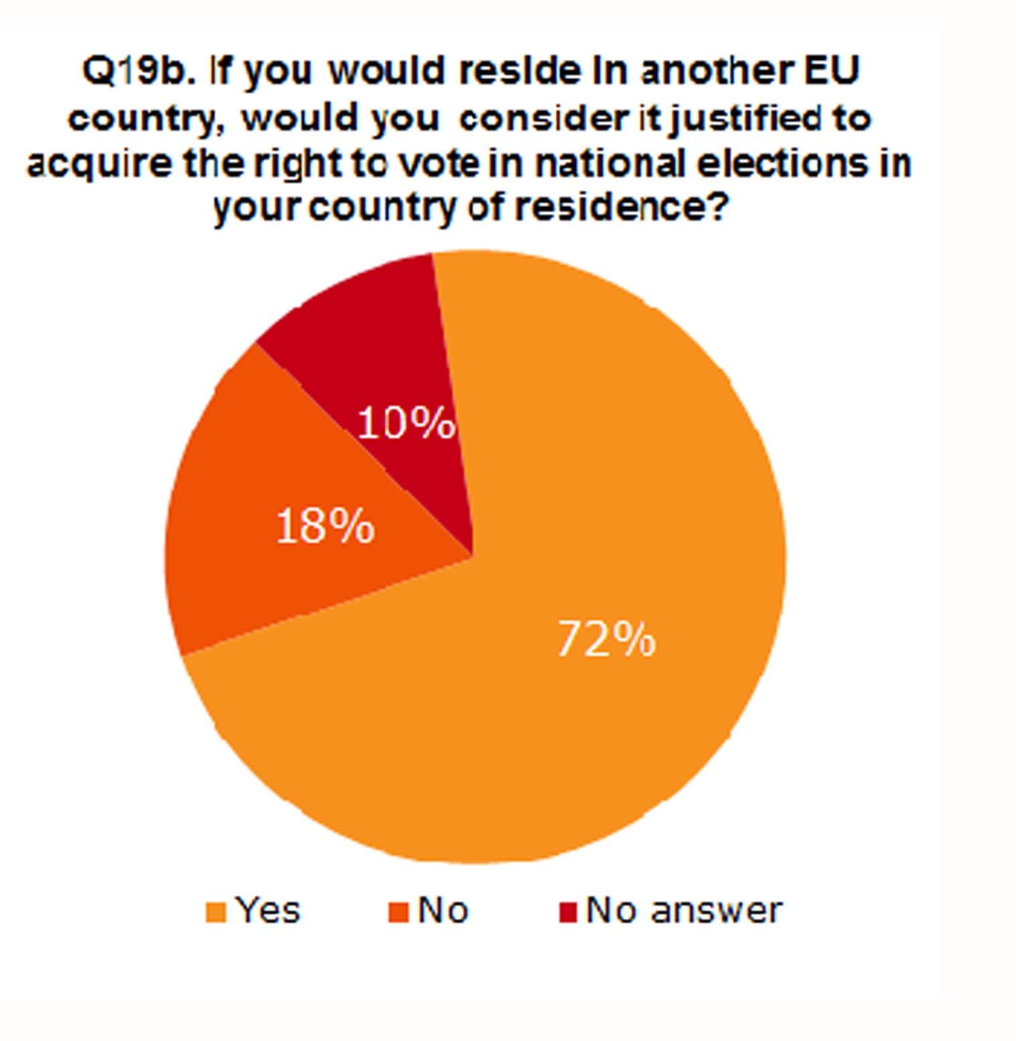
Source: 2012 Public consultation on EU citizenship - Base: All respondents
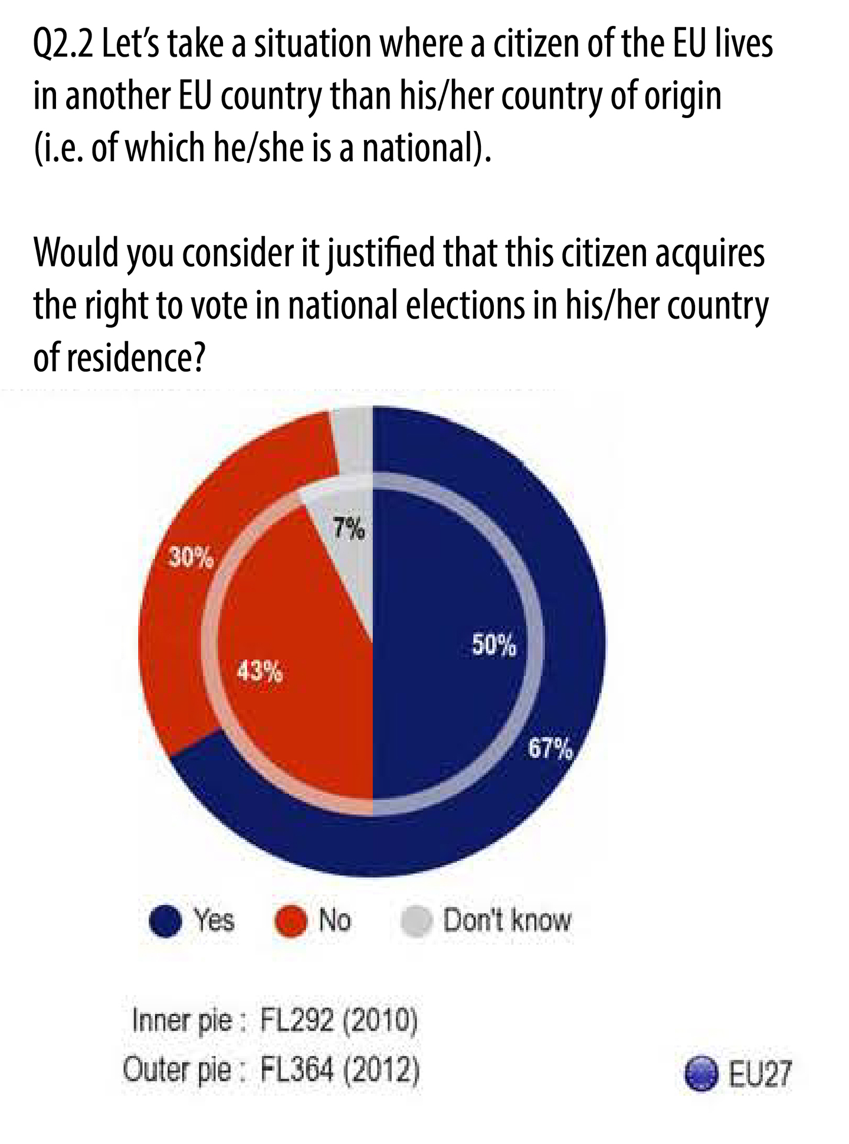
Source: 2013 Eurobarometer on electoral rights
As regards regional elections, 64% of respondents in the 2013 Eurobarometer on electoral rights said that EU citizens should be given the right to vote (assuming such elections are held in that country). Once again, this is a significant increase since 2010 (+10 percentage points).
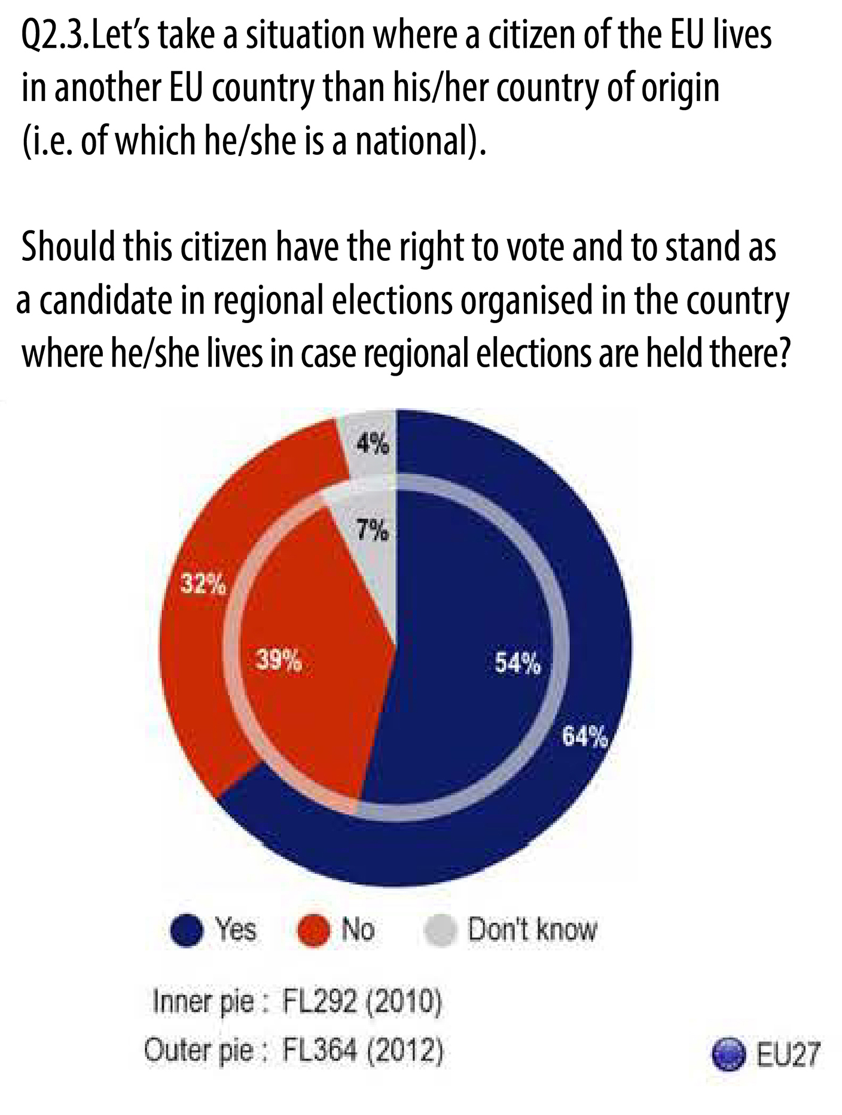
Source: 2013 Eurobarometer on electoral rights
Empowering EU citizens residing in another EU country to determine for themselves, depending on the ties they maintain with their Member State of nationality or have formed with their Member State of residence, in which of these two countries they wish to exercise their key political rights, would give a new impetus to their inclusion and participation in the democratic life of the Union. The dynamic towards strengthening the rights attached to EU citizenship is embodied in the Treaty itself (e.g. Article 25 TFEU). In the context of the broader reflections on the shape of the future of the European Union, the Commission will examine ways to enable EU citizens to participate in national and regional elections in their country of residence.
Citizens and their access to a European Debate
Currently 68 % of EU citizens do not feel sufficiently informed about European affairs. 74 % of people with a negative perception of the EU say of themselves that they are not well informed about it. Despite greater use of the internet and social media, in particular among younger citizens, TV is still the first choice for most people (58%) when it comes to being informed about European affairs. The Audiovisual Media Services Directive promotes media pluralism by opening-up national markets to broadcasters and video-on-demand providers from other EU countries. Moreover the internet makes access to content from other Member States easier. However national TV channels often report on European topics from a national point of view for a national audience. Providing citizens with information about European issues from a European point of view, but also from a range of national perspectives from other Member States, could increase the European public space and contribute to a more informed democratic debate.
Action 12: The Commission will:
- promote EU citizens’ awareness of their EU citizenship rights, and in particular their electoral rights, by launching on Europe Day in May 2014 a handbook presenting those EU rights in clear and simple language;
- propose constructive ways to enable EU citizens living in another EU country to fully participate in the democratic life of the EU by maintaining their right to vote in national elections in their country of origin; and
- explore in 2013 ways of strengthening and developing the European public space, based on existing national and European structures, to end the current fragmentation of public opinion along national borders.

3. Conclusion: A new impetus for EU citizenship
With its 2013 EU Citizenship Report and the wide-ranging consultations that helped shaping it, the Commission draws on citizens' experiences to make sure that they can fully enjoy their EU rights and the benefits Union citizenship brings to them in their daily life.
The report and the debates surrounding it are steps, together with the European Year of Citizens and the ongoing Citizens’ Dialogues, to involve citizens alongside politicians, experts and civil society, in the run-up to the 2014 European Parliament elections, in a genuine debate on the way forward to a stronger and ever closer Union with the citizen at the core of its action.
As underlined by President Barroso in his 2012 State of the Union Address, “Europe has to be ever more democratic”. EU citizens will take the European project forward if they see its concrete benefits for them and their families, if they identify with its goal and vision and if they are involved in the process.
ANNEX 1
Follow up to the 2010 EU Citizenship Report: 25 actions accomplished
The 2010 EU Citizenship Report outlined 25 actions envisaged by the Commission to remove main obstacles faced by EU citizens seeking to exercise their EU rights in different roles in their daily lives. This Annex presents the main actions taken by the Commission to deliver on its 2010 commitments.
Bringing legal clarity regarding property rights of international couples - Action 1
The Commission adopted on 16 March 2011 two Proposals for Regulations on the jurisdiction, applicable law and the recognition and enforcement of decisions
- as regards matrimonial property regimes, and
- the property consequences of registered partnerships.
The proposed Regulations aim to help international couples trying to settle property-related issues in the event of divorce, legal separation or death to identify the applicable law and the responsible court. They also contain rules for recognising and enforcing court judgments on a couple's property in all Member States through a single procedure. Couples could thus save an estimated average of EUR 2.000 to 3.000 per case, depending on its complexity.
Eliminating cumbersome and costly formalities regarding cross-border use of civil status documents and facilitating cross-border access to justice - Actions 2 and 3
Action 2
On 14 December 2010 the Commission issued a Green Paper “Less bureaucracy for citizens: promoting free movement of public documents and recognition of the effects of civil status records” launching, until 10 May 2011, a public consultation. On 24 April 2013, the Commission proposed a Regulation which will make it easier for citizens to secure recognition of public documents required in cross-border situations (such as birth, death or marriage certificates or documents relating to real estate). The proposed rules lead to cutting red tape by simplifying administrative formalities. They will also reduce translation costs related to the use of public documents within the EU. The proposal also establishes EU multilingual standard forms which citizens can request concerning, inter alia, birth, marriage and death.
Action 3
The Commission launched in July 2010 the European e-Justice Portal, an electronic one-stop-shop for access to justice throughout the EU. Citizens dealing with events such as divorce, death, litigation or even moving house and who need to enforce their rights in a court in another EU country, can get quick answers to a number of questions. They can notably find a legal practitioner in another country, learn how to avoid costly court cases through mediation, where to bring a lawsuit, which Member State’s law applies in their cases and whether they are eligible for legal aid.
Reinforcing the protection of suspected and accused persons in criminal proceedings and of victims of crimes - Actions 4 and 5
Action 4
The Commission presented on 8 June 2011 a Proposal for a Directive on the right of access to a lawyer in criminal proceedings and on the right to communicate upon arrest with a view to ensuring that every defendant in criminal proceedings is able to rely on the same basic level of rights – whatever their nationality and in whichever EU country the proceedings take place. This proposal sets out EU-wide minimum standards on the right of access to a lawyer for suspects and accused persons and on the right of people in detention to communicate with a person of their choice, such as a relative, employer or consular authority.
Action 5
On 18th May 2011, the Commission presented:
- a Communication on "strengthening victims' rights in the EU", which sets out the Commission's position on action in relation to victims of crime;
- a proposal for a Directive establishing minimum standards on the rights, support and protection of victims of crime, aimed at reinforcing existing national measures with EU-wide minimum standards, so that any victim can rely on the same basic level of rights – whatever their nationality and in whichever of the EU countries the crime takes place; and
- a proposal for a Regulation on the mutual recognition of protection measures in civil matters (complementing the 2012 Directive on the European Protection Order which applies to criminal protection measures). The proposal aims at ensuring that victims of violence can still rely on a protection measure issued against the perpetrator if they travel or move to another EU country.
Following the Commission’s proposal, the Directive 2012/29/EU establishing minimum standards on the rights, support and protection of victims of crime was adopted on 25 October 2012. The minimum rules it establishes inter alia ensure that victims are treated with respect, get information on their rights and on their case and can actively participate in proceedings. They also ensure that victim support exists in every Member State and that victims with specific protection needs due to their vulnerability (including children) are identified and properly protected.
Removing taxation problems in cross-border situations, in particular regarding taxation of cars, and simplifying re-registration procedures for cars - Action 6
The Commission published, on 20 December 2010, a Communication "Removing cross-border tax obstacles for EU citizens", identifying the most serious tax problems that EU citizens face in cross-border situations and announcing its intention to make proposals in some specific areas as well as, more generally, to assist Member States in making their tax systems more compatible and in cooperating better in the interests of EU citizens. Further, the Commission identified breaches to EU law and took action against the Member States concerned, where necessary.
The Communication on "Double taxation in the Single Market", of 11 November 2011, highlighted the main double taxation problems within the EU and concrete measures that the Commission will propose to Member States to address them, such as the establishment of a forum on double taxation and the adoption by Member States of a code of conduct and a dispute resolution mechanism.
On 15 December 2011, the Commission adopted a comprehensive initiative on inheritance taxation, including a Recommendation intended to provide an impetus for Member States to tackle the problems of double or multiple taxation on the same inheritance. The Commission also provided guidance to Member States on how to make their inheritance tax systems non-discriminatory. Further, the Commission conducted a review of Member States' tax provisions applicable to cross-border inheritance and took action against the Member States in question where necessary. In 2014, the Commission will produce a report.
The Commission launched a public consultation from 3 March to 26 May 2011 to identify main difficulties encountered by EU citizens as regards the registration of cars previously registered in another Member State. On this basis, the Commission adopted on 4 April 2012 a Proposal for a Regulation simplifying significantly the re-registration procedures. This initiative seeks to reduce unnecessary administrative burdens, which would lead to a total savings of at least 1.5 billion euro per year for businesses, citizens and registration authorities.
To address the problems faced by EU citizens related to cross-border car taxation, the Commission presented on 14 December 2012 a Communication "Strengthening the Single Market by removing cross-border tax obstacles for passenger cars", clarifying EU rules on car taxation and identifying best practices that Member States should implement, such as informing citizens of their rights and obligations in relation to the application of car taxes in cross-border situations and refunding part of the registration tax for cars which are permanently transferred to another Member State, so as to avoid double taxation. In the accompanying Staff Working Document, the Commission gives an overview of the legal protection available to EU citizens and economic operators under EU law.
Helping EU citizens fully benefit from cross-border health care and eHealth technology - Action 7
Directive 2011/24/EU on patients' rights in cross-border healthcare entered into force on 24 April 2011 and should be transposed into national law by 25 October 2013. It clarifies patients' rights to access safe and good quality treatment across EU borders, and be reimbursed for it.
Directive 2011/24/EU established a Network of national authorities on eHealth, the so-called eHealth Network. One of the objectives of this Network is to develop guidelines defining a minimum set of patient data to facilitate cross-border exchange of this data among Member States. Moreover, the Network will support Member States in developing common identification and authentications measures to facilitate transferability of data.
In addition, on 6 December 2012, the Commission published a Staff Working Document on the applicability of existing EU legislation to telemedicine services to clarify the legal framework of telemedicine services provided across borders. This document accompanied the Commission eHealth Action Plan 2012-2020 that provides the EU vision for enhancing eHealth deployment as well as patients' and healthcare workers' empowerment in their use of eHealth.
Finally, with a view to equipping Europeans with secure online access to their medical health data, the Commission is funding - as from January 2012 and until the end of 2014 - two pilot projects involving over 20 regions in different Member States.
Giving full effect to the right to consular protection for EU citizens in distress in third countries - Action 8
On 23 March 2011, the Commission presented a Communication “Consular protection for EU citizens in third countries: State of play and way forward” announcing concrete actions to increase the effectiveness of EU citizens’ right to be assisted in third countries, including in times of crisis, by the diplomatic and consular authorities of all Member States. On the same day the Commission launched a dedicated website on consular protection for use by citizens seeking information on consular protection, the addresses of consular and diplomatic representations in non-EU countries and access to Member States' travel advice.
On 14 December 2011, the Commission adopted a Proposal for a Directive on consular protection for Union citizens abroad.
Enhancing citizens’ awareness and the enforcement of their rights when buying holiday packages, and when travelling as passengers and as tourists and removing barriers for persons with disabilities - Actions 9, 10, 11 and 12
Action 9
The Commission has assessed the package travel market thoroughly, including potential policy options for a response to the changes in this market since the adoption of the existing directive in 1990. These developments include in particular the introduction and expansion of the internet as a distribution channel, which has changed the way consumers organise their holidays. The Commission has recently organised several consultations with consumer organisations, industry stakeholders and Member States and expects to announce its proposal for the way forward by summer 2013.
Action 10
New European legislation which entered into force in 2012 and 2013 ensures that passengers have similar basic rights everywhere in Europe, irrespective of whether they travel by air, train, ship or bus: Regulation (EU) No 1177/2010 for passengers travelling by sea and inland waterways entered into force on 6 January 2011, and Regulation (EU) No 181/2011 on the rights of passengers travelling by bus and coach entered into force on 20 March 2011. These new rules ensure that passengers in all those modes have the right to be informed and to get assistance when something goes wrong with their travel. In particular, disabled persons and persons with reduced mobility will benefit from protection and free of charge assistance when travelling.
Between 2010 and 2012, the Commission organised a Europe-wide passenger rights awareness-raising campaign providing information about the rights of air and rail passengers across Europe, including “Airport Day", a pan-European information event in 28 airports on 4 July 2012. The Commission's work raising citizens' awareness of passenger rights in all modes of transport will be carried forward through a new Europe-wide information campaign to be launched in 2013 and lasting until mid-2015.
Moreover, on 13 March 2013 the Commission proposed a revision of air passengers' rights which would strengthen the application of these rights via a clarification of the legal texts and via enhanced enforcement and complaint-handling mechanisms.
Action 11
The Commission adopted, on 15 November 2010, the Disability strategy 2010-2020, aimed at empowering people with disabilities so that they can enjoy their rights and participate fully in society. The strategy focuses on eliminating barriers across eight main areas: accessibility, participation, equality, employment, education and training, social protection and health.
On 11 April 2011 the Commission presented a Report on Regulation (EC) No 1107/2006 on disabled persons and persons with reduced mobility when travelling by air, identifying unclear areas in the application of the Regulation. As a follow-up to this report, the Commission published in June 2012, Guidelines for national authorities and air transport stakeholders providing clarifications and aiming at improving the application of the Regulation. The new Commission awareness raising campaign to be launched in mid-2013 will include specific actions devoted to disabled passengers and passengers with reduced mobility. On 11 March 2013, the Commission adopted Directive 2013/9/EU which adds explicit essential requirements in terms of accessibility of the railway system to disabled persons and passengers with reduced mobility.
A further strand of the Commission's action relates to the ongoing process of standardising accessibility in the built environment. The Commission produced a study which describes the fragmented situation in the EU and provides an overview of more than 250 regulations, standards, and guidelines and, in 2013, will work toward developing a European standard.
Furthermore, the Commission presented on 3 December 2012 for the third time the access city award. This award, given annually on the occasion of the European day of persons with disabilities, celebrates cities with over 50 000 inhabitants which take exemplary initiatives to improve accessibility in the urban environment. Winners so far were Berlin in 2012, Salzburg in 2011 and Avila in 2010.
Finally, the Commission launched, between 12 December 2011 and 29 February 2012, a public consultation to prepare for a European Accessibility Act. This initiative aims to ensure that people with disabilities have access to important goods and services in Member States. It will also benefit people with limited mobility, such as the elderly.
Action 12
To increase consumers' confidence in tourism services the Commission is creating a European Quality Label to ensure consistency in the assessment of the quality of the services offered to consumers. The Commission also aims to increase the number of citizens who can go on holiday, despite their disabilities or difficulties linked to age or economic difficulties. To this purpose it promotes awareness raising among businesses about the benefits of investing in accessibility, it encourages tourism during the low season and engages in dedicated communication activities to promote sustainable tourism destinations.
Increasing consumers’ awareness about their rights and existing means of redress and facilitating the fast and low-cost out-of-court resolution of consumer disputes - Actions 13 and 14
Action 13
In line with the objective of the Digital Agenda for Europe to promote awareness and understanding of citizens’ digital rights, the Commission presented on 17 December 2012 the Code of EU online rights. This Code does not create new rights but sets out in a transparent and understandable way the key existing principles and rights of citizens under EU law protecting them when using online services, buying goods online, and in case of conflict with their providers of these services. Although the Code is not enforceable in itself, the particular rights and principles are enforceable under the national legislation transposing the EU rules from which they derive.
Action 14
To facilitate fast and low-cost out-of-court resolution of consumer disputes in the EU, the Commission presented on 29 November 2011 a legislative package, comprising a proposal for a Directive on consumer Alternative dispute resolution (ADR) and a proposal for a Regulation on consumer Online Dispute Resolution (ODR). The European Parliament and the Council adopted both proposals in December 2012. The legislation will be published in June 2013.
- The Directive on consumer ADR will enable consumers to resolve disputes with traders out-of-court when they have a problem with a product or service which they bought (excluding disputes in the sectors of health and education), by involving an ADR entity (e.g. a conciliator, mediator, arbitrator, ombudsman, complaints board etc.). The ADR entity should respect specific quality requirements (such as transparency, independence, fairness and effectiveness) and should make the outcome of the procedure available within 90 days. Online traders will also need to inform consumers about ADR.
- The Regulation on consumer ODR creates an EU-wide online platform which will provide consumers and businesses with a single point of entry for resolving entirely on-line within 90 days the disputes concerning purchases made on-line. Online traders will also need to inform consumers about ODR.
ADR and ODR are faster, cheaper and easier to use than court proceedings and are expected to save consumers across Europe around 22.5 billion euro a year.
The Commission further focused on promoting mediation, since it can result in significant time and money savings for citizens. EU rules on mediation are comprised in a Directive adopted on 21 May 2008 and which had to be transposed by the Member States by 21 May 2011. The Commission launched in July 2012 a study to evaluate comprehensively the transposition of the Directive by the Member States, also focusing on the importance of promoting the extensive use of mediation for a more citizens-friendly justice. This analysis should also enable the Commission to determine whether there is a need for further action.
Facilitating the intra-EU mobility of EU citizens and the exercise of their social security rights - Actions 15 and 16
Action 15
The Commission pursued a rigorous enforcement policy with a view to achieving the full and correct transposition and application of the EU free movement rules across the European Union. As a result of this policy, the majority of Member States amended their legislation or committed themselves to adopting, within a set deadline, amendments aimed at ensuring full compliance with these rules. Issues solved included the incorrect or incomplete transposition of provisions of EU law regarding the rights of entry and residence for family members of Union citizens, including same-sex partners, the conditions for issuance of visas and residence cards for third-country national family members and the safeguards against expulsions. In seven out of the 12 infringement proceedings launched, the Commission has sent a reasoned opinion to the Member States concerned, which is the last step before bringing the matter before the Court of Justice of the EU. A more detailed assessment can be found in the Report on progress towards effective EU Citizenship 2011-2013 (Report under Article 25 TFEU) annexed to the 2013 EU Citizenship Report.
On 26 April 2013, the Commission proposed a Directive facilitating the effective exercise of the right to free movement of workers in the EU. This proposal aims to improve enforcement of workers' free movement rights, and to prevent discrimination on grounds of nationality. In particular, Member States will be required to set up bodies at national level which will provide information on the rights of mobile EU workers and assist those who suffer from nationality-based discrimination. Moreover, Member States will have to guarantee EU mobile workers who believe they are victims of discrimination with efficient means of redress at national level as well as to ensure that associations and organisations such as labour unions and NGOs may engage in administrative or judicial procedures on behalf or in support of EU migrant workers who are victims of discrimination.
To increase EU citizens' awareness and ensure their easy access to information on their right to move and reside freely within the EU, the Commission published in 2010 simple and reader-friendly information on applicable EU rules and on how to benefit from this right on the dedicated Your Europe portal, which also provides access to personalised assistance services, and in the 2012 booklet "Your Europe- Your Rights". In addition, it published in 2013 an updated version of the guide for EU citizens on freedom to move and live in Europe, spelling out in a reader-friendly manner the rights and possibilities open to them.
Action 16
To help citizens who move around in Europe in the exercise of their social security rights, the Commission is developing the Electronic Exchange of Social Security Information (EESSI), an IT system to help social security bodies across the EU to exchange information more rapidly and securely. Through this system, communication between national social security bodies is taking place using structured electronic documents, thus replacing paper-based exchanges. This system will bring important benefits for citizens, as it allows for a better management and faster calculation and payment of social security benefits and a reduction of errors in processing claims.
The Commission and the Member States are currently developing the central system and will further focus their efforts to support the national social security bodies' preparations toward working in an electronic environment.
Removing obstacles to the exercise of citizens’ political rights - Actions 17, 18, 19 and 20
Initiatives taken by the Commission to remove obstacles encountered by EU citizens seeking to participate in European elections were presented in the Commission Communication of 12 March 2013 "Preparing for the 2014 European elections: further enhancing their democratic and efficient conduct" and summarised in the Report on progress towards effective EU citizenship 2010-2013 (Report under Article 25 TFEU) which accompanies the 2013 EU Citizenship Report.
This section summarises progress achieved in bringing forward two further issues set out in the 2010 EU Citizenship Report.
Firstly, as announced in Action 18, the Commission pursued a rigorous enforcement policy to ensure that all Member States allow non-national EU citizens to found or become members of political parties. The principle of non-discrimination on grounds of nationality implies not only the formal suppression of the nationality requirement as a condition for Union citizens to stand as candidates or vote in municipal and in European elections but also the elimination of any measures which could prevent them from exercising this right under equal conditions, as guaranteed by the Treaty.
The prohibition for non-national Union citizens to become members of a political party deprives them from the possibility to make use of the main platform of political participation, in particular during elections, and has a negative impact on their chances to be elected in comparison with those of nationals. The Commission has taken action against seven Member States and four cases have been satisfactorily clarified and closed.
Secondly, as announced in Action 20, in 2011 the Commission launched a political dialogue with those Member States whose nationals may lose their political rights in their country of origin (be disenfranchised) if they live in another Member State for a certain period of time. The aim was to identify options to prevent EU citizens from thus losing their right to participate in national elections in any country as a consequence of exercising their right to free movement. In particular, it addressed letters to the Member States concerned, explaining its views and inviting their contribution to a common reflection. The replies provided clarifications on current laws and policies and on related debates taking place at national level. This dialogue pointed to the need to seek constructive ways forward with a view to promoting citizens' participation in the democratic life of the EU at all levels, as further explained and taken forward in Action 12 announced in the present Citizenship Report.
Providing easily accessible information to citizens on their EU rights – Actions 21 and 22
Action 21
In the course of the last three years, the Commission has sought a closer integration of the Europe Direct services – the Europe Direct Contact Centre and the Network of around 450 Europe Direct Information Centres, and Your Europe-Citizens web portal in order to provide citizens with a fully multilingual and multichannel information platform: online, by telephone, by e-mail and in person.
The Your Europe portal was completely revamped and now offers user-friendly practical information in 22 languages about EU rights and their national implementation rules from a user's perspective, whilst, for more personalised advice, visitors are guided to relevant help and assistance services (such as Europe Direct, Your Europe Advice, SOLVIT, EURES, ECC-Net). The portal is being further developed, in particular through more intensive cooperation with Member States to ensure the availability of country-specific information on EU citizens' rights (e.g. national authority contacts, guidance on specific procedures to follow or documents to submit in order to exercise EU rights and information on relevant national rules, such as those applicable when buying property). At the same time, the Commission will further reinforce SOLVIT and increase its visibility on and off line.
Throughout 2011 and 2012, the 450 Europe Direct Information Centres in all Member States were thoroughly briefed on the content of Your Europe-Citizens portal and on how to use this content to meet citizens' information needs. The mission of the new Europe Direct Network for the 2013-2017 period was re-defined by stating clearly the role of the Information Centres as key partners of the "one-stop shop" and in terms of providing information about the EU by referring citizens to the relevant content of Your Europe.
In parallel, the Commission endeavoured to bring to the attention of the widest possible number of Europeans the existence of Europe Direct & Your Europe as the primary citizen-friendly one-stop-shop information point on EU rights. As a result of these awareness-raising efforts, the number of queries answered by the Europe Direct Contact Centre increased by more than 20 % in 2012 as compared with 2011. Your Europe also attracted a significantly increasing number of visitors (it had almost 4,3 million visitors in 2012, as compared with 2,4 million in 2011 and 1,5 million in 2010). Recent user surveys indicate a high degree of satisfaction: 70% of visitors find at least some of the information they are looking for and 93% of users rate the portal satisfactory or better.
Action 22
With the support and coordination of the Commission Representations in EU countries, the Europe Direct Information Centres became important information vehicles on EU rights at local, regional and national level. The Representations also reinforced their cooperation with Your Europe Advice to offer personalised advice on legal matters to citizens.
The Europe Direct Information Centres currently act as the main entry points for information at local level: they answer questions from their local audiences or signpost citizens to thematic EU information services and outlets at national level. In 2012, an automated channel was established to connect the Network to the Brussels-based Europe Direct Contact Centre. This channel enables every local Europe Direct Information Centre to submit queries directly to the Contact Centre on behalf of citizens.
Carrying forward its work on streamlining access to the information citizens need on how to benefit from their EU rights, the Commission is currently establishing a "no wrong door" policy i.e. seamless connections between Europe Direct and thematic EU information providers so that citizens' queries will always receive an answer from the right information provider regardless of their point of entry.
The Commission Representations in the Member States undertook numerous awareness-raising and outreach actions in respect of citizens' rights, either with a thematic link or more generally and were also active in awareness-raising about the European Citizens' Initiative, using a variety of communication means. In 2012, the Europe Direct Contact Centre became the central contact point for information on the European Citizens' Initiative.
Raising citizens' awareness about EU citizenship and the rights attached to this status – Actions 23, 24 and 25
Action 23
Based on a Commission proposal, the Council and the European Parliament designated 2013 as the European Year of Citizens. The Year (www.europa.eu/citizens-2013) is intended to raise Union citizens' awareness about their EU rights and the policies and programmes that exist to support the exercise of those rights and to stimulate a debate on, and strengthen civic and democratic participation in, Union policies.
The European Year of Citizens is providing many opportunities across the continent for citizens to debate these important issues. To achieve the objectives of the European Year, the Commission is collaborating closely with many stakeholders, institutions and interested parties, all of whom are vital multipliers, to make sure that the messages of the European Year can reach down to the local level.
In addition, the 7th Framework Programme for Research, the Socio-economic Sciences and Humanities (SSH), managed by the Commission, has devoted an activity area to "The Citizen in the European Union". Research in this area is aimed at furthering knowledge on EU citizenship, raising awareness and disseminating research results among academic communities, policy makers, civil society organisations and the broader public. The Commission has funded a range of multi-disciplinary research projects specifically addressing issues related to achieving a sense of democratic ownership and participation by EU citizens.
Action 24
On 15 November 2011 and on 14 December 2011 respectively, the Commission issued its Proposals for the future Rights and Citizenship Programme and the future Europe for Citizens Programme, respectively. Both these proposals aim to provide financial support for EU citizenship in a consistent and complementary way. In particular, the Rights and Citizenship Programme will address the rights deriving from EU citizenship, whereas the Europe for Citizens Programme will promote the participation of citizens in the democratic life of the Union. The programmes will complement each other, exploiting synergies and avoiding duplications.
In shaping these proposals, the Commission’s overreaching goal was streamlining and simplification. As a result, these programmes are fully aligned with the Financial Regulation, meaning that, in principle, they will be subject to the same overarching rules and will benefit from the simplification elements introduced in the new Financial Regulation.
Action 25
With a view to ensuring high-quality reporting and strengthening information provided on European affairs, new programmes were launched on Euronews in spring 2011 and a Brussels-based studio was opened on 14 June 2011. As a result, daily coverage of EU affairs has been reinforced and become livelier, including more debates and interviews, as well as programmes with the participation of citizens. Furthermore, the Commission signed a partnership agreement with Euronews which has made it possible to support these initiatives over the longer term.
ANNEX 2 - Twelve new key actions to improve EU citizens' lives
1. The Commission will propose a revision of the social security coordination regulation and look into extending the export of unemployment benefits for longer than the mandatory three months, to make it easier for citizens to look for a job in another EU country. The Commission urges Member States to make full use of the current rules in allowing jobseekers to receive their unemployment benefits for up to six months while looking for a job in another Member State.
2. In order to help young EU citizens develop their skills and enter the labour market, the Commission will develop, in 2013, a quality framework for traineeships. The Commission will also put forward an initiative in 2013 to modernise EURES to enhance the role and impact of employment services at national level and improve the coordination of labour mobility in the EU. In addition to the EURES reform, the Commission will launch a pilot initiative to improve the exchange of information about traineeships and apprenticeships opportunities in other EU countries through EURES.
3. In 2013 and 2014 the Commission will work on solutions to remove obstacles faced by EU citizens and their family members who live in an EU country other than their own in relation to identity and residence documents issued by Member States, including through optional uniform European documents for citizens, where applicable.
4. The Commission will, in 2013, take initiatives to promote best tax practice in cross-border situations and ensure the correct application of EU law so as to make it easier for European citizens moving or operating across borders to deal with different sets of tax rules and, in particular, to avoid double taxation.
5. Building on its work to improve EU citizens' safety on the roads, the Commission will, in the course of 2014, take steps towards establishing a 'vehicle information platform' to facilitate the recognition of roadworthiness certificates, making it easier and safer for citizens to travel to another EU country with their car.
6. The Commission will facilitate the mobility of persons with disabilities within the EU by supporting, in 2014, the development of a mutually recognised EU disability card to ensure equal access within the EU to certain specific benefits (mainly in the areas of transport, tourism, culture and leisure).
7. The Commission will, by the end of 2013, propose a package of legal instruments to further strengthen citizens' procedural rights when they are suspected or accused in criminal proceedings, taking into account the specific situation of children and vulnerable citizens.
8. By the end of 2013, the Commission will revise the European Small Claims Procedure to facilitate the settling of disputes regarding purchases in another EU country.
9. The Commission will, by spring 2014, develop in close cooperation with national enforcers and relevant stakeholders, a model for the online display of key requirements to make the information on digital products clearer and easy to compare. It will also, by spring 2014, launch a dedicated EU-wide awareness raising campaign on consumer rights.
10. The Commission will take actions to ensure that local administrations are given the tools to fully comprehend the free movement rights of EU citizens.
11. In the course of 2013, the Commission will make it clearer and easier for citizens to know who to turn to for their rights to be redressed by providing user-friendly guidance on its central Europa web site.
12. The Commission will:
- promote EU citizens’ awareness of their EU citizenship rights, and in particular their electoral rights, by launching on Europe Day in May 2014 a handbook presenting those EU rights in clear and simple language;
- propose constructive ways to enable EU citizens living in another EU country to fully participate in the democratic life of the EU by maintaining their right to vote in national elections in their country of origin; and
- explore in 2013 ways of strengthening and developing the European public space, based on existing national and European structures, to end the current fragmentation of public opinion along national borders.

A blueprint for a deep and genuine economic and monetary union – Launching a European Debate, COM(2012) 777 final/2.
Treaty on the Functioning of the European Union (Title II, Articles 20-24) and Charter of Fundamental Rights of the European Union (Chapter V). In this report the term "citizen" can also refer to any person who resides within the EU in accordance with the relevant Treaty provisions and secondary legislation.
See for instance Case C-184/99, Grzelczyk, paragraph 31.
Case C-34/09, Ruiz Zambrano, paragraph 42.
EU Citizenship Report 2010 on dismantling obstacles to EU citizens’ rights, COM (2010) 603.
The full account of actions taken since 2010 is set out in detail in the Annex 1 to this report.
Public consultation on EU citizenship launched by the Commission on 9 May 2012 (hereinafter 2012 public consultation on EU citizenship) - http://ec.europa.eu/justice/citizen/files/eu-citizen-brochure_en.pdf.
Flash Eurobarometer 365 - European Union citizenship - February 2013 (hereinafter 2013 Eurobarometer on EU citizenship) - http://ec.europa.eu/public_opinion/flash/fl_365_en.pdf.
Flash Eurobarometer 364 - Electoral Rights - March 2013 (hereinafter 2013 Eurobarometer on electoral rights) - http://ec.europa.eu/public_opinion/flash/fl_364_en.pdf.
EU citizenship joint European Parliament and Commission hearing of 19 February 2013 "Making the most of EU citizenship" - http://ec.europa.eu/justice/citizen/document/files/eu_hearing_report.pdf.
Forum of 28 November 2012 "Citizens' Agenda going local" - http://www.cor.europa.eu/en/news/forums/Documents/proceeding_forum_citizens.pdf.
Conference of 22-23 January 2013 "Making the most of the European Year of Citizens".
http://ec.europa.eu/european-debate/index_en.htm.
http://europa.eu/citizens-2013/.
All the proposals for action set out in this section will be subject to the Commission's usual procedures for preparation of the decision-making process and to the multiannual financial framework 2014-2020.
Standard Eurobarometer 78 - European Citizenship - autumn 2012 (hereinafter standard Eurobarometer 78) - http://ec.europa.eu/public_opinion/archives/eb/eb78/eb78_first_en.pdf. Unemployment is a growing concern for EU citizens (+ 4 percentage points since the spring 2012 Eurobarometer survey).
This applies to nine in ten citizens according to the 2013 Eurobarometer on EU citizenship.
2013 Eurobarometer on EU citizenship.
Eurostat - Internet purchases by individuals -http://appsso.eurostat.ec.europa.eu/nui/submitViewTableAction.do. The figures are higher for young people (aged 25-34).
The 2012 public consultation on EU citizenship highlights that one in four respondents encounter problems when shopping online.
http://europa.eu/europedirect/index_en.htm.
http://europa.eu/youreurope/index.htm.
2013 Eurobarometer on EU citizenship.
Ibid.
2012 public consultation on EU citizenship and 2013 Eurobarometer on electoral rights.
COM(2013) 271 - http://ec.europa.eu/justice/fundamental-rights/files/charter_report_2012_en.pdf.
See Employment and social developments in Europe 2011, chapter 6: Intra-EU labour mobility and the impact of enlargement, p.274.
See report by the European Integration Consortium on labour mobility within the EU in the context of enlargement and the functioning of the transitional arrangements, Nuremberg, 2009, p.132. See also "Five years of an enlarged EU, Economic achievements and challenges", European economy 1/2009, p. 135.
Only 3% of working-age EU citizens live in a different EU country. Annual cross-border mobility within the EU stands at an average annual rate of only 0.29%. This is far below the internal mobility rates in Australia (1.5%) and the United States (2.4%). See OECD Economic Surveys - European Union - March 2012 - http://www.oecd.org/eco/49950244.pdf.
According to the Eurobarometer survey on geographical and labour market mobility, almost a quarter of respondents (24%) expects or has encountered problems finding a job abroad. Special Eurobarometer 337 - Geographical and labour market mobility - June 2010 - http://ec.europa.eu/public_opinion/archives/ebs/ebs_337_en.pdf.
Regulation (EC) No 883/2004 on the coordination of social security systems, OJ L 166, p. 70, provides in its article 64, paragraph 1(c) that "entitlement to benefits shall be retained for a period of three months from the date when the unemployed person ceased to be available to the employment services of the Member State which he left, provided that the total duration for which the benefits are provided does not exceed the total duration of the period of his entitlement to benefits under the legislation of that Member State; the competent services or institutions may extend the period of three months up to a maximum of six months". The arrangements for exchanges of information, cooperation and mutual assistance between institutions and services of the Member States concerned, in particular to report on the compliance of the jobseeker with the organised checking procedures, are laid down in Implementing Regulation (EC) No 987/2009, OJ L 284, p.19, article 55.
COM(2012) 173.
Regulation (EC) No 883/2004 on the coordination of social security systems, OJ L 166, p. 1.
COM(2012) 173.
Ibid.
COM(2010) 682.
According to the 2011 Eurobarometer on the Single Market, 28% of EU working-age citizens would consider working in another EU country in the future. The proportion is particularly high (54%) among young people (15-24) and those aged 25-39 (38%). Special Eurobarometer 363 - Internal Market: Awareness, Perceptions and Impacts - September 2011 - http://ec.europa.eu/public_opinion/archives/ebs/ebs_363_en.pdf.
Flash Eurobarometer 319b - Youth on the Move: Education and training, mobility, employment and entrepreneurship - May 2011 - http://ec.europa.eu/public_opinion/flash/fl_319b_sum_en.pdf.
In 2011 the Council adopted a benchmark on learning mobility within higher education according to which at least 20% of higher education graduates should have had a period of higher education-related study or training abroad (either for a full degree or a period of at least three months) by 2020.
Proposal for a Regulation of the European Parliament and of the Council establishing "Erasmus for All" The Union Programme for Education, Training, Youth and Sport, COM(2011) 788.
European Commission Study on a comprehensive overview on traineeship arrangements in Member States - 2012 - http://ec.europa.eu/social/main.jsp?catId=738&langId=en&pubId=6717.
European Youth Forum study - 2011 - "Interns revealed" - http://issuu.com/yomag/docs/yfj_internsrevealed_web.
The Youth Guarantee is a scheme that ensures that all young people under the age of 25 years receive a good-quality offer of employment, continued education, an apprenticeship or a traineeship within four months of becoming unemployed or leaving formal education, in line with the Council Recommendation adopted on 22 April 2013.
Special Eurobarometer 75.1 - The European Ombudsman and Citizens' Rights - July 2011 - http://www.ombudsman.europa.eu/en/press/statistics/eb751_eb_report.faces.
http://ec.europa.eu/public_opinion/archives/flash_arch_374_361_en.htm#365.
http://ec.europa.eu/justice/citizen/files/eu-citizen-brochure_en.pdf.
Your Europe Advice is a legal advice service for the public consisting of a team of lawyers who cover all EU official languages and are familiar both with EU law and national laws in all EU countries. http://europa.eu/youreurope/advice/index_en.htm.
SOLVIT handles problems with a cross-border element that are due to bad application of EU law by public authorities within the EU Member States. http://ec.europa.eu/solvit/.
The action under consideration will be applicable only to Member States which issue ID or registration documents.
Proposal for a Regulation on periodic roadworthiness tests for motor vehicles and their trailers COM(2012) 380, proposal for a Regulation on the technical roadside inspection of the roadworthiness of commercial vehicles circulating in the Union COM(2012) 382 and proposal for a Directive on the registration documents for vehicles COM(2012) 381.
This basic principle of criminal law is laid down in Article 48 of the Charter of Fundamental Rights of the EU and in Article 6(2) of the European Convention on Human Rights; it also results from the constitutional traditions common to the Member States.
The right to legal aid is laid down in Article 47 of the Charter of Fundamental Rights of the EU and in Article 6(3) of the European Convention on Human Rights.
Special Eurobarometer 395 on the Small Claims Procedure - April 2013 - (hereinafter 2013 Eurobarometer on small claims) - http://ec.europa.eu/public_opinion/archives/eb_special_399_380_en.htm#395.
In force since 1 January 2009.
https://e-justice.europa.eu/home.do.
See 2012 public consultation on EU citizenship in particular.
See the EU Citizenship Report 2010 on dismantling obstacles to EU citizens’ rights (COM(2010) 603) in particular actions 9 to 13, the Consumers’' Agenda (COM(2012) 225), and the Single Market Act II - together for new growth (COM(2012) 573).
The Product Safety and Market Surveillance Package consists, among others, of a proposal for a Regulation on consumer product safety (COM(2013) 78), a proposal for a Regulation on market surveillance of products (COM(2013) 75) and a Communication from the Commission setting out 20 actions for safer and more compliant products for Europe: a multi-annual plan for the surveillance of products in the EU (COM(2013) 76). The documents are available at http://ec.europa.eu/consumers/safety/psmsp/index_en.htm.
"Consumer market study on the functioning of e-commerce" (2011), conducted on behalf of the European Commission, DG Health and Consumers, by Civic Consulting.
For more information, see the Report from the Multi-Stakeholder Dialogue on Comparison Tools: http://ec.europa.eu/consumers/documents/consumer-summit-2013-msdct-report_en.pdf.
Committee of the Regions 2012 study "Local and regional authorities promoting EU citizenship and citizens' rights" - http://www.cor.europa.eu/en/news/forums/Documents/summary_cor_study_citizenship.pdf.
European Parliament Eurobarometer 77.4 - Two years to go to the 2014 European elections - June 2012 http://www.europarl.europa.eu/pdf/eurobarometre/2012/election_2012/eb77_4_ee2014_synthese_analytique_en.pdf.
Commission Recommendation on enhancing the democratic and efficient conduct of the elections to the European Parliament C(2013) 1303.
For instance, in the Preston case the UK High Court and the Court of Appeal rejected the claim of a UK national who had lived in Spain for more than 15 years and contested his disenfranchisement. An application for the right to appeal before the Supreme Court was rejected without a reference having been made for a preliminary ruling.
Preamble of Directives 93/109/EC and 94/80/EC, respectively.
The 13 Member States in which regions are vested with legislative capacities are Austria (Länder), Belgium (Régions), the Czech Republic (Kraje), Denmark (Amtskommuner), Germany (Länder) , Spain (Comunidades autónomas), France (Régions), Italy (2 autonomous provinces and 20 regions), the Netherlands (provinciale staten), Poland (województwo), Slovakia (Kraje), Sweden (Landstingsfullmäktige) and the United Kingdom.
Standard Eurobarometer 78 - report on media use in the European Union - http://ec.europa.eu/public_opinion/archives/eb/eb78/eb78_media_en.pdf.
Directive 2010/13/EU on the coordination of certain provisions laid down by law, regulation or administrative action in Member States concerning the provision of audiovisual media services (Audiovisual Media Services Directive) OJ L 95, p. 1–24.
See Commission President Barroso's 2012 State of the Union Address: "I would like to see the development of a European public space, where European issues are discussed and debated from a European standpoint. We cannot continue trying to solve European problems just with national solutions." http://europa.eu/rapid/press-release_SPEECH-12-596_en.htm; see also the European Parliament resolution of 7 September 2010 on "Journalism and new media - creating a public sphere in Europe" (2010/2015(INI)) and German Federal President Joachim Gauck's speech on Europe of 22 February 2013 - http://www.bundespraesident.de/SharedDocs/Reden/EN/JoachimGauck/Reden/2013/130222-Europe.html.
http://europa.eu/citizens-2013/.
http://ec.europa.eu/european-debate/index_en.htm.
The follow-up to the 25 actions presented in the 2010 report will be regularly updated – http://ec.europa.eu/commission_2010-2014/reding/factsheets/pdf/table_of_actions_en.pdf.
COM(2011) 126.
COM(2011) 127/2.
COM(2010) 747.
Proposal for a Regulation on promoting the free movement of citizens and businesses by simplifying the acceptance of certain public documents in the European Union and amending Regulation (EU) No 1024/2012 COM(2013) 228.
COM(2011) 326.
This Proposal is part of a series of measures being put in place to establish clear rights across the EU and safeguard people's fundamental rights to a fair trial and the right of defence. A Directive on the right to interpretation and translation in criminal proceedings entered into force on November 2010 and should be transposed into national law by 27 October 2013 whilst a Directive on the right to information in criminal proceedings entered into force on 21 June 2012 and should be transposed by 2 June 2014.
COM(2011) 274.
COM(2011) 275.
COM(2011) 276.
Directive 2011/99/EU of the European Parliament and of the Council of 13 December 2011, OJ L 338, p.2.
Directive 2012/29/EU of the European Parliament and of the Council establishing minimum standards on the rights, support and protection of victims of crime, and replacing Council Framework Decision 2001/220/JHA, OJ L 315, p. 57.
Including registration and circulation taxes.
COM(2010) 769.
COM(2011) 712.
2011/856/EU.
Proposal for a Regulation of the European Parliament and of the Council simplifying the transfer of motor vehicles registered in another Member State within the Single Market, COM(2012) 164.
COM(2012) 756.
SWD(2012) 429.
Directive of the European Parliament and of the Council of 9 March 2011 on the application of patients’ rights in cross-border healthcare, OJ L 88, p. 45.
To this end, the Network is supported by the eHealth Governance Initiative Joint Action (eHGI) and the Joint Action on Patient Registries (PARENT).
SWD(2012) 414.
Projects SUSTAINS and PALENTE.
COM(2011) 149.
http://ec.europa.eu/consularprotection.
COM(2011) 881.
Regulation of the European Parliament and of the Council of 24 November 2010 concerning the rights of passengers when travelling by sea and inland waterway and amending Regulation (EC) No 2006/2004, OJ L 334, p.1.
Regulation of the European Parliament and of the Council of 16 February 2011 concerning the rights of passengers in bus and coach transport and amending Regulation (EC) No 2006/2004, OJ L 55, p.1.
COM(2013) 130.
COM(2010) 636.
Report from the Commission to the European Parliament and the Council on the functioning and effects of Regulation (EC) No 1107/2006 of the European Parliament and of the Council of 5 July 2006 concerning the rights of disabled persons and persons with reduced mobility when travelling by air COM(2011) 166.
SWD(2012) 171 - http://ec.europa.eu/transport/themes/passengers/air/doc/prm/2012-06-11-swd-2012-171_en.pdf.
Commission Directive amending Annex III to Directive 2008/57/EC of the European Parliament and of the Council on the interoperability of the rail system within the Community, OJ L 68, p.55.
The Code is available in its full version, together with summaries, in the Digital Agenda for Europe website whilst a simplified version is published in the Your Europe-Citizens portal through a new section on Online rights.
Proposal for a Directive of the European Parliament and of the Council on alternative dispute resolution for consumer disputes and amending Regulation (EC) No 2006/2004 and Directive 2009/22/EC (Directive on consumer ADR), COM(2011) 793.
Proposal for a Regulation of the European Parliament and of the Council on online dispute resolution for consumer disputes (Regulation on consumer ODR), COM(2011) 794.
Directive 2008/52/EC of the European Parliament and of the Council of 21 May 2008 on certain aspects of mediation in civil and commercial matters.
Proposal for a Directive of the European Parliament and of the Council on measures facilitating the exercise of rights conferred on workers in the context of freedom of movement for workers, COM(2013) 236.
http://europa.eu/youreurope/citizens/residence/index_en.htm.
http://bookshop.europa.eu/en/your-europe-your-rights-pbKM3212120/.
http://bookshop.europa.eu/en/freedom-to-move-and-live-in-europe-pbNE3210299/
COM(2013) 126.
Findings of a stakeholder survey conducted from 18/12/2012 to 1/2/2013 in order to assess the relevance and usefulness of Your Europe after its revamping in 2009 and of a pop-up exit survey conducted directly on the portal in January/February 2013 to learn more about the profile of portal visitors and their satisfaction with the portal.
Decision No 1093/2012/EU of the European Parliament and of the Council of 21 November 2012 on the European Year of Citizens (2013), OJ L 325, p.1.
For an overview, see http://ec.europa.eu/research/social-sciences/research_en.html.
Proposal for a Regulation of the European Parliament and of the Council establishing for the period 2014 to 2020 the Rights and Citizenship Programme, COM(2011) 758.
Proposal for a Council Regulation establishing for the period 2014-2020 the programme "Europe for Citizens", COM(2011) 884.
See the Commission’s Communications of 8 February 2012, A Simplification Agenda for the MFF 2014-2020, COM(2012) 42, and of 20 September 2012, First Simplification Scoreboard for the MFF 2014-2020, COM(2012) 531.

