Introduction
The on-going economic and financial crisis in the EU has been a catalyst for profound changes. Its impact can be seen in the restructuring of national economies to prepare the ground for growth and competitiveness.
In this reform process, the national justice systems play a key role in restoring confidence and the return to growth. An efficient and independent justice system contributes to trust and stability. Predictable, timely and enforceable justice decisions are important structural components of an attractive business environment. They maintain the confidence for starting a business, enforcing a contract, settling private debt or protecting property and other rights.
Experience in Member States subject to the Economic Adjustment Programmes shows that shortcomings in the functioning of a justice system increase the negative growth spiral and undermine the confidence of citizens and enterprises in the justice institutions. For this reason, in 2011, national judicial reforms became an integral part of the structural components in these programmes.
The improvement of the quality, independence and efficiency of judicial systems is also a priority in the European Semester, the new EU annual cycle of economic policy coordination. In 2012, six Member States were identified as having challenges, particularly with regard to the length of judicial proceedings and the organisation of the judiciary.

The effectiveness of national justice systems is crucial for the EU
Access to an effective justice system is an essential right at the foundation of European democracies and enshrined in the constitutional traditions common to the Member States. It is crucial for the effectiveness of all EU law, in particular the EU economic laws that contribute to growth. For example, national courts play an essential role in enforcing EU competition laws and other EU legislation crucial for the Single Market, in particular in the areas of electronic communications, intellectual property, public procurement, environment or consumer protection.
Whenever a national court applies EU legislation, it acts as a ‘Union court’ and must provide an effective judicial protection to everyone, citizens and enterprises, whose rights guaranteed in EU law were violated. The importance of this right to an effective remedy is enshrined in the Charter of Fundamental Rights of the European Union (Article 47).
Effective justice systems are also indispensable for strengthening the mutual trust needed for the development and implementation of EU instruments based on mutual recognition and cooperation. In line with Article 67 (1) of the TFEU, the Union shall constitute an area of justice, with respect for the different legal systems and traditions of the Member States. Citizens, businesses, judges and authorities are expected to trust, respect, recognise or execute decisions taken by the justice system in another Member State.
Shortcomings in the national justice systems are thus not only a problem for a particular Member State, but can affect the functioning of the Single Market and, more generally, the whole EU.

The need for a systematic overview
In its Annual Growth Survey 2013, the European Commission has highlighted the importance of improving the quality, independence and efficiency of national judicial systems. Before formulating Country Specific Recommendations in this area, there is a need for a systematic overview of the functioning of justice systems in all Member States, one that takes fully into account the different national legal traditions. Objective, reliable and comparable data are necessary to support the justice reforms engaged for a renewed growth.

What is the EU Justice Scoreboard?
The objective of the EU Justice Scoreboard (‘the Scoreboard’) is to assist the EU and the Member States to achieve more effective justice by providing objective, reliable and comparable data on the functioning of the justice systems of all Member States. Quality, independence and efficiency are the key components of an 'effective justice system'. Providing information on these components in all Member States contributes to identifying potential shortcomings and good examples and supports the development of justice policies at national and at EU level.
The main characteristics of the Scoreboard are:
- it is a comparative tool which covers all Member States. Whatever the model of the national justice system or the legal tradition in which it is anchored, timeliness, independence, affordability, and easy access are some of the essential parameters of what comprises an effective justice system. While the Scoreboard includes a comparison on particular indicators, it is not intended to present an overall single ranking or to promote any particular type of a justice system;
- it aims to present trends on the functioning of national justice systems over time. In 2013, the Scoreboard presents data for the first time and it does not necessarily reflect the effects of the on-going reforms in certain Member States. As the Scoreboard is a regular exercise, such effects could become visible in future Scoreboards;
- it is a non-binding tool, to be operated as part of an open dialogue with the Member States which aims to help the Member States and EU institutions in defining better justice policies. It contributes to identify issues that deserve particular attention. Poor performance revealed by indicators requires a deeper analysis of the reasons behind the result and, where necessary, engaging in appropriate reforms, bearing in mind that the comparability of data can be limited by differences in procedures and legal frameworks;
- it is an evolving tool that will gradually expand in the areas covered, the indicators and the methodology, with the objective of identifying the essential parameters of an effective justice system. In dialogue with Member States, the Scoreboard could progressively cover other areas of the justice systems and other elements in the 'justice chain' through which a person or a company must go to get effective justice (e.g. from the initial phase of entering the justice system until the final phase of the execution of a ruling).
Given the importance of national justice systems for the economy, the scope of the 2013 Scoreboard focuses on the parameters of a justice system which contribute to the improvement of the business and investment climate. The Scoreboard examines efficiency indicators for non-criminal cases, and particularly for litigious civil and commercial cases, which are relevant for resolving commercial disputes, and for administrative cases. Administrative justice plays an important role in a business environment for example with regard to delivering licences or for disputes with administration on taxation or with national regulatory bodies.
For preparing this Scoreboard, the Council of Europe Commission for the Evaluation of the Efficiency of Justice (CEPEJ) was asked by the European Commission to collect data and conduct an analysis. The European Commission has used the most relevant and significant data for elaborating this Scoreboard. The Scoreboard also uses data from other sources, such as from the World Bank, World Economic Forum and World Justice Project.

Indicators of the 2013 EU Justice Scoreboard
In 2013, the Scoreboard presents key findings based primarily on the indicators relating to the efficiency of proceedings: the length of proceedings, the clearance rate, and the number of pending cases.
- The length of the proceedings expresses the time (in days) needed to resolve a case in court that is the time for the court to reach a decision at first instance. The 'disposition time' indicator is the number of unresolved cases divided by the number of resolved cases at the end of a year multiplied by 365 days.
- The clearance rate is the ratio of the number of resolved cases over the number of incoming cases. It measures whether a court is keeping up with its incoming caseload. When the clearance rate is low and the length of proceedings is high, backlog develops in the system.
- The number of pending cases expresses the number of cases that still have to be treated at the start of a period (e.g. a year). The number of pending cases influences the disposition time. To improve the length of proceedings therefore requires measures to reduce the number of pending cases.
The Scoreboard further examines indicators on certain factors that can help to reduce the length of proceedings and to increase the quality of justice: the monitoring and evaluation of court activities, the Information and Communication Technology (ICT) systems for courts, the alternative dispute resolution methods and the training of judges. Although several other important factors also have an impact on the length of proceedings, particularly the specificities and complexities of the procedures, the above indicators provide useful information reflecting the awareness of Member States on the importance of these issues and measures taken in that respect.
- The monitoring and evaluation of courts' activities: in order to improve the quality and efficiency of judicial proceedings, the court activities should be monitored through a comprehensive and publicly available system of collection of information, and evaluated regularly. The indicators reflect the availability of regular monitoring systems of court activities and evaluation systems.
The monitoring systems include the publication of an annual activity report and the measurement of the number of incoming cases, of decisions delivered, of postponed cases and of the length of proceedings.
The evaluation of court activities indicator is based on the availability of:
- the definition of performance indicators (such as incoming cases, closed cases, pending cases, backlogs, the performance of judges and court staff, enforcement, costs),
- regular evaluation of performance and outputs,
- the definition of quality standards (such as quality assurance policies, human resource policies, proceedings benchmarks, usage of resources),
- specialised court staff entrusted with quality policy.
- ICT systems for courts: the use of information and communication technologies has become indispensable for the effectiveness of the administration of justice. The indicators reflect the availability of ICT systems for registration and management of cases, and for communication and information exchange between the courts and their environment (e.g. electronic web forms, court website, follow-up of cases on-line, electronic registers, electronic processing of small claims and undisputed debt recovery, electronic submission of claims and videoconferencing).
- Alternative Dispute Resolution methods (ADR) for litigious civil and commercial cases: ADR in their various forms may complement the traditional judicial procedures. This indicator reflects the availability of alternative dispute resolution methods.
- Training of judges: the training of judges, initial training and continuous training throughout their career, is an important element for the quality and effectiveness of judicial decisions. Training can focus on specialisation, but also on improving skills. This indicator provides information on compulsory training of judges.
- Resources: the budget for courts, the number of judges and lawyers provide information on the resources used in the justice systems.
The Scoreboard also presents findings based on indicators relating to the perceived independence of the justice system. Perception of independence is important for investment decisions. The World Economic Forum (WEF) in its annual Global Competitiveness Report provides a ‘perceived independence index’ which is relevant in the context of the economic growth as it is based on a survey answered by a representative sample of firms in all countries and representing the main sectors of the economy (agriculture, manufacturing industry, non-manufacturing industry, and services). The World Justice Project (WJP) in the context of its 2012-2013 Rule of Law Index Report developed an indicator on the 'perceived independence of the civil justice', based on replies from a general population poll and qualified respondents. It should also be noted that the Court of Justice of the European Union and the European Court of Human Rights in examining the independence of the judiciary have underlined the importance of the appearance of judicial independence. According to the case law of these courts, the independence of the judiciary requires detailed rules in order to dismiss any reasonable doubt in the minds of individuals as to the imperviousness of that body to external factors and its neutrality with respect to the interests before it.

Key findings of the 2013 EU Justice Scoreboard

Important disparities in the length of proceedings
Justice delayed is justice denied. Timely decisions are essential for businesses and investors. In their investment decisions, companies take into account the risk of being involved in commercial disputes, labour or taxation disputes or insolvencies. The efficiency with which a judicial system in a country handles litigation is very important. For example, legal enforcement of a supply or service contract becomes very costly the longer the judicial dispute takes, and even meaningless beyond a certain time, as the probability to retrieve money from payments and penalties diminishes.
Data for all charts are from 2010, except when explicitly stated. Member States on the right side of the charts without values are those for which data were not available. Except in figure 4, all figures concern proceedings at first instance. The quality and efficiency of a judicial system should already be reflected at first instance, as the first instance is an obligatory step for everyone going to court.
Figure 1: Time needed to resolve non-criminal cases* (in days) (source: CEPEJ study)
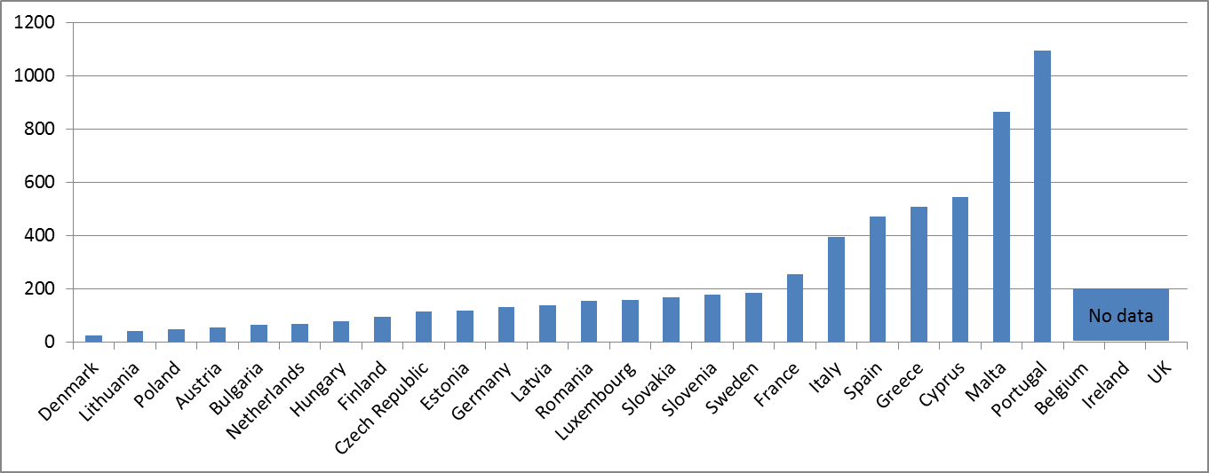
* Non-criminal cases include civil and commercial cases, enforcement cases, land registry cases, business registry cases and administrative law cases.
Figure 2: Time needed to resolve litigious civil and commercial cases* (in days) (source: CEPEJ study)
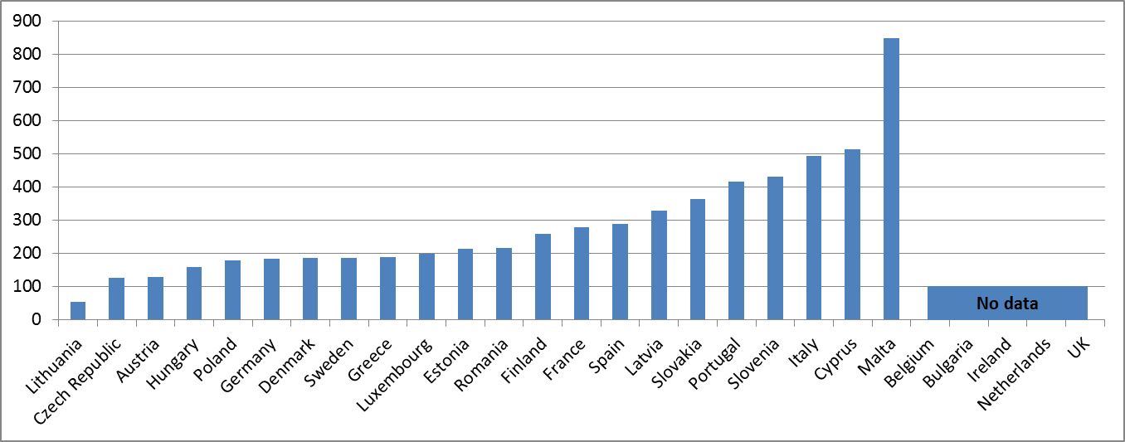
Litigious civil (and commercial) cases concern disputes between parties, for example disputes regarding contracts and the insolvency proceedings. By contrast, non-litigious civil (and commercial) cases concern uncontested proceedings, for example, uncontested payment orders.
Figure 3: Time needed to resolve administrative cases* (in days) (source: CEPEJ study)
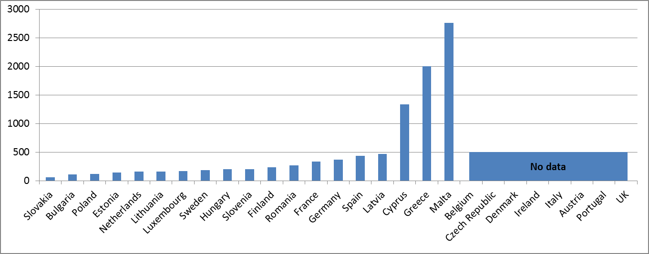
* Administrative law cases concern disputes between citizens and local, regional or national authorities. Administrative law cases are addressed by special administrative courts in some countries, and handled by civil courts in others.
Figure 4: Time needed to resolve insolvency* (in years) (source: CEPEJ study/World Bank: Doing Business)
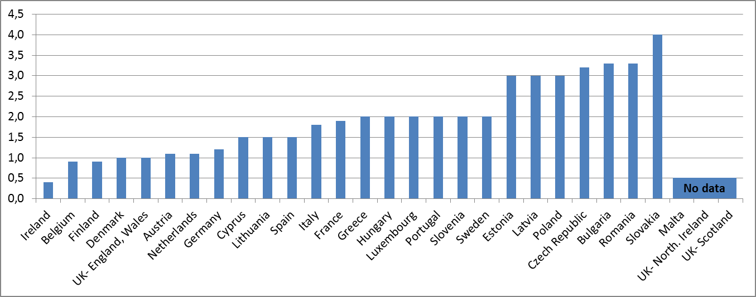
* Time for creditors to recover their credit. The period of time is from the company’s default until the payment of some or all of the money owed to the bank. Potential delay tactics by the parties, such as the filing of dilatory appeals or requests for extension, are taken into consideration. The data are collected from questionnaire responses by local insolvency practitioners and verified through a study of laws and regulations as well as public information on bankruptcy systems.
- The above figures show important disparities in the length of proceedings: at least one third of Member States have a length of proceedings at least two times higher than the majority of Member States.
The length of proceedings is linked to the rate at which the courts can resolve cases, the 'clearance rate', and to the number of cases that are still waiting to be resolved (pending cases). When the clearance rate is about 100% or higher it means the judicial systems is able to resolve at least as many cases as come in. When the clearance rate is below 100%, it means that the courts are resolving fewer cases than the number of incoming cases, and as a result, at the end of the year, the number of unresolved cases adds up as pending cases. If this situation persists over several years, this could be indicative of a more systemic problem as backlogs build up which further aggravate the workload of courts, and which cause the length of proceedings to rise further.
Figure 5: Rate of resolving non-criminal cases (in % - values higher than 100% indicate that more cases are resolved than come in, while values below 100% indicate that fewer cases are resolved than come in) (source: CEPEJ study)
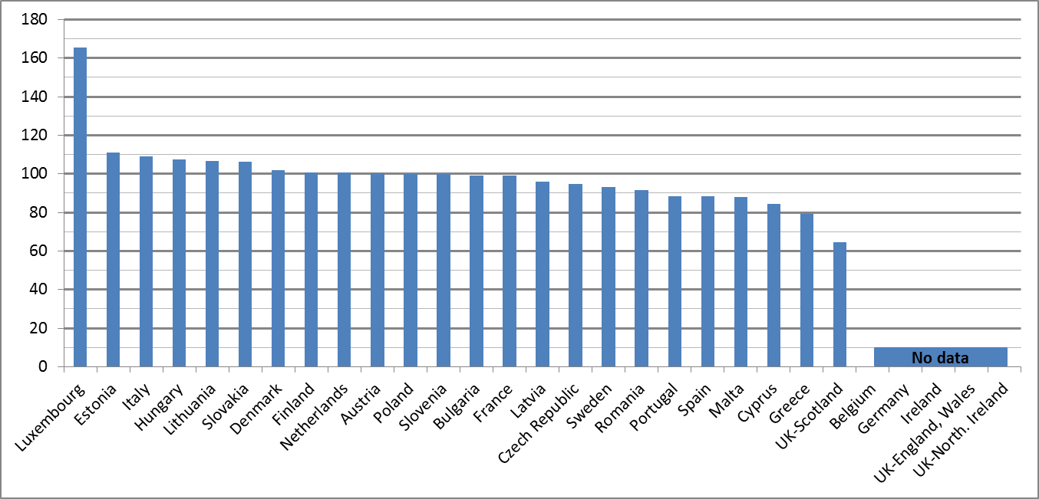
Figure 6: Rate of resolving litigious civil and commercial cases (in %) (source: CEPEJ study)
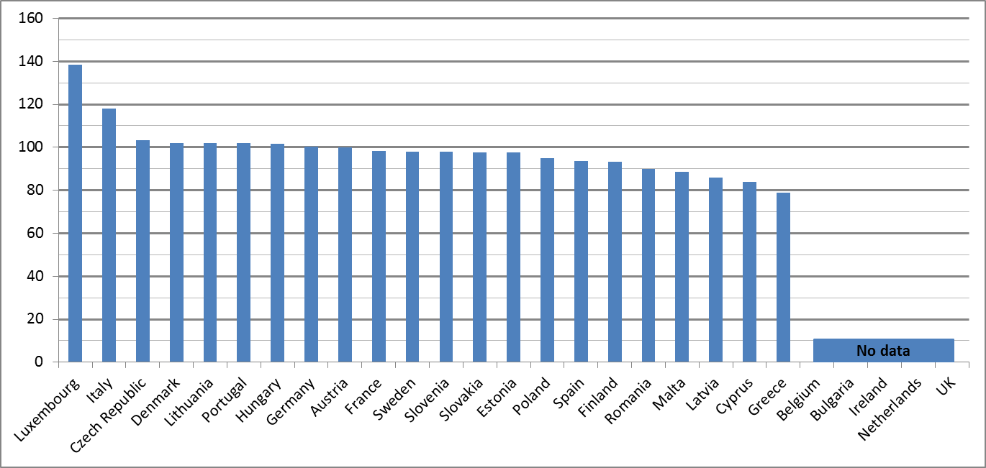
Figure 7: Rate of resolving administrative cases (in %) (source: CEPEJ study)
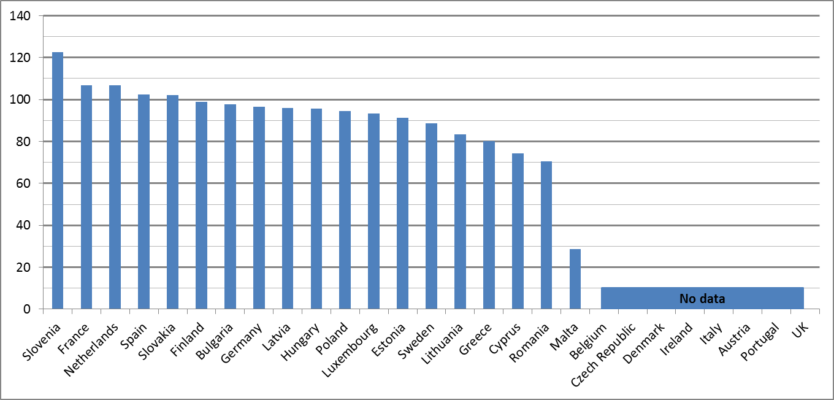
- The above figures indicate that some Member States may experience difficulties in their capacity to resolve particular categories of cases.
Figures 8-10 below show the number of pending cases at the start of the reference year (1 January 2010). These pending cases are the result of the courts' performance of the previous year. For this reason, low rates of resolving cases in the course of 2010, as shown in figures 5-7 above, are not yet reflected in figures 8-10 below on the number of pending cases. An increase of the number of pending cases at the end of the year will be reported in future exercises.

Figure 8: Number of non-criminal pending cases (per 100 inhabitants) (source: CEPEJ study)
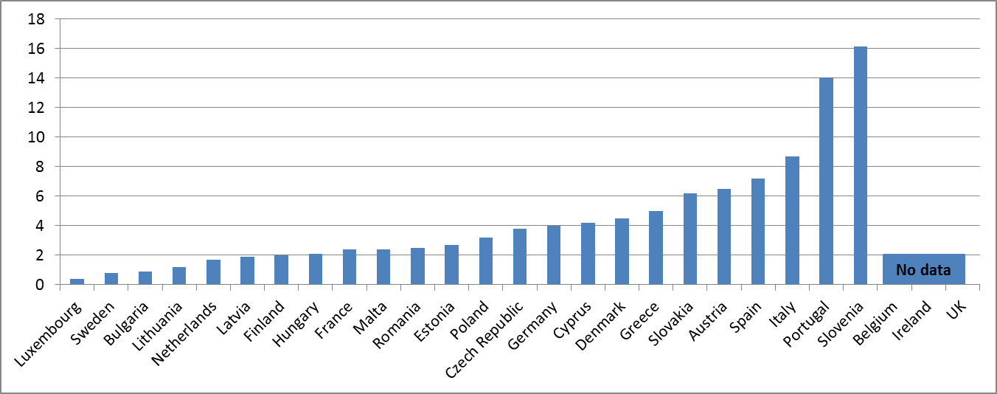
Figure 9: Number of litigious civil and commercial pending cases (per 100 inhabitants) (source: CEPEJ study)
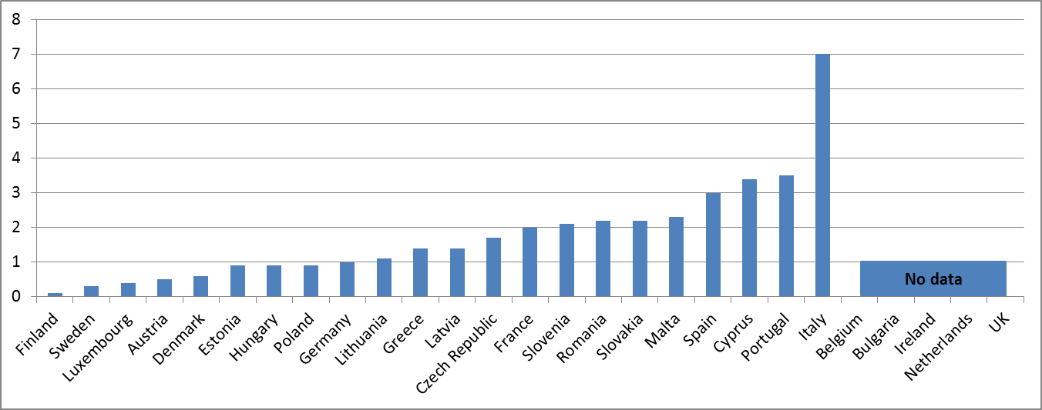
Figure 10: Number of administrative pending cases (per 100 inhabitants) (source: CEPEJ study)
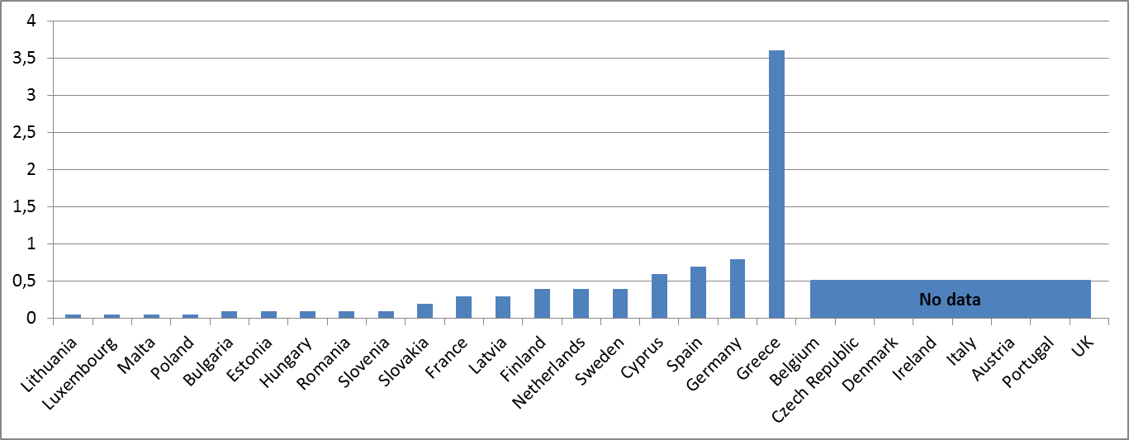
- The above figures show that several Member States have a particularly high number of pending cases.
In conclusion, it appears that:
- Certain Member States combine unfavourable factors: lengthy first instance proceedings together with low clearance rates and/or a large number of pending cases. Such situations merit special attention and a thorough analysis as they could be indicative of more systemic shortcomings for which remedial action should be taken.
- The reduction of the excessive length of proceedings should be a priority in order to improve the business environment and attractiveness for investment.

Monitoring and evaluation helps to shorten the length of proceedings and to increase the quality of justice
The absence of reliable monitoring and evaluation can make improving the functioning of a justice system more difficult. Lack of quality of justice decision can increase risks in doing business for large companies and SMEs and affects consumer choices. It can result in rushed or less predictable decisions, incomprehensible procedures or inaccessible justice. An effective time management of court cases requires that the courts, the judiciary and all justice end-users can be informed on the functioning of courts through a regular monitoring system. The definition of quality policies and the evaluation of the activities of courts are tools to increase the quality of justice in order to improve access to justice, trust, predictability and the timeliness of justice decisions.
Figure 11: Availability of monitoring of courts' activities (source: CEPEJ study)
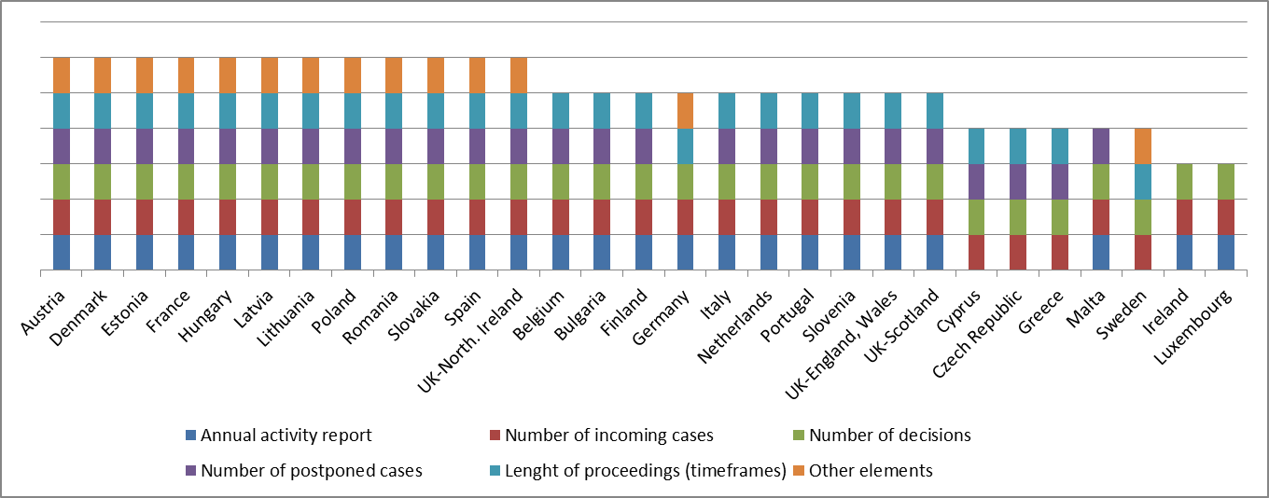
Figure 12: Availability of evaluation of courts' activities (source: 2012 CEPEJ Report)
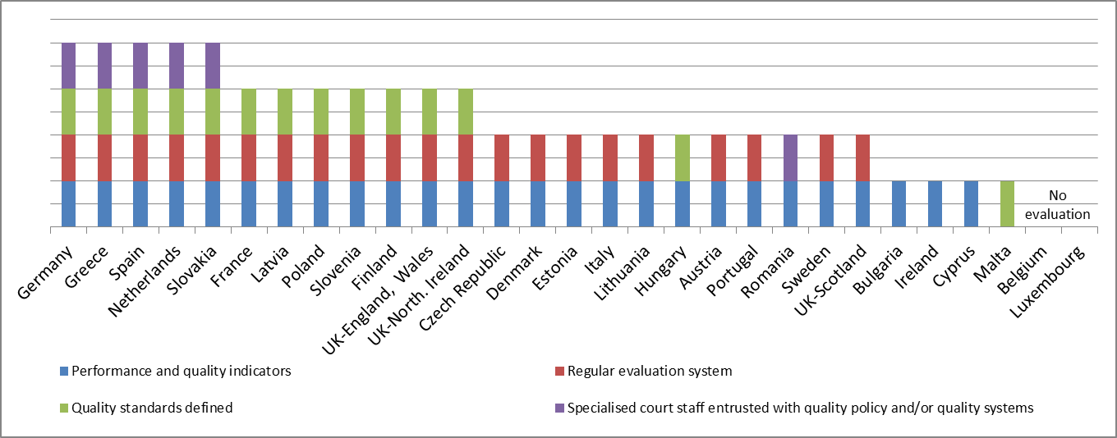

The above figures show
- that a large majority of Member States has a comprehensive monitoring system, but several Member States are lagging behind or do not make the data available;
- that several Member States do not perform regular evaluations of court activities and that quality standards are not defined in more than half of the Member States.

Information and Communication Technology systems help to reduce the length of proceedings and to facilitate access to justice
ICT systems for the registration and management of cases are indispensable tools at the disposal of courts for an effective time management of cases, as they help to improve the rate at which the court can treat cases and thereby to reduce the overall length of proceedings.
Figure 13: ICT Systems for the registration and management of cases (weighted indicator - min=0, max=4) (source: CEPEJ study)
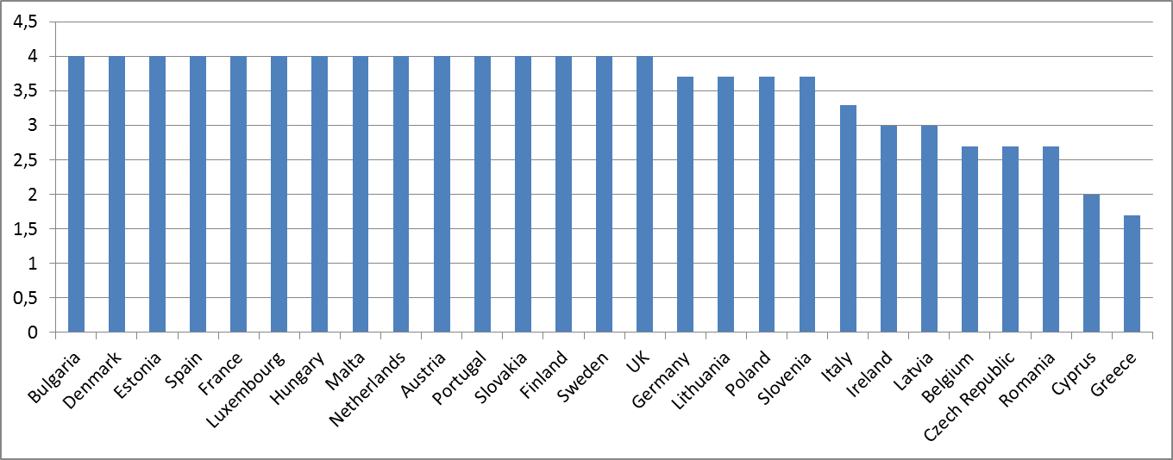
- The above figure shows that a large majority of Member states have a well-developed system for the registration and management of cases; however in several Member States developments are lagging behind.
ICT systems for communication between courts and parties (e.g. electronic submission of claims) can contribute to reduce delays and costs for citizens and businesses by facilitating the access to justice. The ICT systems also play an increasing role in cross-border cooperation between judicial authorities and thereby facilitate the implementation of EU legislation.
Figure 14: Electronic communication between courts and parties (weighted indicator -min=0, max=4) (source: CEPEJ study)
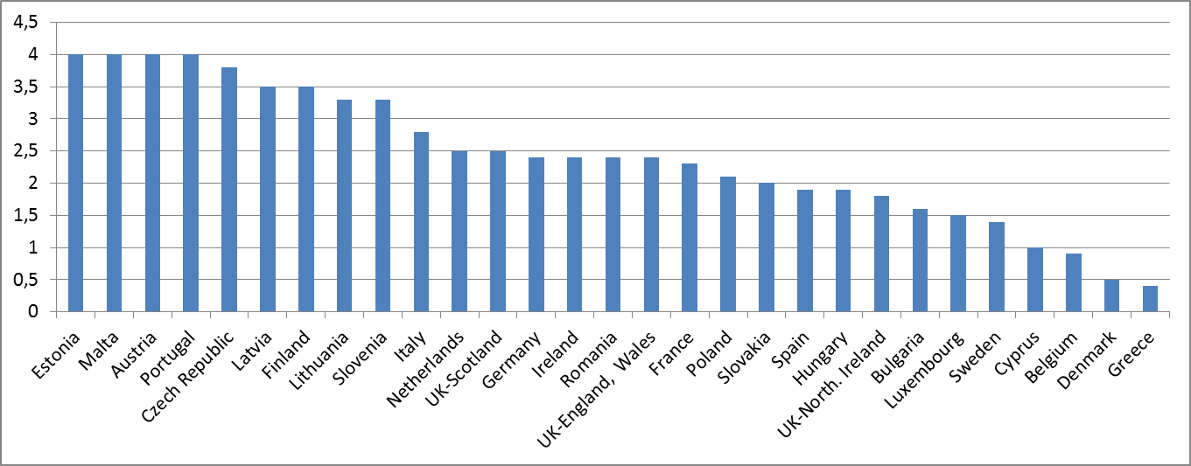
Figure 15: Electronic processing of small claims* (0 = available in 0% of courts; 4 = available in 100% of courts) (source: CEPEJ study)
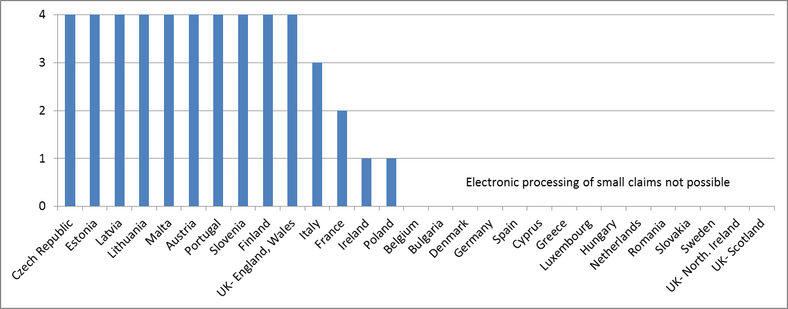
* The notion of “small claims” indicates a civil case where the monetary value of the claim is relatively low (the value varies among the Member States).
Figure 16: Electronic processing of undisputed debt recovery (0 = available in 0% of courts; 4 = available in 100% of courts) (source: CEPEJ study)
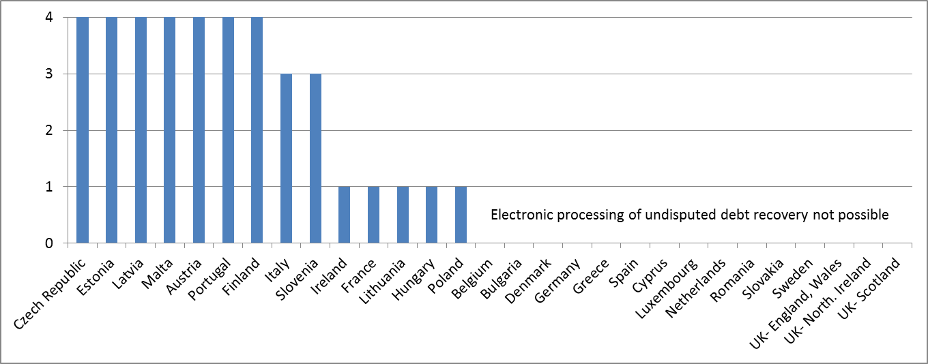
Figure 17: Electronic submission of claims (0 = available in 0% of courts; 4 = available in 100% of courts) (source: CEPEJ study)
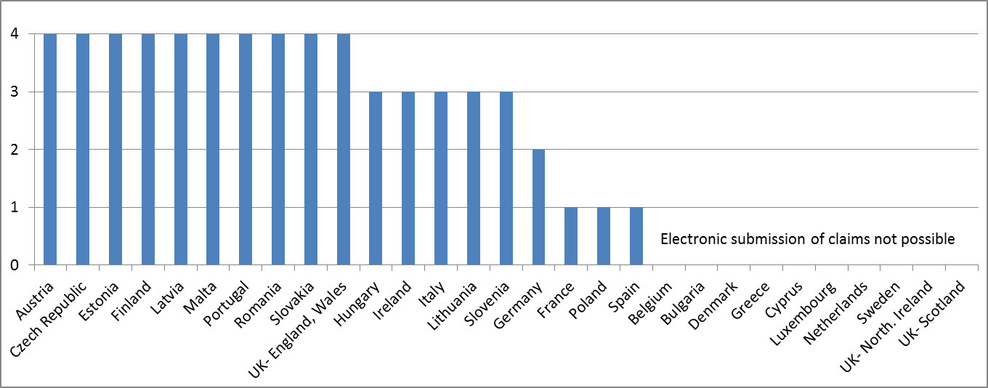
- The above figures show large disparities between Member States in the development of ICT systems for information exchange between courts and the parties.

Alternative Dispute Resolution methods help to reduce the workload of courts
Effective mediation and other alternative dispute resolution (ADR) methods provide an early settlement between parties on voluntary basis, reduce the number of pending cases and can thus have an important positive impact on the workload of courts, which are then more able to keep reasonable timeframes. High quality ADR methods can be a credible alternative to the traditional judicial procedures and can contribute to a culture of peaceful resolution of disputes.
Figure 18: Availability of alternative dispute resolution methods (source: CEPEJ study)
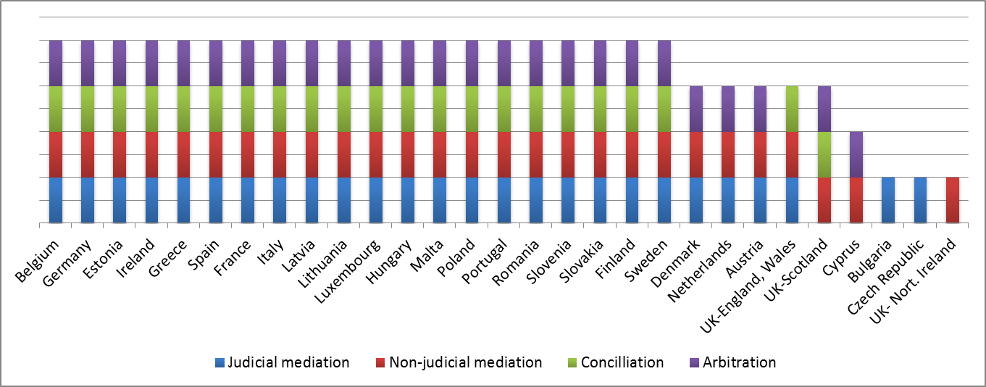
- The above figure shows that in nearly all Member States ADR methods are available, but evidence on their usage in commercial disputes is often not accessible.
- Member States should encourage the availability and quality of mediation and other ADR methods.

Promoting the training of judges can help to improve the effectiveness of justice
Training policies can be part of the quality standards for the judiciary. Initial and continous training is important for maintaining or increasing the knowledge and the skills of justice personnel. Training is particularly important considering the continuous development of national and EU legislation, the increased pressure to meet the expectations of end-users and the trend towards the professional management within the judiciary. Although voluntary training for judges is a normal practice in certain Member States, the compulsory training for judges indicates commitment to promote up-to-date knowledge and skills for judges.
Figure 19: Compulsory training for judges (source: 2012 CEPEJ Report)
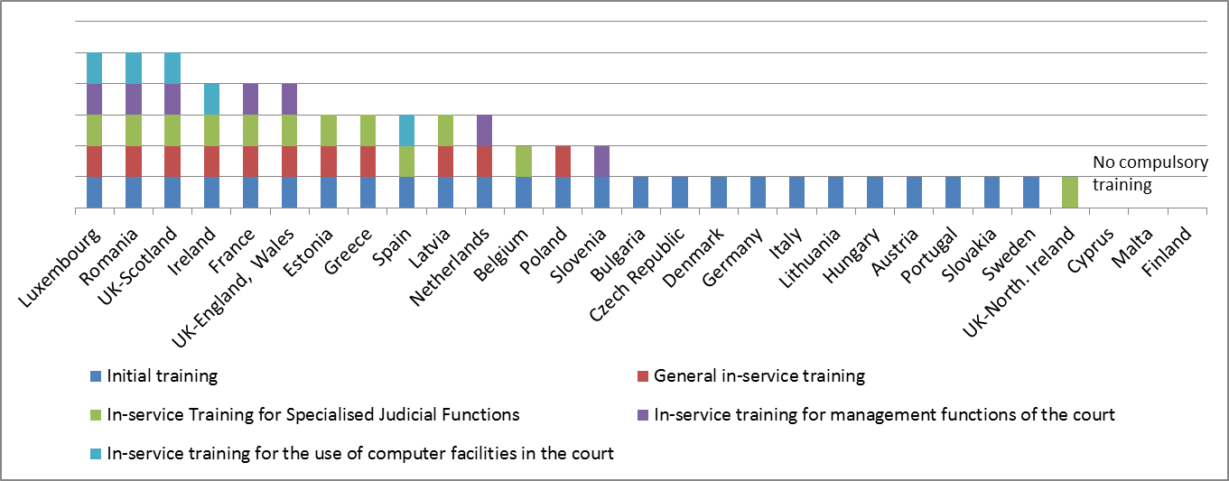
- The above figure shows that policies on compulsory continuous training for judges are very diverse among the Member States.

Resources
To ensure the quality, independence and efficiency of a national justice system, adequate financial and human resources are needed, taking into account the different legal traditions. In this context, the data may also be influenced by the adversarial or the inquisitorial nature of a justice system. Investing in a well organised justice system can make an important contribution to sustainable growth.
Figure 20: Budget for courts* (in EUR per inhabitant) (source: CEPEJ study)
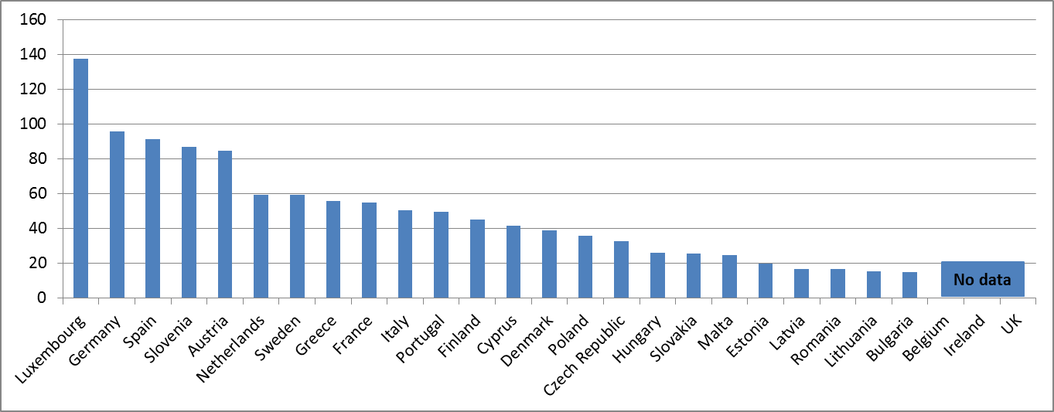
* The annual approved (not the actually executed) public budget allocated to functioning of all courts (civil, commercial and criminal courts, without the public prosecution services and without legal aid), whatever the source of this budget. For the EU Member States whose total annual approved budget allocated to all courts cannot be separated from the figures for the public prosecution department (BE, DE, ES, EL, FR, LU, AT), the chart reflects the total figure (for BE, ES and AT the figure also includes the legal aid). Where appropriate, the annual approved budget allocated to the functioning of all courts includes the budget both at national level and at the level of regional or federal entities.
Figure 21: Number of judges* (per 100.000 inhabitants) (source: CEPEJ study)
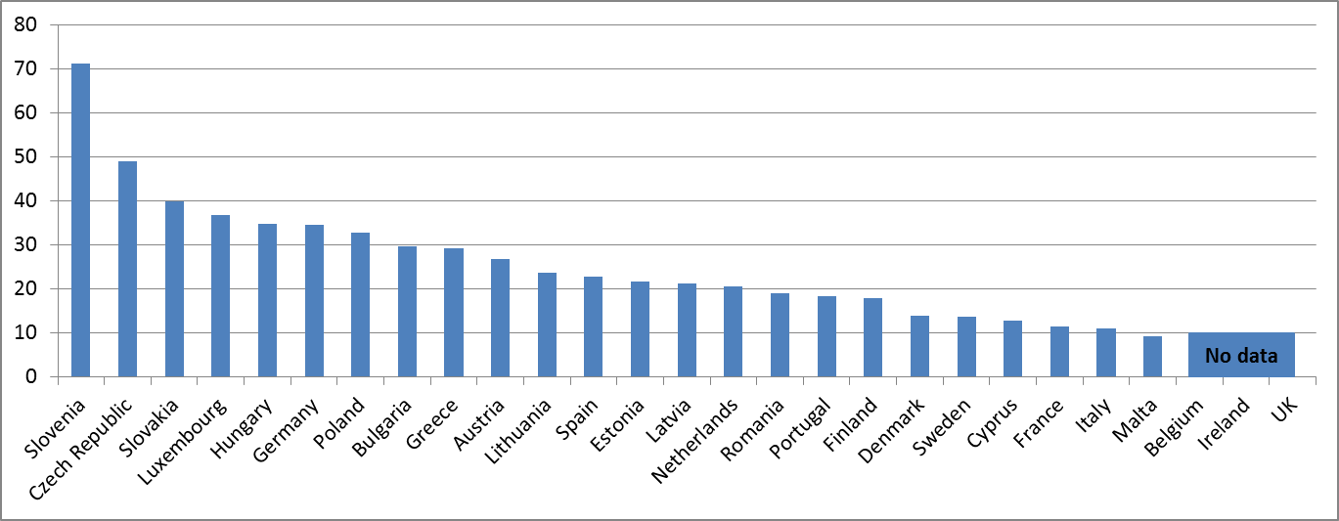
* The category consists of judges working full time plus, where applicable, the so-called Rechtspfleger/court clerks, who have the authority to deliver decisions and/or judgements on their own.
Figure 22: Number of lawyers* (per 100.000 inhabitants) (source: CEPEJ study)
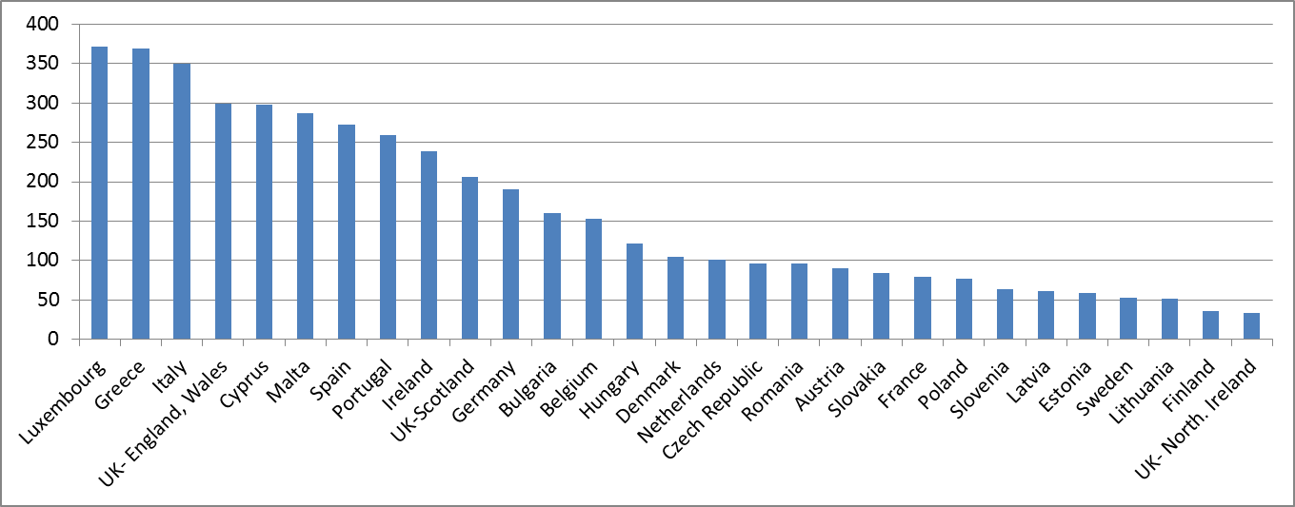
* Lawyer is a person qualified and authorised according to national law to plead and act on behalf of his or her clients, to engage in the practice of law, to appear before the courts or advise and represent his or her clients in legal matters (Recommendation Rec(2000)21 of the Committee of Ministers of the Council of Europe on the freedom of exercise of the profession of lawyer).
- The above figures show different approaches regarding the financial and human resources in justice systems, including among the Member States with similar lengths of proceedings.

Disparity in the perception of independence
The perceived independence of the judiciary is also a growth enhancing factor. As the independence of the judiciary assures the predictability, certainty, fairness and stability of the legal system in which businesses operate, a perceived lack of independence can deter investments. As a general rule, justice must not only be done, it must be seen to be done. The independence of the judiciary is also a requirement stemming from the right to an effective remedy enshrined in the Charter of Fundamental Rights of the EU.
Figure 23: Judicial independence (perception – higher value means better perception)
(source: World Economic Forum)
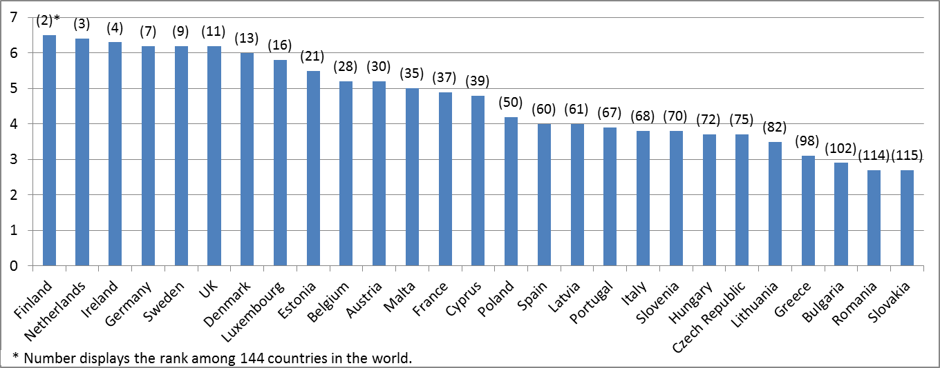
Figure 24: Independence of civil justice (perception – higher value means better perception)
(source: World Justice Project)
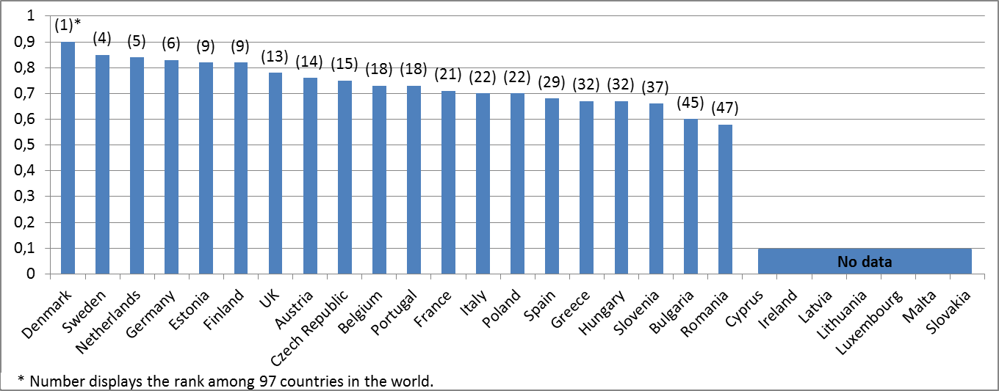
- Even though several Member states are among the top 10 worldwide leaders in terms of the perception of judicial independence, the above figures show a rather low level of perception of judicial independence by business end-users of the justice system in certain Member States. These findings merit special attention and a more detailed assessment into why a lack of trust exists for certain Member States.

Follow-up to the findings of the 2013 Scoreboard

Follow-up in the context of the judicial reforms in the Member States
The key findings of the 2013 Scoreboard highlight the priority areas that need to be addressed. The Commission will translate these priorities into the following actions:
- The issues identified in the Scoreboard will be taken into account in preparing the forthcoming country specific analysis of the 2013 European Semester. They will also guide the work in the context of the Economic Adjustments Programmes.
- The Commission has proposed that Regional Development and Social Funds will be available for reforms of the judicial systems in the next multi-annual financial framework.

Addressing the data gap
The experience with the 2013 Scoreboard reveals the difficulty of gathering reliable and comparable data. The comparability of data is a challenge as the national justice system and procedures vary significantly and some Member States do not use standard definitions for monitoring data.
Despite the good EU average for the existence of monitoring systems, some Member States do not collect data in a way which allows for an objective evaluation and comparison with other Member States. In addition to the difficulty to obtain comparable data, some data are missing for nearly all Member States on issues such as the costs of proceedings, interim measures, mediation cases, and the enforcement procedures.
In view of the importance of well functioning national justice systems in achieving the objectives of the Union, all Member States should address, as a priority, the collection of impartial, reliable, objective and comparable data and make it available in support to this exercise. There is a mutual interest for Member States and national judiciaries to develop the collection of such data to better define justice policies.
In this respect, the role of the CEPEJ is particularly relevant and the Commission underlines the importance for all Member States to cooperate fully with the CEPEJ in the provision of data.
The Commission will also examine ways to improve data collection, in particular it intends to:
- use targeted field studies on how the justice systems function in practice when applying selected growth-related EU legislation and Eurobarometer qualitative surveys for collecting views of legal practitioners and various end-users;
- examine with the networks of judges and judicial authorities how the quality and availability of comparable data could be improved at national level, including as regards the structural independence of the judiciary;
- explore with Eurostat how to improve the collection of comparable data for the most significant indicators.

Further steps
The quality, independence and efficiency of justice systems are important structural components of sustainable growth and social stability in all Member States and are fundamental to the effective implementation of EU law. On the basis of this Scoreboard, the Commission invites the Member States, the European Parliament, and all stakeholders to an open dialogue and constructive collaboration towards the continued improvement of the national justice systems in the EU in the context of the European Semester, of Europe's growth strategy 'Europe 2020', the strengthening of the Single Market and the EU's Citizens' Agenda.
Looking further ahead, the Commission plans to launch a wider debate on the role of Justice in the EU and will organise, on 21 and 22 November 2013, the Assises de la justice, a high level conference, which will bring together senior policy makers at European and national level, judges from supreme courts and other courts, judicial authorities, legal professions and all stakeholders. Such a joint reflection is indispensable for developing a true European area of justice that would meet citizens' expectations and contribute to sustainable growth on the basis of the rule of law and other values upon which the Union is founded.

EL, IE, LV, PT.
Communication from the Commission, Annual Growth Survey 2013, COM(2012) 750 final.
BG, IT, LV, PL, SI, SK.
E.g. Council Regulation (EC) No 1/2003 of 16 December 2002 on the implementation of the rules on competition laid down in Articles 81 and 82 of the Treaty (OJ L 1, 4.1.2003, p. 1–25).
E.g. Directive 2000/31/EC on electronic commerce (OJ L 178, 17.7.2000, p. 1–16).
E.g. Framework Directive 2002/21/EC on electronic communications networks and services (OJ L 108, 24.4.2002, p. 33–50).
E.g. Directive 2004/48/EC on the enforcement of intellectual property rights (OJ L 157, 30.4.2004, p. 45–86).
E.g. Directive 2007/66/EC with regard to improving the effectiveness of review procedures concerning the award of public contracts (OJ L 335, 20.12.2007, p. 31–46).
The role of national courts is highlighted in the Communication from the Commission, Implementing European Community Environmental Law, COM (2008) 773 final.
E.g. Directive 2011/83/EU on consumer rights (OJ L 304, 22.11.2011, p. 64–88).
COM(2012) 750 final.
Where national data are not available, this is mentioned in the relevant figures.
Many Member States are in the process of implementing measures for improving the functioning of their justice systems. In 12 Member States these reforms are developed in the context of EU initiatives and instruments (Economic Adjustment Programmes, Country Specific Recommendations within the European Semester and the Cooperation and Verification Mechanism).
The full study on the functioning of judicial systems and the functioning of the economy in the EU Member States, prepared in 2012 by the CEPEJ for the European Commission, is available on the website of DG Justice http://ec.europa.eu/justice/index_en.htm
These are standard indicators defined by CEPEJ. Their definition and interrelation is available at http://www.coe.int/t/dghl/cooperation/cepej/evaluation/default_en.asp
The WEF indicator is based on survey answers to the question: "To what extent is the judiciary in your country independent from the influences of members of government, citizens, or firms?" The survey was replied to, depending on the country, between 2010 and 2011 by a representative sample of firms in all countries representing the main sectors of the economy (agriculture, manufacturing industry, non-manufacturing industry, and services). The administration of the survey took different formats, including face-to-face interviews with business executives, telephone interviews and mailings, with an online survey as an alternative. Available at: http://reports.weforum.org/global-competitiveness-report-2012-2013/
The WJP Civil justice sub-indicator indicates perceptions on whether the civil justice is free of improper government influence. It is based on replies from: (1) a general population poll conducted by leading local polling companies using a representative sample of 1,000 respondents in the three largest cities in each country (depending on the country data were collected in 2009, 2011 or 2012); and (2) qualified respondents' questionnaires consisting of closed-ended questions completed by in-country practitioners and academics with expertise in civil law (data were collected in 2012). Data are available under indicator 7.4 at: http://worldjusticeproject.org/sites/default/files/WJP_Index_Report_2012.pdf
E.g. C-506/04, Wilson, [2006] I-8613.
E.g. Cooper v. The UK [GC], no. 48843/99, ECHR 2003-XII; Campbell and Fell v. The UK, nos. 7819/77 and 7878/77, 28 June 1984, Series A no. 80.
Study on the functioning of judicial systems and the functioning of the economy in the EU Member States, prepared in 2012 by the CEPEJ for the European Commission. http://ec.europa.eu/justice/index_en.htm
Considering the figures 1, 2 and 3 together.
Indicators in figures 11 to 22 cover all courts.
Figures 13 and 14 show composite indicators constructed from several ICT indicators that each measures availability of these systems from 0 to 4 (0= available in 0% of courts; 4=available in 100% of courts).
The three Member States on the right side at the end of the chart do not have compulsory training for judges.
The survey was replied by a representative sample of firms in all countries representing the main sectors of the economy (agriculture, manufacturing industry, non-manufacturing industry, and services).
In particular the Legal Affairs Committee (JURI), the Civil Liberties, Justice and Home Affairs Committee (LIBE) and the Economic and Monetary Affairs Committee (ECON).

