COMMISSION STAFF WORKING DOCUMENT
IMPACT ASSESSMENT
Accompanying the document
Proposal for a
REGULATION OF THE EUROPEAN PARLIAMENT AND OF THE COUNCIL
on the modernisation of trade defence instruments
1. Introduction 3
1.1. Trade defence 3
1.2. The EU's trade defence instruments 3
1.3. Evolution of EU's Trade Defence Instruments 5
2. Procedural issues and consultation of interested parties 5
2.1. Evaluation study 6
2.2. Consultations with stakeholders and member states 6
2.3. The Impact Assessment Steering Group 7
2.4. The Impact Assessment Board 7
3. Problem definition 7
3.1. Efficiency 7
3.2. Effectiveness 13
3.3. Subsidiarity principle 233
4. Objectives 233
4.1. General objectives 233
4.2. Specific Objectives 244
4.3. Operational objectives 244
5. Policy Options 26
5.1. Identifying the policy options 26
5.2. Description of the policy options 266
6. Analysis of impact 300
6.2. Impacts of Policy Option 1 – no change 322
6.3. Impact of the individual proposals under policy Option 2 355
6.4. Impact of Policy Option 3 400
7. Comparing the options 411
8. Monitoring and Evaluation 422

ANNEX 1: Statistics 444
ANNEX 2: Flow chart 511
ANNEX 3: Omnibus 522
ANNEX 4: Evaluation study 544
ANNEX 5: Summary report public consultation 76
ANNEX 6: minutes IASG meeting 11818
ANNEX 7: codification 1211

1.
Introduction

1.1. Trade defence
The EU's commitment to the liberalisation of international trade depends on a level playing field between domestic and foreign producers based on genuine competitive advantages. The European Commission's role in achieving open and fair trade includes the defence of European production against international trade distortions such as subsidisation or dumping, by applying trade defence instruments ('TDI') in compliance with EU law and WTO rules.
The EU trade defence system operates under the WTO legal framework. WTO rules allow importing countries to protect their industries against dumped or subsidised imports, provided that certain well-defined conditions are met. Article VI of GATT 1994 and the WTO Anti-Dumping (ADA) and Anti-Subsidy Agreements (ASCM) give WTO Members the possibility to adopt trade defence measures. All major WTO Members including the EU use trade defence instruments.
The WTO sets mandatory minimum standards for the application of TDIs which must be respected in all cases. TD measures can only be imposed if the relevant investigation concludes that imported products are dumped in the importing country or benefiting from a subsidy; and that these imports are causing material injury, or threaten to cause material injury, to the domestic industry of the importing country. Moreover, measures imposed must not exceed the level of the dumping or subsidy margin.

1.2. The EU's trade defence instruments
TDI only affect a small trade volume as compared to the EU's total trade activity, i.e. less than 0.5% in 2011. However, for a specific sector or industry concerned by an investigation, the impact can be significant in terms of its financial or employment situation (please refer to annex 1 for TDI statistics that illustrate the overall context of TDI).
TDIs consist of anti-dumping, anti-subsidy and safeguards. The first is the most frequently used trade defence instrument. It addresses imports into the EU of products from a non-EU country which are sold at prices lower than normal value, in circumstances where they are injuring competing EU producers. The anti-subsidy instrument deals with subsidised imports which likewise cause injury.
The anti-dumping and anti-subsidy instruments are very similar in terms of procedure. The EU industry affected by dumped or subsidised imports can lodge a complaint with the European Commission, providing evidence of the dumped or subsidized imports and of the injury they have caused. If the complaint contains sufficient evidence an investigation is opened (which lasts for around 15 months in case of dumping and 13 months in case of subsidisation); and in which all parties concerned (Union producers, exporters, importers, users of the product and consumer organisations) are invited to participate. If the investigation confirms the allegations in the complaint, an anti-dumping or anti-subsidy duty will be imposed. Measures remain in force normally for 5 years but they can be reviewed during this period. There is also a possibility to renew them for another five years if an expiry review confirms the need for such renewal.
The safeguard instrument is the third trade defence instrument. The criteria and procedure to impose safeguard measures are different from the anti-dumping and anti-subsidy instruments. Safeguard measures can be imposed as a result of a sudden surge of imports without the need to provide evidence of unfair practice. Measures can also be imposed much faster, i.e. provisional measures can be imposed at the same time as the initiation of an investigation and measures apply equally to all sources of the imports concerned. The safeguard instrument is thus the most restrictive instrument and the EU has only very rarely used it. Therefore, and because of the different nature of the instrument and the different procedure, as compared to anti-dumping and anti-subsidy, the safeguard instrument is not part of this exercise.
While the EU's trade defence system is constructed on the rules of the World Trade Organisation, the EU applies higher standards in the application of the TDI than those required by the WTO agreements. In order to balance the needs of European industry to receive relief from unfairly traded imports against the interests of user industries and of consumers, the EU has incorporated 'WTO+' features into its TDIs: in particular the "lesser duty rule" and the "Union interest test". None of the other WTO Members applies "WTO pluses" in such a comprehensive manner as the EU.
The lesser duty rule provides that a duty set at a lower level than the margin of dumping or subsidy is imposed in cases where such lower duty is sufficient to remove the injury to the Union industry. In practical terms, after the calculation of both, the dumping/subsidy margin and the injury margin, the two margins are compared and the lower margin is used as a basis for the level of duty to be applied.
Furthermore, antidumping and anti-subsidy measures may not be imposed if they conflict with the Union interest. The Union interest test ensures that the overall economic interests of the EU are considered before measures are imposed – taking into account the interests of the domestic industry producing the product concerned, importing companies, Union industries that use the imported product, and, where relevant the final consumers of the product concerned. In cases where the imposition of the duty would have a disproportionate negative effect on users and consumers of the product, as compared to the benefit that the Union industry would derive from the measures, the duties are not imposed, even though the existence of injurious dumping/subsidisation has been established.
These "WTO pluses" provide the necessary tools to assess the situation of the internal market and to ensure proportionality and balance in the application of the instruments. But they also lead to cases where the EU does not impose measures, in circumstances where the domestic industry in other jurisdictions would have obtained relief from dumped or subsidised imports.
Both the anti-dumping and the anti-subsidy instrument are based on rather long and technical proceedings, involving many different steps and complex procedures and calculations. The flow chart in annex 2 describes a typical anti-dumping investigation.

Even though the EU applies very high standards and its TD system serves as a benchmark for many other users of TDI, the practice over time has shown that certain improvements have become necessary, as explained in section three, in order to ensure its continued efficiency and effectiveness.

1.3. Evolution of EU's Trade Defence Instruments
The EU's trade defence policy started in 1968 when the Community signed the first GATT Anti-dumping Code. Until 1994, a single basic regulation included provisions on both anti-dumping and anti-subsidy. The current TDIs (in the form of separate anti-dumping, anti-subsidy and safeguard basic regulations) were enacted in December 1994 in the course of the implementation of the results of the Uruguay round on multilateral trade negotiations. This was the last major revision of the EU's trade defence instruments.
In 2006/2007, a reform exercise was launched in the form of a green paper. The green paper proposed – among many other issues – to enlarge the legal definition of a Union producer so as to include companies which have outsourced production outside the EU, but which have retained significant operations and employment in Europe (e.g. product design, distribution). It also proposed to strengthen the Union interest test by taking into account a broader set of interests, and by allowing measures to be fine-tuned downwards following the results of the Union interest test. The green paper process failed for a number of reasons. There was no convergence of views among stakeholders and it was impossible to find political support for the most controversial issues e.g. changing the definition of the Union industry and changing the scope of the Union interest test. The reason for this lack of support was that many stakeholders felt that the green paper proposal would only increase the gap between EU practice and that of other WTO members. Because of this deadlock other more practical issues could not be addressed either.
TDIs will be subject in the future to new decision-making rules once the 'Omnibus' regulation is adopted (please see annex 3). The on-going work on the adoption of the Omnibus regulation is a separate exercise from the present initiative and it cannot address any issues specifically related to the efficiency or effectiveness of the TDIs. However, the conclusion of the two will lead to a new and more modern system of rules, procedures and decision-making which can take these instruments forward for the coming decades.

2. Procedural issues and consultation of interested parties
The evidence that supports this initiative has been drawn from the Commission services' own extensive experience with the application of TDI and a number of other sources, including a comprehensive evaluation prepared by outside consultants, informal contacts with key stakeholders at the beginning of the process, a high level conference, and a public consultation.

2.1. Evaluation study
In 2010 an external consultant (BKP Development Research & Consulting GmbH) was commissioned to evaluate the EU's TDIs. The objectives of the study were mainly: to describe the current practice in the field of TDIs; to carry out an economic analysis of the arguments relating to trade defence instruments and their application in the international legal and economic context: and to assess the performance, methods, use and effectiveness of the current system in achieving its objectives. The evaluation was published in March 2012, and provided important input to the modernisation process (please refer to annex 4 for a summary of the evaluation study).

2.2. Consultations with stakeholders and member states
The initiative on the modernisation of TDIs was formally launched in October 2011. To complement the evaluation and to prepare the next steps, DG Trade also conducted preliminary informal consultations with experts in the use of TDIs in November 2011.
A public consultation on the modernisation of TDIs was then undertaken from 3 April to 3 July 2012. The online questionnaire was published in all EU languages on DG Trade's website, and DG Trade participated in a number of different meetings in order to publicize the consultation, to explain the initiative in greater detail, and to clarify the process. From April to June DG Trade participated in around 20 meetings and conferences organized by business associations grouping all the main stakeholders of the EU's trade defence system.
On 10 May 2012 DG Trade organised a conference on the modernisation of TDIs. The purpose of the conference was to present and discuss the modernisation process and the evaluation of the EU's TDIs. Around 200 stakeholders participated and a number of them provided preliminary feedback on the ideas identified in the public consultation.
By the closing date DG Trade had received a total of 310 replies to the online questionnaire. A wide variety of stakeholders participated in the survey, e.g. business associations at European and national levels, European industry, importers, governmental authorities, etc. The views expressed on the various issues addressed in the public consultation were often divergent between Union producers and importers; i.e. issues supported by Union producers were rejected by importers and vice versa. The largest number of responses -- more than two thirds – was received from Union producers and associations representing Union producers, which shows how important and sensitive the subject is for them (for more detailed information on the public consultation results see annex 5). Nevertheless, the replies received from importers' associations represent a very high number of importing companies.
Since the beginning of the process, member states have been kept informed regularly via different interventions in the Council working party on trade questions and the Trade Policy Committee. DG Trade has also participated in different conferences organised by the member states in order to present the initiative to national stakeholders (e.g. Portugal, U.K., France and Germany).

2.3. The Impact Assessment Steering Group
In order to prepare the public consultation and to draft the impact assessment for the initiative, an impact assessment steering group (IASG) was set up by DG Trade in February 2012. All relevant services were invited to participate, and representatives from 11 Directorates General regularly participated in the meetings. The IASG met 4 times and discussed all parts of this impact assessment. The minutes of the last meeting of the IASG are attached to the IA as annex 6. The IA was submitted to the impact assessment board (IAB) on 7 November.

2.4. The Impact Assessment Board
The impact assessment was presented to the board on 5 December 2012. Its comments and recommendations for improvements of the report have been incorporated in this revised text.
In particular, the introduction has been modified in order to better explain the functioning of the trade defence instruments and the specific features of the EU system as compared to the WTO minimum requirements. The problem definition has been streamlined and the impact analysis was refocused in order to first analyse the impact of individual measures before analysing a package option. For illustration several annexes have been added.

3. Problem definition

The problems and the underlying drivers
In its day to day use of the instruments, Commission services have encountered and identified various areas in the current TDI system that call for improvement in order to increase efficiency and effectiveness of the instruments. The evaluation study and stakeholder consultation indicated that a further improvement of the system is desirable in order to cope with the changing trading environment. The following sections highlight the main problems, as well as their specific underlying drivers.

3.1. Efficiency

3.1.1. Suboptimal transparency regarding investigation procedures before provisional measures
Suboptimal transparency at certain steps of a TDI proceeding negatively impacts on efficiency. However, one of the major challenges is to find the right degree of transparency in order to allow for a more efficient investigation but without divulging confidential information.
Currently, importers and exporting producers in the third country(ies) concerned do not have access to the confidential file of the investigation and thus they cannot check the calculations made by the Commission services. They do not receive a disclosure about the investigation prior to the Commission's decision whether or not to impose provisional anti-dumping or anti-subsidy duties. This can in certain cases lead to errors that can have an impact on the level of the provisional duty.
In the public consultation 42% of stakeholders identified a need for advance notice and limited pre-disclosure in order to remedy the information void prior to provisional measures.

3.1.2. Suboptimal transparency about the work of the Anti-dumping/ Anti-subsidy Advisory Committee

The Anti-dumping/Anti-subsidy Advisory Committee (ADC/ASC) established under the basic regulations consists of representatives of each of the Member States and meets roughly every 4 to 6 weeks. At present, stakeholders do not receive any information about proposed measures before the meeting of the ADC/ASC. This is especially a concern in relation to provisional measures. If provisional measures are adopted by the Commission after consultation of the ADC/ASC, they become effective immediately – which creates particular difficulties for shipments already in transit at the time of imposition. In practical terms, the costs of a product could sometimes increase significantly as a result of the imposition of duties. A shipment may have left an overseas port before the imposition of a TD duty, but may reach a port in the Union only after the date the duty entered into force and will thus have to pay the duty. Likewise, and also in order to reduce lengthy and unnecessary uncertainty, interested parties would like to receive prior information in cases where provisional measures are not imposed.

In this context, mechanisms for communication and dissemination of information also play a role in TDIs, and have led to certain inequalities in the system: for example, associations and companies that are represented by specialised lawyers, or that have signed up to certain information networks, often have access to information much faster than other companies which do not avail themselves of such possibilities. This imbalance can lead to clear advantages for those who are aware about whether or not provisional measures will be imposed and at what level, and who can thus take their business decisions accordingly; while others, less well informed, cannot.

3.1.3. Suboptimal transparency with regard to the Commission services' procedures for choosing analogue countries
The need for improved transparency is also evident in investigations where the exporting country is considered to be either a non-market economy or an economy in transition. In such cases information from an analogue country is normally used to establish normal value. The choice of analogue country can be difficult and controversial since it can have a direct effect on the level of the final duty imposed.
Currently, it seems that insufficient information is made public by the Commission services about the methods used for choosing analogue countries, and about possible cost adjustments required for the determination of normal value taken from an analogue country. This can lead to additional requests from parties for explanations which is time consuming and impacts negatively on the efficiency of the proceedings.

3.1.4. Suboptimal transparency regarding the determination of "target profit" levels for use in injury margin calculations
The determination of the Union industry's target profit (for the purposes of the determination of the injury margin and the application of the lesser-duty-rule) is a contentious issue. Problems have arisen because of doubts about the adequacy of the information that is currently disclosed in relation to "target profit" levels and the calculation of injury margins.
As a result, some stakeholders allege that the calculation of the profit margin was in certain specific cases subjective, and resulted in unjustifiably high levels of injury margins. By contrast, some EU producer associations claim that they do not understand why in certain cases a profit margin has been selected that is not in line with typical margins for the industrial sector in question. In their view this could result in an ineffective level of measures being imposed. The injury margin calculation is of particular importance since the EU TDI system has the lesser duty rule as an obligatory feature (a WTO+ element, please see point 1.2 above).
The evaluation study showed that in the period 2005 to 2010 (the evaluation period) the lesser duty rule had led in 26 out of 47 AD cases to duties based on the injury margin. The average reduction of the duty due to the injury margin being lower than the dumping margin was about 9,3 percentage points or 28% over the period.
Table 1: Effect of the lesser duty rule on the duty level
 | 2005 – | 2010
HS chapter and description | Ave. def. dumping margin | Ave. def. duty
20 Vegetable, fruit, nut, etc. food preparations | 9,05 | 7,95
28 Inorganic chemicals, precious metal compound, isotope | 35,32 | 22,76
29 Organic chemicals | 29,49 | 21,89
39 Plastics and articles thereof | 12,75 | 12,75
41 Raw hides and skins (other than fur-skins) and leather | 69,80 | 58,90
44 Wood and articles of wood, wood charcoal | 25,18 | 25,18
54 Manmade filaments | 7,10 | 7,10
64 Footwear, gaiters and the like, parts thereof | 39,90 | 9,85
72 Iron and steel | 30,36 | 20,12
73 Articles of iron and steel | 45,46 | 36,53
76 Aluminium and articles thereof | 33,21 | 17,86
81 Other base metals, cermets, articles thereof | 64,62 | 29,30
83 Miscellaneous articles of base metal | 27,10 | 27,10
84 Nuclear reactors, boilers, machinery, etc. | 41,84 | 41,84
85 Electrical, electronic equipment | 47,33 | 27,84
87 Vehicles other than railway, tramway | 32,57 | 16,87
90 Optical, photo, technical, medical, etc. apparatus | 38,80 | 34,00
95 Toys, games, sports requisites | 5,80 | 5,80
Total average | 33,63 | 24,30
Source: evaluation study, volume 1, section 2.3.2.1

Regarding AS cases, the impact of the lesser duty rule has not been significant in past investigations, since in many cases the subsidy margins have been lower than the injury margins. However, recent cases have shown that subsidy programs result in greater distortions and higher subsidy margins, e.g.:
Investigation | Subsidy margin | Injury margin
PET, Iran | 51,8% | 16,7%
Graphite electrode systems, India | 14,9% | 7,0%

3.1.5. Suboptimal transparency regarding the Union interest analysis
The Union interest test (UIT) is an important feature of the EU's TDI system (see explanation under 1.2 above). There have been a number of cases in which the investigation showed that imposition of measures would be against the Union interest and accordingly, measures were not imposed (e.g. 3 CD-Rs cases, 3 DVD-Rs cases, or polyester staple fibres). In certain cases UIT considerations can also have an impact on the form of the measures, i.e. a minimum import price instead of an ad valorem duty (melamine case).
However, experience in investigations shows that the Commission’s practice during the Union interest analysis is not well understood, in particular, by less experienced stakeholders who have fewer contacts with the Commission’s TD services. This can lead to inefficiencies and frustrations in the proceedings and unnecessary delays.
Partly as a result of the alleged lack of clarity about the Commission’s procedures for conducting this analysis, some stakeholders claim that the UIT is subjective and does not weigh adequately the interests of the different stakeholder groups. (For other issues related to the UIT please refer to chapter 3.2.5. and 3.2.10 below).

3.1.6. Suboptimal transparency about how the Commission services conduct expiry reviews
Expiry reviews are investigations conducted at the end of the five year period of TD measures upon request of the industry, in order to examine whether measures should be renewed for another five years.
Expiry review investigations are more complex than the original investigations, which are exclusively based on data relating to a period in the past. In particular, they involve a so-called likelihood analysis, which is a reasoned and fact-based look into the future. The investigation has to analyse both: whether there has been continuation of dumping/subsidisation and injury; and whether the repeal of measures would be likely to result in a recurrence of dumping/subsidisation and injury (prospective analysis). The practice is thus highly technical, and sometimes stakeholders have doubts about how the likelihood analysis is conducted, as well as about precisely what information is needed from them. This again leads to inefficiencies in the proceedings (e.g. increased workload for all parties involved). Some stakeholders also claim that owing to insufficient information about how Commission services conduct expiry reviews, unnecessary controversy has occurred in some past cases.

3.1.7. Uncertainty about whether or not trade defence measures will expire is considered to be prolonged unnecessarily
As a rule, measures expire after 5 years unless the EU industry concerned lodges a request for an expiry review, at the latest 3 months prior to the end of the 5 year period. However, since the Commission does not immediately announce whether it has or has not received such a request, uncertainty about whether measures will expire or not exists and may have a negative impact on importers' business strategies. However, WTO law does not allow any publicising of the application for the initiation of an investigation, unless a decision has been made to initiate (article 5.5 of the anti-dumping agreement and article 11.5 of the subsidy agreement). Therefore, this idea will not be further pursued under this exercise.
In this context, the table below indicates the number of expiry reviews, initiated over the last decade and the number of terminations and continuations of measures. The 10 year average shows that around two-thirds of expiry review investigations end with the continuation of measures (in this context please also refer to the duration of TDI measures in chapter 3.2.12).

Table 2: Number of expiry reviews initiated and on-going
EXPIRY REVIEWS | 2001 | 2002 | 2003 | 2004 | 2005 | 2006 | 2007 | 2008 | 2009 | 2010 | 2011
initiated | 12 | 13 | 5 | 6 | 23 | 12 | 11 | 7 | 11 | 14 | 8
still on-going | 0 | 0 | 0 | 0 | 0 | 0 | 0 | 0 | 0 | 0 | 2
continuation of measures | 6 | 2 | 5 | 6 | 16 | 5 | 10 | 7 | 10 | 9 | 3
termination | 6 | 11 | 0 | 0 | 7 | 7 | 1 | 0 | 1 | 5 | 3
rate of continuation of measures | 50% | 15% | 100% | 100% | 70% | 42% | 91% | 100% | 91% | 64% | 38%
Source: DG TRADE, Unit H1

3.1.8. Suboptimal non-confidential versions of complaints and submissions
Under the current provisions interested parties do not have access to the confidential file of an investigation. Some stakeholders claim that the content and quality of information included in non-confidential versions of complaints and submissions is in certain cases insufficient and of poor quality. Introducing an APO (Administrative Protective Order) system – by which the legal representatives of parties would be granted access to the confidential files – could greatly increase transparency, and would be welcomed by some stakeholders.
However, Union producers and also importers fear the increased costs of such a system, since it would make the need to hire a lawyer almost unavoidable in order to file a TDI complaint or cooperate in a TDI proceeding. Furthermore, and perhaps even more importantly, due to the different legal systems in the different EU member states, it might be very difficult to handle.
Thus, it seems that any benefits resulting from an APO system for a few stakeholders (e.g. trade defence lawyers) would be largely outweighed by the disadvantages for many others (e.g. Union producers, importers, exporters and EU institutions), without any overall gains in efficiency. This particular idea will therefore not be pursued.

3.1.9. Suboptimal transparency regarding refund procedures and about how to apply for refund of duties paid
Under the provisions of the Basic AD and AS Regulation, importers may claim a refund of all or part of the duties paid if certain conditions are met. In order to cooperate successfully in refund procedures, parties involved have to invest resources. Moreover, it is claimed that Commission services provide insufficient information for importers about how and when to apply for a refund of duties.
Finally, decisions regarding refund applications are currently not published in the Official Journal (in contrast to provisional or definitive duty regulations). There is an increasing number of refund claims over recent years, and therefore the need to facilitate and streamline such claims has become rather urgent in order for the Commission services to be able to deal with the increased work load, with limited resources, and without lowering the quality of the analysis of the claims received.
Table 3: Number of refund applications
 | 2000-2003 | 2004-2007 | 2008-2011
Number of importers applying for a refund | 19 | 52 | 120
Source: DG TRADE, Unit H4

3.2. Effectiveness

3.2.1. Increasing risk of retaliation against actual or potential TD complainants
In recent years, the threat of direct or indirect retaliation against EU producers who use TDIs has become a growing concern. Instances of direct retaliation have been identified after EU producers lodged a complaint with the Commission to start an anti-dumping or an anti-subsidy investigation. Such retaliation can take the form of direct threats from governments of the third country concerned against the company or companies filing a TDI complaint, or even against member states.
In a number of instances, the authorities of the targeted country initiated proceedings against EU firms producing the same group of products, as a reaction to the EU's TDI action (examples include the cargo scanners and carbon steel fasteners TDI cases). In certain instances, the initiation of a specific type of case, (i.e. a threat of injury case or a subsidy case) against a third country was mirrored by the initiation of the same type of cases by the third country against EU exporters. The analysis of such cases showed that they were initiated on purely political grounds, without any sound legal basis under WTO rules. In other instances, companies that were considering filing TD complaints have been warned that such a move might endanger their investments in the third country concerned, (for example, the possibility that planned factory expansions would be refused).

3.2.2. Related increasing risk that EU companies will not co-operate in TD investigations
In its current practice, the Commission encourages EU producers faced with the threat of retaliation to file complaints by keeping the identity of complainants confidential. However, EU industry still fears "tit for tat" strategies from targeted exporting countries, and is often reticent to file complaints or to cooperate in any subsequent investigation. Since no obligation to cooperate exists under current rules, companies that feel threatened by retaliation may also decide to withdraw from a case after initiation. In cases where the withdrawal of one or more producers leaves the Commission with insufficient information at its disposal to continue the investigation, the whole proceeding may be jeopardised and injurious dumping/subsidisation may be left unaddressed.
The problems for TD users arise in the first place because the current TD framework provides insufficient protection for actual or potential complainants.
According to the replies received in the public consultation, 31% of respondents claim to have already been subject to retaliatory behaviour in the form of threats or of unwarranted TD measures being imposed. Many respondents reported that governments of third countries imposed countermeasures on the same or different products than the ones targeted by the EU investigations (see above). In many cases parties reported that they have been subject to aggressive behaviour on behalf of exporters or of their own customers; and in certain instances, they have also been exposed to more direct approaches (such as personal blackmail of a CEO of a company), or to approaches made directly to the EU association.

3.2.3. Growing threat of circumvention of TD measures, and of other types of fraudulent behaviour in the context of TD investigations
A growing problem that occurs after definitive measures have been imposed relates to the circumvention of measures: exporting producers and/or importers find ways and means to import a product subject to an AD or AS duty, without actually paying the duty.
The most frequent forms of circumvention identified in the public consultation are mis-declaration of origin (11%), mis-declaration of customs classification (11%) and slight product modification (8%). Relocation of production to, or re-packaging in, third countries which are not subject to the TDI measures, have also been identified as ways to circumvent AD or AS duties. Another, rather recent development, involves so-called rogue traders. Rogue traders are temporary business set-ups that go bankrupt at the “right” moment, and thus become unable to honour any duty claims. Obviously, such circumvention practices aim at avoiding AD or AS duties which are often significantly higher than ordinary customs duties.
Such practices can considerably reduce the effectiveness of measures for the complaining industry and unduly penalise importers that play by the rules and pay the additional duties.
Various other types of fraudulent behaviour by exporters have been encountered by the Commission services' investigators in the course of investigations. These include practices such as preparing a second specific set of accounts for the purpose of the TD investigation; or submitting an incomplete company structure in order to channel exports through exporters with a lower or no duty. This type of behaviour is aimed at getting a lower duty rate or even a zero rate.
Under the current system, the Commission services carry out circumvention investigations from time to time, and the basic regulations already provide for the possibility to initiate such investigations ex officio. Overall, however, the existing TDI framework provides insufficient deterrent to circumvention and other types of fraudulent behaviour; and the existing Commission services' practice for monitoring of trade flows are not optimal for consistently detecting circumvention and other types of TD-related fraud.
Table 4: Number of anti-circumvention investigations initiated
 | 2005 | 2006 | 2007 | 2008 | 2009 | 2010 | 2011 | 2012  (Sep)
Circumvention investigations initiated | 3 | 2 | 4 | 1 | 1 | 6 | 3 | 7
Source: DG Trade, Unit H1

3.2.4. Remedies for EU industry against third country subsidisation and structural raw material distortions of exports are insufficient to restrain the practice
Subsidisation by third country governments is an increasing concern. Subsidisation means direct intervention in the market by governments by way of financial contributions to their companies. Such subsidisation is considered to be more distortive than dumping. Although dumping may in some cases be at least partly the result of government intervention (for example, when it occurs as a consequence of high import duties on products in the exporting country), dumping remains primarily an unfair practice or strategy by individual firms.
However, the current EU TD system does not provide any means of dissuading third country governments from providing such subsidies to their companies. On the contrary, as a result of the lesser duty rule applied by the EU (in AS cases as well as in AD cases), the same product under investigation in several countries may end up with much higher duties in other third countries than in the EU, which encourages exports to be deflected to the EU. While the latter problem can also occur in AD cases, the impact is amplified when the third country has carried out a combined AD/AS case. As a result, in the vast majority of cases such trade distortive subsidisation does not lead to any disadvantages for the governments and companies involved. Consequently, the number of AS cases is much lower than the number of AD cases and according to statistics the level of AS duties is generally lower than the level of AD duties.
Concern has also been raised with regard to structural raw material distortions. These distortions can take the form of a subsidy (e.g. provision of cheap energy by the government). However, often they are not countervailable and need to be addressed in an anti-dumping context, e.g. various forms of export restrictions, or trading of raw materials on specialised exchanges which are under state influence and to which access of companies is restricted.
Table 5: Number of anti-dumping and anti-subsidy investigations
2005-2010 | Anti-dumping investigations | Anti-subsidy investigations
Cases initiated | 116 | 14
Duties applied | 5,4% to 90,6% | 4,3% to 53,1%
Average duty | 33% | 22,7%
Source: Evaluation study, volume 1, section 2.2.1 and 2.3.2

3.2.5. The level of participation by EU importers and downstream users/consumers in TD investigations, and the quality of their submissions, is often low
In a TDI investigation, findings are mainly based on information provided by interested parties. Cooperation from all interested parties is therefore very important in order for the Commission services to arrive at well-founded decisions. Interested parties cooperate by completing a detailed questionnaire in a timely manner and by accepting a verification visit at their premises, carried out by Commission investigators, in order to check the veracity of the questionnaire reply.
However, problems arise because the time allowed for replying to questionnaires is short; and because the questionnaires are deemed to be complicated. Replying to a questionnaire can thus be a very burdensome and time consuming exercise.
Typically, the level of cooperation received from importers and users of the subject products is lower than that from exporters to the EU or from Union producers.
Data from importers and users is particularly relevant for the Union interest test (please also refer to chapter 3.1.5 above). The difficulties are even greater for SMEs, which often lack the necessary time and resources to complete the questionnaire within the deadlines. By failing to submit their questionnaire responses in time, users and importers deprive themselves of their right to make submissions in the context of the Union interest analysis and the Commission's Union interest analysis may not show the full extent of possible problems resulting from the imposition of TD measures.
These concerns are supported by the majority of importers and users who contributed to the evaluation; they stressed the need for longer time limits to provide responses, due to the complexity of information demanded in the questionnaire.

3.2.6. EU SMEs may be denied protection from dumped or subsidised imports due to the cost and complexity of TD procedures
The technical nature of TDIs means that companies often find it difficult to submit complaints either because of a lack of data available or the associated high costs.
This particular problem is most frequently encountered in fragmented sectors that are composed of a large number of SMEs. They face fundamental barriers such as high organisation costs, and limited resources for gathering the necessary evidence to prepare a complaint, i.e. they cannot provide the prima facie evidence for dumping, injury and causality that is necessary to file a TDI complaint. As a consequence many SMEs do not have the possibility to seek protection against unfair trade.
The particular difficulties faced by SMEs were noted in an earlier evaluation (2005) of the EU's trade defence activities; and the SME helpdesk was created in order to try to address some of the problems. Nevertheless, since the creation of the SME helpdesk, some stakeholders have been complaining that it was understaffed and that difficulties of communication, mainly due to language problems, needed to be remedied. The public consultation showed that 72% of stakeholders saw a need to upgrade the helpdesk.
In this context it should be mentioned that micro companies are not excluded from this initiative. Although micro companies with producing interests are rarely actively involved in TDI proceedings (because of their complexity, and the considerable need for resources, but also because they are usually less active internationally than larger companies), any TDI measures imposed also benefit micro companies which produce the product concerned. Equally, micro companies with importing interests will also be subject to any TDI measures imposed. Micro importers can defend their interests by cooperating in a TDI proceeding on the basis of a simplified questionnaire.

3.2.7. Varying the level of duties following an expiry review
Due to their legal scope, expiry reviews do not always fully take into account market developments that have occurred after the imposition of definitive measures in the original investigation. Expiry reviews are initiated at the end of the normal 5 year duration for TD measures and as a result, measures can either be maintained at the same level or repealed, but not modified. The choice between maintaining and repealing measures is normally adequate because such reviews examine whether dumping/subsidisation and injury would be likely to continue or recur if the measures were repealed.
However, the choice can become problematic particularly in the case of a second or third expiry review, where 10 or more years will have lapsed since the original investigation and many changes may have occurred in the underlying market, (e.g., emergence of new producers, changes in consumption patterns, technological developments, or simply a change in the level of dumping/subsidisation and/or injury). Such changes may warrant a change in the level of measures applied, rather than either maintaining or repealing them. However, current TDI procedures do not permit the level of duty imposed to be varied following an expiry review. (Please also refer to chapters 3.1.6 above and 3.2.7 below).

3.2.8. No reimbursement of duties in cases where measures are repealed after an expiry review
Expiry review investigations usually take around one year and measures remain in force while the review investigation is on-going. Under current rules, the duties collected during an on-going expiry review cannot be reimbursed even in cases where it is decided that the measures should be repealed.
Importers in particular may view the collection of duty in these circumstances as unfair, because it leads to increased costs for them and possibly to higher prices for the final consumer. On the other hand, some producers argue – both in the public consultation and more generally – that such extended protection only serves to compensate for the injury suffered by the industry before measures are first imposed (which can take up to 2.5 years).

3.2.9. Unjustified benefit from TD measures for EU industry involved in anticompetitive behaviour
Normally, a complaint is filed by an industry and if the investigation shows the existence of dumping/subsidisation, injury and a causal link between the dumping/subsidisation and the injury suffered by the industry, TD measures are imposed. Yet, it may happen that subsequently the same industry is found by DG COMP to have been involved in anti-competitive practices such as cartel behaviour or taking advantage of a dominant market position. Such anti-competitive behaviour cannot easily be detected in a TD investigation, but might be the subject of a separate investigation by DG COMP. In such circumstances, any price injury previously found in the TD investigation may then be due to artificially high prices following anti-competitive behaviour and the industry concerned may unduly benefit from the TD measures.

3.2.10. EU firms that choose to outsource the final stage of production may be targeted by TD measures
Nowadays products are often "made in the world" with different stages of production located in different parts of the world, and also incorporating components from a number of countries. However, it is often considered that the current TDI framework does not adequately take into account this increasing global fragmentation of production, with more and more companies depending on outsourcing strategies.
Economists argue that trade defence was originally conceived in order to protect national production systems, and as a result, EU firms which outsource intermediate stages of their production process are well protected by TDI; whereas EU firms which outsource the final stage of production to a third country may become subject to an anti-dumping or anti-subsidy duty when importing the final product into the EU.
The current provisions of the EU legislation, as well as the parallel WTO provisions, provide that "domestic industry" should be defined on the basis of where the physical production takes place, i.e. effectively the last stage of production where the product is brought into being. Economists often raise this as a problem insofar as companies which have outsourced a part of their production may not be regarded as a part of the "domestic industry". As a result, such companies may not have their voice heard as a "domestic (Union) producer".
However, the latter companies will have their case examined under the Union interest test which takes into account positive and negative consequences for all stakeholders when imposing measures, including companies which have outsourced part of the production process. In this context it is recalled that changing the current definition of the Union industry by including producers who have outsourced production was one of the main issues, besides changing the scope of the Union interest test that led, to the failure of the green paper exercise in 2007.

3.2.11. Time taken from onset of injury to imposition of measures
The time required to impose measures and protect EU industry from unfair trade is relatively long. Among peer countries which use TDIs, the EU takes the longest time to impose provisional measures: 9 months from the date of initiation, whereas Canada, Australia, USA and India normally impose provisional measures within 5 months or even earlier. EU producers claim that the long wait before provisional measures are imposed, together with the complexity of the investigations, lead to a low deterrent effect of TDI. Moreover, it takes a certain amount of time for the industry to prepare a complaint. The implication, therefore, is that the existing standards for accepting a TD complaint and for the conduct of a TD investigation are too demanding.
Graph 1: Time taken to prepare a complaint

-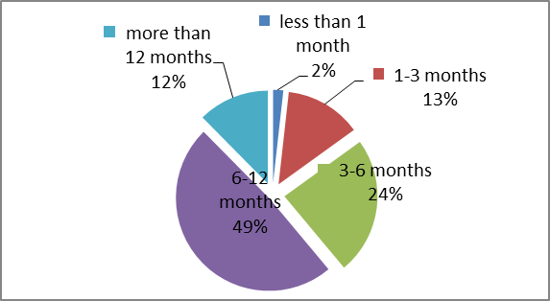
Source: Evaluation study, volume 1, section 5.2.1.3
In the public consultation opinions were voiced in favour of shortening investigations, e.g. maximum 12 months (6 months for the provisional phase), and faster imposition of provisional measures.

3.2.12. TD measures could remain in force too long
The period for which TDI measures are actually in force – normally 5 years – is subject to diverging views.
Current TD regulations provide no time-limits for the duration of TD measures, and EU producers are generally satisfied with the current practice. Some claim that this duration has allowed them to make investments to be able to counteract the effects of dumping/subsidisation practices even after the removal of duties. Importers, on the other hand, complain that duties are often in place for long periods of time without proper justification. They are also critical of the renewal of measures as a result of expiry reviews. They claim that the threshold for initiation is too low and that it is too easy to file an expiry review request. As a result, they argue, measures in some sectors (fertilizers, organic chemicals or salts) have been in place for ten or even more years. Some believe that protection by TDI becomes nearly permanent.
However, actual case statistics show that less than 10% of measures remain in force for more than 15 years.
Table 6: Number of measures in force
 | AD | AS | Total | %
No of measures in force end 2011 | 120 | 10 | 130
For more than 15 years | 9 | 0 | 9 | 6,9%
Source: DG TRADE, unit H1

3.2.13. Interests of workforce, and EU employment, can be poorly protected in cases where management chooses not to file an AD or AS complaint
In the current EU TDI system, investigations are normally initiated following a complaint by or on behalf of the Union industry. Under the current system trade unions cannot file a TD complaint. In order to ensure access to TDI in situations where the interests of EU producers and their workforce diverge (notably, for example, because of fears of retaliation), the evaluation study recommended that labour representatives should also have the right to submit complaints.
However, due the specific nature of the information required to file a complaint, it seems technically unfeasible for trade unions to file a complaint without the cooperation of their management. Regarding the issue of retaliation, it has already been identified as a separate problem (chapter 3.2.1 above) and is being tackled under option 3. Furthermore, this issue was not identified as a priority for stakeholders. It will therefore not be pursued further under this initiative.

3.2.14. Some stakeholders claim that the EU's duty collection system provides insufficient disincentives against dumping or subsidisation of exports to EU
Current TD regulations in the EU stipulate that a prospective duty collection system must be used. This means that duty rates are determined and collected using historical data, i.e. based on the data established during the investigation.
By contrast, under the retrospective system applied by the US, a duty is collected upon importation as a deposit only. The final amount will be determined later, based on the actual dumping/subsidisation during the period of the import transactions in question. In the evaluation, some EU producers requested a change from a prospective to a retrospective system. The reasons are that under a retrospective system, foreign firms that are engaged in unfair practices (i.e. dumping or subsidisation) have a higher incentive to dump less or to seek a reduced level of subsidy, so that they can benefit from a recalculation of the dumping margin.
However, since the exact amount to be paid is not known until at least one year after importation, the financial liability for imports subject to anti-dumping or anti-subsidy measures is extremely difficult to predict; and fear of this uncertainty seems to prevail among stakeholders. Such a system would also entail an enormous increase of administrative burden for stakeholders and the institutions due to yearly reviews.
Under the current basic regulations, parties can request a refund in situations where they can show that the actual dumping/subsidisation is lower than the duty in force. The evaluation did not recommend a change in the system and only a small number of stakeholders raised this issue in the public consultation. This particular idea will therefore not be pursued further.

3.2.15. Codification of the basic regulations with regard to WTO and ECJ jurisprudence

The current basic regulations were enacted at the end of 1994. Since then, a large number of WTO dispute settlement rulings have been handed down which – even if they did not necessarily involve the EU – nevertheless have implications for the EU's practice, since normally such rulings are followed in subsequent disputes. In some instances, the text of the basic regulations has been made obsolete. Moreover, daily application of the basic regulations has also shown that a number of other provisions of a very technical nature should be clarified. In particular the following issues have become problematic in this context:
- Exporters with a dumping margin of less than 2% should not be re-investigated as part of a subsequent review while the text of the law provides that they could.
- The meaning in law of a "major proportion … of the total Union production" needs to be clarified.
- There is currently no explicit legal mechanism to exempt related companies from duties imposed following a circumvention investigation.
- Wording of the EU's basic regulations in respect of sampling provisions needs to be clarified in relation to WTO law.
- Provisions in the EU's basic regulations on who may submit information for the Union interest test do not correspond to current Commission practice.
- Provisions in the EU's basic regulations on registration of imports are not sufficiently clear.
- Current TD regulations do not authorise the Commission services to apply different investigation methods in review or refund investigations from those used in the original investigation.
These issues are not controversial and the Commission is legally required to address them. Please find detailed explanations on each item in annex 7.

3.3. Subsidiarity principle
Under Article 5(3) TEU, the subsidiarity principle does not apply in areas of exclusive EU competence. According to Article 3.1(e) of the Treaty on the Functioning of the European Union (TFEU), the common commercial policy is an exclusive competence of the EU. Article 207 TFEU further states that "measures to protect trade such as those to be taken in the event of dumping or subsidies" shall be based on the uniform principles of the common commercial policy. The subsidiarity principle therefore does not apply to the present initiative

4. Objectives

4.1. General objectives
As provided for in the Treaty on the European Union, in its relations with the wider world the Union shall contribute to free and fair trade (G1).
Trade is also a key element in the EU's efforts to overcome the present economic crisis, as it is a major contributor to jobs and growth. Trade has been identified as a core component of the 2020 strategy with triple benefits from trade opening: economic growth, consumer benefits and labour effects (G2). As elaborated in the communication "Trade, Growth and World Affairs, Trade Policy as a Core Component of the EU's 2020 Strategy" of November 2010, the globalised economy provides greatly increased opportunities for trade, but is also prone to unfair trading behaviour.
The objectives of EU TDI policy are to address the distortions in trade brought about by dumped or subsidized exports by restoring fair conditions (G3) for EU industries affected by goods imported at less than fair value or which benefited from actionable/prohibited subsidies according to WTO rules. TDI's focus is on increasing EU competitiveness and the creation or preservation of employment in sectors adversely affected by unfair imports.
In order to achieve these general objectives a balanced approach is required in order to gain the necessary support from stakeholders and ultimately from Member States and the Parliament. The specific objectives outlined below should contribute to this goal.

4.2. Specific Objectives
- Create a trading environment in which EU industries (and by implication their workers) are able to compete on the basis of their genuine competitive advantages and make sure that they can make full use of the instruments legally at their disposal to restore a level playing field. (S1).
- Allow users and consumers to benefit from imports based on the genuine competitive advantages of foreign suppliers (S2).
- Increase confidence and awareness in the EU's TDI system among all stakeholders, including among small and medium enterprises (S3).
- Improve the level of cooperation of all stakeholders concerned in TDI proceedings (S4).
- Preserve the existing balance of interests between producing and importing interests (S5).

4.3. Operational objectives

4.3.1. Increased transparency and predictability (O1)
- Provide stakeholders with a summarised and non-confidential disclosure of the activities of the anti-dumping/anti-subsidy committees, so as to increase transparency with respect to the decision-making process in trade defence proceedings.
- Provide a prior notification, either that Commission services do not intend to impose measures; or else, about the type of measures that will be imposed, and when; in order to improve transparency and increase predictability for stakeholders.
- Provide a limited prior disclosure to exporters and Union producers that have been individually examined covering calculations and brief summary of the main facts of the case, in order to improve transparency and increase predictability for stakeholders in terms of expected results as well as to help them exercise their rights of defence.
- Improve transparency regarding certain complex elements of an investigation including injury margin, choice of analogue country, expiry reviews or Union interest test, by providing detailed explanations and by describing the various methodologies.

4.3.2. Fight against retaliation (O2)
- Increase the level of protection for potential complainants from threat of retaliation.
- Clarify the circumstances under which the Commission would initiate such investigations on its own initiative, and
- Strengthen the possibilities for the Commission to initiate such investigations on its own initiative by increasing the incentives for EU producers to cooperate in TD investigations, so as to ensure that Commission services have access to the data necessary to conduct investigations in particular in cases where these are launched ex officio.

4.3.3. Improve the effectiveness and enforcement of TD measures (O3)
- Provide closer monitoring of trade flows in order to detect circumvention activities, and take action against those detected as soon as possible.
- Put in place stronger mechanisms to deter market operators from engaging in circumvention practices, structural raw material distortions and/or fraudulent behaviour.
- Enhance the effectiveness of the AS instrument so as to reduce the incentives for market operators to accept trade distortive subsidisation.

4.3.4. Facilitate cooperation (O4)
- Provide all stakeholders, but in particular importers and users, with longer deadlines during investigations both for registering as an interested party and for submission of questionnaires, in order to improve the information available to Commission services when establishing findings in trade defence proceedings.
- Provide better information about, and streamline access to, refund proceedings in order to reduce the administrative burden for stakeholders and the institutions.
- Increase the support given to SMEs so as to help them overcome the problems of cost and complexity, and thus to facilitate their access to the trade defence instruments.

4.3.5. Optimizing review practice (O5)
- Ensure that measures do not remain in force longer than is necessary to offset injury caused by unfair trading practices; and in cases where measures are terminated, that the duties collected during the review investigation are reimbursed.
- Ensure that the level of measures following an expiry review can be adapted to current market conditions, whenever appropriate.

4.3.6. Improve legal certainty (O6)
- Ensure that current best practice is fully reflected in the legal basis.
- Ensure that the latest WTO and ECJ jurisprudence is fully reflected in the basic regulations.

5. Policy Options

5.1. Identifying the policy options
Several areas have been identified in which the efficiency and effectiveness of the current trade defence system can be significantly improved for the benefit of the parties involved. The analysis of problems has highlighted various specific issues, largely independent from each other, where specific actions may bring about the desired improvements. However, due to the nature of the individual problems, in most cases, the choice of options is limited to non-action or action, without many alternatives. Therefore, the different policy options identified are:

    - Policy Option 1 - no change: the first option would be to continue with the current state of affairs, and leave current legislation and practice unchanged.
    - Policy Option 2: option two consists of specific proposed interventions for each individual problem identified (and retained), with alternative solutions in a limited number of cases.
    - Policy Option 3: the third option consists of a package of precisely those specific interventions examined under Option 2 where the overall impact is expected to be positive, and which do not change the balance between producing and importing interests.

5.2. Description of the policy options

Option 1 - No change

The first policy option entails taking no further action at EU level. As mentioned in the previous chapters of this impact assessment, trade defence instruments consist of three different EU regulations (anti-dumping, anti-subsidies and safeguard) which implement WTO trade defence rules in the European Union legal system, and which go further on some specific aspects.
Taking no action would mean maintaining the existing balance of interests between the various stakeholder groups – and the strengths and weaknesses of the existing framework – exactly as they are now.
However, in practice option 1 must be considered as a purely analytical construct for the reasons set out below in section 6.

Option 2 – specific interventions for each individual problem identified
- 'Codification' of the basic regulations in order to address WTO decisions, judgments of the EU courts, or existing Commission practice. In particular, the text of the basic regulations will be brought more clearly into line with two recent WTO dispute settlement rulings. Most of these modifications are already applied in practice, but they also need to be spelled out in the basic regulations.
- A pre-disclosure to interested parties around three weeks before the imposition of provisional measures (i.e. shortly after documents are sent to the ADC/ASC) consisting of: (i) a summary of the proposed measures for information purposes only; and (ii) the relevant calculations and adjustments for each cooperating exporter and the Union industry. Provisional measures would normally not be imposed within 3 weeks after sending the pre-disclosure. To further increase predictability, in cases where Commission services do not propose to impose provisional measures, interested parties would be informed of that fact in good time prior to the 9 months deadline via an advance notice.
- Related to the pre-disclosure is the "three weeks shipping clause". In practical terms stakeholders would have the legal certainty that no provisional measures will be imposed within 3 weeks after sending the pre-disclosure.
  - Alternative: "six weeks shipping clause": stakeholders would have the legal certainty that no provisional measures will be imposed within 6 weeks after sending the pre-disclosure.
- In order to tackle the other issues identified on transparency and predictability, the Commission would publish guidelines on specific key concepts (i.e. on the Union interest test, the choice of the analogue country, the calculation of the injury margin, and expiry reviews). Such guidelines would be based on past cases, and would aim at clarifying the Commission's best practice in particular regarding issues where the basic regulations provide only very little guidance. This would help users to better understand the applied methodology and would also re-enforce the predictability of decisions, as the Commission is under the general administrative duty to treat similar cases similarly.
- Ex officio initiations in order to combat threats of retaliation against TD investigations or measures. Normally, TD investigations are initiated by Commission services on the basis of a complaint lodged by the EU industry. In order not to expose EU companies to threats of retaliation by third countries, the Commission would initiate investigations ex officio, i.e. on its own initiative without divulging the identity of the EU company/ies lodging or cooperating in an investigation. According to the basic regulations, ex officio initiations are permitted in "exceptional circumstances". The current texts would be modified in order to clearly identify threat of retaliation as an "exceptional circumstance".
- In order to make ex officio initiations a more effective tool against retaliation, and in order to ensure that Commission services have access to the data necessary to properly conduct an investigation, the basic regulations would stipulate that EU companies have an obligation to cooperate in ex officio investigations. Moreover, in order to provide Commission services with the means to obtain the necessary data from the companies concerned, procedures would be put in place so that cooperating companies can provide data to Commission services in confidence and can remain anonymous throughout the proceeding (e.g. clarify rules on anonymity, explore possibility of enhanced security in electronic submissions of documents, etc.).
Normally, in investigations initiated on the basis of a complaint by the EU industry, EU companies can choose whether or not to support the complaint, and whether or not to cooperate in the investigation. The obligation to cooperate for Union producers in ex- officio investigations is primarily intended to cover companies vis-à-vis threats of retaliation from third countries. Companies facing such threats could invoke the obligation to cooperate with the Commission, and thus such threats may become less effective. In deciding whether or not to go ahead with an ex officio investigation, Commission services would decide on the basis of the merits of the evidence available on injurious dumping/subsidisation. In addition, the Commission would also take into account available evidence as to whether any measures would have disproportionate economic consequences for the Union as whole, should the investigation confirm the existence of injurious dumping/subsidisation. Opinions expressed by economic operators concerned as to whether or not the case should go ahead will in no way be decisive. It is underlined that such ex officio initiations, and the related obligation to cooperate, would be strictly limited to cases where a threat of retaliation is at issue.
  - Alternative: sanctions in case of non-cooperation: the Commission services would introduce sanctions for EU producers who refuse to cooperate in ex-officio investigations. Such sanctions could take the form of fines or obliging companies to grant access to the Commission services to their premises in order to obtain the data needed for the investigation.
- Ex officio investigations in cases of circumvention. The Commission services would take a more pro-active approach and open anti-circumvention investigations as soon as a change is detected when monitoring trade flows.
- In addition, the current basic regulations would be changed so as to make the lesser duty rule inapplicable in cases of structural raw material distortions or subsidisation by the exporting country concerned. In cases of third country subsidisation and structural raw material distortions the non-application of the lesser duty rule would be applied country wide.
- In order to facilitate cooperation in investigations, longer time-limits would be granted to certain interested parties, i.e. users for registering as an interested party (29 days instead of 15 days), and for replying to questionnaires (51 days instead of 37 days). This would help increase the quantity and quality of information that serves as the basis for decisions, and particularly for the Union interest test analysis. Moreover, the Commission services would help users and consumers to better contribute to the Union interest analysis by identifying a focal point for those interest groups as well.
  - Alternative: further extending time limits, e.g. 45 days for registering as an interested party and 60 days to reply to the questionnaire.

- Simplification of refund proceedings by providing refund request forms and by publishing refund decisions on the Trade website.
- Facilitate SMEs' access to the EU's trade defence activity. The SME helpdesk would be upgraded, and information regarding TDI would be more widely disseminated through specialised work-shops and seminars specifically targeted at SMEs and offered throughout the Union.
- The automatic combination of the 2nd and any further expiry review with an interim review would allow Commission services to examine in one and the same investigation, not only whether measures should be renewed or repealed, but also whether the level of the duty imposed should also be varied.
  - Alternative: the notice of impending expiry, which is published in the Official Journal of the EU around 6 months before the expiration of measures, would be adapted in order to remind exporters and producers of the possibility to request an interim review which could then be carried out in combination with the expiry review.
- Reimbursement of duties collected during expiry review investigations, in cases where the latter are terminated without prolongation of measures.
- Ex officio interim reviews in cases of cartel behaviour. The Commission would open an ex officio interim review, in cases where DG COMP has confirmed that companies were involved in price fixing / abuse of a dominant position and might thus have unjustly benefited from a TD measure.
- Taking into account the interests of EU producers who have outsourced production to a third country. The current provisions relating to the Union interest test would be changed in order to privilege the interests of companies that have outsourced their production outside the EU, but which have retained significant operations and employment in the EU.
- Introduce a limit to the duration of measures (of 10 or 15 years).
- Modify current law and practice by introducing lower standards for initiation. Standards would also be lowered for the conduct of an investigation in order to provide earlier protection. The intention would be to impose provisional measures much earlier than after 9 months, as happens under current practice.

Option 3 - a package of specific interventions with an overall positive impact
Of all the possible single intervention options identified under option 2, a package has been created from precisely those proposals where the impact is expected to be positive (please refer to table 7 below).
Option 3 is considered to provide a major contribution in achieving the objectives without changing the balance between producing and importing interests.

6. Analysis of impact

A thorough analysis was conducted to assess the impact of the different single intervention options identified. Then, option 3, the package of the proposals considered most suitable to achieve the objectives, was compared to option 1 – the baseline. The assessment is based to a large extent on Commission services' own analysis and practical experience, on the results of the public consultation of stakeholders, and on the independent evaluation study.

TD measures affect only a small share of imports (less than 0,5% of total trade was effected by TD measures in 2011). Thus the overall economic impact of any of the analysed proposals, as compared to the total economic activity in the EU is very limited. The social and environmental impact is also in most cases very small. The impact analysis below therefore focuses on the impact that any of the proposals identified under option 2 would have for the stakeholders concerned and in particular on EU producers and importers. Under option 2, the impact of the various proposals is analysed individually and then as a package under option 3.

However, although the impact of TDI on overall economic activity is very small, the existence of the instruments and their application are very important for the stakeholders concerned. For a specific industry or sector concerned by a TD investigation, whether or not TD measures are imposed can have a significant impact on its financial and employment situation. In certain cases it can even determine the survival or not of a particular industry in the EU. Moreover, the very existence of these instruments has a certain influence on economic operators, as some of them will anticipate the possible application of these rules in their economic behaviour.

6.1. Overview of the policy options analysed
In order to best achieve the objectives identified, legislative changes and/or soft law are required. The table below gives an overview of the various options and indicates whether a legislative change 'L', soft law 'S' (communications, notices) or a mere change in practice 'P' are required.
Table 7: Overview of policy options analysed
 | Option 1:  no action | Option 2:  single intervention option | Option 3:  package
EFFICIENCY
Suboptimal |  | pre-disclosure L | ✓
transparency |  | advance notice L | ✓
before provisional measures |  | activities of the ADC L | ✓
 |  | shipping clause 3 weeks L | ✓
 |  | alternative: 6 weeks shipping clause L
Suboptimal transparency regarding the methodologies used in an investigation |  | guidelines S | ✓
Clarification of the BRs with regard to WTO and ECJ jurisprudence |  | codification of the current practice and jurisprudence and improvement of transparency L | ✓
EFFECTIVENESS
Retaliation |  | ex-officio initiations of new investigations L | ✓
 |  | obligation to cooperate in ex officio initiations to address retaliation L | ✓
 |  | alternative: obligation to cooperate combined with sanctions in case of non-cooperation L
Circumvention |  | improved monitoring and ex-officio anti-circumvention investigations P | ✓
 |  |  | ✓
Trade distortive subsidisation and raw material distortions |  | no lesser duty rule in cases of subsidisation, raw material distortions L | ✓
Lack of cooperation |  | extend time limits for parties for Union interest purposes by 14 days P | ✓
 |  | alternative: further extension of time limits
 |  | upgrading SME help desk P | ✓
 |  | facilitate refund procedures S | ✓
No reimbursement of duties when measures are repealed after an expiry review |  | reimbursement of duties in expiry reviews leading to a repeal of measures L | ✓
Varying duty levels following expiry reviews |  | automatic combination of expiry and interim reviews
 |  | alternative: invite parties to request expiry reviews with interim reviews P | ✓
Unjustified benefit from TD measures for EU producers involved in uncompetitive behaviour |  | ex-officio interim reviews P | ✓
Interests of EU producers who have outsourced production are not taken into account |  | take into account interests of EU producers who have outsourced production L
TD measures remain in force too long |  | limiting duration of measures L
 |  | lower standards for initiations P
Time taken from onset of injury to imposition of measures is too long |  | lower standards for the conduct of investigations in order to impose measures earlier P

6.2. Impacts of Policy Option 1 – no change
It may be argued that the EU's TDI as currently applied function rather well and thus that there is no need for a review of the TDI instruments. Furthermore, the failure of the last attempt (the green paper exercise of 2006/2007) – due to a lack of consensus among stakeholders – could be seen as further proof that a majority of stakeholders does not want any change and would prefer the status quo.
However, if no action is taken, all problems identified in the problem definition earlier will remain unsolved while some will even become worse.
Economic impact for the stakeholders concerned
Non-action would have some negative economic impacts as it would likely lead to increased administrative burden and legal uncertainty, which in turn would negatively impact on the efficiency of the system.
No action with regard to further improving transparency and predictability will most likely negatively impact on the investigation process itself. In particular, an increasing number of requests under access to documents provisions, further increasing interventions by the hearing officer, etc. would be likely. Such requests are resource intensive and often difficult to deal with due to the already very tight investigation schedule. Moreover, smooth procedures will be even more important in view of the upcoming "omnibus" regulation, i.e., TDI proceedings will become more time-consuming (due to the revised consultation process that omnibus will entail), and it is essential to introduce changes that can contribute to saving time during the investigation.
Table 8: Activity of the hearing officer
Hearing officer | 2008 | 2009 | 2010 | 2011
Interventions | 19 | 30 | 55 | 81
proceedings concerned | 11 | 24 | 29 | 35
Hearings held | 16 | 14 | 24 | 26
Source: Hearing officers annual reports
The lack of guidelines increases the risk that Commission services' work will be delayed, through e.g. increasing deficiencies in questionnaire replies necessitating lengthy deficiency letters, interventions by the Hearing Officer, access to documents requests etc. and even the risk of additional and avoidable legal challenges.
With regard to the dissemination of information and certain inequalities as to the level of information available to parties in respect of the activities of the anti-dumping/anti-subsidy committee, non-action would mean being aware of these inequalities and allowing clear advantages for some stakeholders – and clear disadvantages for others – to continue or even increase. In order to cooperate in a TDI proceeding and be able to fully exercise one’s rights of defence, timely information regarding imposition of provisional and definitive measures and other deadlines is key. Moreover, parties with a better level of information have better chances to achieve the best possible results for their company in a TDI proceeding, e.g. informed importers can better plan their orders and shipments.
As pointed out above, the current legislation also needs to be amended in order to reflect court rulings of recent years (the specific issues of compliance with ECJ and WTO jurisprudence are analysed under 3.2.15. above), for transparency purposes. Non-action in this regard could lead to uncertainty for stakeholders about their rights in cases where the existing basic regulations do not fully reflect WTO or ECJ decisions and current TDI practice.
As pointed out in the evaluation study the number of TDI cases brought before the EU courts has continuously increased between 2005 and 2010 (the period analysed by the study). Non-action may lead to a further increase of this trend.

Table 9: Breakdown of EU court cases by type of applicant
Applicant | 2005 | 2006 | 2007 | 2008 | 2009 | 2010 | 2005-2010
Exporter |  | 4 | 1 | 5 | 8 | 5 | 23
Importer | 1 | 1 | 1 | 2 |  | 3 | 8
Union producer | 3 |  |  |  |  | 1 | 4
Total | 4 | 5 | 2 | 7 | 8 | 9 | 35
Source: Evaluation study, volume 1, section 3.1.1, page 93

Table 10: Breakdown of EU court decisions on main legal issues (year of decision)
Decision | 2005 | 2006 | 2007 | 2008 | 2009 | 2010 | 2005-2010
Dismissed | 1 | 6 | 3 | 12 | 16 | 28 | 66
Granted | 3 | 1 | 4 | 3 | 5 |  | 16
Total | 4 | 7 | 7 | 15 | 21 | 28 | 82
Source: Evaluation study, volume 1, section 3.1.1, page 93

Stakeholders have also been confronted by a new threat in recent years: retaliation. Retaliation from third countries is having an impact on the opening of new investigations. A failure to address retaliatory behaviour of this kind may ultimately lead to fewer companies exercising their rights under the WTO and EU law to seek relief from unfair trade; with the consequent impacts on growth, EU employment and, in the worst case, the viability of the competing EU producers.
Regarding effectiveness and enforcement, certain developments over the past years require adaptation of the current rules and practice. In particular, non-action with regard to subsidisation, structural raw material distortions, circumvention and fraud by parties in third countries is likely to lead to a further increase of such practices. Due to the mandatory application of the lesser duty rule in all cases in the EU system, there is often no appropriate sanction for such practices (please see section 3.1.4 above for a detailed explanation of the lesser duty rule), and EU producers will suffer disproportionately when compared to their counterparts in other third countries. In instances where also other countries have imposed trade defence measures, increasing deflection of imports to the EU could result from a lenient approach towards illegal and trade distortive practices in combination with the lesser-duty rule.

This is illustrated by a comparison of dumping margins by HS chapter found in the EU and the US cases below:

Table 11: AD duties applied by HS chapter 2005-2010 (in %)

HS chapter | US | EU
20 | 30,6 | 8,0
28 | 84,8 | 19,0
29 | 95,2 | 21,9
36 | 66,1
37 | 47,2
38 | 83,4
39 | 41,0 | 12,7
40 | 12,6
41 |  | 58,9
44 |  | 25,2
48 | 72,6
54 |  | 7,1
55 | 4,4
58 | 124,1
59 | 131,2
63 | 96,0
64 |  | 9,9
68 | 136,7
69 | 136,7
72 | 16,0 | 20,1
73 | 42,5 | 36,5
74 | 34
76 |  | 17,9
81 | 129,3 | 29,3
82 | 21,6
83 |  | 27,1
84 | 68,8 | 37,2
85 | 107,8 | 27,8
87 |  | 16,9
90 |  | 34,0
94 | 113,7
95 |  | 5,8
96 | 154,7
Total average | 77,1 | 23,1
Same sector average | 68,4 | 23,6
Source: Evaluation study, volume 1, section 2.3.1

Regarding trade flows, the impact of non-action is expected to be minimal.

Other impacts
The social and environmental impacts of non-action are also expected to be minimal. However, although impossible to quantify, in the long-term non-action may lead to certain negative consequences for the Union industry which may also have a negative impact on the job situation in the EU and on the environment.
In view of the above, non-action is not recommended. Indeed, besides the negative economic impact and the possible negative consequences in the long-term regarding social and environmental aspects, it may also lead to a certain unfairness in the system, and an increasing number of legal challenges.

6.3. Impact of the individual proposals under policy Option 2
- Advance notice, pre-disclosure and information about the activities of the ADC will have a certain positive economic impact on importers. It would allow them to better plan their imports, which is particularly important for goods already in transit. Costs would not increase unexpectedly.

Impact on EU producers could in theory be negative due to an increase in stock piling, but would in practice be very small. An advance notice does not give full legal certainty to importers; and they would thus neither be able, nor have an incentive, to place additional orders. Stock piling is therefore not expected to increase much as compared to today. Moreover, a large percentage of TD measures are in the areas of steel and chemicals. While advance notice might allow for additional shipments of some small lightweight items by air (e.g. DRAMs in the past) this would be exceptional. So, although there may be instances where imports increase because of the advance notice, the overall effect is expected to be limited.
- The so-called "three weeks shipping clause" would give legal certainty that measures would normally not be imposed for 3 weeks after sending the pre-disclosure. Thus there would be an additional small positive economic impact for importers as compared to the advance notice since importers would have the legal certainty that for 3 weeks no measures would be imposed.
By contrast the negative impact for EU producers would be similarly small as with an advance notice, since the only difference between the pre-disclosure 3 weeks before the imposition of provisional measures and the 3 weeks shipping clause, is legal certainty. The timeframe however remains the same and practically no additional stockpiling is expected. In the public consultation a slight majority of respondents was in favour of disseminating the information sent to the AD/ASC, i.e. 49% in favour, 45% against; 65% of respondents were against the 3 weeks shipping clause, and 53% of respondents were against a pre-disclosure/advance notice. Some respondents also feared that such dissemination of information may lead to pressure on member states through lobbying. However, lobbying is already taking place today.
Given the clearly identified need to improve transparency and predictability in proceedings (operational objective 1), and that any impact on stakeholders, i.e. positive for importers, or negative for producers would be very small, it was decided to pursue this proposal.
  - Alternative: A shipping clause with a duration of 6 weeks would have a significant positive economic impact for importers. Being informed about impending measures 6 weeks before they were to be imposed would not only allow for all goods already in transit to enter the EU without paying the duty, but would also enable importers in many instances to place new orders, to ship them and have them cleared through customs before the duties entered into force. A significant increase of imports prior to the imposition of measures, as well as significant stockpiling, could be expected as a consequence. For the Union industry the effect would be negative since the remedial effect of the measures would be both diluted and significantly delayed. Thus, this proposal would have a significant impact on the balance of interests in favour of importers. Furthermore, in the public consultation a majority of 65% of respondents was against a shipping clause of even 3 weeks and hence 6 weeks would be even more impossible for them to accept. This alternative proposal will therefore not be pursued further.
- The publication of guidelines will also improve predictability and legal certainty for stakeholders In the public consultation a majority of respondents was in favour of the publication of guidelines: 64% in favour of a guidelines on injury margin, 69% in favour of a guidelines on choice of analogue country, 57% in favour of guidelines on Union interest test and 65% in favour of guidelines on expiry reviews.
- Clarifying practice and bringing the EU texts in line with jurisprudence of the EU courts and WTO rulings will ensure increased legal certainty or transparency for stakeholders and limit the EU's exposure to the risk of legal action in the future.
- The proposals for combating threats of retaliation, i.e. ex officio initiations and an obligation to cooperate in such proceedings for Union producers, should improve Union producers' ability to seek protection under the EU's trade defence system against unfairly traded imports, when the relevant criteria are met. To the extent they are better shielded from retaliation threats, they would not suffer increased losses as a result of continued dumped/subsidised imports for want of protection. Even though it may seem at first sight that an obligation to cooperate without any sanctions in case of non-cooperation may not be effective, the procedures to be put in place in order to facilitate cooperation and guarantee confidentiality and anonymity, should entice companies to fully benefit from the possibility of such ex officio initiations. In the public consultation 76% of stakeholders were in favour of ex officio initiations in cases of retaliation or threat of retaliation.
The overall negative economic impact of retaliation is very difficult to quantify, because due to such threats a number of TD cases are never initiated and the lost sales and decreasing profits of the EU producers concerned, due to the continued and uninhibited dumped/subsidised imports are not known.
As pointed out above (under 3.2.1), another form of retaliation is third countries initiating TD cases against EU exporters simply as a reaction to the EU’s own TD cases in order to dissuade either EU companies or the EU as such from using the instruments. In such cases average duty levels in the range of 12% to 35% have been imposed by third countries, thus considerably limiting the export possibilities of the EU companies concerned to those countries. The proposed actions against retaliation can help only to a limited extent with regard to this type of retaliation. Other actions in this respect consist of taking such unwarranted cases up bilaterally and eventually requesting dispute settlement under WTO.
  - Alternative: possible sanctions in cases of non-cooperation would most likely not much increase the effectiveness of this proposal as regards further limiting the threats of retaliation. However, some Union producers may perceive such sanctions as an additional penalty imposed on them by the Commission in an already difficult situation. Therefore, this alternative solution will not be further pursued.

- Improved monitoring and ex officio anti-circumvention investigations would increase the effectiveness of the instruments. Circumvention could be detected faster and anti-circumvention investigations initiated quicker. Thus, the period of circumvention and the volume of imports entering by means of circumvention could be reduced. SMEs as much as larger companies would be able to benefit from these proposals.
- Non-application of the lesser duty rule: In cases of distortive subsidisation and structural raw material distortions the lesser duty rule would not be applied on a country-wide basis. Thus the competitive advantage provided by the third country government to its exporters could be significantly reduced due to a higher AD or AS duty. In any event, the non-application of the lesser duty rule would in a number of cases lead to higher duties and would also have an impact on costs for importers, and possibly ultimately on prices for users and consumers of the imported product. However, the possibility of such higher duties should discourage third country governments and exporters from engaging in unfair/illegal trading practices. A higher duty applied on a country-wide basis may have a significant negative impact on the overall export volume of the product from that country. The impact would be amplified in cases involving other third countries who benefit from the lesser duty rule. The imposition of higher duties would give some breathing space to EU producers affected by such unfair practices (please refer to 3.1.4 for details). In the public consultation 76% of stakeholders were in favour of not applying the lesser duty rule in cases of subsidisation, circumvention and fraud. In regard to fraud and circumvention, sufficient deterrents exist under current legislation, e.g. best facts available can be applied to companies who engage in such behaviour. Structural raw material distortions were raised as a major concern by many stakeholders in the public consultation.

- Longer time limits for users (by 15 days) will have practically no economic impact since this proposal aims mainly at improving the quality of data available at the moment of taking a decision for the imposition of provisional or definitive measures. Although, this proposal was not favourably received in the public consultation (63% against), it is proposed to go forward with this proposal. The proposal is important in the interest of fairness and improving effectiveness.
  - Alternative: further extending time limits. Although this proposal has merit regarding facilitating cooperation for stakeholders and in particular for SME's, extending deadlines beyond the proposed 29 and 51 days would make it almost impossible to complete an investigation within the mandatory deadlines. This alternative will therefore not be pursued further.
- The proposal to re-enforce the SME helpdesk will help reducing the administrative burden for SMEs, i.e. it will help them to find information regarding TDIs quicker and will also provide useful guidance when cooperating in an investigation. At present, many SMEs are not even aware of TDI, although they are often the first businesses to suffer from unfair imports. Improving their awareness of TDIs will enable them to defend themselves against unfair trading practices – a right which at present can be more easily exercised by large, mature enterprises. SMEs will also benefit from many other proposals, e.g. longer time limits for users or facilitating refund procedures.
- Facilitating refund procedures will have a positive impact in particular for importers since procedures will be become somewhat simpler and less time consuming. Improving the efficiency of refund procedures will also help to decrease the administrative burden of the institutions.
- No negative impact for Union producers is expected from the implementation of the proposal to reimburse duties collected in on-going expiry reviews, in cases where a review concludes that measures should be terminated due to no likelihood of injurious dumping/subsidisation and as a result, the measures are repealed. The measures remain in force during the review investigation; the outcome of the review, and whether or not duties will be reimbursed will be made known only at the end of the expiry review investigation (which typically takes between 12 and 15 months to complete). Therefore, it is unlikely that importers would change their import strategy during the period of the on-going expiry review and risk not being reimbursed in case of a prolongation of measures. It is also highlighted that the reimbursement of duties represents a significant increase of administrative burden for the national customs authorities.
In the public consultation 56% of respondents were against reimbursing the duties in case of termination of expiry reviews without prolongation of measures. It was argued that the duties should be kept as a compensation for the injurious dumping/subsidisation that took place before the imposition of measures. This is however a misperception. According to WTO law a TD duty should remain in force only as long as and to the extent necessary to counteract injurious dumping/subsidisation. Moreover, since the positive impact on importers is not accompanied by any negative impact on Union producers it is proposed to go forward with this proposal. It is important to pursue this issue also in the interest of fairness, i.e. it is only fair to reimburse duties in cases where the review investigation shows that measures should be terminated.
- The automatic combination of the 2nd and any subsequent expiry review with an interim review may have a negative impact on stakeholders. Since such combination would not be warranted in all cases, it would thus only serve to create unnecessary additional workload. In the public consultation 57% of stakeholders were against such automatic combination.
  - Alternative: The possibility for exporters to request an interim review in combination with the 2nd expiry review is not expected to have a significant negative impact since first, the burden of showing that the relevant criteria are fulfilled remains with the applicant requesting the interim review; and second, the standards of initiation and investigation for the interim review remain unchanged. This adapted proposal should address the concerns expressed by stakeholders who were against the automatic combination and thus this alternative will be further pursued in this exercise.
- The proposal regarding ex officio interim reviews in cases of anti-competitive (cartel) behaviour will also have a very limited economic impact since these cases are extremely rare (the Commission services are aware of a single case in the past). In the public consultation slightly more respondents were against (44%) than in favour (40%) of this proposal. However, this was most probably due to a misinterpretation of the question, and it is therefore proposed to pursue this issue, in the interest of good administration.
- Changing the definition of EU producers by also including EU companies that have outsourced the final stages of production would constitute an important departure not only from the current EU TDI system, but also from the WTO definition of domestic industry. It would also have a direct impact on the number of AD investigations initiated since a complaint must be supported by a major proportion of Union producers. However, companies that have outsourced production would not support such a complaint. This would mean that EU producers who meet the current definition for Union industry and are faced with dumped and/or subsidised imports would have no means to seek a remedy. The economic consequences for these producers would be significant in terms of declining profits and the threat of job losses and possible company closures. Ultimately, the industry could be significantly weakened or, in cases of predation, even disappear.
It may be argued that certain industries producing in the EU are inefficient and the economic benefit derived from TD duties for EU producers does not justify the increased costs for users and consumers. In this context it should be highlighted that the Union interest test, which is a specific feature of the EU's TDI system – and not a WTO requirement – takes account of outsourced production. According to the Union interest test, measures may not be imposed in cases where despite the existence of dumping/subsidisation, injury and a causal link, such measures would be clearly against the interests of the EU. Thus, the additional costs of a duty for users of the imported product as an input, or for consumers, are weighed against the benefits that the industry would derive from the imposition of a duty. In cases where such additional costs for users and consumers are clearly disproportionate, duties may not be imposed.
Given the important negative economic impact for the Union industry and the fact that interests of EU producers that have outsourced production are already taken into account in the Union interest test, this proposal will not be pursued further.
- Limiting the duration of measures to a maximum of 10 or 15 years is also not foreseen in the relevant WTO agreements. Potentially unlimited TD protection is held by some to allow uncompetitive firms/industries to continue to trade at the expense of the consumer, delaying or preventing restructuring and the reallocation of capital and resources. Proponents of this view argue that limiting AD/AS duties in time would force such uncompetitive businesses either to restructure or to liquidate.
However, since AD/AS measures are only prolonged in cases where an expiry review investigation has shown that the injurious dumping/subsidisation persists, limiting the duration of TD measures would have significant negative consequences for EU producers: they would be left without any remedy against unfair and injurious trading behaviour such as continued distortive subsidisation, or structural dumping. Importers on the other hand would have the certainty that after a certain period, measures would be terminated and imports could resume without any duty being paid. This would also give an incentive to third countries that engage in such practices – namely, that if they continue the unfair trade practice long enough, they will prevail.
Given the important negative consequences for the Union industry and that this proposal would clearly go against general objective 3, i.e. to restore fair trading conditions, this proposal will not be further pursued.
- Lowering standards for initiation and investigations would at first sight seem to be favourable for EU industry since it would facilitate an increase in the number of TDI investigations and potentially, of measures also. At the same time, lowering standards for initiation would in many cases create untenable expectations among producers. Such cases, even if they passed the initiation stage, would in many instances need to be terminated without the imposition of measures, since WTO minimum standards must be complied with. It should be noted that under the current system around 50% of complaints do not meet the threshold for initiation (and are thus rejected); and around 40% of investigations which are opened are terminated without imposition of measures. Thus, lowering the standards might serve only to create an unnecessary additional burden for stakeholders and for the EU institutions (preparing, filing a complaint, co-operating and conducting a costly investigation) without any satisfactory result. Persevering with low quality cases would most likely lead only to an increase of court and WTO challenges. In addition, lowering standards would be perceived by our trading partners as a move towards protectionism at a time when the EU is pushing its partners away from protectionist moves. For these reasons, this proposal will not be further pursued.

6.4. Impact of Policy Option 3
Out of all the proposals analysed individually under option 2, the proposals that are beneficial to all stakeholders, or are beneficial to one group of stakeholders without either undermining the effectiveness of the TDIs or having a disproportionate negative effect on another group of stakeholders, were selected and are put forward as a package in option 3. Thus the proposals selected for option 3 represent a balanced solution for most of the problems identified and best contribute to achieving the objectives.
Economic impact
Increased transparency, predictability and legal certainty, will improve the efficiency of the EU’s TDIs. Cooperation in investigations will become somewhat less resource intensive and less costly for stakeholders. This is beneficial to all stakeholders and of particular importance for SMEs. Irrespective of whether they are affected as producers, importers or users of products subject to investigation, they will be better equipped to make their own judgements about a number of TD issues (for example, about whether or not to intervene in the Union interest test analysis) instead of relying on costly specialized advice.
Furthermore, option 3 focuses not only on improving the effectiveness of the existing remedies against unfair trade but also includes means to prevent such unfair trade, such as ex officio initiations in cases of threats of retaliation, ex officio anti-circumvention investigations or the non-application of the lesser duty rule in specific cases. While restoring a level playing field following unfair trading practices is the main goal of TDI, preventing such unfair practices in the first place would have an even more positive impact, since it would avoid damage to European industry. The chances to retain or even create jobs in the EU would be enhanced.
However, overall, policy option 3 would not significantly change the current TDI activity and therefore its impact on overall trade flows would only be marginal.
Other impacts
Since TD affects only a small part of trade overall, the overall social impact will also be very small. However, for a specific sector or industry concerned, the impact may be significant (please refer to annex 1 for employment data). Option 3 would thus, in certain cases contribute to limiting job losses for Union industry. Any negative impact on the job situation of importers would be clearly outweighed by the positive impact on jobs for the Union industry since in most cases trading is less labour incentive than producing.
Furthermore, in the majority of TDI cases the impact of the duty on the costs of the final product is very small and is often dealt with by adjusting the importers' or users' margin. Even for consumer products such as shoes, the average duty was 1,60 € per pair which had a minimal negative effect on importers and consumers, but helped protect thousands of jobs in the EU shoe industry. In any event, due to the Union interest analysis, measures will not be imposed if they are against the overall Union interest, i.e. if they will have disproportionate effects on importers, users and/or final consumers. While the imposition of AD duties may have a negative impact on the employment situation in the exporting country concerned, it must also be considered that selling at dumped prices is not sustainable in the long term for any business, and sooner or later results in job losses in any event. In cases of predatory dumping, the majority of competitors exit the market, so that the surviving exporting producers can thrive on high monopoly prices with the consequent negative impact for users and consumers.
Regarding the environment, again, since the overall impact of TD measures is very small any impact on the environment is expected to be marginal as well.

7. Comparing the options

Policy option 1
Policy option 1 is the "no change" option, meaning that none of the problems would be addressed and the status quo would remain. However, some of the issues, if not addressed, may in the long-term get worse and result in negative consequences. In order to show the changes that option 3 would bring it is compared to this no change option.
Policy option 2
To the extent it addresses individual problems identified, policy option 2 would meet certain of the operational objectives and partially meet some of the specific objectives. However, since it lacks coherence, it would not make a significant contribution to achieving the general objectives. Such individual approach also bears the risk of creating imbalance between producing and importing interests.

Policy option 3
Objective G 1: Contribute to free and fair trade in the world
This option addresses all operational objectives and contributes significantly to all specific objectives. It is therefore well placed to also fully or partially meet some or all of the general objectives. In particular the proposals which aim at discouraging third country governments from applying trade distortive subsidies and refrain from retaliation would contribute to furthering free and fair trade in the world.
Objective G 2: Improve trade's contribution to economic growth, consumer benefits and labour effects.
Since option 3 includes proposals benefitting importers and ultimately consumers, and other proposals benefiting EU industry, it contributes to improving consumer benefits as well as having a positive effect on labour. It therefore also addresses the related specific objectives S1 and S2 and in particular S6 since it keeps a balance of interests among stakeholders. Thus it would contribute to overall economic growth in the EU without favouring either importing or producing interests. Based on the premise that economic growth builds on free but fair trade, option 3 is also well placed to contribute to economic growth in the EU and in the world.
Objective G 3: Restore fair trading conditions
Besides the proposals mentioned under G1, option 3 also contains other proposals that would help to restore fair trading conditions e.g. non-application of the lesser duty rule in cases of subsidisation or structural raw material distortions, which contribute significantly to making sure that stakeholders can make full use of the instruments that are legally at their disposal to restore a level playing field (S1).
Overall, option 3 contributes significantly to all specific objectives and is well placed to also achieve a great deal with regard to the general objectives.
In terms of economic impact, since the trade volume affected by TD measures is small any overall economic impact of this initiative would be equally small. However, the economic impact of option 3 for a specific sector or industry concerned may be significant. It would have some impact on trade flows, on consumer benefits and also on labour. It is highlighted that option 3 is designed to keep a balance among importing and producing interests. Any social and environmental impact, though limited, would be positive. Moreover, option 3 would also increase fairness in terms of a more equitable information distribution, reimbursement of unwarranted duties etc.

8. Monitoring and Evaluation
The effectiveness of the changes introduced to the TDI system by this initiative should be subject to monitoring and evaluation. In order to be effective, the period of evaluation should cover a minimum of 3 years after the relevant amendments have been introduced. The year 2013 would be used as the benchmark year.
The table below gives an overview of the operational objectives tackled and a set of indicators to monitor the effectiveness of the proposed changes. They may be supplemented by other indicators found suitable for monitoring the changes introduced.
Table 12: Monitoring- objectives and indicators
Objectives |  | Indicators | Sources of information
Transparency and Predictability | Pre-disclosure/ advance notice | - interventions by the hearing officer  - change in number of requests of corrections between provisional and definitive measures  - comparison between the cases before and after the regulation amendment, looking in particular at the trade pattern linked to the advance notice before imposition of provisional measures | - DG TAXUD (surveillance)  - Eurostat  - 14.6 data base
Fight against retaliation | Ex-officio initiations of new investigations | - increase in number of initiations of ex officio cases | - DG TRADE
Effectiveness and enforcement | Ex-officio anti- circumvention investigations | - comparison of the time taken to assess a case of circumvention lodged by the industry before, and ex- officio initiations after the enforcement of the regulation | - DG TRADE
Effectiveness and enforcement | No lesser duty rule in cases of raw material distortions or subsidization | - comparison of level of duties imposed with and without LDR  - change in trade flow following withdrawal of LDR in cases of raw material distortions/ subsidisation | -DG TRADE  -Eurostat,
Facilitate cooperation | Longer time limits for users | - number of users cooperating before and after the introduction of the regulation | - DG TRADE
Facilitate cooperation | SME helpdesk | - change in number of SMEs filing complaints  - change in number of requests for information by SMEs | - DG TRADE
Facilitate cooperation | Facilitate refund procedures | - number of applicants  - number of applications  - amounts claimed  - amounts granted | - DG TRADE
Optimizing review practice | Combined expiry / interim reviews | - increase of number of interim reviews linked to expiry reviews | - DG TRADE
Optimizing review practice | Reimbursement of duties in expiry reviews | -analysis of the trade pattern during the review period, compared to the previous 5 year period of imposition measures | - DG TRADE
Codification | <2% dumping margin companies are excluded from a proceeding | - number of cases opened for companies previously excluded from a proceeding | - DG TRADE
Codification | Possibility to change methodologies in review/  refund investigations | - number of review/refund investigations with a changed methodology applied | - DG TRADE
ANNEX 1
Quantitative Statistics on relevant aspects of TDI activities both in the EU and in WTO.
Period considered 2007-2012
1) Number of cases initiated both by EU (initiation and follow up) and WTO
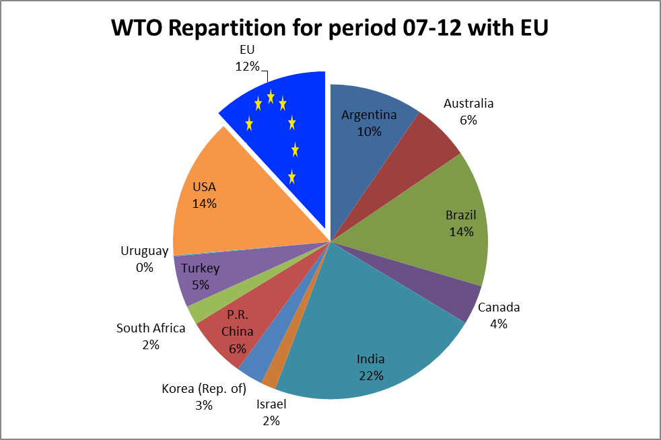
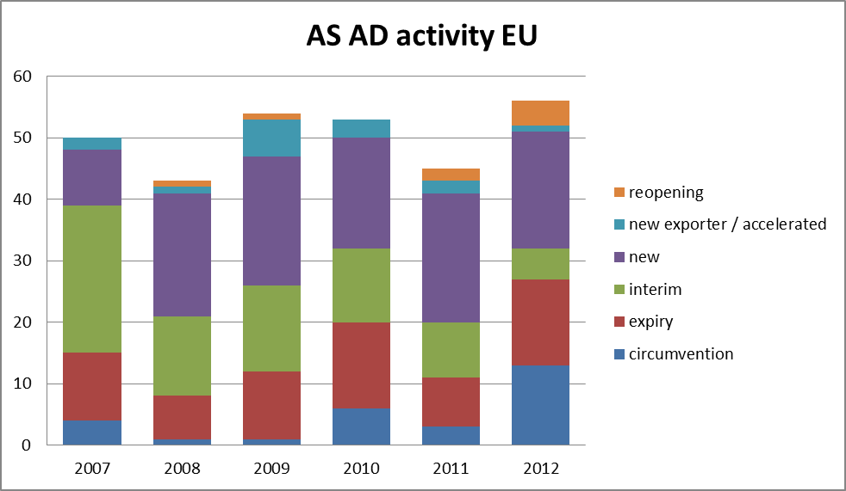
2) Figures about Employment
Decision number | Type of decision | Complainant | Product (originating country) | Period | Employees during RIP
404/2010 | Provisional | EUWA | Aluminium wheels (PRC) | 2006 - 2008 | 13000
512/2010 | Definitive | EFMA | Ammonium nitrate (UKR) | 2005 - 2008 | 3400
478/2010 | Provisional | CIRFS | High tenacity yarn polyesters (PRC) | 2005 -2008 | 1300
472/2010 (473/2010) | Provisional (AS) | Polyethylene Terephthalate Committee of Plastics Europe | Polyethylene terephthalate (Iran –UAE) | 2006 – 2008 | 2000
812/2010 | Provisional | APFE | Continuous filament glass fibre (PRC) | 2006 - 2008 | 3300
1030/2010 | Definitive | Polyethylene Terephthtalate Committee of Plastics Europe | Polyethylene terephthalate (PRC) | 2006 - 2008 | 2000
1035/2010 | Provisional | Borealis Agrolinz Melamine GmbH, Dsm Melamine BV, Zaklady Asotowe Pulawy | Melamine (PRC) | 2006 - 2008 | 600
1042/2010 | Provisional | CEPIFINE | Coated fine paper (PRC) | 2006 - 2008 | 6200
1036/2010 | Provisional | Industrias Quimicas del Ebro SA, MAL Magyar Aluminium, PQ Silicas BV, Silkem d.o.o., Zeolite Mira Srl Unipersonale | Zeolite A powder (BH) | 2005 - 2008 | 200
1186/2010 (1185/2010) | Definitive (AS) | Graftech International, SGL Carbon GmbH, Tokai Erftcarbon GmbH | Graphite electrode systems (India) | 2006 - 2008 | 1800
1261/2010 | Provisional AS | Eurofer | Stainless steel bars (India) | 2007 - 2009 | 900
1242/2010 | Definitive | Eurocord | Synthetic fibre ropes (India) | 2006 - 2008 | 600
 |  |  |  | Total 2010 | 35300
The here outlined decisions are only those which have precise figures regarding the employment in the Union industry published. For the considered period, there are also 14 cases, which for confidentiality do not display the actual numbers and which are not reported here.
Decisions 2010
Decisions 2011
Decision number | Type of decision | Complainant | Product (originating country) | Period | Employees during RIP
82/2011 | Definitive/ terminating partial interim review | FEIC | Okoume' plywood (PRC) | 2006 2008 | 1000
138/2011 | Provisional | Saint-Gobain Vertex s.r.o.,  Tolnatex Fonalfeldolgozo es Muszakiszovetgyarto, Valmieras ‘Stikla Skiedra’ AS  Vitrulan Technical Textiles GmbH | Open mesh fabrics of glass fibres (PRC) | 2006 2009 | 1200
258/2011 | Provisional | CET | Ceramic tiles (PRC) | 2007 2009 | 75000
248/2011 | Definitive | APFE (now GlassFibreEurope) | Continuous filament glass fibre (PRC) | 2006 2008 | 3300
287/2011 | Definitive | Eurometaux | Tungsten carbide (PRC) | 2006 2008 | 600
451/2011  452/2011 | Definitive (both AS AD) | CEPIFINE | Coated fine paper (PRC) | 2006 - 2008 | 6200
990/2011 | Definitive | EBMA | Bicycles (PRC) | 2007 2009 | 13700
 |  |  |  | Total 2011 | 101000

Decisions 2012
Decision number | Type of decision | Complainant | Product (originating country) | Period | Employees during RIP
2/2012 | Definitive | EIFI | Stainless steel fasteners (PRC-India) | 2007 – 2009 | 900
115/2012 | Provisional | EIFI | Stainless steel fasteners (India) | 2008 - 2010 | 800
102/2012 | Definitive | EWRIS | Steel ropes and cables (PRC – UKR) | 2007 – 2009 | 2700
163/2012 | (Com decision) termination | EIFI | Stainless steel fasteners (India) | 2008 - 2010 | 800
349/2012 | Definitive | Distillerie Bonollo SpA, Industria Chimica Valenzana SpA, Distillerie Mazzari SpA, Caviro Distillerie SRL, Comercial Quimica Sarasa SL | Tartaric acid (PRC) | 2007 – 2009 | 200
402/2012 | Provisional | AIRAL Scrl | Aluminium radiators (PRC) | 2008 – 2010 | 1600
585/2012 | Definitive | Defence Committee of the Seamless Steel Tubes | Seamless pipes and tubes of iron and steel (Russia – Ukr) | 2008 - 2010 | 13400
699/2012 | Provisional | Defence committee of the Stell Butt/Welding Fittings Industry | Tube and pipe fittings of iron or steel (Russia – Turkey) | 2008 - 2010 | 800
833/2012 | Provisional | Eurometaux | Aluminium foils in rolls (PRC) | 2008 - 2010 | 300
796/2012 | Definitive | LAMMA | Lever arch mechanisms (PRC) | 2008 - 2010 | 600
845/2012 | Provisional | Eurofer | Organic coated steel products (PRC) | 2008 - 2010 | 5500
924/2012 | Amendment definitive 91/09 | DSB | Iron or steel fasteners (PRC) | 2003 - 2006 | 8600
1072/2012 | Provisional | EU producers (>30%) | Ceramic table ware and kitchenware (PRC) | 2008 – 2010 | 25100
 |  |  |  | Total 2012 | 61300

3) Initiations by Sector
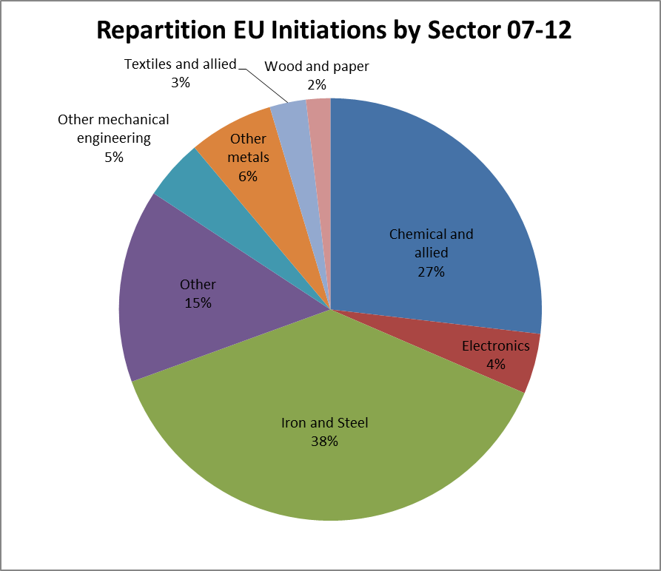

4) Initiations by Country
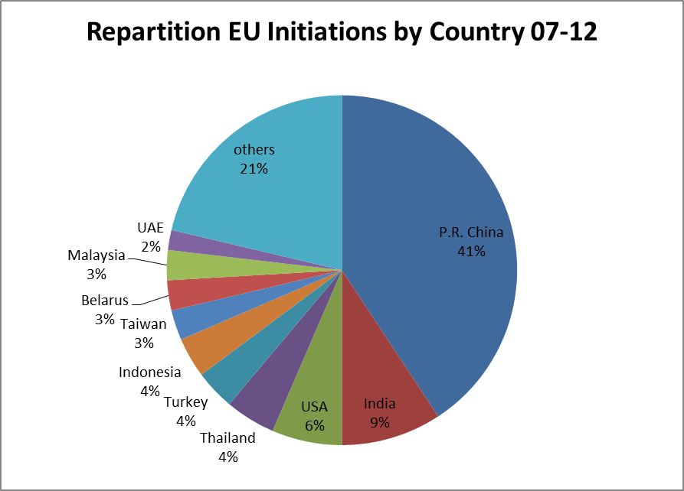
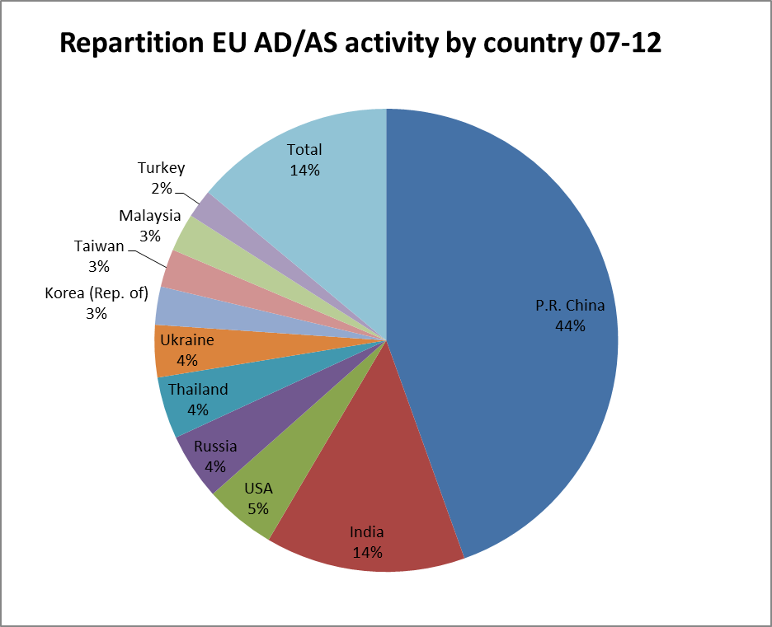

5) Duties Collected by EU MS

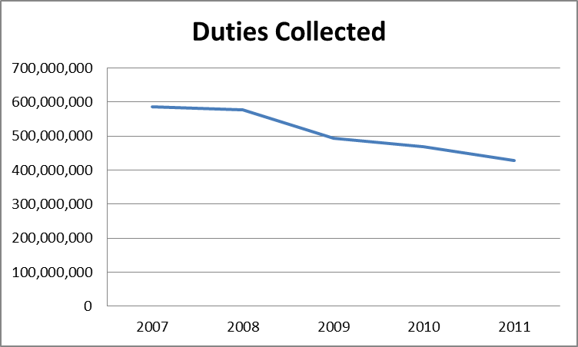

6) Trade affected (Imports under measures/total imports)

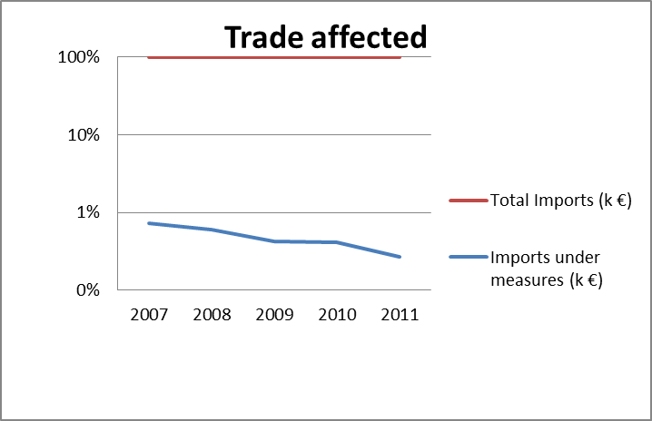
ANNEX 2
Flow chart of a typical anti-dumping investigation
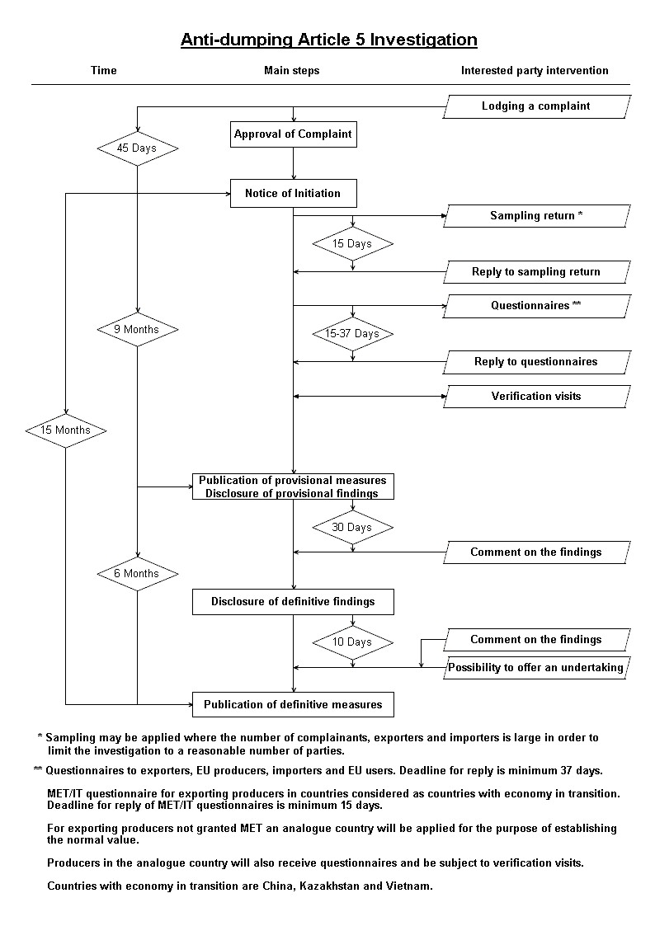
ANNEX 3
Updating trade legislation procedures: the Omnibus I proposal
The Commission today took the first step to update the way decisions on trade policy are adopted in the EU. This follows changes brought about in the Lisbon Treaty and the adoption of the so-called “Comitology Regulation” that entered into force on 1 March.
What legislation will the Omnibus I proposal affect?
The proposal covers 24 regulations in total and includes
- all trade defence instruments,
- the Regulation establishing the EU's Generalised System of Preferences,
- the Economic Partnership Agreement Market Access Regulation,
- the Trade Barriers Regulation,
- the Blocking statute responding to legislation with extra-territorial effect, and,
- a number of regulations implementing safeguard clauses and managing the implementation of
bilateral agreements.
The Commission proposes to modify the procedures for the adoption of acts in these regulations and make certain adjustments related to decision-making procedures but does not propose to amend the substance of these regulations.
What does it mean for decisions taken before this new legislation
enters into force?
All decisions taken between now and the entry into force of the new procedures
remain valid.

What does this mean for the European Parliament and the Council?

The European Parliament, the Council and the Commission agreed that trade policy would be subject to the standard procedures for the control of the Commission's implementing acts and delegated acts where appropriate. This was part of the agreement on Regulation 182/2011 governing the Commission's exercise of implementing powers.

The Parliament will be informed of the Commission's draft measures taken under implementing acts (and could challenge those decisions if it considers that the Commission has exceeded its powers). The Parliament has an equal say with the Council in the adoption of delegated acts.
Member States will remain involved in decision-making procedures for implementing acts in a similar way as under the existing systems. The Commission will continue to work closely with the Member States in a committee and the Member states will be asked to vote on draft measures. For example, they will be able to decide, by qualified majority, to reject a Commission draft measure. A qualified majority in favour will be required for multilateral safeguards, and the adoption of definitive anti-dumping and countervailing duties will move from a simple majority to reject to a qualified majority to reject as of 1 September 2012.
What are the next steps?
This proposal will now be discussed with the Council and the European Parliament and adopted according to the co-decision procedure.
A second proposal, known as Omnibus II, will follow by the summer, which will review whether procedures currently based on the 1999 comitology decision should be converted into delegated powers. Delegated powers are granted to the Commission to supplement or amend legislation. The delegation may be revoked by the Council or Parliament and the Council or Parliament may reject the exercise of the delegated power in specific circumstances. This proposal will concern legislation dealing with textiles and steel as well as certain elements of the EU's Generalised System of Preferences and the Economic Partnership Agreement Market Access Regulation. Why does this legislation only affect trade?
This proposal is a compilation of legal modifications that update a range of trade policy regulations. Omnibus I only concerns trade policy because, together with competition policy, trade policy has largely been excluded from the existing comitology decision. Almost all other areas of EU policy were previously subject to comitology. Omnibus II is part of a broader exercise to review all legislation containing comitology in the light of the entry into force of the Treaty of Lisbon. Similar legislative proposals are being prepared across a number of different policy areas.
For further information
Regulation governing the Commission's exercise of implementing powers ("Comitology Regulation")
http://eurlex.
europa.eu/LexUriServ/LexUriServ.do?uri=OJ:L:2011:055:0013:0018:EN:PDF
Factsheet on the entry into force of the new comitology rules
http://www.consilium.europa.eu//uedocs/cms_data/docs/pressdata/EN/genaff/11951
6.pdf
Contact
John Clancy +32 2 29 53773 john.clancy@ec.europa.eu
Helene Banner +32 2 29 52407 helene.banner@ext.ec.europa.eu
ANNEX 4

EVALUATION OF THE EUROPEAN UNION’S TRADE DEFENCE INSTRUMENTS

Contract No. SI2.581682

FINAL EVALUATION STUDY
27 February 2012

Executive Summary

Trade is a cornerstone of the European Union’s (EU’s) economic prosperity. For EU consumers, trade provides access to a wider variety of goods at lower prices than could be produced domestically. For EU businesses, it provides larger markets and access to essential production inputs, including technology developed abroad. For EU workers, it creates the basis for higher paying jobs as the EU specialises in doing what it does best. And for trading partners abroad, access to the large and dynamic EU market provides reciprocal benefits.

International trade takes place within a framework of rules developed through negotiations, refined through practice, and clarified through litigation before the national courts and international trade dispute settlement mechanisms under the World Trade Organisation (WTO). These rules are designed to ensure that trade works to the mutual benefit of the trading partners and is based on genuine competitive advantages.

The rules-based international trade system provides remedies against unfair trade practices. It allows for the imposition of anti-dumping measures if imported goods are sold at less than fair market value (“dumping”), and for countervailing measures if the imported goods benefit from subsidies provided by foreign governments, provided that the dumped or subsidised imports cause or threaten to cause injury to the domestic industry in the importing country. The EU’s (and other WTO members’) use of these trade defence instruments (TDI) is based on the relevant rules and procedures set out in the WTO Agreements on anti-dumping and subsidies and countervailing measures.

This report evaluates the EU’s use of TDI. The review is timely on several grounds. Firstly, there have been profound changes in the global division of labour and organisation of production over the last decade. This has led the WTO to coin the term “made in the world” to describe how products are made today. Secondly, macroeconomic stress in the context of economic crisis has led countries to resort to extraordinary policy measures with significant implications for global trade flows. Finally, the increased use of TDI by the EU’s trading partners, in particular by emerging economies, has led to an increasing risk of retaliation against EU producers requesting the application of TDI. These changes in the global trading environment raise fundamental questions – not only for the EU but for all countries using TDI – as to the ability of trade defence to deliver its intended results. This report takes up these questions, focussing on the issues of relevance for the EU.

Scope of the Evaluation

This evaluation is made pursuant to the EU regulatory requirement that policies be evaluated regularly and systematically. In line with the Terms of Reference for the evaluation, this report has five inter-related objectives, namely to provide:
Section 1.3
- a concise description of the EU’s TD system and practice;
- a balanced economic analysis of the EU’s use of TDI in the context of the current international legal and regulatory framework and in light of economic realities;
- a review of the EU basic Anti-dumping and Anti-subsidy Regulations in light of the administrative practice of the EU institutions, the judgments of the Court of Justice of the European Union and the recommendations of the WTO Dispute Settlement Body (DSB);
- a comparison of EU policy and practice to that of a selected group of EU trading partners, i.e. Australia, Canada, China, India, New Zealand, South Africa and the USA; and
- in light of the foregoing, an evaluation of the performance, methods, utilisation and effectiveness of the present TDI scheme in achieving its trade policy objectives.

The evaluation period is 2005-2010. This period was chosen in view of the fact that the previous evaluation of EU TDI was undertaken in 2005 and covered practice until the end of 2004. The evaluation does not cover the rarely used safeguards instrument.

Evaluation methodology and sources of information

The evaluation applied a three-dimensional methodology, combining an economic analysis of causes and effects of TDI with a cross-country evaluation of TD policies and procedures and a legal review of the two basic Regulations. The documentary sources for the evaluation were:
Section 1.4
- a review of documents: official EU documents (notices of initiation, regulations), reports and guidelines, secondary literature;
- interviews and written consultations of 65 stakeholders, including the European Commission, other EU institutions and Member States, Union industry representatives, exporters/ importers/users and other stakeholders (consumers, trade unions, trade lawyers, etc.); and
- an online survey among EU firms with 245 responses, to collect their views on, and experience with, the EU’s use of TDI.

How the EU uses TDI

The EU’s use of TD measures is driven by complaints from industry alleging dumping and/or subsidisation of imports and providing evidence of injury or threat of injury. The European Commission investigates the claims, determines whether they are substantiated, calculates the level of duties necessary to remedy the injurious effects, and determines whether imposition of measures would be in the interests of the Union. If measures are imposed, they normally remain in place for five years, unless removed earlier pursuant to an interim review, or extended for an additional term pursuant to an expiry review.
See appendix I1 for a description of EU TDI

While the EU is the third most frequent user of TDI after India and the USA, its use of TDI is moderate in relation to its share in world trade: the EU accounted for 17.8% of world imports (excluding intra-EU trade) during the evaluation period, but only for 10.7% of all TD investigations and 9.4% of all measures imposed. The amount of EU imports affected is also quite small: in-force measures affect about 0.6% of EU imports. Measured this way, on the basis of available evidence, the EU’s use of TDI is moderate, covering a greater share of imports than Australia, Canada and South Africa but a smaller share than China, India and the United States.
Section 1.2

In the evaluation period 2005-2010, the European Commission initiated 68 anti-dumping and 10 anti-subsidy investigations. 80 new measures were imposed. 79 expiry reviews led to the extension of measures in 54 cases. At the same time, the European Commission terminated measures pursuant to interim and expiry reviews in 28 cases; an additional 75 measures expired under the sunset provisions. The stock of in-force measures (excl. undertakings and measures extended following anti-circumvention investigations) decreased from 140 at the beginning of the evaluation period to 117 at the end.

TD measures were taken in a wide range of agricultural and industrial sectors in the evaluation period. However, there was a heavy concentration of cases in the chemicals and metal products sectors, with lesser spikes in the plastics and machinery and equipment sectors.
Section 2.2.1

In terms of exporting countries, 130 countries were named in the new 78 investigations; most of these were developing economies, with China accounting for over one-third of all individual investigations.

The majority of the TD cases opened in the evaluation period concerned fairly basic industrial goods that compete largely on price. Such goods are therefore likely to attract competition from emerging market exporters. Exporters from these countries were involved in 83% of the investigations initiated in the evaluation period.

EU TD investigations, by Major Industrial Sector, 2005-2010 (number of cases)
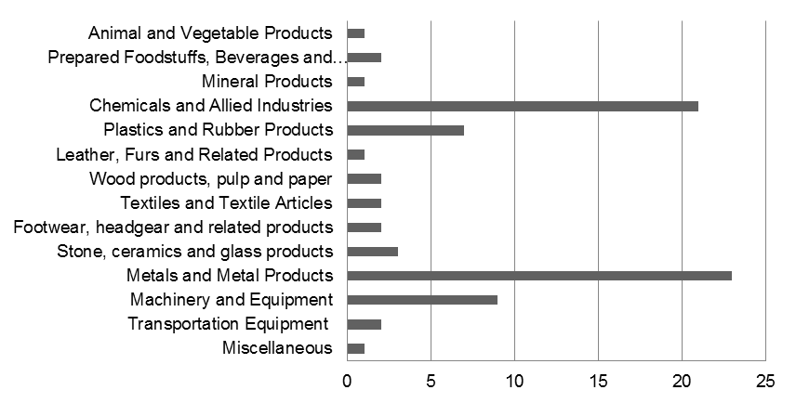
Source: Authors’ calculations based on DG Trade investigations database

Countries Named in EU TD investigations, 2005-2010
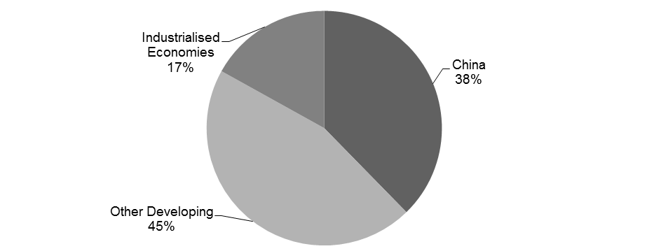
Source: Authors’ calculations based on DG Trade investigations database

Findings

The economics of the EU’s TD practice

The observed effect of TD measures is to raise the price and reduce the volume of imports of the subject goods. This is simply the effect of tariffs and thus indistinguishable from ordinary trade protection: domestic producers benefit but consumers or downstream industries are negatively affected. Since standard economic analysis indicates that the costs to consumers or downstream industries of the higher prices induced by tariffs are normally larger than the benefits to domestic producers, the economic rationale for TD depends crucially on whether the practices addressed by trade defence measures are anti-competitive or market-distorting, or entail excessive adjustment costs by the EU industry.

The economic analysis in chapter 2 demonstrates that trade defence is not ordinary protection: it is targeted, contingent and (in the normal course) temporary. All three features are important. TDI target practices, such as forms of price discrimination by firms and subsidies provided by government, which imply a transfer of economic welfare from the origin country to the EU. In a global perspective, such transfers of welfare are largely neutral as they net out each other. By the same token, the reversal of such practice through trade defence measures is also largely neutral. At the same time, the remedy of injury to the importing country producers can make the intervention globally welfare-improving. Finally, in a multilateral trading system, with many sources of imports and many export markets, imposing trade defence measures on one or a few bilateral flows has limited effects on welfare because trade flows mostly rearrange (trade diversion and deflection) rather than disappear.
Section 2.1

The review of the motives for TDI confirmed the general view in the economic literature that the stated rationale for EU TDI, i.e. countering unfair trading practices, finds little support based on the actual pattern of use. Only a handful of the TDI cases examined involved pricing practices (on the part of the foreign firms) which would be likely to prompt domestic competition authorities to intervene, if similar pricing behaviour had occurred within the domestic market. It would therefore appear that TDI are not usually countering anti-competitive predatory dumping. That being said, in a certain number of cases, primarily those in which measures have been in place for an extended period of time, usually involving countries in transition to market economies, the circumstances suggest TD measures are countering large and persistent distortions in the global economy.
Section 2.2.2

If the EU’s TD practice does not appear to act for the most part as the international trade analogue of domestic competition policy, it is legitimate to ask what it does do. The evaluation therefore examined the following potential roles of TDI:
Sections 2.2.3-2.2.8
- as a macroeconomic buffer;
- as a tool of industrial policy;
- as a retaliatory mechanism to protect domestic exporter interests;
- as the policy tool of choice to deliver insurance against excessive trade pressures stemming from trade liberalisation; or
- as protection for communities vulnerable to disruptive change stemming from trade (e.g., relatively isolated communities heavily dependent on particular plants for local employment).

Most of these motivations appear to be present, in varying degrees, in the EU’s use of TDI in the evaluation period. However, the most important function of TDI appears to have been to safeguard the EU’s economic interests in the wake of the integration of major emerging markets such as China into the global economy. The EU, in liberalising emerging markets’ access to its market, has de facto retained the right to use TDI as a form of insurance policy. This perspective on TDI reconciles trade liberalisation with the simultaneous occasional recourse to protection. The fact that anti-dumping has been the main instrument of this insurance policy, rather than the provisions in the WTO intended for the purpose (safeguards and renegotiation of commitments), appears to reflect weaknesses in the design of these latter instruments. At the same time, in a “second best” sense, it can be considered as a legitimate use of TDI.
Section 2.2.6

This systemic benefit of TDI comes with certain systemic costs. First, TDI have been shown to have a “chilling” effect on firms’ international business decisions, both as importers of intermediate inputs, as exporters and as participants in global value chains. This has negative impacts on their longer-term productivity and innovation performance. Second, when firms respond to TDI duties by re-arranging their global market presence, there is an implied write-off of assets associated with the sunk costs of market entry; these costs are not measured but could be significant. Third, TDI may at times increase the scope for anti-competitive collusive practices by domestic firms. Finally, there are administrative costs of applying TDI.

As in all public policy areas, it is important to assess whether the implementation of TDI achieved its objectives and whether the benefits of the instrument outweighed the costs. In the present evaluation, it could not be confirmed, as stated above, that TDI generally achieve the stated objective of restoring competitive conditions. The question then is whether TDI fulfil the implicit objective as suggested by the observed pattern of use: that is, whether they deliver the protection that the insurance role implies – i.e., is trade defence an effective insurance policy?
Section 2.2.8

The level of protection that the EU provided to industry through TDI in the evaluation period was moderate in international comparison. Anti-dumping duties applied by the EU in the evaluation period ranged from 5.4% to 90.6% with a simple average of about 33%. Countervailing duties ranged from 4.3% to 53.1% with a simple average of 22.7%. This is high compared to the EU’s average applied most-favoured nation duty in 2011 which was 6.4%. However, compared to duties imposed on the same sectors by the USA, the most comparable jurisdiction to the EU, the evaluation shows that US duties were three times as high as those of the EU on average. The “lesser duty rule” that the EU applies (which results in duties sufficient only to offset injury, not necessarily the full amount of dumping or subsidisation found) contributed to this outcome, but only moderately: the average reduction of the EU duty rates as a result of the lesser duty rule was about 9.3 percentage points, resulting in duties 28% lower than they would have been without the lesser duty rule. This means that even without the application of the lesser duty rule EU TDI duties would have still been lower than US duties.
Section 2.3.2

Nonetheless, the available evidence suggests that the level of protection provided is more than sufficient to offset injury:
Section 2.3.3
- industries applying for protection tend to have below average price mark-ups prior to protection;
- protection allows them to increase mark-ups;
- the increase in mark-ups more than compensates for the under-performance in the pre-protection period compared to peer industries; and
- the higher mark-ups persist after protection is terminated.

While trade defence thus appears to be effective in a static sense, questions have been raised concerning its dynamic effects. Firm-level studies suggest that firm exit rates are reduced in protected industries relative to comparable unprotected industries. Accordingly, protection slows the normal pace of renewal of the industry and the transfer of market share from low-productivity to high-productivity firms, apparently weakening productivity growth at the industry level. At the same time, the evidence suggests that lower-productivity firms invest and make structural adjustments to improve their competitiveness during the period of protection. The evaluation raises a caveat concerning this finding: the literature on capital investment shows that young firms investing heavily in new technology and still gaining experience with the new technology are less profitable than older firms that are investing less but are extracting returns from their prior investments and experience capital. However, the extent to which this consideration affects the dynamic effects of TDI would require further in-depth analysis based on firm-level data. Accordingly, only a provisional conclusion is possible here, namely that trade defence measures deployed to protect industries with many young firms and in which the pace of process innovation is rapid will likely have more positive welfare effects than TDI in other sectors.

Trade defence measures might in principle be enforced indefinitely if the conditions that gave rise to injury do not change (e.g., if foreign government subsidy policies remain in place). However, the EU extends only a minority of measures. 52% of EU trade defence measures are revoked during the initial five-year period or expire at the end of it without an expiry review, and an additional 14% are terminated following the expiry review. Another 13% of measures are in force for between ten and 15 years and only 4% of measures were in place for 15 and more years. Most measures which are in place for long periods (more than ten years) are in the chemical sector (fertilisers, organic chemicals and salts). In terms of countries affected by long-term measures, China and Russia are over-represented. Accordingly, TDI protection in EU practice is typically temporary in nature. This is important from a systemic perspective since the provision of protection implicitly comes with the likelihood of trade liberalisation in due course, which firms must take into account.
Section 2.3.2.2

In summary, the evidence assembled in the study suggests that the protection given by EU TDI is on the whole effective and reasonably well calibrated, although the protection is moderately greater than what would be required to offset injury, even with the application of the lesser duty rule.

In a forward-looking sense, three main concerns are raised by the review. First, TDI rules were developed with national production systems rather than global value chains in mind. Effectively, measures are designed so as to protect the last stage of value creation, i.e. the stage which gives a good its definitive character for customs valuation purposes (e.g., a tariff classification). Thus, EU firms that choose to outsource intermediate stages of productions can be protected by TDI. However, EU firms that outsource the final stage of transformation may be targeted by TDI, even though this strategy may add more value to the EU economy. In the evaluation period, the complications for policy posed by this issue arose only in few instances. This reflects the fact that global value chains in which EU firms participate feature predominantly north-north, intra-firm trade, much of it in business services. EU TD measures, by contrast, targeted predominantly north-south trade in goods. However, in some cases identified in the evaluation period, problems did arise. Moreover, in the future, growing use of global production systems can only work to further complicate matters for TDI administration.
Section 2.3.4

Second, the study finds that the EU TD system is comparatively slow and somewhat costly for industry to use: on average, it takes almost 2.5 years from the onset of injury to the implementation of measures. The cost to a complainant of participating in an investigation is typically around EUR 200,000 but can be as high as EUR 1 million. In international comparison, the EU system fares worse in terms of duration of investigations (several peer countries take considerably less time to complete investigations) but better on costs: in the USA, the typical cost for a complainant may easily exceed EUR 700,000 to EUR 1.1 million. While the relatively lengthy process and the associated costs serve as a discipline against overuse, for small and medium-sized enterprises, this compounds the problems of obtaining TDI relief where it might be warranted.
Section 2.3.2.3 and 4.8

Third, the growing threat of retaliation against EU producers – mainly from emerging markets – and the perceived problem of circumvention by foreign exporters of TD measures, are contributing to making TDI a less attractive solution for EU industry.

To summarise, in a larger policy framework, in which it is recognised that trade liberalisation is facilitated by contingent protection, the EU’s TDI use in the evaluation period can be shown to be welfare enhancing. Given the importance of an open trading regime to domestic competitiveness, TDI can therefore be argued to be competitiveness-enhancing. At the same time, it is not appropriately designed for the actual function it fulfils; moreover, basic design features make it increasingly inappropriate for the emerging world of globally fragmented production systems.
Section 2.4

The consistency of EU TD practice with EU regulations and WTO obligations

Over the evaluation period, there were 35 judgments on EU Court cases related to anti-dumping and anti-subsidy instruments (i.e. on average six cases per year). This is only a fraction of the number of TDI court cases in the USA, which has a similar number of TD measures in force. However, the number of cases decided per year rose more or less steadily over the period 2005 to 2010. Also, cases tended to become more complex and to cover more legal issues. Thus, the total number of main legal issues addressed in the 35 cases reviewed amounted to 82, i.e. an average of 2.3 per case, rising from 1.0 in 2005 to 3.1 in 2010.
Section 3.1

The “success rate” of EU institutions in EU Court cases, i.e. the share of claims dismissed by the Courts, stands at 80.5% over the six-year period (66 out of 82 claims), with an increasing trend over time. In 2010 Court decisions, all claims were dismissed (i.e. the success rate was 100%). Compliance of the EU institutions with the basic Regulations is very high and the interpretation of the Regulations by the Commission during investigations and determination of measures is usually confirmed by the Courts to be in compliance with the spirit of the law.

As regards the compliance of EU TDI with WTO rules, since 1995 the EU has experienced fewer challenges than its share in global trade defence measures. Thus, while the EU imposed 11.1% of all anti-dumping measures over the period 1995-2010, it was involved as a respondent in only 9.5% of WTO disputes on anti-dumping. The corresponding shares for countervailing measures were 17.5% (EU share in measures) and 12.6% (EU share in disputes on countervailing measures). In the evaluation period, in the three cases against the EU brought forward by China, South Korea and Norway, the EU’s success rate, as measured by the share of rejected claims was over 50%. It is concluded that, despite recent findings of violation of specific WTO rules by EU TDI (such as individual treatment), the degree of compliance of EU TDI law and practice with WTO rules is satisfactory.
Section 3.2

Overall, the degree of compliance of EU TD practice with the two basic Regulations and WTO rules is satisfactory; the number of legal challenges (in EU Courts or at the WTO) is comparatively low, and the EU’s success rate is high. Accordingly, only a limited number of amendments to the two basic Regulations that implement the EU’s TD system are recommended in response to decisions handed down by the EU Courts or by the WTO Dispute Settlement Body. At the same time, performance trends during the evaluation period (increased number of legal challenges, rising number of issues disputed, and only an average success rate in WTO disputes) show that a certain degree of alertness is warranted. It is understood that the Commission is aware of these trends, and part of the objectives of its internal management programme is to ensure that trade defence practice is in line with the provisions of the basic Regulations and WTO rules.

EU TD practice in international comparison

The international comparison in chapter 4 provides a structured examination of international TD practice. This analysis focuses on a number of contentious issues bearing on the efficiency and perceived fairness of practice, drawing on more complete reviews of the peer country systems assembled in the course of evaluation.

Institutional structure of TDI and the question of independence from political influence: Different countries have adopted different institutional structures to administer TDI. A central question concerns the objectivity of the system and whether decisions are rules-based or subject to political influence. Several countries (including Australia and New Zealand) rely on the established and institutionalised neutrality of their civil service to deliver objective decisions consistent with the rules and principles of the WTO rules-based system; others (including Canada, South Africa and the USA) have established independent investigating authorities to distance TDI proceedings from overt political influence.
Section 4.1

In the EU framework, by contrast, the investigating authority is a Directorate within the Commission, and definitive decisions are taken by a political body (the Council). Notwithstanding the direct involvement of political bodies in the EU’s decision-making process, there is only anecdotal evidence in the context of particularly contentious cases regarding politicisation of decisions; the evaluation team could find no systematic evidence for such interference. In terms of decisions rendered, the EU TD system does not appear to be more politicised than that of most peer countries, an interpretation supported by the degree to which decisions have withstood legal challenge.

The implications of globalisation of production for the ability to benefit from TDI protection: The emergence of global value chains calls into question the established understanding of what constitutes the “domestic industry” under TD practice. With inward and outward FDI, and various business outsourcing and offshoring strategies, a divergence in interests within the domestic industry can emerge, depending on the business strategy chosen by different firms, thus making it more difficult to meet standing requirements for the initiation of investigations. As well, a divergence between the interests of mobile capital and immobile labour emerges which raises the question of whether TDI will be effective in protecting domestic value-added in the emerging global framework.
Section 4.2 and 4.3

In this context, the question has emerged for the EU of whether labour unions should have the right to bring cases and/or whether the Commission should initiate cases ex officio.

International practice varies in both regards. Australia and the USA provide for labour union-initiated complaints; New Zealand and South Africa do as well, but only in cooperation with industry; the EU, along with Canada, China and India do not allow such proceedings. Clearly, given the importance of confidential business information to investigations, such an innovation would have far-reaching procedural implications, including the possible need to impose obligations on industry to cooperate, a power which the Commission does not presently have. Nonetheless, although it is not a panacea for all of the situations mentioned where domestic producers might refrain from submitting or supporting a complaint, it is recommended that the right to submit complaints and have standing be extended to labour representatives. Regarding conflicts between employees and management of domestic producers, guidance could be taken from US rules.

The main alternative is for the TDI authorities to step in with ex officio investigations, particularly in respect of subsidies, given that subsidy investigations directly target a foreign government’s policies and firms might be reticent to take such steps because of the possibility of retaliation or pressure on their business interests in that country. Most peer countries (New Zealand being the exception) provide for ex officio investigations but seldom use it. The EU system also provides for this option but the authorities have not made use of in the past except for reviews; the Commission has indicated that it is willing to consider ex officio cases against subsidies in some cases. The evaluation team recommends that the EU continue to use ex officio initiations of new investigations only in special circumstances where the business interests of some EU firms in the country of export might militate against their joining a specific complaint and thus compromise the ability of the industry to gain standing for a complaint.

Transparency and confidentiality: WTO rules require that non-confidential information be made available to interested parties but allow members the discretion of whether to provide access to confidential information and the design of the system of controls regarding such access. Countries have used the policy space afforded by WTO rules to develop different systems with differing implications for cost and transparency. The USA through its Administrative Protective Order (APO) system, and Canada through individual confidentiality agreements, provide legal counsel for the parties access on a controlled basis, with sanctions for unauthorised disclosure. Other peer countries and the EU do not allow access to confidential information, although the EU does provide access to confidential information to the courts.
Section 4.4

The evaluation team notes that an alternative to an APO system such as the one in the USA is to provide for the possibility of having the Hearing Officer check, upon request by interested parties, that confidential information has been taken into account correctly by the Commission in the investigations. This option has in fact already been selected by the Commission and awaits full implementation. The introduction of a system to provide access to confidential information (such as the APO system) is therefore not recommended at this stage. However, it is recommended that a review be undertaken once some experience has been gained with the Hearing Officer’s role of verifying that confidential information has been duly considered in an investigation.

Treatment of non-market economies (NMEs): Although the WTO Anti-dumping Agreement does not specifically refer to NMEs, in the case of a country which has a complete or substantially complete monopoly of its trade and where all domestic prices are fixed by the State, or in which a “particular market situation” exists, WTO rules provide for TD authorities to determine normal value on a basis other than the normal domestic selling prices in the exporting country. Significant trading countries for which NME status is an issue internationally include China, Vietnam, Russia, the Ukraine and other former Soviet Republics (notably, the EU treats Russia and the Ukraine as market economies whereas some of the peer countries do not). However, international practice varies in terms of how the latitude for NME status is used, ranging from the absence of the concept of NME (in China), a case-by-case assessment (most peer countries), to fixed lists of NMEs (India, USA, and the EU). Likewise, the modalities for a country being granted market economy status (MES) or market economy treatment (MET) for exporters from NMEs vary considerably.
Section 4.5

In the EU, NME countries are listed in the ADR. By contrast, in some peer countries, the determination of whether non-market conditions exist is determined by the administrative authorities on the basis of the factual context of the industry and country concerned. The establishment of MES by the EU tends inherently to be a long process and so far has been completed only by two countries. Regarding the treatment of NMEs at the country level, the EU system provides less flexibility than others that are presently in use. On the other hand, requests for MET, which is treated on an enterprise level (rather than on a sector/industry level as in Canada or the USA), are frequent.

Changes in TD practice will be required with the expiry of China’s NME status in 2016, and Vietnam’s in 2019. Moreover, recent WTO DSB decisions will require EU practice regarding Individual Treatment to be changed or abolished. The practices of Australia, which has granted China market economy status and utilises the “particular market situation” provisions to address cases where domestic Chinese prices may be distorted, and Canada, which applies market treatment as the default but has used the latitude in its system to successfully apply non-market treatment where warranted, are worth examining as the EU considers its next steps.

Lesser duty rule: The WTO rules urge countries to consider applying lesser duties than those indicated by the dumping or subsidy margin, if that would suffice to eliminate injury. The method of calculation of an injury margin is not however specified. Practice internationally varies and no approach grounded in economic theory has so far been developed. Practice in Australia and New Zealand is most comparable to that in the EU, which applies the lesser duty rule in each case. Both countries apply a “non-injurious price”, although different calculation methods are used. The concept of the non-injurious price is based on levelling import prices with what domestic industry prices would be in the absence of dumping or subsidisation (i.e., a price that the domestic industry could have charged absent the price suppression caused by dumping or subsidisation, and thus sometimes referred to as an “unsuppressed selling price” or a “pre-injury price”). The USA does not apply lesser duties, while Canada only rarely does pursuant to a public interest test and with no established methodology. In none of the countries reviewed is the effect of the lesser duty rule on the number of measures affected and the reduction in the level of measures comparable to the EU. In view of the findings in the economic evaluation part, the EU approach is considered preferable to that practiced in the peer countries.
Section 4.6

Public Interest test: WTO rules require that countries provide opportunities for parties adversely affected by duties (industrial users or consumer organisations) to be heard, and urge countries to make the imposition of duties voluntary, rather than mandatory. However, there is otherwise no detailed provision for a public interest test. International practice varies. The USA has no provision for a public interest test. Australia, New Zealand and South Africa have no formal provisions but the Minister responsible for TDI can exercise discretion as to whether to apply duties or not. India and China mention public interest in their legislative framework but no evidence of application was found. Only Canada among the peer countries has provisions for a public interest inquiry and case history of use. However, whereas the EU applies the test in every case, Canada rarely does and only in a separate procedure after measures have been imposed. EU practice thus clearly stands out.
Section 4.7

As regards its impact, although the number of cases terminated based on public interest considerations is limited, a more comprehensive assessment suggests that the role of the test in the EU’s TD system should not be underestimated. At the same time, the EU’s methodology remains underdeveloped, opening up the test to criticisms of discretionary application and limiting the predictability of the system.

The WTO Agreements provide both for the prospective and retrospective collection of anti-dumping or countervailing duties. In a prospective system, the level of the duty is determined during the investigations then applied at this level for the duration of its application, unless reviewed at an earlier stage. Conversely, under a retrospective system, the duty rate established in investigations is for deposit purposes only; the final level of duties due is determined only after products have been imported, and then based on the actual level of dumping or subsidisation. Moreover, duties can be applied on an ad valorem basis, as specific duties, or based on reference prices (which involves applying duties equal to the difference between the amount at which imports are priced and the reference price indicated). Based on the analysis of peer country experience, reference price based systems are used often; as well, there is a tendency towards greater use of ad valorem duties (see, for example, Australia and New Zealand).
Sections 4.9 and 4.10

The various approaches to applying duties have their advantages and disadvantages. In principle, the retrospective method is more accurate as parties only definitively pay whatever duties were in fact due, i.e. if the export price increases subsequent to the imposition of duties lower duties will be collected, while higher duties will be collected if the export prices decreases subsequent to the imposition of the duties. This negates the requirement for refund proceedings and also negates the possibility of absorption of the duty. However, since the definitive level of a duty collected retrospectively can only be determined after the importation has already taken place (and, in most instances, after the imported products have been sold) and as the importer has no control over domestic price movements in the exporting country, this adds uncertainty to the market, which may have a dampening effect on trade. Prospective reference price systems induce exporters to raise their price to avoid duties, which also means that the economic benefits to the importing country from TDI are reduced. Meanwhile, prospective ad valorem duty systems, such as the one used in the EU, are simpler to administer but have a built-in bias against fair exporters (the higher the price charged, the higher will be the duty). One way for exporters to remedy this is by requesting a partial interim review of their dumping. This has been done in a number of cases during the review period. However, it is contingent upon the finding of a lasting nature of the alleged changes and only has an effect on future duties, while not addressing past duty payments. For this, refunds are the only option.

Complex systems such as the retrospective system used by the USA or the prospective reference price systems applied by Canada and Australia would be difficult to implement in the EU, given that 27 different customs authorities would need to apply these measures in the same way. In view of these considerations, and given that no system is clearly superior in all respects, the EU need not consider a change in its duty collection system.

The WTO Agreements provide that trade defence measures may only remain in place to the extent and for the duration required to counter the injurious effects of dumping and subsidised exports. No duty may remain in place for a period of more than five years from imposition or the last substantive review thereof. The two agreements provide for a variety of reviews, including expiry reviews, interim reviews and new exporter reviews.
Section 4.11

The comparative review shows that there are few differences in the policies on reviews among peer countries. Apart from the relatively long duration of reviews, the use of and methodology for reviews in the EU is in line with international practice. Regarding the duration of measures, EU TD measures have a low degree of institutionalisation, with long-standing measures being concentrated in few sectors. The EU policy on the duration of measures can thus be considered good international practice. One area where a change in practice could be warranted is the limited use of (full) interim reviews. The relatively high degree of measures expiring automatically without an expiry review is an indication that such measures have actually been in force longer than necessary. At the same time, the practice in peer countries in this regard is not significantly different from the EU practice.

The effectiveness of anti-dumping or countervailing measures may be jeopardised by various practices aimed at circumventing them in order to avoid payment of duties. Although the evaluation team found no evidence that there has been a systematic increase in circumvention, the issue has received increasing attention from policymakers internationally. However, only a minority of countries – among the peer countries, only South Africa and the USA – has designed special anti-circumvention instruments. The EU’s anti-circumvention instrument is comparatively well developed and counters circumvention to a certain extent.
Section 4.12

Anti-absorption tools are even less common internationally. In the EU, anti-absorption reinvestigations aim at providing an early, “accelerated” and simplified alternative to an interim review of the level of dumping or subsidisation. However, their practical importance is negligible – in only one case in the evaluation period (of three anti-absorption reinvestigations undertaken) have measures been revised upwards.

Recommendations

Based on the analysis, the evaluation team has proposed a number of recommendations. These are grouped into three categories: those that concern issues which require multilateral attention; those that concern the EU’s policy regarding the use of TDI; and those that address narrower issues regarding the framing of the two basic Regulations or specific administrative practices in implementing them.

Recommendations concerning issues to be dealt with at the multilateral level
Section 6.2.1
The evaluation team reached major conclusions in respect of the rationale for and the relevance of TDI. These conclusions relate to the nature of TDI and not to their implementation by the EU. As a result, most recommendations following from these conclusions would not have to be addressed by the EU (or any other WTO member) unilaterally but in the context of multilateral discussions and approaches, as unilateral approaches might introduce distortions into the international trading system and lead to unintended negative consequences. The evaluation team is aware of the fact that the likelihood of a multilateral agreement on these issues (or even an agreement about the need to discuss these issues) is limited; nevertheless such discussion is considered desirable in order to ensure that TDI remain a relevant trade policy instrument in the medium and longer term.

The issues identified for such a multilateral approach include:
- The de facto role of the AD instrument in particular as a substitute for grey area measures and safeguards: The main benefits that can be attributed to TDI as practiced have been ascribed in the present evaluation report to its stand-in role for deficient trade liberalisation insurance instruments, i.e. the majority of TD measures do not protect EU producers against unfair trade practices but rather against import surges. It is important to recognise in this context that the Uruguay Round reforms, which abolished informal diplomatic tools to manage the kind of pressures posed by the integration of major emerging markets into the global division of labour, failed to replace them with effective formal tools. An improved safeguards instrument (or a new instrument) would be required which, given the analysis here, should be framed in insurance terms with no connotation of “unfairness” concerning the disruptive changes caused by trade liberalisation.

- The treatment of NME countries: Differences in treatment of NMEs across WTO members’ AD systems introduce inconsistencies in the international trading system which should be avoided. A harmonisation of NME concepts at the multilateral level would therefore be desirable. Conceptual changes are likely to be required not least in response to the changes in status of China and Vietnam, the two major economies with significant NME characteristics, in 2016 and 2019, respectively. In this context, the evaluation showed that flexible systems that do not rely on lists of countries established by regulation have not apparently impaired the application of NME status to countries/sectors where such treatment is warranted. These considerations suggest that a flexible system of NME treatment such as practiced in some peer countries could be more appropriate than the current system applied by the EU, in particular with regard to the lists of NMEs and the granting of country-wide MES. The practices of Australia, which has granted China MES and utilises the “particular market situation” provisions to address cases where domestic Chinese prices may be distorted, and Canada, which applies market treatment as the default but has used the latitude in its system to successfully apply non-market treatment where warranted, are worth examining as the EU considers its next steps.

- The application and calculation of lesser duties: Current international practice regarding the application of the lesser duty rule varies and is largely not grounded in economic theory. As mentioned, the EU’s consistent application of the lesser duty rule is however consonant with an understanding of TDI as a remedial instrument, and must therefore be considered best international practice. Still, the evidence adduced in this evaluation report concerning the higher profitability of EU firms in protected sectors than in comparable non-protected sectors indicates a trade deterrent effect of TDI that is stronger than required to simply offset injury, even with the application of lesser duties as presently calculated. Given the high proportion of cases which target industrial inputs, the further implication is that, even with the lesser duty rule, the costs imposed on downstream industries, including firms participating in global value chains, are greater than necessary. Based on these findings it would be desirable if the WTO members, first, made the application of the lesser duty rule compulsory internationally and, second, agreed on certain minimum standards for the calculation of lesser duties.

- The alignment of TDI with patterns of trade in global value chains: trade defence measures at present systematically favour domestic firms that outsource their intermediate inputs over firms that outsource the final stage of manufacturing, without regard to the domestic value-added in the two business strategies. In other words, trade defence measures are designed to protect the last stage of value creation, not the domestic contribution to the overall value of the good. Goods are increasingly “made in the world”, but TDI has no metrics at the moment to address this. While in the EU the public interest test provides the necessary flexibility to address value chain issues, a better – and internationally shared – conceptual integration of global value chain issues in TDI would be desirable.

- Reflecting heterogeneous firm theory and empirics in TDI rules: When the WTO rules for TDI were developed the economics profession worked in terms of a “representative firm” model – in theory, industries were assumed to be homogenous in technology and thus in costs. Modern heterogeneous firm theory and empirics show that firms are highly skewed in terms of all performance factors. This is one area where trade defence practices have not kept up with the empirical evidence on firms in international trade. For example, the practice, in cases where sampling is used, of selecting the largest firms of the population, may distort the investigation findings if the characteristics of large firms are different from SMEs. While the economic impacts of trade defence measures have been addressed in a growing number of studies using firm-level data, a systematic assessment of the implications of firm heterogeneity for TDI rules and procedures (e.g., sampling methodologies), has not, to the knowledge of the evaluation team, been done. This is a major undertaking that should be done at the multilateral level.

- Finally, policy coherence between industrial policy and trade defence: Economic theory indicates that, if subsidies are structured to address local market failures, they are not market distorting. However, in current TD practice, all direct countervailable subsidies are assumed to pass-through entirely to export prices and thus to distort markets. Given the widespread reconsideration of industrial policies to address market failures and economic development needs, there is potential for increased frictions with trade defence. One way to establish the basis for policy coherence between industrial policy and trade defence would be to introduce a pass-through analysis into subsidy investigations. This step would introduce greater internal consistency of WTO rules while also providing for more discriminating application of TDI.

Recommendations concerning EU policy choices
Section 6.2.2
An officially-accepted intervention logic for the EU’s use of AD and AS instruments does not currently exist. However, in communications materials, TDI is justified by the absence of a competition policy regime in the multilateral trading system and the divergence of conditions under which international trade takes place from the conditions prevailing in intra-EU commerce, where the “four freedoms” are ensured by the EU economic regulatory framework. The mission statement sets the overall objective for TDI policy to contribute to the competitiveness of EU industry and to the welfare of EU consumers.

Recommendation 1 | See report section(s)
In order to provide better guidance for the implementation of EU TDI and in order to facilitate future evaluation of TDI, it is recommended that DG Trade’s mission statement be complemented by an officially accepted intervention logic. | 1.4.1 Development of intervention logic

The report also presents ideas (in section Error! Reference source not found.) which could serve as an input for the development of such intervention logic.

Initiation of investigations and treatment of non-cooperation: Global economic developments in recent years have raised doubts that current rules for and practice of the initiation of proceedings continue to be effective. In particular, the emergence of global production patterns has resulted in differences of interests among domestic producers, depending on the business strategy chosen. A similar divergence of interests regarding dumped or subsidised imports may occur in the relationship between EU producers and their employees. Finally, increasing international exposure makes EU firms susceptible to retaliation and threats thereof. In the view of the evaluation team, reforms are required to ensure continued effective access to TD for EU industry where it is warranted.

Recommendation 2 | See report section(s)
It is recommended that the Commission use its capacity to initiate new investigations ex officio in circumstances where the business interests of some EU firms in the country of export might militate against their joining a specific complaint and thus compromise the ability of the industry to gain standing for a complaint. Examples of such circumstances include:  - There is a history of firms requesting anonymity in respect of TDI actions in respect of the country concerned.  - There is prima facie evidence of tit-for-tat retaliatory behaviour by the country concerned (e.g., a pattern of launching of reciprocal investigations immediately following decisions to apply measures against that country either in the same product group or on an equivalent amount of exports).  - The producer has significant investments in the country concerned or exports a significant portion of its production to that country.  - The structure of the industry and circumstances of the case do not allow the retaliation threat to be addressed by maintaining the identity of the complainant confidential, an approach the Commission has successfully used in the past.  It is also recommended that the right to submit complaints, and have standing, be extended to labour representatives, in order to ensure that access to TDI is also guaranteed in situations where interests between EU producers and their interests diverge (notably in situations of fear of retaliation). | 4.2 Policy choices regarding the initiation of proceedings

A logical consequence of recommending that labour submit complaints is that options for compelling interested parties to cooperate need to be considered. Furthermore, obligatory cooperation in investigations would also enable EU companies to better handle pressure which may be exerted by allegedly dumping exporters or subsidising governments. At the same time, ensuring that interested parties (both those based in the EU and exporters) provide accurate information is important.

Recommendation 3 | See report section(s)
In order to ensure that investigations initiated in line with the previous recommendations can be based on sufficiently detailed and accurate information, it is recommended that DG Trade be provided with instruments to ensure the cooperation of interested parties (both those based in the EU and exporters) in TD investigations. These instruments should be comparable to those which DG Competition has as part of its investigating powers. In this regard, sanctioning mechanisms (such as fines) for the provision of false information should also be introduced. | 4.3 Obligation to cooperate  5.2.2.2 Investigation instruments

Changes in the Union interest test: The growing complexity of the trading environment due to fragmentation of production across borders raises new challenges for applying TDI. In the longer run, these changes may necessitate fundamental reforms to TD practice at the multilateral level, as outlined above. For the immediate future, the EU is well positioned to address these issues due to the routine application of the Union interest test.

Recommendation 4 | See report section(s)
The evaluation team recommends that the Commission take into consideration out-sourcing strategies (domestic and international) of businesses in its public interest evaluations. In the first instance, following past practice, the Commission could request documentation of EU value added from complainants and from exporters.  It is also recommended that, in addition to the assessment of potential effects of measures as currently undertaken, the following considerations be applied in evaluating the Union interest in any individual case:  - Where the Union industry’s market share is low, the welfare impacts of TDI are likely to be negative.  - Where concentrated impacts on particular communities can be expected from not applying TDI, the welfare case for TDI is strengthened.  - Where the goods in question are intermediate products used by downstream industries, the larger the share of production costs, the greater the likelihood that TDI could have adverse effects on EU industry as a whole.  - Conversely, where the inputs for the like products produced by the Union industry constitute a large share of the EU upstream industries’ output, the welfare case for TDI is strengthened.  - The Commission could also consider excluding those products which are not produced by the EU industry from the product definition.  Furthermore, the role of interested parties should be clarified: in line with the practice in other parts of the investigations, their main role should be to provide information and comment on the Commission’s findings, but the actual analysis of public interest should be reserved for the Commission. In consequence, this would require collection of information on Union interest issues (e.g. through questionnaires) at the same time as information for the dumping/ subsidisation and injury analysis. Basing the Union interest test on representative information would help the Commission to arrive at more robust findings.  While these suggested changes are likely to enhance the robustness and validity of the Union interest test findings, they would also require additional resources. | 2.1.3.4 Systemic Effects: TDI and Fragmented Production Systems  6.1.1.7 Competitiveness impacts on the EU economy in the evaluation period  5.1.6.3 Methods applied in determining the Union interest

Shortening the process for provisional determinations: Although substantially reducing the overall duration of EU trade defence investigations seems infeasible given the procedural requirements of the EU system, a realistic option, in the view of the evaluation team, would be for the Commission to focus on threat determination in the initial phase of its investigation and impose provisional measures earlier. Emphasis also needs to be placed on existing WTO rules that provide for short-term responses in cases of “massive importation” in the form of retroactive provisional duties.

Recommendation 5 | See report section(s)
It is recommended that the Commission address stakeholders’ concerns regarding the length of the period until protection is granted by shortening the investigation up to the imposition of provisional measures, including by taking decisions on provisional duties prior to verifications.  The evaluation team recognises that this would be contingent on the ability to impose disciplines (including the use of sanctions) to ensure full and accurate reporting by interested parties (including exporters) prior to verification processes (see recommendation 3 above). It is also noted that an earlier imposition of provisional measures would reduce the overall duration of an investigation due to the limited time during which provisional measures may remain in place. Accordingly, this recommendation may require additional resources which allow speedier investigations. | 2.3.2.3 Timeliness of measures  4.8 Duration of Investigations and Use of Provisional Measures  5.2.2.1 Duration of investigations

Provision of access to confidential information: The evaluation team has concluded that further improvement in the transparency of proceedings is recommendable, with the provision of access to confidential information being a key element. The EU approach of appointing a Hearing Officer is one that addresses transparency concerns without raising the cost of accessing the TD system for EU industry, especially small and medium-sized firms. At the same time, the team recognises that the full possibilities of the Hearing Officer model that has only recently been introduced by the EU have not yet been fully explored.

Recommendation 6 | See report section(s)
The evaluation team recommends that the Commission actively promote the role of the Hearing Officer within the stakeholder community to ensure that the potential effectiveness of the model is demonstrated in practice. The introduction of a system to provide access to confidential information is not recommended at this stage. However, it is recommended that a review be undertaken once some experience has been gained with the Hearing Officer’s role of verifying that confidential information has been duly considered in an investigation. | 4.4 Transparency and confidentiality  5.2.3 Transparency and Confidentiality of Proceedings

Duration of measures and dynamic impacts of TDI: Given the highly particular nature of TD cases, there can be no objective foundation for generalisations concerning the appropriate duration of measures. EU performance in terms of limiting the length of term of measures stands up well in international comparison. Nevertheless, two modest policy adjustments could ensure further that the duration of measures corresponds to the practice addressed; thereby strengthening incentives for firms in protected sectors to prepare for the trade liberalisation implied by the expiry of TDI, rather than counting on the extension of protection.

Recommendation 7 | See report section(s)
It is recommended that the Commission reduce the threshold for prima facie evidence for changed circumstances regarding dumping/subsidisation or injury to be submitted in requests for interim reviews by interested parties.  In expiry reviews, the Commission could raise the threshold level for a positive finding of likelihood of recurrence of dumping/subsidisation or injury that must be demonstrated to warrant extension of measures. Also, it could be envisaged to extend measures, given a positive finding of continuation or likelihood of recurrence of dumping/subsidisation and injury, by five years as a general rule (except for Union interest considerations) and balance this with a more active use of (full) interim reviews. | 2.3.2.2 Duration of measures  4.11 Policy of Reviews and the Duration of Measures  5.3 Review mechanisms and procedures

Other recommendations
Based on the detailed evaluation of the EU’s implementation of TDI, a number of recommendations regarding certain specific substantive and procedural issues are made. Also based on analysis of EU court judgments and WTO rulings, the present evaluation concludes that a number of specific amendments to one or both of the two basic Regulations are warranted. Last but not least, the evaluation team noted that the Commission is already in the process of change with regard to a number of issues also addressed in this report. The last group of recommendations reinforces these processes of change.
Section 6.2.3

Section 6.2.4

Section 6.2.5

Conclusion

The evaluation conducted in this report of the European Union’s policy and practice in respect of TDI, namely anti-dumping and countervailing measures, took place against a background of:
- Divided views among Member States as to the efficacy of the instruments.
- An assessment by practitioners that the instruments were procedurally burdensome to use.
- Virtually unbridled hostility towards the use of TDI in the professional literature.
- And a growing sense in the policy community that the instruments were out of step with the times as the global organisation of production evolved.

In short, the prevailing perspective on TDI that confronted the evaluation team may be summarised as follows. On the one hand, it is seen by some as a costly, cumbersome, and possibly counterproductive instrument constructed for a system of nation-based production that has been in good measure superseded by one in which goods are “made in the world”. On the other hand, it is seen by others as an indispensable tool to ensure a level playing field for EU firms by addressing unfair pricing by foreign firms and market-distorting subsidies by foreign governments in the context of an incomplete system of market regulation and disciplines in the international domain.

The evaluation identified a number of considerations that greatly mitigate the perceived negative economic effects of TDI, and indeed, depending on what function TDI are understood to serve, that suggest a positive welfare impact. However, it also confirmed that TDI, as established under current WTO rules, are not designed to function effectively in a world of domestically and globally fragmented production chains or webs. This emphasises the importance of the EU’s regular application of the public interest which leaves it better placed than the other countries reviewed in terms of having established procedures to address the emerging issues flexibly. The review of EU practice shows a high degree of compliance with EU law and WTO obligations and validated most of the methodologies and procedures applied by the Commission, while also highlighting certain areas where EU TD practice may benefit from drawing on peer countries’ experience. In conclusion, the evaluation team considers that the EU’s application of TDI as framed under the two WTO Agreements constitutes good practice in many respects. The purpose of the recommendations which have been made throughout this report, the main ones of which are summarised above, is to further strengthen and improve an already good system.

ANNEX 5
Summary of contributions to the European Commission's public consultation on "Initiative on Modernisation of trade Defence Instruments"

1. INTRODUCTION

While the economic environment has changed significantly over the last decade and keeps changing continuously, the rules of the European Union's trade defence instruments (TDI) have remained largely unchanged for more than 15 years. Trade defence instruments are often the only means that companies have in order to react to unfair international trading practices. At the same time, the application of trade defence instruments can have an impact on users and consumers. In October 2011, taking into account the difficult economic environment that companies face, the EU Trade Commissioner Karel De Gucht launched a review to examine in a transparent, balanced and constructive way how to modernise the EU's trade defence instruments.

In this context, the European Commission launched a broad public consultation to gather views from interested stakeholders regarding the future of the EU's Trade Defence Instruments. Respondents provided the European Commission with information, suggestions and opinions regarding the current use of the TDI instruments and the future of these instruments.

2. THE PUBLIC CONSULTATION AND THE QUESTIONNAIRE

The public consultation ran from 3 April to 3 July 2012.

An on-line questionnaire was open to all stakeholders interested. The questionnaire had 31 questions covering six main topics: increased transparency and predictability, fight against retaliation, effectiveness and enforcement, facilitate cooperation, optimizing review practice and codification. Stakeholders were also invited to offer suggestions regarding any other aspects of the EU's rules or practice in the area of TDI which they considered should be updated.

There were 310 replies received from a wide range of respondents. Nearly one third of respondents requested that their replies are treated confidentially.

Almost 70% of respondents represented union producers and 10% represented importers. 5% of the respondents were large business associations representing union producers, users and employers and 2% were responses from Government institutions within the EU. The category others represented 14% and included law or consultancy firms, trade Unions, 1 user and respondents from third countries.
3. EXECUTIVE SUMMARY
The public consultation process highlighted the many diverging interests which exist among the various stakeholders affected by the EU's Trade Defence Instruments.
Regarding Transparency and Predictability, there was strong support among respondents in favour of improving transparency in trade defence investigations in general terms. In this context, the drafting of guidelines on various TDI issues including the injury margin, the analogue country and reviews was seen, by almost two thirds of respondents, as a welcome proposal. While there were differing opinions as to the content of any guidelines it was clear that stakeholders wanted to be involved and contribute in any drafting process. Other proposals aimed at improving transparency were met with varying levels of support depending on the perception by respondents as to which stakeholders might benefit. Over half of the respondents welcomed the proposal to inform stakeholders in good time where provisional measures would not be imposed. On the other hand, respondents were less in favour of providing a limited pre-disclosure around three weeks before the imposition of provisional measures. Even more respondents opposed the notion of creating a shipping clause expressing fears that such a proposal would undermine the effectiveness of the instruments.
The proposals regarding the fight against retaliation, particularly the suggestions regarding ex-officio initiation of investigations and confidentiality were well supported by respondents. Close to a third of respondents had been subject to retaliation in the past and the public consultation showed that it is a matter of serious concern for many stakeholders. While many respondents considered that the Commission should encourage cooperation in investigations there was only little support for the idea that this could be achieved through the imposition of fines or mandatory verification visits.
Under the topic Effectiveness and Enforcement almost two thirds of respondents considered that, while the EU’s trade defence system is effective, there is, nevertheless room for improvement. Proposals aimed at strengthening the EUs powers to tackle circumvention of trade defence measures provoked strong support such as ex-officio initiation of anti-circumvention investigations. While lengthening verification visits was seen by some respondents (40%) as a means of improving the overall quality of investigations, concerns were also expressed that this proposal might impact on the legal deadlines and also create an additional burden for stakeholders.
In the context of the subject Facilitate cooperation, over 50% of respondents stated that they did not experience difficulties in cooperating in trade defence investigations. While almost two thirds of respondents stated that the Commission should not extend the deadlines for users to participate in the process, almost three quarters agreed that the SME helpdesk should be upgraded.
Under Optimizing review practice, over half of respondents were opposed to reimbursing duties where measures are not prolonged after a review, some stating that such a move was tantamount to double remedies for importers as in most cases the duties would have already been passed on to customers. As expected, all importers were in favour of such a move. More than half of the respondents also rejected the proposal to automatically combine second and subsequent expiry reviews with interim reviews. Many respondents highlighted the fact that the possibility to request interim reviews in this context already existed. There was mixed reaction to the proposal that the Commission should systematically initiate interim reviews where anti-competitive behaviour has been identified with around 40% in favour and 44% against.
There were various reactions to the proposals under the heading Codification. In general the proposals regarding; the registration of imports ex-officio; exporting producers with zero or de minimis dumping margin not being subject to a review as well as the possibility for exemption of related parties if they are not involved in circumvention practices were supported by the majority of respondents. Regarding the proposed deletion of Articles 11(9) and 22(4) of the AD and AS regulations respectively, it was clear that respondents prefer a modification of these provisions. The majority of respondents were opposed to the notion that sampling provisions should refer to Union producers and not to complainants, except for the standing test. As regards moves to clarify that the Union interest tests covers all Union producers and not only complainants this was unpopular with the majority of respondents.
The public consultation also invited parties to make proposals to update any other areas of TDI of interest to them. This generated many varied suggestions including; the introduction of greater support mechanisms for SMEs in TDI; improving the possibilities to address circumvention/fraudulent practices; the need to tackle distortions such a dual pricing policies and export bans on raw materials; clarification of the rules of origin in the context of TDIs; the Union interest test should cover wider policy issues e.g. environmental issues and the creation of a guide on how to participate in investigations.
4. OVERVIEW OF RESPONSES TO THE QUESTIONNAIRE
The summary of the responses covers the six main areas covered by the public consultation and, for ease of reference, follows the numbering used in the questionnaire.

I. Increased Transparency and predictability
Q 2.1.1. In your view, should the Commission further improve transparency in trade defence investigations?

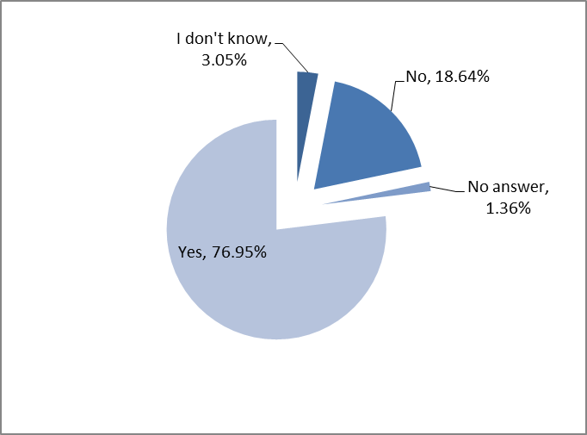
Q.2.1.2. Just over 78% of respondents said that this proposal would have an impact on their activities, while almost 6% stated it would not. The remainder either didn't answer or did not know.

Q 2.1.3. If yes, please explain how. You may also provide additional comments on this issue:

An overwhelming majority of respondents, regardless of the organisation they represent, is in favour of improved transparency in trade defence investigations in general terms. In their replies, they did not always explain how improved transparency can have an impact on their activities but suggested that it is necessary to enhance predictability and understanding of the instruments' particularly complex rules, which is beneficial to all interested parties, including SMEs.

Many importers and Union producers, or their associations, stressed that the instruments are not only balanced and adequate as they are now, ensuring that industry can operate under conditions of "fair competition", but also that they have improved over time. Although they noted that even more transparency could be helpful, it should certainly not serve to weaken the instruments. They also warned against a loss of the instruments' effectiveness in the form of more burdensome, politicised or longer procedures if more transparency-related mechanisms were to be adopted.

A few respondents considered that transparency should be increased to benefit all interested parties alike. Furthermore, a small number of respondents noted specifically that albeit desirable, enhanced transparency should not be seen as a top priority since the current standards are already very high and comply with WTO rules, favouring open and fair trade.

Several respondents pointed to specific benefits of increased transparency, such as improved and more widely accepted results of investigations, as well as increased predictability concerning their outcome. They noted that more transparency can improve decision-making processes as it helps reduce uncertainties.

A few other parties were in favour of improving transparency through the publication of documents relating to the AD/AS Committee's proceedings.

Other respondents provided suggestions of areas in the current procedures in which greater transparency could be particularly useful: in Union Interest testing, injury margin assessments, in the determination of causal links, in determining undertakings, publishing refund proceedings and in (earlier) disclosure in cases where no provisional measures are imposed. They also pointed out to the need for more transparent non-confidential files.

Q 2.1.1 Predisclosure/ Advance notice

Q 2.1.1.1. Should the Commission provide a limited pre-disclosure to interested parties around three weeks before the imposition of provisional measures?

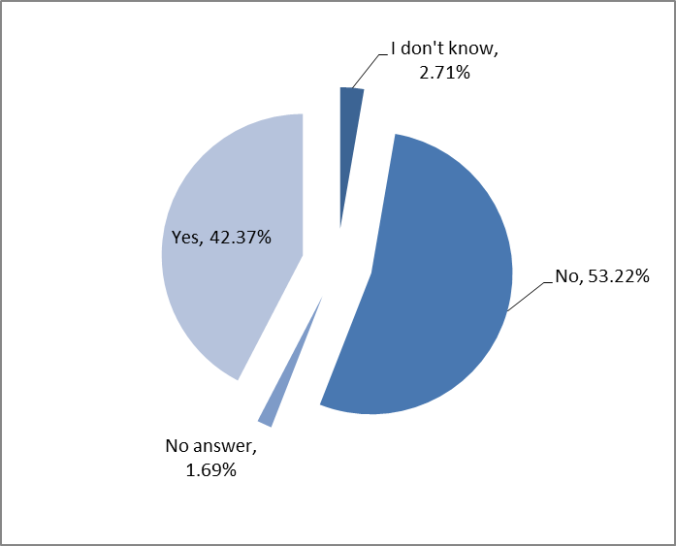

Q 2.1.1.2. 79% of respondents said that this proposal would have an impact on their activities, while just over 5% stated it would not. The remainder either didn't answer or did not know.

Q 2.1.1.3. If yes, please explain how. You may also provide additional comments on this issue:

Over 40% of respondents noted that pre-disclosure would enhance transparency and predictability, which they consider to be positive attributes of trade defence instruments. Among the benefits of pre-disclosure cited by a significant number of parties would be the possibilities of challenging calculations and adjustments ahead of the imposition of provisional measures allowing for the timely correction of errors.

Several importers and/or their associations considered that such a mechanism could help minimise potential problems concerning goods in transit, as they would not be faced with unexpected duties at the last moment. They noted the complexities, costs and work involved in establishing their supply chains, therefore welcoming advance notice of new measures. Several of these respondents nonetheless signalled that three weeks would still be too short considering their lead times to import.

However, a very significant number of respondents also pointed to this proposal’s shortcomings. A majority of Union producers and their industry associations, as well as a few other parties, cautioned against a number of negative effects which could derive from pre-disclosure. An increased risk of politicisation and AD/AS Committee lobbying stood out prominently in the replies as having a potentially negative impact on the decision-making process. An accrued risk of stockpiling, circumvention practices or price distortions resulting from early disclosure were other possible impacts mentioned by a large number of respondents.

A variety of opinions were given concerning the most suitable timing for pre-disclosure. Many parties advocated a maximum of 5 days advance notice, to prevent a surge in imports just before measures are imposed. Several parties noted that the current practice, and the surprise effect conferred by the lack of advance notice of imposition of measures, dissuades importers from market-distorting practices, such as the channelling of exports with low or no duties. Others commented that a 3-week period would not be suitable to address errors, which could, in any event, be rectified prior to the definitive imposition of measures and noted that pre-disclosure could only serve to “formalise” information leaks.

Some parties commented that the implementation of the proposal could hamper the overall procedures, if the Commission and Member States were faced with “expensive legal challenges.”

2.1.2 Advance notice of the non-imposition of provisional measures
Q 2.1.2.1 Should the Commission inform interested parties in good time prior to the expiry of the 9-month deadline, in cases where the imposition of provisional measures is not envisaged?

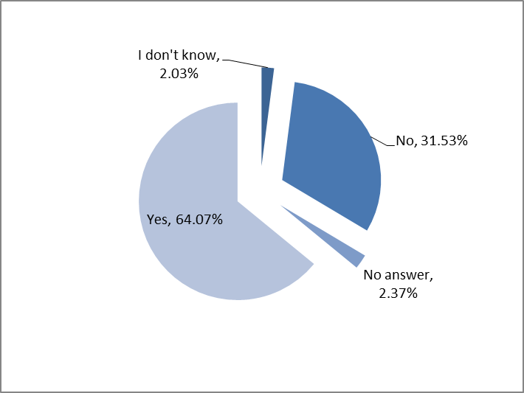

Q 2.1.2.2 80% of respondents said that this proposal would have an impact on their activities, while just fewer than 4% stated it would not. The remainder either didn't answer or did not know.

Q 2.1.2.3 If yes, please explain how. You may provide additional comments on this issue:

A number of governmental bodies did not understand the advantages of disseminating such information before the 9-month deadline and noted that in any event, it is not common for the Commission not to propose provisional measures. Other bodies indicated that selective dissemination of this information, i.e. only to registered interested parties, would be discriminatory, as many other actors, not registered as interested parties, would equally be affected but would have no information about it. It was proposed therefore that, should the Commission decide to implement such a proposal, this information should be more generally disseminated, e.g. publish in the OJ.
Certain governmental bodies considered that this initiative will increase transparency and predictability and invited the Commission to publish, at the same time, the deadline for the imposition of definitive measures. Other respondents supported this proposal as it would increase transparency in the market and suggested receiving this information as early as possible.
A significant number of respondents invited the Commission to specify how many days before the 9–month deadline would the mentioned expression "in good time" mean, while others proposed periods ranging from 60 days to 5 days as a reasonable time before the deadline. A number of them indicated that such a publication should only take place after consulting the ADC.
A number of respondents agreed that receiving this information promptly is advantageous for their planning and managing of their suppliers, capital investment in stocks and storage requirements, while some parties even argued that the Commission should publicise in advance its intention to impose provisional duties as well.
Many respondents disagreed with the proposal and considered that the notification of non-imposition of provisional measures in advance could lead to increased imports, a development which would affect negatively their activities and to an additional procedural step which they deem not to be necessary. Some also argued that publicising this information may send incomplete information to stakeholders because they would not be informed of the facts of the investigation and would therefore not increase transparency. Some also argued that the publication of this information significantly earlier that the legal deadline, may increase the risk of politicization of the proceeding.
2.1.3 Activities of the Anti-dumping/Anti-Subsidy Advisory Committee
Q 2.1.3.1. Should the DG TRADE send a summary document about the proposed measures to interested parties, at the same time as the documents for consultation on provisional and definitive anti-dumping/ countervailing duty measures are sent to the ADC/ASC?

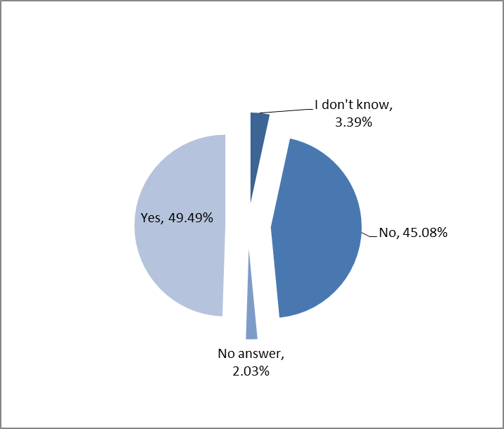

Q 2.1.3.2. 84% of respondents said that this proposal would have an impact on their activities, while just over 4% stated it would not. The remainder either didn't answer or did not know.

Q2.1.3.3. If yes, please explain how. You may also provide additional comments on this issue:

The majority of respondents commented on the enhanced transparency and predictability which would be conferred by allowing parties to have access to information that the Commission would send to the ADC/ASC.

Many parties' suggestions went beyond the provision of summary documents to interested parties, highlighting the need for even further transparency by proposing that DG Trade could also make other documents publicly available and online. Several respondents with importing interests supported the idea on the basis that their forward planning and decision-making could be improved. They suggested that agendas, minutes of the meetings, contact details of committee members and any other information which could not be considered confidential by nature be disclosed also. Some of these respondents noted that such a practice would result in smoother consultations between parties and the improved quality of measures.

However, all categories of respondents, from government institution representatives, business associations, Union importers, users, to producers and their associations commented on the impact this proposal would have in terms of an increased politicisation of the process and lobbying of MS delegates. They argued that the current principles of confidentiality should be allowed to prevail and that decision-making on the basis of objective legal and economic considerations inherent to the instruments should not be undermined. A few parties also considered that it would be best to wait for the implementation of the new rules on comitology before determining whether such a proposal should be adopted. Several parties also considered that the initiative to enhance transparency on committee proceedings could lead to an increased risk of retaliation.

A few respondents commented on certain timing aspects. Some proposed that the information provided to interested parties should be limited to a 5-day advance notice of new measures, but that provisional measures should be imposed within shorter time frames and that retroactive measures should be the norm. Others commented that the proposal should not be implemented if there is a risk of delay in adopting or implementing measures. Some respondents also considered that it would be best if interested parties were informed of preliminary findings and calculations as early as possible.

2.1.4 Shipping Clause
Q 2.1.4.1 It could be foreseen to make a commitment not to impose provisional measures within a period of around three weeks after the sending of the pre-disclosure?
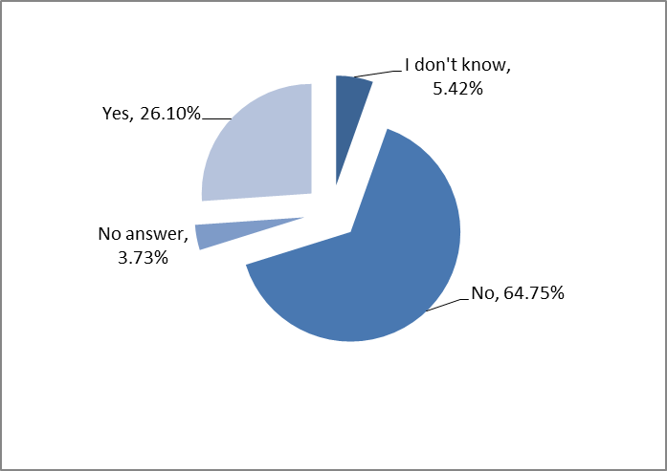
Q 2.1.4.2 Just over 76% of respondents said that this proposal would have an impact on their activities, while almost 6% stated it would not. The remainder either didn't answer or did not know.

Q 2.1.4.3. If yes, please explain how. You may also provide additional comments on this issue:
Almost 65% of respondents were negative regarding the proposal not to impose provisional measures within a period of around three weeks after the sending of the pre-disclosure. Just over a quarter of respondents (26.10%) were in favour of the proposal.

Those opposed considered that it would only weaken the anti-dumping and anti-subsidy instruments by facilitating more imports of unfairly traded products. Many respondents against the proposal argued that the timetable of investigations was well known and once an investigation was initiated, parties were aware that, in general, provisional measures are imposed after nine-months. This period, they considered, was sufficient to facilitate planning by importers and exporters. Many expressed the view that such a delay would simply add to the dumping already taking place and, in turn, increase the injury to the EU producers. Fears were also expressed that this period could be used to stockpile the product in question. Several expressed the view that trade defence instruments were not intended to favour importers and that this proposal represented de facto a concession to exporters.

Those in favour of the proposal considered that it would improve transparency, remove uncertainty, and reduce financial risk while creating a better balance in taking into account the interests of importers and users. However, many stated that the three weeks proposed was not sufficient in view of shipping times particularly from Asia and that this should be increased to six weeks. A number of respondents said that this proposal would help SME's as on-going anti-dumping and anti-subsidy investigations often were a surprise to them.

Q 2.1.5 Injury Margin

Q 2.1.5.1 Should the Commission envisage drafting and publishing guidelines regarding the calculation of the injury margin?

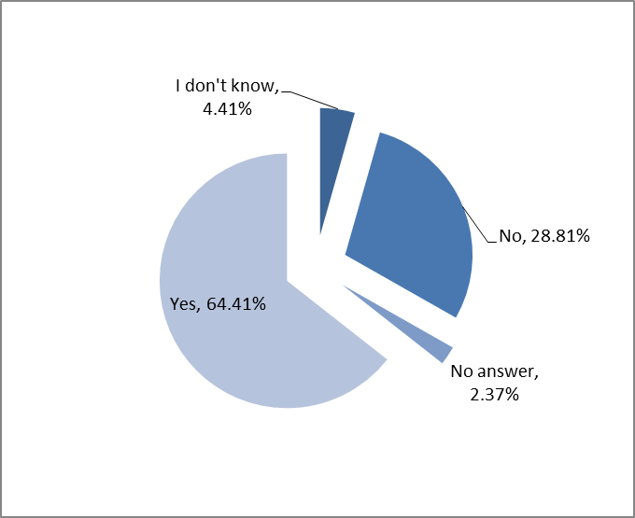

Q 2.1.5.2 Just over 72% of respondents said that this proposal would have an impact on their activities, while almost 9% stated it would not. The remainder either didn't answer or did not know.

Q 2.1.5.3. If yes, please explain how. You may also provide additional comments on this issue:

Almost two thirds (64.41%) of respondents considered that the Commission should envisage drafting and publishing guidelines regarding the calculation of the injury margin. Many of these respondents considered that such guidelines would further improve transparency, increase confidence in the impartiality and accuracy of investigations, generate greater feedback from stakeholders and facilitate better decision making. In addition, several respondents stated that it would help stakeholders to better assess the situation and prevent speculation in cases. A number of parties also expressed the view that increased transparency may lead to a reduction in the number of judicial processes.

However, among the majority of those respondents in favour of having guidelines, there was a clear message that any such guidelines should simply codify existing practice and not introduce any changes to the current practice regarding the calculation of the injury margin.
A number of respondents, in favour of publishing guidelines, considered that these should go further than describing current practice. They believe they should include rules regarding the profit level to be used in calculating the injury margin, particularly in view of the EU's use of the lesser duty rule. A number of respondents cited specific cases where they considered the profit margins used were too high. One respondent stated that, simply publishing guidelines on existing practice only would perpetuate this problem. Many proposed the publication of an objective set of criteria for setting the profit margin for various sectors. Several parties stated that the profit gained in the non-injurious period should be used to establish the profit rate.

A number of parties also proposed that guidelines should not only deal with all factors relevant for the determination of injury but also deal with the examination of factors not attributed to the dumped imports. In this context they state that these factors should be quantified and analysed separately.

Almost 29% of respondents stated that the Commission should not publish guidelines on the calculation of the injury margin. Many of these respondents questioned the purpose of drafting such guidelines i.e. a codification of the current practice or the means to introduce changes to the system. Several respondents stated that their introduction could be dangerous depending on the content and orientation. They also raised the question as to how guidelines would be updated while expressing the fear that the publication of such guidelines may lead to more decisions being challenged in the Courts.

Several respondents raised concerns regarding the legal status of any guidelines. In this regard a number of parties suggested that any guidelines should remain descriptive and not achieve legal status. They expressed concerns that binding rules would reduce the discretionary powers of the Commission. Several respondents stated that the danger with binding rules was that such rigidity would not allow for the specificities and complexities arising in various cases to be addressed. A number of parties proposed that describing examples rather than guidelines would be preferable. One party raised the issue regarding the management of changes in any guidelines involving policy choices and preferences.

Many stakeholders expressed the wish to be involved in the drafting of any such guidelines with a small number stating that such a process should be subject to public consultation.

Q 2.1.6 Analogue Country

Q 2.1.6.1 Should the Commission envisage drafting and publishing guidelines regarding the choice of analogue country?
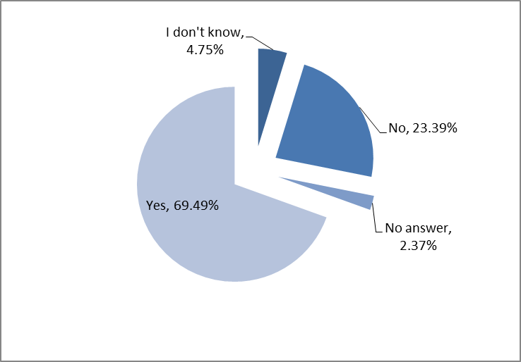

Q 2.1.6.2 76% of respondents said that this proposal would have an impact on their activities, while just over 8% stated it would not. The remainder either didn't answer or did not know.

Q 2.1.6.3. If yes, please explain how. You may also provide additional comments on this issue:

The choice of analogue country is seen by the majority of respondents as a very important issue in investigations given its impact on the outcome of measures.

Almost 70% respondents considered that the Commission should envisage drafting and publishing guidelines regarding the choice of analogue country. The overall opinion among the respondents was that this would improve transparency, thereby increasing confidence and predictability in the investigation process. A number of parties also expressed the view that increased transparency could lead to a reduction in the number of judicial processes.

However, it is clear that the majority of those in favour of having guidelines want to see simply an explanation of the practice up to now and not an introduction of changes to the current method of selecting the analogue country.

Almost a quarter of respondents (23.39%) are of the view that the Commission should not publish guidelines on the selection of the analogue country. Many of these respondents expressed concerns as to the purpose of publishing such guidelines i.e. whether it was intended to simply codify current practice or to introduce major changes. One party raised the issue regarding the management of changes in any guidelines involving policy choices and preferences. Several replies expressed concerns that publishing guidelines would have the effect of 'watering down' the criteria in the legislation, making the process less predictable while increasing the risk of more decisions being challenged in the Courts.

Some respondents were concerned that guidelines would be binding on the Commission and thus reduce their ability to take into account the different factors and market conditions which arise on a case-by-case basis. On the other hand one respondent was of the view that unless guidelines were binding on the Commission they would be of limited value.

Several respondents pointed out that the impact of the selection of the analogue country is enormous with a wrong choice leading to distorted results. A number of respondents stated that the main problem was not one of guidelines. The main problem, according to them, was the Commission's preference for using the analogue country in determining normal value in cases involving non-market economy (NME) countries in favour of the normal value of firms in NME country which had been granted market economy treatment. The current system was further criticised by a number of respondents who allege that the selection of the analogue country was often driven by the willingness of producers in a particular country to co-operate. A number of respondents stated that the Commission should endeavour to ensure that the economic data of the reference country closely resembles those of the home country and take into account all relevant factors, including access to raw materials, productions methods and unit labour costs. A number of respondents also asked that any guidelines include information regarding the criteria applied where the selection of analogue country is changed during the course of an investigation.

Many stakeholders expressed the wish to be involved in the drafting of any such guidelines with a small number stating that such a process should be subject to public consultation.

Q 2.1.7 Union Interest Test

Q 2.1.7.1 Should the Commission envisage drafting and publishing guidelines regarding the Union interest test?

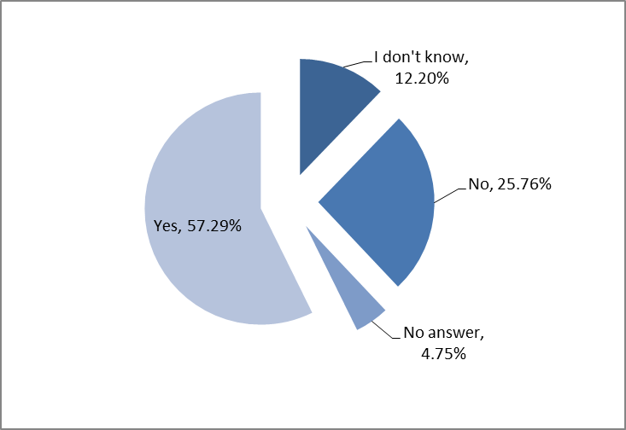

Q 2.1.7.2 67% of respondents said that this proposal would have an impact on their activities, while almost 10% stated it would not. The remainder either didn't answer or did not know.

Q 2.1.7.3. If yes, please explain how. You may also provide additional comments on this issue:

Over half the respondents (57.29%) considered that the Commission should envisage drafting and publishing guidelines regarding the Union interest test. Several of these respondents consider that such guidelines would increase transparency by helping stakeholders to understand how the EU conducts the Union interest test, increase confidence in the manner in which investigations are conducted and would generate greater input from stakeholders thus leading to better decision making.

However many of these respondents expressed concerns that drafting guidelines would be used to instigate changes to the current methodology and stressed their clear preference for guidelines which would codify existing practice only.

On the other hand a number of other respondents, in favour of publishing guidelines, considered that these should go further than simply describing current practice and suggested that this opportunity be used to publish more comprehensive guidelines. One respondent said they would expect impact assessments and cost-benefit analysis to be part of any methodology. One respondent said that the test must be designed in a way which reflects modern global supply chains. Other respondents suggest that the Commission be more active in identifying users and consumers of products in order to have their views assessed in the Union interest test while another stated that silence by these parties should not be seen as approval. One respondent argued that users are often SMEs and are not well organised which makes it difficult for them to argue effectively regarding the impact of measures on their business. One party raised the issue regarding the management of changes in any guidelines involving policy choices and preferences.

Just over a quarter of respondents stated that the Commission should not publish guidelines on the Union interest test expressing concerns that these could introduce changes to the current practice thereby weakening the instrument and possibly giving rise to increased number of challenges in the Courts. They consider that the Union interest test, as it stands, is appropriate. Many respondents expressed the view that, given the Union interest test is unique to the EU and is a WTO+, it should not change in any way which would put EU producers at a disadvantage vis-à-vis their competitors. Several respondents stressed that the purpose of the AD and AS legislation is to combat unfair trade and, once such practices are found, action should be taken to restore fair trade. In this context many expressed the view that placing the burden of proof on users and consumers regarding Union interest was correct. Another respondent expressed the view that it would be difficult to develop guidelines for what they consider to be largely a qualitative issue. Several respondents stated that the danger with binding rules was that it would introduce rigidity which would not allow for the different and diverging views of stakeholders to be taken into account.

Many stakeholders expressed the view that they should be involved in the drafting of any such guidelines.

2.1.8 Expiry Reviews

Q 2.1.8.1 Should the Commission envisage drafting and publishing guidelines regarding expiry review investigations?

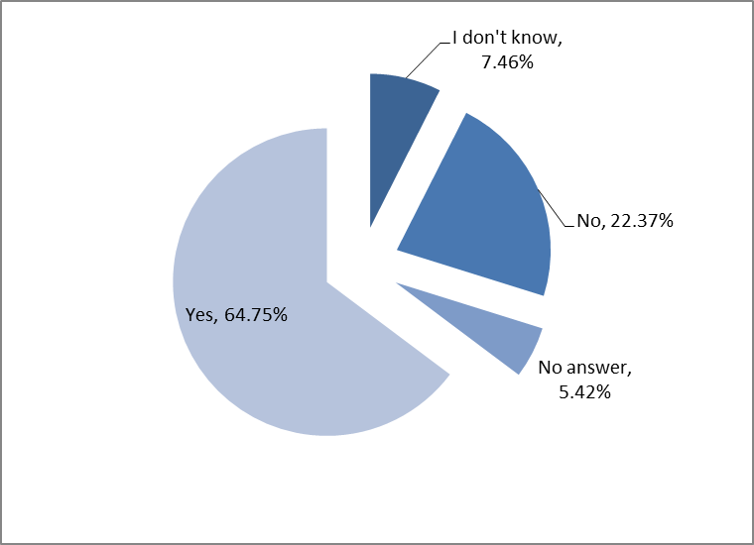

Q 2.1.8.2 Just under 70% of respondents said that this proposal would have an impact on their activities, while 10% stated it would not. The remainder either didn't answer or did not know.

Q2.1.8.3. If yes, please explain how. You may also provide additional comments on this issue:

Nearly two thirds (64.75%) of respondents considered that the Commission should envisage drafting and publishing guidelines regarding expiry review investigations. Some of the replies, in welcoming these guidelines, highlighted the fact that the nature of expiry reviews implies documenting the future which is challenging. A large number of these respondents considered that such guidelines would add to overall transparency in expiry review investigations, increase confidence in the quality of investigations, facilitate greater engagement in the decision making process and help improve business planning by removing some uncertainty and ensuring a more predictable business environment.

There were, however, two very clear messages from the majority of respondents. Firstly, any guidelines should only codify existing practice and be based on existing and established case law and not be used to introduce changes. Secondly, many respondents asked to be consulted on the drafting of any such guidelines.

A few respondents suggested that it would be useful if guidelines included instructions on how to draft a request for an expiry review. Two respondents stated that the main problem with expiry reviews was the fact that the measures cannot be altered. They stated this could not be alleviated by publishing guidelines on existing practice only. They suggested that a progressive liberalisation of any measures would enable the Commission to better assess the likelihood of recurrence of injury. They also stated that a major problem, in their view, is the absence of a Union interest test when initiating expiry reviews.

Almost a quarter (22.37%) of respondents stated that the Commission should not publish guidelines on expiry review investigations. Several respondents feared that the drafting of guidelines would introduce changes to the current system which they felt unnecessary. They also considered that this could open up possibilities for more decisions being challenged in the Courts. A number of respondents expressed concerns that guidelines would restrict the Commission addressing the many various issues which arise from case to case. One party raised the issue regarding the management of changes in any guidelines involving policy choices and preferences.

Q 2.1.4 In order to increase transparency, do you think it would be useful to draft guidelines in any other areas?

The replies to this question were evenly split with 50% of respondents stating there was no need for further guidelines to be drafted in any other areas and 50% of respondents proposing subjects for which they would like to see guidelines.

Amongst those who did not propose further guidelines, a number expressed the view that the drafting and publishing of guidelines would lead to more legal challenges and reduce the effectiveness of what is a legal procedure. Questions were raised by a few respondents regarding the binding nature of any guidelines and the fact that this could limit flexibility in dealing with different cases. Some others expressed the view that the drafting of guidelines would not improve transparency while one respondent stated that it was not necessary as the EU was a model for other countries in the application of TDI.

A number of those in favour of drafting guidelines did not offer any possible subjects for consideration, but expressed general support for such an initiative as they consider it would improve transparency and help stakeholders to better understand the process of investigations. Some respondents suggested that guidelines should be prepared on all issues which were a pre-requisite for measures including all calculations, judgements and assumptions.

Amongst the specific subjects proposed for guidelines the most frequently mentioned was undertakings and how they are constructed, how the EU industry could be involved in the process as well as how breaches of undertakings are dealt with and how the re-imposition of measures are handled.

Many respondents also suggested guidelines on the confidentiality of submissions covering all stages from complaint to the end of an investigation. One respondent suggested that such guidelines should also cover how to prepare non-confidential submissions.

Several respondents would like to see guidelines on the procedural rules for the suspension of measures, the practical implementation of the 'single economic entity' concept and thirdly market economy treatment in investigations. Other subjects mentioned by a few respondents included circumvention, guidelines on the definition of relevant product, geographical markets and Union producer, guidelines on inspections by EU officials, sampling of EU producers, refunds, causal link, normal value and how the Commission assesses dumping.

Finally one respondent suggested that this opportunity should be used to review the Commission's approach on various subjects, in light of developments over the last decade or so. They also proposed that a clear process for updating guidelines be put in place to take account of developments in specific cases or jurisprudence. They also proposed that more is done to alert industry to new investigations, results and decisions taken. They consider an alert to be particularly important where products are subject to registration.

Many respondents requested that they be included/consulted in the drafting of any guidelines.

II Fight against retaliation

Q.2.1 Has your business already been subject to retaliation in the past?

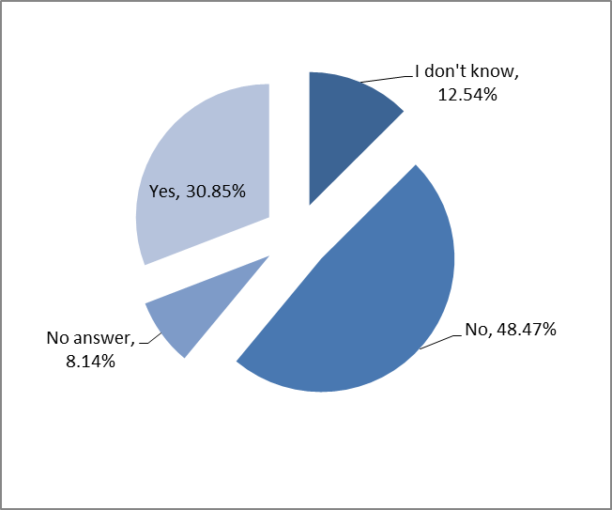

Q 2.2.2 If yes, please explain how. You may also provide additional comments on this issue:

While nearly half of the respondents replied that they had not been subject to retaliatory measures, a third of the respondents reported that they had indeed been subject to retaliatory measures in the past, the latter being mostly Union producers and their associations, but also including several importers as well.
Certain governmental bodies recognise that the threat of retaliation is a concern that must be addressed, while others while they understand the concerns, they were not convinced that resorting to ex-officio investigations would be an effective solution.
In terms of the form that such retaliatory measures may take, many respondents reported that governments of third countries imposed countermeasures on the same or different products than the ones targeted by the EU investigations. In many cases, parties reported that they have been subject to aggressive behaviour on behalf of exporters or of their own customers and in certain instances, they reported more direct approaches like personal blackmail of a CEO of a company or to the EU association directly (EUROALLIAGES). It has also been reported that the retaliation can target the operations of EU companies in China.
As a result of the above, a considerable number of respondents were not willing to participate in or support the lodging of a complaint and asked the Commission to implement methods to protect their identities. In certain cases, complainants had to withdraw their complaint partially or completely. Moreover, certain parties considered that although their industries were not behind TDI complaints, they felt that the Commission should take measures to protect them in case they would be threatened with retaliation simply because they are European companies.
A number of respondents reported that they had not been victims of retaliatory measures in the past, but that they do understand the risk. Others, while recognising that retaliation may be an issue, they considered that the depoliticised decision-making in TDI proceedings based only on technical facts would suffice to alleviate the problem.
2.2.1 Ex-officio AD and CVD investigations
Q 2.2.1.1 Should the Commission initiate ex-officio investigations in situations where there is threat of retaliation?
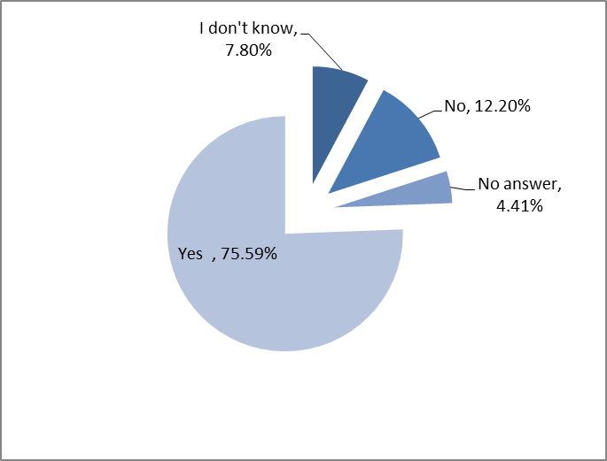
Q 2.2.1.2 66% of respondents said that this proposal would have an impact on their activities, while 7% stated it would not. The remainder either didn't answer or did not know.

Q 2.2.1.3 If yes, please explain how. You may also provide additional comments on this issue:

While a number of governmental bodies consider that this proposal would impact favourably on the operations of EU companies, particularly SMEs that are more easily intimidated by retaliatory threats, others remain either sceptical of its usefulness given the wider industrial interests. They consider that such actions should be targeting specific cases where threat of retaliation is clear. One respondent questioned the possibility provided by the Basic Regulations for the Commission to initiate ex-officio investigations.
Certain parties argued that such a possibility would infer additional, counter-productive powers on the Commission, while others consider that businesses could take advantage of this possibility and indicate "fear of retaliation" as a factor when it may not be so. Other respondents consider that such a proposal would not prevent retaliation, but on the contrary, might be interpreted as a politicisation of instruments which are quasi legal and technical in nature. Such a perception by third countries trade partners may trigger retaliatory actions against wider EU interests not limited to the sector concerned. It was also argued that if countries are prepared to retaliate, the ex-officio initiation of investigations will not change their decision to do so. It must be left to the industry therefore to weigh its interest and act accordingly.
Some respondents also indicated that Article 17 of the WTO ADA provides for a dispute settlement procedure that could serve the purpose of resolving such threats. They also argued that, in order for the Commission to obtain cooperation from Union producers that are afraid of retaliatory practices, it may have to threaten these Union producers with sanctions, which is a very questionable outcome.
A significant number of respondents indicated that the Commission already has the power to initiate ex-officio investigations. While many of them indicated that more frequent use of this power would be welcome particularly in anti-subsidy investigations where the risk of retaliation is higher, many considered that when the number of Union producers is small, their identity would eventually be known to parties involved in the proceeding and therefore, the retaliatory threats would not be avoided. In addition they mention the possibility that transparency of information in such investigations would be weakened.
A significant number of parties consider that this proposal would tackle the fear of retaliation and encourage companies to utilise TDIs. However, many of them specified that it should be used only in special circumstances and some proposed that the Commission should act ex-officio only if the interested industry agrees with or even requests such a move.
2.2.2 Obligation to cooperate in ex-officio investigations
Q 2.2.2.1 Should the Commission establish procedures for the purposes of ex-officio investigations, to allow parties to communicate relevant information in confidence?
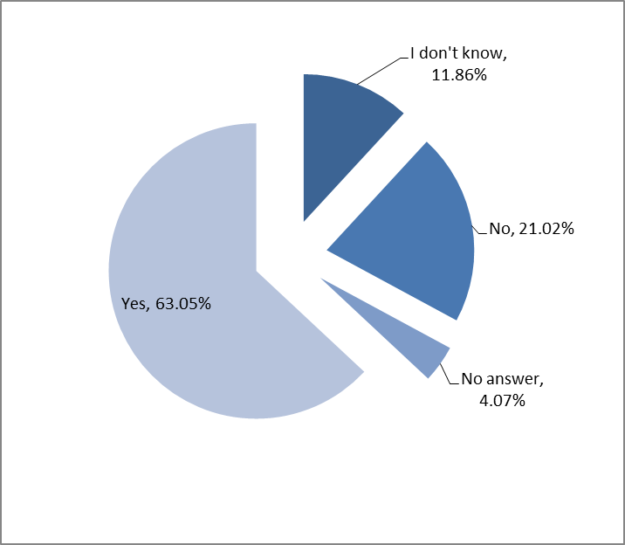

Q 2.2.2.2 What should be the appropriate sanction in cases of non-cooperation?

Many respondents thought that the Commission should encourage cooperation. Most were of the view that this could be achieved by a possibility to communicate information in confidence to the Commission (i.e. keep the identity of the supplier of information confidential). Some rare replies were against such a possibility. Some responses elaborated further by saying that a deadline should be set for receiving data and information from the Union industry and in cases where there is a of lack of cooperation, the investigation should be automatically terminated. Some others said that an investigation should only be initiated if cooperation is forthcoming. However, the vast majority of respondents did not think fines or mandatory on spot checks were a good idea. Only a very small number of respondents agreed to fines and only one agreed to mandatory on-spot verifications. Some thought that it could be an appropriate sanction (and thus a sufficient incentive to secure cooperation) if the Commission refused to open in future any ex officio case if cooperation was not forthcoming.

Q 2.2.2.3 Just under 60% of respondents said that this proposal would have an impact on their activities, while almost 10% stated it would not. The remainder either didn't answer or did not know.

Q2.2.2.4 If yes, please explain how. You may also provide additional comments on this issue:

Most of the replies to this question did not really answer the question, i.e. whether the introduction of procedures for the purposes of ex officio investigations etc. has an impact on their activity. The replies given would normally be more appropriately listed under 2.2.2.2. e.g. many say that they are against sanctions. Many statements also discuss whether or not cooperation in ex officio investigations should be mandatory. Some replies are in favour of mandatory cooperation, while a number are against mandatory cooperation. Some respondents seem only be opposed to sanctions in case of non-cooperation, but not explicitly against a mandatory cooperation. The reasons for such opposition vary: lack of resources (in particular for SMEs), companies would face a difficult choice between retaliation by 3rd country and sanction by EU, insistence that cooperation should be a discretionary decision of each company. Some replies also try to develop other modalities to make ex-officio investigations workable. They suggest that Member States and/or European or national sector associations should play a more active role in this respect. Two trade associations claim that in case of ex-officio initiations, importers, users and consumers should be given a possibility to prepare their case against possible measures.

III Effectiveness and Enforcement
Q 2.3.1 In your view, is the EU trade defence system effective?
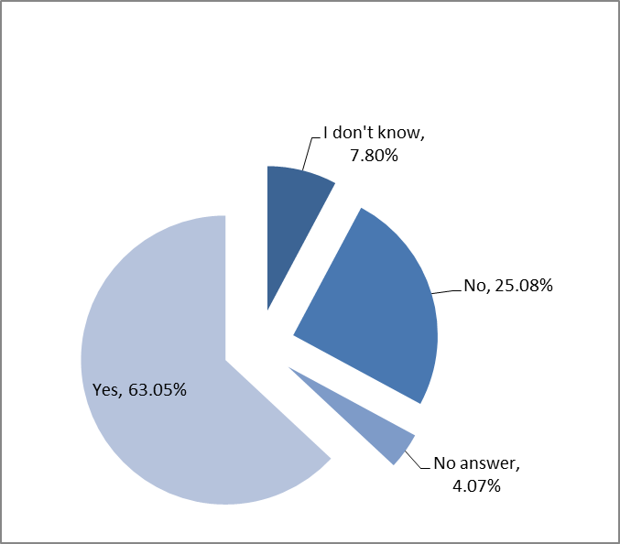
Q 2.3.2 The majority of respondents (63%) considered that the EU's trade defence system is effective. Most of these considered however that there was room for improvement.
A significant number of parties commented that it takes too long to have measures imposed and that ways should be found to accelerate this. Some added that the huge volume of information that needs to be provided in trade defence investigations caused problems particularly for SMEs. Indeed, some parties stated that the EU trade defence system is less effective when applied in sectors where SMEs represent a high proportion of production. This should be addressed through changes in the TDI procedure and the introduction of additional support mechanisms for SMEs.
Some respondents expressed concerns about the decision making process. Some stated that the Union interest test should not be used as a means to modulate the level of measures.
A number of parties considered that raw material distortions in third countries need to be addressed in any reform of the TDIs. Some suggested that the lesser duty rule not be applied where such distortions were found or that exporting producers be refused market economy treatment. On the other hand, a number of parties called for the abolition of the lesser duty rule more generally. Some stated that duties in the EU are often lower than in other countries because of the lesser duty rule and the low target profits used in establishing the injury margins.
Parties also commented on the fact that, in their opinion, anti-circumvention action takes too long and consequently better means to tackle the circumvention of trade defence measures need to be found.
Some parties considered that as the EU's trade defence system is very advanced in comparison with the EU's main global partners, further unilateral changes should be avoided until other partners liberalise their TDI systems. Efforts should be made to export the EU's existing WTO+ elements to other WTO members.
One party considered that there was no proof that anti-dumping measures had made an efficient contribution to strengthening the competitiveness of EU industrial sectors. Indeed, some other parties claimed that trade defence measures are mainly helping third country producers. A number of respondents with importing interests acknowledged the need for trade defence instruments to tackle unfair trade but considered that they were often used to protect inefficient Union industries.
One party considered that to make the trade defence system more effective, greater account needs to be taken of the impact of measures on all stakeholders concerned. This party also considered that better account should be given to the impact of TDI on global supply chains, ensuring that EU companies are in fact not being damaged by measures.
2.3.1 Ex-officio anti-circumvention investigations.
Q 2.3.1.1 Which circumvention practices have you experienced, if any?
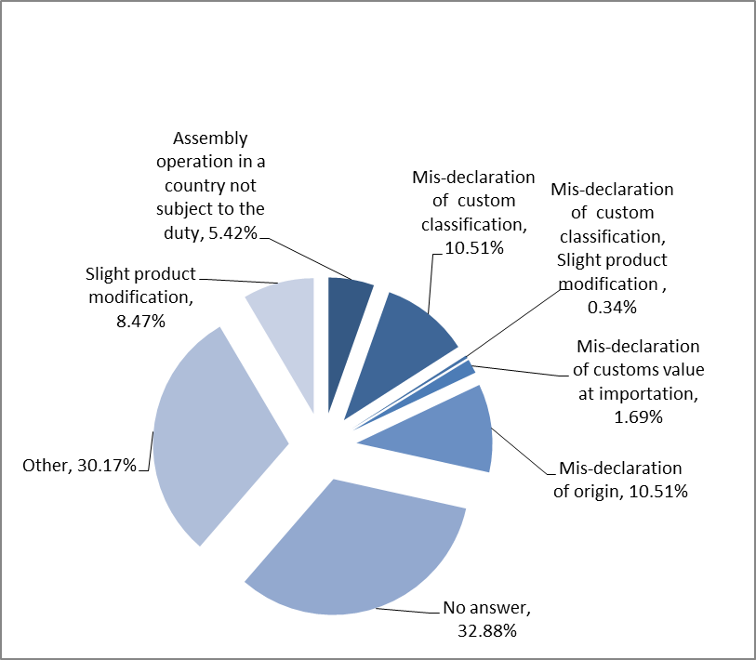
Q 2.3.1.2 There were no other practical examples of circumvention practices highlighted.

Q 2.3.1.3 Should the Commission initiate ex-officio anti-circumvention investigations, if it has sufficient evidence at its disposal?
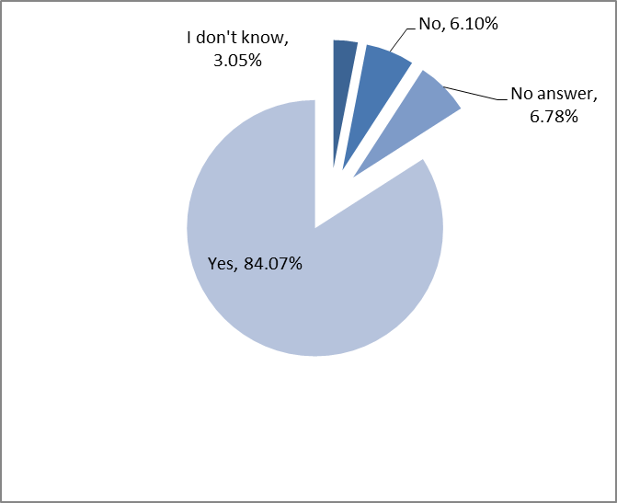
Q2.3.1.4 73% of respondents said that this proposal would have an impact on their activities, while almost 6% stated it would not. The remainder either didn't answer or did not know.

Q 2.3.1.5 If yes, please explain how. You may also provide additional comments on this issue:

A number of governmental bodies agree that if the Commission has sufficient information at its disposal, it should initiate ex-officio anti-circumvention investigations. It was noted though, that increased customs controls, combined with appropriate sanctions, could make such practices less attractive.
Certain parties indicated that circumvention practices, mainly in the form of customs mis-declaration confer unfair advantages to certain operators and should therefore be prevented and sanctioned, while other respondents indicated that sometimes it is the exporting parties that mis-declare the goods without the Union importers being aware of it until the customs controls reveal the reality.
Some respondents mentioned that circumvention investigations effectively block trade with the targeted country and discourage continuation of imports from this country, even if the exporting partners were genuine producers, because it takes too long for them to be granted the necessary exemption from the duties.
Certain respondents expressed their scepticism regarding the proposal and indicated that the Commission should initiate anti-circumvention investigations only in absolutely justified cases and only on the basis of a reasoned request by the Union industry, while some invited the Commission to share detailed statistical data (TARIC level) with the Union industry in order to improve the efficiency of this proposal.
Many respondents consider that all market players should abide by the rules and therefore agree in principle with the proposal for the Commission to initiate ex-officio anti-circumvention investigations, but only if there is sufficient evidence to do so and the transparency of the proceeding is assured and provided that such investigations do not create excessive additional administrative burden to companies that operate legitimately.
A significant number of replies indicate that circumvention practices are illegal, distort the level playing field in the market, increase the injury suffered already by the Union producers, have a negative impact on the Union's customs revenue and undermine the effectiveness of the measures. They urge the Commission to use the statistical data at its disposal, be vigilant and in cooperation with OLAF (the European anti-fraud office), national customs authorities and the industry concerned, stop such practices as soon as possible or even prevent them from occurring by properly training customs officials.
2.3.2 Verification visits
Q 2.3.2.1. Would it be useful for DG TRADE to increase, where appropriate, the length of investigation visits to four or five days per company?

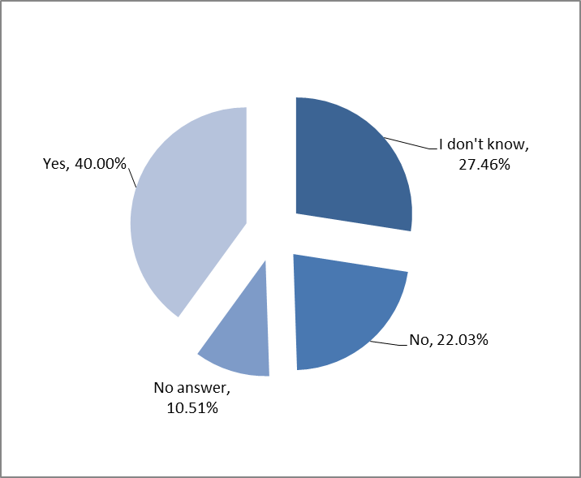

Q 2.3.2.2 Almost 44% of respondents said that this proposal would have an impact on their activities, while over 16% stated it would not. The remainder either didn't answer or did not know.

Q 2.3.2.3 If yes, please explain how. You may also provide additional comments on this issue:

40% of respondents agreed that longer investigation visits would most likely contribute to enhancing the quality of the investigations if done in the least disruptive way possible. Among the supporters, many expressed the opinion that currently verification visits do not allow to sufficiently address problems concerning business activities of the industry concerned. Other replies suggested that the efficiency of the verification visits could be improved, rather than increasing their length which should only be done in exceptional cases. Some replies agreed with an extension within the existing legal framework under the condition that they do not jeopardize the overall time limits of investigations. Moreover it was suggested that the length of visits should depend on the complexity of a case, product type, countries concerned and size of visiting companies. Some respondents thought that since investigation visits are disturbing to the companies' activities they should be well prepared and not take more than 2 days. They were of the view that longer verification visits could impose an additional burden on cooperating companies. They underlined that already now many companies (especially SMEs) refrain from cooperation in investigations due to too high costs and time-consuming procedures.

2.3.3 Lesser duty rule

Q 2.3.3.1 Should the Commission not apply the lesser duty rule in cases of fraud, circumvention or subsidisation?

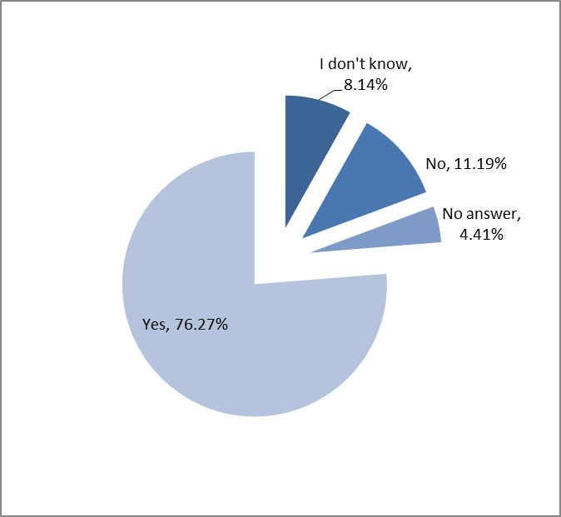

Q 2.3.3.2 Almost 69% of respondents said that this proposal would have an impact on their activities, while over 6% stated it would not. The remainder either didn't answer or did not know.

Q 2.3.3.3 If yes, please explain how. You may also provide additional comments on this issue:

Most comments were of a rather general nature. Some clearly supported the approach, while a number of parties went beyond the proposal, calling for the abolition of the lesser duty rule as such, independently from the type of investigation. They explained that duties in the EU are often lower than in other countries because of the lesser duty rule. On the other hand, a great number of respondents stated that the lesser duty rule is an example of good practice in the EU anti-dumping system and has an important role to play in ensuring a right balance between different interests of parties concerned, thus it should be maintained. On a more general basis, these parties also pointed out that, anti-dumping duties should be used as measures of a purely remedial character and should not be transformed into punitive measures against practises such as fraud and circumventions.
IV Facilitate cooperation

Q 2.4.1 Has your business experienced difficulties in cooperating in trade defence investigations?
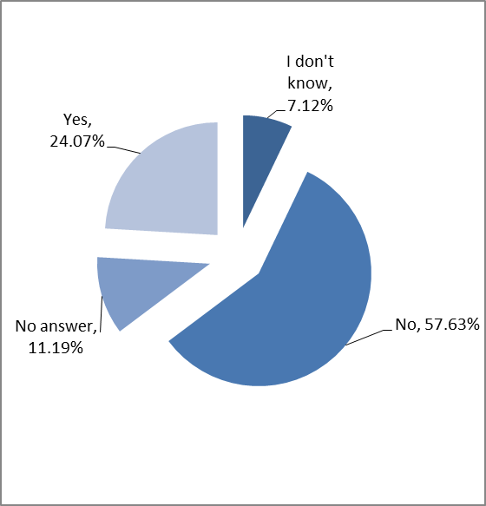

Q 2.4.2 If yes, please explain how. You may also provide additional comments on this issue:

Most respondents did not experience difficulties in cooperating in trade defence investigations but they nevertheless stated that the cooperation could be further facilitated and that Member States authorities could be more involved in improving the level of cooperation. Some replies indicated common problems encountered as follows: too long and too complex questionnaires, too high workload, too burdensome, and too costly procedure, too short deadlines given the availability of data and the format in which such data is requested by the Commission. Several replies suggested a disproportion between high cost and workload invested by the companies and very poor outcome of the investigation, i.e. low level of adopted measures. A number of respondents indicated increasing difficulties in lodging a complaint/request, especially for expiry reviews. They all agreed that due to high technicality and complexity of procedures many companies (especially SMEs) refrain from cooperation.

2.4.1. Time-limits: longer time limits for users to register as interested party and to reply to the questionnaire

Q 2.4.1.1 Should the Commission extend the deadlines for users to make themselves known to the Commission and to submit questionnaire replies?
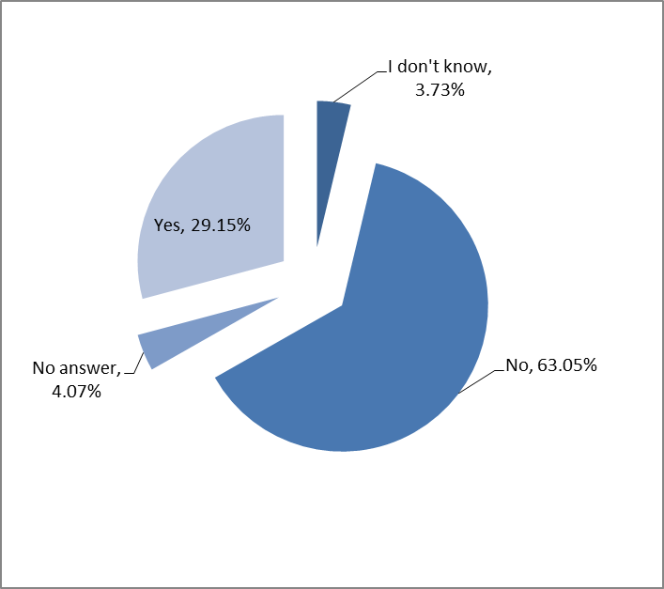

Q 2.4.1.2 68% of respondents said that this proposal would have an impact on their activities, while almost 12% stated it would not. The remainder either didn't answer or did not know.

Q 2.4.1.3 If yes, please explain how. You may also provide additional comments on this issue:

The majority of respondents (63%) considered that there is no need to extend the deadlines for users to make themselves known to the Commission and to submit questionnaire replies. Almost all of these respondents against an extension of the deadlines were categorised as Union producers and associations representing Union producers, whereas most of the respondents who were in favour of an extension consisted of importers and their associations. users and employers. Overall, the majority of the respondents agreed that an extension of such deadlines would have an impact on their activities.

The opinions of the government institutions that replied were divided. Whereas some believe that such an extension can only help users in general and SME's in particular, others are concerned that such an extension could prevent completing the investigation on time and could be seen as discriminatory as it is not covering all interested parties.

Most importers and trade associations representing importers as well as large business associations representing Union producers, users and employers argued that it takes often several days to circulate the information to the members and that therefore longer deadlines would allow for better planning of time and better quality of data. A few trade associations also suggested that to increase the involvement and participation of stakeholders, especially SME's, the Commission could consider accepting contributions in other formats. They claim that in many EU regulatory policies, specific provisions for SME's are created and that therefore anti-dumping policy should not remain an exception. Furthermore, a single trade association representing importers suggested that the Commission could send automatically copies of the non-confidential version of the complaint to the interested parties.

Many of the Union producers and trade associations representing Union producers argued that the adoption of an extension of the deadline for users only would be selective and discriminatory. In their view, the same treatment should be granted to all interested parties. Moreover, some of them fear that an extension of the deadline for users would risk delaying the investigations. In addition, some state that users are already provided with an exceptional opportunity to be heard and that allocating them more time would not be justified.

2.4.2 Simplification of refund procedures

Q.4.2.1 Should the handling of refund applications be reviewed with a view to facilitate such requests and to make such decisions more easily accessible to the public?

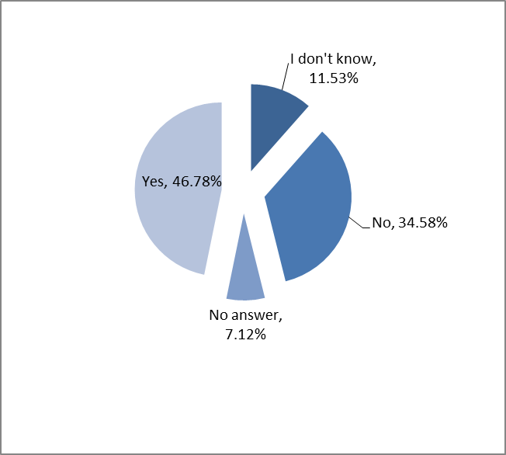

Q 2.4.2.2 55% of respondents said that this proposal would have an impact on their activities, while almost 14% stated it would not. The remainder either didn't answer or did not know.

Q 2.4.2.3 If yes, please explain how. You may also provide additional comments on this issue:

Nearly half of respondents (46%) considered that there is a need to review the handling of refund applications with a view to facilitate such requests and to make such decisions more easily accessible to the public. 34% of the respondents were of the opinion that there is no need for such a review. Union producers and their associations were divided whereby half of the respondents were in favour of such a review and half of them against it. Overall, the majority of the respondents agreed that a review of the refund procedures would have an impact on their activities.

Most of the government institutions that responded argued that it would be useful to give further clarification on the refund procedure. However, they also stated that the burden of proof should rest upon the applicant's side. One government institution suggested that the Regulation should be revised to provide a degree of discretion to the Commission in terms of evidence required and in granting refunds. Another government institution suggested that refunds could be more automatic and that the Commission could inform the affected companies more proactively.

Most respondents argued that a simplification of the process would make refund decisions more accessible to the public (more transparency) and encourage more members to claim a refund. A few trade associations also suggested to the Commission to publish on its website a more user-friendly format of specific related documents (such as reimbursement forms) as well as the contact details of the authorities dealing with the reimbursement. Furthermore, a single large business association representing Union producers, users and employers suggested that the Commission could set up package guidelines related to duty collection systems, forms of duties and refunds (whereby the guidelines would explain the methodology, actors and timeframes).

As far as the Union producers and their associations are concerned, half of the respondents called upon the Commission, in the light of transparency, to simplify the procedures and to make applications for refund public. The other half of the respondents that were categorised as Union producers and their associations argued that facilitating the refund procedure should be addressed only to interested parties and not to parties not directly concerned by the investigation.

2.4.3 Small and Medium Sized Enterprises (SMEs)

Q.4.3.1 Should DG TRADE upgrade the SME helpdesk?

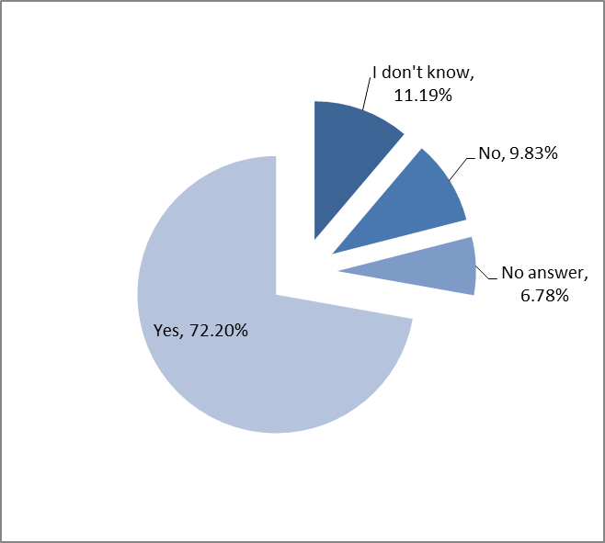

Q 2.4.3.2 57% of respondents said that this proposal would have an impact on their activities, while almost 16% stated it would not. The remainder either didn't answer or did not know

Q 2.4.3.3 If yes, please explain how. You may also provide additional comments on this issue:

The majority of respondents (72%) considered that it would be a good idea to upgrade the SME helpdesk. Almost all of the respondents that were categorised as government institutions and large business associations representing Union producers, users and employers were in favour of such an upgrade. Out of the respondents categorised as importers and trade associations representing importers as well as the Union producers and their associations, the majority was also in favour of such an upgrade. Overall, the majority of the respondents agreed that an upgrade of the SME helpdesk would have an impact on their activities.

Nearly all of the government institutions that responded would welcome an upgrade of the SME helpdesk. Many argued that drafting a new complaint is a real obstacle for SME's and that a simplification of the questionnaires as well as the ability to submit complaints in their own languages would be very important for SME's. In addition, the SME helpdesk could support further SME's and associations in gathering data. Moreover, some government institutions suggested that the Commission could initiate investigations in cases where the majority of the parties affected are SME's.

The importers and their trade associations and large business associations representing Union producers, users and employers argued that an upgrade of the SME helpdesk could make a difference to SME's who often cannot bear monetary costs of qualified technical assistance in the preparation of a complaint. They are in favour of strengthening the helpdesk in a way that more and better information, more support (including legal support and assistance in filling in the questionnaires), and a guaranteed reply within 3-4 days and translation services would become available to SME's. A few trade associations also suggested that the upgraded helpdesk could make available information regarding the deadlines; the possibilities, ways and means to participate and the state of play in the decision-making process.

Some respondents stated however that an upgrade of the helpdesk is unlikely to bring any further benefit to the SME's as they already receive technical assistance at the complaint and investigation stages. It was also mentioned that seminars could be a tool for improving SME's knowledge on the functioning of trade defence instruments.

V Optimizing review practice

2.5.1. Expiry reviews: reimbursement of duties paid if the investigation is terminated without renewal of measures

Q 2.5.1.1 Should consideration be given to reimbursing the duties that had been collected since the opening of the review investigation in cases where, after investigation, the measures are not prolonged?
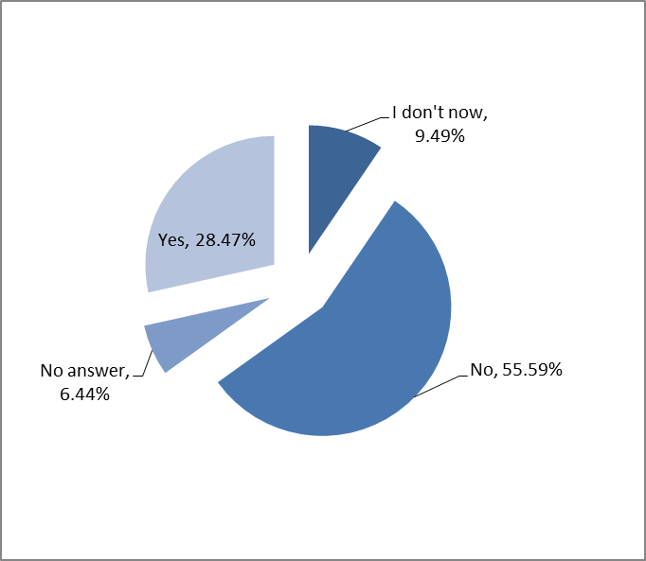

Q 2.5.1.2 59% of respondents said that this proposal would have an impact on their activities, while almost 13% stated it would not. The remainder either didn't answer or did not know.

Q 2.5.1.3 If yes, please explain how. You may also provide additional comments on this issue:

Among the 9 government institutions that responded to the question some were favourable to this idea with the additional comment that if the expiry review were to be concluded before the end of the 5-year duration of the definitive duties, this question would never arise. Other government institutions expressed a negative view referring to the fact that provisional measures are not imposed retroactively to the detriment of the injured Community producers.

The importers were unanimous in their support for reimbursement of duties, proposing automatic refunds or transparent, fast and straightforward procedures to obtain such refunds. One stakeholder proposed that information on whether a request for an expiry review has been received by the Commission services should be announced so as to assist importers in their planning. Another importer emphasized that it would be more willing to cooperate during review investigations if the duties could be refunded should the proceeding be terminated.

Union producers and their associations which constituted some 80 % of all replies were overall negative to the fact that provisional measures are not imposed retroactively and that Union producers have suffered from injurious dumping for a period prior to the imposition of provisional measures without financial compensation.

Moreover, there were claims that the duty had in most cases already been passed on to customers by the importers and therefore a refund would be tantamount to double remedies for importers. A few Union producers had an opposite view stating that duties that are found to be unwarranted should be refunded. Some producers refer to the need for parallelism in (WTO+) rules applied by our trading partners.

2.5.2. Expiry reviews combined with interim reviews

Q 2.5.2.1 Should the second and any further expiry review of measures be combined with an interim review, in order to allow for the level of the duty to be changed if appropriate?
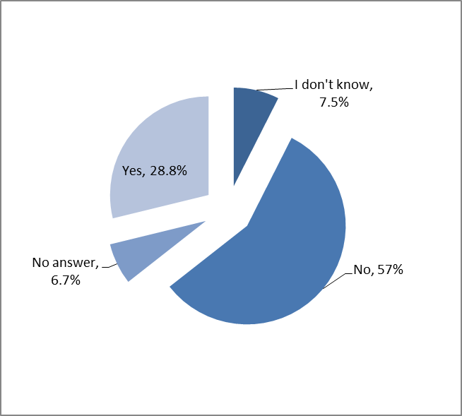

Q 2.5.2.2 Almost 68% of respondents said that this proposal would have an impact on their activities, 6% stated it would not. The remainder either didn't answer or did not know.

Q 2.5.2.3 If yes, please explain how. You may also provide additional comments on this issue:

Among the 9 government institutions that responded to the question, some supported adjustment of the level of duties after a given period (after 1 or 2 extensions of measures). Other government institutions were more sceptical and referred to the already existing possibility for interested parties to submit applications for interim reviews, or for the Commission to ex officio launch such an interim review.

Importers were overall positive towards combining expiry review with interim reviews. Some suggested that this ought to be done ex officio as part of price monitoring, as duties in some cases did not serve their purpose or were exaggerated in times of volatile commodity prices. Alternatively, interim reviews should be introduced already after the first 5-year-period.

Business Associations from some countries believed that continuously changing market conditions called for regular updates of the measures, whereas others believed that it was up to the stakeholders to request interim reviews whenever warranted.

Union producers and their organisations, constituting some 80 % of all replies, were overall negative to such a proposal and referred to the already existing possibility for interested parties to submit applications for interim reviews, or for the Commission to ex officio launch such an interim review. Some saw this as a way to weakening the current system and that any such move should be done only if agreed as part of a reform of the WTO Agreements or in the context of bilateral trade agreements. A few followed the reasoning of the importers, i.e. duties should be adjusted so as to serve their purpose.

2.5.3 Ex-officio interim reviews

Q 2.5.3.1 Should the Commission systematically initiate interim reviews of measures when relevant anti-competitive behaviour has been identified?

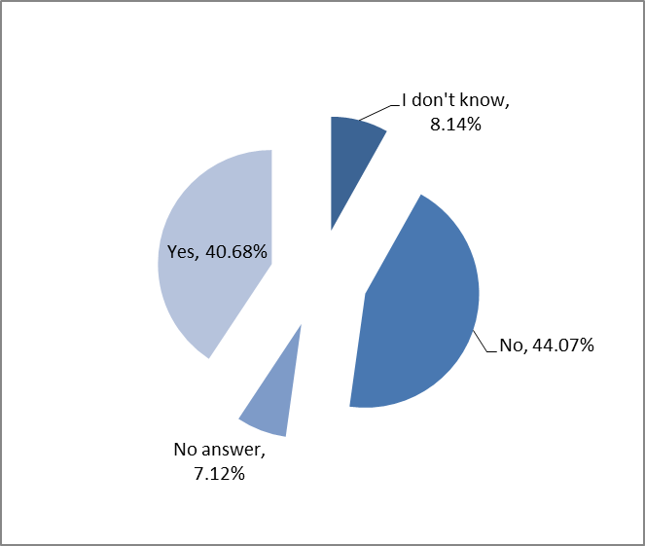

Q 2.5.3.2 Almost 50% of respondents said that this proposal would have an impact on their activities, 20% stated it would not. The remainder either didn't answer or did not know.

2.5.3.3 If yes, please explain how. You may also provide additional comments on this issue:

All 7 government institutions that responded to this question were more or less positive to the initiative. However only under clear conditions and with various degrees of involvement of DG Competition should this, from a formal competence point of view, be appropriate.

Importers were positive towards the Commission opening ex officio interim reviews of measures when anti-competitive behaviour has been identified. One party suggested that the Commission also could open expiry reviews ex officio if Union interest calls for more competition in the market.

The Business Associations representing Union producers, users and employers differed in their opinion. Some stressed that the ex-officio reviews should only be opened very exceptionally as a matter of principle. Others stated that anti-competitive behaviour per se is illegal and should be addressed, and such markets should not be protected from foreign competition in the first place. Overall, a very careful position to such initiative was identified.

Union producers and their organisations, constituting some 80 % of all replies were hesitantly sceptical towards such ex officio interim reviews. They stressed that the purpose and legal basis of TDI and EU Competition Law are different and serve different purposes (and jurisdictions). In any event, anti-competitive behaviour can be addressed under the Union interest test. Some claimed that if the outcome of such a review would be that measures would be repealed despite findings of dumping, one anti-competitive type of behaviour would simply be replaced by another.

Some stressed the sequencing of the Commission combined actions; a decision on the existence of a cartel must precede any ex officio interim review. In any event, many thought that ex officio interim reviews triggered by anti-competitive behaviour are already provided for in the Basic Regulations. One party asked for symmetry and reciprocity in this respect, i.e. a decision on anti-competitive behaviour by competition authorities in third countries could trigger an ex officio interim review by the European Commission.

VI Codification

Q 2.6.1 Registration of imports ex officio
The vast majority of respondents support the proposal that registration of imports should also be possible on the initiative of the Commission ('ex officio').
Many respondents argue that registration and related threat of retroactive collection of duties help to fight circumvention and serve as a deterrent against exporters flooding the market with imports in anticipation of future duties. Some responses go as far as asking for mandatory registration of all imports of products under AD/AS investigations as of the day of opening such investigations. They also reason that early registration of imports could help to improve the quality of import data during the investigation and contribute to more precise assessment of the market. Some argue that registration of imports on the initiative of the Commission would alleviate the bureaucratic burden put on the Union industry to ask for it, which is an improvement of particular importance for industries consisting of SMEs. Several respondents ask for more clarification on practical implications of the proposal, while others express conditional support making it clear that the scope of registrations on the initiative of the Commission should remain limited to new exporter reviews and anti-circumvention reviews.
Only a small number of respondents oppose the proposal and maintain that it would create additional bureaucracy. Some of them propose to completely remove the possibility to register imports in the context of an investigation. Others argue that since the Union industry is the main beneficiary of measures, it is normal that in each case they should take the initiative by asking for the registration in line with the current text of the basic regulations.

Q 2.6.2 Delete article 11(9) of the basic AD regulation and article 22(4) of the basic AS regulation
Most respondents either reject the proposal to delete these articles or express the need to amend them rather than to delete them completely.
Those respondents opposing a complete deletion of the articles maintain that the deletion would decrease transparency and predictability in the use of different methodologies by the Commission, thus adversely impacting legal certainty for interested parties.
However, those respondents that support the deletion argue that it is precisely the current text that creates legal uncertainty, that the deletion would clarify the matters and allow the use of methodology most appropriate to assess actual market situation at the time of an investigation. These two opinions go in line with a major proportion of responses indicating the need for further detailed reflection and discussion of the matter.
Whereas many respondents point out that where there is a relevant change in circumstances, the current legislation already allows a change to the methodology in subsequent investigations, many others suggest amending the legislation by defining, in a precise manner, those situations where the change of the methodology would be warranted. Many responses suggesting amendments include a proposal that in review or refund investigations the Commission should use the methodology used in the initial investigation, unless, on a case-by-case basis, it can be proved in a transparent manner that such a methodology has become inappropriate.

Q 2.6.3 Ensure that exporting producers with a zero or de minimis dumping margin in an original investigation (as opposed to a review investigation) will not be subject to any review
The majority of respondents agree with the proposal to modify article 9(3) of the basic Anti-Dumping Regulation on the grounds that it is already de facto practice of the Commission as well as that it is unquestionable that EU should follow the rulings of the WTO Appellate Body. Some add that changes should nevertheless be strictly limited to those necessary to bring the basic AD regulation in compliance with the ruling, but no more. Only one respondent argued that the changes should go further and exclude from subsequent reviews also those exporters that obtain a zero or de minimis dumping margin in a review investigation.
However, there is also a significant number of respondents opposing the proposal because they are concerned that the exclusion of some exporters from reviews would encourage fraud and circumvention of AD measures. Some elaborate further that for certain third countries it is quite common that when AD measures are imposed on some exporters, but not on other exporters, exporters subject to AD measures try to circumvent them by exporting via exporters that are exempt from AD measures. Knowing that they would not be subject to subsequent reviews could encourage exporters exempt from AD measures to engage in such practices. Even respondents who generally support the proposal frequently mention that the Commission should thoroughly enforce the measures by not allowing such circumvention practices and fraud to happen.
Many opponents of the proposal also argue that all exporters should be subject to a review investigation, so that the investigation could check if companies with a dumping margin of less than 2% in the original investigation have not subsequently increased their dumping. A few responses suggest differentiating between exporters with a zero dumping, which should be excluded from subsequent reviews, and exporters with a dumping margin of less than 2%, which should remain subject to subsequent reviews.

Q 2.6.4 Provide the possibility for exemption also to related parties if they are not involved in circumvention practices
The vast majority of respondents support the proposal and deem it fair and justified. However, many of them also stress that first there must be proof beyond doubt that exporting producers and related companies in question are not involved in circumvention practices before they are exempted. Some of them add that the change of legislation should not create any loopholes for circumvention.
Fears of possible circumvention are the main reason why a few respondents object to the proposal. Many respondents refrained from making any comments before being presented with the text of the proposed amendment.

Q 2.6.5. Clarify the definition of "a major proportion" of the Union industry

There were very diverse views on the proposal. A few responses simply gave their support to the proposal. Others supported the proposal and justified it in order to clarify and sort out grey areas of interpretation, ensure EU's laws compliance with WTO rules (proposing even to use the wording of the WTO agreement).

Many parties argued that there is no reason to delete the reference to Article 5(4) of the basic Anti-Dumping Regulation, but rather a need to clarify what is meant by "major proportion" within Article 4(1). Some responses asked for a higher threshold, (30%, < 33%, or even 40%, were proposed). Other times the proposal was accepted under the condition that the relevant major proportion of the Union industry would not be lowered, and that the "major proportion" could not remain undefined. It was also proposed to clarify the percentage, if it refers to volume, turnover or the number of firms. Other times it was proposed that the threshold should depend on the type of market, and the reference to Article 5(4) in Article 4(1) be deleted and replaced by more comprehensive criteria (geography, raw materials used, share in employment, etc.).

Other respondents expressed the view that the 25% threshold of Union production should stay. It was proposed that Article 4(1) of the basic AD regulation and Article 9(1) of the basic AS regulation explicitly state that a 25% threshold has to be reached, and that the percentage used for the definition of the major proportion, should be the one considered sufficient to initiate the proceeding.

Many respondents were, however, of the opinion that the minimum possible threshold should apply with regard to the ability to initiate complaints, given that all EU producers should have the right to defend themselves against injurious dumping and subsidisation. Other respondents were of the opinion that the percentage should be lowered to around 5%, that there should be no minimum percentage at all, or that it should be judged on a case-by-case basis. However, it was also argued that deletion of the threshold would make the case less transparent and clear.
Many respondents argued that any modification should not lead to set a higher threshold but it should simply clarify what a "major proportion" is in compliance with the WTO report, and that, in any case, the Commission should provide stakeholders with the text of the proposed amendment.

Finally, many respondents disagreed with the proposal. They considered it dangerous since it might lead to consider non-EU subsidiaries as part of the EU standing, or the dominance of producers having more importers' than producers' interests. In such cases, the reasoning went on, the EU industry could easily be taken hostage by the related companies (representing exporting interests to the EU and imposing their own economic interests derived from dumped or subsidised exported products to the EU) and hence the investigation would risk to be biased.

Q 2.6.6. Sampling provisions should refer to Union producers and not to complainants, except for the standing test

A number of responses were received in favour of the proposal. These were justified on the basis that it would add clarity to the legislation, that there is no reason to treat EU producers differently, and that it would add statistical representativeness and reduce the risk of selection of samples skewed towards finding injury.

Secondly, another response widely repeated (the most repeated similar response) was in favour of the suggestion, but only in case the reference would be made with respect to supporting and/or neutral Union producers, and never to Union producers who are against the investigation. One of these respondents argued that these would be considered in any case in the Union interest test.

However, the majority of the respondents were against the proposal or expressed that the proposal would not lead to any substantial improvement in the perspective of modernizing the current TDI regime, since the practise already applies de facto. The reason argued that the reason that the sampling provisions should refer only to the complainants is mainly the possibility to have companies that, not being complainants, might not cooperate properly in the investigation, and might therefore delay it unduly. Some rare answers also argued that the sample should be representative of the country of reference that is suffering the dumping, and therefore, the complainants should only be represented in the sample.

2.6.7. Clarify that the investigation of Union interest covers all Union producers and not only complainants

Many responses were received in favour of the proposal. The justifications were that it would add clarity, it would sort out grey areas of interpretation, and it would enhance representativeness and ensure cooperation when collecting evidence and data.

Some of the respondents expressed an agreement conditional on the producers being 100% EU based companies, companies that physically manufacture the like product within the Union, not EU-based companies manufacturing elsewhere.

However, the majority of the responses were against the proposed change. The reasons were mainly that since the Commission's practise already applies de facto, it would not lead to any substantial improvement in the modernisation of the current TDI's regime, and therefore there is no need to amend the Basic Regulations. The respondents explained that the principal party to the proceedings is the complainant industry and due regard must be made to this throughout the proceedings including in the context of the Union interest. Finally, other respondents argued that a reference to all Union producers would create a number of additional difficulties such as to investigate the reasons why certain manufacturers did not join the applicants or the relationship of the non-complainants with related exporters. A few comments were also received in favour of repealing the Union interest test as a whole, and maintaining only the standard WTO requirements.

VII Any other areas where EU's rules or practice should be updated
There was a clear consensus for the need to have easier proceedings for SMEs, and to support them, with proposals such as to allow national and European Associations to lodge complaints on behalf of their associates and to supply information on their behalf, even without formal written authorisation of the associate, and to support SMEs to lodge a complaint and to allow them to submit it in their own language. It was also proposed that the Commission could initiate more ex-officio investigations in fragmented sectors comprised mostly of SMEs.
Regarding initiation, some associations of importers suggested that consultations with exporting third countries at an early stage could avoid the introduction of anti-dumping or countervailing measures. It was also argued that the Commission should initiate more ex-officio investigations, particularly in respect of subsidies. Finally, some parties claimed that standing and de minimis thresholds should be increased.
Different views were reported on the definition on the Union industry. According to some opinions, the definition of the Union industry and Union producers is too narrow in the current Commission practise and it should consider other economic agents and producers that outsource and have global value chains. Other respondents, however, stated that TDI should uphold only our EU-based industry, defending EU producers' interests and SME's needs, and that those EU companies that undertake a range of ancillary functions such as R&D and design, but that produce elsewhere, should have their interests reflected only in the Union interest test.
Many opinions were received in favour of shortening investigations, for example, maximum 12 months (6 months for the provisional phase), and faster imposition of provisional measures. Many responses supported the retroactive imposition of measures and that retroactivity should be addressed to allow more flexibility. It was also argued that the duration of anti-dumping measures should be aligned with the duration of anti-subsidy measures and when both are to be pursued they should be initiated in parallel.
Many respondents argued that it is necessary to tackle distortions which underlie the dumping found, such as dual pricing policies and export bans on raw materials. Parties also argued that the Commission should integrate its growing intelligence on raw materials and input cost distortions, to try to identify them, and to use special rules, such as different profit margins per sector, not applying the lesser duty rule, product scope actions, etc. Other times, it was requested to apply the same standards, as applied to EU producers.
It also argued that no lesser duty rule should be applied in cases of non-cooperation, or when the minimum standards (environmental, social, etc.) are not met, and if the state influence is strong. Some parties, however, complained about the lack of information to companies in cases of non-cooperation, given how difficult it is sometimes for companies to cooperate.
Many parties asked also for more clarity on the rules of origin applicable to TDI practice. However, views differed on whether to use, for example, the same approach as that of DG TAXUD for the non-preferential origins within the TDI legislation.
It was also argued that the Union interest test should cover wider policy issues. One respondent argued that environmental costs should be considered when calculating dumping and injury margin and another one that there should be a discussion with DG Environment to assess impact on their sustainability initiatives. An association asked for consideration of not only economic dumping, but also social and environmental dumping, and even dumping in the services sector. Another association argued that the Commission should identify relevant user associations and systematically invite them to participate in TDI procedures and that users should have more time to assess investigations. Finally, another association claimed that questionnaires needed to be improved to ensure that all kinds of companies could participate.
Many ways of making the process more clear and predictable for the parties were suggested. Some parties asked the Commission to draft a guide on how to take part in a TDI investigation, aimed at informing and educating unrelated importers, retailers and associations. Other guidelines were suggested regarding sampling and investigation of Union producers. The latest would clearly layout the legal rights of the Union producers, and the information that can be requested during a verification visit.
In circumvention cases where importers have no knowledge of the practice, a time scale of 10 weeks was suggested when applying duties from announcement date unless it could be proven that the importer knew or could have reasonably known about the circumvention, it. Some associations of importers argued that such cases the backdating of duties seems unfair and that it should be limited to 2 months after the start of the investigation.
Other means to increase transparency were also proposed, such as eliminating the possibility to accept confidential information or using an Administrative Protective Order (APO) system such as that existing in the US, and reporting of the activities of the ADC to the interested parties. One party, however, claimed that the confidentiality treatment in practise remains weak in some cases. Many parties insisted on making statistics available to all parties, even at 10 digit level, and not to oblige the complainants to estimate them. Other parties asked for making data on importers subject to duties transparently available in Eurostat. Improved transparency on price undertakings was also requested.
There were other suggestions to improve the proceeding. An association argued that the method to determine a suitable "analogue country" in order to establish normal value in the case of non-market economies should be improved and that the 10 days currently given to parties to comment on the choice are insufficient. It argued also that the Commission should address the comments received after imposition of provisional measures when they are received, and not in the definitive regulation, as it does now, when parties do not have time to react. The 10 days deadline for comments on a definitive disclosure is insufficient, according to this association, especially when disclosure is sent on a Friday. This deadline should be 20 days, failing which, or in addition to, the deadline should start to count on the first working day following its delivery by registered mail. Another association submitted that importers should be entitled to submit information for limiting the CN codes unnecessarily affected by investigations.
Many parties argued that much stronger measures are necessary to detect/prevent fraud, and that the current anti-circumvention processes need to be improved. Parties also claimed that severity and swiftness in addressing fraudulent behaviour or circumvention of measures should be applied, for example, by imposing fines. It was also argued that there is a need to increase the human and budgetary resources needed by DG Trade H, in order to tackle the growing complexities of cases.
More generally, some parties argued that TDI work reasonably well, and that it is the only means to ensure fair competition in the absence of international competition laws and that they will be even more necessary in the future because of the accelerating pace of globalisation. It was also claimed that the EU should take into account the poor standards applied by other countries, in order to act in consequence. It was generally argued that there is a need to improve transparency and compliance with WTO rules, without distorting TDI's purpose, and that the process should be impartially run and its outcome debated with MS. Parties also claimed that the reform of "comitology" should not extend the length of AD/AS investigations nor provide further possibilities for political influence. For some parties, WTO negotiation's standstill and the increasing use of TDI worldwide should also be considered.
ANNEX 6
Impact assessment steering group
on the modernization of TDI
draft minutes of the 4th meeting, 26 October 2012

Participants: Wolfgang Mueller 'WM', Eva-Maria Sanchez, Richard James 'RJ', Delphine Sallard (TRADE), Magdalena Ruda (EMPL), Dimitros Vardakis, Andre' van Aken (TAXUD), Hubert van Vliet, Miguel Franca (LS), Malgorzata Galar (ECFIN), Dominique Lambert (ENTR), Eva Valle, Giovanni Wang (COMP), Klaus Blank (AGRI), Ana-Maria Petrescu, Daniele Westig (stagiaires)
Introduction:
The IASG met in order to discuss chapters 7 and 8 and the problem tree to be inserted before subchapter 3.2. The agenda envisaged also the discussion of comments handed in electronically by ENTR and EMPL regarding previous chapters and the point on reimbursement raised by DG TAXUD. The floor was also open for possible changes in the previous chapters of the IA.
Presentation of the Chapters 7 and 8 of the IA
WM presented the draft of the two chapters and participants made comments as he went along.
Chapter 7 – Impact assessment
EMPL and RJ suggested including in the table at the beginning of the chapter also a column for Option 1 to better highlight the possible negative consequences of the of 'no action' scenario in the long term. The paragraph regarding Option 1 should also be amended accordingly.
In the line concerning General Objective 2, in the column for Option 4, EMPL suggested to add a minus sign to show that there will be a negative social impact if this option is followed.
The question was asked if Option 4 really merits a triple negative sign in the second line of the 'Impact' box. WM explained that indeed certain proposals in this option such as the 6 weeks shipping clause or taking into account producers who have outsourced production when defining the Union industry, would significantly change the balance of interests in favour of importers and thus against Union producers.
Chapter 8 – Monitoring and Evaluation
TAXUD confirmed the availability of weekly data under their import surveillance, which would be useful for the transparency and predictability indicator.
In the last paragraph at the beginning of the third sentence "The year 2013 would be used as the benchmark year" was inserted.

Problem tree
Some drafting changes were suggested:
- Second column first box and following: the wording "lack of transparency" is substituted by "suboptimal".
- Box 3.1.6 "may be" was added before "denied".
- Box 3.1.14 was deleted (and its corresponding boxes on the right)
- Box 3.1.8.4 "incompatible" was substituted by "need to be clarified".
- In the last column of boxes, in the first, the third, the fourth, the fifth the sixth and in the ninth box "claimed to be / is argued to be" was inserted in front of "insufficient".
- In the box corresponding to box 3.1.1.7, "guidelines" was replaced by "guidance".
- The text in the box in the last column corresponding to box 3.1.6 was substituted by "There are too many obstacles for SMEs to initiate a proceeding".
- The text in the second box in the last column corresponding to box 3.1.5 was substituted by "The questionnaires are claimed to be too complicated".
- In the box in the last column corresponding to box 3.1.12, "overall" was added after "no".

Other comments
First the comments submitted in writing by ENTR have been addressed:
Sub-chapter 2.2.2: Redrafting of the 4th paragraph was accepted as suggested.
Regarding subchapter 3.1.1.1, 4th paragraph, ENTR evoked that the information from the public consultation, as used here, was misleading since it did not give the complete picture. TRADE suggested to include a fuller explanation under chapter 6.2, 2nd paragraph.
The title of sub-chapter 3.1.12 has been modified by substituting "can" to "could".
Further to a question from ENTRE, WM explained that regarding subchapter 4.3.2 the wording "in particular" was used to show that not only Operational objective 4.3.2. "Fight against retaliation" aims at improving cooperation but also Operational objective 4.3.4 "Facilitating cooperation".
Some of the changes proposed for subchapter 4.3.5 have been accepted.
6th paragraph of sub-chapter 6.1 will be redrafted i.e. no more mention of "Union producers…"
Regarding sub-chapter 6.3, ENTR wondered whether it was helpful to state that the impact of TD measures is small. WM explained that indeed the overall economic impact of TD measures is small since they affect only a small share of imports. However the existence and legal functioning of these instruments is important for stakeholders. An appropriate paragraph will be inserted at the beginning of chapter 6.
The group then examined the written proposals made by EMPL.
EMPL underlined the importance of introducing also in the description of Option 1 a statement that, due to the shortcomings of the present day status, there may be negative social impacts in the future.
EMPL pointed out an inconsistency regarding the description of Option 4, which at the beginning envisaged two sub-options, but which were not reflected in the subsequent text. The text was changed as suggested by EMPL.
EMPL requested also a clarification regarding the possibility for trade unions to lodge complaints, which has been added in the problem definition under 3.1.9.
LS proposed several changes throughout the text in order not to give the impression that the present system is illegal or lacks legal justification.
Finally, the concern expressed in writing by TAXUD was addressed. TAXUD re-iterated that in Option 3 regarding expiry reviews, they preferred the status quo. It was agreed that the text should be changed to reflect the administrative burden associated with reimbursement.
Conclusive remarks
With this meeting the IASG has concluded its work. None of the participants, whom WM thanked for their constructive and precious collaboration, expressed a wish for further discussion. As this was the last meeting of the IASG, these minutes will be attached to the IA which will be sent to the IAB on 7th November.
ANNEX 7

Codification of the basic regulations with regard to WTO and ECJ jurisprudence
Annex 7 explains the details of the proposed targeted legislative changes to the basic regulations as mentioned in the problem definition under 3.2.15.

- Exporters with a dumping margin of less than 2% should not be re-investigated as part of a subsequent review
According to the EU’s basic AD regulation, producers with a dumping margin of less than 2% in the original investigation are made subject to a duty rate of 0%; but they remain subject to the proceedings, and may be re-investigated in any subsequent review investigation. However, following a WTO dispute settlement ruling, producers with a dumping margin of less than 2% may not be subject to any review investigation.
- The meaning in law of a "major proportion … of the total Union production" needs to be clarified
An AD or AS investigation may not be initiated unless complainants represent a "major proportion" of Union producers: producers must represent at least 25% of the total production of the product concerned in the EU.
The basic regulations provide for maintaining the same threshold also for the injury analysis. However, following a WTO dispute settlement ruling of 2011, for the purposes of demonstrating injury, a "major proportion" during the investigation does not automatically mean the 25% threshold used during initiation of a complaint.
- There is currently no explicit legal mechanism to exempt related companies from duties imposed following a circumvention investigation
According to the basic regulations, companies that can prove that they are not engaged in circumvention practices will be exempted from any duties imposed following a circumvention investigation – unless they are related to an exporter which was subject to the initial investigation.
In a recent case the Commission services had to deal with cooperating exporters who were bona fide producers that were related to exporting producers in the country subject to the initial investigation, but who had clearly not been circumventing the anti-dumping duties themselves. It is difficult to justify an exemption of a related exporter from the anti-circumvention duty even though he is not circumventing, when it is not explicitly provided for in the basic regulations.
- Wording of the EU's basic regulations in respect of sampling provisions needs to be clarified in relation to WTO law
In cases where a large number of producers, exporters or importers cooperate in an investigation sampling may be applied. The current practice of DG Trade – which is also that required under WTO law – is to select a sample from all cooperating Union producers, and not just from complainants (which is what is in fact stated in the basic regulations).

- Provisions in the EU's basic regulations on who may submit information for the Union interest test do not correspond to current Commission practice
Although the basic regulations specifically refer only to "complainants", information for the purposes of the Union interest test is in practice accepted not only from complainants but also from other Union producers.
- Provisions in the EU's basic regulations on registration of imports are not sufficiently clear
According to the basic regulations, registration of imports normally requires a request from the Union industry. However, in cases of ex officio initiations by the Commission services and initiations of investigations for new exporters, the provisions for registration of imports need further clarification.
- Current TD regulations do not authorise the Commission services to apply different investigation methods in review or refund investigations from those used in the original investigation
The basic regulations provide that the methodology used in the original investigation should also be used in review or refund investigations. In certain instances this has led to the maintenance of old, superseded methodologies, sometimes involving the same product but different countries. This may lead to inadequate treatment between companies in different countries, and creates uncertainty among stakeholders regarding the consistency of the institution's practice.
- Procedures to be followed in cases where the EU courts overturn a TD regulation need to be clarified
In certain cases, the EU courts find that a trade defence regulation was flawed and must be annulled, although the flaw actually identified does not entail that no measures at all should have been imposed. E.g., if the correct methodology had been used by the institutions, the case might still have led to the imposition of an antidumping duty, but at a different level from that which was actually imposed.
Sometimes, the courts explicitly limit the extent to which duties imposed must be reduced because of a flawed decision – if they can do so in a simple manner in the operative part of the judgment. However, this is not always possible, and then the court will simply state that the duty is annulled.
In such a situation, fully reimbursing the duty may be perceived as unjustified; it can be argued, in particular, that it leads to insufficient protection of EU industry, unjust enrichment of the relevant importers, and inappropriate budgetary effects. Although the court has already ruled that an anti-dumping investigation can be resumed from the point at which an illegality occurred, it might be useful to clarify the rules applicable in such a situation (this is already the case in some areas of Union law).

The normal value is usually based on the prices paid or payable, in the ordinary course of trade, by independent costumers in the exporting country or on the full cost of production plus a reasonable profit. (Article 2 ADA).
Subsidies are financial contributions by a government or a government body that confer a benefit to a recipient (Article 1 ASCM).
The "Omnibus Regulation" will implement the new Comitology rules as provided for in the Lisbon Treaty and as contained in Regulation (EU) No 182/2011 (OJ L 55, 28.2.2011, p. 13). The implications for TDI proceedings will be significant as it changes the decision making process and also impacts on the deadlines and overall length of a TDI proceeding. Under the current system, measures are imposed by a Council Regulation (following a Commission proposal). The members of the anti-dumping/anti-subsidy committee vote on the basis of simply majority. Under the Omnibus Regulation, also definitive TD measures will be imposed by a Commission Regulation. Member States will have the possibility to ask for amendments or appeal against the Commission proposal in an appeal committee, which can only overturn the COM with a qualified majority.
http://ec.europa.eu/trade/analysis/policy-evaluation/
The experts consulted represented industry and trade association, importers associations, lawyers and economists experts in trade defence.
DG Enterprise, DG Sanco, Secretariat General, Legal Service, DG Ecfin, DG Env, DG Agri, DG Devco, DG Empl, DG Taxud, DG Comp.
The evaluation pointed out that among peer countries only USA and Canada give parties to TD proceedings access to the confidential file (Evaluation Study, Volume 1, Section 4.4.4.
See Final Evaluation Study, Volume 2 Appendices, Section 3.2.3.
See Final Evaluation Study, Volume 2 Appendices, Section 4.6.4.
Case C-340/10 – Grünwald Logistics Service GmbH (judgment of 15 March 2012).
See Evaluation Study, Volume 1 Section 4.5.4, (table 35 provides a comparison of peer countries' and how they deal with non-market economy countries, MES (market economy status) and MET (market economy treatment) requests and the choice of analogue country, and Volume 2 Appendices, Section 4.2.1.
The "target profit" is the profit which the Union industry could expect to achieve in the absence of dumped imports.
In case T-210/95 (EFMA v. Council), EFMA (European Fertiliser Manufacturers Association) challenged the Council's use of a profit margin lower than that claimed by them in establishing the injury margin. The court found in favour of the Council that the profit level should be that which could be achieved in the absence of dumped imports and not necessarily that claimed as necessary by the industry.
See Final Evaluation Study, Volume 1, Section 2.3.2.
See Final Evaluation Study, Volume 2 Appendices, Section 4.5.
For example, proceedings against lawyers that failed to respect their confidentiality obligations might need to be instituted under their domestic law, and would depend on the precise provisions in the relevant domestic laws; Union-wide rules regarding the level of damages might need to be put in place; etc.
See Final Evaluation Study, Volume 1 Main Report, Section 2.2.5.
See Final Evaluation Study, Volume 1 Main Report, Section 4.3.
See Final Evaluation Study, Volume 2 Appendices, Section 4.6.7.
The lesser duty rule provides for a lower duty than the dumping/subsidy margin to be applied, if such lower duty is sufficient to offset injury (article 9.4 of the Basic Anti-dumping Regulation, article 15.1 of the Basic Anti-subsidy Regulation) please also see section 1.2 above).
For more information on the countries and products targeted see Final Evaluation Study, Volume 1 Main Report, Section 2.2.1 and Section 2.3.2.
See Final Evaluation Study, Volume 2 Appendices, Section 3.2.2.
Based on the EU recommendation 2003/361/EC of 6 May 2003, small and medium enterprises are enterprises with fewer than 250 employees, an annual turnover not exceeding 50 mill € and an annual balance sheet total not exceeding 43 mill €; small enterprises are enterprises with fewer than 50 employees and an annual turnover and/or balance sheet exceeding 10 mill €; micro enterprises are enterprises with fewer than 10 employees and annual turnover and/or annual balance sheet not exceeding 2 mill €.
See Final Evaluation Study, Volume 2 Appendices, Section 3.2.2 and Section 3.4.2.
See Final Evaluation Study, Volume 2 Appendices, Section 3.3.
See previous footnote.
See Final Evaluation Study, Volume 1 Main Report, Section 2.1.3.4 and Section 2.3.4.
Note that the Union interest test is a WTO+ feature of the EU's TDI.
See above section 1.3.
See Final Evaluation Study, Volume 1 Main Report, Section 5.2.1.
See Final Evaluation Study, Volume 1, Main Report Section 4.11.
See Final Evaluation Study, Volume 2, Appendices, Section 4.6.3.
See Final Evaluation Study, Volume 1 Main Report Section 4.11.4.
For more details regarding modern heterogeneous firm theory and empirics see Final Evaluation Study, Volume 1 Main Report Section 2.1.3.3.
See Final Evaluation Study, Volume 2, Appendices, Section 3.1.5.
See Final Evaluation Study, Volume 2, Appendices, Section 4.6.5.
Article 3.5 of the Treaty on the European Union: "In its relations with the wider world, the Union shall uphold and promote its values and interests and contribute to the protection of its citizens. It shall contribute to peace, security, the sustainable development of the Earth, solidarity and mutual respect among peoples, free and fair trade, eradication of poverty and the protection of human rights, in particular the rights of the child, as well as to the strict observance and the development of international law, including respect for the principles of the United Nations Charter". Article 206 of the Treaty on the functioning of the European Union: "By establishing a customs union in accordance with articles 28 to 32, the Union shall contribute, in the common interest, to the harmonious development of world trade, the progressive abolition of restrictions on international trade and on foreign investment, and the lowering of customs and other barriers". Article 207 (1) of the Treaty on the functioning of the European Union: "[…] The common commercial policy shall be conducted in the context of the principles and objectives of the Union's external action".
In order to ensure that the instruments are in line with, inter alia, WTO obligations, the Council and Parliament adopted an amendment to the Basic Anti-Dumping Regulation in September 2012 following a ruling of the WTO Appellate Body in 2011. That ruling had found that the provisions of the Basic Regulation concerning the issue of individual treatment of exporting producers in non-market economies was in breach of the WTO Anti-Dumping Agreement. That amendment was adopted as a matter of urgency given the need to respect the reasonable period of time allowed for implementing the necessary change.
A package including all individual interventions would significantly change the underlying principles of the EU's current TDIs and also change the balance between producing and importing interests and is therefore not analysed further.
See problem definition para 3.2.3 and 3.2.4.
See problem definition para 3.2.5.
See problem definition para 3.1.9.
See problem definition para 3.2.6.
See problem definiton para 3.2.10.
See problem definiton para 3.2.12.
See problem definition para 3.2.11.
This is due to the extended possibility to have recourse to the appeal procedure pursuant to Article 6 of Regulation (EU) No 182/2011 ("the Comitology Regulation").
Further guidance on the definition of the Union industry was given in the WTO Panel: Farmed Salmon from Norway, WT/DS337/R of 16.11.2007(paras. 7.107 to 7.122).
Association of Eurpean wheel manufacturers
European Fertilizer Manufacturers Association
European Manmade Fibres Association
European glass Fiber Producers Association
European association of fine paper manufacturers
European Federation of Iron and Steel industries
Liaison Committee of the EU Twine, Cordage and Netting Industries
European Federation of the Plywood Industry
European Ceramic Tiles Manufacturers
European Glass Fibre Association
European Bicycles Manufacturers Association
European Industrial Fasteners Institute
Liaison committee of European Union Wire Rope Industries
International Association of Aluminium radiator Manufacturers Limited Liability consortium
Lever arch mechanism manufacturers association
the second pie chart comprises all actions against third party countries. Circumvention cases are counted to the country which actually is the source of the exported good and not to the one through which the circumvention is perpetrated.
Appellate Body Report WT/DS295/AB/R of 29.11.2005, Mexico – Definitive anti-dumping measures on beef and rice –complaint with respect to rice.
Article 9(3) of the basic AD regulation requires that individual exporting producers that have a dumping margin of less than 2% will not be subject to any duties due to the "de minimis" rule but "they shall remain subject to the proceeding and may be reinvestigated in any subsequent review carried out for the country concerned pursuant to Article 11." Following the WTO dispute settlement case between USA and Mexico, the WTO Appellate Body ruled that exporters that have a "de minimis" dumping margin in an original AD investigation should not be subject to any subsequent review investigations. The reason invoked by the WTO Appellate Body is that such a practice represents a violation of Article 5.8 of the WTO Agreement on Implementation of Article VI of the General Agreement on Tariffs and Trade 1994. The basic AS Regulation contains similar provisions.
DS397 of 15 July 2011 in European Communities – Definitive Anti-Dumping Measures on Certain Iron or Steel Fasteners from China.
Investigations based on an industry complaint cannot be initiated if complainants do not meet the 25% threshold of initiation (see Article 5(4) of the basic AD Regulation and 10(6) of the Basic AS Regulation: No investigation will be initiated when "Union producers expressly supporting the complaint account for less than 25% of total production of the like product produced by the Union industry"). Article 4(1) of the basic AD regulation further stipulates: "For the purposes of this Regulation, the term 'Union industry' shall be interpreted as referring to the Union producers as a whole of the like product or to those of them whose collective output of the product constitutes a major proportion, as defined in Article 5(4), of the total Union production of those products (…)" (emphasis added). Article 9(1) of the Basic AS Regulation contains similar text. However, the Appellate Body in DS397 of 15 July 2011 in European Communities – Definitive Anti-Dumping Measures on Certain Iron or Steel Fasteners from China ruled that the reference to a major proportion in Article 4(1) of the basic AD regulation in the context of the investigation, cannot automatically be equated with the minimum threshold of 25% set in Article 5(4) of the Basic AD Regulation, which refers to the initiation of a case. Thus, the Appellate Body rejected the linkage between both articles. The same applies by implication for Articles 9(1) and 10(6) of the basic AS Regulation.
Implementing Regulation of the Council (EU) No 400/2010 of 26 April 2010 extending the definitive anti-dumping duty imposed by Regulation (EC) No 1858/2005 on imports of steel ropes and cables originating, inter alia, in the People’s Republic of China to imports of steel ropes and cables consigned from the Republic of Korea, whether declared as originating in the Republic of Korea or not, and terminating the investigation in respect of imports consigned from Malaysia, recitals 80 and 81.
Article 13(4) of the basic AD regulation and Article 23(6) of the basic AS regulation have the role of ensuring that companies which are investigated in anti-circumvention procedures and can prove that they are not engaged in circumvention practices will be exempted from any imposition of AD/AS duties. The article in the Basic AD Regulation stipulates: "Where the circumventing practice, process or work takes place outside the Community, exemptions may be granted to producers of the product concerned that can show that they are not related to any producer subject to the measures and that are found not to be engaged in circumvention practices as defined in Article 13(1) and 13(2)." However, the provision does not fully reach its objective and does not fully correspond to the current practice of the Commission services. For the sake of illustration, let us consider two countries A and B with two related exporting firms. The firm in country A is subject to a measure. An anti-circumvention procedure is opened in order to find out whether the measure against country A is circumvented via imports from neighbouring country B. The related company in country B is investigated in this anti-circumvention procedure. If the firm in country B is a genuine producer and not engaged in circumvention practices, the firm in country B should not be subject to any anti-circumvention measure.
Article 17 of the basic AD Regulation and Article 27 of the basic AS Regulation allow the possibility to apply sampling in AD investigations.. Both regulations stipulate that sampling is carried out "[i]n cases where the number of complainants, exporters or importers, types of product or transactions is large (…)" (emphasis added).
Information for the purposes of the Union interest test is accepted not only from complainants but also from other Union producers. However, Article 21(2) of the Basic AD Regulation and Article 31(2) of the Basic AS Regulation stipulate the following: "In order to provide a sound basis on which the authorities can take account of all views and information in the decision as to whether or not the imposition of measures is in the Community interest, the complainants, importers and their respective associations, representative users and representative consumer organisations may (…) make themselves known and provide information to the Commission. …" (emphasis added). The provisions quoted above do not reflect the current practice of DG-Trade, as they would leave unaddressed the situation of producers in the Union that are not part of the complainants.
Article 14(5) of the Basic AD Regulation and article 24(5) of the Basic AS Regulation explain that the Commission services can "direct the customs authorities to take the appropriate steps to register imports, so that measures may subsequently be applied against those imports from the date of such registration". Thus, registration of imports is done with the purpose of applying measures retroactively, where necessary. This possibility is used only in limited circumstances like new exporter reviews or anti-circumvention investigations. According to the text of the Basic Regulations, the registration of imports should normally require a request by the Union industry. The current regulations leave room for interpretation in ex-officio anti-circumvention investigations, i.e. where the Commission services do not initiate based on a complaint lodged by the Union industry but on its own initiative and also in case of initiation of investigations of new exporters.
In reviews and refund investigations the provisions of Article 11(9) of the Basic AD Regulation and Article 22(4) of the Basic AS Regulation state that, "provided that the circumstances have not changed" the Commission services will "apply the same methodology as in the investigation which led to the duty". However, the application of this provision has raised concerns and created uncertainties with respect to the interpretation of a relevant change in circumstances and the consistency of the practice of the Institutions. The aforementioned provisions require that old superseded methodologies continue to be used in review proceedings when such methods are no longer used in current new investigations, possibly concerning the same product but new countries and accordingly creating discriminatory treatment between companies in different countries exporting the same product (please also refer to Evaluation study, volume 1, section 3.3.1).
Even though the reimbursement will be limited to those importers who made their claims in accordance with applicable customs legislation, including the relevant deadlines.
Judgement of the ECJ of 3.10.2000 in Case C-458/98 P, Industrie des Poudres Sphériques v Council, ECR [2000] I-08147, point 39.
Council Regulation (EC) No 139/2004 of 20 January 2004 on the control of concentrations between undertakings (the EC Merger Regulation, Official Journal L 24, 29.01.2004, p. 1-22 , Article 10(5)).

