REPORT FROM THE COMMISSION TO THE EUROPEAN PARLIAMENT AND THE COUNCIL
Concerning Article 8a of Directive 98/70/EC relating to the quality of petrol and diesel fuels and amending Council Directive 93/12/EEC

1. Introduction
Article 8a of Directive 98/70/EC (the “Directive”) requires the Commission to report its conclusions, on the development of a test methodology to assess the risks for health and the environment from the use of metallic additives in fuels, to the European Parliament and the Council.
Metallic fuel additives (“MFA”) are substances intentionally added to fuel (petrol, diesel and biodiesel) to improve its performance. These additives eventually enter the environment since their metallic portion is not degraded during any stage of their production or use. Thus, they can become a source of exposure for humans and/or biota throughout their life cycle. This creates a possible impact on health and the environment . This potential impact justifies their regulation through the adoption of limit values based on the precautionary principle.
The Directive contains a current limit value for methylcyclopentadienyl manganese tricarbonyl (“MMT”) of 6mg of manganese per litre. This value will become 2mg of manganese per litre from 1 January 2014. This limit value may be revised, through a Comitology procedure, on the basis of an assessment carried out following the test methodology referred to in this report.

2. Assessment of potential risks for health and environment of mfa
There is a potential impact on health and the environment by the use of MFA in fuel. This impact is affected by several factors: the type of MFA; the level of concentration; the level and duration of the exposure; and the pathway for this exposure. The metallic components of MFA could be a hazard for both humans and the environment due to their intrinsic reactivity, toxicity and their possible capacity to accumulate within living organisms.
If a substance is considered hazardous to human health and the environment it would have to be assessed and labelled in accordance with the requirements of Regulation (EC) No 1272/2008 on the classification, labelling and packaging of hazardous substances and mixtures (“CLP Regulation”), prior to its placing on the market.
Possible sources of emissions linked to MFA
Emissions of MFA may enter the environment during any stage of their life-cycle from production to disposal. Such emissions can result in the direct or indirect exposure of humans and biota to the MFA, their related emitted compounds or their transformational products and, as such, contribute to the possible risk these substances may raise for human health and the environment.
To assess the potential impacts of MFA on the compounds produced during vehicle fuel combustion and/or remaining in the exhaust it is necessary to compare the emissions produced with and without using MFA. In this context, the Commission’s Joint Research Centre has developed a test protocol for monitoring and calculating the emission data with regard to MFA, focusing on the use stage of their life-cycle. In this protocol, measurements are made at the tailpipe and the emissions are compared for fuel containing MFA with the same fuel without the MFA. The test protocol includes an EU representative car fleet and does not contain predefined pass or fail criteria. The protocol aims to:
- evaluate the short-term effects of MFA on regulated emissions (namely HC, CO, NO_{x}, PM, PN and CO₂);
- measure the mass of the metallic emissions produced by the combustion of the fuel containing MFA, and determine the speciation of the combustion products as well as particle size distribution of particle-bound metals; and
- evaluate the effects of MFA on the long-term emission performance of the vehicle's engine and emission control system.
This test protocol is an integral part of the methodology and its use is a mandatory part of the overall assessment of the risks for the environment and health of MFA.
Possible exposure pathways
The predominant routes of possible exposure throughout the life-cycle of MFA are:
- at the research and development, manufacturing and storage steps;
- in marketing, distribution and transport;
- at the point of use; and,
- from the environment in general.
It is expected that occupational exposure would occur mainly at the first two steps in the life-cycle and exposure by the general public would be largely confined to the final stage. Exposure would come from oral or dermal routes with inhalation being one of the main pathways for humans.
Results and implications
In the past health concerns associated with MFA (such as lead) have led to the phasing out of their use. It is apparent that MFA have metallic components which could in themselves be a hazard for both humans and the environment due to their intrinsic reactivity, toxicity and their possible capacity to accumulate within living organisms.
New substances are being developed for which the available health and environmental data are limited and little is known about their eco-toxicity and toxicity. Determination of their toxicity and eco-toxicity is a prerequisite to assessing their actual impacts on the environment and health. Hence there is a need to develop a test methodology.

3. Test methodology
The purpose of the methodology is to assess the risks for health and the environment from the use of MFA. It is intended to be sufficiently generic so as to apply any MFA. Prior to the assessment a holistic approach for evaluating the environmental implications of various choices among chemicals, products and technologies may be needed to prioritise efforts and to provide input to risk managers to enable better targeted decisions. Such a meta-assessment is shown below:
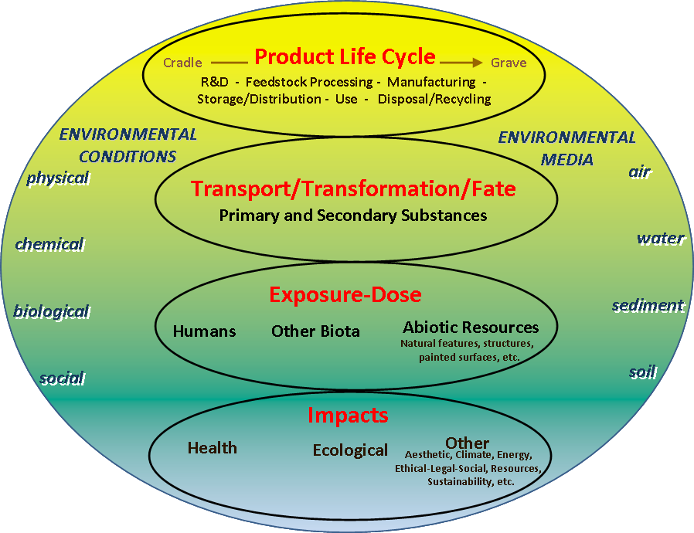
Example of holistic approach for risk assessment of chemicals
adapted from U.S. EPA (2011)
The development of the methodology recognised that there are existing methods and processes like for example REACH and the CLP Regulation in place. REACH already proposes guidance to assess the risks posed by chemical substances, so the methodology should be consistent with this already existing approach. However there is the necessity to assess specific risks for health and the environment from the use of MFA. Consequently the methodology summarised in the figure below, is an adaptation of this framework for the specificities of MFA.
Further details are as follows:
Characteristic of emissions during the life-cycle
Emissions can take place throughout the life-cycle of the MFA and the purpose of this step is to provide guidance on the estimation of emissions to the environment (i.e. into water, soil and the air) of MFA including combusted compounds and transformation products in the use phase. The Commission’s Joint Research Centre test protocol is required for the vehicle use step.
Full details of the test protocol can be found on the Commission’s website:
http://ec.europa.eu/clima/policies/transport/fuel/docs/fuel_metallic_additive_protocol_en.pdf
Hazard assessment
The objective of this step is collect qualitative and quantitative information on possible hazards to humans and the environment of MFA, emitted compounds and transformational products.
Exposure assessment
The exposure assessment is the process of measuring or estimating the dose or the concentration of the substance to which humans and the environment are, or may be, exposed depending on the use of the substance. The exposure assessment would be performed in two steps: the development of exposure scenarios and the estimation of the exposure for both humans and the environment.
Risk characterisation
The risk characterisation has to be performed by comparing the expected levels of exposure to the predicted no effect levels from the hazard assessment for both humans and the environment. The ratio between the exposure and no effect levels will provide a rough measure of the risk and an indication of (a) whether a more refined risk assessment is needed and/or (b) whether or not steps to reduce or manage risks are appropriate.
Risk management
In the case of MFA risk management is typically a process of finding a balance between the benefits and risks of the substances. Given that this methodology calls for a comparative evaluation of fuels formulated with and without a given MFA the information afforded to risk managers should enable them to judge better the risk/reward trade-offs of MFA in relative terms since risk management is inherently a matter of making choices between different options.
Full details of the methodology can be found on the Commission’s website:
http://ec.europa.eu/clima/policies/transport/fuel/docs/bio_report_en.pdf
Application of methodology
The Commission notes that the methodology envisages that any interested party applying the methodology will establish an advisory board comprising members recognized as impartial and objective authorities in various technical disciplines, including fields such as vehicle and fuels technology, exposure analysis, health and ecological effects, and risk assessment/management “to assist in and advise during the preparation and performance of the assessment.” While the Commission does not have a legal basis to require or regulate such advisory boards it does recognise that such an advisory board can contribute to ensuring that the result of the assessment can withstand scientific scrutiny, be credible, reproducible and be established in a transparent manner. Accordingly, the Commission stands ready to provide advice regarding the composition of an advisory board when requested.

4. Conclusion
It is apparent that there is a potential impact on health and the environment by the use of MFA. In order to assess this impact a methodology has been developed to be employed by any party interested in the establishment or revision of limit values for MFA in the Directive.
The Commission will monitor the application of this methodology and will take all appropriate initiatives.

This is dependent on many other factors such as engine compression, other constituents of fuels, etc.
HEI Special Committee on Emerging Technologies (2011) The Future of Vehicle Fuels and Technologies: Anticipating Health Benefits and Challenges. Communication 16 – Health effect institute. Boston, Massachusetts. p.26.
International Council on Clean Transportation (2008) Strategic Plan 2009-2011.
Joint Research Center (2011) Protocol for the evaluation of effects of Metallic Fuel Additives on the emissions performance of vehicles.
Emission measurements should be carried out according to the European type approval procedure: “The exhaust gases are diluted and a proportional sample is collected in one or more bags. The exhaust gases contained in the bag(s) shall be analysed as soon as possible after the end of the test cycle”. The procedure is described in UNECE Regulation 83, revision 4, 26 April 2011: “Uniform provisions concerning the approval of vehicles with regard to the emissions of pollutants according to engine fuel requirements”.
If a substance/mixture fulfils the criteria relating to physical, health or environmental hazards, it shall be classified before placing them on the market (Article 3 CLP). In so doing, manufacturers have to make use of all available information, including information from related substances that can be used. Furthermore, suppliers of hazardous substances shall ensure that the substance/mixture is labelled and packaged according to the CLP (Article 4 CLP). Finally, irrespective of their tonnage, substances or mixtures classified as hazardous shall be notified by the suppliers to the Classification and Labelling Inventory of the European Chemicals Agency (Articles 39-42 CLP).
Report prepared by BIO Intelligence Service for the European Commission: Development of a risk assessment for health and the environment from the use of metallic additives and a test methodology for that purpose.

