1. Public debt
The general government debt is defined as the consolidated gross debt of the whole of the general government sector outstanding at the end of the quarter (at nominal value). The general government sector comprises central government, state government, local government, and social security funds. The debt is measured as a percentage of GDP.
Why does this matter?
The Maastricht Treaty specifies government debt must not exceed 60% of GDP unless it is sufficiently diminishing and approaching 60% at a satisfactory pace. Unsustainable levels of public debt undermine macro-economic stability, increase government spending interests and the higher taxes required to service the debt may act as a drag on growth.
How the EU Member States score?
Government debt-to-GDP ratios increased drastically over the 2008-2012 period in both the euro area (24.9 percentage points) and in the EU-27 (26.2 p.p.), sustained by government budget deficits (negative primary balances), increasing interest payments and lower nominal GDP growth. During the crisis, the total debt-to-GDP ratio of EU-27 registered a negative trend, peaking at 85.2% in the last quarter of 2012 (latest available data).
Country | General Government Gross Debt, fourth quarter 2012
This table shows the five countries with the highest government debt-to-GDP ratio
Greece | 156.9
Italy | 127.0
Portugal | 123.6
Ireland | 117.6
Belgium | 99.6
The highest ratios of government debt to GDP are recorded in Greece (156.9%), Italy (127.0%) and Portugal (123.6%). The total government debt is higher than the annual GDP also in Ireland, and close to this level in Belgium. The lowest ratios, instead, are registered in Estonia (10.1%), Bulgaria (18.5%) and Luxembourg (20.8%). The values of the last quarter of 2012 represent a peak (since 2000) for eleven countries, including Germany, Portugal, Netherlands and the UK. Greece, instead, peaked (170.3%) in the fourth quarter of 2011 and decrease is mainly due to the exchange of bonds. Also Hungary (79.2%) improved its situation compared to the peak recorded in the second quarter of 2010 (85.3%).
Country | General Government Gross Debt, first quarter 2008 - fourth quarter 2012
This table shows the five countries with the biggest increase of government debt-to-GDP ratio
Ireland | 90.0
Portugal | 56.1
Greece | 49.0
Spain | 48.6
UK | 46.7
The highest increases between 2008 and 2012 are registered in Ireland, where the ratio increased by a staggering 90.0 percentage points, Portugal (56.1) and Greece (49.0).
The debt to GDP ratio increased in all EU-27 countries, although Sweden (+0.2 p.p.), Bulgaria (+3.1 p.p.) and Estonia (+6.0 p.p., starting from a very low base) registered a mild increase.
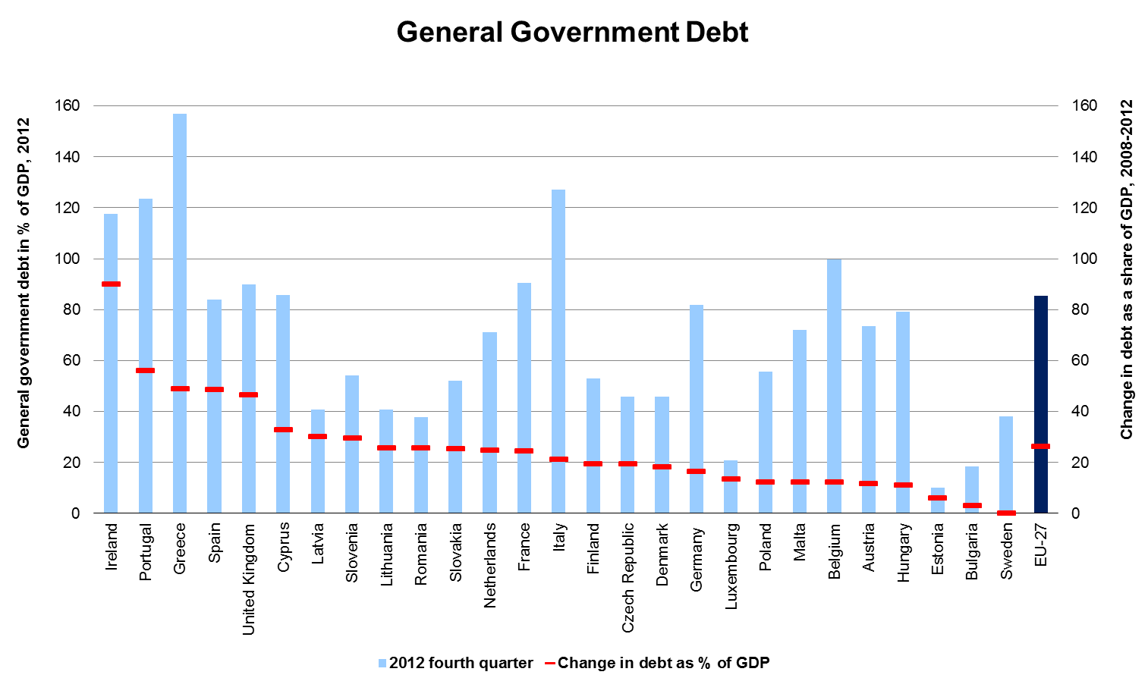
2. House Price Index (HPI)
House Price Indices (HPIs) measure inflation in the residential property market. The HPI captures price changes of all kinds of residential property purchased by households (flats, detached houses, terraced houses, etc.), both new and existing. Only market prices are considered, self-build dwellings are therefore excluded. The land component of the residential property is included.
Why does this matter
Rapid increases in housing prices reduce the affordability of housing, especially for first-time buyers. Rapid reductions in housing prices lead to mortgages which are higher than the current value of the house, so-called negative equity. These reductions also lead to fewer transactions on the housing market, with effects on mobility of workers.
How the EU Member States score?
Housing market bubbles have been one of the main macroeconomic imbalances leading to the current economic crisis. Household indebtedness is closely linked with housing market developments: growth in credit to households, house price increases and high residential investment went hand in hand during the decade preceding the crisis, leading to higher indebtedness of the private sector. While the length and the speed of this expansion has shown significant variations across countries, house prices peaked in a vast majority of Member States in 2007/2008, ending a particularly pronounced price cycle across the EU. In 2006-2007, half of the Member States where data is available recorded price increases above 6%/year, a threshold considered as an alert of internal imbalances.
Taking into account the 2007-2012 period, house prices contracted considerably in Ireland (-49.5%, until 2010), Latvia (-35.7%) and Estonia (-30.2%). In Ireland house prices in 2010 were significantly lower than in 2005. A substantial decrease between 2007 and 2012 was also registered Spain (-28.0%), and Romania (-26.1%, 2010-2012).
Country | House Price Index, 2007-2012
This table shows the five countries with the highest drop of house prices
Ireland (2007-2010) | -49.5
Latvia | -35.7
Estonia | -30.2
Spain | -28.0
Romania (2009-2012) | -26.1

Between 2007 and 2012, house prices kept on increasing considerably in Sweden (+16.3%), Luxembourg (+15.1%), Finland (+14.8%) and Belgium (+14.0%), and at a slower pace in Malta (+8.2%), Germany (+6.8%) and France (+4.5%).
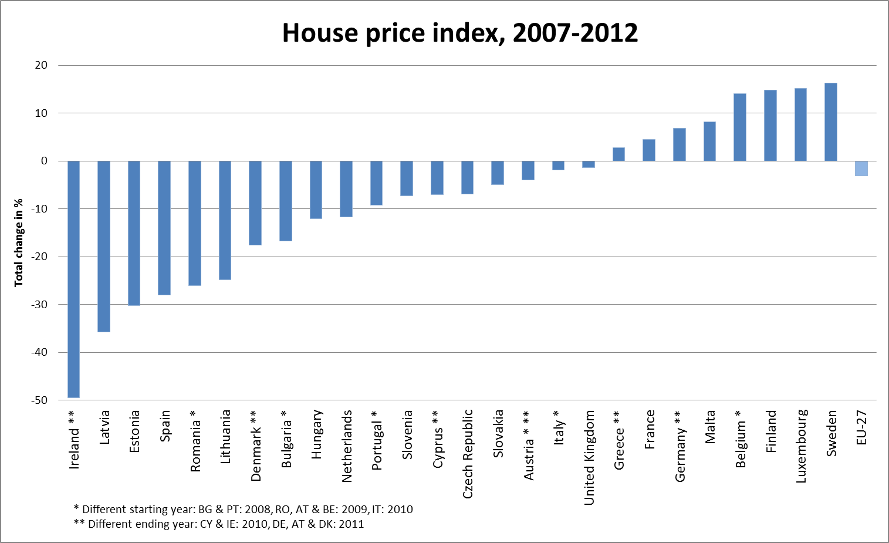
3. Trade in Goods, 2008-2009
International trade refers to selling (exports) or buying (imports) of goods and services along international borders. The analysis is based on the trade volume index. It accounts, simultaneously, for change in prices and in volumes of export and import; therefore it is a suitable indicator of change over time.
Why does this matter?
Through export, countries can expand their market, which is important in particular for countries with small domestic markets. Imports can increase competition on the domestic market and improve the choice of goods and services available to consumers, at lower prices. A positive balance of exports and imports (trade surplus) contributes to GDP growth. A negative balance (trade deficit) lowers GDP.
How do EU countries score?
As the crisis spread across the economies, people started to consume less and firms started to buy less intermediate goods. This led to a serious contraction in both, exports and imports of goods and services, worldwide.
In the EU, the Central and Eastern countries, suffered the highest drop in imports. The countries in the table saw their imports falling by a nearly a quarter in Bulgaria to nearly a third in Latvia, in just one year. Most of the countries that joined the EU after 2004 were enjoying a period of high economic growth fuelled by high investments and high consumption, before the crisis hit them. At the same time, imports grew significantly. The crisis brought this development to a halt during at least two years (2008-2010) before imports started to grow again.
The effect of the crisis on trade in the less developed MS was higher on imports, whereas the import of intermediate products, which will be transformed and exported again, is likely to increase apace with the exports. Imports of final consumption goods will only grow when disposable household income starts to grow again.
The four of the five countries with a reduction in exports of 18% or more (see table) have a GDP per head above the EU average. In general, the decline in trade was associated mainly with falling exports in the more developed MS, indicating that the consumption of final goods did not drop as quickly as in the less developed MS.
In general, imports fell faster than exports and took also longer to recover. By 2011 most of the EU countries reached or nearly reached their trade volumes from the pre-crisis period. However, the consequence of such abrupt fall in consumption and production, for their labour market will take much longer to recover.
4. Foreign Direct Investments
Foreign direct investment is an investment made by a company or entity based in one country, into a company or entity based in another country in order to acquire a lasting interest (10 percent or more of voting stock). The difference in inward and outward FDI is called FDI balance. It is usually expressed with relation to a country's GDP.
Why does this matter?
A negative FDI balance means that a country receives more investment from abroad than it sends abroad. As a result, a negative FDI balance leads to higher private investments. This will boost the economic activity in a country. In addition, it can contribute to efficiency gains, transfer of innovative technologies and higher productivity.
How do EU countries score?
The table shows the countries with the where net inflows were much higher than net outflow as a share of GDP. Most of them are relatively small and open economies with skilled workforce. With the exception of Belgium, they are all Member States with GDP per head (well) below the EU average.
Joining the EU may have contributed to increase of FDI in several of the Central and Eastern Member States due to the access to the single market and the incorporation of the EU acquis into national legislation.
Foreign direct investment dropped rapidly in 2008 and 2009 as global credit conditions started to deteriorate. The fall was more substantial for inflows than outflows of FDI, which led to significantly lower investments in the main recipient of FDI in the EU.
Bulgaria experienced the biggest reduction in inward FDI as share of GDP (- 12 pp). Nevertheless, it still is one of the main destinations for investors in the EU. This is also the case for Malta.
Among the ten Member States with the biggest drop in inward FDI, there are four Western MS. This is not so surprising for small, open economies such as Luxembourg, Denmark and the Netherlands, but it also includes the large economy of the UK, where it dropped by 4 pp.
In 2011, FDI flows showed strong signs of a recovery. Both flows from one EU country to another and from the outside the EU into the EU increased substantially compared to 2010.
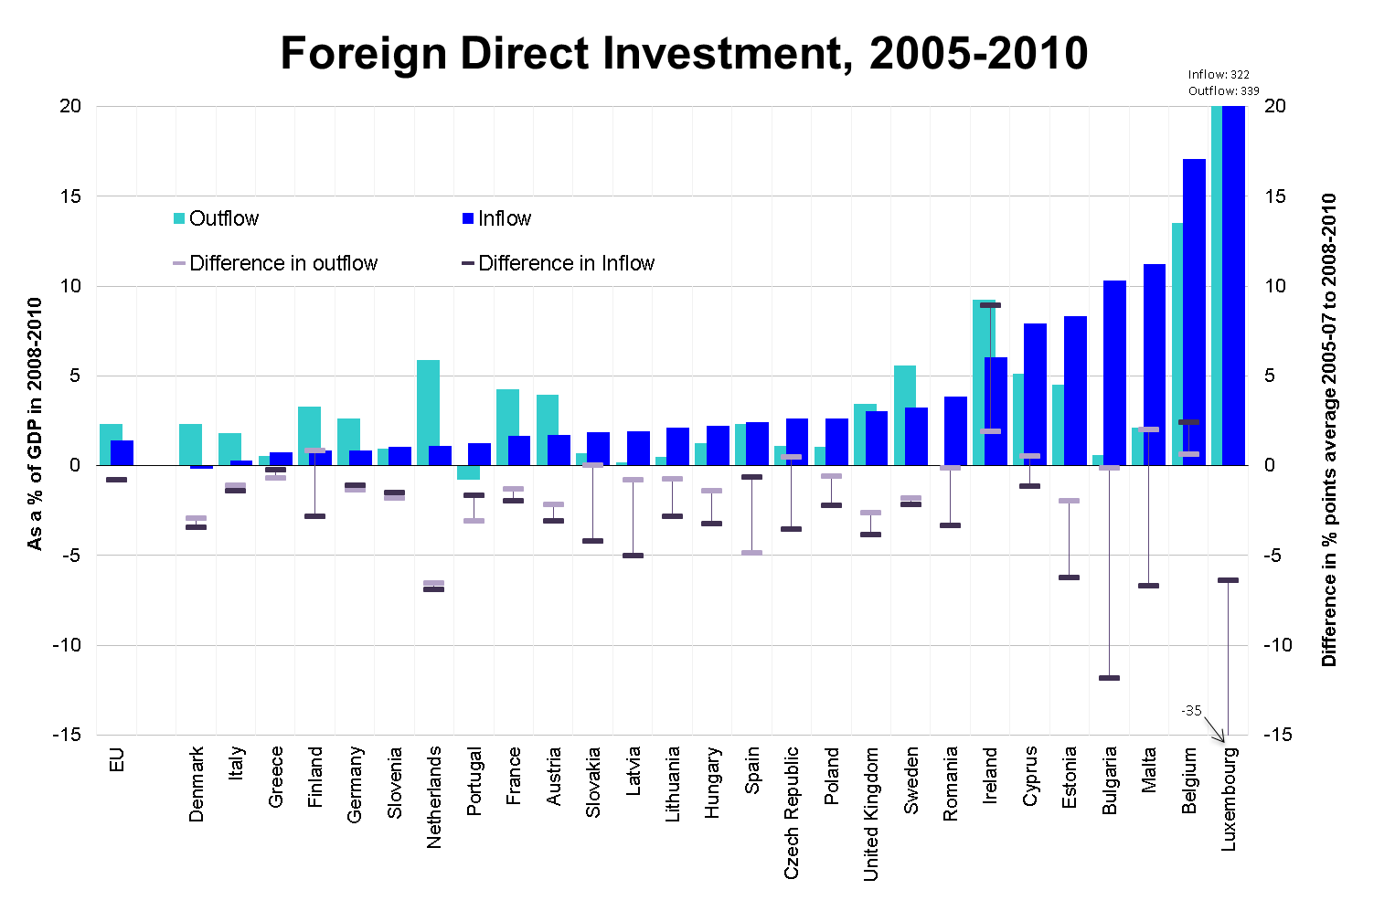
5. Change in GDP and Employment, 2007-2010
These two indicators measure the average annual change in GDP and employment between 2007 and 2010, i.e. the average growth in 2008, 2009 and 2010.
Why does this matter?
Reductions in GDP lead to lower incomes and reduce government revenues. Reductions in employment increase unemployment and demands for unemployment benefits.
How do the EU regions score?
Two out of three EU regions suffered a contraction of their GDP between 2007 and 2010.
The ten regions where GDP shrunk fastest include the three Baltic States and one of the two Irish regions. It does not include a Spanish region as they suffered more from employment than GDP losses.
For Greece no regional growth figures are available. The country's GDP shrunk by -2.5% a year over that period and the contraction of GDP was even harsher after 2010.
The growing regions are mainly located in Poland, Germany, Sweden, Slovakia and the Czech Republic.
More than one out of two regions suffered a reduction of employment between 2007 and 2010. Employment reductions were particularly high in Spain, Ireland and the Baltic States. In Greece, employment only shrunk by 0.7% between 2007 and 2010 and lost far more employment in 2011 and 2012.
Bulgaria and Romania both have regions which saw big declines in employment. National level data shows that employment continued to decline in 2011, but Romania managed return to growth in 2012.
The regions with employment growth were mainly located in Poland, Germany, Austria, Belgium and Luxembourg.
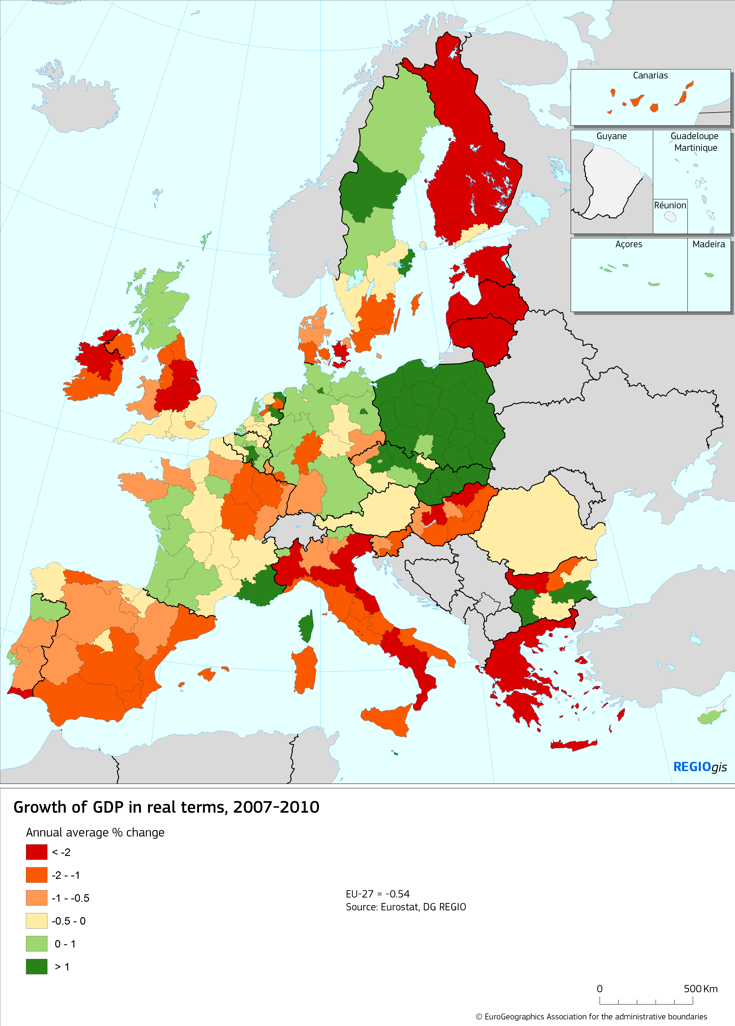 | 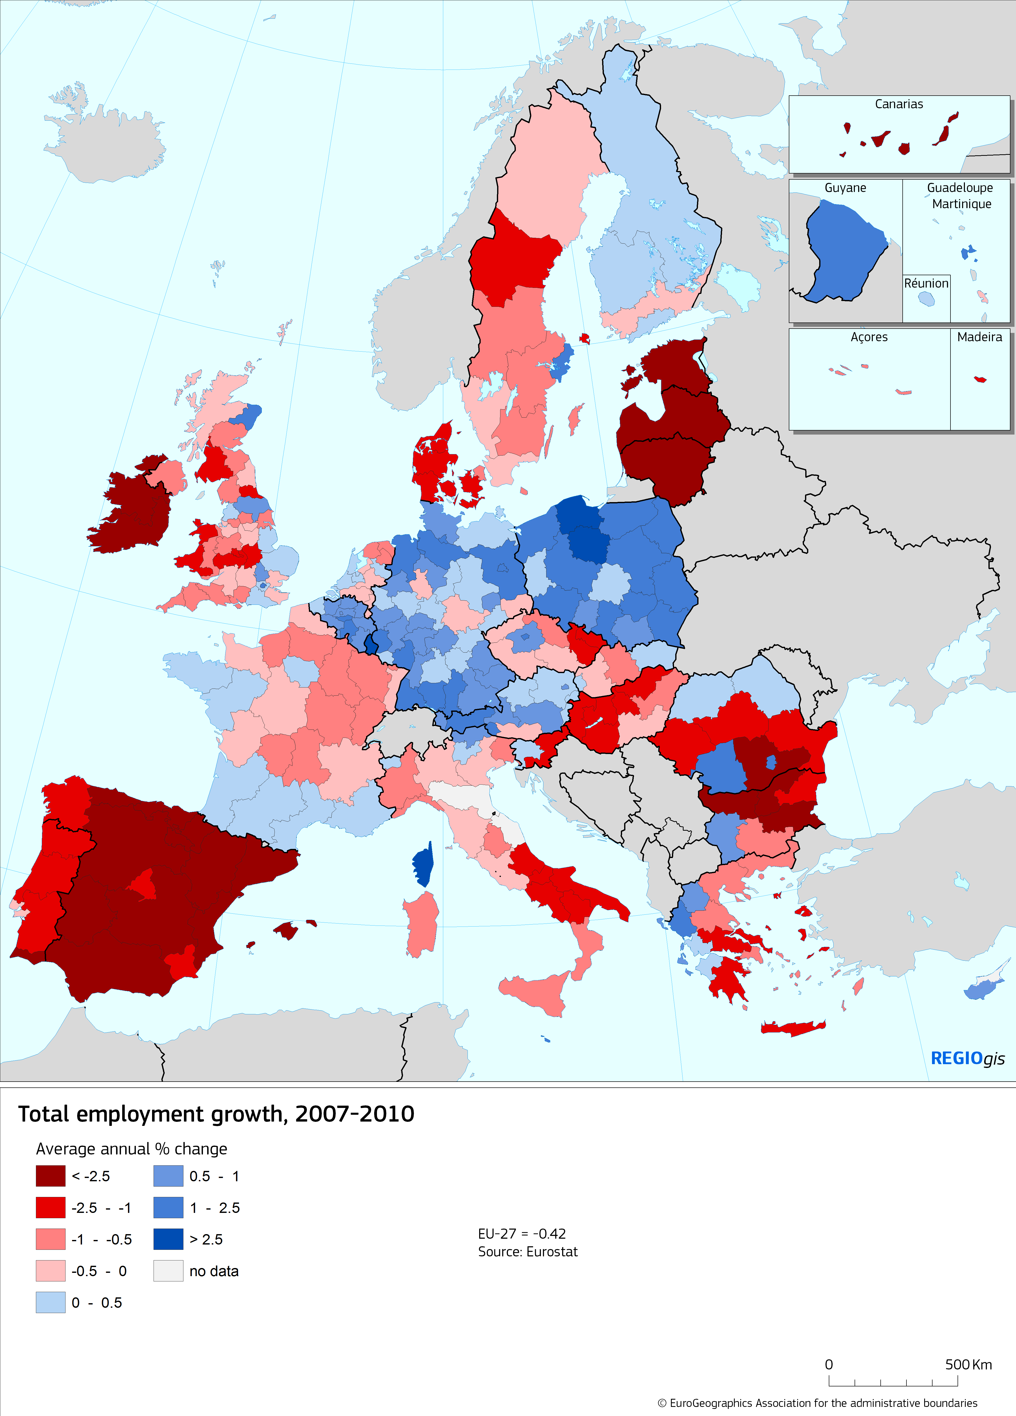

6. Unemployment, 2012
This indicator measures the number of people aged 15-74 who are without work but looking for work and available for work, divided by the number of people aged 15-74 and active in the labour market, i.e. those employed and unemployed.
Why does this matter?
High unemployment is a threat to social cohesion leading to poverty and social exclusion and it is one of the most important incentives for people to leave their regions.
How do the EU regions score?
Regional disparities in unemployment among the EU-27 regions remain high. More than one region in three has an unemployment rate above 10%. The highest rates are registered in Spain, Greece and in the overseas departments of France. In the top-30 regions in terms of unemployment, 29 are located in these three countries.
The regions recording unemployment rates above 15% are almost one out of five (one out of ten in 2010). In contrast, about one region out of six registers unemployment rates below 5% (a total of 45, an increase from the 41 regions in 2011). These regions are mainly located in Austria, Germany, Belgium and Netherlands.
It is possible to identify different trends for the period 2008-2012. Between 2008 and 2012 unemployment increased in four out of five regions. The crisis hit severely regions of Spain, Greece, Ireland and the Baltic States. Instead, unemployment dropped almost exclusively in German regions, especially in Eastern Landers (also due to labour mobility).
One in three regions saw increases until 2010 and have shown some resilience since then. These regions are located in particular in Belgium, Czech Republic, Slovakia, Austria, Sweden and the UK.
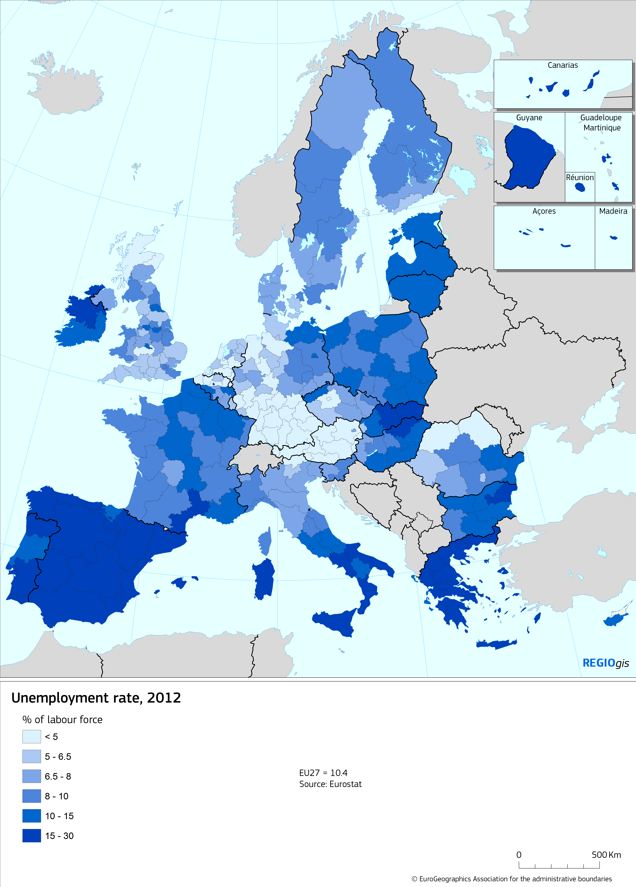 | 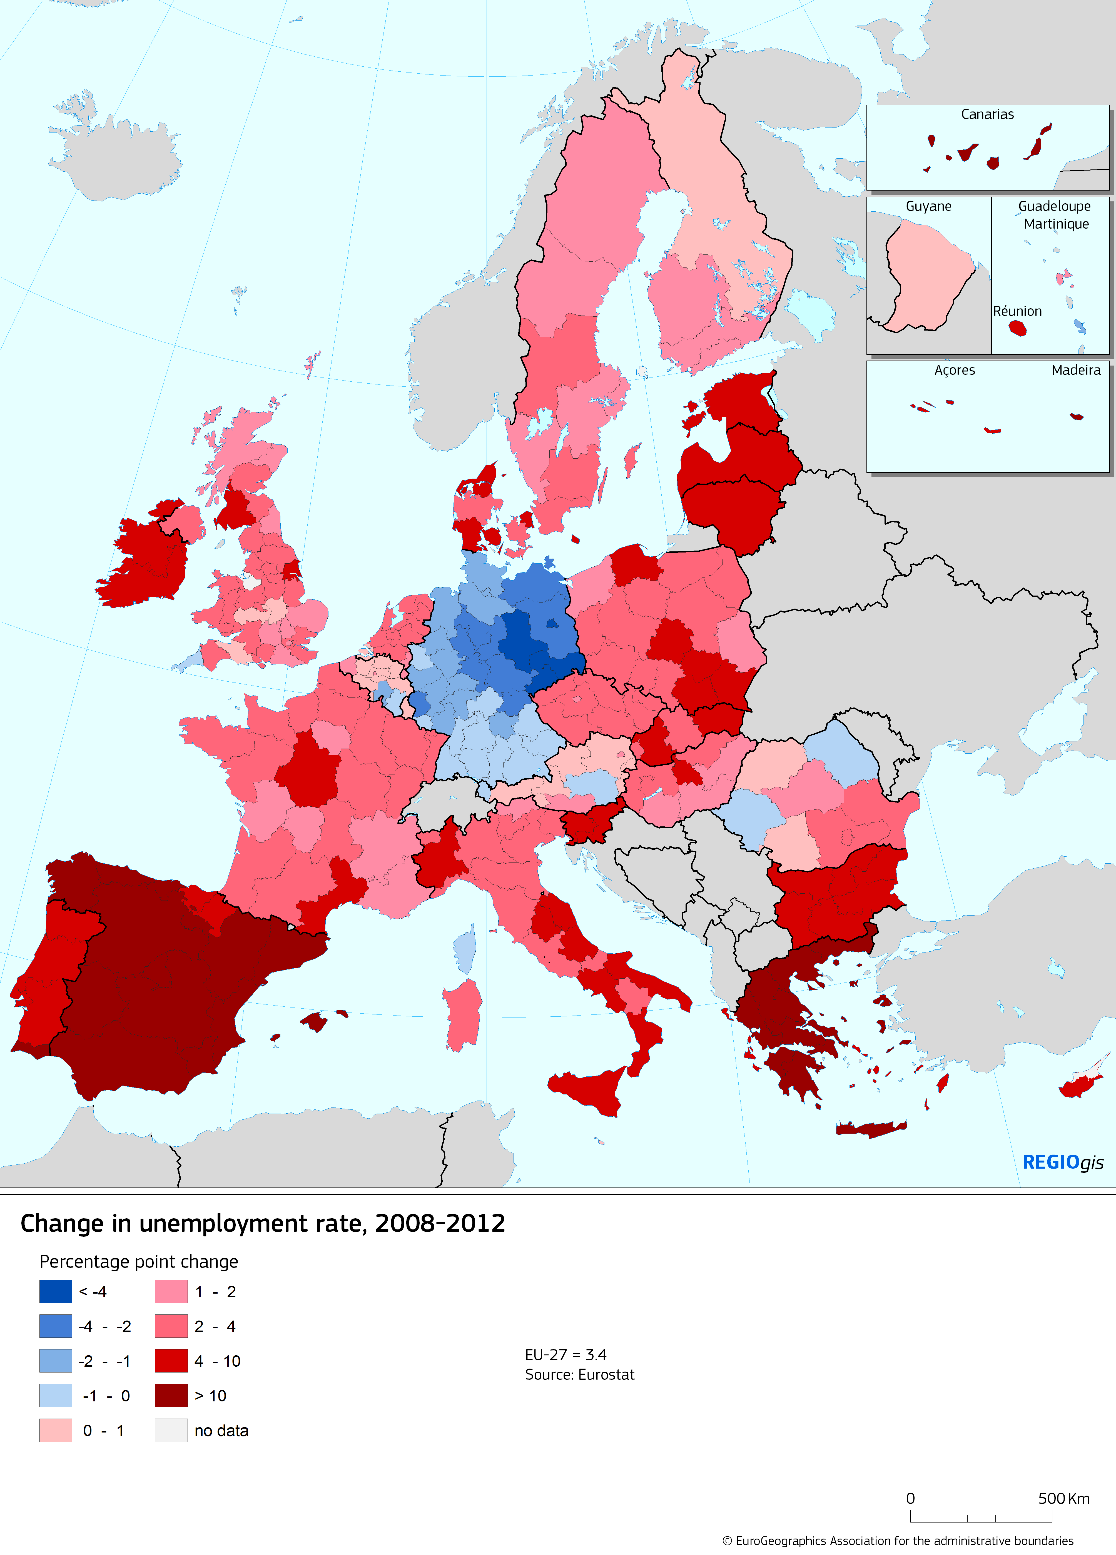

7. Youth Unemployment, 2012
This indicator divides the number of people aged 15-24 who are without work but looking for work and available for work, by the number of people aged 15-24 and active in the labour market, i.e. those employed and unemployed.
Why does this matter?
Unemployment at a young age can have a long-lasting negative impact, a 'scarring effect'. In addition to higher risks of future unemployment, lower wages, these young people are also at a higher risk of social exclusion, of poverty and of facing health problems. High unemployment is one of the main drivers for young people to leave their regions.
How do the EU regions score?
Regional disparities in youth unemployment rates among the EU-27 regions are pronounced – with differences up to 13 times between regions experiencing the highest and the lowest youth unemployment rates.
Two regions out of five have a youth unemployment rate above 25%. The highest youth unemployment rates are registered in Spain, Greece and Italy. In the top-30 regions in terms of youth unemployment, 29 are located in these three countries.
In contrast, only 15% of the regions register youth unemployment rates below 10%, mainly located in Austria, Germany and the Netherlands.
Between 2008 and 2012 youth unemployment increased in four out of five regions. The crisis hit severely regions of Greece, Spain (where the increase in youth unemployment was between 10 percentage points in Navarra and over 27 p.p. in Asturias), Bulgaria, and Lithuania and Latvia.
In contrast, youth unemployment rates dropped in regions, 35 of them located in Germany, 5 in Belgium and 4 in Austria.
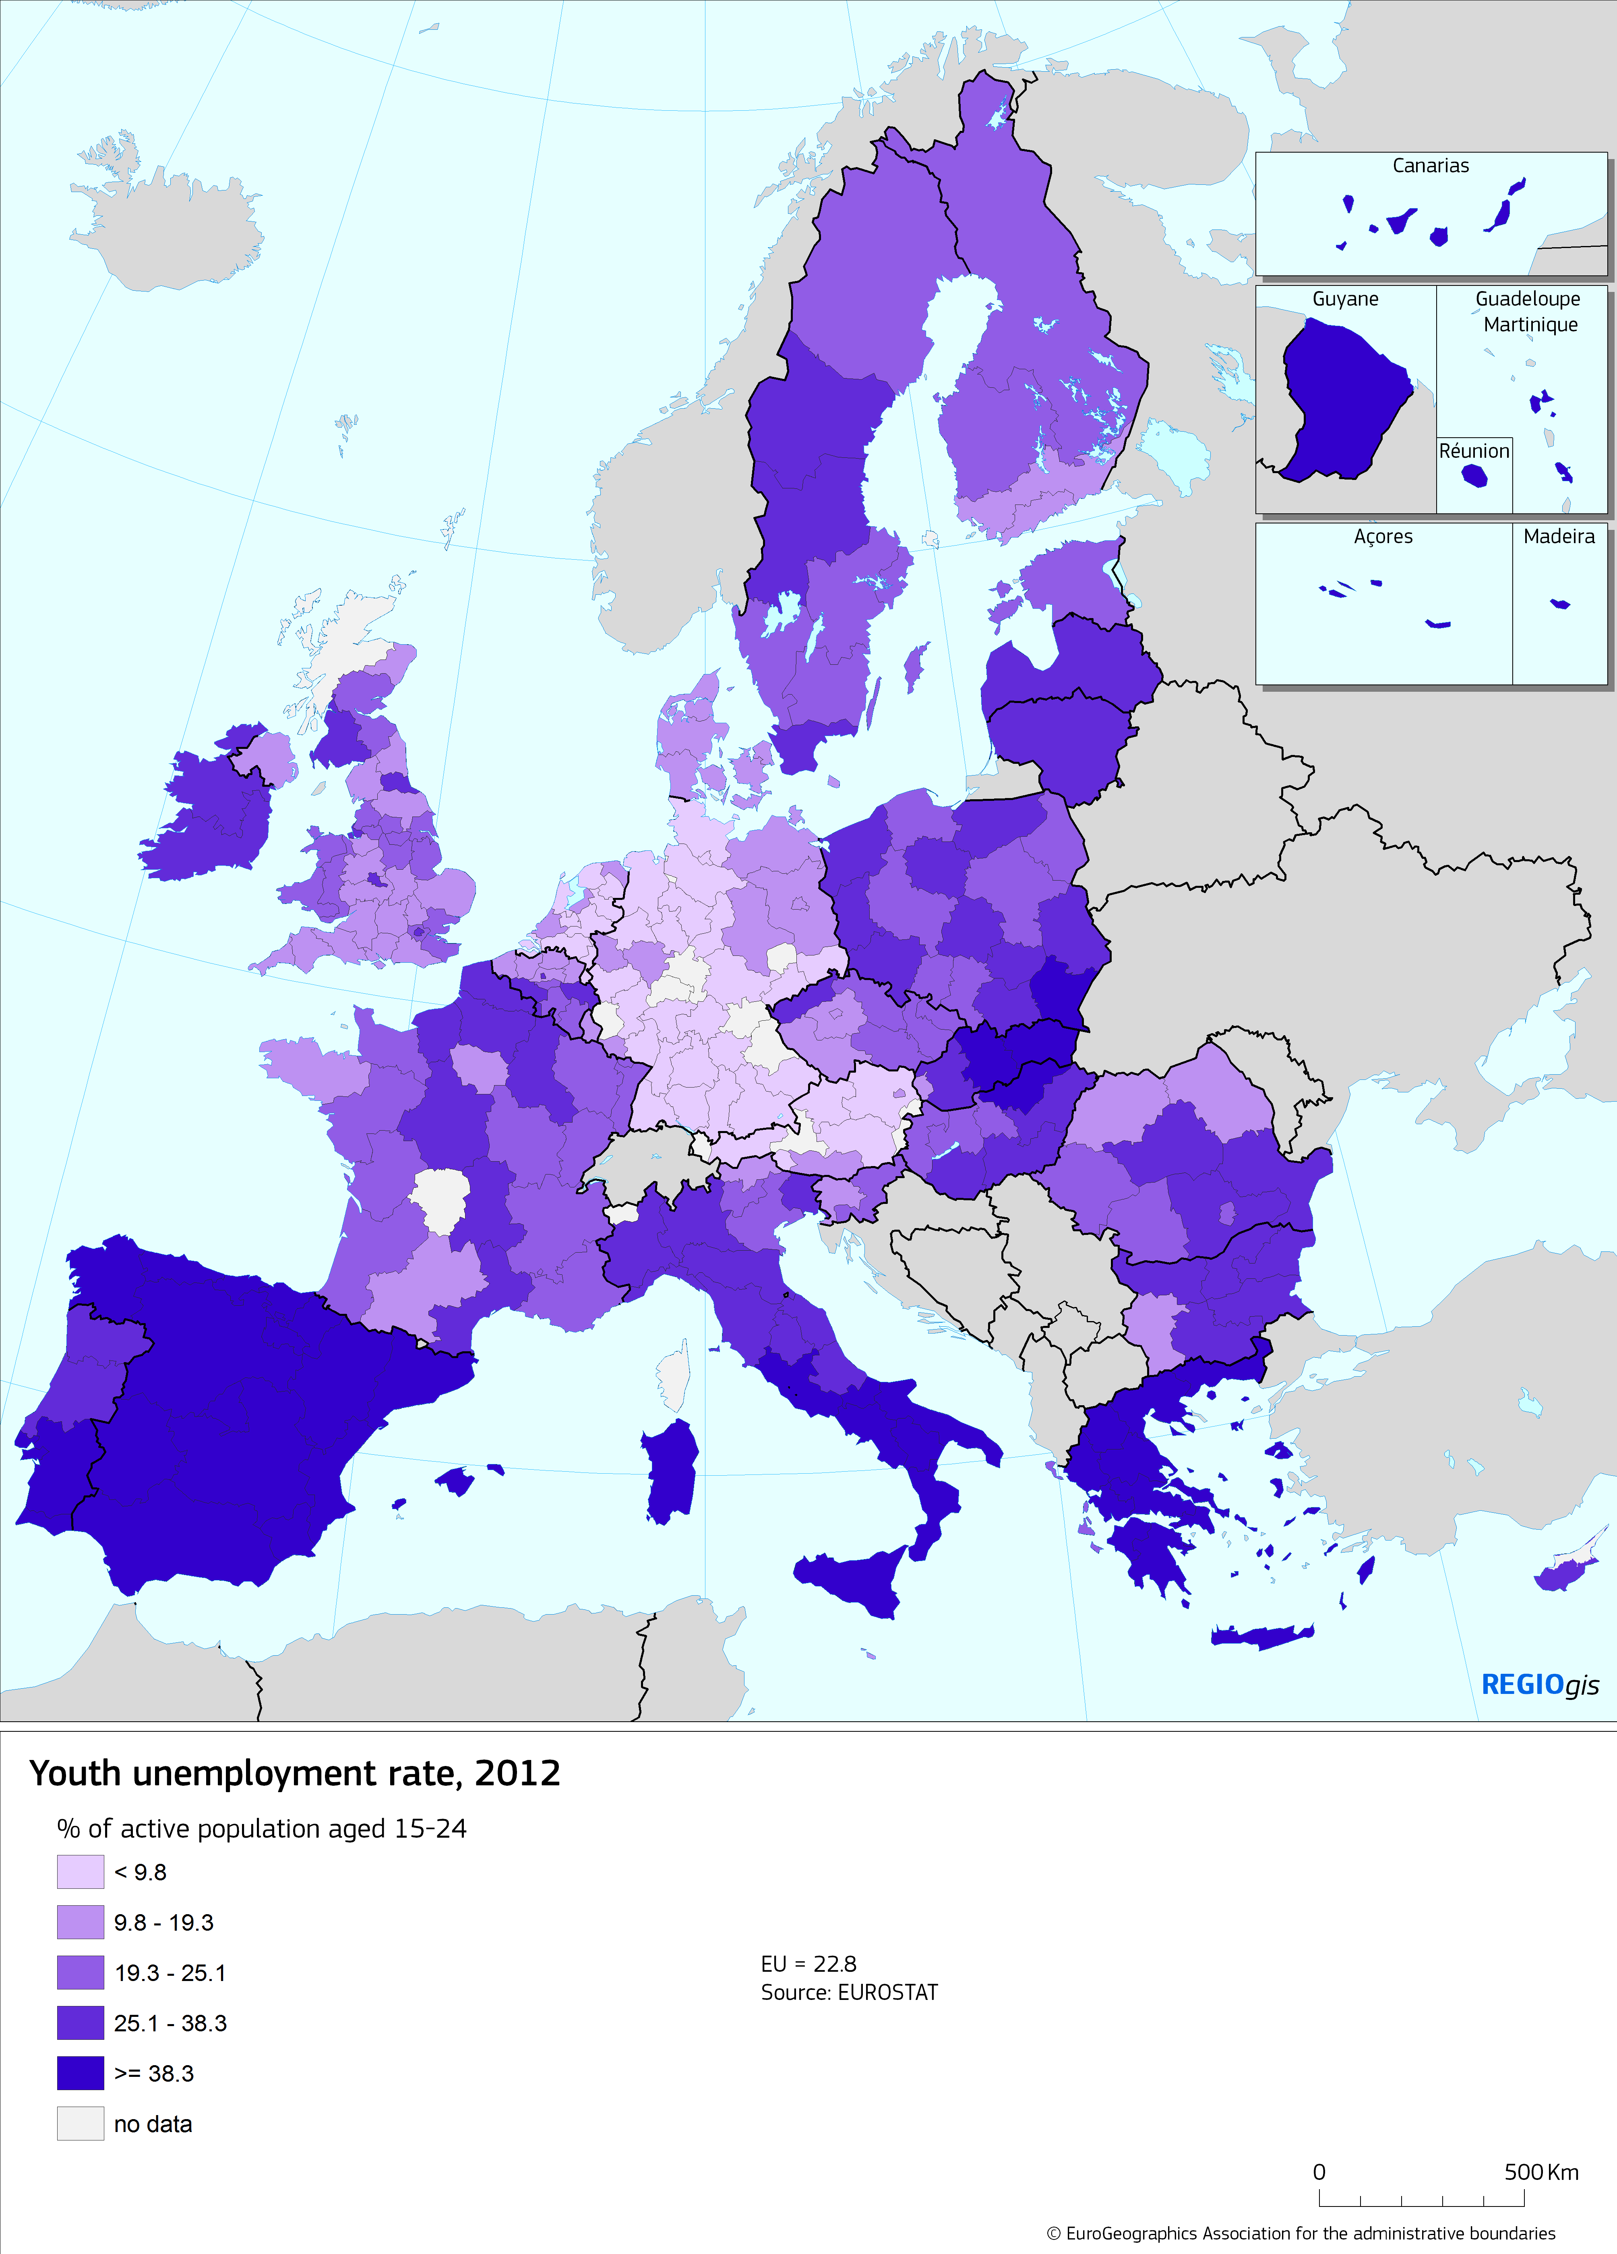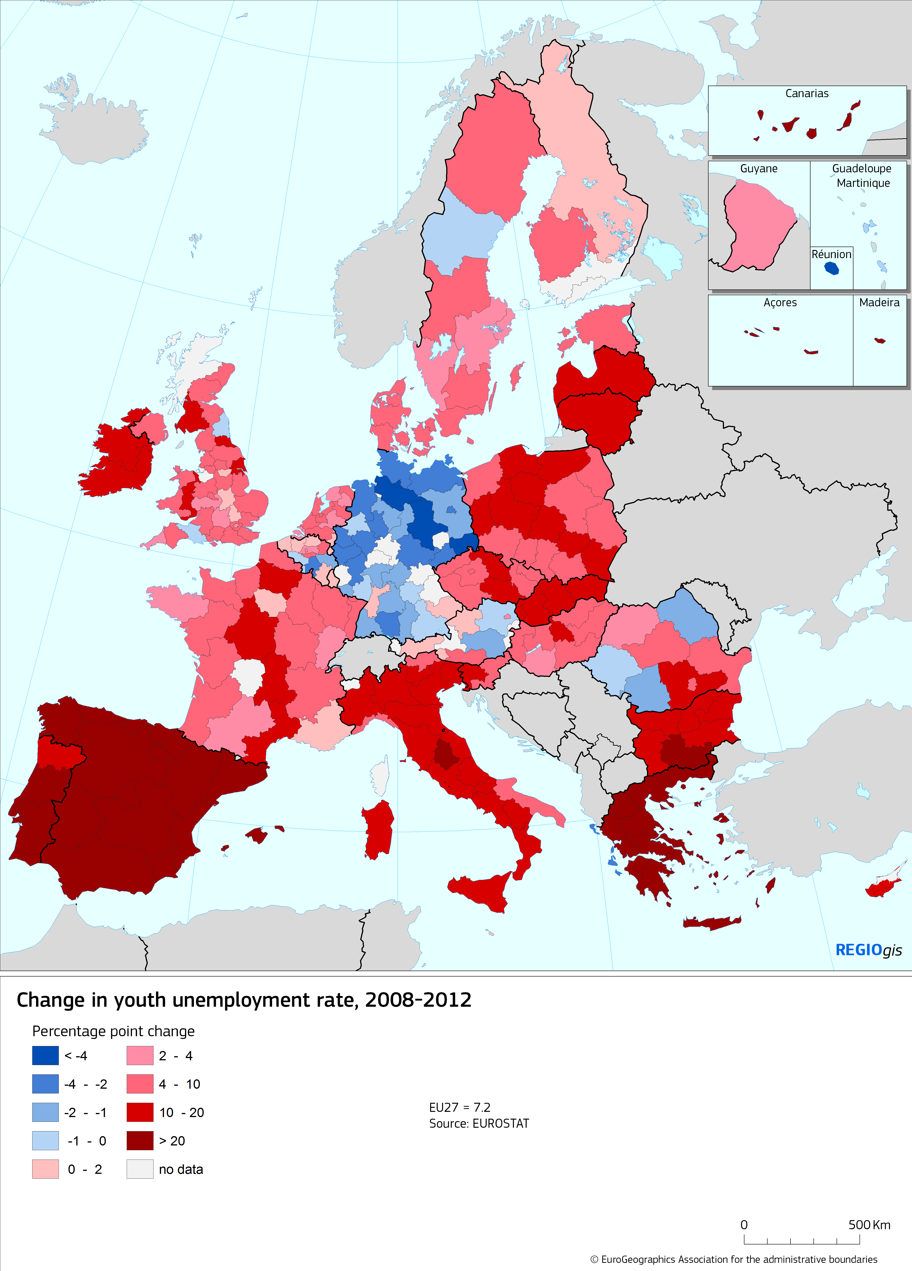

http://ec.europa.eu/economy_finance/economic_governance/documents/alert_mechanism_report_2012_en.pdf
Ibid.

