1. Introduction
This Communication identifies the state of implementation of “end-to-end e-procurement” (from the electronic publication of notices to electronic payment) in the EU, as foreseen by the 2012 Communication “A strategy for e-procurement”. It sets out actions which should be taken by the EU and by Member States to achieve the transition towards end-to-end e-procurement.
The management of public procurement is of primary policy importance in the current context of fiscal consolidation. As public expenditure on goods, works and services represents 19% of the EU’s GDP, managing it more efficiently can significantly contribute to improving the overall efficiency of public expenditure. The current crisis provides an opportunity for Member States to further engage in implementing structural changes in their administration, with the aim of reducing the share of public expenditure in their GDP while leveraging saved resources to invest in growth-enhancing policies. The World Bank estimates that e-procurement can trigger savings of 6 to 13.5% of the total public procurement expenditure.
An effective public administration is a key element of the competitiveness of the EU economy. The modernisation of public administration was identified as one of the five priorities of the Commission’s Annual Growth Survey in 2012 and in 2013. Reform of public procurement, digitisation of public administration, reduction of administrative burden, and increased transparency are all growth enablers.
The transition to end-to-end e-procurement can generate significant savings, facilitate structural re-thinking of certain areas of public administration, and constitutes a growth enabler by opening up the Internal Market and by fostering innovation and simplification. It can also facilitate SME participation in public procurement by reducing administrative burden, by increasing transparency over business opportunities, and by lowering participation costs.
End-to-end e-procurement is not about implementing an IT project which would just replicate paper-based processes; it is an opportunity to fundamentally re-think the way public administration is organised. End-to-end e-procurement is therefore a key enabler of the above priorities, and can contribute to the sustainable growth objectives of the EU 2020 Strategy.
In order to reap the benefits of e-procurement, and as part of the modernisation of the public procurement legal framework, at the end of 2011 the Commission proposed to make the e-notification, e-access to procurement documents, and e-submission phases mandatory. The Commission has now adopted a proposal which aims to digitalise another phase of the procurement process: invoicing. This proposal, foreseen in the 2012 Single Market Act II, aims to achieve a transition towards mandatory acceptance of e-invoices by all public buyers by a deadline linked as closely as possible to that of e-procurement. This would maximise the benefits for the EU economy and allow European companies and contracting authorities to fully take advantage of the benefits of the Digital Single Market.
The modernisation of the public procurement legal framework and the proposal on e-invoicing address the main drivers of the digitisation of public procurement. E-payment is to a large extent already addressed by the legislation on the Single Euro Payments Area (SEPA), while e-ordering depends on the implementation of e-catalogues, contained in the legislative proposal on public procurement. The remaining process (e-archiving) is dependent on e-invoicing, confirming the need to pursue the latter first. Therefore, although the final goal is to conduct the whole procurement cycle from e-notification to e-payment electronically, at this stage the Commission does not foresee legislative proposals to digitalise the remaining processes. The Commission will however monitor future developments in these areas and may decide to undertake action if it deems it useful or necessary.
Member States will play the key role in implementing end-to-end e-procurement, as they will need to set-up actionable strategies to govern the transition. Most strategies which have already been set-up do not contain action plans addressing operational issues. Out of the 22 Member States which have established strategies for e-procurement, only 8 have set e-procurement take-up targets.

2. End to end e-procurement as a means to modernise public administration
Member States should seize the opportunity of implementing end-to-end e-procurement to improve the way public procurement is conducted, and, even more importantly, to fundamentally modernise the functioning of their public administrations. To maximise benefit, it is necessary to take a strategic and holistic approach, setting out the appropriate policy and legislative legal framework, and ensuring governance and coordination. For example, policy choices will have to be made to ensure that companies have easy access to procurement opportunities. This could be achieved by publishing all national procurement opportunities on a single website or by establishing multiple websites which exchange information.
End-to-end e-procurement offers the opportunity to re-engineer the entire procurement procedure, potentially affecting the degree of (de)centralisation of public procurement in the Member States
End-to-end e-procurement can improve the overall administrative efficiency by cutting the duration of the purchase-to-pay cycle, by reducing administrative burden, and by improving auditability. These in turn, reduce the opportunity for corruption and tax fraud, increase security of data and reduce litigation. The Lombardy Central Purchasing Body assessed in 2009 that the introduction of e-procurement reduced the duration of procurement procedures by 26% and litigation by 88%.
Moreover, digitalisation facilitates the monitoring of public procurement and therefore of a significant portion of public expenditure. In Portugal, the public procurement portal ‘Base’ allows the monitoring of public procurement expenditure and volume and the establishment of statistics on the type of purchases, tenders won by companies, etc.
End-to-end e-procurement can also produce spill-over effects by triggering wider digitalisation of government services, resulting in more efficient, citizen and business-friendly public services. This can also stimulate innovation and contribute to achieving the objectives of the Digital Agenda for Europe and the eGovernment Action Plan 2011 – 2015.
The introduction of e-invoicing can contribute to the automation of other post-award processes via spill-overs, such as e-ordering, e-payments, and e-archiving. Moreover, e-certificates may be set up as digital one-stop-shops for all certificates requested in public procurement. Contracting authorities would no longer need to request documents from companies as these would be available online. These e-certificates could be used by other public administrations than contracting authorities leading to simplification and reductions in administrative burden. In Italy such a system is estimated to lead to savings of up to € 1.2 billion per year for companies. The use of e-certificates by UGAP, a French Central Purchasing Body, reduced administrative costs by 35% and the awarding process was reduced by 10 days.
Several countries have already started implementing end-to-end e-procurement. Greater benefits can be achieved if the co-existence of parallel systems (electronic and paper) can be avoided.

3. end-to-end e-procurement to increase SMEs participation in public procurement
A majority of SMEs are equipped for the use of end-to-end e-procurement, allowing them to benefit from its use. According to 2013 Eurostat figures, only 4.6% of SMEs did not have access to the internet in 2012.
In particular, e-invoicing can reduce the costs and complexity of sending invoices; it can also limit errors via automation and it simplifies auditing and tax collection. The latter in turn reduces the administrative burden on enterprises, which weighs more heavily on SMEs.
Several studies show that SMEs find e-procurement beneficial. Positive aspects mentioned by SMEs include swifter access to information, access to a wider pool of tender opportunities, and procedural simplification.
The experience in countries where e-Procurement is common practice (e.g. Portugal, Ireland) is generally positive. In South Korea, the participation of SMEs in public procurement increased by 20% between 2003 (when e-procurement was introduced) and 2010.
Despite these inherent benefits, action should be taken at EU, national and regional levels to facilitate the access of SMEs to end-to-end e-procurement (see section 5). Particularly, Member States should promote low-cost and easy-to-use e-invoicing and e-procurement services with a view to minimising any potential costs and complexity.

4. Low use of end-to-end e-procurement but rapid growth

4.1. E-invoicing state of play
As the benefits of e-invoicing are becoming increasingly recognised, several Member States have undertaken initiatives towards its introduction. E-invoicing in public procurement is currently mandatory to some degree in Denmark, Sweden, and Finland, and will become mandatory in Austria (at federal level) and in Italy as of 2014. The Netherlands have developed a portal (Digipoort) through which e-invoices can be sent to the central government, and steps are currently being undertaken to include regional and local bodies. In France and the Czech Republic, governmental departments can decide to mandate e-invoices if they so choose. Other countries, such as Spain, Belgium, Ireland and Germany, are also taking steps towards broader use of e-invoicing in public procurement.
Despite these efforts, the adoption of e-invoicing in public procurement is still limited in the EU. According to data from Eurostat, only 12% of enterprises use electronic means when sending or receiving invoices to public authorities. Another source indicates that in Europe, e-invoicing accounts for only 4 to 15% of all invoices exchanged.
Enterprises sending / receiving both e-invoices in a standard structure suitable for automatic processing and electronic data to/from public authorities in 2011 [%] (Source Eurostat)
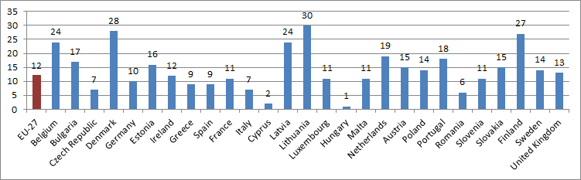
Moreover, those countries which have mandated e-invoicing have often done so on the basis of their own national e-invoicing standards, which for the most part are not interoperable. This has contributed to the fragmentation of the Single Market and therefore raised the cost and complexity of e-invoicing in cross-border public procurement. Potentially significant savings opportunities for all stakeholders are not being realised.
The Commission's 2010 Communication "Reaping the benefits of electronic invoicing for Europe" sets as an objective that "e-invoicing becomes the predominant method of invoicing by 2020 in Europe” and sets out a plan for increasing uptake. The Commission has now adopted a proposal which aims to make e-invoicing the standard invoicing means in public procurement (see 5.1).

4.2. E-procurement state of play
E-notification and e-access to procurement documents are generally available across the EU, though in some Member States these functionalities are not used for all procedures and purchases. 22 Member States have already made the use of e-notification mandatory, well before the entry into force of EU legislation. A study carried out for the European Commission in 2013 estimates the level of up-take of e-submission in the EU at about 10% in 2011 (+13% compared to 2010).
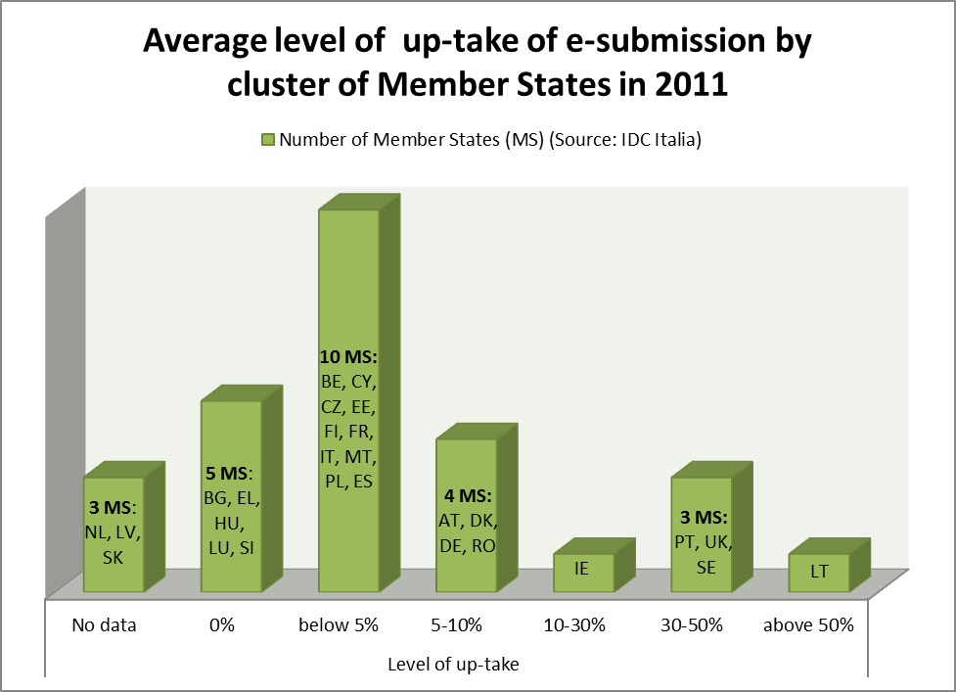
Lithuania, Portugal, Sweden and the UK made significant progress, as uptake was estimated to be above 30% in 2011. However, most countries had a level of uptake of below 5%, while 4 Member States had no e-submission availability in public procurement in 2012: Bulgaria, Greece, Hungary and Slovenia.
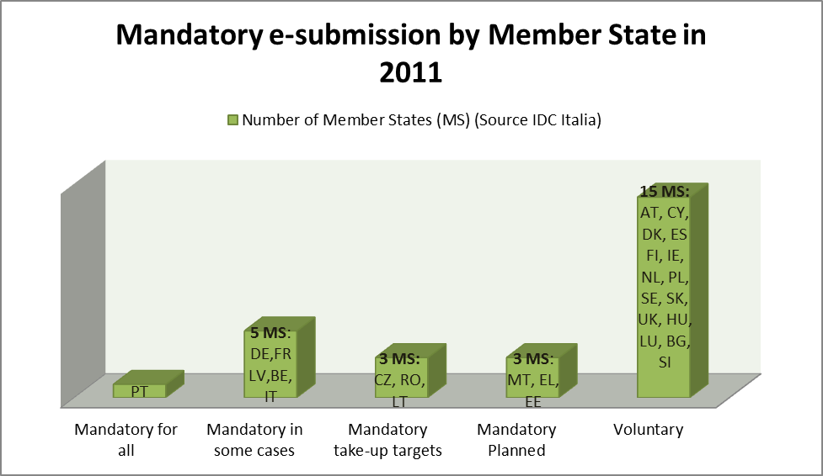
In a majority of Member States (15) e-submission is voluntary. Only Portugal has made it mandatory for all contracting authorities and purchases, but only above a certain threshold. 5 Member States mandate it in certain specific cases. The use of e-procurement in Portugal is estimated to generate savings of 6 to 18% of the total public procurement expenditure. E-procurement has also become mandatory at regional level (e.g. Flanders, Lombardy). Detailed e-procurement country profiles can be consulted at: http://ec.europa.eu/internal_market/publicprocurement/docs/eprocurement/d2-annex-eprocurement-country-profiles-final_en.pdf
Overall, the procurement landscape is highly fragmented and complex, accounting for a high number of different procedures, IT technologies, certification requirements, using practices that do not fully exploit the opportunities offered by IT technologies. The ease of use of e-procurement systems and their interoperability are key elements enabling high e-procurement take-up and large savings and benefits.
In order to overcome the low up-take and to address the risk of market fragmentation, the Commission proposed, as part of the modernisation of the Public Procurement Directives, to make e-procurement mandatory by mid-2016 and to foster its interoperability. The proposal is currently being discussed with the European Parliament and the Council. While the exact deadline for e-procurement implementation is still under negotiation, the co-legislators agree on the principle of completing the transition towards e-procurement. Following the legislative proposal, the Commission issued a Communication which announced measures to support the implementation of e-procurement in the EU (see the Annex for the state of implementation of the actions). In particular, the Commission published a report, ‘The Golden Book of e-procurement’ presenting best practice. Additionally, a Commission Expert Group on E-tendering issued recommendations to simplify the way e-procurement is conducted, particularly for SMEs and cross-border suppliers. Both reports are proving to be effective in improving e-procurement solutions.

5. the way forward
The Commission proposal to make e-notification, e-access and e-submission mandatory and the measures announced in the Communication ‘A strategy for e-procurement’, represent important steps forward towards reaping the benefits offered by e-procurement.
To further enable end-to-end e-procurement, the Commission is now undertaking a series of actions, including a legislative proposal to make e-invoicing the rule rather than the exception in public procurement, and non-legislative measures, meant to further support the implementation of end-to-end e-procurement by Member States. These actions are described below.

5.1. Making e-invoicing the rule rather than the exception in public procurement
Based on the extrapolation of national evaluations of benefits, the Commission estimates that the adoption of e-invoicing in public procurement across the EU could generate savings of up to 2.3 bn €.
In order to reap these benefits, the Commission has adopted a proposal which aims to make e-invoicing the standard invoicing mode for public procurement. Through spill-over effects, this should also facilitate the take-up of e-invoicing by all market operators. The chosen approach is twofold. Firstly, in order to eliminate interoperability issues between national standards, it is proposed to mandate the European Committee for Standardisation (CEN) to develop a new European e-invoicing standard which would standardise the information contained in an e-invoice which is essential to enable cross-border interoperability and to ensure legal compliance. Secondly, the proposal foresees making it obligatory for Member State administrations to accept e-invoices which comply with the new European standard. The European Commission proposes that these obligations enter into force at a deadline linked as closely as possible to the deadline for the obligations on e-procurement foreseen by the Public Procurement Directives.
This approach to e-invoicing implementation is designed to give all stakeholders time to meet the operational challenges, whilst ensuring that all Member States successfully achieve the transition. The Commission calls upon Member States to launch the necessary preparatory work as soon as possible to ensure timely compliance with these provisions. It recommends that Member States make e-invoicing mandatory for all stakeholders as soon as they set up the necessary infrastructure, so as to benefit from these investments as soon as possible. However, Member States should at the same time undertake all necessary steps to ensure that this does not generate any unnecessary additional cost or burden on SMEs. The Commission will review the situation within 5 years after the deadline for the transition in order to assess the progress towards e-invoicing implementation.
KEY ACTIONS:
- European Parliament and Council to agree new legal framework making mandatory the acceptance of e-invoices compliant with a new European standard.

5.2. Standardisation work
The legislative proposals on e-invoicing and on e-procurement are a necessary but not a sufficient condition for the successful implementation of end-to-end e-procurement in the EU. Several non-legislatives measures meant to support the implementation of end-to-end e-procurement are necessary. Particularly, further standardisation work is needed to allow the implementation of the legislative proposal on e-invoicing.
CEN shall therefore carry out the necessary standardisation work on the basis of a mandate by the Commission which will be prepared at a later stage. The mandate will include a list of minimum requirements which the standard will have to incorporate. The work will then be carried out according to standard CEN procedures for developing new European standards. While such a standard can only be adopted by a Technical Committee (TC), the decision as to whether an existing TC can take on this task or whether a new one needs to be created will be taken by CEN. CEN should also continue its work on e-procurement with a view to simplifying e-procurement solutions, to foster SME participation and to improve the monitoring of public procurement via e-procurement systems. The Commission will continue to finance projects that promote the development of end-to-end e-procurement in the EU such as e-SENS, and will ensure that the relevant CEN work is embedded in this project.
Member States should promote the use of the CEN standard within their countries in order to ensure full end-to-end e-procurement interoperability.
As part of the multi-annual financial framework, the Commission proposed to launch the 'Connecting Europe Facility' (CEF) programme. Its goal is to support investments in the infrastructure required to deliver cross-border public services, including e-procurement and e-invoicing, by enhancing the interoperability of cross-border processes. This can foster end-to-end e-procurement standardisation beyond the areas covered by the forthcoming legislation and contribute to limiting non-interoperable national solutions.

KEY ACTIONS:
- European Committee for Standardisation (CEN) to carry out necessary standardisation work to allow the implementation of the legislative proposal on e-invoicing in public procurement. CEN to further standardise e-procurement in order to simplify its usage by SMEs.
- European Commission to finance projects that promote the development of interoperable e-invoicing solutions in the EU (e-SENS).
- European Commission to fund and support the development of end-to-end e-procurement (including e-invoicing) infrastructure across Europe via the proposed Connecting Europe Facility (CEF).

5.3. National strategies for end-to-end e-procurement
Member States play a key role in making end-to-end e-procurement a reality. The Commission therefore encourages Member States to set up national strategies, with detailed action plans to ensure the implementation of e-procurement and of e-invoicing by the deadlines set out in the Public Procurement and E-invoicing Directives. Setting-up these strategies is an opportunity to review the current complex set-up of end-to-end e-procurement (fragmented, sometimes user-unfriendly and non-interoperable solutions), to further rationalise public procurement, and to allow a wider modernisation of public administration.
In order to make these strategies actionable, specific action plans should be established in order to:
- Establish intermediate targets for e-procurement and e-invoicing usage to monitor the progress towards the objectives set out in the Public Procurement and E-Invoicing Directives;
- Govern the transition by choosing a strategy which maximises the benefits of end-to-end e-procurement. The European Commission will launch a study to identify those strategies for e-procurement and e-invoicing which prove to be most successful. This will support Member States in assessing their own policies;
- Promote simplification, administrative burden reduction, and the participation of SMEs and cross-border suppliers in end-to-end e-procurement by taking into account the results of the Golden Book study and the Expert Group on e-tendering (see end of section 4.2);
- Foster the development and use of e-certificates. The use of tools such as the PEPPOL Virtual Company dossier (VCD) could help in establishing them;
- Monitor procurement spend and key performance indicators (e.g. participation of SMEs, benefits of end-to-end e-procurement) at national level by using information generated by e-procurement systems in order to achieve savings and greater transparency;
- Set-up training programmes for companies (particularly SMEs) and contracting authorities to support them throughout the transition. Member States have the possibility of using structural funds to finance training and, if needed, to set up the necessary infrastructure. To take advantage of this possibility, they should include these priorities in their future operational programmes implementing the Structural Funds in the 2014-2020 period.
- Address internal market objectives within national strategies. The European Commission will publish key principles with which any e-procurement system in Europe should comply in order to be compatible with the Internal Market. The guidelines will address issues such as: ease of access for cross-border suppliers (e.g. e-procurement systems should not contain national specific data fields, which could block access from foreign companies), ease of access for SMEs, interoperability requirements, etc. Member States should ensure that their national strategies enforce these guidelines.
KEY ACTIONS:
- Member States to set-up national strategies and detailed action plans for end-to-end e-procurement to ensure implementation by the deadlines foreseen in the Public Procurement and the E-Invoicing Directives.
- European Commission to launch a study that identifies the most successful e-procurement & e-invoicing strategies in Europe.
- Member States to consider the possibility of using Structural Funds to finance training (particularly for SMEs), to strengthen administrative capacity, and to build infrastructure, by including these priorities in their operational programmes as adequate.
- European Commission to publish key principles with which any e-procurement system in Europe should comply in order to be compatible with the Internal Market principles.

5.4. Sharing best practice
The Commission will continue the work of the European Multi-Stakeholder Forum on e-Invoicing and will set-up a similar forum for e-procurement. The forums will identify further standardisation work, will coordinate European and national initiatives, and will share best practice. The forums will group key actors of end-to-end e-procurement: national policy makers, company representatives/SME organisations, contracting authorities/buyers, e-procurement and e-invoicing solution providers, standardisation bodies etc.
The Commission will also launch a study which identifies best practice in the area of e-procurement tools, such as e-auctions and e-catalogues. These tools are occasionally misused – for example, if offers under e-auction procedures are disclosed too early in the process, they can favour collusion between suppliers. The study should identify how these tools could best be used to maximise their benefits.
The Commission is leading by example in the area of e-procurement and e-invoicing. The Commission will implement full e-procurement (covering e-notification, e-access and e-submission) by mid-2015, as indicated in the Communication of 2012. E-invoicing has been used for the procurement of IT goods and services since 2009, generating significant savings, faster processing time, absence of data encoding, etc. The Commission is progressively extending the mandatory use of e-invoicing to other areas of Commission’s procurement. These solutions will be made available to the Member States in an open source basis to reduce investment costs.

KEY ACTIONS:
- European Commission to continue the work of the European Multi-Stakeholder Forum on e-Invoicing. European Commission to set up a similar forum for e-procurement to identify further standardisation work, coordinate European and national initiatives, and share best practice.
- European Commission to launch a study that identifies best practice in the area of e-procurement tools, such as e-auctions or e-catalogues.

6. Conclusion
To achieve the huge benefits offered by end-to-end e-procurement, it is essential to put in place an effective legal framework at EU level. The Commission therefore invites Member States and the European Parliament to adopt the new proposal on e-invoicing in public procurement as soon as possible; this would give a clear political signal of their commitment to the transition. However, benefits can only fully be reaped if Member States put in place strategies to govern the transition and to address the operational challenges.

Annex:
implementation status of the actions of the communication “A strategy for e-procurement”
Key Actions | Implementation status
(1) European Parliament (EP) and Council to agree new legal framework requiring full transition to e-procurement. Deadline: adoption by end-2012. | On-going: The proposal is being discussed with the EP and the Council; a compromise may be reached by mid-2013.
(2) Where necessary, Commission to harmonise technical requirements via delegated acts. Deadline: after adoption of new directives. | Implementation after adoption of the revised Public Procurement Directives.
(3) Commission to propose a new legal framework for electronic identification, authentication and signatures. Deadline: by 2nd quarter 2012. | Done: Proposal adopted on 4 June 2012. The proposal is discussed with the EP and the Council.
(4) e-TEG (Expert Group) to issue recommendations to promote “best of breed” e-procurement systems facilitating cross-border access and ease of use for all companies. Deadline: by early 2013. | Done : report published.
(5) Commission to publish report on best e-procurement practice and to promote it across the EU. Deadline: by mid-2013. | Done : report published
(6) Commission to support the sustainability of PEPPOL components as of mid-2012. | Done: Open PEPPOL was set-up as a non-profit international association under Belgian law and its work is continuing. The Commission continues to support PEPPOL development through the actions included in the ISA programme.
Key Actions | Implementation status
(7) Commission to fund and support the development of e-procurement infrastructure across Europe via Connecting Europe Facility (CEF). Commission to launch projects as of 2014-2015. | On-going: the proposal to establish the CEF was adopted by the Commission end 2011 and modified in May 2013; the proposal is currently discussed under the new multiannual financial framework 2014-2020.
(8) Commission to promote use of Structural Funds to foster e-procurement take-up across Europe, as set-out in the Common Strategic Framework for 2014- 2020. | Done: Several national programmes already include references to e-procurement.
(9) Commission to implement a wide-ranging dissemination strategy on e-procurement. | On-going: Commission organised events: high level conference on e-procurement (June 2012); seminar on e-procurement (December 2012). It attended a high number of conferences and used various networks to disseminate information (e.g. Europe Enterprise Network).
(10) Commission to organise annual conference on e-procurement, starting in mid-2012. | Done: conference organised mid- 2012, 350 participants. Second conference is planned on 18 September 2013.
(11) Commission to lay the foundations for electronic systems to monitor procurement expenditure in real-time. Deadline: by mid-2013. | On-going: The European Commission contracted a study which will be completed by mid-2013.
(12) Commission to issue annual report on e-procurement. Deadline: first report in mid-2013. | Done: See section 4 of the Communication.
(13) Commission to implement full e-procurement by mid-2015 (one year before the deadline for Member States). | On-going: e-notification and e-access to documents are operational. E-submission will enter into a pilot phase by mid-2013.

Key Actions | Implementation status
(14) Commission to make its e-procurement solutions available to Member States that are building their infrastructure, to reduce investment costs. | On-going: Belgium adopted e-Prior, the Commission e-procurement system. Norway and Ireland are currently testing e-Prior.
(15) Commission to promote international regulatory dialogues about open e-procurement systems and to actively monitor relevant international standardisation work. | On-going: dialogues with the US, China and UN/CEFACT launched.

End-to-end e-procurement is the use of electronic communications and transaction processing by public sector organisations when buying supplies and services or tendering public works, from notification to payment.
http://ec.europa.eu/internal_market/publicprocurement/docs/eprocurement/strategy/COM_2012_en.pdf
http://ec.europa.eu/internal_market/publicprocurement/docs/modernising_rules/public-procurement-indicators-2011_en.pdf
http://ec.europa.eu/internal_market/publicprocurement/docs/eprocurement/conferences/speeches/robert-hunja_en.pdf
Communications COM(2011) 815 final and COM(2012) 750 final.
This document refers to e-procurement as e-notification, e-access and e-submission, which are defined below.
http://ec.europa.eu/internal_market/publicprocurement/modernising_rules/reform_proposals_en.htm
Electronic publication of notices announcing public procurement tenders.
Publication of public procurement documentation, such as terms of reference on the web.
Electronic submission of tenders by companies when responding to a call for tenders.
The shift towards centralisation is an on-going trend further supported by the introduction of e-procurement.
The list of benefits is not exhaustive: reduction of CO2 emissions, opening international markets etc.
www.base.gov.pt
The Digital Agenda for Europe, COM(2010) 245 aims at increasing the use of e-Government services by EU citizens and businesses by 2015.
eGovernment Action Plan 2011 – 2015 - COM(2010)743
Rolece in Spain, the French service e-Attestation, and AVCP (Autorità Vigilanza Contratti Pubblici) Virtual Company Passport in Italy.
Estimate of AVCP based on number of companies and tenders, the average number of participation per company, the cost of producing documents and personnel cost.
http://epp.eurostat.ec.europa.eu/portal/page/portal/information_society/data/comprehensive_databases
The National Survey on e-Procurement in Portugal (2012) indicates that 78% of SMEs reported higher transparency, and 50% higher competition. See also: http://ec.europa.eu/enterprise/policies/sme/business-environment/files/smes_access_to_public_procurement_final_report_2010_en.pdf
http://eur-lex.europa.eu/LexUriServ/LexUriServ.do?uri=COM:2010:0712:FIN:en:PDF
The study is carried out by IDC Italia and Capgemini: http://ec.europa.eu/dgs/internal_market/tenders/2011-097-c/download_en.htm
Up-take is estimated as the value of public procurement for which companies submitted offers electronically in the EU, divided by the total value of procurement in the EU.
There are between 250 000 and 300 000 contracting authorities in the EU.
http://ec.europa.eu/internal_market/publicprocurement/e-procurement/golden-book/index_en.htm
http://ec.europa.eu/internal_market/publicprocurement/e-procurement/expert/index_en.htm
All of the actions proposed in this document are consistent and compatible with the current Multi-Annual Financial Framework (MFF: 2007-2013) and the proposal for the new MFF 2014-2020.
Reply from Swedish and Danish national forums on e-invoicing received within the EMSF consultation
eSENS aims at consolidating the core results of the existing Large Scale Pilots lead under the Competitiveness and Innovation framework Programme. http://www.esens.eu Depending on the signature of the Grant Agreement (under finalisation), e-Sens will be an EU co-funded project.
See COM(2011)676, COM(2011)665 and COM(2013) 329 of 28 May 2013.
http://www.peppol.eu/.
http://www.peppol.eu/peppol_components/virtual-company-dossier
Electronic auctions are a specific procurement procedure which is fully electronic.
Electronic catalogues are a means to receive and evaluate offers in a structured form – catalogue.
See Communication COM(2012) 179 final referred to in footnote 2.
http://europa.eu/newsroom/calendar/event/363056/commission-adopts-proposed-regulation-on-eid-and-esignature
http://ec.europa.eu/internal_market/publicprocurement/e-procurement/expert/index_en.htm
http://ec.europa.eu/internal_market/publicprocurement/e-procurement/golden-book/index_en.htm
http://www.unece.org/cefact.html

