REPORT FROM THE COMMISSION TO THE EUROPEAN PARLIAMENT AND THE COUNCIL
Annual report to the European Parliament and the Council on the activities of the EURODAC Central Unit in 2012

1. Introduction

1.1. Scope
Council Regulation EC/2725/2000 of 11 December 2000, concerning the establishment of 'EURODAC' for the comparison of fingerprints for the effective application of the Dublin Convention (hereinafter referred to as 'EURODAC Regulation'), stipulates that the Commission shall submit to the European Parliament and the Council an annual report on the activities of the Central Unit. The present tenth annual report includes information on the management and the performance of the system in 2012. It assesses the output and the cost-effectiveness of EURODAC, as well as the quality of its Central Unit’s service. This is the last Annual Report that will be presented by the Commission – future Annual Reports will be presented by the eu-LISA (IT Agency).

1.2. Legal and policy developments
The Commission tabled a new proposal permitting law enforcement access to EURODAC, presented on 30 May 2012. The Commission first adopted a Recast of the EURODAC Regulation in 2008 that did not permit for law enforcement. Amended proposals were adopted in 2009 to allow for law enforcement (that lapsed with the entry into force of the Treaty on the Functioning of the European Union (TFEU)); and in 2010 again without law enforcement. It became clear that law enforcement access would be an essential element of the Common European Asylum System for the Council and therefore the Commission adopted its 2012 proposal.
THE EURODAC CENTRAL UNIT

1.3. Management of the system
Article 38 of the "IT Agency Regulation" states that the new Agency would take over the management of EURODAC from 1 December 2012. However, in order to ensure the continuity of services as foreseen in the Regulation, a transition period is necessary to complete the transfer of the management of EURODAC from the existing sites in Brussels (Belgium) and Luxembourg to the new sites in Strasbourg (France) and Sankt Johann im Pongau (Austria). Consequently, management of EURODAC is expected to move to the Agency over the course of 2013.
The process of the handover in 2013 involves training the staff of the Agency; establishing a link to allow the Agency to manage the existing EURODAC IT infrastructure, based in Luxembourg, from Strasbourg until a clone of the Central Unit is installed in Strasbourg and the Backup Central Unit in Sankt Johann im Pongau; and then decommissioning the IT infrastructure for the old Central Unit and Backup Central Unit in Luxembourg.

1.4. Quality of service and cost-effectiveness
The Commission has taken the utmost care to deliver a high quality service to the Member States, who are the final end-users of the EURODAC Central Unit. The EURODAC Central Unit in itself did not register any downtime in 2012. Overall, in 2012 the EURODAC Central Unit was available 99.98% of the time.
The expenditure for maintaining and operating the Central Unit in 2012 was €421,021.75 and marked a decrease in the expenditure compared to previous years (€ 1,040,703.82 in 2011, €2,115,056.51 in 2010, €1,221,183.83 in 2009), which was, mainly due to the upgrade of the EURODAC system (EURODAC PLUS).
Some savings were made by the efficient use of existing resources and infrastructures managed by the Commission, such as the use of the s-TESTA network. The Commission also provided (via the ISA Programme) the communication and security services for exchange of data between the Central and National Units. These costs, initially intended to be borne by each Member State in accordance with Article 21 (2) and (3) of the Regulation, were in the event covered by the Commission making use of the common available infrastructures.
In terms of cost-effectiveness, the EURODAC system enables Member States to compare both the data originally transmitted by other Member States and the data they themselves originally transmitted in order to establish whether an applicant has previously applied for asylum (either in another State or in their own). Consequently, this permits important savings for national budgets as Member States do not have to procure a national automated fingerprint identification system (AFIS) for the purpose of comparing the fingerprints of asylum applicants within that State.
As there were 411,236 successful transactions to the Central Unit in 2012 and the expenditure for maintaining and operating the Central Unit in 2012 was €421,021.75, this represents a cost of just €1.02 per transaction.

1.5. Data protection and data security
Article 18 paragraph 2 of the EURODAC Regulation establishes a category of transactions which provides for the possibility to conduct so-called 'special searches' ("Category 9") on the request of the person whose data are stored in the central database in order to safeguard his/her rights as the data subject to access his/her own data.
As pointed out in previous annual reports, during the first years of operation of EURODAC, high volumes of 'special searches' triggered concerns about possible misuse of the purpose of this functionality by national administrations.
In 2012, a total of 111 such searches were conducted which represents a 50.9% decrease in comparison with 2011 (226) but is still much higher than the 2010 figure of 66 or 2009 figure of 42. 51 of the special searches in 2012 (46%) were from France. By contrast, in 2011 Spain had accounted for 79% of all special searches.
In order to better monitor this phenomenon, the Commission has included in its proposal for the amendment of the EURODAC Regulation a requirement for Member States to send a copy of the data subject's request for access to the competent national supervisory authority.

2. Figures and findings
The annex attached to the present annual report contains tables with factual data produced by the Central Unit for the period 01.01.2012 – 31.12.2012. The EURODAC statistics are based on records of (1) fingerprints from all individuals aged 14 years or over who have made applications for asylum in the Member States ('category 1'), (2) fingerprints of persons who were apprehended when crossing a Member State's external border irregularly ('category 2'), or (3) persons who were found illegally present on the territory of a Member State (in case the competent authorities consider it necessary to check a potential prior asylum application) ('category 3').
EURODAC data on asylum applications are not comparable with those produced by Eurostat, which are based on monthly statistical data provided by the Ministries of Justice and of the Interior. There are a number of methodological reasons for the differences. First, the Eurostat data include all asylum applicants, i.e. of any age. Second, their data is collected with a distinction made between persons applying for asylum during the reference month (which may also include repeat applications) and persons applying for asylum for the first time.

2.1. Successful transactions
A 'successful transaction' is a transaction which has been correctly processed by the Central Unit, without rejection due to a data validation issue, fingerprint errors or insufficient quality.
In 2012, the Central Unit received a total of 411,236 successful transactions, which represents a decrease of 0.26% compared with 2011 (412,303). At first glance, this implies remarkable stability compared with the differences in previous years. However, for some Member States the numbers varied very considerably compared with the previous year. The most notable case was Italy, where transactions fell from 96,685 in 2011 to 30,616 (-68.33%) in 2012. This figure is much more in line with previous years and again highlights the effect of the Arab Spring in 2011 both on the numbers of applicants for international protection and of irregular migrants apprehended crossing a border. Other large decreases were notable in Latvia and Finland, as well as a notable reduction in Malta. On the other hand, the number of transactions in Germany, Sweden, Bulgaria, Poland and Greece all increased somewhat. Greece saw the highest percentage increase from 12,469 in 2011 to 34,294 (175%). The big increase in Greece was in category 2 cases, which had seen a significant fall the previous year.
The trend in the number of transactions of data of asylum seekers ('category 1') increased slightly in 2012 to 285,959, up from 275,857 (3.66%) in 2011 and 215,463 in 2010.
Notwithstanding the increase in Greece, there was a general reduction regarding the number of persons who were apprehended in connection with an irregular crossing of an external border ('category 2') from 57,693 in 2011 down to 39,300 in 2012 (-31.88%). The biggest changes were, as noted above, in Greece where the figure went from only 530 in 2011 to 21,951 in 2012 (4042%); Bulgaria from 509 in 2011 to 1,518 in 2012 (198%); Hungary from 906 in 2011 to 260 in 2012 (-71.3%) and Italy from 50,555 in 2011 to 11,272 in 2012 (-77%).
In 2011, 4 States (Czech Republic, Iceland, Latvia, Sweden) did not send any 'category 2' transactions and a further 9 Member States sent fewer than 10 transactions (Belgium, Switzerland, Denmark, Estonia, Ireland, Lithuania, Luxembourg, Portugal, Romania). As explained in the 2009 report, the issue of divergence between the number of category 2 data sent to EURODAC and other sources of statistics on the volume of irregular border crossings in the Member States, highlighted by the EURODAC statistics, is due to the definition in Article 8(1) of the EURODAC Regulation. This issue will be clarified in the framework of the on-going revision of the EURODAC Regulation.
The total number of 'category 3' transactions (data of persons apprehended when illegally present on the territory of a Member State) rose by 9.17% to 85,976, up from 78,753 in 2011 and 72,840 in 2010. Ireland was, as in previous years, the only Member State that did not send any 'category 3' transactions.
Even though 'category 3' searches are not obligatory under the EURODAC Regulation, the Commission encourages Member States to use this possibility before initiating return procedures under Directive 2008/115/EC of the European Parliament and of the Council of 16 December 2008 on common standards and procedures in Member States for returning illegally present third-country nationals. In the cases mentioned by the EURODAC Regulation, such a search could help establish whether the third country national has applied for asylum in another Member State where he/she should be returned in application of the Dublin Regulation. The largest number of 'category 3' transactions in 2012 was from Germany (24,621 or 29%), the Netherlands (11,172 or 13%) and the UK (10,279 or 12%). This is consistent with the trends in 2010 and 2011.

2.2. 'Hits'

2.2.1. Multiple asylum applications ('Category 1 against category 1' hits)
From a total of 285,959 asylum applications recorded in EURODAC in 2012, 27.48% were recorded as 'multiple asylum applications' (i.e. second or more), which means that in 78,591 cases, the fingerprints of the same person had already been recorded as a 'category 1' transaction in the same or another Member State. In 2011, the same figure was 61,819 (22.4%). However, the practice of some Member States to fingerprint upon take back under the Dublin Regulation results in a distortion of the statistics on multiple applications: taking and transmitting again the fingerprints of the applicant upon arrival after a transfer under the Dublin Regulation falsely indicates that the applicant applied again for asylum. The Commission intends to solve this problem and, in its proposal for the amendment of the EURODAC Regulation, has introduced the requirement that transfers should not be registered as new asylum applications.
Table 3 of the Annex shows for each Member State the number of applications which corresponded to asylum applications previously registered in either another ('foreign hits') or in the same Member State ('local hits').
In 2012, a total of 34.4% of all multiple applications were local hits (down from 38.6% in 2011). In a number of Member States (Belgium, Bulgaria, Cyprus, the Czech Republic, Spain, Greece, Ireland, Italy, The Netherlands, Poland, the UK) this figure even exceeds 50%. In the case of Belgium, local hits accounted for 10,037 of the 14,883 applications (67.4%) and in Cyprus local hits accounted for 139 of the 148 applications (93.9%). Indicating cases where a person who has applied for asylum in a Member State makes a new application in the same Member State, local hits in fact reflect the notion of subsequent application under Article 32 of Council Directive 2005/85/EC of 1 December 2005 on minimum standards on procedures in Member States for granting and withdrawing refugee status.
Foreign hits give an indication of the secondary movements of asylum seekers in the EU. As in previous years, the statistics confirm that the secondary movements witnessed do not necessarily follow the 'logical' routes between neighbouring Member States. For instance, France continued to receive the highest number of foreign hits from asylum seekers who previously lodged an application in Poland (2,498). Germany and Switzerland received a high number of asylum seekers who had previously lodged an application in Sweden (2,567 and 1,050 respectively). The statistics show, as in previous years, that foreign hits are not a one-way street from the countries with an external land border or those bordering the Mediterranean to the more northerly Member States. However, the statistics which indicate secondary flows to the countries with an external land border or those bordering the Mediterranean can to a large degree be attributed to the practice of some Member States to fingerprint upon take back under the Dublin Regulation.

2.2.2. "Category 1" against "category 2" hits
These hits give an indication of routes taken by persons who irregularly entered the territories of the Member States before applying for asylum. In 2012 most hits occurred against data sent by Greece (8,097), Italy; (7,171), Spain (1,385), Hungary (291) and Bulgaria (134) (see Table 5). However, it is striking that with respect to Bulgaria most of these hits were in fact local hits (84.9%). In 2011, 85.9% of the hits in Italy were local hits, but in 2012 this had reduced to 46%.
When comparing 2012 with 2011 an increase from 21% to 65.3% in the cases of persons apprehended in connection with an irregular border-crossing, who later decide to lodge an asylum claim, can be observed. This reflects an increase in absolute terms from 7,384 in 2011 to 17,319 in 2012.
The majority of those who entered the EU illegally via Italy and moved on, travelled to Switzerland (2,978), Germany (1,359), or Sweden (881). Those who moved on after having entered illegally via Greece mainly went to Germany (2,168), the Sweden (1,612) or Austria (1,216). Of those entering via Spain, most moved on to either France (410), Germany (284), Belgium (259) or Switzerland (242), while those who moved on after having had their fingerprints taken in Hungary mainly moved on to the neighbouring countries of Germany (61) or Austria (59).

2.2.3. 'Category 3 against category 1' hits
These hits give indications as to where irregular migrants first applied for asylum before travelling to another Member State. It has to be borne in mind, however, that submitting 'category 3' transactions is not mandatory and that not all Member States use the possibility for this check systematically.
The available data indicate that the flows of persons apprehended when illegally present in another Member State from the one in which they claimed asylum mostly end up in a few Member States, in particular Germany (10,798 – up from 7,749 in 2011), The Netherlands (3,742), Switzerland (3,682), Norway (2,382), France (2,165) and Austria (2,111) (see Table 7).

2.3. Transaction delay
The EURODAC Regulation currently only provides a very vague deadline for the transmission of fingerprints, which can cause significant delays in practice. This is a crucial issue since a delay in transmission may lead to results contrary to the responsibility principles laid down in the Dublin Regulation. The issue of exaggerated delays between taking fingerprints and sending them to the EURODAC Central Unit was pointed out in previous annual reports and highlighted as a problem of implementation in the Evaluation Report.
As in 2011, the average delay of transmissions i.e. the time elapsed between the taking and sending of fingerprints to the Central Unit of EURODAC was relatively low in 2012. Most of the Member States and Associated Countries delay in transmitting fingerprints to the EURODAC Central Unit is between 0 and 4 days. Exceptions to this average have been noticed for the following Member States: Cyprus CAT-2 (15.00), Finland CAT-1 (10.16); Greece CAT-1 (5.00) and CAT-2 (10.43); UK CAT-2 (6.01); Germany CAT-1 (5.19), Spain AT-1 (4.41), . The Commission must reiterate that a delayed transmission can result in the incorrect designation of a Member State by way of two different scenarios outlined in previous annual reports: 'wrong hits' and 'missed hits'.
The total number of hits missed because of a delay in the transmission of fingerprints doubled from 9 in 2011 to 18 in 2012, but it should be noted that this is still a huge improvement on the 2010 figure of 362. Of the 18 missed hits in 2012, 12 were attributable to greece, 4 to Spain and 2 to Slovakia.
There was a reduction in the number of wrong hits from 89 in 2011 to 65 to 2012. Of these, 13 were from Finland and 10 from Belgium. The figure from Denmark, that had been 28 in 2011, was reduced to 7 in 2012. The Commission continues to urge the Member States to make all necessary efforts to send their data promptly in accordance with Articles 4 and 8 of the EURODAC Regulation. New transmission deadlines have been included in the Commission's EURODAC Recast proposal with a view to resolving the issue of delays in transmission.

2.4. Quality of transactions
In 2012, the average rate of rejected transactions for all Member States and Associated Countries increased slightly to 6.63%, up from 5.87%, in 2011. The following Member States had a rejection rate of 10% or above: Estonia (22.4%), France (10.51%), Ireland (18.28%), Liechtenstein (13.7%), Malta (30.47%), Portugal (19.37%), and the UK (11.28%). In total, 9 Member States had an above-average rejection rate.
The rejection rate did not depend on technology or weaknesses in the system. The causes of the rejection rate were mainly related to the low quality of the fingerprints images submitted by Member States, human error or the wrong configuration of the sending Member State’s equipment. On the other hand, in some cases these figures included several attempts to send the same fingerprints after they were rejected by the system for quality reasons. While acknowledging that some delay can be caused by the temporary impossibility of taking fingerprints (damaged fingertips or other health conditions hindering the prompt taking of fingerprints), the Commission reiterates the problem of generally high rejection rates already underlined in previous annual reports, and the Commission urges Member States to provide specific training of national EURODAC operators, as well as to configure their equipment correctly in order to reduce the rejection rate.

3. Conclusions
The EURODAC Central Unit provided good results throughout 2012 in terms of speed, output, security and cost-effectiveness.
In 2012, the overall volume of transactions decreased by 0.26% to 411,236. CAT-1 transactions increased by 3.66% to 285,959; CAT-2 transactions decreased by 31.88% to 39,300 (notwithstanding a massive increase in Greece of 4042% to 21,951); CAT-3 transactions increased by 9.17% to 85,976.
The average rate of rejected transactions for all Member States increased to 6.63% in 2012, from 5.87% in 2011.
There was a further general improvement concerning delays in the transmission of data to the EURODAC Central Unit, although further improvements could still be made.
ANNEX
Table 1: EURODAC Central Unit, Database content status 31/12/2012
 | CAT 1 | CAT 2 | Blocked CAT 1
AT | 125.192 | 235 | 8.475
BE | 155.203 | 8 | 3.584
BG | 4.720 | 1.796 | 12
CH | 66.087 | 2 | 4.207
CY | 29.445 | 18 | 0
CZ | 14.455 | 0 | 371
DE | 297.966 | 61 | 19.533
DK | 17.629 | 0 | 0
EE | 204 | 1 | 31
ES | 34.672 | 7.363 | 545
FI | 24.455 | 29 | 758
FR | 358.241 | 738 | 0
GR | 114.615 | 21.329 | 0
HU | 16.998 | 954 | 302
IE | 26.880 | 5 | 1.671
IS | 381 | 2 | 0
IT | 177.342 | 61.776 | 2.502
LI | 50 | 0 | 0
LT | 1.864 | 5 | 47
LU | 8.134 | 2 | 17
LV | 620 | 0 | 0
MT | 5.924 | 6 | 1
NL | 87.154 | 25 | 5.012
NO | 80.713 | 17 | 8
PL | 44.056 | 23 | 441
PT | 1.373 | 1 | 37
RO | 7.317 | 46 | 410
SE | 201.864 | 0 | 5.821
SI | 3.599 | 57 | 31
SK | 15.878 | 43 | 1
UK | 277.619 | 478 | 32.747
 |  |  |  |  | Total
 | 2.200.650 | 95.020 | 86.564 |  | 2.295.670

Table 2: Successful transactions to the EURODAC Central Unit, in 2012

Table 3: Hit repartition – Category 1 against Category 1, in 2012 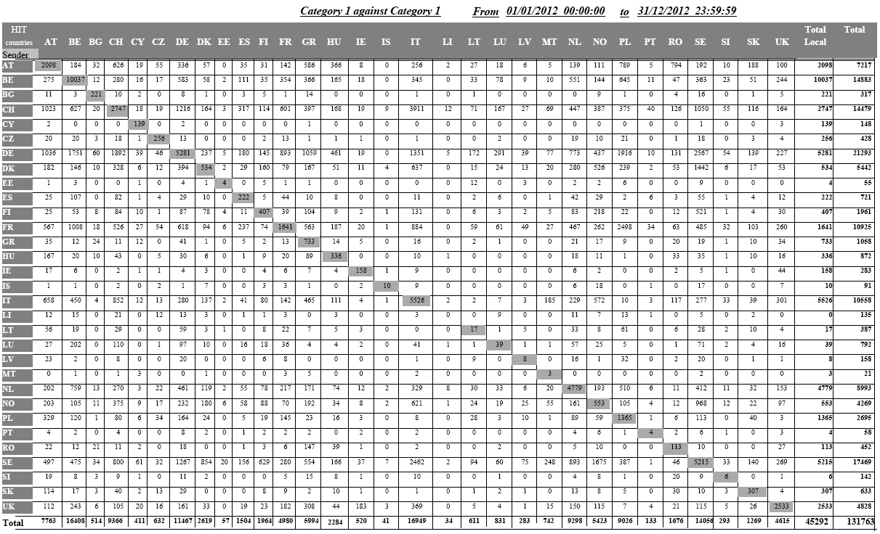
Table 4: Hit repartition – Category 1 against Category 2, in 2012 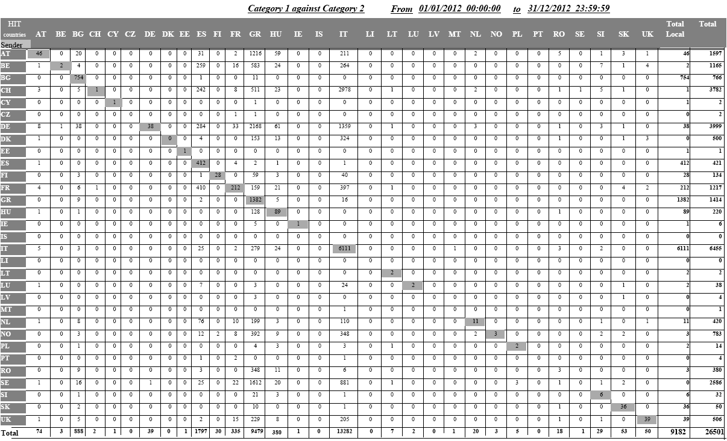
Table 5: Category 1 hits against Category 2 data sets
 | Total | Local | Foreign Hit (Total-Local) | % Local
AT | 74 | 46 | 28 | 62,16
BE | 3 | 2 | 1 | 66,67
BG | 888 | 754 | 134 | 84,91
CH | 2 | 1 | 1 | 50,00
CY | 1 | 1 | 0 | 100,00
CZ | 0 | 0 | 0
DE | 39 | 38 | 1 | 97,44
DK | 0 | 0 | 0
EE | 1 | 1 | 0 | 100,00
ES | 1797 | 412 | 1385 | 22,93
FI | 30 | 28 | 2 | 93,33
FR | 335 | 212 | 123 | 63,28
GR | 9479 | 1382 | 8097 | 14,58
HU | 380 | 89 | 291 | 23,42
IE | 1 | 1 | 0 | 100,00
IS | 0 | 0 | 0
IT | 13282 | 6111 | 7171 | 46,01
LI | 0 | 0 | 0
LT | 7 | 2 | 5 | 28,57
LU | 2 | 2 | 0 | 100,00
LV | 0 | 0 | 0
MT | 1 | 0 | 1 | 0,00
NL | 20 | 11 | 9 | 55,00
NO | 3 | 3 | 0 | 100,00
PL | 5 | 2 | 3 | 40,00
PT | 0 | 0 | 0
RO | 18 | 3 | 15 | 16,67
SE | 1 | 0 | 1 | 0,00
SI | 29 | 6 | 23 | 20,69
SK | 53 | 36 | 17 | 67,92
UK | 50 | 39 | 11 | 78,00

Table 6: Hit repartition – Category 3 against Category 1, in 2012
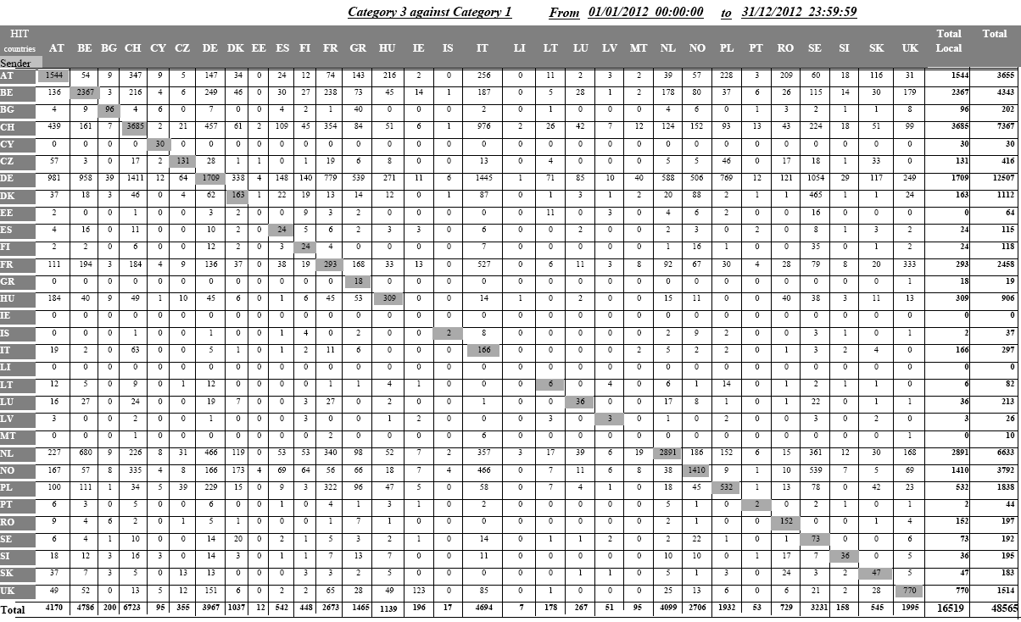
Table 7: Category 3 against Category 1 (flows of persons apprehended when illegally present in another Member State from the one in which they claimed asylum
 | Local | Total | Total-Local
AT | 1544 | 3655 | 2111
BE | 2367 | 4343 | 1976
BG | 96 | 202 | 106
CH | 3685 | 7367 | 3682
CY | 30 | 30 | 0
CZ | 131 | 416 | 285
DE | 1709 | 12507 | 10798
DK | 163 | 1112 | 949
EE | 0 | 64 | 64
ES | 24 | 115 | 91
FI | 24 | 118 | 94
FR | 293 | 2458 | 2165
GR | 18 | 19 | 1
HU | 309 | 906 | 597
IE | 0 | 0 | 0
IS | 2 | 37 | 35
IT | 166 | 297 | 131
LI | 0 | 0 | 0
LT | 6 | 82 | 76
LU | 36 | 213 | 177
LV | 3 | 26 | 23
MT | 0 | 10 | 10
NL | 2891 | 6633 | 3742
NO | 1410 | 3792 | 2382
PL | 532 | 1838 | 1306
PT | 2 | 44 | 42
RO | 152 | 197 | 45
SE | 73 | 192 | 119
SI | 36 | 195 | 159
SK | 47 | 183 | 136
UK | 770 | 1514 | 744
Total | 16519 | 48565 | 32046

Table 8: Rejected transactions, percentage in 2012
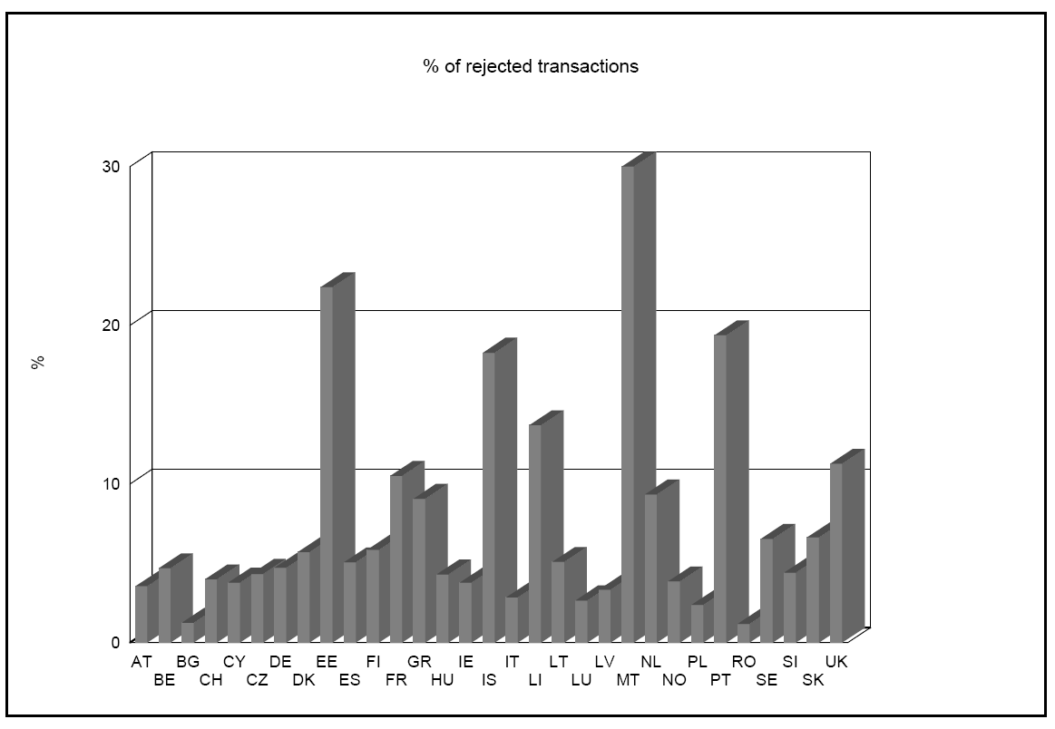
Table 9: Average time between the date of taking the fingerprints and their sending to the EURODAC Central Unit, in 2012
Table 10: Category 1 against Category 1 hit in wrong sense, in 2012
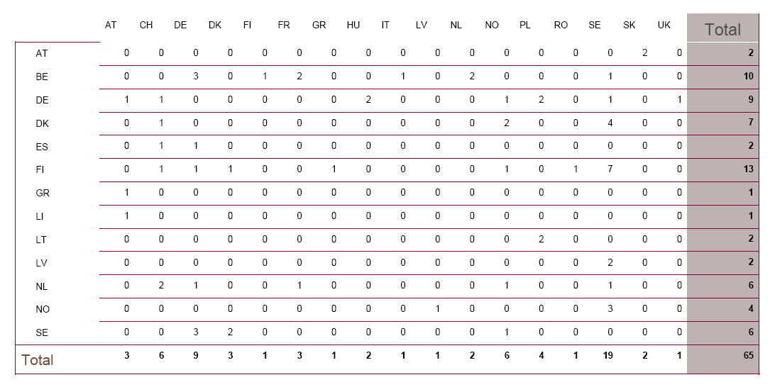
Table 11: Distribution of CAT1/CAT2 hits missed because a delay when sending the CAT2, in 2012
Table 12: Distribution of hits against blocked cases (art. 12 of the EC Regulation 2725/2000), in 2012
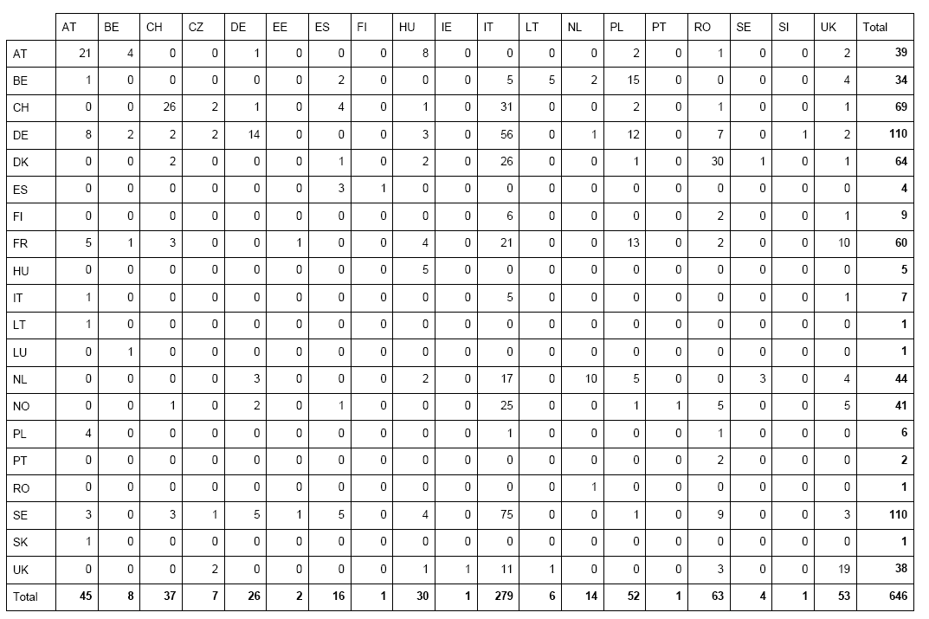
Table 13: Count of category 9 "special searches" per Member State, in 2012

OJ L 316, 15.12.2000, p.1.
Article 24(1) EURODAC Regulation.
COM(2012) 254 final.
COM(2008) 825 final.
COM(2009) 342 final and COM(2009) 344 final.
COM(2010) 555 final.
The EURODAC Regulation provides for the implementation of a Central Unit managed by the European Commission containing an Automated Fingerprint Identification System (AFIS) which shall receive data and transmit 'hit – no hit' replies to the national Units (National Access Points) in each Member State. The EURODAC Regulation and its Implementing Rules identify the responsibilities for the collection, transmission and comparison of the fingerprint data, the means through which the transmission can take place, the statistical tasks of the Central Unit and the standards that are used for the data transmission.
Regulation (EU) No 1077/2011 of the European Parliament and of the Council of 25 October 2011 establishing a European Agency for the operational management of large-scale IT systems in the area of freedom, security and justice, OJ 1.11.2011, L286 p.1
S-TESTA (secured Trans-European Services for Telematics between Administrations) network provides a generic infrastructure to serve the business needs and information exchange requirements between European and National administrations.
ISA (Interoperability Solution for European Public Administrations) is the new programme to improve electronic cooperation among public administrations in EU Member States. It is the follow-on of the previous programme IDA II (Interchange of Data between Administrations) and IDABC (Interoperable Delivery of European eGovernment Services to public Administrations, Businesses and Citizens).
Table 2 of the Annex details the successful transactions per Member State, with a breakdown by category, between 1 January 2012 and 31 December 2012.
'Each Member State shall, in accordance with the safeguards laid down in the European Convention on Human Rights and in the United Nations Convention on the Rights of the Child, promptly take the fingerprints of all fingers of every alien of at least 14 years of age who is apprehended by the competent control authorities in connection with the irregular crossing by land, sea or air of the border of that Member State having come from a third country and who is not turned back.'
OJ L 348 of 24.12.2008.
Article 11 '(…) As a general rule there are grounds for checking whether the alien has previously lodged an application for asylum in another Member State where: (a) the alien declares that he/she has lodged an application for asylum but without indicating the Member State in which he/she made the application; (b) the alien does not request asylum but objects to being returned to his/her country of origin by claiming that he/she would be in danger, or (c) the alien otherwise seeks to prevent his/her removal by refusing to cooperate in establishing his/her identity, in particular by showing no, or false, identity papers.'
The statistics concerning local hits shown in the tables may not necessarily correspond to the hit replies transmitted by the Central Unit and recorded by the Member States. The reason for this is that Member States do not always use the option, provided by Art. 4(4), which requests the Central Unit to search against their own data already stored in the Central database. However, even when Member States do not make use of this option, the Central Unit must, for technical reasons, always perform a comparison against all data (national and foreign) stored in the Central Unit. In these concrete cases, even if there is a match against national data, the Central Unit will simply reply 'no hit' because the Member State did not ask for the comparison of the data submitted against its own data.
OJ L 326 of 13.12.2005.
In the scenario of the so-called 'wrong hit', a third-country national lodges an asylum application in a Member State (A), whose authorities take his/her fingerprints. While those fingerprints are still waiting to be transmitted to the Central Unit (category 1 transaction), the same person could already present him/herself in another Member State (B) and ask again for asylum. If this Member State B sends the fingerprints first, the fingerprints sent by the Member State A would be registered in the Central database later then the fingerprints sent by Member State B and would thus result in a hit from the data sent by Member State B against the data sent by the Member State A. Member State B would thus be determined as being responsible instead of the Member State A where an asylum application had been lodged first.
In the scenario of the so-called 'missed hit', a third-country national is apprehended in connection with an irregular border crossing and his/her fingerprints are taken by the authorities of the Member State (A) he/she entered. While those fingerprints are still waiting to be transmitted to the Central Unit (category 2 transaction), the same person could already present him/herself in another Member State (B) and lodge an asylum application. At that occasion, his/her fingerprints are taken by the authorities of Member State (B). If this Member State (B) sends the fingerprints (category 1 transaction) first, the Central Unit would register a category 1 transaction first, and Member State (B) would handle the application instead of Member State A. Indeed, when a category 2 transaction arrives later on, a hit will be missed because category 2 data are not searchable.
A transaction may be rejected due to a data validation issue, fingerprint errors or insufficient quality (see also section 2.1. ibid).

