Annex 4 – Aid for Trade Monitoring Report 2013
Table of Contents
Annex 4 – Aid for Trade Monitoring Report 2013 1
1. Key Findings 3
2. Concepts and sources of information 6
2.1. Aid for Trade Context 6
2.2. Databases and sources of information 6
3. Global progress of trade related assistance and aid for trade 8
3.1. Trade Related Assistance 8
3.2. Aid for Trade 10
3.3. Analysis by category 13
3.4. Analysis by instrument 17
4. Geographical coverage 20
4.1. Evolution of commitments by geographical region 20
4.2. Analysis of commitments to ACP and LDC 22
5. Trade Facilitation 25
5.1. Analysis of OECD figures 25
5.2. A wider measure of Trade Facilitation 28
6. Qualitative Assessment: EU-EU Member States Joint Aid for
Trade Questionnaire 33
6.1. Dialogue on Aid for Trade 33
6.2. Trade Needs Assessment and Strategies 34
6.3. Joint Operations and Harmonisation 35
6.4. Regional dimension of Aid for Trade 35
6.5. Monitoring and Evaluation 37
6.6. Aid for Trade in Least Developing Countries 37
6.7. Way Forward 38
7. Appendix 1 – Definitions of AfT Categories 39
8. Appendix 2 – EU Member States AfT Donor Profiles 40
9. Appendix 3 – Aid for Trade by Region, Country and Category 69
10. Appendix 4 –Trade Related Assistance by Region, Country and Category 101

1. Key Findings
Global Progress of Trade Related Assistance and Aid for Trade
- In 2011, the EU and Member States confirmed their position as the largest provider of Aid for Trade (AfT) in the world, accounting collectively for 32% of total AfT, despite the global economic downturn and the overall decline of 14% of global AfT (OECD DAC donors).
- Trade related assistance (TRA) commitments increased by 7.9% in 2011 (after a decrease of 7.5% in 2010), reaching a total of EUR 2.8 billion for EU and Member States, far above the EUR 2 billion target to which they committed in the 2007 joint EU Aid for Trade Strategy. The EU and Member States remain the major providers of TRA in the world, with 71% of total TRA commitments (60% in 2010).
- The amount of AfT committed by the EU institutions in 2011 (EUR 2.7 billion) increased compared to the previous year (+7%) and was slightly above the 2006-2008 average, which is the G20 agreed target.
- The collective commitments of the EU and its Member States for AfT amounted to EUR 9.5 billion with a relative slowdown by -11%, which however followed a +17% increase in 2010.
- The decrease in collective EU AfT is not an isolated phenomenon. A similar drift is also observed in AfT provided by other important DAC donors such as the USA (-41%) and Japan (-20%). In the case of EU and Member States, the decline was mostly concentrated in trade related infrastructure. This is partially due to the international economic downturn but also to programming cycles and exercises in the EU and its Member States and to the cyclicality of large infrastructural and productive capacity building projects.
- Two positive aspects concerning the EU and Member States AfT are the highest rate of disbursement (94% of commitments in 2011) with respect to other donors (75% of commitments in 2011) and the importance of ODA grants over loans (100% for EU and 55% for the EUMS in 2011) compared to other donors (40% in 2011).
Geographical Coverage
- Africa remains the most important recipient of AfT programmes, with almost 36% of all EU collective AfT allocated to the region, a slight decrease from 38% in 2010. In 2011, the Sub-Saharan countries increased their share in the total amounts committed to Africa both for the Member States (68%) and the EU (82%). The second most important recipient is Asia, with 17% of committed amounts.
- In 2011, all regions of the world were affected by the decrease in terms of EU and EU Member States AfT committed amounts: Africa (-16%), Asia (-25%), Europe (-21%) and Oceania (-68%). However, this was accompanied by a continuous increase of geographically “unspecified” programmes (allocated globally).
- An important increase of TRA committed amounts from EU and Member States was registered in Africa (+50% with respect to 2010) showing an increased focus on the trade policy and regulation and trade development categories in this region.
- In contrast to the downward trend of the share of EU and Member States AfT committed towards Least Developing Countries (LDC) observed over the past years, 2011 was marked by an increase both concerning the EU (26% compared to 22% in the previous year) and the Member States (16% of the total EUMS AfT compared to 14% in 2010). However, it is important to stress that the share of LDC in the total AfT of EU and Member States (collectively equal to 19% in 2011, up from 16% in 2010) is still lower than in the case of other donors. A significant proportion of the EU AfT is indeed allocated to its neighbouring countries within the EU Neighbourhood Policy and to countries in the process of accession to the EU within the enlargement policy (to the extent that these qualify as developing countries).
- Similarly, the share of the ACP group of countries in the total AfT increased for both EU (from 39% in 2010 to 49% in 2011) and its Member States (27% to 29%).
Trade Facilitation
- Since 2008, almost 30% of all EU and MS commitments in the category trade policy and regulation (TPR) are considered as trade facilitating programmes (cumulatively EUR 636 mn between 2008 and 2011 for trade facilitation). This area shows significant annual variations; after an increase of 50% in 2010, the trade facilitation category registered a decrease of -17% in EU collective commitments in 2011 (EUR 162 mn), while at the same time the wider TPR category registered an increase of 10% in commitments.
- The EU and MS collectively have been the biggest providers of Trade Facilitation since 2008. In 2011, the share of EU and MS in the global Trade Facilitation was 59%. The EU itself provided 48% of global Trade Facilitation. The EU support to Trade Facilitation represented more than 18% of the EU TRA and almost 5% of EU AfT. The figures for MS were respectively of 1.5% of MS TRA and 0.5% of MS AfT.
- On average, since 2007, more than 60% of EU and MS collective commitments to Trade Facilitation have been provided by the EU. Member States’ projects and programmes under this category remain highly concentrated in a few countries (UK, Denmark, Sweden and the Netherlands). However the respective shares have been relatively unstable over time. In fact, in 2011 the picture somewhat changed as more than 80% of EU collective commitments in this category came from the EU.
- Relative to EU and EU Member States, trade facilitation aid commitments from other major donors are generally smaller. Among these other donors, Japan appears to be the largest, accounting for 18% of the EU total.
- Regionally, South East Asia and the EU Neighbourhood appear to receive the greatest concentration of trade facilitation aid whereas Latin America receives the lowest. On an individual country basis, four neighbourhood countries (i.e. Ukraine, Tunisia, Syria, and Palestine) and Afghanistan receive the largest amount, each in excess of EUR 30 million.
- EU collective figures confirm that committed amounts in "wide" trade facilitation might be underestimated when using the too restrictive OECD definition (TF would reach EUR 515 mn in 2011 for EU, to be compared to EUR 131 mn using the OECD definition). However, the lack of data, particularly for MS, does not facilitate the statistical analysis.
Qualitative assessment: EU–EU Member States Joint AfT Questionnaire
- This year’s AfT monitoring exercise shows that EU and Member States continue to advance in the implementation of the EU AfT Strategy through a continued effort to bolster the impact of AfT delivery on the ground.
- On the whole, the survey findings draw a positive picture of progressive improvement in terms of the partner-donor policy dialogue; the availability of updated trade needs assessments; joint operations and harmonisation; the inclusion of strategic regional economic integration priorities into the national development plan or trade strategy; and in highlighting the prominent hurdles for assessing AfT programmes and projects.
- To preserve this momentum and further bolster the effectiveness of the EU AfT Strategy, below are some areas where greater attention is warranted by EU and Member States:
Support programmes that ease constraints of partner countries’ own monitoring and evaluation systems, especially as they pertains to the obtainment of in-country data;
Increase AfT support to LDCs by helping to address concerns regarding low capacity in identifying needs and priorities; and
Bolster the effectiveness of AfT at the local level, which includes supporting greater integration of trade needs assessments into national trade strategies.

2. Concepts and sources of information

2.1. Aid for Trade Context
Helping developing countries to benefit from open global markets is an important part of a long-term strategy for global poverty reduction, alongside debt relief and general development aid. Using a mix of grant aid and trade instruments, the EU has sought to help some of the world's poorest countries to achieve sufficient economic transformation to lift their populations out of poverty.
Aid for trade (AfT) is financial assistance specifically targeted at helping developing countries to develop their capacity to trade. It is one of the key pillars of the EU development policy and includes help in building new infrastructure; improving ports or customs facilities and assistance in helping factories meet European health and safety standards for imports.
Aid for Trade entered the WTO agenda with the Doha Development Round. In 2005, several donors, including the EU and its Member States, made commitments to increase their trade-related support. In December 2005, the WTO Ministerial Conference in Hong Kong set up a Task Force to ‘operationalize Aid for Trade’. In its 2006 recommendations, this Task Force stated that ‘Projects and programmes should be considered as Aid for Trade if these activities have been identified as trade-related development priorities in the recipient country’s national development strategies’.
It specified six groups of activities that it considered to constitute Aid for Trade: Trade Policy and Regulation (category 1), Trade Related Infrastructure (category 3), Building Productive Capacity (category 4, including category 2 trade development), Trade Related Adjustment (category 5) and Other Trade Related needs (category 6). Categories 1, 2 and 6 (category 2 is a subset of category 4) correspond to standard Trade Related Assistance (TRA) and categories 1, 3, 4, 5 and 6 are usually referred as ‘the wider Aid for Trade agenda’ or AfT.
Building on this longstanding commitment, the EU adopted on 15 October 2007 a joint Aid for Trade Strategy. The Strategy aims to support all developing countries, particularly the Least Developed Countries (LDCs), to better integrate into the rules-based world trading system and to use trade more effectively in promoting the overarching objective of eradicating poverty.

2.2. Databases and sources of information
This year's monitoring report is based on four main sources of information:
- The OECD CRS online database is the most comprehensive and accurate database available on AfT flows. Annual data for the period 1975-2011 are available publicly on the OECD website either through the ‘Query Wizard for International Development Statistics’ web portal or through downloadable datasets, but the analysis in this report is focusing on the period 2000-2011. All the data are provided at a very detailed level, with the names of donor countries/institutions, commitments and disbursements, recipient countries and sectors. This database does not report AfT flows from new EU Member States before 2007, and it does not correctly report category 6 for the EU.
- The Doha Development database is a publicly available database on Trade Related Assistance (TRA) flows over the period 2001-2007. It is provided by the World Trade Organization (WTO) through the Doha Development Agenda website (tcbdb.wto.org). This database is particularly useful for historical evaluations of TRA for the period 2001-2006/2007, and particularly for category 2 (Trade Development).
- The Questionnaires of the Accountability Report, sent annually to EU MS for the monitoring of the EU commitments on financing for development, provide useful information on AfT flows. These questionnaires are particularly useful to obtain data from new EU MS, on which AfT figures are not available in the primary sources of data (OECD CRS and Doha Development Agenda Database).
- Replies to the AfT Questionnaires from EU Delegations coordinated with MS field offices in Developing Countries. The questionnaire is an important tool for the qualitative assessment of AfT activities.

Box 1: EU Budget Support and AfT
A considerable amount of EU funds is channelled through General Budget Support (GBS) and Sector Budget Support (SBS). Trade and Private Sector development projects/programmes are very often implemented using budget support. However, the funds disbursed through this aid modality are not included in the statistical analysis of the AfT Monitoring Report as GBS and SBS programmes are reported under a specific DAC code (51010) not linked to any of the 6 AfT categories.

3. Global progress of trade related assistance and aid for trade

3.1. Trade Related Assistance
Trade-Related Assistance (TRA) can be viewed as a subset of Aid for Trade (AfT). It comprises three categories: trade policy and regulation (category 1: training, explaining rules and regulations), trade development (category 2: investment promotion, analysis/institutional support for trade, market analysis and development) and other trade related needs (category 6: other trade related support identified as such by beneficiaries and not captured under the categories above).

Box 2: Example of TRA support

Caribbean Single Market and Economy (CSME) and Economic Integration (2012-2019)
Budget: EUR28,800,000; 10th EDF Contribution: EUR 27,500,000; CARICOM SECRETARIAT contribution: EUR 1,300,000
The overall objective of the programme is to support the beneficial integration of the CARICOM states into the global economy through the advancement of the CARICOM Single Market and Economy.
The specific objectives of the programme are:
1: To further advance the CARICOM Single Market and Economy (CSME)
2: To advance regional and sectoral policies

In 2005, the EU made specific financial commitments pledging to increase its collective expenditures on TRA to EUR 2bn per year from 2010, EUR 1bn from EU institutions and EUR 1bn in bilateral aid from EU Member States. Since then, a positive trend in collective EU TRA commitments can be observed, with only a slowing down in 2010 (-7.5%) , followed again by an increase in 2011(+7.9%), when they reached EUR 2.8bn.

Figure 1: Trade Related Assistance
(EU and Member states, in EUR million)
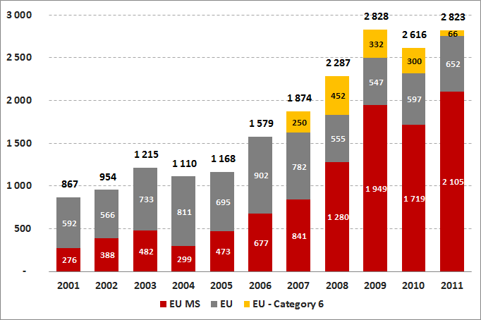
Sources: OECD CRS, EU, EU Accountability Report Questionnaire

This recent increase in TRA is mostly concentrated among some donors, representing almost 80% of total TRA commitments (Germany, Spain, UK and EU). Germany allocated EUR 874mn in 2011 (31% of collective EUTRA). It remains the largest contributor of TRA with an annual increase of +78% in 2011.
Table 1: Trade Related Assistance
(in EUR million)
 | 2005 | 2006 | 2007 | 2008 | 2009 | 2010 | 2011
Austria | 8 | 5 | 14 | 24 | 18 | 23 | 24
Belgium | 28 | 52 | 33 | 58 | 204 | 4 | 7
Bulgaria | n.a. | 0 | 0 | 0 | 0 | 0 | 0
Cyprus | n.a. | n.a. | 0 | 0 | 0 | 0 | 0
Czech Rep. | 0 | 0 | 0 | 0 | 0 | 0 | 0
Denmark | 28 | 48 | 48 | 73 | 97 | 113 | 82
Estonia | n.a. | 0 | 0 | 0 | 0 | 0 | 0
Finland | 15 | 33 | 2 | 51 | 91 | 56 | 116
France | 83 | 106 | 215 | 16 | 84 | 18 | 11
Germany | 81 | 31 | 238 | 680 | 700 | 497 | 874
Greece | 0 | 4 | 6 | 4 | 5 | 1 | 0
Hungary | n.a. | n.a. | 0 | 0 | 0 | 0 | 0
Ireland | 0 | 5 | 8 | 16 | 0 | 15 | 5
Italy | 4 | 6 | 15 | 29 | 33 | 32 | 13
Latvia | n.a. | 0 | 0 | 0 | 0 | 0 | 0
Lithuania | n.a. | 0 | 0 | 0 | 0 | 0 | 0
Luxembourg | 0 | 0 | 0 | 0 | 0 | 2 | 1
Malta | n.a. | n.a. | 0 | 0 | 0 | 0 | 0
Netherlands | 81 | 196 | 126 | 62 | 40 | 159 | 147
Poland | n.a. | n.a. | 0 | 0 | 0 | 0 | 0
Portugal | 2 | 1 | 0 | 2 | 4 | 1 | 1
Romania | n.a. | n.a. | 0 | 0 | 0 | 1 | 0
Slovakia | n.a. | n.a. | 0 | 0 | 0 | 0 | 0
Slovenia | n.a. | 1 | 1 | 2 | 0 | 1 | 0
Spain | 7 | 57 | 73 | 133 | 217 | 207 | 394
Sweden | 46 | 25 | 29 | 36 | 75 | 131 | 153
United Kingdom | 90 | 106 | 32 | 92 | 381 | 457 | 277
EU MS | 473 | 677 | 841 | 1 280 | 1 949 | 1 719 | 2 106
EU | 695 | 902 | 782 | 555 | 547 | 597 | 652
EU cat. 6 | n.a. | n.a. | 250 | 452 | 332 | 300 | 66
EU with cat. 6 | 695 | 902 | 1 032 | 1 007 | 879 | 897 | 718
Grand Total | 1 168 | 1 579 | 1 874 | 2 287 | 2 828 | 2 616 | 2 824
Sources: OECD CRS, EU, EU Accountability Report Questionnaire
Spain’s contribution increased in 2011, with a strong +90%, reaching EUR 394mn, and putting the country in third place after EU institutions (EUR 718mn in 2011, or 25% of the total). Other Member States with contributions exceeding EUR 100mn in 2011 are Sweden (EUR 153mn), The Netherlands (EUR 147mn) and Finland (EUR 116mn).
With more than 70% of total TRA commitments in 2011 (among all DAC donors), EU and its Member States remain the first provider of TRA in the world. Moreover, the graph below show that the share of USA in the total decreased massively in 2011, from 20% of the total in 2010, to less than 2% in 2011(partially substituted by an increase in EU collective as well as multilateral commitments).
Figure 2: Trade Related Assistance
(in EUR million)
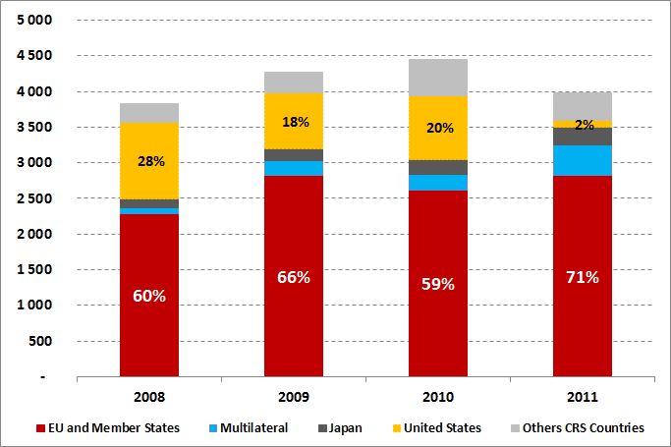
Sources: OECD CRS, EU, EU Accountability Report Questionnaire

3.2. Aid for Trade
Aid for Trade (AfT) is a wider aggregate than Trade Related Assistance. The concept of AfT has widened over the years to include more general support for infrastructure and productive sectors. AfT now comprises the following categories: trade policy and regulation (category 1: training, explaining rules and regulations), trade related infrastructure (category 3: physical infrastructure including transport and storage, communications and energy generation and supply), building productive capacity (category 4, including trade development and productive sectors such as agriculture, forestry, fishing, industry, mineral resources and mining), trade related adjustment (category 5: contributions to government budget for implementation of recipients own trade reforms and adjustments to trade policy measures by other countries) and other trade related needs (category 6: other trade related support identified as such by beneficiaries and not captured under the categories above).
Box 3: Example of wider AfT support

Accompanying Measures for Sugar Protocol Countries, Trinidad & Tobago, 2011 - 2013
Budget: EUR 31,724,161 million
The programme supports the objective of national food security and economic diversification and it also aims at diversifying of economic activities other than agricultural production on the former sugar lands, such as tourism, as well as the protection of the environment.

According to the OECD CRS database, and including EUR 400 mn of EU commitments in the category 6/other trade related support (not reported by the OECD but provided by the EU), the EU collective wider AfT commitment amounts to EUR 9.5bn in 2011. With a decrease of -11% in 2011 (after +17% in 2010), this growth rate is below the average annual growth rate (+10% when measured since 2002).
Figure 3: Aid for Trade
(EU and Member states, in EUR million)
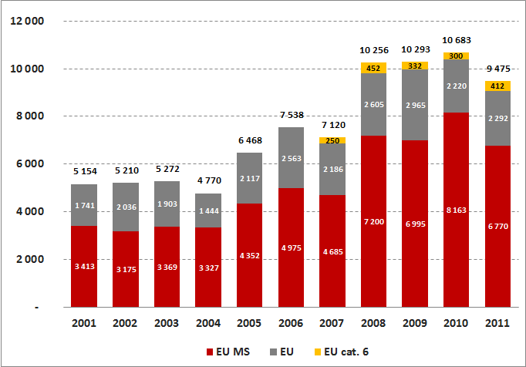
Sources: OECD CRS, EU, EU Accountability Report Questionnaire

Like TRA, AfT disbursement remains concentrated in some EU Member States (Germany, France, UK, Spain and the Netherlands) and EU. The two most important donors, concentrating almost 60% of EU collective AfT in 2011, are Germany (EUR 2.7bn) and the EU (EUR 2.7bn).

Table 2: Aid for Trade
(in EUR million)
EUR million | source | 2005 | 2006 | 2007 | 2008 | 2009 | 2010 | 2011
Austria | CRS | 27 | 26 | 44 | 51 | 58 | 68 | 51
Belgium | CRS | 155 | 156 | 209 | 221 | 389 | 315 | 344
Bulgaria | MQ | n.a. | 0 | 0 | 0 | 0 | 0 | 0
Cyprus | MQ | n.a. | n.a. | 0 | 0 | 0 | 0 | 0
Czech Rep. | MQ | n.a. | 3 | 3 | 0 | 0 | 0 | 0
Denmark | CRS | 410 | 189 | 255 | 173 | 251 | 272 | 218
Estonia | MQ | n.a. | 0 | 0 | 0 | 0 | 0 | 0
Finland | CRS | 100 | 64 | 84 | 135 | 256 | 195 | 237
France | CRS | 722 | 744 | 1 017 | 1 738 | 1 090 | 1 277 | 923
Germany | CRS | 1 138 | 1 495 | 1 213 | 2 036 | 1 889 | 3 345 | 2 681
Greece | CRS | 14 | 22 | 11 | 10 | 13 | 15 | 15
Hungary | MQ | n.a. | n.a. | 0 | 0 | 0 | 0 | 0
Ireland | CRS | 20 | 29 | 30 | 52 | 44 | 49 | 50
Italy | CRS | 310 | 239 | 111 | 186 | 197 | 131 | 64
Latvia | MQ | n.a. | 0 | 0 | 0 | 0 | 0 | 0
Lithuania | MQ | n.a. | 0 | 0 | 1 | 0 | 0 | 0
Luxembourg | CRS | 11 | 12 | 27 | 28 | 22 | 27 | 29
Malta | MQ | n.a. | n.a. | 0 | 0 | 0 | 0 | 0
Netherlands | CRS | 384 | 686 | 510 | 466 | 482 | 424 | 850
Poland | MQ | n.a. | n.a. | 0 | 0 | 0 | 0 | 3
Portugal | CRS | 61 | 7 | 47 | 13 | 66 | 41 | 19
Romania | MQ | n.a. | n.a. | 0 | 0 | 0 | 1 | 0
Slovakia | MQ | n.a. | n.a. | 0 | 0 | 0 | 0 | 0
Slovenia | MQ | n.a. | 1 | 1 | 2 | 0 | 2 | 1
Spain | CRS | 135 | 561 | 474 | 622 | 660 | 1 002 | 467
Sweden | CRS | 200 | 259 | 267 | 225 | 247 | 283 | 250
United Kingdom | CRS | 665 | 480 | 380 | 1 240 | 1 329 | 716 | 566
EU MS |  | 4 352 | 4 975 | 4 685 | 7 200 | 6 995 | 8 163 | 6 770
EU | CRS | 2 117 | 2 563 | 2 186 | 2 605 | 2 965 | 2 220 | 2 292
EU cat. 6 | EU | n.a. | n.a. | 250 | 452 | 332 | 300 | 412
EU with cat. 6 |  | 2 117 | 2 563 | 2 436 | 3 056 | 3 298 | 2 520 | 2 704
Grand Total |  | 6 468 | 7 538 | 7 120 | 10 256 | 10 293 | 10 683 | 9 475
Sources: OECD CRS, EU, EU Accountability Report Questionnaire

A comparison with other DAC donors reveals that the decline in EU collective AfT in 2011 is not an isolated phenomenon and is observed in most DAC donors. In fact, there is a strong correlation between AfT flows from the most important DAC donors since 2005. But the decline in total EU AfT commitments in 2011 remains far below the USA (-41%) and Japan (-20%). A breakdown of total EU AfT transfers shows that this decrease in committed amounts in 2011 is only observed on Member States (with -17%) and not on the EU (+7%).

Figure 4: Aid for Trade  (Annual growth rates, 2005-2011)  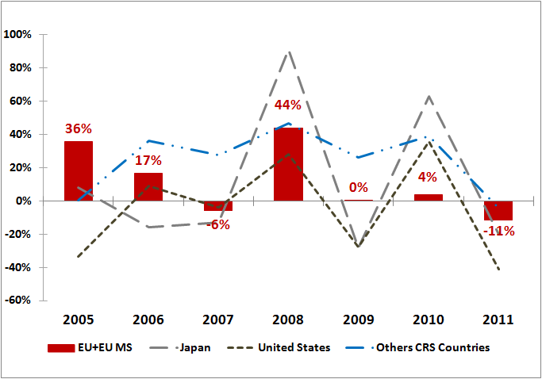  Sources: OECD CRS, EU, EU Accountability Report Questionnaire | Figure 5: Aid for Trade  (Annual growth rates for 2011)  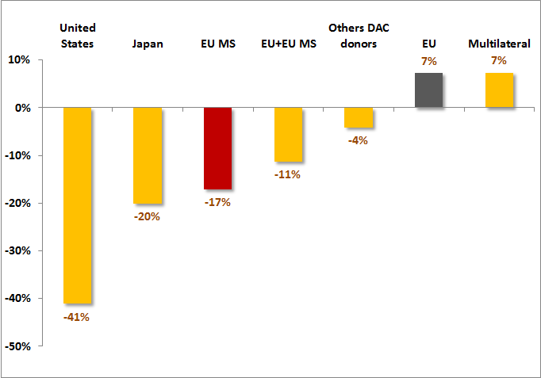  Sources: OECD CRS, EU, EU Accountability Report Questionnaire
The graphs below show the share of EU collective AfT in total ODA in comparison with other DAC donors. In 2011, the EU collective ODA still represents a large share of total ODA (38%), as well as a large share of total AfT flows (30%). However, after a peak in 2006, the EU collective contribution to the total (ODA or AfT) has been regularly decreasing. Symetrically, the share of EU collective AfT in total ODA has been regularly inceasing since 2006, a positive trend that is also observed in other DAC donors, confirming that AfT has become increasingly important to DAC donors (including EU and MS).
Figure 6: EU Collective in total AfT / ODA  (% in total AfT, % in total ODA)  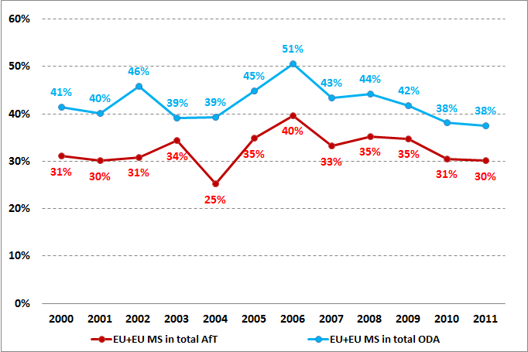  Source: OECD CRS | Figure 7: AfT in total ODA  (% of total)  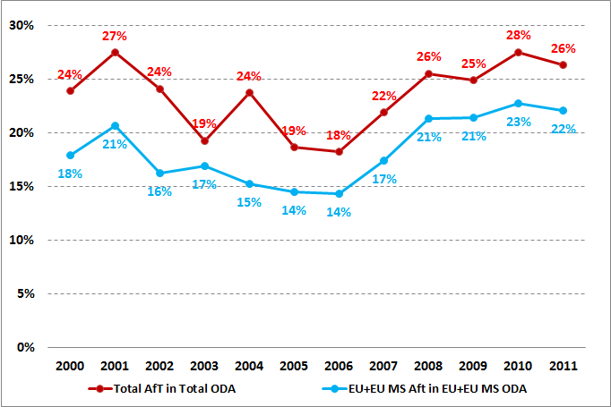  Source: OECD CRS

3.3. Analysis by category
Trade development has represented the bulk of total TRA since 2001. Its share declined from more than 90% in 2001 to 60% in 2008 due to the surge of other forms of TRA (trade policy and regulation and other trade related needs). However, an upward trend is observed since 2009 and the share of trade development in EU collective TRA has reached 77% in 2011.
For EU Member States, the share of trade development has remained almost the same since 2011 (83% on average since 2001), while it has been more volatile for the EU.

Figure 8: Trade Related Assistance by Category  (EU and Member states, in EUR million)  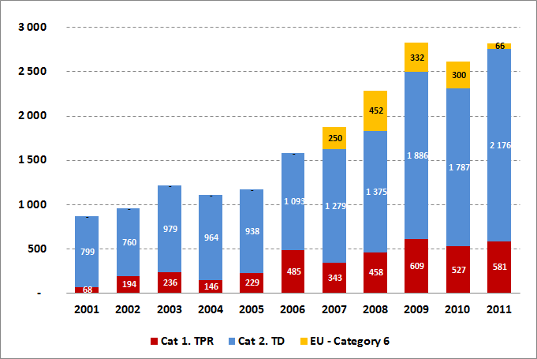  Sources: OECD CRS, EU,  EU Accountability Report Questionnaire | Figure 9: Share of Trade Development  (EU and Member states, % of total TRA)  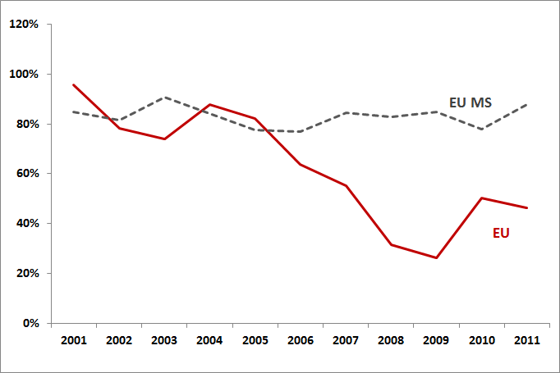 Sources: OECD CRS, EU,  EU Accountability Report Questionnaire
In the case of the wider aid for trade aggregate, more than 90% of EU collective commitments are explained by only two categories: trade related infrastructure (43% of the total since 2001) and building productive capacity (49% of the total since 2001). The category trade related infrastructure is more unstable over time than the building productive capacity category. The EUR 1.2bn decline in EU collective AfT in 2011 is mostly explained by a strong decrease in the category trade related infrastructure.

Figure 10: Aid for Trade by Category  (EU and Member states, in EUR million)  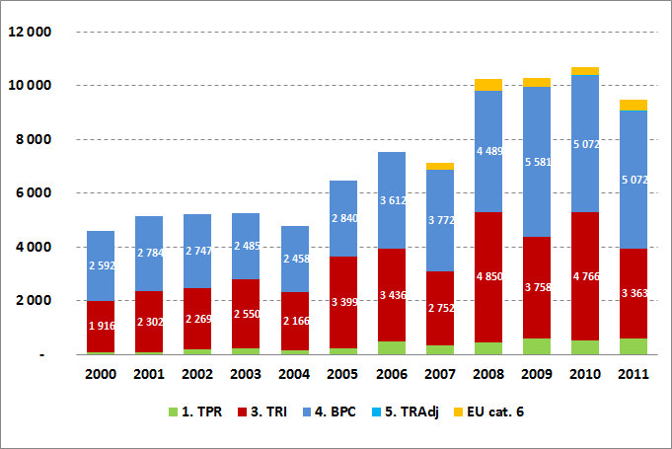 Sources: OECD CRS, EU,  EU Accountability Report Questionnaire | Figure 11: Focus on Two AfT Categories  (EU and Member states, in EUR million)  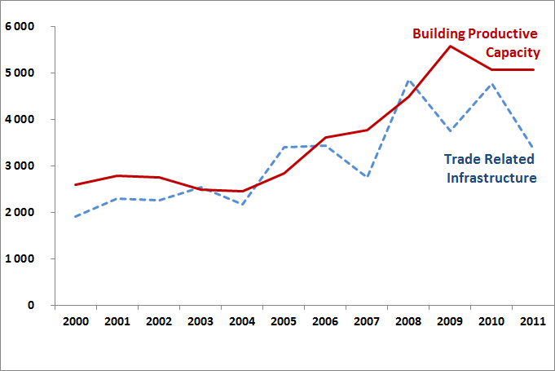 Sources: OECD CRS, EU,  EU Accountability Report Questionnaire
A comparison between EU and its Member States on AfT reveals strong similarities in the structure of AfT by broad category since 2005. These similarities are not confirmed in terms of sectors addressed by AfT programmes. The EU is more specialized on agriculture, transport and storage and trade policy and regulation, while EU Member States are more involved in energy, banking and financial services, business and other services.
Table 3: Structure of AfT by Category
(% of total AfT, averages 2001-2011)
 | EU Member States | EU
Trade Policy and Regulation | 4% | 9%
Trade Related Infrastructure | 42% | 45%
Building Productive Capacity | 55% | 36%
Trade Related Adjustment | 0% | 0%
Other Trade Related Needs | 0% | 9%
Total | 100% | 100%

Figure 12: Aid for Trade by Sector  (EU, in EUR million)  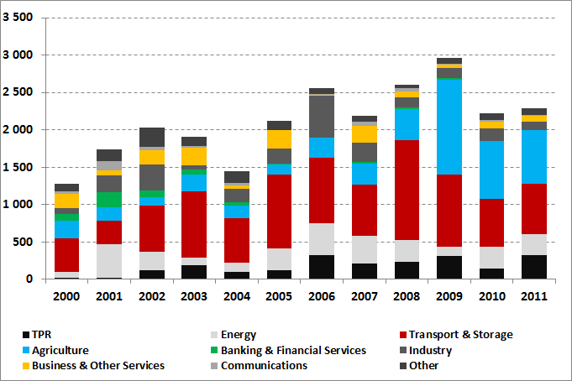 Source: OECD CRS | Figure 13: Aid for Trade by Sector  (Member states, in EUR million)  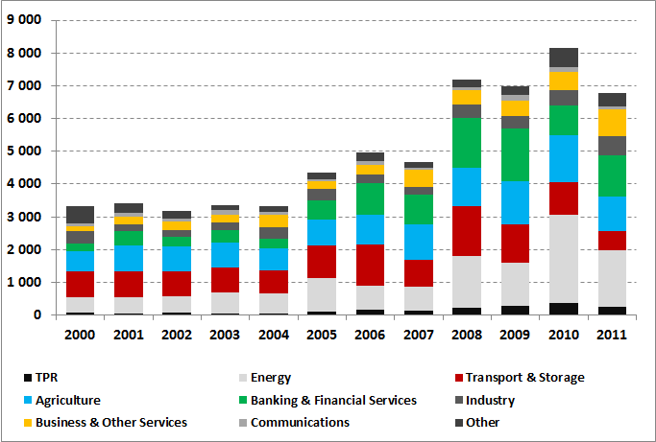 Source: OECD CRS

A comparison of commitments and disbursements reveals that the EU collective AfT is characterised by a high rate of disbursements (94% in 2011). The share of disbursements is less important for other donor, with 75% disbursed in 2011. Moreover, even if it is not a regular process, the relative amount disbursed tend to increase for EU collective, while no such trend is observed in the case of other donors.
Figure 14: Aid for Trade: Disbursement vs. Commitments
EU and its Member States  (in EUR million and percentages)  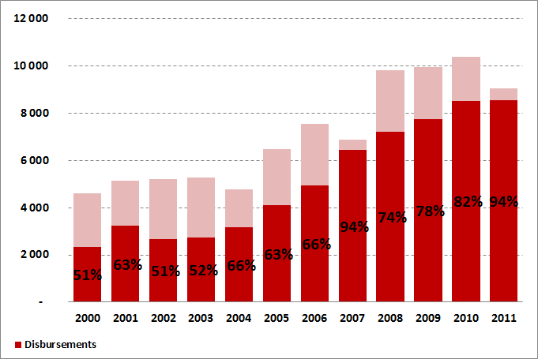  Source: OECD CRS | Other Donors  (in EUR million and percentages)  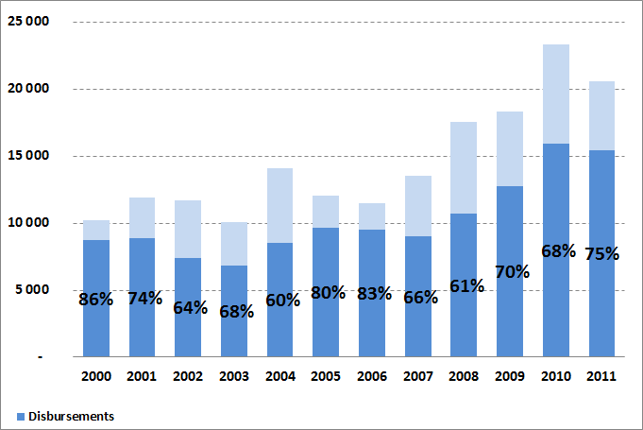  Source: OECD CRS

3.4. Analysis by instrument
Figure 15: Aid for Trade by Type of Flow
(EU and Member states, in EUR million)
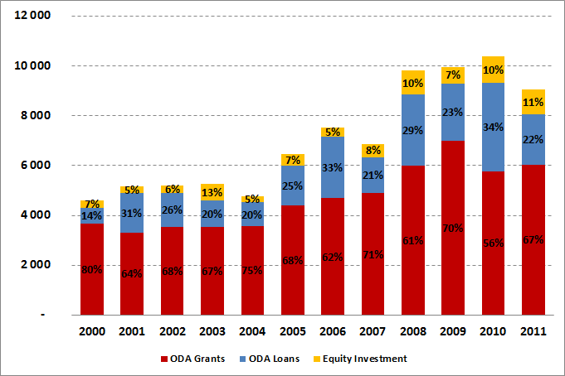
Source: OECD CRS

The grants are the most important instruments in the EU collective AfT. In 2011, they represented 100% of the EU commitments and 55% of the Member States. The grants are less used by other DAC donors (40% of their commitments in 2011).

Figure 16: Aid for Trade – ODA Loans  (% of total AfT)  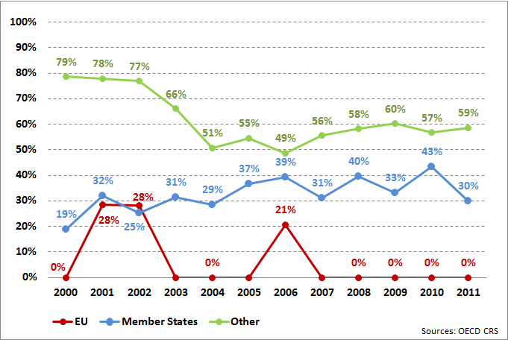  Source: OECD CRS | Figure 17: Aid for Trade - ODA Grants  (% of total AfT)  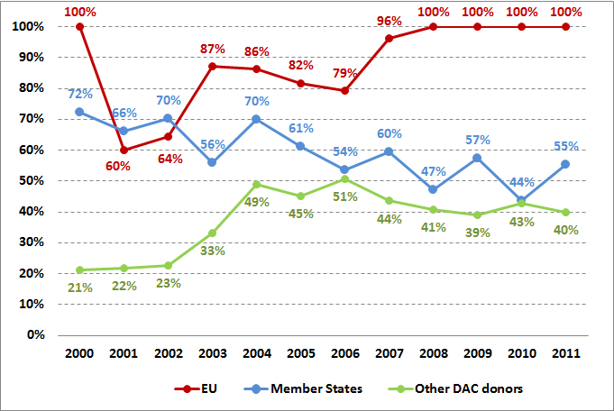  Source: OECD CRS
Among EU Member States, loans are mostly used by Germany (67%) and France (30%), while in the case of equity investment (less than 14% of EU collective AfT commitments), the three major users are Germany (41%), Spain (29%) and UK (23%).

Figure 18: Aid for Trade – ODA Loans  (% of total AfT)  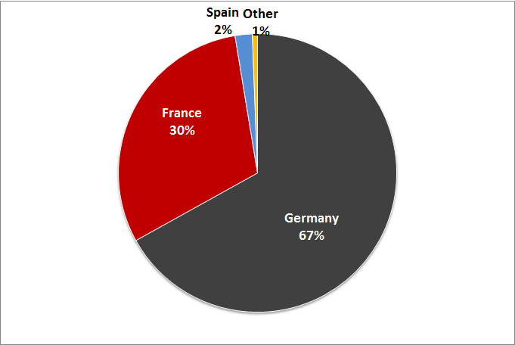  Source: OECD CRS | Figure 19: Aid for Trade - ODA Grants  (% of total AfT)  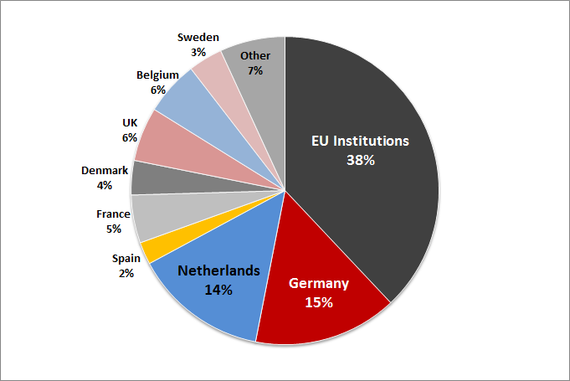  Source: OECD CRS
Figure 20: Aid for Trade – Equity Investment
(% of total AfT)
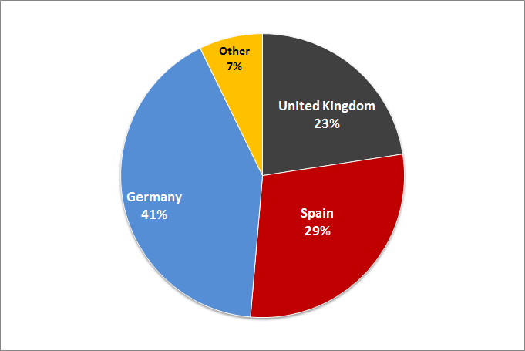
Source: OECD CRS

4. Geographical coverage

4.1. Evolution of commitments by geographical region
Africa remains the most important recipient of collective EU AfT programs, with almost 36% of AfT dedicated to this region. The second most important recipient of EU collective AfT is Asia (17%).
Africa represents the most affected region by the decrease in AfT in 2011in absolute amounts, with a drop of EUR 600mn. In terms of growth rates, the decrease in EU collective AfT had a considerable impact on Oceania (-68%, from EUR 49mn in 2010 to 16mn in 2011), Asia (-25%, from EUR 2.1bn in 2010 to EUR 1.6bn in 2011) and Europe (-21%, from EUR 1.3bn in 2010 to EUR 1.0bn 2011). America and regional programmes were less affected.

Figure 21: Aid for Trade by Region  (EU and Member states, in EUR million)  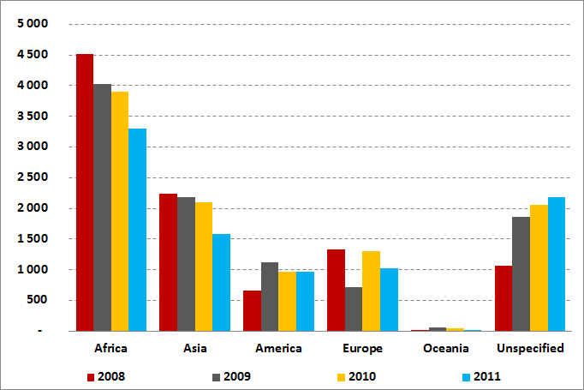 Source: OECD CRS | Figure 22: Trade Related Assistance by Region  (EU and Member states, in EUR million)  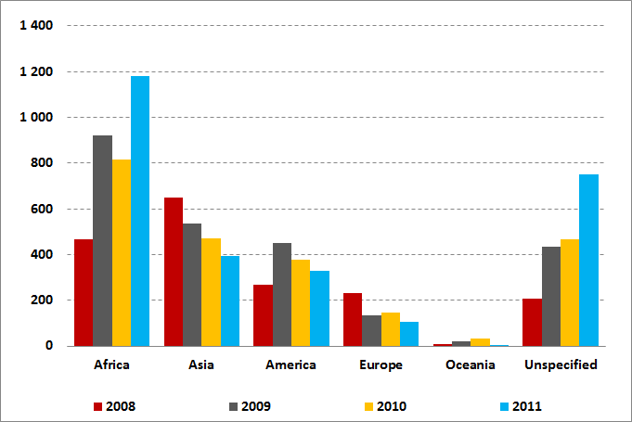 Source: OECD CRS

The following pie charts show the breakdown of the total amounts of AfT flows to Africa. Most EU collective AfT commitments are South of Sahara (82% for EU and 68% for Member States).

Figure 23: Aid for Trade by Region – Africa (breakdown)  (EU in 2010, percentages)  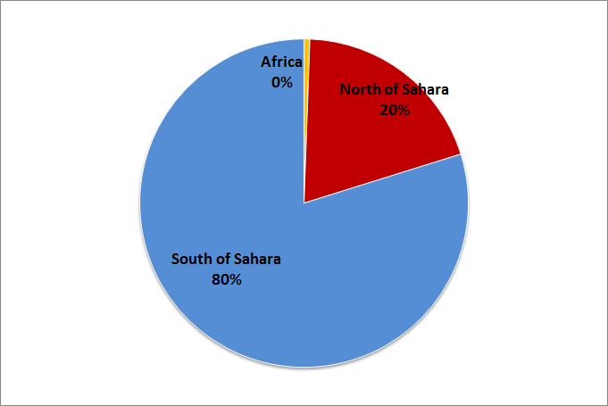 Source: OECD CRS | Figure 24: Aid for Trade by Region – Africa (breakdown)  (EU in 2011, percentages)  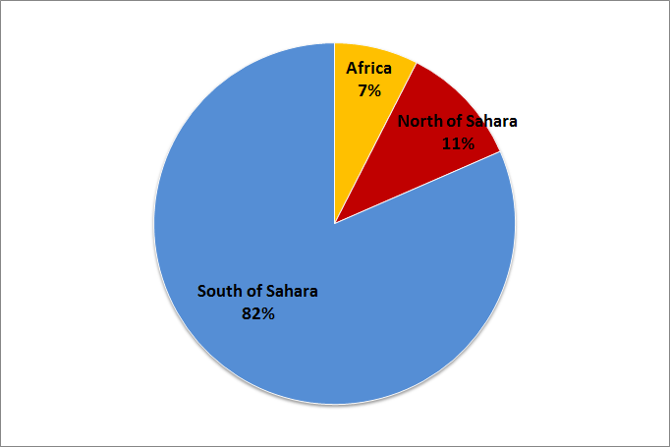 Source: OECD CRS

Figure 25: Aid for Trade by Region – Africa (breakdown)  (Member States in 2010, percentages)  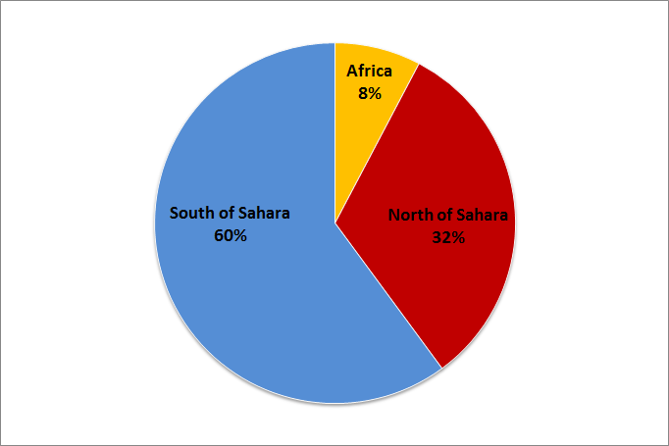 Source: OECD CRS | Figure 26: Aid for Trade by Region – Africa (breakdown)  (Member States in 2011, percentages)  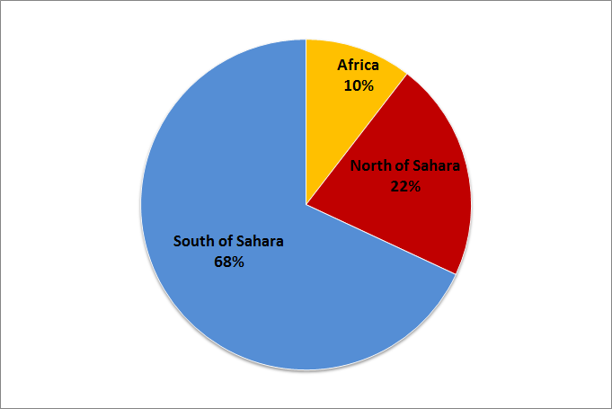 Source: OECD CRS

The breakdown of AfT in Africa reveals a lot of similarities between EU and Member States. South of Sahara is by far the most important region in EU collective AfT in Africa. The East Africa is the most important recipient sub-region both of the EU and of Member States AfT.

Figure 27: Aid for Trade on South of Sahara  (EU, in EUR million)  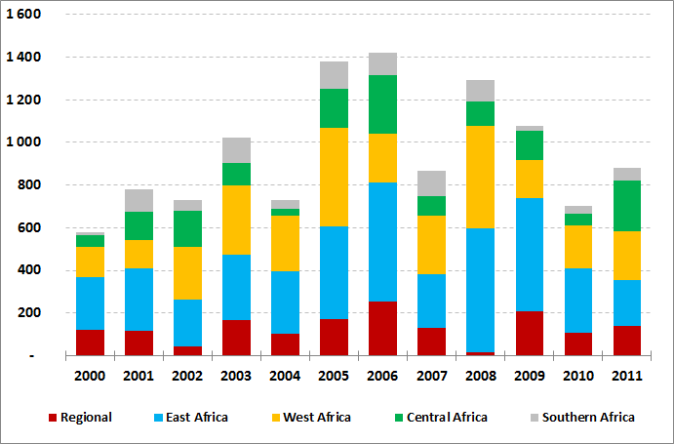  Source: OECD CRS | Figure 28: Aid for Trade on South of Sahara  (Member states, in EUR million)  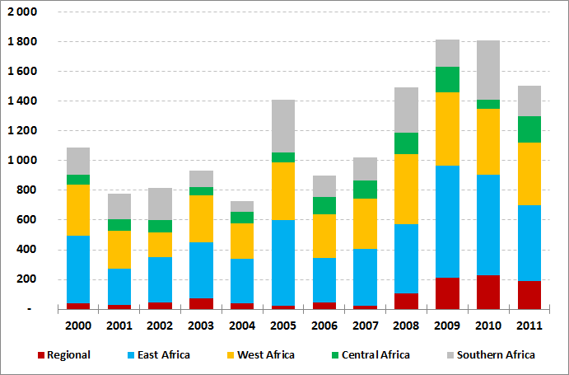  Source: OECD CRS

4.2. Analysis of commitments to ACP and LDC
The share of EU collective AfT to LDCs has experienced a downward trend since 2005 figures. Commitments to LDCs accounted for 31% of EU collective AfT in 2005 and in 2011 they represented only 19% of the total (EUR 1.7bn). African, Caribbean and Pacific Group of States (ACP) have been also affected by this negative trend (from 44% of the total in 2005 to less than 35% in 2011).

Figure 29: Aid for Trade – ACP countries  (EU and Member states, in EUR million)  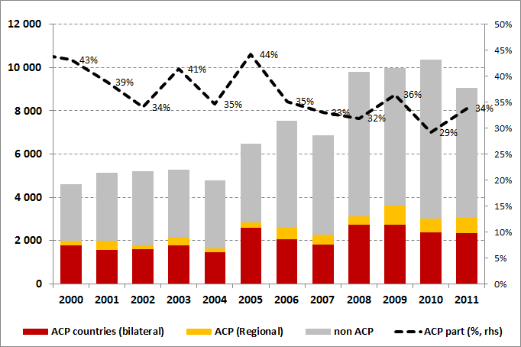  Source: OECD CRS | Figure 30: Aid for Trade by Income  (EU and Member states, in EUR million)  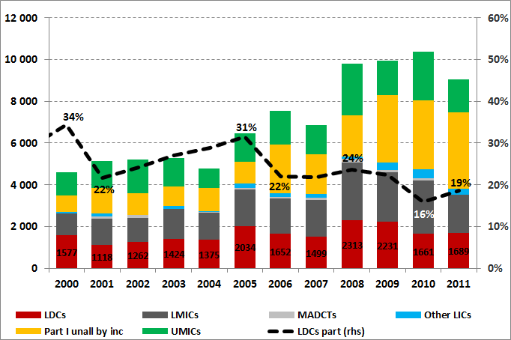  Source: OECD CRS
In the case of ACP, the downward trend concerns the EU more than Member States whereas the share of AfT programs dedicated to this group of countries used to be much higher in the case of the EU than EU Member States. However, the share of the ACP in the total AfT in 2011 increased both for the EU (49% in comparison with 39% in 2010) and Member States (29% with respect to 27% in 2010).
A comparable positive increase was observed for AfT commitments to the LDC countries in 2011 (from 22% in 2010 to 26% in 2011 for the EU and from 14% to 16% for Member States).

Figure 31: Aid for Trade – ACP countries  (EU, in EUR million)  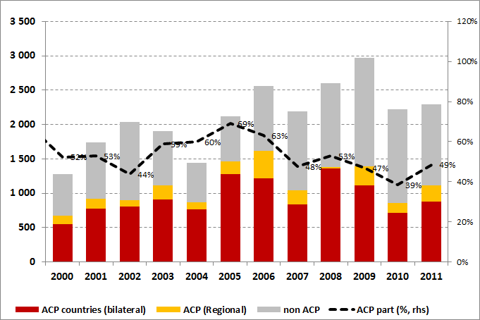  Source: OECD CRS |  | Figure 32: Aid for Trade – ACP countries  (Member States, in EUR million)  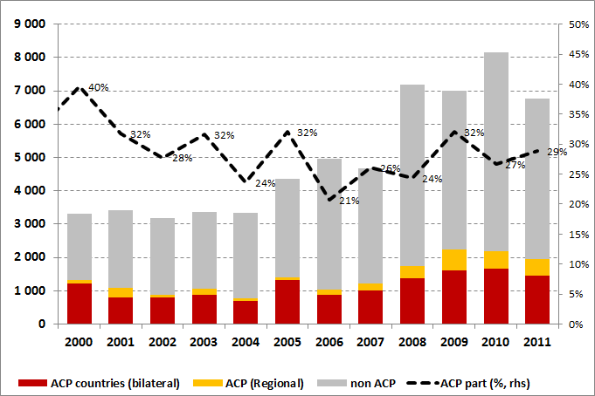  Source: OECD CRS
Box 4: What is the Enhanced Integrated Framework (EIF)
The Enhanced Integrated Framework (EIF) is a global Aid for Trade partnership involving Least Developed Countries (LDCs), donors (currently 23) and international organizations. It supports the LDCs to be more active players in the global trading system. It is the successor of Integrated Framework (IF), set up in 1997 and replaced by the EIF in 2007. The EIF is run by a small Secretariat, hosted in the WTO.
The EIF provides support to LDCs in advancing the mainstreaming of trade, strengthening arrangements for coordinating the effective delivery of the wider aid for trade and build capacity for enhancing capacity to foster greater regional and international trade. The EIF is providing limited funds but with a strategic focus on enhancing the LDC’s capacity for mobilising and promoting the effective utilisation of such wider aid for trade funds.
The EIF has provided support to most LDCs, ranging from diagnostics work and institutional strengthening programmes to targeted efforts and enhancing supply capacity in specific sectors. Most recently, Myanmar has become a full member of the EIF and will soon benefit from the support to strengthen the country’s capacity for deriving benefits from the further integration in regional and international trade.
The EIF works on the basis of a multi-donor trust fund, where existing contributions and pledged amounts amount to more than $200 million. The EU and its Member States (Belgium, Denmark, Estonia, Finland, France, Germany, Hungary, Ireland, Luxembourg, Spain, Sweden and the UK) are by far the largest contributors.
The Implementation period for support measures have been extended till end 2017 allowing time for further tine for a stronger focus and support to the strategic objectives of the EIF.

Figure 33: Aid for Trade by Income  (EU, in EUR million)  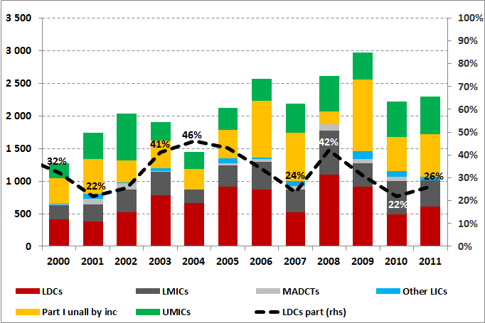  Source: OECD CRS | Figure 34: Aid for Trade by Income  (Member states, in EUR million)  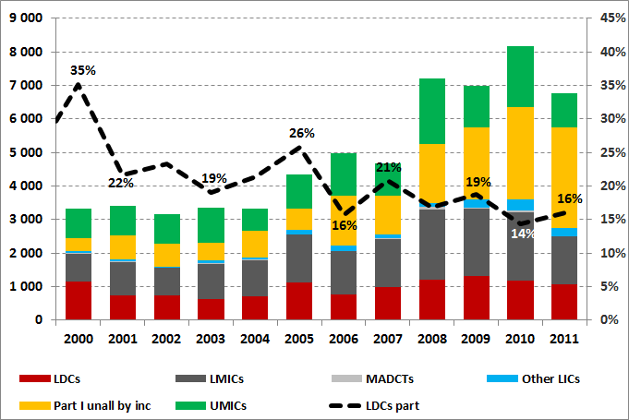  Source: OECD CRS
The share of LDC countries in total AfT has been increasing regularly since 2001 for all DAC donors, while it is decreasing more or less regularly in EU and Member States since 2005.
Figure 35: Aid for Trade to LDCs
(All CRS Donors, % of total AfT)
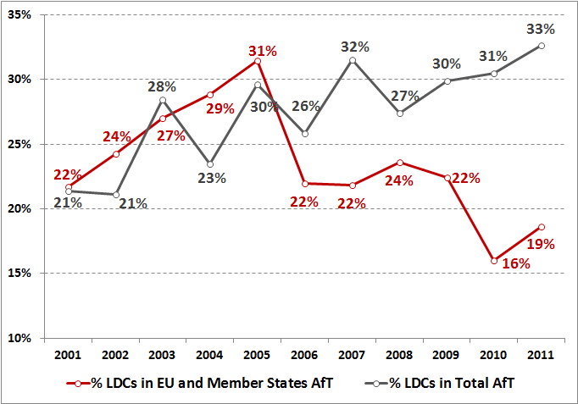
Source: OECD CRS

5. Trade Facilitation
The EU and MS finance a number of projects related to trade facilitation around the world, most of them with a focus on customs issues, and are committed to continue providing support in the future. This commitment has helped to solidify their global role as leading donors of trade facilitation-related aid. A major objective of these projects is to improve trade efficiency, in particular the speeding up of import and export processes.
In fact, experience shows that developing countries who have successfully simplified and modernised their official trade procedures have increased overall trade flows, enjoyed higher revenue collection (due to increase in trade volume, and higher detection rates of fraud) and return of any initial capital costs involved in modernising.
Box 5: case study on TF
Bangladesh trade Support Programme (2005-2009)
Objective: The specific objective of BTSP was to strengthen human resources and institutional capacity of relevant Government Agencies and private sector parties in order to introduce trade reforms and remove barriers to trade.
The total cost of the project was EUR 8,500,000 of which the EC contribution was EUR 7,800,000.
Main achievements:
- Enhanced capacity of Bangladesh in trade issues (by strengthening the newly created Foreign Trade Institute (BFTI), as think-tank on trade, training and research institution.
- Improved capacity of the Ministry of Commerce to implement WTO agreements and trade reforms, in particular thanks to 8 large studies on trade-related issues and the training of a large number of Ministry staff.
- Improved capacity of the Tariff Commission to represent and defend the interest of Bangladesh to WTO through ten selected studies on anti-dumping and other tariff-related topics and five successful tariff-specific training courses.
- Improved regulatory framework related to maritime transport services and its linkages to multi-mode transport through technical assistance to the Ministry of Shipping.

5.1. Analysis of OECD figures
According to the OECD CRS definition, trade facilitation is a subset of the category trade policy and regulation (CRS code 33120), and can be defined as the "simplification and harmonisation of international import and export procedures (e.g. customs valuation, licensing procedures, transport formalities, payments, insurance); support to customs departments; tariff reforms."
On average since 2008, almost 30% of all EU and MS commitments in the category trade policy and regulation (TPR) are trade facilitating programmes. In fact, the graph below shows that if total commitments in the category TPR in 2011 represented EUR 580 mn (6% of EU collective AfT), EUR 162 mn were dedicated to trade facilitating programmes. After +50% in 2010, trade facilitation registered a decrease of -17% of EU collective commitments in 2011, while the broad TPR category registered at the same time an increase of +10% in commitments.

Figure 36: Trade Facilitation and Trade Policy and Regulation
(EU and MS, in EUR million)
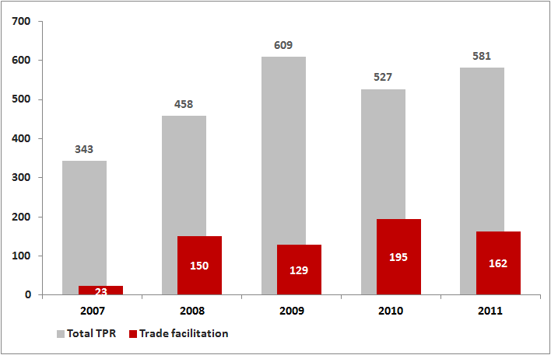
Source: OECD CRS

If a breakdown of the trade facilitation category shows that on average, since 2007, 38% of EU collective commitments have been provided by Member States, it is worth noting that the respective shares have been relatively unstable over time. In fact, in 2011, 81% of EU collective commitments in this category came from EU programmes (only 19% from EU Member States).
Figure 37: EU collective figures on Trade Facilitation
(EU and MS, in EUR million)
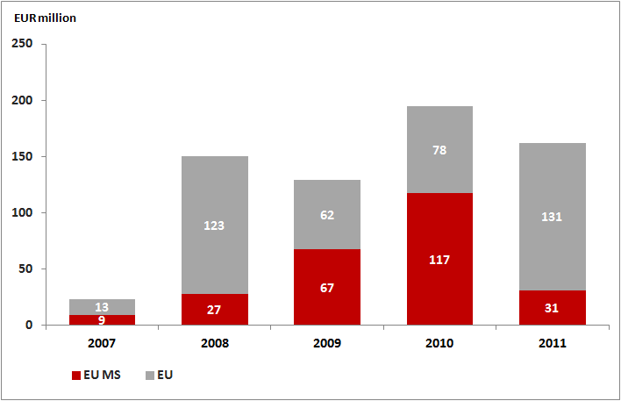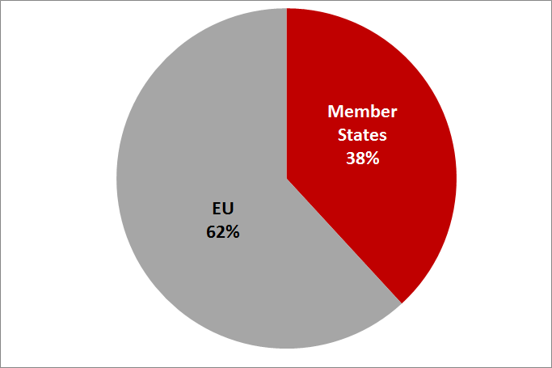
Source: OECD CRS

A breakdown of EU collective trade facilitation programmes by Member States reveals a very high degree of concentration among a few Member States. The graph below shows that the EU and UK account for 86% of EU collective trade facilitating programmes while Denmark, Sweden and The Netherlands account for 10% of the total, with the remainder (less that 5% of the total) being provided by other Member States.
Figure 38: Breakdown of EU collective figures on Trade Facilitation  (EU and MS, total commitments since 2007 in EUR million)  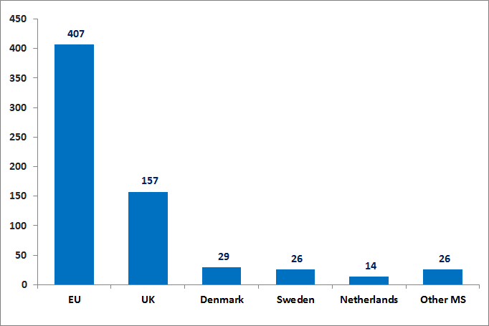  Source: OECD CRS | Figure 39: Total figures for other Donors on Trade Facilitation  (Other Donors, total commitments since 2007 in EUR million)  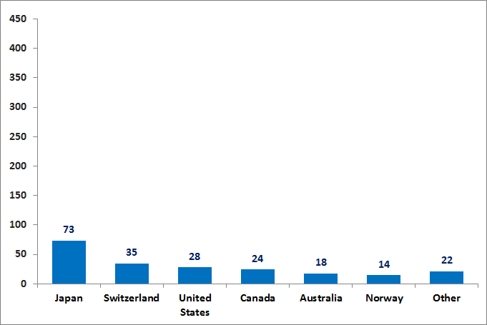  Source: OECD CRS
The EU and MS have been the biggest providers of Trade Facilitation amongDAC donors since 2008. In 2011, they collectively accounted for 59% of global Trade Facilitation.

Figure 40: Breakdown of global Trade Figure 41: Breakdown of global Trade
Facilitation in 2011 in % of total Facilitation since 2007 in EUR million
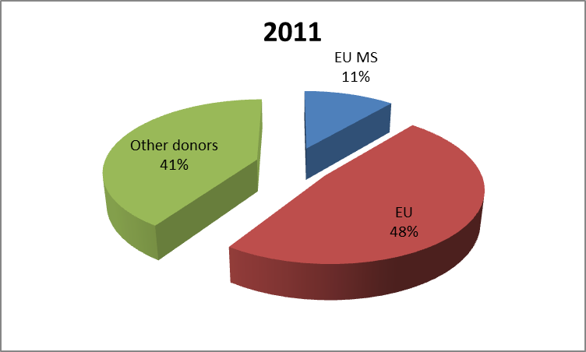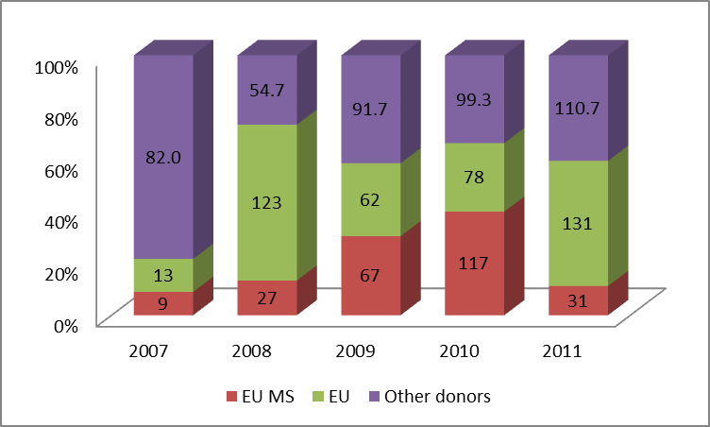

Among other major donors, trade facilitation-related aid is negligible when compared to the EU and UK. Aside from EU and EU Member States, Japan appears to be the largest donor. Nonetheless, it accounts for a mere 46% of the UK total and 18% of the EU total. With the exception of the UK, transfers from other EU Member States (e.g. Denmark and Sweden) are comparable to those observed from Switzerland, the United States, and Canada.
Figure 42: Trade Facilitation Recipient countries
(EU and Member States, in EUR million)
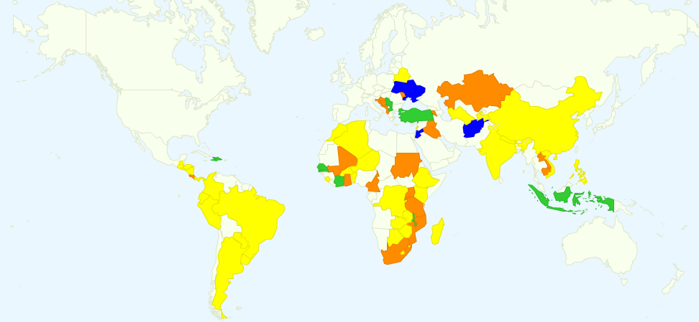
Yellow: <0.5 Million
Orange: 0.5 - 10 Million
Green: 10 – 30 Million
Blue: >30 Million
Source: OECD CRS
The above map highlights the varying destinations of trade facilitation aid. Regionally, South East Asia and the EU Neighbourhood appear to receive the greatest concentration of aid whereas Latin America receives the least. On an individual country basis, four neighbourhood members (i.e. Ukraine, Tunisia, Syria, and Palestine) and Afghanistan receive the largest amount, each in excess of EUR 30 million.

5.2. A wider measure of Trade Facilitation
EU technical assistance and capacity-building programmes in the field of trade facilitation is not necessarily limited to the OECD CRS 'trade facilitation' category (CRS code 33120). In fact, in the European Union Communication to the WTO Negotiating Group on Trade Facilitation (ref: TN/TF/W/149/Rev.4) of June 2012, the EU shows that the scope of the OECD CRS definition is very limited when compared to a wider measure including various projects with a trade facilitation component.
The document lists various programmes that are not necessarily classified in the trade facilitation category but that should fall under this category. These programmes are sometimes classified by the OECD as trade policy and regulation programmes (such as a project in ASEAN that will support ASEAN Economic Integration) or in the building productive capacity category (such as a project in Syria that promotes the economic transition of the countries of the EAP region towards market economies). Moreover, and although not falling under the heading of the Trade Facilitation negotiations, infrastructure projects also play an important role for the development of Trade Facilitation, including those related to the improvement of transit corridors, as well as projects reaching from feasibility study to serious road, energy and transport projects, etc.
The following table lists a few examples of such projects.

Table 4: Example of Trade Facilitation Programmes
(EU definition)
EU/MS | Country or Region | Title | Year | Description | Amount (in EUR)
EU | ASEAN | Support to ASEAN Economic Integration | 2010 | Project will support ASEAN Economic Integration while providing support to the strengthening of the institutional framework to manage integration. | 15000
EU | Caribbean | Caribbean Single Market and Economy (CSME) and Economic Integration | 2010 | To further advance the CARICOM Single Market and Economy (CSME) and to advance regional and sectoral policies | 24940
EU | Rwanda | FED/2009/021-697-ENTRETIEN PÉRIODIQUE DE LA SECTION KIGALI GATUNA DU CORRIDOR | 2009 | The project consists in the periodic maintenance of the section Kigali Gatuna (Ugandan border) | 32000
UK | Southern Africa | Trade Mark Southern Africa - North South Corridor Programme | 2008 | Hardware investment in Southern Africa North South transport corridor | 72762
Source: EU

The following table was elaborated on the basis of OECD CRS Trade Facilitation figures and the Communication from the European Union to the WTO Negotiating Group on Trade Facilitation written in June 2012, and providing a non-exhaustive list of "wider" trade facilitation EU collective programmes (ref: TN/TF/W/149/Rev.4).

Table 5: Comparison of Trade Facilitation Figures
(EU and Member States, in EUR million)
 | 2008 | 2009 | 2010 | 2011
EU
- OECD CRS definition | 123 | 62 | 78 | 131
- wider EU TF concept | 202 | 181 | 263 | 311
- TF related Infrastructure Projects | 868 | 915 | 401 | 204
EU MS
- OECD CRS definition | 27 | 67 | 117 | 31
- wider EU TF concept | 222 | 236 | 100 | n.a.
-TF related Infrastructure Projects | 130 | n.a. | n.a. | n.a.
EU + EU MS
- OECD CRS definition | 150 | 129 | 195 | 162
- wider EU TF concept | 423 | 417 | 362 | 311
- TF related Infrastructure Projects | 998 | 915 | 401 | 204
Source: OECD CRS, EU (TN/TF/W/149/Rev.4, June 2012)

It confirms the large differences between the two concepts/definitions. In fact, EU TF projects are most of the time twice as large as using the OECD definition. Moreover, taking into account infrastructures in the calculation would lead to a totally different picture, with a total of EUR 515 mn of EU commitment in 2011 (to be compared to EUR 131 mn in the OECD CRS database).
However, the table also shows a clear lack of data to go further into the analysis on this "wider" trade facilitation aggregate. The graphs below point out that if the dynamics of the two measures are correlated in the case of EU, the reporting seems much more uncertain on EU MS, particularly since 2010.

Figure 43: EU Trade Facilitation  (in EUR million)  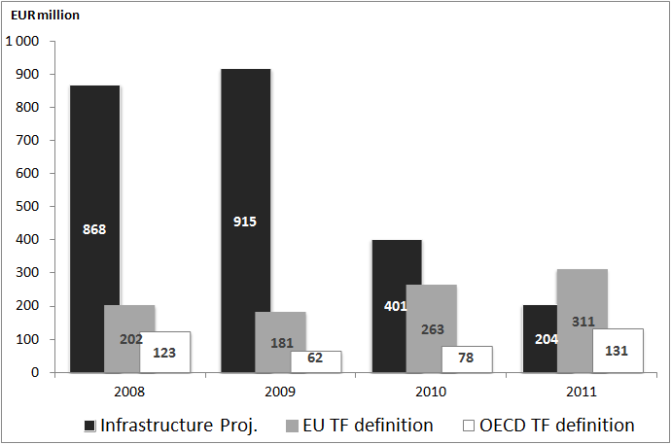Source: OECD CRS, EU | Figure 44: EU MS Trade Facilitation  (in EUR million)  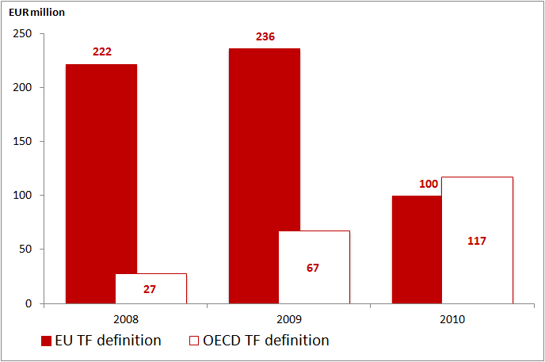Source: OECD CRS, EU

The following map is an illustration of countries targeted by these "wide" trade facilitation examples programmes over the period 2008-2011. EU TF programmes mostly focus on countries, while EU Member States TF programmes are usually regional programmes.

Figure 45: Trade Facilitation Recipient countries
(EU, in EUR million)
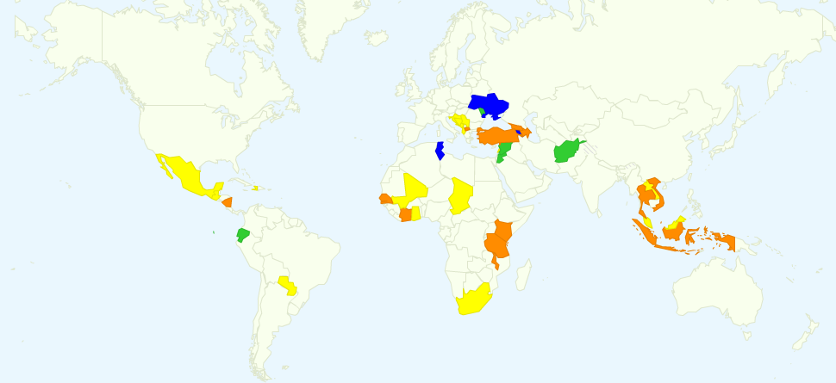
Yellow: <10 Million
Orange: 10 - 20 Million
Green: 20 – 40 Million
Blue: >40 Million
Source: EU (TN/TF/W/149/Rev.4, June 2012)

Based the EU definition of trade facilitation aid, Middle-East, South East Asia and neighbourhood region appear to receive the greatest concentration whereas Latin America receives the least. On an individual country basis, four neighborhood members (i.e. Ukraine, Tunisia, Syria, and Palestine) receive the largest amount, each in excess of EUR 40 million. This is followed by Afghanistan and Ecuador.

Box 6: A single window for the external trade of Peru
Objective
The objective of the creation of the Single Window is the integration and simplification of processes and services of government institutions related to external trade, securing an efficient management of operations.
Main achievements:
- The creation of the Single Window allowed the integration of 82 procedures from seven institutions. This means a reduction of 5% in costs and 25% in time.
- The transactions can be done 24/24 hours.
- The annual saving is estimated to close to EUR 4 million for the public sector and to around EUR 4 million for the private sector.
- Doing Business, the yearly investigation carried out by the World Bank, registered in its 2011 edition that the number of days for export procedures was reduced from 21 to 12 during 2010, and the number of days for import procedures from 24 to 17.

6. Qualitative Assessment: EU-EU Member States Joint Aid for Trade Questionnaire
This chapter reports on the replies of the AfT questionnaire sent to the EU Delegations and EU MS field offices in developing countries. The results are extracted from 68 responses with a geographic breakdown of the following: ACP (34), Asia (11), Latin America (11), and Neighbour (11). The analysis aims to reinforce our understanding of several issues, including the potential expansion of EU and EU Member States work on AfT with recipient countries; the perceived absence of trade needs assessments and strategies; the relatively low share of AfT allocated to LDCs compared to other developing countries; and opportunities for greater regional integration support.
Table 6: Number of Respondents
Region | Number of Respondents
ACP | 35
Asia | 11
Latin America | 11
Neighbourhood | 11
Total | 68

6.1. Dialogue on Aid for Trade
- For a majority of respondents (36 or 59% of the total), trade is a regular topic of discussion in their respective policy dialogue with the partner country. EU Delegations responses came in stronger at 72% (47 respondents). However, this is largely swayed by a significant number of positive replies from non ACP countries (80% of total responses).
Figure 46: Dialogue on Aid for Trade  (% of total responses, EU-EU MS Joint reply)  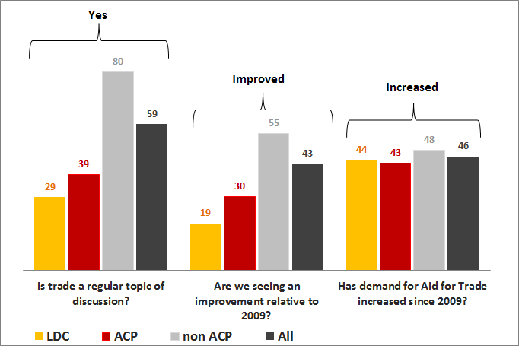  Source: AfTQ2013 | Figure 47: Dialogue on Aid for Trade  (% of total responses, EU Delegations)  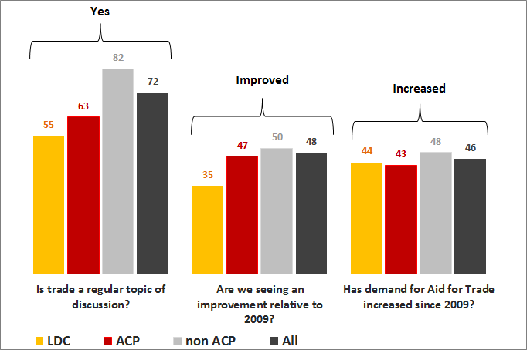  Source: AfTQ2013
- This is in contrast to LDC and ACP countries wherein only 29% and 39%, respectively, responded in the affirmative. Interestingly, counter to replies from EU and EU Member States, more than 50% of EU Delegation responses in LDC and ACP countries believed that trade is a regular topic of discussion.
- When asked whether there has been an improvement in the regularity of these discussions, a slim majority of EU and EU Member States’ (54%) answered that there was no particular change compared to 2009 while EU Delegation responses suggested otherwise, with 48% answering that it has “improved”. Whether we consider EU and EU Member States’ or EU Delegations, much of the replies highlighting an improvement stemmed from non ACP countries. Conversely, only 19% (EU-EU MS) and 35% (EU Delegations) of LDC replies felt that there was an improvement.
- Around 50% of both EU and EU Member States along with EU Delegation replies indicate that demand for Aid for Trade from the partner country has increased since 2009. Moreover, more than 35% believe that little or no change has occurred over the same period.
- Meanwhile, demand for Aid for Trade has more or less increased since 2009 in LDC (44%), ACP (43%), and non ACP (48%) countries.
- Both EU and EU Member States along with EU Delegation responses indicate that civil society would only sometimes be involved in this dialogue (49%).
- Asked whether the partner country has an effective national coordination processes in place to develop and implement an integrated trade strategy, more than 60% of EU and EU Member States answered in the affirmative.

Figure 48: Has demand for Aid for Trade from the partner country increased since 2009?
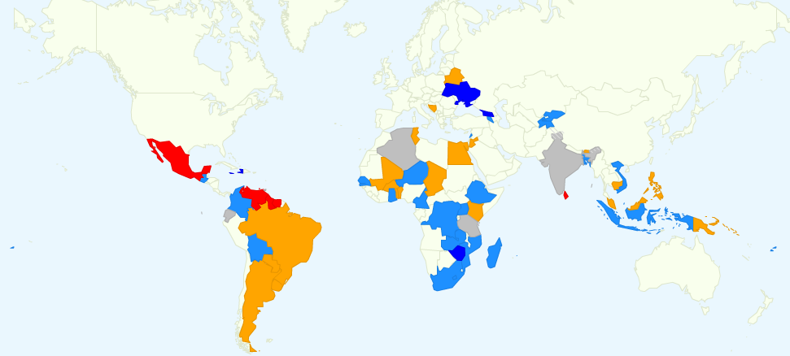
Red: Declined or Not sure
Orange: Little/No change
Light Blue: Increased
Dark Blue: Significantly increased
Grey: No answer

Source: AfTQ2013

- Geographically, based on EU Delegation replies, demand for Aid for Trade in Africa has registered an increase since 2009. On average, there has been little or no change in South America over the same period. For South East Asia, responses appear divided between those that have seen an increase in demand and those that have seen little or no change. Meanwhile, it has declined in parts of Central and South America.

6.2. Trade Needs Assessment and Strategies
- Overall, there is not one preferred answer in the replies of EU and EU Member States’ as to whether the partner country in the last five years has undertaken a comprehensive trade needs assessment (or updated an older one). This stems from the fact that 26 (40%) answered “yes” while 25 (38%) answered “no”, with the remaining 22 respondents indicating “partially” (20%).
- When asked whether the findings of a recent comprehensive trade needs assessment was reflected in the trade strategy of the partner country, 40% of EU and EU Member States indicated that it is partially or not applicable. Meanwhile, a large number of respondents answered “no” (32% of the total), owing to the fact that they had no trade strategy in place, while 25% answered “yes”.

6.3. Joint Operations and Harmonisation
- In sectors under the Aid for Trade umbrella, 38% of EU and EU Member States believe that they have a moderately more coordinated approach (in terms of joint needs assessments, joint implementation, joint monitoring/evaluation, etc…) with other donors compared to 2009. The second most common response (representing 25% of total replies) was that they were not sure or not applicable.
- Likewise, when applied to other non-EU donors, 42% of EU and EU Member States responded that they have a moderately more coordinated approach.

Table 7: Joint Operations and Harmonisation
EU-EU MS Joint reply - between EU and EU MS
In sectors under the Aid for Trade umbrella, do you have a more coordinated approach with other donors compared to 2009?
 | All | ACP | LDC | non ACP
Moderately | 38% (42%) | 45% (43%) | 35% (35%) | 32% (41%)
No | 18% (19%) | 19% (20%) | 15% (15%) | 18% (18%)
Not sure or Not applicable | 25% (27%) | 13% (17%) | 35% (30%) | 35% (35%)
Significantly | 18% (13%) | 23% (20%) | 15% (20%) | 15% (6%)
* In parenthesis: EU-EU MS Joint reply -with other non-EU donors

6.4. Regional dimension of Aid for Trade
- Reflecting the largest number of responses, 40% of EU and EU Member States believe that they have partially supported the partner country in strengthening the inclusion of strategic economic integration priorities in the national development plan or trade strategy whereas EU Delegations generally answered “yes” (41% of total replies). When answering “yes”, EU Member States (38%) and EU Delegations (50%) believe that this applies more so to LDC countries.

Figure 49: Have you supported the partner country in strengthening the inclusion of strategic regional economic integration priorities in the national development plan, or the trade strategy?
(% of yes)
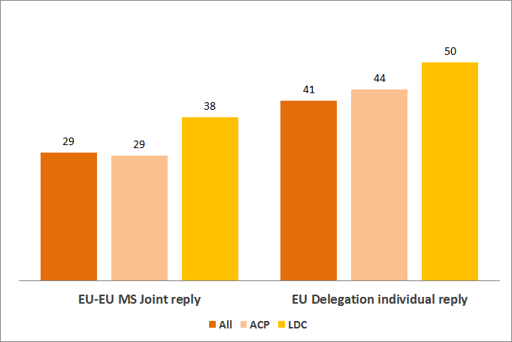
Source: AfTQ2013

- When asked whether this is an improvement from 2009, more than half of EU and Member States (58%) as well as EU Delegations (54%) replies stated that this was somewhat the case. Given that the second most popular answer was “not at all” for both groups, appears to suggest that there was little to no improvement since 2009.

Figure 50: Dialogue and Aid for Trade Amount
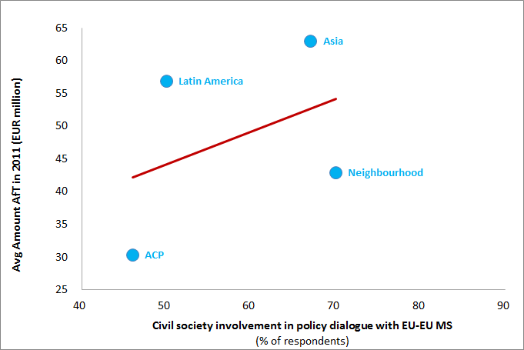
Source: AfTQ2013

- There appears to be a positive relationship between civil society involvement in the policy dialogue with EU and EU Member States and the average amount of Aid for Trade received in 2011. In other words, this suggests that regions such as Asian countries benefited relatively more from encouraging greater civil society involvement in their policy dialogue with EU-EU Member States.

6.5. Monitoring and Evaluation
- Regarding the order of importance in which to place the challenges in assessing Aid for Trade programmes and projects, EU and EU Member States generally agree on the following: (1) Difficulty in obtaining in-country data [“most important” 23%]; (2) Difficulty in identifying quantifiable objectives for interventions [“most important” 15%]; and (3) Difficulty in defining suitable indicators [“most important” 8%].
- Together reflecting the vast majority of responses, EU and EU Member States indicated either “not applicable” (35%) or “not all/not sure” (35%) to whether there are any processes in place to ensure that the results from the monitoring and evaluation of Aid for Trade programmes are fed back into the government’s trade development strategy.

Box 6: The OECD publication “Managing Aid for Trade Results”
The European Commission funded a study by the OECD to develop a menu of limited set of indicators to measure the performance of aid-for-trade interventions towards quantifiable targets and objectives and to take this work to the country level through a series of country case studies in a number of select partner countries. These include: Bangladesh, Colombia, Ghana, Rwanda, Solomon Islands and Vietnam. This OECD study will be published at:
http://www.oecd.org/dac/aft/managingforaidfortradedevelopmentresults.htm

6.6. Aid for Trade in Least Developing Countries
- A notable 75% majority of EU and EU Member States believe that their respective partner country (an LDC) ought to increase attention to trade.
- Regarding the order of main constraints to increasing Aid for Trade in the partner country, EU and EU Member States generally agree that the top two concerns are the low capacity to identify needs and priorities (“most important” 42%) and low absorption capacity (“most important” 24%).
Figure 51: What are the main constraints to increased Aid for Trade in the Partner Country?
(% of responses, AfT in LDCs)
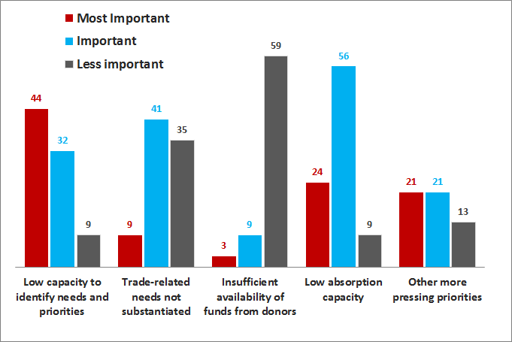
Source: AfTQ2013

- When asked if the Enhanced Integrated Framework (EIF) has made some contribution to the increased trade capacities of the partner country, the common response among EU and EU Member States were either that they were not sure (or that it was not applicable, for 39%), partially (21%), or that it was too early to assess (27%).
- With respect to whether EU or EU Member States were fulfilling their roles in the EIF as Donor Facilitators, 58% of EU and EU Member States answered “not sure or not applicable” while 19% replied “yes”.

6.7. Way Forward
This year’s monitoring exercise benefited of an increased participation from EU Delegations and Member States field offices, which demonstrates their continuous commitment towards the implementation of the AfT strategy.
The responses to the AfT questionnaire show a progressive improvement in terms of coordination, joint operations and harmonisation, and inclusion of strategic regional economic integration priorities into the national development plan or trade strategy.
In order to preserve this momentum and further bolster the effectiveness of the AfT the EU and Member States should:

- Provide more support to LDCs in order to strengthen their capacities in formulating AfT demand. Indeed AfT support depends largely on the extent to which partner countries mainstream these issues in their development agendas.

- Support Developing Countries and in particular LDCs in making better use of trade needs assessments to improve the effectiveness of AfT actions at country level. AfT programmes should be based on Needs Assessments that identify all the constraints a country is facing in participating in the world trading system and recommend a prioritised list of actions to remove the constraints.

- Continue to strengthen the policy dialogue on AfT matters in Partner Countries. Political will at governmental level in the recipient country, to create ownership and ensure demand-driven design and implementation of AfT programmes is essential.
- Continue the support to partner countries' own monitoring of results and impact of Aid for Trade and the progress of their trade development strategies. Obtaining in-country data and defining suitable indicators still remain among the major challenges in assessing AfT programmes and projects.

7. Appendix 1 – Definitions of AfT Categories
Aid for Trade (AfT) figures are obtained summing the following five categories: Trade Policy and Regulation (category 1), Trade Related Infrastructure (category 3), Building Productive Capacity (category 4, including trade development), Trade Related Adjustment (category 5) and Other Trade Related needs (category 6).

Trade Related Assistance can be viewed as a subset of Aid for Trade comprising three categories: Trade Policy and Regulation (category 1), Trade Development (category 2), and Other Trade Related Needs (category 6).

These categories are computed as follows:

• Trade Policy and Regulation (TPR or category 1) refers to trade policy and planning, trade facilitation, regional trade agreements, multilateral trade negotiations, multisector wholesale/retail trade and trade promotion.

This category includes training of trade officials, analysis of proposals and positions and their impact, support for national stakeholders to articulate commercial interests and identify trade-offs, dispute issues, and institutional and technical support to facilitate implementation of trade agreements and to adapt to and comply with rules and standards.

Technically, this category is the sum of the following sectors codes: 33110, 33120, 33130, 33140 & 33181(in the OECD CRS online database).

• Trade Development (TD or category 2) includes support aimed at stimulating trade by domestic firms and encouraging investment in trade-oriented industries, such as trade-related business development and activities to improve business climate, privatisation, assistance to banking and financial services, agriculture, forestry, fishing, industry, mineral resources and mining, and tourism.
This category is the trade-related subset of category 4 (which includes all building productive capacity of a trade related and non-trade-related nature).

This category is obtained my extracting all lines marked as “trade development” from category 4.

• Trade Related Infrastructure (TRI or category 3) includes physical infrastructure including transport and storage, communications, and energy generation and supply.

Technically, this category is the sum of the following sectors codes: 210**, 220**, 230** (in the OECD CRS online database).

• Building Productive Capacity (BPC or category 4) includes business development and activities aimed at improving the business climate, privatisation, assistance to banking and financial services, agriculture, forestry, fishing, industry, mineral resources and mining, tourism. It includes trade- and non-trade-related capacity building.

Technically, this category is the sum of the following sectors codes: 25010, 240**, 311**, 312**, 313**, 321**, 322**, 332** (in the OECD CRS online database).

• Trade Related Adjustment (TRA or category 5). This code was created by OECD/DAC at the end of 2007. It covers contributions to the government budget to assist with the implementation of recipients’ own trade reforms and adjustments to trade policy measures taken by other countries, as well as assistance to manage balance of payments shortfalls due to changes in the world trading environment.

Technically, this category is the sum of the sectors codes 33150 (in the OECD CRS online database).

• Other Trade Related Needs (OTRN or category 6) refers to programmes supporting trade in sectors not comprised in the other five categories (including the wider Aid for Trade agenda), such as vocational training or public sector policy programmes. It is also used to report on larger cross-sectorial programmes with important subcomponents in the other AfT categories. In this year’s Report, the category 6 is split among TRA programmes and other non TRA programmes to better reflect the nature of projects.

The change in methodology from the Doha Trade-Capacity-Building Database to CRS in 2007 and the new definitions create some limitations in the comparisons of figures over time. The amounts captured in the former database as “Trade Policy and Regulation” (category 1) and “Trade development” (category 2) are nowadays split into three categories, namely categories 1, 2 and 6. Due to the definitions of codes in the CRS, it is not possible to continue counting some activities as TPR or TD, since they have different CRS purpose codes and so they are captured in category 6. Moreover, figures prior to 2007 do not include category 6, which did not exist at the time. Therefore comparisons of TRA before and after 2007 need to be taken with caution.

The evaluation of TRA for the period 2001-2011 is therefore inferred from the direct combination of the five different databases: OECD CRS, Doha Development Database, Monterrey Questionnaires, Questionnaires of Accountability Report and EU (for category 6).

8. Appendix 2 – EU Member States AfT Donor Profiles

Aid for Trade flows reported in the following donor profiles come from the following data sources:
- The OECD Creditor Reporting System (CRS), in which most of EU Member States (15 out of 27) provide quantitative data on their Official Development Assistance (ODA).
- Information included in the "Monterrey questionnaire" for data of EU Member States that did not report to the OECD CRS and for the category 6 for EU.

AUSTRIA
Table: AfT Commitments (in thousand EUR)
 |  | 2008 | 2009 | 2010 | 2011
Trade-Related Assistance (TRA)
 | Trade Policy and Regulations  (category 1) | 2 113 | 97 | 71 | 112
 | Trade Development  (category 2) | 21 681 | 18 109 | 23 265 | 23 429
 | Other Trade Related Needs  (category 6) | 0 | 0 | 0 | 0
 | Total Trade-Related Assistance | 23 794 | 18 205 | 23 336 | 23 541
Wider Aid for Trade Agenda (AfT)
 | Trade Policy and Regulations  (category 1) | 2 113 | 97 | 71 | 112
 | Trade Related Infrastructure  (category 3) | 11 503 | 22 692 | 19 886 | 20 544
 | Building Productive Capacity (category 4) | 36 988 | 35 512 | 47 880 | 30 311
 | Trade Related Adjustment  (category 5) | 0 | 0 | 0 | 0
 | Other Trade Related Needs  (category 6) | 0 | 0 | 0 | 0
 | Total Aid for Trade | 50 604 | 58 301 | 67 837 | 50 967

Clarifications sources of data used in the tables:
- Trade Related Assistance: OECD/CRS database is the primary source of data for the two categories (trade development markers are used for the category 2). For 2006, the source of data for the category 2 is the Doha Development Database.
- Aid for Trade: OECD/CRS database is the primary source of data for the four categories.
BELGIUM
Table: AfT Commitments (in thousand EUR)
 |  | 2008 | 2009 | 2010 | 2011
Trade-Related Assistance (TRA)
 | Trade Policy and Regulations  (category 1) | 7 219 | 14 257 | 3 800 | 7 072
 | Trade Development  (category 2) | 51 189 | 190 243 | 0 | 0
 | Other Trade Related Needs  (category 6) | 0 | 0 | 0 | 0
 | Total Trade-Related Assistance | 58 408 | 204 500 | 3 800 | 7 072
Wider Aid for Trade Agenda (AfT)
 | Trade Policy and Regulations  (category 1) | 7 219 | 14 257 | 3 800 | 7 072
 | Trade Related Infrastructure  (category 3) | 44 369 | 105 272 | 59 985 | 48 158
 | Building Productive Capacity (category 4) | 169 282 | 269 502 | 251 588 | 288 480
 | Trade Related Adjustment  (category 5) | 0 | 0 | 0 | 0
 | Other Trade Related Needs  (category 6) | 0 | 0 | 0 | 0
 | Total Aid for Trade | 220 871 | 389 031 | 315 373 | 343 710

Clarifications sources of data used in the tables:
- Trade Related Assistance: OECD/CRS database is the primary source of data for the two categories (trade development markers are used for the category 2). For 2006 the source of data for the category 2 is the Doha Development Database and the Monterrey Questionnaire for 2007.
- Aid for Trade: OECD/CRS database is the primary source of data for the four categories.
BULGARIA
Table: AfT Commitments (in thousand EUR)
 |  | 2008 | 2009 | 2010 | 2011
Trade-Related Assistance (TRA)
 | Trade Policy and Regulations  (category 1) | 3 | 4 | 5.5 | 5.5
 | Trade Development  (category 2) | 0 | 0 | 0 | 0
 | Other Trade Related Needs  (category 6) | 0 | 0 | 0 | 0
 | Total Trade-Related Assistance | 3 | 4 | 5.5 | 5.5
Wider Aid for Trade Agenda (AfT)
 | Trade Policy and Regulations  (category 1) | 3 | 4 | 5.5 | 5.5
 | Trade Related Infrastructure  (category 3) | 0 | 0 | 0 | 0
 | Building Productive Capacity (category 4) | 0 | 0 | 0 | 0
 | Trade Related Adjustment  (category 5) | 0 | 0 | 0 | 0
 | Other Trade Related Needs  (category 6) | 0 | 0 | 0 | 0
 | Total Aid for Trade | 3 | 4 | 5.5 | 5.5

Clarifications sources of data used in the tables:
- Monterrey Questionnaires are the primary source of data for Trade Related Assistance and Aid for Trade.
- n/a: data not provided

CYPRUS
Table: AfT Commitments (in thousand EUR)
 |  | 2008 | 2009 | 2010 | 2011
Trade-Related Assistance (TRA)
 | Trade Policy and Regulations  (category 1) | 0 | 0 | 0 | 0
 | Trade Development  (category 2) | 0 | 0 | 0 | 0
 | Other Trade Related Needs  (category 6) | 0 | 0 | 0 | 0
 | Total Trade-Related Assistance | 0 | 0 | 0 | 0
Wider Aid for Trade Agenda (AfT)
 | Trade Policy and Regulations  (category 1) | 0 | 0 | 0 | 0
 | Trade Related Infrastructure  (category 3) | 0 | 0 | 0 | 0
 | Building Productive Capacity (category 4) | 0 | 0 | 0 | 0
 | Trade Related Adjustment  (category 5) | 0 | 0 | 0 | 0
 | Other Trade Related Needs  (category 6) | 0 | 0 | 0 | 0
 | Total Aid for Trade | 0 | 0 | 0 | 0

Clarifications sources of data used in the tables:
- Monterrey Questionnaires are the primary source of data for Trade Related Assistance and Aid for Trade.
- n/a: data not provided

CZECH REPUBLIC
Table: AfT Commitments (in thousand EUR)
 |  | 2008 | 2009 | 2010 | 2011
Trade-Related Assistance (TRA)
 | Trade Policy and Regulations  (category 1) | 46 | 53 | 28 | 19
 | Trade Development  (category 2) | 0 | 0 | 0 | 0
 | Other Trade Related Needs  (category 6) | 0 | 0 | 0 | 0
 | Total Trade-Related Assistance | 46 | 53 | 28 | 19
Wider Aid for Trade Agenda (AfT)
 | Trade Policy and Regulations  (category 1) | 46 | 53 | 28 | 19
 | Trade Related Infrastructure  (category 3) | 0 | 0 | 0 | 130
 | Building Productive Capacity (category 4) | 0 | 0 | 88 | 190
 | Trade Related Adjustment  (category 5) | 0 | 0 | 0 | 0
 | Other Trade Related Needs  (category 6) | 0 | 0 | 0 | 0
 | Total Aid for Trade | 46 | 53 | 116 | 338

Clarifications sources of data used in the tables:
- Monterrey Questionnaires are the primary source of data for Trade Related Assistance and Aid for Trade.
- n/a: data not provided

DENMARK
Table: AfT Commitments (in thousand EUR)
 |  | 2008 | 2009 | 2010 | 2011
Trade-Related Assistance (TRA)
 | Trade Policy and Regulations  (category 1) | 5 621 | 1 465 | 1 893 | 24 981
 | Trade Development  (category 2) | 67 317 | 95 038 | 111 385 | 57 224
 | Other Trade Related Needs  (category 6) | 0 | 0 | 0 | 0
 | Total Trade-Related Assistance | 72 939 | 96 503 | 113 278 | 82 205
Wider Aid for Trade Agenda (AfT)
 | Trade Policy and Regulations  (category 1) | 5 621 | 1 465 | 1 893 | 24 981
 | Trade Related Infrastructure  (category 3) | 36 995 | 63 382 | 25 845 | 78 780
 | Building Productive Capacity (category 4) | 130 851 | 186 367 | 244 667 | 113 839
 | Trade Related Adjustment  (category 5) | 0 | 0 | 0 | 0
 | Other Trade Related Needs  (category 6) | 0 | 0 | 0 | 0
 | Total Aid for Trade | 173 468 | 251 213 | 272 405 | 217 600

Clarifications sources of data used in the tables:
- Trade Related Assistance: OECD/CRS database is the primary source of data for the two categories (trade development markers are used for the category 2). For 2006 the source of data for the category 2 is the Doha Development Database.
- Aid for Trade: OECD/CRS database is the primary source of data for the four categories.
ESTONIA
Table: AfT Commitments (in thousand EUR)
 |  | 2008 | 2009 | 2010 | 2011
Trade-Related Assistance (TRA)
 | Trade Policy and Regulations  (category 1) | 46 | 13 | 32 | 30
 | Trade Development  (category 2) | 32 | 1 | 3 | 47
 | Other Trade Related Needs  (category 6) |  | 0 | 0 | 0
 | Total Trade-Related Assistance | 78 | 14 | 35 | 78
Wider Aid for Trade Agenda (AfT)
 | Trade Policy and Regulations  (category 1) | 46 | 13 | 32 | 30
 | Trade Related Infrastructure  (category 3) | 320 | 320 | 400 | 300
 | Building Productive Capacity (category 4) | 32 | 1 | 3 | 79
 | Trade Related Adjustment  (category 5) | 0 | 0 | 0 | 0
 | Other Trade Related Needs  (category 6) | 0 | 0 | 0 | 0
 | Total Aid for Trade | 398 | 334 | 435 | 409

Clarifications sources of data used in the tables:
- Monterrey Questionnaires are the primary source of data for Trade Related Assistance and Aid for Trade.
- n/a: data not provided

FINLAND
Table: AfT Commitments (in thousand EUR)
 |  | 2008 | 2009 | 2010 | 2011
Trade-Related Assistance (TRA)
 | Trade Policy and Regulations  (category 1) | 9 141 | 8 448 | 8 545 | 10 336
 | Trade Development  (category 2) | 42 304 | 82 501 | 47 955 | 106 158
 | Other Trade Related Needs  (category 6) | 0 | 0 | 0 | 0
 | Total Trade-Related Assistance | 51 445 | 90 950 | 56 500 | 116 493
Wider Aid for Trade Agenda (AfT)
 | Trade Policy and Regulations  (category 1) | 9 141 | 8 448 | 8 545 | 10 336
 | Trade Related Infrastructure  (category 3) | 14 443 | 123 189 | 40 216 | 45 983
 | Building Productive Capacity (category 4) | 111 764 | 124 280 | 146 131 | 172 948
 | Trade Related Adjustment  (category 5) | 0 | 0 | 0 | 7 729
 | Other Trade Related Needs  (category 6) | 0 | 0 | 0 | 0
 | Total Aid for Trade | 135 347 | 255 917 | 194 892 | 236 996

Clarifications sources of data used in the tables:
- Trade Related Assistance: OECD/CRS database is the primary source of data for the two categories (trade development markers are used for the category 2). For 2006, the source of data for the category 2 is the Doha Development Database.
- Aid for Trade: OECD/CRS database is the primary source of data for the four categories.
FRANCE
Table: AfT Commitments (in thousand EUR)
 |  | 2008 | 2009 | 2010 | 2011
Trade-Related Assistance (TRA)
 | Trade Policy and Regulations  (category 1) | 2 671 | 2 036 | 1 597 | 124
 | Trade Development  (category 2) | 13 809 | 81 534 | 16 203 | 11 054
 | Other Trade Related Needs  (category 6) | 0 | 0 | 0 | 0
 | Total Trade-Related Assistance | 16 479 | 83 571 | 17 800 | 11 178
Wider Aid for Trade Agenda (AfT)
 | Trade Policy and Regulations  (category 1) | 2 671 | 2 036 | 1 597 | 124
 | Trade Related Infrastructure  (category 3) | 1 142 527 | 576 485 | 591 916 | 558 748
 | Building Productive Capacity (category 4) | 593 016 | 511 581 | 683 690 | 364 588
 | Trade Related Adjustment  (category 5) | 0 | 0 | 0 | 0
 | Other Trade Related Needs  (category 6) | 0 | 0 | 0 | 0
 | Total Aid for Trade | 1 738 213 | 1 090 103 | 1 277 202 | 923 460

Clarifications sources of data used in the tables:
- Trade Related Assistance: OECD/CRS database is the primary source of data for the two categories (trade development markers are used for the category 2). The source of data for the category 2 is the Doha Development Database for 2006, the Monterrey Questionnaire for 2007 and subsequent clarifications provided by the French Department of Finances
- Aid for Trade: OECD/CRS database is the primary source of data for the four categories.
GERMANY
Table: AfT Commitments (in thousand EUR)
 |  | 2008 | 2009 | 2010 | 2011
Trade-Related Assistance (TRA)
 | Trade Policy and Regulations  (category 1) | 33 762 | 33 857 | 31 831 | 14 567
 | Trade Development  (category 2) | 646 247 | 666 561 | 464 794 | 859 068
 | Other Trade Related Needs  (category 6) | 0 | 0 | 0 | 0
 | Total Trade-Related Assistance | 680 008 | 700 418 | 496 625 | 873 635
Wider Aid for Trade Agenda (AfT)
 | Trade Policy and Regulations  (category 1) | 33 762 | 33 857 | 31 831 | 14 567
 | Trade Related Infrastructure  (category 3) | 1 037 126 | 746 676 | 2 199 494 | 1 191 209
 | Building Productive Capacity (category 4) | 965 506 | 1 108 401 | 1 113 210 | 1 475 603
 | Trade Related Adjustment  (category 5) | 0 | 0 | 0 | 0
 | Other Trade Related Needs  (category 6) | 0 | 0 | 0 | 0
 | Total Aid for Trade | 2 036 394 | 1 888 934 | 3 344 536 | 2 681 379

Clarifications sources of data used in the tables:
- Trade Related Assistance: OECD/CRS database is the primary source of data for the two categories (trade development markers are used for the category 2). The source of data for the category 2 is the Doha Development Database for 2006 and the Monterrey Questionnaire for 2007.
- Aid for Trade: OECD/CRS database is the primary source of data for the four categories.
GREECE
Table: AfT Commitments (in thousand EUR)
 |  | 2008 | 2009 | 2010 | 2011
Trade-Related Assistance (TRA)
 | Trade Policy and Regulations  (category 1) | 1 353 | 509 | 0 | 0
 | Trade Development  (category 2) | 2 594 | 4 148 | 729 | 256
 | Other Trade Related Needs  (category 6) | 0 | 0 | 0 | 0
 | Total Trade-Related Assistance | 3 947 | 4 657 | 729 | 256
Wider Aid for Trade Agenda (AfT)
 | Trade Policy and Regulations  (category 1) | 1 353 | 509 | 0 | 0
 | Trade Related Infrastructure  (category 3) | 4 359 | 7 237 | 13 717 | 14 923
 | Building Productive Capacity (category 4) | 4 178 | 5 283 | 904 | 313
 | Trade Related Adjustment  (category 5) | 0 | 0 | 0 | 0
 | Other Trade Related Needs  (category 6) | 0 | 0 | 0 | 0
 | Total Aid for Trade | 9 891 | 13 030 | 14 621 | 15 236

Clarifications sources of data used in the tables:
- Trade Related Assistance: OECD/CRS database is the primary source of data for the two categories (trade development markers are used for the category 2). The source of data for the category 2 in 2006 is the Doha Development Database.
- Aid for Trade: OECD/CRS database is the primary source of data for the four categories.
HUNGARY
Table: AfT Commitments (in thousand EUR)
 |  | 2008 | 2009 | 2010 | 2011
Trade-Related Assistance (TRA)
 | Trade Policy and Regulations  (category 1) | n/a | n/a | n/a | n/a
 | Trade Development  (category 2) | n/a | n/a | n/a | n/a
 | Other Trade Related Needs  (category 6) | n/a | n/a | n/a | n/a
 | Total Trade-Related Assistance | n/a | n/a | n/a | n/a
Wider Aid for Trade Agenda (AfT)
 | Trade Policy and Regulations  (category 1) | n/a | n/a | n/a | n/a
 | Trade Related Infrastructure  (category 3) | n/a | n/a | n/a | n/a
 | Building Productive Capacity (category 4) | n/a | n/a | n/a | n/a
 | Trade Related Adjustment  (category 5) | n/a | n/a | n/a | n/a
 | Other Trade Related Needs  (category 6) | n/a | n/a | n/a | n/a
 | Total Aid for Trade | n/a | n/a | n/a | n/a

Clarifications sources of data used in the tables:
- Monterrey Questionnaires are the primary source of data for Trade Related Assistance and Aid for Trade.
- n/a: data not provided
IRELAND
Table: AfT Commitments (in thousand EUR)
 |  | 2008 | 2009 | 2010 | 2011
Trade-Related Assistance (TRA)
 | Trade Policy and Regulations  (category 1) | 2 500 | 295 | 0 | 210
 | Trade Development  (category 2) | 13 325 | 0 | 14 414 | 4 520
 | Other Trade Related Needs  (category 6) | 0 | 0 | 0 | 0
 | Total Trade-Related Assistance | 15 825 | 295 | 14 414 | 4 730
Wider Aid for Trade Agenda (AfT)
 | Trade Policy and Regulations  (category 1) | 2 500 | 295 | 0 | 210
 | Trade Related Infrastructure  (category 3) | 2 088 | 664 | 1 087 | 1 370
 | Building Productive Capacity (category 4) | 47 742 | 43 310 | 47 757 | 48 201
 | Trade Related Adjustment  (category 5) | 0 | 0 | 0 | 0
 | Other Trade Related Needs  (category 6) | 0 | 0 | 0 | 0
 | Total Aid for Trade | 52 330 | 44 269 | 48 844 | 49 781

Clarifications sources of data used in the tables:
- Trade Related Assistance: OECD/CRS database is the primary source of data for the two categories (trade development markers are used for the category 2). The source of data for the category 2 is the Doha Development Database for 2006 and the Monterrey Questionnaire for 2007.
- Aid for Trade: OECD/CRS database is the primary source of data for the four categories.
ITALY
Table: AfT Commitments (in thousand EUR)
 |  | 2008 | 2009 | 2010 | 2011
Trade-Related Assistance (TRA)
 | Trade Policy and Regulations  (category 1) | 577 | 84 | 13 | 603
 | Trade Development  (category 2) | 28 905 | 32 452 | 31 593 | 12 020
 | Other Trade Related Needs  (category 6) | 0 | 5 200 | 0 | 0
 | Total Trade-Related Assistance | 29 482 | 37 736 | 31 606 | 12 623
Wider Aid for Trade Agenda (AfT)
 | Trade Policy and Regulations  (category 1) | 577 | 84 | 13 | 603
 | Trade Related Infrastructure  (category 3) | 37 070 | 34 168 | 57 532 | 29 046
 | Building Productive Capacity (category 4) | 148 546 | 162 624 | 73 245 | 34 242
 | Trade Related Adjustment  (category 5) | 0 | 0 | 0 | 0
 | Other Trade Related Needs  (category 6) | 0 | 5 200 | 0 | 0
 | Total Aid for Trade | 186 194 | 202 076 | 130 789 | 63 891

Clarifications sources of data used in the tables:
- Trade Related Assistance: OECD/CRS database is the primary source of data for the two categories (trade development markers are used for the category 2). The source of data for the category 2 in 2006 is the Doha Development Database. The source of data for the category 6 is Monterrey Questionnaire.
- Aid for Trade: OECD/CRS database is the primary source of data for the four categories. The source of data for the category 6 is Monterrey Questionnaire.
LATVIA
Table: AfT Commitments (in thousand EUR)
 |  | 2008 | 2009 | 2010 | 2011
Trade-Related Assistance (TRA)
 | Trade Policy and Regulations  (category 1) | 257 | 38 | n/a | n/a
 | Trade Development  (category 2) | 0 | 0 | n/a | n/a
 | Other Trade Related Needs  (category 6) | 0 | 0 | n/a | n/a
 | Total Trade-Related Assistance | 257 | 38 | n/a | n/a
Wider Aid for Trade Agenda (AfT)
 | Trade Policy and Regulations  (category 1) | 257 | 38 | n/a | n/a
 | Trade Related Infrastructure  (category 3) | 0 | 0 | n/a | n/a
 | Building Productive Capacity (category 4) | 0 | 0 | n/a | n/a
 | Trade Related Adjustment  (category 5) | 0 | 0 | n/a | n/a
 | Other Trade Related Needs  (category 6) | 0 | 0 | n/a | n/a
 | Total Aid for Trade | 257 | 38 | n/a | n/a

Clarifications sources of data used in the tables:
- Monterrey Questionnaires are the primary source of data for Trade Related Assistance and Aid for Trade.
- n/a: data not provided
LITHUANIA
Table: AfT Commitments (in thousand EUR)
 |  | 2008 | 2009 | 2010 | 2011
Trade-Related Assistance (TRA)
 | Trade Policy and Regulations  (category 1) | 232 | 74 | 66 | 0
 | Trade Development  (category 2) | 60 | 144 | 13 | 0
 | Other Trade Related Needs  (category 6) | 0 | 0 | 0 | 0
 | Total Trade-Related Assistance | 292 | 218 | 79 | 0
Wider Aid for Trade Agenda (AfT)
 | Trade Policy and Regulations  (category 1) | 232 | 74 | 66 | 0
 | Trade Related Infrastructure  (category 3) | 426 | 87 | 82 | 17
 | Building Productive Capacity (category 4) | 114 | 144 | 13 | 0
 | Trade Related Adjustment  (category 5) | 0 | 0 | 0 | 0
 | Other Trade Related Needs  (category 6) | 0 | 0 | 0 | 0
 | Total Aid for Trade | 772 | 305 | 161 | 17

Clarifications sources of data used in the tables:
- Monterrey Questionnaires are the primary source of data for Trade Related Assistance and Aid for Trade.
- n/a: data not provided
LUXEMBOURG
Table: AfT Commitments (in thousand EUR)
 |  | 2008 | 2009 | 2010 | 2011
Trade-Related Assistance (TRA)
 | Trade Policy and Regulations  (category 1) | 300 | 0 | 1 795 | 1 193
 | Trade Development  (category 2) | 0 | 0 | 0 | 0
 | Other Trade Related Needs  (category 6) | 0 | 0 | 0 | 0
 | Total Trade-Related Assistance | 300 | 0 | 1 795 | 1 193
Wider Aid for Trade Agenda (AfT)
 | Trade Policy and Regulations  (category 1) | 300 | 0 | 1 795 | 1 193
 | Trade Related Infrastructure  (category 3) | 3 456 | 590 | 1 785 | 3 406
 | Building Productive Capacity (category 4) | 24 292 | 21 215 | 23 644 | 24 855
 | Trade Related Adjustment  (category 5) | 0 | 0 | 0 | 0
 | Other Trade Related Needs  (category 6) | 0 | 0 | 0 | 0
 | Total Aid for Trade | 28 048 | 21 805 | 27 223 | 29 455

Clarifications sources of data used in the tables:
- Trade Related Assistance: OECD/CRS database is the primary source of data for the two categories (trade development markers are used for the category 2).
- Aid for Trade: OECD/CRS database is the primary source of data for the four categories.
MALTA
Table: AfT Commitments (in thousand EUR)
 |  | 2008 | 2009 | 2010 | 2011
Trade-Related Assistance (TRA)
 | Trade Policy and Regulations  (category 1) | n/a | n/a | n/a | n/a
 | Trade Development  (category 2) | n/a | n/a | n/a | n/a
 | Other Trade Related Needs  (category 6) | n/a | n/a | n/a | n/a
 | Total Trade-Related Assistance | n/a | n/a | n/a | n/a
Wider Aid for Trade Agenda (AfT)
 | Trade Policy and Regulations  (category 1) | n/a | n/a | n/a | n/a
 | Trade Related Infrastructure  (category 3) | n/a | n/a | n/a | n/a
 | Building Productive Capacity (category 4) | n/a | n/a | n/a | n/a
 | Trade Related Adjustment  (category 5) | n/a | n/a | n/a | n/a
 | Other Trade Related Needs  (category 6) | n/a | n/a | n/a | n/a
 | Total Aid for Trade | n/a | n/a | n/a | n/a

Clarifications sources of data used in the tables:
- Monterrey Questionnaires are the primary source of data for Trade Related Assistance and Aid for Trade.
- n/a: data not provided
THE NETHERLANDS
Table: AfT Commitments (in thousand EUR)
 |  | 2008 | 2009 | 2010 | 2011
Trade-Related Assistance (TRA)
 | Trade Policy and Regulations  (category 1) | 62 356 | 40 348 | 159 345 | 147 362
 | Trade Development  (category 2) | 0 | 0 | 0 | 0
 | Other Trade Related Needs  (category 6) | 0 | 33 100 | 0 | 0
 | Total Trade-Related Assistance | 62 356 | 73 448 | 159 345 | 147 362
Wider Aid for Trade Agenda (AfT)
 | Trade Policy and Regulations  (category 1) | 62 356 | 40 348 | 159 345 | 147 362
 | Trade Related Infrastructure  (category 3) | 237 787 | 204 559 | 93 638 | 93 498
 | Building Productive Capacity (category 4) | 165 495 | 237 193 | 171 397 | 609 188
 | Trade Related Adjustment  (category 5) | 0 | 0 | 0 | 0
 | Other Trade Related Needs  (category 6) | 0 | 0 | 0 | 0
 | Total Aid for Trade | 465 638 | 515 200 | 424 380 | 850 048

Clarifications sources of data used in the tables:
- Trade Related Assistance: OECD/CRS database is the primary source of data for the two categories (trade development markers are used for the category 2). The source of data for the category 2 is the Doha Development Database for 2006 and the 2009 EU AfT country fiches report for 2007. The source of data for the category 6 in 2009 is Monterrey Questionnaire.
- Aid for Trade: OECD/CRS database is the primary source of data for the four categories. The source of data for the category 6 in 2009 is Monterrey Questionnaire.
POLAND
Table: AfT Commitments (in thousand EUR)
 |  | 2008 | 2009 | 2010 | 2011
Trade-Related Assistance (TRA)
 | Trade Policy and Regulations  (category 1) | 8 | n/a | n/a | 28
 | Trade Development  (category 2) | 0 | n/a | n/a | 312
 | Other Trade Related Needs  (category 6) | 0 | n/a | n/a | 0
 | Total Trade-Related Assistance | 8 | n/a | n/a | 340
Wider Aid for Trade Agenda (AfT)
 | Trade Policy and Regulations  (category 1) | 8 | n/a | n/a | 28
 | Trade Related Infrastructure  (category 3) | 0 | n/a | n/a | 1 901
 | Building Productive Capacity (category 4) | 0 | n/a | n/a | 850
 | Trade Related Adjustment  (category 5) | 0 | n/a | n/a | 0
 | Other Trade Related Needs  (category 6) | 0 | n/a | n/a | 0
 | Total Aid for Trade | 8 | n/a | n/a | 2 779

Clarifications sources of data used in the tables:
- Monterrey Questionnaires are the primary source of data for Trade Related Assistance and Aid for Trade.
- n/a: data not provided
PORTUGAL
Table: AfT Commitments (in thousand EUR)
 |  | 2008 | 2009 | 2010 | 2011
Trade-Related Assistance (TRA)
 | Trade Policy and Regulations  (category 1) | 33 | 91 | 1 | 7
 | Trade Development  (category 2) | 1 483 | 3 910 | 1 466 | 1 420
 | Other Trade Related Needs  (category 6) | 0 | 0 | 0 | 0
 | Total Trade-Related Assistance | 1 516 | 4 001 | 1 467 | 1 427
Wider Aid for Trade Agenda (AfT)
 | Trade Policy and Regulations  (category 1) | 33 | 91 | 1 | 7
 | Trade Related Infrastructure  (category 3) | 9 845 | 61 515 | 38 741 | 16 255
 | Building Productive Capacity (category 4) | 2 957 | 4 349 | 2 075 | 2 260
 | Trade Related Adjustment  (category 5) | 0 | 0 | 0 | 0
 | Other Trade Related Needs  (category 6) | 0 | 0 | 0 | 0
 | Total Aid for Trade | 12 835 | 65 955 | 40 818 | 18 522

Clarifications sources of data used in the tables:
- Trade Related Assistance: OECD/CRS database is the primary source of data for the two categories (trade development markers are used for the category 2). The source of data for the category 2 in 2006 is the Doha Development Database.
- Aid for Trade: OECD/CRS database is the primary source of data for the four categories.
ROMANIA
Table: AfT Commitments (in thousand EUR)
 |  | 2008 | 2009 | 2010 | 2011
Trade-Related Assistance (TRA)
 | Trade Policy and Regulations  (category 1) | 0 | n/a | n/a | 393
 | Trade Development  (category 2) | 93 | n/a |  | 0
 | Other Trade Related Needs  (category 6) | 0 | n/a | n/a | 0
 | Total Trade-Related Assistance | 93 | n/a | n/a | 393
Wider Aid for Trade Agenda (AfT)
 | Trade Policy and Regulations  (category 1) | 0 | n/a | n/a | 393
 | Trade Related Infrastructure  (category 3) | 0 | n/a | n/a | 0
 | Building Productive Capacity (category 4) | 93 | n/a | 800 | 0
 | Trade Related Adjustment  (category 5) | 0 | n/a | n/a | 0
 | Other Trade Related Needs  (category 6) | 0 | n/a | n/a | 0
 | Total Aid for Trade | 93 | n/a | 800 | 393

Clarifications sources of data used in the tables:
- Monterrey Questionnaires are the primary source of data for Trade Related Assistance and Aid for Trade.
- n/a: data not provided
SLOVAKIA
Table: AfT Commitments (in thousand EUR)
 |  | 2008 | 2009 | 2010 | 2011
Trade-Related Assistance (TRA)
 | Trade Policy and Regulations  (category 1) | n/a | n/a | n/a | 0
 | Trade Development  (category 2) | n/a | n/a | n/a | 0
 | Other Trade Related Needs  (category 6) | n/a | n/a | n/a | 0
 | Total Trade-Related Assistance | n/a | n/a | n/a | 0
Wider Aid for Trade Agenda (AfT)
 | Trade Policy and Regulations  (category 1) | n/a | n/a | n/a | 0
 | Trade Related Infrastructure  (category 3) | n/a | n/a | n/a | 0
 | Building Productive Capacity (category 4) | n/a | n/a | n/a | 169
 | Trade Related Adjustment  (category 5) | n/a | n/a | n/a | 0
 | Other Trade Related Needs  (category 6) | n/a | n/a | n/a | 0
 | Total Aid for Trade | n/a | n/a | n/a | 169

Clarifications sources of data used in the tables:
- Monterrey Questionnaires are the primary source of data for Trade Related Assistance and Aid for Trade.
- n/a: data not provided

SLOVENIA
Table: AfT Commitments (in thousand EUR)
 |  | 2008 | 2009 | 2010 | 2011
Trade-Related Assistance (TRA)
 | Trade Policy and Regulations  (category 1) | 634 | 350 | 939 | 0
 | Trade Development  (category 2) | 900 | 0 | 269 | 218
 | Other Trade Related Needs  (category 6) | 0 | 0 | 0 | 0
 | Total Trade-Related Assistance | 1 534 | 350 | 1 208 | 218
Wider Aid for Trade Agenda (AfT)
 | Trade Policy and Regulations  (category 1) | 634 | 350 | 939 | 0
 | Trade Related Infrastructure  (category 3) | 0 | 38 | 317 | 194
 | Building Productive Capacity (category 4) | 900 | 0 | 269 | 248
 | Trade Related Adjustment  (category 5) | 0 | 0 | 0 | 0
 | Other Trade Related Needs  (category 6) | 0 | 0 | 0 | 0
 | Total Aid for Trade | 1 534 | 388 | 1 525 | 442

Clarifications sources of data used in the tables:
- Monterrey Questionnaires are the primary source of data for Trade Related Assistance and Aid for Trade.
- n/a: data not provided
SPAIN
Table: AfT Commitments (in thousand EUR)
 |  | 2008 | 2009 | 2010 | 2011
Trade-Related Assistance (TRA)
 | Trade Policy and Regulations  (category 1) | 4 535 | 2 692 | 4 766 | 1 147
 | Trade Development  (category 2) | 128 800 | 214 101 | 202 612 | 392 393
 | Other Trade Related Needs  (category 6) | 78 948 | 98 198 | 0 | 0
 | Total Trade-Related Assistance | 212 283 | 314 992 | 207 378 | 393 540
Wider Aid for Trade Agenda (AfT)
 | Trade Policy and Regulations  (category 1) | 4 535 | 2 692 | 4 766 | 1 147
 | Trade Related Infrastructure  (category 3) | 301 918 | 329 370 | 326 893 | 9 473
 | Building Productive Capacity (category 4) | 315 529 | 327 509 | 670 325 | 456 561
 | Trade Related Adjustment  (category 5) | 0 | 0 | 0 | 0
 | Other Trade Related Needs  (category 6) | 78 948 | 98 198 | 0 | 0
 | Total Aid for Trade | 700 930 | 757 769 | 1 001 984 | 467 181

Clarifications sources of data used in the tables:
- Trade Related Assistance: OECD/CRS database is the primary source of data for the two categories (trade development markers are used for the category 2). The source of data for the category 2 in 2006 is the Doha Development Database.
- Aid for Trade: OECD/CRS database is the primary source of data for the four categories.
- Amount reported in category 6 for 2008 taken from the 2010 AfT report and for 2009 in Monterrey Questionnaire.
SWEDEN
Table: AfT Commitments (in thousand EUR)
 |  | 2008 | 2009 | 2010 | 2011
Trade-Related Assistance (TRA)
 | Trade Policy and Regulations  (category 1) | 25 359 | 36 256 | 36 487 | 46 642
 | Trade Development  (category 2) | 10 261 | 38 750 | 94 572 | 106 391
 | Other Trade Related Needs  (category 6) | 0 | 0 | 0 | 0
 | Total Trade-Related Assistance | 35 621 | 75 006 | 131 058 | 153 033
Wider Aid for Trade Agenda (AfT)
 | Trade Policy and Regulations  (category 1) | 25 359 | 36 256 | 36 487 | 46 642
 | Trade Related Infrastructure  (category 3) | 78 993 | 32 032 | 93 087 | 30 613
 | Building Productive Capacity (category 4) | 121 107 | 179 013 | 153 320 | 171 278
 | Trade Related Adjustment  (category 5) | 0 | 0 | 0 | 1 845
 | Other Trade Related Needs  (category 6) | 0 | 0 | 0 | 0
 | Total Aid for Trade | 225 459 | 247 302 | 282 894 | 250 378

Clarifications sources of data used in the tables:
- Trade Related Assistance: OECD/CRS database is the primary source of data for the two categories (trade development markers are used for the category 2). The source of data for the category 2 is the Doha Development Database for 2006.
- Aid for Trade: OECD/CRS database is the primary source of data for the four categories.
UNITED KINGDOM
Table: AfT Commitments (in thousand EUR)
 |  |  |  | 2008 |  | 2009 |  | 2010 |  | 2011
 | Trade-Related Assistance (TRA)
 |  |  | Trade Policy and Regulations  (category 1) |  | 62 741 |  | 152 932 |  | 131 498 |  | 6 521
 |  |  | Trade Development  (category 2) |  | 29 647 |  | 227 711 |  | 325 102 |  | 270 465
 |  |  | Other Trade Related Needs  (category 6) |  | 0 |  | 8 |  | 0 |  | 0
 |  |  | Total Trade-Related Assistance |  | 92 388 |  | 380 651 |  | 456 600 |  | 276 986
 | Wider Aid for Trade Agenda (AfT)
 |  |  | Trade Policy and Regulations  (category 1) |  | 62 741 |  | 152 932 |  | 131 498 |  | 6 521
 |  |  | Trade Related Infrastructure  (category 3) |  | 226 262 |  | 347 231 |  | 251 655 |  | 254 013
 |  |  | Building Productive Capacity (category 4) |  | 950 580 |  | 829 103 |  | 333 125 |  | 305 933
 |  |  | Trade Related Adjustment  (category 5) |  | 0 |  | 0 |  | 0 |  | 0
 |  |  | Other Trade Related Needs  (category 6) |  | 0 |  | 0 |  | 0 |  | 0
 |  |  | Total Aid for Trade |  | 1 239 583 |  | 1 329 274 |  | 716 278 |  | 566 467

Clarifications sources of data used in the tables:
- Trade Related Assistance: OECD/CRS database is the primary source of data for the two categories (trade development markers are used for the category 2). The source of data for the category 2 is the Doha Development Database for 2006.
- Aid for Trade: OECD/CRS database is the primary source of data for the four categories.
EU
Table: AfT Commitments (in thousand EUR)
 |  | 2008 | 2009 | 2010 | 2011
Trade-Related Assistance (TRA)
 | Trade Policy and Regulations  (category 1) | 238 095 | 315 655 | 145 111 | 320 332
 | Trade Development  (category 2) | 317 330 | 262 995 | 451 904 | 331 602
 | Other Trade Related Needs  (category 6) | 451 526 | 332 496 | 299 605 | 66 000
 | Total Trade-Related Assistance | 1 006 951 | 911 146 | 896 620 | 717 934
Wider Aid for Trade Agenda (AfT)
 | Trade Policy and Regulations  (category 1) | 238 095 | 315 655 | 145 111 | 320 332
 | Trade Related Infrastructure  (category 3) | 1 661 064 | 1 103 032 | 950 198 | 967 446
 | Building Productive Capacity (category 4) | 701 599 | 1 535 414 | 1 108 553 | 973 297
 | Trade Related Adjustment  (category 5) | 4 037 | 11 312 | 16 580 | 30 954
 | Other Trade Related Needs  (category 6) | 451 526 | 332 496 | 299 605 | 412 000
 | Total Aid for Trade | 3 056 322 | 3 297 909 | 2 520 047 | 2 704 029

Clarifications sources of data used in the tables:
- Trade Related Assistance: OECD/CRS database is the primary source of data for the two categories (trade development markers are used for the category 2). The source of data for the category 2 is the Doha Development Database for 2006.
- Aid for Trade: OECD/CRS database is the primary source of data for the four categories.
- The source of data for the category 6 is the European Commission.

9. Appendix 3 – Aid for Trade by Region, Country and Category
WEST AFRICA
(mn EUR) | 2000 | 2001 | 2002 | 2003 | 2004 | 2005 | 2006 | 2007 | 2008 | 2009 | 2010 | 2011
1.TPR | 0 | 3 | 2 | 2 | 4 | 4 | 14 | 7 | 2 | 45 | 14 | 1
3.TRI | 222 | 119 | 166 | 388 | 259 | 557 | 230 | 274 | 668 | 271 | 344 | 332
4.BPC | 261 | 269 | 245 | 251 | 241 | 287 | 280 | 332 | 283 | 356 | 288 | 316
5.TRAdj | 0 | 0 | 0 | 0 | 0 | 0 | 0 | 0 | 1 | 0 | 0 | 0
6.Other TR Needs | 0 | 0 | 0 | 0 | 0 | 0 | 0 | 0 | 0 | 0 | 0 | 0
TOTAL | 484 | 391 | 413 | 641 | 505 | 848 | 524 | 613 | 954 | 672 | 647 | 649
Source: OECD CRS
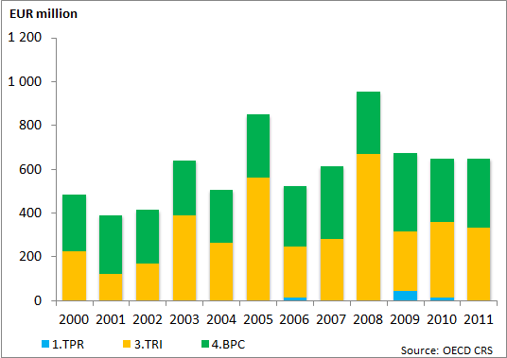
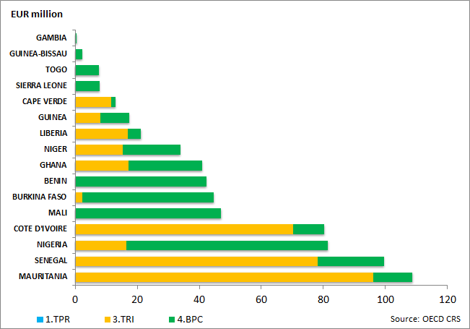
CENTRAL AFRICA
 | 2000 | 2001 | 2002 | 2003 | 2004 | 2005 | 2006 | 2007 | 2008 | 2009 | 2010 | 2011
1.TPR | 0 | 0 | 0 | 0 | 0 | 0 | 0 | 6 | 2 | 29 | 2 | 0
3.TRI | 79 | 164 | 156 | 83 | 56 | 183 | 305 | 111 | 198 | 233 | 42 | 306
4.BPC | 41 | 47 | 93 | 76 | 50 | 63 | 83 | 91 | 58 | 50 | 71 | 107
5.TRAdj | 0 | 0 | 0 | 0 | 0 | 0 | 0 | 0 | 0 | 0 | 0 | 0
6.Other TR Needs | 0 | 0 | 0 | 0 | 0 | 0 | 0 | 0 | 0 | 0 | 0 | 0
TOTAL | 120 | 211 | 249 | 159 | 106 | 247 | 388 | 207 | 259 | 312 | 114 | 413
Source: OECD CRS
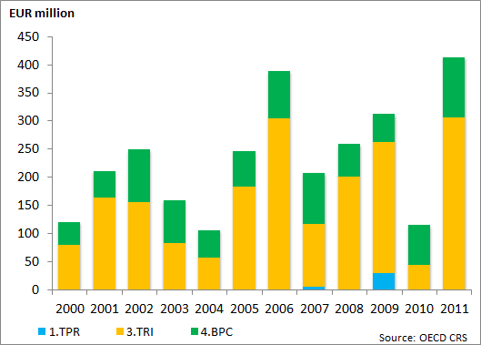
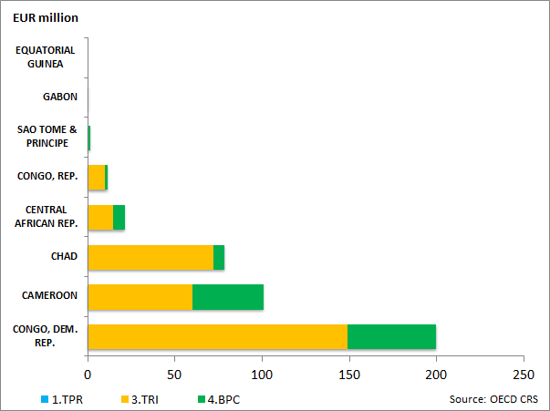
EAC
(mn EUR) | 2000 | 2001 | 2002 | 2003 | 2004 | 2005 | 2006 | 2007 | 2008 | 2009 | 2010 | 2011
1.TPR | 1 | 1 | 0 | 1 | 1 | 10 | 3 | 2 | 8 | 27 | 19 | 9
3.TRI | 230 | 182 | 100 | 107 | 138 | 332 | 183 | 182 | 123 | 566 | 307 | 245
4.BPC | 144 | 124 | 124 | 109 | 126 | 116 | 159 | 99 | 230 | 225 | 272 | 212
5.TRAdj | 0 | 0 | 0 | 0 | 0 | 0 | 0 | 0 | 0 | 0 | 0 | 0
6.Other TR Needs | 0 | 0 | 0 | 0 | 0 | 0 | 0 | 0 | 0 | 0 | 0 | 0
TOTAL | 375 | 307 | 224 | 216 | 265 | 457 | 345 | 283 | 361 | 818 | 598 | 466
Source: OECD CRS
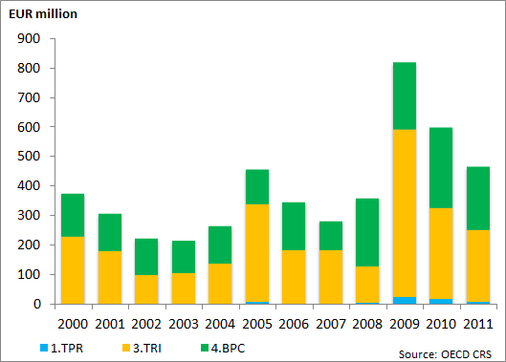
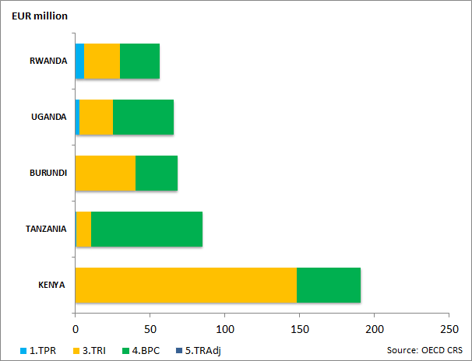
EAST AFRICA EXCL. EAC
(mn EUR) | 2000 | 2001 | 2002 | 2003 | 2004 | 2005 | 2006 | 2007 | 2008 | 2009 | 2010 | 2011
1.TPR | 4 | 0 | 1 | 0 | 1 | 2 | 9 | 5 | 1 | 2 | 13 | 3
3.TRI | 95 | 114 | 183 | 280 | 206 | 389 | 316 | 201 | 510 | 136 | 171 | 31
4.BPC | 234 | 112 | 117 | 186 | 113 | 170 | 188 | 152 | 167 | 328 | 194 | 228
5.TRAdj | 0 | 0 | 0 | 0 | 0 | 0 | 0 | 0 | 2 | 0 | 0 | 0
6.Other TR Needs | 0 | 0 | 0 | 0 | 0 | 0 | 0 | 0 | 0 | 0 | 0 | 0
TOTAL | 332 | 226 | 301 | 467 | 320 | 561 | 513 | 358 | 681 | 466 | 379 | 262
Source: OECD CRS
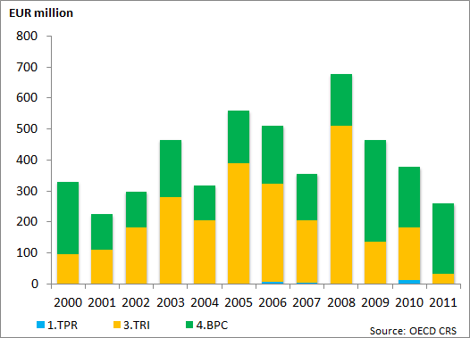
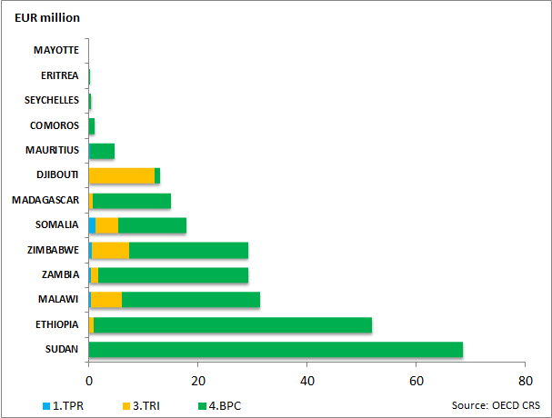
SOUTHERN AFRICA
(mn EUR) | 2000 | 2001 | 2002 | 2003 | 2004 | 2005 | 2006 | 2007 | 2008 | 2009 | 2010 | 2011
1.TPR | 1 | 0 | 0 | 0 | 4 | 2 | 4 | 2 | 18 | 3 | 2 | 3
3.TRI | 102 | 80 | 127 | 149 | 42 | 244 | 87 | 121 | 229 | 83 | 254 | 92
4.BPC | 94 | 193 | 144 | 84 | 69 | 240 | 157 | 159 | 159 | 115 | 187 | 173
5.TRAdj | 0 | 0 | 0 | 0 | 0 | 0 | 0 | 0 | 0 | 0 | 0 | 0
6.Other TR Needs | 0 | 0 | 0 | 0 | 0 | 0 | 0 | 0 | 0 | 0 | 0 | 0
TOTAL | 197 | 274 | 271 | 233 | 115 | 486 | 248 | 282 | 406 | 201 | 442 | 267
Source: OECD CRS
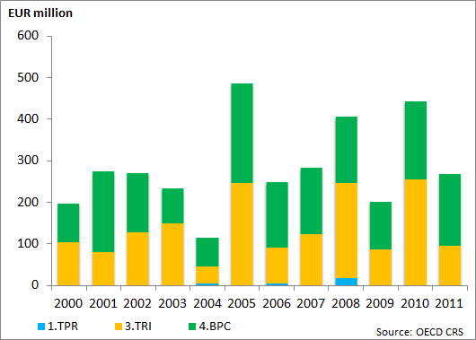
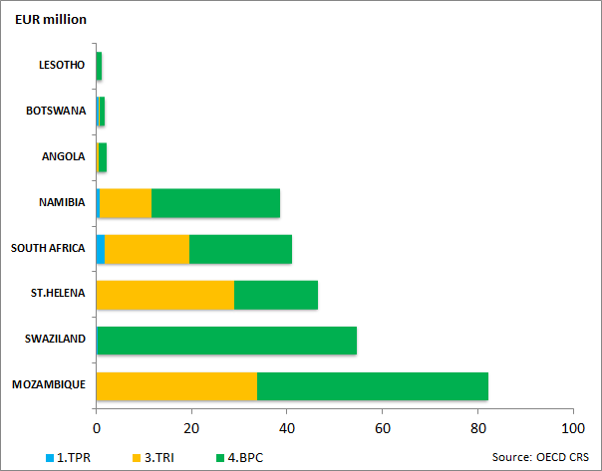
CARIBBEAN
(mn EUR) | 2000 | 2001 | 2002 | 2003 | 2004 | 2005 | 2006 | 2007 | 2008 | 2009 | 2010 | 2011
1.TPR | 0 | 0 | 0 | 0 | 0 | 2 | 5 | 1 | 0 | 0 | 0 | 49
3.TRI | 81 | 70 | 22 | 54 | 63 | 39 | 18 | 27 | 27 | 193 | 53 | 129
4.BPC | 183 | 110 | 82 | 27 | 97 | 73 | 74 | 95 | 95 | 67 | 160 | 108
5.TRAdj | 0 | 0 | 0 | 0 | 0 | 0 | 0 | 0 | 1 | 11 | 17 | 31
6.Other TR Needs | 0 | 0 | 0 | 0 | 0 | 0 | 0 | 0 | 0 | 0 | 0 | 0
TOTAL | 264 | 180 | 104 | 80 | 160 | 113 | 97 | 122 | 122 | 272 | 230 | 316
Source: OECD CRS
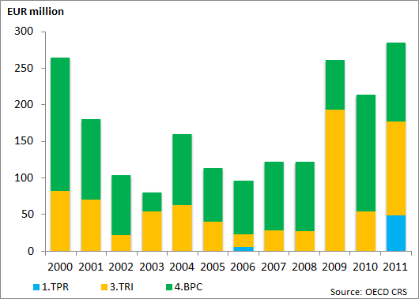
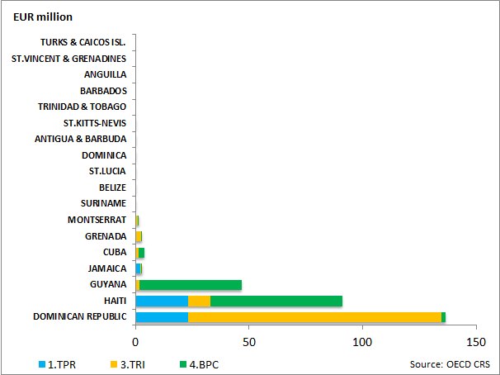
PACIFIC
(mn EUR) | 2000 | 2001 | 2002 | 2003 | 2004 | 2005 | 2006 | 2007 | 2008 | 2009 | 2010 | 2011
1.TPR | 0 | 0 | 0 | 0 | 0 | 0 | 0 | 3 | 0 | 0 | 0 | 0
3.TRI | 13 | 15 | 9 | 10 | 10 | 11 | 0 | 2 | 1 | 23 | 2 | 5
4.BPC | 15 | 5 | 56 | 12 | 9 | 13 | 8 | 7 | 10 | 9 | 10 | 9
5.TRAdj | 0 | 0 | 0 | 0 | 0 | 0 | 0 | 0 | 0 | 0 | 0 | 0
6.Other TR Needs | 0 | 0 | 0 | 0 | 0 | 0 | 0 | 0 | 0 | 0 | 0 | 0
TOTAL | 28 | 20 | 65 | 22 | 19 | 25 | 8 | 13 | 11 | 32 | 13 | 14
Source: OECD CRS
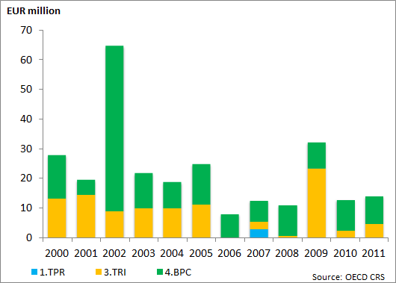
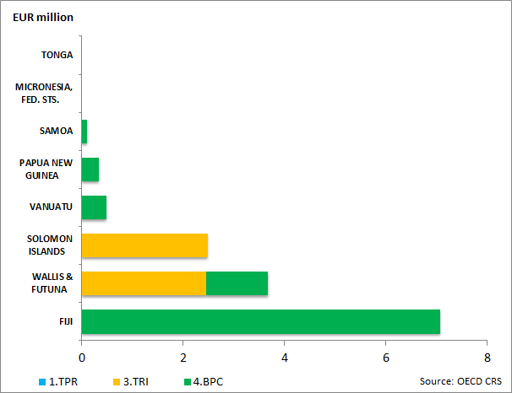
NEIGHBOURHOOD
(mn EUR) | 2000 | 2001 | 2002 | 2003 | 2004 | 2005 | 2006 | 2007 | 2008 | 2009 | 2010 | 2011
1.TPR | 6 | 2 | 77 | 63 | 1 | 22 | 17 | 24 | 79 | 3 | 1 | 38
3.TRI | 168 | 95 | 329 | 334 | 342 | 393 | 454 | 693 | 1 317 | 633 | 862 | 338
4.BPC | 297 | 201 | 297 | 224 | 131 | 242 | 354 | 315 | 436 | 411 | 707 | 267
5.TRAdj | 0 | 0 | 0 | 0 | 0 | 0 | 0 | 0 | 0 | 0 | 0 | 2
6.Other TR Needs | 0 | 0 | 0 | 0 | 0 | 0 | 0 | 0 | 0 | 0 | 0 | 0
TOTAL | 470 | 297 | 703 | 622 | 474 | 657 | 825 | 1 032 | 1 831 | 1 047 | 1 570 | 644
Source: OECD CRS
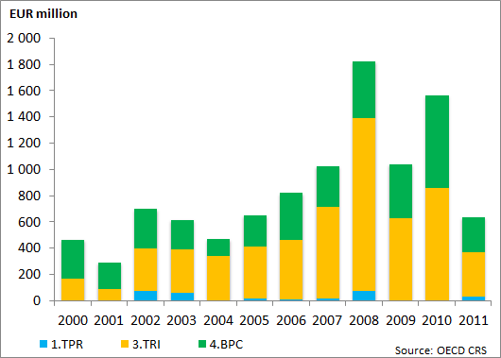

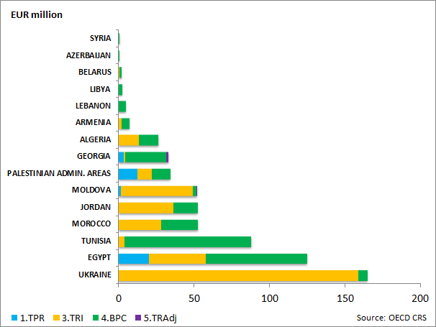
ENLARGEMENT
(mn EUR) | 2000 | 2001 | 2002 | 2003 | 2004 | 2005 | 2006 | 2007 | 2008 | 2009 | 2010 | 2011
1.TPR | 4 | 0 | 0 | 17 | 9 | 8 | 46 | 4 | 66 | 30 | 5 | 42
3.TRI | 128 | 131 | 302 | 314 | 167 | 169 | 460 | 219 | 485 | 229 | 583 | 357
4.BPC | 96 | 124 | 320 | 91 | 125 | 203 | 132 | 209 | 494 | 259 | 388 | 339
5.TRAdj | 0 | 0 | 0 | 0 | 0 | 0 | 0 | 0 | 0 | 0 | 0 | 0
6.Other TR Needs | 0 | 0 | 0 | 0 | 0 | 0 | 0 | 0 | 0 | 0 | 0 | 0
TOTAL | 228 | 255 | 622 | 422 | 301 | 380 | 638 | 432 | 1 045 | 518 | 975 | 739
Source: OECD CRS
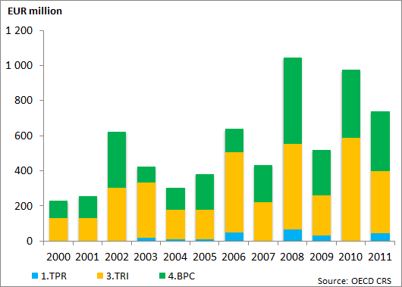

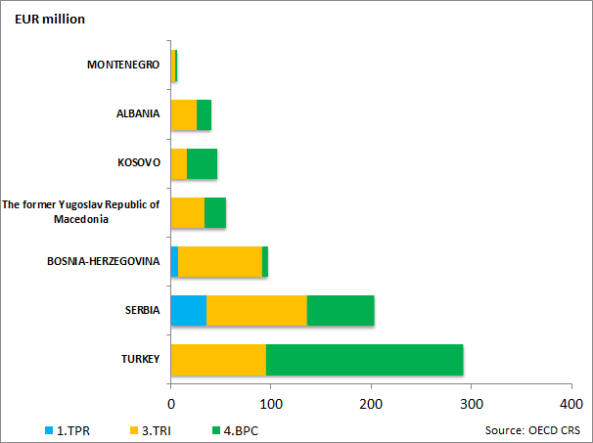
LATIN AMERICA
(mn EUR) | 2000 | 2001 | 2002 | 2003 | 2004 | 2005 | 2006 | 2007 | 2008 | 2009 | 2010 | 2011
1.TPR | 14 | 14 | 9 | 5 | 39 | 16 | 19 | 6 | 17 | 60 | 2 | 7
3.TRI | 116 | 181 | 154 | 89 | 95 | 7 | 15 | 35 | 83 | 168 | 201 | 168
4.BPC | 169 | 237 | 293 | 207 | 210 | 212 | 175 | 318 | 260 | 347 | 376 | 218
5.TRAdj | 0 | 0 | 0 | 0 | 0 | 0 | 0 | 0 | 0 | 0 | 0 | 0
6.Other TR Needs | 0 | 0 | 0 | 0 | 0 | 0 | 0 | 0 | 0 | 0 | 0 | 0
TOTAL | 299 | 432 | 456 | 301 | 344 | 235 | 209 | 359 | 360 | 575 | 580 | 393
Source: OECD CRS
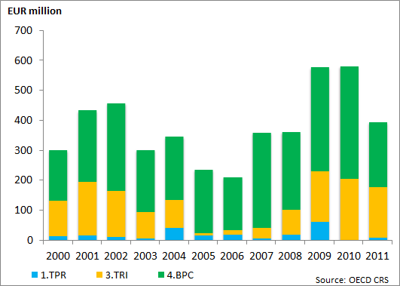
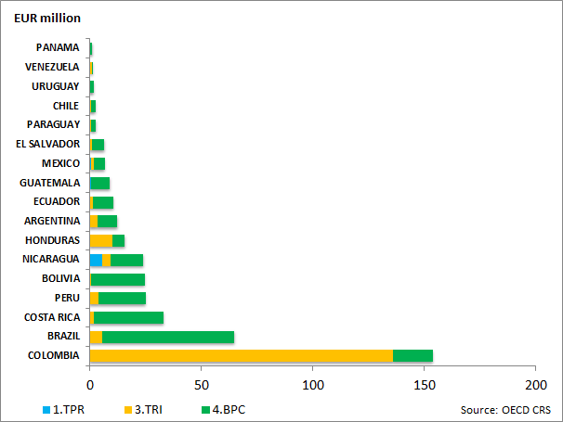
SOUTH ASIA
(mn EUR) | 2000 | 2001 | 2002 | 2003 | 2004 | 2005 | 2006 | 2007 | 2008 | 2009 | 2010 | 2011
1.TPR | 8 | 1 | 1 | 28 | 5 | 4 | 18 | 1 | 31 | 2 | 14 | 1
3.TRI | 235 | 310 | 168 | 178 | 179 | 342 | 196 | 147 | 355 | 245 | 206 | 548
4.BPC | 249 | 163 | 167 | 267 | 98 | 192 | 281 | 305 | 402 | 378 | 148 | 103
5.TRAdj | 0 | 0 | 0 | 0 | 0 | 0 | 0 | 0 | 0 | 0 | 0 | 0
6.Other TR Needs | 0 | 0 | 0 | 0 | 0 | 0 | 0 | 0 | 0 | 0 | 0 | 0
TOTAL | 493 | 474 | 336 | 473 | 282 | 539 | 495 | 453 | 787 | 624 | 367 | 652
Source: OECD CRS
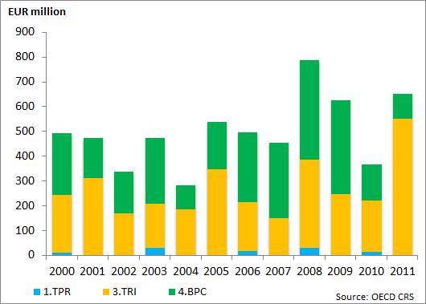
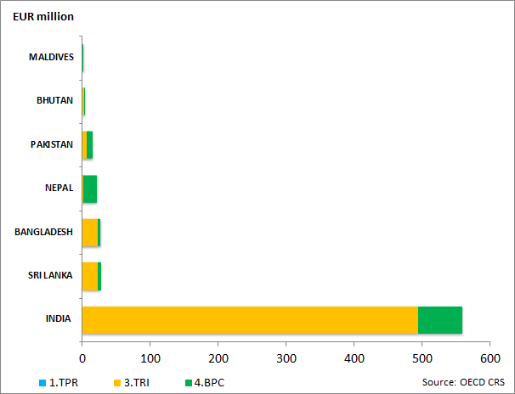
MIDDLE EAST
(mn EUR) | 2000 | 2001 | 2002 | 2003 | 2004 | 2005 | 2006 | 2007 | 2008 | 2009 | 2010 | 2011
1.TPR | 0 | 0 | 7 | 0 | 0 | 0 | 6 | 0 | 0 | 0 | 2 | 9
3.TRI | 20 | 13 | 0 | 37 | 45 | 79 | 7 | 22 | 29 | 11 | 38 | 2
4.BPC | 11 | 0 | 4 | 6 | 56 | 22 | 1 | 1 | 5 | 137 | 25 | 18
5.TRAdj | 0 | 0 | 0 | 0 | 0 | 0 | 0 | 0 | 0 | 0 | 0 | 0
6.Other TR Needs | 0 | 0 | 0 | 0 | 0 | 0 | 0 | 0 | 0 | 0 | 0 | 0
TOTAL | 31 | 13 | 11 | 42 | 100 | 101 | 14 | 24 | 35 | 147 | 65 | 30
Source: OECD CRS
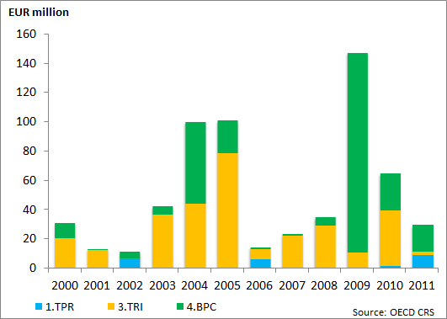
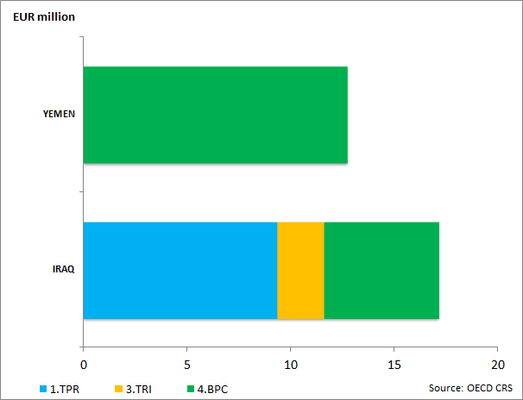
CENTRAL ASIA
(mn EUR) | 2000 | 2001 | 2002 | 2003 | 2004 | 2005 | 2006 | 2007 | 2008 | 2009 | 2010 | 2011
1.TPR | 0 | 0 | 0 | 0 | 1 | 0 | 0 | 1 | 0 | 0 | 0 | 0
3.TRI | 2 | 31 | 0 | 13 | 3 | 40 | 0 | 67 | 48 | 10 | 5 | 4
4.BPC | 5 | 17 | 6 | 17 | 12 | 14 | 17 | 43 | 27 | 48 | 26 | 75
5.TRAdj | 0 | 0 | 0 | 0 | 0 | 0 | 0 | 0 | 0 | 0 | 0 | 0
6.Other TR Needs | 0 | 0 | 0 | 0 | 0 | 0 | 0 | 0 | 0 | 0 | 0 | 0
TOTAL | 7 | 48 | 6 | 30 | 16 | 54 | 17 | 110 | 75 | 57 | 32 | 79
Source: OECD CRS
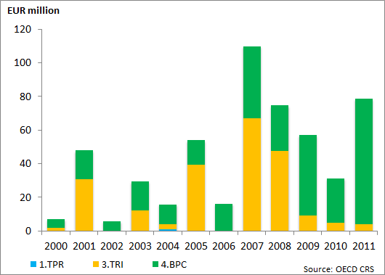
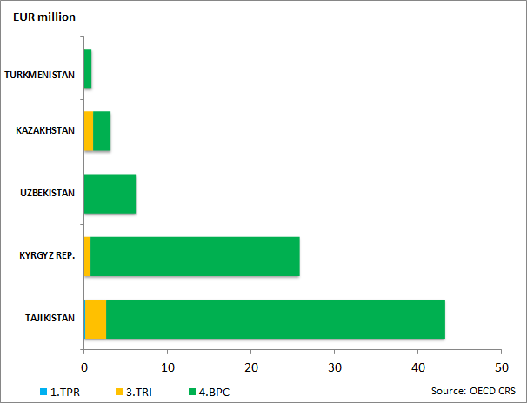
ASEAN
(mn EUR) | 2000 | 2001 | 2002 | 2003 | 2004 | 2005 | 2006 | 2007 | 2008 | 2009 | 2010 | 2011
1.TPR | 7 | 1 | 0 | 12 | 9 | 4 | 8 | 26 | 21 | 0 | 20 | 15
3.TRI | 129 | 241 | 169 | 46 | 133 | 161 | 239 | 176 | 75 | 179 | 205 | 40
4.BPC | 141 | 183 | 159 | 197 | 211 | 234 | 190 | 291 | 187 | 152 | 230 | 172
5.TRAdj | 0 | 0 | 0 | 0 | 0 | 0 | 0 | 0 | 0 | 0 | 0 | 0
6.Other TR Needs | 0 | 0 | 0 | 0 | 0 | 0 | 0 | 0 | 0 | 0 | 0 | 0
TOTAL | 277 | 424 | 328 | 255 | 353 | 399 | 437 | 492 | 283 | 331 | 455 | 227
Source: OECD CRS
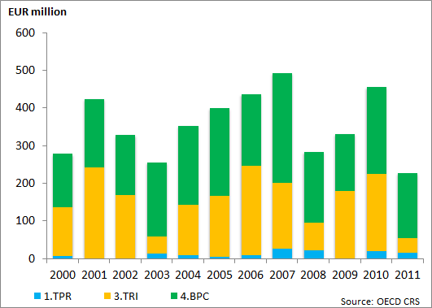
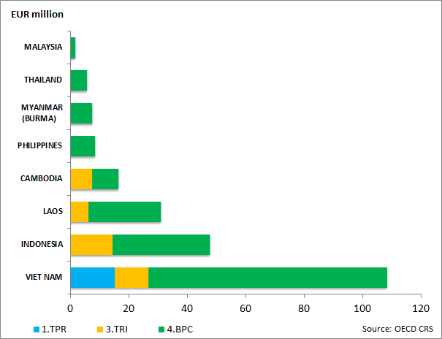
ASIA (other)
(mn EUR) | 2000 | 2001 | 2002 | 2003 | 2004 | 2005 | 2006 | 2007 | 2008 | 2009 | 2010 | 2011
1.TPR | 2 | 2 | 23 | 0 | 5 | 22 | 13 | 1 | 64 | 48 | 30 | 0
3.TRI | 67 | 256 | 103 | 232 | 180 | 179 | 340 | 94 | 298 | 264 | 425 | 145
4.BPC | 158 | 106 | 62 | 130 | 129 | 105 | 63 | 87 | 276 | 334 | 165 | 116
5.TRAdj | 0 | 0 | 0 | 0 | 0 | 0 | 0 | 0 | 0 | 0 | 0 | 0
6.Other TR Needs | 0 | 0 | 0 | 0 | 0 | 0 | 0 | 0 | 0 | 0 | 0 | 0
TOTAL | 227 | 364 | 188 | 363 | 314 | 306 | 417 | 182 | 638 | 646 | 620 | 261
Source: OECD CRS
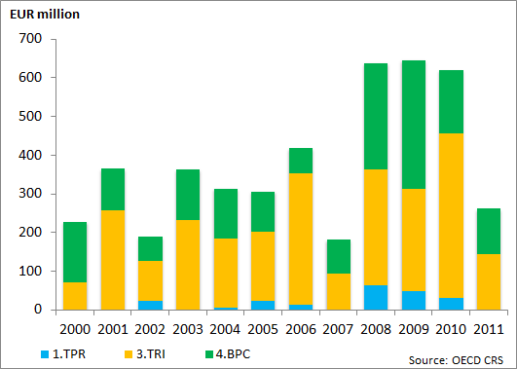
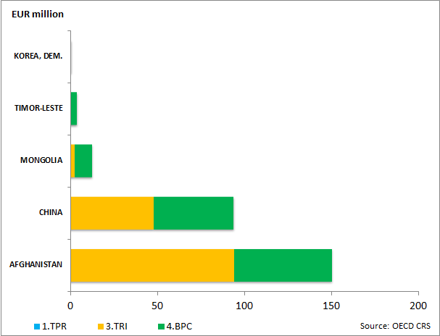
REGIONAL
(mn EUR) | 2000 | 2001 | 2002 | 2003 | 2004 | 2005 | 2006 | 2007 | 2008 | 2009 | 2010 | 2011
1.TPR | 42 | 43 | 74 | 106 | 67 | 133 | 322 | 254 | 150 | 358 | 403 | 404
3.TRI | 227 | 301 | 283 | 236 | 246 | 272 | 585 | 381 | 405 | 515 | 1 066 | 622
4.BPC | 495 | 893 | 579 | 603 | 782 | 654 | 1 451 | 1 269 | 1 399 | 2 366 | 1 824 | 2 611
5.TRAdj | 0 | 0 | 0 | 0 | 0 | 0 | 0 | 0 | 0 | 0 | 0 | 8
TOTAL | 764 | 1 238 | 936 | 945 | 1 096 | 1 059 | 2 358 | 1 905 | 1 953 | 3 239 | 3 293 | 3 644
Source: OECD CRS
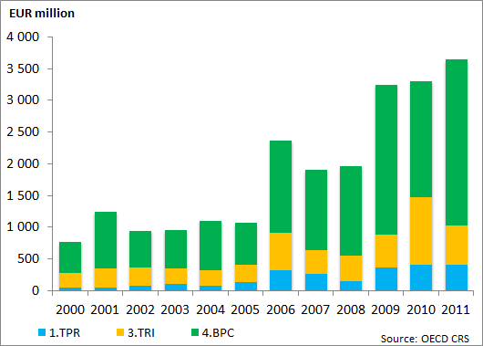
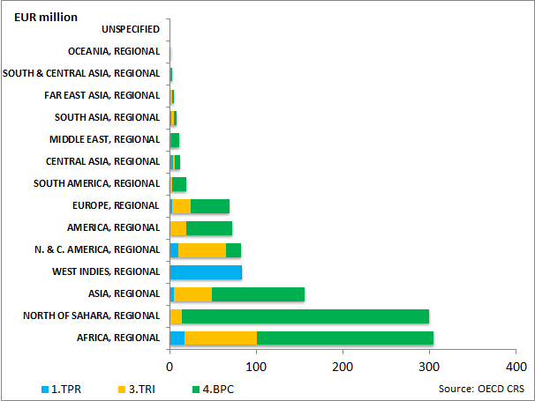

10. Appendix 4 –Trade Related Assistance by Region, Country and Category
WEST AFRICA
(mn EUR) | 2008 | 2009 | 2010 | 2011
1.TPR | 2 | 45 | 14 | 1
2.TD | 50 | 122 | 93 | 179
6.Other TR Needs | 0 | 0 | 0 | 0
TOTAL | 52 | 167 | 107 | 180
Source: OECD CRS
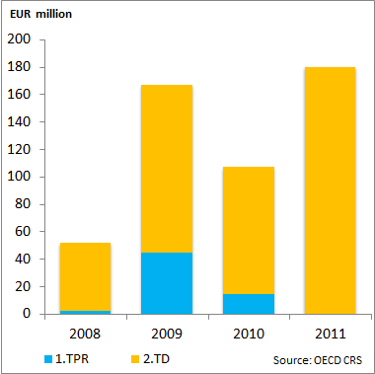

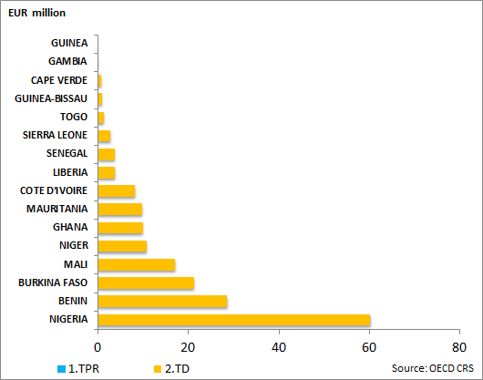
CENTRAL AFRICA
(mn EUR) | 2008 | 2009 | 2010 | 2011
1.TPR | 2 | 29 | 2 | 0.14
2.TD | 17 | 14 | 26 | 53
6.Other TR Needs | 0 | 0 | 0 | 0
TOTAL | 19 | 43 | 28 | 53
Source: OECD CRS
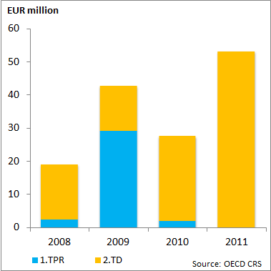
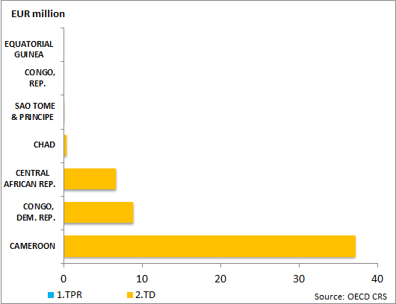

EAC
(mn EUR) | 2008 | 2009 | 2010 | 2011
1.TPR | 8 | 27 | 19 | 9
2.TD | 94 | 77 | 98 | 83
6.Other TR Needs | 0 | 0 | 0 | 0
TOTAL | 102 | 105 | 117 | 93
Source: OECD CRS
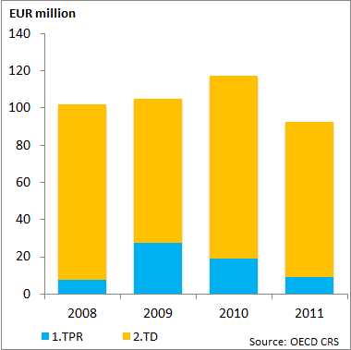
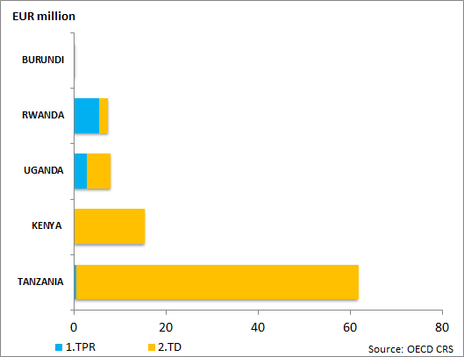
EAST AFRICA EXCL. EAC
(mn EUR) | 2008 | 2009 | 2010 | 2011
1.TPR | 1 | 2 | 13 | 3
2.TD | 42 | 66 | 52 | 52
6.Other TR Needs | 0 | 0 | 0 | 0
TOTAL | 43 | 69 | 65 | 55
Source: OECD CRS
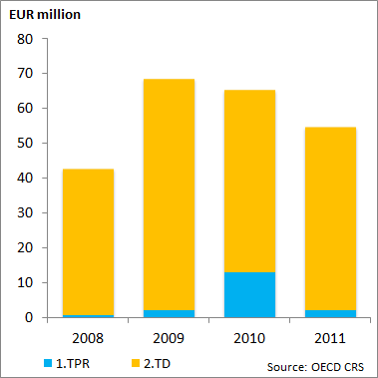
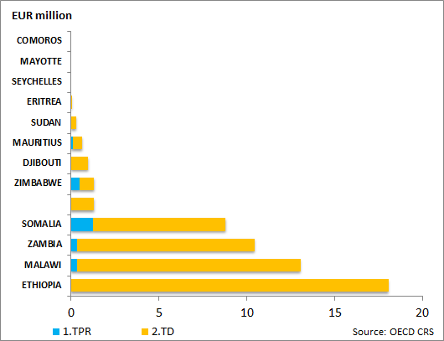
SOUTHERN AFRICA
(mn EUR) | 2008 | 2009 | 2010 | 2011
1.TPR | 18 | 3 | 2 | 3
2.TD | 23 | 41 | 65 | 117
6.Other TR Needs | 0 | 0 | 0 | 0
TOTAL | 42 | 44 | 67 | 120
Source: OECD CRS
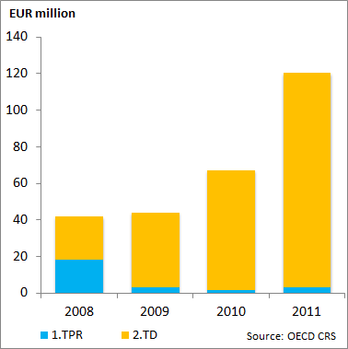

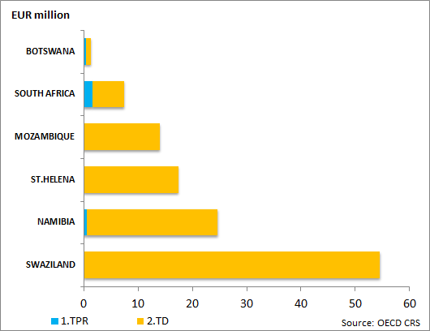
CARIBBEAN
(mn EUR) | 2008 | 2009 | 2010 | 2011
1.TPR | 0 | 0 | 0 | 49
2.TD | 74 | 49 | 113 | 81
6.Other TR Needs | 0 | 0 | 0 | 0
TOTAL | 74 | 49 | 113 | 130
Source: OECD CRS
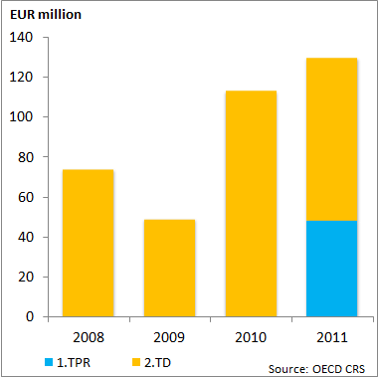
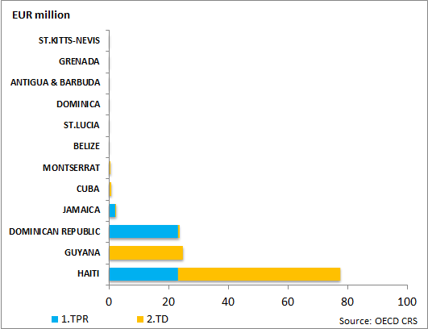
PACIFIC
(mn EUR) | 2008 | 2009 | 2010 | 2011
1.TPR | 0 | 0 | 0 | 0
2.TD | 8 | 6 | 1 | 0
6.Other TR Needs | 0 | 0 | 0 | 0
TOTAL | 8 | 6 | 1 | 0
Source: OECD CRS
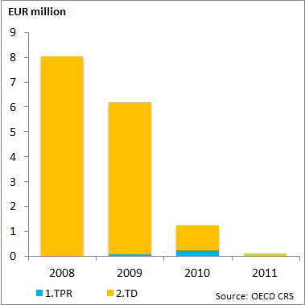
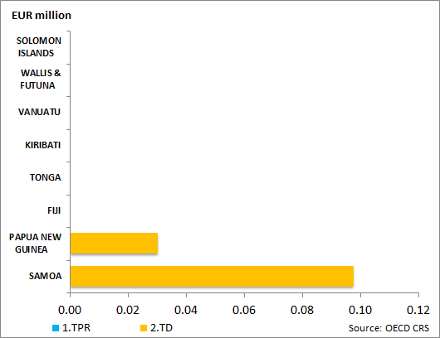
NEIGHBOURHOOD
(mn EUR) | 2008 | 2009 | 2010 | 2011
1.TPR | 79 | 3 | 1 | 38
2.TD | 204 | 138 | 205 | 142
6.Other TR Needs | 0 | 0 | 0 | 0
TOTAL | 282 | 141 | 206 | 180
Source: OECD CRS
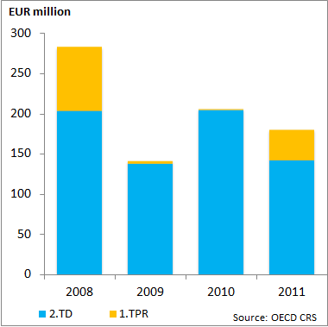

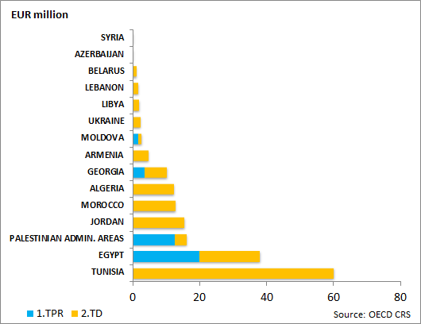
ENLARGEMENT
(mn EUR) | 2008 | 2009 | 2010 | 2011
1.TPR | 66 | 30 | 5 | 42
2.TD | 96 | 46 | 73 | 43
6.Other TR Needs | 0 | 0 | 0 | 0
TOTAL | 162 | 76 | 77 | 85
Source: OECD CRS
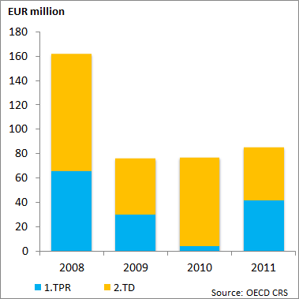
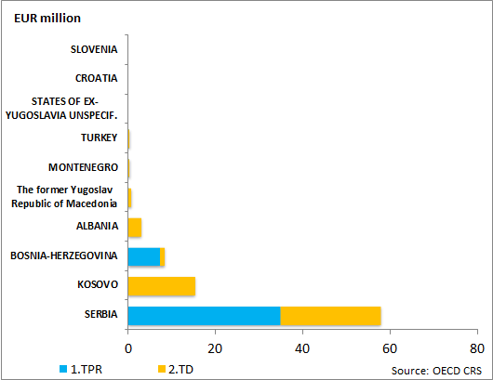
LATIN AMERICA
(mn EUR) | 2008 | 2009 | 2010 | 2011
1.TPR | 17 | 60 | 2 | 7
2.TD | 125 | 173 | 199 | 74
6.Other TR Needs | 0 | 0 | 0 | 0
TOTAL | 142 | 233 | 202 | 81
Source: OECD CRS
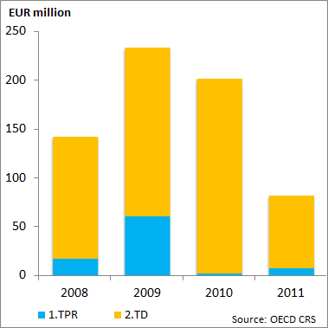
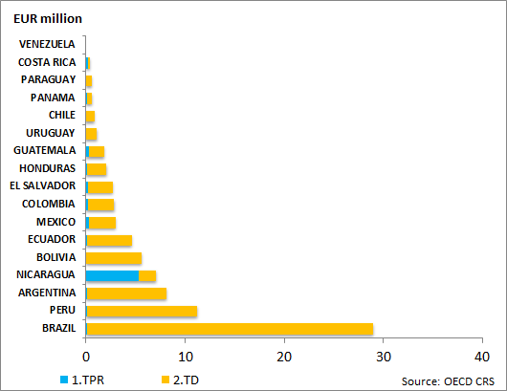
SOUTH ASIA
(mn EUR) | 2008 | 2009 | 2010 | 2011
1.TPR | 31 | 2 | 14 | 1
2.TD | 125 | 200 | 65 | 71
6.Other TR Needs | 0 | 0 | 0 | 0
TOTAL | 155 | 202 | 79 | 71
Source: OECD CRS
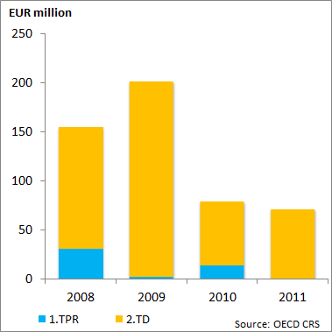
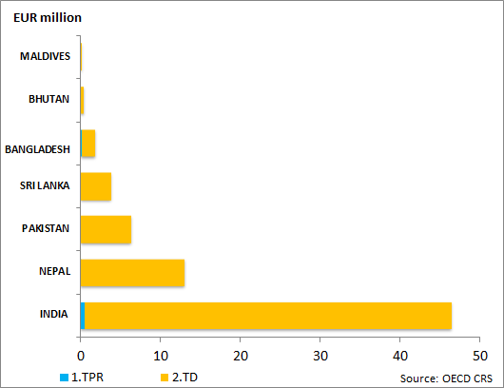
MIDDLE EAST
(mn EUR) | 2008 | 2009 | 2010 | 2011
1.TPR | 0 | 0 | 2 | 9
2.TD | 1 | 18 | 20 | 15
6.Other TR Needs | 0 | 0 | 0 | 0
TOTAL | 2 | 18 | 22 | 24
Source: OECD CRS
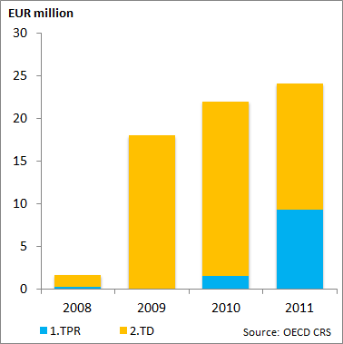
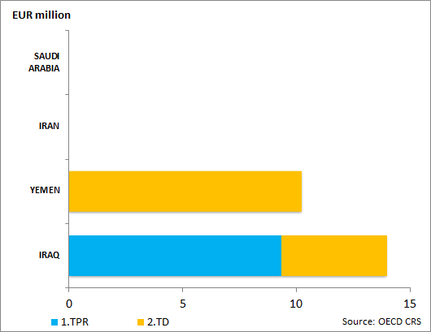
CENTRAL ASIA
(mn EUR) | 2008 | 2009 | 2010 | 2011
1.TPR | 0 | 0 | 0 | 0
2.TD | 9 | 36 | 18 | 37
6.Other TR Needs | 0 | 0 | 0 | 0
TOTAL | 9 | 36 | 18 | 37
Source: OECD CRS
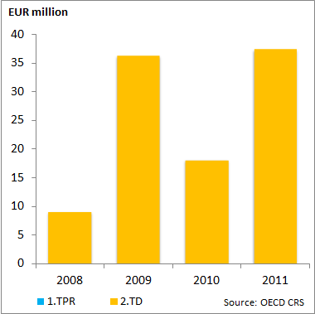
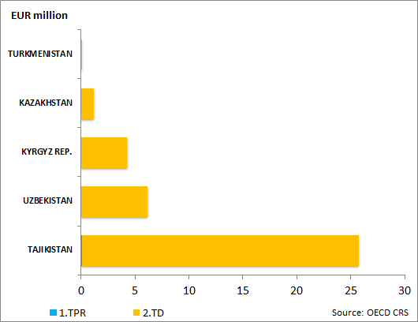
ASEAN
(mn EUR) | 2008 | 2009 | 2010 | 2011
1.TPR | 21 | 0 | 20 | 15
2.TD | 59 | 30 | 100 | 59
6.Other TR Needs | 0 | 0 | 0 | 0
TOTAL | 79 | 31 | 120 | 75
Source: OECD CRS
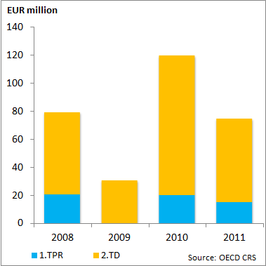
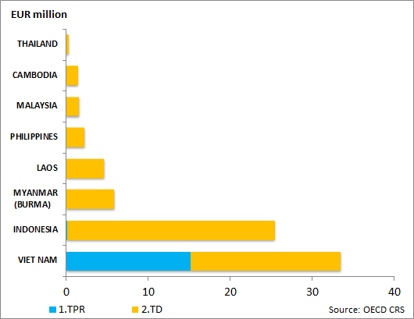
ASIA (other)
(mn EUR) | 2008 | 2009 | 2010 | 2011
1.TPR | 64 | 48 | 30 | 0
2.TD | 135 | 87 | 70 | 62
6.Other TR Needs | 0 | 0 | 0 | 0
TOTAL | 198 | 134 | 100 | 62
Source: OECD CRS
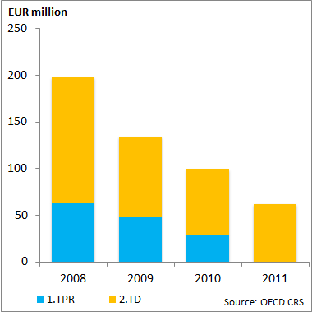
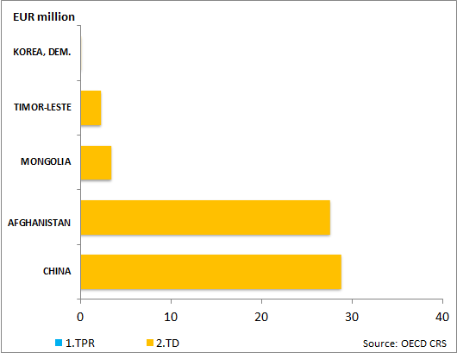
REGIONAL
(mn EUR) | 2008 | 2009 | 2010 | 2011
1.TPR | 150 | 358 | 403 | 404
2.TD | 314 | 783 | 589 | 1 105
6.Other TR Needs | 0 | 0 | 0 | 0
TOTAL | 464 | 1 141 | 991 | 1 509
Source: OECD CRS
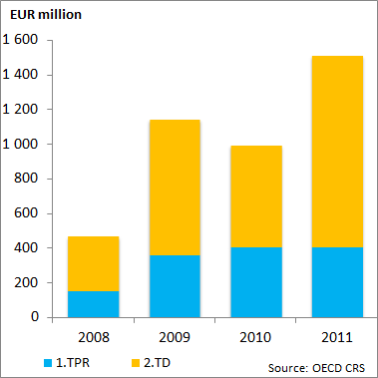

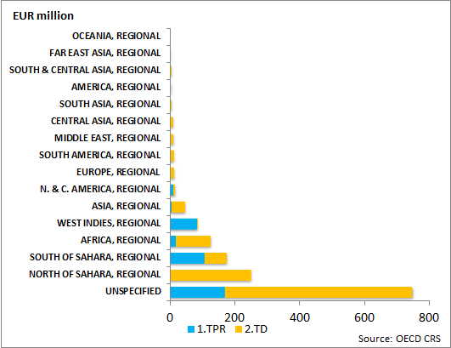

Appendix 5 – EU AfT commitments: Category 6 in 2011
Project title | Geographical Area/country | Amount in  EUR
Framework Programme in support of EU-Georgia agreements (AAP 2011) | Georgia | 9,730,000
Cross-border co-operation fYROM and Kosovo. Kosovo 2011. | Kosovo | 600,000
Cross-border co-operation fYROM and Kosovo. fYROM 2011. | Macedonia | 705,882
CBC Montenegro-Kosovo 2011-2013 (Allocation 2011 Kosovo) | Montenegro-Kosovo | 540,000
Cross-border programme Bosnia and Herzegovina - Montenegro for the year 2011 | Montenegro | 600,000
Cross-border programme Bosnia and Herzegovina - Montenegro for the year 2011 | Bosnia-Herzegovina | 500,000
Cross-border programme Croatia - Montenegro under the IPA Component II for the year 2011; Montenegro part | Montenegro | 500,000
Cross-border programme Croatia - Serbia under the IPA Component II for the year 2011; Serbia part | Serbia | 1,000,000
Cross-border programme Croatia - Bosnia and Herzegovina under the IPA Component II for the year 2011 | Bosnia Herzegovina | 1,000,000
Cross-border programme Croatia - Montenegro under the IPA component II for the year 2011; Croatia part | Croatia | 400,000
Cross-border programme Croatia - Serbia under the IPA component II for the year 2011 | Croatia | 800,000
Cross-border programme Croatia - Bosnia and Herzegovina under the IPA component II for the year 2011; Croatia part | Croatia | 1,000,000
Cross-border co-operation Albania and Montenegro for year 2011 (Montenegro part ) | Montenegro | 600,000
Cross-border co-operation Albania and Montenegro. Albania 2011 | Albania | 850,000
Cross-border co-operation FYROM and Albania. Albania 2011 | Albania | 850,000
Cross-border co-operation FYROM and Albania - fYROM 2011 | Macedonia | 1,000,000
IPA 2011 Cross-border Cooperation Programme for Serbia - Montenegro (Montenegro Part) | Montenegro | 600,000
Cross-border programme for Serbia - Montenegro for the year 2011 (Serbia part) | Serbia | 600,000
Cross-border programme Bosnia and Herzegovina - Serbia for the year 2011 (RS- part) | Serbia | 1,000,000
Cross-border programme Bosnia and Herzegovina - Serbia for the year 2011 (Bosnia - part) | Bosnia Herzegovina | 700,000
2011 National Programme for Albania | Albania | 3,000,000
SPRING 2011 Tunisie Programme d'Appui à l'Accord d'Association et à la Transition | Tunisia | 10,000,000
Serbia National Programme 2011 | Serbia | 4,100,000
2011 Annual Programme for Kosovo* under the IPA Transition Assistance and Institution Building Component | Kosovo | 10,700,000
Turkey National Programme IPA 2011 Com. I Part 2 | Turkey | 15,350,000
Subtotal TRA Programmes |  | 66,725,882
Project title | Geographical Area/country | Amount in  EUR
Poverty Reduction Programme (PRP)-III | Jamaica | 2,000,000
Accompanying measures for sugar protocol countries 2011 – Jamaica – Sector Budget Support | Jamaica | 30,953,000
Support for infrastructure development in Saint Helena, Ascension and Tristan da Cunha | Saint Helena | 16,630,000
EC Support to the second phase of the Public Sector Capacity Building Programme (PSCAP II) | Ethiopia | 10,000,000
Programa de Apoyo a la mejora del entorno financiero y fiscal para las MiPyMEs (PAMEFF) | Bolivia | 35,000,000
Economic Development Programme II: Support to infrastructure rehabilitation and development in Somaliland and Puntland | Somaliland and Puntland | 25,000,000
Support for Partnership Reform and Inclusive Growth (SPRING) - 2011 Allocation | Mediterranean Region | 10,000,000
Rural Development Support Programme in Azerbaijan (AAP 2011) | Azerbaijan | 20,000,000
National Programme for FYROM under the IPA Transition Assistance and Institution Building Component for 2011 | Macedonia | 1,269,000
Investment Facility for Central Asia (IFCA) | Central Asia | 20,000,000
Investment Facility for Central Asia (IFCA) | Central Asia | 20,000,000
EU Budget contribution to the NIF (2011-2013) - ENPI East Region | Region Neighbourhood East | 33,000,000
Support to FEMIP 2011 | North Africa | 20,000,000
EU Budget contribution to the NIF (2011-2013) - ENPI South Region | Region Neighbourhood South | 66,700,000
EU Budget contribution to the NIF (2011-2013) - ENPI East Region | Region Neighbourhood East | 33,000,000
Subtotal NON TRA Programmes |  | 343,552,000

TOTAL Category 6: 410,277,882 EUR

The EU institutions mentioned in the report are the European Commission and the European Investment Bank (EIB). However, the EIB’s figures were reported only until 2007.
Meeting at the Seoul Summit during June 26-27, 2010, the assembled leaders of the Group of Twenty pledged to (at least) maintain aid-for-trade levels that reflect the average of 2006 to 2008 beyond 2011 and tasked the OECD and the WTO to monitor progress.
Other types of AfT flow are ODA loans and Equity investments.
According to the OECD definition, trade facilitation is considered a subset of the category trade policy and regulation, and can be defined as the "simplification and harmonisation of international import and export procedures (e.g. customs valuation, licensing procedures, transport formalities, payments, insurance); support to customs departments; tariff reforms."
The European Union Communication to the WTO Negotiating Group on Trade Facilitation of June 2012 shows that the scope of the OECD CRS definition is limited and lists various programmes that are not necessarily classified under the trade facilitation category but should be considered as TF support (such as infrastructure projects related to the improvement of transit corridors, as well as projects reaching from feasibility study to serious road, energy and transport projects, etc.).
Category 6 (Other Trade Related Needs) refers to programmes supporting trade in sectors not comprised in the other five categories. It is also used to report on larger cross-sectorial programmes with important subcomponents in the other AfT categories. In this year’s Report, the category 6 is split among TRA programmes and other non TRA programmes to better reflect the nature of projects. For more information, please see Appendix I.
Category 6 « other trade related needs» can include all DAC codes with the Trade Development Marker (TDM). However, TDM are not used for GBS by definition.
Other Trade Related Needs (OTRN or category 6) refers to programmes supporting trade in sectors not comprised in the other five categories (including the wider Aid for Trade agenda), such as vocational training or public sector policy programmes. It is also used to report on larger cross-sectorial programmes with important subcomponents in the other AfT categories. In this year’s Report, the category 6 is split among TRA programmes and other non TRA programmes to better reflect the nature of projects.
In 2011 figures, the category 6 is split among TRA programmes and other non TRA programmes to better reflect the nature of projects.
AfT can be in the form of ODA loans, grants or equity investments (definition used in the OECD CRS database).
Under this category only EU figures are reported as those for MS for the years 2009, 2010 and 2011 are not available.

