TABLE OF CONTENTS
1. Introduction 3
2. Overall compliance assessment 4
2.1. Collecting systems 4
2.2. Secondary treatment 5
2.3. More stringent treatment 5
2.4. Big cities/big dischargers 8
2.5. Sensitive areas 8
3. Trends in compliance 8
4. Past and future pollution reduction 9
5. Improvement through co-financing 10
6. Past compliance action 11
7. The “new approach” for compliance promotion 11
8. Conclusions and outlook 12

1. Introduction
The Urban Waste Water Treatment Directive (hereinafter referred to as “the Directive”) is one of the major water policy tools in Europe. Its objective is to protect the environment from the adverse effects of discharges of urban waste water from settlement areas (cities/towns) and of biodegradable industrial waste water from the agro-food sector (e.g. milk processing industry, meat industry, breweries etc.). The Directive requires the appropriate collection of sewage and regulates discharges of waste water by specifying the minimum type of treatment to be provided and setting maximum emission limit values or the major pollutants (organic load and nutrients). Full implementation of the Directive is a pre-requisite for meeting the environmental objectives set out in the EU Water Framework Directive (WFD) and the Marine Strategy Framework Directive.
Implementation of this Directive has been challenging mainly because of the financial and planning aspects related to major infrastructure investment such as sewerage systems and treatment facilities. Low levels of implementation can lead to organic pollution in rivers and lakes and also to the accumulation of excessive nutrient loads (eutrophication) especially affecting lakes, coastal and marine waters which are particularly sensitive. According to the recently published WFD implementation report, point source pollution was still a significant pressure in 22% of EU water bodies. Eutrophication remained a major threat in about 30% of water bodies in 17 Member States. Untreated or insufficiently treated waste water discharges significantly contribute to these problems.
Wastewater pollution can also accelerate biodiversity loss and deteriorate drinking water supplies or bathing waters, causing public health concerns. These include outbreaks of water-borne diseases, especially linked to small water supplies, diseases due to exposure to contaminated bathing water (organic pollution, pollution by algal bloom due to excess of nutrients) or the consumption of contaminated seafood, etc. These impacts may also entail negative consequences for economic sectors such as the tourism or the shellfish farming industry.
The implementation efforts of the Member States have already led to significant improvements in waste water treatment. As a consequence, water quality in Europe has improved significantly in recent decades and effects of pollutants have decreased. However, implementation is far from being completed and pollution problems persist.
The Commission proposal for a 7th Environmental Action Programme (7th EAP) and the new “Blueprint to Safeguard Europe’s Water Resources” recognise the importance of this Directive and underline that re-enforced action is necessary to secure its successful implementation.
This 7th Report on the implementation of the Directive describes the progress made up to the end of 2009/2010. The Report also includes trends in compliance and presents the new approach for "compliance promotion" and its steps towards public information and reporting. In addition to this Report, an Annex with Tables and a more detailed technical "Report" is available. The gaps between data reported and the publication of this report are intrinsic to the way in which data management between the Commission and the Member States was organised in the past. The Commission services are therefore proposing a “new approach” also in relation compliance information and encourage Member States to provide more up to date information online at national level (see point 7).

2. Overall compliance assessment
The compliance assessment has the objective to analyse the degree of compliance with the Directive, on the basis of information which Member States provide. It is based on the application of guidelines and methodology available in EEA's Reportnet. The reported data on wastewater infrastructure is available from water info Waterbase of the Water Information System for Europe (WISE) for the reported settlements and their treatment plants.
This reporting exercise on the implementation of the Directive has been a success. For the first time, 27 Member States have provided information for the report and all largely on time. The report covers almost 24000 towns and cities of more than 2000 inhabitants (generating pollution corresponding to a population of 615 million, so called population-equivalents). Almost 18000 towns and cities (or 81% of the pollution load) are in the 15 Member States which joined the EU before 2004 (EU-15). The remaining are in the 12 Member States which joined the EU in 2004 and 2007 (EU-12). The compliance assessment was carried out for 26 Member States given that for Romania, none of the compliance deadlines agreed in their Accession Treaty had expired by 2010. Croatia joined the EU on 1st July 2013 and therefore was not included in this reporting exercise.
For several other Member States that joined in 2004 or 2007, additional compliance deadlines expired during the reporting period for this report. However, many of their towns/cities will have to comply with deadlines of 2010 and later and therefore have not been assessed in this report.
The main results of the implementation analysis are summarised below (for details per Member States, see table 1 in the Annex, which also includes detailed information on expired deadlines in the 12 Member States joining the EU in 2004/2007).

2.1. Collecting systems
Most of the EU Member States collect their waste waters at very high levels with an average rate of compliance equal to 94% (up from 92%). Some 15 Member States even reach compliance of 100%. All Member States have either maintained or improved on previous results. However, there are still countries where there is either no or only partial collection of sewage. Five Member States still had compliance rates below 30% in 2009/2010 (BG, CY, EE, LV, SI).

2.2. Secondary treatment
In 2009/2010, a total of 82% of the waste waters in the EU received secondary treatment complying with the provisions of the Directive, four percentage points up from the previous Report. Four Member States reached 100% compliance and another six Member States had levels of compliance of 97% and higher. However, the compliance rates in EU-12 Member States are trailing behind significantly with only 39% of their waste waters receiving appropriate secondary treatment. Only CZ, HU, LT and SK achieved compliance results between 80-100%.

2.3. More stringent treatment
This type of treatment of waste waters, also known as tertiary treatment, complements the secondary treatment when needed and is mostly targeted at the elimination of nutrients to combat eutrophication or reduce bacteriological pollution that might affect human health (such as for drinking water zones or bathing waters). There was an overall compliance rate of 77%. However there were particular delays in implementation of more stringent treatment in EU-12 Member States where only 14% of waste waters are treated appropriately. On the positive side, four countries reached 100% compliance.
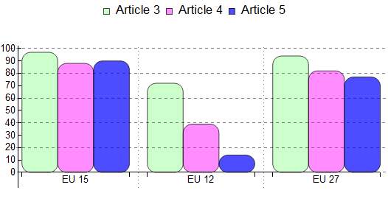
Figure 1: Compliance results at EU-27, EU-15 and EU-12 level regarding article 3 of the Directive (collection), in green, article 4 (secondary treatment), in pink and article 5 (more stringent treatment), in blue. Average values are reflected, weighted by size of MS.
Results at EU-27, EU-15 and EU-12 level are reflected in Figure 1.
Values at EU-15 level are, in general, high, and even very high in countries such as Germany, Netherlands and Austria. EU-12 results are rather low, especially as regards more stringent treatment.
Values at EU-27 level are also high and quite similar to EU-15 values (even though slightly lower), due to:
a) The relatively higher relevance of figures on collection and treatment by EU-15 countries. At EU-15 level, all the deadlines for compliance are expired and therefore the amount of waste waters subjected to compliance is large, also being the related compliance results high.
b) The lower relevance of figures on collection and treatment by EU-12 countries, where compliance results only regard to part of their towns/cities, i.e, those subjected to compliance by 2009/10.
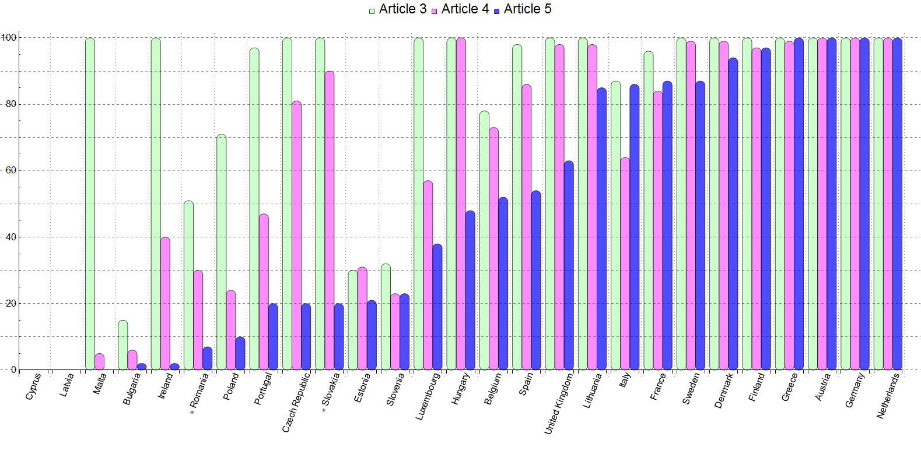
Figure 2:Compliance results per Member State regarding article 3 of the Directive (collection), in green, Article 4 (secondary treatment), in pink and article 5 (more stringent treatment), in blue. Countries are classified showing first those having lowest compliance levels for article 5, and then in increasing order of compliance. In Slovakia (art 5) and Romania (arts 3, 4 and 5), the concept "installations in place" is represented instead of compliance, as the deadlines for those articles had not expired yet by the reported year (figures on compliance were not requested, but MS reported the waste water collected and treated). In Cyprus and Latvia compliance results were equal to 0% because the collecting systems and treatment plants were not fully operational yet in the reported year(2009).; however, significant progress has been made since then and recent compliance rates are much higher.
National results in Figure 2 refer to data and the situation in 2009 or 2010 at the latest. The Commission services are aware that in many Member States, in particular those with low compliance rates, significant progress has been made since then and actual compliance rates are often (much) higher (in particular in Cyprus and Latvia).

2.4. Big cities/big dischargers
There are 585 big cities identified in this Report, which each produce waste water equivalent (or higher) to a population of 150000. The pollution load that is produced by these big cities alone is 45% of the total load collected. Out of these 585 big cities, approximately 91% of the pollution load receives more stringent treatment (best available treatment). This is an improvement in comparison to the previous report where only 77% of the relevant pollution load received such treatment. However, the degree of compliance varies significantly amongst big cities/big dischargers.
To give an example, only eleven of the 27 capital cities of the EU Member States can claim "full compliance" in 2010 even with the most stringent treatment requirements, when applicable (see Table 2 and comments in Annex for details on EU capitals).

2.5. Sensitive areas
The share of EU territory designated or considered as sensitive area has increased since the previous report reaching almost 75% by 2010. The most relevant increases took place in France and Greece. Details of sensitive areas in EU- Member States are available in the WISE mapviewer.

3. Trends in compliance
An assessment of progress towards full compliance of all MS must distinguish between the EU-15 and those Member States having joined in 2004 and 2007. The compliance requirements have regularly changed mainly due to enlargements and with the staged transitional periods in the Directive which have expired. All deadlines for the EU-15 expired by 31 December 2005, but for the EU-12 these will continue to expire with the last and final deadline expiring in 2018. Only data from EU-15 Member States are available until 2004. As a result, the measurement of progress for all 27 Member States level has only been possible since the 5th Report (2005/2006). Bringing all the results published by the previous Commission reports together, an indicative compliance rate increase can be demonstrated. There is just one exception: the decrease from the 5th to the 6th Report resulted from the fact that a number of Member States with the poorer implementation results did not send the necessary information for inclusion in the 5th Report (2005/2006). Despite this, it is positive to note that there is an increase in the trend from the 6th Report (2007/2008) to the 7th Report (2009/2010), as EU-12 Member States have had compliance obligations/deadlines for the first time, but these have not lowered the overall positive results.
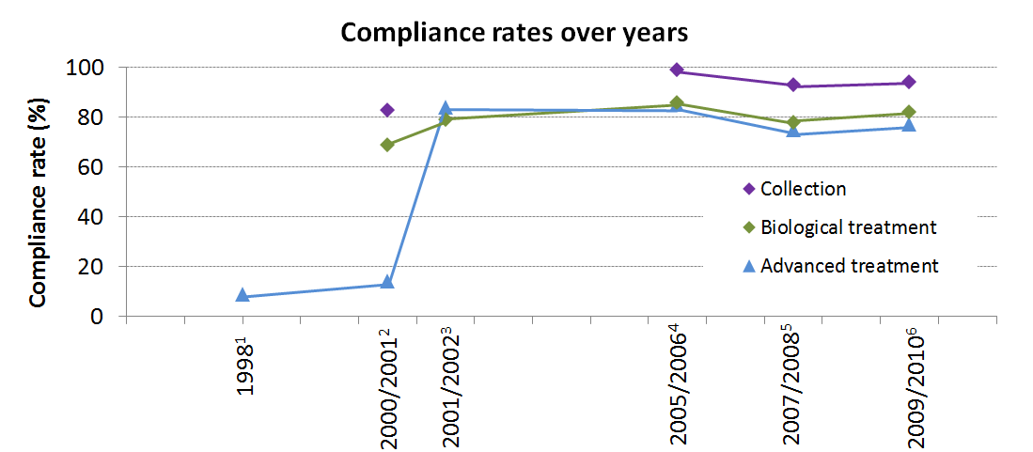
Figure 3 Compliance rate over years: this Figure reflects the evolution of compliance on collection, biological or secondary treatment and more stringent treatment, throughout the several different Implementation Reports (the second Report onwards), in the respectively reported years (1998 until 2009/2010). Not all the results were available in all the Reports: when missing, values cannot be shown on the Figure and a discontinuity in the "trend line" appears.

4. Past and future pollution reduction
The Commission has also assessed the pollution reduction that has occurred as a result of the implementation of this Directive and the expected reductions in the coming years in a situation of full compliance. This was done as part of the FATE project (related to the assessment of fate and impacts of pollutants in terrestrial and aquatic ecosystems).
In 2011/2012, the Commission's Joint Research Centre (JRC) published two reports which looked at the pollution loads and reductions as a result of several EU policies (including the Water Framework Directive, the Nitrates Directive and the Urban Wastewater Treatment Directive) in the past (1985-2005) and the expected loads and reductions (until 2020 with reference year 2005).
As regards the nutrient reduction in the past, the Urban Wastewater Treatment Directive was successful in controlling point source emission of nutrients and thereby reducing the inputs in Europe’s surface water. This is described in one of the above-mentioned JRC reports: "Long term nutrient loads entering the European Seas". According to this report, comparing the estimates of nutrient loads for 2005 with those of 1991 at European continental scale, the total nitrogen export had decreased by 9%, while the total phosphorus load had decreased by around 15%, mainly due to a decrease in point source emissions. It was also stated in the Report that in the North Sea and in the Baltic Sea, the decrease was mainly related to the reduction of point sources due to the implementation of advanced waste water treatment.
As regards future trends under the "business as usual" scenario (assumption: no nutrient mitigation measures have been applied), one of the main conclusions of this report was that this scenario would result in an increase of land based nutrient emissions by year 2020. If now the full implementation of the Urban Wastewater Treatment Directive (UWWTD) is assumed, significant reductions of point source emissions would be reached. In some parts of Europe, however, full implementation of the UWWTD could also result (as a first step) in an increase of point source emissions from non-collected emission, in particular in the lower Danube basin. This is because small agglomerations without drainage systems would receive a more organised collection and discharge resulting in new point sources that do not exist at the moment. Whilst this may reduce the effectiveness of the nutrient reduction to the Black Sea, it still would lead to environmental improvements such as reduced groundwater pollution which was not assessed as part of the study.
In preparation of this implementation report, a specific calculation was carried out in relation to the pollutant loads generated from the non-compliant fraction of waste water from towns/cities (estimation of "distance to compliance"). It did not take into account the towns/cities still without compliance obligations (i.e. where the deadlines in the Accession Treaties had not expired yet in 2009 or 2010, the last year reported by Member States). Based on these estimations, the total annual pollution loads originating from urban waste water in breach with the Directive were approximately of 603 kt/y of nitrogen, 78 kt/y of phosphorus and 3900 kt/y of total organic pollution.
When comparing the above-mentioned figures with the estimated annual total load of nutrients entering the European Seas (nitrogen and phosphorus), in the JRC Report "Long term nutrient loads entering the European Seas", the nitrogen generated by the non-compliant fraction of waste water approximately reaches 15% of the total nitrogen discharged into the seas. Regarding phosphorus, the ratio is even higher, reaching 35% of total phosphorus. Such ratios prove the relevance to fully implement the Directive all over the EU.
Overall, the above-mentioned JRC report concludes that "mitigation of point sources of nutrients is the most effective option to reduce nutrients export to European Seas. However, feasibility of this latter is relatively low and further reduction of nutrient emitted as point sources will involve important costs".

5. Improvement through co-financing
EU funds can be used to assist in the implementation of the Directive, in particular the Cohesion Fund and European Regional Development Fund (ERDF) which help those regions lagging behind or facing structural difficulties in achieving sustainable development. These Funds have significantly supported Member States and the regions to invest in the needed infrastructures for waste water treatment over several programming periods. The financial support for investments in waste water related works and infrastructures was planned to be about 14.3 billion € in 21 Member States in the current programming period 2007-13. It is mainly, but not only, the "new" Member States that have allocated the largest shares of their funding into waste water treatment. During the reported years 2009/2010, the total cumulative allocated funds in the category "waste water" was 3.5 billion € for 2009 and 9.7 billion € for 2010. The Member States with highest cumulative allocated amounts were Poland (3.3 billion €), Romania (1.2 billion €) and Hungary (0.6 billion €).
Despite the significant support from EU funding, the "Fitness check of EU freshwater policy" underlined that the majority of funds necessary to implement EU water policy needs to be generated within the Member States. According to a study of 22 Member States, there is still a significant financing gap in relation to future compliance with the Directive in those Member States.
The main reason for this financing gap is that progress towards achieving cost recovery from water users and implementation of the polluter pays principle, as required by the Water Framework Directive (WFD), have been slow and insufficient in most Member States. To encourage such water pricing policies, the Commission has proposed some ex ante conditions, including the WFD requirements on water pricing which Member States need to fulfil in the future EU Cohesion Policy (2014-2020) for the financing of projects in the water sector.

6. Past compliance action
The Commission has tried to ensure compliance through continued dialogue and, where necessary, also through the launching of infringement procedures, some dating back to 1997. To date, approximately 20 horizontal grouped cases against 10 of the EU-15 Member States are still open.
The recent policy evaluation in the "Fitness check of EU freshwater policy" concluded that the effectiveness in the implementation of the Directive has been positively affected by the infringement procedures speeding up implementation. Even though enforcement action at EU level is a relatively slow and time-consuming process, the majority of cases have been resolved in the pre-litigation phase.
Some successful examples are France (cases with 682 towns in breach launched in 1998 and 2000) and Belgium (175 towns/cities originally in breach in a case launched in 1998). In both examples, practically all the above-mentioned towns/cities are now compliant. Also in Italy 475 towns/cities were in breach when the procedure started in 1998; now only 110 remained in breach when the Court ruling was issued. In addition to these three countries, Spain and Greece have made the most progress since the last reporting exercise amongst those Member States for which infringement procedures are pending, in particular as regards the treatment obligations.

7. The “new approach” for compliance promotion
Despite the encouraging signs of progress, there is still a significant implementation gap, in particular in the Member States that joined the EU in 2004 and after. It now is becoming clear that without re-enforced efforts at EU, national, regional and local level, the implementation delays in these “new” Member States will be as long as or even longer than those in the EU-15 Member States. The prospects of achieving the necessary progress, solely through infringement procedures, are not encouraging. Taking into account the current crisis and the increasing constraints of national budgets, the Commission has identified this Directive as a candidate to launch a pilot initiative for a “new approach” in promoting compliance and implementation.
This “new approach” is set out in the proposed 7th Environmental Action Programme (EAP) and the “Blueprint to Safeguard Europe's Water Resources”. The priority objective 4 in the 7th EAP “To maximise the benefits of EU environment legislation” proposed to carry out specific actions, in particular:
- Establishing systems at national level which actively disseminate information about how EU environment legislation is being implemented, coupled with an EU-level overview of individual Member States’ performance (a so called "Structured Implementation and Information Framework" (SIIF)).
- Drawing up partnership implementation agreements between Member States and the Commission.
The Water Blueprint has established the objective “to improve compliance rates on waste water treatment by 2018 through long-term investment planning (including EU funds and EIB loans)”. In practical terms, the Blueprint announced that the Commission will cooperate with Member States to prepare implementation plans, which can take the form of partnership implementation agreements, by 2014.
The Commission services have started developing these actions with a workshop in December 2012 and will report progress regularly.

8. Conclusions and outlook
Nearly 20 years after the adoption of the Urban Wastewater Treatment Directive, significant progress towards full implementation was achieved by 2010. For the EU-15, average compliance rates are 88% for secondary treatment and higher for collection systems and more stringent treatment (97 and 90% respectively). The frontrunners Austria, Germany and the Netherlands have largely implemented the Directive with several others being very close to it. For them, the priority will be to maintain and renew the existing infrastructure. Moreover, since 2010, further investments took place in those EU-15 Member States with delayed compliance, also as a result of the Commission’s infringement actions. With continued efforts over the coming years, it is possible to (largely) complete implementation successfully in those 15 Member States by 2015 or 2016. This would be 10 years after the expiry of the last deadline in the original Directive.
The picture is different for those Member States which have joined the EU in 2004 and later. Their distance to target is still considerable with average compliance of 72% for collecting systems and 39% and 14% respectively for secondary and more advanced treatment. Without increasing efforts at all levels, expected delays can be similar or longer than those for EU-15 which would bring the laggards in implementation in line with the Directive as late as 2028.
Another area of concern is the lack of compliance in a significant number of “big cities”. E.g. only eleven of the 27 EU capitals have a collecting system and treatment in place which is complying with technical standards of more than 20 years ago. Given the high pollution load of these big discharges, this causes still considerable environmental pollution.
This 7th Implementation Report includes, for the first time, a detailed assessment of compliance for 27 Member States. The reporting infrastructure established within the Water Information System for Europe (WISE) is working well. The process has been improved and the timelines for data processing and assessment significantly shortened. However, in some Member States further improvements in the monitoring and reporting system are still possible. These explain some of the low implementation levels or inconsistency of data over the various reporting exercises.
The proposed 7th Environment Action Programme and the Blueprint to Safeguard Europe's Water Resources underline the importance of collecting and treating urban wastewater. The Commission announced in these recent policy initiatives that it will further increase its support to Member States in their implementation efforts by promoting a “new approach” for reaching compliance. In December 2012, the Commission services started these “new approach” activities with the aim of encouraging Member States to establish or revise implementation plans at the latest by 2014.

Directive 91/271/EEC, OJ L135 of 30.5.1991.
For more details on the scope, objectives and provisions of the Directive, see: http://ec.europa.eu/environment/water/water-urbanwaste/index_en.html.
Directive 2000/60/EC, OJ L327 of 22.12.2000.
Directive 2008/56/EC, OJ L164 of 25.6.2008.
Eutrophication means the “enrichment of water by nutrients, especially compounds of nitrogen and/or phosphorus, causing an accelerated growth of algae and higher forms of plant life to produce an undesirable disturbance to the balance of organisms present in the water and to the quality of the water concerned”.
For more details, see http://ec.europa.eu/environment/water/water-framework/implrep2007/index_en.htm#third.
For more details: EEA (2010): The European Environment – State and Outlook 2010 – Freshwater Quality.
For more details: EEA (2012): European Waters-assessment of status and pressures.
COM (2012) 710 final. For more details, see http://ec.europa.eu/environment/newprg/pdf/7EAP_Proposal/en.pdf.
COM (2012) 673 final. For more details, see http://eur-lex.europa.eu/LexUriServ/LexUriServ.do?uri=COM:2012:0673:FIN:EN:PDF.
SWD(2013) 298
7th Technical assessment of information on the implementation of Council Directive 91/271/EEC of 21 May 1991 concerning Urban Waste Water Treatment as amended by Commission Directive 98/15/EC of 27 February 1998.(Situation as of 31 December 2009 or 31 December 2010).Drafted by Commission's consultant Umweltbundesamt GmbH (Austria).
For more details, see http://rod.eionet.europa.eu/obligations/613.
http://www.eea.europa.eu/data-and-maps/data/waterbase-uwwtd-urban-waste-water-treatment-directive-3.
The term "population equivalents" or p.e. can be found in the Directive and covers the organic pollution generated mainly by the inhabitants of a village/town, and other sources such as non-resident population (tourists) and agro-food industries.
In addition, tertiary treatment technologies (e.g. ozonation, chlorination, UV, membrane technologies, sand filters, are widely discussed as one of the most promising options for the mitigation of micro-pollutants (emerging contaminants, including pharmaceuticals and personal-care products, other industrial chemicals) entering the aquatic environment.
Table 1 (see Annex) reflects results as per Member State and EU-27, EU-15, EU-12 level, classified by ranges of compliance.
Amsterdam, Athens, Berlin, Bratislava, Copenhagen, Helsinki, Madrid, Paris, Stockholm, Vienna and Vilnius.
http://www.eea.europa.eu/themes/water/interactive/soe-wfd/urban-waste-water-treatment-directive-viewer.
http://fate.jrc.ec.europa.eu/rational/home.
http://bookshop.europa.eu/en/scenario-analysis-of-pollutants-loads-to-european-regional-seas-for-the-year-2020-pbLBNA25159/ and http://publications.jrc.ec.europa.eu/repository/bitstream/111111111/15938/1/lbna24726enc.pdf.
Kilotons/year.
Based on chemical oxygen demand (COD).
COWI 2010: Compliance Costs of the Urban Wastewater Treatment Directive. Final report http://ec.europa.eu/environment/water/water-urbanwaste/info/pdf/Cost%20of%20UWWTD-Final%20report_2010.pdf.
A list of most relevant infringement cases (to date) and judgements since the years 2009/2010 is provided in the Annex of the Report (Tables 3 and 4 respectively).
SWD (2012) 393
Annex VI (p. 102 pp) of the Impact Assessment (SWD(2012) 397 final) provide details on the Urban Wastewater pilot action.
https://circabc.europa.eu/w/browse/340cea09-390f-4c11-8e99-712c519c21e4.

