TABLE OF CONTENTS
COMMISSION STAFF WORKING DOCUMENT Statistical evaluation of irregularities reported for 2012 Own Resources, Natural Resources, Cohesion Policy, Pre-accession and Direct expenditure 1
1. Introduction 7
1.1. Scope of the document 7
1.2. Structure of the document 7
Part I - REVENUES 8
2. Traditional Own Resources 8
2.1. Introduction 8
2.2. General analysis – Trend analysis 8
2.2.1. Reporting Years 2008-2012: Cases of fraud and irregularities 8
2.2.1.1. Irregularities reported as fraudulent 9
2.2.1.2. Irregularities not reported as fraudulent 9
2.2.2. Established and estimated amounts 10
2.2.3. Recovery 11
2.2.3.1. Recovery rates 11
2.3. Specific analysis 12
2.3.1. Irregularities reported as fraudulent 12
2.3.1.1. Modus operandi 12
2.3.1.2. Method of detection of fraud cases 13
2.3.1.3. Smuggled cigarettes 13
2.3.1.4. Fraud cases by amount category 14
2.3.2. Irregularities not reported as fraudulent 15
2.3.2.1. Modus operandi 15
2.3.2.2. Method of detection of irregularity cases 15
2.3.2.3. Non-fraudulent irregularities by amount category 16
2.4. Member States’ activities 17
2.4.1. Member States’ classification of cases of fraud and other irregularities and related rates 17
2.4.2. Recovery rates 17
2.4.2.1. Fraud 17
2.4.2.2. Other Irregularities 18
2.4.2.3. Historical recovery rate 18
2.4.3. Commission’s monitoring 18
2.4.3.1. Examination of the write off reports 18
2.4.3.2. Commission’s inspections 18
2.4.3.3. Particular cases of Member State failure to recover TOR 19
2.4.4. Conclusions / Recommendations 19
Part II - EXPENDITURE 21
Section I - Shared Management 21
Natural Resources 21
3. Common Agricultural Policy (CAP) 21
3.1. Introduction 21
3.2. General analysis – Trend analysis 22
3.2.1. Irregularities reported as fraudulent 22
3.2.2. Irregularities not reported as fraudulent 23
3.3. Specific analysis 24
3.3.1. Irregularities reported as fraudulent 24
3.3.1.1. Modus operandi 24
3.3.1.2. Type of control / Method of detection 25
3.3.1.3. Complexity of the irregularities reported as fraudulent 26
3.4. Anti-fraud activities of Member States 27
3.4.1. Detection – Reporting Efficiency 27
3.4.2. Detection of irregularities reported as fraudulent in 2012 by Member State 29
3.4.3. Fraud detection rate 29
3.4.4. Ratio of established fraud 2008-2012 30
3.5. Recovery cases 32
4. Common Fisheries Policy (CFP) 35
4.1. General analysis 35
4.2. Specific analysis 35
4.2.1. Types of irregularity detected 36
4.2.2. Method of detection 36
4.3. Control activity by Member States 36
Sustainable Growth 37
5. Cohesion Policy 37
5.1. Trend analysis 38
5.1.1. Irregularities reported as fraudulent 38
5.1.1.1. Trend by programming period 38
5.1.1.2. Trend by Fund 40
5.1.1.3. Trend by objective 42
5.2. Specific Analysis – Irregularities reported as fraudulent in relation to the Programming Period 2007-13 43
5.2.1. Priorities concerned by the irregularities reported as fraudulent in 2012 43
5.2.2. Types of irregularities / modus operandi detected - Irregularities reported as fraudulent in 2012 44
5.2.3. Type of control / method of detection – Irregularities reported as fraudulent 45
5.2.3.1. Complexity of the irregularities reported as fraudulent 46
5.3. Anti-fraud activities by Member States 47
5.3.1. Detection – Reporting Efficiency 47
5.3.2. Detection of irregularities reported as fraudulent in 2012 by Member State 48
5.3.3. Fraud detection rate 49
5.3.4. Ratio of established fraud 2008-2012 50
Section II - Decentralised Management 52
The EU as a global player / Pre-Accession Policy 52
6. Pre-Accession Policy (Pre-Accession Assistance and Instrument for Pre-Accession) 52
6.1. The Pre-accession Assistance (PAA), 2000-06 and Instrument for Pre-Accession (IPA), 2007-13 52
6.2. General analysis – Trend analysis 55
6.2.1. Trend analysis 55
6.2.2. Reporting efforts 56
6.3. Specific analysis – Financial year 2012 57
6.3.1. Pre-Accession Assistance (PAA) 57
6.3.2. Instrument for Pre-Accession (IPA) 58
6.3.3. Method of detection 59
6.3.4. Recovery for the Pre-Accession Assistance (PAA) – Cumulative results 2002-2012 59
Section III – Centralised Management 61
7. Centralised Direct and Centralised Indirect Management 61
7.1. Introduction 61
7.2. General analysis – Trend analysis 62
7.2.1. Trend analysis 2011-2012 62
7.3. Specific analysis – Financial year 2012 62
7.3.1. Recoveries according to legal entity residence 63
7.3.2. Method of detection 64
7.3.3. Types of error 65
7.3.4. Time delay 65
7.3.5. Recovery 65
COUNTRY FACTSHEETS 66
Belgium 66
Bulgaria 67
Czech Republic 68
Denmark 69
Germany 70
Estonia 71
Ireland 72
Greece 73
Spain 74
France 75
Italy 76
Cyprus 77
Latvia 78
Lithuania 79
Luxembourg 80
Hungary 81
Malta 82
Netherlands 83
Austria 84
Poland 85
Portugal 86
Romania 87
Slovenia 88
Slovakia 89
Finland 90
Sweden 91
United Kingdom 92
ANNEXES 93
ANNEX 1 94
ANNEX 2 95
ANNEX 3 97
ANNEX 4 98
ANNEX 5 100
ANNEX 6 101
ANNEX 7 103
ANNEX 8 104
ANNEX 9 105
ANNEX 10 106
ANNEX 11 107
ANNEX 12 108
ANNEX 13 109
ANNEX 14 111
ANNEX 15 112

1. Introduction

1.1. Scope of the document
The present document is based on the analysis of the notifications provided by national authorities of cases of irregularities and suspected or established fraud. The reporting is performed in fulfilment of a legal obligation enshrined in sectoral European legislation.
The document accompanies the Annual Report adopted on the basis of article 325 of the Treaty on the Functioning of the European Union (TFEU), according to which “The Commission, in cooperation with Member States, shall each year submit to the European Parliament and to the Council a report on the measures taken for the implementation of this article”.
For this reason, this document should be regarded more as an analysis of the achievements of Member States.
The methodology (including the definition of terms and indicators), the data sources and the data capture systems are explained in detail in the Commission Staff Working Document – Methodology for the Statistical Evaluation of Irregularities.

1.2. Structure of the document
The present document is divided in two parts.
The first part is dedicated to the analysis of irregularities reported in the area of the Traditional Own Resources (Revenues).
The second part, concerning the expenditure part of the budget, is composed of three sections, dedicated, respectively, to shared, decentralised and centralised management modes.
The section dedicated to shared management, covers the natural resources (agriculture, rural development and fisheries) and the cohesion policy. Decentralised management refers to the pre-accession policy, while the centralised management section mainly deals with internal and external policies for which the Commission directly manages the implementation.
The document is completed by 27 country factsheets, which summarise, for each Member State, the main indicators and information that have been recorded through the analyses.
15 Annexes complement the information and data of this document, providing a global overview of the irregularities reported according to the relevant sector regulations. Annexes from 1 to 10 concern Traditional Own Resources, Annexes 11 and 12 Natural Resources and Annexes from 13 to 15 the Cohesion Policy.
Part I - REVENUES

2. Traditional Own Resources

2.1. Introduction
For more information about how information concerning irregularities and fraud related to Traditional Own Resources are collected and analysed, see paragraph 1.3 of the Commission Staff Working Document ‘Methodology’.
Charts TOR1 –TOR4 provide an overview of the number of cases of fraud and irregularities per reporting year, established amounts and recovery rates as published in the previous years’ reports and to compare them with the reporting trends observed for the period 2008-2012.
The following analysis is based on the data available on the cut-off date and aims to provide an overview of the reported cases of fraud and irregularities reported for 2012 together with their financial impact.

2.2. General analysis – Trend analysis

2.2.1. Reporting Years 2008-2012: Cases of fraud and irregularities
The number of cases reported via OWNRES for 2012 (4 594) is currently 5 % lower than the average number of cases of fraud and irregularities reported for the period 2008-2012 (4 812).
Conversely, the total established amount of TOR irregularity cases involved (EUR 444 million) is 20 % higher than the average established amount for years 2008-2012 (EUR 371 million).
Chart TOR1: Total cases of fraud and irregularities and amounts affected (2008-2012)
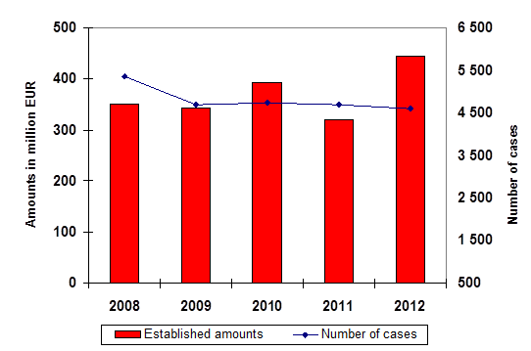
Member States continuously update information on cases of fraud and irregularities regarding previous years.
Annex 1 shows the situation on the cut-off date for the last five years.
The increase of the total amounts affected by fraud and irregularities in 2012 was influenced by six big cases reported by Belgium, Germany, the United Kingdom, the Netherlands and Romania with a total established amount of about EUR 104 million.

2.2.1.1. Irregularities reported as fraudulent
The number of fraud cases communicated to OWNRES for 2012 (682) is currently 20 % lower in comparison with the average number of fraud cases reported for period 2008-2012 (the average number of cases reported for 2008-2012 was 851). The total established amount of TOR involved (EUR 78 million) is 22 % lower than the average established amounts for the years 2008-2012 (EUR 100 million).
CHART TOR2: Cases of fraud and established amounts (2008-2012)
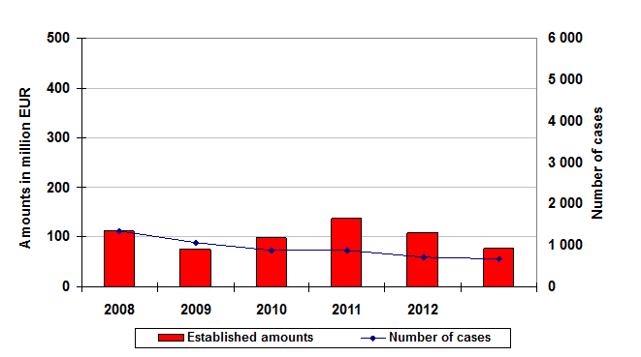
Annex 2 shows the situation on the cut-off date for the last five years.
The Czech Republic, Estonia, Luxemburg, Cyprus, Portugal and Sweden did not communicate any case of fraud exceeding an amount of 10 000 EUR.

2.2.1.2. Irregularities not reported as fraudulent
At the same time, the number of irregularities communicated to OWNRES for 2012 (3 912) is 1 % lower in comparison with the average number of irregularities reported for 2008-2012 which was 3 961).
The total established amount of TOR (EUR 370 million) is 20 % higher than the average established amounts for the years 2008-2012 (271 EUR million).
CHART TOR3: Cases of non-fraudulent irregularities and established amounts (2008-2012)
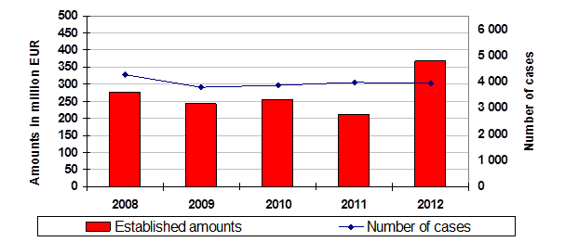
For 2012, Malta and Luxemburg did not report any case of irregularity exceeding an amount of EUR 10 000. On the cut-off date, OWNRES had recorded only one case of irregularity reported by Greece for 2012.
Annex 3 shows the situation on the cut-off date for the last five years.

2.2.2. Established and estimated amounts
The largest part of all amounts of TOR established are recovered without any particular problem and made available to the Commission via the A-account. For 2012 around EUR 21.9 billion TOR (gross) have been collected by the Member States and thereafter made available to the EU budget after deduction of 25 % collection costs. In comparison, according to the OWNRES communications, around EUR 461 million have been established and estimated by the Member States in connection to detected cases of fraud and irregularities where the amount at stake exceeds EUR 10 000.
The total established and estimated amounts reported in OWNRES represent 2.10 % of the total collected TOR (gross) of 2012. This proportion has increased in comparison to the previous years’ reports where a percentage of 1.73% was calculated in 2011 and 2 % in 2010. A percentage of 2.10 % reflects that out of each EUR 100 of TOR (gross) collected an amount of fraud and irregularities is registered as irregular or fraudulent in OWNRES of EUR 2.10. Within the Member States there are differences. In six Member States the percentage is equal or above the average of 2.10%.
For 2012 the highest percentage can be seen in Romania with 17.95 %. This is due to two big cases with a total financial impact of EUR 27.3 million.
For 7 Member States which collected most TOR, the percentage of the established and estimated OWNRES amounts to collected TOR for 2012 was equal to 2.10 %. In comparison to the previous year, these Member States show an increase by almost 0.5 percentage points. For Belgium, Germany and the Netherlands the increase was higher than 0.5 percentage points. Only for Italy, the proportion between established and estimated OWNRES amounts to collected TOR decreased in 2012 when compared to the previous year.
TOR MAP1: Visualising the percentage of established and estimated amounts in OWNRES to collected TOR
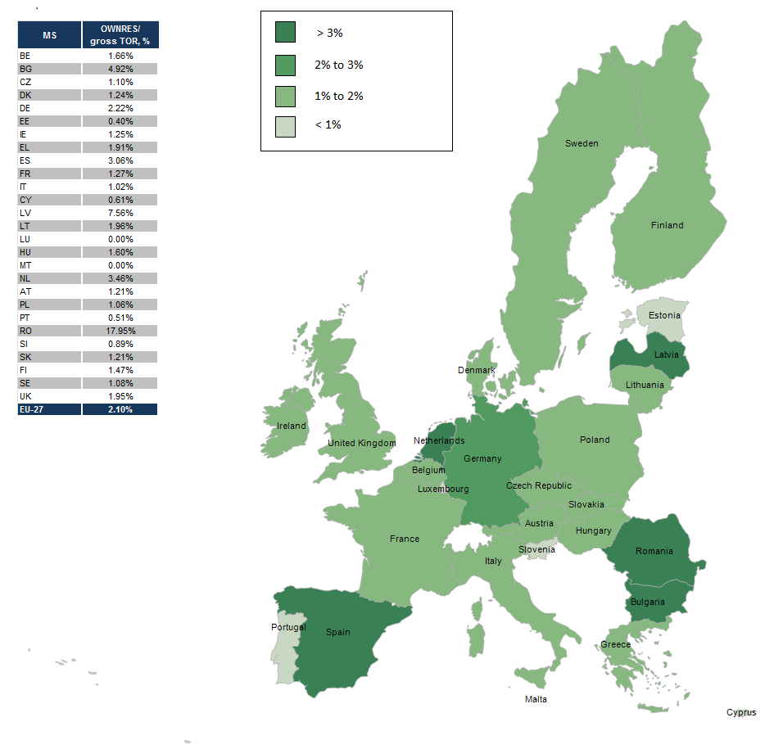

2.2.3. Recovery
The fraud and other irregularity cases which have been detected in 2012 show an established amount of EUR 444 million. Thereof EUR 186 million were recovered in cases where an irregularity was at stake and EUR 22 million in fraud cases. In total EUR 208 million were recovered by all Member States for all cases which were detected in 2012. In absolute numbers Germany recovered most with EUR 82 million followed by the United Kingdom with EUR 34 million in 2012. In addition, the Member States continued their recovery actions related to detected cases of previous years. EU-27 recovered EUR 83 million in 2012 which related to cases detected between 1989 and 2011.

2.2.3.1. Recovery rates
Over the last five years the annual RR has varied between 38 % and 52 %. At present the recovery rate for 2012 is 47 %. In other words, of every over EUR10 000 of duties established and reported for 2012 in OWNRES, approximately EUR 4 700 has already been paid.
CHART TOR4: Annual recovery rates 2008-2012
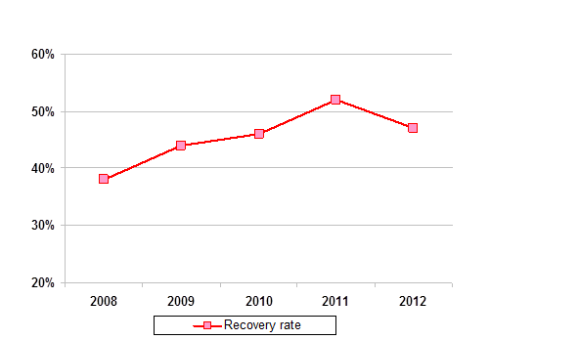
There are big differences of the recovery rate within the Member States. For 2012, the highest recovery rates are in Slovakia (100 %), the Czech Republic (98 %), Hungary (97 %) and Germany (81 %). Differences in recovery results may arise from factors such as the type of fraud or irregularity or the type of debtor involved. Because recovery is on-going, it can be expected that the recovery rate for 2012 will also go up in the future.
The overall recovery rate for 2011 recorded in the last year’s report was 51%, and it has since then climbed to 61%. On the cut-off date, the overall recovery rate (RR) for all years (1989-2012) was 51.81 %.

2.3. Specific analysis

2.3.1. Irregularities reported as fraudulent

2.3.1.1. Modus operandi
In 2012, the most cases (83 %) and the majority of established amounts (95 %) for fraud cases in EU-27 are related to the customs procedure ‘release for free circulation’. A total of 7 % of all cases and 1 % of all established amounts in OWNRES fraud cases registered for 2012 involve the transit procedure. The percentage of established amounts for fraud cases involves customs warehousing and inward processing 2 % and 1 % respectively.
A breakdown of frauds by mechanism type reveals that most cases of fraud relate to false declarations. Incorrect use of preferential arrangements, incorrect origin or country of dispatching, or classification are most frequently mentioned. Smuggling as a fraud mechanism ranked second place in 2012.

2.3.1.2. Method of detection of fraud cases
In 2012, most fraud cases (32 %) were revealed during a customs controls at the time of clearance of goods (either physical inspections or inspections of documents). Other frequently featured methods were inspections by anti-fraud services (28 %), tax audits (22 %), and post-clearance inspections (11 %).
CHART TOR5: Fraud cases - % of the method of detection by cases and established amounts in 2012
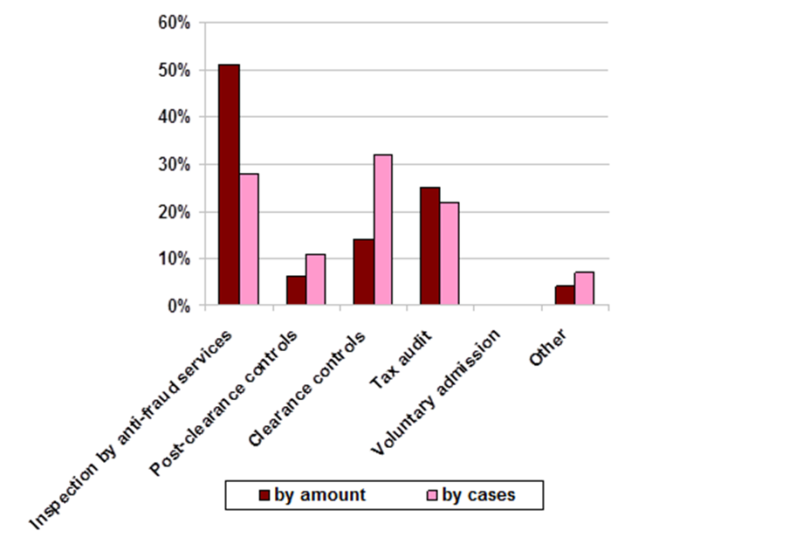
in terms of amounts, out of EUR 77 million established in fraud cases registered for 2012, around 51 % were discovered by anti-fraud services, 25 % by tax audits, whereas 14 % of all cases — in monetary terms — were detected during a clearance control. Only in Spain, tax audits were the most important detection method for fraud cases in monetary terms. In the following five Member States more than 50% of all fraud cases — in established amounts — were detected by anti-fraud services: Belgium, Germany, Italy, Austria and Romania. Clearance controls were the most important method — in amounts — for the detection of fraud in Bulgaria, Latvia, Lithuania and Finland.

2.3.1.3. Smuggled cigarettes
In 2012, there were 224 cases of smuggled cigarettes registered (CN code 24 02 20 90) involving estimated TOR of around EUR 25 million. In 2011 the number of smuggled cigarettes was 291, totalling around EUR 48 million.
Table TOR1: Cases of smuggled cigarettes in 2012
Italy reported 68 cases of smuggled cigarettes, totalling an estimated or established amount of EUR 8.7 million. This is the highest number of cases and the highest amount reported by a Member State in 2012.
No cases were reported by the Czech Republic, Denmark, Estonia, Cyprus, Luxembourg, Malta, the Netherlands, Portugal, Slovakia or Sweden.

2.3.1.4. Fraud cases by amount category
In 2012, in 502 cases of fraud (74 % of all fraud cases) the established amount was below EUR 50 000, whereas for 180 cases (26 %) the established amount was above EUR 50 000.
Table TOR2: Fraud by amount category in 2012
The total established amount in fraud cases where the amount at stake was above EUR 50 000 amounted to EUR 69 million (89 % of all the established amounts in fraud cases).

2.3.2. Irregularities not reported as fraudulent

2.3.2.1. Modus operandi
In 2012 with regard to non-fraudulent irregularities, the greatest part of established amounts in OWNRES (88 %) in EU-27 related to the customs procedure ‘release for free circulation’. In all, 6 % of all established amounts of OWNRES cases in 2012 involved inward processing. Furthermore, 2 % of all established amounts of OWNRES regard customs warehousing and 2 % transit procedure. There was no significant difference among Member States. In Ireland, 49 % of the amounts established regarding irregularities relate to ‘release for free circulation’ and 48 % to inward processing. For 2012, high amounts established regarding inward processing were reported by Spain and the United Kingdom.
A breakdown of non-fraudulent irregularities by mechanism type confirms that most cases of irregularity relate to incorrect declarations (incorrect classification, value, country of origin or use of preferential arrangements); and formal shortcomings (failure to fulfil obligations or commitments).

2.3.2.2. Method of detection of irregularity cases
In 2012, most irregularity cases (59 %) were revealed during a post-clearance customs control. Other frequently featured methods of detection for irregularities were inspections by clearance controls (12 %) and tax audits (11 %) followed by anti-fraud services (7 %).
CHART TOR6: Non-fraudulent irregularity cases - % of the method of detection by cases and established amounts in 2012
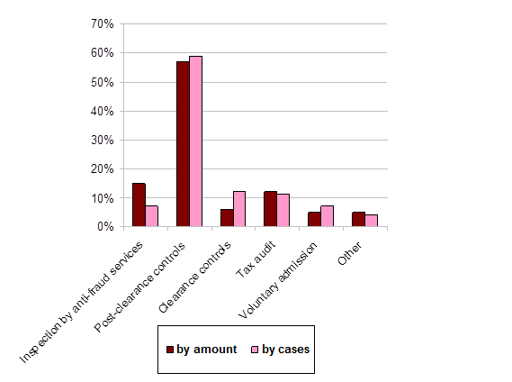
Of all non-fraudulent irregularity cases registered for 2012, around 57% — in established amounts — were discovered by post-clearance controls whereas 15 % were detected through an inspection by anti-fraud services, 12 % during a tax audit and only 6 % at the time of clearance of goods. In eight Member States, more than 50 % of all irregularity cases — in amounts — were detected by a post-clearance control. In Estonia, Greece, France and Romania In the following five Member States more than 50% of all irregularity cases — in amounts — were detected by anti-fraud services. In the following five Member States more than 50 % of all irregularity cases — in established amounts — were detected by primary inspections: Bulgaria, Latvia, Lithuania, Poland and Finland. Spain reported irregularity cases that were admitted voluntarily.

2.3.2.3. Non-fraudulent irregularities by amount category
In 2012, in 3 008 cases of irregularity (77 % of all irregularity cases) the established amount was below EUR 50 000 whereas for 904 cases (23 %) the established amount was above EUR 50 000.
The total established amount in irregularity cases where the amount at stake was above EUR 50 000 amounted to EUR 310 million (85 % of all the established amounts in irregularity cases).
Table TOR3: Non-fraudulent irregularities by amount category in 2012

2.4. Member States’ activities

2.4.1. Member States’ classification of cases of fraud and other irregularities and related rates
For 2012, Member States classified 682 cases as fraud out a total of 4 594 cases reported via OWNRES, which implies a Fraud Frequency Level (FFL) of 15 %. The differences between Member States are relatively large. In 2012 most of the Member States categorised between 10-50 % of all cases as fraud. However, six Member States categorised zero cases as fraud. Five Member States categorised between 1 % and 10 % of the cases as fraud. Four Member States registered more than 50 % of the cases as fraud.
In 2012, in the EU, the total established and estimated amount affected by fraud was EUR 91 million and the overall Fraud Detection Rate (FDR) was 0.42 %. For 2012, the highest percentages can be seen in Bulgaria with 2.63 % and Spain 2.60 %.
The total established and estimated amount affected by irregularities was more than EUR 370 million which implies an Error Rate (ER) of 1.69 %. The highest percentages can be seen in Romania (16.87 %) and Latvia (6.54 %).
The differences between Member States’ classification are large which can also depend on the Member States’ classification practises. This can influence the comparison of the amounts involved in fraud and irregularities by Member States. Also, individual bigger fraud cases detected in a certain year may affect importantly the annual rates. Such factors as e.g. the type of traffic, type of trade, the level of compliance of the economic operators, the location of a Member State factors can influence the rates significantly. Under these variable factors the rates are also affected on the way how the Member State's customs control strategy is set up to target risky imports and to detect TOR related fraud and irregularities.

2.4.2. Recovery rates

2.4.2.1. Fraud
Over the period 1989-2012 OWNRES show that in average 16 % (1989-2012) of the initially established amount was corrected (cancelled). The recovery rate (RR) for all years (1989-2012) is 24.37 %. The RR for fraud cases detected in 2012 was 27.9 % which is above the average rate of 25.5 % for fraud cases for the period 2008-2012. The RR in fraud cases is clearly much lower than that for irregularities.

2.4.2.2. Other Irregularities
OWNRES shows that on the cut-off date, in average 37 % (1989-2012) of the initially established amount in relation to irregularities was corrected (cancelled) since 1989. The RR for irregularity cases reported for 2012 is 50.95%. On the cut-off date, the annual RR for the last five years varies between 51% and 78 %. The overall RR for all years (1989-2012) for irregularity cases combined is 64.32 %.

2.4.2.3. Historical recovery rate
Also in the long term, the HRR indicates an equally strong relation, showing that recovery in fraud cases is generally much less successful than in cases of irregularity (see table TOR4). Classification of a case as fraud is thus a strong indicator for forecasting short- and long-term recovery results.
Table TOR4: Historical recovery rate (HRR)

2.4.3. Commission’s monitoring

2.4.3.1. Examination of the write off reports
In 2012, 168 new write-off reports amounting to EUR 42 million were communicated to the Commission by 17 Member States. Including also earlier reported cases for which Member States sent additional information, the Commission processed in 2012 in total 263 cases totalling to almost EUR 68 million. In 88 of those cases amounting to EUR 17 million, Member States were asked to pay the outstanding amounts as they were not considered diligent in recovering those debts.
Examination of Member States’ diligence in write off cases constitutes a very effective mechanism for gauging their activity in the field of recovery. It encourages national administrations to step up the regularity, efficiency and effectiveness of their recovery activity, since any lack of diligence leading to failure to recover, results in individual Member States having to foot the bill.

2.4.3.2. Commission’s inspections
In its TOR inspections, the Commission has put a special emphasis on Member States' customs control strategies and monitors closely Member States' action in relation to the observations made during its inspections. Member States show their willingness to adapt their control strategies and to implement progressively systems that provide for efficient and effective risk analysis for the protection of the EU’s financial interests. Thematic reports consolidating the results of the inspections and evaluating and comparing Member States performance are frequently prepared and discussed with the Member States in view of remedying the individual shortcomings found. A general conclusion which the Commission draws from its last years inspections in Member States is that the Member States’ control strategies are more and more shifting from the customs controls at the time of clearance of goods to post-clearance customs controls.

2.4.3.3. Particular cases of Member State failure to recover TOR
If TOR is not established because of an administrative error by a Member State, the Commission applies the principle of financial liability. In 2012 Member States have been held financially liable for over EUR 24.3 million and new cases are being given appropriate follow-up.

2.4.4. Conclusions / Recommendations
In its capacity as Authorising Officer, the Commission (DG Budget is the delegated Authorising Officer) monitors the establishment and recovery of TOR by Member States in various ways. The monitoring is carried out in partnership with different Commission departments, including OLAF. To ensure effective monitoring, reliable information regarding the number of fraud and irregularity cases and follow-up must be entered in OWNRES. Member States have a special responsibility to ensure that appropriate statistical information on irregularity and fraud is provided to the Commission.
    - The total number of cases of fraud and other irregularities reported in 2012 was lower than in 2011. The total established amount was, on contrary, higher than in the previous year and totalled to EUR 444 million. This is mainly due to the significant increase of the total amount established for non-fraudulent irregularity cases. The fraud figures reported in relation to TOR vary significantly from one Member State to another and can also be result of different interpretations of the provisions and practices among the Member States. Analysis clearly shows a decreasing trend of the total number of fraud cases over the last five years.
    - For EU-27, the established and estimated amounts (related to both fraudulent and non-fraudulent irregularities) in OWNRES represent 2.10 % of the TOR collected for 2012. The percentage varies among the Member States. Based on experience from previous years, it is likely that this figure for 2012 will change in future years due to new establishments and/or corrections of establishment.
    - During its last years' inspections in the Member States, the Commission observed a shift in Member States’ control strategies from customs controls carried out at the time of clearance of goods to controls carried out after the clearance. The data retrieved from OWNRES confirms this development in the Member States and shows that in particular for the detection of irregularities, customs controls carried out after the clearance of goods are an effective method.
    - Analysis reveals that for the detection of fraud cases, customs controls carried out at the time of clearance of goods are an important method and results in classifying cases as fraud more often than other control methods. During inspections carried by anti-fraud services and tax audits, fraud cases with higher amounts are detected.
    - Based on the above mentioned analysis, it can be concluded that the customs controls at the time of clearance of goods are of high importance for fraud detection. Therefore, Member States should take this fact into account when developing their customs control strategies. In parallel with developing their post-clearance customs controls activities, Member States should ensure that they have effective systems of risk assessment allowing them also to carry out at the time of clearance well targeted controls on imports with high risk of fraud.
    - Almost 47 % of all established amounts in relation to cases of fraud and irregularities reported in 2012 have been already recovered. Analysis shows that certain particulars of a case may be used as indicators for forecasts of recovery. Cases regarding fraud decrease the chance of successful recovery.
Member States should continue their activities in the field of establishment and recovery and provide required statistical information. The Budgetary Authority is entitled to have available the best possible information when monitoring TOR and recovery issues.
Part II - EXPENDITURE
Section I - Shared Management
Natural Resources
Success in previous decades in guaranteeing sufficient food production, has led to a shift in emphasis to, producing higher quality food for consumers, increasing farms' profitability, diversifying the rural economy and protecting the natural environment. There is a direct management component but the majority of expenditure is disbursed by Member States under the following shared management funds.
- The European Agricultural Guarantee Fund (EAGF) which finances direct payments to farmers and measures to respond to market disturbances, such as private or public storage and export refunds.
- The European Agricultural Fund for Rural Development (EAFRD) which finances the rural development programmes of the Member States.
- The European Fishery Fund (EFF) which provides funding and technical support for initiatives that can make the fishery industry more sustainable.
Table NR1 shows the financial resources available for this policy area.
Table NR1: Financial instruments and 2012 appropriations for the Natural Resources Policies

3. Common Agricultural Policy (CAP)

3.1. Introduction
For the last 50 years the Common Agricultural Policy (CAP) has been the European Union's (EU) most important common policy. This explains why traditionally it has taken a large part of the EU's budget, although the percentage has steadily declined over recent years.
The CAP is financed by two funds, EAGF and EAFRD, which form part of the EU's general budget.
Under the basic rules for the financial management of the CAP, the Commission is responsible for the management of the EAGF and the EAFRD. However, the Commission itself does not make payments to beneficiaries. According to the principle of shared management, this task is delegated to the Member States, who themselves work through national or regional paying agencies. Before these paying agencies can claim any expenditure from the EU-budget, they must be accredited on the basis of a set of criteria laid down by the Commission.
The paying agencies are, however, not only responsible for making payments to the beneficiaries. Prior to doing so, they must, either themselves or through delegated bodies, satisfy themselves of the eligibility of the aid applications. The exact checks to be carried out are laid down in the different sectoral regulations of the CAP and vary from one sector to another.
The expenditure made by the paying agencies is then reimbursed by the Commission to the Member States, in the case of the EAGF on a monthly basis and in the case of EAFRD on a quarterly basis. Those reimbursements are, however, subject to possible financial corrections which the Commission may make under the clearance of accounts procedures.
Table NR2 shows the financial resources available for the CAP.
Table NR2: Financial instruments and 2012 appropriations for the CAP

3.2. General analysis – Trend analysis

3.2.1. Irregularities reported as fraudulent
Table NR3 presents the trend of the irregularities reported as fraudulent by Member States for the period 2008-2012 in relation to the fund concerned.
The share of the irregularities reported as fraudulent affecting the EAFRD in 2012 is stable in comparison with the five years period. It is somewhat higher than the part of the financial resources that this fund enjoys within the agriculture policy area.
Table NR3: Irregularities reported as fraudulent by Fund – 2008-2012 for the CAP
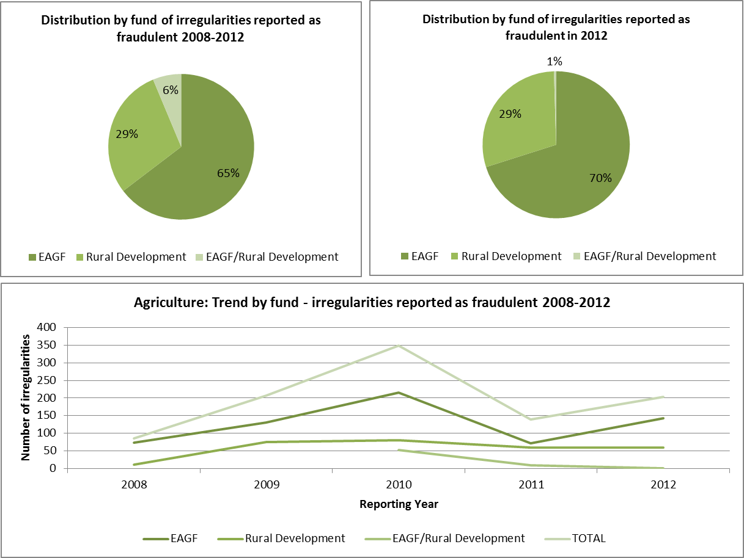
The EAFRD has been established since 2007 and therefore the low number of irregularities reported as fraudulent in 2008 is linked to the initial implementation of this fund. Since 2009 the number of irregularities reported as fraudulent has remained stable, while those linked to the EAGF (referred also partly to financial years before the 2007 reform) have more significant fluctuations.

3.2.2. Irregularities not reported as fraudulent
Regarding irregularities not reported as fraudulent, the number of those reported relating to EAFRD has been constantly increasing, while those related to EAGF has remained relatively stable. Consistently with this trend, also the irregular amounts linked to the rural development instrument have been increasing, but with a trend that is more evident in the last three years.
As a positive remark, which underlines the increasing quality of the information received, the number of the irregularities that could not be related to any fund has been continuously decreasing until disappearing entirely in 2012.
Table NR4 displays the information related to the trend in irregularities not reported as fraudulent.
Table NR4: Irregularities not reported as fraudulent by Fund – 2008-2012 for the CAP
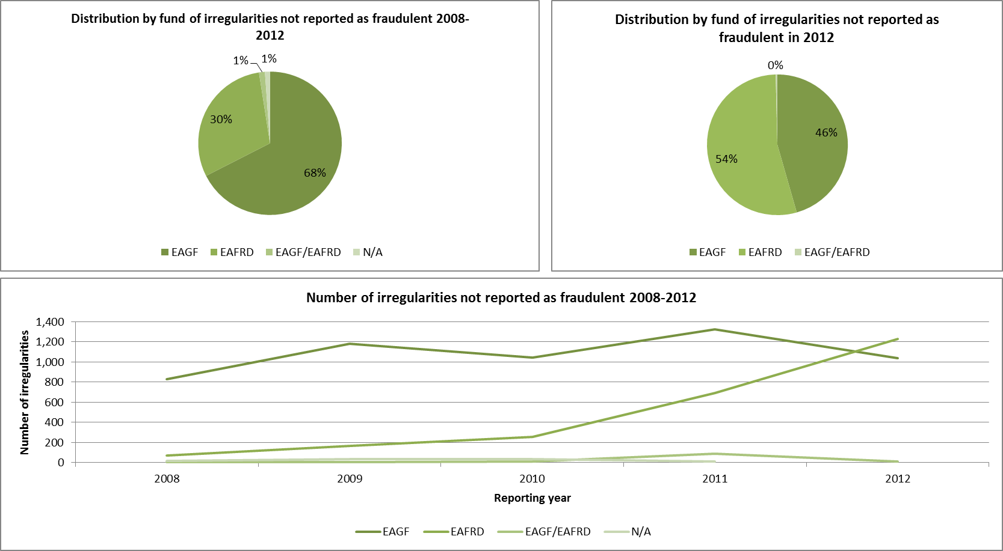
Unlike fraudulent irregularities the largest share, both in terms of numbers and amounts, in 2012 is for the non-fraudulent irregularities linked to the EAFRD.
The increase in the irregular amounts related to the EAFRD is also determining the situation that 2012 represents the highest peak in relation to irregular amounts linked to non-fraudulent irregularities of the last five years.
Table NR5 shows the information concerning the years 2008-2012.
Table NR5: Financial amounts linked to irregularities not reported as fraudulent by Fund – 2008-2012 for the CAP
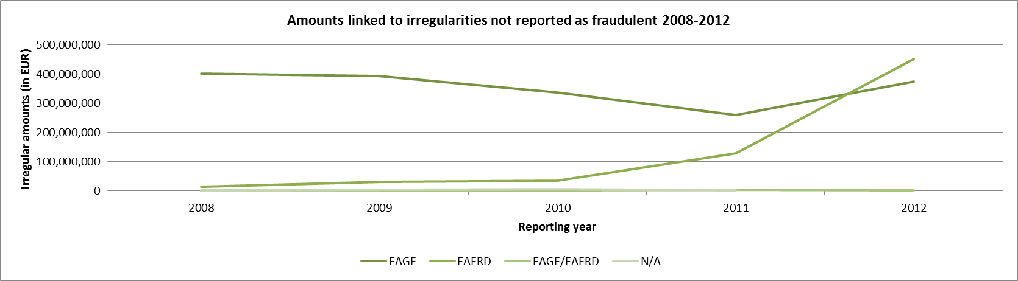

3.3. Specific analysis

3.3.1. Irregularities reported as fraudulent

3.3.1.1. Modus operandi
Table NR6 compares the types of irregulary / modi operandi linked to fraudulent cases detected in 2012 with those detected from 2008 to 2012 (included).
The most recurrent modus operandi is related to the infringement of limits, quotas or thresholds (related, respectively to products, species or land). However, this is the result of the reporting from Denmark of 56 cases, all presenting the same modus operandi and, probably linked to the same investigation.
Anyhow, the most recurring other modi operandi identified have not significantly changed in relation to the period 2008-2012, and are those directly linked to the idea of fraudulent behaviour, i.e. 'false or falsified declarations', 'false or falsified documents' and 'false or falsified request for aid'.
'False or falsified documents' also remains the most "dangerous" type of fraudulent irregularity in relation to the amounts which are affected by this practice.
Table NR6: Types of irregularities in relation to the CAP
A single case of corruption has been reported (it is comprised within the category 'OTHER') and involves an amount of about EUR 28 million (on the 30.5 million of that group). This case, reported by the Netherlands, is related to the financial year 1998 and due to its complexity and the secrecy of investigations has been reported only in 2012.

3.3.1.2. Type of control / Method of detection
Table NR7 shows the types of controls having identified the irregularities reported as fraudulent in 2012.
Table NR7: Control methods having identified the irregularities reported as fraudulent in 2012
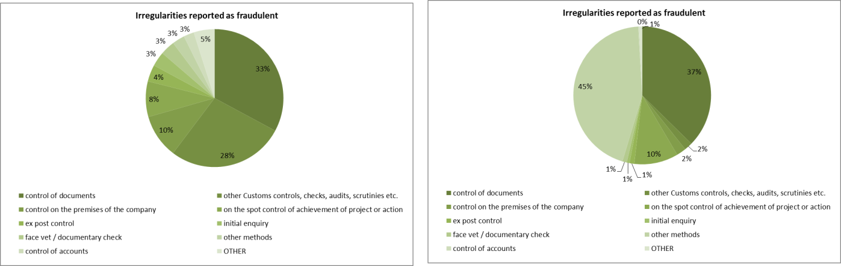
The bodies having identified the majority of the irregularities reported as fraudulent are mainly the anti-fraud bodies, while the criminal investigations deal with the cases with the highest financial impact as showed in Table NR8.
Table NR8: Types of controls having detected the irregularities reported as fraudulent in 2012 in relation to the CAP
Among the 90 cases related to Anti-fraud controls, 56 were reported from Denmark and 27 from Italy.

3.3.1.3. Complexity of the irregularities reported as fraudulent
Table NR9 provides a first estimation of the level of complexity of the irregularities reported as fraudulent. It also compares the situation of those reported in 2012 with those communicated in the reference period 2008-2012 (included).
The share of the 'complex' cases remains stable in 2012 in relation to the reference period, while share of the 'simple' fraudulent irregularities decreases with a consequent increase of the 'moderate' complexity category.
The 'complex' cases are exclusively referred to the EAGF, while none concerns the EAFRD (not only in 2012, but in the whole reference period).
Table NR9: Complexity of fraudulent irregularities detected in relation to the CAP
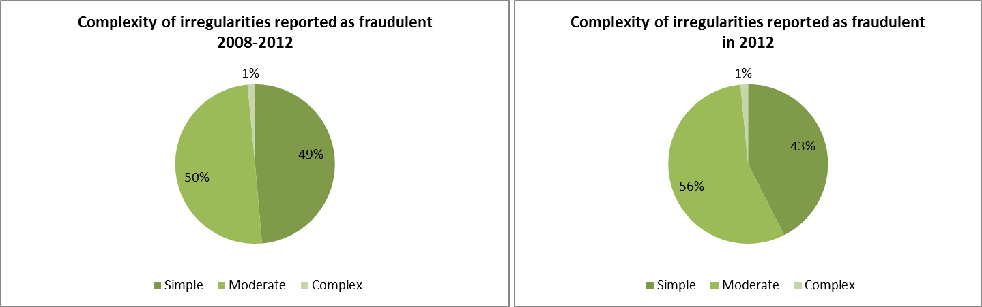
This is the first attempt of estimating the proportion of 'complex' cases on the total fraudulent irregularities identified. Therefore the method is liable of being improved in the next years.

3.4. Anti-fraud activities of Member States
Previous paragraphs have examined the trend and main features and characteristics of the irregularities reported as fraudulent.
The present paragraph aims at examining some aspects linked to the anti-fraud activities and results of Member States. Four elements are taken into account:
    - the time that runs between the beginning of the fraudulent practice and its detection/establishment by the competent authority and reporting to the Commission;
    - the number of irregularities reported as fraudulent by each Member State;
    - the fraud detection rate (the ratio between the amounts involved in cases reported as fraudulent and the payments occurred in the financial year 2012);
    - the ratio of cases of established fraud on the total number of irregularities reported as fraudulent.

3.4.1. Detection – Reporting Efficiency
Table NR10 shows the average number of months between the moment in which the fraudulent practice is put in place and when the fraudulent irregularity it is detected/established (Detection Efficiency – DetE) and then the average number of months between its establishment and the reporting (Reporting Efficiency – RepE) to the Commission.
The EU average is almost four years (47 months) between the first and the last of those events (DetE + RepE).
The duration of the DetE should not be seen as a sign of inefficiency per se. More relevant, in this respect, is the RepE, which is, in average, about 7 months, an acceptable time frame.
For most of the Member States (17) having reported fraudulent irregularities in 2012, have a DetE lower than 40 months. Only three (Italy, Denmark and the Netherlands) are above this average.
Table NR10: Detection and Reporting Efficiency by Member State
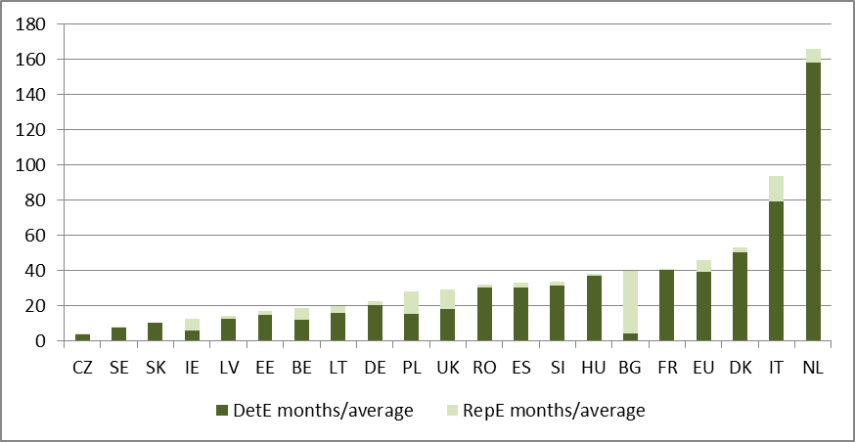
However, it should be taken into account that Italy and Denmark are also among the countries having reported the highest number of fraudulent irregularities, while in the case of the Netherlands, the result depends exclusively on a single case related to an irregularity linked to the financial year 1998, having involved a criminal investigation.

3.4.2. Detection of irregularities reported as fraudulent in 2012 by Member State
Map NR1 divides Member States in four groups, depending on the number of irregularities reported as fraudulent in 2012:
    - Group 1: no irregularities reported as fraudulent irregularities in 2012;
    - Group 2: between 1 and 9 such cases reported in 2012;
    - Group 3: 10 to 30 irregularities reported as fraudulent;
    - Group 4: more than 30 cases reported.
The composition of these groups is similar to the previous years, with the significant exception of Denmark, which is in Group 4, while in previous years it was in Group 1 or 2.
Map NR1: Number of irregularities reported as fraudulent in 2012 by Member State - CAP
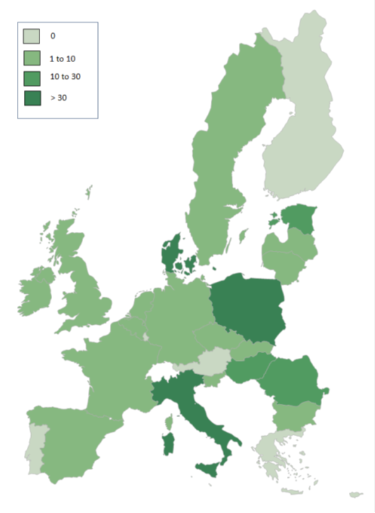
The detailed figures of Map NR1 are showed in Table NR9.

3.4.3. Fraud detection rate
The fraud detection rate compares the results obtained by Member States in their fight against fraud with the payments received by them in a given financial year. This implies that a single case reported as fraudulent and involving a significant financial amount can produce a better result that that achieved by the sum of the financial impact of several irregularities affecting lower amounts. For this reason, this indicator should be read in conjunction with the number of irregularities reported as fraudulent and for this reason they are presented together in Table NR11.
In 2012, the highest fraud detection rates are referred to the Netherlands, Estonia, Italy, Romania, Hungary and Denmark.
Table NR11: number of irregularities reported as fraudulent in 2012, amounts involved and fraud detection rate by Member State
In relation to the Netherlands, the result, as already mentioned, is due to a case related to the financial year 1998, established in 2011 (after a complex criminal investigation in the Netherlands and Belgium) and reported in 2012. In this case, the picture provided by the indicator is clearly distorted and this should be taken into account.

3.4.4. Ratio of established fraud 2008-2012
Table NR12 shows the ratio between the cases of established fraud and the total number of irregularities reported as fraudulent (including suspected and established fraud) in the period 2008-2012. Taking into account only cases reported in 2012 would be meaningless, as the criminal proceedings leading to a conviction for fraud may take several years.
In this respect, the average ratio of established fraud at EU level is 6%, with Latvia, Bulgaria, Germany, the United Kingdom and Slovenia showing a rate above this level, and Poland presenting a rate in line with the EU average.
Table NR12: number of cases of suspected and established fraud and ratio of established fraud – cases reported between 2008-2012 in the CAP
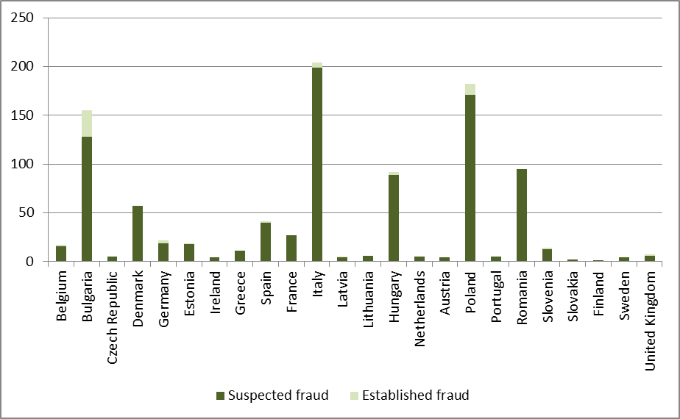
A significant impact on the rate is determined by the number of irregularities reported as fraudulent by Member States. In this respect, the countries which influence the EU average results are Italy, Poland, Bulgaria, Romania and, as of 2012, Denmark.

3.5. Recovery cases
Regulation (EC) No 1290/2005 introduced an automatic clearing mechanism under which 50% of any undue payments which the Member States have not recovered from the beneficiaries within 4 years or, in the case of legal proceedings, 8 years, will be charged to their national budgets (50/50 rule). Even after the application of this mechanism, Member States are, however, obliged to pursue their recovery procedures and, if they fail to do so with the necessary diligence, the Commission may decide to charge the entire outstanding amounts to the Member States concerned. Moreover, since 2008, Member States are required to off-set any outstanding debts against future payments to the debtor (compulsory compensation).
Undue payments that are the result of administrative errors committed by the national authorities also have to be deducted from the annual accounts of the paying agencies concerned and, thus, excluded from EU financing.
Regarding financial year 2012, Member States reported the information about irregularity cases by 1 February 2013. Based on the information available in March 2013, Member States recovered during financial year 2012 EUR 169.4 million from the beneficiaries, and the overall outstanding amount still to be recovered from the beneficiaries at the end of that financial year was EUR 1 216.8 million. The financial consequences of non-recovery for cases dating from 2008 or 2004 will be determined in accordance with the 50/50 rule mentioned above by charging approximately EUR 14.3 million to the Member States concerned. Moreover, around EUR 31.8 million will be borne by the EU budget for cases reported irrecoverable during financial year 2012. Due to the application of the 50/50 rule for the seventh time since its introduction, important non-recovered sums have already been charged to the Member States for EAGF expenditure. Out of the EUR 1 216.8 million to be recovered from the final beneficiaries at the end of financial year 2012 the amount outstanding towards the EU budget was to EUR 961.4 million (the difference having already been charged to the Member States via the 50/50 mechanism). As regards the recovery of undue payments financed by the EAFRD, it has to be noted that the 50/50 rule will only commence being applied after the closure of the rural development programmes.
The new clearance mechanism (50/50 rule) referred to above provides a strong incentive for Member States to recover undue payments from the beneficiaries as quickly as possible. As a result, by the end of financial year 2012, 43% of the new EAGF debts from 2007 and thereafter had already been recovered, which is a significant improvement compared to the past. The detailed breakdown of this recovery rate has developed as indicated in Table NR13.
Table NR13: Rate of recovery from beneficiaries of irregularities detected since 2007 (EAGF)
It is worth noting that some of these new debt amounts were already written off by Member States in the period 2007-2012 (EUR 43.5 million) and therefore they will most likely not be recovered. For more details on the recovery rates at Member State level, see the Table NR14.
Table NR14: Recoveries from beneficiaries for cases detected since 2007 in EUR (EAGF)
The recovery rate of 43% is significantly affected by the low rates displayed by six Member States (below 30%), while it is worth pointing out that 13 Member States have recovered more than 70% of the amounts at stake.
During the years 2008-2012, the Commission has been auditing the correct application of the new clearance mechanism through 21 on-the-spot controls in 14 Member States (including all EU-15 Member States with a low recovery rate for the cases detected since 2007). In general the Member States' authorities have adequate procedures in place to protect the financial interest of the European Union. Deficiencies found during these audits are being followed in the context of conformity clearance procedures. The diligence of the Member States' authorities in the recovery of the most significant individual irregularity cases is assessed in the context of a further 22 conformity clearance procedures (desk audits).

4. Common Fisheries Policy (CFP)
As the activities of each fishing fleet affect the opportunities of other fleets, the EU countries have decided to manage their fisheries in collaboration, through the common fisheries policy (CFP). This policy brings together a range of measures designed to achieve a thriving and sustainable European fishing industry.
Among the most important areas of action of the CFP is the provision of funding and technical support for initiatives that can make the industry more sustainable. These actions are supported by the European Fisheries Fund (EFF).

4.1. General analysis
Implementation of programmes financed by the EFF is proceeding more slowly than that of other policy under shared management. For this reason, the number of irregularities reported by Member States in relation to this fund is limited and has started in 2010.
Table NR15 shows the overall number of irregularities (fraudulent and non-fraudulent reported by year and the related financial amounts.
The increase from one year to the other simply reflects the increased level of implementation of the programmes.
Table NR15: EFF - Irregularities (fraudulent and non-fraudulent reported by year – 2010-2012
Table NR16 provides an overview of the payments and of the detected irregular amounts since the beginning of the implementation of the EFF funded programmes and until the end of 2012.
Table NR16: EFF - Payments and detected irregular amounts 2010-2012

4.2. Specific analysis
Given the limited number of irregularities reported so far, the analysis covers the whole period 2010-2012.

4.2.1. Types of irregularity detected
The number of irregularities reported in relation to the EFF is limited and to some extent incomplete in relation to the typologies of irregularities detected by national authorities.
This is reflected by the circumstance that of the 116 detected irregularities (fraudulent and non-fraudulent), 13 do not indicate the modus operandi (almost 10% of the total).
The most detected typology is 'Not eligible expenditure', followed 'Absence or late declaration' and 'Infringements of public procurement rules'. These three types alone cover almost 60% of the reported irregularities.
In relation to the 5 irregularities reported as fraudulent, the most frequent modus operandi is, the use of 'False or falsified supporting documents'

4.2.2. Method of detection
In relation to the methods of detection, the most frequently reported are 'Control of documents', 'Administrative controls' and 'On-the-spot checks'.

4.3. Control activity by Member States
Table NR17 shows the results of the control activities in the Member States.
Irregularities have been detected and reported by 13 Member States; fraudulent irregularities by 5 Member States. In terms of numbers of irregularities, the majority has been detected by Spain and Poland, while in terms of amounts the highest results have been obtained by Romania and Spain.
Table NR17: EFF – Irregularities (fraudulent and non-fraudulent) reported by Member State – 2010-2012
Sustainable Growth
Cohesion for Growth and Employment is key to achieving the goal of Sustainable Growth to support and promote a competitive, inclusive and green economy. The aim is also to create inclusive growth by ensuring that all citizens and regions can compete and contribute to the economy. Cohesion Policy is promoted using three shared management instruments. Shared management means money is distributed to Member States who adjust to local priorities compatible with the EU aims. Sustainable growth is also promoted through centralised direct management by the Commission and centralised indirect management where the Commission distributes funds to EU and other agencies (see chapter 6).

5. Cohesion Policy
The resources for the Cohesion policy support three main objectives:
- Convergence: aims to modernise and diversify regional economic structures, to support sustainable integrated economic development and create sustainable jobs.
- Regional competitiveness and employment: covers environment and risk prevention, access to transport and telecommunications services; Innovation and the knowledge economy.
- The European Territorial Cooperation objective: focuses on development of economic and social cross-border activities; transnational cooperation, and networking and exchange of experiences between regional and local authorities.
Three financial instruments are the vehicles to achieve the goals of this policy:
- The European Regional Development Fund (ERDF) is the largest fund and aims to support the development and structural adjustment of less developed regions in all Member States through investments in research, infrastructure, business support or direct financial support to SMEs.
- The European Social Fund (ESF) prevents and fights unemployment, by making Europe's workforce and companies better equipped to face new challenges and preventing people losing touch with the labour market. Training programs are the primary method; however advice, coordination and sometimes microfinance are also provided to entrepreneurs and SMEs.
- The Cohesion Fund promotes sustainable development in Member states with a per person GNI below 90% of the EU average. The fund has two components: Transport and Environment.
Table CP1 shows the financial resources available for the Cohesion Policy under the different financial instruments.
Table CP1: Financial instruments and 2012 appropriations for the Cohesion Policy by programming period and financial instruments

5.1. Trend analysis
In comparison with the other budget sectors, the analysis of the Cohesion policy poses a higher level of complexity, given by the fact that the information received is related to different programming periods, which are regulated by different rules.

5.1.1. Irregularities reported as fraudulent

5.1.1.1. Trend by programming period
Table CP2 analyses the trend linked to the communication of the irregularities reported as fraudulent in the last five years (2008-2012), making a distinction by Fund involved and the relevant programming period.
In the last three years, while the fraudulent irregularities linked to the PP2000-06 have been decreasing, those linked to the PP2007-13 have been constantly increasing. These trends are linked to the current implementation of the latter period and the closure of the previous.
Table CP2: trend of the number of irregularities reported as fraudulent between 2008 and 2012 by programming period – Cohesion Policy
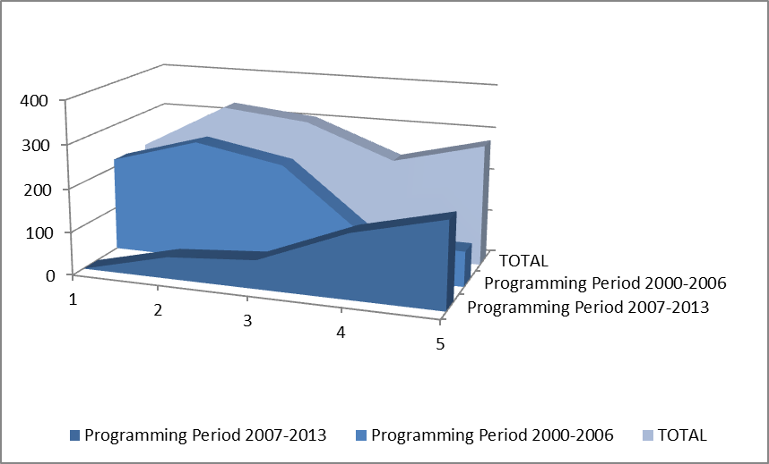
Table CP2 and its associated chart do not include irregularities reported as fraudulent related to previous programming periods, which have been communicated until 2011.
Table CP3 provides in the same form of Table CP2 information about the trends linked to the amounts involved in cases reported as fraudulent and confirms the raising trend related to the PP2007-13, although in this domain fluctuations are much more significant as individual cases involving high amounts can easily distort the overall picture.
Table CP3: trend of financial amounts linked to the irregularities reported as fraudulent between 2008 and 2012 by programming period – Cohesion Policy
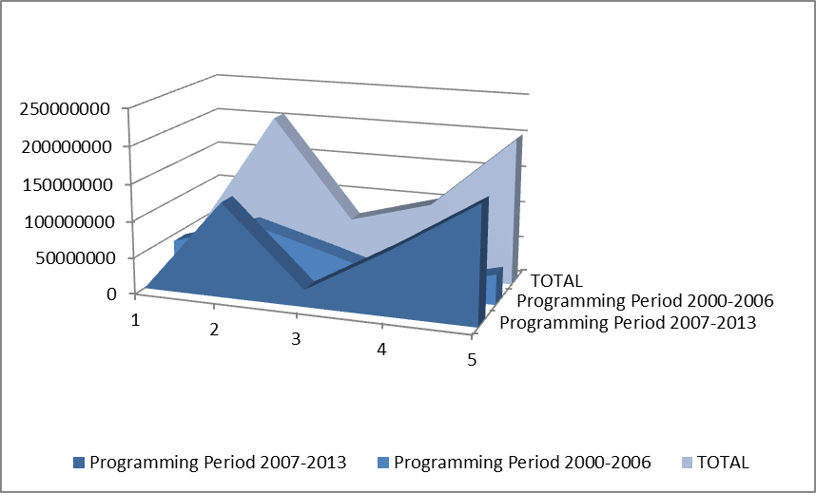

5.1.1.2. Trend by Fund
The analysis of the same data presented in Table CP2 but focussed on the distribution of the irregularities reported as fraudulent by Fund (Table CP4), highlights two circumstances:
    - The increase since 2010 of cases concerning the ERDF and Cohesion Fund
    - A significant decrease, in relation to the years 2009-2010, of the cases related to the ESF.
Table CP4: trend of the number of irregularities reported as fraudulent between 2008 and 2012 by Fund – Cohesion Policy
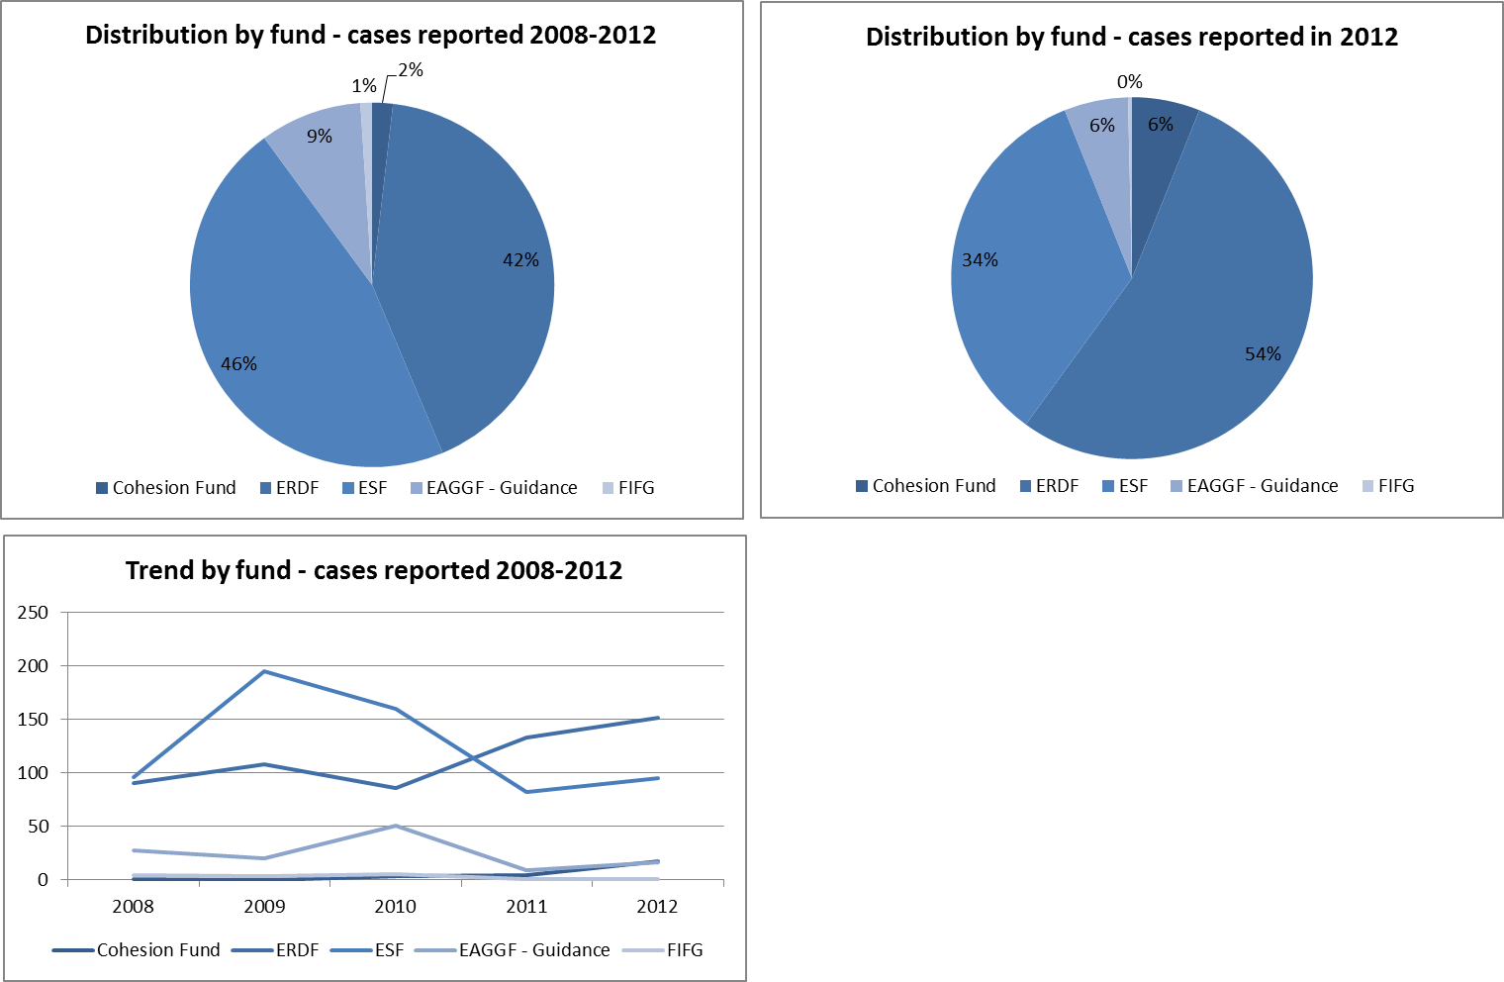
Table CP5 analyses these trends examining the financial amounts linked to the irregularities reported as fraudulent in the reference period.
In this respect, the weight of the ERDF on the total is accentuated by the higher amounts with which this fund contributes to the co-financing of development projects.
Since 2010 the increasing weight of the Cohesion Fund and of the ERDF is confirmed also in relation to the amounts involved.
Table CP5: trend of financial amounts linked to the irregularities reported as fraudulent between 2008 and 2012 by fund – Cohesion Policy
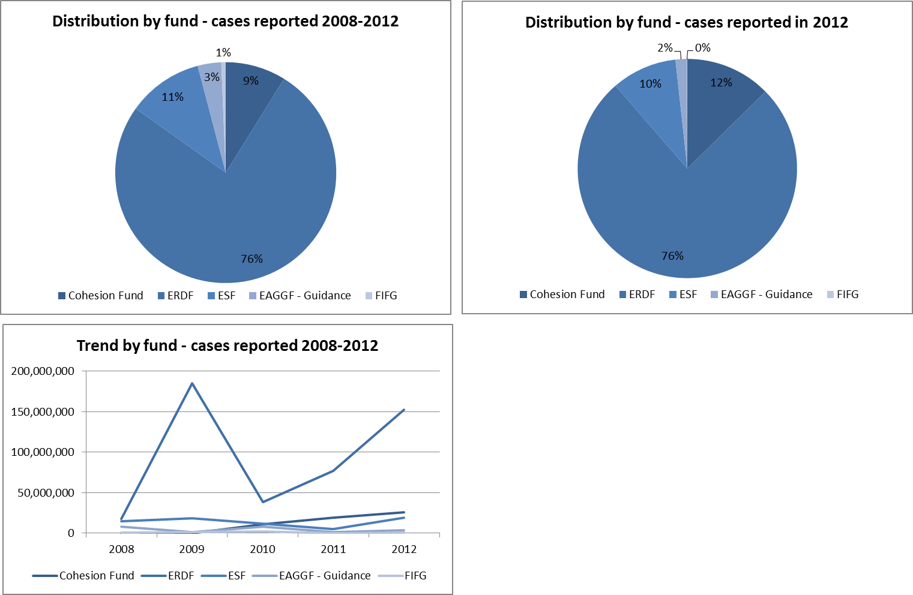

5.1.1.3. Trend by objective
A significant specificity of the Cohesion Policy is that programmes and financial resources available to implement them are closely linked to the geographical dimension, that is to say that the objectives that they pursue depend on the region (and its level of economic development) in which they are implemented. For this reason, the analysis by objective is important.
From this point of view, the analysis of irregularities reported as fraudulent in the last five years do not change the trend already highlighted in previous years.
The fraudulent irregularities detected and reported by Member States mainly concern programmes implemented under the Convergence objective (previously Objective 1), linked to the less economically developed regions in Europe.
Table CP6: trend of irregularities reported as fraudulent between 2008-2012 by Objective
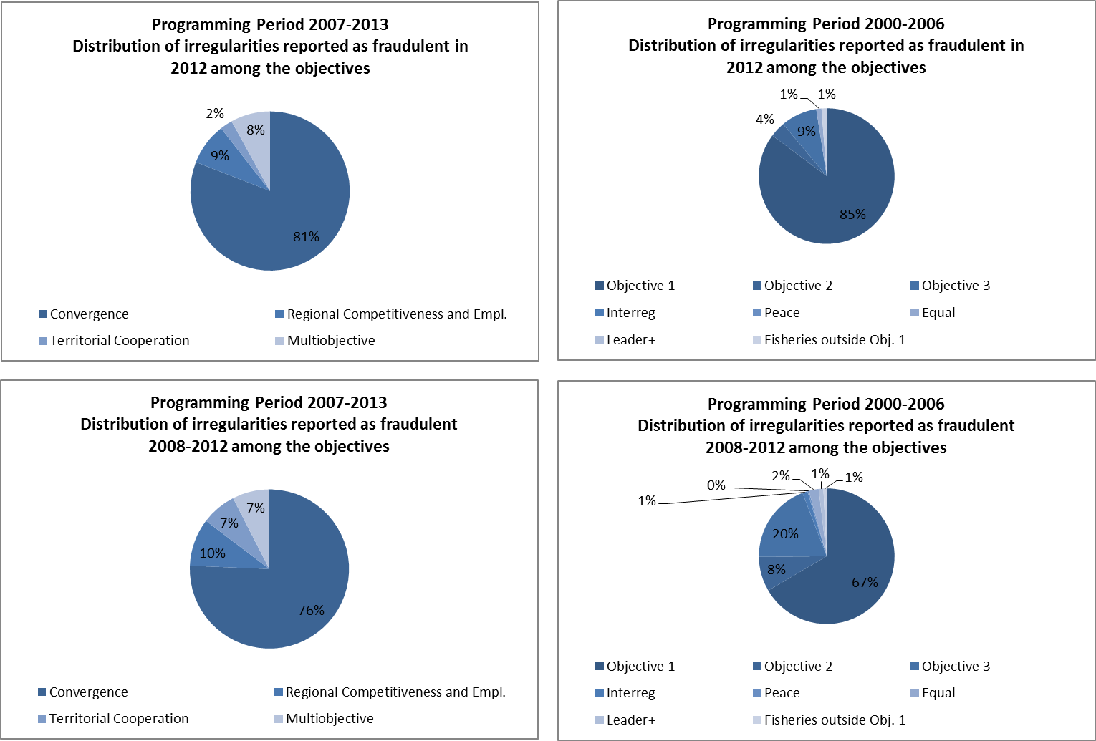

5.2. Specific Analysis – Irregularities reported as fraudulent in relation to the Programming Period 2007-13

5.2.1. Priorities concerned by the irregularities reported as fraudulent in 2012
The operational programmes financed by the Cohesion Policy are implemented in relation to the already mentioned objectives, but also along identified Priorities and Themes.
The information provided by Member States allows for an analysis of the priority areas in relation to which Member States have identified projects affected by potentially fraudulent practices.
Table CP7 shows the number of reported fraudulent irregularities and their related financial amounts.
In terms of numbers, the 'Priorities' most concerned were 'Research and Technological Development', 'Improvement of the access to employment and sustainability' and 'Environmental protection and risk prevention'.
From the amounts point of view, the most significant results concern 'Transport', 'Environmental protection and risk prevention' and 'Investment in social infrastructure'.
Table CP7: PP2007-13 - Irregularities reported as fraudulent by Priority
More than 40% of the irregularities used for this analysis did not provide information in relation to the priority area concerned.

5.2.2. Types of irregularities / modus operandi detected - Irregularities reported as fraudulent in 2012
The analysis of the detected practices used in connection with the irregularities reported as fraudulent in 2012 (Table CP8) reveals a relative decrease of those generically described as 'not-eligible expenditure' and a significant increase of those described linked to the use of 'false or falsified or incorrect documents, certificates or declarations', which intuitively represent the type of behaviour directly linked to fraud as aimed at deceiving the administration/body paying the resources.
However, the most significant increase is linked to 'infringement of public procurement rules' and 'abuses'.
Although marginal on the total, five cases potentially involving corruption have been detected and reported, bringing the total number to 13 in the period 2008-2012. Interestingly, these 13 cases affect the highest amounts reported in the reference period (almost EUR 90 million), followed by 'infringement of rules concerning public procurement'.
Table CP8: Programming Period 2007-13 - Types of irregularity/Modus operandi detected in relation to irregularities reported as fraudulent
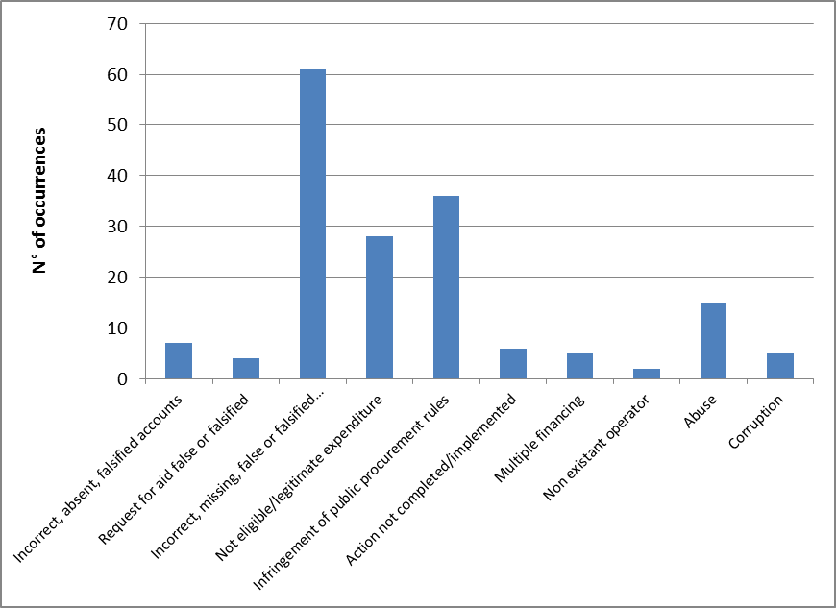

5.2.3. Type of control / method of detection – Irregularities reported as fraudulent
The analysis of the information concerning the Programming Period 2007-13 shows an important shift in relation to the previous programming period. The number of fraudulent irregularities detected by administrative controls is proportionally significantly higher than what was the case in the previous period, where the administrative verifications, on the spot checks and audit of operations would detect less than 20% of the cases, while in the current period they detect about 60%.
Table CP9: Programming Period 2007-13 - Type of checks having detected the irregularities reported as fraudulent
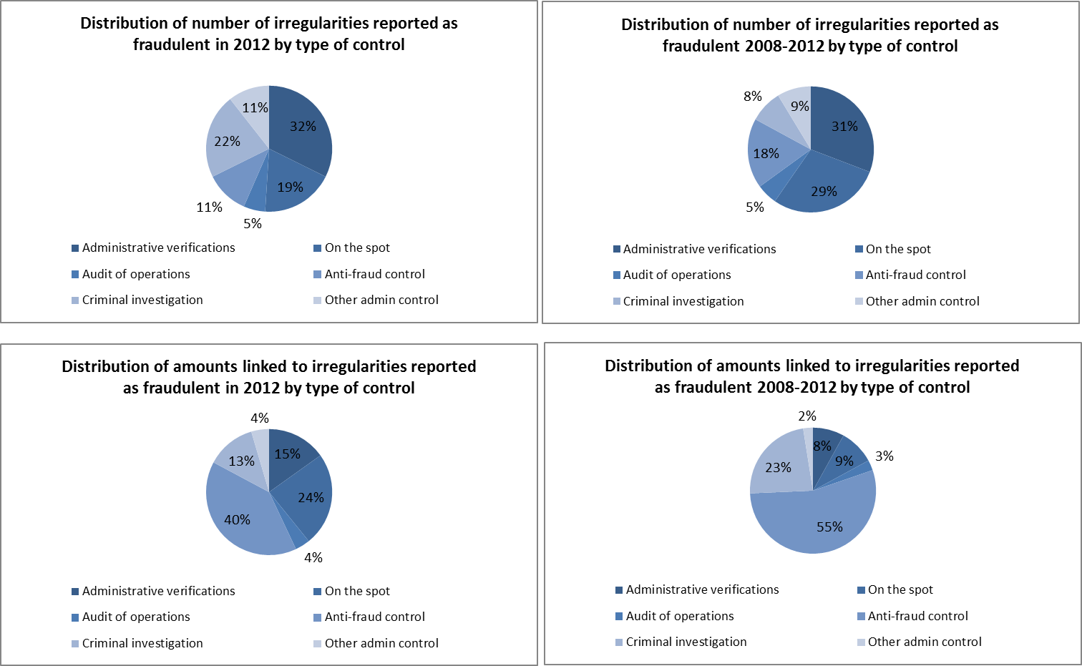
The results of this analysis may be influenced by the accuracy of the information reported by Member States, which may have highlighted the subsequent activity of bodies in charge of the management and control of the funds and neglected the detection activity of the anti-fraud bodies.
Another element to be kept into account is that for 107 cases reported in the years 2009-2011, it was not possible to determine the type of check.

5.2.3.1. Complexity of the irregularities reported as fraudulent
Table CP10 provides a first estimation of the level of complexity of the irregularities reported as fraudulent. It also compares the situation of those reported in 2012 with those communicated in the reference period 2008-2012 (included).
The share of the 'complex' cases remains stable in 2012 in relation to the reference period, while share of the 'simple' fraudulent irregularities increases with a consequent decrease of the 'moderate' complexity category.
The 'complex' cases are mainly referred to the ESF.
Table CP10: Complexity of fraudulent irregularities detected in relation to the CAP
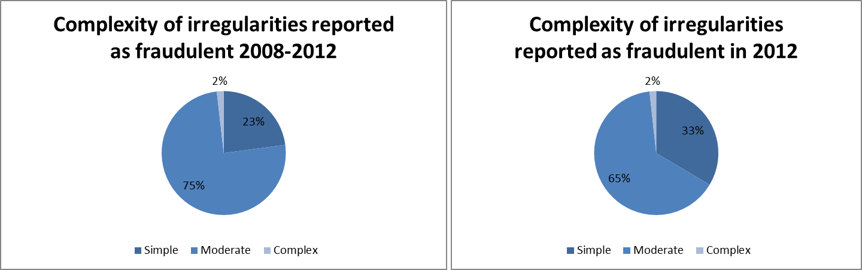
This is the first attempt of estimating the proportion of 'complex' cases on the total fraudulent irregularities identified. Therefore the method is liable of being improved in the next years.

5.3. Anti-fraud activities by Member States
Previous paragraphs have examined the trend and main features and characteristics of the irregularities reported as fraudulent.
The present paragraph aims at examining some aspects linked to the anti-fraud activities and results of Member States. Four elements are taken into account:
    - the time that runs between the beginning of the fraudulent practice and its detection/establishment by the competent authority and reporting to the Commission;
    - the number of irregularities reported as fraudulent by each Member State;
    - the fraud detection rate (the ratio between the amounts involved in cases reported as fraudulent and the payments occurred in the financial year 2012);
    - the ratio of cases of established fraud on the total number of irregularities reported as fraudulent (Ratio of established fraud - REF).

5.3.1. Detection – Reporting Efficiency
Table CP11 shows the average number of months between the moment in which the fraudulent practice is put in place and when the fraudulent irregularity it is detected/established (Detection Efficiency – DetE) and then the average number of months between its establishment and the reporting to the Commission (Reporting Efficiency – RepE).
The EU average is more than three years (39 months) between the first and the last of those events (DetE + RepE).
The duration of the DetE should not be seen as a sign of inefficiency per se. More relevant, in this respect, the RepE, which is, in average, about 12 months, but in 2012 it has decreased to 8 months that is an acceptable time frame.
For nine Member States having reported fraudulent irregularities in 2012, the DetE is lower than 31 months, while 8 are above this average.
The overall time gap between the initial moment and reporting (DetE + RepE) is increasing in 2012 in comparison with previously reported information.
Table CP11: Cohesion Policy – Detection and Reporting Efficiency
Three Member States (United Kingdom, Finland and Ireland) have not reported fraudulent irregularities in 2012 in relation to the programming period 2007-13. For Finland and Ireland, information provided in relation to cases reported in previous years did not allow calculating any average time gap.

5.3.2. Detection of irregularities reported as fraudulent in 2012 by Member State
Map CP1 divides Member States in four groups, depending on the number of irregularities reported as fraudulent in 2012:
    - Group 1: no irregularities reported as fraudulent irregularities in 2012. 9 Member States belong to this group.
    - Group 2: between 1 and 9 such cases reported in 2012. 10 Member States belong to this group;
    - Group 3: 10 to 30 irregularities reported as fraudulent. 3 countries are included in this group;
    - Group 4: more than 30 cases reported. It counts 5 Member States.
Map CP1: Number of irregularities reported as fraudulent in 2012 by Member State – Cohesion Policy
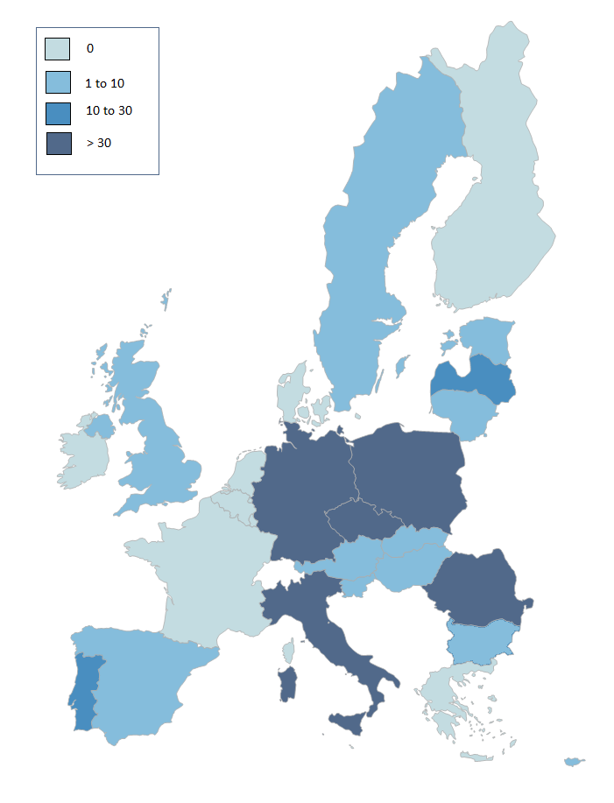

5.3.3. Fraud detection rate
The fraud detection rate compares the results obtained by Member States in their fight against fraud with the payments received by them in a given financial year. This implies that a single case reported as fraudulent and involving a significant financial amount can produce a better result that that achieved by the sum of the financial impact of several irregularities affecting lower amounts. For this reason, this indicator should be read in conjunction with the number of irregularities reported as fraudulent and for this reason they are presented together in Table CP12.
In 2012, the highest fraud detection rates are referred to the Italy, the Czech Republic, Latvia, Bulgaria, Romania and Germany (all above 0.3%).
The highest number of detected fraudulent irregularities for the period 2007-13 originates from Germany, Poland, the Czech Republic, Bulgaria and Romania.
Table CP12: number of irregularities reported as fraudulent in 2012, amounts involved and fraud detection rate by Member State
The high amounts related to Italy and the Czech Republic depend on two cases each which affect very large sums of money.

5.3.4. Ratio of established fraud 2008-2012
Table CP13 shows the ratio between the cases of established fraud and the total number of irregularities reported as fraudulent (including suspected and established fraud) in the period 2008-2012. It would be meaningless to take into account only cases reported in 2012, as the criminal proceedings leading to a conviction for fraud may take several years.
In this respect, the average ratio of established fraud at EU level is 3%, with Cyprus, Slovenia, Estonia and Latvia showing a rate above this level, and Germany presenting a rate in line with the EU average.
Table CP13: number of cases of suspected and established fraud and ratio of established fraud – cases reported between 2008-2012 in the Cohesion policy
A significant impact on the rate is determined by the number of irregularities reported as fraudulent by Member States. In this respect, the countries which greatly influence the EU average results are Germany, Poland, the Czech Republic, Romania, Italy and Bulgaria.
Section II - Decentralised Management
The EU as a global player / Pre-Accession Policy
The goal of the EU as a global player is also promoted through direct management. Pre-Accession Assistance (PAA) is provided through decentralised management where third countries distribute funds but account to the EU for how it is spent. In the last stages new member states manage pre-accession funds under shared management to help them complete the transition.

6. Pre-Accession Policy (Pre-Accession Assistance and Instrument for Pre-Accession)
The assistance in pre-accession is provided on the basis of the European Partnerships of the potential candidates and the Accession Partnerships of the candidate countries. The current candidate countries are Croatia, Iceland, the Former Yugoslav Republic of Macedonia, Montenegro, Serbia and Turkey. Accession negotiations were opened with Croatia and Turkey in October 2005, and with Iceland in July 2010.

6.1. The Pre-accession Assistance (PAA), 2000-06 and Instrument for Pre-Accession (IPA), 2007-13
The old Pre-accession Assistance (PAA), regarding the period 2000-06, was financed by series of European Union programmes and financial instruments for candidate countries or potential candidate countries, namely the programmes for candidate countries, PHARE, SAPARD and ISPA, Phare Cross-Border Cooperation (CBC) and Coordination, Pre-accession financial assistance for Turkey, Assistance for reconstruction, development and stabilisation for potential candidate countries (CARDS) and Transition facility.This assistance has nearly been closed except for a few payments in CARDS.
The current Instrument for Pre-Accession Assistance (IPA), which covers the period 2007-13 is delivered through five components. The policy and programming of IPA consists of Multi-Annual Indicative Financial Framework (MIFF) on a three year basis, established by country, component and a theme, and Multi-Annual Indicative Planning Documents (MIPDs) per country or per groups of countries (regional and horizontal programmes). The Candidate Countries submit also Strategic Coherence Frameworks (SCF) and Multi-annual Operational Programmes, both regarding IPA Components III and IV. Their principal aim is to prepare beneficiary countries for the future use of the Cohesion policy instruments by imitating closely its strategic documents, National Strategic Reference Framework (NSRF) and Operational Programmes (OP), and management modes.
The financing of IPA is provided by the five following different components and DG Enlargement leads in the coordination of the instrument:
    - Component I, Transition Assistance and Institution Building (TAIB), is managed by the European Commission's Directorate General for Enlargement;
    - Component II, Cross-Border Cooperation, is managed by the European Commission's Directorate General for Enlargement and part is managed, under shared management with Member States, by European Commission's Directorate General for Regional Policy;
    - Component III, Regional Development, is managed by the European Commission's Directorate General for Regional Policy;
    - Component IV, Human Resources Development, is managed by the European Commission's Directorate General for Employment and Social Affairs; and
    - Component V - Rural Development, is managed by the European Commission's Directorate General for Agriculture.
The pre- and post-accession assistance is implemented through a variety of management modes which take into account different levels of preparedness of the beneficiary countries. The assistance under IPA is designed also to prepare the beneficiary countries to assume full responsibility for the management of financial assistance granted by the EU.
The eligibility for IPA components differs depending on the state of preparedness. In the use of funds the IPA beneficiary countries are divided into two categories. The EU candidate countries Croatia, the Former Yugoslav Republic of Macedonia, Serbia and Turkey are eligible for all five components of IPA. While the new candidate countries, Iceland and Montenegro (candidate status awarded in 2010), currently remain outside the scope of intervention of IPA Component III, the regional development. The Potential candidate countries in the Western Balkans (Albania, Bosnia and Herzegovina, Montenegro and Kosovo under UN Security Council Resolution 1244/99) are eligible only for the first two components.
Implementation of Components I and II falls under the responsibility of DG Enlargement, which initiates the components under a centralised management mode, with a view to transferring implementation management powers to the beneficiary countries as soon as their administrative capacities are considered sufficiently developed to ensure sound financial management. The EU Delegations play a major role in the delivery of IPA, in particular under the de-concentrated and decentralised management modes.
The implementation can be handled:
- directly by central management: funds are managed by DG Enlargement at headquarters;
- directly de-concentrated: funds are managed by EU Delegations under the supervision;
- directly centralised: cross-delegated when funds are managed by another service of the Commission through cross sub-delegation;
- indirectly in a centralised indirect management: funds are managed by executive agencies, specialised Community bodies (such as the European Investment Bank or the European Investment Fund) and national or international public-sector bodies or bodies governed by private law with a public-service mission;
- indirectly decentralised with ex ante control: funds are managed by accredited national authorities of the beneficiary country, but procurement is subject to ex ante control by the EC Delegation;
- decentralised without ex ante control: funds are managed by accredited national authorities of the beneficiary country and are not subject to ex ante controls by an EC Delegation;
- joint: funds are jointly managed with International Organisations (EBRD, EIB, Sigma, UN agencies, etc.)
In Croatia, the implementation of Pre-accession assistance is decentralised to national authorities. Montenegro is preparing for conferral of management powers for IPA Component I and II. Decentralised management is still under development in the Former Yugoslav Republic of Macedonia. Payments in decentralised programmes remained less than half of the initial forecasts in FYROM. In Serbia, the national authorities submitted an application for the conferral of management in June 2012 and it could be granted by the end of 2013. Absorption capacity under decentralised management in Turkey is not optimal, with delays in tendering, contracting, as well as execution of payments.
For the financial year 2012 in the old pre-accession assistance PAA there have been paid only 7.4 million euros in CARDS. As regards the current pre-accession instrument IPA there have been 818.1 million euros paid in 2012. Table 1 presents payments for financial year 2012 for the component I and II and country made under the centralised management mode (IPA) and completion of CARDS assistance (PAA) in 2012.
Table PA1 – Payments made in financial year 2012 per component and country (IPA and PAA-CARDS)
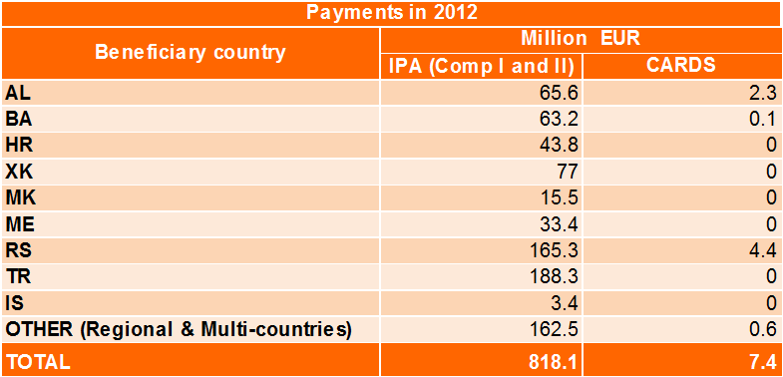
Multi-beneficiary programmes under Component I are designed to complement national programmes and to strengthen multilateral relations in the Western Balkans and Turkey.

6.2. General analysis – Trend analysis

6.2.1. Trend analysis
In the area of the Pre-Accession Assistance, PAA (2000-06) in 2012 the number of irregularities reported as fraudulent continued to decrease. This is due to the fact that support for EU-10 and EU-2 countries is being phased-out and the Pre-Accession Assistance (PAA) is nearly completed with the exception of a few projects and remaining payments as part of CARDS, which is reflected in the current reporting from Hungary, Poland, Bulgaria and Romania and the acceding country Croatia.
Table PA2 – PAA irregularities reported as fraudulent – 2002-2012
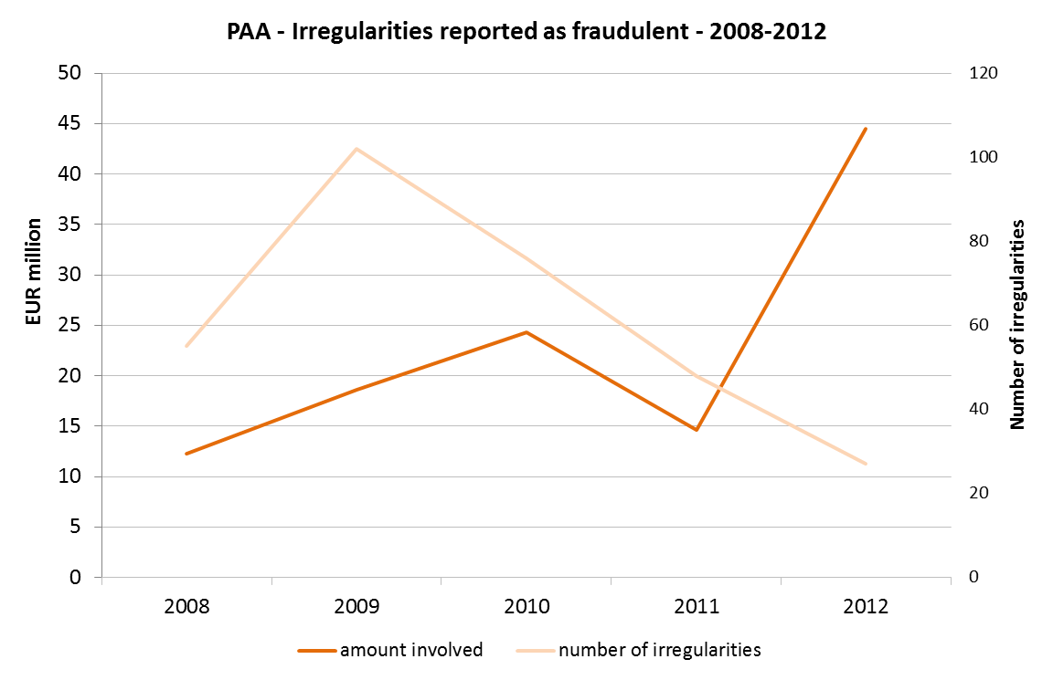
For the total number of irregularities (reported as fraudulent and not reported as fraudulent) for the PAA, there were 230 irregularities reported in 2012 and the amount affected EUR 89 million while in 2011 there were 247 irregularities and the amount affected was EUR 58, 5 million.
Generally it can be said that the trend in relation to IPA (2007-13) reporting has not been developing in a stable upward sloping curve and for the year 2012 it even drops. The low numbers in reporting are result of a poor level of absorption of aid and a backlog in IPA implementation in Croatia, the Former Yugoslav Republic of Macedonia and Turkey.

6.2.2. Reporting efforts
In general the communications received via IMS are complete and in terms of timeliness the reporting behaviour is satisfactory. The level of completeness of the reported information has been improving depending on experience with reporting.
Croatia started to use the IMS in the third quarter of 2012. FYROM is getting ready for reporting into IMS as well as Serbia, a new candidate country, which started to send reports to OLAF in the fourth quarter of 2012. Small inconsistencies regarding correct assessment of irregularity, dates related to the irregularity (and detection) remain.
Turkey has continued in consistent reporting. Croatia increased the number of reported irregularities due to its connection to IMS in October 2012. FYROM continued reporting its first irregularities. Serbia sent the first irregularity report.

6.3. Specific analysis – Financial year 2012

6.3.1. Pre-Accession Assistance (PAA)
In total 27 irregularities were reported as fraudulent with the amount affected EUR 44.5 million. The higher amount reported this year is attributable to two bigger cases (making EUR 38.5 million in total), notified as a suspicion of fraud by Romania regarding the ISPA fund. Without these two exceptional cases the curve would continue in a downward sloping trend in the irregular amounts, as in the previous year.
Table PA3 – Irregularities reported as fraudulent per country (PAA)
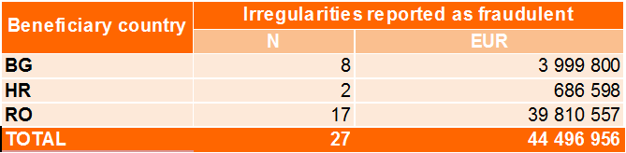
Table PA4 – Irregularities not reported as fraudulent per country (PAA)
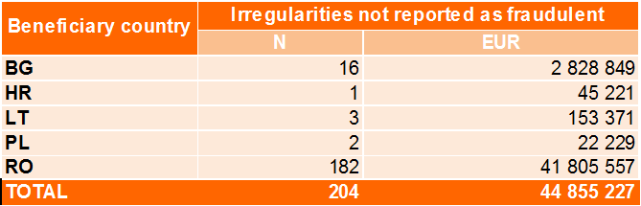
Table PA5 – Irregularities reported as fraudulent per fund (PAA)
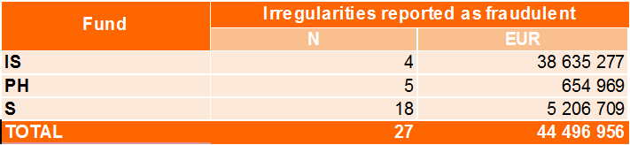
Table PA6– Irregularities not reported as fraudulent per fund (PAA)
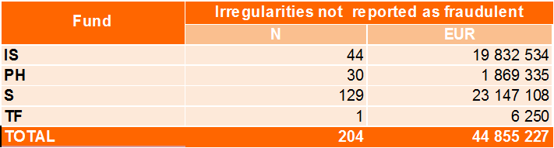
As in 2011, the majority of cases relating to PAA in 2012 concern again SAPARD (the Special Accession Programme for Agriculture and Rural Development). The trend of SAPARD, as the fund representing in the previous years the most important exposure to cases of suspected fraud, is being confirmed.
With 18 irregular fraudulent cases reported, the SAPARD fund remains the most fraudulent (compare with 38 cases in 2011), followed by PHARE with 5 cases and ISPA with 4 cases with higher amounts.
The practices repeatedly employed in committing fraudulent irregularities are mainly falsified supporting documents, followed by manipulation of tendering procedures. Amongst others belongs the conflict of interest, action not carried out in accordance with rules or other cases of irregular documents.

6.3.2. Instrument for Pre-Accession (IPA)
In IPA (2007-13), there were 23 irregularities reported in total involving the amount of EUR 1.6 million, which is a slight increase in both, the number of notified irregularities and amounts involved, in comparison with 20 cases and EUR 1.3 million reported in 2011.
There were 6 fraudulent irregularities reported for 2012 (1 from Croatia, 3 from FYROM, 2 from Turkey) with the total amount affected of EUR 0.3 million, while in 2011 there were 9 cases in total affecting EUR 0.98 million. Croatia, FYROM and Turkey have been receiving assistance during both periods of pre-accession.
Table PA7 – Irregularities reported as fraudulent per country (IPA)
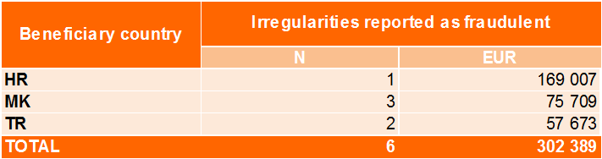
Table PA8 – Irregularities not reported as fraudulent per country (IPA)
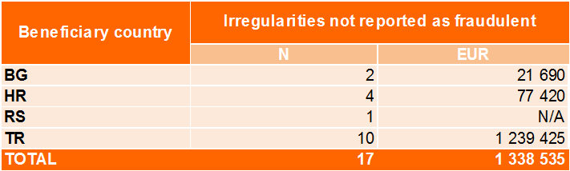
Table PA9 – Irregularities reported as fraudulent per fund (IPA)
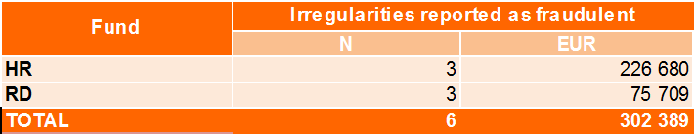
Table PA10 – Irregularities not reported as fraudulent per fund (IPA)
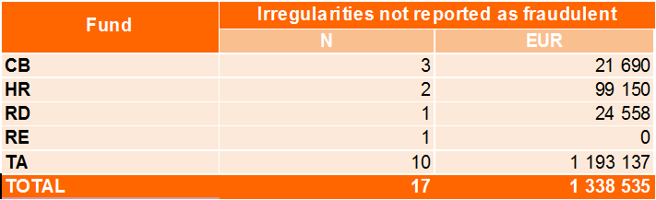
Poor absorption of aid and backlog in IPA implementation in countries using decentralised management (i.e. in Croatia, the Former Yugoslav Republic of Macedonia and Turkey) is an explanation for these low numbers of reported irregularities.
As regards Croatia, the beginning of the IPA period was affected by a substantial back-log in the implementation. As a result, the payments were lagging behind the contracting and remained rather low until 2011 and in 2012 there was only a slow and gradual reduction of the accumulated backlog, considering the further IPA funding allocated to Croatia.
Problems with in the management and control systems under decentralised management led to interruption in the payments to FYROM in 2012.
The absorption capacity under decentralised management in Turkey remained in 2012 suboptimal, with delays occurring in tendering, contracting, as well as execution of payments.
Therefore, following a delay, more reports are likely to come from Croatia, FYROM and Turkey for the 2007-13 IPA.
The key characteristics of practices repeatedly employed as regards the irregularities reported as fraudulent are mainly the following ones: conflict of interests, missing, incorrect or incomplete documents and falsified supporting documents.
Amongst other practices employed either separately or in combination with the previous ones, there are actions not carried out in accordance with rules, infringement of rules concerned with public procurement, undeclared revenue or non-eligible expenditure.

6.3.3. Method of detection
Most of the irregularities in 2012 were detected by the means of European Commission service or EU institution, i.e. by the Community controls (in particular in Romania and Bulgaria), associated controls (Romania), additional controls on the request by the Commission (Croatia) or other controls (Bulgaria, Lithuania, Romania), followed by the control of the documents (Croatia, Poland, Romania). This finding is underlining the importance of audits performed by responsible Commissions services and investigations conducted by OLAF.

6.3.4. Recovery for the Pre-Accession Assistance (PAA) – Cumulative results 2002-2012
The table demonstrates the recovery situation per country. It provides an overview for all years and funds regarding the period 2000-06 as reported into IMS. It represents the recovery rate which is the percentage of total amount recovered on the irregular amounts effectively disbursed.
Table PA11: Recovery by beneficiary country, cumulative results
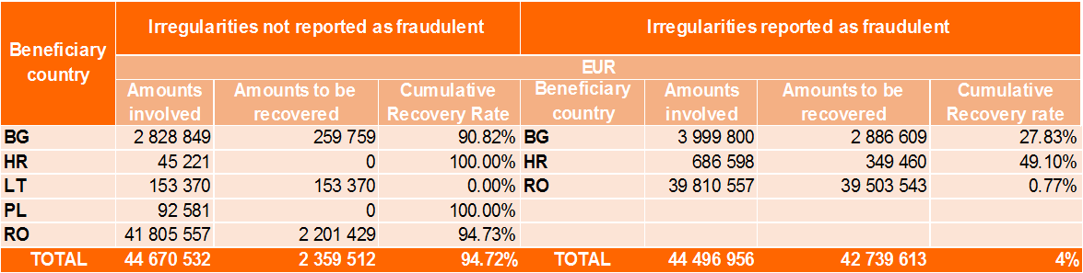
The figures do not take into account the recoveries and financial corrections made by the Commission.
Section III – Centralised Management

7. Centralised Direct and Centralised Indirect Management

7.1. Introduction
This chapter contains a descriptive analysis of the data on recovery orders issued by Commission services in relation to expenditures managed under ‘centralised management’ mode, which is one of the four implementation modes the Commission can use to implement the budget.
The implementation can be handled:
- directly by its departments; in this case the Commission and its departments perform the operations required to carry out the measures concerned without any involvement of the Member States or non-member countries where the recipients of the expenditure reside; or
- indirectly, by various entities to which such tasks have been entrusted.
For financial year 2012, a total of EUR 17.3 billion has been effectively disbursed under the centralised management mode. (Centralised direct: EUR 11.4 billion; centralised indirect: EUR 5.9 billion.) Table CM1 presents the actual payments made in financial year 2012 for the seventeen policy areas corresponding to 98% of the overall payments made under the centralised management mode.
Table CM1 – Payments made in financial year 2012 per policy area

7.2. General analysis – Trend analysis
In 2012, for the seventeen policy areas, the Commission services registered 1674 recovery orders in ABAC that were qualified as irregularities for a total financial value EUR 121.4 million. Among these recovery orders, 26 have been reported as fraudulent, involving EUR 2.7 million irregular amounts.

7.2.1. Trend analysis 2011-2012
As a trend analysis, the comparison between financial years 2011 and 2012 will be hereunder provided.
Generally it can be said that there was an increase in terms of number and related amounts regarding recovery orders qualified as irregularities. Table CM2 summarises the main figures for these two financial years. In 2012 the total irregular amount for all irregularities has almost doubled compared to 2011, meanwhile expenditure under the centralised management mode in relation to the policy areas concerned remained stable. As a consequence, the ratio between irregular amounts recovered and payments made has also doubled.
However, this increase should be interpredted as a result of the efficient irregularity detection systems in place.
Table CM2 – Irregularities not reported as fraudulent and related amounts, 2011 and 2012
Table CM3 – Irregularities reported as fraudulent and related amounts, 2011 and 2012
Table DE3 proposes a comparison between the two financial years with regard to irregularities reported as fraudulent. In 2012, there were less recoveries qualified to be fraudulent however these cases involved higher recovery amounts. As a result, the ratio between fraudulent amounts recovered and payments made has also increased.

7.3. Specific analysis – Financial year 2012
Table CM4 provides a more detailed classification of the policy areas and related irregularities with financial values. The list follows a descending order according to the payments made in the seventeen policy areas in financial year 2012.
Table CM4 – Irregularities reported by policy areas and related amounts, 2012
As it appears from the table, most of the 'irregularities reported as fraudulent' are linked to payments made in the area of external relations. This policy area alone counts for almost half of the number and two-third of associated amounts of recovery orders that proved to be fraudulent.
Regarding the 'irregularities not reported as fraudulent', the 'Energy' policy area stands out with the highest aggregate irregular amount, however almost the entire amount is linked to one single case. It is followed by policy areas ‘Information society and media’ and ‘Research’ that rank second and third in terms irregular recovery amounts. The explanation for the relatively high number of irregularities resides in the fact that Commission services duly detect and report irregularities in ABAC.

7.3.1. Recoveries according to legal entity residence
Table CM5 summarizes the recoveries according to the country of the recipient legal entity. In 90% of the irregular cases (qualified as fraudulent or not) the legal entity was resident in one of the 27 Member States of the European Union. It should be noted at the same time, that the residence of the legal entity is not necessarily the same as that of the main beneficiary. In cases where the legal entity resided in one of the 27 EU Member States, and where the irregularity was qualified as 'irregularities not reported as fraudulent', exactly 90% of the recoveries and 92% of the related recovery amounts were registered for main beneficiaries that were also resident in one of the EU Member States. Meanwhile, in case of 'irregularities reported as fraudulent' the ratio was only 38% and 33% respectively.
Table CM5 – Recoveries per country of residence of the legal entity, 2012

7.3.2. Method of detection
For each recovery order, the Commission service that issues the order has to indicate how the irregularity has been detected. Six different categories have been pre-defined, two of which fall under the direct responsibility of the European Commission: On-the-spot checks and the verification of documents by desk officers and financial officers responsible for the implementation of the commitment. Table CM6 gives a breakdown of the recoveries by source of detection and by qualification.
Table CM6 – Irregularities reported by source of detection and by qualification, 2012
OLAF detected the vast majority of the cases qualified ‘irregularities reported as fraudulent’: the 19 recoveries account for 86.7% of the irregular amounts.
In case of ‘irregularities not reported as fraudulent’, it has been by means of ‘Community controls’ that most of the irregularities were discovered, which all together represent 86.2% of the irregular amounts.

7.3.3. Types of error
The Commission services also have to indicate the type of error that was detected when the recovery order was issued. Several types of error can be attributed to one irregular case. Largely it can be observed that error 'Action not in accordance with the rules' and error 'Expenditure not covered by the legal base' appear most frequently, in 60% of cases of irregularities (reported as fraudulent or not). Besides, 'Missing documents' and 'Incomplete documents' are marked very often as components of the errors description of an irregularity.

7.3.4. Time delay
For the recovery orders issued in 2012, which were qualified as the ‘irregularity reported as fraudulent’, the average delay between the occurrence of the irregularity and its detection is 4 years and 3 months. However, the time delay varies significantly, so the average does not represent the series. Half of the cases were detected within 5 years following the year when the irregularity was committed; meanwhile in the other half of the cases the delay varied between 5 and 10 years.

7.3.5. Recovery
This paragraph describes the payments made to the Commission further to the issuing of the recovery orders. Once a recovery order is issued, the beneficiary has to pay back the undue payment or the amount is offset from remaining payments.
For the recovery orders issued in 2012, full or partial recovery was recorded in almost all of the 1674 irregular cases (reported as fraudulent or not). The financial amount already cashed is EUR 100.9 million (out of EUR 121.4 million). The recovery rate for recoveries qualified as ‘irregularity reported as fraudulent’ is 53.9%; meanwhile the rate for other irregularities is higher: 83.8%.
COUNTRY FACTSHEETS
Belgium
Bulgaria
Czech Republic
Denmark
Germany
Estonia
Ireland
Greece
Spain
France
Italy
Cyprus
Latvia
Lithuania
Luxembourg
Hungary
Malta
Netherlands
Austria
Poland
Portugal
Romania
Slovenia
Slovakia
Finland
Sweden
United Kingdom

ANNEXES
ANNEX 1
ANNEX 2
(The number of irregularities reported as fraudulent measures the results of efforts by Member States to counter fraud and other illegal activities affecting EU financial interests; it should not be interpreted as the level of fraud in their territories)
ANNEX 3
ANNEX 4
ANNEX 5
ANNEX 6
ANNEX 7
ANNEX 8
ANNEX 9
ANNEX 10
ANNEX 11
Irregularities reported in 2012 under Regulation 1848/2006 by Member State
(The number of irregularities reported as fraudulent measures the results of efforts by Member States to counter fraud and other illegal activities affecting EU financial interests; it should not be interpreted as the level of fraud in their territories)
ANNEX 12
Irregularities reported in 2012 under Regulation 498/2007 by Member State
(The number of irregularities reported as fraudulent measures the results of efforts by Member States to counter fraud and other illegal activities affecting EU financial interests; it should not be interpreted as the level of fraud in their territories)
ANNEX 13
Irregularities reported in 2012 under Regulation 1681/1994 by Member State
(The number of irregularities reported as fraudulent measures the results of efforts by Member States to counter fraud and other illegal activities affecting EU financial interests; it should not be interpreted as the level of fraud in their territories)
a) Number of irregularities
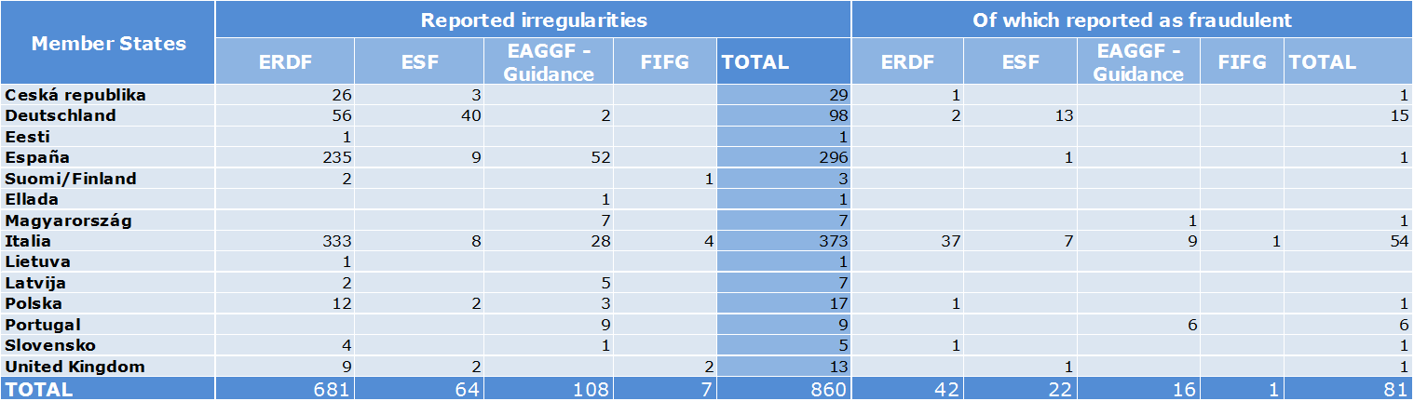
b) Irregular amounts
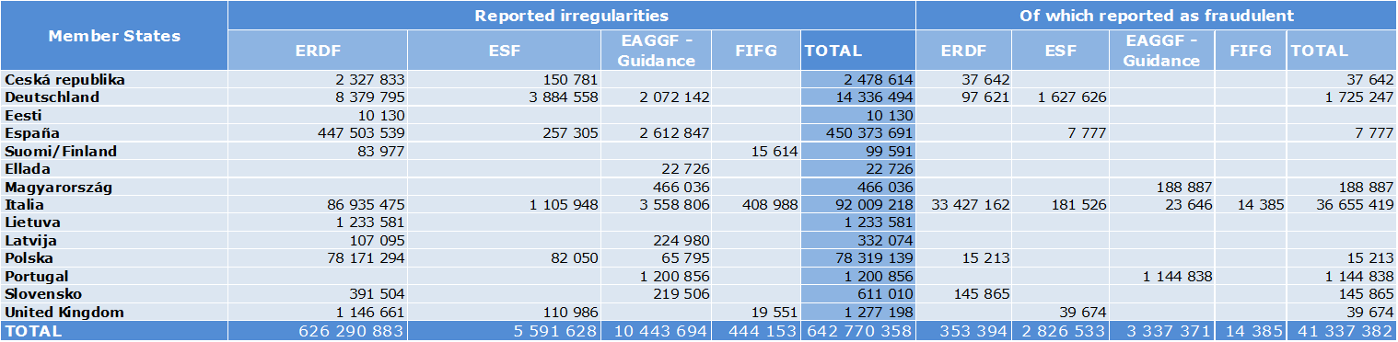
ANNEX 14
Irregularities reported in 2012 under Regulation 1831/1994 by Member State
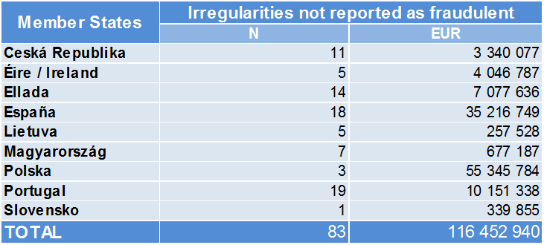
ANNEX 15
Irregularities reported in 2012 under Regulation 1828/2006 by Member State
(The number of irregularities reported as fraudulent measures the results of efforts by Member States to counter fraud and other illegal activities affecting EU financial interests; it should not be interpreted as the level of fraud in their territories)
a) Number of irregularities
b) Irregular amounts

This document does not represent an official position of the Commission.
For comparability reasons the figures of 2008-20011 are based on the data used for the reports of those years.
For comparability reasons the figures of 2008-20011 are based on the data used for the reports of those years.
For comparability reasons the figures of 2008-20011 are based on the data used for the reports of those years.
Further cases have been added after the cut-off date.
See annex 4.
See annex 5.
This calculation is based on 73 841 cases, an established amount of EUR 5.4 billion and a recovered amount of EUR 2.8 billion.
See annexes 6.
One fraud case was detected in Spain amounting almost to EUR 1.5 million.
See annexes 7 and 8.
Combined nomenclature or CN –nomenclature of the Common Customs Tariff.
See annex 6.
See annex 7 and 8.
The Czech Republic, Denmark, Italy, Latvia, Hungary, the Netherlands, Slovakia and the United Kingdom.
Luxembourg did not communicate any OWNRES case.
Germany (6%), Hungary (5%), Slovakia (5%), France (4%) and the Netherlands (2%).
Malta (100%), Greece (97%), Spain (75%), Bulgaria (67%) and Slovenia (52%).
See annex 4.
See annex 4.
This calculation is based on 14 420 cases, an established amount of EUR 1.69 billion (after already processed corrections) and a recovered amount of EUR 0.41 billion.
See annex 9.
On the cut-off date, for years 2008-2012, the annual RR for fraud cases varied between 22% and 33%.
See annex 9.
This calculation is based on 59 421 cases, an established amount of EUR 3.7 billion (after already processed corrections) and a recovered amount of EUR 2.38 billion.
See annex 10.
A report on Member States’ local clearance procedures summing up the results of the inspections carried out in 2011in all Member States was presented to the Advisory Committee on Own Resources on 6 December 2012.
Case C-392/02 of 15/11/2005. These cases are identified on the basis of Articles 220(2)(b) (administrative errors which could not reasonably have been detected by the person liable for payment) and 221(3) (time-barring resulting from Customs’ inactivity) of the Customs Code, Articles 869 and 889 of the Provisions for application of the Code, or on the basis of non-observance by the customs administration of Articles of the Customs Code giving rise to legitimate expectations on the part of an operator.
Judicial authorities performed searches on the premises of involved persons in 2003, first in Belgium, and later on in other Member States including the Netherlands, which reported it in 2012 due to the secrecy of the penal procedure, which was levied at that date. The case represents an anomaly not caused by flaws in the Dutch system of control and financial management.
The report reflects situation as of 2012. In June 2013 Iceland's Foreign Minister Gunnar Bragi Sveinsson informed the European Commission that the newly elected government intended to "put negotiations on hold".
Turkey has been receiving pre-accession assistance since 2002.
Albania, Croatia, FYROM, Serbia, Kosovo under United Nations Security Council Resolution 1244, and Bosnia Herzegovina, Council Regulation (EC) No 2666/2000 of 5 December 2000.
The EU-10 that joined European Union in 2004 received a Transition facility during 2004-2006. However the EU-2 received a Transition facility in 2007 which is regarded as a post-accession assistance.
Potential candidate countries were defined at the Santa Maria da Feira European Council of 20 June 2000.
Following the entry into force of the Treaty of Lisbon, Delegations have become a part of the European External Action Service, with effect from 1 December 2010.
2012 Annual Activity report, DG ENLARGEMENT
Except the CARDS payments (7.4 million euros, nomenclature 22 02 05 02), no payments were made for old pre-accession assistance (PAA) including the Transition Facility in 2012.
The data available for demonstration of the trend would show only two reporting years.
More analysis under 6.3.2
2012 Annual Activity report, DG ENLARGEMENT
The Financial Regulation provides for three types of management, one of them is the centralised management. In accordance with Article 53a of the Council Regulation (EC, Euratom) No 1605/2002 (‘Financial Regulation’) and Commission Regulation (EC, Euratom) No 2342/2002 (‘Implementing Rules’).
Own calculation based on ABAC data for the seventeen policy areas representing 98% of payments under the centralised management mode, excluding administrative expenditure.
Recovery orders that have been qualified by the Commission services as suspected fraud and subsequently reported to OLAF, or recoveries made following to OLAF investigation.

